ANIMAL PRODUCTION
LEVEL-I
Based on March 2022, Version-4 Occupational Standard
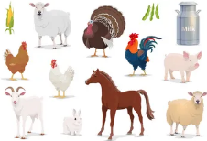
Module Title: - Carrying out Basic Husbandry Practice for Livestock and fishery
LG Code: AGR ANP1 MO1 LO (1-4) LG (1-4)
TTLM Code: AGR ANP1 TTLM 0822v1

September, 2022
Addis Ababa, Ethiopia
Table of Contents
Introduction to the Module 1
LO#1- Identify and prepare materials, tools and equipment for livestock and fishery work 2
Instruction sheet 2
Information Sheet1 3
Self-check 1 37
LO#2- Undertake Livestock and Fishery Work as Directed 38
Instruction sheet 38
Information Sheet 2 39
Self-check 2 55
Operation Sheet -2 56
LAP TEST-2 60
LO#3- Clean up and store materials and equipment 61
Instruction sheet 61
Information Sheet 3 62
Self-check 3 66
Operation Sheet -3 67
LAP TEST-3 68
LO#4- Record and report activities 69
Instruction sheet 69
Information Sheet 4 70
Self-check 4 75
Operation Sheet -4 76
LAP TEST-4 77
Reference Materials 78

Introduction to the Module
This module covers the knowledge, skills and attitude required to carry out basic husbandry practices for Livestock and Fishery that requires the ability to prepare materials, tools and equipment, undertake routine livestock and Fishery activities, handle material and equipment, and clean up on completion of work.

LG #1 | LO#1- Identify and prepare materials, tools and equipment for livestock and fishery work

Instruction sheet
This learning guide is developed to provide you the necessary information regarding the following content coverage and topics:
- Identifying the required materials, tools and equipment
- Conducting checks on all materials, tools and equipment
- Manual handling techniques for loading and unloading materials
- Selecting and checking Suitable Personal Protective Equipment (PPE)
- Identifying and responding OHS hazards
This guide will also assist you to attain the learning outcomes stated in the cover page. Specifically, upon completion of this learning guide, you will be able to:
- Identify the required materials, tools and equipment
- Conduct checks on all materials, tools and equipment
- Manual handling techniques for loading and unloading materials
- Select and check Suitable Personal Protective Equipment (PPE)
- Identify and respond OHS hazards
Learning Instructions:
- Read the specific objectives of this Learning Guide.
- Follow the instructions described below.
- Read the information written in the information Sheets
- Accomplish the Self-checks
- Perform Operation Sheets
- Do the “LAP test”

Information Sheet1

  - Identifying the required materials, tools and equipment

Definition of Terms
Livestock: - include all domesticated animals raised in an agricultural setting to produce commodities such as food, fiber and labor.
Ruminant animals: - are mammals that are able to acquire nutrients from plant-based food by fermenting it in a specialized stomach prior to digestion, principally through bacterial actions. Ruminants have a four-compartment stomach.
Non ruminant animals: -non-ruminants are also called "monogastrics"--animals with a single-compartment stomach.
Poultry: -domestic fowl in general, e.g., chickens, turkeys, ducks, or geese, raised for meat or eggs.
Dairy: - a farm that produces milk and milk products
Beef: - is the culinary name for meat from bovines, especially cattle.
Herd: A herd is a social grouping of certain animals of the same species, either wild or domestic
Fish: any of various cold-blooded, aquatic vertebrates having gills, commonly fins, and typically an elongated body covered with scales
Fishery: The industry or occupation devoted to the catching, processing, or selling of fish, shellfish, or other aquatic animals.
Artificial Insemination (AI):- is the deliberate introduction of semen into a female's vagina or oviduct for the purpose of achieving a pregnancy through fertilization by means other than copulation. It is the medical alternative to sexual intercourse, or natural insemination.
Estrus (heat): is a fairly well-defined period that occurs in no pregnant cows once each 19 to 23 days. In other words, estrus is the time during which the female will accept the male for copulation or breeding.

    - Tools and Equipment’s used in ruminant production

The following lists of equipment and tools are commonly used in both extensive and intensive Dairy, Beef, Sheep and Goat production.

Table. 1.1 Tools and Equipment’s used in ruminant production
No | Name | Use of tools and equipment’s | Image
1 | Burdizo: | The device that is used to castrate male animals. | 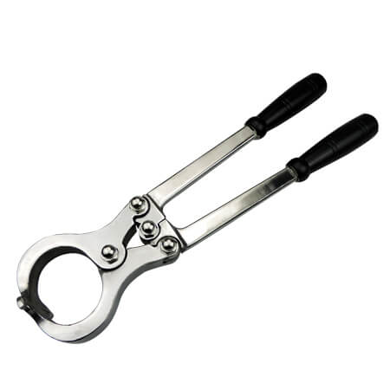
2 | Ear tag and its applicator | used to fixing identification number/sign to the ear of individual animals | 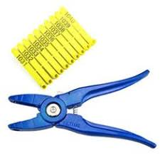
3 | Hoof trimmer | as its name indicated it is used to trim/cut extra or deformed hoof of animals | 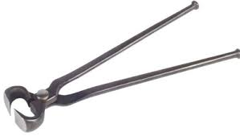
4 | Knapsack sprayer | is used to apply chemicals (acaricide, disinfectant herbicide and other chemicals) to preferred area /location. | 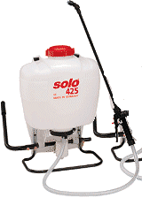
5 | Syringe (different size ) | an instrument consisting of a piston in a small tube, used in conjunction with a hollow needle or tube for the withdrawal and injection of fluids(medicine, chemicals) | 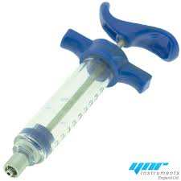
6 | Weighing balance | A device for weighing animals, feed medicine or other objects, for different purposes.
7 | Rope | A rope is a group of yarns, plies, fibers or strands that are twisted or braided together into a larger and stronger form. | 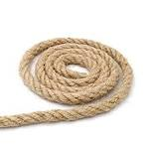
8 | Shovel/spade | a hand tools consisting of a broad, usually curved blade attached to a long handle, used for lifting mixing and moving loose materials (soil ,feed, etc ) | 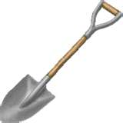
9 | Fencing wire | Strong wire with pointed projections along its length (barbed) used for fencing and barriers.
10 | Wheel barrow | a small cart used to transport things (Feed, waste materials other materials in the farm) usually in the form of an open container with a single wheel at the front and two handles at the back | 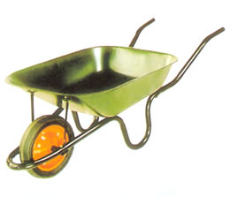
11 | Tape measure | a long roll or strip of fabric, plastic, paper, or thin metal that is marked off in inches or centimeters for measuring the length of something | 
12 | nose ring | A ring made of metal designed to be installed through the nasal septum of domestic cattle, usually bulls. | 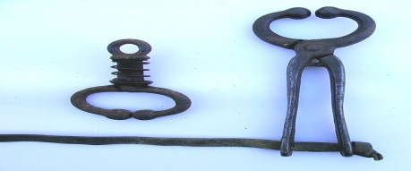

In addition to those listed above the following tools and equipment’s are used specifically in intensive dairy, beef, sheep and Goat production.

Feeder/Feed trough: -a device used for provision of feed for livestock

Waterer/water trough: - device a used to provide/supply water for animals.

Milking machine: - machines that can extract from cow

1.1.2 Milk handling processing machinery, tools and equipment’s

Table. 1.2 Milk handling processing machinery, tools and equipment’s
No | Name of the Item | Figure | Function
 | Cream separator | 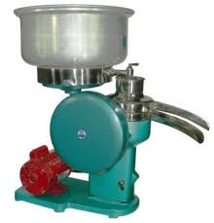 | Used to separate cream from higher-butterfat layer skimmed from the top of milk before homogenization
 | Churner | 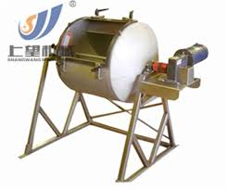 | Used to produce butter
 | Milk pasteurizer | 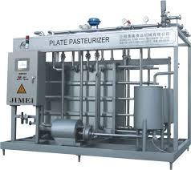 | Used to preserve milk and milk products
 | Refrigerator | 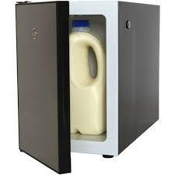 | Used to preserve milk and milk products
 | Milk storage tank | 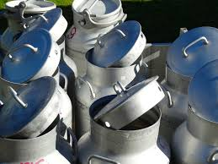 | Used to store milk
 | Milk containers | 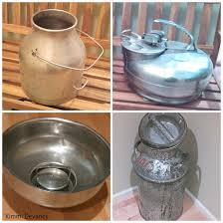
 | Strip cup | 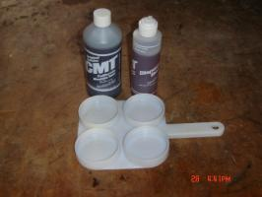 | Used to get milk sample to check diseased or not

1.1.3 Tools and equipment used in Artificial insemination

Table 1.3 Tools and equipment used in Artificial insemination
No | Name of the Item | Figure | Function
 | Liquid nitrogen container and its goblet | 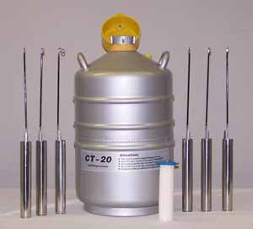 | Used to store semen for long time without loose its quality
 | AI sheath |  | Used to cover Insemination gun
 | Scissors |  | used to cut tip of non-cotton part of semen straw
 | Insemination gun | 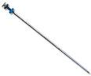 | Used to introduce semen into female reproductive organ
 | Forceps | 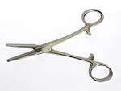 | Used to pick up semen straw from liquid nitrogen container
 | Thermometer | 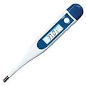 | To measure temperature
 | AI bag |  | To carry AI material
 | Thermo flask | 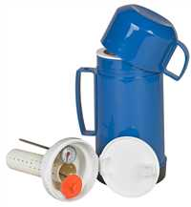 | To store worm water
 | semen straws | 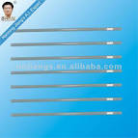 | It is the container of semen
 | Soft soap, little water |  | For cleaning purposes
 | Towel | 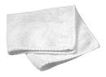 | To clean drop of water from semen straw after it removed from warm water
 | Stove |  | Used to boil water
 | Record book |  | Used for recording all reproductive information
14 | Arm size glove | 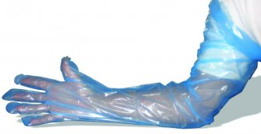 | It protracts all hand parts from feaces during insertion of hand in rectum of female animal to do insemination and pregnancy diagnosis

1.1.4 Tools and equipment used in Fish production

The fishing tools are the instrument used by fish farmers and fisher men to harvest or catch fish in the ponds, lakes, rivers and seas when they mature. The fishing tools commonly used by farmers are:
A. Fishing trap or cages: Various types of traps are made by fish farmers from raffia palm, coconut fronds, bamboo or cane ropes. Baits such as insects, earth worms, small fishes, red soap etc. can be used to attract the fish. The traps are constructed with wide mouth to enable fishes enter the cage.
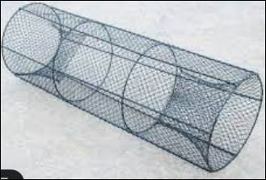

Figure.1.4 A. Fishing trap or cages

B. Fishing hooks: These are small metal instruments that are curved and sharp. Fishing tools are of two types.
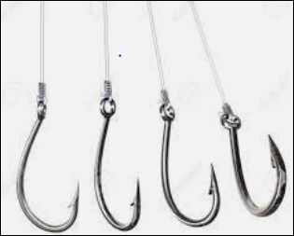

Figure 1.4 B. Fishing hooks

C. Pole and line hook: This consist of a hook, line made of twine and a pole. The hook is attached to the line and the line tied to the pole. Baits are attached to the hook and then thrown into the water. Any heavy substance like stone can be tied to the line so that it will not float on top of water.
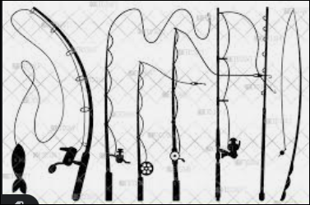

Figure 1.4 C. Pole and line hook

D. The long line hook: This consists of many hooks attached to the line and the line tied to a pole each at both end of the stream. The fishes are caught when they want to swallow the baits attached to the hook.
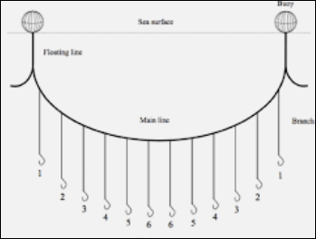

Figure 1.4.D. The long line hooks

E. Fishing net: The fishing net is made of nylon with a suitable mesh size. There are different types of fishing net. These are cast net, hand or scoop net and drag net.
- Cast net: This is sometimes called the throw net and it is used to trap fishes in water.
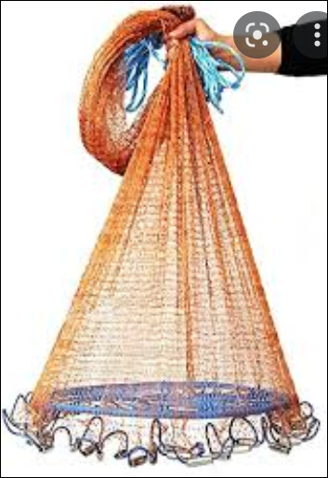

Figure 1.4 E Cast net

- Hand net or scoop: This is used to catch fish in pounds and rivers. like other net, it is made up of nylon with iron handle.
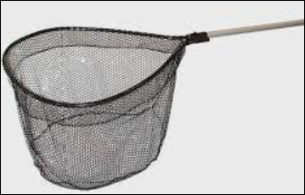

Figure 1.4 E Hand net or scoop

- Drag net: This consists of a thick rope and a cork float on the surface with heavy pieces of lead at the bottom. It is carried out by 4 fisher men or more. The net is dragged to the ground and the fishes are removed.
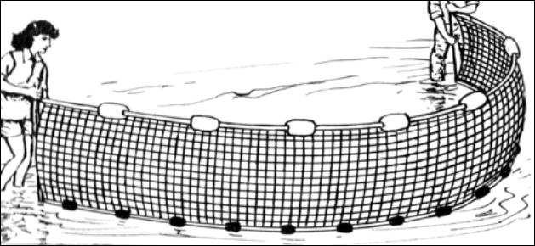

Figure 1.4 E Drag net

F. Fishing canoes: This is a fishing equipment that is carved out from timber or log with different sizes. From the canoes, the cast net can be thrown into the water to catch fish. It is also used to transport caught fish out of the water with the aid of the paddle.
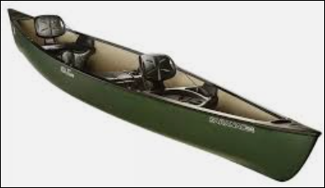

Figure 1.4 F. Fishing canoes

G. Baskets: The basket is made with cane rope or rachis of palm fronds. It is used to scoop through the water in order to catch fishes.
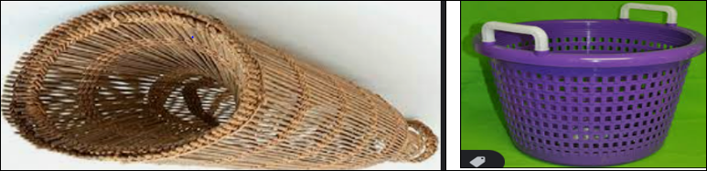
Figure 1.4.F Baskets
H. Buckets: is a round metal or plastic container with a handle attached to its sides. Buckets are often used for holding and carrying fish.
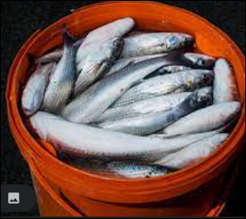

Figure 1.4 H. Buckets

I. Ice box: A compartment in a refrigerator for storing or making ice.
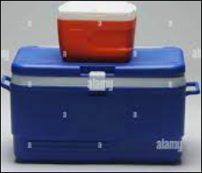

Figure 1.4 I Ice box

J. Refrigerator: is to keep perishable materials cold. Cold temperatures materials stay fresh longer. The basic idea behind refrigeration is to slow down the activity of bacteria so that it takes longer for the bacteria to spoil the material.
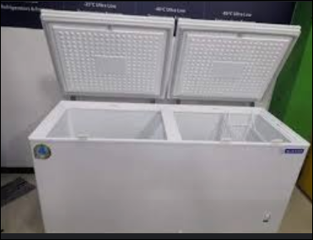

Figure 1.4 J. Refrigerator

K. Measuring board: To get an accurate reading of a fish’s length, anglers use a measuring device called a bump board, a plastic measuring board with a wall at one end. To measure the fish, place its nose on the wall and read the measurement at the tail.

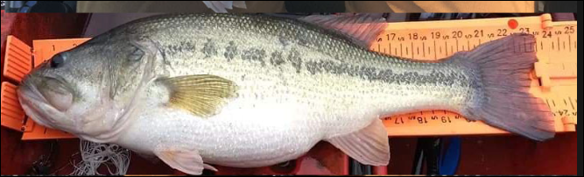

Figure 1.4 K. Measuring board

L. Thermometer: is a device used for measuring temperature of water.

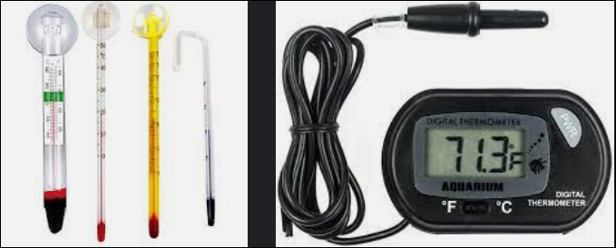

Figure 1.4. L. Thermometer

M. pH meter: used to measure the alkalinity or acidity of water.
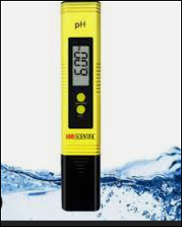
Figure 1.4.M. pH meter

N. Litmus paper: used to determine whether anything is acidic or basic.
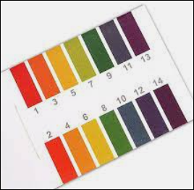

Figure 1.4. N. Litmus paper

O. Sechi disk: An instrument for measuring water transparency in a body of water. A white disk 25-30 cm in diameter, it is hanged by a three colored nylon thread. From the base of the thread up to 20 cm is red colored, next 10 cm is green and rest (100-120 cm) is white colored.

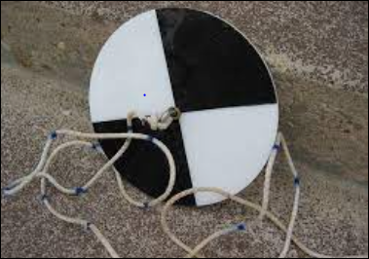

Figure 1.4. O. Sechi disk

P. Dissolved oxygen meter: used to measure the amount gaseous oxygen dissolved in water.
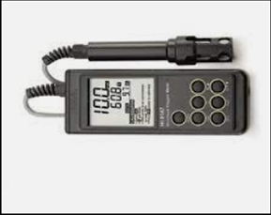
Figure 1.4. P. Dissolved oxygen meter

1.1.5 Tools and Equipment’s used in poultry production

Almost all tools and equipment’s used in free range (extensive) and intensive (deep litter and cage system) poultry production are the same except some which are specific to intensive production. The followings are common in both free range and intensive production.
A. Incubator: Incubator is such a poultry equipment which is used for hatching the bird’s egg in artificial ways. Generally, in natural condition, the poultry birds hatch the egg, but they can maintain and hatch a limited number of eggs.
So, when it is necessary to hatch a large number of eggs then you must have to use an incubator. There are many types of egg incubators in the market.
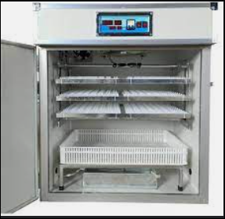
Figure 1.5 A. Incubator
B. Egg Tray: This is an equipment used in setting the eggs. Just like the name, it is a tray-like equipment where the eggs are place for sampling.
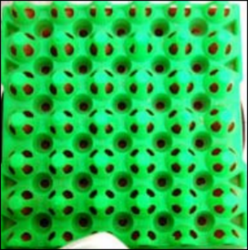
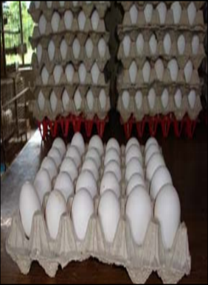

Figure 1.5 B. Egg Trays
C. Laying Nest: Laying nest is another equipment that help the birds for laying of eggs. One of the advantages of this equipment is that it increases the egg productivity of the poultry birds.
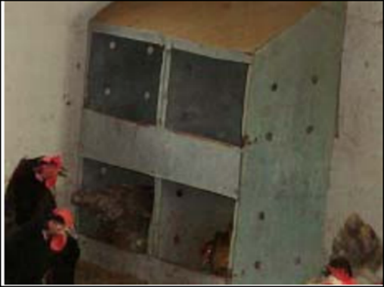

Figure 1.5 C. Laying Nest

D. Feeder: Feeder is such an equipment which is used for feeding the poultry birds. Generally some foods kept in the feeder and the poultry birds starts eating food from there. Plastic or metal feeders are used mostly to feed the chickens.
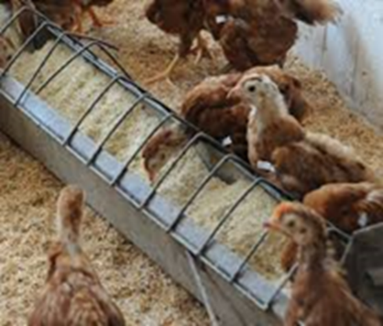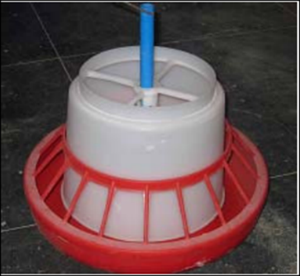
Figure 1.5 D. Feeder

E. waterer: is simply the vessel or system you use to provide water for your birds. Waterers may be basic and made from plastic or metal.
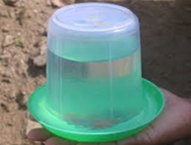
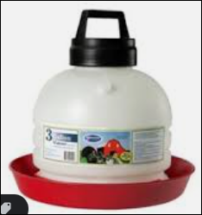
Figure 1.5 E. waterer

F. Heater: Heat management is very necessary for poultry farming. Bulb, heater or other heating equipment can be used to warm up the poultry cage.

G. Egg Handling Nest: Egg handling nest or cages are used for transporting eggs from one place to another places. It reduces the risk of damages of eggs while transporting for marketing purpose.
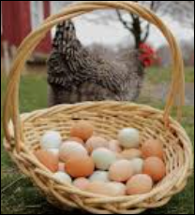

Figure 1.5 G. Egg Handling Nest

H. Brooder: Brooder machines provide warmth and lightning to the chicks.
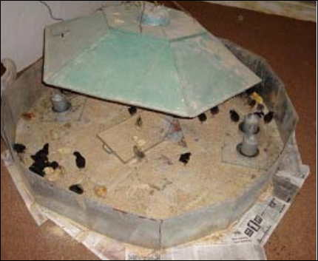

Figure 1.5 H. Brooder

I. Candler: This equipment produces a beam of light which is used to get an idea about the internal quality of eggs without breaking.

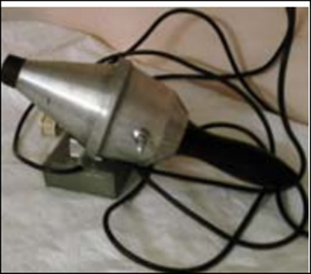

Figure 1.5 I Candler

J. Crates: are box-like structures made of meshwork used for transportation of birds.

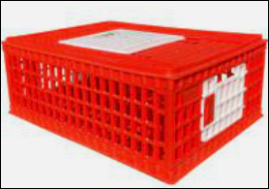

Figure 1.5 J. Crates

K. Debeaker: to remove the tip of the upper mandible of (a bird, such as a chicken) to prevent cannibalism and fighting

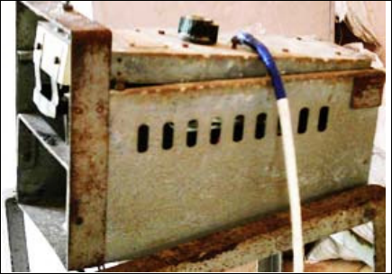

Figure 1.5 K. Debeaker

1.1.6 Tools and equipment used in beekeeping activities
- Smokers
Is manually operated materials used to smoke the hive. It calms down the bees (subdue) & induce them to engorge bees full of honey are easier to handle &expel the bees from the surrounding during work.
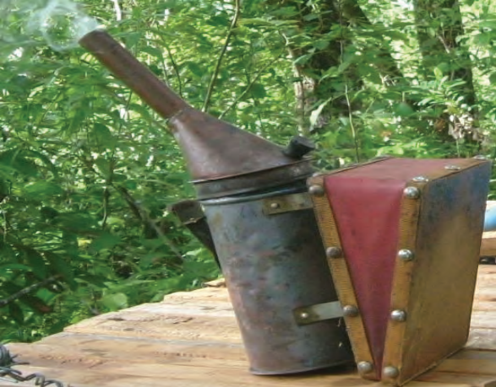
Fig 1.6 A: Bee smoker

B. Chisel /beekeepers tool
It is sharpened at both ends but curved at one end and should be painted with rustproof paint to avoid contamination of honey with corrosion and rusting with honey. It is used to open the hive, clean propels, wax and unnecessary materials from the farm, hive & seen in the hive.
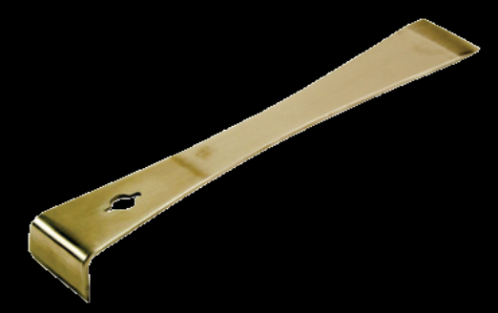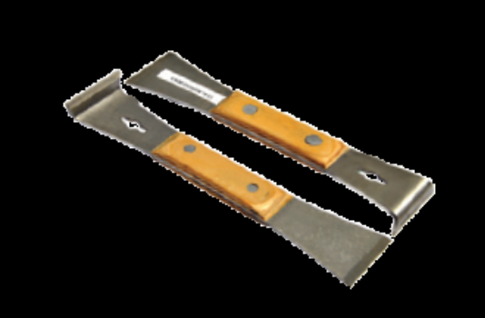

Fig 1.6 B: Chisels

C. Casting mould /wax press/
The instrument used for making foundation sheet from bees wax with the imitation of honey comb cells. It is a metal coated with zinc. It is manually operated equipment used to make artificial comb foundation sheet
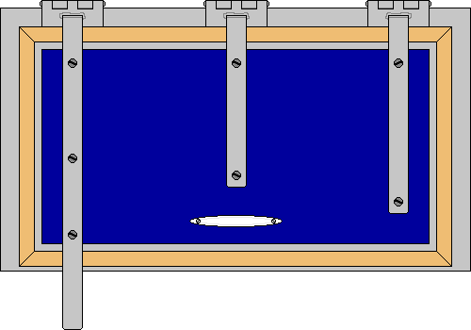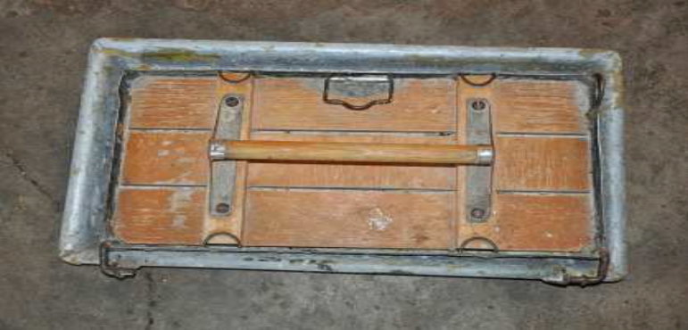
Fig 1.6 C: casting mould

D. Queen excluder
It is a sheet perforated or grid type made up of aluminum sheet or stainless steels, plastic and wire mesh that is placed between the brood chamber and honey chambers. It is a device used to form an appropriate partition between the brood and honey chambers so as to prevent the queen or drone from entering to honey chambers.
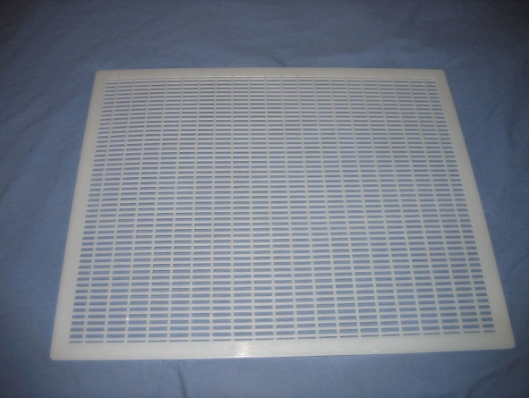

Fig1.6 D. Plastic queen excluder
E. Bee Brush
The bee brush should be made of soft natural fibre e.g. sisal fibre. One can also use bird quill feather or very soft leaves or grass provided they are clean which is used to remove the honey bees from the honey combs and draw the bees to hive while transferring
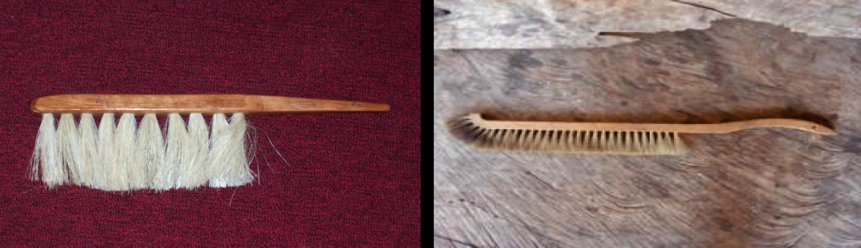
Fig 1.6 E: Bee brush

F. Sprayer: It is a material used to spray water on the bees/especially at low land areas/ to reduce aggressiveness and immediate evacuation from their nest.

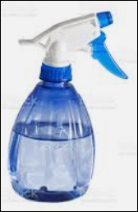

Fig 1.6 F: Sprayer
G. Uncapping fork/ knife: Is a material used to de cup the cells of sealed honeycomb before the frame combs are placed in the honey extractor
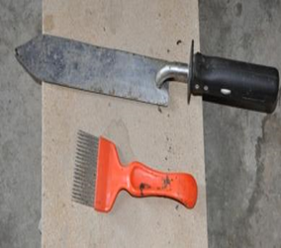
Fig 1.6 G. Uncapping fork/ knife

H. Frame wire: is thin galvanized wire which is stretched through the holes of frames and used to attach & reinforce the foundation sheet to the frame. It supports the honey combs firmly during extraction, so that it will not break off easily.
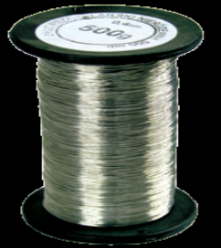
Fig 1.6 H. Frame wire

I. Transformer: - It is an electrical device having 18-24 volts and is used to fix the foundation sheet to frame wires. It converts 220 volts of electricity to 18-24 volts. In the absence electricity, wax embedder (knife or hot wire) can be used.
a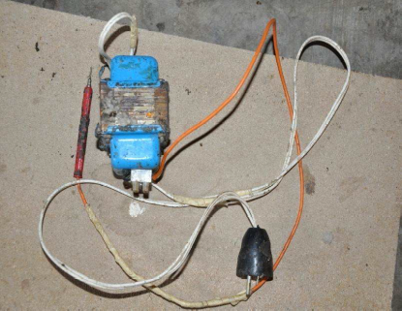
Fig 1.6 I. Transformer

J. Honey extractor: It can be manually or electrically operated centrifugal machine, with removing chambers into which the frames fit. As the handle is worked, honey flows out of the frames by the centrifugal force without breaking the comb.
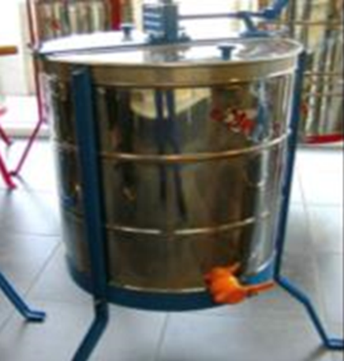
Fig 1.6 J. Honey extractor
K. Honey presser: It is used to extract honey by method of hand pressing of honeycombs, which are not framed.
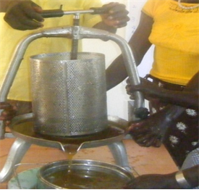
Fig 1.6 K. Honey presser

L. The honey tank: It is metal drum which is serves as a honey tank. The tank is fitting with a special honey tap near the bottom & a smaller tank on the top, the bottom of which is fitted with a honey-straining sieve. The top the small tank is fitted with a tight lid.
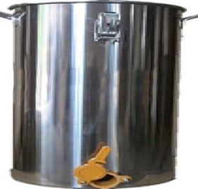
Fig 1.6 L. The honey tank
M. Wax extractor: Is used to separate wax from old brood combs and other impurities.

N. Honey sieve: Is a material that enables to separate honey from pollen, wax and other impurities. All honey as it comes from honey extractor and before it goes into honey jars should run through a strainer.
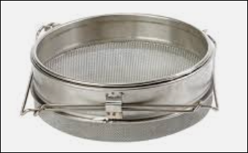

Fig 1.6 N. Honey sieve

O. Honey weighing scale: is used for weighing honey harvested.
P. Queen Cage: Small wooden & wire, or plastic, cage used to ship queens; usually with up to 6-8 attendant bees, also used to release them quietly into cluster.
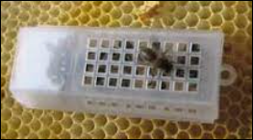
Fig 1.6 P: queen cage

- Queen Cage candy: A made from powdered sugar & invert sugar syrup to be used as bee- edible plug-in queen cage, delaying release of queen to increase acceptance.
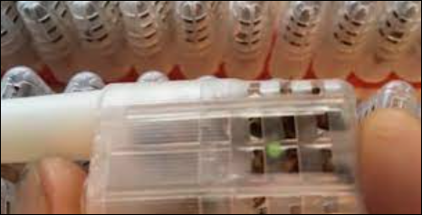

Fig 1.6 Q.Queen Cage candy

- Pollen trap: Device installed over colony entrance with a great sized to scrape pollen pellets from legs of worker bees entering hive. 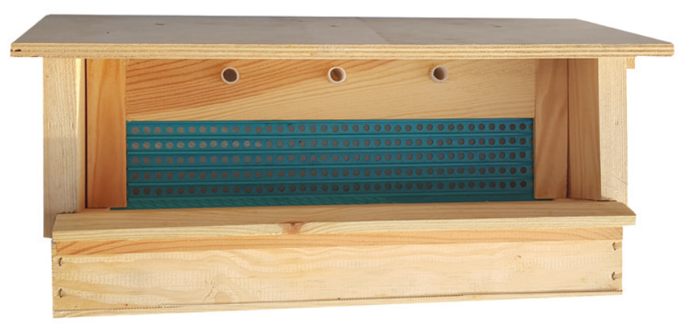

Fig1.6 R. Pollen trap
S. Honey jars (glass or plastic) are materials important (used) in handling honey /extracted/ until reaching the consumer/contain 500gm.
T. Bee-Escape board: Bee escapes are used in removing bees from supers before it is taken from hive. It is a funnel – shaped structure on the inner board which allows the bees to go out the supper.

  - Conducting checks on all materials, tools and equipment

Checking materials, tools and equipment’s refers to the process of examining their parts to ensure their normal functioning.
- Why we check before use?
- To identify the problems (defects, damages) of the Machinery, Tools and Equipment’s and take actions to correct or change them before using them.
- To identify any hazards and risks that can be raised from miss-use of the Machinery, Tools and Equipment’s and take minimization action timely.
- A guideline to conduct pre-operational checks on equipment’s and tools
You should make sure that the equipment’s and tools used for work are safe to use. Here is list of actions that should be taken to ensure this is so.
- Perform a risk assessment to identify the hazards and the control measures you should use
- Check that the equipment/tool is suitable for work and way in which it is going to be used
- Check that the equipment/tool is in good condition
- Make sure that the user knows which personal equipment to use and how to use it
- Think about who will use the equipment/tool including experienced workers, workers with language difficulties, new starter
- Speaking with team members or team leaders who has used the equipment before will help you identify any potential issues or problems.

  - Manual handling techniques for loading and unloading materials

Loading: refers to putting of the load (anything) on to the ship, truck or pack animal
Unloading: removing cargo from carrier or taking the load off a ship, truck, or pack animal

- A guideline to load and unload equipment’s and tools
- Load/unload the material in required order taking care to avoid damage
- Use manual handling techniques of loading /unloading throughout the process to avoid injury or damage
- Install the material in appropriate work or storage area in accordance with direction
- Identify any hazardous items and load /unload these in a manner that minimizes health and safety risks.
- Inspect load prior to transportation to ensure that all items are loaded appropriately and make adjustments as required
- Secure package against shifting within a vehicle during transportation though tying, blocking and bracing the load
- Load packages with orientation marks (up arrow) so that the marks remain pointed up
- Do not allow any smoking or any source of ignition on or near the vehicle when loading flammable
- Always load materials having high weight at the bottom
- Always load similar materials in one side during loading of different types of items

  - Selecting and checking Suitable Personal Protective Equipment (PPE)

Personal protective Equipment’s (PPE): -Personal Protective Equipment’s are those equipment’s that used to protect the body from external hazardous matters or conditions during work activities in the workplace.
1.4.1 Choosing the appropriate Personal Protective Equipment
What protective clothing and equipment is necessary? This depends on the duty being undertaken and chemical being used but the work place instruction and manufacturer’s directions should be used as a guide. The degree of protection required will be relative to the degree of hazard presented by a particular product or/and work.
1.4.2 Common PPE items
There are many PPE items however, we will mention some of the ones that you are most likely to come across in most animal care workplaces.
- Plastic boot: Helps your foot against possible exposure within a contaminated environment.
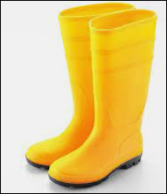
Fig 1.4 A. Plastic boot
- Eye glasses: help protect only your eyes from splatters.
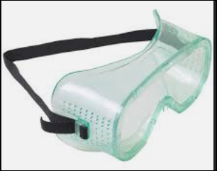
Fig 1.4 B. Eye glasses
- Overall: help protect you from the contamination of clothing with potentially infectious material.
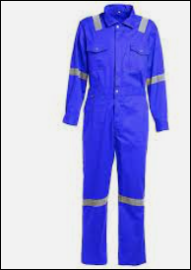
Fig 1.4 C. Overall
- Respirator protection: help protect your nose and mouth from splattered of body fluids, respirators filter the air before you inhale it.

Fig 1.4 D. Respirator protection
- Glove: help protect you when directly handling potentially infectious materials or contaminated surfaces.

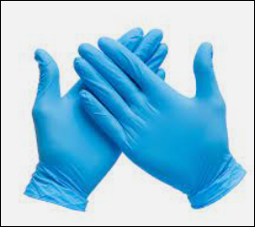
Fig 1.4 E. Gloves
- Sun hat: help protect only your head from sun rays.
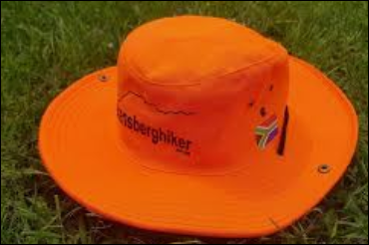
Fig 1.4 F. Sun hat
- Ear protection: help protect only your ear from noise sound and other hazards.
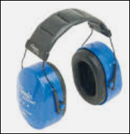
Fig 1.4 G. Ear protection
- Bee veil: helps to protect your face and head from bee’s sting.
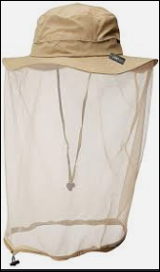
Fig 1.4 H. Bee veil

1.5 Identifying and responding OHS hazards
Hazard: is the term that refers to dangerous conditions that can results risks in the working place. This can be physical, mechanical, chemical, and biological factors which affect or harm the health and safety of all people and animals in the working place.
Every farm is different, but hazards common to most farms include:
- animals – injuries inflicted by animals can include bites, kicks, crushing, ramming, trampling, and transmission of certain infectious diseases such as giardia, salmonella, ringworm and leptospirosis
- chemicals – pesticides and herbicides can cause injuries such as burns, respiratory illness or poisoning
- confined spaces – such as silos, water tanks, milk vats and manure pits may contain unsafe atmospheres, which can cause poisoning or suffocation
- electricity – dangers include faulty switches, cords, machinery or overhead power lines
- heights – falls from ladders, rooftops, silos and windmills are a major cause of injury
- machinery – hazards include tractors without roll-over protection structures (ROPS), power take-off (PTO) shafts, chainsaws, augers, motorbikes and machinery with unguarded moving parts
- noise pollution – noise from livestock, machinery and guns can affect your hearing
- vehicles – crashes or falls from motorbikes, two-wheel and quad bikes, tractors, Utes and horses can result in major injuries
- Water – drowning can occur in as little as five centimeters of water. Dams, lakes, ponds, rivers, channels, tanks, drums and creeks are all hazards. Young children are particularly at risk
- Weather – hazards include sunburn, heat stroke, dehydration and hypothermia.
Preventive measures
- Wear safety shoes with non-slip soles
- Erect fences and post warning signs round open pits in the farm.
- call a qualified electrician to examine and repair faulty or suspect electric equipment
- Wear protective goggles and respiratory protection during work
- Do not ever enter a confined space when you are alone
- Seek medical attention if skin rashes develop; consult an allergy specialist
- Keep a high level of personal hygiene; change clothes at the beginning and end of shift; do not take work-soiled clothes home
- Learn correct lifting techniques and work postures, to avoid low back pain use mechanical aids for the lifting and transport of heavy loads how to deal with sensitivity to solvents and adhesives.
- Install effective exhaust ventilation to remove hazardous gases and vapors, and eliminate obnoxious odors from the farm.

Self-check 1 | Written test

Name…………………………………………… ID………………………… Date……. Directions: Answer all the questions listed below.
Test 1 matching (2pts) A
1. Helps your foot contamination.
2.help protect only your eyes from splatters
3. help protect only your head from sunrays.
4.help protect only your ear from noise.
5.helps to protect your face and head from bee’s sting
B
A. Eye glasses
B. Bee veil
C. Plastic boot
D. Sun hat
E. Ear protection
Test 1: Give short answer for the following questions.
- List at list five tools and equipment’s used for poultry? (5pts)
- List at list five tools and equipment’s used for fishery work? (5pts)
- List at list five tools and equipment’s used for AI work? (5pts)
Note: Satisfactory rating 13 points Unsatisfactory – below 13 points
You can ask you teacher for the copy of the correct answers.

LG #2 | LO#2- Undertake Livestock and Fishery Work as Directed

Instruction sheet
This learning guide is developed to provide you the necessary information regarding the following content coverage and topics:
  - Planning and organizing husbandry activities
  - Using appropriate restraining methods
  - Undertaking livestock and fishery farming activities
  - Undertaking work in a safe and environmentally appropriate manner
  - Carrying out interactions with stakeholders
  - Observing policy and procedures in relation to workplace practices
  - Repairing and maintaining of buildings, fences, fixtures or fittings
This guide will also assist you to attain the learning outcomes stated in the cover page. Specifically, upon completion of this learning guide, you will be able to:
- Plan and organize husbandry activities
- Use appropriate restraining methods
- Undertake livestock and fishery farming activities
- Undertake work in a safe and environmentally appropriate manner
- Carry out interactions with stakeholders
- Observe policy and procedures in relation to workplace practices
- Repair and maintain of buildings, fences, fixtures or fittings
Learning Instructions:
1. Read the specific objectives of this Learning Guide.
2.Follow the instructions described below.
3.Read the information written in the information Sheets
4.Accomplish the Self-checks
5.Perform Operation Sheets
6.Do the “LAP test”

Information Sheet 2

2.1 Planning and organizing husbandry activities
Must be able to plan and organize the work of the work-unit and groups, using goal setting, objectives, targets, creating work schedules and work-plans with associated budgets and resources, according to the Department’s procedures, in order to achieve the tasks, functions and results/outputs required of the work-unit.
Behavioral Indicators for planning and organizing activities:
- Develops annual plans for the work unit.
- Analyses goals and schedules component tasks accordingly.
- Organizes and prioritizes tasks so they can be performed within the budget and to achieve the most efficient use of time.
- Sequences activities and develop schedules.
- Identifies and allocates resources.

2.2 Using appropriate restraining methods
Restraining is technique of keeping animal under the control or within limit. Those facility that are properly constructed and maintained in a good working order will enhance the producer`s time management and safety also provide safety for those working animals’ welfare, sensation of pain, psychological wellbeing and to prevent unnecessary excitement or stress or discomfort. While you are performing any management techniques the restraint method that you want to be used will:
- Minimize danger to the handler
- Minimize danger to the animal
- Minimize the unnecessary pain or fright
- Allow the management techniques completed as necessary
There are different techniques to restrain animals such: -
A. Psychological restraints: it depends upon the manager having a thorough working knowledge of the behavior patterns of the species to be restrained. Example: using voice as a restraint tool.
B. Use of confining chutes, alleys and barriers. They are the most common ways to restrain domestic livestock specially cattle and sheep.
Examples of barriers: placing bales of straw between you and the animal to prevent kicking.
C. Chemical restraints example using different drugs to totally immobilize an animal
commonly used restraining facility.
  - Cattle crush
The use of crush is the most common ways of restraint for domestic animals. The design essential in a crush are that it should be sufficiently strong to restrain any cattle likely to be derived in to it; that cattle should not be able to damage themselves while in it; and that it should provide the necessary facilities for handling the animals, using the minimum labor. Average width of a crush for large tropical type cattle should be no more than 70cm, although the sides of the crush don’t have to be vertical and it is desirable that the standing space in the crush should be narrower. Standing space doesn’t need to be more than 53cm wide.
The height of the crush doesn’t have to be more than 1.5m. The length will depend up on how many cattle the operator wishes to retain in the crush at one time. Five or six are a suitable number. The crush may be constructed of tubular metal, swan timber or roughly dressed timber. Tubular metal is the most satisfactory. The whole lengths of the crush should be floored with concrete and where practicable the concrete should be built up to height of 0.6m on either side of the race. This forms a supporting base for the uprights, a protection for the feet and legs of the Stock and a platform for the workers.

2.3 Undertaking livestock and fishery farming activities
2.3.1 Undertaking livestock farming activities
A. Feeding
Feed is food given to Domestic animals, especially Livestock. Animals need a very balanced diet comprising of water, carbohydrates, protein, vitamins, and minerals for their better growth and development. Good nutrition ensures that the animal grows faster and ready for ating or market. It also increases fertility and litter size.
The quantity of feed consumed by animals depends on; age; breed; sex, size and physiological status (pregnant /lactating.). Pregnant and lactating animals will need more feed to produce milk and to enable the foetus to grow. Clean and nutritious feed/water should be given to animals. Feed should be made available for animals during dry season where there are scares. Feed animals very well for better growth and production. Always provide salt lick to your animals.
B. Mating system
Once heat has been detected, cows should be mated. Mating of good quality animals to produce highly productive and suitable animals for enhancement of overall performance in the subsequent generations and to augment production and profitability is termed animal breeding.
There are two types of mating of animals for production of the progenies. These are
- Natural mating: Mating of animals by natural means. This is where the cow is taken to a bull and left for some time for the bull to serve.
- Artificial insemination (AI): Mating is done through artificial means by collecting semen from male and the inseminating the females. This method helps in use of outstanding males for mating of a large number of females thereby production of large number of highly productive and performing progenies.
The process of artificial insemination starts with a healthy bull, that is disease free and producing ample quantities of high-quality semen. The fertility of the cow is also important, the competency of the inseminator and a clean environment. Farmers are encouraged to use semen from proven bulls which is obtained from AI centers and registered service providers.
C. Parturition
- Parturition in healthy females is generally normal but females in poor condition or small-framed females mated to big males can have difficulty in parturition and may have to be assisted.
- Assistance may also be required during instances of abnormal presentations
- You should first see the front legs and nose or head of the lamb if it is a normal birth.
- In normal parturition case, delivery can be expected within fifteen minutes.
There are different presentations during parturition
- Anterior presentations,
- Posterior presentations
- Normal presentation of twins.
Abnormal presentations of fetus in livestock during parturition that need assistance
- If one leg is held back
- If the two legs held back and only head is presented
- found upside down
when parturition approaches the female shows the following signs of kidding/lambing/calving.
- Restlessness
- Sitting down and getting up
- Smelling the ground
- Kidding/lambing with 1 –2 hrs.
- Appearance of the water bag
- Onset of contraction and
- Appearance of parts of the kid/lamb/calf
D. Docking
Docking is the process of cutting the tail in sheep and pig.
There are several methods of docking
- Using knife: -Should be confined to lambs that are not more than a week or 10 days old as older lambs can easily bleed to death.
- Using hot iron: -Is much lower than knife method, but it is much safer as it sterilizes the wound, sear/burn and prevent bleeding.
- Rubber band method: -Is known as blood less method of docking. Here there is rubber band which will be fitted around the tail with the elastrator, then it will prevent circulation and finally the tail will dry off.
E. Hoof Trimming
In management systems where livestock are mostly confined and do not walk daily on hard groundcover or climb rocks, abrasion of the hoof is not balanced with hoof growth. This affects mobility and could lead to reduced intake from grazing. It may additionally lead to diseases such as foot rot. To avoid these problems, hooves need to be examined regularly and trimmed as needed.
A sharp knife or hoof shears can be used for hoof trimming.
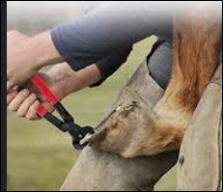
Fig.2.1. E: Hoof trimming
F. Dehorning
Dehorning is the process of cutting the sharp end of the animal horn to prevent injury or damage both the animals and handlers. Dehorning may be performed as a management tool in intensive.

G. Debeaking:
- This involves partial removal of the beak to prevent habits such as:
- pecking,
- feather-pulling,
- cannibalism and
- Egg eating depending on the age these occurs.
- It take place at 3-5 weeks, the birds should be debeaked at least between 15-17 weeks of age.
H. Castration
Castration is the process of severing or crushing the spermatic cords so that sperms can no longer be produced. Bull to be castrated has to be placed in a clean and dry pen where they may be easily caught. There are several methods of castration of which Burdizzo castration is the common one.

I. Hand milking operation
- Hand strip (using finger)
Stripping method is adopted in small cows with narrow teats. Few strips of milk from each teat are let on strip-cup to check for possible incidence of mastitis. Combination of initial full hand milking method followed by stripping at the end is a good method of milking. The first
- Hand squeeze (full hand milking)
Full hand milking stimulates natural suckling of a calf. Cows with large teats and buffaloes are milked with full hand method. Full hand method removes milk quicker than stripping because of no loss of time in changing the position of the hand.
The recommended method is full hand followed by stripping.
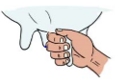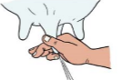
Fig.2.3 I Hand squeeze (Left) and Hand strip (Right)
Important points to be considered during milking
Milking time: milking can be done twice or three times a day. But this interval must be regular. A sudden change in the time of milking affects the total yield
Milking order: clean cow should be milked first. A suggested order
- First calf heifers free of mastitis
- Older cows free of mastitis
- Cows with history of mastitis but not showing the symptoms
- Cows with quarters producing abnormal milk

J. Identifying the Animal in Estrus
Estrus (heat): is a fairly well-defined period that occurs in no pregnant cows once each 19 to 23 days. In other words, estrus is the time during which the female will accept the male for copulation or breeding.
- The female mammal begins to have estrus period when it is old enough to be breed.
- The estrus cycle begins when a follicle on the ovary begins to develop.
- The hormone estrogen is produced and causes the animal to show the sign of estrus.
- This period is characterized by increased sexual activity and acceptance of the bull by cow.
- The period basically begins with the first acceptance of the bull and end with last acceptance.
- European cattle have a 12 to 18 hours heat period, while zebu cattle may exhibit estrus only for 3 to 6 hours.
Table. 2.3.1 J Sign of heat in different species (cow, doe and ewe) of livestock
Cow | Doe | Ewe
- Standing when mounted by another cow (best indicator for the time to breed).  - Nervousness  - Swelling of the vulva  - Inflamed appearance around the lips of the vulva  - Frequent urination  - Mucus discharge from the vulva  - Trying to mount other cattle (cattle not in estrous may do this).  - Bellowing when isolated  - The only reliable signs are standing to be mounted and head-mounting (in small percentage of cows that exhibit this). | - Nervousness  - Frequent urination  - Mucus discharge from the vulva  - Bleating  - Ride other animals and standing when ridden  - Shaking the tail  - Swelling, red appearance of the vulva | - Sheep do not show any visible sign of estrus. The only way to tell if the ewe is in estrous is if she accepts the ram. A ram with an apron to prevent breeding is sometimes used to see if the is in estrous. The apron prevents the ram from completing the act of copulation when mounting the ewe. Most sheep have seasonal estrous periods. They come in to estrous only in the fall. Seasonal estrous in sheep seems to be the result of the shorter hours of day light and the cooler temperature in the fall.

2.3.2 Undertaking fishery farming activities
A. Site selection of fish farm
Site selection: is the process by which various factors indicated are considered to enable one to decide on the right site for a specific production (culture) system. Success or failure of any fish culture venture largely depends on the right selection of the site for it. In choosing a site several factors other than the physical aspect of the site are to be considered.
Selecting the site and type of fish farm
Things should be considered in the site selection of ponds
- Location
- Type of soil
- Area
- Pond slope
- Free of Aquatic weed
- Openness
- Free of pollutant from industriesWater Supply
Adequate supply of good quality water must be available year-round in the site for fish culture.
- The water sources must be reliable and adequate
- Good quality water is rich in oxygen, nutrients and free from pollutants. The most important sources of water for fish ponds are; Perennial streams, Lakes, Rivers, Springs and wells, and, Water reservoirs and dams.
- If there is no enough water all the year round, it is no good making ponds, as they will dry up and the fish will die. And also the water loss due to evaporation, leakage and percolation should be considered in determining the amount of water required.
- Soil Type & Quality
- Many soil characteristics, especially those related to texture, determine its suitability for fishpond purposes.
- Soil texture refers to the relative proportion of sand, silt and clay content of the soil.
Soils belonging to the following textural classification are desirable for fishpond development: clay, clay loam, silty clay loam, silty loam, loam and sandy clay loam. These types of soils are characterized by; High water retention (holding) capacity, Good aeration, Adequate nutrient and Favorable chemical properties.
There are several methods to test the quality of soil for pond construction, the most easy and practical methods include; ball and pit method.
- Topography of the site
Topography refers to the “lay of the land” or the changes in the surface elevations of the ground whether flat, rolling or sloping, undulating, and hilly. Fishpond design, layout and specifications are made largely in accordance with the land topography.
It is desirable or ideal to construct a fish farm on flat land with moderate slop. However, there is no problem in setting up a farm on sloppy side of hills or valley areas.
- Accessibility
This is important for the transport of construction equipment and material, and for production inputs required for daily operations. Transporting costs can considerably increase if materials are manually carried through long distances
- Availability of labour
The cheapest sources of labour are those which can be provided by the local residents, or people living within or near the area. It is important that the customs and tradition of local laborers are known.
- Availability and cost of material
In fishpond production, it is important that critical production inputs such as fish seeds, fertilizers, pesticides and other related materials are readily available when needed. For some inputs, especially inorganic fertilizers, the supply is restricted and the cost is uncontrolled for non-agricultural uses.
- Availability of marketing outlets and prices
Aquaculture products are highly perishable. Immediately upon harvest, products must be disposed of to maintain good quality and for better prices.
- Availability of credit and technical assistance
Fishpond operations require high initial capital investment. In this respect, credit at reasonable terms play a major role in providing the needed cash outlays. Technical assistance may be obtained from government extension services, public or private university research stations and lending institutions.
- Pattern of land and water use
It is important to assess the pattern of land and water use in the area.
- Peace and order situation
Good peace and order conditions at site are favorable for both public and private interests.
B. Fish Pond construction
A fish pond is a fish holding system that is essential for environmentally sustainable and profitable production of fish
A fish pond can be constructed as an earthen pond, concrete pond, or plastic or canopy layer pond. Earthen ponds are the most economical to build as it involves excavation of earthen materials (soil) to create dugout.
Figure 1: Layout of fish pond: Earthen ponds (left side) and Concrete ponds (right section)
- Classification of the ponds based on use
  - Nursery pond
  - Rearing pond
  - Stocking (grow out) pond
- Classification of the ponds based on water retention capacity
  - Perennial pond
  - Seasonal pond
Ideally, fish farms should have three types of ponds based on environmental and economic reasons. These are:
- Nursery pond: Area of nursery pond ranges from 100- 500 m2 and the depth of water should be between 1- 1.5 m. This pond covers 5% area of total productive area of the fish farm. The small size and depth of the pond simulates the natural environment for growth of fingerlings and ease for management practices. This is especially so in partial harvesting for sorting and grading
- Rearing pond: Area of rearing pond varies between 500- 1000 m2 and the depth of water ranges from 1.5- 2.0 m. This type of pond covers 15% area of the total productive area of the fish farm. Sometimes farmers may use this as a stocking pond also.
- Grow-out Pond: Area of stocking pond varies between 1000- 20000 m2 and the depth of water ranges from 2- 2.5 m. This type of pond covers 60- 70% area of the total productive area of the fish farm.
After deciding on the site or location and design of fish pond the pond’s shape size and depth has to be determined.
- Pond shape: the easiest and perhaps best shape is the rectangular with a length twice the width. However, the shape could be modified based on the topography of the area.
- Pond size: depend on the objective of the fish producer. If it is for home consumption then smaller size may be used (E.g., 20m by 10m). For commercial purpose large size is needed( more than 40m by 20m).
- Pond depth: pond should be deeper near the outlet for easy drainage. The average depth of fish pond could be 1m to 1.5m.
- Pond water inlet: is the place water can be let into the pond. There should be a screen (wire net) to prevent wild fish entering pond and gate to open or close when water is needed or not.
- Pond water outlet: water can be let out of the pond .This is usually a pipe fitted with screen and valve to avoid escaping of fish.
- Canal: long and narrow pit leading water from the source into the inlet of the pond.
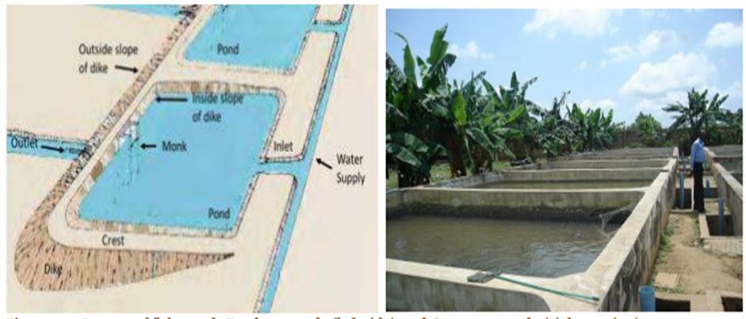

Figure2.3.2 A: Layout of fish pond: Earthen ponds (left side) and Concrete ponds (right section)
C. Fish feeding
- Natural fish feedings
- plankton is a collective term applied for very small (microscopic largely) extremely diverse forms of organism, both plants and animals that are floating forms, drifting into currents. The plankton occurs in all natural water as well as in artificial ponds, reservoirs, irrigation channels, etc.
- Phytoplankton: the organisms are exclusively of plant origin and are thus autotrophs belonging to the first trophic level (producers).
- Zooplankton: the organisms are exclusively animals, and are therefore heterotrophs, belonging to the second trophic (primary consumer) level.
The objective of feeding fish is to provide the nutritional requirements for good health, optimum growth, optimum yield and minimum waste within reasonable cost so as to optimize profits.
Feeding fish correctly means:
- Giving feed of the correct nutritional quality for the specified age of fish,
- Feeding the right feed size for easy consumption,
- Feeding the correct amounts,
- Feeding at the right time(s) each day. When fish are fed correctly, growth rates are good and uniform across the population, feed conversion ratios (FCRs) are low and pond water quality is better managed.
Some practical guidelines for feeding fish are the following:
- Feed the fish at the same time every day and in the same part of the pond. Feeding should be done in the late morning or early afternoon when dissolved oxygen levels are high.
- Do not over feed the fish, as too much feed will decay and use up too much oxygen in the pond.
- Stop feeding the fish for at least one day before breeding, harvesting or transporting them.
In general, fry can be starved for 24 hours, fingerlings for 48 hours and adult fish for about 72 hours. This enables the fish to digest the food completely before stressful events.
2.4 Undertaking work in a safe and environmentally appropriate manner
Procedure is a safe work procedure that must carried out in a given work place for effectiveness of work and manual handling. Some of these may include but not limited to:
- Safe animal handling system and procedures
- Identifying hazards and zoonosis
- Safe system and procedures for outdoor work including protection from solar radiation
- Appropriate use of PPE
- Following work procedure for every activity
Maintaining a safe working environment involves the following:
• Regular housekeeping
• Periodic inspection to detect and correct physical hazards
• Preventive maintenance of equipment, machinery and structures Self-inspection checklists identify areas and items that need scheduled housekeeping, inspection and maintenance
2.5 Carrying out interactions with stakeholders
Other than any day to day interaction between livestock fish Experts and workers, workers with workers, there should be interaction (communication) between this part (livestock and fish producing planting material) and to whom these products are going to be forwarded, mostly this “traditional interactions” can be in practice are infarction with customers (product users) and also with other staffs (knowledgeable and skilled persons) from different organizations related to the demand of livestock and fish products.
2.6 Observing policy and procedures
A policy is a statement which underpins how human resource management issues will be dealt with in an organization. It communicates an organization’s values and the organization’s expectations of employee behaviors and performance.
Workplace policies often reinforce and clarify standard operating procedure in a workplace. Well written policies help employers manage staff more effectively by clearly defining acceptable and unacceptable behavior in the workplace, and set out the implications of not complying with those policies.
A workplace policy consists of a statement of purpose and one or more broad guidelines on action to be taken to achieve that purpose. The statement of purpose should be written in simple terms, free of jargon. The length of the policy may vary depending on the issue it addresses. A policy may allow discretion in its implementation and the basis of that discretion should be stated as part of the policy. A policy may also be required where there is a diversity of interests and preferences, which could result in vague and conflicting objectives among those who are directly involved. The policy should also contain procedures to support the policy in its operation, such as the implications for not complying with the policy.
Here are some examples of common workplace policies that could assist your workplace:
- code of conduct
- recruitment policy
- internet and email policy
- mobile phone policy
- non-smoking policy
- drug and alcohol policy
- health and safety policy
- anti-discrimination and harassment policy
- grievance handling policy
- discipline and termination policy
- Using social media.
2.7 Repairing and maintaining of buildings, fences, fixtures or fittings
Maintenance and repair are needed to tackle the inevitable decay and deterioration of building fabric that occurs because of climatic conditions, wear and tear by building users, neglect, or other threats.
The main objective of maintenance is to limit deterioration. Inspections carried out at regular intervals, coupled with prompt action to pre-empt or remedy problems, are the basis of effective maintenance.
Maintenance is cost-effective, the time and money spent on routine care, regular surveys and minor repairs protect the value of the building. Good maintenance also helps to ensure the health and safety of building users and the general public. Although it is often seen as routine, maintenance forms a cornerstone of building conservation.
Repair can be defined as work beyond the scope of maintenance, to remedy defects caused by decay, damage or use, including minor adaptation to achieve a sustainable outcome, but not involving alteration or restoration. Repair is normally carried out to sustain the significance of the building or place. Equally important in most cases is keeping the building in use, which is the best way to safeguard its future.

Self-check 2 | Written test

Name…………………………………………… ID………………………… Date……. Directions: Answer all the questions listed below.
I. Fill the blank space
1._____________is introduction of semen into a female's vagina or oviduct for the purpose of achieving a pregnancy by means other than copulation. (2pts)
2.____________ is a well-defined period that occurs in no pregnant cows once each 19 to 23 days. (2 pts)
3. ____________ is technique of keeping animal under the control or within limit. (2pts)
II. give short answer
1.Write site selection criteria for fish pond constriction? (5pts)
2.wirte the importance of restraining animal? (3pts)
3.write at least 5 livestock husbandry activities? (5pts)
Note: Satisfactory rating 10 points Unsatisfactory – below 10 points
You can ask you teacher for the copy of the correct answers.

Operation Sheet -2
2.1 Technique of Cattle crush construction
A. Tools and equipment required for cattle crush construction
- Peg
- Rope
- Nail
- Saw
- Pole
- Meter
- Stone
- Sand
- Cement
B. Techniques /procedures
Follow the following procedures and construct cattle crush based on the given specification
- Crush width =53cm wide.
- The height crush =1.5m.
- The length crush=2m/cow
- Select appropriate site for construction
- Prepare all the necessary materials and equipment
- Layout the length, width and height of the crush depending upon the number of animals
- Put peg in each corner
- Level the area that are already selected
- Construct the gun pole and other parts of the crush
- Finally Check the strength of the crush

2.2 Conduct hand milking
A. Materials, tool and equipment PPE
- Rope
- Milking bucket
- Towel
- Strip cup
- Teat dip cup
- feed
- Milk filter (sieve or gauze)
B. Procedures or techniques
    - Prepare all necessary materials
    - Wear PPE
    - Create silent environment
    - Clean properly of milking pen.
    - Provide concentrate feed to the cow for good milk letdown
    - Restrain the cow in number 8 position
    - Wash hands
    - Clean teats with warm water
    - Dry teat by towel
    - Check for mastitis using strip cup
    - Milk using both hands; squeeze properly the teats with full hand.
    - Dip teat after milking
    - Filter/sieve/ milk
    - Weigh or measure the amount of milk
    - Record the amount of milk from each cow
    - Cool the milk to store in time
2.3 Technique of soil testing for fish pond construction by ball method
A. Tools and equipment required for ball method
- Hoe
- Meter
- water
B. procedures
- Dig about 50cm deep pit,
- take a handful of soil from the bottom of the pit,
- moisten it with some water
- squeeze it into a ball.
- Throw the ball of soil into the air and catch it.
Conclusion it will not stick together and the ball will fall apart then reject the site. If the ball sticks together well the soil maybe be good.
2.4. Techniques of fish pond construction
A. tools and equipment required for fish production
- Meter
- Rope
- Hoe
- Water level
- Peg
B. Procedures
- Decided the pond shape, size, and depth.
- Measure the length and width of the pond on the ground and mark it.
- Clear any vegetation grown.
- Begin the excavation (digging). It could be done by machine or manpower.
- Throw the soil that comes out upon the sides to form embankment (dyke).
- Compact well the pond dyke to make strong enough.
- Then make the water inlet, outlet, and canal.

LAP TEST-2 | Performance Test

Name………………………………. ID…………………………….. Date…………………………………….

Time started: ________________________ Time finished: ________________

Instructions: Given necessary templates, tools and materials you are required to perform the following tasks within 5 hours. The project is expected from each student to do it.
Task 1 Perform Cattle crush construction
Task 2 perform and milking
Task 3 Perform soil testing for fish pond construction by ball method
Task 4 Perform fish pond construction

LG #3 | LO#3- Clean up and store materials and equipment

Instruction sheet
This learning guide is developed to provide you the necessary information regarding the following content coverage and topics:
- Handling and transporting materials, equipment and machinery
- Recycling waste material and disposing disposable materials
- Cleaning, maintaining and storing tools and equipment

This guide will also assist you to attain the learning outcomes stated in the cover page. Specifically, upon completion of this learning guide, you will be able to:
- Handle and transport materials, equipment and machinery
- Recycle waste material and dispose disposable materials
- Clean, maintain and store tools and equipment

Learning Instructions:
1. Read the specific objectives of this Learning Guide.
2. Follow the instructions described below.
- Read the information written in the information Sheets
- Accomplish the Self-checks
- Perform Operation Sheets
- Do the “LAP test”

Information Sheet 3
3.1 Handling and transporting materials, equipment and machinery
Materials handling can be also defined as ‘the function dealing with the preparation, placing and positioning of materials to facilitate their movement or storage’.
3.1.1 The general guidelines of handling and moving materials and equipment
- Identify materials and equipment that need to be moved
- Assess risk associated with the materials and equipment to be used
- access other help where necessary
- Ensure that you move and handle materials and equipment:
- follow legal and organizational policies, procedures and requirements
- handle and position the materials and equipment safely, securely and in a way which protects them from damage and/or contamination
- Check materials and equipment weather they are safe and secure
- update records and report any problems about moving materials and equipment, according to legal and organizational requirements
3.1.2 Monitoring the receipt and use of materials and equipment
- Check that any materials and equipment received are correct and not faulty
- Store materials and equipment according to the manufacturer’s, users and organizational recommendations and requirements
- When distributing materials and equipment handle them safely and according to legal requirements and organizational policies and procedures
- Monitor and control the use of materials and equipment to minimize loss and damage
- Record, report and take action to:
  - remedy any faults and incorrect deliveries
  - replace and repair materials and equipment that have been lost and damaged
  - replenish materials and equipment that have run out
Maintaining materials and equipment
- use and encourage others to use, maintain and clean materials and equipment according to:
    - manufacturer’s instructions
    - organizational policies and procedures
- use appropriate protective clothing and equipment when cleaning equipment
- maintain and store materials and equipment so they are easily accessible and ready for future use
- label, remove and report to appropriate people, any materials and equipment that are suitable for use
- you dispose of any waste safely and according to legal and organizational requirements
- keep accurate and up-to-date records of the materials and equipment for which you are responsible
3.2 Recycling waste material and disposing disposable materials
There are different waste material or product which will be produced in work place but the main waste material which will produced at the livestock farm are the following
Litter and broken components
Plant debris
Plastic,
Metal and paper-based
Broken eggs
Dead animals
Animal dung and urine
Waste feed Etc.
These waste materials which are produced in livestock have to be removed from the site on regular manner properly;
The huge quantities of animal manure generated by animal feeding operations can be an economical source of plant nutrients and a valuable soil amendment to improve soil quality and maintain soil PH.
Thus, manure can be a valuable asset to a livestock production operation if its nutrients and organic matter are recycled through land application properly.

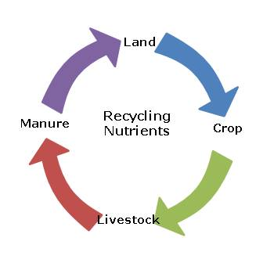
Diag.3.2 Manure recycling
Manure may cause surface and groundwater pollution if mismanaged.
The key to a proper management is to determine the nutrient content of the manure, the percentages of those nutrients that are available to crops, and the nutrient requirements of the crop at a realistic yield goal
Disposal of agricultural waste, is, in many cases similar to regular waste disposal methods. As in, solid materials are often sent to landfills or incinerators. However, this can obviously have a negative effect on the planet – something which those who work within agriculture are likely to be particularly passionate about. In fact, the future of farming relies on taking care of the planet. Fortunately, there are other methods of agricultural waste disposal, such as composting and recycling which can be implemented to help protect the environment.
For example, organic fertilizers can be used again and again, and animal waste (faeces) can be used in composting. Both of which will allow agricultural land to thrive.
Disposable materials properly buried in deep enough trench and should be covered with quicklime and then with soil or use Burning. But burning is the most difficult because the Fumes and smoke may be a problem to the surrounding environment. Mud holes should be frequently filled or exclude the animals away from it quickly.
- N.B. Never dispose waste materials everywhere.

3.3 Cleaning, maintaining and storing tools and equipment
Cleaning: refers to removal of dirt, filth or unwanted substances matter from the materials, tools and equipment.
Work site have to be clean and safe for efficient work of employee. So, any farmer or employee in livestock farm has to keep sanitation of his work site; which mean that he has to clean his work area after completing his task by doing these he can keep healthy himself and his staff members.
After completion of the work all materials, tools and equipment they has to be cleaned, sanitized, disinfected, maintained, and stored properly.
The materials tools and equipment should be Stored in a safe, dry place/ ventilated and away from animals reach, and placed on wooden racks or shelve in order to prevent direct contact with soil.

Self-check 3 | Written test

Name…………………………………………… ID………………………… Date……. Directions: Answer all the questions listed below.
- Define material handling? (2pts)
- Define the term cleaning? (2pts)
- What are the general guidelines of handling and moving materials and equipment? (5 pts)
- List down 5 waste material produced in livestock raising activity. (5pts)
Note: Satisfactory rating 8 points Unsatisfactory – below 8 points
You can ask you teacher for the copy of the correct answers.

Operation Sheet -3
3.1 Cleaning materials tools and equipment used in livestock and fishery work
A. materials, tools and equipment
- PPE
- Rack
- Detergents
- Sweep
- Water
- Brush
- Spongy
- Towel
- Broom
- Vacuum cleaner
B. Procedure
- wear appropriate PPE
- manually removing dust by brush
- Pre-rinsing with water to remove loose dirt
- Cleaning with appropriate detergent
- Rinsing with clean water
- Disinfection by heating or with chemical agents (optional); if this step is included, the cycle ends with a final rinse, if the water quality is good.
- Allow to dry upside down in a dust-free surrounding;

LAP TEST-3 | Performance Test

Name………………………………. ID…………………………….. Date…………………………………….

Time started: ________________________ Time finished: ________________

Instructions: Given necessary templates, tools and materials you are required to perform the following tasks within 1 hour. The project is expected from each student to do it.
Task 1 Cleaning materials tools and equipment used in livestock and fishery work

LG #4 | LO#4- Record and report activities

Instruction sheet
This learning guide is developed to provide you the necessary information regarding the following content coverage and topics:
- Recording and documenting accomplished activities
- Reporting work outcomes
This guide will also assist you to attain the learning outcomes stated in the cover page. Specifically, upon completion of this learning guide, you will be able to:
- Record and document accomplished activities
- Report work outcomes
Learning Instructions:
1. Read the specific objectives of this Learning Guide.
- Follow the instructions described below.
- Read the information written in the information Sheets
- Accomplish the Self-checks
- Perform Operation Sheets
- Do the “LAP test”

Information Sheet 4

4.1 Recording and documenting accomplished activities
To keep records is simply to collect relevant information that can help you to take good decisions and to keep track of activities, production and important events on a farm.
Records can be about
- Any performance of the animals,
- Economic development, or
- Any activity of the farmer.
It is important to keep record keeping simple, and to keep records systematic. If records should be of use for the farmer, than they must be complete (none missing), they should be true (collected carefully). When record can’t be trusted because they are not complete or true, time should not be spent on it at all.
The records can:
- Be used in determining profitability of various techniques used at the farm
- Be used to keep your memory on what you did and/or what happened
- Be used in decision making, especially on a strategic level
- Be used to compare the efficiency of use of inputs, such as land, labour and capital, for example when implementing a new / alternative systems
- Help the farmer / investor in improving the efficiency of farm's operations
4.1.1 Importance of record in livestock and fishery work
If a farmer wants to build a financially successful livestock enterprise, record keeping is a must. The records can be used to further develop the farm and the herd, and thereby the sector in the country. For many farmers, it helps to think of their farm as a business, and to see that good care and good management actually also influences the production and profitability of the farm.
Records are important in (animal) farming because:
- To keep track of all animals (Identification records)
- Evaluation of livestock for selection (breeding records; financial records; production records)
- Control of inbreeding and aid in breeding planning (breeding records)
- Aid in selecting animals with the right characteristics for breeding (production, health, feed efficiency) to improve the herd or flock
- To rationalize labour
- Aids in feed planning and management
- Aids in disease management; keeping track about treatment (disease records)
- Aids in finding the effective treatments
- To assess profitability/losses (financial records)
- Improves bargaining power on products, because you can see the investment and the price of the production (financial records)
- Credit/loan access (financial records)
4.1.2 Types of Records
The following are major types of records which are all described below:
A. Identification Records: Used for identifying individual animals
B. Breeding Records
- The importance of breeding records is to measure the productive efficiency of the herd and to enable culling and selection.
- The most important data in breeding records include:
- Pedigree/parentage (name or other identification of parents and grandparents)
- Fertility (dates of all services (this also allows calculating the number of services per conception), dates of giving birth (allows to calculate the age of first calving/giving birth and the period between successive birth)
- Birth details (number and weight of newborns, was assistance necessary? Stillborn / perinatal deaths / vitality score).

C. Production Records
- These records are useful in measuring the performance of the animals and the herd. It contributes greatly to the economic appraisal of the enterprise. It can help farmers take decisions on investments, based on how many animals produce how much on the farm, so how much surplus can the family expects.
- The records can also be used by the whole sector to improve the genetics of the animals in the country, with specific focus on the production.
D. Feeding Records
- Feeding records give information about the amount, type and quality of the feed
- Feeding records can be used both for day-to-day management and adjustment of the feed ration.
- The important feeding records are:
- Produced and available fodder on farm; quantity and if possible quality of the different feeds. Including content of energy, protein and minerals
- A feeding plan which tells how much feed is required per day per animal in different age groups (grown-ups, newborn, pregnant the first time etc.) or per group of animals (hens):
- Left-over feed if any (per head and per feed, if possible) Spoilage (per batch)
E. Disease and treatment records
- Disease and treatment records are necessary to keep track of the disease events in which each animal is involved during its lifetime. This can guide to better management practices by leading the attention to repeated events or certain vulnerable groups of animals over time (e.g. it can show how animals almost always need disease treatments during weaning).
- Disease and treatment records can for example involve:
  - Disease occurrence and date.
  - All handlings to cure diseases (also non chemical treatment)
-Vaccination
-Dipping/spraying
-Treatment
-De-worming
-Postmortem
F. Financial Records
- The records of the costs and earnings related to the animal farming are kept for cash analysis and enterprise appraisal.
- In most households, the most necessary records are simple overview over the family cash flow, that is, the total economy in the household: what comes in? and what do we buy?
- Economic records are of paramount interest in providing the farmer with information concerning the profitability of his farm. Moreover, they are of great help in decision making at the right time.
  - Reporting work outcomes
An important point in every work including livestock work is recording data, analyzing and reporting, all the steps from the initial to the final product of the work. One of the ways of communicating to the employer or the customer is reporting work outcome. This report includes information regarding
- Raw materials
- Problem encountered
- Length of work
- Hazards and safety
- Techniques and system of work
- Cost expended
- Material availability
- Sustainability of work
- Labor required
- Facilities in work

Self-check 4 | Written test

Name…………………………………………… ID………………………… Date……. Directions: Answer all the questions listed below.
- Mention types of records in livestock production? (5 points)
- Write at least 5 importance of record? (5pts)
- What information should be included in work out come report? (4)
Note: Satisfactory rating 8 points Unsatisfactory – below 8 points
You can ask you teacher for the copy of the correct answers.

Operation Sheet -4
1. Report work outcome
A. Materials
- Pen
- Paper
- Chair
- Table
- Ruler
- Computer
- Printer
- Note book
B. procedures
- Prepare recording file
- Record all the data and steps in work
- Arrange the data
- Select the relevant data to the work
- Interpret according to your work
- Compile the data properly
- Report the total outcomes of the work to the concerned body

LAP TEST-4 | Performance Test

Name………………………………. ID…………………………….. Date…………………………………….

Time started: ________________________ Time finished: ________________
Task 1 Report work outcome
Instructions: Given necessary templates, tools and materials you are required to perform the following tasks within 1 hour. The project is expected from each student to do it.

Reference Materials

Books:
CAB International 1987, Manual on poultry production in the tropics Wallingford, Oxon, United Kingdom
Hall, C.B, 2002. Ponds and Fish culture. Agrobios (Jodhpur) India.
Say, R.R (1987) Manual of poultry production in the tropics. CAB international, Wallingford, UK. 118p, 8-23, 27-36
Web addresses
1. https://rada.gov.jm/tools-livestock-production (access date 27/08/2022)
2. https://www.qcsupply.com/farm-livestock/tools.html (access date 27/08/2022)

The experts who developed the learning guide
No | Name | Qualification | Educational background | Region | Phone number | E-mail
1 | Genanew Abera Teshome | Msc. | Animal genetics and breeding | Alage ATVET  College | 0926672970 | genanewabera@gmail.com
2 | Terefe Tolcha | Msc. | Animal Production | Alage ATVET  College | 0911067132 | terefetc@gmail.com
3 | Temesgen Roro | Msc. | Animal Production | Holeta PTC | 0917657496 | temesgenroro@gmail.com
4 | Solomon Fertewehal | Msc | Animal Production | Alage ATVET  College | 0912648413 | Tosolomon@gmail.com
5 | Gashaw Assefie | Msc. | Animal Production | Agarfa ATVET  College | 0914068274 | lakomelzajournalist@gmail.com
6 | Abenet Getahun | Msc | Animal Production | Gewane ATVET  College | 0940236673 | abenetgetahun@gmail.com
7 | Yirmedie Bayou | Msc | Animal genetics and breeding | Mizan ATVET  College | 0915851079 | Yirmedie123@gmail.com
8 | Sead Taha | Msc | Animal Production | Agarfa ATVET  College | 0916112492 | tahasead@gmail.com
9 | Biru Kefenie | Msc | Animal Production | W/S/ATVET  College | 0913334612 | ukefene@gmail.com

