Animal production
Level-I

Based on March 2022, Version -4 Occupational Standard

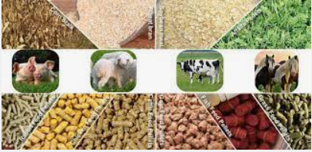
Module Title: Identifying Animal Feed Resource and Feed of Livestock
LG Code: AGR ANP1 M02 LO (1-3) LG (5-7)
TTLM Code: AGR ANP1TTLM 0922v1

September, 2022
Addis Ababa, Ethiopia

Table of Contents
Introduction to the Module 3
LO #1 Assess feed resources 4
Instruction sheet 4
Information Sheet 1 5
Self-check 1 18
LO #2 Prepare materials, tools and Equipment 19
Instruction sheet 19
Information Sheet 2 20
Self-Check – 2 30
Operation Sheet -2 31
LAP TEST-2 32
LO #3 Clean up on completion of work 33
Instruction sheet 33
Information Sheet 3 34
Self-Check – 3 42
Reference Materials 43

Introduction to the Module
This module covers the knowledge, skills and attitudes required to identify animal feed resources and livestock feeding and also required to assess fed resource, preparing materials, tool and equipment, and Clean up on completion of work, livestock production to maximum sustainable production.

Terms and definitions
Before looking at the different types of food stuffs in more detail, there are several terms and definitions with which you should become familiar.
- Feeds: Feed is edible material which, after ingestion by animals, capable of being digested, absorbed and utilized by cell.
- Feed Stuff: This is a broad and general term that is used when referring to any food or fodder. It includes naturally occurring plant or animal products and by-products (e.g. grass, maize, and brewers’ grains). It also includes vitamin or mineral supplements which are chemically synthesized, or otherwise manufactured pure nutrients. In other words, you will be quite safe referring to anything that is fed to an animal as a 'feed stuff'.
- Ration: A ration is a 24-hour allowance of feed stuff that is given to an animal. The important thing to note is that the term carries no implications that the allowance is adequate in quantity or kind to meet the nutritional needs of the animal for which it is intended. Some confusion normally arises as to the difference between the words ration and diet. These can be explained as follows:

LG #5 | LO #1- Assess feed resources

Instruction sheet
This learning guide is developed to provide you the necessary information regarding the following content coverage and topics:
  - Assessing animal feed resources
  - Identifying industrial by-products
  - Determining crop and crop residues
  - Assessing mixed feeds
This guide will also assist you to attain the learning outcomes stated in the cover page. Specifically, upon completion of this learning guide, you will be able to:
  - Assess animal feed resources
  - Identify industrial by-products
  - Determining crop and crop residues
  - Assess mixed feeds
Learning Instructions:
- Read the specific objectives of this Learning Guide.
- Follow the instructions described below.
- Read the information written in the information Sheets
- Accomplish the Self-checks
- Perform Operation Sheets
- Do the “LAP test”

Information Sheet 1

- Assessing animal feed resources
    - Animal feed resources classification
Feeds are naturally occurring ingredients or materials fed to animals for the purpose of sustaining them. Feeds can be classified according to some of their nutritive value and properties.
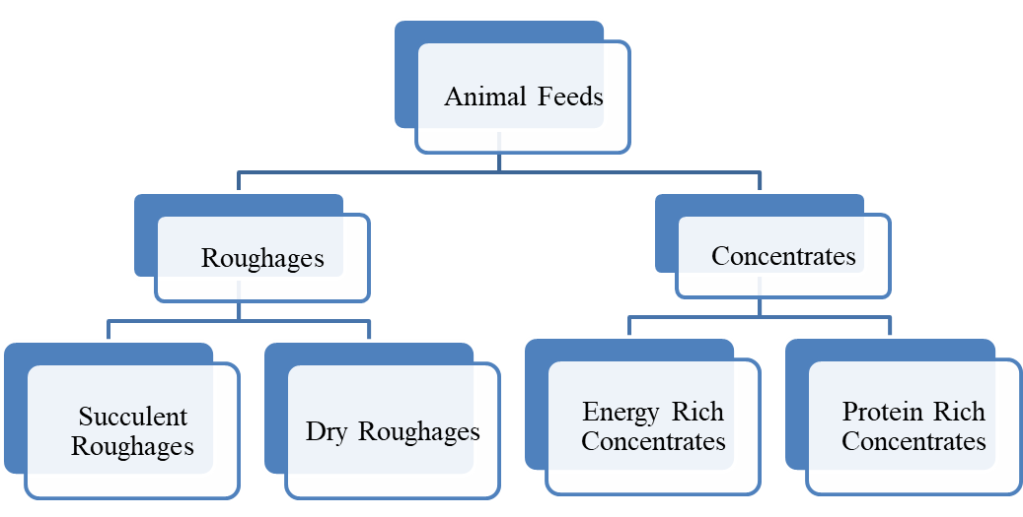

Diagram 1.1. Classification of animal feed resources

- Roughages: - Roughages are bulky materials which have high fiber content and a low nutrient value. Hay, pasture, silage, straw and cottonseed hulls are examples of roughage. They are used primarily in feeds for ruminant or non-ruminant herbivores
- Concentrates: - Concentrates have low fiber content and a high content of either Protein or Energy or both. E.g. corn, sorghum, wheat bran, molasses, bakery waste, citrus pulp distiller and brewers by-products.

1.1.2. Types of Pasture
There are two main types of pastures. These are: Natural pasture and improved pasture
- Natural Pasture: Natural pasture is also referred to as natural grassland or rangeland. In this pasture, grasses and legumes grow naturally on their own and are feed upon by farm animals, i.e., grasses are not planted by farmers.
- Characteristics of Natural Pasture
- Natural pastures of grassland contains poor quality grasses and legumes
- It contains wide varieties of grasses and legumes, some of which may not eaten by livestock
- It has good regenerative ability
- Productivity of natural pasture is very low and resistant to drought
- Forage crops in natural pasture can withstand trampling by farm animals.
- Natural pasture may contain some grasses which cannot be easily eradicated
- New growth is stimulated by burning
- Improved Pasture: This is also referred to as established or sown pasture. In this pasture, grasses and legumes are deliberately planted and managed by man to be fed on by livestock.
- Characteristics of Improved Pasture
- It contains high quality grasses and legumes
- Selected grasses and legumes are grown in adequate proportion
- It has high regenerative ability after being fed on by animals
- It can withstand trampling by farm animals
- It is properly managed for high productivity of the forage crops e.g. fertilization, irrigation and rotational grazing.

Categories of grasses
  - Annual and perennial grass
Rice, wheat, corn, and barley are all grasses as well and all cereals or grains are members of the grass family.
  - Annual grasses – Cereals such as wheat, oats, barley, corn, and rye are annual grasses. They produce from seed to seed in one year, dying at the end of the year. Annual grasses are sometimes seeded into lawns, but several varieties of weedy grasses are annuals. Annual grasses are represented by the main grain crops (corn, sorghums, wheat, rye, barley, oats), and by many weedy types which infests and pastures. Some examples of Annual grasses are ryegrass, annual bluegrass, pearl millet, Sorghum, corn, and Sudan grass.
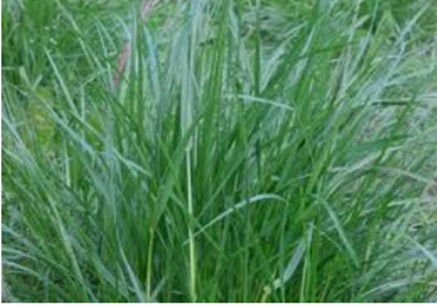
Figure. 1.1.2. I. Annual grass type

  - Perennial grasses – Most lawns are perennial grasses they are including Bahiagrass, bentgrass, Bermuda grass, blue grama grass, buffalo grass, fescue grass, perennial bluegrass, perennial ryegrass, and zoysias. Also, several decorative kinds of grass are perennials. Perennials are plants that continue to produce indefinitely or that regrow each year. Most of the normally used forage grasses function as perennials, reproducing vegetative as well as by seed. Some of the examples of Perennial grasses are orchard grass, tall fescue, and perennial ryegrass.
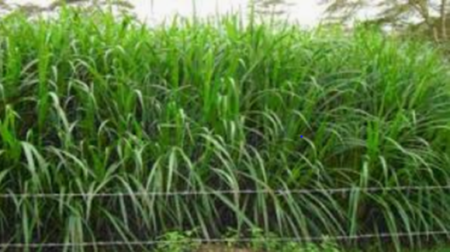
Figure. 1.1.2. II. Perennial grass type

Advantages and disadvantages of grass type animal feed
- Advantages:
- Lowered feed costs;
- Reduced chance of nutritional deficiencies;
- Reduced threat of communicable disease;
- Lowered capital investment costs, Eg. Establishment.
- Reduced management time and skills;
- Good soil conservation;
- Reduced incidence of parasites
- Disadvantages:
- Land used for pasture may produce a greater return for other crops;
- It is difficult to observe the animals;
- Poor nutritive value Soil produces forages of poor nutritive value;
- Parasite problems may occur if pastures are not rotated
- Takes a lot of nutrients from the soil

  - Perennials and annual Legumes
Legumes are members of the plant family, Fabaceae, and include common crops such as peas,
Soybeans, alfalfa, vetch, desmodium, and clovers.
Legumes produce highly nutritious, high-protein seeds for human and animal consumption and high quality forage for livestock.

  - Perennial Legumes.
Perennial species regrow each year from root reserves while annuals grow from a seed each year. In areas of higher rainfall, perennials can have the advantage of already being established and being able to respond to favorable seasonal conditions throughout the year.
A potential new use for perennial legumes is as a living mulch in annual, agroforestry, and perennial grain cropping systems where they have demonstrated effectiveness for suppressing weeds, reducing soil erosion and nitrate leaching, and providing nitrogen credits for companion cash crops

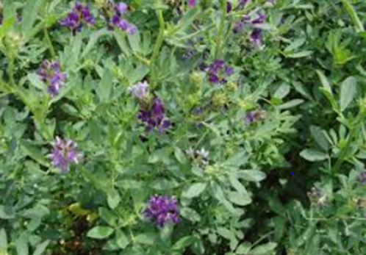
Figure. 1.1.2. I. Legumes species Alfalfa

  - Annuals Legumes
Annuals Legumes can be sown (or may naturally re-sow themselves) to achieve a specific feeding goal, without the need to survive a harsh summer or winter.

Advantages and disadvantages of legumes type animal feed
- Advantages:
- Highly palatable
- High nutrient content
- High yield under irrigation
- Very nutritious
- Highly digestible
- Disadvantages
- Can be poisonous in large amounts due to high mimosine content (leucaena)
- High moisture content

  - Herbaceous /tree specious/ forage
Herbaceous plants can be easily identified because they have non-woody stems. Their above-ground growth largely or totally dies back in winter in the temperate zone, but they may have underground plant parts (roots, bulbs, etc.) that survive.

Herbaceous Plants
Herbaceous plants are plants with flexible, green stems with few to no woody parts. Technically, all annual plants are herbaceous, because an annual is a non-woody plant. Annuals take it a step further and die altogether at the end of their lone growing season, both above the ground and below it. However, perennials can also be considered herbaceous. An example of an herbaceous stem would be a peony, which is a perennial. The tree-like banana plant, also a perennial, is known as the largest herbaceous plant.
Biennials, likewise, lack woody stems, therefore they can also be characterized as herbaceous. However, biennials such as foxglove (Digitalis) and silver dollar plant (Lunaria) maintain live, low-growing foliage above-ground during the winter (known as "basal leaves"). The question of whether a plant is herbaceous or not truly hinges on the presence or absence of woody stems, not on winter die-back.
Trees and shrubs have acquired a special place in semi-arid and rain fed areas due to their better tolerance of unfavorable soil-moisture conditions.

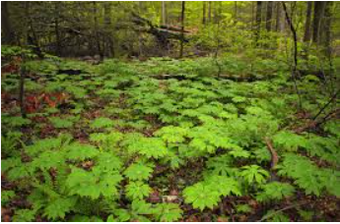
Figure.1.1.2.C. Herbaceous plant

1.2. Identifying industrial by-product
1.2.1. By-product
The by-products that come from different agro-industries can be utilized for feeding of different classes of livestock. Agro-industrial by-products (AIBP) are mostly derived from agricultural processing industries such as cereal grain milling, oilseed extraction, brewery, malt production, fruit and vegetable processing and laughter Houses, Abattoirs, etc. High moisture agro-industrial byproducts such as citrus, sugar beet and tomato pulp are of high nutritional value. In some countries these byproducts are given to animal fresh and/or after being sun-dried.
The by-products from these industries that can be used for feeding different classes of livestock include bran of different cereal grains, oil seed meals (cakes), molasses, brewer’s grain and different slaughter house refusals like blood meal, bone meal, etc. Most of these by-products are concentrates of either plant or animal origin and rich in nutrients like carbohydrates, proteins and minerals. They are, therefore, utilized to supplement nutrients in ration formulation in combination with other feedstuffs.
1.2.2. Classification of By-products.
Agro-industrial by-products could be classified based on their origin as animal origin and plant origin by-products. They can also be classified into protein supplements and energy rich concentrates based on their crude protein contents. These latter form of classification is not different from the basic classification of feedstuffs in animal nutrition.

Table: -1.1. Classification of different agro-Industrial by-products.
Classification | Energy rich concentrate (<18%CP) | Protein Supplement (>18 % CP)
Plant origin | Wheat barn, maize barn, molasses, etc | Oil seed meals, oil seed cakes, etc...
Animal Origin | Whey, | Fish meal, Meat meal, blood meal, etc.

    - Description of selected agro-industrial by-products.
    - Milling by-Product
- Wheat bran:
The outer covering /pericarp/ of the wheat grain separated during processing. Wheat bran contains higher amount of fiber and cannot be fed to poultry. But it is used as energy source for feeding ruminants. (CP content 8-18%, CF 14%)
- Wheat short:
This is the germ part of a wheat grain separated during processing. (CP 17%, CF 6-7%)

    - Sugar industry by-products
- Cane molasses:
By-product of sugar industries, where the maximum amount of sugar is extracted from the juice of sugar cane. It contains 50-60% of soluble sugars (a mixture of sucrose, glucose and fructose) & high in energy. CP 3%, CF 0%, Crude Ash 10%. It is an excellent source of minerals except phosphorus.
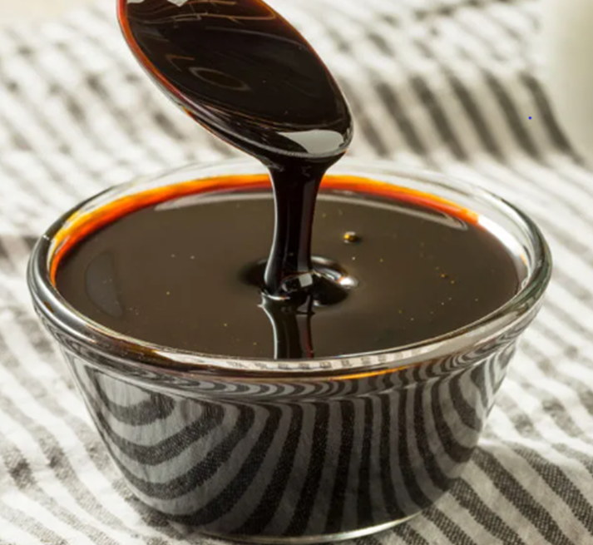
Figure. 1.2.3. B. Molasses

- Cane bagasse:
A highly fibrous residue of the cane sugar that remains after the juice is squeezed out. This is more like crop residues with higher amounts of fiber, which is equal to 36-42%. CP 2-4%, Ash 3%. It is of very low digestibility 20-40%.
    - Brewery by-products
- Brewer’s grain:
A byproduct of the malt culture, where the sugary liquid (“wort”) is mashed out leaving the brewer’s grain. This is used as a feed for farm animals either in wet or dried form. It is an energy rich concentrate containing about 17-18% CP and 15% CF.
- Brewer’s yeast:
The yeast used to ferment the wort and filtered off after the alcohol is removed. This by product is dried and sold as a brewer’s yeast. It contains about 42% CP and it is a valuable source of B- vitamins & phosphorus but low in calcium. Brewer’s yeast is a protein supplement with a very high digestibility that can be used to all classes of livestock.

    - Oil industry by-products
After oil is extracted out of oil seeds, a protein rich by-product of great value as livestock feed is obtained. Oil seed cakes (meals), in general, are a very good source of protein, where 95 % of the nitrogen is found as a true protein. The digestibility of these meals is very much high at about 75-95%. They also contain relatively higher amounts of phosphorus but low in calcium.
- Peanut (Groundnut) meal
- Cottonseed meal
- Soya bean meal
- Sunflower meal
- Rapeseed meal.
- Linseed meal

1.3. Determining crop and crop residues
- Crop Residues
A variety of crops grown for food and their leftover parts after edible by human beings are removed. Crop-residues are important source of livestock feed, following the harvesting of grain. Not all farm animals are able to digest crop-residues fully. Farm animals such as pigs, poultry, donkeys, horses, and guinea fowl cannot digest crop-residues as well as ruminants, such as buffaloes, cows, goats, and sheep. Crop by-products’ is a general term used to refer to both fibrous by-products (e.g. straws, mature grass and tree leaves) and crop residues that are richer in nutrients, such as broken grain, bran, oil and seed cakes.

Types of crop residues
Crop-residues can be categorized depend on their sources:-
- Cereal crop-residues,
Wheat straw, barley straw, sorghum stover, millet stover, teff straw, rice straw, oat straw,
- Legume crop-residues,
Groundnut, chick pea, pea, soya bean, and the dried stalk materials of such crops. Legume straws or haulms possess a higher feeding value than cereal crop residues.
- Other crop residues,
The waste materials from oil palm processing plants, cotton waste, sisal waste, pineapple waste, cocoa pods, and coffee hulls.

1.4. Assessing mixed feeds
Mixed feed is a feed for livestock that consists of a mixture of wheat particles, bran, middlings, shorts, and other material in various proportions and is a by-product of flour milling. Mixed feeds are feeds those are manufactured in the feed processing industry for the livestock production. Mixed feeds prepared in processing industry for different category of livestock, depend on their physiological status, and production age.
Three types of mixed feed are produced full-value feeds, concentrates, and protein-vitamin-mineral supplements. Full-value mixed feeds contain predetermined ratios of all the nutrients animals need. The feeds are used without any other supplements. Concentrated mixed feeds are used to compensate for deficiencies of basic nutrients in the animal diet. Their nutritional value depends on the quality and ratio of the components. Protein-vitamin-mineral supplements are used by their own forage to make mixed feeds. There are mixed feeds for all types of animals. Special mixed feeds are produced for each age group of animal and management category (such as calves, milk cows, and feedlot livestock).

1.4.1. Types of mixed feed
Category of mixed feed by their size and stage of feeding in production can grouped into;
- Starter mixed feed,
- Grower mixed feed
- Finisher mixed feed

A/ Starter mixed feed
A blend of feed for babies of livestock and hatchlings birds, usually in the form of mash; Starter feeds enable the young animal to adapt to solid feed and then to improve absorption of the feeds that come later. A good quality starter feed should contain highly nutritional ingredients to support the growth of very young animals and to lower mortality. The end-product must be highly digestible, palatable and easy to chew to encourage feed intake and optimize performance.

B/ Growers mixed feed
A feed for young livestock and growing birds can be replaced with finisher mixed feed. Growers mixed feed is contains a high-quality protein source, crude fiber, crude ash, and other necessary vitamins and minerals. This range is widely appreciated for its optimum quality, hygienic processing, and easily digestible nature. It contains all micro-ingredients and proteins in a well-mixed concentrate. In addition, it optimizes the performance and persistence of growers with high peak production.

C/ Finisher mixed feed
The complete feed to finishing cattle in dry lot. Before starting finisher mixed feed, cattle should already be consuming 12% grower feed free choice. Gradually replace 12% grower mixed feed with finisher mixed feed over a period of staying days. Continue feeding finisher mixed feed free choice until market. Provide Clean Fresh Water at all times.

    - Forms of mixed feed
A/ Mash
Blend of several feed ingredients, ground to a small size but not too a powder.
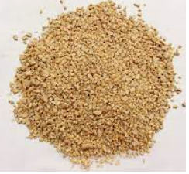
Figure.1.4.2.A. Mash mixed animal feed

B/ Pellets
Small kernels of compressed mash, causing birds to eat the whole blend, not pick and choose

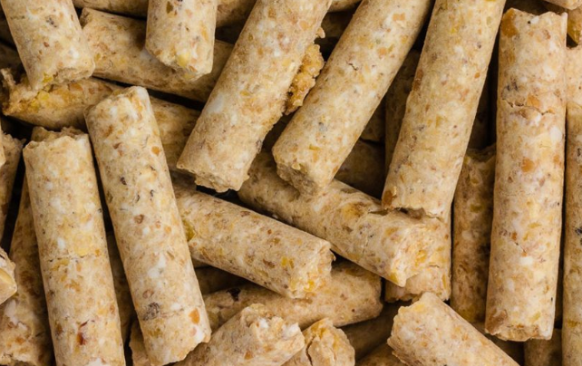
Figure.1.4.2.B. Pellet form mixed animal feed

C/ Crumbles: pellets broken up into smaller pieces.

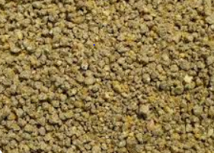
Figure.1.4. 2.C. Crumble form mixed animal feed

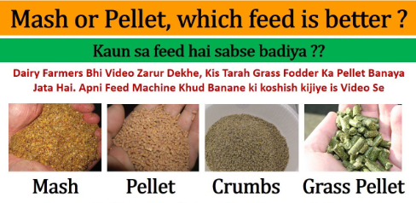
Figure.1.4.2. comparison of mixed animal feed form

    - Problems in feed
Problems such as heat stress can be avoided to a large extent by the correct feeding. However, feeding itself also involves risk factors such as mycotoxins or mold. In finished animal feed, the contamination of an ingredient could cause the contamination of an entire feed batch. Furthermore, the introduction of a feedstuff contaminated with aflatoxin-producing fungi could lead to the spoilage of other feed shipments and serves as a fungi source in the feed industry environment difficult to eliminate. This deterioration effect has a significant repercussion in association with the global trade and the international exchange of animal feed and feed ingredients.
The following are the problem in the feed
- Weeds,
- Chemical residues,
- Trampling losses,
- Grain poisoning,
- Curtailed or shortened lactation,
- Miss-mothering, and scouring.
Self-check 1 | Written test

Name…………………………………………… ID………………………… Date…….
Directions: Answer all the questions listed below.
Test I: Choose the best answer
- Which one of the following is the cereal crop residues sources of animal feed? (1 point)
A/ alfalfa B/ Wheat straw C/ Natural grass D/ lablab
- Which one of the following is not the legumes crop animal feed? (1 point)
A/ Alfalfa B/ Vetches C/ Maize D/ Desmodium
- Which one of the following is not crop-residue animal feed?(1 point)
A/ Wheat straw B/ Sorghum stover C/ Maize stover/ fodder/ D/ alfalfa
- Livestock feed are classified as ____. (1point) A/ roughages B/ crude fiber C/ concentrates D. A and C
Test II: Short Answer Questions
- Name and describe the major components of animal feed (2 point)
- What is roughages? (1 point)
- Name the two general classes of roughages (3point)
- What are the sources of roughages? (2point)
- What is concentrates? (2 point)

Note: Satisfactory rating - 8 points Unsatisfactory - below 6 points
You can ask your teacher for the copy of the correct answers.

You can ask you teacher for the copy of the correct answers.

LG #6 | LO #2- Prepare materials, tools and Equipment

Instruction sheet
This learning guide is developed to provide you the necessary information regarding the following content coverage and topics:
- Identifying materials, tools and equipment
- Conducting and checks on all materials, tools and equipment
- Using correct manual handling techniques
- Selecting and checking suitable Personal Protective Equipment (PPE)
- Identifying and responding of OHS hazards
This guide will also assist you to attain the learning outcomes stated in the cover page. Specifically, upon completion of this learning guide, you will be able to:
- Identify materials, tools and equipment
- Conduct and checks on all materials, tools and equipment
- Use correct manual handling techniques
- Select and checking suitable Personal Protective Equipment (PPE)
- Identify and responding of OHS hazards
Learning Instructions:
- Read the specific objectives of this Learning Guide.
- Follow the instructions described below.
- Read the information written in the information Sheets
- Accomplish the Self-checks
- Perform Operation Sheets
- Do the “LAP test”

Information Sheet 2

2.1. Identifying materials, tools and equipment
  - Wheel barrow
A small cart used to transport things, usually in the form of an open container with a single wheel at the front and two handles at the back.
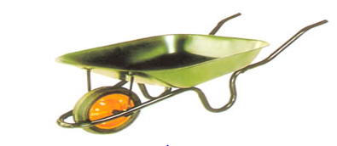

Figure 2.1.A. Wheel barrow

  - Hay Racks: This is used for feeding farm animals with hay and other forages.

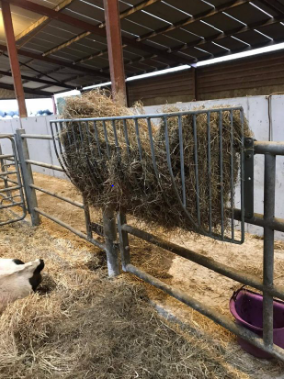
Figure 2.1.B. Hay racks

  - Feeding Troughs: This is used for feeding farm animals with grains and silage. It is a container where the feed of farm animals is placed for them to consume e.g. trays and rubs. Various sizes of feeding troughs are used based on the size, type, and age of the animal. Feeding troughs are usually made of plastic, wood or aluminum materials.
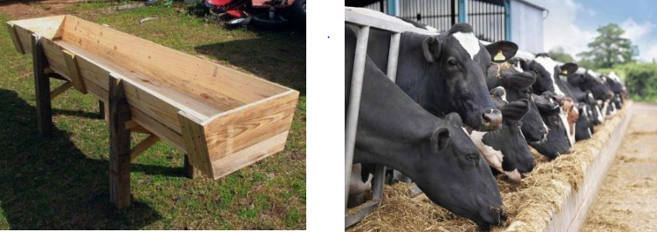

Figure 2.1.C. Wooden feed troughs (left) Concrete feeding troughs (right)

  - Self-Feeders: These are mainly used for fattening cattle. The device is equipped with a feed hopper that automatically supplies feed to livestock.

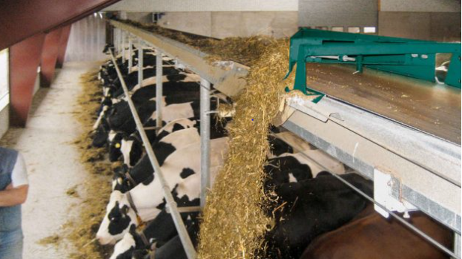
Figure 2.1.D. Self-feeders

  - Water Troughs: These are containers used to supply water to farm animals e.g. pails or buckets. The size of the trough varies and like the feeder trough depends on the type, size, or age of the animal. They are made of aluminum or polythene materials.
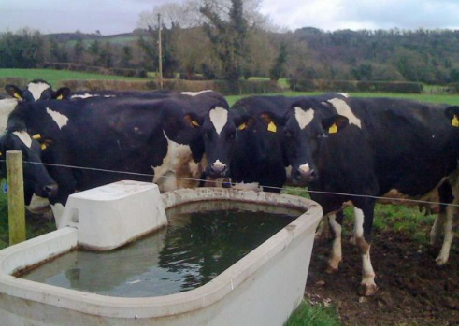
Figure 2.1.E. Water trough

  - Bucket: It is used to fetch water and also used to serve farm animals with water.

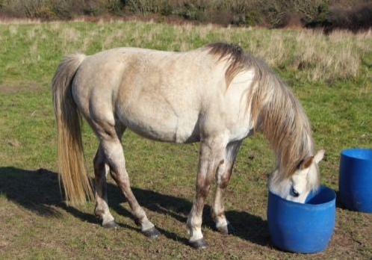
Figure 2.1.F. Horse drinking water from a bucket.

2.2. Conducting and checks on all materials, tools and equipment
Checking machinery, tools and equipments refers to the process of examining their parts to ensure their normal functioning.

2.2.1. Importance conducting pre-operational checks on Machinery, Tools and Equipments
- To identify the problems (defects, damages) of the Machinery, Tools and Equipments and take actions to correct or change them before using them
- To identify any hazards and risks that can be raised from using of the Machinery, Tools and Equipments and take minimization action timely

2.2.2. The causes of risks associated with machinery equipments and tools
- Using wrong equipment or/and tools for a job
- Not fitting adequate guards on machines leading to accident caused by entanglement, shearing crushing and trapping
- Not fitting adequate controls or wrong type of controls so that equipment cannot be turned off quickly and safely, or starts accidentally
- Not providing right information, instruction and training for those using the equipment
- Not maintain work equipment or carrying out regular inspections and thorough examinations
- Not providing the personal protective equipments needed to use certain equipments and machinery

2.2.3. Guidelines to conduct pre-operational checks on equipments and tools
You should make sure that the equipments and tools used for work are safe to use .Here is a list of actions that should be taken to ensure this is so.
- Perform a risk assessment to identify the hazards , the risks arising from those hazards and the control measures you should use
- Check that the equipment/tool is suitable for work and way in which it is going to be used
- Check that the equipment/tool is in good condition
- Make sure that the user knows which personal equipment to use and how to use it
- Think about who will use the equipment/tool including experienced workers, workers with language difficulties, new starter

2.3. Using correct manual handling techniques
2.3.1. Manual Handling
Moving and handling, also known as ‘manual handling’, is any action involving physical effort to move or support an object or person.
By law, employers are required to undertake a risk assessment and do everything that is reasonably practicable in order to reduce the risks associated with manual handling. Amongst other actions, this includes introducing control measures to ensure workers understand how to lift, push and pull correctly, using mechanical aids where available and reducing the need for manual handling altogether.
You can reduce the risks of manual handling by:
- providing handling equipment
- training employees to lift and carry correctly
- avoiding manual handling where possible
- ensure lifting equipment is safe
- provide personal protective equipment

2.3.2. Manual Handling Techniques for Lifting
Before lifting an item, think: Can you use a manual handling aid instead? Where is the load being moved to? Are there any obstructions that may get in the way?
- Adopt a stable position with feet apart and one leg slightly forward to maintain stability. Make sure that you are wearing suitable footwear.
- Get a good hold on the load and hug it close to your body where possible. At the start of the lift, bending at the back, knees and hips is preferable to fully bending the back or squatting.
- When carrying, keep the load close to your waist for as long as possible. Put the heaviest side of the load closest to your body. Keep your head up and look ahead, not down at the load, and avoid twisting or leaning sideways.
- If you need to, put the load down and adjust your grip before continuing the lift.

2.3.3. Pushing or Pulling Loads
When pushing or pulling a load, the Health and Safety Executive provides the following guidance:
- Use an aid with a handle height that is between shoulder and waist height.
- Ensure that pushing or pulling equipment is well maintained.
- As a guide, the amount of force that needs to be applied to move a load over a flat surface is at least 2% of the load weight. For example, if the load is 400kg, then the force needs to be 8kg.
- The force for pushing or pulling will be greater over imperfect conditions.
- Always try to push rather than pull where possible.
- When negotiating a slop or ramp, get help from another worker.
- On an uneven surface, increase the pushing/pulling force to 10% of the load weight.
- To make it easier to push or pull, keep your feet well away from the load and move no faster than walking speed.

    - Loading, unloading and tipping
Loading and unloading means the service of loading or unloading vessels to any place on the terminal and trucks, lighters or barges to any other means of conveyance to or from the terminal facility;
You should consider:
- Ensuring that the area where loading and unloading takes place is clear of other traffic and pedestrians.
- Sourcing safety equipment. For example, you might need guard rails or plates to prevent anything getting caught in machinery such as a vehicle tail lift.
- Ensuring that the vehicle is stable and safe with any brakes properly applied.
- Loading the vehicle safely. For example, you may need to spread the load evenly and avoid overloading.
- Avoiding using vehicles that require the load to be sheeted and unsheeted. If you must use them, minimize the risks.
- Unloading by tipping carries extra risks - for example if the load is tipped onto someone or if the vehicle overturns.

  - Selecting and checking suitable Personal Protective Equipment (PPE)
    - Personal protective equipment
Personal protective equipment, commonly referred to as "PPE", is equipment worn to minimize exposure to hazards that cause serious workplace injuries and illnesses. These injuries and illnesses may result from contact with chemical, radiological, physical, electrical, mechanical, or other workplace hazards. Personal protective equipment may include items such as gloves, safety glasses and shoes, earplugs or muffs, hard hats, respirators, overall or coveralls, vests and full body suits.
    - Select the appropriate PPE
What protective clothing and equipment is necessary? This depends on the duty being undertaken and chemical being used but the work place instruction and manufacturer’s directions should be used as a guide.
Generally the degree of protection required will be relative to the degree of hazard presented by a particular product or/and work.

    - Common PPE items
There are many PPE items however, we will mention some of the ones that you are most likely to come across in most animal care workplaces.

Table: 2.1. Types of persona protective equipment and their functions / uses/
Type of PPE | What are their uses
Clothing | - Long sleeved shirt, long trousers made of water repellent material.  - Overalls, waterproof apron, rain coat, rain suit can be used when mixing or pouring concentrates.  - Overalls do not provide adequate protection against spills and splashes
Gloves | - Elbow length, unlined water proof gloves.  - Only use gloves approved for the chemical or product as some rubber products can be reactive with solvents and dissolve. Read the label or (M)SDS
Shoes/Boots | - Boots must be made of rubber. Trouser bottoms must be worn outside of boots.  - Leather, canvas or cloth boots must not be worn when handling chemicals due their absorbency
Goggles/Face Shields | - Tight fitting and non-fogging goggles or full face shield must be worn to avoid eyes contamination or if there’s a possibility of a splash. Avoid eye contact  - Take caution when using dusts, powder or toxic spray
Glasses | - Wear glasses to avoid eye contact.  - Contact lenses can trap material beneath, hence increasing the risk of poisoning
Respirators | Select the respirator that is solely designed for its intended use  Understand the limitations of the respirator type  - Always use manufacturer’s instructions on use and maintenance.  - Three types of respirators:  - Negative pressure purifying  - Supplied-air  - Self-contained

    - Selecting appropriate personal protective equipment for your workplace
Below are five factors to take into consideration when choosing PPE for your workplace.

A. Proper fit
Make sure that the protective items allow you to complete your work tasks without causing difficulties. When choosing PPE, ensure the correct fit and that the garment allows for a full range of motion. Remember that PPE is not one-size-fits-all.

B. Weight
The weight of PPE is another important factor to consider when choosing PPE as it will affect your range of movement. Heavy PPE will put your employees at risk of work fatigue, which will affect their overall productivity and performance in the workplace. For that reason, lightweight PPE is often the preferred option, although you must ensure that the materials are strong enough to withstand damage and be “fit for purpose”.

C. Comfort
When choosing PPE for your workplace, you must consider the comfort of you. If the PPE is uncomfortable to wear, then it is likely to distract your work tasks and may result in injuries. Make sure that the PPE has a comfortable fit and offers sufficient airflow to avoid heat stress. This is especially important during hot or humid months or where you are exposed to high heat environments.

D. Design
Make sure that the PPE you purchase for your workplace is well-designed and made from quality materials. Choosing PPE with quality features will encourage you to wear protective clothing and follow your workplace health and safety policies when it comes to PPE. This, in turn, should reduce the likelihood of accidents and injuries occurring in the workplace.

  - Identifying and responding of OHS hazards
    - Hazards
A hazard is any source of potential damage, harm or adverse health effects on something or someone. Risk is the chance that a hazard will cause harm. Hazard identification process involves identifying both existing and potential workplace hazards, assessing the risks, determining and implementing the controls, and reviewing hazards.

    - OHS hazards
OHS is a multidisciplinary practice dealing with all aspects of health and safety in the workplace, with a strong focus on preventing workplace accidents.
The OHS standards make it possible for workers to be able to carry out their responsibilities in a safe and secure working environment, free from hazards. OHS includes the laws, standards, and programs that are aimed at making the workplace better for workers, along with co-workers, family members, customers, and other stakeholders. It also ensure good business, a better brand image, and higher employee morale.

    - Identify hazards
There are formal hazard assessments involving all workers before commencing work. Documentation from this should be reviewed as conditions change. There are informal hazard assessments that are ongoing and often undocumented, which consists of continuously scanning surroundings to be aware of condition changes. It is an on-going process.

You can identify hazards:
- During design and implementation
  - Designing new process
  - Purchasing and installing new machinery
- Before tasks are done
  - Using new equipment or processes
  - Each shift in hazardous environments
- During work
  - Be aware of changes, abnormal conditions, or sudden emissions
- After incidents
  - Near misses or minor events
  - Injuries

Self-Check – 2 | Written test

Name…………………………………………… ID………………………… Date…….

Directions: Answer all the questions listed below.
Test I: Short Answer Questions
- List tools and materials that used for livestock feeding (4 points)
- How poor working condition affect worker health and safety? (4 points)

Note: Satisfactory rating -5 points Unsatisfactory - below 3 points

You can ask you teacher for the copy of the correct answers.

You can ask you teacher for the copy of the correct answers.

Operation Sheet -2

- Techniques of manual handling
- Tools and equipments
- Rubber glove
- Animal feed
- overall
- Boots
- Hats
- Procedures/Steps/Techniques
- Wear PPE
- pick up the feed
- Start handling
- Feed the animal without lose
.

LAP TEST-2 | Performance Test

Name………………………………. ID…………………………….. Date…………………………………….

Time started: ________________________ Time finished: ________________

Instructions: Given necessary templates, tools and materials you are required to perform the following tasks within 1 hour. The project is expected from each student to do it.

Task-1 perform proper handle of feed

LG #7 | LO #3- Clean up on completion of work

Instruction sheet
This learning guide is developed to provide you the necessary information regarding the following content coverage and topics:
- Recycling waste material and disposing disposable materials
- Cleaning , maintaining and storing tools and equipment
- Reporting difficulties in completion and work outcomes
This guide will also assist you to attain the learning outcomes stated in the cover page. Specifically, upon completion of this learning guide, you will be able to:
- Recycle waste material and dispose disposable materials
- Clean , maintain and store tools and equipment
- Report difficulties in completion and work outcomes
Learning Instructions:
  - Read the specific objectives of this Learning Guide.
  - Follow the instructions described below.
  - Read the information written in the information Sheets
  - Accomplish the Self-checks
  - Perform Operation Sheets
  - Do the “LAP test”

Information Sheet 3

  - Recycling waste material and disposing disposable materials
All tools and equipment as well as materials and machinery necessary for Pasture Establishment and Preservation of feeds should be handled and transported in safe and appropriate way.
Follow the following principles:
    - If in doubt, take it out.
    - Avoid placing materials on the floor.
    - Provide a home for each material.

    - Recycling waste material produced during work
Recycling
Recovery and reprocessing of waste materials for use in new products. The basic phases in recycling are the collection of waste materials, their processing or manufacture into new products.
Typical materials that are recycled include iron and steel scrap, aluminum cans, glass bottles, paper, wood, and plastics. The materials reused in recycling serve as substitutes for raw materials obtained from such increasingly scarce natural resources as petroleum, natural gas, coal, mineral ores, and trees. Recycling can help reduce the quantities of solid waste deposited in landfills, which have become increasingly expensive. Recycling also reduces the pollution of air, water, and land resulting from waste disposal.

    - Handling waste materials produced during work
Proper handling
Includes the collection, transport, processing, recycling or disposal of waste materials produced by human activity in order to reduce the negative effect on the environment.

Waste is unwanted material or substance produced by human activity, which is usually referred to as rubbish, trash, garbage or junk. Plant debris and waste materials produced during supporting Pasture Establishment and Preservation of feeds activities should be identified, separated and stored safely for further processing.
The major waste materials include
- Plant debris,
- litter and broken components,
- plastic,
- Paper-based materials.

    - Disposable materials produced during work
There are two types of disposing materials such as

A. Solid Waste Disposal
Improperly disposed of waste attracts rodents and insects, contaminates water and air, increases fire hazards, creates unpleasant odors and causes the area to look unattractive. Insects will always be with us but we can reduce our exposure to them by taking simple, yet effective steps. Insects require food to live and most require a moist habitat to breed. Many types of solid waste, especially garbage, provide these two items. We are most concerned about flies due to their ability to transmit organisms from an infected source to humans. If solid waste is disposed of properly, the fly will have to search elsewhere for its food and breeding area.

B. Excretal Disposal
There are many different ways to dispose of excrete, and, to be effective, they all should adhere to the following requirements:
- The surface soil should not be contaminated.
- There should be no contamination of ground water that may enter springs or wells.
- Excreta should not be accessible to flies or animals.
- There should be freedom from odors or unsightly conditions.
- The method used should be simple and inexpensive in construction, operation and maintenance.
- The excrete use for agricultural or other uses only after it has been treated.
- In the installation of excrete disposal facilities, a safe distance from water sources should be maintained (at least 30 meters or 96 feet).
Materials will be stored for varying periods of time before an entry control is performed or at different stages of the production process and after completion of work. Stores should be safe from a health and safety point of view, the material should bear clear identification, and should be standardized and reusable. Chemical reaction of the material with the environment (rust is a very common one) should be avoided, as well as leaks and spillages.

  - Cleaning , maintaining, handling, transporting and storing tools and equipment
3.2.1. Cleaning tools and equipment
Ideally, equipment should be cleaned after every use or at the very least before storing. The most efficient and effective way to clean your agricultural equipment is with a hot water pressure washer. Here are the steps to follow when using one to get rid the dirt and grime on your farm machines.

- Set up a washing station
Farm equipment should be washed on an unpaved area. This allows the soapy water to soak into the ground to be filtered and replenish the groundwater. Washing your equipment on a paved surface is detrimental to the environment, as the runoff flows into a storm drain and the contaminated water is discharged into a nearby lake or stream.
If you have a well, make sure to wash your equipment at least 100 feet away from the wellhead.

- Prep your equipment
Pre-rinse the equipment with hot water, then apply the detergent or degreaser at a low pressure so that the product doesn’t splash away. Allow the product to sit for five to 10 minutes. Use a detergent or degreaser that’s formulated for your particular cleaning task. For example, you can’t use the same product to remove grease from a tractor and fruit debris and sap from orchard equipment.

- Wash and rinse
Thoroughly wash the equipment using a high pressure setting. Farm equipment is made of durable metal and can easily withstand hot, high-pressure water. Use the lances and accessories recommended in your pressure washer’s manual to get more specific cleaning instructions if needed. Finally, perform a rinse, going from top to bottom.

3.2.2. Maintenance tools and equipment
Tools and equipment’s should be properly maintained and kept clean after completion of work and stored at convenient place. When equipment’s are not functional it should be get maintenance services. Maintenance is the preservation or safeguarding of machinery, property & equipment’s according to the manufacture’s manual so that the service life of machineries & equipment’s is prolonged and operate in environment friendly condition.

3.2.2.1 The importance of maintenance
Maintenance is important to make sure the constant production of high quality of production.
You can take the regular maintenance services from your service supplier. A regular maintenance service will reduce production losses and increase constant production.

3.2.2.1. Maintenance Procedure
In order to maintain any given machinery one has to know the procedures to be performed during maintenance.
The maintenance process involves:
- Identifying the main parts of machines & equipment’s
- Identifying machines & equipment’s which need maintenance
- Prepare tools & equipment’s needed for maintenance
- Identify OHS, hazards &risks involved during maintenance
- Prepare personal protective equipment’s to avoid or minimize those risks
Materials will be stored for varying periods of time before an entry control is performed or at different stages of the production process. Stores should be safe from a health and safety point of view, the material should bear clear identification, and means of transport (e.g. boxes, pallets) should be standardized and reusable. Chemical reaction of the material with the environment (rust is a very common one) should be avoided, as well as leaks and spillages. The respective training of transport and warehouse workers is indispensable. Special precautions have to be taken in the case of hazardous materials.
Materials management, often called logistics, holds the responsibility for the transport of materials in many companies. Transport distances depending on the more or less favorable layouts of plants, number of handlings of a material in successive production stages, means of transport (energy consumption, noise and exhaust emissions, electric fork-lift versus diesel fork-lift) and type of transport containers play an important role in environment-friendly materials management. A relatively new task for materials management is the handling of all kinds of wastes and not just the traditional selling.

3.2.3. Transporting tools and equipment
Transporting goods and materials. There are specific legal duties you must comply with if you transport hazardous goods and certain other items, including food, animals and wastes. Minimize the risks of transporting goods. There are some useful steps you can take to protect your goods against common risks:
- Ensure you use the most appropriate form of transport for your goods.
- Consider how best to protect large, heavy or unusual loads.
- Ensure loads are secure and weight is distributed evenly - this is essential, even if you're just carrying a ladder on the roof of a vehicle.
- Consider whether you need goods-in-transit or marine insurance to protect goods being transported. This may be paid for by the buyer or seller of goods, depending on the terms of trade you agree.
- Always take appropriate security measures. For example, for high-value goods you could consider using a vehicle-tracking system.
- Make sure suitable packaging, labelling and containers are used. It's common for goods to be damaged in transit and good protection and effective packaging will help reduce this risk.
- Put suitable warning signs on vehicles - for example, to indicate an overhanging, wide, long or hazardous load.

3.2.4. Storing tools and equipment
Safe storage of materials and equipment is essential for many businesses, such as construction job sites, laboratories, and other locations that handle chemicals, flammable gases and other hazardous materials. Storage methods and procedures are regulated for many such items; when in doubt it is always best to be cautious to prevent accidents. Locking storage cabinets and restricting access to storage areas will prevent unauthorized handling of stored items and minimize the possibility of theft.

  - Reporting difficulties in completion and work outcomes
Reporting is an integral part of monitoring and evaluation. Reporting is the systematic and timely provision of essential information at periodic intervals. For the Global Fund projects reports are provided on quarterly and annual basis. The quality of organizational decision depends on the quality of information reported and organized. Report should be objectively and timely. Because, report enable managers to evaluate progress and plan the future. Detailed report is precious formal document prepared and presented by the workers to the higher management concerning the works on operation or completed
Report may be defined as a formal statement describing a state of affairs or what has happened. It has detailed description of a problem or a situation, findings of an investigation and recommendations or actions taken. Or we can say that it is submitted by a lower authority to a higher authority and it is a back bone of communication. The quality of organizational decision depends on the quality of information reported and organized. Report should be objectively and timely. Because, report enable managers to evaluate progress and plan the future. Detailed report is precious formal document prepared and presented by the workers to the higher management concerning the works on operation or completed.

The report may contain the following.
- The report that represents the result of technical, economic and financial feasibility of the program or project.
- Report serves as the basis on the basis of which the concerned government body gives clearance /sanction of the planned works.
- Report serves as guide for the starting and implementation of the planned activities.
- Report is helpful in achieving the time and cost limits in the completion of the planned activities.
- Report is helpful in obtaining technical and financial assistance from different cooperative organizations and bodies.
- Report reflects commitment of the organization /group of the planned work performers.

Report includes:-
- General information about the work
- Background of the participants of the work
- Details of the work or project Capacity
- Process Technical arrangement
- Raw materials and tools
- Schedule of implementation
- Attitude of beneficiaries
- Participation of stakeholders
- Cost estimated and used
- Means of finance
- Cash flow details
- Economic consideration
- Local, regional and federal government clearance.

    - Types of Reports
Reports could be oral or written. On which oral report is face to face communication which is informal and time saving. On the other hand, written report is formal and relatively more accurate and precise. On the basis of format and procedure; adopted reports may be formal or informal.
- Informal report is report of person to person communication where as
- Formal report is presented in prescribed form and procedures.

    - Characteristics of Good Report
- Simplicity | - Relevance
- Clarity | - Cross-reference
- Accuracy | - Objectivity
- Precision | - Brevity
- completeness | - Reader oriented

Self-Check – 3 | Written test

Name…………………………………………… ID………………………… Date…….

Directions: Answer all the questions listed below.
Test I: Short Answer Questions
- What are disposal materials in animal feeds? 3points
- What are recycling waste materials in animal feeds? 4points
- How we are transport tools and equipment? 3points
- What are the type of report? 2points

Note: Satisfactory rating - 6 points Unsatisfactory - below 6 points
You can ask you teacher for the copy of the correct answers

Reference Materials

Web addresses
(https://www.highspeedtraining.co.uk/hub/manual-handling-techniques/ (Access date 26/08/22)
https://www.agrifarming.in/annual-and-perennial-difference-a-complete guide# Types_ of_ annuals (Access date 27/8/22)
https://stoplearn.com/pasture-and-forage-crops/ (Access date 27/08/22)
https://forages.oregonstate.edu/nfgc/eo/onlineforagecurriculum/instructormaterials/availabletopics/introduction/defineforages (Access date 27/08/22)
https://www.intechopen.com/chapters/56001 (28/08/22)
https://www.kofastudy.com/courses/jss1-agricultural-science-2nd-term-2/lessons/feeding-tools-and-equipment-for-farm-animals-week-4/topic/feeding-tools-and-equipment-for-farm-animals/ (Access date 28/08/22)
http://ohsguide.scsaonline.ca/topic/hazardidentification.html (Accesses date 26/08/2022)
(https://www.osha.gov/personal-protective-equipment ) (27/08/22)
http://ohsguide.scsaonline.ca/topic/hazardidentification.html (Accesses date 26/08/2022)
https://hsewatch.com/ohs-meaning/ (Accesses date 26/08/2022)

https://www.thespruce.com/what-are-herbaceous-plants-2131063 (Accesses date 1/9/22)
https://www.roquette.com/animal-nutrition/specialty-feed/starter-feeds (Access date 4/9/22)

AKNOWLEDGEMENT

Ministry of Labor and Skills and Ministry of Health wish to extend thanks and appreciation to the many representatives of TVET instructors and respective industry experts who donated their time and expertise to the development of this Teaching, Training and Learning Materials (TTLM).

The experts who developed the learning guide
No | Name | Qualification | Educational background | Region | Phone number | E-mail
1 | Genanew Abera Teshome | MSc. | Animal genetics and breeding | Alage ATVET  College | 0926672970 | genanewabera@gmail.com
2 | Terefe Tolcha | MSc. | Animal Production | Alage ATVET  College | 0911067132 | terefetc@gmail.com
3 | Temesgen Roro | MSc. | Animal Production | Holeta PTC | 0917657496 | temesgenroro@gmail.com
4 | Solomon Fertewehal | MSc | Animal Production | Alage ATVET  College | 0912648413 | Tosolomon@gmail.com
5 | Gashaw Assefie | MSc | Animal Production | Agarfa ATVET  College | 0914068274 | lakomelzajournalist@gmail.com
6 | Abenet Getahun | MSc | Animal Production | Gewane ATVET  College | 0940236673 | abenetgetahun@gmail.com
7 | Yirmedie Bayou | MSc | Animal genetics and breeding | Mizan ATVET  College | 0915851079 | Yirmedie123@gmail.com
8 | Sead Taha | MSc | Animal Production | Agarfa ATVET  College | 0916112492 | tahasead@gmail.com
9 | Biru Kefenie | MSc | Animal Production | W/Soddo  ATVET  College | 0913334612 | ukefene@gmail.com

