Animal Production
Level-I
Based on March, 2021 Version-4 Occupational standard

Module Title: - Establishing of Pasture and
Preservation of Feed
LG Code: AGR ANP1 M03 LO (1-4) LG (8-11)
TTLM Code: AGR ANP1 TTLM 0822v4

Septamber, 2022
Addis Ababa, Ethiopia
Table of Contents
Introduction to the Module ………………………………………………………………...…...3
LO-1:Prepare for Pasture Establishment………………………………………………….………3
Instruction sheet 3
Information Sheet 1 4
Self-check 1 19
Operation Sheet -1 20
LAP TEST-1 20
LO-2: Undertake Pasture Establishment 21
Instruction sheet 2 21
Information Sheet 2 22
Self-Check – 2 39
Operation Sheet -2 39
LAP TEST-2 41
LO-3: Clean up and store materials and equipment…………………………………………...…42
Instruction sheet 3 42
Information Sheet 3 43
Self-Check – 3 48
Operation Sheet -3 48
LAP TEST-3 49
LO-4: Record and Report Work activities………………………………….…………….……...50
Instruction sheet 4 50
Information Sheet 4 51
Self-Check4 56
Operation Sheet4 56
LAP TEST4 57
Reference Books……………………………………………………………………….......58

Introduction to the Module
This module describes the knowledge, skills and attitude required to establish pasture and preserve feed. It requires the ability to prepare pasture establishment, handle materials, tools and equipment, Undertake pasture establishment activities, clean up on completion of work, Record and report work activities.
Pasture (from the Latin pastus, past participle of pascere, "to feed") is land used for grazing. Pasture lands in the narrow sense are enclosed tracts of farmland, grazed by domesticated livestock, such as horses, cattle, sheep, or swine. A large grassy field where cows graze on grass is an example of a pasture. The grass that cows eat on a large grassy field is an example of pasture
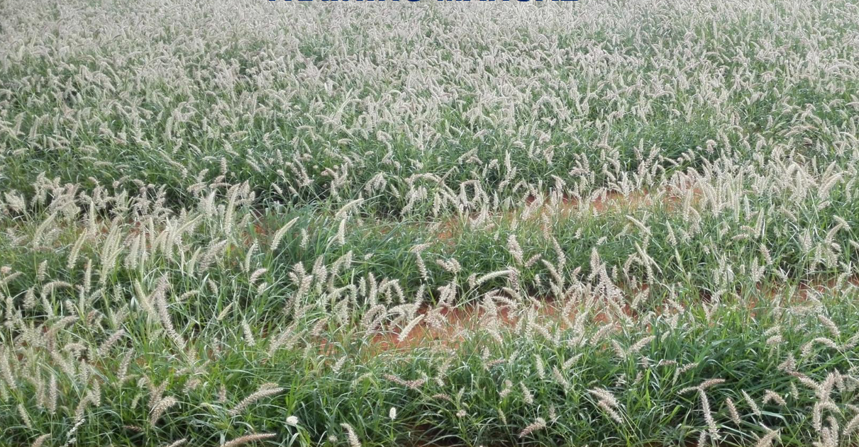
Figer 1: Pasture Establishment

LG-8 | LO-1: Prepare for Pasture establishment

Instruction sheet-1
This learning guide is developed to provide you the necessary information regarding the following content coverage and topics:
  - Selecting and checking suitable Personal Protective Equipment
  - Identifying materials, tools and equipment
  - Identifying Manual handling techniques
  - Identifying OHS hazards
This guide will also assist you to attain the learning outcomes stated in the cover page. Specifically, upon completion of this learning guide, you will be able to:
  - Select and check suitable Personal Protective Equipment
  - Identify materials, tools and equipment
  - Identify manual handling techniques
  - Identify OHS hazards
Learning Instructions:
- Read the specific objectives of this Learning Guide.
- Follow the instructions described below.
- Read the information written in the information Sheets
- Accomplish the Self-checks
- Perform Operation Sheets
- Do the “LAP test”

Information Sheet 1

  - Selecting and checking suitable Personal Protective Equipment

Personal protective Equipment’s (PPE):
Are equipment’s that used to protect the body from external hazardous matters or conditions during work activities in the workplace. Suitable personal protective clothing and equipment’s selected, used, maintained and stored in accordance with Occupational Health and Safety requirements
    - Selecting the appropriate PPE
What protective clothing and equipment is necessary? This depends on the duty being undertaken and chemical being used but the work place instruction and manufacturer’s directions should be ‘used as a guide. The recommended minimum protective clothing and equipment necessary for dealing with a particular work and product is stated on workplace procedures and the product label and MSDS respectively. Generally the degree of protection required will be relative to the degree of hazard presented by a particular product or/and work. Checking PPE refers to the process of examining their parts to ensure their normal functioning
    - Importance conducting pre-operational checks on PPE

- To identify the problems (defects, damages) of the PPE and take actions to correct or change them before using them
- To control any hazards and risks that can be araised from using of the PPE and take minimization action timely.

Basic Types of PPE
The strict controls will not necessarily eliminate all the risks associated with most job tasks and this is where the need for PPE must be evaluated.
A hazard assessment can help identify which specialized PPE will be required. However, the following basic types of PPE should be made available in worksite.
- Eye and face protection
To provide protection during exposure to hazards like flying particles, metal or sparks, liquid chemicals, caustic liquids, light radiation, i.e., welding, lasers. Eye protection should always be worn where there is potential for injury to the eyes or face from small particles, toxic chemicals, flying particles, large objects, thermal or radiation hazards, and lasers. According to the types and extent of hazards, different PPE should be worn. These must always remain clean and free of contaminates. Goggles offer good protection against front and side impact. Unvented or indirect vented chemical splash goggles provide protection from chemical vapors and liquids.

Figer 1.1: Goggle
- Hearing protection:
To provide protection during exposure to high pitch and loud noise levels. Exposure to high levels of noise may result in hearing loss. PPE should be worn when the noise level is 85 decibels or greater averaged over an eight-hour period. Most hearing protection devices have a noise reduction rating (NRR) that indicates the amount of protection provided. In general, look for NRR of 25 or greater.
- Head protection
To provide protection to potential hazards such as falling objects, striking against low-hanging objects, electrical hazards, or chemical application.
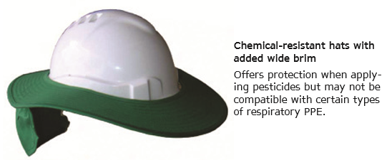
Figer 1.2. Helmets
- Hand protection:
To provide protection during exposure to potential hazards such as sharp objects, abrasive surfaces, temperature extremes, and chemical contact. Selecting proper gloves is very important since the hands are used to handle hazardous materials. In addition, traumatic injuries such as cuts, sprains, and punctures may occur. With the wide range of hazards, there are also a wide range of gloves that may be used as PPE. Chemical-resistant gloves are always recommended when working with pesticides and chemicals. Chemical-resistant aprons add protection from body absorption of hazardous chemicals.
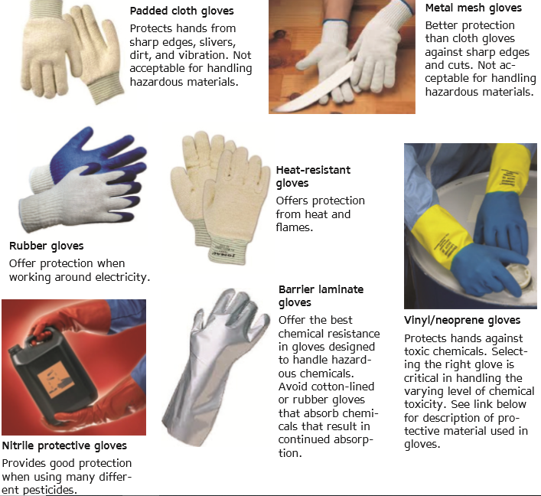
Figer 1.3. Gloves

- Respiratory Protection
Respirators are used to prevent the exposure to air contaminated with Harmful dusts, fumes, mists, gases, smokes, sprays, or vapors.
All respirator usage, including disposable respirators, air purifying respirators, and air-supplied respirators, require annual fit testing and testing and training prior to use.

Figer 1.4. Air Purifying

- Foot protection
To provide protection for situations with the potential of injuries such as falling or rolling objects, chemical or liquid exposures, piercing objects, and where feet are exposed to electrical hazards.
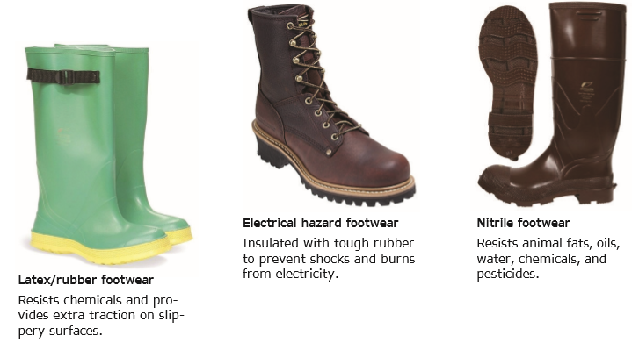
Figer.1.5. Boots
- Body Protection
PPE includes safety vests and suits and should be used for tasks that can cause body injuries from extreme temperatures, flames and sparks, toxic chemicals, insect bites and radiation. Ensure that they are clean and free from cuts and burns. Always get a good fit to ensure full body protection.
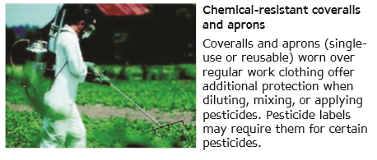
Figer 1.6.over all

  - Identifying materials, tools and equipment

Definition of common terminologies:-
Machinery: are mechanical devices with moving parts, often powered by electricity used to perform a task especially one that otherwise be done by hand. Example: Cyclone seeder, Cultic packer, Spinner spreader, Melcher.
Tools: are devices for doing work: an object designed to do a specific kind of work such as cutting or chopping by directing manually applied force or by means of a motor. Example: Machete picks, Sickle, mattock and shovel/spade, Axe, hay fork
Equipment’s: are necessary items (the tools, clothing, or other items) needed for a particular activity or purpose.
Example: Wheel barrow, water can, sacks, Water pump, sprayer. During working any pasture establishment activities the suitable materials, tools and equipment should be identify. These identified materials, tools and equipment should also be checked the functionality and then use properly. After identifying all the required materials know the operation and maintenance system or check the present condition of tools improve / maintain if necessary. For easy establishments of pasture certain materials, tools and equipment’s have been designed and are used to facilitate management operation. There are Different kinds of materials, tools and equipment’s that can be used in pasture establishment:-

Land preparation tools
- Machete: a large heavy knife with a broad blade used as a tool for cutting through vegetation.
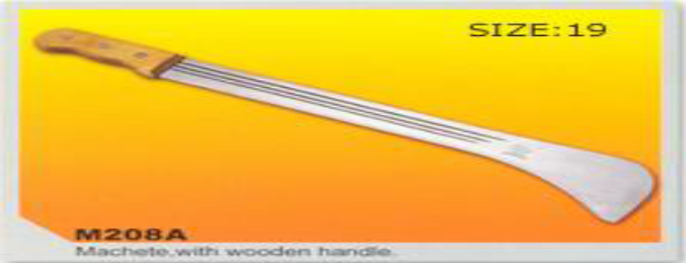
Figer 1.7.A: Machete

- Sickle: a short handled implement with a curved blade used for cutting tall grass or grain.

Figer 1.7.B: Sickle
- Axe: a tool consisting of a flat heavy metal head with a sharpened edge attached to a long handle. It is used to chop wood or fell trees.
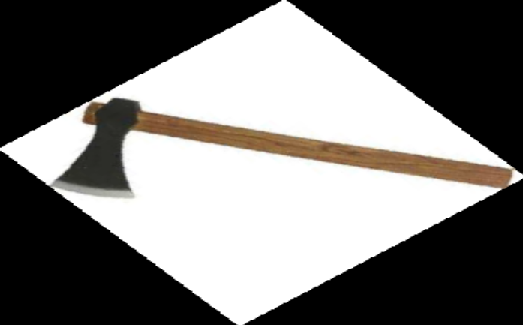
Figer 1.8.C: Axe
- Picks: a tool used for breaking up hard surfaces, consisting of a long handle and a curve metal head that is pointed at one end and either pointed or like a chisel at the other
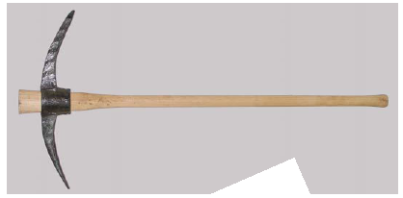
Figer 1.9.D: Picks

- Mattock: tool like a pick axe with one end of its blade flattened at right angle to its handle, used for loosening soil and cutting through roots.
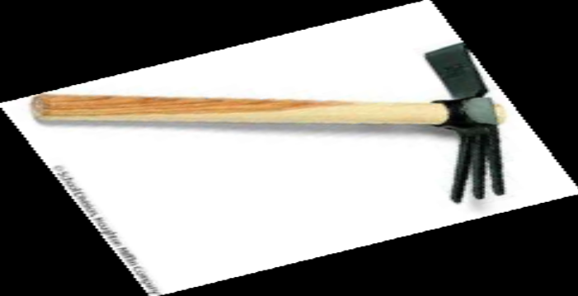
Figer 1.10.E: Mattock
- Shovel/spade: hand tools consisting of a broad, usually curved blade attached to a long handle, used for lifting and moving loose material.

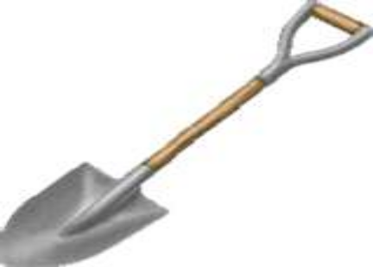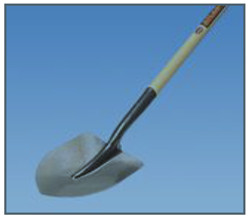
Figer 1.11. F: Shovel and Spade
- Plough: a heavy farming tool with a sharp blade or series of blades for breaking up soil and making furrows, usually pulled by a tractor.
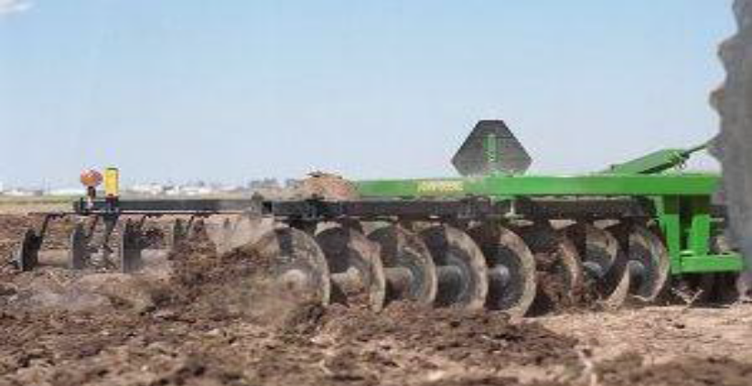
Figer 1.12.G: Plough
- Tractor: farm vehicle (a motor vehicle) used for pulling heavy loads, especially on farms, where its large rear wheels enable it to move in fields.

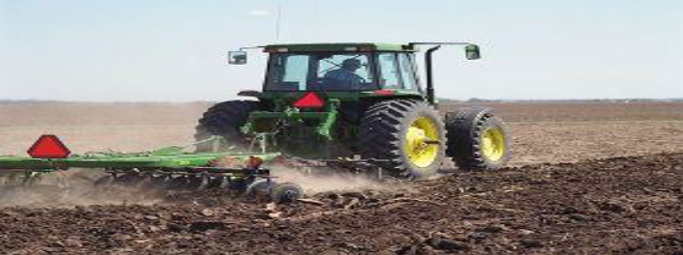
Figer 1.13.H: Tractor
- Mulcher: is a specialized rotary cutter used to cut grass, mulches and spreads it evenly over the cutting width, encouraging quick re-growth.
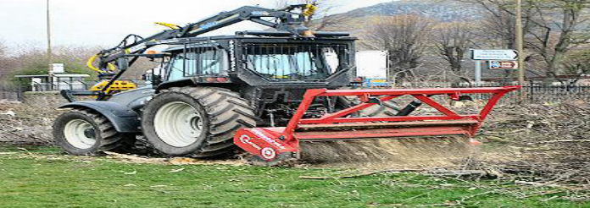
Figer 1.14.I: Mulcher

Seeders or planting (sowing tools)
Seeders are a mechanical device designed to scatter seed on the surface of ground. Seeders are usually either pulled by a tractor or have wheels and a handle that is pushed.
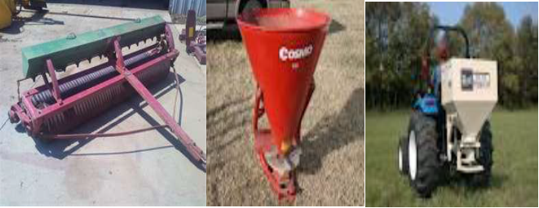
Culti packer Cyclone seeder Spinner spreader
Figer 1.15: sowing tools

Tools and equipment’s used to control weed
- Hoe: a garden implement consist of a long pole with a small flat metal blade set into one end at a right angle to the pole. Use weeding, turning over soil.
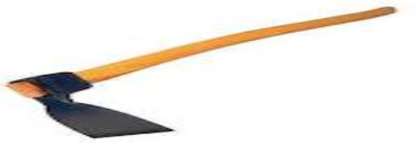
Figer 1.16.J: Hoe

- Sprayer: device that is capable of spraying liquid over an area. It is an atomized or pressurized container that release fine particles of a liquid.

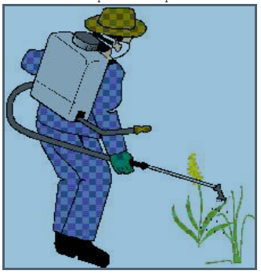
Figer 1.17. K:Sprayer

Watering equipment
- Watering can: a container with a handle and a spout, often with a perforated nozzle, used to water plants.
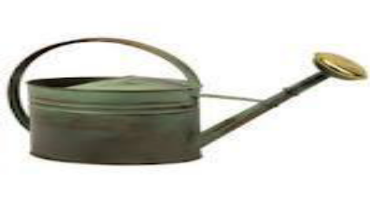
Figer 1.18.L:Watering Cun

- Water pump: is a motorized device that can draw water from its source and pushes through pipe.
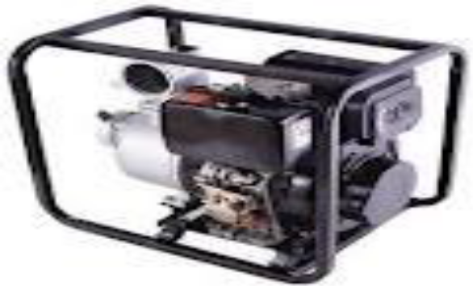
Figer 1.19.M: Water Pump

1.2.6. Machineries and tools for forage conservation tasks
N. Mower: a machine often power- operated that cuts grass with rotating blade.
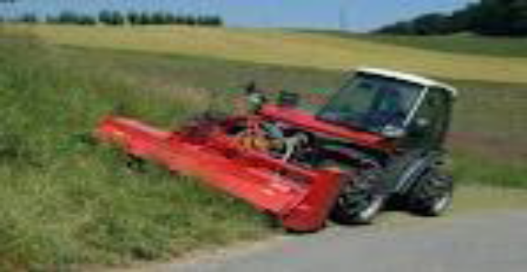
Figer 1.20.N: Mower

- Baler: is a farm machine used to compress a cut and dried crop(hay or straw) into compact bales that are easy to handle, transport and store.
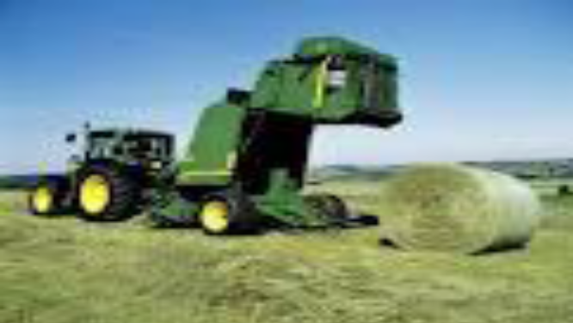
Figer 1.21.O: Baler
- Hay fork: is a grapple device used for moving and turning hay.
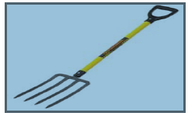
Figer 1.22: Hay fork

- Silo: is a structure or container used for storing fermented green feed known as silage. Silo can be pit silo, plastic bags, barrels and any structure constructed above the ground that can store green feed for fermentation
- Molasses: the thick sticky sweet syrup produced during the refining of raw sugar, which ranges in color from dark brown to gold.
- Plastic sheet: is a sheet of plastic used to cover and pack something. It can be used to cover inner surface of pit silo to prevent moisture and air from entering into the silage.

Other materials and equipment’s
- Forage seed: a forage plant part produced by sexual reproduction that contain the embryo and gives rise to a new individual.
- Pasture: is a land which is enclosed and separated from surrounding areas by fence or other barriers and devoted to the production of forage for harvest primarily by grazing
- Forage: herbaceous plants or plant parts consumed by animals
- Forage crop: plants grown primarily for livestock feeding and either used for grazing or harvested for green chop feeding, silage or hay
- Browse: leaf and twing growth of shrubs, woody vines trees cacti and other non-herbaceous vegetation available for animal consumption
- Fertilizer: an organics or synthetic substance usually added to or spread onto soil to increase its ability to support plant growth.
- Sack: a large bag, especially one that is made from coarse cloth or thick heavy-duty paper used to hold grain and other similar products.
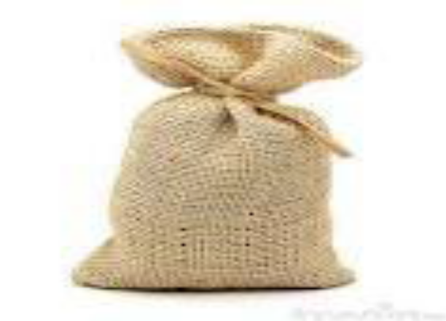
Figer 1.23.G: Sack
- Wheel barrow: a small cart used to transport things, usually in the form of an open container with a single wheel at the front and two handle at the back.
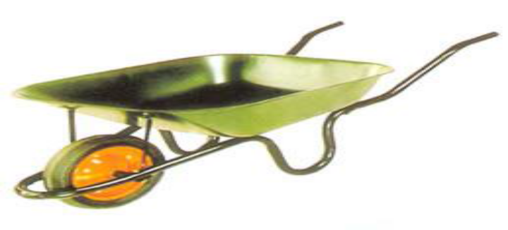
Figer 1.24.H: Wheel barrow

- Tape measure: a long roll or strip of fabric, plastic, paper, or thin metal that is marked off in inch or centimeter/meter for measuring the length of something.

Figer 1.25.I: Tape measure

- Importance conducting pre-operational checks on Machinery, Tools and Equipments

- To identify the problems (defects, damages) of the Machinery, Tools and Equipments and take actions to correct or change them before using them
- To identify any hazards and risks that can be raised from using of the Machinery, Tools and equipment’s and take minimization action timely

- The causes of risks associated with machinery equipment’s and tools

- Using wrong equipment or/and tools for a job
- Not fitting adequate guards on machines leading to accident caused by entanglement, shearing crushing and trapping
- Not fitting adequate controls or wrong type of controls so that equipment cannot be turned off quickly and safely, or starts accidentally
- Not providing right information, instruction and training for those using the equipment
- Not maintain work equipment or carrying out regular inspections and thorough examinations
- Not providing the personal protective equipments needed to use certain equipments and machinery

- Guidelines to conduct pre-operational checks on equipments and tools;
You should make sure that the equipments and tools used for work are safe to use .Here is a list of actions that should be taken to ensure this is so.
- Perform a risk assessment to identify the hazards , the risks arising from those hazards and the control measures you should use
- Check that the equipment/tool is suitable for work and way in which it is going to be used
- Check that the equipment/tool is in good condition
- Make sure that the user knows which personal equipment to use and how to use it

  - Using manual handling techniques
Definitions of common terms:
Loading: refers to putting of the load (anything) on to the ship, truck or pack animal
Unloading: removing cargo from carrier or taking the load off a ship, truck, or pack animal

    - Guidelines to load and unload equipment’s and tools;
- Load/unload the material in required order taking care to avoid damage
- Use manual handling techniques of loading /unloading throughout the process to avoid injury or damage
- Install the material in appropriate work or storage area in accordance with direction
- Identify any hazardous items and load /unload these in a manner that minimizes health and safety risks.
- Inspect load prior to transportation to ensure that all items are loaded appropriately and make adjustments as required
- Secure package against shifting within a vehicle during transportation though tying ,blocking and bracing the load
- Load packages with orientation marks (up arrow ) so that the marks remain pointed up
- Do not allow any smoking or any source of ignition on or near the vehicle when loading flammable
- Always load materials having high weight at the bottom
- Always load similar materials in one side during loading of different types of items
    - Techniques of correct manual handling

Manual handling refers to any activity that requires the use of force to lift, lower, push, pull, carry or move a person, animal or object. By observing simple, safe manual handling methods, you can avoid manual handling injuries.

Since manual handling is intensively used in pasture establishment site practically cannot be free from harms and injuries on the job condition at work place. Through training and risk assessment we aim to eliminate hazardous manual handling activities as far as it is reasonably practicable.

    - Manual Handling Procedure

In order to reduce the risk of injury from manual handling operations, pasture will ensure them:-
- Assess the risks associated with those manual handling activities that cannot be avoided.
- Eliminate hazardous manual handling activities, so far as is reasonable practicable
Employees should ensure that they:-
- Comply with any instruction and training provided in safe manual handling techniques
- Don’t put their own health and safety or that of others at risk by carrying out unsafe manual handling activity
- Report problems including physical and medical conditions, which may affect their ability to undertake manual handling activities to their line manager.
Manual handling is any task that requires you to push, pull, lift, carry, move, hold or lower any object, person or animal. Manual tasks include tasks that have repetitive actions, sustained postures and may involve exposure to vibration.
Manual handling results in 20% of all workers compensation claims at UNSW. The types of injuries related to manual handling include:- Muscle injuries, Nerve injuries, Bone injuries, Injuries to the ligaments or tendons and Injuries from falling objects
    - Manual handling aids

Manual handling aids reduce the physical effort needed to lift and move objects, making it safer.
When providing manual handling aids for the workplace it is important to ensure that:-
- The right equipment is selected for the task
- That all staff are trained in the correct use of the equipment
- The equipment is visually inspected for defects before use
- The wheels are suitable for the floor surface
- The wheels move freely
- The handle grips are comfortable and are in good order
- The handle height is between the waist and shoulder
- If they have brakes do they work?
- The aids are regularly inspected and maintained to ensure it is good working order
- He load secured before moving
Using correct manual handling techniques during loading and unloading materials helps to minimize damage Workers, Other persons, Materials and Vehicles
  - Identifying OHS hazards
    - Hazard:
Is the term that refers to dangerous conditions that can results risks in the working place. This can be physical, mechanical, chemical, and biological factors which affect or harm the health and safety of all people and animals in the working place. There are OHS hazards in pasture establishment and preservation of feeds if the workers do not follow the correct procedures safely.
But these mistakes may be corrected if a worker use PPE correctly and follow work procedure. Some of the OHS hazards associated with pasture establishment and preservation of feeds work include:-
- Physical hazards
- Exposure to high noise levels from mechanical equipment
- Callosities on hands caused by continuous strenuous work with hand tools
- Chemical hazards
- Skin rashes and dermatomes as a result of exposure to cleaners, solvents, disinfectants, pesticides, etc.
- Allergies - contact and systemic
- Biological hazards
- Materials may be contaminated with a variety of bacteria, molds, yeasts, etc., and various diseases (e.g., anthrax, leptospirosis, tetanus, Q-fever, brucellosis, etc.)

- Ergonomic hazard
- Acute musculoskeletal injuries caused by physical over exertion and awkward posture while moving heavy or bulky loads
- Low back pain due to prolonged working in a standing or semi-bending posture and
- Heat stress, in particular when working on warm days in premises lacking good ventilation or air Conditioning.

Preventive measures
- Wear safety shoes with non-slip soles
- Erect fences and post warning signs round open pits in the tannery call a qualified electrician to examine and repair faulty or suspect electric equipment
- Wear protective goggles and respiratory protection during buffing work
- Do not ever enter a confined space when you are alone. To enter such a space, use respiratory protection equipment with autonomous air supply, and have a co-worker stand-by to call a rescue team in case of weakness, asphyxiation or poisoning
- Seek medical attention if skin rashes develop; consult an allergy specialist on
- Keep a high level of personal hygiene; change clothes at the beginning and end of shift; do not take work-soiled clothes home
- Learn correct lifting techniques and work postures, to avoid low back pain use mechanical aids for the lifting and transport of heavy loads how to deal with sensitivity to solvents and adhesives
- Install effective exhaust ventilation to remove hazardous gases and vapors, and eliminate obnoxious odors,
    - Occupational Health and Safety
Employers are responsible for providing a healthy and safe work environment for their employees. The key issues and reference links relating to OH&S requirements in the workplace are: Correct and safe handling of hand tools in pasture establishment and preservation of feeds, Identifying project hazards and risks and Personal Protective Equipment

Self-check 1 | Written test

Name…………………………………………… ID………………………… Date………………...
Directions: Answer all the questions listed below.
- Identify tools and equipment’s for pasture establishment?
- What are the causes of risks associated with machinery equipment’s and tools?
- What is loading?
- What is unloading?
- What are the guide lines of loading and unloading?
- Identify OHS hazards for pasture establishment?

Operation sheet-1
  - Procedures of Preparing materials, tools and equipment’s for establishment of pasture and preservation of feed activities:
- Plan the types of pasture establishment and preservation of feed activities with calendar
- Identify and list the required materials, tools and equipment’s on the paper
- Implement to collect or purchase request for materials tools and equipment’s
- Check materials, tools and equipment’s to be ready for normal functioning
- Store them in the appropriate safe warehouse

LAP Test 1
Instructions: Given necessary templates, tools and materials you are required to perform the following tasks within 3 hours. The project is expected from each student to do it.
Task1: Preparing materials, tools and equipment’s for establishment of pasture.

LG-9 | LO-2: Undertake pasture Establishment.

Instruction sheet-2
This learning guide is developed to provide you the necessary information regarding the following content coverage and topics:
  - Carrying out site selection and land preparation
  - Undertaking pasture establishment activities
  - Undertaking work in a safe environment
  - Carrying out interactions with stakeholders
  - Observing policy and procedures
  - Observing workplace practices, handling and disposal of materials
This guide will also assist you to attain the learning outcomes stated in the cover page. Specifically, upon completion of this learning guide, you will be able to:
  - Carryout site selection and land preparation
  - Undertake pasture establishment activities
  - Undertake work in a safe environment
  - Carryout interactions with stakeholders
  - Observe policy and procedures
  - Observe workplace practices, handling and disposal of materials
Learning Instructions:
- Read the specific objectives of this Learning Guide.
- Follow the instructions described below.
- Read the information written in the information Sheets
- Accomplish the Self-checks
- Perform Operation Sheets
- Do the “LAP test”

Information Sheet 2

  - Carrying out site selection and land preparation
    - Site selection:
When assessing a locations potential for pasture production, it is important to consider the following site characteristics
2.1.1.1. Annual precipitation
Available soil moisture is the limiting factor for plant growth and establishment .sites with less precipitation have limited productivity and may not provide the site should adequate economic return. Therefore the site with adequate annual precipitation should be selected. Most dry land forage species require at least 12 inches of annual precipitation for adequate growth and long term survival.
2.1.1.2. Soil dept
To provide sufficient water holding capacity for productive plant growth, the soil depth must be at least 18 inches.
      - Soil texture
Soil texture and depth determine a soil’s water holding capacity and therefore strongly influence a site’s potential for forage production. Soil texture ranging from a sandy loam to silt or clay loam is most suitable for plant growth.
      - Drainage
Most forage species thrive in well-drained soils that have no shallow sub surface restrictive layers. The common types of restrictive layer are clay lenses and volcanic ash layers.
      - Salt accumulation
Salt –affected soils present several problems for pasture establishment. The accumulation of salt in soils has negative influences on several soil properties, including soil structure, water infiltration and nutrient availability.
      - Freedom from rocks
The presence of large rocks in the soil rules out most cultivation and planting options and significantly reduces the potential for success in establishing pasture.
      - Slope
Slopes should be less than 15% in order to accommodate planting and soil preparation equipment and minimize the potential for erosion.
      - Freedom from over story vegetation
Dense over story vegetation should be removed or thinned both to decrease competition for moisture and light and to reduce the potential for soil erosion. Proper forage establishment is a key step in having a thick, lush, profitable pasture. Many factors influence the success of a forage operation. No single program or system fits all situations. Take soil tests to determine fertilizer requirements and take steps to control weed problems. Soil type, drainage, moisture holding capacity, fertility, and pH all affect plant species selection. Evaluate how each factor impacts your forage system. Consider using improved forage varieties that are adapted to your geographical area and plant at the appropriate time.
Well-planned management will help insure success for this potentially costly endeavor; failure or success often depends on adequate planning. To maximize quality and production, select those management practices that best fit your area, soil, climate, and forage crop. Use controlled grazing management strategies, such as rotational grazing, to protect new seedlings. When planning a new forage program or trying out new technology, it is best to begin on a small scale that is easily manageable and expand as you learn or see benefits from the system.
Pastures must be well established to be highly productive. Before establishing new pastures or renovating existing pastures, producers must evaluate the farm’s forage needs, writes Dr. Rocky Lemus, Assistant Extension Professor, Plant and Soil Sciences, in this Mississippi State University Extension Service publication. It is important to consider whether the forage will be used for grazing or hay, what forage species are best suited for the area, and what resources are available in terms of equipment, money, and time.

    - Land preparation
Land preparation activities include land clearing and seed bed preparation.
- Land clearing
It refers to the activities to remove all unwanted plant materials and other things from the land. The land can be cleaned by hand cutting, by fire and by using land clearing machines like dozer. Which type to use depends on the negative impact on the bio –diversity of the area and cost.
- Seed-bed preparation
Seedbed preparation in farm fields often involves secondary tillage via harrows and cultivator
    - Procedures of seed bed preparation
- The removal of debris.
Insect eggs and disease spores are often found in plant debris and so this is removed from the plot. Stones and larger debris will also physically prevent the seedlings from growing.
- Leveling, The site will have been leveled for even drainage.
- Breaking up the soil.
Compacted soil will be broken up by digging. This allows air and water to enter, and helps the seedling penetrate the soil. Smaller seeds require a finer soil structure. The surface the soil can be broken down into a fine granular structure using a tool such as a rake.
- Soil improvement, The soil structure may be improved by the introduction of organic matter such as compost or peat.
- Fertilizing.
The nitrate and phosphate levels of the soil can be adjusted with fertilizer. If the soil is deficient in any micro nutrients, these too can be added Pastures usually require a well- prepared seed –bed for good germination and establishment.

Two methods of seed –bed preparation are recommended.
- Land tilling
- Refers to plowing (turning over) of the soil. After the tillage operation is completed, the land should be smoothed and firmed.
- Tillage is not recommended for saline soils. It brings the salt to the surface and change soil structure.

Advantages of land tillage
- Allows the seed bed to warm quicker( allowing for better germination at cooler temperatures )
- Controls weeds ( reduce weed infestation )
- Aerate the soil

Disadvantages of land tillage
- Loss of moisture through evaporation
- High potential of erosion
- Higher oxidation of organic matter

- Zero-tillage ( no- tilled seed bed )
- It involves using of herbicides to kill existing vegetation and seeding directly in to the residue. No –tilled seed bed can also be prepared by reducing surface residue prior to seeding by hard grazing or removal.

The advantages of zero- tillage are:
- The reduction of soil erosion
- Improves moisture conservation
- Slower and less uniform seedling emergence is the disadvantages of zero-tillage.

  - Undertaking pasture establishment activities
Definitions of common terminologies:
- Pasture: is a land which is enclosed and separated from surrounding areas by fence or other barriers and devoted to the production of forage for harvest primarily by grazing
- Forage: herbaceous plants or plant parts consumed by animals
- Forage crop: plants grown primarily for livestock feeding and either used for grazing or harvested for green chop feeding, silage or hay
- Browse: leaf and twig growth of shrubs, woody vines trees cacti and other non-herbaceous vegetation available for animal consumption
    - Types of pasture
The most widespread forage resource in the world is the natural vegetation in its various forms, including range; forest .Natural vegetation can be a main source of forage for the animals kept not only by pastoralists but also by smallholder farmers. Pasture is grazing land under relatively intensive management, usually supporting introduced forage species and receiving periodic cultural treatment, such as tillage, fertilization, mowing and irrigation. Pasture can be natural or improved pasture, which is artificially established.
- Natural pasture
Natural grasslands extending over a wide area and composed of native grasses, herbs and shrubs valuable for forage and in sufficient quantity to justify grazing use are referred as rangeland or natural pasture. Natural pastures include annual and perennial species of grasses, forbs and trees. The Natural forage resource, although found in a wide varieties of Agro ecological zone, have several common characteristics.
- Depends on natural plant growth without cultivation , sowing or application of fertilizer or other agrochemicals
- Opportunities to change the composition and structure of the vegetation are limited
- The possibilities of increasing vegetation yield and animal production are very limited

- Improved pasture
Improved pastures have been reseeded, fertilized or fenced to improve productivity and utilization. This term is usually applied to rundown fields that have been renovated or rejuvenated. Areas seeded for pastures have several advantages over natural, unimproved pastures. They are higher yielding, with a better distribution of that yield over a longer grazing season. Pastures can be established with the intention of supplying a grazing area for a short period of time or permanently.
In long term pastures the plant composition will change with time. Improved pasture may be annually or permanently sown improved grasses and legumes. The utilization of improved pasture is properly controlled. For successful pasture and fodder crops establishment, thorough land preparation is essential. In Ethiopia, large-scale pasture development requires at least two field operations, ploughing and harrowing.
Depending on the soil type, more than two operations may be required in some areas. Improved pastures are not usually grazed during first year. However, in the humid warmer areas the growth of the tropical pasture species such as Rhodes grass is very fast and, therefore, they can be cut for hay or silage in the year of establishment. In the highlands of Ethiopia pasture species grow slowly and need the first year for establishment. Established pasture stands are either harvested for conserving in the form of hay or silage or grazed in situ.
Species such as Rhodes grass, Panicums, and alfalfa are highly productive. In the irrigated lowlands, alfalfa and Rhodes grass are very important. About eight harvests from Rhodes grass and 8-10 harvests from alfalfa are common per year. Their yield range is 45-55 t DM/ha/year. This yield is about four times higher as compared to the yield under rain fed conditions. In these areas, the cut and carry technique is used in combination with grazing and hay making.
In the highlands, oats and vetch are very useful for green feeding, hay, and silage. Some small-scale farmers have realized the feed value of oats and vetch and have started these in their own fields. Another high yielding and popular annual crop for the high-altitude areas is fodder beet. Beet is usually planted directly during the light rains or seedlings are raised in a nursery and transplanted during the main rains.

    - Classification of natural forage
The wide diversity of natural vegetation used as forage can be classified as Geo-ecological or in functional terms. These are:
- Savannas in the tropics and sub tropics, essentially grassland either without trees or shrubs or with a crown of woody species covering up to 40% of the area.
- Steppes in Mediterranean and highland areas and in central Asia, normally with dry summers and rainfall in winter, when low temperature can severely limit plant growth. The vegetation consists mainly of perennial grass growing in tussocks, with some short lived annuals in the space between them.
- Semi-desert and desert vegetation, where rainfall is low and very irregular and plant growth is often confined to favorable sites, such as where run-off water flows in.
- Woodland and forests which have denser tree /shrub cover than tree savanna. The herbaceous undergrowth can be grazed, while the tree leaves, fruits, pods and seeds provide further important source of forage.
- Mountain vegetation, consisting of forest and meadows, and grassland above the limit of tree growth. Winter precipitation is often in the form of snow, both temperature and rainfall can limit plant growth. Establishing a new pasture or renovating an existing pasture usually requires some management to get the forage growing quickly and vigorously.
Here are some of the steps involved in establishing or renovating a pasture:
- Soil testing and correcting soil nutrient deficiencies,
- Selecting species adapted to the specific area,
- Implementing the correct seeding method and rate,
- Implementing a weed control program,
- Using proper management to maintain a productive stand.

Pasture establishment activities are described below;
- Site selection
- Forage species selection
- Land preparation
- Sowing
- Management
- Harvesting

    - Forage species selection
Selecting appropriate forage species is one of the most important and fundamental in establishing pasture. The main criteria that should always consider when selecting forage species are the following:

- Land use objective
It is important to choose forage species that are capable of meeting your specific land use objectives of land use pasture. The use objective may include:
- Increasing forage production
- Controlling erosion
- Reducing weed infestation
- Restoring the native forage community
If land use objective is increasing forage production, look for forage species that respond well to grazing and are productive and palatable to the animals. If weed suppression is a concern, consider species with good seedling vigor, high yield potential and herbicides that are commonly used on the site.

- soil and climatic characteristics of the site
It is critical that you select species that are adapted to the soil and precipitation characteristics of the chosen site. Annual precipitation is the most common determining factor for which species will successfully establish and persist on a given site. Do not select species that require more annual precipitation than a typical for the site.
- Availability and cost of seed
Seed prices and seed supplies vary from year to year depending on production and demand. The forage species that can be obtained in least cost should be chosen.

    - Selection of seed
Selection of quality seed is the important aspect towards the success in the establishment of pasture. Seed quality can be determined by proportion of seed that would germinate to form in to healthy plants. The following points should be considered while selecting a seed for pasture establishment:-
- Seed viability
The viability of any seed is its capacity to germinate when it is sown under suitable conditions for germinations. The purchased seed should contain only minimum quantity of dead seeds
- Purity
The seed should be free from contamination due to the seeds of other species, inert material, pests and disease infestation, soil straw and the like
- Seed size
Seed size is another aspect of quality seed and important component of seedling vigour. In germination stage seedlings are dependent of food stored in the seed. If the seed are bold and similar in the shape and size, then seedlings emerging from these will also likely to be similar in vigor and growth.
- Seed dormancy
Seed dormancy is the resting period and a natural phenomenon which prevent seed germination. The reason for seed dormancy may be due to:
- Premature harvest
- Thick seed coat
- Chemicals which inhibit seed germination

    - Sowing
The principles of pasture establishment are similar to those for establishing crop. Generally there are two methods of sowing namely
- line sowing and
- Broadcasting.
The type of sowing method to use depends on the type of equipment’s available and whether sowing is carried out on no-till or tilled seed bed.

- Line sowing (row sowing): - is the dropping of seeds into the soil in line.
- Drilling: involves cutting of a thin furrow in the soil, deposing the seed and then covering it with the soil.
- Culti- packing: - the seed is dropped from a hopper of the culti- packer (sowing machine) on to the soil and pressed below the surface of the soil by toothed rollers fitted on the machine.
- Broad- casting:
The broadcast method involves scattering seeds at random on the seed bed and then covering it lightly with soil. The most important forage species used for sown pasture establishment of improved pasture ; Rhodes, Green panic, Desmodium, Siratro, Stylo, Phalaris, Setaria, Trifolium, Cocksfoot, Tall fescue, Vetch .
    - Seed treatment
The purpose of seed treatment is to break dormancy and improve seed germination. Seed treatment is also done for protection of seeds from seed borne diseases. To break dormancy, the common methods of treating the seed are
- Hot water method,
- Mechanical method and
- Chemical method.
A widely accepted and most suitable method is treating with hot water. The temperature of water is kept according to the recommendations for that particular seed.

Time of sowing
- Sowing time of the forage species is influenced by a number of factors. Among these factors, the important ones are the temperatures and moisture.
- The best recommended sowing time of forage species is just early as possible in the rainy season to obtain maximum growth.

    - Management

- Weeding
Weeding of pasture is essential for proper growth and development of forage, because weed compete with the sown grasses and legumes for moisture, nutrients, space and light. In the first year of pasture establishment one weeding is required after 10 – 15 days of germination.
- Fertilizer application
In areas receiving average annual rain fall up to 30mm, 20kgN and 20kg P/ha should be applied as a basal dose at the time of sowing. But in the areas receiving average rainfall more than 30mm, this quantity can be increased by 40kg N and 20 kg P /ha. In case of more than one cutting, 20kgN/ha per cutting may be applied.
- Grazing management
Utilization of pasture is one of the most important aspects of pasture land management. For proper utilization the entire area should be divided in to number of blocks based on its carrying capacity and rotational grazing system should be applied. In this system of grazing, the sequence of grazing is changed in the way that each block is grazed for specific period and protected for the rest.
    - Forage conservation:
- Is keeping green animal feed (without very much loss of its quality) to use it during deficiency of green feed.
- Conservation of forage to bridge the gap in the supply and quality of fodder between wet and dry seasons is an applicable method of efficient utilization of feed resources.
- Hay Making and silage making are the common methods of forage conservation
- Hay: is grass, legumes or other herbaceous plants that have been cut dried and stored for use as animal feed particularly for grazing animals
- Silage: is fermented, high-moisture fodder that can be fed to ruminants.
- Fodder is any agricultural foodstuff used specifically to feed domesticated animal such as cattle, goats, sheep, horses, chickens and pigs and legumes.

- Hay making
Hay is the most common and important conserved fodder used to maintain feed supplies throughout the year. Hay is produced by dehydrating green forage to a moisture content of 15% or less. It is generally the most convenient form of stored fodder and an appropriate forage conservation method for small-scale farmers and pastoralists with limited resources.
Steps of hay making
- Harvesting
Stage of maturity is the most important factor that influences chemical composition and quality. The more immature the plant at harvesting, the higher the quality of the hay will be. This is primarily due to the proportion of leaf to stem. Hay quality decreases with advancing maturity. Most forage should be mowed just after reaching an early bloom stage of maturity. Time of cutting is, therefore, a compromise between quality and quantity of the harvested forage. The first cut of hay from a hay crop is usually of better quality than subsequent cuttings.
- Drying
Proper drying is essential so that the hay can be stored safely without heating excessively or becoming moldy. Maximum leafiness, green color, nutrient value and palatability can also be retained. The grass should be dried quickly and not unduly exposed to the sun to maintain these characteristics. Turn the hat frequently in the sun to encourage quick drying. Turning should be completed before the forage is completely dry to avoid excessive shattering of leaves and overexposure to the sun. It is better if turning is done when wet with dew, especially when high leaf shattering is expected.
Freshly cut forage contains 75 to 80% moisture, whereas the maximum moisture content for safe hay storage is 25%. Hay of higher moisture content should not be stored because its nutritive value may be greatly lowered. Due consideration should be taken to avoid losses from the following causes during the curing of hay;
- Shattering loss:
Leaves contain 2 to 3 times as much protein as stems. Leaves are also richer in carotene, B-vitamins, minerals, and energy. Legume forages contain a larger proportion of leaves than grasses. The fine leaves dry more rapidly than the coarse stems to which they are attached. This results in considerable shattering loss unless great care is taken. In field cured hay, losses from leaf shattering range from 2 to 5% for grass hay and 3 to 39% for legume hays.
- Bleaching and fermentation loss:
In general, the carotene or pro-vitamin A content is proportional to a hay’s greenness. With severe bleaching, more than 90% of the vitamin A potency may be destroyed. These losses will not be excessive with good weather and proper curing methods. Color loss is due to destruction of chlorophyll by sunlight.
- Leaching loss:
This is the loss due to washing of nutrients by rain. Repeated showers are more damaging than one heavy rain. Leaching may lower the feeding value of hay by one-fourth to one-third or even more with severe exposure.
- Spontaneous combustion:
Wet hay ferments and generates heat. This can result in spontaneous combustion and fire. This usually occurs about a month to six weeks after storing. Indicators of potential spontaneous combustion are hay that feels hot to the hands, a strong burning odor, and visible vapor.
- Storing
Hay must be stored in a dry environment. Good quality hay should never be poorly stored. The type of storage may vary from area to area. A good stack of loose or baled hay will provide satisfactory storage in arid areas where there is little rainfall.
More expensive shelters may be required for high rainfall areas. It is advisable to store hay by kinds and grades in case variable qualities are stored. Hay can also be stored by creating hay stacks. The surface layer of a stack may also be "thatched," in the same manner as a thatched roof to a house.

- Silage making
Silage making is the best method of fodder conservation. Making silage involves cutting fodder at the optimum stage of development, chopping to the right size and proper compaction to create an air-tight condition.
Steps of silage making
- Harvesting fodder to be ensiled
The forage crop going to be made in to silage should be harvested at the right stage of maturity. The quality of silage depends upon the stage of harvesting. The stage of plant growth at harvest mainly affects the amounts of digestible protein and energy. Recommended stages of harvest are:
· Legumes and grass legume mixtures, when legumes reach the 10% bloom stage. In general, grasses should be harvested just before flowering.

- Wilting
The crops should contain about 30-35% dry matter at the time of ensiling. If moisture content is high, first wilt the crop to 30-35 % dry matter content by spreading the fodder under shade and frequently checking the drop in the moisture content so that the material will not be too dry. Wilted silage should produce little or no effluent. Unwilted silage will produce some effluent, which may leak out and cause spoilage especially in case of bag silage. At higher moisture levels, seepage or a sour fermentation can occur and at lower levels, the silage will heat or mold, or both.
- Chopping
Chop the fodder into small pieces (1-3cm) before ensiling. Chopping makes it easy to compact the silage and to remove the air. The fodder can be chopped by hand, with a large knife / guillotine, or using a chaff-cutter with a rotating blade if available.

- Filling and compacting
Fill the chopped fodder into one of the silo layer by layer and compress and compact in such a manner that no air pockets are left. After the silo is filled in such manner it should be packed in the way that rain water or flood and air is not entered to it.
  - Undertaking work in a safe environment
The operation of pasture establishment need care to protect the environment from different problems like Plant debris, Litter and broken components, Plastic, Metal, paper-based materials. These may be recycled, re-used, returned to the manufacturer or disposed of according to enterprise work procedures. During work operation the workers keep the working environment neat or clean by accumulating the generated wastes at the time of preparation of work place. In the other way before starting the work, the working environment should be ready to operate or begin the work. This situation initiates the workers to perform their work properly and accurately. Sometimes unsafe work place may discourage the workers and delay the work activities. To prohibit this condition the workers perform their work in a safe and environmentally sound manner without polluting the environment.
    - workplace safety tips:
- Maintain a clean work area. Not only will you remove many hazards from a work area by keeping it clean, but you will also provide a more productive work environment for your employees.
- Use guards and engineering solutions wherever possible instead of relying on PPE - personal protective equipment. PPE is hard to police and uncomfortable to wear. Find a way to prevent the exposure in the first place. Your workers will be much more productive if they are comfortable
- Assume your employees want to work safely and give them that chance. Many safety incentive programs seemed to be based on the idea that employees want to get hurt and you have to bribe them not to stick their hand in the machine. If you have that idea, then these tips are not for you.
- Give clear work instructions. Make sure your employees know the right way to do what you expect of them. Don't just give them a list of things not to do. Include safety instructions in every procedure you write.
- Don't dwell on worst case scenarios but focus on what is most likely to occur. Start by focusing your energy in preventing your most common incidents. That means you will have to keep an accurate OSHA incident log even if it looks bad to some manager you report to.
- Love your employees. Don't confuse this with something that might get you a sexual harassment claim. I mean, care about your employees and let them know you do. If a machine is becoming unsafe, shut it down before someone gets hurt.
- Spend time getting to know the work your employees do. Even if you once did that job, it is likely it is done differently by different people. Look at what people are actually doing and compare this to what is written in procedures. Maintain the machinery in good working order. Many times employees get into dangerous situations by having to compensate for a machine defect or wear. In the case of wear, it may have occurred so gradually that they think it is normal. A strong preventive maintenance program makes for a strong safety program.
- Avoid unnecessary hazards. Look for new materials or equipment that can eliminate the hazards your workers are exposed to.
- Maintain a clean work area. See workplace safety tip number one above. Potential exposures to hazardous material and conditions can be dramatically reduced simply by keeping the work area clean. And the benefit in employee productivity and morale is worth the effort even without the safety incentive.

  - Carrying out interactions with stakeholders
Interaction is very important to understand the overall activities of conservation works with other staffs. The interaction may create some impression between the workers and other staffs about the significance of pasture establishment and environmental importance. In addition to these the interaction also develops positive relationship among the industry, staff and customers in order to protect the pasture establishment from different damaging agents.

In any workplace, you will need to develop relationships with lots of different people. You can help promote good workplace relations by:-
- Listening carefully to what other people have to say
- Taking notes of important information so you can refer to them later
- Thinking about how you can work towards the goals of your organization
- Being flexible and adaptable
- Concentrating on your work tasks
- Thinking about how you can contribute to a situation and share your ideas with others
- Communicating clearly with other people.
The purpose of this topic is to determine the minimal components of a self-management program necessary to increase positive interactions among staff and clients at work place. Interactions between clients and staff should provide opportunities to develop an understanding of self and others and are characterized by warmth, personal respect, individuality, positive support, and responsiveness. Staff good interaction facilitates interactions among clients to provide opportunities for development self-esteem, social competence, and intellectual growth and accountability as well as transparency in the work. Three interventions were implemented, as needed, in an additive fashion including:
- Instruction and goal setting,
- Self-management, and
- Feedback.
Instruction and goal setting did not increase staff positive interactions to a criterion level of 30% of intervals. However, during the self-management phase, all staff increased their positive interactions with clients, but two staff required feedback to maintain their positive interactions at the criterion level. Measures of generalization, compliance, and acceptability showed that increases in positive interactions occurred outside the assessment sessions; staffs were consistently employing the procedures; and staff found all procedures to be acceptable.

    - Helpful customer service tips
The following are six helpful customer service tips that may assist your staff on how to effectively interact with customer:
- Upon arrival of customers, clients or visitors to the premises always acknowledge them with a friendly smile and warm welcome.
- A simple "hello" or "good morning" or "good afternoon" is perfectly acceptable.
- If you are busy or dealing with another customer and unable to attend to the needs of incoming customers, inform them you will attend in a minute or two. Customers will understand your situation and by letting them know you are aware they are waiting, indicates you are keen to assist them as soon as possible.
- If a customer asks for a product, item or service you can supply then it will be a simple matter of getting it, packaging it up and making the sale. However, if a product is unavailable, sold out or not in stock then the key is to try and do something about it. This could be managed for example by making enquiries to find out if you can source the product required from the supplier or another sister store.
- At all times keep the customer fully informed of what you are doing and what is happening. If you exhaust all avenues tell the customer what you have done. By doing so you are making the customer aware you have gone the extra mile to help even though you have not been able to help in the end.
- If you have completed a sale for a customer, always thank them and ask whether there is anything else you can do for them. Alternatively, if you are unable to help a customer asking whether there is anything else you can do to help may lead to the sale of an alternative or another product that would suit the customer's requirements.
- Always bear in mind that every customer is a potential future return customer who could in turn influence other people such as family members, friends and work colleagues to visit your store or business. It is therefore extremely important to always value your customers business.

  - Observing policy and procedures
Any enterprise has its own policy and procedures that helps to guide the work operators how to use their time, how to perform their work, how to handle their tools, materials and equipment’s and other activities. Therefore, the employee before starting their work, they should know or understand the enterprise policies and procedures to perform their work properly with in proposed time. Knowing the policy and procedures of the enterprise may support the employee from doing wrong things. Policy documents explain the organization’s position on various topics. They detail such things as what is and is not acceptable or what the organization aims to do. A procedure sets out, step by step, the way to do something. In some workplaces, policies and procedures are kept on a computer system so that employees can access the most up-to-date copy whenever they need to.
Policies and procedures may also cover such things as:
- First aid
- Dress code
- Use of work vehicle
- Use of the organization’s Internet and email systems for private use
- Confidentiality of documents and work materials
- Professional development and training
- Equal opportunity
- Quality assurance and continuous improvement strategies.

  - Observing workplace practices, handling and disposal of materials
    - Observing Work place practices

Any enterprise has its own policy and procedures that helps to guide the work operators how to use their time, how to perform their work, how to handle their tools, materials and equipments and other activities. Therefore, the employee before starting their work, they should know or understand the enterprise policies and procedures to perform their work properly with in proposed time. Knowing the policy and procedures of the enterprise may support the employee from doing wrong things.
Self-Check 2 | Written test

Name…………………………………………… ID………………………… Date………………...
Directions: Answer all the questions listed below.
  - Why observe enterprise or cooperative policy and procedures?
  - What is the advantage of work with other staff?
  - Identify problems of environment in pasture establishment?
  - What is feed preservation?
  - What are sowing methods?
  - What is green chopping?
  - What are the characteristics of seed quality?
Note: Satisfactory rating - 5 points Unsatisfactory - below 5 points
You can ask your teacher for the copy of correct answer

Operation Sheet -2
2.1. Procedures of Seed Bed Preparation
A. Required Materials:-
- Machete axe,
- sickle,
- picks,
- hay fork,
- shovel/spade
B. Step:
Step1 The removal of debris.
Step2 Leveling
Step3 Breaking up the soil
Step4 Soil improvement
Step5 Fertilizing
Precautions:
- Safety first (for yourself, friends, tools &equipment’s)
- Use right equipment for the right purpose
- Strictly follow the given procedures
- Put each tools and equipment and work shop after the session

Criteria:
- All steps were completed in the correct sequence.
- All precautions were followed

  - Establish grasses
- Procedure:
  - Wear PPE
  - Prepare materials, tools and equipment
  - Prepare seed bed,
  - Plant seeds of grasses/Legumes
  - Apply fertilizer per plot during planting, cover the seed with soil,
  - Clean and store materials, tools and equipments after completion.
  - Prepare Hay Making
Procedures:
Step1 Harvesting
Step2 Drying
Step3 Storing
Precautions:
- Safety first (for yourself, friends, tools &equipment’s)
- Use right equipment for the right purpose
- Strictly follow the given procedures
- Put each tools and equipment and work shop after the session

Criteria:
- All steps were completed in the correct sequence.
- All precautions were followed.
  - Prepare Silage Making
- Supplies & Materials
- Machete axe,
- sickle,
- picks,
- hay fork,
- shovel/spade

- Procedure:
Step1 Harvesting fodder to be ensiled
Step2 Wilting
Step3 Chopping
Step4 Filling and compacting
Precautions:
- Safety first (for yourself, friends, tools &equipment’s)
- Use right equipment for the right purpose
- Strictly follow the given procedures
- Put each tools and equipment and work shop after the session

Criteria:
- All steps were completed in the correct sequence.
- All precautions were followed.

LAP Test-2 | Performance Test

Instructions: Given necessary templates, tools and materials you are required to perform the following tasks within 4 hour. The project is expected from each student to do it.
Task1. Prepare seed bed
Task2. Establish grasses or Legumes.
Task3.Prepare Hay making
Task4. Prepare Silage Making

LG-10 | LO-3: Clean up, store materials and equipment

Instruction sheet-3
This learning guide is developed to provide you the necessary information regarding the following content coverage and topics:
  - Handling and transporting materials, equipment and machinery
  - Recycling waste material and disposing disposable materials
  - Cleaning , maintaining and storing tools and equipment
This guide will also assist you to attain the learning outcomes stated in the cover page. Specifically, upon completion of this learning guide, you will be able to:
  - Handle and transport materials, equipment and machinery
  - Recycle waste material and dispose disposable materials
  - Clean, maintaine and store tools and equipment
Learning Instructions:
- Read the specific objectives of this Learning Guide.
- Follow the instructions described below.
- Read the information written in the information Sheets
- Accomplish the Self-checks
- Perform Operation Sheets
- Do the “LAP test”

Information Sheet 3

  - Handling and transporting materials, equipment and machinery
Improper manual handling of materials may expose workers to physical injuries, wasting energy and time. Apart from these problems, it can result in damage /breakage of materials. Therefore all work tools and equipments should be handled correctly to enhance safety hazards which can be araised from them.
The general principles involved in safe handling of equipment and tools are:
- Always conduct pre-operational checks on the machine or/tools to identify their fault and take correction measures or change the material totally.
- Always use the machine, tools and equipment for only the work that they made for.
- Self propelled machinery should always be operated by trained workers.
- Manufacturer’s instruction and users manuals should be used.
- Clean the material after the work has completed.
- Check that the handles of hand tools are smooth and free from splinters.
- Check that the blade of digging or cutting hand tools is not cracked.
- Be aware of your own and other people’s physical limitations. Get help to move heavy objects.
- Always lay digging or cutting hand tools with their blade point downward.
- Always examine the tools and equipment during working.
- Always keep the materials in store according to their specification and type.
- Do not use the broken tools and equipment as they can injure you.
- Label the broken tools and equipment and keep them in separate area so as not to be used by other peoples.

  - Recycling waste material and disposing disposable materials
    - Recycling waste material:
Returning materials is to go or come back, as to a former place/position after use.
The main purpose of returning material:-
- For re used next time
- To keep safely without broken after use
- Use resource wisely
The law says you must keep every part of your construction site in ‘good order’ and every place of work clean”. The objective is to achieve what is usually called a good standard of working site. In addition, all contractors must plan, manage and monitor their work so it is carried safely and without risks to health and environment. This includes careful planning on how the site will be kept tidy and work operation actively managed.
Safe and efficient waste materials storage depends on good co-operation and co-ordination between everyone involved including, client, contractors, suppliers and the residents.
- Storage areas- designate storage areas for Plant debris, Litter and broken components, Plastic, Metal, paper-based materials. These may be recycled, re-used, returned to the manufacturer or disposed of according to enterprise work procedures.
- Pedestrian routes- do not allow storage to ‘spread’ in an uncontrolled manner on to footpaths and other walkways. Do not store materials where they obstruct access routes or where they could interfere with emergency escape;
- Flammable materials- will usually need to be stored away from other materials and protected from accidental ignition. Storing of plants and materials involve diverse operations; such as hosting tone of cut wooden materials, piece of irons, destroyed seedlings, surplus plant and materials and others should be collected and stored properly during cleaning. The efficient storing of materials is vital to industry.

    - Disposing west materials:-
Definition: Waste disposing is placement or eradication of wastes, excess, scraps etc under proper process. Is simply removal of excess or unwanted material safe?

Waste materials may include:
- Plant debris,
- litter and broken components,
- Mulches, plastic, metal, and paper-based materials.
- Effluent from silage making
These may be recycled, re-used, returned to the manufacturer, or disposed of according to enterprise work procedures.
Classification/Type of waste, there are two types of wastes.
- Solid wastes disposal
- Liquid wastes disposal
Use/Purpose of disposing waste
- To remove waste and unwanted material safely from work site
- To clean work site suitably and make it attractive

    - Waste management
Is the proper handling of the things we throw away in a manner that does not harm anyone or anything, be it human, animals or the environment? Waste management may include waste reduction and segregation
- Waste reduction, It is the prevention of waste material being created.
3R
Reuse
Recycle
Reduce

Diagram 3.1: West Reduction

- Waste segregation:
Segregate

For sale
Dispose
Reuse
Compost

Diagram 3.2: West Segregation
  - Cleaning , maintaining and storing tools and equipment
Cleaning is the process of removing unwanted substances, such as dirt, infectious agents, and other impurities, from an object or environment. The work place should be clear and safe always, this favorable situation encourages the workers to perform their task properly. To sustain clean and safe work site, this place should be cleaned before starting and after finishing their work. Regular maintenance is essential to keep equipment, machines and the work environment safe and reliable. Lack of maintenance or inadequate maintenance can lead to dangerous situations, accidents and health problems. Maintenance is a high-risk activity with some of the hazards resulting from the nature of the work. Maintenance is carried out in all pasture establishment and all workplaces.
Types of cleaning materials can be:-
      - Cleaning clothes
      - Sponges
      - Water
      - Water hose/pipe
Purpose of cleaning materials:-
- Make material easy to use
- Protect material from dust, rust or rot
- Clean for future use
- Clean for long life use
    - Maintenance of tools and equipment’s
Maintenance is actions necessary for retaining or restoring a piece of equipment, machine, or system to the specified operable condition to achieve its maximum useful life.
Types of maintenance-
  - Periodic maintenance
  - Conditional maintenance
  - Seasonal maintenance
Site maintenance
- The job site shall be kept in a neat, clean, and orderly condition at all times during the operation process.
- All scrap and excess materials are to be regularly removed from the site
- Storing tools and equipment; Storing is keep or accumulate (something) for future use.

Classification/Type:-
Depending on types of industry and policy of the management stores may be classified as three.
- Centralized - materials are supplied to all departments by one store
- Decentralized - for each department there is a separate store
- Centralized stores with sub-stores - there is one central store which holds the stocks in general with separate sub stores for each department which gets supply from the central stores.
Use/Purpose of maintainance:
- Better control & layout.
- Technical skill is high & supervision is better.
- Less storage space is needed because stocks should be kept as low as possible.
- Replenishment should be quicker.

Self-check 3 | Written test

Directions: Answer all the questions listed below.
- Why cleaning, maintaining and store tools and equipment
- Why Handle and transport materials, equipments and machinery?
- Why store waste materials in designated area?
- Define: cleaning, maintenance and storing (6 points)
- List the purpose of cleaning, tools, and equipments (4 points).
- Mentioned the types of maintenance (3 points)
- List the purpose of storing materials, tools and equipments (4 points)
Operation Sheet 3

3.1. Cleaning and storing materials, tools and equipments
Procedure:
Step 1. Wear PPE
Step 2. Select tools and equipment
Step 3. Order tools and equipment separately
Step 4. Clean with water or other cleaning agents
Step 5. Transport material
Step 6. Handle properly and put orderly
Step 7. Store materials properly
Step 8. Wash your hand

LAP Test 3
Instructions: Given necessary templates, tools and materials you are required to perform the following tasks within 1 hour. The project is expected from each student to do it.
Task1: Cleaning and storing materials, tools and equipment

LG-11 | LO-4: Record and Report Work activities

Instruction sheet-4
This learning guide is developed to provide you the necessary information regarding the following content coverage and topics:
- Recording and documenting activities
- Reporting problems or difficulties
- Recording and reporting materials, tools and equipment
- Reporting work outcomes
This guide will also assist you to attain the learning outcomes stated in the cover page. Specifically, upon completion of this learning guide, you will be able to:
- Record and documenting activities
- Report problems or difficulties
- Record and reporting materials, tools and equipment
- Report work outcomes
Learning Instructions:
- Read the specific objectives of this Learning Guide.
- Follow the instructions described below.
- Read the information written in the information Sheets
- Accomplish the Self-checks
- Perform Operation Sheets
- Do the “LAP test”

Information Sheet 4

4.1. Recording, documenting and reporting work activities
4.1.1. Record keeping
You can improve your grazing system with good records of pasture yield, grazing days, and other data because they allow you to evaluate past efforts. If you keep good records and compare yield estimates with data from actual grazing days, you will be able to more closely calculate the actual yield for your farm and your conditions. Grain producers determine the number of inputs to use based on the yield they will gain from each one. Because inputs and the resulting yield are easily measured, grain production systems can be quickly refined and improved. Good pasture records are slightly more difficult to collect, but they can also contribute to rapid improvement of pasture systems. One objective of pasture improvement is to increase yield, but changes in pasture management may also target herbage quality, yield distribution, or persistence. Pasture improvement may result in improved gains, increased carrying capacity, or reduced need for supplementation during summer months.
Records help a manager to:-
- place a value on improvements and
- make decisions on where to spend limited resources to maximize the benefits.
These improvements are not necessarily obvious unless producers keep good records and study them. All your record information should be entered in a timely manner and regularly reviewed. It should include:
- record year,
- paddock identification,
- paddock size,
- monthly rainfall,
- date and amounts of fertilizer,
- seed and pesticide inputs, and
- the most recent soil test data.
In addition, each time a paddock is grazed, record the number and average size of animals, dates in and out, pasture height at the beginning and end of grazing, and yield estimate and stand density at the start of grazing.
Physical and financial records of pasture include:
- seed and fertilizer rates and costs,
- number of paddock operations and fuel costs,
- types of chemicals, rates and costs of applications for weed,
- pest and disease control,
- amount of irrigation water applied and application costs,
- weather conditions during growth,
- purchased labor,
- contracting and share-farming.

These are the things to be considered when:

A. Receiving Materials
  - Match the packing slip to the items received and ensures that the materials are destined on tour department.
  - That you are receiving the materials indicated on the purchase order with regard to quantity and discount.
  - That the materials are in acceptable condition.
  - That terms regarding installation and/or set-up of equipment are met.

B. Receiving Reports
Whenever goods are received:
  - The person receiving the goods must document, using the administrative software, that all goods were received for each requisition before any payment can be made to the vendor.
  - Any exceptions must be noted so that partial payments can be processed or defective goods can be returned.

C. Return of Merchandise
- When merchandise is received which is incomplete or defective, the supervisor will return the materials to the supplier or to the store where it was bought and make arrangements with the vendor for replacement.

D. Make an Inventory Report of the Materials
- All materials received must be listed and be reported to monitor how many materials are already on hand, purchased or damaged.
- Effective management checks are an important means of providing assurance of the integrity and security of the benefit processes.
- They are also useful in identifying training needs; indicating and other activities record.
- Malfunctions, faults, wear or damage to machinery and equipment are identified and reported in line with enterprise requirements.
- Since factors vary among installation sites, equipment users must work closely with each of their suppliers to ensure that proper data is being collected, that the data is being provided to the correct supplier, and that the resulting solutions are feasible.
- All events (failures) that occur during inspections and tests should be reported through an established procedure that includes collecting and recording corrective maintenance information.
- The data included in these reports should be verified and then the data should be submitted on simple, easy-to-use forms that failures are tailored to the respective equipment or software.
4.1.2. Collecting the data
Many problems go unnoticed because insufficient information was provided. Example, someone was able to duplicate the problem being reported. There are three common causes for missing essential data:
- Inspection or testing began before a procedure was in place to report problems.
- The reporting form was difficult to use.
- The person who filled out the form had not been trained
- Operators and maintenance personnel are usually the first to identify problems and, therefore, they should be trained to properly capture all of the information needed for an event report.

4.1.3. Reporting equipment failures
Poor working conditions affect worker health and safety
- Poor working conditions of any type have the potential to affect a worker's health and safety.
- Unhealthy or unsafe working conditions are not limited to factories — they can be found
- Poor working conditions can also affect the environment workers live in, since the working and living environments are the same for many workers.
- This means that occupational hazards can have harmful effects on workers, their families, and other people in the community, as well as on the physical environment around the workplace. A classic example is the use of pesticides in agricultural work.
- Workers can be exposed to toxic chemicals in a number of ways when spraying pesticides: they can inhale the chemicals during and after spraying, the chemicals can be absorbed through the skin, and the workers can ingest the chemicals if they eat, drink, or smoke without first washing their hands, or if drinking water has become contaminated with the chemicals.
- The workers' families can also be exposed in a number of ways. Other people in the community can all be exposed in the same ways as well. When the chemicals get absorbed into the soil or leach into groundwater supplies, the adverse effects on the natural environment can be permanent.
- Overall, efforts in occupational health and safety must aim to prevent industrial accidents and diseases, and at the same time recognize the connection between worker health and safety, the workplace, and the environment outside the workplace.

4.2. Reporting problems or difficulties
Reporting is an account or statement describing in detail an event, situation, or the like, usually as the result of observation, inquiry, etc about problems or difficulties in completing work.
- Types of report
- Research
- Practical
- Laboratory
- Business and
- Investigation reports.
- Use/purpose of report
- To increase student knowledge and skill
- Define work activates
- To communicate information’s
- To maintain record keeping
- To identify available materials
- Components of report
The reports shall include the following components:
- Develop Cover page
- Introduction
- Objective or purpose
- List of materials
- Procedure or steps
- Discussion
- Conclusion
- Recommendation
- Annex/ resource
- Reference
During the process of pasture work operation, the workers and the working environment may face certain challenges; to tackle these challenges reporting of problems and difficulties is very important. This is because inconvenient situations may face the workers and the people those settled around the working environment. Related to the above conditions and performance to achieving the goal of the task, problems and difficulties are practically expected to be seen. These situations should be immediately reported to directly concerned bodies to correct and retain the work functional, productive and safe.
4.3. Reporting work outcomes
During the completion of pasture establishment we should report to the concerned body about all performance of activities and their outcomes. It will be better if the report reflects the target and its achievement on percent base. Concerning tools, equipments and materials, inventory results of all items can be taken as report; especially the condition of all tools, equipment and pasture establishment should be reported. An important point in every work including pasture establishment and preservation of feeds work is recording data, analyzing and reporting, all the steps from the initial to the final product of the work. One of the ways of communicating to the employer or the customer is reporting work outcome .This report includes information regarding
- Raw materials used
- Problem encountered
- Length of work
- Hazards and safety
- Techniques and system of work
- Cost expended
- Material availability
- Sustainability of work
- Labor required
- Facilities in work

Steps to prepare and report work report
  - Prepare recording format
  - Record all the data and steps in work
  - Arrange the data
- Select the relevant data to the work
- Interpret according to your work
- Compile the data properly
Report the total outcomes of the work to the concerned body

Self-check 4 | Written test

Directions: Answer all the questions listed below.
  - What items are report outcomes in pasture establishment?
  - Why report problems or difficulties in completing work
  - When recording activities accomplishment and incidences
  - List the information included in the report (10 points)
  - Describe the steps to prepare and report work report (7points

Operation Sheet 4:

  - Procedures of Preparing Report
Step1. Prepare recording format
Step 2. Record all the data and steps in work
Step 3. Arrange the data
Step 4. Select the relevant data to the work
Step 5. Interpret according to your work
Step 6. Compile the data properly
Step 7. Report the total outcomes of the work to the concerned body

LAP TEST | Performance Test
Instructions: Given necessary templates, tools and materials you are required to perform the following tasks within 1 hours.
Task: Preparing report

Reference Materials:
Books

Arseneau, J.D. 1996. Pasture Management. Univ. of Minnesota Coop. Ext. Serv. Lesson 6. Henning, J.C. and H.N. Wheaton. 1996.

Establishing Forages. Univ. of Missouri Coop. Ext. Serv. Pub. G4650. Henning, J.C., G.D. Lacefield, R.J. Coleman, L.M. Lawrence. 2000.

Establishi Forage Seedings. Univ. of New Hampshire Coop. Ext. Serv. Newhall, R.L. 2005.

Pasture Establishment and/or Renovation. May AgriHint Series # 2005-001. Selecting Legumes and Grasses for Hay and Pasture –1996 MN Beef Cow/Calf Report C-127. Sellers, B., J. Ferrell, J. Vendramini, and Y. Newman. 2007.

Forage Establishment. Virginia Coop. Ext. Serv. Pub. 418-103. Meyer, D.W. 1999. Forage Establishment. North Dakota State Univ. Coop. Ext. Serv. Pub. R-563.
Web addresses
  - https://www.beefresearch.ca › files › pdf › Perennia_pasture
  - 2.
- https://www.dpi.nsw.gov.au ›_data › assets › pdf_file › es...
  - 3.
- https://naldc.nal.usda.gov › CAT87205777 › PDF

AKNOWLEDGEMENT

Ministry of Labor and Skills and Ministry of Health wish to extend thanks and appreciation to the many representatives of TVET instructors and respective industry experts who donated their time and expertise to the development of this Teaching, Training and Learning Materials (TTLM).

The experts who developed the learning guide
No | Name | Qualification | Educational background | Institution | Phone number | E-mail
 | Abenet Getahun | MSc. | Animal Production | Gewane ATVET  College | 0940236673 | abenetgetahun@gmail.com
 | Biru Kefenie | MSc. | Animal Production | W/Soddo  ATVET  College | 0913334612 | ukefene@gmail.com
 | Gashaw Assefie | MSc. | Animal Production | Agarfa ATVET  College | 0914068274 | lakomelzajournalist@gmail.com
 | Genanew Abera | MSc. | Animal genetics and breeding | Alage ATVET  College | 0926672970 | genanewabera@gmail.com
 | Sead Taha | MSc. | Animal Production | Agarfa ATVET  College | 0916112492 | tahasead@gmail.com
 | Solomon Fertewal | MSc. | Animal Production | Alage ATVET  College | 0912648413 | Tosolomon@gmail.com
 | Temesgen Roro | MSc. | Animal Production | Holeta PTC | 0917657496 | temesgenroro@gmail.com
 | Terefe Tolcha | MSc. | Animal Production | Alage ATVET  College | 0911067132 | terefetc@gmail.com
 | Yirmedie Bayou | MSc. | Animal genetics and breeding | Mizan ATVET  College | 0915851079 | Yirmedie123@gmail.com

