ANIMAL PRODUCTION
Level-I

Based on March 2021, Version-4 Occupational standard
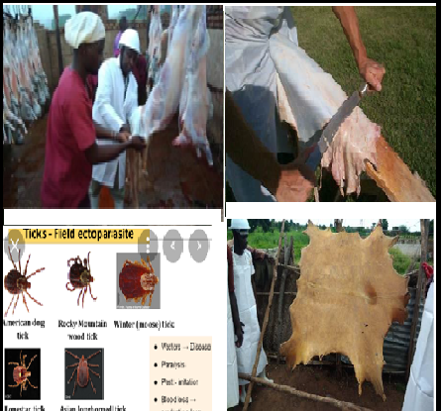

Module Title: - Handling and Preserving Hide and Skin
LG Code: AGR ANP1 M05 LO (1-4) LG (15-18)
TTLM Code: AGR ANP1 TTLM 09 22v1

September, 2022
Addis Ababa, Ethiopia

Table of Contents
Introduction to the Module 3
LO #1- Care for hide and skin on live animal 4
Instruction Sheet 1 4
Information Sheet. 1 5
Self-Check 1. 23
Operation Sheet -1 24
LAP TEST-1 26
LO #2- Prepare hide and skin for preservation 27
Instruction Sheet 2 27
Information Sheet 2 27
Self-Check 2. 41
Operation sheet 2. 42
LAP Test 2. 44
LO #3- Undertake sorting and grading of hide and skin 45
Instruction Sheet 3 45
Information Sheet 3 46
Self-Check .3 56
Operation sheet 3. 57
LAP Test 3. 58
LO #4: Clean up on completion of work 59
Instruction Sheet 4. 59
Information Sheet 4 60
Self-Check 4. 67
Operation sheet 4. 69
LAP Test 4 71
List of Reference Materials 72

Introduction to the Module
This unit covers the knowledge, skills and attitude required in handling and preserving of hide and skin. It requires the ability to prepare materials, tools and equipment, care for hide and skin on live animal, handle, preserve, sort and grade hide and skin and clean up on completion of work.
Raw hides and skins are an essential commodity in ever day life ,and they are obtained from cattle hides ,calf skins, sheep and goat skins ,kids and lambskins and also hides and skins obtained from other animals like horse ,pig, kangaroo, deer ,reptile ,elephant and others….
Today by helping of improved technologies of physical and chemicals processing the raw hides and skins are converted to modern leather products like foot wear, hand bags ,gloves ,belts ,, fur coat, upholstery, wallet home and office accessories and many other improved materials.
Therefore, these valuable, fashionable, high priced and huge renewable natural resources of leather products are the fundamental economic potentials and base for developing country like Ethiopia and others.
Today in our country hides and skins can serves as an export commodity or the larges foreign exchange with semi processed and processed leather from the trade of raw materials as leather goods.

LG #15 | LO #1- Care for hide and skin on live animal

Instruction sheet 1
This learning guide is developed to provide you the necessary information regarding the following content coverage and topics –
- . Protecting bruising of hide and skin
- . Preventing external parasitic infestation
- . Carrying out restraining of animals
- . Using and carrying out appropriate slaughtering procedure
This guide will also assist you to attain the learning outcome stated in the cover page. Specifically, upon completion of this Learning Guide, you will be able to –
- . Protect bruising of hide and skin
- . Prevent external parasitic infestation
- . Carry out restraining of animals
- . Use and carry out appropriate slaughtering procedure
Learning Instructions:
- Read the specific objectives of this Learning Guide.
- Follow the instructions described below 3 to 6.
- Read the information written in the information
- Accomplish the “Self-check ,
- If you earned a satisfactory evaluation from the “Self-check” proceed to “Operation Sheet
and Lap test
- Then proceed to the next learning guide.

Information Sheet. 1

- Protecting bruising of hide and skin

- Introduction
Hides and skins are broadly defined as the external integuments of larger and smaller animals having biological and economical importance. In general the external integuments that cover the carcass of the animal is called skin. The skin of different species of animals varies on their anatomical structure, thinness, Wight, size and also they differ very much in their leather making quality. Therefore for commercial purpose the term hides and skins defined depends on the natural size of the animals (larger & smaller animals).
- Definition of terms
Hide: The external integuments that cover the carcass of matured animals of naturally larger size. E.g. cattle, camel, horse
Skin: The external integument that cover the carcass of matured animal specious of naturally smaller size and immature animals of larger size. E.g. calf, sheep, goat. Therefore the term hides dose not used to refer the external body coverage of calf (immature animals of larger size).
Ripping: refers to the proper cutting line of the hides or skins in order to get a good shape according to international regulation and maintain the cutting value of the finished leather.
Flying: refers to separating/removing/ the hides or skins from the carcass.
Fleshing:-is the process whereby the unnecessary subcutaneous tissues and meat left behind during flaying, especially on the ribs and shoulders area and fat remaining around the tail area, is removed from the hide /skin.
Hazard: is the term that refers to dangerous conditions that can results risks in the working place
Preservation is a process of partial dehydration to keep hides and skins in good condition without Spoilage.
Ripping is proper cutting line of hides and skins in order to get a good shape according to international regulation.
Flaying is the second step of the process helps to separate hides and skins from the carcass.
Tanning is a process of using chemicals to convert hides and skins to leather
Bruising is the escape of blood from damaged blood vessels into the surrounding muscle tissue.
Among existing many defects for example busing caused by a physical blow by a stick or stone, animal horn, branding, stubbing, metal projection or animal fall and can happen anytime during handling, transport, penning or stunning. Bruises can vary in size from mild (approx. 10-cm diameter) and superficial, to large and severe involving whole limbs, carcass portions or even whole carcasses. Meat that is bruised is wasted as it is not suitable for use as food because:
- It is not acceptable to the consumer;
- It cannot be used for processing or manufacture;
- It decomposes and spoils rapidly, as the bloody meat is an ideal medium for growth of contaminating bacteria;
- It must be, for the above reasons, condemned at meat inspection.
Bruising is a common cause of meat, hide and skin wastage and can be significantly reduced by following the recommended correct techniques of handling, transport and slaughter. Injuries such as torn and hemorrhagic muscles and broken bones, caused during handling, transport and penning, considerably reduce the carcass value because the injured parts or in extreme cases the whole carcass cannot be used for food and are condemned. If secondary bacterial infection occurs in those wounds, this causes abscess formation and septicemia and the entire carcass may have to be condemned

- Cross sectional observation of hides and skins
All skin has certain features in common although they vary in thickness. In across section the histological structure shows three main different layers and they are:
- Epidermis
- Dermis
- Hypodermis

1. Epidermis
It is a thin top layer covering about 1-2 % of the total thickness of the entire skin.
Hair is the typical epidermal structure and is entirely a product of epidermis.
The epidermis divided in to 2 layers.
- Reticular layer (the inner layer)
- Corneous layer (the outer horny layer)
2. Corium (Dermis)
This is the main layer of the hides and skins consisting of 98% of the entire thickness. In structure corium is different from epidermis and consists of fibers, which occurs, in boundless. The fiber of corium consists mostly of collagen.
3. Hypodermis
A layer appended to the bottom of corium is called flesh or adipose layer. It is the loose connecting tissue lying between the hide or sin and the actual body of the animal. At the time of flaying, a part of this tissue reaming attached to the hide or skin. Although this layer exists in all the flayed hides and skins and removed during the tanning operation and it is not a part of the hide.
- The epidermis and the hypodermis layer are discarded during the liming and the fleshing process respectively. Hence except in the case of production of leather for the epidermis and hypodermis layer do not existing in finishing.
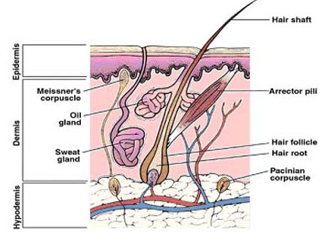
Fig 1.1. Main components of the mammalian skin

1.1.3. Recommended animal Husbandry Practices
Improvement of hides and skins quality at farm level entails controlling defects on the live animal that may occur due to poor animal husbandry practices. These practices include breeding, feeding, physical care, pest and disease control, management of grazing areas and lastly good practice in transporting the animals to the market. In general, large, healthy animals will translate to better quality hides and skins.
The following management practices are recommended since they impact positively on production of good quality hides and skins.

1. Breeding
A recommended breeding practice entails the following:
- selecting and keeping large animal breeds for better sized, heavier and thick hides and skins leading to better income
- Incorporating bulls and bucks selection and Artificial Insemination for breed improvement.
2. Feeds and Feeding
The recommended feeds and feeding practices are as outlined below:
- Feed livestock with high –nutrient fodder, mineral supplements and commercial feeds where applicable
- Maintain adequate and stable feeding by conserving pastures and fodder.
3. Physical care
In order to get quality hides and skins from the livestock, avoid external or internal damage on animals when ploughing, pulling carts and carrying loads to reduce defects on the hides and skins.
4. Pest and disease control
Pests and diseases negatively affect the quality of hides and skins. Tick bites and mange scratches may render skins unfit for commercial applications. Emaciation or weakness of the livestock due to diseases make the skins weak and of poor substance. The skin of a sick animal therefore has less value. Besides, sick animals can infect other healthy animals. It is therefore important for the livestock farmer to:
- Prevent occurrence and spread of diseases
- De-worm to improve livestock growth
- Treat sick animals immediately they show signs of diseases
- Observe and adhere to quarantine notices, which arise from diseases that directly affect hides and skins e.g. lumpy skin disease, Mange, ringworms, tick bites, ECF, and anthrax among others.
5. Traditional Branding
Branding is used by livestock farmers as a proof of ownership. Normally, many farmers use red hot iron to brand their animals. This however, burns the hide making it less useful for leather manufacturing. Appropriate hot iron branding which does not damage the hide should be done on the less important areas of the animal body such as the neck, legs, ears hump and the masks. Figure 2 shows the recommended areas where hot iron branding may be done and these include masks, in between the horns, behind the ears, lower forelimbs, lower hind limbs and the hump. The grey shaded overlay represents the prime part of the body which should be avoided when branding to ensure quality hide for leather production.
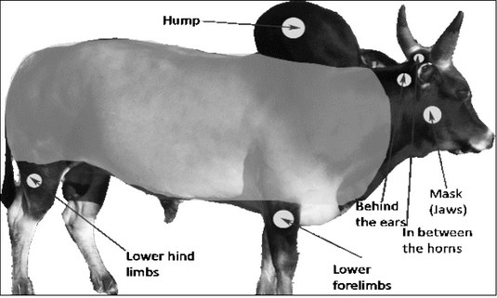
Fig. 1.2. Recommended parts for hot-iron branding of cattle
6. Management of livestock grazing areas
Proper management of livestock grazing areas can reduce damage to hides and skins.
Livestock grazing fields or enclosures should be kept free from sharp objects that may scratch or tear skin. Important practices to observe in grazing areas include:
  - Clearing thorny bushes around the grazing areas and near cattle boma (Cattle boma- - livestock enclosure) where livestock frequent
  - Fencing using plain wires instead of barbed ones where applicable
  - Avoiding sharp and protruding objects like nails and timber especially in handling yards.
  - Dehorning and trimming sharp animals’ horns
  - Separating male animals that are likely to fight

7. Transporting Livestock
Recommended practices for livestock in transit include but not limited to:
- Spreading sand or saw dust on the floor of the truck bed before loading livestock onto trucks. This avoids injury by reducing slipping of animals which may cause damage to hides and skins from the injuries.
- Avoiding overloading by observing the recommended carrying capacities for common trucks iii. Avoiding transporting of livestock on trailers and semi-trailers because they take long to reach destination and hence straining the livestock.
- Loading and offloading livestock at appropriate places/ramps to avoid injury.

1.2. Preventing external parasitic infestation
Hides and skins should have the highest value of any product of slaughter animals, other than the carcass. This is particularly so of cattle hides and small ruminants and ostrich skins. In the case of pigs and poultry, the skin forms part of the edible meat. Useful leather can be made only from undamaged and properly treated skins. Proper handling of these items is important to produce a valuable commodity. Careless damage to hides and skins will cost the industry much loss.
External parasite like tick, dermatitis, lice, mange, and skin disease causes damage to hide and skin. This will lead to low quality of hide and skin as well as tanning products. Therefore it is important to prevent external parasite infestation by good husbandry practice, treatment by dipping or spraying of animal.
a) Tick damage
Tick infestations are of great importance in the production of animal disease. Many of them are active blood suckled and may cause total anaemia and acts as carrier of infection disease. Some tick species like Boophilus species have single host, other like Hyaloma species may have two or three hosts and are the more difficult to control. The two named genera are responsible for damage to cattle hide and to sheep and goat skins. Individual animals can be treated effectively by application of any one of several insecticides by dipping or spraying
b) "Ekek" or meiotic dermatitis
This is a dermatitis occurring in all species is caused by infection with organisms of the genus Dermatophilus. The affected Epidermis proliferates and forms scabs with a distinct lamellar structure. The lesions made by this disease can vary widely in depth and spread in several affected areas, scar tissues is formed and general thickenings of the hides may results, giving the appearance of elephant or rhinoceros hide and making it quite for the production of leather.
c) Follicular or demodetic mange
One of the most commonly seen skin disease defects is made by a mite called demodex folliclorum, a parasite burrowing deep in to the hair follicle, where it established its nest. This disease is called follicular or demodatic mange. The damage is clearly visible on the flesh side of the hide or skin, in the form of raise and whitish spots. These lesions are erroneously called pox marks by the trade.
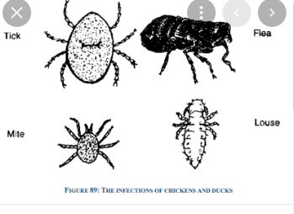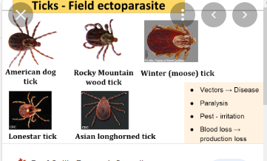
Fig.1.3. External Parasites of hide and skin
1.3. Carrying out restraining of animals
Before performing slaughtering of animals restraining of animals is very important for the safety of operators and the equipments. Restraining is the process of making animals under the control of human being or operator. You must restrain an animal before you stun or kill it.
The equipment for restraining animals must:
  - Be in good working order
  - Allow you to stun or kill an animal effectively
  - Prevent injury or cuts to animals
  - Minimize struggling and vocalization
  - Minimize the time an animal is restrained.
You must only put animals into restraining equipment, including head restraints, when you’re ready to stun or kill the animal.
- Stunning pens for cattle
You must use a stunning pen or restraining pen for adult cattle, including bovine animals such as buffalo and bison. You must only use restraining equipment in the way described in the manufacturer’s instructions. Stunning pens and restraining boxes must:
- Be in good working order
- Only accommodate one animal at a time
- Prevent any large movements forwards, backwards or sideways
- Allow complete access to an animal’s forehead.
- Stunning cattle with a pneumatic captive bolt
If you use pneumatic captive bolts you must have a restraining device in any new stunning pens and restraining boxes. Additionally, you must:
- Restrict an animal’s head from moving both up and down, and side to side
- Allow the release of an animal’s head immediately after stunning.
- Reasons for human slaughter
- To comply with animal welfare requirements
- To prevent needless suffering;
- It results in safer and better working conditions for persons engaged in slaughtering operations;
- It brings about improvement of products and economies in slaughtering operations; and
- To produce other benefits for producers, processors, and consumers that tend to expedite an orderly flow of livestock and livestock products in interstate and foreign commerce.
- Equipment used for stunning and correct stunning position
The commonly used equipment is the captive stunning bolt Figure.3. A captive bolt stunning gun kills the animal and reduces it instantly unconscious without causing pain. The correct position for stunning small stock is shown in Figure 4.4 while stunning for large stock (bovines) is shown in Figure 4. Figure 5 shows stunning in progress.

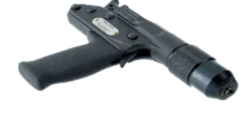 Figure 3: Captive bolt stunner gun
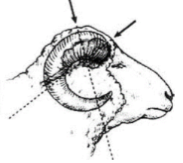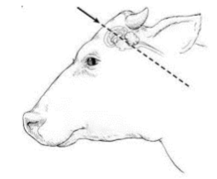
Fig.1.4: Sheep or goat captive bolt position Fig. 1.5: Cattle captive bolt position
1.4. Using and carrying out appropriate slaughtering procedure
1.4.1.Best practices for Pre-slaughter animals
During pre-slaughter, one must ensure that:
  - Animals presented for slaughter should be sufficiently clean
  - Animals should not be stressed during transportation to the slaughterhouse. The mode of transport should be comfortable.
  - Animals should be allowed enough rest, (24 hours) before slaughter to improve quality of meat and hides and skins.
  - The animals should be given a good drink of water for cooling them down and facilitating the loosening of the attachment between the hide/skin and the flesh for ease of flaying
  - The conditions of holding of animals presented for slaughter should minimize cross-contamination and facilitate efficient slaughter and dressing.
  - Slaughter animals should be subjected to ante-mortem inspection.
  - Ante-mortem inspection should be scientific- and non-risk-based
  - Ante-mortem should take into account all relevant information from the level of primary production
  - Relevant information from primary production where available and results of ante-mortem inspection should be utilized in process control.
  - Relevant information from ante-mortem inspection should be analyzed and returned to the primary producer as appropriate.

1.4.2.Slaughtering place
- Field or back yard- animals are slaughtered in an empty room in a dwelling house & / or back yard. Hide & skin obtained from such place are highly contaminated and have low keeping quality.
- Slaughter slabs: – built when small number of animals i.e. more than 2 animals are slaughtered per day. Slab provides basic facilities for production of standard hides and skins. The floor should be hard, smooth & in pervious, sloping towards a drain & grooved to provide a good footing. It should be covered with a roof if possible.
- Slaughter houses: - built where there in slaughtering of lot less than 40 cattle per day. The floor should be smooth & impervious & the wall impermeable. The butcher delivers his animals to the lair age & collects the dressed carcass & offal. In the house hide preservation may take place.
- Abattoir: - built for slaughtering large number of animal for destitution to large consuming area or for export. Such abattoirs process meat, food, skin & hides, animal products (bone & meal) & preserve hide & skins.

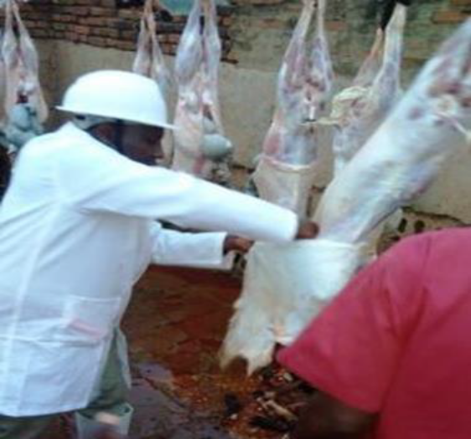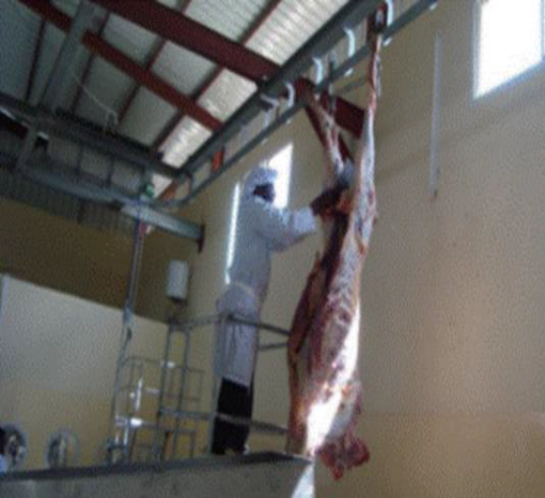
Fig.1.6. Slaughtering house

1.4.3.Physical observation
1.Anti- mortem examination: - Anti mortem examination is important before killing the animals to make sure weather the animals is free from disease especially for zonotic disease than can transmit from animals to human. Also if the animal to be slaughtered is female she must be checked weather she is pregnant or not.
2.Washing the animal: - Animals which have been transported to slaughtering place especially on foot, will carry money dust and other contaminating agent that can contaminate the meat and hides or skins. So to avoid this problem the animals must washes and are allowed to dry.
3.Stunning:-Stunning is an operation intended to make the animals unconscious. a good
stunning method should fulfilled the following criteria
- It should result in unconsciousness of the animals.
- It should not affect the efficiency of bleeding.
- It should not present any damage to the worker.
- It should result some degree of immobilization of the animals so the slaughter may work is facilitates.
The commonly used stunning methods are: -
- Captive bolt (piston)
- Striking instrument (like knife)
- Using carbon dioxide (co2). 70%co₂ and 30% air
1.4.4. Slaughtering equipment
Largely well-fitted slaughterhouses would generally contain a large assortment of equipment and plant to facilitate slaughtering operation. This is a little value in trying to present a full list of such items. However the basic requirements includes the following
- Protective cloth: - Boats, dust coat or overall, hat, chain-mail gloves and scabbard for knives
  - This items are required to keep staff clean and safe and minimize contamination of the products and provide safety
- Ripping knife: - A sharp pointed knife with a straight blade about 150mm long, which is used, for cutting hides and skins and inserting ripping lines. It may also be used for bleeding animals
- Flying knife: - A blunt knife with a curved blade about 150mm long, used to cutting hide & skins off carcasses and fleshing
- Mechanical hoist: - A lifting devices such as a pulley or block-and tackle capable of lifting carcasses to a point 3.5m above floor level
  - A hoist helps in bleeding, flaying and butchering operations
- Miscellaneous items: - Rope to restrain animals during slaughter, string to tie guts, a bucket to collect blood and carry water and a wheel barrow to transport materials
- Sharpening stone: - Flaying Knives should be kept as sharp as possible .It is a mistake to sharpen the knives on rough cement or stone because the cutting edge is quickly and easily warn out. Knives may be sharpened in a smooth stone or sandstone and re sharpened on a piece of hard word or an still file
- Slaughtering operation
- Precaution
The human methods of slaughtering animals should be encourages but in practice, it is difficult to specify and specific methods as it depends in the local condition.
- Fatigues animals especially after a long track on foot or rail should be allowed to recover as otherwise it less to incomplete bleeding and poorer hide keeping quality and also removal of hide and skin also is difficult with more chance of cutting.
- Animals to be slaughtered should have free access to drinking water for at least 24 hrs before slaughtered and give only very little food.
- Slaughtering of animal (cutting throat)
The animals can be slaughtered by cutting the throat using ripping knife. While slaughtering the animal two main points to be kept in mind are
- Fast slaughtering of the animal to cause sudden death of animal and reduce suffering
- To bleed the animal completely
In cutting the throat and making the an incision for breeding the head of the animals should be polled in the direction to the butcher to allow the neck to be stretched
Then butchered should make a cross cut of 12-15 cm deep in the throat closer to the head as much as possible. So that both the arteries and the veins which cross at the point will be cut.

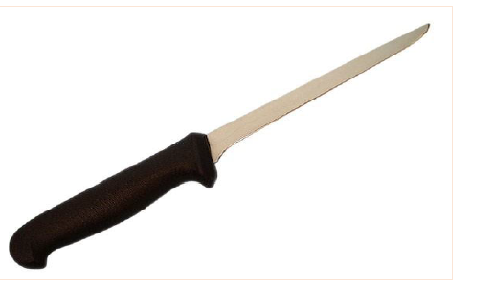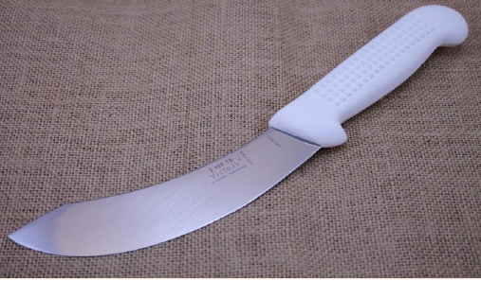
Fig.1.7.. Boning knife Fig.1.8. Skinning (flaying) knife
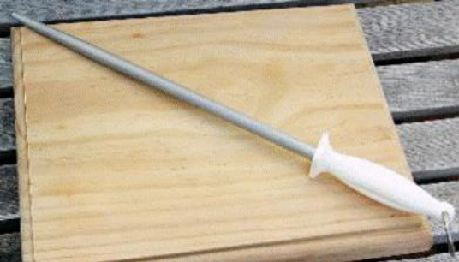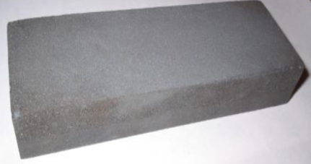
Fig. 1.9. Sharpening steels, grinding tools Fig 1.10 : Sharpening stone (ceramic)
- Bleeding
A reasonable bleeding is extremely important for good quality of meat and for good preservation of the hide. This process is better performed when the animal is suspended by hind legs, leaving the forelegs hanging freely. Therefore whenever possible it should be done in this way rather than in the ground. Hides and skins from animal that is not bleed properly or completely are of inferior quality.
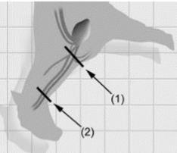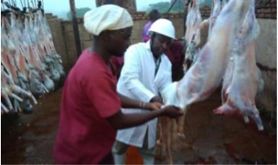
Fig:1.11. Sticking point for the sheep Fig: 1.12.Best Bleeding practice
Step5. Perform Ripping with correct ripening line
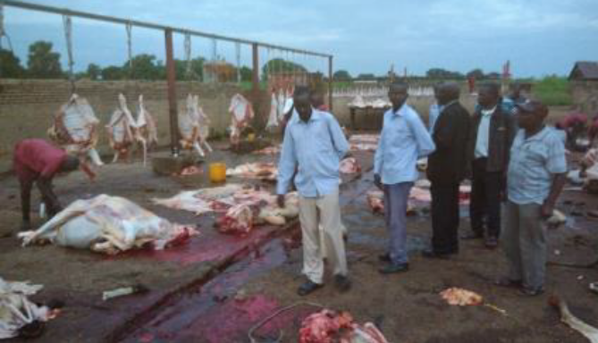
Fig. 1.13. poor bleeding Practice
Step6. Undertake flaying operation
Step7. Perform Evisceration and splitting the carcass
- Ripping and flying
- Definition of ripping and flaying
Removal of hide from carcass takes place in two steps-:
- Flaying
- Ripping
Flying: is the second step of the process in order to separate the hides or skins from the carcass.
Ripping:- is the first step refers to the proper cutting line of the hides or skins in order to get a good shape according to international regulation and maintain the cutting value of the finished leather.
1. Methods of flaying
The full process of flaying can be performed when the animal is in horizontal or vertical position.
A. Flaying in horizontal position:- the full process of flaying is performed on the ground and the slaughtering animal should be placed with its back said in to the hollow to avoid rolling aside or it is placed on a wooden or metal support or on a flaying bed as it is done in slaughter house.
B. Flaying in vertical position:- in this case the flaying process performed by suspending the animal with its hind leg leaving the forelegs freely by means of mechanical hoist over head rail system. Whenever possible, flaying should be done in this way rather than in the ground.
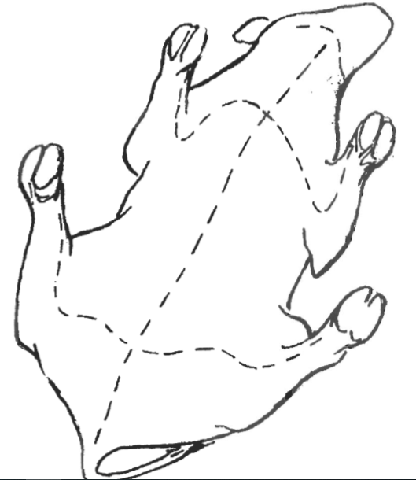
Fig: 1.14.Correct line for ripping with ordinary knife before starting flaying
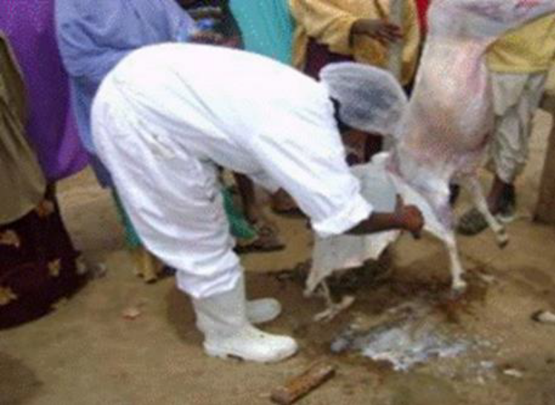
Fig:1.15. Best Flaying technique by pulling skin
2. Operation after flaying
In order to preserve the thigh quality of the skin structure for the leather industry, it should be submitted to a preparatory process for preservation immediately after the skin is removed from the carcass.
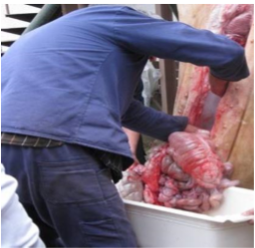
Fig:1.16. Best evisceration technique
A. Washing
As soon as hide and skin is flayed, it should be washed. Whenever possible it should be spread out over a sloping cement table of 250cm by 200cm in size and wetted with clean and fresh water from pipe or shower in order to wash dung, blood and other remaining dirt. This operation is considerably facilitated when the animals are washed and cleaned with a brush before slaughtering. It is proved that through washing with cold and clean water after flaying it is possible to reduce the number of microorganisms by half. If the flesh side is contaminated with blood or dirt it should be turned with the flesh uppermost and washed and cleaned with the smooth edge of the scraper or with a brush for about two minutes. After the completion of washing, the hides are placed with the hair uppermost on wooden floors for draining and losing the natural body heat. The time taken varies from 30 minutes to one hour.
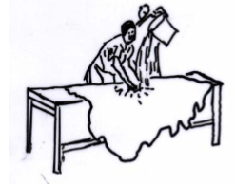
Fig.1.17. Washing of the flesh side before preservation
B. Fleshing
Fleshing is the process whereby the unnecessary subcutaneous tissues and meat left behind during flaying, especially on the ribs and shoulders area and fat remaining around the tail area, is removed from the hide .The delicate operation must be carried out with care to avoid scoring and gouging mark. To do so the following rules should be observed.
- Flesh without delay before the tissue and meat have time to dry up
- Place the hide on a perfectly smooth surface
- Use a sharp knife or scraper
If a table is not available, a smooth log may be used or the hide may be fleshed after it has been placed in to a frame or hung over a horizontal pole
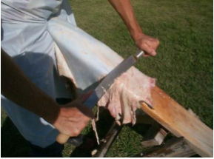
Fig. 1.18. Fleshing using a fleshing knife
C. Trimming
- Head cut straight behind the ears:
- Shanks cut off at right-angles immediately above the knee (fore shanks) and the hock (hind shanks) ;
- Tail cut off not more than 100 mm from the butt for cattle hides, and 40mm for skins.

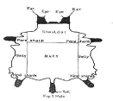

Fig.1.19a. . Trimming cut.

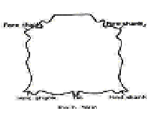

Fig.1.19b. The ship or properly trimmed hide

Self-Check 1. | Written Test

Name…………………………………………… ID………………………… Date…….
Directions: Answer all the questions listed below.
Test I: Choose the best answer (3 point)
1. The external integuments that cover the carcass of matured animals of naturally larger size is
A. Hide B. Skin C. Hide and Skin D. None
2. The escape of blood from damaged blood vessels into the surrounding muscle tissue is
A. External Parasite B. Bruising C. Restraining D. Stunning
3.Which one of the following is External patasite?
A.thicks B.Anthrax C.mites D.A&C
Test II: Short Answer Questions
- Discus the tree layer of hide and skin (3pts)
- What is bruising and how do you prevent bruising (3pts)
- Define restrain? (2pts)
- Discus Reasons for performing humane slaughtering techniques (2pts)
- What is stunning? (2pts)
- Discus about slaughtering equipment? (3pts)
- 11.What is the difference between ripping and flying? (2pts)
Note: Satisfactory rating - 10 points Unsatisfactory - below 10 points
You can ask you teacher for the copy of the correct answers.

Operation Sheet -1

1. 1. Restrain slaughtering animal
A. Materials required
- PPE
- Animals
- rope
B. Procedure for restraining of slaughtering animal
- Wear PPE
- Identify /select slaughtering place
- Prepare restraining materials like rope
- Clean the restrain and casting place
- Cast the animal by reuff method of casting
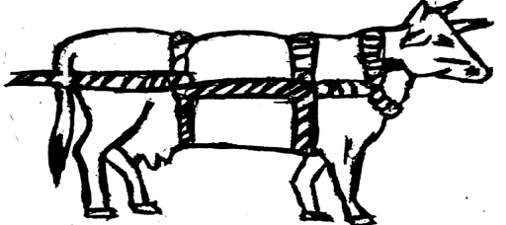
Fig.1.1.20 . Ruff method of casting
- If you like to cast animal by stunning, perform stunning
Fig.1.21. place of stunning
- Tie the animal’s leg
- Complete the operation and be ready for slaughtering operation.
1.2. Perform slaughtering of sheep
A. Materials required
- PPE (apron, plastic boots, plastic glove
- Curved Knife,
- File
- Slaughtering Knife
- Rope
- Bleeding bucket
- Hanging Hooks

B. Procedure for slaughtering sheep
Step1. Wear PPE
Step2. Prepare work site
Step3. Prepare required materials, tools and equipment
Step4. Perform Bleeding of restrained animal on appropriate sticking point
Step8. Store the carcass and skin separately in clean area
Step9. Dispose waste crated during slaughtering
Step10. Complete slaughtering and make the skin ready for preservation.

Table 1.1. The following are some of personal protecting materials
No | Materials | Description
1 | 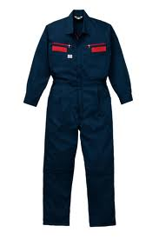 | Body safety cloth (tuta): - This cloth is a type of cloth which covers all the body part except the head and the fingers. Itis used to protect the body from dirty.
2 |  | Sun hat:- is the material, that is used to protect head from direct sun radiation
3 |  | Eye protecting device: - it is used to protect the eye from different damage
4 | 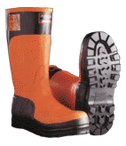 | Boot:- it is used to protect leg from sharpen and other damaging
5 |  | Hand glove: - which is made of leather or strong flexible plastic rubber, it used to cover fingers to protect from sharpen materials.

LAP TEST-1 | Performance Test

Name…………………… ID……………… Date……………………
Time started: ________________________ Time finished: ________________
Instructions: Given necessary templates, tools and materials you are required to perform the following tasks within 2 hour. The project is expected from each student to do it.
Task-1.Perform restrain Of animal (small ruminant/large ruminant)
Task-2.Perform Slaughtering of animal and prepare hide and skin for preservation
Task-3 Perform Disposing of waste materials

LG #16 | LO #2- Prepare hide and skin for preservation

Instruction sheet 2
This learning guide is developed to provide you the necessary information regarding the following content coverage and topics:
- . Determining appropriate site selection
- . Selecting appropriate methods of preservation
- . Preparing preservation materials and equipment
- . Carrying out preservation
- . Undertaking work task
This guide will also assist you to attain the learning outcome stated in the cover page. Specifically, upon completion of this Learning Guide, you will be able to:
- Determine appropriate site selection
- Select appropriate methods of preservation
- Prepare preservation materials and equipment
- Carry out preservation
- Undertaking work task
Learning Instructions:
- Read the specific objectives of this Learning Guide.
- Follow the instructions described below 3 to 6.
- Read the information written in the information
- Accomplish the “Self-check ,
- If you earned a satisfactory evaluation from the “Self-check” proceed to “Operation Sheet
and Lap test
- Then proceed to the next learning guide.

Information Sheet 2

2.1. Determining appropriate site selection
2.1.1. Principles of preservation
The basic idea of curing or preservation is to keep the hides and skins in good condition without putrefaction until they are processed in tanneries. Being portentous (33%) in nature, hides and skins are liable to attacks by bacteria or mould, which leads to putrefaction especially in hot and humid conditions. The portentous matter is hydrolysed by bacteria leading to loss of hide substance resulting in poor quality leather. On the other hand, the moisture content of hide or skin is about 60-62%, which is very ideal for bacterial growth.
The basic principle of preservation therefore lies in creating such conditions that bacterial flora cannot multiply. This can be achieved either by immediate delivery of the hides and skins to the tanner, a condition very unreliable in less developed countries, or by reducing the moisture to a point where bacterial growth stops. A simple way of reducing this unwanted moisture is by exposing the hides and skins to free air circulation. Another method is to absorb the moisture by salt, this, combined with the penetration of salt into hide substance, acts as a kind of dehydration.
2.1.2.Spoilage of hides and skins
A. Spoilage is a steady/gradual/ change and a cumulative Procedure that start as soon as the animals are slaughtered. Beings portentous in nature hide and skins are liable to attack by bacteria or mould, which leads to putrefactions especially in hot and humid conditions. The water content of fresh hides and skins (60-65%) is also good media for multiplication of bacteria. Since a good proportion of hides and skins come from the farmer, trader, village trader and country butchery they got contaminated with different contaminating agents. Contaminated hides and skins get spoiled and affect leather production
The outer side is contaminated with environmental dirt like dust, dung, blood, mud etc and the process of decomposition starts immediately after the hide or skin is taken off. In order to maintain the structure of hides and skins they must be kept in good conditions, otherwise they will be spoiled.

A. Causes of spoilage
Agent that causes spoilage in hide and skins includes
1-physio -chemical decomposition
- Wet and warm conditions are most likely to promote this process
- All organic matters are susceptible
- It is degradable processes that mass affect any material only in hides and skins
- Although fresh hides and skins are affected but the damage only become significant at high temperature over a long period of time

2 . Fungi (mould and beast)
- Fungi generally grow slowly
- Established on incompletely dried material
- They are not usually responsible for early stage of spoilage on hides and skins

3. Viruses
- Are only active in living tissue
- So that cannot be responsible for spoilage even recently dead tissue
- They may be the cause of certain types of pre- slaughter defect that occurs in hides and skins when they are alive
- Principal (main) cause of spoilage
- Are active on fresh unpreserved and inadequately preserved hides and skins
- Responsible for rapid spoilage in fresh hide
- Are also responsible for advanced kind of spoilage, hair- slip.
Sign of spoilage
If hides and skin is not treats properly they gradually exhibit sign of spoilage like:-
- Offensive smell
- Discoloration
- Slippers/ slums structure
- Hair slip
By the time hair- slip is observes the spoilage is already advances enough to make the material useless for leather manufacture
2.1.3.Determination of spoilage
Techniques of determining spoilage are;-
1. Chemical test /laboratory test 2. Physical observation
1. Chemical test
It is the methods of discovering the course of spoilage in laboratory through chemical means. It is not used in practice since only a small part of the hide or skin can be observed at a time.
2. Physical observation
It is the way of discovering spoilage by physical means.
It includes- physical observation for
- Offensive smell
- Discoloration
- Slippers/slims structure
- Hair-slip
2.1.4. Site selection for preservation of hide and skin
Before conducting preservation operation selecting preservation site is very important for the quality of hide and skin.
The site should be fulfilling the following criteria’s:
- It should be have drainage facility or good topography
- Accessible to water
- Free from any waste and hazardous material
- Dry and well ventilated area
- Near to storage house
- Enough space
2.1.5. Hide or Skins drying shed :Drying sheds have three sections:
- Working area
- Drying area
- Storing area

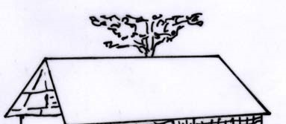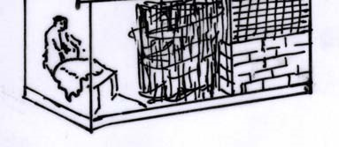
Fig.2.1. hide or skin drying shed

2.1.6. Materials used for preservation of hide and skin

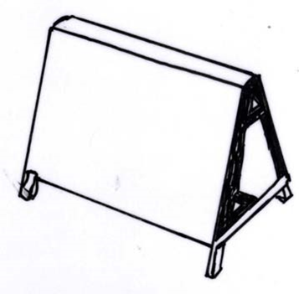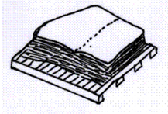
Fig.2.2. Wooden horse draining. Fig.2.3. Hide/skin Piling palate
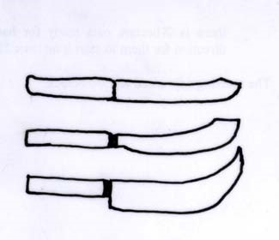
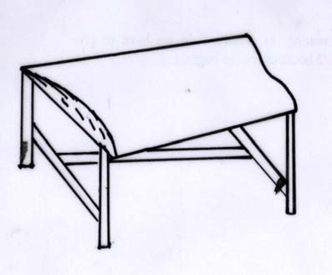

Fig.2.4 Curved-top table Fig.2.5. Different types of Knife

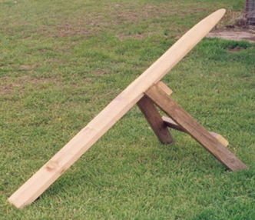

Fig.2.6. Fleshing beam
2.2. Selecting appropriate methods of preservation
Methods of preservation
Preservation is the name given to a variety of procedures which can be applied to hides and skins in order to reduce or stop spoilage. Preservation can only maintain quality. It cannot improve quality. If a badly spoiled hide is preserved, the quality will remain bad, irrespective of how well it has been preserved. Similarly, if a very good hide is well preserved, it should remain equally good during the course of the preservation. It follows that a bad preservation will allow deterioration of all a skin, irrespective of its original quality.
There are two major methods of preservation
1. Air – drying
2. Salting
In all the techniques natural Water is removes so that the low percentage & moisture- Makes the bacteria ineffective. The two methods of presentation / air drying and starting/ can be used depending on the following factor
- Weather condition
- Availability of material
- Location of the tanneries
- Economic factors
So, one can select preservation method that is suitable for his condition.
Preservation procedures applied to hides and skins for the tanning industry must be:
- Effective
- Safe and non-toxic
- Reversible
- Cheap
- Widely applicable
The preservation procedure should not have any adverse affects on the leather-making characteristics of the hide or skin.

2.2.1. Air- drying methods
Drying of hide and skins can be done in different ways. The techniques include drying on the ground, using suspension/frame drying, drying by suspension over cords or wires, and tent and parasol drying. Drying depends on the temperature, relative humidity and movement of air. For example, a skin can be dried in three hours in a dry atmosphere.
A fresh skin placed in warm surroundings will dry more rapidly in moving air. Even if the air is humid but moving, it will dry a damp skin. Therefore, it is bad practice to hang a skin in a closed space with solid walls and no air movement, as this leads to putrefaction. Air currents should move freely in drying skins even if the air is hot. If a skin does not dry in 2–3 days, the chance of putrefaction is very high. The air-drying method means the drying of hides and skin in the open air in order to reduce the moister down to 12- 15%
Air drying can be done in the following ways:
- Suspension frame drying
- Suspension drying over cords or wire
- Ground drying (not recommended)
- Suspension of frame (frame drying)
- Is best as compared to others.
- Frame can be erected in an open air or under sheds.
- The best way is to frame. Drying in shed
- It shed are used. It is important that the sheds shows have ventilation to ovoid spoilage.

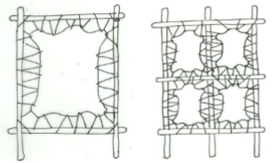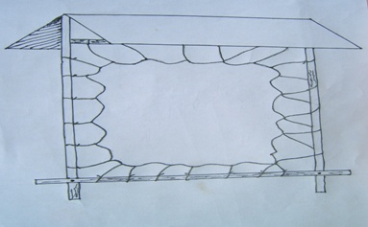

Fig.2.7. Frame drying of skins
Advantage of frame draying
- It allows free circulation of air on both side of hide or skin
- The rain drains of the surface and does not collect in puddles on the hide
- The sun's rays strike obliquely not directly
- No hairclip or putrefaction as there are no folds nor points of contacts b/n the hide and any solid subject (compare ground dried hides which touches the earth, folded hides which touches themselves, or pole-dried hides which touch the solid pole
- It permits the hide to cool off rapidly, since heat is lost through both surfaces
- Cheaper transportation, as dry hides are lighter than salted hides

- Drying by suspension over cords or wires
This technique is employed where wood is scarce. According to the Ethiopian policy all goatskins, which are not salted, should be prepared by these techniques. Suspending them over one, better three, wires or cords stretched horizontally, may also dry sheep and goatskins. This method can yield good results, provided the greatest care is taken that the sides of the suspended skins do not touch each other (which happens when one wire only is used), and that all folds, especially those on the shanks, are stretched out by means of small sticks or straws.
The main drawback of this method is that during drying wrinkles develop which, when stretched out, may lead to cracks. If heavy rope or wire, i.e. thicker than the little finger, were used, it would produce faults similar to those occurring in pole drying, namely, damage along the line of contact due to impeded drying. If the cord or pole is thick, the portion in contact with the pole will not dry and get putrefied.
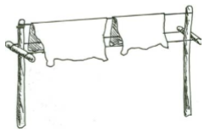
Fig.2.8. Suspension drying over cords.
- Tent and parasol drying.
It is used in the area where there is a shortage of wood for frame construction. Hides and skins are placed on a wire stretched between two poles and edge of the skin or hide is stretched by cords pegged on ground along each side.
The parasol technique is a modification of ground draying method and involves a single central vertical pole to support the middle of the hide with edges stretched out to pegs on ground
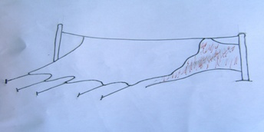
Fig.2.9. Parasol drying

- Ground drying
Hides and skin are placed directly on ground to dry. It is the worst drying technique for skin and hides. Dried skin and hides produced on this way are of poor quality and consequently producer get low return. There is no free air movement underneath and hence sun heat coupled with moisture trapped under the hides and skin encourages bacterial attack causing damage to the product. Thos method is not recommends.
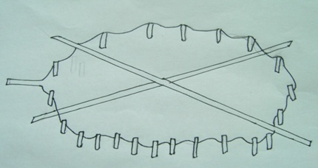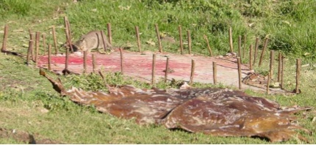
Fig.2.10. Ground drying results in serious, irreparable damage to skins.
2.2.2. Salting
- Wet salting
This was introduced in to Ethiopia around 1977 and at present about 89% of the sheepskins, 20% of goatskins and 5% of cattle hides are preserved using this method. The hide or skin is spread on floor or wooden pallet and salt is uniformly applied on the flesh side with common salt to the extent of 30 to 40% on green weight. The second hide is now spread on the first one with flesh side up and salt applied in the same manner, curing takes approximately 3 weeks and the piles need to be turned and restocked every 10 days.
This salting technique is preferred by the tanners to air drying as tanners find it easier to process wet salted stock and they obtain better results. And also salting is highly beneficial during the long rainy season as hides and skins cannot be properly air dried at that time.
The salt absorbs water from the skins, and the brine (mixture of salt and dissolved fluids)is allowed to drain. The stack is allowed to cure for about five days. It is then opened and put in a new pile with the top skin going to the bottom, applying additional salt wherever necessary. Again, the skins remain for five days in the pile. The skins are then removed and excess salt removed from the flesh side and the grain side to keep it clean.

Bacteria are not destroyed in this technique but a condition is created where they become ineffective. Salt absorbs about 20% of the water from the skin. Some salt is absorbed by the skin to the extent of 13–17%. In smaller skins, the percentage of salt used based on green weight is higher. Rock salt, lake salt and sea salt can be used. Any salt used should have a sodium chloride content of 94–95%.
  - The amount of salt to be used in wet salting is 30-40% of fresh weight of hides and skins. For example for 2kg of fresh sheep skin salt required is:
- Option 1. 30% salt 2 * 30/100 = 0.6 kg of salt
- Option 2. 40% salt 2 * 40/100 = 0.8 kg of salt
Size of salt grain: the salt used should have appropriate size
- Too fine salt: flow as brine and not absorbed
- Too coarse salt: will damage the skin structure during pilling and may not absorbed
The appropriate size:
    - For skin 0.5-1mm
    - For hides 1.15-3mm
Pilling system: it is depends on size of hire of skin i.e. long and short hair
    - long hair skin pilled flesh to hair
    - short hair (cattle, goat) is pilled flesh to flesh or flesh to hair
  - preservation time to wet salting extends up to six month
Disadvantage:
- Cost of salt
- Transportation of wet salted stock is more expensive than the dry ones
- Can be stocked for much lesser time compared to dry ones
- Require trained staff
Advantage:
- Better quality and hence higher price
- The tanneries spend much less in soaking expenses compared with dry ones
- Good during rainy season
- Increase in area compared with dry ones

- Brining:
Green fleshed and washed goat skins and hide are soaked in brine (salt solution) for 15 hrs. the amount of salt added in the water in barrel is for 100 lit. : 24 kg of salt or (24%) in ratio .The amount of goat skin or hide soaked is in the ratio of 3lit/1kg hide or skin weight. The brine solution can be re used till it becomes very filthy.
It has been the practice in some countries to recover and re-use salt swept from skins before these are shipped or sold, sometimes after mixing with fresh salt. It must be recognized that the risk of contamination of sound, fresh raw stock in this way is very high. This is generally practiced where salt is either considered too costly for economic use or is not readily available.

Generally, the best preservation method is salting depending on the distance of raw skin production from tanning factories.
The second best option is air drying. Air drying takes a long time for processing. Dried skins require soaping and wetting before processing. This process has added cost to the tanneries.

- Dry salting
Dry salting is a method of preservation of hides and skins widely used in tropical countries.
The difference between dry-and wet salting is that in dry salting, salt is used for the initial period only (when the hides are highly susceptible to damage), the remaining moisture being removed by the exposure to air.
- Especially suited for preparing stock for export purposes, at the same time overcoming the problems of wet salting.
- The quantity of salt used is 10% less than in wet
- With the advent rains, air-drying of salted hides may cause considerable difficulties. In this period, a mixture of one part of common salt to four parts of anhydrous sodium sulphate is very often used to speed up drying.
- With rains, air-drying of salted hides may [resent considerable difficulties.
- Dry- salted goods do not require protection form beetles but are very susceptible to damage by wetting.
- Butchers or farmers who handle only small number of hides can easily practice-quick dry salting.
This method consists of rubbing salt into the clean, properly fleshed hide approximately at a salting rate of a quarter of the weight of the weight of the hide or skin. The salt is applied and hide is folded with flesh side in. Hide remains in folded condition for two days and taken out and dried.
- Type of salt used for preservation
In our countries sea salt /Asab salt/ are the type of salt used for preservation of hides & skins. Sea salt contain halophillic /salt loving/ bacteria which causes red heat defects if used directly
- Halphillic bacteria are only be infective if the salt is treated with chemicals, therefore it is recommended to use salt which is chemically treated
- The type of chemicals used for salt treatment is naphthalene, sodium silk florid.
- sodium silk florid is the most effective chemicals and for 100kg of salt 2kg of this chemical are used.
use of sale
It must be recognized that there is a high risk of contamination and hence reuse of salt is not recommended.
2.3. Preparing preservation materials and equipment
Before starting preservation of hide and skin the first operation is preparing materials and equipment. These materials should be prepared based on the requirements and standards. The required materials will vary based on the amount of hide or skin, the size of hide and skin, the preservation method and so on.
If the selected preservation method is drying the necessary facilities and materials include:
- Skin or hide
- Protective clothes
- Air drying frame
- Rope
- Store house
Protective clothes like overall, boot, apron, glove and other head and face protective equipment should be prepare for use.
Skin or hide: the skin or hide to be preserved should be prepared for preservation. It should be properly washed after flaying, fleshed unwanted meat and fate and it should be trimmed.
Drying frame: the frame should be constructing before starting preservation. The size of frame will vary by the size of hide and skin.
Size of frame for hides
- 2.5 x 2.5m small
- 2.75x2.75m medium
- 2.75x3m large
- 3x3m extra large
Size of frame for skins
- 1.2x1.2m small
- 1.3x1.3m medium
- 1.5x1.5m large.
Rope: - for tying the hide/ skin to the frame.
Store house: - should also ready for storage of preserved hide/ skin or dried hide and skin.
If the selected preservation method is salt the necessary facilities and materials include:

- Skin or hide
- Protective clothes
- Salt
- Chemicals
- Clean water
- Detergents
- Pallet
- Ware house
Salt: sea salt /Asab salt/ should be treated by chemical’s like naphthalene or sodium silk florid. Sodium silk florid is the most effective chemicals and for 100kg of salt 2kg of this chemical are used.
Chemicals: for treating sea salt which contains Halophillic bacteria like naphthalene or sodium silk florid.
Clean water: for cleaning or washing hide or skin, equipments, PPE, working area etc.
Detergents: - used to remove waste during cleaning.
Pallet: to put the preserved hide or skin.
Other facilities like dirt bin, pit to burn left over and offal, rake axe, trimming and washing table should be prepared.
2.4. Carrying out preservation
After preparation of preservation facilities, materials and equipments, undertaking or performing preservation operation.
On frame drying
2.4.1. Lacing of hide and skin on frames
- Lacings - is the method of stretching and securing hide and skin on frames.
Procedures for lacing
- Make a hole on the edge of hide or skin with 2-3cm from the edge
- Insert the rope through the hole made
- First tie the upper part of the hide or skin
- Using uniform tension finish lacing the hide or skin on frame. Take care not to use over or under stretching which may affect the structure of hide or skin
N.B
- Care should be given while making hole on the edge of hide or skin for lacing
- Wire should not be used since it is not elastic it can tear the hide or skin during stretching
- Wire also cause rust which leads to the development of strains during tanning
- Avoid over stretching and under stretching

2.4.2. Drying Salt
Dry-salting of a hide or skin is carried out by placing the stock flesh-up on a flat surface and applying salt on the flesh side (about 60% to 70% of green weight), taking care to rub salt in, particularly at the edges. The hide or skin is then folded flesh-to-flesh along the backbone and rolled into a bundle. The treated stock is left for 72 hours before opening, excess salt is shaken off and the material dried by hanging over a beam about 8 to 10 cm in diameter to avoid sharp folding of the hide. Beam direction is usually East West to avoid direct exposure of the hide surface to the sun. The neck and the backbone are placed along the beam and the material is turned over several times on the second day. Drysalted goods are light in weight, can be kept indefinitely in good storage conditions (between 2 and 3 years), are immune to insect attack and are relatively easy to soak back.
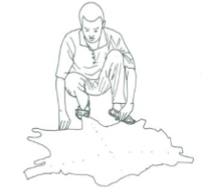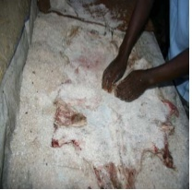
Fig.2.11. Salting skins on cement floor Fig.2.12. Demonstration of salting
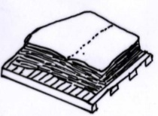
Fig2.13. Dried hide on a pallet
2.5. Undertaking work task
Work task is undertaken in a safe and environmentally appropriate manner according to enterprise guidelines.
Work tasks in hide and skin operation may include, but not limited to:
- Preparing materials, tools and equipment,
- Handling and preserving of hide and skin activities,
- Proper avoiding of waste disposals
These and other work tasks should be undertaking based on enterprise guidelines, supervisor instructions and scientific standards.

Self-Check 2. | Written Test

Directions: Answer all the questions listed below.
Name…………………………………………… ID………………………… Date…….
Test I. Answer the short answer questions listed below.
- What is the advantage of preservation? (2pts)
- Mention methods of preservation of hide and skin? (2pts)
- Which preservation method is the worst drying technique? (2pts)
- Discus the advantage and disadvantage of wet salting? (3pts)
- What is lacing? (2pts)
- How to undertaking work tasks? (2pts)
Test II: Choose the best answer (4 point)
1. The basic idea of curing or preservation is:(2pts.)
A.to dry hide &skin B. to bring market for Hide & skin
C. to keep the hides and skins in good condition without putrefaction D.none
2.Which one is not the cause of hide and skin spoilage? (2pts)
A. physio -chemical decomposition B. Viruses C. Fungi D. None

Note: Satisfactory rating - 10 points Unsatisfactory - below 10 points
You can ask you teacher for the copy of the correct answers.
Note: Satisfactory rating – 3 points Unsatisfactory - below 3 points
You can ask you teacher for the copy of the correct answers.

Operation sheet 2.

2.1.Techniques of Preserving hide and skins
2.1.1.techniques of Frame drying of Hide /skin
A..Equipments, tools and materials
- PPE
- Rectangular frame (1.20 X1.20m for skin and 2.75 X 2.75m for hide)
- Rope
- Nails
- Sharp knife
- Water
- Detergents
B. Procedures
- Wear PPE
- collect Hide/skin
- Flesh and trim by laying down on flat table
- Wash by water (keep the outer part of skin not to contact with water
- Dry the washed skin for 1 hour
- Tie the skin on the frame with nails or rope as available starting from the neck part of the skin.
- After dying detach the frame and put the skin on flat table without turning it
N.B. In frame drying on the edge of hide make a hole by using sharp knife at 2 cm from the edge to inside of skin with 20 cm distance between holes.
Precaution: Use sharp knife appropriately.

2.1.2. Techniques of Salt drying
Purpose: - to remove the moisture from hide or skin and to prevent putrefaction of hide and skin
Salt drying technique is applied in high humid area

A. Equipments, tools and materials
- PPE
- Water
- Salt
- Sharp knife
- Table
- Sensitive balance
B. Procedures for salt drying
- Wear PPE
- Hide or skin is collected
- Fleshing and trimming
- Washing by water
- Put hide or skin on flat floor or table flesh side up
- Apply the grain salt on the flesh side with grain size 0.4-1 mm of salt for skin 1.3-3.2 mm for hide and 33-50% of weight of hide and skin. And also 4% moisture content of the salt.
- Fold the salted hide or skin
- Keep in safe place
Precaution: 1. like over all, rubber boots, rubber glove, moth cover and cape and also use sharp knife appropriately

LAP Test 2. | Practical Demonstration
Name: ____________________________ID.______________ Date: ________________
Time started: ________________________ Time finished: ________________
Instructions: Given necessary templates, tools and materials you are required to perform the following tasks within -2-- hour.
Task 1.prepare material, tools and equipments used for hide and skin handling preservation operations
Task2. Preserve hide and skin using Air drying method
Task 3. Preserve hide and skin using salt drying method

LG #17 | LO #3- Undertake sorting and grading of hide and skin

Instruction sheet 3
This learning guide is developed to provide you the necessary information regarding the following content coverage and topics:
- Carrying out sorting and grading
- Identifying any OHS hazards and taking appropriate action
- Using PPE
- Observing sanitary procedures
- Selecting materials, equipment and machinery
This guide will also assist you to attain the learning outcome stated in the cover page. Specifically, upon completion of this Learning Guide, you will be able to:
- Carry out sorting and grading
- Identify any OHS hazards and take appropriate action
- Use PPE
- Observe sanitary procedures
- Select materials, equipment and machinery
Learning Instructions:
- Read the specific objectives of this Learning Guide.
- Follow the instructions described below 3 to 6.
- Read the information written in the information
- Accomplish the “Self-check ,
- If you earned a satisfactory evaluation from the “Self-check” proceed to “Operation Sheet
and Lap test
- Then proceed to the next learning guide.

Information Sheet 3

3.1.Carrying out sorting and grading
Definition of terms
Quality; is the characteristics of a product or service to what degree it satisfies the need of the customer compared to certain set specification and the price paid to it.
Grade; the measure or degree of quality
Classification; Grouping products and services into classify or group of similar qualities based on purpose (origin material they made), size (area). Weight, main colour
Sorting; Classification of raw hides and skins covers two broad activities, namely sorting and selection. Both of them have the aim of determining the suitability of each piece for manufacture of specific types of leather with differing qualities and characteristics.
Sorting entails the following activities:
- To separate raw hides and skins of different animal species e.g. cattle hides, goatskins, and sheepskins.
- To separate hides and skins according to the type of curing carried out e.g. air dried, dry or wet salted.
- To separate them according to breed e.g. hair-sheep skins, and wool-sheep skins.
- Selection involves the classification of raw hides and skins into different categories of weight ranges and quality grades. The hides or skins can be grouped into various international weight ranges.
Grading is part of selection and is the process by which the quality of the hides and skins is assessed and ranked in an acceptable trade rank scale. The current scale for raw hides and skins consists of five ranks rising from the best to the poorest
I.e. grades 1, 2, 3, 4 and 5. Grade 1 is the best while the fifth grade is commonly referred to as reject.
3.1.1. Benefit of grading / selection
- To decide the price of the product
- To enhance the quality improvement (increase governmental revenue)
- To plan the quality of the product which will be produced in the future
The grading systems as practiced in Ethiopia as per Ethiopian standard are as follows
Grading by appearance; the methods are ,the defect that a hide or skin has shall be examined
Each defect shall then be assessed according to its location and importance Such an assessment shall be made on the basis of the number of defects. However these defects their cause, and effect need to be understood for controlling, sorting and grading purposes.
Hide or skin ( external integument of animals) are liable to different damages either during life time, during slaughtering, during preservation, during storage and transportation period.
3.1.2.Defects of hide and skin
- During life time include:
1. Shortage of feed that results poor substance of hide and skin
2. Poor handling of the animal: during ploughing by slapping, exposing to sharp tools like wire, poor branding practiced for Identification of the animal, beating the animal by strong material and falling it on stone etc resulting bruising.
3. Internal parasite and diseases: which results Scars or defective hide and skin.
N.B. skin or hide from dead animal (stale hide/skin) is not acceptable.
- Defects during slaughtering time include: like
- Siding or corduroying, preside
- Poor pattern
- Weak spot, gouge
- Badly shaped head
- Blood ,dung or traces of urine on hide or skin
- Defects during preservation (due to poor method of preservation) include:
1.putrefaction,stale hide ,heating or grain damage
2.. salt pitting Salt spots, red or purple spots,
- Defects during storage and transportation: could be resulted due to store allowing rain(leaking roof) and moisture, insect damage (gash or channels caused by beetles), pests, rodents . During transportation the truck could be exposed to rain, sun light and rubbing of grain while moving in rough surface road.

Table 3.1. Assessment of defects of large cattle hides
Defects | Defect-units allocated on
Defects | Bellies | Shoulder | Butt
- Hand hole, hole or hole caused by beetles, each  - Weak spot, gouge, or gash or channels caused by beetles, each  - Badly shaped head  - Poor pattern  - Siding or corduroying, preside  - Warble hole, each  - Healed warble hole ,per scar  - Heating or grain damage, per average area of 10 x 30 cm  - Dung or traces of urine, per average area of 15 x 30 cm  - Scars, per average length of 15cm  - Salt spots, red or purple spots, per average area of 30 x 30 cm | 1  1  -  2  1  -  -  1  1  1  1 | 1  1  1  2  -  -  -  1.5  -  1  1.5 | 1  1  -  -  -  1  0.5  2  2  2  2
Total | 9 | 9 | 12.5

Table 3.2 Assessment of defects of sheep and goat skin
Defects | Defect-units allocated
- Hand hole, hole or hole caused by beetles, each  - Weak spot, gouge, or gash or channels caused by beetles, each  - Poor pattern  - Siding or corduroying, preside  - Edge, soiled with urine or dung  - Heating or grain damage, per average area of 10 x 30 cm  - Salt spots, red or purple spots, per average area of 30 x 30 cm | 2  1  2  1  2  2
Total | 12

Table 3.3 Grading of raw hides and skins in relation to defects
Origin of hides and skin | Grading by appearance | Characteristics
Cattle | 1 | No defects visible in the butt; defects in the shoulder or belly assessed at not more than 5 defects-units in total
Cattle | 2 | Defects in the butt, shoulder and belly, assessed at not more than 12 defects - units in total of which not more than 8 in the butt
Cattle | 3 | Defects assessed between 12 and 24 defect unit at the most
Cattle | 4 | Defects assessed at more than 24 defect units, the unusable area of the hide being at the most equal to 50 % of the total area
Cattle | Rejects | Hides of which more than 50 % of the surface is unusable
Sheep and goat | 1 | No visible defects which are likely to depreciate the skin, appearing beyond 5 cm from the edges
Sheep and goat | 2 | Defects assessed to a total of 1-3 defect units
Sheep and goat | 3 | Defects assessed to a total of 4-8 defect units
Sheep and goat | 4 | Defects assessed to a total of more than 8 defect units the unusable area being at the most equal to 50% of the total area
Sheep and goat | Rejects | Skins of which more than 59% of the area in unusable

3. 2. Identifying any OHS hazards and taking appropriate action
- Hazard is the term that refers to dangerous conditions that can results risks in the working place. This can be physical, mechanical, chemical, and Biological factors which affect or harm the health and safety of all people and animals in the working place.
There are OHS hazards in hide and skin preservation if the worker do not follow the correct procedures safely. But these mistakes may be corrected if a worker use PPE correctly and follow work procedure. Some of the OHS hazards encountered in hide and skin preservation process include:-
- Physical hazards
- Exposure to high noise levels from mechanical equipment
- Callosities on hands caused by continuous strenuous work with hand tools
- Eye strain due to poor illumination in the tannery
- Chemical hazards
- Skin rashes and dermatomes as a result of exposure to cleaners, solvents, disinfectants, Pesticides, leather-processing chemicals, etc.
- Allergies - contact and systemic - caused by many of the chemicals used in tanneries
- Biological hazards
- Raw hides and skins may be contaminated with a variety of bacteria, molds, yeasts, etc., and various diseases (e.g., anthrax, leptospirosis, tetanus, Q-fever, brucellosis, etc.)
- Ergonomic hazard
- Acute musculoskeletal injuries caused by physical overexertion and awkward posture while moving heavy or bulky loads, in particular bundles of hides, skins and leather,
- Low back pain due to prolonged working in a standing or semi-bending posture and Heat stress, in particular when working on warm days in premises lacking good ventilation or air Conditioning.
Preventive measures of hazard
- Wear safety shoes with non-slip soles
- Erect fences and post warning signs round open pits in the tannery Call a qualified electrician to examine and repair faulty or suspect electric equipment
- Wear protective goggles and respiratory protection during buffing work
- Do not ever enter a confined space when you are alone. To enter such a space, don respiratory protection equipment with autonomous air supply, and HAVE a co-worker stand-by to call a rescue team in case of weakness, asphyxiation or poisoning
- Seek medical attention if skin rashes develop; consult an allergy specialist on
- Keep a high level of personal hygiene; change clothes at the beginning and end of shift; do not take work-soiled clothes home
- Learn correct lifting techniques and work postures, to avoid low back pain Use mechanical aids for the lifting and transport of heavy loads how to deal with sensitivity to solvents and adhesives
- Install effective exhaust ventilation to remove hazardous gases and vapors, and eliminate obnoxious odors from the tannery.

3.3. Using PPE
The proper use of personal protective equipment can prevent or reduce the extent of injury to employees who are exposed to various hazards The use of this equipment will reduce the incidence and event of injury to the eyes, feet, head, hands, and respiratory tract and prevent hearing loss. This policy establishes the minimum requirements for the use of this equipment.
Personal protective equipment (PPE) includes:
- Overalls
- Eye protection
- Footwear
- Gloves
- Hearing protection
- Respiratory protective equipment (RPE)
- Safety helmets
- Wet weather clothing
When selecting PPE, remember:
- You need to consider and introduce other means of protection first. Provide PPE only as a last resort after taking all other reasonably practicable measures;
- engineering controls provide long-term solutions and are often cheaper than providing, replacing, maintaining and storing PPE;
- controls at source protect all workers in the area, while PPE only protects the wearer;
- It is essential to involve your workers in the selection process, as they often have detailed knowledge of the way things work or the way they do tasks, which can help you.
NB. To use the equipment effectively, workers need suitable information, instruction and training. Make sure all equipment is checked before use and cleaned, maintained and stored in accordance with the
3.4. Observing sanitary procedures
3.4.1.Environmental Sanitation
Sanitation is the act or process of providing adequately, hygienic conditions to ensure a safe, sound, wholesome product fit for human consumption and covers hygienic precautions regarding personal hygiene, process hygiene and cleaning and disinfection. Sanitation may also signify disinfection.
Slaughterhouse cleaners are expected to disinfect and sanitize the building in which animals are killed for consumption. Given the nature of the bodily fluids being spilled inside such buildings, the cleaners must adhere to strict guidelines that clean not only dirt and grime, but kill and dispose of germs, fungal agents and mould. The job keeps the new cuts microbe-free and keeps meat consumers from falling ill. The sanitation process ensures the conditions within the house result in a product people can eat. Environmental sanitation in a slaughterhouse comprises process hygiene, cleaning, disinfection and location.
3.4.2.Process Hygiene
One of the primary functions of a slaughterhouse cleaner is to sterilize the equipment in between uses. This includes hooks, countertops, knives and cutting tools, grinders and other meat processing equipment. To effectively clean these apparatus, the worker must dismantle the machinery and disinfect each piece individually, using cleaning agents such as bleach and vinegar (making sure to thoroughly rinse and dry), high heat, and abrasive sponges and brushes. Slaughterhouse cleaners might also be responsible for the disposal of hazardous fluids coming from the carcasses. They must trap grease and fat, separate the blood and screen the solid wastes. Cleaners will also be expected to take care of pest control, meaning rodents, bugs and birds.
- Cleaning
Slaughterhouse cleaners must remove all trace of fats and proteins from equipment and holding stations in between shipments. They clean these leftovers using high water pressure, heat and intense detergents. They must know which types of cleaning agents to use on each mess. These include sodium-based detergents, which lower the surface tensions, wiping the grime away; ionic surface agents, which break down the chemical makeup of the waste; sequestering agents, which bind calcium, preventing hard water build-up; and acids, which break down stubborn waste materials. Slaughterhouse cleaners often use large machinery to clean wide surface areas, which increases pressure and the strength of cleaning agents. For smaller equipment that must be cleaned by hand, they must use gentler agents to keep themselves safe.

- Disinfection
Cleaning goes further than removing the visible fat, protein and dirt off the machinery. Slaughterhouse cleaners must completely disinfect all areas where meat will be processed, creating a sterilized environment in between shipments. The first step to this in-depth cleaning is usually a high-heat steam treatment. Most microbes cannot survive in high temperatures. This method can be followed up with any of several different compound cleaners, including chlorine treatments, ammonium agents or a mix of hydrogen peroxide and acetic acid.
- Location
The slaughterhouses should be located outside or on the periphery of a city or town and shall be away from an airport. Care should, however, be taken to see that these are easily accessible to the patrons and do not adversely affect the transport of meat to the market place. Main services such as portable water, electricity and proper hygienic waste disposal facilities are a prerequisite and should be taken care of.
- Recommended Procedure for Sanitation
The appropriate procedure for sanitation in the slaughterhouse should ensure that:
- The outer part of the skin or hide does not contact the carcass side.
- There is no puncturing of the viscera organs during dressing and evisceration
- Evisceration is done within the shortest time possible
- The rough offal’s are emptied into their designated receptacles such as a wheelbarrow
- The inedible dirty parts of the animal like hooves, skin, hide and un skinned heads are immediately removed from the dressing areas into sorting rooms
- The flaying knife is sterilized every time it pierces the skin, hides, and cuts an abscess or a lymph node.
- There is a hand washing basin with hot water for use in the bleeding, skinning and evisceration areas
- Have only leg operated hand washing taps
- The facilities and equipment are cleaned before, during and after operations
- The exterior doors open outwards
- Personnel hygiene and safety
Cleaning a slaughterhouse means the workers must also keep themselves germ-free. They should wash their hands before their shifts begin, after each specific disinfecting job, after eating or smoking, and after using the bathroom. Any bacteria on the hands of the workers will be transferred to the food being processed. The workers' uniforms must be clean, and they should change into the outfits onsite, just before beginning their shifts, to keep the contaminants normally found on clothing away from the meat. Uniforms should be washed after each shift. Workers should not wear jewellery, as microorganisms can live in the crevices of the metal. Hair coverings and gloves are a must when cleaning the house and any worker who is ill should call out for the day.
- As shown in slaughterhouse workers must observe the following guidelines while working in the slaughterhouse:
- Wear clean, approved and adequate protective clothing.
- Should not store items in their pockets
- Should not change in operation areas
- Should not keep personal clothes in the operation areas
- Wear hair restraints (hair net, hat, cap or head band, beard restraints, and clothing that cover body hair) to prevent hair from falling on meat
- Change their apron whenever it becomes dirty.
- Be encouraged to cover their mouths when coughing and their nose when sneezing.
- Routinely be checked for medical fitness (every six months).
- Tell the supervisor if they are sick.
- Should tell a supervisor if they are diagnosed with any food borne illness.
- Should not wear false fingernails (artificial nails) or fingernail polish.
- Must not sneeze or cough near meat. If an employee experiences persistent sneezing or coughing, they must not work in meat areas.
- Avoid wearing jewellery while working in the operation/facility. Employees must not wear jewellery on their arms or hands, except wedding bands.
- Should not eat food, drink, chew, or smoke while in the work area.
- Use a disposable towel to wipe sweat
- Wash their hands every time they visit toilets, blow nose, exit from work areas or touch uncovered parts of their bodies
- Keep their bodies clean by washing before work and keeping nails cut.

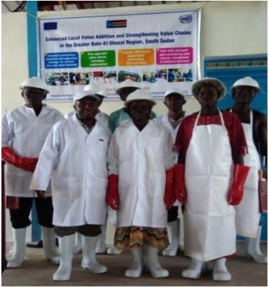
Fig.3.14. Best personal hygiene practices for workers (above);
On the other hand, the slaughterhouse workers must not do the following while in the slaughterhouse:
- Unguarded coughing and sneezing
- Spitting on hands to enable firm grip of an axe
- Licking of fingers to pick up items e.g. papers
- Blowing paper bags to open them
- Blowing or wiping of nose using bare hands
- Brushing of teeth in the slaughterhouse
- Placing meat, knives, sharpening steel in the gumboots

3.5. Selecting materials, equipment and machinery
Tools and equipment’s which are very important for preservation and handling of hides and skins:
Salt, clean water , detergents , rope , Protective clothes, rope materials to construct frames and ware house, Cleaning brush, rubber hose, chemical, plomp, Covering materials, Jar , barrel, air drying frame, Knives , animals, slaughter slab, store house ,Hoist, fixed and movable frames, dirt pit , dirt bin ,Pit to burn left over and offal , rake, axe, trimming and washing table,
- Washing and drainage table helps for washing and draining of water from hides and skins before preservation can takes place
- Air drying frame helps for lacing of raw materials for preservation under the shed and in the ware house.
- Flaying knives which has blunt and rounded tip helps for separating or removing hides and skin from the carcass.
- Ripping knives have a straight cutting edge, curved and sharp pointed knife for inserting line to cut edge foreword and upward with the blunt back edge .
- Mechanical flaying machine is the machine driven by compressed air on an oscillating scissors at round to separate the connective tissue from the carcass without making any cutting on the stock.
Sharpening Stone is the most basic type of knife sharpener, this is not to say that they do not offer great benefits, but only that they do not have a lot of features

Self-Check .3 | Written Test
Directions: Answer all the questions listed below.
Test I. Write the short answer for the following questions
- What are the benefits of grading? (3pts)
- Discus about types of hazards in work place? (2pts)
- Mention some PPE used in hides and skin work? (3pts)
- What is sanitation? (2pts)
- What are thing that workers must not do in the slaughterhouse? (2pts)
- What is the advantage of Air drying frame? (2pts)
- Mention some materials tools and equipment used in handling and preservation of hide and skin? (3pts)
Test 2.Choose the best answer (3pts.)
1. The measure or degree of quality is Known us. A. Qualify B. Grade C. Sort D. all
2. The term that refers to dangerous conditions that can results risks in the working place
is Known as
A. Risk B. hazard C. Grading D.OHS
3. The process of removing unwanted substances, such as dirt, infectious agents, and other impurities, from an object or environment is Known as
A.cleaning B.disinfection C.Location D.none
Note: Satisfactory rating - 10 points Unsatisfactory - below 10 points
You can ask you teacher for the copy of the correct answers.

Operation sheet 3.

3.1.Techniques of Performing sanitary operation
A. Materials Required
- PPE
- Broom
- detergent
- water
B. Procedures for Sanitary operation
- Wear appropriate PPE
- Identify preservation method
- Arrange materials ,tools and equipment
- Adjust good drainage for effluent waste
- Clean working area and disinfect
- Clean all materials and tools after work finished
- Clean hands and PPE

LAP Test 3. | Practical Demonstration
Name: _____________________________ID.______________ Date: ________________
Time started: ________________________ Time finished: ________________
Instructions: Given necessary templates, tools and materials you are required to perform the following tasks within -2-- hour.
Task 1.Perform sanitary operation

LG #18 | LO #4: Clean up on completion of work

Instruction sheet 4
This learning guide is developed to provide you the necessary information regarding the following content coverage and topics –
  - Storing preserved hide or skin
  - Returning and disposing materials
  - Cleaning, maintaining and storing tools and equipment
  - Disposing all waste products
  - Reporting work outcomes
This guide will also assist you to attain the learning outcome stated in the cover page. Specifically, upon completion of this Learning Guide, you will be able to –
- Store preserved hide or skin
- Return and dispose materials
- Clean, maintain and store tools and equipment
- Dispose all waste products
- Report work outcomes
Learning Instructions:
- Read the specific objectives of this Learning Guide.
- Follow the instructions described below.
- Read the information written in the information Sheets
- Accomplish the Self-checks
- Perform Operation Sheets
- Do the “LAP test”

Information Sheet 4

4.1.Storing preserved hide or skin
Hides and skins may be damaged in several ways. Blemishes often arise during the life of the animal as the result of skin disease including viral, bacterial, helminthes, arthropod, protozoa and fungal conditions, abrasions, prolonged contact with dung or brand marks. However the diagnosis and control of skin diseases appear to have received comparatively limited attention.
Factors such as methods of flaying and storage of the hides or skins can also have a profound effect upon the quality of the final product.
Hide and skin after preservation must be stored in clean and safe environment .since there are rodents, lice’s and other parasite which live on dependant on hide or skin. The storing house should be:
- Dry place
- Adequate ventilation
- Well build wall and floor
- Well facilities to put hide and skin according to their size and time of preservation.
During storing of hide and skin you should
- Put hide and skin in the separated place
- Put hide and skins up side of flesh side
- Adjust storing place some up lift
- Put each hide and skin in different time of preservation in different place
- For wet salting hide and skin store at not more than 1m length of height since some larger salt grain may cause damage to the grain of the hide and skin
- For frame dried skin and hide check not to turn each hide and skin and store 1.50m height.
For a capacity of about 200 sheep and goat skins a year, the shed should measure 10 × 14 m, have a cement floor and a corrugated iron roof. The sides should be open and protected by strands of barbed wire with the exception of a line of corrugated iron sheets at the top and further corrugated iron sheet protecting the area where skins are stored. There should be 48 wooden frames (3 × 3 m divided for 4 skins each) giving 192 skin capacity fixed at a height of 0.5 m from the floor, and a distance of 30 cm between frames. The frames, tables and wooden horses will be arranged in an area set for washing of skins where there is also a proper drainage facility.
A cement wall, 2 m high, should separate the wet area from drying area. The storage area will be protected by corrugated iron but windows should be provided to ensure circulation of air.

4.1.2.Defects occurring during storage and transport:
To produce high quality hides and skin, storage conditions are as important as proper preparation and preservation. In Ethiopia, a good percentage of hides and skins are damaged during storage and transportation, especially during the rainy season. Problems that occur in rural drying sheds are the major source of damage and loss of skins. Rural drying sheds are highly infested with skin damaging insects, have leaky roofs, and do not use slatted platforms. Skins become damaged and many are totally rejected. While the main portion of insect damage happens in rural drying sheds, insect damage also occurs in tanneries and warehouses of large traders.
4.1.3.Take precautions to avoid damages during storage:
- Eliminate existing insects in all skin storage and drying sheds. Storage places and drying sheds should be washed or painted, whichever is possible.
- Repair all leaking roofs of storage and drying sheds.
- Provide protection for cured skins from rain and sun.
- Use slatted platforms or improvise using wooden poles for storing skins.
- Spray or dust dried skins with insecticide having an effective insecticide content of 0.5% BHC.
- Aerate and turn skins frequently to provide adequate ventilation.
- If there is a delay in shipping dried skins, they should be inspected and redusted with insecticide if necessary.
Storage sheds in rural areas may be improved with available materials. It may be possible to utilize available storage facilities of other government agencies or parastatals.

4.1.4.Transporting hides and skins
- Transporting procedure should be as rapid and direct as possible
- Transporting without delay may minimize cost of maintaining large stocks of raw materials
- Before transporting they should be properly packed and tied in bundles
- Care should be taken that bundles are
- No loose
- Pack securely: - to avoid damage caused by rubbing with rough, sharp or other
4.1.5.Frictional movements to grain layer
- Damage to grain layer allocated if hides and skins are baled (made in to large bundles) and wrapped with socking and other
- Damage of grain folded edges corners on long journey protected by
  - Proper tying and packing bundles
  - Suitable and effective wrapping of bales
  - Containers bundles or bales
  - Car and truck
- Should be cleaned and free of coarse objects and materials (sharp and rough objects like nail, bolt and other)
- Avoid any projection on the vehicles
- Avoid metallic salts and rusts
- Avoid oil, butter, wax and similar animal and plant products
- Avoid greases, fuel and lubricants materials etc
- Hide and skins should be protect against sun and rain damage
4.2. Returning and disposing materials
Hide and skin preservation may take various stage of process and conditions, in this stages or conditions also various materials are involved these include:-knife, frame, brush salt, PPE, rope, detergent. Among these some of will be used again after one use and store for further purpose and some of may be disposed after use due to various reasons such as:
- Cleanliness of recycling
- Improper use
- Use and throw products
- Date of expiry
- Some chemical action
- Waste solution
Mostly disposed materials include chemicals and detergents
4.2.1. Recycling waste materials
Recycling is a series of activities that includes collecting, storing and transporting of recyclable materials (i.e. fleshing, trimming, salt residues, overflow water, blood during flaying and washing, chemical drains(west detergents), etc. ) as row material for other factories to produce new products.
- The importance of recycling
- There is less pressure on our natural resources when we recycle items, e.g. conserve clean water.
- Company saves costs as the collection companies pays for the waste collected
- Recycling creates new industries and thus creates jobs
- It reduces pollution and saves space
- It saves energy and raw materials
- Disposing of waste products of hide and skin
Hide and skin preservation produces waste after it preserve in air or salt. These waste products pollute the environment and causes chemicals and biological hazards to the worker, society and to the animals. So the worker needs to be disposing the waste properly. Some of the wastes are
- Overflow water
- Fleshing
- Trimmings
- Blood during flaying and washing
- Chemical drains/waste detergent/
- Salt residue

4.3. Cleaning, maintaining and storing tools and equipment
Cleaning is the process of removing unwanted substances, such as dirt, infectious agents, and other impurities, from an object or environment. Cleaning occurs in many different contexts, and uses many different methods. Several occupations are devoted to cleaning.
Cleaning and safeguarding work site is the process of protecting the working environment from different hazardous thing which can cause risk on the society or workers and environment. To keep our work site in safe manner you should follow:
- Providing training to the worker and society
- Regular house keeping
- Periodic inspection of different hazards
- Maintenance of equipments
Generally Cleaning and safeguarding work site increase the product quality and quantity and increase occupational health and safety.
After completion of work, the worker should be:
- Properly clean materials, tools and equipment with detergents
- Maintain materials, tools and equipment
- Store the equipments on their original places.
Maintenance involves functional checks, servicing, repairing or replacing of necessary devices, equipment, machinery, building infrastructure, and supporting utilities in industrial, business, governmental, and residential installations. Over time, this has come to include multiple wordings that describe various cost-effective practices to keep equipment operational; these activities take place either before or after a failure.
So, after completion of work conducting maintenance of equipment is necessary. Then the materials or equipments should be store on their original place.
4.4. Disposing all waste products
4.4.1.Disposal of Slaughterhouse Waste
- Rendering
Rendering is a heating process for meat industries waste products through which fats are separated from water and protein residues for the production of edible lards and dried protein residues. Commonly it includes the production of a range of products of meat meal, meat-cum-bone meal, bone meal and fat from animal tissues. It does not include processes where no fat is recovered.
There are basically two different rendering processes:
- High temperature rendering which involves cooking or steam application. Five methods of high temperature rendering include simple cooking; open pan rendering; kettle rendering; wet rendering; and dry rendering.
- Low temperature rendering (at around 80°C). This process requires finely ground material and temperatures slightly above the fat melting point. It results in better-quality lard. The rendering at low temperatures is a highly-sophisticated process requiring large throughputs and trained personnel. For many developing countries, the system is not suitable.
- Handling of viscera, paunch and intestines
Viscera can be recovered as edible products (e.g. heart, liver). They can also be separated for inedible rendering or processing (e.g. lungs).
The paunch can be handled in four ways:
- Total dumping. All of the paunch contents are flushed away into the sewer.
- Wet dumping. The paunch contents are washed out and the wet slurry is screened on the presence of gross solids, which are subsequently removed.
- Dry dumping. The paunch contents are dumped for subsequent rendering or for disposal as solid waste without needless water flushing.
- Whole paunch handling. The entire paunch may be removed, intact, for rendering or for disposal as solid waste.
Intestines may be rendered directly, or hashed and washed prior to rendering. For the processing of intestines de-sliming prior to thorough washing is necessary. Other wastes crated during work should also properly disposed in:
- Well prepare disposal area
- Waste pin
- Waste pit that are designed of waste disposal.
4.4.2.Waste management
- Solid waste
- Solid wastes could be temporarily stored in holding sheds (manure shades and temporary dumping sites for hides and skins trimmings and fleshing) before transfer to disposal sites
- Solid wastes generated must be removed daily in proper designed carts, wheelbarrows or collection vehicles.
- Spillage during transport should be avoided.
- The chosen waste collection method should transport the waste to disposal at minimal costs.
- Liquid Waste/ Effluent
The liquid waste should be washed away by safe potable and constant supply of fresh water at adequate pressure throughout the premises of slaughtering. The wastewater from slaughterhouse is heavy in pollution and, therefore, it should not be allowed to mix with the municipal drainage system without pre-treatment.as shown in Figure 1. Figure 2 shows well designed slaughter house (smooth and slanting floor) to allow ease of drainage of slaughterhouse effluents. It is important to ensure the following:
      - All liquid wastes must be screened before discharge to remove solid waste materials.
      - The waste must be treated before discharge into the environment.
      - The waste treatment system must be cost effective and efficient.
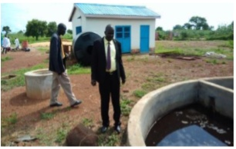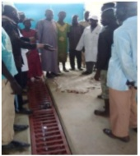
Fig.2..15. Poor separation of liquid and solid Fig.2.16. Slaughtering facility with a
wastes from slaughterhouse slanting floor and slot drainage

4.5. Reporting work outcomes
An important point in every work including livestock work is recording data, analyzing and reporting, all the steps from the initial to the final product of the work. Reporting is informing the work and problems for the concerned body. It is the way of communication to the supervisor, co-workers or customer in the work place.
4.5.1.The report includes information regarding to the following:

- Raw materials
- Problem encountered
- Length of work
- Hazards and safety
- Techniques and system of work
- Cost expended
- Material availability
- Sustainability of work
- Labor required
- Facilities in work

4.5.2. Report work outcome
- Prepare recording file
- Record all the data and steps in work of hide and skin
- Arrange the data
- Select the relevant data to the work
- Interpret according to your work
- Compile the data properly
- Report the total outcomes of the work to the concerned body.

Self-Check 4. | Written Test

Directions: Answer all the questions listed below.
Name_____________________ I.D Date
Test I. Answer short answer for the following questions
- How damage of hide and skin occur during storage? (3pts)
- What is recycling? (3pts)
- Mention wastes crated during working of hide and skin preservation? (3pts)
- When cleaning of materials tools and equipment carried out? (3pts)
- What is maintenance? (3pts)
- Discuss how you manage solid waste? (3pts)
- What is the advantage of reporting on work outcomes? (3pts)
Test II: Choose the best answer (3 point)
1.Which of the following is not the requirement of ware house?
A. Dry place B. Adequate ventilation
C. Well build wall , floor and Well facilities D.none
2. A heating process for meat industries waste products through which fats are separated from
water and protein residues for the production of edible lards and dried protein residues is.
A. Recycling B. maintenance C. Rendering D. none
Note: Satisfactory rating 12 points Unsatisfactory - below 12 points
You can ask you teacher for the copy of the correct answers.

Operation sheet 4.
1. Techniques of Storing preserved hide and skin
- Material required

- PPE
- Rope
- Palate
- Shelf

- Procedure for storing preserved hide and skin
- Wear PPE
- Identify select storage place with well sited
- Clean the storage place and disinfect
- Isolate hide and skin separately
- Put each hide and skin at the same sorting
- Check adequate ventilation
2. Disposing of waste products
- Materials Required
- PPE
- Basket
- Waste Pit
- Procedure for disposal of waste products
- Wear PPE
- Identify preservation method
- Prepare work site
- Drainage system of house
- Arrange Garbage (for fleshing, trimmings)
- Undertake preservation in assigned place
- Collect wastes excreted from preservation properly
- Burry most chemicals (detergent waste…)
- Burn solid waste
- During draining water flow check the drainage system not to the residence and to the animal farm

LAP Test 4 | Practical Demonstration
Name: _____________________________ Date: ________________
Time started: ________________________ Time finished: ________________
Instructions: Given necessary templates, tools and materials you are required to perform the following tasks within -4- hour.
Task1. Sort and Store preserved hide or skin
Task2. Return and dispose materials
Task3. Clean, maintain and store tools and equipment
Task4. Dispose all waste products
Task5. Report work outcomes

List of Reference Materials

- https://www.leatherdictionary.com/index.php/Preservation_bydrying,_salting_or freezing (Access date 26/08/22)
- Sheep and Goat Production Handbook for Ethiopia, Ethiopia Sheep and Goat Productivity Improvement Program (ESGPIP) 2008
- Training manual on improved production and preservation techniques of hides and skins. United Nations industrial development organization, 2017.
- https://www.google.com/search?client=opera&q=Handle+and+Preserve+Hide+and+Skin+module (Access date 27/08/22)

AKNOWLEDGEMENT
Ministry of Labor and Skills and Ministry of Health wish to extend thanks and appreciation to the many representatives of TVET instructors and respective industry experts who donated their time and expertise to the development of this Teaching, Training and Learning Materials (TTLM).

The experts who developed the learning guide

No | Name | Qualification | Educational background | Region | Phone number | E-mail
1 | Abenet Getahun | MSc. | Animal Production | Gewane ATVET  College | 0940236673 | abenetgetahun@gmail.com
2 | Biru Kefenie | MSc. | Animal Production | W/Soddo  ATVET  College | 0913334612 | ukefene@gmail.com
3 | Gashaw Assefie | MSc. | Animal Production | Agarfa ATVET  College | 0914068274 | lakomelzajournalist@gmail.com
4 | Genanew Abera | MSc. | Animal genetics and breeding | Alage ATVET  College | 0926672970 | genanewabera@gmail.com
5 | Sead Taha | MSc. | Animal Production | Agarfa ATVET  College | 0916112492 | tahasead@gmail.com
6 | Solomon Fertewal | MSc. | Animal Production | Alage ATVET  College | 0952648413 | Tosolomon@gmail.com
7 | Temesgen Roro | MSc. | Animal Production | Holeta PTC | 0917657496 | temesgenroro@gmail.com
8 | Terefe Tolcha | MSc. | Animal Production | Alage ATVET  College | 0911067132 | terefetc@gmail.com
9 | Yirmedie Bayou | MSc. | Animal genetics and breeding | Mizan ATVET  College | 0915851079 | Yirmedie123@gmail.com

