Animal Production
Level-II

Based on March 2022, Version-4 Occupational standard
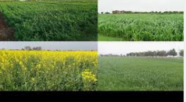
Module Title: - Conducting forage development & preservation
LG Code: AGR ANP2 M01 LO (1-5) LG (1-5)
TTLM Code: AGR ANP2 TTLM 0922v1

September, 2022
Addis Ababa, Ethiopia
Table of contents
Introduction to t module
LO #1- Prepare site for forage development 2
Instruction sheet 2
Information Sheet 1 3
Self-check 1 6
LO #2- Undertake forage development 7
Instruction sheet 7
Information Sheet 2 8
Operation Sheet -2 31
LAP TEST-2 32
LO #3- Monitor forage growth and production 33
Instruction sheet 33
Information Sheet 3 34
Self-Check – 3 45
LO #4- Perform harvesting and Preserve Forage 46
Instruction sheet 46
Information Sheet 4 47
Self-Check – 4 58
Operation Sheet -4 59
LAP TEST-2 68
LO #5- Clean up on completion of work 3
Information Sheet 5 71
Instruction sheet 3
Self-Check-5 8
Reference Materials Error! Bookmark not defined.

Introduction to t module

This module covers the knowledge, skills and attitude required to conduct forage development & preservation to prepare site for forage development, undertake forage development activities, monitor forage growth and production, perform harvesting and preserve forage and clean up on completion in forage development works.

LG #1 | LO #1- Prepare site for forage development

Instruction sheet
This learning guide is developed to provide you the necessary information regarding t following content coverage and topics:
- Preparing forage development materials, tools, equipment and machinery
- Carrying out Site selection and land preparation
- Determining forage development options
- Identifying risk factors in forage development
- Assessing Soil conditions for forage production
This guide will also assist you to attain the learning outcomes stated in t cover page. Specifically, upon completion of this learning guide, you will be able to:
- Prepare forage development materials, tools, equipment and machinery
- Carry out Site selection and land preparation
- Determine forage development options
- Identify risk factors in forage development
- Assess Soil conditions for forage production
Learning Instructions:
- Read the specific objectives of this learning Guide.
- Follow the instructions described below.
- Read the information written in t information Sheets
- Accomplish the Self-checks
- Perform Operation Sheets
- Do the “LAP test”

Information Sheet 1

- Identifying and preparing tools, materials and equipment and machinery
- Machinery
- Tractor:
Tractor is different types of tractors based on tractor power take off (PTO) but tractor function is the same like:
- To plough t land using different equipment like disk plough, mold board, rotary tiller
- To pull an implement for transporting agricultural products from place to place
- To clean an agricultural area
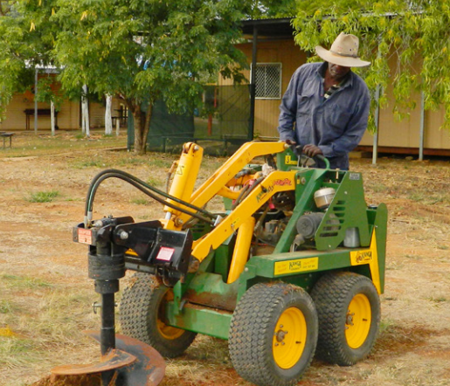
Figure 1.1Tractor

- Combiner
It is an agricultural machine used for harvest crops and it also clean and separate the chaff from the grain so combiner has an important role in agricultural processing.
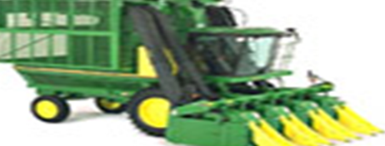
Figure 1.2 Combiner

- Water pumps
Are used in private residences, city water systems, agricultural irrigation, and industrial applications. They range from small pond pumps, to multistage pumps used in wells, to the huge pumps used in municipal and industrial applications.
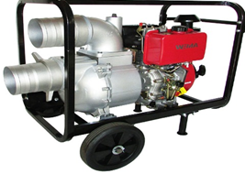
Figure 1.3. Water pump

- Loader is a heavy equipment machine used in construction to move or load materials such as soil, rock, sand, demolition debris, etc. 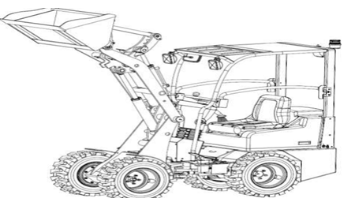
Figure 1.4 loader

- Chopper

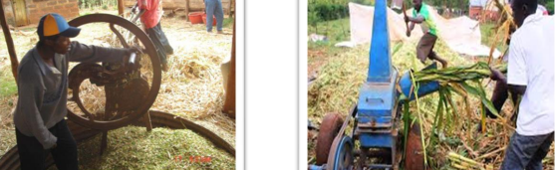
Figure 1.5a.Manual silage chopping 1.5b Automated silage chopping

- Irrigation Equipment
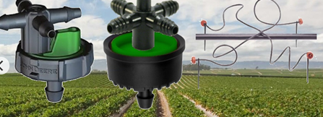
Figure 1.6 irrigation equipment
- Tools & equipment

- Spade
Tre are many jobs in agriculture that require the use of hand tools. A spade, commonly used in gardens, is good for digging because of the flat, sharp shape. A rake, usually with a long handle and a finger-like base, is used in gardening and clean-up. A shovel allows you can scoop and carry because of the size and shape of the base. A hand-held, fertilizing sprayer can be used to fertilize crops in specific areas.

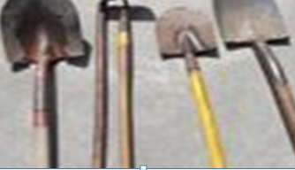
Figure 1.7 Spade

- Rakes: Rakes work a lot like pitchforks in that they can turn over soil so that plants can get more nutrients. The difference is that the prongs on a rake create a right angle next to the handle, where as a pitchfork is only slightly curved.

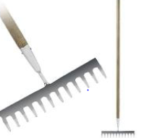

Figure 1.8 Rakes

  - Carrying out Site selection and land preparation

- Site selection
This will depend on the locality upon which the pasture is to be established. However, the site should be good for cultivation of field crops, and it should be plain and not rocky Forage seed production sites must be accessible and as much as possible located in lands suitable for cultivation, irrigation, and fertilizing.

Ecological requirements for a suitable site selection
- A climate and soil suitable to most elite forage species or at least the target species.
- The area must be free of noxious weeds, pest and diseases.
- Adequate space to make isolation possible for multiplying cross-pollinated species.
- Adequate growing season with ample rainfall.
- Access to irrigation to make multiple harvests possible and guarantee against fluctuating rain distribution.
- Free from frost: ensure the site is not located in a frost-pocket in the landscape.
- Sunny weather during flowering to initiate reproductive development, flower opening, pollination and facilitate seed harvesting.

- Characteristics of potential locations of site selection for pasture production

- Annual precipitation
- Soil depth
- Soil texture
- Drainage

- Salt accumulation
- Freedom from rocks
- Slope.
- Freedom from over story vegetation

- Factors influencing site selection
- Climate
- Day length
- Physiological control of flowering
- History of previous land usage

- Land preparation
Land preparation for reseeding or pasture establishment is very critical for the success of sward establishment. Land preparation confers many benefits to pasture establishment, this includes;
- Loosen the soil surface
- Reduces the rate of runoff hence controls soil erosion
- Enables better infiltration of rain water into the soil
- Eases the penetration of roots of the crop into the soil
- Prevents grass seed from being blown away by wind
- Removes all unwanted plants (weeds) so as to give the target crop a head start after planting

    - Land preparation activities:-

- Land clearing
It refers to t activities to remove all unwanted plant materials and other things from the land. It refers to avoiding or cutting all undesirable, trees, bush, grass and any other waste materials from the selected site. This should be done either manually, chemically, mechanically or through burning. However, cost benefit ratio of such methods should be ascertained before making decision

Methods of land clearance
- Mechanical movement of trees and shrubs
- Chemical treatments (2,4,5-T or 2,4-D, mixtures of these, picloram, fenuron, arsenic,
- A combination of mechanical and chemical or mechanical and burning
- Regular burning (if allowed by law).

      - Seed-bed preparation
Seedbed preparation It should be realized that grass seeds are very small in size (most grass seeds are equal to or less than teff seeds), and thus one has to prepare a seedbed favorable for seed germination, seedling emergence, and growth.
Procedures

- Clearing trees
- Ploughing
- Rolling

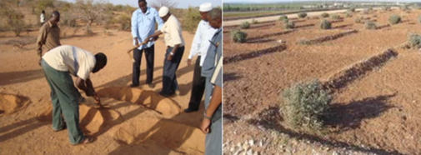
Figure 1.9 seed bed preparation

  - Determining forage development options

- Improving forage productivity
In the mixed crop–livestock (the central highland) and cash crop (the south-western highland) areas, the natural pasture from marginal lands is an important source of livestock feed. Natural pastures provide about 50% of the total annual feed supply depending on availability of alternative feed resources such as crop residues. These marginal-land grazing areas are located mostly on both extremes of topography .these grazing lands can be improved in yield and quality through methods like over-sowing. They can alternatively be made more productive through replacement of the sward with adaptable improved forage species.

- Marginal land used for pasture
- Waterlogged areas
These consist of poorly drained or flooded areas dominated by black clays (Vertisols) or riverbed deposits eroded from various land-forms (alluvial).

- Steep slopes
Sloping land features like gullies, escarpments and peaks are unsuitable for cultivation and are thus generally utilized as communal grazing lands. They serve as the sole source of feed when all cultivable lands are cropped, and waterlogged areas become inaccessible due to flooding during the rainy season.

- Agroforestry
Agroforestry involves a close association of trees or shrubs with crops, animals and/or pasture. Specifically, it is the deliberate combination of trees with crop plantation or pastures, or both, in an effort to optimize the use of accessible resources to satisfy the objectives of the producer in a sustainable way.

- Alley cropping
Alley cropping is an agroforestry practice in which leguminous browse trees or shrubs are planted widely apart so that grain crops are sown in the alleys between rows of trees. The trees are pruned heavily during the cropping season in order to reduce shading, and the pruning is used for fodder, green manure and mulch.

In soil conservation programs, steep slopes are planted with narrow lines of forage intercropped with arable crops. This system is referred to as forage strip or strip cropping. Herbaceous forages such as elephant grass, vetiver grass, Panicum, stylos, desmodium, siratro as grass/legume mixtures or pure stands are established on soil conservation terrace lines for multiple uses, including:
- providing both bulk and quality feed
- preventing soil erosion
- providing fuel wood
- providing shelter and green manure for crops; and
- improving soil fertility

- Integration of forages with food and cash crop
Forage legumes and grasses can be integrated into cropping systems through a number of methods such as:-Intercropping. Intercropping is a method in which two fairly compatible crops, often a leguminous forage species and a cereal crop, are grown together at a given planting pattern during a season.

. The advantages of such an intercropping system are:
- the possibility of nitrogen accretion from the legume to the cereal
- maintenance of continuity of feed supply during the dry season
- more efficient utilization of low-quality cereals through the addition of high-protein forages;
- possibility of returning manure from livestock to the field
- Increasing crop productivity

- Relay or sequential crops
Sequential cropping is practiced when two crops (forage and pulse) are grown during a season, one after the other. The essential feature of this system, known as sequential or double cropping, is that the two crops do not overlap, the second being sown only after the first crop is harvested. This cropping is incorporated between any two cereal crop phases according to the traditional crop rotation.

- Fodder banks and alley farming
This is a system whereby fallow land is sown to leguminous perennial forages or self-seeding annuals for production of high quality dry-season fodder and at the same time rebuilding the nitrogen content of the soil through biological nitrogen fixation. The system is like forage/crop rotation except that the forage phase may last for three or more years until t desired soil fertility level is attained

- Backyard forage crops
Backyard forage/fodder crops include highly productive species grown around a farmer's homestead under intensive management conditions. The objective is to produce high-quality fodder as supplementary feed to highly productive dairy cows and young animals. The system has gained popularity among smallholder farmers since it does not compete with food crops for arable land

  - Identifying risk factors in forage development
Risk factors that consider during forage development may include fire, vermin/pests, flood, over matured of pasture, overgrazing, weed, shattering, leaching, bleaching, molds etc. A mixture of species should be selected for each agro-ecological zone to ensure biodiversity and thus minimize the risks from pests and climatic extremes.

Utilization of developed foraged at optimum time and stage is one of the crucial ways to reduce risks associated with forage development. Also balancing between nutrient content and yield of forage one of the considerations to reduce risk related less nutrient content of forage types. Start from site selection, soil sampling and land preparation requires especial attention to keep balance between quality and yield of pasture as well as animals become better productive.
  - Assessing Soil conditions for forage production
Soil fertility affects forage yield much more than it does quality. While it is possible to produce high quality forage on poor, unproductive soils, it is generally very difficult to produce high yields of high quality forage with an unproductive soil resource. Proper soil phosphorus (P) and potassium (K) levels help to keep desirable legumes in a mixed seeding and also reduce weed problems
Composition of soils
- Soils comprise a mixture of inorganic and organic components: minerals, air, water, and plant and animal material.
- Mineral and organic particles generally compose roughly 50% of a soil's volume.
- The other 50% consists of pores-open areas of various shapes and sizes.

Self-check 1 | Written test

Directions: Answer all t questions listed below.

List requirements in site selection for forage development (2points)

Mention site selection characteristics for forage development (2points)

List methods of land clearing for forage development (2points)
- Mention on farm strategies in forage development strategies (3points)

Note: Satisfactory rating – 15 points unsatisfactory rating –below 8 points
You can ask you teacher for t copy of t correct answers

Name…………………………………………… ID………………………… Date…….

LG #2 | LO #2- Undertake forage development

Instruction sheet
This learning guide is developed to provide you the necessary information regarding the following content coverage and topics:
- Following instructions and directions and clarification sought when necessary.
- Selecting forage species
- Carrying out Site selection and land preparation
- Undertaking forage development activities
- Undertaking Seed treatment techniques
- Recording seasonal growth pattern of forage crop
- Setting Pests, weeds and diseases controlled methods.
This guide will also assist you to attain the learning outcomes stated in the cover page. Specifically, upon completion of this learning guide, you will be able to:
- Follow instructions and directions and clarification sought when necessary.
- Select forage species
- Carry out Site selection and land preparation
- Undertake forage development activities
- Undertake Seed treatment techniques
- Record seasonal growth pattern of forage crop
- Set Pests, weeds and diseases controlled methods.
Learning Instructions:
- Read the specific objectives of this learning Guide.
- Follow the instructions described below.
- Read the information written in the information Sheets
- Accomplish the Self-checks
- Perform Operation Sheets
- Do the “LAP test”

Information Sheet 2

- Following instructions and directions and clarification sought when necessary.

Any employee who works in forage development or any farmer who establish Pasture must follow t following instruction and direction:-
- forage enterprise policies and procedures
- manufacturer instructions
- material safety data sheets (MSDS)
- OHS standards and procedures
- specifications for tools, equipment’s and materials
- standard operating procedures (SOP)
- verbal directions from manager or supervisor
- work instructions and standards

Instructions and directions provided by supervisor must be followed and if we have any question we can ask when necessary. And also employee must observe and follow Enterprise policies and procedures in relation to workplace practices in the handling and disposal of materials.

- Selection of pasture/Fodder type
Reconnaissance visits play an important role before actual decisions on which pastures to produce. This allows one to select species that once existed or that exist but with threats of decline and therefore adapted to local conditions

The key consideration in pasture/fodder species for reseeding are;
- Adaptation to prevailing eco climatic zones (rainfall, temperature, radiation etc.)
- Adaptation to prevailing soils types
- Species attributes such as growth rate, productivity, and resistance to herbivory etc.
- Native plants are usually preferable to non-native plants.
- Available knowledge (scientific or indigenous) about the species
- Multiple species/multiple functional traits preferred than monocultures.
Classification of Pasture Plants

  - Grasses
These belong to the family Gramineae. They are characterized by high energy, low crude protein, fast growth rate, cylindrical stems and leaves. The leaves have parallel venation pattern and stem is hollow. They have fibrous rooting system with light and small seeds. Other related family members in this family include maize, millet sorghum, barley and rye.

  - Legumes: These belong to three different families (Mimosoideae, Caesalpinoideae and
Papilionaceae) depending on the nature and shape of their flowers. They have broad leaves with net venation pattern. They are herbaceous plants with flowers occurring mainly at the terminal buds. However, it is also possible to have flowers in other parts of the plant such as auxiliary branches. These flowers produce seeds in pods.

  - Grazed Plants: These are short herbs that are consumed with both leaves and stems together.Examples include: Brachiaria ruziziensis, Sorghum almum (Columbus grass), Arachis pintoii and Digitaria smutsii.

  - Browed Plants: These are woody plants whose leaves and twigs (soft stems and buds) are eaten while the woody stem is left uneaten.
  - Annuals: These are plants that complete their life cycle within one growing season and urvive the dry season as seeds.
  - Biennials: These are plants that complete their life cycle in two seasons. First season is for vegetative growth and second season for reproductive growth. e.g. Panicum maximum (Elephant grass), Andropogon tectorum (Southern Gamba grass) and Cynodon dactylon (Bermuda grass).
  - Perennials: These are plants that grow throughout the year for many years producing flowers and seeds without dying such as Gmelina aborea tree, Ziziphus mauritiana tree, Ficus thonningiitree and Acacia albida tree.
  - WeedsL These are non-planted plant species that invade an area by itself. e.g. Sorghum
bicolor, Amaranthus spinosis and Tridax procumbens.

    - Fodder crops

  - Oats (Avena sativa L.)
Botanical description: Erect annual grass up to 1.5 m tall
Adaptation: Commonly grown annual crop in cool areas for fodder or grain.
- Altitude range: 1700–3000 m.a.s.l.
- Climatic requirement: 500–800 mm mean annual rainfall, cold- and frost-tolerant.
- Soil requirement: Fairly tolerant to water logging
Cultivation: Requires a well-prepared seedbed.
Propagation: By seed; sowing rate 70–80 kg/ha in pure stand. In mixtures: with vetch: 60 kg/ha + vetch 15–20 kg/ha; with pea: 60 kg/ha + pea 20 kg/ha.
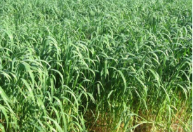
Figure 2.1 Oats (Avena sativa).
  - Vetch (Vicia dasycarpa L.)

Botanical description: Climbing, sprawling annual legume (Figure 8.10).
Adaptation: Medium- to high-altitude highlands.
- Altitude range: 1500–3000 m.a.s.l.
- Climatic requirement: Wide rainfall range, can survive as low as 400 mm.
- Soil requirement: Versatile
Cultivation: Can be established on a rough seedbed.
Propagation: By seed at the rate of: 20 kg/ha (pure stand); 12 kg/ha (undersown); 5–12 kg/ha
(pioneer component of pasture mix); 12–20 kg/ha (sown with oats).
- Fertilizer requirement: Apply 20–40 kg P/ha at planting.
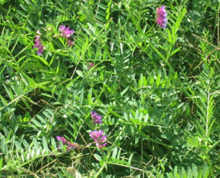
Figure 2.2 Vetch (Vicia dasycarpa)
.
  - Cocks foot (Orchard grass) (Dactylis glomerata L.)
Botanical description: Tufted perennial
Adaptation: Highland adaptive, cold- and frost-tolerant.
- Altitude range: Highlands 2000–3000 m.a.s.l.
- Climatic requirement: Mean annual rainfall 400–1500 mm, cold- and frosttolerant.
- Soil requirement: Versatile in its soil requirement provided drainage is adequate.
Cultivation: Requires a well-prepared seedbed.
Propagation: By seed, sown at the rate of 2 kg/ha.
Fertilizer requirement: Responds well to N and P application.
Companion species: Trifolium alexandrinum, Vicia dasycarpa, Vicia villosa, Lathyrus sativus
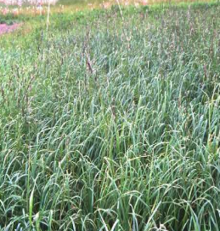
Figure 2.3 Cocks foot (Dactylis glomerata

  - White clover (Trifolium repens L.)

Botanical description: Trailing perennial legume up to 30 cm high
Adaptation: Cool tropical highlands.
- Altitude range: 1800–3000 m.a.s.l.
- Climatic requirement: Mean annual rainfall 800–1500 mm.
- Soil requirement: Versatile.
Cultivation: Well-prepared seedbed
Propagation: By seed at 3–6 kg/ha.
Fertilizer requirement: Responds well to P and S application.
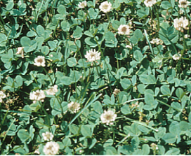
Figure 2.4 White clover (Trifolium repens L.)

  - Buffel grass (Cenchrus ciliaris L.)
Botanical description: Tufted or spreading perennial grass 12–120 cm tall
Adaptation: Adapted to semi-arid conditions.
- Altitude range: Sea level to 2000 m.a.s.l.
- Climatic requirement: Mean annual rainfall 375–750 mm (does not do well in high rainfall areas, but its rainfall requirement ranges widely: 300–1000 mm); temperature 20 30oC; less cold-tolerant than green panic.
Soil requirement: Prefers light-textured soils of high P status, but still performs well on selfmulching soils; has only moderate salt tolerance.
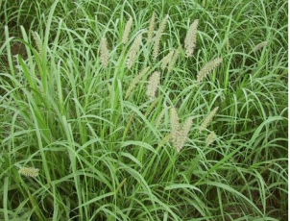
Figure 2.4 Buffel grass (Cenchrus ciliaris L.)

  - Colored Guinea grass (Panicum coloratum L.)
Botanical description: Tufted perennial with variable habit, up to 150 cm high.
Adaptation: Adapted to drier (400 mm) lowland alluvial flood plains of southern Africa (Makarikari, Botswana)
- Altitude range: 500–2000 m.a.s.l.
- Climatic requirement: Rainfall 600–1200 mm; optimum temperature 17–21oC; susceptible to frost.
Soil requirement: Adapted to red and black clay soils. It makes its best expression on black clay soils.
Cultivation: Requires a well-prepared seedbed. Propagation is by seed at the rate of 5–7 kg/ha for broadcasting and 2–3 kg/ha for row planting; sowing depth 2 cm. Planting by rooted cuttings can also be done.
Fertilizer requirement: Responds well to N application; reported to fix N (23 Kg/ha in 100 day . 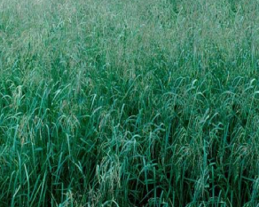
Figure 2. 5 Colored Guinea grass (Panicum coloratum L.).

  - Elephant grass (Napier grass, English or Zihone sar, Amharic) (Pennisetum purpureum)

Botanical description: Robust perennial with a vigorous root system, sometimes stoloniferous with a creeping rhizome, culms 180–360 cm high .
- Adaptation: Best-adapted to high-rainfall areas.
- Altitude range: Sea level to 2000 m.a.s.l.
- Climatic requirement: Rainfall 1480–1620 mm/y; optimum temperature 25–40oC; resists drought if successfully established. Susceptible to frost.
- Soil requirement: Prefers deep, friable fertile soils.
Cultivation: Full land preparation.
Propagation: Usually by stem cuttings buried in 15 cm furrows, 2 nodes in soil and one
exposed. One ha of grass provides planting material for 15–20 ha.
Fertilizer requirement: Responds well to fertilizers applied after every cut.
.
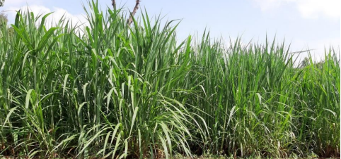
Figure 2. 6. Elephant grass, (Napier grass), (English)
Zihone sar (Amharic) (Pennisetum purpureum)
  - Rhodes grass (Chloris gayana Kunth)

Botanical description: Stoloniferous perennial grass with the erect leafy stems up to 1.5 m bearing at the top 10–12 radiating brownish-green seed spikes
Adaptation: Wide range of adaptation; moderate frost tolerance.
- Altitude range: 600–2000 m.a.s.l.
- Climatic requirement: Rainfall 650–1200 mm.
- Soil requirement: Versatile.
Cultivation: Well-prepared seedbed. Propagation is by seed at the rate of 0.5–7 kg/ha depending upon amount of rainfall. Seeding depth should not exceed 0.6–1.3 cm.
- Fertilizer requirement: Responds well to increasing levels of N application if in balance with P.
- Companion species: Stylosanthes guyanensis, Neonotonia wightii, Macroptilium lathyroides, M. atropurpureum, Medicago sativa, Centrocema pubescens.
- Utilization: Good for grazing and haymaking. If underutilized, it becomes stemmy especially if soil fertility declines.
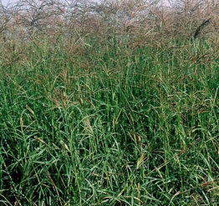
Figure 2.7. Rhodes grass (Chloris gayana)

  - Para grass (Brachiaria mutica(Forsk.) Stapf)

Botanical description: A short-culmed stoloniferous perennial grass up to 2 m high

Adaptation: Semi-aquatic highrainfall/moisture area adaptive.
- Altitude range: Sea level to 1000 m.a.s.l.
- Climatic requirement: Minimum of 900 mm mean annual rainfall; 15–21oC mean annual temperature; frost sensitive.
- Soil requirement: Alluvial and waterlogged soils.

Cultivation: Light cultivation for vegetative and fine seedbed for seed propagation.
- Propagation: Usually by cuttings of 25 cm or 3 node-sized stem spaced 1 m. apart. Also by seed at the rate of 2.5–4.5 kg/ha, no deeper than 1cm, roll after sowing.
- Fertilizer requirement: Responds well to N and P application.
- Companion species: Desmodium heterophyllum, Pueraria phasioloides, Centrocema pubescens, Calopogonium mucunoides.
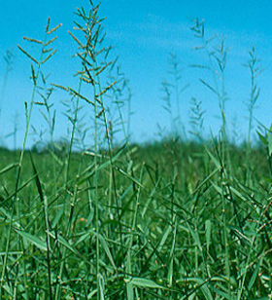
Figure 2.8 Para grass (Brachiaria mutica)
  - Green leaf (Desmodium intortum)

Botanical characteristic: Vigorous perennial herb with ascending or scandent, branched reddish-brown stems
Adaptation: Best adapted to high rainfall areas exceeding 900 mm, with altitude range 800–2500 m.a.s.l.

Herbage yield potential: Varies widely from 3–20 t/ha DM in pure stands.
Propagation: by seed at the rate of 1–2 kg/ha in rows 45 cm wide. Green leaf is highly specific in its Rhizobium requirement.
Fertilizer: Reported to respond well to P and K application.
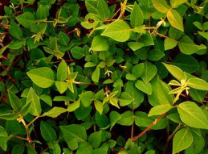
Figure 2.9 Green leaf desmodium (Desmodium intortum).

  - Common stylo (Stylosanthes guianensis (Aublet) Swartz)

  - Botanical characteristics: Erect or sub-erect perennial herb 30–120 cm high (Figure 8.20).
  - Adaptation: Grows best under warm climate; wide range of rainfall 600–2500 mm; survives long dry periods; tolerates low pH or low P status due to endotrophic mycorhiza found in the roots.

  - Herbage yield potential: Varies widely from 2.5–10–15 t/ha DM (as pure). Good for over-sowing natural pasture.
  - Cultivation:
- Propagation: By seed sown at the rate of 2–3 kg/ha. Seed treatment essential by using one of the following methods:
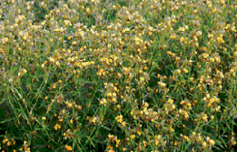
Figure 2.10 Common stylo (Stylosanthes guianensis).

  - Lucerne (alfalfa) (Medicago sativa L.)

Botanical description: Erect perennial herb with deep-growing taproot.
Adaptation:
- Altitude range: Wide range of adaptation from 500–3000 m.a.s.l. altitude and above.
- Climatic requirement: Best adapted to warm, temperate climate. Because of its deep-rooted habit, it can be grown in areas receiving as little as 550 mm of annual rainfall.
- Soil requirement: It is quite intolerant of water logging and requires fertile, well-drained soils. It prefers neutral or alkaline (lime-rich) soils. It is susceptible to acid soils unless top-dressed with lime.

- Cultivation: Well-prepared fine, firm seedbed is required for best result. Propagation is by seed sown at a rate varying with soil moisture: generally 6 kg/ha for rain-fed; 2 kg/ha for areas receiving 600–750 mm of annual rainfall. The rate suggested when sowing in mixtures with grasses is 0.5–2 kg/ha. [Other reports suggest 8–10 kg for pure stand, 5–6 kg/ha for mixtures.] For irrigated pastures, the recommended rate is 14–15 kg/ha so as to obtain fine stems for best hay quality and to control weeds. Sowing depth of 0.5–1.0 cm for heavy soils. Seed inoculation may be necessary if native pastures do not contain medics.
- Fertilizer requirement: Lucerne has high demand for nutrients. Phosphorus may be required for establishment.
- Companion species: Combines with Panicum maximum, Chloris gayana, Cenchrus ciliaris, Sorghum almum.
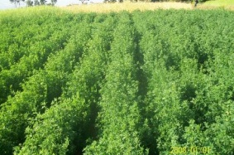
Figure 2.11 Lucerne (Alfalfa), (Medicago sativa)

  - Leucaena (Leucaena leucocephala)

Botanical description: A long-lived shrub or tree up to 20 m high (Figure 8.23).
Adaptation: Performs best under warm climate at low altitudes less than 2000 m, sensitive to frost, drought-tolerant, can grow at 400 mm annual mean rainfall.
- Altitude range: less than 2000 m.a.s.l.
- Soil requirement: Well-drained soils; not tolerant to acid soils; favors a range of soils neutral to alkaline (pH 6.0).

Cultivation: Light cultivation for direct sowing; dug holes for transplanting.
- Propagation: Propagation by seed sown at 4–7 kg/ha, but different rate or spacing can be used depending on utilization; sowing depth: 2–3 cm. Spacing when sown 2–2.5 m between rows to up to 4.0 m between rows/alleys. Usually planted by seedlings.

- Treatments: Seed treatment necessary. Hot-water treatment 60–80oC; H2SO4 for 10 minutes.
- Inoculation with appropriate rhizobium strain is helpful.
- Fertilizer requirement: On acid soils, liming may be necessary.
- Companion species: May be planted to pasture grasses in inter-row spaces.
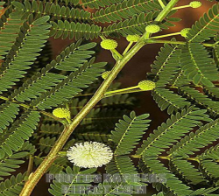
Figure 2.12 Leucaena (Leucaena
leucocephala)
m) Sesbania (Sesbania sesban Scopoli)

Botanical characteristics: Relatively shortlived (6–7 years) shrub or small tree up to 6 m high
Adaptation: A wide range of adaptation, 200– 2400 m.a.s.l. Grows best under moisture-stress
free conditions, versatile in its requirement.
Herbage yield potential: The best fodder tree second only to Leucaena.

Cultivation:
- Propagation: By seed; seed must be scarified by immersing the seed in concentrated sulphuric acid for 30 minutes; also mechanically by using drum scarifiers. Plant seedlings at the onset of first rains. Spacing: variable according to uses:
- Continuous hedges: 50 seeds/m or 2–3 seeds/hole at 0.5 sp
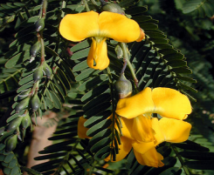
Figure 2.13. Sesbania (Sesbania sesban)

  - Carrying out Site selection and land preparation
Some operational activities are done for successful pasture establishment. These activities are necessary because they help the pasture species to survive in a new environment, full of challenges (e.g. pests and diseases etc). A well-managed pasture can easily adapt to the new environment perhaps due to proper soil moisture, air, nutrients and the right soil structure. However, there should be favorable climatic condition and good management practices. For more detail refer information sheet 1.2 mentioned under learning outcome one (1).
  - Undertaking forage development activities

    - Land Preparation
Land preparation for reseeding or pasture establishment is very critical for the success of sward establishment. The timing and sitting of reseeding areas should be well done. Pasture establishment under rain fed systems requires timing where land preparation and planting are done on time before the rains. This is even more serious considerations in the arid environments where planting should be done early to capitalize on the first rains.

Benefit of Land preparation for pasture establishment, this includes;
  - Loosen the soil surface
  - Reduces the rate of runoff hence controls soil erosion
  - Enables better infiltration of rain water into the soil
  - Eases the penetration of roots of the crop into the soil
  - Prevents grass seed from being blown away by wind
  - Removes all unwanted plants (weeds) so as to give the target crop a head
2.4.2. Ploughing
A plough or plow is a tool or farm implement used for initial cultivation to loosen or turn the soil in preparation for sowing seed or planting. Ploughs were traditionally drawn by working animals such as oxen and horses, but in modern farms are drawn by tractors. A plough may be made of wood, iron, or steel frame with an attached blade or stick used to cut and loosen the soil. It has been a basic instrument for most of history, and is one of the most significant inventions.
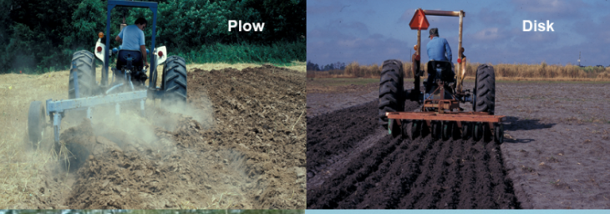
Figure 2.14 Land plow

Pasture Establishment Pasture seeds are too small for most rangeland species and their planting requires careful placement and cover of the seeds to enhance germination. There are several methods of seed placement to the prepared land, where the choice will depend on land size, preparation made and scale of production.

    - Method of seed placement

- Broadcasting (by hand or machine) or seed drilling
This is done manually by hand under small scale production systems. However, we do have seed broadcasting machines where the land area is expansive and the production system in mechanized. This can be tractor pulled equipment (broadcasters) that are calibrated to broad cast seeds at a known rate. Other modifications are use of fertilizer spreaders or seeds. Immediately after seed broadcasting, it should be lightly covered with soil.

The easiest practice can be the use of tree branches pulled over the area broadcasted in small scale farms. While in the large mechanized farms where erosion can occur, rollers are used. Other ways are the use of tractor to pull arranged branches on a bar for the same. The use of homemade harrows can also be used in small farms
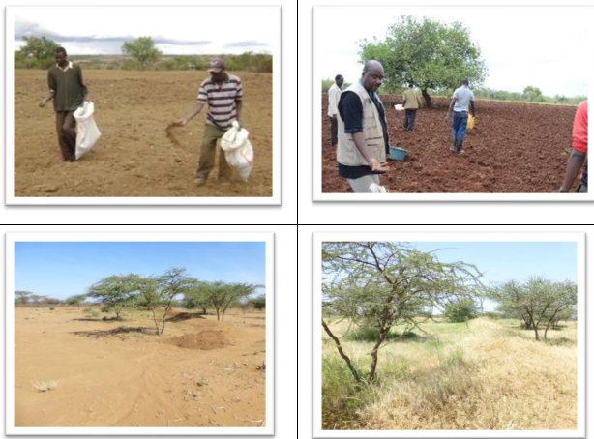

Figure 2.15 seed sowing
- Seeding using seed drill
This method is most suited since the seeds are covered immediately after placement. However, the process is not suitable for many light grass seeds or hairy types like Cenchrus ciliaris since they will not flow well from the driller. There are methods to counter this, maybe mixed with other foreign degradable material like saw dust or rice husks. The advantage is that the depth of seeding can be set on the driller based on seed type. The use of the seed drill is best for large scale reseeding

- Over sowing or sod seeding
This is a pasture establishment technique that involves improving an existing pasture sward by seeding over with an adapted, improved or better forage material. The process demand utilization of existing pastures to lower level before seeding to reduce completion for resources like water and light for the new seeds. Burning can also be done for fire tolerant species, and the method is good since no land preparation disturbs the soil and existing vegetation, hence reduced erosion.

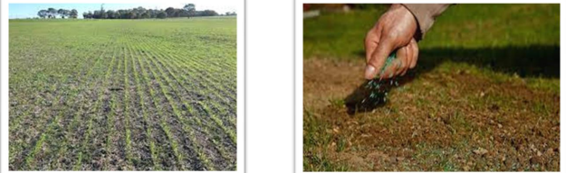
Figure 2.16 over sowing

- Under sowing.
This system integrates other crops in the farm, which are compatible with pasture species either as intercrop or cover crop. This system may not be common in the tropics, but there is high potential, especially for leguminous forages. The process reduces the need for repeated farm operations and also increasing productivity per unit of land. This system may work well under maize systems, where the late sown pasture will be harvested after the main crop, before the next season.
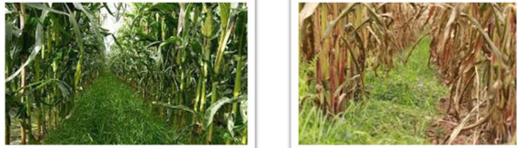
Figure 2.17 Under sowing

- Vegetative propagation
There are many grasses that are low seeders or produce unviable seeds such as Napier grass, kikuyu grass, Bracharia spp and star grass. These species are mostly established vegetatively by use of stem or root cuttings or splits. When using cutting, it is important to ensure at least 2-3 nodes are buried in soil.

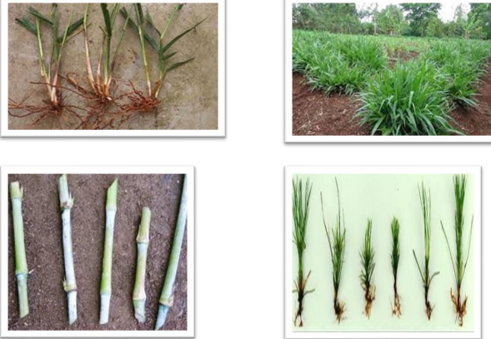
Figures 2.18 Vegetative propagation
Furrow line sowing
This can be done by hand tools with light seeding along the furrow lines covering with light soils
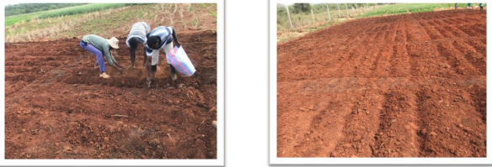
Figure-2.19 Furrow line sowing
    - Mulching
Mulch is a layer of material applied to the surface of soil. Reasons for applying mulch include conservation of soil moisture, improving fertility and health of the soil, reducing weed growth and enhancing the visual appeal of the area. Mulch is usually, but not exclusively, organic in nature. It may be permanent (e.g. plastic sheeting) or temporary (e.g. bark chips). It may be applied to bare soil or around existing plants. Mulches of manure or compost will be incorporated naturally into the soil by the activity of worms and other organisms. The process is used both in commercial crop production and in gardening, and when applied correctly, can dramatically improve soil productivity.
2.4.4. Transplanting
Transplanting or replanting is the technique of moving a plant from one location to another. Most often this takes the form of starting a plant from seed in optimal conditions, such as in a greenhouse or protected nursery bed, then replanting it in another, usually outdoor, growing location. This is common in market gardening and truck farming, where setting out or planting out are synonymous with transplanting. In the horticulture of some ornamental plants, transplants are used infrequently and carefully because they carry with them a significant risk of killing the plant.
  - Undertaking Seed treatment techniques
    - Seed treatment techniques:-
- Chemicals
- Physical
- Biological

Different types of seeds require different treatments for optimal germination. The main purpose is to break their dormancy in order to improve seed flow characteristics, allow rhizobium inoculation and protective chemicals to surround the seed. There are different methods of reduction of seed hardness. These include:
- Hot water treatment or scarification
- Inoculating legumes
- Acid treatment

    - Methods of breaking seed dormancy
Storage: Holding freshly harvested seed in storage will overcome dormancy problems since
dormancy declines with time. Storage is often applied to grass seed

Scarification: Scarification treatments are employed prior to sowing to abrade the seed coat and improve permeability, e.g., most legume and some grass seeds such as Cenchrus, Melinis, and Paspalum notatum require scarification.

  - Recording seasonal growth pattern of forage crop
Seasonal growth patterns of forage may include annual and perennials based on life forms. Annuals complete their life-cycles in one year while perennials survive for more than two growing seasons. Each stem of annual grasses bears an inflorescence. Perennial grasses also bear inflorescences but may also produce vegetative tufts which may flower within two or more years. In the tropics grasses and legumes tend to be annual or perennial. The growth of an annual starts and finishes within one year while perennials exhibit cyclic patterns of growth.
  - Setting Pests, weeds and diseases controlled methods

    - Pests control methods
Pests markedly influence both yield and quality of forages, though insects are known to reduce
yield more than quality. Losses of forages to insects are often not monitored and may be overlooked because of the relatively low value of forage crops compared to other crops which normally makes the high costs of control of pests unjustifiable.

- Insect pests are categorized into 2:
  - Leaf mass consumers - which damage plants mainly by consuming their leaves (they get them perforated or consumed totally) and feed on young developing buds i.e. they cause;
- Defoliation of the plant canopy
- Defoliation of re-growth buds after harvesting or grazing
  - Assimilate removers: these possess piercing and sucking mouth parts with which they extract plant juices thereby disrupt translocation functions of the plant.Defoliating insects initially remove mostly leaf material, which slows subsequent stem development and maturation of plants while the leaf area is being established. The result can be yield reductions, alterations of the leaf / stem ratio or even total damage of plant over an extended period of time.

B) Diseases
Foliar diseases have the greatest adverse effects on forage quality by reducing digestibility. Studies have shown that diseased forages have lower digestibility and non structural carbohydrate concentrations than healthy plants. Diseases have also been associated with browning of leaves and leaf loss

    - Definition and Types of Weeds
Weeds are unwanted plants in pastures that have not been planted by the farmer. They are of different genus and species with the pasture plants, and therefore, when allowed to grow with the selected species, they can easily adulterate the pasture. There are two types of weeds in pastures.
These are:
- Narrow leaved weeds-mainly grasses
- Broad leaved weeds-mainly legumes
There is need to control these weeds before and after planting because at the initial stage of pasture establishment, the pasture species grow very slowly, while weeds grow very fast, thereby smothering the pasture species. However, it is important to note that there are weeds that are beneficial to livestock and farmers (non-toxic weeds) as against toxic weeds which cause economic loss and environmental hazards.
2.7.2.1.. Economic implications of Weeds in Pastures
Weeds in pastures have serious economic implications which may affect the goal of the farm.
These implications include the following:
- Weeds reduce forage yield and quality due to existing competition in the pasture
- Weeds cause serious economic loses to farmers
- Weeds reduce the lifespan of pastures
- Some weeds are poisonous to livestock and herders
- Weeds affect pasture seed quality and viability
- Some weeds serve as hosts to certain pests and diseases
    - Methods of Weeds Control
- Manual method.
- Chemical method.
- Cultural method

Self-Check-2 | Written Test

Directions: Answer all the questions listed below.
- List instruction and direction for forage development. (3points)

List at least 3 each of Pests, weeds and diseases controlled methods in forage development (4points)

Mention the forage seed treatment (1points)

What are the benefits of Land preparation for pasture establishment? (2points)

PART II MULPLE CHOICE
  - Pasture in the wider term includes which of the following component?
- Rangelands.
- Unenclosed pastoral system.
- Pasture land for wild animals.
- All of the above
  - Question 11. What is the key difference point between rangelands and pasture?

- Native vegetation.
- Type of plants.
- Topography.
- Ecosystem
  - Which statement about mixed species pastures is incorrect?
- Lengthens the life of the pasture
- More efficient use of water and nutrient
- Reduces soil erosion
- Can improve livestock performance
- Weed management is easy
Note: Satisfactory rating – 8 points unsatisfactory rating 10 below points
You can ask you teacher for the copy of the correct answers

Operation Sheet -2

2.1. Techniques of field preparation for pasture establishment
- Tools and equipments

- Fertilizer
- Meter
- Weighing scale
- Shovel
- Peg
- Rope
- Boots
- Over all
- Seed
- Hammer
- Record book

- Steps field preparation for pasture establishment
- Land clearing
- Removal of stones and rocks
- Plough the land
- Levelling of the soil
- Seed bed preparation(based on the nature of seed)
- Sowing seed(as required)
- Clean used material and tools
- Return back all tools and materials to store

LAP TEST-2 | Performance Test

Name………………………………. ID…………………………….. Date…………………………………….

Time started: ________________________ Time finished: ________________

Instructions: Given necessary templates, tools and materials you are required to perform the following tasks within 2 hour. The project is expected from each student to do it.

Task-1 Perform pasture seed land preparation activity

LG #3 | LO #3- Monitor forage growth and production

Instruction sheet
This learning guide is developed to provide you the necessary information regarding the following content coverage and topics:
- Determining longer term trends in weed, pest and disease incidence and monitoring any necessary changes to control measures.
- Monitoring Soil structure and erosion and determining necessary changes to cultural practices, grazing management and drainage.
- Checking irrigation and drainage systems
- Monitoring Grazing management
- Monitoring forage maturity for harvesting
This guide will also assist you to attain the learning outcomes stated in the cover page. Specifically, upon completion of this learning guide, you will be able to:
- Determining longer term trends in weed, pest and disease incidence and monitoring any necessary changes to control measures.
- Monitoring Soil structure and erosion and determining necessary changes to cultural practices, grazing management and drainage.
- Checking irrigation and drainage systems
- Monitoring Grazing management
- Monitoring forage maturity for harvesting
Learning Instructions:
- Read the specific objectives of this Learning Guide.
- Follow the instructions described below.
- Read the information written in the information Sheets
- Accomplish the Self-checks
- Perform Operation Sheets
- Do the “LAP test”

Information Sheet 3

- Determining longer term trends in weed, pest and disease incidence and monitoring any necessary changes to control measures.
3.1.1. Methods of forage disease control
A. Chemical Methods
1. Fungicides: Control plant diseases and molds that either kill plants by invading plant tissues or cause rotting and other damage to the fruit before and after it can be harvested.
- Herbicides: Control weeds that compete for water, nutrients, and sunlight and reduce crop yields.
- Insecticides: Control insects that damage crops. Also include materials used to control mites and nematodes.
- Pesticides: Include soil fumigants, growth regulators, desiccants, and other pesticide materials not otherwise classified.

- Cultural Methods
      - Crop rotation -- Alternating the crops grown in a field on an annual basis, which interrupts the life cycle of insect or other pests by placing them in a non-host habitat. Crop rotations can have other benefits such as enhanced fertility and reduced financial risk.
      - Planting and harvesting dates -- Alterations of planting or harvesting date to avoid damaging pest infestations. Delayed planting of fall wheat seedlings may help avoid damage from the Hessian fly, for example.
      - Sanitation procedures -- Removing or destroying crops and plant material that are diseased, provide overwintering pest habitat, or encourage pest problems in other ways. Tillage B Mechanical disturbance of the soil that destroy pests in a variety of ways, for example, by directly destroying weeds and volunteer crop plants in and around the field.
      - Water management -- Water can be used as a pest management technique either directly, by suffocating insects, or indirectly, by changing the overall health of the plant.

C, Biological Methods
- Beneficial -- Pest predators, parasites, and weed-feeding invertebrates that are used to control crop pests and weeds.
- Biochemical agents: Materials such as semiochemicals, plant regulators, hormones, and enzymes.
- Semi chemicals: Pheromones, allomones, kairomones, and other naturally or synthetically produced substances that modify insect behavior and interfere with reproduction.
- Habitat provision for natural enemies: Growing crops and/or developing wild vegetative habitats to provide food (pollen, nectar, non pest arthropods) and shelter for the natural enemies of crop pests.
- Hostplant resistance or tolerance -- Genetic resistance or tolerance helps to reduce damage from insects, disease, or other pests without the use of a pesticide. Resistance can be developed through plant breeding or genetic engineering.
- Microbial pest control agents -- Bacteria, such as Bacillus thuringiensis, viruses, fungi, protozoa and other microorganisms or their byproducts.
- Sterile male technology -- The male of the pest species is produced with inactive or no sperm, and is used to disrupt reproduction in the pest population.
- Trap cropping -- Planting a small plot of a crop earlier than the rest of the crop in order to attract a particular crop pest; the pests are then killed before they attack the rest of the crop

3.1.2. Determine control procedures of forage disease
Proper diagnosis of plant diseases and knowledge of the disease’s cause and life cycle are important to gain before an appropriate control strategy can be considered. If control procedures are indicated, they must take into account both:
- economic factors
- environmental factors
Basic tools for field diagnosis
- Hand lenses
- Pocket knife
- Camera
- GPS unit
- Soil probe, shovel

Disease control strategy integrate
- Select disease resistant forage varieties
- Crop management
- Seed treatment

Category of forage disease
- Category by pathogens that:
- Attack plants below ground
- Attack plants below ground
- Category by pathogens that:
- Attack roots
- Attack stems
- Attack leaves

- Category by pathogens that: Attack specific forage species---for example
- Alfalfa
- Clover
- Birds foot trefoil
- Orchard grass
- Smooth brome grass

    - Weed Control in pasture
Pasture should be established with minimum weed population and some means of keeping weedy plants under control should be employed at all times. Invasion by weeds and shrubby species is always a sign of poor pasture management and usually results from inadequate fertilization and overgrazing of the desirable species. Many weedy species are highly adaptable to low soil fertility and readily invade and rapidly flourish under condition of overgrazing.
- Monitoring Soil structure and erosion and determining necessary changes to cultural practices, grazing management and drainage.

    - Management systems
Soil-quality and land management have the dual goals of meeting the needs of society and conserving essential soil, water, and air resources for future generations. Rangelands are managed for forage production, water harvesting, recreation, and wildlife production, fire wood, and construction materials. On rangelands, management is heavily focused on vegetation. In these systems, animal stocking rates are managed to maintain vegetation composition and productivity, while water-source and mineral-supplement locations are used to improve animal distribution and avoid overgrazing and compaction of the soil. Avoiding compaction and maintaining vegetative cover reduces the potential for erosion and maintains water quality in rangeland watersheds.

Prescribed fire, fertilization, and seeding are other management practices that can be used to improve degraded rangelands and maintain critical soil functions.
In forests, soils are managed for wood and fiber production and other multiple uses such as water harvesting, recreation, and wildlife. During timber-harvesting operations, soil quality is maintained by using practices that minimize the potential for erosion and restore vegetative cover as quickly as possible. Prescribed fire, fertilization, and seeding (or seedling transplants) can be used to improve site productivity and maintain critical soil functions.
In agriculture, soils are managed primarily for the production of food and fiber. Historically, tillage has been used to prepare a seedbed, incorporate residue, control weeds, and distribute agricultural chemicals. Inorganic fertilizer, animal manure, or other organic by-products are applied to provide nutrients needed by the crop but not supplied in sufficient quantities by the soil or to replace nutrients removed by the harvested crop. Soil quality monitoring allows agricultural managers to make assessments of the effects of various combinations of these management factors in the overall system.

    - Tactics for managing the soil surface
- Maintain growing pastures near the start of growth phase II (about 1,200kg green DM/ha) for as long as possible to aid regrowth. This has the added benefit of ensuring the highest possible pasture quality for grazing stock.
- Maintain (or increase) ground cover to manage run-off by removing stock before minimum pasture mass limits are reached (1,200kg DM/ha).

- Aim for medium to high levels of litter (at least two or three handfuls in a 30 × 30cm area) to increase soil organic matter, protect the soil surface, decrease evaporation and increase water-holding capacity. Litter is preferably actively decaying plant matter, not old and inert material.
- Manage grazing practice to increase litter quality and breakdown rate.
- Avoiding excessive cultivation and the application of soil biota-reducing chemicals to encourage build-up of soil biota, to improve soil structure (increased porosity or aeration), litter breakdown rates and incorporation of surface organic matter.
- Avoid grazing when soil is waterlogged to prevent pugging (where animals hooves work clay or loam soil into a soft, plastic condition with no porosity)
- Create stock containment areas to remove stock from at-risk grazing areas.
Change the pasture composition to deep-rooted perennials to ameliorate soils with declining structure
- Checking irrigation and drainage systems

3.3.1 Main types of irrigation
- Flood (or furrow)
- Sprinkler
- Drip (or trickle)
- Manual

      - Sprinkler irrigation systems
Apply water through pressurized sprinkler heads and require conduits (pipes) and pumps. Common systems include stationary sprinklers on risers and traveling overhead sprinklers (center-pivot and lateral). These systems allow for more precise water application rates than flooding systems and more efficient water use. But they require larger up-front investments, and the pumps use energy. Large, traveling gun sprayers can efficiently apply water to large areas and are also used to apply liquid manure

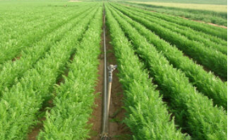
Figure 3.1 sprinkler irrigation system.

- Drip (or trickle)
Irrigation systems also use flexible or spaghetti tubing combined with small emitters. They are mostly used in bedded or tree crops using a line source with many regularly spaced emitters or are applied directly near the plant through a point-source emitter. he main advantage of drip irrigation is the parsimonious use of water and the high level of control.
Drip irrigation systems are relatively inexpensive when used with high-value crops but are not economical for large-scale grain or forage crop production. They can be installed easily, use low pressure and have low energy consumption.

In small-scale systems like market gardens, pressure may be applied through a gravity hydraulic head from a water container on a small platform or even through a human-powered treadle pump. In subsurface drip irrigation systems, lines and emitters are semi-permanently buried to allow field operations. Such systems require attention to the placement of the tubing and emitters; they need to be close to the plant roots, as lateral water flow from the trickle line through the soil is limited

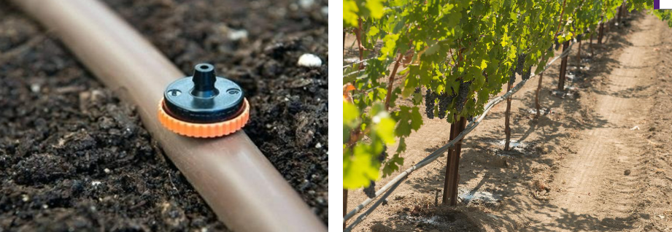
Figure 3.2. Drip irrigation

      - Manual irrigation involves watering cans, buckets, garden hoses, inverted soda bottles, etc. Although it doesn’t fit with large-scale agriculture, it is still widely used in gardens and in small-scale agriculture in underdeveloped countries.

3.3.2. Drainage
Soils that are naturally poorly drained and have inadequate aeration are generally high in organic matter content. But poor drainage makes them unsuitable for growing most crops other than a few water-loving plants like rice and cranberries.

3.3.3. Benefits of Drainage
Drainage lowers the water table by removing water through ditches or tubes. The main benefit is that it creates a deeper soil volume that is adequately aerated for growing common crop plants. If crops are grown that can tolerate shallow rooting conditions, like grasses for pastures or hay, no artificial drainage may be needed and the water table can remain relatively close to the surface or drainage lines can be spaced far apart, thereby reducing installation and maintenance costs, especially in low-lying areas that require pumping.

But most commercial crops, like corn, alfalfa and soybeans, require a deeper aerated zone, and subsurface drain lines need to be installed 3–4 feet deep and spaced 20–80 feet apart, depending on soil characteristics. Drainage increases the timeliness of field operations and reduces the potential for compaction damage.

3.3.4. Common types of drainage practices used in pasture

- Ditches
- Subsurface drain lines (tile)
- Mole drains
- Surface drains
- Raised beds and ridges

- Monitoring Grazing management
Grazing should be deferred until the planted forage species are well established. Stocking rate should be kept low enough or practice rotational grazing system in order not to damage the forage. Alternatively, forage should be harvested for hay for the first few growing seasons, before initiating grazing. well-established forage stand with desirable density, grazing should be managed properly for persistence pasture.

Overstocking of grazing animals damages the forage plant very easily and production goes down after few grazing seasons. As a result, forage species that cannot tolerate continuous grazing may extinct from the system

3.4.1. Basic principles of controlled grazing for natural pastures
- Provide rest or recovery period between grazing cycles.
- During recovery, plants build up nutrient reserves that ensure continued vigor.
- There is a need to take care of palatable species by controlling scrub and brush growth to avoid competition.
- Avoid heavy defoliation of key species during their active growing period
- Plants use up to ¾ of root food reserve (when rate of carbohydrate production is greater than the rate of demand) to produce new vegetative growth until the plant nears flowering.

- Heavy defoliation during active growth will result in the valuable perennials to be replaced first by increasers, then by invaders and finally by bare ground. As a precaution, stocking rate should be highly reduced or grazing totally stopped when no more than 50% of the weight of herbage has been consumed.
3.4.2. Grazing systems
Continuous grazing is an extensive system of grazing in which animals remain on the same pasture area for prolonged periods. Continuous grazing is a normal practice on rangelands and tropical savannahs where, in most cases, the low carrying capacity of the grazing resource may not allow employment of other intensive systems of grazing. In continuous grazing systems, pasture areas are generally under grazed during the rainy season and overgrazed during the dry season, with a consequent deterioration of the sward.
A low stocking rate should be maintained to maintain the grazing system. Major disadvantages of the system include a buildup of tick and nematode infestation and a lack of grazing distribution.
      - Rotational grazing system
In a rotational grazing system, the pasture is divided into two or more subdivisions (paddocks) through appropriate fencing. Watering facility is developed such that animals in each paddock have access to water all the time. Animals are allowed to graze one paddock at a time and moved to another paddock in a sequence or rotation based on forage availability

This system offers uniform grazing opportunity in all portions of the pasture and minimizes the selection of more palatable species over less palatable species. There are two ‘periods’ in this system, namely, the grazing period, during which animals are allowed to graze a paddock, and the resting period, when animals are moved off the paddock and rotated to the remaining paddocks. During the resting period, forage species recover from the grazing stress and regrow. Provision of enough resting period is very important for a sustainable pasture management.

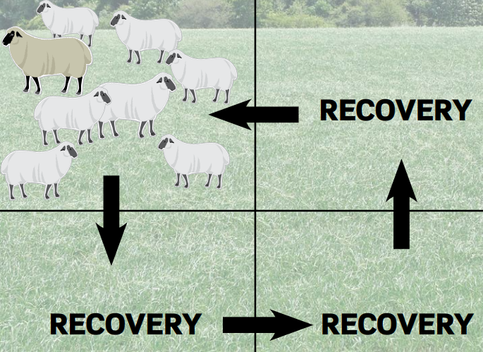
Figure 3.3. A rotational grazing system with four paddocks

      - Strip grazing is a more intensive method of rotational grazing based on the use of electric fence, which is moved forward once or twice a day.
      - Deferred grazing is the setting aside of certain pasture paddocks for use at a later stage, e.g., standing hay. .
      - Soiling or zero grazing is the feeding of cut crops to housed stock.

- Monitoring forage maturity for harvesting
Pastures are harvested at certain stages of their growth for conservation and subsequent utilization during periods of feed scarcity. Pasture harvesting is necessary for better supply of high quality feed, because forage dry matter progressively decreased with advancing maturity. The quality of conserved forage depends on harvesting method and the moisture content at the time of harvest and storage

3.5.1. Growth Stages of Cutting Pasture
There are three growth stages of cutting pasture species:
- Pre-Flowering Stage: This is a stage in pasture growth in which the pasture specie has more vegetative growth before setting flowers for seed production

- Flowering Stage: At this stage, the pasture specie produces flowers for seed production. Fertilized ova result into immature seeds, which can be grazed by livestock or even defoliated for conservation.
- Post-Flowering Stage: During this stage, seeds are set by the pasture specie. However, the moisture content of the seeds is still high compared to dry seeds. This stage is sometimes known as the dough stage in maize plant for silage. The forage at this stage contains high level of fibre for structural support. Livestock feed very little quantity of the forage material at this stage, even though the moisture content is very low.

Self-Check – 3 | Written test

Name…………………………………………… ID………………………… Date…….

Directions: Answer all the questions listed below.
      - As a cow/calf producer, what three management changes can you make that will have the greatest positive impact on your production costs?
- Implement a daily pasture rotation
- Shift the calving season into the growing season
- Extend the rotational grazing season as long as possible after the growing season ends.

      - The growth of your pasture grass will be maximized if:
- You use your grazing herd as a tool to prevent your pastures from going to seed.
- You never graze your pastures shorter than 6 to 10 inches during the growing season.
- You can feed a little hay or silage during the growing season as an emergency measure to prevent your grass from being grazed shorter than 6 to 10 inches.
- All of the above.

      - The primary goal of your intensive grazing strategy during the growing season is to:
- Prepare your pastures for winter grazing.
- Maximize grass consumption when grass is plentiful during the growing season.
- Fatten as many of your cattle as possible before the growing season ends.
- Graze each pasture as short as possible before moving on to the next pasture so that no grass goes to waste.
LG #4 | LO #4- Perform harvesting and Preserve Forage

Instruction sheet
This learning guide is developed to provide you the necessary information regarding the following content coverage and topics:
- Determining harvesting time/stage/
- Storing harvested.
- Determining uutilization of harvested and stored forage
- Undertaking Forage preservation methods
This guide will also assist you to attain the learning outcomes stated in the cover page. Specifically, upon completion of this learning guide, you will be able to:
- Determine harvesting time/stage/
- Store harvested.
- Determine utilization of harvested and stored forage
- Undertake Forage preservation methods
Learning Instructions:
- Read the specific objectives of this Learning Guide.
- Follow the instructions described below.
- Read the information written in the information Sheets
- Accomplish the Self-checks
- Perform Operation Sheets
- Do the “LAP test”

Information Sheet 4
4.1. Determining harvesting time/stage/
    - Effect of Stage Harvesting on Forage Quality and yield
Pasture quality (irrespective plant species) can be affected by the harvesting days of first date of cut and frequency of harvesting which consequently reduces the nutritive value. As pastures mature they are characterized by high content of fiber with a higher grade of lignification and low protein content. Most improved grasses fed at early stages of maturity are more digestible and are eaten in larger quantities than at more mature stages.

Leaf to stem ratio is used as an index of quality, the quality of herbage depends on the proportions of stem and leaf in the particular plant species. Early harvesting had significantly higher leaf to stem ratio as compare late harvesting days. The leaf to stem ratio decreased as the plants advanced in maturity. The presence of an increased proportion of plant stems, typical of older plants, may restrict access to leafy parts and force animals to consume lower quality herbage. Digestibility of stem is much lower than leaf, digestibility of old grass is much lower than young grass while protein content also decreases as the plant ages, particularly in grasses. The aging of forage is frequently associated with a decrease in leafiness and an increase in stem to leaf ratio.

Stage of harvest influence the herbage dry matter yield, crude protein concentration and other chemical constituents. This suggests that there may be a physiological trigger, which leads to the increased production of stem material in tropical pastures. Changes in leaf number are themselves associated with changes in the number of internodes, and thus length of stems. Internodes length of elephant grass increased significantly with increased days of harvesting. Length of internodes per plant was affected significantly by harvesting days. Late harvesting significantly produced longer internodes as compared to early and intermediate harvestings.

Perennial grasses often live for relatively a few or several seasons by succession of secondary tillers, which replace the original tillers. However, annual grasses flower and die without producing replacement tillers which will be the reason for the death of the whole plant. Tiller number per plant of grass increased with increased days of harvesting. The yield and quality of grassland is significantly influenced by harvesting stages of grass.

4.1.2. Harvesting at the Right Stage of Maturity
Harvesting at the right stage of maturity is one way of enhancing crop residue yield and quality. Early harvesting immediately after physiological maturity of the crop was found to improve the crop residue yield and quality without adverse effects on the grain yield and quality.

  - Storing harvested.
    - Proper Handling and Storage
Loss of leaves due to shattering, during harvesting, drying, transport, storage, and feeding of cereal crop residues to livestock feeding may be high due to the losses and inefficiencies associated with these operations. Straws and stovers should be stored only after they are dried to moisture content of less than 10-15%. Rain or moisture during harvest of straw can also cause fungal growth or loss of nutrients due to leaching prior to storage.

In order to minimize spoilage, straws or Stover’s should be stored in well ventilated sheds or in well-staked open heaps. In general, efforts should be made to minimize deterioration of the straw due to shattering of leaves, leaching and microbial attack during storage. Wastage should be minimized during feeding as well. Straws and stovers are offered on a feed trough or on a clean ground to minimize feed wastage due to trampling and soiling with dung.

Hay must be stored in a dry environment. Good quality hay should never be poorly stored. The type of storage may vary from area to area. A good stack of loose or baled hay will provide satisfactory storage in arid areas where there is little rainfall. More expensive shelters may be required for high rainfall areas. It is advisable to store hay by kinds and grades in case variable qualities are stored.
Hay can also be stored by creating hay stacks. Stacks may be covered by plastic sheets to keep out rain. The surface layer of a stack may also be "thatched," in the same manner as a thatched roof to a house.

Hay of higher moisture content should not be stored because its nutritive value may be greatly lowered. It is generally the most convenient form of stored fodder and an appropriate forage conservation method for small-scale farmers and pastoralists with limited resources. Proper drying is essential so that the hay can be stored safely without heating excessively or becoming moldy. Maximum leafiness, green color, nutrient value and palatability can also be retained. The grass should be dried quickly and not unduly exposed to the sun to maintain these characteristics. Hay must be stored in a dry place.

Hay can be bailed and stored under cover. Hay can also be store by creating hay stacks or hay store. These may be created in a field near the source, or close to where the hay will be required later in the year. Stacks may be covered by plastic sheets to keep out rains. The surface layer of a stack may also be thatched, in the same manner as a thatched roof to a house.
  - Determining uutilization of harvested and stored forage
4.3.1. Systems of forage utilization
1. Immediate use
- Grazing
- green chop
- Conserved forage
- standing hay
- hay
- silage
4.3.2. Stored fodder
Storing fodder is an important operation in livestock farming to bridge the gap in feed supply during dry seasons, recurrent drought hazards, and during the cropping season when grazing land becomes scarce. The aim of conserving fodder is to harvest the crop at its maximum nutrient content and minimize losses while at the same time maintaining its acceptability to the animal. The time of harvest may be earlier if higher protein content is required or later if maximum dry matter is desired. Therefore, time of cutting is a compromise between quality and quantity of the harvested forage. Fodder is usually conserved as hay and sometimes as silage especially for dairy business.
4.5 Undertaking Forage preservation methods

Forages can be conserved to feed livestock during periods of shortage, caused by limited pasture growth or inadequate pasture conditions, or as a supplement (for example, when supplementing with a legume). Conserved forages can take the form of hay, haylage or baleage, and silage. While several techniques have been proven as efficient ways to store forages, it is important to keep in mind that, at best, conserved forages can rarely match the nutritive value of fresh forage, and some losses of highly digestible nutrients (sugar, protein, and fat) are unavoidable. The goal in forage conservation should focus on minimizing losses, which start immediately after cutting.

4.5.1. Haymaking steps

The goal of haymaking is to capture the nutrients in grass in a storable form to make them available as a forage feed in the winter months/dry season.
      - Timing:

One of the most critical factors in making quality dry hay is timing. Producers need to time haymaking to coincide with the right stage of plant growth and weather conditions.
      - Mowing:

The first step in haymaking is mowing the hay. The maturity of the grass is the determining factor for starting the first field of the season. The grass should be in the early vegetative stage, and not headed out, with enough growth to make mowing worthwhile

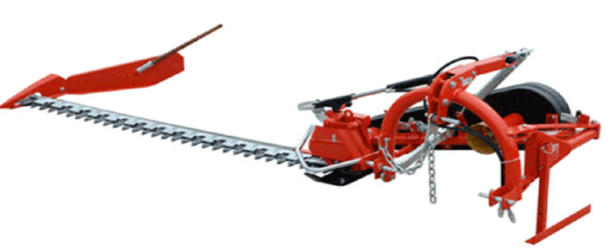

Figure 4.1. Sickle bar mower
      - Tedding:

Once the hay starts to dry, it needs to be worked to promote curing. Tedding, the next step in hay making, fluffs up the cut hay and allows the air and sun to contact the under-surfaces to promote

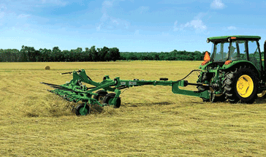

Figure 4.2. Hay tedder.
      - Drying

Some people ted immediately after mowing to spread out the swath. Hay mowed early in the morning could be tedded that afternoon, as long as the mowed swath is dry on the top surface. It may require a second tedding the next day to speed up the drying process. Too much tedding can shatter leaves of alfalfa or clover, lowering the quality of the hay. Proper tedding can be the key to timely haymaking.

      - Raking:

Once the hay has been tedded and is nearly dry, it is ready to rake. Raking turns the hay one more times to dry the bottom and forms it into a windrow ready to be baled

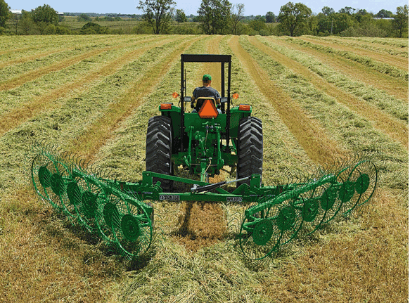

Figure 4.3. Hay wheel rake.

      - Baling

Science and art converge in haymaking with the critical decision of when to start baling. Baling hay too early will trap moisture in the bale and result in spoilage. Baling too dry will cause leaves to shatter and break, lowering hay quality. It takes close visual observation and handling of clumps of hay from several windrows to “feel” if it is ready.

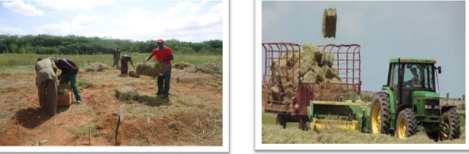

Figure 4.4a homemade bale box and baling of hay Figure 4.4b Tractor making square hay bale

4.5.2. Common losses of haymaking
- Leaf shattering
- Leaves contain 2 to 3 times as much protein as stems.
- Leaves are also richer in carotene, B-vitamins, minerals, and energy.
- Heat damage
- Hay stored with excess moisture (25–35%) may tend to mold, and contain bacterial growth and heat.
- Hay stored dry reaches a maximum of about 29oC.
- Above about 49 oC, nutrient destruction or binding occurs. Proteins are most vulnerable to heat damage.
- When temperature of stored hay reaches 71–73oC, there is a danger of spontaneous combustion.

- Fermentation/plant cell respiration
- Converts sugars and starch to CO2 and H2O representing a loss of nutrients.
- Reduces energy value.
- Destroys carotene.
- Under good condition, accounts for 5–7% of loss in total dry matter.
- Rapid drying is the key to low fermentation losses.
- Bleaching
- Color loss due to destruction of chlorophyll by sunlight.
- Reduces carotene (related to greenness) or Vitamin A.
- Leaching
- Washing of nutrients out of the hay by rainfall.
    - Factors influencing hay quality

- Maturity: Affects both yield and composition of hay.
- Young plants are more digestible because they have less structural fiber and lignin,
- Young plants are higher in protein, minerals and carotene than older plants.
- Young plants are more palatable, tender and less fibrous.
- Leafiness: Applies mainly to legume hay.
- The percentage of leaves is the best index of actual feed value of alfalfa, clover and other legume hays.
- Leaves are higher than stems in protein, fat, ash, nitrogen-free extract, calcium and phosphorus.
- Leaves have a higher digestibility than stems.
- Color: Is an indication of maturity, the care exercised in curing, and the amount of weather to which the hay has been exposed.
- A high percentage of natural green color (pea-green color) in hay indicates early cutting, good curing, high palatability, freedom from must or mold and high carotene content.

- Foreign matter: Indicates hay of low feeding value.
- Injurious foreign matter, such as wire, stones, etc.
- Poisonous plants, hard, bearded grasses etc.
- Condition: Refers to soundness of hay. Unsound hay is an indicator of poor quality and low nutrient content.
- Contains excess moisture (under-cured).
- Heated or hot hay, perhaps a burnt-brown appearance.
- Has a musty or sour, rotten odor, generally due to heating.
- Moldy.
- Lacks the aroma of well-cured hay.
- Texture: Refers to the size of the stems. Texture is influenced by the thickness of the stand, maturity, percent leaves and the rainfall, soil fertility and other environmental conditions affecting the rankness of growth.
- Variety: Refers to kind or variety. Legume hay is more valuable than grass hay of the same maturity condition and foreign-matter content.

    - Silage making

Silage is a fermented feed resulting from the storage of high moisture crops, usually green forages, under anaerobic conditions in a structure known as a silo.
- Ensiling / Ensilage
- The name actually stands for all physical and chemical changes that take place when forage or feed with sufficient moisture are stored in a silo in the absence of air.
- The entire ensiling process requires two to three weeks for converting forage into silage.
- Silo
- A silo is an airtight to semi-airtight structure designed for the storage and preservation of high moisture feeds as silage.
- Characteristics types of silo

- The kind of silo and the choice of construction material should be determined primarily by economics. Silos may be classified as follows:
- Conventional upright (tower)silos
- Concrete stave (thin strips of concrete set edge to edge to form the wall).
- Wood stave
- Tile block
- Brick
- Gastight (oxygen - limiting)silos
- Concrete stave
- Brick
- Pit silos
- Horizontal silos
- Trench silos (below ground level)
- Bunker silos (above ground level)
- Temporary silos
- Plastic or polythene bag silos
- Modified trench - stack silo
- Size of silos for construction

Table 4.1. Size of silos for construction
Number of adult cow | Diameter of silo (metre) | Height of silo (metre) | Tonnes of silage
12 | 3.05 | 7.93 | 39.4
20 | 3.66 | 8.23 | 56.4
30 | 4.27 | 9.14 | 84.6
50 | 5.49 | 10.68 | 141.0
100 | 6.10 | 11.89 | 282.0

- Characteristics and various types of silo pits

- The size should be decided on the basis of the number and kind of animals to be fed daily, the length of the feeding period, and the amount of forage available for ensiling.
- Silos should exclude air from the stored material including entrance of air around the doors of tower soils.
- The side walls should be straight and smooth in order to prevent the formation of air pockets which may retard the normal microbial fermentation.
- Silos should be of adequate depth, thereby making for better packing and less surface area to total mass exposed.

- The walls should be strong and rigid in order to withstand the pressure which develops inside the pit as fermentation take place. Note that silage made from cut grass will exert from a 1/2 to 2 1/2 times as much pressure on the walls as does maize silage. Reinforcement of walls will be desired.
- That adequate provision be made for the escape of surplus juices, either by a drain or by a gravel bottom.

- That it be conveniently located and accessible in all kinds of weather, from the standpoint of both filling and feeding.
- That silo pits (not tower type) are always located preferably at the highest spot on the farm to avoid water seepage.

4.5.5. Crops used for silage making

The most commonly used silage crops are
- Graminaceous
- Maize, sorghum, sudan grass, bajra, hybrid napier, etc.
- Outof all, maize and sorghum are supposed to be the best crops for silage making.
- Leguminaceous
- Lucerne, Berseem, Cowpea etc.,
- For preserving leguminous crops which have less percentages of sugar, the fodder is sprinkled with a solution of molasses in water at every one-third metre of filling to provide the necessary amount of sugar for silage making. Graminaceousforage crops can be mixed with legumes for making silage of good quality

Advantages of silage making are

- when harvested at or before the flowering stage, more nutrients (per area unit, time unit and kg feed) can be available for animal feeding
- losses due to shattering, leaching and bleaching during hay making are avoided
- The silage making is less affected by adverse weather conditions (or fire), as compared to hay making.

Some disadvantages of silage making are:
- it requires labour for filling of the silo
- the construction of a silo requires an investment
- handling and transportation requires more effort as compared to hay, due to the lower dry matter concentration
- nutrient losses are generally 10% over losses with green fodder, which may be more with smaller quantities

Self-Check – 4 | Written test

Name…………………………………………… ID………………………… Date…….

Directions: Answer all the questions listed below.
Test I: Short Answer Questions
  - List instruction and direction for forage development.(2points)

Reason out why mulching carry out in forage development? (2 point)

List methods of sowing forage seed (1 point)

List different types of irrigation methods for forage development (3 point)

Test II: Multiple choices (2points)
- Forage that has been cut and dried until it contains a low level of moisture.

- Pasture
- Hay
- Silage
- Silo

- Green, Chopped forage that has been allowed to permeant in the absence of air.

- hay
- pasture
- silage
- haylage

Note: Satisfactory rating above 9 points unsatisfactory rating –below points
You can ask you teacher for the copy of the correct answers.

Operation Sheet -4

4.1. Techniques/Procedures/Methods of silage making
A. Tools and equipments

- Meter
- Thick plastic sheet
- Molasses
- Salt
- Ph meter
- Mineral mixture
- Water
- Crops
  - Techniques/Procedures silage making
Step 1. Pit making
Step 2. Preparation of fermentation mixture
Step 3. Harvesting and transportation of crop (ensiling
Step 4. Chaffing
Step 5. Filling of silo and compaction
Step 6. Properly sealing and covering of silo pit
  - Techniques/steps of Evaluation mature silage
- Tools and equipments
  - Ph
  - Silage
- Thermometer
B. Steps of silage evaluation
Step 1: Collect a sample of silage that is representative of what is to be fed to the animals.
Step 2: Make an assessment of the silage on physical appearance and texture.
Step 3: Make an assessment of the silage on the basis of color.
Step 4: Make an assessment of the silage on the basis of the aroma of the silage.

LAP TEST-4 | Performance Test

Task 1. Perform silage making
Task 2. Evaluate mature silage

LG #5 | LO #5- Clean up on completion of work

Instruction sheet
This learning guide is developed to provide you the necessary information regarding the following content coverage and topics:
  - Storing Waste materials produced during forage development and preservation
  - Cleaning, maintaining, handling, transporting and storing material, tools, equipment and machinery
  - Reporting difficulties in completion and work
  - carrying out Record keeping
  - Reporting work outcomes
This guide will also assist you to attain the learning outcomes stated in the cover page. Specifically, upon completion of this learning guide, you will be able to:
- Store Waste materials produced during forage development and preservation
- Clean, maintain, handle, transport and storing material, tools, equipment and machinery
- Report difficulties in completion and work
- carry out Record keeping
- Report work outcomes
Learning Instructions:
- Read the specific objectives of this Learning Guide.
- Follow the instructions described below.
- Read the information written in the information Sheets
- Accomplish the Self-checks
- Perform Operation Sheets
- Do the “LAP test”

- Storing Waste materials produced during forage development and preservation

Storage is the temporary containment of the waste. The storage facility of a waste management system is the tool that gives the manager control over the scheduling and timing of the system functions. For example, with adequate storage, the manager has the flexibility to schedule the land application of the waste when the spreading operations do not interfere with other necessary tasks, weather and field conditions are suitable and the nutrients in the waste can best be used by the crop. The storage period should be determined by the utilization schedule.
The waste management system should identify:
- the storage period
- required storage volume
- type
- estimated size
- location, and installation cost of the storage facility
- management cost of the storage process; and
- Impact of the storage on the consistency of the waste.

- Cleaning, maintaining, handling, transporting and storing material, tools, equipment and machinery

    - Cleaning tools and equipment
Definition: Cleaning is the process of removing unwanted substances, such as dirt, infectious agents, and other impurities, from an object or environment.
5.2.2. Classification/Type:-
Types of cleaning materials
  - Cleaning clothes
  - Sponges
  - Water
  - Water hose/pipe
5.2.3. Use/Purpose
- Make material easy to use
- Protect material from dust, rust or rot
- Clean for future use
- Clean for long life use

  - Maintenance of tools and equipments
Definition: Maintenance is actions necessary for retaining or restoring a piece of equipment, machine, or system to the specified operable condition to achieve its maximum useful life.
    - Types of maintenance-
  - Periodic maintenance
  - Conditional maintenance
  - Seasonal maintenance
5.3.2. Site maintenance
- The job site shall be kept in a neat, clean, and orderly condition at all times during the operation process.
- All scrap and excess materials are to be regularly removed from the site
5.4. Storing tools and equipment
Definition:-Storing is keep or accumulate (something) for future use.
5.4.1. Classification/Type of stores :- Depending on types of industry and policy of the.
A. Centralized - materials are supplied to all departments by one store
B. Decentralized - for each department there is a separate store
C. Centralized stores with sub-stores - there is one central store which holds the stocks in general with separate sub stores for each department which gets supply from the central stores.
5.4.2. Use/Purpose:
- Better control & layout.
- Technical skill is high & supervision is better.
- Less storage space is needed because stocks should be kept as low as possible.
- Replenishment should be quicker.
- Reporting difficulties in completion and work
Malfunctions, faults, wear or damage to machinery and equipment are identified and reported in line with enterprise requirements. Since factors vary among installation sites, equipment users must work closely with each of their suppliers to ensure that proper data is being collected, that the data is being provided to the correct supplier, and that the resulting solutions are feasible. All events (failures) that occur during inspections and tests should be reported through an established procedure that includes collecting and recording corrective maintenance information. The data included in these reports should be verified and then the data should be submitted on simple, easy-to-use forms that failures are tailored to the respective equipment or software.
    - Collecting the data
Many problems go unnoticed because insufficient information was provided. Example, someone was able to duplicate the problem being reported. There are three common causes for missing essential data:
- Inspection or testing began before a procedure was in place to report problems.
- The reporting form was difficult to use.
- The person who filled out the form had not been trained
Operators and maintenance personnel are usually the first to identify problems and, therefore, they should be trained to properly capture all of the information needed for an event report.
    - Reporting equipment failures
Poor working conditions affect worker health and safety
- Poor working conditions of any type have the potential to affect a worker's health and safety.
- Unhealthy or unsafe working conditions are not limited to factories — they can be found
- Poor working conditions can also affect the environment workers live in, since the working and living environments are the same for many workers.
- carrying out Record keeping
5.1. Record keeping
You can improve your grazing system with good records of pasture yield, grazing days, and other data because they allow you to evaluate past efforts. If you keep good records and compare yield estimates with data from actual grazing days, you will be able to more closely calculate the actual yield for your farm and your conditions.
Grain producers determine the number of inputs to use based on the yield they will gain from each one. Because inputs and the resulting yield are easily measured, grain production systems can be quickly refined and improved. Good pasture records are slightly more difficult to collect, but they can also contribute to rapid improvement of pasture systems. One objective of pasture improvement is to increase yield, but changes in pasture management may also target herbage quality, yield distribution, or persistence. Pasture improvement may result in improved gains, increased carrying capacity, or reduced need for supplementation during summer months.
Records help a manager:
- place a value on improvements and
- Make decisions on where to spend limited resources to maximize the benefits.
These improvements are not necessarily obvious unless producers keep good records and study them.
All your record information should be entered in a timely manner and regularly reviewed. It should include:
- record year,
- paddock identification,
- paddock size,
- monthly rainfall,
- date and amounts of fertilizer,
- seed and pesticide inputs, and
- the most recent soil test data.
In addition, each time a paddock is grazed, record the number and average size of animals, dates in and out, pasture height at the beginning and end of grazing, and yield estimate and stand density at the start of grazing.
Physical and financial records of pasture include:
- seed and fertilizer rates and costs,
- number of paddock operations and fuel costs,
- types of chemicals, rates and costs of applications for weed,
- pest and disease control,
- amount of irrigation water applied and application costs,
- weather conditions during growth,
- purchased labor,
- contracting and share-farming
- Reporting work outcomes
An important point in every work including pasture establishment and preservation of feeds work is recording data, analyzing and reporting, all the steps from the initial to the final product of the work. One of the ways of communicating to the employer or the customer is reporting work outcome .This report includes information regarding
- Raw materials used
- Problem encountered
- Length of work
- Hazards and safety
- Techniques and system of work
- Cost expended
- Material availability
- Sustainability of work
- Labor required
- Facilities in work
Steps to prepare and report work report
1. Prepare recording format
2. Record all the data and steps in work
3. Arrange the data
4. Select the relevant data to the work
5. Interpret according to your work
6. Compile the data properly
7. Report the total outcomes of the work to the concerned body

Self-Check-5 | Written Test

Directions: Answer all the questions listed below. Use the Answer sheet provided in the next page

List two types of disposing materials in forage development (3 points)

List waste materials that produced during forage development. (2 points)

Discuss requirements that must be fulfilled during disposing excreta waste(2)

What is the importance of maintenance of tools and equipment? (2 point)

List maintenance process of tools and materials (2 points)

What are the characteristics of report writing? (3 points)

List steps in report writing (2 points)

Mention types of report. (2 points)
Note: Satisfactory rating above 16 points unsatisfactory rating below 16 points
You can ask you teacher for the copy of the correct answers

Reference Materials

Books:
- Handbook for Straw Feeding Systems Kiran Singh and J.B. Schiere (eds.), 1995 ICAR, New Delhi, India
- TUSKEGEE UNIVERSITY, 2010 . Forage Selection, Establishment, and Management in Silvopasture
- Barnes, R.F., D.A. Miller, and C.J. Nelson. (1995). Forages, the Science of Grassland Agriculture. 5th Ed., Vols. 1 and 2, Iowa State University Press, Ames, IA.
- Frank B.Fladers ,James R.Gillespie text book of modern livestock and poultry 9th edition
- Forage production Hand Book of forage development by: Bhutan, 2nd Edition June, 2008
Alemayehu Mengistu. 2004. Pasture and forage resource profiles of Ethiopia. Addis Ababa, Ethiopia
Web addresses
NRAES 173 Forage Utilization for Pasture Based Livestock Production. Available at http://www.nraes.org ( access date 30/08/20220)
https://www.agric.wa.gov.au/crops/pastures/pasture-establishment(accessdate 30/08/20220)
https://nwdistrict.ifas.ufl.edu/phag/2020/02/21/7-steps-to-successful-pasture-establishment/
( access date 04/09/20220)

https://idl-bnc-idrc.dspacedirect.org/bitstream/handle/10625/60747/1520ad77-4930-40df-9525-cfaad53aa1d9.pdf?sequence=1(access date 04/09/20220)
https://extension.msstate.edu/sites/default/files/newsletter/forage-news/2008/4.pdf
(Access date 04/09/20220)
https://forages.oregonstate.edu/nfgc/eo/onlineforagecurriculum/instructormaterials/availabletopics/esablishment/advantages(access date 26/08/20220)
https://beeflambnz.com/knowledge-hub/module/principles-pasture-establishment
(access date 05/09/20220)
https://www.farmingahead.com.au/pastures-and-soils/news/1330945/steps-to-successful-pasture-establishment( access date 027/08/20220)
https://www.agriculture.gov.bz/wp-content/uploads/2021/03/PASTURE-ESTABLISHMENT.pdf(access date 25/08/20220)
https://pdf.usaid.gov/pdf_docs/PNADQ897.pdf(access date 04/09/20220)
https://www.pashudhanpraharee.com/procedure-for-silage-making-preventive-measures-to-control-silage-spoilage/(access date 05/09/20220)
https://www.agrifarming.in/silage-making(access date 04/09/20220)

AKNOWLEDGEMENT

Ministry of Labor and Skills and Ministry of Health wish to extend thanks and appreciation to the many representatives of TVET instructors and respective industry experts who donated their time and expertise to the development of this Teaching, Training and Learning Materials (TTLM).

The experts who developed the learning guide
No | Name | Qualification | Educational background | Institution | Phone number | E-mail
1 | Temesgen Roro | MSc. | Animal Production | Holeta PTC | 0917657496 | temesgenroro@gmail.com
2 | TerefeTolcha | MSc. | Animal Production | Alage ATVET  College | 0911067132 | terefetc@gmail.com
3 | Genanew Abera | MSc. | Animal genetics and breeding | Alage ATVET  College | 0926672970 | genanewabera@gmail.com
4 | Solomon Fertewal | MSc. | Animal Production | Alage ATVET  College | 0912648413 | Tosolomon@gmail.com
5 | GashawAssefie | MSc. | Animal Production | Agarfa ATVET  College | 0914068274 | lakomelzajournalist@gmail.com
6 | AbenetGetahun | MSc. | Animal Production | Gewane ATVET  College | 0940236673 | abenetgetahun@gmail.com
7 | Yirmedie Bayou | MSc. | Animal genetics and breeding | Mizan ATVET  College | 0915851079 | Yirmedie123@gmail.com
8 | SeadTaha | MSc. | Animal Production | Agarfa ATVET  College | 0916112492 | tahasead@gmail.com
9 | BiruKefenie | MSc. | Animal Production | W/Soddo ATVET  College | 0913334612 | ukefene@gmail.com

