Animal Production
Level-II
Based on March 2022, Version-4 Occupational standard
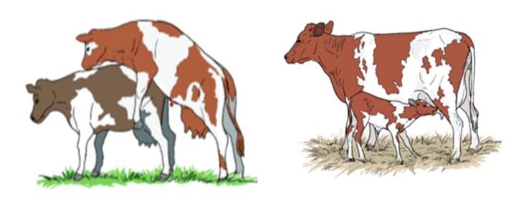
Module Title: - Carrying out Husbandry Practices of
Ruminants
LG Code: AGR ANP2 M02 LO (1-3) LG (6-8)
TTLM Code: AGR ANP2 TTLM 0822v4

September, 2022
Addis Ababa, Ethiopia
Table of Contents
Introduction to the Module2………………………………………………………………………2
LO1-Prepare Husbandary Practices for Ruminant 3
Instruction sheet 1 3
Information Sheet1 4
Self-check 1 28
LO2- Undertake Raising Ruminant Work 29
Instruction sheet 2 29
Information Sheet2 30
Self-Check 2 86
Operation Sheet 2 87
LAP TEST 2 96
LO3- Handle and Clean materials and equipments………………………………………….97
Instruction sheet 3 97
Information Sheet3 98
Self-Check 3 112
Operation Sheet 3 112
LAP TEST 3 113
Reference Books………..……………………………………………………….……..…114

Introduction to the module:
This module covers specifies the knowledge, skill and attitude required to carryout husbandry practice of ruminants that requires prepare husbandry practices for ruminant, undertake raising ruminant work and handle and clean materials and equipment. Ruminant animals are animals that chew and regurgitate their food more than once, and digest it multiple times in different stomachs.
Ruminants have an advantage of the ability to eat and utilize low quality fibrous food that cannot be eaten by human or non-ruminants. For easy production of ruminant or any farm animal certain equipment’s have been designed and are used to facilitate management operation.
Animals are categorized into ruminants and non-ruminants based on some anatomical and physiological differences.
Apart from being a source of meat as other animals, ruminant animals are the main sources of raw materials such as wool, fur, hides and skin, milk and many others for the production of clothing materials, leather materials (such as foot wears like shoes, belt, shawl), milk products like yoghurt, butter, cheese, and many other products. Ruminant animals, especially bull or camel are also used as draught animals for transportation and traction.

LG-6 | LO-1: Prepare Husbandry Practice of Ruminants

Instruction sheet-1
This learning guide is developed to provide you the necessary information regarding the following content coverage and topics:
- Identifying and checking materials, tools and equipment
- Selecting and checking suitable PPE
- Preparing Housing type and facilities
- Using Manual handling techniques
- Providing work tasks required
This guide will also assist you to attain the learning outcomes stated in the cover page. Specifically, upon completion of this learning guide, you will be able to:
- Identify and check materials, tools and equipment
- Select and check suitable PPE
- Prepare type of Housing and facilities
- Use Manual handling techniques
- Provide work tasks required

Learning Instructions
- Read the specific objectives of this Learning Guide.
- Follow the instructions described below and Read the information Sheets
- Accomplish the Self-checks
- Perform Operation Sheets
- Do the “LAP test”

Information sheet-1
  - Identifying and checking materials, tools and equipment
Definition of Common Terminologies:
Animal: is any living thing, other than a human being, that can feel and move.
Production: - the action of manufacturing, growing, extracting etc. of things especially in large quantities. (Oil, egg, energy)
Animal Production: - literally means the action of growing or producing animals and it’s by -products in large quantities, ex.: Animals, eggs, Milk, Beef, and soon. In the comprehensive explanations, the study of livestock farms and farming systems is known as animal production.
Animal husbandry:- a science as well as an art of management including scientific feeding, breeding, housing, and health care, of common domestic animals aiming for maximizing returns.

Introduction about Ruminant Animals
Animal rearing is an age long activity that man carries out basically for food and the production of raw materials for agro-industries. Meat or flesh, milk and eggs are primarily obtained directly from farm animals for consumption by man. Wool, fur, hides and skin are other products from farm animals for industrial use as raw materials.
Animals are categorized into ruminants and non-ruminants based on some anatomical and physiological differences. Apart from being a source of meat as other animals, ruminant animals are the main sources of raw materials such as wool, fur, hides and skin, milk and many others for the production of clothing materials, leather materials (such as foot wears like shoes, belt, shawl), milk products like yoghurt, butter, cheese, and many other products. Ruminant animals, especially bull or camel are also used as draught animals for transportation and traction.
    - The Differences between Ruminant and Non-ruminant Animals
Ruminant animals are animals that chew and regurgitate their food more than once, and digest it multiple times in different stomachs. These animals are quadruped mammals with even toes, hooves and chew the cud. They are herbivores with a complex stomach called a rumen. Some examples of ruminant animals are cattle, sheep, goats, buffalo, deer, elk, giraffes and camels. One of the most significant features of the ruminant digestive system is the presence of a complex stomach with four compartments. They are rumen, reticulum, omasum, and abomasum. The first three compartments, the rumen, reticulum, and omasum break down plant fibers by fermentation with the help of micro-flora. This fermentation results in volatile fatty acids such as acetate, butyrate, and propionate. Hence, this process is called the foregut fermentation. The forth compartment (abomasums) secretes digestive enzymes.
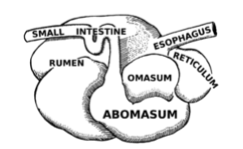
Fig: 1.1.The Four Compartments of Ruminant Stomach

Also, these animals ruminate or completely digest the food by chewing the cud. The four processes of rumination are;
- Regurgitation: Vomiting the cud from the stomach to the mouth
- Re-mastication : Biting and grinding food inside the mouth
- Re-salivation : Secretion and mixing of saliva with the food
- Re-swallow : Taking back the food to the stomach
Non-ruminant animals are omnivores or carnivores with a single stomach compartment within the digestive system.
Hence, the digestive system of the non-ruminant animals is called mono-gastric. Some examples of non-ruminant animals are human, horse, swine, fowl, dog, and rabbit. The components of the non-ruminant digestive system are mouth, esophagus, stomach, small intestine, large intestine, and rectum.
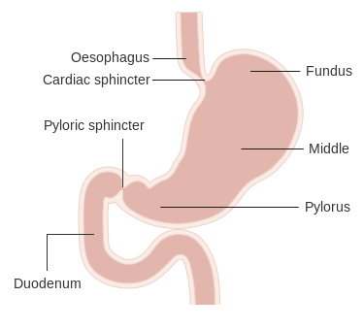
Figure 1.2: Non Ruminant Stomach

Non-ruminant animals do not chew the cud. Also, they do not digest the plant materials such as cellulose through fermentation.

    - Similarity of ruminant and non-ruminant animals

- Ruminant and non-ruminant animals have a complete digestive system
- The digestive system of both consists of a mouth, esophagus, stomach, small intestine, large intestine and a rectum.
- Both eat throughout the day and constantly lose energy

Classes of Ruminant Animals
Ruminant animals are categorized into two main classes based on their body size namely,
- Large ruminant animals: - E.g. Cattle, Buffalo, Camel etc
- Small ruminant animals: - E.g. Sheep and Goat (Shoat)

    - Economic Importance of Keeping Ruminant Animals

Ruminant animals and their products as mentioned in the introduction have tremendous nutritional and economic values to man as stated below:
- Meat and milk of cattle, sheep, goats and other ruminants are good sources of animal protein to man which are of better quality than plant protein.
- They serve as sources of raw materials used in industries e.g. leather goods respectively. Goat hair is also used for making carpets, bag and ropes. Wool is a raw material for the production of clothing for human wear.
- They serve as means of foreign exchange earnings e.g. Hide and skin
- They serve as source of income to subsistence farmers
- These animals are able to survive on fallow lands and others that are not good for arable crop farming thereby maximizing the use of the available land resource
- They are also used as gifts or bride price which serves as family wealth
- They are sources of gainful employment.
- The manure/dung from these animals can be used as a source of organic fertilizer.
- Ruminant animals are slaughtered during festive seasons all over the world. Blood and bones obtained from slaughtering of these animals are often recycled and processed into blood meal, bone meal which are used as components of animal feed
- Cattle, and some other ruminants can also be used as “beast of burden”
Ruminants have an advantage of the ability to eat and utilize low quality fibrous food that cannot be eaten by human or non-ruminants. For easy production of ruminant or any farm animal certain equipment’s have been designed and are used to facilitate management operation. In ruminant animals, this equipment’s appear to be common and work with the same principle. Virtually all of these equipment’s are imported but could also be fabricated locally.

During working any ruminant husbandry management activities the suitable materials, tools and equipment should be identify. These identified materials, tools and equipment should also be checked the functionality and then use properly. After identifying all the required materials know the operation and maintenance system or check the present condition of tools improve / maintain if necessary. Like:-
- Clippers (Shearer):-
is essential for removing wool from sheep quickly, completely, easily and with minimum discomfort to sheep and operator. They can be hand and machine shears. Hand shears are recommended for flocks of 10 or less, hand machine (clippers) for flock of less than 150 and power machine for flocks above that number.
- Weighing scale: -
Special platform scales are required for weighing large animals, sheep and goat, these gives an idea about their condition and wellbeing.
- Castrator: -
Used for removing or destroying testicles, the glands that produce male germ cell. The process is known as castration. There is several method of castration.
- Using knife: -
It is the process of castrating animal by cutting one third of the lower end of the scrotum.
- Electrically
- Using Burdizzo: -
It is an instrument used to destroy the cord leading to the testicles. Here the cord is destroyed, leaving the testicle gradually dry up.
- Dockers
Used for removing tail from the body of the animal. The process is known as Docking. It is mainly applied in the case of sheep with long tail such as Awassi breed for the ease of mating and fattening purpose.

There is several equipment’s used for docking:-
- Using knife:-Should be confined to lambs that are not more than a week or 10 days
Old as older lambs can easily bleed to death.
- Using hot iron:-Is much lower than knife method, but it is much safer as it sterilizes
The wound, sear and prevent bleeding.
- Rubber band method:-Is known as blood less method of docking. Here there is rubber
Band which will be fitted around the tail with the elastrator, then it will prevent circulation and finally the tail will dry off.
- Dip Vat (Tank):-
Is essential to eradicate ecto-parasites (ticks and lice etc) and to remove waste materials and dung from the fleece prior to shearing. Mainly sheep, to some extent cattle, other livestock are rarely dipped. They are usually made of concrete, at the ground level or slightly raised. Can be hand bath method or swim bath.
- Vaccinating gun/Syringe/:-
Important for injecting the animal with vaccine. The process is known as Vaccination. Vaccination stimulates the production of antibodies. Vaccine produces immunity or protection against a given disease. In order to avoid contamination use separate needles /Syringe/for injecting the animal and for dissolving the vaccine. Follow instructions on the package.

    - The following equipment are used in ruminant animal production
Equipment | Advantage | Sample Picture
Weighing scale | This is used to know or measure the weight of the animals, feed and materials | 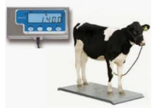
Tractor | Compact tractors are ideal for heavy duty landscaping and tasks such as digging, hauling or plowing in large gardens, fields and pastures. Subcompact tractors have the power and versatility to perform a wide range of horticultural tasks, including mowing, quilting and moving machining gardens. | 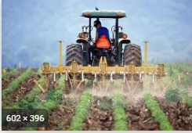
Strip Cup | A strip cup is a very useful tool and a must for all dairy farmers. Milking the first few strips into a strip cup will show if there are any lumps present indicating beginning or advanced mastitis, which should be controlled urgently. | 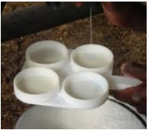
Thermometer | A thermometer is very useful to check body temperature. It is an essential tool for the serious livestock farmer to help her or him in judging animal health. | 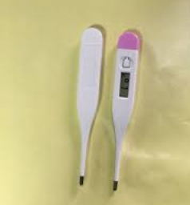
Boling gun | It is used for oral administration of solid drugs. | 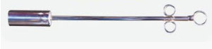
Burdizzo Castrator | This is used to castrate unwanted males on the farm. Castration is the act of making a male animal impotent by open or a surgical removal of its scrotum. | 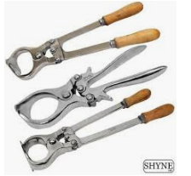
Elastrator | It is a bloodless castrator that use the ring method | 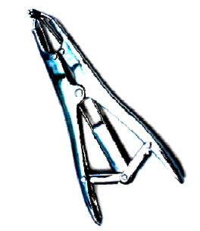
Drenching Gun | This is made of a long tube or rubber hose long enough to enter the mouth of ruminants. It is used for oral administration of liquid drug especially during de-worming exercise | 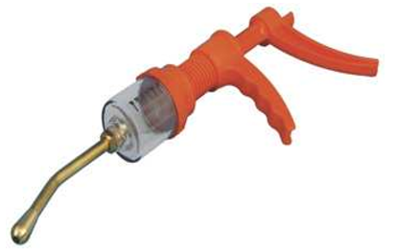
Tattoo pliers | The needles pierce the skin to make clear and readable marks. Black tattoo ink is used for normal use and green tattoo ink for animals with a black or darkly pigmented skin. | 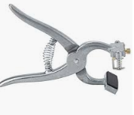
Hooves Trimmer | Used to trim or remove animal hooves. | 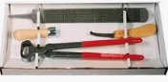
Dehorning saw | Used to cut the horn of animal | 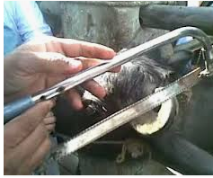
Dehorning wire | Used to cut the horn of animal | 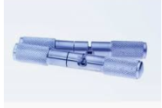
Crush | Used to restrain animal | 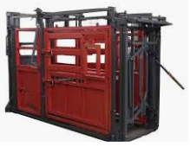
Hammer | A hammer is a simple tool designed to manually drive nails, brads, and other fasteners into softer materials, such as wood or drywall. A hammer has a head and a handle, or shaft. | 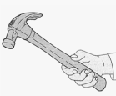
Ear tags | Ear tag is a plastic or metal object used for identification of domestic livestock and other animals. Flexible plastic tags are probably the most widely used for animal identification, as they are readable from a distance. | 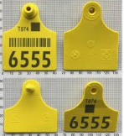
Ear tag applicator | Used for fixing ear tag to the ear of the animal for identification. | 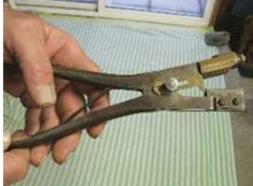
Bull holder/ nose lead | The cattle nose lead cow ring holder is a bull head fixation device. It can be used to spread the attention of cattle by simply clamping it on both sides of the nasal septum. | 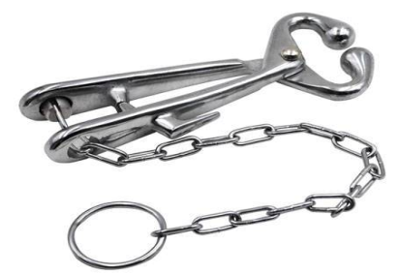
Branding iron | A branding iron is used for branding, pressing a heated metal shape against an object or livestock with the intention of leaving an identifying mark. | 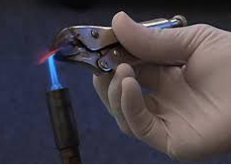
Shovel | A shovel is a tool for digging, lifting, and moving bulk materials, such as soil, coal, gravel, snow, sand, or ore. Most shovels are hand tools consisting of a broad blade fixed to a medium-length handle. Shovel blades are usually made of sheet steel or hard plastics and are very strong. | 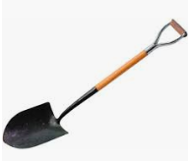
Wheel barrow | A wheelbarrow is a small hand-propelled vehicle, usually with just one wheel, designed to distribute the weight of its load between the wheel and the operator, so enabling the convenient carriage of heavier and bulkier loads than would be possible were the weight carried entirely by the operator. | 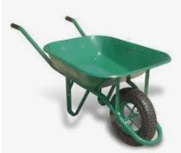
Mineral boxes | Used to store minerals | 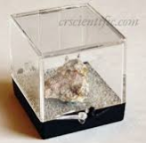
Waterier | Is a man-made or natural receptacle intended to provide drinking water to animals, livestock on farms or ranches or wild animals | 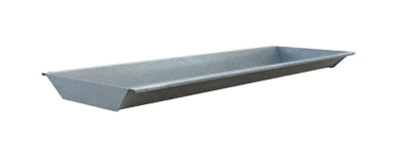
Feeding trough | Is a man-made intended to provide feed for animals | 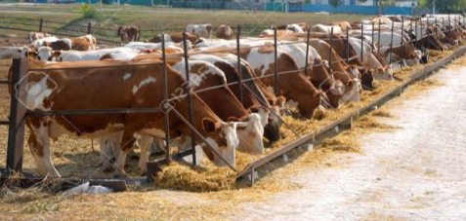
Milking pails/can | Used as storage or continuer of milk. | 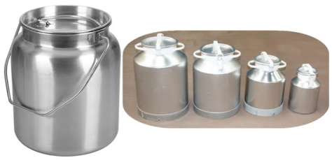
Fork | Used to collect waste | 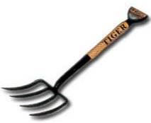
Nipple Feeders | For feeding young cattle with milk replacers | 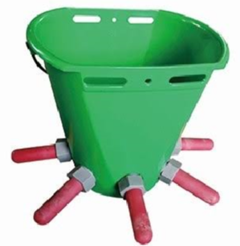
Spade | Used to digging and loosing soil | 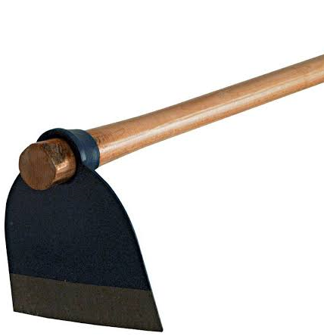
Automatic Syringes | Used to provide vaccine drugs for large numbers of animas. | 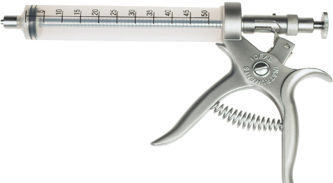

  - Selecting and checking suitable PPE
The Occupational Safety and Health Administration (OSHA) estimates that, every day, 243 agricultural workers suffer a serious lost-work time injury. Five percent of these injuries result in permanent impairment. Many farm and ranch injuries could be prevented or their impacts reduced if farmers and ranchers wore proper personal protective equipment (PPE).
    - Personal protective equipment (PPE)
Refers to any specialized equipment or clothing worn by farmers and ranchers for protection against health and safety hazards. PPE does not prevent accidents, but it does prevent or reduce injury and even fatalities when used. PPE is designed to protect many parts of the body; eyes, head, face, hands, feet, ears, or torso. Some examples of PPE used in husbandry of ruminant animal are Overalls, Gown, Gloves, Safety goggles, Plastic boots/shoes, Sunhats/helmets, Nose protector/respirator etc.

To provide adequate protection, the protective clothing and equipment must always be:
  - appropriate for the particular hazards
  - maintained in good condition
  - properly stored when not in use, to prevent damage or loss
  - Kept clean, fully functional, and sanitary.

Basic Types of PPE
The strict controls will not necessarily eliminate all the risks associated with most job tasks and this is where the need for PPE must be evaluated. A hazard assessment can help identify which specialized PPE will be required. However, the following basic types of PPE should be made available in worksite.
- Eye and face protection
To provide protection during exposure to hazards like flying particles, metal or sparks, liquid chemicals, caustic liquids, light radiation, i.e., welding, lasers. Eye protection should always be worn where there is potential for injury to the eyes or face from small particles, toxic chemicals, flying particles, large objects, thermal or radiation hazards, and lasers. According to the types and extent of hazards, different PPE should be worn. These must always remain clean and free of contaminates. Goggles offer good protection against front and side impact. Unvented or indirect vented chemical splash goggles provide protection from chemical vapors and liquids.
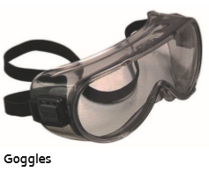
Figer 1.4: Goggle

- Hearing protection:
To provide protection during exposure to high pitch and loud noise levels. Exposure to high levels of noise may result in hearing loss. PPE should be worn when the noise level is 85 decibels or greater averaged over an eight-hour period. Most hearing protection devices have a noise reduction rating (NRR) that indicates the amount of protection provided. In general, look for NRR of 25 or greater.
- Head protection
To provide protection to potential hazards such as falling objects, striking against low-hanging objects, electrical hazards, or chemical application.
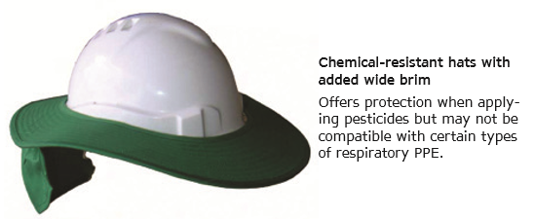
Figer 1.5. Helmets
- Hand protection:
To provide protection during exposure to potential hazards such as sharp objects, abrasive surfaces, temperature extremes, and chemical contact. Selecting proper gloves is very important since the hands are used to handle hazardous materials. In addition, traumatic injuries such as cuts, sprains, and punctures may occur. With the wide range of hazards, there are also a wide range of gloves that may be used as PPE. Chemical-resistant gloves are always recommended when working with pesticides and chemicals. Chemical-resistant aprons add protection from body absorption of hazardous chemicals.
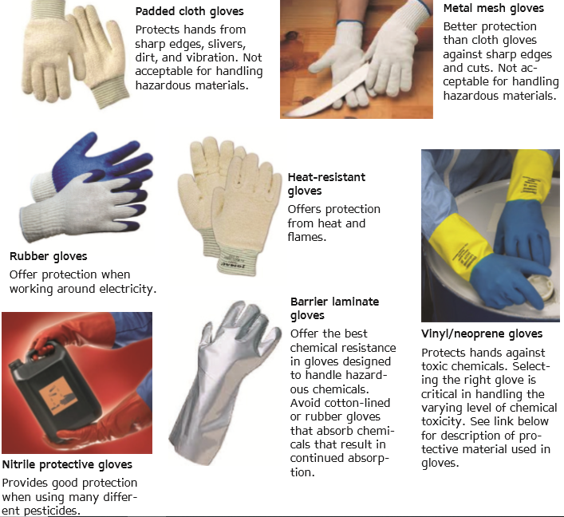
Figer 1.6. Gloves

- Respiratory Protection
Respirators are used to prevent the exposure to air contaminated with Harmful dusts, fumes, mists, gases, smokes, sprays, or vapors. All respirator usage, including disposable respirators, air purifying respirators, and air-supplied respirators, require annual fit testing and testing and training prior to use.
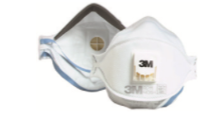
Figer 1.7. Air Purifying
- Foot protection
To provide protection for situations with the potential of injuries such as falling or rolling objects, chemical or liquid exposures, piercing objects, and where feet are exposed to electrical hazards.
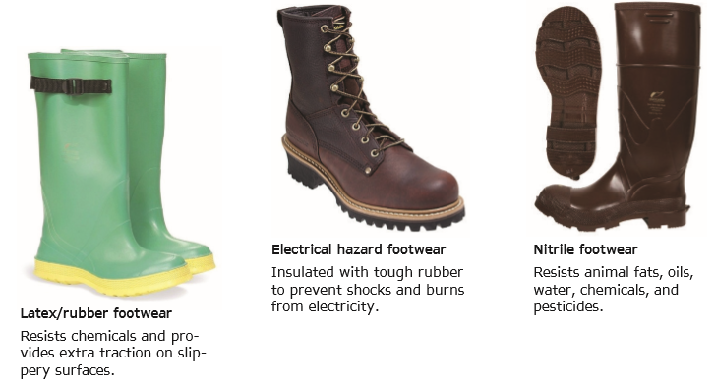
Figer. 1.8. Boots

- Body Protection
PPE includes safety vests and suits and should be used for tasks that can cause body injuries from extreme temperatures, flames and sparks, toxic chemicals, insect bites and radiation. Ensure that they are clean and free from cuts and burns. Always get a good fit to ensure full body protection.

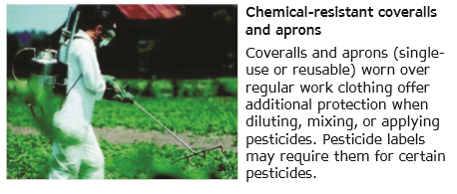
Figer 1.9.over all

  - Preparing types of housing and facilities
Housing is an integral part of management; hence it is of great importance in ruminant animal production. Housing must be well planned with adequate ventilation and sanitation facilities to enhance production of animals. However the housing type depends on the system of production. The basic requirement of good animal housing is that it should alter or modify the environment for the benefit of animals and also protect them from predation and theft.
Animal housing should buffer the animal from climate extremes to reduce stress allowing optimal animal performance in terms of growth, health and reproduction. The main climatic factors from which protection is needed are high and low ambient temperatures, environmental humidity, solar radiation, wind and rain. Additionally, houses are important in protecting feed and equipment from damage, in saving labor, and in aiding effective management, including breeding. Sheep and goat housing should meet animal requirements and serve a producer’s needs at the lowest possible cost.
    - Housing Requirement for Cattle Production
To start a cattle production venture, adequate consideration must be given to how the animals will be housed for better management in a better environment and to prevent theft.
The following points must be considered while designing a house for cattle:
- The building must be sited on a well-drained and not undulating floor,
- There must be proper and adequate ventilation and illumination in the building,
- There must be no draught or condensation in the building,
- The building must have well positioned feeders and drinkers
- The building must be easily accessible,
- The surrounding must not be bushy to prevent predators and disease vectors.

    - Housing for Intensive System of Cattle Production
Generally, cattle are housed in a well shaded open-sided structure called barns or cattle shed. This type of housing is common in the intensive type of production. The size of the barn depends on the number of cattle expected to be housed. An average of 2 to 3 m2 is allowed per adult cattle. The house must be well equipped with feeders and water troughs with adequate space for farm operations to take place.
The floor of the barn is always concrete with rough surface to prevent skidding or falling of the cattle. The construction of the house is such that it has feeding passage with well fitted mangers around the standing area. Drains must be constructed for easy washing, cleaning and evacuation of dung and other waste materials. Individual pens are also used in this system of production especially for calves, breeding bulls and nursing cows.
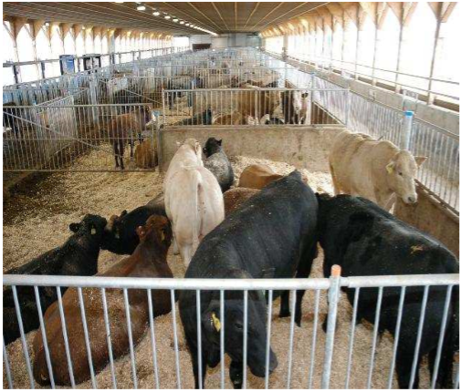
Fig. 1.10. Cattle Barn

    - Housing for Extensive System of Cattle Production
There is no standard for the housing type for this system of production. One of them is cattle kraal (Fig. 4) which is an enclosure in an open field or land where the animals are tethered (or tied to pegs already installed). The walls of the kraal could be made of planks or wood, bamboo, mud blocks or stones. The animals are always housed here after the day’s grazing.
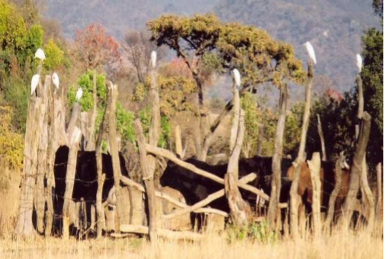
Fig.1.3.3.1: Cattle Kraal

    - Housing and Housing Requirements for Sheep and Goat Production
In your previous study, the housing need for ruminant or any farm animal was established as one, for better management in a good environment and two, for safe keeping of the animals and other assets. The same principle of housing applies to sheep and goat production. However in the tropics, especially in Nigeria and other Sub-Saharan region, housing for sheep and goats is not given prominence as in the temperate region or as even done for cattle. The main consideration for housing for sheep and goat in this part of the world is to provide sufficient protection from unfavorable weather. The essential consideration is that the environment must be cool, dry and free from draught with access to pasture or outside all the time. Small ruminant housing need to:
- Be strong enough to last a long time;
- Be large enough for the number of animals to be accommodated comfortably.
- Allow freedom of movement for all animals;
- Be well-drained or have well-maintained dry bedding and easy to clean. Sheep and goats do not tolerate mud well; therefore, yards and shelters should be built only on well-drained ground;
- Receive morning sunshine evenly;
- Be well lighted and ventilated. Air circulation, dust levels, temperature, relative air humidity and gas concentrations should be at levels that will not harm animals;

    - Traditional methods of housing
Traditional sheep and goat housing is made of varying designs and construction materials depending upon local custom and availability. Some main types of housing include:
- Housing at one corner of the main family house;
- An overhang attached to the roof of a house;
- Open yards with no roof (Figure 1);
- In a basement under the family home such as seen in north Shoa
- Separate houses of thatched roofs (Figure 5).
- Lambs and kids are, in some areas, kept in a dome made of bamboo or other locally available material (Figure 5).
This prevents the young from straying or mixing with the flock, except during suckling. The dome is usually kept outdoors during the day if there is no rain.
    - Intensive/Semi-intensive System of Housing
In this type of housing, the entire house is well roofed with windows to protect the animals during the winter season in the temperate region. In summer they have access to pasture. This type of production require a lot of sophistications in the housing construction and very expensive. It is often associated with high level of production in terms of meat, wool or fleece. Such housing is not profitable in this part of the world. Some government farms or rich individuals do construct a good but simple housing for sheep and goat in Nigeria for semi-intensive production.
Hay racks are provided in some for feeding the animals when they are turned in from the pasture at the end of the day. The roof of the house should not be too high to prevent been blown off by wind nor too short to prevent proper illumination and draught. It is often made of asbestos material or corrugated iron sheet. If the latter is used, the wall must not be too high to allow illumination and ventilation. It could also be made of wood, mud or blocks depending on availability of fund.
The floor must be sloppy for proper drainage and could be made of concrete or rammed. The slats could be of bamboo or wood. What is used is a function of the availability of fund. The house could be divided into pens with drinkers and feeders for concentrate feeding.
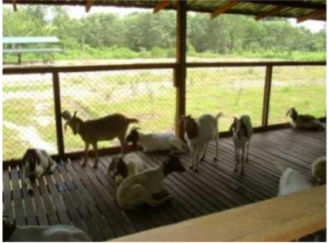
Fig. 1.11. Goat Shed with Slatted Floor
Space requirement: In any type of housing for sheep and goats, adequate floor space must be provided. Recommended space requirements vary depending on animal size and the type of floor used (Table 1). Adjustments may also be made depending on local climate and flock size. Additionally for animals managed totally indoors, an open yard for exercising is required. Sheep and goats should not be crowded and must have room to lie down. Overcrowding promotes ill health.
Table1.3.6.1. Recommended floor space for sheep and goats
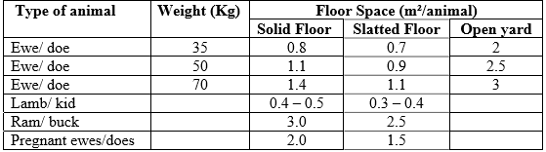
  - Using manual handling techniques of materials
Manual handling is any task that requires you to push, pull, lift, carry, move, hold or lower any object, person or animal. Manual tasks include tasks that have repetitive actions, sustained postures and may involve exposure to vibration.
Manual handling results in 20% of all workers compensation claims at UNSW. The types of injuries related to manual handling include:-
- Muscle injuries
- Nerve injuries
- Bone injuries
- Injuries to the ligaments or tendons
- Injuries from falling objects

    - Manual handling aids

Manual handling aids reduce the physical effort needed to lift and move objects, making it safer.
When providing manual handling aids for the workplace it is important to ensure that:-
- The right equipment is selected for the task
- That all staff are trained in the correct use of the equipment
- The equipment is visually inspected for defects before use
- The wheels are suitable for the floor surface
- The wheels move freely
- The handle grips are comfortable and are in good order
- The handle height is between the waist and shoulder
- If they have brakes do they work?
- The aids are regularly inspected and maintained to ensure it is good working order
- He load secured before moving
Using correct manual handling techniques during loading and unloading materials helps to minimize damage of:-
- Workers
- Other persons
- Materials and
- Vehicles

  - Providing work tasks required
Occupational health and safety (OHS), also commonly referred to as occupational health, or workplace health and safety (WHS), is a multidisciplinary field concerned with the safety, health, and welfare of people at work. The goals of occupational health and safety programs include to foster a safe and healthy work environment. It may also protect co-workers, family members, employers, customers, and many others who might be affected by the workplace environment. In the United States, the term occupational health and safety is referred to as occupational health and occupational and non-occupational safety and includes safety for activities outside of work. Agriculture workers are often at risk of work-related injuries, lung disease, noise-induced hearing loss, skin disease, as well as certain cancers related to chemical use or prolonged sun exposure. On industrialized farms, injuries frequently involve the use of agricultural machinery.
The most common cause of fatal agricultural injuries in the United States and other developed countries is tractor rollovers, which can be prevented by the use of roll over protection structures which limit the risk of injury in case a tractor rolls over. Pesticides and other chemicals used in farming can also be hazardous to worker health, and workers exposed to pesticides may experience illnesses or birth defects.

    - OHS requirements
During performing any agricultural or animal husbandry related works, workers should be fulfilling the following OHS requirements:
- Using of relevant protective clothing and equipment,
- Use of tooling and equipment,
- Workplace environment and safety handling of material, First aid kit
- Hazard control and hazardous materials and substances.
- Using gowns, rubber boots of appropriate size, goggles, gloves etc,
- Following OHS procedure designated for the task
- Checking and fulfilling required safety devices before starting operation
Apply safe operating procedures regarding to; Electrical safety, Machinery movement and operation, and Working in proximity to others and site visitors.
Apply emergency procedures on:
- Emergency shutdown and stopping of equipment,
- First aid application and site evacuation. Electrical safety,
- Machinery movement and operation,
- Working in proximity to others and site visitors.

Self-check-1

Name…………………………………………… ID………………………… Date…….
Directions: Answer all the questions listed below.
- Why you use different materials, tools and equipment in animal production? (2pts)
- If you are ordered to perform animal identification write the materials that you use? (3pts)
- What do you do before using materials, tools and equipments? (2pts)
- What is the advantage of house for the animal?
- Discus the ideal site for housing?
- What is manual handling? (2pts)
- Write the types of injuries related to manual handling (3pts)
- Why agricultural works have more injury? (2pts)
- Write the advantages of PPE? (2pts)
- Discus about the type of PPE with examples? (3pts)
- What is OHS? (2pts)
- Discus about OHS requirements in work place? (2pts)
- What will happen if the worker doesn’t follow OHS requirements and supervisor instructions? (3pts)

LG-7 | LO-2: Undertake Raising Ruminant Work

Instruction sheet-2
This learning guide is developed to provide you the necessary information regarding the following content coverage and topics:
- Providing instructions and directions
- Undertaking husbandry practices
- Observing enterprise policies and procedures
This guide will also assist you to attain the learning outcomes stated in the cover page. Specifically, upon completion of this learning guide, you will be able to:
- Provide instructions and directions
- Undertake husbandry practices
- Observe enterprise policies and procedures

Learning Instructions 2
- Read the specific objectives of this Learning Guide.
- Follow the instructions described below.
- Read the information written in the information Sheets
- Accomplish the Self-checks
- Perform Operation Sheets
- Do the “LAP test”

Information sheet-2

- Providing instructions and directions
Any employee who works in industry which raises ruminant or any farmer who raise his own stock must follow the following instruction and direction:-
- Enterprise policies and procedures
- Manufacturer instructions
- Material Safety Data Sheets (MSDS)
- OHS standards and procedures
- Specifications for tools, equipment and materials
- Standard Operating Procedures (SOP)
- Verbal directions from manager or supervisor
- Work instructions and standards
- Work notes.
While, instructions are defined as:
- The act or practice of instructing or teaching; education.
- Knowledge or information imparted.
- An item of such knowledge or information.
- Usually, instructions, orders or directions: The instructions are on the back of the box.
- The act of furnishing with authoritative directions.
- Computers. A command given to a computer to carry out a particular operation.
Both, directions and instruction act as guidelines. They often appear as a series of steps or stages one must complete one after the other. However, they do differ in some manners. The main difference between the two is the fact that instructions are mainly associated with instruction or teaching. Hence, instructions are given to teach somebody something.
For example: instructions for milking, instructions for honey harvesting , instructions for castration, instructions for completing a project, instructions for writing a report, etc. Directions, on the other hand, are in the form of guidelines. They are mainly utilized while guiding somebody into a particular direction. Directions are mainly associated with driving directions, which aim to get somebody from point A to point B. However, they can be associated with anything that may lead somebody somewhere, especially in a particular direction. For example: Directions for setting up a federal program at a state level, directions for a successful career, a director directs players on stage, the managing director directs the company onto a good position in the market, the company is headed in a good direction, a musician directs the orchestra, etc.
- Undertaking husbandry practices for ruminants

2.2.1. Applying ruminants Restraining techniques
In order to successfully manage animals, especially when that management requires direct contact, it is necessary to understand the responses of animals to frightening or disturbing situations. Animals will often have difficulties in coping with contact from humans and their responses will frequently be similar to a dangerous predator. Previous experience of a situation therefore plays an extremely important role in determining what the effect of human contact on an animal will be, and, as already demonstrated on laboratory, companion and farm animals, an animal will be substantially easier to restrain if it has previously been treated well and handled carefully.
2.2.2. Restraining:
Is the restriction of an animal’s activity by verbal, physical and chemical means so that the animal is prevented from injuring itself or others. Animals are restrained and handled by humans for many reasons, including for medicinal administrations and treatments, examinations, health checks, grooming, castration, hove trimming, docking, bathing etc.
The main objective of restraint is to handle an animal in such a way that a procedure can be done without injuring the animal and without causing any injury to the humans involved in the procedure. Some animals are aggressive while some others are docile or calm when trying to be handled them. Proper follow up of procedures in approaching and handling animals would enable one to avoid unnecessary danger.
When approaching the animal, follow the instructions below.
- Approach it as gently as possible.
- Try to not have a stick in hand as it causes fear and excitement
- You may use a stick with extremely nervous animals.
- Approach it from the rear side at an angle of approximately 450.
- Approaching should be accompanied by a gentle pat on the back of the cattle while at the same time talking to the animal.
- Be confident while at the same time firm and careful with the animal
After approaching the animal, you have to restrain it strongly to perform any thing /operation on its body correctly and safely.
Importance/ purpose/of restraining
Restraining is performed for:
- The safety of the animal
- The safety of the operator
- For fast and accurate performing of certain painful operations and other minor operations.
- Labor saving

2.2.3. There are three types of restraining:-

1. Moral /Psychological / verbal restraining: -
Is the least restrictive type of restraint and would be used in combination with other types of restraint. It is the simplest type of restraining and involves talking to the animal. Sometimes it might need to talk to the animals to perform certain activities. In fact, it requires some training of the animal.

2. Chemical restraining-
Chemical restraint can be extremely useful as an aid to diagnostic or minor surgical procedures or in the control of animals which have a potentially dangerous temperament. Selection of appropriate combinations and doses of drugs to provide ideal restraint for the spectrum of patients and procedures encountered in clinical practice requires experience of a wide range of agents and their effects in different circumstances. A suitable combination for a particular individual may be completely ineffective in another animal of similar breed and size, but different temperament, undergoing the same procedure. The administration of chemical restraint is therefore a much more difficult skill to acquire than that of general anaesthesia. By the same token it can be one of the more satisfying areas of veterinary anaesthesia.

- Physical restraining:
Is the primary method of restraining an animal and involves using the handler’s hands or body along with muzzles, ropes, crush, chute or other equipment. It is commonly used type of restraining for some daily routine activities.
The type of restraining to be used on the animal varies according to:
- Species of animals such as sheep, goat, horse, cattle etc.
- Age of the animal. E.g. Cow and calf
- Sex of the animal. E.g. Cow and Ox /Bull
- Breed - e.g. Holstein cows are docile while zebus are wild
- Individual character of the animal
Physical Restraining Operation can be classified into two:
  - Mass operations:
Vaccination, separating animals, spraying and others activities could be performed by mass. Such operation can be carried with the help of crush. If individually done, it would be time consuming and very difficult.
  - Individual operations:
Diagnosis and treatment of sick animals, P.D test, hoof trimming, castration, dehorning, branding and others are carried with the help of chute by restraining the individual animal. Where chute is not available different techniques of restraining can be applied. Some of the techniques would be mentioned below.
Haltering: is the first and most important physical restraining method. Haltering animals is of practical importance in handling and guiding an animal to the place where we want to take it.
Method to make halter: Follow the procedures listed below to make temporary halters.
- Take 2m length rope
- Make a small loop at one end
- Make another loop at a distance of 15-20 cm
- Pass the standing part of the rope through the first loop.
- Again pass the standing part through the second loop.
- Place the noseband on the bridge of the nose and pass the headstall over the poll and place behind the ears.
- Then tighten the loops and halter.
Note. When haltering an animal, the proper position is that the headstall should be behind the ears with the lead shank pulling the nose lead tightened from under the jaw.

Restraint That Divert Attention:-
- Ear twitch:
This method can be applied by hand or with the aid of a rope. The squeezing of the ear causes pain and the animal diverts its attention to its ear only. Therefore, other operation can be carried on other parts of the animal body.
- Nose lead .
The animal can be restrained by grasping its nasal septum with the use of material called Nose lead. As a result it causes pain around its nose. This also can be done by using our fingers. Therefore, other operation can be carried on other parts of the animal body.
- Tail restraint:
This method is accomplished by grasping the tail at its base with one or both hand and bending the tail to the back to cause pain. Then the animal will be forced to divert it attention around its tail. Therefore, other operation can be carried on other parts of the animal body.
Calf Restraining:
For every young calves the following methods can-be applied.
A- Put the calf between your knees
B- Put the thumb inside the mouth in the open space b/n the incisor and the premolar. Be very careful not to put your fingers between the teeth of the animal.
2.2.4. Casting ; It means placing the animal on the ground.
Time of Casting:
All animals that are to be casted should be fasted at least for 12 hours. If the animal is not fasted, there is a possibility that the intestine would burst when the animal hits or dash the ground hardly. It is advisable not to cast a lactating cow unless it is extremely necessary. When it is necessary, lactating cows should be casted after milking not before milking. Casting the cow before milking would excite the animal and causes decrease in milk production. In casting an animal it is usually good to do it in the morning.
- Reuff Method: -
When casting the animal using this method. The loop on the neck should be tied with a bowline or the non-slip knot. The rope is then passed around the heart girth, passed back and looped around the animal just anterior to the hipbones. A steady pull of the free end will cause the animal to collapse slowly.
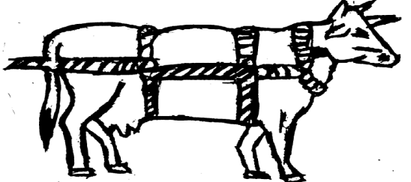
Fig2.1.A. Reuff method of casting

- Cris-cross method of casting:
In this method, the middle of the rope is placed over the neck and the ends passed between the front legs. They cross under the brisket and are then passed upward and crossed over the back and then down wards past the flank and between the hind legs. Traction on the free ends will cause the animal to collapse. The ropes must cross under the briskest (Not on the throat) or the animal will not go down.
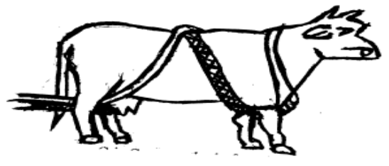

Fig2.2. B. Cris-Cross method of casting
Casting Calves
Calves can also be cast using a rope but this is a rather slow and inefficient method for handling small- animal since they can be easily cast by hand without rope.
To Cast a calf:
- Stand close by the side of the calf with your face to the side of the calf and try to reach the inner two legs of the calf i.e. the front leg and hind leg close to you.
- Bend over the back of the calf and try to reach the legs mentioned and hold firmly.
- Pull the leg out ward while at the same time supporting the calf with your knee.
- Place the calf on the ground.
- Place one of your knee on the shoulder and the other knee on the hindquarter and press firmly so that the calf will not arise. Never get loose.
- If tie is required, take 2 meters long rope; fold the rope into two equal parts. A loop is formed at the center of the rope.
- Place the center of the rope between the hind legs. The two ends of the rope are brought on the outside of the two legs and passed through loop. One on the outside of each leg, the end is again passed through the front leg and tied around the neck of the calf.
2.2.5. Restrain using cattle crush
A cattle crush or squeeze chute is a strongly built stall for holding cattle safely. It is used to enable easy access for examination of different size animals. Crushes are used to minimize the risk of injury. There are different types of cattle crushes with different features. Typical features of the cattle crush include: push – pull lever, dual locking system, side gates (with slam gate latches), needle gates, inspection gates, bottom gate, and walk through vet compartment.
To restrain cattle in a cattle crush, you have to:
- Direct cattle into the open crush. Use the principles of the flight zone. Two people might be needed, one who makes the cow move and one who is ready to close the crush. But don't have too many people around the crush, as it might make the cow nervous.
- Close the dual head gate on the cow’s neck in front of the shoulders. This is done by moving the lever on the side of the crush down.
- Close the rear sliding gate for optimal animal control. By using your foot to manoeuvre the gate you avoid being in reach of the cattle, should it kick in defense.
- Operate the side squeeze in order to position the cattle squeezing the animal in the crush actually calms it down and does not hurt it.
- A head holder can be applied for better control.
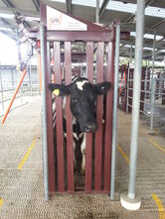
Fig2.3. Cattle restrained in the crush. The head will be outside the gate.

2.2.6. Providing feed and water
In order to get the most out of livestock you must always give animals enough good feed and clean water. Good feed is high in nutrients and provides everything that the body needs in order for the animal to grow and reproduce.
Ruminants have the ability to consume and digest coarse, fibrous feedstuffs that form the major feed base in Ethiopia. The digestive tract of ruminants is unique in structure and function, allowing them to digest the fibrous feeds they consume.
The following are some of the unique features of the ruminant digestive tract compared to monogastric animals (animals with a simple stomach such as swine, dogs, cats, human, etc.):
- Ability to digest carbohydrate sources not digested by monogastric.
- Ability to use sources of non-protein nitrogen (NPN) to satisfy part of their protein needs.
- Large stomach volume to accommodate and utilize bulky feeds.
- Mouth and teeth well adapted for prehension and grinding of fibrous feeds.
- Well-developed salivary glands for production of large volumes of saliva.

What an animal needs in its feed?
- All animals and humans need the nutrients called carbohydrates, proteins, fats, vitamins and minerals in their feed in order to stay healthy, have energy, grow and reproduce.
- Carbohydrates such as sugar and starch are burned in the body to give energy. Fats are broken down in the body to give carbohydrates and water. Animals and humans store carbohydrates as fat in the body.
- Protein forms the building blocks of the body. It is needed to produce the muscles.
- Minerals such as copper and calcium are needed to form the bones, brain, nerves and blood. Plants take in minerals from the soil (A silo is a structure or container used to store silage).
- Vitamins are essential for a healthy body and all plants contain several vitamins. Lack of essential vitamins can cause problems such as blindness and swollen joints.
- If animals do not get enough of any nutrient they will become less productive and may die from a condition called a deficiency disease.
- If an animal does not get enough fat, protein or carbohydrate in its feed it cannot grow properly, loses weight, milk production drops and production of young is affected.
- Lack of minerals results in such problems as failing to come into heat, poor bone growth and loss of hair or wool.
2.2.6.1. Types of feed
A good, rich feed contains more energy than a poor feed and a cow gets as much energy from 1 kg of sorghum, barley or corn as it does from 6 kg of grass. Some feeds are very poor and of little use to the animal. For example, old straw contains little energy, most of it cannot be digested and passes out of the animal as dung.
- Roughage is bulky and low in energy-giving carbohydrates. Examples of such feeds are grasses, maize stalks and sweet potato tops.
- Concentrates are feeds which are rich in proteins and carbohydrates, e.g. grain crops. The large stomach of the ruminant with its four compartments means that it can live mainly on roughage. Animals with single stomachs need more concentrates than ruminants.
- Rations ; A daily ration is the amount of feed an animal needs every day. A good ration will contain all of the nutrients. Some nutrients are found in large amounts in some plants:
Nutrient | Plants
Carbohydrate | maize, sorghum, wheat, oats, rice, grass
Protein | Lucerne (alfalfa), clovers, beans, grass
Fats | cotton seed, sunflower seeds, grass, groundnuts
An example of a good ration which can be given to animals not on pasture is 3 parts of maize, part sunflowers and 1 part unshelled groundnuts. The ration is fed at the rate of 2 - 3% of body weight each day. Green growing grass contains all the nutrients but in the dry season grass contains little protein and vitamins. It is necessary to give additional feeds at this time in order to prevent weight loss, maintain high milk production, growth and reproduction. It may also become necessary to give minerals to the animal.
2.2.6.2. Feed for the dry season
In the dry season grass becomes scarce and is low in nutrients. When grass is plentiful in the wet growing season you can cut grass, and store it until it is needed in the dry season. The grass can be kept as hay or silage.
- Hay is dried grasses. The best hay is prepared from young grasses. Cut the grass and leave it to dry in the sun for several days turning it over to make sure it is completely dry when it can be stored until needed. Do not try to make hay in the rainy season.
- Silage is grass or other plants which are cut while green and stored without air.
- Fodder trees
In some communities’ people traditionally cut tree branches to feed their animals. We now know that some trees are better than others for feed.
The best trees are leguminous trees (Leucaena).The leaves and branches of the trees can be cut through the year and used as animal feed.
Using these trees for feed is beneficial because:
- The leaves of the trees provide good feed for animals all through the year.
- The rotting leaves provide mineral rich mulch (natural fertilizer) for other crops.
- The trees provide fuel wood, timber and shelter from the wind.
- The trees stop soil erosion and improve the fertility of the soil. To know more, ask your agriculture officer or veterinarian about using fodder trees.

- Supplementary feeds
Supplementary feeds are given when the grass is poor and dry or when an animal is pregnant, giving milk or is a working animal. The best supplementary feed is cake. The cheapest of which is the waste material from the processing of coconuts, groundnuts, cottonseed and palm oil. You can use whatever is available locally.
- Water
Animals need plenty of fresh clean water every day. Always give water before feeding animals and allow them to drink at least three times a day. Ruminants on pastures can be watered every 2 - 3 days. Do not allow animals to stand in the water at the drinking place. This can cause disease to spread. Water needs will vary according to the feed they eat and the weather. A pinch of salt can be added to the drinking water to provide minerals.
- Points to remember
Take care not to spread disease through feed and water. Keep water and feed troughs clean and do not allow animals to eat old or musty feed. Change feeds slowly. Take special care when introducing fresh green feed so that bloat is avoided.

Several methods of feeding animals have been developed such as the following:
- Feeding urea-treated straw: Straw is a low nutrient feed for ruminants but if it is wetted with urea and covered for a week it becomes more nutritious.
- Molasses-urea-mineral blocks: Blocks made of molasses, mineral salts and urea are a good supplement for ruminants which lick the block and take in the nutrients.
2.2.7. Preventing and treating of bloating problems
Bloat is a form of indigestion marked by excessive accumulation of gas in the rumen. Immediately after cattle consume a meal, the digestive process creates gases in the rumen. Most of the gases are eliminated by eructation (belching). Any interruption of this normal gas elimination results in gas accumulation or bloat.
Bloat can be caused by:
- A condition secondary to acidosis indigestion
- Certain proteins in forage
- The amount, rate of intake, and coarseness of the roughage
- Rate of digestion of grains as a result of processing (grinding too fine)
- Host-parasite reaction following grub treatment choking
- Enlargement of the lymph nodes between the lungs, which can compress the esophagus or interfere with the function of the vagus nerve
Signs of Bloat
- Animal stops grazing and is reluctant to walk
- The left side of abdomen is distended
- The animal strains to urinate and defecate
- Rapid breathing — mouth may be open with tongue protruding
- Staggering
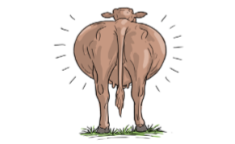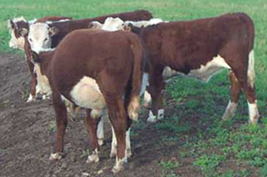
Fig.2.4: Staggering; a sign of bloat in a cow Figure 6. Bloated calf, viewing the calf from the rear, left side distended indicating bloat

2.2.8. Prevention of Bloat
- Pasture management:
Legumes should be introduced into the diet gradually over several days. Avoid cows gorging on new pastures by feeding them on other feeds before letting them out to graze. Silage, hay or more mature pasture can be used to reduce the cow's appetite. Initially, cows should only be allowed access to the pasture for short periods (one hour or so) and monitored closely during grazing and immediately after removal. Cutting and wilting the pasture for 2 - 3 hours prior to feeding reduces the risk of bloat.
- Preventative medication:
- Detergents and anti-foaming agents can be drenched prior to grazing.
- Treatment:
A sharp knife can be used to puncture the rumen on the left side of the animal (at the farm level as an emergency). Puncturing the rumen with the standard trocar and cannula is a quickest way to release the gas which cannot be expelled with a stomach tube. The trocar is used to puncture while the cannula is left in place to release the gas.
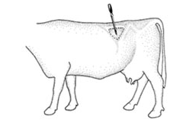
Fig2.5. Insertion point for needle or trocar fitted with a cannula.

Dotted triangle is the left paralumbar fossa where “hollow “of the flank is found
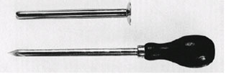
Fig2.6. Trocar (bottom) and cannula

2.2.9. Mating animals
- Heat detection
Estrus or “heat” is a period during the reproductive cycle when female animals become sexually receptive, signaling they are ready for mating. In most cases, this can also be referred to as “standing heat” because the female will stand to be mated by the male.
Heat detection is an extremely important exercise as a missed heat translates into a wasted 21 days while efficient heat detection makes it possible to serve the animal at the right time. The average heat interval is 21 days with a range of 18 to 24 days. Duration of heat is 24 to 36 hours in exotic and crossbred cows.

Signs of heat in ruminants
Heat or oestrus is the period when the female will accept the male and mate. There are signs which mark oestrus in all ruminants. Recognizing when the female is on heat means you will know when to put her with the male or use artificial insemination. The best time to look for signs that the female is in heat is early morning or in the evening. Take care not to disturb the animals but just watch the animals for the signs. Ruminants can be kept on pasture or they may be stabled or tied up for most of the time. It is therefore necessary to consider this when looking for signs of heat:

- Signs of Heat in Free Animals (At Pasture):
- Most females in heat will allow other animals to mount them.
- Cows in heat will mount one another, from the rear or from the front. However, the cow on top may not be on heat.
- The vulva becomes swollen and the area around the tail becomes wet and dirty.
- If cows sniff each other’s' vulva and urine they may both come into heat.
- Cows can be coming into heat if they stand resting the chin on the back of another or are seen to lick or gently butt each other.
- Restlessness and calling loudly can also mean the female is coming into heat. Goats in particular become very noisy.

- Signs of Heat in the stabled or tied animal:
The animals should be allowed out twice a day when they can be watched for signs of heat. If the female is not allowed out then the following will show that she is in heat:
- Swollen vulva.
- The animal is active, there is a loss of appetite and she calls loudly.
- In milking animals the amount of milk produced suddenly drops.
- A jelly-like mucous can be found on the floor with the dung.
- You will need to be able to recognize the differences between signs of heat and signs of ill health in the animal which is tied up.
Several methods are used to detect heat. The most commonly used by farmers are behavioral signs and physical changes.
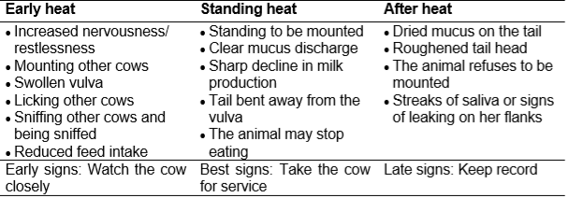
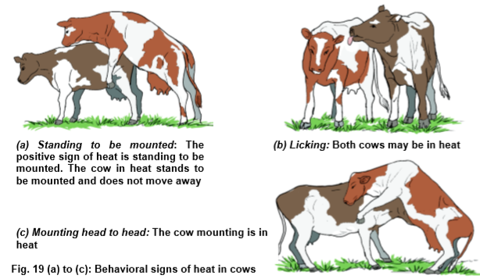
Fig.2.7. behavioral signs of heat in cows

When do animals come into heat for the first time?
- Animals come into heat when they reach puberty. This occurs at different ages in the different ruminants:
- Well-fed cows and buffalo come into first heat at 10 - 20 months of age.
- Sheep and goats come into first heat between 6 - 12 months of age.
How long does heat last?
- The duration of heat is very short.
- In cows and buffalo, it lasts for less than a day.
- In goats heat lasts for 1 - 3 days.
- In sheep heat lasts for 1 - 2 days.
A healthy animal which was not mounted by a male or given artificial insemination will come back into heat.
Cattle and buffalo cows will come into heat after 3 weeks (give or take a day or two), and female goats and sheep will come back into heat after 17 days (give or take a day or two).

- Reasons for female not showing signs of heat
The female may not show signs of heat because she is too old, or she may have been mated without the owner knowing. Sometimes animals come into heat without showing any signs. This is called a "silent heat" and is common in buffalo cows.
If the feed is not sufficient or there is a lack of protein, salts or water, the animal can fail to come into heat. You will need to improve the female's feed to bring it into heat.

- Anoestrus & sub-estrus clinical signs
- Animals not showing regular signs of heat, repeat breeding and early embryonic mortality.
- At times heat signs, not visible properly.
- Reason - Nutritional deficiencies, management disorders, hormonal deficiency and uterine disorders.

2.2.10. Mating system
Once heat has been detected, cows should be mated. Mating of good quality animals to produce highly productive and suitable animals for enhancement of overall performance in the subsequent generations and to augment production and profitability is termed animal breeding.
There are two types of mating of animals for production of the progenies. These are
  - Natural mating: Mating of animals by natural means.
This is where the cow is taken to a bull and left for some time for the bull to serve.

The advantages of this method are:
- The cow has an opportunity to be served more than once; this increase the chance of conception.
- The semen is fresh and of good quality since there is no handling.
- Where the farmer does not own a bull, cost of service is lower compared to A.I.

Natural service has the following disadvantages:
- Rearing a bull is not economical especially to a small holder farmer
- There is risk of spreading breeding diseases.
- There is risk of inbreeding if the bull is not changed frequently
- There is no opportunity to select the type of bull the farmer wants.

Increasing the chances of conception through natural service:
- Take the cow to the bull as soon as it is detected to be in heat and leave it for at least twelve hours.
- Young inexperienced heifers should be mated with old experienced bulls.
- Young inexperienced bulls should be given to old experienced cows.
- The bull should be kept fit and in good health particularly the legs and feet.

Natural mating can be done in two ways:
    - Free/pasture mating –
This method of mating is practiced by farmers who own bulls which run full time with the cows. One bull can serve 20-25 cows. It has the advantage no heat detection required and disadvantage of lack of accurate records and possibility of transmission of reproductive diseases e.g. brucellosis.
- Hand mating-
The bull is enclosed in its pen and the cows are brought in when they show signs of heat. Most small-scale farmers will practice this method since bulls are owned by few farmers and others bring their cows for service at an agreed fee. The advantage is keeping accurate records while the disadvantage is the farmer has to detect heat.
  - Artificial insemination (AI):
Mating is done through artificial means by collecting semen from male and the inseminating the females. This method helps in use of outstanding males for mating of a large number of females thereby production of large number of highly productive and performing progenies.
The process of artificial insemination starts with a healthy bull, that is disease free and producing ample quantities of high quality semen.
The fertility of the cow is also important, the competency of the inseminator and a clean environment. Farmers are encouraged to use semen from proven bulls which is obtained from AI centers and registered service providers.

Benefits of Artificial Insemination
    - Prevention of venereal diseases
    - Indefinite preservation of genetic materials of low cost enabling wide testing and selection of bulls
    - enhances genetic progress as best bulls are used widely nationally and internationally
    - Small scale farmers through AI can access good bulls cheaply
    - One is able to select the bull of interest.
    - When handled properly, there is no chance of spread of breeding diseases.
    - It is easy to control inbreeding.
    - A.I. is the best method of improving the genetic make-up of local breeds because it enables semen from the very best bulls to be widely available.
    - It is cost effective since the farmer does not have to rear a bull.
Disadvantages of AI
    - It requires very accurate heat detection and proper timing of insemination for greater chances of conception.
    - The inseminator must be trained on the technique.
    - It requires high investment in equipment.

    - Selection of Breeding Stock
Selection is used as a tool for livestock improvement. A breeding stock is a group of males and females which act as parents of future generations. Culling is the removal of animals which do not perform to the desired level, from the herd. The animals retained have certain desirable characteristics which make them produce more. Selected animals make up the breeding stock. Selection process repeated for many generations increases chances of formation of desirable qualities in an animal. Selection helps improve characteristics which are highly heritable. Heritability means the likelihood of a particular trait to be transmitted to the offspring and they are strongly inherited. A character like milk yield is lowly heritable, i.e. it is weakly inherited and a bigger percentage of the character is affected by the environment.
- The degree to which selection affects a character depends on the following factors;
The heritability of the character,
- The intensity with which the selection is done and the interval between generations and kind of selection being practiced.

Factors to be consider when selecting Breeding Stock.
- Age
- Level of performance
- Physical Fitness
- Health
- Body Conformation
- Temperament or Behavior
- Quality of products
- Mothering Ability
- Adaptability
- Prolificac
Age
- Young animals,
- Those that have not parturated for more than 3-times should be selected.
- They have a longer productive life.
- Old animals are poor breeders and low producers.
- Production and breeding efficiency decline with age.
Level of performance
- Animals with highest production level selected.
- Performance best indicated by records
Good performance of animal indicated by;
- High milk, wool and egg production,
- Good mothering ability
- High prepotency which is the ability of a parent to pass good qualities to their offspring’s.
- The animals with poor performance should be culled.
- Good records kept and used by the farmer for this purpose.

Physical Fitness
Animals selected should be free from any physical defect e.g.
- mono-eyed,
- limping,
- irregular number of teats,
- scrotal hernia,
- defective and weak backline
Health
- Sick animals do not breed well and are expensive to keep.
- Animals that are resistant to diseases pass these characteristics to their offspring
Body Conformation
- Animals for breeding to be selected according to proper body conformation.
- A dairy cow should be wedge-shaped with a large udder, thin legs, long neck.
Temperament or Behavior
- Animals with bad behaviors should be culled. e.g. Cannibalism, egg eating, aggressiveness, kicking
Quality of products
- Select animals that give products of high quality such as meat, wool, eggs, milk.
Mothering Ability
- Animals selected should have a good mothering ability,
- That is animals with good natural instinct towards their young ones.
- This will enable them to rear the young ones up to weaning.
Adaptability
- Animals selected should be well adapted to the prevailing climatic condition in the area e.g. Arid and semi arid areas.

Prolificacy
- Animals selected should be highly prolific.
- That is, animals with the ability to give birth to many offspring’s at a time(larger litter).
- This is a quality that should be considered when selecting pigs and rabbits.
- The ancestry records assist to choose the prolific breeds for mating

Assisting animal in normal parturition

Parturition or Calving in Cattle
Parturition is giving birth to the young calf. Two months before the expected calving date (the parturition), so 7 months after service, the cow should get plenty of rest, because the growth of the calf takes up a lot of the cow’s energy. This means that 2 months before the expected calving date, a milking cow should be dried off (i.e. you should stop milking her) and a cow you keep for traction should stop working. At about the 272 days of pregnancy, an in-cow is ready to calve.
It must be taken to the calving or maternity pen some few days to end of pregnancy which can be calculated from the records kept by the stockman. If calving must be done on pasture, a clean, quite secluded place must be prepared for it while the stockman watches, in case assistance is required. Towards calving, the udder becomes bigger, the vulva also swells and the ligaments around the tail head drops. Hormones such as oxytocin are released which helps in the contraction of the uterus.

- Parturition can be divided into three stages:
      - The water bags come through the birth canal. This may take 2 to 6 hours.
      - In the second stage the actual delivery of the calf occurs.
First the front legs come out, then the head, and after that the whole body comes out. Once the front legs are out the calf must be out within an hour. Otherwise the calf might suffocate. The normal birth position (presentation) is with the front legs first and with the nose between the front legs. If the calf presents differently the parturition is much more difficult. In that case you will see the cow really working to deliver the calf, but nothing comes out.
If it takes more than 8 hours, get veterinary help. If you help the cow with the delivery of the calf, you should pull at the two legs. Always pull to the side of the legs and udder of the cow and never towards the tail side. If you pull, then only do so with a maximum of 2 people and pull only at moments when the cow is pushing herself.
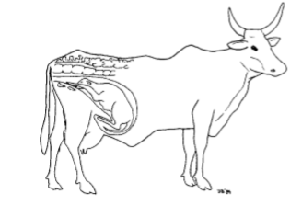
Figure 2.8: Normal presentation of the calf.

The third stage consists of the parturition of the placenta (afterbirth), which normally follows the calf almost immediately. If, however, the placenta has not come out within 12 hours, you should contact a veterinarian. If two calves are born from one cow at the same time, you have to be aware of possible infertility. If these calves are both male or both female there is no problem. If the calves have different sexes, the female calf may be a barren cow. This means that the young calf is infertile; she cannot be used for reproduction or milk production. Soon after birth, calves must be identified by tagging, tattooing, branding or ear notching.

- Lambing or Kidding
The gestation period of ewe is 140 to 150 days (21 to 22 weeks) which is similar to that of a doe. On the average the gestation period in sheep and goat is about 5 months. With this, it is possible for ewe or doe to give birth at least once a year or three in two years. The act of giving birth in sheep is called “lambing” while it is “kidding” in goats.
Ewes and does demonstrate essentially the same characteristics when giving birth. Towards the end of pregnancy, the udder of the animal swells and becomes larger. The ewe or doe becomes restless, bleats and there is a hollow appearance on the flank region of the loin. Some watery discharge that is opaque and yellowish is observed from the vulva and the animals choose a secluded place to give birth. Parturition process is completed within two hours. The animal could be assisted if in distress or invite a veterinarian especially if the foetus position is abnormal. The normal position is when the lamb or kid comes out with head rested on the fore leg coming out first from the vagina. The dam cleans up the lamb or kid by licking the mucus from the body and stimulates the lungs to respire in some cases. The young animal after some time begin to show signs of hunger and thereafter sucks the dam.
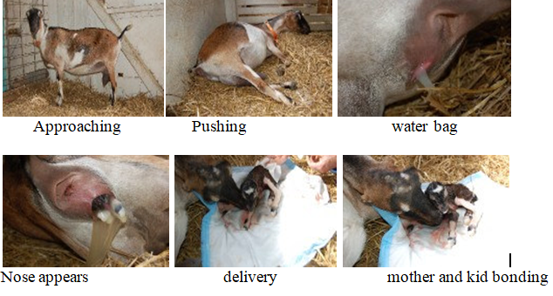
Fig2.9. The sequential process of kidding

2.2.13Rearing new born animals
- Rearing of Calf after Parturition
The calf rearing period, which is the period from birth until 6 months after weaning (weaning is changing of the young’s feed from milk to solid feedstuff), is a period with many risks. The highest mortality rates occur in this period. The newly born calf is very weak and susceptible to diseases. During this period it needs extra care, with particular attention to good feeding, health, hygiene and housing.
- Feeding of the calf
The primary concern in rearing the newborn calf is to ensure it remains healthy. Feeding management should also be directed at addressing nutrient requirements and encouraging rumen development. A calf needs its mother’s milk in order to start a healthy and productive life. Milk contains all the necessary nutrients. It is full of energy, protein, minerals and vitamins. It is very important for the calf to drink a sufficient quantity of the first milk, called colostrum, during the first 48 hours.

This milk contains antibodies, which give the calf resistance to the prevalent diseases. The calf needs 10 % of its live weight in milk each day in order to grow 1 p% in live weight per day. So a calf that weighs 30 kg needs 3 kg milk daily. Too little milk will weaken the calf, make it more susceptible to disease or the calf might die because of malnutrition.

Phases of Calf Feeding
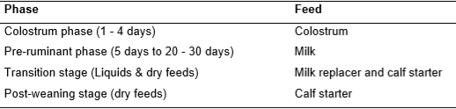
Table2.1. Four phases of the calf feeding program

The aim should be to switch young calves to cheaper feeds as early as possible so that more milk can be available for sale. However, the diet must be able to promote health and growth.

    - Calf Feeding Methods
After the first week during which the calf is left with the dam, several methods can be used for feeding depending on ease and convenience.
- Single suckling
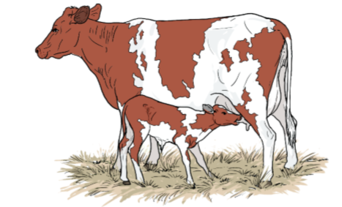
Fig.2.10: A calf suckling
The calf is separated with the mother but during milking it is brought to suckle. The amount of milk the calf consumes is difficult to quantify. Some farmers will allow the calf to suckle one quarter. This method is rarely used in commercial dairies. The disadvantage is that if the calf is not present, then the cow may not let down all the milk. This method is the best in terms of hygiene as the calf gets clean milk at body temperature.
- Foster mother or multiple suckling
In farms where several cows give birth at the same time, one cow can be assigned to a number of calves depending on milk production. The calves suckle in turns ensuring that each calf only suckles the designated quarter. This method is not practical in small scale farms.
- Nipple suckling: -
A plastic nipple is attached to a clean bottle filled with milk and the calf is trained on how to suckle. An alternative is to attach a nipple on a short plastic hose pipe and insert the same into a bucket. The calf is then trained on how to suckle.
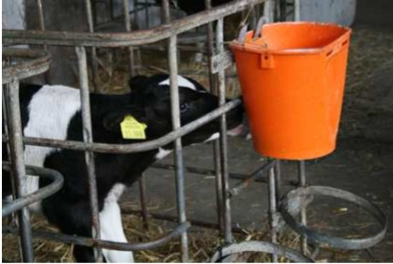\
Fig.2.10. . Calf being Fed in Bucket with a Nipple
- Bottle feeding: -
The milk is placed in a clean bottle and the calf is fed directly from the bottle. This method is tedious and slow if many calves are to be fed. There is a high likelihood of milk going to the lungs via trachea.
- Bucket feeding:
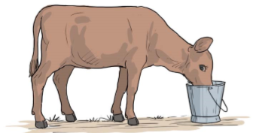
Fig2.11. calf bucket feeding
This is the most commonly used method and milk is placed into a bucket and the calf is trained to drink (place finger in the milk and as calf suckles your finger it takes in milk). Stainless steel buckets, where available, should be used for hygienic reasons as plastic buckets are difficult to clean. Whatever method is used, clean equipment should be used at all times. Sick calves should always be fed last to minimize cross contamination. Attempts should be made to feed milk at body temperature especially during the cold season.
    - Calf Housing
Housing of calves is an important aspect of calf management. Claves are housed for several reasons, the most important being protection from adverse weather conditions and predators, avoid internal and external parasites and control feeding and management.
A calf pen should be constructed where possible from locally available materials. It should be constructed to:
    - Allow approximately 2 m² (1.2 X 1.5m) space per calf
    - Be well drained or bedded
    - Be well lighted (artificial or natural)
    - Be well ventilated
    - Strong to stand predator invasion
Calves can be housed permanently indoor until weaning time when they are turned to pasture or semi-indoor where they housed only at night. The calf house can be permanent or temporary and movable.
Permanent houses should be constructed such that they are easy to clean when a new calf is introduced. Temporary houses are moved from one location to another when new calf moves in.
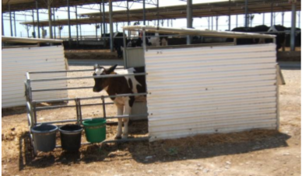
Fig.2.12: A movable calf pen.

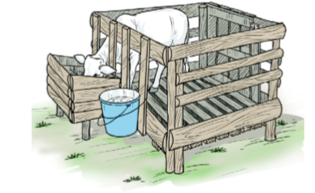
Fig. 2.13: Feeding the calf
    - Management of Lamb/ Kid
The dam should be allowed to suckle kid/lamb immediately after birth. This is because at this time the dam’s milk contains colostrums. Colostrum contains antibodies which help to confer initial immunity to the kid/lamb; it also stimulates the alimentary system. Colostrum production ceases around the third or fourth day after parturition.
It is important to check the test of the female to ensure that milk is available for the kid/lamb. If the dam’s milk supply is low, the kid may have to be fed with alternative milker replaces or placed with a foster mother. Weaning can be done between 4 weeks to 3months depending on age breed and purpose. However, weaning below the age of 3 month is not advisable for tropical sheep and goats. Weaning can be encouraged by the provision of creep feed. The young animal normally begins to nibble at solid food such as leaves. Grasses should be starting to eat at 2-3 weeks of age. Where a dam dies immediately after parturition artificial colostrums should be provided.
Artificial Colostrum is made up of:
  - 0.61 litter of cow’s milk
  - 1 teaspoon of castor oil
  - 1 teaspoon cod liver oil
  - 125mg of broad spectrum antibiotics.
Normally a quarter (1/4) to 1litre of artificial colostrums is given per day for four days.Under the extensive management, the dam (i.e. the female parent) and the baby (lamb or kid) are allowed to run together and penned together. The lamb or kid depend on the dam’s milk for the early part of its life and begin to nib on grasses or forage as from about 3 weeks of age which help stimulate the rumen. The lamb or kids are weaned at about 6 to 8 weeks after birth. Weaning at about 6 weeks is called early weaning. At this stage, the animals are separated. Those for breeding are separated from those for fattening or and maintained as growers.

Undertaking Castration
Castration is the act of removing the testicles of a male animal to render them ineffective. This operation is carried out on all unwanted males in ruminant production. This management operation prevents unwanted breeding and improves the carcass quality of the animal. In addition, castrated males are easier to handle. It can be carried out by surgically operation or bloodlessly by the use of a burdizzo or rubber ring elastrator after the animal must have been haltered. Surgical operation is done within the first week of the animal’s life while the bloodless one could be done within the first two weeks of life. Castration can be done by using an elastrator ring, burdizzo or open castration using a knife.
- Knife castration:
Is the only completely safe method to sterilize male animals and can be done at any age by a qualified veterinarian. With this method of castration there is always a danger that the wound can become infected and the necessary precautions must be taken.
- Elastrator rings:
The rubber ring is applied around the neck of the scrotal sack using the special instrument designed for this purpose. The testicles must be in the scrotal sack distal (away from the body of the calf) to the elastrator ring. To minimize pain when using the rubber ring method of castration, they must be applied within three days of birth.
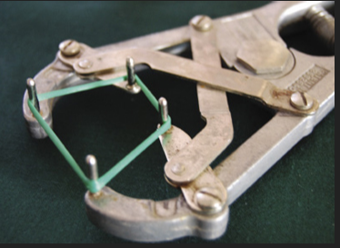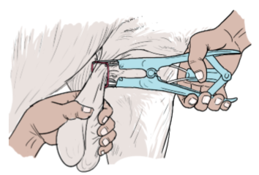
Fig. 2.14: Elastrator method of castration
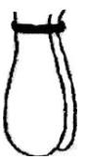
Fig.2.15. Proper placement of the rings
- The burdizzo:
A burdizzo is a pair of pincers used to squeeze and crush the spermatic cords. After application, the testicles degenerate and are absorbed but the external surface of the scrotum is not damaged. Castration with this method can be done at any time; but when done at a later age, it may bring about a shock in growth. The best time to apply the burdizzo is three to four weeks after birth when the spermatic cords can be felt. The burdizzo is applied to each spermatic cord separately (Figure) in such a way that the blood supply to the testicles is damaged, while circulation to the scrotal sack remains intact.
Gangrene can set in where blood circulation to the scrotum is lost. To achieve these objectives, the burdizzo is applied to the individual spermatic cords at opposite sides of the scrotum, leaving a central area free for blood to circulate or applying the burdizzo at different levels on opposite sides of the scrotum.
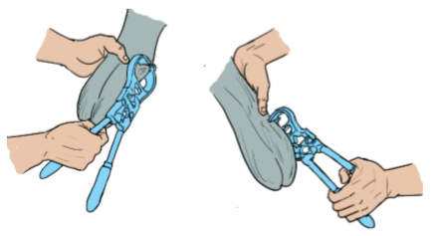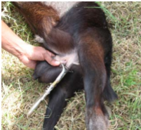
Fig. 2.16: Burdizzo method of castration

The equipment is used to clamp and crush the top of the testicles.
- Castrating is important for the following purposes since have good Carcass composition and weight development
- Castrated animals are good for fattening purpose
- Prevent breeding of related individuals (inbreeding) that can result in genetic defects, poor growth rate, and other problems
- Avoid unwanted pregnancies and the mating of young females before they are of adequate size and age for pregnancy and parturition.
- Enhance on-farm safety for animals, producers and employees. Castrated animals are usually less aggressive and easier to manage.

- Undertaking Dehorning

Dehorning or disbudding is the process of removing horn of the animal and it mainly applied for cattle, sheep and goat. The age to dehorn calves depends on the condition and the method used. The sooner it can be done the less inconvenience is suffered by the calf. Generally the calves that are 3 to 10 days old can be dehorned more easily, because the horn button does not become attached to the skull until the calf pass 10 days of age.

- Debudding

Is the act of removing the horn at its budding stage in cattle, sheep and goats. Most breeds of these animals carry horn which when fully grown may become source of injury to the other animals in the flock/herd. This operation is carried out at about age 3 to 4 weeks of age on any of the animals. Dehorning can be done by several methods.

    - Hot iron:
Electric, gas or fire-heated iron is the most common in calves (4 to 6 weeks). The young ruminant is haltered (i.e. using a rope to restrain it) to a pole, held down by the stockman and the base of the horn is felt with bare hand of the operator. The hair around it is shaved and local anesthesia is injected at the base of the eyelid or forehead to minimize pain. A hot iron cuter is then plugged into electricity. The hotness of the iron is determined by its ability to burn a piece of dry wood. The hot iron is then applied to the horn bud and carefully twisted to remove the bud. A scar is then left over the tissue at this point. This operation is commonly done in ruminant production especially in the temperate region and most local experimental stations. Hot iron dehorning can be done with ease up to the age 3 months (while the dehorning iron still fits over the bud comfortably), thereafter horn growth is fairly rapid, making surgical removal necessary.
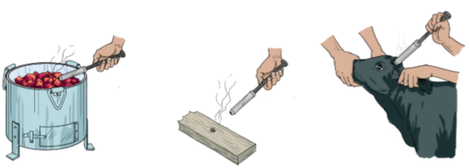
Fig. 2.19: Hot iron dehorning

    - Surgical method:
Use of saw or cutting wire: In older animals, surgical procedures must be used, especially if horns have grown to a length of 2 cm or more. The removal of larger horns causes a great deal of pain and anaesthetics should be used with dehorning and steps taken to prevent bleeding. Blood attracts flies and blow-fly strike causes serious problems in open wounds. Once horns have grown very large, removal of the horns exposes the hollows in the skull and these must be closed to prevent infection.
    - Chemical method of dehorning
The horn button may be prevented from growing by burning with chemicals. This method is most successful if done before the calf is10 days old. The chemical that are most commonly are caustic potash or caustic soda. Dehorning should be done during the cool weather of spring and autumn. It is the best method.
    - Clippers and saws
This method is mainly used when old ruminant animals are to be dehorned.
Advantages of dehorning include:
- Dehorned cattle are quiet & less aggressive and thus easy to handle
- Need lees space at feeding troughs and yards.
- Improves the animal looks (sight)
- Reduce injury of people working with them
- Reduce damage to hides & skin

Undertaking hoof trimming
This carried out by the use of hoof trimming knife. Overgrown hooves are trimmed to ensure it does nor harbor germs or disease and allow the animal to walk well. The debris in the hoof must be removed before carefully cutting the hoof in slices to ensure the tissue is not cut.
- Hooves trimming: -
Is the process of cutting abnormally grown hooves of the animal. Most of the time abnormally grown hooves are difficult for walking and also they are carrier of disease causing organism. In management systems where sheep and goats are mostly confined and do not walk daily on hard groundcover or climb rocks, abrasion of the hoof is not balanced with hoof growth. This will affect mobility and could lead to reduced intake from grazing. It may additionally lead to diseases such as foot rot.

To avoid these problems, hooves need to be examined regularly and trimmed as needed. A sharp knife or hoof shears can be used for hoof trimming.
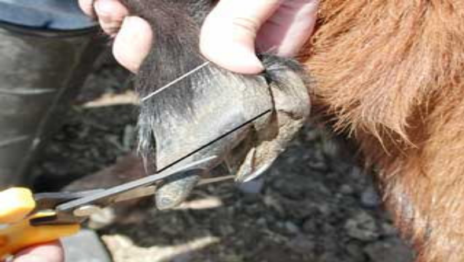
Fig2.20. Hoof trimmer

Some benefits of hoof trimming:
- Reduces toe injuries.
- Reduces lameness.
- Helps prevent diseases like laminitis and foot rot.
- Increases lifespan.
- Increases milk production.
- Makes it easier to stand, eat and drink.
- Higher breed back.

Operating Shearing activities
Sheep shearing;
Is the process by which the woolen fleece of a sheep is cut off. The person who removes the sheep's wool is called a shearer. Typically each adult sheep is shorn once each year (a sheep may be said to have been "shorn" or "sheared", depending upon dialect). They can be hand and machine shears. Hand shears are recommended for flocks of 10 or less, hand machine (clippers) for flock of less than 150 and power machine for flocks above that number.
Wool shearing practices vary in different regions. However, shearing is mostly practiced twice a year in spring and autumn seasons. Sheep are washed at least two days before shearing in order to remove dirt, suint and grease which hinder shearing. Machine shearing is more efficient than manual shearing with scissors as it saves time, avoids injury to the sheep and “second-cuts” of staples. Some producers prefer to shear pregnant ewes before lambing. If ewes cannot be completely shorn before lambing, they should be “crotched out” by shearing the wool from the udder and dock area and from the head and eyes of those breeds with wool on the face. This will make lambing and nursing easier. Shearing before breeding in summer season tends to increase the heat loss from the body and cools the ewe and ram, thus inducing estrus in the ewe and stimulating spermatogenesis in the ram.
- Shearing can be done with a knife, scissors, wool shears or electrically-powered clippers.
- Common mistakes are cutting the skin and to cut some distance away from the skin. Sheep should be shorn when the fleece is dry.
    - Newly-shorn sheep should not be exposed to a wet season nor a very hot season;
    - In highland areas, sheep should have a long fleece to keep warm in the cold season;
    - Where grass seeds are a problem, sheep should be shorn before the seeds are ripe;
    - Finally, ewes should not be shorn in late pregnancy.

Applying Identifications
Identification is necessary for efficient production of animals.
Animal identification is divided into two:-
- Temporary identification
    - Lasts for short period of time
    - Not stay throughout animal life. E.g.
        - cutting brush of animal tail
        - Color Marks like pain
        - mud and charcoal

- Permanent identification:
- Stays throughout animal life.
Example:-
    - Ear notching
    - Ear tagging
    - Tattooing
    - branding
- Branding Hot iron - brand for a short time on the legs so as not to spoil skin. This is permanent but not common in dairy cattle.

- Ear marking
A. Ear notching - cutting the ears in a particular shape and coding the shape. It involves the use of razor or scissors to cut a “V” shape on the tip of the pina. The position of the cut indicates numbers. If it is at the top of the pina it denotes 1, if at the tip, 5 and if under, it is 3. The right ear represent tens while the left represent units. The two is added to give the animal an identification number in the herd.
B. Ear tattooing - difficult to read and does not work in dark animals.
C. Ear tagging - use an applicator, easy to read but expensive. The animal is haltered and the tag is placed in the applicator then clamped to the pina of the ear. Caution must be taken not to damage the blood vessels on the pina of ear.
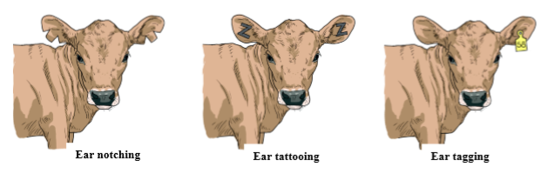
Fig.2.21. calf identification

Handling and transporting ruminant animals
The need to transport food animals occurs essentially in commercial agriculture and to a lesser extent in the rural or subsistence sector. These animals need to be moved for a number of reasons including marketing, slaughter, re-stocking, from drought areas to better grazing and change of ownership. Typically, methods used to move animals are on hoof, by road motor vehicle, by rail, on ship and by air.Generally the majority of livestock in developing countries are moved by trekking on the hoof, by road and rail. Historically, livestock has been moved on foot, but with increasing urbanization of the population and commercialization of animal production, livestock transport by road and rail vehicles has surpassed this. Transport of livestock is undoubtedly the most stressful and injurious stage in the chain of operations between farm and slaughterhouse and contributes significantly to poor animal welfare and loss of production.

Effects of transport
Poor transportation can have serious deleterious effects on the welfare of livestock and can lead to significant loss of quality and production.
Effects of transport and movement include:
-Stress -Bruising -Trampling -Suffocation -Injuries
-Heart failure -Heat stroke -Sun burn -Bloat -Fighting
-Poisoning -Predation -Dehydration -Exhaustion

Methods of transport
- Cattle
The most appropriate methods of moving cattle are on hoof, by road motor vehicle or by rail wagon. Moving cattle on the hoof (trekking) (Fig. 23) is suitable only where road and rail infrastructure does not exist, or when distances from farm to destination are short.
This method is slow and fraught with risks to the welfare and value of the animals. Rail transport is useful for short-haul journeys where loading ramps are available at railheads and communication is direct to destination. Road motor transport is by far the most versatile, the method of first choice and the most users friendly.
The most satisfactory method of transporting cattle is by road motor vehicle. Moving by rail truck requires more careful management and trekking is satisfactory for well-planned distances.
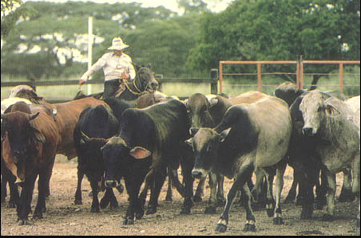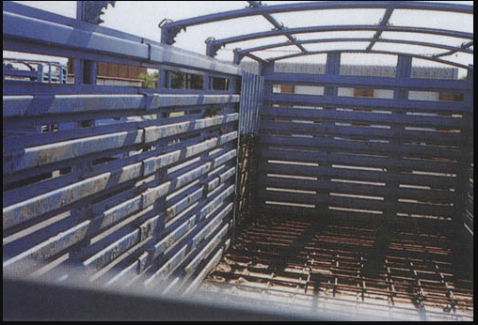
Fig. 2.21: Moving cattle on the hoof Fig. 2.22: Road motor for transporting cattle

- Sheep/goats
Of the food animals these are the easiest to transport and generally travel well on hoof, rail or road. Double-deck trucks are also suitable (Fig. 25).
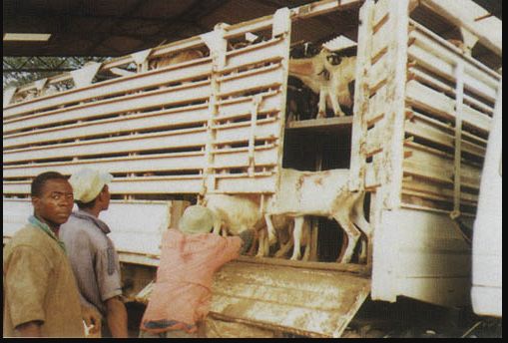
Fig. 2.23: Double-deck truck for transporting sheep/goats

Types of vehicles
Any vehicle used for the transport of slaughter livestock should have adequate ventilation, have a non-slip floor with proper drainage and provide protection from the sun and rain, particularly for pigs. The surfaces of the sides should be smooth and there should be no protrusions or sharp edges. No vehicle should be totally enclosed.
Floor space- Livestock require sufficient floor space so that they can stand comfortably without being overcrowded. Overloading results in injuries or even death of livestock.
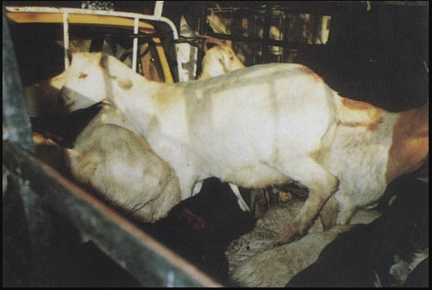
Fig. 2.25: Overloading truck with goats
Table2. Approximate floor space for transporting different classes of animals
Classes of stock | Floor area/animal (m²)
Mature cattle | 1.0 - 1.4*
Small calves | 0.3
Sheep/goats | 0.4

Pre-loading precautions
There are a number of simple procedures that can be implemented prior to the loading of
Livestock, which will considerably reduce the risk of injury and stress.
- Pre-mixing of cattle or pigs leads to greater familiarity and these animals travel better than animals that are strangers.
- Cattle should be mixed in a pen 24 hours before loading. Victimized or wild animals can be weeded out during this period. Fighting amongst pigs that are strangers is common, resulting in skin damage, wounds and stress.
- Mix pigs from different pens together before loading, smearing pigs with litter or excreta from the same pen so that they smell similar.
- Most animals can be fed and watered before transporting. This has a settling effect. However pigs should not be fed before transport as the feed ferments and the gas causes pressure on the heart in the thoracic cavity, leading to heart failure and death.
- Do not mix horned and hornless animals in the vehicles as this cause bruising and injury. Different species should also not be mixed - sheep, goats and calves less than 6 months can be mixed and individual animals can be transported in a loose sack tied at the animal’s neck.
- Feet should not be tied, and animals should be turned every 30 minutes or so. Pigs should not travel with other species unless separated by a partition. Bulls should not be carried together with other stock unless separated by a strong partition.
- Animals that are diseased, injured, emaciated or heavily pregnant should not be transported, and unfit, heavy, pen fed animals should not travel far as they cannot stand up to the rigours of transport.
- Vehicles should be fitted with a portable ramp to facilitate emergency offloading in case of prolonged breakdowns.

Transport operations
A number of factors must be taken into account during the journey in order that the animals do
not suffer, become injured or die.
- Trekking- Only cattle, sheep and goats can be successfully moved on hoof, and here certain risks are involved. The journey should be planned, paying attention to the distance to be travelled, opportunities for grazing, watering and overnight rest. Animals should be walked during the cooler times of the day and, if moving some distance to a railhead, they should arrive with sufficient time to be rested and watered before loading. The maximum distances that these animals should be trekked depend on various factors such as weather, body condition, age etc., but the distance given in Table 3 should not be exceeded when trekked.
Species | One day journey | More than one day
Species | One day journey | First day | Subsequent days
Cattle | 30 km | 24 km | 22 km
Sheep/goats | 24 km | 24 km | 16 km
Table3. Maximum distances for trekking
- Time of the day-
High environment temperatures will increase the risk of heat stress and mortality during transportation. It is important to transport animals in vehicles during the cooler mornings and evenings or even at night. This is particularly important for pigs. Wetting pigs with water will help keep them cool.
- Duration of journey-
Where possible, journeys should be short and direct, without any stoppages. If the vehicle stops, pigs will tend to fight. Cattle and sheep/goats should not travel for more than 36 hours and should be offloaded after 24h for feed and water, if the journey is to take longer than that. Pigs should have access to frequent drinks of water during long journeys, particularly in hot and humid conditions.
4. Driving- Vehicles should be driven smoothly, without jerks or sudden stops. Corners should be taken slowly and gently. The second person should be in attendance to spot downer animals so that the vehicle can be stopped and the animal lifted. Train drivers should avoid “fly shunting” of trucks with livestock.
5. Wind chill- Wind blowing on wet animals being transported in cold weather causes a wind chill factor, where the body temperature is considerably reduced, resulting in severe stress or deaths.

Key things to remember during transportation:
- The size and design of the transport vehicle should be compatible with the number of stock being transported.
- The transport vehicle should be in good repair to ensure cattle arrive at their destination with least injury and in the shortest possible time.
- The stock crate should be well designed so as to minimize bruising. A well designed stock crate will have a large smooth contact surface without projections on which animals can bruise.
- Pens should be approximately 3 meters’ in length (pens should not be longer than 4 meters’) to provide more support to animals during travel and thus reduce stress and allow them to adapt to transport more readily.
It is recommended that the following classes be transported or penned separately:
- polled & dehorned cattle;
- young calves;
- a cow with a suckling calf;
- adult bulls;
- cattle greatly different in size;
- females in advanced stages of pregnancy
Special requirements for transporting bobby calves:
- A livestock transport trailer/truck is the preferred method.
- Front of trailer should be solid to protect calves from the wind.
- All bobby calves should be fed on the farm within 6 hours of transportation for sale.
- Where possible bobby calves should be transported by the shortest route.
- Transport operators should check calves en route at least once every three hours.
- Bobby calves should be loaded at a density so as to allow all calves to lie down while being transported.
- Bobby calves shall be transported in separate compartments from other classes of stock.

Do Not:
- Transport calves in a car boot, sealed container or anything that restricts airflow.
- Tie the legs of the calves in order to restrain them.
- Overload the transport vehicle – you may need to make two trips or find a bigger transport vehicle.
- Speak to your stock agent if transport is required for your new purchase.

Handling facilities
It is important to make sure you have adequate facilities to unload the cattle when you get them back to your property. A set of yards or a small paddock to confine the cattle for the first couple of days is essential. Holding the cattle in a small paddock or set of yards for the first couple of days will help to settle and calm them. It may also help prevent the spread of weeds and disease to your property. This initial step is important for the bio-security of your property.

Feed and water requirements on arrival
The holding paddock or yard must have a supply of water that is accessible to all animals. It would also be a good place to introduce your cattle to some hay, in order to settle them after the transport. When you finally introduce your cattle to the larger paddock, it is best to continue giving hay for at least the first 2 days, so that their rumen (stomach) has time to adjust gradually to the pasture feed. These values will vary with weather conditions, and it is not unusual for a pregnant cow with calf at foot to drink over 150 liters of water per day. As summer progresses, dams start to shrink and evaporation can account for up to a meter of water loss from a dam each day.
- Age estimation of cattle
The age of ruminant animal is determined chiefly by examination of the teeth, and less perfectly by the horn rings or the length of the tail brush; however due to bang-tailing, which is the act of cutting the long hairs at the tip of the tail short to identify the animal after management practices, the latter is least reliable

    - Dental (teeth) method
Cattle are placed in a cattle crush in order to restrain them prior inspecting the mouth and amount of teeth that each animal has. The temporary teeth are in part erupted at birth, and all the incisors are erupted in twenty days; the first, second and third pairs of temporary molars are erupted in thirty days; the teeth have grown large enough to touch each other by the sixth month. Temporary incisors or "milk" teeth are smaller than the permanent incisors.
Cattle have thirty-two teeth, including six incisors or biting teeth and two canines in the front on the bottom jaw. The canine teeth are not pointed but look like incisors. The incisor teeth meet with the thick hard dental pad of the upper jaw. Cattle have six premolars and six molars on both top and bottom jaws for a total of twenty-four molars. The teeth of cattle are designed primarily for grinding, and they use their rough tongues to grasp grass and then nip it off between their incisors and the dental pad.
There is controversy on the reliability of attempting to tell the age of cattle by their teeth, as rate of wear can be affected by the forage that is grazed. Drought or grazing on sandy country will also affect rate of wear.
The following is a guide:
      - Under two years old (No permanent teeth)
      - Two years three months (2 permanent teeth)
      - Three years old (4 permanent teeth)
      - Three years six months (6 permanent teeth)
      - Four years (8 permanent teeth)
      - Old animal, over four years old

How to hold cattle and buffalo to check their teeth
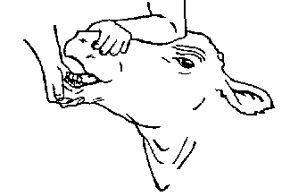
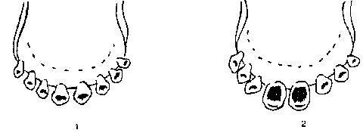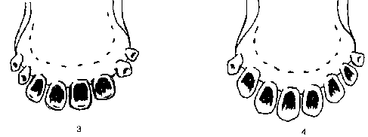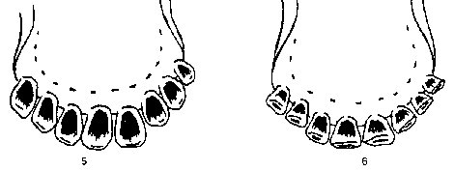
Fig27. Teeth of cattle
    - Horn method
The rings on the horns are less useful as guides. At ten or twelve months the first ring appears; at twenty months to two years the second; at thirty to thirty-two months the third ring, at forty to forty-six months the fourth ring, at fifty four to sixty months the fifth ring, and so on. But, at the fifth year, the three first rings are indistinguishable, and at the eighth year all the rings.
    - Tail brush method
The brush of the tail is only useful as a guide when assessing small, stunted or young cattle. A brush that is about fetlock length or longer is an indication that the beast is twelve months old or older. This method cannot be used on cattle which have been bang-tailed. Bang tailing is the act of cutting the long hairs at the tip of the tail short to act as a simple identifier of animals and is commonly used after a procedure has been performed on an individual animal that belongs to a large mob e.g. the mob is run through a race and each animal is vaccinated - immediately after being vaccinated the animal is bang-tailed so they are identified as vaccinated and will not be given a second dose of vaccine. This is useful when large numbers of animals are being processed by a group of individuals.
    - Other methods
Cattle age in a carcass is determined checking the physiological skeletal maturity (ossification) (red) of the tips or “buttons” of the thoracic vertebrae. The size and shape of the rib bones are important considerations as well as the colour and texture of the flesh. The use of number (year) branding, tattoos or ear tags with numbers or different colors are good methods of identifying the age of cattle, if they are used according to standards.

2.3.4. Age Determination of Sheep and Goats by Dentition
Why is it important?
Indirect ways of determining approximate age of sheep and goats are vital in systems where production records are unavailable. For instance, if the flock structure has to be determined, age of animals needs to be estimated. Application of drugs also requires knowledge of age and/or weight of the animal. A few days after birth, lambs/kids will have milk teeth, also known as temporary incisors, arranged in four pairs in the lower jaw. These are replaced by larger permanent teeth as the age of the animal increases. There is a range of ages at which particular teeth appear because the speed of teeth growth will vary according to health and nutrition of sheep and goats.
The central pair of temporary incisor teeth is shed and replaced by the permanent teeth at approximately 14 months of age. At approximately 20 months, the second pair of milk teeth is replaced by a pair of permanent incisors. At 3 and 4 years, the third and fourth pairs of permanent teeth appear. At 4 years of age the sheep has a "full mouth." When a ewe/doe loses some of her incisor teeth, she is called a "broken mouth."
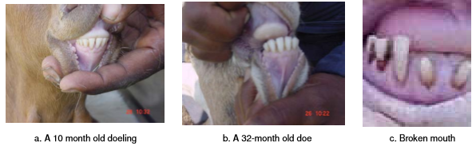
Figure28. Teeth of goats of different age

Note that the doe ling Figure 28b has her milk teeth fully grown and spread out. The doe in Figure 28b has had three pairs of teeth replaced.
Older sheep and goats that have worn teeth have difficulty in eating and will lose condition, become more prone to diseases and breed less than younger animals. Inspecting the teeth can be a very useful way of deciding when to cull.
Age of goats and sheep
- Animal under one year old (no permanent teeth)
- One year old (2 permanent teeth)
- Two years old (4 permanent teeth)
- Three years old (6 permanent teeth)
- Four years old (8 permanent teeth)
- Old animal, more than four years old
How to hold sheep and goat to check their teeth
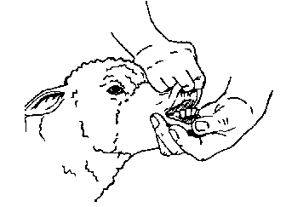
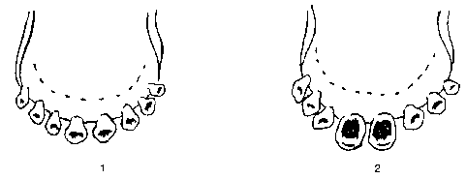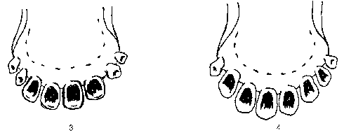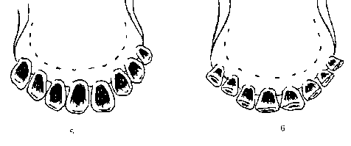
Fig.29. teeth of shoat
  - Observing enterprise policies and procedures
Enterprise policies and procedures in relation to workplace practices in the handling and disposal of materials should be observed. During handling and disposing of materials the worker should be observe work place policies and procedures.
Before handling a carcass and waste materials, consider the diseases that can be passed to humans (anthrax, brucellosis, rabies, ringworm and mange are the most common ones). If the animal died unexpectedly, a post-mortem will reveal the cause of death and guide the means of disposal. Post-mortems should be performed by qualified veterinarian. If anthrax is suspected the carcass should be burned and no post-mortem should be carried out.
How to burn a carcass and waste material
    - Dig two trenches (2 m long, 40 cm wide and 40 cm deep) in the form of a cross. The trenches will provide oxygen to the fire.
    - Place two iron bars so they lie across one of the trenches.
    - Place strong wooden posts across the bars.
    - Place the carcass and a heap of fuel (wood and straw soaked in waste oil) on the wooden posts.
    - Light the fire and burn the carcass.

Disposal by burying
    - Dig a hole 2 m long by 1.5 m wide and 2 m deep.
    - Put the carcass in the hole and cover with soil and logs or large stones to stop wild animals or dogs digging it up again.

Self-check-2

Name…………………………………………… ID………………………… Date…….
Directions: Answer all the questions listed below. Use the Answer sheet provided next to the question:
    - What do you think on the consequence that if the worker don’t follow the instruction of supervisor during working? (3pts)
    - What is the difference between instruction and direction? (3pts)
    - Define animal retraining? (2pts)
    - Mention methods of animal identification? (2pts)
    - What is the importance of performing heat detection? (2pts)
    - Write the importance of hoof trimming? (2pts)
    - What is the advantage of knowing the age of animal? (2pts)
    - Mention methods of age estimation? (2pts)
    - Discus the advantage and disadvantage of dental age estimation? (3pts)
    - Discus the advantage of following enterprise policy and procedures during disposing of waste materials? (3pts)
    - How do you handle and dispose carcass and waste material? (3pts)

Operation sheet-2

  - Procedures for assisting dairy cows in delivery(by using simulstion)
- Prepare materials and equipment
- Glaves-------------
- disinfectant
- Record book
- Simulator(optional)
- Calf puller
- Procedure/techniques:-
Step1- Assist only when absolutely necessary. Many times, birthing a cow requires no human intervention. If the mother or calf appears distressed, obtain professional help if you can. If you cannot find help in a dire situation, you must give calving assistance yourself.
Step2- Wash your hands and the cow's backside with soap and water. Put on a new pair of rubber gloves if you can. You must keep the area as sanitary as possible to prevent infection. If the cow is still standing, try to lead her to a manure-free area, or freshly cleaned stall.
Step 3- Wait until the mother has entered the second stage of labor before assisting further. In this stage, she delivers the water bag and begins straining abdominal muscles. Do not break the water bag, as this often slows down the birth of a calf.
Step 4- Lubricate your hands and arms if possible. Very gently reach inside and lightly pinch the calf. This process is easier if the cow is still standing. Feel for movement to indicate that the calf is alive.
Step 5- Determine which way the calf is facing. Gently find a leg. You can feel two joints between elbow and hoof on forelegs, one joint between hock and hoof on back legs. Birthing a cow in a posterior (rear facing) position is more dangerous for both mother and calf.

Step 6- Make small, mild adjustments to the calf's position if necessary once the cow is constantly straining. Ensure the legs (and head if front facing) are in the birth canal, and not hung up on the pubic bone. Do not attempt to move a rear-facing calf into a forward-facing position. The attempt is likely to harm both animals.
Step 7- Help the cow dilate further by placing freshly washed hands and arms on either side of the calf's head and working them in and out of the birth canal for about five minutes.
Step 8- Watch for signs of distress. As soon as the forelegs and nose appear, lightly pinch the calf's tongue. If the tongue retracts, the calf is likely doing fine. If there is no response, and the tongue appears dark between contractions (a dark tongue during contractions is normal) the calf is in distress. Another sign of a problem is a calf with a yellowish appearance. If no distress signs are apparent, let the cow finish her work. If the calf is in distress, you must try to speed delivery. Try again to dilate the mother. Reach around the calf and pull during contractions in a steady motion. You can pull hard, but do not "yank" on the calf. If at all possible, avoid pulling on the calf's head. Continue to assist until the calf is born.
2.2. Perform Burdizo castration of ruminant animal
A. Equipments /Materials
- Burdizo
- Rope
- Antiseptic like alcohol and iodine solution
- PPE
      - Techniques for Burdizo castration
Step1. Wear appropriate PPE
Step2.The animal should be properly restrained by the assistant. The operator grasps the scrotum in one hand and manipulates the testes down into the scrotum. He then locates the two spermatic cords between the fingers and pushes one cord over to one side of the scrotum. This is the first cord to be crushed.
Step3. Place the jaws of the burdizzo onto the upper scrotum, leaving the rudimentary teats above the crushing point. Do not crush the septum or tissue between the testicles. Rather, do one side of the scrotum at a time.
Step4. Press together the burdizzo over the cord on the side of the scrotum you are doing first. You can generally hear a clicking sound as the cord is crushed.
Leave the instrument closed for 20 to 25 seconds. The spermatic cord is very elusive when you try to crush it. Be sure that you feel it within the jaws of the burdizzo before and after the jaws are closed.
Step5. Release the Burdizzo, move it lower to a new site about 1 cm closer to the testicles and close it again to be doubly sure that the cord is crushed. A site below the first crush is chosen to minimize acute pain from a second crush.
Step6. Locate the cord on the other side of the scrotum and position the burdizzo over it. Close the burdizzo and repeat what you did with the first cord.
Step7. When you are done, you may see a mark on each side of the scrotum and release the animal.
The animal may be sore and move slowly for about a day. Be sure to encourage it to move around. At first the scrotum will swell up a little, but the testicles will gradually shrink over the next few weeks leaving a small scrotal sac.
If the skin is broken, apply an antiseptic like alcohol. Also give an injection of tetanus antitoxin if available.
  - Perform Dehorning
- Materials
- Procedure of Trimming horns (Dehorning)
  - Restrain the calf
  - Clip the hair around the base of the horn button as close as possible with a scissors are electric clippers
  - Clip off the end of the horn button with a sharp pocket knife so that the dehorning chemical can penetrate the horn and destroy the modified skin tissues that produce the horn.
  - Apply the ring of petroleum jelly or Vaseline around the base of the horn bottom.
  - Apply the dehorning chemical. The caustic stick must be applied exactly according to label direction.
  - Apply the caustic stick in a circular motion on top of the horn button and the area immediately around the horn. Care should be taken to minimize skin contact. If paste is used, apply it to the horn until it is approximately the thickness of a dime over the top of the horn button
  - Release the animal
2.4. Hoof trimming of shoat
Equipment, Tools and Materials:
- Hoof cutter,
- Sharp knife
- Automatic squeeze table
- Hoof scatter
- Disinfect ant
- Trimming tools
Conditions:
- Trim hoof immediately after rain or heavy dew, because the hoof wall will be much softer and easier to trim.
- Animals can be allowed to stand in a wet area for 2 to 3 hours before trimming.

Procedure for hoof trimming:
1. Properly restrain the animal.
Sheep: For small number of sheep, it is usually enough to tip the animal, and sit it on its rump, a position normally used for shearing
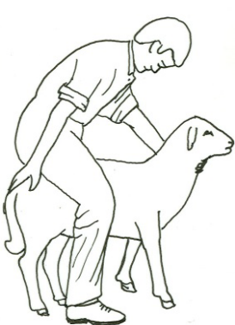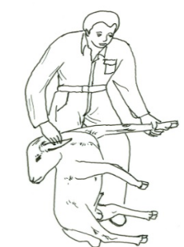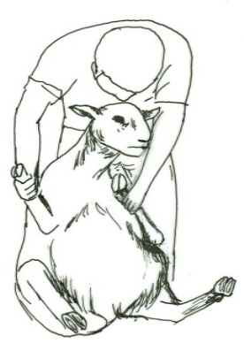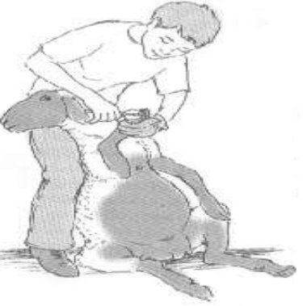
Step1 step2 step3 step4
Goats: Goats can be trimmed while in a standing position. Hoof trimming is best done in a squeeze chute or by positioning or tying the animal next to a wall or fence and trim the hooves.
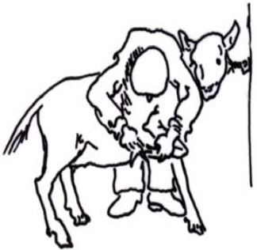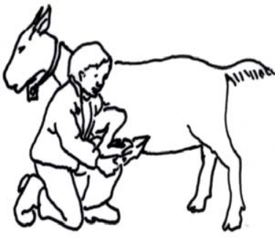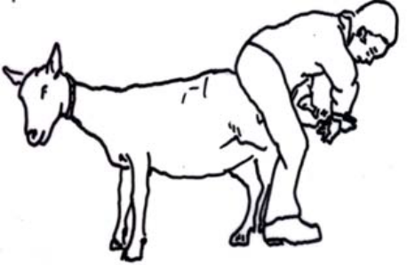
Opetion.1 opetion.2 opetion.3

Options for restraining a goat in a position to trim front (1 and 2) and back hooves (3)
2. Observe the color and check the smell of the hoof. A rotten smell is usually indicative of foot rot and appropriate treatment should be given.
3. The next thing to do is to clean any mud, manure, small stones, etc., from between the walls of the hoof.
4. The ends of the dewclaws can be the starting place for trimming. The tips of the dewclaws should be removed. It is important to remove small bits at frequent intervals to avoid bleeding as a result of cutting too short.
5. It is always advisable to begin by removing very small pieces of hoof wall and toe. The toe and outside hoof wall are trimmed down to where fresh sole can be seen (stop when the sole looks pink) and the bottom of the foot is parallel to the line where the hair stops known as the coronary band.
6: The inside wall of the foot should normally be trimmed a little bit lower than the outside. This allows most of the animal’s weight to be on the outside hoof wall where it should be placed naturally.
2.5. Performing Identification of ruminant animal
A. materials

Procedure of Identification of ruminant animal
- Ear notching
Procedures for Identification by ear notching
Step1. Prepare appropriate PPE
Step2. Restrain the animal properly
Step3. Have ear notching equipment
Step4. Apply safely and humanely
Step5. Apply antiseptic
Step6. Release the animal
- Ear tagging
Equipment’s
- Ears tag applicator
- Plastic materials
- Crush
- PPE
Procedures to follows
      - Wear PPE
      - Restrain the animal
      - Prepare ear tagging equipment
      - Apply ear tag quickly and humanely
      - Release the animal
- Tattooing
  - important equipment
- Pliers
- ink ( color)
- crush
- PPE
  - Procedures for tattooing
  - Put on PPE
  - Restrain the animal
  - Apply pliers(needle)on recommended area
  - Apply(rub) ink on pierced area
  - Complete and release the animal

- Branding
- Hot branding
Important equipments
- iron
- Crush
- PPE
Procedures for hot branding
    - Put on PPE
    - Restrain the animal
    - Prepare hot iron
    - Select appropriate place for branding considering the quality hide
    - Put hot iron on skin for 3 sec
    - Apply antiseptic
    - Release the animals
- Freeze branding
- Using freeze iron for animal identification
- Procedures of freeze branding
    - Put on PPE
    - prepare liquid coolant with -106^{oc} or -157
    - Immerse copper iron in liquid coolant for 20min
    - Restrain the animal
    - Clip hair from branding area
    - Soak clipped area with the same solvent of liquid coolant
    - Re-soak and apply branding iron firmly for 30-35sec( based on animal age)
    - release the animal

2.6. Determine age of cattle by teeth
A. materials
B. Procedure/Techniques of cattle age determination by teeth
- Wear appropriate PPE before starting the operation
- Properly restrain the animal
- Properly hold the animal
- observe number of permanent teeth
- Release the anima
- Estimate the age of cattle

LAP test-2

Instructions: Given necessary templates, tools and materials you are required to perform the following tasks within -5- hour.
Task1. Identify, cheek and maintain materials tools and equipment
Task2. Follow instructions and directions during ruminant animal husbandry
Task3. Apply ruminants restraining techniques

Task4. Provide feed and water

Task5. Prevent and treat of bloating problems

Task6. Undertake natural Mating of animals

Task7. Assist animal in normal parturition

Task8. Undertake Castration of small ruminant

Task9. Undertake Dehorning of bull

Task10. Undertake hoof trimming

Task11. Operate Shearing activities

Task12. Apply Identifications

Task13. Carry out dental age estimation of ruminants

LG-8 | LO-3: Handle and Clean Materials and Equipment’s

Instruction sheet-3
This learning guide is developed to provide you the necessary information regarding the following content coverage and topics:
- Handling waste materials
- Handling and transporting materials, tools and equipment
- Cleaning ,maintaining and storing materials, tools and equipment
- Reporting problems or difficulties
This guide will also assist you to attain the learning outcomes stated in the cover page. Specifically, upon completion of this learning guide, you will be able to:
- Handle waste materials
- Handle and transport materials, tools and equipment
- Clean ,maintain and store materials, tools and equipment
- Reporte problems or difficulties

Learning Instructions 3
- Read the specific objectives of this Learning Guide.
- Follow the instructions described below.
- Read the information written in the information Sheets
- Accomplish the Self-checks
- Perform Operation Sheets
- Do the “LAP test”

Information sheet-3

  - Handling waste materials
Definitions of terms
Waste is described as “any gas, liquid, solid or energy, or a combination of them that is not considered a resource and is surplus to, or unwanted from, any industrial, commercial, domestic or other activity, whether or not of value.”
Animal Wastes refers to waste of a biological nature, which has the potential to cause harm by acting as an infectious agent, while undergoing decomposition. To prevent this occurring, Animal wastes are treated (i.e. by rendering or using incineration).
Animal carcasses refers to the carcasses of domestic and laboratory animals including parts thereof that are not classified as Clinical and Related (Path) waste or Cytotoxic Drugs, waste containing radiation material and Related waste.
Carcass Limbs Any limb which has been removed from the carcass.
Animal litter and foodstuffs refers to left over or contaminated foodstuffs, sawdust from cages and all animal litter.
Faeces any faeces accumulated or faecal specimens used for testing.
Clinical Waste refers to any samples (e.g. Tissue, venom, blood, serum and swabs) that have been in contact with or used in experiments with a pathological substance and includes pathological waste.
Infectious Agent Means an organism, including a micro-organism or worm that causes disease or another adverse health impact in humans.

Waste materials May include, but not limited to:
- Broken rearing and farm items
- Plant debris
- Plastic, metal and paper-based materials
- Returned to manufacturer
- Dung and urine
- Spoiled milk
Objectives of handling waste
- Ensure that the Animal Wastes generated are disposed of in an environmentally sound manner
- Protect human health and the environment from the effects of potentially harmful wastes; and
- Comply with legal requirements for treatment and disposal of Animal Waste.
Collection of waste for disposal
- Where possible, Animal waste shall be placed in a green receptacle/bin with a light green lid with no splits or cracks and a fixed lid;
- The receptacle/bins will be marked as Animal waste;
- The receptacle/bins will not exceed 40kg in weight; and Please place in Clinical and Related Waste or other appropriate waste bins.
N.B. Please exclude the following non-compatible wastes from the Animal Waste bins:
- Sharps
- Disposable gloves
- Any types of plastic (e.g. plastic bags, plastic containers)
- Paper toweling
- Paper that is contaminated (e.g. blood and serum).
Storage of waste
Animal carcasses and parts thereof must be kept refrigerated (e.g. dedicated area within a cold room) as required until the time of removal from site. Animal litter, foodstuffs and faeces must be stored in a cool environment.
The waste shall be stored:
- in a weather protected, well-ventilated area;
- in a secured area and not readily accessible by the general public; and
- In such a manner as to present no threat to health, safety and the environment.
- If possible and safe, stored until the School or Centre has a bin full.
- If not able to comply with the above requirements, disposed of as quickly as possible.
Transporters of Animal Waste
- Animal Waste will be collected and transported by:
- A licensed contractor for the handling of this type of waste; or
- A person or company who can demonstrate suitable knowledge and equipment to handle such waste.
- Transportation shall be in accordance with the Transport Operations
Disposal and Treatment
- Only suitably licensed or approved facilities shall be used to treat this waste for disposal including rendering and composting.
- These facilities are licensed to only accept wastes that are non infected or uncontaminated.
Spills
- Every generator, transporter or handler of Animal Wastes shall hold equipment, and have staff who are trained to carry out clean up of spills of this waste. This will include all measures for containing, removing and disinfecting a spill area.
- Any material generated by responding to a spill should be handled as animal waste unless it is excluded, by its nature, by any part of this procedure.

  - Handling and transporting materials, tools and equipment
Transporting equipment is used to move material from one location to another (e.g., between workplaces, between a loading dock and a storage area, etc.) within a facility or at a site.
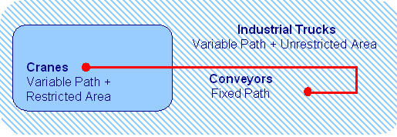
The major subcategories of transport equipment are:
- Conveyors. Equipment used to move materials over a fixed path between specific points.
- Cranes. Equipment used to move materials over variable paths within a restricted area.
- Industrial Trucks. Equipment used to move materials over variable paths, with no restrictions on the area covered by the movement (i.e., unrestricted area).
- No Equipment. Material can also be transported manually using no equipment.
“Materials handling include all movements of materials in a manufacturing situation. It is an art and science involving the moving, packing and storing of substances in any form.” — American Society of Mechanical Engineers
“Material handling involves the movements of materials, manually or mechanically, in batches or one item at a time within the plant. The movement may be horizontal, vertical or the combination of horizontal and vertical”.

The overall objectives of materials handling is to reduce production cost. This general objective can be sub-divided into more specific goals, such as:
- To lowers unit materials handling cost
- To reduce manufacturing cycle time
- To provide better control of the flow of materials
- To provide better working conditions
- To provide contribution for better quality by avoiding damages to products
- To increase storage capacity through better utilization of storage areas
- To provide higher productivity at lower manufacturing costs
- To improve customer service

  - Cleaning ,maintaining and storing materials, tools and equipment
    - Cleaning of materials, tools and equipment’s
Cleaning is the process of removing unwanted substances, such as dirt, infectious agents, and other impurities, from an object or environment. Cleaning occurs in many different contexts, and uses many different methods. Several occupations are devoted to cleaning.
    - Methods of cleaning materials, tools and equipments
Cleaning is broadly achieved through mechanical action and/or solvent action; many methods rely on both processes.
- Washing, usually done with water and often some kind of soap or detergent
  - Pressure washing, using a high-pressure stream of water
- Abrasive blasting, typically used to remove bulk material from a surface, may be used to remove contaminants as well

- Acoustic cleaning, the use of sound waves to shake particulates loose from surfaces
  - Ultrasonic cleaning, using ultrasound, usually from 20–400 kHz
  - Megasonic cleaning, a gentler mechanism than ultrasonic cleaning, used in wafer, medical implant, and industrial part cleaning
- Carbon dioxide cleaning, a family of methods for parts cleaning and sterilization using carbon dioxide in its various phases
- Dry cleaning of clothing and textiles, using a chemical solvent other than water
- Flame cleaning of structural steel with an oxyacetylene flame
- Green cleaning, using environmentally friendly methods and products
- Plasma cleaning, using energetic plasma or dielectric barrier discharge plasma created from various gases
- Sputter cleaning, performed in a vacuum by using physical sputtering of the surface
- Steam cleaning, in both domestic and industrial contexts
- Thermal cleaning, in industrial settings, involving pyrolysis and oxidation
- Wet cleaning, methods of professional laundering that avoid the use of chemical solvents
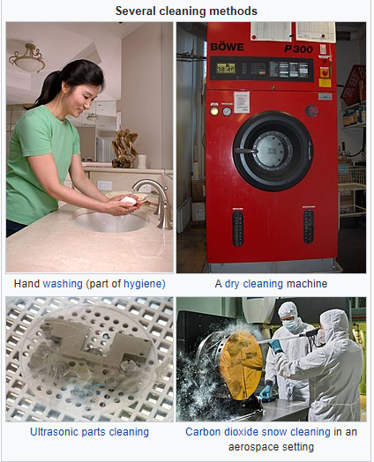
Fig1. Cleaning methods
Cleaning agents are substances (usually liquids, powders, sprays, or granules) used to remove dirt, including dust, stains, bad smells, and clutter on surfaces. Purposes of cleaning agents include health, beauty, removing offensive odor, and avoiding the spread of dirt and contaminants to oneself and others. Some cleaning agents can kill bacteria (e.g. door handle bacteria, as well as bacteria on worktops and other metallic surfaces) and clean at the same time. Others, called degreasers, contain organic solvents to help dissolve oils and fats.
Different cleaning agents are used depending on the item to be cleaned, the cleaning method and the type of soiling found on the item. There are four main types of cleaning agents used in commercial kitchens:

Detergents
Detergents are the most common type of cleaning agent and are used in home and commercial kitchens. They work by breaking up dirt or soil, making it easy to wash it away. The detergents used in commercial kitchens are usually synthetic detergents made from petroleum products and may be in the form of powder, liquid, gel or crystals.

Degreasers
Degreasers are sometimes known as solvent cleaners and are used to remove grease from surfaces such as oven tops, counters and grill backsplashes. Methylated spirits or white spirit were commonly used as degreasers in the past. Most food businesses now try to use non-toxic, non-fuming degreasers in their operations to prevent chemical contamination.

Abrasives
Abrasives are substances or chemicals that depend on rubbing or scrubbing action to clean dirt from hard surfaces. In commercial kitchens, abrasives are usually used to clean floors, pots and pans. Abrasives should be used with care as they may scratch certain types of materials used for kitchen equipment such as plastic or stainless steel.

Acids
Acid cleaners are the most powerful type of cleaning agent and should be used with care. If they are not diluted correctly acid cleaners can be very poisonous and corrosive.
Acid cleaners are generally used to remove mineral deposits and are useful for descaling dishwashers or removing rust from restroom facilities. Always follow cleaning with sanitizing: Cleaning is only the first step to a germ-free kitchen. Cleaning is done using detergent, but it doesn’t kill bacteria or other microorganisms that can cause food poisoning. To kill bacteria and ensure a clean workplace, you must follow cleaning with sanitizing.
Effective cleaning and sanitizing also helps to:
- prevent pests from entering your business
- prevent cross-contamination
- prevent allergic reactions caused by cross-contamination
    - Maintaining materials, tools and equipment’s
The technical meaning of maintenance involves functional checks, servicing, repairing or replacing of necessary devices, equipment, machinery, building infrastructure, and supporting utilities in industrial, business, governmental, and residential installations. Over time, this has come to include multiple wordings that describe various cost-effective practices to keep equipment operational; these activities take place either before or after a failure.
- Any activity—such as tests, measurements, replacements, adjustments, and repairs—intended to retain or restore a functional unit in or to a specified state in which the unit can perform its required functions.
- All action taken to retain material in a serviceable condition or to restore it to serviceability. It includes inspections, testing, servicing, classification as to serviceability, repair, rebuilding and reclamation.
- All supply and repair action taken to keep a force in condition to carry out its mission.
- The routine recurring work required to keep a facility (plant, building, structure, ground facility, utility system, or other real property) in such condition that it may be continuously used, at its original or designed capacity and efficiency for its intended purpose.
Maintenance is strictly connected to the utilization stage of the product or technical system, in which the concept of maintainability must be included. In this scenario, maintainability is considered as the ability of an item, under stated conditions of use, to be retained in or restored to a state in which it can perform its required functions, using prescribed procedures and resources.
Types of maintenance

Preventive maintenance
Preventive maintenance (PM) is "a routine for periodically inspecting" with the goal of "noticing small problems and fixing them before major ones develop." Ideally, "nothing breaks down."
The main goal behind PM is for the equipment to make it from one planned service to the next planned service without any failures caused by fatigue, neglect, or normal wear (preventable items), which Planned Maintenance and Condition Based Maintenance help to achieve by replacing worn components before they actually fail. Maintenance activities include partial or complete overhauls at specified periods, oil changes, lubrication, minor adjustments, and so on. In addition, workers can record equipment deterioration so they know to replace or repair worn parts before they cause system failure.
Main objective of PM are:
- Enhance capital equipment productive life.
- Reduce critical equipment breakdown.
- Minimize production loss due to equipment failures.
Other terms and abbreviations related to PM are:
- scheduled maintenance
- planned maintenance, which may include scheduled downtime for equipment replacement
- planned preventive maintenance (PPM) is another name for PM
- Breakdown maintenance: fixing things only when they break. This is also known as "a reactive maintenance strategy “and may involve "consequential damage."

Planned maintenance
Planned preventive maintenance (PPM), more commonly referred to as simply planned maintenance (PM) or scheduled maintenance, is any variety of scheduled maintenance to an object or item of equipment. Specifically, planned maintenance is a scheduled service visit carried out by a competent and suitable agent, to ensure that an item of equipment is operating correctly and to therefore avoid any unscheduled breakdown and downtime.
The key factor as to when and why this work is being done is timing, and involve a service, resource or facility being unavailable. Planned maintenance is preplanned, and can be date-based, based on equipment running hours, or on distance travelled.

Predictive replacement
Predictive replacement is the replacement of an item that is still functioning properly. Usually it's a tax-benefit based replacement policy whereby expensive equipment or batches of individually inexpensive supply items are removed and donated on a predicted/fixed shelf life schedule. These items are given to tax-exempt institutions.

Condition-based maintenance
Condition-based maintenance (CBM), shortly described, is maintenance when need arises. CBM maintenance is performed after one or more indicators show that equipment is going to fail or that equipment performance is deteriorating.

Advantages and disadvantages of CBM
CBM has some advantages over planned maintenance:
- Improved system reliability
- Decreased maintenance costs
- Decreased number of maintenance operations causes a reduction of human error influences

Its disadvantages are:
- High installation costs, for minor equipment items often more than the value of the equipment
- Unpredictable maintenance periods cause costs to be divided unequally
- Increased number of parts (the CBM installation itself) that need maintenance and checking
  - Corrective maintenance
Corrective maintenance is a type of maintenance used for equipment after equipment break down or malfunction is often most expensive – not only can worn equipment damage other parts and cause multiple damage, but consequential repair and replacement costs and loss of revenues due to down time during overhaul can be significant. Rebuilding and resurfacing of equipment and infrastructure damaged by erosion and corrosion as part of corrective or preventive maintenance program involves conventional processes such as welding and metal flame spraying.
  - Predictive maintenance
This maintenance strategy uses sensors to monitor key parameters within a machine or system, and uses this data in conjunction with analyzed historical trends to continuously evaluate the system health and predict a breakdown before it happens. This strategy allows maintenance to be performed more efficiently, since more up-to-date data is obtained about how close the product is to failure.
    - Storing materials, tools and equipment’s
Safe storage of materials and equipment is essential for many businesses, such as construction job sites, laboratories, and other locations that handle chemicals, flammable gases and other hazardous materials. Storage methods and procedures are regulated for many such items; when in doubt it is always best to be cautious to prevent accidents. Locking storage cabinets and restricting access to storage areas will prevent unauthorized handling of stored items and minimize the possibility of theft.

General Plan
Create a plan for storing all equipment and materials at your site. Assign a specific location to each item or type of item and label the space accordingly. Make certain that work areas and walkways are kept clear of all stored items. Use tape or paint to identify such areas on the floor of a large area, such as a manufacturing facility. In an office, laboratory or similar smaller setting, use cabinets with doors that close securely. Always leave at least 1.5 feet between the top of stored items and fire sprinklers, if present. Make sure that all stacks are solid and secure them whenever possible.

Flammable Materials
Materials that are highly flammable require special handling. Gases such as propane and butane must be kept in pressure-safe containers with appropriate labels. Flammable gases are to be kept in a separate, well-ventilated area. According to the Occupational Safety and Health Association, flammable liquids such as gasoline and kerosene must be stored in approved containers located away from other flammable materials. These can be stored only in a specially constructed room that is able to contain a fire for one to two hours. Keep flammable materials 50 feet away from sources of heat or flame.

Chemicals and Other Hazardous Materials
All chemicals, including cleaning materials, should be kept in their original containers or in properly labeled containers of an appropriate type. Every workplace that uses chemicals of any type should have a book containing all material data safety sheets, and the book must be kept where it is easily accessible. Chemicals must be stored where there is no public access and where tipping or breaking can’t happen, such as secure shelves inside a locked cupboard. The cupboard must be labeled with the type of materials it contains.

Machinery and Equipment
Machinery such as forklifts such must be kept in a safe location where it is protected from unauthorized access, weather and accidental damage. It must be kept away from driveways, walkways and other areas where access is required. All equipment should be turned off when not in use. If there is a chance of oil, hydraulic fluid or other liquids leaking from the vehicle while it is stored, use a drip pan underneath it to catch any spills. Check the area frequently for such leaks and clean them up immediately if any are found, as these represent significant fall hazards for employees.
Remember: always after work was accomplish clean, maintain and store on their original place of materials tools and equipment.
  - Reporting problems or difficulties
A report is a document that presents information in an organized format for a specific audience and purpose. Although summaries of reports may be delivered orally, complete reports are almost always in the form of written documents. In modern business scenario, reports play a major role in the progress of business. Reports are the backbone to the thinking process of the establishment and they are responsible, to a great extent, in evolving an efficient or inefficient work environment.
The significance of the reports includes:
- Reports present adequate information on various aspects of the business.
- All the skills and the knowledge of the professionals are communicated through reports.
- Reports help the top line in decision making.
- A rule and balanced report also helps in problem solving.
- Reports communicate the planning, policies and other matters regarding an organization to the masses. News reports play the role of ombudsman and levy checks and balances on the establishment.

What is reporting?
Reporting is providing information about serious wrongdoing that you have become aware of at your workplace/ place of study. Reporting is about notifying concerning what you believe to be the discovery of breaches of laws and regulations, breaches of ethical norms or serious conditions which might harm individuals, the university, cooperative partners, or society as a whole. Employees have the right and, in some cases, duty to report wrongdoing at the institution, such as when there is a danger posed to life and health.
Examples of situations where employees need to speak out:
- Defects or shortcomings which could lead to a danger posed to life or health
- Breaches of professional and research-oriented ethical guidelines
- When fellow students or colleagues are bullied, harassed (including sexual harassment) or discriminated against in connection with their work at workplace
- Drug use or other forms of problematic addiction
- Environmental crime
- Activities which could damage property or infrastructure
Reporting regarding conditions which are only of internal or personal interest, for example internal personal conflicts in which the employee can be considered to be a part of the conflict, shall be dealt with in accordance with workplace guidelines for managing conflict.
Any difficulties or problems should be report for the concerned body or supervisor with format given by the organization. Report can be regular or scheduled (like annual report, have year report, quarter year report, monthly report, weakly and daily report) and emergency report (report where emergency or uncertainty occur).

Self-check-3

Name…………………………………………… ID………………………… Date…….
Directions: Answer all the questions listed below.
  - Define waste? (2pts)
  - What is the objective of waste handling? (2pts)
  - What will occur if waste is not properly handled? (3pts)
  - What is material handling?
  - Discus the objective of material handling?
  - Elaborate damages causing by poor transporting and handling techniques and give your solution
  - What is report? (2pts)
  - Mention the significance of the reports? (2pts)
  - What is cleaning? (2pts)
  - Discus about methods of cleaning? (2pts)
  - Discus about methods of material maintenance? (3pts)

Add choise…………………………………………….

Operation sheet-3
3.1. Procedures for disposal of waste materials
A. Prepare Materials and tools,………………………….
B. Procedures/Techniques
Step1. Put on appropriate PPE
Step2. Prepare waste disposal materials tools and equipment
Step3. Identify disposable materials with returning material
Step4. Collect waste materials properly
Step5. Dispose waste on designated waste disposal area.
3.2. Procedures for Cleaning materials, tools and equipment’s
A. Prepare Materials and tools,………………………….
B. Procedures/Techniques

Step1. Put on appropriate PPE
Step2. Prepare cleaning materials
Step3. Wash the equipments by water
Step4. Apply suitable detergents for the type of waste present on the equipments
Step5. Rinse the equipments
Step6. Dry the cleaned equipments by towel or heat
Step7. Return or store the equipments on their original place.

  - Procedures of Preparing Report
    - Prepare Materials and tools,………………………….
    - Procedures/Techniques
Step1. Prepare recording format
Step 2. Record all the data and steps in work
Step 3. Arrange the data
Step 4. Select the relevant data to the work
Step 5. Interpret according to your work
Step 6. Compile the data properly
Step 7. Report the total outcomes of the work to the concerned body

LAP test-3
Instructions: Given necessary templates, tools and materials you are required to perform the following tasks within -1:20- hour.
Task1. Dispose waste material properly
Task2. Clean materials, tools and equipment’s
Task3. Prepare report for your work

Reference Materials:
Books:
- National open university of Nigeria. Ruminant animal production. Printed 2018.
- Sheep and Goat Production Handbook for Ethiopia. Edited by Alemu Yami and Merkel R. C . Ethiopia Sheep and Goat Productivity Improvement Program, 2008.
- University of Wyoming Extension. Personal Protective Equipment for Agriculture
- Course guide on ruminant animal production. National open university of Nigeria, 2018.
- Dairy Farmers Training Manual, Ministry of Livestock Development, Nairobi, Kenya 2012.
- Sheep and Goat Production Handbook for Ethiopia, Ethiopia Sheep and Goat Productivity Improvement Program (ESGPIP) 2008
  - Dairy Farmers Training Manual, Ministry of Livestock Development, Nairobi, Kenya 2012.
Web addresses:
- http://www.wyomingextension.org/agpubs/pubs/B1233.pdf
- https://futurebeef.com.au/wp-content/uploads/2013/03/Bull_selection-_buying_better_bulls.pdf
- http://vikaspedia.in/agriculture/livestock/general-management-practices-of-livestock/feed-and-water-for-ruminants
- http://vikaspedia.in/agriculture/livestock/general-management-practices-of-livestock/feed-and-water-for-ruminants
- https://bizfluent.com/how-7576502-store-equipment-materials-safely.html
- https://en.wikipedia.org/wiki/Maintenance_(technical)
- https://www.uia.no/en/about-uia/speak-up/hvordan-varsle/what-is-reporting

The experts who developed the learning guide
No | Name | Qualification | Educational background | Institution | Phone number | E-mail
1 | Abenet Getahun | MSc. | Animal Production | Gewane ATVET  College | 0940236673 | abenetgetahun@gmail.com
2 | Biru Kefenie | MSc. | Animal Production | W/Soddo  ATVET  College | 0913334612 | ukefene@gmail.com
3 | Gashaw Assefie | MSc. | Animal Production | Agarfa ATVET  College | 0914068274 | lakomelzajournalist@gmail.com
4 | Genanew Abera | MSc. | Animal genetics and breeding | Alage ATVET  College | 0926672970 | genanewabera@gmail.com
5 | Sead Taha | MSc. | Animal Production | Agarfa ATVET  College | 0916112492 | tahasead@gmail.com
6 | Solomon Fertewal | MSc. | Animal Production | Alage ATVET  College | 0952648413 | Tosolomon@gmail.com
7 | Temesgen Roro | MSc. | Animal Production | Holeta PTC | 0917657496 | temesgenroro@gmail.com
8 | Terefe Tolcha | MSc. | Animal Production | Alage ATVET  College | 0911067132 | terefetc@gmail.com
9 | Yirmedie Bayou | MSc. | Animal genetics and breeding | Mizan ATVET  College | 0915851079 | Yirmedie123@gmail.com

