Animal Production
Level-II

Based on March 2022, Version-4 Occupational standard
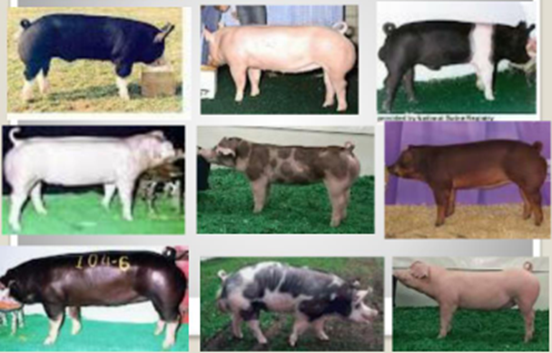
Module Title: - Raising swine production
LG Code: AGR ANP2 M04 LO (1-8) LG (12-19)
TTLM Code: AGR ANP2 TTLM 0822v1

September, 2022
Addis Ababa, Ethiopia
Table of Contents

Introduction to the Module 1
LO #1- Identify and characterize swine production systems 2
Instruction sheet 2
Information Sheet 1 3
Self-check 1 7
LO #2- Identify and select swine breeds 8
Instruction sheet 8
Information Sheet 2 9
Self-Check – 2 17
LO #3-Plan for swine house construction and facilities 18
Instruction sheet 18
Information Sheet 3 20
Self-Check –3 29
LO #4- Formulate ration for swine 30
Instruction sheet 30
Information Sheet 4 31
Self-Check – 4 51
Operation Sheet -4 52
LAP TEST-4 53
Performance Test 53
LO #5- Manage different classes of swine 54
Instruction sheet 54
Information Sheet 5 55
Self-Check – 5 67
Operation Sheet -5 68
LAP TEST-5 71
Performance Test 71
LO #6- Mate and prepare swine for parturition 72
Instruction sheet 72
Information Sheet 6 73
Self-Check – 6 81
LO #7- Carryout swine health care activities 82
Instruction sheet 82
Information Sheet 7 83
Self-Check – 7 91
LO #8- Monitor swine growing environment 92
Instruction sheet 92
Information Sheet -8 94
Self-Check – 8 106
Reference Materials 107

Introduction to the Module
This module covers the knowledge, skills and attitude required for carrying out swine production operations and monitoring housing facilities and growing environment. It requires the knowledge of swine production system, requirements in swine growing environments, and application of routine swine management activities.
LG #12 | LO #1- Identify and characterize swine production systems

Instruction sheet
This learning guide is developed to provide you the necessary information regarding the following content coverage and topics:
  - Identifying and characterizing swine production systems
  - Selecting the feasible swine production system
This guide will also assist you to attain the learning outcomes stated in the cover page. Specifically, upon completion of this learning guide, you will be able to:
  - Identifying and characterizing swine production systems
  - Selecting the feasible swine production system
Learning Instructions:
- Read the specific objectives of this Learning Guide.
- Follow the instructions described below.
- Read the information written in the information Sheets
- Accomplish the Self-checks
- Perform Operation Sheets
- Do the “LAP test”

Information Sheet 1

Introduction
Common Terminologies
Boar: mature male pig kept for breeding purpose.
Gilt: any female pig that has not giving birth
Sow: female pig that has giving birth
Farrowing: the process of giving birth in swine
Pork: meat of pig
Barrow: castrated male prior to sexual maturity
Dystocia- difficulty giving birth
Estrus- readiness to mate
Flushing- increasing energy intake 10 to 14 days prior to estrus to increase number of ova ovulated
Foster- practice of placing piglets from mothers with too many piglets to feed adequately to mothers with extra udder space, should occur in first few days after birth
Grower pig- pig being grown out to market weight, usually takes about 16 weeks
Hand mating- boar is brought to individual female for servicing
Pen mating- boar is placed with group of sows for servicing
Hog- generic term, usually applied to immature swine

Advantages of swine production
Swine production has many advantages:
- Swine convert feed to meat more efficiently than cattle or sheep do.
- Swine are prolific, commonly producing two litters per year and from six to twelve pigs per litter.
- Swine excel in yield of useable carcass compared to other animals that produce red meat.
- Hogs can convert some wastes and by-products into meat. Examples are garden waste and some types of garbage. (Garbage such as food and garden)
- Very little labor is required.
- It is possible to get by with a small investment for buildings and equipment.
- Returns come quickly. A gilt (young female swine) may be bred at eight months, and the pigs are ready for slaughter six months after farrowing.
- Hogs are an excellent source of home-processed meats.

Disadvantages of swine production
There are also drawbacks:
- A hog's diet must rely more heavily on concentrates, which are expensive, than on roughage, which is cheaper.
- Production requires fairly careful management to achieve good results.
- Swine are very susceptible to numerous diseases and parasites.
- Swine. Cannot utilize pasture as effectively as can cattle or sheep.

  - Identifying and characterizing swine production systems
Production system is the way in which animals are kept and managed for specific purpose. Swine production systems can be categorized in to 3 based management, input and land use. These are; intensive, extensive and semi intensive.

1.1.1. Extensive swine production systems
It is characterized by the following features
- Traditional system of keeping pigs
- this is free-range system,
- pigs roam freely around the household and surrounding area,
- scavenging and feeding in the street, from garbage dumps or from neighbouring land or forests around villages
- They may be housed at night in a small shelter, to protect them against theft and predators.
- Requires minimal inputs and low investment of labour, with no or limited money invested in concentrated feed or vaccines.

1.1.2. Semi intensive
It is characterized by the following features
Pigs are confined to a shelter, which can made from a simple pen made with local. The pigs are completely dependent on their keeper for feed, and receive tree branches, leaves, crop residues. Smallholders raise pigs for both subsistence and commercial reasons. Pork is supplied to local markets and to more distant urban markets, through a complex marketing and transport system. limited support from organizations and professional bodies for technical inputs or services

1.1.3. Intensive
Main characteristics of the system
- Pigs are kept in complete confinement.
- Buildings are provided to keep fatteners, boars, sows, and sows with their litters separate.
- Housing amounts to much more than providing a simple shelter.
- Larger numbers of pigs may be kept and the pigs must be well managed because commercial commitments have been made.
- High investments are required to provide improved buildings, and to buy in feeds and medicines.
- In this system of pig keeping, kitchen refuse and agricultural waste products will generally not be sufficient to feed the animals, so certain feeds will have to be bought. Buying in extra feed to help the pig grow faster
- It aimed to provide a major source of income for a group or household.
- The quicker you can get the pig to slaughter weight, the less money you will spend on feed.
Advantages:
- Easy to handle (feeding, water supply, monitoring health, detecting heat, farrowing, etc.).
- Easy to undertake vaccinations and treatments.
- Low risk of diseases when the farmer adheres to good sanitation practices.
- The environment is kept clean and crops are not destroyed by scavenging pigs.
- The manure can fertilize fish ponds or fertilize the field crops (or garden) of the farmer.

Disadvantages:
- High costs of inputs (housing material, feeds and labor).
- Farmer requires more management skills.
- This system is adapted by farmers with a sense for improved pig production.

1.2. Selecting the feasible swine production system
The selection of suitable swine production system depends on farming objective, environmental condition, financial resource, market demand, welfare requirement and other factors. To determine which production system will work best in your situation, you must first consider the following:
- Amount of capital you have
- Labor
- land available
- Level of management and marketing skill needed
- Social and environmental implications associated with manure management

Self-check 1 | Written test

Name…………………………………………… ID………………………… Date…….
Directions: Answer all the questions listed below.

Test I: Give short answer for following question (4 point)
- List the 3 types of swine production systems? (6 points)
- Which production system are kept swine in total confinement? (2 points)
- Write at least 4 characteristics of intensive swine production system(4points)
- Mention factors to be considered in selection swine production system (4point)

You can ask you teacher for the copy of the correct answers.
Note: Satisfactory rating - 11 points Unsatisfactory - below 11points

LG #13 | LO #2- Identify and select swine breeds

Instruction sheet
This learning guide is developed to provide you the necessary information regarding the following content coverage and topics:
- Identifying and charactering swine breeds types
- Selecting specific swine breed
This guide will also assist you to attain the learning outcomes stated in the cover page. Specifically, upon completion of this learning guide, you will be able to:
  - Identify and characterize swine breeds types
  - Select specific swine breed
Learning Instructions:
- Read the specific objectives of this Learning Guide.
- Follow the instructions described below.
- Read the information written in the information Sheets
- Accomplish the Self-checks
- Perform Operation Sheets
- Do the “LAP test”

Information Sheet 2

2.1. Identifying and charactering swine breeds types
Breed: A group of animals that have unique color patterns or body structure because they share common ancestors that were selected from those characteristics. A breed is defined as a group of animals sharing a common ancestry that have distinguishable, fixed characteristics who when mated with a member of the same breed will produce offspring with the same characteristics
Many breeds of swine are commonly raised each breed has characteristics that distinguish it from other breeds of swine.
Some of the major breeds of swine and their characteristics:A. Berkshire
- Ideal Color Pattern
- Black with 6 white points
- Physical Characteristics
- Black body
- White nose
- White feet
- Erect ears
- Berkshires are primarily known for their fast and efficient growth and high quality carcasses.
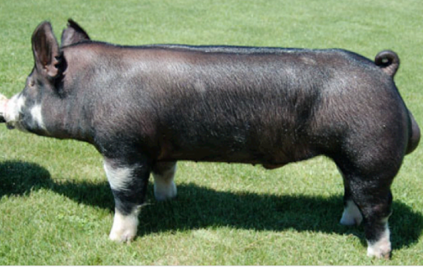
Figure 2.1. A Berkshire
B. Chester White
- Physical Characteristics
- All white body
- Downward ears
- Medium-sized ears
- Their strengths are mothering ability, durability, and soundness.
- Chester Whites are a member of Certified Pedigreed Swine.
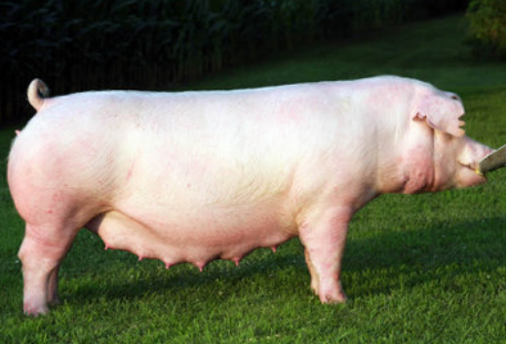
Figure 2.1.B Chester Whites
C. Duroc
- Physical Characteristics
  - Solid red in color (can range from light, golden brown to dark red, almost mahogany color)
  - Downward ears
- Durocs are known to be fast growing and have excellent meat quality.
- They are also competitive with other breeds in terms of carcass leanness and feed efficiency.
- Durocs are a member of the National Swine Registry.
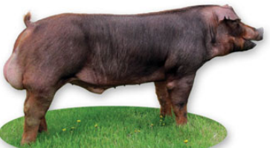
Figure 2.1. C. Durocs
D. Hampshire
- Physical Characteristics
  - Black in color with a white belt.
  - Belt should encircle body and include both legs and feet
  - Erect ears
- Hampshires are primarily known for their lean muscle and good carcass quality.
- Hampshires are a member of the National Swine Registry
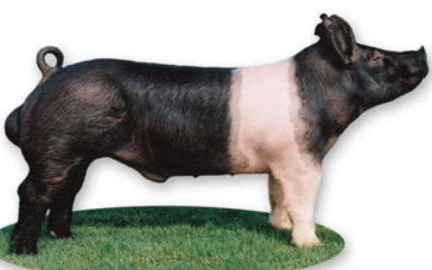
Figure 2.1. D. Hampshire
E. Hereford
- Physical Characteristics
  - Downward ears
  - Red body
  - White legs
  - White face
- Registration Qualifications
  - White face, not less than two thirds red exclusive of face and ears
  - At least three white feet with white showing no less than one inch above the hoof
  - No white belt
  - No swirls in the hair coat
- The Hereford breed is primarily known for its distinct color markings; in addition, they are good feeders and they fatten readily.
- Herefords are a member of Certified Pedigree Swine.
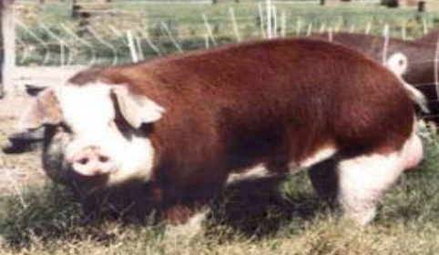
Figure 2.1. E. Hereford
F. Landrace
- Physical Characteristics
    - White in color
    - Downward ears
- The Landrace breed is recognized for its ability to farrow and raise large litters.
- Landrace are a member of the National Swine Registry
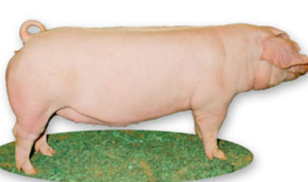
Figure 2.1. F. Landrace
G. Poland China
- Physical Characteristics
  - Downward ears
  - Black body
  - White legs
  - White face
- The Poland China hog today is recognized as a big framed, long bodied, lean, muscular individual that leads the U.S. pork production in pounds of hog per sow per year.
- Poland Chinas are a member of Certified Pedigreed Swine.
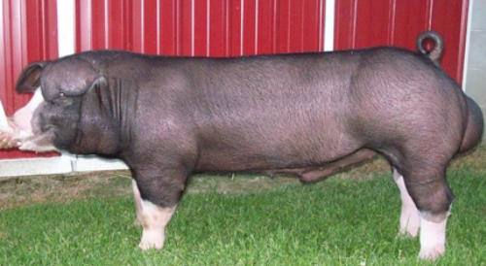
Figure 2.1.G. Poland China
H. Spotted swine
- Physical Characteristics
  - Downward Eared
  - Black and white spotted body
- Spots are popular with farmers and commercial swine producers for their ability to transmit their fast-gaining, feed efficient, meat qualities to their offspring.
- Spots are a member of Certified Pedigreed Swine.
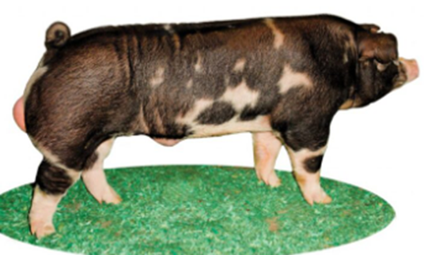
Figure 2.1.H. Spotted
I. Tamworth
- Physical Characteristics
  - Red color (can range from a more golden red to a dark red)
  - Erect ears
- Registration Qualifications Curly coats and too much black pigmentation on the body are grounds for disqualification from registration.
- The Tamworth is a lean type hog who is known for producing high quality bacon.
- Tamworth are a member of the Tamworth Swine Association.
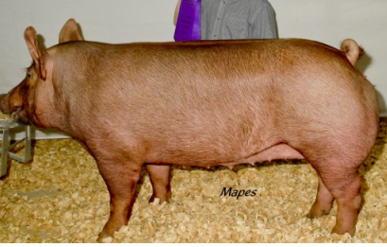
Figure 2.1.I. Tamworth

J. Yorkshire
- Physical Characteristics
  - All white body
  - Erect ears
- Yorkshires are referred to as the “Mother Breed” because they excel in litter size, birth and weaning weight, rebreeding interval, durability, and longevity.
- Yorkshires are a member of the National Swine Registry.
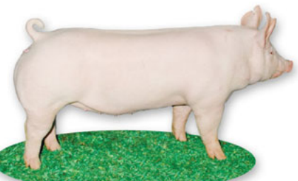
Figure. 2.1. J. Yorkshire

2.2. Selecting specific swine breed
The following criteria should be considered when selecting specific breed of swine:
A. Growth Rate:
Measured by determining the difference in weight at weaning and weight at maturity divided by the number of days. A good rule of thumb is to weigh the animals at two months and then at five months. The daily gain is the difference in weight divided by 90, the number of days in three months. At five months, the live- weight of a pig should be between 65-85kg. The rate of gain should not be less than 600glday.
B. Efficiency of Gain:
A measure of how much feed was consumed to put on the weight gain. It is usually measured for a group of pigs. Add the total feed consumption of the group that was fed together and divide by the total weight gain of the entire group to get the feed efficiency of the group.
C. Litter Size:
Is important, but it is a low heritable trait. Select breeders from amongst large, healthy and well performing litters.

D. Conformation and Sex Characteristics:
Pigs selected for breeding must be physically healthy, have good strong legs, be free from any defects and must not be too fat. It is important to note that the genetic influence of the boar on the next generation is greater than that of the sow since one boar will be used to mate several sows. Boars must have two equally sized and firmly suspended testicles, exhibit sex drive and be void of bad habits. Gilts must have a good underline and udder with at least 12 well-spaced, fully formed teats.

E. Other selection criteria
For the small scale farmers, the above four criteria are adequate but for the large scale farmers and swine breeding or testing stations, other criteria commonly in use. These include:
  - Furrowing rate, number of still born litter
  - Average swine birth weight
  - Swine weaned per litter furrowed
  - Average weaning weight
  - Loin muscle area
  - Carcass length
  - Back fat depth
  - Fat depth
  - Mortality rate at weaning and in growing finished stage.

Self-Check – 2 | Written test

Name…………………………………………… ID………………………… Date…….

Directions: Answer all the questions listed below.
Test I: Short Answer Questions
1. List the factors to be considered in selection suitable swine breeds (5 points)
2. List at least 5 known swine breeds (4 points)
3. Which breed of swine is known as mother breed (2 points?)

Note: Satisfactory rating - 6 points Unsatisfactory - below 6points
You can ask you teacher for the copy of the correct answers.

LG #14 | LO #3-Plan for swine house construction and facilities

Instruction sheet
This learning guide is developed to provide you the necessary information regarding the following content coverage and topics:
- Selecting site swine house construction
- Designing swine house and farm layout space requirement
- Swine house construction facilities and materials
This guide will also assist you to attain the learning outcomes stated in the cover page. Specifically, upon completion of this learning guide, you will be able to:
- Select site swine house construction
- Design swine house and farm layout space requirement
- Swine house construction facilities and materials
Learning Instructions:
- Read the specific objectives of this Learning Guide.
- Follow the instructions described below.
- Read the information written in the information Sheets
- Accomplish the Self-checks
- Perform Operation Sheets
- Do the “LAP test”

Information Sheet 3
3.1. Selecting site for swine house construction
Good, efficient housing makes management easier and helps the producer to successfully. Pigs at different stages of growth need different environments (temperatures). If they are to produce and grow to their maximum potential piglets need special protection against very low temperatures. Growing and reproducing pigs must be protected against high temperatures. The houses must therefore be built in such a way that the pigs are protected against extreme temperatures and other bad weather conditions such as cold winds and continuous rain. Location of new or existing site is inspected and physical elements and features of the site are recorded for assessment of suitability.
Physical elements and features may include an assessment of:

A. Soil
Soils should be free draining to avoid severe poaching by stock and to allow tractor access during the winter. Stony soils and thin soils over rock, especially those containing flint, can damage legs and feet and should be avoided.

B. Topography
Sloping fields should be avoided for farrowing paddocks, as they increase the chances of the movement of piglets and bedding and thus increase the risk of overlying. However, gentle slopes can be used for other stock as they have a positive effect on drainage. If sloping sites are selected, careful consideration should be given to layout

C. Climatic Considerations
- Rainfall: The most important factor of climate is rainfall. Ideally an outdoor pig unit should be sited in an area with less than 800 mm per year. Higher rainfall may be acceptable where the soil type is ideal and the risk of erosion is low. Conversely, where rainfall is very low, a more marginal soil type may be acceptable. Higher standards of management will be required to maintain suitable conditions for the pigs where rainfall is high.
- Sun and wind factor: Other factors that should be considered are the effects of the sun and wind. The risk of chilling, particularly of piglets, is significantly increased when temperatures are low and wind-chill factors are high. The effects of wind chill can be reduced by the selection of sites which offer natural shelter either from the surrounding topography or natural wind breaks such as hedges.

D. Availability of Water
A good water supply is essential to any pig unit. Remote sites can present difficult problems in achieving an adequate supply of water for the stock.

E. Existing vegetation
Siting the unit on paddocks with suitable ground cover, typically established grass, offers a number of important benefits well-established grass sward provides additional drainage and can protect the soil from damage when it is wet. It also offers benefits through its insulation characteristics, providing a cooling effect in the summer. Farrowing paddocks, in particular benefit from the positive attributes of ground cover. Ground cover also provides behavioural benefits to the pigs by allowing grazing.

F. Natural Hazards
Location of the site should take into account the risk of any natural hazards. In particular sites susceptible to flooding should be avoided as it can take a considerable amount of time to move pigs to safety.

G. The availability and accessibility of essential services
Check the availability of feed road, electricity and other service. A farm should also have an accessible path to facilitate the transportation of feed and pigs throughout the year

H. Away from residences (around 8-10 meter away downwind).
In case of a large-scale pig farm, the site selected needs also to be: well connected to roads throughout the year

I. Distance to Other Farms
The ideal distance from other farms and neighbors is approximately one kilometer. This will serve as a natural screen in disease prevention. The distance from neighbors is important to avoid future complaints about pig odors, flies, noise and pollution.

J. The possibility of expansion (Future expansion)
K. Zoning and Permits
Check out local zoning laws and regulations for a proposed location. If it is divided into agricultural areas, the situation must be carefully studied before building the pig facilities or the pig sheds or houses.

3.2. Designing swine house, farm layout and space requirement
Over-crowding is a common cause of depressed performance and low productivity in pigs. Therefore, it is better to consider pig house design and space requirement.

3.2.1. Designing swine house and farm layout
Swine buildings apart from providing protection against inclement weather should also provide proper hygienic conditions required to maintain the healthy growth of pigs. Sheds for pigs are known as sties. Dimensions of the sties and dimensions of managers and water tanks in adult and young pig sties shall be as specified.
The design of housing facilities to meet commercial pig production objectives must be based on weather conditions, local prevailing practices, constraints on land, environmental considerations, governmental regulations, and costs. It is a mistake not to invest in high-quality housing designed by experienced engineers. Farmers/producers have to use qualified person to design and submit plans of the farm layout for approval in commercial farming. The main components of the farm lot are: service areas, pig housing, and water and wastewater lagoon area.

A. Production area
Production area including the piggery and production facilities, which is the main building of pig farms, General construction area accounted for the overall building area of 70%~80%. Breeding boar pigs demand to separate from other pigpen,. Breeding boar pig’s area should be located in the less people places and on Upwind region, to prevent the smell of the sows adverse stimulation for boar, meanwhile to use boar odour stimulates the sow estrus. Farrowing pens need to not only close to the gestation pens, but also close to fatten pigs. Fatten pigs should be located in downwind and near to the pig way out. When design the pig house should have an angle of 60 to 30 degrees according to the dominant wind direction, so that each row of the pig get the best ventilation in the summer.
In short, the pig house should according to the local natural conditions, make full use of favorable factors, to do the most good for production on the layout.
In the entrance of production area, should set up a special disinfection room or disinfection pool, In order to carry out strict disinfection for personnel and vehicles to enter the production area.

B. Breeding management area
Breeding management area includes the required ancillary buildings for farm production management, such as feed processing plant, feed warehouses, repair shops; substations, boiler rooms and pump rooms. They have a closed relationship with the daily breeding work, so this area should be built in close proximity to the production area.

C. Diseased pigs isolating room and waste dump
Diseased pigs isolating room and waste dump should be kept away from the production area, located in the downwind, low-lying areas, so as not to affect the production of pigs.

D. Veterinary office
The veterinary office should be located in the production area and only open for that area, for the purpose of diseased pigs, usually located in the downwind direction.

E. Living area
Including offices, reception room, accounting room, canteen, dormitories, and this is where managers and family live and should be separated.
Generally located in upwind place of the production area, or the side parallel to the wind direction. In addition pig farms should be built wall or Epidemic prevention ditch to prevent animal damage and avoid miscellaneous personnel into the field.

F. Road
Roads play an important role on normal production activities, and epidemic prevention as well as increasing work efficiency. Clean and polluted road should not cross with each other, separate inlet and outlet. The feature of clean road is for the people and the transportation for the product lines and fodder, polluted road is for transporting manure, diseased pigs and lanes of abandoned equipment.

G. Water tower
Water tower is the guarantee for the normal supply of clean drinking water, should choose according the water sources, and should be arranged on the top pig farms.

H. Virescence
Virescence not only beautify the environment, clean air, or heatstroke, but also can cold and improve microclimate of the pig farms, meaning while it can reduce the noise, thus can promote safety and enhance economic efficiency.
So when design the overall of the pig farm, better to consider and arrange a good virescence.
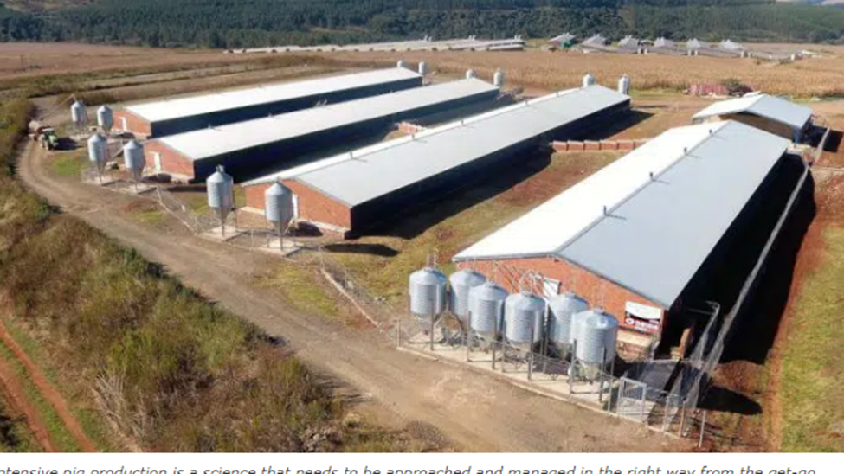
Figure 3.2.1 pig farm design

3.2.2. Space Allowances/ requirement for pig
Space allowances need to meet the movement and social needs of the pigs, and depend on the interaction of a number of factors, including feeding strategies, group size, age, breed, temperature, insulation, ventilation, pen shape, flooring, lighting, and other husbandry factors. Weight, number of pigs per group, air temperature, methods of feeding, ventilation and floor design are factors that affect space requirement.

A. Weaned/Grower/Finisher Pig Space Allowances
When calculating space allowances for pigs, a formula that relates body weight to body surface area is used. Floor space allowance is expressed using a k-value, which, when multiplied by a pig’s body weight (kg) ^{0.667}, gives the floor surface area in m². The optimal k-value may change according to temperature, type of flooring and group size.
Boars are usually housed individually. Boar stalls need to provide enough room for boars to stand and to lie down comfortably.
Pigs must be housed at a space allowance of k ≥ 0.0335. When a short-term decrease in space allowance is needed at the end of the production phase:
- Decrease of up to 15% for nursery pigs and up to 10% for grower/finisher pigs is allowed
- Decrease of up to 20% for nursery pigs and up to 15% for grower/finisher pigs is allowed only if it is demonstrated that the higher densities do not compromise the welfare of the animals as determined by average daily gain, mortality, morbidity and treatment records, as well as the absence of or no increase in vices such as tail-biting.

Table. 3.2.2. A. Space Allowances for different class of swine
Live weight | Floor area per swine
20-50kg(growers) | 1m²
50-100kg(finishers) | 2m²
Dry sow | 2.5m²
Lactating sow and finisher | 10m²
Boar | 9m²

3.3. Identifying swine house construction materials and facilities
3.3.1. Selection house construction materials
Wide range of building materials is available for the construction of buildings and structures. The proper selection of materials to be used in a particular building or structure can influence the original cost, maintenance, ease of cleaning, durability and, of course, appearance.
Several factors need to be considered when choosing the materials for a construction:
  - Type and function of the building or structure and the specific characteristics required of the materials used, i.e. great strength, water resistance, attractive appearance, etc.
  - Economic aspects of the building/structure in terms of original investment
  - Availability of materials in the area.
  - Availability of the skilled labour required to install some types of material.
  - Quality and durability of different types of material.
  - Transportation costs.
  - Selection of materials with compatible properties, dimensions and means of installation.
  - Cultural acceptability or personal preference.

3.3.1. Type of construction materials
Example: Wood characteristics:
- Strength in wood is its ability to resist breaking when it is used in beams and columns.
- Hardness is the resistance to denting and wear
- Woods that are stiff resist deflection or bending when loaded.
- Tough woods will deflect considerably before breaking.
- Nail-holding resistance for hardwoods is greater than for softer woods.
- The workability, such as sawing, shaping and nailing, is better for soft, low-density woods than for hardwoods, but usually they cannot be given a high polish.
- Natural-decay resistance is particularly important in the warm, humid regions
Gravel, sand for blinding, concrete, bricks, mortar, plaster, cement plaster, Wooden posts, gum-poles, corrugated steel sheets, nails, frame-timber, wire, cement, gravel, stone etc

3.3.2. Swine house construction facilities
Pigs need a well-drained, dry and comfortable place to rest, except in situations where sprinklers or misters may be used to prevent heat stress. Management in indoor production systems can have a significant impact on pig welfare. Flooring, bedding, resting surfaces and outdoor yards should be cleaned as conditions warrant, to ensure good hygiene, comfort and minimise risk of diseases and injuries.

Flooring
Floors should be designed to minimise slipping and falling, promote foot health, and reduce the risk of claw injuries. If a housing system includes areas of slatted floor, the slat and gap widths should be appropriate to the claw size of the pigs to prevent injuries. Slope of the floor should allow water to drain and not pool. If bedding or rubber matting is provided it should be maintained to provide pigs with a clean, dry and comfortable place on which to lie.

Proper ventilation
Good air quality and ventilation are important for the welfare and health of pigs and reduce the risk of respiratory discomfort, diseases and abnormal behaviour. Dust, toxins, microorganisms and noxious gases, including ammonia, hydrogen Sulphide, and methane caused by decomposing animal waste, can be problematic in indoor systems. It is particularly important for young pigs, for effective heat dissipation in pigs and to prevent the build-up of effluent gases (e.g. ammonia and hydrogen sulphide), including those from manure and dust in the housing unit

Insulation and bedding materials
Protection from cold should be provided when conditions are likely to compromise the welfare of pigs, particularly in neonates and young pigs and others that are physiologically compromised (e.g. ill animals). Protection can be provided by insulation, extra bedding, heat mats or lamps and natural or man-made shelters in outdoor systems.

Lighting
Indoor systems should have light levels sufficient to allow all pigs to see one another, to investigate their surroundings visually and to show other normal behaviour patterns and to be seen clearly by staff to allow adequate inspection of the pigs. The lighting regime should be such as to prevent health and behavioural problems.

Self-Check –3 | Written test

Name…………………………………………… ID………………………… Date…….

Directions: Answer all the questions listed below.

Test I: Short Answer Questions
1. List down factors to be considered in selection of swine house (5points)
2. Factors need to be considered when choosing the materials for a house construction (5points)
3. Write at least 4 swine housing facilities (4points)
4. Write formula used for calculating space allowance (2points)

Note: Satisfactory rating - 9 points Unsatisfactory - below 9 points

You can ask you teacher for the copy of the correct answers.

You can ask you teacher for the copy of the correct answers.

LG #15 | LO #4- Formulate ration for swine

Instruction sheet
This learning guide is developed to provide you the necessary information regarding the following content coverage and topics:
  - Identifying swine nutritional requirements and nutritional value of feedstuffs
  - Making decisions concerning dietary elements for particular rations
  - Selecting, checking, and maintaining materials, tools and equipment
  - Identifying and obtaining feed ingredients
  - Measuring feed ingredients
  - Specifying and milling ingredients
  - Mixing feed ingredients
This guide will also assist you to attain the learning outcomes stated in the cover page. Specifically, upon completion of this learning guide, you will be able to:
  - Identify swine nutritional requirements and nutritional value of feedstuffs
  - Make decisions concerning dietary elements for particular rations
  - Select, check, and maintain materials, tools and equipment
  - Identify and obtain feed ingredients
  - Measure feed ingredients
  - Specify and milling ingredients
  - Mix feed ingredients
Learning Instructions:
- Read the specific objectives of this Learning Guide.
- Follow the instructions described below.
- Read the information written in the information Sheets
- Accomplish the Self-checks
- Perform Operation Sheets
- Do the “LAP test”

Information Sheet 4

4.1. Identifying swine nutritional requirements and nutritional value of feedstuffs
4.1.1 Swine nutritional requirements
Nutrients: are any feed component or group of feed components that are similar in chemical composition and that aid in the support of animal life. Examples of nutrients are proteins, carbohydrates, fats, minerals and vitamins. The nutrient concentration in the diet is adjusted according to feed intake to meet the requirements during each stage of production. Providing diets with nutrient levels below the requirements results in suboptimal performance, whereas feeding nutrients above the requirements increases feed cost and nutrient excretion.

- Factors affecting nutrient requirements of pig.
Order to ensure optimal production at an economical cost, it is important to understand the factors involved in nutrient requirement estimates and adjust the diet formulation accordingly. Several factors affect the estimation of nutrient requirements in pigs.
Some of the most important factors are:
- Age: younger animals require diets with higher protein levels when compared to adult animals;
- Genetic Potential: fast-growing pig breeds – such as Large White animals, require diets with higher protein content than breeds with a lower growth rate – such as the Hampshire breed,
- Climate: climatic variation in the breeding environment causes the animal to expend more energy to maintain its body temperature in balance. In this case, in order to guarantee its growth rate, it is necessary to provide higher levels of energy in the diet;
- Physiological stage: the need for nutrients also varies according to the animal’s physiological state in the different stages of breeding. Pregnant sows, for example, need different energy and nutritional levels when compared to dry sows, freshly weaned piglets or animals in the finishing phase;
- Ingredients for pork nutrition included in the ration: pigs, because they are monogastric animals, have low fiber digestion. Therefore, unlike cattle feeding, in which it is possible to feed them only with pastures, the pigs need supplementation in the feeding by using ingredients with low fiber content and higher levels of energy and protein;
- Health status
- Feeding strategy and degree of competition for feed
- Presence of molds, toxins, or anti-nutritional factors in the diet
- Inclusion of feed additives in the diet

4.1.2. Classification of nutrient requirements in pig
Different stages of growth, production and reproduction have different nutrient requirements. To be profitable in swine production these different dietary requirements need to be met as inexpensively as possible. The nutrient requirements of pig can be broken down into maintenance and production (lactation, growth, reproduction and extra activity) requirements. Maintenance requirements, growth requirements and production requirements are very important. Good feed is necessary for growth, body maintenance and the production of meat.

A. Maintenance:
All activities and body processes necessary for staying alive and maintaining an animal’s bodyweight. Some specific components include:
- Energy to support essential physiological functions.
- Maintenance of body temperature.
- Repair of body tissue.
An animal is in a state of maintenance when its body composition remains constant, when it does not give rise to any product such as milk, and when it does not perform any work on its environment. Maintenance (nutrient for basic activities (breath, blood flow, low activities) without body weight change. Weight, age, breed, physiological status, activity and environmental conditions are the primary variables impacting maintenance requirements.

B. Production:
Nutrients supplied above those required for maintenance allow for productive functions such as:
- Reproduction: Pregnancy and delivery make demands on the dam which should be met largely from her diet. The fetus increases in size quickly during the last third of gestation, drawing on the body reserves of the dam if she is not fed adequately.
- Growth: Any growth requires nutrients; sheep/goats require large quantities of energy and protein during the main period of growth between weaning and attaining mature body weight.
- Lactation: Milk production requires high levels of energy, protein, and water.
- Extra activity: Livestock in pastoral systems walk long distances in search of feed, particularly in the dry season. Animals may walk 10–15 km each day, which requires a great deal of energy.

4.1.2. Determining nutritional value of feedstuffs
Animal require consistent supply of energy, protein, minerals, vitamins and water to maintain productivity and health. From these components, requirements for energy, protein, minerals, and vitamins are calculated by understanding the different factors that affect requirements, producers can make adjustments to changes. You can use locally available feeds that are less expensive, but can be nutritionally complete when properly prepared. In fact, pigs can be fed well using only kitchen scraps from a family’s household. The nutritional needs of pigs can be divided into six categories or classes. These are water, carbohydrates, fats, proteins, vitamins and minerals.

A. Water
Water is one of the most important nutrients. Swine of all ages should have free access to fresh and clean water at all times. Drinking water is the first requirement for all animals. Clean and fresh water for drinking should be available all the time. Pigs drink about two to five times as much as they eat, depending on the amount of moisture in the feed. Even if you feed them at will, it is advisable to have extra drinking water available. When an animal is under stress, due to heat or disease, it will stop eating but will need extra water to drink. A lactating sow with 10 piglets needs at least 25 litres of water per day. Clean the drinking pan or trough at least once a day.
Modern drinking nipples are a lot cleaner, but should be examined daily to check that they are functioning properly. Although pigs like to wallow in water, to cool down or for fun, this is not necessary and they should not be allowed to lie down in their drinking water. Limiting water intake will result in reduced growth rate and efficiency of gain in pigs and reduce milk production in lactating sows. A severe limitation of drinking water can cause death in pigs. The requirement of water is influenced by many factors including environmental temperature and humidity, composition of the feed and weight of the pig.

B. Energy
Apart from water, energy is the most important food requirement of the pig and will most rapidly influence its survival if withdrawn. It is normally measured in heat units, traditionally as calorie, but now the megajoule (MJ) is the most commonly-used unit (where 1 MJ = 0239 MCals). Nursing pigs derived most of their energy from fat and lactose sugar in milk. Most of the energy for growing pigs is derived from metabolism of starch because of insufficient amylase starch digestive enzyme in the small intestine. For all weight classes of pigs, the metabolisable energy (M.E.) is approximately 96% of the digestible energy requirement. Energy requirement of pigs are influenced by their weight which influences the maintenance requirement by their genetic capacity for growth or milk synthesis and by the environmental temperature in which they are housed.
The energy requirement for maintenance is directly related to metabolic body weight and is approximately 110kcal of digestible energy (D.E.) per kilogram body weight. Some examples are maize, rice, sorghum, cassava, sweet potato and cereal grain.
You can assess whether the pigs are getting enough energy by looking at their condition. When there is extra energy available, the animal will store it as body fat. If the pig is very thin, it means that there is a shortage of energy and the pig’s productivity will be very low. However, if reproductive sows are too fat, their productivity will decrease

C. Protein
Protein consists of some 20 basic units known as amino acids. Nine of the amino acids required by the pig cannot be synthesised by its body, and they must be supplied in the diet. If they are present in insufficient quantities, the pig will not grow and may not even survive. Swine require 10 essential amino acids in its diet for normal body function. A good quality protein is one that provides the amino acids in the amount and proportion necessary for the particular need of the pig (growth, reproduction and lactation). Protein food are oil seed e.g. cotton seed, soybean groundnuts coconut bean, peas, blood meal, fishmeal, etc. amino acid requirement are influenced mostly by age and weight of the pig. In a daily basis the requirement increase as the pig increases weight.
Protein is necessary for physical development: growth, breeding and milk production. Protein is the most important nutrient in the body, because all organs, muscles and enzymes are made of proteins. In the feed, the protein quality is as important as quantity. It is important that the pig gets the right type of amino acids because it uses these to build its own protein (muscle protein, milk protein etc.). The best quality protein (and the highest protein concentration) is from animal products, like fishmeal, milk or meat meal. Some protein of animal origin should be included if possible, especially for the young animals, which need to grow a lot. (Compare with nutritional needs of children.). By-products from plant oils also have a high protein content, e.g. soybean meal or groundnut cake. However, cereals do not have enough protein and need to be supplemented with protein-rich products.

D. Minerals
Compared with energy and protein, minerals are required in very small amount. Thirteen minerals are required in the diet. Major minerals include calcium, phosphorus, sodium, magnesium, choline and the trace minerals includes iron, iodine and selenium. The two minerals required in the greatest amount by swine are calcium and phosphorus. Adequate levels of both calcium and phosphorus must be included in the diet for strong skeletal structure.

E. Vitamins
Vitamins can be defined as organic compounds which function in small amounts (mg or μg) and are essential to the normal functioning of the animal body. They cannot be synthesized inadequate amounts by body tissues and when lacking, provoke deficiency diseases. Fourteen vitamins are required by swine, all in very small amounts. Fat soluble vitamins are A D E and K. while water soluble vitamins are vitamin C and B complex, Riboflavin, Pantothenic acid, Niacin, Vitamin B12, Choline, Pyridoxine, Thiamin, Folic acid and Biotin. Cereal, grains and plant protein supplements are very poor sources of many of the vitamins. From a practical stand point, vitamin premix should be added to swine feed.

4.2. Making decisions concerning dietary elements for particular rations
- Adequate energy and protein
- Pigs need energy to maintain bodily processes, to grow, and to reproduce. Carbohydrates from cereal grains are the most abundant energy source. Fats and oils have more energy than carbohydrates per unit weight.
- Protein can serve as an energy source if supplied in excess but it is usually more expensive than other sources.
- From a nutritional standpoint, there is not a single best formula. Ingredients should selected on the basis of availability, price, and quality.
- Com, barley, sorghum, and wheat are the primary energy sources in commercial feed for swine that weigh more than 5 kg. These grains are low in protein, certain essential amino acids, inorganic elements, and vitamins.
- Soybean meal, oil seed meal, and animal protein meal are commonly used for supplemental protein.
- Vitamin/mineral premixes, salt, calcium, and phosphorus can be added to the pig's diet to provide the required nutrients.

4.3. Selecting, checking, and maintaining materials, tools and equipment
Types of tools and equipment
A. Grinder
- Grinding or particle-size reduction is a major function of feed manufacturing
B. Mixers
- to obtain homogeneous mixtures,
- appropriate for the range of weights and volumes required
C. Weighing equipment
- appropriate for the weights and volumes to be used
- Accuracy of the weighing equipment should be compatible
4.2. Maintenance of tools and equipment
- disassembled
- calibration methods and frequencies
- comply with manufacturers’ recommendations
- Equipments coating, painting, lubricating and etc
- not contribute to unacceptable contamination of feed

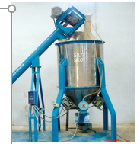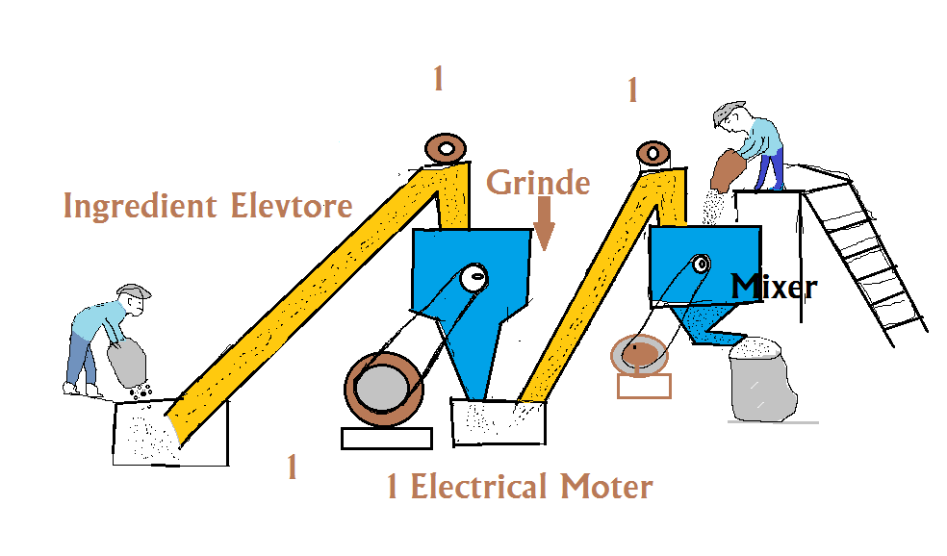

Figure 4.3. B . Feed mixer Figure. 4.3 A . Feed grinder

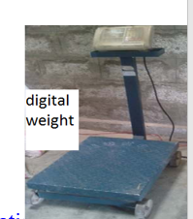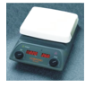

Figure. 4.3. Weighing balances

4.4. Identifying and obtaining feed ingredients
Feed ingredients for swine diets are selected for the nutrients they can provide, the absence of anti-nutritional or toxic factors, their palatability or effect on voluntary feed intake, and their cost. The key nutrients that need to be supplied by the dietary ingredients are amino acids contained in proteins, vitamins and minerals. All life functions also require energy, obtained from starches, lipids and proteins.
Feed ingredients for animal diets are selected for the nutrients they can provide, the absence of anti-nutritional or toxic factors, their palatability or effect on voluntary feed intake, and their cost. The key nutrients that need to be supplied by the dietary ingredients are amino acids contained in proteins, vitamins and minerals. All life functions also require energy, obtained from starches, lipids and proteins.
Most animal feed ingredients manufacturing companies are employ nutritionists who help create formulated mixtures based on the needs of the targeted animals. This process of formulating an animal feed so as to provide a balanced diet to animals is a rather complex process since each group of animals has different nutritional needs. These feeds generally consist of:
- Agricultural products, such as vitamins, wheat, fruits, forage, minerals, corn, barley, distiller’s grain, sorghum and vegetables.
- Co-products which are by-products of either a chemical reaction or a manufacturing process and include ingredients, such as:
  - Animal protein;
  - Blood meal;
  - Bakery co-products;
  - Citrus pulp;
  - Brewer’s yeast;
  - Salt;
  - Soybean meal etc.
Animal feed ingredients play a very important role in the animal husbandry industry. In fact the health of the animals reared in a farm forms the foundation of this industry and thus needs to be properly catered to so as to ensure the health of the industry as a whole.
Feed ingredients are broadly classified into cereal grains, protein meals, fats and oils, minerals, feed additives, and miscellaneous raw materials, such as roots and tubers.
Cereal Grains
The term “cereal gains” here includes cereal grains, cereal by-products and distillers dry grains with soluble. Cereal grains are used mainly to satisfy the energy requirement. The dominant feed grain is corn, although different grains are used in various countries and regions of the world. The amounts and types of cereal grains included in diets will depend largely on their current costs relative to their nutritive values, care must be taken to avoid making large changes to the cereal component of diets as sudden changes can cause digestive upsets that may reduce productivity and predispose the birds to disease.
The quality of cereal grains will also depend on seasonal and storage conditions. Poor growing or storage conditions can lead to grains with a lower than expected energy content or contamination with mycotoxins or toxin-producing organisms such as fungi and ergots. Genetic and environmental factors also affect not only the content of nutrients in grains but also the nutritive value, which takes into account the digestibility of nutrients contained in an ingredient in the target animal.
Protein Meals
Protein is provided from both vegetable and animal sources, such as oilseed meals, legumes and abattoir and fish processing by-products.

Vegetable Protein Sources
Vegetable protein sources usually come as meal or cake, the by-product of oilseed crops. The main oilseed crops include soybean, rapeseed/canola, sunflower, palm kernel, copra, linseed peanut and sesame seed. After the oil is extracted, the remaining residue is used as feed ingredient. Oilseed meals make up 20-30% of a poultry diet. Inclusion levels do vary among formulations for different species and for the same species in different regions.

4.5. Measuring feed ingredients
Weigh feed--There is no substitute for weighing feed ingredients when mixing diets. Scales help you be consistent and accurate as you mix feed. They ensure that ingredients are included in the diet in the proper proportions. Furthermore, scales provide more accurate data for calculating feed efficiency and feed cost/lb. of gain. Some types of on-farm feed mixing equipment, however, are not designed to weigh feed ingredients. It is essential that equipment that measures feed on a volume basis be calibrated frequently to account for changes in bulk density (test weight) and flow characteristics of feedstuffs. For example, the bulk density of soybean meal and commercial supplements can range from 37 to 50 lb. /cu ft. Likewise, the bulk density of grain and vitamin and trace mineral premixes varies. Unless the mixing equipment is calibrated periodically, variations in the nutrient content of diets could be large and affect performance and profits.
Careful attention must be given to the quality of the ingredients used to manufacture swine diets. The quality of the final diet also needs to be checked to ensure it is consistent with that of the original formula specifications or product description. Otherwise, optimal pig performance and economic outcomes may not be achieved. To ensure this consistency, a quality assurance program that involves product specification sheets, proper feed and ingredient sampling, analytical procedures and interpretation of laboratory results should be implemented.

Logical Steps in Formulating a Diet
1. Identify animals to be fed by age, weight, function, and specific conditions under which they are fed. Penning and feeding in uniform lots allow a producer to more closely meet the requirement of the pig.
2. Select a set of nutrient requirements or allowances most appropriate for the animals being fed. An authoritative source of information is Nutrient Requirements of Swine authored by the National Research Council (NRC, 1998). Nutrient requirements depend on a variety of factors, such as stage of growth, lean growth potential, and environmental conditions. Tables 1, 2, and 3 show requirements for amino acids, minerals, and vitamins, respectively, which meet the requirements of swine raised under most production scenarios. Table 4 gives some conversion factors that are very useful in diet calculations.
3. Select suitable ingredients to help ensure that the ration is nutritionally balanced, palatable, safe, and economical. The inclusion of certain feed ingredients should be limited and some guidelines for using different feedstuffs are given in Table 5. Various feeding guides and example diets can be helpful in selecting feed ingredients. Average analyses of selected ingredients are presented in Table 6. However, for the most accurate feed formulation, feedstuffs to be used in the ration should be analyzed, and the values should be used in the formulation.
4. Determine the necessary fixed amount of certain ingredients (minerals and vitamins) and then mix grain(s) relative to protein supplements to provide the desired level of amino acids. Diets can be formulated using a computer ration formulation program or computed by hand. Formulation by computer allows the user to take multiple factors into account and is the superior and most used method of formulation. Calculations by hand can be useful if a diet formulation program is not available. In that case, the ration can be formulated on either a cwt (100lb.) basis or on a ton basis, depending on personal preference. The advantage of cwt basis is that percentage figures for diet nutrients are the same as pound figures for diet nutrients. However, formulating diets on a ton basis can reduce calculation time required, particularly where cost per ton of diet ingredients is to be determined. The quantity of any particular ingredient may be determined by using feeding guides and personal experience. Precision in balancing a diet can be obtained with simultaneous equations or algebraic equations. However, the “Square Method” is most used in balancing diets because it is easy to use when blending two feeds or combinations of feed ingredients into a mixture containing a definite percentage of some nutritive factor.

Balancing Diets for Amino Acids
Diets should be balanced on an amino acid basis rather than on a crude protein basis. This provides a more precise indication of diet adequacy. For the purpose of this discussion, diets will be balanced on a total amino acid basis (i.e., the total content of certain amino acids of feed ingredients); although, formulation based on apparent or true ileal digestible amino acids may provide some additional precision (see PIH-5, “Protein and Amino Acids for Swine,” Hays and Baker, 1998 for more details). Lysine is the amino acid recognized as most limiting in swine diets and is used to balance diets initially. Other essential amino acids will be present in sufficient quantities in corn-soybean meal based rations, but should be checked when using a variety of other ingredients or synthetic lysine.

The Square Method to Formulate Diets
Subtract on the diagonal the smaller number from the larger to obtain relative amounts of corn (3.0 – 0.8 = 2.2) and supplement (0.8 – 0.26 = 0.54). A 0.8% diet would be derived from 0.54 parts of the 3.0% supplement and 2.2 parts of the 0.26% corn. To put this on a percentage basis, divide 0.54 by 2.74 and multiply by 100 to get 19.71% supplement in the diet, and divide 2.2 by 2.74 and multiply by 100 to get 80.29% corn in the diet. Each of these percentage figures can be multiplied by 20 to put the inclusion rates on a ton basis. The lysine content of other grains, supplements, or mixtures can be substituted in the above formula to mix a diet of a desired lysine content.
The method used in Example 2 may be used for any predetermined amount of any ingredient such as 5% fish meal, 10% alfalfa meal, 5% whey, 3% mineral and vitamin premix, etc.
Balancing Diets for Minerals
Example 2
The following procedure is suggested for supplementing diets with minerals.
Use iodized salt and trace mineral mix or swine trace mineral containing salt in rations to meet sodium, chlorine, and trace mineral needs. A trace mineral mix may be available separate from a vitamin premix or as a combination vitamin-mineral premix. Check mineral levels to make sure they are provided in the correct amounts (Table 2).
Use calcium (Ca) and phosphorus (P) sources to meet requirements as shown in Table 2.
Example: Meet the requirements for a finishing pig (from 50- 80kg) of 0.50% Ca and O.45% P in the diet from the previous example.
Step 1. Using ingredient composition from Table 6, calculate the Ca and P supplied from corn, barley, and soybean meal.
Step 2. Subtract the Ca and P supplied by corn, barley, and soybean meal from the requirement. Calcium is still short by 0.404%, and P is short by 0.078%.
Step 3. Meet the P requirement first because most P sources also contain some Ca (P sources are also more expensive than Ca sources). To determine the amount of P source to add, divide the amount required by the P content of the P source. Dicalcium phosphate contains 18.5% P and 22% Ca; therefore, 0.078/0.185 = 0.42% or 8.4 lbs. per ton (0.42 x 20 cwt. Or .0042 x 2000 = 8.4 lbs./ton). Adding 0.42% dicalcium phosphate would meet the P requirement and provide 0.092% Ca (0.42% x 0.22% = 0.092%). This would leave a Ca shortage of 0.312% (0.404% – 0.092% = 0.312%).
Step 4. Provide enough ground limestone to meet the Ca shortage. Do not add excess limestone just because it is cheap. To determine the amount of ground limestone, divide the amount of Ca required by the Ca content of limestone. Limestone contains 38% Ca; therefore, 0.312/0.38 = 0.82% or 16.4 lbs. per ton (0.82 x 20 = 16.4 lbs./ton).
Computer Feed Formulation
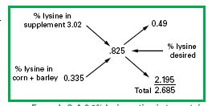
Computer formulation is the preferred method of diet or feed formulation and is available in most areas at a reasonable cost. This method provides additional alternatives of ingredient substitution and reduces time and chances of error in hand calculation. Many swine producers have access to computers to aid decision making. Computers can handle the calculations of diet formulation efficiently, allowing you to examine diets in more detail and evaluate alternatives. The computer can rapidly select combinations of feeds that will meet nutrient requirements; and, when cost data are provided, it will select those that meet the requirements at the lowest cost. Also, a computer can be used to analyze your current feeding program by checking diets against accepted nutrient requirements. However, the computer will not replace the nutritionist or farm manager. To properly use computers, several items are needed:
- Knowledge of diet specifications and requirements including minimum and maximum allowances on nutrients and ingredients
- Up-to-date ingredient information such as nutrient analysis and accurate on-farm prices
- Procedures for converting analysis, results, and feed tag information to a format that can be properly handled by the computer
- An organized system for updating information such as prices, results of analyses, and ingredient availability
- Access to a suitable program

4.6. Specifying and milling ingredients
Foods such as corn grain, rice bran, molasses powder, soybean oil, coconut meal, wheat bran, are examples of energy foods that can be used in pig feed management.
Also, protein intake is necessary because it supplies the animal’s amino acid needs. Amino acids, which are sub classified as essential and non-essential amino acids, are organic compounds that form proteins and play a key role in the construction and maintenance of all tissues and organs. One of the ingredients that have demonstrated great potential as a source of protein for inclusion in pork balance is the Hydrolyzed Chicken Protein. Obtained from the use of meat, offal and liver of chickens, it is an ingredient that presents high protein content, and high coefficient of digestibility. In addition, being an ingredient with a high degree of palatability, it has the advantage of being attractive to consumption by animals.
Feed milling is the process of grinding and processing feed ingredients into a form that is suitable for animal consumption. The feed milling process can be divided into five main stages: raw material handling, grinding, mixing, pelleting, and cooling. Feed milling is a critical step in the production of animal feed, as it creates a uniform mixture that is easy for animals to digest. A feed mill is a facility that manufacture or produces animal feed. Feed mills are used to process grains and other raw ingredients, mix them together, and package them into bags or containers.
Some of the things to look out for when looking for a suitable location for your commercial feed mill include:
- Good and accessible roads, except you want to construct the road yourself.
- Proximity to areas with livestock farms available (poultry farms mostly preferred) or an industrial layout as specified by the government
- If possible, a location close to suppliers or sources of feed ingredients
- Proximity to agricultural engineers, fabricators and access to laborers
- Avoid flood areas or places with a poor water drainage system
- Secured location with a good security system in place
- Areas that allow heavy trucks, lorries and trailers to ply their roads
Grinding or particle-size reduction is a major function of feed manufacturing. Many feed mills pass all incoming ingredients through a grinder for several reasons:
- clumps and large fragments are reduced in size
- some moisture is removed due to aeration and
- Additives such as antioxidants may be blended.
- All of these improve the ease of handling ingredients and their storability.
The grinding of ingredients generally improves feed digestibility, acceptability, mixing properties, pelletability, and increases the bulk density of some ingredients. It is accomplished by many types of manual and mechanical operations involving impact, attrition, and cutting.

A. Hammer mills
Hammer mills are mostly impact grinders with swinging or stationary steel bars forcing ingredients against a circular screen or solid serrated section. Material is held in the grinding chamber until it is reduced to the size of the openings in the screen. The number of hammers on a rotating shaft, their size, arrangement and sharpness, the speed of rotation, wear patterns, and clearance at the tip relative to the screen or striking plate are important variables in grinding capacity and the appearance of the product. Heat imparted to the material, due to the work of grinding, is related to the time it is held within the chamber and the air flow characteristics. Impact grinding is most efficient with dry, low-fat ingredients, although many other materials may be reduced in size by proper screen selection and regulated intake.

Most hammer mills have a horizontal drive shaft which suspends vertical hammers but for some ingredients, such as dried animal byproducts, a "vertical" hammermill is more efficient. In this mill, the drive shaft is positioned vertically and screens and hammers are positioned horizontally. Material successfully reduced in size to the diameter of screen holes or smaller, are carried by gravity outside the mill and thence by air or conveyor to storage in "make-up" bins. Over-size particles, not easily broken, drop through the mill and may be re-cycled or discarded. Thus foreign materials, such as metal and stones, are discharged before they are forced through the screen causing damage.
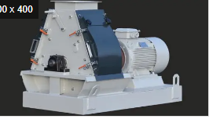
Figure.4.6. Hammer Mill
4.7. Mixing feed ingredients
Feed mixing may include all possible combinations of solids and liquids. Within each ingredient are differences in physical properties. For solids there are differences in particle size, shape, density, electrostatic charge, coefficient of friction as represented by the angle of repose, elasticity or resilience and, of course, color, odour, and taste. For liquids there are differences in viscosity and density.
Particle segregation is due to differences in the physical properties of ingredients and the shape and surface characteristics of the mixer. Particle size may be the most important factor in causing segregation. An improvement in mixing which approaches random distribution of solids by decreasing particle size can be measured quantitatively by statistical methods. In general, the smaller and the more uniformally sized the ingredients are prepared, the more nearly they will approach random distribution during mixing.
Three mechanisms are involved in the mixing process:
- The transfer of groups of adjacent particles from one location in the mass to another,
- Diffusion distribution of particles over a freshly developed surface,
- Shear slipping of particles between others in the mass.
In many methods, a decrease in particle size is necessary to attain a sufficient number of particles of an essential additive (vitamin, mineral, medication) for dispersion in each daily feed unit. This may require the particle size to be the diameter of dust, 10 to 50 microns. Certain ingredients are unstable in finely divided form and likely to acquire an electrostatic charge. Concentration of particles on a charged surface, roughness of the mixed and stickiness of oily and wet ingredients are factors in causing segregation when very small particles are mixed and when these are much smaller than the bulk of other ingredients.
Mixing may be either a batch or a continuous process.

4.7.1. Batch mixing
Batch mixing can be done on an open flat surface with shovels or in containers shaped as cylinders, half-cylinders, cones or twin-cones with fixed baffles or moving augers, spirals, or paddles.
4.7.1. Continuous Process
Continuous mixing proportions by weight or volume, is a technique best suited for formula feeds with few ingredients and minimal changes.
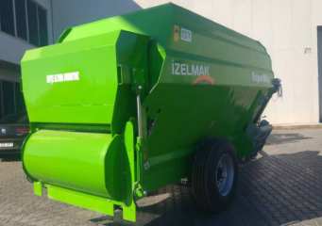
A. Horizontal Mixers
The continuous or "twin-spiral" mixer consists of a horizontal, stationary, half-cylinder with revolving helical ribbons placed on a central shaft so as to move materials from one end to the other as the shaft and ribbon rotate inside Capacity can be from a few litres to several cubic metres. The speed of shaft rotation will vary inversely as the circumference of the outer ribbon; usually optimum between 75-100 metres per minute. Since material travel is from one end to the other, either end may be used for discharge. These mixers may be inverted for cleaning.

B. Vertical Mixers
Vertical mixers may consist of a cylinder, cone, or hopper-shaped container, with a single or double screw (auger) located vertically through the centre (Figure 3). The screw operates at speeds of 100 to 200 rpm and vertically conveys incoming materials from the bottom (generally the intake) end, like a screw conveyor, to the top where they are scattered and fall by gravity. This sequence is repeated several times until a blend is attained (usually from 10 to 12 minutes). These mixers may also be loaded from the top. Results show that vertical mixers are not efficient for uniform mixing of solids and liquids or for materials of quite different particle size or density. This unit is difficult to clean and there may be inter-batch contamination.
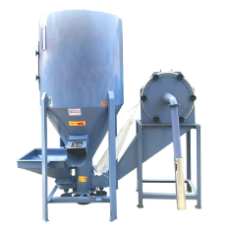
Fig. 3 Vertical Mixer

C. Other Types of Mixers
A third type of mixer is the horizontal revolving drum. This can be a straight-sided cylinder or a cylinder tapered at each end. The sides may be smooth or fixed with baffles or shelves to pick up and drop ingredients. Smooth, dry materials of uniform physical properties are blended best in this type of mixer.

A modification of this type is the turbine mixer which is a fixed cylinder with revolving shaft to which are fixed paddles, ploughs, scrapers, or shelves designed to re-pile materials continually. This mixer is often used as a cooker to dry fish wastes and to blend various types of fish meal into a standardized product. They are also particularly efficient for mixing heavy ingredients and for adding liquids to mixtures which would clump or cake in another type of mixer. Some particle size reduction (grinding) may occur on soft materials, such as rice bran and alfalfa leaves. A complete mixing can usually be attained in 3 to 6 minutes unless longer time is necessary to eliminate lumps caused by added liquids. Mixer shaft rotation is regulated to provide some centrifugal action, but this must not be excessive.

D. Liquid Mixers
Oils and water-miscible oil preparations are often added to dry ingredients as a source of energy or as a specific nutrient. Although the oil-soluble vitamins. A, D, E, and K, are available in dry carrier concentrates, they may be obtained in pure form and premixed by the feed manufacturer. Liquids containing nutrients can be mixed faster and with more uniformity than the same nutrient in dry concentrate condition. Therefore, a liquid blender may be needed in the feed plant.

Liquid blenders usually consist of a horizontal tub or cylinder with a number of wires or paddles equally spaced around a shaft which revolves inside. Sometimes the shaft is hollow and liquids are forced through holes in the paddles in a spray effect. Some models have a shaft speed of 400 to 600 rpm while others rotate at 1 200 rpm. Ingredients such as condensed fish or fermentation solubles, molasses, or fish oils are often premixed in a bowl type variable speed mixer, blending the liquid with dry ingredients.

3.5 Mixing Operation and Evaluation
Accurate mixing requires the addition of ingredients in a tested sequence from batch to batch. The usual practice is to add large-volume ingredients first, then those of smaller amount. Unless already premixed, liquids should be added after all dry ingredients have been mixed. Total mixing time is critical and is influenced by the composition of the formula. All mixers should be calibrated by laboratory recovery of known additives (physically or chemically) so that under and over mixing does not occur. Uniformly sized salt, graphite, or iron particles coated with water soluble dyes are often used as "tracers". Each mixer should be calibrated for its mixing time and capacity by volume for best results.

Self-Check – 4 | Written test

Name…………………………………………… ID………………………… Date…….

Directions: Answer all the questions listed below.

Test I: Multiple choice (1points each)
1. Which one of the following factors affect nutrient requirement of swine
A. Age B. Environmental condition C. Sex D. All
2. The following is/are not indicator maintenance requirement of swine
A. Nutrient required for normal breathing B. Nutrient required for normal body temperature C. Nutrient required for growth and development of tissue D. All
3. Which of the following nutrient is required for animal in small quantity
A. Energy B. Protein C. Vitamin D. None

Test II: Short Answer for the following questions
1. Write at 5 factors which affect nutrient requirement of swine (5points)
2. Mention production requirement of swine (3points)
3. Write importance of water for swine (2points)

Note: Satisfactory rating - 7 points Unsatisfactory - below 7 points

You can ask you teacher for the copy of the correct answers.

You can ask you teacher for the copy of the correct answers.

Operation Sheet -4

4.1. Procedures of feed formulation for pig
A. Tools and equipment
- Glove
- Boot
- Overall
- Hair cover
- Weighing balance
- Shovel
- Feed container
- Feed ingredients
B. Procedures:
- Wear personal protective cloth
- Identify materials, tools and equipment used for determining
- Identify ingredients used in ration formulation
- Refer feed composition table to know the nutrient content of selected feed
- Consult feeding standard tables to check the nutrient requirement of dairy animals
- Calculate the ratio and amount of ingredients used for ration formulation
- Grinded them at recommended sieve size
- Blended the crushed ingredient thoroughly by using Mixer
- Add minerals, vitamins and other additives in the ration
- Pack and store the formulated ration
- Offer the ration for the group it is formulated according to feeding schedule

LAP TEST-4 | Performance Test

Name………………………………. ID…………………………….. Date…………………………………….

Time started: ________________________ Time finished: ________________

Instructions: Given necessary templates, tools and materials you are required to perform the following tasks within 2 hour. The project is expected from each student to do it.

Task- formulate ration for pig

LG #16 | LO #5- Manage different classes of swine

Instruction sheet
This learning guide is developed to provide you the necessary information regarding the following content coverage and topics:
  - Identifying swine routine management activities
  - Cleaning equipment, swine house and it’s environment
  - Carrying out piglet rearing activities
This guide will also assist you to attain the learning outcomes stated in the cover page. Specifically, upon completion of this learning guide, you will be able to:
  - Identify swine routine management activities
  - Cleaning equipment, swine house and it’s environment
  - Carrying out piglet rearing activities
Learning Instructions:
1. Read the specific objectives of this Learning Guide.
2. Follow the instructions described below.
3. Read the information written in the information Sheets
4. Accomplish the Self-checks
5. Perform Operation Sheets
6. Do the “LAP test”

Information Sheet 5

5.1. Identifying wine routine management activities
Various routine management activities are required in a farm some of them are described below.

5.1.1. Feeding and watering
Pigs are monogastric animals and can utilize fibrous food only to a limited extent. Part of the protein in the diet of pig should come from animal source such as fish, meat etc. Feeding based on swill (kitchen waste including left over human food, vegetables, meat and fish cuttings) is recommended as pig rearing based on commercial feed is not economical. On an average, pig requires 4-8 kg swill per day. All categories of pigs can be given small quantity of green fodder or may be sent to pasture.
When providing feed to pig, there are certain types of feed you’ll want to avoid for reasons ranging from slowed growth rate to outright toxicity. Here are the general foods to avoid in pig feed:
- Sweets and high-sugar foods
- Dog food
- Cracked corn
- Milk
- Fish
- Meat
- Fruits
- Potatoes
Foods high in sugars can slow growth rates while milk, meats, and fish can harbor viruses. Pits and seeds of apples, pears, apricots and peaches contain a naturally occurring substance called amygdalin which is a cyanogenic glycoside that is released when chewed causing illness, discomfort, or even death. Potatoes contain natural toxins called glycoalkaloids, which can cause severe stomach ache or even death (though rare), and also contain solanine which destroys red blood cells, causes diarrhea, and heart failure.
Clean, cool and good-quality water must be available at all times, except in situations when providing adequate quantities of whey to grower pigs is more appropriate. Provide lots of fresh, clean water. Water is the central part of a pig’s diet. One-half to two-thirds of its body weight is water. Access to clean drinking water is essential to a pig’s growth rate. Newly weaned pigs are especially prone to dehydrate. However water is supplied, water devices must be sanitized and properly positioned. Pigs must have water readily accessible for drinking throughout the day to maintain proper hydration. Pigs don’t sweat, access to lots of fresh water is important to help keep them cool.
Recommended Practices in feeding and watering of swine
- check feeders daily to ensure they are functioning properly
- Use feeder trays made of an easily cleaned material.
- provide sufficient feeder space to accommodate pigs
- where pigs are limit fed, provide enough space for all pigs to eat simultaneously
- use tray dividers to prevent small pigs from getting in the feeder in nursery pens
- keep feeders clean
- Cooking the different raw materials together to improve digestibility, and to breakdown toxins from some feeds
- Food waste or garbage fed to swine must be cooked and sterilized properly.
- position waterers over slatted floors in partially slatted pens
- adjust flow rates on nipple waterers according to the age and size of pigs in the pen
- take remedial action if persistent bullying is leading to deprivation from food

5.1.2. Assist Parturition of sow
The days before farrowing at the end of the pregnancy the sow should be observed closely to determine start of farrowing and if necessary to assist the sow and secure the life of the young piglets. On many farms, 30% of all piglets born are lost in the first 4 days.
A. Farrowing/parturition stage
Correct husbandry can save many weak piglets. This can be considered in three stages, the pre-farrowing period, the farrowing process and the immediate post-farrowing period when the afterbirth is expelled.

Stage 1 - The pre-farrowing period
The preparation for farrowing starts some 10 to 14 days prior to the actual date, with the development of the mammary glands and the swelling of the vulva. At the same time teat enlargement occurs and the veins supplying the udder stand out prominently. The impending signs of farrowing include a reduced appetite and restlessness, the sow standing up and lying down and if bedding is available chewing and moving this around in her mouth. If she is loose-housed on straw she will make a bed. Within 12 hours of actual delivery of piglets, milk is secreted into the mammary glands and with a gentle hand and finger massage it can be expressed from the teats. This is one of the most reliable signs of impending parturition. A slight mucous discharge may be seen on the lips of the vulva. If a small round pellet of faeces is seen in the mucous and the sow is distressed, farrowing has started and it is highly likely the first piglet is presented backwards. This small pellet is the meconium or first faeces coming from the rectum of the piglet inside. An internal examination is immediately required. The final part of stage 1 is the opening of the cervix to allow the pigs to be pushed out of the uterus, through the vagina and into the world.
Stage 2. The farrowing process
This can range from 3 to 8 hours and piglets are usually delivered every 10 to 20 minutes but there is a wide variation. Consult the sow and litter card to see if there have been any previous problems at farrowing. For example if a sow has had high stillbirth rates, monitor her more closely and take any necessary actions. There is often a gap between the first and second piglet of up to three quarters of an hour. The majority of pigs are born head first but there are more pigs presented backwards towards the end of the farrowing period. Immediately prior to the presentation of a pig the sow lays on her side, often shivering and lifting the upper back leg. This is an important point to take note of because it may indicate the presence of a stillborn pig. Twitching of the tail is seen just as a pig is about to be born.
Stage 3. Delivery of the placenta
This usually takes place over a period of one to four hours and is an indication that the sow has finished farrowing although some afterbirth will sometimes be passed during the process of farrowing. Once the sow has completed the farrowing process there are certain signs that should be observed.
B. Sing of farrowing;
- Restlessness, uneasiness, biting of hurdles and guard rails
- Sow is always in “sitting dog” position
- Enlarged and distended udder. Pink, shiny and pointing outside direction
- Teats produces milk (farrowing in 12-24 hours) but not always
- Small round size manure of sow and frequent urination
- Swollen vulva, mucus discharge and meconium (first feces of piglets). Red and loosen.
- Signs of labor like muscular spasms, deep and fast breathing
The following things should be prepared before farrowing:-
- The farrowing pen with straw on the floor
- The udder and nipples must be cleaned
- A clean cloth for cleaning and drying
- Oxytocine to assist the sow in making contractions

5.1.3. Restraining and handling swine
Correctly handling and restraining a pig will reduce the risk of injury and stress to both the pig and stockperson. Having a basic knowledge of the animal’s behavior is important in safe and humane handling. Pigs can be accustomed to accept restraint and handling and will learn more quickly with positive reinforcement and reward than with punishment. Pigs are strong, loud, quick animals, and handlers should be coordinated and confident in their management and handling at all times so as to avoid injury to animals or themselves. Basic types of restraint are: Manual restraint, Mechanical restraint (e.g., v-trough, snare, slings, crowd panel, and restraining crate) and Chemical restraint

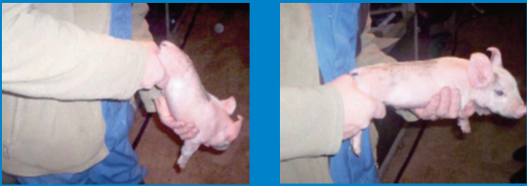
Figure.5.1.3. Manual handling/restraint method

5.1.4. Marking and Identification
I. Ear Tagging:
This is done for identification purposes. The animal is haltered and the tag is placed in the applicator then clamped to the pina of the ear. Caution must be taken not to damage the blood vessels on the pin. Other operations for identification includes: tattooing, ear notching, skin branding, horn branding and the use of neck chains or tags- either plastic or metals.
II. Tattooing:
This is the art of drawing a design on the body of the animal that is peculiar to the animal and well known by the farm manager.
III. Ear notching
Is cutting the ears in a particular shape and coding the shape. It involves the use of razor or scissors to cut a “V” shape on the tip of the pina. The positions of the cut indicate numbers. If it is at the top of the pina it denotes 1, if at the tip, 5 and if under, it is 3. The right ear represents tens while the left represent units. The two are added to give the animal an identification number in the herd.
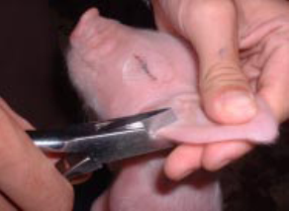
Figure.5.1.3 B.III Ear notching

IV. Skin branding
Is very common in our local setting. Hot iron is used to write numbers and at times names of owners of the animal on their skin.
5.1.5. Teeth Removal
Piglet needle teeth should be clipped off with a pair of clippers to prevent them from wounding their sow’s teat which might make her refuse them suckling.
Recommended practices of teeth removal/clipping
- only clip teeth of piglets that show aggressive behaviour to littermates or nursing sows
- avoid shattering of teeth
- Avoid clipping too short or too sharp. Remove the tips of teeth only or grind needle teeth with an appropriate grinder. Remove only one-third to one-half of the tooth
- clip teeth as early as possible when deemed necessary
- avoid teeth clipping on low birth weight piglets

5.1.6. Castration
Castration is the act of removing the testicles of a male animal to render them ineffective. Piglets are almost always castrated using an open technique and using manual traction to remove the testicle. Surgical operation is done within the first week of the animal’s life while the bloodless one could be done within the first two weeks of life. Piglets are generally castrated 4-14 days of age. This avoids the first few days when they are absorbing colostrum, makes it easier to identify inguinal hernias, and is still well before weaning. The same reasons for early castration of calves also apply to pigs: castrate young animals for easier restraint and handling, fewer complications and minimal impact on pig weight gain, etc. Piglets should be castrated at least 5 days prior to weaning to minimize the risk of combined stressors. This operation is carried out on all unwanted males in the herd. This management operation prevents unwanted breeding and improves the carcass quality of the animal. It can be carried out by surgically operation.

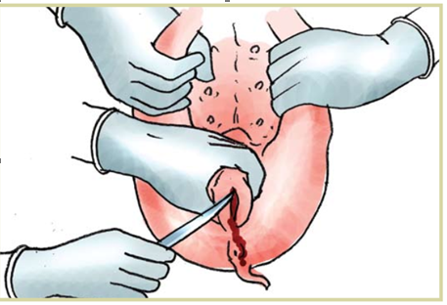
Figure.5.1. D. Open castration
5.1.7. Tail Docking
The undocked tail is a very convenient target for tail biting or cannibalism. This leads to injury and possibly infection. To reduce tail biting, dock (or cut off) the tail of newborn piglets within about 24 hours after birth. Tail docking is usually required by purchasers of early weaned or feeder pigs. It should be done within about 24 hours after birth because it is least stressful on the piglet for these reasons: the piglets are small and easy to hold; at this age, littermates are less likely to investigate and nip or bite a newly docked tail; the piglet and farrowing quarters are still clean; and the piglet is well protected with antibodies from the colostrum of the sow. However, some producers delay docking the tails of male piglets in the litter until castration. The males are easier to find in a litter if their tails have not been docked.

Dock the tail about one inch (or width of your thumb) from the place where the tail joins the body of the piglet. Cutting the tail too short could interfere with muscle activity around the anus later in the piglet’s life and could be an aggravating factor in rectal prolapse or rear leg paralysis. If too much tail is left, tail biting might still occur. Occasionally, a tail will bleed excessively. If this occurs, tie it off using the same method as for umbilical cords.

5.1.8. Culling of Sows
To maintain overall productivity in the herd, it is important to have a culling policy so that sows removed at the correct time. The reasons for culling include; Lameness, other injuries, farrowing problems, poor litter-size, poor mothering ability, and low fertility. A sow that regularly produces a good litter will eventually start to decline with age, probably around her tenth litter if she is producing well; a god guide is to allow her to remain in the herd until her performance falls below the average of the gilts in the herd. At the same time, it is important to have a supply of pregnant gilts available to replace sows that need to be culled.
5.2. Cleaning equipment, swine house and its environment
Disease causing agents may be contained in urine, feces, exhalation and nose and mouth discharges. These may act as media for growth of disease causing agents. Excrement must be removed frequently from the immediate surroundings. Manure may be heaped so that the heat generated kills the parasites and microbes. It is recommended that manure be kept in a covered concrete pit and the manure in the put sprayed with insecticides to inhibit development of disease causing organisms and flies.
The house should facilitate proper cleaning, disinfection and maintenance of sanitary conditions. The following recommended swine house cleaning practice
- Remove and clean feeders and other equipment then remove all loose dung from the pen, walls and floor.
- Hose down walls and ceilings to remove dust and soak pen with water and detergent (a cleanser and solvent which makes caked-on material easier to remove).
- Soak heavily caked pens for 24 hours. Soaking the pens and using detergents reduces water use and cleaning time.
- Pressure-clean using a ideally with hot water or steam.
- Take care not to damage concrete surfaces. When cleaning floor and weaner accommodation, ensure all piglets and weaners are protected or removed from adjacent pens to prevent chilling.
- Disinfect the roof, walls and floor with a spray disinfectant. Disinfectants are substances selected to kill infectious agents including bacteria, viruses and fungi. To save time and money it is essential to thoroughly clean the pen before disinfecting it as most disinfectants adversely react with organic matter.
- Disinfect the water system.
Pigs kept on pasture should be rotated in the paddocks. Rotation on pasture will disrupt the life cycle of many disease causing agents as these agents are sometimes specific for certain hosts. Pastures may be rotated between different species.
- Provide suitable feed and water containers
- Isolate new animals
- Dispose of dead pigs properly
- Use of disinfectants
- Hire a veterinarian doctor
- Control rats, mice and flies by keeping the site tidy and free of overgrown grass and weeds
5.3. Carrying out piglet rearing activities
It is essential for all piglets to take colostrum from the mother. They will take the first feed within 1 hour of being born. If a sow dies during farrowing her lifter can be fostered to another. The orphans should be mixed in with the sow's own litter so that she will accept them. However the foster mother will not be able to feed both lifters at the same time and it will be necessary to use several foster mothers to feed the orphans.

5.3.1. Nursing Piglets
For the first two days the piglets should be fed at regular intervals 5 times a day, for about 10 minutes each time. On the third and on the fourth day they should be fed four times a day, and after that 3 times a day. After 14 days, increase the quantity of milk at each feed, but gradually decrease the number of feeds per day. Gradually change over to more solid feed, so that by the age of about three weeks they should be able to take regular feed. If no nutritious feed is available they should continue on milk for a while longer. The weaker ones can be fed four times a day for a longer time.
The following are essential management activity for piglet
- All piglets must have access to colostrum as soon as possible after birth, and within 12 hours.
- It is essential for all piglets to take colostrum from the mother.
- Piglets at risk of dying from inadequate nourishment must be cross-fostered, split suckled, hand-reared or euthanized.
- When a sow dies or fails to produce milk or does not claim her piglets, the piglets should be promptly shifted to a foster mother.
- Care should be taken to simulate the conditions including the odour and body size of piglets when admitted to a foster mother.
- If a suckling sow is not available, hand feeding would be necessary. Cow's milk is the best substitute for sow's milk,
- Creep feed must be provided to nursing piglets after 28 days of age to help maintain sow body condition.
- Supplemental iron must be administered to piglets reared indoors to prevent nutritional anemia.
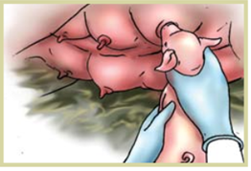
Figure.5.3.1 helping newborn piglet to suckle

5.3.2. Caring Newly Weaned Pigs: First Week
- All newly weaned pigs must have continuous access to fresh feed and feeder design must be appropriate for the size of the pigs.
- All newly weaned pigs must be observed frequently in the period following weaning to ensure that all are eating.
- The piglets are removed as they are farrowed and kept warm in creep space until farrowing is complete.
- Take care of new born piglets by providing guard rails.
- Treat / disinfect the navel cord with tincture of iodine as soon as it is cut with a sharp knife.
- Feed on mothers’ milk for first 6-8 weeks along with creep feed.
- Protect the piglets against extreme weather conditions, particularly during the first two months.
- Needle teeth should be clipped shortly after birth.
- Vaccinate the piglets as per recommended vaccination schedule.
- Supplementation of Iron to prevent piglet anemia is necessary.
- The piglets meant for sale as breeder stock must be reared properly.
- Male piglets not selected for breeding should be castrated preferably at the age of 3-4 weeks which will prevent the boar odour in the cooked meat thus it enables production of quality meat.
- Additional feed requirements of lactating sow must be ensured for proper nursing of all the piglets born.

Self-Check – 5 | Written test

Name…………………………………………… ID………………………… Date…….

Directions: Answer all the questions listed below.
Test. I Matching (1point each) A
1. Act of removing the testicles of a male animal
2. Removal of the teeth also prevents the young pigs
3. Method used to identify other animals
4. Removal of unproductive sow from herd
B
A. Ear tagging
B. Culling of Sows
C. Castration
D. Teeth clipping

Test II: Give Short answer for the questions
1. Write proper handlings of newborn piglet (4points)
2. Write sign of swine approaching to farrowing (5points)
3. Write at least 3 importance castration in pig (3points)

Note: Satisfactory rating - 9 points Unsatisfactory - below 9 points

You can ask you teacher for the copy of the correct answers.

You can ask you teacher for the copy of the correct answers.

Operation Sheet -5

5.1. Techniques of restraining/handling piglet for inspection
A. Tools and equipment required
- Glove
- Boots
- overall
- respiratory mask
B. Procedures/Steps/Techniques
- Wear appropriate PPE
- Smoothly approach to the piglet
- Lift the piglet by the back leg
- Place your other hand under the chest of the piglet to provide support
- Lift the piglet and hold so that it is horizontal
- Hold the piglet firmly to minimize the piglet’s ability to move
- after lifting, place the piglet over your forearm with
5.2. Techniques/Procedures/Methods of castrating swine
A. Tools and equipment required
- Knife/surgical blade
- Glove
- Boots
- overall
- respiratory mask
- Scalpel
- antiseptic
B. Procedures/Steps/Techniques
- Wear appropriate PPE
- Hold the piglet by both hind legs with its head down.
- Use the thumb, push up on both testicles.
- Make an incision through the skin of the scrotum over each testicle in the direction of the tail.
- Be sure the incisions are made low on the scrotal sac to allow for fluid drainage.
- Pop the testicles through each incision and pull on them slightly.
- Pull each testicle out while pressing your thumb against the piglet’s pelvis.
- Cut free of the cord using a scraping motion.
- Cut away any cord or connective tissue protruding from the incision
- Spray the wound with antiseptic.

  - Techniques/Procedures/Methods Clipping the teeth
A. Tools and equipment
- Clipper
- Gloves
- Boot
- Respiratory mask
- Detergent
B. Procedures/Steps
- Wear PPE
- If the sow is not tied up separate her from her young and place her in another pen.
- Corner the young pigs and keep them together or place them in a box.
- Hold the head and press the corner of the piglet's mouth so that the jaws open.
- Place the clippers on either side of one pair of teeth making sure that the tongue is not in the way.
- Tilt the head so that the pieces of the teeth will fall out of the mouth.
- Cut the teeth as close as possible to the gums.
- Clean the clippers before using them on another piglet.
- When you have finished put the piglets back with their mother immediately.
- Keep young piglets warm

5.4. Procedure of preparing Farrowing area
A. materials, tools and equipment
- Gloves
- Boot
- Cleaning detergents
- Towel
- Bedding material
- mask
B. Procedure
- Wear appropriate PPE.
- Clean farrowing area thoroughly.
- Allow area to dry.
- Check equipment and flooring for needed repairs and make repairs as needed.
- Apply disinfectant to farrowing area and equipment
- Prepare farrowing crates with bottom rail above floor
- Provide nonabrasive flooring in creep area, if needed.
- Provide heat source and maintain temperature just prior to and following farrowing.
- Place bedding in farrowing area and creep area if desired. (Do not use bedding in slotted floor or in other self-cleaning situations).

LAP TEST-5 | Performance Test

Name………………………………. ID…………………………….. Date…………………………………….

Time started: ________________________ Time finished: ________________

Instructions: Given necessary templates, tools and materials you are required to perform the following tasks within 3 hours. The project is expected from each student to do it.

Task-1 restrain/handle piglet for inspection
Task- 2 castrate pig
Task-3 Clip tail of pig
Task-4 Prepare farrowing area
LG #17 | LO #6- Mate and prepare swine for parturition

Instruction sheet
This learning guide is developed to provide you the necessary information regarding the following content coverage and topics:
  - Selecting breeding stock
  - Facilitating natural and artificial breeding
  - Diagnosing swine pregnancy
  - Handling pregnant sows
This guide will also assist you to attain the learning outcomes stated in the cover page. Specifically, upon completion of this learning guide, you will be able to:
  - Select breeding stock
  - Facilitate natural and artificial breeding
  - Diagnose swine pregnancy
  - Handle pregnant sows
Learning Instructions:
- Read the specific objectives of this Learning Guide.
- Follow the instructions described below.
- Read the information written in the information Sheets
- Accomplish the Self-checks
- Perform Operation Sheets
- Do the “LAP test”

Information Sheet 6
6.1. Selecting breeding stock
The successful pig farmer always uses good breeding animals. The piglets that are produced must grow fast and produce quality carcasses with a high percentage of meat and a small quantity of fat. Therefore, when you buy breeding animals, make sure that the pigs come from a farm known to have pigs of good quality and where the management and standard of hygiene are excellent. When buying pigs for the first time, it is advisable to take someone along who has the necessary knowledge and experience.
In the case of a small-scale farm the following selection and breeding program can be used:
- Always buy good (above average) purebred boars. Buy from a farmer of repute who keeps good records so that the performance of the boar and his parents are known.
- Buy boars from prominent breeds, such as the Landrace and Large White.
- When buying gilts (young female pigs) for the first time, make sure that they come from a breeder with good pigs and who keeps accurate records.
- When at a later stage you want to select your own gilts for breeding, it is important to apply strict selection measures and to keep accurate records of growth and feed conversion. If you do not have a record system, it will be advisable to buy replacement gilts.
- Always buy gilts from the same breeder (farm) and make sure that a breeding plan (policy) is used. Consult an adviser, if necessary. If pigs are always bought from the same breeder it is advisable to let him dictate the breeding policy

6.1.1. Boar selection
Important considerations when selecting boar:
- Select boars that are free from defects (see chapter on management).
- Buy efficient animals that:
  - Grow faster than average
  - Have less backfat than the average of the breed
  - Have eaten less feed than average to reach a specific weight.
- A good boar will reach 90 kg live weight before it is 140 days old
- Buy boars at least four or five weeks before they are used for the first time. This will allow you time to keep them in quarantine and the boars to adapt to the new environment.

6.1.2. Gilt (sow) selection
Only the best among the young growing female animals on the farm must be selected and kept for breeding. Select breeding gilts from sows that produce large litters with above average growth rate, and carcasses with a low fat content.
The following characteristics should be considered when selecting gilts:
- Strong, straight legs with large, even-sized claws.
- Gilts should walk straight and well, and stand up on their claws without falling over at the pastern joints just above the foot.
- A well-formed vulva and six well-shaped, prominent teats on each side of the belly.
- The teats should start well forward and be spaced evenly to allow adequate suckling for the piglets.
- A well-developed ham, good length with light shoulders and head

6.2. Facilitating natural and artificial breeding
Breeding or mating systems are the approach taken to pairing individuals for breeding in order to incorporate or maintain desired traits. There is no defined ‘breeding season’ in the domestic pig. Gilts reach puberty around 6 to 8 months of age and post-pubertal females generally exhibit estrus every 21 days. After weaning, sows usually return to estrus within 5 to 7 days.
There are two types of mating system. Natural mating/breeding and Artificial insemination

6.2.1. Natural Mating/breeding
There are two types of natural mating in swine production:

A. Hand Mating-
Is the practice of bringing the sows to the boar for individual service when they are standing heat It is the most common method of mating is purebred animals

B. Pasture mating
In this system of mating, the boar is permitted to run with sows. An aggressive yearlings or mature boar can actually serve 15 to 20 sows in a pasture mating system

6.2.2. Artificial insemination
This is a reproductive technique in pigs that consists of the deposition of diluted refrigerated or fresh semen inside the sow, through a cannula or catheter. The most common location to deposit it is at the cervical level, but good results have also been reported in the post-cervical area (in the uterus); there are commercial catheters for each one. When using artificial insemination, the boar does not breed directly with the sow. With the AI method, semen from the boar is collected and “artificially” inserted by the inseminator into the uterus of the sow.
Advantages of artificial pig insemination
  - Reduction in the risk of transmission of several diseases
  - increase in the number of piglets produced from a high-quality parent
  - Increased access to high-quality semen and genetic material from other regions or countries
  - Decreased costs related to boar breeding and possible work accidents during the service
  - Improvement in productive parameters when using male semen with higher genetic value
- Disadvantages of artificial swine insemination
  - Difficulty in accessing technology in some regions
  - Lack of availability of qualified personnel for collection, semen conservation and insemination processes of the sows

6.2.3. Heat Detection in Swine
The most important step for successfully breeding swine is good heat detection. Heat detection takes skill, good observation skills, and routine Sows come into heat every 18-24 days with the average being 21 days Some sows have shorter or longer heat cycles so keeping good records on your animals can help a producer be better prepared for breeding their sows Estrous Cycle is the 21 day cycle between breeding periods Estrus is the name for standing heat or when the female is receptive to being bred by the boar. The normal heat period lasts for three to five days.
Common signs of heat in pig are:
- general restlessness
- vulva turns red and swollen
- white mucus discharge
- vulva less red and swollen, slimy mucous discharge
- tendency to mount and be mounted
- Sow or gilt will stand still when pressure is applied to her back.
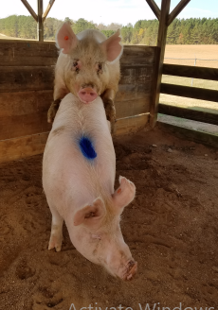
Figure.6.2.3 Sign of heat in sow

Once good standing heat has been detected then it is time to start breeding 12 hours after the standing heat is detected is the best time to breed if using artificial insemination. A second breeding 12 hours after the first is recommended as sows are often receptive for 24 hours or more. If you are using a boar for breeding then sows should still be checked for heat and if in heat the boar and sow can be placed together for the day or a few days to allow the boar time to breed the sow

6.2.4. Good Practices for Detecting Estrus
- Use a sexually motivated boar in an adjacent pen or introduce the boar directly into the pen containing the females to be tested.
- Boars used for estrus testing should be 9 months of age or older.
- Be certain that the boar is familiar with and comfortable working in the testing environment.
- Allow sufficient time to do a thorough job in all pens.
- Change boars regularly.
- Allow no more than 15 – 20 seconds of vigorous courtship.
- Supervise the testing procedure at all times.
- Keep accurate records of weaning, suspicious and actual mating dates.
6.2.5. Selecting Boar for Mating
Boars are selected following performance testing to ensure efficient performance of their offspring. The parameters usually considered include:
- Fast growth rate than average
- Less back fat than average
- Eats less food than average
- High feed utilisation due to low fat production
- Two equally sized and firmly suspended testicles and with good sexual libido
- Good body conformation, strong straight feet and good temperament.

6.3. Diagnosing swine pregnancy
Sows and replacement gilts require considerable attention in the mating area but only casual observation once they are pregnant. Thus, producers usually place pregnant females in a gestating area but need some reliable method to check that conception occurred before animals are moved from the mating unit. All attendants should be aware that domesticated animals rarely exhibit any signs of sexual behavior one cycle interval after a fertile mating. Thus, for animals mated on known dates, demonstration of sexual receptivity when the next estrus period is due indicates no conception from the previous service. In contrast, the absence of sexual behavior is strong evidence for pregnancy. Sows and replacement gilts should remain in the mating area, with daily boar contact to check for estrus, for around 25 days after service. Once they pass three weeks without estrus signs they can be presumed pregnant and moved to the gestating area.
Several methods are used to diagnose Pregnancy some of them are discussed below:

A. Visual observation
After the sow has been artificially inseminated or mounted by the boar, the gestation should be monitored. One way is to check at 18-25 days post-insemination if the sow has signs of heat (estrus) again. Mainly the stillness reflex or the also called the lordosis test is re-evaluated. If the test is positive, it means that the sow did not get pregnant and went into heat again. The management consists of inseminating again. The advantage of this method is that the test does not require any specialized equipment and is easy to perform in field conditions.

B. Vaginal biopsy
The vaginal biopsy is reported to have between 90% and 100% reliability for the diagnosis of pregnancy and 75% for the detection of empty females. A vaginal biopsy consists of assessing under a microscope the cell layers that make up the vaginal epithelium, as well as the shape and structure of the cells in the strata.

C. Ultrasonography (ultrasound)
Ultrasonography is one of the most widely used diagnostic methods in porcine reproduction to evaluate the gestation of sows. In addition to confirming or discarding gestation, it allows counting the number of piglets expected in childbirth. Reproductive ultrasonography is recommended to be performed at day 35 of gestation, which is the time when the embryo becomes a fetus. Once the fetus has been consolidated in this period, it begins its process of bone formation where ultrasonography becomes important. The equipment provides images compatible with the bones of the piglets which allows to check its health status.

D. Serum analysis
This can be carried out after day 22 by using a small stylette to puncture the ear vein. A thin capillary tube collects a spot of blood which is then tested for pregnancy hormones. It is time consuming, expensive and little used. Techniques are being developed to examine faeces to detect pregnancy but as yet are not perfected for commercial use.

E. Rectal palpation
Rectal palpation is a useful procedure for pregnancy diagnosis in sows but cannot be used in gilts because of the smaller body size

6.4. Handling pregnant sows
The gestation period is 114 days (three months, three weeks and three days). Pregnant sows should not be too crowded in their pens as this can cause abortion. Give special attention to pregnant sows one week before farrowing by providing adequate space, feed, water etc. The sows as well as farrowing pens should be disinfected 3-4 days before the expected date of farrowing and the sows should be placed in the farrowing pen after bedding it properly. provide plenty of water to help prevent congested gut during farrowing. In preparation for farrowing, the farrowing pen should be kept clean and free form draughts. Disinfect the farrowing pen thoroughly and scrub crevices with insecticides to control mange and lice ten days before the commencement of farrowing. Pregnant sows should be housed separately in special pens with sufficient floor space. If space is available exercise is strongly recommended. Slippery floors may lead to falling causing accidental abortions.
Pregnant sows can be kept in a variety of housing systems. Sow housing and management systems should:
- Provide every animal access to appropriate feed and water;
- Promote good air quality and allow proper sanitation;
- Protect sows from environmental extremes;
- Reduce exposure to hazards or conditions that result in injuries, pain, distress, fear or disease;
- Facilitate the observation of individual sows to assess their well-being;
- Provide sows with adequate quality and quantity of space that allows sows to assume normal postures and express normal patterns of behavior
Self-Check – 6 | Written test

Name…………………………………………… ID………………………… Date…….

Directions: Answer all the questions listed below.

Test I: Multiple choice (1points each)
1. Which one of method is are not used to diagnose in pregnancy
A. Vaginal biopsy B. Rectal palpation C. Ultrasonography D. None
2. The following characteristics good gilt for breeding
A. Strong, straight legs with large B. even-sized claws
C. Gilts should walk straight D. All
3. The following is/are parameters used to select boar for mating
A. Fast growth rate than average B. High back fat than average
C. Less feed utilization due to low fat production D. None
4. Which following is/are signs of heat in pig?
A. white mucus discharge B. standing when being mounted
C. vulva turns red and swollen D. All

Test II: Short Answer Questions
1. Write at least 6 good practices for detecting estrus in pig (6points)
2. Mention the two types of hand mating system (6points)
3. write important considerations when selecting boar for breeding stock (5points)

Note: Satisfactory rating - 12 points Unsatisfactory - below 12 points

You can ask you teacher for the copy of the correct answers.

You can ask you teacher for the copy of the correct answers.

LG #18 | LO #7- Carryout swine health care activities

Instruction sheet
This learning guide is developed to provide you the necessary information regarding the following content coverage and topics:
  - Undertaking swine health care activities
  - Identifying main swine diseases and parasites
This guide will also assist you to attain the learning outcomes stated in the cover page. Specifically, upon completion of this learning guide, you will be able to:
  - Undertake swine health care activities
  - Identify main swine diseases and parasites
Learning Instructions:
- Read the specific objectives of this Learning Guide.
- Follow the instructions described below.
- Read the information written in the information Sheets
- Accomplish the Self-checks
- Perform Operation Sheets
- Do the “LAP test”

Information Sheet 7

7.1. Undertaking swine health care activities
Animal health is a key component of animal welfare. Factors that can affect animal health are nutrition, ventilation, housing, genetics and management practices. Pain and discomfort caused by health issues impact an animal’s well-being such that good animal welfare requires good animal health. An effective health management can contributes to animal well-being by providing a strategy for disease prevention, rapid diagnosis and effective treatment.

7.1. Important advices to keep swine health
A. Provide adequate shelter
- Pigs require shelter that protects them from extreme weather and from predators. Electric fences protect pigs and prevent escape.
- Straw makes good bedding provided it is not moldy. Keep bedding dry and change it completely between batches of pigs.
- Rotate pigs between pastures. Their foraging behavior can be aggressive and they can rapidly damage vegetation

B. Clean barns regularly
- Remove all bedding, feces and spilled food regularly, especially where conditions are damp.
- Each pen should be scraped, washed, disinfected and dried between batches of pigs.
- The entire barn should be washed and disinfected yearly

C. Quarantine new pigs
- Establish an isolation pen or area of the farm that is separate from livestock, especially from other pigs that are already on the farm.
- Quarantine newly purchased pigs in this area for 30 days, provided they remain healthy. The quarantine time should be extended if any new pigs are treated for illness.
- Newly purchased pigs can be treated for parasites or be given vaccinations during quarantine.

D. Avoid stress
- Common stressors include: overcrowding, mixing groups or adding pigs, empty feeders or waterers, dirty barns, poor ventilation, drafts, severe weather or rapid changes in weather.
- Move pigs gently. A push board (half-sheet of plywood with a handle) is an excellent tool to gently encourage pigs to move. Never use dogs or electric prods.
- During and after stressful events watch the herd closely for signs of illness.

E. Keep treatment records
- Records are the best way to know where you are making money.
- Records help you learn from past problems and predict what will happen with your herd.
- Treatment records are critical to ensure pigs are not slaughtered for food before a drug withdrawal time is complete.
Pigs must be examined daily for sickness and/or injury. Pigs that are sick or injured must be monitored at a frequency appropriate to their conditions, and at least daily.

7.1.2 General signs of sick swine
Sick swine generally have the following signs:
- It may not eat or not show interest in feed /water
- It may breathe rapidly indication of a fever
- In white skin-colored pigs the skin may become reddish.
- It may have diarrhea which may sometimes be bloody or blood stained.
- Droopy ears or ears pointing downwards.
- Dull eyes.
- Dull skin and hair.
- Its tail will become limp.
- Separates itself from the rest
7.2. Identifying main swine diseases and parasites
7.2.1. Identifying main swine diseases
A. African swine fever (ASF)
This is a viral infection. highly contagious viral disease of domestic pigs manifested by fever, blotching of skin, haemorrhage of the lymph nodes, internal organs and haemorrhage of the gastrointestinal tract. It is observed in acute and occasionally sub-acute and chronic forms. The spread of the virus is by contact with affected pigs and infected fomites, ingestion of contaminated uncooked pork garbage, tick bites and contact with domestic and wild carrier pigs. Prevent direct contact between domestic and wild pigs. No vaccine, no treatment thus far for this disease. There should be strict prevention of movement of pigs, personal and vehicles between pig farms. Do not feed pigs with uncooked garbage from hotel this may contain the virus. In case of outbreak of ASF, bury or burn the carcasses, disinfect house with strong disinfectants. Rest the house for three months.
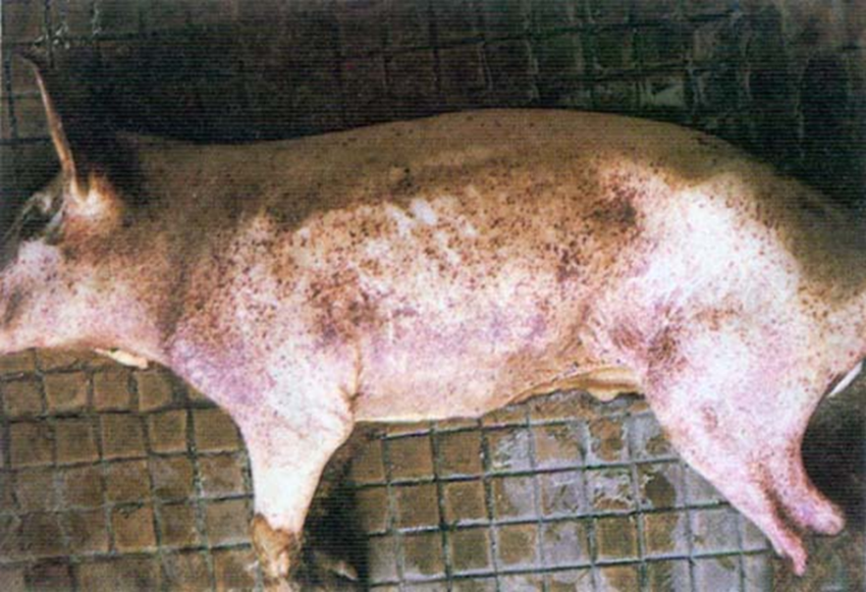
Figure.7.2.1 A. Swine diseased African swine fever

B. Foot and Mouth Disease
FMD is a contagious, viral disease of swine, cattle, sheep, goats and pigs and other cloven footed animals. Transmission is direct and indirect contact with infected animals. The virus can also be spread by aerosol, saliva, nasal discharge, blood, urine, faeces, semen, infected animal by-products, and swill containing scraps of meat or bones and by biological products, particularly vaccines. Pigs can transmit the disease to cattle and other animals. Most contagious of all known viral diseases. There is no cure. If outbreak occurs in nearby farms, pigs can be vaccinated. Vaccinate with the right antivirus.
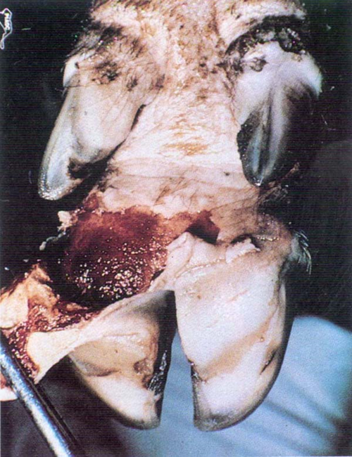
Fig. 7.2.1.B.Foot and Mouth Disease on foot

C. Swine Erysipelas
Caused by a bacterium that lies in the soil. Treatment is effective with right antibiotics and should be timely. Excellent vaccines are available. Routine vaccination programme is recommended to prevent infection.

D. Anthrax
An acute, and often fatal bacterial disease which often cause mortality in humans. There is effective vaccine against the disease. If the disease is suspected carcass should not be open as this releases infective spores. Infected carcass should be buried at sufficient depth to prevent transmission of the spores.

E. Enteritis (Inflammation of the Intestine)
This is a condition that can be caused by a variety of micro-organisms or inappropriate feed. It is characterised by some of the following symptoms: loss of energy and interest, high temperature, loss of appetite, diarrhoea (sometimes bloody) and weight loss. If the problem is food-related, starve the animal and give only clean water for one or two days. After that, gradually increase the feed to normal levels. The cause of the problem may be a sudden change in diet, in which case the same procedure should be followed. Common intestinal problems are listed here:
Clostridium enterotoxaemia: This usually occurs in piglets that are one to five days old. There is no good treatment. The sows can be vaccinated, so that the piglets build up antibodies through the sows’ milk. The piglets can also be given injections of ampi/amoxycilline.

F. Tetanus
Tetanus bacteria can develop if a deep closed wound is incurred from rusty metal (standing on a rusty nail for example). The animals finally die as a result of severe cramps. There is no treatment.
Mastitis This affects the tissue of the udder and can result in permanent damage, so that breeding pigs can no longer be used. Infection can be avoided to a degree by good hygiene. If mastitis is noticed, the sow must be injected with antibiotics and oxytocin as soon as possible.

G. Brucellosis
Brucellosis in pigs is manifested by abortion and sterility in sows, heavy piglet mortality and orchitis in boars. It is caused by Brucella suis, although there are also outbreaks of this disease caused by Br. abortus. Brucella suis is found more often in adult pigs. This causes abortion in female animals and infection of the reproductive organs in the male animal. Sterility may result. Although treatment with antibiotics is sometimes possible for females, it is better to dispose of infected animals. The boars should be carefully controlled because the germs from the boar can be transmitted without the boar himself being ill.
H. Trypanosomiasis
This is transmitted by the tsetse fly. The infected animals are feverish, lack appetite and breathe very fast. Prevention is only possible by eradicating the fly from the region. Pig breeding is therefore almost impossible in tsetse infested areas. Long acting drugs could be used to protect the pigs.

I. Pneumonia
May be caused by bacteria, viruses (usually by both at the same time) or parasites (lung worms and intestinal worms that have found their way into the lung). Infection spreads from the sow to the suckling pigs, and in adult pigs, by common contact and via air. Mycoplasma hyopneumoniae is not isolated from the respiratory tract of healthy animals. The condition is made worse by keeping too many pigs in a small space, low temperatures, draughts, insufficient air humidity, and dusty surroundings. The illness is more common in the rainy season and at this time the pigs should have dry and draught-free conditions. The animals start coughing, especially after exertion and when roused, and they breathe with convulsions. Their growth is retarded. If viruses and bacteria are the cause, treatment is by antibiotics (streptomycin-penicillin, tetracycline). Ripercol R or Ivermectine is used if lung worms are involved.

J. Weil’s Disease (Leptospirosis)
This disease is marked by sudden abortion by a number of sows, usually towards the end of their pregnancy. The piglets are often different in size. Sometimes very weak piglets are born at the normal time. After the abortion there is no loss of fertility in the sows, and the disease dies out of its own accord within a few months. During a leptospirosis epidemic, abortions can be prevented by giving all the pregnant sows two injections of dihydrostreptomycine in doses of 25mg/kg body weight, with an interval of one week in between each injection.

K. Feed-Related Diseases
Some diseases are related to nutritional disorders which could be either due to absence are feeding too much of a particular nutrient. Some of these disorders are described below
- Anaemia (Iron deficiency)
This is an important problem, especially for young piglets kept indoors. The piglets become very pale a few weeks after birth and their growth slows down. The cause is an iron deficiency in the mother’s milk. This can be prevented by putting iron-rich soil (mud from the ditches, forest soil) in the pen every day, giving the pigs something to root in. This soil should not have been in contact with pigs previously, and it must not carry worms. Give soil from the very first week. Very young pigs (0-3 days old) can be given an injection of irondextran if it is available. This is commonly done in (semi-) intensive systems. Wood ash may also be put in the pen. Wood ash will not provide iron, but it provides other minerals such as calcium and phosphorus which are important for the growth of the piglets’ bones.
- Constipation
Constipated sows should have a 60 g dose of linseed oil in their feed every day. If this does not help, give 60 g of Epsom salts and the sow should be made to take exercise.

L. Other Problems
- Sunstroke
This is cause by too much sun. The skin gets burned and pigs feel pain. White skinned pigs are most susceptible to sunstroke, and their skin turns red. To prevent this, make sure there is enough shade available. An effective treatment is to bath its head in cold water. If possible, give it some brandy or whisky with a teaspoon. Make sure it has shade.
- Skin or Leg Problems:
  - Wounds or Injuries The main causes are either housing if there are sharp edges or fighting especially in overcrowded conditions. In order to prevent this happening the housing should be improved, avoid overcrowding and keep different ages of pigs separate. For treatment use antibiotic injections for three to five days, clean/disinfect wound and use ointment
  - Arthritis (Swollen Joints) This is cause by bacteria and the symptoms include one or more leg joints seriously swollen. The pig limps, feels a lot of pain and has fever (often a body temp. > 40 °C). For prevention, disinfect umbilical cords, smooth floors. Treatment includes the use of antibiotic injections for 5 days.

7.2.2. Identifying swine parasites
Parasites are defined as organisms which live on and obtain food from the body of another, known as the host. They may live on the exterior of the pig, when they are known as external parasites or within the internal tissues and organs when they are known as internal parasites. Parasites will seldom result in the death of the host except in the case of massive infestations or if the host is also stressed in other ways.
A. External Parasites
These mainly cause irritation to the skin surface, often leading to wounds and an increased susceptibility to other infections. The most common external parasites are mange-mites, ticks, lice, fleas and flies. Control: Regular treatment either dipping or spraying with suitable acaricides/anti mange medication, regular spraying of pigs and their quarters and chronic cases to be culled.
B. Internal Parasites
These include round worms, tape worms and lung worms. The control of these parasites includes breaking the life cycle i.e. regularly moving range pigs on to fresh grounds. Frequent removal of faeces in housed pigs. Breeding pigs should be routinely dosed with broad spectrum anti- helminthes and young stock dosed after weaning. Also, preventing pigs access to human faeces is particularly important in controlling tape worms.
Self-Check – 7 | Written test

Name…………………………………………… ID………………………… Date…….

Directions: Answer all the questions listed below.

Test I: Short Answer for the following Questions
1. Write general signs of diseased swine (6points)
2. Mention nutritional disorders/feed related diseases (2points)
3. Write common stress which affect the health of swine (3points)
4. Write the difference between external and internal parasites (2points)
4. Describe important advices to keep swine health (5points)

Note: Satisfactory rating - 9 points Unsatisfactory - below 9 points

You can ask you teacher for the copy of the correct answers.

You can ask you teacher for the copy of the correct answers.

LG #19 | LO #8- Monitor swine growing environment

Instruction sheet
This learning guide is developed to provide you the necessary information regarding the following content coverage and topics:
  - Monitoring environmental parameters
  - Monitoring hygienic procedures
  - Monitoring disposal of waste and debris
  - Monitoring feed diet
  - Monitoring fresh palatable feed
  - Inspecting and checking all buildings and structures
  - Checking equipment and installations
  - Identifying, assessing risk and implementing OHS hazards
This guide will also assist you to attain the learning outcomes stated in the cover page. Specifically, upon completion of this learning guide, you will be able to:
  - Monitor environmental parameters
  - Monitor hygienic procedures
  - Monitor disposal of waste and debris
  - Monitor feed diet
  - Monitor fresh palatable feed
  - Inspect and check all buildings and structures
  - Check equipment and installations
  - Identify, assess risk and implementing OHS hazards
Learning Instructions:
- Read the specific objectives of this Learning Guide.
- Follow the instructions described below.
- Read the information written in the information Sheets
- Accomplish the Self-checks
- Perform Operation Sheets
- Do the “LAP test”

Information Sheet -8

8.1. Monitoring environmental parameters
Maintaining environmental conditions inside the fattening houses is essential to optimizing the performance of the pigs. Adequate temperature, humidity and air quality stimulate consumption, prevent the appearance of diseases, and prevent animals from using part of the properties provided by food to thermo regulate. Hog houses must be well ventilated. A ventilation system has several functions. Ventilation helps to remove from the house the extra moisture that is present in large amounts, especially in the winter. Odors are also removed by ventilation.
Hogs are healthier when they have fresh air. A ventilation system helps to provide the necessary fresh air. The ventilation system also dilutes airborne disease organisms that are present in the hog house. The amount of ventilation needed for each of these functions varies. If enough ventilation is provided for fresh air and temperature control, the other functions are generally served.
Baby pigs require temperatures of 80°F to 90°F (26.7°C to 32.2°C).They must be kept dry and free of draft s. Heat lamps, brooders, and under-floor heating systems can be used to provide the conditions necessary for baby pigs. Sows are most comfortable with air temperatures of 50°F to 60°F (10°C to 15.6°C). The body heat of the sows will provide enough heat if the building is well insulated. In cold areas, it may be necessary to provide some additional space heating.
8.2. Monitoring hygienic procedures
The following hygienic procedures must be followed:
- Do not allow visitors to enter houses, pens, and yards.
- Clean coveralls and disinfected rubber footwear should be worn by anyone who must enter the poultry area.
- Place a foot pan with disinfectant in it at the door, to be used before entering.
- Replace the disinfectant in the pan frequently.
- Use only clean and disinfected equipment.
- All dead swine must be disposed of promptly.
- Use of incinerators, composting, or deep burying are recommended for disposal of dead birds.
- Dispose of manure by spreading it thinly on land that is not used for swine.
- Do not put swine on the land where the manure was spread for at least 4 years.
- Eliminate places for pests, such as flies, to breed.
- Do not pile up manure outside of the swine house.
- Control lice and mites inside of the house by using approved chemicals.
Proper hand washing
The single most effective way to stop the spread of disease should be frequently, clean
    - before starting work
    - after any break,
    - after visiting,
    - after handling dirty equipment, delivery packaging, refuse
    - after cleaning surfaces or equipment

8.3. Monitoring disposal of waste and debris
Swine farm waste may include the following:
A. General Farm Waste
All garbage and waste materials generated through normal production processes, including vegetable culls, cracked eggs and vegetable and barn wash water. Learn about the storage of manure and compost.

Storage
- Locate farm waste storage areas away from food handling, input storage and livestock housing areas to prevent cross-contamination and avoid attracting pests.
- Make sure farm waste storage areas and containers are adequate for the amount of waste generated between disposal times.
- Clean farm waste storage areas often enough to avoid creating conditions that can cause cross-contamination or attract pests.
- Where possible, use containers with lids for the storage of farm waste until removal.

Disposal
- Remove farm waste often enough and in a manner to prevent cross-contamination and avoid attracting pests.
- Dispose of all materials according to municipal by-laws and provincial regulations.
- If farm waste can be used by other sectors, store and ship them so as not to pose a food safety hazard. Unless properly sanitized, vehicles used for transporting farm waste should not be used to transport food products and farm inputs.
Note: Crops grown on-farm can be fed to livestock housed on the same farm. Follow pesticide label instructions regarding grazing and feeding crops to livestock.
B. Medical Waste

Medical waste: Used medical equipment (for example, needles), unused or expired medicated feed, animal health products, packaging and/or containers.
Storage
- Store used needles, empty medicine containers and unwanted or expired animal health products in rigid, leak-proof containers and labelled non-hazardous waste (medicine bottles) or biomedical waste (needles, scalpels and other “sharp” equipment).
Disposal
- Follow suppliers’ or manufacturers’ instructions for disposal of syringes, medications and other items as well as outdated medical supplies.
- Another viable disposal option may be your veterinarian. Disposal on your property or in burn barrels are not desirable disposal options.
- Contact Ministry of Environment at 1-800-663-3456 when disposal quantities are in excess of 5 kg or 5 litres.
- Make sure medicated feed and water are disposed in a manner that does not contaminate the environment.

C. Used Pesticide Containers
Unwanted pesticides and/or containers.
Storage
Triple-rinse all empty pesticide containers by following these steps:
- Fill empty containers with water to a minimum of one-tenth of the container size.
- Rinse by recapping the container and shaking or rolling.
- Empty pesticide container contents into sprayer tank.
- Repeat steps 1 to 3 two times.
- Do not reuse pesticide containers for storage of other items.
Disposal
Take rinsed containers to a pesticide container collection site for recycling.
There are four options to dispose of unwanted pesticides:
- Return unopened pesticide container to the dealer before winter.
- Apply pesticide to another crop specified on the label.
- Pay a Hazardous Waste Disposal Company to dispose of the pesticide.
D. Dead stock
It covers all on-farm livestock mortalities
Storage
Remove, compost or bury all regulated dead animals according to provincial regulations.
Locate dead stock burial pit and composting site away from:
- Animal housing,
- Fruit or vegetable production areas,
- Areas of high livestock or human traffic, and
- Any sources of water.
- Protect all stored deadstock from other livestock, poultry and predators and away from public view.
Disposal
Choose a method of regulated dead animal disposal that is currently approved in B.C. These include:
- Pick up by a provincially licensed Dead stock Pick-Up Service;
- Composting at least 15 m from any watercourse and 30 m from any source of water used for domestic purposes;
- Burial at least 30 m from any source of water used for domestic purposes and pits constructed to prevent pollution.

8.4. Monitoring feed diet
Producers should take great care in ensuring that the swine get timely and adequate quality feeding.

8.4.1. Pig Feeding Guide
The amount of feed depends on the age and the reproductive state of the pig. A foraging pig will obtain some of its food from natural sources as long as the foraging area is able to provide it. This would include grass, brambles, acorns, apples, and even earth worms. It is important to supplement this with a balanced compound feed, to ensure that the pig receives all the nutrients it requires. Potatoes, carrots and other fruit and vegetables can also be fed, as long as these are not catering waste, from your own or a commercial kitchen or anywhere that sells meat.
Two important points to note are:
Foods such as potatoes do not provide the nutritional value of compound feeds.
It is illegal to feed any household waste of any sort or in any form to pigs. It is permissible to feed fruit and vegetables from non-catering premises. These premises must not handle any materials banned from being fed to pigs i.e. any meat or catering waste.
Pigs prefer their feed wet, so adding water or surplus goat’s milk to their feed will be appreciated, as long as the milk has not entered the kitchen where it would be deemed as catering waste. The diet must not consist of more than 80% of waste milk unless you register with Animal Health.

It is important to provide pig troughs if you have more than one pig, otherwise the more timid members of the herd will not get enough to eat. Alternatively, spread the feed widely around the ground. This should only be done on clean areas, and will inevitably result in more feed being wasted.

8.4.2. Feeding tips for different category of swine
Practical feeding tips for different types of swine is summarized below.

A. Feeding during pregnancy
- For the first two and a half months of pregnancy the daily allowance for the Sow is 3 Kgs
- The feed intake should be increased gradually by 0.25 kg in the 11th week of pregnancy through to 0.75 kg in the last week of pregnancy.
- Do not over feed. Fat sows tend to have problems at farrowing
- A day before farrowing, cut the feed down by a half to avoid constipation

B. Lactating sow and her piglets
- The amount of feed given to a Sow depends on the number of piglets in her litter
- The basic maintenance ration is 3 kg of Sow meal
- Add 0.25 kg for every piglet in her litter.
- As an illustration, if her ration is 3 kg and she has 10 piglets in her litter, her daily allowance will be 3+(10 x 0.25) = 5.5 kg per day
- Divide the feed in two equal parts. Feed one part in the morning and the other in the afternoon
- Feed greens and roughage in between the two meals
- From the 6th until the 8th week of lactation, reduce the daily allowance gradually, so that by weaning she is getting just 3 kg.
- This gradual reduction helps to dry up the sow in preparation for weaning
- Inject piglets with iron on the second or third day after birth
- Provide creep feed to the piglets 10 days after birth

C. Growing and finishing stages
- Piglets should average 12 kg at weaning
- Growing stage is identified as the stage from weaning to about 5 months (60 kg). Such a pig is called a baconer when slaughtered
- The aim is to maximize lean muscle production and minimize fat deposition
- Over feeding increases the proportion of fat and this may be un-acceptable to the market
- The amount of feed will depend on weight of the pig
- Each pig should receive feed equivalent to 4% of its body weight. For example, if a pig weighs 60 kg, it will get 60 x 0.04 = 2.4 kg daily
- Since growing animals are kept in groups daily feed is obtained by multiplying the feed per pig by the number of animals in the pen
- For example, a pen holding 15 pigs of 60 kg body weight on average will require (15 x 60) x 0.04 = 36 kg daily
- Divide the feed in two equal meals to be given in the morning and afternoon
- Measure the pigs every 7 days to determine new feed ration corresponding to weight gained the previous week.

8.5. Monitoring fresh palatable feed
There are two major factors that affect feed intake in pigs: energy density and palatability. Thus, diets need to be well-balanced and palatable to achieve high feed intakes. palatability usually designates those characteristics of a feed that invoke a sensory response in the animal The main dietary factors involved in palatability and some aspects of the utilization of the senses by the animal are then analyzed.

8.6. Inspecting and checking all buildings and structures
Daily inspections of a pig barn or facility are important and easy steps producers can and should take. The main advantage of a daily inspection is the early identification of any problem that might need to be resolved for individual animals, pens, and for the facility, generally. A thorough inspection should be conducted in the morning and a more general walk-through performed near the end of the day. Inspectors should pay attention to the sights, sounds, and odors of the facility to make sure nothing is obviously out of the ordinary. When a problem is discovered, immediate action should be taken to fix the issue.

8.6.1. Pig Pen Inspections
The pen should be inspected for anything that can negatively affect the well-being of the animals.
- Scan the pen floor for signs of diarrhea, excessive wetness, or accumulated manure.
- Scan the pen for any structural dangers—protruding nails, wires, or bars/rods; make sure partitions are solid.
- Make sure the pen has enough floor space for the number of pigs contained. Weather conditions will determine the amount of floor space each pig needs to be comfortable.
- Make sure each hospital/recovery pen is warm, dry, and draft-free.
- During warm months, be sure to evaluate the animal cooling system each morning.

8.6.2. Pig Barn Inspections
The emphasis of barn-level inspections is to make sure the general environment is comfortable for the pigs and that mechanical systems are functioning properly.
- Check and record the air temperature at various locations in the facility and determine if the readings indicate a comfortable level for the animals based on age, health, and season. Note any “hot spots.”
- Look for and note any particularly humid locations and look for wet equipment, walls, or wetness in the ceiling.
- In a naturally ventilated facility, inspect air inlets for obstructions, wall-curtains, and sidewall doors to make sure they are properly positioned. If they are not, adjust them manually or inspect automated controls for failures.
- Inspect any curtains for wear including holes and fraying. Make sure curtains have no gaps and are not sagging.
- Inspect all fans, making sure:
  - Ventilation fans are operating properly
  - Temperature-activated fans are operating properly
  - Fan shutters are closed in non-operating fans
  - Fan blades and shutters are clean and operating smoothly
  - Pit fans are operating properly
- Inspect manure pit volume to see if it’s too full for proper pit fan function/air movement and whether or not the pit needs to be emptied.
- In summer, make sure any evaporative cooling systems are functioning properly—including the condition of pad and water/misting systems.
- In winter, make sure there are no sidewall or window/casing cracks admitting cold air.
- Make sure automated feed systems are operating properly.
- Listen for any unusual mechanical sounds from fans, auger, and heaters and identify the source.
8.7. Checking equipment used for delivering of feed and water
The amount and quality of feed would determine the growth rate of the swine. You need to provide a feeding area and mechanisms for eating. The mechanisms could be automated or manual depending on the pen construction.
The automatic cylinder feeder should have a regulating system and base plate. Regulate the feeding time and speed control of the device. You need feeding pans, troughs and feeders.
Other equipment is feed scale to measure exact portion fed to the animal and a feed scoop. The function of a feed scope is to move feed from the bag to a feeder unit or bucket. Use a bucket to carry water or feed to the animals. A good steel or aluminium bucket with a handle will surface.
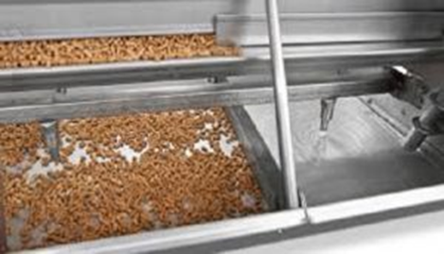
Figure. 8.7. Automatic cylinder feeder
The water supply should be cool (maximum 18-20°C). Supply lines should be buried or insulated particularly if they are black poly pipe outside in the full sun; otherwise the water is hot and undrinkable when it is most needed. If nipple drinkers are used it should be checked that the water pressure coming through the drinkers is suitable for the age group of pigs to allow sufficient water intake. As a guide: 0.5 litres/min for piglets and weaners, 1.0 litres/min for growing pigs and dry sows and 2.0 litres/min for lactating sows.

8.8. Identifying, assessing risk and implementing OHS hazards
8.8.1. Identifying OHS hazards
Hazard is the potential for harm or an adverse effect (for example, to people as health effects, to organizations as property or equipment losses, or to the environment). Hazard identification is part of the process used to evaluate if any particular situation, item, thing, etc. may have the potential to cause harm.
Hazard identification can be done:
- During design and implementation
  - Designing a new process or procedure
  - Purchasing and installing new machinery
- Before tasks are done
  - Checking equipment or following processes
  - Reviewing surroundings before each shift
- While tasks are being done: Be aware of changes, abnormal conditions, or sudden emissions
- During inspections: Formal, informal, supervisor, health and safety committee
- After incidents
  - Near misses or minor events
  - Injuries
Hazard can be identified by
- Look at all aspects of the work and include non-routine activities such as maintenance, repair, or cleaning.
- Look at the physical work environment, equipment, materials, products, etc. that are used.
- Look at injury and incident records.
- Talk to the workers: they know their job and its hazards best.
- Look at the way the work is organized or done (include experience of people doing the work, systems being used).
- Look at foreseeable unusual conditions (for example: possible impact on hazard control procedures that may be unavailable in an emergency situation, power outage)
- Determine whether a product, machine or equipment can be intentionally or unintentionally changed (e.g., a safety guard that could be removed).
- Review all of the phases of the lifecycle.
- Examine risks to visitors or the public.
- Consider the groups of people that may have a different level of risk such as young or inexperienced workers, persons with disabilities, or new or expectant mothers.
A common way types of hazards are categorized as follow:
Biological – bacteria, viruses, insects, plants, birds, animals, and humans
Chemical – depends on the physical, chemical and toxic properties of the chemical,
Ergonomic – repetitive movements, improper set up of workstation
Physical – radiation, magnetic fields, temperature extremes, pressure extremes (high pressure or vacuum), noise
Psychosocial – stress, violence
Safety – slipping/tripping hazards, inappropriate machine guarding, equipment malfunctions or breakdowns.
8.8.2. Assessing the risk
A risk assessment is a thorough look at your workplace to identify those things, situations, processes, etc. that may cause harm, particularly to people.
Risk assessments are very important as they form an integral part of an occupational health and safety management plan. They help to:
- Create awareness of hazards and risk.
- Identify who may be at risk (e.g., employees, cleaners, visitors, contractors, the public
- Determine whether a control program is required for a particular hazard.
- Determine if existing control measures are adequate or if more should be done.
- Prevent injuries or illnesses, especially when done at the design or planning stage.
- Prioritize hazards and control measures.
8.8.3 Implementing suitable control measure of OHS hazards
Effective controls protect workers from workplace hazards; help avoid injuries, illnesses, and incidents; minimize or eliminate safety and health risks; and help employers provide workers with safe and healthful working conditions. The processes described in this section will help employers prevent and control hazards identified in the previous section.
To effectively control and prevent hazards, employers should:
- Involve workers, who often have the best understanding of the conditions that create hazards and insights into how they can be controlled.
- Identify and evaluate options for controlling hazards, using a "hierarchy of controls."
- Use a hazard control plan to guide the selection and implementation of controls, and implement controls according to the plan.
- Develop plans with measures to protect workers during emergencies and nonroutine activities.
- Evaluate the effectiveness of existing controls to determine whether they continue to provide protection, or whether different controls may be more effective. Review new technologies for their potential to be more protective, more reliable, or less costly.

Self-Check – 8 | Written test

Name…………………………………………… ID………………………… Date…….

Directions: Answer all the questions listed below.

Test I: Matching (1points each)
A
1. Thorough look at your workplace to identify those things, situations,
2. Repetitive movements, improper set up of workstation
3. Unused or expired medicated feed, animal health products
4. It covers all on-farm livestock mortalities

B
A. Ergonomic Hazard
B. Dead stock
C. Risk assessment
D. Medical waste

Test II: Give Short answer for the questions
1. Mention importance of risk assessments in workplace (5points)
2. How hazard can be identified in work place (4points)
3. Write practical feeding tips for swine during pregnancy (6points)
4. Describe the way how general farm waste can disposed (3points)
You can ask you teacher for the copy of the correct answers.

Reference Materials

Books:
National Research Council (1998). Nutrient Requirements of Swine Subcommittee on Swine
Nutrition, Committee on Animal Nutrition, Board on Agriculture, National Research Council 10th ed., National Academy Press: Washington, D.C., 189p. + 1 computer laser optical disc
Smith, P. (2001). Practical Pig Keeping Crowood Press: Marlborough, UK, 208 p., ISBN: 1-86126- 388-0.
National Research Council. Nutrient Requirements of Swine, 9th ed. 1998. National Academy Press, Washington, DC.

Web addresses
https://pdf.usaid.gov/pdf_docs/PNABC964.pdf (Access date 31/08/2022)
https://www.pashudhanpraharee.com/housing-requirements-for-different-categories-of-pigs/ (Access date o1/09/2022)
https://openprairie.sdstate.edu/cgi/viewcontent.cgi?article=1700&context=extension_circ (Access date o1/09/2022)
https://porkgateway.org/resource/environment-swine-housing/ (Access date 30/08/2022)

AKNOWLEDGEMENT
Ministry of Labor and Skills wish to extend thanks and appreciation to the many representatives of TVET instructors and respective industry experts who donated their time and expertise to the development of this Teaching, Training and Learning Materials (TTLM).

The experts who developed the learning guide
No | Name | Qualification | Educational background | Institution | Phone number | E-mail
1 | Terefe Tolcha | MSc | Animal Production | Alage ATVET  College | 0911067132 | terefetc@gmail.com
2 | Temesgen Roro | MSc | Animal Production | Holeta PTC | 0917657496 | temesgenroro@gmail.com
3 | Genanew Abera | MSc | Animal genetics and breeding | Alage ATVET  College | 0926672970 | genanewabera@gmail.com
4 | Solomon Fertewal | MSc | Animal Production | Alage ATVET  College | 0912648413 | Tosolomon@gmail.com
5 | Gashaw Assefie | MSc | Animal Production | Agarfa ATVET  College | 0914068274 | lakomelzajournalist@gmail.com
6 | Abenet Getahun | MSc | Animal Production | Gewane ATVET  College | 0940236673 | abenetgetahun@gmail.com
7 | Yirmedie Bayou | MSc | Animal genetics and breeding | Mizan ATVET  College | 0915851079 | Yirmedie123@gmail.com
8 | Sead Taha | MSc | Animal Production | Agarfa ATVET  College | 0916112492 | tahasead@gmail.com
9 | Biru Kefenie | MSc | Animal Production | W/Soddo  ATVET  College | 0913334612 | ukefene@gmail.com

