Animal Production
Level-II
Based on March 2022, Version-4 Occupational standard

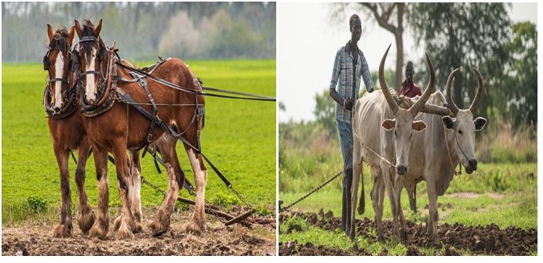
Module Title: Performing husbandry practices of
Draft animal
LG Code: AGR ANP2 M05 LO (1-5) LG (20-24)
TTLM Code: AGR ANP2 TTLM 0922v4

September, 2022
Addis Ababa, Ethiopia

Table of Contents
Introduction to the Module2………………………………………………………………………1
LO1-Prepare and provide house and work for draft animals…………….…………………………………2
Instruction sheet 1…………………………………………………………………………………………………………………………….2
Information Sheet1………………………………………………………………………………………………………………….…………3
Self-check 1…………………………………………………………………………………..…….18
LO2- Perform daily work program………………………………………………………………….………………………………….20
Instruction sheet 2…………………………………………………………………………………………………………………………..20
Information Sheet2………………………………………………………………………………………………………………………….21
Self-Check 2……………………………………………………………………………………….38
Operation Sheet 2…………………………………………………………………………………………………………………….…….39
LAP TEST 2……………………………………………………………………………………….39
LO3- Select , catch and tie up draft animals……….……………………………………….40
Instruction sheet 3…………………………………………………………………………………………………………..………………40
Information Sheet3……………………………………………………………………………………….………………………………..41
Self-Check 3……………………………………………………………………………………….62
Operation Sheet 3………………………………………………………………………………………………………………………….63
LAP TEST 3………………………………………………………………………………………..64
LO4- clean and maintain stable gear and surrounding areas……………………………………………………………..65
Instruction sheet 4……………………………………………………………………………………………………………………….65
Informationsheet 4…………………………………………………………………………………………………………………………66
Self check……………………………………………………………………………………………………………………………………..67
LO5- Monitor health and welfare of horses………………………………………………………………………………………..72
Instruction sheet 5……………………………………………………………………………………………………………………………72
Information sheet 5……………………………………………………………………………………………………………………..73
Self check 5…………………………………………………………………………………………………………………………….83
Reference Books………..……………………………………………………….…………84
Acknowledgment …………………………………………………………………………..115

Introduction to the Module
This Module covers the knowledge, skills and attitude required to Perform husbandry practices of draft animal. It also requires the ability to prepare and handle materials, tools and equipment for the work and clean up on completion of work.Generally, draught animal power (DAP) describes the use of animals to provide the vital power for crop cultivation and transport. There are a number of words used to describe the same, and include: animal traction (AT) and draught animal technology (DAT). Note that draft and draught have been used interchangeably to describe the ‘pull’ force. Animal traction, animal-powered mechanization, and animal draft are terms which describe the use of animals to pull farm equipment, vehicles, and other loads. In many rural communities, cattle, donkey’s mules, horses, camels and other working animals are used by farmers in tillage operations and provision of transport services. Ethiopia is the richest country of Africa in draft animals, including cattle, camel, donkey, mule & horse. Draft animals assist the societies in different tasks. The most common use of draft animals (except oxen) is as pack animals for transport of goods and people. They are important in reducing drudgery and intensifying agricultural production. Structurally, DAP describes a system of interaction between the operator, the implement and the animal. Each of the sub-systems is fundamental and entails a number of factors that are important in ensuring proper functionality

LG 20 | LO 1: Prepare and provide house and work for draft animals

Instruction sheet 1
This learning guide is developed to provide you the necessary information regarding the following content coverage and topics:
- Providing required housing or building
- Providing feed and water
- Interpreting and confirming draft animal management
- Selecting, checking and maintaining material, tools and equipment
- Selecting, using and maintaining PPE
This guide will also assist you to attain the learning outcomes stated in the cover page. Specifically, upon completion of this learning guide, you will be able to:
- Provide required housing
- Provide feed and water
- Interpret and confirm draft animal management
- Select, check and maintain material, tools and equipment
- Select, use and maintainPPE
Learning Instructions:
- Read the specific objectives of this Learning Guide.
- Follow the instructions described below.
- Read the information written in the information Sheets
- Accomplish the Self-checks
- Perform Operation Sheets
- Do the “LAP test”

- Definition of draft animal
Generally, draught animal power (DAP) describes the use of animals to provide the vital power for crop cultivation and transport. There are a number of words used to describe the same, and include: animal traction (AT) and draught animal technology (DAT). Note that draft and draught have been used interchangeably to describe the ‘pull’ force. Animal traction, animal-powered mechanization, and animal draft are terms which describe the use of animals to pull farm equipment, vehicles, and other loads.In many rural communities, cattle, donkey’s mules, horses, camels and other working animals are used by farmers in tillage operations and provision of transport services.
Ethiopia is the richest country of Africa in draft animals, including cattle, camel, donkey, mule & horse. Draft animals assist the societies in different tasks. The most common use of draft animals (except oxen) is as pack animals for transport of goods and people. They are important in reducing drudgery and intensifying agricultural production. Structurally, DAP describes a system of interaction between the operator, the implement and the animal. Each of the sub-systems is fundamental and entails a number of factors that are important in ensuring proper functionality

- Providing required Housing

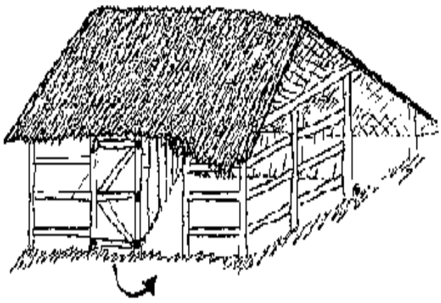
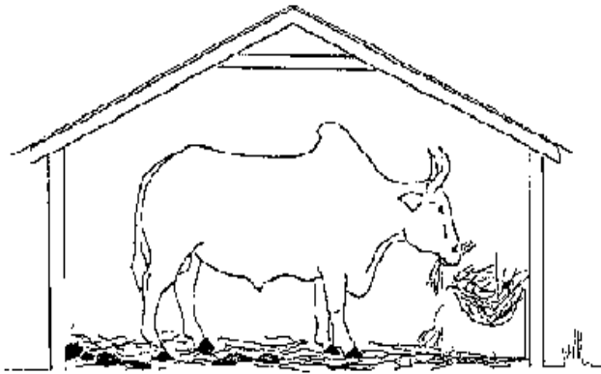
Housing of draft animals: located near the residence of the user, the housing must provide good comfort to the draft animal. Housing of draft animals must have a pen where animals are constrained or free, means of distributing water and food (buckets, troughs, racks and fodder troughs), a restraint system with simple poles of tie stall or corridor of contention, shelter against the weather or the sun, a system of concentration of dejections or manure. Then, for shelter, there should be 4-5 m2 per cow to park at night and from 3.25 to 3.75 m2 for the cowshed, plus a corridor of 1 to 1.5m behind the animals and an area of pause; for the pit, a volume of approximately 9 m3. Stabling must be maintained in a clean condition and not wet: setting pit regular litter, regular cleaning of troughs, buckets and feeders. During the night, your oxen are kept in a COWSHED. An oxen farmer without a cowshed is no real oxen farmer. The housing of your oxen win give you a lot of advantages.
Fig. 1.2 A good COWSHED is made up of three rooms

Fig. 1.1: A good cowshed. During the night feeding in the cowshed

Providing feed and water

- Providing feed and water
- Feeding to draft animal animals
A good feeding program is essential in maintaining the strength and health of draft animals. Food is the fuel which an animal converts to energy and pulling power. Animals that are not fed enough of the right feeds can show chronic fatigue, will lose the ability to work, and are more susceptible to disease. Excess calories are stored as fat, causing animals to become inefficient workers, lazy, stubborn and ill-tempered.A basic knowledge of the dietary, needs of draft animals and of the nutritional content of available feeds will enable owners to plan a feeding program that will help their animals to work to their full potential.
Grazing draft animals need supplemental feeding for the following reasons:
- to increase energy intake and prevent protein, vitamin-and mineral deficiencies
- Because of limited grazing time or limited forages availability.

Animals burn many more calories when working than when idle or grazing. This means that the energy requirements of an animal will increase with the work load. Experience and research have shown that animals need about twice their normal energy maintenance requirement when they are used for.
- General Rules for Feeding:-
- Feed the animal so that it gains weight and maintains strength but does not become fat or lazy .Never let it lose weight.
- Feed large quantities of grass, straw, and other bulky, fibrous foods. These foods are called roughages. If they are of good quality, they supply all the nutrients that a grazing (non-working) animal needs for body maintenance. Protein, phosphorous and Vitamin A maybe deficient in forage growing on arid land.
- If only poor quality roughage diet is available, supplement the roughage diet with grain and other concentrate feeds such as beans, seeds, mill by products and oil cakes. These feeds give the animal' additional energy for work.
- Give the animals salt and mineral supplements.
- Deworms the animals regularly if parasites are present. This ensures that parasites do not interfere with digestion and that animals get the full value of food.
- Use quality feeds:
- Do not let animals graze in pastures where herds of other animals graze, or eat grain or hay from the ground or stable floor. These may be contaminated with parasites.
- Never feed mouldy or dusty feeds. These cause serious digestive problems.
- Improve the nutritional value of insect-infested grain by mixing good grains, mill by-products, or peanut or cotton-seed cake into the daily ration.
- Never give animals’ free access to lush; young grass or leaves of young corn or peanut plants. These can cause serious conditions like bloat, colic, or dehydration due to diarrhoea.
- How much to feed
The amount of extra feed that draft animal need depends on their size, the amount of work load, the quantity and quality of pasture available and the type and quality of feed used for supplementation. E.g. Draft animal have stomachs designed for frequent small meals (such as when grazing naturally) so the more often they are fed the better. It is not a good idea to feed a lot of forage in the morning before work.
Give small amounts then and during rest periods in the day. Supply supplementary forages in the afternoon and evening, allowing donkeys to feed during the night. A nursing jenny needs the equivalent of about 2 - 3% of her body weight a day if she is only fed forage. A working donkey needs about 3 - 4% of its body weight a day. Thus an average donkey will need about 4 to 6 kg of fodder a day if nursing or working. A jenny that is both nursing and working will need more. If a donkey cannot obtain this amount from available grazing, it will need supplements. In any case, if donkeys are fed concentrate each working day, they will require less grazing, and learn that work brings rewards.

- Watering to draft animals
During the rainy season, grazing animals get considerable amounts of water from the grasses and other succulent forages they consume. Under these circumstances, drinking water consumption is not an accurate indication of water requirements. Actual water needs are determined by size, species, environment, and intensity of work. Larger animals drink more because they have a greater body mass to cool. Muscular activity (work) generates additional heat. Working animals lose water from sweating and therefore need to increase their water intake.

Table 1.1:Water Requirement's of Draft Animals

Animal | Litters per day
Oxen | 10-30 rainy season
Oxen | 15-40 dry season
Horse | 30-50
Donkey | 10-20
Mule | 15-30

Working animals should have access to water at least three times per day--morning, noon, and night. Horses and some cattle engaged in heavy work may need a short drink every two or three hours. Zebu cattle, donkeys and mules can work for longer periods without drinks but still should be offered water during the mid-day resting/grazing period. A heated animal should never be allowed free access to water

Some animals will drink too much water in the evening. This may prevent them from eating their concentrate feeds. They should not be allowed to drink freely until after feeding. A small drink maybe given before food is offered

- Interpreting and confirming draft animal management

Before attempting to determine the kind and number of animals required for any particular farm, animal owners should be familiar with the concepts of pulling (draft) capacity and power. They should also consider the working characteristics of draft animalsAnimals vary not only in their ability to pull loads, but also in the number of hours they will work. Oxen will pull between one-seventh and one-tenth of their weight for 4-5 hours per day. Donkeys will pull about one-fifth lid their weight for 3-4 hours. Bulls worked longer when the load was decreased slightly and the work done in two sessions, 2 to 3 hours in the morning and 2-3 hours in late afternoon. Donkeys refused to work beyond 3-4 hours regardless of how the work was distributed and in spite of a reduction in the size of the load.

- Selecting, checking and maintaining material, tools and equipment

- Selecting Tools and equipments
There are different kinds of tools and equipments according to their uses and their selection as the requirements
- Essential components of animal draught and the equipment
Anything drawn by animals has 5 essential components:
- The animal/s (power source)
- The harness (what is on the animals to enable them to pull)
- The hitch (connection between harness and implement)
- The implement (includes carts)
- The work (in the case of carts, this is the load they take).
Each one of these has an effect on the functioning of the others. Bad design in one can have an adverse effect on the efficiency of every other component.

- Selecting tools and Equipments for transport
- Sledges
Sledge is the most simple load vehicle made out of a Y-shaped tree branch which attached to the animal by a trek chain.

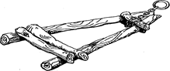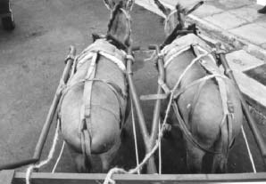
Fig 1.3: Simple wooden sledge
- Cart
Carts are two-wheeled vehicles, which can be small and light, pulled by one equine, or may carry over one ton and be hitched to a team of donkeys.
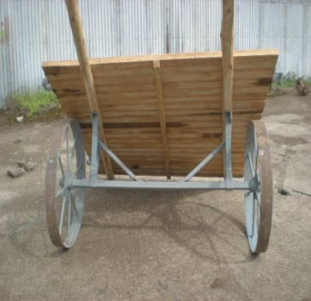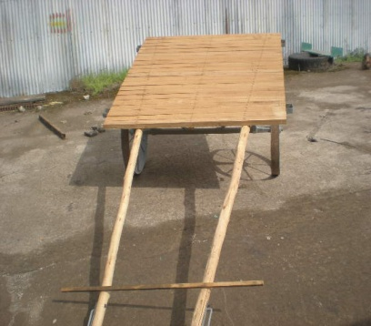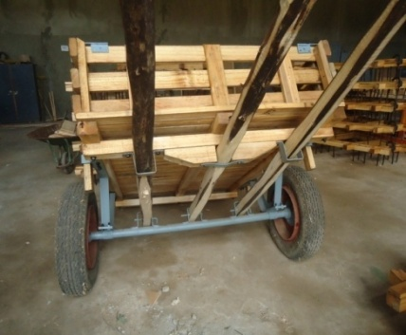
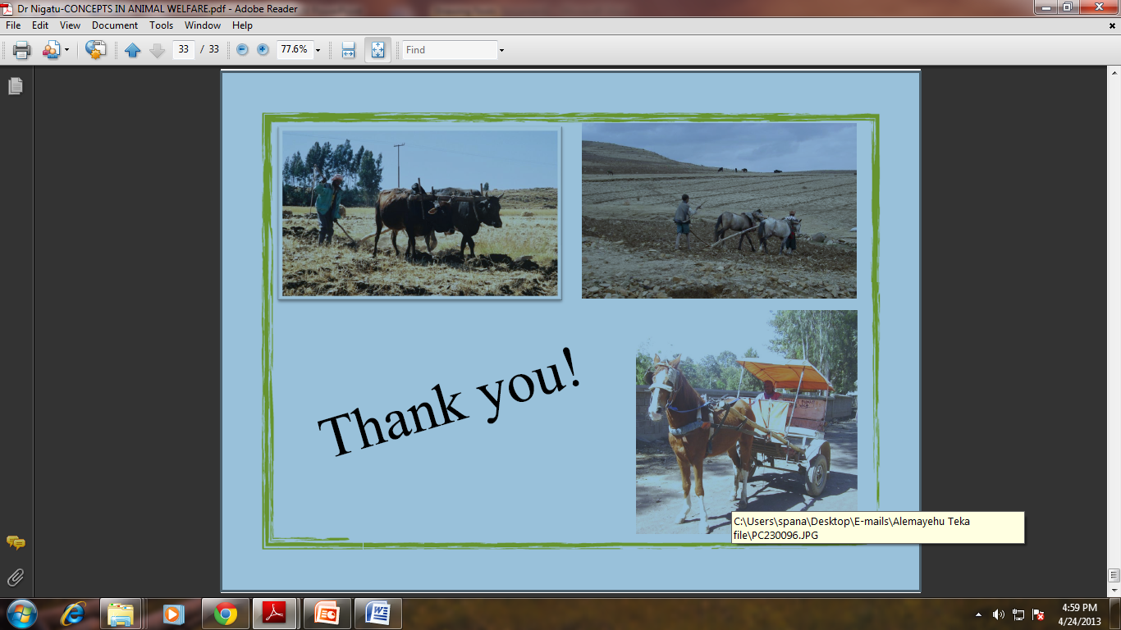
Fig1.4. carts
- Wagons
Wagons are four-wheeled vehicles with a higher weight capacity than carts (figure 3). They are best suited to tarred and level roads and to areas where the increased load capacity is cost-effective

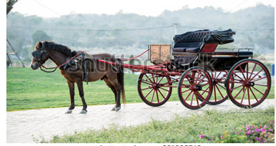
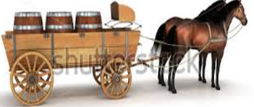
Fig1.5: Wagons
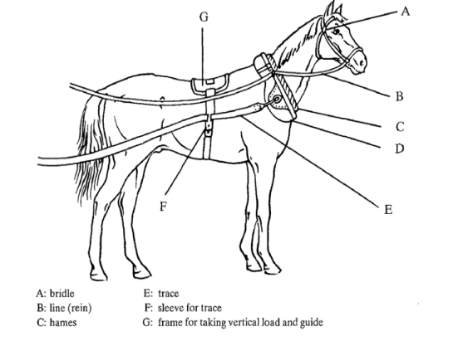
- Yokes and harnesses
- Harness: - the equipment links the draft animal to the carts, wagons or implements to transmit power of its work load. These are breast band, collar, bit, bridle, rein (line), girth, trace, saddle beech. Breast straps (bands): - are the materials which made fromleather, syntheticwebbing, or industrial webbing, beltingand tyre webbing that Horses, mules and donkeys pull best from their chest andshoulder.It
Fig1.6: parts of Harness:

- is a strap positioned across the breast and supported by one or two straps; the first one passes over the withers and the second one over the back. Its width is about 6cm
- Breech: - the strap that passes around the hindquarters of the harnessed animal and transmits a reverse draught to the cart. Used for braking and reversing.
- Collar harness: - a padded collar positioned around the neck; traction is transferred from the shoulders through rigid hams and traces.
- Trace: - the chains or ropes used to transmit the draft force from the collar or breast-band harness to the work load.
- Bridles: - straps around head of an animal to which reins are attached for controlling head.
- Saddle: - wide strap across equine back for taking load.
- Swingle: - a wooden pole to which the traces attach at each end and the work load attaches at the centre. This allows the harness to move with the shoulders, so reducing rubbing
- Yokes:- strong bar, usually made of wood, which an animal can push against in order to pull an implement. Trek chains are attached between the yokes and the implement to be pulled.

- Anatomy of a horse showing some harnessing options.
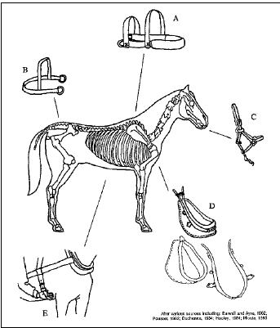
- Breast band harness (very commonly used for agriculture and transport).
- Breeching strap (uncommon, but useful for slowing down equipment).
- Bridle and bit (useful but not essential).
- Full collar harness, showing its component collar and hams (rarely used in Africa).
- Back strap and belly strap (useful if animal supporting weight of cart or if breeching strap fitted).
Fig. 1.7: Anatomy of a horse showing some harnessing options.

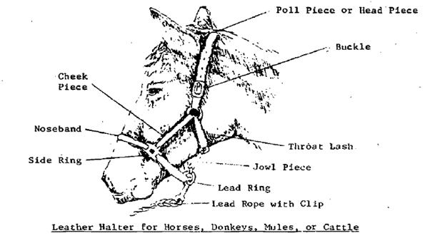

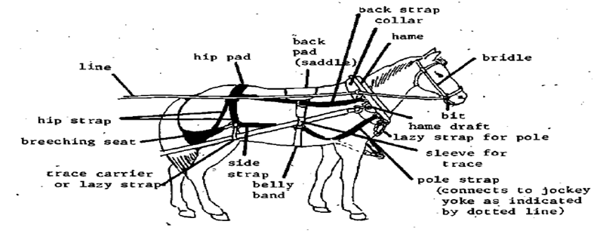

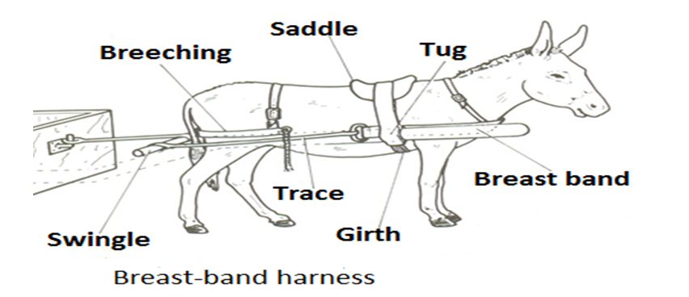
Fig1.8: -Different harnessing equipments.

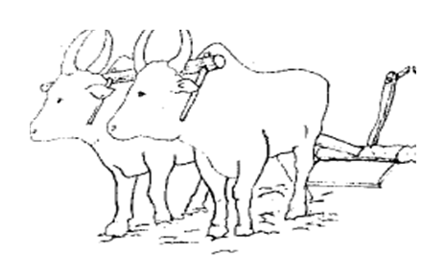
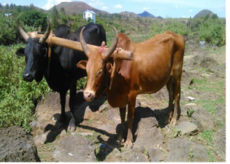
Fig 1.9: Yoke

- Selecting, using and maintaining PPE

This may include boots, helmet, overalls, gloves, protective eyewear, hearing protection, and respirator or face mask, and sun protection. The selection of PPE and devices to protect workers in any given hazard situation should be based on consideration of at least three factors:
- Information (yielded by the hazard assessment) on the nature and magnitude of the hazard.
- Performance data on the PPE and/or device under consideration.
- The estimated level of residual risk to which the worker will be exposed.
Use of PPE is trained to the worker in form of training program
Training programs should seek to orient learners to correct use of PPE via an optimal mix of cognitive (information-based), affective (attitudinal), and applied (laboratory practice) approaches

- Basic Types of PPE
The strict controls will not necessarily eliminate all the risks associated with most job tasks and this is where the need for PPE must be evaluated. A hazard assessment can help identify which specialized PPE will be required. However, the following basic types of PPE should be made available in worksite.
- Eye and face protection
To provide protection during exposure to hazards like flying particles, metal or sparks, liquid chemicals, caustic liquids, light radiation, i.e., welding, lasers. Eye protection should always be worn where there is potential for injury to the eyes or face from small particles, toxic chemicals, flying particles, large objects, thermal or radiation hazards, an lasers. According to the types and extent of hazards, different PPE should be worn. These must always remain clean and free of contaminates.Goggles offer good protection against front and side impact. Unvented or indirect vented chemical splash goggles provide protection from chemical vapors and liquids.

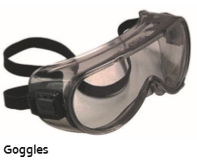
Fig 1.10: Goggle
- Hearing protection:
To provide protection during exposure to high pitch and loud noise levels. Exposure to high levels of noise may result in hearing loss. PPE should be worn when the noise level is 85 decibels or greater averaged over an eight-hour period. Most hearing protection devices have a noise reduction rating (NRR) that indicates the amount of protection provided. In general, look for NRR of 25 or greater.

- Head protection
To provide protection to potential hazards such as falling objects, striking against low-hanging objects, electrical hazards, or chemical application.
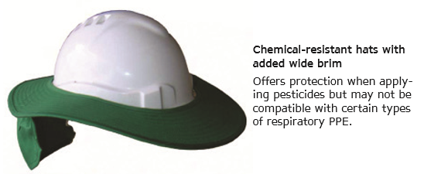
Fig 1.11: Helmets
- Hand protection:
To provide protection during exposure to potential hazards such as sharp objects, abrasive surfaces, temperature extremes, and chemical contact. Selecting proper gloves is very important since the hands are used to handle hazardous materials. In addition, traumatic injuries such as cuts, sprains, and punctures may occur. With the wide rangeof hazards, there are also a wide range of gloves that may be used as PPE. Chemical-resistant gloves are always recommended when working with pesticides and chemicals. Chemical-resistant aprons add protection from body absorption of hazardous chemicals
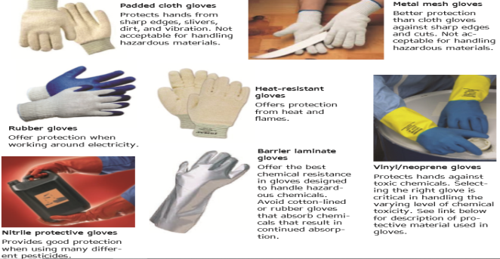
Fig 1.12: Gloves
- Respiratory Protection
Respirators are used to prevent the exposure to air contaminated with Harmful dusts, fumes, mists, gases, smokes, sprays, or vapors.All respirator usage, including disposable respirators, air purifying respirators, and air-supplied respirators, require annual fit testing and testing and training prior to use.
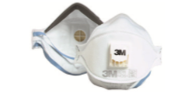
Fig 1.13: Air Purifying

- Foot protection
To provide protection for situations with the potential of injuries such as falling or rolling objects, chemical or liquid exposures, piercing objects, and where feet are exposed to electrical hazards.
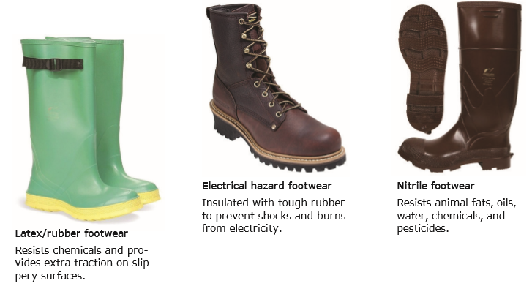
Fig 1.14: Boots

- Body Protection
PPE includes safety vests and suits and should be used for tasks that can cause body injuries from extreme temperatures, flames and sparks, toxic chemicals, insect bites and radiation. Ensure that they are clean and free from cuts and burns. Always get a good fit to ensure full body protection.Remember: Disposable clothing is designed to be disposed of regularly (and strictly after exposure to chemical). If you re-use this clothing you may be compromising your safety


Fig 1.15: over all

Self-check 1 | Written test

Name…………………………………………… ID………………………… Date…….
Directions: Answer all the questions listed below.

Test I: Choose the best answer (4 point)
- The terms which describe the use of animals to pull farm equipment, vehicles, and other loads is
- Animal traction
- Draft animal power
- Animal power mechanization
- All
2. The reason for grazing draft animals need supplemental feeding (1pt)
- Because of limited grazing time
- Limited forages availability
- To increase energy intake
- Prevent protein, vitamin-and mineral deficiencies

Test II: Short Answer Questions
- List at least four (4) the purpose of draft animal power housing (2pts).
- List at least three transporting equipments
- Name the harnessing materials for horse riding by cart.
- List the protective equipment equipments used in draft power

LG 21 | LO 2: Perform daily work program

Instruction sheet
This learning guide is developed to provide you the necessary information regarding the following content coverage and topics:
- Carrying out Work program for each stable animal
- Selecting and preparing draft animals
- Contacting supervisor as required
- Washing down draft animals after working
- Keeping and maintaining routines work and performance records
This guide will also assist you to attain the learning outcomes stated in the cover page. Specifically, upon completion of this learning guide, you will be able to:
- Carry out Work program for each stable animal
- Select and prepare draft animals
- Contact organizational procedures
- Wash down draft animals after working
- Keep and maintain routines work and performance records
Learning Instructions:
- Read the specific objectives of this Learning Guide.
- Follow the instructions described below.
- Read the information written in the information Sheets
- Accomplish the Self-checks
- Perform Operation Sheets
- Do the “LAP test”

Information Sheet 2

- Carrying out Work program for each stable animal

Work program is the organizational standard operation and supervisor instruction for working with draft animals. It is setting the programs in the care, and cleaning equipment, maintaining all equipments and keeping hygiene of animal- farming premises according to the instruction of stable manager.
Regularly the following work program shall be carried out for stable animals:
- The shed should be open into paddock to allow the animal to exercise.
- The shed and the paddock should be free from sharp objectives like nails or broken rails.
- Mud and manure should not allow accumulating in the in building.
- Manure should be removed from the shed daily, unless it has a deep litter system where system whereby fresh bedding material is added daily. If this manure is pilled in the draft animals outside it loses its quality rapidly; because sunlight accelerates loss of minerals, hence nitrogen is lost rapidly. In addition rain water leashes the nutrient in the manure.
- The healthy of animal program checks and work for stable animals
- Keep his welfare during and after work

- To check the health and condition of draft animal the following signs are observed.
- The animal should have smooth shiny coat
- The muzzle should be cool and moist but not watery.
- The dung and urine should be normal, urine; a beer color, dung; not watery; but piles up.
- The animal should have alert ears, moving to fro.
- The eyes should be clear and bright.
- The appetite must be good.
- Breathe normally and chew the cud.
- Draft animals are secured by using rearing bit, war bridle, blindfold, twitch, neck skin hold, leg strap, hobbles, and sidelines

- Selecting and preparing draft animals

- Selecting draft animals for professional services
Animals should be selected according to the type of work to be performed, the local environment, socio-economic conditions and the availability of local animals. Indigenous breeds tend to be well adapted to the local climate, feed availability, and diseases and to traditional management systems. Those animals are:

    - Donkey
- Donkeys provide power for agriculture and transport at a low cost.
- Donkeys adapt well in dry areas.
- They eat less than cattle and for this reason do better than cattle under drought conditions and in heavily stocked areas.
- They are also lighter and smaller than cattle.
- Donkeys can live a long life and can be worked up to 25 years of age.
- They can carry goods and people on their backs in hilly as well as flat areas, pull carts, turn mills and waterwheels, cultivate fields and can even be used to guard sheep against predators such as jackal and lynx.
- Carts can be pulled faster than in the case of oxen, but donkeys are better suited to lighter field work and cannot work for long periods.
- Women and children can also handle donkeys.
- The animals are very patient, hard working and dependable.
- The common idea among the general public, commercial farmers and extension officers that donkeys are lazy or eat too much is quite unfounded.

    - Cattle
- Oxen are some of the most powerful draught animals but they are slow and labour intensive.
- They are generally used for heavy work where speed is not essential (ploughing and pulling heavy carts and wagons).
- Cows can be used where the work is light and infrequent (planting and cultivating).
- Bulls can also be used as part of a span
    - Horses
- Horses and ponies are mostly used for riding in highland areas.
- They provide strong, fast transport but do not generally have the hardiness of other draught animals.
- They may be used for ploughing, harrowing, planting, weeding and transport.
- These animals have not been used as widely as oxen as a result of horse sickness which occurs in low-altitude areas.
- Horses are used to pull carts in the rural areas.
- Sometimes “thoroughbreds” are bought cheaply from the racing industry.
- As they have not been bred as draught animals, they do not do well and generally do not live long.
- Heavy breeds such as Percherons, Clydesdales and Shires may be used as traction animals on farms. The Percheron appears to adapt best to South African conditions
    - Mules
- Mules are strong, intelligent, hardy and hard-working animals.
- Because they are large animals, they are more easily used by men than by women or children.
- They cost the same as oxen, but are considerably more expensive than donkeys.
- Mules can be used for ploughing, harrowing, planting and logging.
- They can also be used for packing and to pull carts and wagons.
- The animals can work on poor quality feed, under hard conditions up to an age of 35 years.

Farmers must be able to select the animal or animals most appropriate for their needs. The animals they choose must be culturally acceptable, trainable, maintainable, and profitable within the overall farm plan. It is also important that the animal be available locally, since these animals are already adapted to local feeds and climate and are likely to be resistant to diseases in the region. Of course, farmers should choose healthy animals from strong stock. In some areas, farmers must consider social or religious traditions which restrict the ownership or use of animals.
- Preparingdraft animals for professional services
Before introducing harnesses and starting draft animals to this professional work/ services, both the animal and the farmer must be trained. Training animals for traction involves an understanding between the trainer & the animal. The animals need to trust you. For that we need to be patient and reward them for good behaviour. Training may be carried out at training centres, but when undertaken on the farm or within the village community, this provides a more practical and “homely” environment. If possible, the farmer should train his or her own animal, because the sooner a good relationship is established between farmer and animal, the better. Training requirement scan vary greatly and depend upon both the ability of the trainer and the temperament of the animal. An experienced trainer may be able to go through the exercises much faster. The program of training consists of four phases. During the first two phases, the animals are taught to obey voice commands individually. In the last two, the individuals are yoked as a team, re drilled on all voice commands, and then made to pull log (packing).
Training of draft animals
- Introduction
The dressage of draft animals is a set of successive learning, based on repeat orders and constraints imposed on animals to obtain a docile and voluntary behavior both for the execution of the work.

- Qualities of a trainer
A good trainer must be patient, attentive to the signs of fatigue, calm and firm.
- Duration of training
The duration of training is about a month. It also depends on the qualities of the trainer and character of animals. The training can start three or four years, even without rushing animals two years. The best time is the end of the dry season, which allows the perfect dressage at the first plowing. The animals trained for the traction become fully operational after two to three crop years.
- Methods of training
Three training methods are used for cattle.
- The first is to develop two new young bulls under the same yoke. This is the most common, but the most difficult.
- The second method called "Parrain" is to educate a young animal with an experienced one. Those two young animals then are gathered under the same yoke.
- The third so-called "Sandwich" is done with a yoke of three places; the candidate dressage is in the middle of an experienced pair.

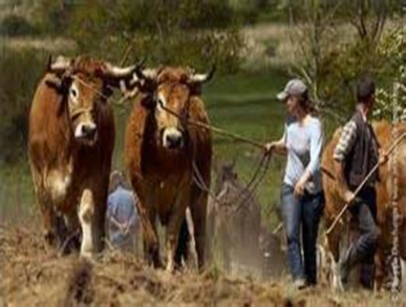
- How to Train:
- The user must perform hitch himself straightening his team or at least participate actively. So we have to:
- Talk to the animals;
- Give to the animal a very short name (two syllables, for example);
- accustom the animal to respond to the following orders: advancer, stop, turn left, right, back. Each order must be accompanied by an effective stress;
Fig. 2.1: Use of a stress mean (a stick thin) for an unexecuted order.
- Use immediately after stress means an unexecuted order, but gently (stop the stress means just after an executed order). A wooden stick thin, flexible and brutal voice can be used.

Stages of training:
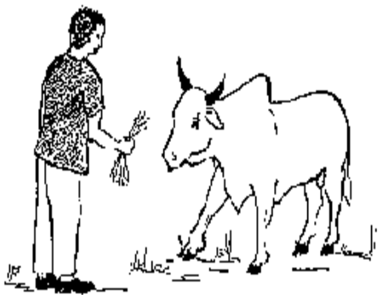
The training involves several stages, each about a week:
1) Habituation to a dresser man: allows to approach and touch the animal without causing his concern. Piercing the nasal septum with a special clamp and trimming horns (3 to 5 cm at the ends) can help dressing. Restraint can be total while immobilizing the animal to the ground (often standing) to perform delicate operations such as: treatment and care of the nasal septum piercing. For piercing nasal septum, use the nose clip easy to use and much more secure (Figure 2);
Fig. 2.2:: Approach your animal from the front and call his name

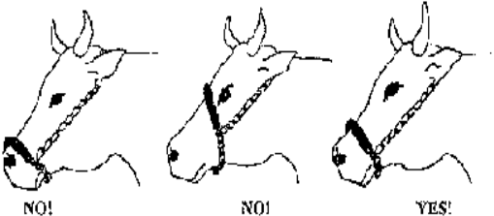
The harness consists of the following parts : halter chain or nasal ring, yoke, head joint rope, steering rope. Adjust your Halter Chain correctly to the animals to avoid wounds at the eyes, muzzle or mouth (Figure 3).
Fig. 23: Correct adjustment of the halter chain
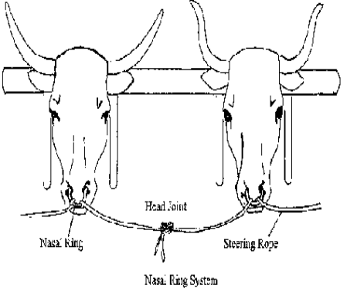
The head joint and steering ropes are attached to the halter chain or nasal ring to control the oxen. The steering rope is 12 mm thick and 20 m long, head joint rope is 6 mm thick and 2 m long (Figure 4). Avoid wrong adjustment of the head joint. Figure 5 and 7 show the wrong way to make the head joint. Despites, Figure 6 shows the right way.
Fig.2.4: The Head Joint joins the two animals and the Steering Rope leads round their rears to the

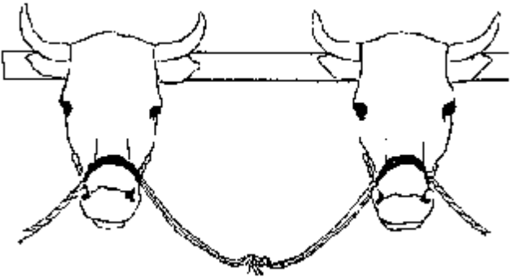
Fig. 2.5: No! The head joint is too long.

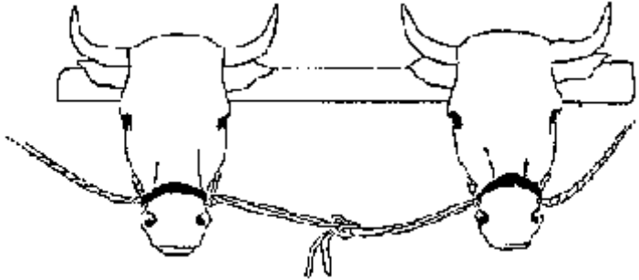
Fig. 2.6: Yes! Head Joint and Steering Rope are correct

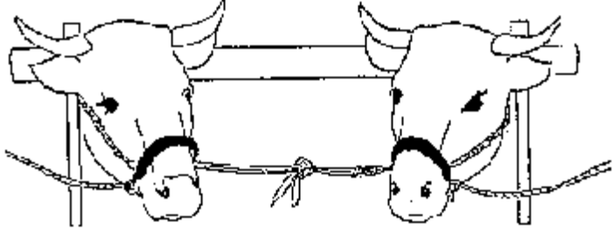
Fig. 2.7: No! The head joint is too short

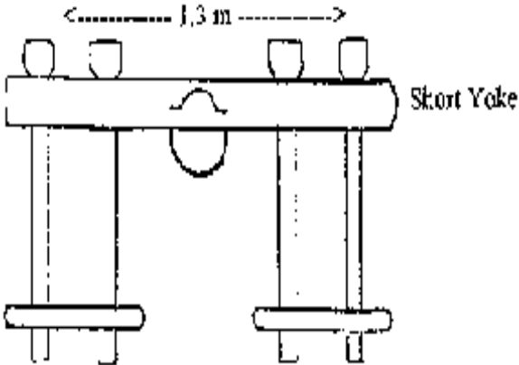
2) Installation and safety of yoke: animals are tied by the horns to the horizontal rod to familiarize them with human activities. The yoke connects the two draft animals. All traction implements are attached to the yoke by the pulling chain (prow, harrow) or the beam (cart, roller cutter). The yoke consists of the yoke beam, the yoke pegs and the peg beam. You have two kinds of yokes:
Fig: 2.8: Use the short yoke for plowing and weeding rice and wheat (40 cm rows)

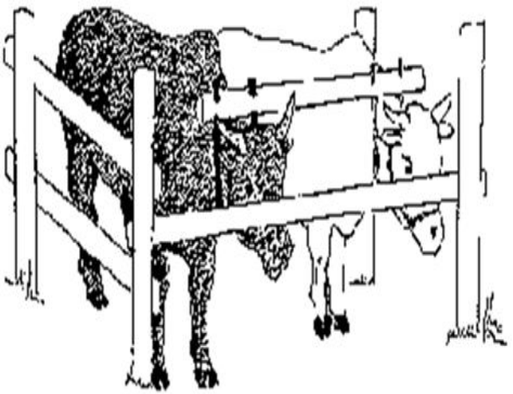

- The short yoke with a length of about 1.3 m, used for pillowing, harrowing, transport, clearing.
- The long yoke with a length of about 1.7 m and adjustable to different working distances, used mainly for ridging, weeding and molding.
- For weeding or Ridging use the maximum distance between the animals. Leave central holes of the yoke free (80 cm ridges). For plowing, reduce the distance between the animals by changing the pegs Weeding: of 60 cm ridges.
Fig. 2.9: A pair of draft animal should be equal in size, weight, height and temperament. Here a new pair is tied in the dressing room or stock

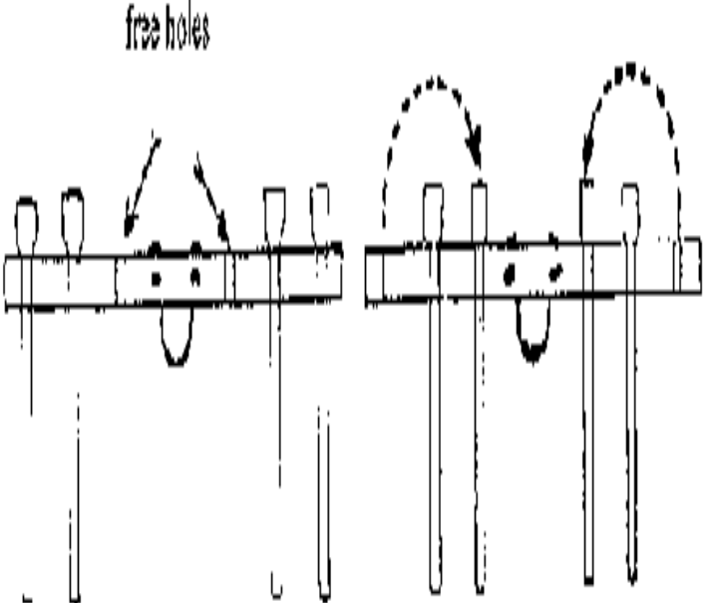
Stapes 3 The practices to walk: often requires the presence of three persons (one in front of animal, two on the sides). It allows to the herdsman to give the voice command. Initially, the animals are kept closely (if necessary, by means of ropes), in the end, the animals walk alone without the presence of aid and
obeys the voice and guides. Allow short rests from time to time. Avoid shouting, give clear commands, go slowly and steadily, never beat the animals, be patient, show no anger.

Fig. 2.10: Use the long yoke for ridging, weeding and moulding

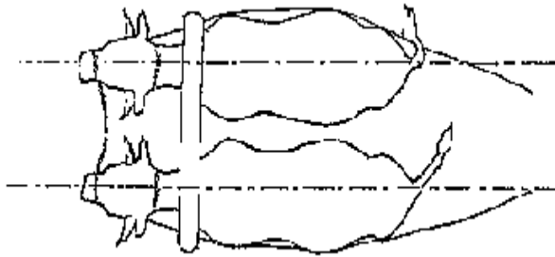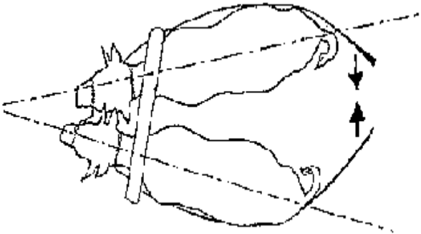
Fig. 2.11: Teach them to go in line! Fig. 2.12: Use the steering rope to keep them in line!

- Change positions from time to time. Allow both the farmers and the partner to learn the handling exercise
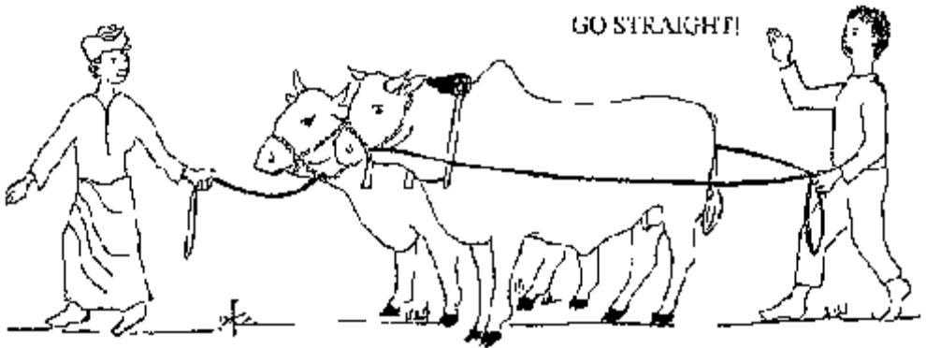
Fig 2.13 the handling exercise

- Teach them to start and stop: use the commands "go" and "stop

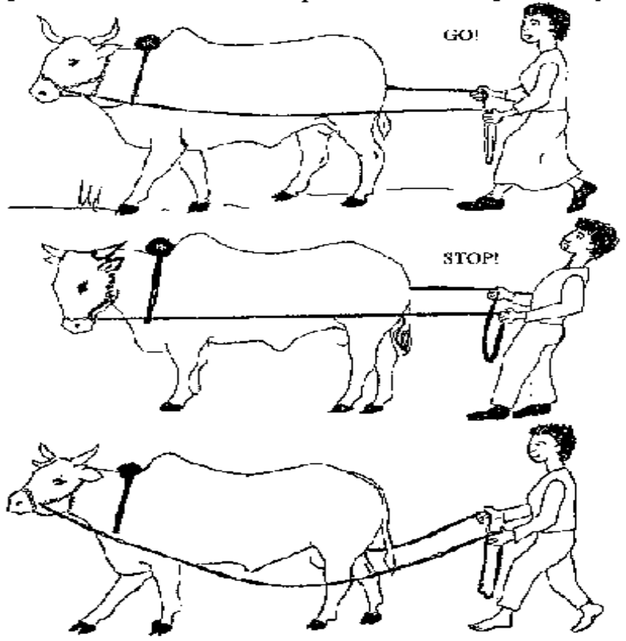

Fig 2.14 Teach them to start and stop

- Continue to call the names and the commands until the animal have learned to follow the commands

- Start to teach them to turn left and right by using the commands "go left" - "go right

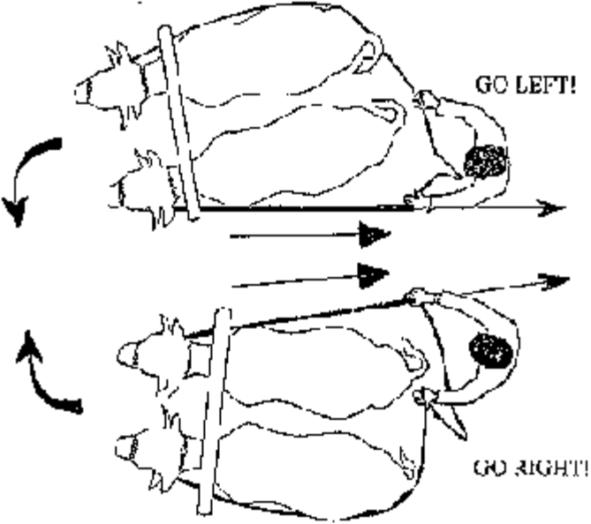

Fig 2.15 teach them to turn left and right

When the animal walks steadily and follow your commands you hook the pulling chain to the yoke and continue practicing for the first day.
As soon as the oxen are accustomed to the chain
- attach a small light log to the end of the chain and pull
- each the animals to pull straight
- give commands to turn left and right while pulling
- increase the size of the pulling log
- attach a harrow, first upside down and pull - then turn
- give a short break after some minutes
Try to control the animal alone as far as possible. Change with your partner, to allow him to learn the exercise as well.
Stapes4 The development of a traction effort: consists to accustom the draft animals to tow a load which is gradually and progressively increased in weight. Traction sequences are interspersed with many pauses (example 10 minutes of work and 30 minutes of pause). Check the adjustment of your harness before you start pulling. Wrong adjustment can hurt or wound the animal.
Stapes5 The traction with agricultural tools: consists of accustoming the draft animals to perform the agricultural work on a field. The traction with one cattle is less common than the use of two pair cattle. It is recommended for small work which require little effort, as the medium transport, weeding, hilling

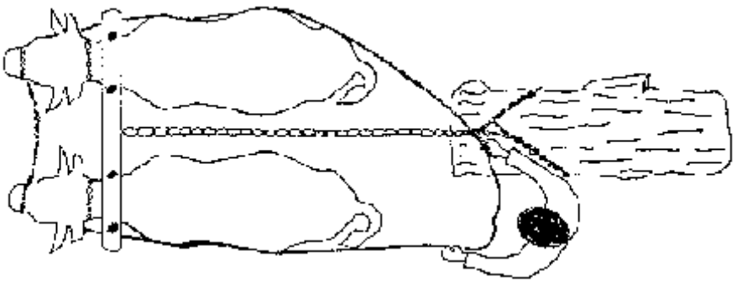
Fig. 2.16: Develop draft effort by pulling a log and accustoming of draft animals to cultivate

stapes6 The management of the Careers of draught animals (cattle): The duration of use of draft cattle is highly variable. It depends on how the use of animals, but also market conditions fixing the purchase price of young cattle and the sale price of cull cattle. Several activities are performed to assure the effectiveness of animal traction including housing, food, health and hygiene.

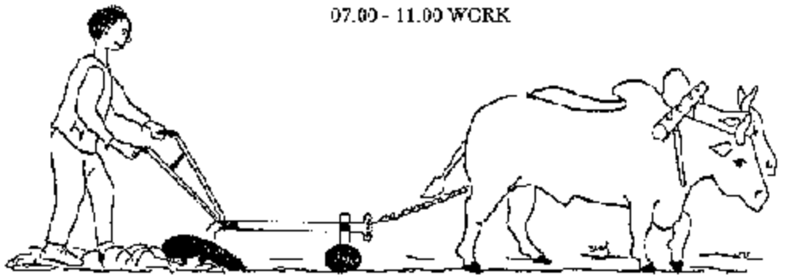

Fig. 2.18: Animal Work from 07:00 - 11:00

- Conducting organizational procedures
All employees should be given adequate information, training, instruction and supervision in respect of all matters affecting their health and safety at work. The worker will able to follow Supervisors oral or written instructions, livestock production program, organization standard operating procedures, specifications, routine maintenance schedules, work notes; product labels and Material Safety Data Sheets; manufacturers service specifications and operators manuals, waste disposal, recycling and re-use guidelines, and OHS procedures in all draft animal activities.
- Washing down draft animals after working
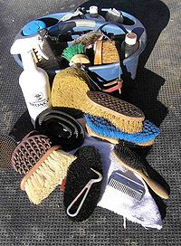
After use, the regardless of the species, the animal should be cleaned to remove sweat, dust and dirt. This should be done with a stiff brush followed by a cloth and water. To keep their hygiene and shininess of the hair of the animal shall be groomed.

Fig 2.19 scrubbing brush with stiff plastic or fiber bristles

Grooming is the means of taking care of the hair and skin of the draft animals. Daily grooming is important for the health of working draft animal. The animal enjoy being groomed and will become tamer by this daily routine. Grooming keeps the skin healthy and prevents dirt from causing harness sores. Give special attention to those parts of the skin that are in contact with the harness and/or back pad. Grooming is usually done first with:
- Stiff round comb,
- Made of plastic,
- Hard rubber or metal.
This is used to loosen the dirt. A body brush is then used to remove the dirt. Brush in the direction of the hair (i.e. head to tail) using firm pressure. If such items cannot be purchased locally, a scrubbing brush with stiff plastic or fiber bristles can be used. A piece of cloth or wad of clean straw rubbed in a circular motion also helps to clean the animal. Keep grooming equipment clean and periodically soak it in a disinfectant. This will help prevent the spread of disease, especially if the equipment is used on more than one animal. If animals get very dirty or sweaty, it may be helpful to wash it all over with clean or soapy water. Take a damp cloth and wipe out the nostrils and around the eyes. Any secretions that may have occurred during the night should not be left on the face during the day, as these will attract flies. Check the coat for external parasites such as ticks. Ticks do not only create wounds, but also spread many infectious diseases. Check especially under the tail and inside the legs where the donkey cannot easily reach when grooming itself. Remove by hand any ticks that are found. Pick up and handle the feet of the donkey early and often in its training, calling a clear command like leg, so that it will not object to this care later on during its working life
- Keeping and maintaining routines work and performance records
Keeping record is simply to collect relevant information that can help you to take good decisions and to keep track of activities, production and important events on a farm. Records can be about any performance of the animals, economic development, or any activity of the farmer or veterinarian.
The real value is to support the farmer and the advisors to keep track and take decisions.
The records should be simple, easy and quick to interpret, and then they can be supplemented with remarks which can explain some unusual events or findings.
Records are important in draft animal farming because:
- To keep track of all animals (Identification records)
- Evaluation of livestock for selection (species records; financial records; production records)
- Aid in selecting animals with the right characteristics for draft
- To rationalize labor
- Aids in feed planning and management
- Aids in disease management; keeping track about treatment (disease records)
- Aids in finding the effective treatments
- To assess profitability/losses (financial records)
- Improves bargaining power on products, because you can see the investment and the price of the production (financial records)
- Credit/loan access (financial records)Aids in selection of animals
- Enables monitoring of farm implements and other accessories
- Enables the stockowner to monitor profit or loss and take remedial
- Provide use full information for planning, budgeting and securing of loans
- Types of Records
The major types of records which are all described below:
  - Identification
  - Feeding
  - Disease and treatment records
  - Financial records

- Identification Records
- An identification method should be cheap, not harming the animal, reliable to read at a distance of at least 2-3 meters and by preference be permanent.
- Identification of animals is usually through use of numbering, by marking of the animal.
- Intrusive methods of identification can be subdivided into 2 categories: permanent at the animal itself (which affect the animals most when doing it) and non-permanent.

- Feeding Records
Feeding records give information about the amount, type and quality of the feed. Feeding records can be used both for day to day management and adjustment of the feed ration. The important feeding records are: Produced and available fodder on farm; quantity and if possible quality of the different feeds. Including content of energy, protein and minerals
- Disease and treatment records
Disease and treatment records are necessary to keep track of the disease events in which each animal is involved during its lifetime. It provides information about the health status of each individual animal and the whole heard, and it can help ensuring important vaccinations given at the right time.
- Disease and treatment records can for example involve:
- Disease occurrence and date
- All handlings to cure diseases (also non chemical treatment)
- Vaccination
- Dipping/spraying
- Treatment
- De-worming
- Post-mortem

- Financial Records
The records of the costs and earnings related to the animal farming are kept for cash analysis and enterprise appraisal. In most households, the most necessary records are simple overview over the family cash flow, that is, the total economy in the household: what comes in? And what do we buy? In addition to this, keeping records of the animal enterprises is an important part, because it can show whether it gives an income to the family or not. If records are kept particularly for the animal herd as an income generating commodities, it will help the family to see what they invest in it, and what it costs to produce it. Also in relation to the animal farm, an investment is more than expenditure; an investment hopefully enables and improves the production in the future. It is also important to count approximately how many hours of work it has taken in the animal herd, because it can help price setting.
Economic records are of paramount interest in providing the farmer with information concerning the profitability of his farm. Moreover they are of great help in decision making at the right time. For example, is it profitable to feed concentrates, is it advisable to apply for a loan or credit to invest in a machinery or technology? Answering these questions is only possible if adequate records are available. Moreover, for tax purposes and for the purpose of getting loans or credit, economic records are required.

Self-check 2 | Written test

Name…………………………………………… ID………………………… Date…….
Directions: Answer all the questions listed below.

Test I: Choose the best answer (- point)
- One is not describes the character of draft animals selected professional purposes
- Culturally acceptable
- Trainable
- Maintainable
- Profitable within the overall farm plan
- None
- Which one true about training animal for preparing to professional work
- Both the animal and the farmer must be trained
- you need to be patient
- Training requirements vary upon ability of the trainer and the temperament of the animal
- All
Test II: Short Answer Questions
- What are work program carried out for stable animals
- Write the program of training steps
- write the organizational procedures and instructions
- What is the purpose of draft animal?
- What is grooming
- Write types of recording? (4pts)

Operation Sheet -2

Techniques/Procedures/Methods of training draft animals:
- Tools and equipments
- PPE
- Eye and face protection
- Head protection (Helmets)
- Gloves
- Foot protection (Boots)
- over all
- harness or yoke
- Heavy loads.

- Procedures/Steps/Techniques
- Wear PPE
- Roping and Walking the animal
- Harnessing and Walking the Animals
- Pulling Loads
- Pulling Implements

LAP TEST-2 | Performance Test

Instructions: Given necessary templates, tools and materials you are required to perform the following tasks within 1 hour. The project is expected from each student to do it.

Task-1 Perform training draft animals:

LG 22 | LO 3 : Select, catch and tie up draft animals

Instruction sheet
This learning guide is developed to provide you the necessary information regarding the following content coverage and topics:
- Identifying individual characteristics of draft animals
- Catching selected draft animal
- Inspecting legs and hooves
- Leading and securing draft animal
- Identifying and implementing OHS hazards
- Handling draft animals
This guide will also assist you to attain the learning outcomes stated in the cover page. Specifically, upon completion of this learning guide, you will be able to:
- Identify individual characteristics of draft animals
- Catch selected draft animal
- Inspect legs and hooves
- Lead and secure draft animal
- Identify and implementOHS hazards
- Handle draft animals
Learning Instructions:
- Read the specific objectives of this Learning Guide.
- Follow the instructions described below.
- Read the information written in the information Sheets
- Accomplish the Self-checks
- Perform Operation Sheets
- Do the “LAP test”

Information Sheet 3

- Identifying individual characteristics of draft animals

Once farmers decide what kind of draft animal will be used, they must be choosing individual animals which are sound an able and have a considerable work expectancy and resale value. Selecting a good draft animal is a matter of evaluating both physical and behavioural attributes. Age, sex, conformation (shape), and temperament are helpful criteria for judging a draft animal's value. The farmer's total animal needs mast be noted when judging an individual animal. If it is to be, used as a pair, it should be roughly the same age and size as its work mate, and should be the same sex.
    - Age of cattle/oxen
Ideally, farmers should raise their own draft cattle or purchase them when they are very young. Oxen are, normally, put to work between the ages of three and four years. They may be trained at two to three years of age and given light work for a season. However, before the age of three, oxen have little power, and hard work can stunt their growth or cause abnormal development of bone and muscle. After the age of four, animals may be difficult to handle and train; they must be broken of old habits before their power can be used.
Although Oxen can work until they are 12 or older, many farmers prefer to sell them as soon as their work capacity tapers off. A common practice is to work oxen hard until age seven or eight, use them as reserve or alternate animal (or pair) for a season or two and then sell them for butchering.

    - Age of Equines
Recommended' ages for training and working equine animals are very similar to those outlined for cattle. However, in practice, these animals are worked until they are older because their meat is non valuable in our case.
The age of a horse, donkey or mule can be determined by comparing the animal's mouth. As the animal grows older, the enamel wears off the tooth, giving it a smooth, white grinding surface b(the dark centre disappears).The teeth grow longer and begin to slant the entire mouth elongates.
    - Sex of cattle
Sex has a bearing on the power and temperament of draft animals. As a rule males tend to be bigger, more powerful, and more difficult to train, than females. Females have less endurance and, of course, cannot be used when they are carrying or nursing young.
    - Sex of Equines
Castrated horses or donkeys (geldings) are preferred over stallions because they are even tempered and manageable in the presence of females. Female horses, mules and donkeys are nearly as powerful as males and geldings, but are known for their stubbornness and unpredictable moods.
- Identifying selection criteria’s

The primary criteria for the selection of draft animals employed are:
- Breed or breed-cross
- Age
- Sex
- Condition
- Color and markings
- Possibilities of multiple utilization
Once farmers decide what kind of draft animal will be used, they must be able to choose individual animals which are sound and trainable and have a considerable work expectancy and resale value. Selecting a good draft animal is a matter of evaluating both physical and behavioral attributes

- Examining for Conformation (body condition)
Conformation refers to the form or shape of an animal. An animal with good conformation has a shape which shows the normal characteristics of its species and breed.
Good draft animals, regardless of species or breed, will have the following qualities:
- Head well proportioned; squared, sculptured look balanced vision and hearing; head carriage high and straight.
- -normal mouth; good teeth and jaw structure body should have depth and width; short, full neck, full shoulders, broad chest, and straight, broad back wide, thick hindquarters, low-set and evenly-fleshed
- short legs, straight and square to the body; ample bone
- Clean, well-developed joints no swelling or unusual boniness; no turning in or out of knees or hoofs; free movement of limbs feet straight, hard normal angulations of hoof.

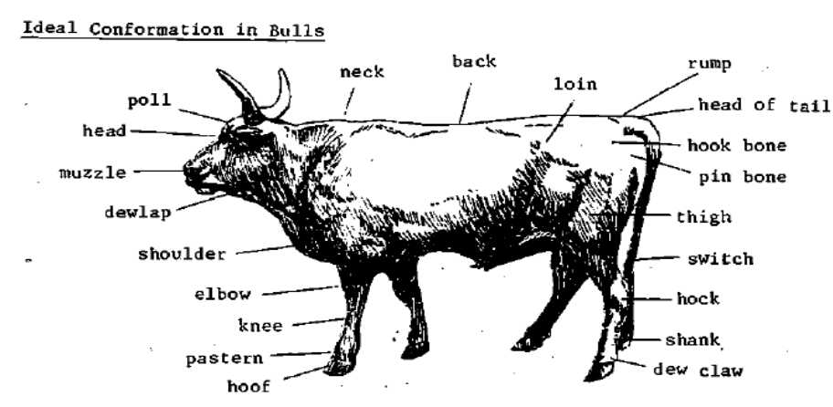
Fig 3.1 ideal conformation in bulls

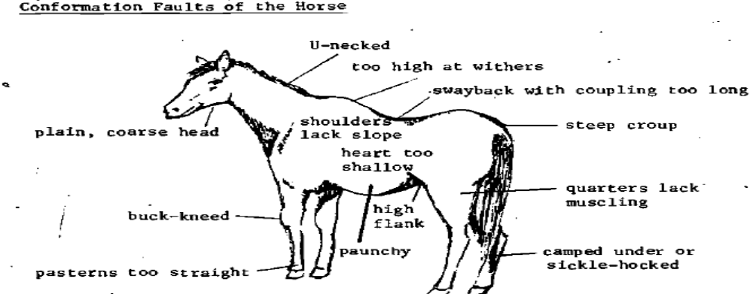
Fig 3.2 conformation faults of the horse
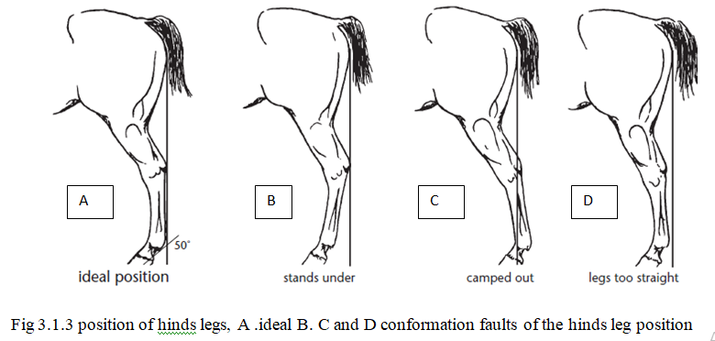

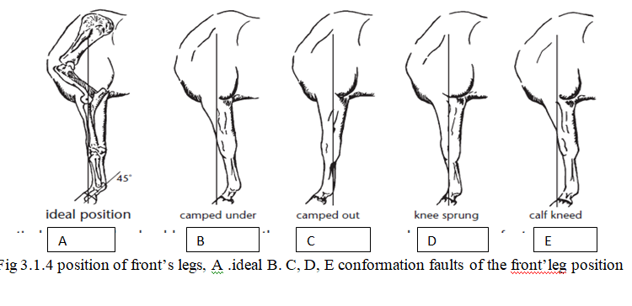

- Temperament
Temperament refers to the nature or disposition of animal. Part of its temperament is deter-mined genetically, both by breed and parentage; some of it is learned a response to the treatment it receives from other animals or the people who raise and handle it. Temperament is reflected in an animal's behaviour, the way it moves and acts, and the way it reacts to the things around it. A donkey that is mishandled and mismanaged might kick or butt at its owner, or at any adult, but be led away quite easily by a child. The buyer must be aware of such possibilities and at the same time draw some basic conclusions about the animal's/ temperament.
- The following are signs of good temperament:
- Good overall conformation and health. e.g. An animal with bad vision or hearing, an un sound leg or joint, or with a chronic respiratory or muscular weakness, protects itself by balking, spooking, shying, refusing to be harnessed or lying down during work. Its temperament is affected or shaped by its physical condition.
- The animal accepts the hand ling of the owner. The owner can pick up the animal's foot, open its mouth; lead it with a rope without having to use force or harsh measures.

- Catching selected draft animal
They may be caught in stables, yards or paddocks
- Guideline of Safe Animal Handling:
- Be aware of the special stressors for animals in the working setting
- Avoid direct eye contact
- Avoid high-pitched, excited talk
- Always protect yourself
- Safe and effective animal handling (understand normal behavior & responses of each species)

- Installation and safety of yoke:
Animals are tied by the horns to the horizontal rod to familiarize them with human activities. The yoke connects the two draft animals. All traction implements are attached to the yoke by the pulling chain (prow, harrow) or the beam (cart, roller cutter). The yoke consists of the yoke beam, the yoke pegs and the peg beam. For weeding or Ridging use the maximum distance between the animals. Leave central holes of the yoke free (80 cm ridges). For plowing, reduce the distance between the animals by changing the pegs Weeding: of 60 cm ridges.

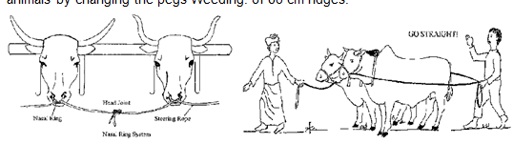
Fig 3.1.1Installation and safety of yoke:

Often requires the presence of three persons (one in front of animal, two on the sides). It allows to the herdsman to give the voice command. Initially, the animals are kept closely (if necessary, by means of ropes), in the end, the animals walk alone without the presence of aid and obey the voice and guides. Allow short rests from time to time. Avoid shouting, give clear commands, go slowly and steadily, never beat the animals, be patient, show no anger.

- How to Put on a Halter
Make friends with the animal

- Talk to it, touch it, feed and-water it, clean its Stall, occasionally give it a tidbit or hand-feed it salt.
- Stand next to the animal'sleft side, facing the side of its head. Hold the free end, or poll piece, in your right hand, and the noose-like nose-band in your left.
- Make a large loop 1m in diameter at the end of a rope 3 deters long. Use a fixed knot for Knot, do not use a slip knot
- Make a small fixed loop about one-third of the way down one side of the large loop.
- Pass the free end of the rope throughthe small loop made in the second step.
- Place the halter over the animal's head so that the non-slipping portion (the headband) fits behind its ears. The slipping section (noseband) fits over the muzzle.
- Pass the free end under the animal's jaw and up toward the right ear. At the sametime, begin to slip the nose-band over the muzzle. If it tosses its head, try to move with it; speak to it in a low, soft tone.
- Flip the end of the poll piece so it passes behind the ears and drops down toward you. This is done with the right hand. The right hand remains against the right cheek, still holding the middle of the poll piece.
- If your right hand is highenough on the cheek, there will be enough tension On the nose band to keep it in place while you use your left hand- to grab the tip of the poll piece.
- Feed the end of the poll piece through the ring or buckle of the cheek piece. The more you lighten it, the higher the nose band rides on the muzzle. You want the noseband to circle the muzzle--not squeeze it. You should be able to slide your hand (flat) between the band and the muzzle.
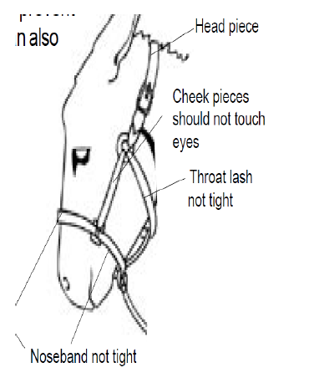
- Placement of Halters and bridles
- These are used to control the donkey, mule or horse during work.
- Controlling an animal’s head is the best way to control it
- A halter consists of a simple head piece and noseband with a single rope (or two reins) attached.
- The parts of the halter or bridle in contact with the animal should feel smooth to the touch, especially at joints
- The joints should be on the outside away from the animal.
- Make sure bit is put in the mouth the right way round, with the inside curve of the bit to the back of the mouth so the bit ring is flat against the side of the animal’s head.
- Do not make a bit out of a wire. This will cut the animal’s mouth, tongue and lips
Fig 3.2 parts of the halter

- Inspecting legs and hooves

Inspect an animals (specially, equines) hooves daily and take care of them. Their hoofs should be short and upright with an oval bottom. If the toes become long and slanted, it should be trimmed. Excess hoof wall, as well as ragged loose pieces of frog, can be removed with a sharp, strong knife. Cracks and chips in the wall can spread, and eventually destroy the entire hoof. Metal horseshoes are used in some countries to protect the hooves of donkeys. If shoes are not available, the rough edges of the hooves can be smoothed with a wood file.
Coating them daily with oil or grease may help hooves that are very dry or brittle, badly cracked or broken. This prevents them from further dehydration and assists healing. Animals will pick up their foot if the tendon is pinched at the back of the leg, just above the pastern. Pick up and handle the feet, clean out the bottom of the hooves with a hoof pick before each use of the donkey, to prevent lameness from stones or other materials penetrating the sole of the foot. Clean from the heel towards the toe, especially in the grooves between the frog and the bars of the hoof.
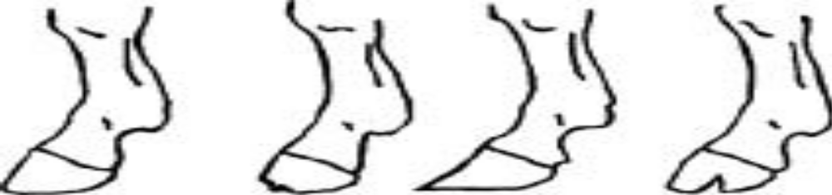

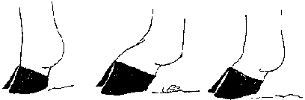

Fig 3.2 A. No! The foot must not be too straight! . B. No! It must not be bent too much! C. Yes! It must bslightly bent!
A horse’s hooves should be round and smooth with minimal chips and no cracks or sections missing. The hoof wall should grow approximately ¼ to ½ an inch per month, and it should form a straight line with the front of the pastern when viewed from the side. The heels should be wide, and the frog should be supple and flexible. Horses that are shod must be re-shod and trimmed regularly to maintain this shape. Excessively long toes and toes curving upward in front are evidence of need for attention by a competent furrier.

3.5. Leading and securing draft animal
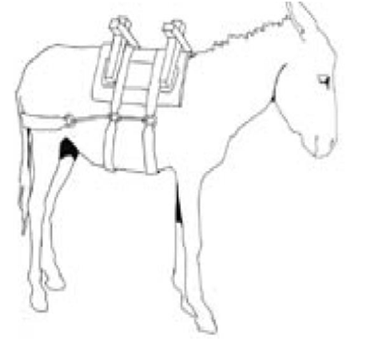
- The saddle harness enables donkeys, horses, and mules to carry substantial loads on their backs. The saddle is usually made out of wood.
- Padding should be used between the pack saddle and the animal’s back
- The harness may have three or four straps for belly, breast and hind quarters to keep it in place
Fig 3.3 saddle harness
- The straps should be of leather, webbing or canvas.
- Thin ropes can cut and rub the animals and these, and synthetic or plastic materials must not be used.
- The straps should be properly adjusted so that they fit well without restraining the animal’s breathing or causing skin sores

3.6. Identifying and implementing OHS hazards

3.6.1. OHS hazard identification
By the very nature of their work, animal care takers are frequently exposed to potential safety hazards, including bite wounds and other animal-related injuries. Anyone who has worked with animals under stress or in pain will relate personal accounts of injuries from animals.
    - Common OHS hazard
Exposure to hazardous chemicals
You may not think about it, but many products that you use every day can be hazardous. Every chemical, even common ones like cleaning supplies have the potential to cause you harm. Some chemicals contribute to health problems while others may be flammable and pose a fire threat.
Common chemicals used in veterinary practice during animal care work are cleaning and disinfecting agents and insecticides and pesticides
II. Physical hazards (Animal related injuries/accidents)
The most important animal-related hazards in veterinary environment are as follows:
- Animal kicks, bite wounds, scratches, squeeze injuries, and other physical trauma
- Parasites and zoometric diseases
- Allergy to animal dander or fleas
- Exposure to feces, urine, blood and tissues that contain pathogenic microorganisms.

III. Exposure to diseases/ biological hazards
Infectious diseases that can be passed from animals to humans are known as zoonotic disease. These diseases may or may not easily transmit from animals to human.
- Route of disease transmission
- Inhalation
- Contact with broken skin
- Ingestion
- Inoculation by needle.

    - Factors (hazards) that affect the use of animal traction
The use of the draught animal power is conditioned by several factors. Among them, the main to be considered there are:
- Agronomic factors: soil texture and position of the land
- Zoo technical factors as race, size and aptitudes of the animals
- Veterinary factors: parasites and pathogens such as trypanosome
- Climate: dry, wet, monsoon, etc. and altitude
- The position of the land, its slope, and the situation of the road networks
- The type of vegetation: arid, savannah, etc
- Anthropological factors such as the presence of the culture of the use of livestock and the familiarity with the animals
- The fragmentation of the properties and the geometry of the fields
- Financial and economic factors related to the cost of buying and maintaining the working animals.
Besides lice and mites, ticks are very important external parasites in the tropics, attacking nearly all types of animals including poultry. They suck blood from animals causing discomfort and in extreme cases causing anemia thus affecting growth. They also can transmit diseases and damage animal skin.

3.7. Handling draft animals
- Handling techniques and restraint methods
This section will deal first with Handling techniques and restraint methods of draft animalsThe techniques detailed below are recommended because they are safe and easy to learn, and require minimum equipment.
Choosing the right technique is important because animals that repeatedly outsmart or overpower their trainers become headstrong, inattentive, and increasingly hard to handle. Before trying to catch an animal, watch its movements, judge its disposition, and decide which measures are most likely to work.

Handling techniques for cattle
- Lead Rope Method
(For quieter animals who have been raised in domestic situations and handled frequently)
- 1Make a running noose at the end of a 3-or 4-meter rope. This is done by tying a fixed loop, or honda, at one end of the rope and then threading the opposite end through it.

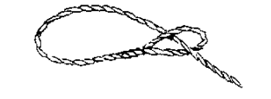
Fig. 3.4 fixed loop, or honda, at one end of the rope

- Approach the animal slowly and slip the noose around its horns. If it shies away, speak to it in a low, calm voice and approach it from another angle. Once the rope is on the horns (or tied to the halter if the animal has one), lead it to a post or hitching rail and tie it so its forehead is close, but not against, the wood. This is called "tying the animal on a short lead."
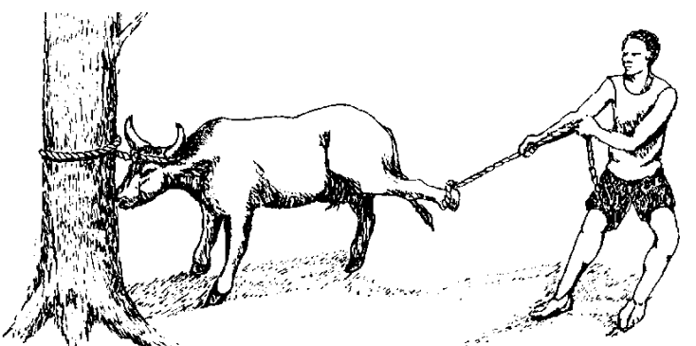

Fig 3.5. tying the animal on a short lead."

- If the animal is frightened or unruly, lock its horns and head securely against the wood by carefully shortening the rope.
- If the animal kicks or swings its hindquarters while being yoked or harnessed, attach a rope to a rear leg.
B. Pole and Noose Method
(For animals accustomed to some handling, but which shy, balk, or butt at the approach of the trainer)
- Hang a running noose on the end of a 3-meter pole. Holding the pole in one hand and the free end, or shank, of the rope in the other, approach the animal slowly and position the noose in front of its hind leg.
- Use your voice and body position to make the animal step toward the loop. Be prepared to drop the pole and pull on the rope as soon as the foot is inside the loop. Pull up and back; if you simply pull back, the noose will slide out under the hoof and you will have to try again.
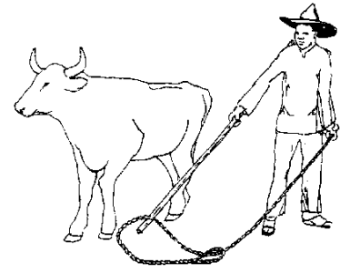

Fig 3.6 Pole and Noose Method

- Pull the animal backward to the centerpost of the corral and hold it secure while a second person approaches from the front and slips a rope around its horns. Avoid using a post which is part of the fence; animals are often injured when they kick out and catch a foot between the rails.
- Open Noose Method
(For animals brought in from the range; animals which are large and aggressive; animals which cannot be caught with a pole and noose)
- Put a sturdy post inside a corral. The post should be chest-high, smooth, and very firmly set. It should be 21/2 to 3 meters from the fence. Refer to this post as the "centerpost"
- ) On a fencepost opposite this post, put a nail or peg at a height of 6 or 7 cm (3-4 inches) above ground level.
- Make a running noose at one end of a 5-meter rope. Arrange the rope on the ground between the peg and the centerpost so it forms the letter "P". The top of the "P", or loop, should be near the fence. The bottom of the "P", or shank, is stretched back toward the centerpost. Hang the upper-left-hand portion of the loop over the peg. The rest of the loop should be on the ground.
- Stand near the centerpost and hold the shank of the rope with one hand. Have a second person drive the animal around the corral from the right. When the animal's midsection is passing over the loop, raise your arm quickly and without bending the elbow. A properly-timed motion will throw the entire lefthand portion of the loop into the air and across the path of the oncoming hind legs. The noose will close as your arm rises
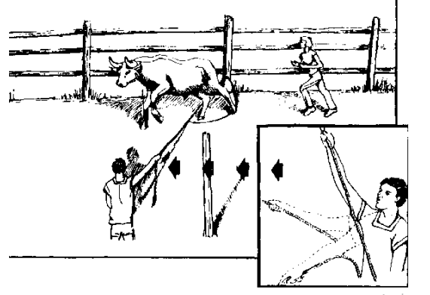

Fig 3.7 Open Noose Method
The technique works because the natural tendency of the animal is to run along the fence. Hanging the rope on the peg makes it easier for the trainer to start the noose moving in an upward direction-or, to give it "lift".

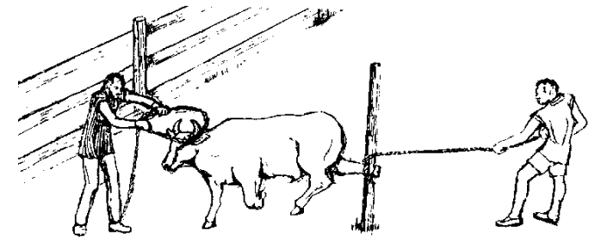

Fig 3.8 tithing both the horns and a hind leg

- Draw the animal back until you are in a position to wind the rope once around the post. Then get behind the post and continue to draw the animal in until its leg is snug against the wood.
- With the animal secured by this first rope, someone can safely approach from the front and slip a second rope over its horns. If the animal has been caught by a foreleg, it will be necessary to attach ropes to both the horns and a hind leg

- Casting a Bull
Sometimes an animal must be immobilized completely before it can be treated or harnessed. This is done by casting it-pulling it to the ground and tying its legs. To do this,
- Tighten a noose around its horns.
- Bring the free rope back to the withers and cinch it loosely around the animal's girth.
- Then pass the rope back and cinch it again around the loins.
- Pulling the free end exerts pressure on the loin area, and the animal sinks down.
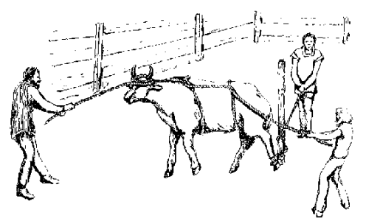
Fig 3.9 Casting a Bull

- Once the animal is down, the rear legs can be bound with rope at the fetlocks. To further immobilize the animal, one person can hold its head, while another puts his or her knee on the animal's front shoulder.
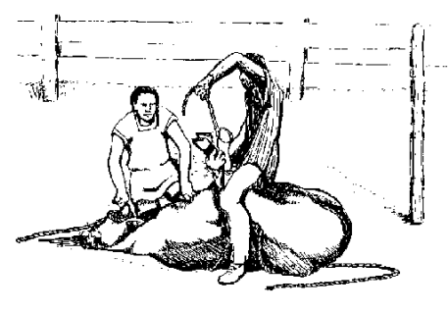
Fig 3.10 once the animal is down, the rear legs can be bound with rope at the fetlocks

3.7.2. Handling techniques for donkeys and mules
Whether staked out or corralled, these animals are generally caught using very simple methods. Approached slowly and spoken to softly, or offered a handful of grain, they rarely refuse to be taken by the halter and led. They are easily cornered in a corral and grabbed by the halter, or by the nose and ear; in some cases, a rope may be slipped over the animal's head.
- Cross-tying
Cross ties are ropes which used to immobilize a horse or donkey in a standing position. To make cross ties,
- fasten two pieces of rope one meter long to each of two posts or trees which are spaced two meters apart. \
- Fasten the ropes to the halter, one at each side,
- Drawing them tight so the animal cannot move its head.
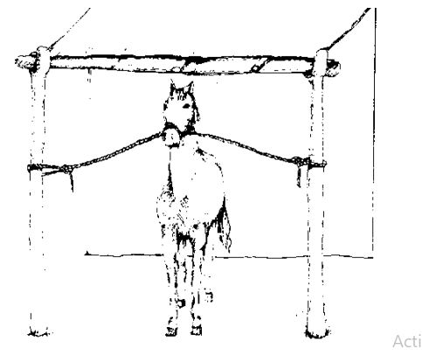

Fig 3.11 Cross-tying
To immobilize the animal, lift one of its legs, squeeze the tendon above the fetlock and pull the leg upward. Thus forced to stand on three legs, the animal cannot move. If working alone, the trainer can use a belt or rope to hold one of the front feet. The animal will not fall and will remain still while being treated for ticks or wounds. It is especially useful if one of the animal's feet must be kept in a bucket of water.

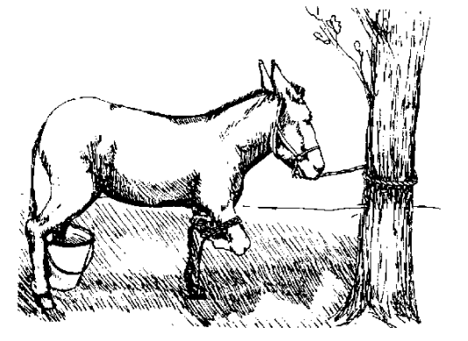
Fig 12
- Casting an Equine
- Casting a horse or donkey by pulling the hind legs out from under it is best accomplished in the following manner:
    - Choose soft terrain.
    - Hold the animal in front with cross-ties, or by a strong lead rope or "twitch", which is a loop attached to a short handle.
    - To apply the switch, put the loop over the muzzle and twist until very secure.
    - Tie a fixed loop in the center of a long rope, and fit the loop around the animal's neck like a collar. The knot rests on the withers and the two ends are parted over the back, one on each side, and brought along the flanks and down between the hind legs. The right-hand rope circles behind the right pastern and is brought forward along the animal's right side. The left-hand rope is used in a similar fashion on the left side.

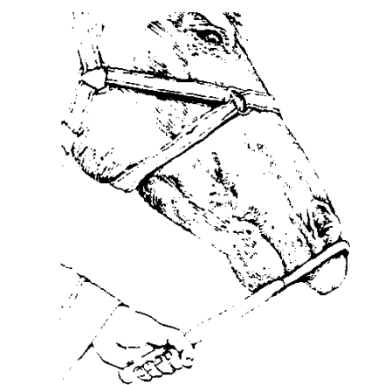
Fig 3.13

- Casting a Horse
    - People on either side of the animal pull ropes, "walking" the rear legs forward until the animal sinks gently into a sitting position
- Rope burns caused by the casting method can be reduced by running the ropes through anklets attached to the animal's feet. Further advantage can be established by placing a surcingle around the girth of the animal and feeding the ends of the draw-ropes through the support rings.
- Once the animal is cast, special care should be taken to ensure that its head is kept low and outstretched; serious neck and back injuries may result when a horse or donkey is allowed to raise its head once it is on its side

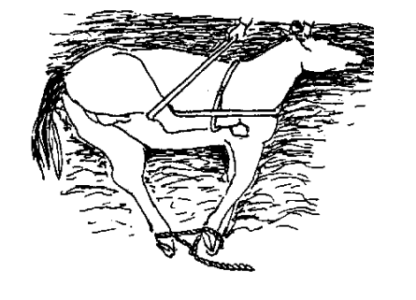
Fig 3.14 Casting a Horse

Self-check 3 | Written test

Name…………………………………………… ID………………………… Date…….
Directions: Answer all the questions listed below.

Test I: Choose the best answer (4 point)
- Which of the following is correct foot of draft animals? (2pts)
- The foot must be too straight. C. It must be slightly bent!
- It must be bent too much D. It must be bent too much

Test II: Short Answer Questions
- What are the useful criteria for judging a draft animal's value? (3Pts)
- Write the quality of good draft animals(4pts)
- How you prevents the hooves of your draft animal from further dehydration?(3)
- Write the Guideline of Safe Animal Handling (3pts)
- Write the list of working gear?(3pts)

Operation Sheet -3

Task 1 Techniques/Procedures/Methods of How to Put on a Halter
- Tools and equipments
- Boots
- Over all
- Gloves
- Helmet

- Procedures/Steps/Techniques
- Make friends with the animal
  - Talk to it, touch it, feed and-water it, clean its Stall, occasionally give it a tidbit or hand-feed it salt.
- Stand next to the animal'sleft side, facing the side of its head. Hold the free end, or poll piece, in your right hand, and the noose-like nose-band in your left.
- Make a large loop 1m in diameter at the end of a rope 3 deters long. Use a fixed knot for Knot, do not use a slip knot
- Make a small fixed loop about one-third of the way down one side of the large loop.
- S Pass the free end of the rope throughthe small loop made in the second step.
- Place the halter over the animal's head so that the non-slipping portion (the headband) fits behind its ears. The slipping section (noseband) fits over the muzzle.
- Pass the free end under the animal's jaw and up toward the right ear. At the sametime, begin to slip the nose-band over the muzzle. If it tosses its head, try to move with it; speak to it in a low, soft tone.

LAP TEST-1 | Performance Test

Instructions: Given necessary templates, tools and materials you are required to perform the following tasks within 1 hour. The project is expected from each student to do it.

Task-1 Perform Procedures/Methods of How to Put on a Halter

\

LG 23 | LO 4: Clean and maintain stable gear and surrounding areas

Instruction sheet
This learning guide is developed to provide you the necessary information regarding the following content coverage and topics:
- Checking all gear for wear and damage
- Cleaning and polishing gear
- Maintaining or repairing work gear
- Cleaning and storing work gear and saddlers
- Reporting unsafe buildings and fixtures

This guide will also assist you to attain the learning outcomes stated in the cover page. Specifically, upon completion of this learning guide, you will be able to:
- Check all gear for wear and damage
- Clean and polishing gear
- Maintain work gear
- Clean and store work gear and saddlers
- Report unsafe buildings and fixtures

Learning Instructions:
- Read the specific objectives of this Learning Guide.
- Follow the instructions described below.
- Read the information written in the information Sheets
- Accomplish the Self-checks
- Perform Operation Sheets
- Do the “LAP test”

Information Sheet 4

  - Check gear regularly for wear and damage
Before starting work with draught animal all gears must be checked for their normal functioning and if there is any problem on the working gear it have to be renovated or avoided from the farm because damaged gear will cause illness or injury to our draught animal.
    - Cleaning and polishing gear
Gear refers to any equipment, material or tools which we will use while manipulating different tasks concerning with farm. These equipment, material or tools might include harness, saddles, ropes, reins, breastplates, martingales, bridles, cruppers, saddlebags, headstalls, saddlecloths, feeders, leads and rugs.
    - Clean and polish Gear thoroughly and applying oils after use
After use, the regardless of the material, the harness should be cleaned to remove sweat, dust and dirt. This should be done with a stiff brush followed by a cloth and water. Soaking a harness in water can make it stiff and rough so it should be washed using a wet brush and/or a wet cloth, not soaked. Warm water gets rid of sweat and dirt more easily than cold water. The bit should be washed to keep it clean. If a leather harness is used, which is relatively expensive, care should take to ensure that it lasts longer. The harness should therefore be kept soft and oiled
regularly. The use of animal fat to soften the harness is one of the traditional methods used by horse, mule and donkey owners. Clean cooking oil can be used if animal fat is not available. Harnesses should be cleaned and checked for worn-out parts regularly, preferably each day following use. When not on the animals, the harness should be stored on a hook (away from rodents or dogs) in a dry, clean and safe place.

  - Maintaining work gear
    - Maintenance of farming equipment
Equipment for arable farming needs regular maintenance to ensure long-lasting and reliable functioning.
For power sources, the following routines are recommended for proper maintenance.
- Daily maintenance and inspections
- Scrape off the soil while still in the field.
- When returned to the farm, thoroughly clean the implement, so that a detailed inspection can be made of all parts.
- Check the tightness of all nuts and bolts with the correct spanner; never use a wrench or pair of pliers.
- Make sure that bolts and nuts used for field adjustments can be turned freely; oil them if necessary.
- Check the condition of the wearing parts and plan to replace them whenever necessary or advised.
- Check the implement for distortion. Redress any bent parts or send them for repair.
- Maintain working parts in a polished condition to stop the onset ofRust and to reduce unnecessarily high draft forces when the implement is returned to work. Wipe all working surfaces with a rag Soaked in oil.
Rains or the delayed onset of rains may halt tillage or cultivation for several days. Such a period of rest allows for completing repairs.

    - Maintenance of equipment’s at the end of the work
Follow the normal daily maintenance schedule. This will allow identification of all worn parts and damaged nuts and bolts. Take advantage of the end of the season to carry out a general over haul:
- Completely dismantle the main components of the implement.
- Repair or replace the parts as required.
- Clean the components thoroughly, remove any rust and if necessary, repaint them. Alternatively, protect them by wiping them with an oil-soaked rag.
- Do not paint, however, the working surfaces. These should just be wiped with oil.
- Replace all damaged nuts and bolts, again wiping them with oil on assembly.
- Reassemble the implement and make sure it has all been wiped with oil.
- Store it in a safe, dry place and away from animals, sacks of grain and any stored fertilizer.
    - Maintenance and Repair
PPE and devices wear out—sometimes quickly, because of irreparable accidental damage, or gradually, through normal use over time. Excessive use and wear of PPE in extreme conditions can result in premature failure. Sometimes PPE can fail catastrophically, resulting in the injury or death of the wearer. To avoid such risks to personnel, all PPE and devices must be kept in top condition.
    - Maintenance of the Harness
The Harness is made of wood. Wood is easily destroyed by water. A harness that is stored in a dry place like the cowshed can stay for 10 years. If you expose your harness to rain and sun, it will rot and break after 1 year. Proper storage of your harness will save you money

  - Cleaning and storing work gear and saddlers

Gear refers to any equipment, material or tools which we will use while manipulating different tasks concerning with farm. These equipment, material or tools might include harness, saddles, ropes, reins, breastplates, martingales, bridles, cruppers, saddlebags, headstalls, saddlecloths, feeders, leads and rugs.
    - Check gear regularly for wear and damage
Before starting work with draught animal all gears must be checked for their normal functioning and if there is any problem on the working gear it have to be renovated or avoided from the farm because damaged gear will cause illness or injury to our draught animal.
    - Clean and polish Gear thoroughly and applying oils after use
After use, the regardless of the material, the harness should be cleaned to remove sweat, dust and dirt. This should be done with a stiff brush followed by a cloth and water. Soaking a harness in water can make it stiff and rough so it should be washed using a wet brush and/or a wet cloth, not soaked. Warm water gets rid of sweat and dirt more easily than cold water. The bit should be washed to keep it clean. If a leather harness is used, which is relatively expensive, care should take to ensure that it lasts longer. The harness should therefore be kept soft and oiled
regularly. The use of animal fat to soften the harness is one of the traditional methods used by horse, mule and donkey owners. Clean cooking oil can be used if animal fat is not available. Harnesses should be cleaned and checked for worn-out parts regularly, preferably each day following use. When not on the animals, the harness should be stored on a hook (away from rodents or dogs) in a dry, clean and safe place.

  - Reporting unsafe buildings and fixtures
Reporting is an integral part of monitoring and evaluation. Reporting is the systematic and timely provision of essential information at periodic intervals. The report is provided quarterly and annual basis. The quality of organizational decision depends on the quality of information reported and organized. Report should be objectively and timely. Because, report enable managers to evaluate progress and plan the future. Detailed report is precious formal document prepared and presented by the workers to the higher management concerning the works on operation or completed
Report may be defined as a formal statement describing a state of affairs or what has happened. It has detailed description of a problem or a situation, findings of an investigation and recommendations or actions taken. Or we can say that it is submitted by a lower authority to a higher authority and it is a back bone of communication. The quality of organizational decision depends on the quality of information reported and organized. Report should be objectively and timely. Because, report enable managers to evaluate progress and plan the future. Detailed report is precious formal document prepared and presented by the workers to the higher management concerning about building in need of maintenance.
- The report may contain the following:
- The report that represents the result of technical, economic and financial feasibility of the program or project
- Report serves as the basis on the basis of which the concerned government body gives clearance /sanction of the planned works.
- Report serves as guide for the starting and implementation of the planned activities.
- Report is helpful in achieving the time and cost limits in the completion of the planned activities.
- Report is helpful in obtaining technical and financial assistance from different cooperative organizations and bodies.

Self-check 4 | Written test

Name…………………………………………… ID………………………… Date…….
Directions: Answer all the questions listed below.
Short Answer Questions
- Write the daily activities to maintain working gear.(3pts)
- What you use for softening harnessing equipments.
- What is reporting?(1pt)
- When you provide your report to your supervisor?(2pts)

LG 24 | LO 5: Monitor health and welfare of horses

Instruction sheet
This learning guide is developed to provide you the necessary information regarding the following content coverage and topics:
- Identifying Signs of good health
- Checking draft animal condition, health and soundness
- Identifying symptoms of commonillnesses and injuries
- Reporting inspected manure, stale feed and soiled bedding
- Isolating abnormal conditions
- Cleaning feed bin, hay nets/bins and water troughs
- Sweeping and removing walkways
- Providing basic first aid
This guide will also assist you to attain the learning outcomes stated in the cover page. Specifically, upon completion of this learning guide, you will be able to:
  - Identify Signs of good health
  - Check draft animal condition, health and soundness
  - Identify symptoms of commonillnesses and injuries
  - Report inspected manure, stale feed and soiled bedding
  - Isolate abnormal conditions
  - Clean feed bin, hay nets/bins and water troughs
  - Sweep and remove walkways
- Provide basic first aid
Learning Instructions:
- Read the specific objectives of this Learning Guide.
- Follow the instructions described below.
- Read the information written in the information Sheets
- Accomplish the Self-checks
- Perform Operation Sheets
- Do the “LAP test”

Information Sheet 5

  - Identifying Signs of good health

- Appearance and behavior: Healthy animals exhibit normal posture. They are alert, having clear eyes and respond well to a touch. Any abnormal running nose and dull eyes may indicate ill health.

- Movement: Any animal that cannot walk or stand properly must be closely watched since something might be wrong with it. When you notice that the animal is walking and favoring on the leg, it would be advisable to you restrain that animal and find out what is causing it to do so.

- Appetite and feeding: Healthy animals have a good appetite for feed and generally like to feed to their satisfaction. Sick animals have no appetite for food. When you notice that your animal suddenly lose appetite for food, you shouldn’t take it as normal because it may be a sign of it beginning to fall ill.

- Urine: The normal color of urine is pale yellow. Much deviation like deep yellow, blood-stained or cloudy urine shows ill health. When your animal finds urination painful, it shows that there is something wrong with its urinal system and any other color apart from pale yellow is a sign of ill health.

- Coughing: When an animal coughs continuously, it shows that something is irritating its throat and you need to find out why that keeps happening. Coughing is a good sign of good health but it shouldn’t be a continuous cough.

- Pain: Healthy animals do not show any sign of pain but when animals begin to show signs of pain by grinding of teeth or groaning, it is an indication that something is wrong and such animal needs to be examined immediately.

- Feces and defecation: Any deviation of the faeces i.e. too hard, too watery or stained with blood, or contaminated with worm segments, is an indication of ill health. When you see that your animal begins to defecate on its body it is an indication that it has a problem in its alimentary canal and immediate attention needs to be given to the animal.

- Skin and coat: The coat of healthy animals should be clean, smooth and shiny and show complete cover. Signs of ill health are; the coat looks dull and hairs fall out. Cold, dry and scary skin signifies diseases. When you see your animal suddenly show symptoms of skin disorder, immediate attention should be given to the animal because if that is not done, the hide’s value of the animal will reduce.
- Temperature, pulse rate and respiratory rate: Every animal has a specific range of body temperature, pulse rate and respiratory rate that determines healthy condition. Radical deviation from these values signifies ill health. You will have to check your farm animal to ensure that it is physically, mentally and psychologically fit. Any deviations in these show that your animal is ill.

- Mucous membrane: These are the lining of various system and organs of the body, e.g. eyes, nose, anus etc. The mucous lining of healthy animals is moist. When all these places become dry the animal experiences discomfort and when noticed immediate attention should be given to the animal before it becomes very severe.

  - Checking draft animal condition, health and soundness

To distinguish between normal and abnormal, the farmer must know the normal condition of his animal.
- Health animal;
- eyes must be bright, clear and clean
- muzzle must always be cool and wet
- ears must be upright and clean
- skin must be supple and coat smooth and dense
- faces must be of normal consistency
- urine must be a normal yellow color
- must react on your voice or other disturbances
- tail and ears must be active
- ribs cannot be seen
- when lying down to rest, legs are turned inward
- Sick animal;
-  dullness, watering eyes, discharge
- dry muzzle
- ears are stiff or hanging
- wounds from parasites, yoke or beating
- coat is poor and rough, hairs standing up
- feces is of abnormal consistency, mixed with blood
- color of the urine is red or dark brown
- the ribs can be see

  - Identifying symptoms of common illnesses and injuries

Acidosis
Acidosis is a common metabolic condition that can affect all types of cattle. It typically occurs when the rumen pH is out of balance and acid is produced at a rate faster than it can be absorbed or used by the animal. Here are some details about acidosis and its symptoms, causes and prevention.

- What Is Acidosis?
Ruminal acidosis occurs when the rumen pH drops to less than 5.8. The pH of a normal rumen sits between 6.5 and 7.0. When the pH drops below the ideal level, movement in the rumen stops, impacting appetite and feed conversion. This, in turn, stimulates more acid production and creates a spike in cortisol levels.
Subsequently, a change in the rumen’s acidity decreases the rumen’s beneficial microbial populations, allowing the harmful microbes to multiply. As the population of “bad” microbes increases, the toxins they release, in addition to a spike in lactic acid causes the pH to drop significantly.

- What Are the Symptoms of Acidosis

When acidosis is acute, causing a rapid spike in acid production, it results in debilitating illnesses that can include liver abscesses, sometimes resulting in mortality. It is also not uncommon that cattle will develop scours and an elevated heart rate while becoming inappetent.
The most common symptoms of sub-acute ruminal acidosis include:
- Lethargy
- Elevated respiratory and pulse rate
- Increased temperature
- Diarrhea
- Weight loss
- Decreased feed intake

- What Causes Acidosis?
Various factors can lead to the rapid increase of acid in the rumen. Some of these include:
- Feeding cattle concentrated feeds, such as fermentable grains
- Switching rapidly from high forage to feed with high concentrate
- Feeding cattle a low-fiber diet
- The presence of mold and spores that produce mycotoxins in the body
When there is a rapid change to a diet high in starch and sugar, the starch will encourage the growth of microbes that produce lactic acid. This issue will eventually decrease the pH of the rumen and cause acidosis.

- How to Prevent Acidosis
To reduce the risk of cattle developing acidosis, maintaining good rumen health is essential. This can be achieved by encouraging an active population of healthy microbes. This can include:
- Providing a consistent supply of dry forage: Doing so gives the microbes an adequate supply of nutrients to keep the rumen’s pH balanced.
- Ensure cattle receive adequate fiber: Fiber promotes healthy movement in the rumen and increases saliva production for lower rumen acidity.
- Select feed grains carefully: Choose feed grains that have a thick hull so that the rumen microbes have more time to digest the fiber in the hull.
- Process grains carefully: Using tempered grain can help the cow better utilize the starch, reducing the rate of fermentation and acidity.
- Give the cattle a prebiotic: A good prebiotic like CattlActive® will help the cow’s healthy microbial populations to grow and stabilize the rumen’s pH. These microbes also help the cow absorb essential nutrients and promote weight gain and production

  - Reporting inspected manure, stale feed and soiled bedding

Manure, Manure, soiled bedding and stale feed must be inspected, removed, and abnormal conditions have to be reported. bedding and feed waste that is collected from barns, draught animal yards and other areas should be properly stored in a suitable location until it can be safely recycled on gardens and cropland. If there is a lack of land and equipment available for spreading manure on-farm, then it should be taken to other places that can safely recycle it. Manure, bedding and feed waste can also be properly composted on-farm to produce a stable, soil-like product that is free of pathogens and weed seeds. This may also increase desirability for use by others (gardeners, etc.). The main objective of manure handling is to prevent surface and ground water pollution. Generally, the wastes must be held in some way until they can be properly disposed of on the land. Animal manure may be collected and handled as a solid, and/or as a liquid. If the manure is handled as a solid, then bedding may also be handled with the manure. Liquid systems generally cannot handle bedding.
- Proper location of manure storage areas, composting areas, and draught animal yards
- Locate at least 100 feet away from a drinking water well or other water resource including ponds, streams, wetlands and storm drains and ditches.
- Locate downhill from a drinking water well and other water resources where possible.
- Consider neighbors, property boundaries and prevailing winds. Leave a buffer.

  - Isolating abnormal conditions

The most likely way for disease to arrive on your farm is through the arrival of new animals, or the return of your own animals from elsewhere.
You can help to protect animals already on your farm against disease by separating them from the arriving animals until your vet is sure they are free of disease. This is referred to as quarantine and is a key part of reducing disease impact.
Disease may also develop within your stock at any time, so you will look to separate sick animals to protect your healthy animals. This is referred to as isolation and it allows sick animals to rest and recover and prevents disease spreading around the pen, group or wider farm.
The key adviser is your vet who will ensure the design of your own quarantine and isolation programs form part of your Health and Insecurity Plan.

- Can take steps to prepare your farm so you can effectively quarantine or isolate animals
- Designate specific areas of your farm to be used for quarantine or isolation. You could require several areas at one time, for example:
  - A quarantine area for newly arriving/returning animals
  - An isolation area for animals in quarantine which develop disease
  - An isolation area for resident animals which become sick

- Disinfectant footbaths placed at the isolation area entrance act as a barriers to disease:
  - Keep these clean and topped up regularly with approved disinfectant at appropriate dilution
  - Aim to protect them from dilution or contamination by rainwater
- When managing animals that are in quarantine and isolation day-to-day
- Make all farm staff fully aware of recommended separation procedures
- Best practice is for separate staff to take responsibility for tending animals in quarantine or isolation, using separate Personal Protective Equipment
- Where it is not possible to use separate staff:
  - Use separate Personal Protective Equipment
  - Tend to these animals last, after healthy animals
- Always disinfect or change Personal Protective Equipment after the tending routine is complete
- Inspect animals in quarantine regularly and look closely for signs of disease
- If you identify signs of disease contact your vet immediately regarding diagnosis, treatment and future management
- Inspect animals in isolation regularly, monitor closely and report progress to your vet
- Take care when handling and disposing of contaminated bedding, waste and feed

  - Cleaning feed bin, hay nets/bins and water troughs

Feed bins, hay nets/bins and water troughs also must be cleaned thoroughly and troughs are filled with fresh water. Walkways have to be swept and/or raked and manure removed.
- Method of Cleaning:
- Manual: - removal of soil by scrubbing in the presence of detergent solution.
- Applying Low pressure High volume Spry: - the application of water or detergent solution in large volume at low pressure.
- High Pressure Low volume Spry: - application of water and detergent solution low volume at high pressure.
- Foam Cleaning: - the application of detergent in the form of foam. The foam is allowed to react for 15- to-20 minutes and then rinsed off with water spray.

- Properties of an Ideal Detergent are: -
✓ Good wetting capacity,
✓ Ability to remove soil,
✓ Ability to hold soil in suspension,
✓ Good rinsing property, and
✓ None corrosive

- Feed bin management
- Avoid unnecessary waste while cleaning feed bins.
- Leaving spilt feed under the bin only encourages rodents and vermin to the farm - which then consume their own share of feed.
- Routinely and regularly check the outside and inside of feed bins and their distribution systems.
- Management may help to:
1. Use the right feed at the right time
2. Use correct feed
3. Developing a good feed preparation

- Feed bin filling
When the feed bin is being filled, avoid all wasted and spilt feed. Once the feed has been delivered, ensure that the feed bins are properly re-sealed.

- Feed barrows
If feed is moved around the farm in barrows, ensure that the barrow is kept out of the rain and is covered at all times. Do not overfill feed barrows as this often leads to spillage of feed whilst moving the barrow around the farm. The major important feature of shed is water and water trough for concentrate feed. These can be made of concrete, metal, even wood or plastic. They are put in front of the animal behind yoking bar. Feeding rack can also be constructed for feeding hay and crop residues such as maize Stover.

  - Providing basic first aid

First aid: The initial administration of care for an injured animal until more thorough veterinary attention can be sought

- Basic first aid care may include:
- Stop bleeding.
- Administer oxygen.
- Minimize impact of shock by keeping animal quiet, warm and away from activity or noise.
- Immobilize limb injuries, if soft tissue damage or fractures are suspected, if possible.
- hose or apply water, if available, in cases of burns or heat exhaustion

- Procedure Outline
Animals requiring first aid may be encountered in a variety of situations, however the same decisions or steps are required to assess the situation and determine the best course of action.
The decision to treat, seek veterinary/expert care, euthanase, release/leave an animal will depend on a judgement of the likely prognosis of the animal. An animal should only be removed from where it is found if the animal is expected to respond positively to care within 24 hours. The suffering of an animal should not be prolonged if the prognosis is poor.
- Assessment levels:
- Leave the animal
- Treat the wound (e.g. superficial or marking wound) or condition (e.g. hypothermia, shock etc)
- Seek veterinary treatment
- Euthanasia the animal

To make this decision some knowledge about the situation and the seriousness of the animal’s injuries or condition is needed. Refer to Appendix 1 for the decision making process. The first step in first aid for animals is therefore an assessment of the situation and making a decision on whether to treat and how to treat. After which injuries or conditions (e.g. shock) may require treatment. Advice for initial assessment of the situation as well as treatment of common injuries and conditions is contained in the following sections.
Table 5.1: Types of wounds and their management
Type of wound | Description and management
Bruise | A closed wound with bleeding below the surface of the skin. If not extensive, or not causing disability, then it’s better to release as soon as possible to avoid stress and struggling resulting in further injury and exacerbating bruising.
Abrasion | An open wound with the outer layer of skin and underlying blood vessels exposed. The wound should be cleaned with dilute antiseptic. The animal can generally be released.
Cut | An open wound caused by something sharp, where the skin, soft tissue or muscle is severed. The wound needs to be cleaned thoroughly and generally the animal can be released. If the cut is large or deep it will require veterinary care or euthanasia.
Laceration | An open wound (e.g. caused by wire, teeth or claws) where the skin and underlying tissue are damaged. The wound should be cleaned thoroughly. If the laceration is extensive it will require veterinary care or euthanasia.
Puncture | An open wound caused by blunt or pointed objects in which the skin and underlying tissue is damaged, as well as possibly organ damage. Wound should be cleaned thoroughly. If the puncture severe it will require veterinary care or euthanasia.
Tea | An open wound caused by something sharp. The skin and other soft tissue will be partially or completely torn away. The skin should be returned to its original position and a pressure bandage applied. The animal may require veterinary care or euthanasia
Embedded object | An open wound in which an object has embedded itself. Do not try and remove the object. The animal will require veterinary care or euthanasia.

Self-check 5 | Written test

Name…………………………………………… ID………………………… Date…….
Directions: Answer all the questions listed below.
- List the activities in Preventive health care for successful draft animal keeping
- Why you inspect manure, stale feed and bedding
- List methods of cleaning.
- What is the feed bin management helps you

Reference Materials

Books:
- International Livestock Centre for Africa (ILCA). (2003). Federal strategies for draught animal. ILAC annual report. Addis Ababa, Ethiopia: 67-71.
- Musa, L. (2008). The relevance of animal power in agriculture in the tropics. Agrosatellite Journal. Vol.1. No.2. Pp.22-28
- FAO. 1994. Draught animal power manual: A training manual for use by extension agents.
- STARKEY P. (1988). - Animal drawn wheeled tool carriers - perfect yet rejected. Vieweg.
- STARKEY P. (1989). - Harnessing and implements for animal traction. Vieweg.
- Bukanawo, D. (2001). Yokes or Collars: Harnessing techniques for draught Cattle. Agro-Satellite. Vol. No.1 Pp.1-4.
- Directorate Animal and Aquaculture Production (nd). Guideline on animal traction. Republic of south Africa
- R. Anne Pearson1, Timothy E. Simalenga2 and Rosina Krecek3; 2003. Harnessing and hitching donkeys, horses and mules for work. 1Centre for Tropical Veterinary Medicine. University of Edinburgh, UK; 2Department of Agriculture and Rural Engineering, University of Venda for Science and Technology, South Africa. 3P.O.Box 12832, Onderstepoort, 0110, South Africa, 2003
- SIMALENGA, T.E. & JOUBERT, A.B.D. (Eds) 1997. Animal traction in South Africa: Today and tomorrow. Proceedings of SANAT workshop,March 1996:82.
- Aeschlimann M. & D. Austbo. Donkey harness with straight hames. 2000. Draught Animal News, No.32, CTVM, University of Edinburgh, UK. ISNN 1354-6953.
- Dibbits H.J.Harnessing guidelines for donkeys pulling a single donkey cart. 1995. IMAG-DLO, Wageningen, The Netherlands

Web adders
https://www.google.com/search?q=providing+basic+first+aid+for+animals&oq=providing+basic+first+aid+for+animals&aqs=chrome..69i57j0i22i30.33807j0j15&sourceid=chrome&ie=UTF-8#:~:text=Basic%20first%20aid%20care,burns%20or%20heat%20exhaustion
https://www.cdu.edu.au/files/2019-11/dpaw-sop14.2-first-aid-for-animals.pdf

The experts who developed the learning guide
No | Name | Qualification | Educational background | Institution | Phone number | E-mail
1 | AbenetGetahun | MSc. | Animal Production | Gewane ATVET  College | 0940236673 | abenetgetahun@gmail.com
2 | BiruKefenie | MSc. | Animal Production | W/Soddo  ATVET  College | 0913334612 | ukefene@gmail.com
3 | GashawAssefie | MSc. | Animal Production | Agarfa ATVET  College | 0914068274 | lakomelzajournalist@gmail.com
4 | GenanewAbera | MSc. | Animal genetics and breeding | Alage ATVET  College | 0926672970 | genanewabera@gmail.com
5 | SeadTaha | MSc. | Animal Production | Agarfa ATVET  College | 0916112492 | tahasead@gmail.com
6 | Solomon Fertewal | MSc. | Animal Production | Alage ATVET  College | 0912648413 | Tosolomon@gmail.com
7 | TemesgenRoro | MSc. | Animal Production | Holeta PTC | 0917657496 | temesgenroro@gmail.com
8 | TerefeTolcha | MSc. | Animal Production | Alage ATVET  College | 0911067132 | terefetc@gmail.com
9 | Yirmedie Bayou | MSc. | Animal genetics and breeding | Mizan ATVET  College | 0915851079 | Yirmedie123@gmail.com

