Animal Production
Level-II

Based on March 2022, Version -4 Occupational Standard

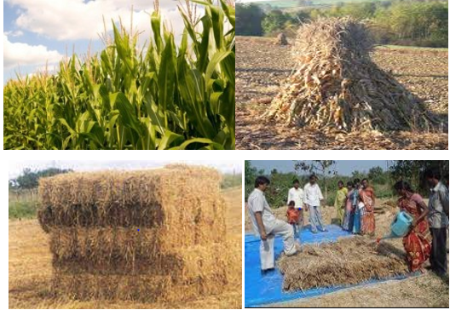

Module Title: Conducting Crop Residues Treatment and Urea Molasses Block
LG Code: AGR ANP2 M09 LO (1-5) LG (39-43)
TTLM Code: AGR ANP2 TTLM 0922v1
September, 2022
Addis Ababa, Ethiopia

Table of Contents

Introduction to the Module 1
LO #1:-Determine the type of crop residues 2
Instruction sheet 2
Information Sheet 1 3
Self-check 1 7
Operation Sheet -1 8
LAP TEST-1 9
LO #2:- Determine the method of treatment 10
Instruction sheet 10
Information Sheet 2 11
Self-Check – 2 24
LO #3: Prepare appropriate packing material for treatment 25
Instruction sheet 25
Information Sheet 3 26
Self-Check – 3 34
Operation Sheet -3 35
LAP TEST-3 36
LO #4:- Complete treatment and store 37
Instruction sheet 37
Information Sheet 4 38
Self-check 4 46
Operation Sheet -4 47
LAP TEST-4 49
LO #5:-Prepare urea-molasses block (UMB) 50
Instruction sheet 50
Information Sheet 5 51
Self-Check – 5 63
Operation Sheet -5 64
LAP TEST-5 65
Reference Materials 66

Introduction to the Module
This module covers the knowledge, skills and attitude required to conduct crop residues treatment and Urea molasses block making for different types of crop residues and ingredients, Determine the type of crop residues, Determine the method of treatment, Prepare appropriate packing material for treatment, Complete treatment and store, and Prepare urea-molasses block (UMB).
In the farming systems of developing countries, animal production is integrated with crop production. However, as the expansion of crop land from time to time, the availability of grazing land decreases thus limiting the scope for increased livestock production. Under such circumstances crop residue play an important role in supplying feed to ruminant animals. These residues provide fodder at low cost since they are by- products of existing crop production systems. They are important adjuncts to natural pastures and planted forages and are often used to fill feed gaps during periods of acute shortage of other feed resources. On average, crop residues provide 10 to 15 % of the total feed intake and in some exceptional cases this could increase up to 50 %. The contribution of crop residues to the feed resource base is significant. Under the Ethiopian condition, crop residues provide 40 to 50% of the annual livestock feed requirement. In most central highlands of Ethiopia, crop residues account for 27% of the total annual feed supply during the dry periods.

LG #39 | LO #1:-Determine the type of crop residues

Instruction sheet

This learning guide is developed to provide you the necessary information regarding the following content coverage and topics:
  - Identifying types of crop residues
  - Determining the amount of crop residues
  - Selecting suitable personal protective equipment (PPE)
This guide will also assist you to attain the learning outcomes stated in the cover page. Specifically, upon completion of this learning guide, you will be able to:
- Identify types of crop residues
- Determine the amount of crop residues
- Select suitable personal protective equipment (PPE)
Learning Instructions:
- Read the specific objectives of this Learning Guide.
- Follow the instructions described below.
- Read the information written in the information Sheets
- Accomplish the Self-checks
- Perform Operation Sheets
- Do the “LAP test”

Information Sheet 1

  - Identifying types of crop residues
Crop residues
Crop residues are fibrous materials that are by-products of crop cultivation of cereals, pulses, oil plants, roots and tubers and represent an important feed resource for smallholder farmers in developing countries. Crop residues have low crude protein content in the range of 3–13% of the dry matter. This is a basic limitation of residues such as straw and bagasse with crude protein contents around the border-line level of 6–7% required to create an appropriate rumen environment to promote dry matter digestibility and intake. Most residues are deficient in fermentable energy and minerals. Crop residues have low palatability and digestibility that leads to poor intake, particularly when fed as the sole roughage. The availability of crop residues is closely related to the farming system, the type of crop produced and the intensity of cultivation. Teff, wheat and barley straws are the major residues available in the highlands. Pulse crop residues like chickpeas, haricot beans and lentils are also important. Residues of maize and sorghum form the bulk in the lowlands. The common practice in utilizing crop residues is feeding in the long dry form

1.1.1. Types of crop Residues
These fibrous agricultural by-products constitute an important and often the major fed resources available and utilized by smallholder farmers in tropical livestock feeding systems. Depending on the type of crop, crop residues may be left on the field either as cereals, legumes and others crop-residues.
A/ Cereal crop residues
Cereal crop residues usually consist of the above ground part of cereal plants after grain removal. Cereal crop residues includes; wheat straw, barley straw, teff straw, rice straw, maize stover, sorghum stover, millet stover and oat straw. Due to their rigid structure and poor palatability, intake of crop residues is low. These constraints are mostly related to their specific cell wall structure and chemical composition, but there are also deficiencies of nutrients essential to rumen micro-organisms, such as nitrogen, Sulphur, phosphorus and cobalt.

B/ Legume crop residues
The haulms of legume crops such as groundnut, chick pea, pea, soybean and the dried stalk materials of such crops. Legume straws or haulms possess a higher feeding value than cereal crop residues.
C/ Other residues
There are other roughage feeds available at specific locations such as; the waste materials from oil palm processing plants, cotton waste, sisal waste, pineapple waste, cocoa pods, coffee hulls, etc. The feeding value of these materials varies, but it is usually low. Sugar beet tops and residues can be an important by-product from agricultural production. The energy content could balance the hay silage feeding (with high content of protein). Often, these residues can be obtained from sugar factories.
Various crop residues have their own nutritional values and are used for different animal species. Sweet potato vines and peanut hay are relatively rich in protein, available energy and vitamins, and are mainly fed to pigs in most rural areas. Wheat straw and rice straw have high contents of cell walls, and are basically used for feeding ruminants. Millet straw and soybean straw, in contrast, are fairly palatable for herbivores, and are mostly used as feed sources for horses, donkeys, mules and rabbits.

- Determining the amount of crop residues
The amount of crop residues to be treated depends on:
- The number of animals
- The daily crop residue intake /consumption/ by the animals
- The duration of feeding period /Number of days/
As a rough estimate it can be said that animal’s daily straw intake is 2 to 3 percent of live weight (2% to 3% body weight). Maximum of 3 kg of straw for every 100 kg body weight (3% of body weight=3% BW).
So the amount of straw needed to treat for one animal is:
Amount to treat= No. of days x Daily straw intake (% LBW) x LBW of the animal
For more than one animal it is calculated as:
Amount to treat= No. of days x Daily straw intake (% BW) x total LBW of the animals
Example: 1- In the farm there are 2 cows, 4 heifers, and 4 calf.
Calf |  |  |  | Heifer |  |  |  | Cow
1 | 2 | 3 | 4 | 1 | 2 | 3 | 4 | 1 | 2
90 | 80 | 100 | 120 | 250 | 300 | 270 | 200 | 310 | 350

Determine the amount of crop residues to be treated to feed the animals for 4 weeks taking maximum straw intake of 3% LBW for the above animals listed in the table.
Amount to be treated = 28 days x 0.03 x total weight of the animals
= 28 x 0.03 x 2,070 kg
= 1,738.8 kg of DM needs to be treated

Example; 2- in the farm there are 2 sire, 3 rams, 2 bucks and 3 heifer. Determine the amount of crop residue to be treated to feed the animals for 4 weeks taking maximum straw intake of 2% BW. The body weight of the animals in kg is shown in the table below.
Sire |  | Rams |  |  | Bucks |  | Heifer
1 | 2 | 1 | 2 | 3 | 1 | 2 | 1 | 2 | 3
400 | 450 | 45 | 40 | 50 | 45 | 55 | 350 | 300 | 250
Amount to treat =28 days x 0.02 x total weight of the animals, total live body weight =400+450+45+…+250
= 28 x 0.02 x 1985 kg
= 1111.6 kg of DM need to be treated

    - Materials and Equipment’s required
- Crop residues
- Measuring balance
- Bridge or suspended balance (to measure the animals)
- Heart girth tape (incase bridge balance is not available use heart girth tape to measure body weight of the animals)
- Chopper (manual or mechanical chopper)
- Calculators
- Note book

1.2.3. Preparing crop residues for treatment by chopping
The baled or collected and stacked crop residues should be chopped into pieces to about 2-10 cm long. The general principle is that thick and hard crop residues, such as maize and sorghum Stover, should be cut shorter, while soft materials such as Teff, wheat and barley straw may be a little bit longer.

    - Advantage of chopping before treatment
- Facilitates easy feeding
- Saves plastic (packaging material)
- Easy for compaction during treatment
- Reduces the danger of puncturing the plastic (packaging material)

  - Selecting suitable personal protective equipment (PPE)
Appropriate personal protective clothing and equipment should be selected and used in order to avoid the hazards and risks. The important personal protective clothing and equipment used during crop residue treatments include:
- Overall | - Respiratory mask
- Plastic Boots | - Safety goggle
- Plastic Glove | - Hats

Self-check 1 | Written test

Name…………………………………………… ID………………………… Date…….
Directions: Answer all the questions listed below.

Test I: Choose the best answer
- Which one of the following is/are not the materials and equipment of crop residues treatment? (1 points). A/ weigh balance B/ calculator C/ chopper D/ ax
- Which one of the following is not advantage of chopping before treatment crop residues?(1points)
A/ facilitate feeding B/ increasing intake C/ reduce intake D/save place for storing
Test II: Short Answer Questions
- What are Materials and Equipment’s required for crop residues treatment? (3 points)
- What are the important of crop residues chopping? (2 points)

Mention types of crop residues (3 points)

Discuss crop residues that categorized under cereal. (4 points)

Note: Satisfactory rating 8 points unsatisfactory rating below 6 points
You can ask you teacher for the copy of the correct answers

Operation Sheet -1

Techniques of determining the amount of crop residues to be treated
- Tools and equipments
- Weighing /heart girth/
- Crop residues
- Animal
- Suspended balance
- Overall
- Plastic Boots
- Plastic or leather gloves
- Respirator mask
- Safety goggle
- Hats
- Steps of determining the amount of crop residues to be treated
Step 1: Wear PPE
Step 2 Identify required material for treatment
Step 3: Identify animals’ number
Step 4: weigh animals
Step 5: Add their body weight
Step 6: Set duration
Step 7: Identify daily intake
Step 8: Calculate weight of crop residue to be treated
Step 9: Ready the amount to be treated

LAP TEST-1 | Performance Test

Name………………………………. ID………. … Date………………

Time started: ________________________ Time finished: ________________

Instructions: Given necessary templates, tools and materials you are required to perform the following tasks within 45 minutes. The project is expected from each student to do it.

Task-1 Perform determining the amount of crop residues to be treated

LG #40 | LO #2:- Determine the method of treatment

Instruction sheet

This learning guide is developed to provide you the necessary information regarding the following content coverage and topics:
- Assessing advantage of treatments
- Selecting appropriate type of treatment
- Preparing treatment ingredients
This guide will also assist you to attain the learning outcomes stated in the cover page. Specifically, upon completion of this learning guide, you will be able to:
- Assess advantage of treatments
- Select appropriate type of treatment
- Prepare treatment ingredients
Learning Instructions:
- Read the specific objectives of this Learning Guide.
- Follow the instructions described below.
- Read the information written in the information Sheets
- Accomplish the Self-checks
- Perform Operation Sheets
- Do the “LAP test”

Information Sheet 2

- Assessing advantage of treatments.
Treatment of crop residues increase voluntary intake by improving palatability, dissociate cellulose and hemi-cellulose from lignin and silica, the dissociation increases microbial action, the microbial action resulting in increased digestibility of organic nutrients, increase energy availability by reducing losses in digestive processes, increase surface area for providing more exposed surface for the microorganisms and their enzymes resulting in high digestibility, enrich the crop residues with deficient nutrient either by treatment or supplementation, very often combination of both is used for efficient utilization and balancing the diets of the animals, reduces the bulkiness through densification, increases keeping quality and storage duration, removal or neutralization of harmful constituent in the feeds, reduce feed wastage and refusal during feeding, make animal production cost effective and economical ensure balanced intake of nutrients by reducing the slope of feed sorting. The objective of crop residue treatment is to increase the digestibility of straw and/or the amount of it voluntarily consumed so that digestible energy intake by animals from straw is increased.

- Selecting appropriate type of treatment
To improve the feeding value of crop residues several treatment systems have been advocated and thrived, often depending on;
- Practical problems
- Cost of the treatment
- Quality of the treated crop residue
- Response of animal fed on treated crop residues
Response of animal fed on treated crop residues of the four chemicals (sodium hydroxide, calcium hydroxide, anhydrous ammonia, and urea) most tested as improving agents for crop residues, urea is the best qualified for use in smallholder systems in the tropics.
The reasons to prefer urea ammonia to treat crop residues to improve its feeding value over other methods are:

- It is usually available as a product (ammonium nitrate) with which farmers are familiar.
- Sufficient urease to ensure breakdown of urea to ammonia does not appear to be a problem in a warm climate.
- Urea breaks down the ligno-cellulose bonds of the residue
- Increasing rate and extent of rumen microbial digestion.
- It improves the nitrogen status of the residue.
- It is relatively safe and easy to use.
- It is easy to transport, if necessary in small quantities.
- There are no recorded social or cultural reasons prohibiting its use.
- There is no damage to the environment

    - Types of crop residues treatment
Improved utilization of crop residues is very important because low quality roughages have both physical and chemical constraints to obtain optimum animal production. Ruminants despite their unique and highly efficient digestive system are not able to extract sufficient energy to grow and produce milk from low quality or highly lignified crop residues. As crop residues are such an important feed source for livestock in the tropics there is a major interest in improving their digestibility and hence their feeding values. The treatment method of crop residues can be classified as follows.
- Physical
- Chemical
- Biological

A/ Physical treatment
Crop residues can be ground, soaked, pelleted or chopped to reduce particle size or can be treated with steam or pressure cooked. Grinding and pelleting of grass hay decreased dry matter degradability in cows from 73 to 67%, which was mainly due to a decreased fermentation rate (9.4-5.1%/h) and decreased total retention time of the solids from 73 to 54 hours, resulting in an increased intake. The use of steam treatment in a high pressure vessel at different pressures and for a range of different treatment times increased the degradation in vitro in rumen fluid after 24 hours and the rate of degradation, but could not enhance the potential degradability of the fibrous fractions (NDF, ADF and hemicellulose). Physical treatments of crop residues have received an appreciable amount of research. Many of these treatments are not practical for use on small-scale farms, as they require machines or industrial processing. This makes these in many cases economically unprofitable for farmers as the benefits may be too low or even negative. However, small machines to grind or chop rice straw may be feasible. Numerous physical treatments processing techniques to enhance the utilization of crop residues by ruminants have been used, with varying degrees of success. In this section, the more common methods - including chopping, water soaking, steam treatment, grinding and pelleting will be briefly reviewed.

- Chopping
Chopping crop residues used to reduce wastage, reduces possibilities for selected consumption, affects the ultra-structural makeup of fibers, and reduces particle size, increases consumption, increases digestibility and this is expected to be due to increased rate of passage and better fermentation in the rumen. Physical treatment usually implies a reduction of particle size mainly by chopping the crop residue. Stover and straw are chopped to about 2cm in length before feeding.

- Water soaking
Water soaking affects the physical & chemical characteristics through swelling of the fiber, softening of particles, loosening the linkages within structural CH2O, ultimately effects palatability and improves intake after soaking 12 hours before feeding.
- Grinding and Pelleting
Grinding involves fine chopping or grounding of straw by grinder. Grinding and pelleting increases voluntary intake, improves (uniformity, density, dustiness, handling, wastage rate) but higher rate of passage and depression of DM digestibility compensated by higher intake. Ground crop residues are often pelleted or cubed before feeding.

- Steam Treatment
Steam treatment is a physical treatment that helps to degrades cellulose and hemi-cellulose, increases voluntary intake, and increases digestibility.

Advantages of physical treatment
Chopping and Grinding decreases particle size, increases surface area and bulk density of both leaf and stem fractions, and hence raises feed intake. The increase in intake due to chopping and grinding is generally higher with low quality than with high quality residues.
- Reduces selection of the feed by animal, hence reduce wastage.
- Benefits derived from pelleting include a further increase in density,
- Decreased dustiness and easier handling.
- Pelleting usually increases straw intake due to quicker passage.
- Generally the net benefit of feeding ground and/or pelleted crop residues in practice is increased feed intake and animal performance.

Disadvantages of physical treatment
- Digestibility of ground or pelleted straws is depressed primarily due to faster passage rate.
- Cost of labor and machinery input

B/ Chemical treatment
Since the beginning of the 19th century, attempts have been made to improve the digestibility and nutritive value of crop residues. A major breakthrough was chemical treatment to remove encrusting substances (cellulose, hemi-cellulose and lignin).
Many chemicals have been screened for their potential to enhance digestibility. However, only four are being routinely used:
- Sodium hydroxide (NaOH),
- Calcium hydroxide Ca (OH) 2,
- Ammonia (NH3) and
- Urea.
The modes of action of chemical treatment on crop residues especially with alkalis involve;
- Hemi-cellulose solubilization.
- Increases in cellulose and hemi-cellulose digestion
- Increases in digestion rate for cellulose and hemi-cellulose.

- Urea treatment
The non-protein Nitrogen content of fertilizer grade urea is 46.7 percent. Its formula is CO (NH2)2. It is decomposed into ammonia and carbon dioxide by urease at ambient temperature. Urease is an enzyme that converts urea into ammonia. The chemical reaction is:
Urea is widely used to generate ammonia for improving poor quality fibrous feeds. This is because of its low cost or relatively easy availability compared with other chemicals used for treatment of crop residues lower effect on environmental pollution, its added value of nitrogen over other alkalis like sodium hydroxide for rumen microorganisms and ease of application. Urea as feed for animals can be supplemented to concentrates to save on protein costs or supply some readily soluble non protein nitrogen along with other nutrients such as phosphorus, Sulphur and some readily available energy that can improve the rumen function. Supplementation is possibly achieved either by spraying the roughage with urea solution or by incorporating urea in urea molasses blocks.
Urea treatment has, however, emerged as the method of choice for use at farm level in the tropics as it is best adapted to the conditions of smallholder farmers. The major advantages of using urea for crop residue ammonization are that it is easy to handle and transport, and it does not pose any risk to those handling and using it. Moreover, fertilizer grade urea is readily available and relatively cheap compared to either aqueous or anhydrous ammonia.
Urea dosage needed to treat straw may vary a lot. The recommended dosage is 4-5 percent urea on DM basis, taking into consideration the effect of ammonization and costs.
- Urea can be transported conveniently at normal temperature and pressure.
- It is harmless to humans.
- Treating straw with urea does not need complex equipment and the sealing conditions are not as strict as with anhydrous ammonia.

Methods of Treatment with Urea
There are many variations in the methods of treatment of low quality roughages with urea. However, the principal method consists of dissolving urea in water and sprinkling it on layers of stover or straw. The level of urea used varies, but it is commonly between 4 - 5% of air-dry mass of the straw/stover, and the amount of water used also varies from as low as 0.2 liters per kg of straw to as high as 1 liter per kg of straw. The treatment of the straw can be done in pits, clamps (three sided wall structure built on the ground) using polyethylene sheets as inner linings. Airtight conditions are important during the treatment period, especially for small quantities of straws. Polyethylene sheet is very effective for excluding air, but a number of locally available materials such as banana leaves, soil, jute bags and cow dung are also used. The treatment period depends on the temperature of the surrounding and may be as low as 1 week in warm areas and up to 8 weeks in cold environment.
Table.1.1. Nutritive values of straw before and after urea treatment
 | Before | After
Crude protein | 3-5% | 7-10%
Digestibility | 40-50% | 45-55%
Intake |  | +20-40%

Factors affecting the Effectiveness of Urea Treatment
Urea treatment affected by level of urea, treatment temperature, curing period, moisture content, structure used and type of straw. Presence of urease particularly affects the process of ureolysis that requires the hydrolysis of urea to ammonia in the presence of the enzyme urease in the straw or stover to be treated.
The moisture content of crop residues to be treated is critical for the success of urea treatment. In the application of moisture during urea treatment of crop residues, more emphasis should be given to the final moisture content of the crop residue rather than the quantity of water to be added, as there can be variations in initial water content of the materials used for urea treatment. The final moisture content is recommended to be between 30-60% for effective ureolysis and ammonization of straws. Final moisture content of less than 30% in urea treated crop residue reduces severely the process of ureolysis and hence, the ammonization process as a whole. It may as well result in loosely packed material as it causes difficulty of compression and packing. The optimum temperature for ureolysis lies between 30-60⁰C and the rate of ureolysis doubles or decreases by a factor of 2 for every ten-degree rise or fall in temperature, respectively. Ureolysis can be completed within 1-7 days at temperatures between 20 & 45⁰c. However, the activity of urease is severely reduced or even canceled when temperature falls below 5⁰ C to 10⁰C.
During Application rates prepare the ingredients 100 kg straw, 100 liters water, 10 liters of molasses and 4-5% urea. Most experiments indicated little improvements in digestibility from increasing the level of ammonia above 3 to 4 percent. However, recommended treating straw with 5% urea as it has produced satisfactory results in Africa and Asia.

- Sodium hydroxide treatment
Sodium hydroxide (NaOH) treatment of crop residues basically followed the procedure, where NaOH is applied at 3-5 percent and the moisture content is 20-30 percent of DM. Alkali treatment may saponify the ester bonds between lignin and carbohydrates or the phenol acid-carbohydrate complexes in plant cell wall. Through these effects, structural carbohydrates in both lignified and unlignified plant tissues become more digestible, with consequent increases in rate and digestibility.

Advantage of Sodium hydroxide treatment
The treatment with NaOH results in
- Increases in crop residue palatability
- Increases digestibility, and
- Increases animal performance.

Disadvantage of Sodium hydroxide treatment
Although NaOH treatment works effectively in improving the nutritive value of crop residues,
- Expensive
- Corrosive
- Its use may result in significant excretion of sodium ions in animal excreta.
- Long-term accumulation of sodium may lead to soil fertility problems and environmental pollution.
Thus, application of NaOH treatment of crop residues is not popular with the farmers at present.

- Calcium hydroxide treatment
Since limestone is available cheaply, the use of calcium hydroxide Ca(OH)2 to treat crop residues attracted a great deal of interest. Calcium hydroxide is generally less effective in treating crop residues than other alkaline sources, such as NaOH or NH3.
Advantage-Cheap availability of Limestone
Disadvantage- less effective
Combining Ca(OH)2 with urea or other alkalis seems to solve this problem. Combining Ca(OH)2 with urea increased the CP content, DM digestibility, DM intake and weight gains of animals.

- Urea-ammonia treatment
Ammonization is the use of ammonia treat crop residue to improve feeding. The main component of crop residues (straw) is fiber, including cellulose and hemi-cellulose that can be digested by ruminants. Some cellulose and hemi-cellulose are bound to lignin and resistant to microbial attack. The role of ammonization is to destroy this link, so these fractions are available to the animal.

Advantages of Urea-ammonia treatment
- Ammonization usually increases digestibility by 20 percent.
- It improves palatability and consumption rate (feed intake).
- Addition of nitrogen (non-protein nitrogen) to treated residues that increase its crude protein up to 1-2 times.
- Absence of chemical accumulation in soils (Pollution).
- Ammonization reduces mold development, destroys weed seeds, parasite eggs and bacteria.

- Ammonia sources for crop residue treatment
The sources of ammonia to treat straw include anhydrous ammonia, urea, ammonium bicarbonate and aqueous ammonia.

  - Anhydrous ammonia
Anhydrous ammonia means "ammonia without water." Its formula is NH3, and its N content is 28.3%. The normal dosage is 3 percent by weight of the straw DM. It is the most economical source of ammonia. At normal temperature and pressure, anhydrous ammonia is a gas.

Disadvantage
- Expensive
- Expensive pressure containers are required not only to keep it as a liquid, but also to transport and store it.
- Requires expensive equipment and machinery
- Potentially dangerous and toxic material, and stringent safety precautions need to be observed when using it.
- Its natural ignition temperature is 651⁰C. If the ammonia content in the air reaches 20 percent, an explosion from self-ignition could occur. Attention should be paid to possible ammonia explosions, even though it seldom happens.

  - Ammonium bicarbonate
The nitrogen content of ammonium bicarbonate is 15-17 percent; its formula is NH4HCO3. It can be decomposed into NH3, CO2 and H2O at a suitable temperature (above 60°C).
The chemical reaction is:
The dosage of ammonium bicarbonate, estimated by its N content, is 14-19 percent of straw DM.

Advantages
- It is available as a major product of the fertilizer industry
- It is easy to use.

Disadvantage
- It does not decompose completely at low temperature, thus in cold climates the effectiveness of treatment with ammonium bicarbonate is not good.
- Less effective

  - Aqueous ammonia treatment
Aqueous ammonia is a solution of ammonia in water. The concentration is quite variable, but the usual value is 20 percent. At this concentration, the normal dosage is 12 percent by weight of straw DM. It is only adapted to areas near to fertilizer factories because its low N content makes transport expensive.

  - Urea- molasses treatment
The use of molasses with urea for the treatment of crop residues is a common practice in Ethiopia. Molasses is used to provide energy and improve the palatability of the treated crop residues. The recommended ratio is 4kg urea: 10ltr molasses: 80 -100 ltr of water: 100kg of straw/Stover. But the amount of water is determined based on the following factors as:
- Moisture content/dry matter of the straw
- Weather /climatic condition of the environment

C/ Biological Treatment
Biological treatment of fibrous crop residues using fungi to improve nutritive value has a long research-history to find microbes which improve digestibility (by delignification) and increase protein content, whilst minimizing loss of biomass. Recent years, much interest has been forwarded to develop new bio-techniques for improving the nutritive value of lingo-cellulose fibrous using biological treatment in solid substrate fermentation (SSF) under non-sterile conditions. The use of fungi and/or their enzymes that metabolize lignocelluloses is a potential biological treatment to improve the nutritional value of straw by selective delignification; it is currently too early to apply this method in developing countries due to the difficulties and lack of technology to produce large quantities of fungi or their enzymes to meet the requirements.
Many species of white-rot fungi which are effective lignin degrader’s have been used to assess their ability to improve the nutritive value of fodder for ruminant nutrition. To extract the enzymes from white rot fungi that are responsible for breaking down the bonds in lignin and within the matrix of cell wall carbohydrates, but without also extracting enzymes affecting hemicelluloses and cellulose. Using these enzymes on wheat straw the in vitro NDF degradability (IVNDFD) increased.

- Effective microorganisms (EM)
Effective microorganism technology has been used in the fields of agriculture and forestry recently. This technology is totally natural and environmentally friendly. A product of this technology includes the photosynthetic lactic acid bacteria, ferments and products that are formed by the metabolism activities of these ferments and bacteria (enzymes, vitamins etc.) This microbiological fertilizer has a positive effect in growing plants; to their development and metabolism. Effective microorganisms (EM) are various blends of common predominantly anaerobic microorganisms in a carbohydrate-rich liquid carrier substrate (molasses nutrient solution) of EM Research Organization. The efficacy of EM on agricultural crops has been studied throughout the world.

- Preparing treatment ingredients
To prepare ingredients for the treatment, the following information points should be decided;
- The type of treatment
- The concentration of ingredients per unit of crop residues
- The amount of crop residues to be treated

2.3.1. Concentration or amount of ingredients per unit crop residues
Optimum dosages (per 100 kg of straw) are:
- 2 -3 kg for anhydrous ammonia
- 4 -6 kg for urea
- 8-12 kg for ammonium bicarbonate
- 10-14 kg for aqueous ammonia (20% N).
As a rule 4kg to 6 kg (4%-6%) urea for 100kg air dry straw and stover is recommended. 4kg urea (4%) has been found to be the optimum amount for wheat, teff and barley straw; while 5kg (5%) urea for 100kg maize, sorghum and millet stover is optimum. Normally, treating 100 kg air-dry straw requires either 3 kg of anhydrous ammonia, 8-12 kg of ammonium bicarbonate or 11-12 kg of aqueous ammonia (20% N).

    - Moisture content of straw
Moisture content of straw is another important factor determining the effectiveness of treatment. Water is mainly necessary in the process to dissolve the urea to react with the ammonia and to act as a medium for reaction. Ammonia combines with water to form ammonium hydroxide (NH₄) OH with the proportions 100 kg straw: 100 kg water: 5 kg urea, gave good results despite the high moisture content.
On the whole, higher moisture content of straw may improve digestibility. Moisture content can reach 50 percent or more, if straw can be transported and stored without becoming mouldy.
A practical ratio of water to straw/stover is 1:1 (one liter of water for every 1kg of straw) although slightly less appears to be equally good (8 liter of water for 10 kg of air dry straw or stover. Too much water can causes a wet mass at the bottom of the heap. Using too little water makes the treated straw dry and reduces compaction. The table shows the concentration of ingredients to be applied per unit of straw/Stover that is 100kg air dry straw or Stover
Table. 2. 1. Treatment method and ingredients needed at each method
Treatment method | Ingredients
Treatment method | Amount (kg/ltr) | Straw(kg) | Water (ltr) | Molasses (ltr)
Anhydrous ammonia | 2-3 | 100 | 20 | 0
Urea | 4-6 | 100 | 100 | 0
Urea-molasses | 4-6 | 100 | 80 | 10
Ammonium bicarbonate | 8-12 | 100 | 30 | 0
Aqueous ammonia | 10-14 | 100 | 20 | 0
Example 1.
- The recommended urea: water: straw/stover ratio for urea treatment is 4kg urea: 100ltr water: 100kg straw/stover. Determine the amount of urea required for 1000kg air dry straw/stover.
Amount of urea required=4kg urea x amount of crop residue to be treated
100kg straw/stover
=4 x 1000 = 40kg urea
100
- The recommended urea: molasses: water: straw/stover ratio for urea-molasses treatment is 4kg urea: 10Ltr molasses: 80ltr water: 100kg straw/stover. Determine the amount of urea and molasses required.
Amount of urea required=4kg urea x amount of crop residue to be treated
100kg straw/stover
=4 x 1000 = 40kg urea
100
Amount of molasses required=10kg urea x amount of crop residue to be treated
100kg straw/stover
=10 x 1000 = 100Ltr molasses
100
The required amount of ingredients should be calculated and then prepared for treatment.
Self-Check – 2 | Written test

Name…………………………………………… ID……………………… Date……….

Directions: Answer all the questions listed below.
Test I: Short Answer Questions
- What is the practical ratio of water to straw? (3 points)
- Reason out why crop residue low in digestibility (4 points)
- Mention factors that limit utilization of crop residues (3 points)
- Discuss methods of improving nutritive value of low quality roughage. (4 points)
- Why urea is prefer to treat crop residue than others (3 points)
- What is the practical ratio of water to straw? (3 points)

Note: Satisfactory rating – 10 points unsatisfactory rating –below 10 points
You can ask you teacher for the copy of the correct answers

LG #41 | LO #3: Prepare appropriate packing material for treatment

Instruction sheet

This learning guide is developed to provide you the necessary information regarding the following content coverage and topics:
- Determining the type of packing materials and equipment for crop residue treatment
- Preparing packing materials and equipment
This guide will also assist you to attain the learning outcomes stated in the cover page. Specifically, upon completion of this learning guide, you will be able to:
- Determine the type of packing materials and equipment for crop residue treatment
- Prepare packing materials and equipment
Learning Instructions:
- Read the specific objectives of this Learning Guide.
- Follow the instructions described below.
- Read the information written in the information Sheets
- Accomplish the Self-checks
- Perform Operation Sheets
- Do the “LAP test”

Information Sheet 3

  - Determining the type of packing materials and equipment for crop residue treatment
The treatment needs time for reaction. Therefore the straw has to be stored during treatment. The storage should be airtight. If airtight condition is not maintained ammonia (NH₃) will escape and the occurrence of mold will increase and the treated straw will be poor quality. Until now recommendation is to keep or store the straw completely airtight. It should be made clear that any system which is airtight will suffice.
There are different storage systems which can be used
- Stalk on the ground,
- Pit on the ground or
- Bunker in the ground.
- Sack
- Tower silo
- Trench silo
- Cellar silo

A/ Stack method
This type of storage method implies a pile of crop residues on the ground surface. On flat and dry ground, plastic sheet is placed underneath and the crop residue is laid in a stack. The top is covered with plastic and sealed all round with soil. Sandbags, or any other suitable objects, are placed on top to prevent the top cover from being blown away by the wind.

Advantages of Stack method
- Low cost and flexibility of placement
- Easy to load and unload
- Stronger walls are required in case a pit is constructed

Disadvantages of Stack method
- Ammonia may leak through small opening that reduces straw quality.
- Easy damage of the plastic sheet by sunlight, not durable
- Only suitable for anhydrous ammonia treatment of crop residue

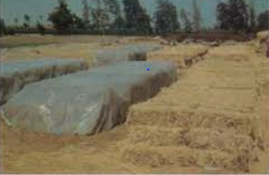
Figure.3.1.A. Stack method packaging type

B/ Pit/bunker method
This storage method involves storing the treated crop residue above or in the ground by building walls.

    - Tower (above ground) silo
Tower silos are constructed from brick, and are several meters in diameter and 10-20 m in height. The advantages of this type of silo include: long life, small space required, low storage losses, and possibility for mechanization. Both the filling operation and daily extraction can be mechanized. However, tower silos are expensive.
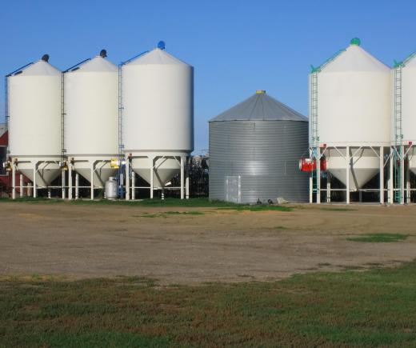
Figure.3.1.II. Tower silo above the ground

    - Cellar silo
The cellar type is the most common silo on individual farms. Round or square concrete silos are usually built inside houses for protection from the weather. Advantages are lower cost and easy management. Size can be adjusted according to scale of production. A disadvantage is high effluent loss, especially with clay walls.

    - Trench/ bunker silo
This type is generally built underground or semi-underground, with two solid walls of 1.5-2 m in height. Advantages are similar to the cellar silo, but the trench silo is more suitable for mechanization. The tractor can be driven on top from one side to the other for compaction purposes. After compaction, it is covered with a plastic sheet pressed down with soil, sandbags or straw bales to maintain anaerobic conditions. On many dairy farms, trench silos are built on the surface of ground. This type of silo has vertical walls of 0.4-0.5 m in thickness and 3-4 m in height. This design makes mechanization more convenient, and may also prevent bottom leakage.

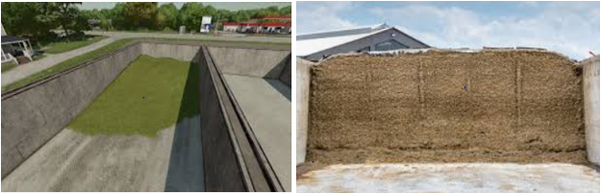
Figure. 3.1. III. Pit in the ground (Left) pit above the ground (Right)

- Advantages
- Pit or bunkers are easy to manage and avoid rodent damage to plastic films.
- Silos or bunkers constructed with cement are the best, since they save on plastic (only one sheet is needed, to cover) and minimize repairs.
- Once a silo or bunker is constructed, it can be used for several years. In addition, the
- Pit or bunker facilitates the estimation of straw weight.

- Disadvantages
- Difficult to load and unload
- Water may collect inside
- Especially in sand soils the wall tends to cave in, making the straw dirty.

3.1.1 Determine the size and amount of plastic film for stack method
Measurement of the stack density
Weighing the stack is a basic task for straw treatment. It is well known that it is important to use the correct amount of ammonia gas or urea: too little ammonia is ineffective; too much ammonia increases the cost and has no further effect on treatment. The exact weight of straw must be known so that the correct amount of ammonia can be applied. But weighing is difficult under field conditions. A simple method is to first measure the average density of stack for various straws, then to multiply it by its volume. Stack density depends upon plant species, moisture content and particle size. Of course, density also varies with time. In order to get reliable data, it is necessary to measure many stacks (at least 8 for each straw type). Density is expressed in kg/m³.
In old stacks, volume is measured first, and then it is weighed. New stacks are weighed before stacking and volume measured after. It is very easy to calculate the volume of rectangular and cylinder stacks. The volume of stack with irregular shape may only be estimated.

3.1.2. General guidelines in determining of crop residue stack density
The average density of air dry teff, barley and wheat straw ranges 55 and 79 kg/m³ for new and old whole straw respectively.
The average density of air dry maize and sorghum stover ranges 79 and 100 kg/m³ for new and old, whole stover, respectively.
For chopped crop residue average density is 100kg/m³.
Based on these guidelines the volume of a given weight of straw/stover could be determined, so that the amount of plastic film required could be calculated. However, if the crop residues is chopped the density increases, that is the amount of crop residue increases as compared to un-chopped straw/ stover.
Example: Based on the above general guidelines calculate the average volume of
- 1000kg new stack of wheat straw
- 1000kg old stack of wheat straw
- 1000kg new stack of maize stover
- 1000kg old stack of maize stover
- 1000kg chopped crop residue
Answers use the formula Density= $\frac{Mass}{Volume}$
The average volume of 1000kg new stack of wheat straw = 1000kg/55kg/m³= 18.2 m³
The average volume of 1000kg old stack of wheat straw = 1000kg/79kg/m³= 12.7 m³
The average volume of 1000kg new stack of maize stover = 1000kg/79kg/m³= 12.7 m³
The average volume of 1000kg old stack of maize stover = 1000kg/100kg/m³= 10 m³
The average volume of 1000kg chopped crop residue = 1000kg/100kg/m³= 10 m³
The amount of plastic film required can be calculated by the size of stack.
Size of bottom sheet: | Length = Length of stack + (0.5-0.7) m (overlap)
 | Width = Width of stack + (0.5-0.7) m
Size of covering sheet: | Length = Length of stack + height x 2 + (0.5-0.7) m
 | Width = Width of stack + height x 2 + (0.5-0.7) m

3.1.3. Determining Size of pit or bunker
To determine size of pit or bunker to build depend on; density of straw, animal type (daily straw intake 2 to 3 percent of live weight (2 to 3% body weight), number of animals and number of days. Generally it should be known how much straw (air dried) can be placed per m³ of bunker; how much ammoniated straw an animal requires per day.

- Straw density-
Average weight of air-dried and chopped crop residue (wheat, teff, barley and maize) is about 100 kg per m³, but could range 70-110 kg (air-dry: straw per m³. It will be low when the straw is very crisp and dry and higher when the straw is moister (chopping can again increase the density. Once the volume required is known the dimensions of pits are governed by width of the polythene and the reasonable height.
Example: if 1000kg of chopped crop residue is required to treat, the volume of the pit/bunker is calculated as: Volume = Weight/Density = 1000kg/100kg/m³ = 10m³
Therefore, to treat 1000kg crop residue 10m³ pit need to be dig out. This means that pit of 10m length, 10m width and 10m high is adequate to treat 1000kg crop residue.

3.1.4 Recommended pit/bunker dimensions
The height or depth of the pit should not be more that 1.5 m high or deep.
The width of the pit should not be more than 3m wide
The length of the pit depend on the amount of crop residue to be treated, however it should not be more than 15m long.
The following table shows the dimensions of pits, there volumes and the amount of crop residue to be treated.

Table. 3.1. Recommended pit/bunker dimensions
Length | Width | Height | Volume | Quantity to be treated
4.4ft | 3ft | 3ft | 40ft³ | 100 kg straw
1.25m | 0.9m | 0.9m | 1m³ | 100kg straw
11.7m | 3m | 1.5m | 52.56m³ | 5256kg straw

N.B: The treated crop residue needs to be properly packaged and stored. In both stack and pit/bunker storage methods plastic film is required to cover the crop residue stack or to line the bottom and walls in case of pit/bunker method. Therefore, the amount of packaging materials required needed should be calculated before treatment.

  - Preparing packing materials and equipment
Materials, equipment’s and tools required for the urea ammonia treatment of crop residues are listed below. The amount of materials depends on the amount and type of crop residues, type of treatment pit or packaging materials.

    - Materials
- Urea
- Water
- Polyethylene plastic sheet
- Molasses
- Crop residue (cereal straw or stover)

    - Tools and equipment’s
- Suspended measuring balance- to measure urea, water and crop residues.
- Bucket– to contain urea, urea and water
- Barrel or open container- to contain urea solution
- Wooden stick- to stir and dissolve urea in water
- Watering can- to sprinkle urea solution on the crop residue
- Machete or chopper- to chop the crop residue to the required size
- Spade
- Pick axe
- Wheel barrow
- Sacks

To prepare the packaging materials and storage of crop residue follow the following steps:
Stack method
- Determine the amount of crop residue to be treated
- Determine the volume of crop residue to be treated
- Measure the width of the plastic film (sheet)
- Select elevated flat area and clear it from vegetation
- Cover the area with the plastic sheet

Pit/bunker method
- Determine the amount of crop residue to be treated
- Determine the volume of crop residue to be treated
- Measure the width of the plastic film (sheet)
- Decide the height or depth of the pit
- Calculate the length of the pit
- Select elevated flat area and clear it from vegetation
- Measure the length and width of the required size, and mark it
- Start digging the ground and make a pit or bunker
- After reaching the required depth or height
- Level the bottom and cover the bottom and walls with plastic sheet
- Now the pit/bunker is ready for treatment

Self-Check – 3 | Written test

Name…………………………………………… ID………………………… Date…….

Directions: Answer all the questions listed below.

Test I: Short Answer Questions
- List storage systems of treated crop residue (3 points)
- Mention advantages of stack method in storing crop residues (3 points)
- What is the advantage of wooden stick in crop residue treatment? (3 points)
- Mention tools and equipment’s in crop residue treatment(3 points)

Note: Satisfactory rating – 6 points unsatisfactory rating –below 6 points
You can ask you teacher for the copy of the correct answers

Operation Sheet -3

  - Methods of Preparing packing materials (1m³ pit)
- Tools and equipments
- Polyethylene plastic sheet
- Meter
- Pegs
- Barrel or open container
- Machete
- Spade
- Pick axe
- Sacks
- Overall
- Boots
- Mask

- Steps of preparing packing materials
Steps1. Wear PPE
Step 2. Identify and collect material need
Step 3. Identify area / site/
Step 4. Dig the pit
Step 5: Label the pit
Step 6. Cover the pit with plastic sheet
Step 7. Finish the work

LAP TEST-3 | Performance Test

Name………………………………. ID…………………………….. Date…………………………………….

Time started: ________________________ Time finished: ________________

Instructions: Given necessary templates, tools and materials you are required to perform the following tasks within 1 hour. The project is expected from each student to do it.

Task-1 perform preparing packing materials and equipment

LG #42 | LO #4:- Complete treatment and store

Instruction sheet
This learning guide is developed to provide you the necessary information regarding the following content coverage and topics:
- Performing treatment of the crop residue
- Maintaining clean and safe area
- Storing treated crop residue properly
- Determining livestock groups to be fed the treated crop residues
- Maintaining clean and safe area (repeated title)
- Determining livestock groups to be fed the treated crop residues (repeated title)
This guide will also assist you to attain the learning outcomes stated in the cover page. Specifically, upon completion of this learning guide, you will be able to:
- Perform treatment of the crop residue
- Maintain clean and safe area
- Store treated crop residue properly
- Determining livestock groups to be fed the treated crop residues
- Maintain clean and safe area (repeated title)
- Determine livestock groups to be fed the treated crop residues (repeated title)

Learning Instructions:
- Read the specific objectives of this Learning Guide.
- Follow the instructions described below.
- Read the information written in the information Sheets
- Accomplish the Self-checks
- Perform Operation Sheets
- Do the “LAP test”

Information Sheet 4

4.1. Performing treatment of the crop residue
There are many variations in the methods of treatment of low quality roughages with urea. However, the principal method consists of dissolving urea in water and sprinkling it on layers of straw. The level of urea used varies, but it is commonly between 4 - 5% of air dried mass of the straw/stover, and the amount of water used also varies from as low as 0.2 liters per kg of straw to as high as 1 liter per kg of straw. The treated straw can be stored in various ways. However, airtight storage produces the best result. The treatment of the straw can be done in pits, using polyethylene sheets as inner linings. Airtight conditions are important during the treatment period, especially for small quantities of straws. Polyethylene sheet is very effective for excluding air, but a number of locally available materials such as banana leaves, soil, jute bags and cow dung are also used. The treatment period depends on the temperature of the surrounding and may be as low as 1 week in warm areas and up to 8 weeks in cold environment. Treatment time and temperature are inversely correlated and more time is required in colder climate. Once treated and if properly covered to preserve anaerobic conditions, the urea-ensiled material can be stored for several months. The pit shouldn’t be opened before it is necessary to use the treated feed.

Table.4.1. Time required for urea treatment of crop residues over different temperature
Temperature (⁰C.) | Treatment time
<5 | >8 weeks
5-15 | 4-8 weeks
15-30 | 1-4 weeks
>30 | <1 weeks
>90 | <1 day

Procedures of crop residue treatment
- Determine the amount of crop residues to be treated. This depends on:
  - The type and number of animals
  - Daily crop residue intake of animals
  - Body weight of the animal/s
  - Duration of feeding period
- Prepare crop residues for treatment. This includes chopping the residues into pieces to about 2-10 cm long.

Step by step procedures of crop residue treatment
Step.1 Determine the amount of crop residues to be treated. This depends on:
- The type and number of animals
- Daily crop residue intake of animals
- Body weight of the animal/s
- Duration of feeding period

Step.2 Prepare crop residues for treatment. This includes chopping the residues into pieces to about 2-10 cm long.
Steps | Procedures | Pictures
Step 1 | Pit/bunker method-Build the pit, cover the floor and sides of the pit with plastic sheet  Stalk method- Select an area with an elevated, dry and even surface, then covered it with plastic sheet. | 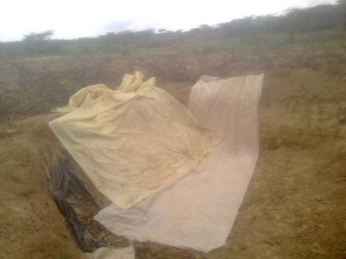
Step 2 | Weight the crop residue using weighing scale | 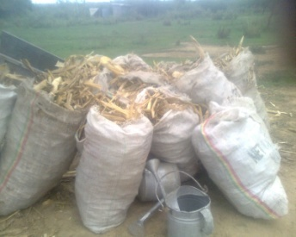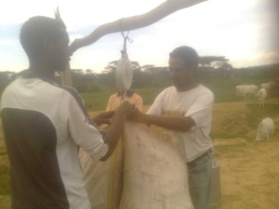
Step 3 | Spread the chopped crop residue on the floor | 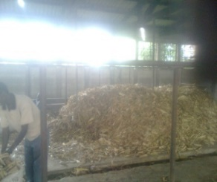  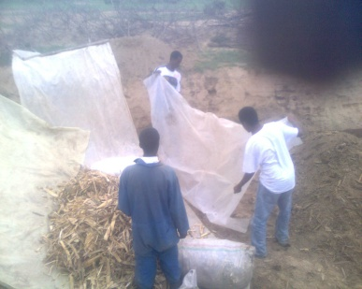
Step 4 | Fill water can with water | 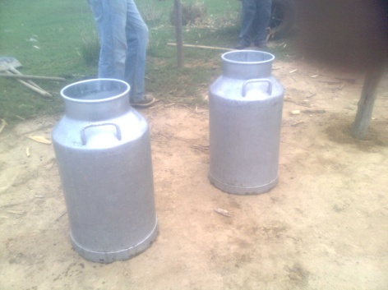
Step 5 | Measure and take urea, pour in to water container | 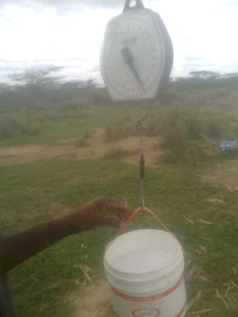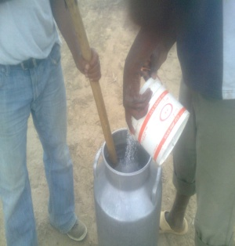
Step 6 | Mix the urea and the water thoroughly using wooden stirrer to make urea solution | 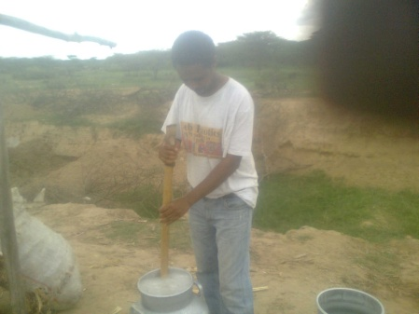
Step 7 | Sprinkle the urea solution on the crop residues and then thoroughly mix the solution and the straw/stover | 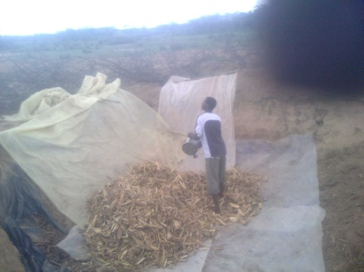
Step 8 | Compact the straw/stover by trampling with your foot to remove air as much as possible | 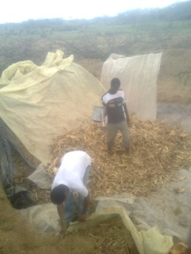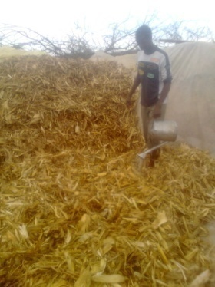
Step 9 | Repeat step 2, 3, 4, 5, 6, 7, and 8 until enough straw has been treated to suite the requirement
Step 10 | Pit/bunker method -Cover the pit with polyethylene sheet and load it with stones, woods or soil to prevent ammonia escaping | Stalk method- Seal the top and the sides by rolling them with the bottom plastic sheet to prevent ammonia escaping

- Determine the amount and size of packaging material requirement
- Determine the amount of ingredients and prepare for crop residue treatment
- The standard procedure in the urea treatment is to use:
  - 4% urea (4Kg urea/100 kg straw)
  - Maximum of 1:1 = water: straw ratio
  - A treatment duration= Minimum 14 days and maximum 28 days
- The standard procedure in the urea-molasses treatment is to use:
  - 4% urea (4Kg urea/100 kg straw)
  - Urea: molasses: water ratio= 4kg urea: 10kg molasses: 80kg water
  - A treatment duration= Minimum 14 days and maximum 28 days
- Properly stack or store the treated crop residue

4.2. Maintaining clean and safe area
Cleaning and maintaining working area
Effective workplace housekeeping can help get the job done safely and properly. Workplace housekeeping includes keeping the work area neat and tidy, keeping slip and trip hazards off of the travel area, removing fire hazards from the work area and maintenance of buildings, equipment and vehicles.
A good workplace housekeeping system will provide for proper inspection, maintenance, keepup and repair of tools, equipment, machines and processes. Tasks and the equipment required to carry them out should also be set up in a fashion that minimizes the number of times items have to be handled.

Common Hazards
Poor workplace housekeeping can often lead to workplace injuries from:
- Being hit by falling objects
- Tripping over objects on the floor, stairs and platforms
- Slipping on wet, greasy, dirty or icy surfaces
- Hitting projecting items and stacked materials
- Cutting, puncturing or tearing the skin on projecting nails, wire, etc.

Safe Procedure
- Flammable, combustible, toxic and other hazardous materials should be stored in approved containers in designated areas.
- Materials are to be stored in a safe and orderly manner. If materials are to be piled ensure that the stacking (height, placement) doesn’t render the pile unstable.
- Waste should be regularly collected and disposed of in an approved manner. Place clearly labeled containers in suitable locations for the easy collection of recyclable materials and wastes.
- Clean spills as they happen and properly dispose of any absorbent material immediately.
- Replace or fix broken or damaged items at the earliest opportunity.
- Keep areas well-lit and replace or clean light fixtures as required.
- All tools should be returned to the designated storage area after use. Do not place any tool or object where it may pose a hazard.
- Where practical, provide/use mechanical appliances for carrying materials and supplies.
- Keeping the work site tidy, wearing the proper footwear and working at the appropriate pace are all critical for preventing any injuries in workplace and making the area safe.

4.3. Storing treated crop residue properly

After treatment the treated crop residue has to be stored properly. It has to be protected from flood.
In the selection of crop residue storage and packaging materials the advantages and disadvantages of each method should be considered.
- If durable and long lasting storage method that can be used for several years, the pit/bunker with concrete walls should be constructed. However, it is expensive.
- Less expensive but that can last longer can be constructed by digging the pit and covering the walls with plastic sheet.

Selection of plastic film/sheet
The basic requirements for plastic film are that it is non-toxic, durable and suitable for sealing. The plastic often used is polyethylene.
Thickness, width and colour of polyethylene plastic sheet are determined by practical situations.
- Thick film (about 0.12 mm) is used for maize and sorghum stover; thin film (less than 0.12 mm) for barley, teff and wheat straw.
- Width of film is determined by the size of stack and market availability.
Color of plastic sheet-
If used in the open air, black colour should be preferred, because it is durable and absorbs solar energy, which heats the stack and shortens treatment time. If used indoors, film colour has no obvious influence on treatment, sunlight, rainfall, contaminated substances/any foreign bodies.

4.3. Determining livestock group to be fed treated crop residue
4.3.1. Quality evaluation of urea treated crop residues
There are three methods to evaluate quality of ammoniated straw: sensory evaluation, chemical analysis and biological tests.

A/ Sensory evaluation
Properly ammoniated straw is soft, brownish yellow or light brown, and with a light fragrance after excess ammonia has evaporated. If straw appears white or grey and is sticky or clumps, it means that it has been attacked by mould. This damaged straw should not be used as feed. Of course, this situation seldom occurs if treatment is correct. Mould normally results from high moisture content, defective sealing or delayed ventilation after opening. If, after ammoniation, straw colour is nearly the same as before treatment, it means that ammoniation did not go very well, but it can still be used as feed.

B/ Chemical analysis
By chemical analysis, the components of straw such as fiber component (NDF and ADF) and crude protein (CP) can be measured, but by itself it cannot give an estimate of overall nutritive value and animal intake.

C/ Biological evaluation
The most reliable method of evaluation of straw quality is through biological tests such as feeding the treated straw and measurement of digestibility, feed intake animal performance.

4.3.2. Incidence of Fungi or moulds development
Sometimes fungi or moulds will develop in the heap. This is mainly due to poor compaction; too much water or an initial poor straw quality the pattern of occurrence is not always predictable. Incidence of mould increases when the duration of treatment extends Better sealing and compaction certainly reduces the incidence of moulds of different kind occur both in too moist and too dry heaps. The moulds of different kind occur both in too moist and too dry heaps. The moulds can have either beneficial or negative effects. Generally speaking one should avoid feeding moldy straw.

4.3.3. Feeding treated crop residue
Aeration
After opening the pit of ammonia treated straw, the treated crop residue has a strong smell of ammonia. This strong smell of ammonia reduces the appetite of the animal therefore it should be aerated for a time before feeding.

Class of animals that treated crop residues can be feed
Ammoniated cereal straws and stover can be offered to beef cattle, heifers, sheep (ram and ewe), goats (bucks and does), and lactating cows as sole roughage or as large proportion of the diet. However, do not feed urea treated crop residue to young calves, lambs, kids, pregnant cows that are at the last stage of pregnancy (7 months pregnancy). And also do not fed urea treated crop residue to mono-gastric animals such as poultry (chicken), swine (pigs).

Supplementation
In addition to treated crop residues animals should be supplemented with grass, tree levees and concentrate to improve the productivity of the animals. Basically the treated straw should be fed and considered as medium quality grass. Feeding of minerals is necessary. The constant supply of plenty of clean drinking water and common salt should be given.

4.5. Maintaining clean and safe area
These title was repeated on the OS and Curriculum but for further discuss refer 4.2 in these learning out come

4.6. Determining livestock group to be fed treated crop residue
These title was repeated on the OS and Curriculum but for further discuss refer 4.4 in these learning out come

Self-check 4 | Written test

Name…………………………………………… ID………………………… Date…….
Directions: Answer all the questions listed below.

Part I: Choose the best answer
    - Which one of the following is the techniques of evaluation of urea treated crop-residues? (1 point)
A/ sensory evaluation B/ Animal intake C/ amount of crop D/ amount of urea
    - Which one of the following is not the technique of fed livestock of urea treated crop-residues? (1 point)
A/ feed with grass B/ feeding with mineral C/ feeding with concentrate D/ feeding alone
Part II: Short Answer Questions
1. List methods of evaluation quality treated crop residues (3 points)
2. Why molds or fungi develop in the heap of crop residues? (3 points)
3. List animals that do not allowed to feed urea treated crop residues. (4 points)

Note: Satisfactory rating 6 points unsatisfactory rating below 6 points
You can ask you teacher for the copy of the correct answers

Operation Sheet -4

  - Procedures of performing crop residue treatment

- Tools and equipments
- Plastic sheet
- Stalk method pit
- Urea
- Water
- Water can
- Weighing balance
- Crop residues
- Chopping materials
- Overall
- Boots
- Mask
- Glove

- Steps
- Wear PPE
- Build the pit cover the floor and sides of the pit with plastics
- Weight the crop residue using weighing scale
- Chop the crop residue
- Spread the chopped crop residue on the floor
- Fill water can with water
- Measure and take urea, pour in to water container
- Mix the urea and the water thoroughly using wooden stirrer to make urea solution
- Sprinkle the urea solution on the crop residues and then thoroughly mix the solution and the straw
- Compact the straw
- Compact for airtight the straw again and again
- Cover the pit with polyethylene sheet and load it with stones, woods or soil to prevent ammonia escaping

LAP TEST-4 | Performance Test

Name……………………. ID…………………. Date………………
Time started: ________________________ Time finished: ________________

Instructions: Given necessary templates, tools and materials you are required to perform the following tasks within 2:00 hour. The project is expected from each student to do it.

Task-1 Perform crop residue treatment

LG #43 | LO #5:-Prepare urea-molasses block (UMB)

Instruction sheet

This learning guide is developed to provide you the necessary information regarding the following content coverage and topics:
- Preparing ingredients and materials
- Calculating proportion
- Undertaking mixing procedures
- Undertaking molding, drying and storing
- Carrying out feeding
- Cleaning material, tool and equipment
This guide will also assist you to attain the learning outcomes stated in the cover page. Specifically, upon completion of this learning guide, you will be able to:
- Prepare ingredients and materials
- Calculate proportion
- Undertake mixing procedures
- Undertake molding, drying and storing
- Carry out feeding
- Clean material, tool and equipment

Learning Instructions:
- Read the specific objectives of this Learning Guide.
- Follow the instructions described below.
- Read the information written in the information Sheets
- Accomplish the Self-checks
- Perform Operation Sheets
- Do the “LAP test”

Information Sheet 5

5.1. Preparing ingredients and materials
Urea molasses block can be made from a variety of components depending on their local availability, nutritive value, price, existing facilities for their use, and their desired influence on the quality of blocks.
As the name suggests, these are lick blocks that contain urea, molasses, vitamins, minerals and perhaps other nutrients. The feeding of the blocks is a convenient and inexpensive method of providing a range of nutrients, which may be deficient in the diet, that are required by both the rumen microbes and the animal.
The ingredients are designed to provide a wide range of nutrients to cover all potential deficiencies. Urea molasses blocks (UMB) have proven to be an excellent tool for the improvement of ruminant feeding. They are cheap, relatively safe and a practical means of supplying nutrients. They create an efficient rumen ecosystem which favors the growth of young animals and milk production. They also improve conception rates and the size of offspring.
The urea molasses block technology should be encouraged in Ethiopia to make better use of available feed resources at the small farmer level.

The common ingredients used in making Urea Molasses blocks are:
- Molasses
- Urea
- Fibrous feeds such as wheat bran
- Salt
- Cement (a binding agent).

A/ Molasses
Molasses provides fermentable substrate and various minerals and trace elements (but low amounts of phosphorous). Because of its pleasant taste and smell, it makes the block very attractive and palatable to animals. The degree of the molasses should be as high as possible as and preferably higher than 85, to ensure solidification. Degrees Brix is a hydrometer scale for sugar solutions graduated so that readings at a specified temperature represent percentages by weight of sugar in the solution. So 85° Brix is equivalent to 85 percent sugar.

B/ Urea
Urea provides fermentable nitrogen, which is the most important component of the block. With the increase of the microflora in the rumen, urea may increase the intake of straw and other low quality forages as well as their digestibility. The intake of urea must be limited to avoid toxicity problems. However its intake must be sufficient enough to maintain ammonia levels in the rumen consistently above 200 mg N/l for growth of microorganisms in the rumen and high rates of degradation of fiber. It is important that urea and molasses are provided together to provide ammonia and energy at the same time, hence, their combination in UMB.
The urea used in this formula is fertilizer grade, normally used as a nitrogen fertilizer in sugarcane plantations and rice fields. Since the urea is hygroscopic it is possible that during storage lumps may form in the sacks. In order to prevent excessive consumption of urea in too short a period, which may cause intoxication of the animals, it is necessary that all the lumps are crushed before introducing the urea into the mixture. This will guarantee a homogenous mixture of urea in the mass.

C/ Wheat or rice bran
These serve a multiple purpose in the blocks.
They provide some key nutrients including fat, protein and phosphorus.
They also act as an absorbent for the moisture contained in molasses and give structure to the block. They may be replaced by other fibrous materials such as dry and fine bagasse (the residue from sugar cane processing) or groundnut hulls which are finely ground.

D/ Other crop residues
Other crop residues can also be included in urea molasses block. This depends on availability. Some crop residues and by-products will provide more nutrients than others.

E/ Minerals
These may be added where appropriate. Common salt is generally added because this is often deficient in the diet and it is cheap. Calcium is supplied by molasses and by the gelling agent, calcium oxide or cement Although phosphorus is deficient, there is no evidence that its addition is beneficial where animals are at below maintenance requirements when grazing on dry mature pastures or fed low-quality forage. Mineral requirements are reduced at maintenance or survival levels. Deficiencies will generally become a problem only when production is increased, particularly when a bypass protein supplement is given. Proteins that are not degraded by rumen microorganisms and are digested in the intestines.
In these cases, phosphorus should be included in that supplement.

F/ Binder
A gelling agent or binder is necessary in order to solidify the blocks.
Various products have been tried successfully:
- Magnesium oxide,
- Bentonite,
- Calcium oxide,
- Calcium hydroxide, and cement.
The use of cement has raised questions about possible negative effects on animals. Research on the use of cement or its by-product, cement kiln dust, as a mineral supplement have not shown adverse effects at levels of 1 to 3 percent of the total diet dry matter.
The USDA has restricted the use of cement kiln dust since it could cause a deposit of heavy metals in animal tissue. Various chemicals or drugs for the control of parasites or for manipulation of rumen fermentation can be added to the molasses blocks, which can be an excellent carrier for these products.

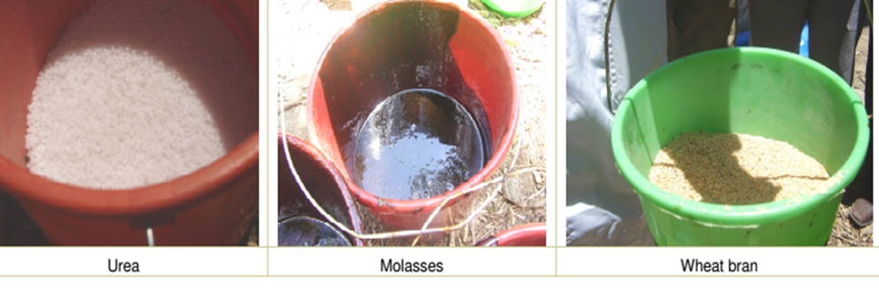
Figure.5.1. the ingredients of UMB

Stages of urea-molasses block preparation
Urea molasses blocks can be manufactured on the farm. Manufacture is easy and simple and different processes exist which may be used according to local conditions. The manufacturing can be divided into four stages:
- Preparing the components
- Mixing
- Molding
- Drying

5.2. Calculating proportion of UMB
The blocks can be made from a variety of components depending on their availability locally, nutritive value, price, existing facilities for their use and their influence on the quality of blocks. They can also include specific components.

Proportion of components
The amount of the different ingredients depends on the size of the block to be manufactured and the formula to be used. Below table shows the amount of ingredients to be mixed to make 1, 5, or 15 kg of block based on formula alternative.

Table.5.1. Amounts of ingredients to mix to make different sizes of UMB
No | Ingredients | % | Size of block to be made
No | Ingredients | % | 1kg | 5kg | 15kg
1 | Molasses | 40 | 0.4 | 2 | 6
2 | Urea | 10 | 0.1 | 0.5 | 1.5
3 | Bran | 25 | 0.25 | 1.25 | 3.75
4 | Cement | 10 | 0.1 | 0.5 | 1.5
5 | Oil cake | 10 | 0.1 | 0.5 | 1.5
6 | Mineral mix | 1 | 0.01 | 0.05 | 0.15
7 | Salt | 4 | 0.04 | 0.2 | 0.6
 | Total | 100 | 1 | 5 | 15
8 | Water (to mix cement) |  | 40g (0.04kg) | 0.2 | 0.6

5.3. Undertaking mixing procedures UMB
Salt in the range of 5–10% is added to the blocks to supply minerals and to control the rate of consumption. Calcium carbonate and di-calcium phosphate can be added to provide additional calcium and phosphorus. Cement is used to make the block hard. About 10–15% is sufficient. Higher levels make the blocks too hard. Cement also provides calcium. Clay such as that used in brick-making can be mixed with cement to improve block hardness and reduce drying time. It can also reduce cost of making the block. Other ingredients can be added to provide additional nutrients. Oilseed cakes or brewery by-products can be added to supply protein. Trace mineralized salt can be used to provide additional minerals that may be lacking. Good mixing is crucial for good block-making. Urea must be mixed thoroughly by breaking up lumps to avoid pockets of high concentration that could harm animals.
Do the following to mix the ingredients.
- Weigh the amount of ingredients needed based on the formula of the block.
- Add urea to the molasses while continuously mixing.
- Mix the urea with molasses thoroughly by stirring for about 20 minutes
- The molasses can be heated in the sun to improve handling and mixing.
- Never add water to molasses. It has to be thick.
- Add bran and any other fibrous material such as noug seed cake, if it is part of the formula, and mix thoroughly.
- Make the cement into a paste with water prior to adding to the rest of the ingredients.
- Mixing the salt with cement accelerates hardening.
High levels of molasses and urea tend to decrease block hardness. Check block hardness after drying and make the following adjustments to the formula. If the block is too hard, reduce the proportion of cement or clay and slightly increase the proportion of molasses. If too soft, increase cement or clay and reduce molasses.

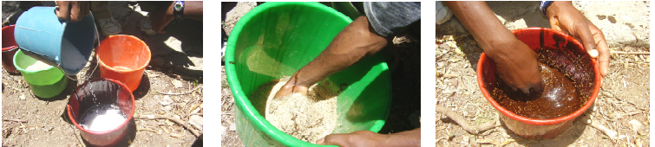
Figure.5.3. Mixing urea, molasses and bran

5.4. Undertaking molding, drying and storing UMB
    - Casting and molding
Once the ingredients are thoroughly mixed, place the mixture into molds. Any local container, such as tin cans or small buckets can be used as a mold. Using a plastic sheet to line the molds will make block removal from the mold easier.

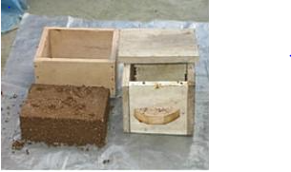
Figure.5.4.1.A. Simple wooden mold and Urea-Molasses Block

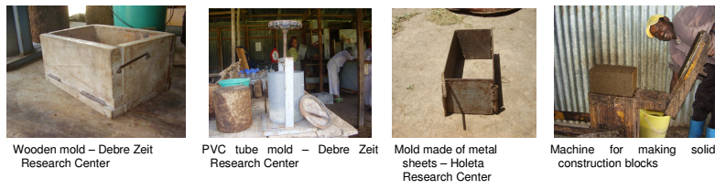
Figure.5.4.1.B. Different types of molds

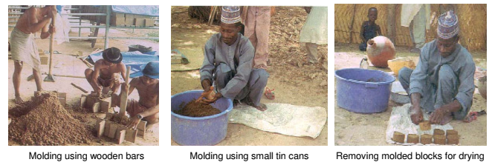
Figure.5.4.1.C. Molding UMB

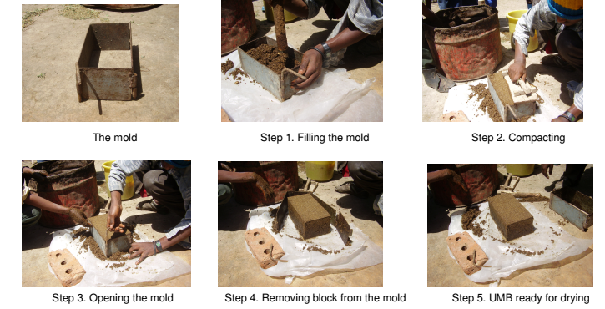
Figure.5.4.1.D. Steps of UMB making

5.4.2. Drying and storage of urea molasses blocks
Remove the blocks from the molds after 24 hours and place on racks to dry. Leave the blocks to dry for at least 5 days depending upon the weather condition.
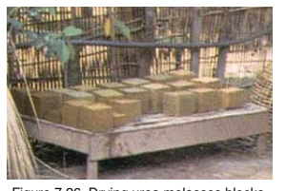
Figure.5.4.2. Drying UMB

5.4.3. Characteristics of a good urea molasses block
A block is considered good when it fulfills the following:
- Ingredients are well-distributed throughout the block.
- It does not have lumps of urea and lime.
- It is hard enough to resist being squashed between fingers or breaking when a person
steps on it.
- The sticky molasses can be felt when holding the block. The amount of molasses needs to be increased if the block doesn’t feel sticky.

5.5. Carrying out feeding of UMB to animal species and status
Blocks should be fed as a lick so that only the top surface is accessible to animals. This prevents animals from pushing the blocks around, breaking them up and consuming large chunks that could cause urea toxicity. Blocks should be introduced to animals slowly and should be fed after animals have consumed adequate forage. This prevents animals from consuming too much at any one time. Urea molasses blocks should never form the main diet. They are meant to be a supplement to a basal diet of forage. Allow access by animals for one hour per day during the first week of adaptation, two hours during the second week and free access after the third week. Some animals may need to be forced to consume the blocks by preventing access to lush feed other than dry roughage during the adaptation period. Block hardness will affect its rate of intake. If too soft, it is consumed too rapidly and there is the risk of toxicity. If too hard, intake may be too little. Urea at high levels is unpalatable. High levels of urea in urea molasses blocks may reduce intake of the block as well as of straw due to the bitter taste. High levels or imbalances in minerals may result in excessive consumption in a short time, also leading to urea poisoning. Precautions should be taken to avoid this problem of over-consumption in drought prone areas, particularly towards the end of the dry season when feed is scarce.
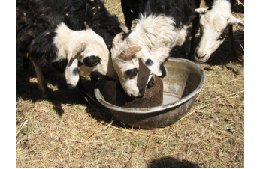
Figure. 5.5. Feeding UMB to sheep

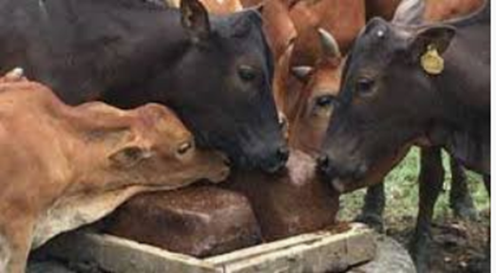
Figure. 5.5. Feeding of UMB to Livestock
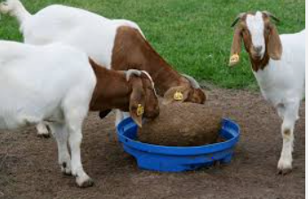
Figure. 5.5. Feeding UMB to the goats

Precautions while supplementing with urea molasses blocks
It is essential to note the following while supplementing urea molasses blocks.
- Feed to ruminants only (sheep, goats, cattle, camels).
- Do not feed to mono-gastric, i.e., horses, donkeys, or pigs
- Do not feed to young ruminants less than six months of age (lambs, kids).
- Blocks should be used as a supplement and not as the basic ration.
- A minimum of coarse forage in the rumen is essential.
- Never give blocks to an emaciated animal with an empty stomach. There is the risk of poisoning due to excessive consumption.
- The amount of blocks fed to sheep and goats should be limited to 100 g/day.
- Blocks should never be supplied in ground form or dissolved in water as this can result in overconsumption.
- Supply sufficient amount of water

5.6. Cleaning material, tool and equipment
Ideally, equipment should be cleaned after every use or at the very least before storing. The most efficient and effective way to clean your UMB equipment is with a hot water pressure washer.
Farm equipment should be washed on an unpaved area. This allows the soapy water to soak into the ground to be filtered and replenish the groundwater. Washing your equipment on a paved surface is detrimental to the environment, as the runoff flows into a storm drain and the contaminated water is discharged into a nearby lake or stream. If you have a well, make sure to wash your equipment at least 100 feet away from the wellhead. The equipment with hot water, then apply the detergent or degreaser at a low pressure so that the product doesn’t splash away. Allow the product to sit for 5 to 10 minutes. Use a detergent or degreaser that’s formulated for your particular cleaning task. Thoroughly wash the equipment using a high pressure setting. Use the lances and accessories recommended in your pressure washer’s manual to get more specific cleaning instructions if needed. Finally, perform a rinse, going from top to bottom.

Self-Check – 5 | Written test

Name…………………………………………… ID………………………… Date…….

Directions: Answer all the questions listed below.
Test I: Short Answer Questions
1. List difficulties of molasses in the liquid form (4 points)
2. Mention common ingredients used in making feed block (5 points)
3. Discuss advantages of urea in making urea molasses block. (2 points)
4. What is the main advantage of adding salt in to urea molasses block? (2 points)
5. What is the problem of adding high level of molasses to urea molasses block? (3 points)
6. What do you do if the block is too hard in urea molasses block? (4 points)

Note: Satisfactory rating – 10 points unsatisfactory rating –10 below points
You can ask you teacher for the copy of the correct answers

Operation Sheet -5

  - Procedures of UMB making
- Tools and equipments
- Cement
- Urea
- Wheat bran/ rice bran/
- Molasses
- Salt /minerals
- Balance
- Casting mold
- Plastic containers
- Procedures/Steps/Techniques
- Wear PPE
- Weighing ingredients
- Set containers
- Add urea to molasses
- Mix salt with cement separately
- Add no 4 and 5
- Add wheat bran
- Add in casting mold
- Dry in proper way
- Feed animal

LAP TEST-5 | Performance Test

Name………………………………. ID…………………………….. Date…………………………………….

Time started: ________________________ Time finished: ________________

Instructions: - Depend up on the given, tools and materials you are required to perform the UMB for Shoat. Given cement, rice bran, molasses, salt, and urea. Operate the task within 1:30 hour. The project is expected from each student to do it.

Task-1 Operate making urea molasses block

Reference Materials

Books:
Alemayehu Mengistu, 1997. Conservation-based forage development for Ethiopia. Self-help Development International Institute for Sustainable Development. Berhanena Selam Printing Enterprise. Addis Ababa, Ethiopia. 1p.
Azage Tegegne, Workneh Ayalew, Berhanu Gebre Medhin and Salvador Fermandez-Rivera, 2002. Opportunities for improved dairy production in Ethiopia. In: Resource Management for Poverty Reduction. Approaches and Technologies. Ethio-forum 2002. 118p.
Chenost, M., 1995. Optimizing the use of poor quality roughage through treatments and
supplementation in warm climate countries with particular emphasis on urea treatment. First Electronic Conference on Tropical Feeds with particular Emphasis on Urea Treatment. FAO, Rome.
Getachew Eshete, 2002. An assessment of Feed Resources, Their Management and Impact on Livestock productivity in the Ginchi Watershed Area. MSc. Thesis. Alemaya University of Agriculture, Alemaya. Pp 171.
Ibrahim, M.N.M. and J.B. Schiere, 1989. Feeding of urea-ammonia treated rice straw. A compilation of miscellaneous reports produced by the straw utilization project (Sir Lanka). Pudoc. Wageningen. pp. 1-28.
Lulseged Gebrehiwot and Jamal Mohamed, 1989. The potential of crop residues, particularly wheat straw, as livestock feed in Ethiopia. p. 144. In: A.N. Said, B.H. Dzowela (eds). Overcoming constraints to the efficient utilization of agricultural by-products as animal feed. International Livestock Center for Africa (ILCA). Addis Ababa, Ethiopia.
Web addresses
https://teca.apps.fao.org/teca/es/technologies/4497 (Access date 31/08/22)

AKNOWLEDGEMENT

Ministry of Labor and Skills wish to extend thanks and appreciation to the many representatives of TVET instructors and respective industry experts who donated their time and expertise to the development of this Teaching, Training and Learning Materials (TTLM).

The experts who developed the learning guide
No | Name | Qualification | Educational background | Region | Phone number | E-mail
1 | Genanew Abera Teshome | MSc. | Animal genetics and breeding | Alage ATVET  College | 0926672970 | genanewabera@gmail.com
2 | Terefe Tolcha | MSc. | Animal Production | Alage ATVET  College | 0911067132 | terefetc@gmail.com
3 | Temesgen Roro | MSc. | Animal Production | Holeta PTC | 0917657496 | temesgenroro@gmail.com
4 | Solomon Fertewehal | MSc | Animal Production | Alage ATVET  College | 0912648413 | Tosolomon@gmail.com
5 | Gashaw Assefie | MSc. | Animal Production | Agarfa ATVET  College | 0914068274 | lakomelzajournalist@gmail.com
6 | Abenet Getahun | MSc | Animal Production | Gewane ATVET  College | 0940236673 | abenetgetahun@gmail.com
7 | Yirmedie Bayou | MSc | Animal genetics and breeding | Mizan ATVET  College | 0915851079 | Yirmedie123@gmail.com
8 | Sead Taha | MSc | Animal Production | Agarfa ATVET  College | 0916112492 | tahasead@gmail.com
9 | Biru Kefenie | MSc | Animal Production | W/Soddo  ATVET  College | 0913334612 | ukefene@gmail.com

