Natural Resources Conservation and Development
Level – I

Based on March, 2022 (V- I) Occupational standard (OS)

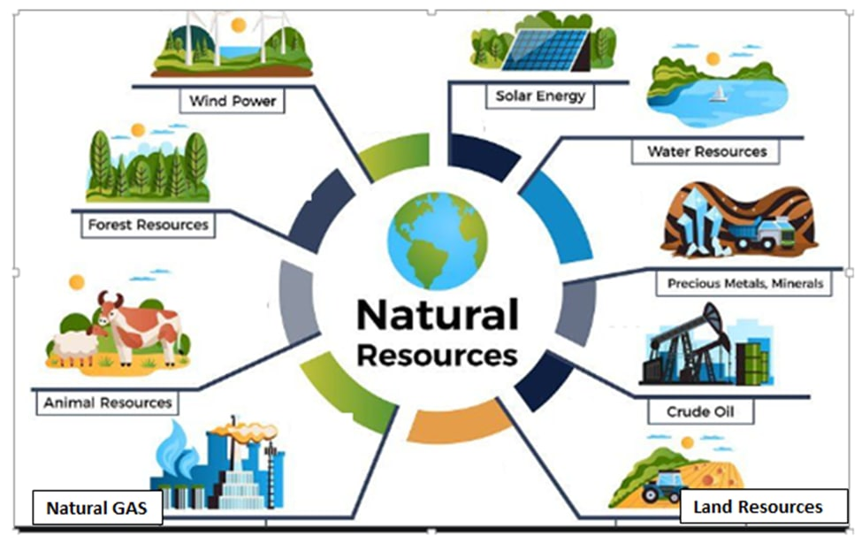

Module Title: -Applying 5S Procedures
LG Code:AGR NRC1 MO10LO (1-4)LG (48-53)
TTLM Code:AGR NRC1 TTLM 0922v1

September, 2022
Addis Ababa, Ethiopia
Table of Contents
Introduction to the Module 1
LO #1- Prepare for work 2
Instruction sheet 1 2
Information Sheet 1 3
Self-check 1 13
Operation Sheet -1 14
LAP TEST-1 15
LO #2- Sort items 16
Instruction sheet 2 16
Information Sheet 2 17
Self-check 2 31
Operation Sheet -2 32
LAP TEST-2 33
LO #3- Set all items in order 34
Instruction sheet 3 34
Information Sheet 3 36
Self-check 3 46
Operation Sheet -3 47
LAP TEST-3 48
LO #4- Perform shine activities 49
Instruction sheet 4 49
Information Sheet 4 50
Self-check 4 58
Operation Sheet -4 59
LAP TEST-4 60
LO #5- Standardize 5S 61
Instruction sheet 5 61
Information Sheet 5 62
Self-check 5 65
Operation Sheet -5 66
LAP TEST-5 67
LO #6- Sustain 5S 68
Instruction sheet 6 68
Information Sheet 6 70
Self-check 6 76
Reference Materials 77

Introduction to the Module
This module covers the knowledge, skills and attitude required to apply 5S techniques to his/her workplace. It covers responsibility for the day-to-day operations of the workplace and ensuring that continuous improvements of Kaizen elements are initiated and institutionalized.

LG #48 | LO #1-Prepare for work

Instruction sheet 1
This learning guide is developed to provide you the necessary information regarding the following content coverage and topics:
- work instructions
- Reading and interpreting job specifications
- Identifying OHS requirements
- Preparing and using tools and equipment
- Identifying and checking safety equipment and tools
- Preparing and using Kaizen Board

This guide will also assist you to attain the learning outcomes stated in the cover page. Specifically, upon completion of this learning guide, you will be able to:
- Followwork instructions
- Read and interpret job specifications
- OHS requirements
- Prepare and use tools and equipment
- Identify and check safety equipment and tools
- Prepare and use Kaizen Board
Learning Instructions:
- Read the specific objectives of this Learning Guide.
- Follow the instructions described below.
- Read the information written in the information Sheets 1
- Accomplish the Self-checks 1
- Perform Operation Sheets 1
- Do the “LAP test” 1

Information Sheet 1

Introduction
What is 5S?A Management philosophy devoted to the proper arrangement and orderliness of the workplace.5S is short for: Sort, Set in Order, Shine, Standardize and Sustain.
- Sort - All unneeded tools, parts and supplies are removed from the area
- Set in Order - A place for everything and everything is in its place
- Shine - The area is cleaned as the work is performed
- Standardize - Cleaning and identification methods are consistently applied
- Sustain - 5S is a habit and is continually improved
Also - Work areas are safe and free of hazardous or dangerous conditions. 5S is a method of creating a self-sustaining culture which perpetuates a neat, clean, efficient workplace.
5S lays the foundation for continuous improvement. It is method for removing all excess materials and tools from the workplace and organizing the required items such that they are easy to find, use, and maintain.
It is all about having what you need to do your job when you need it; no more, no less!
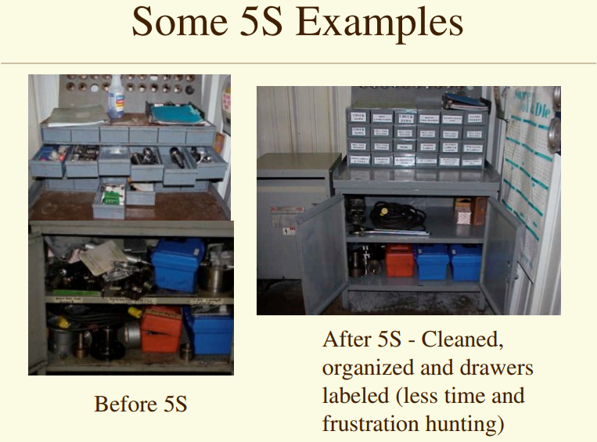
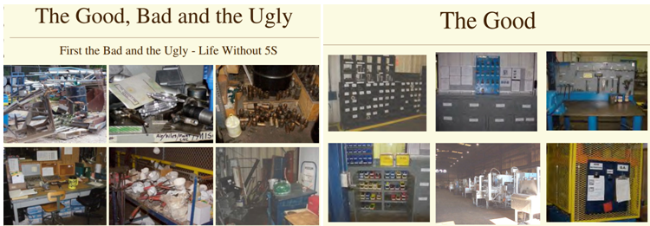
Figure1.1: some 5S Examples
5S Benefits to YOU
- It will make your workplace a safer, cleaner and more pleasant place to work
- Make your job more satisfying.
- Eliminate overburdens and disappointment.
- Make it easier to communicate with everyone you work with
- Gives you an opportunity to give creative input how your work place
5S Benefits to Organization
- Stability in the process allow optimization
- Zero defects brings higher quality
- Zero waste brings reduced cost
- Zero delay brings reliable delivery
- Zero accident increase safety
- Zero breakdown, increase productivity
- Zero complaint brings greater confidence and trust

Figure1.2: 5SOrganizational Structure
  - Work instructions
Information about the work
- Describe what workers need to be able to do on the job
- Work functions
- Key activities of each work function
- Performance indicators
- Describe what task to be done or work roles in a certain occupation
Work instruction is a description of the specific tasks and activities within an organization. A work instruction in a business will generally outline all of the different jobs needed for the operation of the firm in great detail and is a key element to running a business smoothly.
In other words it is a document containing detailed instructions that specify exactly what steps to follow to carry out an activity. It contains much more detail than a Procedure and is only created if very detailed instructions are needed. For example, describing precisely how a Request for Change record is created in the Change Management software support tool.
Procedures vs. Work Instructions
Many people confuse “procedures” with “work instructions”. In fact, most people write work instructions and call them procedures. Knowing the differences of procedures vs work instructions can help you understand the documentation process much better and, therefore, procedure documentation.
Procedures describe a process, while a work instruction describes how to perform the conversion itself. Process descriptions include details about the inputs, what conversion takes place (of inputs into outputs), the outputs, and the feedback necessary to ensure consistent results.
Questions that need to be answered in a procedure include:
- Where do the inputs come from (suppliers)?
- Where do the outputs go (customers)?
- Who performs what action when (responsibilities)?
- How do you know when you have done it right (effectiveness criteria)?
- What feedback should be captured (metrics)?
- How do we communicate results (charts, graphs and reports)?
- What laws (regulations) or standards apply (e.g., ISO 9001, 8th EU Directive, IFRS, Sarbanes-Oxley)?
  - Reading and interpreting job Specification

Job specification is an official document which describes the duties, required knowledge, skills and abilities, and minimum qualifications of State jobs.It is statement of employee/workers characteristics and qualifications required for satisfactory performance of defined duties and tasks comprising a specific job or function. The job specification lists qualities that the employee should – or sometimes, must – have in order to qualify for the job. Also known as employee specifications, a job specification is a written statement of educational qualifications, specific qualities, level of experience, physical, emotional, technical and communication skills required to perform a job, responsibilities involved in a job and other unusual sensory demands. It also includes general health, mental health, intelligence, aptitude, memory, judgment, leadership skills, emotional ability, adaptability, flexibility, values and ethics, manners and creativity, etc.
Purpose of Job Specification
- Described on the basis of job description, job specification helps candidates analyze whether are eligible to apply for a particular job vacancy or not.
- It helps recruiting team of an organization understand what level of qualifications, qualities and set of characteristics should be present in a candidate to make him or her eligible for the job opening.
- Job Specification gives detailed information about any job including job responsibilities, desired technical and physical skills, conversational ability and much more.
- It helps in selecting the most appropriate candidate for a particular job.
Components of Job Specification
There are many parameters which are considered while giving the job specification for a certain profile.
1. Educational Qualification
This parameter gives an insight on how qualified a certain individual is. It covers their basic school education, graduation, master’s degree, other certifications etc.
2. Experience
Job specification clearly highlights the experience required in a particular domain for completing a specific job. It includes work experience which can be from a specific industry, position, duration or in a particular domain. Managerial experience in handling and managing a team can also be a job specification criteria required for a particular position.
3. Skills & Knowledge
This is an important parameter in job specification especially with knowledge and skill based profiles. The higher the position in a company, the more niches the skills become and more is the knowledge required to perform the job. Skills like leadership, communication management, time management, team management etc. are mentioned.
4. Personality traits and characteristics
The way in which a person behaves in a particular situation, handles complex problems, generic behavior etc. are all covered in the characteristics of a job description. It also covers the emotional intelligence of a person i.e. how strong or weak a person is emotionally.

Job Specification Example
Here is a sample job specification, which is prepared for a marketing manager in a telecom company.
Table1.1:Job Specification Example
Education | Must be an engineer and MBA in marketing for a reputed MBA institute
Work experience | Must have prior work experience in marketing & sales (preferably telecom or FMCG)
Skills & Knowledge | 1. Must be a good communicator and must be able to lead a team.  2. Prior experience in handling ATL-BTL activities and managing promotional events.  3. Must be able to handle social media like Facebook, Twitter and help build online brand  4. Experience in managing PR and media  5. Strong analytical skills and problem solving skills  6. Must understand business, come up with innovative products and launch them
Personality Traits & Characteristics | 1. Must be presentable and a good orator  2. Should be calm in complex situations and show leadership skills in managing multiple teams  3. Should be emotionally strong and should give timely deliverables

Job Requirements
A Job can be defined as a piece of work, especially a specific task done as part of the routine of one's occupation or for an agreed price.
- A post of employment; full-time or part-time position
- Anything a person is expected or obliged to do; duty; responsibility
- An affair, matter, occurrence, or state of affairs.
- The material, project, assignment, etc., being worked upon.
- The process or requirements, details, etc., of working.
- The execution or performance of a task.
  - OHS requirements

OHS requirements are legislation/regulations/codes of practice and enterprise safety policies and procedures. This may include protective clothing and equipment, use of tooling and equipment, workplace environment and safety, handling of material, use of firefighting equipment, enterprise first aid, hazard control and hazardous materials and substances.

Personal protective equipment includes those prescribed under legislation/ regulations/codes of practice and workplace policies and practices. Safe operating procedures include the conduct of operational risk assessment and treatments associated with workplace organization.
Emergency procedures include emergency shutdown and stopping of equipment, extinguishing fires, enterprise first aid requirements and site evacuation. Occupational safety and health (OSH) also commonly referred to as occupational health and safety (OHS) or workplace health and safety (WHS) is an area concerned with the safety, health and welfare of people engaged in work or employment. The goals of occupational safety and health programs include fostering a safe and healthy work environment. OSH may also protect co-workers, family members, employers, customers, and many others who might be affected by the workplace environment.
  - Preparing and using tools and equipment
Tools and materials are required to implement sort, set in order and shine activities in work stations. The following are some tools and materials used to implement the first pillar of 5S-Sort.

- Red tags sticker
- Hook nails
- Shelves chip wood
- Sponge broom
- Pencil shadow board/ tools board
- Paint
- Hook
- Sticker
- Signboard
- Nails
- Shelves
- Chip wood
- Sponge
- Broom
- Pencil
- Shadow board/Tools board
- Formats (for recording necessary and unnecessary items, plans etc…
  - Identifying and checking safety equipment and tools
Safety equipment and tools May include;
- Dust masks/goggles
- Glove
- Working cloth
- First aid and safety shoes
  - Preparing and using Kaizen Board
1.6.1. Definition of Kaizen
Kaizenmeans improvement, continuous improvement involving everyone in the organization from top management, to managers then to supervisors, and to workers. It is a philosophy of never being satisfied with what was accomplished last week, last year or last time.
Kaizen targets or elements

- Productivity
- Quality
- Cost
- Delivery time
- Moral / Motivation
- Safety
- Environment
- Gender equality

1.6.2. Concept and parts of Kaizen board
Kaizen board is a bulletin board set up at a workplace or in a publicly accessible place in the factory or the company in order to disseminate information about the Kaizen activities at the workplace and the company. It is a place where you can display all the ideas your employees generate. Ask each employee to submit something once a month. Hang these ideas up on the Kaizen board so they can be applauded and implemented.
Kaizen Boards can come in all shapes and sizes. You can list problems on a giant sheet and allow everyone to brainstorm solutions or you can use forms with “Before and After” pictures. The important part is that they are public, accessible and transparent. With a Kaizen Board, you can harness the creative talents of everyone at your organization by bringing problems out of the shadows. Often when there are defects or mistakes, our first instincts are to blame the person responsible, or worse, sweep it under the rug and pretend like it didn’t happen. This is exactly the wrong approach, you want to bring each of these incidents out into the open and turn them into learning experiences, since they are opportunities for process improvement.
Tips for your Kaizen Display: A good rule of thumb is; can someone read a Kaizen, as displayed on the board, and understand the problem and potential solutions in under a minute or two? Can someone from a completely different department read the display and understand the problem enough to suggest solutions? Consider including a space for pictures or illustration of the Kaizen, or if the defective product is small enough, attach it to the board.
Below are some examples of Kaizen Boards (although the first one is technically a “Kaizen Newspaper”).
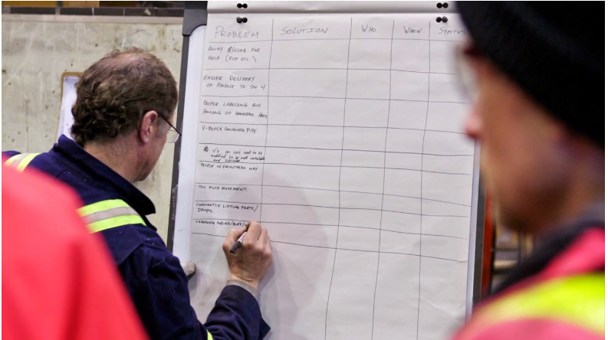
Source:https://uttana.com/blog/kaizen-boards-in-practice/ (Received date 1/9/2022)
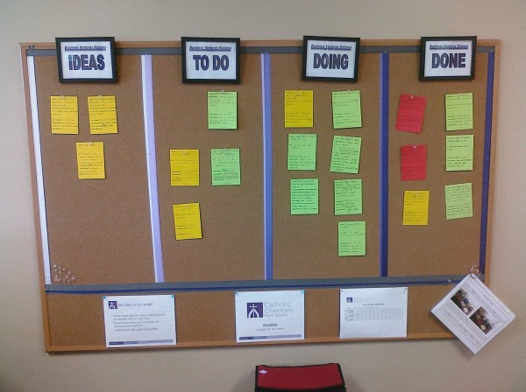
Figure1.3: Examples of a Kaizen board
Prepare Kaizen board
Materials

- Chip wood
- measuring tape
- Sponge
- nails
- hook
- Cloth
- Others
- Markers
- Problem and solution formats
- Plaster
- Papers Pins: green, red, and blue - (red for low performer,
- blue for average performer, and green for best performer)

Self-check 1 | Written test

Name…………………………………………… ID………………………… Date…….
Directions: Answer all the questions listed below.
Test I: Choose the best answer (2 point)
1.________is a description of the specific tasks and activities within an organization
A. Procedures B. Job specificationC. Work instruction
2.______is an official document which describes the duties, required knowledge, skills and abilities, and minimum qualifications of State jobs.
A. Job descriptionB. Job specificationC. Feedback D. None
Test II: Short Answer Questions

List the components of job Specification. (3 points)

Describe work instruction in your own words. (2 points)

Explain the difference between procedure and work instruction? (5 points)

What is 5S? (5 points)

What is Kaizen Board? Explain benefits of Kaizen Board.(5 points)

Operation Sheet -1

1.1. Steps of 5S
- Tools and equipments

- Red tags sticker
- Hook nails
- Shelves chip wood
- Sponge broom
- Pencil shadow board/ tools board
- Paint
- Hook
- Sticker
- Signboard

- Steps

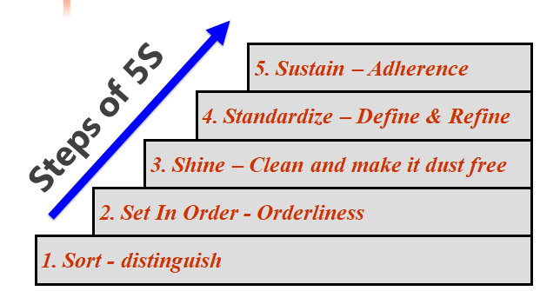

LAP TEST-1 | Performance Test

Name………………………………. ID…………………………….. Date…………………………………….

Time started: ________________________ Time finished: ________________

Instructions: Given necessary templates, tools and materials you are required to perform the following tasks within 3hour. The project is expected from each student to do it.
Task-1: Apply 5S in your laboratory

LG #49 | LO #2- Sort items

Instruction sheet 2
This learning guide is developed to provide you the necessary information regarding the following content coverage and topics:
- Preparing plan
- Following appropriate procedure
- Performing Cleaning activities
- Identifying all items in the workplace
- Checking necessary items regularly in the workplace

This guide will also assist you to attain the learning outcomes stated in the cover page. Specifically, upon completion of this learning guide, you will be able to:
- Prepare plan
- Follow appropriate procedure
- Perform Cleaning activities
- Identify all items in the workplace
- Check necessary items regularly in the workplace
Learning Instructions:
- Read the specific objectives of this Learning Guide.
- Follow the instructions described below.
- Read the information written in the information Sheets 2
- Accomplish the Self-checks 2
- Perform Operation Sheets 2
- Do the “LAP test” 2

Information Sheet 2

Introduction
Definition and concepts of Sort
Sort, the first pillar of 5S, means classifying items in the workplace in to two categories – necessary and unnecessary - and removing all the unnecessary items that are not needed for current operations.
- Clearly distinguishing between what is necessary and what is unnecessary, while disposing of the latter.
- Evaluate all items in the workplace and determine which items are really needed.
- Understand why items are needed.
- Keep only what’s needed.
- Throw out what’s not needed.
Sort
Where?  - Walkways, Floors  - Storage shelves  - Cabinets  - Drawers, Desks  - Walls, Bulletin Boards  - Between Dock Doors  - Around poles  - On and around machine | What?  - Excess materials  - Tools, fixtures, gauges  - Spare parts  - Documents  - Brushes  - Cloths  - Furniture  - Seldom used equipment
Benefits of sort activity
Implementing this first pillar creates a work environment in which space, time, money, energy, and other resources can be managed and used most effectively. Sorting can lead to a much safer workplace. By clearing out the items you no longer need, people will have more room to work and things like trip hazards and items falling off shelves will be greatly reduced. Sorting also improves work flow since there is less clutter to deal with and will most definitely increase productivity in both production and office environments.
- Space, time, money, energy and other resources can be managed and used most effectively
- Problem and hassle in the work flow are reduced.
- Communication between employees is improved.
- Product quality and Productivity is enhanced.
  - Preparing plan
Table2.1:Sort activity plan sheet (sample)
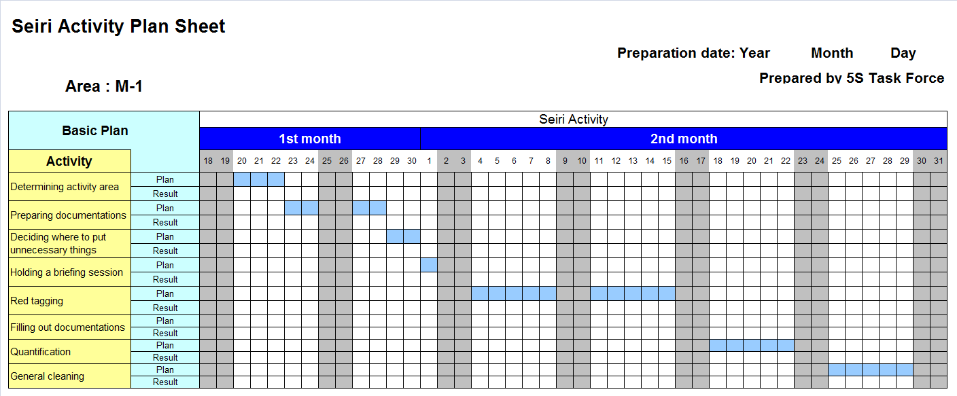
  - Following appropriate procedure
For implementing sort activities, the procedure to be followed must be prepared in written, verbal and computer based or in some other format.

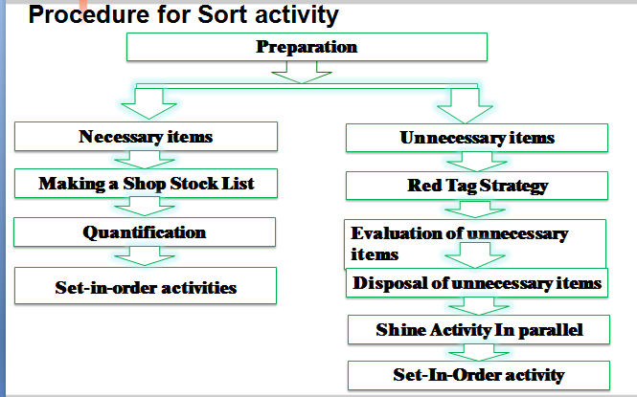
Figure2.1:Procedure sort activity
  - Perform Cleaning activities
- After sorting task, Clean all tools and Equipment used in your organization
- Clean work area regularly
Table2.2:Sample for regular cleaning activity
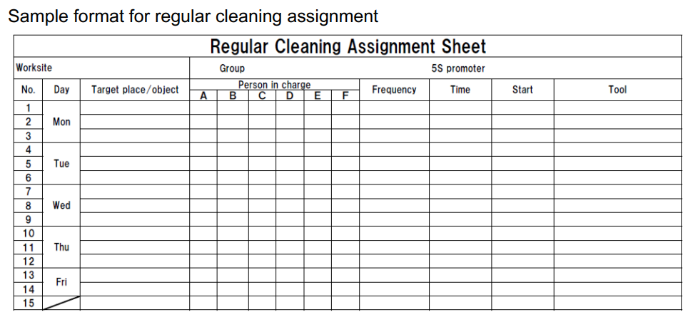

  - Identifying all items in the workplace
List all items at the work place using the following sample format.
Table2.3: sample formatto record Items in the work place
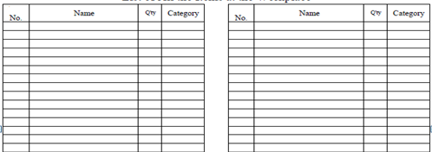
It is not always easy to identify unneeded items in a factory or workshop. Workers seldom know how to separate items needed for current production from unnecessary items. The following procedures will help in implementing sort activity.
    - Listing necessary and unnecessary items
Three main factors determine whether an item is necessary or not. These factors are:
- The usefulness of the item to perform the work at hand. If the item isn’t needed it should be disposed of.
- The frequency with which the item is needed. If it is needed infrequently it can be stored away from the work area.
- The quantity of the item needed to perform this work. If it is needed in limited quantity the excess can be disposed or stored away from the work area
Items May include, but not limited to:

- Tools
- Jigs/Fixtures
- Materials/components
- Machine and equipment
- Manuals
- Documents
- Personal items (e.g. Bags, lunch boxes and posters)
- Safety equipment and personal protective equipment
- Other items which happen to be in the work area

    - Red tag strategy for unnecessary items
Overview of red tagging
The Red-Tag Strategy is a simple method for identifying potentially unneeded items in the factory or workshop, evaluating their usefulness and dealing with them appropriately.
Red-tagging means putting red tags on items in the factory or workshop that need to be evaluated as being necessary or unnecessary. A Red tag is a red colored tag used to identify items no longer needed in a particular work area. The red tags catch people’s attention because red is a colour that stands out. A format prepared with a red color paper or card which is filled and attached temporarily on the unnecessary items until decision is made. The red tag catch people’s attention because red is a color that stands out. So to fill and attach red tag on items, asks the following three questions:
“Red Tagged” Item
An item with red tag is asking three questions;
  - Is this item needed?
  - If it is needed, is it needed in this quantity?
  - If it is needed, does it need to be located here?
Red tag item is subject to;
  - Hold in a “Red Tag Holding Area” for certain time period to see whether they are needed.
  - Disposed of.
  - Relocated.
  - Left exactly where they are.
Red-tag Holding areas
In order to implement the red-tag strategy effectively, a red-tag holding area must be created. A red-tag holding area is an area set aside for use in storing red-tagged items that need further evaluation. Red-tagging is helpful when the need or frequency of need for that item is unknown. When an item is set aside in a red-tag holding area and watched for an agreed-upon period of time people tend to be more ready to let it go when that time is over.
There are two red-tag holding areas: local and central holding areas. Local red-tag holding area is used to manage the flow of red-tagged items with in a local department or production area. Central red-tag holding area is used to manage the flow of items that cannot or should not be disposed of by individual departments or production area. Usually central red-tag holding area is used by an organization that is launching a companywide red-tagging effort.
Red-tag targets
There are two red-tag targets:
- Items: in the manufacturing area items like inventory (warehouse and in-process inventory), equipment, and space are targets for red tags. Warehouse inventory include material, parts, products etc.
- Areas: It is better to define a smaller area and evaluate it well than to define a larger area and not be able to evaluate it fully in available time.
Red-tag criteria
As already mentioned, the most difficult thing about red-tagging is differentiating what is needed from what is not. This issue can be managed by establishing clear-cut criteria for what is needed in particular area and what is not. The most common criterion is the next month’s production schedule.
- Items needed for that schedule are kept in that location.
- Items not needed for the schedule can be disposed of or stored in a separate location.
Three main factors determine whether an item is necessary or not. These factors are:
- The usefulness of the item to perform the work at hand. If the item isn’t needed it should be disposed of.
- The frequency with which the item is needed. If it is needed infrequently it can be stored away from the work area.
- The quantity of the item needed to perform this work. If it is needed in limited quantity the excess can be disposed or stored away from the work area.
- Each company must establish its own red-tagging criteria and each department may customize this standard to meet its local needs.
Making red-tags
Each company has specific needs for documenting and reporting the movement, use, and value of materials, equipment, tools, inventory and products. The company’s red tags should be designed to support this documentation process.
Various types of information on a red tag may include:
- Category: provides a general idea of the type of item (e.g., a warehouse item or machine). Categories include raw materials, in-process inventory, products, equipment, jigs, tools and dies.
- Item name and manufacturing number.
- Quantity: indicates the number of items included under this red tag.
- Reason: describes why a red tag has been attached to this item.
- Division: includes the name of the division responsible for managing the red-tagged item.
- Value: includes the value of the red-tagged item.
- Date: includes the red-tagging date.
Evaluating the red-tagged items
In this the red-tag criteria established are used to evaluate what to do with red-tagged items. Options include:
- Keep the item where it is.
- Move the item to a new location in the work area.
- Store the item away from the work area.
- Hold the item in the local red-tag holding area for evaluation.
- Dispose of the item.
Disposal methods include:

- Throw it away.
- Sell it.
- Return it to the vendor.
- Lend it out.
- Distribute it to a different part of the company.
- Send it to the central red-tag holding
Red Tag Sample
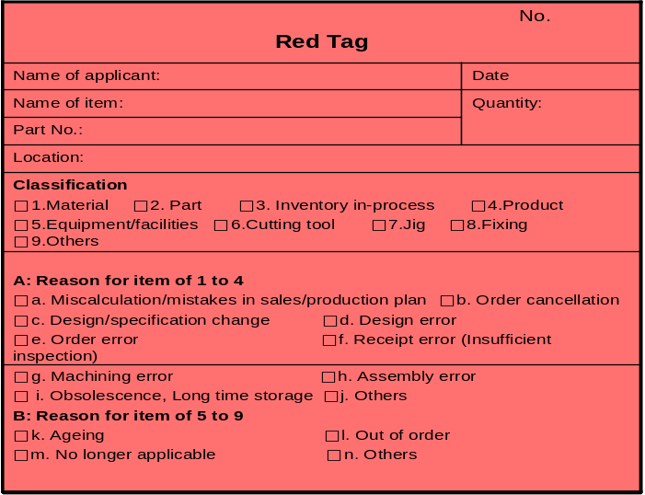
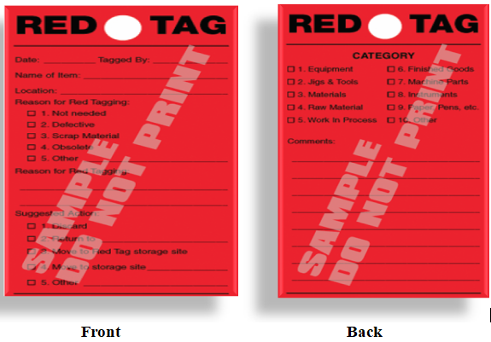

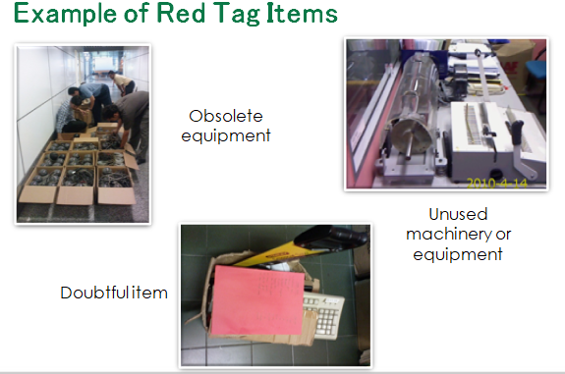
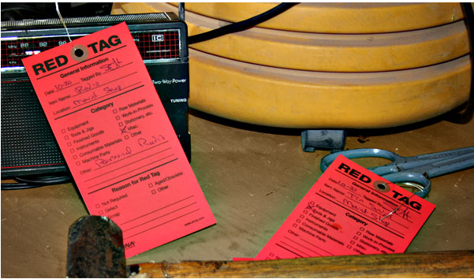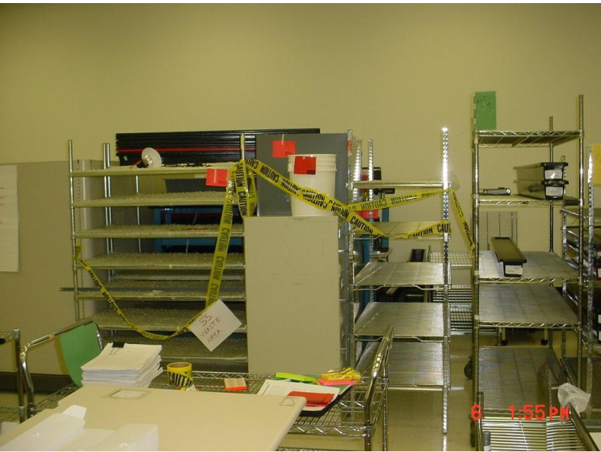
Figure2.2: Examples of Red Tagged Items
    - Placing unnecessary items in an appropriate place
Types of unnecessary items
Unnecessary items are items not needed for current production or administrative operation.
Some of types of unnecessary items are:

- Defective or excess quantities of small parts and inventory
- Outdated or broken jigs and dies
- Worn-out bits
- Outdated or broken tools and inspection gear
- Old rags and other cleaning supplies
- Electrical equipment with broken cords
- Outdated posters, signs, notices and memos
- Some locations where unneeded items tend to accumulate
- In rooms or areas not designated for any particular purpose
- In corners next to entrances or exists
- Along interior and exterior walls
- Next to partitions and behind pillars
- Under the eaves of warehouses
- Under desks and shelves and in desk and cabinet drawers
- Near the bottom of tall stacks of items
- On unused management and production schedule boards
- In tools boxes that are not clearly sorted

Table2.4: Sort-Evaluation of unnecessary items
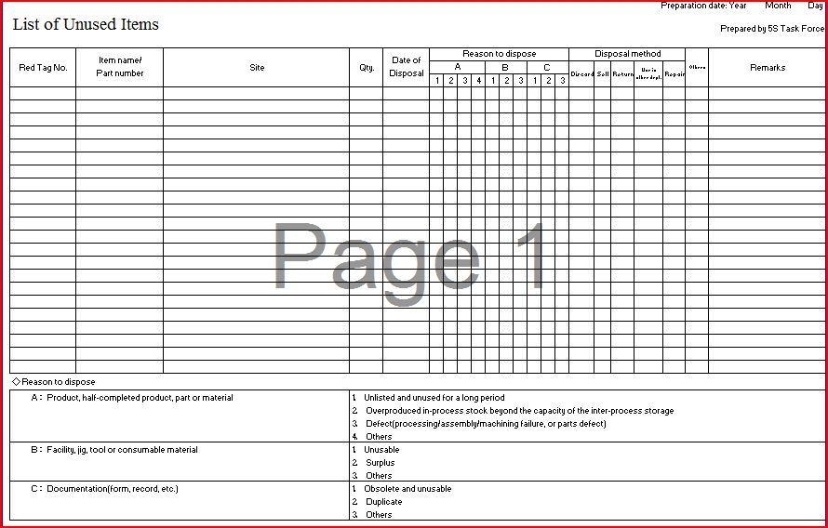
Places where unnecessary items accumulate
Ideally, unnecessary equipment should be removed from areas where daily production activities take place. However, large equipment and equipment or machine attached to the floor may be expensive to move. It is sometimes better to leave this equipment where it is unless it interferes with daily production activities or prevents workshop improvements. Label this unneeded and difficult to move equipment with a “freeze” red tag, which indicates that its use has been “frozen,” but that it will remain in place for the time being.
Some locations where unneeded items tend to accumulate are:
- In rooms or areas not designated for any particular purpose
- In corners next to entrances or exists
- Along interior and exterior walls, next to partitions, and behind pillars.
- Under the eaves of warehouses.
- Under desks and shelves and in desk and cabinet drawers
- Near the bottom of tall stacks of items
- On unused management and production schedule boards
- In tools boxes that are not clearly sorted
    - Recording and quantifying necessary items
Necessary items: are required in the workplace for current production or administrative operation in the amount needed.
The following sample formats can be used to record all necessary and unnecessary items.
Table2.5: A sample format for recording all items at the workplace
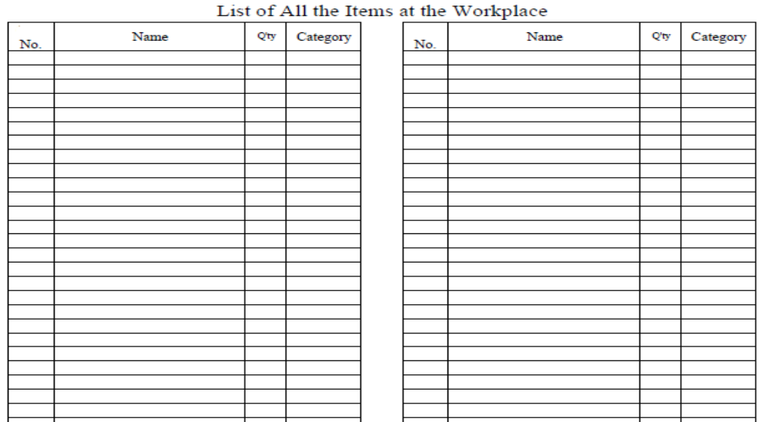
    - Reporting performance results
Reporting quantitative and qualitative results gained by implementing the 1st S – Sort using the following formats.
- Quantitative Results
Record tangible/quantitative results and changes that are achieved by applying Sort activity using the following indicators
Table2.6:A sample format for recordingtangible/quantitative resultsSort activity
No | Improvement Indicators | Before Kaizen | After Kaizen | Improvement % | Remark
1 | Free floor space
2 | Searching time
3 | Transaction made/income
4 | Labour saving
5 | Raw materials saving
6 | Frequency of machine failure
7 | Production volume/day
8 | Delivery time
9 | Defect rate
10 | Minimized costs
Qualitative Results
Record intangible/qualitative results and changes that are achieved by applying Sort activity using the following indicators.
Table2.7:A sample format for recording intangible/qualitative results of Sort activity
No | Improvement indicators | Description of results
1. | Knowledge gained
2 | Team work
3 | Morale of the workers
4 | Communication between workers by removing unnecessary items
5 | Relationship with customers
6 | Awareness of safety
  - Checking necessary items regularly in the workplace
At this stage we are requested to undertake the regular supervision of the work place in order to the checking the necessary items.

Self-check 2 | Written test

Name…………………………………………… ID………………………… Date…….
Directions: Answer all the questions listed below.
Test I: Short Answer Questions
- What are the benefits of implementing sort activity? (4 points)
- What problems occur in a workshop if sort activity is not implemented? (6 points)
- What are the reasons for the accumulation of unnecessary items in a workshop? (3 points)
- What is red-tagging strategy? (3 points)
- What are red-tag holding areas and explain the types? (4 points)
- List at least seven items that are considered as unnecessary. (7 points)
- Name places where unnecessary items are accumulated? (6 points)

Operation Sheet -2

2.1. Procedure of Sort activity
- Tools and equipments
- red tags sticker
- hook nails
- shelves chip wood
- sponge broom
- pencil shadow board/ tools board
- Formats (for recording necessaryand unnecessary items, plans etc…)
- Procedure for Sort activity
Step 1- Evaluate and take pictures of the work area. It’s extremely important to take pictures during this evaluation step since referencing them after improvements have been made can be very enlightening. To help you get started use also a 5S evaluation form.
Step 2 - Identify and red tag the items you no longer need.
Step 3 - Decide what to do with the tagged items.
2.2. Steps/procedures in Red tagging
Step 1: Launch the red-tag project
Step 2: Identify red-tag targets
Step 3: Set red-tag criteria
Step 4: Make red-tags
Step 5: Attach the red tags
Step 6: Evaluate the red-tagged items
Step 7: Document the results of red-tagging

LAP TEST-2 | Performance Test

Name………………………………. ID…………………………….. Date…………………………………….

Time started: ________________________ Time finished: ________________

Instructions: Given necessary templates, tools and materials you are required to perform the following tasks within 4hour. The project is expected from each student to do it.
Task-1: Implement Sort activity by following appropriate procedures
Task-2: Perform Red tagging

LG #50 | LO #3- Set all items in order

Instruction sheet 3
This learning guide is developed to provide you the necessary information regarding the following content coverage and topics:
- Preparing plan
- Performing general cleaning activities
- Deciding location/layout, storage and indication methods
- Preparing and using tools and equipment for setting in order activities
- Placing items in their assigned locations
- Returning the items to their assigned locations after use
- Reporting performance results using formats
- Checking each item regularly in its assigned location and order

This guide will also assist you to attain the learning outcomes stated in the cover page. Specifically, upon completion of this learning guide, you will be able to:
- Prepare plan
- Perform general cleaning activities
- Decide location/layout, storage and indication methods
- Prepare and use tools and equipment for setting in order activities
- Place items in their assigned locations
- Return the items to their assigned locations after use
- Report performance results using formats
- Check each item regularly in its assigned location and order
Learning Instructions:
- Read the specific objectives of this Learning Guide.
- Follow the instructions described below.
- Read the information written in the information Sheets 3
- Accomplish the Self-checks 3
- Perform Operation Sheets 3
- Do the “LAP test” 3

Information Sheet 3
Introduction
Definition and concepts of Set in Order
- Set in Order: - Set in order means arranging necessary items so that they are easy to use and labeling them so that anyone can find them and put them away. The key word in this definition is “anyone”.
- Set in order can be implemented only when the first pillar- sort is done first. No matter how well you arrange items, set in order can have little impact if many of the items are unnecessary and not sorted. Similarly, if sorting is implemented without setting in order, it is much less effective.
- Where necessary items should be placed should be made clear for anyone to immediately find them and return them easily. Hence, Sort and Set in order work best, when they are implemented together.
- Arrange needed items so;
  - It is easy to use.
  - Label them so that anyone can find them easily and put them again.
- Set-in-order is important because it eliminates;
  - Time spent searching for an item
  - Motion wastes
  - Difficulty returning item to its original place
  - Excess inventory
  - Reduce damage
  - Hazards and injuries
Benefits of set in order
Setting in order is important because it eliminates many kinds of waste from operations in a workplace. These include searching time waste, waste due to difficulty in using items, and waste due to difficulty in returning items. In general, the following problems and wastes are avoided when set in order is well implemented.
- Motion wastes
- Searching time wastes
- The waste of human energy
- The waste of excess inventory
- The waste of defective products
- The waste of unsafe conditions
The set in order step is actually at the core of so many important business principles such as safety, ergonomics, quality, inventory control, productivity, standard work, the visual workplace and employee morale. Also it is the core of standardization. This is because the workplace must be organized before any type of standardization can be implemented effectively. Standardization means creating a consistent way of doing or carrying out tasks. When we think of standardization, we have to think about anyone. For example, machinery standardization means anyone can operate the machinery. Also if we have operation standardization this means anyone can perform the operation.
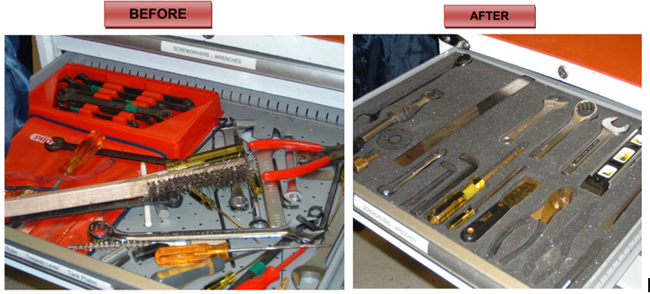
Figure3.1: Examples of set in order

- Preparing plan
Table3.1: Sample plan sheet for implementing set in order
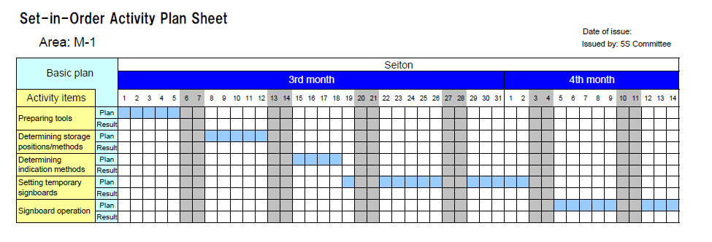
- Performing general cleaning activities
- Prepare materials needed for cleaning
- Regularly clean dust, solid waste from materials and tools before setting in order.
- Clean place prepared for setting in order.
- Properly drying after cleaning
- Lubrication and Replacing missing parts
- Deciding location/layout, storage and indication methods
There are some principles for deciding best locations for tools and equipments. Jigs, tools and dies differ from materials, equipments, machinery and parts in that they must be put back after each use. Some of the principles for jigs, tools and dies also apply to parts, equipments, and machinery. These are:
- Locate items in the workplace according to their frequency of use. Place frequently used items near the place of use. Store infrequently used items away from the place of use.
- Store items together if they are used together, and store them in sequence in which they are used.
- Device a “just let go” arrangement for tools. This approach involves suspending tools from a retractable cord just within reach so that they will automatically go back in to their correct storage position when released.
- Make storage places larger than the items stored there so that they are physically easy to remove and put back.
- Eliminate the variety of jigs, tools and dies needed by creating a few jigs, tools and dies that serve multiple functions.
- Store tools according to function or product. Function-based storage means storing tools together when they have similar functions. This works best for job-shop production. Product-based storage means storing tools together when they are used on the same product. This works best for repetitive production.
There are principles helpful in deciding the best locations for parts, equipments, and machinery, as well as tools by removing motion wastes. Motion wastes are unnecessary movements created when people move their trunks, feet, arms, and hands more than needed to perform a given operation. These wastes lead to waste of time, energy and effort. These motion wastes can be minimized by locating parts, equipments, and machinery in the best locations possible. More important than removing motion wastes is asking why it occurs. By asking ‘why’ we can find the methods of manufacturing that work and approach the zero-waste mark. Eliminating the unnecessary motions from existing operations is called Motion improvement. And finding ways to eliminate the whole operations to remove the wastes is called Radical improvement.
The principles that are helpful to eliminate or reduce motions that operators make are:
Principle 1: Start and end each motion with both hands moving at once.
Principle 2: Both arms should move symmetrically and in opposite directions.
Principle 3: Keep trunk motions to a minimum.
Principle 4: Use gravity instead of muscle.
Principle 5: Avoid zigzagging motions and sudden changes in direction.
Principle 6: Move with a steady rhythm.
Principle 7: Maintain a comfortable posture with comfortable motions.
Principle 8: Use the feet to operate on and off switches for machines where practical.
Principle 9: Keep materials and tools close and in front.
Principle 10: Arrange materials and tools in the order of their use.
Principle 11: Use inexpensive methods for feeding in and sending out materials.
Principle 12: Stand at a proper height for the work to be done.
Principle 13: Make materials and parts easy to pick up.
Principle 14: Make handles and grips in efficient, easy-to-use shapes and positions.
Improving the layout of parts
The following figure shows an improvement in how plastic packaging sheets are used. The sheets are moved from a rack behind the operator to a hook in front of the operator and above the production line. This improvement eliminates four seconds of motion waste from each unit of packing work.

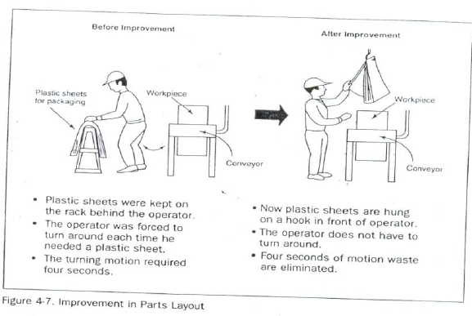
Figure3.2: Improvement in parts layout
Set in order strategies
Once best locations have been decided, it is necessary to mark these locations so that everyone knows what goes where, and how many of each item belongs in each location. There are several strategies for marking or showing what, where and how many.
  - Motion Economy strategy
Following the principles explained in the above, we can remove motion waste from existing operation. By using human body appropriately, by organizing the workplace and by redesigning of tools and equipments, we can minimize motion waste.
  - Visual control Strategy
A visual control is any communication device used in the work environment that tells us at a glance how work should be done. There are several strategies for setting in order items so that to easily identify what, where and how many (visual control). These visual control strategies are discussed in the next contents.Common visual control techniques;
  - Signboard strategy
  - Painting strategy
  - Color-code strategy
  - Outlining strategy
  - Visual Management Board (Kaizen board) Strategy
- Signboard strategy: uses signboards to identify what, where, and how many. The three main types of signboards are:
- Location indicators that show where items go.
- Item indicators that show what specific items go in those places.
- Amount indicators that show how many of these items belong there.
Signboards are often used to identify:
- Names of work areas
- Inventory locations
- Equipment storage locations
- Standard procedures
- Machine layout
For example, in order to identify inventory stored on shelves in a warehouse, a whole system of signboards may be used. Every section of shelving may have a signboard identifying the section. Within that section, vertical and horizontal addresses on shelves can be identified with additional signboard. Each item stored on the shelve may also have a signboard showing the “return address” for that item. The “return address” allows the item to be put back in the proper location once it has been removed.
- Painting strategy
Painting strategyis a method for identifying locations on floors and walkways. It is called the Painting strategy because paint is the material generally used. But also plastic tape, cut in to any length, can be used. Plastic tape, although more expensive, shows up just as clearly as paint and can be removed if the layout is changed.
The painting strategy is used to divide the factory’s or workshop’s walking areas (walkways) from the working areas (operation areas). When putting lines to divide walkways from operation areas, the following factors should be considered:
- U-shaped cell designs are generally efficient that straight production lines.
- In-process inventory should be positioned carefully for best production flow.
- Floors should be levelled or repaired before we put lines.
- Walkways should be wide enough to avoid twists and turns and for safety and a smooth flow of goods.
- The dividing lines should be between 2 and 4 inches in width.
- Paint colors should be standardized. For example
- operation areas are painted by green;
- walkways are fluorescent orange or red;
- Lines that divide the walkways from operation areas are yellow in color.
Dividing lines can be used to show:
- Cart storage locations,
- Aisle directions,
- Door range, to show which way a door swings open,
- For worktables,
- Tiger marks, to show areas where inventory and equipment should not be placed, or to show hazardous areas.
- Color-code strategy
Color-code strategy is used to show clearly which parts, tools, jigs and dies are to be used for which purpose. For example, if certain parts are to be used to make a particular product, they can all be color-coded with the same color and even stored in a location that is painted with that color. Similarly, as shown the picture in below, if different types of lubricants are to be used on different parts of a machine, the supply containers, oil cans, and machine parts can be color-coded to show what is used where.
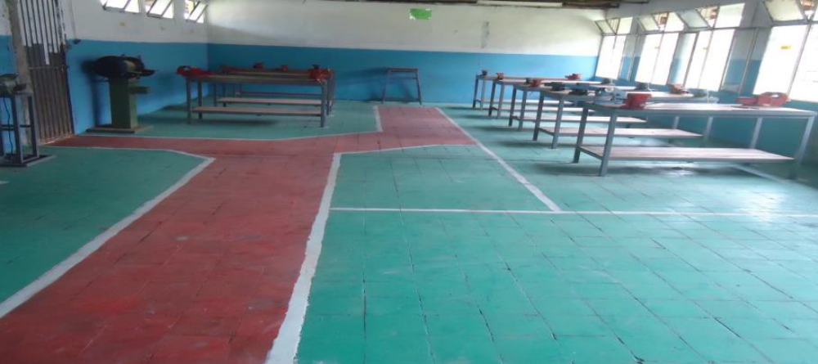

Figure3.3:Color-coding
- Outlining strategy
Outlining strategy is used to show which jigs and tools are stored where. Outlining simply means drawing outlines of jigs and tools in their proper storage positions. When you want to return a tool, the outline provides an additional indication of where it belongs.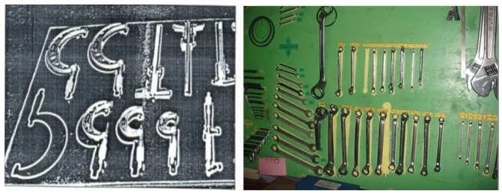
Figure3.4:Outlining of tools to show their locations
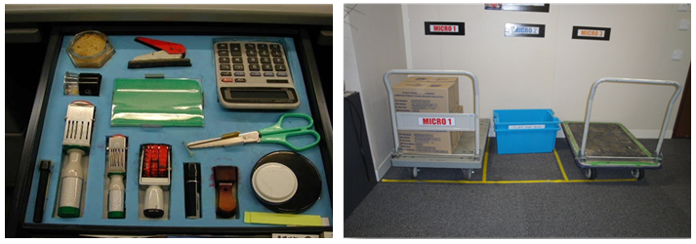
Figure3.5:Outlining of tools and equipments to show their locations
- Preparing and using tools and equipment for setting in order activities
Tools and materials used to implement set in order
The following are some tools and materials used to implement the second pillar of 5S-Set in order.
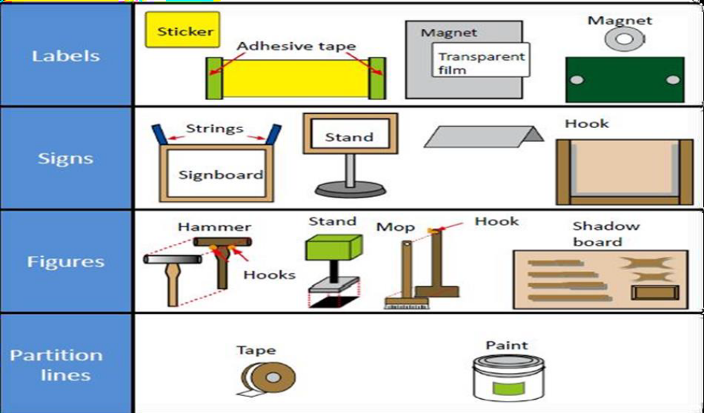

- Placing items in their assigned locations
- After you prepare layout, storage place, signboard, you have to Place all items on designed location according to their specification.
- Returning the items to their assigned locations after use
Each item stored on the shelve have a signboard showing the “return address” for that item. The “return address” allows the item to be put back in the proper location once it has been removed.
Self-check 3 | Written test

Name…………………………………………… ID………………………… Date…….
Directions: Answer all the questions listed below.
Test I: Short Answer Questions

What are the strategies for implementing set in order? (3 points)

What factors should we follow when applying the painting strategy? (6 points)

What are the three standardized colors used for dividing and marking walkways and operation areas? (3 points)

Operation Sheet -3

3.1. Techniques/Procedures/ for implementing set in order
- Tools and materials
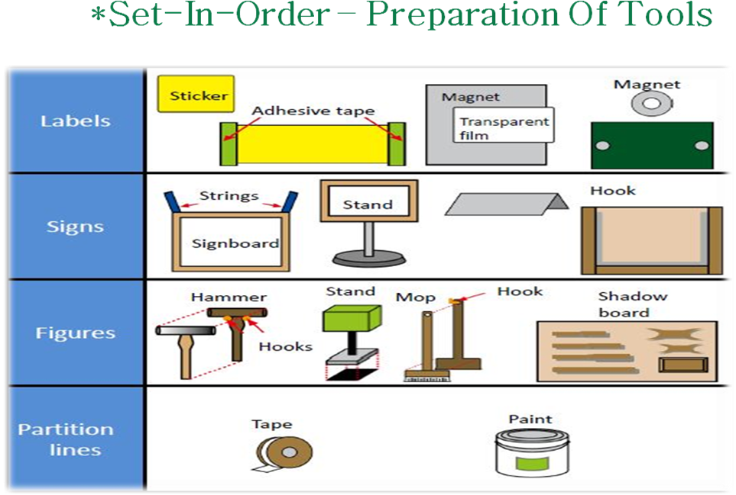
- Procedure for Set-In-Order Activity
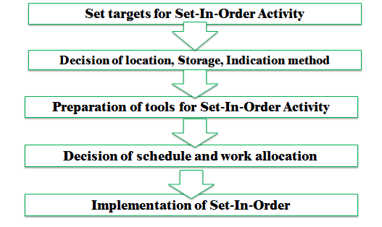
LAP TEST-3 | Performance Test

Name………………………………. ID…………………………….. Date…………………………………….

Time started: ________________________ Time finished: ________________

Instructions: Given necessary templates, tools and materials you are required to perform the following tasks within 2hour. The project is expected from each student to do it.
Task-1: Following the procedures of set in order, perform set in order in the assigned workshop.

LG #51 | LO #4- Perform shine activities

Instruction sheet 4
This learning guide is developed to provide you the necessary information regarding the following content coverage and topics:
- Preparing plan
- Tools and equipment for shinning activities
- Implementing Shine activity
- Reporting performance results
- Conducting regular shining activities

This guide will also assist you to attain the learning outcomes stated in the cover page. Specifically, upon completion of this learning guide, you will be able to:
- Prepare plan
- Prepare Tools and equipment for shinning activities
- Implement Shine activity
- Report performance results
- Conduct regular shining activities
Learning Instructions:
- Read the specific objectives of this Learning Guide.
- Follow the instructions described below.
- Read the information written in the information Sheets 4
- Accomplish the Self-checks 4
- Perform Operation Sheets 4
- Do the “LAP test” 4

Information Sheet 4

Introduction
Definition and concepts of Shine
What is Shine?
- Shine means keep everything clean.
When we shine, we can’t avoid inspecting the item at the same time. Therefore Shine and Inspect come together. Shine also includes saving labor by finding ways to prevent dirt, dust, and debris from piling up in the workshop. Shine should be integrated in to daily maintenance tasks to combine cleaning checkpoints with maintenance checkpoints.
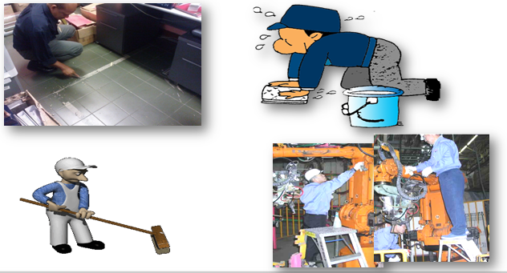
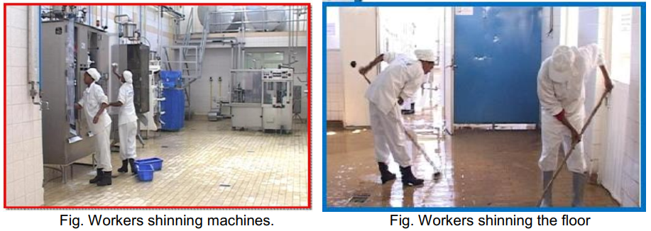
Figure4.1: some examples of shinning
Benefits from Shine
- Clean and comfortable workplace.
- Increase visibility to defects when it occurs.
- Helps to maintain safer workplace.
- Good working environment increase morale.
- Early detection of machinery and equipment failure.
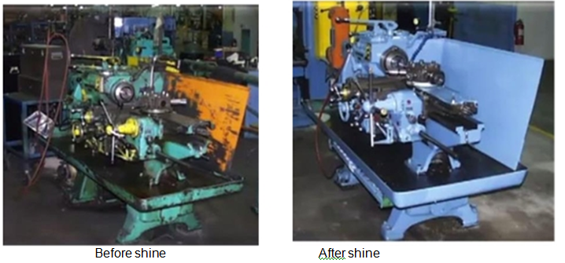
Figure4.2: Benefits of shinning
- Preparing plan
Shine activities should be taught as a set of steps and rules that employees learn to maintain with discipline. The following sample format can be used to prepare a plan for implementing shine activities.
Table4.1: Shine activity plan sheet (sample)
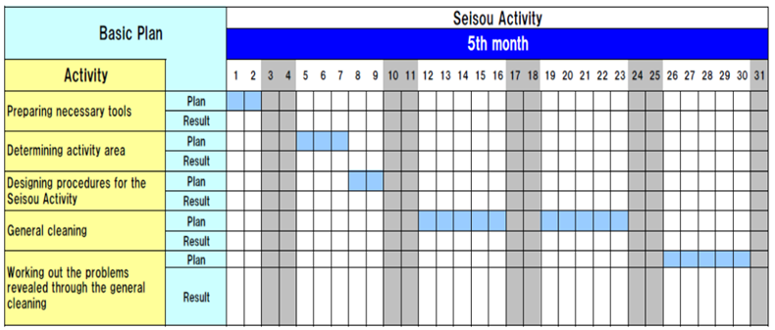
- Tools and equipment for shinning activities
Tools and materials used to implement shine
The following are some tools and materials used to implement the third pillar of 5S-Shine.
● Sponge oil
● Broom detergent s
● Brush spade
● Vacuum cleaner bolts
● Garbage containers floor scrubber cleaning Pads
● Screws etc…


Figure 4.3:Tools and equipment for shinning activities
- Implementing Shine activity
Implementing measures to eliminate the sources of dirt and smudges and ensure cleanliness with minimal effort.
Shine activity May include, but not limited to:
- Inspection
- Cleaning
- Minor maintenance May include, but not limited to:
- Tightening bolts
- Lubrication and Replacing missing parts
Determine shine assignments
- Who is responsible
- Which area
- Which days and time allocate
Table 4.2: Examples of shine schedule
Type of cleaning | Time | Frequency (timing) | Responsibility
Daily cleaning | 5 – 10 min. | Minor operation before/after working hour at each shop | Team A, Team B
Weekly cleaning | 15 – 30 min. | Weekend | Mr. X and Mr. Y
Monthly cleaning | 30 – 60 min. | End of month | All employee
General cleaning several times a year | 2 – 4 hrs. | Before consecutive holidays | All employee
Location which is not easy to clean | 1 – 2 days | In case of necessity for assistance request to other division | Team C
Shine target areas
Shine target areas are grouped in to three categories: warehouse item, equipmentsand space. Warehouse items include raw materials, procured subcontracted parts,parts made in-house, and assembly components, semi-finished and finished products.Equipment includes machines, welding tools, cutting tools, conveyance tools, generaltools, measuring instruments, dies, wheels and casters, worktables, cabinets, desks,chairs and spare equipment. Space refers to floors, work areas, walkways, walls,pillars, ceilings, windows, shelves, closets, rooms and lights.
Shine Assignments
Workplace cleanliness is the responsibility of everyone who works there. Each employee should be assigned specific area to clean. To do these two methods can be used: A 5S Assignment Map – shows all the target areas for shine activity and who is responsible for cleaning them.
A 5Sschedule – shows in detail who is responsible for cleaning which areason which days and times of the day. Then this schedule should be posted in the work area.
Example 1
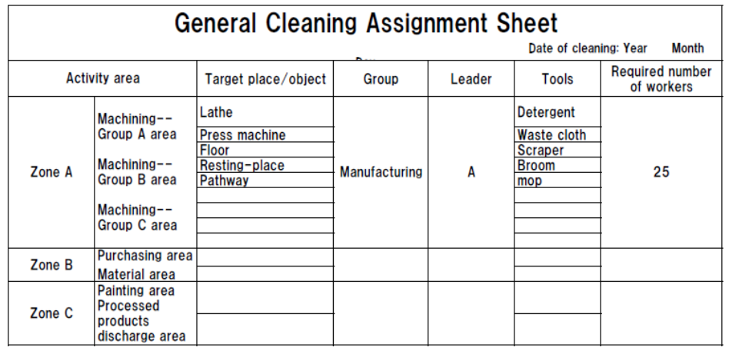
Example 2
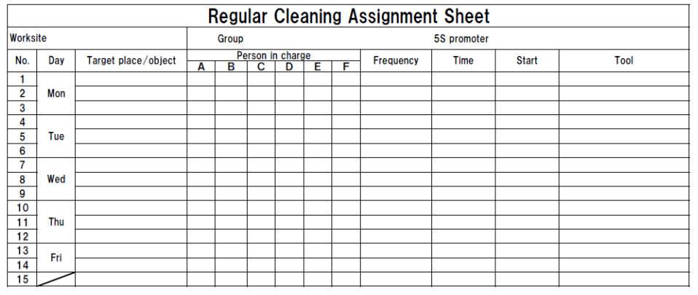Shine methods
Shine activities should be a natural part of the daily work. Shine activities and inspection should be done before a shift starts, during work time and at the end of the shift.

Determining shine methods include:
- Choosing targets and tools– define what will be cleaned in each area and what supplies and equipments will be used.
- Performing the five-minute shine– cleaning should be practiced daily and should not require a lot of time.
- Creating standards for shine procedures– people need to know whatprocedures to follow in order to use their time efficiently. Otherwise, they are likely to spend most of their time getting ready to clean.
When implementing the shine procedures, consider the following suggestions:
- Be sure to sweep dirt from floor cracks, wall corners, and around pillars.
- Wipe off dust and dirt from walls, windows, and doors.
- Be thorough about cleaning dirt, scraps, oil, dust, rust, cutting shavings, sand, paint, and other foreign matter from all surfaces.
- Use cleaning detergents when sweeping is not enough to remove dirt.
Inspection
it is natural to do a certain amount of inspection whileimplementing shine activities. Once daily cleaning and periodic major cleanupsbecome a habit, we can start incorporating systematic inspection procedures in to theshine procedures. Even when equipment in the workplace appears to functionnormally, it may be developing many problems. Always when machines or otherequipment begin to show sign of minor, sporadic malfunctions, the operators not themaintenance people notice it first. Therefore, it is important to consider the operatorsinformation about the equipment.
The following types of equipment problems frequently exist in factories:
1. Oil leaks from the equipment on to the floor.
2. Machines are so dirty that operators avoid touching them.
3. Gauge displays and other indicators are too dirty to be read.
4. Nuts and bolts are either loose or missing.
5. Motors overheat.
6. Sparks flare from power cords.
7. V-belts are loose or broken.
8. Some machines make strange noises.
Daily cleaning or inspection can help to find these problems and solve them.

Self-check 4 | Written test

Name…………………………………………… ID………………………… Date…….
Directions: Answer all the questions listed below.
Test I: Choose the best answer (2 point)
1. From the following which is not Benefits from Shine?
A. Clean and comfortable workplace C. Helps to maintain safer workplace
B. Increase defects D. Early detection of machinery and equipment failure
Test II: Short Answer Questions (6 point)
- Explain benefits of shinning
- List and Discuss Shining activity

Operation Sheet -4
4.1. Techniques/Procedures/ for implementing shine
A. Tools and materials for implementing shine

- sponge
- broom
- detergent s
- brush
- spade
- vacuum cleaner
- oil
- bolts
- garbage containers
- floor scrubber
- cleaning Pads
- screws etc…
- Procedures
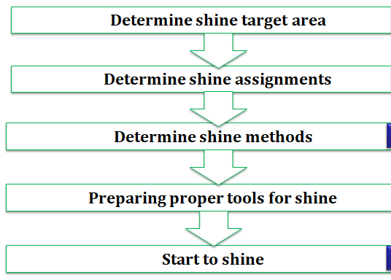

LAP TEST-4 | Performance Test

Name………………………………. ID…………………………….. Date…………………………………….

Time started: ________________________ Time finished: ________________

Instructions: Given necessary templates, tools and materials you are required to perform the following tasks within 3 hour. The project is expected from each student to do it.
Task-1: Implement shining activities

LG #52 | LO #5- Standardize 5S

Instruction sheet 5
This learning guide is developed to provide you the necessary information regarding the following content coverage and topics:
- Planning to standardize 5S activities
- Tools and techniques to standardize 5S based on relevant procedures
- Following checklists and reporting to relevant personnel
- Keeping the workplace to the specified standard
- Avoiding problems by standardizing activities

This guide will also assist you to attain the learning outcomes stated in the cover page. Specifically, upon completion of this learning guide, you will be able to:
- Plan to standardize 5S activities
- Prepare tools and techniques to standardize 5S based on relevant procedures
- Follow checklists and report to relevant personnel
- Keep the workplace to the specified standard
- Avoid problems by standardizing activities
Learning Instructions:
- Read the specific objectives of this Learning Guide.
- Follow the instructions described below.
- Read the information written in the information Sheets 5
- Accomplish the Self-checks 5
- Perform Operation Sheets 5
- Do the “LAP test” 5

Information Sheet 5

Introduction
What is Standardize?
- Standardize is the method you use to maintain the first three pillars (Sort, Set in order and Shine). Cleaning and identification methodsare consistently applied.
- Make it a rule to perform given work in the given manner.
- Standardize is different from the first three pillars because it is a method used to sustain the first three pillars rather than housekeeping activity.
- Standardize means to set up rules for Sort, Set-in-order and Shine Activities
- It is all about
“Make up the rules and follow them!”
Benefits from Standardize
1. Lead to workplace standardization
  - prevent setbacks in the first three pillars
  - Make implementing them a daily habit
  - Ensure that all the three pillars are maintained in their fully implemented state.
2. Lead to work standardization
  - Muda elimination
  - Quality improvements
  - Cost reduction
  - Delivery time improvements
  - Process improvements
- Tools and techniques to standardize 5S based on relevant procedures
Standards for Sort
- Red Tag Rules
  - When to Red Tag
  - How to Red Tag
  - What’s go on the Red Tag
  - more…
- Rules for the Red Tag Holding Area
  - When to clear out
  - How to dispose of items
  - more…
Standards for Set-in-order
- Which items
- Where
- How many
- Who replenishes
- Return all items…
- What to do when items are missing
- Visual standards – signs, lines, labels and color codingmore…
Standards for Shine
- Clean and Inspect (C&I)
- Show the task, person responsible, itemsneeded, frequency, desired workplace
- Where to keep cleaning supplies, how to replenish when finished more…
Tools and techniques to standardize 5S May include, but not limited to:

- 5S Job Cycle Charts
- Visual 5S
- The Five Minute 5S
- Standardization level checklist
- 5S checklist
- The five Whys and one How approach(5W1H)
- Suspension
- Incorporation and Use Elimination
- 5S slogans
- 5S posters
- 5S photo exhibits and storyboards
- 5S newsletter
- 5S maps
- 5S pocket manuals
- 5S department/benchmarking tours
- 5S months
- 5S audit
- Awarding system
- Big cleaning day

- Patrolling system May include, but not limited to:
- Top management Patrol
- 5S Committee members and Promotion office Patrol
- Mutual patrol
- Self-patrol
- Checklist and Camera patrols
- Following checklists and reporting to relevant personnel
Relevant procedures May include, but not limited to:
- Assign 5S responsibilities
- Integrate 5S duties into regular work duties
- Check on 5S maintenance level
- OHS measures such as signage, symbols / coding and labeling of workplace and equipment
- Creating conditions to sustain your plans
- Roles in implementation
- Keeping the workplace to the specified standard
Tools for Standardizing
Once you’ve made decisions on how to change your work practices, those decisions need to be communicated to workers. This communication is a key part of the Standardize step. Common tools for this process include:
- 5S checklists – Listing the individual steps of a process makes it easy for workers to follow that process completely. It also provides a simple auditing tool to check progress later on.
- Job cycle charts – Identify each task to be performed in a work area, and decide on a schedule or frequency for each of those tasks. Then, assign responsibility to a particular worker (or job duty). The resulting chart can be posted visibly to resolve questions and promote accountability.
- Procedure labels and signs – Provide operating instructions, cleaning steps, and preventative maintenance procedures right where that information will be needed.

Self-check 5 | Written test

Name…………………………………………… ID………………………… Date…….
Directions: Answer all the questions listed below.
Test I: Short Answer Questions (6points)
- Benefits from Standardize
- List tools for standardizing
- What is Standardize?

Operation Sheet -5

5.1. Steps to Implement Standardize
Step 1: Decide who is responsible for which activities with regard to maintaining 3S conditions.
Step 2: Integrate 3S maintenance duties in to regular work activities.
Step 3: Check on how well 3S conditions are being maintained.
Step 4.Periodic evaluation

LAP TEST-5 | Performance Test

Name………………………………. ID…………………………….. Date…………………………………….

Time started: ________________________ Time finished: ________________

Instructions: Given necessary templates, tools and materials you are required to perform the following tasks within 3hour. The project is expected from each student to do it.
Task-1: Implement Standardize activities

LG #53 | LO #6- Sustain 5S

Instruction sheet 6
This learning guide is developed to provide you the necessary information regarding the following content coverage and topics:
- Preparing plan
- Tools and techniques to sustain 5S
- Inspecting workplace for compliance to specified standard
- Cleaning up workplace after and before completion
- Identifying situations where compliance to standards is unlike
- Recommending improvements to lift the level of compliance in the workplace
- Following Checklists to sustain and reporting activities to relevant personnel
- Avoiding problems by sustaining activities

This guide will also assist you to attain the learning outcomes stated in the cover page. Specifically, upon completion of this learning guide, you will be able to:
- Prepare plan
- Prepare tools and techniques to sustain 5S
- Inspect workplace for compliance to specified standard
- Clean up workplace after and before completion
- Identify situations where compliance to standards is unlike
- Recommend improvements to lift the level of compliance in the workplace
- Follow checklists to sustain and reporting activities to relevant personnel
- Avoid problems by sustaining activities
Learning Instructions:
- Read the specific objectives of this Learning Guide.
- Follow the instructions described below.
- Read the information written in the information Sheets 6
- Accomplish the Self-checks 6
- Perform Operation Sheets 6
- Do the “LAP test” 6

Information Sheet 6

Introduction
What is Sustain?
The fifth pillar is Sustain. In the context of the five pillars, to sustain means to make a
habit of properly maintaining correct procedures. In your life in general, what do you
mean when you talk about sustaining something? Usually, you think of it as drawing
on something from inside yourself in order to maintain a course of action-even when
forces in your life challenge in this effort.
Why Sustain Is Important
Usually you commit yourself to sustain a particular course of action because the rewards for keeping to the course of action are greater than the rewards for departing from it (see figure above). Viewed another way, the consequences of not keeping to the course of action may be greater than the consequences of keeping to it. For example, suppose you want to start an exercise program –say you decide you want to work out at a gym three times a week. You probably have difficulty sustaining this course of action. This is because forces in your life, such as limits on your time and energy as well as the power of inertia, challenge this plan. However, if the rewards of sticking to your exercise program (for example, feeling and looking better) are greater than the rewards of not sticking to it (for example, having more time for other things that you need to do), your commitment will increase and you will probably sustain this program over time.
- Tools and techniques to sustain 5S
There are many tools and techniques your company can use to help sustain commitment to 5S implementation. We offer these below so you will be aware of them. At some point in your 5S implementation work, you may be called upon to use or even coordinate the use of these techniques.
Common Tools and techniques to sustain 5s are:
There are many tools and techniques your company can use to help sustaincommitment to 5S implementation. We offer these below so you will be aware ofthem. At some point in your 5S implementation work, you may be called upon to useor even coordinate the use of these techniques.
These are:
•5S slogans
•5S posters
•5S photo exhibits & storyboards
•5S newsletter
•5S maps
•5S pocket manuals
•5S department/benchmarking tours
•5S months
•5S audit
•Awarding system
•Big cleaning day
- Patrolling system
- Top management Patrol
- 5S Committee members and Promotion office Patrol
- Mutual patrol
- Self patrol
- Checklist patrol
- Camera patrol
5S Slogans
5S Slogans communicate the themes of the five pillar campaign in your company.They are most effective when they are suggested by you and your coworkers. Theycan be displayed on buttons, stickers, flags, or posters.It encourages all the participants.
Samples of slogan
“Refresh yourself and workplaces by 5S activity.”
“Let's maintain current 5S activity and KAIZEN for tomorrow”
“We polish “Our Minds” as well as our factories”
5S Posters
Posters displaying 5S Slogans or descriptions of 5S activities can be posted
throughout the workplace. They can serve to remind everyone of the importance of
the five pillars, or to communicate the results or status of 5S activities.

Samples of poster
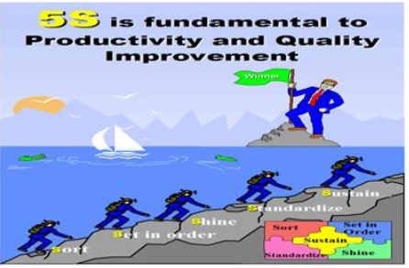
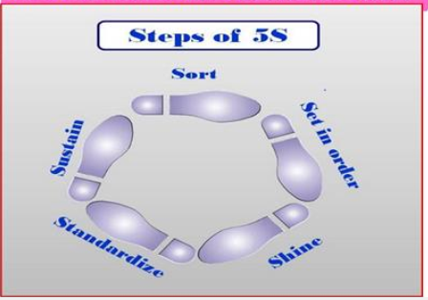
Figure 6.1:Samples of posters
5S Photo Exhibits and Storyboards
When it comes to communication about 5S implementation, the old saying that a"picture is worth a thousand words" is definitely true. Photo Exhibits and Story boardsshowing the before and after of 5S implementation activities are powerful tools forpromoting the five pillars. Photos and Storyboards can also communicate the statusof five pillar activities.

5S Newsletter
55 Newsletters are in-house news bulletins centered on five pillar topics. They carryfactory reports on 5S conditions and activities. 5S Newsletters are most effectivewhen issued on a regular basis, perhaps once or twice a month and at staff meetings.
55 Maps5S Maps can also be used to get employees involved in five pillar improvement on anongoing basis. 5S improvement Maps should be hung in a central location withsuggestion cards attached so anyone can suggest improvements.

55 Pocket Manuals
A 5S Pocket Manual can be created that contains five pillar definitions anddescriptions, and is small enough to fit into the pocket of work clothes. Shop floorworkers, supervisors, and managers can all use SS Pocket Manuals for easyreference to the 5S essentials.
55 Department Tours
When one department in a company has implemented the five pillars successfully, itcan serve as a model area for other departments to come visit. Since "seeing believes," this technique is extremely effective for promoting 5S implementationthroughout a company.

55 Months
Companies should designate two, three, or four months every year as "5S Months.” During these months, various activities such as 5S seminars, field trips, and contests can be carried out of further promote 5S implementation in the company.
- Following Checklists to sustain and reporting activities to relevant personnel
Reporting May include, but not limited to:
- Verbal responses
- Data entry into enterprise database
- Brief written reports using enterprise report formats

Relevant personnelMay include, but not limited to:
- Supervisors, managers and quality managers
- Administrative, laboratory and production personnel
- Internal/external contractors, customers and suppliers
- Avoiding problems by sustaining activities
Problems Avoided by Implementing Sustain
Here are some of the things that happen in a company when Commitment to the five pillars is not sustained.
1. Unneeded items begin piling up as soon as sorting is completed
2. No matter how well Set in Order is planned and implemented, tools and jigs donot get returned to their designated place after use.
3. No matter how dirty equipment becomes, little or nothing is done to clean it.
4. Terms are left protruding into walkways, causing people to trip and get injured.
5. Dirty machines start to malfunction and produce defective goods.
6. Dark, dirty, disorganized workplaces lower workers' morale.
These 5S related problems and others are likely to occur in any factory or office that lacks a commitment to sustain the five pillar gains over time.
How to Implement Sustain
The implementation of the sustain pillar is different from that of the sort, set in order, shine, or standardize pillars in that the results are not visible and cannot be measured. Commitment to it exists in people's hearts and minds and only that have shows its presence. Because of this it cannot exactly be “implemented” like a technique, However, we can create conditions that encourage the implementation of the sustain pillar.
Company’s can create conditions or structure that will help sustain to the five pillars. The types of conditions that are most useful for this are:
- Awareness:-You and your coworkers need to understand what the five pillars are and how important it is to sustain them.
- Time: - You need to have or make enough time in your work schedule to perform 5S implementation.
- Structure: - You need to have a structure for how and when 5S activities will be implemented.
- Support:- You need to ha e support for your efforts from management in terms of acknowledgement, leadership, and resource
- Rewards and Recognition: - Your efforts need to be rewarded.
- Satisfaction and Excitement: - The implementation of the five pillars needs to be fun and satisfying for you and the company.

Self-check 6 | Written test

Name…………………………………………… ID………………………… Date…….
Directions: Answer all the questions listed below.
Test I: Choose the best answer (2 point)
1. From the following which one is the types of conditions that are most useful help sustain to the 5S?
A. Rewards and Recognition C. Support B. Awareness D. Satisfaction and Excitement E.All

Test II: Short Answer Questions (6 point)
- Why Sustain is important?
- List Problems Avoided by Implementing Sustain

Reference Materials
Books:
- Ethiopia Kaizen Manual (2011)
- 5S for operators (1995)
Web addresses
http://ndl.ethernet.edu.et/bitstream/123456789/88936/1/7MD.pdf (Received date 2/9/2022)
https://uttana.com/blog/kaizen-boards-in-practice/(Received date 2/9/2022)
https://www.google.com/search?q=job+Specification&oq=job+Specification&aqs=chrome.(Received date 2/9/2022)
https://www.managementstudyguide.com/job-description-specification.htm
https://www.creativesafetysupply.com/glossary/5s-standardize/(Received date 3/9/2022)

The experts who developed the learning guide
No | Name | Qualification | Educational background | Region | Phone number | E-mail
1 | KormeTusuru | MSc | Biodiversity and conservation Management | Oromia | +251916145234 | bilisumakorme@gmail.com
2 | GelasaTola | MSc | Biodiversity and conservation Management | Oromia | 0920049614 | tologelasa@gmail.com
3 | Gezahegn Tadesse | MSc | Drainage and Watershed Management | Alage | 0968445006 | sihine29@gmail.com
4 | Geleta Bekele | BSc | Forestry | Afar | 0925482964 | geletabk12019@gmail.com
5 | DegaregeMitkie | BSc | Water Resource & Irrigation Engineering | South West | 0921281867 | mitkiedegarege@gmail.com
6 | GetnetAsmare | MSc | Production Forestry | Amhara | 0912846540 | getnetasmare40@gmail.com
7 | Kifle Tolossa | MSc | Soil Science | Alage ATVET | 0910895568 | kifletolossadechasa@gmail.com
8 | Tolessa Sori | MSc | Forest & Natural Management | South West | 0917007821 | tolosa.sori@gmail.com
9 | YeshitilaWondosen | MSc | Climate change & Development | BenshangulGumuz | 0911071229 | yeshiwondo@gmail.com
10 | Zeleke Dessie | MSc | Agroforestry | Oromia | 0911091388 | zelekedessie@gmail.com
11 | Ziyad Rube | MSc | Water Resource Engineering & Management | Afar | 0921484656/  0962639851 | Yoomnaaf51@gmail.com

