Natural Resources Conservation and Development
Level – I

Based on March, 2022 (V- I) Occupational standard (OS)

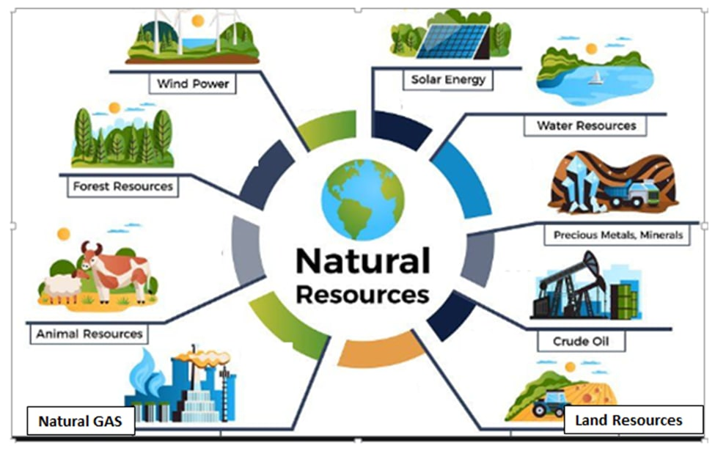

Module Title: - Identifying basic soil properties
LG Code: AGR NRC1 MO2 LO (1-4) LG (4-6)
TTLM Code:AGR NRC1 TTLM 0922v1

September, 2022
Addis Ababa, Ethiopia
Table of Contents
Introduction to the Module 1
LO #1- Collect soil samples for testing 2
Instruction sheet 1 2
Information Sheet 1 4
1.1. Preparing tools and equipment needed to collect soil samples 4
1.2. Identifying soil samples collection area 5
1.3. Locating services using site plans 7
1.4. OHS hazards 7
1.4.1. Identifying OHS hazards 7
1.4.2. Assessing risks 8
1.4.3. Implementing controls measures 9
1.5. Selecting, using and maintaining suitable safety and PPE 10
1.6. Taking and preparing samples for onsite or off site analysis 10
1.7. Labelling and recording samples 14
Self-check 1 16
Operation Sheet -1 17
LAP TEST-1 23
LO #2- Perform basic soil tests 24
Instruction sheet 2 24
Information Sheet 2 25
2.1. Determining soil profile 25
2.1.1. Soil Profile Definition 25
2.1.2. Components of the Soil Profile 26
2.2. Testing or inspecting soils for physical properties 28
2.3. Recording results 40
Self-Check – 2 41
Operation Sheet -2 42
LAP TEST-2 47
LO #3- Complete soil testing operation 48
Instruction sheet 3 48
Information Sheet 3 49
3.1. Cleaning equipment 49
3.2. Disposing of containers, leftover fluids and wastes 49
Self-Check – 3 50
Reference Materials 51

Introduction to the Module

This module covers the knowledge, skills and attitude required to determine the basic properties of soil. It requires the ability to collect samples and perform basic tests and it also requires knowledge of sample collection techniques, basic soil properties, and basic understanding of soil and plant relationships.

LG #4 | LO #1- Collect soil samples for testing

Instruction sheet 1
This learning guide is developed to provide you the necessary information regarding the following content coverage and topics:
  - Preparing tools and equipment needed to collect soil samples
  - Identifying soil samples collection area
  - Locating services using site plans
  - Identify OHS hazardsand Implementing risk controls measures
  - Selecting, using and maintaining suitable safety and PPE
  - Taking and preparing samples for onsite or off site analysis
  - Labelling and recording samples

This guide will also assist you to attain the learning outcomes stated in the cover page. Specifically, upon completion of this learning guide, you will be able to:
  - Prepare tools and equipment
  - Identify soil samples collection area
  - Locate services using site plans
  - Identify OHS hazards and Implement risk controls measures
  - Select, use and maintain suitable safety and PPE
  - Take and prepare samples for onsite or off site analysis
  - Label and record samples
Learning Instructions:
- Read the specific objectives of this Learning Guide.
- Follow the instructions described below.
- Read the information written in the information Sheets 1
- Accomplish the Self-checks 1
- Perform Operation Sheets 1
- Do the “LAP test” 1

Information Sheet 1

PreparingTools and Equipment Needed to Collect Soil Samples
Introduction

Soil samplingis the process of taking a small sample of soil, which is then observed on the field or sent to a laboratory for assessment or to determine the soil chemical, physical and biological properties. The first and most critical step in soil testing is collecting a soil sample.

Why collect soil samples?
Soils are analyzed for a variety of reasons including describing their inherent chemical, physical and biological properties, matching specific plant species and cultivars with soil characteristics, assessing organic and inorganic contaminants and accumulation, determining nutrient availability, monitoring changes due to inputs and management and assessing environmental risk. Soil sampling is important as it; Measures the nutrients that are left in your field following harvest. Tells you which nutrients are lacking or are in excess throughout the soil in a field. Helps you determine the most favorable fertilizer plan to increase or maintain yields for the following year.
Sampling tools and accessories: - Proper soil sampling should be done using appropriate soil sampling kits. Different tools are used in soil sampling. It is commonly recommended to use a soil auger to collect samples for agronomy, soil fertility, and fertilizer recommendation experiments depending on field conditions.
- A tube auger and spade are appropriate tools for sampling of soft and moist soils.
- A screw-type auger is more convenient for hard or dry soils.
- A post-hole auger is preferable for sampling excessively wet (waterlogged) soils.
- Core samplers are used to collect undisturbed soil samples for bulk density and moisture content analysis

- Bucket /tray
- Hammer
- Wooden block
- Garden Trowel
- Flat-bladed knife
- Sealable paper bags and marker pen for labeling
- Soil sample information sheet
- Pen/pencil
- Tape meter
- Plastic sheet
- GPS
- Safety equipment (PPE)
- Soil probes etc.

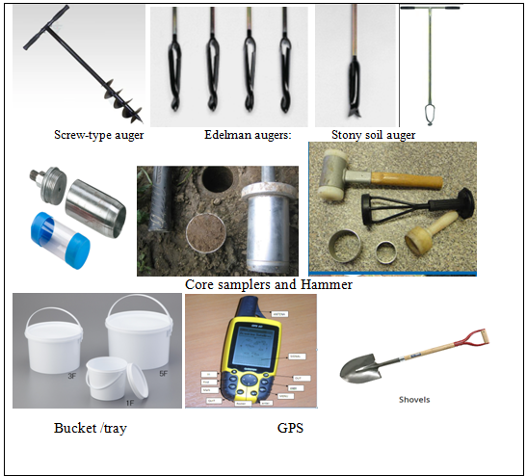Figure 1.1. Sampling tools and accessories

Identifying soil samples collection area
The area from which soil samples are to be collected is identified from workplace records or supervisors instructions. Determining where to take soil samples depends largely on the management strategy you employ on your farm.
Identify areas with differences in topography, nutrient application rates, soil type or texture, or soil tillage practices to create sampling zones with uniform characteristics. A sampling zone is typically an entire field or production area, but differences in soil may require an area with the same crop and management to be split into different sampling zones.
Some areas may be separated by a physical barrier, such as a ditch or road, or even be non-contiguous, but may be considered one sampling zone if they have uniform characteristics.
Sampling zones measuring nitrate are not limited to a size when no other differences in soils, cropping system, or management exist. In situations where large areas need to be sampled, alternative sampling strategies, such as directed benchmark sampling, may be used.

Selection of a sampling unit
Avisual survey of the field should precede the actual sampling. Note the variationin slope, colour, texture, management and cropping pattern by traversing thefield. Demarcate the field into uniform portions, each of which must be sampledseparately. Where all these conditions are similar, one field can be treated as asingle sampling unit.
Assign a unique identifier to each sampling zone, such as a name or number, to keep track of each year’s sampling areas. By keeping a record of sampling zones and previous results, soil nutrient management practices can be compared from year to year.
Precautions
Regardless of soil sampling strategy, when collecting samples in the field or identifying soil-sampling locations, there are several areas you may wish to avoid. These problem areas are areas in the field where, due to some disturbance of natural variation, the soil may not be representative of the rest of the soil in a field or zone. If your soil samplingpoint lies within or near one of these problem areas, consider relocating the sample point to a new location.
For all sampling guidelines, avoid sampling areas that would not be considered representative of an area. This includes:
- land immediately adjacent to drainage ditches
- highly eroded areas
- areas close to trees, roads, and fences
- current or previous manure piles
- fertilizer storage areas
- livestock excrement in grazed areas
- small areas of the field that are known to have distinctly different soils due to depth or texture

.Locating services using site plans
For soil analysis and reporting the results, all necessary services must be prepared according to site plan.Services May include, but not limited to:

- Water supply
- Gas
- Electricity
- Telecommunications
- Irrigation
- Storm water and drainage

.OHS hazards

1.4.1. Identifying OHS hazards
Occupational health and safety is one of the most important aspects of human concern. It aims an adaptation of working environment to workers for the promotion and maintenance of the highest degree of physical, mental and social well being of workers in all occupations. Making working conditions healthy and safe is in the interest of workers, employers and governments, as well as the public at large. The goals of occupational safety and health programs include fostering a safe and healthy work environment. It may also protect co-workers, family members, employers, customers, and many others who might be affected by the workplace environment.
Hazards are classified into five different types. They are;
- Physical - stairs, work platforms, steps, fire, falling objects, slippery surfaces, manual handling (lifting, pushing, pulling), excessively loud and prolonged noise, heat and cold, radiation, poor lighting, ventilation, air quality
- Mechanical and/or electrical - includes electricity, machinery, equipment, pressure vessels, dangerous goods, cranes, hoists
- Chemical - includes chemical substances such as acids or poisons and those that could lead to fire or explosion, cleaning agents, dusts and fumes from various processes such as welding
- Biological - includes bacteria, viruses, mould, mildew, insects, vermin, animals
- Psychosocial - includes workplace stressors arising from a variety of sources.
What hazards may be associated with performing soil sampling and testing?
Hazards may include:
- Chemicals and hazardous substances such as acids and hydrocarbons,
- Wildlife, such as snakes, spiders and domestic animals,
- Soil and water-borne microorganisms,
- Dust,
- Noise,
- sharp hand tools and equipment,
- Disturbance or interruption of underground services,
- Solar radiation,
- Moving machinery and machinery parts,
- Falling objects and uneven surfaces.
There are potential hazards from poisons, fumes and sources of heat inherent in every soil testinglaboratory. At all times be knowledgeable about the chemicals and equipment you are handling and organize both your thoughts and the laboratory space you are using.

1.4.2. Assessing risks
After all the possible hazards are identified, the occupational health risk that could be associated with the hazard must be identified by studying previous incident reports, first aid/injury records, and health records of the employees.
When you identify a hazard, do a risk assessment. A risk assessment process means you:
- Gather information about each identified hazard.
- Consider the number of people exposed to each hazard and the duration of the exposure.
- Use the information to assess the likelihood and consequence of each hazard.
- Use a risk assessment table to work out the risk associated with each hazard.
- Conduct regular, systematic inspections of the workplace.
- Observe what hazards exist in the workplace and ask, ‘what if?’
- Listen to feedback from the people performing work tasks.
- Maintain records of the processes used to identify hazards.
- Talk to your health and safety representatives.
You should consider the following factors during the risk assessment process
- The nature of the hazard posing the risk
- Combinations of hazards
Many people believe that soil sampling contains little risk, but this is not true. Soil sampling techniques available involve shovels, hand augers; backhoe pits, hydraulic direct push probes, and drill rigs that advance hollow stem augers.
Some of the potential risks include;

- Sampling in areas containing buried utilities,
- Dehydration,
- Muscle skeletal injury, and allergic and insect stings.
- Pit cave-in,
- Equipment failure etc.

1.4.3. Implementing controls measures
The correct course of action once a hazard is identified is to use control measures. These generally fall into three categories.
- Eliminate the hazard
- Minimize the risk
- Use ‘back-up’ controls when all other options in the previous categories have been exhausted
The best way to control a hazard is to eliminate it.All operations must comply with enterprise OHS and environmental management requirements. Implement safety procedures to control OHS hazards and risk that many happen during soil sampling and soil test.
This may include:
- use of personal protective equipment, such as hard hats, hearing protection, gloves, safety glasses, goggles, face guards, coveralls, gowns, body suits, respirators and safety boots
- Determine potential hazards, safety precautions, remedial actions and waste disposal techniques before starting any soil test procedure.
- Using signage and safety barriers during and removing after surveying activities are completed;
- Wash hands with soap and water before leaving the work area – even if you wore gloves.
- Backfilling soil survey holes and pits; and swiftly and efficiently removing and processing debris and waste from the work area.
- use of biohazard containers and laminar flow cabinets
- correct labeling of reagents and hazardous materials
- handling, and storing hazardous materials and equipment in accordance with labels, MSDS, manufacturer instructions, and enterprise procedures and regulations
- regular cleaning and/or decontaminating equipment and work areas
- machinery guards
- signage, barriers, service isolation tags, traffic control and flashing lights
- lock-out and tag-out procedures
- Report any and all accidents immediately to your supervisor.

.Selecting, using and maintaining suitable safety and PPE
Use the correct personal protective equipment for your work.PPE May include, but not limited to:
- Safety clothes, Hat (3M hard hat safety helmet), boots, overalls, gloves (Leather gloves), goggles, respirator or face mask, face guard, hearing protection, sunscreen lotion and helmets.

. Taking and preparing samples for onsite or off site analysis
Background
Soil sampling is regarded as the most critical step in soil testing or analyses program because errors that occur during soil sampling will give invalid results even when the analysis is carefully done.A poor sample may result in erroneous soil test results and poor recommendation.
Error in sampling=wrong result=wrong interpretation=wrong decision=economic loss, even loss in health and death. The quality of soil sample depends on extent of cares taken during collecting, handling and transportation of the sample. Thus, soil should be truly representative of the field being studied.
Consideration should be given to variations in slope, color, crop growth, and management during sampling. In Soils showing widevariations, the intensity of sampling should increase with heterogeneity.
1.6.1. Soil sampling techniques
The methods and procedures for obtaining soil samples vary according to the purpose of the sampling. Analysis of soil samples may be needed for engineering and agricultural purposes. This guide describes soil sampling for agricultural purposes.
There are two types of soil sampling techniques; Random and Grid sampling.
1. Simple random sampling:-Collecting soil samples from different spots within a field by walking randomly.Random Sampling is a sampling methods used in a uniform field. This may be accomplished by walking in transect or zig-zag pattern across the sampling area to ensure homogeneity.
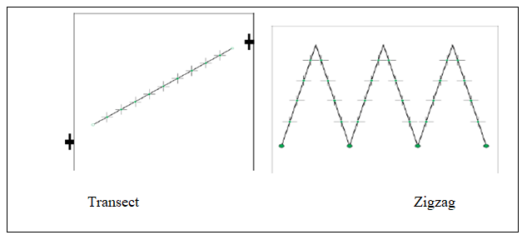
Figure 1.2.Schematic showing the layout of a random sampling

2. Systematic sampling (Grid sampling) involves taking samples at regular intervals across the landscape of a field. Grid sampling should be used when there is little information available about the variation in nutrient levels across a field. Grid sampling may be useful in fields where variability is expected but the field history is not well known, topography is uniform but differences in soil type occur, varied management patterns have been used in the past or manure applications have occurred. Proper grid sampling makes it possible to identify variation within a field and is an important data layer when determining future management zones for fertilizer applications.
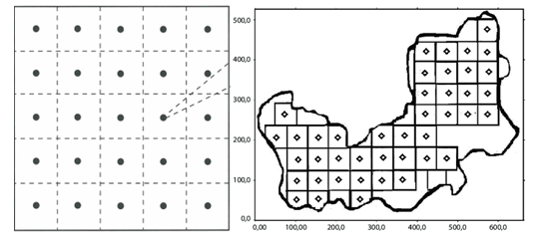
Figure1.3.Schematic showing the layout of a square grid sampling

There are two types of samples; disturbed and undisturbed soil samples.
A. Disturbed samples: the structure of the sample is disturbed to considerable degree by the action of the boring tools or the excavation equipment. Disturbed samples are generally obtained to determine different physical, chemical and biological properties of the soil.
B. Undisturbed soil samples: It retains as closely as practicable the true in-situ structure and water content of the soil. Undisturbed samples also used to determine the bulk density, infiltration rate and moisture content of the soil.

2.6.2. Points to be considered in soil sampling operations
There are several factors to be considered during soil sampling operations. The major are:
- Collect the soil sample during fallow period.
- In the standing crop, collect samples between rows.
- Sampling at several locations in a zig-zag pattern ensures homogeneity.
- Fields, which is similar in appearance, production and past-management practices, can be grouped into a single sampling unit.
- Collect separate samples from fields that differ in color, slope, drainage, past management practices like liming, gypsum application, fertilization, cropping system etc.
- Avoid sampling in dead furrows, wet spots, areas near main bund, trees, and manure heaps and irrigation channels.
- For shallow rooted crops, collect samples up to 15 cm depth. For deep rooted crops, collect samples up to 30 cm depth. For tree crops, collect profile samples.
- Always collect the soil sample in presence of the farm owner who knows the farm better
Timing of sampling: - The most convenient time to collect soil samples is when there is no standing crop in the field (i.e. in the spring prior to planting or in the fall after harvest).
Sampling frequency: - The number of times that a soil sample should be obtained for analyses depends on the nature and objective of the analysis and the type of soil parameter. For analyses of soil parameters that are relatively less sensitive to management practices (e.g., soil texture and bulk density), sampling once in a season (before planting) is sufficient, unlike for the management of sensitive parameters such as pH, soil organic carbon, nutrient status, and others.
Sampling depth: - Sampling depths is decided based purpose, soil type and types of plant grown. Sampling depth for most soils is typically tillage depth (which can vary depending on soil type) at an interval of 20 cm. The top 20 cm of soil has the most root activity, and this is the depth at which fertilizer, lime, and gypsum applications are made. On the other hand, abundance of plant roots in the soil depth is an important consideration in deciding the sampling depth. Therefore, the following depths can be considered:
For most annual crops such as cereals, pulses, and vegetables, composite soil samples should be collected from 0-20, 20-40, and 40-60 cm depths.For deep-rooted perennial crops (fruit trees, sugarcane, coffee, plantation crops, and others), composite soil samples should be collected from 0-20, 20-50, 50-80, and 80-110 cm depths using four to five pits.For nutrient calibration studies, soil samples should be collected from 0-15 cm depth at 21 days after planting.Since acidity can vary along the soil depth in acidic soils, soil sampling for pH and exchangeable acidity analysis should be done at least to a depth of 30 cm divided into 0-15 and 15-30 cm depths. Sampling beyond 30 cm depth in a single sample could seriously underestimate a soil acidity problem in the critical root zone.

.Labelling and recording samples
Sample labeling: - Proper labeling of soil samples is as important as the care needed to obtain the samples. Samples need to be labeled properly for identification. A label of thick paper with an identification mark and other details should be put inside the sample bag, and another one carrying the same details tied/pasted outside the bag. In case the soil sample is wet (for calibration studies);the label should be written with a lead pencil or a permanent ink marker, or put inside a small separate plastic bag before air-drying. With the advance of digital technology, it is advisable to use digitized sample labeling and tracking procedures in all soil and agronomic research activities.
A sample label should contain the following:
- Site, code, slope, collection date, depth, name of collector
- Production and cropping system
- Site name: district, kebele, and farmer’s name
- Site geographic coordinates
- Altitude [m]
- Sampling
- Date [dd/mm/yyyy]
- Sampling depth [cm]
Soil sample record sheet: - In addition to location descriptors relevant information about slope, irrigation, drainage, previous cropping history, fertilizer and manure applied, and other relevant information must be recorded and sent along with the soil samples as required.
Soil sampling information submission sheet for laboratory
- Sample collector Name: -------------------- Phone: --------- Email address: ----------------
- Organization: --------------------------------- Phone: -------------------------------------------
- GPS datum: --------------------------
- Sample code sampling date sampling depth Latitude longitude Altitude
_________ _________ __________ ________ _________ _____
- Slope: ______________
- Landscape position (High, medium or low): ____________________________
- Location (Region, Zone, Woreda and Kebele): ____________________________
- Production systems (irrigated, rain-feed and land use): ________________________
- Previous season crops or land use:________________________________________
- Parameters to be analyzed and methods: ___________________________________

Self-check 1 | Written test

Name…………………………………………… ID………………………… Date…….
Directions: Answer all the questions listed below.
Test I: Choose the best answer (4 point)
1. Which one is not purpose of soil sampling?
A. To describe soil chemical, physical and biological properties
B. To degrade the soil
C. To determine nutrient availability
D. To assess potential organic and inorganic contaminants of soil
2. During soil sampling, collect the sample;
A. From fence lines and near to plant C. From sheds and road ways
B. Near main band D. During fallow period
3.Identify from the following groups of choice only the physical hazards
A. stairs, bacteria, slippery surface, insect C .bacteria, virus, insect, mildew
B. ladders, fire, heat and cold, slippery surface D. acid, stressor, dust, vibration
4. From the following which one is method of minimizing the risk?
A. Substitution C. Isolation
B. Modification D. All
Test II: Short Answer Questions (8 points)
1. List all tools and equipment needed to collect soil samples.
2. List and describe soil sampling techniques.
3.Explain OHS hazards.
4. List the relevant information which must be recorded on sample label

Operation Sheet -1
- Techniques/Procedures/ of soil sampling
- Tools and equipments

  - Auger
  - Bucket /tray
  - Soil sample information sheet
  - Pen/pencil
  - Tape meter
  - Plastic sheet
  - Safety equipment (PPE)
  - Sealable paper bags and marker pen for labeling

- Sampling Procedures and preparation
Procedures
- Divide the field into different homogenous units based on the visual observation and farmer’s experience.
- Remove the surface litter at the sampling spot.
- Drive the auger to the required depth and draw the soil sample.
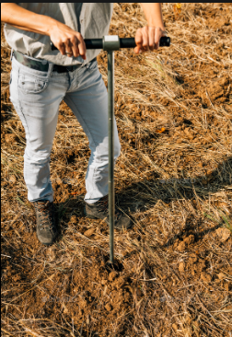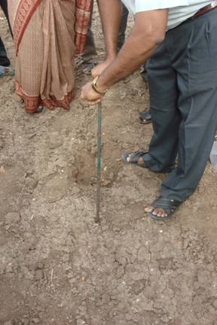
- Collect at least 10 to 15 samples from each sampling unit and place in a bucket or tray.
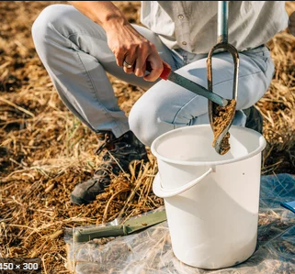
- If auger is not available, make a ‘V’ shaped cut to a required depth in the sampling spot using spade.
- Remove thick slices of soil from top to bottom of exposed face of the ‘V’ shaped cut and place in a clean container.
Preparation
- Mix the samples thoroughly and remove foreign materials like roots, stones, pebbles and gravels.
- Reduce the bulk to about half to one kilogram by quartering.
- Quartering is done by dividing the thoroughly mixed sample into four equal parts. The two opposite quarters are discarded and the remaining two quarters are remixed and the process repeated until the desired sample size is obtained.
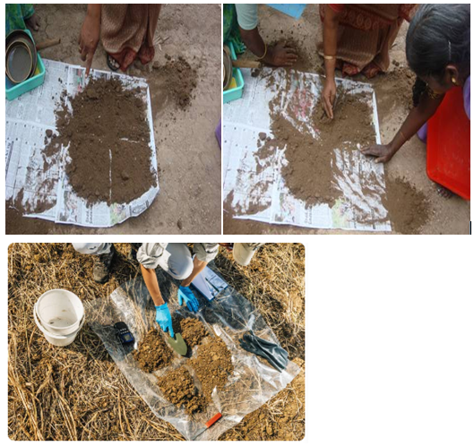
- Collect the sample in a clean polythene bag.
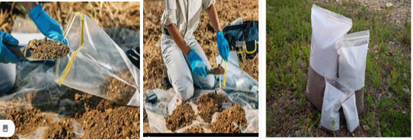
- Label the bag with information like name of the farmer, location of the farm, survey number, previous crop grown, present crop, crop to be grown in the next season, date of collection, name of the sampler etc.
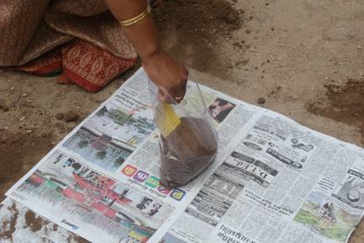

1.2. Procedures/Steps/ of collecting soil samples from a profile
- Tools and equipments

- Spade
- Flat-bladed knife
- polythene bag
- polythene sheet
- Soil sample information sheet
- Pen/pencil
- Tape meter
- Safety equipment (PPE)
- Sieve Sealable paper bags and marker pen for labeling

- Procedures/Steps/Techniques
- After the profile has been exposed, clean one face of the pit carefully with a spade and note the succession and depth of each horizon.
- Prick the surface with a knife or edge of the spade to show up structure, colour and compactness.
- Collect samples starting from the bottom most horizons first by holding a large basin at the bottom limit of the horizon while the soil above is loosened by a Spatula.
- Mix the sample and transfer to a polythene or cloth bag and label it.
Processing and storage
- Assign the sample number and enter it in the laboratory soil sample register.
- Dry the sample collected from the field in shade by spreading on a clean sheet of paper after breaking the large lumps, if present.
- Spread the soil on a paper or polythene sheet on a hard surface and powder the sample by breaking the clods to its ultimate soil particle using a wooden mallet.
- Sieve the soil material through 2 mm sieve.
- Repeat powdering and sieving until only materials of >2 mm (no soil or clod) are left on the sieve.
- Collect the material passing through the sieve and store in a clean glass or plastic container or polythene bag with proper labeling for laboratory analysis.
- For the determination of organic matter it is desirable to grind a representative sub sample and sieve it through 0.2 mm sieve.
- If the samples are meant for the analysis of micronutrients at-most care is needed in handling the sample to avoid contamination of iron, zinc and copper. Brass sieves should be avoided and it is better to use stainless steel or polythene materials for collection, processing and storage of samples.
- Air-drying of soils must be avoided if the samples are to be analyzed for NO3-N and NH4-N as well as for bacterial count.
- Field moisture content must be estimated in un-dried sample or to be preserved in a sealed polythene bag immediately after collection. Estimate the moisture content of sample before every analysis to express the results on dry weight basis
1.3. Procedures of collecting soil sample by core methods
A. Materials needed

- 5 – 10 cm diameter ring
- Hammer
- Wooden block
- Garden Trowel
- Flat-bladed knife
- Sealable paper bags and marker pen for labeling
- Scale
- An oven
- Safety equipment (PPE)

B. Sampling Procedure:
- On the field, identify the sampling point. Try as much as possible to avoid sampling on the trail marks as they tend to be compacted or close to plant roots.
- Then remove some loose soil on the surface and some plant debris or some crop residues.
- Place the ring on the soil surface where the sample is to be taken
- Place the wooden block on top of the metal ring to evenly drive the metal ring into the soil
- Using the hand sledge/hammer drive the ring into the soil to a depth of 7 cm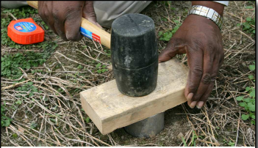
- If the metal ring is not fully pushed into the soil, the exact depth of the ring must be determined for accurate measurements of soil volume. To do this, the height of the ring above the soil should be measured. Then subtract the height of the ring above the soil from the overall height of the ring.
- Remove the ring from the soil.
- Remove excess soil.
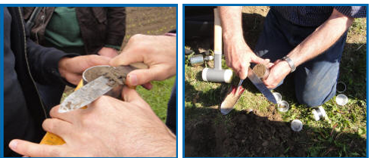
- Using the flat-bladed knife, push the soil sample from within the metal ring into the sealable paper bag. Be careful while transferring the sample and make sure that the entire sample is placed into the bag. Properly seal it and label accordingly.
- Dry the sample using oven drier.
- After drying, weigh the dry sample (soil + sampling bag). Then subtract the weight of the sampling bag from the sample (dried soil + sampling bag). This is the weight of dry soil without the sampling bag (Wd).
Calculate the soil’s bulk density as: $=Wd/V$
Where: = bulk density (g/cm³)
Wd = weight of dry soil (g)
V = volume of soil (cm³)

LAP TEST-1 | Performance Test

Name………………………………. ID…………………………….. Date…………………………………….

Time started: ________________________ Time finished: ________________

Instructions: Given necessary templates, tools and materials you are required to perform the following tasks within 5hour. The project is expected from each student to do it.
Task-1: Preform soil sample collection from surface
Task-2:Perform soil sample collection from a profile
Task-3:Perform soil sample collectionby core sampler and determine soil bulk density

LG #5 | LO #2- Perform basic soil tests

Instruction sheet 2
This learning guide is developed to provide you the necessary information regarding the following content coverage and topics:
- Determining soil profile
- Testing or inspecting soils for physical properties
- Recording results

This guide will also assist you to attain the learning outcomes stated in the cover page. Specifically, upon completion of this learning guide, you will be able to:
- Determine soil profile
- Test or inspect soils for physical properties
- Record results
Learning Instructions:
- Read the specific objectives of this Learning Guide.
- Follow the instructions described below.
- Read the information written in the information Sheets 2
- Accomplish the Self-checks 2
- Perform Operation Sheets 2
- Do the “LAP test” 2

Information Sheet 2

Determining soil profile

2.1.1. Definition of Soil Profile
If you look in a soil pit or on a roadside cut, you will see various layers in the soil. Soil profile is defined as the vertical section of the soil from the ground surface downwards to where the soil meets the underlying rock.Horizon is layer of soil with somewhat uniform color, texture, and structure.
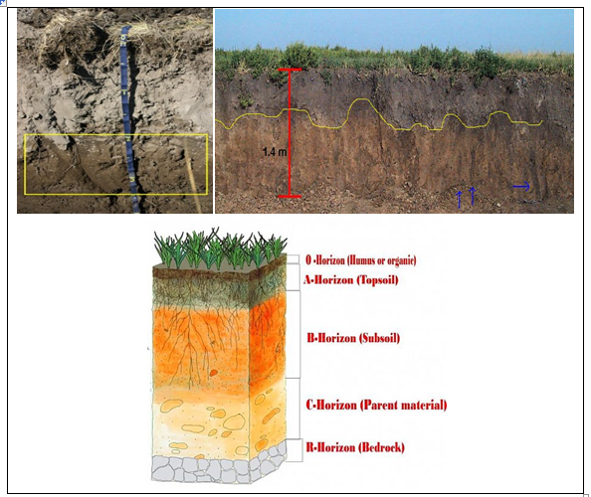
Figure2.1. Illustrated differences in soil profiles
Source:https://www.pinterest.com/pin/753016000186922258/(Received date 8/26/2022)
- See the following video to get further information about soil profile and horizons
https://www.youtube.com/watch?v=nEShY_S_KGc (Received date 8/26/2022)

2.1.2. Components of the Soil Profile
The soil profile is composed of a series of horizons or layers of soil stacked one on top of the other. The soil profile extends from the soil surface to the parent rock material. Soil horizons differ in a number of easily seen soil properties such as color, texture, structure, and thickness. Other properties are less visible. Properties, such as chemical and mineral content, consistence, and reaction require special laboratory tests. All these properties are used to define types of soil horizons.
There are 5 master horizons in the soil profile: O, A, E, B, and C. (R is used to denote bedrock.)Not all soil profiles contain all 5 horizons; and so, soil profiles differ from one location to another.
Table 2.1.Summarry ofdescription of master horizons in the soil profile
Name | Description
O | - Dominated by organic soil material:  - Horizons formed from organic litter derived from plants and animals and deposited on either an organic or a mineral surface.  - It is most prominent in forested areas where there is the accumulation of debris fallen from trees.  - Horizons usually are present at the soil surface, but they may constitute the entire thickness of the soil in the case of organic soils, or may be buried by mineral soil.
A | - Mineral horizons that formed at the surface or below the O horizon with partly to highly decompose organic matter.  - It has humified organic matter mixed with mineral material resulting from the decomposition of plant residues or has properties resulting from cultivation or pasturing that has physically disturbed the horizon.  - They also show evidence of obliteration of much or all of the original rock structure, including fine stratification of sediments, and often show evidence of eluviations of clays, salts, carbonates, iron and aluminum compounds, and soluble organic compounds.
E | - The E horizon is a subsurface horizon that has been heavily leached.  - Leaching is the process in which soluble nutrients are lost from the soil due to precipitation or irrigation.  - The horizon is typically light in color. It is generally found beneath the O horizon.
B | - B Mineral horizons  - Formed below O, A, and/or E horizons.  - Mineral horizon that has an accumulation of clay, iron, and humus.  - It is the horizon of maximum development due to soil forming processes.  - The parent material has been significantly altered by  - Accumulation of silicate clay, iron, aluminum, carbonates, gypsum, silica, or humus,  - Removal of carbonates or gypsum,  - Alteration in the form of brittleness, development of soil structure, increased redness of soil color, gleying, or residual concentration of oxide compounds.
C | - Mineral horizons  - Layers, other than strongly cemented and harder bedrock, with little or no alteration by soil forming processes.  - C horizons or layers lack properties of O, A, E, or B horizons.  - Horizon containing parent materials that have relatively little development which upon weathering form soil.  - Plant roots such as tap roots of trees or a few fine roots that leave only trace amounts of organic carbon upon their death may be present at widely spaced intervals in some C horizons.
R | - Bedrock that are strongly cemented to indurate.  - Rock material that is of sufficient hardness that hand digging with a spade is impractical even when the material is moist is designated R.  - Small cracks, partially or totally filled with soil material and occupied by roots, are frequently present in R layers.

Testing or inspecting soils for physical properties
2.2.1. Background
Soil test is the analysis of soil samples to determine the nutrient and contamination levels, composition, and other characteristics such as the acidity or pH level. Soils contain nutrients, water, and living organisms that help create healthy and sustainable farms. By conducting a soil test, you will get the right information enabling you to make informed decisions like the quantity of fertilizer needed and the exact type that is needed to improve the soil on your farm thus minimizing expenditure. Effective soil testing provides information on the fertility status of soils within a field that can be used for making fertilizer or lime application recommendations, monitoring changes in soil fertility over time and even identifying and targeting low fertility soils within larger fields.
Three Categories of Basic Soil Properties
- Physical: texture (proportions of sand, silt and clay), structure, bulk density, moisture, infiltration, porosity,Color,etc
- Chemical: nutrient content, salinity, pH, organic matter, mineral content (parent material)
- Biological: activity of microbes (bacteria, fungi), biomass, biodiversity, biological activity
Soils may be tested for basic physical properties such as soil depth, colour, texture, structure, compaction, bulk density, porosity.Soil properties are measured or inferred from direct observations in the field or laboratory.

2.2.2. Soil physical properties
Soil physical properties profoundly influence how soils function in an ecosystem and how they can be best managed. Success or failure of agricultural projects often hinges in the physical properties of the soil used. Some of selected soil physical properties are discussed below.
1. Soil texture
Soil texture refers to the proportion of sand, silt, and clay in a soil. Sand,silt,andclayarenamesthatdescribethesizeofindividualparticlesinthesoil. Soils with the finest texture are called clay soils, while soils with the coarsest texture are called sands.
Texture influences almost every aspect of soil use, both in agricultural and engineering applications, and even how natural ecosystems function. Many scientists consider soil texture the most important soil property as it can inﬂuenced soil/water relationships, gas exchange, and plant nutrition. It is fundamental tosoilpropertiesandtheirimpactonplantgrowthandoverallfarmproductivity.Accurately determining soil texture in a lab requires time and money; therefore, it is often necessary to estimate soil texture in the field by feel, which can be very accurate if done correctly.
- Sand: particles smaller than 2 mm but larger than 0.5 mm termed sand
- Sand are the largest particles feel “gritty”
- Sand particle has little capacity to hold water and nutrients and do not stick into a coherent mass
- But well aerated and loose, infertile and prone to drought
- Silt: particles smaller than 0.05 mm but larger than 0.002 mm in diameter are classified as silt
- Silt feels smooth or silky when rubbed between the fingers
- Silt composed of weatherable minerals, the relatively small size (and large surface area) of the particles allows weathering rapid enough to release significant amounts of plant nutrients.
- Clay: clay particles are smaller than 0.002 mm
- has high stickiness and plasticity
- When wet, clay is sticky and can be easily molded (high plasticity)
- Fine clays behave as colloids and if suspended in water they do not readily settle out
- The pores between clay particles are very small and convoluted, so movement of water and air is very slow
- Clay soils have different properties such as
- Shrink- swell behavior
- Plasticity
- High water holding capacity
- High Soil strength
- High chemical absorption
Methods of testing soil texture
A. Methodstotestsoiltexturein the field
- The feelmethod: Thetexturalclasscanbeestimatedinthefieldbysimplefieldtestsandfeelingthe constituents of the soil. Forthis,thesoilsamplemustbeinamoisttoweakwetstate.Gravelandotherconstituents>2mmmustberemoved.
- Theribbon method; scloselyrelatedtothefeelmethodasitfocusesonhandlingthesoil todetermineitstexturalclass.Thiseasytousemethodcanhelpusersdeterminesoil texturebyforming ribbons with moist soil.
- The shaking test(to differentiate clay from silt)
B. Methods of testing Soil Texture in a Lab
Hydrometer measures relative density of liquids. The density of the soil-water suspension is measured with a Bouyoucos hydrometer that is calibrated to read the density of the soil-water suspension in grams per liter (g/liter), or calibrated directly in percentages, for a given time and temperature.
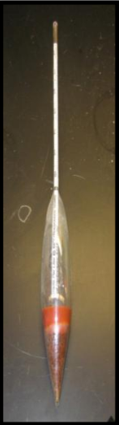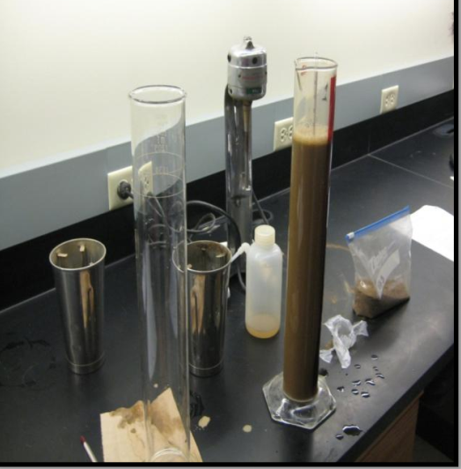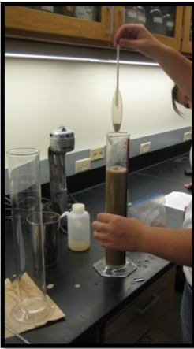
Figure2.2. Determining Soil Texture in a Lab by a Bouyoucos hydrometer

The soil triangle can be used to classify the basic soil textural class. The type of soil texture class is determined by the ratio of clay, silt and sand.
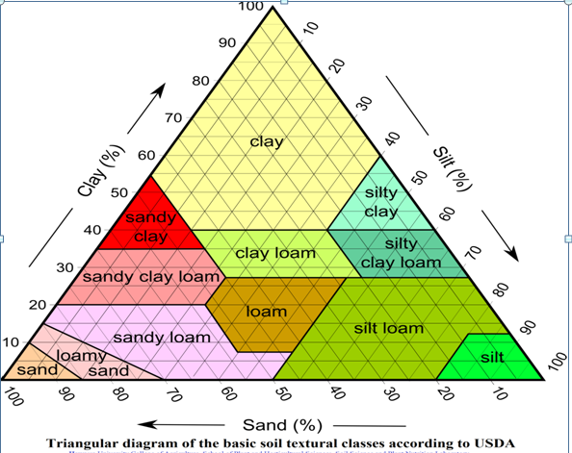
Figure2.3.Soil texture triangle
(Source: https://www.pinterest.com/pin/416020084307318708/ (date received 8/26/2022)).

2. Soil Structure
- Soil structure is the arrangement of soil particles (solid parts of the soil) and the pore space between them,
- Soil structure describes the manner in which soil particles are aggregated.
- It is determined how individual soil granules clump, bind together and aggregate, resulting in the arrangement of soil pores between them
- Soil structure has a major influence on water and air movement, biological activity, root growth and seedling emergency,
- The type and grade of structure plays an important role in the movement of water within soils.
- Soil structures affects permeability by influencing the path by which water can flow through the soil.

- The type of structure determines the number of interconnected macropores, which readily permit downward movement of water.
- Look at a sample of undisturbed soil from each layer of your pit and examine the soil structure,
- Soil structure is most usefully described in terms of grade (degree of aggregation), class (average size) and type of aggregates (form)
- There are eight structural types commonly recognized in soil profiles: Granular, single grain, blocky, prismatic, columnar, platy, wedge, and massive.
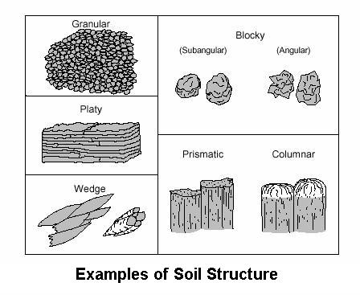Figure2.4.Examples of the shapes of different soil structures
Tables2.2.Summary of common types of soil structures
Granular | Rounded aggregates usually less than 1/4 inch in diameter | 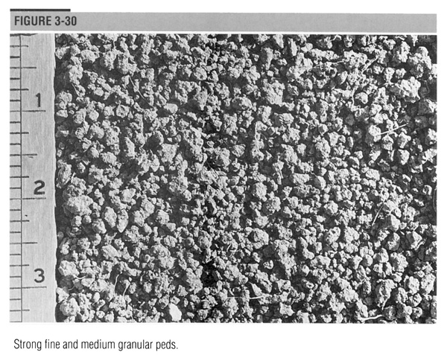
Single grain | Each individual soil particle is separate and there is essentially no structure.  This is only found in very sandy soils and is the type of structure commonly seen in sand dunes at the beach. | 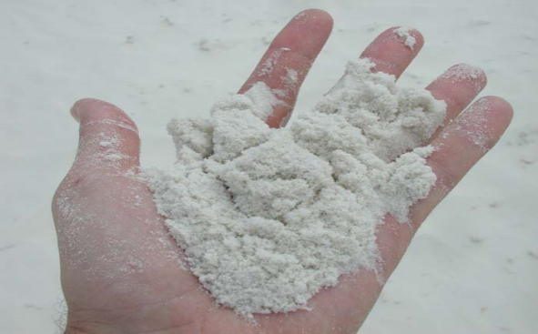
Blocky | The original aggregates have been reduced to blocks, irregularly faced, and basically equal in height, width, and depth.  Blocky structure is the most common type of structure seen in the subsoil (B horizon) | 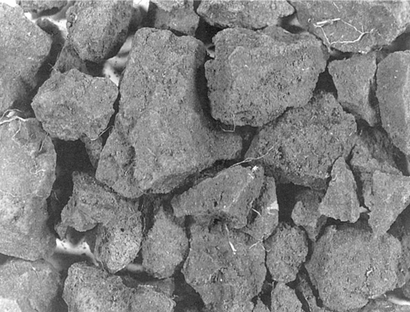
Prismatic | Characterized by vertical oriented aggregates or pillars with flat tops.  These elongated columns vary in length with different soils.  Prismatic structure is commonly seen in soils with high clay content and in horizons dominated by high shrink-swell clays. | 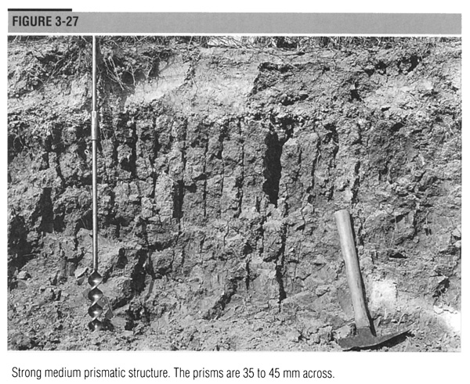
Columnar | Characterized by vertical oriented aggregates or pillars with rounded tops.  These elongated columns with flat tops vary in length with different soils.  Most commonly seen in soils that have high sodium content in a dry climate. | 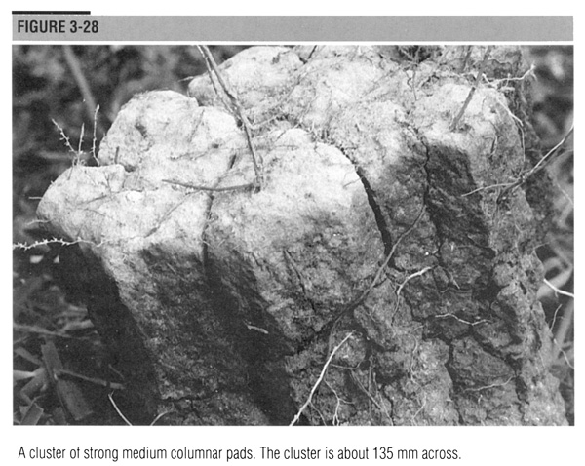
Platy | The aggregates are arranged in thin horizontal plates or sheets.  This structure is commonly found in soil layers that have been compacted.  Platy structure inhibits the downward movement of water. | 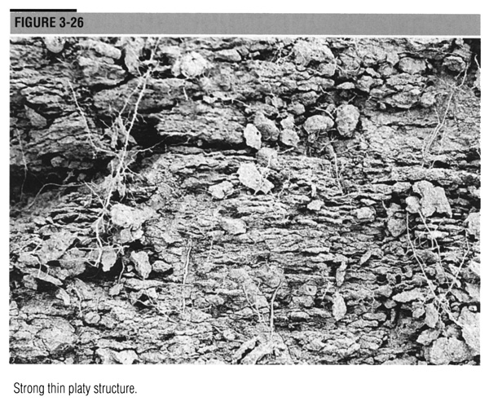
Source:https://www.fao.org/fishery/docs/CDrom/FAO_Training/FAO_Training/General/x6706e/x6706e07.htm(Received Date 8/30/2022)
3.Particle density (ρ_{m})
- Particle density is a weighted average density of mineral grains.
- Can be measured by displacement techniques
- Where W_{s} is the mass and V_{s} is the volume of the mineral grains ρm= Ws/Vs
- In practice this is difficult so usually assumed to be around 2.65 g cm⁻³

4.Bulk Density
- Is defined as the dry weight of soil per unit volume of soil
- Bulk density considers both the solids and the pore space; whereas, particle density considers only the mineral solids
- Bulk density reflects the soil’s ability to function for structural support, water and solute movement, and soil aeration.
- Bulk density is also used to convert between weight and volume of soil.
- It is used to express soil physical, chemical and biological measurements on a volumetric basis for soil quality assessment and comparisons between management systems.
- This increases the validity of comparisons by removing error associated with differences in soil density at time of sampling.
- Bulk density is changed by crop and land management practices that affect soil cover, organic matter, soil structure, and/or porosity.
- High bulk density is an indicator of low soil porosity and soil compaction.
- It may cause restrictions to root growth, and poor movement of air and water through the soil.
- Compaction can result in shallow plant rooting and poor plant growth, influencing crop yield and reducing vegetative cover available to protect soil from erosion.
- By reducing water infiltration into the soil, compaction can lead to increased runoff and erosion from sloping land or waterlogged soils in flatter areas.
- Weight of unit volume of soil after oven-drying at 105ºC for 24 hrs can be used for bulk density determination
- Soilbulkdensityisanindicatorofsoilcompaction. The most commonly used methodstoassesssoil bulkdensityinthefield are core methods.
- Bulk density is typically expressed in g/cm3.
Soilbulkdensity test byCore method
Thismethodusesametalcoreofaknownvolume,whichrepresentsthevolumeof thesoilforthepurposeofthecalculationofthesoilbulkdensity.Thecoreshouldbeofcylindrical shapetoallowforeasydeterminationofitsvolume.Thecoresampleispushedintothesoiltothedesireddepthandthengentlyremovedwithoutalteringthecontentsofthecore.Afterobtainingthesoilusingthecore,thesoilweightismeasured,andusingtheknownvolumeofthecore(anestimationofsoilvolume),soilbulkdensitycanbe determined.
5. Soil porosity
- Porosity or pore space refers to the volume of soil voids that can be filled by water and/or air
- It is inversely related to bulk density. Porosity is calculated as a percentage of the soil volume:
%solid space = Bulk density x 100
Particle density
%Pore Space = 100% – % Solid Space
6. Soil Color
Soil color is determined by mineral composition, element concentration, organic matter, and moisture content. It reflects soil properties and soil processes, and it is an important diagnostic feature for soil horizon delineation and soil classification. It is useful tool for providing information about soil properties. Soil colour indicates the types of minerals found in a soil and indicates how soils were formed. It is useful tool for providing information about other soil properties:
- Organic matter content
- Soil minerals
- Seasonal high water tables
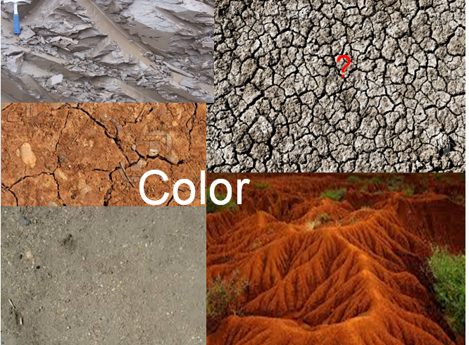
Figure 2.5.Soil color
Soil color is influenced by its mineral composition as well as water and organic contents. For example, soils high in calcium tend to be white, those high in iron reddish, and those high in humus dark brown to black. Soil needs only about 5% organic material to appear black when wet.Methods used to describe soil color
There are a number of methods used to describe color, but the standard method for soils is the Munsell system. Soil color has been described on both dry and moist soil samples by comparing its color with the Munsell color chart.This chart allows soil scientists to uniformly describe soil color. In the field, soil scientists compare the colors found in the soil with the color chips found on the chart.
The Munsell system identifies color based on three measurable variables: hue, value, and chroma.
- Hue is the dominant spectral color and is related to wavelengths of light.
- Value is a measure of degree of darkness or lightness of the color and is related to the total amount of light reflected.
- Chroma is a measure of the purity or strength of spectral color.
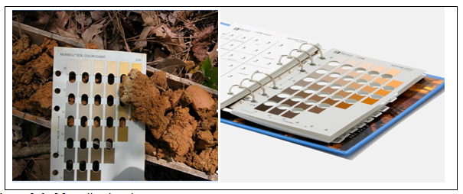
Figure 2.6.:Munsell color chart
- See the following video to see in detail on how identifying soil color by usingmunshell color chart.
https://www.youtube.com/watch?v=6RSd2y7cDvs(received data (8/28/2022)

7. Consistence
- Consistence of soil material is an evaluation soil of the cohesive and adhesive properties and of the response of the soil material to applied pressure.
- Consistence relates to the firmness of the individual peds and how easily they break apart.
- Field evaluation of soil consistence includes rupture resistance, stickiness, and plasticity of hand specimens. Soil water content is critical to the assessment of these propertie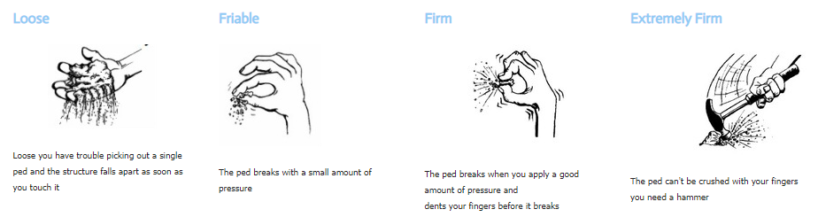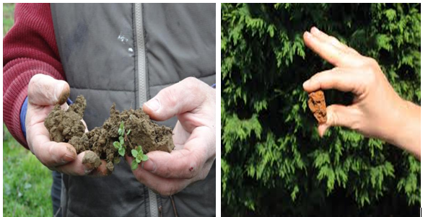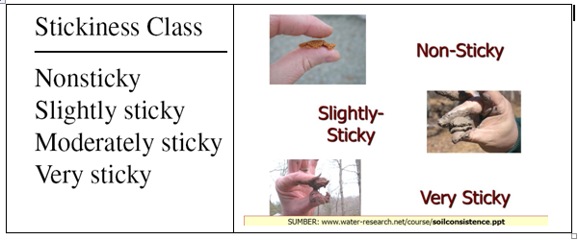Figure2.7. Inspecting or testing soil Consistence

. Recording results
The results are recorded and documented in standard format.Problems or difficulties in completing work to required standards or timelines are reported to supervisor. The result must be properly recorded according to Sample/Field Number” line which contains the identifying name or number you attached to the sample on the Soil Sample Information Sheet when you sent it to the laboratory. Give names or numbers and maintain a list of the sample identifiers you attached to each sample location. Soil Result recording information sheet must included: Submitter name, Address (Phone number, Email), Sample number, Soil properties name, result etc.

Self-Check – 2 | Written test

Name…………………………………………… ID………………………… Date…….
Directions: Answer all the questions listed below.
Test I: Multiple choice (4points)
1. Which one is not purpose of soil test or analysis?
A. To evaluate the fertility status C. To determine the PH
B. To over-fertilize soil D. To determine lime requirements in acidic soil
2._______is defined as the vertical section of the soil from the ground surface downwards to where the soil meets the underlying rock.
A. Soil profile B Horizon
3. _______describes the manner in which soil particles are aggregated.
A Bulk density B. Texture C. Porosity D. structure
4. Soil color is determined by:
A. Mineral composition, C. Organic matter
B. Element concentration D. Moisture content
E. All
Test I: Short Answer Questions (6points)
1. List and explainmaster horizons in the soil profile.
2. What is the purpose of soil testing?
3. List and explain physical soil properties

Operation Sheet -2

2.1.Procedures of testing soil texture by feel methods
A. Tools and equipments
- Water
- Soil
B.Procedures
Start: Take approximately 1 tablespoon of soil and wet by adding water in small amounts. Knead to break down all aggregates until soil is plastic and mouldable, like moist putty.
Step 1.Try to form a ribbon of uniform thickness and width by gently pushing the soil between thumb and forefinger. Allow the ribbon to emerge and extend over the finger, breaking from its own weight.
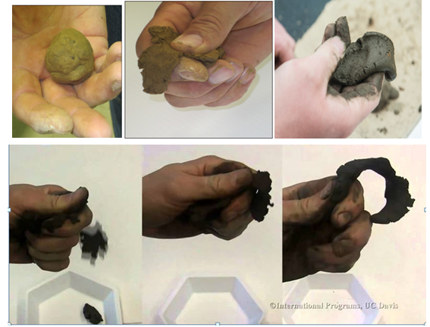
Figure: Soil texture test by feel methods
A. soil does not ribbon=course texture
B. Soil does ribbon=what is the length of the ribbon?
B1:If the ribbon is over2inches long=fine texture
B2: If the ribbon is 1 to 2inches long=moderately fine texture
B3: If the ribbon is less than 1inches long=Go to step2
Step2: Excessively wet a small pinch of soil in your palm and rub with finger.
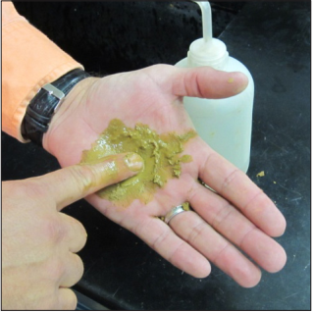
C: Is the soil gritty?
C1: The soil is not gritty=Medium texture
C2: The Soil is gritty=moderately coarse texture
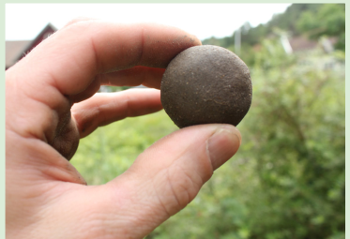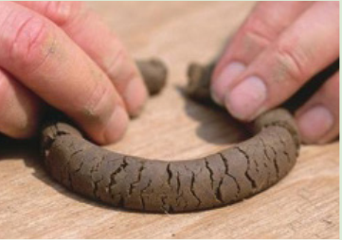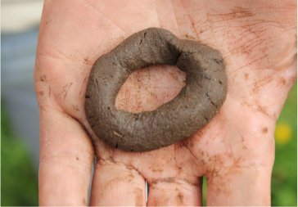
Ribbon Sand light clay/ Clay
Source:https://www.researchgate.net/figure/Formation-of-a-bolus-and-ribbon-to-determine-soil-texture_fig4_276417142/download((Received date (8/26/2022))
- See flow chart belowfor the next steps:
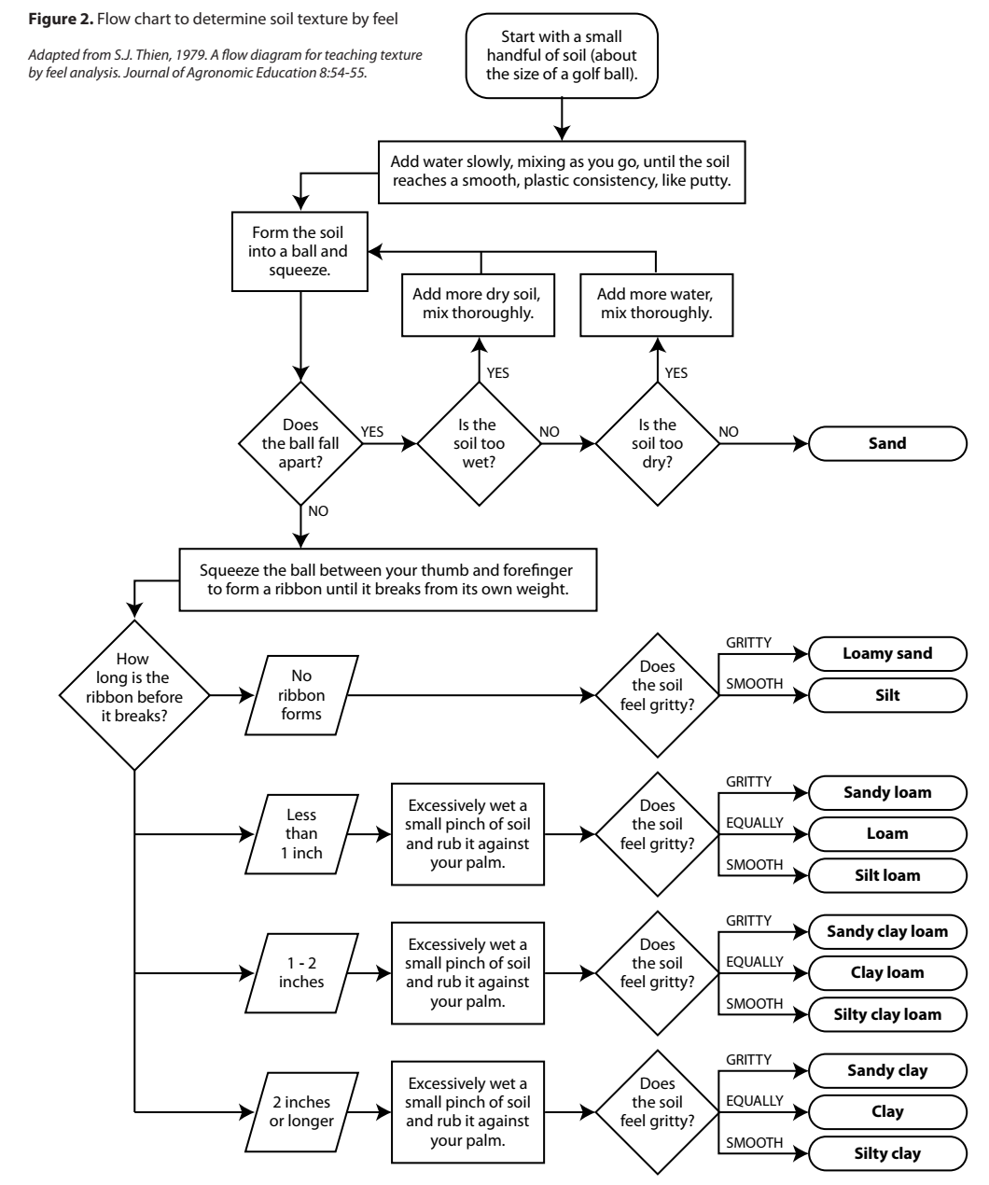
Figure2.8.Soil texture test by feel flow chart
(Source: https://schoolgardening.rhs.org.uk/Resources/Info-Sheet/Soil-texture-test-as-flow-diagram (Received date (8/26/2022))

  - .Techniques ofidentifying soil color by munshell system
- Munshell color chart
- Water
- Procedures/Steps/Techniques
- To identify the soil colour take an undisturbed soil ped in your hand.
- Carefully break open the ped.
- If the soil is dry, carefully moisten the inside surface with a spray of water.
- Place a sample of the soil from each layer on a white sheet.
- Keep the soil sample in the sunlight.
- Look carefully at the colours on the soil colour chart on the back and compare them with your soil to decide the colour of your soil.
- Compare the sample with this chart and identify the main colour match and a secondary colour match
- Record the colour matches by hue, value and chorma. The symbol for hue are the first letter of the colour, R for red, Y for yellow, Y-R for yellow-red. The number before the colour indicates progression from yellow to red .Value goes from 0 (white) to 10 (black). Chroma is indicated in a 0 to 20 range for colour
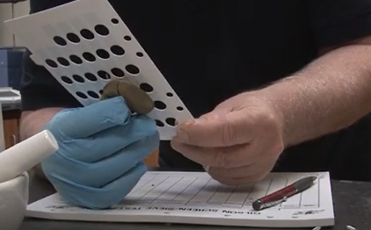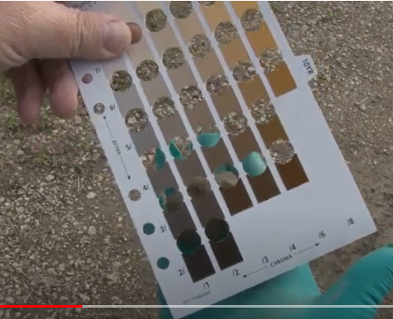
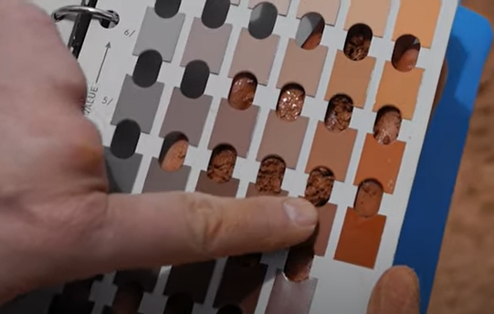
- See in detail from below video on how to identify soil color by using munshel color chart.
https://www.youtube.com/watch?v=N6doCSP8T7I
https://www.youtube.com/watch?v=6RSd2y7cDvs
https://www.youtube.com/watch?v=826cPcxeULw (Received date: 8/28/2022)

LAP TEST-2 | Performance Test

Name………………………………. ID…………………………….. Date…………………………………….

Time started: ________________________ Time finished: ________________

Instructions: Given necessary templates, tools and materials you are required to perform the following tasks within3hour. The project is expected from each student to do it.

Task-1: Perform soil texture test by feel methods.
Task-2: Identify soil color by using Munshell color chart

LG #6 | LO #3- Complete soil testing operation

Instruction sheet 3
This learning guide is developed to provide you the necessary information regarding the following content coverage and topics:
- Cleaning equipment
- Disposing of containers, leftover fluids and wastes

This guide will also assist you to attain the learning outcomes stated in the cover page. Specifically, upon completion of this learning guide, you will be able to:
- Clean equipment
- Dispose of containers, leftover fluids and wastes
Learning Instructions:
- Read the specific objectives of this Learning Guide.
- Follow the instructions described below.
- Read the information written in the information Sheets
- Accomplish the Self-checks
- Perform Operation Sheets
- Do the “LAP test”

Information Sheet 3

. Cleaning equipment
Equipment is cleaned in accordance with manufacturer’s specifications, organizational procedures and regulations. Tasks may include disabling unused tools, equipment and machinery and storing neatly out of the way of surveying activities; safely storing materials on site;
The purpose of cleaning tools and equipment after soil sampling and testing work is;
- Keep from damage
- Extend the life span of tool
- Protecting the tools for rust

.Disposing of containers, leftover fluids and wastes
All containers, leftover fluids and waste are disposed of safely and appropriately. Wastematerials are disposed of in an appropriate and safe manner according to supervisor's instructions.
Waste May include, but not limited to:
- Plastic, metal ,poly trays, bags, and waste water , chemical substances such as acids or poisons and those that could lead to fire or explosion, dusts and fumes
- Swiftly and efficiently removing and processing waste from the work area.
- Plastic, metal, paper-based materials may be recycled, re-used, returned to the manufacturer or disposed of according to enterprise work procedures. Recycling waste water or disposing using approved discharge system.
- Prompt removal and/or disinfestations of organic waste, use of mixing site, neutralizing pits for disposal of chemicals and cleaning products, recycling seed trays.
- Chemical substances such as acids or poisons and those that could lead to fire or explosion, dusts and fumes from various processes must be disposed of safely and appropriately.
- Surplus materials are stockpiled for removal according to supervisor's instructions.

Self-Check – 3 | Written test

Name…………………………………………… ID………………………… Date…….

Directions: Answer all the questions listed below.
Test I: Multiple choice (4points)
1. Maintaining a clean environment is important because clean environment,
A. promotes the damage of the natural ecosystem. C. Increase health problem.
B. Attract tourist to bolster economies D. cause depression in people living near it.
2. Which one is not purpose of cleaning tools and equipment after soil sampling and testing work?
A. Keep from damage C .Expose the tools for rust
B. Extend the life span of tool D.A &B
Test II: Short Answer Questions (6points)
1. List the purpose of cleaning tools and equipment.
2. List and explain types of waste materials during soil sampling and testing process.
3. Explain how to handle and disposeleftover fluids and wastes materials during and after completing soil testing actives.

Reference Materials
Books:
​Buol, S.W., Southard, R.J., Graham, R.C. and McDaniel, P.A., 2011. Soil genesis and classification. John Wiley & Sons.
Cope, J.T. and Evans, C.E., 1958. Soil testing. In Advances in soil science (pp. 201-228). Springer, New York, NY.
FAO. 2006. Guidelines for soil description. 4th ed edition. Rome, Food and Agriculture Organization of the United Nations. 97 pp.
FAO. Date. General Training – Soil Texture. Fisheries and Aquaculture Department [CDROM]. Rome.
FAO. 2020. Manual for the implementation of the Soil Doctors Global Programme at the country level - A farmer-to-farmer training programme. Rome.
Hodgson, J.M., 1978. Soil sampling and soil description. Oxford University Press.
JG, R., Estefan, G. & Rashid, A.2002. Soil--Plant-Analysis Soil and Plant Analysis Laboratory Manual
Mason, B.J., 1992. Preparation of soil sampling protocols: sampling techniques and strategies (No. PB-92-220532/XAB). Nevada Univ., Las Vegas, NV (United States). Environmental Research Center.
Peck, T.R. and Soltanpour, P.N., 1990. The principles of soil testing. Soil testing and plant analysis, 3, pp.1-9.
Web addresses
https://agritech.tnau.ac.in/agriculture/agri_soil_sampling.html.(Recieved date 27/8/2022)
https://www.sciencedirect.com/topics/agricultural-and-biological-sciences/soil-color.
https://uknowledge.uky.edu/cgi/viewcontent.cgi?article=1139&context=anr_reports
https://www.pinterest.com/pin/753016000186922258/ (Received date 29/8/2022)
https://publiclab.org/notes/DanielleS/03-08-2019/diy-soil-texture-tests-learn-more-about-your-soil (Received date 29/8/2022)
https://www.pinterest.com/pin/416020084307318708/ (Received date 29/8/2022)
https://www.fao.org/fishery/docs/CDrom/FAO_Training/FAO_Training/General/x6706e/x6706e07.htm.(Received date 29/8/2022)
https://www.extension.purdue.edu/extmedia/AY/AY-368-w.pdf (Received date 8/31/2022)
https://www.nrcs.usda.gov/Internet/FSE_DOCUMENTS/nrcs142p2_053256.pdf.
https://www.nrcs.usda.gov/Internet/FSE_DOCUMENTS/nrcs143_019165.pdf.

The experts who developed the learning guide
No | Name | Qualification | Educational background | Region | Phone number | E-mail
1 | KormeTusuru | MSc | Biodiversity and conservation Management | Oromia | +251916145234 | bilisumakorme@gmail.com
2 | GelasaTola | MSc | Biodiversity and conservation Management | Oromia | 0920049614 | tolagelasa@gmail.com
3 | Gezahegn Tadesse | MSc | Drainage and Watershed Management | Alage | 0968445006 | sihine29@gmail.com
4 | Geleta Bekele | BSc | Forestry | Afar | 0925482964 | geletabk12019@gmail.com
5 | DegaregeMitkie | BSc | Water Resource & Irrigation Engineering | South West | 0921281867 | mitkiedegarege@gmail.com
6 | GetnetAsmare | MSc | Production Forestry | Amhara | 0912846540 | getnetasmare40@gmail.com
7 | KifleTolossa | MSc | Soil Science | Alage ATVET | 0910895568 | kifletolossadechasa@gmail.com
8 | Tolessa Sori | MSc | Forest & Natural Management | South West | 0917007821 | tolosa.sori@gmail.com
9 | YeshitilaWondosen | MSc | Climate change & Development | BenshangulGumuz | 0911071229 | yeshiwondo@gmail.com
10 | Zeleke Dessie | MSc | Agroforestry | Oromia | 0911091388 | zelekedessie@gmail.com
11 | Ziyad Rube | MSc | Water Resource Engineering & Management | Afar | 0921484656/  0962639851 | yoomnaaf51@gmail.com

