Natural Resource Conservation and Development
Level I

Based on March 2022, Version One Occupational standard
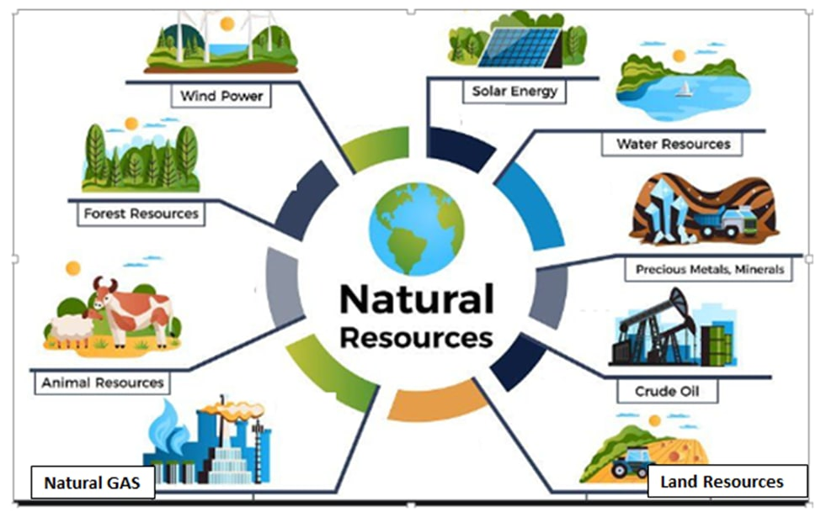

Module Title: - Performing Nursery work
LG Code: AGR NRC1 M04LO (1-9) LG (15-23)
TTLM Code:AGR NRC1 TTLM 0922v1

September 2022
Addis Ababa, Ethiopia

Table of Contents

Introduction to the Module 1
LO #1- Prepare materials, tools and equipment for nursery establishment 2
Instruction sheet 2
Learning Instructions: 3
Information Sheet 1 4
Self-check 1 19
LO #2- Select appropriate site for nursery establishment 20
Instruction sheet 20
Information Sheet 2 21
Self-Check – 2 24
LO #3- Demarcate the Area and Sketch the Map 25
Instruction sheet 25
Information Sheet 3 26
Self-Check – 3 31
LO #4- Establish nursery 32
Instruction sheet 32
Information Sheet 4 33
Self-Check – 4 37
LO #5- Undertake basic nursery work 38
Instruction sheet 38
Information Sheet 5 40
Self-Check – 5 53
Operation Sheet -5 54
LAP TEST-5 59
LO #6- Transplant the seedling 60
Instruction sheet 60
Information Sheet 6 61
Self-Check – 6 66
Operation Sheet -6 67
LAP TEST-6 68
LO #7- Maintain the nursery environment 69
Instruction sheet 69
Information Sheet 7 70
Self-Check – 7 76
LO #8- Clean up and Store Materials 77
Instruction sheet 77
Information Sheet 8 78
Self-Check – 8 80
LO #9- Record and Report 81
Instruction sheet 81
Information Sheet 9 82
Self-Check – 9 88
Reference Materials 89

Introduction to the Module

This Module covers the knowledge, skills and attitude required to perform nursery establishment and implement appropriate seedbed preparation and seedling producing techniques. It requires the ability to prepare, materials, tools and equipment to undertake nursery establishment and basic nursery work activities, store and stockpile materials.
LG #15 | LO #1- Prepare materials, tools and equipment for nursery establishment

Instruction sheet
This learning guide is developed to provide you the necessary information regarding the following content coverage and topics:
- Introduction to nursery
- Identifying the required materials, tools and equipment for nursery tasks/instructions
- Conducting checks on all materials, tools and equipment
- Using correct manual handling and techniques for loading and unloading materials
- Selecting and checking Suitable Personal Protective Equipment (PPE)
- Providing nursery support
- Identifying and reportingOHS hazards

This guide will also assist you to attain the learning outcomes stated in the cover page. Specifically, upon completion of this learning guide, you will be able to:
- Identify the required materials, tools and equipment
- Conduct checks on all materials, tools and equipment
- Use correct manual handling and techniques for loading and unloading materials
- Select and check Suitable Personal Protective Equipment (PPE)
- Provide nursery support.
- Identify and reportOHS hazards

Learning Instructions:
- Read the specific objectives of this Learning Guide.
- Follow the instructions described below.
- Read the information written in the information Sheets
- Accomplish the Self-checks

Information Sheet 1

- Identifying the required materials, tools and equipmentfor nursery tasks/instructions.

- Introduction
Nursery is a managed site or area designed to produce or raise seedlings or young plants under favorable conditions until they are ready for out-planting on farms, community areas, forests (enrichment planting or plantations) or public areas. It is a place where seeds and cuttings are grown with special care and protection up to the point where the young seedling is able to establish and flourish under field condition. It can also be defined as an area, in which new saplings are raised and nourished until they are ready for sale or transplanting at a permanent place in a field.

- Importance of nursery
- It is possible to grow and maintain a large number of plants per unit area.
- When seeds are sown in seedbeds, their germination percentage increases and the vigour of the seedlings also improves.
- The management of seedlings can be done in a better way with minimum care, cost and maintenance as the nursery area is small.
- Manipulation of growing conditions for plants becomes easy.
- Better and uniform plant growth can be obtained in the main field by selecting vigorous and healthy seedlings.
- Management of insect-pests, diseases and weeds is easy in a nursery.

- Types of Nursery
Nurseries are classified on the basis of duration, plants produced and structures used. These are permanent Nurseries and temporary nurseries.

A. Permanent nursery:
In this type of a nursery, the plants are nourished and kept for a longer period of time till they are sold out or planted permanently in a field. The area covered under such a nursery is larger than a temporary nursery and it has all features that are required in a permanent nursery.
Some of the important cultural operations carried out in the permanent nursery throughout the year are as follows:
- It requires a large area and must be well connected by road.
- Such type of a nursery requires intensive management and supervision.
- High initial cost is involved in the establishment of such a nursery.
- Permanent nursery comprises office, store, mother blocks, nursery beds, protected structures, irrigation source, electricity, transportation facilities, packing yard, manure, cattle and machinery shed.
Advantages
- Greater range of planting stocks, such as seedlings, grafted plant, budded plants, layers, rooted cuttings, etc., are available.
- Being permanent in nature, it becomes a perpetual source for the supply of planting material for many years.
- Being concentrated at one place, its supervision and management is better due to the availability permanent staff.
- The initial production cost is reasonable but profits go up in the long run.
Disadvantages
- The initial investment cost is high.
- The transportation cost is more.
- Such a nursery needs intensive labour management.
- It must be backed by a large market for the sale of plants and seedlings.
- It requires skilled human resource round the year.

B. Temporary/short-term nursery:
This type of nursery is developed only to fulfil seasonal requirements or a targeted project. Such a nursery is, usually, small in size and is set up for a short period after which it is abandoned. Temporary nurseries are mostly used for raising seedlings of vegetables and flower crops. Such nurseries are found near the main planting area.

Features
- It is constructed for a short period and is small in size.
- Intensive manuring and fertilisation is not necessary in such a nursery as it is constructed at a site rich in humus.
- As it is located near a planting site, the distance between the nursery and the actual planting site is less.
- No major transportation is required, and if any, the cost is less.

Advantages
- Mortality or injury due to shock of lifting and transportation of seedlings is negligible due to less distance between the nursery and actual planting site.
- Initial investment in a temporary nursery is less as compared to a permanent one.

Disadvantage
Because of its temporary nature, basic facilities like irrigation may not be adequate. Therefore, special arrangements need to be made in order to keep the plants and seedlings in healthy condition.
- Tools required for working on the soil
- Pickaxe:
It is made of carbon steel. Pickaxe has two edges with provision of axial hole for attachment with handle. One edge of pick –axe is pointed and another is broadened. Pick axe is used for digging hard, compact and stony soils.
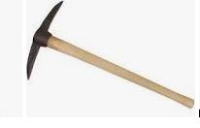
Figure 1.1: Pickaxe
- Spade:
It is used for lifting and turning the soil. Also used for digging the pit, preparing channel for irrigation and drainage lines.

Figure 1.2: Spade:

- Long handled hoe:Used for breaking up the soil. For loosen the soil.

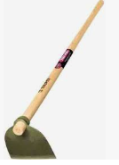
Figure 1.3: Long handled hoe:
- Short handled hoe:used for cultivation, for getting rid of weeds, for thinning crops, working in the fields.
Figure 1.4: Short handled hoe:
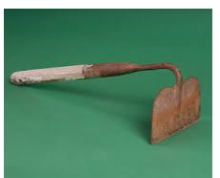
Figure 1.4: Short handled hoe

- Shovel:
It has iron blade of spoon shape and wooden handle and is used for within field transport of dug out soil required for leveling of field for preparation of nursery beds. It is also used for moving earth, sieving soil and soil mixing.

Figure 1.5: Shovel
- Flat-pronged fork: for loosening the soil.
- To lift bare-roofed seedlings and to turn over compost.
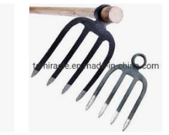
Figure 1.6:Flat-pronged fork
- Rake: break up and level the soil; and it has a row of 10-16 teeth and is kitted up with a 1.80m handle.
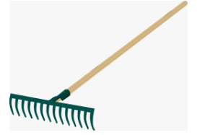
Figure 1.7: Rake

- Tools required for layout
- Compass: used to determine direction during nursery site establishment.
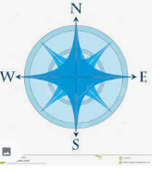
Figure 1.8: Compass

- GPS: used to delineate nursery area.

Figure 1.9: GPS
- Ranging pole: used to correct slope reading.
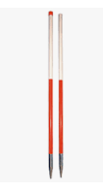
Figure 1.10: Ranging pole

- Measuring tape: used to measure the distance between two points.

Figure 1.11: Measuring tape

- Rope: used to make strait line.
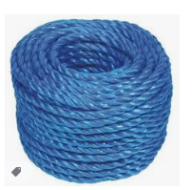
Figure 1.12: Rake
- Tools required for preparation of soil pot filling
- Sieve: soil for seed beds and for potting should not contain large-size particles, stones, pieces of weed or something alike. Sieve size approximately 1.5 and dimension 1×1.5m.
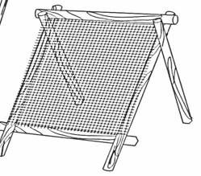
Figure 1.13: Sieve
- Funnel: for speeding up pot filling if inserted in the polythene tube.
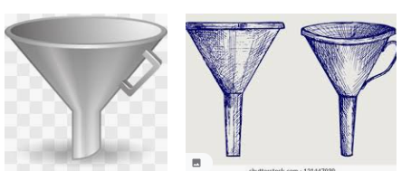
Figure 1.14: Funnel

- Scoop- made of metal sheet, it is an efficient tool for filling and compacting soils in pots.
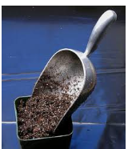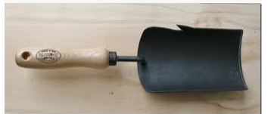
Figure 1.15: Scoop
- Pot cutting roll: a simple cutting gauge that permits rapid cutting of the tube into pots of standard length (15, 20 or 30cm).It can be made locally.
- To obtain pots in 20cm length, the piece of rounded tube has to have diameter of 6.5cm and of 9.5cm for 30cm long.
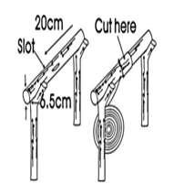
Figure 1.16: Pot cutting roll

- Tools required for watering
Watering can: it can be made of metal or plastic; and it should have a capacity of 10-12L; kitted up with fined-perforated sprinkler to avoid damage to young plants and dentation of root from splashing water.
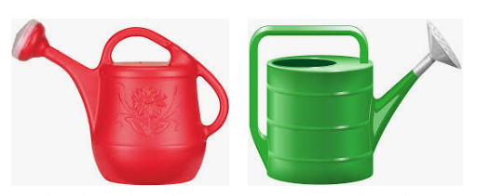
Figure 1.17:Watering can
- Tools required for transport within Nursery
- Wheelbarrow: It is manually operated small trolley, used for carrying nursery plants, compost, fertilizes, leaf litter, horticultural produce, stones etc. from one place to another place.
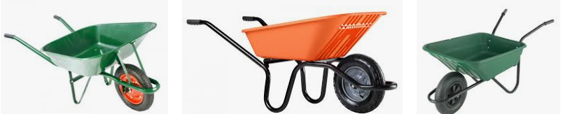
Figure 1.18: Wheelbarrow

- Tools required for tending operations
- Pruning knives: used to prune the roots that grow out of the pot.
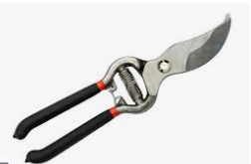
Figure 1.19: Pruning knife

- Pruning shear: It is made of iron fitted with wooden handle. It is used to prune unwanted branches, collection of scion, trimming of the edges and hedges and topiary work.
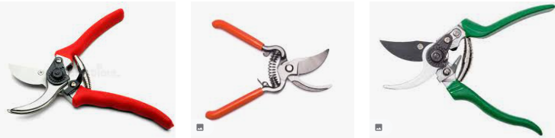

Figure 1.20: Pruning shears

- Trowel: It is of shovel shape but small in size with iron blade and wooden handle. It can be made in many shapes as per local designs and requirements. It is used for hoeing, weeding andnursery plants and also for transplanting seedlings.
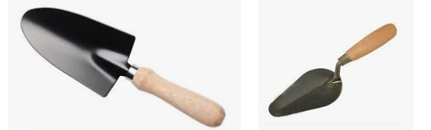
Figure 1.21: Trowels

- Secateurs: Secateurs are considered as the most important tool for a propagator or a nurseryman. It is used for removing scions, lopping off the rootstock, preparation of scion sticks, removal of undesirable shoots/sprouts from the stock and training and pruning operations. The blades of secateurs should be of high quality carbon blade for giving smooth cuts to the stock and scions.
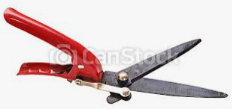
Figure 1.22:Secateurs

Machete: long knife, which can be used for many purposes such as:
- cutting fence posts
- Removing weedy fences
- Trimming living fences
- Chopping leftover seedlings for composing…etc.
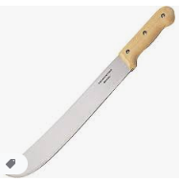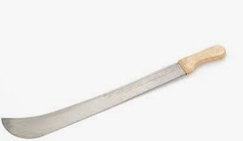
Figure 1.23:Machete

- Tools required for weeding
Simple tools like a pointed piece of stick, with strong hammered flat at one end and a handle at the other, are useful for weeding on seedbeds& potted stock.
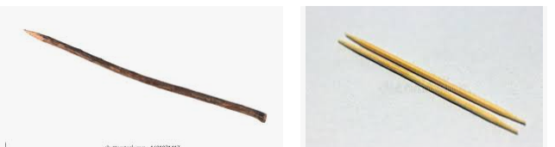
Figure 1.24:a pointed piece of stick
- Tool for pricking out
- A small shovel, a flat piece of wood, or simply a spoon is useful to lift germinated seedlings for pots transplanting without damaging their roots.
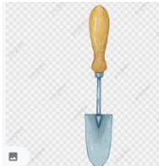
Figure 1.25:small shovel
- Checking materials, tools and equipment
Before and after using the different materials in the nursery, it is very important to check the equipment. This makes the equipment free from some things unpleasant, undesirable, damaging that happen unexpected during work operation in the work place. If the materials are damaged it is possible to report to the supervisor immediately. Every nursery should have a sufficient supply of tools for different operations. A good care shouldtaken of the tools, which would then have a long life. It is not wise to keep workers sitting idle at critical periods of work because of shortage of tools. All tools should be hung or otherwise stored in fixed place in the nursery where they can be readily found. They should be stored in-groups of similar articles so that checking to ensure that all tools have returned after work done at a glance.

- Using correct manual handling techniques for loading and unloading materials
- Techniques of correct manual handling
Manual handling refers to any activity that requires the use of force to lift, lower, push, pull, carry or move a person, animal or object. By observing simple, safe manual handling methods, you can avoid manual handling injuries.
Since manual handling is intensively used in nursery, the work site practically cannot be free from harms and injuries on the job condition at work place. Through training and assessment of risk, we aim to eliminate hazardous manual handling activities as far as it is reasonably practicable.
In order to reduce the risk of injury from manual handling operations, Nursery will ensure them:-
- Assess the risks associated with those manual handling activities that cannot be avoided.
- Eliminate hazardous manual handling activities, so far as is reasonable practicable.

- Employee’s duties for loading and unloading materials
Employees should ensure that they:-
• Comply with any instruction and training provided in safe manual handlingtechniques
• Don’t put their own health and safety or that of others at risk by carrying outunsafe manual handling activity
• Report problems including physical and medical conditions (e.g. pregnancy, back problems), which may affect their ability to undertake manual handling activitiesto their line manager

- Selecting and checking suitable PPE
- Concept of PPE
Personal protective equipment (PPE) is defined in the Regulations as ‘all equipment (including clothing affording protection against the weather) which is intended to be work or held by a person at work and which protects him against one or more risks to his health or safety.eg. Safety helmets, gloves, eye protection, high visibility clothing, safety footwear and safety harnesses.

- Types of personal protective equipment

- Protective clothing:protect the skin from direct contact with harmful agent (dust, heat and chemical). E.g. Overall
- Eye and face protectors: Eye/ faces are frequently injured in many kinds of works by flying particles and foreign bodies like chemical, heat and light, dust and splashes of liquids.
- Head protectors: protectour head from falling objects like branches, loads lifted, tools, etc.
- Hand protectors: Wear gloves to protect against cuts, vibration, cold, harmful vegetation (thorn).
- Legs and feet protectors: All workers engaged in performing nursery establishment shall wear safety leg protection and footwear which safety toe caps.
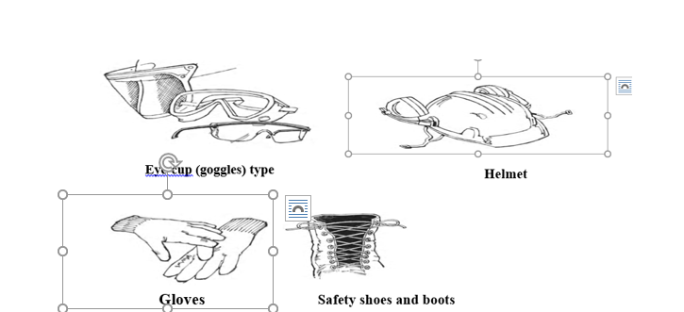
Figure 1.2:personal protective equipment

- Providing nursery support

- OHS requirements and workplace information
During performing nursery work the workers use different tools, which are sharpen. To keep their health the workers expected to fulfill the following requirements;
- Provide first aid kit
- Before starting their work, the workers check the arrangement of the tools
- Pick up the tools with great care
- Take care of sharpen tools
- Use these tools properly
- Identify rusted tools
- If they are reusable use them for other purpose
Before beginning their activities, the workers be aware about the work place. This awareness may help the workers about what they will do, which instruments they will use, and what type of conservation mechanism they will apply and so on.
During these activities different occupational health hazards may occur. From these hazards some of them may be; erosion, slip, injury and others damages are expected.

- Identifying and reporting OHS hazards

Occupational Health and Safety (OHS)is concerned with all factors relating work, working methods, conditions of work and the working environment that may cause diseases and injuries and including chemical, physical and mechanical hazards.

Hazard is a condition or combination of condition that left uncorrected may lead to an accident, illness, property damage
- Careful analysis of potential hazards in the work place has led to many of today’s widely used safety measures and practices
- Farmer’s unsafe use of insectsides and pesticides can sustain such hazards when they try to protect their crops from insects

Report is an account or statement describing in detail an event a happening
- The hazard condition observed in the work place should be reported
- The purpose of the report is to record the finding of the accident investigation, cause of the accident, and recommendation for corrective action
The report should contain the following information
- Location and date of the accident
- Victims name, sex, age, home address and telephone
- Types of injury and how it took place
- Cause of the accident

Self-check 1 | Written test

Name…………………………………………… ID………………………… Date…….
Directions: Answer all the questions listed below.
Test I: Choose the best answer (3 point)
1. Which of the following is used to produce sufficient number of seedlings?
A. Permanent nursery
B. Temporary nursery
C. Flying nursery
D. All
2.Tools required for working on the soil include:
A. Pickaxe C. Rake
B. Traditional hue D. All
3. ________ is a simple cutting gauge, which permits rapid cutting of the tube into pots of standard length.
A. Funnel C. Scoop
B. Pot cutting roll D. Watering can
Test II: Short Answer Questions (10 point)
1.Define nursery (2 point).
2. What is personal protective equipment? (2point)
3. What are the tools for preparation of putting soiled pot filling?(4point)
4. Where do hazard arises? (2point)

Note: Satisfactory rating - 13 points Unsatisfactory - below 13 points

You can ask you teacher for the copy of the correct answers.

LG #16 | LO #2- Select appropriate site for nursery establishment

Instruction sheet
This learning guide is developed to provide you the necessary information regarding the following content coverage and topics:
- Confirming the availability of water supply
- Considering the proximity of nursery site
- Favorable climatic and land features
- Identifying the depth and fertility of the soil
- Request and obtain a plot of land

This guide will also assist you to attain the learning outcomes stated in the cover page. Specifically, upon completion of this learning guide, you will be able to:
- Confirm the availability of water supply
- Consider the proximity of nursery site
- Reviewfavorable climatic and land features
- Identify the depth and fertility of the soil
- Request and obtain a plot of land
Learning Instructions:
- Read the specific objectives of this Learning Guide.
- Follow the instructions described below.
- Read the information written in the information Sheets
- Accomplish the Self-checks

Information Sheet 2

- Confirmation of the availability of water supply

- General concept of water availability
Water: - is the liquid that has no color taste or smell, that falls from clouds as rain that forms stream, lakes, and seas that is used for drinking, washing etc. Water is one of the best criteria for choosing nursery site. The nursery site should be next to the area where water is available all the year near ponds, springs, rivers; lakes, etc.

- Nursery water supply
Water is one of the best criteria for choosing nursery site. A reliable and adequate water supply is always a requisite in nursery establishment.The nursery site should be next to the area where water is available all the year near ponds, springs, rivers; lakes, etc.The nursery site should be located near the source of water either from a running stream or main pipe water supply to sustain rapid and healthy growth of the seedlings. The ideal situation is where there is a perennial stream at a higher level than the nursery, and fairly close to it, so that water can be diverted from the stream to the nursery in high density plastic pipes. Alternatively, a water storage tank should be installed for sustainable water supply.

- Considering the proximity of nursery site

- Location
The nursery site should be located near the plantingsite to minimize injury in handling and duringtransportation. It must be easily accessible to facilitatenursery field operations and supervision. Access roadsshould be usable during all seasons of the year.
If we are establishing a permanent nursery especially, the site selected should be near themain roadand should be connected to the main road by any means.These should have transport facilities (also),electricity supply and housing facilities for the workers near the nursery (if possible). A lot of labour is required for the construction of a nursery and subsequent nursery activities. Hence, nurseries should be located where labour is available. Siting a nursery on a main trail near a village will also increase awareness and enhance patronage.

- Favorable climatic and land features
- Climate: includes climatic factors mainly rainfalls, temperature, and wind
- Select a nursery site with similar climatic condition as that of the planting site.
- Select a nursery site with similar temperature and rainfall condition as that of the planting site. Avoidareas with extremes of climatic condition: Hightemperature; High rainfall; High ice, storms
- Topography:
The area for tree nursery establishment is preferably flat with a gentle slope to allow for drainage. Contour terracing should be done if the slope is in excess of 3 per cent.
The appropriate slope for selectingnursery should be gentle slope (1-3% slope).If hilly (> 3%), susceptible for soil erosion and in valley foot areas (< 1% slope) water logging is happen.

- Identifying the depth and fertility of the soil
Soil is one ofthe most important factors for selecting nursery site (especially for the production of bare rooted seedlings using the native soil. However, if seedlings are to be raised using pots, adequate source of soil mixture should be available in the near areas (helps to reduce transport distance and saves cost).
The chosen nursery site should have appropriate soil texture, depth and soil PH value.
Deep, good-structured, easily pulverized soil is desirable. Avoid shallow soils with a hard sandstone band near the surface. A very sandy-structured soil should also be avoided because of poor moisture retention characteristics and faster leaching of plant nutrients. Soil containing too much clay has poor drainage characteristics and should not be considered in site selection.
The best soil for planting is loam. The PH of the soil should be between 5-7 for broad-leaved plant (most indigenous) and between 4.5-6 for conifers (most exotic species).
A valuable guide in selecting a potential fertile site is to look at the past agronomic history andnative vegetation.

- Request and obtain a plot of land

- Land availability
It is important that the site selected for the nursery have enough land to raise the number of seedlings needed, and if possible, room for expansion.The size of the nursery depends on the number of plants to be produced, the time they will remain in the nursery, as well as the quality and slope of the site. It is also important to ascertain who owns the land. If it is institutional or privately owned land it is important to formalize the use of the land by obtaining a letter from the owner agreeing to its use as a tree nursery for a defined period of time.

Self-Check – 2 | Written test

Name…………………………………………… ID………………………… Date…….

Directions: Answer the questions listed below.

Test I: Short Answer Questions 10 point
- List and discuss factors considered during nursery site section. (5pts)
- write the sources of water for nursery (5pts)

Note: Satisfactory rating - 10 points Unsatisfactory - below 10 points

You can ask you teacher for the copy of the correct answers.

You can ask you teacher for the copy of the correct answers.

LG #17 | LO #3- Demarcate the Area and Sketch the Map

Instruction sheet
This learning guide is developed to provide you the necessary information regarding the following content coverage and topics:
- Surveying the nursery area
- Calculating the nursery site
- Fencing the area
- Developing the sketch map

This guide will also assist you to attain the learning outcomes stated in the cover page. Specifically, upon completion of this learning guide, you will be able to:
- Survey the nursery area
- Calculate the nursery site
- Fence the area
- Develop the sketch map
Learning Instructions:
- Read the specific objectives of this Learning Guide.
- Follow the instructions described below.
- Read the information written in the information Sheets
- Accomplish the Self-checks

Information Sheet 3

- . Surveying the nursery area

- Concept of surveying
Surveying is concerned with determining the area of any portion of the earth surface, the lengths and direction of the bounding, and contour of the surface with accurately delineating the whole on paper.Surveying the nursery areas should be conducted to assessthe communities’ interest in developing tree seedlings for production of commodities for improving livelihoods as well as forest/land rehabilitation.

- Purpose of surveyingthe nursery area
The main purpose of the survey is
- to know the status of forest tree nursery and tree planting in the given area
- to identifydifferent components of nursery.
- to know indicator of success of tree nursery
- to know quality of germplasm
- to know status of technical capacity and business on nursery
- to know status of forest tree planting, and
- to identify constraints on implementation of forest tree planting the given area.

- Calculating the nursery site
In determining the nursery site, we should consider:
a) The size of the nursery
b) The shape of the nursery

a) The size of the nursery
To determine the most appropriate nursery size, the following information is required:
1) Total seedling to be produced yearly (Annual seedling production)
E.g. 250,000 seedlings/per year
2) Production technique:
- Container seedlings required less space.
E.g., 10m x 1.2m bed can host 5 times more container seedlings than bare-rooted seedlings.
3) Length of stay in the nursery
- Container seedlings needs shorter production cycle (8~12 months).
- Bare rooted seedlings needs 8~14 months
- Bare rooted seedlings occupy much space than container seedlings (twice of it)
4) Infrastructure of the nursery
It accounts for 25% of the total area of the nursery.
E.g. paths, access roads, working paths, irrigation channel, offices, storing places.
To calculate the nursery area we can use the following simple formula:
- NA=(PB+TB)/0.75
- PB=K1×S/(R×104)
- TB=( K1×S) K2/(d×104)
Note:
PB =Potential production area (hectare) of propagation beds.
TB = Potential production area of transplanting beds
NA=Nursery area (hectare)
S=the number of seedlings required for reforestation activity
K1= Correction factors expressing the necessary surplus to production to cover losses in propagation beds.
K2=the same as K1 but for transplant beds
K=correction factor. It ranges from 1~1.35
R=plant density per ㎡ in propagation beds
D= plant density per ㎡ in transplanting beds
Example: In a certain planting program, there is a plan to produce 800,000 seedlings, and the plant density for propagation and transplant beds are 110 seedlings/㎡ and 90 seedlings/㎡ respectively with K1=1.2 and K2=1.35. Then calculate the nursery area:
Given: K1=1.2 S=800,000 seedlings
K2=1.35 R=110 seedlings/㎡
D= 90 seedlings/㎡
PB = K1×S/{r×104}
=1.2×800,000÷ {110×104}
=0.873 (hectare) of propagation beds
TB= (K1×S) K2/d×10,000
=1.44 (hectares) of transplantation beds
NA= (PB+TB)/0.75= (0.873+1.44)/0.75=3.1 (hectares)
b)Shape: Ideally, a forestry nursery should be square shaped because the perimeter of the square is less than that of a rectangular for the same area.
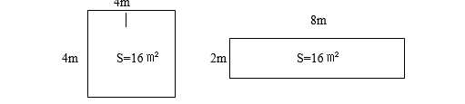
Figure 3.1:Shape of the nursery
From the pictures, we can know that the square has the minimum boundary. As a result, it reduces the cost of fencing. In many cases, however, a rectangular shape is preferred because of a longer working line. In general, the shape of the nursery depends on the terrain condition of the site.

- Fencing the area
Prior to the establishment of a nursery, a good fence with barbed wire must be erected all around the nursery to prevent tress pass of animals and theft. The fence could further strengthened by planting a live hedge with thorny fruit plants.
A nursery usually surrounded with a fence or hedge to demarcate and to protect them against animals and some extreme winds.
Fencing may done in these ways:
- using barked or plain galvanized (zinc) wire
- wire mesh (chi ken net wire)
- wooden materials
- electric fencing
- stone wall

- Developing the sketch map
Producers should first look at the entire parcel to note the natural features of the land. Invariably there will differences in slope, wind exposure, and native vegetation. A modern, inexpensive hand-held GPS (global positioning system) unit can be used to record all of the important features of the field. What was once a time consuming task with tape and transit is now relatively easily accomplished in less than a day on a 10 acre parcel. The first measurement to record is the actual size of the field. By walking the boundaries of the field and then downloading the data from the GPS unit onto an office desktop or portable laptop computer, a very accurate nursery plot map can be developed. Differences in elevation can also be determined using a GPS unit. Steep areas will need to be either avoided if they have excessive slope, or terraced. All existing roads, culverts, fences, buildings, and wells should be noted as well.
The direction of the prevailing wind should be observed and noted. On windy sites, field stock can be deformed by prevailing wind.

- Developing a Layout
In designing the nursery layout, we have to consider different components of nursery.
These are:

A. Production area:
- Seedbeds
- transplanting beds
- and reserve beds

B. Non-production area:
- Administration area--- office
- Store area for storing tools and equipment
- Access roads and paths
- Compost making area
- Soil mixing area, etc.
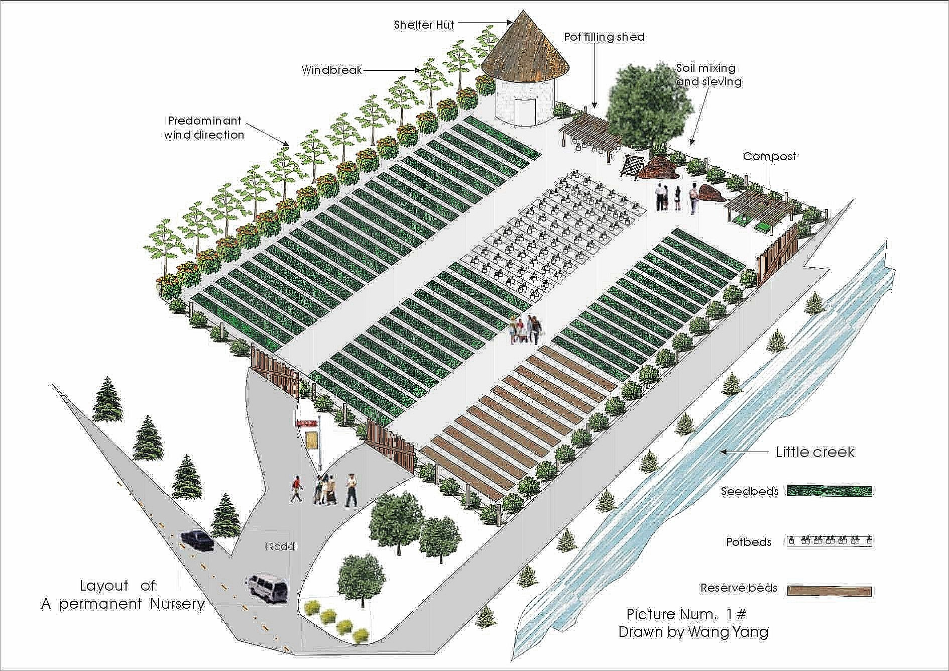
Figure 3.2: Map of a permanent nursery

Self-Check – 3 | Written test

Name…………………………………………… ID………………………… Date…….

Directions: Answer all the questions listed below.

Test I: Short Answer Questions 10 point
1. What is surveying? (5pts)
2. Write down importance of fencing. (5pts)

Note: Satisfactory rating - 10 points Unsatisfactory - below 10 points

You can ask you teacher for the copy of the correct answers.

You can ask you teacher for the copy of the correct answers.

LG #18 | LO #4- Establish nursery

Instruction sheet
This learning guide is developed to provide you the necessary information regarding the following content coverage and topics:
- Selecting and preparing blocks for the construction of offices and store
- Identifying and selecting blocks for the preparation of seed beds and transplanting beds
- Leaving block for damping materials
- Selecting and identifying trial blocks
- Developing and incorporating construction and installation of water system
- Incorporating access roads
- Incorporating strips for hedges and wind breaks

This guide will also assist you to attain the learning outcomes stated in the cover page. Specifically, upon completion of this learning guide, you will be able to:
- Select and prepare blocks for the construction of offices and store
- Identify and select blocks for the preparation of seed beds and transplanting beds
- Leave block for damping materials
- Select and identify trial blocks
- Develop and incorporate construction and installation of water system
- Incorporate access roads
- Incorporate strips for hedges and wind breaks
Learning Instructions:
- Read the specific objectives of this Learning Guide.
- Follow the instructions described below.
- Read the information written in the information Sheets
- Accomplish the Self-checks

Information Sheet 4

- Selecting and preparing blocks for the construction of offices and store
The inclusion of an office and storage facilities depends on the size and useful life of the nursery
and the availability of funds. Generally the office and the storage area occupy the same building
with the exception of fuels and other inflammable or toxic materials for which separate storage
facilities should be arranged. The office should be located close to the main entrance to avoid
routine movement of personnel, visitors and vehicles from disrupting nursery activities. It would
be an advantage if the location overlooked the production areas to facilitate management and
supervision. Very often washing and toilet facilities and a lunch room are overlooked when
nurseries are being planned. These are essential to ensure high standards of personal hygiene as
most workers are in daily contact with soil and chemicals and sometimes have to work at very
close quarters with each other in large numbers.

- Identifying and selecting blocks for the preparation of seed beds and transplanting beds
- Seed beds blocks
Thisarea that is set aside for the germination of seeds is best located near the office, to enable
the supervisor to maintain a close watch on the activity. It is customary to sow the seeds in
elevated metal or plastic trays erected waist high above the ground level. Round wood is
commonly used but a more permanent foundation is recommended to avoid frequent
replacement. One alternative is to build permanent seedbeds of concrete blocks.

- Blocks for transplanting bed
The nursery beds for growing bare rooted plants or for standing containers occupies the greater
part of the nursery area and it is here that the transplanted or direct sown seedlings are grown
until they are ready for planting in the field.
The only fixture in the transplant area is the watering system if one has been installed. However,
in very hot and dry locations, and with certain species, better results may be obtained by
transplanting and raising seedlings under a roof shed to control the light intensity. The building
need not be elaborate but it should be high enough for workers to stand underneath. Pickets of
wood or bamboo slats are commonly used and preservative treatment will extend their useful
life. Imported polypropylene shade cloth is available in different light intensities offering a
longer lasting, tidy and more efficient material.

- Leaving block for damping materials
During nursery site division into different blocks,we should leave blocks for damping materials.
Consider if the material can continue to perform over an extended time period and through a wide range of temperatures and environmental conditions without losing its effectiveness. The characteristics that make a material best for damping in your application will work be the ones that specifically increase the lifespan of your equipment or improve the safety of your employees.

- Selecting and identifying trial blocks
After selection of site for the establishment of a nursery, planning may be done in consultation with experienced nurserymen. By doing so the cost on establishment, production and marketing can be reduced substantially, besides performing various nursery operations most efficiently and economically. While compartment split is being done, trial blocks should be identified and selected.Trial blocks can be used for students to practice different nursery activities.

- Developing and incorporating construction and installation of water system

- Introduction
Pumping machinery is used for transfer of water from one place to another and pumping of water from water sources. Installation of water systemcan be done from sources of water such as ground water, open well, tube well/bore well, hand pump.
Special consideration must be given to a site where the quantity and quality of water are adequate for current and possible future requirements.
In most nurseries, irrigation is necessary during the growing season and for frost protection. Restrictions on flow and on periods of delivery must be closely inspected. Lakes are a good source of irrigation water. Storage capacity, draw-down, other uses, and contaminants must be examined before any commitment is made. Screening may be necessary to remove water-borne debris. Streams are sometimes used for nursery irrigation and must be checked for water rights, other uses, and quality. In addition, attention must be paid to intakes, diversions for pumping stations, protection during runoff periods, and maintenance of the stream channel to ensure maximum carrying capacity. Stream water may need to be screened to alleviate contamination by vegetation, weed seeds, frogs, fish, algae, and other water-borne debris. Irrigation water delivered through open ditches is usually controlled by irrigation districts and is subject to specific short delivery periods. Such a source is not reliable unless storage is made available on site and therefore is not recommended. Water drawn from wells is probably one of the best irrigation sources for most locations. Draw-down and pumping capacity must be checked to ensure that water is available in reliable quantities when it is required. Domestic or irrigation pipelines are reliable. In many instances, clean water will be supplied with adequate pressure and volume to eliminate the need for pumping. The two types of pipelines are similar, both generally well designed and constructed, although domestic water lines usually have more connections creating a high demand for water and more concern for failure of the system. Systems must be reviewed to ensure that maintenance is adequate and repairs are timely.
Water quality: Chemical contaminants may be introduced into an irrigation source through the soil or from precipitation or surface runoff. Contamination by minerals such as calcium or boron, for example, will usually be found in well water. However, because streams, lakes, and ditches also may have mineral contaminants, any potential site must have its water sources evaluated for mineral content and concentration. Water originating from any open source (lake, stream, or ditch) is subject to contamination by weed seeds. High concentrations of these can lead to unwanted vegetation in seedbeds and cover crops-a major problem. Special, well-designed screening devices can alleviate this problem.

- Incorporating access roads
Roads provide access to the nursery site and to growing fields. When the nursery site is developed, all access roads should be paved and they must be capable of taking heavy "semi" truck and tractor traffic in all kinds of weather. Parking areas must be evaluated and particular attention given to pedestrian and vehicle traffic flows. Possible conflicts with people, vehicles, buildings, and landscaping must be taken into consideration. The potential maximum number of future employees must be anticipated and allowances made for future parking if they needed.
When considering connecting points (entries and exits) to existing road systems, the development team should solicit input from the local community.
- Incorporating strips for hedges and wind breaks
- Hedges
- It is a one or two rows of seedlings, which is/are, planted in a straight line.
- Can be considered as life fences
- It can serve as shelterbelt in protecting seedlings against strong winds.
- It may take 2-3 years to grow it in full size.
- Need continuous and regular tending operation. (Hoeing, Weeding & watering)
- Fast growing species selected for making hedge.
  - E.g., Cupressus lustanica, Juniperus procera, Casuarinas, Dodonea, Viscosa etc.
- A fully grown Cupressus hedge can grow up to 1m height and 1m width at base (can be attained at 3~4 years age)

- Wind breaks:
These are three or four rows of suitable trees and shrubs planted on windward sides of production areas, germination beds or around the nursery.They help to reduce drying, eroding, and abusive effect of winds on growing seedlings, and sometimes they protect the nursery from animals.
Avoid selecting those species whose root systems compete with bare rooted seedlings for water and nutrients.
Any insect or disease out of the windbreaks should controlled quickly to reduce the risk of spreading to nursery seedlings.
When designing a windbreak, the direction of the wind must be considered. A barrier should be established perpendicular to the direction of the prevailing wind for maximum effect. To protect large areas, a number of separate barriers can be created as parts of an overall system. When the prevailing winds are mainly in one direction, a series of parallel shelterbelts perpendicular to that direction should be established; a checkerboard pattern is required when the winds originate from different directions. Before establishing windbreaks, it is important to make a thorough study of the local winds and to plot on a map the direction and strength of the winds.

Self-Check – 4 | Written test

Name…………………………………………… ID………………………… Date…….

Directions: Answer all the questions listed below.

Test I: Short Answer Questions 15 point
  - What are the factors affecting the inclusion of an office and storage facilities? (5pts)
  - List down purposes of hedge. (5pts)
  - List down importance of wind break. (5pts)

Note: Satisfactory rating - 15 points Unsatisfactory - below 15 points

You can ask you teacher for the copy of the correct answers.

You can ask you teacher for the copy of the correct answers.

LG #19 | LO #5- Undertake basic nursery work

Instruction sheet
This learning guide is developed to provide you the necessary information regarding the following content coverage and topics:
- Ploughing manually the seed and transplanting blocks
- Pulverizing seeding and transplanting blocks
- Levelling and preparing of seeding and transplanting blocks
- Preparing seeding and transplanting beds
- Sieving and preparing nursery inputs
- Mixing and filling the nursery inputs
- Arranging the filled polythene tubes
- Carry out sowing on beds and nursery tending operations
- Maintaining a clean and safe work site

This guide will also assist you to attain the learning outcomes stated in the cover page. Specifically, upon completion of this learning guide, you will be able to:
- Plough manually the seed and transplanting blocks
- Pulverize seeding and transplanting blocks
- Level and prepare seeding and transplanting blocks
- Prepare seeding and transplanting beds
- Sieve and prepare nursery inputs
- Mix and fill the nursery inputs
- Arrange the filled polythene tubes
- Carry out sowing on beds and nursery tending operations
- Maintain a clean and safe work site

Learning Instructions:
- Read the specific objectives of this Learning Guide.
- Follow the instructions described below.
- Read the information written in the information Sheets
- Accomplish the Self-checks
- Perform Operation Sheets
- Do the “LAP test”

Information Sheet 5

- Ploughing manually the seed and transplanting blocks

Seedbed and transplanting blocks can be ploughed manually in four ways. These include:
- Shallow plough to clear weeds (crops) and forages. The depths depend on different land types: for crop field or bed 4~7cm; for deserted land 10~15cm.
- Advantage: destroy weeds, diseases, and insect pests, facilitate the coming up plough
- Deep plough: major step of the land- clearing. Half month late after firststep.
Plough depth depends on different materials: seeds bed 20~25cm, cutting beds 25~35cm. The time of plough depends on the water content of the soil.If the soil water content is about 50~60%, the land is more suitable for plough. It can be tested like taking a handful of soil; making it a dumpling first and then let it fall down at 1m height; if the dumpling is smashed, it is good for plough. The purpose of plough is to loosen the lower layer and turn over the upper layer.
- Harrowplough:to break clod; cover fertilizer; layer soils; keep water and clear away weeds in order to improve soils. (Do not harrow excessively in case of disturbing soil structure)
- Firm the soil to improve the capillary of the soil. It can be done before or after the sowing. When soil is muddy or soil water content is high, firming may give rise to hardening of the soil.

- Pulverizing seeding and transplanting blocks
Pulverizingor breaking operation is required to produce a granular soil structure in the final seedbed. Tine cultivator and disc harrow are used for breaking of clods. Generally, these are operated after Seedbed and transplanting blocks should be ploughed. Direct harrowing or cultivator operation is also performed when the fields are clean and free from plant residues of previous crop. Clod crushers, patent harrow, etc., are very effective for clod crushing under favorable soil moisture conditions but their effect is confined to soil surface only.

- Levelling and preparing of seeding and transplanting blocks
The basic production unit is the compartment with beds running parallel to the shortest side. Before preparing seed beds seeding and transplanting blocks shouldbeleveled well. Each bed should be 1m wide and 0.4~0.6m apart for working path, enabling laborers to reach the center of the beds during watering and weeding on both sides. One compartment can hold 10~20 beds. It is good if a single compartment can contain 10 beds to shorten the walking distance. Germination compartment building, as well as soil storage occupies one compartment each.For management purpose, several compartments can be combined to form blocks that can be framed by hedges.

- Preparing seeding and transplanting beds
- Seed bed
It refers to a land, which is made free from weeds, stumps, stones, pebbles, etc., and is used for sowing of seeds to raise seedlings and multiplication of different species of plants through asexual means.
Ideal size of the bed is 1m wide. It should not be wider than 1m because of the difficulty of reaching the center when weeding, watering or manuring. Seedbeds which are narrower than 1m are a waste of land. The length of the bed is relatively less important, though 5m to 10m may be convenient for drainage purposes. If possible, the beds should be oriented from east to west to provide better shade against the midday sun. Paths should be 40cm to 60cm wide to provide adequate working space. When the area for the beds has been levelled, protect the corners and the edges. The boarder effect of seed should be 50cm.
- Preparation of the seed bed
Seedbeds can be prepared in three different ways:
1.Raised Bed:
- Such a nursery bed is prepared in heavy rainfall areas.
- This type of bed is prepared about 15 cm high from the ground level.
- The width is kept at 1m and length 5−10 m. This enables adequate drainage during rains and checks water stagnation.
- A space of 40−60 cm is left between two beds in order to carry out cultural practices smoothly.
2. Sunken Bed: In dry region, sunken beds are prepared. It helps in pounding water. The depth for sunken seed bed should be 15~20Cm deep, 1m wide and a convenient length 5-10m.
- This type of nursery bed is prepared in dry and windy areas.
- In dry areas, the bed is kept 10−15 cm below the ground level, which helps in conserving water.
- The width is kept at 1m and length 5−10 m.
- Sunken bed facilitates the deposition of irrigation water or rainwater for a longer time.
- In case of water scarcity, this type of bed helps to conserve the moisture.
- Such a bed can be easily irrigated during dry season.
- A sunken bed provides protection to the seedlings during high wind conditions as they are covered.

3. Flat/level Bed:
- This type of seed bed is prepared in moderate rainfall areas.
- Usually, a flat bed is 1-metre wide and has length according to the slope of the field.
- Such a bed is prepared during non-rainy season (summer and winter) so that there is no waterlogging.
- Adequate drainage provision is made and preference for sandy or sandy loam soil is given when preparing a flat bed.

- Sieving and preparing nursery inputs
Sieving: Soil for seedbeds and for potting should not contain clods, stones, pieces of wood or similar objects. The potting mix ingredients (soil, sand and compost/manure) are passed through a coarse sieve with a mesh opening of 1 cm or, preferably, 0.5 cm. The mesh should be of wire fitted to a metal or sturdy wooden frame of at least 1 m x 1.5 m.

- Mixing and filling the nursery inputs
- Mixing the nursery inputs
Nursery potting soil should have the following characteristics:
- it must be light;
- it must be cohesive;
- it must have good water retention capacity;
- it must have high organic matter;
- it must be fairly fertile
The proportion/ratio of different soil components to be used varies from place to place based on:
- the species to be raised, and
- the availability of soil ingredients
Even though the standard soil mixture various from country to country, but the mixture used will normally contain:
1. Humus-rich soil as found under trees or in forest
2. Ordinary agriculture soil as found in crop fields, garden, or fallows
3. Sandy soil the soil contains too much clay that they are heavy and crack when they are dry.
Decide on the best mixture/ratio through trail/experiment.
Once the ratio of different soil components are determined, there quire quantity of forest soil, sand soil, compost, local soil and others can be calculated.
e.g. 3 parts agricultural soil (clay soil), 1 part forest soil/ humus, 1 part sand (3:1:1 ratio).
Parameters required for calculating each components are:
- Container size (dimension)
- Number of seedlings to be produced.
- The proportion (ratio) of each component in the total soil mixture.
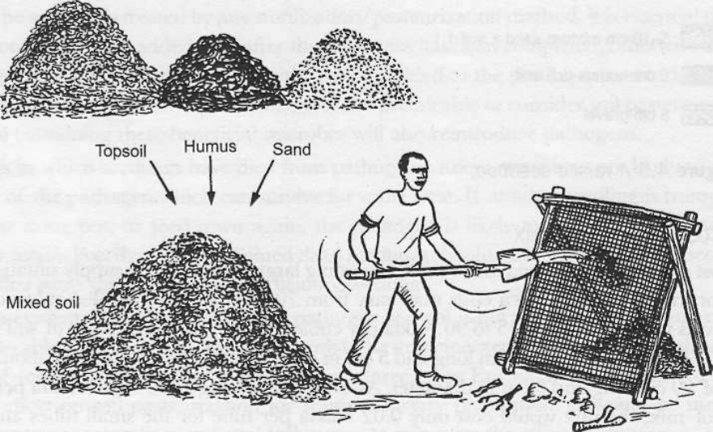
Figure 5.1: Sieving and mixing nursery inputs

- Filling the nursery inputs

Pot filling is the filling of pots with soil. After the preparation of a suitable potting mix, and having cut endless polythene tube to the required length, you can begin pot filling. The soil mix should be moist but not saturated to facilitate rapid filling of pots to the required density. The labor and time spent on filling tubes is a major component in the cost of running nurseries and so this task should be carried out efficiently. The use of a simple funnel and scoop helps to hasten filling and is widely recommended in lab our-intensive nurseries. These tools are especially useful when filling larger tubes such as the most commonly used size in Ethiopia is 7-8cm lay flat tubes & length 12-15cm.During pot filling the lower third of the polyether should be strongly compacted to prevent the soil from falling out of the bottom of open-ended tube and the filling pot stay to the upright position. The upper part should be gently or slowly because roots penetrate easily.
The pot size to be used varies depending on the tree species to be raised from place to place, planting site and to some extent means of propagation and seed size.
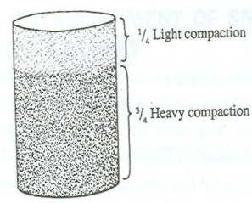
Figure 5.2: Pot compaction standard

- Arranging the filled polythene tubes
5.7.1. Determining the number of pots arranged on the bed
Number of pots arranged on the bed mainly depend on the size of the polythene tubes and size(length and width) of the bed used.
- To calculate the number of pots arranged on the width of the bed the width of the bed should be divided to the diameter of the pot.
- Number of pots arranged on the width of the bed = width of the bed/diameter of the pot
- To calculate the number of pots arranged on the length of the bed the length of the bed should be divided to the diameter of pot.
- Number of pots arranged on the length of the bed = length of the bed/diameter of the pot.
Note that:
C = $π$d or twice of lay flat tube (2* lay flat tube),
d = C/$π$ or d = twice of lay flat tube/$π$where
C = Circumference of the pot,
d = diameter of the pot
$π$ = constant ≈ 3.14.
The filled tubes can conveniently be stacked and carried to pot beds in robust planting trays. The tubes must remain in a vertical position all the time, in contrast to the compacted soil tubes, which are stacked horizontally for convenience of nursery workers. The best ways for producing vigorous healthy seedlings must take precedence over the convenience of the labor force when it comes to how things are done in the nursery. Pots should be placed into pot beds exactly vertically to prevent roots growing unevenly within the pot. Pots should be packed tightly, but without deformation. This will leave spaces for drainage of any excess water between pots.

Proper placing of pot
            - Pots are placed in upright positions
            - Pots space is to be left for rain and excessive water drained off easily
            - Placed in a straight row

Effects of improper placing of pot in beds:
            - Deformity of pots
            - Insufficient space for drainage
            - Disordering of root development

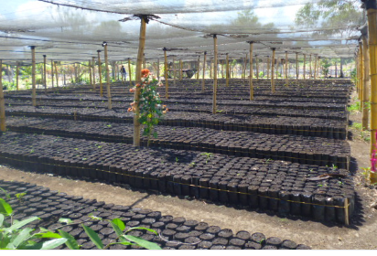
Figure 5.3: Arrangement of the filled polythene tubes

- Carry out sowing on beds and nursery tending operations

- Seed sowing
- Time of Sowing
Time of sowing is important since seedling to be of the right size and quality by the plantingseason. For example, if the seedling takes 3 months to be ready for planting size and quality, then
seed should be sown this amount of time in advance.
- Method of sowing: Seed sowing can be divided into three methods. These include:
- Broadcast sowing
This is nowadays the most common method of sowing onto seedbeds. It is used to sowing seeds of all sizes, but is best suited to sowing of small seeds.
The bed should be well watered the day before sowing. The bed moisture is usually checked in the morning of the day of sowing to ensure that the correct moisture condition is maintained. The seeds are then broadcast sown as evenly as possible, either from hand or from a stiff paper packet. To get even distribution of seeds, the person who is sowing could first go across the bed over the allocated area then along the bed. Then mixing the seeds with an equal or double amount of fine sand and sowing makes sowing evenly possible. The seeds are then covered with seedbed soil mixture or with sand at a depth of about twice the thickness of the seed. The sand is firmed with a flat board to eliminate any air pockets between the seeds and the soil to void seed being washed by water during watering.
- Direct sowing
Direct sowing onto pots has become increasingly popular. The advantages of direct sowing are lower cost and the avoidance of damage to seedlings through careless transplanting. It eliminates the time consuming operation of transplanting which causes slowed growth and even seedling mortality. Only one seed is necessary for one pot if the germination rate is high, if not the aim is to sow an average of two or three seeds per container.
With small seed, special methods need to be used to regulate the amount to be sown. In some nurseries, a shaker is used. It is made from a small bottle with graduated holes in the lid set to allow a given number of seeds to drop per shake.
The seeds are placed in the middle of the pot, pressed down and covered with soilso that the covering layer is about the thickness of the seed. For large seeds, a hole is first pressed in to the soil by a pricking stick. Then the seed is put into it and then covered. Again, it is important to see that no air pockets are left round the seed.
- Line/Drill sowing
It is an appropriate method of sowing seeds in a nursery.
Sowing in lines improves germination and quality of seedlings. In this method, each seed gets independent space, and grows healthy and vigorously. Here, the diseased seedlings and weeds can be easily managed.
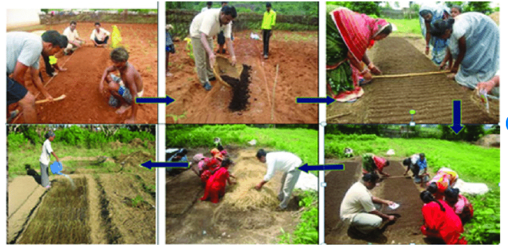
Figure 5.4: Process of sowingseeds ona seedbed

- Nursery tending operations
- Mulching
Mulching may be defined as any artificial modification of the soil surface. It can be done in many ways, such as mulching by ordinary cultivation and covering of grass, leaves straw, sawdust, etc.
The primary purpose of mulching is to conserve soil moisture by lowering soil temperature and by physically blocking the loss of water in areas where watering is necessary through the year, mulching helps to reduce both the frequency of watering and the amount of water needed.To be effective, a layer of mulching should be 1-2 cm thick.
Water is applied in large enough quantities that will sink through the mulch and soak the soil. Light watering is ineffective as a high proportion of water is trapped by the mulch and evaporated off without any marked effect on the condition of the soil under the mulch.
Soil surface of pots or beds should not be covered in rainy areas as soil aeration would be reduced and risk of damping off would be increased.
- Grass mulching of Sowings
In Ethiopian nurseries, sown seeds both in seedbeds and in pots are covered with a layer of grass. The reason is to prevent the soil surface and seeds from being washed aside in watering, as local watering cans have very rough sprinklers and the drop size is large. The grass mulch has some disadvantages. It may bring into pots or beds weed seeds and insects. Introduce of fine-hose watering cans could bring about considerable improvements in nursery techniques in Ethiopia.

- Watering
Watering is commonly conducted twice a day, i.e. at 06:00-09:00 o’clock and at 16:00-18:00. Watering is done by using sprinklers or manually. The size of water droplets should be kept as fine as possible to avoid disturbance to germinating seeds.
The main objective of watering seedling is to maintain enough moisture to the rooting zone to enable the seedlings grow satisfactorily. The frequency and amount of watering depend on the rate at which water is absorbed by the roots and the water holding capacity of the soil. The rate of absorption depends on species, size of seedling, density of seedling, and on weather conditions. Gradually, the frequency of watering is reduced while at the same time the amount of water applied at each watering are increased, so that the total amount of water per day is slowly increased.
The most important factor in seedling production is water but too much water can be harmful.
- For small seedlings, a heavy dose of water is unsafe and may leaches out the soil nutrients.
- Several light applications of water is far better than one or two heavy applications.
- Keep the soil moist but never sodden, watering preferably in the mornings and avoiding the mid-day period when the sun will cause excessive evaporation.
- Over Watering
- Excess water is nearly always damaging since the water tends to replace the air in the soil and cause compaction.
- Excess water also promotes development of fungal diseases like damping off.
- The visible symptoms of over watering are slight to severe yellowing and stunted growth.
- Over watering tends to occur in nurseries with heavy soils.
- Under Watering
- Wilting is one of the early signs of under watering.
- Any signs of wilting should be immediately supplied by the addition of water so as toprevent permanent damage.

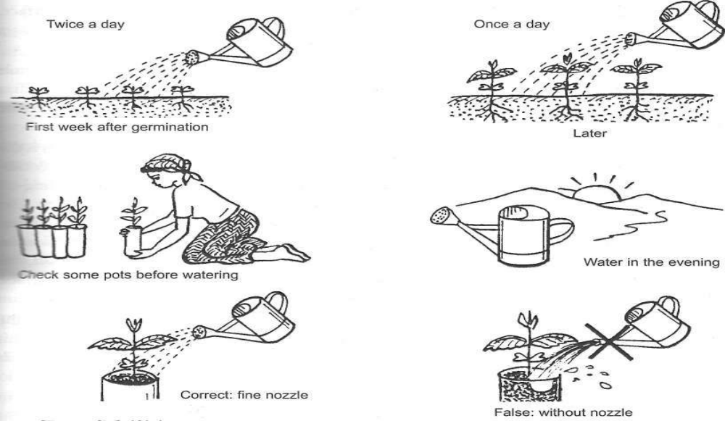
Figure 5.3: Watering the seedlings

- Weeding
Weeding refers to the removal of all unwanted plants (weeds) from the nursery. Periodic removal of weeds is beneficial for the growth and development of seedlings as it prevents competition with the main plants for sunlight, water, air and nutrients. It also acts as secondary host for insect-pests and disease-carrying organisms. If they are not eradicated on time, the competition may suppress the growth of young seedlings. Eradication of weeds is more difficult after they have invaded the seedlings growing in transplant beds, both the potting soil and the pre-filled containers.Thus, the nursery area must be kept free from weeds. Hand weeding and hoeing are the most common practices to remove weeds. To control a large number of weed species, pre-emergence herbicides can also be sprayed just after the sowing of seeds.The plastic potsshould be filled 4 weeks in advance of transplanting or direct sowing if weedfree potting soil isnot available.

- Fungi and Insect Control

- Control of Fungi /Damping Off
Damping Off is a common and serious disease in nursery plants, which can even cause their death.It is a pre-emergence and seedling disease caused by fungi, such as Pythium, Phytopthora, Rhizoctonia and Fusarium. These fungi attack at the time of seed germination.
In this disease, girdling takes place near the base of the seedlings and the infected seedlings collapse due to rottingin the collar region. Damping-off is favoured by high humidity and damp soil surface, coupled with hot and cloudy weather, vis-a-vis, dense planting.
Important points to be remembered:
- Heavy watering, particularly in the afternoon and evening hours encourages the disease,watering should be in the mornings.
- If possible, to prevent seedlings from damping off, the seedbed should be sprayed once aweek with a solution of a copper-based fungicide.
- To control the attacks of the fungus, the fungicide should be applied every three days
until they are to be controlled.

- Control of Insect Pests
- Temporary control of pests can be achieved by isolating the plant until spraying is done.
- Protection against leaf eating insects is sometimes necessary. A number of formulationsare available on the market, and distributors should be consulted on the most suitablechemical for the particular problem.

- Hardening Off(acclimatized)
In a nursery, seedlings are kept under ideal conditions; therefore, hardening is essential to make them strong enough to tolerate the harsh conditions of the planting site. It is generally done by reducing the amount of watering about one month before the date of planting.
Characteristics of hardened seedlings:
- Seedlings have firm, lignified stems, often brown in colour
- They are robust, well-developed crowns with leaves extending over three quarters the
length of the stem.
- Seedlings have vigorous, healthy, leathery leaves and compact rather than oversized andweak

- Thinning
It is important to maintain seedling density in rows so as to ensure adequate light and air to the seedling. During this process, weak, diseased or damaged plants are pulled out, allowing the growth of healthy seedlings.

5.9. Maintaining a clean and safe work site
Maintaining a safe workplace is imperative for the well-being of employeeswhile undertaking nursery activities.A clean work environment accomplishes two things. First, obvious hazards are removed by keeping the place clean. This includes the level and elevated work areas. Secondly, employees are more productive in clean work areas.
Unsafe workplaces can be a burden to your workers and the families involved. Any injuries, sufferings or death can massively reduce productivity, reputation and competitiveness of your nursery business.
Do not rely entirely upon PPE to keep workers safe. PPE can be uncomfortable to wear and may be hot or cumbersome. Workers want to work safely. They have families and lives at home. Workers want the opportunity to work safely. Use safety incentive programs designed to procure the help of your workers. Encourage safety suggestions and bonuses for prolonged periods without incident.

Self-Check – 5 | Written test

Name…………………………………………… ID………………………… Date…….

Directions: Answer all the questions listed below.
Test I: Choose the best answer (2 point)
1. From the nursery seed bed which one is prepared in heavy rainfall areas?
- Raised seed bed
- Sunken seed bed
- Level seed bed
- All
2. Which of the following is characteristics of nursery potting soil?
- it must be light
- it must be cohesive
- it must have high organic matter
- All
3. ________ refers to the removal of all unwanted plants from the nursery.

- Watering
- Root pruning
- Weeding
- Mulching

Test II: Short Answer Questions(10 point)
1. Write down the effect of Over Watering seedlings. (5point)
2. Define the term hardening off. (2 point)
3. Define the term damping Off and give recommendation how to control. (3point)

Note: Satisfactory rating - 16 points Unsatisfactory - below 16 points

You can ask you teacher for the copy of the correct answers.

You can ask you teacher for the copy of the correct answers.

Operation Sheet -5

5.1. Seed bed preparation
5.1.1. Raised seed bed preparation
- Tools and equipments

- Measuring tape
- Ranging poles
- Water level
- Safety shoes
- Overall
- Compass
- Clinometers
- Riveting board
- Agricultural soil
- Gravel
- Sandy soil
- Forest soil
- Pickaxe
- Shovel
- Rake
- Spade
- Rope
- Page
- Shovel
- Flat pronged fork
- Short and long handled hoe

- Procedures
- Layout the area in which seed beds can be prepared by using 3, 4, 5, methods.
- August the border effect. Note: the border effect of seed bed is usually half the width of bed (50cm).
- Breaking up the soil.
- Level the site where bed is to be constructed and firm the soil.
- Make out the required size and shape of beds with pegs and cords.
- Erect reverting boards 15 m³ ~4cm in size around the marked area.
- Place a layer of gravel having 3cm thickness or sand sieved to a depth of 5cm in the bed followed by smoothing and pressing lightly with a flat board. Apply 2~3cmthick layer of un-sieved forest soil on the top of gravel for good drainage, it acts as filter layer for seed bed to the top with seed bed soil that will be leached down.
- Fill the remaining part of the seed bed to the top with seed bed mixture.
- Level the soil with flat board.
- Firm the soil on bed using hands to avoid any space unfilled with atmosphere.
- Later, firm the soil using flat boards.
- Protect the surface of beds with a thick layer of green grass and leaves.

5.1.2.Sunken seed bed preparation
  - Tools and equipments

- Measuring tape
- Ranging poles
- Water level
- Safety shoes
- Overall
- Compass
- Clinometers
- Pickaxe
- Shovel
- Rake
- Spade
- Rope
- Page
- Shovel
- Flat pronged fork
- Short and long handled hoe

  - Procedures
- Layout the area in which seed beds can be prepared by using 3, 4, 5, methods.
- August the border effect. Note: the border effect of seed bed is usually half of the width of bed (50cm).
- Plough the land up to 25-30 cm deep.
- Remove all stumps and grassroots.
- Pulverizing (grading) crashing collides of soil.
- Dry mater burn on bed to kill harm full insects.
- Rake and level the soil.
- Prepare the bed of 15~20 cm deep, 1m wide and a convenient length.
- Leave 40-60cm between two beds as awaking path.
- Number the bed serially to maintain the record of planting.

5.1.3. Level seed bed preparation
A. Tools and equipments

- Measuring tape
- Ranging poles
- Water level
- Safety shoes
- Overall
- Compass
- Clinometers
- Pickaxe
- Shovel
- Rake
- Spade
- Rope
- Page
- Shovel
- Flat pronged fork
- Short and long handled hoe
B. Procedures
- Layout the area in which seed beds can be prepared by using 3, 4, 5, methods.
- August the border effect. Note: the border effect of seed bed is usually half the width of bed (50cm).
- Breaking up the soil.
- Remove all stumps and grassroots.
- Pulverizing (grading) crashing collides of soil.
- Dry mater burn on bed to kill harm full insects
- Rake and level the soil.
- Prepare the bed of 1~2 cm high, 1m wide and a 5-10 m length.
- Leave 40-60cm between two beds as awaking path
- Number the bed serially to maintain the record of planting
5.2. Pot filling
A. Tools and equipments

- Humus-rich soil
- Ordinary agricultural soil
- Sand
- Compost
- Polythene bag
- Funnel/ scoop
- Pot cutting roll
- Sieve
- Water
- Overall
- Safety shoes
- Sharp knife
- First aid kit
- Watering can
- Spade/shovel

- Procedures
- obtaining soil ingredients
- sieve the soil mixture through 2mm mesh to remove clods/stones
- mix the ingredients based on the given ratio and turn with shovel
- keep the soil mix moist
- Cut the Polythene tube into the required length
- Fill the bag and firmly compact the lower third of container. You can use scoop/ funnel to fill the bag
- avoid air pockets in containers during the bag fill
- place pots in straight rows in blocks/ beds in an upright position

5.3. Seed sowing on seedbed
- Tools and equipments
- Seeds of various species and sizes
- Watering can
- Watering hose
- Filled pots with soil mix
- Grass mulch
- Overall
- Shoes
- Sun hat
- Procedures/Steps
- Make a line across seed bed with the help of stick.
- Put seed in rills running across the bed.
- Place seeds at the right depth; mix small seeds with sand.
- Coverer the seeds with sand or soil and gently press.
- Water the seedbeds or pots with cans with fine nozzles.
- Finally, cover the seedbeds or pots with shading material/mulching.

LAP TEST-5 | Performance Test

Name………………………………. ID…………………………….. Date…………………………………….

Time started: ________________________ Time finished: ________________

Instructions: Given necessary templates, tools and materials you are required to perform the following tasks within 30hour. The project is expected from each student to do it.

Task-1Perform seed beds preparation:
  - Raised bed
  - Sunken bed
  - Level bed
Task- 2 Perform pot filling
Task-3 Perform seed sowing

LG #20 | LO #6- Transplant the seedling

Instruction sheet
This learning guide is developed to provide you the necessary information regarding the following content coverage and topics:
- Constructing shading structures for transplanting beds
- Watering polythene tubes
- Carry out the transplanting

This guide will also assist you to attain the learning outcomes stated in the cover page. Specifically, upon completion of this learning guide, you will be able to:
- Construct shading structures for transplanting beds
- Water polythene tubes
- Carry out the transplanting
Learning Instructions:
- Read the specific objectives of this Learning Guide.
- Follow the instructions described below.
- Read the information written in the information Sheets
- Accomplish the Self-checks
- Perform Operation Sheets
- Do the “LAP test”

Information Sheet 6

- Constructing shading structures for transplanting beds
Construct a shade to protect the seedlings from direct sunlight for two to three weeks after pricking out.Seedlings need protection from drought, cold wind, heavy rain and burning sunshine. For these reasons, shades must be provided especially when the seedlings are young.During the first sign of germination, the shed must be lifted to about 30 cm or higher.
Forked sticks can be used for support shades, which is 60-100 cm from the ground. Too low shades make watering difficult. Depending on the direction of aspect, the shade facing the strongest sunshine is usually shorter than the one facing relatively less baking sun.Use locally available materials such as grass, mats, or banana fibers for shade construction.

Benefit of shade:
- Reduce soil temperature
- Reduce the daytime temperature and the rate of evaporation from soil and plants beneath them.

The need for shading /shade intensity differs according to:
- Species
- Stage of seedling development,
- Weather condition &
- location of the nursery
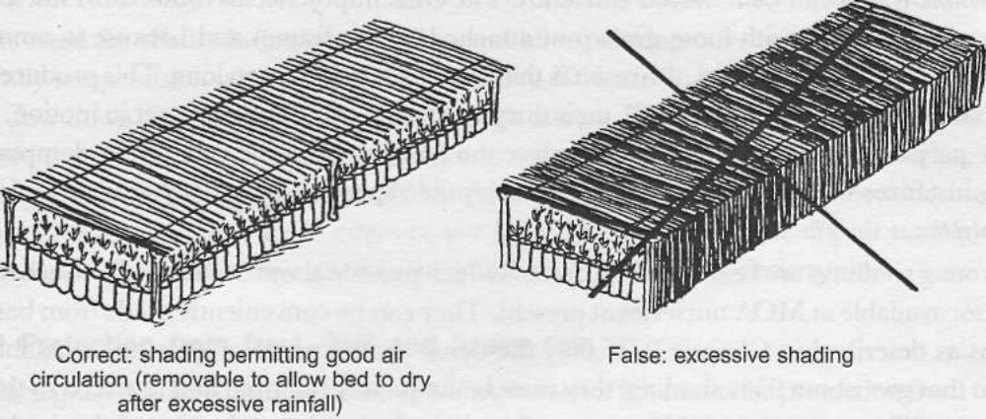
Figure 6.1: Shading

- Watering polythene tubes before transplanting
When seedlings are grown in containers, watering should wet the soil to the base of pot. If the seedlings are properly watered, the roots can be made to grow within a shallow surface zone.
For a couple of weeks before the intended transplanting day, the empty pots or beds should be watered lightly for some days. This encourages germination of weeds. As soon as the weeds have emerged, they should be removed.
A good watering should be given if it is too dry while exposure to sun should be done if it is too wet. The pots/ beds should be moist but not too wet at the time of transplanting.
Therefore, light watering is carried out 2-4 times a day depending on the progress of the seedlings.

- Carry out the transplanting tasks
6.3.1. Transplanting/pricking out: is the process of transferring young and tender seedlings from seedbeds into containers (pots). Pricking out should be carried out when the seedlings reach a height of 2 cm. This is usually about two weeks after sowing but depends on the species.
Transplanting is a crucial stage in the life of a plant. It always causes a shock to the seedling, even when carefully done and bad transplanting easily kills the seedling.
Size of seedlings to be transplanted:
- Conifers can be transplanted immediately after the seed coat appears above the soil surface at the “match stick” stage.
- Broad-leaved seedlings should also be transplanted soon after germination.
- Some foresters claim that Eucalyptus must be transplanted when they have developed four leaves.
- Acacia and other legumes are transplanted when the first leaves appear after the complete unfolding of cotyledons.
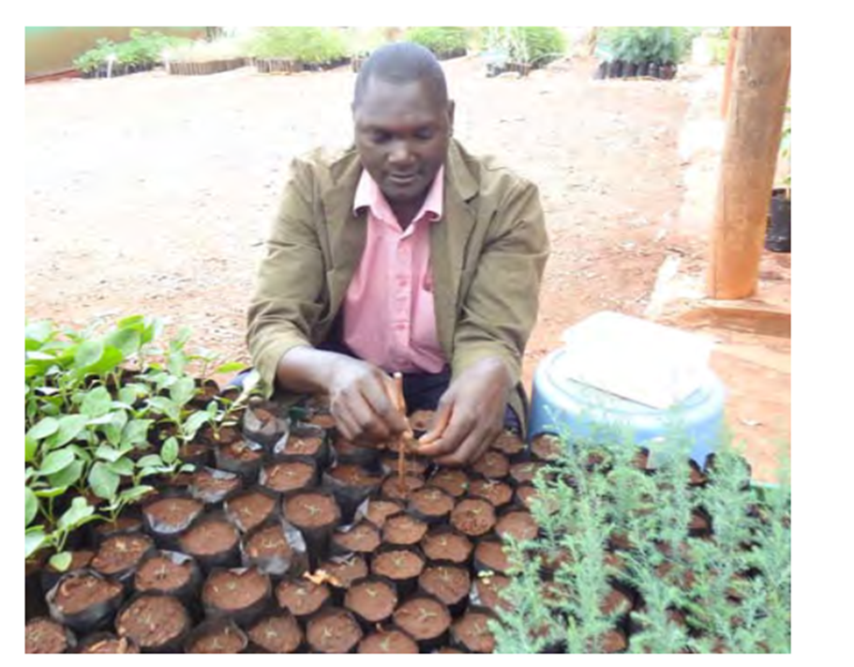
Figure 6.2: Transplanting seedlings into polybags without coiling
the roots
6.3.2. Root Pruning
Root pruning is the cutting of roots to control root system development beyond the container. When seedlings have reached to a certain size and their roots become longer than the depth of the pots. If the roots are left without pruning, they penetrate into the ground and develop the root systems there. Once the root system develops under the ground, it is hard to move the pots, and if the roots are cut when the seedling is old, the seedlings will be weakened; hence periodical root pruning is required before the root system reaches into the ground. The period and interval of pruning depends on different species and other conditions. Root pruning should be done regularlypreferably every 2 –3 weeks. Prune when seedlings are the height of the span of your palm and when their roots have started to penetrate into the undersurface.

- Root Pruning by Lifting
- In this, the first row of plants are carefully removed fromthe bed to provide operational space and each plant in the second row is lifted andplaced in the vacant row after root pruning is done with pruning scissors or asharp knife.
- Do not shock the seedlings by lifting them forcibly as this damages the roots
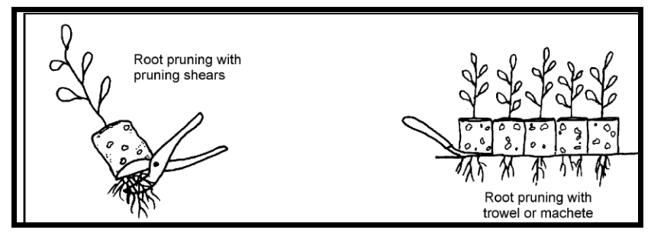
Figure 6.3:Pruning container grown plants

- Root Pruning in Bare Root Transplant Beds
- Root pruning of the seedlings in the bare rooted transplant beds can be carried out in
underground with a sharpened spade; vertical cuts are made between the seedlings to
shorten long lateral roots (see Figure 6.3).
- The pruning level should not be neither too deep nor too shallow ranging from 10 to
30 cm below the soil surface depending on the species and the size of the seedling.
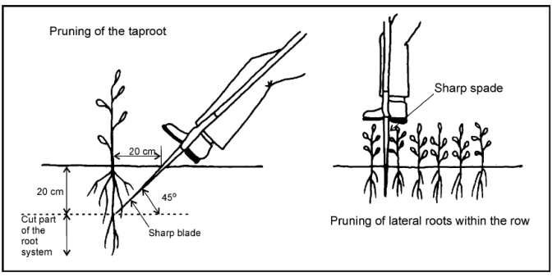
Figure 6.4:Root pruning bare root seedlings in a transplant bed.

Self-Check – 6 | Written test

Name…………………………………………… ID………………………… Date…….

Directions: Answer all the questions listed below.

Test I: Choose the best answer (2 pts each)
1. The need for shading intensity differs according to:
- Species
- Stage of seedling development
- Weather condition
- All
2. If a seedling is lifted from its bed and planted to another bed or pot it is known as __________.

- Planting
- Transplanting
- Planting out
- Plantation

Test II: Short Answer Questions (6 pts)
1. List down benefits shading. (3pts)
2. Why root pruning of seedling is needed? (3pts)

Note: Satisfactory rating - 10 points Unsatisfactory - below 10S points

You can ask you teacher for the copy of the correct answers.

You can ask you teacher for the copy of the correct answers.

Operation Sheet -6

6.1. Transplanting seedlings
  - Tools and equipments
- Very young seedlings
- Seedling root covering cloth
- Small shovel
- Root pruning knife/pruning shear
- Wedge shaped flat pieces of wood
- Dibble
- Polythene bags filled with required soil mixtures
- Watering can
  - Procedures
- The day before transplanting, water the beds (propagation).
- Hold seedlings at the base of the stem and pull it out gently from the mother beds.
- Place the uprooted seedlings in a container half-filled with water to maintain turgidity. and to avoid damage before transplanting to the poly pots.
- Discard retarded, deformed or diseased seedlings because they have less chances of survival.
- Water the pots to moist the soil.
- Make a hole with a dibble. (Tools made of wood for making holes).
- Hold the seedlings at the base of the stem and insert root system in.
- Hold the dibble in a slanting position; insert it in the soil about 1/2 inches away from seedling to the same depth as the whole.
- Replace the soil, slightly compact it.
- Never bend the roots and do not force the seedlings into the hole. Keep transplanted seedlings under proper shade until they have recovered.

LAP TEST-6 | Performance Test

Name………………………………. ID…………………………….. Date…………………………………….

Time started: ________________________ Time finished: ________________

Instructions: Given necessary templates, tools and materials you are required to perform the following tasks within 10hour. The project is expected from each student to do it.

Task-1. Perform seedling transplanting.

LG #21 | LO #7- Maintain the nursery environment

Instruction sheet
This learning guide is developed to provide you the necessary information regarding the following content coverage and topics:
- Surveying and packing out the perimeter of the nursery site
- Digging and preparing the pits for wind break
- Preparing and planting appropriate plant species
- Planting hedge rows
- Monitoring environmental protection measure parameters
- Altering environmental parameters and market requirements

This guide will also assist you to attain the learning outcomes stated in the cover page. Specifically, upon completion of this learning guide, you will be able to:
- Survey and pack out the perimeter of the nursery site
- Dig and prepare the pits for wind break
- Prepare and plant appropriate plant species
- Plant hedge rows
- Monitor environmental protection measure parameters
- Alter environmental parameters and market requirements
Learning Instructions:
- Read the specific objectives of this Learning Guide.
- Follow the instructions described below.
- Read the information written in the information Sheets
- Accomplish the Self-checks

Information Sheet 7

- Surveying and packing out the perimeter of the nursery site
Survey of land resources –climate, water, soils, landforms, forestry, and range lands-are needed to avoid costly mistakes and to improve efficiency of investment. Valid survey have been developed for all types of resource, and the method of land evaluation has helped in translating environmental data into terms land use potential.
There are two basic stages to the assessment of land resources: Natural resource survey and land evaluation.
Natural resource survey refers to the description, classification, and mapping of the physical environment: climate, water, geology, land forms, soils, vegetation, and fauna. In practice geology survey is a separate task, and soil surveyors make use of whatever data available. Land forms are generally surveyed jointly with soils. An alternative to assessing factors individually is to map the physical environment as a whole, as in the land systems approach.
Soil survey is the basic stages in description and identification of soil types, classification, and mapping.

- Digging and preparing the pits for windbreak
Pit preparation for planting windbreaks around the nursey site should be conducted towards the direction of strong wind. Digging has to be done several days before planting the windbreaks. Preferably, only topsoil should be used for filling the hole. It is advantageous particularly for uncultivated land. At the end, the soil around the plant is firmed with feet.
Double diggings is a very labor-intensive but effective way to prepare land for planting. The goal of this system is to dig down deep in the soil to loosen a deep section of the soil for future plants.
The advantage of this system is that it creates a very deep, loose area of soil, rich in organic material, which makes future planting easy. But it also heavily disturbs the soil and requires a large amount of physical labor.

- Preparing and planting appropriate plant species between the blocks and around the nursery
In the selection of tree or shrub species for planting between the blocks and around the nursery, the following characteristics should be sought:
- Rapid growth;
- Good crown formation;
- Deep root system, which does not spread into nearby fields;
- Resistance to drought;
- Resistance to diseases, etc.

- Planting hedge rows
Hedgerows are often planted to separate the nursery blocks and around the roadside.A hedgerow can be thought of as a living fence. However, unlike a fence, hedgerows provide more benefits than just marking boundaries or keeping people and animals in or out of an area.
The layout of the hedgerow depends on its desired function and location.However, a mixed hedgerow that includes a variety of trees, shrubs, nitrogen fixing plants, herbs, and flowers often creates a healthier ecosystem. To create a self-sustaining ecosystem, choose plants that perform more than one function.
A hedgerow can be short or tall. A short 4 to 6-foot (1.2-1.8 meters) hedgerow could be planted around a nursery without casting too much shade. Though a taller one could be used to block winds or provide late-afternoon shade to help deal with droughts.
Planting a hedgerow is to break it into rows of plants that have similar growing habits. One row could be all trees that get to a similar height. Another could be shade tolerant shrubs and another could be shorter, fast-growing shrubs.
This makes it easier to plan and make sure the plants grow together in a way that lets your new hedgerow serve the functions it was supposed to.
A hedgerow should have2-3 rows of plants.For a 6-foot (1.8 meters) wide hedgerow, you could fit in all 3 rows, placing them 2 feet (0.6 meters) apart. On the other hand, just have 2 rows either along the edges or in a bit from the edge.
If you are aiming for a dense hedgerow, (ideal for privacy and keeping people/animals in or out,) then put roughly 2 feet (0.6 meters) between each planting row. For less dense hedgerows, a row every 3 feet (0.9 meters) can work. Make sure to figure out how many planting rows you need before you start a hedgerow.

- Monitoring environmental protection measure parameters
Seedling growth is affected by conditions both;
- Aboveground: humidity, carbon dioxide, temperature and light and
- Belowground: water and mineral nutrients.
- Other organisms, either beneficial or harmful, can influence plant growth.
Improving the nursery standards by providing a reliable water supply, uniform shading, and protected propagation and weaning areas can help greatly to produce uniform and healthy stock.
Increased investment in nursery production is almost always recovered in increased plant survival and productivity. Controlling the atmospheric environment, on the other hand, may be necessary only in specific cases.

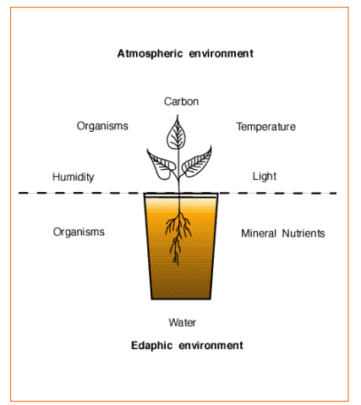
Figure 7.1:Environmental parameters affecting seedling growth in nursery.

- Altering environmental parameters and market requirements

    - Altering environmental parameters
- Light
Light is an essential factor in maintaining plants. The rate of growth and length of time a plant remains active is dependent on the amount of light it receives. Light energy is used in photosynthesis, the plant’s most basic metabolic process. When determining the effect of light on plant growth there are three areas to consider: intensity, duration and quality.
The right amount of light is critical for healthy plant development of seedlings. Too much shade, for example in high plant densities, leads to etiolated and elongated growth of the seedlings and makes them weak and prone to fungal diseases. Too much light leads to sun scorching and drying out of the tender tissue. Use good-quality shade cloth to provide durable and uniform shade to the seedlings. Avoid using grass, reed or bamboo mats as they are not durable, do not provide uniform shade, and can harbor pests and diseases.
Nursery managers must decide whether shade should be permanently installed and plants moved from one shade level to another, or whether the plants should remain in position and the shade be moved.

- Temperature
Most plants tolerate normal temperature fluctuations. In general, foliage plants grow best between 70 degrees and 80 degrees F. during the day and between 60 degrees to 68 degrees F. at night. Most flowering plants prefer the same daytime temperature range, but grow best when nighttime temperatures range from 55 degrees to 60 degrees F. Lower nighttime temperatures help the plant: recover from moisture loss, intensify flower color and prolong flower life. Excessively low or high temperatures may cause: plant stress, inhibit growth, or promote a spindly appearance and foliage damage or drop. Cool nighttime temperatures are actually more desirable for plant growth than high temperatures. A good rule of thumb is to keep nighttime temperatures 10 to 15 degrees lower than daytime temperatures.

- Gas exchange
Rooting cuttings and germinating seedlings have high respiration rates. This means that oxygen is consumed and carbon dioxide released. The proper exchange of these gases is very important for good root development. In heavy soils and under waterlogged conditions, root development is hindered, resulting in the accumulation of toxic amounts of carbon dioxide in the root zone. On the other hand, plants need to take up CO2 for assimilation through the stomata on the leaves. Plants stressed by drought or nutrient deficiency have their stomataclosed and cannot assimilate CO2 properly, and this results in retarded development. Atmospheric air contains about 0.03% CO2 and 21% O2. For specialist purposes, plants can be grown under elevated CO2 levels of up to 3% toincrease production.
In enclosed structures, the ambient level of CO2 can drop so much that its assimilation through the stomates is slowed down. Opening the doors briefly for ventilation at set intervals can avoid this.

- Humidity
Maintaining the proper atmospheric humidity in container tree nurseries is important biologically for several reasons: low humidity subjects seedlings to water stress caused by excessive transpiration, proper humidity promotes rapid growth, and excessive humidity promotes the growth of fungal pathogens and other nursery pests such as moss and liverworts. The challenge to the nursery manager is to maintain humidity that are high enough for good seedling growth without encouraging pests.

    - Altering market requirements
Market plays an important role in the success of nursery business. Various type of inputs like seeds, fertilizers, pesticides, fungicides, plant growth regulators, poly bags, agricultural implements, different type of spare parts and other miscellaneous items required in the nursery must be available in the nearby market. The nursery must be located near the city or an area from where people can purchase the plants. Alternatively, a mechanism to explore domestic and international markets must also be worked out for the success of nursery business.
For wholesale nurseries, the type of customer will depend partly on the characteristics of the nursery location and site (e.g., soil texture, temperature) as they affect the products to be sold (rooted cuttings, liners, balled and potted, or container grown seedlings).
Each nursery owner must analyze and organize his or her own marketing channels, develop a sales
Programme, prepare the product for distribution, extend credit, and make collections.

- Marketing strategy
Marketing strategy is based on becoming an option forcontractors and the general public to fill their plant needs and must include performance inthe following areas:
- Customer service
- Knowledgeable staff
- Affordable prices
- Great location
- Quantity and quality of plants, seedlings, treesand saplings

Self-Check – 7 | Written test

Name…………………………………………… ID………………………… Date…….

Directions: Answer the questions listed below. 5 point
- Define the term natural resource survey. (2pts)
- What environmental parameters are to be taken into account for seedling growth? (3pts)

Note: Satisfactory rating - 5 points Unsatisfactory - below 5 points

You can ask you teacher for the copy of the correct answers.

You can ask you teacher for the copy of the correct answers.

LG #22 | LO #8- Clean up and Store Materials

Instruction sheet
This learning guide is developed to provide you the necessary information regarding the following content coverage and topics:
- Disposing plant debris and waste materials
- Stockpile surplus materials
- Cleaning, maintaining and storing tools and equipment

This guide will also assist you to attain the learning outcomes stated in the cover page. Specifically, upon completion of this learning guide, you will be able to:
- Dispose plant debris and waste materials
- Stockpile surplus materials
- Clean, maintain and store tools and equipment
Learning Instructions:
- Read the specific objectives of this Learning Guide.
- Follow the instructions described below.
- Read the information written in the information Sheets
- Accomplish the Self-checks

Information Sheet 8

  - Disposing plant debris and waste materials

- Storing plant debris and waste materials produced during nursery work
When working in nursery there is range of un wanted waste materials left over that needs to be dealt with things such as old or broken pots/tubs, unused root bound plants, unwanted cutting materials , surplus potting media, soil, fertilizer, ,bags, tags ,packing materials ,mulches, plant debris and faulty irrigation parts. It is best practice when finished to leave completely clean working areas free of rubbish. All materials should be disposed of according to local council guidelines and the waste management and pollution control.
- Methods of waste disposal could include

- Organic waste; mulch and composting is suitable for plant debris, recycle card board and paper.
- Inorganic waste; plastic/ metals /paper-based materials may be recycled, reused or returned to manufacturer.
- For inorganic materials that cannot be recycled it is best to take them to an authorized land fill (don’t burn old containers as given off are toxic).
- Always clean up and dispose or recycle your old pots

8.2. Stockpile surplus materials of nursery
- The contractor shall plan his activities so that materials excavated from borrow pits and cuttings, in so far as possible, can be transported direct to and placed at the point where it is to be used.
- The areas for the stockpiling of excavated and imported material shall be indicated and demarcated on the site plan.
- Together with the contractor’s proposed measures for prevention, containment and rehabilitation against environmental damage should be submitted.
- Stockpiles shall be positioned and sloped to create the least visual impact.

  - Cleaning, maintaining and storing tools and equipment

8.3.1.Cleaning equipment
Cleaning in a working environment involves removing dirt, grime, scraps and grease from all surfaces, equipment, utensils, crockery, etc.
While each piece of equipment has different cleaning requirements, there are some basic principles which are common to all equipment. These include:
- ensure power is turned off and power cords are disconnected
- gas equipment should have the gas turned off and
- the pilot lights extinguished correct chemicals should be used
- protective clothing, gloves, goggles, and other equipment should be used
- ventilation should be provided
- Stainless steel surfaces should not be cleaned with scourers

8.3.2. Maintaining and sorting tools and equipment
All equipment needs to be maintained and sorted according to size and type. Staff must take care that sensitive tool and equipment are not over-stacked and that correct lifting techniques are used whenhandling them. Expensive equipment should be securely stored.

- Correct equipment storage
To reduce chances of injury, equipment must be stored in the correct manner. For example:
  - all sharp objects, e.g. knives, scissors should be stored in the appropriate drawers, knife blocks or tool boxes
  - large heavy items should not be stored on high shelves
  - electrical equipment should not be stored or used near wet areas
  - all washed equipment, utensils, crockery, etc., should be dried after washing
  - Any mobile equipment, crockery, cutlery, etc., also need to be secured against theft.

Self-Check – 8 | Written test

Name…………………………………………… ID………………………… Date…….

Directions: Answer the questions listed below.

Test I: Short Answer Questions 10 point
- What is cleaning (5 pts)
- List down the basic principles of cleaning requirements for tools and equipments. (5pts).

Note: Satisfactory rating - 10 points Unsatisfactory - below 10 points

You can ask you teacher for the copy of the correct answers.

You can ask you teacher for the copy of the correct answers.

LG #23 | LO #9- Record and Report

Instruction sheet
This learning guide is developed to provide you the necessary information regarding the following content coverage and topics:
- Recording and documenting nursery establishment and activities
- Reporting problems or difficulties
- Recording and reporting materials, equipment and machinery
- Communicating work completion and hazards information
- Reporting work outcomes

This guide will also assist you to attain the learning outcomes stated in the cover page. Specifically, upon completion of this learning guide, you will be able to:
- Record and document nursery establishment and activities
- Report problems or difficulties
- Record and report materials, equipment and machinery
- Communicate work completion and hazards information
- Report work outcomes
Learning Instructions:
- Read the specific objectives of this Learning Guide.
- Follow the instructions described below.
- Read the information written in the information Sheets
- Accomplish the Self-checks

Information Sheet 9

- Recording and documenting nursery establishment and activities
- Recording work place information
Recording:is process of writing down something that it can be used or seen again in the future.
Documenting: is something or paper that gives information about something or that is used as proof some work like nursery establishment.
With the aim to ensure the complete stand history of certain plantation, it is indispensable to note all operation of nursery tending activity. Moreover, for good nursery management, recording all work done, the progress made is essential. Recording of workplace information may include:
- Environmental parameters (light, temperature humidity and wind)
- Date of treatments
- Type of treatment and
- Rate of treatment
A careful recording will also help to tend nursery plant the most appropriate production data for each species.
Nursery registration form: The recording is done on individual nursery bed basis.
- Species ----------------
- Provenance ------------------
- Date of seed collection
- Reception date of seeds
- storing condition
- Method of seed pretreatment
- Density of sowing
- Quantity seed per sq. m ---kg
- Area seed bed ---sq. m
- Protective measures taken
- Registration number of seed bed
- responsible person
- Expected number of seedlings per sq. and in total
- seedling description for planting
- Destination of seedling Transportation specification (date, seedling transported, seedlings eliminated) and so on
Nursery calendar: Here we record all the activities to be done and when they are to be done.
Table 9.1:Example nursery calendar
Activity | S | O | N | D | J | F | M | A | M | J | J | A
Bed preparation
Pot filling
Seed sowing
Mulching
Watering
Weeding
Root Pruning
Treatment application
Shading
Transplanting

Nursery delivery Record: this shows how and where the seedlings were distributed.
Table 9.2: Nursery delivery record format.
Date | Species | Number | Bed No. | Receiving station

Table 9.4: Attendance sheet format for daily laborers.
Name/date | 1 | 2 | ---------------------------------------------- | 30
 | P | S |  | H
 | A | P |  | O
Where: p= present, A = absent, S = sick, H = holiday, O = off duty

- Reporting problems or difficulties
Common problems in nursery plants are recognized, and rectified and/or reported to the supervisor. The most common problems of nursery plants may include:
- Dehydration/lack of moisture
- Pests and diseases
- Nutrient deficiencies
- Birds
- Rodents
- Plants deformity, etc.

- Recording and reporting materials, equipment and machinerycondition after work

9.3.1.Operation of machinery and equipment in different weather and difficult terrain
Operation of machinery is not always done on level and comfortable land surfaces but sloppy, hilly, adulating, stony, sandy, etc.Difficult terrains concerning the natural weather, rainfall, foggy visions, and muddy roads can be taken as an example of unfavorable condition in operating machinery and equipments. Since both weather and difficult terrains are naturally environmental phenomena, any operator of machinery should take care of his life and expensive assets. Moreover, any machineries should not be operated before the checkup of all parts and old tyers also replaced by the new ones so as to make drive free from any slides either on difficult terrain or on muddy grounds. With these lightening, traffic hazard indicators should bechecked and well maintained for their actively functioning.

9.3.2. Reporting unsafe or faulty machinery and equipment

After pre operational check an operator must identify and report unsafe or faulty machinery and equipment and prepare for repair and maintenance. This may include dismantling and assembling procedures, testing, tightening, minor adjustments and repairs, and routine servicing procedures including lubricating, and checks of cooling system, fuel, grease and oil, and battery levels. It may also include inspections of tire pressure, fan belts, leads, lines, connections, air filters, air conditioning, brakes, clutch, electrical, gearbox, hydraulics, steering, lighting, transmission, and confirmation of safety guards.

- Communicating work completion and hazards information
9.4.1. Identifying and reporting Occupational Health and Safety hazards in the workplace
- Move field roads further from canals and ditches.
- Control the vegetation and/or clearly mark the location of canals, ditches, and other hazards.
- Maintain field roads. Widen the roads, bridges, and culverts. Eliminate sharp, blind corners or Curves and rough or slippery surfaces.
- Prune or hedge trees to improve visibility and reduce the danger of accidents caused by tree limbs.
- Remove tree stumps and other field obstacles.
- Conduct walk-through inspections of hillsides for washouts before beginning tractor operations.
- Clearly mark or fill dangerous washouts.
Risk associated with working in Difficult Terrain
- Be on the lookout for potential hazards when riding. Rocks, bumps, irrigation pipes and wildlife all have the potential to cause an accident, and should be approached with caution.
- Take extra care when operating a bike on unfamiliar or rough terrain. Where possible, use familiar farm tracks.
- Be particularly careful when turning, approaching a rise or navigating an obstacle.
- Develop a "safety first" attitude. Follow safe work practices all the time and a good example for others

9.5. Report work out comes
An important point in every work including nursery work is recording data, analyzing and reporting, all the steps from the initial to the final product of the work. One of the ways of communicating to the employer or the customer is reporting work outcome .This report includes information regarding
- Raw materials
- Supplies
- Problem encountered
- Length of work
- Alternative measures
- Hazards and safety
- Techniques and system of work
- Cost expended
- Material availability
- Sustainability of work
- Labor required

Self-Check – 9 | Written test

Name…………………………………………… ID………………………… Date…….

Directions: Answer all the questions listed below.

Test I: Short Answer Questions 12 point
- What do you do when risks under take in work area (4 pts)
- What types of information included in material &safety data sheet(3pts)
- what types of information included during work out come report(5pts)

Note: Satisfactory rating - 12 points Unsatisfactory - below 12 points

You can ask you teacher for the copy of the correct answers.

You can ask you teacher for the copy of the correct answers.

Reference Materials

Books:
Forest Research Center. (1987). Tree nursery manual: ministry of natural resources developmentand environmental protection. Ethiopia, Addis Ababa.
Keats C. Hall (2003). MANUAL ON NURSERY PRACTICES. Forestry Department Ministryof Agriculture 173 Constant Spring Road Kingston 8 Jamaica (West Indies).
Landis TD, Tinus RW, McDonald SE and Barnett JP. 1992. Atmospheric environment. vol. 3, The container tree nursery manual. Agriculture Handbook 674. Washington, DC, USA: US Department of Agriculture, Forest Service. 145 pp.
Landis TD, Tinus RW, McDonald SE and Barnett JP. 1994. Nursery planning, development and management. vol. 1, The container tree nursery manual.
Munjuga MR, Gachuiri AN, Ofori DA, Mpanda MM, Muriuki JK, Jamnadass RH, Mowo JG. 2013.Nursery management, tree propagation and marketing: A training manual for smallholderfarmers and nursery operators. Nairobi: World Agroforestry Centre.
Teshome Tesema, Efrem Garedew and Yigardu Mulatu. 2017. Tree Nursery Manual. Ethiopia, Addis Ababa.

Web addresses
www.worldagroforestry.org (Access date: 29/08/2022)

AKNOWLEDGEMENT

Ministry of Labor and Skills wish to extend thanks and appreciation to the many representatives of ATVET instructors who donated their time and expertise to the development of this Teaching, Training and Learning Materials (TTLM).

The experts who developed the learning guide
No | Name | Qualification | Educational background | Region | Phone number | E-mail
1 | Korme Tusuru | MSc | Biodiversity and conservation Management | Oromia | +251916145234 | bilisumakorme@gmail.com
2 | Gelasa Tola | MSc | Biodiversity and conservation Management | Oromia | 0920049614 | tolagelasa@gmail.com
3 | Gezahegn Tadesse | MSc | Drainage and Watershed Management | Alage | 0968445006 | sihine29@gmail.com
4 | Geleta Bekele | BSc | Forestry | Afar | 0925482964 | geletabk12019@gmail.com
5 | Degarege Mitkie | BSc | Water Resource & Irrigation Engineering | South West | 0921281867 | mitkiedegarege@gmail.com
6 | Getnet Asmare | MSc | Production Forestry | Amhara | 0912846540 | getnetasmare40@gmail.com
7 | Kifle Tolossa | MSc | Soil Science | Oromia | 0910895568 | kifletolossadechasa@gmail.com
8 | Tolessa Sori | MSc | Forest & Natural Management | South West | 0917007821 | tolosa.sori@gmail.com
9 | Yeshitila Wondosen | MSc | Climate change & Development | Benshangul Gumuz | 0911071229 | yeshiwondo@gmail.com
10 | Zeleke Dessie | MSc | Agroforestry | Oromia | 0911091388 | zelekedessie@gmail.com
11 | Ziyad Rube | MSc | Water Resource Engineering & Management | Afar | 0921484656/  0962639851 | yoomnaaf51@gmail.com

