Natural Resources Conservation and Development

Level – I
Based on March 2022, Version-1 Occupational standard

Module Title: - ConductingSurvey and Navigation
LG Code: AGR NRC1 M07 LO (1-5) LG (35-39)
TTLM Code:AGR NRC1 TTLM0922v1
September, 2022
Addis Ababa, Ethiopia

Table of Content

Introduction to the Module 1
LO #1- Prepare for surveying 2
Information Sheet 1 3
Self-check 1 11
Operation sheet-1 12
LAP TEST-1 13
LO #2- Perform survey techniques 14
Information sheet 2 15
Self-check 2 28
Operation sheet-2 29
LAP TEST-2 31
LO #3- Apply leveling and topographic survey 32
Information sheet 3 33
Self-check 3 41
Operation sheet-3 42
LAP TEST-3 43
LO #4- Develop map 44
Information sheet 4 45
Self-check 4 53
Operation sheet-4 54
LAP TEST-4 56
LO #5plan the route and conduct navigation 57
Self-check -5 69
Operation sheet-5 70
LAP TEST-5 72
References materials 73

Introduction to the Module

This Module covers the competence required skill, knowledge & attitude of surveyingand navigation in untracked, remote areas. It requires the ability to undertake surveying activities in the field and developing map in the office; interpretation and use of maps and other navigation aids; evaluating activities related with surveying. This modules have covers five learning out comes and twenty four modules contents.
Without a proper survey of the areas involved it will be very difficult to work out a proper management plan for a natural resources such as land, water, forest, wildlife conservation area and minerals based on surveying the physical dimensions of the area involved to figure out what you have. Therefore, it requires the ability to preparing for surveying, performing survey techniques, applying leveling and topographic survey, developing map and conduct navigation.

LG #35 | LO #1- Prepare for surveying

Instruction sheet
This learning guide is developed to provide you the necessary information regarding the following content coverage and topics:
- Specifying and complying applicable Occupational Health and Safety (OHS)
- Gathering information and identifying and checking relevant factors
- Selecting and checking suitable tools, equipment and surveying aids
- Detecting and correcting faults or errors in tools and equipment
- Establishing and maintaining communication with others
This guide will also assist you to attain the learning outcomes stated in the cover page. Specifically, upon completion of this learning guide, you will be able to:
  - Specify and comply applicable Occupational Health and Safety (OHS)
  - Gather information and identifying and checking relevant factors
  - Select and check suitable tools, equipment and surveying aids
  - Detect and correct faults or errors in tools and equipment
  - Establish and maintain communication with others
Learning Instructions:
- Read the specific objectives of this Learning Guide.
- Follow the instructions described below.
- Read the information written in the information Sheets 1
- Accomplish the Self-checks 1
- Perform Operation Sheets 1 and try to understand the procedures discussed
- Do the “LAP test 1

Information Sheet 1
  - Introduction
    - Definition
- Surveying isthe art of determining the relative positions of distinctive features on the surface of the earth by means of measurements of distances, direction and elevations.
- The art of determining the relative position of various features above, on, or beneath the surface of the earth by means of different instruments.
- Basically conducted for measuring the linear parameters as well as the angular parameters for the establishment of points by means of which the plans and maps can be prepared

    - The main objectives of surveying
- To determine the relative position of various points above, on, or beneath the surface of the earth
- To take the linear measurements and angular measurements between various points.
- To prepare the plans and maps i.e. for the representation of a measured plot of the area on a horizontal plane

    - Uses of surveying
The important uses of surveying can be listed as follows:
- It is essential in the preparation of the topographical maps indicating the forests, hills, and other topographical features of an area.
- It is vital for the planning, designing, and construction of infrastructures such as roads, bridges, pipeline systems, etc.
- It is necessary for the preparation of cadastral maps for demarcating the boundaries and property lines.
- It is also necessary for the planning and fixing of navigation routes.
- develop data banks of land-use and naturalresources information which aid in managing ourenvironment
- to lay out irrigation and drainage lay out
- to lay out the physical soil and water conservation structure

    - Types of surveying
- Geodetic surveying:is the type of surveying which takes into account the curvature of the earth’s surface. Surveying is carried out for a larger area exceeding 250 km²
- It is a higher surveying
- It required higher degree of precision or accuracy
- It extended over larger area
- Plan surveying: is the types of survey in which deals the earth surface is assumed as a plan but does not account the curvature of the earth. Surveying is carried out for a small area of less than 250 km²
- It is a lower surveying
- It extended over small areas
- It used for engineering work

    - Different methods of surveying
- Control Survey: Made to establish the horizontal and vertical positions of arbitrary points.
- Boundary Survey: Made to determine the length and direction of land lines and to establish the position of these lines on the ground.
- Topographic Survey: Made to gather data to produce a topographic map showing the configuration of the terrain and the location of natural and man-made objects.
- Mining Survey: Made to control, locate and map underground and surface works related to mining operations.
- Construction Survey: Made to lay out, locate and monitor public and private engineering works.
- Route Survey: Refers to that control, topographic, and construction surveys necessary for the location and construction of highways, railroads, canals, transmission lines, and pipelines

  - Specifying and complying applicable Occupational Health and Safety (OHS)
Occupational health and safety (OHS): is keeping people safe and healthy at their place of work by prevention of accidents, injury and illness. It is about ensuring safe and healthy working conditions, and preventing illness and injury in the workplace

- Occupational Health & safety may include
- OHS hazard identification, risk assessment and control
- implement procedures for dealing with hazardous events
- Hazards may include disturbance or interruption of services, solar radiation, dust, soil- and water-borne micro-organisms, sharp hand tools and equipment, manual handling, falling objects, and uneven Surfaces

- Legislative Requirements may include:
- award and enterprise agreements
- industrial relations
- Ethiopian Standards
- confidentiality and privacy
- OHS
- the environment
- equal opportunity
- anti-discrimination
- relevant industry codes of practice duty of care

- Personal protective equipment
- Each employee is furnished personal protective equipment which shall be consistently used
- Employees are responsible for wearing hard hats with chin straps during any work activity that may expose them to a head injury

- The hard hat must be worn when working within any street or highway right of way or on a construction site
- High visibility apparel (vest, shirt, or jacket) of orange, strong yellow-green or fluorescent versions of these colors must be worn whenever working within any highway right of way or on a construction site

  - Gathering information and identifying and checking relevant factors
Before starting to conduct surveying and navigation we have to gathering all information and relevant factors required
Gathering information may relate to:
- local inhabitants
- type of terrain or features of the route
- access and exit routes
- natural protection or shelter
- land management and legislative requirements guide books
Relevant factors may relate to:
- types of terrain and gradient
- weather conditions
- obstacles
- hazards and access to required resources and facilities
- distance
- estimated travelling time magnetic bearings

  - Selecting and checking suitable tools, equipment and surveying aids
- In planning for surveying, decisions should be made on the kind of tools, equipment and instruments will be selecting and checking suitability for each of the required measurements
- It is best to settle upon a standard set of tools, equipment and instruments
- To avoid systematic errors, the chosen instruments should be periodically checked to see that they are in adjustment

Table 1.1 Surveying tools, equipment and instrument most frequently used
Name | Uses | Picture
Measuring tape | is used to measure the length or distance between two points | 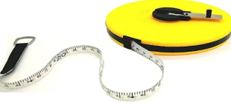
Arrow (pins) | is used for marking the end of the tape, or intermediate points, when taping over grass or unpaved ground. | 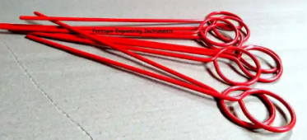
Pegs | Used for points which are required to be permanently marked | 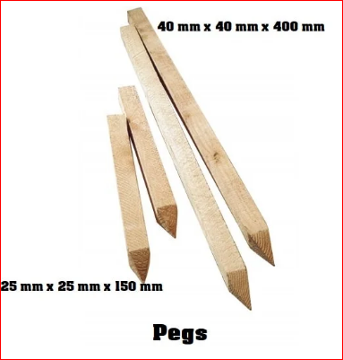
Range pole | Pole that used in the measurement of lines with the tape, and for marking any points  which need to be seen | 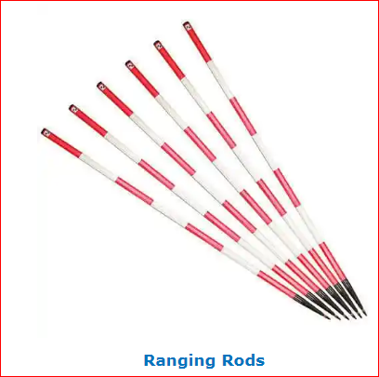
Sunto clinometer | This instrument is used for measuring angles of ground slopes (slope angle) | 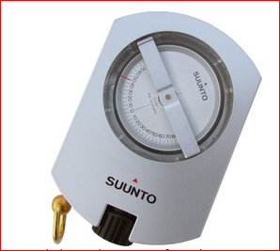
Compass | surveying instrument that used to measure the direction of survey line and also used as navigation aids | 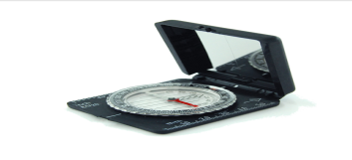
The Global Positioning System (GPS) | Is a navigational or positioning system which provides point position (Latitude/Longitude) and Relative Position (Vector). | 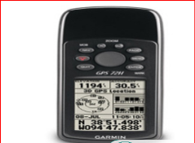
Plumb bob | Small metal that used for checking the perpendicularity of range pole | 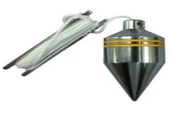
Optical Square | This instrument is used for setting out lines at right angle to main chain line. | 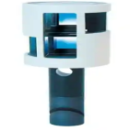
Level | Is an instrument most extensively used in levelling . It is used to provide a horizontal line of sight | 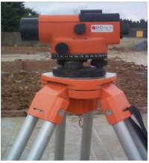

The Global Positioning System (GPS):
- GPS is a positioning system based on a network of satellites that continuously transmit coded information.
- The information transmitted from the satellites can be interpreted by receivers to precisely identify locations on earth by measuring distances from the satellites
- As one of the first satellite positioning systems, GPS has become integral to work done worldwide, including precision agriculture, autonomous vehicles, marine or aerial surveying
- Now the time of technology, the trainee should understand how to use,handle, open, closed, find the five page the GPS for measurement use
- GPS used for distance measurement, to read the location, area measurement, mapping the measured area and for navigation purposes
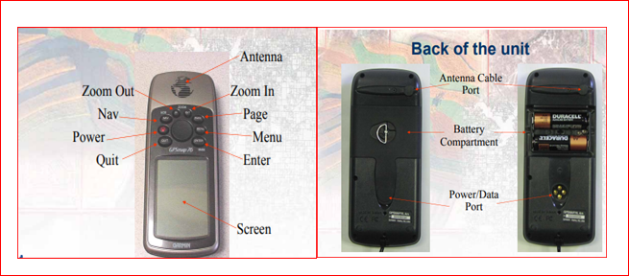
Figure 1.1 How to open and closed GPS
- The nominal GPS operational constellation consists of roughly 24 satellites and working access at least 4 satellite

- All of the information needed to operate you the device is found on the five main pages: the GPS information page, the map page, the compass page, the high way page and the active rout page(Figure 1.2)
- The GPS information page: displays your speed, elevation, the estimated accuracy, receiver status, satellite locations, satellite signal strength, the date, the time and GPS receivers current location
- The map page: guides you to your destination with a graphic compass display and a bearing or course pointer
- The compass page: select the number of data fields that appear on the compass page
- The high way page: for navigating when a straight line course can be followed
- The active rout: displays the rout information that you are navigating
- By pressing the PAGE button to navigate through the main pages and then pressing MENU to access the menu for these pages and use the rocker and the ENTER button to select the option you want to change. Press MENU twice to access the main menu
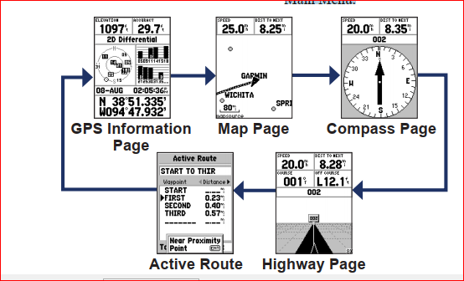
Figure 1.2 the five main pages of GPS
  - Detecting and correcting faults or errors in tools and equipment
- Even when carefully following established surveying procedures, observations may still contain errors
- Errors, by definition, are the difference between a measured value and its true value
- The true value of a measurement is determined by taking the mean value of a series of repeated measurements
- Surveyors must possess skill in instrument operation and knowledge of surveying methods to minimize the amount of error in each measurement
- Instrument errors are caused by imperfectly constructed, adjusted, or calibrated surveying equipment
- Prolonged storage, exposure to rapid changes in temperature, and jarring during transportation may lead to instrument maladjustments
- Collimation and other sighting errors can be determined and compensated for by specific instrument adjustments
- Before making instrument adjustments or beginning surveying operations, allow the instrument to adapt to the ambient temperature before proceeding
- A blunder (or gross error) is a significant, unpredictable mistake caused by human error that often leads to large discrepancies
- Blunders are typically the result of carelessness, miscommunication, fatigue, or poor judgment

  - Establishing and maintaining communication with others
Communication may include
- verbal and non-verbal language
- constructive feedback, active listening
- questioning to clarify and confirm understanding
- use of positive, confident and cooperative language
- use of language and concepts

Self-check 1 | Written test
Name…………………………………………… ID………………………… Date…….
Directions: Answer all the questions listed below.
Test I: Choose the best answer (each 1 point)
1. Surveying is a discipline, which encompasses all methods for measuring, processing, and disseminating information about the physical earth and our environment.
  - False B. True
2. The GPS menu pages that displays your speed, elevation, the estimated accuracy, receiver status, satellite locations, satellite signal strength, the date, the time and GPS receivers current location
A. GPS information page B. Compass page C. Active rout page D. Highway page
3. Occupation health and safety keeps the people from
- Accident B. Injury C. Illness D. All

Test II: Short Answer Questions
    - What is surveying? (3 points)

    - Describe the importance of surveying? (5 points)

    - Identify the names of surveying tools and equipment and their uses? (5 points)

Note: Satisfactory rating - 16 points Unsatisfactory - below 16 points
You can ask you teacher for the copy of the correct answers.

Operation sheet-1
  - Check the use andmaintain of each surveying tools and equipment
- Tools and equipment
- Clinometers
- Compass
- GPS
- Level
- Procedures/Steps/Techniques
- Wear personal protective equipment
- Select GPS the surveying equipment the required
- Properly identify the names and their uses of GPS
- Operate the all the five pages of GPS
- Properly identify the names and their uses of compass, level and clinometer tools and equipment’s
- Check the suitability of each tools and equipment for up coming measurement
- Properly identify how to handle and maintain each surveying tools and equipment’s
- Finally safely return all tools and equipment to their place

LAP TEST-1 | Performance Test
Name………………………………. ID…………………………….. Date…………………………………….

Time started: ________________________ Time finished: ________________

Instructions: Given necessary templates, tools and materials you are required to perform the following tasks within 2:30hour. The project is expected from each student to do it.

Taske-1Performsto check the use andmaintain eachof the three surveying tools and equipment
      - Compass
      - Clinometer
      - GPS

LG #36 | LO #2- Perform survey techniques

Instruction sheet
This learning guide is developed to provide you the necessary information regarding the following content coverage and topics:
  - Basic principles of survey
  - Identifying surveying methods
  - Preparing and applying surveying techniques
This guide will also assist you to attain the learning outcomes stated in the cover page. Specifically, upon completion of this learning guide, you will be able to:
  - Understand basic principles of survey
  - Identify surveying methods
  - Prepare and apply surveying techniques
Learning Instructions:
  - Read the specific objectives of this Learning Guide.
  - Follow the instructions described below.
  - Read the information written in the information Sheets 2
  - Accomplish the Self-checks 2
  - Perform Operation Sheets 2 and try to understand the procedures discussed
  - Do the “LAP test 2

Information sheet 2
- Basic principles of survey
Surveying is based upon a number of principles but the first two the fundamental principles which can be listed as follows:
- Working from whole to part
- According to the first principle, the whole survey area is first enclosed by main stations and main survey lines.
- The area is then divided into a number of divisions by forming well-conditioned triangles
- As the name itself implies, the survey work must be carried out from whole to part. This means that when an area is to be surveyed, first of all, a system of control points is established such that it covers the entire area with a higher degree of precision. After this, the minor control points and details are further established with a lesser degree of precision
- The main survey lines are measured very accurately with precise survey instruments. The remaining sides of measured
- During measurement, if there is any error, then it will not affect the whole work, but if the reverse process is followed then the minor error in measurement will be magnified
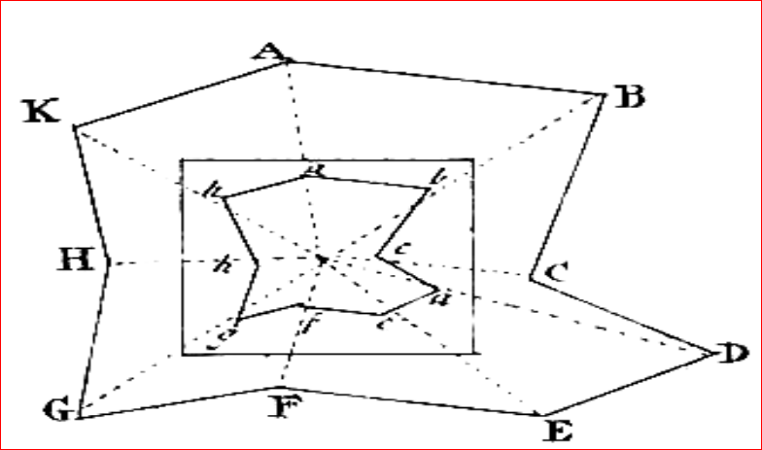
Figure 2.1 Work from whole to the part

- Location of point by measurement from two points of reference
- According to the second principle the points are located by linear or angular measurement or by both in surveying.
- If two control points are established first, then a new station can be located by linear measurement.
- Let A and B are control points, a new point C can be established
- Following are the methods of locating point C from such reference points A &B.
- The distance AB can be measured accurately and the relative positions of the point can be then plotted on the sheet to some scale.
- Taking linear measurement from P and Q for R (fig. a)
- Taking linear measurement of perpendicular from R to S (fig.b)
- Taking one linear measurement from R and one angular measurement ∕ABC(fig.c)
- Taking two angular measurement at & B as angles / RPQ and /RQP (fig.d)
- Taking one angle at B as / RQP and one linear measurement from A as RQ(fig.e)
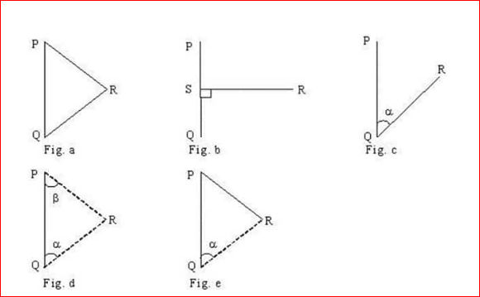
Figure 2.2 Location of a point from two reference points

- Consistency of work
- Another important principle of surveying is the consistency of work.
- It must be noted that keeping consistency in the method, instrument, reading and noting observations helps to gain the desired level of accuracy
- Independent check
- According to this principle, every measurement that is taken in the field must be re-checked by adopting a suitable method of independent field tests and observations so that any mistake if present is not passed without notice

- Accuracy required
- According to this principle of surveying; the proper method and instrument must be used for the survey work on the basis of the degree of accuracy required

- Preparing and applying surveying techniques
Thecommon types of surveying techniques
- Trilateration
- Chain surveying is used to define position of points with distance measurement only and no angular measurement
- To form a triangle to additional distances are measured from two terminal points of the base side to the third point to fix its position
- It is surveying techniques; survey area covered by a network of triangles in which only sides of triangles are measured
- It is a method of surveying in which the area is divided into network of triangles and the sides of the various triangles are measured directly in the field with a chain or tape without including angular measurements
- It is the simplest kind of surveying and is most suitable when the area to be surveyed is small in extent and is fairly level and open with some details

- Measuring horizontal distance
- Horizontal distance measurement involves the demarcation of the line to be measured. This is done by fixing ranging poles at the ends of the line
- To keep the line during taping, one has to establish intermediate points on the line between its end points with ranging poles. Those points can be established by ranging out
- The objective of ranging out to make the survey line straight before measuring the horizontal distance
- Ranging out done first fix ranging poles at the two end points of the survey line (at A and B in Figure2.3) and get an assistant to hold another pole near some intermediate point C to make all the three rage pole seen as one
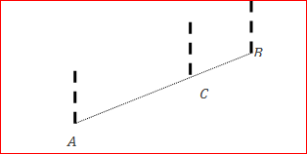
Figure 2.3 Ranging out
- Measuring of horizontal distance on gentile slope (inclination of the ground less than 30 ) is directly the meter stretch on the ground and above the ground for obstacle between the two range pole
- This is because on the gentile slope horizontal distance equal to surface distance (Figure 2.4)
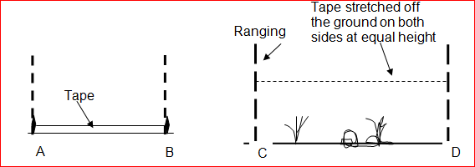
Figure 2.4 Measuring horizontal distance on gentile ground

Measuring horizontal distance on sloppy ground

Tapping on slopping ground using trigonometric method
- On sloping ground, horizontal distance(HD) of a survey line can be determined by using trigonometric method
- The inclination of the ground is observed by a clinometer and measuring the surface distance (SD) using measuring tape and the measurement along the ground is reduced by the calculation below(figure 2.5)HD = SD*Cos θ
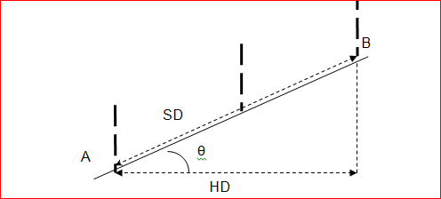
Figure 2.5Determining the horizontal distance using the trigonometric method

- Direct measurement of horizontal distance (tape-breaking)
- On sloping ground, direct measurement of horizontal distance can be conducted using stepping (tape-breaking) technique
- If there are breaks in slope along the survey line as shown in Figure 2.6, slope and distance measurements are taken for each slope class separately using water level, string and measuring tape
- Then, the corresponding horizontal distance will be computed for each class(HD1, HD2, & HD3)
- The sum of the horizontal distances is equal to the horizontal distance between the end points of the survey line (HD). Therefore, HD= HD1 + HD2 + HD3
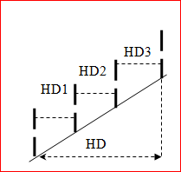
Figure 2.6 Direct measurement of horizontal distance

- Triangulation
- The principle is that, given a base if two angle of a triangle is known it is possible define triangle
- Thus, if a base side is established ,and two angle with a transit, compass or anyanglemeasuring equipment are measured from a terminals of the base side to a third point whose position is required ,the position of the third point can be fixed
- Compass is an instrument in which a magnetic needle assumes a more or less definite line of reference from which angular direction lines known as bearings can be measured
Parts of compass
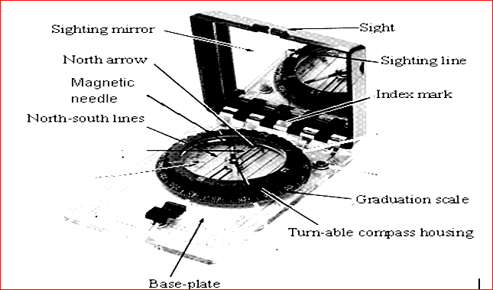
Figure 2.7 Silva-Sighting compass

- Observing the bearing of a line
- Bearings are horizontal angles measured from the north and south points of a reference meridians, and may be true or magnetic bearings accordingly. The axis of the compass needle serves as a reference line known as a magnetic meridian, or n and s line.
- Bearing is the direction of any line with respect the given meridian measured with fixed line of reference.
- Every line has two bearing observed at each end of a line(Figure 2.8)
- Fore bearing (FB): the bearing measured in the direction of the progress of the survey line. Used for map development
- Back bearing (BB): It is the bearing in the opposite reverse direction. Used for check compass measurement is correct or not
- Therefore, the calculation for to check the compass measurement correct or not is FB equal to BB plus or minus 180⁰
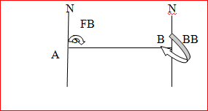
Figure 2.8 measuring of fore bearing (FB) and back bearing (BB)

- The two modes of observing bearings are
- Whole-circle bearings (W.C.B) or simply azimuths are angles measured clockwise from the north point from 0⁰ to 360⁰
- The graduated circles of Silva compasses are divided in the whole-circle system, 0⁰ to 360⁰ clockwise, which are read directly
- The azimuth of OA is 30⁰;of OB, 140⁰; of OC, 230⁰; of OD, 300⁰; as simply read on the circle in Figure 2.9
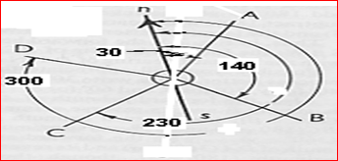
Figure 2.9 Whole circle bearing

- Reduced bearings (R.B) are horizontal angels measured to the east or to the west from the north or south point, in either direction from 00 to 900, the angular value being preceded by the initial letter N or S, and followed by the terminal letter E or W.They are read directly on circles divided in the quadrant system, 0⁰ to 90⁰

Table 2.1 Calculate the reduced bearing from WCB
Line | OA | OB | OC | OD
Formula | First quadrant  RB = WCB  N(0⁰ up to 90⁰)E | Second quadrant  RB = 180⁰ –WCB  S(90⁰ UP TO 180⁰)E | Third quadrant  RB = WCB -180⁰  S(180⁰ UP TO 270⁰)W | Fourth quadrant  RB = 360⁰–WCB  N(270⁰ UP TO 360⁰)W
Example of changing WCB in to RB
WCB | 30⁰ | 140⁰ | 230⁰ | 300⁰
RB | N30⁰E | (180⁰-140⁰)  S40⁰E | (230⁰-180⁰)  S50⁰W | (360⁰-300⁰)  N30⁰W

- Traverse
- A traverse is a series of connected lines whose lengths and directions are to be measured and the process of surveying to find such measurements is known as traversing
- In general, chains are used to measure length and compass or theodolite are used to measure the direction of traverse lines
- The types of traverse and methods of traversing are discussed in this article
- It is the technique used defines position of fielded points by combination of distance and angular measurement
- Distance along a line between successive points are measured at each point where the traverse change directions, an angular measurement is taken
- It is travels consist of service of straight lines in which position is determined by a combination of angles and distance measurement between successive lines joining control stations
- When you survey by traversing, you need to make measurements to find information on:
- the distance between traverse stations
- the direction of each traverse section
- Type of traverse
    - Open travels: - is a travels start from known point and ends at unknown point. Since open, there is no computational check on measurement
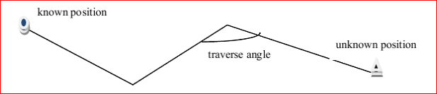
Figure 2.10 Open traverse

    - Closed travels:A traverse is said to be closed traverse when the traverse formed a closed circuit as shown in the figure. In this case, both starting and terminating points of the traverse coincide with each other. It is suitable for the survey of boundaries of ponds, sports grounds, forests
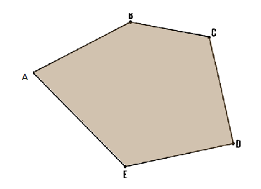
Figure 2.11 Closed traverses

- Choosing the route of a traverse
When selecting the route a traverse will follow:
- Make each straight section of the traverse as long as possible (40-100 m)
- Make the traverse sections as equal in length as possible
- Avoid very short traverse sections - under 25 m long
- Choose lines which can be measured easily
- Choose lines along routes which avoid obstacles such as heavy vegetation, rocks, standing crops and property
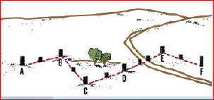
Figure 3.12 Mark the station

- Methods of Traversing
The three common methodsof traversing as follows:
- Chain Traversing
- Chain traversing is done by taking linear measurements only.
- Hence, chain or tape is enough for chain traversing.
- The angle between the adjacent traverse lines is measured using the chain angles concept.
- Chain traversing is performed in areas such as ponds etc. where it is difficult to adopt triangulation.
- The chain angles concept is nothing but finding the angle between two adjacent sides by establishing the third side using tie stations
- This angle between the sides can also be fixed by establishing a chord of known length between the sides

- Compass Traversing
- In the case of compass traversing, both linear and angular measurements of traverse lines are taken by using chain and prismatic compass respectively
- Both fore bearing and back bearings are measured and required corrections for local attraction are applied
- You need to survey traverse AF then the first, walk along the traverse. Mark its course by placing high stakes about every 50 m. If necessary, place additional stakes at important traverse stations, such as where the traverse changes direction, where hills or other changes in elevation reduce visibility between traverse stations, or where there are particular landscape features such as a road, a river, or rocks
- Start traversing at the first point A. Remove the ranging pole and stand at point A. With the magnetic compass, measure the azimuth of the line joining point A to point B, the next visible point. Point A becomes station 1. The direction you measure from there to point B, or station 2, is called a foresight (FS) because you are measuring forward (Figure 3. 13)
- Replace the ranging pole at station 1 (point A) and move to station 2, while measuring the horizontal distance AB by pacing or chaining. Like this continue measure all the survey station distance and direction
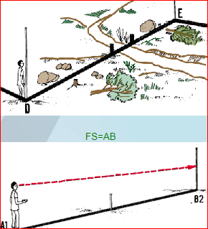
Figure 3.13 Compass traverse

- Theodolite Traversing
- In the case of theodolite traversing, the linear measurements are done by using chain or stadia method and angular measurements are done by theodolite
- Using theodolite, the magnetic bearing of the first traverse line is measured and from that magnetic bearing of other sides are calculated
- This method is very accurate compared to other methods

- Offsetting
- This is another way of distance measurement where offset is used to fix points withreference to base lines
- Offset often used to with trilateration traversing and to locate position ofdetails inside triangulation systems
- Offset are lateral measurements made from known points on thesurvey lines to point not falling on the survey lines. Positions of details inside the frame work aredefined with offset measurement
3.3 Collect tools and equipment
Levelling and topographic survey work required different types of tools, equipment’s andinstrument for measuring the horizontal distance, vertical distance and direction on both open and closed traverse. Therefore, all the required tools and equipment’s should select and check for upcoming works
The tools and equipment includes:
- Level and their accessories
- Magnetic compass
- Clinometer
- Measuring tape
- Clipboard
- Pencil

Self-check 2 | Written test
Name…………………………………………… ID………………………… Date…….
Directions:Answer all the questions listed below.
Test I: Choose the best answer (1 point each)
- ____is the simplest method of surveying in which only linear measurement taken
  - Chain surveying B. Compass surveying C. Levelling D. all
- ____ is a series of connected lines whose lengths and directions are to be measured and the process of surveying to find such measurements
  - Trilateration B. TriangulationC. TraversingD. Bearing
- Which one is the principle of surveying?
  - Working from the whole to the parts
  - Location of point by measurement from two points of reference
  - Accuracy required
  - All
Test II: Short Answer Questions

- Write and briefly describe the two principles of surveying?(5 points)

- Clearly differentiate between chain and compass surveying?(5 points)

Note: Satisfactory rating - 13 points Unsatisfactory - below 13 points
You can ask you teacher for the copy of the correct answers.

Operation sheet-2
  - Apply surveying techniques to measure horizontal distance and direction of survey line
- Select tools and equipment
- Compass
- Clinometer
- Measuring tape
- Range pole
- Arrow
- Line level
- Note books
- Pencil
- Procedures/Steps/Techniques
- Wear personal protective equipment
- Select both open and closed traverse site and mark all the survey station
- Properly range out all the survey line
- Read the fore and back bearing of eachmain survey station and line
- Record the measured fore and back bearing on the note book in the form of whole circle bearing
- Measure the horizontal distance on the main survey line on both sloppy and gentile ground
- Then after the measurement calculate the reducing bearing from the measuredwhole circle bearing
- If your selected area sloppy, calculate the horizontal distance from the measured surface distance

  - Apply measurement using GPS
- Equipment
- GPS
- Map
- Ruler
- Note book
- Pencil
- Procedures/Steps/Techniques
- Wear personal protective equipment
- Prepare the GPS and access for satellite to check ready for measurement
- Select small area and measure distance , direction and the area
- Measure the boundaries, the elevation of selected area
- Find the location of you by reading Northing and Easting grid line with GPS
- Access the map of the area you measured on the GPS

LAP TEST-2 | Performance Test
Name………………………………. ID…………………………….. Date…………………………………….
Time started: ________________________ Time finished: ________________

Instructions: Given necessary templates, tools and materials you are required to perform the following tasks within 3:40hour. The project is expected from each student to do it.

Taske-1Perform surveying techniques to measure
- horizontal distance
- direction (bearing) of survey line
Task-2 Perform measurement of distance, direction and area with GPS

LG #37 | LO #3- Apply leveling and topographic survey

Instruction sheet
This learning guide is developed to provide you the necessary information regarding the following content coverage and topics:
- Identifying leveling and topographic techniques
- Procedures of leveling and topographic survey
- Collecting tools and equipment
- Applying leveling and topographic survey techniques

This guide will also assist you to attain the learning outcomes stated in the cover page. Specifically, upon completion of this learning guide, you will be able to:
- Identify level and topographic techniques
- Understand procedures of leveling and topographic survey
- Collect tools and equipment
- Apply leveling and topographic survey techniques
Learning Instructions:
- Read the specific objectives of this Learning Guide.
- Follow the instructions described below.
- Read the information written in the information Sheets 3
- Accomplish the Self-checks 3
- Perform Operation Sheets 3 and try to understand the procedures discussed
- Do the “LAP test 3

Information sheet 3
  - Identifying leveling and topographic techniques
- Identify leveling techniques
- Leveling is defined as the process of measuring the difference in height between points on the surface of the earth
- Leveling is a branch of surveying which is :to find elevation of points with respect to a given or assumed datum and to establish points at a given elevations with respect to a given or assumed datum
- In surveying, all measurements of lengths are horizontal, or else are subsequently reduced to
horizontal distances
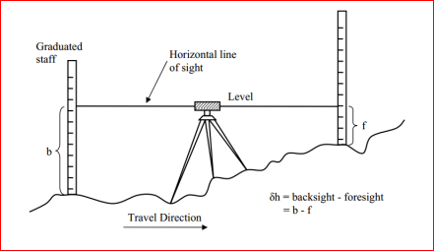
Figure 3.1 Levelling

  - Level instrument
- The instrument most extensively used in levelling is the Level
- It is used to provide a horizontal line of sight
- It have four parts: the head, tripod, telescope and bubble tube
- Automatic level is the latest one

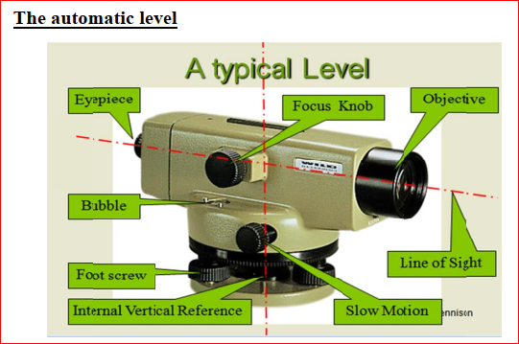
Figure 3.2 Automatic level and their head parts

  - Basic terminologies used in leveling
- Horizontal line: - a straight line perpendicular to vertical /a line which pass in horizontal plane
- Datum: - Any level surface to which elevation are referred. (eg above means sea level) called datum plane. Usually adopted above means sea level
- Reduced level (RL) - RL of points is its elevation above the datum adopted.
- Elevation –is the vertical distance from the datum, usually above means sea level, to a point or object
- Bench mark(BM): - a fixed point of reference marked whose elevation above or below adopted datum is known or assumed
- A station: - a point where reading staff is held but not where the level is step up
- Line of sight or line of collimation: - the line of sight or collimation is an imaginary straight line which joins the intersection of the cross-hairs of the diaphragm to the optical center of the object glass and continues beyond the object glass
- Back sight (BS) – is the first reading or sight taken on a leveling staff. It is always taken on point of reduced level of w/c is known or can be computed
- Fore sight (FS) – is the last sight taken before moving the instrument to another station
or completion of the survey operation.
- Intermediate sight (Is) – Any reading other than BS& FS on a point of un known RL from the same set up of instrument.
- Height of instrument (HI) – is the reduced level of line of collimation following the correct level of instrument. HI = BM + BS
- Difference in height (ΔH) = BS-FS Arithmetic check - ∑BS – ∑FS = last RL – First RL
- Change point (CP) or turning point (TP) – is last station where Fore sight is taken before moving the instrument to next Point where it is set up on for further reading
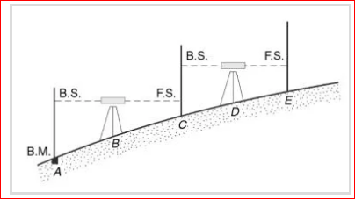
Figure 3.3 Reading on leveling staffs

  - Uses of levelling
- In Engineering Surveying, a longitudinal section (or profile) is taken along the complete length of the existing ground level
- Leveling can be used to measure heights at points on the center line so that the profile can be plotted
- Generally, this type of section provide data for determining the most economic formation level, this being the level to which existing ground is formed by construction methods
- The optimum position for the formation level is usually found by using a computer aided design package but the longitudinal section is sometime drawn by hand and a mass – hand diagram prepared
- In the construction of other projects such as roads and railways, existing ground level information at right angle to the center line is required.
- This is provided by taking cross sections at right angles to the center line such that information is obtained over the full width of the proposed construction.
- A ranging rod is placed on either side of the center line to mark each cross –section
- A contour is defined as an imaginary line joining points of the same height or elevation above or below a datum. These are shown so that the relief or topography of an area can be interpreted
- In addition to the relief, the topographic map depicts natural features such as streams, rivers lakes, trees, etc. as well as artificial features such as highways, railroads, canals, towns, houses, fences, and property lines
- The topographic maps are very essential for the planning and designing of most engineering projects
- The relief on a topographic map is most commonly and accurately represented by contours

- Identify topographic survey techniques
- Topographic surveying is the process of determining the positions, both on plan and elevation, of the natural and artificial features of a locality for the purpose of delineating them by means of conventional signs upon a topographic map
- By topography is meant the shape or configuration of the earth’s surface
- On a plan, the relative altitudes of the points can be represented by shading hachures, form lines, or contour lines

- The purposes of topographic surveying
- The purpose of the first type of topographical survey is to establish, on a horizontal plane, the position of one or more points in relation to the position of one or more other points. To do this, you will measure horizontal distances and horizontal angles or directions
- Topographical surveys will help you to make plans or maps of an area that show: the main physical features on the ground, such as rivers, lakes, reservoirs, roads, forests or large rocks; or the various features of the fish-farm, such as ponds, dams, dikes, drainage ditches or sources of water; the difference in height between land forms, such as valleys, plains, hills or slopes; or the difference in height between the features of the fish-farm. These differences are called the vertical relief
- Preparing topographic maps
- It is used in constructing topographic (cross-sectional) profiles
- It is also used in establishing vertical and horizontal control for accurately defining locations
- Topographical surveys are essential for land development projects as they help to correctly plan out and coordinate proposed layouts.
- Accurate land measurements will allow you to see how the existing site is arranged, including the height of items
- Re-positioning boundaries
- Correctly designing drainage schemes
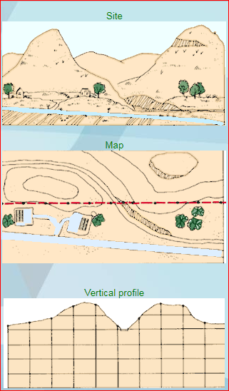
Figure 3.4 Topographic survey

  - Applying leveling and topographic survey techniques
- Methods of leveling
- Simple levelling
- It is the simplest operation in levelling used to find the difference in elevation between two points, both of which are visible from a single position of the level
- Suppose A and B are two such points and the dumpy level is set up at O, approximately midway between A and B to eliminate the effect of instrumental error, but not necessarily on the line joining them
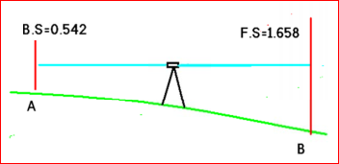
Figure 3.5simpleleveling
- Differential leveling
Differential levelling is the directmethod of levelling used to determine the difference in elevation between points when:
- the points are situated far away from each other
- the difference in elevation between them is too great
- there is a presence of obstacles between the points
- In such a case, it is necessary to set up the level in several positions and to work in a series of stages. In each of the successive stages, the method of simple levelling is employed
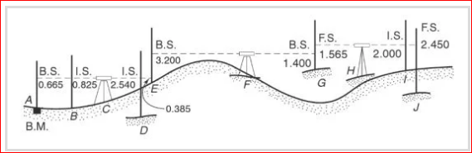
Figure 3.6differential leveling
- Barometric leveling
- By using special barometers to measure air pressure
- In the indirect method of levelling, the relative elevation the points are found by indirect observations
- It is a method of levelling in which the altitudes of points are determined by means of a barometer, which measures atmospheric pressure
- Barometric levelling is based on the principle that atmospheric pressure varies inversely with the altitude of a point.
- The weight of air above the observer decreases as the observer rises in altitude.

  - Booking and Reduction of the levels
There are two methods of booking and reduction of levels
- Height of instrument method
Height of instrument methods deals with obtaining the RL of the line of collimation by adding BS reading of a point whose RL is known. The RL of line of collimation is called Height of Instrument. From this, the staff readings of all intermediate stations are subtracted to get the RL at those points. In this method, height of instrument (HI) is calculated for each setting of the instrument by adding the back sight (BS) to the elevation of the bench marks (BM) HI= BM + BS. The reduced level (RL) of the first station is obtained by subtracting its fore sight (FS) from the instrument height (HI). RL= HI-FS/IS
Table 3.1 Height of Instrument Methods
Station | BS | IS | FS | HI | RL | Remarks
A | 2.42 |  |  | 822.42 | 820 | BM
B | 3.56 |  | 1.2 |  | 821.22 | TP
C | 0.39 |  | 1.35 | 824.87 | 823.43 | TP
D |  |  | 0.94 | 823.82 | 822.88
Total | 6.37 |  | 3.49

- Rise and fall methods
In this method, the difference of level between two consecutive points for each setting of the instrument is obtained by comparing their staff readings. The difference between their staff readings indicates a rise if the back staff reading is more than the fore sight and a fall if it less than the fore sight
Table 3.2 Rise and fall methods
Station | BS | IS | FS | Rise | Fall | RL | Remarks
A | 2.42 |  |  |  |  | 820 | BM
B | 3.56 |  | 1.20 | 1.22 |  | 821.22 | TP
C | 0.39 |  |  | 2.21 |  | 823.43 | TP
D |  |  | 0.94 |  | 0.55 | 822.88
Total |  |  |  | 3.43 | 0.55

Self-check 3 | Written test
Name…………………………………………… ID………………………… Date…….
Directions: Answer all the questions listed below.
Test I: Choose the best answer (1 point each)
----1._____ is the first reading or sight taken on a leveling staff
- Back sight B. Back bearing C. Fore sight D. Turning point
___2. An instrument most extensively used to provide a horizontal line of sight
- Levelling B. Level C. Water level C. Line level
___3. ____ is an imaginary line joining points of the same height or elevation above or below a datum.
- Datum B. contour C. Station D. Survey line
___4.The topographic surveying is used for
- Preparing topographic maps
- Constructing topographic
- Establishing vertical and horizontal control D. All E. None
Test II: Short Answer Questions
1.Write the name, and accessories parts of level instrument(5 points)
- Discuss the methods of leveling and their difference? (5 points)
- Write the aim of topographic survey? (3pts)
Note: Satisfactory rating - 5 points Unsatisfactory - below 5 points

You can ask you teacher for the copy of the correct answers.

Note: Satisfactory rating - 17 points Unsatisfactory - below 17 points
You can ask you teacher for the copy of the correct answers.

Operation sheet-3
  - Apply levelling and topographic survey techniques
- Tools and equipment
- ,Automatic level, levelingstaff,tripod, topographic map, note book, pencil
- Procedures/Steps/Techniques
- Wear safety cloths
- preparing to use a level the instrument
- To fix the instrument on the tripod, release the clamp screw of the instrument
- Hold the instrument in the right hand and fix it on the tripod by turning round only the lower part with the left hand.
- Screw the instrument firmly.
- Place the instrument in a desired position at a convenient height for sighting with the tripod legs spread well apart
- Bring all the foot screws in the center of their run.
- Fix any two legs firmly into the ground by pressing them with the hand
- Move the third leg to the right, or left until main bubble is approximately in the center.
- Place the telescope parallel to a pair of foot screws and bring the bubble to the center of its run by turning these screws equally
- Turn the telescope through 90 degree so that it lies over the third foot screw, and center the bubble by turning this screw.
- Again bring the bubble to the center of its run, and repeat these operations until the bubble remains in the center of its run in both positions, which are at right angles to each other.
- If the instrument is in adjustment, the bubble will traverse (i.e. remain central) for all directions of the telescope.
- Then find the elevation of points with respect to a known datum

LAP TEST-3 | Performance Test
Name………………………………. ID…………………………….. Date…………………………………….

Time started: ________________________ Time finished: ________________

Instructions: Given necessary templates, tools and materials you are required to perform the following tasks within 2:45hour. The project is expected from each student to do it.

Taske-1 Perform leveling and topographic techniques

LG #38 | LO #4- Develop map

Instruction sheet
This learning guide is developed to provide you the necessary information regarding the following content coverage and topics:
- Identifying types of maps, charts, scales and their uses
- Understanding map development and reading technique
- Identifying collecting materials
- Understanding of developing map

This guide will also assist you to attain the learning outcomes stated in the cover page. Specifically, upon completion of this learning guide, you will be able to:
- Identify types of maps, charts, scales and their uses
- Understand map development and reading technique
- Identify collect materials
- Understand of developing map
Learning Instructions:
- Read the specific objectives of this Learning Guide.
- Follow the instructions described below.
- Read the information written in the information Sheets 4
- Accomplish the Self-checks 4
- Perform Operation Sheets 4 and try to understand the procedures discussed
- Do the “LAP test 4

Information sheet 4
  - Types of maps, charts and scales and their uses
- Definition
- Map is a representation of the whole or part of the earth’s surface in miniature orIt isa conventional delineation of the earth’s surface or portion thereof on flat sheet
- Every resource manager must acquire the skills of reading a map quickly and correctly
- An experienced map reader can visualize the country delineated on a map its terrain, undulations, ridges, valleys, hills and depressions

- Uses of maps
- To getaccurate picture of the ground by interpreting the scale, conventional signs and symbols used in the map
- Maps are very important and useful documents to meet day-to-day requirements in natural resource management and especially in accessible and infrequently visited where maps are indispensable
- Demarcation of forest areas and give record of boundaries, encroachments illicitly possessions, if any, can be checked and detected by reference to these maps
- A map can allow you to accurately plan a journey, giving a good idea of landmarks and features you will pass along the route, as well as how far you will be travelling.
- For forest management purpose
- They are very essential records for resource management and protection purpose as well
- maps also prepared for soil conservation works known as land use capability maps

- General requirement of a map
- The title
- The scale
- The North Point (north direction)
- Legend, as to the symbols employed
- Contours, hachures or spot levels
- Constructional lines and symbols for building and civil engineering works
- Location of the survey
- Details of the control grid used

- Scale of map
- Scale is the fixed rotation that every distance in the map (plan) bears to the corresponding horizontal distance on the ground. The scale depends on the purpose and the extent of details desired to be represented in the map. From the scale of a map an idea of the ground distance can be effectively and correctly attained. It can be represented by the following method
- Engineer’s scale
- On the plan represents some whole no of meters on the ground. Eg. 1cm = 500m
- Representative fraction: - one unit length on a plan represents some no of the same units of length on the ground. Eg 1/500
- The ratio of the map distance to corresponding ground distance is independent of unit
measurement

- Graphical scale
- Is a line sub divided into plan distance corresponding to convent unit length on the ground
- If a plan or a map is used a few years, the numerical scale may not give accurate results if thesheet or paper shrinks.
- However, if graphical scale is also drawn, it will shrink proportionallyand distance can be found accurately.
- That is why, scale are always drawn on all surveymaps

Table 4.1 Common scales generally used in various surveys
Type of survey | Scale
Topographic survey
1. Building site | 1cm = l0 m or less1cm = 50 to 100m
2. Town planning schemes, reservoirs etc | 1cm = 20 to 50m
3.Location surveys | 1cm = 0.25km to 2.5km
Cadastral maps | 1cm = 5m to 0.5km
Geographical map | 1cm = 5km to 160km

- Types of maps
There are three types of maps depending the nature of their use
- Topographic map:- Intended to show the natural and artificial features of the terrain such as hills, rivers, forests, swamps and towns’ villages roads bridges, canals, power lines
- Cadastral map: -this map shows the boundaries of properties.
- Thematic map: - Show one of more themes or subjects on a topographic background such as the distribution of the in habitants over the country or the concentration of energy sources in a area, or composition of the soil of the country

- Map reading elements
Reading topographic map requires understanding the map elements that available at the top, bottom and the main body includes:
- Using map symbols (Legend)
- The map legend identifies the symbols used to depict the prominent natural and manmade objects that exist on the ground
- The legend is found from the bottom of the map
- Rather than containing descriptions, maps have symbols to show where certain things are
- Symbols are used so maps don’t have to be covered in writing, as this would make them very confusing
- Ordnance Survey uses different shapes, colors and symbols to show all the roads, buildings, rivers and other features of a landscape
- Symbols are designed to be simple, often looking like the features they represent
- This means things can be quickly and easily recognized as you look at a map
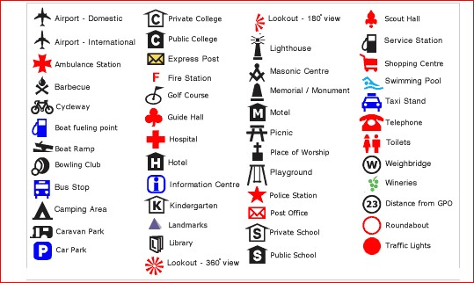
Figure 4.1 Legend used for map reading

- Using map scale
- The scale of the map important to read the map, by changing the map distance into ground distance it possible measure the distance, the area and any measurement on the map
- To create an accurate picture of a landscape on paper everything has to be made much, much smaller
- This is done by ‘scaling down’ the actual size of the land

- Using colors
- Black indicates cultural (man-made) features such as buildings, railroads, and roads
- Red and brown combinations identify cultural features (such as major roads),relief features, and contour lines on red-light readable maps
- Blue identifies water: lakes, swamps, rivers, and coastal waters
- Green identifies vegetation such as woods, orchards, and vineyards
- Brown identifies cultivated land on red-light readable maps—on older maps, brown represents relief features and elevation such as contours
- Red was used on older maps to mark populated areas, main roads, and boundaries

- Using grid references
- Ordnance Survey maps are covered in a series of faint blue lines that make up a grid
- The lines have numbers accompanying them that allow you to accurately pinpoint your location on a map
- Once you have located where you are, the grid system makes it simple to give others an accurate description of your location
- This description, which will be a series of numbers, is known as a grid reference
- Before you begin to look at grid references it is important to be aware that all the numbers going across the face of the map

  - Using reading contours and relief
- Understanding the shape of the land by looking at a map is a very useful skill and can be essential if you’re going to be walking in mountainous terrain
- The height and shape of the land is shown on a map using ‘contour lines’
- These lines appear as thin orange or brown lines with numbers on them
- The number tells you the height above sea level of that line
- A contour line is drawn between points of equal height, so any single contour line will be at the same height all the way along its length
- An easy way to understand and visualize contour lines is to think of them as high tide lines that would be left by the sea
- The picture below shows how contour lines can be used on maps to describe different landscapes
- Even though all the lines look similar at first, they are describing very different landscape features
- The closer together the contour lines, the steeper the slope of the hill
- If a hill is very steep the contour lines might even merge into each other
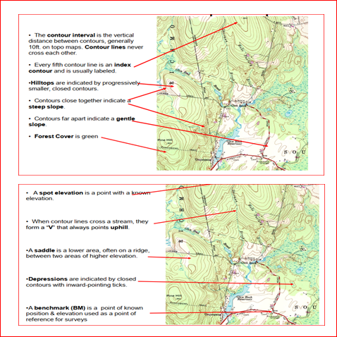
Figure 4.2Representation of topographic features on maps

  - Map development techniques
Methods of drafting of a map dived in the four methods
- Plotting the traverse:
- The measurement of angle and length are used to plot a traversemanner as those for details.
- Distance is plotted from the selected scale
- An angle of travels can be plotted by:
        - Coordinate: is the most accurate method if the latitude and departure of traverse lines are available from area computation the total x-coordinator and y-coordinator for each angle point are readily determined and plotted from an origin through one corner of traverse.
        - Tangent method: to lay of any angle by tangent methods, a convenient distance is measured along the reference line to serve as a base
        - Chord method: to lay off an angle by chord method as indicated in fig a convent base length of 10 units is first marked on the side BA giving points with the vertex B as the center and radius of unites, and are is swing
        - Protractor method: are universally used for plotting details but are not suitable for high precision work on traverse or control

- Plotting details
- Are done by coordinate or tapers methods, but the protractor is used for most details
- Contours found by direct method are sketched through the points.
- Interpolations between the sketched points are necessary for indirect method.
- Interpolation to find contact points between points of known elevation can be done in the several ways.
- Estimating
- Scaling the distance b/n points of know elevation and locating the contour points by proportion
- Using rubber bund graduated to some scale and stretching it to make convenient
marks fall on the known elevation
- Using triangle and scale
- Using a converging line device – which can be pivoted and adjusted to for the difference in elevation by any points

- Finishing map
- Topographic feature: - used to represent special topographic features, thereby making it possible to show many details on single sheet
- Locating a traverse on a map sheet:- the appearance of a finished map has considerable bearings on its acceptability and value
- A border lines somewhat heavier than all other lines improves the appearance of the sheet.
- The first step in arrangement is to determine the position of the traverse and topography which will poorly balance the sheet
- Before any plotting is done, the proper scale for a sheetof a given size must be determined.

Self-check 4 | Written test
Name…………………………………………… ID………………………… Date…….
Directions: Answer all the questions listed below.

Test I: Choose the best answer (1 point each)
- The map that shows both natural and artificial features
- Thematic B. Topographic C. Cadastral D. Rout
- The symbol that used provide guide to read the map
- Title B. Scale C. Legend D. Grid

Test II: Short Answer Questions
1.Write types of maps? (2pts)
2. Write the purpose map ? (5pts)
3. List the map reading elements?(5pts)

Note: Satisfactory rating - 14 points Unsatisfactory - below 14 points
You can ask you teacher for the copy of the correct answers.

Operation sheet-4
  - Read topographic map and accurately interpret

- Tools and equipment
- Compass
- Topographic map of the area
- GPS
- Ruler
- Marker
- Note book
- Procedures/Steps/Techniques
- Wear personal protective equipment
- Choose the right map for the place and activity for practicing map reading
- The key points to knowing your map are
- understand scale and distance on your map
- be familiar with map symbols
- learn to read contour lines
- Orientate the map
- The top of the map is always north and you naturally hold the map that way to read the words
- Properly practice and determine the features on the topographic map
- Based on the characteristics of the contour identify and interpret the features
- Based on the grid (northing and easting) find your location on the map

  - Develop base map
- Tools and equipment
- Compass
- Clinometer
- Meter
- Ranging pole
- Arrow
- Protractor(360⁰)
- Note book
- Pencil
- Procedures/Steps/Techniques
- Wear personal protective equipment
- Select closed traverse piece of land
- Select and establish all main survey station with arrow and range pole
- Measure the fore bearing and back bearing of each survey line and the horizontal distance between each station with meter and clinometer using survey techniques
- Establish your scale and change the measured horizontal distance in to map distance
- Using plotting traverse map development method(fore bearing drawn with protractor and the map distance with ruler), develop the map of the measured land on the A4 paper
- Remember before starting drawing please put vertical line that show the north point and at the middle of the put point of beginning the drawing

LAP TEST-4 | Performance Test
Name………………………………. ID…………………………….. Date…………………………………….
Time started: ________________________ Time finished: ________________

Instructions: Given necessary templates, tools and materials you are required to perform the following tasks within 3:00hour. The project is expected from each student to do it.

Taske-1 Read and interpret topographic map

Task 2: Develop base map

LG #39 | LO #5- plan the route and conduct navigation

Instruction sheet
This learning guide is developed to provide you the necessary information regarding the following content coverage and topics:
- Planning route
- Examining map symbols, information and navigation data
- Calculating grid and magnetic bearings
- Planning emergency or contingency exit routes and other risks
- Undertaking navigation
- Orientating maps to surroundings
- Using equipment and navigation aids
- Navigating alternative routes to bypass obstacles

This guide will also assist you to attain the learning outcomes stated in the cover page. Specifically, upon completion of this learning guide, you will be able to:
- Plan route
- Examine map symbols, information and navigation data
- Calculate grid and magnetic bearings
- Plan emergency or contingency exit routes and other risks
- Undertake navigation
- Orient maps to surroundings
- Use equipment and navigation aids
- Navigate alternative routes to bypass obstacles
Learning Instructions:
- Read the specific objectives of this Learning Guide.
- Follow the instructions described below.
- Read the information written in the information Sheets 5
- Accomplish the Self-checks 5
- Perform Operation Sheets 5 and try to understand the procedures discussed
- Do the “LAP test” 5

Information sheet-5
  - Planning route

When planning your route on a map it pays to remember that the straightest line between your starting point and destination may not be the easiest, quickest or safest.

Examine the map of the area you are walking in very carefully before planning a route

If you are going to be walking in mountainous or rough terrain it is often a good idea to plan a route following contour lines. This is called contouring

The first stage of navigating with a map and compass involves working out your grid bearing.
- Before you set out, take the time to plot your route and mark it on your map
- If it’s your first experience with a map and compass, start with a short route in an area you’re
familiar with
- Interpreting the shape of the land on a map using contour lines is an extremely useful navigational
- Looking at the lines and creating a mental picture of the landscape will allow you to plan a journey effectively
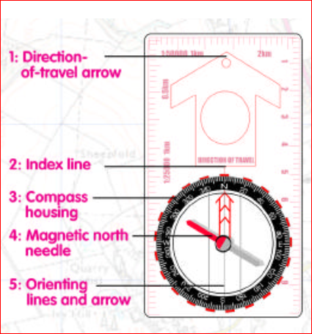
Figure 5.1: Navigation aid compass

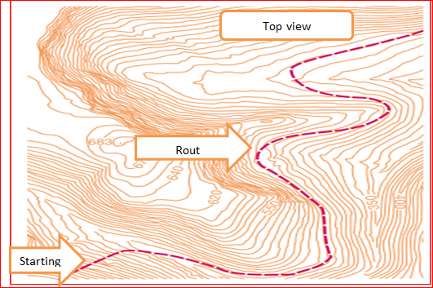
Figure 5.2 Planning rout navigation

  - Examining map symbols, information and navigation data
- You should always produce a navigation data sheet before setting off on a cross-country move. A navigation data sheet helps you to plan your navigation, and records the bearing and distance between bounds.The navigation data sheet can be written on any notepaper, but should be readable so that it can be checked and copied by a check navigator.
- It is impossible to write down all of the information about the "going" and the "relief" of the ground, and a navigational data sheet can never replace a map. Therefore, the information in the navigational data sheet is only to aid the memory
- Navigation data may include: grid reference points, grid and magnetic bearings, distances, estimated travelling times, height gain/loss, gradient, identifiable features and exit route

Table 5.1 Navigation data sheet(Example how to write the navigation data on the sheet)
SN | From | To | Magnetic bearing  (Degree) | Distance  (meter) | Estimated time  (in minute) | Going | Remarks
1 | A | B | 280⁰ | 200 | 25 | a.120m gentle down slop from river  b. 80m gentile uphill | Creek 120m flow left to right
2 | B | C | 80⁰ | 70 | 15 | Undulating ground slopping right to left from river

- Symbols and information may include: grid lines and numbers, contour lines, magnetic variation, scale, map legend, topographic features, markers and beacons, water depth

  - Calculating grid and magnetic bearings
- Measuring bearing
Before taking calculating grid and magnetic bearing, we have to know a bearing take with compass
    - The first step is finding the two points on the map that you want to travel from and to. Line up your compass edge between the two points, so that your direction-of travel arrow is pointing to your destination

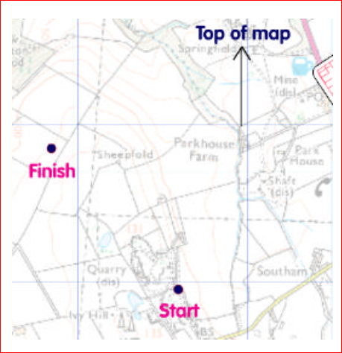
Figure 5.3 Line up compass on the map

    - Rotate the compass housing until the orienting lines in the center are pointing to the top of your map. You can do this by lining them up parallel to the grid lines.
    - Now rotate the dial until the north pointer lines up with the mark on the dial that joins the direction of travel arrow (this is called the index line)
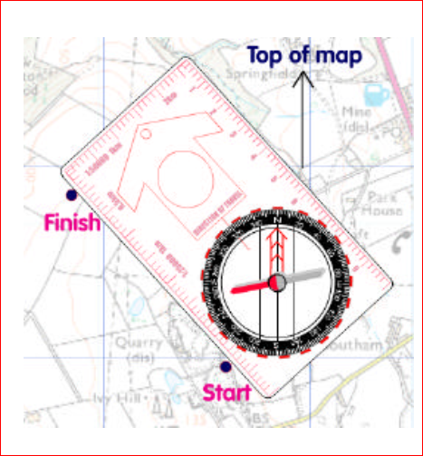
Figure 5.4 rotating the compass house

    - Now read the bearing at the bottom of the direction-of-travel arrow, at the index line. In our example, the bearing is 320°. You will need to take into account the difference between grid north (on your map) and magnetic north (on your compass). This is called magnetic variation and your map will tell you how many degrees to add to your bearing
    - To head in the right direction, you must now re-orientate your compass. This means turning the whole compass around until the magnetic north needle points in the same direction as the orienting arrow. The way the direction-of-travel arrow is now pointing is the direction you must walk in to get to your destination
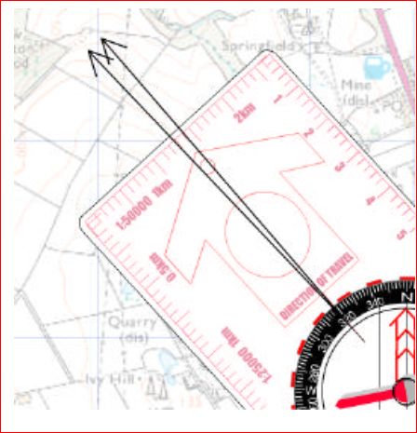
Figure 5.5 Reading the bearing at the index line

- Grid Reference
- The grid shown on the map is made up of two sets of equally spaced parallel lines intersecting at right angles to form squares
- Maps are normally printed with north at the top of the sheet and with the superimposed grid lines running vertically and horizontally
- The interval between the grid lines is the same throughout the map and is usually chosen to match the map scale

When giving grid references the grid lines are referred to as follows:
- Eastings: the vertical grid lines which divide the map from west to east are knownas Easting’s. They are numbered from west to east
- Northings:the horizontal grid lines which divide the map from south to north are
known as northings. They are numbered from south to north
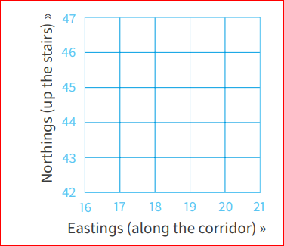
Figure 5.6 Grid lines

- When giving grid references the easting (that is the left to right reading of grid values) is always given before the northing (that is the bottom to top reading of grid values). Remember – Easting before Northing

The calculation of grid and magnetic bearings
- Compass bearings (magnetic bearings) must be converted to grid bearings for plotting on a map.
- On the other hand, grid bearings taken from a map will have to be converted to magnetic bearings before they can be used on a compass
- To convert bearings, you simply add or subtract the grid magnetic angle

- Magnetic bearing to grid subtract
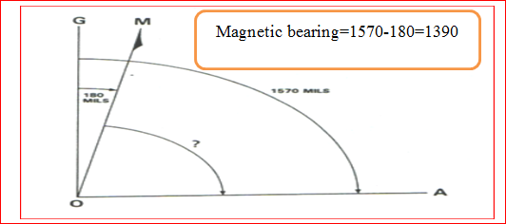
Figure 5.7 Converting Gird bearing into magnetic bearing

- Grid to magnetic add
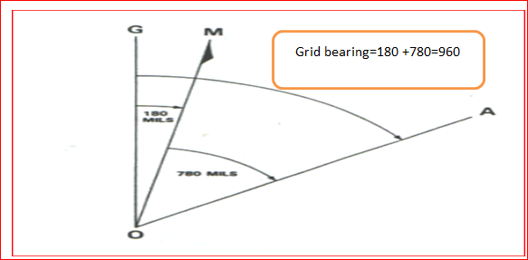
Figure 5.8Magnetic bearing converting into gird bearing

  - Planning emergency or contingency exit routes and other risks
- Navigating in fair conditions should present no great problemsto an advanced walker
- Poor conditions don’t require newtechniques, just a more skillful and determined use of thoseyou already possess
- Nevertheless, it is important to drawattention to certain aspects that require special considerationthat would prepare you for such conditions
- Your route plan should note possible escape paths alongyour route have a record of compass bearings, distancesand estimated times
- Check through your equipment before you set off to makesure everything is in working order

  - Undertaking navigation
- Where do you want to go? From your starting point on the map place the index line on an imaginary line between where you are now and where you want to be – with the direction of travel arrow on the base plate pointing the way
- Start by drawing a line from A to B now
- Holding the baseplate in place, rotate the compass housing so the orienting arrow lines up with grid north on the map.
- The orienting lines should be parallel with the vertical blue gridlines (easting)
- Plot course on map and plan detours. When the final route is decided use navigation data Sheet
- Check compass and map at regular intervals. Map and compass are always right
- Locate each bound before setting off for the next. Bounds should be made easy to recognize
- Count paces and estimate distance travelled. In close country, there is a tendency to over-estimate
- Allow for error when bound point is small eg: track junction. Aim off using an alternative
object
- Always stay strictly on your bearing. When trained scouts can maintain direction
- Bypass obstacles by using measured bearings. Use square method or similar

  - Orientating maps to surroundings
- Surroundings may include: Ground/terrain, bodies of water, beacons and markers, natural formations, landmarks and man-made features
  - Using equipment and navigation aids
- Navigation aids may include:Track and creek junctions and crossings, survey markers, beacons, track markers, cairns, paths, signs, arrows, compass and man-made objects or features
- Plan and conduct an efficient navigation effectively bypassing obstacles within designated timeframes
- This part of the booklet will introduce you to some advanced map-reading techniques that can be useful when navigating
- These techniques are largely used when you are off the beaten track in mountainous or difficult terrain, where excellent navigation skills are essential
- Before reading this part you should have a good understanding of how to use a compass
and map to navigate
- Obstacles may include:thick vegetation, drops and climbs, marshes and bogs, fog, rivers, lakes and dams, tides, hazards

  - Navigation with GPS
- A route is an ordered set of waypoints that represents the path between two locations
- A route allows you to set intermediate waypoints on your path from A to B that take into account terrain, roads or other relevant factors
- The GPS will report the length of the entire route as well as the lengths of each of the segments between waypoints
- If you are navigating a rout, the active route page displays the rout information
- Rout is a sequence of way points that lead you to your destination
- To create rout press Menu twice and then select Routes
- Create a route using the Routes Page and add waypoints to a rout
- You can also create routes using map source mapping
- Your position on the map is represented by triangle position icon
- Waypoints names and symbols are also shown on the map
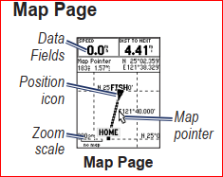
Figure 5.9 Waypoints on map pages
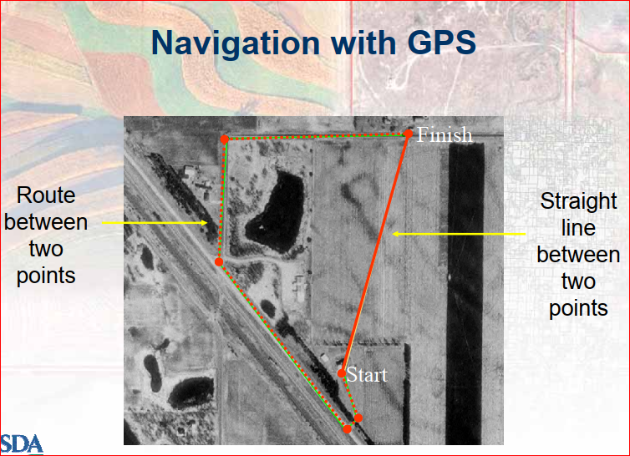
Figure 5.10 Navigation with GPS

Self-check -5 | Written test
Name…………………………………………… ID………………………… Date…….
Directions: Answer all the questions listed below.

Test I: Short Answer Questions
1. What is navigation?(2 pts)
2. The instrument that used for navigation (3pts)
3. What is the difference between grid and bearing?(5pts)

Note: Satisfactory rating - 10 points Unsatisfactory - below 10 points
You can ask you teacher for the copy of the correct answers.

Operation sheet-5
  - Navigate appropriatelythe site using magnetic compass
- Tools and equipment
- Compass
- Protractor
- Arrow
- Map
- Survey marker
- Track markers
- Signs
- Beacons
- Data sheet
- Pencil
- Procedures/Steps/Techniques for navigating in remote areas
- Select the site to be navigate
- Plan the rout of the site be navigation
- Line up compass on the map
- Rotate the compass house
- Reading the bearing at the index line to determine the rout direction
- Plot course on map and plan detours
- When the plan route is decided use navigation data Sheet
- Check compass and map at regular intervals
- Locate each bound before setting off for the next
- Mark the rout direction to be made easy to recognize
- Count paces and estimate distance travelled
- Always stay strictly on your bearing
- Finally show the rout of your navigation on your map clearly

Task-5.2Perform navigation of the site using GPS
- Tools and equipment
- GPS
- Topographic map
- Marker
- Note book
- pencil
- Procedures/Steps/Techniques
- Select the site to be navigate using GPS
- Open the GPS and access to satellite to start navigation
- To create rout press Menu twice and then select Routes
- Create a route using the Routes Page and add waypoints to a rout
- Navigating a rout, the active route page displays the rout information
- You can also create routes using map source mapping
- Your position on the map is represented by triangle position icon
- Waypoints names and symbols are also shown on the map
- Finally save the navigation the site rout, the navigation data and the map on the GPS screen

LAP TEST-5 | Performance Test
Name………………………………. ID…………………………….. Date…………………………………….

Time started: ________________________ Time finished: ________________

Instructions: Given necessary templates, tools and materials you are required to perform the following tasks within 2hour. The project is expected from each student to do it.

Taske-1 Perform navigation of a site accurately with compass
Task-2 Perform navigation of the site with GPS

References materials

Books:
- A.Bannister &et al, 1998. Surveying, 7th edition, Singapore
- A.M.Chandra, 2002. Plane surveying. New Age. International publisher, India
- A.Zamir 1994.A text book of surveying. Vicas publishing house pvt.Ltd. India
- R.Agor, 2003. A text book of surveying& levelling khanna publishers, India
- UNESCO 2008. Basic principles in surveying I course code: SUG 101,Version 1: December 2008
- FAO 1985. guidelines for land use planning page 20-32

Web addresses

https://www.youtube.com/watch?v=THCSsoQcDTQ(Accessdate 26/08/2022)
https://www.youtube.com/watch?v=THCSsoQcDTQ(Access date26/08/2022)Map reading techniques video
https://www.youtube.com/watch?v=iiR6BfLxIfw(Access date 26/08/2022)Map reading techniques
https://www.youtube.com/watch?v=RNwX3b4pmoM(Access date 26/08/2022) compass navigation video
https://www.youtube.com/watch?v=bFP4rCJcKd8(Access date 26/08/2022)contour map reading
https://www.youtube.com/watch?v=GBM1ctFks5o(Access date 26/08/2022)new compass navigation
https://www.youtube.com/watch?v=hVai8JwvwrM(Access date 26/08/2022) calculate grid
https://www.youtube.com/watch?v=T40AMljjgrU(Access date 26/08/2022)Calculate bearing

The experts who developed the learning guide
No | Name | Qualification | Educational background | Region | Phone number | E-mail
1 | Zeleke Dessie | MSc | Agroforestry | Oromia | 0911091388 | zelekedessie@gmail.com
2 | Gelasa Tola | MSc | Biodiversity and conservation Management | Oromia | 0920049614 | tolagelasa@gmail.com
3 | Degarege Mitkie | BSc | Water Resource & Irrigation Engineering | South West | 0921281867 | mitkiedegarege@gmail.com
4 | Yeshitila Wondosen | MSc | Climate change & Development | Benshangul Gumuz | 0911071229 | yeshiwond@gmail.com
5 | Geleta Bekele | BSc | Forestry | Afar | 0925482964 | geletabk12019@gmail.com
6 | Kifle Tolossa | MSc | Soil Science | Oromia | 0910895568 | kifletolossadechasa@gmail.com
7 | Gezahegn Tadesse | MSc | Drainage and Watershed Management | Alage | 0968445006 | sihine29@gmail.com
8 | Korme Tusuru | MSc | Biodiversity and conservation Management | Oromia | 0916245234 | bilisumakorma@gmail.com
9 | Ziyad Rube | MSc | Water Resource Engineering & Management | Afar | 0921484656 | yoomnaaf51@gmail.com
10 | Tolessa Sori | MSc | Forest & Natural Management | South West | 0917007821 | tolosasori@gmail.com
11 | Getnet Asmare | MSc | Production Forestry | Amhara | 0912846540 | getenetasmre40@gmail.co

