Natural Resources Conservation and Development
Level-I

Based on March 2022, Version IOccupational Standard
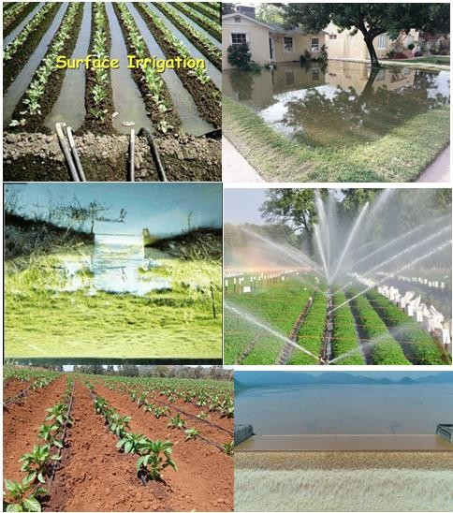
Module Title: - Undertaking Irrigation Work
LG Code: AGR NRC1 M09 LO (1-4) LG (44-47)
TTLM Code:AGR NRC1 TTLM 0922v1

September, 2022
Addis Ababa, Ethiopia

Table of Contents

Introduction to the Module 1
LO #1- Prepare Materials, Tools and Equipment for Irrigation Work 2
Instruction sheet 1 2
Information Sheet 1 4
Self-check 1 16
LO #2- Undertake irrigation work 16
Instruction sheet 2 17
Information Sheet 2 19
Self-Check – 2 43
Operation Sheet 2 46
LAP Test 2 52
LO #3- Handle & Clean Up and Store Materials and Equipment 53
Instruction sheet 3 53
Information Sheet 3 54
Self-Check – 3 59
LO #4- Complete Documentation 60
Instruction sheet 4 60
Information Sheet 4 61
Self-Check – 4 67
Reference Materials 68

Introduction to the Module

This module covers the knowledge, skills and attitude to conduct the irrigation and maintenance of watering and drainage systems. It requires the ability to prepare materials, tools and equipment for irrigation work, undertake irrigation activities, handle materials and equipment, and clean up on completion of work.

LG #44 | LO #1- Prepare Materials, Tools and Equipment for Irrigation Work

Instruction sheet 1
This learning guide is developed to provide you the necessary information regarding the following content coverage and topics:
- Irrigation and drainage concepts
- Identifying materials, tools and equipment for irrigation tasks
- Check and report materials, tools and equipment
- Using manual handling techniques for loading and unloading materials
- Selecting and checking PPE
- Providing irrigation support according to OHS requirements and workplace information
- Identifying and reporting OHS hazards
This guide will also assist you to attain the learning outcomes stated in the cover page. Specifically, upon completion of this learning guide, you will be able to:
- Understand Irrigation and drainage concepts
- Identify materials, tools and equipment
- Check materials, tools and equipment
- Manual handling Techniques when loading unloading materials
- Select and check personal protective equipment (PPE).
- Identify OHS requirements, hazards and workplace information

Learning Instructions:
- Read the specific objectives of this Learning Guide.
- Follow the instructions described below.
- Read the information written in the information Sheets
- Accomplish the Self-checks

Information Sheet 1

1.1 Introduction to Irrigation and Drainage Concepts
1.1.1What is Irrigation?
Plants are living beings and do require water and air for the survival, as do human beings require. Different types of plants require different quantities of water and at different times, till they grow up completely
An adequate water supply is important for plant growth. When rainfall is not sufficient, the plants must receive additional water from irrigation. Various methods can be used to supply irrigation water to the plants.
Irrigation is the science of artificial application of water to the land, in accordance with the crop requirements throughout the crop period for full nourishment of the crops.
Irrigation is the process of supplying water, in addition to natural precipitation, to field crops, orchards, vineyards, or other cultivated plants. The role of irrigation is to improve production and the effectiveness of other inputs.
Objectives of irrigation
- To Supply Water Partially or Totally for Crop Need
- To Cool the Soil ,Plant and the environment
- To Leach Excess Salts
- To improve Groundwater storage
- To Facilitate continuous cropping
- To Enhance Fertilizer Application- Fertigation
Necessity of irrigation
Water is normally supplied to the plants by nature through the rains. However, the total rainfall in a particular area in terms of amount, frequency and distribution are unpredictable, may be insufficient, and untimely. In order to get the maximum yield it is essential to supply the optimum quantity of water and to maintain correct timing of water through irrigation. That is by collecting water during the periods of excess rainfall and releasing it to the crops as when it is needed.
Generally the following are some of the factors that necessitate irrigation.
- Inadequate rainfall
- Uneven distribution of Rainfall
- Increasing the yield of the crops
- Growing a number of crops
- Insuring against drought
- Growing perennial crops
- Benefits & Ill-Effects of Irrigation
- Benefits of irrigation
There are various direct and indirect advantages of irrigation are
Increase in food production: Irrigation helps in increasing crop yields through controlled and timely supply of water to the crop.
Optimum benefits: optimum utilization of water is made possible by irrigation. Optimum utilization implies obtaining maximum crop yield with required amount of water.
Elimination of mixed cropping in areas where irrigation is not ensured, generally mixed cropping is adapted. Mixed cropping is growing two or more crops simultaneously in the same field.
General prosperity: A Revenue return with well-developed irrigation, are sometimes, quite high, and helps in all round development of the country and prosperity of the entire nation and community.
Generation of hydroelectric power: cheaper power generation can be obtained on objects primarily designed for irrigation alone.
Domestic water supply: - irrigation helps in augmenting the water supply in nearby villages and towns, where water is not available or scarcely available. It also provides water for swimming, bathing, and cattle drinking etc.
Facilities of communication: Irrigation channels are generally provided with embankments and inspection roads. These inspection paths provide a good road way to the villagers for walking, cycling or even motoring.
In land navigation: sometimes, larger irrigation channel can be used and develop for navigation purpose.
Ill-effects of irrigation
Ill-effects of irrigation occur only when the scheme is not properly designed and implemented. Most of these are due to excess irrigation water application. Some of the common ill-effects are
Water logging: when cultivators apply more water than actually required by the crops, excess water percolates in to the ground and raises the water table. Water logging occurs when the water table reaches near the root zones of the crops. The soil pores become fully saturated and the normal circulation of air in the root zones of the crop is stopped and the growth of the crops is decreased. Thus crop yield considerably reduces.
Long term application of pesticides: Long term application of pesticides under large scale irrigation system might have a negative influence on soil microbial activities, on the quality of surface and sub-surface water resources and the survival of the surrounding vegetation. Irrigation may contribute in various ways to the problem of pollution.
Outbreak of disease: Irrigation may result in colder and damper climate causing outbreak of disease like malaria.
Complex and expensive: Irrigation is complex and expensive in itself. Sometimes cheaper water is to be provided at the cost of the government and revenue returns are low.
1.1.2 What is Drainage?
During rain or irrigation, the fields become wet. The water infiltrates into the soil and is stored in its pores. When all the pores are filled with water, the soil is said to be saturated and no more water can be absorbed; when rain or irrigation continues, pools may form on the soil surface Part of the water present in the saturated upper soil layers flows downward into deeper layers and is replaced by water infiltrating from the surface pools.
Drainage is the removal of excess water and dissolved salts from the surface and subsurface of the land in order to enhance crop growth.
Drainage can be either natural or artificial. Most areas have some natural drainage; this means that excess water flows from the farmers' fields to swamps or to lakes and rivers.
Sometimes, however, the natural drainage is inadequate to remove the extra water or salts brought in by irrigation. In such a case, an artificial or man-made drainage system is required.
A man-made drainage system is an artificial system of surface drains and/or subsurface drains, related structures, and pumps (if any) to remove excess water from an area.
Therefore drainage is needed for successful irrigated agriculture because it controls ponding, waterlogging and salinity.
Benefits of Drainage
One of the benefits of installing a drainage system to remove excess water is that the soil is better aerated. This leads to a higher productivity of crop land or grassland because:
- The crops can root more deeply.
- The choice of crops is greater.
- There will be fewer weeds.
- Fertilizers will be used more efficiently.
- There will be less denitrification.
The grass swards will be better.
1.2. Identifying materials, tools and equipment for irrigation tasks
Irrigation systems use equipment’s which range from sophisticated to locally available materials. To have efficient irrigation system, we need to identify and prepare irrigation tools pre-season.
Identification of tools and equipmentis about choosing the various components which make up the system. In this topic the main components are listed, and guidance is given in how to choose,for preliminary purposes, between the various options and component configurations available.
For Identification of tools and equipment to lock at the following criteria
- Purposes(Work will be done )
- Available skill or required labor inputs
- Natural conditions type of crop
- previous experience with irrigation
- Costs and benefits or capital
- Etc.
In identification of materials, tools and equipment we have to consider materials, tools and equipment already identified and on use in nursery and gardening work but other materials, tools and equipment specifically related to irrigation technology are identified bellow.
Table 1.1; materials, tools and equipment used for irrigation work
Name | Use/Purpose | Image
Water pump | Used for pumping water from water source to the working sit. | 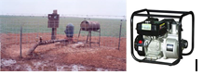
Hoses (sucking and discharging) | It is a water media transporting water from the pump to the working place. | 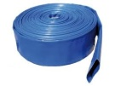
Water reservoir/Tanker/ | It is water storage at working place. | 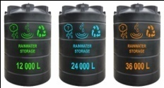
Small sized (1/2 inch, ¾ inch...) | Hoses for distributing water from water reservoir filled by the discharged water from water resource by pump.  It is used for sparing water drops from the reservoir to the plants. | 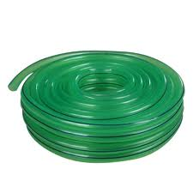
Watering can | It can be used as a substitute for a sprayer to apply insecticides too. | 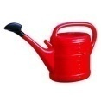
Leveling equipment | Leveling instruments are employed for determining the relative heights of different points on the earth's surface. | 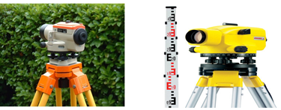
Wheelbarrow | -A wheelbarrow is a small open cart with one wheel and handles that is used for carrying things. | 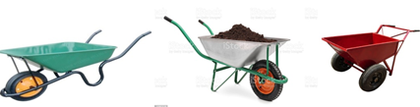
Tape measures | A tape measure or measuring tape is a flexible ruler used to measure size or distance. | 
Spades | A spade is a tool primarily for digging consisting of a long handle and blade | 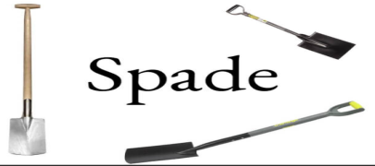
Shovels | A shovel is a tool for digging, lifting, and moving bulk materials, such as soil, coal, gravel, snow, sand, or ore. | 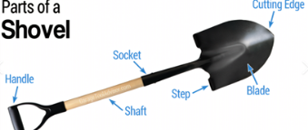
Rakes | Rake is a simple Farm tool used for leveling and spreading of soil surface after hoeing. | 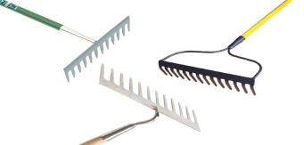
Broom | Cleaning tool consisting of usually stiff fibers often made of materials such as plastic, hair, or corn husk. | 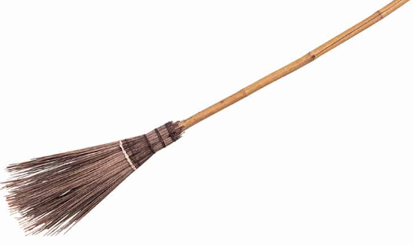
Hacksaws | A hacksaw is a hand tool with a removable blade used for cutting metal and plastic. | 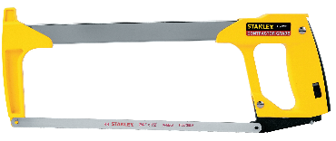

The common irrigation materials and tools
Delivery system
- Mainline distribution to field - Sub- mainline
- Feeder tubes or connectors
- Drip tube or tape
Filters
- Sand
- Screen
- Disk
Pressure regulators
- Fixed outlet
- Adjustable outlet
- Valves or gauges
Chemical Injectors
- Positive displacement injectors
- Pressure differential injectors
- Water-powered injectors
Controllers
- Manual
- Computer
1.3 Check and report materials, tools and equipment
1.3.1. Purpose of checking materials, tools and equipment’s
In supporting irrigation work, materials tools and equipment’s selected should be checked before and after usage. Checking materials, tools and equipment before usage is very important. Because of the quality and capacity of each and individual item will be determine the efficiency, effectiveness and productivity of the target to be implemented. And it is also highly contributes to safe work condition to the workers. In relation to reporting tools, material and equipment technician on irrigation work should inspect all require type of materials, tools and equipment, either their amount in kind, their quality of performing the required operation, their existing condition (damaged, mint for maintenance, replace what is lost, and what is purchased and other related situations should be reported to the nearest supervisor before, during and after the completion of irrigation. Because irrigation work highly will be influenced by effective and efficient supply of materials, tools and equipment selected to conduct the task.
1.3.2. Conducting Checks on all materials, tools and equipment
It is essential to check irrigation system, tools and equipments for damage or malfunction and shall report damage or malfunction to the authorized representative in writing. If failed to maintain the broken or malfunctioning irrigation system components within few days of the breakage or malfunction, there will be a loss due to damages resulting from the broken irrigation system component.
Hence, it is necessary to check the system, materials and equipments. In addition, maintenance of the system has to be carried out regularly.
Do not begin construction of the irrigation system without having the meter taps installed.
Read and fully understand the irrigation standard details and technical specs.
Do not deviate from the details without the written consent of field services or designee. All changes must be initialed, signed, dated, and noted on plan.
If you are unsure about any of the provisions in these specifications, contact a representative from Field Services for clarification. This may require an onsite meeting.
Irrigation System Scheduled Maintenance and check:
Each valve zone shall be observed for signs of damage on a weekly basis during the irrigation season.
The landscape maintenance worker shall maintain the irrigation system, including cleaning of filter screens yearly or more often as needed, and flushing pipes, as part of this contract.
Drip irrigation systems need periodic flushing to remove sediment. When flushing is necessary, it shall be performed as part of this contract. Drip systems shall be flushed at least once a year. Open ends of drip lines and run for at least 15 minutes at full flow to flush. It may be necessary to install flush outlets in order to flush the drip system.
Run-off of water from irrigation systems into or onto streets, sidewalks, stairs, or gutters is not permitted. The contractor shall immediately shut down the irrigation system and make adjustments, repairs, or replacements as soon as possible to correct the source of the run-off.
1.4 Manual handling Techniques when loading unloading materials
1.4.1. Techniques used when loading and unloading materials
The techniques used when loading and unloading materials should demonstrate correct manual handling and minimize damage to the load and the vehicle while transporting irrigation equipments.
The most common techniques of loading and unloading materials use the following guidelines:
- Develop an operations plan that describes procedures for loading and/or unloading.
- Conduct loading and unloading in dry weather if possible.
- Cover designated loading/unloading areas to reduce exposure of materials to rain.
- Consider placing a seal or door skirt between delivery vehicles and building to prevent exposure to rain.
- Design loading/unloading area to prevent storm water run-on, which would include grading or berming the area, and position roof downspouts so they direct storm water away from the loading/unloading areas.
- Have employees load and unload all materials and equipment in covered areas such as building overhangs at loading docks if feasible.
- Load/unload only at designated loading areas.
Use drip pans underneath hose and pipe connections and other leak-prone spots during liquid transfer operations, and when making and breaking connections. Several drip pans should be stored in a covered location near the liquid transfer area so that they are always available, yet protected from precipitation when not in use. Drip pans can be made specifically for railroad tracks.
Pave loading areas with concrete instead of asphalt.
Avoid placing storm drains in the area.
Inspection
- Check loading and unloading equipment regularly for leaks, including valves, pumps, flanges and connections.
- Look for dust or fumes during loading or unloading operations.
1.5 Selecting and checking PPE
PPE
Any irrigation activity that requires squirting, spraying, or pressure release of fluid requires personal protective equipment that includes gloves, gown, mask with eye shield to prevent exposure to debris and aerosolization of microorganisms. Splash shield devices will still require wearing of gowns, and face protection due to splash potential.
Personal protective equipment (PPE):- is used to protect an individual from hazards associated with their work tasks or environment. Specific types of personal protective equipment include protective clothing, eyewear, respiratory devices, protective shields, gloves, and hearing protection. Personal protective equipment is not a substitute for engineering controls such as chemical fume hoods and bio safety cabinets, or for administrative controls and good work practices. PPE is used in conjunction with these controls to provide safety and maintain health
General Types of PPE
- Protective glove
- Protective clothing
- Protective footwear
- Safety spectacles
Here are some examples of PPE for Irrigation Work
Footwear: - Apart from saving your casual shoes or trainers from getting dirty or damaged, having a pair of heavy duty shoes or boots will also protect your feet from stones, falling items or tools, so it's worth investing in a sturdy pair of gardening shoes or wellington boots.
Gardening Gloves
A pair of gardening gloves is a must to keep your hands protected from cuts and abrasions. There are many varieties available from light-weight cotton gloves to thick waterproof heavy duty gloves so it may be worth investing in a pair of each type.
Work wear: - This cloth is a type of cloth which covers all the body part except the head and the fingers. It’s used to protect the body from dirty
Sun hat: is the material that is used to protect head from direct sun radiation.

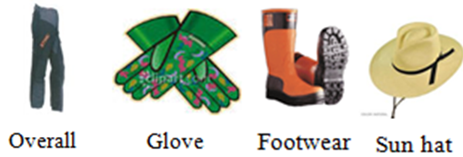
Figure 1.1 PPE Examples
Some of the commonly used PPE include the following:
- Eye protection
- It is required to use eye protection equipments like goggle, eye shield, to protect our eye from dusts, chemicals, etc by all workers engaged in hazardous activities or are exposed to identified eye hazards;
- Hand Protection (gloves)
It is required to use appropriate hand protection when hands are exposed to hazards, such as:
Skin absorption from harmful substances;
- Cuts, lacerations or abrasions;
- Chemical exposure;
- Thermal burns and/or temperature extremes
- Potentially infectious material.
Body Protection
Chemical Resistant Clothing: Protective apparel and apron designed to provide a barrier against a variety of chemical hazards. Chemical resistive clothing may be required for tasks where chemical splashing is anticipated or large volume transfers are conducted. Prior to selection of chemical resistant clothing, EH&S should be consulted;
Laboratory Apparel and Scrub Suits: A wide variety of styles and materials are available to protect employees during laboratory operations. The selected type of lab coat or other apparel is designed to protect the wearer against accidental splashes or day-to-day handling of chemicals;
Clean room Apparel: Clean room apparel is designed and classified to meet federal requirements for the control of airborne particles;
- Overalls
- Ear and Hearing Protection
- Ear plugs and muffs are available for any employee potentially exposed to noise levels.
- Respiratory Protection
- Steel capped boots/shoes,
- Sun hat
- Sunscreen lotion
- Face mask
1.6 Providing irrigation support according to OHS requirements and workplace information
Environmental and health requirements must be taken into account when treated wastewater is the source of irrigation water.
A lack of corporate commitment to health and safety will result in OHS remaining a marginalized and insufficiently funded workplace irrigation activity. A six point approach has been devised to help you implement effective occupational health and safety systems. This plan can help prevent accidents, incidents, injuries, and irrigation work-related ill health. The six points are:
- Develop locally fit and properly implement an OHS policy and related programs;
- Set up a consultation mechanism;
- Establish a training strategy;
- Establish a hazard identification and workplace assessment process;
- Develop and implement risk control.
- Promote, maintain and improve these strategies;
These points are not necessarily in order because all workplaces are different. Some of you may want to repeat some of the steps at different stages. It is important however, that all six steps are included in your occupational health and safety strategy.

Self-check 1 | Written test

Name…………………………………………… ID………………………… Date…….
Directions: Answer all the questions listed below.
Test I: Choose the best answer (6 point)
- Which one of the followings are not the factors that necessities irrigation.
- Inadequate rainfall
- Uneven distribution of Rainfall
- decreasing the yield of the crops
- Growing a number of crops
- ________is the removal of excess water on the surface of the land
- Drainage
- Irrigation
- Leaching
- Rainfall
- Which one of the following ppe is respiratory protection?
- Glove
- Mask
- Overall
- Sunhat

Test II: Short Answer Questions (9point)
- List the objectives of irrigation.
- Write the most common techniques of loading and unloading materials
- List at least four benefits of irrigation
Note: Satisfactory rating – 15 points Unsatisfactory - below 15 points
You can ask you teacher for the copy of the correct answers.

LG #45 | LO #2- Undertake irrigation work

Instruction sheet 2
This learning guide is developed to provide you the necessary information regarding the following content coverage and topics:
- Identifying irrigation and drainage methods
- Understanding irrigation and drainage system components
- Following instructions and directions
- Arrange small scale irrigation water lifting devices
- Fit the different irrigation kits in their position
- Align and maintain drainage lines/waterways
- Carry out interactions with other staff and farmers
- Observing Enterprise/farm policy and procedures

This guide will also assist you to attain the learning outcomes stated in the cover page. Specifically, upon completion of this learning guide, you will be able to:
- Identify irrigation and drainage methods
- Understand irrigation and drainage system components
- Follow instructions and directions
- Arrange small scale irrigation water lifting devices
- Fit the different irrigation kits in their position
- Align and maintain drainage lines/waterways
- Carry out interactions with other staff and farmers
- Observe Enterprise/farm policy and procedures

Learning Instructions:
- Read the specific objectives of this Learning Guide.
- Follow the instructions described below.
- Read the information written in the information Sheets
- Accomplish the Self-checks
- Perform Operation Sheets
- Do the “LAP test”

Information Sheet 2

2.1 Identifying Irrigation and Drainage Methods
    - Irrigation Methods
Based on energy use, there are two general methods of applying irrigation water; first irrigation by using gravitational energy and; second Irrigation due to pressurized energy.
- Gravitational Irrigation Methods
- Surface irrigation methods
In this method, water is applied gravitationally to the lower field from a channel at the upper reach of the field .The general requirements of prime importance to obtain high efficiency in surface irrigation methods are:
- Properly constructed water distribution systems to provide adequate control of water the fields.
- Proper land preparation to permit uniform distribution of water over the field.
There are different types of surface irrigation methods, namely border irrigation, basin irrigation, furrow irrigation and uncontrolled or wild flooding.
- Furrow irrigation
It is the common method of irrigating row crops. A furrow consists of a narrow ditch between the rows. Water is applied in small streams between rows of crops, grown on ridges or in furrows.
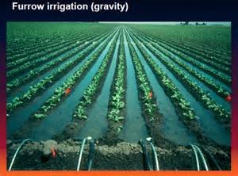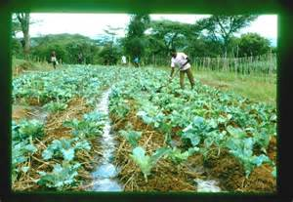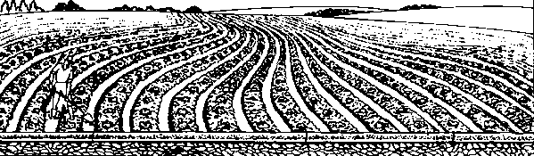

(b) Contour furrows
(a) Graded furrow irrigation system
Figure 2.1 Furrow irrigation
- Basin Irrigation
Basin irrigation is the most common method of irrigation in many countries. Here, the field is divided into smaller unit areas so that each smaller unit has nearly leveled surface. Bunds or ridges are constructed around the small unit areas so that they form basins with in which irrigation water can be controlled. Water is conveyed to the field by a system of supply channels and lateral channels.
Three types of basin irrigation are:
A. Rectangular B. Contour C. Ring
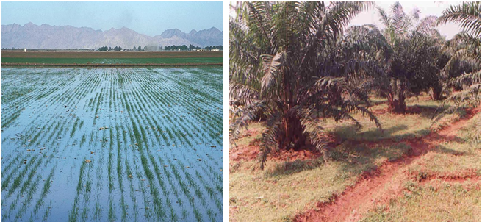
Figure 2.2 Basin Irrigation
- Border irrigation
The border method of irrigation makes use of parallel ridges to guide a sheet of flowing water as it moves down a slope. The land is divided in to a number of long parallel strips called borders that are separated by low ridges. The border strip has no cross slope but has a uniform gentle slope in the direction of irrigation.
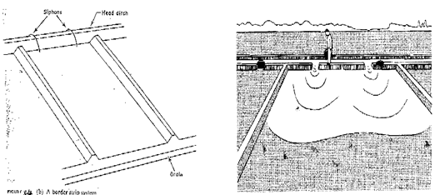
Figure 2.3 Border Irrigation
- Uncontrolled flooding
There are many cases where croplands are irrigated without regard to efficiency or uniformity. These are generally situations where the value of the crop is very small or the field is used for grazing or recreation purposes. Small land holdings are generally not subject to the array of surface irrigation practices of the large commercial farming systems.
- Pressurized irrigation methods

In this method, water is pumped under pressure, carried through high pressure main line and then to the outlet.
Classification of pressurized irrigation method
- Sprinkler irrigation
Sprinkler irrigation simulates natural rainfall to spread water in the form of rain uniformly over the land surface just when needed and as much needed at a uniform pattern and at a rate less than the infiltration rate of the soil so as to avoid surface runoff from irrigation. This method is also known as overhead irrigation because the water is supplied to the soil or crop from some height above the surface (shower like form).
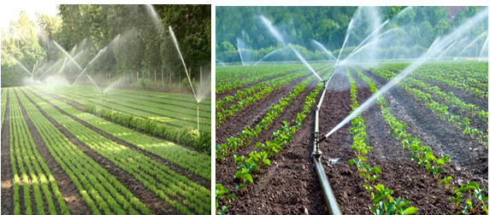
Figure 2.4 Sprinkler irrigation

- Drip irrigation
Almost called trickle irrigation, in this system water is applied in the form of drops directly to plants through drip nozzles from which it drops in to the soil slowly and frequently to keep the soil moisture within the desired range for healthy plant growth; so that the plants do not experience any moisture stress throughout their life cycle.

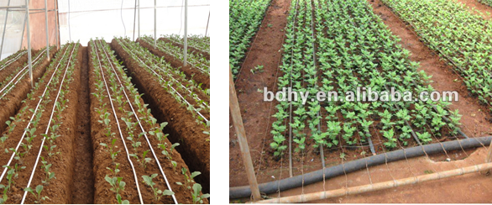
Figure 2.5 Drip irrigation
    - Types of Drainage Systems

There are two types of drainage systems are:
- Surface drainage systems
A surface drainage system is a system of drainage measures, such as open drains and Land forming, to prevent ponding by diverting excess surface water to a collector drain.
Types of surfaces drainage systems are open drains, humps and hollows, levees, and grassed waterways. A cast-in-place trench drain is a perfect example of a surface drainage system.
- Subsurface drainage systems
A subsurface drainage system is a system for the removal of excess water and dissolved salts from the soil, using the groundwater as a "vehicle".
A subsurface drainage system is a man-made system that induces excess water and dissolved salts to flow through the soil to pipes or open drains, from where it can be evacuated.
Subsurface drainage systems are implemented beneath the top layer of soil. Sometimes referred to as a French drain, they work at the root level to remove excess water. Dig ditches to install the pipes of subsurface drains.
  - Understanding irrigation and drainage system components
    - Components of Irrigation
- Surface irrigation components
Some of the components of surface irrigation
- Watersource:-This could be a well, irrigation pond, irrigation ditch, river, etc.
- Diversion structure: - The various components of diversion headwork’s are as follows:
  - Weir or Barrage
  - Divide wall
  - Fish ladder
  - Under sluices or scouring sluices
  - Silt excluder
- Conveyance structure: -The following points highlight the three main types of water conveyance system used in irrigation. The types are:
- Open Canals: An open canal, channel or ditch, is an open waterway whose purpose is to carry water from one place to another.
- Earthen Canals: - Disadvantages of earthen canals are the risk of the side slopes collapsing and the water loss due to seepage. They also require continuous maintenance in order to control weed growth and to repair damage done by livestock and rodents.
- Lined Canals:Lining of channels is necessary to:
- Reduce seepage losses during water conveyance
- Prevent weed growth, which obstruct free flow in the channel
- Reduce erosion in the channel.
- Distribution control structures
Distribution control structures are required for easy and accurate water distribution within the irrigation system and on the farm.
a. Division boxes
Division boxes are used to divide or direct the flow of water between two or more canals or ditches.
Water enters the box through an opening on one side and flows out through openings on the other sides. These openings are equipped with gates.
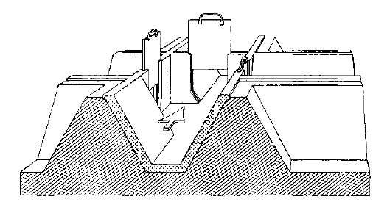
Figure 2.6 Division Box with Three Gates
b. Turnouts: -Turnouts are constructed in the bank of a canal. They divert part of the water from the canal to a smaller one. Turnouts can be concrete structures or pipe structures.
c. Checks: -To divert water from the field ditch to the field, it is often necessary to raise the water level in the ditch. Checks are structures placed across the ditch to block it temporarily and to raise the upstream water level.
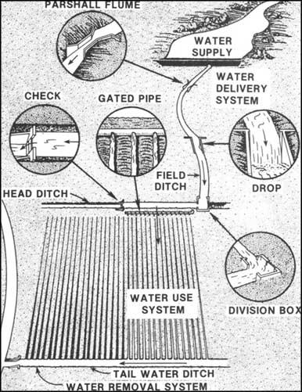
Figure 2.7: Components of surface irrigation
- Pressurized irrigation system components
- Components of sprinkler irrigation
  - water source/ tanker
  - the timer (or, controller)
  - backflow preventer
  - control valves
  - sprinkler heads
  - shut-off valve
  - Pumps,
  - Supply lines,
  - Main lines,
  - Lateral lines, and
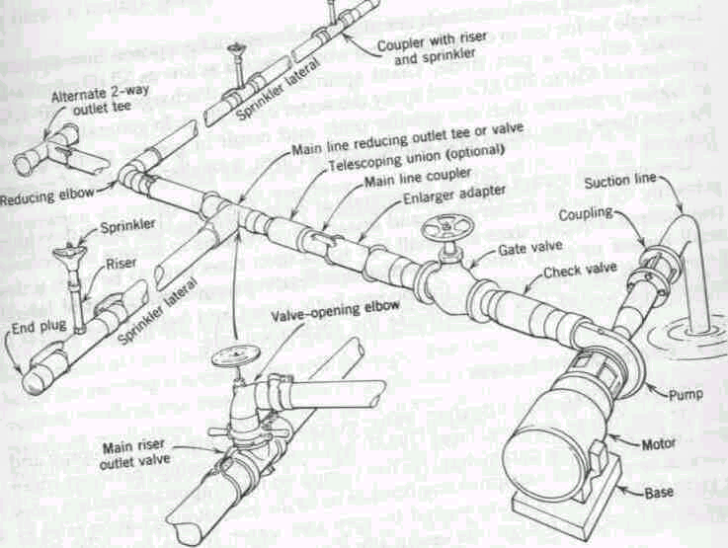
  - Risers
Figure 2.8: Components of sprinkler irrigation
- Components of drip irrigation
The components of the drip irrigation system are the parts that are assembled together for the system to function properly
The following are the components of a drip irrigation system:
  - Drip Tapes/Lateral line/: - The drip tape is a type of hose with pre-installed drip emitters. The drip tape is usually manufactured with polythene. The drip tapes are laid to run parallel to the rows of plants on a farm.
  - Main Line: - The main line is usually the main pipe or hose that brings water from the source of water to the irrigation system.
  - Lay Flat Hose: - The lay flat hose usually serves as the sub-main in the drip irrigation system. It is laid across the farmland. The drip tapes connect to the lay flat hose through lay flat connectors. The lay flat hose joins to the main pipe.
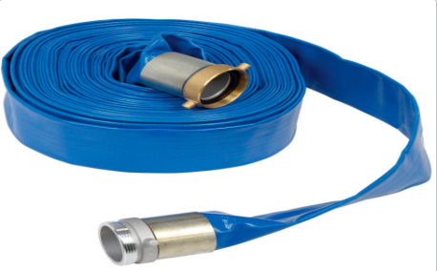
Figure 2.9: lay flat hose
  - Venturi Injector: - The venturi injector works as the fertigator in the drip irrigation system. It injects soluble fertilizers and other chemicals into the drip irrigation system. Without a venturi injector, fertigation and Chemigation cannot be done.
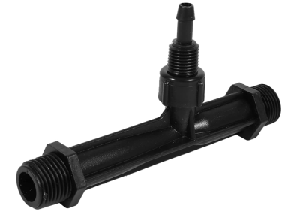
Figure 2.10: Venturi Injector
  - Valves; the valves are used to control the flow of water in an irrigation system. The valves used for drip irrigation is similar to that used for plumbing work.
  - Backflow Preventer: - This is a type of valve that prevents the back flow of water to the source of water. If you fertigate and pass fertilizers and chemicals through your drip irrigation system, it is a must that you use a backflow preventer. Failure to use this type of valve will make harmful chemicals flow back to your source of water.
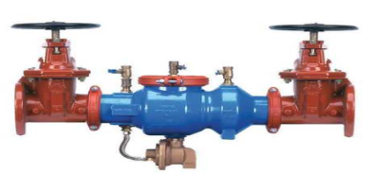
Figure 2.11: Backflow Preventer
  - Lay Flat Connector: - The lay flat connector is also called a croco connector. It is used to connect the drip tapes to the lay flat hose. Without the lay flat connector, it will be challenging for you to connect your drip tape to the lay flat hose.
  - Puncher: - This is also called a punch tool. It is used for the creation of hole on the lay flat hose; the lay flat connector is usually inserted in the hole.
  - End Plugs: -These are used to close up the end of drip tapes so that the flowing water in them will not waste or escape.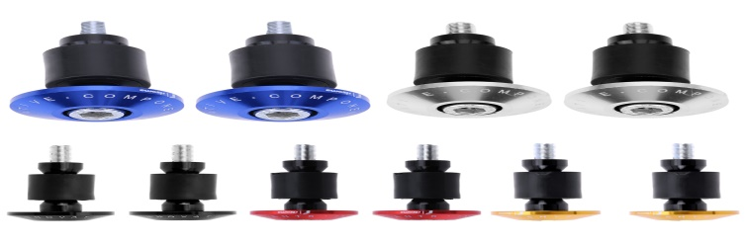
Figure 2.12:End Plugs
  - Filters: - Without filters, you are likely to get your drip tapes or pipes clogged. Filters remove the impurities and unwanted materials from the drip irrigation system.
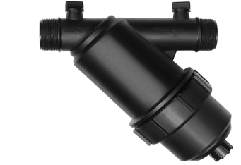
Figure 2.13: Filter

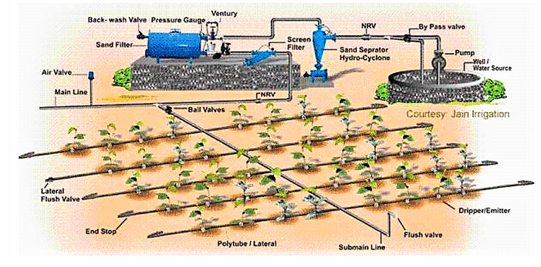
Figure 2.14: Components of drip irrigation

    - Components of a Drainage System
A Drainage system has three components:
- A field drainage system, which prevents ponding water on the field and/or controls the water table.The field drainage system is a network that gathers the excess water from the land by means of field drains, possibly supplemented by measures to promote the flow of water to these drains
- A main drainage system, which conveys the water away from the farm.
The main drainage system is a water-conveyance system that receives water from the field drainage systems; surface runoff and groundwater flow, and transports it to the outlet point.
- An outlet, which is the point where the drainage water is led out of the area.The outlet is the terminal point of the entire drainage system, from where the drainage water is discharged into a river, a lake, or a sea.
2.3 Following instructions and directions
2.3.1 Providing instructions and directions by supervisors
All irrigation installations and repairs are to be made under the direct supervision of a licensed irrigator or irrigation technician.
The main areas where irrigation assistance at the farm level is needed are:
- Advice to farmers on how to improve their irrigation practices and to establish irrigated crops,
- assistance to farmers in improving the farm layout, and
- Encouragement for farmers to organize themselves into groups for the operation and maintenance of the tertiary systems and their improvement when needed.
A potential Irrigation Assistance Service (IAS) can therefore be engaged in numerous different activities depending on the particular needs of the irrigation scheme.
In countries where on-farm developments are somewhat disregarded, the tendency should be for the IAS to concentrate first on designing a suitable farm layout and supervising its construction; and then at the second stage, to give greater weight to assistance on irrigation practices.
In countries where the on-farm layout is part of the whole irrigation development process, the emphasis should be on helping the farmer to use suitable irrigation techniques, particularly scheduling of the irrigation water.
Lastly, in irrigation schemes constructed long ago where experience is good with irrigated agriculture and the farm layouts are appropriate, the greater need would be to identify the areas where rehabilitation of the tertiary system is necessary, followed by better organization of the farmers to distribute the water and operate the system.
Therefore irrigation assistance at the farm level can be channeled in the three ways already
Mentioned and which, for reasons of easy reference, can be called:

- Irrigation practices improvement,
- On-farm development, and
- Tertiary canal system improvement.

Main activities
Before any on-farm development assistance takes place, a brief review should be made of the elements that constitute the farm layout. They may already exist or have to be added, depending on the complexity desired. The elements of the farm layout are the following in the most complex case:
- Intake (one or several),
- Head-farm ditches,
- Water retention structures (checks),
- Land preparation for the irrigation method (furrow, border, basin, contour furrows, contour border), and related land grading,
- Drains collecting tail water,
- Farm drain
- Location and layout of the family orchard,
- Fences (mainly in case of livestock),
- Watering facilities for livestock
- Tail water ponds and reuse facilities.
If the house is located within the farm:
- Location of the house and distribution of farm dependencies,
- Access to the house, and
- Water supply and sanitation
To improve the irrigation and drainage layout of the farm and to prepare for suitable land grading, the following actions must be taken
- The farmer's concurrence sought for any works to be done,
- Detailed topographic survey made of the farm (scale 1:1000),
- Data collected on soil characteristics and intended cropping pattern,
- The future layout designed in full cooperation with the farmer,
- The planned work should be undertaken as far as possible with the farmer's working means, or else with the machinery of the programmed.
In summary supervisors must
- Ensure they provide leadership and set a good example for staff and students in occupational health and safety matters.
- Ensure they consult with the staff and students they supervise to identify, assess and control OHS risks in accordance with the OHSRM Program.
- Ensure that safe working practices are developed and maintained at all times.
Arrange for their staff and students to be instructed in safe and healthy working procedures, warned about particular hazards, and told how to avoid, eliminate or minimize them.
Coordinating
This important stage consists of inter relating the various parts of the work. It involves coordinating the various job roles and responsibilities of yourself and other staff, of your unit and other units within the same organization, and of your unit with the broader community.
There are two forms of coordination:
- Vertical reporting to your supervisor(s) and to your staff, and
- Horizontal reporting to your colleagues and your management team.
Adult and extension educators are usually involved in very complex organizations such as governments, colleges and universities, and boards of education. Because of the size of the organization, the increasing demands for public accountability, the many government regulations and policies, the increasing competition among providers of adult education opportunities, and the changes in technology, it is essential that the coordinating role be given top priority. How, then, can effective coordination be accomplished?
- Coordination needs professional, competent leadership, a democratic style that leads to trust, open communication, and ease of information flow.
- Coordination needs a constant definition and communication of mission and objectives that are understood by all managers.
- Coordination, to be effective, must have open, two-way channels of communication. Coordination involves a sharing atmosphere as well as commonly agreed on direction. Because effective coordination requires cooperation and communication, the meeting technique is still the most effective format for assuring the interrelationships among the various job responsibilities.
- In recent years, formal systems of community coordination of adult and extension education activities have been developed. Such councils of continuing education provide more than just a network of workers but in fact lead to discussions of community needs, agency priorities, and an agreement as to who is going to look after what. Such voluntary coordination does not eliminate competition; it focuses on the multi way flow of information
Reporting

This function, closely related to the coordinating function, consists of keeping those to whom you are responsible informed as to what is going on. It is essential that competent managers keep the information flowing, especially in this age when there is so much information being transmitted in so many forms. The reporting function is more than preparing an annual report, quoting statistics, and informing your staff of current developments. The reporting function is almost an evaluation function since it compares how you are doing with what you set out to do. It reviews your objectives and determines to what extent you are meeting your objectives. It consists of more than course numbers or annual statistics, but relates program direction, policy changes, refinement in objectives, and changes in structures and priorities. It also uses the vertical and horizontal flows of information as presented previously.
One of the key elements of the reporting function is the annual report. Such a report gives you the opportunity to summarize programmers’, projects, and activities and to provide statistics as well. Such a report can be used as a public information document by having it distributed to other adult education agencies in the community, to your senior levels of management, to your own managers, to your colleagues, and to the press. In addition, it will prove to be a valuable document to satisfy the requests you receives asking about your program activities.
  - Arrange small scale irrigation water lifting devices

Water lifting devices enable the lifting of water from a lower level to a higher one. Water sources can either be underground water reservoirs, open natural water bodies (rivers and lakes), or artificial water bodies (canals).The use of water lifting devices is often crucial to transport water from the water source to the field or to the consumer.
Water lifting devices can be divided into two groups:
- Devices that are run by muscle power of humans or domestic animals and
- Devices mechanized by lift irrigation techniques.
Devices which are run by muscle power are often very time-consuming in real terms, due to their low productivity. Mechanized lift irrigation techniques, while more efficient, need to be adapted to the local conditions and to the different demand needs. To establish and implement water lifting devices, local people need to be trained on how to use these technologies in a water-efficient way, as well as how to maintain these technologies in the long run.

Benefits
Water lifting technologies free the farmers from the limitations of inadequate rain during dry seasons, thus raising their capacity to grow crops up to two or three plantings annually. Thus, additional income possibilities for the subsistence economy of the households are provided.
In addition, water efficient technologies such as pumps can bring an improvement to the situation of women by increasing household food security and nutritional variety, as well as decreasing the amount of labor required to obtain water. Most pumps can easily be operated by women.
Types of water lifting devices

Below are listed the eight main types of water lifting devices used in small-scale irrigation, followed by several visual examples.
- Swim pump: a type of pump which is powered by the kinetic energy of the flowing water.
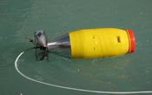
Figure 2.15: Swim Pump
- Ram pump: a hydraulic pump powered by water with a height difference.
- Treadle pump: a foot powered water pump widely used in Asia and increasingly in Africa.
A treadle pump is a human-powered suction pump that sits on top of a well and is used for irrigation. It is designed to lift water from a depth of seven metres or less. The pumping is activated by stepping up and down on a treadle, which are levers, which drive pistons, creating cylinder suction that draws groundwater to the surface.
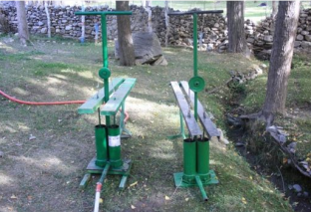
Figure 2.16: Treadle pump
- Rope pump: a modern and low cost pump, and one of the few designs that can truly be operated and totally maintained at a village level
- PVC pump: includes a large number of different hand pump designs, whose majority of parts are constructed from PVC
- Solar pump: a pump running on electricity generated by solar panel
- Wind pump: a windmill used for pumping water
  - Fit the different irrigation kits in their position

    - How to install irrigation system

Part 1: Choosing a Watering Device
- Install a dripper system to water individual plants. Dripper irrigation systems provide a steady flow of water to individual plants. If you want to water each plant on its own, choose a dripper system to give your plants a direct water source.
  - A dripper system consists of many square, flat waterspout-like "drippers" hooked to your irrigation piping that emit a small, steady water flow.
  - Dripper systems also work well for potted outdoor plants.
  - If you have a large yard or want to cover more area, you may want to choose another system.
- Choose a sprinkler irrigation system to cover more distance.
- Sprinkler heads can water a radius between 3 feet (0.91m) to 30 feet (9.1m), depending on the flow rate and water pressure. Pick a sprinkler system if you have a large yard that needs even watering.
- Sprinkler irrigation systems consist of many sprinkler bulbs hooked to the irrigation piping that spray water out of their nozzles
Part 2: Planning the System

- Measure your yard's perimeter and area. Take measurements of the perimeter and area of your yard. Take measurements of the length and width, and then multiply these numbers to find the land's total area. •Work slowly to keep the land's measurements as accurate as possible
- Trace the mapon your irrigation system on grid paper. Grid paper can keep your drawing precise. Assign each grid a certain distance to help you visualize your backyard and plan an accurate layout. You might assign each grid, for example, a distance of 1 square foot (0.093 square meters).
Part 3: Laying out the Tubing

- Attach a vacuum breaker to the outdoor faucet and irrigation tubing. Vacuum breakers prevent contaminated water in your irrigation system from washing back up into your home's water supply. Screw the vacuum breaker onto your outdoor faucet, and attach your irrigation tubing to the opposite side of the vacuum breaker.
  - Vacuum breakers are cylindrical metal tubes that screw into your home's outdoor faucet at the top.
  - You can buy vacuum breakers from most garden centers or home improvement stores.
- Spread the irrigation tubing around your yard based on your layout plans. Position 1⁄2 in (1.3 cm) poly tubing along the areas that you plan to water with the irrigation system. Cut the tubing with pruning shears when you have reached the end length of your system or areas where you will need to make angles.
- Let your tubing sit in the sun for several hours before using it to make it more flexible and easier to work with.
- You can buy poly tubing from most hardware or home improvement stores.
- Use 90-degree fittings to make bends in the layout, if needed. If you want your system to turn at an angle, cut the tubing with pruning shears and press its end into a 90-degree fitting, twisting it in place. Attach the other end of the 90-degree fitting to the opposite half of the tubing to continue laying out your system.
- Buy 90-degree fittings online or from most home improvement stores.
- You can also use T-fittings as an alternative using the same method.
A T-fitting is a tube that bends at a slight angle to accommodate turns in your irrigation layout
- Install a ground stake every 1–2 feet (0.30–0.61m) to pin the tubing in place. Hook the top of the ground stake over the tubing and pin it to the ground. This will prevent the tubing from moving around when you turn on the water.
- Look for ground stakes at a home improvement store or garden center
- Close the tubing shut with a tubing clamp /end cup/ : when you've laid out all of the tubing, turn on the water for a few minutes to flush out the dirt from the system. Slide a tubing clamp the approximate size of the tubing around the end of the system to crimp it shut and avoid waterlogging an area of your yard.
- Turn off the water before clamping your tubing shut.
- Tubing clamps are small, oval-shaped metal clips that secure open tubing ends. You can buy these clamps from most hardware or home improvement stores.
Part 4: Connecting the Watering Devices

- Punch 1⁄4in (0.64cm) wide holes into the tubing. Use a hole punch tool to mark wherever you want to install a sprinkler, bubbler, dripper, or sprayer. Push the hole punch firmly into the tubing and twist it until it makes a complete, clean hole through the other side.
- Attach 1⁄4in (0.64cm) poly tubing to the holes with a barbed connector. Push the barbed connector through the hole in the irrigation tubing. Attach a length of 1⁄4in (0.64cm) tubing to the opposite side of the barbed connector, cutting it with pruning shears when it reaches the area that you want to water.
- You can find barbed connectors, which are cylindrical metal tubing connectors, and 1⁄4in (0.64cm) tubing from most home improvement stores
- Install the watering device at the end of the 1⁄4in (0.64cm) tubing. Attach the dripper, sprayer, bubbler, or sprinkler by connecting it through the end of the 1⁄4in (0.64cm). To hold it in place, attach a small gardening stake to the end and press it into the ground near the area it needs to cover.
- Flush and test the irrigation system via the outdoor faucet. Turn on your outdoor faucet to flush out any remaining dirt and test your irrigation system. Adjust the positioning of the watering devices or add more as needed.
- If you notice any issues with a watering device, check the 1⁄4 in (0.64 cm) tubing to make sure it is attached securely.

  - Align and maintain drainage lines/waterways

There are many different types of drainage solutions and drainage installation methods. Choosing the right one often can help alleviate a drainage problem. Ascertaining the exact drainage problem usually is a good first step. This may give an idea of what type of drainage solution should be used. Employing the draining installation methods properly can be a subsequent crucial step in solving the problem.
Generally, the most common type of drainage problem is the collection of excess water in a yard which can lead to flooding of the home, such as in the basement. The buildup of water can be a result of the shape of the landscape. Inclines and slopes in the land make some spots more prone to collect water.
Surface drainage can be particularly effective for localized surface ponding, or the control of runoff, particularly when integrated with a whole property plan. They are not always useful for water table control, particularly in heavier soils, because the slow rate of water movement through the soil requires them to be too dose together to be practicable. Surface drains are often used to collect tail water and rainfall runoff from irrigated fields, and as the collection point for the discharge of subsurface drains. The flow of water along a surface drain depends on its cross-sectional area, and bed slope. Their correct design therefore requires detailed analysis of the site topography, the drainage requirement, and the discharge conditions. Subsurface drains have the potential to provide greater control over water table depth, with minimum disturbance to surface conditions (following installation). Surface ponding can also be partly controlled by providing for the entry of surface water.
The flow rate along the drain depends on its size and slope. The flow rate into them depends largely on the permeability of the soil they are installed in, which for a particular soil type, dictates the depth and spacing they should be installed. Drain design is also dependent on the presence or absence of any impermeable layer which might be preventing vertical movement of water through the soil profile. If such a layer exists in reasonable proximity to the root zone, the drain is likely to require a higher capacity, and may be best located on the impermeable material. Where a subsurface drain assists control of a rising watertable, they are sometimes referred to as "relief' drains.
Subsurface drainage materials and installation
Traditionally, earthenware tiles were installed in trenches, end to end. Water enters the drain in the small crack between adjacent tiles. Because the base of the trench is constructed along a slight predetermined gradient, water entering the drain can flow along it. A filter cloth can be placed over each join to help prevent earth being washed into the drain. Coarse gravel can be used to assist filtration, to increase the effective cross- sectional area of the drain, and possibly to provide greater stability to the trench surrounding the drain. Perforated plastic pipe is now in widespread use. There are two main types; slotted PVC (used also as seepage pipe), and more commonly, perforated corrugated polyethylene pipe.
Drainage systems
The layout of the drains needs to be matched to each particular situation. A number of options is possible:
- A grid system may be necessary on flat or near-flat sites, where the value of the crop can justify the cost. Drains are located in a parallel grid, at a spacing determined by soil characteristics and the required drainage rate, and connected to an outlet pipe or ditch at one side (or in the center for large fields)
- Where the area being drained has a concave surface, or a narrow natural flow path, a herringbone system could be considered, especially where the drainage laterals are long.
- Where drainage requirement is localized, a random drainage pattern is acceptable. These are not really random, but directed to where they are needed, following natural drainage lines or connecting localized depressions to an outfit.
- Interception drains are used to help prevent water reaching a particular area; for example: Intercepting runoff from high ground. Seepage control from groundwater or leakage from channels. Around building sites.
- Deep well drainage systems operate on a Merent principle. A well or bore is installed, and water extracted from it by pumping. This has the effect of lowering the watertable in a cone of depression around the well, possibly (and hopefully) extending for a substantial distance. This technique is usually applied on a regional basis, sometimes utilizing multiple wells.
Drain design
The design of a drainage system must consider the rate at which excess water is to be removed, and then the size and placement of the drains needed to remove it. Drainage capacity this refers to the peak volume or rate of removal of surplus water, and will depend on a number of factors:
- Size of the drained area.
- Permeability of the soil (its hydraulic conductivity, vertical and horizontal).
- The rate at which water should be removed from the site, based on the tolerance of the crop to waterlogging, and the expected benefit to be derived.
- The rainfall pattern of the area (or the irrigation practices employed).
- The runoff characteristics of the site
Drain maintenancegoes a long way to keep your drains in good working condition. When practiced as a regular routine, it can help save you costs in home maintenance. Clogged drains occur all too often in the home. In many cases, the incidence of blocked drains can be minimized by regular drain care. Both kitchen and bathroom drains need to be cleaned on a regular basis. Below are 5 maintenance tips to help keep your drains in good condition.
2.7. Carry out interactions with other staff and farmers

2.7.1 Carrying out interactions with staff and customers

We can all agree that customer interaction is critical in today’s market, but what does that mean? Some scholars said “We fundamentally believe that our customers want three things in any of the departments; tell them the truth, do what you say you are going to do and keep them informed.”
The term “customer interaction” may have several definitions. Let’s define it as communication between one of staff members and the customer. We still need to improve at the basics; smile, make eye contact, slow down, be sincere, focus on your customer, tell the truth now, make promises and keep them, ask good questions then shut up and listen. Do not take these for granted. We all tend to get wrapped up in our busy days and we slip a little further away from what we know is right without intention. Watch your people execute these fundamentals daily.

“Ask the customer what they want and give it to them” has long been our premise for doing business but that is no longer enough. Interaction for its own sake falls short; it must fit our customers’ desires. We must now learn our customers as individuals and anticipate their wants and needs. This includes how they wish to interact with us on a personal level, how often, in how much detail and method.
Positive interactions with staff help create an atmosphere which is calming and safe, especially it encourage treating each other with kindness and respect.
An environment where staff relationships are positive, where staffs are able to express their emotions appropriately and where staffs feel satisfaction within their job helps create an ideal environment. High quality interactions lead to meaningful experiences on both sides.
An environment with clear boundaries that is rich in open ended materials allows to actively and independently engage in activities lends it to positive interactions.

To achieve quality interactions you need time, with minimal disruption. Creating interaction times will enable staff to have meaningful connections with the children in their care, leading to high quality experiences on both sides, of any quality service.
Effective communication allows people of all ages to give direction, praise, show respect, display emotion, and tell a story! Talking, listening and body language are important components of communication. As an adult, our role in the conversation is to ask open-ended questions while keeping the conversation flowing.
2.7.2 Interactions with other staff and customers
In surface and drip irrigation projects, since most water sources are common for all and traditional shared and jointly program is settled for watering schedule, communication and interaction between them is common through which all types of conflicts can be resolved.
Interaction with other external staff and service costumers in relation to the mechanical encountering problems can be kept in touch leaded by the enterprise supervisor like communication with engineers for maintenance of water pumps and irrigation structures, for tasting of different technological products or request may be forwarded in showing how the equipment’s and machineries work.
2.8 Observing Enterprise/farm policy and procedures
2.8.1 Understanding enterprise policy and procedures

Any enterprise has its own policy and procedures that helps to guide the work operators how to use their time, how to perform their work, how to handle their tools, materials and equipment’s and other activities. Therefore, the employee before starting their work, they should know or understand the enterprise policies and procedures to perform their work properly with in proposed time. Knowing the policy and procedures of the enterprise may support the employee from doing wrong things.
In this level since the learner is assumed to be operator under supervision, he should implement all orders of activities as supervisor’s instruction of steps for job accomplishment. The learner may not be asked for distortion of procedures but to the maximum, his efforts should be responded to the supervisor.
2.8.2. Reporting of problems or difficulties

During the process of undertaking irrigation work as directed, reporting of problems or difficulties should be considered very important. Because the plan and settled direction of irrigation work is expected to indicate all required tools, equipment and materials, procedures for occupational health and safety condition of work place.
Related to the above conditions and performance of achieving the goal of the task, problems and difficulties are practically expected to be seen. These conditions should be automatically reported to the supervisor and other concerned body so as to correct and retain the work place functional, productive, save expenditure and safe working environment.

Self-Check – 2 | Written test
Name…………………………………………… ID………………………… Date…….
Directions: Answer all the questions listed below.
Test I: Short Answer Questions/15 pt/
- Write the types of irrigation and drainage system.
- List at list 8 components used in drip irrigation system.
- List all types of small scale irrigation water lifting devices.
Test II: Multiple choices and Blank space/5pt/
- Which one of the following components are used in surface irrigation system

- Pump
- Canal
- Valves
- Pressure regulator

- _______ is the terminal point of the entire drainage system, from where the drainage water is discharged into a river, a lake, or a sea.

  - Field drainage system
  - Main drainage system
  - Outlet
  - Surface drainage

- Which one of the following components are not drip irrigation system

- Riser
- Main line
- Lateral line
- Pump

- ___________is surface irrigation system component used to divide or direct the flow of water between two or more canals or ditches.

Note: Satisfactory rating - 20 points Unsatisfactory - below 20points

You can ask you teacher for the copy of the correct answers.

You can ask you teacher for the copy of the correct answers.

Operation Sheet 2
2.1 Construction of Furrows on Flat or Mildly Sloping Land
    - Tools and equipment’s

- Leveling equipment
- Shovel
- Spade
- Pick-Axe
- Pegs
- Spirit Levels
- Hammers
- Hacksaws
- Tape meter
- Leveling road/staff/

    - Steps for Construction of Furrows on Flat or Mildly Sloping Land
- Setting out; forming one (or more) ridge(s); line is set out in the field along the proposed line of furrows. This can be done by setting up ranging poles or marking a line on the ground with chalk powder or small mounds of earth straight an experienced ploughman should be able to plough along the line by aligning the poles or earth mounds.
- Forming one (or more) the ridger is moved along the line. The resulting furrow should be straight. If not, the area should be ploughed again and the procedure repeated.
3. Parallel ridge(s). About every five (5) meters, a new straight line should be set out. If a ridger drawbar connected with a tractor is used, four furrows can be drawn simultaneously.

  - Construction of Basin Irrigation
    - Tools and equipment’s

- Leveling equipment
- Shovel
- Spade
- Pick-Axe
- Pegs
- Spirit Levels
- Hammers
- Hacksaws
- Tape meter
- Leveling road/staff/

    - Steps for Construction of Basin Irrigation
Step 1: Setting Out
Before construction can begin the location of the basins and bunds must be set out on the ground. This can be done using pegs, string lines or chalk powder to mark the lines of the bunds.
Step 2: Forming the bunds
Both temporary and permanent bunds can be formed by hand labor or by animal or tractor powered equipment. When soil is gathered from an area close to the bund a 'borrow-furrow' is formed. This furrow can be smoothed out later or be used as a farm channel or drain.
Step 3: Smoothing the land
This can be the most difficult part of basin construction and involves very careful leveling of the land within each basin.
  - Sprinkler irrigation systemInstallation
    - Tools and equipment’s

- Shovel
- Water source,/tanker/
- Shut-off valves,
- PVC pipe,
- Wires,
- String
- Water source
- The timer (or, controller)
- Backflow preventer
- Control valves
- Sprinkler heads
- Shut-off valve
- Pumps,
- Supply lines,
- Main lines,
- Lateral lines, and
- Riser

    - Installation steps for Sprinkler irrigation system

Step1. Place a stake or flag at every sprinkler location as indicated on your layout. Use string to show where the pipe will run.
Step 2.Dig trenches following the string. Mark the sprinkler locations with flags or the stakes. Typical trench depths range from 6 to 12 inches.
To run pipe under existing walkways you can "drill" using water pressure. Get a piece of PVC long enough to go under the walk, glue a slip-female thread adapter to one end and attach a hose. On the other end glue a slip-male thread adapter and connect a Jet Spray Nozzle (available at most home improvement and home & garden retailers).
- Dig your trench up to the walk on both sides. Now turn on the water and work your way through. It may take a while, and it will get muddy so turn off the water once in a while to let the water soak in.

To make trenching easier ask your local tool rental supplier about a "power trencher." If you are using a Poly Pipe, ask about a pipe pulling machine, which will bury pipe without digging up your lawn. Be sure to put enough space between valves on the manifold so that they can be removed in case they ever need to be replaced.
Step3.Hook up your water supply. Did you check with your Rain Bird Dealer to find out which connections are right for your local codes and conditions?
Step 4.Assemble your valve manifold. Connect the back-flow preventer if required.
- PVC pipeis available in a variety of diameters and wall thickness'. Your system will operate better and be more durable using a larger diameter (3/4", 1", or 1 1/4"), heavier gauge (schedule 40) pipe.
- Poly pipeis mostly used in colder climates. Poly pipe is more flexible and is less likely to be damaged by freezing. Rain Bird does not recommend using poly pipe for the main line connecting pipe.
- PVC cementis applied to the inside of the fitting and the outside of the pipe. Quickly insert pipe all the way, giving a 1/4 turn to distribute the cement and hold a few seconds.
- Aprimeris available to prepare the pipe and fittings for gluing. Read the manufacturer’s instructions before using PVC cement.
- Poly is assembled by sliding a clamp over the pipe, insert the fitting all the way then bring the clamp into position and tighten.
Step 5.Place lengths of pipe along the string after laying out the right sprinklers and connectors at each stake. Note: Using swing joints or EZ Pipe makes positioning sprinklers easier.
Step 6.Start assembling moving from one sprinkler location to the next. Don't connect the sprinkler until everything is assembled so that you can flush the system with water to clear out any dirt that got in the pipes.
Step 7.Manually flushes the system.
- Turn on the water at the "shut-off" to supply your system, then operate the valves manually to flush the system. Open each valve to flush the pipe with water, then close.
- Refer to the valve instructions for manual operation. You should do this with each valve.
Step 8.Attach the sprinklers after flushing the system with water.
Step 9.Wire the valves to the timer following the instructions that come with your timer. Be sure to write down which timer "station" runs which zone and keep these notes near your timer.
- Now test each zone, using the timer to control the valves. Make any adjustments to the distance and directions of the sprinklers.
- When everything is working right, bury the pipe.

  - Drip irrigation system Installation

  - Tools and equipment’s

- Water source,/tanker/
- Shut-off valves,
- PVC pipe,
- Wires,
- String
- Water source
- The timer (or, controller)
- Backflow preventer
- Control valves
- Shut-off valve
- Pumps,
- Supply lines,
- Main lines
- Shovel
- Lateral lines,

  - Installation steps for Drip irrigation system
Step1. Install the mainline with a backflow preventer.
Every irrigation mainline must be its own closed system, with backflow assemblies preventing any contamination back into the drinking water supply. Your backflow assembly must stop all backflow from both back pressure and back-siphon age, and comply with all laws and local code.
Step2.Hook up a controller.If you want to water your garden automatically, install an irrigation controller to a convenient location. Wire this to each zone control valve using direct burial irrigation wire (type AWG-UF) and waterproofed wire splices. Sheathe any above ground wires in conduit.
Step3. Add a filter. Drip tubing is easily clogged by rust, minerals, and other particles in the water. Use a mesh sized 155 (100 microns) or higher, and rated for twice your expected water pressure.
Step4.Connect a pressure regulator if necessary. Also called a pressure reducing valve, this reduces and regulates water pressure in your irrigation lines. Install this if your system has a water pressure above 40 psi (2.8 bars).
Step5. Fit the lateral line if necessary. If more than one drip line will run from this line, install your PVC lateral line first. Each drip line in the area will run from this pipe.
Don't forget to protect your lateral line from sunlight using aluminum tape.
Step6.Assemble the the drip lines. Use a tubing cutter to cut the drip tubing to desired lengths. Push each drip tube into a connector and attach the connector to your pressure regulator or lateral line. Lay out the drip lines on the surface of the garden.
  - Do not bury your drip lines, or they may end up chewed by rodents. Cover them with mulch if you wish to hide them —after you finish installation.
  - Add control valves before each drip line if you want to be able to adjust or shut them off individually.
Step7.Stake the drip lines in place. Secure the drip lines using ordinary garden stakes.
Step8.Attach the emitters. If you are using drip emitters or micro-sprinklers, attach these along your drip lines. Use a small punch tool to pierce the drip tube, and then insert the emitter tightly.
- Do not use a nail or other improvised object, which may create a leaky, ragged hole.
Step9. Cap the end of each drip tube. Attach a flush valve or end cap to each drip tube to prevent water leaking out the end. While you could just bend the tube back and crimp it shut, these tools make it easy to inspect and clean clogged tubing.
Step10.Test the system. Set the timer on manual and turn on the water supply. Adjust the control valves until the emitters release a slow, steady trickle of water. Once finished, set the timer according to your garden's needs.
- Check the whole system for leaks and repair if needed: For metal to metal connections, either wrap the threads with Teflon tape no more than three times, or apply a small amount of pipe thread paste ("pipe dope"). Using too much tape or pipe dope can make leaks worse, especially with soft metals such as brass or copper.
- Plastic threaded connections seal better than metal and are not designed to work with Teflon tape or pipe dope. Tighten them as far as you can by hand, then use a hand tool to tighten no more than one full turn.

LAP Test 2 | Performance Test

Name………………………………. ID…………………………….. Date…………………………………….

Time started: ________________________ Time finished: ________________

Instructions: Given necessary templates, tools and materials you are required to perform the following tasks within 20 hour. The project is expected from each student to do it.

Task-1 Construct furrow irrigation system
Task-2 Construct Basin irrigation system
Task-3 Install sprinkler irrigation system
Task-4 Install drip irrigation system

LG #46 | LO #3- Handle & Clean Up and Store Materials and Equipment

Instruction sheet 3
This learning guide is developed to provide you the necessary information regarding the following content coverage and topics:
- Storing waste material and debris
- Cleaning and storing materials, equipment and machinery
- Good site and environmental practices
This guide will also assist you to attain the learning outcomes stated in the cover page. Specifically, upon completion of this learning guide, you will be able to:
- Store waste material and debris
- Clean and storing materials, equipment and machinery
- Good site and environmental practices

Learning Instructions:
- Read the specific objectives of this Learning Guide.
- Follow the instructions described below.
- Read the information written in the information Sheets
- Accomplish the Self-checks

Information Sheet 3
  - Storing waste material and debris

Irrigation sewage should be disposed of wherever and however:
- Via privies,
- “Behind the bush,”
- Cesspits,
- Cesspools,
- Pipes or
- Troughs away from the homes, etc.
Basically waste materials and debris produced or generated during irrigation work is stored in a designated area according to enterprise guidelines with close supervision and responsibility of supervisor assigned.
Wasteis defined as "refuse from places of human or animal habitation." The World Book Dictionary defines waste as "useless or worthless material; stuff to be thrown away." Unfortunately, both definitions reflect a widespread attitude that does not recognize waste as a resource. “Zero Waste America” defines waste as "a resource that is not safely recycled back into the environment or the marketplace." This definition takes into account the value of waste as a resource, as well as the threat unsafe recycling can present to the environment and public health.
The word 'waste' and the act of 'wasting' are human inventions. Waste doesn't exist in nature. In nature, everything has a purpose. Waste was created by humans for short-term convenience and short-term profit. Wasting results in long-term harmful consequences for humans, nature, and the economy. Based on this understanding of waste in irrigation work activity most wastes generated are valuable recourses for re-fertilizing of productive soils like from the wastes we can process Humus and organic materials.
The remnants are the common phenomenon of any work places. These items are varying from material to material, because different work operation needs different materials. These materials should be segregated according their characteristics, based on this segregation the reusable remnants should be processed to use again and non-reusable remnants disposed without polluting the environment. If the materials are stored properly in a planned manner we can mitigate or reduce the dangers on the employees and on the environment. Storing materials in an open yard requires attention not to be spread around work places. The reusable output should be forwarded to recycling process.
3.1.1 Disposing of or returning materials to store
Irrigation practices generate waste materials, such as catch basin sludges and street sweeping debris. Virtually all irrigation practices generate waste by-products. Typical wastes include:
  - Slurry from road repair and resurfacing activities and right-of-way utility work.
  - Base material and gravels from road base and shoulder repair activities.
  - Sludges, sediment, and debris from streets, parking lots, catch basins, and storm drain lines which are picked up with mechanical sweepers, vacuum/air sweepers, vacuum equipment, or by hand.
  - Dredged sludge materials from channel, stream and detention pond maintenance.
  - Dropped leaves that are collected seasonally.
  - Other vegetation such as grass clippings, woody debris and dead plants and shrubs, that are collected by crews maintaining streamside areas, roadsides, medians, parks and other vegetated public areas.
  - Deicing sands and gravels from road and bridge snow and ice control operations.
Currently there are several options for recycling some of the waste materials described above. Leaf and other vegetative debris can be made into compost for use at public park facilities, or sold to suppliers in the local area (see Case Study later in this chapter). Sand and gravels can be collected and washed for reuse as deicing materials, or used “as-is” for trench backfill and for road base and shoulder material.
3.1.2 Dewatering practices
Dewatering is commonly used by most agencies to reduce the volume and weight of debris to be recycled or land filled. Dewatering facilities should be contained (e.g., concrete pad, berms and roof if possible) and should be plumbed to the sanitary sewer system, not to the storm sewer or nearby streams.
Irrigation sewage should be disposed of wherever and however: via privies, “behind the bush,” cesspits, cesspools, pipes or troughs away from the homes, etc. These approaches worked for a long time in the new United States -- until, in certain cases, the density of the involved cities and towns evolved to the point that the sewage disposal locations were getting too close to (and/or negatively impacting the taste, odor and quality of) the area’s drinking water supplies.
3.2 Cleaning and storing materials, equipment and machinery
Cleaning: -is the process of removing dirt’s and unwanted materials from workplace.
The equipments used in irrigation work require cleaning, maintaining and storing properly after use. Maintenance and storing of equipments has been discussed before.
Cleaning is one of the most essential elements in maintaining a safe tool and equipment. Some of the equipments commonly used for cleaning purpose are listed below.
- air freshener dispenser,
- sealer applicators, rubbish bins, waste bins, large industrial bins, tidy bins,
- brooms, handles,buckets, mop buckets, window cleaning buckets, brushes, Bannister, flue, bottle brush, brickies brushes, dairy scrub, deck scrub, grout brush, kitchen brush, lint roller, nail brush, shoe brush, spirit brush, scrubbing brush,
- Freedom spray Mop
- wire brush, toilet brush, toilet set, dust pans, duster, lambswool duster, feather duster, mops, mop heads, carpet bonnets, nippers,
- rubbish picking up tools, wall washers, wall washing, warning sign, safety signs,
- wet floor sign, tool holders
Site maintenance
- The job site shall be kept in a neat, clean, and orderly condition at all times during the installation process.
- All scrap and excess materials are to be regularly removed from the site and not buried in trenches.
- Trenching, laying pipe and backfilling shall be continuous so that the amount of open trench at the end of each work day is minimized. Any open trench or other excavations shall be barricaded and marked with high visibility flagging tap.
Guideline for handling and transporting of materials, equipment and machinery
The Manual Handling Operations Regulations define it as 'any transporting or supporting of a load (including the lifting, putting down, pushing, pulling, carrying or moving thereof) by hand or by bodily force'. In effect, any activity that requires an individual to lift, move or support a load will be classified as a manual handling task. Handling and transporting will be conducted as of the instruction and guidelines of which the enterprise follows.
Related to the shuttle or transporting of these materials, equipment and machineries workers should understand characteristic of materials that should be transported from one place to other. Because some irrigation works equipment, tools and machineries are made of iron, sharp and difficult to handle with bare hands. For these conditions we have to think more before this activity is started and make ready of personal protective equipment (PPE) and aware about occupational health and safety (OHS) regulations and rules.
Handling and transporting materials, equipment and machinery
Material handling equipment (MHE) is used for the movement and storage of material within a facility or at a site. MHE can be classified into the following five major categories:
- Transport Equipment. Equipment used to move material from one location to another (e.g., between workplaces, between a loading dock and a storage area, etc.). The major subcategories of transport equipment are conveyors, cranes, and industrial trucks. Material can also be transported manually using no equipment.
- Positioning Equipment.Equipment used to handle material at a single location so that it is in the correct position for subsequent handling, machining, transport, or storage. Unlike transport equipment, positioning equipment is usually used for handling at a single workplace. Material can also be positioned manually using no equipment.
- Unit Load Formation Equipment. Equipment used to restrict materials so that they maintain their integrity when handled a single load during transport and for storage. If materials are self-restraining (e.g., a single part or interlocking parts), then they can be formed into a unit load with no equipment.
- Storage Equipment. Equipment used for holding or buffering materials over a period of time. Some storage equipment may include the transport of materials. If materials are block stacked directly on the floor, then no storage equipment is required.
- Identification and Control Equipment. Equipment used to collect and communicate the information that is used to coordinate the flow of materials within a facility and between a facility and its suppliers and customers. The identification of materials and associated control can be performed manually with no specialized equipment.
  - Good Site and Environmental Practices

An efficient and cohesive workplace is all about building the morale and productivity of your employees and minimizing complaints, disruptions and legal argument, so everyone can get on with their work. This adds to your bottom line and builds your reputation in the business community. Following are a range of best practice guidelines for induction, appraisal, promotion, staff development and training, positive work environment and grievance procedures to help you building and maintain a workplace free from discrimination and harassment. Best practice guidelines for the workplace environment checklist to use as a guide is included at the end of this section. All the above conditions and points indicated should be computed and environmentally balanced targeting the issue of making a site good in quality and sustaining human life and tending activities

Self-Check – 3 | Written test
Name…………………………………………… ID………………………… Date…….
Directions: Answer all the questions listed below.
Test I: Short Answer Questions (10pts)
  - Define material handling equipment.
  - Write the five categories of material handling equipment.
  - What does waste mean.
  - How could you dispose wastes or return to store? Explain it.
  - How do you keep the irrigation work site good?
Test II: Multiple choices/4pt/
1. -is the process of removing dirt’s and unwanted materials from workplace.
- Wasting
- Handling
- Storing
- Cleaning
- Which one of the following MHE is used to restrict materials so that they maintain their integrity when handled a single load during transport and for storage.
- Positioning Equipment.
- Unit Load Formation Equipment.
- Storage Equipment. Equipment
- Identification and Control Equipment.

Note: Satisfactory rating - 14points Unsatisfactory - below 14points
You can ask you teacher for the copy of the correct answers.

You can ask you teacher for the copy of the correct answers.

LG #47 | LO #4- Complete Documentation

Instruction sheet 4
This learning guide is developed to provide you the necessary information regarding the following content coverage and topics:
- Reporting problems or difficulties
- Identifying and reporting malfunctions, faults, wear or damage
- Reporting work outcomes
This guide will also assist you to attain the learning outcomes stated in the cover page. Specifically, upon completion of this learning guide, you will be able to:
- Report problems or difficulties
- Identifyand reporting malfunctions, faults, wear or damage
- Report work outcomes

Learning Instructions:
- Read the specific objectives of this Learning Guide.
- Follow the instructions described below.
- Read the information written in the information Sheets
- Accomplish the Self-checks

Information Sheet 4

4.1 Reporting problems or difficulties
In the work of irrigation project (either installation or maintenance) there are different problems or difficulties you may face. But, an important point in every work including any irrigation project is reporting the problems or difficulties you encountered to concerned body and finding of solutions to problems. The report may include:-
- Work place
- Work type
- Type of problems or difficulties encountered
- Time of problems or difficulties encountered
- Any hazards you face due to problems or difficulties encountered
- Any Measures taken to minimize risk, and
- Recommendations to protect work place before any hazard occur
Many hand tools for the irrigation come with wooden handles which need special care to prevent splitting and breaking. At least twice a season sand them with a medium grit sandpaper and then rub in linseed oil to create a protective barrier. Wood handled tools need to be stored indoors and dried before storage.
If a handle fails or breaks, replacements can usually be found in hardware or garden stores. Generally it is simply a matter of removing the old screws and installing the new handle with fresh hardware
Putting irrigation tools away properly for the winter can add years to the life of your equipment. Your tools will be protected from rust and wear, and better yet, they'll be ready to go the moment spring fever hits on that first balmy day next year.
Tips & Warning
- Protect wooden handles and make tools easier to find by giving them a coat of red paint before putting them away for the winter.
- Never leave irrigation tools outside over the winter, as this dramatically increases their chances of springing leaks. Instead, drain the hoses at the end of the season and hang them in a garage or other protected spot until spring
4.2 Identifying and Reporting Malfunctions, Faults, Wear or Damage
4.2.1Identification and reporting of OHS hazards
The first step in managing irrigation workplace risks is to identify them. It is important to involve everyone participating in this task. Tools that can assist you to identify and address risks are a risk assessment and a structured workplace inspection using a workplace inspection checklist.
Workplace risk inspections steps:
Step1: Select inspection team
Step2: Inspect work place using checklist
Step3: Identify risk
Step4: Conduct risk assessment
Step5: Record risk/actions on risk log
Step6: Implement OHS action plan
Step7:Monitor and Review Out Comes
4.2.2 Hazard Identification
Hazard identification is a process used to identify all possible situations where people may be exposed to injury, illness or disease, the type of injury or illness that may result from these and the way in which work is organized and managed. It is the first part of a risk management strategy described in Occupational Health & Safety Management System (OHSMS).
On induction staffs are made aware that they are an active part of the organization’s OHS policy. Each staff member has a responsibility to their colleagues and their organization to report and act upon any potential workplace hazard.
All staff needs to be aware of the type of hazards that are possible in their work environment.
Procedure:
- Identify the hazard
- Clear the area close to the hazard
- Partition the hazard off or clearly identify the area to protect other people from harm
- If the hazard is easily and safely cleared, then do so, If not…
- Report the hazard to the appropriate person, to obtain assistance
Following clearing of the hazard fill out the correct documentation to assist in identifying improved practice to reduce further incidence of hazards.
If the workplace hazard appears to be dangerous to staff and clients and professional assistance is required:
- Call the supervisor or manager and advise them of the problem and the urgency of the matter.
- Depending on the risk it may be called as an evacuation.
- Follow the evacuation procedure.
The supervisor or manager will call in the fire brigade or specialized personnel who will deal with the spill.
Safety in the workplace is a cooperative venture, and staff and students have obligations to contribute towards and maintain safety.
The Staff are responsible for ensuring that their work environment is conducive to good occupational health and safety by:
Complying with occupational health and safety instructions, including the regulations and procedures as set out in the safety handbook. Safety regulations are in place to protect all members of the staff and other community.
- Taking action to avoid, eliminate or minimize hazards
- Reporting hazards to the relevant supervisor, manager or service unit.
- Making proper use of safety devices and personal protective equipment.
- Not willfully placing at risk the health, safety or well-being of others at the workplace.
- Seeking information or advice where necessary, particularly before carrying out new or unfamiliar work.
- Wearing appropriate clothing and protective equipment for the work being carried out, where this is required.
- Being familiar with emergency and evacuation procedures, and if appropriately trained, the location of and use of emergency equipment.
- Co-operating with directions from emergency wardens and other emergency personnel
- providing instructions and directions by supervisor
Workplace Health and Safety Regulations require employers to ensure that appropriate measures are undertaken to identify all hazards and to manage risk in the workplace.
Hazard: a situation at the workplace capable of causing harm (i.e. capable of causing personal injury, occupationally related disease or death).
Risk: the chance of a hazard actually causing injury or disease. It is measured in terms of consequences and likelihood.
Risk Management:- the overall process of risk identification, risk analysis, control of risks and risk evaluation.
Risk Control: that part of risk management which involves the implementation of policies, standards, procedures and physical changes to eliminate or minimize adverse risks.
4.2.3. Reporting Hazards and Accidents
Employees are required to report any situation or occurrence in the workplace that may present a risk or have the potential to affect the health and safety of employees or others in the workplace
It is required that all injuries, incidents and hazards are properly reported, investigated and recorded in accordance with the procedures detailed below
An accident is commonly used to describe an incident which has resulted in an injury.
An incident is any unplanned event resulting in or having the potential for injury, ill health, damage or loss.
A hazard is a source or a situation with the potential for harm in terms of human injury or ill health.
Injury Reporting
In the event of an injury the person involved should:
- seek first aid or medical attention as required,
- inform their supervisor as soon as possible,
- complete the Confidential Incident / Injury Report Form, and
- Assist their supervisor in the investigation and reporting on the incident or accident
The Supervisor of the person(s) involved in the incident is required to:
- ensure that any injured person is promptly attended to,
- conduct an initial investigation into the cause of the incident;
- complete the Confidential Incident / Injury Report Form and ensure that it reaches the Safety and Health,
- Notify and liaise with the local Safety & Health Representative and line management in relation to the incident, and
- Ensure that all serious injuries are reported to the Safety and Health immediately after hours of assistance.
On identifying a hazard, staff must act as quickly as possible to eliminate it. This may mean a simple alteration, substitution or removal of the hazard or even talking to the people involved to enlighten them of their hazardous practices
  - Reporting work outcome
Reporting work outcomes to the supervisor
Work outcome reports must be submitted to the supervisor after completion of irrigation work.
The reports shall include;
- Specification of the quantity and each of the principal work accomplished
- The results of the environmental monitoring program,
- A summary of disposal unit survey and maintenance activities,
- A summary, by waste class, of activities and quantities of waste disposed of,
- Any instances in which observed site characteristics were significantly different from those described in the application; and
- Any other information the Commission may require

Report work out comes
An important point in every work including nursery work is recording data, analyzing and reporting, all the steps from the initial to the final product of the work. One of the ways of communicating to the employer or the customer is reporting work outcome .This report includes information regarding
- Raw materials
- Supplies
- Problem encountered
- Length of work
- Alternative measures
- Hazards and safety
- Techniques and system of work
- Cost expended
- Material availability
- Sustainability of work
- Labor required
- Facilities in work

Self-Check – 4 | Written test
Name…………………………………………… ID………………………… Date…….
Directions: Answer all the questions listed below.
Test I: Short Answer Questions (15pt)
- Write the importance of reporting problems to supervisor.
- what are the problem that can occur in irrigation work
- What is the differences between incident and accident
- What is hazard identification
- What are the information includes regarding report
.
Test II: Multiple choicesand Blank space (5pt)
- _____ is any unplanned event resulting in or having the potential for injury, ill health, damage or loss.
- Injury
- hazard
- incident
- accident
- ________the overall process of risk identification, risk analysis, control of risks and risk evaluation.

Note: Satisfactory rating - 20 points Unsatisfactory - below 20points
You can ask you teacher for the copy of the correct answers.

You can ask you teacher for the copy of the correct answers.

Reference Materials
Books:
  - Dr. EZZAT FINDI(2012) Introduction To Irrigation Principles A Guideline Manual
  - SANTOSH KUMAR GARG(2006)Irrigation Engineering and Hydraulic Structures
  - Peter Waller • Muluneh Yitayew (2016) Irrigation and Drainage Engineering.
  - Kay M. /1983/ Sprinkler Irrigation: Equipment and Practice.

Web addresses
  - https://www.rainbird.com/homeowners/sprinkler-system-installation-guide
  - https://www.wikihow.com/Install-a-Drip-Irrigation-System
  - http://en.wikipedia.org/wiki/Irrigation_in_Brazil
  - http://www.ifad.org/english/water/innowat/topic/irrigation.htm
  - http://en.wikipedia.org/wiki/Irrigation

The experts who developed the learning guide
No | Name | Qualification | Educational background | Region | Phone number | E-mail
1 | Korme Tusuru | MSc | Biodiversity and conservation Management | Oromia | +251916145234 | bilisumakorme@gmail.com
2 | Gelasa Tola | MSc | Biodiversity and conservation Management | Oromia | 0920049614 | tolagelasa@gmail.com
3 | Gezahegn Tadesse | MSc | Drainage and Watershed Management | Alage | 0968445006 | sihine29@gmail.com
4 | Geleta Bekele | BSc | Forestry | Afar | 0925482964 | geletabk12019@gmail.com
5 | Degarege Mitkie | BSc | Water Resource & Irrigation Engineering | South West | 0921281867 | mitkiedegarege@gmail.com
6 | Getnet Asmare | MSc | Production Forestry | Amhara | 0912846540 | getnetasmare40@gmail.com
7 | Kifle Tolossa | MSc | Soil Science | Oromia | 0910895568 | kifletolossadechasa@gmail.com
8 | Tolessa Sori | MSc | Forest & Natural Management | South West | 0917007821 | tolosa.sori@gmail.com
9 | Yeshitila Wondosen | MSc | Climate change & Development | Benshangul Gumuz | 0911071229 | yeshiwondo@gmail.com
10 | Zeleke Dessie | MSc | Agroforestry | Oromia | 0911091388 | zelekedessie@gmail.com
11 | Ziyad Rube | MSc | Water Resource Engineering & mgt | Afar | 0921484656/  0962639851 | yoomnaaf51@gmail.com

