Natural Resources Conservation and Development
Level-I
Based on March 2022, Version one Occupational standard
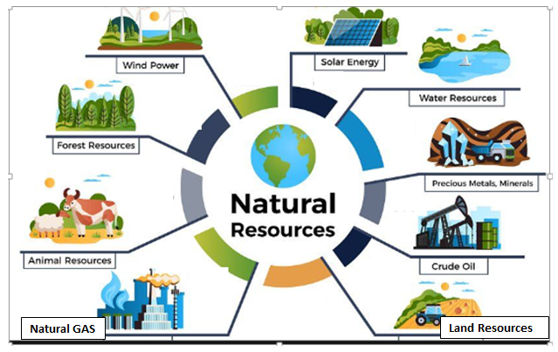

Module Title: - Undertaking Plantation Work
LG Code: AGR NRC1 M05 LO (1-4) LG (24-27)
TTLM Code: AGR NRC1TTLM 0922v1

September, 2022
Addis Ababa

Table of Contents

LO #1- Prepare for planting operations 2
Instruction sheet 2
Information Sheet 1 4
Self-check 1 14
Operation Sheet -1 15
LAP TEST-1 16
LO #2- Plant forest tree seedlings 17
Instruction sheet 17
Information Sheet 2 19
Self-Check – 2 30
Operation Sheet -2 31
LAP TEST-2 35
LO #3- Perform tending operations 36
Instruction sheet 36
Information Sheet 3 37
Self-check 3 51
Operation Sheet -3 52
LAP TEST-3 54
LO #4- Record, document and report 55
Instruction sheet 55
Information Sheet 4 56
Self-check 4 61
Operation Sheet -4 62
LAP TEST-4 64
Reference Materials 65

Introduction to the Module

This module covers knowledge, skills and attitude required to undertake tree planting and tending operations.
LG #24 | LO #1- Prepare for planting operations

Instruction sheet
This learning guide is developed to provide you the necessary information regarding the following content coverage and topics:
- Identifying and compiling applicable OHS, legislative, organizational and environmental requirements
- Identifying and applying planting requirements and factors
- Selecting, checking and using equipment
- Identifying and assessing potential and existing risks, hazards and site conditions
- Storing planting stock
- Establishing and maintaining communication

This guide will also assist you to attain the learning outcomes stated in the cover page. Specifically, upon completion of this learning guide, you will be able to:
- Identify and compile applicable OHS, legislative, organizational and environmental requirements
- Identify and apply planting requirements and factors
- Select, check and use equipment
- Identify and assess potential and existing risks, hazards and site conditions
- Store planting stock
- Establish and maintain communication

Learning Instructions:
- Read the specific objectives of this Learning Guide.
- Follow the instructions described below.
- Read the information written in the information Sheets
- Accomplish the Self-checks
- Perform Operation Sheets
- Do the “LAP test”

Information Sheet 1

  - Identifying and compiling applicable OHS, legislative, organizational and environmental requirements.
- Understanding concept of plantation work
Over 1 billion people live in and around forests, depending on them for fuel, food, medicines and building materials. And all of us use wood in our daily lives: in fact, global demand for timber products is expected to more than triple over the next three decades.
But human impacts have already led to the loss of around 40% of the world’s forests. And today, an area the size of a football pitch is still being destroyed every second. Protecting and restoring forests has never been more urgent.

Tree planting and protecting our biodiversity from degradation is the action of saving every life. Because forests provide many of the resources that we use in our daily lives. Just look around your house how many things are made from wood or other forest products? Many common household items such as furniture and books are derived from forest resources. What about your floors, doors, or siding? Timber is the primary material used to construct homes in many parts of the world. Not to mention, many families rely on wood fuel to heat their homes. So planting and conservation is the only option rather than deforesting.

‘’Sustainable development is development that meets the needs of the present without compromising the ability of future generations to meet their own needs.”
Plantation is cultivated forest ecosystems established by planting and/or seeding, which aids in the process of afforestation and reforestation for the purposes of wood biomass production, soil and water conservation and/or wind protection.Natural forests have not undergone any major transformations resulting from extensive industrial operations. They are also called “preindustrial forests”. Their description is not static, but considers their “variability”, i.e., their fluctuations over time under the influence of natural processes (e.g., natural disturbances, mortality and regeneration)
Some differences b/n plantation and natural forest.

PlantationNatural forest
- Mono species different species
- Mostly exotic mostly indigenous
- Even/uniform aged uneven aged
- Manmade forest/cultivated, managed naturally regenerated
- Manipulated by human being. no human interference
- The same vertical structure Different vertical structure
- Regularly spaced not regularly spaced
- less ecological complexity High diversities in natural forest ecosystems
- Occupational health and safety (OHS)
Occupational health and safety (OHS) is a branch of public health aimed at improving workplace health and safety standards. It studies injury and illness trends in the worker population and offers suggestions for mitigating the risks and hazards they encounter on the job.Every occupation has health or safety risks associated with it, and it is every employer’s responsibility to ensure that their employees can carry out their work as safely as possible.

The field of occupational health and safety sets standards to mandate the elimination, mitigation, or substitution of jobsite hazards. OHS programs also include processes and procedures to minimize the consequences of workplace incidents.Occupational health and safety is a very broad umbrella. It covers not only first aid provisions and the safe operation of heavy machinery, but also infection prevention, ergonomic best practices, and methods for responding to workplace violence.

- Personal protective equipment (PPE)

Personal protective equipment, commonly referred to as "PPE", is equipment worn to minimizeexposure to hazards that cause serious workplace injuries and illnesses. These injuries and illness may result from contact with chemical, radiological, physical, electrical, mechanical, or other workplace hazards.PPE requirements may include;

Safety equipment (Over all)

First aid equipment

Firefighting equipment

Hazard and risk control

Equipment for Elimination of hazardous materials and substances

Equipment for Manual handling including shifting, lifting and carrying

Figure 1.1 Personal protective equipment’s

- Legislativerequirements
Legislative is Acts, ordinances, regulations, subordinate legislation, by-laws, orders, awards and proclamations and delegated legislation (whether national, state, territory or local) applicable where the Subcontractor's Activities or any part are being performed. Legislativerequirements include;
- Award and enterprise agreements
- Industrial relations
- Confidentiality and privacy policies
- OHS regulation
- Environmental protection codes
- Equal opportunity
- Anti-discrimination rules & regulations
- Relevant industry codes of practice
- Duty of care procedures

- Organizational and environmental requirements
- Legal, organizational and site guidelines, policies and procedures relating to own role and responsibility,
- Quality assurance, procedural manuals, quality and continuous improvement processes and standards,
- OHS, emergency and evacuation,
- Ethical standards, recording and reporting,
- Access and equity principles and practices, equipment use, maintenance and storage,
Environmental management (waste disposal, recycling and re-use guidelines, moisture, temperature, soil condition, topography, pests)

  - Identifying and applying planting requirements and factors
    - Factors affecting tree planting
Planting trees require careful study of various factors to ensure its proper adaptability and growth. Important factors to be considered to achieve success in planting trees;
- Climate
Climate is the most important factor affecting the growth of trees.it has been observed that different varieties of trees grow best in certain climatic conditions.
Climate includes temperature, sunlight and rainfall.
- Soil
Tree like other plants are also dependent in the nutrients that the soil provides.as a primary growing medium plants the soil contains mineral elements necessary for normal plant growth and development of the trees. Nutrients such as nitrogen, potassium, phosphorous and others are being observed by the roots of the tree for the plant to grow.
- Water
Tree cannot survive without water for its forms part of every plant cells and tissues. Tree is very dependent on water because it serves as a solvent for the nutrients from the soil.
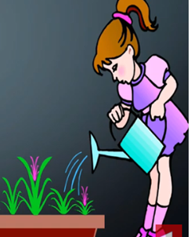
Figure 1.2. Watering
- Fertilizer
Fertilizers are added to soil to increase its productivity. The two types of fertilizers are organic and inorganic fertilizer.
- Organic fertilizer
Organic fertilizer Come from compost of decayed fruit and vegetable peelings, animal manures, and food washing. The use of organic fertilizers, which contain a high percentage of nutrient helps in maintaining and improving the structure and fertility of the trees.
- Inorganic fertilizers
Inorganic fertilizers are made up of synthetic materials.
- Planting plan
Successful establishment of forest tree plantings requires planning; a commitment of time and resources, proper planting, maintenance and protection. Planting seedlings has advantages over direct seeding. A key advantage is that seedlings will more effectively compete with unwanted plants such as grasses, shrubs and herbaceous plants for moisture, sunlight and soil nutrients.
Forest tree seedlings are more likely to successfully establish and develop when the following planting plan conditions are met:
- Appropriate site is selected
- The site is properly prepared.
- Species appropriate for the site are selected.
- Quality seedlings are selected or purchased.
- Seedlings are properly cared for and handled before, during and after planting.
- Proper planting techniques are used.
- Proper tree maintenance practices are followed.
- Proper planting depth are excavated
- Appropriate seedlings root are placed
- Seedlings roots are firmed vertically

  - Selecting, checking and using equipment
Site clearing and stock planting tools
For site clearing/soil working purpose, tools required such as spades, hoes, gesso, mattocks, Brush hook, Machete, Slashes, Rakespickaxes, etc. should be checked and arranged before starting the work activities in the field.
AreaLaying out tools
For laying out purpose, tools required such as, meters, pegs, ranging pole, water level, GPS, etc. should be checked and arranged before starting the work activities in the field.
Seedling Transporting Tools
Seedlings, both bare rooted and containerized, should be safely transported and delivered to the planning site. For bare rooted seedlings, preparation of covering materials such as banana leaves or any suitable covering materials is important. Containerized seedlings should be transported by using wheelbarrow, trays and boxes and covering materials should be arranged to minimize damage to the seedling by sun and wind.

  - Identifying and assessing potential and existing risks, hazards and site conditions
One of the "root causes" of workplace injuries, illnesses, and incidents is the failure to identify or recognize hazards that are present, or that could have been anticipated. A critical element of any effective safety and health program is a proactive, ongoing process to identify and assess such hazards.

Effective controls protect workers from workplace hazards, help avoid injuries, illnesses, and incidents, minimize or eliminate safety and health risks, and help employers provide workers with safe and healthful working conditions. The processes described in this section will help employers prevent and control hazards identified in the previous section.
To effectively control and prevent hazards; employers should:
- Involve workers, who often have the best understanding of the conditions that create hazards and insights into how they can be controlled.
- Identify and evaluate options for controlling hazards, using a "hierarchy of controls.
- Use a hazard control plan to guide the selection and implementation of controls, and implement controls according to the plan.
- Develop plans with measures to protect workers during emergencies and non-routine activities.
- Evaluate the effectiveness of existing controls to determine whether they continue to provide protection, or whether different controls may be more effective.
- Review new technologies for their potential to be more protective, more reliable, or less costly.
  - Storing planting stock
While being lifted; tree seedlings are subject to mechanical damage. At the same time, their foliage may be inoculated with soil-borne spores of storage-mold fungi. During subsequent handling and storage, stock condition may change rapidly as a result of desiccation, molding, metabolic activity, or developmental processes.
Damage to or deterioration of stock during and after planting may be minimized through;
- Choice of the method and date of lifting;
- Prelift root pruning,
- Fungicide application, and physiological conditioning;
- Post-lift control of stock water potential and temperature.
Grading can improve stock quality either by identifying inferior seedlings or batches of stock for culling or by revealing deficiencies in quality that can be avoided in the future through changes in stock-production techniques. To be useful, grading must be in accordance with standards which reflect the stock characteristics necessary for satisfactory field performance. To improve stock quality through changes in cultural and handling practices, nursery managers must investigate the effects of alternative practices on the field-performance potential of the stock they produce.

Generally, seedlings should be planted as soon as you receive them. However, in ideal conditions of between 35°F to 38°F, most seedlings can be stored for several weeks. One exception is longleaf pine, which should be planted within 7-to-10 days of leaving the nursery. Seedlings come packaged from the nursery either in paper sacks or cardboard boxes. Keep seedlings within their original package until time for planting. Keep the bag or box tightly sealed to keep moisture inside the package. Tape over any tears or holes in the packaging immediately. Store seedlings in a cool, damp and shaded location that is sheltered from the wind. Do not allow seedlings to freeze or come into contact with direct sunlight. When stacking seedling bags or boxes, provide gaps between the bags/boxes to allow air circulation. Only stack to a maximum of 3-high.

  - Establishing and maintaining communication
Definition
Communication can be defined in many ways. In simple terms communication is:
- Information transmitted
- A verbal or nonverbal message
- A process by which information is exchanged between individuals through a common system of symbols, signs, or behavior
Elements of communication
There are three key elements in the communication process, which we will refer to throughout our discussion of interpersonal communication.
- You
- Your audience
- Your message
YOUbring professional experience and education and training to the communication process. You have earned credibility with your employees, your board members, the public, the media, and your fellow workers. In order to be an effective communicator, you need to know who your AUDIENCEis.
The MESSAGEelement is equally important. What do you want to say? What is the best way to communicate the message?
There is a basic rule used by journalists for writing a newspaper story that can help you focus your message. A well-written story should contain the: who, what, when, where, why, and howof the story in the first paragraph or two. If it does not,it will not hold our attention.
Communication tools
There are four basic communication tools;
- Listening
- Speaking
- Reading
- Writing
All four of these basic tools can be learned and improved. First, you must want to improve your communication skills. Next, you must understand them, and recognize their importance in the communication process. Then, you need to learn some new skills. Finally, you must practice good skills to become a better, more effective communicator.
How we get and use information
How much information we retain in the communication process depends on many factors. It is important for each of us to recognize how we learn best. Do we remember most of what we read? Most of what we hear? Do we learn more if someone shows us?
Typically, we retain information at these rates:
- 10 percent of what we read
- 20 percent of what we hear
- 30 percent of what we see
- 50 percent of what we see and hear
- 70 percent of what we see and discuss
- 90 percent of what we do

Communication may be:
Nonverbal messages: unspoken and more difficult to interpret than verbal messages, but are just as important. This is particularly true when you think that someone is saying one thing and showing body language that tells a different story.
Writing: a type of unspoken communication. Communication in writing is powerful and lasting. Whether you write a letter, a memo, or an email message, written communication can be recalled word for word. Spoken: this is often misquoted and misremembered.

Self-check 1 | Written test

Name…………………………………………… ID………………………… Date…….
Directions: Answer all the questions listed below.
Test I: Choose the correct answer (2 points each)
- From the following which is/are important factor to be considered during tree planting?
- water
- Soil
- Climate
- All
- Which is/ are the basic communication tools?
  - Listening
  - Speaking
  - Reading
  - All
Test II: Short Answer Questions
- Write the difference between plantation and natural forest?
- What are the tree planting requirements?

Note: Satisfactory rating - 5 points Unsatisfactory - below 5 points
You can ask your teacher for the copy of the correct answers.

Operation Sheet -1

  - Determining hazards or risks presented or will be presented at workplace
      - Important Tools and equipment’s
- Over all
- Note book
- Pen and pencil
- Digital camera
      - Steps for determining hazards or risks
- Collect and review information about the hazards present or likely to be presented in the workplace.
- Conduct initial and periodic workplace inspections of the workplace to identify new or recurring hazards.
- Investigate injuries, illnesses, incidents, and close calls/near misses to determine the underlying hazards, their causes, and safety and health program shortcomings.
- Group similar incidents and identify trends in injuries, illnesses, and hazards reported.
- Consider hazards associated with emergency or non-routine situations.
- Determine the severity and likelihood of incidents that could result for each hazard identified, and use this information to prioritize corrective actions.

LAP TEST-1 | Performance Test

Name……………………………….ID……………………………..Date…………………………….

Time started: ________________________ Time finished: ________________

Instructions: Given necessary templates, tools and materials you are required to perform the following tasks within 2hour. The project is expected from each student to do it.

Task-1 Perform hazards or risksdetermination

LG #25 | LO #2- Plant forest tree seedlings

Instruction sheet
This learning guide is developed to provide you the necessary information regarding the following content coverage and topics:
- Assessing and preparing planting site
- Selecting tree seedlings planting methods and patterns
- Selecting and planting tree stock
- Identifying and resolving problems
- Maintaining and storing equipment

This guide will also assist you to attain the learning outcomes stated in the cover page. Specifically, upon completion of this learning guide, you will be able to:
- Assess and prepare planting site
- Select tree seedlings planting methods and patterns
- Select and plant tree stock
- Identify and resolve problems
- Maintain and store equipment

Learning Instructions:
- Read the specific objectives of this Learning Guide.
- Follow the instructions described below.
- Read the information written in the information Sheets
- Accomplish the Self-checks
- Perform Operation Sheets
- Do the “LAP test”

Information Sheet 2

- Assessing and preparing planting site
    - Elements of planting area selection
  - Patterns & Placement
Several techniques are used to create spaces within the landscape using different types of line and planting patterns. Plantings are laid out in shapes and forms to create "outdoor rooms" based on the type of activity the area is intended for. Deciding on whether a planting should be formal or naturalistic will help create a sense of rhythm within the planting. A formal planting will have balanced geometric shapes and lines while a naturalistic planting will take on a "soft" line as trees would if they grew naturally instead of being placed. These two types of plantings can be integrated to fit the style of the building being framed in either an urban, suburban or rural landscape.
  - Diversity
A variety of plant material brings interest to a design throughout the seasons. For design purposes, diversity is important to bring scale, color, texture, line, form, balance and emphasis to a site. Choosing an array of plant material is also important in terms of preventive management, which means designing to minimize potential problems and reduce maintenance. For example, many street plantings of the past involved a monoculture of elm trees due to their appearance and adaptability to street settings. When Dutch-Elm Disease infected thousands of elm trees in the Northeast, most trees died and had to be removed, leaving bare streets that were once lined with elms. For this reason alone, it is very important to plant a variety of trees as a preventive measure.

Scale & Form
Scale refers to the mature size a tree will reach, while form refers to the growth habits or shape of the tree. Trees can take on the following forms: round, conical, pyramidal, spreading, weeping, oval, columnar, open, and irregular and vase shaped.

Texture
Texture usually refers to the leaf type or size, but should also include branching habit. Texture divides plants into three categories: fine-textured, medium-textured and coarse-textured leaves. Branching habit exhibits the same categories and is important because it can greatly alter the appearance of trees in the winter months.

Color
When landscape architects choose a tree, they look at the different characteristics a tree displays throughout all seasons. In the spring there are many trees that display a range of bright flowers. In summer, almost all trees provide a shade of green, which is why texture is such an important factor because it creates contrast. Many deciduous trees have leaves that turn rich, vivid colors in the fall, and some have interesting bark or berries that persist into winter or evergreen needles/leaves that add color during our long winter months. Some trees exhibit attractive qualities for all seasons, while others may be absolutely spectacular during only one season of the year. Again, it is the mix of different qualities that add interest to a landscape.

    - Site preparation
Site preparation is an extremely important step in a successful tree planting. You would not think of planting a garden without tilling and preparing the soil. The same applies to planting trees.

- Vegetation clearing
On most sites trees, bushes and grass have to be cleared away to prevent them from competing with the young plants. This is very important when using light-demanding trees such as Eucalyptus, Pine or Cupressus. If more shade-tolerant species are chosen, existing trees do not have to be cleared. Total clearing of the grass and bushes is needed on moist grassland sites and for species sensitive to grass competition, like some Eucalyptus.The two methods of site clearing are mechanicaland chemical. Mechanical site clearing involvesphysically removing any competing vegetation from theplanting site. Chemical site preparation consists of using herbicidesto control competing vegetation. Usually the herbicideis sprayed in a spot treatment around each seedling or instrips where the tree rows will be planted.
- Ground preparation
Ground preparation is needed to soften the soil, and to allow the roots to affix firmly and deeply. Since nutrients are washed out in the surface soil layer, it is also important to mix soil for the deeper. Layer with soil from the surface layer to guarantee availability of the nutrients needed by the seedling. The method depends on the site and the species planted. Usually digging holes and uprooting grasses with the planting hoe about one meter around the planting hole is enough.
The work should be carried out along the contour line, not up and down the slope; otherwise rain water may start to wash away the soil and form gulley’s.
In sites with crusts, hard pans or other hard soil layers it may be necessary to use mechanized soil preparation. For this a bulldozer, a sub-soil or a scarifies drawn by a tractor can be used.
  - planting methods and patterns
2.2.1 Planting methods
There are three common methods of tree planting;
      - Line or rectangular planting
In this patterns two or more lines form rectangles. Each plant in the successive row is opposite to the previous one.
      - Square planting
In this pattern, the distance between line-to-line and plant-to-plant is the same and plants are at the corner of each successive square.
      - Triangular Planting
In this pattern, each plant in the succeeding row gets position in the middle of the proceeding row so that they are at the corner of each adjacent equilateral triangle.
2.2.2Marking the planting spots /planting patterns
The most commonly used planting patterns are square spacing or rectangular spacing. The appropriate spacing varies with;
- The site,
- The purpose of the plantation and
- The species chosen.
It is also a compromise between expected yield and the cost of establishing the plantation.
- Wider spacing (more than 3x3 m) is preferred;
- For fruit trees;
- when planting on agricultural or grazing land;
- To reduce the cost of planting;
- To avoid competition for water and nutrition;
- To reduce the number of thinning (if the aim of the plantation is large diameter timber)
- Closer spacing (3x3 m or closer) is preferred:
- To avoid expensive replacement planting;
- To give early soil cover;
- When weed competition needs to be suppressed by early tree canopy closure;
- When there is a market for smaller dimension wood from thinning
- On dry sites most trees are now planted with an average of 3 or 4 meters between trees (i.e. 1111 or 625 trees/ha, respectively). On fresh sites in tropical highlands and in temperate climates a spacing of 2 square meters (i.e. 2500 trees/ha) is common.

  - Selecting and planting tree stock
    - Planting season
Tree seedlings must be planted in late winter or early spring, when the seedlings are dormant and the ground has thawed. The exact dates will vary with latitude and weather conditions. During this period, soil moisture and air temperature are ideal for seedling growth and survival. A cool (35 to 60 degrees F) overcast day with little or no wind (less than 10 mph) provides an ideal setting for planting tree seedlings.

    - Criteria of selecting tree stock
Trees have many favorable qualities and provide a variety of benefits. With proper consideration prior to planting, the end result of planting trees can be extremely favorable as trees give shade, shelter, visual interest and can increase the value of property. Moreover, trees are a source of enjoyment. If you plan on planting trees in your yard, take into account the following design strategies that a landscape architect does when selecting trees.

- Site Location
When selecting trees for a planting design a Landscape Architect’s main goal is to find the right tree for the right location. The characteristics of the site will answer a lot of questions on what is feasible to plant in a given location.If the tree will be planted near the road, what is its tolerance to salt? Will its growth interfere with utilities, sidewalks, site distances or other site amenities? Moreover, does the location provide adequate space for the tree to grow to its full potential? Nurseries will provide information on hardiness, exposure and culture on plant tags and will sell plants that are appropriate for the area. If you are unsure if the tree you selected will thrive in your yard, contacting your local extension service for additional information is good.
Plants should be placed in a location where they will thrive and not merely survive. Before you decide to plant a tree, ask yourself the following questions: Does this location provide the sun exposure and culture (water, fertility, and pH) the tree needs to reach its destined size?

- Species
Trees should be selected on terms of how they will develop in the landscape and not based on their appearance in the nursery. Native plants are always a good choice as they naturally occur in an area and do not have to be introduced. Native species are not always available in desirable sizes at nurseries, but are well worth seeking out. There are many selections and cultivars which are still native species, but have been selected for superior survivability, form, pest and disease resistance and other favorable qualities.

With these thoughts in mind, a landscape architect next thinks about how a tree fits the landscape based on the elements of design.Because of the many species involved, their size, and their origin, the Department developed a coding system for assigning the specification item numbers for planting of trees and other vegetation.

  - Identifying and resolving problems
    - Beating up
Beating up is a planting operation done shortly after major plantation establishment to replace failures occurred for various reasons. Mortality after the main planting activity is inevitable. This initial mortality may be due to:
- Equipment faults and malfunctions,
- quality of stock,
- unsuitability of stock,
- common diseases and pests,
- Nutritional deficiencies,
- communication and misunderstandings,
- environmental issues or damage,
- Production quality and safety
- Deterioration of seedlings by mishandling
- Improper planting technique
- Seed competition
- Animal damage

Beating up is expensive as this involves larges holes, larger stock, and long distance per plant. Therefore, it is carried out if the established stocks considered being unacceptably low.
Up to 20% mortality is accepted but if survival is less than 25% the plantation needs a complete replanting. It is also influenced by the pattern of mortality. If it occurs in an evenly distributed pattern, the need for beating up could be lesser. But if it is patchy creating scattered large gaps, we need to carry out beating up.

The time of beating up vary with the growth rate of the species. For fast growing species like eucalypts, the beating up needs to be done with in the season- usually 3-4 weeks after planting. For slow growing species, it can be done after a year or the next growing season. When it is done in the same season an extra amount of seedlings in the same stock must have been kept, so that they will be of the same size with the previously planted seedlings. Beating up should mainly consider areas of concentrated or continuous mortality. All single isolated failures need not necessarily be planted. Seedlings used must be robust healthy and having good root development.

    - Animal Grazing
Tree seedlings may also be harmed by animals such as Cattle, sheep, goats and sometimes wild animals must be kept out of the plantation until the trees are big enough to withstand grazing. This problem is most acute in dry areas with sparse vegetation where animals turn to planted trees for food. Without the cooperation of the livestock owners’ protection will be difficult. To discuss the problem early during planning and to meet regularly after planting to sort- out problems.

When bigger areas representing a large portion of the accessible grazing lands are being planted and where grazing is scarce, it might be necessary to divide the planting area into compartments and to plant them one at a time. The livestock is then allowed into the first compartment when the second one is being planted some years later, and so on. In this way the area where grazing has to be avoided is minimized. It may also be necessary to use species that are not readily grazed by the animals. If these measures are not sufficient, fences should be built before or during planting.
For smaller plantations fences can be built with branches cut from thorny trees or other suitable material to protect the plants for the first couple of years. However, these kinds of fences require a large quantity of branches and may put an additional pressure on an already stressed forest or bush land.
Hedges of closely planted bushes and trees (live fences) can also be created. Thorny plants such as Cactus, Euphorbia, Aloe, Sisal, Acacia or Juniperus can be used. Species that can be grown from large cuttings are preferable. Live fences must, however, be planted some years before the trees are planted and be given time to reach a sufficient size to keep out the animals. All types of fences have to be maintained. Where fences alone do not protect the plantation, a watchman can also be used to look after the plantation.

    - Fire
Bush fires in planted areas are almost always man-made. Fire is used to clear land, to improve grazing and to chase away wild animals. Fires may also be caused by carelessness during charcoal burning and honey collection. Prevention of fire depends to a great extent on information and extension work. Firebreaks combined with a well-designed road system may keep the fire from spreading. Firebreaks consist of corridors about 20 m wide that are kept without vegetation cover. Maintenance of firebreaks is simple but labor intensive. They must be cleared at least once a year at the beginning of the dry season. Controlled grazing or cutting grass for stall-feeding can be used to minimize the amount of flammable dry grasses in the forest. Controlled grazing can also be used for clearing firebreaks.

Plantation staff and peasant association members may be trained in fire control. Small fires might be extinguished with water or plantation tools such as hoes or spades. If a fire has spread over a bigger area, the only practical way to control the fire is to remove flammable fuel from the path of the fire by opening up corridors without vegetation (fire lines). Already existing fire lines such as firebreaks and roads can be enlarged. Large forest fires can be fought with the help of backfire. A backfire is started on a strong fire line and directed towards the main fire. A wide corridor will be burned and when the two fires meet they will die for lack of fuel. Backfiring techniques need a lot of labour and should only be used under the supervision of an experienced firefighting crew since there is always a danger that the fire can spread away from the back of the fire, starting new main fires.

    - Insects, diseases and rodents
Tree seedlings may also be harmed by insects, diseases and rodents. Species liable to insects and diseases should be avoided. The best form of protection is to diversify the plantation, using various tree species. Treatment with pesticides or dipping of plants (i.e. planting seedlings treated with pesticides) may also be used.

Rodents may cause damage to saplings, especially at high altitudes. The best form of protection from rodents is to keep the soil around the seedlings bare, i.e. well weeded. Rodents avoid bare soil where they are visible to birds of prey. Therefore, weeding limits the damage that can be done by rodents above the soil surface. Mechanical protection of the lower stem of young trees also works quite well. A suitable protection would be a split bamboo tube. The two halves of the tube are placed around the stem and tied together with a string. Protecting seedlings from rodents that damage the roots underground is more difficult. Traps, repellants or poisoning may be used.

  - Maintaining and storing equipment
    - Maintenance
Sharp tools produce the best cuts and reduce cutting fatigue. Use a sharpening stone or device to hone cutting edges of hand pruners, loppers and pole pruners. For dull pruning saws, have them professionally sharpened or install a replacement blade. Learn to sharpen rope saws and chainsaws yourself, or have them professionally sharpened.

Sanitize tools between cuts, especially when you know you're dealing with a diseased tree. Pruning cuts provide the perfect entry point for disease organisms such as bacteria, fungi or other microorganisms. You can reduce the need for sanitizing tools between cuts by pruning during the dormant season, when disease organisms are inactive.To disinfect tools between cuts, immerse blades for 1-2 minutes in rubbing alcohol, Lysol or Listerine. Bleach and Pine-Sol also sanitize tools, but corrode metal. If you use these items, clean tools with soap and water after immersing them in the sanitizing solution. Dry thoroughly before using.

After use, clean cutting blades. Remove sticky sap by wiping blades with a rag dipped in some type of solvent (mineral spirits, turpentine, etc.). Rub blades with lubricating oil to prevent rust. Lubricating joints and moving parts keep tools operating smoothly.

Maintenance of axes: An axe is sharpened in a series of steps. First blade taper is measured with a taper gauge. The grindstone is used to reshape the edge. After the edge has the desired symmetric shape, the grindstone is used to sharpen the edge on both sides. The whetstone is then applied for final honing. Often it is necessary to remove a broken axe handle. On one method, the first step is to saw off the top of the handle stub (close to the eye) to make a flat surface.

Maintenance of Hand saws: Before beginning maintenance of the bow saw blade it must be verified that the saw blade is straight (not twisted) in the frame.
a. Cleaning the saw blade: Resin, rust, oil and dirt are wiped off the blade with a cotton cloth moistened in cleaning fluid. A suitable cleaning sedition consists of 70% kerosene, 20% turpentine, and 10% engine oil. A burr knife, made of a discarded bow saw blade also can be used for cleaning. Care must be exercised so as not to scratch the saw blade.
b. Jointing, shaping, setting and filing the teeth
- Jointing: the saw blade is effective only if the top of all teeth is at the same height. The teeth are
brought to the same height with the help of a flat file and a jointer.
The jointer acts as gauge to keep the file perpendicular to the edge of the saw blade at the desired tooth height.A self-made wooden jointer for the bow saw blade can be checked for accuracy with the help of pocket mirror. The kerf of the jointer is perpendicular to its sides, than the line of the kerfs and their reflections in the mirror should be perfectly parallel. A self-made wooden jointer for the crosscut blade may be checked in the same way. The jointing is done by pushing the file forwarded over the top of the jointer does the jointer. The jointing stroke should be touching all of the teeth. Because the blade wears most heavily in the middle, extra filing strokes may be necessarily at the ends of the blade.

After jointing, each tooth should have a clearly defined flat top of 0.5-1.0 mm. This flat top will diminish in to a small dot during the filing of the tooth bevels.
- Shaping: The correct height and form of the teeth are obtained by shaping depending on the gullets between them (For inexpensive bow saw blades, it is not worthwhile to file the gullets.)
Once the gullets are deepened, the burrs need to be removed. This can be done with a hard flat file or whetstone. The whole side of the whetstone must rest against the blade.

- Setting: teeth are set by bending them alternately to the right and left. Thus the kerf is always wider than the thickness of the blade. For example, the width of the kerfs will be 1.3mm for a blade thickness of 0.90mm and a setting of 0.20mm. Settings are wider for soft woods than for hard woods as follows:
Different setting devices are available. Precise setting can be achieved with a setting iron and a simple wooden setting indicator.

- Filing: Filing sharpens the teeth so that they slice through the fibbers of the wood oblique bevels (half bevels) are made when only the outer (upper) part of the tooth is filed. Oblique bevels are needed for two-man crosscut saws. Full bevels are made when the whole side of the tooth is filed. Full bevels are made on bow saws only.
- Removing burrs: When filing bevels, burrs are formed on the reverse side of the teeth. If they are left there, they make it difficult to file the other bevels.
For a bow saw blade, a burr knife is held against the blade with the thumb. Burrs are first removed from the bottom of the tooth. The burr knife is side up the tooth, and down the bevel of the other side.
Burrs are removed from a crosscut blade with a whetstone. The whetstone is rested flat against the blade and passed slightly along both sides of it.
- Making a sawing test: Having carried out the preceding steps in saw maintenance, the worker evaluates the results. A visual inspection is followed by a sawing test at a felled tree of at least 15 –20cm diameter. A smaller tree may not correctly test the saw’s performance. The sawing test will show if the saw runs obliquely, pinches, or jumps.

Sharpening stones
Traditional sharpening stone, abrasive stones are often shaped to have a traditional rectangular or square sharpening bed.
Revolving grindstone: it consists of a sand stone wheel, equipped with a crank, stone and a water container.
Whetstone: there are two main types of whetstones, natural and synthetic. The granules of the synthetic stones are extremely hard and cut steel very well. Honing the edge with a whetstone requires water, which speeds the sharpening and makes the edge smoother.
Files: The file is the most common general-purpose tool for sharpening saw and various kinds of edged implements. The cutting patterns of files can be described as either double-cut or single-cut.
File maintenance: oil and grease are removed from a new file by putting the file in to warm water. Alternatively, the file is rubbed (in the direction of the teeth) with a Harwood stick, pieces of charcoal, or wire brush, during use the steel particles, which collect in the file, can be removed in the same way, or by tapping the file against a block wood.
Rasps: Rasps are used to shape soft materials like wood for tool handles and the hooves of draft animals. Rasps are not used on metals.
Filing vices: A stump vice is suitable to help hold two man cross cut saws for filling or for setting teeth. A portable wooden vice can be useful for both bow saw and crosscut saws.

2.5.2 Storing equipment’s
Plant debris and waste materials produced during plantation work activities should be identified, separated and stored safely for further processing. Biodegradable waste materials such as plant debris should be separated from none-biodegradable one, such as plastics, and stored separately. These materials should be prepared and processed in an appropriate and safe manner. Surplus west materials should be stockpiled for removal and safe disposal out of the nursery site after transporting seedlings to planting area. A clean and safe work site should be maintained while completing planting activities.

After completion of activities, all tools and equipment must be cleaned. The nursery working environment should be kept clean of any west materials and plant debris. If there is any broken tools and equipment, it should be maintained. Broken handles and blunted tools should be maintained and made ready for work. All tools and equipment should be well organized and stored in groups of similarity after maintenance.

Self-Check – 2 | Written test

Name…………………………………………… ID………………………… Date…….
Directions: Answer all the questions listed below.
Test I: Short Answer Questions
- Write the advantages of site clearing?
- Discuss the three common methods of tree planting?
- Why beating up?
Test I: Multiple choice
- From the following alternative which one is/are tools used for site clearing?
- Spade
- Shovel
- Mattock
- All

Note: Satisfactory rating - 7 points Unsatisfactory - below 7 points

You can ask you teacher for the copy of the correct answers.

You can ask you teacher for the copy of the correct answers.

Operation Sheet -2
  - Site clearing
- Tools and equipment’s
- spades
- hoes
- gesso
- Mattocks
- Brush hook
- Machete
- Slashes
- Rakes
- pickaxes
- Techniques of Site clearing
- Remove any competing grass and weeds that will rob new seedlings of moisture and nutrients so the newly planted seedlings will have a better chance of survival
- For small plantings, remove grass and weedsfrom a spot 3 feet in diameter where each tree is to beplanted.
- For larger plantings, plow or disk 3-foot-widestrips where the rows will be planted
- Leave vegetationbetween the rows will help prevent soil erosion. However, if your planting is a bottomland field, it is okay to clear the entire area.

  - Determiningnumber of tree seedlings
- Tools and equipment’s
- Meters
- Pegs
- Ranging pole
- water level
- GPS
- Steps of determining number of tree seedlings
- lay out Planting area by using 3,4,5 method
- Adjust boarder effect of the row and plant.
- Boarder effect of the row = ½*space between the row.
- Boarder effect of the plant =1/2*space between the plant
- Calculate number of rows
- Number of row=length/space between row.
- Calculate number of plants per row.
- Number of plant per one row =width/space between the plant
- Calculate total number of plants to be planted on the given area.
- Calculate number of plants per hacter.

.

  - Planting tree seedlings
- Tools and equipment’s
    - spades
    - hoes
    - Gesso
    - Mattocks
    - pickaxes
- Steps for planting tree Seedlings
- Dig a fairly straight hole from 8-to-10 inches deep and from 4-to-5 inches square. The hole should be deep enough and wide enough for all the seedling roots to fit without forcing them.
- Remove only one seedling at a time from its package or planting bag. Carefully separate the seedlings to avoid damaging the roots.
- Examine the seedling to assure it is a quality seedling. Discard poor quality seedlings.
- Insert the root system to the bottom of the hole, and then slightly lift up the seedling to its desired planting depth.
- Keep the tree roots straight and avoiding J-shaped or L-shaped roots.
- Hold the seedling upright while closing the hole.
- When planting containerized seedlings, fill topsoil back into the hole until the hole is as deep as the container
- When planting bare-rooted stock, put the seedling into the hole with the root collar 2cm -3cm below ground level. The roots should be well centered. They must not be bent or curved and must never be allowed to get twisted or bent in the planting hole. If the tap root is too long it should be cut to about 20-25 cm. Put the soil back into the hole. Make sure that the seedling stands straight. At the same time sorts out stones and green grass.
- For bare-rooted seedlings make sure that the hole is deep enough to allow the taproot to hang down vertically without bending its tip. Pile the soil on the sides of the hole without scattering it too much. Loosen, if necessary with a pickaxe, the bottom of the hole to make it easier for the plant roots to penetrate the soil.

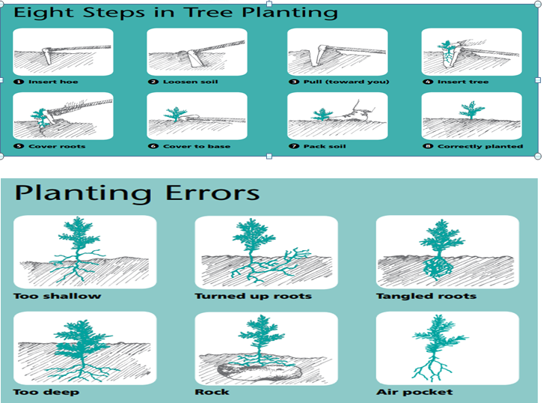
Figure 2.1 Steps in tree planting and planting errors
LAP TEST-2 | Performance Test

Name………………………………. ID…………………………….. Date…………………………………….

Time started: ________________________ Time finished: ________________

Instructions: Given necessary templates, tools and materials you are required to perform the following tasks within 4 hour. The project is expected from each student to do it.

Task-1 Perform site clearing
Task -2 Determine numbers of tree seedlings
Task- 3 perform tree seedlings planting

LG #26 | LO #3- Perform tending operations

Instruction sheet
This learning guide is developed to provide you the necessary information regarding the following content coverage and topics:
  - Identifying and compiling tending operation
  - Identifying and adhering site environmental protection measures
  - Determining and checking tending operation
  - Selecting and checking equipment
  - Inspecting and assessing hazards and site conditions
  - Establishing and maintaining communication

This guide will also assist you to attain the learning outcomes stated in the cover page. Specifically, upon completion of this learning guide, you will be able to:
  - Identify and compile tending operation
  - Identify and adhere site environmental protection measures
  - Determine and check tending operation
  - Select and check equipment
  - Inspect and assess hazards and site conditions
  - Establishing and maintaining communication
Learning Instructions:
- Read the specific objectives of this Learning Guide.
- Follow the instructions described below.
- Read the information written in the information Sheets
- Accomplish the Self-checks
- Perform Operation Sheets
- Do the “LAP test”

Information Sheet 3

  - Identifying and compiling tending operation
    - Definition
Tending is defined as operations carried out for the benefit of a forest crop at any stage of its life between the seedling and mature stages. It essentially covers operation on the crop itself and competing for vegetation and include weeding, cleaning, thinning, felling, pruning, climber cutting, girdling but exclude soil working, drainage, irrigation, and burning, etc.For the establishment of the regeneration and subsequent development of the forest crop up to harvesting, several operations are carried out. These operations are carried out in the forest crop at different stages of growth in order to provide a healthy environment for their development.

Why tend?
Tending can potentially improve the health of a plantation. It facilitates future management operations by providing access with the provision of racks and concentrating management on those trees that will benefit from it the most. Diameter growth of selected stems will increase due to reduced competition.

Two major needs of tending;
1.Sanitation: The act of reducing the chanced of insects and other diseases in sanitation. The trees which are susceptible, injured, broken, weak, diseased, or infected by insects are removed.
2.To provide growing space for trees.
Looking for space in which trees extend their masses, lastly tending operations are essential for providing, the tree with more light water nutrients, etc.

3.1.2 Weeding

Any unwanted plant that interferes or tends to interfere with the growth of the individuals of favored species’ is called a weed. Weeding is defined as ‘a tending operation done in the seedling stage in the nursery or in a forest crop that involves the removal or cutting back of all weeds.

Weeding is an operation done to eliminate or suppress all undesirable vegetation that could impair the growth of the plantation stock. The main objective of weeding is to promote the growth development of plantation crop, while keeping the costs of the operation within acceptable limit. For this reason proper understanding on how weeds affect each particular crop is needed.

Objectives of Weeding
- To protect the crops from suppression
- To reduce root competition for moisture and nutrients available in the soil
- To improve light conditions.

When Weeding is done?
It is done at the seedling stage. A common practice for weeding is that it must be done before weeds start suppressing the seedling crops and when seedlings have stopped growing in the season. Weeding should be carried out when the weeds have tender roots and shoots, otherwise, it will be difficult to uproot. In plantation, weeding is done during and after the monsoon. Number of weeding depends upon the intensity of weed growth and the rate of growth of seedlings of the favored species, three weddings are usually done in the first year, two in the second year and one in the third year, whereas fast-growing species require weeding for one or two years.

3.1.3 Cleaning
Cleaning is carried out in a crop which has not crossed the sapling stage. It is defined as the cutting made in order to face the best individuals from undesirable one of the same age which interfere or are likely to interfere with the growth of the desired individuals.Advantage offered by cleaning is the proper regulation of the composition of the crop, particularly in mixed crops.

3.1.4 Climber Cutting
A plant that attaches itself to other plants or objects such as posts and walls as it grows is a Climber. This difficulty is faced in nurseries usually seedlings are twined by climbers. Afterwards, the internode increases in length. The climber pulls the head of the seedling. Since this host climber can’t be extended, shoot of the seedling is broken. Sometimes it completely girdles the shoots and plants die of suffocation. Removal of climbers is necessary.

3.1.5 Pruning
Pruning is defined as the elimination of branches in order to obtain trees with clean bole. The elimination of branches by physical and biotic agencies of the environment is called Natural
pruning. Removal of branches from the selected portions of the tree by mechanical means is referred as artificial pruning.

On the basis of the pruning, it is classified into:

Natural pruning: The natural death and fall of branches of standing trees from such causes as deficiency of light, decay, snow and ice. It is also known as self-pruning. Teak, most Eucalyptus species and Podocarpus falcatus are good natural pruners.

Artificial pruning: The pruning done by forester without waiting for nature to do it in dense natural crops or where nature cannot do it due to artificially large spacing between stems in man-made plantations to reduce the cost of formation and rotation. It is a costly operation. So, artificial pruning is carried out considering the funds or outcomes.

Plantation cannot be raised in closer spacing because it leads to higher investment and therefore artificial pruning, sometimes may be necessary. The use of handsaw has been found useful than laded instruments. A small ladder is also necessary. The height up to which pruning should be carried out artificially depends upon species, age and local conditions. In young plantations it should be carried out up to one half to three fifth of the total height of the tree.

Whyprune?
- Toimprovetreestemquality
- Toreduce“knottycore”width
- Toremoveforksanddisproportionatelargebranches
- Toproducecleanknot-freetimberuptoatleast6meters

Howtoprune

Whenremovingbranchesitismostimportant toidentifytwokeyfeaturesonthetreestem;

1.TheBranchCollar-usuallyaswelling aroundthebaseofthebranchwhereitjoinsthemain stem

2.TheBranchBarkRidge(BBR)-identifiedasaraisedridgeofrougherbarkthatdevelopsinthebranchcrotchandrunsdownwardatanangletothemainstem.

Itis importanttoavoidinjuryordamagethatcanleadtodisease.Avoid“flushcuts”thatremovethebranchcollar.AlsoavoidleavingstubsFlushcutsandstubsprolongthehealingprocess andcanincreasethelikelihoodofdiseaseincidenceandwooddiscoloration.Neverallowbranchestogrowgreaterthan5cminbasaldiameter.Alargebranchgenerallyhasabasaldiameteratleasthalfthesizeofthemainstem.
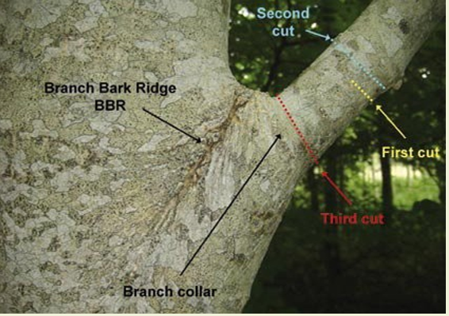
Figure3.1 The3-cutmethodofpruningalargebranch
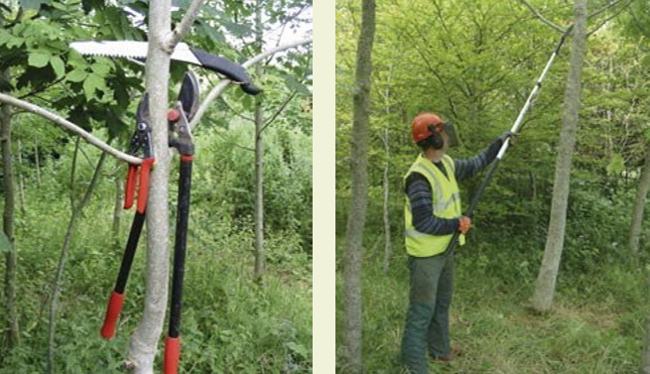

Figure 3.2 Secateurs,loppersandpruningsaw(left)and telescopicpruningsaw(right)

3.1.6 Thinning

What is thinning?
Thinning is the removal of a number of trees from a plantation to reduce competition and provide increased room into which the remaining trees can extend their canopies and grow faster.

Why thin?
Thinning occurs naturally in all broadleaf woodlands but in a haphazard fashion. By carrying out thinning operations, the best quality trees can be selected and favored. Thinning increases the amount of light and space available to the remaining trees. It will increase the stem volume of these favored trees over time, reduce the time to final felling, and may provide an interim income.

When to thin?
Thinning should be carried out when canopy competition occurs between trees. This can begin at different times depending on species, initial stocking, and growth rates.

How to thin
Tending and thinning in broadleaves are often carried out with a chainsaw, rather than a harvesting machine, thereby lessening possible damage to the remaining crop during the felling process. Racks are often established in the tending operation to provide suitable access routes to enable extraction of later thinning by forwarder if required. Extraction by quad bike with a skidder or trailer is possible in small areas during early thinning.
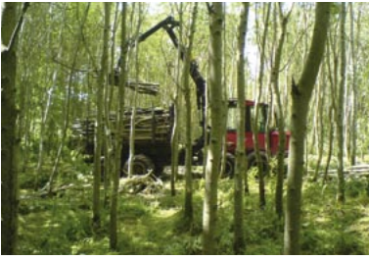
Figure 3.3 Extraction of broadleaf thinning by a forwarder

Factors affecting thinning practice
The following factors are important for deciding the adoption of thinning practice.
i) Nature of Species
Light demanders are less tolerant of crowding than shade bearers and therefore, frequent thinning is required to remove competition in light demander species.
ii) Age
In young age, when the crown formation has not completed, mechanical thinning or stick thinning by some numerical formula is carried out with success.
iii) Site Quality
On poor sites, heavy thinning is not recommended because the rate of growth on such sites is poor and the heavy openings may not be occupied.
3.2 Identifying and adhering site environmental protection measures
3.2.1 What Is Environmental Protection?
Environmental protection can be defined as the prevention of unwanted changes to ecosystems and their constituent parts. This includes
- The protection of ecosystems and their constituent parts from changes associated with human activities; and
- The prevention of unwanted natural changes to ecosystems and their constituent parts.

One issue associated with this definition is whether ‘ecosystems and their constituent parts’ include humans and communities, or whether environmental protection is only concerned with the protection of natural capital. From an ecological perspective, humans are regarded as an integral part of the ecosystem. Separating humanity from the natural environment can therefore be seen as artificial. While this is true, the phrase environmental protection is not used to refer to measures that are designed to regulate or mediate direct interaction between people. For example, laws prohibiting assault are not regarded as environmental protection measures. Environmental protection is concerned with the relationship between people and the natural environment rather than the relationships between people and communities.

    - Effective and practical control measures for minimizing environmental pollution

  - Combustible solid wastes should be burnt in incinerators. This method does not solve the problem in a real sense because in this, solid waste is being converted into gaseous wastes causing air pollution. Unless it is properly controlled, incineration may cause more nuisances.
  - Solid organic wastes including fecal matter and wastes from tanneries should be converted into compost manure at the places far away from the cities and human dwellings. The composting should be done in pits or in heaps adequately covered with layers of soil at least 8-10 cm thick to prevent fly breeding and rat menace which are important carriers of various diseases.
  - Non-combustible solid waste materials like ash, rubbish, tins, glass pieces if not recoverable for usual purposes should be disposed of by landfill method in low-lying areas. There should be cut back in the use of fertilizers, herbicides, pesticides and other agrochemicals as far as possible.
  - Excessive and undesirable burning of vegetation should be stopped.
  - Waste management is based on principle of ‘3Rs’ i.e. Reduce, Recycle and Reuse. Used boxes, bags, plastics and bottles should be reused whenever possible.
  - Smoking should be stopped (there is 5, 00,000 tonnes tobacco pollution annually).
  - Proper attention should be given by the government to make people realize the implications of environmental problem.
  - Legislation against pollution should be strictly implemented.
  - International action is needed to deal with the problems presented by highly toxic pollutants like lead, mercury, organ chlorine pesticides released in to the atmosphere and carried far beyond the country of origin as well as carried down to the sea by rivers. Successful action to improve environmental qualities depends mainly on the acceptance by industry and local authorities of the need to reduce greatly both quantities and toxicity of certain wastes at present being discharged into the sea and the modernization and expansion of sewage disposal systems.
  - Environmental education is the best programme to deal with the environmental problems. It is most fundamental in our efforts to combat and control pollution, over-population and misuse of natural resources.

Environmental education includes the following objectives;

    - Awareness of the problems.
    - Providing knowledge to deal with the problems.
    - Developing new attitudes towards environmental problems.
    - Developing skills for solving environmental problems.
    - Providing development or evaluation ability in work place.
    - Increasing participation and involvement of public.
    - A broad recognition of the facts that we are all responsible for helping to solve environmental problems.

  - Determining and checking tending operation requirements
3.3.1 Basic Pruning Principles

Any arboricultural practice including pruning should not damage or impair the health of the tree. Proper technique and timing are critical to long-term tree health. The most important principle to remember is that each cut has the potential to change the tree considerably. Pruning trees should not be a common practice used to force them into aesthetic constraints or spaces. However, in distinctive circumstances such as espalier, topiaries or pollarding, specialized pruning practices would be necessary. Occasional pruning may be required during the life of the tree to remove branches interfering with buildings or with pedestrian or vehicular traffic. So, plan for a location that allows the tree to expand into its natural shape with limited conflicts, reducing the need for continual pruning.
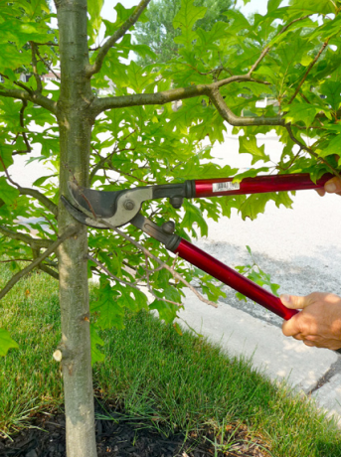
Figure .3.4 prune on a newly planted tree.

Another key principle is the pruning dose or amount of green tissue mass removed during any one pruning episode. Pruning amounts will depend upon previous pruning cycles and pruning objectives. How long has it been since the last pruning episode? What do you want to accomplish with this pruning activity? These questions will determine amount of pruning necessary. If extensive pruning is needed, consider phasing in the pruning process over a period of several months or years. Removing dead, damaged, or dying tree parts doesn’t figure into the mass when calculating pruning dose. However, severe pruning, especially during times of stress such as drought conditions, can have severe consequences on tree health.
Table 3.1: maximum % of total foliage removed at one pruning
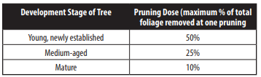

Some things you should never do. Topping is a form of poor pruning that can ruin the tree’s shape and health with excessive canopy removal and poor cuts. Topping is the indiscriminate removal of branches between internodes and not where branches meet, leaving stubs and wounds which cannot heal properly. This provides the opportunity for disease and decay, creating serious problems for the tree. The tree responds to topping by producing many sprouts that are poorly attached and prone to damage from wind, ice, and snow. The dormant buds on the stems, which have flushed, are only connected to the xylem and do not overlap or commingle with the main supporting stem. This is a poor attachment that grows quickly and will become a safety concern. Because of this weak attachment, the branches are likely to fail more easily and pose a higher risk of injury or damage around the tree.
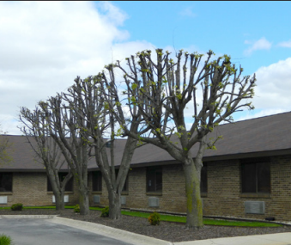
Figure .3.5 Trees topped will be prone to many problems

  - Selecting and checking equipment
3.4.1 Pruningequipment

Successful pruning starts with the right tools. As you stock your toolshed, focus on quality cutting tools that will stand the test of time. They'll cost more, but high-quality tools often offer replacement parts, withstand repeated use and sharpening, and can last a lifetime.
Choosing the right tool for a cutting job mostly hinges on the size of branches you'll be pruning. Cutting smaller branches is always ideal because a tree can seal a small wound more easily than a larger one. You’ll have an easier time pruning if you tackle intentional pruning when trees are young.
  - Hand Pruner
Grab hand pruners when you're cutting branches with a diameter of 1 inch or less. For the cleanest cuts, choose bypass pruners, which cut like a pair of scissors, with a curved cutting blade that slides past a lower broad blade.
  - Lopper
Also called lopping shears, a lopper is the tool of choice for cutting branches 2 inches in diameter. The lopper label should specify the branch size it will cut. Again, bypass cutting blades yield a cleaner cut without crushing plant tissues. Some lopper designs include a gear-like feature that increases cutting power, essentially multiplying your effort. Look for loppers with handles in varying lengths, including ones that telescope to extend your reach.
  - Pruning Saw
Most pruning saws are designed to cut branches with a diameter of 3 inches, although with more effort you can use them to cut slightly larger branches. Blades are tempered metal and remain sharp for many uses. Unlike many saws, pruning saws cut on the pull stroke as well as on the push stroke, so that every movement of the saw produces a cut.
  - Rope Saw
A rope saw uses a chain-type cutting blade and is ideal for cutting branches 5 inches in diameter, although it will cut through thicker limbs with more effort. Most rope saws allow you to stand on the ground and cut limbs up to 25 feet high. Simply add extension ropes to increase the reach.
  - Chainsaw
A chainsaw provides the cleanest cut when you're dealing with limbs thicker than 3 inches. If your pruning job requires a chainsaw, it's recommended that you contact a certified arborist.

  - Pole Pruner
A pole pruner allows you to cut branches that are beyond your reach. Most pole pruners cut limbs up to 2 inches in diameter. For the cleanest, healthiest cuts, choose a bypass-style pruner. For versatility in tackling larger branches, purchase a pole pruner that includes interchangeable cutting tools for the pruning head: a bypass pruner and a pruning saw
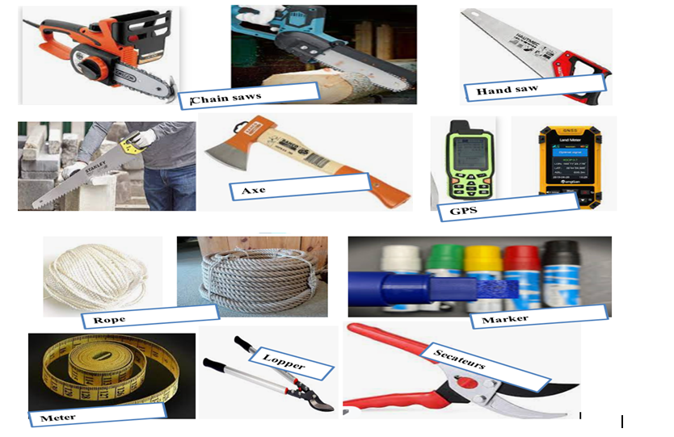
Figure 3.5 pruning and thinning equipment’s

3.5 Inspecting and assessing hazards and site conditions
3.5.1 Find out what could cause harm
The following can help to identify potential hazards;
- Observing the workplace to identify how work will be carried out.
- Considering the physical work environment; equipment; materials and substances use.
- Working tasks and how they are performed; and working design and management.

Hazards associated with tree tending operation can include;
- Tree hazards ( falls)
- manual tasks i.e. Lifting, pushing, pulling, repetitive movements, holding machinery
- Contact with energized overhead electric lines or underground services
- crush injuries, entanglement, cuts and abrasions from the incorrect use or lack of maintenance of machinery e.g. Chainsaws, wood chippers and stump grinders
- Falling objects
- punctures and cuts from tree branches
- allergic reactions to trees and poisonous plants, and
- Biting or stinging hazards including ants, bees, wasps and snakes.
3.5.2 Assess the risk.
In many cases the risks and related control measures will be well known. In other cases you may need to carry out a risk assessment to identify the likelihood of somebody being harmed by the hazard and how serious the harm could be. A risk assessment can help you determine what action you should take to control the risk and how urgently the action needs to be taken.

When carrying out a risk assessment thinks about;
- The stability and integrity of the tree:
- Is the tree decayed or dead and unsafe to climb or be attached to?
- Is the species or the particular tree susceptible to branch failure when under load?
- Is the tree stable in the ground?
- Is the crown of the tree leaning heavily in one direction?
- Is the tree suitable to be climbed? „
- Ensure that no person, plant or thing will come within an unsafe distance of an overhead electric line.
- Ground surface condition including type of soil, underground services, underground tanks, leach drains and gradients of ground surface.
- Maintenance of plant and equipment.
- Access by people and management of traffic.
- Animal and insect management e.g. are there insects or other animals in the tree that may be a risk to a worker?
- Workers being trained including in emergency procedures, working near overhead or underground services, use of equipment, work tasks and on-site communication.
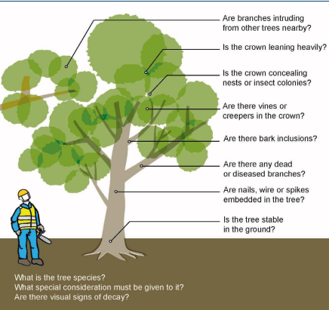
Figure.3.6 Tree lean

Self-check 3 | Written test

Name…………………………………………… ID………………………… Date…….
Directions: Answer all the questions listed below.

Test I: Choose the correct answer(2 points)
1.From the following whichone is/are tending operation?
      - Weeding
      - Thinning
      - Pruning
      - All
Test II: Short Answer Questions (8points)
- What is tending operation?
- Write the two major needs of tending operation?
- What are the objectives of weeding?
- Explain the objectives of thinning?

Note: Satisfactory rating - 10 points Unsatisfactory - below 10 points
You can ask your teacher for the copy of the correct answers

Operation Sheet -3
  - Tree pruning
A. Tools and Equipment’s
- PPE
- Secateurs
- loppers
- handsaws
- telescopic pruning
- Tree
B. Steps of tree pruning
1. Make deep cut underneath the branch at about 30cm up the branch
2. Move the branch and make a second cut completely through the branch from above
3. Cut slight angle away from the main stem just outside the collar and BBR
4. Take care to the bark tear the remainder of the branch comes away from the main stem

3.2 Thinning;
A. Tools and Equipment’s
- Chainsaws
- Handsaws
- Axes
- GPS
- Meters
- Ropes
- Paint/marker
- PPE
B. Methods of thinning
1) Mechanical Thinning (systematic);
      - Carried out the first and second thinning at the age of 4 and 8 years respectively.
      - Reduce the tree stock from 2500 per ha to 1250 per ha after first thinning and then to 650 trees per ha after second thinning.
      - Use the spacing 2m x 2m in to about 2.85 m x 2.85m in for first thinning and then ultimately to 4 m x 4m in for second thinning
      - Mark tree individuals recommended for removing depending up on the given spaces
      - Cut the marked tree
2) Ordinary Thinning (selective thinning);
      - Remove the lower crown classes suitable for area where there is no danger of soil deterioration.
      - Mark or paint trees which are dead, dried, infected, lean or expected as unsuccessful for the production
      - Remove trees infested with climbers and where there is risk of crown fire.
3) Crown Thinning;
      - Mark the best tree individuals
      - Retain the dominated and suppressed stems unless they are dead, drying or diseased.
      - Remove the less promising one in the interest of the best individuals;

LAP TEST-3 | Performance Test

Name…………………………… ID…………………… Date…………………………………….

Time started: ________________________ Time finished: ________________

Instructions: Given necessary templates, tools and materials you are required to perform the following tasks within 5hour. The project is expected from each student to do it.

Task-1 perform tree pruning
Task-2 perform forest thinning

LG #27 | LO #4- Record, document and report

Instruction sheet
This learning guide is developed to provide you the necessary information regarding the following content coverage and topics:
- Identifying and reporting problems
- Recording and documenting all field forest tree seedlings, planting and tending activities
- Reporting problems and hazards information
- Recording and reporting work outcomes

This guide will also assist you to attain the learning outcomes stated in the cover page. Specifically, upon completion of this learning guide, you will be able to:
- Identify and report problems
- Record and document all field forest tree seedlings, planting and tending activities
- Report problems and hazards information
- Record and report work outcomes
Learning Instructions:
- Read the specific objectives of this Learning Guide.
- Follow the instructions described below.
- Read the information written in the information Sheets
- Accomplish the Self-checks
- Perform Operation Sheets
- Do the “LAP test”

Information Sheet 4

  - Identifying and reporting problems
4.1.1 Some health and safety issues for tree planters
Tree planters face a variety of physical, biological, chemical, ergonomic and safety hazards. These include:
- Insect bites or stings.
- West Nile virus (mosquitoes).
- Lyme disease or rocky mountain spotted fever
- Rabies.
- Allergic reaction to plants.
- Exposure to bird or rodent droppings:
- Exposure to chemicals.
- Risk of pain or injury from working in awkward positions, performing repetitive tasks or lifting.
- Risk of injury from hitting a hidden rock with a shovel.
- Exposure to extreme temperatures or other extreme weather conditions.
- Driving - vehicle safety hazards.
- Slips, trips and falls.
- Working with chainsaws and other tools/equipment.
- Stress.
- Working alone.
- Extended work days.
4.1.2 Preventive measures for tree planters
- Learn safe lifting procedures.
- Keep tools and equipment in good working order.
- Use appropriate personal protective equipment (PPE) for the task.
- Wear appropriate footwear.
- Avoid awkward postures and repetitive manual tasks, or take frequent breaks.
- In the warmer months, cover up for protection from sun, heat and insects.
- Stay hydrated.
- In vehicles, always wear a seatbelt.
4.1.3 Good general safe work practices
Use safety procedures for:
- Safe lifting
- Selection, use, maintenance and storage of PPE
- Working with pesticides and other substances
- Using chainsaws and other tools or equipment
- Know how to report a hazard.
- Follow good housekeeping procedures.

  - Recording and documenting all field forest tree seedlings, planting and tending activities
Proper labeling and record keeping are required in order to keep track of species and seedling batches produced. This is particularly important when several provenances or cultivars of the same species are planted in the plantation area. The minimum information required includes:
- Species name and provenance, source of seedlings (e.g., who produced seedlings, name of seedlings planters).
- Date of planting.
- Number or quantity (in number) of seedlings planted.
- If unavoidable: date of pricking out.
- Type and size of containers.
- Substrate used.
- Any treatment given during nursery period – such as fertilizer (when, which, how much), shade (density), pest and disease control (when, which pest/disease, which method used, product name, concentration).
- Date and number of seedlings damaged and reason (e.g., diseased, damaged, bad development).
- Date and methods of tending activities done
- Materials and tools used for tending activities
- Methods applied for pruning and thinning activities
- Season at tending activities done
- Simple entries in a plantation area logbook are sufficient, although a variety of computerized systems have been developed that may be more convenient if a large number of tree species are being planted.

  - Reporting problems and hazards information
Any actual or potential health and safety hazards should be reported immediately to supervisor. Do not need to wait for an inspection team to come by.Health and safety legislation requires workers to report hazards to supervisor. Reporting health and safety hazards to health and safety committee or representative is necessary option.

The immediate hazard reporting process allows workers to report hazardous conditions or practices as they notice them. This procedure allows for prompt reporting and steps can be taken to control the hazards without waiting for the next round of regular inspections.Hazards can be reported verbally, electronically or by filling out company specific forms that should be available at bulletin boards or other conspicuous places. Asking supervisor, or health and safety committee or representative if there is a formal process for reporting hazards is better. If supervisor, health and safety committee or representative, and union fail to respond to hazard report, may contact the government department responsible for occupational health and safety for region for further guidance is also another option. However, before contacting a government department, trying to resolve concerns internally is encouraged.

Table 4.1 Hazard reporting form.
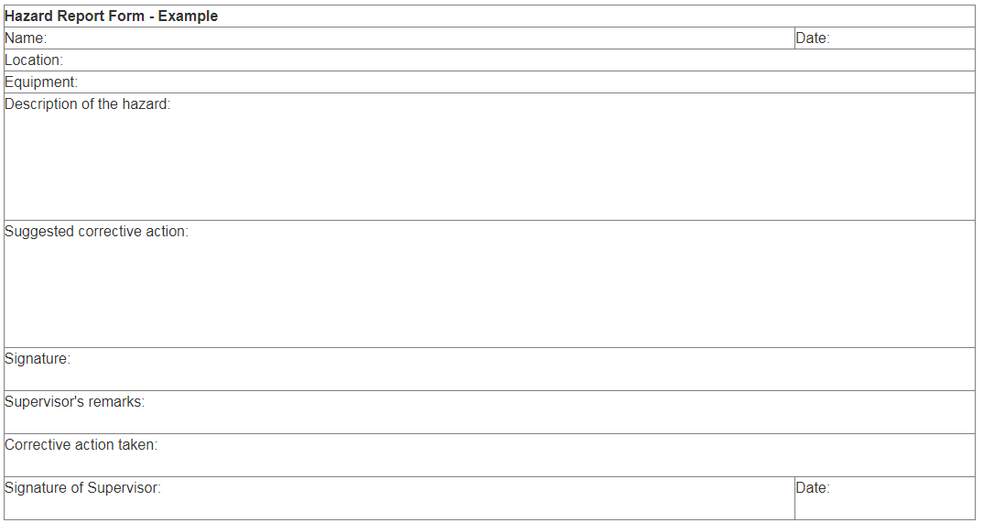

  - Recording and reporting work outcomes
4.4.1 Benefits of recording outcomes
A key benefit of recording outcomes is clarity of purpose with a shift from focusing solely on what is going to be done to why. This means starting by identifying the desired outcome, and working backwards to consider the who, what, when and where. Recording outcomes and sharing documentation with individuals, can flush out mistaken assumptions about the purpose of involvement. There should be space to record differences of opinion and the record can be used as a negotiating tool over time. In some cases an individual may wish to sign overall agreement with their plan whilst wishing specific areas of disagreement to be noted. A clearly recorded plan of outcomes should be worded in a way that is meaningful to the individual.

4.4.2 Reporting tools
The report has been pre-populated with key pieces of information to make it as easy as possible to complete. Upon signing into the report the following fields are already completed:
- Organization & Program Name/Description
- Program Contact & COR Report Contact
- Funding Contact
- Program Area
- Funding Amounts (as per program funding agreements)
- Mandatory or assigned outcomes and indicators
Many of these fields will be asked to confirm if the information is still accurate, and if not, it will give the opportunity to update it. Some of the fields do not allowmaking any updates.

Self-check 4 | Written test

Name…………………………………………… ID………………………… Date…….
Directions: Answer all the questions listed below.
Test I: Choose the correct answer (2 points)
- From the following one is/are report tool?
  - Program Contact & COR Report Contact
  - Funding Contact
  - Program Area
  - All
Test II: Short Answer Questions (6points)
- What are the benefits of recording outcomes?
- Write the minimum requirements of recording and reporting tending activities?
- Explain some health and safety issues for tree planting?

Note: Satisfactory rating - 8 points Unsatisfactory - below 8 points
You can ask your teacher for the copy of the correct answers

Operation Sheet -4
  - Recording and reporting tree planting outcomes
- Tools and equipment’s
- Over all
- Note book
- Pen and pencil
- Digital camera
- Methods of recording and reporting tree planting outcomes
    - Determine the Cause of tree planting. Hence, outcome reports can be of various types. This type is determined based on the objective of your report. For instance, if you want to determine the outcome of a tree planting then you need to make a plantation outcome report. Before you start writing the report, think carefully about the goals that you want to achieve through the report.

    - Take Records during tree planting. To make a report, an important task is to take records while the planting activity is occurring. These records do not have to elaborate descriptions of the trees planting. Providing just enough information that you can use later to make the report is well. Take records of what is being discussed. This includes issues raised and the solutions provided to them, respectively, if any. Jot down or record using a recorder the main points of discussion during planting.

    - Provide the Summary. The first part of writing the report is to provide a summary of the planting or tending activities for which the report is being made. A person who does not have time to read the entire report thoroughly must be able to get a picture of the current status of the planted species through the summary of the status report.

    - Mark the Progress. There is no use of making an outcome report id the report is not able to show how much the individual, group or organization has progressed. The outcome report hence must include complete information on achievements, timelines and, most significantly, the milestones of your operation. Operation milestones are the fulfillment of duties of great importance. These milestones function as a level of standard progress. During the scheduling phase of the plantation activities, what forms the specific milestones should be recognized.

    - Provide a Comparison. The outcome report must be able to show a comparison between the current status of the tree planted and the ideal status that the planted trees should reach. It should incorporate a contrast between what was effectively accomplished at a specific stage of your task and what was expected to have been accomplished. It should inform you if the planting is going according to plan, ahead of it, or behind it.

    - Do the Analysis. An assessment of the effect on the event should be produced and submitted in the outcome report for any variances recorded and reported between the goals and real achievements. It is also necessary to state the grounds for such variations in the study. This assessment is normally done with the help of analysis. The kind of analysis that you will perform will depend upon the type of outcome report you are making.

LAP TEST-4 | Performance Test

Name………………………………. ID…………………………….. Date…………………………………….

Time started: ________________________ Time finished: ________________

Instructions: Given necessary templates, tools and materials you are required to perform the following tasks within 1 hour. The project is expected from each student to do it.

Task-1 Record and report tree planting outcomes

Reference Materials

Evans.J. 1992. Plantation forestry in the tropics. Oxford University press, New York.
ILO. 1993. Planting trees, all illustrated and technical guide and training manual. Booklet No.7
Phil O’Callaghan, Frank Delahunty and Gaynor Baker. 2008. OH&S: A quick reference guide for broad acre agriculture. Publication No. 06/111. www.rirdc.gov.au.Accessed on December 2010
Phil O’Callaghan, Frank Delahunty and Gaynor Baker. 2008. OH&S: A quick reference guide for broad acre agriculture. Publication No. 06/111. www.rirdc.gov.au.Accessed on December 2010 Takele Tadesse and Mengesha Admassu. 2006. Occupational Health and Safety. www.cartercenter.org/resources/pdfs/health/ephti/library/lecture_notes/env_health_sci.org/resources/pdfs/health/ephti/library/lecture_notes/env_health_sci.
Toni Rosenbaum. 2005. Effective Communication Skills. Ithaca, New York 14853-5701. www.clrp.cornell.edu.
Vinod,K. . Nursery and Plantation Practice in Forestry, IFS
Yemiru. T and Abram, Plantation Establishment and Management Hand out (unpublished material)

AKNOWLEDGEMENT
Ministry of Labor and Skills wish to extend thanks and appreciation to the many representatives of TVET instructors who donated their time and expertise to the development of this Teaching, Training and Learning Materials (TTLM).

The experts who developed the learning guide
No |  | Name | Qualification | Educational background | Region | Phone number | E-mail
1 |  | Korme Tusuru | MSc | Biodiversity and conservation Management | Oromia | +251916145234 | bilisumakorme@gmail.com
2 | Gelasa Tola |  | MSc | Biodiversity and conservation Management | Oromia | 0920049614  0912061230 | tolagelasa@gmail.com
3 |  | Gezahegn Tadesse | MSc | Drainage and Watershed Management | Alage | 0968445006 | sihine29@gmail.com
4 |  | Geleta Bekele | BSc | Forestry | Afar | 0925482964 | geletabk12019@gmail.com
5 |  | Degarege Mitkie | BSc | Water Resource & Irrigation Engineering | South West | 0921281867 | mitkiedegarege@gmail.com
6 |  | Getnet Asmare | MSc | Production Forestry | Amhara | 0912846540 | getnetasmare40@gmail.com
7 |  | Kifle Tolossa | MSc | Soil Science | Alage | 0910895568 | kifletolossadechasa@gmail.com
8 |  | Tolessa Sori | MSc | Forest & Natural Management | South West | 0917007821 | tolosa.sori@gmail.com
9 |  | Yeshitila Wondosen | MSc | Climate change & Development | Benshangul Gumuz | 0911071229 | yeshiwondo@gmail.com
10 |  | Zeleke Dessie | MSc | Agroforestry | Oromia | 0911091388 | zelekedessie@gmail.com
11 |  | Ziyad Rube | MSc | Water Resource Engineering & Management | Afar | 0921484656/  0962639851 | yoomnaaf51@gmail.com

