Natural Resources Conservation and Development
Level – II

Based on March, 2022 (V- I) Occupational standard(OS)

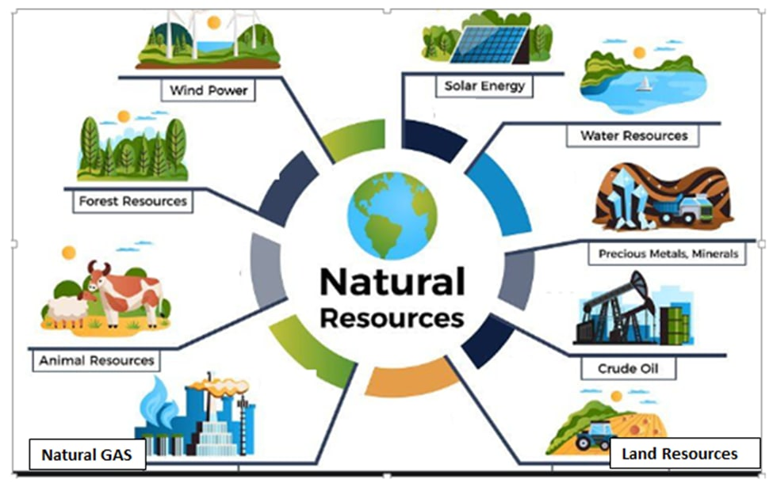

Module Title: -Conducting Agroforestry Practices
LG Code: -AGR NRC2 MO5LO (1-6)LG (20-25)
TTLM Code:AGR NRC2 TTLM 0922v1

September, 2022
Addis Ababa, Ethiopia
Contents
Introduction to the Module 1
LO #1- Classify Agroforestry systems 2
Instruction sheet 2
Information Sheet 1 3
Self-check 1 9
Operation Sheet 1 10
LAP Test 4 11
LO #2- Identify Agroforestry species 12
Instruction sheet 12
Information Sheet 2 13
Self-Check – 2 20
Operation Sheet 2 21
LAP Test 2 22
LO#3- Characterize traditional agroforestry potentials 23
Instruction sheet 23
Information Sheet 3 25
Self-Check – 3 29
LO#4- Apply Agro-Forestry technology for soil productivity and protection 30
Instruction sheet 30
Information Sheet 4 31
Self-Check – 4 41
Operation Sheet 4 42
LAP Test 4 43
LO #5- Identify and manage component inter-action in agroforestry system 44
Instruction sheet 44
Information Sheet 5 45
Self-Check -5 52
Operation Sheet 5 53
LAP Test 5 54
LO #6- Record and report information 55
Instruction sheet 55
Information Sheet 6 57
Self-Check -6 61
Operation Sheet 6 62
LAP Test 6 63
Reference Materials 64

Introduction to the Module
This module has six learning outcomes and each learning outcomes has their own instruction sheets, learning instructions, information sheets including their content and explanation, self-checks, operation sheets and lab test, the purpose of this module is to increase the knowledge, skill and attitude of trainees on agroforestry practices

LG #20 | LO #1- ClassifyAgroforestry systems

Instruction sheet
This learning guide is developed to provide you the necessary information regarding the following content coverage and topics:
      - Classifying of agroforestry systems
      - Components of agroforestry system
      - Benefits of agroforestry

This guide will also assist you to attain the learning outcomes stated in the cover page. Specifically, upon completion of this learning guide, you will be able to:
    - Classify Agroforestry systems
    - Identify components of Agroforestry systems
    - Know benefits of agroforestry systems

Learning Instructions:
- Read the specific objectives of this Learning Guide.
- Follow the instructions described below.
- Read the information written in the information Sheets
- Accomplish the Self-checks
- Perform Operation Sheets
- Do the “LAP test”

Information Sheet 1

  - Identifying Agro forestry systems based on components
Concepts of Agroforestry
Agroforestry is a collective name for land-use systems and practices where woody perennials (trees, shrubs, bamboos, vines etc.) are deliberately integrated with crops and/or animals on the same land management unit.
The cycle of AF system is always more than one year and even the simplest AF system is more complex ecologically (structural and functional) and economically, than a mono cropping system.
Basically, agroforestry involves the deliberate growing of trees and shrubs, collectively called woody perennials, on the same unit of land as agricultural crops or animals/pastures, in some form of either spatial mixture or temporal sequence.
Are AF systems the only that promotes tree planting? No
- There are:
- Social forestry isthe practice of using tree and/or tree planting specifically to pursue social objective, usually for betterment of the poor, through delivery of the benefits to the local community.
- Community forestry is a form of social forestry where tree planting activities undertake by a community on communal lands.
- Farm forestry indicates tree planting on farms.

Agro forestry systems based on components

Based on components agro forestry systems are classified in to three. Those are:

- Agro- silviculture systems: crops (including shrubs/ vines) and trees.
- Silvopastoral systems: pasture/ animals and trees.
  - Includes practices such as Forage hedges, Tree, shrubs and bushes for pasture; Integrated woody perennial and animal production, Protein bank etc…
- Agro- silvo- pastoral systems:crops, pasture/animals and trees
- Multipurpose woody hedges, Crop/animal/woody perennial mix around dwellings, etc… are some practices in this system.
Other systems: multipurpose tree lot, aqua-silviculture
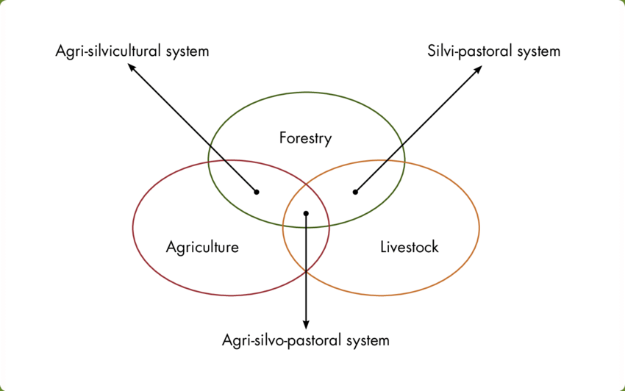
Figure 1.1 Component of agroforestry based on nature
    - Attributes of agroforestry
- Productivity (Output per unit of input) most if not all agroforestry systems aim to maintain or increase production.
Agroforestry can improve productivity in many different ways, this includes: increased output of tree products, improves yield of associated crops, reduction of cropping system inputs, and increased labour efficiency
2. Sustainability: by conserving the production potential of the resource base, mainly through the beneficial effects of woody perennials on soils, agroforestry can achieve and indefinitely maintain conservation and fertility goals.
Agroforestry can play a key part in enabling a farming system to produce crops and other products sustainably.
3. Adoptability: The word adopts here means accept (acceptance of the practice by the farming community). This implies that the merits of agroforestry systems are not only assessed in terms of production (quantities), but also based on the extent to which the resource base is sustained, and the practice is adopted by the local land users.
    - Identify agroforestry systems and practices
- Agroforestry practice
An agroforestry practice is a general term which would be used to describe land use practices with a tree component. Specific species need not be described. Agroforestry practices can usefully be broken down into those practices with a predominantly 'productive' or those with a predominantly 'protective' function.
- Agroforestry system
An agroforestry system is a cropping or livestock system which contains agroforestry practices. An agroforestry system describes the specific components (species, tools, management practices) observed on a particular farm and may require a detailed description of each. There may be many hundreds of different agroforestry systems but they can all be generally described by about 20 agroforestry practices.
The five major components from which agroforestry definition developed are the following.
- Land
- Environment
- Agriculture (livestock + crop) component
- Forestry component
- Management strategy

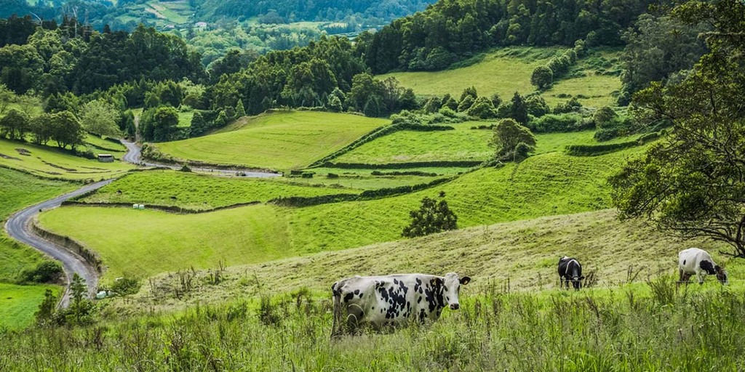
Figure 1.2.Component of agro forestry
  - Identifying Agro forestry systems based on benefit
This refers to the major function or role of the system, usually furnished by the woody components (these can be of a service or protective nature, e.g., windbreak shelterbelt and soil conservation)
- Socio economic basis
This refers to the level of inputs of management (low input, high input) or intensity or scale of management and commercial goals (subsistence, commercial, intermediate)
- Ecological basis
This refers to the environmental condition and ecological suitability of systems based on the assumption that certain types of systems can be more appropriate for certain ecological conditions; i.e. there can be separate set of Agroforestry systems for arid and semi arid lands , tropical low lands, highlands of humid.
- Production role
This implies that agroforestry systems have a productive function yielding one or more products that usually meet basic needs of local peoples or social objectives.
- Protection role
Protecting and maintaining the production of food, energy, shelter, raw materials, and cash, etc.
  - Identifying Agro forestry systems based on Arrangements
The arrangement of components refers to the plant components of the systemespecially if the system involves plant and animal components. Such plant arrangements in multispecies combinations can involve the dimensions of space and time.
  - Spatial arrangements
In agroforestry mixtures vary from dense mixed stands（as in home gardensto sparsely mixed stands （as in most silvopastoral systems）. In spatial systems, the association is primarily one of trees and crops together on the same land management unit. Spatial systems are divided into mixed and zoned.
In spatial mixed arrangements, the trees and other components are grown as intimate mixture, with the trees distributed over more or less the whole of the land area.
In spatial zoned arrangements, the trees are either planted in some systematic arrangement, such as rows, or are grown on some element in the farm, like field boundaries or soil conservation structures.
  - Temporal arrangement
Temporal arrangementof plants in agroforestry can also take various forms. An extreme example is the conventional shifting cultivation cycles involving 2 to 4 years of cropping followed by more than 15 years of fallow cycle when a selected woody species or mixture of species is planted or is allowed to regenerate naturally. In agrosilvopastoral systems, the association between trees and crops (or pastures) takes place primarily over time, although there may also be some degree of overlap.
The relative arrangement of the components can be taken as a basis for classification. The arrangement can be considered spatially:
- Densely mixed systems, such as home garden;
- Scattered mixed systems, such as tree on agricultural field
- Strip system, such as contoured wooded strips on bench terraces or terraces,
Edge systems; such as a line of trees bordering a grazing plot.

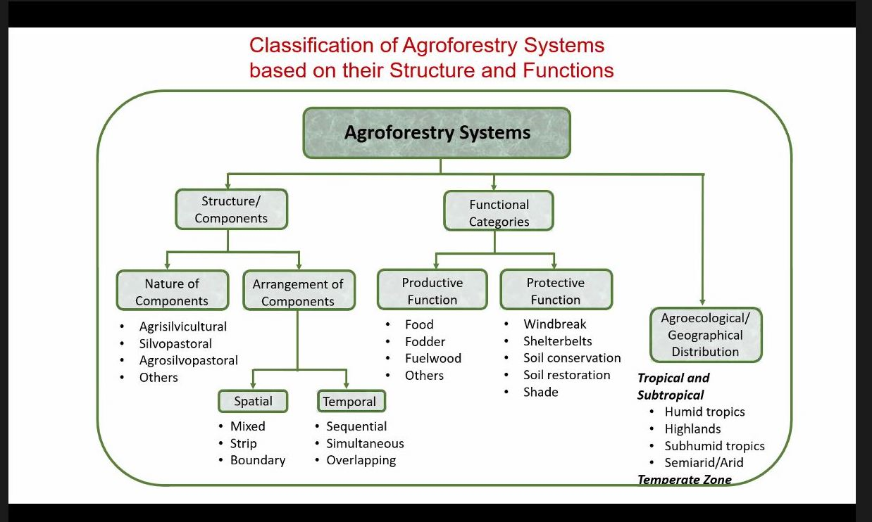
Figure 1.3 Classification of agroforestry on different basis

Self-check 1 | Written test

Name…………………………………………… ID………………………… Date…….
Directions: Answer all the questions listed below.

Test I: Choose the best answer (2 points each)
- Which one of the following is component of AF including tree with animal
    - Agri-silvicultural B. Silvo-pastural C. Agri-silvopastural
- ___________ is a collective name for land-use systems and practices where woody perennials are grown with crops and animals on the same land management unit.
A. Forestry B. Agroforestry C. Pasture D. wildlife

II. Match column “B”with column “A” (2pts each)
AB
- Agri-silvicultural A. windbreak, soil conservation, shade
- Silvo-pastural B. Fodder, food, fuel wood
- Agri-silvopastural C. Tree + agricultural crops + livestock
- Productive function of AF D. Tree + agricultural crops
- Protective function of AF E. Tree + livestock

Note: Satisfactory rating - 7 points Unsatisfactory - below 7 points

Operation Sheet 1

1.1 Identify component of AF system in your environment.
Materials, tools and equipment:
- Paper
- pen
- note pad
Procedure/Steps/Techniques
- Wear safety cloths
- Survey the environment and collect data.
- Identify the interactions.
- List the classification of AF and use of AF,

LAP Test 4 | Performance Test

Name: _____________________________ Date: ________________
Time started: ________________________ Time finished: ________________
Instructions: Given necessary templates, tools and materials you are required to perform the following tasks within 2hour.

Task 1- Classify component of AF system in your environment

LG #21 | LO #2- Identify Agroforestry species

Instruction sheet
This learning guide is developed to provide you the necessary information regarding the following content coverage and topics:
  - Agro-forestry species
  - Matching species with site

This guide will also assist you to attain the learning outcomes stated in the cover page. Specifically, upon completion of this learning guide, you will be able to:
  - Identify agro-forestry species
  - Identify matching species with site

Learning Instructions:
- Read the specific objectives of this Learning Guide.
- Follow the instructions described below.
- Read the information written in the information Sheets
- Accomplish the Self-checks
- Perform Operation Sheets
- Do the “LAP test”

Information Sheet 2

- Identify agroforestry species
The term agro forestry species usually refers to woody species and they have come to be known as multipurpose trees and shrubs (MPTs). In agroforestry there is significant interaction (ecological and economical) between the woody and the non woody components. There are three attributes which, theoretically all agroforestry systems posses, these are:
- Multipurpose trees (MPTs)
Multipurpose trees and shrubs are trees which make more than one substantial contribution as products or services function, to the land use system in which they are grown. High qualities of nitrogen fixing multipurpose trees are much more preferable for agro forestry systems. The selection of an agroforestry species depend on the following factors:
a. Agro ecological condition
b. The characteristics and growth requirements of the species
c. Objectives / purpose of agroforestry
- Agroforestry trees species
Trees used for agroforestry provide food, forage, industrial raw materials, lumber, fuel, and mulch, while diversifying diets and income.
- Desirable characteristics of agroforestry species
- Tree species selected should not interfere with soil moisture
  - Tree species selected for agroforestry should have very less water requirement
  - Should not compete with main agricultural crops for water.
  - Tree species should be deep tap rooted so that they can draw water from deep strata of the soil.
- Tree species should not compete for plant nutrients
  - Tree species should not utilize more plant nutrients
  - They should help in building soil fertility,
  - Leguminous tree species which fix atmospheric nitrogen in their roots should be prefer.
  - The root system and root growth characteristics should ideally result in to exploration of soil layers that are different to those being trapped by agricultural crops.
- Tree species should not compete for sunlight
  - Tree species should not interrupt sunlight falling on the crops.
  - Tree species should be light branching in their habit.
  - Trees permit the penetration of light into the ground and promote better crop, pasture growth and yield.
  - Tree species can withstand pruning operation if it posses dense canopy.
- Tree species should have high survival rate and easy establishment
  - Trees species should have high survival percentage,
  - Leave little or no gaps after transplanting.
  - Hardy tree species are easy to establish.
  - They have less mortality percentage because they can tolerate transplanting shocks easily.
  - Trees should have the ability to regenerate lateral roots within a short period of time after transplanting.
- Tree species should have fast growing habit and easy management
  - Tree species for agroforestry system should be essentially fast growing,
  - Rapid growth, especially in the early years,
  - Tree should have short rotation (the period between planting and final harvesting)
  - Fast growing species such as Poplar, Casuriana, Leucaena leucocephala etc. are important species which provide lot of opportunities to be planted in AFS
- Tree species should have wider adaptability
  - A tree species selected for agroforestry combinations must have a wider adaptability.
- Tree species should have high palatability as a fodder
  - Most of the Indian farmers rear livestock separately and cut and carry method of fodder production is quite prevalent.
  - Therefore, in agroforestry, farmer must select those tree species which are palatable to livestock and had a high digestibility.
- Tree species should have shelter conferring and soil stabilization attributes
  - Some tree species, because of their inherent growth habit and adaptability, are especially helpful in providing protection for soils, crops and livestock.
- Tree species should have capability to withstand management practice
  - Many agroforestry systems demand extensive pruning and lopping of the trees in order to maximize production. In such cases, the trees must be able to withstand such treatment without drastically restricting growth rate.
- Tree species should have nutrient cycling and nitrogen fixation attributes
  - Within an agroforestry system, trees can play an important role in recycling nutrients, leached down through the soil profile and minerals released from weathering parent material such as rocks and sediments.
  - Deciduous trees drop most of their leaves in autumn leaving a thick mat of leaves on the ground, whereas most evergreen species maintain some level of litter fall throughout the year.
- Tree species should have thin bark
  - Species selected for agroforestry combinations should not shed its bark regularly but it should retain for longer period as bark shedding creates unhygienic conditions for under-ground crop.
- Tree species should be free from chemical exudations
  - The species selected for agroforestry combination must be free from allelo-chemicals as these allelo-chemicals affect the growth of under-ground crops.
- Tree species should have easily decomposable leaves
  - The suitable tree species for agroforestry will be that one in which fallen leaves decompose with fast rate.
  - The leaves of most of the legume tree species are small in size, decompose quickly and easily, and add a large quantity of organic matter and nutrients to the soil.
  - Tree species having broad leaves such as teak, mango and banyan should not be preferred for agroforestry system.
  - They contain more fibre matter and also require longer time for decomposition. Further, broad leaves when fall on the tender crop plants, block their photosynthetic activities.
- Tree species should have their multiple uses
  - The selected tree species should have multiple uses.
  - The tree should yield more than one of the main produce like fuelwood, leaf fodder, edible fruit, edible flower and fibre.
- Tree species should have high yield potential
  - High yield potential is the most important criterion of selection of tree species for agroforestry systems as the main aim is to obtain overall more output per unit area. Care should be taken before collection of seeds and seedlings that they are being procured from reliable source.
- Characteristics of agricultural crops for agroforestry

    - Agricultural crops should be short duration and quick growing.
    - They should be at least partially tolerant to shade.
    - Most of them should belong to Leguminosae family.
    - They should respond well to high density tree planting.
    - They should bear some adverse conditions, like water stress and/or excess of watering;
    - Crops should return adequate OM to soil through their fallen leaves, root system, stumps, etc
    - Crops should appropriately be fitted in intensive or multiple cropping system.

The following are a few tree species which help in fixing atmospheric N through their roots:
Table2.1 Nitrogen fixing tree species
1. | Acacia albida | 21. | Bauhinia variegate
2. | Acacia auriculiformis | 22. | Butea monosperma
3. | Acacia catechu | 23. | Cassia fistula
4. | Acacia aneura | 24. | Cassia siamea
5. | Acacia dealbata | 25. | Casuarina equisetifolia
6. | Acacia decurrens | 26. | Dalbergia latifolia
7. | Acacia farnesiana | 27. | Dalbergia sissoo
8. | Acacia implexa | 28. | Delonix regia
9. | Acacia leucophloea | 29. | Gliricidia sepium
10. | Acacia mearnsii | 30. | Hardwickia binate
11. | Acacia melanoxylon | 31. | Leucaena leucocephala
12. | Acacia mollissima | 32. | Moringa oleifera
13. | Acacia nilotica | 33. | Oogeinia oojeinensis
14. | Acacia planifrons | 34. | Parkinsonia aculeate
15. | Acacia Senegal | 35. | Peltophorum ferrugineum
16. | Albizia chinensis | 36. | Pithecellobium dulce
17. | Albizia lebbek | 37. | Prosopis alba
18. | Albizia procera | 38. | Prosopis chilensis
19. | Alnus nepalensis | 39. | Prosopis cineraria
20. | Alnus nitida | 40. | Robinia pseudoacacia
41. | Samanea saman | 44. | Sesbania bispinosa
42. | Saraca indica | 45. | Sesbania grandiflora
43. | Sesbania aegyptica | 46. | Tamarindus indica

- Matching identified species with site
This Consider the possibilities and limitations in species selection for agroforestry includes indigenous species, exotics and species introduction, and genetic variation and tree improvement.
- Indigenous species
Indigenous species are species that grows naturally in the country concerned though not necessarily in all parts and certainly suited to all sites. With such species there are no political or quarantine problems and there are some important biological advantages.

  - Growths of natural stands provide some indication of possible performance in plantation.
  - The species is adapted to the environment and already filling an ecological niche.
  - The species even in monoculture are generally considered more ecologically valuable than exotics for conservation of natural fauna and flora.
- Exotic tree introduction
Majority of successful plantation for agroforestry in the tropics consists of exotics. There are several factors which can lead to great success if a careful choice of exotics is used.
- Ecologically an exotic tree are more free from pathogens and pests and also more vulnerable to serious, uncontrolled damage once they occur.
- Ecological consideration is the first priority to other factors when considering the tree selection in all agro forestry plantations planning work.
- Agro forestry species can be combined with agricultural crops/ animals and produce net positive effects.
- Tree species chosen to be grown with agriculture crops
- They should be able to tolerant a relatively high incident of pruning, that is, their photosynthetic efficiency should not significantly decrease with heavy pruning;
- They should have a low crown diameter to bole diameter ratio, that is, the width of their crown should be small, relative to the bole diameter;
- They should be tolerant of side shade, if indeed not of full overhead shade in the early stage of growth;
- Their phonology, particularly with respect to leaf flushing and leaf fall, should be advantageous to the growth of the annual crop in conjunction with which they are being raised;
- Their above ground changes over time in structure and morphology should be such that they retain or improve those characteristics which reduce competition for solar energy, nutrient and water;
- They should be efficient nutrient pumps.

- Characteristics of tree examined for agroforestry
              - Root characteristics
              - Bole Characteristics
              - Phonological Characteristics
              - Nutrition and water requirement
              - Shelter to insect pest and diseases
              - Crown characteristics
              - Growth characteristics

Self-Check – 2 | Written test

Name…………………………………………… ID………………………… Date…….

Directions:Answer the question below.

I. Choose the correct answer and encircle it (4pts)
1. The selection of an agroforestry species depend on
A. Agro ecological condition
B. The characteristics and growth requirements of the species
C. Objectives / purpose of agroforestry
D. All are correct answer
2. All are characteristics of crops for agroforestry except
A. Most of them should belong to Leguminosae family.
B. They should be shade intolerant
C. They should be at least partial shade tolerant
D. They should be short duration and fast growing
Test I: Short Answer Questions

1. What is the difference between indigenous and exotic tree species?(3pts)
2. Discuss characteristics of agroforestry species?(3pts)

Note: Satisfactory rating - 5 points Unsatisfactory - below 5 points

You can ask you teacher for the copy of the correct answers.

You can ask you teacher for the copy of the correct answers.

Operation Sheet 2

2.1Identifying Agro forestry species
Materials, tools and equipment:
- Paper
- pen
- note pad
- Camera
Procedure:
- Wear safety cloths
- Surveying the environment
- Contact the households exercising the system, manual of plant identification
- Record data
- Identify AF species in your environment

LAP Test 2 | Performance Test

Name: _____________________________ Date: ________________
Time started: ________________________ Time finished: ________________
Instructions: Given necessary templates, tools and materials you are required to perform the following tasks within 1:30 hour.

Task 1- Identify Agro forestry species

LG #22 | LO#3- Characterize traditional agroforestry potentials

Instruction sheet
This learning guide is developed to provide you the necessary information regarding the following content coverage and topics:
  - Characterizing traditional agroforestry potentials
  - Characterizing Agro forestry potentials based on farming practice
This guide will also assist you to attain the learning outcomes stated in the cover page. Specifically, upon completion of this learning guide, you will be able to:
- Characterize traditional agroforestry potentials
- Characterize Agro forestry potentials based on farming practice

Learning Instructions:
1. Read the specific objectives of this Learning Guide.
2. Follow the instructions described below.
3. Read the information written in the information Sheets
4. Accomplish the Self-checks

Information Sheet 3

- characterize agroforestry potentials
- Edaphic factors
The factors which relate to structure and composition of soil are called edaphic factors. Soil is very complex medium. A good fertile soil contains mineral matter (40%), organic matter (10%), water (15%) and air (25%). Mineral matter in the soil occurs in the form of particles. Soil can be studied under physical and chemical properties. Edaphic factors affect the organisms (bacteria, plant life etc.) that define certain types of ecosystems.
This committee classifies the highlands in to three main agro ecological zones. The main criteria considered are rainfall, altitude, and farming intensity.
- High potential perennial zone (HPP)
An ecological zone with warm, humid and length of growing period >240 days
- High potential cereal zone (HPC)
An ecological zone with intermediate climate and having length of growing period more than 180 days.
- Low potential cereal zone (LPC)
An ecological zone with high variability of rainfall, occasional drought and having length of growing period 90 – 150 days.
- Agro-pastoral and Pastoral Dry lands (arid and semi-arid lands)
This classification is based on the length of growing period (LGP) which is a function of such things as precipitation, evaporation, temperature and stored moisture in the soil. The farming system agro-ecological classification is a modern system of plant growth potential classification.

- Climatic factors
Generally speaking, our climate is defined by the complex interaction of all factors: the sun, earth, sea, air, ice caps of earth, wildlife and other life forms. Many climate phenomenon’s disrupt the climate
- Characterizing Agro forestry potentials based on farming practice
1. High potential perennial zone (HPP)
The high potential perennial zone is characterized by warmer and more humid climate with a growing period of more than 240 days. Many distinct land use systems with agroforestry features were identified in this zone.
a) Enset – Coffee – Cereal – livestock system (in areas of 1500 – 2500 m.a.s.l.)
- Hilly topography and intensive farming systems (labor and land) mostly found in Wolaita, Sidamo, Gedeo zones
- Hilly, extensive farming systems found in areas of Wolkite, Jimma areas
b) Forest – Coffee – Enset – Livestock system (1500 – 2000 m.a.sl.)
- Hilly, extensive farming systems found in areas of Jimma, Agaro, Bedele
- Enset – Barely – Livestock system (2500 – 3000 m.a.s.l.)
- Hilly, extensive farming systems in Gurage and Goffa highlands

Specific examples
Cereal/Enset/Livestock Bale mountains
Enset/Coffee/Livestock Sidamo Highlands
Enset/Cereal/Livestock Butajira, Hosaena, Sodo
Enset/Root crop/Coffee/Maize Wolaita Highlands
Enset/Livestock Gurage Highlands
Coffee/Cereal/Livestock Gofa Highlands
Coffee/Maize/Root crop/Enset Kaffa Highlands
Coffee/Cereal/Livestock West Highlands
2. In the High Potential Cereal zone (HPC)
The HPC zone can be characterized by an intermediate climate and usually with a growing period of more than 180 days. In this zone both crops and livestock production is important and the role of trees is minimal. Farmers tend to clear fell as they prepare land for agriculture as well as to meet wood fuel and timber requirement both for domestic and to sale as additional cash income. In this zone the role of cash crops such as fruits, coffee, chat etc. is minimal. Equally important is the lack of tree planting tradition in the zone.
The following agro forestry systems are evident in the land use system, namely:
- Scattered trees on agricultural lands (i.e. Acacia trees)
- Scattered trees on grazing lands (i.e. Acaia, Croton, Cordia, Albizia, etc.)
- Farm woodlots based on Taungya (i.e. Eucalypt woodlands)
- Beekeeping vis-à-vis crop lands
- Natural Fallow (not too short for tree regenertion)
- Chat/food crops/livestock system (agriculture in Harar mid-lands)
Specific agro forestry systems in this zone and areas of practice
- Mixed cereal – livestock system (1500 – 2500 m.a.s.l.)
7. Flat, intensive in areas of Rift Valley floor, parts of Arsi/Bale, Central plateau
8. Hilly, intensive farming systems in areas of Hararghe highlands, parts of central plateau, Bahir Dar, Mota
- Barely – livestock farming system (2500 – 3000 m.a.s.l.)
- Flat, intensive farming system in parts of Arsi/Bale areas
- Flat intensive farming system in parts of central plateau, Addis Ababa, Debre Birhan)
- Hilly, intensive farming systems in areas of Wollega, Debre Birhan, Debre Sina
12. Hilly, intensive farming system in Merto le Mariam area

3. Low Potential Cereal Zone (LPC)
The low potential cereal zone can be characterized by high rainfall variability and occasional drought and pest infestation (desert locust, armyworm, striga, weaver bird damages). The length of the growing period ranges from 90 to 150 days. This zone is further characterized by land degradation due to over cultivation, over grazing and deforestation. As a result, much of the ecology is man-made or induced by poor and bad farming practices without any use of agro forestry practices to protect the environment and maintain land productivity over the year. The two land use or farming systems of the HPC are also found here but the tree component has virtually disappeared from the land use system. Beekeeping or honey production is common but it is based on wild honey collection and not integrated with crop farming. The following agro forestry systems can be said to exist, namely:
- Trees/shrubs on soil and water conservation structures (terraces)
- Hillside afforestation with grass cut-and-carry
- Chat/food crops (wollo and Bahir Dar area)

Self-Check – 3 | Written test

Name…………………………………………… ID………………………… Date…….

Directions: Answer the question below
I. Choose the correct answer and encircle it (2pts each)
1. The factors which relate to structure and composition of soil are called ____________
A. Edaphic factors B. Chemical factor C. Organic matter D. Soil partcles
2. ________is a zone can be characterized by an intermediate climate and usually with a growing period of more than 180 days.
- High potential perennial zone (HPP)
- High potential cereal zone (HPC)
- Low potential cereal zone (LPC)
- Agro-pastoral and Pastoral Dry lands

II. Match column “B”with column “A” (2pts each)
A | B
1. High potential perennial zone (HPP) A. drought and have growing period 90 – 150 days.
2. Low potential cereal zone (LPC) B. warm, humid and length of growing period >240 days
3. High potential cereal zone (HPC)C. Arid and semi-arid lands
4. Agro-pastoral and Pastoral Dry lands D. intermediate climate with a growing period > 180 days
Note: Satisfactory rating - 6 points Unsatisfactory - below 6 points

LG #23 | LO#4- Apply Agro-Forestry technology for soil productivity and protection

Instruction sheet
This learning guide is developed to provide you the necessary information regarding the following content coverage and topics:
- Promotingdifferent Agroforestry practices
- Identifying Agroforestry technologies
- Practicing Agroforestry technologies

This guide will also assist you to attain the learning outcomes stated in the cover page. Specifically, upon completion of this learning guide, you will be able to:
- Promotedifferent Agroforestry practices
- Identify Agroforestry technologies
- Practice Agroforestry technologies

Learning instruction
1. Read the specific objectives of this Learning Guide.
2. Follow the instructions described below.
3. Read the information written in the information Sheets
4. Accomplish the Self-checks
5.Perform Operation Sheets
6.Do the “LAP test

Information Sheet 4

  - Promoting different Agroforestry practices

It has been stressed that major adverse effects of soil erosion is lowering of fertility and that is the main reason why measures should be taken for its control. The hazard of water erosion is at its most serious on slopping land as well wind erosion in the semi- arid zone, Level or nearly level land in the sub- humid and humid zones, there is no substantial erosion hazard, but frequently subjected to soil degradation or lowering of soil fertility through “ over- cultivation.
Agro forestry for control of erosion and fertility maintenance
Soil erosion is the cause of substantial lowering of crop yields and loss of production. The effect on yield is in general greater on tropical than on temperate soil .The major causes of such yield reductions are loss of organic matter and nutrient. Hence agro forestry practices, which combine maintenance of fertility with control of erosion/soil loss, are particular importance.
    - Effects of trees on soils

- Beneficial effects trees on soils
- Maintenance or increase of soil organic matter: This is proven and widely demonstrated, including through build-up of organic matter. One of the main avenues of organic matter addition to the soil by trees is believed to be through continuous degeneration of roots of live trees.
- Nitrogen Fixation: Some leguminous trees have shown the addition of nitrogen to the soil and have been proven through soil nitrogen balance studies and by observation of nodulation.
- Nutrient up take: This is probable, but has not been specifically demonstrated. The hypothesis is that, in general, trees are more efficient than herbaceous plants in taking up nutrients released by weathering of the deeper soil horizon, potassium, Phosphorus and micronutrients are released by rock weathering particularly in the B/C and C soil horizons into which tree roots penetrate. Thus nutrients in deeper horizons, which are unavailable to shallow rooted crops are taken up by deep root trees are recycled through litter decomposition and can be used by crops.
- Atmospheric inputs: It consists of nutrient dissolved in rainfall (wet-deposition) and those contained in dust (dry-deposition). However, it is difficult to determine what proportion originates from leaf leaching and from washing.
- Protection from erosion: Forest cover reduces erosion to low levels, primarily through ground-surface litter cover and under story vegetation. Trees and shrubs can also be employed, through proper planting arrangement and management, as effective barrier to control soil erosion.
- Enhanced nutrient-use efficiency: This is related to nutrient uptake. It is commonly supposed that tree-root system intercept, absorb and recycle nutrients on the soil otherwise be lost through leaching (e.g. the efficiency of mycorrhizal associate with trees on facilitating the up-take of nutrients).
- Biological methods of soil conservation would also be promoted.
The terraces would be planted with grass species (e.g. bana grass) and fruit trees to assist in their stabilization. Stall feeding for cattle and fodder crops would be encouraged.
      - Adverse effects of trees on soils
Trees can sometimes have a direct adverse effect on soil properties with consequences for crop performance. Such adverse effectsare,
- Loss of organic matter and nutrients in tree harvest
- Nutrient competition between trees and crops
- Moisture competition between trees and crops
- Production of substances which inhibit germination or growth.

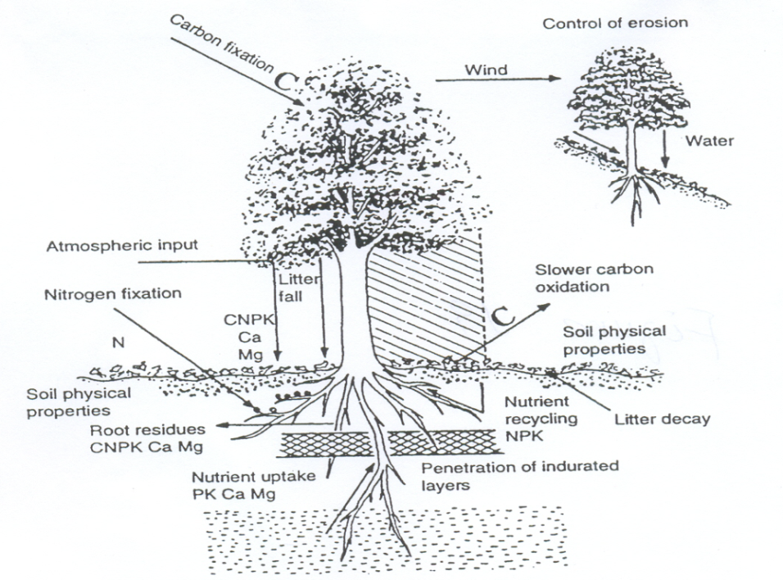
Figure 4.1 Schematic presentation of the processes by which trees can maintain or improve soils
  - Identifying Agroforestry technologies

- Contour hedgerows
This is a form of alley cropping adapted for planting on sloping land. The hedges are planted along the contour. The functions for soil conservation are:
- Cover effect of vegetation and by laying prunings on the cropped alleys.
- To reduce surface runoff, increase infiltration and reduce soil loss through their barrier effect.
- To develop terraces progressively, through the accumulation of soil upslope of hedgerows and stabilization of the risers by stems and roots.
- Trees on erosion control structures
i) Trees on grass strips
Where grass strips form an effective contour barrier to soil transportation, trees can be planted at intervals along the grass strip to increase productivity in fruit, wood, fodder or other products. The tree roots will further anchor the soil to deeper levels. Obviously you have to select carefully tree species, which will be compatible with the grass species, and the trees must not be planted too closely together or they may cause shading.
ii) Trees on ditch-and-bank structures
Many soil and water conservation structures employ a combination of ditches and banks. Such structures are suitable for tree planting for the same reasons as above.
iii) Trees on terraces
Trees can be planted on terrace risers. They are then either pruned or coppiced and serve the following multi-purpose functions;
- Stabilization of terrace risers, reducing the need for maintenance.
- Production of fuel wood, fodder or fruit
- Cover protection by canopy and by encouraging under storey growth.
This has a lot of potential in Ethiopia where wide scale terracing is going on. Additionally it must be emphasized that in dry climates the moisture capture by the terraces may be the difference between survival and mortality in any seedlings planted. So afforestation with terracing is mutually beneficial method of erosion control and multi-purpose tree establishment in dryland Ethiopia.
- Reclamation agroforestry
Physical and chemical constraints to plant growth severely limit the productivity of vast areas of land in the world. Water logging, acidity, aridity, salinity and alkalinity, and the presence of excessive amounts of clay, sand, or gravel are some of the constraints. According to an estimate 65 % (4,900 million ha) of the tropics is classified as ‘wasted’ because of these constraints.
Management options involving these species include:Planting or maintaining them either in block configurations for a few years, as in managed fallow systems planting them in association with crops in alley cropping or planting designs Establishing multipurpose trees (especially fodder and fuel wood species) for reclamation of severely eroded and degraded grazing land is another often-recommended technology.
- Wind break and shelter belt
Trees are planted in lines across the direction of damaging winds, to reduce wind erosion and wind or frost damage to crops. They can also provide shelter for animals in silvopastoral systems. There is no clear distinction in terminology, but windbreaks can usefully be considered as narrow, sometimes single-tree rows, while shelterbelts are wider than is necessary to achieve the shelter functions. These systems become agroforestry in the strict sense where the trees are managed for multiple purposes, over and above the shelter function.
Where wind is a major cause of erosion and moisture loss, windbreaks can a make a significant contribution to sustainable production. When properly designed and maintained, a windbreak reduces the velocity of wind, and thus its ability to carry and deposit sand. It can improve the microclimate in a given protected area by decreasing water evaporation from the soil and plants.
Generally speaking, trees mitigate the effects of climate. This is particularly noticeable in dry zones. The trees have an effect on the air and the wind, on the humidity of the air and the soil, and light and temperature. The following tree species are known to make good wind breaks: Balanites aegyptica, Acacia tortilis, Parkinsonia aculeata, Terminalia catapa, Dalbergia sisso, Acacia arabica, Acacia nilotica, Acacia senegal, Azandirachta indica, Leucaena leucocephala. The qualities of a woody perennial used in this way are:
- adaptability on the local site
- drought resistant
- tolerance to salinity
- resistance to wind, browsing, pests, and diseases
- ease of planting
- regular habit
- fast growing
- leaf retention for maximum period
- little development of creeping roots/deep rooted
- Production: wood, forage, fruits, etc.

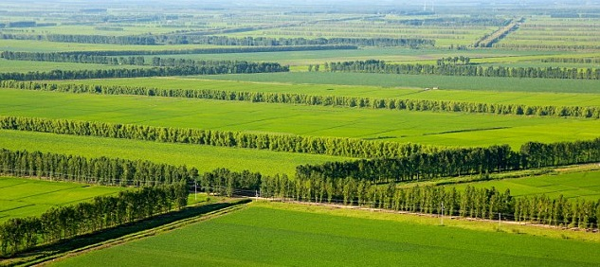
Fig4.2 wind break and shelter belt structure
- Alley cropping
Alley cropping, also known as hedgerow intercropping, involves managing rows of woody plants with annual crops planted in alleys in between. The woody plants are cut regularly and leaves and twigs are used as mulch on the cropped alleys in order to reduce evaporation from the soil surface, suppress weeds and/or add nutrients and organic matter to the top soil. Where nitrogen is required for crop production, nitrogen-fixing plants might be the main components of the hedgerows.
The primary purpose of alley cropping is to maintain or increase crop yields by improvement of the soil microclimate and weed control. Farmers may also obtain tree products from the hedgerows – including fuelwood, building poles, food, medicine and fodder – and on slopping land, the hedgerows and prunings may help to control erosion.
Ideally the MPTs used in alley farming should meet the following criteria:
- can be established easily
- grow rapidly
- have a deep root system with few lateral branches near the soil surface
- resistant to drought, flooding, soil variability, other climatic hazards
- have a light, open crown that lets sunlight through
- high above-ground biomass, particularly leaf biomass production
- foliage has moderate to high and balance nutrient content
- foliage has desirable quality for use as mulch or as green manure
- ability to re-sprout quickly after pruning, coppicing or pollarding
- contain no toxic or allopathic chemicals in shoots and roots
- provide useful by-products such as fodder, food, stakes, fuel wood and timber
- some degree of resistance to fire
- Are resistant to (and will not serve as hosts to) pests and diseases, particularly those of crops grown in the alleys.

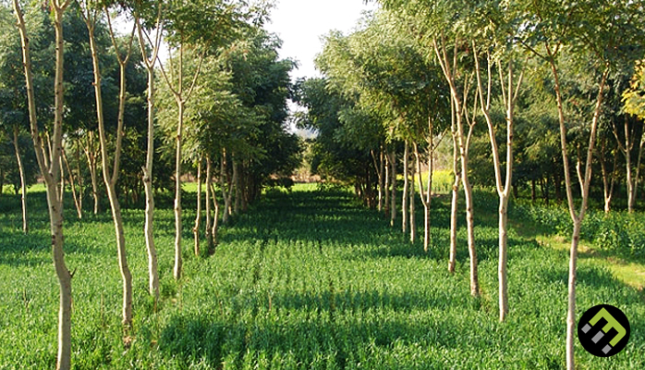
Fig4.3 Agricultural crops between hedgerows of tree and shrubs
- Ecological importance
This refers to the environmental condition and ecological suitability of systems based on the assumption that certain types of systems can be more appropriate for certain ecological conditions; i.e. there can be separate set of Agroforestry systems for arid and semi arid lands , tropical low lands, highlands of humid. The variation here is dictated by differences in land location Environmental type, Agricultural production system, Socio economic and Ethnological differences. The management system also varies accordingly.
Agro ecological condition includes: climate, soil, physiography, and biotic factors. The species selection first must be adapted to the site condition. The climate, soil, and biotic factors affect the growth and performance of trees shrubs and other forms of vegetation directly while the physiographic factors affect the climate and the soil thus affect the vegetation From the point of view of selecting species for various agroforestry systems, several climatic parameters should be considered, such as annual rain fall, humidity, number of rainy days, mean minimum and mean maximum with extreme range of temperature.
- Socio economic importance
This refers to the level of inputs of management (low input, high input) or intensity or scale of management and commercial goals (subsistence, commercial, intermediate)
It has been defined as a tree growing, production –oriented activity conducted with the purpose of providing forest based products for the direct benefit of the local community that take part in the activity. The basic framework of the community forestry program is that any local community, through its active involvement and participation in a forest production activity is able to benefit directly from the produce that is made available.
Community forestry can take place on any piece of land, regardless of land use type. It is performed by the community at large (peasant associations, cooperatives and urban dwellers association), by schools and by individual farmers and families.
Agroforestry techniques involving planting multipurpose trees that are tolerant to these adverse soil conditions have been suggested as a management option for reclamation of such areas. For example, several genera of economically useful trees have been identified as capable of growing in saline-alkaline conditions, including Casuarina, and Prosopis. Acid tolerant trees and shrubs useful for agroforestry include Gmelina arborea, Erythrina spp. Tree species potential for soil amelioration in salt-affected soils include Acacia nilotica, Acacia tortilis, Prosopis juliflora, Eucalyptus spp.
  - Role of Agro forestry technologies for soil productivity and protection
Agro forestry is a system in which woody perennials (trees and shrubs) are grown in association with herbaceous plants (crops and pastures) and/or livestock in a spatial arrangement, in which there are both Ecological and Economic interactions, between the tree and non-tree components of the system. Vegetation in Agro forestry has positive effects for soil conservation purposes, both in the detachment phase and the transport phase. Trees aid soil stability by a combination of rain fall interception, regulation of run off penetration, provision of ground cover and soil organic matters through litter production and by capturing and recycling leached nutrients carried by sub surface flow & reduce wind speed to reduce wind erosion.
    - Agro forestry practices important for soil conservation

a. Multi-storey cropping: - trees, shrubs and herbaceous plants are grown together in a dense intimate spatial mixture. There may be large number of plant species in combination such as timber trees, mango, maize, green tea, sugar-cane, and annual crops. Planting is done at any time, on an opportunistic basis when light is available. Multi story plantation practice makes the land more productive, improve soil fertility and reduce soil erosion.
b.Taungya- is the practice of growing crops on forest land and at the same time to establish inter-cropped trees. Intercropping continues for 1-3 years until competition from the trees (for light) prevents further growth of crops.
c. Alley cropping: - crops are grown in the space between rows of trees or shrubs. Tree/shrub rows are usually 4-10m apart and they are regularly pruned: pruning is either removed (for fodder and fuel wood) or retained on the soil. Alley cropping produces multipurpose biomass, increases soil fertility, reduces soil erosion, increases water storage within the soil profile.
d. Trees on crop land
This consists of trees (of faidherbia albida or Accacia albida and moriga olifera) grown on cropland in open, mixed spatial system. The trees may be planted or natural (i.e. left when the land was cleared).
e. Trees on pasture This is also called parkland system trees are grown on rangeland, in an open, mixed spatial system. The trees usually are natural & randomly spread. The tree provides shelter for grazing animals and often influences the soil and growth of grass beneath them.
Summary of Inventory of Indigenous agroforestry systems Results on agro ecology
There are thousands of specific agroforestry systems in the world , but only some major groups
- Humid Lowlands
  - Shifting cultivation
  - Taungya
  - Plantation crop combinations
  - Multilayer tree gardens
  - Interecropping systems
- Semiarid Lowlands
  - Silvopastoral systems
  - Windbreaks and shelterbelts
  - Multipurpose trees for fuel and fodder
  - Multipurpose trees on farmlands,
- Highlands
  - Soil conservation hedges
  - Silvopastoral combinations, Plantation crop combinations
    - Agro forestry practices for soil productivity

When trees are planted together with crops, more organic matter is added to the soil and the conditions for microorganisms and soil fauna are improved.

Self-Check – 4 | Written test

Name…………………………………………… ID………………………… Date…….

Directions: Answer the question below
- Choose the correct answer and encircle (4pts each)
- Which one of the following are agro forestry practices important for soil conservation
A. Trees on pasture B. Alley cropping C. Taungya D. All are correct
2. A crops grown in the space between rows of trees or shrubs is called____________
A. Taungya B. Alley cropping C. Intercropping D. Shifting cultivation

Note: Satisfactory rating - 4 points Unsatisfactory - below 4 points

Operation Sheet 4

4.1 Applying Agro Forestry technology for soil productivity and protection
Materials, tools and equipment:

- Paper
- Pen
- note pad
- hoe
- shovel
- spade
Procedure/Steps/Techniques
- Wear safety cloths
- Select site
- Prepare land
- Plant different seedlings for agro-forestry
- Managing the planted seedlings
- Construct ditch and cut-off drain
- Construct house in selected area

LAP Test 4 | Performance Test

Name: _____________________________ Date: ________________
Time started: ________________________ Time finished: ________________
Instructions: Given necessary templates, tools and materials you are required to perform the following tasks within 12hour.

Task 1- Apply Agro Forestry technology for soil productivity and protection

LG #24 | LO #5- Identify and manage component inter-action in agroforestry system

Instruction sheet
This learning guide is developed to provide you the necessary information regarding the following content coverage and topics:
- Interactions of Agroforestry components
- Managing Component interactions

This guide will also assist you to attain the learning outcomes stated in the cover page. Specifically, upon completion of this learning guide, you will be able to:
- Interactions of Agroforestry components
- Manage Component interactions

Learning Instructions:
- Read the specific objectives of this Learning Guide.
- Follow the instructions described below.
- Read the information written in the information Sheets
- Accomplish the Self-checks
- Perform Operation Sheets
- Do the “LAP test”

Information Sheet 5

  - Agro forestry component interactions

Component interaction refers to the influence of one component of the system on the performance of the other components as well as the system, as a whole. The interactions are mostly competitive between components for growth factors through roots (nutrient and water) and (radiant energy) intercepted through leaves. In practices it is difficult to separate above and below ground competition in agro forestry. Interaction between trees and none tree components in agroforestry system can be expressed as complementary, competitive or neutral.
    - Positive interactions
It is called Production-enhancing.
At the tree-crop interface
- Nutrient addition to the soil by trees: biological nitrogen fixation is inexpensive and environmentally sound manner for meeting the needs of nitrogen from the vast reserves of atmospheric nitrogen most important element in agricultural production. Nitrogen fixation takes place through symbiotic association of plant roots with nitrogen fixing microorganisms. Green leaf manure and root decomposition: fallen leaf, litter or cut incorporated, decomposes realizing humus and nutrients by the press of nutrient pumping.

    - Negative interactions
Negative (production-decreasing) interactions
                - A tree-crop interface
- competition for light
- Competition for nutrient
- Competition for water
- Allelopathy is a biological phenomenon by which an organism produces one or more biochemicals that influence the germination, growth, survival, and reproduction of other organisms. These biochemicals are known as allelochemicals and can have beneficial (positive allelopathy) or detrimental (negative allelopathy) effects on the target organisms and the community
B) At tree- animal interfaces
- Production of toxic subsistence by the fodder
- Mechanical damage of trees by animals
- Trees or shrubs harboring diseases or pests
- Deterioration of soil properties through compaction

Other common terms that can be used in component interaction are:
a) Commensalisms (+, 0) When one is benefited without affecting the other
b) Amensalism (-, 0): -when one affects the other without getting benefit
c) Monopolistic (+, -) when one is benefited but the other is affected
d) Inhibitory (-, -) when the two components affect each other
e) Synergistic (+, +) when both components benefit each other

  - Managing Component interactions
The magnitude of interactive effect between the trees and other components of agro forestry systems depends on: -
- The characteristics of the species
- Their planting densities
- The spatial arrangement
- Management practices
Manipulating densities and arrangements is probably the most powerful method for capitalizing on beneficial effects of trees while reducing negative ones .e.g. pruning, thinning, pollarding, lopping, fertilizer application, application of mulch and manure, and etc.
The different manipulations can be grouped as growth enhancing or growth reducing according to their effects on the targeted.
Table 5.1 Summery of different Management Option

Management options to achieve
1) Increased growth | 2) Decreased growth
- Microclimatic amelioration  - Fertilization  - Application of mulch /manure  - Irrigation  - Soil tillage  - Adapted species  - supplemental feeding | - Pruning  - pollarding  - Root pruning  - Trenching  - Excesses shading  - Herbicides  - grazing / harvesting

    - Management of Trees in Agroforestry/tending operations
The major role of tending operation in agroforestry is restoration of health co-existence among integrated crops of a given land use system. Because woody perennial usually have well structured and strengthened rooting and branching systems as compared to other adjoining systems, the negative influence comes from tree and shrubs.
- Pruning
It is an act of removing the branches wood perennial close to the stem and roots of woody perennial.
  - Pollarding can be exercised after the woody crop develop coppicing stem. In free grazing areas branches are pruned beyond the animal reach like in the Case of Acacia albida tree enter-crop. Such management practice enables farmers to provide fodder depending on the need.
  - Pruning is practiced in all AF systems.
  - Side pruning is practiced to maximize term growth, facilitate access to a passer by, and reduce competition for light and moisture against adjoining crops.
  - It is better practiced when the branch basal diameter is no exceeding l inch.
  - Pruning cuts are close to the stem and it is worth doing for quality tree species

- Thinning
In forestry, thinning is the selective removal of trees, primarily undertaken to improve the growth rate or health of the remaining trees.
- Low Thinning (German Method)
- High Thinning (French Method)

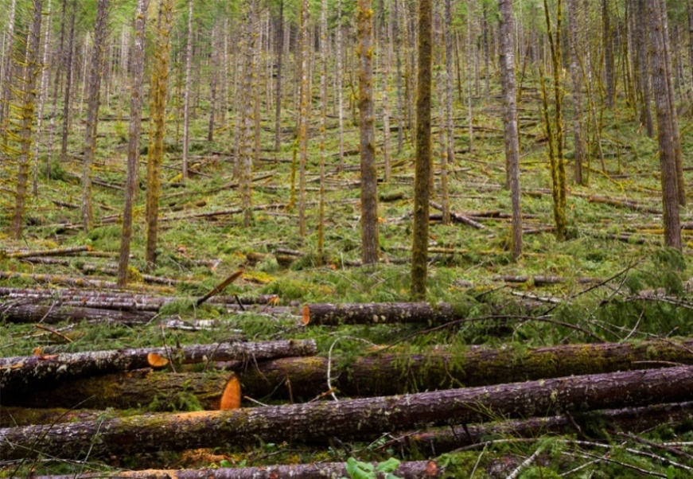
Fig5.1 tree thinning operation
- Lopping
It is removal of portion of branches of woody perennial.
- It may be practiced in AF systems.

- Coppicing is the woodland management technique of repeatedly felling trees at the base (or stool), and allowing them to regrow, in order to provide a sustainable supply of timber. It’s also called clear cutting system

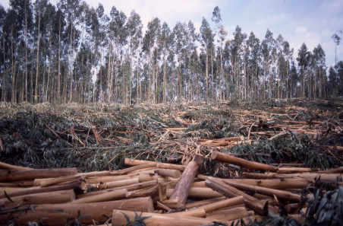
Fig5.2 Coppicing/clear cutting system

- Pollarding
- It is removal of the crown total.
- Pollarding occurs when the adjoining crop is in its pick growing period.
- It helps the adjoining crop by removing the shading effect.
- It is usually practiced in Agri-silvi-culture and agri- silvi-pasture systems.

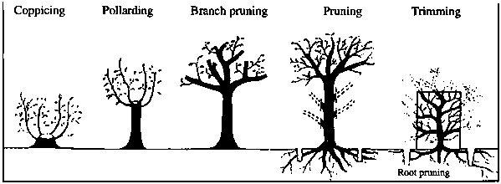
Fig5.3 different tree management operations
Note: The overall aim of component management practices in agro forestry system is to increase the production enhancing (positive) interaction and to reduce the production decreasing (negative) interaction
    - Occupational health and safety during tree management operation
- Communication: - A minimum of two people should be present during tree-climbing operations.
- Rescue/recovery equipment: - Equipment should be kept close to the work area for immediate use.
- First aid: - First aid should available for injuries associated with falls and cut injuries
- Local emergency services: - The local emergency services, for example available of ambulance
Self-Check -5 | Written Test
Directions: Answer all the questions listed below.
I. Match column “B”with column “A” (2pts each)
 | A |  | B
1. | Thinning | A. | Removal of the crown total.
2. | Pruning | B. | Removal of portion of branches of woody perennial.
3. | Pollarding | C. | An act of removing the branches wood perennial close to
4. | Coppicing |  | the stem and roots of woody perennial.
5. | Lopping | D. | Selective removal of tree to increase growth.
 |  | E. | Clear cutting system

II. Write the correct answer for the following questions.

- What are the magnitude of interactive effect between the trees and other components of agro forestry systems(4pts)
- What is the different between pollarding and lopping (2pts)

Note: Satisfactory rating - 8 points Unsatisfactory - below 8 points

Operation Sheet 5

5.1 Carryout Pruning, pollarding, thinning operations
Materials, tools and equipment:
- Paper
- pen
- note pad
- pruning shear
- chain saw,
- Meter
- Axe,
- digging hoe
Procedure/steps/techniques
- Wear safety cloths
- Select tree
- Conduct Pruning, pollarding, thinning
- Managing the conducted activities

LAP Test 5 | Performance Test

Name: _____________________________ Date: ________________
Time started: ________________________ Time finished: ________________
Instructions: Given necessary templates, tools and materials you are required to perform the following tasks within 2hour.

      - Carryout Pruning, pollarding, thinning,… activities

LG #25 | LO #6- Record and report information

Instruction sheet
This learning guide is developed to provide you the necessary information regarding the following content coverage and topics:
- Assessing all activities
- Documenting and reporting agroforestry component interaction
- Reporting problems or difficulties or hazards information
- Documenting and reporting work outcomes

This guide will also assist you to attain the learning outcomes stated in the cover page. Specifically, upon completion of this learning guide, you will be able to:
  - Assess all activities
  - Document and report agroforestry component interaction
  - Report problems or difficulties or hazards information
  - Document and report work outcomes

Learning Instructions:
      - Read the specific objectives of this Learning Guide.
      - Follow the instructions described below.
      - Read the information written in the information Sheets
      - Accomplish the Self-checks
      - Perform Operation Sheets
      - Do the “LAP test”

Information Sheet 6

  - Assessing all activities
This module provides an overview of agroforestry systems; it also describes how to identify the most appropriate agroforestry system and to design, adapt, establish and manage it. A section on the “enabling environment” is targeted primarily at policymakers, including national and local authorities.
Agroforestry systems can contribute to biodiversity conservation and climate-change. Participatory rural assessments, other means of collecting information on stakeholders, and market analyses can help community.
Agroforestry needs specialized extension services and support to farmers together with backing from farmers’ associations so that farmers learn that well-managed agroforestry practices are compatible and not in conflict with the aim of increasing agricultural production in the short and long term.
- Community reacts up on agroforestry activities
The adaptation or design of an agroforestry system is the process of choosing and arranging components spatially and temporally. Common components of an agroforestry system are: · Trees or other woody perennials – trees can provide fruit, fodder, wood fuel, timber and other products, as well as environmental services such as soil fertility replenishment, erosion control and carbon sequestration. Trees normally remain in a landscape for many years, with rotation lengths depending on species and desired end-products. · Crops or forage such as grains, tubers, roots, vegetables and even flowers. The rotation for crops is generally much shorter than for trees. · Animals – animals for dairy, meat and egg production, as well as fish, snails and other edible organisms. The most common agroforestry systems are: · Agrosilvicultural systems (crops – e.g. annual crops and vines – plus trees) - improved fallow - taungya - alley cropping - multilayer tree gardens - multipurpose trees in croplands - plantation–crop combinations - homegardens - trees for soil conservation and reclamation - shelterbelts, windbreaks and live hedges - woodfuel production. · Silvopastoral systems (trees plus pasture and animals) - Trees or shrubs on rangelands or pastures - Protein banks (blocks or lines of trees or shrubs established and managed for fodder production) - Plantation crops with pastures and animals · Agrosilvopastoral systems (trees plus crops plus pasture and animals) - homegardens involving animals - multipurpose woody hedgerows - apiculture with trees - aquaforestry-multipurpose,-woodlots.
Maintenance is needed to ensure that an agroforestry system functions effectively. Common maintenance practices include: seedling protection, weed control, pest control animal browsing, fertilization, irrigation, thinning, pruning, coppicing, harvesting post-harvesting operations.
Agroforestry systems are dynamic; their performance, and the impacts of outside factors, should be monitored.
  - Documenting and reporting Agro forestry component interaction and management
A written or printed paper is that bears the original, official, or legal form of something and can be used to furnish decisive evidence or information. Something, such as a recording or a photograph that can be used to furnish evidence or information.
Documentation plays a crucial role in any treatment setting. Documentation helps assure continuity of care. Thorough documentation helps to assist the farmers. It's important for practitioners, who may serve the community down the line, have proper information.
  - Reporting Problems or difficulties information
Supervisors, including department, shall be experienced, trained or knowledgeable in the safety and health hazards to which employees and students under their immediate direction and control may be exposed, and shall be knowledgeable of current practices and safety requirements in their field.
Department, staff and students shall have or be provided the knowledge to protect themselves from hazards in their working and learning environment. Supervisors, both department and staff, shall ensure that employees and students have received appropriate training and information regarding:
  - Documenting and reporting work outcomes
Documenting is an official paper or book that gives information about something, or that can be used as evidence or proof of something. In this case, documenting the information means, recording in an official paper about accurate information
Therefore, documenting of information is process of writing and retaining record of every step of ex-situ conservation and its recommended action. Finally reporting to responsible bodies
Report - is a statement of the results of an investigation or of any matter on which definite information is required. The following stages are involved in writing a report:
- clarifying your terms of reference
- planning your work
- collecting your information
- organizing and structuring your information
- writing the first draft
- Checking and re-drafting
Outline of a Report format
- Introduction, which:
- gives the background
- explains the purpose, scope and methods used
- outlines the terms of reference
It should be a brief, accurate background for the body of the report
- The body, which covers the work done and what you found. It’s divided into topics which are arranged in a logical order with headings and sub-headings
- Methodology – methods or procedure used
- Result and discussion – out puts of findings
- Conclusion covers the writer’s judgment based on information in the body of the report.
- Recommendations:
- gives solutions to the problems
- suggests possible courses of action as a result of the conclusions,
e.g. Who should take action?
What should be done?
When and how it should be done?
- Appendices- contain evidence which supports the report but is not essential because it’s either too long or too technical for the audience.
- Bibliography -includes all sources of information used in the report and often those used for background reading as well.
- Glossary- is an alphabetical list of special words, phrases and terms used in the report, accompanied by a short explanation of each.

Self-Check -6 | Written Test
Directions: Answer all the questions listed below.
I. Write the correct answer for the following questions.
- Discuss outline of reporting (8 pts)

Note: Satisfactory rating - 4 points Unsatisfactory - below 4 points
You can ask you teacher for the copy of the correct answers.

Operation Sheet 6

6.1 Recording data
Materials, tools and equipment:
- Paper
- Pen
- note pad,
Procedure/steps/techniques
- Wear safety cloths
- Develop format
- Record data day to day activity
- Compile information
- Report the finding
- Document

LAP Test 6 | Practical Demonstration

Name: _____________________________ Date: ________________
Time started: ________________________ Time finished: ________________
Instructions: Given necessary templates, tools and materials you are required to perform the following tasks within 2 hour.

Task 1- Record data on agro forestry practices

Reference Materials
Books:
Azene Bekele Tesemma. 1993. Useful Trees and Shirubs for Ethiopia. Identification, Propagation and Management for Agricultural and Pastoral communities.
________.2009. Training, Teaching and Learning Material (TTLM) on Applying Farm forestry Techniques for Natural Resource Development Technique, Soddo
Bashir Jama, Abednego Kiwia and Annah Njui. 2004. Market-oriented agroforestry: options and strategies for their dissemination in East and Central Africa. World Agroforestry Centre (ICRAF), Nairobi
Dechasa Jiru. 2006. Agro-forestry Training Manual. sustainable land use forum (SLUF) Part 2: Methods and Techniques for Improved Land Use (Unpublished)
Nair, P.K.R. 1993. An introduction to Agroforestry. Kluwer Academic Publishers, The Netherlands.
Young, A. 2002. Agroforestry for Soil Management. 2nd Edtion. CAB International, UK
Baumer, M. 1990. Agroforestry and Desertification. The Neatherlands.
FAO. 1978. Forestry for Local Community Development. FAO, Forestry Paper 7. FAO, Rome
Samra, J. and H. Eswaran (2000). Challenges in ecosystem management in watershed context in Asia. In:Lal, R.(Ed.) Integrated Watershed management in the global ecosystem. New York: CRS press
Surash, R. (2002). Soil and water conservation Engineering. New Delhi: standard publisher.
Chloe J.(2006). Introduction to agroforestry

Web addresses
“Tree for future
<http://www.plant-trees.org/>
“World agroforestry
<http://www.worldagroforestry.org/>
https://www.youtube.com/watch?v=jLZ0KtNx354 (access date August 30/2022) https://www.youtube.com/watch?v=q1IHqAZxLrc (access date August 29/2022)

AKNOWLEDGEMENT

Ministry of Labor and Skillswish to extend thanks and appreciation to many representatives of TVET instructors and respective industry experts who donated their time and expertise to the development of this Teaching, Training and Learning Materials (TTLM).

The experts who developed the learning guide
No | Name | Qualification | Educational background | Region | Phone number | E-mail
1 | Korme Tusuru | MSc | Biodiversity and conservation Management | Oromia | +251916145234 | bilisumakorme@gmail.com
2 | Gelasa Tola | MSc | Biodiversity and conservation Management | Oromia | 0920049614 | tolagelasa@gmail.com
3 | Gezahegn Tadesse | MSc | Drainage and Watershed Management | Alage | 0968445006 | sihine29@gmail.com
4 | Geleta Bekele | BSc | Forestry | Afar | 0925482964 | geletabk12019@gmail.com
5 | Degarege Mitkie | BSc | Water Resource & Irrigation Engineering | South West | 0921281867 | mitkiedegarege@gmail.com
6 | Getnet Asmare | MSc | Production Forestry | Amhara | 0912846540 | getnetasmare40@gmail.com
7 | Kifle Tolossa | MSc | Soil Science | Oromia | 0910895568 | kifletolossadechasa@gmail.com
8 | Tolessa Sori | MSc | Forest & Natural Management | South West | 0917007821 | tolosa.sori@gmail.com
9 | Yeshitila Wondosen | MSc | Climate change & Development | Benshangul Gumuz | 0911071229 | yeshiwondo@gmail.com
10 | Zeleke Dessie | MSc | Agroforestry | Oromia | 0911091388 | zelekedessie@gmail.com
11 | Ziyad Rube | MSc | Water Resource Engineering & Management | Afar | 0921484656  0962639851 | yoomnaaf51@gmail.com

