Natural Resources Conservation and Development Level-II

Based on March 2022, Version-1 Occupational Standard

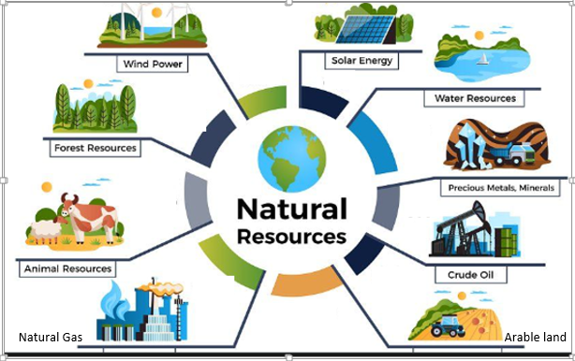

Module Title: -Apply in-situ Moisture Harvesting Technologies
LG Code: AGR NRC2 M02 LO (1-6) LG (4-9)
TTLM Code:AGR NRC2 TTLM 0922v1

September, 2022
Addis Ababa, Ethiopia

Table of Contents

Introduction to the Module 1
LO #1- Prepare for work 2
Instruction sheet 2
Information Sheet 1 3
Self-check 1 15
LO #2- Plan design requirements 16
Instruction sheet 16
Information Sheet 2 17
Self-Check – 2 27
Operation Sheet -2 28
LAP TEST-2 29
LO#3-Identify benefits &limitations of in-situ moisture Harvesting Technologies 30
Instruction sheet 30
Information Sheet 3 31
Self-Check – 3 35
LO#4-Design and implement in-situ moisture harvesting technologies 36
Instruction sheet 36
Information Sheet 4 37
Self-Check – 4 44
Operation Sheet -4 45
LAP TEST-4 47
LO #5- Manage and maintain in-situ moisture harvesting technologies 48
Instruction sheet 48
Information Sheet 5 49
Self-Check – 5 53
LO #6- Finalize work and report 54
Instruction sheet 54
Information Sheet 6 55
Self-Check – 6 57
Operation Sheet -6 58
LAP TEST-6 59
Reference Materials 60

Introduction to the Module
This module had six learning outcome and covers the learning guides from 4-9.This module covers the knowledge, skills and attitude required to identify, plan design requirement, designing, constructing and maintaining appropriate in-situ moisture harvesting technologies or micro catchments following the legislation and guideline.

LG #4 | LO #1- Prepare for work

Instruction sheet
This learning guide is developed to provide you the necessary information regarding the following content coverage and topics:
  - Identifying in-situ moisture harvesting technologies
  - Assessing ecological and socio-economic factors
  - Identifying Tools and equipment

This guide will also assist you to attain the learning outcomes stated in the cover page. Specifically, upon completion of this learning guide, you will be able to:
  - Identify in-situ moisture harvesting technologies
  - Assess Ecological and socio-economic factors
  - Identify tools and equipment required for in situ moisture harvesting
Learning Instructions:
- Read the specific objectives of this Learning Guide.
- Follow the instructions described below.
- Read the information written in the information Sheets
- Accomplish the Self-checks

Information Sheet 1

  - Identifying in-situ moisture harvesting technologies
    - Basic Conceptof in-situ Moisture Harvesting
Rainwater harvesting describes methods of collecting, storing and spreading various forms of runofffrom different sources for domestic, agricultural, etc uses. It is a deliberate collection of rainwater from a surface (roof/ground catchment) and its storage (soil and structural) to provide a supply of water.It is also a concept of rain fall concentration that multiplies the amount of rain falling on a cropped area by a factor greater than one. At the same time erosion will be controlled and fertility of the soil is managed.This concept differs from the practice of Soil and Water Conservationin which there is no rainfall multiplication and concentration. In soil and water conservation the multiplying factor = 1. Rainwater harvesting can be classified as in-situ moisture harvesting, macro catchment and flood water harvesting.
In-situ moisture harvesting systems using physical soil storage systems (micro catchment runoff farming or 'within-field' water harvesting systems) is a concept of rainfall concentration that multiplies the amount of rain falling on a cropped area by a factor greater than one.
Micro-catchments are normally within-fieldsystems since runoff comes from within thevicinity of the cropped area, where overlandflow harvested from short catchment lengthand the runoff stored in soil profile as shown in (Figure 1.1).
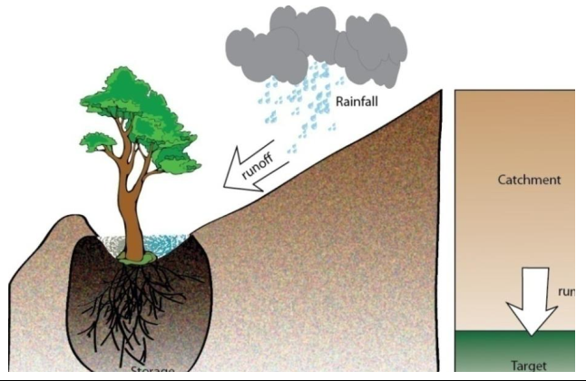
Figure 1.1.Runoff stored in soil profile
In design, a small portion of upslope land is allocated for runoff collection, which is "harvested" and directed to a cultivated area (run-on area or cropped area) down slope. The runoff within a field is directed either to single plants e.g. fruit trees, or to clusters of plants or row crops e.g. maize, sorghum or groundnuts.
The in-situ moisture harvesting for crop production is applied in arid and semi-aridregions where rainfall is either not sufficient to sustain a good crop and pasture growth or where, due to theerratic nature of precipitation and the risk of crop failure is high. So it is an ingenious way of improving the productivity of rain-fed agriculture in dry regions where conventionalmethods are unreliable.
The main aim of in-situ moisture harvesting is to minimize the runoff losses and to increase the available soil moisture for crop growth. The water retention within the field allows infiltration and thus results in better crop/forageyields.
    - Types of In-Situ Moisture Harvesting Technologies
There are several types of in-situ of moisture harvesting technologies. Among them the following are the major one.

- Ridges and Tie Ridging
- Micro Trenches
- Deep Trenches
- Micro Basins
- Eyebrow Basins
- Herring Bones
- Semicircular Bunds
- Runoff-Run-on Area Bunds
- Runoff-Run-on strips
- Percolation Pits

Ridges and tied ridges

Tied ridges are small rectangular series of basins formed within the furrow of cultivated ﬁelds mainly to increase surface storage and to allow more time for rainfall to infiltrate into the soil. This method is also known as furrow blocking, furrow damming or furrow diking. It is usually an activity to be performed as a normal cultivation operation. Suitable on area greater than 2%. The principle or purpose is to increase surface storage by first making ridges and furrows, then damming the furrows with small mounds, or ties. Making tied ridges manually is time and labor consuming and hence it is usually associated with mechanized farming.
There have been some attempts at achieving it with oxdrawn (Maresha attached ridge tier) implements, but the system really needshigh draught for speed and precision. Either ridging alone or tied ridging hasoccasionally been practiced using hand labor, but the high labor requirementusually makes this unpopular with subsistence farmers. Hand-made ridges areusually less efficient. They are more likely to depart from a true contour andto have variations in the height of the ridge, both of which will increase therisk of overtopping.
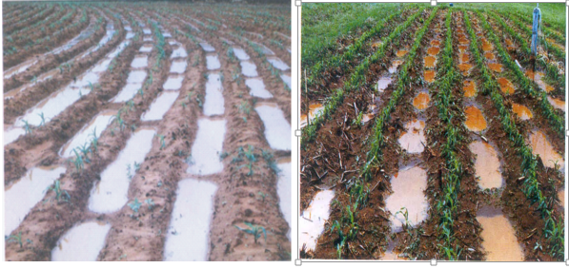
Figure1.2. Ridge and tied ridge
Applicable in cultivation land with gentle slopes. Availability of various cultivation equipment’s and the type of soil better mechanization can be adopted to areas where the volume of rainfall is small and variable. It requires a high value of soil storage, usually deep soils with good infiltration and permeability. Suitable mostly in semi-arid and arid parts of the country but also in medium rainfall areas with deep and well drained soils.

Micro Trench
Micro Trenches are pits constructed along the contours with the main purpose of storing rainfall water to support the growth of trees, shrubs, cash crops and grass or various combinations of those species in moisture stressed areas (350-900 mm rainfall). Trenches canhave flexible design, to accommodate the requirements of different species. Therefore, they can suit what the farmer want to grow. Trenchescollect and store considerable amount of runoff water, thus vegetation grows faster and vigorous.

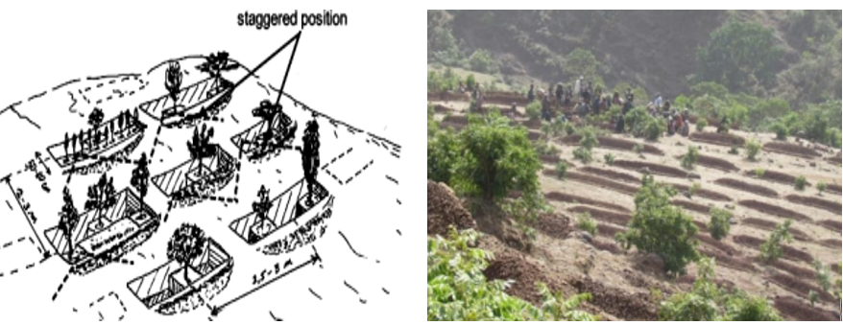
Figure 1.3. Micro Trench
They protect cultivated fields locateddownstream from flood and erosion. Part of the water captured by the trenches reaches the underground aquifer. Therefore, water tables arerecharged and supply springs and wells with good quality water and for a long period of time. There are various trenchesknown by shape and size such as circular, square or trapezoidal and small or large.
Suitable on hillsides where soil at least 50 cm deep and not too rocky (from 5-50% slopes); On abandoned lands that you wish to restore for growing tree/shrubs or other crops; On portions of forest land or closures that should be enriched; On homesteads for growing high value trees or other crops. Do not construct trenches in rocky areas and steep slopes above 50%. Highly suitable in many areas in the highlands to improve closures and plantations.
Smaller water collection trenches are also applicable in steep and degraded hillsides (max slope 100%) and for community closures. Can be combined with other measures such as hillside terraces, stone bunds, and trenches based upon soil, slope, and surface stoniness. Can also be applied inside large gully areas for tree planting.

- Deep trenches
Deep trenches :- are large and deep pits constructed along the contour with the main purpose of collecting and storing rainfall /runoff water to support the growth of trees, shrubs, cash crops and grass or various combination of those species in moisture stressed areas as well as they are ground water recharging structure. It is the most appropriate and effective moisture harvesting technologies selected and being practiced in the regions to minimize the prevailing and rapidly escalating land degradation and rehabilitate bare hillside.Simple or normal trench bund ormicro trench that was practiced in the past did not suffice /trap to deal with huge run off createdas the result of torrential rainfall with high intensity (rainfall falling in short period of time).
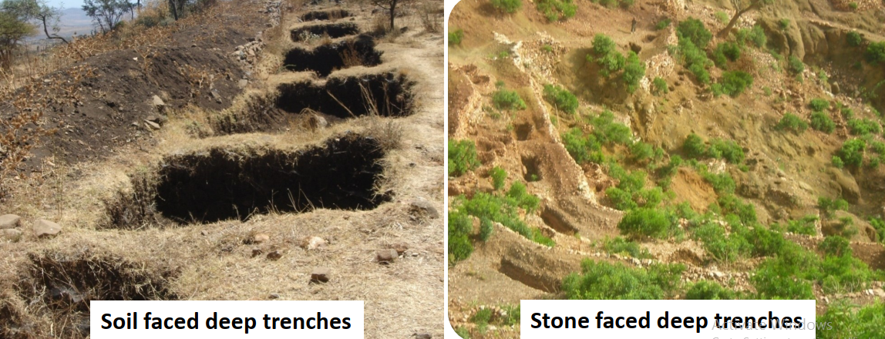
Thus, deep trench + soil bund is discovered to be the best technology for surface waterharvesting and contribute to raise the groundwater table for the use of hand dug wells, shallowwells, irrigation and domestic water supply.Two types of deep trench can be used as shown in (figure 1.4).
Figure 1.4.Soil and Stone face deep trench
- Micro basin
Micro basin is a small structure with the shape of a half or a full circle, excavated to obtain a small basin for planting a tree. It is vary in size according to their designation to conserve water; they are small in moist agro-ecological zones and large in dry ones.Micro basins are used in order to store precipitation water by collecting surface runoff.The collected rainwater is then used for direct irrigation or infiltration into the soil to enhance soil moisture and recharge groundwater. Also used for optimization of water use in agriculture, conservation of soil moisture, surface and groundwater recharge.They are mostly used for small scale tree and bush planting in areas with moisture deficit.
Suitable in degraded areas, mostly in semi-arid and medium rainfall areas with stony as well as shallow soils. Commonly practiced in dry and moist areas for the growth of trees and support to plantations in area closure. Applicable in steep and degraded hillsides (max slope 50%) and for community closures.
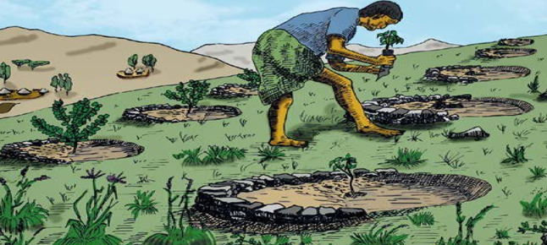
Figure 1.5. Micro basin
- Eyebrow basins (EBs)
Eyebrow basins or eyebrow terraces are larger circular and stone faced structures for tree and other species planting.Based upon experience they are effective in low rainfall areas to grow trees and harvest moisture. Can be constructed in slopes above 50% for spot planting. It controls runoff and contribute to recharge of water tables. If laid out and constructed in staggered arrangement significant reduction in runoff can be achieved.Suitable in degraded areas, mostly in semi-arid and medium rainfall areas with shallow soils. Commonly practiced in dry as well as moistareas for the growth of trees and support to plantations in area closure. Applicable in steep and degraded hillsides (max slope100%) and for community closures. Can be combined with other measures such as hillside terraces, stone bunds, and trenches based upon soil, slope and stoniness.
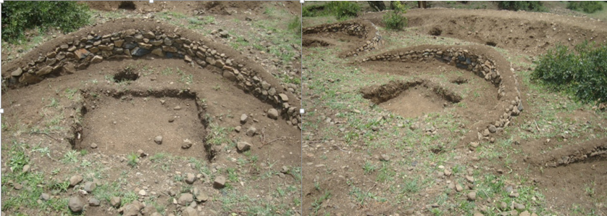
Figure 1.6. Eyebrow basin
- Herring Bones
Herring bones are small trapezoidal structures (called also A structures) for tree and another species planting. They are suitable for both dry and medium rainfall areas, and medium soil depth. Based upon experience herring bones are most effective in medium/low rainfall areas (500 - 900 mm).
Suitable mostly in semi-arid and medium rainfall areas. Not very common in Ethiopia but has possibility to expand in many areas, including pastoral areas for improving grazing reserves - can support the growth of different species.They can be constructed on slopes < 5% and soils > 50 cm depth.
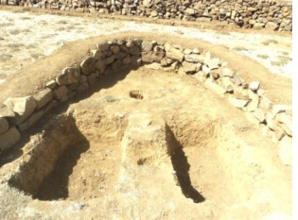
Figure1.7. Herring bone with two water collection

- Semi-circular bunds
Semi-circular bundsare earth embankments in the shape of a semi-circle and the tips facing directly up slope.They are createdat a spacing that allows sufficient catchment to provide the requiredrunoff water, which accumulates in front of the bund, where plantsare grown. They are usually placed in staggered position. These bunds, usually thesmaller sizes, are used mainly for the rehabilitation of rangeland orfor fodder production, but may also be used for growing trees, shrubsand in some cases field crops (e.g. sorghum). They vary dependingon the crop type, soil and the rainfall amount. When it is large, like0.5 ha food crops such as sorghum or millet can be planted. They aresuitable structures to enable cultivation of drought resistant crops inareas with very low rainfall. They also used as water/runoffspreading bunds too.
They are usually placed in staggered position.It is also suitable structures to enable cultivation of drought resistant crops in areas with very low rainfall. Semicircular bunds are suitable for arid and semi-arid areas (rangelands and degraded grazing lands) where annual rainfall ranges about 200 - 750 mm rainfall, deep soils and low slopes (2 -5%). It can be applied in areas with sandy and sandy loam soils affected by low fertility levels and thin surface crusts that inhibit infiltration and increase runoff.

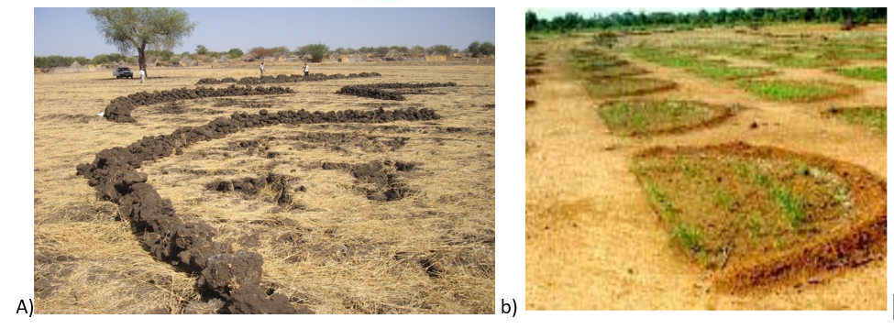Figure 1.8. a. Semicircular bund and b.semicircular bund with sorghum crop

- Runoff – Run on Area Bunds
Runoff - Run on area measures are micro-catchment systems in which surface runoff are collected from a small catchment area with mainly sheet flow over a short distance.These runoff harvesting or runoff farming systems are based on the utilization of surface runoff combined with natural rainfall, to grow crops. In these systems, the source of runoff is close to the cropped area and is also called as 'within-field' or 'on-farm' micro-catchment systems.
Runoff water is usually applied to an adjacent agricultural area, where it is either stored in the root zone and used directly by plants, or stored in a small reservoir for later use. The target area may be planted with trees, bushes, or with annual crops. The size of the catchment ranges from a few square meters to around 1000 m. The ratio of catchment (runoff)-to-cultivated area (run on) can range from 1:1 and up to 5:1. The selection of the C/CA ratio and design of structures may be modified taking into consideration farm size and various crop spacing. All the components of the systems are constructed inside farm/rangeland boundaries, and easily maintained and managed by the land users - controlled by the land users.

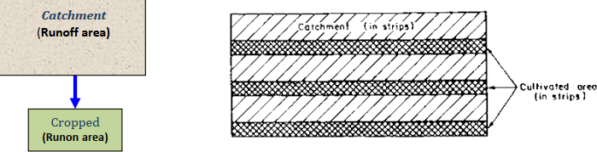
Figure 1.9.Illustration of Runoff -Run-on area and catchment –cultivated area ratio 1:1
The main characteristics of runoff-runon micro-catchment are:-
  - Overland flow harvested from short catchment length
  - Catchment length usually between 1 and 30 meters
  - Runoff stored in soil profile
  - Ratio catchment: cultivated area usually 1:1 to 3:1
  - Normally no provision for overflow and plant growth is even

- Run off strips
This technique is similar to contour strip cropping except that alternate strips are here used as runoff catchments. It also known as inter row rain water harvesting.The farm is divided into strips along the contour and an upstream strip is used as a catchment, while a downstream strip supports crops. The downstream strip should not be too wide for drier areas and the catchment width is determined in accordance with the amount of runoff water required. The technique of runoff strips is suitable in areas where rainfall is low and slopes are gentle. The strips are used to support field crops.Runoff strips are best for field crops such as cereals and legumes. It is common in pastoral areas of Ethiopia.

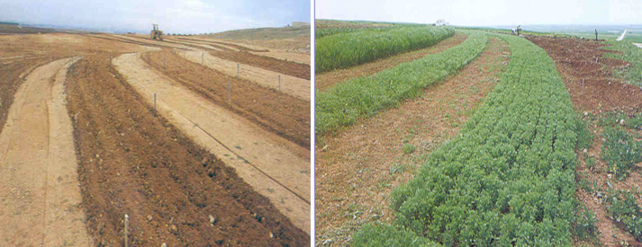
Figure 1.10. Run off strips
- Percolation pits
A percolation pit/percolation pond is a structure, constructed on any marginal land, pervious soil with the following objectives:-
  - Recharge, augment, replenish the groundwater so that the water can be harvested by digging hand dug wells, shallow wells, and boreholes too
  - Enhanced ground water availability for human and livestock use and irrigation
  - Enhances biomass production through improved water availability in the soil profile as water stored in the upper 1-3 m of the soil profile can sustain vegetative growth.
Reduce runoff and subsequently erosion and land degradation. Suitable in all areas where there is no drainage problem or where the groundwater table is deep and specifically:
  - It is suitable in areas where the ground is pervious
  - Can be constructed on any topography with adequate runoff; in series along waterways, marginal lands and gullies
  - It should be considered only as an element of an integrated watershed development

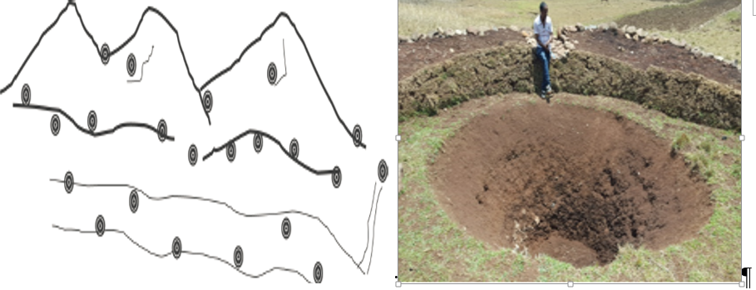
Figure 1.11. Percolation pits design and excavated pits.
  - Assessing Ecological and socio-economic factors
Assessment is the process of collecting the information about something we are interested to know. In this context, it consists of two components: the collection of background site factors, and an analysis into how these factors will shape the development and storm water management plan for a proposed site. Site assessment must be completed in the early stages of project design, and information gained from the assessment will be requested as part of the existing resources and site analysis.
Different in-situ moisture harvesting technology may requires different ecological and socioeconomic factors. Therefore assessment of ecological and socioeconomic factor are very important in order to select and install/construct it.
The required ecological factor are:
  - Topography:-this may include slope angle and length of slope
  - Climate:- Temperature, intensity and duration rainfall
  - While the socioeconomic factor affecting these technology are:-
  - Adaptation and adoption/acceptance of in situ moisture harvesting
  - Land tenure and water law issues
  - Land suitability and area differences
  - People’s demand and priorities for in-situ moisture harvesting
  - People’s experience with water harvesting
  - People’s participation and gender issues
  - Identify and prepare Tools and equipment
There are different materials, tools and equipment required during installation and maintenance of in -situ moisture harvesting.Some of the tools and equipment used for in-situ moisture harvesting are as presented in the following table.
Table1.1.Tools, their purpose and image

Tools | Purpose | Image
Pix axes | A tool for breaking hard surfaces, with a long wooden handle and a curved metal bar with a sharp point. | 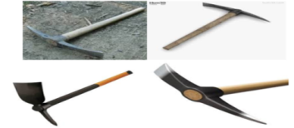
Shovel | Shovels are used for digging and lifting loose soil or other substances. | 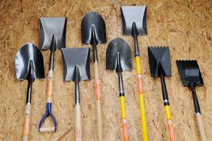
Meter | Used to measure distance between two points | 
Pegs | Used to mark appoint on the ground | 
Hammer | Used to install peg on the ground. It also used for driving and pulling out nails | 
Range pole | Used to layout contour or gradient line | 
Water level | Used to determine the point of the same elevation on the ground | 
Rope | Used to keep straight line between two points | 
A frame | Also used to mark contour like line level | 

Self-check 1 | Written test

Name…………………………………………… ID………………………… Date…….
Directions: Answer all the questions listed below.
Test I: Choose the best answer (4 points)
      - -----------is a small structure with the shape of a half or a full circle.
- Micro Trench
- Percolation pits
- Micro basin
- Eyebrow basin
      - Which of the following tools used to measure distance between two points.
- Ranging pole
- Rope
- Meter
- Spade
Test II: Short Answer Questions
- List at least 6 in –situ moisture harvesting Technologies? (3 points)
- List some of tools and equipment required for in –situ moisture harvesting Technologies? ( 1point)
- Mention ecological and socioeconomic factor the affect in-situ moisture harvesting? (2points)

Note: Satisfactory rating - 10 points Unsatisfactory – below 10 points

You can ask you teacher for the copy of the correct answers.

You can ask you teacher for the copy of the correct answers.

LG # 5 | LO #2- Plan Design Requirements

Instruction sheet
This learning guide is developed to provide you the necessary information regarding the following content coverage and topics:
  - Determining cost elements and work norm
  - Planning technical design requirements
  - Determine period of implementation across seasons

This guide will also assist you to attain the learning outcomes stated in the cover page. Specifically, upon completion of this learning guide, you will be able to:
  - Determine cost elements and work norm
  - Plan technical design requirements
  - Determine period of implementation across seasons
Learning Instructions:
- Read the specific objectives of this Learning Guide.
- Follow the instructions described below.
- Read the information written in the information Sheets
- Accomplish the Self-checks
- Perform Operation Sheets
- Do the “LAP test”

Information Sheet 2

- Determining cost elements and work norm
- Definition of terms
Cost element:-in this context it refers to the material and labor required to do in-situ moisture harvesting technology.
Work norm: Work norm is the jobs/work an individual person can do/complete per day. It may vary based on types of structure required and availability of the resourcesnearby.
- Cost element and work norm for Tied ridges
Implements for building tied ridges are tractors, oxen and ridgers to betrailed by tractor or oxen. For manual labor, hoe, shovels and pick axe are required. If it has to be done by hand it will take 20 person daysper ha. In Ethiopia, Mareshaattached tie ridging can be carried out by 2person days per person each having pair of oxen. Staggering of the ties alongneighboring furrows is required.
- Cost element and work norm for micro Trench
A-frame level or water hose level linked to 2 poles placed at 3mdistance. If not available use the normal water level hooked to astring linked to range poles placed at 5m distance. The required Tools are: crowbars, pick axes and shovels (1 crow bar: 2 pick axes: 2 shovels).
For all trenches work norm includes excavation of soil,embankment, compaction and digging of plantation pit (s).
Work norm= 2 PD/3 trenches per day. For trenches 5meters long and 2-3 ties/pits apply 1PD/trench/day.
- Cost element and work norm for micro basin
This mayinclude digging foundation,placement of stone raiser, cut and fill andsealing and plantation pit activities.
Thework norm=1 PD/5 MBs.
- Cost element and work norm for Eyebrow basin(EB)
Precise layout using A-frame or other level; Collection of stones from working site; Excavation of foundation and construction of stoneriser; Excavation of water collection area, cut and fill, plantation pit and sealing of stone riser. Work norm: 2 EB/person /day.

- Cost element and work norm for Herring bones(HBs)
Work norm includes precise layout (using A-frame or other level), excavation ofcollection ditch and planting pit, embankment building and compaction. Work norm: 4 HBs/Person /day.
- Cost element and work norm for Semicircular bund
Quantities of earthworks for semi-circular micro-catchments is indicated in below Table 2.1.

 | Table 2.1. For work norms, apply 1PD/0.5m³ earth work volume.
land slope |  | Radius (m) | Length of bund(m) | Impounded area per bund(m²) | earth works per bund(m³) | bunds in ha Earth work perha(m³)
Design “a” up to 1% slope |  | 6 | 19 | 57 | 2.4 | 73
Design “b” up to 2 % slope |  | 10 | 31 | 160 | 13.2 | 16
Design “c” up to 4 % slope |  | 20 | 63 | 630 | 26.2 | 4

- Cost element and work norm for Runoff run-on bund
Work norm is same with similar bunds. Work norm for Small Stone bunds, Narrow Stone Lines and Stone bunds with runoff-run-on measures = 250 PD/km, for Stone faced and Soil bunds = 150 PD/km are applicable.
- Cost element and work norm for percolation
Tools: crow bars, pick axes and shovels (1 crow bar: 2 pick axes: 2 shovels ratio, 1 crowbar). For all percolation pits work norm includesexcavation of soil, carting away the soil and use it for the embankment and its compaction (spillway if it is in the waterways). Work normis 12 to 15PD/ percolation pit/D including digging, gravel collection and backfilling.

- Planning Technical design requirements for in-situ moisture harvesting

- Definition of Planning
Planning: - can be defined as a process of setting up of goals and objectives for a given period of time, formulating alternatives for the course of action to be taken, and finally deciding an appropriate action from the various alternatives. Whereas technical design requirementis specific criteria regarding system parameters.

- Technical design requirement for ridge and tied ridges
The design question is when to go for drainage and when to go for storage. Gradedridges alone will usually lead to an increase of surface run-off compared with flatplanting, while tied ridges will decrease the run-off and increase the storage. Indifferent seasons either of these two effects may be preferable. The possibility ofhedging by tying alternate furrows is also possible. This would reduce the amountof damage by too much run-off or too much retention. In Ethiopia, within the RiftValley system, oxen drawn ridgers have been developed. Three safety back-upsare required to minimize the risk of damage by erosion:
- The furrows should be on gentle grade to assist runoff if the ties fail;
- The ties should be lower in height than the ridges so that the ties fail along the furrows before the ridges fail down the slope;
- There should be a back-up system of conventional graded channels terraces to prevent damage if the ridges do overtop or fail
Further Consideration during design
  - Height of the tie ridge can be 15 - 20 cm within a furrow depth of 20-30cm.
  - They are constructed in staggered position along neighboring furrows.
  - Row spacing and tying interval could range between 1 and 10m.
  - The steeper the slope, the higher the rainfall intensity and the lower the water holding capacity of the soil.
  - Row spacing and tying interval dependent on slope of the land, intensity of rainfall and water holding capacity of the soil.
  - Training and demonstration is needed on how to insert into the traditional implement

- Technical design requirementfor Micro Trench
- It can be constructed to grow 1 or up to 3 trees in each trench. The designs of the trench depend on the type of soil, rainfall, and thetype and position of trees
- Take advantage of the water harvesting effect of the trench by planting 1 fast growing tree and 1 or 2 additionalslow growing trees (which require less water);
- Catchment Area/Trench Area ratio CA/TA is 3-5:1 (based on rainfall and tree waterrequirements) – normally 2-3 meters distance between lines of trenches - ratio can vary depending on dryness;
- Trench with two treesplanted on pits dug in two ties;
- Trench with 1 tree planted in a tie and 2 trees on pits dug in front of trench;
- Trench with 2 trees plantedin two ties and 1 tree planted in front of the trench;
- They are constructed in staggered position one from another (triangle);
- No oftrenches/ha from 800-1200.

- Technical design requirement for Deep Trenches
In order to design the deep trench we have to follow the following steps:-
        - Determination of direct runoff volume:
Deep trenches are designed to hold part of the runoff from a storm of daily maximum rainfall. The volume of runoff from the design storm is estimated using the following equation.
Q = 10*C*R*A
Where; Q = Runoff volume in m³; C = runoff coefficient (from Rational Formula); R = Maximum daily rainfall in mm; and A = Watershed area (ha).
        - Determination of cross-sectional area and volume of deep trench + bund:
The cross-section of deep trench can be rectangular or trapezoidal. The size of the deep trench depends up on the soil depthavailable at the site and workmanship.In relatively deeper soil, depth of trench is generally fixed at 1m while for shallower soil; depth of trench may reduce to about 0.4 to 0.5m.As far as the length of deep trench is concerned 3m is adopted for convenience of layout and construction.
The length of the bund should be between 50 to 100m. In other way it can be also designed (considered the deep trench dimensions) based on the runoff volume you havecalculated in the Rational Formula or the above equation.
The horizontal water spread length resulted due to the construction of the bund can be determine at different length of the upstream sideusing the equation:Y = S*X/100; Where, Y = height of the bund or water rise at X=0 distance from bund; X = distance from the crest of the bund to thepoint where Y = 0; and S = Slope of the ground in %.
The size of bund includes its height (Y), top width, side slopes and bottom width. For evaluation of bund size, the height of it is fixed first.Normally, the height is half the vertical interval, with minimum height of 50 cm. This height is required in order that there is sufficientrunoff retention capacity on 0.3m effective bund height.
Once the height of the bund is determined, the other dimensions such as top widthand base width can easily be obtained. The height of bund mainly depends on the land slope, spacing of the bund and expected maximumrainfall intensity of the area. The excavated soil from the deep trench is used to make an embankment on the lower side and a berm of 10to 25 cm should be left between the embankmentand the edge of the channel /trench to prevent thesoil from sliding back.
Slope in % | Vertical interval ,fix bund height
3-8% | 0.7-1
8-15% | 1.1-2
15-30% | 1.2-1.7
30-50% | 1.7.2.0
Table 2.2.Vertical interval of two consecutive bunds

Initially, bund may not be compacted, and allow for compaction a 15 - 20% increase in height required. Therefore, if the design requires a 0.3cm height, the initial construction should be up to 50cm. Low points are to be avoided b/c they are points of frequent failure.
        - Determination of spacing:
Spacing is expressed in terms of horizontal (HI) based on the run off: run on area ratio of the expected excess runoff for deep trench. For soil bund the water surface profile computation to upstream of the bund is crucial in designing the spacing between two consecutive deep trench + soil bund. Therefore, the horizontal water spread length resulted due to the construction of the bund can be determined at different length of the upstream side using the following equation:
$$HI= \frac{Cross sectional area of deep triench+cross sectional of bund }{dxEffective Runoff depth }$$
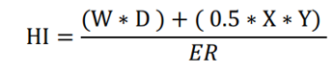
Where;
Y= effective height of bund in m
X= water spreading length in m
W= width of the deep trench in m
D= depth of the deep trench
HI=horizontal interval (spacing) between two consecutive deep trench + soil bund
ER=Excess run off depth in m
        - Determination of number of deep trenches:
To determine the number of deep trench to be constructed in a particular catchment area use the following steps and formulas
- Determine the space between two contour deep trench bund in section
- Determine the length of one row to be constructed in a ha
- Determine the number of rows expected in ha and the total number of row for the given catchment area
𝑁𝑜𝑜𝑓𝑟𝑜𝑤𝑠(𝑏𝑢𝑛𝑑) 𝑖𝑛 1ℎ𝑎 =$\frac{width of the area in m}{spacing of the bund in m}$
T𝑜𝑡𝑎𝑙𝑛𝑜𝑜𝑓 (𝑏𝑢𝑛𝑑) = 𝑁𝑜𝑜𝑓 (𝑏𝑢𝑛𝑑) 𝑖𝑛 1ℎ𝑎∗𝑡𝑜𝑡𝑎𝑙𝑎𝑟𝑒𝑎𝑖𝑛ℎ𝑎
- Determine the number of deep trench in one row
No of deep trench in one row =$\frac{length of one row }{(tie ridg length + length of one deep trench)}$
- Determine total number of deep trench to be constructed in a hanumber of deep trench in 1ha = number of deep trench in one row ∗ total number of rows in 1ha
- Finally determine number of deep trench constructed in the given total area
Total number of deep trench= number of deep trench in one row ∗ total number of rows or
Total number of deep trench = number of deep trench in 1ha ∗ total area in ha

- Technical design requirement for Micro basin
Different design types are possible, including half-moon, V-shaped, diamond-shaped, trapezoidal, aswell as contour bund basins. The height of theridges relies strongly on the slope and the size ofthe catchment.
Technical standard are:-
  - Diameter: range from 1 - 1.5 m
  - Stone riser: 0.2 m
  - Foundation and height: 0.2 - 0.4 m above ground based on slopes
  - Plantation pit: 0.4 m diameter x 0.5 m depth
  - Soil sealing: sealed with soil from cut area
  - Constructed in staggered position b/n rows and in rather close spacing within row in case of 1 m diameter basins

- Technical design requirement for Eyebrow basin
  - Size: 2.2 - 2.5 m diameter
  - Stone riser: stabilized by brushwood or life fence
  - Foundation: 0.2 m depth
  - Height: 0.4 - 0.6 m
  - Place larger stones on the back side (lower side) and smaller ones on the upper side so that space is effectively filled
  - Stone riser sealed with soil excavated from water collection area
  - Water collection area is dug behind the plantation pit: 1 m width x 1 m length x 20-25 cm depth (lower side)
  - Plantation pit (s) of 50cm depth x 40cm diameter dug between riser and water collection area
  - Water collection ditch can be placed sideways or in front of plantation pits depending on soil type
  - The distance between two EBs along the contour as well as consecutive rows of EBs is each 2.5 m
  - The area occupied by one semi-circular or EB at the runoff to planted area ratio is 4:1
  - With this kind of spacing there exists 800 EBs per hectare.

- Technical design requirement for herring bones
  - Spacing:the structures are placed 3m apart (max 4m in very dry places) along the contours and have extended arms conveying water towards the planting area.
  - A water collection ditch:(1m x 1m x 0.3 m depth at lower side) is dug behind the planting pit (40 cm diameter x 50 cm depth).
  - The tips of the extended arms are 2.5-3 m apart (average)
  - Embankment:Max. height down slope (0.4 - 0.5 m) and decreases to 20 cm at the end of the side arms.

- Technical design requirement for semicircular bund
  - Two distinct designs are used depending on whether the crop is a tree or a row crop. While the geometry of the bunds is the same, if the crop is cereal the diameter tends to be large and small for the case of a tree. For cereals they can be as large as 40m diameters and for forage and tree crops their size is 6-12m.
  - The space between tips of consecutive bunds is used for discharging of excess runoff.
  - The top width of the bunds is usually 10 cm and the height may be uniform where the topography is flat.
  - The side slopes are 1:1 although flatter sides are also possible. As the slope increases, the height is increased accordingly from the tip to the lowest point. The minimum height at the tip is 25cm.
  - When they are smaller it is suggested that they can be used up to 5% slope similar to eyebrow terrace.

- Technical design requirement for Runoff –run-on area
Basic requirement during design of runoff –run on area are ratio of runoff area to run on area have to be considered as:-
  - Runoff area <1000m2
  - Run-on area <100m2
  - Ratio =1:1-10

- Technical design for percolation pits
- Shape: it may be circular or trapezoidal. Trapezoidalshape is when the perviousness of the whole soil profile is uniform and Circular or telescopic is when there is more pervious layer under the top soil layer.
- Site Selection: On site selection, land use, soil and topography should be assessed. Discussing and agreeing with farmers on design and layout is essential; provide on-the job training.More specifically, on site selection, it is appropriate to construct percolation pit or percolation pond within shallow waterways where runoff can be directed from left and right of the catchment and can safely surpass it when it gets filled.The larger the size the better the recharge of the groundwater. Minimum spacing between two percolation ponds shall be about 50 meters.
- Layout: Precise layout and follow-up/adaptations required. To layout, mark the top 0.5m deep pond, again mark the 2.5m pit, and the 1.5m diameter.
- Depth: depth of percolation pit can be 3m and above.

- Determine period of implementation across seasons
The period of implementation of in-situ moisture harvesting technologies may vary from one area to another based on agro ecology and as we as types of technology itself as indicated in (Table 2.3). However, it shall be doneduring the dry season and period not interfering with land preparation/when the most of community are free.
Table 2.3. Period of implementation in-situ moisture harvesting across seasons
Name of Technology | Period of implementation across seasons
Ridge and tied ridges | During planting or seeding and also during cultivation operation.
Micro trenches and Deep trenches | Mostly during the dry season or after short rainy season for hard soils. One month before rainy season is also good to enable plantation pitto weather.
Micro basin, Eyebrow and basin Herring bones | Mostly during the dry season or after short rainyseason for hard soils.
Semicircular bunds | Only during the dry season and period not interferingwith land preparation. Construction shall start and becompleted in the dry season.
Runoff-Run-on area bunds | Construction during the dry season, plantationand composting during cropping seasons.
Runoff -run-on strips | At the start of the rainy seasons and during sowing/planting.
Percolations pits | Only during the dry season and period not interfering with Agriculture.

Self-Check – 2 | Written test

Name…………………………………………… ID………………………… Date…….

Directions: Answer all the questions listed below.

Test I: choose the best answer (2 points)
- Which one of the following in-situ moisture harvesting is implement at the start of the rainy seasons and during sowing/planting.
- Micro basin
- Runoff run-on strips
- Percolation pits
- Eyebrow basin
Test II:-Short Answer Questions
- Write down the work norm for micro trench, micro basin, eyebrow basin,herring bones and semicircular?(3points)
- Write down the technical design requirement for micro basin, herring bones and percolation pits separately?( 3points)
- At what season the implementation of in-situ moisture harvesting technology is undertaken? (2 points)

Note: Satisfactory rating - 10 points Unsatisfactory - below 10 points

You can ask you teacher for the copy of the correct answers.

You can ask you teacher for the copy of the correct answers.

Operation Sheet -2

2.1. Planning for in-situ moisture harvesting technology construction
- Tools and equipment’s

- Pen
- Notebook
- Meter
- Ranging pole
- Rope
- Pegs
- Learning guide #5 of in-situ moisture harvesting
- Procedure of planning for in-situ moisture harvesting technology
- Assess the site
- Collect ecological and socioeconomic factors
- Organize the information
- Select the best alternative from ecological and socioeconomic issue
- Set the specification of technical design requirement for each structure
- Estimate work norm and required budget
- Prepare Action plan

LAP TEST-2 | Performance Test

Name………………………………. ID…………………………….. Date…………………………………….

Time started: ________________________ Time finished: ________________

Instructions: Given necessary templates, tools and materials you are required to perform the following tasks within 6hour. The project is expected from each student to do it.

Task-1. Perform planning for in-situ moisture harvesting technology

LG # 6 | LO#3-Identify Benefits and Limitations of in-situ Moisture Harvesting Technologies

Instruction sheet
This learning guide is developed to provide you the necessary information regarding the following content coverage and topics:
  - Benefits of in-situ moisture harvesting technologies
  - Limitations of in-situ moisture harvesting technologies

This guide will also assist you to attain the learning outcomes stated in the cover page. Specifically, upon completion of this learning guide, you will be able to:
  - Understand benefits of in-situ moisture harvesting technologies
  - Know limitations of in-situ moisture harvesting technologies
Learning Instructions:
- Read the specific objectives of this Learning Guide.
- Follow the instructions described below.
- Read the information written in the information Sheets
- Accomplish the Self-checks

Information Sheet 3

- Benefits of in-situ moisture harvesting technologies
In general they are simple in design, low-cost and relatively easy to install since they mostly require just manual labor.Therefore, micro-catchment systems are easily replicable and adaptable. Within-field systems also tend torequire less mechanization, relying more on manual labor and animal draught. They also achieve higher runoffefficiency than large scale water harvesting systems, with almost no conveyance losses and plant growth isusually even. Micro-catchment systems carry element of erosion control, thus conserve both water and soilnutrients.Specifically foreach in-situ moisture harvesting technologies the benefits are as indicated in Table (3.1).
Table 3.1. Benefits of in-situ moisture harvesting across seasons
Name of Technologies | Benefits
Ridge and tied ridges | - Good potential to improve production exists because of effective moisture conservation.  - It is also possible to divert runoff directed to the cultivated fields other than for rainfall.
Micro trenches and Deep trenches | - Used for reduction of runoff and sediments.  - Good for degraded hillsides rehabilitation.  - Good for groundwater recharging and rising water table.  - Significantly improve watershed rehabilitation  - Can easily be understood /adopted after demonstration.
Micro basin and Eyebrow basin | - Simple design and construction; can beapplied to even/uneven grounds; andapplicable for very small scale  - Good potential to improve degraded andsteep hillsides - mostly for area closure andmultipurpose trees and fodder treesplantations  - When combined with sound moistureconservation it will contribute to watershed rehabilitation, biomass production andrecharging of water tables
Herring bones | - Good potential to improve degraded areas with gentle slopes - mostly suitable for medium textured and drained soils (sandy loams,sandy clay loams).  - WhenCombined with other measures it can be significantly improve watershed rehabilitation, biomass production and the recharging of watertables.
Semicircular bunds | - When used for forage, it provides sufficient moisture.  - If applied correctly it is a very effective for the reclamation andrehabilitation of shallow and crusted sandy areas, and changes marginal lands productive.  - It is usually a zero runoff system thus reduceserosion significantly. Once the technique is properly sited and demonstrated acceptability is high.
Runoff-Run-on area bunds | - Allow to develop large extension of pastures in pastoral and agro-pastoral areas, creating “grazingreserves or fodder banks” to use during drought events and/or to restore cattle conditions before selling them to markets.  - Improve productivity in areas with stones and with gentle slopes (max 3-5%).  - If appliedover large areas it can slow down water runoff and control erosion  - Allows large portions of degraded lands to be rehabilitated where cultivation was not considered possible.
Runoff-run-on strips | - It requires less farm labor compared to many other RWH measures  - In dry areas where farmers can set aside a strip of land for runoff generation it can produce crop and forage biomass.  - The stripping avoidsthe extra effort needed in the ploughing, seeding, weeding, cultivation, and harvesting, thus optimizing production in a given segment offarm.  - The catchment area can be usedfor grazing after the crop has been harvested.
Percolations pits | - Reduction of runoff and sediments.  - Good potential to rehabilitate degraded hillsides and flat to gently sloping lands.  - It is also very good for groundwaterrecharging and raising the water table  - Can easilybe understood /adopted after demonstration.

- Limitations of in-situ moisture harvesting technologies
Runoff farming requires relatively large labor inputs and land requirements. It also utilizes more land thanconventional rain-fed cultivation. The catchment area is sometimes removed from potentially arable land,especially in micro-catchment systems. The catchment area has to be maintained, i.e. kept free of vegetationwhich requires a relatively high labor input.
If overtopping takes place during exceptionally heavy rainstorms,the systems may collapse affecting other crops and structures downhill. Runoff farming requires that crops areplanted with relatively wider spacing or structures are spread out, resulting in low crop densities and hencelower yields per unit area, in comparison with conventional rain-fed cropping systems.Specifically for each technologies their limitation are as presented in Table (3.2).
Table 3.2. Limitation of in-situ moisture harvesting across seasons
Name of Technologies | Limitation
Ridge and tied ridges | - Hand-made ridges are usually less efficient.  - They depart from a true contour and to have variations in the height.  - Once made during planting it requires little maintenance, however it has to be done for every cropping season.
Micro trenches and Deep trenches | Labor intensive and can be applied in areas where farmers/communities are willing. Need some 50 cm of top soil to beapplied.
Micro basin | - Labor intensive and applied where farmers orcommunities are willing.  - Implementation isnot mechanized and only applicable to smallscale.  - Can be easily overtopped – needintegration with hillside terraces.  - Require maintenance if not well constructedand stabilized.  - Not recommended in rocky areas and steep slopes above 50%.
Eyebrow basin | - Labor intensive and can be applied in areas where farmers are willing.  - Only applicable to small scale,mainly because their implementation is not easily mechanized.  - Require maintenance if not well constructed and stabilized.
Herring bones | - Suitable only in gentle slopes - layout is demanding.  - Require maintenance if not well constructed and stabilized.
Semicircular bunds | - Labor intensive and not effective above 5% slope.  - Design and layout of large bunds requires careful consideration.
Runoff-Run-on area | Required continuous maintenance with a relatively high labor input.
Runoff-run-on strips | Since a small ridge is formed during cultivation along the upstream edge of the cropped strip, uniform distribution of runoff across thecropped strip is a potential problem. To overcome this problem it is recommended that the cropped strip should not exceed 2m width, andthat water distribution should be helped by good preparation of the strip surface.  Difficult to apply in small parcel areas as farmers tend totry the whole field irrespective of the dryness
Percolations pits | Labor intensive and can be applied in areas where farmers are willing.

Self-Check – 3 | Written test

Name…………………………………………… ID………………………… Date…….

Directions: Answer all the questions listed below.

Test I: Short Answer Questions
- Write down the benefits of Micro basin, Eyebrow and deep trench? (3 points)
- What is the limitation of Micro trench, semicircular bund and percolation pits? (2 points)

Note: Satisfactory rating - 5 points Unsatisfactory - below 5 points

You can ask you teacher for the copy of the correct answers.

You can ask you teacher for the copy of the correct answers.

LG # 7 | LO#4-Design and Implement in-situ Moisture Harvesting Technologies

Instruction sheet
This learning guide is developed to provide you the necessary information regarding the following content coverage and topics:
  - Selecting in situ moisture harvesting technologies
  - Designing in-situ moisture harvesting technologies
  - Layout and construction procedure
  - Constructing in situ moisture harvesting technologies

This guide will also assist you to attain the learning outcomes stated in the cover page. Specifically, upon completion of this learning guide, you will be able to:
  - Select in situ moisture harvesting technologies
  - Design in-situ moisture harvesting technologies
  - Understand layout and construction procedure
  - Construct in situ moisture harvesting technologies
Learning Instructions:
- Read the specific objectives of this Learning Guide.
- Follow the instructions described below.
- Read the information written in the information Sheets
- Accomplish the Self-checks
- Perform Operation Sheets
- Do the “LAP test”

Information Sheet 4

- Selecting in situ moisture harvesting technologies
Before selecting a specific technique, due consideration must be given to the social and cultural aspects prevailing in the area of concern as they are paramount and will affect the success or failure of the technique implemented. This is particularly important in the arid and semi-arid regions of Africa and may help to explain the failure of so many projects that did not take into account the people's priorities. In arid and semi-arid of Africa, most of the population has experienced basic subsistence regimes which resulted over the centuries in setting priorities for survival. Until all higher priorities have been satisfied, no lower priority activities can be effectively undertaken.
Moisture harvesting structure/scheme will only be sustainable if it fits into the socio-economic context of the area as described in the information sheet 1 (subsection 1.2). While the main ecological factor are:-slope, Rainfall and soils.

- Designing in-situ moisture harvesting technologies
Design in-situ moisture harvesting technology means drawing the required structure on paper showing its dimension before construction following the technical design requirement for each structure as shown in Figure (4.1- 4.3).
The design should be meet the minimum technical design requirement/standard mentioned in the planning section under information sheet 2 for each in-situ moisture harvesting technologies. During the design of in-situ moisture harvesting we may use either free hand sketch, shape file orAutoCAD software. For example consider the design of Eyebrow basin, half moon, micro trench, percolation pit and deep trench as follows.
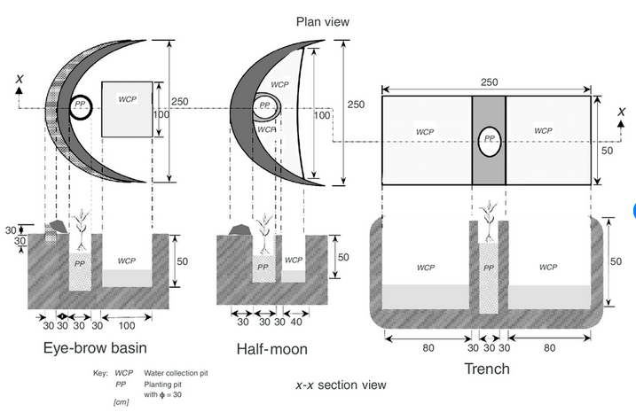
Figure 4.2. Design of Eye-brow basin, half -moon and trench
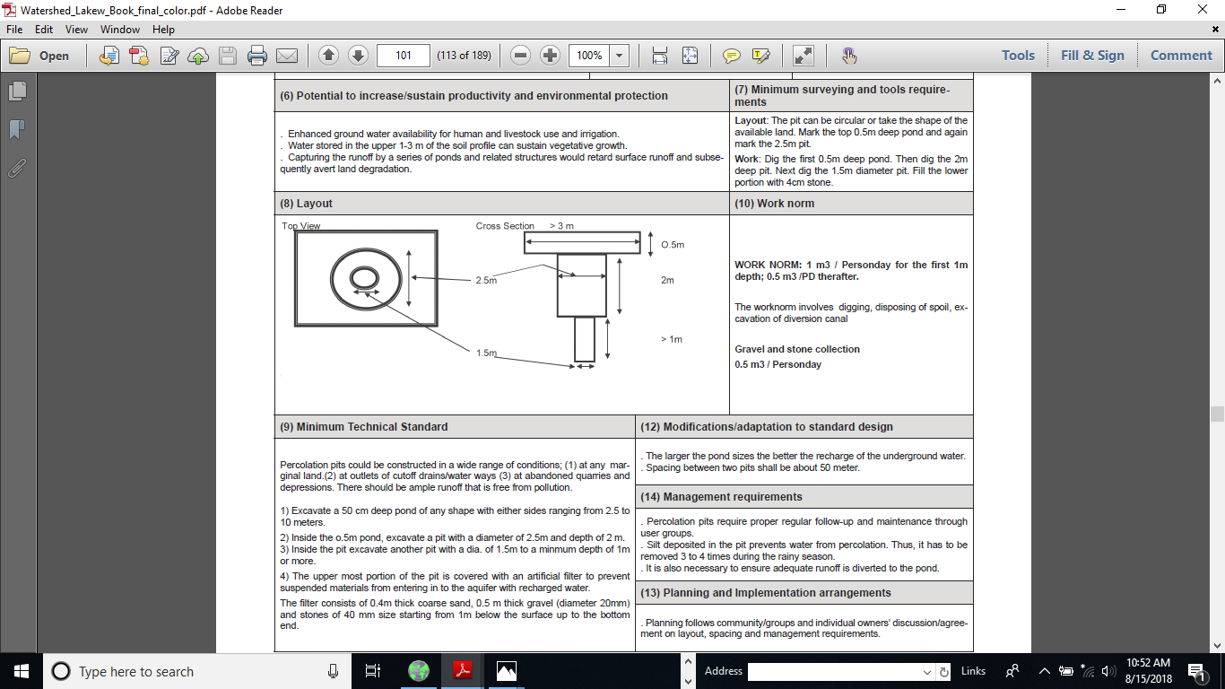
Figure4.2.design of percolation pits
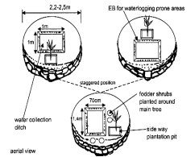
Figure 4.3. Design of eyebrow basin

- Layout and construction procedure of in-situ moisture harvesting technology
- Layout and construction procedure for ridge and tie ridge
Layout: No much need of surveying equipment as such but need perfect contoured furrows run with oxen or tractor. If tie ridges are to be made by hand then use of A-Frame is advised. Making an implement to form the ridges is straight forward, it is interrupting the ridging process to leave a tie that is difficult. Possibilities are:
- Intermittent lifting by hand if the ridger is pulled by tractor or by oxen;
- Automatic lifting devices based on an eccentric wheel; and
- Intermittent hydraulic lift either manual or triggered by rotation of tractor wheels.

- Layout and construction procedure for micro trench and deep trench
- Start from the top of the hill or field
- Using an A-frame (or other level) the same size of the trench (2,5-3 m long) level the two tips of the frame and then mark the shape of the trench
- Continue marking more trenches with the A-frame adjacently and below the first one
- Spacing between two trenches laterally is 25-50 cm
- After layout dig soil to reach 20-25cm depth x 50cm width x 2,5-3m length
- Keep some of the good topsoil aside for filling planting pit (s)
- Then dig a 50 x 50 cm wide x 40cm deep pit in the middle of the trench
- Bottom of the pit should be 10-15 cm deeper than bottom of trench
- Side ditches may slope towards ties for maximum utilization oflight rain showers
- Demarcate the tie around the pit (10cm from pit border on both sides) and proceed to deepen the collection ditcharound the ties up to the required depth of 50cm
- The embankment is to be shaped level and well compacted; and for more constructionsequence.

- Layout and construction procedure for micro basin
- Layout: In order to layout first we have to observe the technical design standard set in the information sheet 2 for micro basin. Then collect the required material (tool and equipment’s)helps for this purpose. Final the layout should be instaggered position.
- Construction Procedure:-
- Site selection
- Mark the contour line using water level
- Set the diameter following the contour line using technical standard
- dig the foundation
- placement of the stone rise
- cut and fill
- dig the plantation pits

- Layout and construction procedure for eyebrow basin
The layout and construction procedure are almost similar except the dimension of basin. Few series of staggered lines of Eyebrow basin or Semicircular bunds can be constructed in betweenwidely spaced hillside terraces (say every 10 -15 meters) on slopes up to 50% - rows of eyebrow basindecrease as distance between hillsidesdecreases > 50% slope (for example one lineof HTs and one of EBs). Two planting pits pereyebrow basin can be arranged.

- Layout and construction procedure for herring bones
Layout: One A-frame. The A frame can directlyprovide the shape of the HB when laid down at groundlevel. Water line level not as good as A frame but canbe used for marking major contour lines - then proceedwith direct assessment by sight and adjustingorientation of herring bone based on micro slopes.

- Layout and construction procedure for semicircular bunds
- Steps to be followed during layout and construction:
- Determine the diameter, spacing and height of the bunds based on technical standard
- Stake out a contour line at thetop of the field just below the cut-off drain;
- Cut a string equalto a diameter and a half, marking into three equal parts. With it,mark the tips of a bund, its center and the spacing on the contour;
- With a peg tied at two ends of the half diameter portion,inscribe the bund below the contour. Similarly, complete the rowof bunds on the contour;
- Measure the position of the next rowfrom the bottom of the row above using the calculated spacing.The centers of bunds in this row should vertically line with themid-point of the space between the bunds in the first row. Repeatuntil all rows are done;
- A small trench outside the bund toget soil. Make the bunds in layers of up to 10 cm and compacteach until the required height is achieved;
- Protect bund tipswith stones to avoid erosion. If stones are not available, plant asuitable dense grass instead

- Caution:
  - Structures are semi-circular bunds 5 -15 meters large, 50 - 75 cm highand with a decreasing height at their tips to evacuate excess wateralthough soils are often permeable enough. Slopes should not exceed5% and soil depth should be not less than 30 - 50 cm
  - The runon-runoff ratio should be 1:1 to max 1:3 as more runoff canbreak the embankment. This means a 5 meter diameter half-moon(has 2.5 meters width of cultivated area) will be distant from the nextone 2.5 meters; with 3:1 ratio.

- Layout and construction procedure for Runoff strips
Runoff strips based on catchment to cultivated area ratio principle are left purposefully between cropping fields (along the contour) so thatrunoff flowing down the slope is directed to the cropping field. Sometimes it is difficult for the runoff water to be uniformly distributed forthe crops and some grooving required between the runoff and run-on line.

- Layout and construction procedures for percolation pits
Layout: Precise layout and follow-up/adaptations required. The pit can be circular, trapezoidal or take the shape of the available land. Tolayout, mark the top 0.5m deep pond, again mark the 2.5m pit, and the 1.5m diameter The depth of the percolation pitcan be 3m and above.
Construction procedure: Dig the first 0.5m deep pond with 3m diameter. Then dig the 2m deep pit with 2.5m diameter. Next dig the1.5m diameter pit. Fill the lower portion of the percolation pit which is ≥ 1m depth with gravel of 4cm diameter stone gravel; the next 1mdepth with 4cm diameter gravel; the next 50cm depth with 2cm diameter gravel; the next 40cm depth with coarse sand; the next 10 &50cm depth as seen in (figure 4.2)to be left for water storing until it is soaked in.

- Constructing in situ moisture harvesting technologies
At this stage the selected and designed in-situ moisture harvesting technology according to technical design requirement have to be constructed on the ground with specific dimension set on design for each selected technology. Step to be followed for construction:-
- Site selection
- Determine rainfall amount, depth of soil and slope of the site assessed.
- Determine appropriate types of in-situ moisture harvesting for investigated site
- Training on benefits, layout and construction of in-situ moisture harvesting technologies
- Set agreements for use rights and management of treated areas (areas shared amongst individuals, groups or managed by community or mixed).
- Plan period of implementation
- Provide the required material for selected technology
- Layout the dimension of required structure on the ground
- Excavate/construct the in-situ moisture harvesting technologies according their specification.
- After construction management and maintenance are also very important.

Self-Check – 4 | Written test

Name…………………………………………… ID………………………… Date…….

Directions: Answer all the questions listed below.

Test I: Short Answer Questions
- Explain/elaborate the layout and construction procedure for micro trench and herring bones? (3points)
- Design eyebrow basin and percolation pit using dimension set on technical design requirement? (2points)

Note: Satisfactory rating - 5 points Unsatisfactory - below 5 points

You can ask you teacher for the copy of the correct answers.

You can ask you teacher for the copy of the correct answers.

Operation Sheet -4

  - Techniques/Procedures of constructing semicircular bund, percolation pit and micro basin
- Tools and equipment’s

- Water level
- Meter tape
- Sledge hammers
- Shovels
- Ranging pole
- Pick axes
- Rope
- Pegs

- Techniques/Procedures of constructing semicircular bund
- Site selection
- Determine slope gradient and mark contour line
- Determine the diameter based on design you went to use from technical standard
- Mark center point on contour( determine the radius)
- Fix the radius on string and make semicircle
- Excavate of small trench outside the bund to get soil
- Construct bund in layers of 10-15 cm and compact it until the required height obtained

- Techniques/Procedures of constructing percolation pits
- Site selection
- Demarcate/layout dimension of the pits
- Dig the first 0.5m deep pond with about 3m diameter
- Then dig the 2m deep pit with 2.5m diameter
- Next dig the 1.5m diameter pit
- Fill the lower portion of the percolation pit which is ≥ 1m depth with gravel of 4cm diameter stone gravel
- The next 1m depth with 4cm diameter gravel
- The next 50cm depth with 2cm diameter gravel
- The next 40cm depth with coarse sand
- The next 10 and 50cm depth as seen in the telescopic-shape of figure 4.2.

- Procedure for construction micro basin:-
- Site selection
- Mark the contour line using water level
- Set the diameter following the contour line using technical standard
- dig the foundation
- placement of the stone rise as required
- cut and fill
- dig the plantation pits

LAP TEST-4 | Performance Test

Name………………………………. ID…………………………….. Date…………………………………….

Time started: ________________________ Time finished: ________________

Instructions: Given necessary templates, tools and materials you are required to perform the following tasks within 12hour. The project is expected from each student to do it.

Task-1. Perform/construct semicircular bund.
Task-2. Perform/construct percolation pit.
Task-3. Perform/construct micro basin

LG # 8 | LO #5- Manage and Maintain in-situ Moisture Harvesting Technologies

Instruction sheet
This learning guide is developed to provide you the necessary information regarding the following content coverage and topics:
  - Managing in-situ moisture harvesting technologies
  - Maintaining in-situ moisture harvesting technologies

This guide will also assist you to attain the learning outcomes stated in the cover page. Specifically, upon completion of this learning guide, you will be able to:
  - Manage in-situ moisture harvesting technologies
  - Maintain in-situ moisture harvesting technologies
Learning Instructions:
- Read the specific objectives of this Learning Guide.
- Follow the instructions described below.
- Read the information written in the information Sheets
- Accomplish the Self-checks

Information Sheet 5

- Managing in-situ moisture harvesting technologies

    - Management of ridge and tied ridges
There is a danger of soil erosion if the ridges are overtopped and break so that the water temporarily stored in the depressions is suddenly released. This will not happen if the combination of surface storage plus the amount which infiltrates into the soil surface is less than the storm rainfall.
This implies a high value of soil storage, usually deep soils with good infiltration and permeability. In some systems the infiltration is increased either by mulching in the furrow bottoms or by sub soiling or cultivating.

    - Management of Micro Trench and deep Trench
Cut unpalatable grass from trench and surroundings to mulch pits and water collection area. Apply compost into planting pit (s) and water collection ditch. Check distance, size and layout of trenches. If trenches have more than one tree check growth of trees and prune/thin as required. Heavily mulch and apply compost around fodder/cash crop belt. Mulching to continue for at least 2 years and apply compost for multipurpose trenches.

    - Management of Micro basin
Controlled grazing and area closure are necessary or a precondition for micro-basins to control light trampling that will compromise their function.
The field can be additionally protected from excess water runoff with the construction of a cut-off drain or a retention ditch. Fodder growing on micro-basins should not be uprooted but cut and carried. Few series of staggered lines of micro-basins can be constructed in between hillside terraces (say every 10 - 15 meters) on slopes up to 30% - rows of micro-basins decrease as distance between hillsides decreases, especially > 30% slope. Fodder legumes, shrubs can be planted along the filled area (Pigeon peas, Tree Lucerne, etc.) in smaller planting pits instead of a tree. Manuring pits and mulching (decrease evaporation and enhance growth). Integration with check-dams in depression points and in gullies.

    - Management of Eyebrow basin
- Control grazing and closure of areas treated with Eyebrow basin is necessary and is a precondition as even light trampling will compromise their function.
- Fodder legumes shrubs and cash crops (on better soils) can be planted along the filled area in addition to the tree, fodder/cash crops growing on Eye brow basins should not be uprooted but cut and carried.
- Manuring of plantation pits and mulching required (decrease evaporation and enhance growth)
- Integration with strong check dams along depression points and small gullies
- EBs constructed using sods and stabilized with plants up to 20% slope);
- Can also be planted with a mix of trees, shrubs and cash crops. AndMultipurpose EBs (tree + fodder + cash crop).

    - Management of Herring bones
- 2 - 3 series of staggered lines of HBs in between bunds (say every 10-15 meters) can be constructed in areas with slopes up to 5% (8%in sandy soils with good percolation).
- Control grazing and closure of areas treated with HBs necessary.
- Fodder legumes, shrubs and cash crops can be planted along the embankment (pigeon peas, tree Lucerne, Sesbania, etc.).
- Manuring of plantation pits and mulching required.
- Integration with trenches and other structures as soon as slopes increase and there is a danger of overtopping.

    - Management of semicircular bunds
Where necessary, protect the field from external run off with a cut-off drain at a maximum gradient of 0.25%. Plant a suitable grass on the bunds to avoid erosion. Stone pitching required at the tip of the bund to control scoring by runoff. Integrated with control grazing and tree/shrubs planting on embankment.

    - Management of Runoff run on bund
- In areas developed for fodder crops, first year crop stocks should be cut half their height and the stubble mulched.
- In case of grass/legume pastures, first year reseeding should be allowed and grass cut after grass seeds reach maturity.
- To improve water holding capacity of the area and encourage fast growth of pasture ripping is recommended (one passage every 1m) followed by 1 ploughing operation.
- Sowing of drought resistant legume fodder.
- Use Cut and carry and control grazing.

    - Management of Run off strips
The same cropped strips are cultivated every year. Clearing and compaction may be needed to improve runoff generation/inducement andits distribution by making grooves or corrugations from the catchment to the cropping field. Under good management, continuous cultivationof the cropped strip can build up soil fertility and improve soilstructure, making the land more productive.

    - Management of percolation pits
Activities such as spring development, hand dug wells, shallow wells, construction of community ponds, construction of trenches andpercolation pits, cutoff drains, and artificial waterways can be integrated and managed along percolation pits. If the top part is sealed withfine sediments then scratching it and removing would be required for temporary fresh runoff storage. Safety during digging, for depthsgreater than 3m or so is crucial as collapsing walls can cave in.

- Maintaining in-situ moisture harvesting technologies
All water harvesting systems based on earth bunds, breaches are possible in the early stages of the first season, before consolidation has taken place. Thus there must be planning for repair work where necessary and careful inspection after all runoff events.
Maintenance is done primarily during the course of normal or day-to-day i.e. It requires the timely supervision and repairing of the structure immediately if they break. There are two types of maintenance:-preventive and corrective maintenance.
The preventive maintenance is a maintenance that undertaken before the structure damaged/broken. It is very important for the sustainability of the structure. Because, it cover 80% of maintenance part. While corrective maintenance is the action of repairing the structure after damaged/broken.
The maintenance of in-situ moisture harvesting technologies shall be required each individuals, communities, development and extension workers, technicians follow up to make it productive than remaining idle.

Self-Check – 5 | Written test

Name…………………………………………… ID………………………… Date…….

Directions: Answer all the questions listed below.

Test I: Short Answer Questions
- Define maintenance term? (1point)
- List down two type of maintenance and explain difference between them?(2 points)
- Elaborate the required management for semicircular bund? (2 points)

Note: Satisfactory rating - 5 points Unsatisfactory - below 5 points

You can ask you teacher for the copy of the correct answers.

You can ask you teacher for the copy of the correct answers.

LG # 9 | LO #6- Finalize Work and Report

Instruction sheet
This learning guide is developed to provide you the necessary information regarding the following content coverage and topics:
- Clean, maintain and store tools and equipment
- Identify and report layout and implementation faults and/or corrective actions
- Documentand report problems and work outcomes
This guide will also assist you to attain the learning outcomes stated in the cover page. Specifically, upon completion of this learning guide, you will be able to:
- Clean, maintain and store tools and equipment
- Identify and report layout and implementation faults and corrective actions
- Document and report problems and work outcomes
Learning Instructions:
- Read the specific objectives of this Learning Guide.
- Follow the instructions described below.
- Read the information written in the information Sheets
- Accomplish the Self-checks
- Perform Operation Sheets
- Do the “LAP test”

Information Sheet 6

- Clean, maintain and store tools and equipment
After completion of the in-situ moisture harvesting work,tools and equipment are required to be cleaned, maintained and stored according to manufacturers’ specifications and supervisor's instructions.This may include the activities of:
- Checking the presence of all material so as not leave on site
- Cleaning all tool and equipment as in order to prevent rust and increase life span.
- Maintain the broken tools and equipment’s before storage in order to make read for next work.
- Hold the tool and equipment properly in order to keep it from damage
- Return all the tools and equipment into the store

- Identify and report layout and implementation faults and corrective actions
In order to identify and report fault of in-situ moisture harvesting:-
- We have to monitor/Regular supervision of ongoing work/activities
- If the fault occurred,we have to determine whether it is due to layout or during implementation
- Report the corrective action basedon design, specification and technical design requirement for each structureon proposed plan.

- Document and report problems and work outcomes
Document is a written or printed paper that gives information about something. The purpose of a document is to facilitate the transfer of information from its author to its readers.In this case it is process of writing and retaining record of every step of in-situ moisture harvesting construction/work done, problems and action taken.
A report is a statement of the results of an investigation of any matter on which definite information is required. During we undertake in-situ moisture harvesting it required to record all on going activities/process from time to time and document it for a final evaluation. Finally upon completion of the work we shall be report the problems we encountered during the work and as well as work outcome properly to our supervisor or to any concerned body.
Outline of a Report format
- Title: - is terms of reference on which we write a report.
- Acknowledgements: -is as an expression of thanks somebody for their contribution.
- Contents: - a list of idea contained in the report.
- Introduction: - brief background information, problems and scope of terms.
- Methodology: - procedure or method used to do that terms.
- Results and Discussion: - giving key information on out puts of findings.
- Conclusion: - covers the writer’s judgment based on information in the body of the report.
- Recommendations: - gives solutions to the problems and suggests possible courses of action as a result of conclusions
- What should be done?
- Who should take action?
- When and how it should be done?
- References: - includes all sources of information used in the report and often those used for background reading as well.

Self-Check – 6 | Written test

Name…………………………………………… ID………………………… Date…….

Directions: Answer all the questions listed below.

Test I: Multiple choice
- -------- is a statement of the results of an investigation of any matter on which definite information is required.(2 point)
- Document
- Plan
- Report
- Problem
- ------- is a written or printed paper that gives information about something.(1point)
- Plan
- Report
- Document
- Problem
Test II: Short Answer Questions
- Define the terms document and report?(2 points)
- Explain the difference between document and report?(2 points)
- List down the procedure to write a report?(3 points )

Note: Satisfactory rating – 10 points Unsatisfactory - below 10 points

You can ask you teacher for the copy of the correct answers.

You can ask you teacher for the copy of the correct answers.

Operation Sheet -6

6.1. Techniques/Procedures for writing a report
- Tools and equipment
- Pen
- Not book
- Computer
- Printer
- Paper
- Techniques/Proceduresfor writing a report
- clarifying your terms of reference
- planning your work
- collecting your information
- organizing and structuring your information
- writing the first draft
- Checking and re-drafting
- Finalize and submit to concerned body/supervisors

LAP TEST-6 | Performance Test

Name………………………………. ID…………………………….. Date…………………………………….

Time started: ________________________ Time finished: ________________

Instructions: Given necessary templates, tools and materials you are required to perform the following tasks within 4hour. The project is expected from each student to do it.

Task-1:perform/writea report on LAP Test 4.

Reference Materials

Alamerew Ephraim, Berhanu Fentaw, and Seid Ali. "Traditional rainwater harvesting systems for food production: The case of Kobo Wereda, Northern Ethiopia." Addis Abeba: ERHA (2002).
Itabari, J.K. and Wamuongo, J.W. (2003) Water-Harvesting Technologies in Kenya, KARI Technical Note Series No. 16, June
MoA. (2020). Community Based Participatory Watershed and Rangeland Development: A Guideline. Second edition. Ministry of Agriculture, Addis Ababa, Ethiopia.
MoA. (2016). Guideline for development agents onSoil and Water Conservation in Ethiopia. 2nd edition.
Moges, Yitebitu, Water Harvesting Techniques: Training and Construction Manual, Consultancy
Sub-report, No. 2, Tropical Forestry, March 2004.
Tasisa Temesge, Firew Bekele and Anteneh Abebe. (2020) Review: Rainwater harvesting technology practices and implication of climate change characteristics in Eastern Ethiopia, Cogent Food & Agriculture, 6:1, 1724354
Tumbo S.D, Determination of Suitability Levels for Important Factors for Identification of
Potential Sites for Rainwater Harvesting, Soil Water Management Research Group, Mwanza,Tanzania 2007.

Address :-
https://www.fao.org/3/u3160e/u3160e07.htm (access date, August 29, 2022)

AKNOWLEDGEMENT

Ministry of Labor and Skills wish to extend thanks and appreciation to the many representatives of TVET instructors and respective industry experts who donated their time and expertise to the development of this Teaching, Training and Learning Materials (TTLM).

The experts who developed the learning guide
No | Name | Qualification | Educational background | Region | Phone number | E-mail
1 | Ziyad Rube | MSc | Water Resource Engineering and Management | Afar | 0921484656/  0962639851 | yoomnaaf51@gmail.com
2 | Korme Tusuru | MSc | Biodiversity and conservation Management | Oromia | +251916145234 | bilisumakorme@gmail.com
3 | Gelasa Tola | MSc | Biodiversity & conservation Management | Oromia | 0920049614 | tologelasa@gmail.com
4 | Gezahegn Tadesse | MSc | Drainage &Watershed Management | Alage | 0968445006 | sihine29@gmail.com
5 | Geleta Bekele | BSc | Forestry | Afar | 0925482964 | geletabk12019@gmail.com
6 | Degarege Mitkie | BSc | Water Resource & Irrigation Engineering | South West | 0921281867 | mitkiedegarege@gmail.com
7 | Getnet Asmare | MSc | Production Forestry | Amhara | 0912846540 | getnetasmare40@gmail.com
8 | Kifle Tolossa | MSc | Soil Science | Oromia | 0910895568 | kifletolossadechasa@gmail.com
9 | Tolessa Sori | MSc | Forest & Natural Management | South West | 0917007821 | tolosa.sori@gmail.com
10 | Yeshitila Wondosen | MSc | Climate change & Development | Benshangul Gumuz | 0911071229 | yeshiwondo@gmail.com
11 | Zeleke Dessie | MSc | Agroforestry | Oromia | 0911091388 | zelekedessie@gmail.com

