Natural Resources Conservation and Development
Level – II

Based on March 2022, Version-1 Occupational Standard

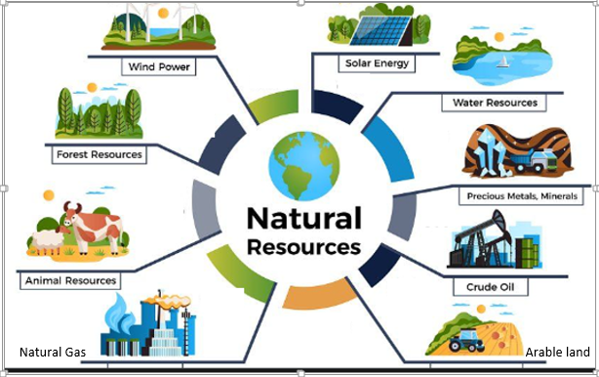

Module Title: - Conducting Erosion and Sediment Control Activities
LG Code: AGR NRC2 M01 LO (1-3) LG (1-3)
TTLM Code:AGR NRC2 TTLM 0922v1

September, 2022
Addis Ababa, Ethiopia

Table of Contents

Introduction to the Module 1
LO#1-Align Worksite Practices with Erosion and Sediment Control Principles 2
Instruction sheet 2
Information Sheet 1 3
Self-check 1 16
1.2 Operation Sheet -1 17
LAP TEST-1 18
LO #2- Implement Erosion and Sediment Control Measures 19
Instruction sheet 19
Information Sheet 2 20
Self-Check – 2 34
Operation Sheet -2 35
LAP TEST-2 37
LO #3- Finalize Erosion and Sediment Control work 38
Instruction sheet 38
Information Sheet 3 39
Outline of a Report format 39
Self-Check – 3 41
Operation Sheet -3 42
LAP TEST-3 43
Reference Materials 44

Introduction to the Module
This module had three learning out come and cover learning guide one up to three. The learning module cover the required knowledge, skill and attitude to carry out erosion and sediment control activities in both urban and rural environments. It requires the ability to identify erosion and sediment control structures, carry out routine work in compliance with control measures.

LG #1 | LO#1-Align Worksite Practices with Erosion and Sediment Control Principles

Instruction sheet
This learning guide is developed to provide you the necessary information regarding the following content coverage and topics:
- Processes of erosion and sedimentation
- IdentifyingErosion types and causes of erosion
- Impacts of erosion and sedimentation on the environment
- Erosion and sedimentation legislation
- Erosion and sediment control procedures

This guide will also assist you to attain the learning outcomes stated in the cover page. Specifically, upon completion of this learning guide, you will be able to:
- Understand the Process of erosion and sedimentation
- Identify erosion types and causes of erosion
- know impacts of erosion and sedimentation on the environment
- understand erosion and sedimentation legislation
- understand erosion and sediment control procedures
Learning Instructions:
- Read the specific objectives of this Learning Guide.
- Follow the instructions described below.
- Read the information written in the information Sheets
- Accomplish the Self-checks
- Perform Operation Sheets
- Do the “LAP test”

Information Sheet 1

- Processes of Erosion and Sedimentation
Soil erosion, is the movement of soil from one part of the land to another through the action of wind or water. Soil erosion is a two-phase process consisting of the detachment of individual soil particlesfrom the soil mass and their transport by erosive agents such as running water and wind.Whensufficient energy is no longer available to transport the particles, a third phase, deposition
occurs.Once erosion occurs, these sediments can be mobilized by rain and are deposited to portions of waterways, such as riverbanks, flood plans, coastlines, and estuaries.
Sedimentation is the process of allowing particles in suspension in water to settle out of the suspension through gravity. The particles that settle out from the suspension become sediment.
Sediment means solid material, mineral or organic, that is in suspension, is being transported, or has been moved from its site of origin by air, water or gravity as a product of erosion. Sedimentation is the deposition of eroded soil offsite or downstream on grazing land, in reservoir or lake. The basic erosion and sedimentation process are detachment, transport and deposition (sedimentation) as shown in figure (1.1).
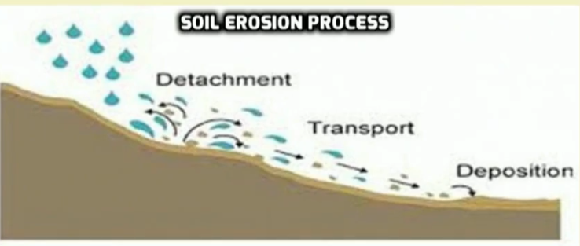
Figure 1.1. Soil erosion process and sedimentation
The severity of erosion depends upon the quantity of material supplied by detachmentover time and the capacity of the eroding agents to transport it. Where the agents have the capacity to transport more material than is supplied by detachment, the erosion is described asdetachment-limited. Where more material is supplied than can be transported, the erosion is transport limited.
Detachment occurs when water splashes onto the soil surface and dislodges soil particles, or when wind reaches sufficient velocity to dislodge soil particles on the surface.
Once soil particles are detached from the surface and suspended in runoff waters, they will remain there until the velocity of the water is reduced. Flowing waters create turbulence that constantly churns and mixes the flow, holding the particle in suspension. In order for the particles to be removed, the velocity of the flow must be reduced sufficiently to allow the particle to settle out by gravity. Over time, this sediment accumulates, forming large deposits and can eventually fill in a water body completely. Sediment is the largest pollutant (by volume) in storm water runoff. The resulting deposits can destroy ecosystems and are difficult and expensive to remove.

- Identifying Erosion Types and Causes of Erosion

    - Types of Erosion
Broadly we classify types of erosion as natural and accelerated erosion.
- “Natural Erosion.” is the wearing away of the earth’s surface by water, wind, or other naturalagents under natural environmental conditions undisturbed by man. Naturally the soil erosion and soil formation from decomposition of organic matter are at equilibrium. Wind can also detach soil particles.The detached soil is moved by wind in one of three ways:
a. Suspension: Very fine silt and clay particles (smaller than 0.002 inches in diameter) may be picked up by the wind and carried in suspension. Suspended dust may be moved great distances, but does not drop out of the air unless rain washes it out or the velocity of the wind is dramatically reduced.
b. Saltation: Fine silts up to medium sand particles (0.002 to 0.02 inches in diameter) move in the wind in a series of steps, rising into the air and falling after a short flight. This movement is called saltation. A vast majority of wind erosion is a result of the saltation process.
c. Creep: Soil particles larger than medium sands (greater than 0.02 inches) cannot be lifted into the wind, but particles up to 0.04 inches (coarse sand) may be pushed along the soil surface by saltating grains or direct wind action. This action is called creep.
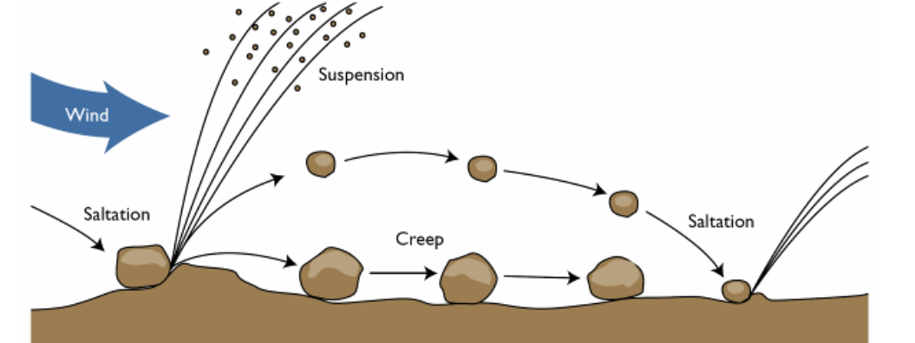
Figure 1.2. Movements of soil particle by wind
- “Accelerated Erosion.” Any increase over the rate of natural erosion as a result of land disturbing activity.This types of erosion is the most severe type of erosion, particularly in developing areas.
- Further accelerated/water generated types of erosion can be classified as splash, sheet, and Rill, Gully and Stream bank erosion.

- Splash Erosion
Splash erosion is the first step in the erosion process begins as raindrops impact the soil surface. Raindrops typically fall with a velocity of 20 to 30 feet per second.Rain splash is the most important detaching agent. The raindrop impact detach /brake down soil particles into small pieces.As a result of raindrops striking a bare soil surface, soil particles may be thrown through the air over distances of several centimeters. Such process is called splash erosion.
- Sheet Erosion:-
Sheet erosionis the total removal of top soil that detached by raindrop impact. Occurs as runoff travels over the ground, picking up and transporting the particles dislodged by raindrop impacts. The process of sheet erosion is uniform, gradual, and difficult to detect until it develops into rill erosion.
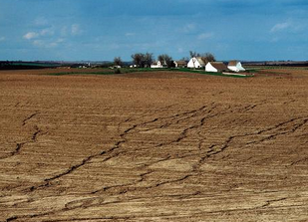
Figure 1.3. Sheet erosion
- Rill Erosion:
Rill erosion means erosion that cuts a number of small channels less than one foot in depth into the soil by water moving over and concentrating in low places in the soil surface. It is the removal of soil by runoff water to create small channels up to 30cm deep. Rill erosion is the intermediate process between sheet and gully erosion. The channel of rill erosion can be filled with normal ploughing operation.
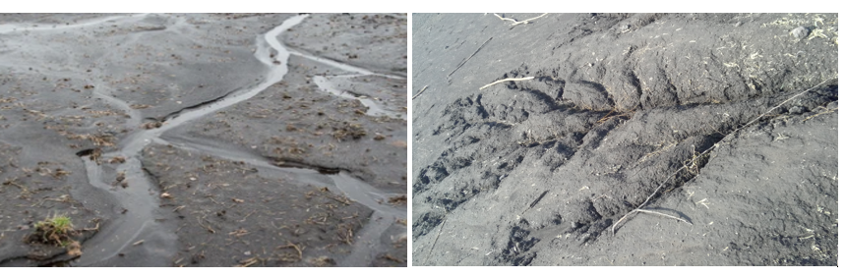
Figure 1.4. Rill erosion

- Gully Erosion
A gully is a deep channel created as a result of severe soil erosion, usually caused by water moving in rills, which concentrates to form larger channels. It occurs when concentrated flows of water scouring along flow routes cause channels deeper than 0.5 m. It is an advanced stage of rill erosion which cannot be smoothed over by normal tillage operations.
The major difference between gully and rill erosion is the matter of magnitude. Gullies are too large to be repaired with conventional tillage equipment and usually require heavy equipment and special techniques for stabilization.
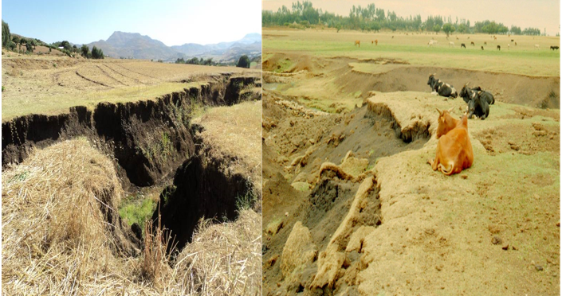
Figure 1.5. Gully erosion
- Main process of gully formation
- Head cut
- Gully bed erosion erodes the gully bed
- Bank/lateral erosion
- Gully can be classified depending on shape and size.
  - Based on shape we classify as :-
  - V-shaped/Triangular
  - U-Shaped Parabolic or Trapizoidal

- Based on size we can classify gully as:-
- Small: <3m deep and drainage area<20ha
- Medium:3-5m deep and drainage area 20-60ha
- Large: >5m deep and drainage area >60ha
- Stream Bank Erosion
Streambank erosion is a natural process that occurs when the forces exerted by flowing water exceed the resisting forces of bank materials and vegetation. It is also the scouring of material from the sides and bed of a water channel and the cutting of the banks by running water. As the streambed erodes and the channel deepens, the sides of the channel become unstable and slough off, resulting in stream bank erosion. Stream bank erosion can also occur as soft materials are eroded from the stream bank or at bends in the channel. This type of stream bank erosion results in meandering waterways.
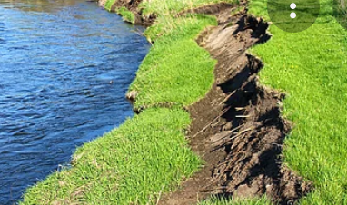
Figure 1.6. Stream bank erosion
    - Causes of Erosion
The main causes of soil erosion are classified into two categories. Those are natural and manmade/artificial.
- Natural cause are due to two erosive forces of wind and water. Wind or water erosion is the physical weathering of the earth’s surface.
- Visual indicators of water erosion may include:-
- Presence of channels ,rills and gullies in the field
- Formation of Pedestals
- muddy water
- Siltation and sedimentation
- Plant root exposure to the surface

- Visual indicators of wind erosion may include:-:
- Presence of dusts in buildings, on plant leaves, etc.
- Sand dunes
- Dust storms and dust carrying wind
- Accelerated/manmadeare caused by deforestation, overgrazing, and mismanagement of cultivated soils.
The main causes of deforestation may include construction, mining, forest fire and hydroelectric projects. Whereas the effect of deforestation are results with runoff water &floods, soil erosion, extinction of organisms, reeducation of forest resources and contributes to global warming.
    - Factor Influence Erosion
The extent of erosion that occurs is dependent on a number of factors including soil erodibility, climate, vegetative cover/land management practices, topography, and season.

- Soil erodibility:
Soil erodibility: -is the vulnerability or susceptibility of soil to erosion. The erodibility of a soil depends on its texture and physical properties. The characteristics that influence the potential for erosion are those related to the infiltration capacity of the soil and its ability to resist detachment. Soil properties that affect erodibility include texture, organic matter content, soil structure, and permeability.
In general, soils with a high percentage of fine sand and silt are the most erodible. These particles are easily detached and carried away by rainfall and runoff. As the clay and organic content of a soil increases, the erodibility of the soil tends to decrease. Clay particles have the ability to bind together, reducing the potential for detachment by raindrop splash.
However, they are also more impermeable, resulting in increased runoff. The increase in runoff increases the erosion potential (especially rill and gully), offsetting some of the benefit that the binding effect has against resisting erosion.
The problem with clay particles is that once they have eroded, they are easily transported by water and are very difficult to remove. Soils that are high in organic matter content have a more stable texture and increased permeability. This allows the soil to resist detachment and infiltrate more precipitation. Well-draining sands and gravels are the least erodible soils. Soils with high infiltration rates such as these significantly reduce the amount of runoff, thereby reducing the potential for erosion.
The USDA county soil surveys provide an indication of soil erodibility. This value (K) ranges from 0 to approximately 0.7. Higher values indicate a greater potential for erosion.
The following four factors are important in determining soil erodibility.
- Soil texture
- Percentage of organic content
- Soil structure
- Soil permeability
- Climate

The rainfall frequency, intensity of rainfall and duration of rainfall are fundamental factors in determining the amounts of runoff produced in a given area. The rate of erosion is directly related to the amount and type of precipitation that occurs. High intensity storms increase particle detachment. In addition, frequent or lengthy storms can saturate the soil, reducing infiltration and increasing runoff. Increased detachment and runoff both contribute to erosion. Erosion risks are high where precipitation is frequent, intense, or lengthy.

As the volume and velocity of runoff increases, the capacities of runoff to detach and transport soil particles also increase. When precipitation falls as snow, no erosion will take place. However, when the temperature rises, melting snow adds to runoff, and erosion hazards are high. Because the ground is still partially frozen, its absorptive capacity is reduced.

- Topography
The size, shape and slope characteristics of a watershed influence the amount and rate of runoff. As both slope length and gradient increase, the rate of runoff increases and the potential for erosion is magnified. Slope orientation can be a factor in determining erosion potential. For, example, a slope that faces south and contains droughty soil may have such poor growing conditions that vegetative cover will be difficult to re-establish.
- Vegetation cover
The vegetation cover can significantly reduce erosion potential. Because, vegetative residue, mulch, and compost, as well as the leaves and branches of vegetation, intercept precipitation and shield the ground from raindrop impacts. This result with reduction of surface runoff and protecting surface soil from erosion.The roots of vegetation help hold soil particles together and prevent them from becoming detached. Ground cover slows runoff velocity, increases infiltration, and can even filter sediment out of runoff.

- Season:
The potential for erosion varies throughout the year.In winter months when the ground surface is frozen, there is little chance of water erosion.As spring approaches, the surface soils begin to thaw, but the ground below remains frozen.This creates a high potential for erosion. An early spring rain at this time cannot infiltrate into the frozen subsoils. However, the newly thawed surface can be easily washed away, even by a light rain.
Erosion potential is also high in the summer months, due to the high-intensity thunderstorms that occur during this period.

- Impacts of erosion and sedimentation on the environment

    - Impacts of soil erosion on environment
The impacts of soil erosion on environment may include:-
- increase pollution
- sedimentation in streams and rivers
- poor internal drainage
- Disfigure the landscape
- salinization and soil acidity problems
- carries infectious disease organisms
- Productivity decrement
- Groundwater declining

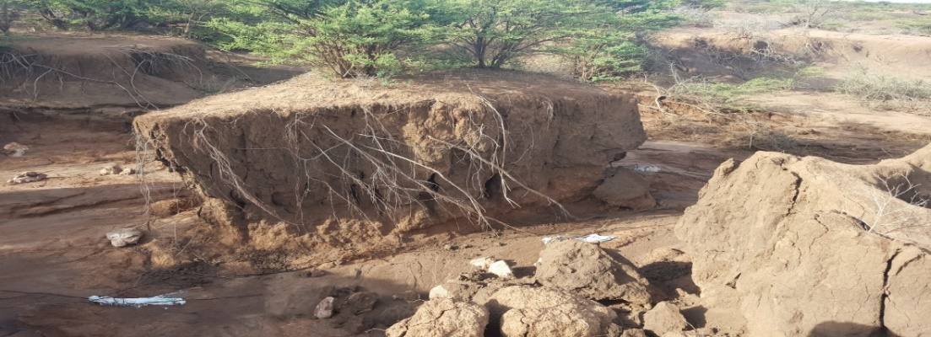
Figure 1.7. Degraded land due to erosion

    - Impacts of sedimentation
Overtime, natural processes and human activity have led to an increase in sediment deposition in lakes, rivers, and oceans, in a process known as sedimentation. Although the sedimentation process is part of the natural geological cycle, there are environmental impacts that are associated with the increase in sedimentation. These may include:-
- impact aquatic habitat and water quality by causing high turbidity
- Reduction of reservoir capacity due to the interception of river solid transport.
- covering of fish spawning areas
- increased algal productivity
- increases the cost of treating drinking water
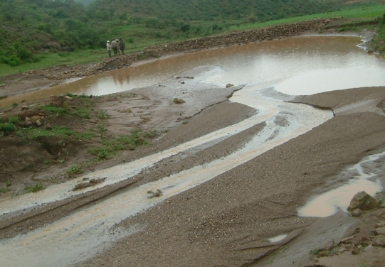
Figure 1.8. Impacts sediment on down stream

- Erosion and sedimentation legislation
The Purpose of erosion and sedimentation legislation are:-
- Regulating certain land disturbing activity to control accelerated erosion andsedimentation in order to prevent the pollution of water and other damage to lakes, watercourses, and other public and private property by sedimentation; and
- Establishing procedures through which these purposes can be fulfilled.

- Erosion and sediment control procedures
The strategies for controlling erosion and sedimentation involve reducing soil detachment, reducing sediment transport, and trapping sediment before it reaches water. For both water and wind erosion, the first objective is to keep soil on the field. The easiest and often most effective strategy to accomplish this is to reduce soil detachment.
The process of erosion control and sediment control can be described as follows:
- Erosion control is the process whereby the potential for erosion is minimized, it isan attempt to stop erosion before it happens. It is the practice of preventing or controlling wind or water erosion in agriculture, land development, coastal areas and banks.
- Sediment control is the process whereby the potential for eroded soil beingtransported and/or deposited beyond the limits of the construction site isminimized. It is the practice of practices of preventing sediment leaving the site.
For effective and cost-efficient erosion and sediment control we have to:-
  - control run-on water
  - protect the land surface from erosion
  - Prevent sediment from leaving the site
Develop Erosion and Sediment Control Plans prior to commencing works and continually amend these plans to minimize environmental harm. The followings are some procedures for applying erosion and sediment control plans:
1. Minimize the soil disturbance
2. Divert water around the work area
3. Protect the soil against erosion initiated by raindrops, wind, or concentrated flows.
4. Control storm water flows onto, through and from the site.
5. Use sediment controls to prevent off-site impacts
6. Stabilize disturbed area progressively
7. Inspect and maintain control measures
The effectiveness of sediment control practices depends on several factors,including:
- The contaminant (e.g. sediment, phosphorus) to be controlled;
- The nature of the soil particles to be controlled;
- The types of practices or controls being considered
- Site-specific conditions (e.g. crop rotation, topography, tillage,harvesting method)
- Operation and maintenance.

Self-check 1 | Written test

Name…………………………………………… ID………………………… Date…….
Directions: Answer all the questions listed below.

Test I: Choose the best answer (4 point)
    - ----- is types of erosion occurs when concentrated flows of water scouring along flow routes cause channels deeper than 0.5 m.
- Sheet erosion
- Gully erosion
- Stream bank erosion
- Rill erosion
    - Which one of the following is the removal of soil by runoff water to create small channels up to 30cm deep?
A. Sheet erosion
- Gully erosion
- Stream bank erosion
- Rill erosion
Test II: Short Answer Questions
    - Define the term soil erosion? (2 points)
    - What is the difference between erosion and sedimentation?(2 points)
    - List down the causes of erosion?(2 points)
    - List at four indicator of water erosion? (2 points)

Note: Satisfactory rating - 12 points Unsatisfactory - below 12 points

You can ask you teacher for the copy of the correct answers.

You can ask you teacher for the copy of the correct answers.

Operation Sheet -1

- Procedures of erosion and sediment control plan
- Tools and equipment’s
- Pen
- Note book
- GPS
- Camera
- Meter
- Ranging pole
- Water level
- Rope
- Proceduresfor developing erosion and sediment plan
- Site assessment
- Identify cause of erosion and sedimentation
- Discuses with community about impacts of erosion and sediment
- List down the alternative solution or management option
- Select the best management option
- Prepared/develop the plan with community
- Under take temporary measures until the plan finalized
- Impalement best management practice

LAP TEST-1 | Performance Test

Name………………………………. ID…………………………….. Date…………………………………….

Time started: ________________________ Time finished: ________________

Instructions: Given necessary templates, tools and materials you are required to perform the following tasks within 3:00hour. The project is expected from each student to do it.

Task-1 perform erosion and sediment plan

LG #2 | LO #2- Implement Erosion and Sediment Control Measures

Instruction sheet
This learning guide is developed to provide you the necessary information regarding the following content coverage and topics:
- Erosion and sediment control measures
- Applying Industry practices for erosion and sediment control

This guide will also assist you to attain the learning outcomes stated in the cover page. Specifically, upon completion of this learning guide, you will be able to:
- Understand erosion and sediment control measures
- ApplyIndustry practices for erosion and sediment control
Learning Instructions:
- Read the specific objectives of this Learning Guide.
- Follow the instructions described below.
- Read the information written in the information Sheets
- Accomplish the Self-checks
- Perform Operation Sheets
- Do the “LAP test”

Information Sheet 2

- Erosion and sediment control measures
Soil erosion and control measure can be classified as practices to reduce detachment, reduce transportation and trap sediment.
- Measure to Reduce Detachment:-
There a number of practices use to reduce the detachment of soil. Some of them are as listed below.
- Conservation cover: - Establishing and maintaining perennial vegetative cover to protect soil and water resources on land retired from agricultural production.
- Conservation crop rotation: An adapted sequence of crops designed to provide adequate organic residue for maintenance or improvement of soil tilth.
- Residue Management: Any tillage or planting system that maintains at least 30% of the soil surface covered by residue after planting to reduce soil erosion by water; or, where soil erosion by wind is the primary concern, maintains at least 1,000 pounds of flat, small- grain residue equivalent on the surface during the critical erosion period.
- Cover crop: A crop of close-growing grasses, legumes, or small grain grown primarily for seasonal protection and soil improvement. It usually is grown for 1 year or less, except where there is permanent cover as in orchards.
- Critical area planting: - Planting vegetation, such as trees, shrubs, vines, grasses, or legumes, on highly erodible or critically eroding areas (does not include tree planting mainly for wood products).
- Seasonal Residue Management: - Using plant residues to protect cultivated fields during critical erosion periods.
- Diversion: - A channel constructed across the slope with a supporting ridge on the lower side.
- Windbreak/shelterbelt establishment: - Linear plantings of single or multiple rows of trees or shrubs established next to farmstead, feedlots, and rural residences as a barrier to wind.
- Mulching: Applying plant residue or other suitable material to the soil surface.
- Tree planting: Establishing woody plants by planting or seeding.
- Pasture and hayland planting: Establishing and re-establishing long-term stands of adapted species of perennial, biannual, or reseeding forage plants.
- Waste utilization: Using agricultural or other wastes on land in an environmentally acceptable manner while maintaining or improving soil and plant resources.
- Wildlife upland habitat management: Creating, maintaining, or enhancing upland habitat for desired wildlife species.
- Practices to Reduce Transport within the Field
Sediment transport can be reduced in several ways, including the use of crop residues and vegetative cover. Vegetation slows runoff, increases infiltration, reduces wind velocity, and traps sediment. Reductions in slope length and steepness reduce runoff velocity, thereby reducing sediment carrying capacity as well. Terraces and diversions are common techniques for reducing slope length. Runoff can be slowed or even stopped by placing furrows perpendicular to the slope, through practices such as contour farming that act as collection basins to slow runoff and settle sediment particles. By decreasing the distance across a field that is unsheltered from wind and by creating soil ridges or other barriers, sediment transport by wind will be reduced. There are several techniques/measure used to control sediment transport.
- Contour farming: Farming sloping land in such a way that preparing land, planting, and cultivating are done on the contour. This includes following established grades of terraces or diversions.
- Field windbreak:-Establishment of trees in or adjacent to a field as a barrier to wind.
- Grassed waterway:-A natural or constructed channel that is shaped or graded to required dimensions and established in suitable vegetation for the stable conveyance of runoff.
- Contour strip cropping: Growing crops in a systematic arrangement of strips or bands on the contour to reduce water erosion. The crops are arranged so that a strip of grass or close-growing crop is alternated with a strip of clean-tilled crop or fallow or a strip of grass is alternated with a close-growing crop.
- Herbaceous Wind Barriers: Herbaceous vegetation established in rows or narrow strips across the prevailing wind direction.
- Field strip cropping: Growing crops in a systematic arrangement of strips or bands across the general slope (not on the contour) to reduce water erosion. The crops are arranged so that a strip of grass or a close- growing crop is alternated with a clean-tilled crop or fallow.
- Terrace: An earthen embankment, a channel, or combination ridge and channel constructed across the slope
- Contour Buffer Strips: Narrow strips of permanent, herbaceous vegetative cover established across the slope and alternated down the slope with parallel, wider cropped strips.
- Practices to Trap Sediment
The sediment leaving the filed needed to trap before reaching the wetland or riparian area. The deposition of sediment is achieved by practices that slow water velocity or increase infiltration. Some of the measures used to trap sediment are as follows:-
- Sediment basins: - Basins constructed to collect and store debris or sediment.
- Field border: - A strip of perennial vegetation established at the edge of a field by planting or by converting it from trees to herbaceous vegetation or shrubs.
- Filter Strip: Strip of vegetation above ponds, diversion structures, or other elements to retard flowof runoff water and thereby reduce sediment flow.
- Water and sediment control basin: - An earthen embankment or a combination ridge and channel generally constructed across the slope and minor watercourses to form a sediment trap and water detention basin.
- Grade stabilization structure: A structure used to control the grade and head cutting in natural or artificial channels.
- Stream bank and Shoreline Protection: - Using vegetation or structures to stabilize and protect banks of streams, lakes, estuaries, or excavated channels against scour and erosion.
- Trench packing: filling of a gully with woody brush to provide a barrier to retard water flow and accumulate sediment.

- Applying Industry practices for erosion and sediment control

There are different industry responsible for erosion and sediment control. Among those Agricultural, road, environmental and health industry are the main one. Some of industry practice are rehabilitation of gully, sediment basin, sediment trap, waste disposal, drainage channel and etc.

    - Rehabilitation of gully

First of all keep in mind: ‘prevention is better than cure’. Save money and labour by treating a gully in its early stage, when it is easy, rather than waiting until it is too late. There are three major principles for controlling gullies:
- Reducing the runoff coming into the gully by conserving water in the catchment so that it does not reach the gully e.g. by Bunds, Mulch, Micro basin, Trench or Area Closure, etc.
- Diverting the water away from the gully with a Cutoff Drain or safe Waterway.
- Conveying the water safely through the gully by reducing its speed and breaking itserosive force with Check dams and or various vegetative barriers.The gully can be rehabilitated in two ways: biological and physical measures
The gully control measures can be classified as physical and biological measure.
- Physical measures:-Some of the physical measure for gully control such as follows:-
- Brush wood check dams: aremade of posts and brush are place across the gully and used to hold the fine material carried by flowing water in the gully. Suitable for Small gully heads, no deeper than 1m.
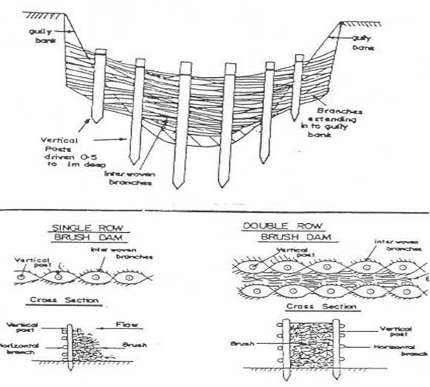
Figure 2.1. brush check dams
- Stone check dams:Constructed across the bottom of a gully or a small stream, which reduces the velocity of run off and prevent the deepening and widening of the gully. Soil trapping and reduction of the gradient between the check-dams
Technical design for stone check dams
- Side key; 0.7-1m inside gully sides.
- Bottom key and foundation; 0.5m depth* width ofcheck dam.
- Height; min 1m and max 1.5m excluding foundation.
- Top width; 0.4 x h
- Base width; min 1.5
- Make drop structures and apron
- Central spillway with sufficient freeboardand permissible velocity.
- Spacing (S)= Height (m)*1.2/Gradient( in decimal)

- Sandbag check dams: - This types of check dam used where stones are not available and need to be reinforced with woody material as shown in the following figure.
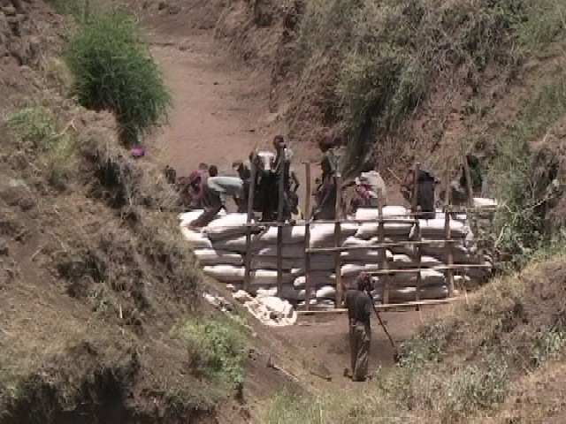
Figure 2.2.sandbag check dam

- Dry Stone Measures (DSM)
The term Dry-Stone Measure (DSM) refers to the complete rehabilitation operation of a given area of degraded land. They are designed to reduce degradation and prevent gully erosion over large areas of land by:-
- reducing the speed of surface run-off
- retaining organic matter of the land
- Trapping the sediment as shown in figure (2.3)
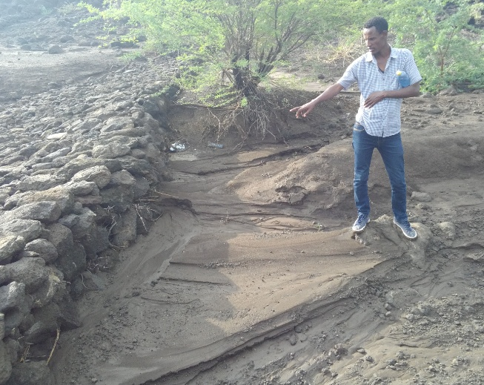
Figure 2.3. Sediment trap by DSM structure
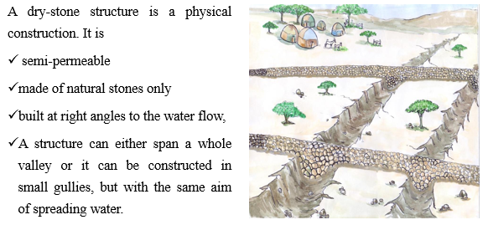
Figure 2.4. Design of DSM
Suitability of dry-Stone Measures are:
- on the slopes of valleys for early stages of degradation (such as decreasing yields and biomass or biodiversity)
- Where a gully is not deeper than 2 meters and not too wide.
- Biological gully erosion measure
In order to stop further undercutting of the gully head, a reshaping of the gully head is needed. The reshaped gully head has to be protected by grass or a stone rip-rap. In order to revegetate the gully walls, reshaping is also necessary here to allow the seed or seedlings to take root, as plants cannot establish themselves on the vertical gully walls.
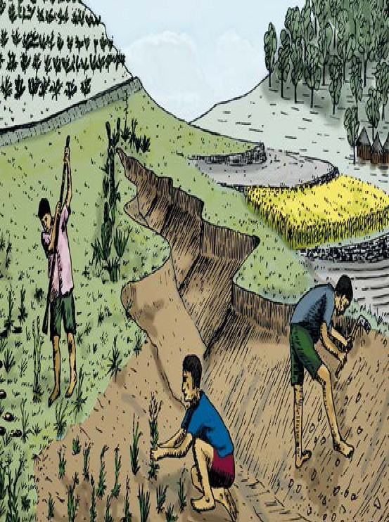
Figure 2.5.Gully rehabilitation with vegetation

    - Sediment basin
Sediment basins, like sediment traps, are temporary structures that are used to detain sedimentladen runoff long enough to allow a majority of sediment to settle out. Sediment basins are larger than sedimenttraps, serving drainage areas between 5 and 100 acres.
Sediment basins use a release structure to control the discharge, and normally have an emergency spillway torelease the flow from larger storms. If properly planned, the basins may also serve as permanent stormwatermanagement facilities, such as detention basins or permanent sediment removal structures.
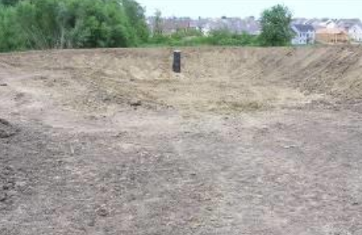
Figure 2.6. Sediment basin
Typical Uses:
Used below disturbed areas where the contributing drainage area is greater than 5 acres. Basins require significant space and the appropriate topography for construction.
Advantages:
- Can greatly improve the quality of runoff being released from a site by removing suspended sediment on alarge-scale basis.
- May be designed as a permanent structure to provide future detention, or for long-term water quality enhancement.
Limitations:
- Large in both area and volume.
- Use is somewhat dependent on the topography of the land.
- Must be carefully designed to account for large storm events.
- Not to be located within live streams.
- May require protective fencing.

    - Silt Fences
Silt fence is a temporary sediment barrier of geotextile fabric that is anchored into the ground andsupported by posts on the downstream side of the fabric. Silt fences temporarily impound runoff and retainsediment onsite. They are most effective when designed to provide comprehensive water and sediment controlthroughout a construction site and if used in conjunction with erosion control practices.It is one of the most commonly used sediment control practices.For sediment control applications, the maximum contributing area should not exceed 1/4 acre per 100 feet of fence.
Typical Uses: Used to control sheet flow runoff from disturbed land. May also be used to create a sediment trapfor removal of suspended particles from low volume concentrated flows.
Advantages:
- Widely used BMP due to ease of installation and availability of materials.
- Relatively low cost.
Limitations:
- Ineffective against high flows.
- Must be removed after final stabilization.
- Could involve frequent maintenance related to removing accumulated silt behind the silt fence.

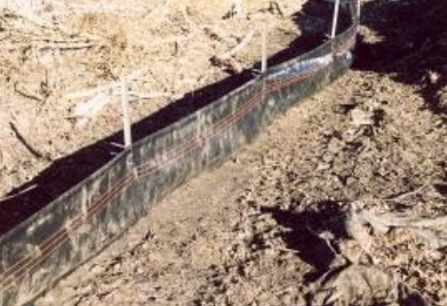
Figure 2.7. Silt fence

    - Dust Control

Dust control measures include minimization of soil disturbance, spray-on adhesives, tillage, chemicaltreatment and water spraying, and ensuring trucks are tarped upon leaving the construction site. Inmany cases, measures incorporated into the project to prevent soil erosion by water will indirectlyprevent wind erosion.
While there are a number of temporary alternatives for dust control, one option is to permanently modify the site to eliminate dust generation. Modifications could include measures such as covering exposed areas with vegetation, mulch, stone or concrete. For the purpose of this standard, the focus is on temporary dust control measures.
Typical Uses: Used in open, windy areas such as the tops of hills and on construction sites with exposed soil inopen areas. Also used in locations where construction traffic is high, such as the entrance to the site. Dust control may also be applied to soil stockpiles.
Advantages:
- Low visibility conditions caused by airborne dust are minimized.
- Dust control methods are widely applicable.
- Most dust control methods are inexpensive and promote the growth of stabilizing vegetation.
- Most dust control methods are easy to install/apply and maintain.
Limitations:
- Some temporary dust controls must be reapplied or replenished on a regular basis.
- Some controls are expensive (e.g., chemical treatment), may be ineffective under certain conditions, or havetheir own associated impacts.
- If chemical dust control treatment is over-applied, excess chemicals could potentially cause both surface andgroundwater contamination.
- Petroleum products should not be used for dust control as there is potential for storm water pollution andgroundwater contamination.

    - Erosion control mulching
Mulching is the application of organic material over soil that is bare or immediately over soil thathas been seeded. Mulch prevents erosion by preventing the detachment of soil particles, slows runoff velocity,and retains moisture to improve germination and establishment of vegetative cover. The mulch may used alone or applied over seed, mulch provides immediate erosion protection. Mulching withoutseeding may be considered for very short-term protection. Mulch protects the disturbed soil surfaceby absorbing the impact of raindrops, thereby preventing detachment of the soil particles. It alsoretains and absorbs water, slowing runoff. These properties allow for greater infiltration of water intosoil; help to retain seeds, fertilizer and lime in place; and improve soil moisture and temperatureconditions for seed germination. Mulch is essential in establishing good stands of grasses andlegumes. In order to prevent movement by wind or water, it is important that the mulch be anchoredto the soil.

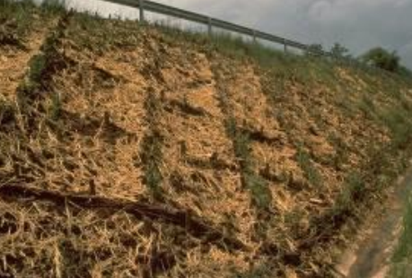
Figure 2.8. Mulching on soil
Typical Uses: This practice may be applied on exposed soils as a temporary control where soil grading orlandscaping has taken place or in conjunction with temporary or permanent seeding. When time constraintsprevent the establishment of vegetation (seeding), mulch such as wood chips, straw, or compost can be usedindependently as a temporary soil stabilization practice that protects the soil surface until vegetation establishmentcan be completed.

Advantages:
- Provides immediate surface protection.
- Suppresses weed growth.
- Conserves soil moisture.
- Acts as a thermal layer for seed.
- If used in conjunction with seed, allows seed growth through the mulch.
- Useful for dust control.
Limitations:
- If applied too thick, it may inhibit seed germination.
- Can blow or wash away if not anchored properly
    - Sediment Traps
Surface roughening is a temporary practice incorporated during grading, that reduces soil loss by
reducing the flow velocity of runoff. Surface roughening may also be used as a method of reducing dust.

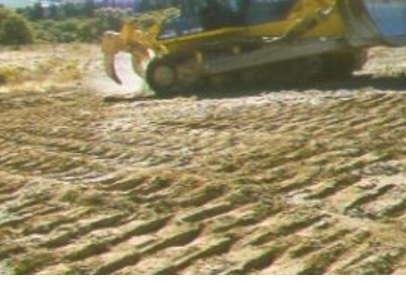
Figure 2.9. Sediment traps

Typical Uses: For slopes where additional grading is anticipated prior to permanent/temporary stabilization. To reduce runoff velocity, trap sediment, increase infiltration, and aid in the establishment of vegetative cover. Typically performed as an end-of-day practice.

Advantages:
- Simple and cost-effective.
- Immediate, short-term control.
- Reduces both wind and water erosion
Limitations:
- Could increase soil compaction, requiring additional seedbed preparation.
- Not a stand-alone practice - it must be used in conjunction with other erosion and sediment control measures.

Self-Check – 2 | Written test

Name…………………………………………… ID………………………… Date…….

Directions: Answer all the questions listed below.

Test I: Multiple choice
- Which one of the following used to reduce sediment transport? (2points)
- Sediment basin
- Contour farming
- Mulch
- Crop rotation
Test II: Short Answer Questions
- Write down major principles for controlling gully erosion?( 3points)
- List down types of check dams? (2points)
- Write down the technical design for stone check dam? (3points)

Note: Satisfactory rating – 10 points Unsatisfactory - below 10points

You can ask you teacher for the copy of the correct answers.

You can ask you teacher for the copy of the correct answers.

Operation Sheet -2
- Techniques/Procedures constructing stone check dams
- Required Tools and equipment
- Pix axes
- Meter
- Pegs
- Rope
- Shovel
- Note book
- Pen
- Stone
- Procedures/Steps/ for constructing stone check dam for sediment control

Step 1. Site selection
Step 2. Layout the dimension on the ground and estimate the volume of stone required as V= ½(Bottom width + top width) *depth of gully * width of check dam required
Step 3. Collect the stone to the site
Step 4. Construct a cut off drain above the gully head to direct the water to a natural or artificial waterway.
Step 5. Dig a foundation at least 50 cm deepand 1- 1.5m wide. Thisshould beextended 0.5m on both sides of the gully. Deposit the excavated earth upslope. Fill the trench with gravel/ stones
Step 6. Use large stones (preferably of 30cmdiameter or more) for casing the dam wall.
Work along the whole length in layers. Use smaller stones to pack the centre.
Step 7. Finish with a top layer of large stones. Check with awater tube level if crest is level throughoutits length
Step 8. Arrange rough stone layers below the constructed dam to act as an apron to check scoring below the dam and to break the force of the water falling through the spillway.(1.5 * height of check dam)
Step 9. Reshape the head and sides of the gully to a slope ratio of 1:1 and plant with grasses, shrubs and trees.
2.2. Procedure of construction dry stone measure (DSM)
1. Tool and equipment’s
- Meter
- Pix axes
- Rope
- Pegs
- Water level
- Procedure of construction of DSM
- Site selection
- Demarcating the position of the DSM that is planned in a straight line, at 90° to the gully and using a spirit level. Low and short DSM can be done by eye
- Before the construction begins at least 50 % of the stones should be on site.
- Start construction by placing big stones below the rope that is demarcating the upper border line of the structure. Big stones have an approximate size of 30 by 30 cm.
- Excavate a small ditch and place the big stones into it at the downstream end of the structure. Consider for the ditch a distance to the up line with the ration between1:3 up to 1:5 (height: width).
- Smaller stones should be used to fill the structure
- Once the planned height is reached cover it with big flat or round stones from the top to the bottom.

LAP TEST-2 | Performance Test

Name………………………………. ID…………………………….. Date…………………………………….

Time started: ________________________ Time finished: ________________

Instructions: Given necessary templates, tools and materials you are required to perform the following tasks within 12:00hour. The project is expected from each student to do it.

Task-1 perform stone check dam
Task-2Construct Dry stone measure

LG #3 | LO #3- Finalize Erosion and Sediment Control work

Instruction sheet
This learning guide is developed to provide you the necessary information regarding the following content coverage and topics:
- Cleaning and checking all equipment and materials
- Recording and documenting all assessment and measurements
- Reporting the use of resources

This guide will also assist you to attain the learning outcomes stated in the cover page. Specifically, upon completion of this learning guide, you will be able to:
- Clean and checkall equipment and materials
- Record and document all assessment and measurements
- Report the use of resources
Learning Instructions:
- Read the specific objectives of this Learning Guide.
- Follow the instructions described below.
- Read the information written in the information Sheets
- Accomplish the Self-checks
- Perform Operation Sheets
- Do the “LAP test”

Information Sheet 3

- Cleaning and checking all equipment and materials
After completion of the erosion and sediment control,tools and equipment are required to be cleaned and checked, maintained and stored according to manufacturers’ specifications and supervisor's instructions.This may include the activities of:
- Checking the presence of all material so as not leave on site
- Cleaning all tool and equipment as in order to prevent rust and increase life span.
- Maintain the broken tools and equipment’s before storage in order to make read for next work.
- Hold the tool and equipment properly in order to keep it from damage
- Return all the tools and equipment into the store

- Recording and documenting all assessment and measurements
Recording is the process of capturing data or translating information to a recording format stored on some storage medium, which is often referred to as a record.
Document is a written or printed paper that gives information about something. The purpose of a document is to facilitate the transfer of information from its author to its readers. In this case it is process of recording every assessment of the causes of erosion, severity of erosion and sediment as well as erosion and sediment control measure to be taken.
- Reporting the use of resources
A report is a statement of the results of an investigation of any matter on which definite information is required. During we undertake erosion and sediment control procedure, we have toreport severity of erosion, causes and effects properly to our supervisor or to any concerned body.

Outline of a Report format
- Title: - is terms of reference on which we write a report.
- Acknowledgements: - is as an expression of thanks somebody for their contribution.
- Contents: - a list of idea contained in the report.
- Introduction: - brief background information, problems and scope of terms.
- Methodology: - procedure or method used to do that terms.
- Results and Discussion: -giving key information on out puts of findings.
- Conclusion: - covers the writer’s judgment based on information in the body of the report.
- Recommendations: - gives solutions to the problems and suggests possible courses of action as a result of conclusions
- What should be done?
- Who should take action?
- When and how it should be done?
- References: - includes all sources of information used in the report and often those used for background reading as well.

Self-Check – 3 | Written test

Name…………………………………………… ID………………………… Date…….

Directions: Answer all the questions listed below.

Test I: Short Answer Questions
- Explain the difference between record and document?(2point)
- Write the outline of report format?(2point)
- What is the benefits of cleaning and checking tools and equipment’s after work?(1point)

Note: Satisfactory rating - 5 points Unsatisfactory - below 5 points

You can ask you teacher for the copy of the correct answers.

You can ask you teacher for the copy of the correct answers.

Operation Sheet -3

- Procedures for writing a report up on completion of work on erosion and sediment control procedures
- Tools and equipment
- Pen
- Not book
- Computer
- Printer
- Paper
- Techniques/Procedures for writing a report
- clarifying your terms of reference
- planning your work
- collecting your information
- organizing and structuring your information
- writing the first draft
- Checking and re-drafting
- Finalize and submit to concerned body/supervisors

LAP TEST-3 | Performance Test

Name………………………………. ID…………………………….. Date…………………………………….

Time started: ________________________ Time finished: ________________

Instructions: Given necessary templates, tools and materials you are required to perform the following tasks within 4:00hour. The project is expected from each student to do it.

Task-1 perform report writing on LAP test one and two

Reference Materials

https://courses.lumenlearning.com/geo/chapter/reading-causes-of-soil-erosion/(accessdate: August 30, 2022).
http://omafra.gov.on.ca/english/engineer/facts/12-053.htm(access date: August 31, 2022)
https://www.environment.nsw.gov.au/-/media/OEH/Corporate-Site/Documents/Land-and-soil/guidelines-erosion-sediment-control-building-sites.pdf(accsess date: September 2, 2022)
https://intrans.iastate.edu/app/uploads/sites/15/2020/12/Chapter_07-2020.pdf(accessdate: September 2, 2022)
MoA. (2016). Guideline for development agents on Soil and Water Conservation in Ethiopia. 2nd edition.

AKNOWLEDGEMENT

Ministry of Labor and Skills wishto extend thanks and appreciation to the many representatives of TVET instructors and respective industry experts who donated their time and expertise to the development of this Teaching, Training and Learning Materials (TTLM).

The experts who developed the learning guide
No | Name | Qualification | Educational background | Region | Phone number | E-mail
1 | Ziyad Rube | MSc | Water Resource Engineering & Management | Afar | 0921484656/  0962639851 | yoomnaaf51@gmail.com
2 | Korme Tusuru | MSc | Biodiversity and conservation Management | Oromia | +251916145234 | bilisumakorme@gmail.com
3 | Gelasa Tola | MSc | Biodiversity & conservation Management | Oromia | 0920049614 | tolagelasa@gmail.com
4 | Gezahegn Tadesse | MSc | Drainage &Watershed Management | Alage | 0968445006 | sihine29@gmail.com
5 | Geleta Bekele | BSc | Forestry | Afar | 0925482964 | geletabk12019@gmail.com
6 | Degarege Mitkie | BSc | Water Resource & Irrigation Engineering | South West | 0921281867 | mitkiedegarege@gmail.com
7 | Getnet Asmare | MSc | Production Forestry | Amhara | 0912846540 | getnetasmare40@gmail.com
8 | Kifle Tolossa | MSc | Soil Science | Oromia | 0910895568 | kifletolossadechasa@gmail.com
9 | Tolessa Sori | MSc | Forest & Natural Management | South West | 0917007821 | tolosa.sori@gmail.com
10 | Yeshitila Wondosen | MSc | Climate change & Development | Benshangul Gumuz | 0911071229 | yeshiwondo@gmail.com
11 | Zeleke Dessie | MSc | Agroforestry | Oromia | 0911091388 | zelekedessie@gmail.com

