Crop Production
Level -I
Based on April 2022, Version 4 Occupational
Standard
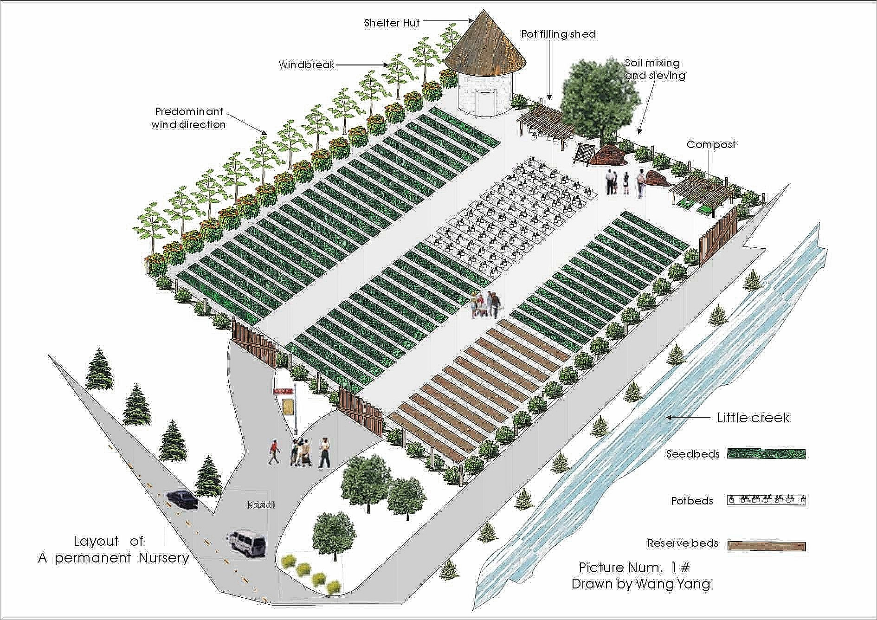

Module Title: Carrying out nursery work.
LG Code: AGR CRP1 M03 LO (9-14) LG (9-14)
TTLM Code: AGR CRP1 TTLM 0922v-I

September 2022
Addis Ababa Ethiopia

Table of Contents
Introduction to the Module 1
LO# 1-Prepare Materials, Tools And Equipment 2
Instruction sheet 2
Information Sheet -1 3
Self-Check – 1 21
Operation Sheet -1 22
Operation Sheet -1.2 23
LAP Test 24
LO# 2 - Prepare seed bed and Pots 25
Instruction sheet 25
Information Sheet -2 27
Self-Cheek -2 43
Operation Sheet -2 44
Operation Sheet -2.1 45
Operation Sheet -2.2 46
LAP Test 47
LO #3- Carrying out planting/sowing 48
Instruction sheet 48
Information Sheet -3 49
Self -Check -3 70
Operation Sheet- 3 71
Operation sheet – 3. 1 72
Operation Sheet -3.2 73
Operation Sheet -3.3 75
LAP Test 76
LO #4- Caring Seedlings 77
Instruction sheet 77
Information Sheet -4 78
Self -Cheek -4 87
Operation Sheet – 4 88
Operation Sheet - 4.1 89
LAP Test 90
LO #5- Storing and Stocking Materials. 91
Instruction sheet 91
Information sheet -5 92
Self -Check -5 94
Operation Sheet -5 95
LAP Test 96
LO #6- Cleaning and Reporting on Completion of Nursery Work. 97
Instruction sheet 97
Information Sheet -6 98
Self -Check -6 110
Operation Sheet -6 111
LAP Test 112
Reference 112

Introduction to the Module
This module covers the knowledge, skills and attitude required to Identify and prepares materials, tools and equipment, selecting appropriate site for nursery work, undertake nursery work activities, land clearing, land preparation, ploughing, pulverize, farm lay out, seed bed and pot preparation, seed collection, Carry out planting/sowing Operations, nursery management, transplanting seedlings Care for Seedlings, stockpile materials, clean up on completion of nursery work finally record and report

This module provides and support a set of principles and practices” guidelines for nursery work and describes specific propagation techniques, nursery management, and etc.
Farmers aim to ensure that the safety and quality of their products will satisfy the highest expectations of the food industry and consumers. In addition, on-farm practices should ensure that Forest, Fruit and vegetable crops are produced under sustainable economic, social and environmental conditions.
To that aim, this module provides a set of principles and practices for sustainable fruit and vegetable production for the mainstream market in all regions of the country. This document is meant to be revised regularly on the basis of practical experience. It is also meant to be completed with specific guidelines and practical tools based on local innovations and adapted to local prevailing conditions (according to the region and its climates, ecological variables, Farming systems, cultures etc) as well as respecting ATVET, national law and regulations.
N.B this module is not full document for carry out nursery work, its initial document. So Instructors should be contribute their effort, experience, skill and knowledge to improve this module.

LG# 9 | LO# 1-Prepare Materials, Tools and Equipment

Instruction sheet
This learning guide is developed to provide you the necessary information regarding the following content coverage and topics:
  - Identifying and Checking materials, tools and equipment
  - Demonstrating techniques of loading and unloading materials
  - Selecting and checking suitable Personal Protective Equipment (PPE).
  - Providing nursery support and workplace information.
  - Identifying and reporting OHS hazards
This guide will also assist you to attain the learning outcomes stated in the cover page. Specifically, upon completion of this learning guide, you will be able to:
  - Identify and Check materials, tools and equipment
  - demonstrate techniques of loading and unloading materials
  - Select and check suitable Personal Protective Equipment (PPE).
  - Provide nursery support and workplace information.
  - Identify and reporting OHS hazards
Learning Instructions:
- Read the specific objectives of this Learning Guide.
- Follow the instructions described below.
- Read the information written in the information Sheets
- Accomplish the Self-checks
- Perform Operation Sheets
- Do the “LAP test”

Information Sheet -1

  - Identifying and Checking Materials, Tools and Equipment.
Materials, tools and equipment’s for carryout nursery work includes materials used during land preparation, cultivation, fertilizer and pesticide application, irrigation, picking, packing, loading and transporting of the produce or inputs.

Before starting the nursery operations the required materials, tools and equipment’s for nursery work is identified. The trainees should know the materials, tools and equipment’s names, function and identify those tools and equipment’s physically.
Identifying and checking of different materials, tools and equipment’s to carryout nursery work;
is very important point for carrying out a day-to-day routine cultural operations in the nursery, various tools, implements and accessories are required. Some tools are simple and are used for simple operations, whereas for carrying out specific operations, special types of equipment’s are required.
Different kinds of tools are required in the nursery to carry out various kinds of operations:
1.1.1. Essential operations in the nursery work are:
- Digging
- Pruning
- Hoeing
- Watering
- Raking
- Spraying
- Site Clearing
- Seed collection etc
- Digging Tools required for working on the soil.
- Hand hoe:
There are three type of hand hoes based on their structure, depth of digging and area covered.
- Two tined hoe:
- Used for digging loosening
- Used for harvesting underground crops like tubes, bulbs, root crops etc.
- It covers smaller area but digs dipper depth when compared with three and for tined hand hoes.
- Three tined hoe: It used for digging
- Cover wider area than two tined hoes
- Digs relatively shallower depth than four tined hoe.
- Four tined hoe:
- It is used for shallow depth digging
- Cultivation b/n rows of vegetables
- Covers wider area than other tined hoes
- Generally tined hoes are used for digging and loosening the soil burying organic residues.
- Pickaxe: It is made of carbon steel. Pick axe has two edges with provision of axial hole for attachment with handle. One edge of pick –axe is pointed and another is broadened.
- Used for digging hard, compact soils.
- Used to break up hard and stony ground.
- Traditional hoe; also called western Indian hoe, long handled hoe.
- Used for loosen the soil
- Especially used for shallow depth
- Spade (flat); It has iron blade of spoon shape and wooden handle
- It used for digging excavating the soil
- Used for turning the soil
- For irrigation and drainage lines
- It is used for lifting and turning the soil
- Shovel: It has iron blade of spoon shape and wooden handle, Round point with blade size 30cm by 24cm, wooden handle, overall length 160cm.
- It is used for moving earth, for sieving soil and soil mixing.
- Used for within field transport of dug out soil required for leveling of field for preparation of nursery beds.
- Used for carrying (transporting) soil manure, rubbishes etc.
- Used for shoveling of and excavating soil.
- Rake; it has a row of 10-16 teeth and is kitted up with a 1.80 m handle.
- Break up and level the soil
- used for leveling seed beds prior to planting
- Removing leaves, roots, weeds from seed beds etc.
- Cultivating hoe;
- It is used for Cultivation of soil
- Breaking of soil clods
- Rooting up of annual weed
- Forks; there are three types of forks.
- Digging fork;
- Used for breaking of soil clods and separation of medium size soil during preparation of nursery bed or fields
- Used for digging hard and compact soil
- Garden Fork:
- It is used to collect plant west’s
- Transport (carry) manure, hay straw etc in the garden
- Especially used for turning compost
- Hand Fork ;
- It is used for mixing fertilizers with soil
- Breaking soil clods
- Cultivating b/n very closely spaced plants
- Pulling out bare rooted seedlings
- Watering Tools required for watering the seedlings.
- Watering cane;
- it can be made of metal or plastic; and it should have a capacity of 10-12L; kitted up with fined-perforated sprinkler nozzle to avoid damage to young plants and dentations of root from splashing water.
- Used for watering the garden.
- Hose pipe: This is available in convenient length.
- Used for irrigate to nursery plants is made possible to any extent.
- Sprinklers; its pressurized or manually operated by hand used for sprinkling seedlings.
- Materials tools and equipment required for cuttings
- Sickle: It is a curved metal blade shaped towards the inner side or may be toothed and attacked with straight wooden handle.
- Sickle; is used for many purposes like separating onion & garlic bulbs from their leaves, harvesting of leafy vegetable and cutting of grassy weeds.
- It is used for cutting grass and leafy vegetables.
- Cutting grass of weeds (to clear the area)
- Scythe: It is long knifed, fitted with wooden handle. It is used for slashing of weeds.
- pruning knives, shears: Used to prune the roots that grow out of pot/root zone
- Secateurs: Secateurs are considered as the most important tool for a propagator or a nurseryman. It is used for removing scions, lopping off the rootstock, preparation of scion sticks, removal of undesirable shoots/sprouts from the stock and training and pruning operations.
- Pruning Knife: Knives having combined blade for grafting and budding purposes. A grafting/budding knife has a straight 7.5cm long blade and strong long handle.
- Ladders: In propagation work, ladder is required for operations like cutting of bud wood, training of vigorous plants, performing layering operations and top working of declining plants.
- Pruning shear: It is made of iron fitted with wooden handle. It is used to prune unwanted branches, collection of scion, trimming of the edges and hedges and topiary work.
- Cutlass, dah or machete; long knife which can be
- Used for many purpose such as cutting fence posts
- Used for cutting woody weeds shrubs plants etc.
- Cutting small trees around nursery
- Used four harvesting sugar cane
- Removing weedy fences
- Trimming living fences
- Chopping left-over seedlings for composing…etc
- Machete or Panga; long knife which can be used for many purpose such as ;
- Cutting fence posts,
- Removing woody weeds,
- Trimming living fences,
- Chopping tree branches for composting, etc.
- Hand saw; used for cutting woods, pegs, branches etc.
- Axe; Used for Cutting hard and semi hard woods.
- Materials Tools and equipment required for layout.
  - Hammer. Used for hammering pegs nails etc.
  - Tracing line --- thin hemp or nylon cord 10 cm long (with knots at 1m intervals), attached to 30~50 cm long pegs at each end, and used to trace straight lines. e.g. boards of seed beds or pot beds to measure distance.
  - Nylon string: used to keep the street line measured by meter during layout or bed preparation.
- Meter tape: used for measuring distance b/n two points
- Tools required For Pot Filling
- Hand Trowel. It is of shovel shape but small in size with iron blade and wooden handle.
- Used for planting, transplanting and potting….
- Sieve—soil for seed beds and for potting should not contain large-size particles, stones, pieces of weed or something alike.
- Sieve size approx 1.5m
- Dimension 1×1.5m
- Funnel: for speeding up pot filling if inserted in the polythene tube.
- Scoop - made of metal sheet, it is an efficient tool for filling and compacting soils in pots.
- Pot cutting roll---- a simple cutting gauge which permits rapid cutting of the tube into pots of standard length (15, 20 or 30cm).It can be made locally.

- Pots: Pots of different shapes and sizes are used in nursery. They may be of clay, metal or plastic usually 10cm, 15cm or 20cm for single specimen. Pots are of different types, tube pots, ¼ size,1/2 size,3/4 size and full size.
- Used for potting ornamental plants, fruit plants, sprouts etc.
- Iron pots/ plastic pots are used for irrigation purpose also.

- Materials Tools and equipment required for transport within Nursery.
- Wheel barrow; It is manually operated small trolly,
- Used for carrying nursery plants, compost, fertilizes, leaf litter, horticultural produce, stones etc. from one place to another place,
- For transferring all kinds of materials in the nursery; potting soil, seedling ready for delivery…etc
- Used to transport all materials tools and equipment to the work site.
- Animals; like Camel, donkey etc.
- Vehicles; Pickup, lorry etc.
- Materials Tools and equipment required for tending seedlings.
- Grafting and budding knifes; used for propagation of seedlings.
- Pruning knives, shears: Used to prune the roots that grow out of pot/root zone
- Trowels ; pots into the ground of the pot bed
- Flexible steel wire; Used to prune the roots that grow out of pot/ root zone.
- Materials Tools and equipment required for weeding
- Simple tools like a pointed piece of stick, with strong hammered flat at one end and a handle at the other, are useful for weeding on seed beds & potted stock.
- A picture of materials tools and equipment’s required to carry out nursery work.

Table 1.1 pictures of materials tools & equipment.

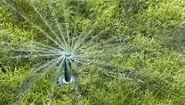  Sprinkler |  Hand saw
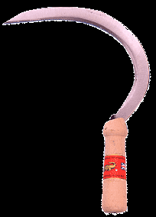  Sickle | Pot cutting roll  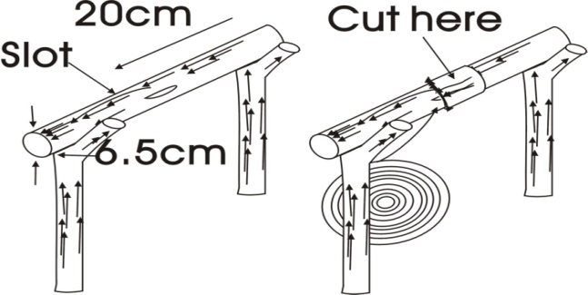
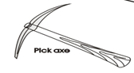 | Soil auger 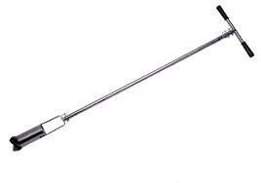
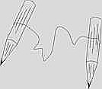  Tracing line | 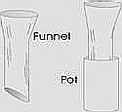

Fig1 .1
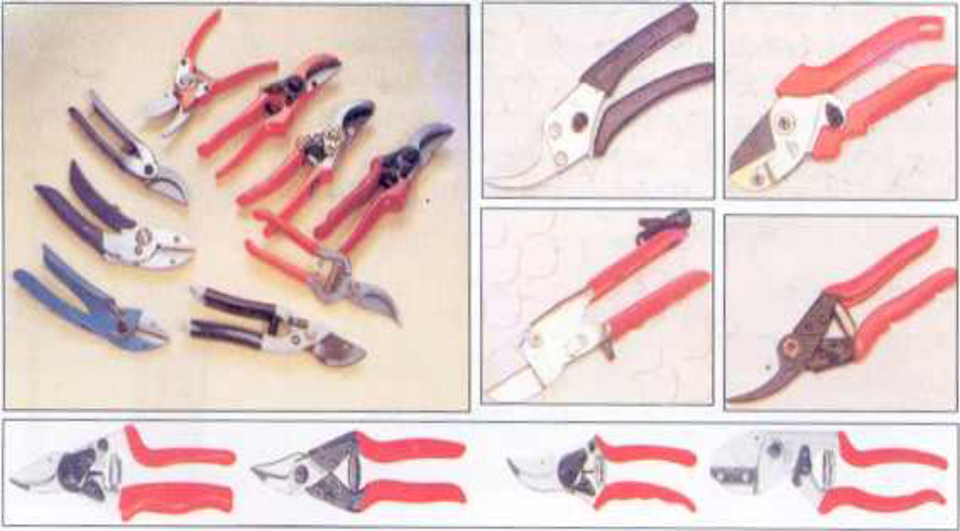
Table 1.2. Picture of different tools and equipment used for different operation.
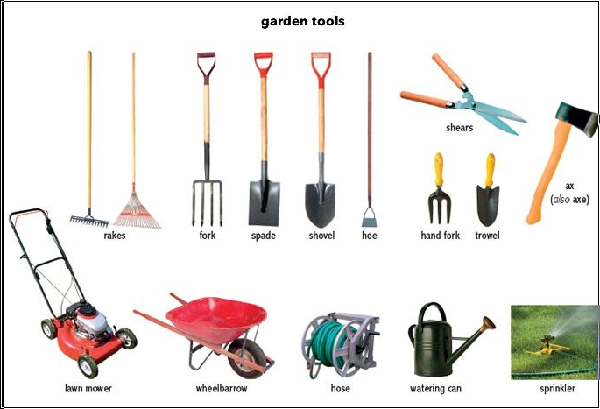
    - Checking the materials, tools and equipment.
Before and after using the different materials in the nursery it is very important to check the equipment. This makes the equipment free from some things unpleasant, undesirable, damaging that happen unexpected during work operation in the work place. If the materials are damaged it is possible to report to the supervisor immediately. Every nursery should have a sufficient supply of tools for different operations. A good care should be taken of the tools, which would then have a long life. It is not wise to keep workers sitting idle at critical periods of work because of shortage of tools. All tools should be hung or otherwise stored in fixed place in the nursery where they can be readily found. They should be stored in-groups of similar articles so that checking to ensure that all have been returned after work done at a glance.
  - Demonstrating techniques of loading and unloading materials.
- Loading: - is putting the material/tool on the vehicle
- Unloading: -taking out the materials from the vehicles to perform the work.

Loading and unloading operations are common in nurseries such as materials tools and equipment’s, agricultural inputs etc. To prevent damages of tools injuries among workers carrying out these operations, proper securing and safe loading and unloading practices are crucial.
To do Nursery work, we need to properly prepare the working materials in a working area for this purpose materials should be transported from where they are stored to the working site. In this regarded the required type and their sufficient number is already decided by the supervisor, hence these materials will be counted and will be loaded on a transporting vehicle and in the working site these materials will be unloaded.
    - Care during loading and unloading
- Do not throw materials from ground on to the vehicle
- Do not throw materials from vehicle on to ground
- Hold and place materials one by one rather than making more than one or two
- When placing materials on the vehicle place them in stable position
- Place materials on ground in stable position
- Place similar materials together on the vehicle while loading and on ground when unloading
- Two or more people are necessary one or more on the vehicle and one or more on ground.
- Be sure to bend your knees and lift with your legs as you loading material, be careful not to twist with heavy load.
- When using a shovel to move large quantities of material, position your body and your work. So you don’t have to turn or twist.
- For example, if you’re shoveling top soil into a wheel barrow facing your target, and in a position relative to the pile that allows you to scoop, lift and dump without twisting.

    - Minimize damage to the load, to the worker and the vehicle by following the following lifting and handling procedures:
- Check the load to ensure it is within lifting capacity and can safely be handled without causing injury from strain, sharp edges, splinters or other conditions.
- Ensure the work area is clear of obstructions if the load is to be carried from one place to another.
- Stand close to the load with the feet apart, one foot behind and the other beside the load.
- Bend knees, grasp the load and lift by straightening the legs.
- Avoid reaching, bending forward to lift, twisting the back or bending sideways.
- Be able to see over or around the load before moving. Face the spot where the load is to be placed, bend the knees to lower the load, keeping the back as straight as possible and the load close to the body. Protect fingers from pinching before release of load.
- Do not try and lift or move objects beyond your capacity—ask for help. Co-ordinate lifting, moving and lowering by pre-arranged signals.
- Report problems including physical and medical conditions (e.g. pregnancy, back problems), which may affect their ability to undertake manual handling activities to their line manager.
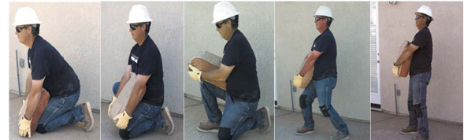
Fig 1.4 Correct manual handling
1.3. Selecting suitable personal protective equipment (PPE)
Definition PPE, as defined by the Occupational Safety and Health Administration, or OSHA, is“specialized clothing or equipment, worn by an employee for protection against injury by blunt impacts, chemicals, infectious materials etc.”
1.3.1. Selecting personal protective and equipment.
Selecting (PPE) implies the process of ensuring that the personal protective equipment is directly related in protecting the person as related to the job performed. In the process one has to know the likely risks that might arise from the agricultural crop works. Therefore during the work the likely risks could be to be hit/ injured by the materials, mostly on hands and legs or foot, hence in addition to the care that we take during loading and unloading we need to protect our hands and legs. Therefore from among other protective equipment’s we select over all’ clothes, hard hat, boots, gloves, respiratory musk, eye goggle e.t.c In similar manner you need to identify the likely risks that might occur on your body or sense organs from specific horticultural production works, then once you identify the risks it is necessary to select the necessary personal protective equipment that fit the body or the sense organ involved.

1.3.1.1 Purpose of PPE
The purpose of PPE is to reduce employee exposure to hazards when engineering controls and administrative controls are not feasible or effective to reduce these risks to acceptable levels.
PPE is defined in the Regulations as ‘all equipment (including clothing affording protection against the risk or hazards) which is intended to be work or held by a person at work and which protects him against one or more risks to his health or safety. eg. Safety helmets, gloves, eye protection, high visibility clothing, safety footwear and safety harnesses.
1.3.2. Checking Suitability of Personal Protective Equipment.
Checking involves many things such as the checking in faultiness of the personal protective equipment, checking the size, and checking the sufficiency in number of the materials for the available work force. If one of these is missing based on the level of the risk that occurs the expected risk could occur. Therefore don’t proceed a job until the problems with the PPE will be solved. The size of PPE should be fit with your size, if the PPE is faulty it should be maintained or a new one should be provided, and if the number is not sufficient only people with the PPE should work the job
Example of PPE Safety helmets, gloves, eye protection, high visibility clothing, safety footwear and safety harnesses.
Hearing protection and respiratory protective equipment provided for most work situations are not covered by these Regulations because other regulations apply to them. However, these items need to be compatible with any other PPE provided.

    - Personal Protective equipment that must be available
- Gloves – protect hands
- Overalls – protect skin and/or clothing
- Masks and respirators– protect mouth/nose
- Respirators – protect respiratory tract from airborne infectious agents
- Eye Goggles – protect eyes
- Face shields – protect face, mouth, nose, and eyes
- Ear protectors- protect ears from heavy noise or sounds.
- Boots/shoes – Protect foots from different hazards
- Sun hat – protect from solar radiation
- Sunscreen lotion -protect from sun light

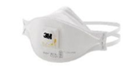Respiratory Musk | Hand Glove
 Eye goggle | 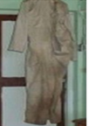Overall
Suitable PPE |  Boots/shoes
 Complete PPE | 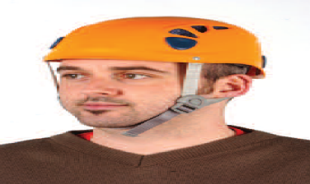  Head protection
Fig. 1.5 PPE materials.
- Important Points about PPE
- Do before going to worksite
- Use carefully – don’t spread contamination
- Remove and discard carefully, after finishing work
- Immediately perform hand hygiene
- Sequence for Removing PPE
- Gloves
- Boot
- Gown/ Over all
- Mask or respirator protection.
- goggles

  - Providing nursery support and workplace information.
Any work in the agricultural or horticultural industries may be dangerous in some way. It is important to know about your workplace’s occupational health and safety procedures. As an employee you have a responsibility to:
- Follow your workplace’s occupational health and safety procedures
- Follow manufacturers’ guidelines for machinery and equipment
- Respond to a situation where someone is put at risk of injury (as long as you do not endanger yourself)
- Report any incidents or situations which cause you or other people injury, or put you or others at risk.
Provide and support Safety in the nursery work: Strategic approaches to reducing farm injury risk are multifaceted and include:
    - Identifying elimination and substitution options
    - Improving design and engineering solutions
    - Administrative or work practice solutions, including education and skills development
    - Identification of requirements for personal protective clothing and equipment
    - Identification of incentives for adoption of improved systems
    - Ensuring compliance with regulatory requirements for supply of safe plant and equipment and safe operation in the farm workplace.
While providing the support there are possible risks that may endanger your health and safety, the dangers could be those which cause physical injury during land preparation, loading, unloading, mounting different plowing implements to tractors, etc.
In agricultural crop work support, there are jobs or activities that might harm your health and safety, hence you need to take care of those hazards by using the appropriate personal protective equipment, and by taking all the necessary care as it has been said “prevention is better than cure”; even sometimes the risk may not be cured letting

- Records of workplace information may include:
- Environmental parameters (light, temperature humidity and wind)
- Date of treatments and
- Type of treatment and
- Rate of treatment
    - Identifying and reporting OHS hazards
- Introduction
- Hazard: a situation at the workplace capable of causing harm (i.e. capable of causing personal injury, occupationally related disease or death).
- Risk: the chance of a hazard actually causing injury or disease. It is measured in terms of consequences and likelihood.
- OHS hazards is chemicals and hazardous substances, dust and pollen, incorrect manual handling, moving equipment, machinery, and vehicles, noise sharp hand tools and equipment’s, slippery or uneven surfaces, soil-born microorganisms, solar radiation, wet working environment, including electricity
- Hazard identification; Hazard identification is a process used to identify all possible situations where people may be exposed to injury, illness or disease, the type of injury or illness that may result from these and the way in which work is organized and managed.
- Risk Management: The overall process of risk identification, risk analysis, control of risks and risk evaluation.
- Risk Control: that part of risk management which involves the implementation of policies, standards, procedures and physical changes to eliminate or minimize adverse risks.

Reporting Hazards and Accidents

Employees are required to report any situation or occurrence in the workplace that may present a risk or have the potential to affect the health and safety of employees or others in the workplace
- Hazards arise from
- The work environment
- The use of machinery and substances
- Poor work design
- Inappropriate systems and procedures
1.4.4. Types of hazards; many kinds of hazards are found in workplaces.
- Chemical hazards; are substances that can harm people’s health when they are breathed in or absorbed through the skin, or when they irritate the skin.
- Physical hazards; include electricity, noise, temperature, lighting, radiation and vibration. radio actives materials, Lifting and moving loads;
- Biological hazards; such as infectious diseases can also be present in workplaces
- Psychological stress; can result from workplace violence, bullying, threats or intimidation.
- Ergonomic hazard; such as the heat of work bench, the shape of a vehicle seat and the length of a control lever.

Self-Check – 1

Name…………………………………………… ID………………………… Date…….
Directions: Answer all the questions listed below.
Test I: Choose the best answer (3 point)
1. From the following hazards which one is cause of infectious?
A. Physical hazards; C. Biological hazards
B. Chemical hazards D. All of the above
2. One is important Points about Personal Protective Equipment
- Wear before going to worksite
- Use carefully – don’t spread contamination.
- Immediately perform hand hygiene
- Remove and discard carefully, after finishing work
- All
- None of the above
Test II: Short Answer Questions
- List and explain materials tools and equipment’s names and their functions? (3pints)
- Write PPE used during nursery work? List them and their importance? (3pints)
- Define the term hazard? List types of hazards explain? 2 pints
- Why Care should be taken during loading and unloading? (3pints)
- Where do hazard arises from? (3pints)

Note: Satisfactory rating – 15-20 points Unsatisfactory - below 15 points

Operation Sheet -1

  - Techniques of Identifying and Checking materials, tools and equipment for nursery work.
- Tools and equipment’s required
- Hoes, Forks , rake
- Machete, sickle, meter tape nylon steering
- Shovel, spade, pick axe
- Wheelbarrow, water cane etc. needed for practicing.
- Procedures
- Wear appropriate PPE before starting the work.
- Make your practical work area as clean as possible.
- Obtain all the necessary stationery materials from the practical area or lab.
- Preparing tools and equipment for identification
- Displaying
- Familiarize yourself with equipment.
- Practicing how to operate safely.
- Know their name and function of each materials tools and equipment.
- Precautions:- The materials tools and equipment must be checked for their correct operation before and after use.

Operation Sheet -1.2

  - Demonstrating techniques of loading and unloading materials
- Tools and equipment’s
- Lift
- Glove
- Ladder
- Wheelbarrow.
- Agricultural inputs seed fertilizer…
- Procedures
- Wear appropriate PPE before starting the work.
- Make your practical work area as clean as possible.
- Obtain all the necessary stationery materials from the practical area or lab.
- Do not throw materials from ground on to the vehicle
- Do not throw materials from vehicle on to ground
- Hold and place materials one by one rather than making more than one or two
- When placing materials on the vehicle place them in stable position
- Place materials on ground in stable position
- Place similar materials together on the vehicle while loading and on ground when unloading

LAP Test

Name: _____________________________ Date: _______________________
Time started: ________________________ Time finished: ________________
Instructions: Given necessary templates, tools and materials you are required to perform the following tasks within 2 hours.
Task 1: Perform Identification and checking suitability of material, tools and equipment for nursery work.
Task 2: Demonstrate techniques of loading and unloading materials

Instruction sheet
This learning guide is developed to provide you the necessary information regarding the following content coverage and topics:
- Plough, Pulverizing and Leveling soil
- Identifying and preparing potting materials
- Selecting, mixing, filling and arranging soil for potting
This guide will also assist you to attain the learning outcomes stated in the cover page. Specifically, upon completion of this learning guide, you will be able to:
- Plough, Pulverizing and Leveling soil
- Identify, and preparing potting materials
- Select, mixing, filling and arranging soil for potting
Learning Instructions:
- Read the specific objectives of this Learning Guide.
- Follow the instructions described below.
- Read the information written in the information Sheets
- Accomplish the Self-checks
- Perform Operation Sheets
- Do the “LAP test”

LG # 10 | LO# 2 - Prepare seed bed and Pots

Information Sheet -2

2.1. Plough, Pulverizing and leveling soil.
- Definition. Ploughing is the mechanical manipulation of the soil creates optimum environmental conditions for seed germination and seedling growth.
- It is the activity of making the area of land ready to prepare a good seedbed.
- It is the activity of digging and turning over soil; especially before seeds are sown.
- Pulverizing: - the activity changing soil in to a fine powder.
- Leveling: - the activity of making the land level. It is the task of making the height difference equal using line level.
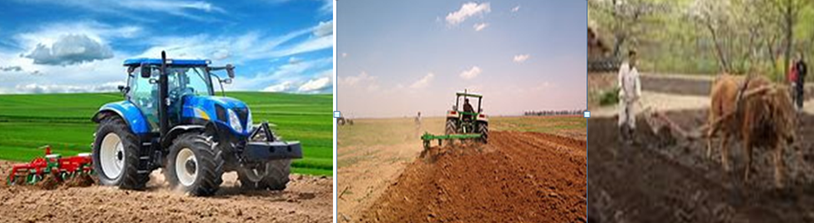
Fig. 2.1 ploughing
Leveling and pulverizing the soil for nursery work is used for good crop growth, it is necessary that seed should be placed at uniform depth. This is only possible when fields are kept fairly leveled. The leveling also reduces run off which is very common in sloppy and undulated fields. By preventing run off, washing away the nutrient along with water and soil can also be checked. In areas where irrigation and drainage channels are to be constructed, leveling is an important aspect for uniform distribution of water. The implements which can be used for leveling are planter, ridger, roller, scraper and bund former.

2.1.1. Nursery
- A nursery is compact place where seedlings are grown under intensive care or
- Is a compact place where seedlings are raised under intensive care for fureter transplanting. Vegetables like tomato, onion, cabbage, cauliflower, lettuce, eggplant, chilies, etc require rising of nursery.
2.1.2. Types of Nursery
A nursery can be classified into different categories based on time duration. The nursery is supposed to be serve (for few or many years) and scale of production (small or large number) In general; we have two types of nurseries. These are:

- Permanent nurseries:
- Large centrally located nurseries that are established where there is a demand for a large number of seedlings for long period of time (more than five years). ‘
- Usually it has permanent workers including trained foreman or foresters
- It has a better control in most activities and produces quality seedlings.
- Annual plant production exceeds 500,000 and
- Requires bigger capital to establish and run them. eg. Government nurseries.

B. Temporary/flying/satellite nurseries:
- Annual plant production is less than 500,000
- Establish for a short period (<5 years).
- Require lesser capital to establish and run them. E.g. Ethiopian Farmers and SME Nurseries.

2.1.3. Nursery site selection.
Selecting the best possible site for nursery based on preliminary survey of areas is essential. Because no potential site is perfect, site selection inevitably requires a compromise between different factors. The facility for growing transplants, otherwise called the nursery, can be as simple as a raised bed in a selected corner of the field (usually near the water source), or as sophisticated as a glasshouse with micro-sprinklers and an automatic temperature control system.

- The major factors to be considered in nursery site selection are:
- The availability of water supply
- The proximity of nursery to the plantation site
- Availability Labor for different activities.
- Slope or Topography of the site.
- Outside the reaches of roots of trees.
- Protected from strong winds.
- What is its land history?
- Land availability:
- Favorable climatic, soil and land features
- Legal framework

2.1.3. Importances of carryout nursery work are as following:
- To apply optimum growing conditions to the plant during the very early development stages
- To give better conditions for germination.
- To economize seeds that are expensive, especially hybrid seeds
- To eliminate weak and diseased plants, to get strong seedlings and even stand in the field.
- To obtain large number of plants (seedlings) from a small area.
- To raise seedlings to rain fed fields.
- To produce seedlings in adequate quantity and quality.

Land preparation
Before seed/seedling is planted, the land must be prepared in some fashion to provide an adequate seed bed. Land preparation entails removing vegetation and loosening the soil to facilitate seed germination and root penetration. The nursery owners, managers or grower/producer need have thorough understanding of good tillage practices to maintain the productivity of the seedlings and preserve soil viability for future use. Seedling will grow on a wide range of soil types, the main requirement being that they are fertile and well drained.

Importance of Land preparation

- Removing old crop residues, stone, etc from the field
- Loosening the compact layer of soil and pulverizing it; there by improving aeration and the growth of plants.
- The harmful insects, pathogens and weeds harboring in the soil are exposed the sun and killed.
- Proper and uniform germination of seeds. Because it creates favorable conditions for seed germination, seed establishment, and subsequently management of the crop.It ensure easy and quick establishment of transplanted crops. So the mortality of plants is reduced.

Purposes of Clearing

- Avoiding competition of nutrients, water, light and air
- Reduction of shading and making the land convenient for cultivation
- Eliminating shelter of pests and diseases
- Enhancing good germination and growth of seedling.

Materials to be removed from the nursery Site are as follows:

- Unwanted vegetation (such as trees, bushes, weeds, etc.) and plant residues.
- Tree roots and stumps.
- Stones, bricks, etc.
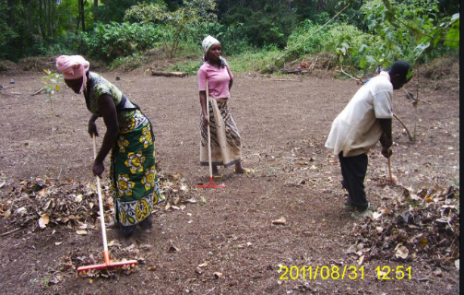
Fig. 2.2. Land clearing
    - Prepare nursery seed beds
Before sowing seeds the beds should be leveled and pressed gently to make it firm.
Procedures:
- Clearing the site
- Plough it
- peg out location of blocks/ compartment, roads
- Leveling the ground (scrapping of top soils, compacting subsoil) sometimes gravel then spreading the top soil over.
2.1.6 Field lay out
Field lay out is a very important tools to make plot or block. To do field lay out at least three (3) people are required. Always a proper field lay out is done by Phytagorous theorem which is ($a^{2}+b^{2}=c^{2}$). We use A and B interchangeably like $a^{2}+b^{2}$ = ${b^{2}+a}^{2} =c^{2}$. Eg. 3² + 4² = 5 or 4² + 3² = 5².
A one important issue during lay out preparation is using similar thickness pegs, accurate measurement and checking its accuracy by measuring the diagonals. If the difference of the diagonals are less than 5cm almost it is correct or it must be equals but if not repeat your lay out.
Using Pythagoras theorem formula (3, 4, 5 method) to make a right angle triangle at one corner
Repeat for the other corner
After putting pegs on all four corners, check the diagonal length to be equal but 5 cm error is possible.

Example. 1. Prepare three types of seedbeds Raised bed, sunken bed and level, by using the above formula 3,4,5 on the land size length.(L) 5m and width (w) 5m bed size or width 1m path 0.5 m and 50cm border spacing in both side make your bed east to West direction.

N.B:-See on page 32

7m
8m
6m 8m
9m
5m 9m 10
10m12m
4m 11m
12m
3m 2m 1m 0m &

50cm
L=4m

50cm
50cm
50cmm
50cm

1m
50 cm

Picture. 2.3. Sketched layout

Types of nursery Seedbeds
There are three types of beds commonly used:
- Raised,
- sunken, and
- Flat seedbeds
- Raised seedbeds
This type of beds is prepared in heavy rain fall areas in a height of 15cm – 20cm above ground level with supporting structures like bricks, stones or bamboos which prevent falling apart of embankments( edges) of beds. This type of bed is prepared for avoiding excessive water condition or water logging. On well cultivated field, area is demarcated having 1.0 to 1.5 meters width but 1m width are always preferred for raising nursery. However, its length should be made according to the requirements or size of plots but should not exceed 5-20 m. In between beds, drains of about 50-60 cm width are prepared and connected to the main drain for removal of excess water during heavy pour. This space facilitates easy movement during intercultural operations and acts as physical barrier for inoculums spread.
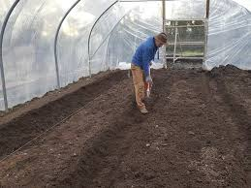
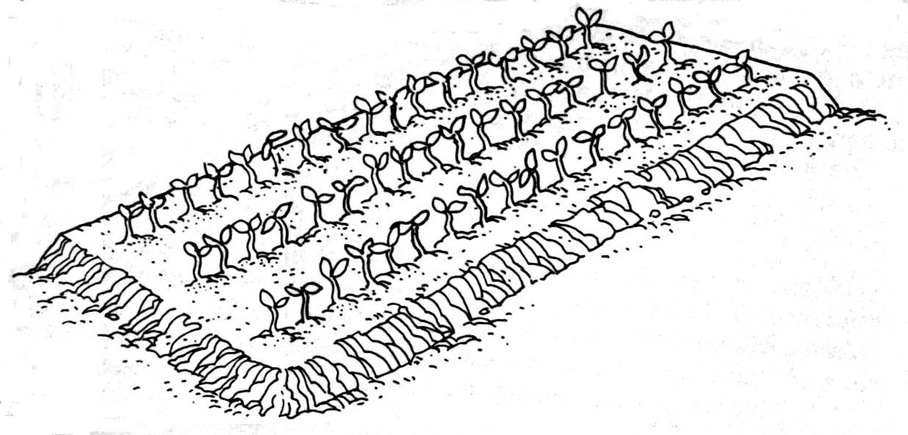

Fig.2. 1. Raised Seedbed
- Advantages of Raised Seedbed
- It encourages drainage: So, it is mostly practiced in wet tropics.
- It facilitates easy removal of seedlings without damaging their roots.
- Thickening soil tilth, enhancing the development of plant roots.
- Enhancing the soil’s temperature in early spring.
- Watering of seedlings can be done as per their needs
- Used for conducting essential operation like, weeding, watering, spraying insecticides
- Disadvantage of raised bed
- Require labor and additional cost.
- Sunken seedbed
- Sunken beds: is prepared in arid and Sami arid areas depth of 8cm – 15cm and 1m wide and a convenient length in to the ground. The objective of this type of bed is conservation of the available moisture or avoiding flow of water outside the bed and to reducing evaporation. Usually constructed in areas where there is low rain fall and soil moisture.
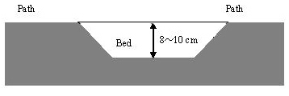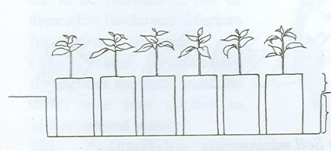
Fig 2.2 Sunken seedbed
- Advantages
- Conserves moisture.
- Reducing evaporation.

- Level or Flat seed bed.
This is an old but popular type of bed commonly used by the farmers in villages. The width of the bed is adjusted to approach its center conveniently. This types of bed is prone to over watering and thus decaying of seedlings. It is not recommended specially during rainy season. During spring – summer, seedlings are raised in flat bed. Further, in areas where rainfall is not so heavy and field is well leveled and drained, flat bed is preferred. Soil is dug 15-20cm deep and all clods are broken and irrigation channel runs in between two tows of the beds and each bed is connected with it.

- Advantage of flat bed
- Flat bed is easy to produce or prepare
- Cost for preparation is less
- Disadvantage of flat bed

More chances of getting excess irrigation H₂O which is always harmful to the plants.

Soil becomes more compact, and results in root purring when seedlings are up rooted
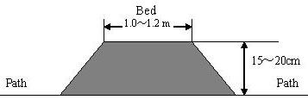
Fig 2.3. Sunken seedbed
N.B Beds 1m wide and 5-10 m long are most convenient. If the beds are wider, weeding and watering the center is more difficult. On terraces, beds must be along the contour.
Between the beds, access paths are needed for transport, weeding, watering etc. they should preferably be 60 cm wide. Note that paths are needed on either side of the beds. On flat bed this is achieved with one path per bed. On terraces additional paths are required.

Fig. 2.4. of good nursery

2.2. Identifying and preparing potting materials.
Seedlings are raised in pots and planted in the field with soil from the original raising site .The survival rate of potted seedlings are higher .That is because of the soil moisture ,nutrient and other conditions .The seedling will not be exposed to harsh conditions .The disadvantage is high cost of production .e.g. Need higher quality seed .Bulk to transport and great amount of soil required to fill the pots .Containers must be removed at the time of planting to allow root development .If seedlings are left in the container for a long period of time .They become root-bound.
    - Potting mixture and potting yard:
For better success of nursery plants, a good potting mixture is necessary. The potting mixtures for different purposes can be prepared by mixing fertile soil, well rotten FYM, leaf mold, oil cakes etc. in different proportions. The potting mixture may be prepared well in advance by adding sufficient quantity of superphosphate for better decomposition and solubilization. The potting mixture may be kept near the potting yard, where potting/ pocketing is done. Construction of a potting yard of suitable size facilitates potting of seedlings or grafting/ budding operations even on a rainy day.
There are several media and mixtures of different kind are available for use in propagation such as in seed germination, rooting of cuttings and for growing container stock. Commonly used media with a brief description of properties are given below:
- Soil:
A soil is composed of materials in the solid, liquid and gaseous states. These materials must exist in the proper proportions for satisfactory plant growth. The texture of a soil depends upon relative proportions of sand, silt and clay. Maintenance of a favorable granular and crumb soil structure is very important.
- Prepare compost
Compost. is humus rich organic substance which provides organic matter to improve moisture holding capacity and nutrients as well. Compost is prepared by letting, alternative layer of C-rich composed through microbial action in a pile or pit.
- Sand:
Sand consists of small rock grains (0.05 to 2.0 mm) formed as result of the weathering of various rocks. Its mineral composition depends on type of rock. Quartz sand is generally used for propagation and plastering grade is used for rooting of cuttings. Sand should be preferably sterilized before use.
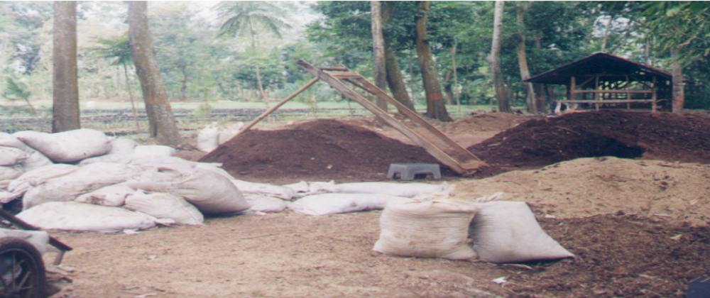
Fig. 2.5. Preparation of potting materials in a nursery
    - Sieving and preparing Nursery inputs
Sieving: Soil for seedbeds and for potting should not contain clods, stones, pieces of wood or similar objects. The potting mix ingredients (soil, sand and compost/manure) are passed through a coarse sieve with a mesh opening of 1 cm or, preferably, 0.5 cm. The mesh should be of wire fitted to a metal or sturdy wooden frame of at least 1 m x 1.5 m.
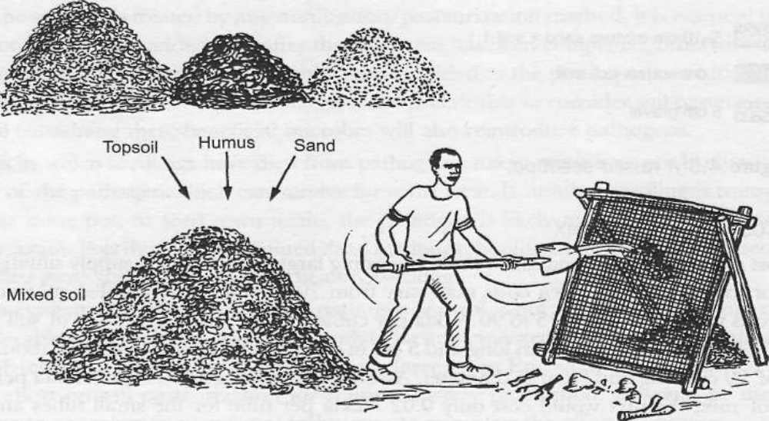
Figure 2.6 Sieving and mixing potting soil
The proportion/ratio of forest soil, sand soil, compost are different to be used varies.
- From place to place
- The species to be raised, and
- The availability of soil ingredients
- Find out the best possible potting soil using material available nearer to the nursery
- Decide on the best mixture/ratio through trail/experiment.
Pot cutting roll: a simple cutting gauge which permits rapid cutting of the tube into pots of standard length (15 or 20) cm. It can be made locally.
To obtain pots in 20 cm length, the piece of rounded tube has to have diameter of 6.5. cm
Perimeter / circumference of round object is:
C = $π$d, d = C/$π$, where C = pot length, d = diameter
$π$ = constant ≈ 3.14

2.3. Selecting, mixing, filling and arranging soil for potting.
Different crops response differently in different soil and nutrient and they also require different ratio of soil and nutrient. The soil ready for spice production should be well fertile with alternative nutrient and organic manures. Top soil rich in humus and organic manure is essential for cultivation of most crops. In order to make the soil proportional in ratio;
The standard soil mixture various from country to country, but the mixture used will normally contain:
- Humus-rich soil as found under trees or in forest
- Ordinary agriculture soil as found in crop fields, garden, or fallows
- Sand soil the soil contains too much clay that they are heavy and crack when they are dry. Since the mixture depends very much on the quality of the soil available. No standard is given it varies from locality to locality. The suitable mixing proportion should be determined by experiment or experience.
Hence, every nursery develops its own standard soil mixture.
E.g., the nursery uses forest soil, compost, and sand at a ratio of 5:2:1 3:2:1 4:2:1
    - Filling soil mixes in pots /Containers
- Sieve the soil mixture through 2mm mesh to remove clods/stones
- Mix the ingredients and turn with shovel
- Fill the bag by firmly compacting the lower third of container
- avoid air pockets in containers during the bag fill
- keep the soil mix moist while filling

Potting method

Potting; is the filling of pots with soil. After the preparation of a suitable potting mix, and having cut endless polythene tubing to the required length, you can begin pot filling. The soil mix should be moist but not saturated to facilitate rapid filling of pots to the required density. The labor and time spent on filling tubes is a major component in the cost of running nurseries and so this task should be carried out efficiently. The use of a simple funnel and scoop (see Figures 4) helps to hasten filling and is widely recommended in lab our-intensive nurseries. These tools are especially useful when filling larger tubes such as the most commonly used size in Ethiopia is 7-8cm lay flat tubes & length 12-15cm.During pot filling the lower third of the polyether should be strongly compacted to prevent the soil from falling out of the bottom of open-ended tube and the filling pot stay to the upright position. The upper part should be gently or slowly because roots penetrate easily.

The pot size to be used varies depending on the tree species to be raised from place to place, planting site and to some extent means of propagation and seed size
Funnel: A simple funnel, which can be made from waste metal cans, considerably speeds up pot filling, especially if larger size pots are used. The diameter of the lower end of the funnel should be just a little smaller than the diameter of the tubes to be filled.

Potting: Potting mixture (soil, sand and compost/manure) should be moistened and then pressed into containers to a depth of about three-quarters of the height of pots. Pots should then be topped up more loosely with mixture and pressed down slightly to about 2 cm below the top.

- Heavy compaction should be avoided at the top of pots because it will inhibit root penetration.
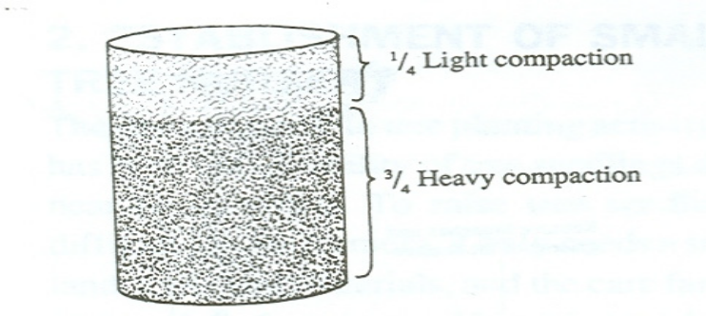
Fig. 2.7. Filled polythene bag or pot
Before planting seed, containers should be watered lightly. Sometimes, more than one seed can be planted in a pot and then, if more than one germinates, seedlings can be removed to leave a single individual. This approach might be used if germination rate is expected to be quite low
- Filling poly pots
When the mixture of soil/ sand/ compost is ready you can fill the poly pots by hand. A scoop made from an old half-liter plastic bottle will help speed up the process. Make the mixture very slightly moist, but keep it loose so that you can easily pour it. Fill the pot in three or four stages, firming down the mixture after each stage. Do not fill the whole pot and then try to firm all the soil at once, because this leaves air pockets. Fill the pot completely. Allow the mixture to settle for about four weeks. Do not allow the pots to dry out during this period. Water them periodically to permit the development of micro-organisms. This is especially important if the soil has been stored dry for some time. The pots are then ready to take seeds or transplants.
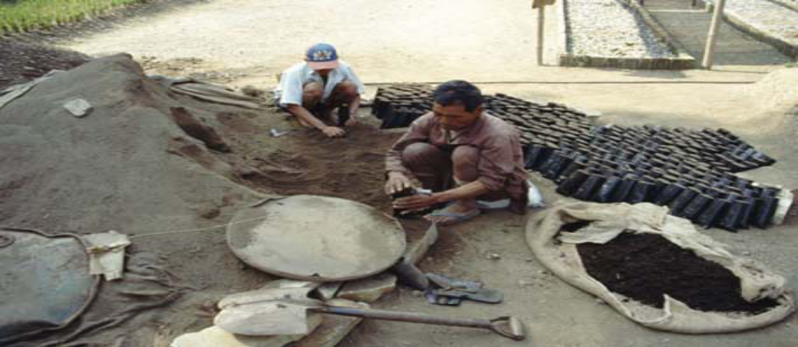
Figure.2.8 Filling poly pots
2.3.2 Mixing and filling in polythene tubes
Soil mixture can be made by mixing soil, sand and compost (FYM) in the ratio 2:1:1 or 1:1:1 to make /prepare suitable growing media. Common components of soil mixture includes: sphagnum or peat moss, sand, bark and sow dust, quarry dust, humus, forest soil, leaf molds, organic matter, and vermiculite.
- Method of potting operation
- by machines designed for potting ( for large scale nursery stock production)
- manually operated
- Objectives of arranging pots in blocks.
- to reduce bad growth of nursery
- to enhance good root growth
- to crate sufficient space for drainage
- Placing pots in blocks/ beds
- place pots in an upright position
- leave spaces between pots for rain and excess water drainage
- place pots in straight rows in blocks/ beds
- Improper placing will result in:
- deformity of pots
- insufficient space for drainage
- distortion of root growth
- distorted growth of the nursery stock

Self-Cheek -2

Name…………………………………………… ID………………………… Date…….
Directions: Answer all the questions listed below.
Test I: Short Answer Questions.
1. Assume that you are agricultural expert in your woreda, Agro- production enterprise wants to invest on different nursery seedlings and they want expertise on the field. So what you advise them and what activities you should perform to establish and carryout nursery work as an expert? 6 points
2. What is nursery? List factors considered during nursery site selection? 2 point
3. What is land preparation? 3 points
4. List types of nursery beds? Explain briefly the appropriate situation to use them? 4 point
5. How to perform farm layout? 5 Point

Note: Satisfactory rating - 20 points Unsatisfactory - below 20points
You can ask your teacher for the copy of the correct answers

You can ask you teacher for the copy of the correct answers.

Operation Sheet -2

2.1.2 Nursery site selection
A. Materials
- Meter -
- Surveying materials
- Metrological data
- Bag
- Digging materials
- Procedures
- Undertake all Nursery site selection criteria.
- Survey the topography of the land whether undulating, slopping or plain
- Locate suitable spot for digging pits at 2-3 places in one hectare as areas, the number of pits may be more according to the area and the topography
- Collect the soil samples layer wise from 0-60,60-120cm,120-200 meter
- Put samples in bags, label individual bags indicating location of pits and depth
- Indicate the source of water (such as well or irrigation canals)
- Take the water sample in plastic bottles from 4-5 places for testing its suitability for irrigation purposes
- Have the soil and water sample analyze in soil testing laboratory
- Collect the metrological data from the nearest metrological observatory for the least 5 years.
- Depending on the metrological data and soil and water test results, select the site for crop planned to be grown.

Operation Sheet -2.1

2.1.5. Prepare Nursery Seed beds
- Materials tools and equipment required.
- Hoes , forks ,shovel/spade, Rake Hoe, Axe, Peg ,Saw etc

PPE Safety shoes, overall, sun hat, gloves ….

Water cane, mater tape, steering,
- Procedures
- Select a suitable area near water source, dig and bring to fine tilth.
- Nursery beds direction should be east-west oriented.
- Scheck layout 3,4,5
- Prepare 5m long, 1m wide and 10-15cm high beds by using tape, spade, tracing line the length is decided by the land shape etc.
- Keep to 50cm space between two adjacent beds and they may be arranged in staggered manner to check erosion.
- Apply 15kg compost or well- decomposed FYM and 0.5kg NPK 15:15:15 fertilizer mixture per bed and mix it well with the soil.
- Sterilize soil with 2% solution of formaldehyde or drench with fungicides like captan, thiram, bavistin @ 0.2 to 0.3% solutions.
- Mark shallow channels at 5cm to 10cm intervals with a pointed peg width wise.
- The depth of planting depends upon size of the seed, sow larger seeds at 2cm depth and small seeds at 0.5 to 1cm depth
- Cover the seeds lightly with surrounding topsoil and dry grass
- Water the beds with the watering can fitted with hose shower when necessary.
- Remove the grass cover when seedlings start emerging.
- Cover the beds with thatched shade during afternoons in summer and during nights in winter.
- Undertake thinning of seedlings if necessary after 15-20 days of sowing.

Operation Sheet -2.2

  - Mixing, Filling and arranging soil for potting
- Materials required
- Humus-rich soil
- Safety shoes
- First aid kit
- Funnel/ scoop
- Polyethylene bag
- Spade/ shovel
- Water Watering can
- Sieve
- Ordinary agricultural soil
- Pot cutting roll
- Sand
- Sharp knife
- Overall
- Procedures
- Sieve the soil mixture through 2mm mesh to remove clods/stones
- Mix the ingredients and turn with shovel
- Keep the soil mix moist while filling
- Fill the bag and firmly compact the lower 1/3 compacted container
- 2/3 should be gently compacted. You can use scoop/ funnel to fill the bag
- Avoid air pockets in containers during the bag fill
- Place pots in an upright position
- Place pots in straight rows in blocks/ beds in an upright position
- Place pot in bed:-to prevent the pot from falling away the beds should be framed by Stone Timber etc.

LAP Test

Name: _____________________________ Date: _______________________
Time started: ___________ _____________ Time finished: ________________
Instructions: Given necessary templates, tools and materials you are required to perform the following tasks within 3 hour.

Tasks 1- perform nursery site selection
Tasks 2- Prepare the 3 types of nursery seedbeds
Task 3. Perform Mixing, Filling and Arranging Soil for Potting

LG #11 | LO #3- Carrying out planting/sowing Operations

Instruction sheet
This learning guide is developed to provide you the necessary information regarding the following content coverage and topics:
- Selecting, Treating and Maintaining Planting material
- Handling and transporting planting material
- Carrying out Planting
This guide will also assist you to attain the learning outcomes stated in the cover page. Specifically, upon completion of this learning guide, you will be able to:
- Select, Treating and Maintaining Planting material
- Handle, and transporting planting material
- Carry out Planting
Learning Instructions:
- Read the specific objectives of this Learning Guide.
- Follow the instructions described below.
- Read the information written in the information Sheets
- Accomplish the Self-checks
- Perform Operation Sheets
- Do the “LAP test”

Information Sheet -3

- Selecting, Treating and Maintaining Planting material
    - Selecting planting materials
Plant materials include a wide and varied group of plant parts from many species. General categories of plant materials include grasses, rushes, barks, woods, gourds, stems, roots, seeds, and leaves.
3.1.1.1. Criteria for mother tree selection.
- Trees which had pure quality.
- High adaptability to local climate and soil condition.
- Grow strong (vigor growth).
- Pest and disease free.
      - Purpose and Importance of seed selection

The use of good quality seed has a great importance in crop production. Even though, all conditions require for growth is controlled, the yield will not be good if poor variety is used. Therefore seed selection and preparation have exceptional role in.
- Adaptability- they have the capacity to overcome environmental and natural hazards.
- Yielding ability- increased yield performance
- Improve quality of the produce or nutritional value
- Increase pest resistance trait (insect, disease, weed, etc.)
- To obtain a pure variety- no varietal mixture of the same crop
      - Criteria of Seed selection
Good seeds must not only belong to a good variety, but they must also have the following characteristics:-
- Seed should be fully matured.
- They should have strong germination ability
- They should have uniform crop stand in the growing fields
- They should have high and stable yielding ability
- They Resistance to pests and diseases
- Uniformity- uniform head or fruit producing ability

3.1.1.4. Characteristics of good quality seed
- They are pure variety (true to type)
- They are viable, and have germination capacity up to the standard
- They have uniform size, shape, color, texture, structure and appearance
- They are healthy free from inert matter
- They are whole (no break) and contain the desired moisture level.

3.1.2. Treating of planting materials
      - Seed treatment

Seed treatment is the process of applying physical, chemical or biological treatment to the seeds to keep it viable and healthy.
Treating planting material is vital when it comes to avoiding a diseased crop. It is very important to treat the plant material to make sure that you have a successful crop and to prevent illness in animals, insects and humans. There are a variety of ways to treat plant materials. You can use fungicides or insecticides, and some treatments simply use hot water.
- Seed treatment pesticides include
- Bactericides
- Fungicides and
- Insecticides.
Seed treatments can be applied to vegetative propagation materials, such as bulbs, corms, or tubers (such as potato seed pieces).
3.1.2.2 Seed Pre-sowing Treatments
Pre-sowing treatments are methods applied to overcome seed dormancy to ensure rapid, uniform and timely seed germination that facilitates seedling production. Pre sowing treatments are applied to seeds immediately before sowing. Most methods require only a few minutes to 24hours. However some pre-sowing methods require a few to several days. Appropriate pre sowing treatment methods depend on the dormancy characteristics of the seed being treated.
- The most common pre-sowing treatment methods are:
- Soaking in cool water
- Soaking in hot water
- Boiled water treatment
- Scarification (acid, mechanical, manual) methods.
- Fire or heating methods
- Soaking in chemicals
- Alternate wetting and drying
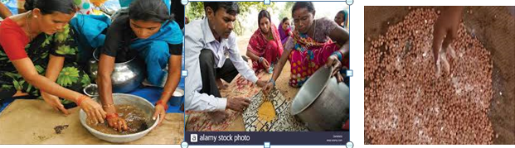
Fig 3.1 seed treatment
- Hot Water Treatment
- Use the cloth to loosely wrap the seeds. Use a rubber band to seal the cloth so the seeds will not fall out.
- Warm the seeds for 10 minutes at 100° F.
- Place the seeds (still in the cloth) inside cold water for 5 minutes.
- Remove the seed from the cloth and spread out on the screen to begin drying out.
- Sprinkle Thiram over the seeds after they are dried. Use 1 tsp/1 lb of seed. On the other hand, when our planting materials are prepared from cutting of roots, leaf, stem and bulbs, we have to apply chemicals to cut materials to avoid viral and fungal infection.

- Objectives of seed treatment:-
- To prevent the infestation of insect- pests and diseases in filed and storage conditions
- To break enforce dormancy of seeds, whichever is needed
- To induce higher germination percentage
- To harden the seed by inducing tolerance to adverse weather ans soil conditions
- To inoculate the seeds with rhizobium. Azotobacter and Azospirilleum biofertilizers.
- For example, Seed treatment with fungicides is necessary to destroy seed borne pathogens and protect the germinating from soil inhibiting microorganisms. Seed treatment is done 24 hrs. Prior to sowing.
3.13. Maintaining planting materials.
Maintaining planting materials may include;
- keeping seeds and planting materials dry and cool,
- Keeping plants and plantlets cool and moist to prevent dehydration.
After collection, fruit and seed must be processed and stored.

Before planting the seedlings the following important operations should be done:-
- Treating of planting materials /seedlings/
The seed/seedlings must be treated with fungicides and insecticides to reduce the infestation of disease and insects E.g.; - Preventing dumping off, cut worm, etc

Trimming abundant leaves:-
- Purpose – to reduce transpiration, remove deformed and diseased leaves.

Peddling and its benefits
- Feeding root lets.
- Protecting roots from diseases
- Root pruning and its purpose.
- Removing deformed and diseased roots
- Providing good growth
- Shoot pruning and its purpose.
- Removing deformed and diseased shoot.
- Providing good growth
- Compensation of loss of roots (pruned roots)
  - Handling and transporting planting material
Handling uprooted seedlings: is the care that is needed to reduce the damage that could occur to the seedlings due to inappropriate handling. The process encompasses:
Transporting is taking of planting materials from place of storage to place of work and visversa.

3.2.1. Storing Seedlings:
After uprooting the seedlings; they need to be stored under the shade temporarily. This is important for it helps in reducing the damage until the replanting time. The process is of very much importance if the main planting site is far away from the nursery site.
- keep the moisture content of the soil (bound the root and the soil with a wet cloth or sisal sack)
- Hold the seedlings at the base of the stem
- Avoid direct sunlight
- Avoid holding too many seedlings together
- Provide seedlings with mist of water (improve the humidity of the air)
3.2.2. Transportation Seedling
The same principles of seedling care during storage apply to transporting seedlings. The seedlings should be protected from heat and drying. In the absence of refrigerated trucks for delivery from the nursery cold storage unit to the planting site, several precautions need to be taken:
- Move the trees as fast as possible, planning trips so weekend layovers are avoided.
- Use tarps to prevent drying.
- Use a ventilated truck to prevent heat buildup.
- Park in shade when possible
Transporting: if the main field is far from the nursery site it important to transport them to the place where they are permanently planted. This may involve moving the seedling by using wheelbarrow, trailers, Lorries, etc.
- During Transporting planting materials
- Care should be taken during loading and unloading
- During transporting seedlings care should be taken not to harm/damage seedlings from sun light and other physical conditions
- After transporting to the planting site seedlings until planting they must be kept under shade
When transporting different planting materials we have to handle carefully and also take special care while transporting form one place to another.

3.2.3. Seedling Transporting Tools.
Seedlings, both bare rooted and containerized, should be safely transported and delivered to the planning site. Depending upon the location of planting site, transportation facilities such as arrangement vehicles should be done before stinting seedling transportation. For bare rooted seedlings, preparation of covering materials such as banana leaves or any suitable covering materials is important. Containerized seedlings should be transported by using trays and boxes and covering materials should be arranged to minimize damage to the seedling by sun and wind. All tools and equipment as well as materials should be handled according to the manufactures guidelines. Tools and equipment should be maintained regular and arranged in groups of similarity. Tools and equipment should be checked for any problem regularly. Broken tools should be identified, maintained and made ready for work.
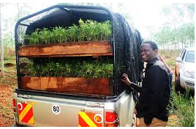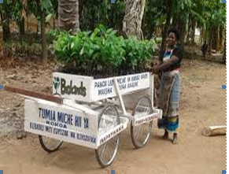
Fig 3.2 Handle & Transport seedling
  - Carrying out Planting
- Propagation:- The reproduction or multiplication of plants by sexual (seeds) and asexual means (vegetative structures), is called propagation
- Objectives of propagation:-
- To multiple seeds and vegetative parts of vegetable crops
- To develop new hybrid varieties
- To develop disease and pest resistant, drought resistant variety of a particular crop.
- To use benefits of rootstocks by grafting with superior quality plants.
    - Methods of propagation:-
- Sexual Propagation / by seeds/ - Seed propagation is by planting seeds resulting from fertilization of ovules and often an exchange of genetic material through cross pollination.
- Asexual Propagation /by vegetative structure/ - Vegetative propagation does not involve an exchange of genetic material. The offspring, therefore, are genetically identical to the parent plant.
- Propagation by seed:-
- Advantages of propagation by seed :-
- It is the only possible or practical method of propagation for vegetable crops that cannot be conveniently raised by vegetative structures.
- Seedlings are comparatively cheap and can be more easily raised from seeds than vegetative structures.
- Seed is the most important means of developing new hybrid cultivars.
- Seeds also offer convenient method for storing plants for long time
- Limitations of propagation by seeds :-
- Seedling plants are not true- to type. They are not uniform in their growth, yielding capacity and fruit quality compared with vegetative structures.
- By seed propagation it is not possible to derive the benefits of rootstocks, if the plant is not propagated by grafting or budding.

3.3.2. Calculation of Seeding Rate
Before they are sown, the seeds are tested for germination. The test helps determine seeding rate, and shows if the seed is sufficiently vigorous for sowing. For instance, if the required number of plants is 1,000 and the germination is 85%, then 1,000/0.85 or 1,176 seeds must be planted. If the seeding rate is too high, excess seedlings may have to be thinned out, a practice which is wasteful in seeds and labor. On the other hand, if the seed rate is too low, replanting, an equally expensive process, may have to be done.
Example .1 Calculate the quantity of seed required for 1 ha cabbage with the following details.
- Germination percentage (GP)= 90%
- b) Purity percentage (PP) = 50%
- Test weight of seed = 4g
- Spacing =60cm x 30cm

Seed rate (kg/ha) = Area x Test weight_______
- P x PP x Spacing (m²)
3.3.2.1. Sowing seeds: Sowing or planting; the term sowing is used for seeds and planting is used for vegetative parts like tubers, bulbs, rhizomes, cuttings etc. Before sowing the seeds to directly field or rising of nursery, seeds need to be treated physically and using appropriate chemicals.
- Direct sowing :- It can be done by following methods:-
- Broadcasting;
- In broadcasting method, the seeds are spread uniformly over well prepared land. It may be done by hand or mechanical spreader.
- Broadcasting is suitable for close planted crops that do not require specific crop or plant geometry.
- It is used when the number of plants per unit area is more important than definite spacing from plant to plant. This is the usual method of sowing field crops.

- Fodder crops and spices like coriander and cumin are sown by broadcasting.
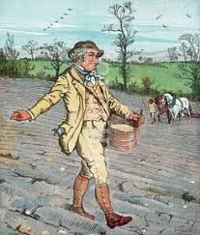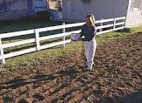
Fig3.3. broadcast sowing
- Drilling sowing
- Drilling is the practice is of dropping seeds in rows or lines.
- Furrows at specified distance are made, and the seeds are dropped at definite depth and distance, covered with soil and are compacted Fairley.
- Seed can be drilled with help of seed drills (bullock or tractor drawn) and seeding funnels attached with country plough.
- Seeds and fertilizers can be drilled simultaneously. Crops such as wheat, barley, mustard, carrot and sesame are sown by drilling.
- Advantages of drilling
- It maintains uniform plant population per unit area.
- Reduce competition between plants.
- Reduce seed rate.
- Disadvantages of drilling
- It requires more time, energy and cost.
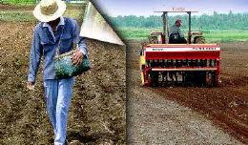
Fig 3.4 Drilling sowing
- Dibbling or planting
- This method consists of putting or placing individual seed or seed material in a hole or pit, made at pre-determined depth and spacing by manual labor or with the use of mechanical dibbler or planter.
- Generally, the crops with bigger size seeds and those needing wider spacing and specific crop geometry for their canopy development are sown by this method.
- This method is suitable to plant crops like maize, cotton, potato, sun flower, sugar cane, onion, garlic, ginger etc.
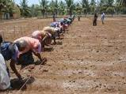
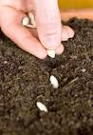
Fig 3.5 Dibbling sowing
- Advantages of dibbling or planting
- It requires less seeds
- It gives rapid and uniform germination with good seedling vigor
- Disadvantages of dibbling
- It is more laborious
- It is time consuming
- It is expensive compared with broad casting and drilling

3.3.3 Factors determining depth or sowing:-
As a thumb rule, the soil covers after sowing, should be five times the diameter of seeds. The depth at which the seed is placed in the soil is influenced by:-
- Seed size: - coarse seeds like peas, beans melons, etc should be sown at deeper depth (6-10 cm) and smaller seeds like tomato, onion, spinach, beetroot, carrot, etc should be sown at shallow depth (3-5 cm). Large seeds have ample quantities of stored food material for germination process. They can produce vigorous seedlings, which may emerge from great depths.

.
- Type of germination: - In epigeal germination likes beans, fenugreek, and melons. Et cotyledons above the surface and therefore have limited ability to emerge from great depth. In hypogeal germination like peas, tomato spinach etc. cotyledons remain inside the seed coat under the soil surface, which can emerge from great depths.
- Moisture status of the soil: - Under dry condition seeds should be sown deeper in order to depth contact of the seeds with moist soil
- Soil type: - Seeds can emerge from greater depths seeds in sandy soil than in clay soil. Sowing depth can, therefore, be adjusted according to soil texture.
- Planting the seedlings in pot
- Factors determining whether a seedling withstands transplanting/transferring.
- The retained amount of root system during transplanting
- The capacity of retained roots to absorb water
- The rate of new root formation
- Ways of planting seedlings in pots:
- Take care not to break the roots of seedlings when you lift them
- Choose seedlings that grow best (avoid stunted and poor looking seedlings)
- Prepare the seedlings by trimming off part of the roots and leaves
- Moist the soil to be worked upon enough (not wet enough to be sticky)
- Make holes with a dibbler.
- Plant the seedlings into holes and bury the roots up to the crown
- Pack the soil down well around the plant
- Take care not to disturb the roots
- Water the planted seedlings thoroughly.

- Asexual propagation: when any vegetative part of the plant is used for propagation purpose

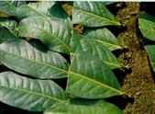
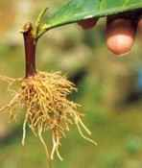

Fig.3.6 vegetative propagation
- Advantage Of Asexual Propagation
- Maintenance of clones: vegetative propagation is asexual in that it involves mitotic cell divisions that duplicate the genotype of the plant. Such genetic duplication is known as cloning and the population of offspring plants is known as a clone. Cloning is particularly important in horticulture because the genotype of most fruit cultivars is highly heterozygous and unique characteristics of such plants are immediately lost if propagated by seed.
- May be easier and faster than seed propagation, as seed-dormancy problems may be completely eliminated and avoidance of long juvenile period (fruit plants grown from seed go through a juvenile period in which flowering does not occur. Vegetative propagation then retains the flowering capacity and avoids the non-flowering juvenile phase.
- Propagation of seedless plant. Such as pineapples, bananas, and seedless cultivars of grape, orange etc.

- Limitation Of Asexual Propagation:
- Less vigorous and short lived than sexual propagation.
- New varieties cannot be evolved through asexual propagation.
- Are complicated and requires skilled man power.
- Types of asexual propagation.
- Layering.
- Grafting.
- Budding.
- Cutting.
Eg. Layering: -is a propagation method by which adventitious roots are caused to form on a stem while it is still attached to the parent plant. The rooted, or layered, stem is detached to become a new plant growing on its own roots. It is a simple and effective means of propagation that can be practiced in the field. Conditions necessary for layering are quite similar to those necessary for rooting cuttings. The wood should be young, so that it will form adventitious roots easily. Root formation during layering is stimulated by various stem treatment, which cause an interruption in the downward translocation of organic materials (carbohydrates, auxins, and other growth factors) from the leaves and shoot tips. These materials accumulate near the point of treatment, and rooting occurs at the point of interruption.
    - Advantages of layering
- Effective means of propagation of species which do not root readily on cuttings.
- The parent plant supplies the new individual with water, food, etc.
- Easy to perform and does not require elaborate facilities.
- Limitations of layering:
The propagation method is usually limited to plants which form growing points readily and the method does not facilitate the production of a large number of individuals in a relatively short time.

- Techniques of layering or main methods of layering:
- Mound layering or stool layering
- Tip layering
- Air layering or mar cottage
- Trench layering (etiolating method):
- Simple layering
- Compound layering
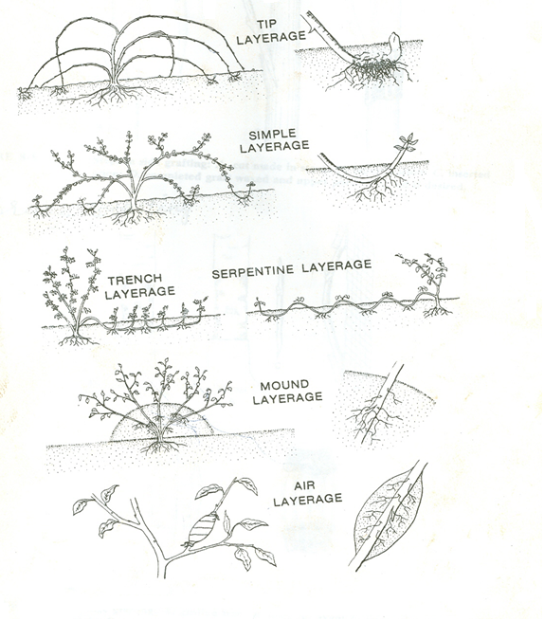
Fig. 3.7. Different types of layering
- The nursery raising and transplanting is completed in three steps.
- Nursery raising
- Uprooting or pulling-up of seedlings and
- Transplanting.

3.3.4 .Transplanting
Definition: - Transplanting; is lifting of plants seedlings carefully from one place (temporary growing area) and planting them, at another permanent place of production area.
Transplanting can be defined as picking of seedlings from the seed bed either bare root or with the ball of the earth and placing to their permanent place. You may use two methods.
Seedlings are transplanted on well-prepared and properly fertilized field.
- The best time of transplanting is late in the evening when day temperature cools down and humidity raises.
- Transplanting also can be done at any time of the day if it is cloudy, raining, dizzying or about to rain.
- Depending on the crop, proper row-to-row and plant-to-plant spacing should be maintained. At each point of hill, two-three seedlings should be planted.
- During planting, root must have enough contact with moist soil.
- The soil around root may be compressed lightly to provide more soil-root contact and remove the air gap in the soil.
- Seedlings should be transplanted when they are at least 12 to 15 cm tall
- Seedlings of cabbage ,cauliflower , Chinese cabbage, etc. can be transplanted when they are 3 or 4 weeks old, whereas tomato, chilies and eggplant takes 5 to 6 weeks and onion seedlings are planted at an age of 6 8 weeks.
- At the time of transplanting seedlings should have two or three pairs of true leaves
- Seedlings should produce good root system.

3.3.4.1 General principles of transplanting:-
- The seedlings should be well hardened
- Water the seedbed before lifting the seedlings
- Lift seedlings using fork
- As soon as lifting keep seedlings in a trench dug in shade.
- Under take some important seedling management before transplanting
3.3.4.2. Steps of Transplanting process
- The day before transplanting, water the beds (propagation)
- Hold the leaves of the seedlings and insert a dibble underneath the root system to loosen soil.
- Pull out seedlings gently; immediately put those into water can (make vessels full of water)
- Water the pots. (To moist the soil ;
- Make a hole with a dibble. (Tools made of wood for making holes)
- Hold the seedlings leaves, and insert root system in.
- Hold the dibble in a slanting position; insert it in the soil about 1/2 inches away from seedling to the same depth as the whole
- Replace the soil, slightly compact it.
3.3.4.3. Factors determining transplanting depth
- Seedling size
- The way the young plant develops
- Time of the year, season
- Soil type
- Moisture supply
- Species or variety to be grown
- Establishing capacity of the seedling
- The required amount of population density
Transplanting is a crucial stage in the life of a plant. It always causes a shock to the seedlings even when done carefully and bad transplanting easily kills the seedlings. So cares must be taken during transplanting operation.

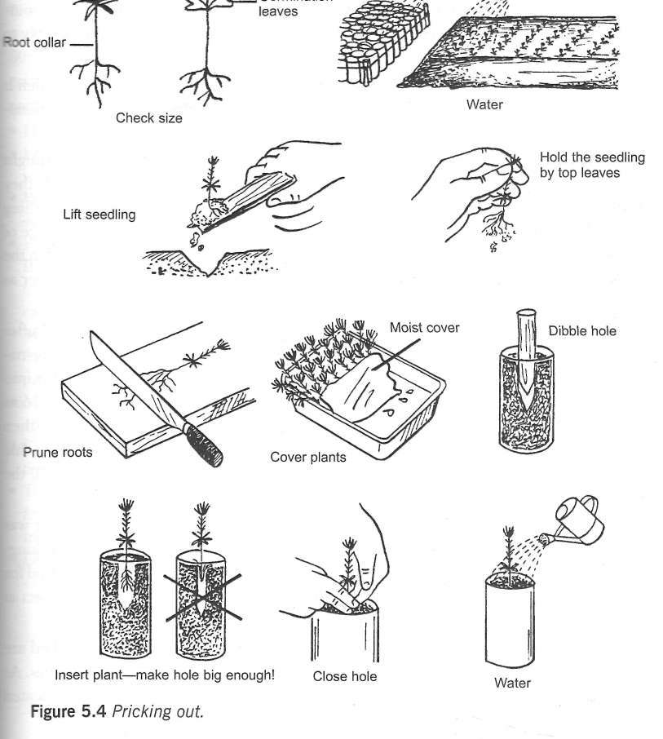

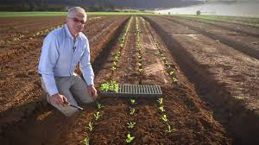
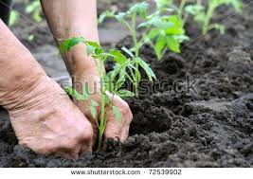
Fig .3 .8 Transplanting
3.3.5. Nursery Management or operation
- Any activities perform from site selection to transplanting seedlings are called nursery management.
Tree nursery operations involves various activities such as,
- Mulching
- Watering
- Protections
- Seed bed preparation
- Potting
- Thinning
- Sowing seeds
- Hardening off
- Shading
- Pruning
- Weeding
- Pricking out
- Root pruning
- Application of additional fertilizers or manure

- Mulching
Definition: - the practice of covering the soil surface with an organic water or synthetic materials to make conditions more favorable for plant growth, development and crop production.

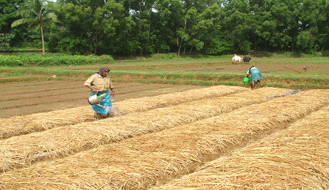
Fig.3.6 mulching seedbed

Importance of mulching:-
- Mulches protect the topsoil from erosion and loss of structure caused by heavy rainfall loss of structure and crusting may severely inhibit seedlings emergence.
- Moisture loss in reduced, thus promoting seed germination and plant growth.
- Mulch controls the soil temperature either by keeping it cool (using straw mulch in lowland tropics ) or keeping it warn (using plastic mulch in highland tropics)
- To some extent mulches reduces weed growth by shading. Black plastic is very effective in controlling weeds.

Disadvantages of mulching
- Mulches tend to harbor pests and diseases like termites, rodents, fungi, nematodes etc.
- Mulches may catch fire easily
- Cost of plastic mulch is very high.
- Mulching materials includes:-
- Cut grass
- Saw dust
- Synthetic mulches
- Black polyethylene sheet
- Sugarcane leaves
- Wood Chippings
- Rice husks
- Dead leaves Straw/ Hay
- Watering
Watering up to first week to germination watering should be done 2 times/ day and from second week on ward 1 time /day. very approximate recommendation for total amount of watering per day is equivalent 8 mm of rainfall. This means 8 liters of waters/sq. m of seedbed.
If the seedbed is covered with mulch grass, the moisture of the soil surface should be frequently checked. Some of the water is absorbed and evaporated by the grass, which, on the other hand, slows down evaporation from the bed surface. For these reasons, watering is done less frequently but in greater quantities than to bed without grass mulch.
- Avoid excessive watering
- Use water cane fitted with fine nozzle
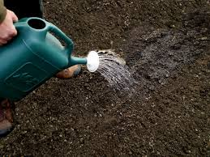
Figure 3.9. Watering seedbed
- Shade ; Cover the beds with thatched mats during afternoon in summer and during nights in winter
- Application of additional fertilizers or manure; apply 10 kg well decomposed manure and 0.5kg NPK/S per bed 5m2 size before sowing the seeds.
- Thinning; is the process of removing part of the standing crop of trees to allow the remaining, selected trees to grow at their optimum rate to reach the size required by the objects of the plantation, with in the period of rotation. Undertake thinning of seedlings is necessary after15-20 days of sowing.
- Pest and disease control: - Protect plant against pest and disease by spraying of pesticides as and when necessary.
- Pruning
Pruning is the removal of live or dead branches or multiple leaders from standing trees for the improvement of the tree or its timber.
- Hardening off;
It’s a process by which the seedlings are conditions to
adverse weather conditions after transplanting to the field like higher or lower temperature, wind, dry soil or air and hot sunshine. This is done by exposing seedlings to full sunlight and gradually withholding of watering for about 7 to 10 days before transplanting. This treatment will make hard, strong and vigorous seedlings to withstand transplanting shock.
- Windbreaks and shelterbelts
In arid zones, the harsh conditions of climate and the shortage of water are intensified by the strong winds. Living conditions and agricultural production can often be improved by planting trees and shrubs in protective windbreaks and shelterbelts which reduce wind velocity and provide shade. Windbreaks and shelterbelts, which are considered synonymous in this manual, are barriers of trees or shrubs that are planted to reduce wind velocities and, as a result, reduce evapotranspiration and prevent wind erosion; they frequently provide direct benefits to agricultural crops, resulting in higher yields, and provide shelter to livestock, grazing lands, and farms.

Main objective of windbreaks and shelterbelts is to protect the agricultural crops from physical damage by wind. Other benefits include:
- Preventing, or at least reducing, wind erosion;
- Reducing evaporation from the soil;
- Reducing transpiration from plants;
- Moderating extreme temperatures.
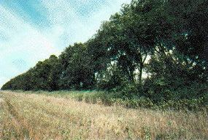

Fig.3.8 windbreak

Staking; Definition of staking: - providing support to tall growing and vine or twining plants is called staking Trellising and staking. Trellises, stakes, cages or other supports minimize the ground space used and increase garden productivity. Support materials can consist of wood, extra stakes, twine, or a nearby fence.

Self -Check -3

Instructions: Answer all the questions listed below
What are the main objectives of wind break? 2 point
- Describe procedures of hot water treatments of planting materials? 3point
- What is mulch and Importance of mulch? 3point
- Mention all nursery management operations? 3point
- What are Factors determining depth or sowing? 3point
- Explain briefly about propagation? Types of propagation and propagation methods? 3point
- What are selection criteria Seed? 3point

Note: Satisfactory rating - 20 points & Unsatisfactory - below 15 points
You can ask your teacher for the copy of the correct answers

Operation Sheet- 3

  - Selecting, Treating and Maintaining Planting material
- Materials required
- Crop Seeds
- Water
- Treating chemicals
- Boiling materials etc.
- Procedures
- Hot water treatment
- Use the cloth to loosely wrap the seeds.
- Use a rubber band to seal the cloth so the seeds will not fall out.
- Warm the seeds for 10 minutes at 100° F.
- Place the seeds (still in the cloth) inside cold water for 5 minutes.
- Remove the seed from the cloth and spread out on the screen to begin drying out.
- Sprinkle Thiram over the seeds after they are dried. when our planting materials are prepared from cutting of roots, leaf, stem and bulbs, we have to apply chemicals to cut materials to avoid viral and fungal infection.

Operation sheet – 3. 1

3.1.2 Criteria of Seed selection
- Materials required
- Binoculars
- Basket
- Rope
- Ladder
- Overall
- Safety shoes
- Long handled shear/sow
B. Procedures
- Selecting good parent plant for seed
- Select straight and vigorously growing parent plant
- Select disease resistant and disease free parent plant
- Select productive parent plant
- Select parent plant that processes all qualities of the grower demand
- Select mother plant adapted to the cultural methods and climate of the area
- Select healthy parent plant which produces healthy offspring
- Select parent plant which possess only well ripened fruits
- Collect seeds of trees producing fine fruits and those with fruits that open at maturity when the fruit is still attached to the tree.

Operation Sheet -3.2
  - Carrying out Sowing /Planting
- Materials required
- Seeds of various species and sizes
- Watering can
- Watering hose
- Filled pots with soil mix
- Grass mulch
- Overall
- Shoes
- Sun hat etc.
- Procedures
- For sowing in pots, place a number of seeds into each pot depending on the germination (G) rate. Accordingly, G% = 51-80%, sow two seeds and G% > 80%, sow one seed
- For sowing in seedbeds, the seed is best put in drills running across the bed.
- Place seeds at the right depth; mix small seeds with sand
- Coverer the seeds with sand or soil and gently press
- Water the seedbeds or pots with cans with fine nozzles
- Finally, cover the seedbeds or pots with shading material/mulching
Sowing in a nursery beds for transplanting:- Nursery in open ground:-
- Select a suitable area near water source, dig and bring to fine tilth.
- Prepare 5m long, 1m wide and 10-15cm high beds by using tape, spade, tracing line etc.
- Keep to 50cm space between two adjacent beds and they may be arranged in staggered manner to check erosion.
- Apply 15kg compost or well- decomposed FYM and 0.5kg NPK 15:15:15 fertilizer mixture per bed and mix it well with the soil.
- Sterilize soil with 2% solution of formaldehyde or drench with fungicides like captan, thiram, bavistin @ 0.2 to 0.3% solutions.
- Mark shallow channels at 5cm to 10cm intervals with a pointed peg width wise.
- The depth of planting depends upon size of the seed, sow larger seeds at 2cm depth and small seeds at 0.5 to 1cm depth
- Cover the seeds lightly with surrounding topsoil and dry grass
- Water the beds with the watering can fitted with hose shower when necessary.
- Remove the grass cover when seedlings start emerging.
- Cover the beds with thatched shade during afternoons in summer and during nights in winter.
- Undertake thinning of seedlings if necessary after 15-20 days of sowing.

Operation Sheet -3.3

3.3.3. Transplanting
- Materials:
- Very young seedlings
- Seedling root covering cloth
- Small shovel
- pruning knife/pruning shear
- Wedge shaped flat pieces of wood
- Polythene bags filled with required soil mixtures
- Watering cane
- Procedures
      - Erect a large portable shade above the bed.
      - The Trans planters should work in pairs on opposite side of bed. They can sit on low small stools.
      - A hole is made with the dibble in the center of each pot.
      - The root of seedling is placed carefully in the hole, and the soil is pushed toward the root with dibble to make sure no air is left around the root.
      - If the seedlings has left too long in the seed bed the root should be trimmed back to 2-3 cm

The soil around the seedlings must be firmed gently and smoothed with the fingers so that no depression is left around the site.

LAP Test
Name: _____________________________ Date: _______________________
Time started: ________________________ Time finished: ________________
Instructions: Given necessary templates, tools and materials you are required to perform the following tasks within 1hour.

Task- 1. Apply Treating and Maintaining Planting material
Task -2. Carryout Planting / sowing
Task-3. Perform Seed collection
Task-4 Perform Transplanting

LG #12 | LO #4- Caring Seedlings

Instruction sheet

This learning guide is developed to provide you the necessary information regarding the following content coverage and topics:
- Applying treatments for seedling.
- Application of water for seedling
- Training seedlings
This guide will also assist you to attain the learning outcomes stated in the cover page. Specifically, upon completion of this learning guide, you will be able to:
- Apply treatments for seedling.
- Apply of water for seedling
- Train seedlings
Learning Instructions:
- Read the specific objectives of this Learning Guide.
- Follow the instructions described below.
- Read the information written in the information Sheets
- Accomplish the Self-checks
- Perform Operation Sheets
- Do the “LAP test”

Information Sheet -4

  - Applying Treatments for Seedling
Treatments are applied to assist plant growth as directed by the supervisor. Generally, application of treatment for nursery plants includes:
- Pesticides
- Fungicides
- Fertilizer, mulching
- Removing weeds
- Removing dead material
- Tip pruning
- Formative pruning
- Aeration
- Staking
- Tying
- Spacing and thinning

- Pesticides; are chemicals used to kill insects. Usually the larval stage of an insect life cycle is harmful. At this stage, most feeding on leaves, shoots, roots and boring in stem takes place. An exception is the weevil group in which adults mostly cause the damage. In general, a particular insect problem is localized to; certain nurseries and tree species.
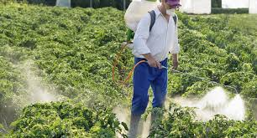
Fig. pesticide Application
- Fungicides; are chemicals used to kill fungi. Damping-off is a disease of young seedlings caused by a number of soil born fungi (such as fusarium, pythium, Rhizoctonia etc) altogether there are about 30 species of fungi.
- Fertilizer application
Horticultural crops are nutrient demanding crops. There are two types of fertilizer, organic and inorganic. Organic fertilizer releases its nutrient slowly and improves soil structure and fertility in sustainable way while inorganic fertilizer releases its nutrient much faster than organic fertilizer. The rate/amount of fertilizer, time of application, the type of fertilizer to be applied, is decided by the supervisor.
- Methods of fertilizer application in solid form: It depends on the nature of fertilizer, soil type, the difference in nutrient requirement and nature of crops.
- Broadcast: the fertilizer is spread over the entire soli area to be treated. Broadcasting can be broadcast at planting and topdressing
- Placement: placement of fertilizer irrespective of position of the seed, seedling or growing plant before sowing or after sowing. Placement can be different types, your supervisor will instruct you during fertilizer application.
- Fertigation: application of fertilizer in liquid form. There are three methods to apply liquid fertilizer, foliar application, direct application to the soil, direct application to the water.
- Removing weeds.
Weed management in Nursery: - weed is a plant growing where it is not desired. Weeds compete with crops for water, nutrient and light. Weeds can be controlled by manual method or by using chemicals, so you should able to identify tools and equipment and other materials such as chemicals, sprayers, cultivating hoe, cultivator (tractor).
Weeds can be eliminated by
- Manually by hand
- Mechanically
- Chemically.
- Biologically
- Insect pest and disease control: Insect are organisms which possess three distinct body segmented while diseases are any abnormal functioning of the plant or disturbance of the plant part. There are various disease and insects which cause damage to the crops. Your supervisor will identify the disease and insects and recommend the required measurement. According to your supervisor’s recommendation you under take spraying chemicals or other mechanical methods or cultural methods to control insect pests and disease.

4.2. Application of water for seedling
- Watering
The single most important factor in germination and seedling production is water but too much water can be just as harmful as too little water. With seeds and tiny seedlings, it is not necessary to provide heavy doses of water as this not only leaches out the soil nutrients but can expose seed or wash out seed before germination begins. The answer to this problem is not to plant the seed any deeper, as is sometimes done, but to adjust the hose nozzles to allow a finer spray or cover the seed temporarily until they germinate. Source:
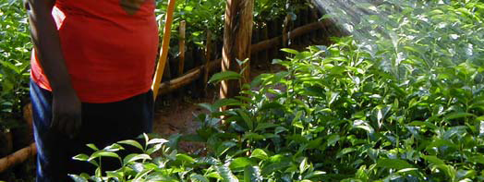
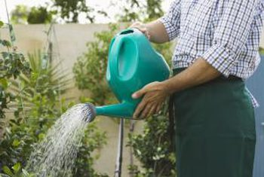
Water the containers before sowing and immediately after covering the seed with the sowing medium or sifted sand. The sowing medium should not be allowed to get dry. Several light applications of water at this stage are far better than one or two heavy applications. Keep the soil moist but never sodden, watering preferably in the mornings and avoiding the mid-day period when the sun will cause excessive evaporation. Water deposited on the surface of leaves heats up readily in the overhead sunlight, causing the tender leaves to scorch.

Fig.4.2 watering seedling

The main objective of watering seedling is to maintain enough moisture to the rooting zone to
enable the seedlings grow satisfactorily. The frequency and amount of watering depend on the rate at which water is absorbed by the roots and the water holding capacity of the soil. The rate of absorption depends on species, size of seedling, density of seedling, and on weather conditions. For these reasons, it is impossible to establish very general rules about watering. Every nursery manager should find best possible watering regime himself/herself.
A fine- hose watering can should be used when seedlings are still small. Gradually, the frequency of watering is reduced while at the same time the amount of water applied at each watering are increased, so that the total amount of water during a day is slowly increased. A watering can is with a coarse hose which produce large drops of guarantees that water penetrates through the foliage to reach the soil.
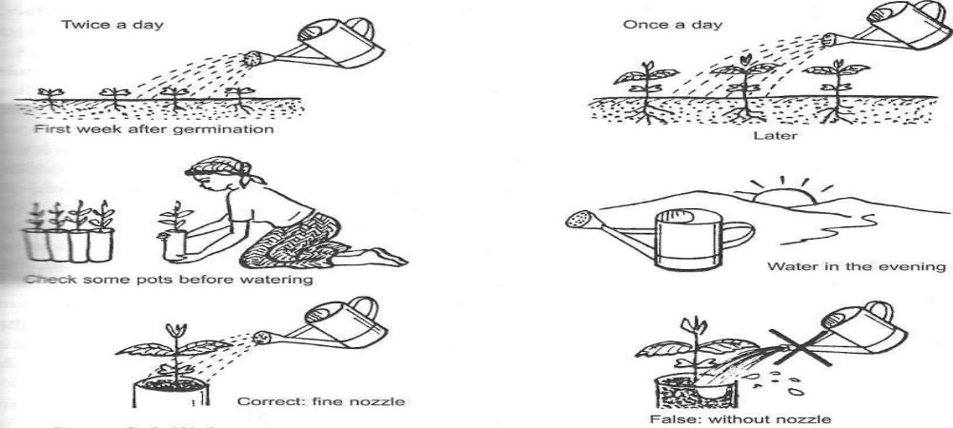
Figure 4.3 watering the seedling

4.2.1. Factors affecting amount of water required by seedlings.
- Type of the soil: - Sandy and sandy loam soils need more frequently watering than heavy of clay loams.
- Development stage of the seedlings: - More amount of watering is required at growth stage.
- Climatic conditions of the area: - Hot and dry weather conditions require more amount of water than moist and cool conditions.

Considered for water application:-
- Water slowly so that soaks down roots
- Avoid heavy watering
- Use hose or fine nozzles on the watering can
- Test for water penetration.
- Water along the furrows when vegetables planted on ridges
  - Training seedlings
- Training seedling; is an important operation in nursery farm in order to maintain shape and direction of seedling growth.
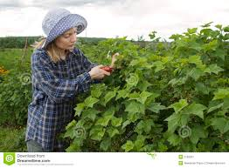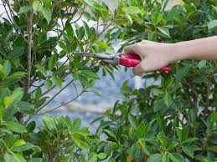
Fig. 4.4 Training seedling
- Training may be done by using
- Thinning,
- Trimming;
- Staking or trellising;
A primary objective of training and pruning is to develop a strong tree framework that will support required production.
Proper tree training also opens up the tree canopy to maximize light penetration. For most stimulant crops, especially coffee and tea require training to give maximum product. Light penetration is essential for strong flower bud development and optimal fruit set, flavors, and quality. Although a mature tree may be growing in full sun, a very dense canopy may not allow adequate light to reach 12 to 18 inches inside the canopy. Opening the tree canopy also permits air movement through the tree, which promotes rapid drying to minimize disease infection and allows thorough spray penetration.
- Pruning
Root Pruning is a standard in most Ethiopian nurseries. Root pruning involves cutting of the taproot, in some cases also of lateral roots, to encourage the development of fibrous root system. This kind of root system gives the seedlings the best possible start in plantation. Root pruning also controls depth of root penetration and makes lifting of seedlings easier and less harmful.

Root pruning helps the seedlings to have a balanced root-shoot ratio.

It also helps the seedling to have an adequate root collar diameter (because of the slowdown of the top growth).
- Staking
Stacking refers to arrange nursery seedlings in an order pile/straight up to avoid growth of root deformity.

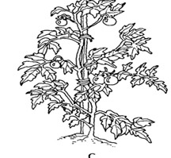
Fig.4.5 stalking
- Spacing

Avoid very dense spacing in germination and nursery beds, because diseases can spread easily. Close spacing can also lead to etiolated and weak plants which are susceptible to disease.

Self -Cheek -4

Name…………………………………………… ID………………………… Date…….
Directions: Answer all the questions listed below.
Test I: Short Answer Questions
- What is objective of training and pruning?
- What is the purpose thinning?
- Define Transplanting and list general principles of transplanting?
- What are the common treatments for seedling?

Note: Satisfactory rating - 20 points & Unsatisfactory - below 15 points
You can ask your teacher for the copy of the correct answers

Operation Sheet – 4

  - Applying treatments and Training for seedling.
- Materials, Tools and equipment’s inputs.
- Water cane with fitted Nozzle
- Hose pipe
- Sprinkler
- Pruning knives
- Hoes for weeding
- Grasses
- Pesticides
- Fertilizers.
- Procedures.
- Water slowly Use hose or fine nozzles on the watering can Avoid heavy watering.
- Harding of seedling
- Pruning or training to the required shape
- Thinning disease and thin seedlings
- Weeding periodical weeding
- Shading during dry season
- repair of damaged seedlings
- application of pesticides, if necessary
- Application of fertilizers, based on rate and time of fertilizer application.

Operation Sheet - 4.1

  - Application of water for seedling
- Tools and equipment’s and inputs.
- Water cane with fitted Nozzle
- Hose pipe
- Sprinkler
- Procedures.
- Water slowly so that soaks down roots
- Avoid heavy watering
- Use hose or fine nozzles on the watering can
- Water along the furrows when vegetables planted on ridges
- Test for water penetration.

LAP Test

Name……………………………… ID…………………………….. Date……………………………………. Time finished: ________________
Time started: ________________________

Instructions: Given necessary templates, tools and materials you are required to perform the following tasks within 1hour.

Task-1 Applying treatments and Training for seedling.
Task -2 Apply water for seedlings.

LG #13 | LO #5- Storing and Stocking Materials.

Instruction sheet
This learning guide is developed to provide you the necessary information regarding the following content coverage and topics:
- Storing, preparing and processing plant debris and waste materials
- Stocking Surplus materials
This guide will also assist you to attain the learning outcomes stated in the cover page. Specifically, upon completion of this learning guide, you will be able to:
- Storing, preparing and processing plant debris and waste materials
- Stocking Surplus materials
Learning Instructions:
- Read the specific objectives of this Learning Guide.
- Follow the instructions described below.
- Read the information written in the information Sheets
- Accomplish the Self-checks
- Perform Operation Sheets
- Do the “LAP test”

Information sheet -5

  - Storing, preparing and processing plant debris and waste materials.
Definition; Wastes are unwanted or unusable materials. Waste is any substance which is discarded after primary use, or it is worthless, defective and of no use.
When working in nursery there is range of un wanted waste materials left over that needs to be dealt with things such as old or broken pots/tubs un used root bound plants, un wanted cutting materials , surplus potting media, soil, fertilizer, ,bags, tags ,packing materials ,mulches, plant debris and faulty irrigation parts. It is best practice when finished to leave completely clean working areas free of rubbish all materials should be disposed of according to local council guidelines and the waste management and pollution control act
5.1.1. Waste management
Waste management or waste disposal is all the activities and actions required to manage waste from its inception to its final disposal. Waste can take any form that is either solid, liquid, or gas and each have different methods of disposal and management.
Waste management is the collection, transport, processing, recycling or disposal, managing and monitoring of waste materials. The term usually relates to materials produced by human activity, and is generally undertaken to reduce their effect on health, the environment or aesthetics. Waste management is also carried out to recover resources from it.
Waste management practices differ for developed and developing nations, for urban and rural areas, and for residential and industrial producers. Management for non-hazardous waste residential and institutional waste in metropolitan areas is usually the responsibility of local government authorities, while management for non-hazardous commercial and industrial waste
is usually the responsibility of the generate.

.
- Proper disposal of human waste is important to avoid pollution of environments, avoid the negative implications of someone else finding it, minimize the possibility of spreading disease, and maximize the rate of decomposition.
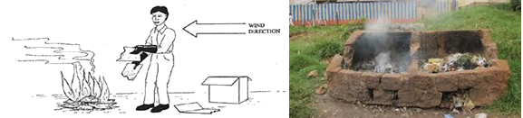
Fig.5.1.waste disposal
5.2. Stocking Surplus materials
5.2.1. Stockpile surplus materials of nursery
The Contractor shall plan his activities so that materials excavated from borrow pits and cuttings, in so far as possible, can be transported direct to and placed at the point where it is to be used. Should temporary stockpiling become necessary, the areas for the stockpiling of excavated and imported material shall be indicated and demarcated on the site plan submitted in writing to the organization for his approval, together with the Contractor’s proposed measures for prevention, containment and rehabilitation against environmental damage? Stockpiles shall be positioned and sloped to create the least visual impact. No foreign material generated / deposited during construction shall remain on site.

Self -Check -5

Name…………………………………………… ID………………………… Date…….
Directions: Answer all the questions listed below.
I: Short Answer Questions
      - What is waste management?
      - Waste hierarchy refers? List them?
      - What are the overall impacts of waste?
      - Differentiate organic and Inorganic wastes?
      - What types of wastes are produced during nursery work? List them?

Note: Satisfactory rating - 20 points & Unsatisfactory - below 15 points
You can ask your teacher for the copy of the correct answers

Operation Sheet -5

  - Storing, preparing and processing plant debris and waste materials.
- Materials tools and equipment required.
- Wheelbarrow
- Brush
- PPE safety materials, glove, boot, Respiratory musk
- Bucket or boxes
- Garden fork
- Shovel
- Procedures.
- Wear PPE
- Collect waste ,
- Sorting wastes
- Transport,
- Processing,
- Recycling Clean up and dispose or recycle your old pots.
- Manage and monitoring of waste materials
- Dispose, far away from residential or workplace in designated place

LAP Test

Name………………………………. ID…………………………….. Date…………………………… Time finished: ________________
Time started: ________________________

Instructions: Given necessary templates, tools and materials you are required to perform the following tasks within 1 hour. The project is expected from each student to do it.

Task-1. Perform Storing, preparing and processing plant debris and waste materials.

LG #14 | LO #6- Cleaning and Reporting on Completion of Nursery Work.

Instruction sheet
This learning guide is developed to provide you the necessary information regarding the following content coverage and topics:
  - Cleaning, maintaining and storing tools and equipment.
  - Recording and documenting nursery establishment and activities
  - Reporting problems or difficulties
  - Recording and reporting materials, equipment and machinery condition
  - Communicating work completion and hazards information
  - Reporting work out come
This guide will also assist you to attain the learning outcomes stated in the cover page. Specifically, upon completion of this learning guide, you will be able to:
- Cleaning, maintaining and storing tools and equipment.
- Recording and documenting nursery establishment and activities
- Reporting problems or difficulties
- Recording and reporting materials, equipment and machinery condition
- Communicating work completion and hazards information
- Reporting work out come
Learning Instructions:
- Read the specific objectives of this Learning Guide.
- Follow the instructions described below.
- Read the information written in the information Sheets
- Accomplish the Self-checks
- Perform Operation Sheets
- Do the “LAP test”

Information Sheet -6

  - Cleaning, maintaining and storing tools and equipment.
Every after completion of the work clean maintains and store materials tools and equipment’s. Carefully all materials tools and equipment’s used for carryout basic nursery work. Hand pruners, lopping shears, and pole pruners should be periodically sharpened with a sharpening stone. Replacement blades are available for many styles. Pruning saws should be professionally sharpened or periodically replaced. To reduce cost, many styles have replaceable blades. Tools should be clean and sanitized as well as sharp. Although sanitizing tools may be inconvenient and seldom practiced, doing so may prevent the spread of disease from infected to healthy trees on contaminated tools.
Tools become contaminated when they come into contact with fungi, bacteria, viruses and other microorganisms that cause disease in trees. Most pathogens need some way of entering the tree to cause disease, and fresh wounds are perfect places for infections to begin. Microorganisms on tool surfaces are easily introduced into susceptible trees when subsequent cuts are made. The need for sanitizing tools can be greatly reduced by pruning during the dormant season. If sanitizing is necessary it should be practiced as follows: Before each branch is cut, sanitize pruning tools with either 70% denatured alcohol, or with liquid household bleach diluted 1 to 9 with water (1 part bleach, 9 parts water). Tools should be immersed in the solution, preferably for 1-2 minutes, and wood particles should be wiped from all cutting surfaces. Bleach is corrosive to metal surfaces, so tools should be thoroughly cleaned with soap and water after each use the removal of all debris and rubbish, replacing and leveling soil that is disturbed, re-planting or repairing grassed areas and dead, dying or damaged plants, reinstating or repairing damaged or removed structures such as fences and pergolas, and sweeping and/or hosing down paths and pavements to remove soil and surface mat .Clean the blades with soapy water and treat with linseed oil after using solvents.
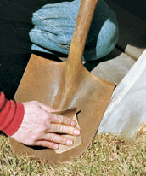
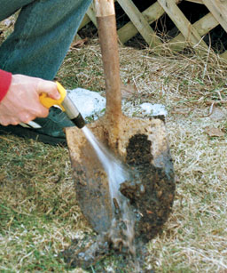
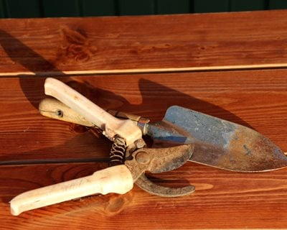
Fig. 6.1 cleaning tools
    - Cleaning, securing and storing tools and equipment.
What Is Cleaning?
Cleaning is the removal of dirt and organic substances from surfaces of tools and equipment. Through the cleaning procedures, high numbers of microorganisms (90% and more) present on the mentioned objects will be removed.
Inactivation of those microorganisms requires antimicrobial treatments, carried out through hot water or steam or through the application of disinfectants. Disinfectants are chemical substances, which kill microorganisms but should not affect human health through hazardous residues and not cause corrosion of equipment.
- Cleaning in a working environment involves removing dirt, grime, scraps and grease from all surfaces, equipment, utensils, crockery, etc.
- Using Chemicals
A working area effectively cleaning does not merely involve wiping a damp cloth over surfaces. Correct cleaning procedures are required to minimize hygiene problems. This is why cleaning agents, detergent sand/or chemicals, are used extensively
- Cleaning Equipment
While each piece of equipment has different cleaning requirements, there are some basic principles which are common to all equipment.
- Storing Chemicals
A general rule of thumb is to follow the manufacturer’s instructions for storing chemicals. Most will recommend:
- An effective cleaning agent must be capable of:
Dislodging dirt and grime sanitizing disinfecting (making it hard for bacteria to grow)
Pre-wash; Cold water pre-wash is used to remove excess grime and soften other grime.

Washing; complete removal of waste from items being cleaned, usually with detergent
Drying; When washing is complete drying is apply to evaporate the water.
6.1.2. Stacking and Sorting Equipment
All equipment needs to be sorted according to size and type. This facilitates operations, especially when busy. Staff must take care that sensitive tool and equipment are not over-stacked and that correct lifting techniques are used when handling them. Expensive equipment should be securely stored.
    - Correct Equipment Storage
To reduce chances of injury, equipment must be stored in the correct manner. For example:
- All sharp objects, e.g. knives, scissors should be stored in the appropriate drawers, knife blocks or tool boxes
- large heavy items should not be stored on high shelves
- electrical equipment should not be stored or used near wet areas
- all washed equipment, utensils, crockery, etc., should be dried after washing
- Any mobile equipment, crockery, cutlery, etc., also need to be secured against theft. This is achieved by locking these items in secured rooms or wire cages with padlocks
- Identifying and reporting malfunctions, faults, wear or damage to tools and equipment
  - Recording and documenting nursery establishment and activities
Recording is process of writing down something that it can be used or seen again in the future.
Documenting:-is something or paper that gives information about something or that is used as proof some work like nursery establishment.

6.2.1 Recording work place information
With the aim to ensure the complete stand history of certain plantation; it is indispensable to note all operation of nursery tending activity. Moreover for good nursery management, recording all work done, the progress made is essential. Records of workplace information may include:
- Environmental parameters (light, temperature humidity and wind)
- Date of treatments and
- Type of treatment and
- Rate of treatment
A careful recording will also help to tend nursery plant the most appropriate production data for each species
6.2.2 Nursery registration form:-The recording is done on individual nursery bed basis.
- Species____________________________
- Reception date of seeds_______________
- Date of seed collection________________
- Method of seed pretreatment ___________
- Protective measures taken______________
- Provenance _________________________
- Storing condition_____________________
- Area seed bed ---sq. m________________
- Density of sowing ____________________
- Responsible person__________________
- Registration number of seed bed_________
- Quantity seed per sq. m ---kg____________
- Expected number of seedlings per sq.m and in total___________________
- seedling description for planting___________________________________
- Destination of seedling Transportation specification (date, seedling transported, seedlings eliminated) and so on.
- Nursery diary: all the operations and observations of the day should be mentioned in this book as detail as possible.

- Example.
Date | Work done | Remark
22/1/2015 | 2 people prepared beds

- Nursery calendar: here we record all the activities to be done and when they are to be done.
Example
Activity | S | O | N | D | J | F | M | A | M | J | J | A
Weeding
Pruning
Treatment application
Mulching

- Nursery delivery Record: this shows how and where the seedlings were distributed
Example.
Date | Species | Number | Bed No | Receiving station
20/1/ 2015 | Capsicum Annum | 30000 | A2 | Nedjo
22/1/ 2015 | Solanum | 20000 | B3 | Ardaita
23/01/2015 | Moringa | 10000 | C4 | Gidda

- Attendance book: daily of laborers’ is important.
Example
Name/date | 1 | 2 | ---------------------------------------------- | 30
 | P | S |  | H
 | A | P |  | O
Where: p= present, A = absent, S = sick, H = holiday, O = off duty
- Workers and work organization
- It is recommended to employ permanent workers for the following activities: Sowing, Transplanting, Grading, Foremen, watchman
- For pot filling, manufacturing of shading and mats temporary workers can be employed
  - Reporting problems or difficulties
A hazard is anything that has the potential to harm the health or safety of a person and in the case of dangerous goods, includes damage to property.
OHS hazard in tree nursery work place include heavy materials and equipment, slippery or uneven surfaces, moving machinery and vehicles, solar radiation, and potential dangers from handling potting media, fertilizers, watering systems, and spider and insect bites.
The workplace needs to be free from these hazards, therefore all persons on a daily basis when walking and working around the property, need to be on the lookout for potential hazards and report it. In many cases, there is a desire to plant trees in order to give protection to degraded areas. On such fragile sites, great care should be taken not to disturb the soil. Often complete protection of the already existing vegetation is sufficient to obtain a natural re-growth after sometimes. When trees are to be inserted on to such sites, it must be done carefully often in combination with the construction of small check dams.
6.3.1. Problems or difficulties during completing or undertaking nursery work
Warning about Nursery and Garden Center products. They market products that are harmful to your plants, your health, and the environment. The # 1 product to avoid is "Weed and Feed" as they may contain a toxic herbicide called atrazine which if used around your shrubs and trees will kill them! It should not be used on residential property at all because; the roots of trees cover the entire property of most lots. Atrazine is also poisoning our clean water sources which directly affect human health. Furthermore, the two ingredients in these products aren't suitable to be applied at the same time. The pre-emergent herbicide part of the products needs to be applied about 2 months earlier than the soluble fertilizer part of the products. Some of the specific products that you should avoid are Scotts Bonus S, Vigero, or any labeled Weed and Feed and/or contain atrozine and also plant disease and different plant pests.
Disease is defined as any detrimental plant disturbance that interferes with its normal structure, function, or economic value. In other word, a harmful alteration of the normal physiological processes of the plant causes by a continuous irritation. Or, more simply, is a condition in which the affected plant differs from a healthy plant in either structure or function.
Diseases are caused by a biotic (nonliving) and biotic (living) factors. A biotic factor that cause diseases include air pollutants, light, moisture, nutrients, pesticides, pH, and temperature. Living disease-causing pathogens belong to groups of organisms classified as bacteria, fungi, virus, nematodes, parasitic higher plants, and protozoa. So, diseases can be classified according to the pathogens. The main diseases are as follows:
Insects are small animals belong to arthropod phylum. Their body is divided into three sections: head, thorax and abdomen. Most adult insects have three pairs of legs and one or two pairs of functional wings.
6.3.2 Identifying Common problems in nursery plants
Common problems in nursery plants are recognized, and rectified and/or reported to the supervisor. The most Common problems of Nursery plants may include:
- Dehydration/lack of moisture
- Pests and diseases
- Nutrient deficiencies
- Birds
- Rodents and
- Plants deformity.

  - Recording and reporting materials, equipment and machinery condition.
After completion of activities, all tools and equipment must be cleaned. The nursery working environment should be kept clean of any west materials and plant debris.
If there is any broken tools and equipment, it should be maintained. Broken handles and blunted tools should be checked on time, maintained and made ready for work.
All tools and equipment should be well organized and stored in groups of similarity after maintenance Plant diseases and pests can be checked by proper hygiene conditions in the nursery. Keep the nursery area itself free of weeds. Many plant species can be alternate hosts of nursery pests. This precaution includes a sensible selection of ornamentals, shade, hedge and windbreak plants in and around the nursery, as they too can be hosts for pests such as nematodes. The substrate can harbor plant pathogens and should therefore be steam pasteurized, if necessary. A simple steam pasteurizer can be constructed from an old and clean oil drum. Containers and seeds can be surface sterilized by soaking them in a 10% household bleach solution for 12-24 hours.
With time and heavy use, blades will become blunt, will chip and even break. Blunt or broken blades affect productivity, apart from being uncomfortable to work with. Regular maintenance is important.
Loose handles are dangerous and should be fixed immediately. Raised safety grips on the handles reduce the force needed to guide the tool and prevent tools from slipping out of the hands. Repair or maintenance can be done by sharpening the blade with a file or, when the blade is extremely damaged, by cutting back the blade and then sharpening it again.
Check regularly that tools are in good working order. Supervisors play a major role in observing if the tools are suitable for the different tasks, if they are properly maintained and sufficiently durable Ability to produce a large amount of litter
6.4.1 Operation of machinery and equipment in different weather and difficult terrain
Operation of machinery is not always done on label and comfortable land surfaces but sloppy, hilly, adulating, stony, sandy, etc access area can be work and driving Medias. These traffics can be considered as difficult terrains, concerning the natural weather, rainfall, foggy visions, muddy roads, etc can be taken as an example of unfavorable condition in operating machinery and equipment. Since both weather and difficult terrains/bad land feature or terrains/ are naturally environmental phenomena. Any operator of machinery should take care of his life and expensive assets. Moreover any machinery should not be operated before the checkup of all parts of machinery and old tiers also replaced by the new ones so as to make drive free from any slides either on difficult terrain or muddy grounds. With these lightening, traffic hazard indicators should be checked and well maintained for their actively functioning.
6.4.2 Identification and reporting of environmental implications
In identification of environmental implications related to basic green infrastructure development and beatification of any ground area. WE should focus and assess indication source or vulnerable resource gose with the developmental processes like offsite ground water or soils from solids, debris, nutrients or chemicals, and level of noise, dust, high activity vehicle traffic and water runoff. Based on the above indicators and their natural standard against the assessment results will be analyzed by workers and verbally reported to the supervisor.
6.4.3. Identifying unsafe or faulty machinery and equipment
Hand tools, personal protective equipment, hand held power tools, grease guns, cleaning and maintenance supplies including grease, fuel, oil, chemicals, water steam, power and air.
After pre operational check an operator must identify and report unsafe or faulty machinery and equipment and prepare for repair and maintenance. This may include dismantling and assembling procedures, testing, tightening, minor adjustments and repairs, and routine servicing procedures including lubricating, and checks of cooling system, fuel, grease and oil, and battery levels. It may also include inspections of tire pressure, fan belts, leads, lines, connections, air filters, air conditioning, brakes, clutch, electrical, gearbox, hydraulics, steering, lighting, transmission, and confirmation of safety guards, PTO stubs and shafts.
6.5 Communicating work completion and hazards information
Agriculture: - is one of the most dangerous occupations in many parts of the world; for instance in USA the resent data show a death rate of 21 workers per 100,000. There are 150,000 disabling accidents involving farm workers are injuries on the farm. Other major causes of none fatal injuries on farms, in descending order of importance are machinery, hand tools, slips and falls, and tractors. In general, the annual cost of farm accidents in the US is estimated to be between 4&5 billion dollars.

  - Information in regards to identify hazards and control risks in the work place can be provided
Regularly as source materials. These may include variable written and graphical instructions,
- Work bulletins,
- Data sheets,
- Diagram or sketches,

- OHS manual,
- Industry or workplace codes of practice,
- Organization operating procedures,
- Safety work procedures / manuals and
- Material safety data sheets (MSDS),
- Workplace guidelines / work shop manuals;
- Manufacturer diagrams, charts, catalogue specification manual,
- Service and operation manuals;
- Design specification manual,
- Repair request documentation job cards, and Record
- Report.

2. Human and Environmental Factors Relating to safety.
Human error is usually a major factors in the cause of accidents on the farm Being tiredness, paying not attention, and use of poor judgments are frequent causes of accidents involved to animals.
People both younger and older than 25 & 64 years, respectively have more accidents on the farm than those between this ages. Farming is an occupation in which children are likely to be in the work area. Their curiosity and lack of experience can easily lead them in to situations where they get hurt or exposed. They may have poorer balance and failure vision. This may cause them to have more accidents around in work place . Sometimes workers are not properly instructed in handling tools and material. This can also results in accidents.
There are many dangerous hazards involved to in nursery. Such as Physical hazards,
Physical factor refers to situations causing accidents like curiosity and lack of experience, poorer balance and failure to vision due to older age or other cases, lack of instruction in handling animals, working for prolonged period of time during a day, being tired, mistakes in judgment, etc. that are related to equipment and vehicle operation and repair, trip and fall hazards, and lifting heavy weights, which are common to other industries. Physical hazards should be prevented and controlled according to applicable guidance presented as safety rules or procedures.

  - Reporting work out comes.
Once you have finished your nursery work activities, you have to report the result that what you are done the entire nursery activities must be record daily what, when, how, why the nursery is step by step and must be report the work out comes to the supervisor as well as to the enterprise and concerning body.
When you report work out comes to the concerning bodies/enterprise you should be fill full:
- Both success and failures
- Reason of success and failures
- Tools, materials and equipment you used
- Those who are involved in the nursery work
- Feedback of the nursery work
- Comment/suggestion if you need to arrange for further improvements

S. No. | Work outcomes | Productivity  (kg/quintal) | Production  (kg/quintal) | Problems
1 | Low yield q/ha | 60q/ha | 400 kg/40q/ha | Lack Inorganic fertilizer
2
3
4

- Date of sowing.
- Number or quantity (in g) of seeds sown.
- Location and or condition of germination (e.g., seed bed, heated, sand).
- Germination percentage (or number of seedlings emerged).
- If unavoidable: date of pricking out.
- Type and size of containers.
- Substrate used.
- Any treatment given during nursery period – such as fertilizer (when, which, how much), shade (density), pest and disease control (when, which pest/disease, which method used, product name, concentration).
- Date and number of seedlings removed – and reason (e.g., diseased, damaged, bad development).
- Date and number of seedlings harvested for experimental reasons, sold, planted or given out.
Simple entries in a nursery logbook are sufficient, although a variety of computerized systems have been developed that may be more convenient if a large number of batches are being raised. A batch of seedlings should be given a unique serial number at sowing, which is retained until the last seedling of this batch has left the nursery.
An important point in every work including nursery work is recording data, analyzing and reporting, all the steps from the initial to the final product of the work. One of the ways of communicating to the employer or the customer is reporting work outcome .This report includes information regarding
- Raw materials
- Supplies
- Problem encountered
- Length of work
- Alternative measures
- Hazards and safety
- Techniques and system of work
- Cost expended
- Material availability
- Sustainability of work
- Labor required

Self -Check -6

Name…………………………………………… ID………………………… Date…….
Directions: Answer all the questions listed below.
Test I: Short Answer Questions
  - What Is Cleaning?
  - What are the common problems in nursery work?
  - Define report?
  - What is Record? List same records of workplace information?

Operation Sheet -6

  - Cleaning and maintaining Tools and equipment
- Materials tools and equipment required.
- Water
- Soap
- Sharp stone
- Oil
- Brush etc.
- Procedures
- Collect tools together
- Remove some dirty material properly
- Apply oil to prevent rust
- Remove rust with a wire brush
- Sharpen tools for peak efficiency
- Grind battered tools into shape
- Put tools and equipment properly on shelf for storage in a clean and dry place according to their category.

LAP Test

Name______________________________ Date: _____________________
Time started: ________________________ Time finished:_______________
Instructions:
Task 1- perform Cleaning and maintaining Tools and equipment

Reference

- Duryea. Mary L., and Thomas D. Landis (eds.). 1984. Forest Nursery Manual: Production of Bareroot Seedlings. Martinus Nijhoff/Dr W. Junk Publishers. The Hague/Boston/Lancaster, for Forest
- Research Laboratory, Oregon State University. Corvallis. 386 p.Consortium Co-Principle Investigator, NAIP Project & Professor and Director,

- In Duryea. Mary L., and Thomas D. Landis (eds.). 1984. Forest Nursery Manual: Production of Bare root Seedlings. Martinus Nijhoff/Dr W. Junk Publishers. The Hague/Boston/Lancaster, for Forest ISBN: 978-92-9059-235-8
- Mbora A., Lillesø J-PB., Jamnadass R. 2008. Good Nursery Practices: A Simple Guide. Nairobi. The World Agroforestry Centre. 36 pp.
- Resource Book on Horticulture Nursery Management : 1 Dr. Surya Gunjal School of Agricultural Sciences, Yashwantrao Chavan Maharashtra Open University, Nashik
- The World Agroforestry Centre, United Nations Avenue, Gigiri, PO Box 30677-00100, Nairobi, Kenya.Tel: (+254 20) 722 4000, Fax: (+254 20) 722 4001; Email: icraf@cgiar.org Web address: www.worldagroforestry.org
- R J Nissen Horticulture Consultant Queensland Department of Primary Industries PO Box 5083

Web addresses
https://www.hsa.org.uk/loading-and-unloading/loading-and-unloadin( Date 24/08/20220)
https://en.wikipedia.org/wiki/Plough ( Access date 26/08/2022)
https://en.wikipedia.org/wiki/Seedbed (access date 28/08/2022)
https://en.wikipedia.org/wiki/Environmental_impact_of_agriculture ( access date 25/08/2022)
https://en.wikipedia.org/wiki/Farmworker (access date 01/09/2022)
https://en.wikipedia.org/wiki/Farmworker ( access date 02/09/2022)
https://en.wikipedia.org/wiki/Personal_protective_equipment ( access date 29/08/2022)

AKNOWLEDGEMENT

Ministry of Labor and Skills wish to extend thanks and appreciation to the many representatives of TVET instructors who donated their time and expertise to the development of this Teaching, Training and Learning Materials (TTLM).

The experts who developed the learning guide
No | Name | Qualification | Educational background | Region | Phone number | E-mail
1 | Yimam Mohammed | BSc. | Plant science | Oromia | 0913624360 | leylasalo@gmail.com
2 | Tilahun Getu | MSc | Biotechnology | Amhra(3) | +251-918726766 | tile21eme@gmail.com
3 | Degefa Guluma | MSc | Soil science | Oromia | +251-913440464 | deguluma@gmail.com
4 | Bayisa Abeshu | MSc | Agronomy | South west Ethiopia | 0921434086 | Bayoabeshu@gmail.com
5 | Berhanu Asefa | BSC | Plant science | South west Ethiopia | 0922182673 | berhanuasefa@gmail.com
6 | Fikadu Tilahun | BSc | Plant science | Afar | 0917363367 | fikadutilahun80@gmail.com
7 | Wendimu Terfa | BSc | Plant science | Oromia | 0911266570 | gurachoterfa@gmail.com
8 | Gosa Shura | MSc | Horticulture | Oromia | +251-923041032 | gossashura@gmail.com
9 | Eyaya Tigabie | MSc | Agronomy | Afar | +251-921944452 | eyayatigabie@gmail.com
10 | Taka Magarsa | MSc | Horticulture | Oromia | +251917210371 | takamagarsa430@gmail.com
11 | Elias Mohammed | BSC | Horticulture | Oromia | +251946706670 | reweda1@gmail.com

