Crop Production
Level-I

Based on March 2022, Version (V-I) Occupational standard

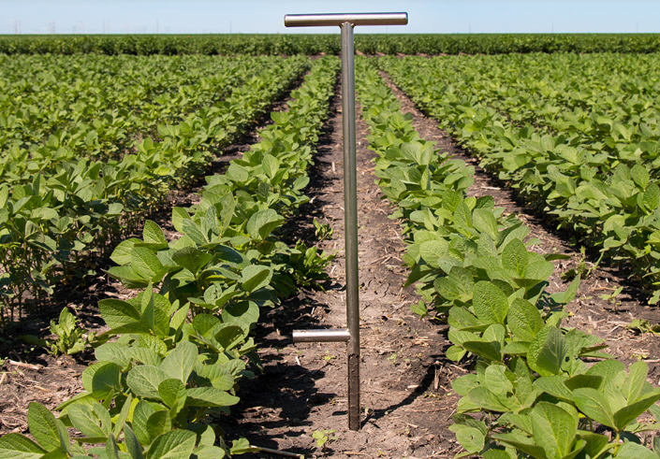

Module Title: - Identifying and Determining Basic Properties of Soil
LG Code: AGR CRP1 M04 Lo (1-3) LG (15-17)
TTLM Code: AGR CRP1TTLM 0922v1

September, 2022
Addis Ababa, Ethiopia

Table of Contents

Introduction to the Module 1
Instruction sheet 2
Information Sheet 1. 3
Self-Check – 1 13
LO #2- Collecting Soil Samples for Testing 14
Instruction sheet 14
Information Sheet 2 16
Self-Check – 2 27
Operation Sheet -2 28
LAP TEST-2 30
LO #3- Identifying Soil Profile and Physical Properties of Soil 31
Instruction sheet 31
Information Sheet 3 32
Self-Check – 3 45
Operation Sheet -3 46
LAP TEST-3. 49
Reference Materials 50

Introduction to the Module
This module covers the knowledge, skills and attitude required to prepare for soil sampling, collect soil samples for testing, identify soil profile and physical properties and assist soil testing operations. The work is usually done within routines, methods and procedures where some discretion and judgment is required in the selection of sites, equipment and materials, organization of work, services, actions and the achievement of outcomes within time and budgetary constraints.

LG #15 | LO #1- Preparing for Soil Sampling

Instruction sheet
This learning guide is developed to provide you the necessary information regarding the following content coverage and topics:
  - Introduction to the module
  - Selecting tools, equipment and machinery according to site conditions
  - identifying soils sample techniques based on site plans requirements
  - identifying areas of homogeneous soil types for sampling
  - selecting and using suitable personal protective equipment (PPE)
  - maintaining and cleaning work area

This guide will also assist you to attain the learning outcomes stated in the cover page. Specifically, upon completion of this learning guide, you will be able to:
  - Select and identify Tools, equipment and machinery according to site conditions and testing agency
  - Identify soil sample techniques according to site plans requirements
  - Identify areas of homogeneous soil types for sampling
  - Select and use suitable safety equipment and personal protective equipment (PPE)
  - Maintain, clean and safe work area throughout and on completion of work
Learning Instructions:
- Read the specific objectives of this Learning Guide.
- Follow the instructions described below.
- Read the information written in the information Sheets
- Accomplish the Self-checks
- Perform Operation Sheets
- Do the “LAP test”

Information Sheet 1.
Introduction
Definition of Soil
Soil is a natural body comprised of solids (minerals and organic matter), liquid, and gases that occurs on the land surface, occupies space, and is characterized by one or both of the following: horizons, or layers, that are distinguishable from the initial material as a result of additions, losses, transfers, and transformations of energy and matter or the ability to support rooted plants in a natural environment.
The soils are three-phase systems, which consists of:
- Solids
- Liquids
- Gases
- Selecting Tools, Equipment and Machinery According to Site Conditions
Tools and equipment’s for soil sampling includes the following,
- Shovel
- Spade
- Soil auger or sampling probe
- Bucket (pail) of 8 – 10 litters capacity or a wooden box
- Paper sack (soil bag)
- Sieve, mortar and pestle
- Ruler, pencil and note pad for labeling each container and recording information.
- Drier

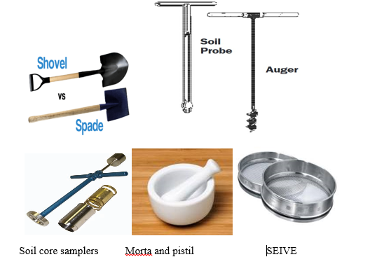
Fig.1.1. Tools for Soil Sampling
Uses of Tools and Equipment’s
- Shovels and spade are tools used to take an individual sample from the top surface of soil. To make a composite sample shovel and spade should be avoided because to make a composite/average mixture equal volume of different soil samples should be used for mix up, then to get this equal volume of soil an auger is best used as it can take similar volume of soil sample from same depth.
- A clean bucket is used to mix the samples to make it composite
- Paper bag is used to hold each sample separately and take to laboratory
- Mortar and pistil or soil grinder is used to break the soil clods in to pieces, to suit the soil for the different tests.
- Sieves are used to separate the desired size of soil particles according to the test for example to test soil texture a sieve with 2mm diameter is needed, and different diameter sieves for nutrient tests.
- Ruler, pencil and not pad is use to label the soil sample after preparation and documentations.

  - Identifying Soil Sample Techniques Based on Site Plans Requirements
Definition
Soil sampling involves the analysis of a soil sample (from the area of which you will be landscaping) to give you clear information on the soil. This will include its nutrient content, composition and other characteristics that are important to plant health, such as acidity and pH level and detrimental contaminants.

1.2.1. Making the Site Plan for Soil Sampling
The goal of the sampling plan is to determine where and when to collect soil samples that are representative of the field to be fertilized. If soil is submitted from only a few locations that do not represent the entire area to be fertilized, the fertilizer added may be too much or too little for the majority of the area, causing decreased yields, reduced crop quality, or wasted fertilizer

Sampling depth and timing of sampling are critical components of a well-designed sampling plan. The sampling plan may be constructed in the sampler’s head, but it may be more objective to sketch out the plan ahead of time. In addition, the actual sampling areas need to be recorded or flagged, to help the producer to determine where to fertilize.

Each soil series has different characteristics, and will likely have different amounts of available nutrients. In addition, the soil maps are based on aerial photographs that can prove useful in determining your relative location when out in the field.

1.2.2. Sampling Techniques
Draw a diagram of your property where samples are to be taken. Sample dissimilar parts of the yard separately. Plot the areas to be sampled, and then keep the diagram for future reference (see illustration). Since only a small portion of the soil is used for testing, it is very important that the sample be representative of an area. Usually, it is better to prepare a single soil sample from several cores or slices rather than to have several tests made within an area. So after you have divided the property into sample areas (front yard, shrub bed, garden, etc.), take several samples from each area. Mix these together by area to get your representative sample or "average" for each area. For large areas, 10-15 cores are needed, but for narrow shrub or flower borders, 4-6 cores will do the job.
Be sure to take all samples from an area and place them together in a clean pail or box. Also, be sure to keep an accurate record of the sampled areas, and include this information in the soil report (called a field record) so you will be able to interpret the results.

1.2.3. Soil Sampling Method (Sampling Pattern)
The most common samplings collection designs are the following:
- Grid Sampling: A grid with suitable spacing is placed on the map and measured. The sampling will be taken at the intersections of the grid or from inside of the grid cells. Grid sampling provides equally spaced observations and it reveals any systematic variation across the tract under study.
- Area (cell) Sampling
The sampling pattern should be selected to best represent the field, accounting for known sources of variability:-
- major soil type changes
- Past cropping patterns, etc.).
A grid pattern is usually the best way to be sure the entire field is represented.
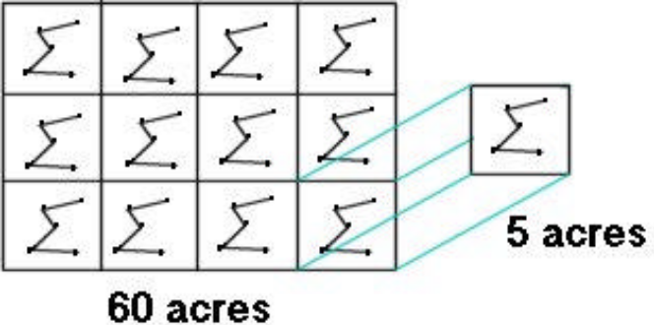
Fig 1.2: Area (Cell) Sampling Technique - Soil Test Values Represent an Area.

- Grid Point Sampling
- To better characterize the field for site-specific management and variable-rate application,
- Point samples can be used to measure the variability across the field.
- Dividing the field into 2 ½ acre grids and collecting a sample for each cell,
- The grids lines help ensure a good spatial representation of the field that can be used to develop a nutrient map.
- The collection of data for all points in the field provides the basis of nutrient variability maps.
Separate soil samples should be collected from areas or fields that have had
- Different crop history
- Yield and
- Fertilizer treatments or
- That varies substantially in slope, texture, depth, or soil color.
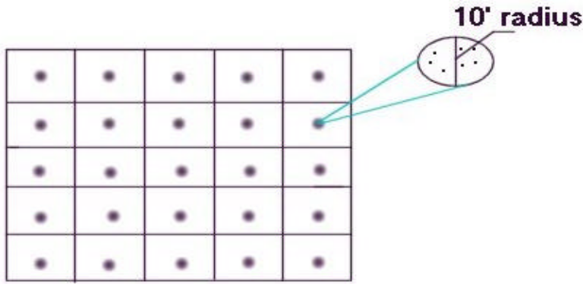
Fig.1.3.Grid point sampling

- Random Sampling: Sample locations are selected at random, with equal probabilities of selection and independently from each other. The sample produced from one sampling area consists of 10-20 sub-samples collected randomly throughout the sampling area using a zigzag pattern. The sub-samples should only be collected from representative sites, avoiding areas like anthills, bunds, boundaries, etc. The sampling process starts with the cleaning of the surface area then removing the top litter from the surface to approximately 1 cm deep. Dig a “V” shaped hole to a depth of 15 cm to collect a sample of the topsoil; for a sample of subsoil, the hole should be about 45 cm deep.
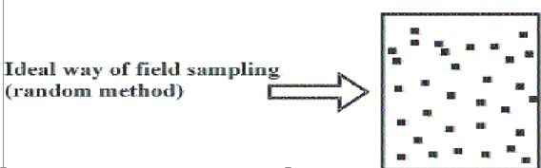
Fig 1.4. Random sampling method
- Random Stratified Sampling: The area is first divided into a number of subsections, called strata, and then random sampling design is applied to each of the strata separately. The random sampling method is not a systematic collection technique; meanwhile the stratified random sampling method provides a kind of mixture of the systematic and non-systematic soil sampling collection methods.


Fig 1.5: Stratified Systematic Sampling Triangle, Diamond, or Hexagon.

- Transects: Soil samples are taken along straight lines across the targeted area. The spacing between sampling points might be equal, nested, or random.

- Target Sampling: Based on specific attributes (e.g. slope, aspect, plan or profile curvature, color, etc.) the technician identifies homogeneous and heterogeneous patterns of the targeted area, which will allow the fixation of representative sampling points where the sampling will be taken. This technique minimizes the effort and cost and maximizes the information content.

Other different soil sampling method depending on the field area

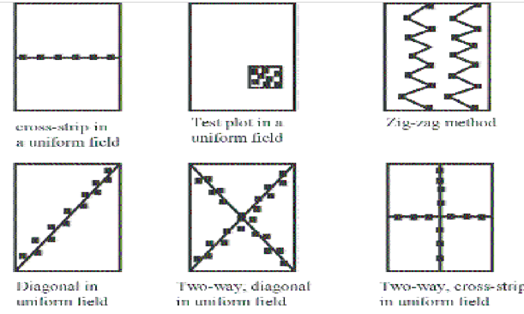
Fig 1.6. Different soil sampling technique.

Number of soil samples to be collected
This is dependent on
- The size of the field
- The variability within the field
- The fertilizer application equipment
- How feasible it is to change application rates within a field, and
- How much time and money you have allocated for sampling.

1.3. Identifying Areas of Homogeneous Soil Types for Sampling
Identify Areas of Homogeneous Soil Types
Since most field soils are not homogeneous, naturally or due to past and/or current cultural practices, the challenge for the sampler is to obtain a sample that is representative of the field under test. Each sample should represent only one soil type or area-for example, a lawn, vegetable garden or perennial landscaped area. For each unique area, take at least six to eight subsamples and combine them to make one sample. If one area of your yard seems healthy and another has bare or yellow areas, sample healthy and unhealthy areas separately even if both are lawn grasses or flower gardens, etc.
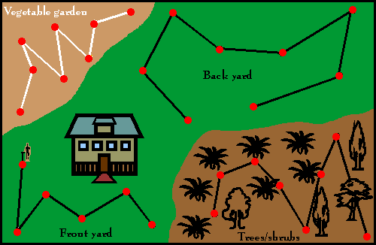
Fig.1.7.Identify homogenous area

1.4. Selecting and Using Suitable Personal Protective Equipment (PPE)
Personal Protective Equipment
Personal protective equipment is to include that prescribed under legislation, regulations and enterprise policies and practices.

Personal Protective Clothing and Equipment May Include:
- Hat/hard hat
- Overalls
- Gloves
- Protective eyewear
- Hearing protection
- Respirator or face mask
- Sun protection, e.g., sun hat, sunscreen

Different Types of PPE are Described Below
Foot Protection   | Workers must wear closed-toe shoes at all times to protect feet from chemical spills and sharp objects. Steel-toed footwear and puncture-resistant soles. Slip-resistant shoes for anyone who works in wet environments.
Eye Protection: Use safety glasses for minor splash hazards, goggles for moderate hazards, and goggles combined with a face shield for severe hazards.


Hand Protection: Hand protection is indicated for the possibility of severe cuts, lacerations, or abrasions, punctures, temperature extremes, and chemical hazards. (Nit rile loves are usually a good choice for general use.) Use heavy-duty gloves for non-incidental contact and gross contamination.

Body Protection: Protective clothing includes lab coats, smocks, scrub suits, gowns, rubber or coated aprons, coveralls, uniforms, and pierce-resistant jackets and vests.


Head Protection: Hard hats must be worn by electricians, construction workers, and any other workers when there is a danger of objects falling from above.



1.5. Maintaining and Cleaning Work Area
Establish decontamination areas for “dry” and/or “wet” decontamination, depending on the decontamination needs at the site. The working area should be free from any contamination of unwanted material that will affect the result of our work.

Many precipitates can be removed from the filter surface simply by rinsing from the reverse side with water Drawing water through the filter from the reverse side with a vacuum pump is also effective. Some precipitates tend to clog the pores of a fritted filter and may require special cleaning solutions
The major steps in cleaning are:
- Washing
- Rinsing and
- Drying and
- Finally storing

Self-Check – 1 | Written test

Name…………………………………………… ID………………………… Date…….

Directions: Answer all the questions listed below.

Test I: Choose the Best Answer (4 point)
1. Which of the following materials are used for grinding the soil sampled?
A. Auger B. mortar and pistil C. spade D. pencil
2. From the following one is not PPE?
A. spade B. overall C. helmet D. glove

Test II: Short Answer Questions (3points each)
    - Define and write constituents of soil?
    - Write tools and equipment used to undertake soil sample?
    - Define soil sampling?
    - What are the factors that determine number of soil sampled?
    - List and explain method of soil sampling?

Note: Satisfactory rating - 19 points Unsatisfactory - below 19 points

You can ask you teacher for the copy of the correct answers.

You can ask you teacher for the copy of the correct answers.
LG #16 | LO #2- Collecting Soil Samples for Testing

Instruction sheet
This learning guide is developed to provide you the necessary information regarding the following content coverage and topics:
- Preparing tools and equipment for collecting soil sample
- Identifying area for soil sample collection
- Excavating holes and taking samples randomly from designed area
- Identifying, assessing, implementing and reporting OHS hazards
- Selecting, using and maintaining suitable safety and PPE
- Collecting, preparing, packing, labelling and dispatching samples
This guide will also assist you to attain the learning outcomes stated in the cover page. Specifically, upon completion of this learning guide, you will be able to:
- Prepare tools and equipment for collecting soil samples
- Identify area for soil sample collection from workplace records according to enterprise work procedures
- excavate hole and take Samples randomly from the designated area according to recognized sampling techniques
- OHS hazards are identified, risks assessed and controls implemented and reported to the supervisor.
- Select, use and maintain suitable safety and PPE are.
- Collect, prepare, package, accurately label, record and dispatch Samples for site and off-site testing according to testing agency requirements and enterprise work procedures.
Learning Instructions:
- Read the specific objectives of this Learning Guide.
- Follow the instructions described below.
- Read the information written in the information Sheets
- Accomplish the Self-checks
- Perform Operation Sheets
- Do the “LAP test”

Information Sheet 2

- Preparing Tools and Equipment for Collecting Soil Sample
Tools and equipment used during soil sampling should be prepared depending on the size of the area to be sampled, depth & uniformity of the sample, Information provided. Before going to take sample materials used for soil sampling should be cleaned based on its need.

Materials Used for Soil Sampling:
- Tools should be either stainless steel or chrome plated
- Do not used brass, bronze or galvanized tools b/c they will contaminate samples with Cu and/ or Zn. If the shovel or spade is used, dig a vi-shaped hole to sample depth.
- Mix soil cores for each sample in a clean, plastic bucket (wash if used for fertilizer or chemicals).
Example:-Probe, tape meter, an auger, spade or shovel, mortar and pistil, spatula and plastic bag

- Identifying Area for Soil Sample Collection
2.2.1. Identifying the Sampling Area
Before taking any sample the first thing to do is to delineate the area for sampling and know which area the sample represents. It is sometimes important to have topographic and soil survey map of the area to easily point the sampling areas, therefore we need to have a sampling plan.

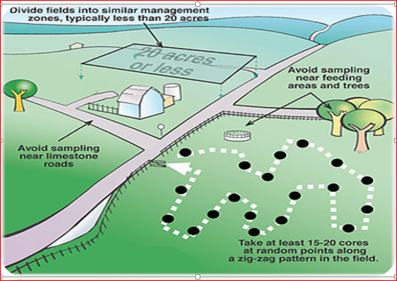
Fig 2.1. Identify area of soil sample.

    - Considerations in Determining the Sapling Area
- The sample should be truly representing the field/area it belongs to.
- A field can be treated as a single sampling unit if it is uniform. Generally an area not exceeding 0.5 ha is taken as one sampling unit.
- Variations in slope, color, texture, crop growth, and management practices are the important factors that should be taken in to account for sampling. Separate samples are required from areas differing in these characteristics.
- Recently fertilized plots, bunds, channels, marshy tracts, and areas near trees, wells, compost piles or other no representative locations must be carefully avoided during sampling.
- An area of about 3-3 meters along all the sides of the field should be left in large fields.
- Larger area may be divided in to appropriate number of smaller homogeneous units for better representations of the field.

- Excavating Holes and Taking Samples Randomly From Designed Area
Soil is excavated to take soil sample that will represent the area of land to be analayised. There are two different methods for sampling. The first sampling method is performed at a fixed depth while the second sampling technique is taken from each horizon. The specific method and processing strategies of the sampling collection are indicated in the soil sampling design. The designer should have a simple map of the area; it does not to be exact – a rough sketch will do. First, one must indicate on the map the number of sampling areas, selected on the basis of uniformity of size and type of important in order to achieve the objective as well as factual information about this part of the farm. After this division of land, one composite soil sample must be taken from each area. Soil sampling is carried out using different sampling designs, which are indicated in the map or sketch of the targeted area.

Soil sampling procedures
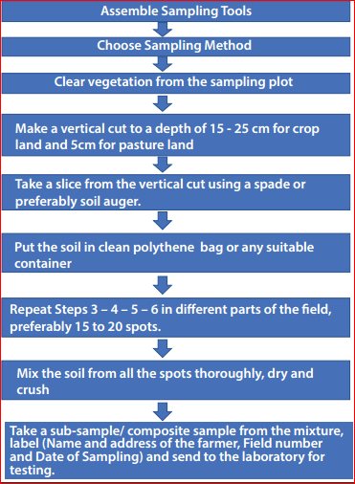
Fig.2.2. soil sampling steps
2.3.1 Preparing Soil Sampled for Testing
Soil samples are prepared for testing by using different methods by taking from different points. Take 10 or more sub-samples from different locations within each uniform sampling area to make a composite sample. Take the sub-samples in a random manner, such as with a zigzag pattern to minimize the variability that may be present in your sampling area. This allows you to obtain a reasonably representative soil sample.

The larger the area, the more sub-samples that are needed. The more sub-samples you take, the more representative your sample will be of your landscape area. When you have taken sufficient sub-samples from a uniform area, thoroughly mix the sub-sample slices or cores, breaking up clumps and removing all foreign matter such as roots, stalks, rocks, etc. Now you are ready to prepare the sample for the Soil Testing Laboratory.

In the following figure, composite sample #1 contains 12 sub-samples. 2 should contain at least 10 sub-samples as well. You should avoid the eroded area when making composite samples #1 and #2.

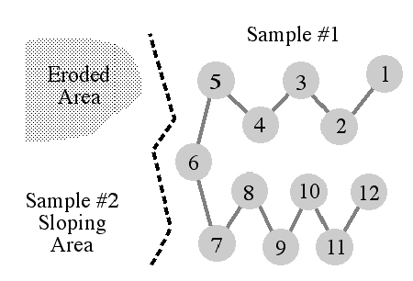
Fig. 2.3.composite sample.

For the preparation of a test sample, split up the laboratory sample into representative portions until the required sizes of samples are obtained. Avoid the production of dust as much as possible. Select the method of sub sampling according to the nature of the sample, the requirements of the subsequent determinations and the equipment available.
Mix the soil sample thoroughly and spread it into a thin layer on a tray of a type which will not influence the composition of the sample. Separate the soil into four equal portions (quadrants). Combine two of the four portions diagonally, rejecting the other two. Repeat this procedure until the desired amount of soil is obtained.
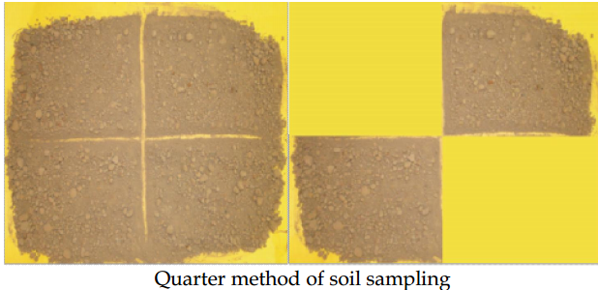
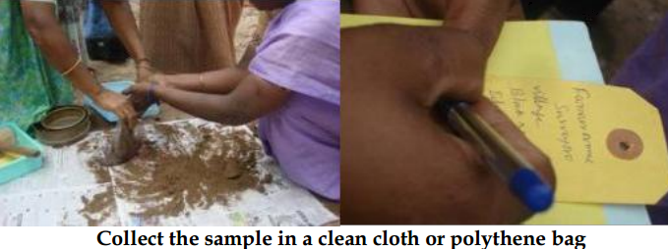


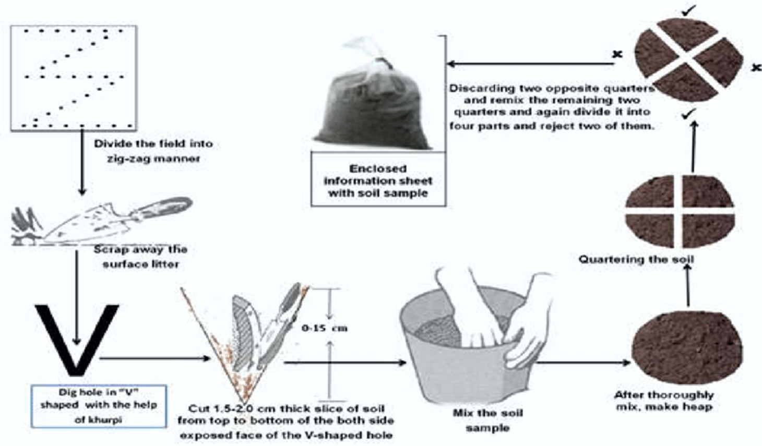
Fig. 2.4. Steps for sampling soil.

Which Precautions Should you Observe when Collecting Soil Samples?
Sample all soil horizons over 10 cm in thickness; all samples should represent natural soil horizons or stratifications; samples should not be taken at arbitrary depths;
Keep soil samples separate: If you have to examine and compare the soil samples when you take them, carefully collect them in separate piles to avoid mixing different samples and place the piles on sheets of plastic or newspapers so that they do not become mixed with other materials such as leaves, manure or gravel which may be on the ground;
Bag soil samples: If you do not plan to examine and compare the soil samples when you take them, place them immediately in strong plastic bags or in canvas bags with plastic liners; tie all bags tightly;
A soil sample label: Label all sample bags carefully and completely; write clearly on the label the identification number of the sampling location, the upper and lower depths of the horizon sampled, and the date.

- Identifying, Assessing, Implementing and Reporting OHS Hazards
Identification of OHS Hazards and Controlling Risks
Occupational health and safety is concerned with health and safety in its relation to work the working environment.
Aims of occupational health
Occupational health should aim at:-
- The promotion and maintenance of the highest degree of physical, mental and social well-being of workers in all occupation
- The prevention amongst workers of departures from health caused by their working conditions.
- The protection of workers in their employment from risks resulting from factors adverse to health.
- The placing and maintenance of workers in an occupational environment adapted to his physiological and psychological capabilities and
- To summarize the adaptation of worker to man and of each man to his job.

Hazards
To undergo safe work identifying and assessing wok related hazards and risks and taking control measures to avoid the danger accompanied with the risks and hazards is crucial.
OHS requirements may include:
- Identifying hazards
- assessing risks and implementing controls
- Cleaning
- Maintaining and storing tools, equipment and machinery
- Appropriate use of PPE including sun protection; safe operation of tools, equipment and machinery
- Safe handling, use and storage of chemicals and hazardous substances
- Correct manual handling
- Personal hygiene and reporting problems to supervisors

- Selecting, Using and Maintaining Suitable Safety and PPE
Selecting personal protective clothing and equipment
Suitable personal protective clothing and equipment is selected, used, maintained and stored in accordance with Occupational Health and Safety requirements.
Select PPE Based on the PPE Hazard Assessment
Consider these factors when selecting PPE:
- Type of hazardous materials, processes, and equipment involved
- Routes of potential exposure (ingestion, inhalation, injection, or dermal contact)
- Correct size for maximum protection
- Minimal interference with movement

- Collecting, preparing, packing, labelling and dispatching samples
    - Collecting soil sample
The accuracy of soil analyses and the subsequent interpretation of test results depends on various factors:
- How the soil samples were collected in the field,
- How they were handled and
- How they were processed during the analysis.
In collecting soil samples we have to remember that soil characteristics vary even in a small piece of land. Their texture and chemical composition depends on different factors.
Therefore we have to divide the area into small units and collect sufficient samples to represent the whole area. The size of a sampling unit is often decided by various factors, such as the differences in soil color or texture, slopes and/or drainage characteristics, the previous use of the land for cropping and the consideration of uneven growth areas.

Step-wise process of collecting soil samples (a) soil sample collection using a hand-held push probe, (b) divide each core sample into desired depths, (c) make a composite of samples for each depth in a clean bucket, (d) mix the soil samples, (e) transfer required amount of soil samples in a clean soil sample bag, and (f) label the bag.

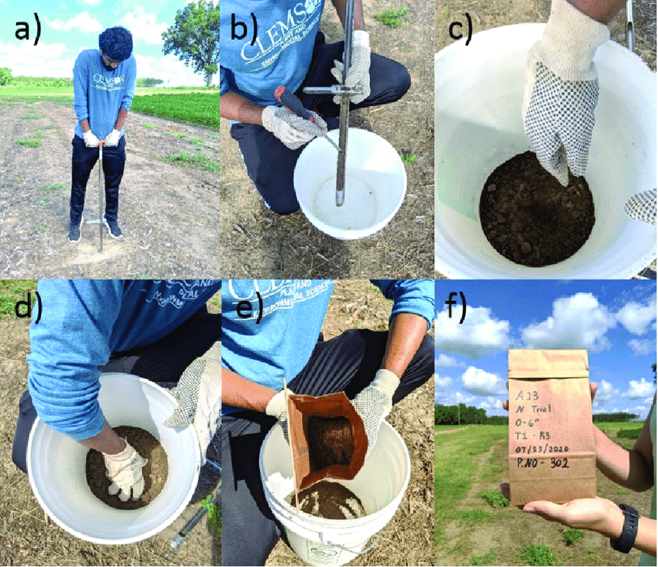
Fig 2.5.Soil sampling to labeling steps

    - Drying the soil sample
Dry samples at room temperature (Do not use artificial heat.) Break up any lumps and remove all stones, debris, etc. When dry, mix well and crush so all the soil is the size of wheat grains or smaller, but do not pulverize.

    - Grinding the soil sample
The sample portion that was sieved will be ground to a particle size of approximately 2.50mm. Set up a catch pan under the grinder to collect all the ground material. Take the fine sample, load the grinder hopper, and allow the fine sample to pass through the plate grinder into the catch pan.

    - Sieving the soil sample
All samples will be sieved prior to grinding to separate out the coarse and fine fractions. All sieving activities will take place in the ventilation hood. Samples will be weighed during sieving activities. All measurements, any required maintenance, and the analytical balance number will be recorded on the Analytical Balance Calibration and Maintenance Log.

    - Labeling and packing
      - Labelling of soil sample
Once a sample is obtained it should be clearly and unmistakably marked. Normally, a containerized sample should have a label having all the required information on it. This can be done, for example, by either using adhesive labels, writing the information directly on the container, or putting the label inside the container with the sample. Labels should be short and simple, to avoid mistakes arising in transcribing numbers. It is recommended that at least the sample number should be placed on both the container and the lid to avoid undesired mix-up of containers and lids. The sample number should not be placed only on the lid. Before samples are dispatched and on receipt in the laboratory, a check should be made that sample numbers on the container and on the lid can be correlated with the respective sampling report.
Label may include the following information:
- Sampler name,
- Address,
- Phone Number,
- Email address,
- Soil depth,
- Sample location(farm, orchard, home)
- Sample date
- Last season crop

      - Packaging of samples
Pack the samples properly. Each sample shall be packed in a container that does not react with the soil, is clean and carefully sealed to avoid loss of the contents or exposure to external agents (infiltration of water, dust, etc.) The identification label shall be attached to the outside of the packaging.

    - Dispatch of Soil Samples to the Laboratory
Before sending soil samples to the testing laboratory by a farmer, it should be ensured that proper identification marks are present on the sample bags as well as labels placed in the bags. It is essential that it should be written by copying pencil and not with ink because the ink will smudge and become illegible. The best way is to get the soil sampling bags from soil testing laboratory with most of the information printed or stenciled on them with indelible ink.

Self-Check – 2 | Written test

Name…………………………………………… ID………………………… Date…….

Directions: Answer all the questions listed below.

Test I: Choose the best answer (4 point)
    - Which one is true
A. Use single sampling unit for homogenous soil
B. Variations in slope and color does not considered
C. Avoided recently fertilized plots and bunds during sampling.
D. Sampling is not recommended
2. One concerned with health and safety in its relation to work and the working environment.
A. Occupational health and safety B. Hazards
C. Risks D. Tools
Test II: Short Answer Questions (3points each)

1. Write the considerations in determining the sapling area?
2. What we have to consider when selecting PPE?
3. Differentiate labeling and packing?

Note: Satisfactory rating - 13 points Unsatisfactory - below 13points

You can ask you teacher for the copy of the correct answers.

You can ask you teacher for the copy of the correct answers.

Operation Sheet -2

Techniques of Soil Sampling Procedure
- Tools and Equipment

- Auger, Knife
- Spade /shovel
- Measuring tape/ruler
- Sticky labels
- sampling probe,
- Bucket, spatula and plastic bag,
- Sieve,
- mortar and pestle,
- Ruler, pencil and note pad
- Balance

- Procedures/Steps/Techniques
1st step _ prepare your tools and equipment that are needed for soil sampling
2nd step _ make the sampling plan in the chosen field of about one hectare
- Is there any variability on the field in terms of slope, soil color, depth and texture?
- Consider also any other variability such as cropping history, fertilizer application, etc.
3rd step_ following the variability you observed divide the one hectare field in to homogenous sampling units
4th step _ taking one sampling unit area for one group, then locate the sampling points on you sampling unit.
- Choose a large distance/interval to locate the sampling points as your area is approaching to homogeneity
5th step _ Using the auger take at least 9 samples (or your own sample numbers) from the located points
- Put the soil sample you take in paper bag first and
- Then composite the nine paper bag samples in to one clean bucket
6th step- Air dry the soil samples by spreading them in old newspapers or mats under the shade or indoor.
7th step-Be sure to avoid contaminations among the samples and keep them away from dirt or foreign matters especially cigarette ash.
8th step- Divide representative soil samples into four and Remove soil samples 1and 3 and retain soil samples 2 and 4.
9th step- Repeat the process until you obtain the required sample.
10th step-Finally Label the bags properly and take them to the Soils Laboratory for analysis

LAP TEST-2 | Performance Test

Name………………………………. ID…………………………….. Date…………………………………….

Time started: ________________________ Time finished: ________________

Instructions: Given necessary templates, tools and materials you are required to perform the following tasks within 4 hour. The project is expected from each student to do it.

Task-1. Perform Soil sampling procedure

LG #17 | LO #3- Identifying Soil Profile and Physical Properties of Soil

Instruction sheet
This learning guide is developed to provide you the necessary information regarding the following content coverage and topics:
- Identifying physical characteristics of the soil
- Determining soil profile based on guide line
- Cleaning and storing sampling and testing tools and equipment
- Disposing waste material
- Recording results in an established format
This guide will also assist you to attain the learning outcomes stated in the cover page. Specifically, upon completion of this learning guide, you will be able to:
- Identify the physical characteristics of the soil according to investigative requirements and best practice guidelines
- Determine soil profile where appropriate according the guidelines.
- Clean and return sampling, testing tools and equipment of all residues and storage according to manufacturer specifications and enterprise work procedures.
- Dispose all containers, leftover fluids and wastes safely and appropriately.
- Record Results in established format according to enterprise work procedures
Learning Instructions:
- Read the specific objectives of this Learning Guide.
- Follow the instructions described below.
- Read the information written in the information Sheets
- Accomplish the Self-checks
- Perform Operation Sheets
- Do the “LAP test”

Information Sheet 3

- Identifying Physical Characteristics of the Soil
Introduction
There are different basic properties of soil Physical properties (texture, structure, soil depth, color, bulk density, Soil Consistence, etc.), Chemical properties (soil pH, CEC, EC, Salinity, nutrient), Biological properties (soil fauna and flora) of soil.

3.1.1. PHYSICAL PROPERTIES OF SOILS
The occurrence and growth of many plants and the movement of water and solutes over and through the soil are closely related to soil physical properties. Physically, a mineral soil is a porous mixture of inorganic particles, decaying organic matter, air and water. There are a number of soil physical properties of which texture and structure are the most important ones as the others are directly or directly dependent upon them. Others, which will further be discussed, include: particle and bulk densities, pore spaces, soil color, soil, consistence, soil water, soil air and temperature.

- Soil Texture
Soil texture is one of the most important physical properties of soil. It refers to the basic composition of the soil separates/particles that are sand, silt and clay. The soil texture directly or indirectly affects almost every single characteristic of the soil. The classifications of particles

The classifications of particle sizes are as following (units: mm):
- Clay: < 0.002 (It is recognizable by its stickiness. It is hard and cloddy when dry)
- Silt: 0.002 - 0.05 (Particles cannot be detected, but their presence makes the soil feel smooth and soapy and only very slightly sticky.)
- Fine sand: 0.05 - 0.1 (Sand particles grate against each other and they can be detected by sight. Sand shows no stickiness or plasticity when wet.
- Medium sand: 0.1 - 0.
- Coarse sand: 0.5 - 1.0
- Very coarse sand: 1.0 - 2.0
There are different methods to establish the soil sample’s textural class.
The arrangement and organization of soil particles in the soil, and the tendency of individual soil particles to bind together in aggregates; Aggregation creates intra-aggregate and inter-aggregate pore space, there by changing flow paths for water, gases, solutes and pollutants. These can be natural aggregates, “peds”, or artificial aggregates “clods” that are evidence of human intervention.
Soil textural class names have become standardized to express the variation of soils in composition of the different sized particles (sand, silt and clay).There are three basic soil textural names (Sand, clay and Loam) whose combination gave a total of twelve soil textural classes ( Sand, Loamy Sand, Clay, Silty Clay, Sandy Clay, Loam, Sandy Loam, Silt Loam, Silty Clay Loam, Clay Loam, Sandy Clay Loam).Sand, Silt and Clay take each of the sides of the triangle. After knowing the percentage of each of the soil separates their textural class name is sought in the textural triangle. (A scanned map of textural triangle)

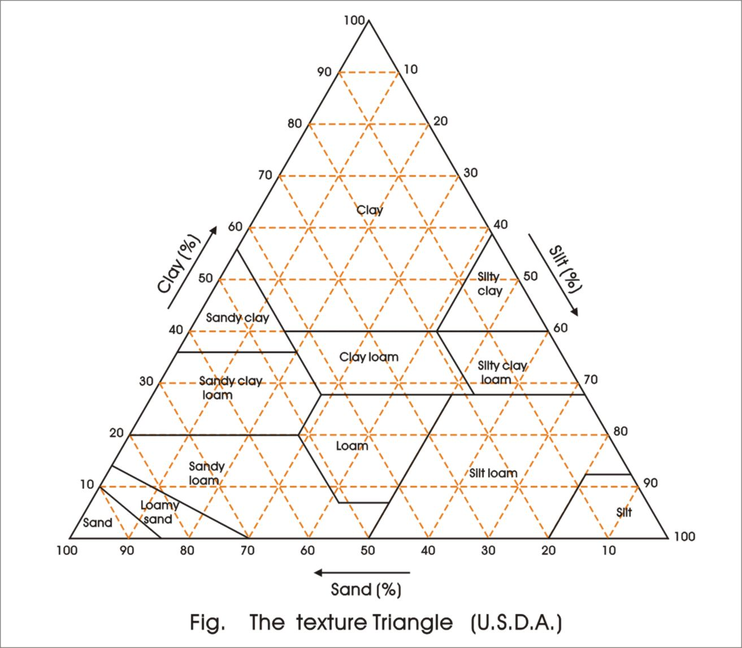
Fig .3.1 soil textural triangle

The criteria for identification of soil texture:
A soil sample with a suitable amount of relative moisture content, which is around 60-70%, will appear different characteristics, when it is twisted, scraped, or pinched.

Table. 3.1. Criteria for soil texture identification.
Soil texture | Dry method | Twist | Scrape | Pinch
Sand soil | Loose and scattered | No matter how much is water content, it cannot be twisted to be a ball | There is only rough sand particles on the scraped surface | Cannot be a ribbon
Loam sand soil | Loose clods but once you touch it, easily scattered | Can be twisted to be a ball but can not be a bar | It cannot become a thin slice; there are a lot of fine sand particles on the scraped surface. | Cannot be a ribbon
Light loam soil | A little close clods, under small strength it breaks, feel gritty | Can be twisted to be a 3-5 mm size small bar, but it is easily broken | A little difficult to become a thin slice, the scraped surface is rough and like fish scale. | A little difficult to be a ribbon with big split edge, and easily broken.
Mid loam soil | Close clods, under a big strength it breaks, feel silty | When the small bar is curved to be a ring round, there are some cracks | It can become a thin slice, the scraped surface is a little rough with split edge | Can be a ribbon but when it is swayed, it is easily broken.
Heavy loam soil | Very close clods, and a little difficult to break | When the small bar is curved to be a ring there is no crack, but when it is pressed to be flat, there are some cracks | The scraped surface is smooth and slippery with round and flat edge, and no shining. | When the ribbon is swayed it is difficult to be broken.
Clay soil | Hard clods, very difficult to break it. | Whether the small bar is curved to be a ring or pressed to be flat there is no cracks | The scraped surface is smooth and slippery, and shining. | It can be pinched to be a curved ribbon and cannot be broken.

- Soil Structure
Soil structure is a field term descriptive of the gross, overall aggregation, or arrangement of the primary soil separates. It influences water movement, heat transfer, aeration, bulk density and porosity. Soil structure can be classified based on three parameters.
- Type (or Shape) describes the shape of the soil aggregates;
- Class describes the size of the peds; and,
- Grade (or distinctness) refers to how distinct and strong the peds are.

Granular structure: Rich in organic matter, with good porosity, easy water-air exchange and capacity for movement. This is typical surface soil structure, where aggregates are glued together by organic matter.

Platy structure: Sub-surface soil, where the platy layers separate more easily. Normally this soil is the result of leaching and compaction.

Blocky structure: Common in sub-soils, or surface soils with high clay content. When the surface dries up, it shows features of cracking and peeling of the clay. The shape is dependent by the surrounding blocks. These can also be classified in to two:
- Blocky - edges are sharp and the faces distinct.
- Sub-angular blocky - When sub-rounding has occurred.

Massive Structure: Amorphous material, a coherent mass showing no evidence of any distinct arrangement of soil particles; separates into clusters of particles, not peds (Clayey soils).

Prism-like- Vertically oriented aggregates or pillars varying in length. Most commonly, it occurs in the B-horizons of arid and Semi-arid Soils. The prisms are very dense, therefore these types of soils are not fertile. They can be grouped in to two: Columnar- and Prismatic-

- Soil Density:
Like other matter, soil has density. There are two kinds of soil density: bulk density and particle density/real density.
- Bulk density is the weight of a given volume of soil, including the network of pore spaces, i.e. the gaps between the particles.
- Real soil density excludes the pore spaces, leaving only the volume of the soil solids.

- Pore Spaces:
Through these spaces the soil exchanges water and gases with the environment. This network is the path for the flow of nutrients and heat. The main soil characteristic like structure, texture or organic matter content is related with the pore space system. There are two types of pore spaces: macro (larger than 0.06 mm), indicating the spaces between aggregates, and micro (smaller than 0.06 mm.) for the space within individual aggregates. Micro pores look like a trap, with no way for the trapped water and air to flow in or between them. The pore space content of the soil is called porosity.

- Water Holding Capacity of the Soil:
The capacity of the soil to hold water, to allow it to flow and to fix it is one of the most important conditions for successful agricultural production. These characteristics of the soil are closely related to other physical properties of the soil, e.g. porosity, density, color, texture and structure. In other words, the water in the soil is determined by the soil’s physical properties on one hand and by the hydrologic cycle of the ecosystem on the other. The latter can be modified by human intervention through irrigation and other agro-technical methods.

- Soil Consistence:
Soil Consistence: is the resistance of the soil to deformation or rupture. It is determined by the cohesive and adhesive properties of the entire soil. It is basically described at three moisture levels: wet, moist and dry.

- Wet consistence: two parameters are used here, the stickiness (non-sticky, slightly sticky, sticky and very sticky) and the plasticity (non-plastic, slightly plastic, plastic and very plastic).

- Moist consistence: is important since it best describes the condition of soils when they are tilled in the field. It is the measure of the resistance of the soil to crushing between the thumb and the forefinger. Terms used are: Loose, Very friable, Friable, Firm, Very firm, and Extremely firm
- Texturally speaking course sands would be expected to have loose consistence.
- Well-granulated loam and silt loam soils would be very friable, friable or perhaps firm.
- Clay, silty clay, and silty clay loam soils are more likely to be firm or very firm

- Dry Consistence: the degree of the resistance of dry soils to crushing or other manipulations
- It is related to the attraction of the particles to each other.
- The following terms are used: Loose, Soft, Slightly hard, Hard, Very hard and extremely hard.

- Soil Color
Soil color indicates chemical, biological and physical transformations and translocations that have occurred within a soil. Soil organic matter causes a dark brown to black color in the soil. The higher the organic matter contents of the soil, the darker the color. A bright and light color can be related to an alluvial horizon, where carbonates and clay minerals have been leached out. Subsoil color is related more too physical and chemical processes. In well aerated soils, Fe³⁺ is present, which gives the soil a yellow or reddish color. In poorly drained soils under anaerobic conditions, the iron compounds are reduced and the Fe²⁺ content shows itself as a dark grey color.
During soil tests, remove the course particles larger than 2 mm. In accordance to the abundance of these fragments in the soil, a modifier can be added to the soil textural class.

Table 3.2. Main Soil Color Categories
Soil color | Attributes and Conditions
Brown to dark black | It has high organic matter content, which is well humified. Fertile soils. Developed under humid grassland. Organic matter content is around 7%
Black (subsurface horizon) | It indicates Manganese accumulation. Very hard when it is dry. Slowly permeable for water and roots. Usually the subsoil is rich in clay content. Frequently sodic or alkali soil.
Dark grey, bluish | It contains reduced Iron (Fe2 +). They normally poorly drained soils. Its permeability is very low, which causes anaerobe conditions in the soil. It frequently waterlogged.
White to grey | Accumulation of salts. Developed under conditions, when the evapo-transpiration is higher than precipitation. There is an upward movement of water and soluble salts in the soil.
Dark red | Iron and aluminum accumulation. Feral and Ferro soils
Yellow to reddish | Rich in oxidized Iron (Fe3 +). They are well aerated soils.

- Depth of Sampling
The depth of the sampling is important because the mobility of the nutrients varies with the nutrient content in the different soil zones. The mobility of each nutrient in the soil is also varying from each other.

Table.3.3. Recommended depth for sampling
- 0-15 cm To measure pH, P, K, Cl, S, Ca, Mg, Zn, NH4 + -N, Fe, Mn, Cu, soluble salts
- 15-60 cm To measure soluble salts, NO3-N, S, Cl (in addition to 0-15 cm depth)
- 60-120 cm To measure NO3-N (in addition to 0-15 cm and 15-60 cm depth)

The depth of the sampling also varies according to the crop in use:
- Annual Flowers: Sample the top 15 to 20 cm of soil.
- Perennial Flowers: Sample the top 15 to 30 cm of soil.
- Commercial Production of Field-Grown Flowers: Sample the top 20 or 30 cm of soil.
- Home Landscape Trees, Shrubs, & Field-Grown Nursery Stock: Sample the top 15 to 30 cm of soil. Take samples from under the established trees (under tips of the longest branches all the way around the tree), or just outside the root ball or planting area for newly planted trees.
- Home Vegetable Gardens: Sample the top 15 to 30 cm of soil
- Commercial Vegetable Fields: Sample the top 20 or 30 cm of soil.
- Fruit Trees: Sample the top 30 to 45 cm of soil. Take samples from area under branch tips (or closer to trunk for newly planted trees).
- Bush and Vine Fruits: Sample the top 20 or 30 cm inches of soil.
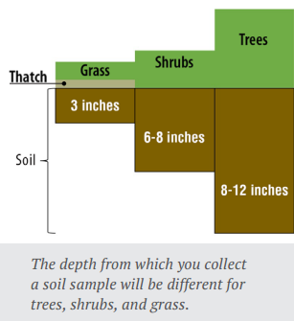
Fig.3.2 Soil sampling depth

- Soil Water
Water is needed for evapotranspiration consumption of plants (Crops).water is solvent and makes soil solution (With nutrients). Water is a constituent of plant body. Water controls Soil air and temperature. Water is active agent in soil erosion

3.2. Determining Soil Profile Based on Guide Line
3.2.1 Identifying Soil Profile and Properties
The soil profile is comprised of two or more soil layers called horizons, one below the other, each parallel to the surface of the land. The soil profile is therefore the vertical section of the soil differentiated in to layers one falling over the other known as the soil horizon. Important characteristics of the various horizons are:
Soil horizons differ in
- Color
- Texture
- Structure
- Consistence
- Porosity and soil reaction.
Soil horizons may be several feet thick or as thin as a fraction of an inch. Generally, the horizons merge with one another and may or may not show sharp boundaries. Horizons in a soil profile are like the parts of a layer cake without the clear bonds of frosting between them. Soil horizons in a profile are named by alphabetic letters or combinations of them.

Descriptions of the Three Major Horizons

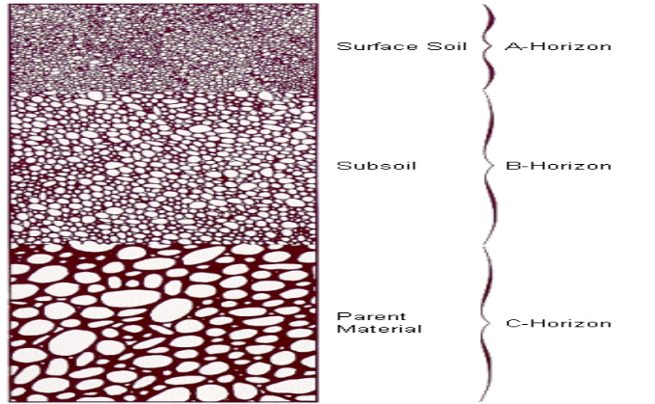
Fig 3.3. Major soil horizon

The A Horizon...is the uppermost layer in the soil profile or surface soil. It includes
- The mulch layer and plow layer.
- Living organisms are most abundant in this horizon consisting of plant roots, bacteria, fungi and small animals.
- Organic matter is most plentiful, particularly in the mulch layer. When a soil is tilled improperly, the A Horizon may be eroded away.
The B Horizon...lies immediately beneath the A Horizon and above the C Horizon. It is called the subsoil. The B Horizon has properties of both A and C. Living organisms are fewer in number than in the A Horizon but more abundant than in the C Horizon. Color is transitional between A and C as well. It is frequently higher in clay than either of the other horizons. The C Horizon...is the deepest of the three. This is the material from which the mineral part of the soil forms. It is the parent material of soils. It may have been accumulated in place by the breakdown of hard rock or it may have been placed there by the action of water, wind, or ice.

More Elaborated Soil Profile
The more elaborated soil horizon has five master horizons (O, A, E, B, C) and the transition horizons such as (AB, EB, BA, Etc.)

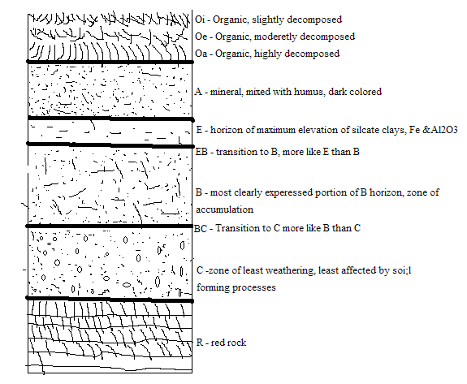
Fig 3.4. More elaboration of soil horizon

Description of the major soil profile including the transition horizons
Transition Horizons: these are horizons transition between two master horizons. These may be dominated by properties of one horizon rather than the other, however exhibit the property of the two master horizons. E.g.: AE, EB, BE, BC horizons etc.
- A Mineral horizon darkened by organic matter accumulation. Under Oa horizon, it is usually thin and is more porous than E. (known as A1 by old naming).
- E A mineral horizon lighter colored than an A above it or BA below it. Fine clays and minute organic substances have been washed out of it by percolating waters, which is leached zone. Usually it is common in high rainfall areas; especially under forests (known as A2 by old naming).
- AB A transition horizon more likes the A above it than like the B below it (known as A3 by old naming).
- BA A transition horizon more like the B below it than like the A or E above it (known as B1 by old naming)
- B layer of alluvial colloids or evidence of weathering below the A & E horizon. Early B horizon development stages of soils may have only redder (orange, yellow, brown) colors of weathering caused by the colored iron hydrous oxides. The top of the B may start at a depth ranging from about 15-50cm below the soil surface (Known as B2 by old naming).
- BC A transition horizon from B to C horizons (known as B3 by old naming).
- C Unconsolidated material below A or B horizons
- R Underlying consolidated (hard) rock (also R by old naming).

3.3. Cleaning and Storing Sampling and Testing Tools and Equipment
Cleaning and Storing Sampling Materials
Check all the tools and equipment before store, are all functional or not? Are all clean of any soil contaminants? During sampling any contaminant soil remaining on the sampling tools can affect the sampling tools and equipment. If any faulty tool and equipment is found, maintain it
- Shovel and spade: - stiffen the handle and the head together and clean from soil remains.
- Auger :- put together tightly the head and the handle and clean from soil remains
- Prepare the appropriate storage area for materials
- If there is any material totally none functional and cannot be maintained purchase it.

  - Disposing Waste Material
All waste should be disposed of in an environmentally responsible way. It is the responsibility of the generator of waste to consider how it will be disposed of prior to conducting any experiment work and manage it until the waste contractor collects and disposes of it or it is treated in-house as appropriate.
Risk assessments should include procedures for disposing of all chemical waste and ensure that all waste is properly labeled, in a suitable container and stored appropriately. It should not be assumed that all waste can be disposed of by contractors. They may not have the relevant license and/or facilities. Therefore the generator must investigate alternative ways to dispose of the material, if this cannot be done the experiment should not be performed.

  - Recording Results in an Established Format
Recording of Soil Sample Keeping
A soil sampler should try to keep track of the following information from observation to observation. This is not an exhaustive list, nor is it necessary to record all of these items for every observation. Generally, with more information available, better sampling decisions can be made.

A record-keeping system doesn't need to be complicated, although some systems are.
- Information should be organized by date or time, because every observation will have a time associated with it.
- A paper-based record-keeping system can be just as useful.

Records that need to be taken during sampling
- Sampling Date | - Sample Depth
- Sampler  - Name  - Address  - City  - Phone number  - Email address | - Last season/year crop
 | - Organic amendments
 | - Liquid
 | - Solid
- Irrigation system
  - Drip
  - flood
  - sprinkler
 | - Depth to ground water
- Sample location  - Farm  - Home  - Orchard | - Water Nitrate-N credit
- Field ID
- Geographic location

Self-Check – 3

Name…………………………………………… ID………………………… Date…….

Directions: Answer all the questions listed below.
Test I: Choose the best answer (6 point)
    - Which one is not physical properties of soil
A. CEC B. color C. Texture D. Structure
2. The weight of a given volume of soil, including the network of pore spaces
A. Bulk density B. Particle density C. Real density D. pore space
3. Which one is transition horizon?
A. BC-horizon B. A- horizon C. B-horizon D. E-horizon
Test II: Short Answer Questions (9points)
    - Differentiate soil structure and texture.
- Define transition horizon
- Write information that should be recorded?

Note: Satisfactory rating - 15 points Unsatisfactory – below 15 points

You can ask you teacher for the copy of the correct answers.

You can ask you teacher for the copy of the correct answers.

Operation Sheet -3

Techniques/Procedures/Methods of Identifying Soil Profile and Soil Texture.
3.1. Techniques/Procedures/Methods of Identifying Soil Profile.
- Tools and Equipment

- Field data notebook
- Pen or pencil
- Shovel or spade
- Trowel or metal spoon
- Plastic tarp or sheet
- Meter stick or tape measure
- Camera
- Gloves,
- Hammer
- Munsell color charts

- Steps/ Procedures
- Identify a location within your field site where you can dig a soil pit.
- Look for less compacted and disturbed areas of soil away from concrete, pavement or roads.
- The presence of grasses, trees and other types of vegetation are usually a good indicator that you can dig a successful pit.
- Look for and avoid safety risks like broken glass or other sharp objects that may be obscured by grass.
- At most sites you will want to have any buried public facilities marked so you can avoid digging them.
- In your field notebook, describe characteristics of the site that could influence the soil profile.
This includes features like:
  - vegetation types, percent of coverage and heights
  - Land use (urban, agricultural, recreation, wilderness, etc.)
  - Buildings or other artificial features (fences, roads, benches, power poles, etc.)
  - approximate slope of the site and exposure to sun and shade
- Dig a pit that is at least 1 meter (3 feet) deep.
- The pit should be wide enough that you can easily observe the different layers (horizons) of soil
- remove soil from the pit with the shovel,
- Starting at the top of the profile determine the types of soil horizons (O, A, E, B, C, R) present and the depths at which horizons are located.
- Take depth measurements from top to bottom of each horizon starting with 0 cm at the top of the profile.
- Make a sketch of the profile horizons types and depths in your field notebook.
- Take a photograph of the profile that clearly shows the horizons.
- Examine each horizon for moisture, color, smell, texture, and structure.
- Refill your soil pit and pick up any equipment you have used.
- Finally as much as possible, return the site to the condition it was in before you dug the pit.

3.2. Techniques/Procedures/Methods of Soil Texture Determination by Rapid Feel Method.

- Tools and Equipment’s

- Shovel
- Spade
- Soil auger or sampling probe
- Bucket
- Paper sack (soil bag)
- Sieve,
- mortar and pestle
- Ruler, pencil and note pad
- Water cane

- Procedures/Steps/Techniques
- Take a sample of soil from the different horizons of a pit that you have made for soil profile study.
- Remove any external material such as roots, stones, clods, e.t.c. from your soil sample.
- Take a soil partially full of your hand and moisten that soil in to uniform putty like consistency, slowly adding water.
- The soil should be moist but not glistening.
- Mixed until stiff and squeezed out between thumb and finger.
- The feel to fingers ease of forming ball, stickiness, or grittiness, whether forming soil ribbons or merely crumbling on squeezing, etc. are observed. The sample is assigned approximate textural class as follows:
- Sand: very gritty, does not form ball, does not stain finger.
- Loamy sand: very gritty, forms ball but very easily broken, stains fingers slightly.
- Sandy loam: moderately gritty, forms fairly firm ball, which is easily broken, definitely stains finger. (ribbon is dull & breaks off when less than 2.5 cm long)
- Loam: neither very gritty nor very smooth, forms firm ball but does not ribbon, stains finger appreciably.
- Silt loam: floury, `smooth or sticky, buttery feel, forms firm ball, stains and has a slight tendency to ribbon with flaky surface.
- Clay loam: moderately sticky, slightly gritty feel, forms moderately hard ball when dry, stains, ribbons out on squeezing but the ribbon breaks easily.
- Silty clay loam: same as clay loam but very smooth, shows flaking on ribbon surface, similar to silt loam.
- Clay: very sticky feel, forms ball which on drying cannot be crushed by fingers, stains heavily, squeezes out at right moisture in to longer than 5 cm ribbon.

LAP TEST-3. | Performance Test

Name………………………………. ID…………………………….. Date…………………………………….

Time started: ________________________ Time finished: ________________

Instructions: Given necessary templates, tools and materials you are required to perform the following tasks within 8 hour. The project is expected from each student to do it.

Task-1. Perform soil profile identification

Task-2. Perform soil texture by rapid feel method.

Reference Materials

Dhyan, Singh, Chhonkar P.K. and Dwivedi B.S., 2005. Manual on soil, plant and water analysis. Westville publishing house, New Delhi.
Growing, c., suvannang, N. and Caon, L.2020.How to produce a soil sample for the proficiency testing of the Global Soil Laboratory Network (GLOSOLAN)-General instructions. Rome,FAO.
James D, Wells KL. Soil sample collection and handling: technique based on source and degree of field variability. In: R. L. Westerman (ed), Soil testing and plant analysis. 3rd ed. Soil Sci. Soc. Am., Inc. Madison, WI, 1990, p. 25-44.
Jones JB Jr, Case VW. Sampling, handling, and analyzing plant tissue samples. In: R.L. Westerman (ed), Soil testing and plant analysis. 3rd ed. Soil Sci. Soc. Am., Inc. Madison, WI, 1990, p. 389-447
Kyle Daniel & Rosie Lerner, Department of Horticulture and Land scape Architecture Jason Ackerson, Department of Agronomy.

Website address
www.biovisionafricatrust.org (accessed date, 29/8/2022)

AKNOWLEDGEMENT

Ministry of Labor and Skills and Ardaita ATVET wish to extend thanks and appreciation to the many representatives of TVET instructors and respective industry experts who donated their time and expertise to the development of this Teaching, Training and Learning Materials (TTL

The experts who developed the learning guide
No | Name | Qualification | Educational background | Region | Phone number | E-mail
1 | Gosa Shura | MSc | Horticulture | Oromia | 0923041032 | gossashura@gmail.com
2 | Tilahun Getu | MSc | Biotechnology | Amhra(3) | 0918726766 | tile21eme@gmail.com
3 | Degefa Guluma | MSc | Soil science | Oromia | 0913440464 | deguluma@gmail.com
4 | Bayisa Abeshu | MSc | Agronomy | South west Ethiopia | 0921434086 | Bayoabeshu@gmail.com
5 | Berhanu Asefa | BSC | Plant science | South west Ethiopia | 0922182673 | berhanuasefa@gmail.com
6 | Fikadu Tilahun | BSc | Plant science | Afar | 0917363367 | fikadutilahun80@gmail.com
7 | Wendimu Terfa | BSc | Plant science | Oromia | 0911266570 | gurachoterfa@gmail.com
8 | Yimam Mohammed | BSc. | Plant science | Oromia | 0913624360 | leylasalo@gmail.com
9 | Eyaya Tigabie | MSc | Agronomy | Afar | 0921944452 | eyayatigabie@gmail.com
10 | Taka Magarsa | MSc | Horticulture | Oromia | 0917210371 | takamagarsa430@gmail.com
11 | Elias Mohammed | BSC | Horticulture | Oromia | 0946706670 | reweda1@gmail.com

