Crop production
Level-I

Based on March 2022, Version 4, Occupational standard



Module Title: - Preparing Compost
LG Code:-AGR CRP1 M05 LO (1-4) LG (18 - 21)
TTLM Code: AGR CRP1 TTLM 0922v1

September, 2022
Addis Ababa Ethiopia

Table of Contents

Contents
Introduction to the Module 1
Lo. 1 Prepare raw materials for compost preparation 2
Instruction sheet 2
Information Sheet-1 4
Self-check 1 19
Operation Sheet -1 20
LAP Test 1 21
Lo. 2 Preparing compost 22
Instruction sheet 22
Information Sheet 2 24
Self-Check – 2 41
Operation Sheet -2 43
Opetion Sheet 45
LAP TEST-2 48
Lo.3 Monitor Composting Process 49
Instruction sheet 49
Information Sheet 3 50
Self-Check – 3 55
Lo.4 Conduct Quality Control Inspection. 56
Instruction sheet 56
Information Sheet 4 58
Self-Check – 4 66
Operation Sheet-4 67
LAP Test 4 70
References 72

Introduction to the Module

This unit covers the knowledge, skills and attitude required to prepare raw materials for compost preparation, monitor composting process, manage crop residue/by-product, conduct quality control inspection and clean up area.

LG #18 | Lo. 1 Prepare raw materials for compost preparation

Instruction sheet
This learning guide is developed to provide you the necessary information regarding the following content coverage and topics:
  - Identifying raw materials and additives
  - Collecting and checking locally available materials
  - Assessing physical contamination
  - Using composting technology and methods
  - Pre-processing raw materials variously into suitable forms
  - Mixing pre-processed raw materials into suitable feedstock
  - Separating, collecting and storing crop residue/by-product
  - Selecting and checking PPE and OHS hazards.

This guide will also assist you to attain the learning outcome stated in the cover page. Specifically, upon completion of this Learning Guide, you will be able to:
  - Identify raw materials and additives
  - Collect and check locally available materials
  - Assess physical contamination
  - Use composting technology and methods
  - Pre-process raw materials variously into suitable forms
  - Mix pre-processed raw materials into suitable feedstock
  - Separate, collect and store crop residue/by-product
  - Select and check PPE and OHS hazards.
Learning Instructions:
- Read the specific objectives of this Learning Guide.
- Follow the instructions described below.
- Read the information written in the information Sheets
- Accomplish the Self-checks
- Perform Operation Sheets
- Do the “LAP test”

Information Sheet-1

INTRODUCTION

Compost is an organic fertilizer that can be made on the farm at every low cost. The most important input is farmer’s labor. Compost is decomposed organic matter, such as crop residues and animal manure. Most of these ingredients can be easily found around the farm. Compost is organic material that can be added to soil to help plants grows. Compost is a soil amendment produced through the metabolism of an organic substrate by aerobic (oxygen-requiring) microbes under controlled conditions.

Composting is an ancient agricultural technology going back to biblical times that still has important applications in modern agriculture. Composting is a very old art, and some of its basic principles have been appreciated and used in practice for centuries. Composting can be carried out in two ways i.e. aerobically and anaerobically. During aerobic composting aerobic micro-organisms oxidase organic compounds to Carbon di oxide, Nitrite and Nitrate. Carbon from organic compounds is used as a source of energy while nitrogen is recycled. Composting without oxygen results in fermentation. This causes organic compounds to break down by the action of living anaerobic organisms. As in the aerobic process, these organisms use nitrogen, phosphorus, and other nutrients in developing cell protoplasm.

1.1. Identifying raw materials and additives

The most common raw materials used to make compost are yard wastes such as grass clippings, leaves, weeds, and small pruning’s from shrubs and trees. Most home garden compost piles and municipal compost facilities use yard wastes exclusively because of the large volume of materials available. Some carbonaceous organic materials such as rice straw, corn stalk, rice hull, and sawdust are very useful in improving the physical and biological properties of soil, but they are very slow in releasing nutrients like nitrogen, phosphorus, and potassium. Compost pile should have an equal amount of browns to greens. You should also alternate layers of organic materials of different-sized particles. The brown materials provide carbon for your compost, the green materials provide nitrogen, and the water provides moisture to help break down the organic matter.

    - What to compost or raw materials used to make compos

- Fruits and vegetables
- Crushed eggshells
- Coffee grounds and filters
- Tea bags
- Nut shells
- Shredded newspaper
- Shredded cardboard
- Shredded paper
- Yard trimmings

- Grass clippings
- Houseplants
- Hay and straw
- Leaves
- Sawdust
- Wood chips
- Fireplace ashes

    - What not to compost and why

- Black walnut tree leaves or twigs because releases substances that might be harmful to plants
- Coal or charcoal ash because might contain substances harmful to plants
- Dairy products (e.g., butter, milk, sour cream, yogurt) and eggs because create odor problems and attract pests such as rodents and flies
- Diseased or insect-ridden plants because diseases or insects might survive and be transferred back to other plants
- Fats, grease, lard, or oils because create odor problems and attract pests such as rodents and flies
- Meat or fish bones and scraps because create odor problems and attract pests such as rodents and fliesPet wastes (e.g., dog or cat feces, soiled cat litter) because might contain parasites, bacteria, germs, pathogens, and viruses harmful to humans
- Yard trimmings treated with chemical pesticides because might kill beneficial composting organisms

1.2. Collecting and checking locally available materials

Agricultural compost facilities use materials readily available on nearby farms.
Available materials: - includes materials such as animal manures, used stable straw, spoiled fruits and vegetables, field refuse vineyard, orchard pruning’s dead leaves, branches and other agricultural waste products.
Greens include materials: - such as grass clippings, vegetable waste, fruit crops, and coffee grounds.
Water having materials: - the right amount of water, greens vegetation’s.

During composting, microorganisms such as bacteria and fungi break down complex organic compounds into simpler substances and produce carbon dioxide, water, minerals, and stabilized organic matter (compost). The process produces heat, which can destroy pathogens (disease-causing microorganisms) and weed seeds.

Correct equipment storage
To reduce chances of injury, equipment must be stored in the correct manner. For example:
- All sharp objects e.g. should be stored in the appropriate drawers, knife blocks or tool boxes.
- Large heavy items should not be stored on high shelves.
- Electrical equipment should not be stored or used near wet areas.
- All washed equipment, should be dried after washing.
- Any mobile equipment, crockery, cutlery, etc., also need to be secured against theft.

This is achieved by locking these items in secured rooms or wire cages with padlocks
Identifying and reporting malfunctions, faults, wear or damage to tools and equipment

Materials or tools used for compost preparation:-

Table 1.1 Tools, materials and equipment’s.
No | Name of tools or equipment’s | Figure of tools or equipment’s | Use of tools and equipment’s
1 | Water cane | 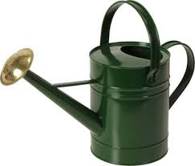 | This farm tool is used for the light irrigation of crops in the dry season to prevent them from wilting and dying
2 | Rake | 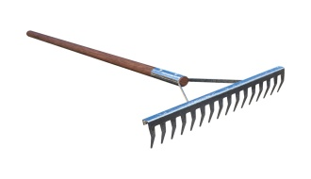 | An implement consisting of a pole with a toothed crossbar or fine tines at the end, used especially for drawing together cut grass or smoothing loose soil or gravel.
3 | Shovel | 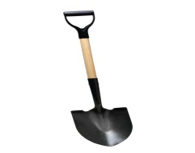 | Tool resembling a spade with a broad blade and typically upturned sides, used for moving coal, earth, snow, or other material.
4 | Spade | 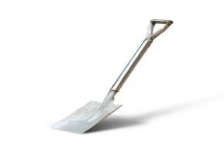 | Tool with a sharp-edged, typically rectangular, metal blade and a long handle, used for digging or cutting earth, sand, turf and etc.
4 | Rope | 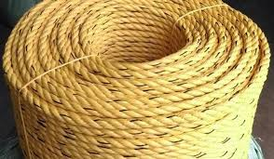 | Used for jobs such as pulling cars, tying up boats, or tying things together.
5 | Peg | 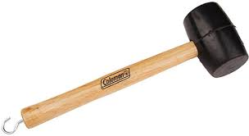 | Used for securing something in place, hanging things on, or marking a position.
6 | Wheelbarrow | 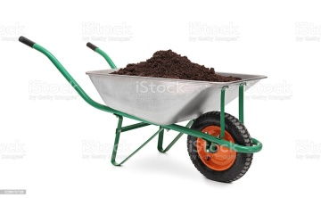 | Used to carrying small loads and is fitted with handles at the rear by which it can be pushed and guided.
7 | Hoes | 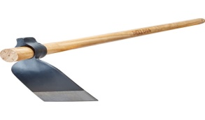 | Commonly used in gardening and horticulture to loosen soil and chop weeds.
8 | Pick axe | 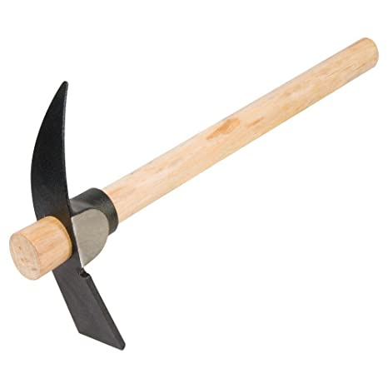 | Used for breaking up rocks or the ground.
9 | Ganga | 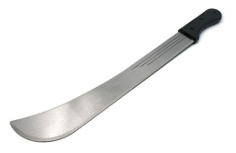 | Used to cut raw materials for composting
10 | Thermometer | 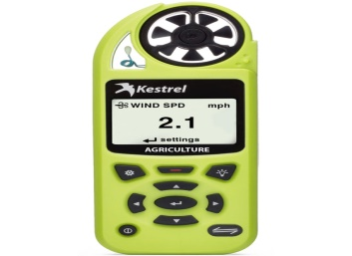 | An instrument that measures temperature
11 | PH test | 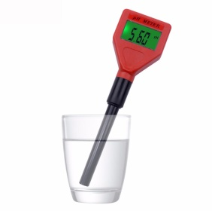 | PH test use to measure the acid or basic level of compost
12 | Meter |  | Use for measuring and sometimes recording the time or amount of something
Personal protective equipment’s (PPE)

 | Name of equipment’s | Finger of equipment’s | Use of equipment’s
13 | Glove |  | Help keep your hands clean and lessen your chance of getting germs that can make you sick.
14 | Overall |  | To protect body from disease pathogens and injury
15 | Boot | 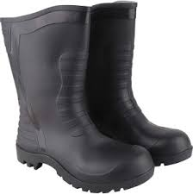 | To protect from disease pathogens and injuries
16 | Eye glass |  | To protect eyes from disease pathogens and injuries
17 | Helmet |  | To protect head injuries

1.3. Assessing physical contamination
Maintaining and improving compost product quality is vitally important for ensuring continued confidence in organic waste recycling industries around the world. One quality criterion of particular interest from the general public’s perspective is physical contamination (also known as foreign matter or inserts content) from such materials as plastic, glass and metal. This contamination makes “poor quality” compost immediately apparent compared to other quality criteria that require some form of laboratory analysis for their detection.

The quality of compost products is highly dependent on the quality of the feedstock materials. Therefore, considerable effort has been made in recent years to educate the public and stakeholder groups on feedstocks destined, either knowingly or unknowingly, for composting.
Although physical contaminants in composts are largely assessed on a weight basis both commercially and in research publications, an alternative is surface area based quantification.

Types of contaminations:-
- Biological contaminants such as pathogens
- Chemical contaminants such as pesticides or heavy metals
- Physical contaminants such as:

- glass
- metals
- plastics
- rubble
- stone and soil
- sharps

1.4. Using composting technology and methods

Composting is nature's process of recycling decomposed organic materials into a rich soil known as compost. Anything that was once living will decompose. Composting technology (CT) is a bridge between organic waste and soil carbon pool, which also a critical technology on the sustainable development of agriculture
Composting is an aerobic method of decomposing organic solid wastes. It can therefore be used to recycle organic material. The process involves decomposing organic material into a humus-like material, known as compost, which is a good fertilizer for plants.

The composting process involves four main components: organic matter, moisture, oxygen, and bacteria. Organic matter includes plant materials and some animal manures.
Composting is the most recommended method for recycling food wastes. Composting is a process that involves biological decomposition of organic matter, under controlled conditions, into soil conditioner. Aerobic fermentation is the decomposition of organic material in presence of air.

Types of Composting and Understanding the Process

A Composting Basics.
B Onsite Composting.
- Vermicomposting.
- Aerated (Turned) Windrow Composting.
- Aerated Static Pile Composting.
- In-Vessel Composting

    - Basic Compost is prepared by managing the aerobic decomposition of organic materials like yard debris, grass, leaves, kitchen scraps, paper, manures, straw, hay, wood chips and sawdust.

    - Onsite Composting can significantly reduce the amount of wasted food that is thrown away. Yard trimmings and small quantities of food scraps can be composted onsite. Animal products and large quantities of food scraps are not appropriate for onsite composting.

    - Vermicomposting or worm composting is a simple technology for converting biodegradable waste into organic manure with the help of earthworms. Earthworms are valued by farmers because, in addition to aerating the soil, they digest organic matter and produce castings that are a valuable source of humus.

    - Aerated window composting involves forming organic waste into rows of long piles called “windrows” and aerating them periodically by either manually or mechanically turning the piles. The ideal pile height is between four and eight feet with a width of 14 to 16 feet.

    - Static composting, organic matter is piled up and then broken down by bacteria. As the pile decomposes, nutrients are released back into the compost and heat is released.

    - In-vessel composting involves the use of naturally occurring aerobic processes which break down organic matter to produce an organic material suitable for use as a soil conditioner and a source of nutrients in agriculture and horticulture.

In-vessel method involves feeding organic materials into a drum, silo, concrete-lined trench, or similar equipment. This allows good control of the environmental conditions such as temperature, moisture, and airflow. The material is mechanically turned or mixed to make sure the material is aerated.

Open compost is anything organic, a bit, and not really. Dead leaves, lawn clippings, food scraps (except meat or fat), newspaper, cardboard, and manure are all organic matter and will break down in your compost pile. Ideally, you want to add a diversity of ingredients. Bins retain some warmth and moisture and make better compost more quickly, but even an open heap (not enclosed in a bin) will compost eventually. Any of the compost bins on the market should produce compost as long as they exclude rain, retain some warmth, allow drainage and let in air.

1.5 Pre-processing raw materials variously into suitable forms

The solid waste must first be processed to remove contaminants and prepare the organics for composting. Pre-treatment of waste streams coming from different sectors and industries to make it suitable/homogenized for feeding into the kiln system to avoid process fluctuations.

These wastes are treated chemically and physically to bring them to a uniform characteristic and convert into appropriate form for its optimum utilization in co-processing. Such waste materials used for co processing are referred to as Alternative Fuel Resources (AFR).Received liquid solvents are carried to site in Tankers or barrels and are transferred into the properly designed storage tanks. Nitrogen blanketing is to be present in the tank to avoid any vapors coming out of the storage tank to atmosphere.

1.6. Mixing pre-processed raw materials into suitable feedstock
Composting is a biological process in which biological wastes are stabilized and converted into a product to be used as a soil conditioner and organic fertilizer. This process depends upon the activity of microorganisms. To these activities the microorganisms must be provided with a suitable environment and a source of nutrients that should be present in proper proportions. The extent to which we supply those two needs and the way in which we do so, determine to a large degree our influence on the compost process and its optimization.

The major sources of nutrients for composting are organic waste materials. However, it is rare that a waste material in the condition in which it is available consistently possesses all of the characteristics essential for efficient composting. To compensate for this deficiency, it is usually necessary to blend in suitable proportions of another waste or low cost material. For example, in the U.S., the excessively high moisture content of sewage sludge usually is lowered by blending a “bulking” agent such as wood chips or sawdust. In Europe, municipal solid wastes often serve as the bulking agent. For farms, excessively moist manure can be blended with crop residues, or perhaps with waste from a nearby lumber operation.

1.7. Separating, collecting and storing crop residue/by-product
Crop residues collection
and storage practices were observed to depend on the mechanism of harvesting the grain from the crops and the
type of crop. Small seeded crops such as: teff, wheat and barley are transported to a threshing ground located in
the homestead area where they are threshed to separate the grain from the straws. The straw is then stored in the
form of a heap around the homestead. The heap is commonly fenced with locally available materials especially
Crop residues collection
and storage practices were observed to depend on the mechanism of harvesting the grain from the crops and the
type of crop. Small seeded crops such as: teff, wheat and barley are transported to a threshing ground located in
the homestead area where they are threshed to separate the grain from the straws. The straw is then stored in the
form of a heap around the homestead. The heap is commonly fenced with locally available materials especially
Crop residues collection
and storage practices were observed to depend on the mechanism of harvesting the grain from the crops and the
type of crop. Small seeded crops such as: teff, wheat and barley are transported to a threshing ground located in
the homestead area where they are threshed to separate the grain from the straws. The straw is then stored in the
form of a heap around the homestead. The heap is commonly fenced with locally available materials especially
Crop residues collection
and storage practices were observed to depend on the mechanism of harvesting the grain from the crops and the
type of crop. Small seeded crops such as: teff, wheat and barley are transported to a threshing ground located in
the homestead area where they are threshed to separate the grain from the straws. The straw is then stored in the
form of a heap around the homestead. The heap is commonly fenced with locally available materials especially
Practice of conserving crop residues.
The practice of conserving crop residues in the present study area is shown in figure 1. Crop residues collection
and storage practices were observed to depend on the mechanism of harvesting the grain from the crops and the
type of crop. Small seeded crops such as: teff, wheat and barley are transported to a threshing ground located in
the homestead area where they are threshed to separate the grain from the straws. The straw is then stored in the
form of a heap around the homestead. The heap is commonly fenced with locally available materials especially
Crop residues are the non-economic plant parts that are left in the field after harvest. The harvest refuses include straws, stubble, Stover and haulms of different crops. Crop remains are also from thrashing sheds or that are discarded during crop processing. This includes process wastes like groundnut shell, oil cakes, rice husks and cobs of maize and sorghum. The greatest potential as a biomass resource appears to be from the field residues of sorghum, maize, soybean, cotton, sugarcane etc.

Crop residues accumulated in different locations are to be brought to compost yard. The compost yard is located in anyone corner of the farm with accessibility via good road. Water resource should also be available in sufficient quantity. The crop residues that are brought to compost yard should be heaped in one corner for further processing.
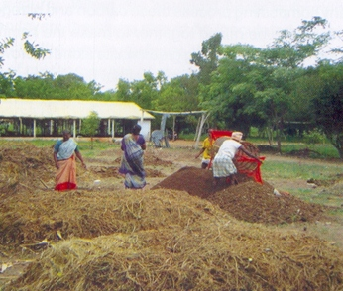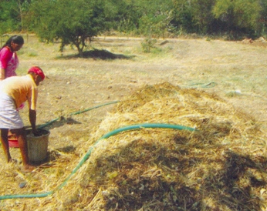
Fig 1.1 Raw materials identification.

1.8. Selecting and checking personal protective equipment’s (PPE) and occupational health safety (OHS) hazards

Personal protective equipment (PPE), commonly referred to as "PPE", is equipment worn to minimize exposure to hazards that cause serious workplace injuries and illnesses. These injuries and illnesses may result from contact with chemical, radiological, physical, electrical, mechanical, or other workplace hazards.
- PPE should include:

- Coveralls.
- Respirators.
- Boots or shoe covers.
- Gloves.
- Eye protection.
- Head protection
- Boot and etc.

Occupational health and safety (OHS) is one of the most important aspects of human concern. It aims an adaptation of working environment to workers for the promotion and maintenance of the highest degree of physical, mental and social wellbeing of workers in all occupations.

There are many types of hazards:-

- Biological hazard: - biological substances that pose a threat to the health of living organisms, primarily that of human.
- Chemical hazards: - is any substance, regardless of its form that can potentially cause physical and health hazards to people, or can result in harm to the environment.
- Ergonomic hazards: - is any factor in the workplace that may cause injury or health issues, such as musculoskeletal injuries. Objects, environments and systems are the three primary types of ergonomic hazards that can result in poor posture or uncomfortable working conditions.
- Physical hazards: - include exposure to slips, trips, falls, electricity, noise, vibration, radiation, heat, cold and fire. The following table summarizes the sources of physical hazard exposure and their health effects.
- Psychosocial: - is anything that could cause psychological harm (e.g. harm someone's mental health). Common psychosocial hazards at work include: job demands, low job control and poor support.

Self-check 1

Name…………………………………………… ID………………………… Sign…….
Direction: - Answer all the questions listed below.
Test I: Write all the questions listed below.

- List tools, equipment’s and materials used for compost preparation.(5point
________________________________________________________________________________________________________________________________________________________________________________________________________________________________________________________________________________________________
- List the personal protective equipment’s used for compost preparation.(5points)
________________________________________________________________________________________________________________________________________________________________________________________________________________________________________________________________________________________________
- Write types of contaminations.(5point)
________________________________________________________________________________________________________________________________________________________________________________________________________________________
- List physical contaminations in compost preparation.(5point)
______________________________________________________________________________________________________________________________________________
- List types of hazard
_______________________________________________________________________
_______________________________________________________________________
Note: Satisfactory rating - 10 points Unsatisfactory - below 10 points

You can ask you teacher for the copy of the correct answers.

Operation Sheet -1

  - Techniques/Procedures/Methods of cleaning, collecting and storing tools and equipment’s.

- Tools: -

- Water
- Boom
- Scrub brush
- Micro fibber cleaner
- Vacuum cleaner
- Bleach
- Ammonia
- Oil

- Procedures

- Prepare PPE and wear
- Collect tools together
- Remove some dirty material properly
- Apply oil to prevent rust
- Remove rust with a wire brush
- Put tools and equipment’s properly on shelf or store.

LAP Test 1

Name_________________________ sign: ________________
Time started: ________________________ Time finished____________

Instructions: Given necessary materials, tools and equipment’s you are required to perform the following tasks within 4: 00 hours.

Task. I. 1. Clean tools and equipment’s in appropriate
2. Check and store tools in appropriate place.

LG #19 | Lo. 2 Preparing compost

Instruction sheet
This learning guide is developed to provide you the necessary information regarding the following content coverage and topics:
- Selecting and cleaning site for compost preparation
- Handling feedstock mixtures for composting
- Assigning batch numbers and documentation
- Preparing compost
- Maintaining clean up area
- Cleaning processing equipment to avoid contamination
This guide will also assist you to attain the learning outcome stated in the cover page. Specifically, upon completion of this Learning Guide, you will be able to:
- Select and clean site for compost preparation
- Handle feedstock mixtures for composting
- Assign batch numbers and documentation
- Prepare compost
- Maintain clean up area
- Clean processing equipment to avoid contamination

Learning Instructions:
- Read the specific objectives of this Learning Guide.
- Follow the instructions described below.
- Read the information written in the information Sheets
- Accomplish the Self-checks
- Perform Operation Sheets
- Do the “LAP test”

Information Sheet 2

  - selecting and cleaning site for compost preparation

To make the best possible compost, the micro-organisms must be able to work optimally. This can be achieved if the following four factors are combined to the best advantage: type of organic material, air, moisture, and temperature. The acidity (pH) is also considered by some to be an important factor.

Choose an open, level area with good drainage. You do not want your compost to sit in standing water. An area with partial sun or shade is also ideal. Too much sun can dry the pile out, while too much shade can keep it overly wet. Organisms need free contact with both soil and atmosphere and suitable environments of warmth and moisture. The pile should not be directly exposed to sun, wind, rain, nor sited in a low-lying place subject to unnecessary dampness and standing water. Strong sun not only dries, but also is hostile to micro-organisms.

Composting site should be:
- Within permitted areas: Check local zoning ordinances for any setback requirements or specific backyard composting rules, i.e., no food wastes permitted, etc.
- Near water source: A large quantity of water is essential to maintain the compost pile (especially hot compost). Access to a hose or irrigation system is ideal.
- Good drainage: Keep the pile or bin on well drained, slightly-sloped soil, to avoid excess moisture.
- Away from wood on buildings: The heat, bacteria and fungi generated in the composting process may discolor or degrade wood siding if placed in contact with it.
- Near the destination of the compost: If possible, locate the pile or bin close to where you want to use the compost, to avoid transporting the heavy material long distances.
- Out of wind and hot sun: In the summer, keep the pile or bin shaded to avoid excess heat. In the fall, spring and winter, the sun’s warmth will help extend the biological activity. Protect it from the wind, since it will dehydrate the pile in any season.
- Out of sight: Consider planting shrubs, tall grasses, etc. or installing attractive fencing or arbors

2.2. Handling feedstock mixtures for composting

Feedstocks are the raw ingredients for composting. They are organic materials, usually solid, and usually in an active state of decomposition. There are four basic ingredients in the compost pile, nitrogen, carbon, water, and air. Compost Feedstock or “Feedstock” means any decomposable organic material used in the production of compost or chipped and ground material including, but not limited to, green wastes, animal material, manure, bio solids and solid waste.

For best results, start building your compost pile by mixing three parts brown materials with one part green material. If your compost pile looks too wet and smells, add more brown items or aerate more often. If you see it looks extremely brown and dry, add green items and water to make it slightly moist.
Compost is safe to handle as long as the usual garden hygiene rules are followed:
- Keep cuts covered.
- Wash hands with soap and running water after handling compost (especially before eating)
- Keep anti-tetanus protection up to date.

To make good compost, you need a 50:50 mix of materials that are rich in nitrogen and carbon. Nitrogen comes from lush, green material such as grass clippings. Carbon comes from brown material, such as woody stems and cardboard. Since there are many ways of making compost, its actual composition will vary considerably. While the raw materials going into the compost pile are important, the value of the final compost depends upon the construction and management of the pile.

There is a vast difference, for instance, between compost from a well-made, well-managed pile and that from the all-too-common untidy dump or hole in the ground. Also, a well-made pile is agreeable to work with while a random pile is generally messy and may breed flies and other problems. Following the general principles below will produce a neat and productive compost pile. Collect equal amounts of green yard and livestock waste (such as fresh grass clippings and weeds or cow manure) and brown scraps (such as dead leaves, straw and old hay). Shred large chunks of waste into smaller sections that are less than about 3 to 4 inches in diameter.

Cold composting is the lazy gardener's method. While a cold compost pile needs both brown and green materials, you don't have to be as exact with the proportions. Instead of saving the materials up before creating the pile, add them when you have them. Though an excess of browns is common, there's a negative result to adding too many greens. Excessive nitrogen can cause your compost to heat up very quickly and even spontaneously combust, which becomes an obvious fire risk. healthy compost pile requires a mix of dry, carbon-rich "brown" items (e.g. dry leaves and grasses, newspaper, dead plant clippings, wood branches, hay, straw, sawdust, and pine needles) and wet, nitrogen-rich "green" items (e.g. grass clippings, food scraps, coffee grounds, tea bags, and fresh

  - Assigning batch numbers and documentation

Batch composting simply involves mixing all your materials together at once then letting everything sit without adding more materials (aside from water), until it becomes compost. This approach is most applicable on a larger scale, and almost always will involve some variation of 'hot composting'. When it's time to cook up a batch of compost, place these materials in alternating layers into a bin of some kind and water them down. To ensure that mixture has enough nitrogen and microbes, add a compost starter, such as Super-Hot Compost Starter, as the layering the ingredients.

Depending on the size of compost pile, what put in it, and how tend to it, this process can take three months to two years. With a Compost Aerator, it's easier to add air to the pile. Aeration gives oxygen-hungry microbes what they need to break down materials faster. Depending on the size of your compost pile, what you put in it, and how you tend to it, this process can take three months to two years. With a Compost Aerator, it's easier to add air to the pile. Aeration gives oxygen-hungry microbes what they need to break down materials faster. Continuous composting involves one pile that you can take finished compost from while still adding new waste. Batch composting involves making a pile all at once and letting it decompose without adding any new waste. "Batch composting" does exactly that. Rather than adding material continuously to a pile that's already in the process of decomposing, you save up your raw materials in separate piles until you have enough for one big batch.

The largest of your piles will ideally be brown materials, such as dry leaves. It can take anything from three months to a year or two to make compost in a pile. The one- to two-year time frame is for organic wastes you dump and leave to break down without your help. In general, the more effort you put in, the quicker you will get compost. When the ingredients you have put in your container have turned into a dark brown, earthy smelling material, the composting process is complete. It is then best left for a month or two to 'mature' before it is used.

  - Preparing compost

The presence of organic matter in the soil is fundamental in maintaining the soil fertility and decreasing nutrient losses. Compost is an organic fertilizer; it adds organic matter and nutrients to the soil. Composting is the natural process of recycling organic matter, such as leaves and food scraps, into a valuable fertilizer that can enrich soil and plants. Compost is a mixture of ingredients used to fertilize and improve the soil. It is commonly prepared by decomposing plant and food waste and recycling organic materials. The resulting mixture is rich in plant nutrients and beneficial organisms, such as worms and fungal mycelium.

The most common raw materials used to make compost are yard wastes such as grass clippings, leaves, weeds, and small pruning’s from shrubs and trees. Most home garden compost piles and municipal compost facilities use yard wastes exclusively because of the large volume of materials available.

Compost is ready or finished when it looks, feels and smells like rich, dark earth rather than rotting vegetables. In other words, it should be dark brown, crumbly and smell like earth. The Florida Online Composting Center is one of the few sites that offer detailed home tests for the maturity of compost.

Worm Farm Composting for many, is the most common and preferred choice of composting because of their capabilities to grow worms, produce compost and compost tea and keep rats out of your compost. The worms produce castings concentrated with nutrients lower in nitrogen compared to other composting methods. Compost can be used to improve the soil structure and drainage, as a mulch to cut down on water loss, and as a fertilizer to improve the soil's fertility. Enriches soil, helping retain moisture and suppress plant diseases and pests.

Different phases of composting have been classified according to their temperature as:
- Hot Phase (Mesophilic Phase).
- Curing Phase (Thermophilic and Hygienization Phase).
- Cooling or Mesophilic Phase II.
- Maturation Phase.

- Hot phase: - refers to a method in which microbial activity within the compost pile is optimized, resulting in finished compost in a much shorter period of time. It requires some special equipment, as well as time and diligence.

- Curing phase: - compost usually lasts 3 to 4 weeks. Curing is a very important and often neglected part of the composting process. Curing occurs at mesophilic temperatures. The importance of curing increases if the active composting stage is either shortened or poorly managed.

- Cooling phase: -when carbon and nitrogen have been consumed, the temperature is lowered down to 40-45 ºC. The mesophilic appears again and decomposes the remaining material of cellulose and lignin.

- Maturation phase: - is usually carried out with less control and monitoring than the bio-oxidative phase.

2.4.1 Methods of compost preparation.

2.4.1.1 Heap method

Heaping method is a compost making process on the surface. It is an appropriate method for areas where there is excess moisture through high rain and irrigation. If the compost making is in a pit, excess moisture may enter into the pit and change the decomposition of the compost from a good smelling aerated process into a sour or ammonia smelling process. A compost heap is generally a pile of brown and green matter. It is a great way to reduce food wastage, and it helps in saving the environment.

The compost heap consists of decomposing organic matter, which decays and leaves behind fertilizer rich in nutrients, which is perfect for gardens. A compost heap is generally a pile of brown and green matter. It is a great way to reduce food wastage, and it helps in saving the environment. The compost heap consists of decomposing organic matter, which decays and leaves behind fertilizer rich in nutrients, which is perfect for gardens. You can use a compost heap to recycle all your kitchen and garden waste into rich, organic compost that's great for the soil and plants.
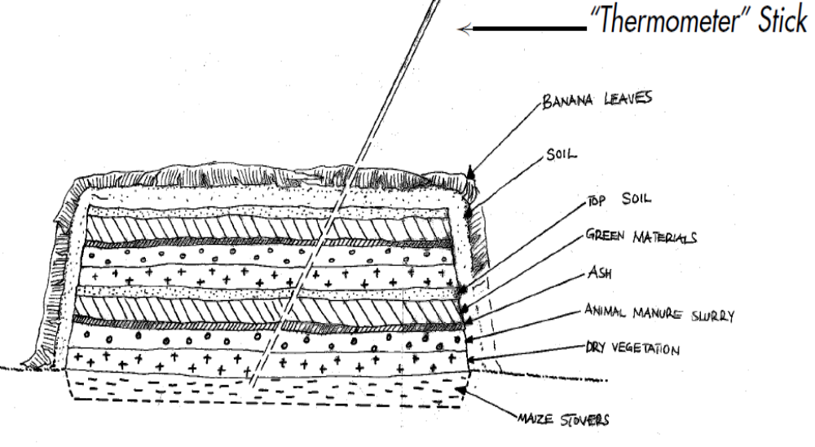
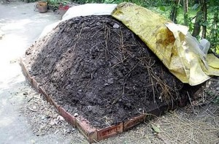

Fig. 2.1 Heap compost

2.4.1.2. Pit Compositing method

Pit method is a compost making process in pits, which is much better to be used in moisture stress and cold areas. This is because in moisture stress areas the pit keeps the available moisture for a longer time while in the cold, the pit keeps the inside temperature high enough for the decomposition process to continue
A pit made to generate manures and fertile substances by the process of dumping the decaying biodegradable substances is known as a compost pit. Peels of vegetables and fruits, kitchen wastes, and rotten veggies are used to make manure in a compost pit. Enriches soil, helping retain moisture and suppress plant diseases and pests.

A compost pile that is too dry will fail to decompose. Since there is no bacterial activity, there will be no heat. Make sure your pile has adequate moisture. The simplest way to check this is to reach your hand into the pile and squeeze. The pit should be about 1 m deep, 1.5-2 m wide, and of a suitable length. The material brought from the cattle shed is spread in the pit in even layers of 10-15 cm. Slurry made from 4.5 kg of dung, 3.5 kg of urine-earth and 4.5 kg of inoculum from a 15-day-old composting pit is spread on each layer.

How to Compost
- Start your compost pile on bare earth.
- Lay twigs or straw first, a few inches deep.
- Add compost materials in layers, alternating moist and dry.
- Add manure, green manure (clover, buckwheat, wheatgrass, grass clippings) or any nitrogen source.
- Keep compost moist.
Labelling or using a label: - is describing someone or something in a word or short phrase. For example, the label "criminal" may be used to describe someone who has broken a law. Labelling theory is a theory in sociology which ascribes labelling of people to control and identification of deviant behavior.
- Date of preparation
- Materials
- Labor require
- Who is prepared?
- Labor cost
- Place of preparation and etc.

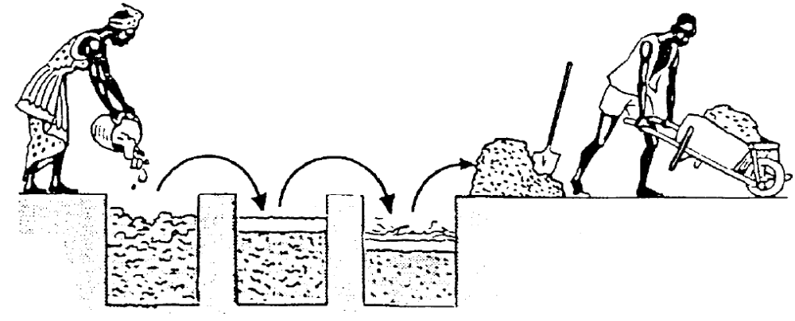

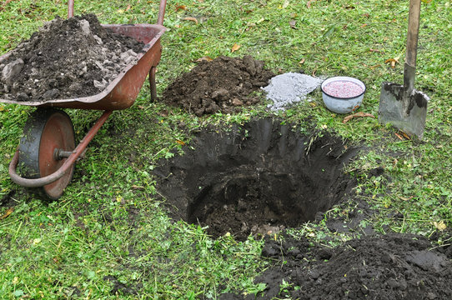

Fig.2.2 Pit compost

2.4.1.3 Barrel method

It’s a barrel that can be rotated or turned. Often made from recycled plastics, the barrel is filled with organic yard and kitchen wastes. The composting process, contained within the barrel, is activated with commercial starters, manure, already finished compost, garden soil or nothing at all. When rotate the drum of a compost tumbler, the waste 'tumbles' around, and introducing air pockets to the decomposing matter inside. These air pockets provide oxygen for the microorganisms that help break down food waste and other organics, enabling them to do their job.

Under ideal conditions, convert waste to finished home compost in as little as three weeks in a sealed compost tumbler. Outdoor temperature, time of year, and the correct balance of carbon and nitrogen matter are factors that influence the speed of composting. There are various compost tumblers on the market, so emptying one is directly related to the style of tumbler you have. For most models, the simplest method for emptying is to tilt the bin so that the opening faces the ground, then, using a spade or rake, pull the contents out and downwards. 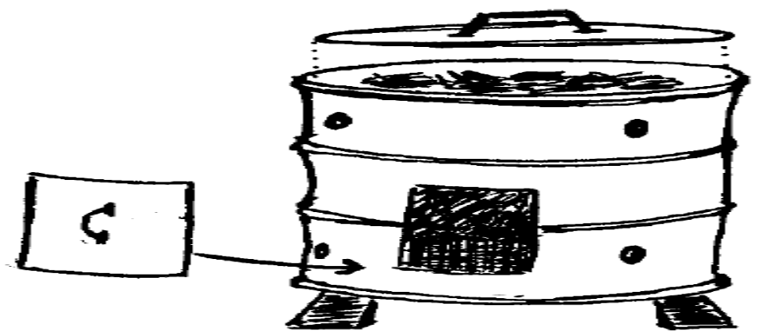
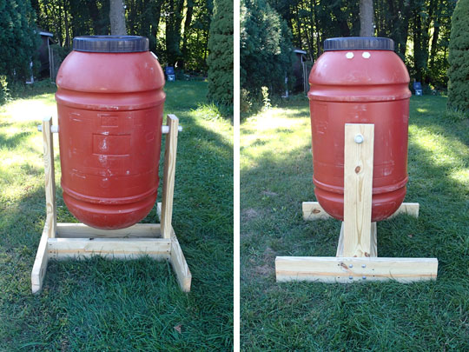
Fig.2.3 Barrel compost

2.4.1.4. Basket method

Where the piece of land to be put under a crop is small, such as a kitchen garden, or where there is not enough FYM, then the basket method can be used to make compost. Basket composting is the process by which decomposable home garbage, garden and farm waste and leguminous leaves are allowed to rot in baskets half-buried in garden plots as a method of producing organic fertilizer. Place the rotting garbage and manure into the basket first. Fill to the brim with other organic wastes. Fresh manure can be used. Place the undecomposed mater composed materials like Ipil leaves or any recommended leguminous leaves, grasses and weeds next cover the organic wastes with a thin layer of soil.

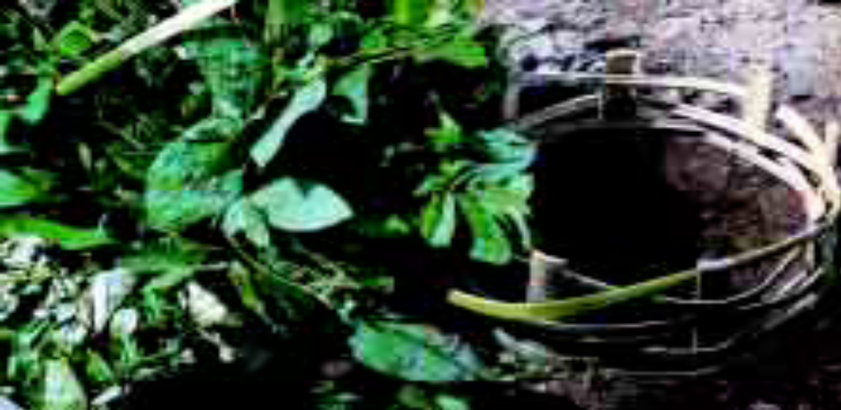

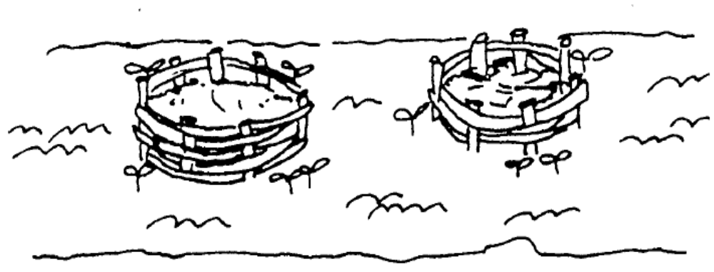
Fig.2.4 Basket compost

2.4.2. Advantage of compost
- It improves the soil structure.
- It improves the resistance of the soil against the erosive action of rain and wind.
- It retains water and releases it slowly, so that water is available to the plants (water storage capacity) over a longer period.
- It retains nutrients and releases them to the plants slowly over a longer period.
- It contains the main nutrients: nitrogen (N), phosphorus (P) and potassium (K), which become available to the plants after decomposition.
- Reduce fertilizer requirements
- Improve water infiltration and drought tolerance
- Reduce soil compaction and crusting
- Improve root growth and yields
- Increase microbial and earthworm populations in soil
- Protect plants from disease
- Slowly release nutrients to plants
- Improve nutrient-holding capacity
- Increase ease of cultivation
2.4.3 Disadvantages of Composting
- Requires initial investment.
- Efficiency depends on your amount of organic waste.
- Unpleasant smell.
- Neighbors may complain.
- May attract rats, snakes and bugs.
- Rather unpleasant physical appearance.
- Involves plenty of work.
- Needs some monitoring

2.4.4. Qualities of good Compost

Compost quality determines a product's ability and capacity to perform its intended function. Although the composting process is also influential, feedstocks are the primary factor in determining the qualities of compost. You take a handful of compost, squeeze it firmly and then open the fist. If the compost is too dry, the compost will then fall apart. If the moisture content is normal, then compost stays together. Compost is ready or finished when it looks feels and smells like rich, dark earth rather than rotting vegetables. In other words, it should be dark brown, crumbly and smell like earth.

2.4.5. Characteristics of Compost quality:-

- Compost should be dark brown in color with profuse fire fangs.
- Compost should have moisture percentage of about 68-70 percent.
- PH of the compost should be in the range of 7.2-7.8.
- There should not be any smell of ammonia.
- It should not be sticky or greasy

2.4.6. Factors affect the composting process

- The concentration of carbon and nitrogen in the organic material.
- The volume of the material being composted.
- Aeration of the pile.
- Moisture content within the pile.
- Surface area of the pile and particle size.
- The temperature of the pile.

  - Maintaining clean up area

Effectively cleaning working area does not merely involve wiping a damp cloth over surfaces. Correct cleaning procedures are required to minimize hygiene problems. This is why cleaning agents, detergent sand/or chemicals, are used extensively.
Maintaining a compost pile depends largely on what type of system you've set up. No-turn compost systems require zero maintenance; hot ones require more.

Compost pile should be moist, but not soggy. Most of your water will come from rain, as well as the moisture in green materials, but you may need to water the pile yourself on occasion. If the pile gets too wet, you can turn it more frequently to dry it, or add more brown materials to soak up excess moisture. Instead of soap, which can damage your local ecosystem, use vinegar, lemon, and baking soda to sanitize and de-stink the bin. Some preventative measures will help keep your curbside compost bin cleaner longer. You can line it with newspaper and sprinkle that with baking soda to absorb moisture and odors.

If compostable products are placed in an open landfill or dump where oxygen is available, they will decompose at a rate similar to other biodegradable materials in the same setting. So, what happens to compostable items in a landfill? Once again, they will “compost.” But the costs are high. The organic food waste you're tossing out will end up in an anaerobic composting pile. A healthy compost pile should have much more carbon than nitrogen. Nitrogen or protein-rich matter (manures, food scraps, green lawn clippings, kitchen waste, and green leaves) provides raw materials for making enzymes. A healthy compost pile should have much more carbon than nitrogen.

If you have a small bin indoors that you use to collect kitchen waste, keep it in the freezer to maintain sanitary conditions and reduce odors. Even so, you should wash it regularly, just as you would wash dishes. For washing a compost bin for curbside pickup, you’ll need to get out the hose and some natural cleaners. Instead of soap, which can damage your local ecosystem, use vinegar, lemon, and baking soda to sanitize and de-stink the bin. Some preventative measures will help keep your curbside compost bin cleaner longer. You can line it with newspaper and sprinkle that with baking soda to absorb moisture and odors. Also, look for compostable bags to hold scraps. Make sure your waste pickup service accepts the bags first. If you make your own compost, a full cleaning is not necessary very often. What you need to focus on instead is cleaning out the finished compost.

  - Cleaning processing equipment to avoid contamination

Cleaning is the process of removing unwanted substances, such as dirt, infectious agents, and other impurities, from an object or environment. Cleaning material means a solvent used to remove contaminants and other materials such as dirt, grease, oil, and dried. Cleaning occurs in many different contexts, and uses many different methods

    - Cleaning processes are:

- Pre-Clean. The first stage of cleaning is to remove loose debris and substances from the contaminated surface you're cleaning. ...
- Main Cleaning: - This involves using hot water and a detergent.
- Disinfection cleaning :- works by using chemicals to kill germs on equipment’s
- Final Rinse cleaning: - is a specially formulated mild acid solution with a pH of 2.5 - 3.0 that is used as the final step in the wet cleaning process.
- Drying cleaning: - very similar to regular home laundering, but a liquid solvent is used to clean your clothes instead of water and detergent.

    - Advantages of Cleaning Equipment:-

- Equally effective for general as well as tougher cleaning tasks.
- High cleaning capability.
- Reduce work fatigue and increase productivity.
- Save the time.
- easy to operate

Self-Check – 2

Name…………………………………………… ID………………………… Sign…….

Direction: - Answer all the questions listed below.

Part I: - Choose the correct answer.
  - Which one is not a criteria to select composting site (2point).
    - Water source B. Good drainage area C. out of sun light D. out of wind break. E. None
  - Which one is a phase of composting?(2point)
    - Hot phase
    - Cooling phase
    - Curing phase
    - Maturation phase
    - All

Part 2:- Write all the questions listed below
- List advantage of compost (5point).
___________________________________________________________________________________________________________________________________________________________________________________________________
- List disadvantage of compost(5point)
__________________________________________________________________________________________________________________________________________________________________________________________________
- List criteria of good compost(5point)
___________________________________________________________________________________________________________________________________________________________________________________________________
- Write advantage of cleaning compost materials(5point)
__________________________________________________________________________________________________________________________________________________________________________________________________

Note: Satisfactory rating - 10 points Unsatisfactory - below 10 points

You can ask you teacher for the copy of the correct answers.

You can ask you teacher for the copy of the correct answers.

Operation Sheet -2

2.1 Techniques/Procedures/Methods of heap compost preparation
- Tools, raw materials and equipment

- Meter
- Animal dung or slurry
- Timber
- . Spade
- Maize stalk
- .Shovel
- Green vegetation
- .Digging hoes
- Dry vegetation
- .Pegs, plastic sheet,
- Ash
- .Water cane
- Water
- .Appropriate PPE etc.
- Plastic cover

- Procedures

1. Prepare plan: - Consider the maturity time
2. Prepare required materials tools and equipment such as;
3. Select suitable site;
4. Measure a rectangular timber 120-150cm for easy operation or more long. The length depends on the quantity of composting material. If too broad or too high, aeration is poor.
5. Prepare and erect post (1.7m-2.2m long) at the four corners of the site for the pile.
6. Chop the rough materials e.g. Maize stalk or hedge cuttings and put the first layer. Pile up to 15-20cm deep and sprinkle water.
7. Add second layer of dry vegetation of hedge cuttings to about 15-20cm thick and sprinkle water.
8. Add a layer of 2cm animal manure or slurry - this provides microorganisms that are essential for decomposition.
9. Sprinkle ash as it contains essential minerals including K, P, Ca and Mg. the ashes also neutralize the acids produced during decomposition, especially by the animal manure.
10. Add the fourth layer, consisting of green materials from leguminous trees such. This layer should be 15-20 cm thick.
11. Sprinkle a little topsoil up to 5-10cm thick. The soil contains bacteria, which helps in decomposition.
12. Repeat the placement layers as in steps 6-11 above; starting with dry vegetation, then animal manure/slurry, ash, green vegetation and topsoil. Remember to sprinkle water on every layer. The final pile should be 1.5 m high at most with vertical sides and a flat top. Building the heap should be done quickly, preferably within a week.
13. Complete the pile, cover with a layer of 10 cm thick of topsoil. This prevents loss plant nutrients, temperature and humidity escaping from compost pile.
14. Cover the whole compost pile with dry vegetation e.g. banana leaves to reduce moisture loss through evaporation.
15. Use a long pointed stick to check the decomposition. This stick is driven into the pile at an angle. Note that decomposition starts 3 days after pile formation. The stick should be left in the pile and only removed once a week.
16. When you pull out the stick (“Thermometer”) from the pile, it should be warm and moist but not wet. This confirms that decomposition is in progress, while a cold stick is an indication of no decomposition.
17. Sprinkle 20 liters of water on the pile every 3 days during dry spells.
18. Turn the pile after 2-3 weeks (the first turning over of the heap). Do not add any fresh material except water. Compost turning ensures layers are mixed and enhances decomposition.
19. Place the drier and outer, less decomposed part of the old heap in the central part of the new heap. The drier material will have to be watered before the heap can be built up further. This core is covered with the rest of the material. The original layered structure is lost.
20. Ready compost should have a fresh soil smell and should not contain grass leaves or animal manure. Compost is ready after 3-6 month depending on the type of material used and temperature.
Precautions: all activities are performed according to OHS requirements

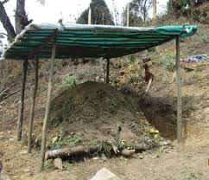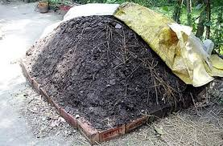

Fig 2.5 . Heap compost

Operation Sheet

2.2 Techniques/Procedures/Methods of pit compost preparation

- Tools raw materials and equipment

- Meter
- Animal dung or slurry
- . Spade
- Maize stalk
- .Shovel
- Green vegetation
- .Digging hoes
- Dry vegetation
- .Pegs, plastic sheet,
- Ash
- .Water cane
- Water
- .Appropriate PPE etc. .
- Plastic cover

- Procedures

1. Prepare plan: - consider the maturity
2. Prepare required materials tools and equipment prior to start its establishment.
3. Select suitable site;
4. Demark the pit and dig 1m3 pits
5. Prepare and erect post
6. Chop the rough materials e.g. Maize stalk or hedge cuttings and put the first layer. Pile up to 15-20cm deep and sprinkle water.
7. Add second layer of dry vegetation of hedge cuttings to about 15-20cm thick and sprinkle water.
8. Add a layer of 2cm animal manure or slurry - this provides microorganisms that are essential for decomposition.
9. Sprinkle ash as it contains essential minerals including K, P, Ca and Mg. the ashes also neutralize the acids produced during decomposition, especially by the animal manure.
10. Add the fourth layer, consisting of green materials from leguminous trees.
11. Sprinkle a little topsoil up to 5-10cm thick. The soil contains bacteria, which helps in decomposition.
12. Repeat the placement layers as in steps 6-11 above; starting with dry vegetation, then animal manure/slurry, ash, green vegetation and topsoil. Remember to sprinkle water on every layer
13. Complete the pile, cover with a layer of 10 cm thick of topsoil. This prevents plant nutrients from escaping. Fill the pit and have a raised dome shaped top nearly 50cm above the ground level next to pit
14 cover the whole compost pile with dry vegetation e.g. banana leaves to reduce moisture loss through evaporation.
15. Use a long pointed testing stick to check the decomposition. It is used to test moisture and temperature of the inside part of the compost .this stick is driven into the pile at an angle. Note that decomposition starts 3 days after pile formation. The stick should be left in the pile and only removed once a week.
16. When you pull out the stick (“Thermometer”) from the pile, it should be warm and moist but not wet. This confirms that decomposition is in progress, while a cold stick is an indication of no decomposition.
17. Sprinkle 20 liters of water on the pile every 3 days during dry spells.
18. Turn the pile after 2-3 weeks (the first turning over of the heap). Do not add any fresh material except water. Compost turning ensures layers are mixed and enhances decomposition.
19. Placed the drier and outer, less decomposed part of the old heap in the central part of the new heap. The drier material will have to be watered before the heap can be built up further. This core is covered with the rest of the material. The original layered structure is lost.
20. Compost is ready after 3-6 month depending on the type of material used. Ready compost should have a fresh soil smell and should not contain grass leaves or animal manure.
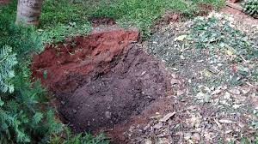

Fig 2.6 Pit compost

LAP TEST-2 | Performance Test

Name………………………………. ID…………………………….. Date…………………………………….

Time started: ________________________ Time finished: ________________

Instructions: Depend on the given materials and tools you are prepare to perform the following tasks within 3:00 hour. The project is expected from each student to do it.

Task -1, 1. Prepare heap compost.
Task -2, 1. Prepare pit compost.

LG #20 | Lo.3 Monitor Composting Process

Instruction sheet
This learning guide is developed to provide you the necessary information regarding the following content coverage and topics:
- Monitoring composting batch by observation
- Maintaining processing and operations records
- Observing, reporting and taking remedial action
.

This guide will also assist you to attain the learning outcome stated in the cover page. Specifically, upon completion of this Learning Guide, you will be able to:
- Monitor composting batch by observation.
- Maintain processing and operations records.
- Observe report and take remedial action.

Learning Instructions:
- Read the specific objectives of this Learning Guide.
- Follow the instructions described below.
- Read the information written in the information Sheets
- Accomplish the Self-checks
- Perform Operation Sheets
- Do the “LAP test”

Information Sheet 3

3.1. Monitoring composting batch by observation

Monitoring compost piles is done for several reasons. Monitoring provides the composter with insight into activity in the compost pile, and this information in turn guides management choices regarding the specific piles you are monitoring, as well as how you make and manage compost on a going basis.
As composting proceeds, a number of changes occur in its physical, chemical, and biological characteristics. Monitoring some of these variables will help you to assess the status of your compost and to compare the progress of systems with different initial conditions or ingredients.

The simplest test is to put your compost in a couple of pots and plant some radish seeds in the compost. If 3/4 or more of the seed sprout and grow into radishes, then your compost is ready to use in any application. Radishes are used because they germinate (sprout) and mature quickly. A good way to evaluate the effect of compost on the fertility of a soil is to obtain a soil test after applying compost. The soil test measures available plant nutrients, soil pH, and heavy metal accumulation in the soil.

During the composting process, different microorganisms (bacteria, fungi, protozoa) decompose the organic matter. The microorganisms break down the organic food items to produce a simpler substance called compost. It is important to note that composting needs oxygen, heat and water to be successful. Monitoring compost piles is done for several reasons. Monitoring provides the composter with insight into activity in the compost pile, and this information in turn guides management choices regarding the specific piles you are monitoring, as well as how you make and manage compost on an going basis. Organic wastes, such as food waste and yard waste, make up 25 to 50% of what people throw away. While you may not be able to compost all of the organic waste you generate, composting can significantly cut down on your overall trash
When monitoring and working on the site:
- Observe the compost pile’s overall shape. Windrows that are slumping or unable to maintain a vertical conformation (parabolic or triangular) indicate poor structure.
- While performing the moisture content squeeze test, observe the compost’s density, diversity of particle sizes, looking for a range of visible particles from 1” and down within the mix. Woody particles in particular provide excellent structure.
- Observe crusting on pile surfaces, which will reduce air exchange in the pile.
- More involved field and lab tests are usually not needed unless there is a consistent problem. Field tests for bulk density and porosity can be found on-line and lab analysis of porosity, particle size and bulk density are also available.

  - Maintaining processing and operations records.

The two activities of “operation” and “maintenance” are very different in nature. Operation refers to the direct access to the system by the user, to the activities of any operational, and to the rules or by-laws, which may be devised Maintenance, on the other hand, is to do with the technical activities, planned or reactive, which are needed to keep the system working. Maintenance requires skills, tools and spare parts.

The composting process is carried out by a diverse population of predominantly aerobic micro-organisms that decompose organic material in order to grow and reproduce. Composting is the natural process of recycling organic matter, such as leaves and food scraps, into a valuable fertilizer that can enrich soil and plants. Compost pile should be moist, but not soggy. Most of water will come from rain, as well as the moisture in green materials, but may need to water the pile on occasion. If the pile gets too wet, turn it more frequently to dry it, or add more brown materials to soak up excess moisture. Add water to the compost pile as needed to keep the materials damp but not saturated. Rain adds moisture to the pile, but may need to add water during dry periods. Turn the pile more frequently or add more dry, brown materials if the pile becomes too wet.

How to start maintain compost?
- Select food scraps. Start with fruits and veggies, the skin of a sweet potato, the top of strawberry. Also tea bags, coffee grounds, eggshells, old flowers, even human hair
- Store those food scraps.
- Choose a place to make your compost.
- Make the compost mix.
- Wait and Aerate.

Recording is process of writing down something that it can be used or seen in each activity.
Records of workplace information may include:

- Environmental parameters (light, temperature humidity and wind)
- Date of treatments and
- Type of treatment and
- Rate of treatment

3.3. Observing, reporting and taking remedial action

Rework and repair are generally the remedial actions taken on products, while services usually require additional services to be performed to ensure satisfaction. Organic wastes, such as food waste and yard waste, make up 25 to 50% of what people throw away. While you may not be able to compost all of the organic waste you generate, composting can significantly cut down on your overall trash.

During the composting process, different microorganisms (bacteria, fungi, protozoa) decompose the organic matter. The microorganisms break down the organic food items to produce a simpler substance called compost. It is important to note that composting needs oxygen, heat and water to be successful. Remediation via composting can be accomplished by mixing contaminated soils with fresh, high-energy feedstocks or by simply adding mature, finished compost to contaminated soils. A mix ratio of 30 percent soil and 70 percent feedstocks has been observed to reach thermophilic temperatures

Furthermore, the addition of mature compost to contaminated soil accelerates plant and microbial degradation of organic contaminants and improves plant growth and establishment in toxic soils. Compost bioremediation refers to the use of a biological system of micro-organisms in a mature, cured compost to sequester or break down contaminants in water or soil. Micro-organisms consume contaminants in soils, ground and surface waters, and air. According to the EPA, “Treatment approaches can include: flushing contaminants out of the soil using water, chemical solvents, or air; destroying the contaminants by incineration; encouraging natural organisms in the soil to break them down; or adding material to the soil to encapsulate the contaminants and prevent Biodegradation is the process of decomposing organic materials in the environment by microorganisms. Bioremediation is a waste management technique that uses biological agents to clean the contaminants in the environment.

The main four types of environmental remediation and reclamation
- Soil remediation. There are many factors that affect the soil condition.
- Groundwater and Surface water remediation.
- Sediment remediation.
- Sources.

A solution to the problem of soil contamination is soil remediation. Soil remediation is a way of purifying and revitalizing the soil. It is the process of removing contaminants in order to protect both the health of the population and the environment. Furthermore, the addition of mature compost to contaminated soil accelerates plant and microbial degradation of organic contaminants and improves plant growth and establishment in toxic soils. Take a handful of compost, squeeze it firmly and then open the fist. If the compost is too dry, the compost will then fall apart. If the moisture content is normal, then compost stays together. Organic matter in compost improves soil structure and water holding capacity. C: N ratio is used as a measure of stability. A ratio of less than 25 likely indicates s compost (the composting process is finished) from which nitrogen will be more available as mineral nitrogen (nitrate and ammonium).

Self-Check – 3

Name…………………………………………… ID………………………… Date…….

Direction: - Answer all the questions listed below.

Part I: - Write all the questions listed below
  - List what you consider when monitoring and working on the field (5point).
___________________________________________________________________________________________________________________________________________________________________________________________________
  - How to start maintain compost(5point)
_________________________________________________________________________________________________________________________________________________________________________________________________
  - What is the good way to evaluate the effect of compost on the fertility of a soil (5point).
___________________________________________________________________________________________________________________________________________________________________________________________________
  - List what the records of work place includes(5point)
__________________________________________________________________________________________________________________________________________________________________________________________________
  - What is monitoring and recording? List the differences(5point)
____________________________________________________________________________________________________________________________________________________________________________________________________

Note: Satisfactory rating - 10 points Unsatisfactory - below 10points

You can ask you teacher for the copy of the correct answers.

LG #21 | Lo.4 Conduct Quality Control Inspection.

Instruction sheet
This learning guide is developed to provide you the necessary information regarding the following content coverage and topics:
- Determining fundamental characteristics of compost quality
- Inspecting and assessing finished compost
- Observing and reporting faults or variations
- Processing further non-compliant product
- Confirming compliance of compost.
- Completing batch documentation
- Reporting work outcomes.
  - Noting feedback.

This guide will also assist you to attain the learning outcome stated in the cover page. Specifically, upon completion of this Learning Guide, you will be able to:
- Determine fundamental characteristics of compost quality
- Inspect and assess finished compost
- Observing and reporting faults or variations
- Process further non-compliant product
- Confirm compliance of compost.
- Complete batch documentation
- Report work outcomes.
Learning Instructions:
- Read the specific objectives of this Learning Guide.
- Follow the instructions described below.
- Read the information written in the information Sheets
- Accomplish the Self-checks
- Perform Operation Sheets
- Do the “LAP test”

Information Sheet 4

4.1 Determining fundamental characteristics of compost quality

Although the composting process is also influential, feedstocks are the primary factor in determining the qualities of compost.

Quality characteristics can be grouped into three categories:-
- Product performance (e.g., nutrients),
- Product aesthetics (e.g., odor, plastic), and
- Product safety (e.g., pathogens, glass). Parameters such as the carbon- to-nitrogen (C:N) ratio, organic matter content, salinity, total nitrogen, total phosphorus, stability, phytotoxicity, pH, maturity, boron, chloride, sodium, particle sizes, heavy metal concentration, and pathogen concentrations are factors to evaluate when you are comparing available.

The most important for composting success is microorganisms in your pile that break everything down prefer an oxygen rich environment. That's why aeration might be the most important factor to successful composting. By turning your pile regularly, you provide much needed oxygen and redistribute beneficial bacteria, fungi, and other organisms.

Compost quality is determined by starting materials (feed- stocks), as well as the management of moisture, temperature, other production factors and storage conditions. All of these factors influence the rate of biological decomposition and ultimately determine final compost quality.

    - Qualities of good Compost

- Compost should be dark brown in color with profuse fire fangs.
- Compost should have moisture percentage of about 68-70 percent.
- PH of the compost should be in the range of 7.2-7.8.
- There should not be any smell of ammonia.
- It should not be sticky or greasy.

    - Four ways to better compost

- Make an efficient heap. Home-made compost heaps should be at least 1m x 1m, to promote decomposition.
- Use a mix of ingredients.
- Kitchen peelings.
- Turn compost regularly.

Even if compost looks brown, at one extreme, compost can be harmful to plants, at the other, it is nature's best growing medium. Not all 'compost' is the same and need to know what have before spreading it on your garden. It is hard for a home composter to do detailed testing.

The microorganisms in pile that break everything down prefer an oxygen rich environment. That's why aeration might be the most important factor to successful composting. By turning pile regularly, provide much needed oxygen and redistribute beneficial bacteria, fungi, and other organisms. Fruit and vegetable trimmings, coffee grounds and filters, and eggshells are great items for the compost pile. Do not use animal products such as grease, fat or meat trimmings or dairy products because they break down very slowly, attract rodents and other pests, and have an unpleasant odor when they decompose.

    - Signs that may compost be struggling or bad.

- The pile is moist but the material is matted and slow to break down.
- Your compost smells (very) bad.
- Brown leaves added last year are not breaking down.
- Your compost caught fire!
- There are no worms or bugs in the pile.
- Sticks are not breaking down.

  - Inspecting and assessing finished compost

Recognition of a familiar pattern leading to immediate solution of a mathematical problem solves by inspection. Checking or testing of an individual against established standards. Water content in the compost and is expressed as a percentage of total dry weight compost, which will affect handling and transportation.

Dry compost will be light and dusty and Moisture content lower than 30% will indicate dry compost and higher than 60% is wet compost will be heavy and clumpy. Take a handful of compost, squeeze it firmly and then open the fist. If the compost is too dry, the compost will then fall apart. If the moisture content is normal, then compost stays together.

Inspection Parameters:-
- Carbon- to-nitrogen (C:N) ratio,
- Organic matter content,
- Salinity, total nitrogen,
- Total phosphorus,
- Stability, phytotoxicity, pH,
- Maturity, boron, chloride, sodium, particle sizes, heavy metal concentration, and pathogen concentrations are factors to evaluate when you are comparing available.

  - Observing and reporting faults or variations

Common problems include smelly compost bins, slimy ingredients that have become excessively wet, or compost that has simply stopped rotting down before it's ready. The most common problem is excess moisture, which causes foul odors, flies, and the production of substances harmful to your plants. Adding too much fresh material, instead of a balanced mix of fresh and dry materials, is the usual culprit.

Fresh materials such as vegetable peelings and grass clippings have a high water content, which makes them heavy. If too much is added to your compost heap at once it can become compacted, excluding air or filling air spaces with water. These oxygen-starved ‘anaerobic’ conditions enable harmful microbes to thrive the same microbes responsible for creating the unpleasant smells that arise from such putrid conditions. Fresh materials are mostly 'greens' which have a high nitrogen content, so mixing in more carbon-rich 'browns' will help solve the problem. If your compost heap is too wet, dig it out completely, and then turn the ingredients to incorporate more air before restacking. Add dry materials into the mix to get a balance of greens and browns, improve drainage and prevent the compost from clogging up again. Ingredients such as shredded pruning’s, sawdust, straw and cardboard torn into smaller pieces will create channels within the compost that allow air to percolate and excess moisture to drain away.

The composting process is greatly affected by environment factors (temperature, moisture content, pH, and aeration). Moisture content is an essential parameter that influences the changes in physical, chemical, and biological properties of waste materials during the advancement of decomposition of organic matter.

Assessments with own senses

Observations of compost with own senses (eyes, nose, and touch) can provide information about the compost quality. These observations cannot replace chemical analyses or plant tests, but they can complement them.

Types of assessments or observations of compost

- Colors of the compost.

At the beginning of the composting process, the material presents a mosaic of color deriving from the input materials. During the process, a homogenization of the color takes place, and, with the evolution of the mummification, the compost becomes brown or blackish. If the compost is too dry during the process, grey molds can be observed.

- Odors of Compost.

Always smells but the odors can be more or less intensive and more or less agreeable depending on the management process. The odor of a compost depends on its maturity and on the process management. Young composts containing nitrogen-rich materials smell of ammonia, and will be transformed during the maturation processes into a product with the smell of forest soil. Disagreeable odors such as that of “rotten eggs” or butyric acid are typical for poorly controlled anaerobic processes in the compost pile. Organic acids are formed as a result of oxygen starvation, and they cannot be transformed forward, which causes the emission of intense and disagreeable odors.

- Structure of the compost.

Mature compost produced by an optimal process has a crumbly structure and no recognizable starting material except for some wooden pieces. The presence of much fibrous material is a sign that the compost is not sufficiently mature. This can happen if the humidity content of the compost pile was too low especially in the hot phase.

The ammonium present in the pile would therefore be lost as ammonia, leading to a shortage of N for the microorganisms and insufficient decomposition, even when water is available. When such fibrous compost is applied, there is risk of nitrogen immobilization in the soil. The wood breaking test also allows the characterization of the degree of maturity of the compost and the risk of nitrogen immobilization in the field after its use.

Degradation of wood starts after the high temperature phase. Hence, we observe only minor degradation of wood in young compost, and clearly attacked wood in mature compost. If relatively raw wood is applied to a field soil, the microorganisms responsible for its degradation will immobilize the available nitrogen in the soil in order to perform the degradation. This nitrogen is therefore temporarily unavailable to the plants which inhibit their growth.

  - Processing further non-compliant product

The three basic steps when it comes to controlling nonconformity are identifying the problem or violation, recording it, and taking the appropriate action to put a stop to it. In order to be able to properly deal with the issue that is at hand, the nonconformity must first be identified.

The non-conformance process flow includes steps:
- Identification of the source or root cause of the failure.
- Documentation of the non-conformance such as the material, problem, disposition, and signature of the person responsible.
- Evaluation of the nonconformity and determine if an investigation is required

Ways of following non-conforming products:

- Elimination – The non-conforming item can be scrapped or returned to the vendor. .
- Releasing – By authorizing its use, release or acceptance under concession by an authorized representative of the customer
- Correction - is action to eliminate a detected nonconformity. For example, correction may involve replacing nonconforming product with conforming product or replacing an obsolete procedure with the current issue, etc. Corrective action cannot be taken without first making a determination of the cause of nonconformity

Addressing Non-Conformances and Corrective Actions
- Containment.
- Correction/Immediate Corrective Action.
- Root Cause.
- Corrective Action/Long Term Corrective Action.
- Verification of Effectiveness.

  - Confirming compliance of compost.
Compliant Compost is a new, simple code of practice that can be independently verified by approved auditors. The code is focused on demonstrating that the compost will not introduce human pathogens into the environment or onto food. Compost certified using the “compliant compost” program can therefore be used on farm without restriction.

Product Quality Compliance is a system to ensure that products adhere to industry standards. It gives consumers peace of mind that products are safe for use. Having such a system is proof of a brand’s commitment to tangible quality and is a key element in converting satisfied customers into loyal followers. Without it, a tiny defect spotted by the end-user could result in unnecessary costs, or worst.
Quality of conformance refers to the capability of a product, service, or process to meet certain design standards set by the producer. It measures how close a product, service, or process is to meeting design specifications.
  - Completing batch documentation.

When it's time to cook up a batch of compost, you place these materials in alternating layers into a bin of some kind and water them down. To ensure that your mixture has enough nitrogen and microbes, you can add a compost starter, such as Super-Hot Compost Starter, as you are layering the ingredients.

Means the documents and other records that are produced in connection with the manufacture of a composting batch and/or lot. Batch Documentation includes master manufacturing formula, a listing of raw materials and corresponding specifications, packaging and storage instructions, testing requirements and exception documentation, such as deviations, failures, out-of-specification investigation reports, non-conforming material reports and additional documentation which may have been generated and/or processed as part of the production record of the Batch.

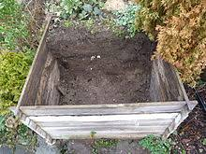
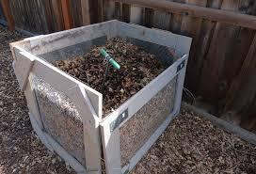
Fig 4.1 Batch compost

  - Reporting work outcomes.

Outcome reporting bias refers to selective/distorted reporting of results, and/or biased interpretation of available information. This may involve overlooking some results or using specific statistical methods to achieve a desirable and often pre-determined outcome.
An important point in every work including compost preparation is recording data, analyzing and reporting, all the steps from the initial to the final product of the work. One of the ways of communicating to the employer or the customer is reporting work outcome
This report includes information regarding.

- Date of preparation
- who is prepared
- Raw materials
- Supplies
- Problem encountered
- Length of work
- Alternative measures
- Hazards and safety
- Techniques and system of work
- Cost expended
- Material availability
- Sustainability of work
- Labor required

Self-Check – 4

Name…………………………………………… ID………………………… Date…….

Direction: - Answer all the questions listed below.

Part I: - Write all the questions listed below

- List quality of good compost (5point)
________________________________________________________________________________________________________________________________________________
- Write factors that affect compost quality(5point)
________________________________________________________________________________________________________________________________________________
- List sign that compost may be struggling or bad(5point)
________________________________________________________________________________________________________________________________________________
- Write ways to better compost(5point)
________________________________________________________________________________________________________________________________________________
- Write environmental factors which greatly affect composting process and discuss on each of them(10point)
___________________________________________________________________________________________________________________________________
Note: Satisfactory rating - 15 points Unsatisfactory - below 15points

You can ask you teacher for the copy of the correct answers.

You can ask you teacher for the copy of the correct answers.

Operation Sheet-4

Techniques/Procedures/Methods of batch compost preparation
.
- Tools raw materials and equipment
- meter
- Spade
- Shovel
- Batch material
- Plastic sheet,
- Water cane
- batch
- Appropriate PPE etc.
- Animal dung.

- Maize stalk.
- Dry grass
- Green vegetation
- Ash
- Water
- Top soil
- Plastic cover

- Procedures: -
  - Collect tools together
  - Collect raw materials and chop in a required size.
  - Remove contaminant from raw materials.
  - Mix raw materials
  - Fill mixed raw materials in to batch
  - Cover the batch.
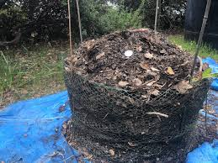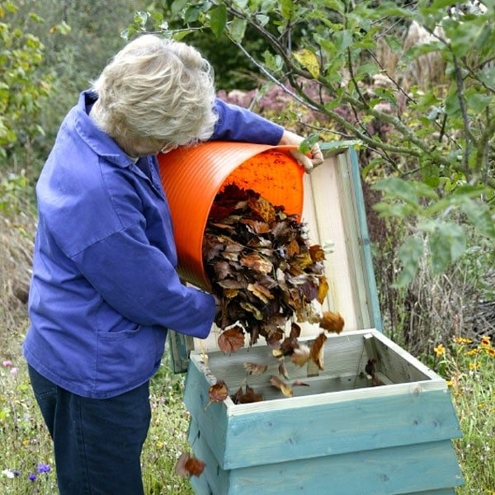

Fig 3.1 Batch compost

LAP Test 4

Name_________________________ Date: ________________
Time started: ________________________ Time finished:_______________

Instructions: Work bath compost depends on given necessary, tools and materials you are required to perform the following tasks within 3: 00 hours.

Task 1, 1. Prepare batch compost.

AKNOWLEDGEMENT

Ministry of Labor and Skills and Ministry of Agriculture to extend thanks and appreciation to the many representatives of TVET instructors and respective industry experts who donated their time and expertise to the development of this Teaching, Training and Learning Materials (TTLM).

References

- Chang S.S. 1995. Research and development in the appropriate use of organic materials for crop productions current status and perspective. pp. 1-14. In: Taiwan Agricultural Research Institute (ed.), Proceedings of the Conference on Rational Application of Organic Fertilizer.
- Huang S.N. and C.C. Lin. 2001. Current of organic materials recycling in southern Taiwan. pp. 14-24. In: Food and Fertilizer Technology Center for Asian and Pacific Region (ed.), Proceedings of the International Workshop on Recent Technologies of Composting and Their Applications.
- Hsieh, S.C. and C.F. Hsieh. 1990. The use of organic matter in crop production. 315:1-19. Taiwan, ROC: Taichung District Agricultural Improvement Station.
- Lin, Y. W., T. S. Liu, and C. H. Wang. 2003. Study on nitrogen mineralization characteristics of organic materials. J. Agric. Res. China 53:178-190.
- Wang, H.H. 1989. Utilization of agricultural wastes in organic farming. Organic Farming, special publication 16:217-227. Taiwan, ROC: Taichung District Agricultural Improvement Station. (In Chinese).
- Yen, S.C. 1989. Utilization of animal wastes in organic agriculture. Organic Farming, special publication 16:229-242. Taiwan, ROC: Taichung District Agricultural Improvement Station. (In Chinese).
Web site
- htt://www.epa.gov.(accessed date 29/8/22)
- htt://www.science direct.com(accessed date 30/8/22)

The experts who developed the learning guide
No | Name | Qualification | Educational background | Region | Phone number | E-mail
1 | Wendimu Terfa | Bsc | Plant science | Oromia | 0911266570 | gurachoterfa@gmail.com
2 | Fikadu Tilahun | Bsc | Plant science | Afar | 0917363367 | Fikadutilahun80@gmail.com
3 | Imam Mohamed | Bsc | Plant science | Oromia | 0913624360 | leylaso@gmail.com
4 | Gosa shura | Msc | Horticulture | Oromia | 0923041032 | Gossashura@gmail.com
5 | Tilahun Getu | Msc | Biotechnology | Amhara | 0918726766 | Tile21eme@gmail.com
6 | Degafa Guluma | Msc | Soil science | Oromia | 0913440464 | deguluma@gmail.com
7 | Bayisa Abeshu | Msc | Agronomy | South west | 0921434086 | bayoabeshu@gmail.com
8 | Berhanu Asefa | Bsc | Plant science | South west | 0922182673 | Berhanuasefa2012@gmail.com
9 | Eyaya Tigabie | Msc | Agronomy | Afar | 0921944452 | eyayatigabie@gmail.com
10 | Taka Magarsa | Msc | Horticulture | Oromia | `0917210371 | takamagarsa@gmail.com
11 | Eliyas Mohamed | Bsc | horticulture | Oromia | 094670667o | rewedal@gmail.com

