Crop production
Level-II

Based on March 2022, Version IV Occupational standard

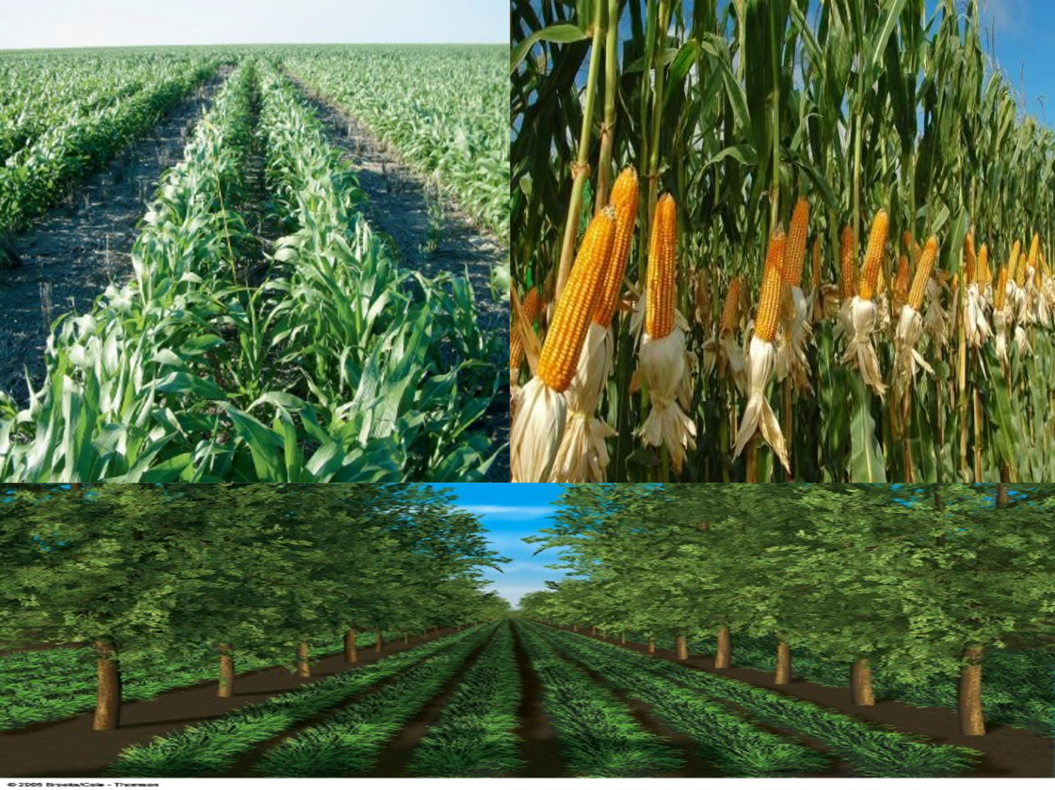

Module Title: - Establishing and Maintaining Field Crop
LG Code: AGR CRP2 M01 LO (1-7) LG (1-7)
TTLM Code: AGR CRP2 TTLM 0922v1

September, 2022
Addis Ababa, Ethiopia

Table of Contents

Introduction to the Module 1
LO #1- Prepare Field Crop Establishment Operations 2
Instruction sheet 2
Information Sheet 1 3
Self-check -1 15
LO #2- Preparing Site for Crop Establishment 16
Instruction sheet 16
Information Sheet 2 17
Self-Check – 2 27
Operation Sheet -2 28
LAP TEST-2 29
LO #3- Carrying out Filed Crop Establishment Operations 30
Instruction sheet 30
Information Sheet 3 31
Self-Check – 3 42
Operation Sheet -3 42
LAP TEST-3 45
LO #4- Completing Filed Crop Establishment Operations 46
Instruction sheet 46
Information Sheet 4 47
Self-Check – 4 50
Operation Sheet -4 51
LAP TEST-4 52
LO #5- Preparing for Field Crop Maintenance Operations 53
Instruction sheet 53
Information Sheet 5 55
Self-Check – 5 70
LO #6- Undertaking Crop Maintenance Operations 71
Instruction sheet 71
Information Sheet 6 73
Self-Check – 6 97
Operation Sheet -6 98
LAP TEST-6 100
LO #7- Completing Maintenance Operations 101
Instruction sheet 101
Information Sheet 7 102
Self-Check – 7 107
Operation Sheet -7. 108
LAP TEST-7 109
Reference Materials 110

Introduction to the Module

This module covers the knowledge, skills and attitude required to establish and manage field crops. Establishment operations include site selection, land clearing, prepare the site, seed selection, sowing, carry out establishment operations and complete establishment operations. In addition, this unit covers purpose, methods and implementing of field crop maintenances operations such as weeding, nutrition program, disease and pest control, irrigation program and pre and postharvest operations.
LG #1 | LO #1- Prepare Field Crop Establishment Operations

Instruction sheet
This learning guide is developed to provide you the necessary information regarding the following content coverage and topics:
- Identifying and collecting inputs for field crop establishment
- Selecting and preparing tools, equipment and machinery
- Identifying, assessing and reporting OHS hazards and risks
- Identifying environmental implication of crop production plan
- Selecting, using and maintaining suitable personal protective equipment
This guide will also assist you to attain the learning outcomes stated in the cover page. Specifically, upon completion of this learning guide, you will be able to:
  - Identify and collect inputs for field crop establishment
  - Select and prepare machinery, equipment and tools for the task being undertaken
  - Identify, assess and report OHS hazards and risks
  - Identify the environmental implications of the crop production plan
  - Select, use and maintain suitable personal protective equipment
Learning Instructions:
- Read the specific objectives of this Learning Guide.
- Follow the instructions described below.
- Read the information written in the information Sheets
- Accomplish the Self-checks
- Perform Operation Sheets
- Do the “LAP test”

Information Sheet 1

1.1. Identifying and collecting inputs for field crop establishment

Definition of terminology
- Field: - is area of land which is used for growing crops, keeping animals.
- Crop: - refers to plants sown and harvested by man for food and economic purpose or when several plants similar in respect to life-cycle, morphology or physiology are grown
- Establishment: - The act of starting something that is meant to last for a long time.
- Field crops: - The crops grown in the field in larger areas to get food, clothes, animal feed and other human requirements. For example, Cereal, pulse, oilseed, sugar crop, fiber crop
- Crop production: - is the practice/art/ of growing and harvesting of crops. Crop producing is a complex operation. Its success depends on both the crop and environmental factors. It consists: -clearing the vegetation, Land preparation, sowing seeds, controlling insect pest, diseases and weeds, Harvesting, processing and storing seeds

1.1.1. Classification of field crops
- Cereal: - cereals crops are cultivated grasses grown for their edible starch grains. Cereal grain contains 60 to 70% of starch and is excellent energy rich foods for humans
e.g., Maize, Sorghum, Wheat, Barley, Teff, Millet etc.
- Pulse: - crops are leguminous crops whose seeds are used as ‘dal ’on splitting and are rich in protein. Pulses are preferred for protein rich value & also economic important in cropping system
e.g., Faba bean, Field pea, Haircoat bean, etc.
- Oilseed: - Those crops which are rich in fatty acid are cultivated for the production of vegetable oil. They are used either for edible or industrial or medicinal purposes
e.g., Flax, sunflower, Nug, Ground nut, etc.
- Sugar crop: - Crops which are grown for production of sugar and starch
e.g., Sugar cane, sugar beet
- Fiber crop: - Crops which are grown for obtaining fiber e.g., Sisal, cotton; Jute etc
- Forage Crops: - Forage crops refer to vegetative matter, fresh or preserved, utilized as feed for animals. e.g., fodder, hay, silage and pastures.
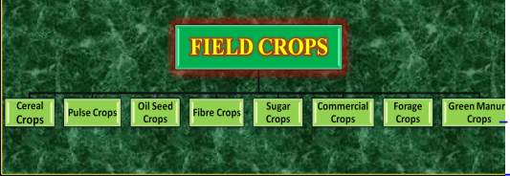
Fig.1.1.1: Classification of field crop

Careful planning for establishment and maintenance of field crops is an essential part of good production of field crops. During establishment of field crop one of the earliest decisions that must be taken is where to locate the farm (correctly selection of the site).
- Before planting a crop, it is important to assess and predict:
    - Labour requirements
    - Equipment requirements
    - Input requirements (Seed, Fertilizer and suitable cultural practices)

Inputs are things put into the production process such as land, labour, implements, seed, mechanization (tractors) fertilizer, pesticides.
The most commonly used consumable inputs are:
- High-quality seeds
- Fertilizers
- Insecticides
- Pesticides

1.2. Selecting and preparing tools, equipment and machinery
- Definition
- Farm tools
  - Objects that are usually light and are used without the help of animals and machines.
- Farm implements
  - Accessories pulled by animals or mounted to machineries to make the work easier.
- Farm Equipment
  - Are machineries used in land preparation and in transporting farm inputs and products.
  - This equipment needs a highly skilled operator to use.

Farm tools, implements, and equipment play very important role in agricultural crop production. Their availability makes the work much easier and faster. In order to do crop production operations successfully, one must have a good working knowledge of the tools, implements and equipment before using them.

Before starting to establishment of field crops, all necessary tools and equipments should be gathered. These should include a minimum of:
- Tractors and associated land preparation
- Seeding equipment,
- Cultivators and Fertilizer spreaders,
- Seeding or planting machinery bagged or bulk seed,
- Field tool boxes, cane knives, and planting trailers.

1.2.1. Preparing tools
- Spade: - used for digging the soil & making bunds & ridge


- Axes and saws: - The shrubs and trees are cut down with axes & saws and removed from the field manually or by animal drawn carts.
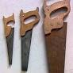
- Cutlass or machetes: - to lift root crops & to weed
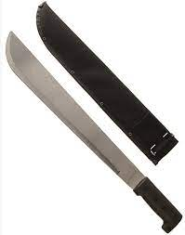
- Hand hoes: - used for weeding, available in different shapes of blades.

- 
- Sickle: - Most common hand tools used through Asian & African countries to cut the grasses & for harvesting the crops.
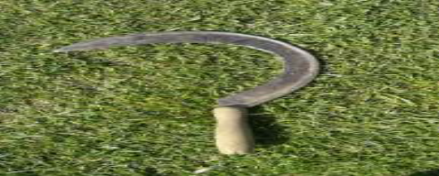
- Shovel: - for working with loose soil modified animal drawn implements


- Rake: - is used for cleaning the ground and leveling the topsoil.

- Spading fork: - used for loosening the soil, digging out root crops, turning over the materials in a compost heap.


- Hand cultivator: - is used for cultivating the garden plot by loosening the soil and removing weeds around the plant.

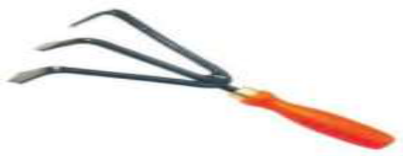

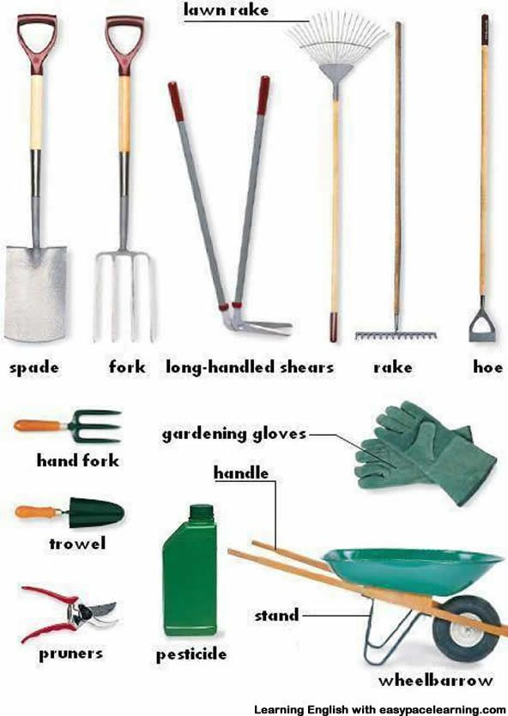
Fig.1.2.1: Hand tools used for crop establishment

1.2.2. Preparing machinery

Machineries: The use of bulldozers for clearing is very common to establish large scale farms. The Bulldozers operate by uprooting the trees, shrubs and pushing the plant material to some designated trash areas of the field to perform burning.
- The disadvantages of bulldozers are:
- Bulldozers are heavy machines & cause considerable soil compaction.
- Bulldozer operation reduces organic matter from the soil.

Plough implements: - Modern ploughs are used to open the soil & pulverize it. Ploughs are also used to incorporate the crop residues & manures. Implements may be of animal drawn or power operated.
- Mould Board plough: - It is an improved tillage implement over local country plough. It used for departing a layer of soil from the under lying subsoil and is inverted.
- Disc Plough: - Have steel disc of 50-90 cm diameter. The discs are made of hard high carbon steel & have sharp cutting edge. The discs are set at an angle to the direction of travel. It is very suitable where soils having hard plough pan. It works where M.B. plough does not work, particularly in sticky soils. It is a tractor drawn because of their weight & size.
- Harrows: - it is suitable for the preparation of land after ploughing in grassland & virgin lands & also for incorporation of manures.
- Cultivators: - Secondary tillage implements used after initial ploughing of the soil. They are used for pulverization & to bring the soil to desired tilth. They destroy weeds & mix manures & fertilizer with the soil.
- Ridging plough: - A double MB plough having adjustable wings with which the width can be suitably altered at the rear. May be animal or tractor drawn.
- Paddling plough: - used for paddling in wet lands.
- Dry land welders: - manually operated and used for removing weeds in line sown crops under dry land condition.
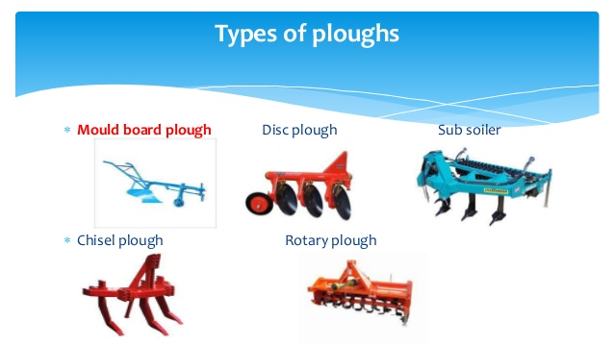
Fig.1.2.2: Types of ploughs

1.3. Identifying, assessing and reporting OHS hazards and risks

During establishment of field crops, some activities can be potentially toxic or hazardous to human beings and pollutant environmental conditions. Occupational and environmental hazards may be occurred through: -
- Use of machinery
- Moving machinery and machinery parts from one place to another
- Plant debris
- Chemicals and hazardous substance
- Manual handling
- Solar radiation
- Dust, and noise
- The contamination of off-site ground water or soils from solids, debris, nutrients or chemicals
- Land disturbance
- Spread of noxious weeds and water run-off.
Risk assessment

The purpose of risk assessment is to consider the risk factors involved in each hazard and rank them in priority order in doing so, a judgment can be made as the to most serious and most likely hazards. Risk assessment provides a systematic way of determining:
- Hazard that needs to be tackled first.
- Hazard that can be managed in medium term.
- Hazards that can be managed at some point in the future, but necessarily immediately.
Risk assessments need to consider:
- Frequency and level of exposure.
- Pattern of exposure.
- Adequacy of existing control measures.
- Consequences of injury.

1.4. Identifying environmental implication of crop production plan

Careful planning for establishment of field crops is an essential part of good production of field crops. During establishment of field crop one of the earliest decisions that must be taken is where to locate the farm (correctly selection of the site). It means where in the country or region or place the farm should be located. Factors to consider in the final decision of the farm site are: -

1.4.1. Climate factor

Climate largely determines the type of vegetation that grows naturally in any part of the world and the kinds of agriculture that are possible. The three most important factors in climate from the standpoint of plant response are temperature, water supply/precipitation/ and light.
There are also other factors like humidity, solar radiation, wind and atmospheric gases but generally they are of less influence than the three mentioned.

- Temperature: - is often the factor limiting the growth and distribution of plants. It influences the rate of growth, development and number of flowers that produce seeds. When temperature is below 15 ºC frost or pale-yellow color of the plant parts occur. In any given locality, the length of growing season is known to vary as much as 30 days for different years. The ranges of maximum growth of the plant are 15-32 ºC.

- Water supply/irrigation availability
Water supply is the most important factor in determining the distribution of a crop plant. Although total annual precipitation is important, its distribution plays an essential role in crop production. In case of plant growth for their seed, the most critical period or the period of greatest need for moisture, is when fertilization of the flowers is taking place. Crop plants differ in their water requirements, even though they are almost all require an average amount of water.

- Light
Light affects the development of crop plants mainly through affecting their structural development, their food production and the time required for certain species or varieties to produce seeds. Many plants are influenced by the length of day, especially in regard to flowering, fruiting, and the production of seed. This effect of light on plants is known as photoperiodism. Some plants are known as long day plants and other as short day. The long day plants need a comparatively long day for flowering and their vegetative growth increases when the days are short. Wheat and oats are among the long day plants. The short-day plants such as maize, soybean and sorghum achieve their vegetative growth when the days are long and flower and produce seed when the days are short.

1.4.2. Soil factors
Soil factors are nutrients and water, soil moisture, soil temperature, soil air, soil reaction (acidity or alkalinity).
- Soil moisture: - the amount of soil moisture has impact on performance of individual plants. If soil pores are completely filled with water, water logging condition is happened. Then water logging resulting in shortage of oxygen, leaching of plant nutrients, poor germination or nil, stunted growth, failure of seed formation, yellowing of leaves etc.
- Soil temperature: - it is another soil factor that determining the growth of plants. It influences the rates of absorption of water and solutes, germination of seeds, growth of seeds, growth of roots, and decomposition of organic matter.
- Soil reaction (soil acidity or soil alkalinity): - Some soils contain such as an excess of soluble salts that they interfere with crop growth. Plants are varying in their tolerance of alkaline soil or acidic soil. Among the tolerant crops are sugar cane, sugar beet, cotton, rye and many of the grasses. Grasses or cereals seem to be more tolerant than the legumes. Many crops are tolerant to acidic soil conditions and often make satisfactory growth. Some of these crops are tobacco, cow pea etc. Most legume crops differ greatly in their adaption to acid soil most grow well on slightly or moderately acidic soil. Small grains, maize, some legumes are broadly tolerant, growing well within the pH ranges 5.8 to 7 or slightly or above.

1.4.3. Altitude/Elevation factor
The choice of a crop to be cultivated in a given locality is determined by its altitude. Based on altitude or elevation field crops are classified in to different groups. These are: -
- Wurch: - greater than 3500m a.s.l.
- High land (Dega): - 2500-3500m a.s.l.
- Medium land (Woynadega): - 1500-2500m a.s.l.
- Low land (kola): - 500-1500m a.s.l.
- Desert (harrur): - less than 500m a.s.l.

1.4.4. Pests factor
The presence or absence of particular diseases or pests that attack the proposed crops should be checked.

1.4.5. Availability of inputs and other materials, tools and equipments

Different inputs like land, planting materials, labour, etc and other materials like tools and equipments should be available.

1.4.6. Accessibility
The site should be accessible to all times and preferably be near the road, markets, processing facilities and ease for supervision.

1.5. Selecting, using and maintaining suitable personal protective equipment

During establishment of field crops you should have to follow safety required to avoid hazards. Skin contacts with crop residues which may be toxicants during clearing, working with sharp machinery and use of other chemical substances must be avoided. Wearing of persons engages like: -hat, boots, overalls, gloves, goggles, respirator or face mask, hearing protection, and sunscreen lotion is a must.
Consider these factors when selecting PPE:
- Type of hazardous materials, processes, and equipment involved
- Routes of potential exposure (ingestion, inhalation, injection, or dermal contact)
- Correct size for maximum protection
- Minimal interference with movement
Coverall –is a loose-fitting garment worn over ordinary clothes. It can have long or short sleeves. It is used to protect skin against harmful substances such as pesticides.
Goggles- is a close-fitting protective glass with side shields. It protects eye from dust particles, fumes and harmful chemicals. Safety glasses should be worn during spraying chemicals.

Respirator mask- is an apparatus worn over the face to cover the nostrils. It used to prevent the inhalation of dust. It can also protect against dust. It has a filter so when worn on face you are able to breathe clean air.
Boots-is the PPE that covers the feet, ankles and the lower legs. It is water proof that is the feet are protected from getting wet. Checks should be taken to be ensuring there are no holes in them. The feet are also protected when using sharp tools.

Gloves- Are covering for hands. There are separate parts for each finger and thumb. Gloves are necessary to protect the skin from exposure to toxic materials.

Head protection: Hard hats must be worn by electricians, construction workers, and any other workers when there is a danger of objects falling from above.


Self-check -1

Name…………………………………………… ID………………………… Date…….
Directions: Answer all the questions listed below. Illustrations may be necessary to aid some explanations/answers.
Test 1: Short Answer Questions
- What is crop in general? (4pts)
- List environmental implications to be considered during establishment of field crops. (5pts)
- List some machinery, tools and equipment which are used to establish field crops. (4pt)
- What is the purpose of selecting suitable materials, tools and equipment during establishment of field crops? (3pts)
- List PPEs used during field crop establishment? (4 pts)
Test 2: Choice the best answer
  - Which one of the following is not agricultural inputs (2pts)
A. Seed
B. Fertilizer
C. Insect
D. Pesticide

  - Which one of the following is correctly matched (2pts)

    - Cereal crop---rice
    - Pulse crop----wheat
    - Oil crop------cotton
    - Fiber crop-----bean

Note: Satisfactory points =20 and above Unsatisfactory =below 20 points
You can ask your teacher for the copy of your answer.
LG #2 | LO #2- Preparing Site for Crop Establishment

Instruction sheet
This learning guide is developed to provide you the necessary information regarding the following content coverage and topics:
- Removing plant debris, waste materials and pre-treat the soil
- Applying soil treatment and amendments
- Working the site according to crop production plan
- Implementing appropriate plant spacing
- Marking out planting pattern
- Operating and checking tools, equipment and machinery
This guide will also assist you to attain the learning outcomes stated in the cover page. Specifically, upon completion of this learning guide, you will be able to:
- Remove plant debris, waste materials and pre-treated the soil before crop establishment.
- Apply soil treatment and amendments according to soil test results
- Work site according to the crop production plan
- Implement appropriate plant spacing according to the crop type
- Mark out planting pattern according to the crop Production plan.
- Operate and check machinery, equipment and tools according to guidelines
Learning Instructions:
- Read the specific objectives of this Learning Guide.
- Follow the instructions described below.
- Read the information written in the information Sheets
- Accomplish the Self-checks
- Perform Operation Sheets
- Do the “LAP test”

Information Sheet 2

2.1. Removing plant debris, waste materials and pre-treat the soil

2.1.1. Disposing of old crops

Once the site for the farm has been selected and acquired, the farmer proceeds with clearing. This involves cutting down the vegetation that is growing on the land and then removing the dead plant material (old crops) from the cropping area. In traditional practice, the plant material is cut down with cutlasses, axes and saws.
Clearing: -this involves cutting down of vegetation and removing the dead plant material from the cropping area. The purpose of clearing is to do tillage operation for seedbed preparation to perform sowing in order to produce crop. While clearing the land some trees are left standing which fall into three groups: -
- Any economic trees such as oil palms.
- Slender up right shrubs that will serve as live stacks for various climbing crops like cucumbers.
- Very high trees such as silk cotton, which are spared due to high felling cost.
- Purposes of clearing: -
- Avoiding competition of nutrients, water light and air
- Reduction of shading
- Eliminating the shelter of pests and diseases
- Enhancing good crop development
Burning: - is the most common method of clearing plant debris. But it has positive and negative effects.

Benefits of burning: -
- It may kill harmful pests& weed seeds.
- It leaves an alkaline ash that serve as soil amendment and nutrient source such as K & Ca.

Removing waste materials
- Materials to be removed from the field crop: -
- Unwanted vegetation (trees, bushes, weeds, etc)
- Tree roots
- Stones
- Stumps
- Clearing Operations: -
- Removing shrubs and trees
- Cutting, burning, burying all diseased vegetation
- Removing stones and larger pebbles
- Keeping few trees to provide shade for compost heaps and the nursery
- Avoiding cleared materials from the site: -
- Burning waste, woods and diseased vegetation
- Use the crop trash for making compost heaps
- Construction materials
Advantages of removing waste materials
- It helps in loosening the compact layer of soil and pulverizing it, thereby improving aeration & the growth of plants.
- The harmful insects, pathogens and weeds harboring in the soil are exposed to the sun & killed.
- It helps in proper & uniform germination of seeds.
- It helps to bury surface vegetation and crop residues from the previous seasons crop; so as to make it easy to plant & resulting in the addition of organic matter into the soil.

2.2. Applying soil treatment and amendments
- Definition
Soil amendment is the process of modifying soils to provide what the native or existing soils do not naturally provide. The amelioration required can vary depending upon the existing soil and the traits of the soil that require alteration, be it improving the drainage of a heavy clay soil, increasing the nutrient holding capacity of a highly sandy soil or repelling the negative effects of a saline soil near the coast with the application of calcium.
- Improving soil conditions
- Soil conditioning: - Any crop gives its best yields in suitable soil conditions in regard to texture, water holding capacities, nutrients, pH and so on.
- Organic manuring: - Apart from supplying some of the plant nutrients, organic manures play other significant roles. These include the improvement of soil structure and water retention capacity within the root zone, increase aeration of the rooting medium, lower bulk density and increases holding of other major nutrients like nitrogen and phosphorus.
- Chemical fertilizers: -. Compound fertilizers like Diamonium phosphate (DAP) and Urea are useful for field crop growing.
- Cover crop: - This is an essential practice for improving soil fertility and in preventing the buildup of soil borne organisms. It has been shown that in areas where manure or fertilizer is not available in large quantities, the inclusion of two-year legume provides sufficient fertility and organic matter for continuous cropping

- Liming
Soils with a pH below 5.0-5.5 (depending on the soil) can adversely affect crop growth in four ways:
- Aluminum, manganese, and iron toxicities: These three elements increase in solubility as soil pH drops and may actually become toxic to plants at pH's below 5.0-5.5. Beans are especially sensitive to aluminum toxicity which is the crop's biggest yield limiting factor in some areas. Many soils labs routinely test for soluble aluminum levels in very acid samples. Manganese and iron toxicities can be serious, too, but usually are not a problem unless the soil is also poorly drained.
- Very acid soils are usually low in available P and have a high capacity to tie up added P by forming insoluble compounds with iron and aluminum.
- Although very acid soils usually have enough calcium to supply plant needs (except for peanuts), they are likely to be low in magnesium and available sulfur and molybdenum.
- Low soil pH depresses the activities of many beneficial soil microbes such as those that convert unavailable N, P, and S to available mineral forms. Low soil pH depresses the activities of many beneficial soil microbes such as those that convert unavailable N, P, and S to available mineral forms. Maize and cowpeas may tolerate soil acidity in the pH 5.0-5.5 range depending on the soil's soluble aluminum content. Sorghum is somewhat more tolerant than maize to soil acidity.

Green manure
Crop grown for the purpose of restoring or increasing the organic matter content in the soil are called green manure crops. Their use in cropping system is called “green manuring” where the crop is grown in situ or brought from outside and incorporated.
Various nitrogen fixing leguminous and non-leguminous species, particularly trees, creepers, and bushes can be used as green manures. The criteria for selection of plants as green manure are: -

- High biomass production
- Deep rooting system
- Fast initial growth
- More leaf than wood
- Low C/N ratio
- Nitrogen fixing ability,
- Good affinity with mycorrhiza,
- Efficient water use
- Non-host for crop related pests and diseases
- Easy and abundant seed formation

- Advantages Green manuring
- Green manuring has a positive influence on the physical and chemical properties of the soil.
- It helps to maintain the organic matter status of arable soils
- Green manure serves as a source of food and energy for the soil microbial population which multiplies rapidly in the presence of easily decomposable organic matter.
- The enhanced activities of soil organisms not only cause rapid decomposition of the green manure but also result in the release of plant nutrients in available forms for use by the crops.
- Green manuring improves aeration in the rice soils by stimulating the activities of surface film of algae and bacteria.
- Many green manure crops have additional use as sources of food, feed and fuel.

2.3. Working the site according to crop production plan

Growth & development of crop plants depends judicious management of intrinsic (genetic & heredity) & extrinsic (environmental factors such as the soil & atmosphere). The interaction of these two natural entities acting in conjunction with the genetic makeup of the plant combined with the activities of human being regarding to selecting appropriate site suited for the particular crop and supplying appropriate input determine the growth pattern of the crop concerned and its ultimate yield.

2.3.1. Land preparation

Soils need to in a condition suitable for establishing of crop. The purpose of land preparation is to provide condition that is favorable for the germination and growth of the seeds to be planted. Before seeds is planted, the land must be prepared well to provide an adequate seed bed. Land preparation entails removing vegetation and losing the soil to facilitate seed germination and root penetration. The extent of soil disturbance is depending on the types of technology, knowledge of the producer, and the environment. Plowing is an age-old method of land preparation for seeding. Site Tillage system has changed over the years.
- The main objectives of soil cultivation are:
- Burying trash (previous crop remains)
- Reducing compaction
- Producing a suitable
- Shaping the soil for the next crop
- Improving harvesting conditions
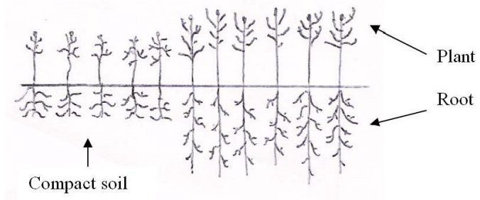
Fig.2.3.1. Effect of compact soil and prepared soil on plant growth

- Preparing a site for sowing a crop depends on factors that include:
- Climate and weather
- Ground condition and previous treatment
- One of the biggest factors that influence preparation of the land is the intended crop.
- Reasons for preparing land:
- To save moisture by eliminating competing vegetation.
- To create a firm soil surface that allows seeds to be planted at the proper depth to ensure contact with moisture.
- To eliminate competition for light and nutrients by killing undesirable plants before desirable plants are planted.
After the land has been cleared various tillage operations should be carried out. Tillage includes all operations and practices used for the purpose of modifying the physical characteristics of the soil. These are: -

a) Plowing/Digging: plowing is initially done to open the compact or hard soil. During this operation the soil is inverted, weed uprooted and stubbles incorporated into the soil. The depth of digging varies from 10 to 30 cm. It has different purposes like
- Cutting and turning the soil
- Loosening the soil and good root penetration
- Aerating the soil and making it permeable
- Reducing weeds and insect infestation
- Incorporating organic matter and soil amendments to improve the structure of the soil
- Shaping soil: - tillage is done to create raised beds for planting or to create furrows for irrigation.
- Erosion control: - like in conservation tillage

b) Harrowing/pulverizing: if the lumps (clods) of soil left after digging are too large, they must be broken up before planting/sowing if broadcasting and before furrow preparation if row methods of sowing. Purpose of harrowing is
    - Cutting the clods and sods to a considerable depth
    - Producing fine seedbed and leveled soil
    - Obtaining weed free soil

c) Leveling: - is done to improve surface drainage, for installation of irrigation equipment, or to facilitate the use of farm machineries and equipment.

2.4. Implementing appropriate plant spacing

Plant spacing, on the other hand, refers to the arrangement of plants on the area planted. Widely varying plant spacings such as 1 000 mm x 10 mm, 500 mm x 20 mm and 100 mm x 100 mm, all give a plant population of 100 plants per square meter. Individual plant productivity is typically limited by competition for light, water, soil nutrients or competition of each. To avoid nutrient competition sufficient spacing between plants and rows is vital to get maximum yield in a given plot of land. Appropriate spacing enables the farmer to keep the appropriate plant population in his field.

Hence, a farmer can avoid over and less population in a given plot of land which has a negative effect on yield. Determine the optimum plant population or spacing for a specific crop is difficult because; factors such as climate, soil, cultivar, market requirements, managerial ability of the grower, and many others, all play a role. For this reason, one will often find that a range of spacings or populations is recommended. For example, a recommendation for cabbage may be a plant spacing of 350 mm to 500 mm in rows drawn 500 mm to 700 mm apart, and a plant population of 35 000 to 45 000 plants per hectare. At any specific plant population, individual plants are likely to perform best where a uniform spacing of plants, equidistant from one another in all directions, is adopted. However, it is usually more practical to plant fairly closely in rows, with the rows being spaced wider apart. This allows for easier access into the planting for inspections, weeding, pest and disease control and harvesting.
- There are two types of spacing used in crop cultivation
- Intra spacing: - space between plants
- Inter spacing: - space between two rows

2.4.1. Importance of plant spacing

In your garden, if there is not enough space between plants then resources like nutrients, water and light are squeezed out or over consumed and the plants can suffer. Improper spacing can lead to slow plant growth, low yields and overall reduced plant health

2.5. Marking out cropping pattern

Cropping pattern is defined as the spatial representation of crops rotations, or as the list of crops that are being produced in an area and their sequence in time.
- Benefits of cropping pattern
- Improving the fertility of the soil
- Increasing the yield of the crops
- It ensures crop protection and availability of nutrients to the crops.
- Factors affecting crop pattern
- Physical and technical factors
- Economic factors
- Government policy
- Improvements in technology
- Availability of agricultural inputs and facilities
- Type of cropping pattern
- Mono cropping (sole cropping): Growing one crop variety alone in the field in a normal density.

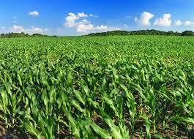

- Crop rotation: The practice of planting a succession of crops in a field over a period of years. The crops are classified based on the time they are rotated one-year rotation, two-year rotation, and three-year rotation, depending upon their duration. Legumes are included within the crop rotation program to extend soil fertility. The crops which require a high fertility level are often grown after the legumes. The crops which require low inputs are often grown after the crops that need high inputs.
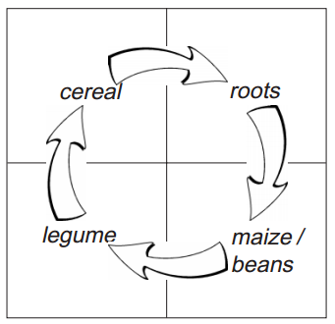
- Mixed cropping: is growing two or more crops simultaneously intermingled without any row pattern. It is common practice in most of dry land areas

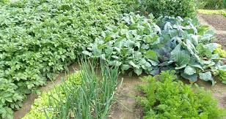

- Intercropping: Growing two or more crops simultaneously on the same field.

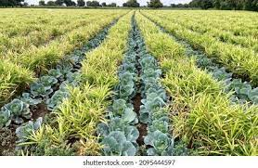

- Alley cropping: Agro forestry, farm forestry and family forestry can be broadly understood as the commitment of farmers, alone or in partnerships, towards the establishment and management of forests on their land
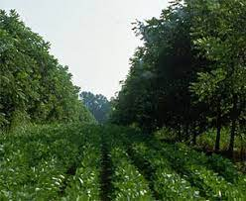

2.6. Operating and checking tools, equipment and machinery

For establishment and maintenance of field crop selecting and preparing materials, tools and equipment is the first steps. Next to this checking service ability of materials, tools and equipment is one the important ways. After serviceability of material, tools and equipment has been checked and operating (making ready) machinery, tools and equipment are the necessary steps which make land preparation activities easier and more suitable.

Self-Check – 2

Name…………………………………………… ID………………………… Date…….

Directions: Answer all the questions listed below.

Test I: Short Answer Questions
- After the site has been selected what activity to be proceed? (5pts)
- What materials to be removed from field crop site? (3pts)
- Write the major application of soil treatment (5pts)
- Describe steps of land preparation(5pts)

What is the purpose of operating equipment and tools during land preparation for establishment of field crops? (3 pts)

What is the difference between ploughing and harrowing? (5pts)
Test II: Choice the best answer
- Which of the following is not purposes of land clearing (2pts)
- Avoiding competition of nutrients, water light and air
- Reduction of shading
- Eliminating the shelter of pests and diseases
- Decreasing good crop development

Note: Satisfactory rating - 20 points and above Unsatisfactory - below 20 points
You can ask you teacher for the copy of the correct answers

Operation Sheet -2

  - Procedure/Techniques of land preparation activities

- Tools and equipments
- Hand tool (spade, hoe, shovel, rake, fork, bolo, saw etc.)
- Machinery (tractor, plough, harrow, seed planter etc)
- PPE
- Procedures/Steps/Techniques
- Prepare and make ready (operate) your materials, tools and equipment’s which are required for crop establishment.
- Clear and dispose waste materials like weed, stone, insects, etc from selected areas
- Plough/dig the land by tractor or by other ploughing system
- Harrow/pulverize the ploughed land to break clods and make fine soil
- Level the land to improve surface drainage, for installation of irrigation equipment (canal), or to facilitate the use of farm machineries and equipment.
- Prepare row or hole based on selected planting pattern.

LAP TEST-2

Name………………………………. ID…………………………….. Date…………………………………….

Time started: ________________________ Time finished: ________________

Instructions: Given necessary templates, tools and materials you are required to perform the following tasks within 1 hour. The project is expected from each student to do it.

Task 1: You are required to perform any of the following:
1.1. Prepare the material which used for land preparation
1.2. You are requested to perform the following task in front of your teacher
- Use and maintain properly personal protective equipments
1.3. Operate ploughing machinery

Task 2. Request your teacher for evaluation and feedback

LG #3 | LO #3- Carrying out Filed Crop Establishment Operations

Instruction sheet
This learning guide is developed to provide you the necessary information regarding the following content coverage and topics:
- Selecting planting material
- Treating planting material
- Handling and transporting planting material
- Carrying out planting
This guide will also assist you to attain the learning outcomes stated in the cover page. Specifically, upon completion of this learning guide, you will be able to:
- Select planting material according to the type of crop and seed quality standards
- Treat planting material according to the crop type
- Handle and transport planting material to the site
- Carry out planting according to the planting plan
Learning Instructions:
Read the specific objectives of this Learning Guide.
Follow the instructions described below.
Read the information written in the information Sheets
Accomplish the Self-checks
Perform Operation Sheets
Do the “LAP test”

Information Sheet 3

3.1. Selecting planting material

Seeds are the pre-operational unit of flowering species and the economic part of grain crops, consists miniature plant called embryo. To produce high quality and quantity of field crops selection of good seeds are very important.

3.1.1. Basic considerations for seed selection

- Start by choosing carefully the location and actual plants from which you collect seeds.
- Collect seeds from plants growing in sites similar to the ones you are going to plant the seedlings on.
- Collect seeds from plants with the characteristics you want (e.g., good rooting): seedlings grow like their parents.
- All seed plants should be healthy and growing vigorously.
- Always collect seed from at least 10 plants, to increase the genetic diversity.

3.1.2. Methods of seed selection and collection

Whether you are going to collect flower, shrub, or tree seeds, the basic methods apply to each is the same.
- Select adult plants which are healthy, strong, and free from disease or insect infestation, from which to collect seeds.
- Collect the seeds during the time of seed production.
- Select species which grow in the same kind of environment as that in which the seedlings will be planted.
- Select mature seeds.
- Select seeds which are of the same color, size and shape.
- Be certain that the seeds are free from disease.
- Dry the seeds well before storing them. Those seeds which are naturally moist or sticky should be washed well before drying.
- Do not mix seed of different plants. Put them in jars or envelopes, labeling each by name, date and plant location.
- If needed, a dust insecticide such as Malathion can be mixed with the seeds to control insect pests.
- Keep the seeds in a cool, dry place.

3.1.3. General seed selection criteria

- Fitting within the usual period of the raining season
- High and stable yield
- Resistance to insect pests and diseases
- Uniform heading and fruiting
- High oil, protein or starch content
- Moderate one thousand seed or grain weight

Table 3.1.3: Main crop on 1000 weight and grain number
Type of crop | 1000 weight(g) | Grain numbers per Kg
Wheat | 17-25 | 50000-55000
Maize | 350-550 | 2000-3000
Sorghum | 22-220 | 8000-10000

3.1.4. Characteristics of good seeds

- Pure (true to type)
- Must be viable: - good germination capacity
- Matured: - well developed, uniform size, shape, color, texture etc
- Health: - clean, and free from inert matter
- Free from other crop seeds
- Free from any pest and seeds borne diseases
- Should be whole, not broken, crushed, shriveled, rotten etc
- Should contain the required amount of moisture
- Seeds free from weed seeds
- Seed quality usually measured by germination percentage.
- Seed germination
  - is a projection of radicle or seedling emergence.
  - results in crack of the seed coat and emergence of seedling from embryonic axis.
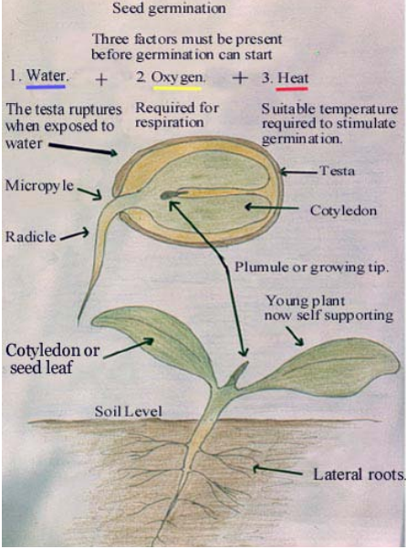
- Factors required for germination:
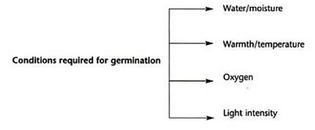
Seed damage may be caused by mechanical injury, insects, fungi, and bacteria. the quality of seed is governed by its purity, viability, germination capacity, seed health (pathogens) test, genetic purity test etc. If seed lacks in any of the characteristics it may become unfit for sowing.
a. Seed purity test (Physical purity test): -Seed purity is the percentage of pure seed (only the seed of the desired kind without contaminants) in the sample tested. The contaminants include: -
- Seed of others: - like wheat seed may be found in barley seeds.
- Weed seed
- Inert materials: - includes materials (foreign matter) such as small stones, pieces of wood, and other plant materials.
Purity percentage = weight of pure seed x 100
Total weight of sampled seed

b. Seed viability test: - Seed viability is the capacity of seeds to germinate. A viable seed is one capable of germinating to produce a health, normal seedlings. It is not enough to tissues in the seed to be viable; the seed must able to grow to produce seedlings.

c. Seed germination test: - See germination is the sequence of events in a viable seed starting with the absorption of water that leads to growth of the embryo and development of seedlings. When the seeds are placed in proper conditions of moisture, temperature and oxygen, the growth of embryo or germination commence. The degree to which germination has been completed is usually expressed in percentage, normally determined at time intervals of germination period in terms of germination power and germination capacity.
Germination % = Numbers of germinated seeds x 100%
Numbers of planted seeds/sample taken

d. Seed health (Pathogen) test: -It evaluates the presence of insect on the seed like change in color, presence of spots etc, and then placed under optimum germination condition for germination to occur.

3.2. Treating planting material

3.2.1. Objectives of seed treatment; -
- To prevent the seed against pest and diseases infestation.
- To break seed dormancy and to induce higher germination percentage.
- To inoculate the seed with rhizobium bio fertilizer.
- To induce tolerance to salinity, drought frost etc.
- To promote nitrogen fixation by treating it with rhizobium

3.2.2. Important of seed treatment

Seed treatment is the process of applying physical, chemical or biological treatment to the seed to keep it viable and health.

3.2.3. Types of seed treatment
- Physical treatment
- Biological treatment
- Chemical treatment

1.Physical seed treatment
- It includes subjecting seeds to solar exposure, immersion in conditioned water etc.
- To induce higher germination, the seeds may be soaked in water before sowing or may be exposed to warm temperature. Early rooting may be induced by treating seeds with IBA or GA solutions.
- To induce or facilitates sowing and better germination in cotton seed treated with
- Sulphuric acid (H₂SO₄).
2. Biological Seed treatment
It includes the treatment of seeds with microbial cultivars such as that of Rhizobium to inoculate the seeds with microbial cultivars, to fix atmospheric nitrogen and release to the soil.
3.Chemical seed treatment
It includes treating seeds with fungicides, insecticides, nematocides etc.
- Types of chemicals used for seed treatment
  - Insecticides: - Parathion, phorate, chlorphriphos, furadan, dimethoate etc
  - Fungicides: - Thiram, thiophante(topsin), carbendazim, vitavax, dexon etc

Handling and transporting planting material

Seeds used for planting require more careful handling than those used for grains (i.e., food or feed). Good quality seed spells good field emergence, seedling stand, crop growth, yields and healthy vigorous seeds. Seed handling is the procedure of drying, cleaning, grading, treating and storing seeds.
- Care to be taken during drying sowing seeds
- Temperature is controlled under 40⁰c
- Do not dry seeds too fast
- Don’t make seeds over dry
- Avoid seed mechanical damage

For storage of sowing seeds, the following condition should be fulfilled:
1. Condition for storage of packing and facilitated
- Low seed moisture content (seeds moisture content) is, wheat and barley (13%), maize (14%), oil crops (10 %) etc.
- Maintain low temperature by installing ventilators
- Effective pest control
- Low relative humidity
During transporting sowing seeds from storage area to the site appropriate care should be undertaken to avoid damage of seeds.

3.4. Carrying out planting

3.4.1. Sowing
Planting/sowing is also the placement of the specific quantity of seed in the soil at optimum position for germination & growth. The establishment of good plant stand depends upon time, seed rate, plant spacing, depth & method of sowing
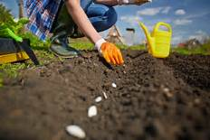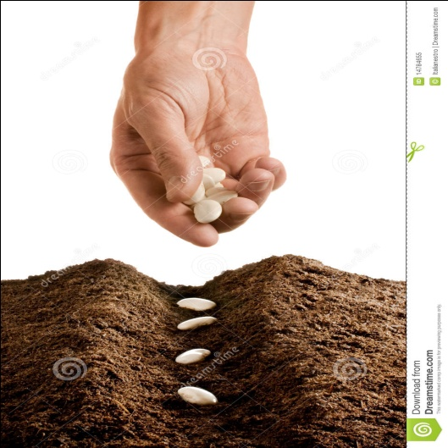

3.4.2. Methods of Sowing / Planting

- Types of sowing/planting methods are as follows
- Broad Casting
- Drilling
- Planting/dibbling
- Transplanting
- Broadcasting
- Is the most primitive, ancient and widely followed methods of sowing crops
- Seeds are spread uniformly over well-prepared land and are covered by light ploughing or planking
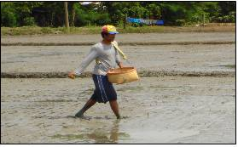

- Drilling
- Drilling the seeds in lines is practiced widely and specifically under dryland areas.
- Crops can be sown in lines with seed drills.
- Weeds can be controlled economically
- In addition, drilling or line sowing facilitates
  - uniform depth of sowing
  - uniform germination and crop stand.
  - Reduce seed rate

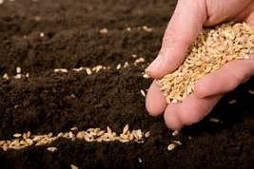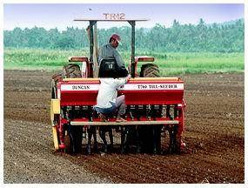

- Planting
- Individual seed material is placed in the soil by manual labour.
- Crops with bigger sized seeds and those needing wider spacing are sown by this method.
- Planting is done for crops like cotton, maize, potato, sugarcane etc.
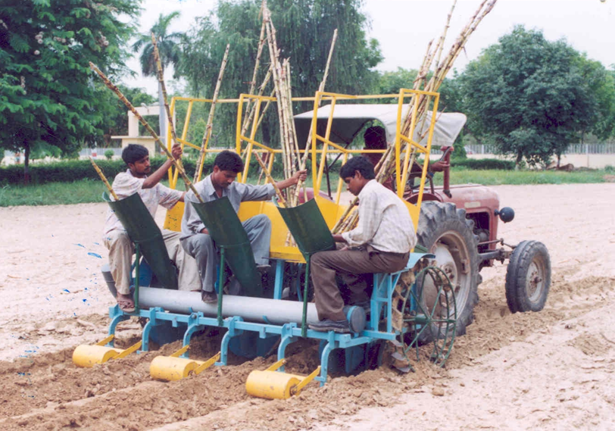Sugarcane planter

- Transplanting
- Seeds are sown in a small area called nursery and all the care is taken to raise the seedlings.
- When seedlings grow to certain stage, they are pulled out from the nurseries and transplanted in the main field.
- The advantages of transplanting are saving in irrigation water, good stand establishment and increase in intensity of cropping.

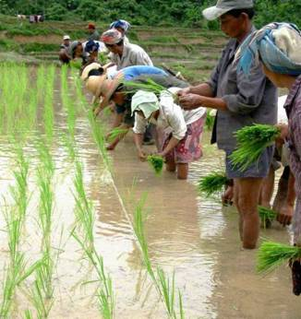

3.4.3. Factor that determines a successful crop establishment

- A successful crop establishment seeds need to be sown፡-
- Proper sowing date
- At the correct seed rate,
- At the correct sowing/planting depth
- Have an optimum density/population.
- These factors vary with the type of crop that is grown.
- Sowing date
Field seeding should be done at the appropriate time. Field cropping is a seasonal operation. Weather conditions are not conducted for cropping all year round. Many crop production regions have a large major cropping season, and a shorter minor cropping season. Time of seeding is especially critical if production is to be rained. The optimal time of seeding is chosen for several reasons. Time of sowing: - Early sowing is the most cost-effective ways of increasing crop yield because it minimizes cost production. An early start is very beneficial to encourage a longer growing season and higher yields.

Factors affecting sowing time
- Rainfall: - has a dominant influence in crop production: - the effect of moisture on crop grown can be attributed to at least two of its aspects. during germination and emergence of seedling, the amount of moisture needed is much less but sensitive
- Temperature: - is also an important factor in limiting the growing of certain crops. Each plant has its own temperature range i.e., minimum, optimum, and maximum for growth
- Day length: -long day plant need relatively long flowering time, but they increase their vegetative growth at short day. Short day plants need short interval of light for flowering
- Occurrence of Disease & Pest: - is diseases and pest that destroy seeds and seedlings are more prevented at certain times in the growing season.
- Marketing
- Cropping system
- Availability of labor & equipment Time taken maturity

- Seed rate
Seed rate is the quantity of seed required for sowing or planting in a unit area. The seed rate (kg seed per hectare) is determined by three factors
    - Desired plant population
    - Seed weight (1000 grain weight)
    - Expected establishment percentage
e.g., If 125 kg of wheat is needed to plant 1 hectare of land, what will be the amount of seed needed for 10*10 m² plot? Solution 125=10000m² _{Answer =1.25kg}
? = 100m2
Factors Influencing Plant Population / Seed Rate
- Size of cultivar: - Crops having tillering characteristics require less seed,
- Dwarf cultivars more seed,
- Tall cultivars – less seed since they are subjected to lodging.
- Size of seed: - Bigger seed- more seeds / higher seed rate.
- Amount of moisture available- good moisture status- less seed rate.
- Fertility status of the soil: - good fertility – less seed rate.
- When more number of crop grown together – more seed rate is required.
- Germination capacity of the seeds: - If the germination capacity of the seed is higher, the lesser seeding rate needed.
- Sowing method – broadcasting require more seed rate than row sowing. Dibbling requires less seed rate.

- Sowing depth

The selection of the correct depth of sowing for any crop is based on the conflicting needs to plant deeply enough to protect the seed from desiccation within the surface layer of soil, yet shallow enough to permit easy and rapid emergence of the shoot (Donald and Puckridge, 1975). The factors that influence seed desiccation and shoot emergence need to be considered. The relatively large seed of a cereal has a good carbohydrate store enabling it to germinate from relatively deep sowings; Deeply sown cereals will show low early vigours and have a hooped appearance. Shallow sown seeds can suffer from an inadequate root system which is susceptible to frost damage.

Table 3.4.3: Average depths of sowing for agricultural field crops crop depth of sowing (cm)
Crop | Depth of sowing(cm)
Wheat | 2-4
Oats | 2-4
Barley | 2-4
Maize | 3-5
Sorghum | 3-4
Field pea | 3-4
Safflower | 3-5
Linseed | 1-2

- Optimum plant population

Optimum plant population is the number of plants required to produce maximum output or biomass per unit area.
- Importance of plant population
  - Yield of any crop depends on final plant population.
  - The plant population depends on germination percentage and survival rate in the field.
  - Under low plant population, individual plant yield will be more due to wide spacing.
- Depending on the crops and varieties, the plant population varies.
- Rice ፡-
    - 666,667 plants/ha (15 cm x 10 cm)
    - 5,00,000 plants/ha (20 cm x 10 cm
- Maize:
    - 53,333 plants/ha (75 cm x 25 cm)
- Therefore, Plant population = Given Area/Planting space

Self-Check – 3

Name…………………………………………… ID………………………… Date…….

Directions: Answer all the questions listed below.

Test I: Short Answer Questions

What is planting materials? (3pts)

Explain the major methods of planting (5pts)

List and explain the good characteristics of seed. (5pts)

Mention some techniques which are used to determine seed quality (3 pts)

Write factors that can be considered during sowing or panting, planting materials? (3pts)

What is the importance of determining time of sowing, depth of sowing, rate of sowing and methods of sowing during establishment of field crops? (5 pts)
Test II: Choice the best answer
- All are general seed selection criteria except (2pts)

- High and stable yield
- Susceptible to insect pests and diseases
- Uniform heading and fruiting
- High oil, protein or starch content

Note: Satisfactory point =20 and above Unsatisfactory points = below 20
Ask your teacher for the copy of the answer

Operation Sheet -3

  - Procedure/Techniques of seed test
- Tools, materials and equipments
- Seed
- Blotting paper
- Petri dishes
- Water
- Bag, try
- Procedures/Steps/Techniques
- Select seeds
- Analysis purity of seeds
- First take equal amount of seed from each container and mix it completely.
- If the seed is in a bag try to take the sample from different parts of the bag with probe.
- Separate sample in to pure seed, other crop seed and inert matter.
- Weigh the separated pure seed, other seed and inert matter individually
- Determine the percentage of each separated pure seed, other seed and inert matter
Purity percentage = weight of pure seed x 100
Total weight of sampled seed
- Analysis germination capacity
- Count 50 seeds for each of the seed lot considered
- Cut the blotting (tissue) paper in pieces
- Wet the sample and the blotting paper (not too much) and then place your seeds on top or between two layers (the seeds should be well spaced)
- Finally fit the lid of the Petri dishes or the cover of the trays
- Count the number of seeds germinated to determine the germination percentage. (The first count may be taken at one week and germinated seeds discarded with a formal count taken later)

Germination % = Numbers of germinated seeds x 100%
Numbers of planted seeds

3.2. Procedure/Techniques of Sowing/planting of seeds
- Tools, materials and equipments
- Seed
- Broadcasters
- Drills
- Planter
- Hand fork
- Rake
- Procedures/Steps/Techniques
- Determine optimum sowing time based on types of crops and other factors
- Decide recommended seeding rates based on types of crops and other factors
- Select proper sowing/planting methods which are suitable for crops
- Place /plant/sow the seeds at proper depth based on types of crops

LAP TEST-3

Name………………………………. ID…………………………….. Date…………………………………….

Time started: ________________________ Time finished: ________________

Instructions: Given necessary templates, tools and materials you are required to perform the following tasks within 1 hour. The project is expected from each student to do it.

Task 1: You are required to perform any of the following:
1.1. Determine purity and germination percentage test
1.2. Show to your trainer how to sowing or planting

Task 2. Request your teacher for evaluation and feedback

LG #4 | LO #4- Completing Filed Crop Establishment Operations

Instruction sheet
This learning guide is developed to provide you the necessary information regarding the following content coverage and topics:
- Cleaning and sterilizing tools and equipment
- Disposing off wastes and debris
- Recording work place
This guide will also assist you to attain the learning outcomes stated in the cover page. Specifically, upon completion of this learning guide, you will be able to:
- Clean and sterilize tools and equipment according to the manufacturer’s specifications, enterprise procedures and regulations
- Dispose all containers, leftover fluids, waste and debris
- Complete all required workplace records accurately and promptly in accordance with enterprise requirements
Learning Instructions:
Read the specific objectives of this Learning Guide.
Follow the instructions described below.
Read the information written in the information Sheets
Accomplish the Self-checks
Perform Operation Sheets
Do the “LAP test”

Information Sheet 4

Cleaning and sterilizing tools and equipment

Tools and equipment should be cleaned and sterilized according to the manufacturer’s specifications, enterprise procedures and regulations. This is used to increases life span of tools and equipments and avoids scarcity of tools and equipments at critical periods. Always before storing of tools and equipments cleaning is a must.

It is absolutely critical to have good sanitation, as dirty equipment does nothing but invite bacteria and unwanted yeast to infect your mead. Some people say you cannot sanitize too much, but there is a point of diminishing returns. A general rule of thumb is to always clean and dry equipment that is going into long-term storage. Secondly, always clean and sanitize a piece of equipment before you use it. Here is some information that should allow you to make sanitizing decisions.
First of all, there are three important words we all use a lot when talking about getting our equipment scrubbed clean and ready to make mead.

CLEANING refers to the physical removal of visible dirt, residue, lees, fruit remains, etc. - usually done with scrub brushes, squeegees or a clean towel. You must clean your equipment before sanitizing it. It is impossible to sanitize equipment with visible residue on it. This is because molds, wild yeasts and bacteria like living in hidden nooks and crannies, and any sanitizing solution you might use won’t penetrate effectively into these areas.

SANITIZING means that you’re treating the surface or piece of equipment to reduce, eliminate or prevent the growth of molds, wild yeasts or bacteria to an acceptable level. It is just another way of saying that you’re killing microorganisms that can ruin your mead.

STERILIZING: When something is sterilized, it means that it is completely free of bacteria or other microorganisms. Sterilization is mostly carried out hospitals and labs.
All materials handling equipment has rated capacities that determine the maximum weight the equipment can safely handle and the conditions under which it can handle those weights.
The equipment-rated capacities must be displayed on each piece of equipment and must not be exceeded except for load testing. When picking up items with a powered industrial truck, the load must be centered on the forks and as close to the mast as possible to minimize the potential for the truck tipping or the load is falling.

Disposing off wastes and debris

The processing of products generates a large quantity of waste that can serve as food and shelter for pests. It is therefore very important to plan an effective waste disposal system. This system should always be maintained in good condition so it does not become a source of product contamination.
The following should be considered:
- Waste disposal systems and facilities should be provided. All refuse should be disposed of in containers with lids and stored away from the facility to prevent harborage of pests.
- Refuse containers should be emptied regularly.
- Areas for garbage recyclables and compost able waste should be identified and all waste should be stored and disposed of in a manner to minimize contamination.
- Waste should be disposed of on a frequent basis to avoid attracting pests (e.g., flies, rodents).

Recording work place

Recording is one of the principal tools used in controlling consulting assignments. With the exception of very short assignments, the assignment plan will foresee several progress or interim reports to be drafted and submitted by the consultant. The consultant may also produce technical reports on specific subjects treated by the assignment. These technical reports may even be the main tangible products of the assignment, e.g., in feasibility or sectoral studies, or in diagnostic surveys of training needs.

The design of progress reports must facilitate their use in assignment control and monitoring. A good progress report is short, concise, simply structured and clearly worded, drawing management's attention to the main achievements of the period under review and corrective measures required. A progress report is not a piece of literature, but a practically focused paper for managerial action. It’s essential elements cover:
- Work performed
- Resources used
- Progress made towards interim and final objectives and targets:
- Obstacles encountered
- New problems discovered
- New ideas and opportunities brought to the client's attention
- Staffing and other difficulties
- Suggestions for adjustments in the assignment schedule
- Suggestions for any other action by the client and the consultant.

Self-Check – 4

Name…………………………………………… ID………………………… Date…….

Directions: Answer all the questions listed below.

Test I: Short Answer Questions

  - Define cleaning(5pts)
  - Define sterilizing(5pts)
  - Define sanitizing(5pts)
  - Why we need to disposing waste and debris after completing field crop establishment operations(5pts)

Note: Satisfactory point =15 and above Unsatisfactory points = below 15
Ask your teacher for the copy of the answer

Operation Sheet -4

  - Procedure of completing establishment operations
- Tools, materials and equipments
- Water
- Sterilizer
- Oils
- Procedures/Steps/Techniques
- Identify methods of keeping the safety of the tools and equipments
- Cleaning & Sterilizing tools and equipments
- Clean, and dispose the waste and debris
- Mention essential elements of recording work place

LAP TEST-4

Name………………………………. ID…………………………….. Date…………………………………….

Time started: ________________________ Time finished: ________________

Instructions: Given necessary templates, tools and materials you are required to perform the following tasks within 2 hours. The project is expected from each student to do it.
Task 1: You are required to perform any of the following:

1.1. Clean tools and equipment after use
1.2. Write report after complete crop establishment

Task 2. Request your teacher for evaluation and feedback

LG #5 | LO #5- Preparing for Field Crop Maintenance Operations

Instruction sheet
This learning guide is developed to provide you the necessary information regarding the following content coverage and topics:
- Identifying crop fields maintenance
- Determining and clarifying purpose and method of maintenances
- Identifying environmental implication of field crop maintenance plan
- Identification and collection of pest control measures
- Identifying and reporting PPE and OHS hazards
- Selecting and preparing tools, equipment and machinery
- Carrying out pre operational and safety checks on equipment and machinery
This guide will also assist you to attain the learning outcomes stated in the cover page. Specifically, upon completion of this learning guide, you will be able to:
- Identify crop fields that require maintenance according to organization work procedures and the crop regulation program
- Determine and clarify the purpose and methods of maintenances according to organization work procedures
- Identify the environmental implications of the field crop maintenance plan
- Identify and collect pest control measures
- Identify and report suitable personal protective equipment and OHS hazards
- Select and prepare machinery, equipment and tools for the task being undertaken
- Carry out pre-operational and safety checks on equipment and machinery according to manufacturer’s specifications and organization work procedures
Learning Instructions:
Read the specific objectives of this Learning Guide.
Follow the instructions described below.
Read the information written in the information Sheets
Accomplish the Self-checks
Perform Operation Sheets
Do the “LAP test”

Information Sheet 5

Identifying crop fields maintenance

Field crop maintenance needs same work procedure this includes
1. Check the crop ether maintenance is necessary or not. Then Prepare the area and equipment selected to maintain the crop. The type and the arrangement of work must be prepared.
2. Use a moderate quantity of a natural manure to fertilize the soil and ensure proper growth of the crop stalks. Throw fertilizer in the furrows using a semicircular movement of your wrist or attach a fertilizer drill to a tractor to distribute fertilizer. For a dry area, sprinkle a small quantity of fertilizer. A heavily cultivated crop uses up the water in the ground more quickly.
3. Managing weed the major goal of weed control is to reduce the competition with cultivated crops. The elimination of weeds from a field is impossible. Often when one pesky species is controlled, another arises to fill its niche. Practical control is achieved through one or a combination of methods.

Determining and clarifying purpose and method of maintenances

Crop management begins with the sowing of seeds, continues with crop maintenance during growth and development, and ends with crop harvest, storage, and distribution. In order to achieve a successful crop production, a farmer needs to manage all segments properly. Therefore, after soil preparation and planting are completed, there is no time for a break. Farmers who want to achieve high yield and quality crops must practice crop maintenance regularly throughout the growing season.
Crop maintenance practices which are necessary for proper crop growth are as follows:

- Weeding
- Soil cultivation
- Irrigation
- Mowing
- Insect pest and disease control
- Removal of standing water
- Pruning

Specifically, agricultural maintenance fulfills these purposes: -
- Preventing breakdowns and accidents.
- Keeping planting, fertilizing, harvesting, and so forth on schedule.
- Maintaining the quality of end products

5.3. Identifying environmental implication of field crop maintenance plan

A) Chemical Loading of Soil and Ground/Surface Water
An important potential impact from beanery feedstock production is the introduction of agricultural inputs into the environment. Inputs such as fertilizers and pesticides (Including herbicides, fungicides, insecticides, and infanticides) are likely to be used for growing perennial, beanery feedstock, although to a lesser extent than for annual row crops. Fertilizers can lead to nutrient overloading of surface waters and accelerate the growth of algae, while inhibiting the growth of other aquatic species. Persistent toxins in pesticides can bio-accumulate and poison wildlife, workers, and communities, with human impacts ranging from cancer to immune disorders to hormone disruption.

Resistance to these same chemicals can appear in pests, making them all the more difficult to control. As they have come to recognize the environmental and health impacts of agricultural chemicals, farmers and agronomists have developed a range of management practices to minimize the need for such inputs. These practices should be applied to beanery crops, even though they already have lower chemical input requirements. One example is integrated pest management (IPM), which relies less on chemical inputs and more on nature’s species diversity, adaptability, and nutrient cycling capability.

Farmers in many places are demonstrating that IPM is an ecological and cost-effective alternative to conventional chemical-intensive practices for a wide array of crops and regions - contrary to the expectations of some conventional farmers and researchers. In many cases, IPM has proven to be more profitable, although farmers sometimes bear the costs of a transition period of one or two years.
Farmers in many places are demonstrating that [integrated pest management] IPM is an ecological and cost-effective alternative to conventional chemical-intensive practices for a wide array of crops and regions - contrary to the expectations of some conventional farmers and researchers.
Several steps can be taken to reduce reliance on fertilizers. Using nitrogen-fixing species and using green manure (including crop residues and compost) can maintain or enhance soil fertility without the use of fertilizers. Rotation of crops can slow or prevent the depletion of nutrients, as well as the spread of diseases and pests.

Intercropping (Growing two or more crops simultaneously), cover crops (crops that cover and protect the soil during periods when it would otherwise be bare), crop residue management, and changes in tillage practices can improve soil quality and enhance nutrient availability.
Similarly, many options are available for eliminating or reducing the use of pesticides. Where labor is readily available, farmers can employ labor-intensive methods of applying inputs and controlling weeds that use inputs more efficiently than methods typically used in highly mechanized agriculture. Very effective non-chemical traps have been developed for many insects. For example, a program in Kenya reduced tsetse flies’ populations by more than 95 percent with non-chemical traps, greatly reducing the incidence of trypanosomiasis infections in cattle. Steps can be taken to increase the diversity of beneficial insects and to restore the natural predator-prey interactions in crops. For example, if some portion of the land is set aside and preserved in its natural state, it can function as a habitat for predators that reduce. The need for pesticides on adjacent cropland. Traditional plant breeding can also be used to develop more pest-resistant strains.

B) Effect of fertilizer on soil Ph
Fertilizers can be acid, basic, or neutral in their effect on soil ph. large applications of manure or compost also have a gradual acid-forming effect.
The Practical Implications of Acid-Forming Fertilizers Continued use of acid-forming fertilizers over the years will eventually lower soil pH enough to require liming, unless the soil is very alkaline.
The rate that soil pH will fall depends on the kind and amount of fertilizer applied and the buffering capacity (negative charge, C.E.C.) of the soil. Since clayey soils or those high in organic matter tend to have more buffering capacity, they're usually more resistant to pH change than sandy soils.

Why not add lime to acid-forming fertilizers? Some fertilizer labels state the amount of lime required to neutralize the acidity produced per 100 kg of the fertilizer, but this is just a legal requirement. Mixing in lime with such a fertilizer will convert much of its ammonium into ammonia gas which is then lost to the air. Don't add lime to the soil after each fertilizer application, either; it's unnecessary and time consuming. At any rate, most limited-resource farmers won't be applying high enough rates to markedly lower the pH in a year or two.

C) Nature of irrigation-induced salinity
Water serves as the vehicle by which salt is transported into and out of the root zone. The amount of water in the root zone is a function of the level of rainfall, irrigation applied,
Seepage from irrigation canals, and drainage; the rate of evaporation and transpiration the depth of the water table; and the area's proximity and elevation relative to natural bodies of water.

The salt content in the root zone of plants is therefore Controlled by the difference between the volume and salt concentration of the water supplied to the production area and the volume and salt concentration of the water discharged from the same area. Irrigation-induced salinity can arise as a result of the use of any irrigation water, irrigation of saline soils, and rising levels of saline ground water. When surface or ground water containing mineral salts is used for irrigating crops, salts are carried into the root zone. Most of the water returns to the atmosphere through transpiration by plants and through evaporation from the soil surface. In the process, the salt is left behind in the soil, since the amount taken up by plants and removed at harvest is quite negligible. The more arid the region, the larger is the quantity of irrigation water and, consequently, the salts applied, and the smaller is the quantity of rainfall that is available to leach away the accumulating salts.

The amount of salt which accumulates is further influenced by the water table depth, the capillary characteristics of the soil, and the management decisions regarding the amount of water applied in excess of plant vapor transpiration to leach the salt away In many arid and semi-arid areas, the soil strata are naturally saline. When these areas are developed for irrigation, the salt in the soil is mobilized by seepage water from canals and irrigation. If the volume of water applied is less than the volume of water needed to leach the salt away, the salt concentration at the root zone increases.

In some cases, application of irrigation water results in rising saline ground water levels. When the water table approaches the bottom of the root zone, capillary action results in the Stalinization of the root zone and the surface soil.
A problem closely related to the problem of irrigation-induced salinity is that of alkalinity or sodality; its impact is manifested by the degradation of the soil structure. The application of irrigation water to areas with abundant salts (common in arid and semi-arid areas) and more than 15% exchangeable sodium lead to the formation of "alkaline’ Or "soda" soils, through the process of alkaline hydrolysis. If the soil has a low chloride and calcium content and if the soil and/or irrigation water applied have abundant

Exchangeable sodium bicarbonate and/or sodium carbonate (over 15% exchangeable sodium), the clay particles in the soil adsorb the sodium and magnesium salts and swell.
The soil loses its permeability (ability to conduct air and water) and filth (friability of the seedbed). When this occurs, water infiltration is hindered and plant roots/soil organism may be starved.
D) Soil compaction
Soil structure can be damaged by use of heavy farm machinery which compact the soil and reduce its permeathty.

5.4. Identification and collection of pest control measures
- Definition
Pest is any organisms which interfere with human activities. They are reducing quality and quantity of crops.

5.4.1. Controlling weeds
Weed is any plant that grow out of place or in wrong place. Often the weeds are more aggressive than the crop being grown. In some cases, the weeds emerge and use up available nutrients before the crop plants are large enough to compete effectively. Some weeds require more water for maximum growth than the crop in which the weeds are growing. The competition depends on the environmental conditions, the root structure and of weed, and the crop being grown. Broadleaf weeds growing with grass crops are partially adapted to compete for the sun light.
- Effective weed control can be classified as physical, biological, cultural, and chemical.

- Physical methods (mechanical weed control)
- Hand weeding: - it is physical removal or pulling of weeds by hand
- Weeding with hand held implements: - including, shovel, hoes and other hand tools. Weeding with hand tools may bring many underground roots to the surface, where they may be killed as they dried out by the sun or frozen.
- Mechanical tillage
- Mowing or chopping: - mowing or chopping cut off the weeds above the ground, providing them from growing, maturing and producing viable seeds.
- Mulching
Mulching the soil surface with a 5-10 cm layer of crop residues, dead weeds or grass can give very effective weed control and provide a number of other benefits:
- Erosion is greatly reduced on sloping soils.
- Soil water loss by evaporation and runoff is greatly reduced.
- In very hot areas, soil temperatures are reduced to a more beneficial level for crop
- growth.
- Organic matter is eventually added to the soil. In trials conducted by IITA in
- Burning
When land is cleared by burning, standing annual weeds are killed along with weed seeds very near the soil surface. However, burning will not kill weed seeds or reproductive underground parts of perennial weeds if they are deeper than 4-5 cm. Furthermore, as the brush is often placed in windrows or piles before burning, much of the soil may not be affected by the fire. Some perennial tropical grasses are actually stimulated into dense re-growth by burning. On the other hand, weeds may be less of a problem under slash and burn farming, because the soil is usually not turned by plowing or cultivation which brings more weed seeds to the soil surface.
- Flooding in rice crops
- Shading (The Row Crop Principle)
Arranging crops in rows facilitates hand weeding, but also makes possible mechanical cultivation (weeding) with tractor or animal drawn equipment. In addition, the rows permit the crop to exert better shade competition against the weeds.
- Biological weed control
It is host parasite relationship exists between organisms, that limits weed infestation several bio-agents such as insects, herbivores, fish other animals, diseases organisms and even competitive plants.
- Cultural methods
The cultural methods to control weeds are /Hoe and Machete Cultivation. Weeding with hand tools is an effective method if sufficient labor is available. It is common, however, for small farmers who rely on this method to fall behind in weeding and crop yields often suffer. It includes: -
- Stirring the soil at frequent intervals when the weeds are germinating
- Uprooting weeds when in the seedling stage
- Cutting weeds below the soil surface and
- Smothering the weeds.
- Types of control methods
- Land preparation
- Time of sowing
- Use of crop rotation
- Chemicals weed control
The chemicals used for controlling weds or killing the plants are known as herbicides.

E. Integrated weed management/System approach/
It is where more than one method of weed control in a coordinate program is considered to most practical approach to weed control. Example, maize or sorghum:

- Time of sowing +fertilizer (N-fertilizer) higher dose for striga control+ pre-emergence herbicide hand weeding at 30-35 days.
- Pre-emergence herbicide + hand weeding ad 25-30 days
- Intercropping with soy bean (with maize) and cowpea (with sorghum) +pre-emergence herbicide.

5.4.2. Insect control

Insects: - are small animals which belong to Anthropoid phylum. Their body is divided into three sections, head, thorax and abdomen. Most adult insects have three pairs of legs and one or two pair of functional wings.

Major Insect pests of field crops

Sorghum shoots fly (Atherigona soccata)
- Causes damage after 1-4 weeks of emergence
- Maggot feeds tops resulting in the wilting of the central leaf
- Cause dead heart and later produce seed tillers.
Control: - Start control when 10% dead heart or one egg/seed/line in 10% plants are
observed in the field. Seed treatment with furadan 50% at 100gm /kg seed. .

Stem borer (chilo partellus)
- Infect crops from 15 days till maturity
- Larvae initially feed on the leaves, later on; the larva bore in to the main stem tunneling leading to breakage of stem.
- Start control measures only when 8% dead heart or 10% plants are affected in the field.
Control: - Prevent by uprooting and burning the stubbles of previous crop and
Use endosulfan or Malathion 10 D.

5.4.3. Disease control

- Major diseases of field crops
They generally classified into two groups: -
- Infectious diseases (biotic diseases): - are transmissible
Example, fungi, bacteria, nematodes, etc
- Non-infectious diseases: - are non-transmissible and they are environmental factors.
Example: - temperature effect, soil moisture, light, nutrient, mineral deficiency
- Leaf blight
Control: - resistance varieties, chemicals, clean plant debris
2. Rust
Control: - select resistance varieties, chemical control
3. Brown spots
Control: - resistance varieties, clean plant debris, crop rotation, avoid weeds.

5.5. Identifying and reporting PPE and OHS hazards

Identifying hazards involves finding all of the foreseeable hazards in the workplace and understanding the possible harm that the hazards may cause.

Hazards commonly associated with farm machinery tools: -
- Moving machine parts that may cause laceration, entanglements and crushing injuries.
- Flying objects which may hit the operator or others in the vicinity.
- Noise from machinery.
- Sharp edges on machines that may cause lacerations and bruising.
- Dust and fragments that may cause eye injury
- Dust that is inhaled.

5.5.1. Hazards of manual handling

Manual handling is "any activity requiring the use of force exerted by a person to lift, lower, push, pull, carry or otherwise move, hold or restrain a person, animal or thing". Thus, manual handling applies to a wide range of everyday activities that occur in any workplace. Unfortunately, many of these manual handling tasks have led to injuries to workers. What is causing these manual handling injuries? Look at:
- Actions and movements used
- Layout of the workplace
- Position of the body while working
- How often, and for how long, manual handling is done
- Where the load is positioned and how far it has to be moved
- Weights and forces involved
- Characteristics of the loads and equipment
- Organization of the work
- Work environment
- Skills, experience and age of the workers
- Type of clothing worn; and
- Special needs of workers.

5.5.2. Hazards of chemicals and toxic substances

To ensure maximum crop production, modern farmers must use a wide range of chemicals, including fertilizers, fuels, equipment sanitizers and protectants, refrigerants, and a wide range of pesticides to control weeds, fungi, insects and other adverse organisms. Hazardous and toxic substances are defined as those chemicals present in the workplace which are capable of causing harm. In this definition, the term chemicals include dusts, mixtures, and common materials such as paints, fuels, and solvents.

5.5.3. Hazard of pesticides

Human beings can be exposed to pesticides in two ways:
- Environmental exposure Indirectly through pesticide contaminated food, air, and water.
- Occupational exposure directly during the mixing, loading, or application of pesticides. There are two main groups of pesticides, organ chlorines and organophosphates.
Organ chlorines -skin irritation, burning sensation, stiff and sore muscles, headache, nausea and vomiting, abdominal pain.
Organophosphate- (mild exposure) headache, fatigue, dizziness, blurred vision, excessive sweating, nausea and vomiting, diarrhoea;(moderate exposure) inability to walk, chest
discomfort, muscle twitching; (severe exposure) unconsciousness, convulsions. While some people might understand the hazards of pesticides to human beings and animals, few know that indiscriminate use of pesticides can lead to deterioration of the environment and ecological imbalance. By far, most insect species are beneficial to humans. Each has an important place in the ecological system. But pesticides kill beneficial insects and pests alike, disturbing the natural balance and leading to surges in pest populations. In time, the continuous use of pesticides leads to resistant pest populations. Combating these resistant populations with higher doses of pesticides leads to poisoned soil and water.

5.6. Selecting and preparing tools, equipment and machinery

- Power hand tractors
The most useful design among the power hand-tractor is one in which the wheels, as well as the tines or tillage implements, are driven by the engine. This design is easy to
operate, much easier than other types, and is more adaptable to different garden locations. It can be maneuvered easily on hillsides as well as on terraces and beds.
Power hand-tractors often have many attachments that can be very useful. For example, there is a 40" sickle bar mower, which could be used to cut grass on hillsides for mulch
or hay. Other attachments include a small irrigation pump, electricity generator and two-wheel carts for pulling loads.

- Sprayers
Sprayers come in many sizes and designs. For the professional market gardener, a large backpack sprayer with either a hand-operated pump or a gas engine-powered pump is
best. These sprayers will give long service with good care and maintenance.

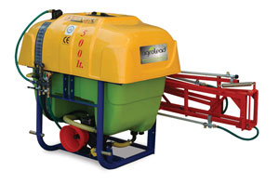

tractor mounted sprayer

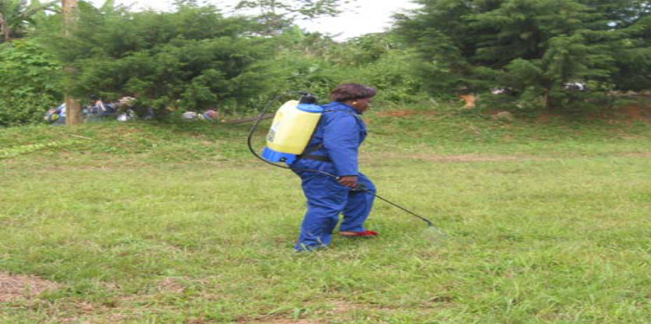

A knapsack sprayer is widely used in agriculture. Chemicals are used for a variety of purposes on a farm such as controlling pests, diseases and even weeds. For this reason, a sprayer is very important on a farm and the operator should be aware of all the safety precautions associated with its use.
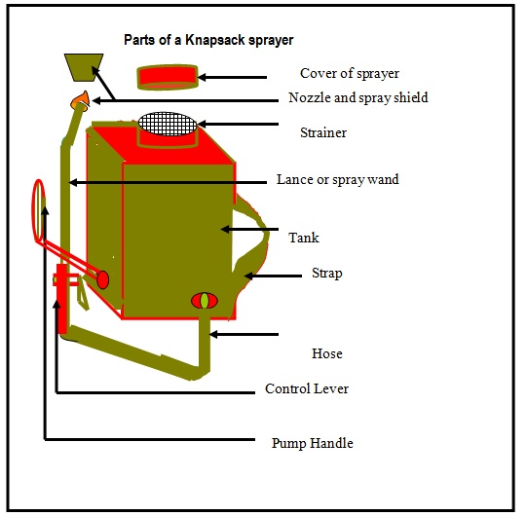
Sprinkler heads and nozzles
Types of materials that sprinkler heads and nozzles are made.
· Metal (generally brass)
· Plastic
· Combination metal and plastic
The most common sprinkler units are:
- mobile multi sprinkler lines
- mobile multi sprinkler lines with lateral flexible hoses
- travelling sprinkler unit with hose winch
- center pivot: travelling sprinkler line

- Hoe and Machete Cultivation
These tools are used for weed controlling. Weeding with hand tools is an effective method if sufficient labor is available. However, small farmers who rely on this method commonly fall behind in weeding, and crop yields often suffer.
- spike tooth harrow
Spike tooth harrow can also be used to control emerging weeds up until the crop is about 7.5-10 cm (3-4) tall without serious damage.
- pump
The pumping station is located at the water source, and the pump lifts the water and makes it available under pressure to the system. The pump is required to overcome
Elevation differences between the water source and the field, counteract frictional losses within the system, and provide adequate pressure at the nozzle for good water Distribution. A gravity flow system uses the potential energy in an elevation drop to create pressure for its operation.

5.7. Carrying out pre operational and safety checks on equipment and machinery

5.7.1. Checking machinery
A very good safety habit to adopt is to conduct daily pre-operational checks of machinery and equipment each day before you use them. Pre-operation checks are not only a good safety practice, they can also save you a lot of money in maintenance and downtime costs.
If you find any problems during your pre-operational check, make sure you correct the problem before using the machine.

For example, before operating a machine it is important to;
- Walk around and look at all fluid levels such as engine oil, coolant, fuel, and hydraulic fluid.
- Look underneath the tractor; do you see any big leaks or puddles of fluid that have accumulated under the tractor?
- Look closely at the tires. Do they look properly inflated?
- Check the batteries to make sure they are securely held down; the connections are clean and the electrolyte level is good.
- As you are walking around, look for any obvious damage like cracked or broken parts, leaking or damaged hoses.
- Make sure that the steps are clean of any grease or mud that could cause you to slip.
- Check to see that the operator’s platform or cab is free of any objects that could interfere with the operation of the tractor. If you have a cab tractor, keep the windows clean for good visibility.
- Properly adjust the seat for a comfortable position. Check the seatbelt to see if it is functioning

5.7.2. Identification of unsafe and faulty machinery and equipment

Any piece of equipment (including tools and furniture) identified as unsafe, either in normal day-to-day activities or during a safety inspection, must be promptly tagged using a tag out (danger) tag. then further action must be taken for repair or disposal. Equipment identified as faulty should be disconnected and tagged, and appropriate service people contacted to arrange repair or replacement.
Think, plan and check
- Lockout procedure must be employed whenever a piece of equipment is being repaired and there is the possibility of that equipment being switched on without the knowledge of the repairer.
- Identify all parts of any equipment or system that needs to be shut down.
- Find the switches, valves or other devices that need to be switched off.
- Follow the correct procedure for the shutdown of equipment so you don’t endanger anyone.

5.7.3. Receiving instruction

- Tell all staff potentially affected by the tag out of that piece of equipment
- confirm all equipment located
- Make sure all personnel are informed of any potential danger.
- Verify that the main disconnect switch or circuit breaker cannot be accidentally turned on.
- Only an authorized person who has been directly notified of the repairs by the service person should remove the tag out tag and lockout device.
- Notify all users of the equipment that the tag out tag has been removed.
- Unsafe equipment should be reported by the staff member to their supervisor.

Self-Check – 5

Name…………………………………………… ID………………………… Date…….

Directions: Answer all the questions listed below.

Test I: Short Answer Questions

      - List reasons for weed management? (5)
      - List major insect pest of field crop(5pts)
      - List major diseases pest of field crop(5pts)
      - Enumerate and describe hand tools, machinery and equipment appropriate to job requirements (5 pts)
      - Enumerate and describe Hazard of pesticides? (5 pts)
      - How Chemicals Load into Soil and Ground (5pts)?
      - Explain Effect of fertilizer on soil ph. (5pts)?
      - Explain Nature of irrigation-induced salinity (5pts)

Note: Satisfactory rating – 35 and above points Unsatisfactory - below 35 points

You can ask you teacher for the copy of the correct answers.

You can ask you teacher for the copy of the correct answers.

LG #6 | LO #6- Undertaking Crop Maintenance Operations

Instruction sheet
This learning guide is developed to provide you the necessary information regarding the following content coverage and topics:
- Applying agronomic practice
- Understanding pre and post harvesting handling
- Undertaking field crop maintenance operations
- Identifying and applying crop pest management
- Operating crop regulation tools, equipment and machinery
This guide will also assist you to attain the learning outcomes stated in the cover page. Specifically, upon completion of this learning guide, you will be able to:
- Apply agronomic practice and Instructions about field crop maintenance activities
- Undertake the crop maintenance operations according to principles and OHS requirements
- Identify and apply crop pest management activities
- Operate crop regulation tools, equipment and machinery safely and effectively
- Use and maintain suitable personal protective equipment
Learning Instructions:
Read the specific objectives of this Learning Guide.
Follow the instructions described below.
Read the information written in the information Sheets
Accomplish the Self-checks
Perform Operation Sheets
Do the “LAP test”

Information Sheet 6

Applying agronomic practice

Providing weed control program

A weed is generally defined as any plant that is out of place. The chances of a farmer losing his entire crop to weeds is relatively inaccessible, nevertheless, weeds cause a great deal of damage each year. Weeds prevent plants from growing well they take out of the soil the mineral salts that the crops need. But weeds are not always bad for farmers same examples
- Some weeds can be used as additional forage for livestock.
- Other weeds can be returned to the soil to increase OM.
- Weeds provides shelter to many beneficial insects.
The major goal of weed control is to reduce the competition with cultivated crops. The elimination of weeds from a field is impossible.
Weeding – is the removal of unwanted plants that grow together with the crops.
To minimize competition weeding should be at various stages of plant growth.
Reasons for Weeding
  - To reduce the competition for plant nutrient, water and sunlight with our crops.
  - To improve the quality of the harvest
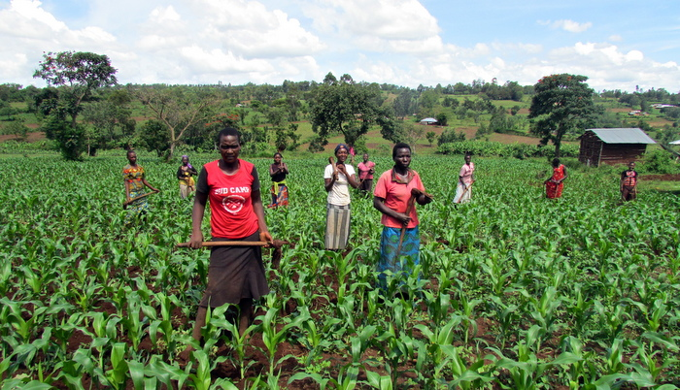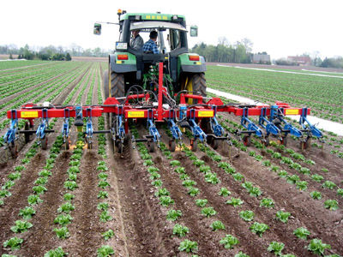

- Weed control methods

- There are four main systems of controlling weeds:
- Preventative (not letting weeds become established)
- Cultural (practices like adjusting planting date that aid or deter weed development)
- Mechanical (cultivation or hand pulling as examples)
- Chemical (herbicide application)
A. Preventative weed control
- Control weeds in non‐cropland areas,
- Plant only high-quality weed‐free crop seed
- Do not spread manure, hay, crop residues, etc. contaminated with weed seed on crop land
- Clean farm machinery between fields
B.Cultural weed control
- Adjusting row spacing
- Proper planting date and seed rate
- Using resistant varieties
- Adequate soil fertility
- Adequate drainage
- Seed treatments
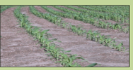

- Mechanical weed control
- Physical disruption of the environment
- Tillage
- Cultivation and rotary hoeing
- Mulching
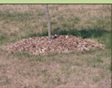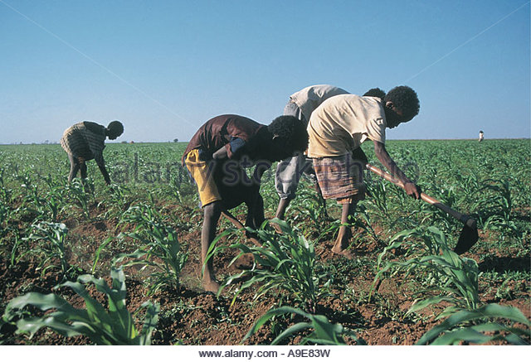

- Chemical weed control
- Herbicide use
- Selective
- Nonselective
- Rate and timing are critical
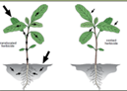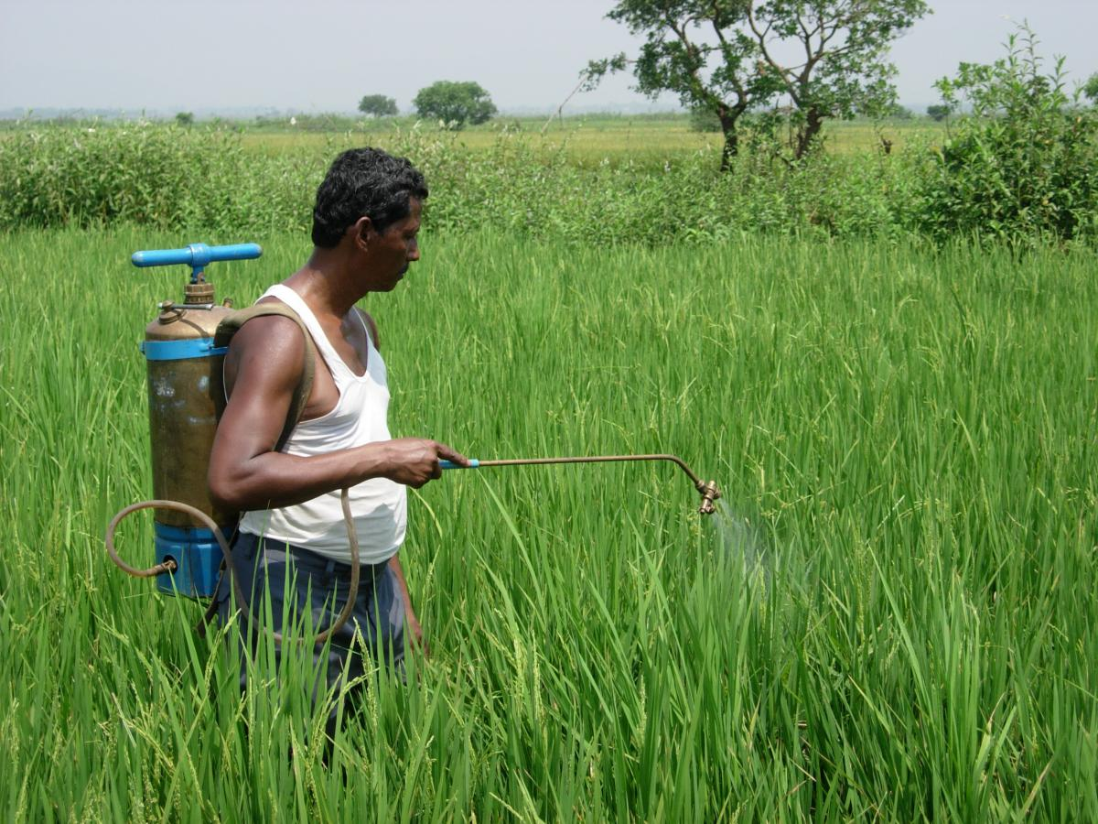

6.1.2. Providing pest and disease control program
Diseases: - Plant diseases can be defined as harmful alteration of the normal physiological process of the plant.
Disease Triangle: - Interaction of the three elements is necessary for plant disease to develop (1) A susceptible host (2) A pathogen (disease causing agent) (3) a favorable environment for disease development.

A pathogen

Susceptible Host Favorable environment
- Types of Diseases

- Parasitic and
- Non-parasitic Diseases
- Parasitic diseases are caused by፡ Fungi, Bacteria, Nematodes and Viruses that invade plants and multiply within their tissues.
- Non-parasitic diseases are caused by unfavorable growing conditions such as:
- Excesses, deficiencies or imbalances of soil nutrients
- Excessive soil acidity or alkalinity
- Temperature extremes
- Poor drainage or drought
- Mechanical, fertilizer or pesticide injury
- Air pollutants like ozone and sulfur dioxide

- Fungal Diseases

Fungi are actually tiny parasitic plants without roots, leaves or chlorophyll which feed on living or decaying organic matter. They reproduce and spread by means of microscopic seeds called spores. Some fungi, such as those that help break down crop residues into humus, are beneficial. Fungi can penetrate directly into seed, leaf or rock tissue or can enter through wounds or natural openings. General types of fungal diseases are leaf spots leading to possible defoliation; rotting of seeds, stems, stalks, roots, grain heads, pods, and ears; and storage molds and wilts.

- Bacterial Diseases
Bacteria are microscopic single cell organisms that multiply by cell divisor. Like the fungi, some bacteria are beneficial and perform essential functions like converting unavailable organic forms of soil nutrients to available inorganic (mineral) forms. Others invade plants and cause diseases that produce leaf spots, wilts, galls, and fruit and
Stem rots. For several reasons, bacterial diseases are generally much less prevalent than fungal diseases.

- Viral Diseases
Viruses are microscopic particles consisting of a core of nucleic acid (genetic material) surrounded by a protein coat. Viruses can multiply by diverting living host cells into the
production of more virus particles and can also mutate to produce different strains. They are largely spread by sucking insects such as aphids, leafhoppers, and trips. The relationship between these insect vectors (insect that transmit disease) and the viruses is sometimes very specific. For example, peanut rosette virus is transmitted by only one species of Aphid. Weeds are susceptible to certain viruses and serve as alternate hosts for viral diseases which are transmitted by sucking insects to crops. Viruses usually do not kill plants, but can greatly reduce yields and quality.

- Controlling Major Disease of Field Crops
Controlling includes all the measures taken to reduce the damage caused by disease causing agents below that causes economic threshold level. There are two primary methods of managing a plant disease:
    - Preventing the disease from developing, and
    - Suppressing the disease after it has occurred.

A) Cultural Control
Use of healthy seed from known source: A rapidly growing agribusiness in many communities is the production and sale of disease-free planting material and certified seed. Crop seeds such as maize and wheat should be treated to prevent the spread of fungal and bacterial diseases.
Proper Crop Rotation: Crop rotation will rarely eliminate a pathogen, but it may break the pathogen’s life cycle. The use of non-host plant will greatly reduce the survival of plant pathogens between seasons. Most pathogens do not survive well if a host plant is not available. Crop rotation will thus reduce the pathogen level in the soil.
Removal of Crop Residue: Many pathogens live in residue. Removal of crop residue is an excellent means of disrupting the over-wintering and survival of plant pathogens
Correcting Potassium Deficiency in the Soil: potassium induces disease resistance in plants, therefore it is always advisable to give balanced fertilizers. If only N is given then it leads to luxuriant crop growth which favors disease infestation
Maintaining Planting Time & Optimum Plant Population: The plant may avoid being inflected under certain environmental conditions by modification the planting time. Plant population affects the light, temperature and soil moisture near the soil surface. Disease development will be repressed under an adverse environment in optimum plant population.
For example, planting winter wheat when soil temperature is too high may result in increased damage from root-rotting fungi.
Balanced application of fertilizers: Excessive nitrogen keeps plant in a succulent condition, which often make more susceptible to disease. Potassium deficiency also makes plants more susceptible to disease. The skillful formation and application of fertilizer are critical to vigorous plant growth.

B) Mechanical Control
Proper Tillage Practice: Removing of crop residues and cleaning the land with tillage is a good farming practice. Placing planting material and seeds at the proper depth in an undamaged condition is critical. Planting too deep will delay germination and emergence, giving disease organisms a better chance to infect the plant.
Removing & Burning Disease Plants (Phytosanitation): Diseased plants are sources of the pathogen that spread to healthy plants. Removing & burning disease plants may prevent pathogen from spreading to the healthy plants.
Host Plant Resistant: Use of resistant varieties: Resistant varieties are some cultivars that have the ability to avoid a disease attack, or tolerate the presence of diseases to a greater degree than other cultivars. Resistant varieties limit the development of plant diseases. It is effective, economic and environmentally friendly method of plant disease management.
C) Chemical Control
Use of properly, approved wide-spectrum pesticides can effectively control some pathogens. Most of the chemicals used in the control of pathogens are classified as fungicides. A small number of bactericides and nematicides are available.
Sulfur and copper were among the first chemicals used to control plant diseases by helping from a barrier against disease organisms. Such chemical compounds which help to protect the plant are applied to its surface before the pathogen arrives.
Systemic-type chemicals enter the host plant and help provide protection from plant diseases from within the plant. They can be used to treat diseases which are already present within the plant.
Table 6.1.2: Important fungicides and their function
Fungicide | Diseases can be controlled
Zineb | Rust of wheat, barley; downy mildew; anthracnose
Thiram | Dressing seed: smut of wheat, barley, maize Spraying: downy mildew
Chlorothalonil | Northern blight of maize; rust, black rot of peanut; late blight, downy mildew of potato
Carbendazim | Smut, head blight of cereals; wilt, anthracnose of cotton; wilt, root rot of peanut; potato black rot; sheath blight of cereals
Baviston | Powdery mildew of cereals, vegetables, tobacco

Controlling Major Insect Pests of Field Crops

Controlling Methods of Insect Pests of Field Crops: Indiscriminate use of broad-spectrum chemical agents is considered unwise, as it destroys both beneficial and harmful insects. A combination of chemical, mechanical, cultural and biological techniques is being recommended to minimize adverse effects on the environment while conserving natural control agents. Integrated pest management has been defined as the selection of management practices that promote favorable economic, ecological, and sociological outcomes.

          - Cultural Control
Modification of Planting/sowing and Harvesting Dates: Modification of ideal planting date may avoid excessive reduction of crop yield. For example, Management of Hessian fly population is aided by destroying volunteer wheat during the summer and sowing wheat after fly-free date. This technique may reduce the opportunities for Hessian fly females to lay eggs. Some insects can be kept under control by harvesting the crop early.
Planting Resistant Varieties: Planting resistant varieties may reduce pest populations. Wheat varieties should be resistant to Hessian fly and sorghum varieties resistant to green bugs.
Deep Plowing: A number of insects that infest the wheat crop can be prevented from emerging by plowing under the wheat stubble after harvest.
Deep Plowing/Tillage: Timely tillage practices throughout the growing season may help destroy insect cocoons and eggs by exposing them to the sun or bury them so deeply that the insects cannot emerge.
Crop Rotation: Rotating crops have been proved to be an effective control measure for those insects with specialized feeding habits.

B) Mechanical Control
Hand picking and killing: is one of the earliest methods of pest control and is still regarded as a profitable method for the removal of large sized insects and their larvae from plants.
Trapping: trapping of insects by either using light trap or pheromone traps which attract insects.
Hindrance: Coating the fruit with bag: Fruit covered with a bag may avoid being damaged by insects.
Digging groove: Some insects such as armyworm cannot pass the groove.
Temperature, Moisture Adjustment
Sunlight: Many insects die above 50 ºC and cannot live in dry environment.
Boiled water: Treated with boiled water for 25-30 seconds, the insects in the seed will die.
Low temperature: Many insects stop reproducing under the temperature of 3-10 ºC.
Radiation and Laser Treatment: Most insects cannot live or reproduce under the radiation and laser.

C) Chemical Control
A registered insecticide is one that has been approved, following extensive scientific research to prove its reliability, ability to selectively kill insects, and safety to humans when used at recommended rates on the appropriate crop and under proper conditions.
A stomach poison is one that attacks the internal organs of the insect after the material has been swallowed. Contact insecticides kill when the material comes into contact with the insect and is absorbed through the external parts of the insect’s body. The insecticide is sprayed where the insects can come into contact with the poison.
Fumigant insecticides enter the insect’s body through the breathing tubes of its skin as a gas. They can be used to kill many kinds of insects and nematodes that attack the root system of growing plants.
A relatively new group of insect poisons are classified as systemic insecticides. A systemic insecticide is absorbed by the plant or animal, and the insect is killed when it feeds on the plant or animal.
D) Integrated pest management: despite the 5 million tons of pesticides being applied every year, pests around the globe still destroy about 35% of all potential crops before harvest, strongly indicating that the use of pesticides has been only marginally successful at improving agricultural productivity. The hazards associated with pesticide use are well known, of which contamination of the environment is most pronounced. So, it gives rise to the concept of biological control based on integrated pest management (IPM) system where biological control agents are seen as essential and of first priority in building IPM systems. The methods and components of IPM include cultural, mechanical/physical, biological and use of environmentally friendly chemicals.
IPM approaches are based on the following assumptions:
- For pest control do not depend on any single pest control measures but integrate two or more measures like cultural, mechanical, biological and environmentally friendly chemicals.
- Chemicals should be last options and used when it is necessary
- The control measures should be economical
- The control measures should be environmentally friendly

6.1.3. Providing nutrition program

Nutrition is crucial to sustained production. Highly weathered being inherently low in nutrient reserves, must have a regular and supplemental nutrient supply to facilitate intensive cultivation for increased food production. Intensive land use and high yields on soils of low inherent fertility can be achieved only by raising the nutrient levels through the use of inorganic fertilizers, organic amendments, and nutrient recycling. Nutrient enhancement for these soils is indispensable. Although crop production can be increased by increasing fertilizer use, many small land holders and resource-poor farmers cannot afford the expense.
A combination of inorganic and organic fertilizers is a useful strategy to minimize dependence on synthetic fertilizers, and enhance soil structure and physical characteristics. The rate of application of inorganic fertilizers can also be reduced by minimizing losses and increasing the recycling of nutrients. Losses by volatilization, Leaching and erosion can be controlled through conservation tillage, timely application by split doses, fertilizer placement, and slow-release formulations.
- Determining fertilizer needs
The amount of nutrients that different crops must absorb from the soil to produce a given yield is fairly well known. Yet proper fertilization is not a simple matter of adding this amount for several reasons:
- The farmer needs to know what share of the nutrients are already in the soil in available form.
- A plant's ability to recover nutrients, whether from fertilizer or natural soil sources, depends on the type of crop, the particular soil's capacity to tie up different nutrients, weather conditions (sunlight, rainfall, and temperature), and leaching losses, physical soil factors like drainage and compaction, and insect and disease problems.
- Methods of determining fertilizer needs
- Soil testing
- Plant tissue testing
- Fertilizer trials
- Spotting visual "hunger signs"
- Making an educated guess
- Soil Testing
Soil testing by a reliable laboratory is the most accurate and convenient method for determining fertilizer rates.
- Plant Tissue Tests
Tissue tests are best used to supplement soil test data, since the results can be tricky to interpret by non-professionals. The crop can be tissue-tested while growing in the field for N-P-K levels in the sap. Deficiencies of one nutrient such as N can stunt plant size and cause P and K to the plant sap, giving falsely high readings.

- Fertilizer Trials
Severe nutrient deficiencies usually produce characteristic changes in plant appearance, particularly in color. Spotting these "hunger signs" can be useful in determining fertilizer needs.
- Making an Educated Guess
If no soil test results are available for a farmer's field, a reasonable estimate of N-P-K needs can be made based on at least four or more of the following criteria:
- Available soil test results from nearby farms with the same soil type and a similar liming and fertilizer history.
- Data from fertilizer trials on the same soil type.
- An extension pamphlet on the crop with fertilizer recommendations for the area soils. · The particular crop's relative nutrient needs.
- A thorough examination of the soil for depth, drainage, texture, filth, slope, and other factors that may limit yields or fertilizer response, including soil pH.
- Yield history and past management of the farm regarding fertilizer and liming.
- The farmer's management ability, available capital, and willingness to use complementary.

- Fertilizer types and how to use them
Chemical fertilizers supply only nutrients and exert no beneficial effects on soil physical condition. Organic fertilizers do both. However, compost and manure are very Low-strength fertilizers; 100kg of 10-5-10 chemical fertilizer contains about the same amount of NP-K as 2000 kg of average farm manure. The organic fertilizers need to be applied at very high rates (about 20,000-40,000 kg/ha per year) to make up for their low nutrient content and to supply enough humus to measurably improve soil physical Condition.
- Guidelines for applying organic fertilizer
- To avoid “burning" the crop seeds and seedlings, fresh manure should be applied at least a couple of weeks in advance; rotted manure is unlikely to cause·
- Organic fertilizer containing large amounts of straw may actually cause a temporary N deficiency unless some fertilizer N is added.
- If quantities are limited, farmers are better off using moderate rates over a larger area rather than a high rate on a small area.
- Manure also can be applied in strips or slots centered over the row if farmers are willing to make the extra effort involved. This is a good way to use scarce amounts. Fresh manure may burn crop if not mixed well with the soil.
- Basic guidelines for applying chemical fertilizers

- Nitrogen

When fertilizing maize, sorghum, and millet, one-third to one-half of the total N should be applied at planting time. This first application will usually be in the form of an N-P or N-P-K fertilizer. The remaining N should be applied in one to two side dressings (fertilizer applications made along the row while the crop is growing) later on in the growing season when the plants' N usage has increased. A straight N fertilizer like urea (4546 percent N), ammonium sulfate (2021 percent N) or ammonium nitrate (33-34 percent N) is recommended for side dressings. When one side dressing is to be made, it is usually best applied when the crops are about knee-high (25-35 days after plant emergence in warm areas). On very sandy soils or under high rainfall, two side dressings may be needed and are best applied at the knee-high and flowering stages.

- Phosphorus
Phosphorus is virtually immobile in the soil. This means that fertilizers containing P should be placed at least 7.5-10 cm deep to assure good root uptake. The roots of most crops are not very active close to the soil surface (unless some form of mulching is used) since the soil dries out so readily. For these reasons, all the P fertilizer should be applied at planting time:
- Young seedlings need a high concentration of P in their tissues for good early growth and root development.
- Phosphorus does not leach, so there is no need to make additional side dressings.
- To be effective as a side dressing, P would also need to be placed deep (except on a heavily mulched soil), and this might damage the roots.
NOTE: Many farmers waste money by side dressing with N-P, N-P-K or P fertilizers after already applying P at planting. Others do not apply P until the crop is several weeks old In either case, crop yields suffer.

- Potassium
Potassium ranks midway between N and P in terms of leaching losses. As with P, all the K can usually be applied at planting time, often as part of an N-P-K fertilizer. Where leaching losses are likely to be high (very sandy soils or very high rainfall), split applications of K are sometimes recommended.
Unlike N and P, about two thirds of the K that plants extract from the soil ends up in the leaves and stalks rather than in the grain. Returning crop residues to the soil is a good Way of recycling K. Burning them will not destroy the K, but will result in the loss of their N, sulfur, and organic matter.
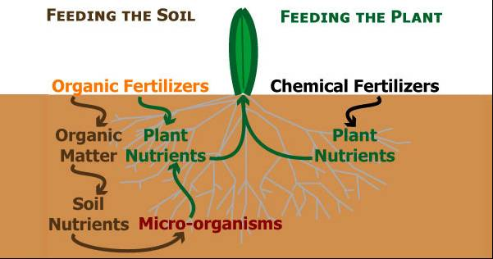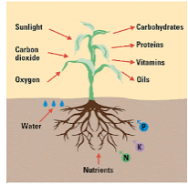
Fig 6.1.3: Summary of plant nutrition

- Fertilizer application methods

- Broadcasting
- Banding
- Side dressing
- Top dressing
- Fertigation
- Foliage Spraying

- Broadcasting
Broadcasting refers to spreading the fertilizer evenly over the soil surface with or without working it into the soil
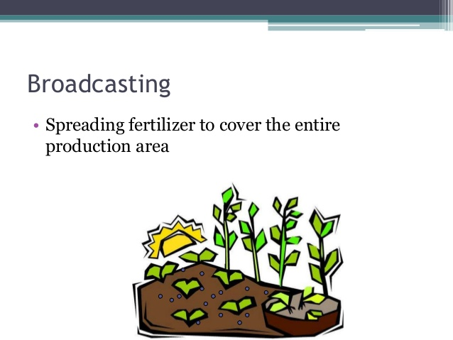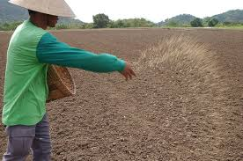

- Banding
- Fertilizer is placed near the seed
- Usually used on row crops
- Fertilizer is placed 5cm below and to the side of the seed
- Keeps it from injuring the seedling
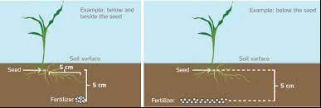

- Side dressing
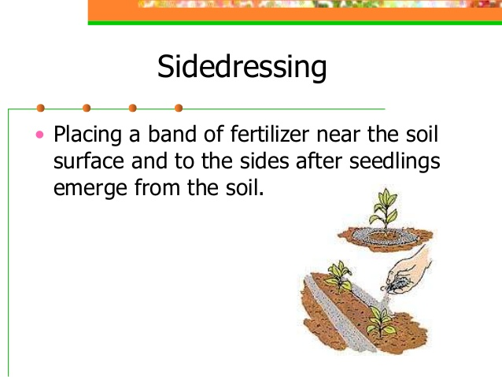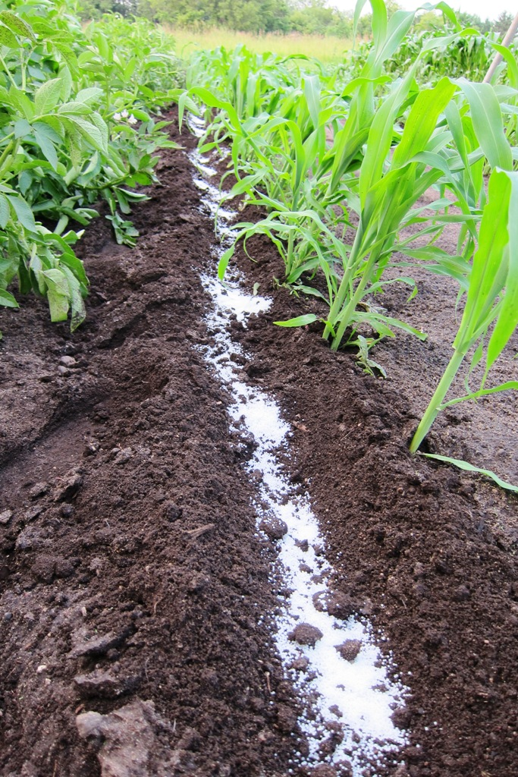

- Top dressing
Applying a second application to the soil surface. Used mainly on; Small grains, Legumes, Grasses.
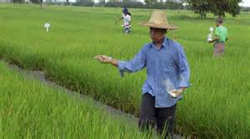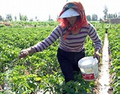

- Fertigation
Applying fertilizer through irrigation water. works best with; Nitrogen, Potassium, most effective when water is uniformly distributed, most efficient in a sprinkler-type irrigation system
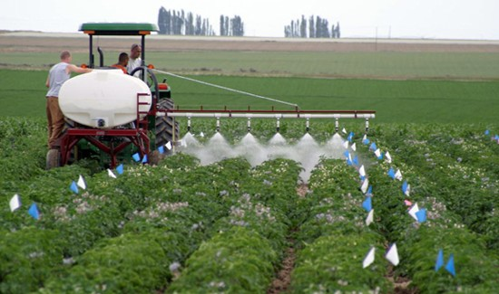
- Foliage Spraying
Satisfactory when trace elements are needed immediately. nutrients must be applied to sandy soils. Popular on; Citrus and Ornamental crops
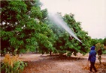

Providing paddock maintenance program

- Protection from grazing
Crops may also be harmed by animals. Cattle, sheep, goats and sometimes wild animals must be kept out of the plantation until the trees are big enough to withstand grazing. This problem is most acute in dry areas with sparse vegetation where animals turn to planted trees for food. Without the cooperation of the livestock owner’s protection will be difficult. It is therefore essential to discuss the problem very early during planning and to meet regularly after planting to sort out problems. When bigger areas representing a large portion of the accessible grazing lands are being planted and where grazing is scarce, it might be necessary to divide the planting area into compartments and to plant them one at a time.

The livestock is then allowed into the first compartment when the second one is being planted some years later, and so on. In this way the area where grazing has to be avoided is minimized. It may also be necessary to use species that are not readily grazed by the animals (for example proposes ailanthus and some eucalyptus). If these measures are not sufficient, fences should be built before or during planting.
For smaller plantations fences can be built with branches cut from thorny trees or other suitable material to protect the plants for the first couple of years. However, these lands of fences require a large quantity of branches and may put an additional pressure on an already stressed forest or bush land. Hedges of closely planted bushes and trees (live fences) can also be created. Thorny plants such as Cactus, Euphorbia, Aloe, Sisal, Acacia or Junipers can be used. Species that can be grown from large cuttings are preferable. Live fences must, however, be planted some years before the trees are planted and be given time to reach a sufficient size to keep out the animals.

Providing irrigation program

Irrigation: -the artificial supply of water to support plant growth and production in the absence of adequate supply of water through rainfall is known as irrigation.

- Importance of irrigation
Plants need adequate supply of water for their normal growth and production. Where there is a shortage of water, particularly during critical growth stages like flowering and fruiting, there can be drastic reduction in yield, hence the necessity of irrigation to make up this deficiency of water.

- System of irrigation
There are four systems of irrigation. These are: -
- Surface irrigation
In surface irrigation systems, water moves over and across the land by simple gravity flow in order to wet it and to infiltrate into the soil. Surface irrigation can be subdivided into flooding, basin method, furrow method and ring method. This system is simple and cheap, and is widely used by societies in less developed parts of the world as well as in the U.S. The problem is, about one-half of the water used ends up not getting to the crops. The system is used when there is:
- ample water supply
- on medium to fine texture soils
- on uniform sloping land with slopes ranging from 0-1%
- Sub-surface irrigation/Drip irrigation
In this system, water is led into underground perforated pipes. Water slowly reaches the root regions by the upward capillary movement.
Drip or trickle Irrigation: For irrigating fruits and vegetables this method is much more efficient than flood irrigation. Water is sent through plastic pipes (with holes in them) that are either laid along the rows of crops or even buried along their root lines finally out through mechanical devices called emitters. Evaporation is cut way down, and up to one-fourth of the water used is saved, as compared to flood irrigation. Water is delivered at or near the root zone of plants, drop by drop. This method can be the most water-efficient method of irrigation, if managed properly, since evaporation and runoff are minimized. In modern agriculture, drip irrigation is often combined with plastic mulch, further reducing evaporation, and is also the means of delivery of fertilizer. The process is known as Fertigation.
Drip irrigation is used where there is:
- water scarcity
- a very low water holding capacity of soils
- a very high or low infiltration rate and drainage of excess irrigation water is difficult
- water salinity
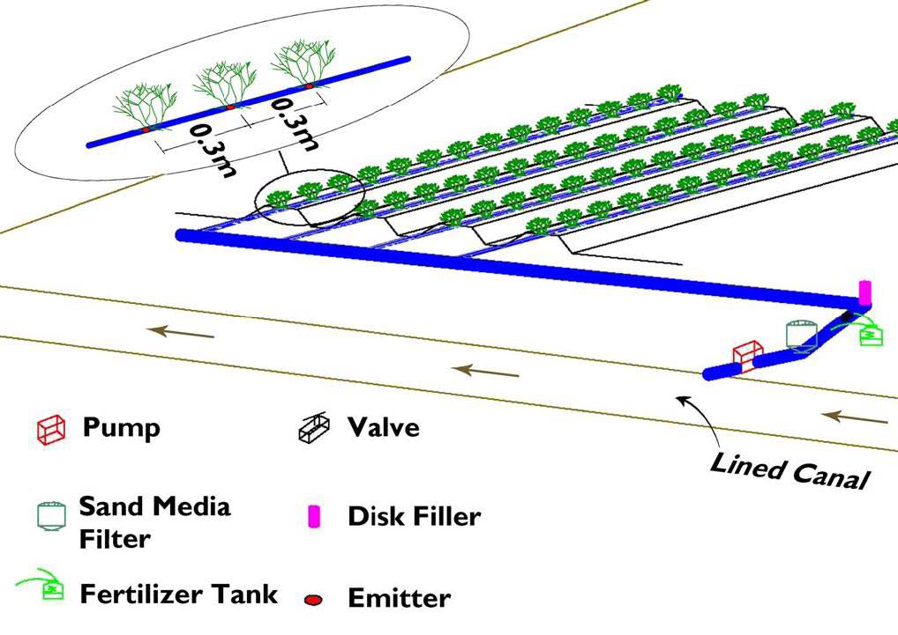

- Spray Irrigation:

Spray irrigation is a more modern way of irrigating, but it also requires machinery. This system is similar to the way you might water your lawn at home - stand there with a hose and spray the water out in all directions. Large scale spray irrigation systems are in use on large farms today. These systems have a long tube fixed at one end to the water source, such as a well. Water flows through the tube and is shot out by a system of spray-guns.
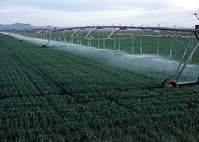
D. Sprinkler system
In sprinkler or overhead irrigation, water is piped to one or more central locations within the field and distributed by overhead high-pressure sprinklers or guns. A system utilizing sprinklers, sprays, or guns mounted overhead on permanently installed risers is often referred to as a solid-set irrigation system
Sprinkler irrigation is used where there is:
- water scarcity
- soils with low water holding capacity and high infiltration rate
- irregular topography and soils too shallow to be levelled
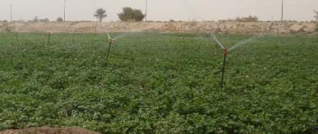

6.2. Understanding pre and post harvesting handling

6.2.1. Crop Maturity Concepts

There is a relationship of moisture to maturity in crops that determines the most optimum time for harvest and the best conditions for storage. Plants reach maximum dry weight at physiological maturity. This maturity usually refers to the maximum dry weight of the total plant, but in grain crops this term is often associated with the maximum dry weight of the seed. At as high a moisture content as 40 percent, most grains have already accumulated their maximum dry weight although this moisture percentage may vary by 5 to 10 percent depending on crop species and variety. If one harvests before physiological maturity is reached, the effect is lower yield, lower quality, lower starch/sugar content, shriveled kernels and lower test weight. Just because physiological maturity has been reached, however, this point may not be the optimum moisture content to store the crop.

Harvest maturity is the point at which the crop is at the best combination of yield and quality and at or close to a moisture content at which the forage or seed may be stored. As you might guess, the optimum moisture content for different harvested grains varies depending on the crop use and the harvesting equipment available as well as any environmental conditions that allow harvest to proceed. Harvesting at physiological
maturity but before proper harvest maturity can result in crop damage due to mechanical damage
to kernels, spoilage in storage, and even field losses due to harvesting equipment not properly picking up all of the crop or grain.
Problems with High-Moisture Grain or Silage
  - storage time for the crop is reduced (spoilage can accelerate)
  - fines may be numerous when excessive grain damage during harvest occurs which then interferes with grade, quality and storage life
  - fractures to grain during harvest to high moisture seed exposes the grain to mold and insect attack in storage, again lessening storage life
  - visual appearance of the grain or silage can be poor, lessening grade and quality as well as possibly increasing the risk toward spoilage

Harvest maturity for most forages’ ranges from 70 to 85 percent moisture concentration on a fresh weight basis and depending on the forage species, fertility regime the crop was grown under, the weather conditions and other production factors.

Delaying harvest until after the grain or forage has reached proper harvest maturity can also result in yield loss. Seed or ear losses as well as stalk lodging in the crop may lower yield. Crop quality may also be compromised as lower bushel weight, lower seed germ and even deteriorated grain due to field weathering and losses. In forages such as alfalfa, digestibility decreases about
0.5 percent a day beyond the early flowering stage of alfalfa, intake decreases about 0.5 percent or more per day beyond the early flowering stage of alfalfa, and thus the feeding value decreases about one percent (0.5 + 0.5) per day when harvest is delayed beyond the early flowering stage.
Each quality factor loss is an expensive penalty to the producer for poor timeliness in harvesting.
Especially with forages, there exists the common misconception that higher yields may be obtained if harvest is delayed. Indeed, in some cases, dry matter may increase but forage quality may be decreasing making the harvested feed nutrients less than a crop harvested in a timely manner. In crops that have multiple cuttings within the season such as alfalfa, a late first cutting gives less of a growing season for subsequent harvests, resulting in lower dry matter yields for the entire growing season. In hay crops, color, leafiness, protein content and digestibility are all affected by the stage of maturity when the crop is cut. Digestible dry matter (DDM), intake and crude protein also decrease with delays in harvest.

6.3. Undertaking field crop maintenance operations

Maintenance of crop health is essential for successful farming for both yield and quality of produce. This requires long-term strategies for the minimization of pest and disease occurrence preferably by enhancing natural control mechanisms, growing a healthy crop.
Crop maintenance practices important for proper crop growth include:

- Weeding
- Soil cultivation
- Irrigation
- Mowing
- Nutrition program
- Insect pest and disease control
- Removal of standing water
- Pruning

6.4. Identifying and applying crop pest management

6.4.1. Characteristics of pests

When we speak of crop pests, we mean all organisms that threaten the quality and yield of crops. These can be higher animals, such as rats, mice and birds, but they are more often lower animals, such as insects, mites, nematodes (microscopically small worms) or snails. Microorganisms, such as fungi, bacteria and viruses, can also cause harmful plant diseases. Higher plants, acting as weeds, can be classified as pests as well. However, the mere presence of these organisms on your farm does not make them pests.
Of course, not all plants and animals found on your farm can develop into pests. All potential crop pests share the following characteristics:
- They can damage individual plants in a crop.
- Under favourable conditions, they can multiply very rapidly.
- They harm the farmer because the damage they cause reduces the yield or quality of the harvested product, or can only be controlled at great expense.

6.4.2. Disease Management
Successful control of crop diseases requires an integrated program that includes the use of resistant varieties, crop rotation, balanced soil fertility, weed and insect control, and proper crop culture, as well as the proper selection, timing, and method of applying fungicides, bactericides, or nematocides. Economical control depends on establishing an overall disease management system for the entire farm. Keeping careful records of the crops planted, the problems encountered, and the pesticides used are important.
This is an approach that utilizes different techniques other than the use of chemical pesticides to control pests. It involves natural pest population-control methods, including cultural and biological controls the use of botanical pesticides as needed.

6.4.3. Cultural method of pest control

These methods are aimed either at reducing the sources of inoculums or at reducing the exposure of plants to infection. Its primary objective is the prevention of pest damage and not the destruction of an existing and damaging pest population.
1. Good soil preparation
This is the first important element in pest control strategy. A healthy soil means healthy plants which are relatively more resistant to pests.
2. Use of indigenous varieties
Traditional varieties are hardier and relatively more resistant to pests. They can withstand harsh environmental conditions better than modem hybrids.
3. Pest control through the use of mesh screen (nylon nets)
Younger plants are usually preferred by insects and they suffer significantly from such attacks when compared to older plants.
4. Multiple cropping
This provides genetic diversity to minimize pest increase. Variation in susceptibility among species or varieties to a particular disease is great.
5. Crop rotation
This is a practice of following a crop susceptible to a pest by a resistant crop. There is no build-up of the organism to a high level since the growth cycle of the organism has been broken.

6.4.4. Biological pest control
Biological pest control is the suppression of pest populations by living organisms such as predators, parasites and pathogens. These agents are responsible for keeping pests under control most of the time. Predators are usually other insects and spiders. Both, but particularly spiders, feed on a wide range of insects.

6.4.5. Disease control
The best way to ensure success of a disease-management program is to adapt it to the diseases expected and to use integrated disease-control measures. Among these measures are resistant or tolerant varieties, crop rotations, fungicides, nematocides, and suggested agronomic practices. The success of any one or all of these measures may depend on how carefully you scout your crops. Because periodic scouting increases the likelihood that disease controls will be applied properly, it can help prevent loss through disease and unnecessary use of pesticides.
- Quarantine
Where in a diseased patch of vegetation or individual plants are isolated from other, healthy growth.
- Cultural
Farming in some societies is kept on a small scale, tended by peoples whose culture includes farming traditions going back to ancient times.

- Plant resistance
Sophisticated agricultural developments now allow growers to choose from among systematically cross-bred species to ensure the greatest hardiness in their crops, as suited for a particular region's pathological profile. Breeding practices have been perfected over centuries, but with the advent of genetic manipulation even finer control of a crop's immunity traits is possible.
- Chemical
Many natural and synthetic compounds that could be employed to combat the above threats exist. This method works by directly eliminating disease-causing organisms or curbing their spread; however, it has been shown to have too broad an effect, typically, to be good for the local ecosystem.
- Biological
Crop rotation may be an effective means to prevent a parasitic population from becoming well-established, as an organism affecting leaves would be starved when the leafy crop is replaced by a tuberous type, etc. Other means to undermine parasites without attacking them directly may exist.

- Integrated
The use of two or more of these methods in combination offers a higher chance of effectiveness.

6.4.6. Weed control

Most weeds are harmful because they compete with the crop plants for light, water and nutrients. This slows down the crop’s growth. Some plants are considered to be weeds because they are parasitic. This means that they live on the roots of plants and extract nutrients and water from the plant through direct contact. For instance, the parasitic weed Striga on the roots of a Sorghum crop. Other plants are weeds because they host pest insects or disease-causing microorganisms.

Loss of soil water through weed transpiration can seriously reduce the amount of water available to crops. Consequently, timely and effective weed control practices are essential. The presence of a thick layer of residues on the surface is a very effective way of controlling weeds. Where weed control measures are needed, the use of herbicides or appropriate crop rotations is often preferable from a conservationist perspective to mechanical weed control, unless it is practiced with no soil disturbance. Post-emergence herbicides leave weed residues on the soil surface as a protective cover whereas cultivation leaves soil exposed to the impact of raindrops and sun, accelerates drying of the surface soil and tends to disrupt and destroy soil porosity through smearing and compaction.

6.5. Operating crop regulation tools, equipment and machinery

For establishment and maintenance of field crop selecting and preparing materials, tools and equipment is the first steps. Next to this checking service ability of materials, tools and equipment is one the important ways. After serviceability of material, tools and equipment has been checked and operating (making ready) machinery, tools and equipment are the necessary steps which make land preparation activities easier and more suitable.

Self-Check – 6

Name…………………………………………… ID………………………… Date…….

Directions: Answer all the questions listed below.

Test I: Give short Answer accordingly

  - Enumerate and describe type of plant disease(5pts)
  - Write method of weed control(5pts)
  - How we determine fertilizer need of crop(5pts)
  - Describe importance of providing irrigation program for field crop(5pts)
  - List fertilizer application method(5pts)
  - What are causal agents of diseases? (4 pts)

Test II: Choice the best answer
1. Which one of the following is not disease triangle? (2pts)
A. Host C. Environment
B. Pest D. Pathogen
2. Which one of the following is correct about crop rotation? (2pts)
A. Teff –maize C. Teff- sesame –wheat
B. Sorghum- teff - maize D. Maize- legume- sesame

Note: Satisfactory rating – 25 and above points Unsatisfactory - below 25 points

You can ask you teacher for the copy of the correct answers.

You can ask you teacher for the copy of the correct answers.

Operation Sheet -6

6.1. Procedure/Techniques of weed control
- Tools, materials and equipments
- Herbicide
- Hoe and Machete Cultivation
- Animal and Tractor-drawn Cultivation
- Knapsack sprayer
- Water
- PPE
- Procedures/Steps/Techniques
Mechanical method
A) Prepare the crop for mechanical methods
1. Hand weeding
2. Mulching
3. Shading (the row crop principle)
4. Hoe and machete cultivation
5. Animal and tractor-drawn cultivation
B) Prepare the crop for chemical and calibrate the herbicides methods
    - Rinse out the tank and refill it with clean water.
    - Remove and clean all nozzles and screens. Use an old toothbrush.
    - Start the sprayer and flush the hoses and boom with plenty of clean water.
    - Replace screens and nozzles and make sure that they are of the correct spray pattern type and size.
    - Check all connections for leaks.
    - Adjust the pressure regulator to the correct pressure with the tractor engine running at field operating speed and with the nozzles running.
    - Check the water output of each nozzle and replace any that are 15 percent above or below the average.
    - Remember to: · Calibrate the sprayer using the same tractor speed and spray pressure that will be used to apply the pesticide.
    - When using water to calibrate, the spray rate of the water may differ somewhat from that of the actual pesticide-water solution due to differences in density and viscosity

6.2. Procedure/Techniques of crop nutrition
- Tools, materials and equipments
- Fertilizer (organic or inorganic)
- Animal and tractor drawn cultivator
- Fertilizer driller
- Procedures/Steps/Techniques
- Determine fertilizer needs by using;
- Soil testing
- Plant tissue testing
- Fertilizer trials
- Spotting visual "hunger signs"
- Making an educated guess
- Identify type of fertilizer NPK or other
- Select suitable method for our crop
- Broadcasting
- Localized placement (band, hole, half circle)
- Special placement considerations for furrow irrigated soils.
- Application through the irrigation water
- Foliar applications
- Provide nutrition program
6.3. Procedure/Techniques of pest and disease control

- Tools, materials and equipments
- Pesticide
- PPE
- Knapsack sprayer
- Water
- Procedures/Steps/Techniques
- Proper identification of damage and responsible pest
- Monitor pest activity or learn pest and host life cycle
- Monitor or sample environment for pest population
- Determine/establish action threshold (economic, health or aesthetic)
- Choose appropriate treatment options and make treatment
- Evaluate results.

LAP TEST-6

Name………………………………. ID…………………………….. Date…………………………………….

Time started: ________________________ Time finished: ________________

Instructions: Given necessary templates, tools and materials you are required to perform the following tasks within 4:30 hour. The project is expected from each student to do it.

Task-1 You are required to perform any of the following:
  - Perform weed control
  - You are expected to control disease, insects and weeds by using chemicals according to the recommendation given on the label by assessing the walking speed on 1x100m2 areas. Measuring output of sprayer and swath width calibrate the knapsack sprayer and find out the amount of water require for one hectare?
Assumption
- Chemicals, herbicides (round up)
- Chemical per hectare=4 liter
- Volume of tank capacity=16 liter
  - Perform nutrition program
  - Perform pest and disease control

Task 2. Request your teacher for evaluation and feedback

LG #7 | LO #7- Completing Maintenance Operations

Instruction sheet
This learning guide is developed to provide you the necessary information regarding the following content coverage and topics:
- Disposing off waste material
- Using correct manual handling techniques of heavy loads
- Cleaning, maintaining, sterilizing and storing tools and equipment
- Maintaining clean and safe work area
- Recording and reporting work activity
This guide will also assist you to attain the learning outcomes stated in the cover page. Specifically, upon completion of this learning guide, you will be able to:
- Dispose waste material removed from the site
- Use corrects manual handling techniques when lifting or moving heavy loads.
- Clean, maintain, sterilize and store tools and equipment according to the manufacturer’s specifications, procedures and regulations.
- Maintain a clean and safe work area throughout and on completion of work
- Complete and report all required workplace records accurately and promptly
Learning Instructions:
Read the specific objectives of this Learning Guide.
Follow the instructions described below.
Read the information written in the information Sheets
Accomplish the Self-checks
Perform Operation Sheets
Do the “LAP test”

Information Sheet 7

7.1. Disposing off waste material

The processing of products generates a large quantity of waste that can serve as food and shelter for pests. It is therefore very important to plan an effective waste disposal system. This system should always be maintained in good condition so it does not become a source of product contamination.
The following should be considered:
- Waste disposal systems and facilities should be provided. All refuse should be disposed of in containers with lids and stored away from the facility to prevent harborage of pests.
- Refuse containers should be emptied regularly.
- Areas for garbage recyclables and compost able waste should be identified and all waste should be stored and disposed of in a manner to minimize contamination.
- Waste should be disposed of on a frequent basis to avoid attracting pests (e.g. flies, rodents).
There are five types of west chemical
- Empty container
- Excess mixture
- Excess product
- Rinse water from container and application equipment
- Material generates from cleanup of spills and leaks

7.2. Using correct manual handling techniques of heavy loads

At the time of performing different activities, proper handling, moving and lifting of heavy load is important to minimize health risks
Proper methods of lifting and handling protect against injury. Proper lifting makes work easier. You need to "think" about what you are going to do before bending to pick up an object. Over time, safe lifting technique should become a habit.

Safe lifting and material handling means keeping your back aligned and balanced when lifting. Most standard loads fewer than 25kg can be lifted and carried safely by following these steps. You begin by bending from the knees (not the waist), tucking your pelvis and tightening your stomach muscles. You then hug the load close to you, and gradually lift yourself up using the strong muscles in your legs. When carrying the object, be sure not to twist or bend. Then, bend at the knees and slowly slide the load down your body until you can comfortably put the load down

Mechanical Aids
Not all material can (or should) be manually lifted. Carts, bins, hand trucks, dollies, and fork lifts are all mechanical aids that can help transport a load without putting undue strain on your back. Pushcarts and bins can be useful for light, awkward material handling tasks, while hand trucks and forklifts can help move heavier, stackable material. When using mechanical aids for material handling, be sure that the load is secured in place before moving, and be sure to push the device rather than pulling it. When manually moving materials, you should seek help when a load is so bulky it cannot be properly grasped or lifted, when they cannot see around or over it, or when a load cannot be safely handled. Workers also should use appropriate protective equipment as necessary to help reduce accident potential. For loads with sharp or rough edges, wear gloves or other hand and forearm protection. To avoid injuries to the hands and eyes, use gloves and eye protection. When the loads are heavy or bulky, the mover should also wear steel-toed safety shoes or boots to prevent foot injuries if the worker slips or accidentally drops a load.

When mechanically moving materials, avoid overloading the equipment by letting the weight, size, and shape of the material being moved, dictate the type of equipment used for transporting it. All materials handling equipment has rated capacities that determine the maximum weight the equipment can safely handle and the conditions under which it can handle those weights All stacked loads must be correctly piled and cross-tiered, where possible. Precautions also should be taken when stacking and storing material. Stored materials must not create a hazard. Storage areas must be kept free from accumulated materials that may cause tripping, fires, or explosions, or that may contribute to the harboring of rats and other pests. When stacking and piling materials, it's important to be aware of such factors as the materials' height and weight, how accessible the stored materials are to the user, and the condition of the containers where the materials are being stored.

The following are the basics steps of safe lifting and handling.
1. Size up the load and check overall conditions. Don't attempt the lift by yourself if the load appears to be too heavy or awkward. Check that there is enough space for movement, and that the footing is good. "Good housekeeping" ensures that you won't trip or stumble over an obstacle.
2. Make certain that your balance is good. Feet should be shoulder width apart, with one foot beside and the other foot behind the object that is to be lifted.
3. Bend (the knees; don't stop. Keep the back straight, but not vertical. (There is a difference. Tucking in the chin straightens the back.)
4. Grip the load with the palms of your hands and your fingers. The palm grip is much more secure. Tuck in the chin again to make certain your back is straight before starting to lift.
5. Use your body weight to start the load moving, then lift by pushing up with the legs. This makes full use of the strongest set of muscles.
6. Keep the arms and elbows close to the body while lifting.
7. Carry the load close to the body. Don't twist your body while carrying the load. To change direction, shift your foot position and turn your whole body.
8. Watch where you are going!
9. To lower the object, bend the knees. Don't stop. To deposit the load on a bench or shelf, place it on the edge and push it into position. Make sure your hands and feet are clear when placing the load. Make it a habit to follow the above steps when lifting anything-even a relatively light object.

7.3. Cleaning, maintaining, sterilizing and storing tools and equipment

It is absolutely critical to have good sanitation, as dirty equipment does nothing but invite bacteria and unwanted yeast to infect your mead. Some people say you cannot sanitize too much, but there is a point of diminishing returns. A general rule of thumb is to always clean and dry equipment that is going into long-term storage. Secondly, always clean and sanitize a piece of equipment before you use it. Here is some information that should allow you to make sanitizing decisions.

First of all, there are three important words we all use a lot when talking about getting our equipment scrubbed clean and ready to make mead.
CLEANING refers to the physical removal of visible dirt, residue, lees, fruit remains, etc. - usually done with scrub brushes, squeegees or a clean towel. You must clean your equipment before sanitizing it. It is impossible to sanitize equipment with visible residue on it. This is because molds, wild yeasts and bacteria like living in hidden nooks and crannies, and any sanitizing solution you might use won’t penetrate effectively into these areas.

SANITIZING means that you’re treating the surface or piece of equipment to reduce, eliminate or prevent the growth of molds, wild yeasts or bacteria to an acceptable level. It is just another way of saying that you’re killing microorganisms that can ruin your mead.

STERILIZING: When something is sterilized, it means that it is completely free of bacteria or other microorganisms. Sterilization is mostly carried out hospitals and labs.

MAINTENANCE: Tools and equipment should be kept in an appropriate state of repair and condition to facilitate cleaning and disinfection.

7.4. Maintaining clean and safe work area

Maintaining clean work environment is the responsibility of everyone. These tasks may include:
- disabling unused tools, equipment and machinery and storing neatly out of the way of field crop maintenance activities;
- safely storing materials on site;
- Using signage and safety barriers during field crop maintenance and removing them after activities are completed.
- Swiftly and efficiently removing and processing debris and waste from the work area.

7.5. Recording and reporting work activity

Record Keeping is an essential part of Agricultural activities. Management of the farm is the first reason to keep a good set of records. Record keeping can aid in planning of your activities. Your records should contain the usage of materials on fields, crops, and other related resources along with fertilizer and restricted use pesticide applications, soil amendments, and resulting crop yields. The producer can use this recorded information to determine the best amendments for subsequent crop plantings as well as to meet certain governmental reporting requirements. Record Keeping can play a major role in the success of your farm in reducing risks. A successful farm business needs records to monitor the progress of their business and help prepare financial statements. Keeping good records can determine if a farm operation is in a good condition and final evaluation of work results. Based on record kept, work out come is reported for supervisor of the work eventually. It’s essential elements cover:
    - Work performed;
    - Resources used;
    - Progress made towards interim and final objectives and targets:
    - Obstacles encountered;
    - New problems discovered;
    - New ideas and opportunities brought to the client's attention;
    - Staffing and other difficulties;
    - Suggestions for adjustments in the assignment schedule;
    - Suggestions for any other action by the client and the consultant.

Self-Check – 7

Name…………………………………………… ID………………………… Date…….

Directions: Answer all the questions listed below.

Test I: Short Answer Questions
- Describe how to dispose different kind of chemical containers(5pts)
- Discuss the importance of correct handling techniques (5 pts)
- What are correct handling techniques to lift heavy materials? (5 pts)
- Discuss the difference between sanitizing and sterilizing. (3 pts)
- What is the importance of maintaining at end of field crop establishment and maintenance? (4 pts)
- List things that considered as waste materials during field crop establishment and maintenance. (5 pts)
- Discuss the necessity of work place record keeping. (5 pts)

Note: Satisfactory rating – 25 and points Unsatisfactory - below 25 points

You can ask you teacher for the copy of the correct answers.

You can ask you teacher for the copy of the correct answers.

Operation Sheet -7.

  - Procedure/Techniques of Lifting and handling of heavy load
- Tools, material and equipments
- Glove
- Overall
- Lifter
- Wheelbarrow
- Ladder
B. Procedures/Steps/Techniques
1. Size up the load and check overall conditions.
2. Don't attempt the lift by yourself if the load appears to be too heavy.
3. Check that there is enough space for movement, and that the footing is good.
4. Make certain that your balance is good.
5. Feet should be shoulder width apart, with one foot beside and the other foot behind the object that is to be lifted.
6. Bend (the knees; don't stop. Keep the back straight, but not vertical.
7. Grip the load with the palms of your hands and your fingers.
8. Use your body weight to start the load moving, then lift by pushing up with the legs.
9. Keep the arms and elbows close to the body while lifting.
10. Carry the load close to the body. Don't twist your body while carrying the load. To change direction, shift your foot position and turn your whole body.
11. Watch where you are going!
12. To lower the object, bend the knees. Don't stop. To deposit the load on a bench or shelf, place it on the edge and push it into position. Make sure your hands and feet are clear when placing the load.

LAP TEST-7

Name………………………………. ID…………………………….. Date…………………………………….

Time started: ________________________ Time finished: ________________

Instructions: Given necessary templates, tools and materials you are required to perform the following tasks within 1 hour. The project is expected from each student to do it.

Task-1 Perform lifting

Reference Materials

Donald CM and Puck ridge DW (1975) The ecology of the wheat crop. In Lazenby A and Matheson EM (eds.) Australian Field Crops 1: Wheat and Other Temperature Cereals. Angus and Robertson, Sydney
Eugene L. Madsen, in Advances in Agronomy, 1995
https://www.agrivi.com/blog/how-can-regular-crop-maintenance (access date 29/8/2022)
https://cdn.csu.edu.au/__data/assets/pdf_file/0005/2805566/Chapter8_PratleyStanton.pdf (access date 29/8/2022)
https://extension.unr.edu/publication.aspx?PubID=4103 (access date 28/8/2022)
https://www.researchgate.net/publication/331901731_Agronomic_Operation_and_Maintenance_of_Field_Irrigation_Systems (access date 22/8/2022)
https://www.upkeep.com/learning/agricultural-maintenance (access date 24/8/2022)

https://cdn.csu.edu.au/__data/assets/pdf_file/0005/2805566/Chapter8_PratleyStanton.pdf (access date September 1/9/2022)
Walia, M. 2021, Basics of Crop Management, Extension, University of Nevada, Reno, FS-21-07

AKNOWLEDGEMENT

Ministry of Labor and Skills wish to extend thanks and appreciation to the many representatives of TVET instructors and respective industry experts who donated their time and expertise to the development of this Teaching, Training and Learning Materials (TTLM).

The experts who developed the learning guide
No | Name | Qualification | Educational background | Region | Phone number | E-mail
1 | Bayisa Abeshu | MSc | Agronomy | South west Ethiopia | 0921434086 | bayoabeshu@gmail.com
2 | Gosa Shura | MSc | Horticulture | Oromia | +251-923041032 | gossashura@gmail.com
3 | Tilahun Getu | MSc | Biotechnology | Amhara (3) | +251-918726766 | tile21eme@gmail.com
4 | Degefa Guluma | MSc | Soil science | Oromia | +251-913440464 | deguluma@gmail.com
5 | Berhanu Asefa | BSC | Plant science | South west Ethiopia | 0922182673 | berhanuasefa@gmail.com
6 | Fikadu Tilahun | BSc | Plant science | Afar | 0917363367 | fikadutilahun80@gmail.com
7 | Wendimu Terfa | BSc | Plant science | Oromia | 0911266570 | gurachoterfa@gmail.com
8 | Yimam Mohammed | BSc. | Plant science | Oromia | 0913624360 | leylasalo@gmail.com
9 | Eyaya Tigabie | MSc | Agronomy | Afar | +251-921944452 | eyayatigabie@gmail.com
11 | Taka Magarsa | MSc | Horticulture | Oromia | +251917210371 | takamagarsa430@gmail.com
12 | Elias Mohammed | BSC | Horticulture | Oromia | +251946706670 | reweda1@gmail.com

