CROP PRODUCTION
Level-II
Based on March, 2022 Version 4, Occupational standard
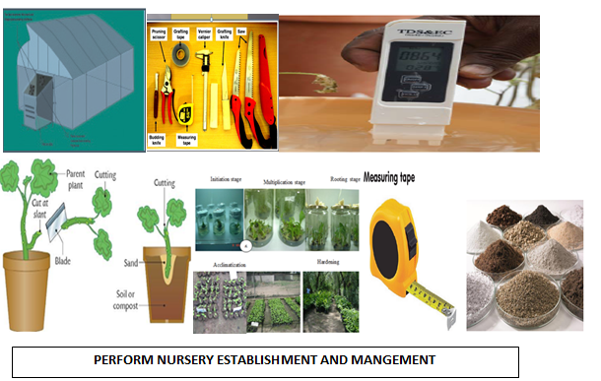
Module Title: Performing Nursery Establishment and Management

LG Code: AGR CRP2 M02 LO (1-5) LG (8-12)
TTLM Code AGR CRP2 TTLM 0922v1

September, 2022
Addis Ababa, Ethiopia
Table of Contents
Introduction to the Module 1
LO #1- Selecting nursery site 2
Instruction sheet 2
Information Sheet 1 3
Self-check 1 6
Operation Sheet -1 7
LAP TEST-1 8
LO #2- Establishing nursery site 9
Instruction sheet 9
Information Sheet -2 10
Self-Check – 2 21
Operation Sheet -2 22
LAP TEST-2 24
LO #3-. Preparing nursery inputs 25
Instruction sheet 25
Information Sheet - 3 26
Self-Check – 3 35
Operation Sheet -3 36
LAP TEST-3 39
Instruction sheet 40
Information Sheet -4 42
Self-Check –4 58
Operation Sheet -4 59
LAP TEST-4 63
Instruction sheet 64
Information Sheet- 5 65
Self-Check –5 69
Reference Materials 70

Introduction to the Module
This module covers the knowledge, skills and attitude required to Select nursery site, prepare nursery beds, establish nursery, Maintain the nursery environment& plants and complete nursery plant maintenance operations. It also provides the details of nursery establishment techniques, infrastructure management operation and its requirements in agriculture.

LG #8 | LO #1- Selecting nursery site

Instruction sheet
This learning guide is developed to provide you the necessary information regarding the following content coverage and topics:
- Selection of nursery site
- Conducting, surveying, designing and locating nursery site
- Clearing nursery site
- Ploughing organic waste into the soil
This guide will also assist you to attain the learning outcomes stated in the cover page. Specifically, upon completion of this learning guide, you will be able to:
- Select nursery site
- Survey, design and Locate the nursery site
- Clear the Land from any vegetation
Learning Instructions:
- Read the specific objectives of this Learning Guide.
- Follow the instructions described below.
- Read the information written in the information Sheets
- Accomplish the Self-checks
- Perform Operation Sheets
- Do the “LAP test”

Information Sheet 1

1.1. Selection of nursery site
Nursery is a place where plants are grown for the sake of being transplanted to the main field where they are completing their life cycle.
There are several considerations to select nursery site. Those are:
- Permanent water source availability
- Availability of skilled labor
- Topography (relatively gently in slope )
- Accessibility of infrastructure like road, electricity etc
- Market proximity
- Soil fertility
- Near to main field
- Availability of windbreak about 10m distance is also important to protect strong wind
- No extreme condition (very hot, very cold, strong wind, dry or flooding etc.)
- Availability of store house

1.2. Conducting, surveying, designing and locating nursery site
Surveying is a technique of assessing and conducting analysis to collect necessary information about nursery site to design the correct plot. Seedlings are usually needed in large numbers, and young plants most species do not survive well if directly grown on the plantation site. It is therefore easier and cheaper to grow seedlings in one place (the nursery) .The purpose of a nursery, therefore, is to grow seedlings of the required species, the right size and sturdiness at the beginning of the planting season, in sufficient numbers and for the intended planting objective.

Designing and locating is practice of measuring distances on the ground so that they can accurately plotted. Design is a plan of field for nursery site preparation and bed lay out.
Plot is a small area of land covered by specific Seedlings. In the design of a commercial nursery, all the nursery structures and other facilities are arranged to ensure a constant flow of activities.

The layout of the nursery depends on
- Climatic and environmental conditions.
- The type of scheme in operation.
- The type of propagation structure in use.
- The resources available.
- Other factors unique to each individual situation
Aim of design
- To provide adequate space to plants.
- To accommodate more number of plants.
- Easy intercultural operations.
- System of planting
1.3. Clearing nursery site
Land preparation starts with clearing or cutting of all tall grasses, removing trees to avoid shade, stumps, bushes, stones and any other obstacles from the area to be used. This will ease the ploughing process and all other farming activities.
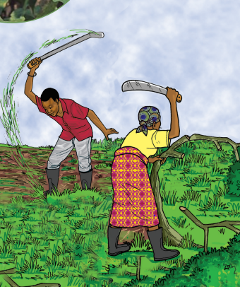
Fig.1.1. Land clearing

1.4. Ploughing organic waste into the soil
Organic waste ploughing is any material of plant or animal origin that can be added to the soil to improve soil conditions and stimulate biodiversity. Incorporation of organic waste can help to increase or maintain soil organic matter and improves soil fertility.

Cultivation of soil, especially through tillage, affects soil physical properties by altering soil structure and promoting loss of soil organic matter (SOM). However, these potentially negative impacts of tillage can be minimized by adding large amounts of crop residues like leaves, grass clippings, cover crops, and kitchen scraps (Karlen et al., 1994) or organic fertilizers, such as farm manure (Mando et al.,2005).

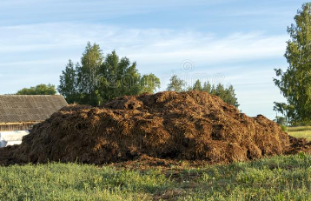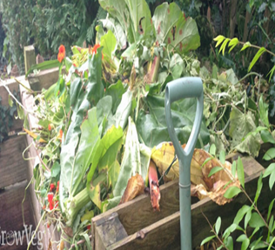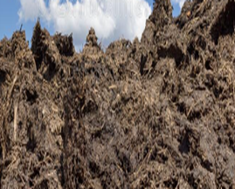
Animal manure
Crop waste
Dry plant residue

Fig.1.2. Organic wastes

Self-check 1 | Written test

Name…………………………………………… ID………………………… Date…….
Directions: Answer all the questions listed below.
1. Write definition of nursery site? (2point)
2. List down nursery site selection criteria (4 point)
3. Write the importance of incorporating organic waste in to the soil (3point)
4. Write the type of organic waste source (3point)
5. Write the aim of designing nursery site (3point)

Operation Sheet -1

Techniques of incorporating organic waste into the soil
- Material ,Tools and equipment’s

- Organic waste (both animal and plant source)
- Machete
- Wheel barrow
- Shovel
- Hoe
- Chopper
- Mixer
- Spreader
- Tractor
- PPE(Gloves, Over all, Helmet, Mask ,Boots)

- Procedures/Steps
- Wear appropriate personal protective equipment
- Collect the available organic waste
- Chop /mix organic waste
- Load organic waste
- Transport to the nursery site
- Uniformly spread the organic waste over the plot
- Incorporate the organic waste in the soil by using the tractor or long handled hoe

.

LAP TEST-1 | Performance Test

Name………………………………. ID…………………………….. Date…………………………………….
Time started: ________________________ Time finished: ________________
Instructions: Given necessary templates, tools and materials you are required to perform the following tasks within 4 hour. The project is expected from each student to do it.

Task-1. Perform organic waste incorporation activities in the soil

LG #9 | LO #2- Establishing nursery site

Instruction sheet
This learning guide is developed to provide you the necessary information regarding the following content coverage and topics:
- Establishing nursery site
- Developing area closure for nursery site
- Facilitating infrastructures
- Mulching or composting of plant material
- Establishing clonal garden in the nursery
This guide will also assist you to attain the learning outcomes stated in the cover page. Specifically, upon completion of this learning guide, you will be able to:
- Establish Nursery Site
- Protect Area of nursery site
- Facilitate Infrastructures in the nursery site
- Establish Clonal garden

Learning Instructions:
- Read the specific objectives of this Learning Guide.
- Follow the instructions described below.
- Read the information written in the information Sheets
- Accomplish the Self-checks
- Perform Operation Sheets
- Do the “LAP test”

Information Sheet -2

2.1. Establishing nursery site
A nursery is a place, where different type of plants are propagated and grown to usable sizes. A comprehensive definition of nursery is “the place, where seedlings, plantlets, trees, shrubs and other plant materials are grown and maintained until they are shifted to a permanent place. Nursery plants production is one of the key steps in establishment of modern orchards. This step should be planned and implemented properly by adopting the scientific techniques. These nursery plants contribute to their survival rate after planting and subsequent growth performance. Good quality nursery plants have positive correlation with their survival, growth and productivity. Cuttings of different horticultural plants for rooting are first planted in the nursery for better care and management. For “hardening” of seedlings/grafts/layers etc., nursery is the right place for this treatment.

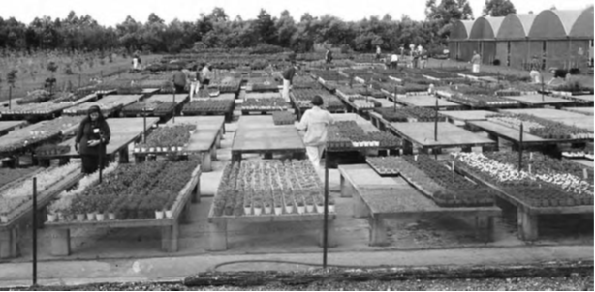

Fig.2.1.Nursery site

Advantage of nursery establishment
- It is convenient to provide intensive care for the crop
- Provide time to prepare the main field
- Helps to escape harsh time for crop establishment
- Reduced field management costs
- Higher rates of seed germination, especially when using expensive hybrid seeds
- Easy to eliminate weak and diseased plants that are not appropriate for planting and select healthy seedlings in order to obtain an even stand on the field.
- For economize use of seeds (To minimize excessive seed rate comparing broadcasting).
- It avoids gap filling to replace the missed plants, due to poor germination.
- Greater control over seedling densities in the nursery, allowing optional spacing, which helps to produce stronger plants with earlier and higher yields.
Dis advantage of seedling establishment
- Transplant shock which delays growth but is not as severe on cell raised seedlings compared to bare rooted seedlings.
- Cost of seedlings which adds to production cost.
- Labour Intensive

2.1.1. Classification of Nurseries
A. Based on their duration
There are basically two types of nurseries based on their duration of function as nursery site i.e. permanent nursery and short-term nursery. The permanent nursery is established for a long-term seedling production and Short term nursery is established for short term of seedling production.

B.Based on their purpose
Multipurpose nursery: In this type all kind of plants are propagated and reared for sale, which may include fruit plants, timber trees, shrubs, creeps, bulbous plants, succulent, ferns plants, seed and seedling of vegetation and annuals etc. This type of nursery needs a quite large area not less than 5 acre with substantial infrastructure to make it economically viable. These nurseries are known as commercial nurseries.

Single Purpose Nursery:-This type of nursery raises only one group of plants like fruit plant nursery, ornamental plant nursery, vegetable nursery, and nurseries raising seedlings of vegetable and flower, raising seeds of annual and vegetable, bulbs and corms etc.

Specialized Nursery: - This nursery is one where a particular kind of plant is raised for instance Mango, Guava or Lemon etc (Garba et al., 2019).

2.1.2. Nursery bed
Nursery bed is defined as ‘prepared area in a nursery where seed is sown or into which cuttings are rooted. Bed preparation facilitates the ease in the cultivation operations like sowing and transplanting and later in the intercultural operations. There are different types of nursery seed bed those are:-
- Raised seedbed: It is raised above the ground at 15-20 cm height. This width facilitates weeding and watering without trampling the bed. Raised seedbed is more applicable during rainy seasons in order to facilitate drainage and in areas with poorly drained soils (clay soil).

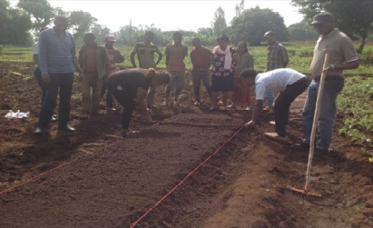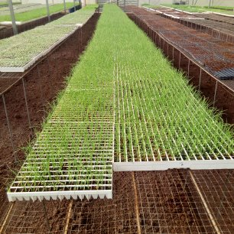
Fig .2.2.Raised seed bed

- Sunken seedbeds: Made like basin with depth of about 15-20cm. Applicable in dry seasons and light drained soils like sand, low rainfall areas and low land areas.
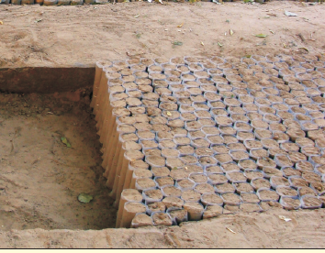

Fig 2.3.Sunken bed

- Flat seedbed: prepared where the land is level with adequate drainage system. It is applicable in areas where there is minimum water availability.

I. Factors determining the choice of type of seed bed
- Soil characteristics
- Water availability
- Types of plants to be cultivated

2.2. Developing area closure for nursery site
The nursery area is required to be adequately protected from animal damage with proper fencing. This may adequately be provided by forest or mature plantation trees, otherwise well supported fence of split bamboo held in line by horizontal places of rough timber, should be erected until growing hedging is being established. Hedge is live fence to demarcate the garden from public road, which also acts as a barrier. It separates the drive and parking areas from the main garden. In addition it helps to:-
- To provide various degrees of protection and/or privacy
- To define the shape and limits of the nursery site
- To control circulation patterns within the nursery site
- Protect from animal damage
- Reducing the winds force to make the area more comfortable For seedling

2.3. Facilitating infrastructures
To support nursery operation several infrastructures are needed depending on the nursery types. There is no physical requirement for a short-term nursery, but for a permanent nursery needs more representative facilities. Facilities needed commonly are office, water storage and watering installation, electricity, communication equipment’s, media preparation house, storage house to store equipment, fertilizer, pesticides etc., green house, propagation chambers, shaded nursery beds and open nursery beds.

- Propagation Structures: are necessary for ensuring better root growth, bud/graft union, hardening and higher success rate in plant multiplication. The specific requirements of plant growing structures vary for different types of nurseries. For multiplication of perennial horticultural crops as predicted under the model pattern, the following structures are considered necessary.

- Cell tray
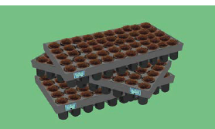
Fig. 2.4.cell tray

- Pot (plastic, Clay and polyethylene bags )

Clay pots: Different sizes and shapes are available in the market. Round types occupy more area in nursery and are avoided. These are porous in nature and permit aeration and water movement. However, their continuous use may result in blockage of pores due to accumulation of salts

Plastic pots: Plastic pots are available in square and round shapes and in different sizes. These are non-porous but have several advantages; these are durable, light weight, reusable and require small place in nursery .

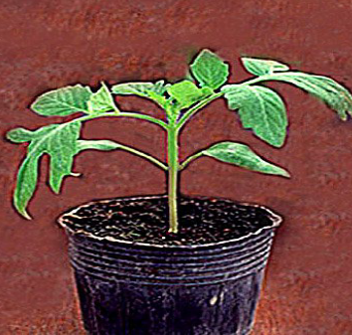
Fig. 2.5.Plastic pots

Polythene bags: These are now widely used mainly because these are comparatively cheaper, light in weight and easily available. These are available in different sizes and thickness, and in white or black colour. Polythene bags of usually 10 × 6 cm size are used for raising vegetable seedlings .

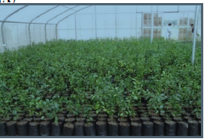
Fig. 2.6.Polyethylene bags
- Irrigation system
Depending upon the production components of integrated nursery units which comprises of mother plant garden, rootstock nurseries, poly tunnels, mist chambers, etc., different types of irrigation systems are required to be designed and installed. These include:
- Drip irrigation system
- Manual watering with cans or micro sprinklers for root stock nursery beds and shade net areas
- Micro sprinkler for poly tunnels for vegetable nursery production where envisaged
- Water storage tank (masonry structure or HDPE tanks of 10000 L capacity)
- A well laid out pipe line distribution system across the nursery unit to meet the above requirements.
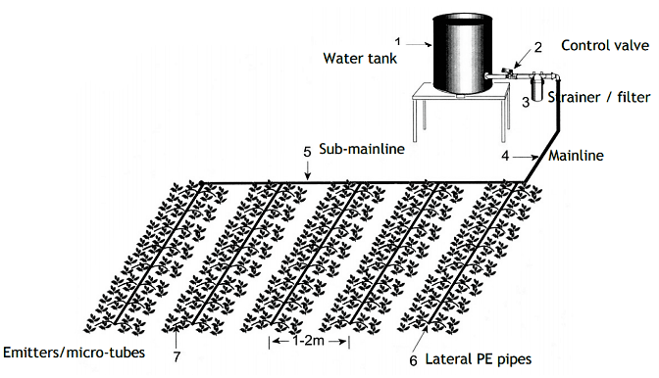
Fig .2.7.Component of drip irrigation

- Mist Chambers
Mist chambers provide a humid and cool micro environment that is necessary for propagation of soft wood cuttings, hard to root species. The requirement of mist chamber for perennial fruit crops nursery depends upon the species/varieties to be propagated. For propagation, framed structures such as green house, poly tunnels, culture room, hardening chamber and mist chamber are some important structures.
- Shade net area
Shade net area provides necessary microclimate for acclamization and hardening of layered/budded / grafted plants and offer protection from direct sunlight, heavy rainfall and heat waves/dry winds. Shade house would also facilitate raising of seedlings in bags directly where necessary.

- Electricity: For operating power machineries and to provide control environment in nursery.

- Equipment and Machinery: The nursery operations like transporting, watering and sales depend on the vehicle and machineries and equipment in the nursery. Among them tractor with trolley, disc plough, water tanker are necessary. The nursery potting media filling machine or automated container filling machines for nursery mixture preparation and filling, grafting machine facilitate the speedy operation of nursery in cost effective way.

- Pot mixture preparation area
Preparation of potting mixture and potting are important activities for which adequate space is necessary for keeping of inputs (soil, leaf mold, manure, pots, etc). For better growth and establishment of nursery plants after grafting operations, a good potting mixture is necessary. The potting mixtures is prepared by mixing fertile red soil with well decomposed FYM and leaf mold, and sand in 2:1:1 proportion which is utilized for filling of pots / polybags. An area of 30 to 50 m² is demarcated for potting operations.

- Store house
Garden tools, implements, raw materials, insecticides, fungicides, manures, fertilizers, boards, polythene bags etc are stored in store house. An ideal nursery has at least one well managed office for keeping all registers, notebooks, information books and for instructing the team. The record of mother plants, progeny, stock of plants, etc is preserved in office.

- Fencing
The nursery area is required to be adequately protected from stray cattle and tress-passing with proper fencing.

- Mother Plants
Scion source: - Establishment of improved varieties of tropical fruits mother trees which serve as source of scion materials is the most important factor for successful nursery. Mother plants should be known for vigorous, healthy, high yield and fruit quality, regular bearing habit, free from pests, diseases and viruses and must be genetically pure.
The source must be from research center (e.g. MARC) or registered farms. It should be selected corresponding to the demand of the nursery plants.
Rootstocks source: Establishment of mother trees which serve as rootstock seed source some distance far away from the nursery site is also required. The rootstock seedling can be raised from varieties are recommended for root stock purpose by research center, if not available it is possible to use local cultivars. The selected mother plants should be vigorous, high yielder, free from pests, diseases and viruses. In general, any strong seedling may serve as rootstock, but the vigor of the rootstock may affect the new tree. A weak rootstock may not withstand the stresses of grafting or it may grow into a small, weak tree. On the other hand, an extremely vigorous rootstock may outgrow the graft, sprouting branches and overwhelming the grafted portion of the tree.

- Propagation tools: There should be a special grafting knife which is different from an ordinary knife as it is sharpened on one side only. It must be kept very sharp and clean at all times. Use special 1.25 cm wide grafting tape available from most nursery shops or other plastic pots which have 20 to 22 mm micro thickness. Clean-cutting secateurs are useful for cutting bud wood. A fine sharpening stone is necessary to maintain a very sharp knife and 70% alcohol for sterilization of propagation tools and operator hands.

2.4. Mulching or composting of plant material
Mulching may be defined as any artificial modification of the soil surface. It can be done in many ways, such as mulching by ordinary cultivation and covering of grass, leaves straw sawdust, sand etc. The primary purpose of mulching is to conserve soil moisture by lowering soil temperature and by physically blocking the loss of water in areas where watering is necessary through the year, mulching helps to reduce both the frequency of watering and the amount of water needed. Soil surface of pots or beds should not be covered in rainy areas as soil aeration would be reduced and risk of damping off would be increased. Mulching is important to:-

- Regulate temperature
- Maintain moisture
- Protect the seeds from moving away
- suppress weed
- Can be used as fertilizer after being decomposed
- Promote soil microorganism activities
- Prevent soil compaction

- Types of mulching materials
- Organic
- Wood Chips/Bark
- Straw/Leaves /Grass Clippings/Seed Hulls /Newspaper

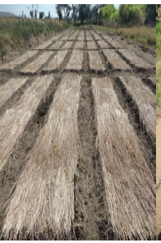

Fig. 2.8.Grass mulch
The grass mulch has got some disadvantages. It may bring into pots or beds weed seeds and insects.
- Inorganic (Inert)
- Plastic

2.5. Establishing clonal garden in the nursery
The method of clonal production best suited to mass producing clones at a commercially viable price in very large numbers for agriculture. The process of mass production of clonal crops by cuttings is vastly different from that of traditional seedling production, and this impact on price and production scheduling, which in turn impacts on ordering time tables and payment schedules and structures.
Clone is genetically identical assemblage of individuals propagated entirely by vegetative means from a single plant. Plant tissue culture is the technique of growing plant cells, tissues and organs in an artificial prepared nutrient medium.
Aseptic culture: under conditions free of microbial contamination.
In vitro: in culture vessels (like test tubes) under controlled environment and nutritive growth medium.
Most methods of plant transformation require that a whole plant is regenerated from isolated plant cells or tissues. This regeneration is conducted in vitro to produce a large number of regenerable cells. Clonal production is a continuous process of harvesting cuttings from the mother stock over a period of time. Clonal plantations confer many advantages over traditional seedling plantations. Qualities selected by breeders for the mass-production of superior clones include:
- Increased growth rate or vigor
- Increased yield
- Large number of plantlets is produced
- Help to disease free planting material

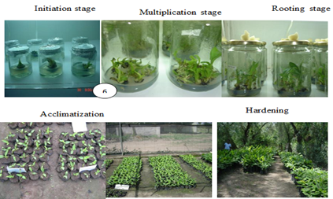

Fig.2.9. Cloning garden

Self-Check – 2 | Written test

Name…………………………………………… ID………………………… Date…….
Directions: Answer all the questions listed below.
Test I: Multiple choice
- Which of the following is importance of nursery establishment?
- It is convenient to provide intensive care for the crop
- Labor intensive
- Transplanting shock which delay maturity
- Increase production cost
2. From the following mulching material one is odd
  - Straw
  - Grass
  - Plastic
  - Leave
3. Nursery at which all types of plants are established is called _______
- Single purpose nursery
- Specialized nursery
- Multi-purpose nursery
- Raised bed
Test II: Short Answer Questions
- Write definition of clone
- Write at least four infrastructures required for nursery establishment
- Write advantages of cloning over traditional nursery establishment

You can ask you teacher for the copy of the correct answers.

Operation Sheet -2

- .Techniques/Procedures/ of preparing nursery bed
- Tools and equipment’s

- Long handled hoe
- Rope /string
- Peg
- Hammer
- Rake
- shovel
- Wheel barrow
- Meter /measuring tape
- PPE(Boots, mask, Gloves, over all, hat)

- Procedures/Steps/Techniques of bed preparation
- Wear PPE
- Prepare required tool and equipment’s
- Clear the site
- Dig the land to loosen the soil
- Level land and measure the plot size and boarder
- Lay out involves (peg sticking and tying rope at width of 1m-1.20 m and convenient length (5-10m) and 50cm between bed to demark the clear boundary of bed and boarder
- Prepare the bed shape by using shovel following the string line

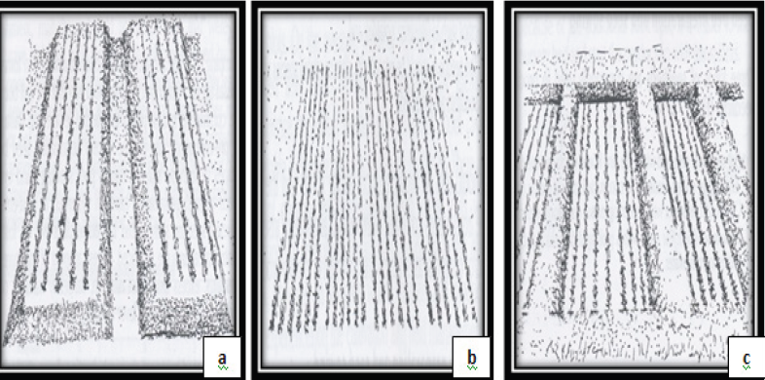
Fig.2.10.Raised, Sunken and Flat bed
2.2. Techniques of preparing nursery bed in container
- Material ,Tools and equipment’s

- PPE (Boots, mask, Gloves, over all, Hat)
- Prepared growing media
- Polyethylene bags
- String
- Peg

- Water cane
- Meter
- Shovel
- Stacking tool(stick)

- Procedures of preparing nursery bed by arranging polyethylene bags
- Wear PPE
- Moist the growing media
- Fill the polyethylene bags with the growing media
- Arrange filled the polyethylene bags in prepared sunken bed
- Stalk the arranged Polyethylene bags sick
- Remove and safely dispose waste at appropriate point
- Clean and store tool

LAP TEST-2 | Performance Test

Name………………………………. ID…………………………….. Date…………………………………….
Time started: ________________________ Time finished: ________________

Instruction: Given necessary templates, tools and materials you are required to perform the following tasks within 5 hour. The project is expected from each student to do it.

Task-1 .Perform nursery bed preparation
Task -2.Perform nursery bed preparation by arranging polyethylene bags

LG #10 | LO #3- Preparing nursery inputs

Instruction sheet
This learning guide is developed to provide you the necessary information regarding the following content coverage and topics:
- Preparing, testing planting media and material
- Performing sowing or planting
This guide will also assist you to attain the learning outcomes stated in the cover page. Specifically, upon completion of this learning guide, you will be able to:
- Prepare Planting media according to the climatic condition
- prepare planting material according to the requirement
- Sow/Plant according to the requirement
Learning Instructions:
- Read the specific objectives of this Learning Guide.
- Follow the instructions described below.
- Read the information written in the information Sheets
- Accomplish the Self-checks
- Perform Operation Sheets
- Do the “LAP test”

Information Sheet – 3

3.1. Preparing, testing planting media and material
Growing media, Propagules, seed, fertilizers, and chemicals are nursery inputs.

A. Growing media
It is the substrate on which seeds are sown, germinated, seedlings grown and cuttings rooted is known as growing medium. Different ingredients are used in varying composition for preparing commercial or homemade growing media. Media for plant growth and seed germination have great significance in nursery business. The material for rooting and growing media may be used either alone or incorporated with one or more products in combination. The materials used for rooting media may be natural or manufactured artificially. Soil is a very common easily available and comparatively cheaper medium used in nursery. Sand is generally used in mother bed and vegetative plant propagation media. The other media used in nursery are peat soil, sphagnum mass, vermiculite, perlite, leaf mold, saw dust, grain husk and Coco peat. Among them vermiculite is mostly used for cuttings while sphagnum mass is used for air layering. Ideal medium has the following qualities:-
- Should be firm and dense that can hold the propagation material (seeds, cuttings, layers etc.) properly.
- Should have good water holding capacity and must be porous so that air can move and excessive moisture can drain out easily.
- Supply enough nutrients to propagule
- Should be free from weeds, diseases and insect-pests.
- Should be properly decomposed with pH range from 5.5-6.5, C: N 20:1 and very low concentrations of salts.
- Should be cheap, easily available and can easily be mixed with other media

Functions of Growing Media
- Physical Support
The growing medium must be porous yet provide physical support. Young plants are fragile and must remain upright so that they can photosynthesize and grow. With larger nursery stock in individual containers, a growing medium must be heavy enough to hold the plant upright against the wind.
- Aeration
Plant roots need a steady supply of oxygen to convert the photosynthate from the leaves into energy so that the roots can grow and take up water and mineral nutrients. The byproduct of this respiration is carbon dioxide that must be dispersed into the atmosphere to prevent the buildup of toxic concentrations within the root zone. This gas exchange occurs in the large pores (macro pores) or air spaces in the growing medium. Because nursery plants grow rapidly, they need a medium with good porosity—a characteristic termed “aeration”
- Water Supply
Nursery plants use a tremendous amount of water for growth and development, and this water supply must be provided by the growing medium. Growing media are formulated so that they can hold water in the small pores (micro pores) between their particles. Many growing media contain a high percentage of organic matter such as peat moss and compost because these materials have internal spaces that can hold water like a sponge. Therefore, growing media must have adequate porosity to absorb and store the large amounts of water needed by the growing plant.
- Supply of Mineral Nutrients
Most of the essential mineral nutrients that nursery plants need for rapid growth must be obtained through the roots from the growing medium. Most mineral nutrients are electrically charged ions. Positively charged ions (cations) include ammonium nitrogen (NH4+), potassium (K+), calcium (Ca+2), and magnesium (Mg+2). These cations are attracted to negatively charged sites on growing medium particles up to the point when the roots extract the cations. The capacity of a growing medium to adsorb these cations is referred to as cation exchange capacity (CEC).Different media components vary considerably in their CEC, but peat moss, vermiculite, and compost have a high CEC value, which explains their popularity in growing media.
- Growing media mixes
- Commonly used media
- Soil- good texture=> depends upon relative proportion of sand, silt and clay (i.e., have proper proportion of solid, liquid and gaseous states).
- Sand- the size of sand varies from 0.05 - 2 mm in diameter
- Compost – Prepared by decomposing bulk organic waste rich source of mineral nutrients with good water holding capacity
Ratio of mixture = 2:1:1/3:2:1 (soil, sand and compost) and solarisation

- Testing growing media
As each nursery develops its own growing media based on local ingredients, issues can arise because of variability in materials. Homemade materials, particularly composts, may vary in their quality despite best efforts to achieve a consistent product year after year. Purchased materials can also be variable on occasion depending on source and quality control procedures.
- Testing EC growing media
The salinity (salt level) of the growing medium is a key parameter affecting the development and health of plant roots. An electrical conductivity meter (EC meter) measures the electrical conductivity in a solution, and this gives a measure of the amount of salts in the water. The higher the EC, the higher the salts in the water or media, the more likely they are to cause damage to the seedlings.
- Testing pH growing media
pH is a measure of acidity or alkalinity of the medium and water. The more acid, the more hydrogen ions are present. It is measured by using glass electrode pH meter.

B. Chemicals: Pesticides, fungicide, herbicides and growth regulators.

C .Propagules
- Seed: is one of the vital inputs in enhancing agricultural productivity
- Cutting: Refers to a portion of a stem, leaf, or root is cut from parent plant and placed under favorable condition to form roots and shoots thus produce a new independent plant.

- Selection of Mother plants for cuttings
Scion:-is the upper part of the stem that develops into a shoot system. Success of a nursery depends on genetically purity of mother plants. It is because the mother plants are main source of buds for budding and grafting. Therefore, a separate block is allotted for planting of desired varieties.
Mother plants are selected based on good characteristics and are planted at recommended distances. Management practices such as control of pests, diseases, weeds, balanced nutrition and irrigation are performed regularly for good and healthy vegetative growth.
- Characteristics of a good scion
- The mother plant must be true to type (genetically pure) and superior in quality.
- It should be vigorous, healthy, high yielding and regular bearer.
- It should be free from insect-pests, diseases and viruses.
- It should either be raised in the nursery or obtained from a reliable nursery according to the demand of people and receipt should be preserved to show the originality and authenticity of stock.
- Care of scion
- Use good quality water to irrigate mother plants.
- Apply manure and fertilizers at proper stage in proper quantity.
- Vegetative growth is encouraged to for maximum number of bud sticks.
- Maintain health of mother plants by regular testing of for control of viruses and other organisms.

Rootstock-is the lower part that develops into a root system. In modern fruit culture, due to established effects of rootstocks on scion cultivars, rootstocks have now become the integral part of fruit industry. Rootstock cannot be changed during the life time of a plant; therefore, it is very important to give due attention at the time of its selection. Rootstock influences production, vigour, leaf nutrients status, fruit characters (fruit weight, rind/peel thickness, seed number etc.), and precocity in bearing, fruit maturity, fruit quality and resistance against diseases, insects and adverse climates of scion. Hence, rootstock should be selected properly and planted carefully .
Mature, disease-free seeds of desired. Root stocks are collected and sown on well prepared seed beds. Proper irrigation, nutrition, weed management, insects and diseases control practices are performed regularly and properly to raise healthy rootstocks .
- Characteristics of an ideal rootstock
- It should be easy to propagate and must have healthy root system to uptake nutrients and provide good support to composite plant in soil.
- It must produce good, clean, upright stem which can be easily budded or grafted.
- It should have good adaptability to soil and climatic conditions.
- It must have good resistance against diseases and insect-pests, and tolerance against adverse climatic condition
- Types of cuttings

- Stem cuttings - Mature or woody dormant stem materials
E.g. Grape, fig, mulberry olive, pomegranate , Camellia, citrus,

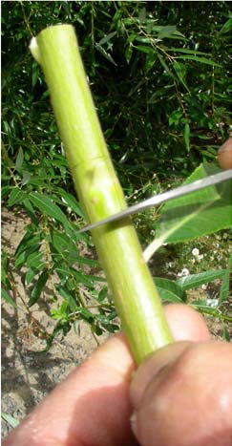
Fig.3.1. stem cutting

- Herbaceous
Eg. Geraniums, carnations
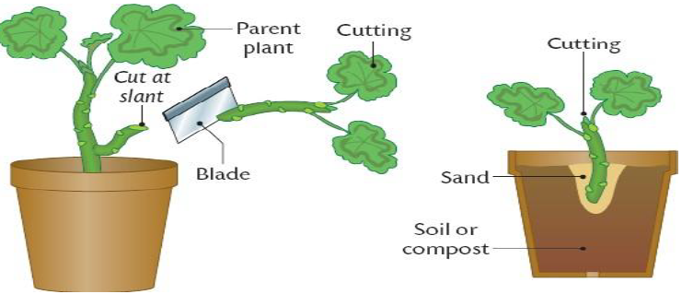
Fig.3.2. Herbaceous cutting
- Leaf cuttings - must form both adventitious shoots and roots (except leaf bud).
- Leaf petiole Eg. Sansivera, begonia…etc.
- Leaf blade Eg .Lemon, camellia.
- Leaf bud

Bud
Blade

Leaf
Fig 3.3. Leaf cuttings
- Other types of cutting
- Rhizome cutting
- Root cutting
- Tuber cutting
- Corm cutting
E.g. Enset, Potato, Ginger

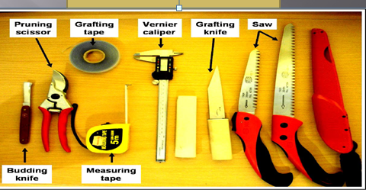
Fig. 3.4.Equipment required for cutting preparation
3.2. Performing sowing or planting
Sowing is the uniform spreading of the seed over well prepared land to establish the crops. There are different sowing techniques. Those are broadcasting, drilling and dibbling or planting.
3.2.1. Techniques of sowing
- Broadcasting is uniformly spread the seeds are over well prepared land. It may be done by hand or mechanical spreader. Broadcasting is suitable for close planted crops. It is used when the number of plants per unit area is more important than definite spacing from plant to plant. This is the usual method of sowing field crops. Fodder crops and spices like coriander and cumin are sown by broadcasting

- Disadvantages of broadcasting
- Seeds at shallow depth emerge early and seeds fallen deep in the soil may not germinate.
- There is a lot of wastage of seeds.
- Agricultural operations like weeding, hoeing, and ear thing-up and bullock-drawn implements cannot perform well.
- Plant population become sparse at some places and overcrowded at other
- Drilling is the practice of dropping seeds in rows or lines. Furrows at specified distance are made, and the seeds are dropped at definite depth and distance, covered with soil and are compacted Fairley. Seed can be drilled with help of seed drills (bullock or tractor drawn) and seeding funnels attached with country plough. Seeds and fertilizers can be drilled simultaneously. Crops such as wheat, barley, mustard, carrot and sesame are sown by drilling.
- Advantages of drilling
- It maintains uniform plant population per unit area.
- Reduce competition between plants.
- Reduce seed rate
- Disadvantages of drilling
- It requires more time, energy and cost.
- It is labour intensive
- Dibbling is consists of putting or placing individual seed or seed material in a hole or pit, made at pre-determined depth and spacing. Generally, the crops with bigger size seeds and those needing wider spacing and specific crop geometry for their canopy development are sown by this method. This method is suitable to plant crops like cotton, potato, sun flower, sugar cane, garlic, ginger etc.
- Advantages of dibbling
- It requires less seeds
- It gives rapid and uniform germination with good seedling vigor

- Disadvantages of dibbling
- It is more laborious
- It is time consuming
- It is expensive compared with broad casting and drilling

    - Pre-sowing treatments are methods applied to overcome seed dormancy to ensure rapid, uniform and timely seed germination that facilitates seedling production. Pre sowing treatments are applied to seeds immediately before sowing. Most methods require only a few minutes to 24 hours. However some pre-sowing methods require a few to several days. Appropriate pre-sowing treatment methods depend on the dormancy characteristics of the seed being treated.

The most common pre-sowing treatment methods are:-
    - Soaking in cool water
    - Soaking in hot water
    - Boiled water treatment
    - Scarification (acid, mechanical, manual) methods
    - Soaking in chemicals
    - Alternate wetting and drying

Self-Check – 3 | Written test

Name…………………………………………… ID………………………… Date…….
Directions: Answer all the questions listed below.
Test I: Multiple choice
1. Which of the following is propagule of nursery establishment
- Urea
- Labor intensive
- Stem Cutting
- Growing media
- From the following one is odd
- seed
- leaf
- stem
- Rhizome
Test II: Short Answer Questions
- Define EC meter
- Write method of pre sowing seed treatment
- Write growing media mixes

You can ask you teacher for the copy of the correct answers.

Operation Sheet -3

3.1. Techniques of measuring pH and EC value of growing medium
A. Measuring pH value of growing medium
Material and equipment

- pH meter
- Buffer solution
- Growing media
- Distilled water
- Beaker
- Pen
- Exercise book
- Spoon

Steps of measuring pH value of growing medium
- Take a sample of the medium and mix bottled drinking water or de mineralized water at 2 parts per 1 part of medium.
- Mix well, shake vigorously and wait. Allow it to sit for 1-2 minutes.
- Turn on the pH meter and be sure to calibrate the meter before running the test (please refer to instructions in the manual).
- Remove the cap to expose the sensor and dip the sensor completely in the solution.
- Record the reading displayed on the meter.

B. Technique of measuring EC value of growing media
Material and equipment’s

- Growing media
- EC meter
- Distilled water
- Beaker
- Spoon
- PPE

Procedure of testing EC of the growing medium
- Take a sample of the growing medium and mix it with bottled drinking water or demineralized water at 3 parts per 1 part of medium.
- Add some more water if required to ensure that the EC meter dips in the mixture properly
- Stir the mixture well and leave it for 15 minutes.
- Then draining it and collect the solution in another container, growing medium may be pressed using a spoon to release the solution.
- Measure its EC by dipping the EC meter in the solution and note down the reading (ECg)
- Measure the EC of the demineralized water directly (ECw).
- Subtract ECw from ECg to get the true EC of the medium.
- EC of Growing media = ECg – Ecw
- Similarly, check the EC of water to be used for irrigation.
.

3.2. Techniques of seed sowing
Material Tools and equipment’s

- Seed /planting material
- Fertilizer
- Water cane
- Meter
- Peg
- Rope
- PPE
- Dibbler
- Paper
- Pen
- Mulch (material)
- Cultivation hoe

Steps of seed sowing
- Wear PPE
- Measure to determine the space between row on the bed
- Stick small peg
- Make hole /line at the specified distance by using dibbler
- Put/drill the seed in hole/line and gently cover with soil
- Apply the recommended amount of fertilizer about 5cm apart from the seed placement
- Mulch by using locally available material
- Apply water by using water cane manually /irrigate by using overhead irrigation equipment like sprinkler
- Lable the plot
- Remove and dispose waste material at appropriate position
- Clean and store tools and equipment

LAP TEST-3 | Performance Test

Name………………………………. ID…………………………….. Date…………………………………….
Time started: ________________________ Time finished: ________________
Instructions: Given necessary templates, tools and materials you are required to perform the following tasks within 6 hour. The project is expected from each student to do it.

Task-1. Perform Measuring pH value of growing media
Task -2. Perform measuring EC value of growing media
Task -3.Perform sowing of seed

LG #11 | LO#4-Maintaining nursery environment and infrastructures

Instruction sheet
This learning guide is developed to provide you the necessary information regarding the following content coverage and topics:
- Identifying OHS hazards, assessing and minimizing risks (EG)
- Selecting and using tools and equipment for plant maintenance
- Clarifying plant growth and health requirements.
- Undertaking nursery operations
- Maintaining and preparing irrigation system components
- Principle and operation of irrigation system (EG)
- Calibration and application of treatments to assist plant growth (EG)
- Undertaking seedling hardening off practice
This guide will also assist you to attain the learning outcomes stated in the cover page. Specifically, upon completion of this learning guide, you will be able to:
- Identify OHS hazards and assess risks in the nursery environment
- Tools and equipment are selected and used for plant maintenance
- Clarify Plant growth and health requirements
- Undertaken nursery operations according to OHS requirements
- Serviced and faulty components irrigation system
- Apply Treatments to assist plant growth
- Harden off seedling at the required time

Learning Instructions:
- Read the specific objectives of this Learning Guide.
- Follow the instructions described below.
- Read the information written in the information Sheets
- Accomplish the Self-checks
- Perform Operation Sheets
- Do the “LAP test”

Information Sheet -4

4.1. Identifying OHS hazards, assessing and minimizing risks
4.1.1. Identifying OHS hazards
Agriculture is associated with a variety of occupational illnesses and injuries. Agricultural workers are at higher risk of death or disabling injury than most other workers.
- Respiratory illness and health problems from exposures to farm chemicals are major concerns, and, certain cancers problems. Respiratory disorders develop from the inhalation of grain dust, other types of organic dusts, and facilities.
- Skin cancers caused by sun exposure are a serious problem.
- Irritant and allergic dermatomes occur from exposures to plants and farm chemicals.
- .Various pesticides can cause acute illness. So that, identifying different OHS hazards and related risks with a certain agricultural activity is essential to ensure safe work conditions.
- Skin contact with crop residues which may be toxicants during clearing, working with sharp machinery and use of other chemical substances.
- Splash of chemical to eye
- Physical injury, like cut

4.1.2. Minimize risks
During establishment crops on nursery you should have to follow safety required to avoid hazards.
- Wear PPE
Also make sure that
- Is effective and gives adequate protection against the hazards in the workplace;
- Is suitable and matches the wearer, the task and the working environment, so it does not get in the way of the job being done or cause any discomfort.
- Does not introduce any additional risks, e.g. limits visibility;
- Is certified equipment’s marked to confirm that it has been made to an appropriate standard;
- Is compatible with any other PPE that has to be worn?
- Make sure all equipment is checked before use and cleaned, maintained and stored in accordance with the manufacturer’s instructions.
- Follow work protocol carefully
- Check the tool, equipment’s going to use
- Safely handle the tool, equipment’s
- Use MSDS
4.2. Selecting and using tools and equipment for plant maintenance

Table 4.1.Tools and equipment required for nursery plant maintenance include

No- | Name of tools and equipment | Function of equipment
1 | 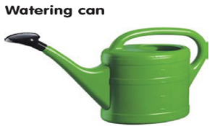 | A portable water container used for watering smaller areas and containers
2 | 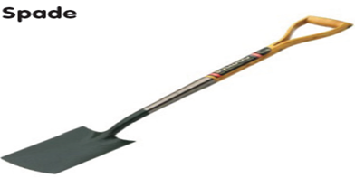 | - A long handled tool traditionally used for  - Digging, shoveling soil and compost  - Moving shrubs of plants
3 | 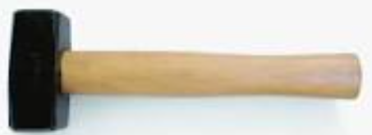  Hammer | Used to stick ped during lay outing
4 | 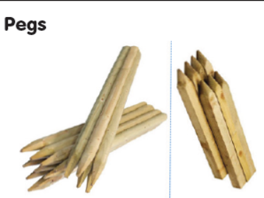 | - Used for securing net, line or fleece to the ground
5 | 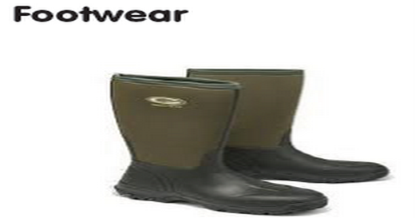 | - Used to protect feet from stones, falling items or tools.
6 | 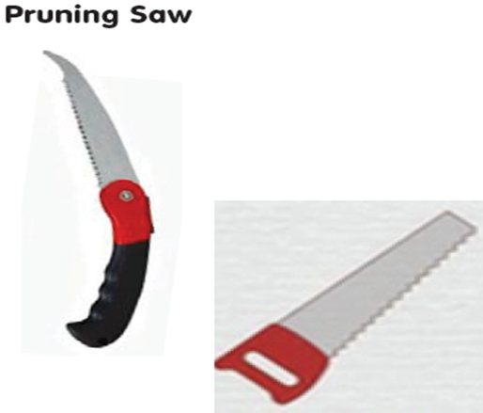 | Short, sharp saw for cutting limbs too thick for hand or lopping shears
7 | 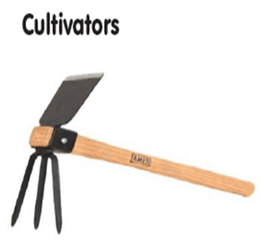 | Used to break up compacted soil, spread fertilizers and compost, remove shallow rooted weeds without disturbing the roots of surrounding plants
8 | 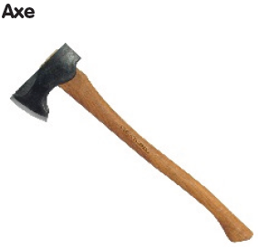 | Axe is multipurpose cutting tool used de limbing of trees, splitting of logs for firewood and dressing of logs for timber conversion.
9 | 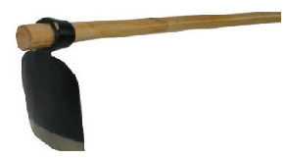  Hoe Long handled | Used to remove weeds by agitating and grooming the soil surface  Used to dig, move and hill soil during preparation for planting
10 |  | - Used to protect hands and fingers from cuts, blisters, calluses, sun damages, abrasions and dirt.
11 | 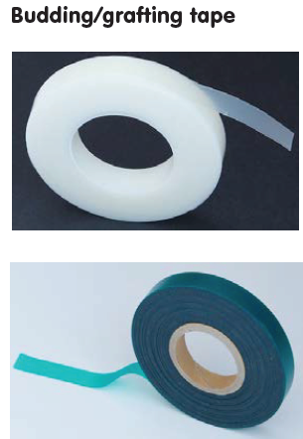 | Used for wrapping graft-union point while grafting and/ or budding fruit species.
12 | 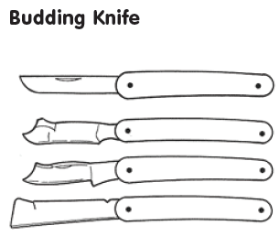 | A small knife designed for delicate budding grafting with a single eye or bud.
13 | 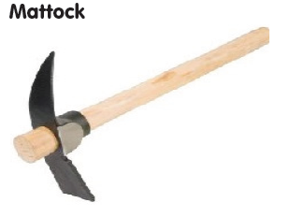 | Used For digging hard soils
14 | 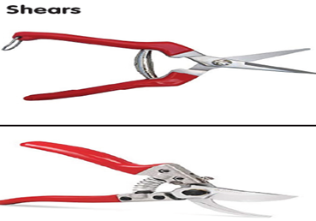 | - Shears for different purposes (Pruning)
15 | 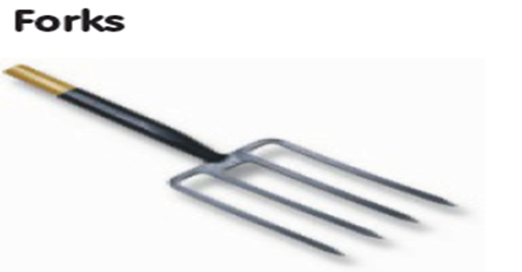 | Used for digging of soils in situations where the use of spade may be difficult for turning of soils  Used to till large areas of soil and break up compacted clods
16 |  | Made from steel or wooden and used for layout of seedbed, plots and plant spacing
17 | 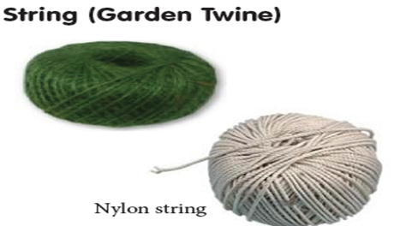 | Used for lay outing activities and tying plants to stakes  Available in natural jute and coated
18 | 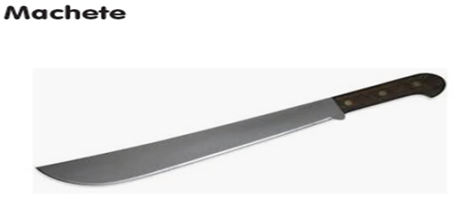 | A large, strong blade usually around half a meter long.  Effective in cutting small branches and heavy underbrush.
19 | 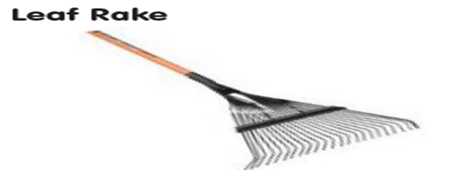 | - Long, flexible steel tines for raking leaves
20 | 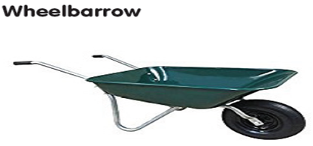 | It is carrier, usually having only one wheel, a tray bolted to two handles and legs  Used to transport seedlings soil, composts as well as small loads
21 | 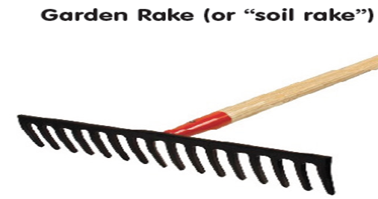 | A long handled tool used to create a fine tilt and level the seedbeds ideal for raking soil or moving heavy material)  Collect plant debris and stones from the seedbed surface

4.3. Clarifying plant growth and health requirements.
4.3.1. Factor affecting plant growth and Health
A. Abiotic
- Drought or waterlogging
- Excessively high or low temperature
- Injury due to chemicals
- Physical damage, for example shearing off roots
B.Biotic

- Bacteria
- Viruses
- Fungi
- Insects
- Weeds, birds and mammals) that interfere with plant production

Disease like damping off, wilt, root rot, rust and powdery mildew are caused by pathogen infection and results in stunted growth of seedlings. These pathogens may be soil, seed or air borne in nature.
Nurseries established in the recently cleaned land hardly invite parasitic organisms. Stunted growth of seedlings indicates the loss of soil fertility, excess watering and dumping of seedlings in shady areas.
Weed is any plants present in the cultivation area which is out of our interest. They compete with the seedlings for nutrients, water and light and suppress the growth of young plants because the weeds are usually more vigorous and grow at a faster rate.
The most troublesome are grasses or dicotyledonous plants that grow from a root stock. If such a weed is cut off at the ground level, it will sprout again and continue to grow from the carbohydrates stored in its root tissue hence the need to remove the whole plant.
Insect pest
The most commonly observed insect pests in nurseries are whiteflies, leaf miners, thrips and aphids. They affect plant growth and health if not early managed.
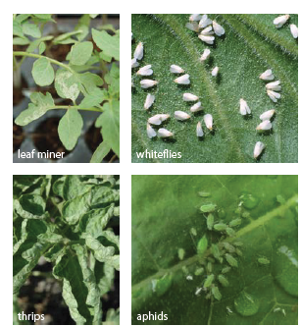
Fig .4.3.1.Commonly observed insect pest in nursery

4.3.2. Practice to be undertaken to maintain plant growth and health
The use of proven seedling raising technologies such as:-
- Proper media preparation (hygienically )
- Using seedling trays (washed )
- Maintaining hygienic conditions (sterilization ,flushing media etc)
- Using quality insect mesh
- Fertigation and
- Using shade net materials, or a double door system are more efficient way to grow healthier seedlings.
As a preventive measure sterilization of nursery mixture, pre-treatment of seeds with fungicide can control the disease. If the disease occurs, the casual pathogen may be identified by expression of symptoms and accordingly fungicide and insecticide may be applied. This requires different skills and equipment than traditional seedling production, but results in stronger, healthier plants that farmers prefer to get their commercial crops off to a good start.

Pruning at planting appears to have little, if any, positive impact on transplant survival and growth after planting. However, structural defects should be corrected at planting to reduce maintenance costs later. Formative pruning is practiced on young/immature/non bearing fruit tree. It is started in a nursery, but normally carried out when the tree is 2-3 age at field. Pruning should be minimal from juvenile to the productive stage .Avoid severe pruning, because it delays early fruit production.
Thinning is removing an entire shoot, stem, or branch back to its point of origin, the main stem, a lateral stem, or even to the ground.
- It opens woody plants, promoting good health by reducing foliage and allowing more air and light to reach their interiors.
- It is less invigorating than heading, produces less re-growth, and better allows plants to retain their natural forms.
- Thinning cuts are also used on fruit trees to establish strong frameworks and to direct and shape growth.

4.4. Undertaking nursery operations
Nursery management practices include the cultural activities which could be carried out in the nurseries. These cultural activities are involves fertilizer application ,watering, mulching, shading, Cultivating ,weeding, root pruning, shoot pruning (sometimes when the seedlings are too long), culling or grading the seedlings and finally distributing the seedlings for out planting in the field (Daniels and Simpson, 1994; Rose and Haase, 2005).
- Fertilizer application
Fertilizers are commonly applied through the irrigation system (fertigation). The frequency and concentration of fertilizers applied vary depending on the crop, stage of maturity and climate conditions (e.g. solar radiation and temperature). Some commercial substrates for transplant production contain a “starter charge” of fertilizers, in which case no fertilization is required for the first few days.
- Watering
An irrigation system must provide uniform water distribution – crucial for uniform growth of seedlings. Water is essential to the survival of all types of plants.
Growing a healthy plant to market specification requires the right amount of water and nutrients as well as a suitable growing environment. Plants growing under optimum conditions of light, temperature, nutrition and water will reach marketable size as quickly as possible. Water serves as a solvent to transport nutrients to cells and remove waste, maintains turgor pressure for physical structure, regulates temperature and supports photosynthetic reactions. Water management is crucial to the success of a nursery. Applying water evenly, to replace only the losses from the containers with a small leaching fraction, will typically result in substantial savings in water consumption, less contaminated waste water and more even and efficient fertilizer uptake. It is best to irrigate in the morning. If seedlings are irrigated in the evening, water droplets will remain on the leaves and lead to fungal infections. If the growing medium is porous, less water is required.
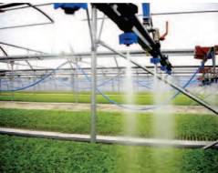
Fig. 4.3.2.water application by mist chamber
- Providing shade
Shading should be done to protect the young seedlings from high heat intensity in sunny areas and also from heavy rain. Shade can be provided by polythene nets or even grass. The shade should be removed some days before transplanting to allow the seedlings to acclimatize to field conditions.
- Disease management
This is a continuous process from seedling emergence to transplanting. It is normally done by physical means but chemicals can also be used if the need arises. Early detection is critical to control biological problems and minimize damage. Propagation of vegetable seedlings is usually conducted in short cycles; nevertheless, pests and diseases spread very rapidly because of the high density.

Aim to minimize the risk: Be familiar with the symptoms of commonly occurring pests and diseases, in order to help identify problems at an early stage and minimize the loss of plants. Minimize access to the affected area and notify workers of the outbreak as soon as any symptom is found. Apply appropriate control methods (chemical or biological) in consultation with the local extension agent or advisor. Do not apply foliar fungicides under high-temperature conditions as this may injure foliage.

Table 4.3.2. listed the important nursery disease ,and their control measures
Symptom | Affected seedling | Control measure
Collar rot | Tomato | Soil drenchingwith0.1%carbedazim
Leaf spot | Pomegranate | Copper Oxychloride 0.2%
Powdery mildew | Pepper | Thiovet

E.Weed management practice
Effective weed management practices include those that reduce the potential for weeds to adversely impact crop growth and yield. These practices often allow the crop to utilize all available resources necessary to achieve its yield potential. Weeds require many of the same resources for growth as crop plants, and any resource utilized by the weed is unavailable for use by the crop. The nursery and its surroundings have to be weed-free. This is because weeds can host pests and diseases that can attack the seedlings. The most common weed management practices in agronomic crops include cultural, mechanical, and chemical approaches.

Cultural weed management practices allow the crop to become established without experiencing any negative effects of weed interference. Proper crop variety selection and planting date, adequate soil fertility and pH, and crop row spacing are examples of factors that can be manipulated to improve the competitive ability of the crop.
Mechanical weed management involves physical disturbance of the weeds, through activities including pulling weeds, tilling the soil before or after weeds emerge, and mowing.
Weed management by using Chemicals: Herbicides are often the primary tools of choice for weed management. Many different herbicides and herbicide formulations are commercially available, including soil-applied and foliar-applied products, selective and nonselective products, products with long soil persistence, and products with no soil residual activity. Product Label inspection is very important .Every herbicide product commercially available is required by law to have a label. The label provides a great deal of information about the product, including how it is to be applied, where, and in what quantity. The label is considered a legal document; using a herbicide in a manner inconsistent with its labeling is illegal.
F. Common insect pest observed in nursery management Practices
- Cultural method
Sticky traps are an important part of an Integrated Pest Management (IPM) program. They are easy to implement and inexpensive. Sticky cards will trap the adult stages of flying insects such as thrips, whiteflies, leaf miners and winged aphids. Remember, immature stages of thrips and white flies will not be caught on the cards.
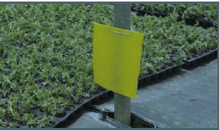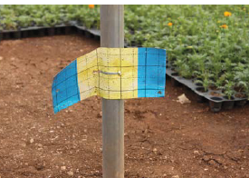
Yellow and blue trap
Yellow trap

Fig. 4.3.3.Yellow and Blue card /trap

Why use sticky traps?
Because sticky traps/cards can be used to:
- Track insect population trends, and make more informed and timely pest management decisions.
- Mass trap adults during high incidence of insect pests.
- Mass trap Lepidopteran insects by sticking pheromones/lures on them.

Assembly and placement of the trap: After unwrapping the outer covering, carefully remove the plastic cover from the glued area of the trap to expose the sticky surface. Then hang the trap above the crop using the plastic-coated wire provided. Attention should be taken to avoid placing the trap where the sticky surface can easily come in contact with either the plants or fittings.

- Insect pest control by chemical

Table.4.3.2. listed the important nursery insect pest,and their control measures

Symptom | Affected seedling | Control measure
Thrips | Onion | Radiant
Aphid | Cabbage | Profit

4.5. Maintaining and preparing irrigation system components
Irrigation work involves the maintenance and repair of all the components of the irrigation system. The scope of work includes, but is not limited to, the point of connection, piping system, electrical system and the sprinkler heads that apply water to the nursery. Proper maintenance of an irrigation system involves having a working knowledge of the functionality of the basic components that are common in all systems. This knowledge can be directed toward detecting and preventing problems associated with improperly functioning systems, thus preventing deterioration of plants. Replacement of irrigation system components must be made with materials of the same manufacturer and model as the original equipment.
Maintenance period of non-use to prepare the system:
- For the off season shut-down; and
- For use before the next season.
All equipment requires a certain amount of care in handling for storage and maintenance. Preventive maintenance of the pumping system is essential during the irrigation season. Equipment manuals contain trouble-shooting chapters which are useful for solving common problems associated with the normal operation of the pumping unit.

The following checks and inspections are recommended for most engine or electric motor driven pumps:

- noise
- vibration
- leakage
- temperatures of bearings and windings
- fuel/power consumption
- capacity and output (water discharge and dynamic head)
- ventilation screens, clean where necessary
- Oil pressure; oil, lubrication, change where necessary.

4.6. Principle and operation of irrigation system
The application of the exact amount of water required by the crops at the right time is the main achievement of the irrigation installation. Farmers normally understand matters concerning the main elements of irrigation programming, such as water discharge and rate, operating hours and irrigation frequency, and they can follow instructions. Properly installed, operated and maintained irrigation networks enable farmers to exercise absolute control over water use at farm level. Thus, it is easy for them to apply irrigation schedules based on crop, soil, weather, and water availability and quality factors.

Starting and shutting down the pressurized irrigation installation needs to be done very carefully in order to prevent surges and water hammer and to avoid air pockets in the pipelines. The opening and closing of the valves at the head of the system, the main and sub main pipelines, should always be done slowly. Where there is a pump, engine or motor driven, the supplier’s instructions should be followed. Priming the pump, filling the pipes, adjusting the speed and lubricating the pumping equipment are matters of major importance. Manufacturers provide detailed instructions in their literature for starting and operating each pumping unit.

4.7. Calibration and application of treatments to assist plant growth
Calibration is the process of determining the amount of material applied per the unit area. Equipment for applying both liquid and dry material must be accurately calibrated for the pesticide to work properly and to avoid damaging or killing the crop.
Calibration of equipment ensures the product is being applied as specified on the label and that environmental contamination will be minimized. Applying the wrong amount of pesticide can result in poor control if not enough is used or overuse if too much is applied.
Before start:
- Run the sprayer to flush out the hoses.
- Make sure your tank is properly rinsed
- Make sure you have clean and non-leaking nozzles and screens
- Check nozzles to make sure they are spraying properly at the desired pattern and size.

4.8. Undertaking seedling hardening off practice
Hardening-off.
The practice of hardening preconditions transplants to tolerate transplanting stress by exposing them to several hardening factors such as water stress and direct sun light. The practice is more commonly applied to transplants destined for open-field production or for cultivation under environmental conditions harsher than those they were exposed to during propagation. Nevertheless, excessive hardening should be avoided.

During the hardening phase, energy is diverted from shoot growth to root growth. Root collar diameter and roots reach target specifications, and shoot growth is discouraged or even stopped. Plants are “hardened” – conditioned to endure the stresses of harvesting, transporting, and out-planting. They are also fortified so that they have the energy reserves to survive and grow after out-planting.
Hardening is a crucial phase. It is a common mistake to rush hardening, resulting in plants poorly prepared for conditions on the out-planting site. When plants are not properly hardened, they may have the correct physical characteristics but survival after out-planting will be low because of an inadequate physiological condition. The goal of the hardening phase is to get plants conditioned for stress, prepared for out planting, and ready to be delivered to the client in a timely fashion to avoid problems with holdover stock.
Generally, hardening is imposed from about 1 to 2 weeks prior to transplanting seedlings, by gradually exposing them to higher (or lower) temperature and the higher light intensity prevailing in the field.
It should, however, not involve any treatment that may reduce the rate of photosynthesis, such as nutrient stress. Care should be taken not to over-harden plants, as this may delay maturity and in some instances even reduce crop yields.

Self-Check –4 | Written test

Name…………………………………………… ID………………………… Date…….
Directions: Answer all the questions listed below.
Test I: Multiple choice
1. Which of the following is affecting plant growth and health requirement
- Urea
- Labor intensive
- Growing media
- Water stress
2.From the following which one is cultural insect control method
- Trap
- Chemical
- Insecticide
- Pesticide
Test II: Short Answer Questions
1. Write weed management practice
2. Write insect commonly observed in nursery

You can ask you teacher for the copy of the correct answers.

Operation Sheet -4

4.1. Techniques of calibrating chemical spray equipment’s
Material and equipment

- Water
- Spray tank
- Beaker
- Pen
- Note book
- Bucket
- PPE: Glove, Boots, Apron /overall ,Mask ,Eye Google

Calibration Procedure
- Mark off 18 m² of land.

3

3m
6m

- Fill the spray tank with clean water and mark the level.
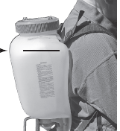
Water level

- Spray the water on the marked 18 m², as if you were making an actual pesticide application. Operate at the proper speed.
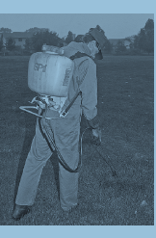

- Mark the new water level in the spray tank.
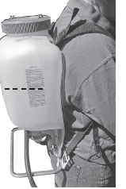
Volume of water after spraying the 18m² area land

- Measure the amount of water needed to refill the sprayer to the first marked water level. This measured amount of water equals the volume of pesticide solution needed to cover the 18 meter square.
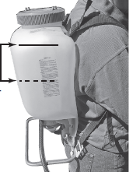
Volume of pesticide needed to cover the 18m²area
- Use the amount from Step 5 to find out how much liquid you need to cover the area you are treating. For instance, if you are treating 90 m², you will need 5 times the amount of water needed for 18 meter square.
18m²
18 m²
18 m²
18m²
18m²

=90 m² area
+ + + +

- Read the label and determine the pesticide application rate. Calculate the total amount of pesticide you will need for the entire treatment area and the total amount of liquid mixture. Calculate the amount of pesticide needed for each tank for the desired application rate.

B. Techniques of chemical application
Material and equipment

- Chemical
- Spray tanker
- Water
- Bucket
- Stirring stick
- PPE

Procedures of chemical application
- Wear PPE
- Calculate the amounts chemical required
- Pour the water in spray tanker up to 1/2 of the tanker volume
- Open the cap of chemical container properly
- Measure the amount of the chemical required for the given area
- Pour the chemical in spray tanker and continue to fill the water to required level
- Agitate thoroughly
- Properly hold the spray tanker on shoulder
- Run the pump to build up pressure in the system
- Engage trigger (clutch) and move forward as soon as spraying starts in constant speed.

LAP TEST-4 | Performance Test
Name………………………………. ID…………………………….. Date…………………………………….
Time started: ________________________ Time finished: ________________

Instructions: Given necessary templates, tools and materials you are required to perform the following tasks within 4 hour. The project is expected from each student to do it.

Task-1.Perform equipment calibration
Task -2.Perform chemical application

LG #12 | LO #5-Completing nursery plant maintenance operations

Instruction sheet
This learning guide is developed to provide you the necessary information regarding the following content coverage and topics:
- Recording workplace information
- Collecting and disposing off waste or recycle to minimize external environmental impact
- Cleaning and storing tools and equipment
- Nursery hygiene practices and quality control
This guide will also assist you to attain the learning outcomes stated in the cover page. Specifically, upon completion of this learning guide, you will be able to:
- Workplace information is recorded in the appropriate format
- Waste is collected and disposed of or recycled to minimize damage to the external environment
- Tools and equipment are cleaned and stored
- Nursery hygiene practices are followed to minimize risk of contamination.
Learning Instructions:
Read the specific objectives of this Learning Guide.
Follow the instructions described below.
Read the information written in the information Sheets
Accomplish the Self-checks

Information Sheet- 5

5.1. Recording workplace information
The record of past and ongoing nursery experiments is advisable. Simple experiments testing new potting mixtures, watering regimes, seed pretreatments etc. should be part of normal nursery management and, without accurate records of these, valuable information is likely to get lost. A nursery calendar is a very essential tool in nursery planning. The date for sowing seeds can be calculated by counting backwards from the anticipated date of planting, taking into consideration the number of days needed for germination and further seedling development until the right stage for planting. A well-kept and up-to-date nursery inventory helps to assess whether the nursery is operating as planned, and whether demands are being met. Inventory should list all plants currently in the nursery by bed or frame number, and details of delivery of seedlings, including the site, name of owner and site conditions.

It can be an important tool to record feedback from the planting sites and can then help to determine whether seedlings have the right quality for the sites on which they are planted. Keep a register for each species by seed lot, with information about seed sources used, pre-treatment’s, sowing date, time to germination, percentage of germination, percentage of germinants pricked out, potting substrate, plant development and condition under which produced.

Pests encountered and control treatments, if any, as well as data of plant and/or substrate nutrient analyses. All this information is important for nursery research and might later help explain unexpected results. It can also be used to compare results with published information and alert you to possible problems originating in the nursery, for example if the development is much slower than is reported elsewhere,It might open additional research areas, for example it might lead to trying different substrates, shading or fertilizer treatments. Good documentation about species handling and development is also necessary when staff changes.

5.2. Collecting and disposing off waste or recycle to minimize external environmental impact
Agricultural solid wastes are produced mainly from farming activities. However, it is not limited to the production but other activities associated with farming and food chain. Every stage and phase of the agricultural-food chain can generate significant agricultural solid wastes. The broad classification of agricultural solid wastes includes the following.
  - Crop production solid wastes
  - Chemical wastes.
Crop production solid wastes crop solid wastes are associated with agricultural solid wastes typically produced from agricultural activities involving crop production. Examples of such agricultural solid wastes are crop residues like dropped leaves that are collected seasonally, other vegetation such as grass clippings, woody debris and dead plants and shrubs that are collected at different times should be removed and disposed.
Horticultural production solid wastes:-these groups of agricultural solid wastes refer to solid wastes generated from cultivation and maintenance of horticultural plants and landscape for beautification. Examples of such wastes are prunings and grass cuttings.
Farming activities: - The main source of agricultural solid waste generation is agriculture. Beginning from land clearing till harvest, every phase of farming activities results in the generation of agricultural waste. From preparing the pen for the arrival of the animals to the farm, preparation of pasture/paddock till the animals are slaughtered and sold, solid wastes are generated.
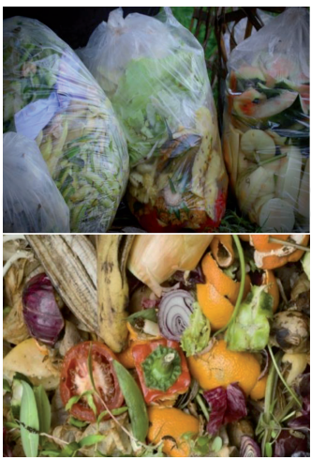
Fig.16 . Solid waste

Effective management of agricultural solid waste
There are options on how agricultural solid wastes could be handled. This is necessary because of the need to focus people’s attention on efficient ways of managing these wastes. Traditionally, shafts from palm oil processing could be used as fuel in fuel wood for cooking and heating. In the recent time, some of these wastes are put into better uses. Some of these agricultural solid wastes could be used as additives in cement mixes, water glass manufacturing, paper making, ethanol production, animal feed, electricity and biogas generation, heavy metal removal, mulching, organic fertilizers, and compost. An effective means of managing agricultural solid wastes is to recycle them to produce useful products. This can be achieved through:-
i. Compositing/organic manure
ii. Nonconventional feed ingredient
ii. Alternative energy sources and bio-fuel production
5.3. Cleaning and storing tools and equipment
One of the most fundamental requirements for healthy propagation is the cleaning and sterilization of tools, equipment and other working surfaces between crops or batches. This must be done, regularly and properly, which means cleaning first and then sterilizing.

5.4.Nursery hygiene practices and quality control
Many production nurseries fail to regularly review hygiene standards and as a result underlying and unreliable problems are not obvious until it is too late. Hygiene problems in propagation can easily affect plants for their entire life. Preventing the spread of plant pathogens results in fewer pest and/or disease problems and a reduced need for using pesticides. Nursery operators need to regularly review their hygiene protocols, as practices and infrastructure can slowly deteriorate .Hygiene matters in all stages of propagation. It may be easier to review your hygiene standards within the four stages of propagation.

Hygiene protocol for propagation
- Ensure hands are clean, wear an apron and latex gloves
- Use clean and disinfected secateurs, cutting tools and containers
- Surface sterilize cutting material (if required)
- Clean and disinfect the tool holders
- Disinfect tools between batches or regularly if large batches – a plastic bottle with a 70% methylated spirits solution works well.
- Clean and sterilize benches and other working surfaces before and after use
- Use only clean, healthy and disease free material
- If required, drench with a fungicide or another sterilizer.
- Use growing media that is known to have been prepared and stored hygienically, such as from an accredited growing media supplier.
- Use clean trays/pots or tubes.
- If you must re-use then you must sterilize them properly. Washing alone is not adequate.
- Ensure the hardening off; potting and tubing up areas are free from weeds, and moss.

Self-Check –5 | Written test

Name…………………………………………… ID………………………… Date…….
Directions: Answer all the questions listed below.
Test I: Short Answer Questions
1. Define hygiene practice
2. Write hygiene protocol

Reference Materials

Garba I., Isah S., Galadima, M., Dr. Karaye, A., Idris, S.2019. Establishment and Management of Plant Nursery System. Jigawa Agricultural Research Institute
Joginder, Rashi N, Wajid H, Anan .2018. Advances in Horticultural Crops
Haldwani, Nainital.2011. Applied Horticulture: Crop Production Technology (Vegetable Crops)
Chepauk, Chennai, Sixth Revised Edition.2004 .Crop Production Techniques of Horticultural crops

Web addresses
file:///C:/Users/Gossa/Downloads/Agricultural_Solid_Wastes_Causes_Effects_and_Effec%20(2).pdf(accesed date 02/09/22)
http://cazri.res.in/publications/PRathaKrishnan.pdf(accessed date 02/09/22)

AKNOWLEDGEMENT
Ministry of Labor and Skills to extend thanks and appreciation to the many representatives of TVET instructors and respective industry experts who donated their time and expertise to the development of this Teaching, Training and Learning Materials (TTLM).

The experts who developed the learning guide
No | Name | Qualification | Educational background | Region | Phone number | E-mail
1 | Gosa Shura | MSc | Horticulture | Oromia | +251-923041032 | gossashura@gmail.com
2 | Tilahun Getu | MSc | Biotechnology | Amhra(3) | +251-918726766 | tile21eme@gmail.com
3 | Degefa Guluma | MSc | Soil science | Oromia | +251-913440464 | deguluma@gmail.com
4 | Bayisa Abeshu | MSc | Agronomy | South west Ethiopia | 0921434086 | Bayoabeshu@gmail.com
5 | Berhanu Asefa | BSC | Plant science | South west Ethiopia | 0922182673 | berhanuasefa@gmail.com
6 | Fikadu Tilahun | BSc | Plant science | Afar | 0917363367 | fikadutilahun80@gmail.com
7 | Wendimu Terfa | BSc | Plant science | Oromia | 0911266570 | gurachoterfa@gmail.com
8 | Yimam Mohammed | BSc. | Plant science | Oromia | 0913624360 | leylasalo@gmail.com
9 | Eyaya Tigabie | MSc | Agronomy | Afar | +251-921944452 | eyayatigabie@gmail.com
10 | Taka Magarsa | MSc | Horticulture | Oromia | +251917210371 | takamagarsa430@gmail.com
11 | Elias Mohammed | BSC | Horticulture | Oromia | +251946706670 | reweda1@gmail.com

