CROP PRODUCTION
Level-II

Based on March 2022 Version 4, Occupational standard
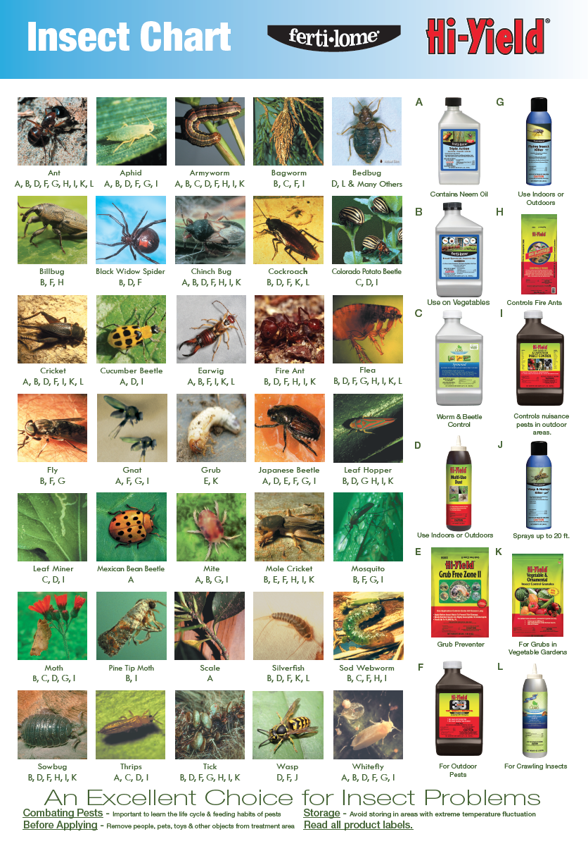
Module Title: - Determining crop pests and disorders

LG Code: AGR CRP1 MO1 LO (1-4) LG (18-21)
TTLM Code:AGR CRP1 M01 TTLM 0922v1

September, 2022
Addis Ababa, Ethiopia

Table of Contents
Content Page
Introduction to the Module 1
LO #1- Understand the main agriculturally important crop biotic and a biotic factors 2
Instruction sheet 2
Information Sheet 1 4
Self-check 1 15
LO2 # Identifying the major agriculturally crop pest and disorders 16
Instruction sheet 16
Information Sheet 1 18
Self-check 1 36
LO #3- Assessing pests and take sample 37
Instruction sheet 37
Information Sheet 3 38
Self-Check – 3 47
Operation Sheet -3 48
LAP TEST-3 49

LO #4 Record and Report pest occurrence 50
Instruction sheet 50
Information Sheet 4 51
Self-Check – 4 55
Reference Materials 56

Introduction to the Module

This module covers the knowledge, skills and attitude to understand the main agriculturally important crop biotic and a biotic factors, identify the major agriculturally crop pest and disorders, assess pest occurrence and take sample. Furthermore, able to record and report pest occurrence to the organization
Definition of terms:
- Pest: In crop protection, pests can be defined as any form of plant or animal life, or any pathogenic agent, which is injurious or potentially injurious to crop or crop products.
- Pathogen: Disease causes organisms.
- Disease: A plant disease is a physiological or structural abnormality that affects the plant, or reduces its economic value. Any biotic, abiotic & biotic agent that causes damage on crops, animals humans & his possessions.
- Plant disorder: states from the physiology of the plant attributed to environmental factors and nutritional deficiencies.

LG #18 | LO #1- Understand the main agriculturally important crop biotic and a biotic factors

Instruction sheet
This learning guide is developed to provide you the necessary information regarding the following content coverage and topics:
  - Understanding classification of biotic and abiotic factors
  - Identification of biotic factors causes
  - Identifying means of biotic factors disseminations and sources of infections
  - Understanding biotic factors favorable environmental condition and crop preference
  - Understanding biotic factors of over wintering
This guide will also assist you to attain the learning outcomes stated in the cover page. Specifically, upon completion of this learning guide, you will be able to:
- Understand classification of biotic and a biotic factor
- Identify causes of biotic factors
- Identify means of biotic factors disseminations and sources of infections
- Understand biotic factors favorable environmental condition and crop preference
- Understand biotic factors means of over wintering.

Learning Instructions:
- Read the specific objectives of this Learning Guide.
- Follow the instructions described below.
- Read the information written in the information Sheets
- Accomplish the Self-checks
- Perform Operation Sheets
- Do the “LAP test”

Information Sheet 1

  - Understanding classification of biotic and abiotic factors

The biotic factors are referred to living organism(s) such as bacteria, virus, fungi, nematode ; while abiotic factors are referred to non-living things such as temperature, water, minerals, wind flow, polluted air etc. Abiotic affect the productivity of agricultural crops as well as the microbial activity in soil.
    - Abiotic factors
- Abiotic factors fall into three basic categories:
- Climatic factors include humidity, sunlight and factors involving the climate.
- Edaphic factors refer to soil conditions, so edaphic abiotic factors include soil and geography of the land.
- Social factors include how the land is being used and water resources in the area.
- Generally, abiotic factors that cause plant stress (disorder) include:
- Moisture
- Air pollutants
- Toxic chemicals (including road salt)
- Pet urine
- Temperature extremes (hot and cold) or wind
- Lack of light, water or soil nutrients
- People pressures (heavy use, soil compaction)
- Damage by equipment (e.g., string trimmer damage to trees, mower damage to golf greens)
- Disorders (injury) caused by abiotic factors may be:

- Leaf scorch
- Drought stress
- Winter burn
- Sun scald
- Splitting fruits
- Iron chlorosis
- Chemical burn
- Mechanical damage etc

    - Biotic factors
- Biotic factors include :
- Pathogen like:

  - Bacteria
  - Fungus
  - Virus and
  - Nematodes.

- Pests (insects, weeds, rodents, birds and plant feeder animals).

- Common insect pests are:
- Whiteflies—tomato, lantana, gerbera daisy, poinsettia, and eggplant.
- Spider mites—marigolds and roses.
- Aphids—sweet peppers and fuschias.
- Thrips—petunias and impatiens.
- Tomato Spotted Wilt Virus—petunias and gloxinias.
- Necrotic Spotted Wilt Virus—impatiens.

Table 1.1 Difference between biotic and abiotic factors:
Biotic factors | Abiotic factors
- Living organism | - Non living
- Can transfer (infectious) | - Can not transfer (non infectious)
- Needs host to be survive | - Didn’t need host

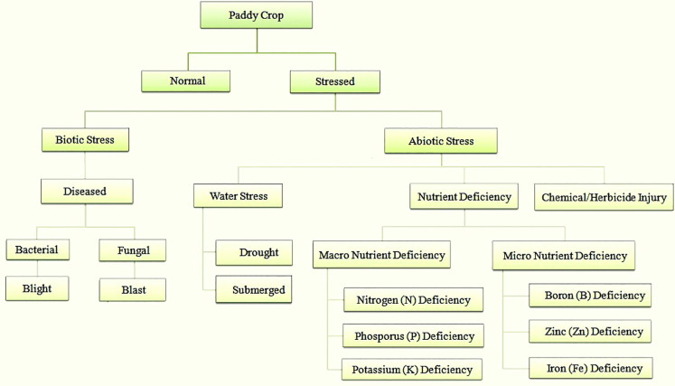 Figure 1.1 Crop stress classification tree
Crop
Source: https://www.sciencedirect.com/science/article/pii/S2214317318304700 (31/08/2022).

  - Identification of biotic factors causes

Biotic stress in plants is caused by living organisms, specifically viruses, bacteria, fungi, nematodes, insects, arachnids, and weeds. In contrast to abiotic stress caused by environmental factors such as drought and heat, biotic stress agents directly deprive their host of its nutrients leading to reduced plant vigor and, in extreme cases, death of the host plant. In agriculture, biotic stress is a major cause of pre- and postharvest losses.
In contrast to vertebrates, plants lack an adaptive immune system, or the ability to adapt to new diseases and memorize past infections. Though lacking an adaptive immune system, plants have evolved a plethora of sophisticated strategies to counteract biotic stresses. The genetic basis of these defense mechanisms is stored in the plant's genetic code. Plant genomes encode hundreds of biotic stress resistance genes. With the completion of several plant genome sequences during the past decade – among them are important agricultural crops such as maize, sorghum, and rice – we obtained a first glimpse into the wealth of biotic stress resistance genes encoded within plant genomes. However, we have just started to uncover the molecular mechanisms and networks controlling biotic stress resistance in cereals.

Biotic factors:

- Fungi: Fungi are primitive microscopic plants that have no chlorophyll and vascular tissue for food manufacture and must therefore either parasite on plants or live on dead material, and range in form from a single cell to a body mass of branched filamentous hyphae that often produce specialized fruiting bodies. Most of the species are strictly saprophytic.
- Bacteria: are microscopic single celled organisms and reproducing by fission. The majority of bacteria are strict saprophytic and have three groups namely:

  - Bacilli (rod shaped),
  - Cocci (round) and
  - Spirilla (spiral).

- Viruses: Viruses are the smallest organisms of all and are invisible under an ordinary microscope. For practical purposes, they are recognizable only by the symptoms they cause and can be transmitted to a healthy plant by mechanical means or a specific vector such as an insect.
- Nematodes: Nematodes are slender round worms, which commonly occur in soils. In vegetable gardens, they cause root rots disease in many vegetables e.g. root knot of tomato, root knot of cabbage, etc.
  - Identifying means of biotic factors disseminations and sources of infections
Plant disease, an impairment of the normal state of a plant that interrupts or modifies its vital functions. All species of plants, wild and cultivated alike are subject to disease. Although each species is susceptible to characteristic diseases, these are, in each case, relatively few in numbers. The occurrence and prevalence of plant diseases vary from season to season, depending on the presence of the pathogen, environmental conditions, and the crops and varieties grown. Some plant varieties are particularly subject to outbreaks of diseases while others are more resistant to them.

Sources of plant biotic factors:
- Infested Soil
Many plant pathogens can be found in soil. Fungi such as Cylindrocladium, Pythium, Phytophthora, Fusarium, Rhizoctonia, and Thielaviopsis, crown gall bacteria (Agrobacterium) and most nematodes reside in the soil. Pythium species can be found in sand and peat as well. When containerized nursery crops are potted in a mix containing these pathogens, the pathogens are stimulated into activity by nutrients that leak from the plants' roots and disease may begin. Therefore, the potting mix must be free of pathogens before planting.
A potting mix that has been treated to kill plant pathogens or a soilless mix purchased with the assurance of being free of pathogens should be used so that unwanted organisms are kept out. It should be stored on a clean surface, moved with clean implements to a clean potting area, and placed in clean containers.
No matter how careful a grower is, disease caused by soil borne pathogens still can occur in container production. Besides the potting mix, soil from the surrounding area can be moved into the containers by the wind, by workers' and pets' feet, and by using dirty machinery and tools. Care must be taken to avoid getting contaminated soil into the potting mix. Tools, hose ends and other things that have the potential of moving pathogen-containing soil into a pathogen-free potting mix must be thoroughly cleaned and disinfested. Containers are often placed on the ground and not separated from the underlying soil. It is best to first put down a sheet of porous plastic and then cover the sheet with 4 to 6 inches of coarse gravel or small stones. By placing the containers on this surface, they are away from underlying and possibly contaminated soil. This surface also greatly reduces puddles and splashing of irrigation water.
- Plant Debris
Most plant pathogens have a stage in their life histories that can rest in a dormant state and survive periods of time when temperatures are extreme or moisture is not sufficient for growth. Some pathogens have evolved a strategy of becoming dormant in the dead leaves, stems, branches, and roots where they previously caused disease. Inside those tissues they are protected from the hostile environments of the soil and air and are away from competition with other organisms in the soil and air. They have at hand a ready supply of nutrients for when conditions become favorable again. Bacteria such as Erwinia and Pseudomonas, fungi such as Botrytis, Phytophthora, Thielaviopsis, Rhizoctonia, Cylindrocladium, Phomopsis, Botryosphaeria, Sphaeropsis, Verticillium, Cytospora, and Nectria, foliar nematodes (Aphelenchoides), and tobacco mosaic virus, survive for months in plant debris. A disease may recur if infested debris is left in the nursery where it may come in contact with the crop.
- Host Plants
Some pathogens must have living plant tissues in order to grow, reproduce, and survive. Most viruses like tomato spotted wilt and cucumber mosaic only survive in living plant cells. Rusts, such as pine gall rust and cedar-quince rust, must pass from living plants to other living plants or they die. Thus, plants in and around the nursery act as reservoirs of pathogens and should be under strict disease control.
Non-crop plants (weeds) fall under this heading. If junipers are the crop, then wild apples and hawthorns should be removed from in and around the nursery because they are alternate hosts of cedar-apple, -quince, and -hawthorn rusts. Likewise, if crabapples, quinces, or hawthorns are the crops, then wild junipers should be removed from in and around the nursery.
Recognize that the plants you buy from a supplier to grow on in your operation may already be infected with pathogens including Agrobacterium and Phytophthora. Get to know the operation from which you buy plants. It is their responsibility and legal obligation to sell only healthy plants. If you find that you are receiving infected seedlings or young transplants, change suppliers. This is especially true if you purchase vegetatively propagated crops. Any disease affecting stock plants is likely to be found on cuttings taken from those plants, particularly if the pathogens reside inside the plant. Vascular wilt diseases such Verticillium wilt, virus diseases, foliar nematodes, all will accompany cuttings if stock plants are infected. The propagator must assume responsibility for strictly controlling diseases on stock plants so that these diseases are not sold to you. The Department of Agriculture inspectors are of great assistance in inspecting plants. However, you must also inspect purchased material carefully as soon after arrival as possible. If inspection is put off until the plants have been in the nursery for several months, it is not possible to determine whether the pathogens accompanied the plants or moved to them from sources within your operation. Train your employees to look for problems. Workers who handle a large number of plants is most likely to first notice a problem. Encourage them to be your 'scouts'.
- Irrigation Water
Phytophthora and Pythium, which can cause damping-off, root and stem rots, cutting rots, and top diebacks are probably the main pathogens that can be spread in the nursery in water. Surface water supplies such as lakes, ponds, rivers, and streams contain Pythium in the bottom sediment. Some also contain Phytophthora in the sediment as well as free in the water at certain times of the year. Note that run-off can carry these fungi from into wells. Care should be taken to avoid pumping bottom sediment from water supplies into the irrigation system. If Phytophthora is an ongoing problem in your nursery, your water source should be tested for that fungus. This is particularly true if you recycle water within the nursery.
- Polluted Air
The spores of powdery mildew fungi, rust fungi, and others can be carried by air currents for long distances outdoors. Infected plants in nearby gardens and forests can supply enormous numbers of spores. Thus, even if great care is taken to eliminate other sources of pathogens, the air we breath may carry certain disease-causing organisms into the nursery. This is another reason why non-crop plants that harbor pathogens of crops plants should be eliminated from within and around the nursery.
There are other sources but these are the first to suspect when trying to answer the question "Where did the disease begin?" Every nursery manager should be aware of the sources of pathogens for each crop grown in their particular operation and should plan to eliminate those sources of disease to the greatest extent possible. Money can be saved by not losing plants during production and by minimizing the expense of purchasing and applying disease control chemicals.
  - Understanding biotic factors favorable environmental condition and crop preference

The interaction between host, pathogen, and environment is no spatial, ranging in order of interactions which completely facilitate the disease to those in which a susceptible plant is not infected at all. Environmental variables are known to have a significant impact on a host plant’s substantial state, such as, its expansion, resistance mechanisms in accordance to biotic/abiotic stress response, along with a pathogen’s survival, germination, and production of virulence proteins. These ever-changing environmental criterions can result in a host plant being fully vulnerable to being fully resistant, whereas the pathogen, on the other hand, ranges from being severely virulent to being weakly pathogenic.
Some examples of crop preference by biotic factors
- Chickpea
- Helicoverpa larvae are the only major pest. They are most damaging from pod set to maturity, reducing both grain yield and quality.
- Hairs on the leaves, stems and pods secrete an organic acid (malic acid), making the crop unattractive to most insects.
- Seedling insect pests, such as cutworm, can attack chickpeas, but are seldom an economic problem.
- Other minor pests include locusts, aphids, false wireworm, thrips, loopers, green vegetable bug and blue oat mite.
- Maize
- The main pests of maize are fall armyworm, helicoverpa and soil insects. Other pests are infrequent, although maize leafhoppers can transmit wallaby ear disease.
- Millets and panicums
- While serious insect pests are not generally considered a problem, helicoverpa, cutworm, armyworm, locusts and shoot fly can occasionally reach damaging levels.
- Mungbeans
- Insect pests can attack mungbeans at any stage from seedling to harvest but the crop is most susceptible from budding onwards. Monitor crops once a week during vegetative growth as the first buds are borne below the top of the canopy.
- Major pests include helicoverpa, pod-sucking bugs, mirids and bean pod-borer.
- Minor pests include caterpillars (loopers, cluster caterpillar, Etiella), bean fly, cowpea aphid, thrips and cowpea bruchid (post-harvest).
- Peanuts
- Pest damage to peanuts can occur from planting to maturity. Under intensive production a number of pests will warrant control.
- Major pests include helicoverpa, mites, Etiella and peanut scarab.
- Minor pests include whitefringed weevil, false wireworm, leafhoppers/jassids, cluster caterpillar, mirids, silverleaf whitefly, thrips, armyworm and cutworm.
- Sorghum
- Sorghum is susceptible to insect pests from emergence to late grain fill. IPM programs incorporate latest varietal releases and soft biopesticides.
- Major pests include Helicoverpa armigera, fall armyworm and sorghum midge.
- Minor pests include false wireworm, cutworm, black field earwig, armyworm, corn aphid, Rutherglen bug, sorghum head caterpillar and yellow peach moth.
- Soybeans
- Soybeans can be attacked by pests at any stage from seedlings to close to harvest, but are most attractive from flowering onwards.
- Major pests include helicoverpa, pod-sucking bugs and silverleaf whitefly.
- Minor pests include brown shield bug, caterpillars (cluster caterpillar, loopers, soybean moth, legume webspinner, Etiella), redshouldered leaf beetle, lucerne crownborer, soybean aphids and mirids.
- Sunflowers
- Sunflowers are attacked by a number of insect pests at various stages of crop development. Sunflowers are more susceptible to seedling damage from soil insects than other field crops because damaged seedlings lack the capacity to regrow or tiller.
- Other pests include Rutherglen bug, helicoverpa, whiteflies, loopers and green vegetable bug.
- Winter cereals (includes wheat, barley, oats, canary and triticale)
- Insects are not normally a major problem in winter cereals but there will be times when they build up to an extent that control may be warranted.
- Pests of winter cereals include cutworm, aphids, armyworm, helicoverpa and mites.

  - Understanding biotic factors of over wintering

Overwintering is a term used in several categories such as pests, birds, and plants. In our case, we are most often referring to pests and their activities that allow them to survive the cold temperatures. An overwintering pest is a bug that hides away in a warm spot during the winter season, waiting for springtime. Many insects overwinter as adults, such as leaf beetles, some aphids, most leafhoppers, and many beetles. Overwintering sites include those under the loose bark of trees, fallen leaves, and other debris on the ground.
  - Leaf beetles
- Leaf beetle adults are susceptible to cold weather, and most will die if exposed to air temperatures below 14°F. However, they avoid harsh temperatures by burrowing under plant debris and loose soil. Each spring, adult beetles emerge from their overwintering habitat and migrate to available hosts, such as alfalfa, tick trefoil, and various clovers.
- As the season progresses, bean leaf beetles move to preferred hosts, like soybean. While initial adult activity can begin before soybean emergence, peak abundance often coincides with early-vegetative soybean.
  - Aphids
- Aphids are able to survive cold weather because they’re cold-hardy insects that have adapted to regional weather fluctuations. Adults and nymphs have been known to survive in temperatures below 30℉ (-1.1℃), and some aphid eggs can survive short-term exposure to temperatures as low as -40℉ (-40℃).
  - Grasshoppers
- Grasshoppers are hungry insects that can quickly destroy plants and vegetables in your garden. Although they seem small and insignificant, large numbers of grasshoppers can become garden pests. An invasion of grasshoppers can rapidly munch their way through green vegetable leaves, broadleaf plants, and grasses.
  - Leaf hoppers
- The small, streamlined insects hop when disturbed, and may be green, brown, or yellow in color; some species are striped. Adult leafhoppers overwinter in plant debris near the garden and some also migrate north from warmer zones during the growing season. They lay eggs on the leaves of host plants and the nymphs feed on the underside of leaves.
- Stunted growth or leaves that are curled, stippled, or have a burned appearance are signs of leafhopper damage. The adults and nymphs pierce foliage and suck out plant juices. Their toxic saliva produces the characteristic damage symptoms and also transmits viral diseases. In vegetable gardens, leafhoppers seem to prefer potatoes, beans, lettuce, peppers and beets.
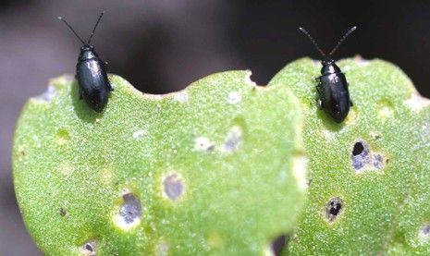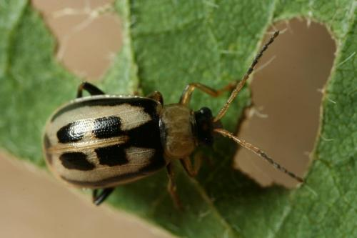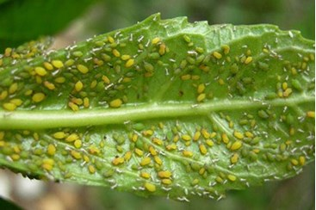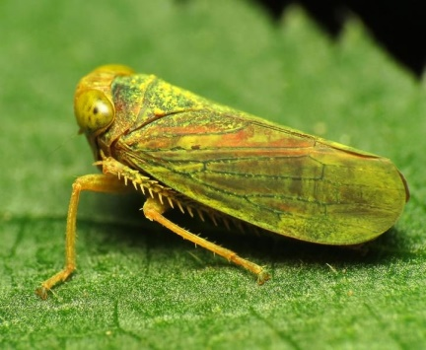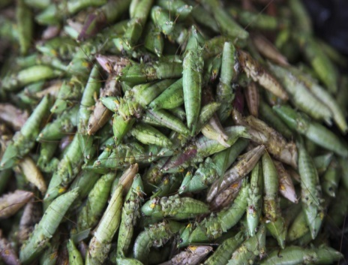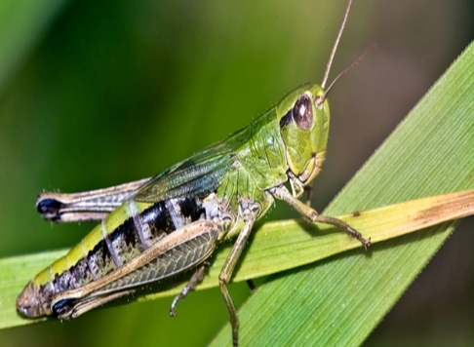
Grass hopper
Grass hoppers in group
Leaf hoppers
Leaf beetles
Aphids
Leaf beetles
Figure: some examples of overwintering pests
Source: https://www.bing.com/images/search?q=APHIDS&qs (28/08/ 2022)

Self-check 1 | Written test

Name…………………………………………… ID………………………… Date…….
Directions: Answer all the questions listed below.

Test I: Short Answer Questions
- Write at least 5 sources of abiotic factors.(2 points)
- Write the means of biotic factor dissemination. (2 points)
- Define the following terms. (5 points)
  - Stimulant crops
  - Spice crops
  - Post-harvest handling
  - Pest
  - Disease
  - Disorder
- Write at least 5 spice crops and 2 stimulant crops (3).
- Write at least

Note: Satisfactory rating – 11 points and above Unsatisfactory - below 11 points
You can ask you teacher for the copy of the correct answer

LG # 19 | LO2 # Identifying the major agriculturally crop pest and disorders

Instruction sheet 2
This learning guide is developed to provide you the necessary information regarding the following content coverage and topics:
- Identifying common names of disorders and crop pests
- Identifying agriculturally important crop pest behaviour
- Understanding major insect pests’ favourable environmental condition & crop preference
- Recording and reporting details of the plant pests and disorder
- Checking, selecting and preparing equipment’s
- Selecting and checking prior to use suitable personal protective equipment (PPE)
- Identifying Occupational Health and Safety hazards and reporting risks
This guide will also assist you to attain the learning outcomes stated in the cover page. Specifically, upon completion of this learning guide, you will be able to:
- Identify common names of disorders and crop pests
- Identify agriculturally important crop pest behaviour
- Understand major insect pests’ favourable environmental condition & crop preference
- Record and reporting details of the plant pests and disorder
- Check, select and prepare equipment’s
- Select and check prior to use suitable personal protective equipment (PPE)
- Identify Occupational Health and Safety hazards and reporting risks

Learning Instructions:
- Read the specific objectives of this Learning Guide.
- Follow the instructions described below.
- Read the information written in the information Sheets
- Accomplish the Self-checks
- Perform Operation Sheets
- Do the “LAP test”

Information Sheet 2

2.1 Identifying common names of disorders and crop pests

A pest can be described as an organism, whether plant or animal, which causes economic damage to crop plants, livestock, man and his possessions. They attack crops on the field as well as in the store. They may harm crops directly or introduce diseases into them. Some examples of pests are mosquitoes, rodents, and weeds. Not all insects are pests. Many different kinds of insects eat other insects and are beneficial species.
Major pests include helicoverpa, spider mites, murids, aphids and whiteflies. Minor pests include trips, green vegetable bug, pale cotton strainer bug, cotton harlequin bug, soil insects (true and false wireworm), red shouldered leaf beetle, leafhoppers/jessed, and mealybug.
Major pests are the species that need to be controlled. In the past a broad-spectrum insecticide (organochlorine) was usually applied to the crop, and it killed most of the major pests.Crop damage from pathogens and pests are a worldwide problem. Insects (mosquitoes, lice, fleas, bed bugs) and ticks are able to transmit a number of diseases caused by infectious agents: viruses (chikungunya virus, yellow fever, dengue fever, etc.), bacteria (Lyme disease, plague, etc.), parasites (malaria, sleeping sickness, leishmaniosis, filariasis, etc.).
- The first step in controlling plant pests, diseases and disorders should be identification or accurate diagnosis. It is important to differentiate between:
- Infectious diseases (e.g. those caused by fungi, bacteria, viruses, and nematodes that can spread from plant to plant) and
- Noninfectious diseases or disorders (e.g., damage caused by mites and insects, physiological disorders, air pollutants, nutrient imbalances, and herbicide injury).
- The choice of a proper management tactic must be based on accurate knowledge of:

- The pathogen causing the disease
- Its life cycle
- Time of infection
- The part of the plant involved
- The method of agent distribution
- Past, present, and future environmental conditions and
- Certain economic considerations.

- Effective management techniques include controlling crop pests: -
- Use of resistant varieties
- Use of non-infested soil or long rotations
- Sterilization of soil with steam or chemicals
- Use of clean seed, either certified or grown in disease-free areas
- Treatment of seed with heat or chemicals
- Control of insects and weed hosts
- Monitoring of weather conditions
- Use of biological control agents
2.1.1 Categories of pests

A. Vertebrates

Vertebrates are one of the categories of pests that damage crops. This category is considered a genuine concern of many as it can affect many aspects. If you think vertebrates cannot harm you and your life, well, then you are wrong. The pests involved in this category also impact your whole self and the economy as they can affect one’s property. Mice, rats, other rodents, rabbits, exotic animal pests, and even birds, snakes, and fish belong to the vertebrate’s category of pests. All of these animals are a threat, and they have already created an enormous population that can easily access and damage your crops.

B. Arthropods
Arthropod is another category of pests in pest control. These are the pests whom they call joined feet. This category of pests can live anywhere, such as in-ground, soil, and water. Other pests in this category can also live in the forest, houses, and desert. One of the examples of arthropods is insects which are considered the largest group of pests in this category. Insects may differ in their kind and size, but they tend to be one of the most annoying and disturbing pests that can harm people. However, aside from insects, other examples of arthropods are ticks, mites, and spiders. Yes, you read it right; even spiders are part of this category and are harmful. If you find spiders interesting, you can check out what is the best pest control for spiders for more details about the fantastic method you can apply.

C. Weeds
If you wonder why weeds are part of the major categories of pests, this is the time that you analyse the concept of pest and pest control. Believe it or not, weeds can also affect people, their property, and the environment. Weeds are considered plants that grow in the wrong place or place they do not want. This factor explains that there is a possibility that it can destroy something such as property. Some examples of weeds are grasses, sedges, broadleaves, annuals, biennials, and perennials.

D. Pathogens
Pathogens are also considered one of the major categories of pests as they may affect our health and well-being. This particular category of pests is called microbial organisms or organisms that cause humans to have diseases. Pathogens also have three main groups: fungi, bacteria, and viruses. These groups can also be a threat because they can easily infect plants, insects, animals, and humans.

E. Nematodes
The last major category of pests is called nematodes. If you wonder what nematodes are, then let yourself find the answers in this portion. Nematodes are tiny worms that sometimes live in water or soil. This category has a sharp hollow, often referred to as a needle which is scary because they can easily poke some plant parts .It is also possible that the nematodes can increase the problems related to diseases as they can go into the pole created by the organisms.

2.1.2 Common Plant Diseases
- Black Spot: Plants are stunted and grow poorly. Infected roots may initially have small dark brown to black bands where infection has taken place.
- Powdery Mildew: Affect many types of plants, such as squash and all cucurbits, phlox, roses, dogwoods, and crepe myrtles.
- Blight: When plants suffer from blight, leaves or branches suddenly wither, stop growing, and die. Later, plant parts may rot.
- Canker: Frequently kill branches or structurally weaken a plant until the infected area breaks free, often in a wind or ice storm.

Pests can be broken into four main categories:
- Vertebrate Pests. Have a backbone. Examples: Rodents, birds, reptiles, and other mammals.
- Invertebrate Pests. No backbone. Examples: Insets, spiders, ticks, slugs.
- Weeds. Any plant growing out of place.
- Diseases. Fungi, bacteria, viruses, and other microorganisms.

Here are some of the most destructive pests in agriculture:

- Locusts. Locusts are notorious in the agriculture industry.
- Japanese Beetles.
- Mormon Crickets.
- True Bugs.
- Corn Rootworm.
- Colorado potato beetle.
- Stink Bugs.

2.2 Identifying agriculturally important crop pest behaviour

Behavioural control refers to facts that show whether there is a right to direct or control how the worker does the work. A worker is an employee when the business has the right to direct and control the worker. Behavioural controls utilize some chemicals to modify insect pest behaviour, and control pest without the use of toxins, thereby playing an important role in area-wide control system. At present, behavioural modification method e.g. (pheromones) have been used to confuse or trap the male.

In most cases, it relies on the use of weeds volatile compounds (i.e., semi chemicals) that aim at disrupting, inhibiting or promoting target behaviours, which in turn prevent or reduce crop losses. Behavioural manipulation for pest control involves the use of natural and/or artificial signals, such as pheromones, kairomones, sounds and vibrations, to interfere with fundamental behaviours, such as feeding and mating.

Behaviourism, also known as behavioural psychology, is a theory of learning which states all behaviours are learned through interaction with the environment through a process called conditioning. Thus, behaviour is simply a response to environmental stimuli.
In most states, for example behavioral control, signs are posted in restaurant bathrooms reminding employees that they must wash their hands before returning to work. The dress codes that are enforced within many organizations are another example of behavioral control.
Pest control plays a vital role in protecting our nation's public health and food supply. Pests can spread diseases such as West Nile virus, Lyme disease, salmonellosis, and encephalitis.

Pest management is an important component of crop production. Pests can have a detrimental effect on horticultural operations by affecting the quantity, quality and ultimately, the marketability, of the crops grown. A pest is any animal, insect, weed or disease that attacks a crop. Mosquitoes, fleas, bugs, black ants, beetles are some examples of pests. - An animal also can be a pest when it causes damage to a wild ecosystem or carries germs. The term pest is employed to refer specifically to harmful animals but it also relates to all or any other harmful organisms, including fungi and viruses. Performance of behaviour is influenced by the presence of adequate resources and ability to control barriers to behaviour’s. The more resources and fewer obstacles individuals perceive, the greater their perceived behavioural control and the stronger their intention to perform behaviour’s.
.
Insects eat in many different ways and they eat a huge range of foods. Around half are plant-eaters, feeding on leaves, roots, seeds, nectar, or wood. Aphids and leafhoppers suck up the sap from plants

2.2.1 Feeding system of insects.
Insects can be distinguished by their method of feeding: chewing/rasping or piercing-sucking. Chewing/rasping insects have mouthparts that are able to chew holes into leaves, buds, roots, seeds, fruits or woody parts of plants. Insects use one of two modes of feeding: they either bite off and chew their food or imbibe liquid nourishment. Biting-chewing insects, known as manipulates, possess the ancestral and more general type of mouthparts. There are three pairs of appendages, which more or less oppose one another. Insects eat roots, stems, leaves, flowers, fruits, pollen, spores, sap and other plant parts or plant secretions in a manner that varies widely. Insects either use their jaws to bite and chew their food (such as dragonflies) or suck it up using a proboscis (like a butterfly.) The housefly uses sponging to soften the food with saliva before absorbing the liquid food.

2.2.2 Production system of insect pest.

Nearly all insects reproduce by sexual reproduction. This involves the formation and fusion of gametes: sperm from the testes and eggs from the ovaries. There are some species of insects that can also reproduce asexually. They do this by a process called parthenogenesis.
Insects may reproduce by laying eggs or, in some species; the eggs may hatch within the female which shortly thereafter deposits young. In another strategy common to aphids, the eggs hatch within the female and the immatures remain within the female for some time before birth.

2.2.3 Metamorphosis of insects:

The changes in the form of that occur as insect approaches adulthood. When the immature insects and the adults are similar in appearance, the process is called simple metamorphosis, and the juvenile insects are called nymphs.

Complete and incomplete metamorphosis is two types of growth forms in insects.

- The complete metamorphosis. Occurs through four stages: egg, larva, pupa, and adult.
- The incomplete metamorphosis. Occurs through three stages: egg, nymph, and adult.

2.2.4 Parthenogenesis

Is a form of asexual reproduction whereby offspring are produced without the embryo being fertilised by a male. There are a reasonable number of species of insect that can reproduce parthenogenetically but perhaps the most well know is the Indian or Laboratory stick insect (Carausius morosus). It is a method in which a new individual developed without fertilization. Here, males do not have any role to play and only female gametes develop into new offspring. Examples of plants showing parthenogenesis include honey bees, ants, and birds.

Nearly all insects reproduce by sexual reproduction. This involves the formation and fusion of gametes: sperm from the testes and eggs from the ovaries. There are some species of insects that can also reproduce asexually. They do this by a process called parthenogenesis. In the insect order Hymenoptera (which includes bees, wasps, and ants), parthenogenesis can take one of three forms: arrhenotoky, thelytoky, and deuterotoky.

.

2.3. Major insect pests’ favourable environmental condition & crop preference
    - Major types of plant diseases
I. Leaf diseases
The most common types of leaf diseases in plants include:
- Blights. When plants suffer from blight, leaves or branches suddenly wither, stop growing, and die. Later, plant parts may rot.
- Fire blight: This bacterial disease affects apples, pears, fruit trees, roses, and small fruits. Infected shoots wilt and look blackened.
- Alternaria blight (early blight): This fungal blight infects ornamental plants, vegetables, fruit trees, and shade trees worldwide. On tomatoes, potatoes, and peppers, it is called early blight. On leaves, brown to black spots form and enlarge, developing concentric rings.
- Phytophthora blight (late blight): Phytophthora fungi suffer dieback of shoots and develop stem cankers. Prune to remove infected branches and to increase air movement. On peppers, potatoes, and tomatoes, Phytophthora infection is known as late blight. The first symptom is water-soaked spots on the lower leaves.
- Bacterial blight: Foliage and pods display water-soaked spots that dry and drop out. On stems, lesions are long and dark colored. Some spots may ooze a bacterial slime. To control, plant resistant cultivars, remove infected plants, and dispose of plant debris. Use a 3-year rotation and don't touch plants while they are wet, as you may spread the disease.
- Anthracnose. Anthracnose is a fungal disease that over-winters on old leaves or cankers on branches. The water-borne spores are spread by splashing by rain or overhead irrigation. The fungal spores infect young leaves and branches, causing dead spots and dieback.
Damage: Dead spots develop where the anthracnose fungus enters leaves.
3) Powdery Mildew. Powdery mildew can affect many types of plants, such as squash and all cucurbits, phlox, roses, dogwoods, and crepe myrtles. Powdery mildew is also different from many fungal diseases because it does not require leaf wetness for infection to take place.
4) Rust. Infection takes place during wet weather, and these develop into pustules on the under sides of leaves. Leaves infected with rust may be spotted or mottled in color and may become twisted and distorted. In severe cases, leave s may fall off.
- Stem diseases
- Cankers.
Canker sores, also called aphthous ulcers, are small, painful sores that appear inside the mouth on the lips, cheeks, on the gums, and tongue. They are appropriately named, too: In Greek, aphthae (root of aphthous) means "to set on fire." Canker sores are not contagious and can't be spread through saliva.
Bacterial canker, one of the most important sweet and sour cherry pathogens, is caused by two different pathogens, Pseudomonas syringae and P. morsprunorum, and is characterized by oozing of gum (gummosis) at infection sites. Disease development is most prevalent during the cool, wet periods of early spring. A ‘canker’ is really a symptom of an injury often associated with an open wound that has become infected by a fungal or bacterial pathogen. Canker diseases frequently kill branches or structurally weaken a plant until the infected area breaks free, often in a wind or ice storm. Bacterial canker infections occur during fall, winter and early spring (during cool, wet weather) and are spread by rain or water, and pruning tools. The bacteria overwinter in active cankers, in infected buds and on the surface of infected and healthy trees and weeds.
Cankers usually form on woody stems and may be:-
- Cracks,
- Sunken areas, or raised areas of dead or abnormal tissue.
- Ooze conspicuously.
- Girdle shoots or trunks
- Phytophthora rot
Phytophthora is most commonly associated with root rot disease. However, this pathogen can also damage above-ground plant parts such as fruit and leaves. The disease is known as buckeye rot in tomatoes and leather rot in strawberries. The soil-borne oomycete Phytophthora spp. Steam heat is effective to kill Phytophthora in contaminated soil, media or on planting containers such as pots. If you re-use pots you can soak pre-cleaned pots in hot (180°F) water for at least 30 min or use aerated steam (140°F) for 30 min. Once a Phytophthora problem is established in a landscape site, the best option is to remove the affected plants and replace with resistant species.
Some good choices include Clethra alnifolia (summersweet), Itea sp (sweetspire), Physocarpus opufoliius (Eastern ninebark), and Leucothoe fontanesiana.It is vital that you do not carry soil from one area to another, risking the spread of phytophthora. Start your trip with clean, dirt-free gear. Remove dirt from vehicles, boots, bushwalking and camping equipment and bike tyres. Wear soft-soled shoes
- Phytophthora root and stem rot, caused by the soil borne fungus may attack plants at any stage of growth:
- Older plants may develop dull dark brown lesions
- The taproot becomes dark brown,
- Infected plants usually turn yellow, wilt, and die.
- The withered leaves commonly remain attached to dead plants for a week or more.
- Pod and stem blight
- Pod and stem blight occurs primarily on plants nearing maturity.
- Damage is most severe in wet seasons when harvest is delayed.
- Seed infection is greater in densely populated fields, due to lodging of plants.
- Root disease
Root disease is referred to as “a disease of the site” because the fungi colonize dead and dying trees and remain in dead roots and soils for many years. Many of these fungi have the ability to act as both pathogens in live trees and saprophytes in dead wood material.

The major root diseases are:

- Brown root disease: Phellinus noxious (Fumes noxious)

Brown root disease: is a disease of woody plants that causes decline and death of trees throughout the tropics. The name brown root rot refers to a dark brown crust formed by the fungus, Phellinus noxious (Corner) Cunningham, on exposed roots and lower plant stems.

- White root disease: Rigidoporus lignosus (Fomes lignosus)

As the disease progresses, the infected tissue becomes rotten. Trees develop a generally unthrifty appearance with leaf yellowing, halted root growth, wilt, small leaves, early leaf fall and small, shrivelled fruit (Figure 2). Infected trees will eventually die.

- Black root disease: Rosellinia pepo Pat

Black root rot is also called Thielaviopsis root rot. Plants are stunted and grow poorly. Infected roots may initially have small dark brown to black bands where infection has taken place. As the disease progresses, roots can become badly rotted.
2.3.2. The most Insect pests in crop production are;
Table 2.1 Insect pests in crop production
Name of insects pests | The injury caused | Picture
Aphids | Causing loss of vigour, and in some cases yellowing, stunting or distortion of plant parts | 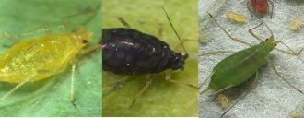
Beetles | Chewing the leaves of crop plants, sucking out plant juices, boring within the roots, stems or leaves, and spreading plant pathogens. | 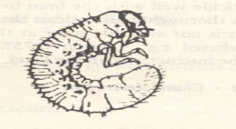
Snails | Damage plant seeds, seedlings, underground tubers, leaves and fruit | 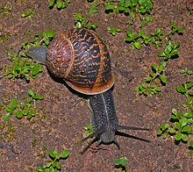
Trips: | Damage fruit, leaves, and shoots and very noticeably affect plants' cosmetic appearance. | 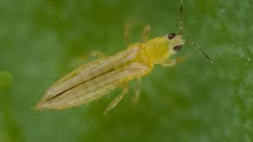
Caterpillar | Damage plants by chewing on leaves, flowers, shoots, and fruit and sometimes other parts of the plant. | 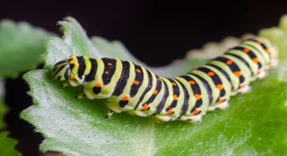
Moth | Damage the crowns or growing points of young plants or Brussels sprouts. | 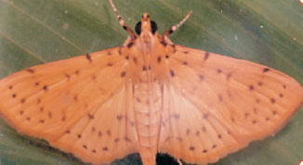
Leaf hoppers | Reduces the photosynthetic capacity of affected leaves, | 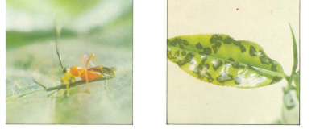
Saw fly | Reduces the plant's vascular efficiency and results in fewer kernels per head and lower kernel weight. | 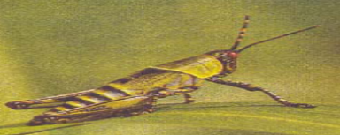

2. 3.2.1 Crops and Major pests
Table 1. Crops and Major pests
Crop | Pests
Rice | Rice weevil stem borers, army worms and leaf rollers
Maize | Maize weevils (sitophilus zea), stem borers and army worms
Yam | Yam beetles and rodents
Cocoa | Stem borers, root mealy bug, aphids, black tea thrips, and scales
Cotton | Cotton bollworm
Cotton bollworm | Thrips
Thrips | Leaf rollers Leaf beetle
Leaf rollers Leaf beetle | Bean beetle, grain weevils
grain weevils | Stored produce e.g. rice, cowpea, maize

2.3.2.2. Crop diseases and pest managements

Pest and disease management consists of a range of activities that support each other. Most management practices are long-term activities that aim at preventing pests and diseases from affecting a crop. Management focuses on keeping existing pest populations and diseases low. It provides for the protection of beneficial insects, as well as prevention of secondary pest outbreaks, pest resurgence, and the spread of disease. As mentioned above, there are many pest control methods available to choose from, but they can be loosely grouped into six categories:

- Hygienic methods

Preventing and eliminating pests through their excretions, they can transfer allergens that cause allergies and infections. Common hygiene pests include flies, rats, mice, cockroaches, bedbugs, fleas and lice.

- Biological methods
Is the use of living organisms to suppress pest populations, making them less damaging than they would otherwise be. Natural enemies of insects play an important role in limiting the densities of potential pests. These natural enemies include predators, parasitoids, and pathogens.

- Chemical methods

Any method to eradicate or limit the growth of pathogens which transmit disease to plants, especially: Herbicides.
Chemical control is using pesticides, fungicides and bactericides to control pests and diseases. Pesticides may be contact, stomach or systemic poisons. Problems with chemical control include residues, crop damage, killing of beneficial insects and poisoning of humans and their animals.

- Physical methods

Methods include hand picking of pests, sticky boards or tapes for control of flying insects in greenhouses and various trapping techniques such as traps for rodents. is one of the natural methods of pest control; it is a non-chemical pest control method.

- Fumigation methods

Fumigation is a method of pest control that completely fills an area, such as an FIBC, with gaseous pesticides or fumigants.

- Fogging and Heat treatment methods

Is a technique used for killing insects that involves using a fine pesticide spray (aerosol) which is directed by a blower? In some cases, a hot vapour may be used to carry the spray and keep it airborne for longer. Fast-acting pesticides like pyrethroids are typically used.

2.4. Recording and reporting details of the plant pests and disorder

All required work place records should be completed accurately and promptly in accordance with enterprise requirements. Recording and documenting your work activities in an area serves you for several purposes simultaneously.
- It helps you in evaluating and learning from past field establishment efforts.
- It helps you to organize your own work for the future and allows you more closely monitor your activities.
Pest records are essential components of the information used to establish the status of a pest in an area. Accurate pest records can be provided easily, overseas access bids can be made more quickly, with obvious benefits. Accurate pest records will help to ensure that when conducts a pest risk analysis.

Pest (including disease) records are principally maintained at pest collections held by State departments of agriculture, and other organisations such as universities and museums. However, there has been no national standard for documenting pest records and determining pest status. This has resulted in difficulties in establishing the accuracy and reliability of pest records, especially when attempting to make determinations of whether particular pests are present or absent.

The aim of this recording is to develop a standard system for recording pests and determining pest status. The National Standard was developed at a workshop of pest collection curators and subsequently distributed to the various collections. A key component of the National Standard is a framework to determine the reliability of pest records.
Any unusual plant pest or disease should be reported immediately to the relevant state or territory agriculture agency. Early reporting increases the chance of effective control and eradication.

2.5. Checking, selecting and preparing equipment’s

Before managing disease and pests dis order select, check and prepare each equipment’s. Material selection is a step in the process of designing any physical object. In the context of product design, the main goal of material selection is to minimize cost while meeting product performance goals. Materials testing help us to understand and quantify whether a specific material or treatment is suitable for a particular application. With the wide variety of materials and treatments available in the marketplace, testing can help narrow down the choices to the most appropriate selection for the intended use.

Equipment’s used to pest control.

- Pheromone traps
- Bait
- Sweep traps
- Aspirator
- Yellow board,
- Light trap
- Insect killing jar,
- pressing board
- Hand lenses
- Weed pressing board

  - Selecting, and checking prior to use suitable PPE

During identifying agricultural crop pest you should have to follow safety required to avoid hazards. Which may be toxicants during clearing, working with sharp machinery and use of other chemical substances must be avoided. Wearing of persons engages like: -hat, boots, overalls, gloves, goggles, respirator or face mask, hearing protection, and sunscreen lotion is a must.

Personal protective equipment’s:-

Personal protective equipment is to include that prescribed under legislation, regulations and enterprise policies and practices. Face masks are available for rubbing back and painting. Selecting personal protective clothing and equipment Suitable personal protective clothing and equipment is selected, used, maintained and stored in accordance with Occupational Health and Safety requirements.
Selecting PPE based on the PPE Hazard Assessment
- Consider these factors when selecting PPE:
- Type of hazardous materials, processes, and equipment involved
- Routes of potential exposure (ingestion, inhalation, injection, or dermal contact)
- Correct size for maximum protection
- Minimal interference with movement
- Personal protective clothing and equipment may include:

- Boots
- Hat/hard hat
- Overalls
- Gloves
- Protective eyewear
- Hearing protection]
- Respirator or face mask
- Sun protection, e.g., sun hat, sunscreen

Table 1.1 personal protective equipment’s
NO | Name of equipment’s | Picture | Its use
1 | Boot | 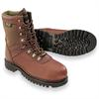 | To protect feet from chemical spills and sharp objects.
2 | Eye glass | 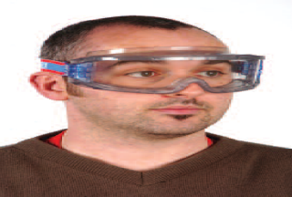 | Use safety glasses for minor splash hazards, goggles for moderate hazards, and goggles combined with a face shield for severe hazards.
3 | Glove |  | Hand protection is indicated for the possibility of severe cuts, lacerations, or abrasions, punctures, temperature extremes, and chemical hazards.
4 | Overall | 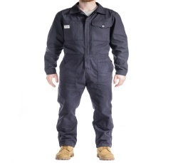 | Protect head from injuries and disease pathogens and any other when there is a danger of objects falling from above.
5 | Helmet | 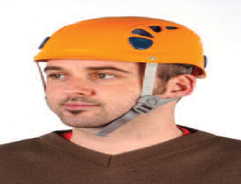 | Protect head from injuries and disease pathogens and any other when there is a danger of objects falling from above.

2.7. Identifying OHS hazard risk assessed and reported

- During identifying agricultural crop pest, some activities can be potentially toxic or hazardous to human beings and pollutant environmental conditions.
- Occupational and environmental hazards may be occurred through:
- chemicals and hazardous substances
- Manual handling
- Dust, and noise
- The contamination of off-site ground water or soils from solids, debris, nutrients or chemicals
- Land disturbance
- Spread of noxious weeds and water run-off.

Self-check 1 | Written test

Name…………………………………………… ID………………………… Date…….
Directions: Answer all the questions listed below.

Test I: Choose the best answer (8 point)
- Write at least 4 insect pests. (3 points)
- Write the control methods of pests. (4 points)
- Write the difference between disease and disorder.(3 points)
- Write atleast 4 pathogens that can cause disease to plants.(2 points)

Note: Satisfactory rating – 12 points and above Unsatisfactory - below 12 points
You can ask you teacher for the copy of the correct answer

LG #20 | LO #3- Assessing pests and take sample

Instruction sheet
This learning guide is developed to provide you the necessary information regarding the following content coverage and topics:
- Differentiating scouting techniques
- Understanding sampling methods
- Taking sample of different crop pests
This guide will also assist you to attain the learning outcomes stated in the cover page. Specifically, upon completion of this learning guide, you will be able to:
- Differentiate assessment/scouting techniques/methods
- Understand sampling methods
- Take sample of different crop pests.
- Identify Occupational Health and Safety hazards,, assessing and reporting risk
Learning Instructions:
- Read the specific objectives of this Learning Guide.
- Follow the instructions described below.
- Read the information written in the information Sheets
- Accomplish the Self-checks
- Perform Operation Sheets
- Do the “LAP test”

Information Sheet 3

  - Differentiating scouting techniques
  - Crop scouting is the process of precisely assessing pest pressure (typically insects) and crop performance to evaluate economic risk from pest infestations and disease, as well as to determine the potential effectiveness of pest and disease control interventions. Ideally, farmers should scout their own fields to know first-hand how their crops are performing. For various reasons, many farmers are using commercial agronomy services for field scouting.
  - Scouting for plant diseases is one of the most important practices you can adopt to help combat diseases on your farm. Scouting allows you to:
- Accurately identify disease symptoms early in the growing season so you have time to make a decision regarding foliar fungicide application before the disease becomes well-established in your crop and economic losses occur.
- Determine the effectiveness of your fungicide program. This will aid your decision about whether subsequent applications are needed, when they should be applied and what product to choose.
- Save time and money in the end.
The goal is to develop a regular and systematic approach to disease scouting. If you become accustomed to a regular weekly scouting routine, the process should become second nature, saving time and maintaining efficiency.
  - There are four main methods to consider for scouting your field. These methods include:
    - Visual observation
    - Sweep net sampling trapping and
    - Environmental monitoring.
  - Visual observation of crops and environmental monitoring should occur routinely to identify an early presence of pest or disease.
  - The frequency with which fields are scouted depends on:
    - the type of crop grown,
    - stage of crop life cycle,
    - present and expected pest(s) and their lifecycle, and
    - Environmental conditions (weather).
    - Based on these variables, field visits should be planned to ensure that crop establishes itself, that growth proceeds with healthy development and does not proceed into a population bottleneck, and that pests do not pass the economic threshold level, after which they could become a major problem. This is generally not a problem after the crop has reached a specific stage in development (specific to variety), so the number of visits can be reduced. Frequency of visits to problem fields should not be reduced, and these fields should be strictly monitored.
    - A scouting report should be filled out every time a field is scouted even if no serious problems are found, as farmers are often interested in crop health and growth stage.

  - Understanding sampling methods

Sweep netting, vacuum sampling, sticky traps, Malaise and light traps may all be used to sample plant pests.. But all these methods have the disadvantage that you may learn little about the host plant. It is possible to sweep or vacuum from individual plant species.

Sweep nets
Sweeping has the advantage of being simple. Many short-winged forms will be captured in sweep samples, although species that live low on plants or in the thatch may be missed. Vacuum sampling may be more effective at producing the more uncommon species. It is generally easiest to process net contents in the field by holding the net open and aspirating plant hoppers as they attempt to escape.

Malaise traps
Malaise traps are a type of interception trap and an excellent way of passively collecting many types of insects. They may be left unattended for some days, the catch accumulating in pots of alcohol. Some species may often appear in large numbers in Malaise samples, although brachypterous forms are, not surprisingly, not often collected.

Sticky traps
Sticky sheets, especially yellow in colour, are often used to monitor insect pests in greenhouses. However, they can also be used to monitor and sample flying insects in the field. Double sided yellow plastic sheets can be covered in sticky glue- or can be purchased ready prepared. Sheets may be hung among crops and also may be hoisted into the canopy of trees, where it may give some indication of those insects flying around the canopy. The glue which is frequently used may be dissolved in ‘white spirit’ to remove specimens.

Light traps
Many leafhoppers and plant-hoppers are attracted to light, sometimes in large numbers. It is difficult to be sure where species have been feeding but it is a good way to obtain specimens of many species.

Vacuum sampling
Vacuum sampling may be one of the most effective ways of sampling delphacids and many leafhoppers, especially those that live low on the plant or in thatch that would otherwise be missed by sweeping, and would not ordinarily come to Malaise or light traps. Many now use inexpensive vacuum samplers, which are modified garden ‘leaf blowers’ or ‘blower vacs’. The modification is to add a mesh net to the inlet tube (by tape, rubber bands or metal clip) of a petrol powered (2-stroke oil-petrol mixture) leaf blower that has been arranged for vacuuming. This type of arrangement is excellent for sampling short grass habitats or grass or sedges that grow in clumps that otherwise could not be sampled by sweeping. Samples taken this way can be processed in the field similar to a sweep sample.
  - The following is a list of characteristics to help in the identification of insects on sticky traps:
- Aphids. The wings of aphids often settle symmetrically into the adhesive to either side of the body. They sometimes give birth to one to five nymphs before they die. The front wings usually have two parallel veins close to the front edge. These veins end at a dark, skinny spot on the front edge. The legs and antennae seem to be long and skinny.
- Fungus Gnats. These are small, dark, mosquito-like insects with gray wings. The wing has a distinct, Y-shaped vein at the tip. They have long, skinny legs and antennae.
- Leaf miner Flies. Unless the specimen is totally embedded in the adhesive, it is possible to see a conspicuous yellow spot on each side. They have short antennae and moderately long legs.
- Parasitic Wasps. These usually have antennae with elbows like an ant, and the forewings have only one vein which zigs toward the front margin and zags away. Usually parasitic wasps are more pointed at the rear than shore flies.
- Shore Flies. These are the largest common fly usually found on sticky traps. They have pale spots on the wings, the antennae are short and the legs are moderately long. Care should be taken when identifying, since shore flies are often confused with fungus gnats.
- Thrips. These are the tiniest insects found in any numbers on the trap. Most appear spindle-shaped with the wings protruding neatly at the rear. Hairs line the edges of the wings. Often, the stocky antennae protrude in a V-shape at the front.
- Whiteflies. Whiteflies lose their white, waxy bloom as they are entrapped by the adhesive. They are only a little larger than thrips and show up orange on the traps. Usually enough of a wing or leg protrudes above the adhesive so that the white bloom reveals the identity.

3.3. Taking sample of different crop pests
  - Sampling patterns must be completely randomized to ensure that each subdivision in a field has an equal chance of being sampled. Restrictions to these randomized sampling techniques are imposed to correct the possible error of oversampling in a specific area, and to make sure that all areas of the field are sampled.
  - Some of the most common randomized patterns are a predetermined zigzag or M-shaped route through rectangular shaped fields. Routes for irregular shaped fields should be made, ensuring that every subdivision of the field is visited; these randomized routes are field specific. Scouting along the edge of a field should not be practiced unless for specific pests, this kind of sampling usually does not show the baring of effects on the whole field.
- Tools and equipments for sampling scouting:
  - Scout Report Forms
  - a clipboard and writing utensils
  - pocket knife (splitting stalks and cutworm scouting)
  - magnifying glass for accurate pest ID,
  - Containers (bags, vials, etc.)
  - Electronics such as a digital camera or a GPS.
  - A small digging trowel should be used when looking for root diseases
  - Spray bottle of sterilizer (e.g. diluted Lysol solution) for cleaning boots or equipment between fields, or use disposable plastic boot covers. This precaution is more important for field scouts and agronomists, as it will help prevent transmission from diseased fields to healthy fields.
  - Paper or plastic bags and other containers for collecting samples.

- How to collect a plant sample (for submitting to the lab):
  - Sampling
- Choose specimens showing various stages of disease symptoms such as light to severe symptoms. Include some healthy specimens for comparison.
- Submit whole plants including the roots to determine if a root pathogen is the cause.
- Record the parts of the plant that are affected, the distribution of the symptoms within the field and the cropping history of that field.
- It is important to include information on chemical use both in the present cropping season and for the previous four years, fertilizer timing and rates and any extreme weather events noted.
- The Crop Protection Laboratory (CPL) diagnostic form should be filled out as completely as possible.
  - Packaging and handling
- Wrap specimens in dry paper towel or in a paper bag. Do not add moisture and do not use plastic bags. The exception to this rule is if a viral or bacterial disease is expected. In this case, keep the plant material as fresh as possible. Wrap the sample in slightly moistened paper towel and submit to the lab as quickly as possible.
- When including a root/soil ball, tie this portion off in a plastic bag leaving the above ground parts loosely packed in dry paper towel.
- Submit the sample in a rigid container like a cardboard box or Styrofoam cooler. Loosely pack newspapers or paper towel around the plant sample to prevent it from moving during shipping.
- Whole plants, including roots, should be submitted. Do not worry about sending what you think is too large a sample or too many plants! The more material the lab has to work with, the better.

When to start scouting:
- Ideally, scouting should occur weekly from crop emergence to maturity. A good time to start looking for unusual crop growth is during the emergence stage while carrying out weed control operations. Keep a notebook handy and record areas you would like to return to later.
- Scouting specific crops more intensively at particular times is also important because of different periods of vulnerability. By spending a little extra time and effort at these peak periods, you can greatly increase crop protection.
- Seedling diseases in all crops will be visible at the seedling stage, just after emergence.
- Canola is most susceptible to diseases such as sclerotinia stem rot just prior to or during the flowering stage.
- Cereals should be scouted throughout the growing season. However, during the period of flag leaf growth they are most susceptible to loss of yield from leaf diseases and should be scouted more frequently. Risk of fusarium head blight should be determined at the early heading stage.
- Chickpea is highly susceptible to ascochyta blight and scouting should begin at the seedling stage and continue until pods have well-formed seeds.
- Lentils should be scouted at the vegetative (eight to10 node) stage until after flowering for both ascochyta and anthracnose.
- Field pea should be scouted during the early bloom stage until after flowering is complete.
- Forage crops should be scouted for leaf spots prior to head emergence (grasses) or the vegetative to early bloom stages (legumes). For alfalfa, risk of blossom blight should be determined at early bloom until after flowering is complete.
It is important to note that after periods of rain and high humidity, scouting should occur more frequently and with greater diligence.
How to scout:
For leaf diseases (such as ascochyta blight in pulse crops), use flags to mark specific areas for regular monitoring during the growing season. This allows you to return to a specific site to look for lesions developing on new plant growth and to determine the effectiveness of your fungicide program. If you are using flagged sites, remember to walk the rest of the field as well, or use a different path to get to the site so you do not miss new areas of infection.
If the field is less than 100 acres, check a minimum of five sites and if the field is greater than 100 acres, check a minimum of 10 sites.
  - Be most diligent scouting fields at greater risk to disease that include:
- Fields that were planted to infected or poor quality seed;
- Fields that have a short crop rotation or are adjacent to infested crop residue from the previous season; and
- Fields that were planted to a susceptible crop variety.
  - In addition, check for areas in the field that are potential hot spots for disease development:
    - Areas of the crop that may be heavier seeded or have increased fertility (e.g. headlands);
    - Areas where moisture may have accumulated (e.g. hollows or near fence lines); and
    - Areas where plants received damage from wind-blasting, drought, herbicide injury, frost, hail or other stresses.
Symptoms may occur in patches, be limited to field edges or be scattered across the whole field. That is why it is important to determine the full extent of the problem by scouting the entire field. Walk in a W-shape pattern or a large circular pattern throughout the field, stopping to inspect five to 10 sites. Keep your eyes open for discolored plants and/or small discolored spots on the leaves. Stop at each site and look down within the crop canopy, remove some plants and closely inspect the leaves and roots.
Inspect both the top and bottom of leaves. Use a magnifying glass to help distinguish small spots and to look for tiny chew marks or shredding, which could indicate damage caused by insects. Remember to rub small spots with your thumb if they come off easily, they likely are not disease.
Inspect the roots. Root rot usually results in stunted growth and the plants may be light green, yellow, or brown in colour. Plants with root rot will pull easily from the soil. Look for lesions on crown region or on roots. In cereals, common root rot is observed as streaks on the sub crown internode. In pulses, root rots are often accompanied by poor nodulation or death of nodules.
Disease Surveys – What do the numbers mean?
- Disease Prevalence: number of crops with disease / total number of crops.
- Disease Incidence: number of infected plants / number of total plants surveyed.
- Disease Severity: severity of disease on the plants: may be rated as trace, slight/light, moderate, severe; may be rated using a scientifically derived rating scale specific for the disease or type of disease (eg. per cent of leaf tissue with symptoms).
- Disease Distribution: where the symptoms are showing up in the field or an area – groups, slopes, knolls, low areas, scattered, most of field, margins, patchy, etc.

Accurately diagnosing the problem:
- Stress factors can cause discolored splotches on leaves or plants that may be mistaken for disease. It is important to be able to differentiate between stresses and disease symptoms in order to prevent costly application of fungicide.
- Every time a field is scouted, it is important to keep the big picture in mind and undergo a process of elimination for other causes. Be investigative and systematic in your approach to disease scouting, even if you or your client want an immediate answer. For example, it is important to consider prior weather events and to review the field records for details as to herbicides, fertilizers, dates, crop rotation, etc.
- Also, keep in mind where the problem is occurring in the field and if there is a pattern to it. A uniform pattern, such as damage only along a field edge, within a seed row, or in an area as wide as a sprayer boom, could indicate agronomic problems. How- ever, if the damage occurs in a random pattern or is spreading, it could be caused by a disease or insect pest.
Eliminate problems caused by determining:
  - Linear and/or repetitive symptoms: Possible causes:

- Abiotic (not spreading)
- Related to sowing
- Old swath row
- Overlap / miss of a chemical application

  - Random symptoms only affecting individual plants:
- Possible causes:

    - Biotic (spreading)
    - Infected seed / soil-borne pathogen
    - Airborne spores
    - Wind-blown insect vector
    - Abiotic (herbicide residue, nutrient).

These initial infection sites, called foci, serve as inoculum sources to spread to surrounding plants, usually by rain-splash or root-to-root spread, and would result in patches of infection (i.e. ascochyta blight in pulse crops, anthracnose in lentil, cereal leaf spotting diseases).
  - Environmental stresses: This could include dry soils, waterlogged soils, high temperatures, frost, hail and strong winds causing sandblasting. Scout your fields within two days following an extreme environmental occurrence to determine its effects on the crop. Record weather events on a calendar for future reference.
  - Nutrient deficiencies or toxicities: Nutrient stresses are often exhibited as a yellow, red or purple discolouration of the plant tissue, and in extreme cases, as stunting or plant death. Some nutrients are mobile within the plant, so deficiencies will show up on older leaves, whereas others are not mobile and symptoms occur on new growth. It is important to become familiar with nutrient deficiency and toxicity symptoms so they are not mistaken for diseases.
  - Herbicide injury: One of the most common injuries results from the improper timing of application, as herbicides can cause severe crop damage if applied at the wrong growth stage. As well, some herbicides can have negative residual effects on future crops for one to five years. It is very important to check the product label and plan your rotations accordingly. Finally, herbicide injury can occur when herbicide drifts from the target crop to a neighbouring crop. A primary indicator of herbicide drift is injury symptoms near the field edge. Proper application techniques as specified on the product label must be followed in order to prevent herbicide injury.
  - Insect damage: Insect feeding on plants may be mistaken for disease. Insects can also serve as vectors of plant diseases. Carry a sweep net and insect identification guides with you to help distinguish insect damage from disease damage.
  - Physiological or genetic off-types: Physiological flecking can occur on some varieties of crops, such as winter wheat. Although the causes are not fully understood, physiological damage could be a result of environmental or nutrient issues. Occasionally, genetic offtypes will occur within a plant population and show up as malformed growth, white/yellow striping on leaves, or different coloured flowers. These symptoms may be mistaken for diseases caused by viruses or phytoplasmas, but they are very infrequent within the field. The best way to remove off-types is by rouging.

Self-Check – 3 | Written test

Name…………………………………………… ID………………………… Date…….

Directions: Answer all the questions listed below.

Test I: Short Answer Questions

  - Write the importance of pest scouting? (2)
  - What are the methods of pest scouting? (2)
  - Write the methods of taking sample of different crop pests. (3)
  - Write the factors that determine the frequency of pest scouting. (4)

Note: Satisfactory rating – 11 points Unsatisfactory - below 11 points

You can ask you teacher for the copy of the correct answers.

You can ask you teacher for the copy of the correct answers.

Operation Sheet -3

Techniques of insect-pest scouting.
- Tools and equipments
- PPE
- Pen
- Exercise book
- Hand- held magnifying lenses
- Procedures/Steps/Techniques
- Wear appropriate PPE
- Decide your walking pattern (V, X, W, zigzag or diamond-shaped).
- Decide fixed number of plants for sample
- Contract check point (location for sample)
- Inspect the check point daily
- Record the observation daily
- Decide controlling measure depending on your record result.

LAP TEST-3 | Performance Test

Name………………………………. ID…………………………….. Date…………………………………….

Time started: ________________________ Time finished: ________________

Instructions: Given necessary templates, tools and materials you are required to perform the following tasks within 1 hour. The project is expected from each student to do it.

Task-1 Perform pest scouting by following standard procedure.

LG #21 | LO #4 Record and Report pest occurrence

Instruction sheet
This learning guide is developed to provide you the necessary information regarding the following content coverage and topics:
- Preparing materials and format for pest occurrence record
- Recording and documenting identified pest
- Reporting the pest occurrence

This guide will also assist you to attain the learning outcomes stated in the cover page. Specifically, upon completion of this learning guide, you will be able to:
- Prepare materials and format for pest occurrence record
- Record and document identified pest
- Report the pest occurrence

Learning Instructions:
- Read the specific objectives of this Learning Guide.
- Follow the instructions described below.
- Read the information written in the information Sheets
- Accomplish the Self-checks
- Perform Operation Sheets
- Do the “LAP test”

Information Sheet 4

  - Preparing materials and format for pest occurrence record

Pyrethrins and Pyrethroids are the most common pest control substances. Chemicals in this class include the active ingredient Permethrin. These substances are made to mimic botanical insecticides, specifically varieties of chrysanthemum that are toxic to insects. Pyrethrins and pyrethroids are effective insecticides that are often used in household sprays, aerosol bombs, insect repellents, pet shampoos, and lice treatments. Using products containing these compounds will expose you to these chemicals.

One of the most regularly used chemicals in pest control is boric acid. This substance can be taken from both rocks and water sources. It can come in multiple forms, such as powder and pellets. Boric Acid is considered a safer alternative than more hazardous synthetic chemical pesticides.

Pesticides (chemicals used for killing pests, such as rodents, insects, or plants) Pesticides are a class of chemicals designed to kill pests (rodents, insects, or plants) that may affect agricultural crops or carry diseases like malaria and typhus.
As mentioned above, there are many pest control methods available to choose from, but they can be loosely grouped into six categories: Hygienic, Biological, Chemical, Physical, Fumigation, Fogging and Heat treatment.

- Types of Pesticide Ingredients
- Insecticides,
- Herbicides,
- Rodenticides, and.
- Fungicides.
The earliest recorded instance of pest control is the ancient Sumerians using sulphur compounds to kill insects. The ancient Greek civilization used fire to chase away locusts to the sea.
Sampling for pests are interested in estimating a trait of the pest population or commodity that is a good indicator of the damage potential of the pest (such as estimating pest population density or percentage of damaged plants in a cropping system)

  - Recording and documenting identified pest
Most states require that pest control businesses keep records for a minimum of two years. Most commonly, this means holding onto written reports, but a wealth of other information can also prove useful, such as images, videotapes, wet readings, etc.
Record keeping is an integral part of pest management. A regularly updated record, accessible by both the service provider and the client, forms the core of a pest management program. It keeps track of what's been seen and done and often points the way to future action.

The records should provide information about when and where pest problems have occurred, information on the agricultural practices applied (irrigation, cultivation, fertilisation etc.) Farm records are simply the records of all the activities that take place on the farm within a period say a farming season or year. It can also be defined as all written documents showing major activities going on in the farming business.

- Types of records are:
- Correspondence records. Correspondence records may be created inside the office or may be received from outside the office.
- Accounting records. The records relating to financial transactions are known as financial records.
- Legal records.
- Personnel records. for treatment and damage repair
- Progress records.
- Miscellaneous records.

  - Reporting the pest occurrence

A pest inspection includes a search for bugs and other creatures that can cause damage to the structure of your property, a health hazard or both. One common structural concern is caused by termites that get their nutrients from the wood in your house, but various other bugs and rodents can also cause concerns.

Pest Inspection entails or consists.

- A thorough search for any infestations. A trained pest inspector will look through the interior and exterior of your home for all manner of critters that could be a hazard.
- An evaluation of any structural damage.
- A detailed pest report.
- Instructions.
If you see a pest or find indications that you might have a pest infestation,
You should contact a Pest Control Operator (PCO). What should you do if you spot any signs of pests such as?
Call a professional: if nothing else helps and rodents still occupy your property, we highly recommend you to book a professional rodent control. They will inspect your property and find other hiding places that you've probably missed.

Pest prevention procedures:-
- Remove sources of food, water and shelter.
- Store food in sealed plastic or glass containers.
- Fix leaky plumbing and don't let water accumulate anywhere in the home.
- Clutter provides places for pests to breed and hide and makes it hard to get rid of them

Table: 1 Pest record sheet or pest record format
Date | Time | Distribution of pest | pest treatment appointment | Job completed | Staff accomplish | Signature

Self-Check – 4

Name…………………………………………… ID………………………… Date…….

Directions: Answer all the questions listed below.

Test I: Short Answer Questions
  - What is pesticide means? (3 points)
__________________________________________________________________________________________________________________________________________________________________________________________________
  - List types of pesticide. ( 4 points)
___________________________________________________________________________________________________________________________________________________________________________________________________
  - List types of record. ( 4 points)
___________________________________________________________________________________________________________________________________________________________________________________________________
  - Write pest prevention procedure. (3 points)
___________________________________________________________________________________________________________________________________________________________________________________________________
  - Write materials for pest occurrence report. (2 points)
__________________________________________________________________________________________________________________________________________________________________________________________________

Note: Satisfactory rating – 15 points Unsatisfactory - below 15 points

You can ask you teacher for the copy of the correct answers.

Reference Materials

Web addresses
- https://www.bing.com/search?q=disease%20swvwrity&qs (26/08/2022).
- https://www.bing.com/search?q=disease+and+disorder+of+crops (27/08/2022).
- https://www.bing.com/search?q=pest+scouting+in+farm&form ( 29/08/2022).
- https://www.canr.msu.edu/news/scouting_for_vegetable_insect_pests_using_direct_counts ( 27/08/2022).
- https://www.bing.com/search?q=plant+diseases&form (29/08/2022).
- https://www.sciencedirect.com/science/article/pii/S2214317318304700 (31/08/2022).

AKNOWLEDGEMENT

Ministry of Labor and Skills wish to extend thanks and appreciation to the many representatives of TVET instructors and respective industry experts who donated their time and expertise to the development of this Teaching, Training and Learning Materials (TTLM).

The experts who developed the learning guide
No | Name | Qualification | Educational background | Region | Phone number | E-mail
1 | Taka Magarsa | Msc | Horticulture | Oromia | +251917210371 | takamagarsa430@gmail.com
2 | Wendimu Terfa | BSc | Plant science | Oromia | +251911266570 | gurachoterfa@gmail.com
3 | Gosa Shura | MSc | Horticulture | Oromia | +251-923041032 | gossashura@gmail.com
4 | Tilahun Getu | MSc | Biotechnology | Amhra(3) | +251-918726766 | tile21eme@gmail.com
5 | Degefa Guluma | MSc | Soil science | Oromia | +251-913440464 | deguluma@gmail.com
6 | Bayisa Abeshu | MSc | Agronomy | South west Ethiopia | 0921434086 | Bayoabeshu@gmail.com
7 | Berhanu Asefa | BSC | Plant science | South west Ethiopia | 0922182673 | berhanuasefa@gmail.com
8 | Fikadu Tilahun | BSc | Plant science | Afar | 0917363367 | fikadutilahun80@gmail.com
9 | Yimam Mohammed | BSc. | Plant science | Oromia | 0913624360 | leylasalo@gmail.com
10 | Eyaya Tigabie | MSc | Agronomy | Afar | +251-921944452 | eyayatigabie@gmail.com
12 | Elias Mohammed | BSC | Horticulture | Oromia | +251946706670 | reweda1@gmail.com

