CROP PRODUCTION
Level-II

Based on March 2022, Version 4 Occupational standard
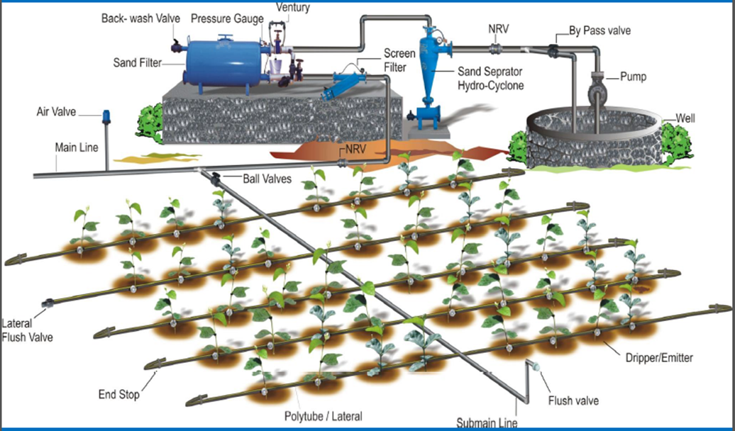
Module Title: - Operating Gravity Fed and Pressurized Irrigation Systems

LG Code: AGR CRP2 M06 LO (1-7) LG (23-29)
TTLM Code: AGR CRP2 TTLM 0922v1
September 2022
Addis Ababa, Ethiopia

Table of Contents

Introduction to the Module 4
LO #1- Setting Up Of Movable Irrigation Components 5
Instruction sheet 5
Information Sheet 1 6
Self-check 1 20
Operation Sheet -1 21
LAP TEST-1 23
LO #2- Setting up field for gravity fed irrigation 24
Instruction sheet 24
Information Sheet-2 25
Self-check 2 34
Operation Sheet -2 35
LAP TEST-2 36
LO #3- Carrying Out Gravity Fed Irrigation Operations 37
Instruction sheet 37
Information Sheet-3 38
Self-check 3 58
Operation Sheet -3 59
LAP TEST-3 60
LO#4- Setting up of movable irrigation components 61
Instruction sheet 61
Information Sheet-4 62
Self-check 4 70
LO#5- Carry Out Routine Maintenance Activities on Gravity Fed Irrigation Delivery Systems 72
Instruction sheet 72
Information Sheet-5 73
Self-check 5 85
Operation Sheet -5 86
LAP TEST-5 87
LO#6- Carrying Out Routine Maintenance Activities on Drainage Systems 88
Instruction sheet 88
Information Sheet-6 89
Self-check 6 94
Operation Sheet -6 95
LAP TEST-6 96
LO#7- Monitoring And Controlling Weed Growth On Drainage Systems 97
Instruction sheet 97
Information Sheet-7 98
Self-check 7 104
Reference Materials 106

Introduction to the Module

The knowledge, abilities, and attitudes covered in this module include those needed to set up mobile irrigation parts and a field for gravity-fed irrigation, perform gravity-fed irrigation operations, perform pressurized irrigation operations, monitor and control weed growth on drainage systems, and clean and store irrigation equipment. This session provides a concise and thorough overview of the technical design and operational elements of high efficiency (pressurized) irrigation systems. This document provides a concise and thorough explanation of the technical design and operational features of high efficiency (pressurized) irrigation systems. An extensive study of pressurized irrigation systems, including their classifications, selection criteria, and components, is covered in the first book before moving on to the fundamentals of design. It has been considered to use a design preform for drip and sprinkler irrigation system.

LG #23 | LO #1- Setting Up Of Movable Irrigation Components

Instruction sheet
This learning guide is developed to provide you the necessary information regarding the following content coverage and topics:
  - Handling irrigation equipment safely
  - Identifying OHS hazard and selecting relevant PPE (RV)
  - Positioning irrigation equipment
  - Checking irrigation components
  - Assembling irrigation system components
  - Checking water outlets
This guide will also assist you to attain the learning outcomes stated in the cover page. Specifically, upon completion of this learning guide, you will be able to:
  - Handle Irrigation equipment’s safely in accordance with OHS practices.
  - Position Irrigation equipment’s in accordance with organization requirements.
  - Check and take action irrigation components, as required, in accordance with enterprise policy and procedures.
  - Assemble and join irrigation system components.
  - Check water outlets in accordance with organization practices.
Learning Instructions:
- Read the specific objectives of this Learning Guide.
- Follow the instructions described below.
- Read the information written in the information Sheets
- Accomplish the Self-checks
- Perform Operation Sheets
- Do the “LAP test”

Information Sheet 1

Introduction

What is irrigation?
Irrigation is the artificial application of water to the soil for the purpose of crop production. Irrigation water is applied to supplement rainfall. In many areas of the world, the amount and timing of rainfall are not adequate to meet the moisture requirement of crops and so irrigation is necessary to meet the needs of food and fiber designed to allow farming in arid and semi-arid regions to reduce drought. The increasing need for crop production for the growing population is causing the rapid expansion of irrigation throughout the world. The main principle of irrigation is to provide the root zone of the crop with usable amounts of water during periods of need.

  - Handling irrigation equipment safely

    - Handle Irrigation equipment safely in accordance with OHS practices.
Application systems accomplish this goal by delivering irrigation water to a field and then

distributing it within the field. The size and type of an irrigation system is primarily dependent on the available water source. Irrigation components may include- pumps, pipes, valves (including solenoids), and sprinkler heads/emitters. Irrigation systems may range from manual operation and monitoring to fully automated with computer control and monitoring.

- Portable Systems.
In Maine, these include many variations of portable components including pumps, transmission piping, and distribution piping. The difference between fixed or portable (moveable) irrigation systems is the type of piping network used to supply water to the irrigation application hardware. The most common portable systems require that the transmission and distribution piping be moved with each application. While this may work well on small farms where fields are located close together, this system is very labor-intensive for larger farms that may have difficulty keeping up with plant demand during peak consumptive-use periods. In addition, portable piping systems

require large quantities of additional pipe to be available to guarantee that transmission

and distribution are ahead of actual irrigation.

    - Proper use of tools, materials and equipment

Tools, equipment and machineries are selected consistent with the requirements of the job. Select the right tool - not only for its function, but also for its length and weight to fit you. Before each use, inspect your lawn and garden tools whether they are in proper condition or not.

If the product is damaged, don't use it and don't attempt to make repairs yourself Equipment, tools and materials should be prepared pre-season for effective operation in accordance with design specifications and enterprise standards. Mechanical equipment is serviced in accordance with the operator’s manual or as directed. Use of personal safety devices/clothing- Before using any tool or appliance, read and follow the manufacturer's use and care instructions that come with the product.

Emergency procedure- identifies physical and health hazards in the workplace. Physical hazards include moving objects, fluctuating temperatures, high intensity lighting, rolling or pinching objects and sharp edges. Health hazards include overexposure to harmful dusts, chemicals or radiation. Handling hazards-Hazards exist in every workplace in many different forms: sharp edges, falling objects, flying sparks, chemicals, noise and a myriad of other potentially dangerous situations.

  - Identifying OHS hazard and selecting relevant PPE (RV)
- Identifying OHS hazard

There are different types of potential accidents that can cause injury or death when working
on or around irrigation systems including:

- Electrical Contacts/Accidents
- Contacts/Entanglements with Moving Parts
- Chemical Exposures/Poisonings
- Falls from the System
- Drowning
- Physical (Head, Eye, Ear, Hand & Foot) Accidents

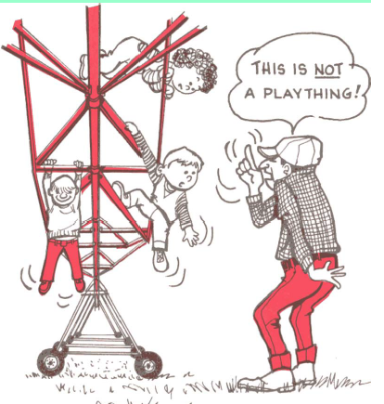

Fig .1.2.
- Irrigation Problem Areas

Typical irrigation accidents fall into the following three categories or combinations including:

- Faulty Equipment and/or Installation by
- Manufacturer, dealer or installer.
- Equipment/Installation correct but modified or
- Poorly maintained by owner (state of disrepair).
- Unsafe work practices by individuals during
- Maintenance, repair and testing.

- Irrigation Safety Requirements
- Manufacturers must design equipment to safety standards.
- Dealers must install equipment correctly.
- Owners, Irrigators and Service people must maintain equipment correctly.
- Owners, Irrigators and Technicians must use Safe Work Practices.

- Personal Protective Equipment (PPE)

- Provides people protection from various hazards likely to arise in the workplace.
- The most common types of PPE include head, ear, eye, hand, and foot protection.

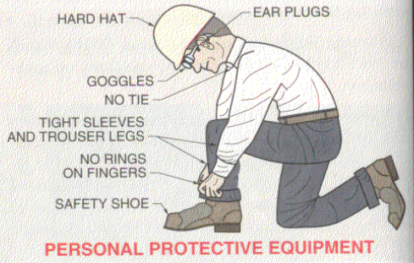
Fig .1.2.2.PPE
- Clothing/Personal Protective Equipment

- Before leaving for the site consider
- What clothing & personal protective equipment
- do I need?
- Clothing - What’s the weather like? (hot or cold)
- If it’s hot, bring drinking water……don’t rely on drinking
- water from the irrigation system.
- Footwear - Boots…..Rubber or Leather?
- Hand Protection - Gloves….Rubber or Leather?
- Head Protection - Class 1 Hard Hat.
- Hearing Protection - Earplugs or Earmuffs.
- Eye Protection - Safety Glasses.
  - Positioning irrigation equipment
    - sprinkler irrigation
A typical sprinkler irrigation system consists of the following components: Pump unit- The pump unit is usually a centrifugal pump which takes water from the source and provides adequate pressure for delivery into the pipe system. The mainline and sub mainlines - are pipes which deliver water from the pump to the laterals. Laterals- deliver water from mainlines or sub mainlines to the sprinklers. A sprinkler irrigation system generally includes sprinklers, laterals, submains, main pipelines, pumping plants and boosters, operational control equipment and other accessories required for efficient water application. In some cases, sprinkler systems may be pressurized by gravity and therefore pumping plants may not be required.

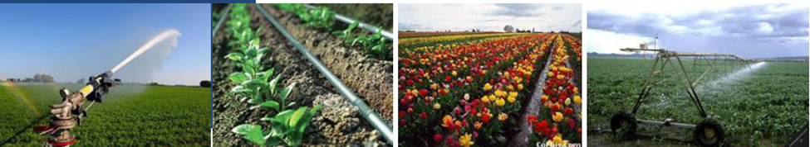

Figure 1.1 sprinkler irrigation
    - Drip or trickle irrigation
Drip is one of the latest methods of irrigation, which is becoming increasingly popular in areas where there is water scarcity and salt problem. It allows water to be applied uniformly and slowly to the plant so that essentially all the water is placed in the root zone. In drip irrigation conventional losses, deep percolation, runoff, and soil water evaporation are minimized.

Drip irrigation is categorized according to their placement in the field: surface drip system – water is applied directly to the soil surface, sub surface drip irrigation system- water is applied below the soil surface through perforated pipes. In this method, irrigation water is accomplished by using small diameter plastic lateral lines and a device called emitter or dripper at selected spacing to deliver water to the soil surface near the base of the plant

Figure 1.12 drip irrigation

- The irrigation installer shall be:
- Before commencing/beginning installation, verify that water tap/ valves etc. /, flow rate and pressure meet design criteria.
- Install the irrigation system’s components according to the design specifications and manufacturer’s published performance standards, If a design does not exist, then go no further until one is created.
- Where deviations from the design are required (for example, adding sprinkler heads to an area larger than the plan shows), consult with the designer prior to making the change to ensure that the change is within design performance specifications.

- Furnish/provide record drawings to the owner of the system. The record drawings shall describe the system layout and components including all changes from the original design.

- Test the irrigation system to verify that the system meets the design criteria.
- Perform an irrigation audit using an accepted procedure and provide the end user (or owner) with system specifications and a zone performance summary report that includes individual zone precipitation rates in inches per hour.

  - Checking irrigation components
Gravity fed irrigation: Usually the land in an area that uses irrigation is flat (often on a flood plain) allowing the water to be easily moved from the natural source to the irrigated area. That means you do not have to pump water up and down big hills, which requires expensive mechanical pumps. Surface irrigation systems, such as furrow and level basin systems, can apply water very uniformly if the irrigation area is properly selected, designed and operated. These systems work best on soils, which contain large percentages of clay and silt.

Action may include: Remove, repair, replace or clean components. It may also include bleeding solenoid valves, lubrication and priming pumps.
Irrigation equipments should be checked for efficient operation.
Random checks of output from emitters throughout the system should be carried out on a regular basis.

- The components needed include:
- A water reservoir
- It must be able to contain at least one days worth of water
- The greater the capacity of the reservoir is proportional to how often it must be refilled
- The complication of having a very large container is that you must elevate it above the crop and refilling a very high container is more work
- The reason to elevate the tank is that it adds pressure which needs to be kept consistent at the point where the drip lines are fed so that the water is distributed equally

- A structure to support the water reservoir
- Can be constructed of anything that can support the weight of the container when it is filled with water
- It must also be able to withstand outside forces such as the wind
- An 880 gal container full weighs 4 tons

- Piping
- There must be a pipe at the base of the reservoir that lets water flow out and having a shut off valve at this connection point is a good idea if the reservoir is larger than one days’ worth of water.

- The piping if using the timer method then feeds the water through a filter
- Different sized piping should be used to increase the pressure
- This is done by gradually decreasing the size of the lines being used such as starting with a 2ft line at the base of the reservoir then decreasing the size every 1-4ft so that it would then be a 1ft, 6in, 3in, 1in, 1/2in, down to the 1/8in emitters in the drip lines

- Timer and Filter
- There are many models of battery powered timers that can be set up and run for a whole season
- These timers control the frequency that water is emitted into the drip lines
- A filter must be installed in the water line before the timer valves
- This prevents the smaller lines from becoming clogged

- Valves and Drip lines
- Shut off valves should be placed between the reservoir pipes and the irrigation pipes and before the timer valves
- Drip lines are the average lines and emitters that can be purchased at any garden supply store.

    - Gravity feed type
Gravity fed irrigation systems may include border check, furrow irrigation, hillside flooding, and basin irrigation. Border check systems may be either permanent or temporary earth, plastic or concrete devices for insertion in a drain for reticulating water, contour banks used to collect and distribute water along the perimeter of an irrigation plot, contour banks within a plot to collect/ distribute water, or larger scale systems to stop water exiting one area to another. Gravity fed systems may range from manual operation and monitoring to fully automated with computer control and monitoring.
- Basin irrigation
The most prevalent type of surface irrigation, particularly in areas with modest field configurations, is basin irrigation. A field is referred to as a basin if it is level in all directions, protected from runoff by a dike, and receives an uncontrolled flow of water. A basin is normally square, however they can also be found in many different irregular and rectangular shapes. It may have raised beds for the benefit of particular crops, be furrowed or corrugated, but as long as the inflow is unregulated and undirected into these field alterations, it remains a basin.
- Border irrigation
Border irrigation can be viewed as an extension of basin irrigation to sloping, long rectangular or contoured field shapes, with free draining conditions at the lower end. Water is applied to individual borders from small hand-dug checks from the field head ditch. When the water is shut off, it recedes from the upper end to the lower end. Sloping borders are suitable for nearly any crop except those that require prolonged ponding.

- Furrow irrigation
Furrow irrigation avoids flooding the entire field surface by channeling the flow along the primary direction of the field using 'furrows,' 'creases,' or 'corrugations'. Water infiltrates through the wetted perimeter and spreads vertically and horizontally to refill the soil reservoir. Furrows are often employed in basins and borders to reduce the effects of topographical variation and crusting.

Furrows provide better on-farm water management flexibility under many surface irrigation conditions. The discharge per unit width of the field is substantially reduced and topographical variations can be more severe. A smaller wetted area reduces evaporation losses. Furrows provide the irrigator more opportunity to manage irrigations toward higher efficiencies as field conditions change for each irrigation throughout a season. This is not to say, however, that furrow irrigation enjoys higher application efficiencies than borders and basins.

- Any variations in output and distribution could be due to:
  - incorrect pressure in the system
  - incorrect selection of components
  - wear in the components
  - blockages in the components
  - Faults/breakages in the components.

- Repair or replace
Consider the following points:
  - Components need to be replaced if they can't be repaired
  - Consider replacing older components rather than repairing. If similar components in a system are starting to break down, consider replacing them all rather than repairing them.
  - Repairing or replacing depends on costs of repairs and labor compared with costs of replacement parts and installation.

  - Assembling irrigation system components
The lateral pipe is located in the field until the irrigation is complete. The pump is then switched off and the lateral is disconnected from the mainline and moved to the next location. It is re-assembled and connected to the mainline and the irrigation begins again. The lateral can be moved one to four times a day. It is gradually moved around the field until the whole field is irrigated. This is the simplest of all systems. Some use more than one lateral to irrigate larger.

    - Description of the Small Farm Drip Irrigation System
The materials that were used for the construction and installation of the small farm gravity drip irrigation system were: plastic water tank, mainline pipes, sub-mainline pipe, lateral pipes, water filter, valves/regulators, and micro emitters (improvised). The system was a complete irrigation unit, all the pipes were made of PVC and it operated by gravity from a plastic tank of 2000 liters placed 2.8 m above the ground level so that the system will have enough head for water pressure.

It has a fertigation chamber attached to the mainline. The lateral lines, which were connected to the sub main lines, were laid along the crop rows and micro emitters, installed at spacing of 30cm. There is a drain tap at the bottom of the water tank for frequent flush out and cleaning from suspended solid particles.
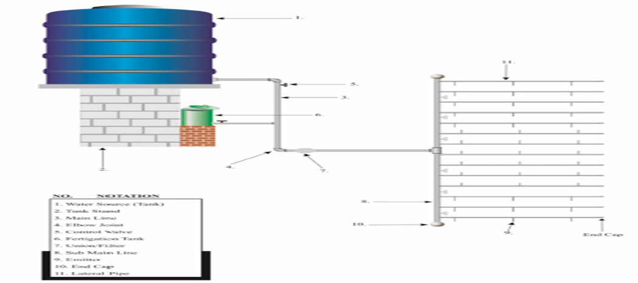

Figure 1.3 sprinkler irrigation

    - Installation of the Small Farm Drip Irrigation
The installation of the small farm gravity drip system was divided into three stages. This includes the followings: (i) Construction of the water tank stand, fertigation chamber stand and installation of the tanks (ii) Laying of pipes and fittings (iii) Testing of fittings and etermination of emitter flow rate a water tank stand of burnt bricks was constructed at a height of 2.8 m above ground level to achieve minimum pressure requirements.

Water was supplied into the water tank (water source) by a water tanker vehicle. The system was connected to the water source and a simple filter was screwed into a union and connected to the mainline pipe to prevent clogging of emitters. Fertigation chamber on a stand of 1.00 m high was connected to the system through the main line pipe. Six control valves were installed on the sub mainline. The laterals were attached to the sub mainline slopping down the ground along the plant rows.
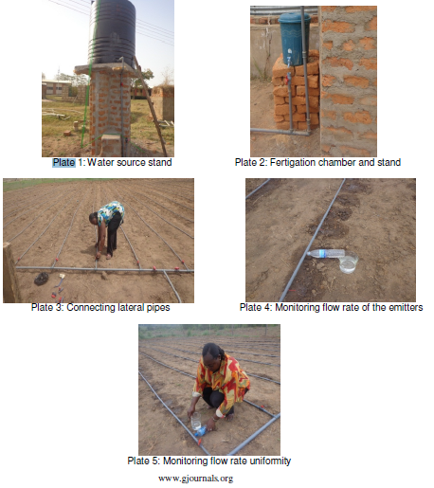

Figure 1.4 sprinkler irrigation

- Irrigation systems generally consist of three major components:
- Pumps- A major component of any irrigation system is the pump. Water must be delivered to all sprinklers or emitters at the proper pressure and flow rate.
- Piping- Piping is separated into two categories: transmission piping and distribution piping
Transmission piping is the largest diameter piping required to transport water long distances without causing excessive pressures or “head loss”.
Distribution piping moves the water to the application hardware (nozzles, emitters, etc.). These pipes are generally smaller in diameter than transmission piping to handle the lower flow rates, but must be large enough to ensure that the pressure at the end of the system is adequate for the applicator

Note. Improper sizing of pumps and piping is a major cause of under- or over application of water. This is especially true for portable systems where pumping distance and changes in elevation vary from field to field.
Application hardware- There are many choices for application hardware but, in general, the technology can be grouped into three basic delivery methods for the in-field distribution of water: big guns (includes center pivots), small sprinklers

  - Checking water outlets
Outlets may include-drip lines, pipes, risers, valves, sprinklers and emitters .Damage or faulty pumps, valves, fittings, main/sub mains, laterals, electrical components and other materials and tools should be recorded and reported, and action taken to effect repairs.

    - Check valves, slopes, hillsides
Install check valves if the drip system is on a hillside of slope to prevent the water in the tubes from draining out through the lowest emitter each time the system stops running.
Flush valves and end caps. Install a flush valve or end cap at the end of each drip tube. Automatic flush valves are available; however manual flush valves are preferable.
Emitters & Sprinklers
When a zone comes on, the water flows through the lateral lines and ultimately ends up at the irrigation emitter (drip) or sprinkler heads. Many sprinklers have pipe thread inlets on the bottom of them which allows a fitting and the pipe to be attached to them. The sprinklers are usually installed with the top of the head flush with the ground surface. When the water is pressurized, the head will pop up out of the ground and water the desired area until the valve closes and shuts off that zone.

Once there is no more water pressure in the lateral line, the sprinkler head will retract back into the ground. Emitters are generally laid on the soil surface or buried a few inches to reduce evaporation lose.

    - Checks of water, power, fuel and lubricants
There will always be pre-start checks that you need to make on your irrigation system. Checks of water, power, fuel and lubricants must be made to ensure that all are available and the control system is functional. Pumps will need to be primed as necessary and valves and controls are opened and closed as directed. Pressure and flow testing equipment may need to be calibrated. Refer to enterprise procedures and the operator’s manuals for other pre-start checks that need to be undertaken. Your trainer will go through all the necessary pre-start checks for the system that you are using in your enterprise.

Self-check 1 | Written test

Name…………………………………………… ID………………………… Date…….
Directions: Answer all the questions listed below.

Test I: Choose the best answer (4 point
All are Outlets except
- drip lines
- pipes
- valves
- Slope
- The installation of the small farm gravity drip system was divided into three stages
- True b. False

Test II: Short Answer Questions
- How to handle irrigation equipment (5)

- What will be check in irrigation components (5)

Operation Sheet -1

- Techniques to identify sprinkler and drip irrigation components
- Tools and equipments
  - Main lines and sub mains
  - Laterals,
  - Emitters/drippers and sprinkler heads
  - End line
  - End plug
  - Different fittings/ valves, tee and head controllers, adaptors, ball valve, elbow etc
- Procedures/Steps/Techniques
  - Use PPE
  - Prepare all the tools and materials
  - Identify the different parts of the systems
  - Check the components if they are factional
  - Identify the different parts of the systems
  - After identifying the components store the components properly
1.2. Techniques to designing basin system
- Tools and equipments
  - Tape meter
  - String ,
  - Spade, hoe, rake, shovel
  - Peg
- Procedures/Steps/Techniques
    - Prepare all the tools and materials
    - Lay out the area
    - Cultivate and label the area
    - Construct the bunds of the basin
    - Level the basin
    - Clean the tools and materials after the completion of the operation
    - Store the tools and materials
- Techniques to designing furrow system.
    - Tools and equipments
  - Tape meter
  - String ,
  - Spade, hoe, rake, shovel
  - Peg
    - Procedures/Steps/Techniques
- Prepare all the tools and materials
- Lay out the area
- Cultivate and level the area
- Construct the furrows according to the given crop spacing
- Clean the tools and materials after the completion of the operation
- Store the tools and materials

LAP TEST-1 | Performance Test

Name………………………………. ID…………………………….. Date…………………………………….

Time started: ________________________ Time finished: ________________

Instructions: Given necessary templates, tools and materials you are required to perform the following tasks within 1 hour. The project is expected from each student to do it.

Task-1 perform identification of sprinkler and drip irrigation components
Task-2 Perform designing of basin system
Task-3 Perform designing of furrow system

LG #24 | LO #2- Setting up field for gravity fed irrigation

Instruction sheet
This learning guide is developed to provide you the necessary information regarding the following content coverage and topics:
  - Checking water source area for irrigation set up
  - Checking pumps, bores and other water delivery mechanisms
  - Positioning and securing tarpaulins or other water control devices
  - Basic operation of gravity fed irrigation system (EG)
This guide will also assist you to attain the learning outcomes stated in the cover page. Specifically, upon completion of this learning guide, you will be able to:
  - Handle Irrigation equipment’s safely in accordance with OHS practices.
  - Position Irrigation equipment’s in accordance with enterprise requirements.
  - Check Water source area for irrigation set up and action taken as required in accordance with enterprise policy and procedures.
  - Check Pumps, bores and other water delivery mechanisms for irrigation set up and action taken, as required in accordance with enterprise policy and procedures.
  - Position and secure tarpaulins or other water control devices as required in accordance with enterprise procedures
Learning Instructions:
- Read the specific objectives of this Learning Guide.
- Follow the instructions described below.
- Read the information written in the information Sheets
- Accomplish the Self-checks
- Perform Operation Sheets
- Do the “LAP test”

Information Sheet-2

  - Checking water source area for irrigation set up

Water Sources
Characteristics of irrigation water that define its quality vary with the source of the water. There are regional differences in water characteristics, based mainly on geology and climate. There may also be great differences in the quality of water available on a local level depending on whether the source is from above ground (rivers and ponds) or from groundwater aquifers with varying geology, and whether the water has been chemically treated.

Municipal system water and deep wells generally provide the best water source for greenhouse operations. Chemical treatment of water may be required when pollutants such as iron, sodium, dissolved calcium and magnesium or bicarbonates are present. Surface water such as ponds and streams may have more particulate matter such as suspended soil particles, leaves algae or weeds that needs to be filtered out.

A sample of a potential water supply should be sent to an irrigation water testing laboratory for analysis. The main sources for irrigation water are groundwater from wells, surface water, drainage ponds, rain and municipal water. Drilled wells are a clean source of water for many greenhouse operations however, the water yield from drilled wells is usually limited. Groundwater is found in aquifers that are located below the earth surface. The flow of water from a well depends on the permeability and size of the aquifer, its recharge area and the amount of rainfall.

A well in one location may provide a very low yield, while another area, may provide a high water yield. In most areas, well drillers keep an accurate record of the depth and yield of wells they drill. Groundwater quality varies due to the parent material. For example, in the Berkshires of western Massachusetts groundwater is often drawn from limestone aquifers. Even for one site, the location and depth of the well can have an important effect on water quality. Elemental content and bicarbonate levels can also change with the seasons of the year, and the amount of pumping from the wells. Surface water includes streams, rivers, lakes and ponds which are dependent on runoff from adjacent land or from ground water springs. These are dependent on rainfall rates that vary from year to year.

Surface water is subject to contamination from sources such as sediment, chemicals and plant growth. High levels of particles can reduce the life of pumps and clog irrigation systems and multiple filters may be required. It is also possible that surface waters can become contaminated with road salt, industrial, agricultural chemicals, algae and plant pathogens. Drainage ponds are usually a combination of rain water and run-off. Drainage ponds commonly contain fertilizers or other agricultural chemicals. Because of the size and lack of aeration, biological conditions such as algal growth may be a concern.

Rain water can be collected from greenhouses or building roofs without contacting the ground and held in a concrete cistern, fiberglass or polyethylene tank, water silo or other holding tank. It is clean except for any debris that gets into the system. Rain water will be very low in elemental or chemical contamination unless there is industrial air pollution or fallout on the roofs. The pH of collected rain may be low (4.0 – 5.0) but is not considered detrimental to crops because it is not buffered (does not resist change in pH) and changes readily. Rain water is an excellent and underutilized source of irrigation water.

A 1” rainfall on an acre of greenhouse amounts to 27,100 gallons. A common yield is about 65% with losses due to evaporation, wind, leakage of piping system and diversion of the first few minutes of the rainfall to remove debris. To calculate the quantity in gallons that can be collected, multiply the square feet of greenhouse building floor (footprint) by 0.4.

A basic system consists of a storage tank, roof washer, inflow pipes, overflow pipes and a diverter to redirect the excess water when the tank is full. Concrete or plastic tanks can be used but are usually limited to about 15,000 gallons. Corrugated steel tanks can be built to almost any capacity as they are delivered in preformed panels and assembled on site. Before the water is collected for irrigation, a device called a roof washer is normally used to divert the first flush of water that is collected to remove debris from the water. Also an overflow is needed to handle excess water. The excess water is diverted to a drainage area where it will not flood neighboring property. Once rainwater is collected, it can be distributed to the greenhouses through the normal irrigation system. Municipal water includes water supplied by city, county or municipality. Either, ground, rain, and/or surface water may be used. The cost and quality are typically high since much of the water is for residential use and drinking water and is treated.

The key concerns are whether supply is guaranteed in times of shortages and what water treatment procedures are used that may influence plant growth. Municipal water may have fluoride and/or chlorine added at rates which is not a problem for most crops. Occasionally, sodium compounds are added to treat hard water.
  - Checking pumps, bores and other water delivery mechanisms

A pump produces liquid movement or flow: it does not generate pressure. It produces the flow necessary for the development of pressure which is a function of resistance to fluid flow in the system.
The purpose of a pump test is to obtain information on well yield, observed drawdown, pump efficiency, and calculated specific capacity. To check if your pump is operating efficiently, measure the power consumed by the pump and checks it against the pump’s performance curve. The pump curve will specify how much power you should be using at the flow and pressure your pump is generating. This helps you to identify which pumps are not operating efficiently.
Mechanisms of water pump
When the water hits the rotating impeller, energy of the impeller is transferred to the water, forcing the water out (centrifugal force). The water is displaced outward, and more water can now enter the suction side of the pump to replace the displaced water.

These pumps are classified into various types:
- Centrifugal Pump
- Horizontal Centrifugal Pump
- Vertical Centrifugal Pump
- Fire Hydrant Systems
- Submersible Pump
Water issues have always been troublesome, both in rural and urban areas. Irrespective of the fact that the rainfall was good enough or the lakes that supply water are filled or not, we often face the wrath of water scarcity. In order to strike back, mankind came up with a smart device called "Water Pumps". With simple mechanism and innovative technology, these water pumps draw water from underground sources and supply it to our homes. In most rural and industrial areas, these water pumps are eradicating the issue of water scarcity and are proven to be an amazing help.

A bore pump pressurizes water from an underground source like an aquifer, to force water to the surface, where it is either stored in a tank, or directly into your irrigation system to water your plants. There are in fact three major categories of well: dug wells, driven wells and drilled wells, commonly known as boreholes.
    - Planning for checking the availability of irrigation water
Without an adequate and reliable water supply, it is difficult to realise the full benefits of an irrigation system. It is important the designer establishes the quantity of water available for irrigation and designs the system for this quantity of water. The quantity of water available is often limited for some or all of the irrigation season. For example:
- Bore yields may be limited
- Scheme or regulatory restrictions may apply
- Seasonal volumes
- Interference effects
- There may be reduced flows in the source streams
- Groundwater levels may fluctuate
As part of the planning process for conducting gravity fed irrigation, you need to ensure or should check the availability of the water, Pumps, bores and other water delivery mechanisms.
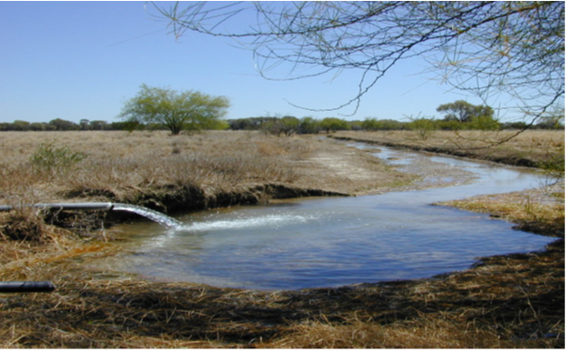

Figure 2.1 Ground water

The simplest way to access groundwater is to dig a well. Wells can be dug manually to reach the shallow water table within the unconfined aquifer. However, if an aquifer is deeper than a few meters, a proper borehole needs to be drilled. Choosing a site, drilling method and bore construction are complex tasks requiring hydro geological knowledge, a skilled driller and specialized equipment.

  - Positioning and securing tarpaulins or other water control devices
    - Operating the System
There are various methods of delivering and control of water from the channel into the head of the bay or furrow. These include:
- Siphons.
The water level in the channel is higher than the soil level in the bay or furrow. So it will easily siphon using plastic or aluminum tubes. Normally one siphon is used for each bay or furrow. The siphon is started manually at the start of the irrigation and the irrigation can be stopped by draining the channel or by removing the siphon. The use of siphons is labor intensive and costly, although larger diameter siphons are shifted and started by machines.

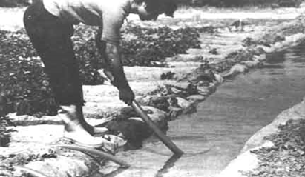

Figure 2.2 Priming of a siphon

- The gated pipe system
Gated pipe systems utilize portable rigid pipes or flexible tubing with uniformly-spaced rectangular adjustable outlets for diverting water into the furrows. Water flow from each outlet is regulated by adjusting the size of the outlet opening. Short flexible sleeves may be attached to the outlets to dissipate energy and minimize erosion at furrow inlets.

When the desired depth of water has been infiltrated at the lower end of the field, outlets along the head end of the field where the next irrigation set is to occur are opened and the previous ones are closed. The newly flowing outlet openings are then adjusted to provide nearly equal flow to all furrows in the irrigation set.

- Gates. Used with bays, a gate is opened in the wall of the channel.
- Pipe outlets. Also used with bays, a pipe is installed in the wall of the channel at the time Of construction. A cap or plug is removed to allow water into the channel.

Various types of rigid and ‘lay-flat’ plastic pipes are available as alternatives to channels in furrow irrigation layouts. In some applications, buried pipes with risers at each furrow head are used. You should note that there are many versions of tarpaulins techniques in use. The operation of the system will vary according to the water delivery mechanism, so you should check with the workplace supervisor to determine the specific enterprise procedures.

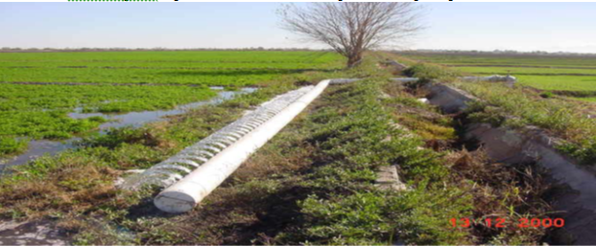

Figure 2.3 Plastic gated pipe for furrow irrigation

- In some intensive agricultural and horticultural applications, alternative distribution methods are common using low pressure pipelines. In the gated pipe system a pipeline is installed at the top of the field with gates allocated to correspond with each furrow.Figure.3. Gated pipe

  - Basic operation of gravity fed irrigation system
A gravity fed irrigation system is a cheap and effective way to provide water for a smaller sized crop area. It would be especially cost effective if the climate of the area can provide enough precipitation to consistently keep a reservoir filled using rain water harvesting techniques. The basic system is very simple consisting of an elevated reservoir with a pipe coming out the bottom that feeds water into a basic drip irrigation system that is all controlled either by hand or with a very efficient battery powered timer that controls the rate at which the crop is watered.
The components needed include:
- A water reservoir
- It must be able to contain at least one day worth of water
- The greater the capacity of the reservoir is proportional to how often it must be refilled
- The complication of having a very large container is that you must elevate it above the crop and refilling a very high container is more work
- The reason to elevate the tank is that it adds pressure which needs to be kept consistent at the point where the drip lines are fed so that the water is distributed equally

- A structure to support the water reservoir
- Can be constructed of anything that can support the weight of the container when it is filled with water
- It must also be able to withstand outside forces such as the wind
- An 880 gal container full weighs 4 tons

- Piping
- There must be a pipe at the base of the reservoir that lets water flow out and having a shut off valve at this connection point is a good idea if the reservoir is larger than one day worth of water.
- The piping if using the timer method then feeds the water through a filter
- Different sized piping should be used to increase the pressure
This is done by gradually decreasing the size of the lines being used such as starting with a 2ft line at the base of the reservoir then decreasing the size every 1-4ft so that it would then be a 1ft, 6in, 3in, 1in, 1/2in, down to the 1/8in emitters in the drip lines
- Timer and Filter
- There are many models of battery powered timers that can be set up and run for a whole season
- These timers control the frequency that water is emitted into the drip lines
- A filter must be installed in the water line before the timer valves
- This prevents the smaller lines from becoming clogged
- Valves and Drip lines
- Shut off valves should be placed between the reservoir pipes and the irrigation pipes and before the timer valves
- Drip lines are the average lines and emitters that can be purchased at any garden supply store

The Construction:
If you are using a small system that can be refilled daily with no timer it can be created for about 20 dollars. If you use the large system the price will vary greatly depending on what is bought at what price so for safety I will round up on the average price of materials.
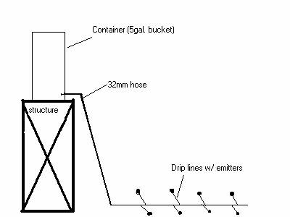
Fig .2.4.1. The Small System

Self-check 2 | Written test

Name…………………………………………… ID………………………… Date…….
Directions: Answer all the questions listed below.

Test I: Short Answer Questions
- List the importance of checking area for irrigation set up(5)
- Write down the importance of checking of the availability of irrigation (5)
- write basic components of small system irrigation

Operation Sheet -2

- Techniques to perform pre-start checks for gravity fed irrigation
- Tools and equipments

- Siphons,
- cups,
- fluming,
- pipes,
- gates/slides/doors,
- pumps and valves

- Procedures/Steps for pre-start checks for gravity fed irrigation
- Prepare pre-start checkup plan
- Use appropriate PPE’s
- Check pump functionality
- Check the outlet components
- Check valves
- Check for loss fitting
- Check for leakage
- Check for loss fitting
- Check for water
- Check for power
- Check for fuel and lubricants
- Fixing parts together or Installed at fixed permanent or seasonal positions.
- Check the functionality of each installed components and finish the task

LAP TEST-2 | Performance Test

Name………………………………. ID…………………………….. Date…………………………………….

Time started: ________________________ Time finished: ________________

Instructions: Given necessary templates, tools and materials you are required to perform the following tasks within 1 hour. The project is expected from each student to do it.

Task-1 Perform necessary pre start check for components of gravity fed irrigation systems

LG #25 | LO #3- Carrying Out Gravity Fed Irrigation Operations

Instruction sheet
This learning guide is developed to provide you the necessary information regarding the following content coverage and topics:
  - Checking water source area for irrigation set up
  - Checking pumps, bores and other water delivery mechanisms
  - Positioning and securing tarpaulins or other water control devices
  - Basic operation of gravity fed irrigation system (EG)
This guide will also assist you to attain the learning outcomes stated in the cover page. Specifically, upon completion of this learning guide, you will be able to:
  - Handle Irrigation equipment’s safely in accordance with OHS practices.
  - Position Irrigation equipment’s in accordance with enterprise requirements.
  - Check Water source area for irrigation set up and action taken as required in accordance with enterprise policy and procedures.
  - Check Pumps, bores and other water delivery mechanisms for irrigation set up and action taken, as required in accordance with enterprise policy and procedures.
  - Position and secure tarpaulins or other water control devices as required in accordance with enterprise procedures
Learning Instructions:
- Read the specific objectives of this Learning Guide.
- Follow the instructions described below.
- Read the information written in the information Sheets
- Accomplish the Self-checks
- Perform Operation Sheets
- Do the “LAP test”

Information Sheet-3

- Irrigation schedule

Irrigation scheduling is one of the factors that influence the agronomic and economic viability of small farms. It is important for both water savings and improved crop yields. The irrigation water is applied to the cultivation according to predetermined schedules based upon the monitoring of: the soil water status and crop water requirements. The type of soil and climatic conditions have a significant effect on the main practical aspects of irrigation, which are the determination of how much water should be applied and when it should be applied to a given crop.

In addition to the basic factors relevant to the preparation of irrigation schedules examined below, other important elements should also be considered, such as crop tolerance and sensitivity to water deficit at various growth stages, and optimum water use

- Irrigation structures: -
Irrigation system consists of intake (main) or pumping station (main), conveyance, distribution, field application and drainage systems Intake or pumping station (main):- is built at the entry to the irrigation system. Its purpose is to direct water from the original source of supply in to the irrigation system. Conveyance and distribution system: - consists of canals transporting the water through the whole irrigation system.

Open canals (channel or ditch):- is an open waterway whose purpose is to carry water from one place to another, channels or canals refer to main waterways supplying water to one or more farms, field ditches have smaller dimensions and convey water from the farm entrance to the irrigated fields
- Canal characteristics: -
Rectangular, triangular, trapezoidal, circular and irregular or natural earthen canals: - simply dug in the ground and the bank is making up from the removed earth. Disadvantages of the se canals are collapsing of the side slopes, the water loss due to seepage and require continuous maintenance .Lined canals: - lined with impermeable materials, prevent excessive seepage and growth of weeds, control canal bottom and band erosion. The materials used are concrete, brick or rock masonry and asphalted concrete (a mixture of sand, gravel and asphalt).

- Canal structures:
The flow of irrigation water in the canals must always be under control. These canal structures help to regulate the flow and deliver the correct amount of water. Four main types of structures. Erosion control structures:- soil particles along the bottom and banks of an earthen canal are lifted, carried away, and deposited downstream where they may block the canal and silt up structures there for drop structures are required to reduce the bottom slop of canals lying on steeply sloping land in order to avoid high flow velocity and erosion risk. Distribution control structures: - are required for easy and accurate water distribution within the irrigation system and on the farm.

- Division boxes: -
Used to divide or direct the flow of water between two or more canals or ditches. Water enters the box through an opening on one or more canals or ditches and flows out through openings on the other sides. These openings are equipped with gates.
- Turnouts
Turnouts are constructed in the bank of a canal. They divert part of the water from the canal to a smaller one. Turnouts can be concrete structures or pipe structures.
- Checks
To divert water from the field ditch to the field, it is often necessary to raise the water level in the ditch. Checks are structures placed across the ditch to block it temporarily and to raise the upstream water level. Checks can be permanent structures or portable
Crossing structures: - used to carry irrigation water across roads, hillsides and natural depressions
- Flumes
Carry irrigation water across gullies or other natural depressions
Open canals make of wood metal or concert which often need to be supported by pillars
- Culverts
Carry the water across roads
Consists of masonry or concrete headwalls at the inlet and outlet connected by a buried pipeline
Water measuring structures: - the principal objective of measuring irrigation water is to permit efficient distribution and application the most commonly used water measuring structures are weirs and flumes. The water depth is read on a scale which is part of the structure. Using this reading, the flow rate is then computed from standard formulas or obtained from standard tables prepared specially for the structure.

- Soil, plant and water relationships

Imgation is the controlled application of water to arable lands in order to supply crops with the water requirements not satisfied by natural precipitation. In arid climates adequate food and fibers cannot be produced without irrigation. Because of the potential for low crop yields and risk of crop failure due to variations in rainfall, irrigation in semiarid regions is needed most of the time.

Furthermore, imgation in humid and sub humid regions is desirable as insurance against crop losses. Even though summer rainfall ordinarily is sufficient for crop growth, sometime during the year a drought may occur. Production of a profitable crop is generally the objective of agriculture. Irrigation provides the insurance for a profitable agriculture in semiarid, sub humid and humid areas; it is a necessity in arid regions.

Water is introduced to the soil by an imgation system, by a regulated water table, or by precipitation. It is stored in the soil matrix and then extracted by plant roots to meet the plant evapotranspiration (ET) needs. This chapter on soil plant-water relationships treats the physical properties of soils and plants that affect the movement, retention, and use of water and that must be considered in designing and operating systems for conservation imgation.

In planning and designing an imgation system, the technician is concerned primarily with the water-holding capacity of a soil, particularly in the root zone of the plant; with the water-intake rate of the soil; with the root system of the crop to be grown; and with the amount of water that the crop uses. In addition, a working knowledge of all soil-plantwater relationships is necessary in order to plan and manage efficiently the imgation for particular crops grown on particular soils and in order to adjust the design to various conditions. Soil acts like a reservoir that holds water and nutrients plants need to grow. Some soils are large reservoirs with more holding capacity that release water and nutrients easily to plants, while other soils have limited reservoirs. The following discussion focuses on soil water as it relates to plant availability and applying irrigation water.
- Soil Water Content.
Soil water content is the amount of water stored in the soil at a given time. The most commonly defined soil water content values are saturation, field capacity, wilting point, and oven dried. At saturation, which usually occurs immediately after a heavy rainfall or an irrigation application, all pore spaces in the soil are filled with water.

When the soil is at or near saturation, some of the water is free to drain or percolate due to the force of gravity. This excess water is referred to as gravitational water. Since this percolation takes time, some of this extra water could be used by plants or lost to evaporation. Field capacity is defined as the amount of water remaining in the soil after rapid percolation has occurred. This is not a definite soil water point; therefore, field capacity often is defined as approximately one-third atmosphere tension. Tension is defined in a following section.

Wilting point is defined as the soil water content at which the potential or ability of the plant root to absorb water is balanced by the water potential of the soil. Most crops show significant signs of stress, such as wilting to the extent of dying, if soil water reaches the wilting point, especially for extended periods of time. Wilting point is usually approximated by a value of 0.15 atmospheres (bars). Soil that has been oven dried is used as a reference point for determining soil water content.

- Critical measures for moisture availability

The critical moisture content is the average material moisture content at which the drying rate begins to decline. he critical moisture content varies depending on the material, and it is further related to velocity and temperature. Because many factors affect the critical moisture content, we used the average value of the critical moisture content.
The temperature and relative humidity of the drying gas significantly affect the equilibrium moisture content, which is different depending on the material. At a high drying temperature and low relative humidity, the equilibrium moisture content becomes close to zero. The drying rate starts to decrease after passing the critical moisture content, and the moisture is no longer evaporated when reaching the equilibrium moisture content.
Available water is expressed as a volume fraction (0.20), as a percentage (20%), or as an amount (in inches). An example of a volume fraction is water in inches per inch of soil. If a soil has an available water fraction of 0.20, a 10 inch zone then contains 2 inches of available water. Available water capacity is often stated for a common depth of rooting (where 80 percent of the roots occur). This depth is at 60 inches or more in areas of the western United States that are irrigated and at 40 inches in the higher rainfall areas of the eastern United States. Some publications use classes of available water capacity. These classes are specific to the area in which they are used. Classes use such terms as very high, high, medium, and low.

- Opening and shutting get valves

    - Gates and/or valves are opened and shut as necessary in accordance with enterprise procedures
An open canal, channel, or ditch, is an open waterway whose purpose is to carry water from one place to another. Channels and canals refer to main waterways supplying water to one or more farms. Field ditches have smaller dimensions and convey water from the farm entrance to the irrigated fields.
- Pressurized irrigation system and how does it work
A pressurized system is a system that relies on water pressure for the system to work. If the system is connected to the pressurized water main (mains pressure) no pump is needed, however, if the water source is not pressurized, then a pump will be needed to pressurize the system.
- Drip irrigation /trickle irrigation/
  - Water is delivered at or near the root zone of plants, drop by drop.
  - Much less wasted water! For this reason, drip is the preferred method of irrigation in arid areas.
  - The most water-efficient method of irrigation, if managed properly, since evaporation and runoff are minimized,
  - Means of delivery of fertilizer known as fustigation.
  - Easy to install, design, inexpensive, and can reduce disease problems associated with high levels of moisture on some plants.
  - If you want to grow a rain forest however, drip irrigation will work but might not be the best choice!

  - The high efficiency of drip irrigation results from two primary factors.
- The first is that the water soaks into the soil before it can evaporate or run off.
- The second is that the water is only applied where it is needed, (at the plant's roots) rather than sprayed everywhere.
Consists of an extensive network of pipes, usually of small diameter, that deliver filtered water directly to the soil near the plants.
The water outlet device in a pipe is called an emitter discharging only a few liters per hour.
From the emitters, the water spreads laterally and vertically by the soil capillary forces. The area wetted by an emitter depends upon the flow rate, soil type, soil moisture, and vertical and horizontal permeability of the soil.

- Advantages and Limitations of drip irrigation
- Advantages
- Uniform and controlled water distribution close to plant roots along plant rows
- Application of water and fertilizer at optimum rate to the root system
- Minimizes loss of water by deep peculation below root zone
- Eliminates land leveling and irrigation on steeper slopes
- Efficient water application to orchards
- Restrict weed growth to wetted areas
- Permits use of poor quality water and frequent irrigation

- Limitations
- Higher initial cost of installation
- Clogging of openings in the emitters
- Presence of dissolved salt left in the soil.

- Design of drip irrigation system
The design of the drip irrigation system consists in deciding size of pumping unit, size of main line and laterals, location of emitters, their discharge capacity etc.
The design of the system is done taking into consideration the following points:

1. Water source such as a well or a tank
2. Plant spacing and irrigation requirements of crops
3. Topographic condition
4. Infiltration ate, water holding capacity, texture, structure and bulk density of soil.
5. Hydraulic characteristics of the pipelines and components used
6. Available material

- Components of drip irrigation system
The system essentially consists of:
- Main line
- Sub mains
- Laterals
- Emitters/drippers

Auxiliary components include
- Filters
- Pressure regulators
- Valves
- Fertilizer application components.

The main line delivers water to the sub mains and the sub mains into the laterals. The emitters, which are attached to the laterals, distribute water for irrigation. The mains, sub mains and laterals are usually made of black PVC tubing’s. The emitters are also usually made of pvc material. So they are not damaged when distributing saline water or water mixed with fertilizers. Appropriate connections are to be used between pipe lines and other equipments. Emitters supply water at the desired rate. The discharge rate of the emitters generally ranges from 2 to 10 litres per hour.

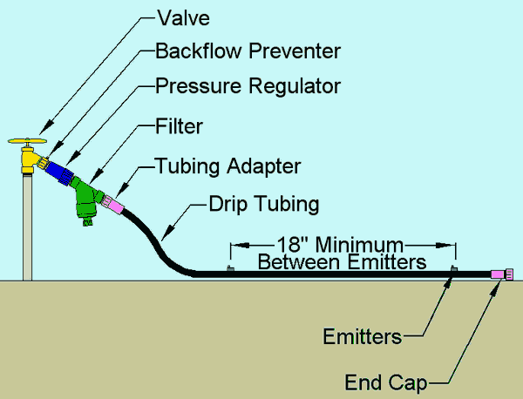

Figure 3.1 Drip line

- Sprinkler irrigation

- When to use sprinkler irrigation
- Method of applying irrigation water which is similar to rainfall.
- Water is distributed through a system of pipes usually by pumping.
- Spray water into the air and irrigate the entire soil surface through spray heads
- The water breaks up into small water drops which fall to the ground.
- Sprinklers provide efficient coverage for small to large areas and are suitable for use on all types of soil properties.
- It is also adaptable to nearly all irrigable lands since sprinklers are available in a wide range of discharge capacity.
- All the products are made out of high strength & chemical resistance engineering plastics to achieve functional satisfaction and to maintain cost economics.
- Suitable for almost all field crops like wheat, gram, pulses as well as vegetables, cotton, soya bean, tea, coffee, and other fodder crops.
Advantages - unsuitable or uneconomical for leveling
  - Suitable for sandy soil
  - Ideally suited to steep slopes or irregular topography
  - Rate of flow available is too small to distribute water efficiently by surface irrigation
  - Used for irrigating high valued crops like tea, coffee, orchards, etc.
  - Higher water application efficiency
  - For frequent and small amount application of water
  - For application of fertilizer and pesticides
Limitations: - Large initial investment and high annual depreciation
  - Unsuitable for very fine textured soils
  - Requires well organized service facilities
  - Uneven water distribution caused due to high winds
  - Evaporation losses when operating under high temperature
  - Requires water free from silt and debris.
Valves are opened and shut, as necessary
  - Opening the valves to let the water through - turning the irrigation system on.
  - Closing the valves when the operation is complete - turning the irrigation system off.
  - Turning the system on and off - main line water supply
  - If the system is attached to mains water, turning an irrigation system on and off will just be a matter of turning a valve on or off. You should do this slowly (when turning on and off) to prevent a sudden surge in pressure through the lines which results in water hammer.
  - Turning the system on and off - pump water supply
  - Where it is necessary to start a pump to operate the system, it is important that there are sufficient irrigation lines open.
  - Sometimes the foot valve on the end of the suction line may leak allowing water out and allowing air into the suction line. If this happens, after a short time the pump will stop pumping.
Achieving and maintaining required head and water level in head ditch
Required pressures and water flows are achieved and maintained to ensure sufficient water availability. Maintenance activities fall into three general categories: Routine Maintenance - Activities that are conducted while equipment and systems are in service. These activities are predictable and can be scheduled and budgeted. Generally, these are the activities scheduled on a time-based or meter-based schedule derived from preventive or predictive maintenance strategies. Some examples are visual inspections, cleaning, functional tests, and measurement of operating quantities, lubrication, oil tests, and governor maintenance.

Maintenance Testing - Activities that involve using test equipment to assess condition in an offline state. These activities are predictable and can be scheduled and budgeted. They may be scheduled on a time or meter basis but may be planned to coincide with scheduled equipment outages. Since these activities are predictable, some offices consider them “routine maintenance” or “preventive maintenance.” Some examples are governor alignments and balanced and unbalanced gate testing.

Diagnostic Testing – Activities that involve using test equipment to assess the condition of equipment after unusual events, such as equipment failure/ repair/replacement or when equipment deterioration is suspected. These activities are not predictable and cannot be scheduled because they are required after a forced outage. Each office must budget for these events. Some examples are governor troubleshooting, unit balancing, and vibration testing.
Achieving and maintaining the required pressures and water flows to ensure that the crops get the required amount of water.
  - the wetting pattern from a single rotary sprinkler is not very uniform
  - the area wetted is circular
  - the heaviest wetting is close to the sprinkler
  - for good uniformity several sprinkler must be operated close together so that their patterns overlap

  - for good uniformity the overlap should be at least 65% of the wetted diameter
  - uniformity of sprinkler applications can be affected by wind and water pressure
  - Spray from sprinklers is easily blown even by a gentle breeze and this can seriously reduce uniformity.
  - To reduce the effects of wind the sprinklers can be positioned more closely together

  - Sprinklers work well at the right operating pressure recommended by the manufacture. If the pressure is above or below the standard then the distribution will be affected
- Application rate
The average rate at which water is sprayed on to the crops and is measured in mm/hr.
Depends on the size of sprinkler nozzles, the operating pressure and the distance between sprinklers. The average application rate must be less than the basic infiltration rate of the soil to reduce evaporation and runoff
- Sprinkler drop size
- As water sprays from a sprinkler it breaks up into small drop between 0.56and 4mm in size.
- Small drops fall close to the sprinkler
- Larger drops fall close to the edge of the wetted circle
- Large drops can damage delicate crops and soil, so in such conditions it is best to use the smaller ones.
- Drop size is controlled by pressure and nozzle size
- Determining required water volume
Efficient water use for irrigation depends on measurement. Accurate measurement of irrigation water permits more intelligent use of these voluble natural recourses. Such measurement reduces excessive wastes and allows the water to be distributed among users according to their needs and right.
Information concerning the relationships between water, soils, and plant cannot utilize in irrigation practices without the measurement of water

    - Required head and water levels in head ditch for sufficient water flow
Water Fall Head is the energy that drives water through an irrigation system. Put simply, it is a measure of water pressure. Head is measured in millimeters, meters or kilopascals (1 m = 9.806 kPa = 1.42 psi).

In surface systems, we are mainly interested in the head associated with elevation and gravity. Maintaining head in surface irrigation is important, because the energy maintains flow rate and the movement of water through the system.
For free discharge or sufficient water flow, the head is the difference between the water level in the farm channel and the outlet from the pipe. For drowned or submerged discharge, the head is the difference between the water level in the farm channel and in the field. Discharge/ water flow can be changed by a change in pipe diameter or a change in the head.

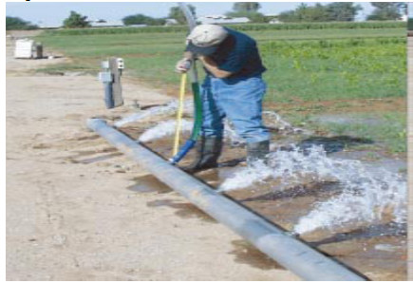

Figure 3.2 Gated pipe system
  - Opening required number of siphons

    - Siphon operation, cleaning and lifting after Operation of Irrigation
Siphon tube systems utilize curved aluminum or plastic pipes that are laid over the bank of an open ditch to divert water into the furrows. Water flows into the submerged end of the tube, is siphoned over the bank of the open ditch, and delivered into the furrow when there is sufficient operating head and the tube is positioned correctly and primed.

The flow rate of the siphon tube is controlled by its diameter and the elevation difference (head) between the water level in the open ditch and the center of the outlet end. The advantage of siphon tubes is the ease with which nearly equal inflows to all furrows can be achieved. When the desired depth of water has been infiltrated at the lower end of the field, the siphon tubes are collected and redistributed along the head of the field where the next irrigation set is to occur and each is primed again. Trash screening is often required to remove floating debris from the water to prevent clogging the siphon tubes.

A nearly constant water supply is required to ensure that siphon tubes do not stop flowing (loose prime) during the irrigation. Farmers often spill 3 to 6 percent of this water at the end of the ditch to reduce flow fluctuations to their siphon tubes.

    - Siphons for application of gravity fed irrigation
Siphons are small diameter pipes used to convey water over the channel embankment/ furrows.
Furrows are small, parallel channels, made to carry water in order to irrigate the crop. The crop is usually grown on the ridges between the furrows.

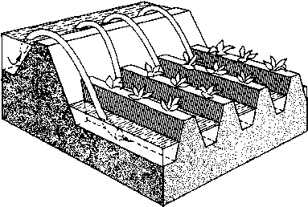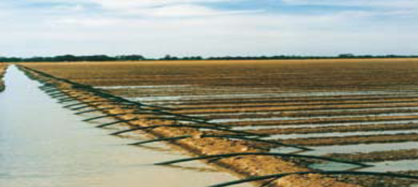
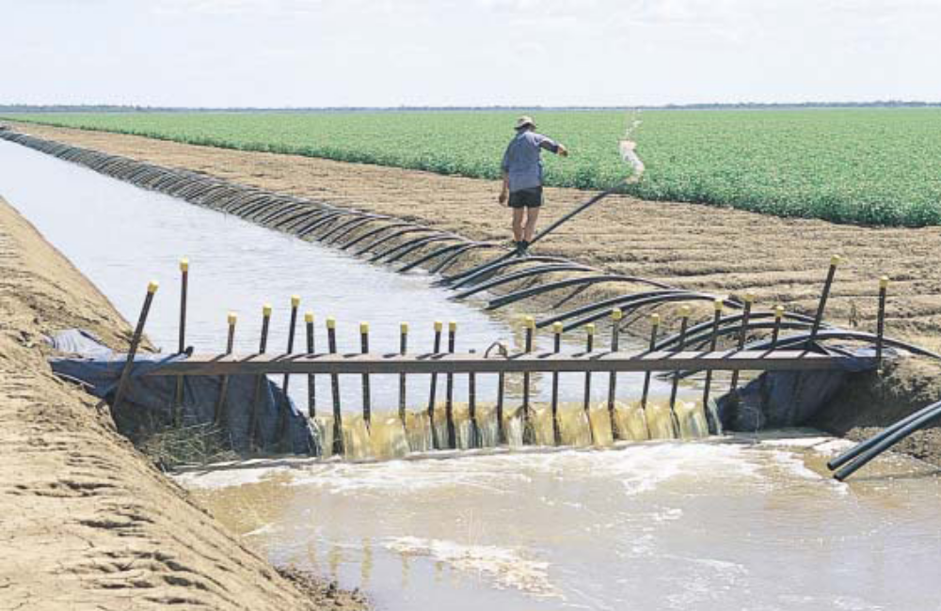

Figure 3.3 siphon

  - Monitoring progress of water flow in furrows

    - Monitoring the Progress of Water Flow (Co-Ordinate Irrigation Activities – Monitor System)
An irrigation system should have adequate access for water control, stock, and machinery, but each structure will cause some head loss. Your system should have the minimum number of structures feasible for your management purposes.
In general, there are three types of structures:
  - Culverts
  - Checks
  - Outlets
Culverts: Pipe culverts are installed to allow access across supply channels and tail water drains. They should:
- Have minimal head loss
- Flow full without sucking air (overtaxing)
- Be large enough in capacity and length for future developments
- Incorporate headwalls (these reduce head losses and erosion and make crossings more visible)
- Be constructed to combine checks and drop checks to reduce the number of structures used
- Be long enough to allow ease of access across for machinery and trucks.
Checks: Checks are used to reduce the earthworks needed in channel construction and to control height and thus manage flow. Overshot drop board checks are used to control upstream channel levels. Undershot checks (gated) control downstream levels and flow, particularly where supply rates fluctuate.
Checks should:
- Have minimal head loss at full flow
- Be large enough for any future development
- Be easily accessible
Gravity fed irrigation systems have two principal sources of inefficiency, deep percolation and surface runoff or tail water the remedies are competitive. To minimize deep percolation the advance phase should be completed as quickly as possible so that the intake opportunity time over the field will be uniform and then cut the inflow off when enough water has been added to refill the root zone. This can be accomplished with a high, but non-erosive, discharge onto the field.

However, this practice increases the tail water problem because the flow at the downstream end must be maintained until a sufficient depth has infiltrated. The higher inflow reaches the end of the field sooner but it increases both the duration and the magnitude of the runoff. There are three options available to solve this problem, at least partially:

(1) Dyke the downstream end to prevent runoff as in basin irrigation
(2) Reduce the inflow discharge to a rate more closely approximating the cumulative infiltration along the field following the advance phase, a practice termed 'cutback
(3) Select a discharge that minimizes the sum of deep percolation and tail water losses, i.e., optimize the field inflow regime.

Once the gravity fed irrigation activity has started as shown in figure below the water flow progress in the whole elements/components of surface irrigation, you should monitor the crew activities for efficient team work and provide the appropriate directions and instructions. The water levels in the ditches and channels must be monitored and maintained to provide sufficient head.

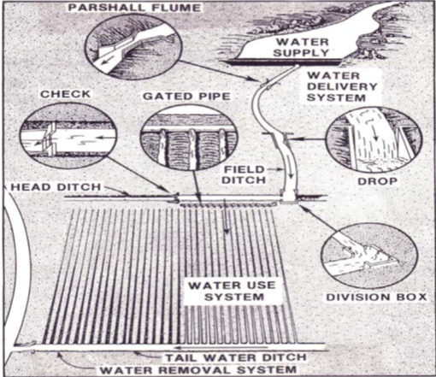

Figure 3.4 Typical components of a gravity fed irrigation system

Depending on the available flow in the farm channel, several furrows can be irrigated at the same time. When there is a water shortage, it is possible to limit the amount of irrigation water applied by using 'alternate furrow irrigation'. This involves irrigating alternate furrows rather than every furrow.
  - Lifting siphons where irrigation completed

    - Siphon operation, cleaning and lifting after Operation of Irrigation
Siphon is small diameter pipes used to convey water over the channel embankment/ furrows. Furrows are small, parallel channels, made to carry water in order to irrigate the crop. The crop is usually grown on the ridges between the furrows.Water flows into the submerged end of the tube, is siphoned over the bank of the open ditch, and delivered into the furrow when there is sufficient operating head and the tube is positioned correctly and primed. The flow rate of the siphon tube is controlled by its diameter and the elevation difference (head) between the water level in the open ditch and the center of the outlet end.

The advantage of siphon tubes is the ease with which nearly equal inflows to all furrows can be achieved. When the desired depth of water has been infiltrated at the lower end of the field, the siphon tubes are collected and redistributed along the head of the field where the next irrigation set is to occur and each is primed again. Trash screening is often required to remove floating debris from the water to prevent clogging the siphon tubes.

A nearly constant water supply is required to ensure that siphon tubes do not stop flowing (loose prime) during the irrigation. Farmers often spill 3 to 6 percent of this water at the end of the ditch to reduce flow fluctuations to their siphon tubes.

  - Carrying out and marking irrigation change

    - Progress of water flow in furrows is monitored in accordance with enterprise procedures
- Canal structures-
The flow of irrigation water in the canals must always be under control. For this purpose, canal structures are required. They help regulate the flow and deliver the correct amount of water to the different branches of the system and onward to the irrigated fields. There are four main types of structures: erosion control structures, distribution control structures, crossing structures and water measurement structures.
- Irrigation change is carried out and marked as required.
An irrigation change must indicate that when to apply irrigation water and how much quantity of water to be applied, several approaches have been used for irrigation changes by irrigation experts and farmers that includes:
- Soil moisture depletion: - the available soil moisture in the root zone is a good criterion for irrigation change. When the soil moisture in a specified root zone depth is depleted to a particular level (in most cases 50-60%) it is too replenished by irrigation
- Plant basis or indices: - it can be taken as a guide for irrigation change. The deficit of water will be reflected by plants it self such as dropping, curling or rolling of leaves and change in foliage colour as indication for irrigation change or indication for watering the crop.

- Climatologically approach: - Evapotranspirtion mainly depends up on climate that includes temperature, humidity, radiation, wind and rainfall. The amount of water lost by Evapotranspiration is estimated from climatologically data and when ET reaches a particular level irrigation is applied

- Critical crop growth stages: - in each crop, there are some growth stages at which moisture stress leads to irrevocable yield loss. These stages are known critical periods or moisture sensitive periods. If irrigation water is available insufficient quantities, irrigation is scheduled whenever soil moisture is depleted to critical moisture level, say 25 or 50% of available soil moisture.

Irrigation equipment is shifted, as required, for irrigation changes in accordance with OHS guidelines. Implementing irrigation shifts-The irrigation time is the time needed to supply the required irrigation depth in mm. The irrigation time depends on the stream size l/sec, the required irrigation depth in mm and the size of the field to be irrigated in ha. The following formula is used to determine the irrigation time
Irrigation time (hours) = 2.78 x irrigation depth (mm) x field size (ha)
Stream size l/sec
Example: if for example the required irrigation depth is 50mm the available stream size is 20l/sec and the size of the field is 75 x 50m, the irrigation time is calculated as follows:
Step 1: determine the field size in hectares: - The size is 75m x 50m = 3750m² = 3750m²/10000m² = 0.375 ha

Step 2: determine the irrigation time: - Irrigation time (hours) = 2.78 x irrigation depth (mm) x field size (ha) Stream size l/sec
= 2.78x 50mm x o.375ha = 2.6 hours = 156 minutes
20l/sec
Applying the quarter time rule it would mean that the water has to reach the end of the furrow or cover the basin in 156/4 = 39 minutes. If it takes longer the stream size per furrow or basin has to be increased or the furrow length or basin size reduced.
Irrigation depth: - the amount of water that needs to be applied to an irrigated system when soil water is reduced to the specified depletion level
Irrigation intervals: - refers to the number of days between irrigation during periods without rainfall. it is a function of crop, soil and climate.

Irrigation interval = allowable soil moisture depletion
Daily water use
In implementing irrigation shifts determine the area to be irrigated, irrigation time, irrigation depth, and irrigation frequency according to the crop water need which is affected by crop growth stage, climatic factors, and soil moisture depletion.
    - Irrigation Site change
- There may be a number of fields to be irrigated. The operator must be aware of the schedule so that as one field is shut down, the next field is started. Any malfunctions to equipment, damage to water courses, blockages, seepage or leakage are corrected or repaired immediately and reported in accordance with enterprise agreements.
- Changes to, or closure of, a site can result in product being lost to ground as a result of either deliberate or accidental release during dismantling and removal of pipe work or other infrastructure or from abandoned plant and equipment. In addition, a risk could arise off-site if contaminated pipes and equipment are not disposed of in an appropriate manner.
Key considerations include:
Whether proposed methods for changing/decommissioning the site could result in release of product to ground or surface water?
Will any redundant equipment containing solvent remain in situ (e.g. in pipes, drainage system, tanks, bunds)?

If there is a risk of release of product to the ground or surface water, or if solvents would remain in situ in redundant equipment, the decommissioning proposals should be readdressed. In general it is preferable to remove all redundant pipe work and equipment. Specific care needs to be taken with respect to changing or decommissioning underground storage tanks. Consideration should be given to the relevant section of the “Groundwater Protection Code: Petrol stations and other fuel dispensing facilities involving underground storage tanks”.

Self-check 3 | Written test

Name…………………………………………… ID………………………… Date…….
Directions: Answer all the questions listed below.
Test I: Short Answer Questions
- How to handle irrigation equipment (5)

- What will be check in irrigation components (5)

Operation Sheet -3

  - Techniques to sample record
Table: Sample record sheet
No. | Components | Damage & blockage type | Degree of damage & blockage | Cause | Location | Section of the system affected | Date of detection | Action taken | Effect of maintenance action | Cost | Remark
1 | Of pump
2 | head regulator
3 | canals

LAP TEST-3 | Performance Test

Name………………………………. ID…………………………….. Date…………………………………….

Time started: ________________________ Time finished: ________________

Instructions: Given necessary templates, tools and materials you are required to perform the following tasks within 1 hour. The project is expected from each student to do it.

Task_1: Conduct the maintenance activities according to instructions

LG #26 | LO#4- Setting up of movable irrigation components

Instruction sheet
This learning guide is developed to provide you the necessary information regarding the following content coverage and topics:
  - Achieving and maintaining required pressure and water flow
  - Relocating equipment’s
  - checking water flow from outlets
This guide will also assist you to attain the learning outcomes stated in the cover page. Specifically, upon completion of this learning guide, you will be able to:
  - Open and shut valves as necessary, in accordance with enterprise procedures.
  - Achieve and maintain required pressures and water flows to ensure sufficient water availability.
  - Relocate Equipment’s if necessary, in accordance with working procedures and guidelines.
  - Check water flow from outlets as necessary, to verify freedom from blockage.
Learning Instructions:
- Read the specific objectives of this Learning Guide.
- Follow the instructions described below.
- Read the information written in the information Sheets
- Accomplish the Self-checks
- Perform Operation Sheets
- Do the “LAP test”

Information Sheet-4

  - Achieving and maintaining required pressure and water flow

    - Carrying out pre- and post-season maintenance
  - Pre-season preparation of the equipment
- Pre-season Maintenance
Before you begin irrigating each year, you should prepare your irrigation system for the new season. Many temporary repairs made last year will probably need attention. Irrigation systems are more than just a method to deliver water to the crop. They are becoming a management tool. A properly designed and maintained system allows the grower to supply precise amounts of water, nutrients, and other materials to the crop. Careful management and preseason maintenance can allow the grower to realize the full benefits of irrigation system.
- weed control,
- motor servicing,
- Desilting channels,
- Descaling and equipment service
- flushing and supply distribution

- Flushing/Draining the System:
Place the Disconnect Switch in the “OFF” position. Only water is required for this procedure – the System does not need to move. DO NOT start the flushing procedure while the System is under water pressure. Removing Sand Trap Caps while the System is under pressure can cause personal injury or death!

Remove the Sand Trap Cap and pump water through the System. This will flush out any foreign material that might plug the Sprinkler Heads or Sprinkler Valves. This is particularly important on newly installed Systems, because of possible straw, dirt or any other material may be accumulated in the pipe during erection. After the Sand Trap Cap is back in place, pump water through the System and check the Sprinklers for proper operation. The arc travel of the End Gun should be set as the diagrams show on page 16 of the owner’s manual. Also, check the System water pressure to see if it is operating at the proper pressure.

- Flush the main line.
Depending on the system and pump capabilities, it may be a good idea to close a portion of the system to increase the pressure and velocity. Find out what the safe maximum operating pressure is before flushing.

- Flush tubing in the field
Hose ends are now opened and again, a portion of the laterals may be closed to ensure good pressure and velocity for a thorough flushing of the drip tubing. After the entire system has been flushed, the system needs to be checked line by line. One of the most efficient methods utilizes an irrigator walking and checking every row, wearing a cloth pouch like you would find in a lumber store. In it are emitters, couplings, punch, plugs, and hose ends to make the necessary repairs.

For example, if your utility company offers off-peak rates you may be able to save on your power bill by irrigating at night. If the power is off for a length of time you may not know that the field did not receive all of the water you had scheduled without such a recording device.

- Filters
Several items need to be checked on both screen and media filters prior to start-up. On filters that flush automatically, the controller and valves should be checked for proper operation. If the controller is equipped with a pressure differential switch, the setting should be checked against the manufacturer's specifications. A differential can be created by removing one of the leads to simulate a high differential. If the differential switch is operating correctly, this will initiate a flush cycle. Once the equipment that filters and delivers the water to the field has been checked and repaired, the drip lines, emitters, and peripheral equipment need to be inspected. A thorough flushing of the system is the first priority, and this should be done in steps.

- Visual Inspection:
Make a visual check of all bolts in the System making sure something has not become loose during the idle period. When the System has been newly installed, all the bolts should be checked with an end wrench to make sure they have been tightened by the erection crew. One loose bolt may cause serious structural damages. Check the electrical boxes and wiring of the System to make sure the Ground Wires are secured and rodents or insects have not damaged the Systems’ mechanisms.

- Lubrication:
Grease fittings are located on the Power Tower Cart (Lateral Move only), Pivot Point, at any optional Steel U-joints (1 each), and on any Towable Gearboxes (2 each). These fittings should be greased with good quality grease. Check the oil level in the center Drive and Wheel Gearboxes. Water condenses in the Gearboxes and should be drained. The water may be drained by loosening the drain plug on the bottom. When the plug is removed, if there is any water, it will be the first to drain out. Do not overfill any of these Gearboxes! Overfilling may result in seal damage. NOTE: Refer to the Reinke Wheel Gearbox Maintenance Section.

- Tires:
Tire pressure should be maintained according to the chart in the owner’s manual. Also, inspect the Tires for impending problems (cuts, breaks, etc.).
  - Post season maintenance of the system and making resistant to damage
- Cleaning Water Lines
If there is heavy scaling on the collector and/or blocked water passages, consult for cleaning recommendations. Chlorine present in tap water is harmful to the klystron water passages. Thorough flushing with de ionized water will remove all traces of chlorine. Never use tap water for final refill or for makeup water.
- Other cleanliness issues
The sight glass and float of the water-flow indicators must also be kept clean to achieve efficient system operation. The water-flow indicators usually become contaminated during use, and this contamination collects on the sight glass and float, making the readouts difficult to see. If too much contamination is present on the glass and float, they may stick and produce an erroneous reading. The detergent and cleaning solutions may not remove all of this contamination. If this is the case, the flow meter must be removed and cleaned and the glass surface brushed.
- Flushing the Klystron Water Lines
It is good engineering practice to flush all cooling passages before installing the device. VEDs that have been in service for some time will develop scale on the collector. Contaminated water also contributes to dirty water lines. The following back flushing procedure is suggested for units having contaminated water lines, corrosion, scale, or blocked passages.
- Post-season Equipment storing
- Retrieval and Storage Instructions
The extensive scope of irrigated fields’ demands updated conveyance methods for drip line, which will ensure satisfactory performance and efficient storage of the valuable equipment.
- General Instructions
1. Reel in only one lateral length at a time and close off both tubes ends with a plug or by bending and tying up.
2. Pack carefully, layer upon layer and avoid pressure on the edges of the reel. Ensure that the drip line is not flattened.
3. When winding, leave10 cm. at the outer edge of the reel so that the drip line does not touch the soil. The reels sink during storage.
4. It is recommended to store the drip line in an orderly way in a shady place.
Store on shelves to keep clean and avoid attack by vermin.
    - Required pressures and water flows are achieved and maintained to ensure sufficient water availability
The long-term operation of the irrigation installation depends upon simple maintenance carried out by the farmer. Trained maintenance and repair personnel carry out the periodic servicing of pumping plants and the repair of special devices (filters, injector, etc.) Maintenance is carried out during a period of non-use to prepare the system: a) for the off-season shut-down; and b) for use before the next season.

All equipment requires a certain amount of care in handling for storage and maintenance. For every installation there is a procedure which concerns various aspects of the distribution network and the pumping unit.
- Achieving and maintaining the required pressures and water flows to ensure that the crops get the required amount of water.
- wetting pattern
- the wetting pattern from a single rotary sprinkler is not very uniform
- the area wetted is circular
- the heaviest wetting is close to the sprinkler
- for good uniformity several sprinkler must be operated close together so that their patterns overlap
- for good uniformity the overlap should be at least 65% of the wetted diameter
- uniformity of sprinkler applications can be affected by wind and water pressure
- Spray from sprinklers is easily blown even by a gentle breeze and this can seriously reduce uniformity.
- To reduce the effects of wind the sprinklers can be positioned more closely together
- Sprinklers work well at the right operating pressure recommended by the manufacture. If the pressure is above or below the standard then the distribution will be affected
Application rate
- The average rate at which water is sprayed on to the crops and is measured in mm/hr
- Depends on the size of sprinkler nozzles, the operating pressure and the distance between sprinklers
- The average application rate must be less than the basic infiltration rate of the soil to reduce evaporation and runoff
Sprinkler drop size
- As water sprays from a sprinkler it breaks up into small drop between 0.56and 4mm in size.
- Small drops fall close to the sprinkler
- Larger drops fall close to the edge of the wetted circle
- Large drops can damage delicate crops and soil, so in such conditions it is best to use the smaller ones.
- Drop size is controlled by pressure and nozzle size
Determining required water volume
- Efficient water use for irrigation depends on measurement. Accurate measurement of irrigation water permits more intelligent use of these voluble natural recourses. Such measurement reduces excessive wastes and allows the water to be distributed among users according to their needs and right.
- Information concerning the relationships between water, soils, and plant cannot utilize in irrigation practices without the measurement of water

  - Relocating equipment’

    - Safely Handling of Irrigation Equipment
Farmers, now a day’s probably hire others to help run their farm operation. The farm is no longer just a “family farm”. It is a business enterprise involving “employer-worker” relationships in similar way as irrigation investment. As the employer, you experts are responsible to safety of all irrigation equipment and ensure the health and safety of all people working on irrigation farm. Just as you need to know crop management, you also need to know what is required by Ethiopian government occupational health and safety legislation. The legislation can be used as farm management equipments which can help the irrigation farm more safely and more profitably.

No farm can function without farm equipments. They save valuable time and are essential to agricultural productivity. They also represent an ever-present danger to the people who operate them. There are a host of hazards that makes agricultural machinery the leading cause of injury and death on farms. Safe equipment/machinery operation primarily depends on how you operate the equipment/machine. Equipments/Machines are inanimate objects; they cannot think, reason, or adapt to meet the needs of people.

The responsibility for machinery safety rests with you. Just as we are told to drive defensively when operating an automobile, machine operators should always be thinking ahead and anticipating potential hazards. When examining Irrigation equipments, machineries and workshop areas take notice of the common hazards associated with the equipment and tools on farms. Train workers to use extra caution and handling when working with identified hazardous areas of equipment.
    - Equipment is relocated, if necessary, in accordance with enterprise procedures and OHS guidelines
If the crops require more water, or some of the crops are not receiving enough water, you may be required to relocate and/or reposition or adjust the irrigation equipment as required .Your will need to:
- recognize the symptoms of over-watering plants
- recognize the symptoms of under-watering plants (water stress)
- adjust the irrigation system to suit the requirements of the crop
- measure sprinkler output and performance
- take soil moisture readin
- gs before and after irrigation

  - Checking water flow from outlets

    - Water outlets are checked in accordance with enterprise practices
Outlets may include-drip lines, pipes, risers, valves, sprinklers and emitters .Damage or faulty pumps, valves, fittings, main/sub mains, laterals, electrical components and other materials and tools should be recorded and reported, and action taken to effect repairs.

- Check valves, slopes, hillsides:
Install check valves if the drip system is on a hillside of slope to prevent the water in the tubes from draining out through the lowest emitter each time the system stops running.
- Flush valves and end caps
Install a flush valve or end cap at the end of each drip tube. Automatic flush valves are available; however manual flush valves are preferable.
- Emitters & Sprinklers
When a zone comes on, the water flows through the lateral lines and ultimately ends up at the irrigation emitter (drip) or sprinkler heads. Many sprinklers have pipe thread inlets on the bottom of them which allows a fitting and the pipe to be attached to them. The sprinklers are usually installed with the top of the head flush with the ground surface. When the water is pressurized, the head will pop up out of the ground and water the desired area until the valve closes and shuts off that zone. Once there is no more water pressure in the lateral line, the sprinkler head will retract back into the ground. Emitters are generally laid on the soil surface or buried a few inches to reduce evaporation lose.
- Checks of water, power, fuel and lubricants
There will always be pre-start checks that you need to make on your irrigation system. Checks of water, power, fuel and lubricants must be made to ensure that all are available and the control system is functional. Pumps will need to be primed as necessary and valves and controls are opened and closed as directed. Pressure and flow testing equipment may need to be calibrated. Refer to enterprise procedures and the operator’s manuals for other pre-start checks that need to be undertaken. Your trainer will go through all the necessary pre-start checks for the system that you are using in your enterprise.

Self-check 4 | Written test

Name…………………………………………… ID………………………… Date…….
Directions: Answer all the questions listed below.

Test II: Short Answer Questions
- What is the purpose of valve (5)

- What will be check in irrigation components (5)

LG #27 | LO#5- Carry Out Routine Maintenance Activities on Gravity Fed Irrigation Delivery Systems

Instruction sheet
This learning guide is developed to provide you the necessary information regarding the following content coverage and topics:
  - Carrying out all maintenance activities
  - Servicing mechanical equipment
  - Flushing and cleaning supply and distribution system
  - Maintaining system inlets, outlets, structures and fittings
  - Checking system for smooth running and free of damage
  - Clearing silt
  - Identifying and reporting adverse environmental impacts of the irrigation system
  - Using appropriate materials for backfilling and repairing banks
This guide will also assist you to attain the learning outcomes stated in the cover page. Specifically, upon completion of this learning guide, you will be able to:
  - Carry all maintenance activities out according to the maintenance program
  - Service mechanical equipment in accordance with the operators’ manual
  - Flush and clean supply and distribution system as directed.
  - Maintain system inlets, outlets, structures and fittings as directed.
  - Check system for smooth running, free of damage, leaks and blockages in channels, drains and outlets
  - Clear silt is from channels, drains, sumps and crossings
  - Identify and report adverse environmental impacts of the irrigation system
  - Used appropriate materials for backfilling and building/ repairing banks
Learning Instructions:
- Read the specific objectives of this Learning Guide.
- Follow the instructions described below.
- Read the information written in the information Sheets
- Accomplish the Self-checks
- Perform Operation Sheets
- Do the “LAP test”

Information Sheet-5

  - Carrying out all maintenance activities

Maintenance activities can be more easily undertaken in the off-season, as during this period, labor from the farming community is normally plentiful. Furthermore, if farmers are engaged in maintenance work on their own land for their own benefit, they' are more likely to work willingly. Also, operational personnel are more free at that time of the year and can be engaged to supervise or execute part of the maintenance work themselves.

The irrigation network is perhaps the most costly element of an irrigation scheme and is designed to last a long time. However, all too often one finds that irrigation schemes not long constructed bear little resemblance to the original construction and design. Silt deposition, weed infestation, malfunctioning of structures and other undesirable situations make it practically impossible to control the flow in these canals. As a result, the system is unable to deliver the necessary water and distribute it equitably. It is not surprising that farmers working in those irrigation schemes sometimes feel frustrated because they know the potential benefits of irrigation and yet cannot realize their expectations.

On the other hand, there are many examples illustrating that with proper maintenance and cooperation among farmers in this task, irrigation systems may last much longer than their original designers or constructors ever envisaged. Irrigation schemes that have been in operation for centuries can be found in Spain, Egypt, Italy, Pakistan and other countries, and are a living testimony that properly maintained irrigation schemes can be of permanent benefit to many generations. Planning the activities to be undertaken in the following year is particularly important in countries where government allocations for operation and maintenance are made on the basis of planned expenditure. A good justification of the work to be done and the consequences if it is not undertaken is of foremost importance to obtain financing for maintenance work. Even where this is not the case, planning the activities that can be executed within the limited resources available is a useful exercise.

- Types of maintenance
There are three main types of maintenance, namely:
- Routine or normal maintenance which includes all work necessary to keep the irrigation system functioning satisfactorily and is normally done annually;
- Special maintenance including repairs of damage caused by major disasters, such as floods, earthquakes and typhoons.
- Deferred maintenance including any work necessary to regain the lost flow capacity in canals, reservoirs and structures when compared to the original design. It often includes large modifications to the canal system and structures arising from important changes (cropping patterns, drainage problems, etc.) that have occurred in an irrigation scheme.
    - Servicing mechanical equipment in accordance with the operators’ manual or as directed.
The Maintenance Service is entrusted with the overall responsibility for keeping the irrigation and drainage systems working in a satisfactory manner, within the limitations imposed by the initial design.
Similarly to the Operation Service, the main functions to be undertaken are:

- Planning the maintenance activities;
- Implementing the maintenance activities planned and those unforeseen;
- Monitoring the above mentioned activities.
A Maintenance Service requires data for good planning which can be obtained by regular monitoring. Without reliable data on costs for the different units of work and on productivity no realistic planning can be done. Later in this text, productivity data are given for machinery and manpower engaged in maintenance operations. They will be helpful when planning and costing activities if no better data are available, but a project should endeavor to have its own data based on the specific conditions of the area.

  - Servicing mechanical equipment
The Maintenance Service is entrusted with the overall responsibility for keeping the irrigation and drainage systems working in a satisfactory manner, within the limitations imposed by the initial design.
Similarly to the Operation Service, the main functions to be undertaken are:
- Planning the maintenance activities;
- Implementing the maintenance activities planned and those unforeseen;
- Monitoring the above mentioned activities.

A Maintenance Service requires data for good planning which can be obtained by regular monitoring. Without reliable data on costs for the different units of work and on productivity no realistic planning can be done. Later in this text, productivity data are given for machinery and manpower engaged in maintenance operations. They will be helpful when planning and costing activities if no better data are available, but a project should endeavor to have its own data based on the specific conditions of the area.

  - Flushing and cleaning supply and distribution system
    - Flushing
This method consists of pumping water under pressure into the distribution systems, thus removing the dirt by jet action. It can be done with a high pressure nozzle (80-100 atmosphere) delivered from a farm tractor of about 40 hp, or with a low pressure nozzle (20 atmosphere) delivered from a movable motor; 1000 m/day of tile drain can be cleaned with this machine. Its disadvantage is that it only removes a small portion of the silt and in sandy soils there is the risk of sand entering the pipes. With this method drains of up to 350 m can be cleaned.

To flush and clean a drain, a reasonable supply of water must be available. One method to consider is using an irrigation system. A large volume of flow rather than high pressure should be used. The effect of jetting with high pressure will not be felt any great distance down the drain. If the water supply is limited, a catch basin, or hole at the upper end of the plugged section will serve as a water reservoir. Block off the upper end of the drain and fill the catch basin or hole with water, then remove the block and allow the water to flush suddenly through the drain. This simple procedure of flushing may solve the problem
    - Cleaning
Cleaning subsurface drains uses the same procedures as those used with sanitary sewers. Holes are dug down to the drain at intervals of 10 to 25 m, depending upon the size of the drain and the amount of sediment to be removed. A short section of the drain is removed to allow a fabricated 6 m diameter steel rod with a hook or corkscrew end, or short- jointed sewer rods, to be inserted into the drain. It may be convenient to dig the hole below the level of the drain as a temporary sediment basin
    - Maintaining Operation area
Maintenance of operation area one of the maintenance activities carried out in drainage systems. To maintain operation area, follow the following:
- The job site shall be kept in a neat, clean, and orderly condition at all times during the installation process.
- All scrap and excess materials are to be regularly removed from the site and not buried in trenches.
- Trenching, laying pipe and backfilling shall be continuous so that the amount of open trench at the end of each work day is minimized. Any open trench or other excavations shall be barricaded and marked with high visibility flagging tape.
  - Maintaining system inlets, outlets, structures and fittings

Inlets:-are way of water which takes water from the source or from some diversion structures
Outlets:-are way of water which diverts or takes water for the required area for specific purposes from a given source ofwater.
Inlets and outlets:-
  - Siphons, cups. Flumes, pipes, gates etc.
  - Irrigation structures is any structure or device necessary for the proper conveyance, control, measurement or application of irrigationwater
There are several important steps in replacing faulty components in an irrigation system. These include:
- Shutting down the system
- Isolation procedures
- Securing the area
- Replacing irrigation system components
- Installing replacement components
- Returning system to normal operating status
- Operational tests.
- Shutting down the system
When shutting down any pressurized irrigation system there is a sequence that should be followed. If the correct system is not followed, components in the system may be damaged. The sequence can be different for the various types of systems. The sequence is normally specified in the system operation specifications or in the technical manuals associated with the system components.
Don't forget that in some circumstances you may have to drain the water from the system. With gravity-fed systems, simply shutting-off the water at the source may be all that is required to shut down the system. Any water in the system will drain because of gravity.
- Isolation procedures
After the irrigation system has been shut down, the part of the system containing the problem needs to be isolated. Procedures for this are found in system specifications and technical manuals.
- Securing the area
Once safe shutdown or isolation has been confirmed, safety or security lock-off devices and signings should be installed where appropriate.
- Replacing irrigation system components
The faulty components are removed from the system according to instructions in manufacturer's maintenance manuals. The specifications of the faulty component should be noted and determined from the system specifications. Suitable replacement parts should be obtained from storage or ordered in.
- Installing replacement components
Replacement parts should be installed in accordance with the system specifications and technical manuals. You will need to be able to identify the range of components that need to be replaced and demonstrate the correct replacement procedure for each component.
- Returning system to normal operating status
Once the faulty components have been replaced, the isolated or shutdown components are returned to service in accordance with system specifications and technical manuals.
- Operational tests
Once the faulty components have been replaced, the system needs to be tested to ensure that the system is operating correctly. Your supervisor will show you how to replace faulty components in the irrigation system(s) used in your enterprise.

  - Checking system for smooth running and free of damage
During the pre-start-up inspection, the water level must be checked, and the pump, filters and valves must be checked and cleaned.The water level in the water source must be such that the pump will not run dry, as this can lead to cavitation.The pump must be checked for leaks, vandalism, loose bolts, etc., cleaned and oiled or greased (if necessary) before being started.Filters must be checked for leaks and other damage. Filters must also be cleaned through back flushing if necessary. Valves must be checked to ensure that they open and close properly and that they are not leaking. A pre-start-up inspection checklist is completed before the pump is started. A pump must be primed before being started, meaning that it must be filled with water so that all air is expelled. Good control of irrigation water will reduce the labor required to irrigate and check erosion and unnecessary water loss. Such structures include check structures, diversion boxes and turnouts.
There will always be pre-start checks that you need to make on your irrigation system during the operation of gravity fed irrigation systems. That includes:
- Checks of water
- Power
- Fuel and lubricants
The components must be made to ensure that all are available and the control system is functional. Pumps will need to be primed as necessary and valves and controls are opened and closed as directed. Pressure and flow testing equipment may need to be calibrated.
Refer to enterprise procedures and the operator’s manuals for other pre-start checks that need to be undertaken.

  - Clearing silt
    - Clearing silt from channels, drains, sumps and crossings
- Silt clearance
Silt is still removed manually in many parts of the world, provided that the water levels in the canals can be lowered sufficiently or, even better, the canals dried for several days. This method is quite effective, although the actual organization of the work can be a problem. Where water-borne diseases are known to be prevalent, the use of labour should be restricted to those canals that can be dried completely for several days, otherwise mechanical means should be adopted.

Productivity of labor is generally low due to the muddy conditions in which they often work. Although some effort has been made to increase productivity by developing more appropriate tools like dredging scoops, specially designed digging hoes and forks, traditional tools (head baskets and shovels) are still used and productivity remains low. Output therefore varies widely
from 2 to 8 m³/manday, depending on several factors such as working conditions, tools, lifting and hauling distance.

Several types of machines are utilized for silt removal and canal reshaping. The productivity depends largely on how well suited the machine is to the particular work. As already mentioned, only large irrigation schemes are likely to have specialized machinery for each type of maintenance work. Table 3 rates the productivity of machinery most commonly used for removing canal silt and reshaping, but most of these machines can do a certain amount of weed clearance at the same time, which affects their productivity.

The given rates are applicable to medium or small size canals and refer mostly to dry working conditions. The output will be reduced by 20-30 percent under wet conditions except for the machines (dredgers) specially designed to work in running water. The selection of machinery is mainly influenced by its reach and working conditions: wet or dry, accessibility, amount and type of work, weed infestation, etc.

  - Identifying and reporting adverse environmental impacts of the irrigation system
The environmental impacts of irrigation are variable and not well-documented. Impacts are usually site specific, and they can be profound, even where they may occur only for a relatively short period. Across Europe as a whole, the main types of environmental impact arising from irrigation appear to be:
- Water pollution from nutrients and pesticides;
- Damage to habitats and aquifer exhaustion by abstraction of irrigation water;
- Intensive forms of irrigated agriculture displacing formerly high value semi-natural ecosystems;
- Gains to biodiversity and landscape from certain traditional or ‘leaky’ irrigation systems in some localised areas (eg creating artificial aquatic habitats);
- Increased erosion of cultivated soils on slopes;
- Salinisation, or contamination of water by minerals, of groundwater sources;
- Both negative and positive effects of large scale water transfers, associated with irrigation projects.
Of these, the most significant problems are indicated in relation to:
A. combination of over-abstraction of groundwater supplies, salinisation and severe pollution by nutrients, pesticides and other farm inputs in signifcant areas of intensive irrigated agriculture.
soil erosion, arising both from intensive irrigation itself, and from the abandonment of formerly hand-irrigated, traditional terrace agriculture in the hills. Erosion is a serious concern. The dessication of former wetlands and the destruction of former high nature value habitats including dryland arable, low intensity pastures and sensitive aquatic environments by the expansion of irrigated agriculture and its knock-on effects. Investment in irrigation and associated rural infrastructure, in the coming year

Ameliorating environmental impact
A variety of measures is available for mitigating the negative impacts of irrigation and enhancing environmental benefits where these are achievable. Some of these are technical or site specific but many could also involve policy changes and adjustments to the institutional management of water at national and regional levels. Some technical measures can be applied to increase the efficiency of irrigation systems, reducing both abstractions and soil erosion, for example, switching from sprinklers to drip irrigation. However, the environmental gains may be very limited if more efficient techniques do not result in lower net water use, but simply allow an increase in irrigated volume or area.

  - Using appropriate materials for backfilling and repairing banks

The soil placed around a buried pipe must be:
- The right type of soil
- In firm, complete contact with the pipe

Foundation
The foundation is the inp lace material beneath the pipe. If the foundation is unsuitable, it must be removed to a minimum depth of 150 mm (6 in) and replaced with appropriate material. In some instances, removal of 1 to 1.5 m (3 to 5 ft) or more of Material may be necessary. Unsuitable foundations would include:
- Potentially expansive material
- Shale
- Mudstone
- Si1t stone
- Clay stone
- Dry, dense, fat clay (CH)

Select Material
Select material used for the bedding and embedment must be a cohesionless, free-draining material (5 percent fines or less), and the maximum size shall not exceed 19 nun ( in). In addition, not more than 25 percent of the material can pass the No. 50 sieve. This latter requirement prevents the use of fine sands which can be difficult to compact. The requirement of 5 percent fines or less is particularly critical when the soil is to be compacted by saturation and vibration. Rarely can soils from the trench excavation be used for select material without processing. In most cases, the select material used for the bedding and embedment is
imported to the site from a processing plant.

Trench Plugs
Since the bedding and embedment are constructed using cohesionless, free-draining soils, a path is created for water to flow easily (french drain effect) alongside the pipe. In areas where there is high ground water, where the pipeline crosses streams or aquifers, or where the natural ground water flow would be affected or even diverted by the select material, trench plugs of compacted, cohesive, impervious soils should be constructed at intervals along the pipeline. The trench plug area will have a bedding of compacted, cohesive soil, whereas the bedding on both sides of the trench plug will have a bedding of uncompacted, cohesionless soil. The bedding must be compressed equally when the pipe is lowered into the trench and onto the bedding.
The first lift of cohesive soil may have to be at a moisture content considerably higher than the optimum moisture content so that the settlement of the compacted, cohesive soil will match the settlement of the uncompacted. cohesionless soil.

Checking
Height of Embedment The height of the compacted embedment, 0.37 0.0. for rigid pipe or 0.7 0.D. for flexible pipe, should be checked frequently during construction. Meeting this requirement is the contractor's responsibility, and the inspector shall not mark the pipe. The height should be checked after compaction of the embedment and before the backfill is placed.

Shored Trenches/Trench Boxes
If the bottom of a trench excavation will be 1.5 m (5 feet) or more below the ground surface, the trench walls must either be shored or sloped for safety reasons. Shoring is generally considered to be a wall support system that has to be disassembled and reassembled as the trench progresses. Trench boxes are allowed under the shoring requirement. Trench boxes (trench shields) are rigid structures that are pushed or pulled forward as the work progresses. Where soil is to be compacted at the bottom of a shield or support system, the shield/support must be positioned so the soil can be compacted across the full trench width so a void is not created in the soil when the shield/support is moved.

Backfill
Most soils may be used for backfill over the pipe, except there are maximum particle size restrictions (as shown in the table below) in a zone 300 nun (12 in) around the pipe. These restrictions are necessary to prevent damage to the pipe or its coating from a hard, possibly sharp rock particle. Above this zone, any rock particle with a dimension greater than 450 mm (18 in) is not allowed in the backfill. Particles larger than this may easily penetrate through the 300-mm (12-in) zone around the pipe (from rolling down the trench wall slope or being dropped), impacting the pipe and damaging the pipe or its coating or lining. Frozen soils shall not be used. Where backfill is to be compacted to the ground surface (such as at road crossings) peat or other organic materials shall not be used. Local requirements for compacted backfill under roads must also be met. Backfill material must not be dropped on the pipe and large, hard clods should be prevented from rolling down slopes and impacting the pipe.

Self-check 5 | Written test

Name…………………………………………… ID………………………… Date…….
Directions: Answer all the questions listed below.
Test I: Short Answer Questions
- How to handle irrigation equipment (5)
- Define Backfill(3)
- What will be check in irrigation components (5)

Operation Sheet -5

Techniques of clearing Silt from channel

- Tools and equipment’s

- PPE
- Shovel
- Machete
- Rope
- Meter
- Pole

- Procedures/Steps of flushing of pump
- Wear PPE
- Measure the slope of the predetermined level
- Remove the mud/ any obstruct to the water flow
- Leave the channel for several days until dry

LAP TEST-5 | Performance Test

Name………………………………. ID…………………………….. Date…………………………………….

Time started: ________________________ Time finished: ________________

Instructions: Given necessary templates, tools and materials you are required to perform the following tasks within 1 hour. The project is expected from each student to do it.

Task-1 perform silt clearing from the channel

LG #28 | LO#6- Carrying Out Routine Maintenance Activities on Drainage Systems

Instruction sheet
This learning guide is developed to provide you the necessary information regarding the following content coverage and topics:
  - Carrying out all maintenance activities
  - Flushing and cleaning drainage system
  - Inspecting and recording drainage system
This guide will also assist you to attain the learning outcomes stated in the cover page. Specifically, upon completion of this learning guide, you will be able to:
  - Carry all maintenance activities out according to the maintenance program
  - Flush and clean drainage system with simple components.
  - Inspect visually drainage system for leaks and operating faults, and record observations
Learning Instructions:
- Read the specific objectives of this Learning Guide.
- Follow the instructions described below.
- Read the information written in the information Sheets
- Accomplish the Self-checks
- Perform Operation Sheets
- Do the “LAP test”

Information Sheet-6

- .Carrying out all maintenance activities
Maintenance activities can be more easily undertaken in the off-season, as during this period, labor from the farming community is normally plentiful. Furthermore, if farmers are engaged in maintenance work on their own land for their own benefit, they' are more likely to work willingly. Also, operational personnel are more free at that time of the year and can be engaged to supervise or execute part of the maintenance work themselves.

The irrigation network is perhaps the most costly element of an irrigation scheme and is designed to last a long time. However, all too often one finds that irrigation schemes not long constructed bear little resemblance to the original construction and design. Silt deposition, weed infestation, malfunctioning of structures and other undesirable situations make it practically impossible to control the flow in these canals. As a result, the system is unable to deliver the necessary water and distribute it equitably. It is not surprising that farmers working in those irrigation schemes sometimes feel frustrated because they know the potential benefits of irrigation and yet cannot realize their expectations.

On the other hand, there are many examples illustrating that with proper maintenance and cooperation among farmers in this task, irrigation systems may last much longer than their original designers or constructors ever envisaged. Irrigation schemes that have been in operation for centuries can be found in Spain, Egypt, Italy, Pakistan and other countries, and are a living testimony that properly maintained irrigation schemes can be of permanent benefit to many generations.

Planning the activities to be undertaken in the following year is particularly important in countries where government allocations for operation and maintenance are made on the basis of planned expenditure. A good justification of the work to be done and the consequences if it is not undertaken is of foremost importance to obtain financing for maintenance work. Even where this is not the case, planning the activities that can be executed within the limited resources available is a useful exercise.
- Types of maintenance
There are three main types of maintenance, namely:
- Routine or normal maintenance which includes all work necessary to keep the irrigation system functioning satisfactorily and is normally done annually;
- Special maintenance including repairs of damage caused by major disasters, such as floods, earthquakes and typhoons.

- Deferred maintenance including any work necessary to regain the lost flow capacity in canals, reservoirs and structures when compared to the original design. It often includes large modifications to the canal system and structures arising from important changes (cropping patterns, drainage problems, etc.) that have occurred in an irrigation scheme.

- Flushing and cleaning drainage system

- Flushing
This method consists of pumping water under pressure into the distribution systems, thus removing the dirt by jet action. It can be done with a high pressure nozzle (80-100 atmosphere) delivered from a farm tractor of about 40 hp, or with a low pressure nozzle (20 atmosphere) delivered from a movable motor; 1000 m/day of tile drain can be cleaned with this machine. Its disadvantage is that it only removes a small portion of the silt and in sandy soils there is the risk of sand entering the pipes. With this method drains of up to 350 m can be cleaned.

To flush and clean a drain, a reasonable supply of water must be available. One method to consider is using an irrigation system. A large volume of flow rather than high pressure should be used. The effect of jetting with high pressure will not be felt any great distance down the drain. If the water supply is limited, a catch basin, or hole at the upper end of the plugged section will serve as a water reservoir. Block off the upper end of the drain and fill the catch basin or hole with water, then remove the block and allow the water to flush suddenly through the drain. This simple procedure of flushing may solve the problem

- Cleaning
Cleaning subsurface drains uses the same procedures as those used with sanitary sewers. Holes are dug down to the drain at intervals of 10 to 25 m, depending upon the size of the drain and the amount of sediment to be removed. A short section of the drain is removed to allow a fabricated 6 m diameter steel rod with a hook or corkscrew end, or short- jointed sewer rods, to be inserted into the drain. It may be convenient to dig the hole below the level of the drain as a temporary sediment basin

6.3. Inspecting and recording drainage system
The following points will help you inspect an irrigation system for wear or blockage and correct many of the problems you find. The result should be substantial water savings for you and your community. Note that some communities, water utilities, and businesses offer landscape water audits for those who want this service.

- Examine the condition and type of irrigation heads. Make regular checks for blocked, damaged or missing spray heads and leaking lines.
- Slopes and breams are hard to water efficiently because the water applied naturally runs off
- Nozzles with a lower precipitation rate may be required on slopes in addition to using cycle and soak applications.
- Evaluate dry spots. Dry spots may be caused by poor coverage if irrigation heads have been installed too far apart or not in a recommended square or triangle pattern. Other causes can be low system water pressure, a plugged nozzle or a south, west or windy exposure.

- Evaluate wet spots. Wet areas may be due to normal system drainage—draining of water to the lowest point (head) in a zone after the zone shuts off. However, a leaky valve that causes constant seepage out to the heads is like a dripping indoor faucet. Open the valve box and either replace worn diaphragms in the solenoid valves, or with sealed units, replace the entire valve.

- Adjust run times on the controller accordingly. A shady or northern exposure will likely require 1/2 the water of a level, sunny landscape. A south or west-facing slope may require two times the water of a level landscape area that is in full sun.

    - Visually inspecting drainage system for leaks and operating faults, and recording observations
The following questions will help you inspect an irrigation system and correct many of the problems you find. The result should be substantial water savings for you and your community. Note that some communities, water utilities, and businesses offer landscape water audits for those who want this service.

Step 1. Examine the condition and type of irrigation heads. Make regular checks for damaged or missing spray heads and leaking lines. Are there heads that spray a hard surface or that leave part of the landscape without water? Are any nozzles clogged? Are irrigation heads buried by surrounding grass or other plant growth? Twist to raise or if necessary dig out and reposition heads on flexible risers (swing pipe), or add a threaded riser to raise heads on inflexible risers to grade level.

What types of heads are installed? Spray heads deliver the same amount of water in 1/3 the time of rotors. Rotor heads are well suited to irrigating large turf areas and are rated more efficient than spray heads. Set a zone with rotor heads to run three times the number of minutes of a spray head zone if the same amount of water is required on the two landscape locations. The heads on one zone should all be of the same type. Replace different heads so all the heads within the same zone match.

Step 2. Is the area level or on a slope? Slopes and berms are hard to water efficiently because the water applied naturally runs off. Nozzles with a lower precipitation rate may be required on slopes in addition to using cycle and soak applications. Adjust run times on the controller accordingly.

Step 3. Evaluate dry spots. Dry spots may be caused by poor coverage if irrigation heads have been installed too far apart or not in a recommended square or triangle pattern. Other causes can be low system water pressure, a plugged nozzle or a south, west or windy exposure.

Step 4. Evaluate wet spots. Wet areas may be due to normal system drainage—draining of water to the lowest point (head) in a zone after the zone shuts off. Wet spots could also be present in north-facing exposures or shaded areas that are over-irrigated. However, a leaky valve that causes constant seepage out to the heads is like a dripping indoor faucet. Open the valve box and either replace worn diaphragms in the solenoid valves, or with sealed units, replace the entire valve.

Step 5. Is the exposure full sun, shade, southwest slope, or something else? Adjust run times on the controller accordingly. A shady or northern exposure will likely require 1/2 the water of a level, sunny landscape. A south or west-facing slope may require two times the water of a level landscape area that is in full sun.

Step 6. What type of plants are being grown? Group plants with similar water requirements together and water appropriately. An established border of medium to low water-using shrubs require less irrigation than bluegrass turf or a vegetable garden.

Step 7. Calculate precipitation rates and determine run times to set the controller. If you are unsure or need to confirm the manufacturer’s ratings of how much water spray heads deliver per hour (precipitation rate), follow these steps. Place four identical, straight-sided cans between irrigation heads in a zone. Operate the zone for 15 minutes. Pour water from three of the cans into the fourth. Use a rule and measure, in inches, the depth of water collected in can four. Because each can represents 15 minutes or one-quarter hour of collection time, the total water in the fourth can represents four times 15 minutes or one hour of collection. Therefore, the water measured in can four is the sprinkler precipitation rate in inches per hour for that zone.
To convert precipitation rates to minutes of run time for a zone, divide the water you want to apply in inches (ET) by the precipitation rate calculated in inches per hour, and multiply by 60 minutes per hour. The result is the run time in minutes for setting the controller.

Self-check 6 | Written test

Name…………………………………………… ID………………………… Date…….
Directions: Answer all the questions listed below.

Test I: Short Answer Questions
- Write inspection protocol (5)

- Write the importance of inspection(5)

Operation Sheet -6

- Techniques of Maintenance of surface drains
Tools and equipment:- Use tools, equipments, and materials of irrigation and drainage work

- Procedures/Steps/Techniques
- Wear PPE.
- Prepare materials and tools.
- Remove Weeds and grasses manually.
- Remove silt & mud.
- Provide stability for the side slopes of the drain ditch with shaping.
- Plant trees on banks of drain

LAP TEST-6 | Performance Test

Name………………………………. ID…………………………….. Date…………………………………….

Time started: ________________________ Time finished: ________________

Instructions: Given necessary templates, tools and materials you are required to perform the following tasks within 5 hour. The project is expected from each student to do it.

Task-1 Perform maintenance of drain

LG #29 | LO#7- Monitoring And Controlling Weed Growth On Drainage Systems

Instruction sheet
This learning guide is developed to provide you the necessary information regarding the following content coverage and topics:
  - Checking system to ensure weed free and unobstructed water flow from outlets
  - Minimizing damage to plants, structures and fittings
  - Maintaining operation area
This guide will also assist you to attain the learning outcomes stated in the cover page. Specifically, upon completion of this learning guide, you will be able to:
  - Checks system to ensure a weed free and unobstructed water flow from outlets
  - Minimize damage plants, structures and fittings by using recognized mechanical and chemical methods of weed control
  - Maintain operation area in a clean and safe condition.
Learning Instructions:
- Read the specific objectives of this Learning Guide.
- Follow the instructions described below.
- Read the information written in the information Sheets
- Accomplish the Self-checks
- Perform Operation Sheets
- Do the “LAP test”

Information Sheet-7

  - Checking system to ensure weed free and unobstructed water flow from outlets
The six steps involved in making a setup of joint are:
- Clean, clamp and align the pipe ends to be joined
- Face the pipe ends to establish clean, parallel surfaces, perpendicular to the center line
- Align the pipe ends
- Melt the pipe interfaces
- Join the two pipe ends together by applying the proper fusion force
- Hold under pressure until the joint is cool
- In the same way that valves and fittings control water flow in pipes, there are various structures in channels that have a similar function. These include:
- Gates; to control the direction of flow of water
- Checks and weirs; to stop water flow and increase the height of the water level in the Channel
- Drop structures; where it is necessary to bring water to a channel lower in height
- Culverts; where access roads are required to cross the channel.
- As part of the planning process for conducting gravity fed irrigation, you need to ensure that all these structures are in good working order.

  - Minimizing damage to plants, structures and fittings

    - Methods of Weed Control
Weed management decisions vary according to plant life cycles, infestation size, environmental parameters and management objectives. Hand-pulling a perennial weed species such as Canada thistle or leafy spurge is a futile effort, but very effective for control of a biennial plant such as diffuse knapweed. Releasing biocontrol insects for control of dalmatian toadflax on a 500 acre property is wise, but relying on insects for controlling small patches on a 40 acre pasture is inefficient. Successful weed management requires proper plant identification, selection of effective management methods and monitoring the effects over time.

- Preventive Control
Prevention is the most essential aspect of weed management. Once a noxious weed infestation becomes established, any increase in size and density creates increasingly more expensive management efforts. Awareness of weed seed sources and plant identification is a must. Feel free to call the Weed District office for help with identification or to set up a site visit, and recognize:
Weed seed can be spread from neighboring properties, adjacent road rights-of-way and trails. Direct sources are often livestock, manure, seed, hay, vehicles and equipment.

Disturbed ground is most vulnerable to weed invasion; new roads, pipelines and other sites where competitive vegetation has been removed. With no restoration (see cultural control) weeds will likely appear. Early detection and rapid response saves time and money. Aggressive management action on small, newly established infestations can result in eradication. "An ounce of prevention is worth a pound of cure."
- Cultural Control
Cultural control, the establishment of competitive and desired vegetation, prevents or slows down invasion by weedy species and is a key component of successful weed management. Weeds are typically opportunistic and readily invade disturbed sites. Impacts from road construction, intensive livestock grazing, densely populated prairie dog colonies and other disturbances that damage or remove desirable and competitive vegetation create sites for noxious weed invasion. Controlling weeds on such sites can be futile without vegetative restoration, as weeds will readily re-invade the disturbed area.

Establishment of grassland or pasture can be challenging. Success often depends on proper species selection suitable for a particular soil type, moisture regime and growing season. Other factors such as soil compaction, seeding depth, time of year, and weed control during establishment can be critical to success.
end_of_the_skype_highlighting
- Chemical Control

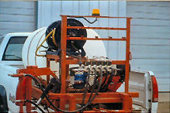

Figure 3.3 Mechanical Sprayer

Herbicide application can provide the most effective and time-efficient method of managing weeds. Numerous herbicides are available that provide effective weed control and are selective in that grasses are not injured. Along with herbicide use is user responsibility and compliance with all product label requirements for herbicide handling, use, and cleanup. Always read the label and keep in mind the label is legally binding. When using herbicides be mindful of proximity to water, trees, shrubs and other desirable vegetation.

Herbicides are applied by spot spraying - single nozzle application targeting individual plants, or broadcast spraying - multiple nozzles covering an entire area. Whatever method is used, calibration of spray equipment (gallons per acre spray output) is essential for accurate delivery and mixing calculations. Estimating or guessing sprayer output can lead to misapplication which either injures non-target plants or results in failure to control the target weed species.

- Mechanical Control
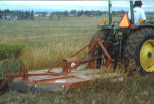

Figure 3.3 mowing

Mechanical control consists of methods that kill or suppress weeds through physical disruption. Such methods include pulling, digging, disking, plowing and mowing. Success of various mechanical control methods is dependent on the life cycle of the target weed species.
Hand pulling and digging are effective on annual and biennial species such as kochia, musk thistle, and diffuse knap weed. It is important to remove the upper 2-3 inches of taproot to prevent re-growth. Hand pulling or digging a perennial weed such as leafy spurge can be a futile effort unless one has the time necessary to diligently dig or pull re-growth over several seasons.
Shallow tillage with a disk or sweep is effective for controlling annual species such as cheat grass or kochia, but can actually be counterproductive if trying to control perennial weeds such as Canada thistle, field bindweed, leafy spurge or Russian knapweed. Perennial root systems often have meristematic buds that can set roots and produce a new plant from root segments deposited on the soil surface. Shallow tillage of perennial weeds can result in a larger, denser and more uniform infestation than the initial patch.

Moldboard plowing (complete turnover of the top 10-12 inches of soil) disrupts underground root systems and buries seed from the surface to a depth too deep to germinate. This type of tillage is seldom feasible to practice on a regular basis. Mowing is a suppression measure that can prevent or decrease seed head production. Mowed weeds will re-grow and set seed from a reduced height so a combined control method is necessary to be effective.

Mowing causes perennial plants to weaken when forced to send up carbohydrates from underground root reserves to nourish re-growth. So mowing a perennial weed such as Canada thistle a couple of times during the summer can significantly weaken the plants, and when combined with a fall herbicide application, provides excellent control.

  - Maintaining operation area
    - Site maintenance
- The job site shall be kept in a neat, clean, and orderly condition at all times during the installation process.
- All scrap and excess materials are to be regularly removed from the site and not buried in trenches.
- Trenching, laying pipe and backfilling shall be continuous so that the amount of open trench at the end of each work day is minimized. Any open trench or other excavations shall be barricaded and marked with high visibility flagging tape.
Irrigation work sites are expected to be clean, tidy, comfortable, good and well maintained to create conducive environment for work. Cleanliness is the most essential elements in maintaining a healthy and safe work environment. Not only does a clean workplace reflect the professionalism of a business or facility and help motivate employees, it also promotes a healthy workforce as a clean environment prevents accidents and the spread of germs. Many office managers strive to maintain a clear work site policy, few succeed. However, each employee as Health & Safety is responsibility in maintaining a clean work environment. However, there is only so much cleaning the team can do during each shift and in such cost conscious times it makes sense for employees to adopt some simple good housekeeping practices and allow the cleaning team to concentrate on hygiene and deep cleaning tasks.

Self-check 7 | Written test

Name…………………………………………… ID………………………… Date…….
Directions: Answer all the questions listed below.

Test II: Short Answer Questions
- Define preventive control (5)

- Write weed control mechanism (5)

Reference Materials
Books:

Web addresses

AKNOWLEDGEMENT

Ministry of Labor and Skills wish to extend thanks and appreciation to the many representatives of TVET instructors and respective industry experts who donated their time and expertise to the development of this Teaching, Training and Learning Materials (TTLM).

The experts who developed the learning guide
No | Name | Qualification | Educational background | Region | Phone number | E-mail
1 | Gosa Shura | MSc | Horticulture | Oromia | +251-923041032 | gossashura@gmail.com
2 | Tilahun Getu | MSc | Biotechnology | Amhra(3) | +251-918726766 | tile21eme@gmail.com
3 | Degefa Guluma | MSc | Soil science | Oromia | +251-913440464 | deguluma@gmail.com
4 | Bayisa Abeshu | MSc | Agronomy | South west Ethiopia | 0921434086 | Bayoabeshu@gmail.com
5 | Berhanu Asefa | BSC | Plant science | South west Ethiopia | 0922182673 | berhanuasefa@gmail.com
6 | Fikadu Tilahun | BSc | Plant science | Afar | 0917363367 | fikadutilahun80@gmail.com
7 | Wendimu Terfa | BSc | Plant science | Oromia | 0911266570 | gurachoterfa@gmail.com
8 | Yimam Mohammed | BSc. | Plant science | Oromia | 0913624360 | leylasalo@gmail.com
9 | Eyaya Tigabie | MSc | Agronomy | Afar | +251-921944452 | eyayatigabie@gmail.com
10 | Taka Magarsa | MSc | Horticulture | Oromia | +251917210371 | takamagarsa430@gmail.com
11 | Elias Mohammed | BSC | Horticulture | Oromia | +251946706670 | reweda1@gmail.com

