CROP PRODUCTION
Level-II

Based on March 2022 Version 4, Occupational standard

Module Title: - Perform Post-harvest Handling of Stimulants and Spices Crops

LG Code: AGR CRP2 M08 LO (1-6) LG (36-41)
TTLM Code: AGR CRP2 M08 TTLM 0922V1

September , 2022
Addis Ababa, Ethiopia
Table of Contents
Content Page
Introduction to the Module 1
LO #1- Dry the harvested product 2
Instruction sheet 1 2
Information Sheet 1 3
Self-check 1 11
Operation Sheet -1 12
LAP TEST-1 14
LO #2- Process spice crops 15
Instruction Sheet 1 16
Information Sheet 2 17
Self-Check – 2 25
Operation Sheet -2 26
LAP TEST-2 27
LO #3- Preparing dry coffee 29
Instruction sheet 3 29
Information Sheet 3 30
Self-Check – 3 36
Operation Sheet -3 37
LAP TEST-3 38
LO #4- Perform Coffee Hulling 39
Instruction sheet 4 39
Information Sheet 4 41
Self-Check – 4 51
Operation Sheet -4 52
LAP TEST-4 53
LO #5- Preparing Washed/semi washed Coffee 54
Instruction sheet 5 54
Information Sheet 5 56
Self-check 5 70
Operation Sheet -5 71
LAP TEST-5 73

LO #6- Store stimulant & spice products 74
Instruction sheet 74
Information Sheet 6 75
Self-Check – 6 88
Operation Sheet -6 89
LAP TEST-6 90
Reference Materials 91

Introduction to the Module
This module covers the skill, knowledge & attitude to carry out harvesting, dry the harvested product, process spice crops, prepare dry coffee, Perform Hulling, Prepare Washed/semi-washed coffee, and store stimulant & spice products.

Spice crops means crops which have essential oils and oleoresins that give foods and beverages : flavor, aroma, and sometimes color. The major importance of spices:- seasoning the food ,coloring the food, preservative, medicine, to give flavor and aroma for food, income for farmer, recreation, cosmetics etc. The major spices cultivated in Ethiopia are:-ginger, hot pepper, fenugreek, turmeric, coriander, black cumin, cardamom, black pepper ,long pepper, chillies, kororima, bishps weed, and etc. Ethiopia is the homeland for many spices, for example Kororima , long pepper, black cumin, Bishops weed and coriander.

Stimulant crops are crops which contain psychoactive chemical that stimulate (activate) central nervous system or which increase the activity in brain. Major stimulant crops are coffee(Coffea arabica) , chat(Chata edulis, tobacco, gesho (Rhamnus prinoides) , tea(Camellia senensis), cocoa and etc. Though each stimulant has unique effects, all stimulants increase your heart rate, blood pressure, and body temperature.

LG #36 | LO #1- Dry the harvested product

Instruction sheet 1

This learning guide is developed to provide you the necessary information regarding the following content coverage and topics:
- Identifying drying place based on type of spice crop
- Preparing suitable drying equipment’s
- Checking moisture content
This guide will also assist you to attain the learning outcomes stated in the cover page. Specifically, upon completion of this learning guide, you will be able to:
- Identify drying place based on type of the spice crop
- Preparing suitable drying equipment’s as per the crop requirement.
- Checking moisture by using moisture tester

Learning Instructions:
- Read the specific objectives of this Learning Guide.
- Follow the instructions described below.
- Read the information written in the information Sheets
- Accomplish the Self-checks
- Perform Operation Sheets
- Do the “LAP test”

Information Sheet 1
  - Identify drying place based on type of the spice crop

Drying is a mass transfer process consisting of the removal of water or another solvent by evaporation from a solid, semi-solid or liquid. This process is often used as a final production step before selling or packaging products. To be considered "dried", the final product must be solid, in the form of a continuous sheet. Drying saves crops from different types of insects or pests that cause crops damage. Drying is essential to improve product quality.

- Therefore the Purposes of drying are :
- Increase in shelf life/Preservation.
- Reduction in transportation cost.
- Easy material handling.
- Improve or maintain properties (flow ability or compressibility)

A source of heat and an agent to remove the vapor produced by the process are often involved. In bio products like food, simply expose the leaves, flowers or seeds to warm, dry air. Leave the spice and stimulants in a well-ventilated area until the moisture evaporates. Sun drying is not recommended because the herbs can lose flavor and color.

The best time to harvest most herbs for drying is just before the flowers first open when they are in the bursting bud stage. Dehydrator drying is a fast and easy way to dry high quality herbs because temperature and air circulation can be controlled. Pre-heat dehydrator with the thermostat set to 95°F to 115°F. In areas with higher humidity, high temperature 125°F may be needed. After rinsing under cool, running water and shaking to remove excess moisture, place the herbs in a single layer on dehydrator trays. Drying times may vary from 1 to 4 hours.

- Pre-drying activities:
- Harvesting when it is fully matured
- Sorting = removing the damaged, diseased, immature and undersized from the product.
- Washing = cleaning from dirty materials
- Pilling and Cutting in to small pieces( for stem, rhizome , fruit, bark and leaf spices= to facilitate drying
- Blanching =The major benefit of blanching is the reduction of color degradation

The following are some general methods of drying:
- Based on mode of heat transfer three types of drying methods are:

- Conduction drying: Heat is transferred to the wet solid mainly by conduction through solid surface (Normally a metal) .the vaporized water is removed independent of heating media.

- Convection drying: this method of drying is the most popular in grain drying Heat is transferred to wet soil by convection drying agent (hot gases) used to supply heat and carry away the vaporized moisture.
- Under natural air drying, the unheated air is utilized for drying the spice crops.
- This method is generally used in the farm level for drying products for short term –storage. However, for large quantity, heated air is used to dry the product at short span of time.

- Radiation drying. Sun drying is an example for radiation drying. The radiant energy is absorbed by the product and transferred in to heat energy.

- Individual spice crops drying were listed below:
  - Cinnamon
After peeling the bark long pieces that are used to make the outer cover of the quills are kept 2-3 hours, for shade drying. During this period bark curls inversely. In rainy season this period is extended up to 5-8 hours.
  - Turmeric
Rhizomes have to be cured after harvest for both color and aroma. The traditional method of curing rhizomes is to steam or boil fresh rhizomes in lime or a 0.1% sodium bicarbonate solution. The ‘curing’ is to remove the raw odor, reduce the drying time, gelatinize the starch and produce a more uniformly-coloured final product. Traditionally the cooked rhizomes were spread in the sun to dry and this process takes 10-15 days. The final moisture level should be close to 6% moisture content. Today the majority of internationally-traded turmeric rhizomes are artificially dried with hot-air drums, tray and continuous tunnel driers and in India a maximum temperature of 60°C is advised. An important factor in drying time is the preparation of the rhizome. Rhizomes to be dried can be sliced or whole, with slicing generally producing a more uniform and brightly coloured powder. The yield of the dried product varies from 10-30% depending on the variety and the crop-growing environment.
  - Ginger
curing of the rhizome prior to drying directly affects the fiber and volatile oil content. Removal of the skin reduces the fiber content and also increases the oil loss. Peeling also affects the pungency as these compounds (gingerols) are in the skin. When sun drying is not an option wood-fired or solar driers can be used .The final dry matter should be in the 7-12% range with a weight loss during drying of 60-70%. Artificial drying minimizes the loss of quality and can also eliminate microbial contamination. Drying temperature, airflow and the length of drying all affect the flavor compounds in ginger. Slicing, splitting and peeling operations are mostly carried out to facilitate the next processing operations, particularly the drying operations.Drying of the rhizomes: - ginger rhizomes are dried on properly prepared drying materials, preferable raised structures. Drying should be carried out under closer supervision to maintain the product quality. During drying there a need to turn the products frequently to:
- Have uniform drying reduce drying time
- Avoid mound formation
Breaking ginger/turmeric rhizomes during drying
Breaking the rhizomes into smaller pieces has its own negative impact on the quality of the dried product by decreasing the volatile oil content of the rhizome on one hand, and enhancing the development of the Aflatoxins on the other. Similarly, peeling off and damaging of the rhizome skin during the process of harvesting and drying should be minimized.
While drying, the rhizomes need to be frequently overturned to maintain uniformity of the rhizomes until the product attains the moisture content of 7 to 12%, which is required for dry ginger.

Washing the rhizomes before drying
There is no significant price variation per unit volume was made between products that have subjected to drying on the cemented and non-cemented floor. As far as the volume of ginger that a farmer owns and water availability for washing the rhizomes is concerned, washing rhizomes at individual farmer’s level would be impractical. Therefore, it will be essential to design the strategy, which possibly involves cooperatives and/or interested investors. The cooperatives or the investors may collect fresh ginger rhizomes from individual farmers on a given price agreement and they may add value to the product by washing and drying or they can sellout the rhizomes after washing to any enterprise/company for further processing.

  - Drying korarima
Pre-drying:-harvested capsules stored in a warm place covered with straws, inset leaf or other materials for 10 to 15 days.
Drying: - performed in two ways
- Sun-drying: - capsules are spread on clean ground or on materials prepared for this purpose. Drying in this way takes 10 – 15 days depending on the length of sunny hours and the intensity of sunlight
- Drying by smoke: - involves spreading the capsules on a wooden bed
over chimneys under the roof for 15 - 20 days. In some cases both methods couldemployed depending particularly on weather condition. Both methods of drying have advantages and disadvantages.
An advantage of sun drying is, the process is rapid, and quality of korarima maintained but it requires high labor. Whereas the advantages of drying by smoke is its applicability during cloudy time but it reduces quality.

Table.1. 1 Advantages and disadvantages of korarima drying methods
Method | Advantages | Disadvantages
Drying in the sun | - Rapid  - Quality maintained  - Uniform drying | - Laborious
Drying by smoke | - Helps during cloudy time  - Less laborious | - Reduce the quality of  the spice  - Requires much fuel wood  than normally needed  - Non-uniform drying

  - Drying cardamom
The harvested fruits are dried in different ways. In large plantations drying (curing) is done in drying house in which fruits are heated by a system of pipes through which hot air from a furnace is passed. In small-scale holdings, they are dried on open platforms heated from below and sheltered by a roof. Drying is also done on a beaten ground or on a mat in the sun.

  - Drying black pepper
The pepper berries are dried on clean clothes on bed like coffee or on a cemented surface with frequent turning over for uniform drying of the berries. The color of appropriately dried pepper berries is dark brown or black and bold sized which is with the mesocarp that gives it more pungent characteristics than white pepper. The recommended or safe moisture (11-12%) level should be attained during drying, which in this case can be proved by crashing in our teeth and if it breaks easier and with sound. Drying can be performed by keeping the produce in the sun during the day and in the house during the night to prevent from night moisture or rain.

- Drying place for spice crops :
- On cement floor: Traditionally, spice products are spread on a concrete floor to dry using the natural heat from the sun.
- On ground : Drying the spices by spreading the spice product on the cleaned ground
- On wire mesh: place on wire mesh racks in the centre of the oven and turn a few times to ensure even drying. The herbs should be dried until they are crisp.
- Oven-drying: quick method to remove water from herbs and spices; however, during the drying process essential oils are lost and therefore it is not advisable.


Drying On wall

Drying on concrete Drying on drying tray
Fig 1. 1 Spice drying Stractures .
Source:https://www.google.com/search?q=drying+spice+on+meshwire+table&tbm(27/08/2022).

1.2 Prepare Suitable drying equipment’s as per the crop requirement.
Dryer is a device that removes moisture by heating the mass to a level where it becomes safe to store.
- selection of equipment depends on general consideration:
- Physical/Chemical properties of materials.P`roduction capacity
- Initial and final moisture content required
- Particle size distribution
- Temperature and drying characteristics
- Explosion and toxicological characteristics
- Dryer must operate reliably, safely and economically.
- Operating and maintenance must not be excessive
- Pollution must be controlled
- Energy consumption must be minimized
Drying Equipments may be:-Tray Dryers, Tunnel Dryers, Roller or Drum Dryers, Fluidized Bed Dryers, Spray Dryers, Pneumatic Dryers, Rotary Dryers, Trough Dryers and etc.

  - Check moisture content by using moisture tester

The term spice product moisture content normally denotes the quantity of water present in a product sample per unit mass of its dry matter and moisture combined. The amount of water is determined by subtracting the dry weight from the initial weight, and the moisture content is then calculated as the amount of water divided by the dry weight or total weight, depending on the reporting method.
- Pre drying:- Initial moisture content Conditions (during harvesting time),
- Between harvest and processing:-Degradation during storage through self-heating, enzymes, etc. Microbial infestation
- During drying Air temperature: - Significant impact on product temperature Losses of valuable components, Relative humidity inside the dryer Air flow (risk of recirculation. pathogen accumulation) Bulk (weight/height) Influencing factors on quality .
- During drying: - Quality losses during drying cannot be compensated in further processing steps! • The whole processing chain needs to be excellent! The drying process (duration, process parameters) depends on the raw material • Each drying process is individual and should be controlled dependent on the raw material quality and loading capacity Influencing factors on quality. Targeted short drying times risk the application of too high drying temperatures • Porous surfaces and cell damages of the final product, degradation processes.
Moisture content affects the processibility, shelf-life, usability and quality of a product. Accurate moisture content determination therefore plays a key role in ensuring quality for many industries including spice and stimulant crops.
- Typically, moisture content is determined(measured) by:
- Thermo-gravimetric approach
- Digital moisture meter

- Thermo-gravimetric approach, i.e., by loss on drying, in which the sample is heated and the weight loss due to evaporation of moisture is recorded.

Wet basis moisture content (MC_{wb}, also known as W) is most common for farmers and producers and is defined as:
$$MCwb=\frac{weight of water }{weight of dry matter+weight of water }×100$$
Herbs and spices are stable at 10% MCwb.
Dry basis moisture content (MC_{db}, ) is most common for scientists and is defined as:
$$MCdb=\frac{weight of water }{weight of dry matter }×100$$
It is converted as follows:
$$MCwb=\frac{MCdb }{100+MCdb }×100 or MCdb=\frac{MCwb }{100-MCwb }×100$$

- Digital moisture tester method
Moisture meters are used to measure the percentage of water in a given substance. This information can be used to determine if the material is ready for use, unexpectedly wet or dry, or otherwise in need of further inspection. Horticultural products like spices, stimulant crops, medicinal crops, vegetables, fruits and herbs are very sensitive to their moisture content.

Figure 1.2. Digital moisture tester (Moisture meter)
Souece:-https://www.indiamart.com/proddetail/digital-moisture-meter-for-spices (27/08/2022).

Self-check 1 | Written test

Name…………………………………………… ID………………………… Date…….
Directions: Answer all the questions listed below.

Test I: Choose the best answer (4 point)
- From the following which one is not pre drying activity?

- Packing
- Washing
- Sorting
- Cutting the spice product in to pieces

- From the following which one is spice drying method?

- conduction drying
- convection drying
- Radiation drying
- All of the above

Test II: Short Answer Questions (8 points)
- Write the importance of post-harvest management for spice crops .
- Write at least 10 popular spices in Ethiopia.
- Write the importance of drying spice before storing.
- Write two methods of testing moisture of spice product.

Note: Satisfactory rating - 12 points Unsatisfactory - below 12 points
You can ask you teacher for the copy of the correct answers.

You can ask you teacher for the copy of the correct answers.

Operation Sheet -1

  - Techniques of ginger drying.
- Tools and equipments
- Knife =to cut the rhizome in to pieces
- Clean water
- Mortar and pistil
- Drying tray
- PPE
- Ginger rhizome
- Solar collector and drying units
- Digital moisture
- Procedures of spice drying.
- Wear appropriate PPE
- Wash the ginger rhizome appropriately
- Pill the skin of ginger rhizome by using knife
- Cut the ginger rhizome in pieces by using knife.
- Grind the washed, and cutted in to pieces ginger rhizomes by mortal and piltil.
- Spread the grinded ginger rhizome on drying tray
- Put under drying units
- Check its moisture content by using digital moisture meter.

  - Techniques of checking spice moisture using digital moisture method.
- Materials,Tools and equipments
- PPE
- Spice product
- Digital moisture meter
- Pen and paper for recording data
- Procedures (steps) to check spice moisture content.
- Wearing appropriate PPE
- Turn on the moisture meter and make sure that button indicating "paddy" is on.
- Fill the tray of the moisture tester with paddy to the required level.
- Turn the knob until the moisture reading is displayed.
- Take measurements of 3−5 samples and compute the average moisture content.

LAP TEST-1 | Performance Test

Name………………………………. ID…………………………….. Date…………………………………….

Time started: ________________________ Time finished: ________________

Instructions: Given necessary templates, tools and materials you are required to perform the following tasks within 3.5 hours. The project is expected from each student to do it.

Task-1. Perform ginger drying.
Task-2. Check moisture content of spice product by using digital moisture meter.

LG #37 | LO #2- Process spice crops

Spice processing is the process of manufacture involves cleaning, drying, grinding, blending, pulverizing, sieving and packing of spices such as chilly, pepper, turmeric, coriander, ginger, and etc. either individually or in combination with other spices to ensure high product quality and hygiene. Spice products are usually prepared by drying of the raw material as a whole or in coarsely cut form. The plant material is commonly spread on the ground and sun-dried, whereas artificial drying and the use of solar-dryers are scarce.

- Benefits of Gentle Processing:
- Eliminates microbes in spices
- Reduces moisture content and prevents mould
- Enables safe and long-term storage (long shelf life).
- Enhances the food production and spice extraction process
- Fortifies flavors and antioxidant properties of spices.

Instruction Sheet 1

This learning guide is developed to provide you the necessary information regarding the following content coverage and topics:
- Identifying processing equipment’s and machineries
- performing processing seeds, fruits, leaves, bark and rhizomes
- performing grading the processed spices
This guide will also assist you to attain the learning outcomes stated in the cover page. Specifically, upon completion of this learning guide, you will be able to:
  - Identify Processing equipment’s and machineries based on the type and purpose of processing.
  - Perform Processing seeds, fruits, leaves, bark and rhizomes
  - Perform Grading the processed spices based on size, quality and market demand
Learning Instructions:
- Read the specific objectives of this Learning Guide.
- Follow the instructions described below.
- Read the information written in the information Sheets
- Accomplish the Self-checks
- Perform Operation Sheets
- Do the “LAP test”

Information Sheet 2
2.1 Identifying processing tools, equipment’s and machineries
- The tools, equipments and machineries required for spice processing are the following:

- Peeling knife
- Flat plate or bamboo mat or concrete or mesh wire raised bed (for drying),
- Rope = for hanging some spices to drying it
- Distilling machine=to extract oil from spice
- Source of heat(electric or solar)
- Siever
- Pistil and mortar,
- Autoclaves ,
- Blanchers ,
- Capping machines ,
- Centrifuges ,
- Chilling equipment,Conveyors
- ,Cooking equipment,
- Cutters and etc

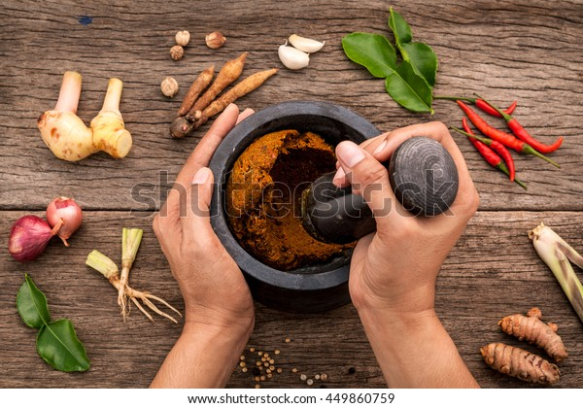  Pistil and mortar |   Grinder |   Spice cutter
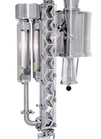  Laboratory zigzag classifier | 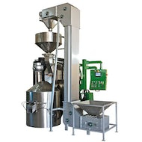  Roaster |   Cutter, dryer, roaster etc
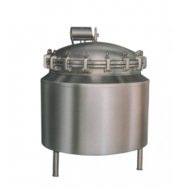  Autoclave | 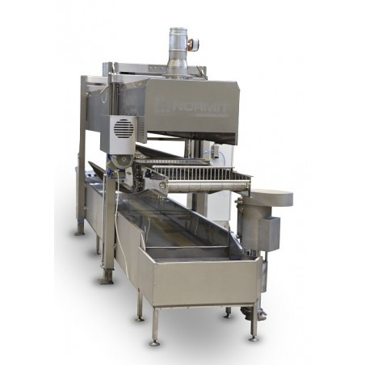  Spice blancher | 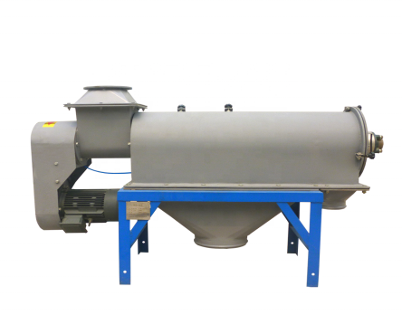  Spice centrifugal sifter
Figure 2.1. Tools and equipments for spice processing
Source: https://foodtechprocess.com/en/95-spices (26/08/2022).

  - Performing processing seeds, fruits, leaves, bark and rhizomes

Spice processing offers opportunities in terms of employment, adds value to products, reduces waste due to spoilage and encourages development of technical and marketing skills in villages.

    - Ginger processing
Before processing ginger, it is recommended that a market survey is carried out. This will include information on the availability of raw material, availability of processing materials and equipment, access to markets and demand for the different ginger products. This information should indicate whether your business is likely to succeed. Ginger is usually available in three different forms: fresh (green) ginger, preserved ginger in brine and syrup dried ginger spice.

- Fresh ginger
- Fresh is usually only eaten in the area where it is produced although it is possible to transport fresh roots internationally. the immature fresh rhizomes (5-7 or less month after planting) consume as vegetable
- Preserved ginger
Preserved ginger is only made from the immature rhizomes. Making preserved ginger is not simple, it requires a lot of care and attention to quality, only the youngest, most tender stems of ginger should be used.

Preparation of preserved ginger
- Immature, very succulent and loose in texture and most tender rhizomes are preserved in sugar syrup, brine .
- Rhizomes are cut in to pieces, peeled, shaped and put in cold water and boiled for 10 min.
- remove the ginger prick with a fork
- Boil again in syrup for about 45 min/first boiling.
  - Syrup = 800 gm sugar for each kg of ginger.
  - Making preserved ginger is not simple it requires, a lot of care and attention to quality, only the youngest, most tender stems, of ginger should be used it is very difficult to compete with the well-established Chinese and Australian producer.
- Dried ginger

Making dried ginger
Prepared from the mature rhizome (8- 10 months)
Dried ginger – can be ground and directly used as a spice
Dried ginger is available in many forms. The rhizomes may be left whole or they may be split or sliced in to smaller pieces to accelerate drying. Sometimes the rhizomes are killed by peeling or boiling them for 10 -15 minutes. This results in a black product which can be bleached using lime or a sulphurous acid. The only product which is acceptable for the UK market is cleanly peeled dried ginger.

- Dried ginger is produced according to the following steps:
- Removal of the above ground plant part (leafy shoots) and root hairs adhering in to the rhizomes, just upon digging and lifting up of the rhizomes, using sharp cutting materials.
- Wash all soils and foreign materials adhering on to the rhizome. Immediate washing after digging is recommended as delay in washing brings about quality deterioration
- Killing of the rhizomes: - this is a process whereby the life activity in the rhizome ceases.

- This operation has two options and can be achieved through:
- Boiling of the rhizomes by immersing the rhizomes in boiling water for about 10mins. This operation enables to produce whole rhizomes and is done when whole rhizomes are in demand.
- Scraping or peeling of the outer skin or cork layer of the rhizomes with the help of peelers, like bamboo peelers, knives etc. peeling should be done on the surface in shallower depth as deep peeling may damage the secretory tissues beneath the cork layer and damage the essential oil thus affecting yield and quality. The rhizomes pieces are then dried. This is often by sun drying
Polishing of the rhizomes: - This is the final processing steps in the preparation of drying ginger and is carried out to improve the appearance of the product and improve its quality.
These objectives are achieved through removal of root hairs and any foreign materials adhering onto the rhizomes and removal of adhering soil and cork layers.

- Polishing of the rhizomes can be achieved through:
- rubbing the rhizomes one another
- using mechanical polisher such as drums

    - Cinnamon processing
Bark peeling
The stems are taken one by one and two cuts are made round the stem about 30 cm apart and two longitudinal splits are made on opposite sides of the stem. The bark is then carefully eased-off the wood by the pointed side of the knife. The barks are then packed in bunches and heaped for about 24 hours, to undergo partial fermentation. After partial fermentation, the epidermis, cortex and green cork are removed by scraping. The scraped barks are dried under slight shade. During drying and upon losing its moisture, the bark tips become rolled naturally forming quills. The quills are used on the outside while the inside is filled with similar smaller quills.

Preparing quills, feathering and chips

Quills: - peeled scraped and dried inner bark, with straight appearance and standard length (usually 41 inch), obtained from stem. This forms first grade bark and dominates world cinnamon market.
Chips: - unscraped barks from trimming of shoots or from broken portions of stems.
Feathering
Peeled, scraped and dried inner bark obtained from twinges and or twisted shoots that don’t give straight quills of normal size and length.

- pepper processing
- Preparing black pepper

To prepare black pepper, vines are collected using ladder while they are green but matured and dried under shade up to (11 %). Berries are separated from spikes by rubbing them between the hands or trampling them under the feet. After the separation, the berries are dried in the sun for 7- 10 days until outer skin becomes black and shrunken and assumes the characteristic wrinkled appearance of commercial pepper. Finally it will attain black color. It has more pungent than that of white pepper. Black pepper accounts for about 75% the world pepper production.

Preparing white pepper
Harvest red, ripe, mature, and soaked in water then the pericarp removed and then dried under shed. Finally it develops a white color.It is less pungent. The reason for the reduction in pungency is, the pungent principle “peperine” removed together with the pericarp. Has 25 – 28% recovery percentage.

- Cardamom processing
Dried cardamom requires cleaning to remove all stalks and dried remains of floral parts. This is done by hand for small-scale level but for large-scale; it is done by rubbing dried cardamoms over a coarse surface of wire mesh or bamboo trays.

Different cardamom product types are known in the international market, some of which are: whole green cardamom, whole bleached cardamom, decorticated seeds and the one that is prepared in our country is “whole white straw” colored type cardamom. Fresh cardamom capsules have up to 75% moisture and it should be reduced to 13% through drying.

The white whole straw cardamom is prepared by drying in the sun. Ripe capsules are dried on clean surface or on wire bed in the sun with continuous turn over for 3 - 5 days by preventing remoistening.

- Korarima processing
As the dried products of korarima are the fruits, only mature red fruits should be harvested and dried. In areas producing the crop, fruits are usually pierced near the top and strung on strips of ropes and hung to dry in the sun or on smoke.

- Turmeric processing/curing
Steps:
- Sweating:
  - The leaves are cut–off and the roots washed carefully in water. The branch rhizomes (fingers) are cut off from the central mother rhizome. The fingers and mother rhizomes are heaped separately, covered by leaves to sweat for a day.
- Boiling:
- The rhizomes are boiled or steamed to remove the raw odor, reduce the drying time, gelatinize the starch and produce a more uniform product.
- Traditionally, pans or earthen pots, barrels can be used
Recommended practices
- The rhizomes are placed in a boiling pan
- Water is added to a level at 5- 7 cm above the rhizomes
- Add 0.1% alkali (sodium bicarbonate)
- Boil for about 45 min – 60 min depending on variety.
- The rhizomes are removed and dried in the sun.
- The final moisture content should be 8-10% on wet basis. When a rhizome snaps/breaks cleanly with a metallic sound, it is sufficiently dry
- Polishing:
- The dried rhizomes are polished to remove the outer skin, root lets and produce a smooth and bright yellow colored rhizome. This can be achieved through rubbing of the rhizome by hand, or by the use of polishing drum (rotating drum)
  - Performing grading the processed spices
Sorting of the agricultural products into different lots according to their various quality specifications is known as grading. The practice of grading agricultural commodities ensures the farmer's to adopt the quality specifications for their products, which in turn avoid them being exploited from the traders and obtaining good price for the produce. Since the graded products possess fixed standards there is no scope for cheating consumers.

- Grading of cardamom and Korarima
Grading of cardamom and korarima involves both mechanical and analytical consideration.
- Mechanical attributes for grading are as follows:

  - Physical appearance
  - Color of the capsules
  - Physical form: - whole decorticated, splits or shriveled etc.
  - Absence or presence of surface blemish
  - Cleanliness
  - Emptiness of the capsules
  - Seed weight
  - Uniformity of the lot

Generally, round and well-formed capsules free of stalk and foreign materials, whose lot is free of immature, split and shriveled capsules are regarded as best quality product.
Beside these physical parameters, now a day, organoleptic qualities of these products are also increasingly being used to ensure authenticity and purity of the product in trade. These organoleptic qualities (properties) include: volatile component, flavor or aroma, pungency, bitterness, extractive ash contents etc.

Quality Characteristics

With regard to the quality of the dried product, larger, round and uniform pods having a good dark-green color always fetches the highest price. In markets, cardamom of different color, sizes, and shapes are available. This color ranges from attractive green to brown. Green color is an indication of its freshness. The real quality lies in seeds as the skin is generally thrown away. Most of the aroma which is due to essential oil and other volatile compounds resides in seeds. Capsules should not be cracked, hollow (empty), shriveled, immature (insect-infested) and possess the characteristic aroma.
- Black pepper Grading

For the pepper corn produce to have international acceptance, the following quality criterion are
required:- Appearance: clean, free of external materials, unbroken fruit.
- Color: black brown or black
- Aroma, flavor, pungency: should be in acceptable range
- Free of any external odd materials that have bad smell
- Cinnamon Grading
- Quality of cinnamon is assessed on the basis of:
- appearance
- volatile oil content
- aroma and flavor character

The relative importance of these quality attributes is dependent on the intended end-use. For example, appearance is important when whole cinnamon bark is in demand. In this case cinnamon bark is considers to have good quality when the barks have yellowish-brown color and with convenient size.

- Ginger
Preparation of rhizomes into the desired physical form. Ginger rhizomes, especially dried ones, are marketed on the bases of geographical origin and physical form.

Quality and grading of ginger:
- The physical forms in which ginger appears on market are:
- whole form
- splitted rhizomes
- sliced rhizomes
- peeled rhizomes
- The qualities requirement for dried ginger production includes:
- appearance, good appearance, free of any foreign materials and surface blemish
- content of volatile oil, maximum volatile oil content preferred
- fiber content, low fiber content preferred
- pungency level, high pungency level preferred
- aroma and flavor, optimum volatile oil contents and agreeable aroma and flavor are the essential quality attributes

- Turmeric
Quality and Grading
Turmeric like ginger is marketed on the basis of its geographical origin and its physical form. Different growing areas/countries prepare turmeric in different physical forms. Turmeric rhizomes from different growing areas have different chemical composition indicating the influence of environment and cultural practices on its quality.
- Quality of the product is assessed based on:
- Curcumin content
- Volatile oil content (high volatile oil content preferred)
- Fiber content (low fiber content preferred)
- Organoleptic characteristic: the overall aroma, flavor, pungency and bitter compounds in the product
- These quality attributes are influenced by:
- The type of cultivar grown
- Stage of maturity at harvest
- Post-harvest handling

Self-Check – 2 | Written test

Name…………………………………………… ID………………………… Date…….
Directions: Answer all the questions listed below.
Test I: Short Answer Questions
    - Write the importance of spice processing (8 points).
    - Write what spice grading means?
    - Write the quality parameters for the following spices:
  - Cardamom
  - Ginger
  - Pepper
  - Turmeric
  - Kororima
    - Write the factors that influence quality parameters of different spices.
Note: Satisfactory rating - 5 points Unsatisfactory - below 5 points

You can ask you teacher for the copy of the correct answers.

Note: Satisfactory rating - 8 points Unsatisfactory - below 8 points
You can ask you teacher for the copy of the correct answers.

You can ask you teacher for the copy of the correct answers.

Operation Sheet -2
Perform spice processing:
      - Tools and equipments

- Peeling knife
- Cutters
- Flat plate or bamboo mat or concrete or mesh wire raised bed (for drying),
- Rope = for hanging some spices to drying it
- Distilling machine=to extract oil from spice
- Source of heat(electric or solar)
- Siever
- Pistil and mortar,
- Autoclave

      - Procedures/Steps/Techniques

- Wearing appropriate PPE
- Cleaning
- pilling
- cutting in to small pieces
- Drying (roasting or sun drying)
- Grinding
- Packing

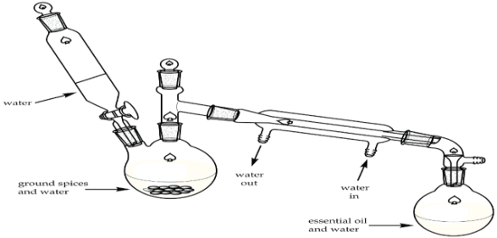
Figure 2.2: Oil extractor simple machine (water steam distillation)
Source: https://www.azom.com/article.aspx?ArticleID=11355 (26/08/2022)

LAP TEST-2 | Performance Test

Name………………………………. ID…………………………….. Date…………………………………….

Time started: ________________________ Time finished: ________________

Instructions: Given necessary templates, tools and materials you are required to perform the following tasks within 2 hours. The project is expected from each student to do it.

Task-1. perform spice process.

LG #38 | LO #3- Preparing dry coffee

Instruction sheet 3

- This learning guide is Identification of drying place
- Inspecting and maintaining appropriateness of the dry floor and table
- Inspecting moisture condition for dry coffee
- Drying by spreading and turning in thin layer developed to provide you the necessary information regarding the following content coverage and topics:
This guide will also assist you to attain the learning outcomes stated in the cover page. Specifically, upon completion of this learning guide, you will be able to:
  - Identify drying place according to pre-set criteria.
  - Inspect and maintain appropriateness of the drying floor and table to fulfil the required standard.
  - Inspect moisture condition for dry coffee according to the required level.
  - Spread and turn drying in a thin layer to avoid fungus development.
  - Carryout Storing dry coffee using sacks
Learning Instructions:
- Read the specific objectives of this Learning Guide.
- Follow the instructions described below.
- Read the information written in the information Sheets
- Accomplish the Self-checks
- Perform Operation Sheets
- Do the “LAP test”

Information Sheet 3
  - Identification of drying place
Before storing coffee beans we must be consider the place in which it’s stored because the moisture content of the earth can affect quality of the seed since coffee seed is very sensitive to absorb moisture of the environment. Moisture management and mould prevention during coffee drying limits the risk of quality claims that moisture content on arrival overseas will not exceed 12%.
  - Inspection and maintenance of drying floor and table
Coffee is dried in two main ways. The first is by spreading beans out under the sun on raised beds or patios. The second is by using dedicated mechanical coffee dryers. Uncontrolled fermentation may occur when coffee is not dried quickly enough, as microorganisms break down compounds within the coffee and generate undesirable flavours. Animal contamination includes larger wild animals causing physical damage to the beans and animal droppings (such as those from birds) falling among the drying coffee. Finally, improper manual drying occurs when coffee is not turned properly, leading to uneven exposure to temperature and airflow.

Treatment of coffee drying table and floor is very important in order to get pure or quality seed i.e. the coffee beans that should be free from disease, insect pest attack. So that inspection and maintenance of the tables and floors on which coffee beans are stored must be cleaned before storing on it because coffee seeds are very sensitive to absorb moisture content of the area and odor around their storage room.

The risks of sun-drying coffee include uncontrolled fermentation, animal contamination, improper manual drying, and adverse weather conditions, all of which can have a major impact on cup quality.
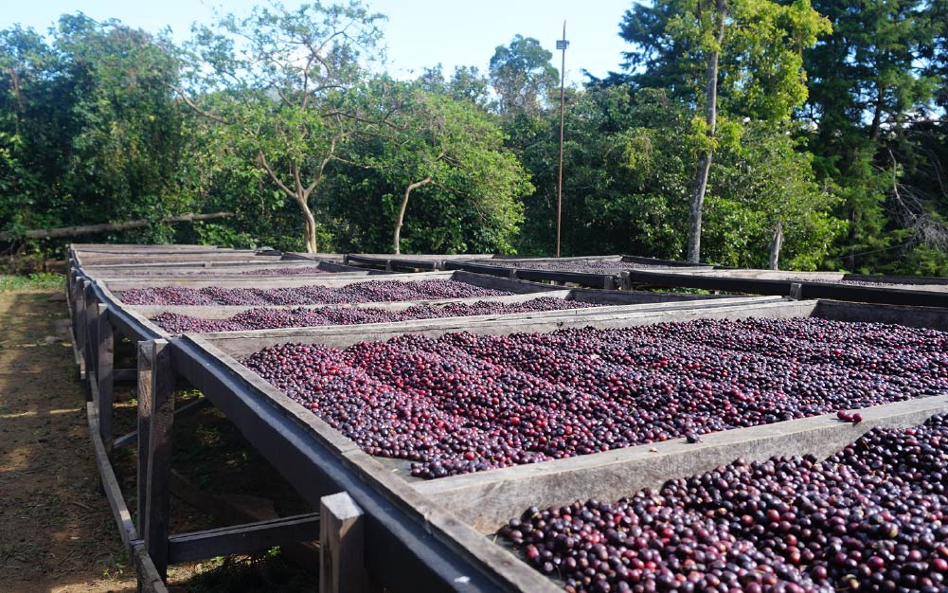
Figure 3.1 Drying coffee berries and beans on raised bed.
Source: https://www.google.com/search?q=coffee+drying+place (29/08/2022).

Machine Drying: Effective management of temperature and moisture are critical when machine drying. Neither drying too quickly at excessive temperatures nor drying too slowly with a low temperature will bring good results. The ideal temperature for drying is between 45 and 55ºc. An increase of only 1ºc of air temperature lowers the relative humidity of the air by approx. 5%. This shows how much care must be taken in temperature control. When the air for drying exceeds 55ºc for prolonged periods, the air is withdrawing moisture from the beans too quickly and unevenly. One part will be dry while others remain wet. Very often at excessive temperatures, the outside of beans is dried rapidly and a hard shell on the outside develops which prevents air penetrating the bean and hinders further drying.

  - Inspecting (checking) moisture condition for dry coffee
Drying, storage, marketing, and roasting are four important aspects of coffee handling in which moisture plays an important role. Moisture measurement at the end of drying is essential to follow up drying course and to decide whether it is achieved or not.
On one hand, too long a drying course may have bad consequences for quality and food safety because of unexpected fermentations and mould growth. On the other hand, the next step in the process is storage. Also, drying to too low moisture content can result in income losses - for example, a truck which weighs 1000 kg with beans at 12 % moisture, will weight only 967 kg at 9 % moisture.
Storing coffee with too high a moisture content may involve high risks of mould growth. Temperature and length of roasting must be adjusted to usual moisture of 12 % to 13 %. Above these values, roasting requires more energy and might be incomplete. Below these values, beans might end up being over-roasted.

Methods of Measuring Moisture Content
- The methods of determining moisture content in coffee can be divided into three broad categories:
- Direct measurement: water content is determined by removing moisture and then by measuring weight loss;
Eg. Modified distillation method,
- Indirect measurement: an intermediate variable is measured and then converted into moisture content. Building up calibration charts before applying indirect measurements is a prerequisite.
Eg. ƒmoisture meters, Hydrometers, weight of a constant volume,
- Empirical measurement: refers to methods such as biting, shaking, crunching, commonly used by both producers and small traders. These empirical measurements are both indirect and subjective. Surveys carried out during the ‘Enhancement of Coffee Quality through the Prevention of Mould Formation’ project have shown that these subjective methods of moisture determination to be insensitive over the range 12–20% moisture content, and therefore unsuitable for determining the end of drying (i.e. when coffee has a maximum of 12% moisture), or for verifying that coffee in the marketing chain is at a safe moisture content.
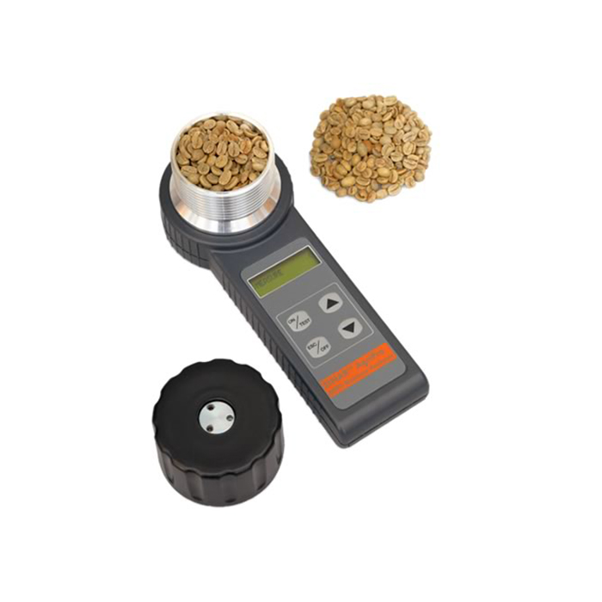
Figure 3.2. Moisture meters used to check coffee moisture
Source: https://www.google.com/search?q=coffee+moisture+meter&tbm (28/08/2022).

3.4 Drying by spreading and turning in thin layer
Since coffee is very sensitive to moisture of the area in which it is stored, the moisture of the environment in which coffee is stored must be inspected and the moisture content of the seed must be maintained to keep it for long period of time by their quality. After wet processing, parchment coffee needs to be dried quickly to prevent the development of microbiological activities (moulds, yeasts, etc.) which can result in severe cup defects as well as create toxins which can pose health risks to consumers. Coffee can be dried by two methods i.e. by sun light and machine.

Sun drying: Whenever climate conditions allow, sun drying is the preferred drying technique. It is cheap and in addition, the ultraviolet light of the sun is considered to bleach out chlorophyll from the beans, reducing green and grassy flavor components. Sun drying needs to be supervised very carefully as site and climate conditions strongly influence coffee quality. For effective drying, the relative humidity of the drying air must be lower than the equilibrium relative humidity of parchment coffee. When this condition is given, surface moisture of beans will evaporate and the coffee beans dry. During drying, the moisture trapped inside the bean slowly migrates to the outside and is absorbed by the warm air. Thus, a chain reaction takes place - moisture evaporates from the surface of beans causing moisture from the inside of the bean to travel to the surface.

Drying air must also move past the beans quickly enough to carry away the excess moisture and maintain this differential. When it remains static, drying air will be saturated which means no further drying can take place. Uniform drying will be achieved, if temperature and relative humidity of the air are correct and coffee is regularly turned. 10-12% Moisture content fully dry bean, i.e. no sign of blackness, bleach out of the typical green colour from the beans making the bean look yellowish and slightly transparent whilst being very hard.

- Most of the coffee producers produce coffee that is not washed due to :
- lack of modern technology
- lack economy/resource
- lack of knowledge and
- lack of materials used for wet processing.
- How to drying coffee berries:
- Identify material required for coffee drying
- Spread coffee berries on prepared materials and perform turning up operation for effective drying
- Drying matured coffee from moisture content of 60-65% to 11-12%
- After it is dried, it is sold to processing industries or wholesalers

In order to keep the quality of berries and external damage of it, the bed and floor should be well prepared. Even though coffee is dried it is very sensitive to absorption of moisture and odour of environment. So it must be stored in a place that is free from dirty thing. Dried berries should be turned up frequently in order to avoid fungus development and rottening of coffee seed.

  - Carrying out storing of dry coffee
To preserve your beans’ fresh roasted flavor as long as possible, store them in an opaque, air-tight container at room temperature. Coffee beans can be beautiful, but avoid clear canisters which will allow light to compromise the taste of your coffee. Keep your beans in a dark and cool location. A cabinet near the oven is often too warm, and so is a spot on the kitchen counter that gets strong afternoon sun. Coffee's retail packaging is generally not ideal for long-term storage. If possible, invest in storage canisters with an airtight seal. Coffee begins to lose freshness almost immediately after roasting. Try to buy smaller batches of freshly roasted coffee more frequently - enough for one or two weeks.

Exposure to air is bad for your beans. If you prefer to keep your beans in an accessible and/or attractive container, it may be a good idea to divide your coffee supply into several smaller portions, with the larger, unused portion in an air-tight container.This is especially important when buying pre-ground coffee, because of the increased exposure to oxygen. If you buy whole beans, grind the amount you need immediately before brewing. Freshness is critical to a quality cup of coffee. Experts agree that coffee should be consumed as quickly as possible after it is roasted, especially once the original packaging seal has been broken.

While there are different views on whether or not coffee should be frozen or refrigerated, the main consideration is that coffee absorbs moisture – and odors, and tastes – from the air around it, since it is hygroscopic (bonus vocabulary word for all the coffee geeks out there). Most home storage containers still let in small amounts of oxygen, which is why food stored a long time in the freezer can suffer freezer burn. Therefore, if you do refrigerate or freeze your beans, be sure to use a truly airtight container. If you choose to freeze your coffee, quickly remove as much as you need for no more than a week at a time, and return the rest to the freezer before any condensation forms on the frozen coffee.

Therefore, before coffee beans are shipped, they have to be stored, to prevent them from spoiling or losing quality and a number of precautions have to be under taken. These include paying particular attention to humidity, storage facility, location, and storage duration. Coffee must be stored in dry and cool conditions. Exposure to the sun or moisture will rapidly deteriorate the coffee seed. The preferred place to store coffee is in the vicinity of its production site, i.e. a relatively high altitude with low air moisture. If it is too humid, beans are not
Separated from their husk (sun-dried pulp) or hull (parchment membrane) until sending them for shipping.

Coffee beans should be stored in low moisture conditions so as not to be attacked by mold. The maximum water level, safe in the bean is 12% by weight. After reaching this thorough drying, any re-wetting and airborne moisture absorption must be prevented (e.g. rain, fog, condensation).
Raw coffee beans are often stored for years before roasting. Their sturdy structure usually prevents them from being spoiled by external agents; however, nothing can be done against the inherent biochemical activity in the seed. In this case, some minor components transform into other components which taste woody and harsh after roasting.

Self-Check – 3 | Written test

Name…………………………………………… ID………………………… Date…….

Directions: Answer all the questions listed below.
Test I: Short Answer Questions (9 points)
- Write coffee drying structures (coffee drying places). ( 2 points).
- Write the importance of inspecting the place for coffee drying? (2 points).
- Write the objective of testing the moisture content of coffee seed? (2 points).
- Write the two method of coffee drying? (1 point).
- Write the factors to be considered before storing coffee seed? (2 points).

Note: Satisfactory rating – 9 points Unsatisfactory - below 9 points
You can ask you teacher for the copy of the correct answers.

You can ask you teacher for the copy of the correct answers.

Operation Sheet -3

- Perform coffee drying:

A.Tools and equipments for drying coffee
- PPE
- Washed mesh wire
- Raised bed
- Source of heat
- Sack
- Coffee stirrer
B.Procedures :
- Wearing PPE
- Washing the coffee beans
- Cleaning mesh wire beds
- Loading the pulped and washed coffee bean to the drying place.
- Spreading on raised mesh wire bed.
- Selecting the source of heat (sun light, machine).
- Converting the coffee bean and exposed it to the sun light
- Checking its moisture level
- Collecting the dried coffee under the shaded and clean room.
- Packing in the sack.

LAP TEST-3 | Performance Test

Name………………………………. ID…………………………….. Date…………………………………….

Time started: ________________________ Time finished: ________________

Instructions: Given necessary templates, tools and materials you are required to perform the following tasks within 2 hours. The project is expected from each student to do it.

Task-1 Perform coffee drying

LG #39 | LO #4- Perform Coffee Hulling

Instruction sheet 4

This learning guide is developed to provide you the necessary information regarding the following content coverage and topics:
  - Sorting out foreign materials for smooth run of hulling machine.
  - Performing minor machine adjustment of fill the hopper
  - Performing Hulling
  - Sorting out pea berries, elephant beans and break beans
  - Storing clean beans
  - Taking husk to appropriate place for reuse
This guide will also assist you to attain the learning outcomes stated in the cover page. Specifically, upon completion of this learning guide, you will be able to:
- Sort out foreign materials t to keep the smooth running of hulling machine.
- Perform minor machine adjustment and filling the hopper.
- Perform hulling with the required standard.
- Sort out Pea berries, elephant beans and broken beans
- Store clean beans following the suitable storage procedure
- Take husk to appropriate place for reuse

Learning Instructions:
- Read the specific objectives of this Learning Guide.
- Follow the instructions described below.
- Read the information written in the information Sheets
- Accomplish the Self-checks
- Perform Operation Sheets
- Do the “LAP test”

Information Sheet 4

  - Sorting out foreign materials for smooth run of hulling machine

Sorting of coffee is a long, continuous process of preparation which starts with re-drying insufficiently dried coffee beans arriving from the farm to home area to 10-12 % moisture level. Optimum bean moisture content ensures that outer coverings are removed more easily during the hulling and de-husking, respectively, wet and dry processed coffee, thus reducing the risk of residual parchment or husk finding its way into cleaned and bagged green coffee.

Consignment of dry parchment coffee and specially dried coffee cherry, arriving from the estate, will almost certainly contain a wide range of dense foreign objects including stones, glass and metal with potential to damage coffee bean hulling machinery. Initial cleaning is a three-part process involving a screen-fitted hopper to out medium to large objects, a magnetic separator to remove metal objects and a cleaner-separator which integrates sieve and pneumatic forces for dust removal.

Before being exported, the coffee beans will be even more precisely sorted by size and weight. They will also be closely evaluated for color flaws or other imperfections. Typically, the bean size is represented on a scale of 10 to 20. The number represents the size of a round hole's diameter in terms of 1/64's of an inch. A number 10 bean would be the approximate size of a hole in a diameter of 10/64 of an inch and a number 15 bean, 15/64 of an inch. Beans are sized by being passed through a series of different sized screens. They are also sorted pneumatically by using an air jet to separate heavy from light beans.

Next defective beans are removed. Though this process can be accomplished by sophisticated machines, in many countries, it is done by hand while the beans move along an electronic conveyor belt. Beans of unsatisfactory size, color, or that are otherwise unacceptable, are removed. This might include over-fermented beans, those with insect damage or that are un-hulled. In many countries, this process is done both by machine and hand, insuring that only the finest quality coffee beans are exported and aroma development during roasting.

They are sorted by using an air-jet to separate heavy and light beans. Over fermented or un-hulled beans are now removed. This is usually done by hand as the beans move along a conveyor-belt. It can also be done by electronic sorting which can remove beans known as ‘stinkers’ that are defective but cannot be distinguished by eye. Flawed or discolored beans are removed before bagging into sacks marked with grade, plantation, and country of origin, ready to be exported. Post-harvest process for the coffee bean is more complicated than most, if not all, other agricultural commodities. Unlike grains in a field of wheat, all coffee berries do not mature at the same time and invariably rely on some measure of human selection at harvest. All coffee beans, whether dry or wet processed, require drying and cleaning at some stage. Premium Arabic’s are steeped in water for partial fermentation, a combination of moisture and microbes that is finely balanced between success and failure.

What can go wrong, will go wrong. The net result of sorting is a broad range of potential defects to match the wide spectrum of events experienced by the red, ripe cherry before, during and after picking and the bean as it moves through the various washing, drying and cleaning stages of on-farm processing. Sorting by differences in density-in order to remove light beans- is carried out by using pneumatic (air pressure) or gravimetric (gravity flow) methods. This is the first stage in the final sort before roasting and depends on differences in density between normal, healthy beans and those which are mechanically damaged, deformed, insect damaged or unhealthy. (Density is a comparative measure, which relates the mass [weight] of two objects having the same volume or size). Density sorting is efficient to a certain degree. Many defective beans, and especially those caused by external color differences or bad internal chemistry, have virtually the same density as normal beans. The term, defect is used in the coffee industry to describe quality-related factors that determine the proportion of defective beans and the presence of extraneous (foreign) matter of coffee and non-coffee origin. The type of defect and potential problems caused may relate to the presence of hard abrasive objects that damage machinery, downgrade by buyers due to non-pleasing appearance (shape and color) and lack of uniformity and chemical factors that interfere with taste.
  - Performing minor machine adjustment of fill the hopper

The longitudinally divided hulling cylinder is made of cast iron. The rotating roller inside the cylinder is equipped with exchangeable conveying and hulling ribs made of tool steel, and arranged in an oblique pattern. The upper part of the hulling cylinder is grooved on the inside.

The hulling cheeks of wear-resistant special cast iron are embedded in the casing of the cylinder. The distance between hulling cheeks and roller is adjustable by hand wheels according to the characteristics and size of the coffee beans. The bottom part of the cylinder is fixed with hinges and can easily be opened for screen exchange or cleaning purposes. For hulling parchment coffee, steel sheets with slot holes are used; strong wire mesh is used for cherry coffee.

The air-flow of a powerful ventilator allows for the perfect separation of peels, husks, skins, and dust inside the amplydimensioned aspiration casing. This ventilator also blows out any particle of peels that drop through the screens and transports the husks - even over long distances. The pressure of the air-flow in the exhaust pipe can be increased by a supplementary air inlet if the pipe is too long or if it has many bends. The sides of the machine are made of steel and, unlike cast iron, will not fracture. The shafts are pivoted on precision ball bearings.

The hulling shaft is operated by an electric motor and a multiple-grooved V-belt drive. The ventilator is run by its own directly coupled motor. Driving elements for operating by internal-combustion engines or by transmission are available
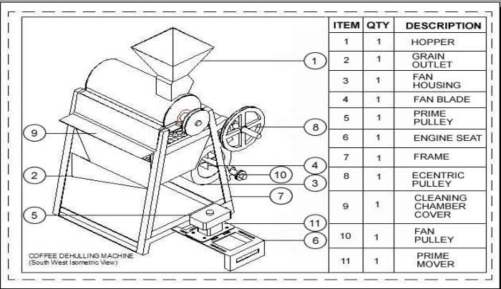
Figure 4.1 coffee processing machines

Table 4.1 Characteristic of Coffee processing machine
Adjustment of the taste and the water quantity | The users can select the different types of coffee or other drink and water discharge by the machine referring to their personal taste.
Adjustment of the temperature of the water | There is hot water tank inside so as to adjust the temperature of the water freely. (The rank of the temperature of the water is from 68 to 98)
Environment friendly raw material bucket with great capability | The raw material bucket is made by the environment-friendly and sanitary material. The maximal capability of the raw material bucket may be 2800g, which may reduce the times of addition of raw material and the trouble arising from addition
Display when no water or cups | Where the quantity of the cups or water is lower than the setting level, the machine may alarm automatically to avoid the malfunction.
Confirmation of the sales quantity | The sales quantity of each drink can be confirmed so that the management of the sale of each drink shall be more effective.
Design of placing with purified water tank | The machine is suitable to the place where need to supply much drink because there a purified water tank in the top of the machine. Such design may avoid the trouble arising from addition of water.
System of air exhaust and moisture proofing | The system of air exhaust and moisture proofing inside the machine will keep the air inside the machine dry fresh and clean, and protect the raw material from coagulating.
Function of automatism cleaning | Where the pipes inside are clogging up during the use, the automatism cleaning system may resolve the problem
Function of delivery drink continuously | Using advanced international temperature control technology, ensuring that the machine can supply delicious coffee and drink continuously during the rush hour
High rotary speed mix system | This system can fully mix raw material and water, make the foam of drink more delicate and taste more pure
Fault self-diagnosis system | When there is something wrong with the circuit part of machine, this system can display the fault code on the machine screen and the machine automatically locked. So that maintenance staff can expel the breakdown and guarantee the machine and personal safety

  - Performing Hulling

Removing the outer coverings of the bean (dried coverings of the original berries in dry process, hull and dried parchment layer in wet process) is known as ‘hulling’ and is usually done just before the coffee beans are sold for exporting. Hulling machines are used to remove the parchment layer (endocarp) from wet processed coffee. Hulling dry processed coffee refers to removing the entire dried husk, the exocarp, mesocarp & endocarp of the dried cherries.

Coffee Huller: This high efficiency "Spectrum Coffee Huller" can be used for hulling both parchment and dry cherry coffee. This hulling method is extremely efficient resulting in higher outputs with lower power consumption. The friction between the coffee beans is minimum and therefore there is no loss due to the generation of coffee dust or breakage of beans.

Polishing: this is an optional process in which any silver skin that remains on the beans after hulling is removed in a polishing machine. While polished beans are considered superior to unpolished ones, in reality there is little difference between the two.

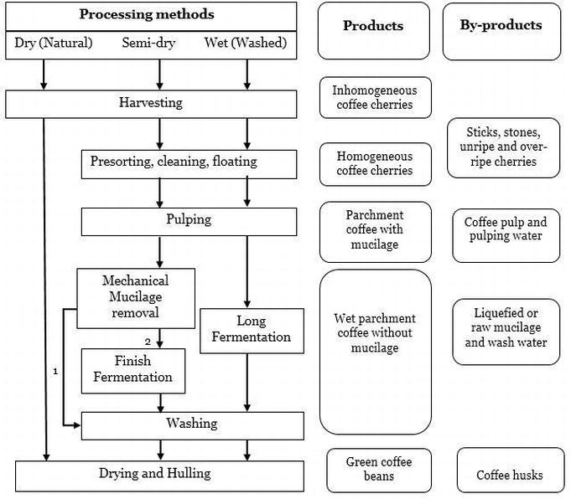
Figure: 4.2 Wet and dry Processing of coffee
Source: https://www.bing.com/images/search?view (29/08/2022).

4.4 Sorting out pea berries, elephant beans and broken beans
Coffee is at the mercy of physical, chemical and biological factors that can harm a bean’s integrity and the very heart of coffee quality at any time between growth and ripening of berries on the tree until green coffee is bagged on the farm.
- There are some 20 different bean defects in green coffee that must be removed before roasting:
- Common occurring defects classified and categorized by bean color, size, shape or aroma/taste, aberration and presence of foreign matter will include:
- Black bean- the most common defect in green coffee that describes any bean which is 50% black externally or internally. Black bean defect is caused by the prolonged fermentation of fruits that have been picked up from the ground
- Dark gray bean - this common color defect is the penalty of harvesting berries before they are fully ripe and/or poor drying of the beans
- Foxy bean - a classic rusty red color caused by over-doing artificial drying of beans
- Glassy bean - also called the white or opalescent bean defect and is the result of inadequate drying or re-absorption of moisture by previously dried beans
- Blotchy bean - beans exhibit external spots of different color which are caused by oxidising reactions on the surface of the bean following physical injury
- Drought affected bean - characterized by under-sized beans with a dull gray-green color and having a tendency for sticky skin. This defect is caused by harvesting several weeks before full ripeness
- Broken bean - a broken bean is classified as any piece of bean that is less than a normal half bean size
- Crushed bean - beans possess a flattened shape with the median furrow laid open and resulting from the processing of inadequately lots
- Pitted bean - the surface of the bean riddled with holes due to insect damage
- Elephant bean - a large deformed bean.
- Aborted bean - flat under-sized beans with a dull, wrinkled surface
- Stinker bean - stinker beans appear normal, but when cut they release an unmistakable volatile and putrid odor. Stinker bean is the most difficult defect to detect and now rivals black bean in occurrence.
- Musty bean - possesses that characteristic old musty smell caused by growth of fungal molds on the external surface
- Rancid or acid bean - beans are dark brown in color and release unpleasant odors when cut.
- Foreign matter - includes a wide range of coffee and non-coffee materials related to harvest and on-farm processing, including small stones, glass, metal, soil, dust, dry cherry, pulp, parchment, leaves, twigs and fragments of wood
Bean size grading after hulling is important to maximize financial return on larger beans, including pea berries, and to ensure a uniform roast. Furthermore, it makes subsequent sorting of beans by differential density much easier. Size grading is carried out using a flat screen grader, that retains beans of the required size on a vibrating screen, or a cylindrical drum grader where the different size grades of beans pass through the revolving screen at successive points along the drum. Although coffee beans are of fairly uniform size and proportion, they are graded first by size and then by density.

The elephant bean is the only exception. Beans are sized into different grades by running the beans through sieves and screens with specifically sized holes Green coffee at the post hulling and size grading stage will still contain a significant amount of dust and other very low density particles, along with varying proportions of light-weight beans and other defective beans which are misshapen, discolored or damaged by insects and mold fungi.

4.5 Storing clean beans
Storage facilities should be away from coffee hulling, grading and cleaning operations that could be sources of contamination. For all storage systems, good store management aims to maintain the coffee within the ‘safe’ range of moisture content over the required duration of storage, to protect the product from damage by insects or other pests, and to prevent cross contamination or new contamination from other sources. It also facilitates identification and handling of coffee lots.
- key elements of good storage practice were provided below:
- Physical facility
- Insulated roofs with air vents minimize heat transfer to the storage area and
- facilitate good ventilation
- Storage area (walls and floors) should be constructed of impermeable
- smooth, easily-cleaned materials
- Good Hygiene Practices along the coffee chain
- External surfaces should prevent entry of pests (well-fitting doors (< 0.5 cm space))
- No cracks in walls; drains and vents appropriately covered.
- proper lighting in the storage area with protective covering to prevent hazards from broken glass.
- Coffee is extremely sensitive to light: - exposure to UV rays and extreme heat or cold will cause coffee to degrade fast. Because of this; you shouldn’t store your coffee beans in glass or transparent plastic containers left out in the open. Use a plastic coffee storage container and keep it deep in a dark cupboard.
- Coffee’s biggest enemy is moisture: - moist, humid environments are ideal for bacteria and enzymes that break down food.
Because of this, coffee exposed to moisture will quickly begin to lose its flavor. Not only that, but you run the risk of brewing coffee with moldy beans and no one wants that.
- The best practices should be followed during coffee bean storing are :
- Keep the coffee beans away from moisture. This step ensures that oxidation does not occur and the quality is retained.
- Keeping the coffee beans in a cool, dry area can keep away moisture and even mold growth.
- Use gas-tight storage bags. Doing this guarantees that no contaminants can affect the coffee beans. Additionally, gas-tight storage bags also lock in the freshness of the beans.
- Keep the beans away from insects. Though there are not many insects that infest green coffee beans, it is still an important move so every batch is pure.
- Storing the beans in areas where insects can be controlled is a step worth taking.
- Store green coffee beans for a maximum of 1 year.
- Sometimes, roasters order a larger amount of beans than necessary and these ends up being stored for a longer period than intended. This is a situation when roasters and traders have to "move" the stocks. Storing coffee beans for more than 1 year may affect freshness, resulting in less-than-stellar roasts and brews.

Do not open and close the containers repeatedly. Constantly exposing the coffee beans can result in a loss of freshness. The best way to store coffee is to keep the gas-tight bags sealed until the stock will be used. Storing the coffee beans in small quantities, such as in 15 kg bags, can help preserve the fine quality that coffee connoisseurs love.

Having a holistic storage solution for coffee is one of the best practices that roasters, traders, and producers can adopt. Post-harvest issues such as loss of quality and volume can lead to a decrease in prices and, ultimately, profits. When this happens, everyone in the chain, from producers to processors and traders up to consumers, loses.
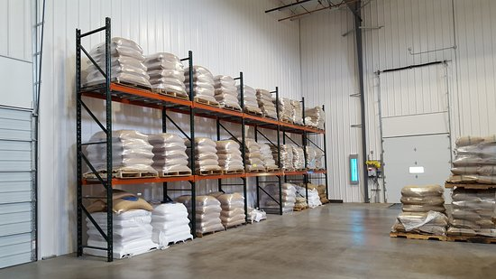
Figure 4.3. Coffee clean bean storage
Source: https://www.google.com/search?q=coffee+bean+storage+facility&sxsrf (28/08/2022)

4.6 Taking husk to appropriate place for other purpose
Advances in industrial biotechnology offer potential opportunities for economic utilization of agro-industrial residues such as coffee pulp and coffee husk. Coffee pulp or husk is a fibrous mucilaginous material (sub-product) obtained during the processing of coffee cherries by wet or dry process, respectively.

Coffee pulp/husk contains some amount of caffeine and tannins, which makes it toxic in nature, resulting the disposal problem. However, it is rich in organic nature, which makes it an ideal substrate for microbial processes for the production of value-added products. Several solutions and alternative uses of the coffee pulp and husk have been attempted. These include as fertilizers, livestock feed, compost, etc.
However, these applications utilize only a fraction of available quantity and are not technically very efficient. Attempts have been made to detoxify it for improved application as feed, and to produce several products such as enzymes, organic acids, flavor and aroma compounds, and mushrooms, etc. from coffee pulp/husk. Solid state fermentation has been mostly employed for bioconversion processes. Factorial design experiments offer useful information for the process optimization. This paper reviews the developments on processes and products developed for the value-addition of coffee pulp/husk through the biotechnological means.

Self-Check – 4 | Written test

Name…………………………………………… ID………………………… Date…….

Directions: Answer all the questions listed below. (8 points)
Test I: Short Answer Questions
- Define what coffee hulling means. (1 point)
- Write the method of coffee sorting.(2 points)
- Write the importance of sorting of coffee.(2 points)
- Write the importance of adjusting coffee processing machine before using it.(3 points)

Note: Satisfactory rating - 8 points Unsatisfactory - below 8 points
You can ask you teacher for the copy of the correct answers.

You can ask you teacher for the copy of the correct answers.

Operation Sheet -4

Techniques of coffee bean hulling.
- Tools and equipments
- PPE
- Huller (hulling machine)
- De-stoner
- Magnet
- Polisher
- Bag
- Procedures/Steps/ to perform coffee hulling:
- Wear the PPE
- Dry the coffee bean appropriately
- Sort the coffee bean:
  - Remove small stones=by de stoner , manually by hand
  - Remove iron materials = by magnet, manually by hand
  - Remove dusts = by pumping
- Adjust the huller (machine )
- Add the dried coffee bean to the hopper
- Switch on hulling machine
- Polishing the hulled coffee bean
- Sorting and grading hulled coffee bean.
- Putting the coffee bean in the bag (packing)
- Storing in appropriate place

LAP TEST-4 | Performance Test

Name………………………………. ID…………………………….. Date…………………………………….

Time started: ________________________ Time finished: ________________

Instructions: Given necessary templates, tools and materials you are required to perform the following tasks within 2 housr. The project is expected from each student to do it.

Task-1 . Perform coffee bean hulling.

LG #40 | LO #5- Preparing Washed/semi washed Coffee

Instruction sheet 5

This learning guide is developed to provide you the necessary information regarding the following content coverage and topics:
- Performing minor machine adjustment and calibration
- Carrying out pulping operation to get parchment coffee
- Inspecting fermentation process and checking fermentation time
- Carrying out washing process for parchment coffee
- Performing dry operation using solar radiation or artificial drier
- Sorting out damage, immature and over ferment parchment coffee
- Checking appropriate moisture content
- Storing dried coffee
This guide will also assist you to attain the learning outcomes stated in the cover page. Specifically, upon completion of this learning guide, you will be able to:
- Perform minor machine adjustment and calibration.
- Carry out Pulping operation to get parchment coffee
- Inspect fermentation process and check time of fermentation.
- Carry out washing accordance with the standard for parchment coffee.
- Perform drying operation using solar radiation or artificial drier.
- Sort out damaged, immature and over fermented parchment coffee .
- Check appropriate moisture content by using appropriate techniques.
- Store dried coffee according to coffee storage procedures

Learning Instructions:
- Read the specific objectives of this Learning Guide.
- Follow the instructions described below.
- Read the information written in the information Sheets
- Accomplish the Self-checks
- Perform Operation Sheets
- Do the “LAP test”

Information Sheet 5

5.1 Performing minor machine adjustment and calibration

The pulper machine has a knuckled, rotating drum that as it rotates, presses the cherries against an iron faceplate. The pressing action squeezes the seeds from the cherry and the machine utilizes channels that discard the seeds from one side and the pulp from the other side of the machine. So, the pulping machine should be adjusted and calibrated appropriately.

5.2 Carrying out pulping operation to get parchment coffee

Three methods of coffee processing are used in Ethiopia. These are dry processing, semi washe and fully washed coffee processing.
Dry processing:-un-pulped cherries are dried whole in the sun under natural conditions after harvesting. In the natural method, the coffee berries are allowed to remain on the mother tree after the fully ripe stage and is partially dried before harvesting. After harvesting it is dried and dehulled.
Fully washed (wet processing):-the cherries are pulped immediately after picking followed by fermentation and washing to remove mucilage cover. The washed coffee is then dried to 12% moisture content and then yellow parchment layer is removed in a hulling machine and the finished green coffee results.
Semi washing (wet processing) = the cherries are pulped and washing without fermentation. The difference between fully washed and semi washed coffee is presence of fermentation in case of fully washed.

- Factors that determine to choose method of coffee processing are:
- Area under coffee
- How long a farmer has been growing coffee
- Education level of the farmer
- Access to water
- Distance to nearest coffee washing station and age of the farmer.

5.2.1 Coffee wet processing

Wet method is applicable for ripe berries, which are harvested by priming method. The wet process involves removing the outer flesh of the coffee fruit through a water based process. After the flesh has been removed the coffee seed is still incased in mucus like substance called pectin. The pectin is not easily removed mechanically so it needs to be allowed to deteriorate naturally before attempting to get at the seeds within. To remove the mucus the coffee seeds are placed in large bins to ferment. This fermentation can be done both with and without water (though many believe that water negatively affects the flavor).

The fermentation gently deteriorates the pectin layer after which the seeds are dried. The drying works much like dry processing in which the coffee needs to be carefully tended to. Wet processing is popular especially with technologically and economically advantages areas (especially countries that have invested in coffee infrastructure) primarily for the reasons of consistency however wet processing does expedites the time to market as well.
5.2.2 Coffee dry processing
This is the oldest and most basic processing method. True dry processing involves laying the coffee fruits out in the sun and allowing them to naturally dry. When flesh of the fruit has dried the layer outside of the seed will be removed by hand or mechanically. This method requires constant tending of the coffee fruits as they dry so that drying occurs both evenly and without disease or mold growing. Due to the unpredictability of air drying it is painstakingly difficult to control the result thus only select few regions that actively utilize dry processing.

5.3 Inspecting fermentation process and checking fermentation time
The beans are then stored in fermentation tanks for up to two days during which time the slimy layer of the berry is separated from its parchment-like covering, by natural enzymes. The length of the fermentation process is based on the condition of the beans and the climate’s condition. When the altitude is low, the fermentation time is short. At higher altitudes, the fermentation can take up to 48 hrs.

  - Coffee pulping

The beans are separated from the skin and pulp by using a pulping machine that squeezes the berries between fixed and moving surfaces. The flesh and the skin of the fruit are left on one side and the beans, enclosed in their parchment covering, on the other. The clearance between the surfaces is adjusted to avoid damage to the beans. The lighter, immature beans are then separated from the heavier, mature beans through specially designed washing channels or by shaking the beans through a strainer into a tank of water.

  - Coffee fermentation
The coffee beans covered in the slippery mucilage can be sent to the patios to dry as pulped natural coffees or can be sent to coffee fermentation tanks. The coffee fermentation tanks are used to remove the mucilage before drying. The pulped coffee beans are put into cement tanks with water and are allowed to ferment for 16-36 hours. On the way to the fermentation tanks, another density separation can occur. The highest quality coffees are the densest and should be separated and fermented in a different tank.
- The coffee fermentation time depends on a number of factors including :
- The amount of coffee fermenting
- Water
- Temperature and
- Humidity.
- The mucilage is made up of pectin materials including :
- protopectin (33%),
- reducing sugars including glucose and fructose (30%),
- non-reducing sugars such as sucrose (20%), and
- cellulose and ash (17%).
- Protopectin is not water soluble and will hydrolyze to pectinic acid in the fermentation tanks. Hydrolysis of the protopectin and degradation of the pectin by enzymes is the process that occurs to remove the mucilage during fermentation. Currently, the best way of determining the end of coffee fermentation is to feel the coffee beans to determine if they are still encased in mucilage.
- If the Coffee beans are fermented for 36-72 hours, stinker beans develop.
- Lactic, acetic, and propionic acids are produced in this process and are believed to prevent the traditional fermentation taste by inhibiting mold growth that regularly occurs during drying on a patio in humid conditions.
- Pre-condition for coffee fermentation:
- Fermentation tanks smooth, repaired and painted/tiled
- Fermentation tanks marked with parchment grades
- Fermentation tanks clean prior to parchment reception
- All water drained off to allow dry fermentation
- Extra pulp and floaters on parchment 1 and 2 removed
- Fermentation time monitored – start/stop - 18-36 hours depending on weather.
- Parchment physically checked regularly to avoid over fermentation.
- A gritty sound is produced upon rubbing the coffee on your hands
- Mucilage on parchment surface washes away easily.
- Fermentation tanks have roof protection against rains and tanks covered with sheet at night to regulate temperature

5.4 Carrying out washing process for parchment coffee
Washing coffee beans – sometimes known as the ‘wet method’ of production as opposed to the dry one – sees their outer casing removed using water, before the beans are eventually dried and bagged for shipment. For this reason, the process uses substantial quantities of water.
Once coffee cherries have been picked, it is necessary to process the crop in particular ways in order to end up with the finished green beans in jute bags.
- Three types parchment coffee depending on its processing methods:
- Unwashed = by dry processing (no washing, no fermentation).
- Washed =by wet processing (washing and fermentation.
- Semi-washed (washed without fermentation).

        - Fully-washed beans
For fully-washed beans, first of all, once picked the cherries are put in water in order to separate them out. The ripe ones will sink, whereas the poor ones will float. Then, the skin of the cherry and some of the pulp is removed from each individual bean by pressing it through a screen using a machine. Nevertheless, a lot of the pulp will still stick rigidly to the beans, so it is then necessary to use either a more traditional ferment-and-wash method or a more modern process called aquapulping, mechanical demucilaging or machine-assisted wet processing to get rid of the last of it. The former method sees the remaining pulp broken down by fermenting the crop with microbes and then washing the beans with water – something which has to be overseen and monitored very carefully to ensure that the fermentation process does not unfavourably alter the final flavour of the coffee. It is also necessary to thoroughly wash the beans afterwards to ensure that no fermented mucilage remains.
Meanwhile, the more modern demucilaging process removes the remaining pulp with mechanical scrubbing, which can be preferable particularly in some hotter countries due to the fact that less water is needed. In addition to this benefit, it is easier to monitor and predict outcomes for the process.
        - Semi-washed beans
Semi-washing beans involve fewer steps than the fully-washed method, as would be expected. Also known as ‘wet hulling’, ‘Giling Basah’ (from the Indonesian meaning ‘wet grinding’) or the ‘pulped natural process’, processing beans in this way is said to reduce the acidity of the final coffee, rendering it more full-bodied and potentially preferable for espresso coffee. For this method, the outer skin from the cherries is removed using machines, following which the coffee beans – still with their mucilage attached – are then stored. Following this period, the mucilage is then washed off with water, before the beans are subsequently dried.

        - The drying process
After beans have been washed, they of course need to be dried in order to produce the green beans to be shipped, which will ultimately go in the roasting machines. Often, the beans are laid out in the sun for this to happen, but in some humid climates it may be necessary to finish off this process using a machine, before the beans can ruin due to mildew. As with all steps in the farming, harvesting and processing of coffee cherries, there is much debate surrounding the best way to carry out each individual step – and drying is no different. Some will favour spreading the beans out on large patios and raking them every few hours to ensure that the drying process is even across all of the produce. Others will prefer to lay them out on raised tables and turn them by hand, which requires more labour.
The waste water
Naturally, with so much waste water being produced as a result of the washing process, those processing the beans have to be responsible about what they do with it, with some farms reusing it as a fertiliser or returning it to the land once it has been made safe to do so
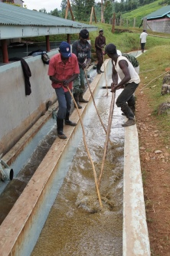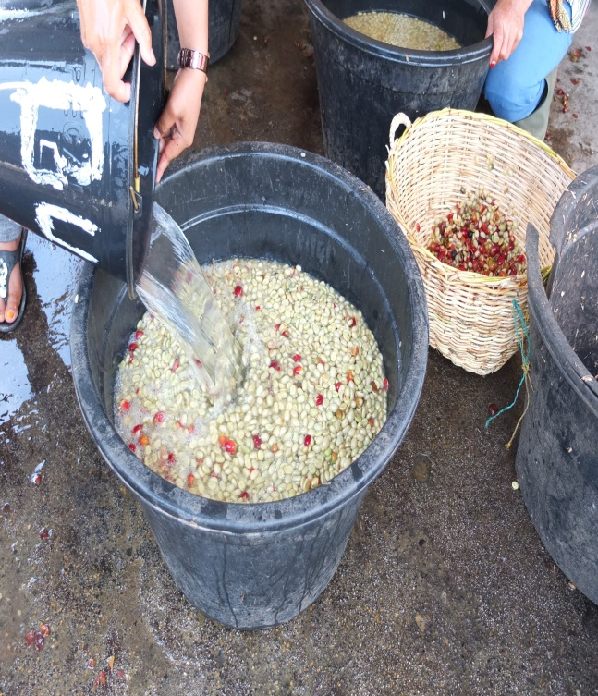
  - Washed coffee
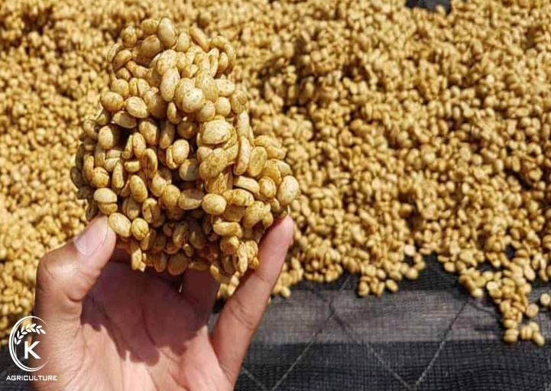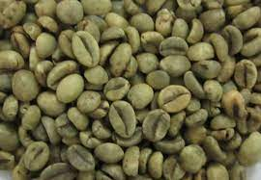
  - Semi washed coffee c. unwashed coffee
Fig 5.1 . Coffee washed,semi-washed and unwashed coffee beans.
Source : https://www.google.com/search?q=semi+washed+coffee (28/08/2022).
5.5 Performing dry operation using solar radiation or artificial drier
After the completion of processing either wet or dry processing the coffee beans should be dried by spreading on washed mesh wire raised bed. Since, coffee is highly hygroscopic it needs attention to protect contamination. To convert it we have to use cleaned tools to ignore contamination.
- During coffee bean drying :
- Drying tables flat and mesh wire is straightened
- Shade nets and nylex in good condition (not torn)
- Coffee at skin drying spread thin (+/-5cm), dry within 8 hours from washing
- Coffee on skin drying tables hand-picked for defects directly after washing .so parchment still wet
- Coffee when moved to drying tables are separated by grades and drying stage
- Coffee labeled on drying tables
- Coffee on drying tables turned continuously, each 1-2 hours
- Coffee depth on tables not more than 5-7cm or 3 inches
- Bean temperature is monitoring (by infrared meter or feeling by hands) not to exceed 35 degrees Celsius
- Coffee partially covered with shade netting during peak overhead sun hours
- Coffee covered overnight and during rains
- Moisture readings are taken at the same time daily
- Coffee is dried to 11-12 % moisture content before movement to store
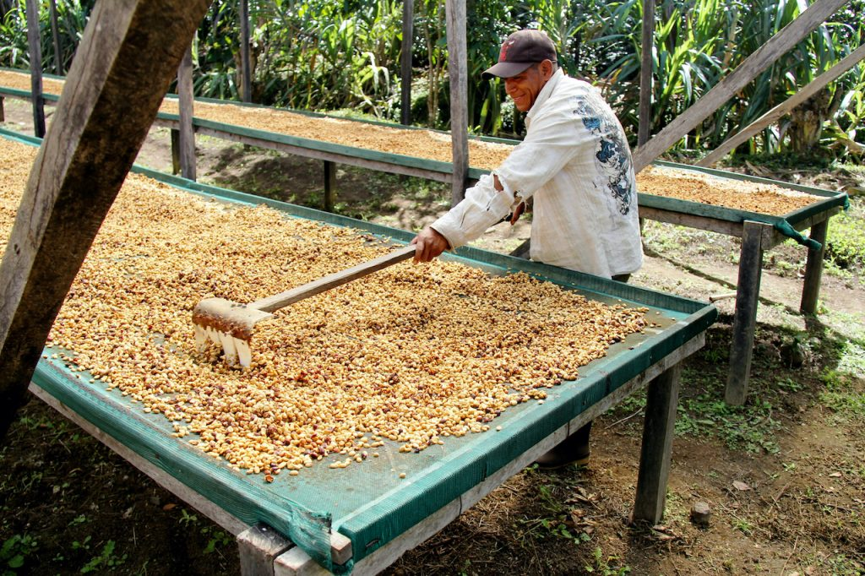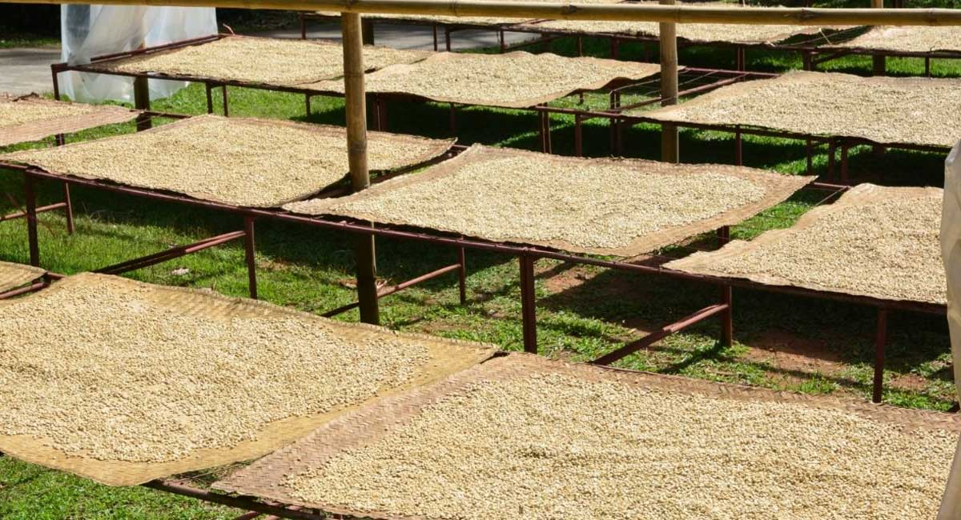
Figure 5.2. Coffee bean drying
Source: https://www.google.com/search?q=coffee+bean+drying (29/08/2022).

5.6 Sorting out damage, immature and over ferment parchment coffee
After dried the defected beans like broken, under sized, oversized, immature, over fermented, abnormal, inert matters and etc should be removed out from the dried coffee bean.
The final steps in coffee processing involve removing the last layers of dry skin and remaining fruit residue from the now dry coffee, and cleaning and sorting it. These steps are often called dry milling to distinguish them from the steps that take place before drying, which collectively are called wet milling. These are:

- Removal of dried fruit residue
The first step in dry milling is removing what is left of the fruit from the bean, whether simply the crumbly parchment skin in the case of wet-processed coffee, the parchment skin and dried mucilage in the case of semi-dry-processed coffee, or the entire dry, leathery fruit covering in the case of dry-processed coffee. The machines that do this range from simple millstones in Yemen to sophisticated machines that gently whack at the coffee.

- Sorting by Size and Density
Most fine coffee goes through a battery of machines that sort the coffee by density of bean and by bean size, all the while removing sticks, rocks, nails, and miscellaneous debris that may have become mixed with the coffee during drying. First machines blow the beans into the air; those that fall into bins closest to the air source are heaviest and biggest; the lightest (and likely defective) beans plus chaff are blown in the farthest bin. Other machines shake the beans through a series of sieves, sorting them by size. Finally, an ingenious machine called a gravity separator shakes the sized beans on a tilted table, so that the heaviest, densest and best vibrate to one side of the pulsating table, and the lightest to the other.

- Sorting by Color
The final step in the cleaning and sorting procedure is called color sorting, or separating defective beans from sound beans on the basis of color rather than density or size. Color sorting is the trickiest and perhaps most important of all the steps in sorting and cleaning.
  - Color Sorting by Eye and Hand
With most high-quality coffees color sorting is done in the simplest possible way — by hand. Teams of workers, often the wives of the men who work the fields, deftly pick discolored and other defective beans from the sounds beans. The very best coffees may be hand-cleaned twice (double picked) or even three times (triple picked). Coffee that has been cleaned by hand is usually called European preparation. Most specialty coffees, since they are whole bean and consumers see what they get, are European preparation.
- Color Sorting by Machine
Sophisticated machines now can mimic the human eye and hand. Streams of beans fall rapidly, one at a time, past sensors that are set according to parameters that identify defective beans by value (dark to light) or by color. A tiny, decisive puff of compressed air pops each defective bean out of the stream of sound beans the instant the machine detects an anomaly.
These machines are not widely used in the coffee industry for two reasons. First, the capital investment to install these delicate machines and the technical support to maintain them is daunting. Second, and perhaps most importantly, sorting coffee by hand supplies much-needed work for the small rural communities that cluster around coffee mills. The vision of huge rooms filled with women and a scattering of teenage boys patiently picking through piles of green coffee may offend urbanites, but the economic suffering caused by replacing these women with machines and a highly paid technician from the city is not a comfortable alternative either, particularly in small rural communities with strong communal values.
On the other hand, computerized color sorters are essential to coffee industries in regions with relatively high standards of living and high wage demands, places like Brazil and Hawaii, for example. Readers who have seen television depictions of the slums of Rio may doubt that a labor shortage exists in rural Brazil, but it does. The main areas of coffee production in Brazil are quite prosperous, with a per capita income approximately equal to Belgium.
At the other extreme of the coffee/economic spectrum is Ethiopia, where even the usual battery of machines that sort coffee by density and size are unknown, and hand sorting and cleaning is the only sorting and cleaning this wonderfully idiosyncratic coffee receives.
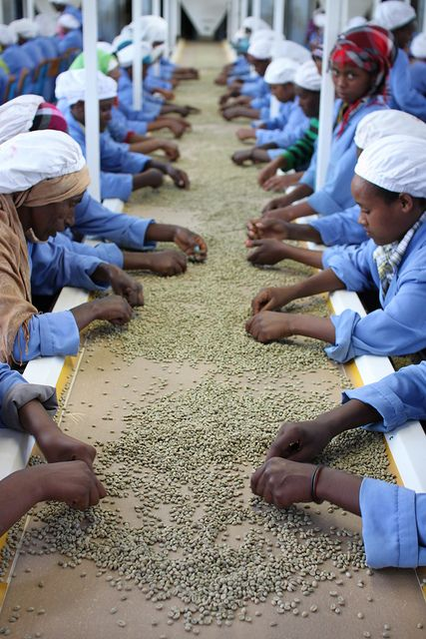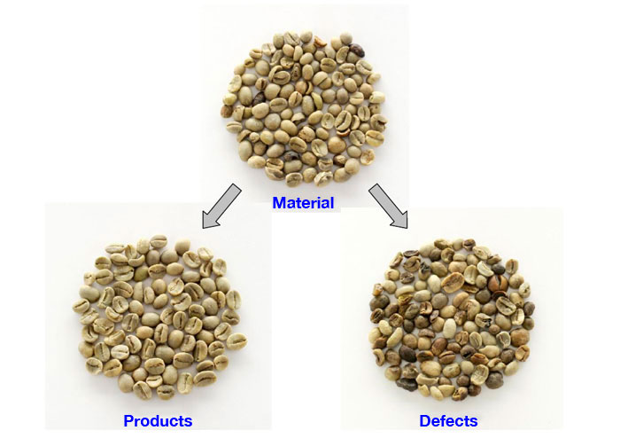
Figure 5.3. Sorting coffee bean
Source: https://www.google.com/search?q=coffee+sorting (29/09/2022).

5.7 Checking appropriate moisture content

Coffee beans require a reliable moisture measurement and control system to ensure the manufacturing process is not wasting product, time or energy. Very accurate coffee bean moisture levels have become a critical component during production of coffee because without close attention, the coffee bean moisture can easily become out of acceptable range.

Why measure coffee bean moisture content?
Green coffee that is high in moisture (greater than 12 percent wet basis) can deteriorate due to bacteria, mold, or yeast, especially if the seed is killed. If the seed remains alive, enzymatic activity will cause the cupping quality to change.

In any case, the parchment coffee moisture level should be lowered to below 12 percent soon after harvest. When the ambient relative humidity is about 70 percent, coffee beans will gradually equilibrate to about 12 percent moisture. Thus green bean coffee is generally dried to 12 percent, and bought and sold at this moisture percentage.

If the bean dries to below 9 percent moisture, it will shrink enough to become distorted, which will give the appearance of low-quality coffee. To meet the Hawai‘i Department of Agriculture standards for coffee (see www.hawaiiag.org/hdoa/adminrules.htm), the moisture level must be between 9 and 12 percent, ± 0.3 percentage points. Coffee of consistent quality commands a higher price. The range for maintaining quality is quite broad, making it easier to know the coffee is at the correct moisture. Precisely knowing the coffee is at 12 percent moisture is not necessary except in the market. Knowing the coffee is between 12 and 9 percent moisture at all times after it is dried is important to ensuring that your coffee has the best quality at the time of sale. A deviation of one percentage point from 12 percent moisture content represents 1 pound of water per 100-lb.

Ways of measuring coffee bean moisture:

    - Oven (standard method)
The internationally accepted standard method for determining moisture in coffee is the loss of weight on heating. Although the loss in weight may not be only water, in coffee the other volatiles are not significant when using the standard drying time and temperature. For this method, you should have a scale capable of accurately determining the weight of your samples to 1 part in 1000 or better. You also need a hot-box (e.g., an oven) that can maintain a temperature of 220°F (105°C) ± 5°F, with natural airflow, for 24 hours. Airflow should not be overly restricted. Airflow is needed to carry off the moisture.
A convenient sample size is 100 g initial weight. The samples are placed in the oven at 220°F for 24 hours. They are then weighed again (final weight). The difference between the initial weight and the final weight is the water, and it is also the percent moisture in the sample if you started with 100 grams. If you use a different initial weight, you will have to divide the difference in weight by the initial weight to get the percent moisture.

    - Brittleness of parchment
The hull on parchment becomes brittle as it dries. When you can easily crumble the hull in your hand the parchment is dry under normal drying conditions. The bean may still be on the high side of 12%t. When the coffee is drying, the hull will be drier than the bean; in storage, the bean will be drier than the hull. Use hull brittleness only as a very rough indicator of bean moisture. The bean can still be quite wet when the hull is brittle, and it could mold in storage.

    - Color
Coffee beans at 12 % moisture are a rich green with a slight translucence. Wet coffee or coffee that has been rewetted and re dried is more opaque and whiter. There is little change in color until moisture drops well below 12 %, but the beans will tend to become distorted. Although there may be a few individuals that can, with much experience, judge moisture by color.. A bag of molded green bean would be a bigger loss than the cost of a moisture meter. Use color only as a rough guide—if the beans are not a rich green color, they are not dry, or they have some other problem. It is best to check the moisture with a reliable meter.

    - Hardness of bean
A bean fresh from demucilaging, whether through fermentation or mechanical means, will be at 45–55% moisture. Removing the hull is not easy and the bean inside is rubbery. If you bite on it, it will be about “al dente,” in the sense that the term is applied to spaghetti. As the bean dries, it will get harder. At 12% it will be quite hard and will crack rather than shear or dent when you bite it. The hardness may be slightly different under different growing conditions, but we have not done any research to show this. Combining color and hardness observations will make a guess at the moisture level better, but it still will be a guess.

    - Moisture meter direct
You should have a pile of at least 300 g of beans. Use a moisture meter to test the level of humidity and record it. When parchment coffee beans reach around 12% moisture, they are usually bagged in burlap or water-resistant bags and stored until milling.

5.8 Storing dried coffee
Before coffee beans are shipped, they have to be stored, to prevent them from spoiling or losing quality and a number of precautions have to be under taken. These include paying particular attention to humidity, storage facility, location, and storage duration. Coffee must be stored in dry and cool conditions. Exposure to the sun or moisture will rapidly deteriorate the coffee seed. The preferred place to store coffee is in the vicinity of its production site, i.e. a relatively high altitude with low air moisture. If it is too humid, beans are not separated from their husk (sun-dried pulp) or hull (parchment membrane) until sending them for shipping.
Coffee beans should be stored in low moisture conditions so as not to be attacked by mold. The maximum water level, safe in the bean is 12% by weight. After reaching this thorough drying, any re-wetting and airborne moisture absorption must be prevented (e.g. rain, fog, condensation).
Raw coffee beans are often stored for years before roasting. Their sturdy structure usually prevents them from being spoiled by external agents; however, nothing can be done against the inherent biochemical activity in the seed. In this case, some minor components transform into other components which taste woody and harsh after roasting.
- Conditions before, during and after drying:
- Properly dried coffee is moved into store
- Coffee stored in clean bags
- If reusing the bags, previous parchment removed from the bags
- Coffee bags in store weighed, sealed and labeled Store is clean, pest and rodent free
- Store is leak proof
- Store is well ventilated
- Store used exclusively for coffee (no agrochemicals, fuels, other crops)
- Coffee stacked on wooded pallets
- Pallets raised 15 cm from the floor and 30 cm from the walls and roof
- Coffee in store rotated on first in- first out basis
- Coffee in store separated by lots and grades (label or bag writing must include day of pulping and grade)
- Transportation to dry mill during the day
- Truck is clean, closed and leak proof
- Truck in good condition – new tires, engine function, experienced driver
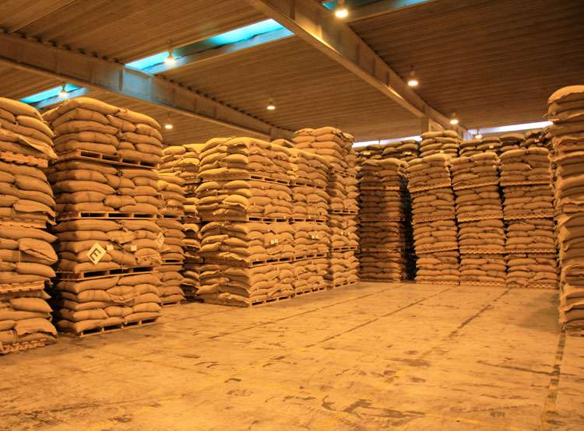
Figure 5.4. Coffee storage
Source: https://www.google.com/search?q=coffee (28/08/2022)

Self-check 5 | Written test

Name…………………………………………… ID………………………… Date…….
Directions: Answer all the questions listed below. (10 points)
Test I: Short Answer Questions
  - Write the difference between dry and wet coffee processing.(2 points)
  - Write the importance of drying coffee beans.(2 points)
  - Write the methods of coffee bean moisture determination.(3 points)
  - Write what sorting means and list methods of sorting.(1 points)
  - Write the importance of sorting coffee beans.(2 points)

Note: Satisfactory rating - 10 points Unsatisfactory - below 10 points
You can ask you teacher for the copy of the correct answers.

You can ask you teacher for the copy of the correct answers.

Operation Sheet -5

Techniques of Coffee wet processing
A. The required tool and materials:

- PPE
- Pulpier
- Suck
- Mesh wire raised table
- Hopper
- Washing brush and
- Fermentation container

B. Procedure for coffee wet processing.

- Select of location of factory
- Wear appropriate PPE.
- Select red and ripe coffee cherry
- Sort Coffee cherry
- Add to hopper
- Adjust the pulping machine
- Add coffee berries to the hopper
- Operate the Pulping machine and start cherry pulping
- Wash (by using labor force) and grade (by machine itself) the pulped bean Pre fermentation
- Facilitate Fermentation process
- Soak and Wash the fermented bean
- Spread the pulped bean on mesh wire table for drying
- Store the dried coffee bean
- Hull the dried coffee bean.
- Polish the hulled coffee bean (grean bean).
- Sort the hulled and polished grean bean.
- Grade the processed coffee bean.
- Pack the coffee bean.
- Transport the packed product to the storage and store it appropriate storage room..

LAP TEST-5 | Performance Test

Name………………………………. ID…………………………….. Date…………………………………….

Time started: ________________________ Time finished: ________________

Instructions: Given necessary templates, tools and materials you are required to perform the following tasks within 2 hours. The project is expected from each student to do it.
Task-1. Perform coffee wet processing.

LG #41 | LO #6- Store stimulant & spice products

Instruction sheet

This learning guide is developed to provide you the necessary information regarding the following content coverage and topics:
- Identifying storage places, structures and time of storage
- Understanding extraction of essential oils (characteristics essential oils)
- Transporting processed stimulant & spice products
- Storing stimulant & spice products
- Identification of processing equipment’s and machineries
- Understanding processing techniques
- Performing regular inspection spice products
This guide will also assist you to attain the learning outcomes stated in the cover page. Specifically, upon completion of this learning guide, you will be able to:
  - Identify storage places and structures based on the type and time of storage
  - Transport processed stimulant & spice products to the storage area.
  - Store stimulant & Spice products with suitable temperature and relative humidity
  - Perform regular inspection to control the quality of the stored spice products.
Learning Instructions:
- Read the specific objectives of this Learning Guide.
- Follow the instructions described below.
- Read the information written in the information Sheets
- Accomplish the Self-checks
- Perform Operation Sheets
- Do the “LAP test”

Information Sheet 6
  - Identifying storage places, structures and time

    - Storage places

Storing spice and stimulants in the proper environment is absolutely necessary to ensure freshness. The flavor of a spice can be affected by light, temperature and humidity. Seasonings and stimulants should always be stored in a cool, dark place where there is no moisture. Keeping a spice and stimulants rack on a countertop exposed to direct sunlight will result in a loss of quality. Storing spices and stimulants above or close to your stove or other cooking surfaces can expose them to temperature changes that can alter the taste. The best place to keep your stimulants and spices is in a pantry or cabinet that maintains a cool temperature and is protected from direct sunlight and moisture. All seasonings should always be stored in airtight containers.

If you have large amounts of whole stimulants and spices; and want to keep them preserved, storing them in the freezer is an option. Just like pantry storage, stimulants and spices placed in the freezer should be kept in airtight containers to prevent air and moisture from entering. It is not recommended to keep spices in a refrigerator. A refrigerator has a higher level of humidity, which can alter the taste and freshness of your spices.

6.1.2 Storage structures
To store stimulants and spices for long time, keep them somewhere cool, dark, and dry and protect them from oxygen. The best way to do this is to repackage spices in airtight containers with oxygen absorbers.

      - Right Storage Container
Because oxygen causes spices to go bad quickly, you must store stimulant and spices in airtight containers. There are only two good options for this:
- Mylar bags
- Mason jars with two-part metal lids
Both Mylar bags and mason jars are completely airtight when closed. They won’t let any air or moisture from the environment into the packaging.
By contrast, the lids on spice jars don’t create a very good seal. It will allow air and moisture from the air in, which can cause spoilage. For this reason, you should never store them long-term in their original containers.

      - Mylar Bags
When stored in Mylar bags with oxygen absorbers and kept away from heat, spices should last anywhere from 2 to 10 years. Herbs like parsley and basil retain their flavor longer than volatile spices like cumin and red pepper flakes.

  - Vacuum sealing?
Vacuum sealer bags aren’t airtight. Over time, they will allow air and moisture to leak in. So, they aren’t a good solution for long-term spice storage. Read more about vacuum seal vs. mylar bags here.

  - Oxygen Absorbers
Oxygen absorbers (OAs) are little packets of iron. It absorbs oxygen from around it. It creates a completely oxygen-free environment if put in an airtight container like a sealed Mylar bag.
When you put stimulant and spices in an airtight container, there will still be oxygen already inside. This oxygen will cause them to go bad gradually.
In addition, there may be insect eggs in the stimulants and spices (it sounds grosser than it is). These eggs can hatch, resulting in an infestation inside the container.

  - Cool and Dark place
Even if kept in an oxygen-free environment, stimulant and spices will degrade from heat and light. You must keep them somewhere cool and dark. Mylar bags don’t allow light through, but mason jars will. You can put them in a box or wrap them in bags to protect against light.
Freezing stimulant and spices will keep them fresh indefinitely. However, freezing isn’t usually a good long-term storage solution. The spices might pick up smells from other items in your freezer. Also, if there were a long-term power outage, your spices would start to go bad. store some stimulant and spices in the freezer – but not for long-term storage.

  - Use Small Containers
Spices are only used in small amounts. They also go bad very quickly. Because of this, it doesn’t make sense to stockpile spices in bulk quantities. If a long-term emergency hit, your spices would go bad before you could use them up. Instead, only stockpile a small amount of spices per container. We can use small Mylar bags.

    - Storage time

The shelf life (storage time) of a stimulant and spice product refers to the length of time for which it can be stored, under specified conditions, while remaining in optimum condition and safe for consumption. Produce can be stored for both short-term and long-term purposes. A few crops are adapted for long-term storage. These can be held in store well beyond the normal harvesting period. When they are eventually sold higher prices can usually be obtained and, by extending the marketing season, a larger volume of produce can be marketed.
- The most successful stores are located in urban areas because:
- Produce can be released rapidly onto the market when prices increase
- Rrefrigerated facilities in urban areas can also be used for a variety of products
(E.g. apples in the winter, citrus in the summer, butter and other milk products).
- To determine the storage time of stimulants and spice crops variables to consider include:

    - Their type,
    - Their processing
    - Storage facilities
    - Water activity
    - Moisture content
    - pH
    - Salt content
    - Sugar content
    - Nutrient content
    - Oxidation potential and etc.

For example, processed spices and stimulants have long shelf life as compared to unprocessed one.

  - Storage time for spices
- Dried herbs typically last 1–3 years. Examples include:

- basil
- thyme
- rosemary
- dill
- mint
- sage

- Ground, or powdered, spices typically have a shelf life of 2–3 years. Common examples include:

- powdered ginger
- garlic powder
- ground cinnamon
- chili powder
- ground turmeric
- ground allspice
- ground cardamom
- ground paprika
- crushed red pepper flakes
- seasoning blends

Whole, or unground, spices have the longest shelf life, as less of their surface area is exposed to air, light, and moisture. This allows them to retain their aromatic oils and flavor compounds longer than their ground counterparts.
- If stored properly, whole spices can last up to 4 years. Examples include:

- whole peppercorns
- coriander
- mustard seeds
- fennel seeds
- caraway seeds
- cumin seeds
- whole nutmeg
- cloves
- cinnamon sticks
- whole dried chili peppers
- lemongrass

Salt is the exception to the rule, as it can be used indefinitely regardless of its size and shape without spoiling or losing flavor. That said, if you’re using a seasoned salt, any accessory seasonings may lose their potency over time.

  - Storage time for stimulants
- Storage time of coffee when unopened or sealed:

- Ground coffee lasts for 3-5 months when kept in a pantry at room temperature, but it can last 1-2 years in the freezer.
- Whole-bean coffee lasts for 6-9 months in the pantry and up to 2-3 years in the freezer.
- Instant coffee lasts for 2-20 years in the pantry, depending on the packaging. Most instant coffee packets are made with an aluminum layer. This provides an opaque cover that keeps out moisture and heat. Mold spores have no means to get in, so the coffee’s shelf life is prolonged. In the freezer, sealed instant coffee packets will keep indefinitely.

- Storage time of coffee When Opened:
- Ground Coffee – Lasts up to 5 months at room temperature, or in the freezer
- Whole Bean Coffee – Lasts up to 6 months at room temperature in the pantry; up to 2 years in the freezer.
- Instant Coffee – Same as above. Extracts

6.2 Understanding extraction of essential oils
- Essential oils are generally derived from one or more plant parts, such as:
- Flowers (e.g. rose, jasmine, carnation,Clove,Mimosa, rosemary,lavander),
- Leaves (e.g. mint, Ocimum spp., lemongrass, jamrosa),
- leaves and stems (e.g. geranium, patchouli, petitgrain, verbena, cinnamon),
- Bark (e.g. cinnamon, cassia, canella),
- Wood (e.g. cedar, sandal, pine),
- Rroots (e.g. angelica, sassafras, vetiver, saussurea, valerian),
- Seeds (e.g fennel, coriander, caraway, dill, nutmeg),
- Fruits (bergamot, orange, lemon, juniper),
- Rhizomes (e.g. ginger, calamus, curcuma, orris) and
- Gums or oleoresin exudations (e.g. balsam of Peru, Myroxylon balsamum, storax, myrrh, benzoin).

Methods of Producing Essential Oils
- Regarding hydro distillation, the essential oils industry have developed terminology to distinguish three types:
- Water distillation
- Water and steam distillation; and
- Direct steam distillation.
- This process goes through four stages:
- heating, vaporization,
- condensation, and
- cooling, after which the purified component is collected from the apparatus.
- Distillation is used to purify and extract components from a mixture both in a laboratory as well as on an industrial scale.

Extraction of the aroma and flavour components from dried plant materials is one of the oldest chemical operations developed by human kind.
The preparation of a cup of tea or coffee is an everyday example of extracting the flavour and aroma components, including the stimulant caffeine, with hot water.
- Steam distillation is used to extract the essential oils from spices.
Example:
- Trans-anethole [1-methoxy-4-(1-propenyl)benzene] from star anise and
- Trans-cinnamaldehyde [(2E)-3-phenylprop-2-enal] from cinnamon bark.

  - Transporting processed stimulant & spice products

The main role of transport is to deliver agricultural products from farms to markets and to cities worldwide. Correct logistics is the key to managing the assets or goods from the point of origin to the consumers. Moreover, the national well-being depends on transport.
In short, transport enables agriculture and emboldens the farmer to invest more and increase production. And without this transport system, large quantities of painstakingly farmed produce would be laid
Sometimes, especially equipped trucks (e.g. Refrigerated trucks) are needed to protect the product from damage in transit.

- Transportation can be by:
  - rail, land,
  - water (ship) or
  - air (plane)
  - By humans by carrying the harvested product on their heads, shoulders or backs.
  - Donkeys, horses and mules.
- Some studies show that the losses caused during on farm / off site transporting operation are estimated to be 2-3% due to the extended utilization of old sacks made of goat skin, sisal, plastic or others.
- The mechanism employed to move crops from place to place may vary depending on the level and availability of the technology, i.e. on the back of animals or using sledges and carts.
For small-scale farmers, suitable on farm transport technologies include the use of the following.
i. Hand pushed wheel barrows, they are:
- Suitable to transport loads up to 100 kg
- Simple and cheap to make them from local material in local workshops and easy to repair.
- Good in the relief of human druagery
- Better in saving lost of working times which could be used for other farm or houses hold activities
ii. Animal drawn Carts
In the rift valley flat areas of Ethiopia, farmers make donkey carts from wasted metal and wood to carry their farm produces. Due to improper design, wrong choice use of materials for making them, these carts couldn’t carry more than 300 k.gs
On top of this, sometimes they cause injury to pulling animal Because of this farmers using these carts always has an scort donkeys with them, in case problem areas us while on transportation activities .

- Therefore, an improved animals drawn carts are necessary, because they are;
- could carry loads up to 800 kg s
- are efficient and May wholly made of local materials
- could carry different kinds of crops cither bagged or not threshed
- may be hired during off season to generate additional income for the household, and
- Make no harm to the pulling animal
- Serve at least 50 times greater efficiency in transporting the farm produces than human labor.

6.3.1 Spice transportation
Fresh, whole spices are shipped more often in bags than boxes, and should be kept free of excessive water while also being properly ventilated. This will keep them from mold or spoilage.

Shipping Fresh Spices
This is going to be more dependent on the individual spice in question since they are all unique. However, some general rules do apply. Fresh, whole spices are shipped more often in bags than boxes, and should be kept free of excessive water while also being properly ventilated. This will keep them from mold or spoilage, which these are more easily susceptible to since they are unprocessed.

Also, if bags are used to transport the spices, hooks should be avoided to hang or move them since that can damage the valuable freight within. Fresh spices have the shortest shelf life of the three, so you don’t want to make any mistakes that will shorten it.

Shipping Dried Spices
If the spices are being shipped “loose” to be sold in a farmer’s market, supermarket or health food stores, you’ll want to take a bit more care with them. These can be shipped in waterproof containers or large sacks/bags. The spices need to be kept cool and dry to make it to retailers. At this point, if the spices are ground up and dry, they can become ruined or at least unfit for retail because it will clump together. Also wet or damp spices can attract bacteria such as salmonella or end up promoting mold growth. If the pre-dried spices are individually packaged, this is generally in plastic, sealed bags or small plastic or glass containers that should be completely sealed and waterproof by design. Avoid excessive moisture around the products. Using

cardboard boxes to ship these will suffice since that should provide adequate protection during transportation. If the boxes are sturdy enough, they can even be stacked, which should allow you to ship more spices in a single load.

6.3.2 Stimulant crop transportation
- To transport different stimulant crops like coffee, tea,cocoa,gesho and etc the following points should be considered:

- Method of transportation
- Type of stimulant crop
- Processing quality
- Time of transportation
- Package
- Distant of transportation and etc.

Coffee transporting
Large corporations and cooperatives tend to ship their precious coffee almost exclusively as bulk good in specially designed bulk carriers for inland rivers and in bulk good shipping containers. Today, about 95% of the coffee is being shipped as bulk good in shipping containers.
- The 6 challenges may be faced during coffee transportation:
- During shipment the temperature can affect the moisture content of green coffee beans. Because coffee is hygroscopic and contains water, drastic temperature changes can result in condensation inside the container. The “sweating of the bean”, so to speak.
- Depending on the type of container, the lining of the container, and type of packaging that is used for storing the coffee, the effect of condensation can lead to the development of moulds and ochratoxin A. Which can have a negative effect on your health?
- Delay in processing shows growth of moulds and ochratoxin A. in green coffee beans. This delay also results in a lower to poor cup quality. But whether if moulds, that grows during transport, have the same effect on cup quality has not been investigated yet.
- The type of packaging and the use of modified atmosphere packaging can have positive and/or negative influence on the quality of coffee beans during storage. For instance, the difference between a jute packaging, that has no protection, or a vacuum pack.
- Climate controlled and ambient (non-climate controlled) storage in the warehouse also have an impact on the quality of the coffee. This is in direct relation to the type of packaging and/or modified atmosphere packaging that is being used.
- Storing coffee in parchment shows great benefits to the sensorial and chemical quality of green coffee beans over a longer period.
- Therefore, to increase shelf life green coffee bean, the following conditions are required:
- Drying well
- Shouldn’t exposed to high sun heat
- Should be processed
- Appropriate packaging (sealed).
- Selecting appropriate transporting structure and etc.

6.4 Storing stimulant & spice products
Stimulants are permanent trees or shrubs whose fruits or leaves are characterized by their alkaloid content, such as caffeine, theobromine and theine. Spices are plants which in one or the other of their components (rhizome, bark, fruits, berries, seeds, etc.), contain strongly flavoured and aromatic substances.

6.4.1 Storing stimulant crops
Coffee storage
For one to get the perfect brew, coffee beans need to be cared for meticulously. That aromatic taste can only be had if all the steps in harvesting, processing, and even transporting coffee beans are sure to be exact. Failure to secure the beans during these steps can lead to a disappointing batch or, even worse, loss due to spoilage. One important step that can easily be overlooked is safely storing the beans. This step is significant because the quality of the coffee is directly affected by how the beans are stored.
- The important best practices when storing coffee beans are:
    - Keep the coffee beans away from moisture. This step ensures that oxidation does not occur and the quality is retained. Keeping the coffee beans in a cool, dry area can keep away moisture and even mold growth.
    - Use gas-tight storage bags. Doing this guarantees that no contaminants can affect the coffee beans. Additionally, gas-tight storage bags also lock in the freshness of the beans.
    - Keep the beans away from insects. Though there are not many insects that infest green coffee beans, it is still an important move so every batch is pure. Storing the beans in areas where insects can be controlled is a step worth taking.
    - Store green coffee beans for a maximum of 1 year. Sometimes, roasters order a larger amount of beans than necessary and these end up being stored for a longer period than intended. This is a situation when roasters and traders have to "move" the stocks. Storing coffee beans for more than 1 year may affect freshness, resulting in less-than-stellar roasts and brews.
    - Do not open and close the containers repeatedly. Constantly exposing the coffee beans can result in a loss of freshness. The best way to store coffee is to keep the gas-tight bags sealed until the stock will be used. Storing the coffee beans in small quantities, such as in 15 kg bags, can help preserve the fine quality that coffee connoisseurs love.

6.4.2 Storing spice crops
Each container of spice needs to be clearly labeled and positioned in/near the kitchen so that you can readily find it when needed. There are options in organizing spices. One tried and true method is to label and line them up alphabetically. Others find it better to separate spices into sections with baking spices in one area. Other cooks set up their bottles by size. Use whatever works for you. In our home we use a hybrid of alphabetical organization, with baking and savory spices separated, and large jars of seasoning salts and other frequently used spices on their own shelf in a cabinet.

Figure 6.1. Spice storage Cabinet in kitchen
Source: https://www.closetworks.com/closet-blog_spice-storage (30/08/2022).
6.5 Identification of processing equipment’s and machineries

- Equipment Performance and Maintenance during processing:

- Proper design
- Preventative maintenance
- Contractor control
- Equipment calibration

- Temporary repair procedures

Equipment should be designed to minimize the cross-contamination of food, the accumulation of food residues during the production and for ease of cleaning. If equipment is difficult to clean, or poorly cleaned, microbiological growth can occur that will contaminate the product.

To ensure that the manufacturing environment does not add to the risk of introducing a hazard into the product there can be programs to ensure this contamination controlled or eliminated.

- Process control procedures can include but are not limited to:
- Bag opening controls:-to ensure that raw material packaging does not introduce a potential hazard.
- Knife control programs: - to ensure correct sanitation and identification of potential breakage.
- Control of bag stitching needles :-to ensure that a broken needle does not get into the product
- Control of magnets :-to ensure they are cleaned and maintained correctly
- Control of utensil, such as brushes and scoops:-to ensure they remain in good condition and are not a risk for cross contamination (particularly allergens)
- Sampling procedures:-to prevent contamination and to ensure that sampled product is correctly sealed .
- Control of screens / sieves:- to ensure that they do not break and become potential contaminants and to ensure that they remain undamaged.

6.6 Understanding processing techniques
Processing of coffee consists of removal of the skin, pulp, parchment and silver skin. The quality of the final product depends upon the method of processing. There are two main methods used in coffee processing viz, washed (wet) process and natural (dry) process. In the wet process, the ripe fruit is squeezed in a pulping machine which removes most of the soft outer pulp. The product is called washed coffee. The washed coffee is then dried to 12% moisture content and then yellow parchment layer is removed in a hulling machine and the finished green coffee results. In the natural method, the fruit is allowed to remain on the tree after the fully ripe stage and is partially dried before harvesting. After harvesting it is dried and dehulled.
After coffee is harvested in its fruit form there is still many things that need to happen before it is ready to be roasted. There are very particular methods for removing the meat of the fruit from the seed. Since coffee has to be processed local to growing regions, processing methods used are not wholly dependent on technological factors but also regulatory and cultural factors. The methods below represent the both the progressing technologies in coffee processing as well as a world coffee culture that still hangs close to its roots.
The choice of processing method to use depends on a number of factors. Among these are area under coffee, how long a farmer has been growing coffee, education level of the farmer, access to water, distance to nearest coffee washing station and age of the farmer. In order to determine the factors that significantly affect choice of the processing method a binary logistic regression model was used.

6.7 Performing regular inspection spice products
To ensure freshness, it is best to open and visually check spices and herbs annually: Open and visually check if the spice or herb looks fresh. Crush a small amount of the spice or herb in your hand and smell it. Compare the aroma (Be aware, however, that subtle changes may also occur with each new crop.)

Self-Check – 6 | Written test

Name…………………………………………… ID………………………… Date…….

Directions: Answer all the questions listed below. (10 points)
Test I: Short Answer Questions (2 points each).
- Write the importance of storage for spice and stimulant crops!
- Write the storage facilities for spice and stimulants.
- Write the consideration before and during storage of spice and stimulant crops.
- Give at least 3 storage structures for spice and stimulant crops.
- Write transport technologies for spice and stimulant crops.

Note: Satisfactory rating - 10 points Unsatisfactory - below 10 points

You can ask you teacher for the copy of the correct answers.

You can ask you teacher for the copy of the correct answers.

Operation Sheet -6

Techniques of storing spice!
- Tools and equipment required.
- PPE
- Shelf
- Airtight container
- Shelf
- Coffee beans
- Store cleaner tools
- Storage room sanitizer
- Procedures/Steps/Techniques
    - Wear PPE.
    - Cleaning the store and sanitize the store
    - Check the rodent entrance and maintain it.
    - Adjust the storage room temperature
    - The product should be dried, well processed and sealed appropriately.
    - Store the product in storage structure.
    - Inspect regularly (following time to time).

LAP TEST-6 | Performance Test

Name………………………………. ID…………………………….. Date…………………………………….

Time started: ________________________ Time finished: ________________

Instructions: Given necessary templates, tools and materials you are required to perform the following tasks within 1 hour. The project is expected from each student to do it.

Task-1 store spice crops according to spice storage standard.

Reference Materials
Books:
Richard O. Musebe, Charles Aguwanda and Mitiku Mekonin, 2007. Primary coffee processing in Ethiopia: patterns, constrains and determinants.

Web addresses
- https://foodtechprocess.com/en/95-spices (accessed date 26/08/2022).
- https://www.azom.com/article.aspx?ArticleID=11355 (accessed date 26/08/2022)
- https://www.bing.com/images/search?view (29/08/2022).
- https://www.google.com/search?q=coffee (accessed date 28/08/2022)
- https://www.google.com/search?q=coffee+bean+drying (accessed date 29/08/2022).
- https://www.google.com/search?q=coffee+bean+storage+facility&sxsrf (accessed date 28/08/2022)
- https://www.google.com/search?q=coffee+drying+place (accessed date 29/08/2022).
- https://www.google.com/search?q=coffee+moisture+meter&tbm (accessed date 28/08/2022).
- https://www.google.com/search?q=coffee+sorting (accessed date 29/09/2022).
- https://www.google.com/search?q=drying+spice+on+meshwire+table&tbm (accessed date 27/08/2022).
- https://www.google.com/search?q=semi+washed+coffee (accessed date 28/08/2022).
- https://www.hawaiiag.org/hdoa/adminrules.htm (accessed date 29/08/2022)
- https://www.indiamart.com/proddetail/digital-moisture-meter-for-spices (accessed date 27/08/2022)

AKNOWLEDGEMENT
Ministry of Labor and Skills wish to extend thanks and appreciation to the many representatives of ATVET instructors and respective industry experts who donated their time and expertise to the development of this Teaching, Training and Learning Materials (TTLM).

The experts who developed the learning guide
No | Name | Qualification | Educational background | Region | Phone number | E-mail
1 | Taka Magarsa | Msc | Horticulture | Oromia | +251917210371 | takamagarsa430@gmail.com
2 | Gosa Shura | MSc | Horticulture | Oromia | +251-923041032 | gossashura@gmail.com
3 | Tilahun Getu | MSc | Biotechnology | Amhra(3) | +251-918726766 | tile21eme@gmail.com
4 | Degefa Guluma | MSc | Soil science | Oromia | +251-913440464 | deguluma@gmail.com
5 | Bayisa Abeshu | MSc | Agronomy | South west Ethiopia | 0921434086 | Bayoabeshu@gmail.com
6 | Berhanu Asefa | BSC | Plant science | South west Ethiopia | 0922182673 | berhanuasefa@gmail.com
7 | Fikadu Tilahun | BSc | Plant science | Afar | 0917363367 | fikadutilahun80@gmail.com
8 | Wendimu Terfa | BSc | Plant science | Oromia | 0911266570 | gurachoterfa@gmail.com
9 | Yimam Mohammed | BSc. | Plant science | Oromia | 0913624360 | leylasalo@gmail.com
10 | Eyaya Tigabie | MSc | Agronomy | Afar | +251-921944452 | eyayatigabie@gmail.com
11 | Elias Mohammed | BSC | Horticulture | Oromia | +251946706670 | reweda1@gmail.com

