Irrigation and Drainage
Level-I

Based on March 2022, Version Occupational standard

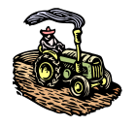

Module Title: - Basic Measurement and Calculation
LG Code: AGR IRD1 M08 LO (1-4) LG (4-7)
TTLM Code: AGR IRD1 TTLM 0822v3

August, 2021
Addis Ababa, Ethiopia
Table of Contents

INTRODUCTION TO MODULE 1
LO #1- STANDARD AND PRINCIPLE OF ESTIMATION 2
Instruction sheet- 1 2
Information Sheet - 1 3
Self-check 1 12
Operation Sheet -1 13
LAP TEST-1 14
LO #2- MEASUREMENT 15
Instruction sheet - 2 15
Information Sheet – 2 16
Self-Check – 2 30
Operation Sheet -2: 31
LAP TEST-2 32
LO #3- MEASUREMENT 33
Instruction sheet- 3 33
Information Sheet – 3 34
Self-Check – 3 42
LO #4- GPS 43
Instruction sheet-4 43
Information Sheet-3 44
Self-check 4 52
Operation Sheet -4 53
LAP TEST-4 55
REFERENCE MATERIALS 56
AKNOWLEDGEMENT 57

INTRODUCTION TO MODULE

This module covers the knowledge, skills, and attitudes required to perform simple measurement and calculation techniques, prepare materials, tools and equipment for measurements, and working with handheld GPS.

LG #4 | LO #1- STANDARD AND PRINCIPLE OF ESTIMATION

Instruction sheet- 1
This learning guide is developed to provide you the necessary information regarding the following content coverage and topics:
- Introduction to the module
- SI units and Unit conversion principles
- Standards and code of practice
- Irrigation terminology
- Tolerances and Accuracy in measurement
- Confirm and applying Work instruction
This guide will also assist you to attain the learning outcomes stated in the cover page. Specifically, upon completion of this learning guide, you will be able to:
- Apply SI units and Unit conversion principles
- Implement Standards and code of practice
- Identify Irrigation terminology
- Evaluate Tolerances and Accuracy in measurement
- Confirm and apply Work instruction
Learning Instructions:
- Read the specific objectives of this Learning Guide.
- Follow the instructions described below.
- Read the information written in the information Sheets
- Accomplish the Self-checks
- Perform Operation Sheets
- Do the “LAP test”

Information Sheet - 1

1.1 SI units and Unit conversion principles
SI unit is that it is an abbreviation of the French word Système International. The International System of Units (SI) is the metric system that is used universally as a standard for measurements. SI units play a vital role in scientific and technological research and development. It is made up of 7 base units which are used for defining 22 derived units. The SI units can be expressed either as standard multiple or as fractional quantities. These quantities are defined with the help of prefix multipliers with powers of 10 that range from 10⁻²⁴ to 10²⁴.
Having a standard unit system is important because it helps the entire world to understand the measurements in one set of unit systems. Following is the table with base SI units: There are seven basic units, from which other units are derived.
There are several SI units that used to express the different quantities. The quantities can be classified into two group’s i.e. base units and derived units.

SI Base Units: These are the fundamental units and are considered as the building blocks of the system. All the other units are derived from the SI Base units.
. The seven units along with their SI unit and symbol are given below:
Such units are:
Table 1.1 SI units
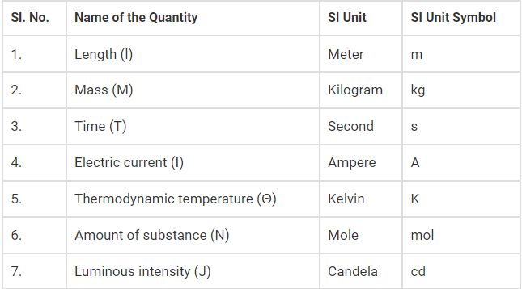
- SI Derived Units: The derived units are unlimited as they are formed by different operations on the base units. For derived units, the dimensions are expressed in terms of the dimensions of the base units. The derived units might also be expressed with the combination of base and derived units. Some of the most widely used SI derived units are:
- The SI unit of momentum (P) is kilogram meter per second (kg⋅ m/s)
- The SI unit of the magnetic field (B) is Tesla
- The SI unit of heat is the unit joule
- The SI unit of velocity is m/s
- The SI unit of force, weight is newton(N) which is kg⋅m⋅s⁻²
- The SI unit of Energy, Work, Heat is joule(J),which is kg.m².s⁻²

Why is the SI system important?
The following are the reasons why SI system is important:
- The SI system is based on precise and definite standards.
- The base used in the SI system is 10, which makes the conversion easier.
- Latin and Greek prefixes are used in the SI system and these refer to the numbers.
- Without the use of conversion factors, the SI units can be derived from one another.

Principle of unit conversion
- Unit conversion is a multi-step process that involves multiplication or division by a numerical factor, selection of the correct number of significant digits, and rounding
- Dimensional analysis is a technique used to convert measurements. For example, changing the magnitude of a SI quantity or converting between SI and non-SI units
- Conversion factor is an expression for the relationship between units that is used to change the units of a measured quantity without changing the value. Conversion ratio (or unit factor) always equals one (1), where the numerator and the denominator have the same value expressed in different units.
Steps to construct a unit conversion problem so one (or more) of the units cancel until only the desired unit remains:
- Identify the unit you have. These are the Starting Units.
- Identify the unit you want. These are the Desired Units.
- Identify appropriate unit conversion factor(s). These are the Linking (or Ratio) Unit(s). Use EXACT conversion factors whenever available.
- Cancel units and perform the math calculations (e.g., multiply, divide). Repeat the calculation (double check).
- Evaluate the result. Does the answer make sense?

  - Standards and code of practice
A code of practice: A code of practice is an instrument made under health and safety legislation that is designed to provide practical guidance about discharging your duty of care.it provide detailed information on how you can achieve the standards required under the work health and safety (WHS) laws. These do not replace the WHS laws, but codes of practice can be issued to help make understanding what you have to do a little easier. An inspector can refer to a code of practice when issuing an improvement or prohibition notice.
Under the Work Health and Safety Act 2011, codes of practice are admissible in court proceedings. Courts may regard a code of practice as evidence of what is known about a hazard, risk or control, and rely on it to determine what is 'reasonably practicable' in the circumstances to which the code relates.

It is recognized that equivalent or better ways of achieving the required work health and safety outcomes may be possible. For that reason compliance with codes of practice is not mandatory providing that any other method used provides an equivalent or higher standard of work health and safety than suggested by the code of practice.
Standard Code of practice in agriculture is dedicated to the farmers and agricultural workers who feed the world in the expectation that it will improve safety and health in agriculture. The main advantages of standard code of practice in agriculture includes:
- raise awareness of the hazards and risks associated with agriculture and how they can be effectively managed and controlled and accidents and diseases prevented
- prevent occupational accidents and diseases and improve the working environment in practice in individual agricultural enterprises
- encourage governments, employers, workers and other stakeholders to cooperate in their efforts to prevent accidents and diseases to workers in agriculture
- raise awareness of OSH issues concerning particular groups of workers, such as women, young workers and migrant workers
- promote more positive attitudes and behavior towards OSH in agriculture throughout the sector
- ensure that good workplace health and safety practices are applied to all workers in the workplace regardless of age or gender in accordance with the Discrimination
- provides guidance on the roles of the competent authorities, employers, workers and their organizations in promoting OSH

  - Irrigation terminology
The following terms and definitions are generally accepted as standards within the irrigation industry, regardless of state or region
- Irrigation: Application of water by artificial means to the soil for full growth of the crop in accordance with its requirement..
- Precipitation: For agricultural water purposes, the verb form of the term precipitation is the natural deposition on the earth's surface of water in the forms of rain, sleet, hail, snow, or mist (fog)
- Water: The liquid form of the compound H₂O that exists between ice (at temperatures below 0 degrees Centigrade or 32 degrees Fahrenheit) and vapor (at temperatures above 100 degrees Centigrade or 212 degrees Fahrenheit).
- Root Zone: The depth of soil profile occupied by the root system of the crop. The root zone is the portion of the soil profile that is generally considered to store water available for crop use.
- Deep Percolation, DP: Water, or the volume of water, that drains vertically through the bottom of the crop root zone such that it is lost with respect to potential crop use.
- Infiltration, z: The passage of water through the surface of the soil or the volume of water that passes into the soil profile over a unit irrigated area.
- Irrigation Uniformity, U: A measure of the spatial variability of applied or infiltrated waters over the field.
- Basins: Water is ponded on a flat or slightly graded field with bermed boundaries. Water is introduced onto the field surface in amounts equal to the water requirement and allowed to infiltrate into the root zone.
- Borders: Water is spread in sheet flow over a field from a head ditch or field ditches in a controlled flooding situation. Fields are either level or graded with either ditches or berms separating field units.
- Furrows: Gravity is used as the driving force which pushes water down shallow, closely spaced ditches to spread water over a field surface. Fields are generally sloped and open at the bottom end, allowing runoff to occur
- Drip: A category of trickle irrigation in which water is applied to the soil surface in discrete or continuous drops, or tiny streams through emitters
- Trickle: A low pressure system where water is distributed through closed pipelines. Water is applied directly, or very near to the soil surface, either above or below the ground surface,
- Sprinkler: A pressurized system where water is distributed through pipes to the field and applied through a variety of outlet sprinkler heads or nozzles
- Absorption Rate – The rate (or speed) at which soil will accept water. The speed at which water can penetrate or infiltrate the soil. Also called percolation or infiltration rate.
- Available Water – Water (measured in inch of water per inch of soil) that is actually accessible for the plant to use.
- Emitters – A small mechanical device (used in drip irrigation) to limit water flow to a drip or slow trickle. Discharge rate is usually expressed in gallons per hour rather than gallons per minute.
- Evaporation – The natural process of changing water into vapor. Evapotranspiration (ET) – The combination of water that has evaporated from the soil and transpired from the plant material. This is the measurement of total amount of water needed for plants to grow
- Pressure – The amount of energy available to move water through the irrigation components. Usually expressed in PSI.
- Surface irrigation: the application of water by the gravity from higher elevation to lower elevation
- Pressurized irrigation: application of water by pumping system.

  - Tolerances and Accuracy in measurement
Tolerance: refers to the total allowable error within an item. This is typically represented as a +/- value off of a nominal specification. Products can become deformed due to changes in temperature and humidity, which lead to material expansion and contraction, or due to improper feedback from a process control device. As such, it's necessary to take errors into consideration with regard to design values in the manufacturing and inspection processes. If these errors cannot be tolerated, most products will be deemed unacceptable. In this way, tolerance is meant to be used when setting the acceptable error range (the range within which quality can still be maintained) based on the design value with the assumption that variation will occur at any given step.
Example: When manufacturing a cylinder with a length of 50 mm and with a tolerance of ±0.1 mm. i.e. the acceptable range is between 49.9 mm to 50.1 mm).

Accuracy: represents a measurement's degree of correctness. Accuracy can be used in such expressions as, “This measurement system offers a high degree of accuracy, so it can be assumed that the expected measurement results can be obtained,” or, “The accuracy of the measurement system has decreased; calibration may be required.” When applied to the measurement process, accuracy is referred to as measurement accuracy. The accuracy of the measurement equipment can be used as in indicator in determining how accurate the results will be. Measurement systems with higher measurement accuracy are able to perform measurements more accurately.

Difference between Accuracy, Tolerance, Uncertainty, and Error
- Accuracy is the closeness of agreement between a measured quantity value and a true quantity value of a measured.
Example: Reading of 20 bar pressure can be in between 19.2 bar to 20.8 bar. Any reading between them is an accurate reading.
- Error is difference between measured value and reference value.
Error = Reading – Reference value
Correction = Reference value – Reading
Example: The Master Pressure Gauge reading is 20 bar. And UUC reading is 19.8 bar. Error = 20 – 19.2 = 0.2 bar.
- Tolerance is the maximum deviation that is accepted in the design of the user for its manufactured product or components.it is defined by user according of need of product.
Example: For automobile manufacturing, it needs a piece of metal of 10 mm with a tolerance of ± 0.01 mm. In this case measurement of the length of a piece of metal should have an accuracy of more than 0.01 mm.
N.B: Most of the time, people get confused between Accuracy and Tolerance and they are used as synonyms. But both terms are different. Accuracy is manufacture defined and Tolerance is User-defined.
- Uncertainty: is the quantification of the level of doubt we have about any measurement. Uncertainty means how certain or uncertain are we on measured readings. No reading is 100% accurate. It has some level of uncertainty present. Uncertainty includes many factors like Personal Skill, Resolution of Instrument, and Accuracy of Instrument, etc. We should combined Uncertainty and Error to find whether given instrument is within accuracy or within tolerance or out of accuracy or tolerance.

N.B: Every time while commenting on the result as ‘Pass and Fail’ of the instrument, the uncertainty of measurement should be considered.

Decision Rule?
- If the measurements are within the tolerance including the uncertainty, then it is a ‘pass’.
- If the measurements are outside the tolerance including the uncertainty, then it is considered ‘fail’ or ‘out of tolerance’.
- If one of the uncertainty limits is outside the tolerance while the other limits are inside the tolerance limit, then it is not a pass or a fail, we call it ‘Indeterminate’. The decision now is based on the user.
Example: the figure below shows the decision of measurements based on the upper limit and the lower limits. In the Figure below, Upper Limit and Lower Limit are Tolerance ranges.

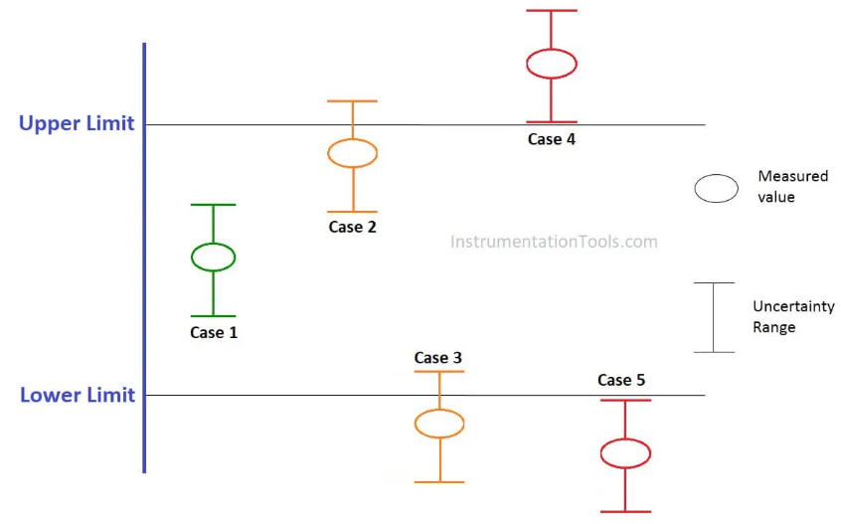
Fig 1.1: decision rules

- Case 1: Measured value including uncertainty range is within the tolerance limit. Hence, ‘PASS’
- Case 2: The measured value is within the tolerance limit but the uncertainty range partially lies outside the tolerance limit. Hence, ‘Indeterminate’
- Case 3: The measured value is outside the tolerance limit also uncertainty range partially lies outside the tolerance limit. Hence, ‘Indeterminate’
- Case 4: The measured value is outside the tolerance limit also uncertainty range lies outside the tolerance limit (Upper Limit). Hence, ‘FAIL’
- Case 5: The measured value is outside the tolerance limit also uncertainty range lies outside the tolerance limit (Lower Limit). Hence, ‘FAIL’

  - Work instruction
Work Instructions are documents that clearly and precisely describe the correct way to perform certain tasks that may cause inconvenience or damage if not done in the established manner. That is, describe, dictate or stipulate the steps that must be followed to correctly perform any specific activity or work.
Work instructions: describe the correct way to perform a certain task or activity. Each task is part of a larger process, so every step must be followed accordingly in order for the task to be performed properly, otherwise it will affect other aspects of the business.

Work instructions are sometimes called work guides, job aids, or standard operating procedures. However, work instructions actually differ from the three. It is more detailed than a standard operating procedure and it is mandatory, unlike a work guide. Meanwhile, work instructions are just a category under job aids.

What are the benefits of a work instruction?
- Help reduce risk and prevent errors or accidents. Most work instructions are prepared after multiple refinements, which means that they can establish the safest way to do a job correctly
- Save time in the long run. Work instructions help train employees thoroughly so there’s less chance of them wasting time correcting mistakes later on.
- facilitate the continuous improvement of processes and systems so workers can do their jobs better over time
- Providing a reference for correct and ideal scenarios, work instructions help with workers’ problem-solving skills and serve as a guide for how workers can execute corrective actions.

What should be included in a work instruction?
The structure and content of work instructions vary depending on the job. However, most work instructions consist of these essential parts:
- Title and short description of the task
- Objectives or expected results
- Purpose of the task
- Scope of the task
- Tools or skills required
- Safety requirements
- Step-by-step instructions for the task
- Expected outcome for each step

Self-check 1 | Written test

Name: ______________________________________ ID: ______________Date: _________
Directions: Answer all the questions listed below.
Test I: Choose the best answer (1point each)
      - Which of the following measurements has SI base unit?
  - Force B. length C. velocity D. energy
      - One of the following is NOT the advantage of standard code of practice
- Raise awareness of hazard and risk C. provide clear work instruction
- Encourage workers D. develop negative attitude and behavior towards OHS
      - The amount of water in a crop root zone that can be easily extracted by the crop is called?
- Hygroscopic water C. soil water content
- Readily available water D. gravitational water
Test II: Short Answer Questions
            - Write the steps to construct a unit conversion problem.(5pts)
            - Explain the difference between accuracy, tolerance, error and uncertainty? (4pts)
            - What is the work instruction? Write its advantage.(5pts)
Note: Satisfactory rating – 15 points above Unsatisfactory - below 15 points
You can ask your teacher for the copy of the correct answers

Operation Sheet -1
  - Techniques of measuring accuracy and error in pressure measurement
- Tools and equipment Pump for lifting water
- Pipe for flow of water
- Pressure gauge
- Notebook
- Calculator

- Procedures of measuring accuracy and error in pressure measurement
- Prepare and adjust pump for lifting water from the river
- Connect the flow pipe one end with the delivery of the pump and the other end to the pressure measuring guage
- Read pressure of the flow water in bar and repeat the reading until constant readings observed
- Take maximum and minimum readings as a range of acceptancy region
- Decide all readings are in between the range as accurate readings
- Determine the measurement error as error = reading – reference value

  - Techniques of measuring accuracy and error in pressure measurement
- Tools, Materials and Equipments
- Tap
- Ruler
- Caliper
- Compass
- Notebooks and Calculator
- Techniques/Steps or Method of Measurement
- Prepare tools and equipments for measurement
- Select objects to be measured
- Measure the length, area and volume of the object
- Decide about measurement accuracy, error and corrections.
LAP TEST-1 | Performance Test

Name: _________________________________________________ID: ________________ Date: _____________________________
Time started: ________________________ Time finished: ________________

Instructions: Given necessary templates, tools and materials you are required to perform the following tasks within 1 hour. The project is expected from each student to do it.

Task 1.1: perform measuring the accuracy and measurement errors
Task 1.2: perform measurement and calculations length, area and volume as provided by your instructor

LG #5 | LO #2- MEASUREMENT

Instruction sheet - 2
This learning guide is developed to provide you the necessary information regarding the following content coverage and topics:
- definition and Purpose of measurement
- measurement and calculation equipment
- ruler or tape measurement
- Geometrical shape measurement
- Canal and Irrigation field measurement
This guide will also assist you to attain the learning outcomes stated in the cover page. Specifically, upon completion of this learning guide, you will be able to:
- Understand definition and Purpose of measurement
- Identify and Prepare measurement and calculation equipment
- Perform ruler or tape measurement
- Apply Geometrical shape measurement
- Perform Canal and Irrigation field measurement
Learning Instructions:
- Read the specific objectives of this Learning Guide.
- Follow the instructions described below.
- Read the information written in the information Sheets
- Accomplish the Self-checks
- Perform Operation Sheets
- Do the “LAP test”

Information Sheet – 2

2.1 Definition and Purpose of measurement
Measurement is the process of associating numbers with physical quantities and phenomena. Measurement is fundamental to the sciences; to engineering, construction, and other technical fields; and to almost all everyday activities. For that reason the elements, conditions, limitations
Measurement of any kind is a matter of determining how much or how little, how great or how small, how much more than or how much less than. Measurement involves the process of quantification. Quantification indicates to what extent a particular attribute is present in a particular object.

Measurement is important to measure certain things right, distance, time, and accuracy are all great things to measure. By measuring these things or in other words, by taking these measurements we can better understand the world around us.

According to the different researchers measurement have the following definitions:
- R.N. Patel: Measurement is an act or process that involves the assignment of numerical values to whatever is being tested. So it involves the quantity of something.
- James M. Bradefield: Measurement is the process of assigning symbols to the dimension of phenomenon in order to characterize the status of phenomenon as precisely as possible.
- J.P. Guilford: Measurement as the ‘assignment of numerals to objects or events according to certain rules.
- Norman E. Gronlund: Measurement results are some score or numerical value and quantitative descriptions of the pupils.

Types of Measurement
- Qualitative Measurement: Perceiving the characteristics of an object, person or activity in the form of a quality is called qualitative measurement; for example, describing the purity and impurity of irrigation water is qualitative measurement.
- Quantitative Measurement: measuring the characteristics of an object, person or activity in the form of quantity is called quantitative measurement; for example, the volume of water, the area of canal, and the root depth is quantitative measurement.

Difference between Qualitative and Quantitative Measurement
- The bases of qualitative measurement are often norms; and those of quantitative measurement are units.
- The norms of qualitative measurement are generally not universal, while the units of quantitative measurement are universal.
- There is never a situation of zero (0) in qualitative measurement
- Qualitative measurement has no mathematical relationship but quantitative measurement has mathematical relationship
There are 7 basic units of measurement?
- Length – meter (m)
- Time – second (s)
- Amount of substance – mole (mole)
- Electric current – ampere (A)
- Temperature – kelvin (K)
- Luminous intensity – candela (cd)
- Mass – kilogram (kg)
- Purpose of measurement: there are two common reasons why measurements are made, being either an ongoing monitoring measurement or a more specific investigative one.
- Monitoring measurement: act as indicators of the general health of the process. Several considerations should be taken into account when identifying monitoring measurements:
- The measurement should identify the presence of problems, but not necessarily the cause
- The measurement should not be intrusive or upset the process in any way
- Each measurement should be repeatable and made under similar conditions
- It should be possible for measurements to be made on a regular basis. This is easy where the process repeats frequently
- As it is made frequently, the measurement should be relatively inexpensive and easy to perform.
- Investigative measurement: are made specifically to find out more about known problems or causes. This may be likened to specific medical tests such as measuring blood pressure. The limited nature of an investigative measurement means that it may differ from monitoring measurement in several ways:
- The measurement may be intrusive.
- The cost of measurement is not particularly important.
- Many different measurements may be made, where each measurement covers a specific area in more detail.

2.2 Measurement and calculation equipment
A measuring instrument is a device to measure a physical quantity. In the physical sciences, quality assurance, and engineering, measurement is the activity of obtaining and comparing physical quantities of real-world objects and events. These are some of the things that we measure in everyday living.
Time, Speed, Money Distance or length, Temperature, Area, Mass, Volume and Capacity etc.
The following units are most commonly used and it is important to remember their symbols (or shortened form):
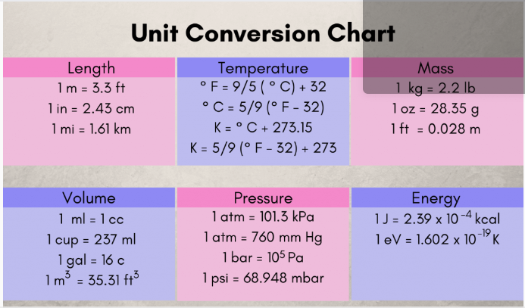

Discover the different types of measuring tools you'll need for measuring distances, dimensions, angles, planes, water pressure, temperature, time, speed, miles, ingredients, and blood sugar level.

The following instruments are used to measure the daily activities:
  - Calipers: are used to accurately measure the distance between two sides of something. It is a simple measuring tool that is very important when you need accurate data about an object. . It is made from stainless steel and will always give you proper data.
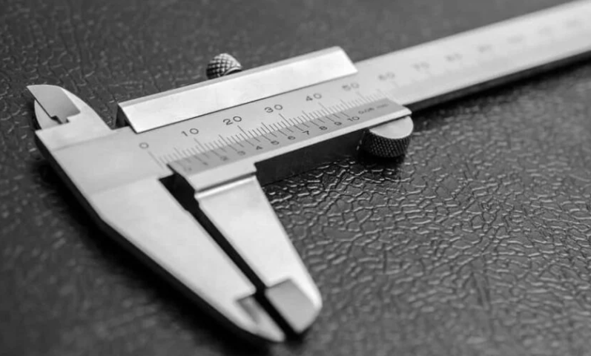
Fig 2.1: Caliper to measure distance

  - Ruler: Everyone knows how a ruler works, as you simply line it up with something to determine how long it is. Whether it is an architect using a ruler to help to design a building, or a construction worker determining if his work is straight,
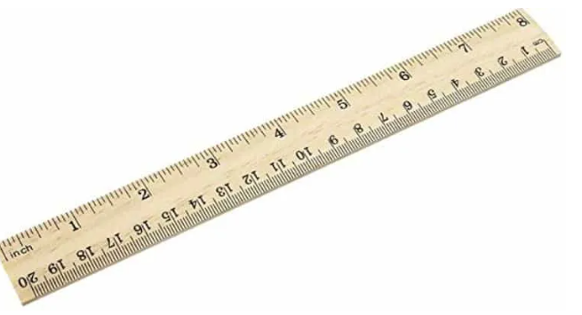
Fig 2.2: Ruler to measure length
  - Compass: A compass is going to be a very important tool for many different jobs. It is used to draw circles and can be useful for determining the distance between two points on a map. This is commonly used in shipbuilding as well as carpentry
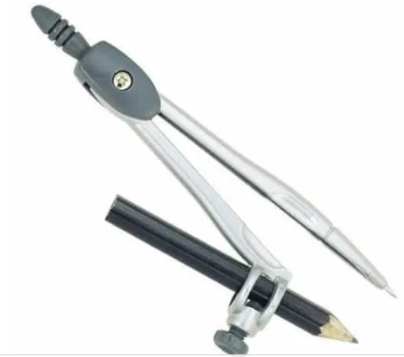
Fig 2.3: Compass for drawing circle

  - Square: It is going to come in handy when you are framing and when you need to find right angles. Everything from cutting lumber to making markings can be aided with the use of a square
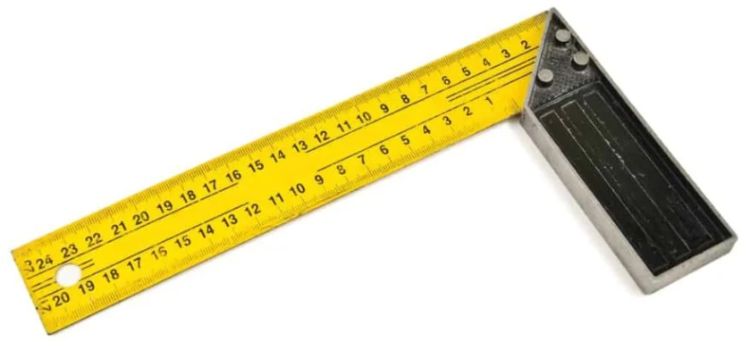
Fig 2.4: Squares for measuring 90 degree/corner

  - Measuring tap: is a simple tool that will help you to measure the length of something. You can also measure how wide an object is and can generally figure out all of the information that you will need to know. Most measuring tapes come with a handy switch that will lock the tape into place.
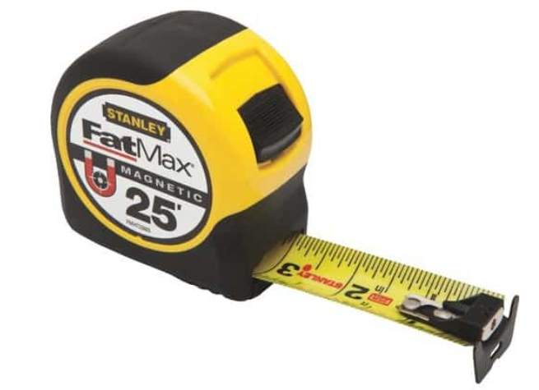
Fig 2.5: Measuring tap for measuring distance

  - Level: This is a measuring tool that can determine if everything is level and balanced. There are many different styles of levels on the market too. This model is a standard beam level, so all you need to do is set it on top of something and then look at the vial to determine if you are level or not.
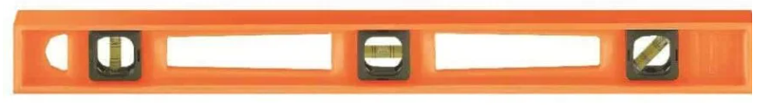
Fig 2.6:Measuring level

  - Pressure guage: Pressure gauges are a really common and crucial measuring tool. These types of gauges are used in many different things. The measurement tool being shown here is a water pressure gauge. It determines the pressure of the water that you’re using and is commonly attached to a hot water heater of some sort.
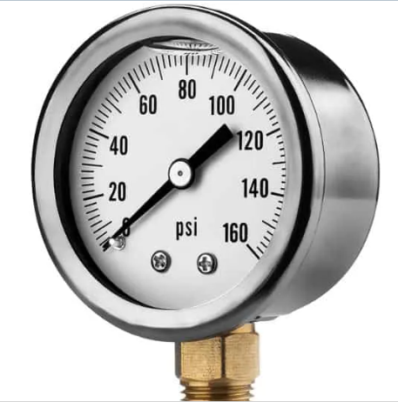
Fig 2.7: Water measuring gauge

10. Thermometers: are tools used to measure the temperature. They can be used to measure the temperature outside but you may also use thermometers to measure body temperature.
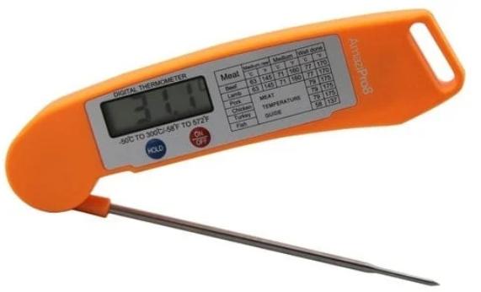
Fig 2.8: Thermometer for measuring temperature
11. Tensiometer: a device for measuring soil water tension. It consists of a cylindrical pipe about one inch in diameter with a porous ceramic cup attached to one end and a vacuum gauge attached to the other (see Figure 2.9, below).
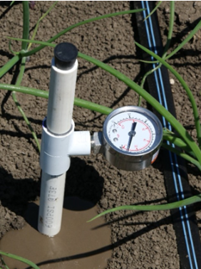
Fig 2.9: Tensiometer for measuring soil moisture

2.3. Ruler or tape measurement
Tape measure or measuring tape: is a flexible ruler used to measure size or distance. It consists of a ribbon of cloth, plastic, fiber glass, or metal strip with linear measurement markings. It is a common measuring tool. Its design allows for a measure of great length to be easily carried in pocket or toolkit and permits one to measure around curves or corners. Today it is ubiquitous, even appearing in miniature form as a keychain fob, or novelty item. Surveyors use tape measures in lengths of over 100 m.
There are two basic types of tape measures with cases. Spring return pocket tape measures and long tape measures:
- Spring return pocket tape measures: will generally fit in a pocket. They are small; the case is up to about three inches across. The tape is returned to the case by a spring mechanism. Pocket tape measures have a tape 1 to 15 feet (0.30 to 4.57 m) in length and ¹⁄₄ to ³⁄₄ inch (6.4 to 19.1 mm) across( refer fig 12).
- Long tape: These are cased tape measures with tapes of 25, 50, 75, 100, 200, 300, and even 500 feet in length, designed for engineers and builders. Because surveying was usually done in rods, surveyors use long tapes of 33 feet (2 rods), and 66 feet (4 rods). Surveyors also used 49+¹⁄₂ feet of a 50-foot tape for 3 rods and 99 feet of a 100-foot tape measure for 6 rods. Long tapes, instead of being returned by a spring, were usually returned by hand crank.
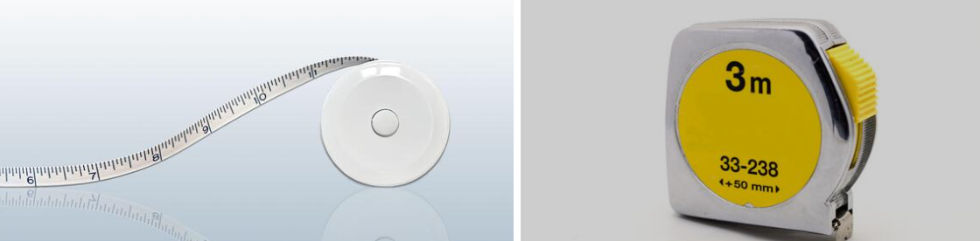
Fig 2.10: Spring return pocket tape measures

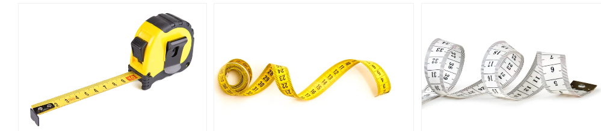
Fig 2.11: long tap

2.4. Geometrical shape measurement
Geometrical shapes are the figures which represent the forms of different objects. Some figures are two-dimensional, whereas some are three-dimensional shapes. The two-dimensional figures lie on only the x-axis and y-axis, but 3d shapes lie on the x, y and z axes. The z-axis shows the height of the object. As we have already discussed in the introduction, there are different shapes defined in geometry.
To draw or design any of these figures start with a line or a line segment or a curve. Depending upon the number and arrangement of these lines, we get different types of shapes and figures like a triangle, a figure where three line segments are connected, a pentagon (five-line segments) and so on. But every figure is not a complete figure.

Types and Properties of Geometric Shapes
- Triangles: Triangle is a polygon, which is made of three sides and consists of three edges and three vertices. Also, the sum of its internal angles equals to 180º.
- Circle: Locus of all points at a fixed distance from a reference central point is called a Circle
- Square: Square is a quadrilateral where all the four sides and angles are equal and the angles at all the vertices are equal to 90° each.
- Rectangle: A quadrilateral has two pairs of opposite sides equal in length and interior angles are at the right angles.
- Parallelogram: A parallelogram is a quadrilateral with two pairs of parallel sides and opposite angles are equal in measure.
- Polygons: These are made up of line segments and no curves. They are enclosed structures based on different lengths of sides and different angle
Area calculation for different geometric shapes
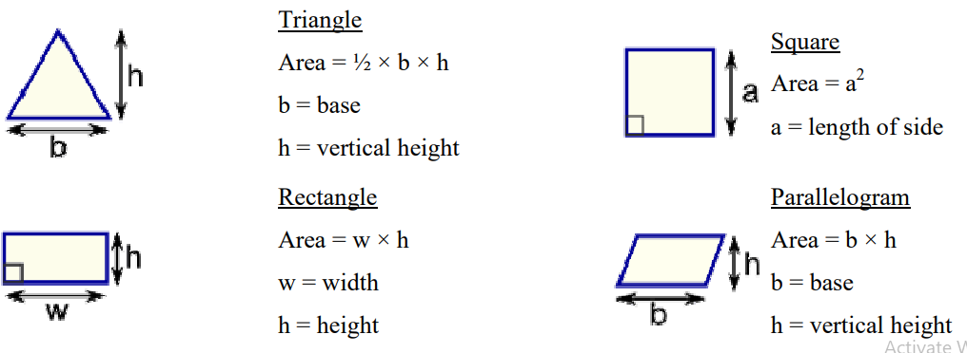
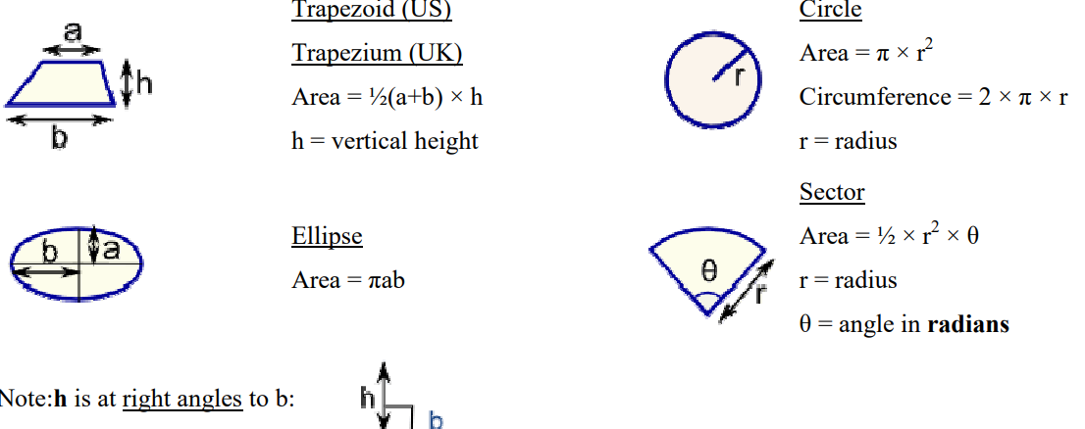

Fig 2.12: Area formula for geometric shapes

- Distance measurement: it refer to the space between two stationary points (for instance, a person's height is the distance from the bottom of his or her feet to the top of his or her head) or can refer to the space between the current position of a moving object and its starting location. Most distance problems can be solved with the following equations.
Distance (d) = Savg × t
Where d is distance, Savg is average speed, and t is time, or using
d = √ ((x2 - x1) 2 + (y2 - y1) 2), where (x1, y1) and (x2, y2) are the x and y coordinates of two points.
- Volume Calculations: Some of the formulas to find out volumes of basic shapes are:

Table 2.1: Volume formulas for different geometric shapes
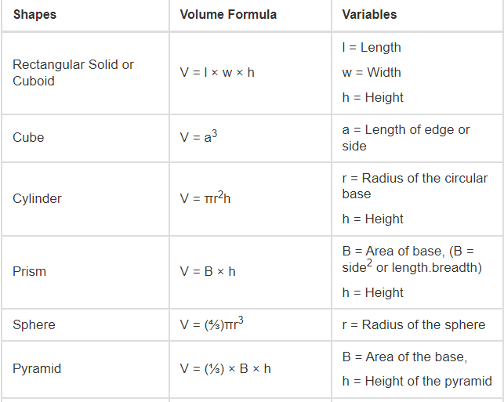
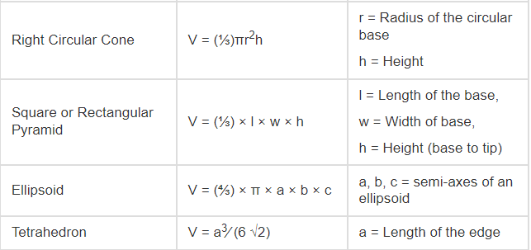
2.5. Canal and Irrigation water measurement
A canal is an artificial channel that is constructed to carry water to the fields to perform irrigation. The water is taken either from the river, tank or reservoirs. The canals can be constructed either by means of concrete, stone, brick or any sort of flexible membrane which solves the durability issues like seepage and erosion.
Managing our water resources begins with knowing how much water is being used for irrigation and comparing that with how much the crop uses. This can help identify water losses and improve application efficiency, which can reduce pumping costs and protect or conserve natural resources.
- Discharge measurements: Discharge is the volume of water moving down a stream or river per unit of time, commonly expressed in cubic feet per second or gallons per day. In general, river discharge is computed by multiplying the area of water in a channel cross section by the average velocity of the water in that cross section. The discharge in the lined canal can be efficiently determined by the estimated mean velocity and the cross-sectional area.
Discharge = area x velocity.
Methods used to measure water discharge in irrigation canal can be grouped in to:-
- Direct method /volume method.
- Velocity area method
- Use of weirs and orifices
1. Direct method: in this method the water is collected in a container of known volume for a definite period of time. Only a bucket of known volume and a stop watch are required.
Discharge = Volume of bucket (Lit)
_______________________________
Time required to fill up the bucket (sec)

- Velocity area method: - the rate of flow passing a point in a pipe, a ditch or channel can be determined by multiplying the cross sectional area of water flow section at right angle to the direction of flow by the average velocity of water. Then, discharge is calculated as
Q=A.V
Where, Q = discharge in L/sec or m³/sec
A = cross sectional area of the channel in m²
V = Flow velocity in m/sec

- Use of weirs and orifices: Orifice plates are variable-pressure, constant-area flowmeters. Rotameters are constant-pressure, variable-area flowmeters. Weirs are variable-pressure, variable-area flowmeters. As one might expect, the mathematical functions describing each of these flowmeter types is unique!

The first form of open-channel flowmeter is the weir, which is nothing more than a dam obstructing passage of liquid through the channel. Three styles of weir are shown in the following illustration; the rectangular, Cippoletti, and V-notch:
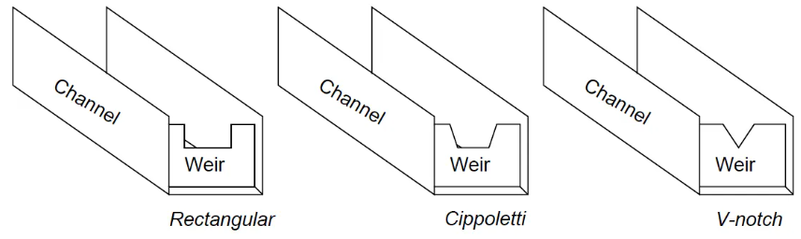
Fig 2.13: Types of weir for flow measurement

Dependence of notch area on flow rate creates a very different relationship between flow rate and liquid height (measured above the crest) than the relationship between flow rate and differential pressure in an orifice plate.

Self-Check – 2 | Written test

Name: ______________________________________ ID: ______________Date: _________
Directions: Answer all the questions listed below.
Test I: Choose the best answer (2point each)
    - The process of associating numbers with physical quantities and phenomena’s is called_______
- Calculation B. measurement C. Evaluation D. none
    - Which of the following is NOT measured by numerical values?
- time B. money C. attitude D. volume
    - One of the following is different from the others?
- Tensiometer B. ruler C. measuring tape D. caliper
Test II: Short Answer Questions
- What are the purpose of measurement? (3pts).
- List the different geometric shapes and state the formulas to calculate their areas and volume?(5pts)
- List and explain method of flow measurements in the canal? (6pts).
- Write the procedure to measure flow in the canal using weir and orifice method(5pts)

Note: Satisfactory rating – 20 points above Unsatisfactory - below 20 points
You can ask your teacher for the copy of the correct answers.

Operation Sheet -2:

  - Techniques of measuring accuracy and error in pressure measurement

- Tools and equipments
- Known volume of bucket
- Stop watch
- Note book
- calculator
- Procedures/Steps/Techniques
- Select narrow and straight canal cross section
- Buried the known volume of bucket at the canal bottom
- Record the time taken to fill the bucket
- Repeat the procedure at list three times and evaluate average time
- Calculate the flow of water in the canal as the known volume the bucket per the average time taken to fill the bucket.

  - Techniques of measuring accuracy and error in pressure measurement
- Tools, Materials and Equipments
- Tap
- Stopwatch
- Floating material
- Notebooks
- Calculator
- Techniques of method of measurement
- Choose a suitable straight reach with minimum turbulence (ideally at least 3 channel widths long).
- Mark the start and end point of your reach.
- If possible, travel time should exceed 20 seconds.
- Drop your object into the stream upstream of your upstream marker.
- Start the watch when the object crosses the upstream marker and stop the watch when it crosses the downstream marker.
- You should repeat the measurement at least 3 times and use the average velocity discharge calculation using as cross sectional area times velocity of flow.

LAP TEST-2 | Performance Test

Name: _________________________________________________ ID: ________________ Date: _____________________________
Time started: ________________________ Time finished: ________________
Instructions: Given necessary templates, tools and materials you are required to perform the following tasks within 1 hour. The project is expected from each student to do it.
Task – 2.1: perform measuring the flow of water in the canal using direct method
Task 2.2: perform measurement of discharge using velocity area method

LG #5 | LO #3- MEASUREMENT

Instruction sheet- 3

This learning guide is developed to provide you the necessary information regarding the following content coverage and topics:
- Method of calculation
- Calculating Scale and grade in material calculation
- Percentage, Ration and Frication
- Evaluating Area and Volume Calculation in irrigation
- Error estimation
This guide will also assist you to attain the learning outcomes stated in the cover page. Specifically, upon completion of this learning guide, you will be able to:
- Determining Method of calculation
- Calculating Scale and grade in material calculation
- Performing Percentage, Ration and Frication
- Evaluating Area and Volume Calculation in irrigation
- Applying Error estimation
Learning Instructions:
- Read the specific objectives of this Learning Guide.
- Follow the instructions described below.
- Read the information written in the information Sheets
- Accomplish the Self-checks
- Perform Operation Sheets
- Do the “LAP test”

Information Sheet – 3

3.1 Method of calculation
Calculation: is something that you think about and work out mathematically. Calculation is the process of working something out mathematically. Calculation technique or model is used to analyses the interaction of design options with fixed constraints. Such a process is necessarily iterative, with adjustments made to parameters over which control is possible, until an optimum design solution is achieved. A calculation is a deliberate process that transforms one or more inputs into one or more results. The following methods are used to estimating errors:
- Basic Formula.
- Ratio and Proportion.
- Fractional Equation.
- Basic Formula: basic calculation is the addition or subtraction of numbers. Basic calculations provides training material for situations in which basic calculation skills need to be improved. It offers exercises at upper primary – lower secondary level. It is suitable for use in groups, but can also be used as self-tuition material.
- Ratio and Proportion: A ratio is an ordered pair of numbers a and b, written a / b where b does not equal 0. A proportion is an equation in which two ratios are set equal to each other. The comparison or simplified form of two quantities of the same kind is referred to as a ratio. This relation gives us how many times one quantity is equal to the other quantity. In simple words, the ratio is the number that can be used to express one quantity as a fraction of the other ones.

Key Points to Remember:
- The ratio should exist between the quantities of the same kind
- While comparing two things, the units should be similar
- There should be significant order of terms
- The comparison of two ratios can be performed, if the ratios are equivalent like the fractions
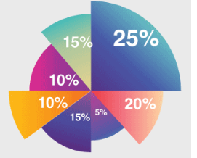
Fig 3.1: Diagrams for ratio and proportion

- Fractional Equation: A fractional equation is an equation involving fractions which has the unknown in the denominator of one or more of its terms. The Cross-Product property can be used to solve fractional equations. If AB=CD then A⋅D=B⋅C

3.2. Scale and grade in material calculation
- Scale: is a ratio that represents the relationship between the dimensions of a model and the corresponding dimensions on the actual figure or object. It helps in representing real-world things on paper with comparatively smaller dimensions. Scale is mostly used in maps and blueprints used for the construction of buildings. For construction material scale used to calculate the proportion of ingredients during mixing.
- Grading: is the act of classifying something on a scale by quality, rank, size, or progression, etc.
- Aggregate Grading: is a measure of how well distributed the sizes of the particles in an aggregate are. A well graded aggregate will have a good range of particle sizes and will have a fair representation from every size of particle.
- Grade of concrete: is defined as the minimum strength the concrete must possess after 28 days of construction with proper quality control. Grade of concrete is denoted by prefixing M to the desired strength in MPa.

There are two main gradation types categorized by aggregate morphology, namely continuous gradation and gap gradation, or three types by air voids, namely dense gradation, open gra- dation and semi-open gradation.

What is the necessity of grading?
Additionally, grading provides students with feedback on their own learning, clarifying for them what they understand, what they don't understand, and where they can improve. Grading also provides feedback to instructors on their students' learning, information that can inform future teaching decisions. For example, there are seven grade of concrete. Namely: M5, M10, M15, M20, M25, M30 and M35.

3.3. Percentage, Ration and Frication
- Percentage: a relative value indicating hundredth parts of any quantity. One percent (symbolized 1%) is a hundredth part; thus, 100 percent represents the entirety and 200 percent specifies twice the given quantity. Percentage. Multiply the number by 100. If you are required to convert a decimal number like 0.57 to a percentage, you simply multiply it by 100. That is, 0.57 x 100 = 57. Therefore, 0.57 as a percentage equals 57%.
We use percentages to make calculations easier. It is much simpler to work with parts of 100 than thirds, twelfths and so on, especially because quite a lot of fractions do not have an exact (non-recurring) decimal equivalent.
- Ratio: A relationship between two quantities, normally expressed as the quotient of one divided by the other. For example, if a box contains six red marbles and four blue marbles, the ratio of red marbles to blue marbles is 6 to 4, also written 6:4. A few basic types of ratios used in ratio analysis are profitability ratios, debt or leverage ratios, activity ratios or efficiency ratios, liquidity ratios, solvency ratios, earnings ratios, turnover ratios, and market ratios.

Ratios occur frequently in daily life and help to simplify many of our interactions by putting numbers into perspective. Ratios allow us to measure and express quantities by making them easier to understand. Examples of ratios in life: The car was traveling 60 miles per hour, or 60 miles in 1 hour.
- Fraction: Fractions are the numerical values that are a part of the whole. A whole can be an object or a group of objects. If a number or a thing is divided into equal parts, then each part will be a fraction of the whole. A fraction is denoted as a/b, where a is the numerator and b is the denominator.
In Math’s, there are three major types of fractions. They are proper fractions, improper fractions and mixed fractions. Fractions are those terms which have numerator and denominator.

3.4. Area and Volume Calculation in irrigation
- Volume: The amount of water your crop needs is measured as a volume. Knowing the volume of water available and the seasonal water requirements of the crop you want to grow will help you estimate your cropping area.
- Area: To calculate the area watered per irrigation: multiply the number of rows being watered by the row spacing (meters) and the block length (meters), then divide by 10,000 to get an area in hectares.
- Flow rate: The flow rate onto the farm limits how quickly water may be applied, and so how much area can be irrigated in a given time.
- Flow from pumps: is generally fixed, but variations in water levels, pump condition and pump speed can change it.

Introduction to irrigation management, Water Wise on the Farm and The available flow from a district supply system can vary with changes to supply levels, outlet sizes, and location on the system, so it is especially important to consider what flow is available during peak demand periods. Your system needs to be designed and managed to account for these limitations.
To determine how much water (volume) you need to irrigate your field you need to know:
- soil RAW
- the area to be irrigated,
- the efficiency of your supply component and
- Field application component.
Flow required per irrigation (shift) = soil water volume × area ÷ efficiency Calculation.
Area that may be irrigated per shift = flow × efficiency ÷ soil water volume
The exact irrigation water volume = gross depth of irrigation * the irrigated area, if the gross irrigation depth = 70 mm and the irrigated area = 1 hectare then,
Volume = (7 cm/ 100) * 1 ha * 10,000 = 700 cubic meter / ha.

The irrigation rate unit is unit depth* (unit area) / time so if the irrigation rate = 7mm per hour and the gross irrigation depth = 70 mm the time of irrigation = 70 mm / 7 mm/hr = 10 hours.
This the time of supplying irrigation water to the field if the surface irrigation system was suitable to the soil properties. For high frequency irrigation systems (as trickle or sprinkler), the specific hydraulics of the system was affected the design assumptions.

Simple calculations for furrow irrigation:
- Average inflow rate (L/sec)
- Area watered per irrigation (ha)
- Volume applied per irrigation (ML)
- Volume applied per hectare (ML/ha)
- Compare application to crop use
Some simple measurements and calculations are valuable when evaluating a furrow irrigation system. These measurements and calculations provide a baseline and can be used to evaluate the effect of any changes.
- Average inflow rate (L/sec): The simplest way to measure the inflow rate is with a bucket and stopwatch. Fill a bucket with water at the cup and record the volume (L) and time (sec). Take 3-4 readings per row over four or more rows, the more the better. Calculate the average volume and time for each row. Then calculate the average inflow rate (L/sec) for each row by dividing the average volume by the average time.
Calculate the average inflow rate across all measured rows by adding the inflow rates for each row and dividing by the number of rows.

- Area watered per irrigation (ha): To calculate the area watered per irrigation: multiply the number of rows being watered by the row spacing (metres) and the block length (metres), then divide by 10,000 to get an area in hectares. Area (ha) = (row spacing x no. rows per irrigation set x row length) / 10,000
- Volume of water applied per irrigation (ML): The total volume of water applied during an irrigation event in mega liters (ML) is:
The inflow rate (L/sec) multiplied by 3,600 (to convert to L/hr) by the number of rows being irrigated by the irrigation duration (hrs) divided by one million. ML
= (inflow rate x 3,600 x rows watered x irrigation duration) / 1,000,000
- Volume applied per hectare (ML/ha): To calculate the volume of water applied per hectare, divide the total volume of water applied by the area being irrigated.
ML/ha = total volume (ML) / area (ha)
- Compare volume applied to crop water use: Crop water use (mm) can be calculated using Water Sense or crop factors. The crop water use can then be compared to the amount of water applied by irrigation (mm) to see if the irrigation is supplying sufficient water or an excess amount:
- If the irrigation application efficacy is greater than 1, the amount of water being applied by irrigation is more than is being used by the crop.
- If the number is less than 1, then the irrigation is not replacing the water used by the crop.
Water that is applied in excess of crop use can be lost through run-off or deep drainage.
Irrigation water applied (mm/ha) = ML/ha x 100 Crop water use (mm) = days between irrigations x daily water use (mm/day)
Irrigation application efficacy = applied water / crop water use

3.5 Error estimation
Error: The difference between an estimated value and the true value of a parameter or, sometimes, of a value to be predicted. When attempting to estimate the error of a measurement, it is often important to determine whether the sources of error are systematic or random. A single measurement may have multiple error sources, and these may be mixed systematic and random errors.
- To identify a random error, the measurement must be repeated a small number of times. If the observed value changes apparently randomly with each repeated measurement, then there is probably a random error. The random error is often quantified by the standard deviation of the measurements. Note that more measurements produce a more precise measure of the random error.
- To detect a systematic error is more difficult. The method and apparatus should be carefully analyzed. Assumptions should be checked. If possible, a measurement of the same quantity, but by a different method, may reveal the existence of a systematic error. A systematic error may be specific to the experimenter. Having the measurement repeated by a variety of experimenters would test this type of error.

Estimation of Errors - Key takeaways
You can estimate the errors of a measured value by comparing it to a standard value or reference value. The error can be estimated as an absolute error, a percentage error, or a relative error.
The absolute error measures the total difference between the value you expect from a measurement (X0) and the obtained value (Xref), equal to the absolute value difference of both Abs = | Xo-Xref |.

Example: Imagine you calculate the length of a piece of wood. You know it measures 2.0m with a very high precision of ± 0.00001m. The precision of its length is so high that it is taken as 2.0m. If your instrument reads 2.003m, your absolute error is | 2.003m-2.0m | or 0.003m

The relative and percentage errors measure: the fraction of the difference between the expected value and the measured value. In this case, the error is equal to the absolute error divided by the expected value rel = Abs / Xo for the relative error, and divided by the expected value and expressed as a percentage for the percentage error per = (Abs / Xo) * 100. You must add the percentage symbol for percentage errors.

Example: Using the figures from the previous example, the relative error in the measurements is | 2.003m-2.0m | abs| 2.0m | or 0.0015. As you can see, the relative error is very small and has no units.
To estimate the error in a measurement, we need to know the expected or standard value and compare how far our measured values deviate from the expected value. The absolute error, relative error, and percentage error are different ways to estimate the errors in our measurements. Error estimation can also use the mean value of all the measurements if there is no expected value or standard value.

Here, we are going to distinguish between estimating the absolute error, the relative error, and the percentage error:
- To estimate the relative error, we need to calculate the difference between the measured value x0 and the standard value xref and divide it by the total magnitude of the standard value Xef.
- To estimate the percentage error, we need to calculate the relative error and multiply it by one hundred. The percentage error is expressed as ‘error value’%. This error tells us the deviation percentage caused by the error.

Frequently Asked Questions about Estimation of Errors
- What is the best fit line?: The line of best fit is the line that best approaches all data points in a plot, thus serving as an approximation of a linear function to the data.
- What does the term ‘error estimation’ mean? The term ‘error estimation’ refers to the calculation of errors introduced when we measure and use values that have errors in calculations or plots.

Self-Check – 3 | Written test

Name: __________________________________________ ID: ____________Date: _________
Directions: Answer all the questions listed below.
Test I: Choose the best answer (2point each)
  - The formula written as a/b for ordinary numbers a and where, b different from zero refers to:
    - Basic formula B. Ration/Proportion C. fractional formula D. None
  - The difference between an estimated value and true value of a parameter is called ________
    - Accuracy B. uncertainty C. Error D. correction
Test II: Short Answer Questions
- Why we make calculation?(2pts)
- Define best fit line and error estimation(4pts)
- List the point you know determine how much water needed to the command area?(5pts)
- Explain:
- Absolute Error (2pts).
- Percentage Error (2pts).
- Relative Error (2pts).

Note: Satisfactory rating –15points above Unsatisfactory - below 15 points
You can ask your teacher for the copy of the correct answers.

LG #4 | LO #4- GPS

Instruction sheet-4
This learning guide is developed to provide you the necessary information regarding the following content coverage and topics:
- GPS Setting
- Taking track line and track point
- Perform reading and measurement data
- Loading data
This guide will also assist you to attain the learning outcomes stated in the cover page. Specifically, upon completion of this learning guide, you will be able to:
- Perform GPS Setting
- Take track line and track point
- Perform reading and measurement data
- Undertake Loading data
Learning Instructions:
- Read the specific objectives of this Learning Guide.
- Follow the instructions described below.
- Read the information written in the information Sheets
- Accomplish the Self-checks
- Perform Operation Sheets
- Do the “LAP test”

4.1 GPS

Information Sheet-3
What is GPS? Global Positioning System, is a satellite-based system that allows anyone with a GPS receiver to find their exact position anywhere in the world. It is used as an aid in navigation, for example in airplanes, in boats and by hikers. The GPS receiver uses the signals from the satellites to calculate its latitude, longitude and (sometimes) elevation. Most receivers also have the capability to store locations (known as waypoints), Sequences of locations that make up a planned route and a track log or track of the receivers movement over time. Waypoints, routes and tracks are the three basic feature types in GPS data.

The Global Positioning System (GPS): is a satellite-based navigation system made up of at least 24 satellites. GPS works in any weather conditions, anywhere in the world, 24 hours a day, with no subscription fees or setup charges. The U.S. Department of Defense (USDOD) originally put the satellites into orbit for military use, but they were made available for civilian use in the 1980s.
- How to use GPS: GPS tools are now used in cars, boats, planes, construction equipment, and movie making gear, farm machinery, and laptop computers. Our interest in them lies mostly with use in hiking and backpacking experiences, but we have great units for auto travel as well. And, we have devices that combine use of GPS satellites with communication satellites that allow backcountry travelers to stay in touch with home, and for those at home to know where the user is located.
- Handheld units: There are many different styles, types and sizes of GPS units available, and all will, and won't, do certain thing of importance to hikers. Watch our video on our GPS units.
For example, here are a few practical things you can do with a good GPS unit while exploring the woods:
- Pinpoint your exact location in longitude and latitude even when it’s dark, foggy, or you don't otherwise have the slightest idea where you are.
- Determine the distance and direction from your location to another specified point
- Mark where you park your car, so you always know which way to get back.
- Establish your altitude, and track your elevation history as a profile.
- Automatically trace a route you are hiking, so you can retrace your steps if necessary without getting lost.
- Show what direction you need to go to get back on track.
- Mark locations along your route, or intended route, with "waypoints" - like digital bread crumbs and flag markers
- If you will. Offer traditional navigation assistance with a built-in digital compass, if available.

The basic GPS skills first learn to operate:
- How to set a waypoint of your current location;
- How to enter the coordinates of a different location from a map or other reference source;
- How to determine directions from your current location to another waypoint;
- How to use the built in compass and altimeter
- How to replace the batteries.
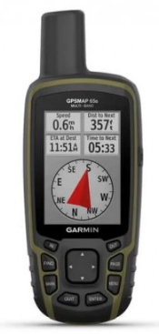
FIG 4.1 Global Positioning System (GPS)

4.2 Taking track line and track point
Types of Points
There are waypoints, track points, via points, points of interest, events, icons, cities, exits, etc. They all have at least a two dimensional coordinate - latitude/longitude, easting/northing, etc. - because they are all geographic locations. Some will have the elevation too. They are defined by the role they play and the attributes they have.
- Waypoints: Besides the coordinates (2D or 3D) waypoints have:
- Name and usually a symbol (airport, square, dot, stadium, bridge, point slag, building, bus stop, etc.).
- Color for the symbol and/or name text, how to display, depth, proximity distance (for proximity alarms), and a text field (comment, message, description).
- Stand by themselves that is independent of other points.
- Are shown as a "point" on either the receiver’s screen or the computer screen. The "point" can be some sort of symbol (icon) to represent the type of location.
- Is simply a unique address for any point in the world, but instead of the traditional Street/city/state/zip format we’re used to for road travel.
- Is saved to your GPS by either “marking” a location with the appropriate button on the GPS.

Tracks and Track points:
The receiver usually records track points as you travel. The track points define a track formed by connecting the points with lines. The "track" would represent the road, trail, path, etc. that you followed. Curves are formed with short line segments. The GPS receiver draws your track on the map screen with lines defined by the track points and a mapping program (with GPS support) draws your track on the computer screen (with or without background maps).
In general track points don't have names or symbols.
- They may have a date/time stamp that allows the speed to be calculated for the track segment (track leg - line connecting two track points).
- The distance is calculated from the location coordinates.
- The elevation is often recorded too so it's possible to get an elevation profile for the track or a 3D view of it along with average speeds, time, and total distance, etc.
A track has a datum for all its points, a color and a width (in pixels) used in displaying it on the map. The color will be sent to the GPS receivers supporting it, in which process a color matching algorithm will be applied if the original color is not in the set of colors accepted by the receiver.

To navigate a specific waypoint:
- First find the full list of waypoints on your GPS. This may be a simple as pressing the “find” button on your GPS if it has one, or otherwise shuffling through the menu pages until you find an option on a page named “waypoints”.
- selected the “waypoints” option, you should see a list of waypoints Most GPS units will allow you to sort the waypoint list in alphabetical sequence, or to list the waypoints that are closest to you first.
- After found the waypoint of interest, scroll down to it and press the GPS ENTER key.
- That will take you to a new page with more detailed information about that waypoint, which may include its coordinates, distance and direction from your current location, and elevation, etc.
- You can usually also edit the name or delete it from this menu page. The option we’re interested in is “GOTO” or similar menu choice – highlights that and press ENTER. The GPS is only showing you, distance in a straight line, without regard to the actual curvature or meandering of trails to get to that point, nor is it telling you of barriers between you and the waypoint – canyons, rivers, mountains, etc. For that, you have to use a top map to more accurately determine a route to your destination.

- How to mark a waypoint:
A waypoint: is simply a unique address for any point in the world, but instead of the traditional street/city/state/zip format we’re used to for road travel, GPS units utilize waypoints expressed in mapping formats such as latitude/longitude or the UTM Grid. The GPS determines your location by receiving signals from orbiting satellites which determine distances from each satellite, triangulating a location on earth that is expressed in a mapping format.

For example, the Lower Gear Backpacking Center is located at 1828 E. University Drive, Tempe, AZ 85281. But to a GPS, our location would be more commonly expressed in one of these formats, which all point to the same location:
- 12S 415638E 3698162N
- 33° 25’ 16” N 111° 54’ 27” W
- 33° 25.274N 111° 54.443’ W

4.3. Perform reading and measurement data
How to use GPS-enter coordinate:
This article discusses how to manually enter a waypoint coordinate on a GPS device and why and when you might want to do so. We often use a basic Garmin unit as our go-to example, but all GPS units function in very similar ways and have similar features.

Before you start with these instructions, learn which keys, buttons or menu selections activate the following basic functions on the GPS you’re using:
- Move between pages or menu screen: - Usually a button labeled “Page”. Like choosing between open programs or tabs on your computer screen.
- Scroll within choices on a page: – this may be a “rocker” button or two “up-and-down” buttons, similar to the function a mouse or cursor movers does on a computer.
- Select a choice: – usually a button that says “Enter”. Serves the same function as the enter key on a computer or “OK” on a Smartphone.

How to set your GPS for auto-tracking:
Most GPS units have a feature that records a “track”:- a series of waypoints every few seconds or at some set interval that can be saved for subsequent use, such as returning to your original spot via the exact same route by following the GPS, or following a faint trail again at a later date as examples. Tracks can also be uploaded to a GPS and used in mapping or routing software of various types.

Most GPS units have a menu option called “tracks” on their main or home menu page. Select this option and you’ll typically see sub-options such as:
- Turning the feature ON OR OFF -turn off to save battery life when not using the feature>
- Track interval:– can be left at its default interval, or set to record at intervals of time or distance>
- What to do when at full capacity – there is some limitation on the number of tracks a device can hold, so you can tell the GPS to either quit when at capacity, or to wrap around and replace the beginning with new tracks so you always have the latest tracks saved. >
- Edit/Save/Delete: – you may want to clear out old tracks to make room for new recordings after you’ve saved a track, you can re-trace your steps and navigate the track route by using the GPS navigation features. Most GPS units will allow you to choose to either follow the track from beginning to end, or from end to beginning.

How to Navigate a Waypoint with a GPS:
Following a track works the same way as being guided to a specific waypoint. Your GPS will show the track against a map background usually represented by a dotted line and you can look at the map to make sure you are still on course.

We have a nice library of how-to articles on this site. If you rent a GPS from Lower Gear, we will also include a print or online user guide with full details on how to use it. We are also available to assist you over the phone.

How to mark a waypoint with a GPS for more information:
The map will have reference coordinates marked at periodic intervals. Every minute for example, or every kilometer on the UTM grid. Armed with one half of the coordinate pair from the GPS, find the closest reference points on the map, and estimate the distance you are between the tic marks.

For example: assume the longitude tic marks are shown for 111 degrees, 25 minutes and 111 degrees, 26 minutes, etc. If the GPS shows you at 111 degrees, 25.345 minutes longitude then you knows you are approximately 1/3 of the way between the 2 map tic marks. Draw a vertical line down from that estimated point.

Then do the same process for the latitude coordinates: assume the latitude tic marks are shown for 33 degrees, 43 minutes and 33 degrees, 44 minutes, etc. If the GPS shows you at 33 degrees, 43.769 minutes latitude then you knows you are approximately 3/4 of the way between the 2 map tic marks. Draw a horizontal line across from that estimated point.
4.4 Loading data to the computer which has GIS software
A geographic information system (GIS): is a computer system for capturing, storing, checking, and displaying data related to positions on Earth’s surface. GIS can show many different kinds of data on one map. This enables people to more easily see, analyze, and understand patterns and relationships.

With GIS technology, people can compare the locations of different things in order to discover how they relate to each other. For example, using GIS, the same map could include sites that produce pollution, such as gas stations, and sites that are sensitive to pollution, such as wetlands. Such a map would help people determine which wetlands are most at risk.

GIS can use any information that includes location. The location can be expressed in many different ways, such as latitude and longitude, address, or ZIP code. Many different types of information can be compared and contrasted using GIS. The system can include data about people, such as population, income, or education level. It can include information about the land, such as the location of streams, different kinds of vegetation, and different kinds of soil. It can include information about the sites of factories, farms, and schools, or storm drains, roads, and electric power lines.

How to download waypoints and other data from Garmin GPS to computer?
These steps were written using a Garmin GPS 72H receiver. If you are using a different Garmin receiver, certain details may be different:

General tab: The general tab contains settings for receiver mode, was, backlight time out, beeper and language.
- Mode: allows you to choose from the following operation modes:
- Normal: default mode set from the factory
.

Use this setting for best performance.
Settings: - The main menu contains settings and features not found on the main pages and sub-menus. The main menu is accessible from any page by pressing menu twice.
To select a menu item or customize an option, use the rocker and the enter button. Menu options used memory backlight battery indicator power Main menu page zoom in go to/ mob power quit rocker buttons Quit-press to return to the previous page and cycle through the main pages in reverse order.

- Power: press and hold to turn the device on or off. Press and release to adjust the backlight.
- Go to/mob: press to begin or stop navigation to a waypoint. Press and hold (man overboard function) to store the current location and begin navigation to that point.
- Zoom in: press to zoom the map in. Zoom out--- page menu enter/mark.

Self-check 4 | Written test

Name: __________________________________________ ID: ____________Date: _________
Directions: Answer all the questions listed below.

Test I: Choose the best answer (2point each)
- Which of the following TRUE about GPS waypoints?
- Way Points have name and symbol
- Waypoints have color for the symbol and the name
- Waypoints are dependent on other points
- Waypoints are unique address for any point in the world
- Which GPS button used to begin or stop navigation to waypoints?
- Power B. Enter C. Got to/mob D. Exit
- Which of the following is the purpose of track points?
- Used to calculate speed to a track segment
- Used to calculate distance from location coordinates
- Used to provide information about elevation profile
- All

Test II: Short Answer Questions
- What is GPS and why we need GPS? (4pts).
- What are track line and way point? Explain. (4 pts).
- List the advantages of GPS? (5pts).
- What is the purpose of GPS and GIS system? (2pts).
- What is the advantage loading data from GPS to computer/GIS software? (5pt).

Note: Satisfactory rating - 20 points above Unsatisfactory - below 20 points
You can ask your teacher for the copy of the correct answers.

Operation Sheet -4

  - Procedures to navigate specific waypoint
- Tools and equipments
- GPS
- Notebooks
    - Procedures:
- First find the full list of waypoints on your GPS. This may be a simple as pressing the “FIND” button on your until you find an option on a page named “WAYPOINTS”.
- selected “waypoints” option, you should see a list of waypoints Most GPS units will allow you to sort the waypoint list in alphabetical sequence
- After found the waypoint of interest, scroll down to it and press the GPS ENTER key.
- You can edit the name or delete it from this menu page. The option we’re interested in is “GOTO” or similar menu choice highlights that and press ENTER.

  - Procedures to download waypoints and other data from Garmin GPS to computer?
    - Tools and equipments needed:
- GPS
- COMPUTER
- USB cable

    - Procedures/Steps/Techniques
- Connect the GPS unit to the computer: You will need a cable. Garmin makes one, of course, and there are also third-party cables available.
- Configure the GPS receiver: Ensure that your GPS unit is "Garmin" transmission mode. For the Garmin 12 receiver, this is done by accessing the Main Menu page, choosing Setup Menu, then choosing Interface, highlighting the first line, then changing it to the GRMN/GRMN setting.
- Start the download software: - There are many software solutions available for downloading waypoints from your GPS. Example:
- Garmin's software is called Map Source and is available from Garmin as part of any of their Map Source CDs.
- Waypoint± available: that will allow download waypoints and other data from GPS unit.
- Download the waypoints: Using the map source software, go to edit - preferences. In the preferences window, set distance and speed to metric and position format to 'lat/lon hddd.ddddd'. Click 'ok' to close the window and go to file - open from device. Select waypoints, routes and tracks to be downloaded and click on open. Transferring tracks, routes, or waypoints tracks, routes and waypoints can be transferred between your device and a computer using map source.
- To transfer tracks, routes, or waypoints to and from map source:
- Connect your device to the computer with a USB cable.
- Open map source on your computer.
- Select tracks, routes, or waypoints to transfer.
- Click receives from device or sends to device on the map source transfer menu.

LAP TEST-4 | Performance Test

Name: _________________________________________________ ID: ________________ Date: _____________________________
Time started: ________________________ Time finished: ________________
Instructions: Given necessary templates, tools and materials you are required to perform the following tasks within 1 hour. The project is expected from each student to do it.
Task – 2.1: perform navigate specific waypoint
Task 2.2: download waypoints and other data from Garmin GPS to computer?

REFERENCE MATERIALS

October 2022, Flow Measurement and Instrumentation: Volume 87( access date: 08, 2022)
Math Courses / PLACE Mathematics: Practice & Study Guide / PLACE Mathematics: Measurements & Conversation.
Official U.S. government information about the Global Positioning System (GPS)
Ash, M. E., Determination of Earth Satellite Orbits, Tech. Note 1972-5, 258 pp., Institute of Technology, Lincoln Laboratory, Lexington, 1972.
Colombo, O. L, Ephemeris errors of GPS satellites, Bulletin Geodesies, 60, 6484, 1986.
Murray, M. H., Global Positioning System Measurement of Crustal Deformation in Central California, Ph. D. thesis, Massachusetts Institute of Technology, 223 pp., 1991.
RD-453-84. Procedural Instructions. Characteristics of the Errors of Measuring Equipment in the Actual Operating Conditions. Calculation Methods. (In Russian.).

Web addresses:
https://www.youtube.com/watch?v=bWcH2Ca09aI (access date 08, 2022)
https://www.dtwd.wa.gov.au/sites/default/files/teachingproducts/BC1940_CCBY_0.PDF (access date: 087, 2022)

AKNOWLEDGEMENT

Ministry of Labor and Skills and Ministry of Health wish to extend thanks and appreciation to the many representatives of TVET instructors and respective industry experts who donated their time and expertise to the development of this Teaching, Training and Learning Materials (TTLM).

The experts who developed the learning guide
No | Name | Qualification | Organization/College | Mobile number | E-mail
1 | Serawit Gensa | Msc. Water Resource Engineering | W/Sodo AVET | 0916740916 | serawitgen@gmail.com
2 | Edao Hassen | Msc.Irrigation Engineering | Alage AVET | 0911098097 | hassedao@gmail.com
3 | Mekete Agizew | Msc. Water Resource Engineering | Amh/Kombolcha ATVET | 0925221192 | gen.mam09@gmail.com
4 | Wondu Alemayehu | Msc.Irrigation Engineering | Or/Kombolcha ATVET | 0910-28-99-61 | woldualem@gmail.com
5 | Ademe Ayalew | Msc.Irrigation Engineering | Agrafa AVET | 0912720547 | Ademe2004@gmail.com
6 | Said Mohammed | Msc.Irrigation& drainage Engineering | Alage ATVET | 09-17-18-01-81 | Siyamsdmhmmd@gmail.com/
7 | Molalign Asfaw | Bsc.Water Resource &Irrigation Engineering | Alage ATVET | 0921431096 | Mollalign410ass@gmail.com
8 | Yonas Hailu | Bsc.Water Resource &Irrigation Engineering | Agrafa AVET | 0934715578 | yonashailuw@gmail.com
9 | Lemessa Mulata | Msc.Irrigation Engineering | Agrafa AVET | 0913266845 | Lamimulle2022@gmail.com
10 | Misganew Yimer | Bsc. Soil and Water Engineering | Woreta ATVET |  | Misge1976@gmail.com
11 | Daniel Derese | Bsc. Soil and Water Engineering | W/sodo AVET | 0912-79-28-85 | danielderesse7@gmail.com
12 | Teshome Getachew | Msc.Irrigation & drainage Engineering | Alage ATVET | 0925-50-13-99 | teshomegetachew131@yahoo.com

