IRRIGATION AND DRAINAGE
Level I

Based on March 2022, Version 3 Occupational standard
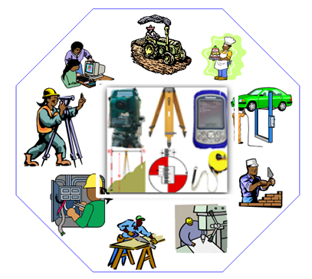
Module Title: - Irrigation Design and Surveying Tools
LG Code: AGR IRD1 M03 LO (1-3) LG (8-11)
TTLM Code: AGR IRD1 M03 0822 v1

August, 2022
Addis Ababa, Ethiopia

Table of Contents

Introduction to the Module 1
LO #1-Irrigation design principles 2
Instruction sheet 2
Information Sheet 1 3
Self-Check - 1 12
Operation sheet - 1 13
LAP Test - 1 14
LO #2 Surveying tools and equipment 15
Instruction sheet 15
Information Sheet 2 16
Self-check -2 24
Operation Sheet -2 26
LAP test -2 28
LO #3 Materials and tools 29
Instruction sheet -3 29
Information Sheet -3 30
Self-Check - 3 34
Operation sheet – 3 35
LAP Test -3 36
LO #4 Handle Surveying Instrument 37
Instruction sheet 37
Information sheet 4 38
Self-check -4 45
Operation Sheet - 4 46
LAP test - 4 47
Reference Materials 48

Introduction to the Module
This Module covers the knowledge, skill and attitude required to identify, prepare, care and handling of irrigation design and surveying tools, instruments and equipment according to supervisor and organization guidelines

LG #3 | LO #1-Irrigation design principles

Instruction sheet
This learning guide is developed to provide you the necessary information regarding the following content coverage and topics:
  - Basic surveying tool and equipment
  - Irrigation design and surveying instruments
  - Type of leveling instrument
This guide will also assist you to attain the learning outcomes stated in the cover page. Specifically, upon completion of this learning guide, you will be able to:
- List irrigation design principles
- Identify basic Surveying tools
- Select Materials, tools and equipment
- Handle Surveying Instruments
Learning Instructions:
- Read the specific objectives of this Learning Guide.
- Follow the instructions described below.
- Read the information written in the information Sheets
- Accomplish the Self-checks
- Perform Operation Sheets
- Do the “LAP test”

Information Sheet 1
Introduction
Irrigation designs: - a condition that needs an account during the planning and development of the physical works of irrigation schemes and helps for the sustenance of the scheme.
1.1 Principles of irrigation systems design
irrigation systems design should answers
- What is the soil texture?
- What is the size of the field?
- What is the topography of the field?
- Will the field be divided to irrigation sections?
- What is the planting density of the crop?
- What is the depth of the crop's root system?
Irrigation designers evaluate site conditions and prepare professional plans to meet the needs of an individual project.
Whether focused on maximizing crop yield or landscape aesthetic appeal and functionality, effective irrigation designers:
- Evaluate site conditions and determine water availability and use requirements.
- Choose the right irrigation methods and equipment for the site and project.
- Apply innovative technologies, products and practices to maximize water-use efficiency.
- Develop efficient and cost-effective irrigation designs that meet the project’s needs.
1.2 Basic surveying tool and equipment
What is surveying?
Surveying is defined as a method of determining the relative position of the points on, above, or below the earth’s surface by taking direct or indirect measurements of distance, direction, and elevation.
Two types of measurements:
- Linear measurements
- Angular measurements.
There are different types of surveying equipment used in irrigation design such as
Chain, Theodolite, dumpy level, cross–staff, plane table, ranging road, measuring tapes, etc.

1.3 Importance of Surveying for irrigation design
Planning and design of all irrigation design projects require measurements from surveying. Execution of work needs surveying too for transferring the points onto the ground. Fixing of state and national boundaries also required measurements obtained from surveying. Control points can be established with the help of surveying. Hydrographical and oceanographic charting and mapping are facilitated by surveying. A topographic map of the land surface can be prepared with the help of surveying.
1.4 Fundamental Principles of Surveying
Two basic principles of surveying are:
- Always work from whole to the part, and
- To locate a new station by at least two measurements (Linear or angular) from fixed reference points.
1.5 Purposes of surveying instruments for Irrigation design
Measuring Tapes: It is made up of cotton, coated linen, or any other synthetic material. Centimeters or decimeters are marked on the tape. They are available in length of 20, 30, or 50 meters
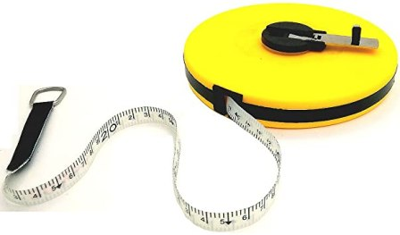
Fig. 1.1: Measuring Tape
Surveying Chains for irrigation: A chain is a surveying instrument that is made up of connecting links of galvanized mild steel. The mild steel wire is bent into a ring and joined to each other with three small circular or oval rings. Each connecting link measures 20 cm.
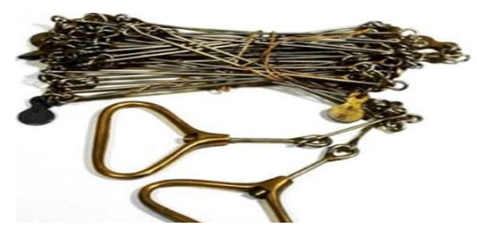
Fig. 1.2: Surveying Chains for irrigation

Purpose of Chains for irrigation
The chain is used to measure the distance on the ground. It gives much more accurate measurement as compared to tape. A tally marker or a special joint is also installed sometimes to mark the distance of 5 meters. The total length of the chain is 20 meters or 30 meters, which also includes a brass, handle on each end. The handles are provided with swivel joints for they can be easily turned during surveying without being twisted.
Some of commonly used chains in surveying
Metric chain– Widely used and available in lengths of 5, 10, 20, and 30 meters.
Surveyor’s chain: Length is 66 feet and has 100 links widely used for land measurement as 10 square chains make 1 acre.
Engineer’s chain: Length is 100 feet and has 100 links. Brass tags are installed at every 10 feet.
Revenue chain: Length is 33 feet and has 16 links.
Note: - A chain has to be tested if it is accurate and necessary adjustments are made if not.

Arrow: Arrows are used for marking and are made up of hardened, and tempered steel wire of good quality.
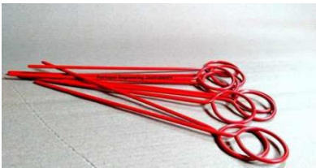
Fig. 1.3: Surveying Arrow
10 arrows are usually sold with a chain. Its length is about 25-50 cm. One of its ends is sharpened while the other end is bent into a circular loop.
Peg: Pegs are mostly made of timber. They are also used to mark out the locations on the ground at terminal points or the end of the survey line. They are 2.5-3 square centimeters and are of 15-centimeter length with a tapered end.

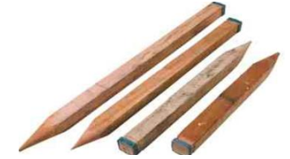
Fig. 1.4: Peg
Note: - A hammer is used to drive the peg into the ground.
Ranging Rods: are 2-3 meters in length and are painted with alternate bands of two colors like white and black, red and white in succession. Each band is kept at a length of 20 centimeters. Ranging rods are made of well–seasoned timber. Their cross-section is kept either circular or octagonal with a 3 cm nominal diameter. They are used to range an intermediate point on a survey line. A red, yellow, or white flag is tied at its top while carrying out longer surveys because the rod is not visible beyond a 200-meter distance.
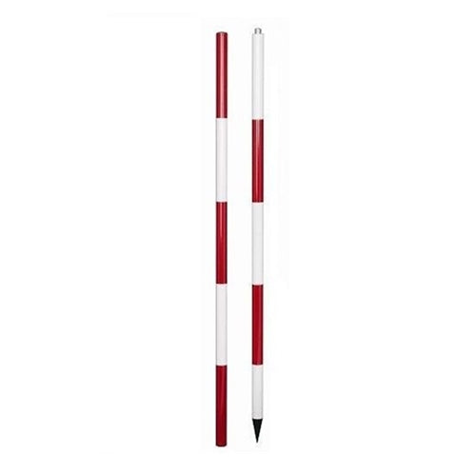
Fig. 1.5: Ranging Rods
Offset Rods: It is similar to a ranging rod but is of 3-meter length. They are also wooden rods, circular in cros-section. Its one end is pointed with an iron shoe and at the other; a notch or hook is provided. It is used to take rough offsets in the nearby regions. Also, the right angles can be set out with its help as it has two narrow slots at its center.
Plumb Bob: It is used to transfer the points to the ground on a slope while chaining. It is also used to make the ranging poles vertical. In theodolites, compass, plane table, and other surveying instruments, it is used for centering purposes.
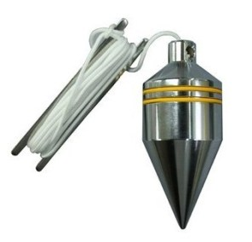
Figure 1.6 Plumb Bob

Cross Staff: It is the simplest instrument for setting out right angles on a survey line. It has a frame containing two pairs of opposite slits mounted on a pole. The pole can be used to fix the instrument on the ground.
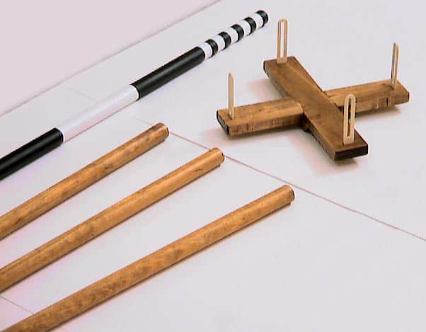
Fig. 1.7: Cross Staff
Prismatic Compass
It comprises a magnetic needle attached to a graduated circular ring made up of aluminum. The needle orients itself to the magnetic meridian if it is on the pivot. Object vane and eye slit are attached to the compass box and help in locating the line of sight. It is a magnetic compass that measures the magnetic meridian. It is portable and hence convenient too. It can be either used in the palm or fixed on a tripod.
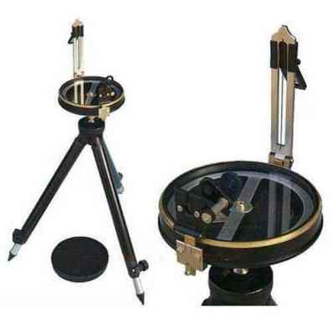 | 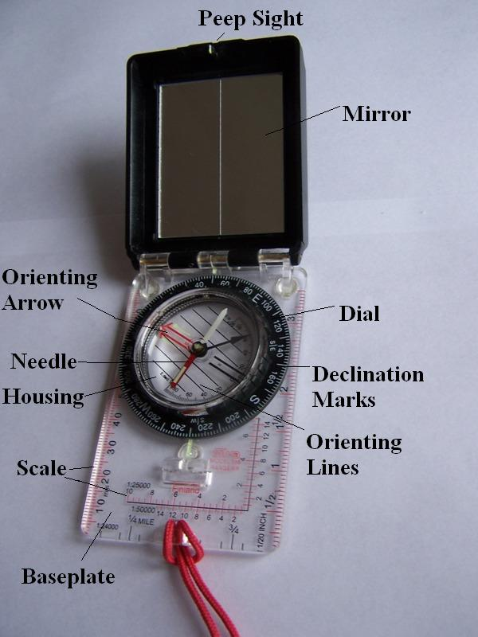
Fig. 1.8: Prismatic Compass and its part

Theodolite: It is the most precise instrument for the measurement of horizontal and vertical angles. It is popular in various surveying applications. There are two types of theodolite– transit, and non-transit. Non-transit theodolites have become obsolete these days.
Transit theodolite is such theodolite in which the telescope can be resolved by 180° in the vertical plane.
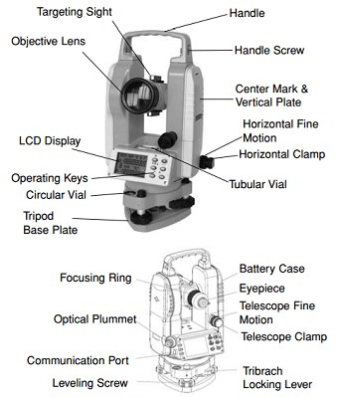
Fig. 1.9: Theodolite
Purpose of Theodolite,
- Measure the magnetic bearing of a line
- Measure direct angles
- Measure deflection angles
- Extend a straight line
- Establish a straight line between two points
- Locating point of intersection between two straight lines
- Setting out a horizontal angle
- Setting out an angle by repetition
- Establish grade
- Measure the difference in elevation
- Setting out curves
Note: - Repetition method or Reiteration methods can be employed for setting out horizontal angles to obtain more precise results.
Total Station: It is an electronic transit theodolite with an electronic distance meter (EDM).The crosshairs on the reflector of TS are aligned to the ranging rod and the vertical and horizontal angles are measured along with slope distances simultaneously.

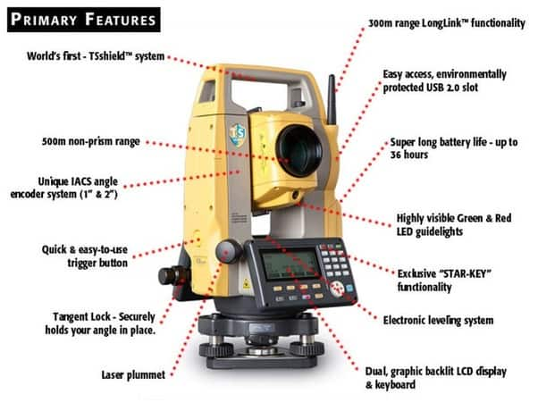
Fig. 1.10: Total Station
It is used to take the measurement of
Horizontal angles: The rotation of the optical axis of TS from the instrument north in a horizontal plane gives the horizontal angle.
Vertical angle: The inclination of the optical axis of TS from the local vertical gives a vertical angle.
Slope distance: The distance between TS and target gives the slop distance.

Tripod: A tripod with a device for leveling and controlling its orientation is used in the plane table surveying.

Plane Table: This survey table is used for high precision works and is more accurate than the previous two. There are three–foot screws for accurate leveling. A clamp and tangent screw are also provided for moving the table about the vertical axis.
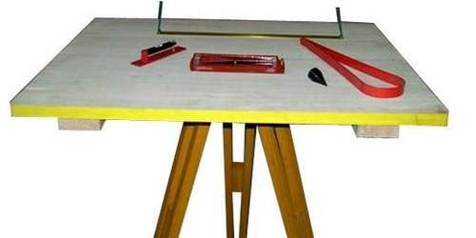 | 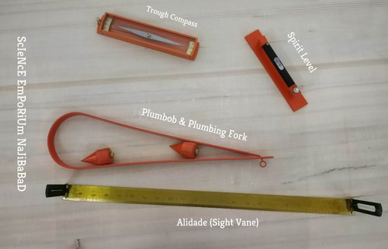
Fig. 1.11: Plane Table | Fig. 1.12: Plane Table Accessories
1.4 Instruments for Direct Leveling
It is used to provide a horizontal line of sight. A horizontal line can be established with the help of a level. It is the line perpendicular to the plumb line. The telescope, level tube, leveling head, and tripod are the main parts present on every level. Differential leveling, profile leveling, cross–sectioning, reciprocal leveling, and precise leveling are some of the methods of precise leveling that can be carried out by a level. Temporary adjustments of station adjustments are to be made each time the level is set up including setting up the level, leveling up, and eliminating parallax.
There are four types of levels:

Dumpy level: on dumpy level a telescope is firmly attached to two collars, which can be fixed by adjusting screws carried by a vertical spindle. The movement of the spindle about the vertical axis is regulated by a clamp screw. A tangent screw is used for precise movements. Two parallel plates are fixed on either three or four–foot screws in leveling head.
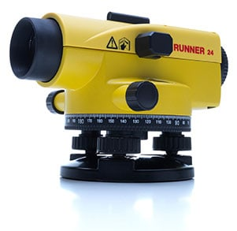
Fig. 1.13: Dumpy level
Wye/Y Level: At this machine level, the telescope is carried on two vertical wye supports. Wye supports are in the form of curved clips. The telescope can be rotated or removed by raising the wyes. By fixing the eyes, the movement of the telescope is restricted.
The bubble tube is attached to either telescope or the stage that has wyes. Leveling head is similar to the dumpy level. Adjustments are done easily with accuracy in the case of the Y level, unlike the dumpy level.
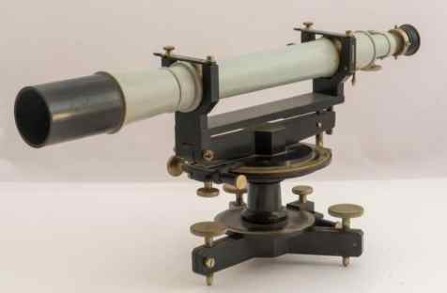
Fig. 1.14: Wye/Y Level

Reversible Level: It is a combination of dumpy level and Y level. The telescope is fixed into two rigid sockets connected to the spindle with the help of a stage. After pushing the telescope in the socket through either end or tightening the screw, it acts like a dumpy level.

Tilting level: In the tilting level, the line of sight can be tilted slightly without tilting the vertical axis. Hence, this level facilitates quick leveling. The vertical axis is made roughly vertical with the help of the foot screws and bubble tube. The line of sight is made exactly horizontal when the staff is sighted by centering the bubble with the help of a fine pitched tilting screw with respect to vertical.

Leveling Staff: It is a straight rod with graduation marks with zero from the bottom. It helps in determining how much above or below the station from the line of sight.
There are two types of leveling staff
- Self–reading staff and
- Target staff.
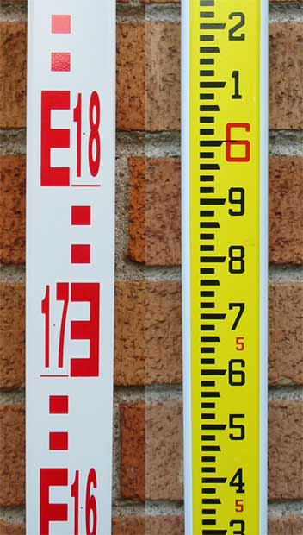
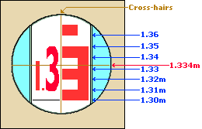 | 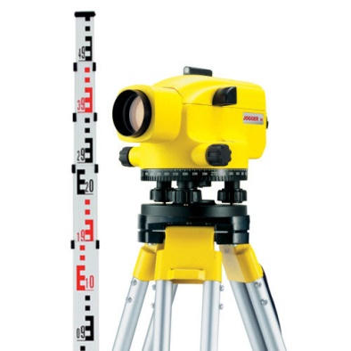
Fig. 1.15: Leveling Staff

Self-Check - 1

Name…………………………………………… ID………………………… Date…….
Directions: Answer all the questions listed below.
Test I: Multiple choice (2 pts. each)
1. What is surveying?
a) Surveying is used to find the elevations of given points with respect to given or assumed datum
b) Surveying shows the relative positions of the objects on the surface of the earth
c) Surveying is to find the elevation of points having the same contour interval
d) All of the mentioned
2. Which of the following is the first principle of surveying?

a) Whole to whole
b) Part to part
c) Part to whole
d) Whole to part

3. In which of the following type of surveying only linear measurements are made?

a) Dumpy level
b) Theodolite surveying
c) Chain surveying
d) Contouring

4. Which of the following is not required for chain surveying?

a) Dumpy level
b) Pegs
c) Arrows
d) 20 m chain

5. Which of the following is the last step in chain surveying?

a) Fixing
b) Reconnaissance
c) Running survey lines
d) Marking

6. Which of the following are the principles of surveying?

a) Covering the entire area
b) Working from whole to part
c) Taking measurements
d) Determining the elevation differences

Test I: Short Answer Questions
- What is irrigation designs mean? (5 points)----------------------------------------------------------------------------------------------------------------------------------------------
- What is the purpose of surveying in irrigation? (4 points)------------------------------------------------------------------------------------------------------------------------------
- What do mean by surveying? (3 points)---------------------------------------------------------------------------------------------------------------------------------------------------
- List the types of electromagnetic distance measuring waves? (5 points)-------------------------------------------------------------------------------------------------------------
- What tools and equipment are required for irrigation design and surveying work? (5 points)------------------------------------------------------------------------------------------------------------------------------------------------------------------------------------------
Note: Satisfactory rating - 25 points and above Unsatisfactory - below 25 points
You can ask you teacher for the copy of the correct answers.

Operation sheet - 1

Name: _________________________ Date: ____________ Date: ____________
Time started: _______________ Time finished: __________________________
Instructions:
1. You are required to perform any of the following:
1.1 Request your teacher to arrange for you to visit the nearby irrigation design and surveying. You should identify important tools, materials and equipment. Submit your report to your teacher for evaluation.
2.1 Demonstrating surveying tools and equipments
Tool and equipment
All available tool and equipment will be provided to trainees
Procedure :
- Wear appropriate PPE
- Observe and identify surveying tools and equipments which are provid by your instructore in the practical session
- List tools and describe the function of tools and equipments in the format provided.
- Write report according to the format.

LAP Test - 1
Name: _________________________ Date: ____________ Date: ____________
Time started: _______________ Time finished: __________________________

Instructions: Given necessary templates, tools and materials you are required to perform the following tasks within 2 hour. The project is expected from each student to do it.

Task 2.1. List surveying tools and equipment’s.

LG #3 | LO #2 Surveying tools and equipment

Instruction sheet

This learning guide is developed to provide you the necessary information regarding the following content coverage and topics:
  - Distance measuring equipment
  - Angle and elevation measurement
  - Dumpy level
  - Laser levels
  - Accessories
This guide will also assist you to attain the learning outcomes stated in the cover page. Specifically, upon completion of this learning guide, you will be able to:
- Measure Distance Angle and elevation by using surveying equipment
- Setup Dumpy level for distance measurement
- Operate Laser levels
- Select survey instrument Accessories
Learning Instructions:
- Read the specific objectives of this Learning Guide.
- Follow the instructions described below.
- Read the information written in the information Sheets
- Accomplish the Self-checks
- Perform Operation Sheets
- Do the “LAP test”

Information Sheet 2
2.1 Distance measuring equipment
Distance measurements in surveying can be performed by mainly three methods namely direct method, electromagnetic methods and optical methods.
    - Direct Methods of Linear Measurements These methods are used in reconnaissance survey or to detect major mistakes committed while measuring with better methods.
Pacing: The pacing technique is mostly employed in preliminary surveys and explorations. In this method, the surveyor is required to conduct a rough survey quickly. These also roughly check the distance measured by other means.
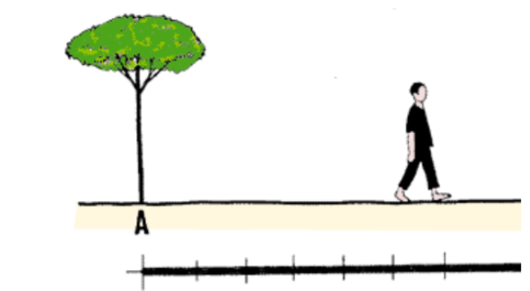
Fig. 2.1: Pacing in Surveying
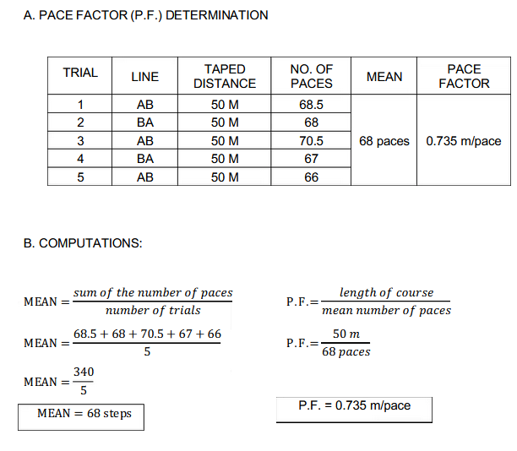
In this method, the number of paces between the two points of the line is counted. Knowing the average length of the pace helps to know the length of the line. The length of the pace is dependent on the person who is measuring, the ground, the speed of pacing and the slope of the country.
- Passometer: The passometer is a watch like instrument that is carried on the person's pocket or tied on the man's leg. This instrument records the paces when the man moves from one point to another.
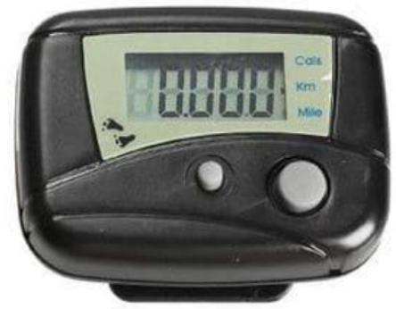
Fig. 2. 2: Pacing in Surveying
This technique hence overcomes the monotony and strain in counting the paces by the surveyor. The distance is calculated as the product of the number of paces and the average length of the pace.
Odometer: Odometer is an instrument that measures the number of revolutions of a wheel. The number of revolutions taken to cover the length multiplied by the circumference of the wheel gives the value of the distance covered.
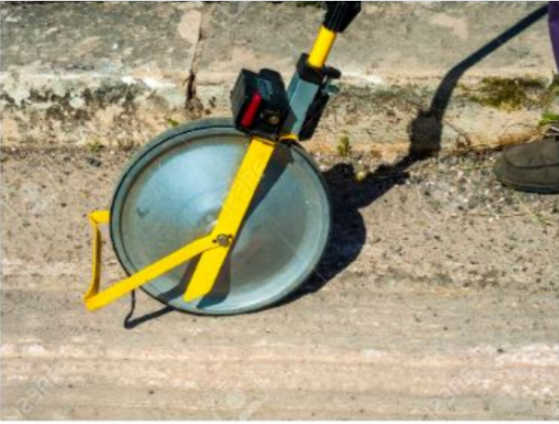
Fig. 2.3: Odometer surveying
- Chaining: Chaining method determines the distance by means of a tape or a chain. This is one of the accurate methods to determine the linear measurements.
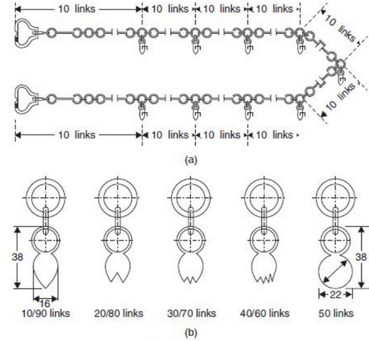
Fig. 2.4: chain surveying for irrigation

Principle of Chaining
- To measure any distance, you simply compare it to a known or calibrated distance; for example by using a scale or tape to measure the length of an object.
- The calibrated distance, in this case, is the wavelength of the modulation on a carrier wave.
- Modern EDM’s use the precision of a Quartz Crystal Oscillator and the measurement of phase-shift to determine the distance.
- The EDM is set up at one end of the distance to be measured and a reflector at the other end.
- The EDM generates an infrared continuous-wave carrier beam, which is modulated by an electronic shutter (Quartz crystal oscillator).
- This beam is then transmitted through the aiming optics to the reflector.
- The reflector returns the beam to the receiving optics, where the incoming light is converted to an electrical signal, allowing a phase comparison between transmitted and received signals.
- The amount, by which the transmitted and received wavelengths are out of phase, can be measured electronically and registered on a meter to within a millimeter or two.
    - Measurements by Optical Means
In this system, the telescope of the angle measuring instrument called theodolite. To measure distance ‘D’ between two point P and Q instrument is set at P and a graduated staff is held vertically at Q and vertical intercept AB is recorded. Then distance D can be computed as explained below
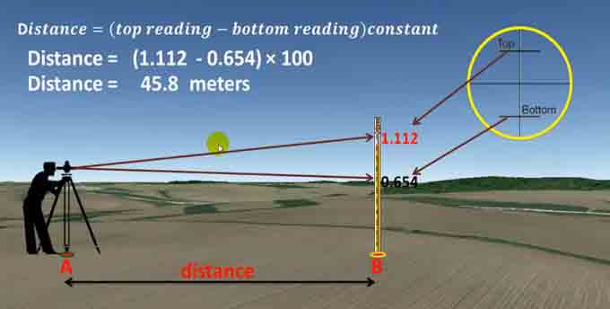

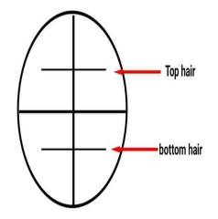 | 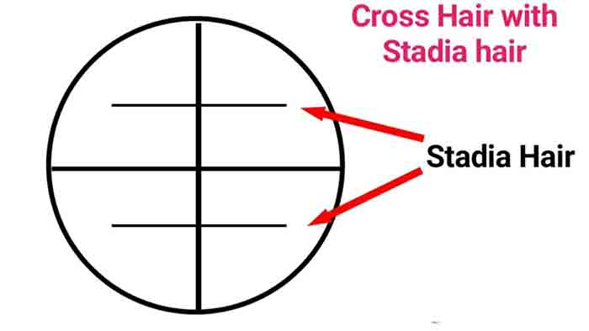 | 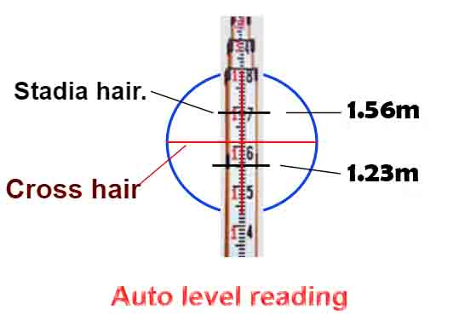
Fig. 2.5: optical means of measurement
2.2 Angle and elevation measurement
Measuring distances alone in surveying does not establish the location of an object. We need to locate the object in 3 dimensions. To accomplish that we need:
- Horizontal length (distance)
- Difference in height (elevation)
- Angular direction.
An angle is defined as the difference in direction between two convergent lines. A
horizontal angle is formed by the directions to two objects in a horizontal plane. A
vertical angle is formed by two intersecting lines in a vertical plane, one of these lines
horizontal. A zenith angle is the complementary angle to the vertical angle and is
formed by two intersecting lines in a vertical plane, one of these lines directed toward
the zenith.
Types of Measured Angles
Interior angles: - are measured clockwise or counter-clockwise between two adjacent lines on the inside of a closed polygon figure.
Exterior angles: - are measured clockwise or counter-clockwise between two adjacent lines on the outside of a closed polygon figure.
Deflection angles: - right or left, are measured from an extension of the preceding course and the ahead line. It must be noted when the deflection is right (R) or left (L).
bearing is an angle less than 90° within a quadrant defined by the cardinal directions.
Azimuth is an angle between 0° and 360° measured clockwise from North. "South 45° East" and "135°" are the same direction expressed as a bearing and as an azimuth.

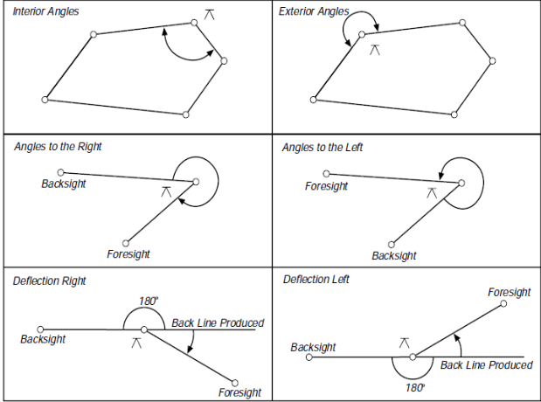
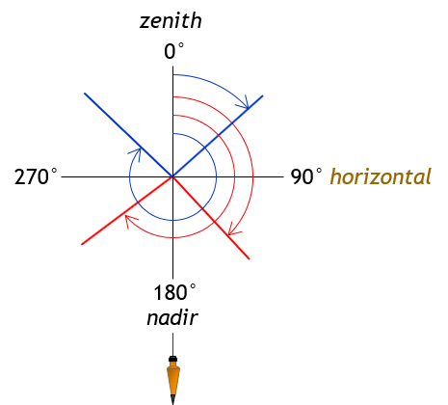 | 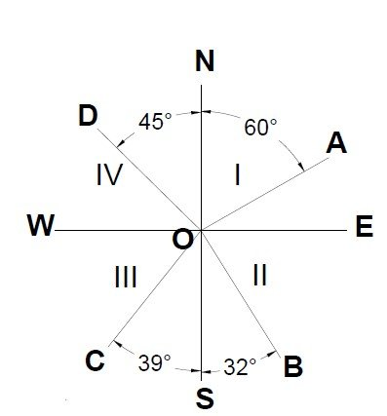

Fig. 2.6: Azimuths and bearings in different quadrants
Table 1.1: Value of bearing and azimuth in different quadrant and how to set

Quadrant | Azimuth to Bearing Conversion
I (NE) | Bearing = Azimuth
II(SE) | Bearing = 180⁰ – Azimuth
III(SW) | Bearing = Azimuth - 180⁰
IV (NW) | Bearing = 360 – Azimuth
Line | Bearing | Azimuth
A-B | S55⁰E | 125⁰
B-C | S89⁰E | 91⁰
C-D | N49⁰E | 49⁰
D-E | N80⁰W | 280⁰
E-A | S64⁰W | 244⁰

2.3 Theodolite survey
The system of surveying in which the angles are measured with the help of a theodolite, is called Theodolite surveying.
The Theodolite is a most accurate surveying instrument mainly used for:

• Measuring horizontal and vertical angles.
• Locating points on a line.
- Prolonging survey lines.
• Finding difference of level.
• Setting out grades

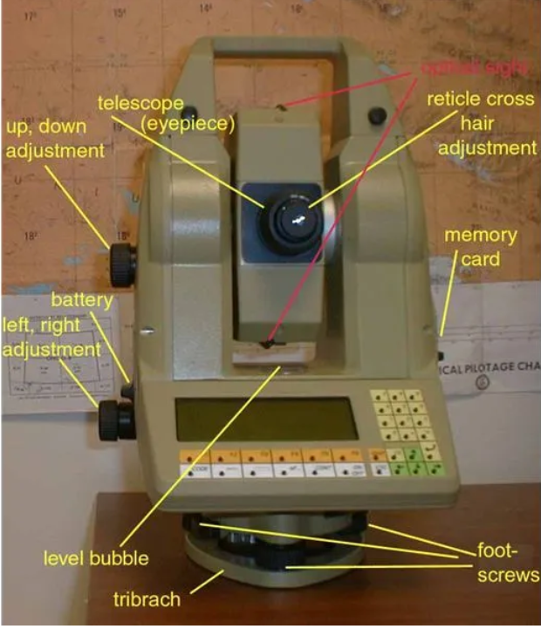
Fig. 2.7: Vernier theodolite
Vertical Angle: A vertical angle is an angle between the inclined line of sight and the horizontal. It may be an angle of elevation or depression according as the object is above or below the horizontal plane.
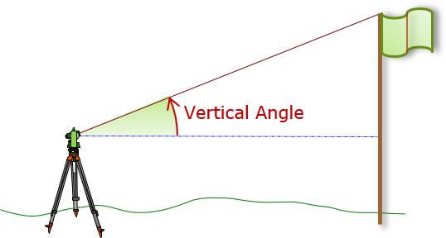 | 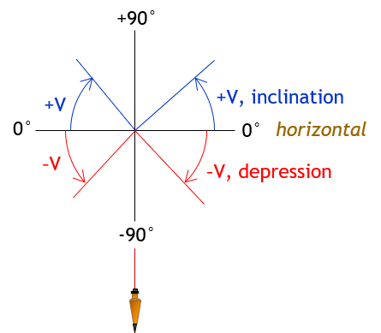  Fig. 2.8: vertical angle measurement
2.4 Dumpy Level Instrument
The dumpy level operates on the principle by establishing a visual relationship between two or more points, through an inbuilt telescope and a bubble level. The desirable level of accuracy can be achieved through steps.
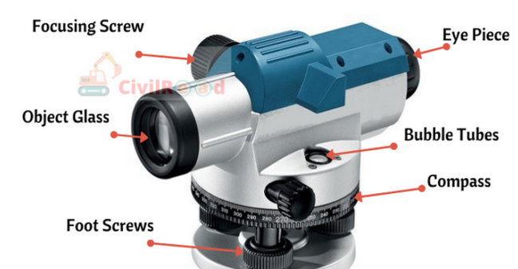 | 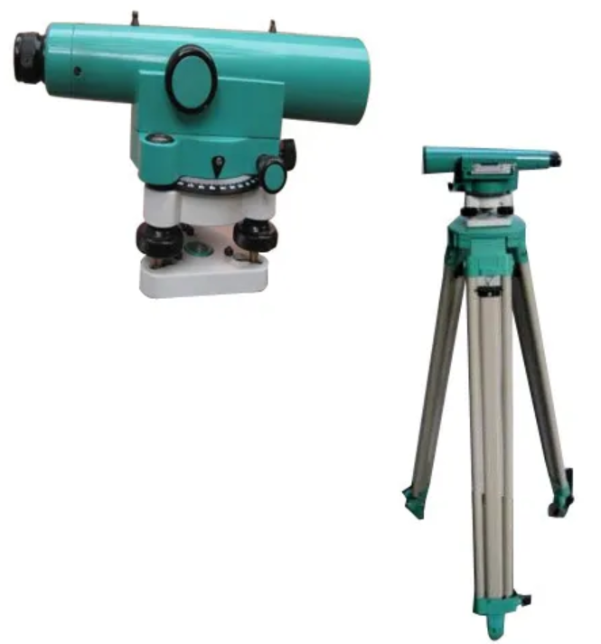

Fig. 2.9: Dumpy Level Instrument
Precautions while setting up Dumpy level:
Necessary precautions should be taken while handling the instrument.
- The tripod must be adjusted till eye height.
- Try to avoid touching or applying pressure on the tripod while moving around.
- When moving around the tripod, make sure you don't trip over the legs.
- Keep checking the bubble, minute fluctuation in a bubble gives inaccurate results.
- Avoid setting up the instrument on soft ground.
Note:-If the instrument is not properly setout it will go out of level and process inaccurate results.
Advantages of dumpy level:
The dumpy level is amongst the most famous used surveying instrument. The prominent advantages of dumpy level are as follows:
- Simpler construction with minimum movable parts
- Minimum adjustments are to be made
- High rigidity makes it versatile for long-duration surveys
- High optical power
- Cost-efficient in terms of usage on diversified construction sites
Limitations of dumpy level:
Despite being such a versatile instrument, Dumpy level even has some limitations. These limitations minimize the application to a certain extent.
- Limited to the site with horizontal angle measurement
- There might be a certain level of discrepancies in the values obtained.
2.5 Accessories
Table 2.2: Following are different surveying equipment and their uses
Sr. No. | Instrument | Uses
1. | Measuring tape | Measure linear distances
2. | Chain | Measure linear distances with precision
3. | Arrow | Mark a single chain distance
4. | Peg | To fix points on the ground To mark the terminal points of survey lines on the ground
5. | Ranging rods | Mark the position of stations To sight the stations To range straight lines
6. | Plumb bob | Establish a vertical line
7. | Cross Staff | Set out a right angle from a survey line
8. | Optical Staff | Set out a right angle from a survey line
9. | Prism Square | Set out a right angle from a survey line
10. | Site Square | Set out a right angle from a survey line
11. | Prismatic | Find the bearing of traversing To find included angles
12. | Surveyor’s Compass | Find a bearing and angles between two survey lines in a traverse
13. | Level | Establish relative heights of points with the help of leveling staff
14. | Leveling Staff | Determine the height difference between two points To measure the height or depth of a point with respect to the datum
15. | Theodolite | Measure the angle between two pre-decided visible points in either a horizontal or vertical plane.
16. | Total Station | Measure horizontal angle To measure vertical angle To measure slope distance
17. | Tripod | Support surveying instruments like a compass, level, theodolite, or total station
18. | Plane table | Provide a solid and level surface to make field drawings
19. | Alidade | Sight a distant object and establish a line of sight in plane table surveying
20. | Plumbing fork | Centering of alidade in plane table surveying
21. | Spirit Level | Level the table in plane table surveying
22. | Trough Compass | Set the orientation towards magnetic north in plane table surveying

Name…………………………………………… ID………………………… Date…….

Self-check -2
Directions: Answer all the questions listed below.
Test I: Choose the best answer (4 point)
1. Which instrument used to support surveying instruments like a compass, level, theodolite, or total station
- Plane table B. Total Station
- Tripod D. Spirit Level
2. A metallic tape is made of
A) Steel C) Linen
B) Invar D) Cloth and wires
3. Cross staff is an instrument used for
A) Measuring approximate horizontal angles C) Measuring bearings of the lines
B) Setting out right angles D) None of the above
Test II: Short Answer Questions
  - What does the height (elevation) of a point mean? (5pts)----------------------------------------------------------------------------------------------------------------------------------
  - What does it mean, when point B is at a higher elevation? (4pts)-------------------------------------------------------------------------------------------------------------------------
  - List the advantage of dumpy level? (5pts)----------------------------------------------------------------------------------------------------------------------------------------------------
  - List surveying accessories (4pts)---------------------------------------------------------------------------------------------------------------------------------------------------------------
Test III write true if the statement is correct and false if the statement is incorrect (1pts each)
  - A closed traverse begins and ends at a station of known coordinates
  - Angles to the right are clockwise angles with back sights at the “rearward” station and the foresights on the “forward” station.
  - The intersection of two lines with known lengths always results in two possible solutions

Part III much column “A” from “B” (3 pts. each)
 | A |  | B
____1 | Chaining | A. | Inclined line of sight and the horizontal.
____2 | Passometer | B. | Minimum adjustments are to be made
____3 | Odometer | C. | Watch like instrument
____4 | Vertical Angle: | D. | Determines the distance by means of a tape
____5 | Advantages of dumpy level | E. | Measures the number of revolutions of a wheel.

Note: Satisfactory rating - 40 points and above Unsatisfactory - below 40 points
You can ask you teacher for the copy of the correct answers.

Operation Sheet -2
Name…………………………………………… ID………………………… Date…….
2.1. Chain Surveying
Materials required

- Peg
- Meter tap
- Ranging pole
- Hoe
- Note book

The procedure of chain surveying is as follows,
- Reconnaissance: The preliminary inspection to be surveyed is named the reconnaissance.
- Evaluates the area to be surveyed, surveys, or prepares an index drawing or key plan.
- evaluate the problems of plotting the survey line and supplementary work
- Fixe up the required two stations at the spot from where the maximum possible station can be plotted
Some Operation includes but not limit:-
- Fixing of ranging rod or poles.
- Driving pegs.
- Making a cross (X) if the surface is hard.
- Digging & fixing a stone.
  - Choose a way for passing the mainline.
  - The ranging rods are fixed on the station.
  - After fixing the stations, a chain in could be initiated.
  - Make ranging where ever essential.
  - Measure the chain edge and offsets.
  - Enter the observation and measurement in the field book.
2.2 Measurement of vertical angles:
Materials and equipment required

- Tripod
- Theodolite
- Plumb bob
- Ranging pol
- Note book
- Staff

Procedures to measure the Vertical Angle
- Set up the theodolite at station point O and level it accurately with reference to the altitude bubble.
- Set the zero of vertical vernier exactly to the zero of the vertical circle clamp and tangent screw.
- Bring the bubble of the altitude level in the central position by using clip screw. The line of sight is thus made horizontal and vernier still reads zero.
- Read both verniers on the vertical circle, the mean of the two vernier readings gives the value of the required angle.
- Change the face of the instrument and repeat the process. The mean of the two vernier readings gives the second value of the required angle.
- The average of the two values of the angles thus obtained, is the required value of the angle free from instrumental errors.
- Loosen the vertical circle clamp screw and direct the telescope towards the object A and sight it exactly by using the vertical circle tangent screw.
2.3 Pace measurement
Materials required

- Note book
- Calculator
- Meter tape

Procedures for Pace measurements
- Base line should be paced at least three times and until at least a 1/50 precision is consistently achieved
- Reasonable resolution is a half pace.
- All pace counts are recorded, those outside the precision will be rejected for subsequent computations
- Compute conversion factor and pace count.
- Conversion factor is base line length over the average pace, Equation B-1.
- Pace count is the number of paces per 100 feet (or 100 meters), Equation B-2.
$$MEAN=\frac{Sum of the number of pace}{number of trial}$$
$P.F.=\frac{length of course}{mean number of pace}$

LAP test -2
Name: _________________________ Date: ____________ Date: ____________
Time started: ________________________ Time finished: ________________

Instructions: Given necessary tools and materials you are required to perform the following tasks within 6 hour. The project is expected from each student to do it.
Task 2.1:- Perform Pace measurements
Task 2.2:- Measure vertical angles:
Task 2.3:- Conduct chain Surveying

LG #3 | LO #3 Materials and tools

Instruction sheet -3
This learning guide is developed to provide you the necessary information regarding the following content coverage and topics:
- Personal Protective Equipment (PPE)
- Gender sensitive Irrigation design
- OHS hazards
This guide will also assist you to attain the learning outcomes stated in the cover page. Specifically, upon completion of this learning guide, you will be able to:
- Select personal Protective Equipment (PPE)
- Apply gender sensitive Irrigation design
- Conduct OHS hazards
Learning Instructions:
- Read the specific objectives of this Learning Guide.
- Follow the instructions described below.
- Read the information written in the information Sheets
- Accomplish the Self-checks
- Perform Operation Sheets
- Do the “LAP test”

Information Sheet -3
3.1 Personal Protective Equipment (PPE)
Table 3.1: Personal Protective Equipment (PPE)
PPE Hazard | PPE Hazard
Safety goggles/glasses flying particles, dust, sawdust, | Safety goggles/glasses flying particles, dust, sawdust,
(eye protection) corrosives or intense light | (eye protection) corrosives or intense light
Face shields dust, splashes or sprays of hazardous | Face shields dust, splashes or sprays of hazardous
(face protection) liquid | (face protection) liquid
Welding shields radiant light, flying sparks, spatters, | Welding shields radiant light, flying sparks, spatters,
(face protection) slag chips | (face protection) slag chips
Hard hats/helmets injury from impact, falling objects, | Hard hats/helmets injury from impact, falling objects,
3.2 Gender sensitive Irrigation design
Women play a central part in the provision, management and safeguarding of irrigation water application and drainage system ‘This pivotal role of women as providers and users of water and guardians of the living environment has seldom been reflected in institutional arrangements for the development and management of water resources. Acceptance and implementation of this principle requires positive policies to address women-specific needs and to equip and empower women to participate at all levels in water resources programs, including decision-making and implementation.
Reasons for limitation of women’s involvement in irrigation work
- Gender division of labor work
- Lesser access to economic opportunities than men
- Less Participation in irrigation management training
- Under-representation in agricultural market.
- Low access to information and knowledge
- Poor collaboration opportunities.
- Restricted mobility due to social, economic and cultural norms. ▪
- Limited involvement in the decision making or irrigation – drainage planning.
- Deemed lesser productive
- Higher labor burden than men
- Mostly employed in part-time, seasonal and/or low-paying jobs
Gender-specific responsibilities, ownership and rights are different; however, policies mostly do not consider this Patriarchal structure assumes men as the natural choice for the leader.

Fig. 3.1: participation of women’s in irrigation activities
3.3 OHS hazards
Definition: - Occupational health and safety is the discipline concerned with preserving and protecting human resources in the workplace.
Hazard Identification: This is the process of examining each work area and work task for the purpose of identifying all the hazards which are “inherent in the job”
Risk: - The likelihood, or possibility, that harm (injury, illness, death, damage etc) may occur from exposure to a hazard
Risk Assessment: - Is defined as the process of assessing the risks associated with each of the hazards identified so the nature of the risk can be understood. This includes the nature of the harm that may result from the hazard, the severity of that harm and the likelihood of this occurring.
Risk Control: - Taking actions to eliminate health and safety risks so far as is reasonably practicable. Where risks cannot be eliminated, then implementation of control measures is required, to minimize risks as far as is reasonably practicable
Monitoring and Review: - This involves ongoing monitoring of the hazards identified, risks assessed and risk control processes and reviewing them to make sure they are working effectively.
3.4 Risk Assessment Procedure
The risk assessment procedure can best be illustrated in the following way
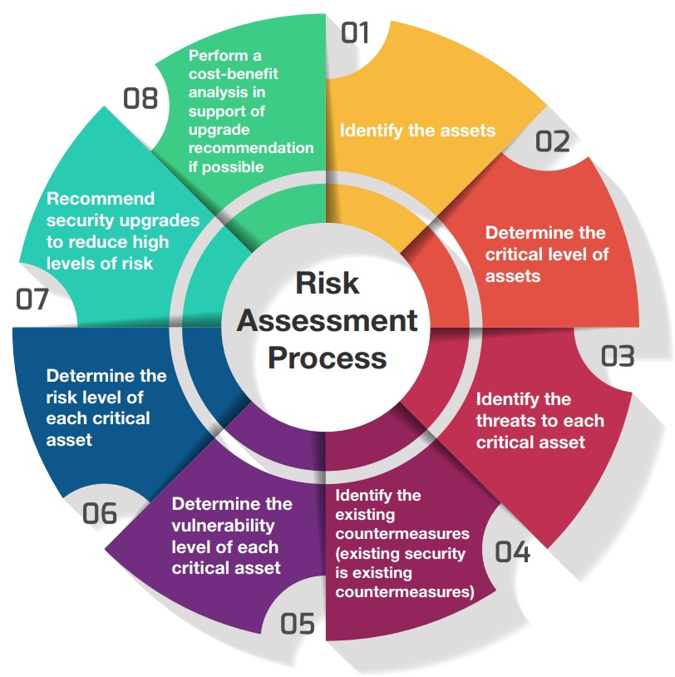
Fig. 3.2: Risk Assessment Procedure circle
The risk assessment procedure can best be illustrated in the following way.
Step 1: Identify Hazards
WHS legislation in New South Wales requires that PCBUs, in consultation with workers identify all potentially hazardous things or situations that may cause harm. In general, hazards are likely to be found in the following;
    - Physical work environment,
    - Equipment, materials or substances used,
    - Work tasks and how they are performed,
    - Work design and management
Step 2: Assess Risks Risk assessment involves considering the possible results of someone being exposed to a hazard and the likelihood of this occurring. A risk assessment assists in determining:
- How severe a risk is
- Whether existing control measures are effective
- What action should be taken to control a risk
- How urgently action needs to be taken
Step 4: Implement additional risk controls
Having identified the hazards in your workplace, assessed their risks and reviewed the existing controls, all hazards must be managed before people are hurt, become ill or there is damage to plant, property or the environment.
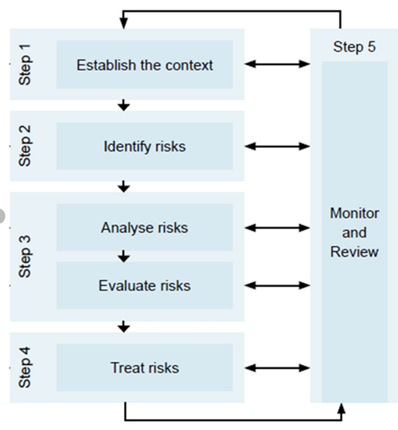
Fig. 3.3: Hierarchy of Controls
Step 5: Monitor and Review
Hazard identification, risk assessment and control is an on-going process. Therefore, regularly review the effectiveness of your hazard assessment and control measures

Self-Check - 3

Name……………………………….ID ………………….. Date……………………...…

Time started: ________________________ Time finished: ________________

Directions: Answer all the questions listed below. Illustrations may be necessary to aid some explanations/answers (5pts. each).
  - Explain the importance of selecting suitable PPE? -------------------------------------------------------------------------------------------------------------------------------------------------
  - What is PPE? ----------------------------------------------------------------------------------------------------------------------------------------------------------------------------------------------
  - List and explain the different types of PPE? --------------------------------------------------------------------------------------------------------------------------------------------------------
  - Explain risk management process? -------------------------------------------------------------------------------------------------------------------------------------------------------------------
  - What is occupational health and safety? -------------------------------------------------------------------------------------------------------------------------------------------------------------
  - Define hazard? -------------------------------------------------------------------------------------------------------------------------------------------------------------------------------------------
  - Define accident? -----------------------------------------------------------------------------------------------------------------------------------------------------------------------------------------
  - Explain and list the class of hazards? ----------------------------------------------------------------------------------------------------------------------------------------------------------------
  - Explain OHS hazards associated with equipment operation? -----------------------------------------------------------------------------------------------------------------------------------------------------------------------------------------------

Note: Satisfactory rating - 25 points and above Unsatisfactory - below 25 points
You can ask you teacher for the copy of the correct answers.

Operation sheet – 3
Name……………………………….ID ………………….. Date………

Time started: ________________________ Time finished: ________________
3.1 Implement risk assessment procedure
Procedures
Materials required
- Note book
- Personal protective equipment
Risk assessment procedure
Step 1: Identify Hazards
Step 2: Assess Risks Risk
Step 4: Implement additional risk controls
Step 5: Monitor and Review

LAP Test -3
Name_______________________________ID ……………Date……………….……

Time started: ________________________ Time finished: ________________

Instructions: Given necessary templates, tools and materials you are required to perform the following tasks within 3 hour. The project is expected from each student to do it.
Task 3.1 conduct risk assessment procedure

LG #3 | LO #4 Handle Surveying Instrument

Instruction sheet
This learning guide is developed to provide you the necessary information regarding the following content coverage and topics:
- Maintenance of tape and Chains
- Transportation of surveying Instrument
- Mount and adjusting instrument on tripod
- Checking instruments
- Clean and Storing equipment
This guide will also assist you to attain the learning outcomes stated in the cover page. Specifically, upon completion of this learning guide, you will be able to:
- Maintain tape and Chains
- Transport survey Instrument
- Mount and adjust instrument on tripod
- Check instruments
- Clean and Store equipment
Learning Instructions:
- Read the specific objectives of this Learning Guide.
- Follow the instructions described below.
- Read the information written in the information Sheets
- Accomplish the Self-checks
- Perform Operation Sheets
- Do the “LAP test”

Information sheet 4
4.1 Maintenance of tape and Chains
Necessary precautions in using chain surveying instruments
  - After use in wet weather, chains should be cleaned, and steel tapes should be dried and wiped with an oily rag.
  - A piece of colored cloth should be tied to arrow (or ribbon – attached) to enable them to be seen clearly on the field.
  - Ranging rods should be erected as vertical as possible at the exact station point.
  - The operating tension and temperature for which steel bands/tapes are graduated should be indicated.
  - Linen tapes should be frequently tested for length (standardized) and always after repairs.
  - Always keep tapes reeled up when not in use.

Care of Instrument
- An instrument that has a telescope attached should not be lifted by a telescope. The instrument should be lifted from the base plate.
- The instrument should be carried on the shoulder and the clamps should be tightened, but not entirely so that they can yield if bumped.
- The lens of the telescope should be covered with a cap if not in use.
- To clean the lens, the dust can be brushed off with a brush. Avoid rubbing with a silk or muslin cloth.
- Tripod legs should not be spread on the smooth ground carelessly. Else, the legs can easily spread out.
- The graduation marks on the vertical circle or other places should not be touched more. They should not be exposed to sunlight, dust, or dampness.
- A fine film of water oil should be applied to the instrument if the survey is to be carried out near seashore to avoid the effects of saltwater.
- The instrument should not be left on the road unguarded.
- The screw or any part of the instrument should not be moved against strain by force. It can be lubricated to facilitate easy movement.
- The compass needle should not be allowed to swing needlessly. It should be lifted off the pivot when not in use.
4.2 Mount and adjusting instrument on tripod
Setting up the tripod A tripod is used as a stable platform to hold the leveling device. To correctly set up and stabilize a tripod, consider the following tips.
- Do not position the tripod legs too far apart or too close together.
- On sloping ground, set the tripod so that one leg is uphill and the other two are downhill on the slope.
- Set up on firm, dry ground that doesn’t shift as you walk around.
- Push the tripod’s pins into the ground as far as they will go.
- Extend the legs on the tripod so that the tripod is just above chest height (the leveling instrument should be at eye height) as bending down or standing on tiptoe can be tiring.
- Set the top of the tripod as level as possible with the leg adjustment.
This will minimize the adjusting that needs to be done with the base plate, adjusting screws or compensating devices and the amount that an automatic or laser level will need to correct itself.

Mount and adjusting Dumpy Level on tripod
A dumpy level, also known as an automatic level or builder’s level, is a tool designed to find the height of land masses.

Part one Setting up Your Level
  - Find a benchmark location near the spot you want to measure.
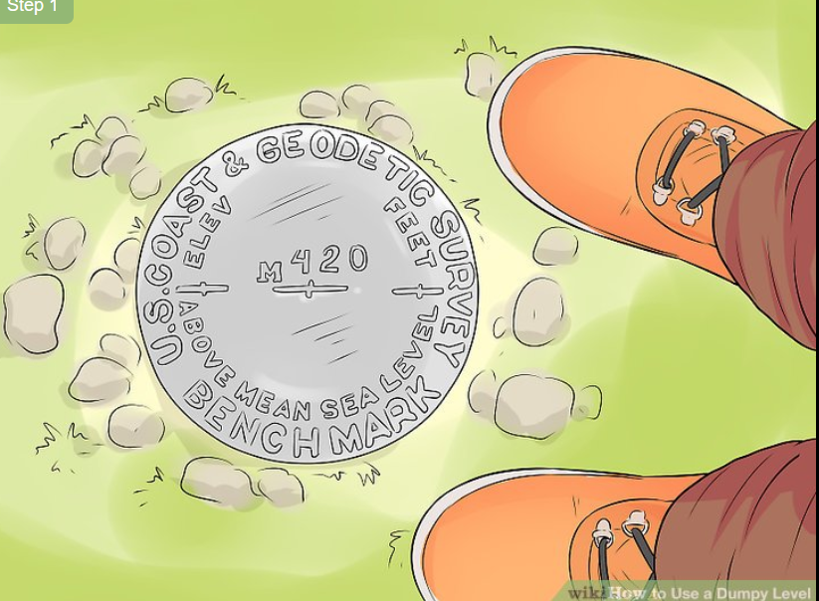
- Set your tripod up near the spot you want to measure.
Place your tripod on a patch of flat, clear ground that sits between your benchmark location and the spot you want to measure.
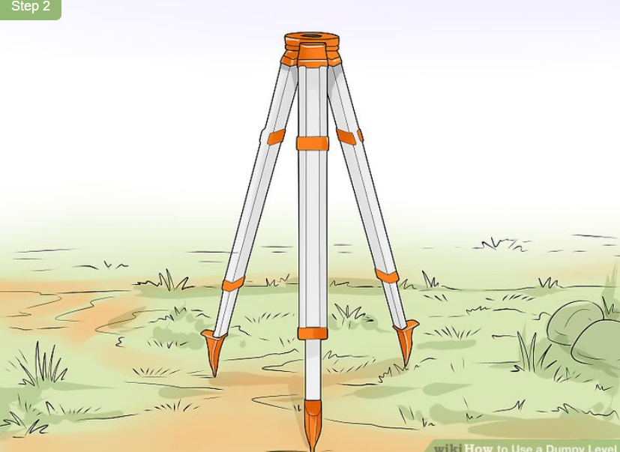
Almost all tripods come with a built-in bubble level. You can use this to assess whether or not the tripod is level.
To measure the area properly, make sure you set up in a spot that’s slightly higher than your benchmark location.
- Connect your device to the tripod and position it over 2 leveling screws.
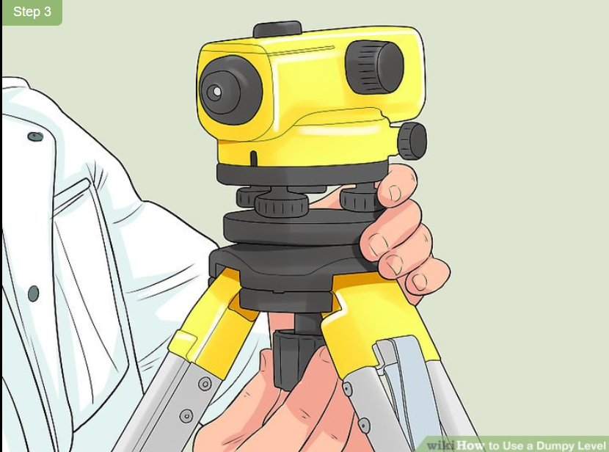
- Level the device by adjusting the 2 leveling screws.
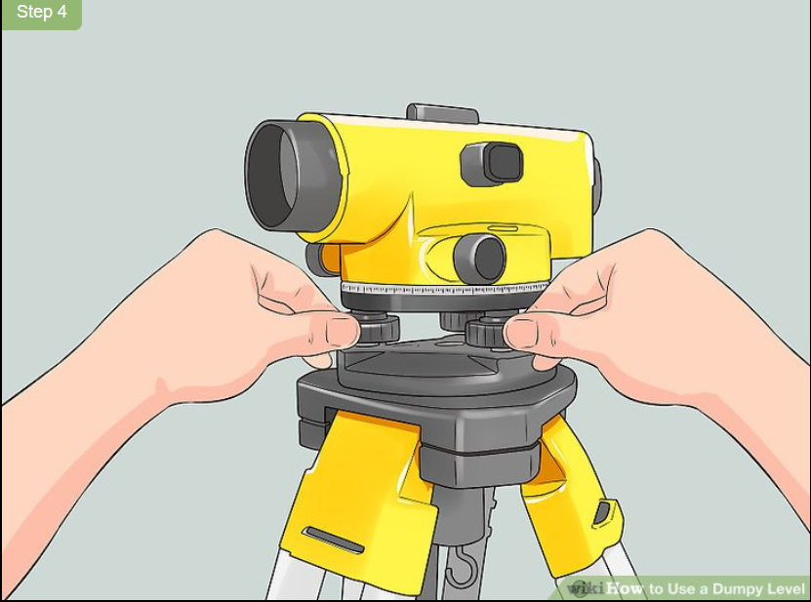
- Turn your telescope 90 degrees and adjust the third leveling screw.
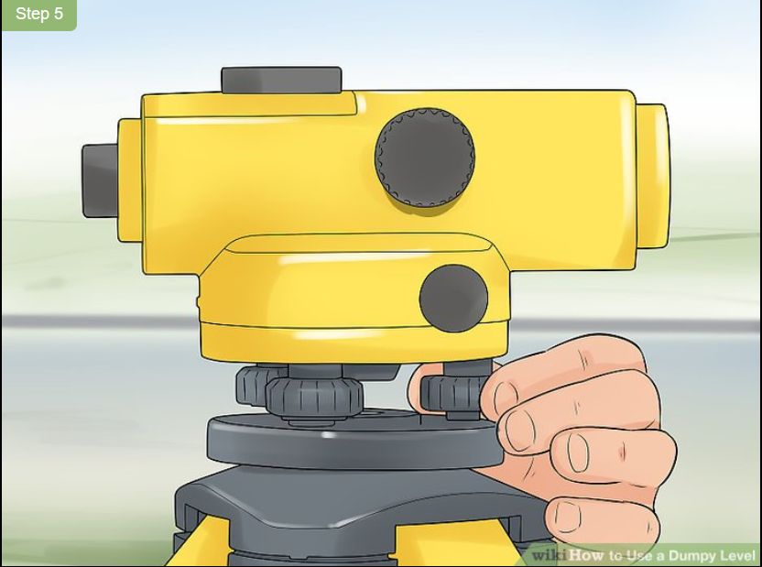
- Check your level’s calibration by turning it 180 degrees.
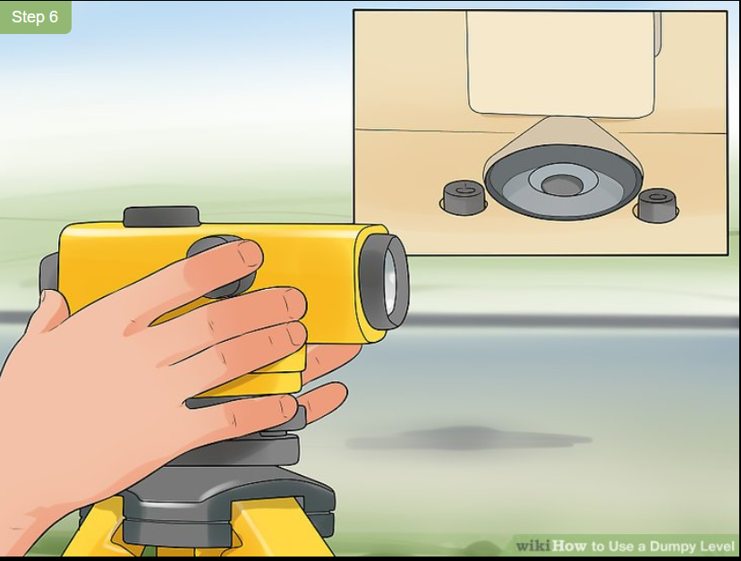
If the bubble is not centered in any of the 3 positions, repeat the leveling process until it is.

Part two Focusing Your Level
Remove your dumpy level’s lens cap. The lens cap protects your device’s lens from unwanted dirt, grime, and debris. To avoid damaging your instrument, leave the lens cap on until you’re ready to use the device.
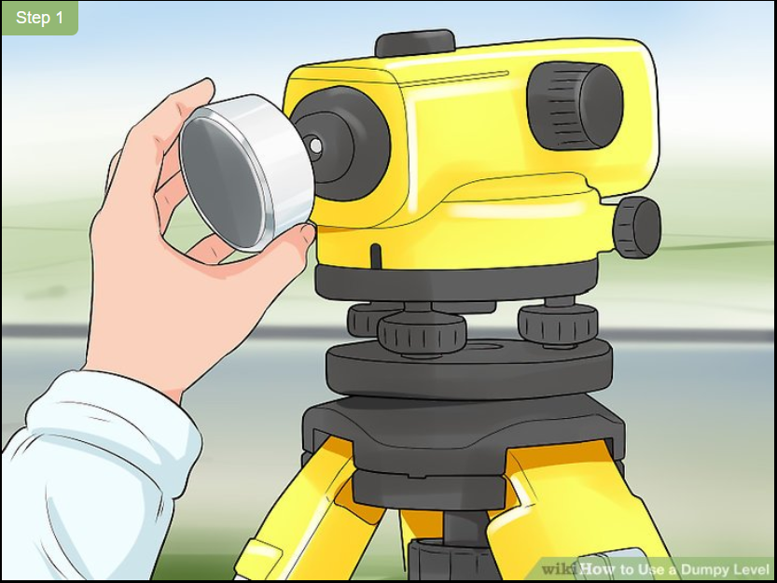
1f your lens is dirty, wipe it down with a pre-moistened lens wipe. You can find these at most camera stores and a number of big-box stores.
  - Adjust the eyepiece until you can see the device’s crosshairs.

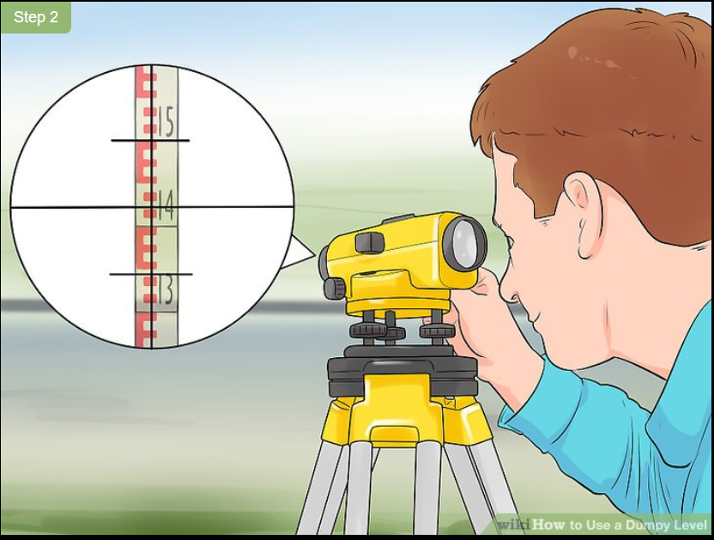

  - Twist the device’s focusing knob until the image is clear.
Once you can see the crosshairs, point your device’s telescope toward your benchmark spot.
If you’re having trouble focusing, ask a friend or colleague to hold an E staff near the benchmark spot. This metered measuring stick will give you an easy object to focus on.
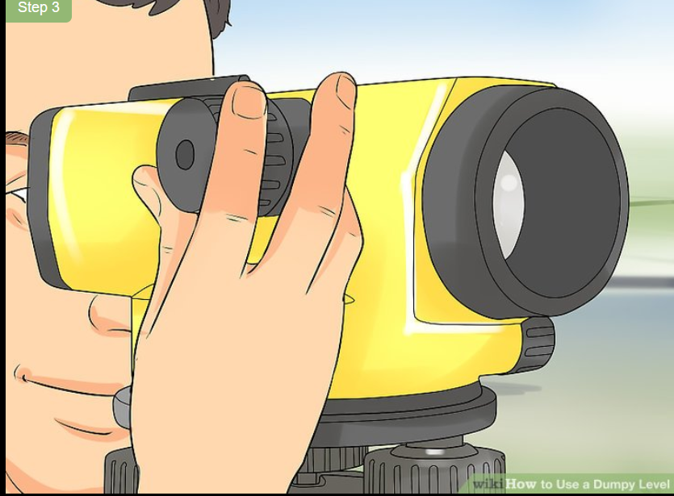
When finished, your crosshairs should appear dark, sharp, and easily noticeable.

Part 3 Taking a Measurement
Position an E staff on top of your benchmark spot.
Friend or colleague holds the staff on top of your benchmark spot.
- For the most accurate measurements, have your friend rock the staff forwards and backwards and record the lowest number you read.
- Most E staffs collapse to save space, so make sure you extend your staff before taking any measurements.
- Use a fiberglass staff instead of a metal version if you’re taking measurements in an area beneath power lines.
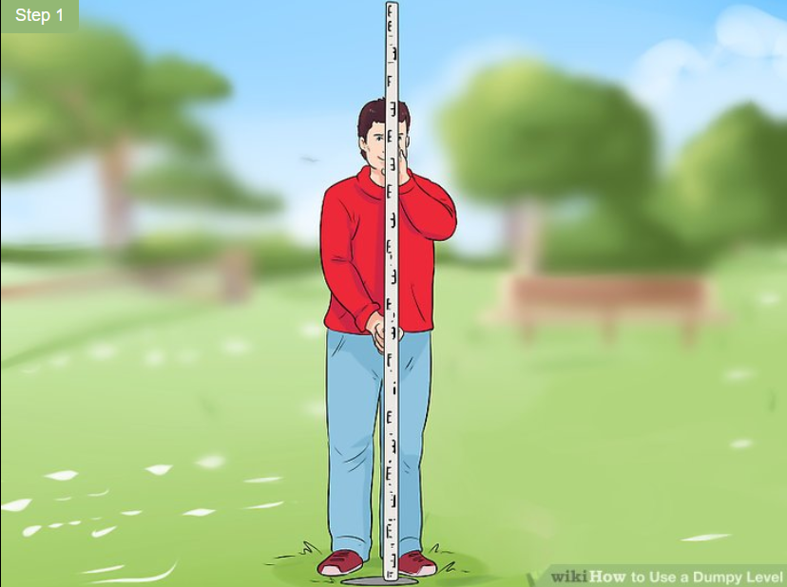
- Find the height difference between your level and the benchmark spot.
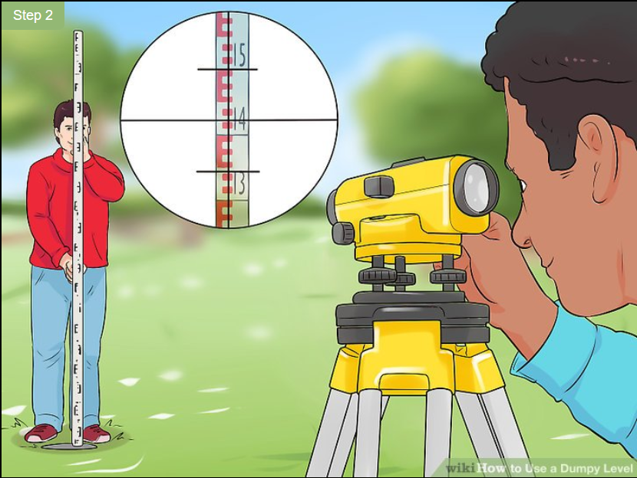
- Calculate your level’s actual height using the benchmark height.
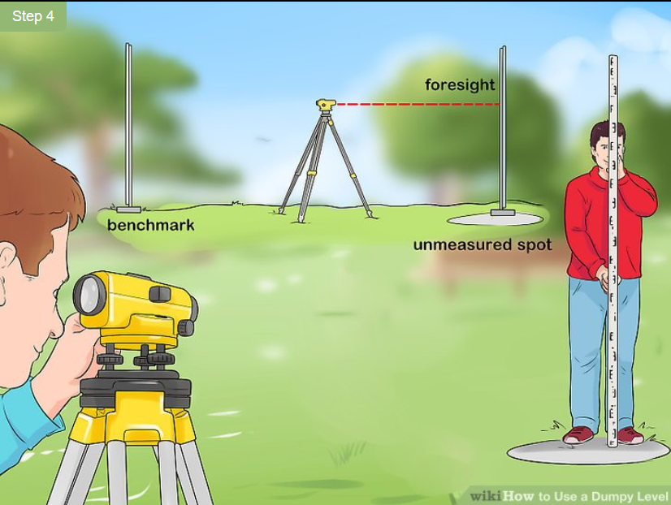
- This measurement is known as your foresight.
- If necessary, adjust your eyepiece’s focusing knob until you can see the staff.
- If the spot is too high or far away for you to measure, move your staff to a lower, closer spot first. Find the height of this new spot, then move your dumpy level to it and restart the measuring process.
- Calculate the spot’s actual height using your level’s height.
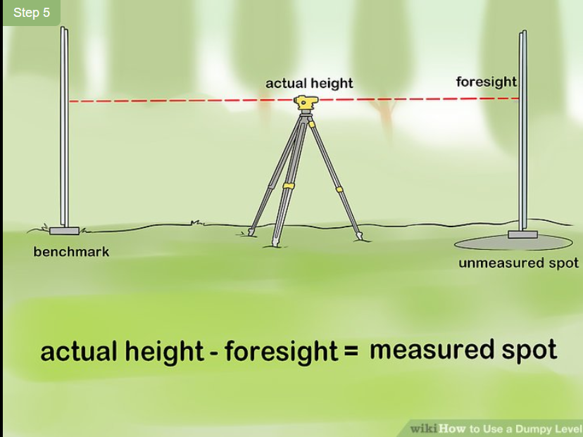
Unlike with your previous calculation, you’ll need to subtract your foresight measurement from your dumpy level’s actual height. This will give you the height of the spot you measured. When your record this height, make sure to include a thorough description or diagram of the spot you measured. That way, if you return to the area, you’ll be able to find the measured spot easily.
  - Transporting and Storing equipment
Improper storage and transportation- both can damage the survey instrument severely. Tips to follow while storing and transporting the survey equipment are:
- Use of an efficient storage case for the instrument.
- The compartment has to be provided within the survey vehicle to keep the equipment and the related tool supplies separated. This helps to avoid damage and easy sorting of items.
- Carry heavy instruments in the lower parts of the vehicles, without contact with other tools or equipment.
- The entire survey crew must follow good care and general housekeeping of the vehicle. Do not mix up the passenger compartment and the equipment
- Most of the instruments'-carrying case takes the shape at which it must be placed and handled. Follow the same position while storing and handling. This is applicable for optical targets, staff, and prisms used.
- Jolting and excessive vibration of the instruments while transporting can be avoided by providing cushioned compartments.
- Before removing the instrument, make a plan to remove it and the way it must be placed. It must be kept back in the case in the same way it was taken out.
- Always take the equipment out with proper grip in both the hands. Do not exert pressure on the vertical circle, circular levels, or the tubular levels. compartment together.

Self-check -4
Name: _________________________ Date: _______________ Directions:
Answer the following questions in the space provided
  - What are the benefits of cleaning tools after use?
_ _ _ _ _ _ __ _ _ _ _ _ __ _ _ _ _ _ __ _ _ _ _ _ __ _ _ _ _ _ __ _ _ _ _ _ __ _ _ _ _ _ __ _ _ _ _ _ __ _ _ _ _ _ __ _ _ _ _ _ __ _ _ _ _ _ __ _ _ _ _ _ __ _ _ _ _ _ __ _ _ _ _ _ __ _ _ _ _ _ __ _ _ _ _ _ __ _ _ _ _ _ __ _ _ _ _ _ __ _ _ _ _ _ __ _ _ _ _ _ __ _ _ _ _ _ __ _ _ _ _ _ __ _ _ _ _ _ __ _ _ _ _ _
2. What should you do with waste (rubbish) at the end of the project?
_ _ _ _ _ _ __ _ _ _ _ _ __ _ _ _ _ _ __ _ _ _ _ _ __ _ _ _ _ _ __ _ _ _ _ _ __ _ _ _ _ _ __ _ _ _ _ _ __ _ _ _ _ _ __ _ _ _ _ _ __ _ _ _ _ _ __ _ _ _ _ _ __ _ _ _ _ _ __ _ _ _ _ _ __ _ _ _ _ _ __ _ _ _ _ _ __ _ _ _ _ _ __ _ _ _ _ _ __ _ _ _ _ _ __ _ _ _ _ _ __ _ _ _ _ _
3. How should leveling tools and equipment be cleaned and stored?
_ _ _ _ __ _ _ _ _ _ __ _ _ _ _ _ __ _ _ _ _ _ __ _ _ _ _ _ __ _ _ _ _ _ __ _ _ _ _ _ __ _ _ _ _ _ __ _ _ _ _ _ __ _ _ _ _ _ __ _ _ _ _ _ __ _ _ _ _ _ __ _ _ _ _ _ __ _ _ _ _ _ __ _ _ _ _ _ __ _ _ _ _ _ __ _ _ _ _ _ __ _ _ _ _ _ __ _ _ _ _ _ __ _ _ _ _ _ __ _ _ _ _ _ __ _ _ _ _ _ __ _ _ _ _ _ __ _ _ _

Note: Satisfactory rating - 25 points and above Unsatisfactory - below 25 points
You can ask you teacher for the copy of the correct answers.

Operation Sheet - 4
4.1 Setting up level
Material requirement
- Dampy level
- Note book
- Reading staff
- Plubob
- Ranging pole
- Find a benchmark location near the spot you want to measure.
- Set your tripod up near the spot you want to measure.
- Connect your device to the tripod and position it over 2 leveling screws.
- Level the device by adjusting the 2 leveling screws.
- Turn your telescope 90 degrees and adjust the third leveling screw.
- Check your level’s calibration by turning it 180 degrees.
4.2 Focus your level
Material requirement
- Dampy level
- Note book
- Reading staff
- Plubob
- Ranging pole
  - Remove your dumpy level’s lens cap.
  - Adjust the eyepiece until you can see the device’s crosshairs.
  - Twist the device’s focusing knob until the image is clear.
4.3 Take measurement
Material requirement
- Dampy level
- Note book
- Reading staff
- Plubob
- Ranging pole
  - Position an E staff on top of your benchmark spot.
  - Find the height difference between your level and the benchmark spot.
  - Calculate your level’s actual height using the benchmark height.
  - Calculate the spot’s actual height using your level’s height.

LAP test - 4
Name…………………………………. ID………………….. Date…………………………

Time started: ________________________ Time finished: ________________

Instructions: Given necessary templates, tools and materials you are required to perform the following tasks within 8 hour. The project is expected from each student to do it.

Task 4.1. Setting up Your Level

Task 4.2. Focus Your Level

Task 4.3. Take measurement

Reference Materials

Books:
Basic Surveying, Raymond E Paul (Author), Walter Whyte (Author)
Delmar .2003. Land scape surveying learning.
Electronic vs. Conventional Surveys, R. Dixon(Author)
Field manual topographic surveying, 16 January 2001. cartome.org 3-34.331
Fundamentals of Surveying: Sample Examination, George M. Cole PE PLS (Author)
Instruction manual for surveyor’s course in jamama district lower juba, somalia Agrosphere April 2004
International labour organization. Surveying and setting out, Module 8
Saswat Suman Sharma, Lecture note on surveying and leveling 4th semester civil engineering
N Basak, 1994. Surveying and levelling. New Delhi
Ninth Annual Seminar Presented by the Oregon Department of Transportation Globetronics, Oregon
Fiji. NIWA: April 2004. Pacific Island Hydrology Course.
Ramsay J. P. Wilson, Mac Donald and Evans .1983. Land surveying Ltd. ISBN 0-721-2705-4
Sample Handout on carrying out basic surveying and leveling For Crop Production Extension Techniques November 2009 Dilla
Web addresses
http://squidstation.net/Surveying.html (access date 08/22)
www.ordnancesurvey.co.uk/gps/ (access date 08/22)

AKNOWLEDGEMENT
Ministry of Labor and Skills and Ministry of labor and skill wish to extend thanks and appreciation to the many representatives of TVET instructors and respective industry experts who donated their time and expertise to the development of this Teaching, Training and Learning Materials (TTLM).

The experts who developed the learning guide
No | Name | Qualification | Educational background | Region | Phone number | E-mail
1 | Serawit Gensa | M.sc. | Water Resource Engineering | W/Sodo AVET | 0916740916 | serawitgen@gmail.com
2 | Edao Hassen | M.sc. | Irrigation Engineering | Alage AVET | 0911098097 | hassedao@gmail.com
3 | Mekete Agizew | M.sc. | Water Resource Engineering | Amhara. Kombolcha ATVET | 0925221192 | gen.mam09@gmail.com
4 | Wondu Alemayehu | M.sc. | Irrigation Engineering | Oromia Kombolcha ATVET | 0910-28-99-61 | woldualem@gmail.com
5 | Ademe Ayalew | M.sc. | Irrigation Engineering | Agrafa AVET | 0912720547 | Ademe2004@gmail.com
6 | Seid Mohammed | M.sc. | Irrigation& drainage Engineering | Alage ATVET | 09-17-18-01-81 | Siyamsdmhmmd@gmail.com
7 | Molalign Asfaw | B.sc. | Water Resource &Irrigation Engineering | Alage ATVET | 0921431096 | Mollalign410ass@gmail. com
8 | Yonas Hailu | B.sc. | Water Resource &Irrigation Engineering | Agrafa AVET | 0934715578 | yonashailuw@gmail.com
9 | Lemessa Mulata | M.sc. | Irrigation Engineering | Agrafa AVET | 0913266845 | Lamimulle2022@gmail.com
10 | Misganew Yimer | B.sc. | Soil and Water Engineering | Woreta ATVET |  | Misge1976@gmail.com
11 | Daniel Derese | Bs. c. | Soil and Water Engineering | W/sodo AVET | 0912-79-28-85 | danielderesse7@gmail.com
12 | Teshome Getachew | M.sc. | Irrigation & drainage Engineering | Alage ATVET | 0925-50-13-99 | teshomegetachew131@yahoo.com

