Irrigation and Drainage Works
Level I
Based on March, 2022, Version- I Occupational standard

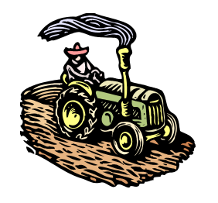

Module Title: - Irrigation Structures
LG Code: AGR IRD1 M04 LO (1-3) LG (12-14)
TTLM Code: AGR IRD1 TTLM 0822v1

August, 2022
Addis Ababa, Ethiopia

Table of Contents

Table of Contents I
Introduction to the Module 1
LO #1- Material, tools and equipment preparation 2
Instruction sheet 2
Information Sheet -1 3
Self-check 1 15
Operation Sheet – 1 17
LAP TEST-1 17
LO #2- Identification of irrigation structure works 18
Instruction sheet 18
Information Sheet 2 19
Self-check- 2 42
Operation Sheet - 2 43
LAP TEST-2 44
LO #3- Maintaining and cleanup of irrigation work site 45
Instruction sheet 45
Information Sheet 3 46
Self-check 3 50
Operation Sheet - 3 51
LAP TEST-3 52
Reference 53

Introduction to the Module
Module Description: This module covers the knowledge, skills and attitudes required to identify and prepare material, irrigation structure work, maintain, clean up and store worksite and equipment on irrigation systems

LG #12 | LO #1- Material, tools and equipment preparation

Instruction sheet
This learning guide is developed to provide you the necessary information regarding the following content coverage and topics:
- Purpose of irrigation structures
- Equipment and tools selection
- Techniques of loading and unloading materials
- Personal protective equipment selection
- Provision of irrigation structures
This guide will also assist you to attain the learning outcomes stated in the cover page. Specifically, upon completion of this learning guide, you will be able to:
- Describe purpose of irrigation structures
- Select equipment and tools
- Use techniques of loading and unloading materials
- Select Personal protective equipment selection
- Provide irrigation structures
Learning Instructions:
- Read the specific objectives of this Learning Guide.
- Follow the instructions described below.
- Read the information written in the information Sheets
- Accomplish the Self-checks
- Perform Operation Sheets
- Do the “LAP test”

Information Sheet -1

1.1 Purpose of irrigation structures
Irrigation is the application of water to soil for the purpose of supplying the moisture essential for plant growth. Irrigation plays a vital role or benefit for increasing crop yields and stabilizing production and has some ill-effect if not properly managed.

Irrigation structures are any structure or device necessary for the proper conveyance, control, measurement, or application of irrigation water.
The Purpose of irrigation structures are:
- To transport water from an irrigation source to irrigated lands and water distribution between particular farms, crop-rotation plots and fields within the irrigated lands' boundaries.
- To rise the water level at the head of the canal.
- To form a storage by constructing dykes (embankments) on both the banks of the river so that water is available throughout the year
- To control the entry of silt into the canal
- To control the deposition of silt at the head of the canal and
- To control the fluctuation of water level in the river during different seasons

1.2 Equipments, tools and materials selection
Equipments are all appliance and whatever nature for the use in or for the execution, completion, operation or maintenance of the work.
Tools are any instrument or simple piece of equipment that you hold in your hands and use to do a particular kind of work. A tool can be any item that is used to achieve a goal.

Materials are defined as the physical components of something, to relevant facts, to jokes or items that are part of a performer’s routine, or to the things required to build something or accomplish a task.

It is essential to select, identify and check equipments, tools and materials for irrigation structure works in order to:
- Identify and provide necessary materials, tools and equipments to construct and maintain irrigation structures.
- report damage or malfunction tools and equipments to the authorized representative in writing.
The necessary equipments, tools and materials required for irrigation structure works are listed below.
- Valves

The term “valve” applies to a variety of devices for controlling the flow of liquid. Various valves allow for on-off control, modulation of the flow rate through the system, and prevention of back flow.
- Gate Valves
A gate valve is the most common type of on-off service valve. Its flow control element is a disk or wedge attached to the valve stem.
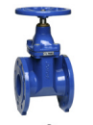
Fig.1.1 Gate valve

- Plug Valves
A plug valve is also intended as an on-off type of valve. The flow control element is a plug which is transversely pierced to allow liquid to flow when the pierced section is exposed by turning the plug 90° (Figure 4). Plug valves do not have linear flow characteristics when partially closed.

- Ball Valves
A ball valve is a modification of the plug valve with the plug replaced by a spherical flow control element (Figure 5). Like a plug valve this valve is very compact and operates on 90° turns. Ball valves are full-flow units and create minimum pressure loss through the valve when fully open
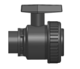
Fig.1.2: Ball valve
- Globe valve
A globe valve is the only type of manual valve recommended for regulating the flow with minimum friction loss. It consists of a movable disk plug aligned with a fixed ring located in the stream. Operated by screw action using a handwheel.

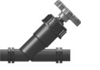
Fig.1.3: Glove valve

- Check valve (One-way valve)
The function of the check valve is to prevent water flow in the opposite direction to that desired.

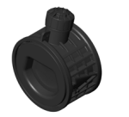
Fig.1.4: check valve

- Water Meters
Water meters measure and record the volume of water passing through them, without considering the time element. Reading the output of a water meter gives information about the volume of water that passed through the appliance in a period, beginning with the last reading or zeroing of the meter. The most common type used for irrigation water is the Woltmann type with an impeller for axial flow.

- Flow meter
The flow meter measures the velocity of flow or, less often, the rate of flow or discharge. The most common type is the rotameter where a specially shaped float moves freely in a tube so that the flow velocity or rate is directly indicated by the float rim.
- Pipes
Th pipes are the basic component of all irrigation networks. There are various kinds and types available in many pressure ratings and in different sizes (diameters). All these pipes are described below.

- Water mains
water main is a primary underground pipe in irrigation and a municipal water distribution system. It is a major artery that supplies water to smaller pipes

- Polyvinyl chloride (PVC)

- Rigid PVC pipes.
Extruded from unplasticized polyvinyl chloride, also called uPVC for unplasticized polyvinyl chloride (or PVC-U), these pipes are ideal for irrigation, (cold) water conveyance and distribution lines as mains and submains. In many cases they can also serve as manifolds and laterals. Very light in weight, they are easy to transport and to handle on site.

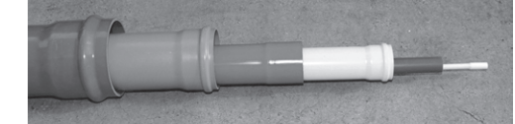
Fig. 1.5: - Rigid PVC pipes.

- Polyethylene,
Flexible black Polyethylene PE pipes are extruded from polyethylene compounds containing certain stabilizers and 2.5 percent carbon black which protect the pipes against ageing and damage from sunlight and temperature fluctuations. LDPE (low-density resin) pipes are also known as soft polyethylene and PE 25, while HDPE pipes (high density resin) are more rigid and known as hard polyethylene or PE 50 (the numbers correspond to the pipe material’s hydrostatic design stress).

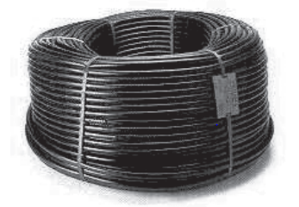
Fig.1.6: Polyethylene pipe in a coil.

- Steel and cast iron
- Steel threaded pipes.

Galvanized steel pipes have been used widely in every country for all kinds of water works. In the past they were used as mains and submains in pressure piped irrigation solid installations.

Due to their excellent properties, they have the ability to withstand stress, to resist high pressures and to maintain their strength for the duration of their service life,

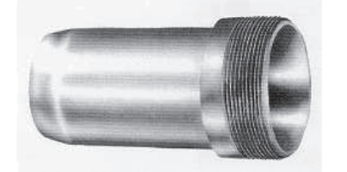

1.7: A threaded steel pipe fitting (male adapter).

- Quick coupling light steel pipes.
These pipes are made of light rolled strip steel which has been hot-galvanized inside and outside. Each pipe is equipped with a hand-lever quick coupling welded on one end while the other end is arranged accordingly for water and pressure proof tight closure. The standard pipe length is 6 m and the working pressure (PN) ranges from 12.0 to 20.0 bars.

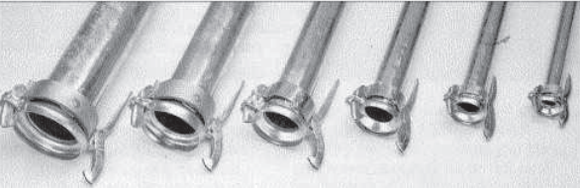
Fig.1.8: Quick coupling light steel galvanized pipes and fittings.

- Quick coupling aluminum pipes.

They are mostly used, always above ground, as moveable lateral lines in sprinkler irrigation portable installations. Made of aluminum alloy by extrusion or by fusion welding, they are light in weight (about half that of the light steel ones), relatively strong and durable.
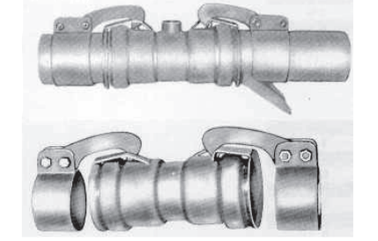
Fig.1.9- Quick coupling aluminium pipes.
- Fittings
Pipe Fittings are a piece (such as T-connectors, a coupling, J-bolt, Bolted flanges, elbow) used to connect pipes or as accessory to a pipe.
- Malleable iron threaded
These fittings are made for use with galvanized steel threaded pipes and they are available in a wide range as elbows, bends, reducers, tees, plugs, nipples and other (Figure 3.7). They are characterized by toughness and ductility and they provide a sound joint able to withstand pipeline expansion and contraction and other stresses. They are manufactured with screw type joints male and female (taper threads) in accordance with BS 21, DIN 2999, ISO R 7 and American standards in nominal sizes (inside diameters) as in the galvanized steel pipes.

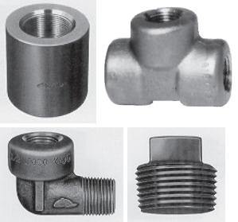
Fig. 1.10: Threaded galvanized steel pipe fittings.

- Polypropylene (PP) pipe connector fittings.
PP connector plastic pipe fittings (joints) are primary suitable for use with PE plastic pipes. There is a full range of all kinds, sizes and types of these pipe fittings worldwide.

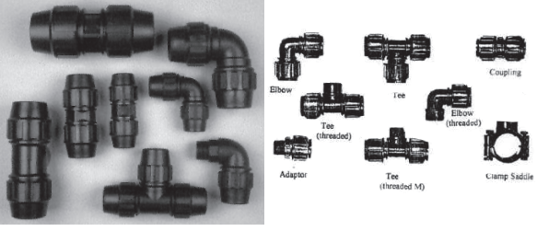
Fig.1.11: Polypropylene (PP) pipe connector fittings
- Others construction materials

- cement,
- sand,
- aggregate,
- reinforcement bar,
- timber,
- eucalyptus poles,
- nails, black wire,
- bitumen,
- construction joints,
- water stops…

1.3 Techniques of loading and unloading materials
The techniques used when loading and unloading materials should demonstrate correct manual handling and minimize damage to the load and the vehicle while transporting irrigation equipments.
The most common techniques of loading and unloading materials:
- Develop an operations plan that describes procedures for loading and/or unloading.
- Conduct loading and unloading in dry weather if possible.
- Cover designated loading/unloading areas to reduce exposure of materials to rain.
- Consider placing a seal or door skirt between delivery vehicles and building to prevent exposure to rain.
- Design loading/unloading area to prevent storm water run-on, which would include grading or berming the area, and position roof downspouts so they direct storm water away from the loading/unloading areas.
- Have employees load and unload all materials and equipment in covered areas such as building overhangs at loading docks if feasible.
- Load/unload only at designated loading areas.
- Pave loading areas with asphalt instead of concrete.
- Avoid placing storm drains in the area.
- Grade and/or berm the loading/unloading area to a drain that is connected to a dead end.

1.4 Personal protective equipment selection
Personal protective equipment (PPE) is used to protect an individual from hazards associated with their work tasks or environment. Personal protective equipment should be selected based on work requirement. Specific types of personal protective equipment include protective clothing, eyewear, ear muff, mouth clamp, gloves, hard hat and safety shoe.
Some of the commonly used PPE are listed in the table below.

Table1.1 Personal protective equip
Body protection (PPE) |  | Purpose
Gloves |  | It is used to protect severe cuts,  abrasions, punctures, temperature, and chemical hazards.
Hard hat |  | - It is required to protect the head from sun, accident and dust.
Safety shoe |  | - It is required to protect the foot from different hazards.
Goggles |  | .It is required to protect eye from dusts, chemicals, etc by all workers engaged in hazardous activities.
Ear muff |  | - It is required to protect the ear from dangerous sound and dust.
Mouth clamp / Mouth guard |  | - It is required to protect the mouth from the entering of dust and different chemicals.
Overalls |  | - It retains heat radiated from the body and keeps the wearer warm in the cold weather

1.5 Provision of irrigation structure works
The aim of irrigation facilities is to divert water from a source, convey it to appropriate locations in the system and distribute it within the field so that water reaches the roots of the crops in an optimal manner to ensure improvement of agricultural production.

Irrigation networks are man-made facilities put in place to achieve the above-mentioned objective. Irrigation networks also include drainage networks which are responsible for the removal of excess water from the field and road networks which are required for access to the various parts of the irrigation system. Drainage is usually a complementary component of irrigation and irrigation schemes without a drainage facility is seldom successful particularly in poorly drained heavy soils.

Irrigation structure works are provided according to occupational health and safety requirement and work place information. According to WHO (1995), occupational health and safety can be defined as a multidisciplinary activity aiming at:
• Protection and promotion of the health of workers by eliminating occupational factors and conditions hazardous to health and safety at work
• Enhancement of physical, mental and social well-being of workers and support for the development and maintenance of their working capacity, as well as professional and social development at work
• Development and promotion of sustainable work environments and work organizations

Identify OHS hazards in the working area
Contamination of collected rainwater with disease causing microorganisms (bacteria, viruses and protozoa), from birds and other animals, poses the biggest risk to health. There is always the possibility of inadvertent ingestion while washing hands or inhalation of the microorganisms found in harvested rainwater. Leaching from roof materials, like lead, copper and other roof materials may also occur when rainwater harvesting. There are many potential health and safety hazards associated with farmer's duties

Self-check 1 | Written test

Name…………………………………………… ID………………………… Date…….
Directions: Answer all the questions listed below.

Test I: Choose the best answer (4point)
- Any structure or device necessary for the proper conveyance, control, measurement, or application of irrigation water is ------------
    - personal protective equipment
    - Irrigation Structures
    - loading and unloading materials
    - Irrigation
  - Which one of the following is used to protect the head from sun, accident and dust.
    - Goggle
    - Safety shoe
    - Hard hat
    - Over all
Test II: Match the following from B to A (4pts)
A B
- Ear muff A. Used to protect eye
- Goggle B. Used to protect ear
- Water mains C. To measure and record the volume of water
- Water meter D. primary underground pipe in irrigation and a
municipal water distribution system.
E. Used to protect hand
Test III: Short Answer Questions
1. Write at least five tools and equipments used in irrigation structure work?
2. List personal protective equipment used in irrigation structure works?
3. Mention the techniques used to load and unload irrigation structure equipment?

Operation Sheet – 1

1.1 Identify materials, tools and equipment using for irrigation structure work
- . Tools, Equipments and materials
- Note book,
- pen,
- Safety shoe,
- Hard hat,
- glove,
- over all
- Procedure
- Wear protective equipments
- Provide Working site/store /work shop
- Identify the following Tools and materials
- Water mains,
- Valves,
- Meters
- Pipes
- Polyvinyl chloride (PVC),
- Polyethylene,
- Cast iron
- Steel
- Fittings
- construction materials

- cement,
- sand,
- aggregate,
- reinforcement bar,
- timber,
- eucalyptus poles,
- nails, black wire,
- bitumen,
- construction joints,
- water stops

LAP TEST-1 | Performance Test

Name………………………………. ID……………………………. Date…………………………………….

Time started: ________________________ Time finished: ________________

Instructions: Given necessary templates, tools and materials, you are required to he following tasks within 2 hours. The project is expected from each student to do it.
Task1: Identify materials, tools and equipments used in irrigation structure work.

LG #13 | LO #2- Identification of irrigation structure works

Instruction sheet
This learning guide is developed to provide you the necessary information regarding the following content coverage and topics:
- Identification of diversion structures
- Identification and management of conveyance structures
- Identification of field distribution systems
This guide will also assist you to attain the learning outcomes stated in the cover page. Specifically, upon completion of this learning guide, you will be able to:
- Identify diversion structures
- Identify and manage of conveyance structures
- Identify of field distribution systems
Learning Instructions:
- Read the specific objectives of this Learning Guide.
- Follow the instructions described below.
- Read the information written in the information Sheets
- Accomplish the Self-checks
- Perform Operation Sheets
- Do the “LAP test”

Information Sheet 2

2.1 Identification of diversion structures
Diversion head works are structures constructed across a river (head of a canal) to facilitate a regulated and continuous diversion of water into the off-taking canal. Whenever the source of water for irrigation is a river, it is hardly possible to divert a regulated and continuous flow into the main canal without a headwork. This is due to the fact that the flow in the river is never uniform and varies from season to season.
Thus, there is a need to regulate the flow into the canal system in order to ensure a continuous diversion of water. There is practically no storage provided by a diversion structure. The purpose is to raise and keep the water level more or less constant (reduce the fluctuation of water levels) at the head of the canal.
Components of Diversion structures /Headwork’s
Diversion structures /head works generally consist of the following components:
- Weir wall/Barrage
- Under sluices
- Divide wall
- Canal head regulator
- Silt excluder
- Guide banks
- Wing walls (Marginal bunds)

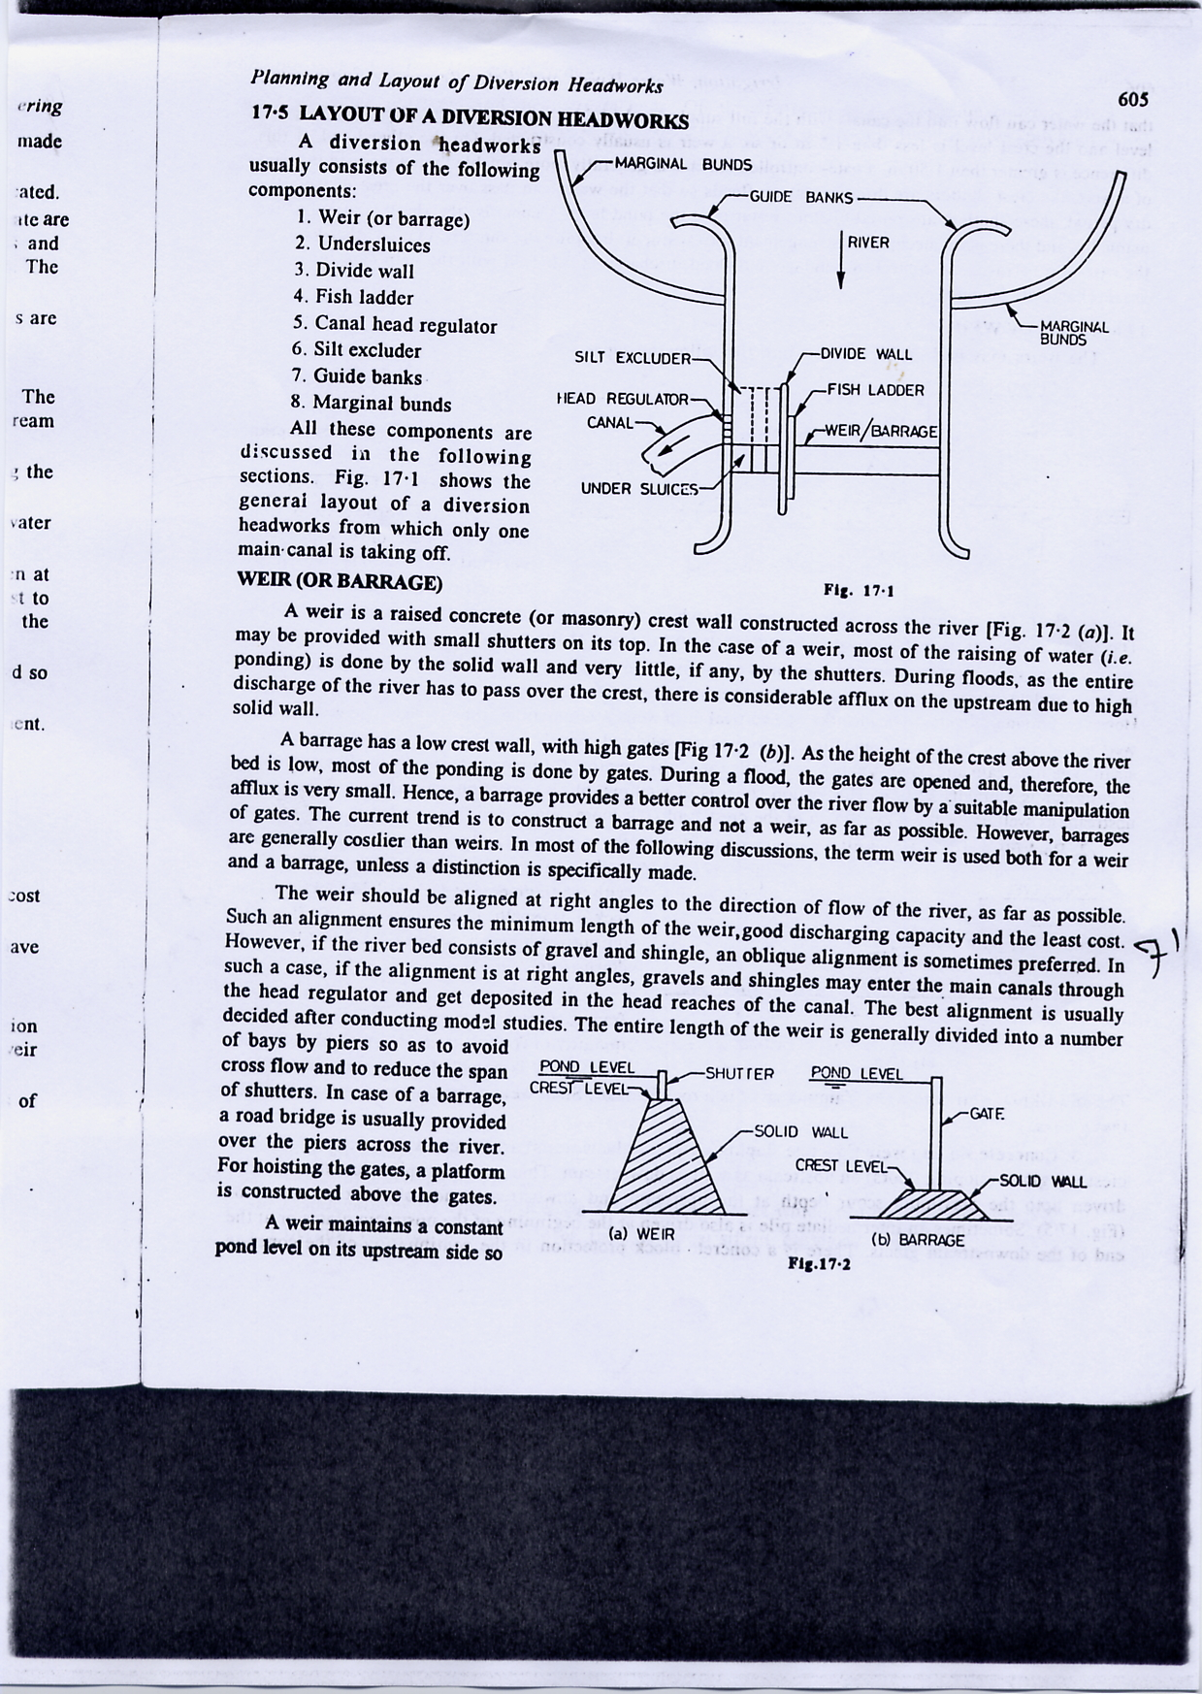
Fig. 2.1- Typical layout of diversion headwork
Types of diversion structure works
- Weir
A weir is a barrier (structure) constructed across a river to raise the water level in the river behind it so as to enable regulated diversion of water. A weir has a raised crest behind which a small ponding of water will take place. Weirs can be constructed with or without shutters on the crest of the weir.

Types of weirs based on construction materials and shape
- Masonry weirs with vertical or slightly sloping u/s and d/s face
- Rock fill weirs
- Concrete weirs with sloping glacis
- Reinforced concrete weir
- Cyclopean weir

- Masonry weirs with vertical or slightly sloping u/s and d/s face
These weirs have a horizontal floor constructed of masonry and a crest wall with vertical or slightly sloping downstream face. The height of the crest depends on the actual site conditions and head required behind the weir. Sheet pipe walls are driven at the upstream and downstream of the floor. These weirs are suitable whenever the drop in water levels is small.
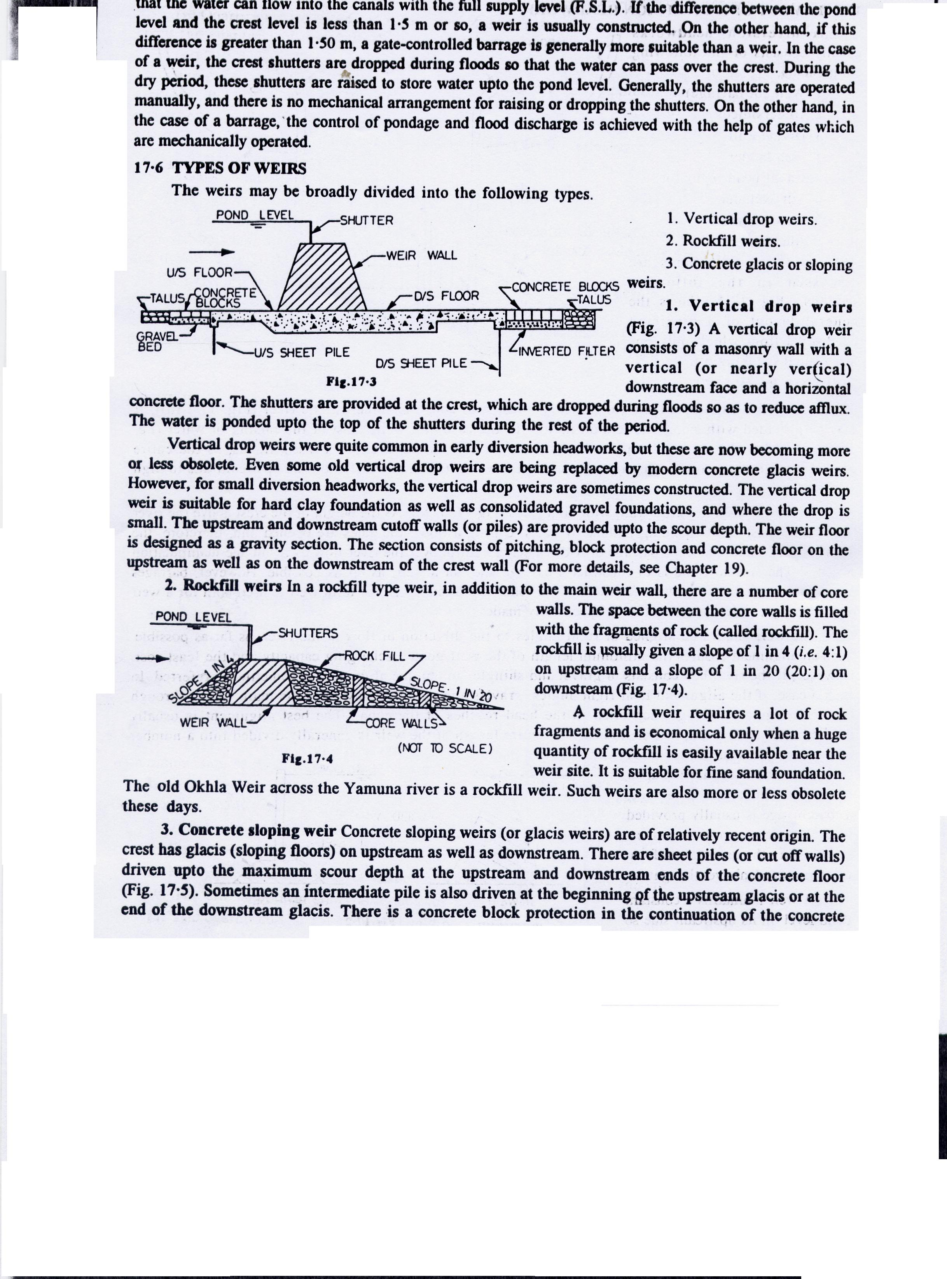
Fig.2.2-Vertical drop weir
- Rock fill weirs
These weirs are constructed of rocks with extremely sloping downstream face. Such weirs are suitable whenever there is excess stone available for construction.
Fig.2.3 - Rock fill weir

- Concrete weirs with sloping glacis
The crest of this weir has sloping glacis both on the upstream and downstream. Cutoff sheets are provided at the upstream, intermediate and downstream of the floor to the depth equal to the scour depth. Hydraulic jump is formed on the downstream slope for energy dissipation. These weirs are suitable whenever the drop in water level is large.

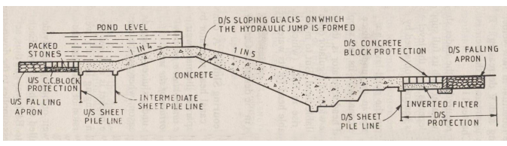
Fig.2.4 - Concrete weir with sloping glacis
- Reinforced concrete weir
All components’ aprons, crest, glacis etc are constructed out of reinforced concrete. Mostly sloping downstream glacis is provided to create hydraulic jump in a short distance.

- Cyclopean concrete weir
The major control section of the weir is constructed out of cyclopean concrete, a mix of rubble stone & cement concrete.
Types of weirs based on shape
- Broad crested weir
- Sharp crested weir
- Ogee crest weirs

- Broad crested weir

The weir comprises a horizontal crest between vertical abutments and two vertical or inclined faces.

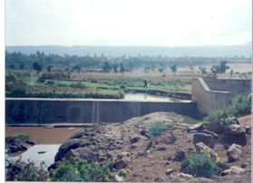
Fig. – 2.5 Broad crested weir
- Sharp crested weir
From an economic point of view, spillway must safely discharges a peak flow under the smallest possible head, while on the other hand the negative pressure on the crest must be limited to avoid the danger of cavitations

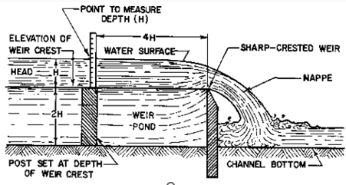
Fig. – 2.6 Sharp crested weir

- Ogee crest weirs
Ogee crest weir is a weir whose crest wall is rounded to increase the discharge coefficient. It consists of a concrete weir wall with vertical upstream face and rounded top and downstream. It is designed as gravity section similar to vertical drop weir.
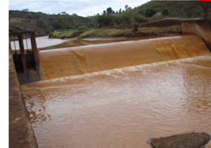
Fig.2.7: Ogee crest weir
Types of the weir based on weight of the weir

- Gravity weirs
- Non-gravity weirs

- Gravity weirs
There is uplift force on the floor of the weir from water seeping under the foundation of the weir. Whenever weir is designed so that the weight of the weir is sufficient to balance the uplift pressure caused by seeping water, it is called gravity weir.
- Non-gravity weirs
when the concrete slab (floor) is designed continuously with the weir body to keep the structure safe against uplift it is called as non-gravity weir.

- Barrage
A barrage is also an obstruction constructed across a river for raising the water level and regulates the diversion of water to canals. However, the crest wall of a barrage is low and pounding of water takes place by gates. The gates are fitted on the top of the crest wall and can be closed and opened as required based on the flow in the river.
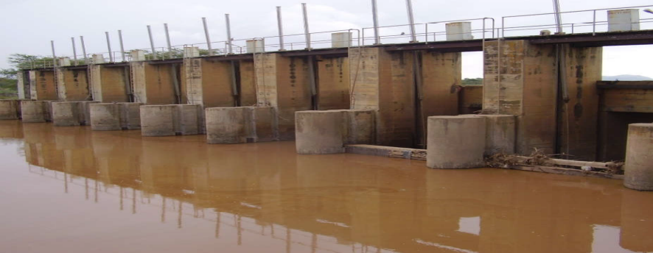

Fig.2.8.-Barrage

2.2 Identification of Conveyance, distribution and management structures
- Conveyance structures
Conveyance structures are structures used to convey irrigation water (simply water) from source to the irrigation field (command area) through canals. The conveyance system assures the transport of water from the main intake structure or main pumping station up to the field ditches.
Conveyance structures are those structures such as road crossings, inverted siphons, drops, chutes, flumes, canals, and pipelines that are used to safely transport water from one location to another traversing various existing natural and manmade topographic features along the way.

- Canals
Canals are structures used to carry water through it. Canal is any conduit or passage in which water flows with a free water surface. Canals are classified in to different types based on different criteria.
Types of canals based on construction material;
- Lined canals
- Earthen/ un lined canals
Types of canals geometrically shapes or cross-section:
- Rectangular canal
- Trapezoidal canal
- circular canal
- Triangular canal
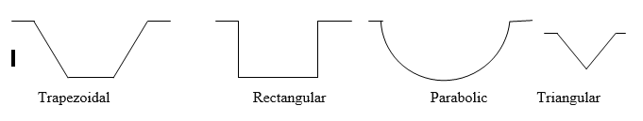
Fig. 2.10 various shapes of canals

Classification of Canals based on alignment:
- Contour canal
- Watershed (ridge) canal
- Side slope canal
Classification of canals based on size:
- Primary canal (main canal)
- Secondary canal
- Tertiary canal
- Quaternary canal
- Field channels
- Siphon
Siphon is a tube that is used to move liquids between locations without any mechanical pumping. This device uses pressure to keep the liquid flowing without exerting external force. Siphons operate using atmospheric pressure.

Pipes are the most widely used conveyance device. Pipes for irrigation structure works are made from the following materials:
- Cast iron,
- Steel,
- Pre-stressed Concrete,
- Asbestos Cement
- Reinforced Concrete, and
- Polyethylene, low or medium density.
- Other types (e.g. Aluminium and copper materials).

- Distribution structures
Distribution structures are structures used to distribute water though canal and in the command area.
Distribution structures include:
- Division boxes
Division boxes: - Division boxes are used to divide or direct the flow of water between two or
more canals or ditches. Water enters the box through an opening on one side and flows out through openings on the other sides. These openings are equipped with gates.

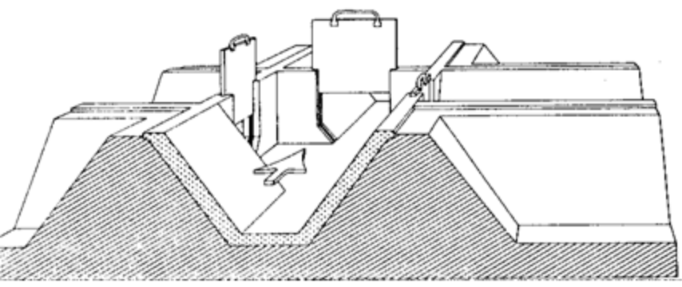
2.11 Division boxes
- Turnouts
Turnouts: - Turnouts are constructed in the bank of a canal. They divert part of the water from
the canal to a smaller one. Turnouts can be concrete structures or pipe structures.

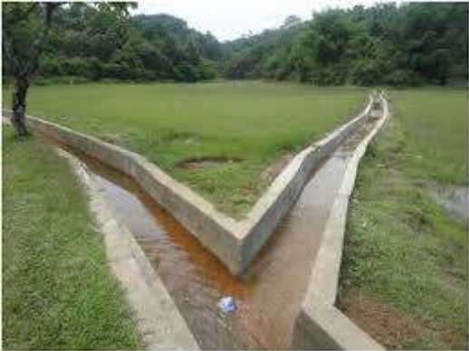
Fig.2.12 Turnouts
- Spile

It is a small short pipe buried in the canal embankment for letting water from field channel to the field. Spiles are made of bamboo, concrete or baked clay pipes. Good water intake control can be obtained either by adjusting the water level in the field channel or by closing individual spiles with a plug or lid. However, spiles can become blocked with mid or plant debris, and thus needs to be regularly inspected.

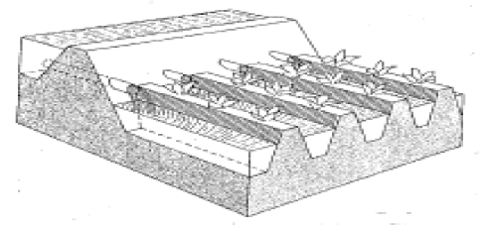
Fig.2.13.- Spile
- Stop logs

Stop logs are frequently used to temporarily block flow through a spillway or canal during routine maintenance. At other times stoplogs can be used over longer periods of times, such as when a field is flooded and stoplogs are being used in smaller gates in order to control the depth of water in fields.
- Checks
Checks are structures placed across the ditch to block it temporarily and to raise the upstream water level. Checks can be permanent structures. Checks are used to divert water from the field ditch to the field, it is often necessary to raise the water level in the ditch.
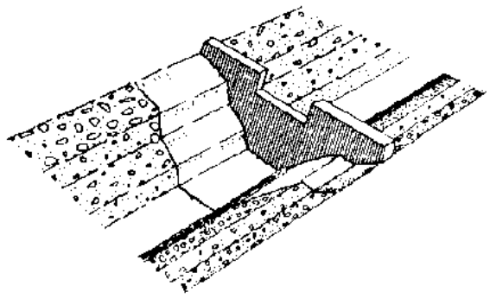
Fig. 2.14 Checks

- Drop Structures
Drop Structures are structures placed to pass water to a lower elevation while controlling the energy and velocity of the water as it passes over. The function of drop structures is to convey water from a higher to a lower elevation and to dissipate excess energy resulting from this drop. It is used on canals laid on sloping ground that are steep enough to cause erosion and thus helps reduce such erosive slopes. The different kinds of drops that may be used are:
      - vertical,
      - rectangular inclined, and
      - Pipe drops.
The components of a drop structure are:
- the inlet,
- the vertical wall section and
- the outlet.

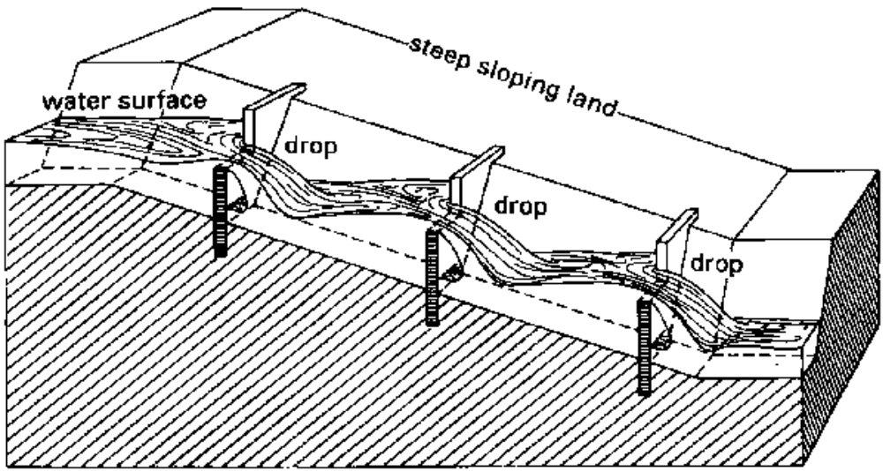
Fig. 2.15 Drop Structures

- Chutes
Chutes are used to convey water from a higher elevation to a lower elevation on slant surface. A chute structure may consist of an inlet, a chute section, an energy dissipater, and an outlet transition.
- Management (control) structures
Management (control) structures: - are structures used to manage or control the amount of water in the canal by using different water control gates. This mainly includes the main intake structures and water control structures.

- Main intake structure
Main intake structure is built at the entry to the irrigation system. Its purpose is to direct water from the original source of supply (lake, river, reservoir etc.) into the irrigation system.

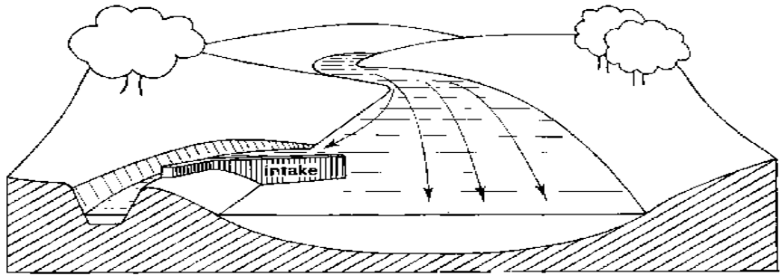
Fig.2.16 Intake structure
- Water control gates
Water control gates control the flow of water from point to point in open channel situations. We offer a variety of flap gates, sluice gates, slide gates, overshot gates, radial gates and roller gates to meet specific needs. Gate systems include manual or power operating systems, stems, accessories and, in some cases, automation packages for operating the gates.

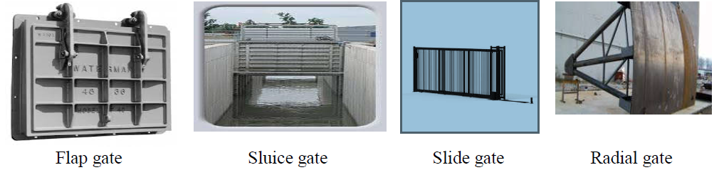
Fig. 2.17 water control gates
- A trash racks

A trash rack is a wooden or metal structure, frequently supported by masonry, that prevents water-borne debris (such as logs, boats, animals, masses of cut waterweed, etc.) from entering the intake of a water mill, pumping station or water conveyance. This protects water wheels, penstocks, and sluice gates from destruction during floods. They are sometimes fitted to storm drain inflows and outflows to prevent debris from entering a natural watercourse.

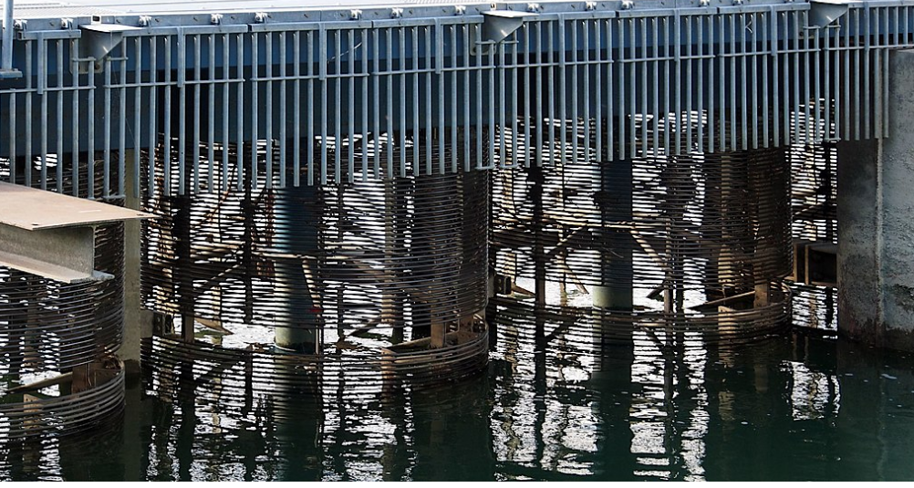
Fig. Trash racks
- Crossing structures
It is often necessary to carry irrigation water across roads, hillsides and natural depressions. Crossing structures, such as flumes, culverts and inverted siphons, are then required.
- Flumes
Flumes are used to carry irrigation water across gullies, ravines or other natural depressions. They are open canals made of wood (bamboo), metal or concrete which often need to be supported by pillars
. 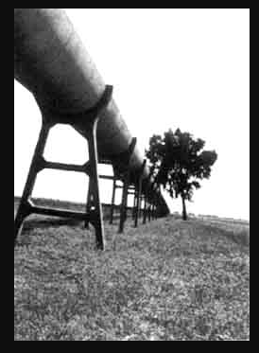
Fig.2.18 Flumes
- Crossing culverts
Crossing culverts are used to carry the water across roads. The structure consists of masonry or concrete headwalls at the inlet and outlet connected by a buried pipeline. Road crossing structures are used to convey canal water under roads or railroads. Pipe conduit is generally used for these purposes
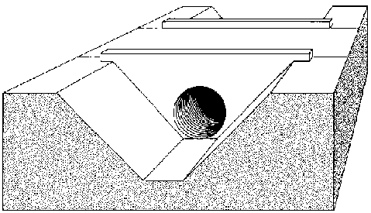
Fig. 2.19- culvert

Inverted siphons Inverted siphons are used to convey canal water by gravity under roads, railroads, other structures, various types of drainage channels, and depressions. A siphon is a closed conduit designed to run full and under pressure.
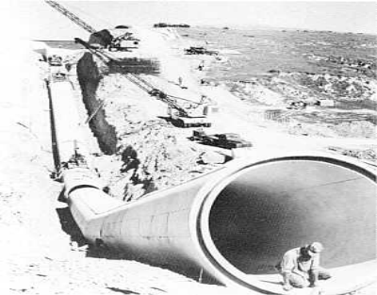
Fig 2.20. Inverted syphon
- Aqueducts
Aqueducts are Structures used to carry canal water over a natural stream. Conveying a canal over a natural watercourse may be accomplished in two ways. There are two types of aqueducts such as;
- A trough type aqueduct
In this type of aqueduct normal canal section is reduced to a rectangular section and carried across the natural stream in the form of a bridge resting on piers and foundations.
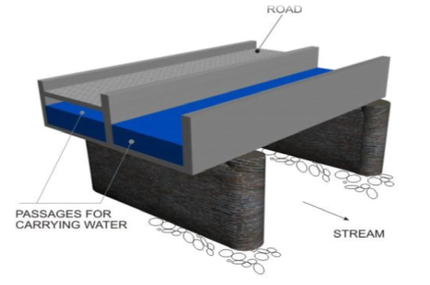
Fig.2.21- Trough type aqueducts

- A barrel type aqueduct.
In this type of aqueduct normal canal section is continued across the natural stream but the stream section is flumed to pass through barrels or rectangular passages.

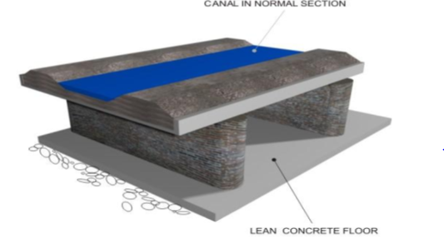
Fig. 2.22- Barrel type aqueducts
- Water measurement structures
The principal objective of measuring irrigation water is to permit efficient distribution and application. By measuring the flow of water, a farmer knows how much water is applied during each irrigation.
In irrigation schemes where water costs are charged to the farmer, water measurement provides a basis for estimating water charges. The most commonly used water measuring structures are weirs and flumes. In these structures, the water depth is read on a scale which is part of the structure. Using this reading, the flow-rate is then computed from standard formulas or obtained from standard tables prepared specially for the structure.

- Weirs
In its simplest form, a weir consists of a wall of timber, metal or concrete with an opening with fixed dimensions cut in its edge. The opening, called a notch, may be rectangular, trapezoidal or triangular.
- A rectangular weir

Rectangular weirs are used to measure comparatively large discharges. It has a horizontal crest and vertical sides.
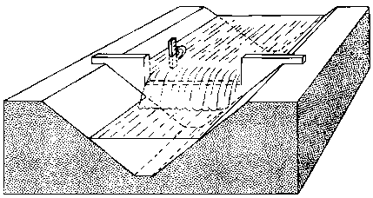
Fig. 2.23 Rectangular weir
- A triangular weir
The 90⁰ V – notch weir is commonly used to measure small and medium size streams. The advantage of the V – notch weir is its ability to measure small flows accurately.
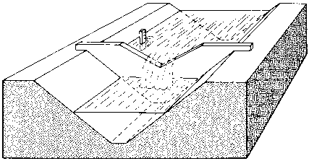
Fig. 2.24Triangular weir
- A trapezoidal weir
It is a contracted trapezoidal weir in which each side of the notch has a slope of 1 horizontal to 4 verticals. It is commonly used to measure medium discharges.
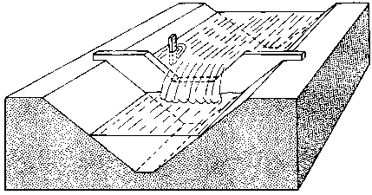
Fig. 2.25 Trapezoidal weir
- Flumes
- Parshall flumes

The Parshall flume consists of a metal or concrete channel structure with three main sections: (1) a converging section at the upstream end, leading to (2) a constricted or throat section and (3) a diverging section at the downstream end. The Parshall flume is an open channel type measuring device that operates with a small drop in head. The floor of the upstream section of the flume is level and the walls converge towards the throat section. The walls of the throat section are parallel and the floor is inclined downward. The walls of the downstream section diverge toward the outlet and the floor is inclined upward.
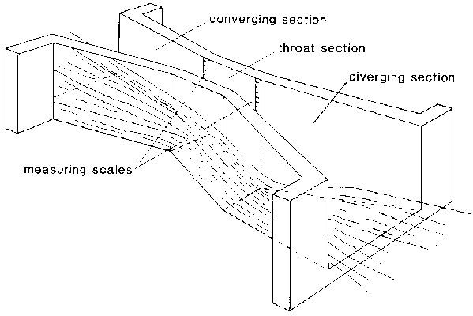
Fig. 2.26. A Parshall flume
Depending on the flow condition (free flow or submerged flow), the water depth readings are taken on one scale only (the upstream one) or on both scales simultaneously.
- Cut-throat flume
The cut-throat flume is similar to the Parshall flume, but has no throat section, only converging and diverging sections (see Fig. 89). Unlike the Parshall flume, the cut-throat flume has a flat bottom. Because it is easier to construct and install, the cut-throat flume is often preferred to the Parshall flume.

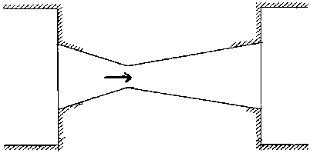
Fig. 2.27. A cut-throat flume
- Night storage structure
An Irrigation Storage Reservoir is a water storage structure made by constructing a dam, reservoir, tanker etc. The purpose of the practice is to conserve water by holding it in storage until it is needed to meet crop irrigation requirements.
The selection of the appropriate method of water storage depends on the following factors:
- Topography
- Geology (soil profile characteristics)
- Accessibility for personnel, equipment, and materials
- Costs
- Demand characteristics
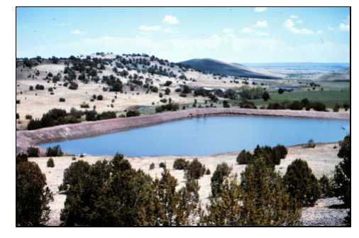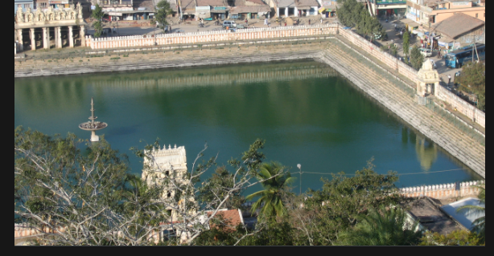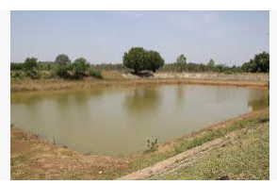
Fig.2.28: Night storage structures

2.3 Identification of Field distribution systems
Field distribution systems are systems used to distribute irrigation water in the field. In surface irrigation water is applied to the fields at ground level, either the entire field is flooded or the water is directed into furrows or borders.
- Furrow irrigation
Furrows are narrow ditches dug on the field between the rows of crops. The water runs along them as it moves down the slope of the field.
The water flows from the field ditch into the furrows by opening up the bank or dyke of the ditch or by means of syphons or gates or spiles. Siphons are small curved pipes that deliver water over the ditch bank. Spiles are small pipes buried in the ditch bank.

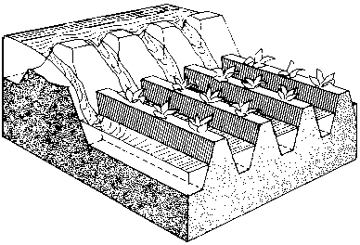 | 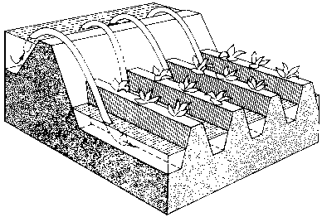 | 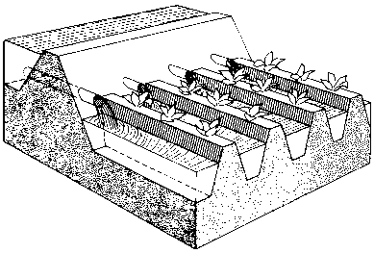
Fig. 2.29: Openings in the bank | Fig. 2.30 Siphons | T Fig. 2.31: Spiles

- Border irrigation
In border irrigation, the field to be irrigated is divided into strips (also called borders or border strips) by parallel dykes or border ridges.

The water is released from the field ditch onto the border through gate structures called outlets. The water can also be released by means of siphons or spiles. The sheet of flowing water moves down the slope of the border, guided by the border ridges.
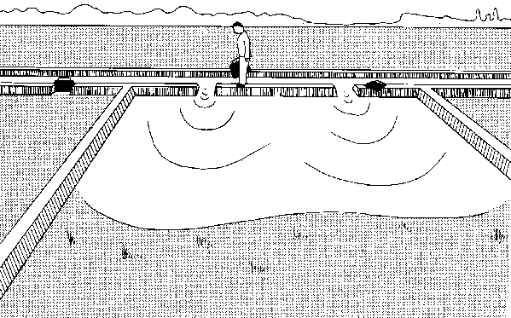
Fig.2.32: Border irrigation
- Basin irrigation
Basins are horizontal, flat plots of land, surrounded by small dykes or bunds. The banks prevent the water from flowing to the surrounding fields. Basin irrigation is commonly used for rice grown on flat lands or in terraces on hillsides. Trees can also be grown in basins, where one tree usually is located in the Centre of a small basin.

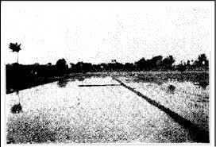
Fig.2.32- Basin irrigation

Self-check- 2 | Written test

Name…………………………………………… ID………………………… Date…….
Directions: Answer all the questions listed below.

Test I: Choose the best answer (4points)
  - Which one of the following is a small short pipe buried in the canal embankment for letting water from field channel to the field.
- Spile
- Checks
- Siphon
- Flume
  - Which one of the following used to divide or direct the flow of water between two or more canals or ditches?
  - Division box
  - Inverted siphon
  - Culvert
  - chute
Test III: Short Answer Questions
1. What does mean diversion structure, weir and barrage? (3pts)
2. Write component of diversion structures? (2pts)
3. What does mean conveyance, distribution and management structures? (3pts)

Operation Sheet - 2

2.1 Identify irrigation structures
- Tools, Equipments and materials
- PPE
- Note book
- Pen
- Procedure
- Wear personal protective equipment
- Go to field where Irrigation structure was constructed
- Identify types of diversion structures.
- Identify conveyance, distribution and management structures.

LAP TEST-2 | Performance Test

Name………………………………. ID……………………………. Date…………………………………….

Time started: ________________________ Time finished: ________________

Instructions: Given necessary templates, tools and materials, you are required to perform the following tasks within 1hours. The project is expected from each student to do it.
Task:1. Identify different types of structures

LG #14 | LO #3- Maintaining and cleanup of irrigation work site

Instruction sheet
This learning guide is developed to provide you the necessary information regarding the following content coverage and topics:
- Checking, maintaining and storing equipment, tool and materials
- Restoring work site and environmental improvements

This guide will also assist you to attain the learning outcomes stated in the cover page. Specifically, upon completion of this learning guide, you will be able to:
- Check, maintain and store equipment, tool and materials
- Restore work site and environmental improvements
Learning Instructions:
- Read the specific objectives of this Learning Guide.
- Follow the instructions described below.
- Read the information written in the information Sheets
- Accomplish the Self-checks
- Perform Operation Sheets
- Do the “LAP test”

Information Sheet 3

3.1 Checking, maintaining and storing equipment, tool and materials
The equipments, tools and materials used in irrigation structure work require checking, cleaning, maintaining and storing properly after use.
- Checking equipment, tool and materials
In workplaces, there are different types of equipment, tools and materials that we use to carry out everyday tasks. Equipments, tools and materials may have the potential to cause problems in the workplace, so you need to check and ensure that it remains safe to use and that you’re not putting employees at risk. In work place also equipment, tools and materials are inspected to check presence of damage and to ensure they need maintenance or not.
- Maintaining equipment, tool and materials
Tools and equipment require proper care and maintenance, not only for longevity but also to remain useful and safe for the task at hand. Here are some care and maintenance Practices for tools and equipment.
- The Importance of Proper Tool and equipment Maintenance
- Ensures a Longer Life
- Results in Cleaner Projects
- Keeps Users Safe
- Types of maintenance
- Routine or normal maintenance
- Special maintenance
- Deferred maintenance
- Storing equipment, tool and materials
Proper storage entails shielding tools from harsh weather conditions, damage and theft. It is particularly crucial for metallic tools to be kept away from moisture to avoid rusting. Having a cabinet where these tools and equipment are stored will be vital to ensuring a secure storage area.
Also, greasing, lubricating or oiling metallic tools and equipment is essential to prevent rust from forming while keeping the tools in the best condition for future tasks.
- Cleaning equipment, tool and materials
Cleaning is one of the most essential elements in maintaining a safe tool and equipment. Some of the materials, tools and equipments commonly used for cleaning purpose are listed below.
- Air freshener dispenser
- Sealer applicators, rubbish bins, waste bins, large industrial bins, tidy bins,
- Brooms and wire brush
- Rubbish picking up tools, wall washers, warning sign, safety signs
- Detergents and oils
- Grease and other lubricants
Maintaining equipments, tools and materials after the use for work and finally must be store in the stock pile.
stages of cleaning are:
      - pre-Clean
The first stage of cleaning is to remove loose debris and substances from the contaminated surface you’re cleaning. You can do this by wiping with a disposable towel, sweeping, or rinsing. The aim is to remove as much loose debris as possible to prepare the area for the next stage of cleaning.
      - Main Clean
The second stage of cleaning is to loosen any substances, dirt, grease, and debris that you were unable to remove during the pre-clean stage. This involves using hot water and a detergent. You may be able to wipe away the loosened substances right away with something suitable, such as a cloth or mop, or you may have to allow the disinfectant to do its work for a certain amount of contact time before doing so.
      - Rinse
The third stage of cleaning is to remove all the loosened substances, dirt, and debris as well as the detergent, that was present in the second stage. You can do so using clean, hot water with a cloth, mop, squeegee, etc.
      - Disinfection
The fourth stage of cleaning is to disinfect the surface, which will destroy bacteria and other microorganisms. For example, by using heat or a chemical disinfectant for an adequate contact time. Follow the instructions for any products or equipment you use.
      - Final Rinse
The fifth stage of cleaning is to remove any disinfectants from the previous stage using clean, hot water. This step may not always be carried out however, depending on the disinfectant and surface you’re cleaning.
      - Drying
The sixth and final stage of cleaning is to dry the surface, and it’s recommended that you air dry where possible. You can use drying cloths if needed.
3.2 Restoration of work site and environmental improvements
Irrigation structure work sites are expected to be clean, tidy, comfortable and good to create conducive environment for work. Cleanliness is the most essential elements in maintaining a healthy and safe work environment. Not only does a clean workplace reflect the professionalism of a business or facility and help motivate employees, it also promotes a healthy workforce as a clean environment prevents accidents and the spread of germs.
Like Health & Safety, maintaining a clean work environment is the responsibility of everyone. Working together we can all contribute to creating a safe and healthy workplace and a professional looking facility for employees, visitors and customers.

Irrigation structure and site maintenance
- The job site shall be kept in a neat, clean, and orderly condition at all times during the installation process.
- All scrap and excess materials are to be regularly removed from the site and not buried in trenches.
- Trenching, laying pipe and backfilling shall be continuous so that the amount of open trench at the end of each work day is minimized. Any open trench or other excavations shall be barricaded and marked with high visibility flagging tape.

Self-check 3 | Written test

Name…………………………………………… ID………………………… Date…….
Directions: Answer all the questions listed below.

Test I: Short Answer Questions
- List some of the equipments commonly used for cleaning purpose. (2pts)
- Why do you need to make good working site? (2pts)
- Mention stages of cleaning(1pts)
- The Importance of Proper Tool and equipment Maintenance(3.5pts)
- Mention types of maintenance (1.5)

Operation Sheet - 3
  - Maintain, clean up and store tool and equipment

Objectives: to provide the trainees with the skill of cleaning, maintaining and storing equipments, tools and materials
    - Tools and equipment
- PPE
- Water
- Brooms
- Detergents and oils
- Grease
    - Procedure
- Wear PPE
- Inspect equipments, tools and materials
- Separate damage equipments. tools and materials
- Maintain damaged equipments, tools and materials correctly
- Clean equipments tools and materials properly
- Store equipments, tools and materials properly in the right place

LAP TEST-3 | Performance Test

Name………………………………. ID……………………………. Date…………………………………….

Time started: ________________________ Time finished: ________________

- Task 1. Maintain, clean up and store tools and equipment

Reference
Irrigation Engineering and Hydraulic structures by santosh Kummar Garg (14th edition)
Irrigation Engineering practices (Irrigation Development Department (ministry of Agriculture)) Design of R.C.C structures by Dayaratnam(3 rd Edition.)
Karassik, Igor J. et al., eds.; Pump Handbook (3rd Edition), McGraw-Hill 2001 ISBN 978-0-07-034032-9 page 10-5^
Loibner, M., Hagauer, S., Schwantzer, G., Berghold, A. and Zatloukal, K., 2019. Limiting factors for wearing personal protective equipment (PPE) in a health care environment evaluated in a randomised study. PloS one, 14(1), p.e0210775.
U.S. Army Corps of Engineers, Ice Engineering - Engineering and Design (EM 1110-2-1612) ISBN 978-1-61583-638-3 page 20-11

https://www.dictionarist.com/english-english/irrigation+structure(accessed date august 2022)
https://www.dictionarist.com/english-english/irrigation+structure ( accessed date august 2022)

AKNOWLEDGEMENT

Ministry of Labor and Skills to extend thanks and appreciation to the many representatives of TVET instructors and respective industry experts who donated their time and expertise to the development of this Teaching, Training and Learning Materials (TTLM).

The experts who developed the learning guide
No | Name | Qualification | Organization/ College | Mobile number | E-mail
1 | Serawit Gensa | Msc. Water Resource Engineering | W/Sodo AVET | 0916740916 | serawitgen@gmail.com
2 | Edao Hassen | Msc.Irrigation Engineering | Alage AVET | 0911098097 | hassedao@gmail.com
3 | Mekete Agizew | Msc. Water Resource Engineering | Amhara. Kombolcha ATVET | 0925221192 | gen.mam09@gmail.com
4 | Wondu Alemayehu | Msc.Irrigation Engineering | Oromia Kombolcha ATVET | 0910-28-99-61 | woldualem@gmail.com
5 | Ademe Ayalew | Msc.Irrigation Engineering | Agrafa AVET | 0912720547 | Ademe2004@gmail.com
6 | Said Mohammed | Msc.Irrigation& drainage Engineering | Alage ATVET | 09-17-18-01-81 | Siyamsdmhmmd@gmail.com/
7 | Molalign Asfaw | Bsc.Water Resource &Irrigation Engineering | Alage ATVET | 0921431096 | Mollalign410ass@gmail.com
8 | Yonas Hailu | Bsc.Water Resource &Irrigation Engineering | Agrafa AVET | 0934715578 | yonashailuw@gmail.com
9 | Lemessa Mulata | Msc.Irrigation Engineering | Agrafa AVET | 0913266845 | Lamimulle2022@gmail.com
10 | Misganew Yimer | Bsc. Soil and Water Engineering | Woreta ATVET |  | Misge1976@gmail.com
11 | Daniel Derese | Bsc. Agricultural Engineering | W/sodo AVET | 0912-79-28-85 | danielderesse7@gmail.com
12 | Teshome Getachew | Msc.Irrigation & drainage Engineering | Alage ATVET | 0925-50-13-99 | teshomegetachew131@yahoo.com

