Irrigation and Drainage
Level- I

Based on March, 2022, Version 3 Occupational standard

Module Title: - Machinery and equipment for Irrigation and Drainage works
LG Code: AGR IRD1 M05 LO (1-3) LG (15-17)
TTLM Code: AGR IRD1 TTLM 0822v1

August, 2022
Addis Ababa, Ethiopia
Table of Contents

Introduction to the Module 1
LO #1- Identify machinery and equipment 2
Instruction sheet 2
Information Sheet- 1 3
Self-check 1 20
Operation Sheet -1 21
LAP TEST-1 22
LO#2-Select machinery and equipment for irrigation works 23
Instruction sheet-2 23
Information Sheet 2 24
Self-Check – 2 27
LO#3- Handle machinery and equipment 28
Instruction shee-3 28
Information Sheet-3 29
Self-check 3 33
Operation Sheet -3 34
LAP TEST-3 35
Reference Materials 36

Introduction to the Module

This module covers the knowledge, skill and attitude required to identify, prepare, check, clean and store basic machinery and equipment for irrigation and drainage.

LG #15 | LO #1- Identify machinery and equipment

Instruction sheet
This learning guide is developed to provide you the necessary information regarding the following content coverage and topics:
- Personal protective equipment (PPE)
- Selection and usage of machinery and equipment
- Maintenance and storage machinery and equipment
- Identification of basic machinery and equipment
- Parts of machinery and equipment
This guide will also assist you to attain the learning outcomes stated in the cover page. Specifically, upon completion of this learning guide, you will be able to:
- Use Personal protective equipment (PPE)
- Select and use of machinery and equipment
- Maintain and store machinery and equipment
- Identify of basic machinery and equipment
- Identfy parts of machinery and equipment
Learning Instructions:
- Read the specific objectives of this Learning Guide.
- Follow the instructions described below.
- Read the information written in the information Sheets
- Accomplish the Self-checks
- Perform Operation Sheets
- Do the “LAP test”

Information Sheet- 1

Introduction:
Agricultural machinery is any kind of machinery used on a farm to help the farming process. The best-known example of this kind is tractor
Machine: Is mechanically, electrically, or electronically operated device for performing a task.
Tools. Any physical item that is used to achieve a goal but is not consumed during this process. It can perform a variety of functions such as cutting and chopping, moving, shaping, fastening, guiding, enacting chemical changes, fastening, information and data manipulation, etc.

Equipments: Set of tools that are designated for a specific task is known as equipment. This could be a small set of functional items in a finished product. For example, equipment of a car may be alternators, absorbers, optical, electronic boxes.

  - Personal protective equipment
Personal protective equipment is to include that prescribed under legislation, regulations and enterprise policies and practices. Face masks are available for rubbing back and painting. Suitable personal protective clothing and equipment is selected, used, maintained and stored in accordance with Occupational Health and Safety requirements.

    - Select PPE based on the PPE Hazard Assessment
Consider these factors when selecting PPE:
- Type of hazardous materials, processes, and equipment involved
- Routes of potential exposure (ingestion, inhalation, injection, or dermal contact)
- Correct size for maximum protection
- Minimal interference with movement
Personal protective clothing and equipment may include:

- boots
- hat/hard hat
- overalls
- gloves
- protective eyewear
- hearing protection]
- respirator or face mask
- sun protection, sunscreen

Different types of PPE are described below
Foot protection  Eye protection |   Workers must wear closed-toe shoes at all times to protect feet from chemical spills and sharp objects. Steel-toed footwear and puncture-resistant soles.  Fig.1.1 Boots    Use safety glasses for minor splash hazards, goggles for moderate hazards, and goggles combined with a face shield for severe hazards.

Fig.1.2. Eye glass

Hand protection: Hand protection is indicated for the possibility of severe cuts, lacerations, or abrasions, punctures, temperature extremes, and chemical hazards. (Nit rile loves are usually a good choice for general use.) Use heavy-duty gloves for non-incidental contact and gross contamination

Body protection: Fig.1.3 Glove
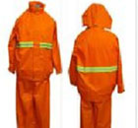
Protective clothing includes lab coats, smocks, scrub suits, gowns, rubber or coated aprons, coveralls, uniforms, and pierce-resistant jackets and vests.

Fig.1.4. Over all

Head protection: Hard hats must be worn by electricians, construction workers, and any other workers when there is a danger of objects falling from above.


Fig.1.5 Elment
  - Selection and usage of machinery and equipment
    - selection
The equipment selected should possess certain desirable characteristics or meet certain criteria to be best suited to the desired task. Some of these criteria are:

- Fit into the system.
- Be as simple as possible.
- Require minimum space.
- Be flexible and adaptable.
- Require minimum of loading, unloading and re handling.
- Call for as little maintenance

    - Uses of of machinery and equipment
- Use of natural forces: Machinery has harnessed the forces of nature in the service of man.
- Heavy and delicate work: Tasks which are too heavy or too delicate for human muscles to do can be done easily by a machine. A crane can lift loads which man never can.
- Faster Work: While man can make only a few dozen pins in a day by himself, with the help of machinery he can make thousands.
- More accurate work: No painter can paint exactly the same picture twice. But a machine can turn out thousands of identical articles.

  - Maintenance and storage of machinery and equipment.
Take care of your machinery and equipment, supplies by securing or storing them properly at the close of each business day. After pre operational check an operator must identify and report unsafe or faulty machinery and equipment and prepare for repair and maintenance.This may include dismantling and assembling procedures, testing, tightening, minor adjustments , repairs and routine servicing procedures including:-

- Lubricating
- checks of cooling system
- fuel level
- Grease, oil, and battery leve

    - Schedules for service, maintenance and repair
All work equipment is maintained in an efficient state, in efficient order and in good repair; where any machinery has a maintenance log, the log is kept up to date; and that maintenance operations on work equipment can be carried out safely.
The profitability of the machine is based on their correct and effective use, as well as their proper service, maintenance and repair.
- After sale service
This is the responsibility of the dealer in our country/after a certain km/
- Daily service
This is the task of the driver. He must check oil levels (of the engine, transmission and hydraulics), oil leaks, and radiator leaks, tyres pressure and damage, refuel and cleaning the tractor.
- Periodical maintenance
This may includes the periodical change of motor oil, motor filter or hydraulic filter and replacement of other parts
- Machine repair
It must be done soon after an unusual sound reveals. If it is a minor repair, the driver may make it at work place if the problem is serious the machine must be stopped at roadside and a rapid field repair should be organized.
The frequency and nature of maintenance should be determined through risk assessment, taking full account of:

- the manufacturer's recommendations
- the intensity of use
- operating environment
- user knowledge and experience
- the risk to health and safety from any foreseeable failure or malfunction
Preparation on equipment may include:
- cleaning, lubricating
- identifying and segregating unsafe or faulty equipment for repair or replacement
Checks are conducted on all materials, tools and equipment with insufficient or faulty items reported to the supervisor. As the business grows and you get more clients and more assignment, you can get more tools and equipment and offer more services. Employers are also required to ensure that those using equipment have sufficient knowledge and training to use it safely.

A maintenance schedule should be in place before going to the work to ensure that your equipment is maintained at least at intervals indicated in the manufacturer’s operating instructions or more frequently if indicated by the risk assessment. Any daily checks should be undertaken as recommended by the manufacturer. This will help prevent problems such as:-
- blockages,
- Leaks or breakdowns, which can increase risks.
The need of pre operational check is: it minimizes the occurrence of hazards on the machine or on the operator.https://youtu.be/yTrBEUvIqxI

  - Identifying basic machinery and equipment
Machinery and equipment are identified and selected in accordance with supervisor's instructions. There are many different types of machinery used in the various areas in horticulture and agriculture.
The machine selection depends on:

- the work to be carried out
- the condition of the ground,
- proximity to people and buildings w
- availability of the machine
- How the machine can be transported to the sit

A.Small engine machinery:

- mowers
- brush cutters
- pumps
- air compressor
- generators

Hand tools equipment.
- wheelbarrows
- spades
- shovels and forks

Other material

- sprinkler,
- drip and surface irrigation structure,
- triple pump,
- rope and washer pump,
- solar pump,
- wind mill pump,
- bucket,
- dynamo or electric pump,
- tensiometer,
- infiltrometer,
- water measuring device,
- Farm machinery

  - Parts of machinery and equipment
Machinery and equipment type.
- Mowers:-
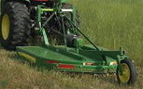
It is a simple machine can be operated simply by hand or can be pulled by tractors for removing or leveling lower growing plants and grass. It is used to cut grass and other forage crops. The cut material is left in a swath. Here the grass is cut by the shearing action of a reciprocating knife. The basic principle of cutting remains the same as a scissor i.e. two sharp straight blades shear the stalk of the grass at a certain speed. This action is defined as mowing.https://youtu.be/puK4NxGKNdQ
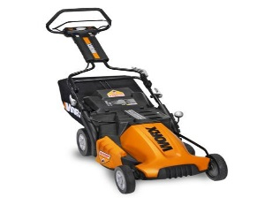
Types of mowers:-
- Pushed mower,
- Riding mower

Fig 1.7. Mower
- Brush cutters
A brush cutter is a lawn and garden tool used to trim lawn edges, cut back bushes and unruly plants, and maintain a landscape. A brush cutter relies on rotary device that spins a dense plastic string. Spun at a high speed, the string cuts through any vegetation you wish to prune or remove.

Purpose of the Brush cutters
- Used to clear Anyone with wooded, dense or overgrown property,
- Designed for public works departments and individual property owners,
- Appropriate for maintaining trails, cutting troublesome brush or periodically clearing meadows.
- 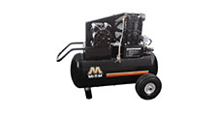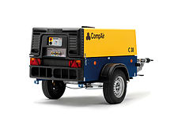An air compressor is a device that converts power (using an electric motor, diesel or gasoline engine, etc.) into potential energy stored in pressurized air (i.e., compressed air)

Fig 1.7. Air compressors
IV. A tensiometer measures the force with which water is held in the soil by the soil particles.
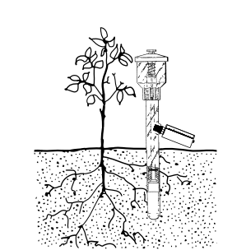
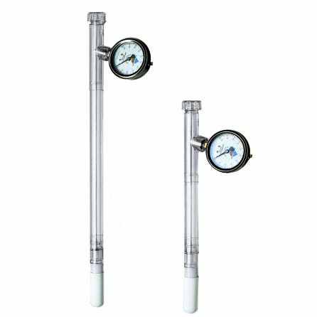
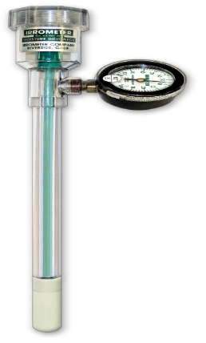

Fig 1.8. Tensiometer

V. Pumps
Are used to transfer of liquid from one place to another place (e.g. water from an underground aquifer into a water storage tank or to the command area).
There are different types of pump depending on source of power (manual. animal, solar. wind, electrical and chemical powered).

Treadle pump
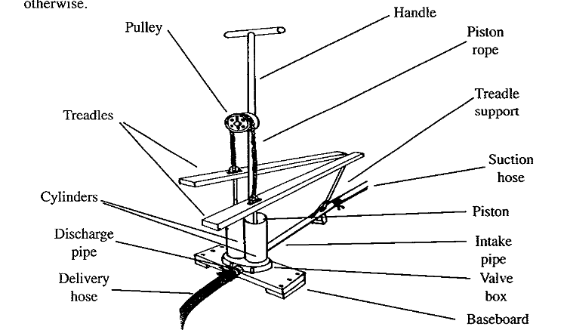
The pump is operated by moving two pedals while standing on the pump and can be operated for several hours as opposed to the more arduous process of hand pumping and hand watering.https://youtu.be/vd71Au7O39s

Fig 1.9. Treadle pump

Rope and Washer pumps
The rope and washer pump is used to lift water from shallow wells and works most satisfactorily when the lift is about 6m. The pump consists of an endless chain on which discs are mounted at the interval of about 25cm.
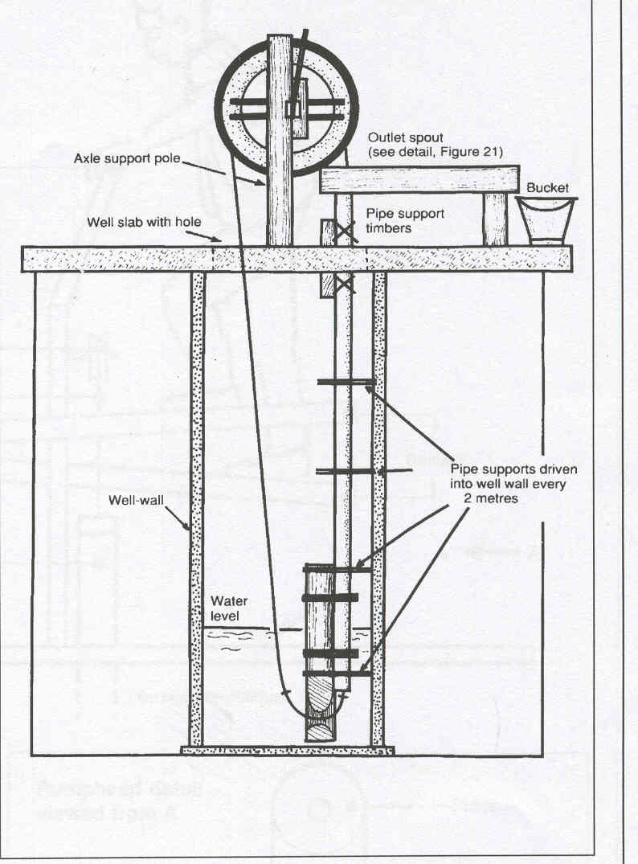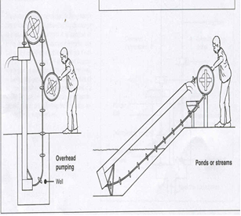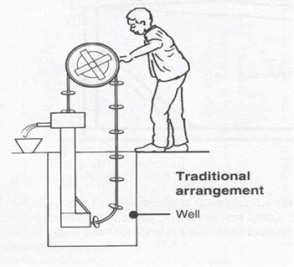
Fig 1.10. Rope and washer pump
Wind mill pump/Wind pumps are fairly large tower-mounted multi-bladed wind rotors used particularly for raising water from a borehole to provide a water supply or facilitate irrigation in an off-mains location.
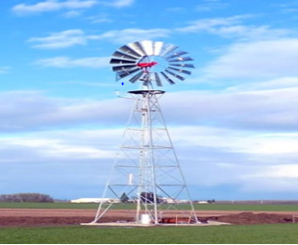

Fig 1.11. Wind mill pump
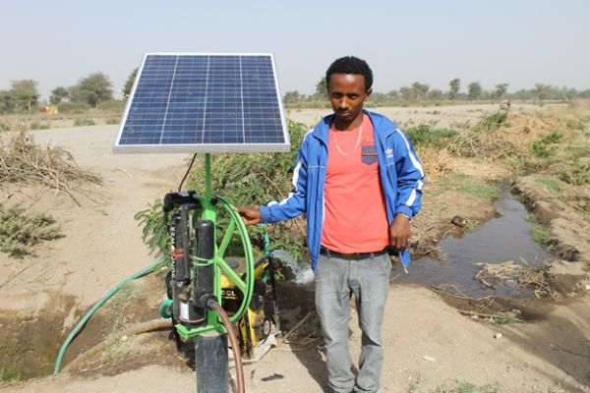A solar-powered pump is a pump running on electricity generated by photovoltaic panels or the radiated thermal energy available from collected sunlight as opposed to grid electricity or diesel run water pumps.

Fig1.11. Solar pump
Generator is a device that converts motive power into electrical power for use in an external circuit.
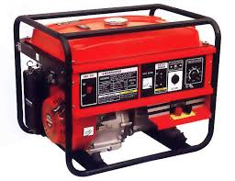

Fig.1.12. Generators
VI. Water measuring device
Most flow measurement devices and techniques are based on the measurement of head (depth or pressure) or velocity Here, the term “flow rate” refers to volumetric rate, or volume per unit time
- Trapezoidal flume
Trapezoidal flumes are often used for small flows, such as for individual furrows in surface irrigation evaluations
Current Meters: Current meters with a rotating unit that senses the water velocity are either vertical- shaft or horizontal-shaft types
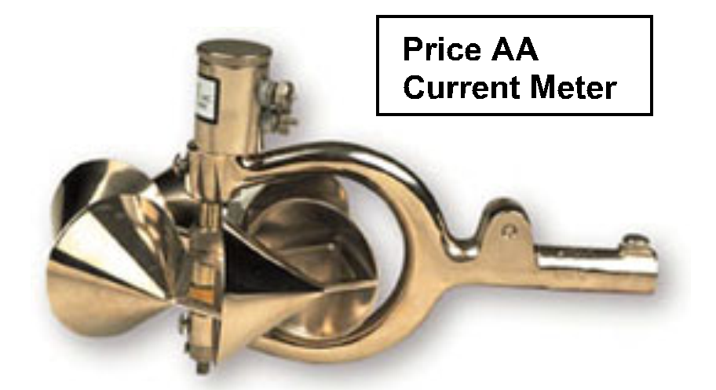

Fig 1.13. Current meter
3. Weirs for Flow Measurement
Weirs are overflow structures built across open channels to measure the volumetric rate of water flow.
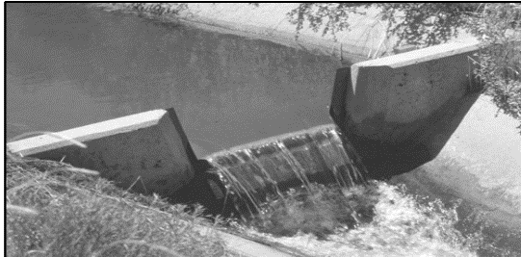
Trapezoidal weir

Fig 1.14. Tarpizoidal wier
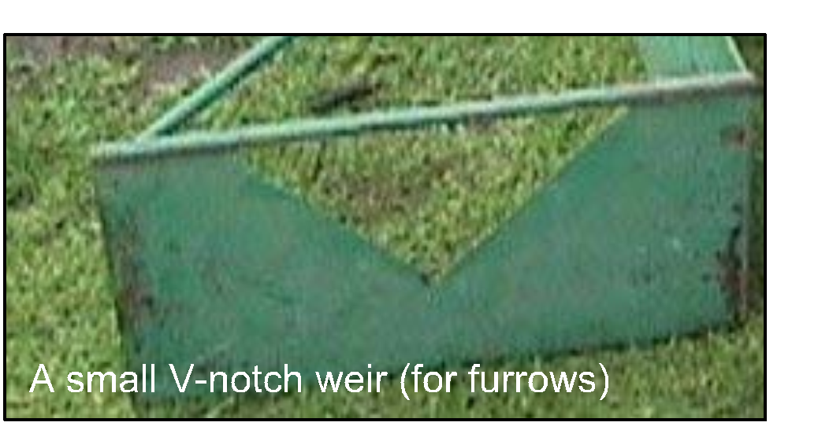
V-Notch Weirs: Triangular, or V-notch, weirs are among the most accurate open channel constrictions for measuring discharge

Fig 1.15. 90⁰ V- Notch weirs
VII. Drip irrigation is a type of micro-irrigation that has the potential to save water and nutrients by allowing water to drip slowly to the roots of plants, either from above the soil surface or buried below the surface. The goal is to place water directly into the root zone and minimize evaporation.
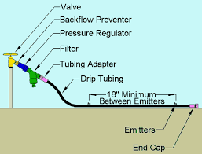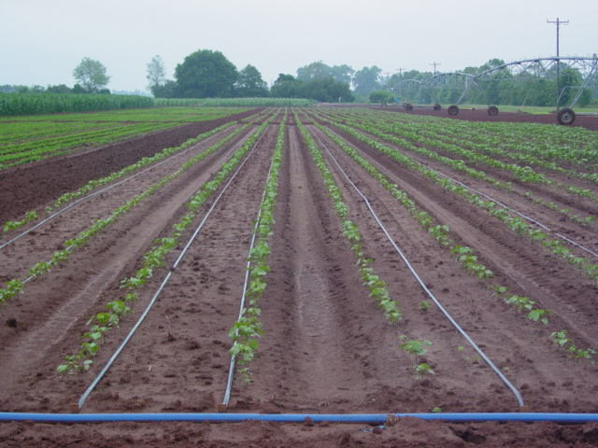

Fig 1.16. Drip irrigation system
VIII. Sprinkler Irrigation is a method of applying irrigation water which is similar to rainfall. Water is distributed through a system of pipes usually by pumping.
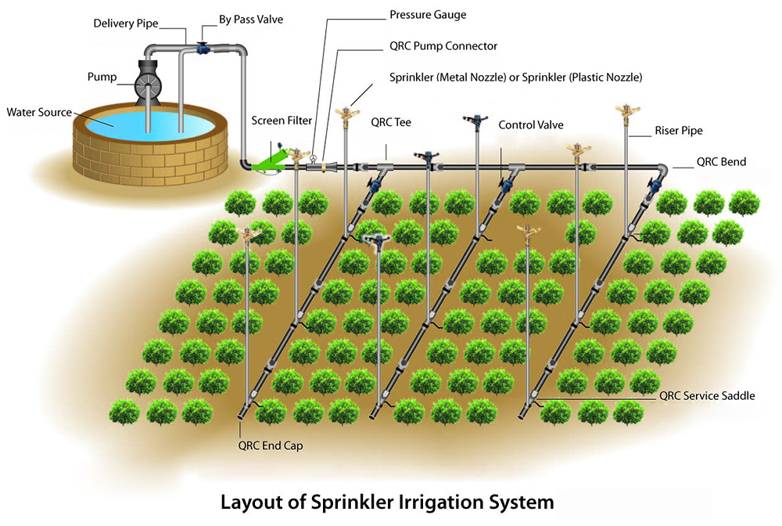
Fig 1.17. Sprinkler irrigation system

Equipment:-Some hand tools used in different operation.

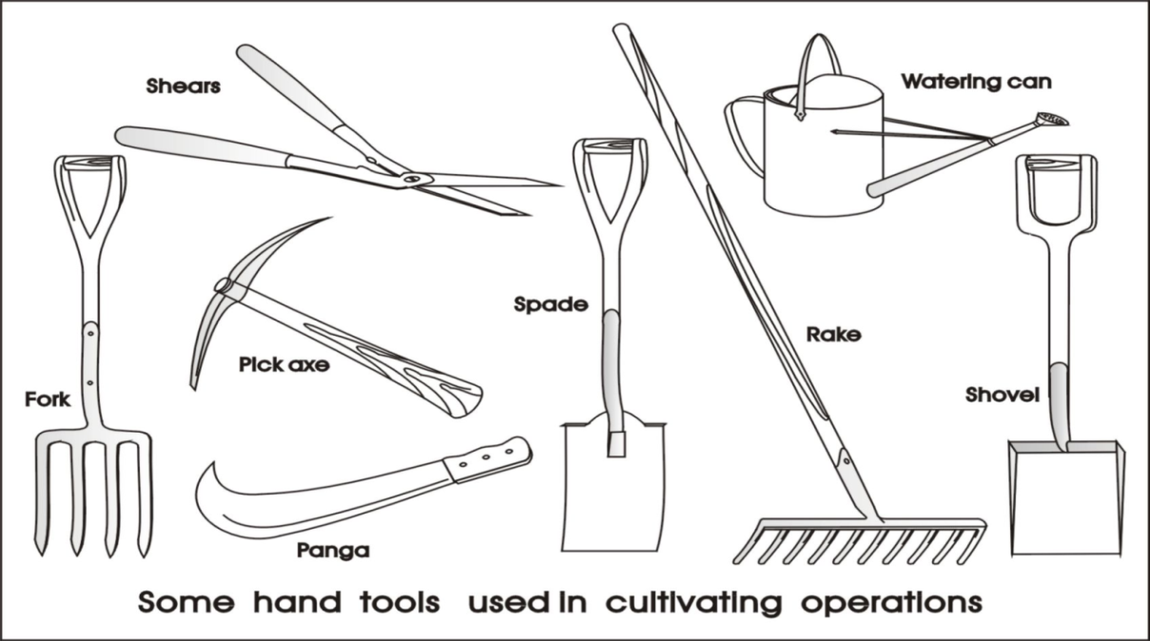
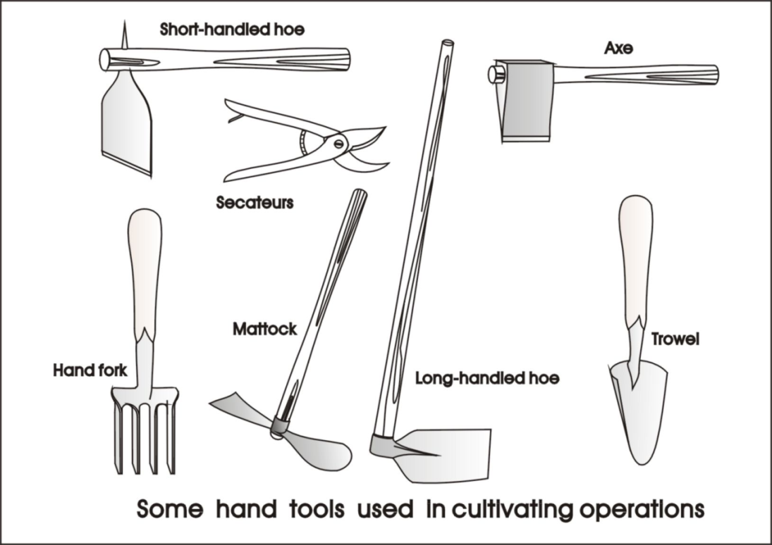

Secateurs:-They are strong enough to prune hard branches of trees and shrubs, sometimes up to two centimeters thick. They are used in gardening, arboriculture, farming, flower arranging.
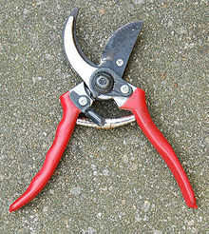

Fig.1.18. Secateurs
Wheel barrel:
- Used for transferring all kinds of materials in the work site.
- Is essential for carrying important tools, seed and seedlings into the field.
- Keep tres pumped up, grease all moving parts, wash out soil or rubbish after use and store out of the weather.

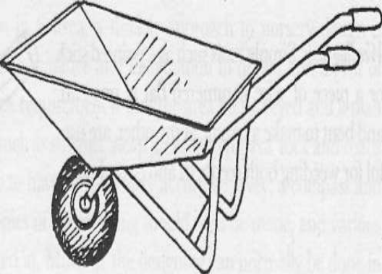

Fig.1.19. Wheel barrel.
Spade.
- There are many jobs in agriculture that require the use of hand tools. A spade, commonly used in gardens, is good for digging because of the flat, sharp shape.
- Useful for cutting and digging heavy soil, digging straight-sided, flat-bottomed trenches, or removing a layer of soil
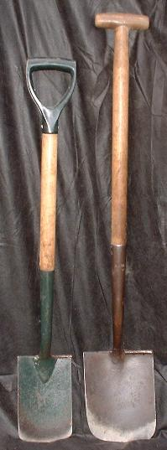

Fig.1.20. Spade
Shovels:- .

- Used for moving earth, sieving soil, soil mixing, etc.
- Shovels are used for digging and lifting loose soil or other substances.
- A shovel is a tool for digging, lifting, and moving bulk materials, such as soil, coal, gravel, snow, sand, or ore.
Forks:-Used for turning compost, lifting bare-root seedlings, loosening soil.

Rakes
- A rake, usually with a long handle and a finger-like base, is used in gardening and clean-up.
- Break up and level the soil; and it has a row of 10-16 teeth and is kitted up with a 1.80 m handle.
- A rake is a tool used to gather or loosen material or to grade or level a surface.
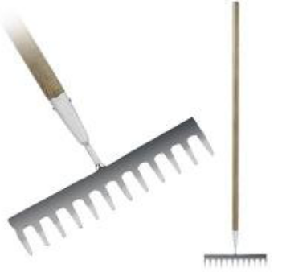
- Rakes work a lot like pitchforks in that they can turn over soil so that plants can get more nutrients. The difference is that the prongs on a rake create a right angle next to the handle, where as a pitchfork is only slightly curved

Fig.1.21. Rakes
Hand Fork:-
The most useful garden tool when hand weeding to loosen the soil around the weeds and ensure that all of the roots come out. Then afterwards a general scuffle over the surface leaves a tidy finish. It can also be used for planting out.
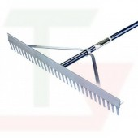

Fig.1.22. Hand fork
Pickaxe
- used to break up hard and stony ground
- Picks and mattocks are used to work soil that is hard, rocky or root filled.
- A pick has a pointed tip on one end and a chisel like tip on the other.
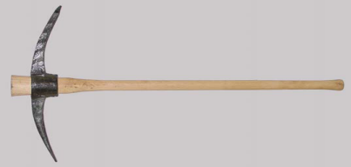

Fig.1.23. Pickaxe
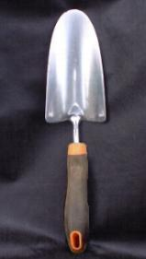
Hand Trowel:-For smaller jobs such as planting bulbs and bedding plants in cultivated soil. A stainless steel version is probably best as the blade stays cleaner and is easier to spot if left lying around.

Fig.1.24. Hand Trowel
Hoe:-The two main types are the draw hoe and the cutting hoe. The draw hoe has its blade set at a right-angle to the shaft and is used to draw soil towards the operator when making planting drills
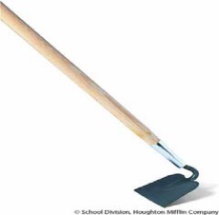

Fig.1.25. Hoe
Panga or Mattock
- are used to cut down stubborn weeds, reeds, tree saplings and can also be used to harvest grain
- Mattocks are used for loosening soil that is root filled.
- Mattocks have an axe-head on one side and a flat hoe like head on the other

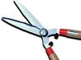
Shears:-Shears are large scissors that farmers and gardeners use to prune their plants. They can be used to cut off dead or dying portions to save the healthy part of the plant.

Fig.1.26. Shears
    - Carry out routine pre-operational checks of machinery and equipment
Agricultural machinery and equipment is tangible personal property that is used directly in cultivating or harvesting a crop, collecting or processing of an agricultural product on the farm area. This may include routine safety and pre-start checks and preparatory procedures including cleaning, lubricating, and hand sharpening, priming pumps, clearing filters, tightening, basic repairs and adjustments.
Pre-operational checks: On machinery and equipment may include checkin
Fuels, fuel lines and oils: check the oil and the fuel line if it is not in good condition change or fill the oil and fuel respectively.
Battery electrolyte levels, wheels and tyres pressure: when servicing the battery or checking the electrolyte level, wear rubber gloves, a rubber apron, and eye protection. Batteries contain sulfuric acid which is destructive. If it comes in contact with your skin, wash it off at once with water. Acid may splash on the skin or into the eyes inadvertently when removing electrolyte caps
The tyre pressure needs to be checked as well; this may be visual and then check with a gauge once a week.
Air filters: check the air filter if there is impurities on it, clean it with appropriate materials like air compressors.
Primary or main filter, Cover, Air cleaner housing and Safety filter (fits inside the primary filter) respectively.

.

Self-check 1 | Written test

Name…………………………………………… ID………………………… Date…….
Directions: Answer all the questions listed below.

Test I: Choose the best answer (4 point)
  - Which one is used for removing or leveling lower growing plants and grass?
    - Mower B. brush cutter C. tension meter D. pumps
  - Which one is the uses of basic machinery?
    - To use natural forces B. To easy heavy and delicate work C. To faster work D. To more accurate work
  - Which one is categorized under PPE?
    - Boots B. hat C. overall D. gloves E. all
  - ________Is mechanically, electrically, operating devices for performing tasks.
    - Machine B .Tools C. equipment D. all
  - Device which used to measure water held in soil particle is called
    - tension meter B. air compressor C. treadle pump D. all
  - Which one is operated by moving two pedals?
    - Centrifugal pump B. treadle pump C. rope and washer pump D. wind mill pump
  - Device that convert motive power into electrical power for use in electrical circuit is called
    - Generator B. air compressor C weir D all.

Test II: Short Answer Questions
- What is machinery?
- What is equipment?
- Write the most common types of machinery
- What are the purposes or uses of farm machineries and equipment’s

Operation Sheet -1

  - Procedure to maintain small engine machinery and equipment.

  - Equipment(PPE)

- boots
- hat/hard hat
- overalls
- gloves
    - Machinery
- Small engine machinery
    - Materials
- Manual
- screw
- plstic bag
- dipstick
- other accessories.
Procedures
1. Use personal protective equipment.
- Collect equipment and machinery.
- Inspect regularly.
- Carry out regular maintenance
- Replace parts when needed.
- Clean after use.
- Store in the storage place.

LAP TEST-1 | Performance Test

Name………………………………. ID…………………………….. Date…………………………………….

Time started: ________________________ Time finished: ________________

Instructions: Given necessary templates, tools and materials you are required to perform the following tasks within 5 hour. The project is expected from each student to do it.
Task.1.1. Maintain small machinery and equipment.

LG #16 | LO#2-Select machinery and equipment for irrigation works

Instruction sheet-2
This learning guide is developed to provide you the necessary information regarding the following content coverage and topics:
  - Identification and segregation machinery and equipment
  - OHS hazards
This guide will also assist you to attain the learning outcomes stated in the cover page. Specifically, upon completion of this learning guide, you will be able to:
- Identify unsafe or faulty machinery and equipment
- Reported OHS hazards
Learning Instructions:
- Read the specific objectives of this Learning Guide.
- Follow the instructions described below.
- Read the information written in the information Sheets
- Accomplish the Self-checks
- Perform Operation Sheets
- Do the “LAP test”

Information Sheet 2

  - Identification and segregation machinery and equipment
After pre operational check and maintenance continued safe operation of your equipment depends on regular maintenance and testing of the equipment and its operating and protective controls. The tests and checks out-lined below are designed to determine whether or not the equipment and controls are in good operating condition.
Machinery accidents can be prevented by keeping the machine in good repair, fitting and ensuring all safety equipment are operating with the machine at all times
To avoid any type of machinery-related injury strict safety practices must be employed.

- Never operate machinery under the influence of drugs or alcohol.
- Protective clothing should be worn
- Most machinery is designed for one rider, not two or three.
- Turn off the engine
- Never smoke
- Keep all people away from work areas and working machinery .
- Motors should be shut-down on do periodic
- Parking or leaving a piece of machinery for any length of time; even to check a malfunction; .

Completing work
Work is completed to supervisor's satisfaction and in accordance with Occupational Health and Safety requirements.
  - OHS hazards
3.1.1. Identifying hazards in the workplace
Workplace injury is a major cause of concern for all involved in occupational health and safety. The factors which cause workplace accidents and occupational illnesses are called hazards. The need for systematic management of OHS hazards and their attendant risks applies to all organizations and all activities and functions within an organization.

Risk management is a four step process:

  - Identify the hazard
  - Assess the risk associated with the hazard
  - Control the risk
  - Review the proces
It may not be possible to avoid particular significant hazards during the maintenance of work equipment so appropriate measures should be taken to protect people and minimize the risk. These may include:
- physical measures, eg providing temporary guarding, slow speed hold-to-run control devices
- management issues, including safe systems of work, supervision, monitoring
- personnel competence (training, skill, awareness and knowledge of risk)
Why is occupational health and safety important?
Work plays a central role in people's lives, since most workers spend at least eight hours a day in the workplace, whether it is on a plantation, in an office, factory, etc. Therefore, work environments should be safe and healthy. Every day workers all over the world are faced with a multitude of health hazards, such as:

- dusts
- gases
- noise
- vibration;
- Extreme temperature
Unfortunately some employers assume little responsibility for the protection of workers' health and safety. In fact, some employers do not even know that they have the moral and often legal responsibility to protect workers. As a result of the hazards and a lack of attention given to health and safety, work-related accidents and diseases are common in all parts of the world.
Work-related accidents or diseases are very costly and can have many serious direct and indirect effects on the lives of workers and their families. For workers some of the direct costs of an injury or illness are:

- the pain and suffering of the injury
- the loss of income;
- the possible loss of a job;
- Health-care costs.

It has been estimated that the indirect costs of an accident or illness can be four to ten times greater than the direct costs, or even more. An occupational illness or accident can have so many indirect costs to workers that it is often difficult to measure them. One of the most obvious indirect costs is the human suffering caused to workers' families, which cannot be compensated with money.

Agricultural worker - When spraying crops the worker may be exposed to hazardous chemicals contained in the spray. Many pesticides and herbicides that have been banned in some countries because of their toxic effects are still used in many developing countries. If spraying takes place on a windy day, the spray can be breathed into the lungs and blown on to the skin where it can cause damage. It can also be absorbed into the body through the skin.
https://youtu.be/_qAIaf0nZac (Identfy OHS hazard)

What environmental implications may be associated with maintaining the workplace?
Environmental implications associated with the operation of tools and equipment
- Negative environmental impacts may result from excessive noise and exhaust emissions, the incorrect use and disposal of maintenance debris (oil containers, chemical residues), hazardous substances (fuel, fertilizer), and damage to fauna and flora in natural areas
- Impacts may also include run-off flows of water and cleaning agents from servicing, maintenance and cleaning activities, soil disturbance and dust problems from high activity traffic (including irrigation equipment)
- Environmental pollution
Generally non-mechanical hazards associated with machinery and equipment can include harmful emissions, contained fluids or gas under pressure, chemicals fluids or gas under pressure, chemicals and chemical by-product, electricity and noise, all of which can cause serious injury if not adequately controlled. In some cases, people exposed to these hazards may not show signs of injury or illness for years.

Self-Check – 2 | Written test

Name…………………………………………… ID………………………… Date…….

Directions: Answer all the questions listed below.

Test I: Short Answer Questions
- Define environmental effect
- Write at least for negative environmental impacts associated with the operation of tools and equipment
- What are the non-mechanical hazards associated with machinery and equipment operations

Test I: Multiple choice
  - Machinery accident can be prevented by
A. Keeping the machine in good repair B. Ensuring all safety equipments
C. Operating machine at all times D. All
  - Work place areas can be affected through---------?
      - Dust B. gas under pressure C. extreme temperature D .all
  - None mechanical hazards associated with machinery and equipment can include
      - Harm full emission B. gas under pressure C. Chemical fluids D. all
  - Amoung the following which one is affect health and safety of the workers?
      - Gases B. Noise C. Dusts D. All
  - Which one is the correct step process of risk management?
      - Identfy hazards---Asses associated with hazards ---control the risk---review process
      - Asses associated with hazards ---Identfy hazards--- ---control the risk---review process
      - Asses associated with hazards ---Identfy hazards--- ---control the risk---review process
      - review process---- Asses associated with hazards ---Identfy hazards--- ---control the risk

LG #17 | LO#3- Handle machinery and equipment

Instruction shee-3
This learning guide is developed to provide you the necessary information regarding the
following content coverage and topics:
  - Organizational policy
  - Cleaning, securing and storing equipment
  - Recognizing and reporting equipment
  - Safe workplace and environmentally responsible
This guide will also assist you to attain the learning outcomes stated in the cover page. Specifically, upon completion of this learning guide, you will be able to:
  - Organize policy
  - Clean, secure and store equipment
  - Recognize and report equipment
  - Safe workplace and environmentally responsible
Learning Instructions:
    - Read the specific objectives of this Learning Guide.
    - Follow the instructions described below.
    - Read the information written in the information Sheets
    - Accomplish the Self-checks
    - Perform Operation Sheets
    - Do the “LAP test”

Information Sheet-3

  - Organizational policy:
Machinery and equipment are cleaned, secured and stored to manufacturers’ specifications and supervisors’ instructions. Almost every homeowner has their own lawn and garden equipment to maintain the work property. To help lawn and garden equipment to last longer it’s important to store those items properly to insure that they will be in proper working condition for the next time that the owner wants to use them.

  - Choose a moisture free environment:
  - Clean the equipment after every use: .
  - Keep from children’s reach
  - Cover if necessary:
- Keep your equipment within reach:
- Take extra security measures if necessary:
- Make sure gas tanks are secure:

  - Cleaning, securing and storing equipment
Machinery and equipment use is detailed and recorded in accordance with enterprise requirements. Standard operating procedures (SOPs), industry standards, production schedules, material safety data sheets (MSDSs), work notes, product labels, manufacturers specifications, operators manuals, enterprise policies and procedures
    - Cleaning
These are the equipment that remove debris, soil and/or water from a surface by suction. In these, motor drives an impeller, which sucks in air through an inlet, creating a difference in pressure between the air within and the air outside the machine
    - Securing
Safeguards are essential to protect workers from injury. Any machine part, function, or process that might cause injury should be secured.When the operation of a machine may result in a contact injury to the operator or others in the area, the hazard should be removed or controlled

    - Storing
Storing your tools prevents them from collecting dust, grease, and rust. If you take care of your tools, they'll last longer and perform better for a more extended time. Taking care of your tools also allows you to save money, as you'll avoid having to replace damaged ones

  - Recognizing and reporting equipment
Malfunctions, faults, wear or damage to machinery and equipment are identified and reported in line with enterprise requirements. Since factors vary among installation sites, equipment users must work closely with each of their suppliers to ensure that proper data is being collected, that the data is being provided to the correct supplier, and that the resulting solutions are feasible. All events (failures) that occur during inspections and tests should be reported through an established procedure that includes collecting and recording corrective maintenance information. The data included in these reports should be verified and then the data should be submitted on simple, easy-to-use forms that failures are tailored to the respective equipment or software.

    - Collecting the Data
Many problems go unnoticed because insufficient information was provided. Example, someone was able to duplicate the problem being reported. There are three common causes for missing essential data:
- Inspection or testing began before a procedure was in place to report problems.
- The reporting form was difficult to use.
- The person who filled out the form had not been trained
Operators and maintenance personnel are usually the first to identify problems and, therefore, they should be trained to properly capture all of the information needed for an event report.

    - Poor working conditions affect worker health and safety
Poor working conditions of any type have the potential to affect a worker's health and safety. Unhealthy or unsafe working conditions are not limited to factories — they can be found Poor working conditions can also affect the environment workers live in, since the working and living environments are the same for many workers. This means that occupational hazards can have harmful effects on workers, their families, and other people in the community, as well as on the physical environment around the workplace. A classic example is the use of pesticides in agricultural work. Workers can be exposed to toxic chemicals in a number of ways when spraying pesticides: they can inhale the chemicals during and after spraying, the chemicals can be absorbed through the skin, and the workers can ingest the chemicals if they eat, drink, or smoke without first washing their hands, or if drinking water has become contaminated with the chemicals.

The workers' families can also be exposed in a number of ways. Other people in the community can all be exposed in the same ways as well. When the chemicals get absorbed into the soil or leach into groundwater supplies, the adverse effects on the natural environment can be permanent.
Overall, efforts in occupational health and safety must aim to prevent industrial accidents and diseases, and at the same time recognize the connection between worker health and safety, the workplace, and the environment outside the workplace.

    - Risk management
Risk management programs are cyclical, once current workplace hazards are successfully controlled the process does not stop. Systematic monitoring and reviews must be implemented because of the potential for new hazards to be introduced into a workplace. These hazards can be due to :
  - The use of new technology, equipment or substances
  - The introduction of new work practices or procedures
  - A change in work environment (moving to a different office, staff reduction)
  - The introduction of new staff with different skill/ knowledge levels.
  - Lack of knowledge about how to use machinery and equipment
  - Safe workplace and environmentally responsible
Workplace areas are cleaned and maintained in line with occupational health and safety and enterprise requirement
Workers in every occupation can be faced with a multitude of hazards in the workplace. Occupational health and safety addresses the broad range of workplace hazards from accident prevention to the more insidious hazards including toxic fumes, dust, noise, heat, stress, etc. Preventing work-related diseases and accidents must be the goal of occupational health and safety programmer, rather than attempting to solve problems after they have already developed.
Hazards in the workplace can be found in a variety of forms, including chemical, physical, biological, psychological, non-application of ergonomic principles, etc .

Management commitment to health and safety and strong worker participation are two essential elements of any successful workplace health and safety programmers. The most effective accident and disease prevention begins when work processes are still in the design stage.
Floors and other areas -

- Clean oil spills immediately. .
- Tools not in use in the shop should be returned to their respective locations
- Do keep floors, staircases clean and clear of waste
- Keep work areas adequately lighted
- Inspect & clean tools and machinery regularly
- Clean up spills immediately

Spill Control: The best spill control method is to stop them before they happen. Organized programs for cleaning and maintaining buildings and equipment is the best way to avoid or at least reduce the potential for spills. .
Waste Disposal: Collecting, sorting and grading scrap metal and wood all are traits of good housekeeping practices. Allowing scrap to remain around the floors or corners of the shops only creates more work - a potential for a trip hazard - and extra time to clean up the whole “mess.” Containers for scrap metal and wood located in convenient areas and good follow up will eliminate idle scrap lying around on the floors and corners of the shop.

Self-check 3 | Written test

Name…………………………………………… ID………………………… Date…….
Directions: Answer all the questions listed below.
Test I: Choose the best answer
1.Which one is used for collecting and storing scrap material and wood?
A.waste disposal B. spill control C. risk D. all
2. Which one is the source of humanity injury and ill ?
A.OHS B. hazards C. risk D. all
3. Which one is the main cause of missing essential data ?
A. Inspection or testing began before procedure
B. use difficult reporting form
C. use untrained person
D. all
4. Hazard in chemical can be found in the form of _____?
A.Biological. B. Chemical C. Physical D. all

Test II: Short Answer Questions.
1. Define unsafe or faulty machinery and equipment
2. Describe the purpose of identifying and segregating faulty or unsafe machinery and equipment
3. whats are the advantages of cleaning,storing and securing work place area
4. Describe the causes of hazards

Operation Sheet -3

  - Procedures of cleaning ,storring machinery and equipment.
I.Machinery.
- pumps
- mowers
II.Tools
- brush.
- Multi-purpose duster.
- Sponges.
- Vacume pump.
- Microfiber cleaning cloths.
- Broom and dust pan.
Procedure
  - Use personal equipment
  - Read and follow manual
  - Select storage shed to protect
  - Clean after use pumps
  - Inspect tools regularly
  - clean and dry
  - Store in storing house.

LAP TEST-3 | Performance Test

Name………………………………. ID…………………………….. Date…………………………………….

Time started: ________________________ Time finished: ________________

Instructions: Given necessary templates, tools and materials you are required to perform the following tasks within 8 hour. The project is expected from each student to do it.
Task 3.1. Clean,and store machinery and equipment

Reference Materials

Books:
- .ERIC O.(2012).Machinery hand book 29th edition
- Eric O.(2022).Machinery hand tool box Thirty first Edition.
- Heriss person smith.(2011).farm machinery and equipment .
- Jagvir D.(2018).farm machinery and equipment –I(practical manual).
- Dovered ed.(2012).basic machinery.
- Brown M.(2004). managing maintenance planning and scheduling
- KingS.(2016).the role and meneaning of effective use of equipment in the enterprise from the mining sectors

Website
- https://youtu.be/_qAIaf0nZa (acesse, 08, 2022)
- https://youtu.be/yTrBEUvIqxI(acesse, 08, 2022)
- https://youtu.be/puK4NxGKNdQ(acesse, 08, 2022)
- https://youtu.be/vd71Au7O39s(acesse, 08, 2022)
AKNOWLEDGEMENT

Ministry of Labor and Skills wish to extend thanks and appreciation to the many representatives of TVET instructors and respective industry experts who donated their time and expertise to the development of this Teaching, Training and Learning Materials (TTLM).

The experts who developed the learning guide
No | Name | Qualification | Organization/ College | Mobile number | E-mail
1 | Serawit Gensa | Msc. Water Resource Engineering | W/Sodo AVET | 0916740916 | serawitgen@gmail.com
2 | Edao Hassen | Msc.Irrigation Engineering | Alage AVET | 0911098097 | hassedao@gmail.com
3 | Mekete Agizew | Msc. Water Resource Engineering | Amhara. Kombolcha ATVET | 0925221192 | gen.mam09@gmail.com
4 | Wondu Alemayehu | Msc.Irrigation Engineering | Oromia Kombolcha ATVET | 0910-28-99-61 | woldualem@gmail.com
5 | Ademe Ayalew | Msc.Irrigation Engineering | Agrafa AVET | 0912720547 | Ademe2004@gmail.com
6 | Said Mohammed | Msc.Irrigation& drainage Engineering | Alage ATVET | 09-17-18-01-81 | Siyamsdmhmmd@gmail.com/
7 | Molalign Asfaw | Bsc.Water Resource &Irrigation Engineering | Alage ATVET | 0921431096 | Mollalign410ass@gmail.com
8 | Yonas Hailu | Bsc.Water Resource &Irrigation Engineering | Agrafa AVET | 0934715578 | yonashailuw@gmail.com
9 | Lemessa Mulata | Msc.Irrigation Engineering | Agrafa AVET | 0913266845 | Lamimulle2022@gmail.com
10 | Misganew Yimer | Bsc. Soil and Water Engineering | Woreta ATVET |  | Misge1976@gmail.com
11 | Daniel Derese | Bsc. Soil and Water Engineering | W/sodo AVET | 0912-79-28-85 | danielderesse7@gmail.com
12 | Teshome Getachew | Msc.Irrigation & drainage Engineering | Alage ATVET | 0925-50-13-99 | teshomegetachew131@yahoo.com

