Irrigation and Drainage
Level-I

Based on March 2022, Version-3 Occupational standard

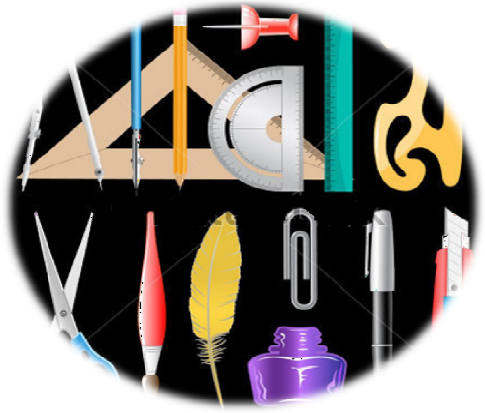

MODULE TITLE: - TECHNICAL DRAWING
LG Code: AGR IRD1 M06 LO (1-5) LG (18-22)
TTLM Code:AGR IRD1 TTLM 0822v1
August, 2022
Addis Ababa, Ethiopia

Table of Contents
Introduction to the Module 1
LO #1- Drawing instruments 2
Instruction sheet 2
Information Sheet 1 3
Self-check-1 17
LO #2- Sketch and Lettering 19
Instruction sheet 19
Information Sheet 2 20
Self-check-2 33
Operation Sheet -1 35
LAP TEST-1 39
LO #3- Schetch geometry 40
Instruction sheet 40
Information Sheet 3 41
Self-Check – 3 43
Operation Sheet -2 44
LAP TEST-2 46
LO #4 - Multi view and Sectioning 47
Instruction sheet 47
Information Sheet 4 48
Self-Check – 4 54
Operation Sheet -3 56
LAP TEST-3 58
LO #5 - Axonometric projection 59
Instruction sheet 59
Information Sheet 5 60
Self-Check – 5 63
Operation Sheet -4 65
LAP TEST-4 67
Reference Materials 68

Introduction to the Module
This module covers knowledge, skills and attitudes required to identify and select drawing instruments, sketching and lettering, identify geometry related to technical drawing, overview multi view and sectioning and determine axonometric projection drawings.
LG-18 | LO #1- Drawing instruments

Instruction sheet
This learning guide is developed to provide you the necessary information regarding the following content coverage and topics:
  - Identfying drawing materials and measuring tools
  - Identifying tables and straight edges
This guide will also assist you to attain the learning outcomes stated in the cover page. Specifically, upon completion of this learning guide, you will be able to:
  - Identify drawing materials and measuring tools
  - Identify tables and straight edges
Learning Instructions:
- Read the specific objectives of this Learning Guide.
- Follow the instructions described below.
- Read the information written in the information Sheets
- Accomplish the Self-checks
- Perform Operation Sheets
- Do the “LAP test”

Information Sheet 1 | Identify drawing instruments

Introduction
Drawing is a representation of forms or objects on a surface by means of lines. It's an illustration that is drawn by hand and published in a book, magazine, or newspaper. Engineering drawing is a two dimensional representation of three dimensional objects. In general, it provides necessary information about the shape, size, surface quality, material, manufacturing process, etc., of the object. It is the graphic language from which a trained person can visualize objects.
Drawings prepared in one country may be utilized in any other country irrespective of the language spoken. Hence, engineering drawing is called the universal language of engineers. Any language to be communicative should follow certain rules so that it conveys the same meaning to everyone. Similarly, drawing practice must follow certain rules, if it is to serve as a means of communication.
An engineering drawing, rather than being an image, is used to illustrate the size and shape of a product and can include details such as appropriate variants, load limits, materials, and any other information that may aid in a full understanding of the product.
Drawing instruments are materials we use in/for drawing.

- Uses of Technical Drawing
Technical drawing is essential for communicating ideas in industry and engineering. To make the drawings easier to understand, people use familiar symbols, perspectives, units of measurement, notation systems, visual styles, and page layout. The precise details of the technical drawing helps builders create objects without errors, delays or other costly issues. This, alone is the most important duty of the drawings.

- The purpose of drawings
There are many purposes of drawing such: describe or record something, document some evidence or history, explore different objects or nature, remember the past or past moments, change people understanding or thinking, express feelings and emotions and many more. Usually all our drawings come from our memory.

- Classification of Technical Drawinngs
There are different types of classifications of technical drawings, for example:
- By method (manual or CAD),
- By dimensions (2D or 3D),
- By format (isometric, oblique, single-point perspective, 2 point perspective, 3 point perspective).

- Drawing materials and measuring tools

- Drawing materials
In Engineering Drawing, we have to draw and understand the largest buildings (or other items) on a drawing sheet, not by reducing the dimensions but by reducing the scale.
Drawing materials - an instrument used by a draftsman in making drawings.
The scales - in engineering drawing are the ratio of the linear dimension of an element of an object as represented in the original drawing to the actual linear dimension of the same element of the object itself.
Table 1.1: Types of Drawings Instruments [Instruments Used in Engineering Drawing]
- Drawing Board  - T-Square or Drafter (Drafting machine)  - Set Squares  - Protractor  - Duster or Handkerchief  - Drawing Instrument Box  - Drawing Sheet  - Drawing Pencils | - Drawing Pins/Clips  - Comapss  - French Curve  - Scales (Ruler)  - Roll & Draw  - Circle Master  - Eraser  - Sharpener
- Rulers - used in technical drawing are usually made of polystyrene.It is used for drawing lines and connecting points. Rulers come in two types according to the design of their edge. A ruler with a straight edge can be used with lead pencils and felt pens, whereas when a technical pen is used the edge must be grooved to prevent the spread of the ink.
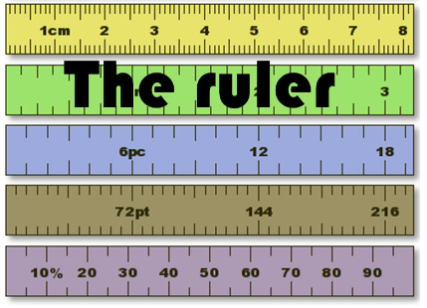 | 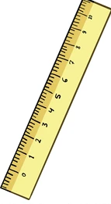 | 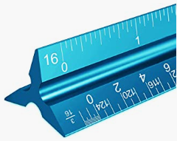
Fig. 1.1.: Rulers |  |  | scale ruler
- A scale ruler is a scaled, three-edged ruler which has six different scales marked to its sides. A typical combination for building details is 1:20, 1:50, 1:100, 1:25, 1:75 and 1:125. There are separate rulers for zoning work as well as for inch units. Today scale rulers are made of plastic, formerly they were made of hardwood. A pocket-sized version is also available, with scales printed on flexible plastic strips.
- Pencils - Pencils with leads of different degrees of hardness or grades are available in the market. The hardness or softness of the lead is indicated by 3H, 2H, H, HB, B, 2B, 3B, etc. The grade HB denotes medium hardness of lead used for general purpose. The hardness increases as the value of the numeral before the letter H increases.

The lead becomes softer, as the value of the numeral before B increases. The selection of the grade depends on the line quality desired for the drawing. Pencils of grades H or 2H may be used for finishing a pencil drawing as these give a sharp black line. Softer grade pencils are used for sketching work. HB grade is recommended for lettering and dimensioning. Nowadays mechanical pencils are widely used in place of wooden pencils. When these are used, much of the sharpening time can be saved. The number 0.5, 0.70 of the pen indicates the thickness of the line obtained with the lead and the size of the lead diameter. Micro-tip pencils with 0.5 mm thick leads with the following grades are recommended.

HB Soft grade for Border lines, lettering and free sketching H Medium grade for visible outlines, visible edges and boundary lines 2H Hard grade for construction lines, Dimension lines, Leader lines, Extension lines, Centre lines, Hatching lines and Hidden lines.
- Graphite pencils: These are the most common pencils used in art and writing. Charcoal pencils: Create dark and rough lines, but not as versatile as the other options. Colored pencils: Similar to normal graphite pencils but in color
  Mechanical (pixer) pencil |   Colour pecils
Fig. 1.2: Types of Pencils
- Drawing sheet - is a white paper on which an object is drawn which is available in various sizes. The sheet used for engineering should be of good quality. It should be white in color with uniform thickness with must resist the easy torn of paper. The surface of sheet must be smooth. The drawing sheets are designated by symbols such as A0,A1,A2,,A3,A4 and A5. A0 being the largest.
Table 1.2: Sizes of drawing sheets
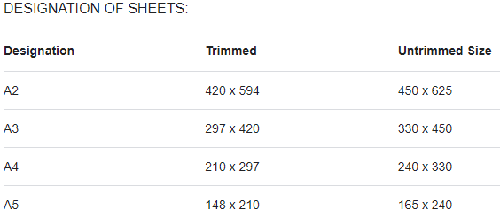
 | 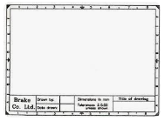 | 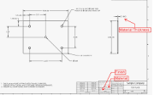
Fig. 1.3: Forms of drawing sheet
- Compasses - are used for drawing circles or arc segments of circles. One form has two straight legs joined by a hinge; one leg has a sharp pivot point and the other has a holder for a technical pen or pencil. Another form, the beam compass, has the pivot point and pen holder joined by a trammel bar, useful when drawing very large radius arcs. Often a circle template is used instea of a compass when predefined circle sizes are required.
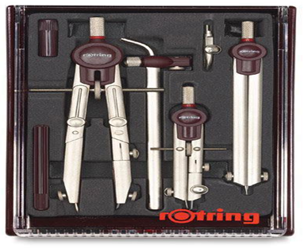 | 
Fig. 1.4: Compasses
- Templates - Templates contain pre-dimensioned holes in the right scale to accurately draw a symbol or sign .Letter templates are used for drawing text, including digits and letter characters. Diagrams are usually of a standard letter shape and size to conform to standards of encodings (e.g. DIN or ANSI). For example, in Finland the series used is 1.8 mm, 2.5 mm, 3.5 mm, 5.0 mm and 7.0 mm. Except for the very biggest ones, the templates are only suitable for technical pen drawing. For drawing circles and circle-arcs, circle templates which contain a set of suitably-sized holes are used. Templates are also available for other geometric shapes such as squares and for drawing ellipses, as well as many specialized varieties for other purposes.
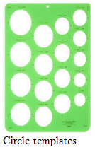 | 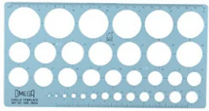  Circle maste | 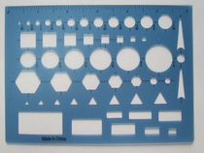
Fig. 1.5: Templates
- Drawing Pins and Clips - These two are used to fix the drawing sheet in place on the drawing board. And are short nail or pin used to fasten items to a wall or board for display and intended to be inserted by hand, usually using the thumb.

Fig. 1.6: Drawing Pins and Clips
- Sharpener - A pencil sharpener is a device that shaves the worn surface of a pencil to sharpen the writing edge.
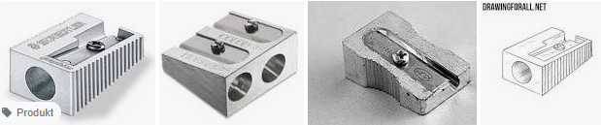
Fig. 1.7: Sharpeners

- Eraser - An eraser is a tool that is used to remove pencil marks from paper or sheets.
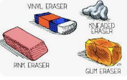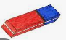 | 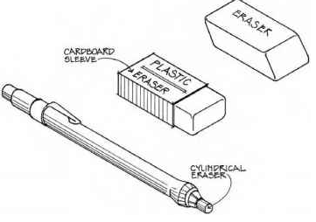
Fig. 1.8: Erasers

- Duster or Handkerchief- To clean the paper on which the drawing is being done, a duster or handkerchief is often used. They come in a variety of colors and sty.
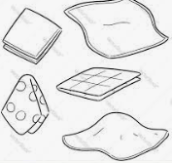 | 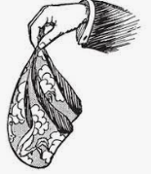
Fig. 1.9: Duster or Handkerchiefs

- Divider a drafting instrument resembling a compass that is used for dividing lines into equal segments or for transferring measurements. It is an instrument for measuring, transferring, or marking off distances, consisting of two straight adjustable legs hinged together and ending in sharp points.
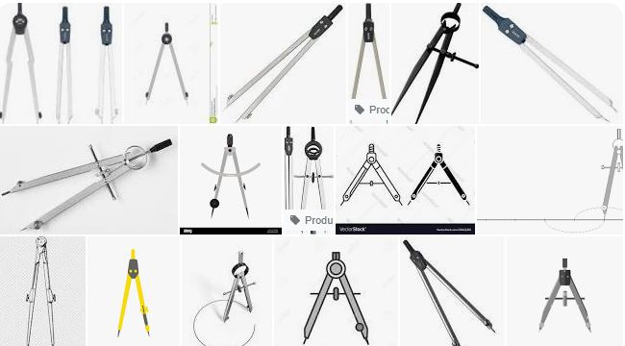
Fig. 1.10: Dividers
- Protractor - are used to calculate or label angles between 0 and 180 degrees. They have a semicircular shape (diameter 100mm) and made of plastic or celluloid, which has a longer life span. Protractors with a circular shape that can mark and measure from 0 to 360 degrees are also available on the market.
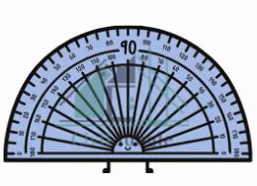 | 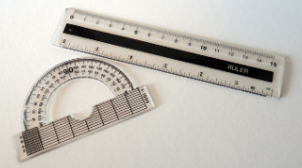
Fig. 1.11: Protractors

- Triangle - is a drafting tool used to draw accurate parallel lines, vertical lines, and other angled lines. Generally, two right-angled triangular pieces of differing angles form one set.
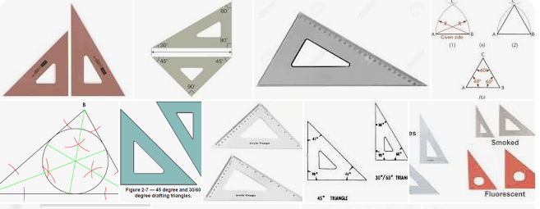
Fig. 1.12: Triangle
- T-square - Strong wood is used to make T-squares. A T-square is made up of two parts: the stock and the blade, which are connected at right angles by screws and pins. Set squares are used to draw parallel lines, vertical lines, or inclined lines at 30°, 60° to the horizontal using the working edge of a T-square. It is a straightedge which uses the edge of the drawing board as a support. It is used with the drafting board to draw horizontal lines and to align other drawing instruments.
Wooden, metal, or plastic triangles with 30° and 60° angles or with two 45° angles are used to speed drawing of lines at these commonly used angles. A continuously adjustable 0–90° protractor is also in use. An alternative to the T-square is the parallel bar which is permanently attached to the drawing board. It has a set of cables and pulleys to allow it to be positioned anywhere on the drawing surface while still remaining parallel to the bottom of the board. The drafting machine replaces the T-square and triangles.
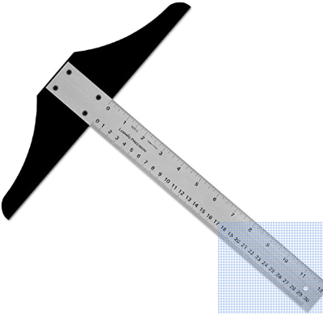 | 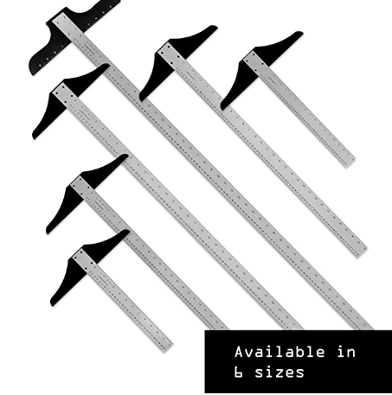
Fig. 1.13: T-squares
- Drawing board- is an essential tool. Paper will be attached and kept straight and still, so that the drawing can be done with accuracy. Generally, different kind of assistance rulers is used in drawing. The drawing board is usually mounted to a floor pedestal in which the board turns to a different position, and also its height can be adjustable. Smaller drawing boards are produced for table-top use.
 | 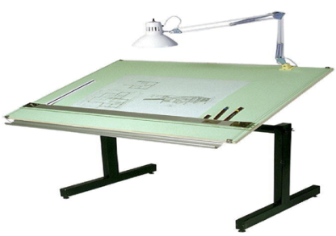 | 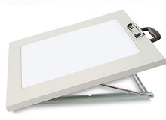
Fig. 1.14: Drawing boards

- Drawing Instrument box- It consists of the following components:
- Large size compasses,
- Large size divider,
- Small size bow pen, bow divider, and
- Lengthening bar.
What is important is the position of the pencil lead with respect to the tip of the compass. It should be at least 1 mm above as shown in Fig. 1.15 because the tip goes into the board for grip by 1 mm.
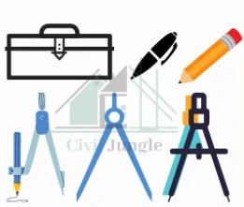 | 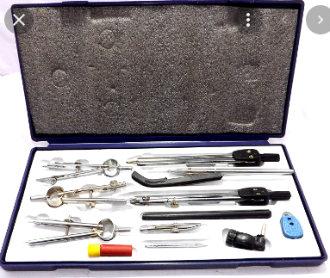
Fig. 1.15: Drawing instrument boxs

- Set squares - Plastic or celluloid are the most popular materials used to make set squares. They are triangular in shape, with one right-angle triangle as a corner. A pair of set squares (30°–60°) and 45° (a 45° set square is usually used with a Protractor) make it easier to mark angles. They’re used to draw lines at 30°, 60°, and 45° angles to the vertical and horizontal.
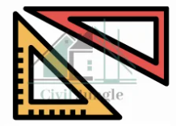 | 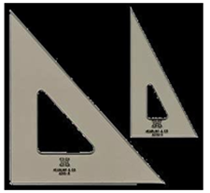
Fig. 1.16: Set squares
- Set of scales (Calipers)- Scales are used to make drawing of the objects to proportionate size desired. These are made of wood, steel or plastic. BIS recommends eight set-scales in plastic/cardboard with designations M1, M2 and so on.
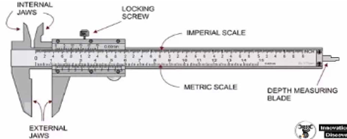 | 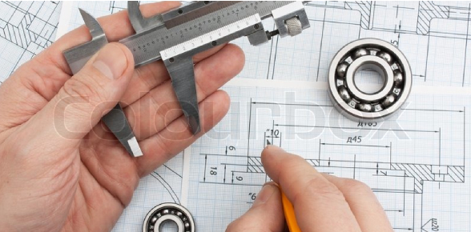
Fig. 1.17: Caliper

- Roll and Draw - is an incredibly useful method for easily generating charts and parallel lines. It’s also known as “the best friend of a draftsman.” It’s also a multipurpose drawing tool that allows you to quickly and easily draw quadrants, triangles, circles, angles, crosshatching, and the Rolling Ruler is a universal drawing tool for making parallel lines, circles and arcs. Draw Horizontal Parallel Lines Hold the centre of the ruler and roll it up/down to draw the straight parallel lines vertical and horizontal parallel lines in centimeters.

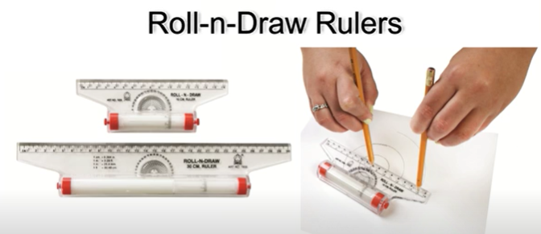
Fig. 1.18: Roll and draw
- French curves - are made of wood, plastic or celluloid. Some set squares also have these curves cut in the middle. French curves are used for drawing curves which cannot be drawn with compasses.
A faint freehand curve is first drawn through the known points; the longest possible curve that coincides exactly with the freehand curve is then found out from the French curves. Finally, a neat continuous curve is drawn with the aid of the French curves.
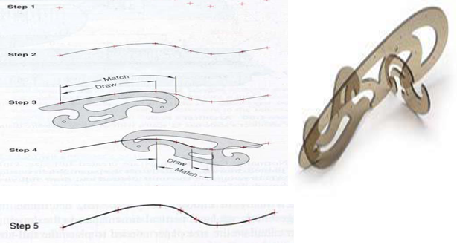
Fig. 1.19: French curves
- Other Drawing Tools
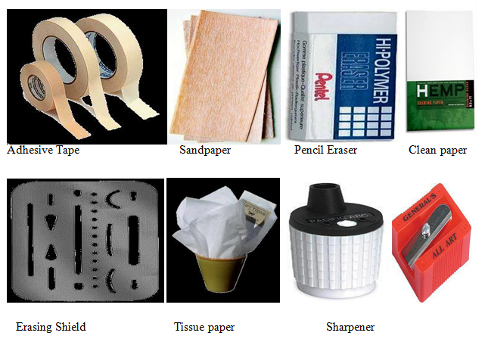
Fig. 1.20: Other drawing tools
- Measuring Tools
Are used to create precise drawings or to measure the length of existing lines or angles
- Angle locator  - Caliper  - Compass | - Digital angle gauge  - Laser level  - Level | - Micrometer  - Etc
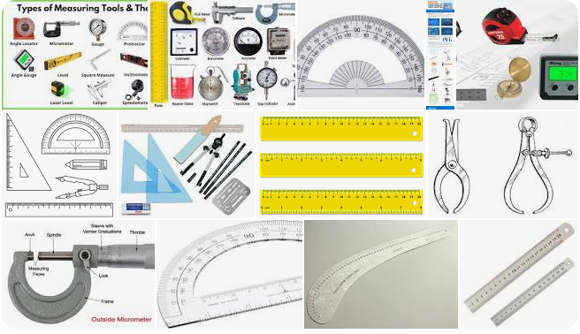
Fig. 1.21: Tpes of measuring tools in drawing
- Table and Straight Edge
- Tables
A drawing board (also drawing table, drafting table or architect's table) is, in its antique form, a kind of multipurpose desk which can be used for any kind of drawing, writing or impromptu sketching on a large sheet of paper or for reading a large format book or other oversized document or for drafting precise.
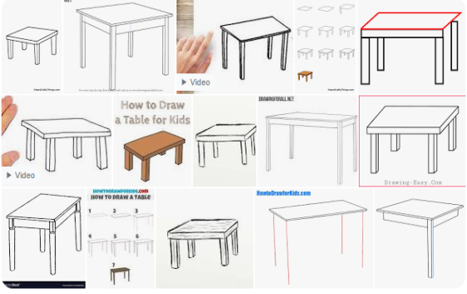 | 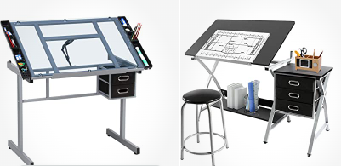
Fig.1.22: Simple drawing tables | Fig.1.23: Adjustable glass drafting tables
- Straight Edge
A bar or piece of material (as of wood, metal, or plastic) with a straight edge for testing straight lines and surfaces or for cutting along or drawing straight lines.
A straightedge or straight edge is a tool used for drawing straight lines, or checking their straightness. If it has equally spaced markings along its length, it is usually called a ruler.
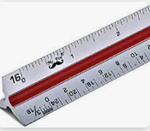 | 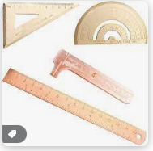
Fig. 1.24: Straight Edges

Self-check-1 | Written test

Name…………………………………………… ID………………………… Date…….

Directions: Answer all the questions listed below.
Test I: Choose the best answer (1 point each).
- The art or technique of representing an object or outlining a figure, plan, or sketch by means of lines.
A. Drawing B. Painting C. Sketching D. Doodling
- An idea for something you want to build you may draw it roughly, without using instruments or accurate scales.
A. Drawing B. Drafting C. Sketching D. Painting
- The relationship between the measurement of an object drawn on a sheet of paper, and the measurements of the actual object.
A. Size B. Annotation C. Draft D. Scale
- Used by draftsmen primarily as a guide for drawing horizontal lines on a drafting table.
A. T-square B. Ruler C. Triangle D. Drawing Scale
- Used to draw circles and arcs.
A. Divider B. Compass C. French Curve D. Protractor
- Used to draw maps, charts, and any drawings that require decimal measurements.
A. Engineer's Scale B. Drafting Table C. Lead Pointer D. Technical Pen
- An instrument for measuring, transferring or marking off distances, consisting of two straight adjustable legs hinged together and ending in sharp points.
A. Divider B. Compass C. Protractor D. French Curve
- The use of abstract symbols rather than actual pictures to represent things.
A. Pictorial B. PCB/Layout C. Schematic D. Component layout
- A thin, flat, plastic tool with various size openings of different shapes used to expedite the drawing of standard features
A. Template B. Compass C. Eraser D. Scale

Test II: Short Answer Questions
- Explain technical drawing: _______________________________________________

Test II: Fill in the blank
- ____________ is used to draw arcs and circles.
- ____________ instrument is used to transfer measurement from one point to
another.
- The drawing instrument used for measuring angles is _________________ .

Note: Satisfactory rating -10 points Unsatisfactory – below 10 points

LG-19 | LO #2- Sketch and Lettering

Instruction sheet
This learning guide is developed to provide you the necessary information regarding the following content coverage and topics:
  - Sketching points and lines
  - Identifying types of lines
  - Sketching angles, quadrilaterals and polygons
  - Sketching circles and arcs
  - Sketching circular and elliptical objects
  - Conducting graduation of measurement devices
  - Sketching lettering
This guide will also assist you to attain the learning outcomes stated in the cover page. Specifically, upon completion of this learning guide, you will be able to:
  - Sketch points and lines
  - Identify types of lines
  - Sketch angles, quadrilaterals and polygons
  - Sketch circles and arcs
  - Sketch circular and elliptical object
  - Conduct measurement device graduation
  - Sketch lettering
Learning Instructions:
- Read the specific objectives of this Learning Guide.
- Follow the instructions described below.
- Read the information written in the information Sheets
- Accomplish the Self-checks
- Perform Operation Sheets
- Do the “LAP test”

Information Sheet 2 | Sketching and Lettering

Introduction
Sketching is almost always the first step in the preparation of Engineering Drawings (ED). The work piece (object) is carefully studied and all the necessary dimensions are measured. The views that are necessary to completely describe the object are very roughly drawn (free hand). All dimensions are indicated on the sketch as deemed necessary. In most situations, axonometric views of the object are drawn. Sketches are never submitted anywhere. They are just drawn to assist you at a later time when preparing standard drawings. That is, the only purpose of preparing sketches is to enable you to transfer useful information from the spot to a convenient place where you can actually prepare acceptable EDs. For this reason, there are no hard rules or general guidelines with respect to sketches. Nevertheless, sketches should be drawn accurately so that they may prove useful at a later stage.
Lettering is an umbrella term that covers the art of drawing letters, instead of simply writing them. Lettering is considered an art form, where each letter in a phrase or quote acts as an illustration. Each letter is created with attention to detail and has a unique role within a composition
- Poinls, Lines and angles
- Points
A point is defined as a location in any space and is represented by a dot (.). It does not have any length, height, shape, or size. It marks the beginning to draw any figure or shape and is labeled with capital letters.
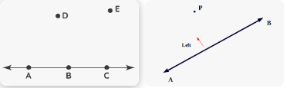
Fig.2.1: points and lines
- Lines
Technical drawing Lines are used for different purposes to provide specific information for designers, manufacturers, etc. looking at the drawing. The person who will read drawings have to learn what they mean. Line types are also a language type to communicate between technical people.
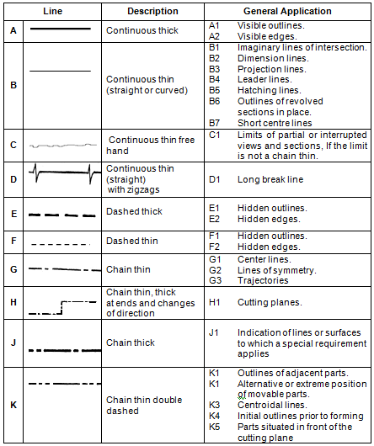
Fig.2.2: Various types of lines, their description and general appliction
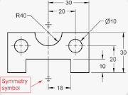 | 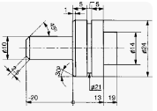
Fig. 2.3: Locting and dimessioning lines
- Angle
Angle- is very important to be able to draw angles in Technical Graphics. With your set squares sitting on your T-square you can four commonly used angles. These are 30°, 45°, 60° and 90°.
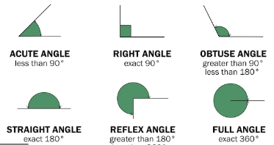

Fig.2.4: Types of angles

- Quadrilateral
Quadrilateral just means "four sides" (quad means four, lateral means side). A Quadrilateral has four-sides, it is 2-dimensional (a flat shape), closed (the lines join up), and has straight sides.
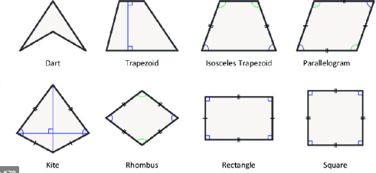
Fig.2.5: Quadrilaterls

- Polygon
Polygon, in geometry, any closed curve consisting of a set of line segments (sides) connected such that no two segments cross. The simplest polygons are triangles (three sides), quadrilaterals (four sides), and pentagons (five sides).

A polygon is any plane figure bounded by straight lines. If the polygon has equal angles and equal sides, it can be inscribed in or circumscribed around a circle and is called a regular polygon.
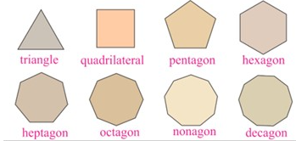
Fig.2.6: Types of polygon

- Circular and elliptical object

- Circular objects
A circle is a plane figure that is bounded by a curved line called a circumference which is always equidistant from its center. That "equal distance" from the center is known as the radius of the circle. The diameter of a circle is a line that passes through the center of the circle and has its endpoints on the circle.
A round shape consisting of a curved line that completely encloses a space and is the same distance from the centre at every point. Something in the shape of a circle is circular.

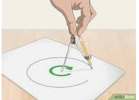 | 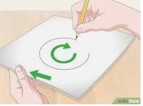 | 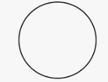
Fig. 2.7: Circles
- Elliptical object
The adjective elliptical refers to the shape of an ellipse, which is an elongated circle, stretched into an oval. This word can also be used to describe a way of speaking that cuts out extra, unnecessary language. When writers use an elliptical style, it sometimes makes the work obscure and hard to interpret.
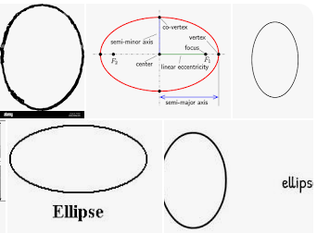
Fig. 2.9: Ellipses
- Arc
An arc is a portion of a circle. The default method for drawing an arc is to specify three points; the start point, a second point, and the endpoint.
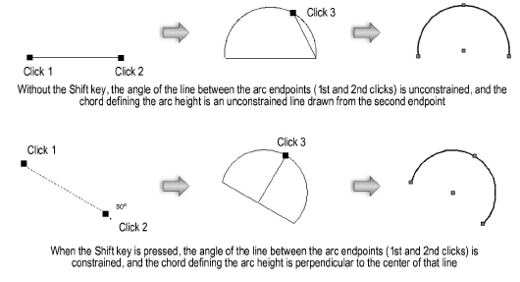
Fig. 2.10: Arcs

- Gradution of measurement device

A graduation is a marking used to indicate points on a visual scale, which can be present on a container, a measuring device, or the axes of a line plot, usually one of many along a line or curve, each in the form of short line segments perpendicular to the line or curve. Often, some of these line segments are longer and marked with a numeral, such as every fifth or tenth graduation. The scale itself can be linear (the graduations are spaced at a constant distance apart) or nonlinear.
Graduate: mean marked with divisions indicating degrees or units of measurement a graduated cylinder/tube graduated measuring cups: divided into or arranged in grades, steps, or successive levels usually proportionally a graduated series of honors.
- Sketching and lettering
A sketch is a quickly executed, freehand drawing that is usually not intended as a finished work. In general, sketching is a quick way to record an idea for later use.
Lettering is defined as writing of titles, sub-titles, dimensions, etc., on a drawing.

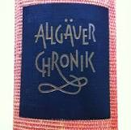 | 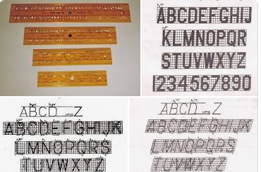
Fig. 2.11: Vertical and inclined lettering

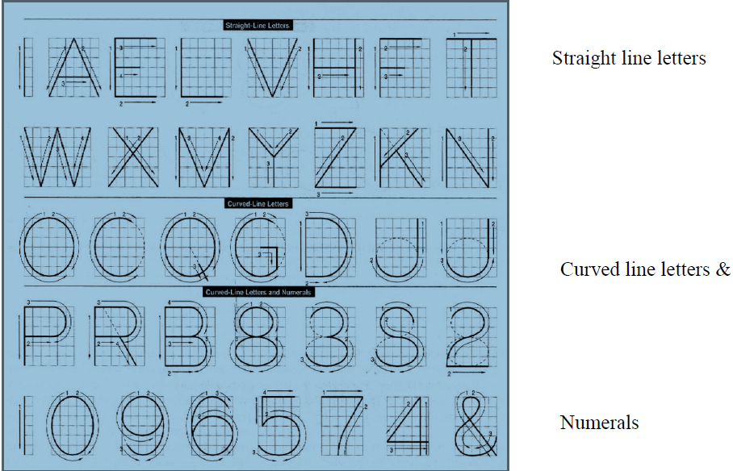
Fig.2.12: Straight and curved line lettering

- Importance of Lettering
Lettering is used to specify details of an object on a drawing. Lettering is one type of freehand drawing. A perfectly legible freehand lettering is an essential part of engineering drawing. All the information on the drawing is always mentioned through lettering.
To undertake production work of an engineering component as per the drawing, the size and other details are indicated on the drawing. This is done in the form of notes and dimensions.
- Main Features of Lettering
Are legibility, uniformity and rapidity of execution. Use of drawing instruments for lettering consumes more time. Lettering should be done freehand with speed. Practice accompanied by continuous efforts would improve the lettering skill and style. Poor lettering mars the appearance of an otherwise good drawing.
- Single Stroke Letters
The word single-stroke should not be taken to mean that the lettering should be made in one stroke without lifting the pencil. It means that the thickness of the letter should be uniform as if it is obtained in one stroke of the pencil.
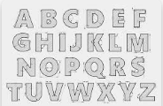 | 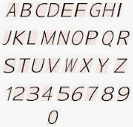
Fig. 2.13: Single stroke letters

- Types of Single Stroke Letters
- Vertical - (Type A)
In this chart of single stroke letters, the capitals are arranged in “family order,” first the straight letters, then slant line and curved letters.
Each letter is shown in a square, so that the proportion of its width to height may be easily learned. In this style many of the letters just about fill the square.
The arrows and figures give the order and direction of strokes, which must be learned for each letter, Vertical strokes are all made downward and horizontal strokes from left to right.
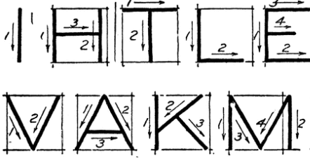 | 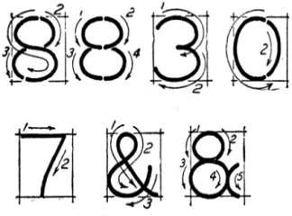 | 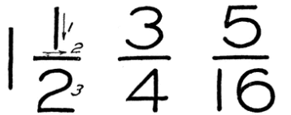
Fig. 2.14: Vertical captal letters

- Inclined – (Type B)
The single stroke inclined letter made to a slope of between 60 and 70 degrees is preferred by perhaps a majority of draftsman. The order and direction of strokes for the capitals of this form will be the same as in the upright form, but these letters are usually not extended.
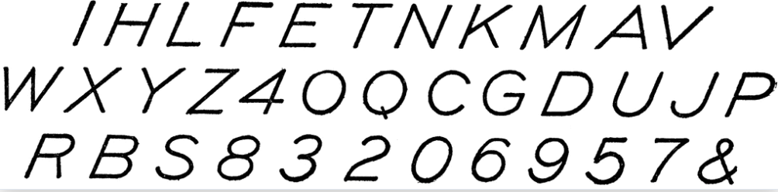
Fig.2.15: Inclined Capital Letters
Note: Both vertical and inclined letters and numerals are suitable for general use.
- Type B Preferred
In Type A, height of the capital letter is divided into 14 equal parts, while in Type B; height of the capital letter is divided into 10 equal parts. Type B is preferred for easy and fast execution, because of the division of height into 10 equal parts.

- Vertical Letters Preferred- Vertical letters are preferred for easy and fast execution, instead of sloped letters.
Note: Lettering in drawing should be in CAPITALS (i.e., Upper-case letters).
- Lower-case (small) letters are used for abbreviations like mm, cm, etc.

- Size of Letters
Size of Letters is measured by the height h of the CAPITAL letters as well as numerals. Standard heights for CAPITAL letters and numerals recommended by BIS are given below : 1.8, 2.5, 3.5, 5, 6, 10, 14 and 20 mm
Note: Size of the letters may be selected based upon the size of drawing.

Table 2.1 Lettering Proportions
Letters | Recommended Size (height h) of letters/numbers
Main Title | 5 mm, 7 mm, 10 mm
Sub-Titles | 3.5 mm, 5 mm
Dimensions, Notes, etc. | 2.5 mm, 3.5 mm, 5 mm
- Dimensioning of Type B Letters - BIS denotes the characteristics of lettering as :
- h (height of capita) letters),
- c₁(height of lower-case letters),
- c₂ (tail of lower-case letters),
- c₃ (stem of lower-case letters),
- a (spacing between characters),
- b₁& b₂(spacing between baselines),
- e (spacing between words) and d (line thickness),

- CAPITAL Letters
- Ratio of height to width for most of the CAPITAL letters is approximately =10:6
- However, for M and W, the ratio = 10:8 for I the ratio = 10:2

- Lower-case Letters - Height of lower-case letters with stem / tail (b, d, f, g, h, j, k, I, p, q, t, y) = C₂ = C₃ = h
- Ratio of height to width for lower-case letters with stem or tail = 10:5
- Height of lower-case letters without stem or tail C₁is approximately = (7/10) h
- Ratio of height to width for most lower-case letters without stem or tail = 7: 5
- However, for m and w, the ratio = 7: 7. For I and I, the ratio = 10:2
- Numerals
- For numerals 0 to 9, the ratio of height to width = 10 : 5. For I, ratio = 10 : 2
- Spacing
- Spacing between characters = a = (2/10)h
- Spacing between words = e = (6/10)h

- Practice example of lettering capital and lower case letters and numerals of type B are shown in Figs.2.16 and 2.18.
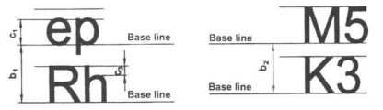
Fig.2.16: Lettering letters and numbers
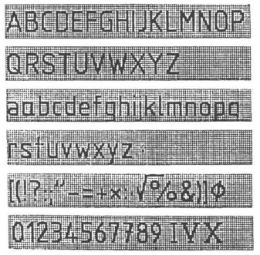
Fig.2.18: Verttical lettering

- The following are some of the guide lines for lettering (Fig 2.29 & 2.30):
- Drawing numbers, title block and letters denoting cutting planes, sections are written in 10 mrn size.
- Drawing title is written in 7 mm size.
- Hatching, sub-titles, materials, dimensions, notes, etc., are written in 3.5 mm size.
- Space between lines = ~ h.
- Space between words may be equal to the width of alphabet M or 3/5 h.
- Space between letters should be approximately equal to 115 h. Poor spacing will affect the visual effect.
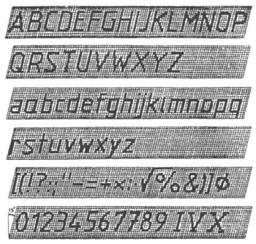
Fin.2.29: Inclined lettering

- The spacing between two characters may be reduced by half if th is gives a better visual effect, as for example LA, TV; over lapped in case of say LT, TA etc, and the space is increased for letters with adjoining stems.

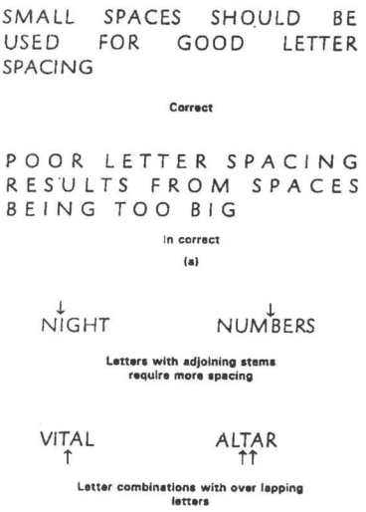
Fig.2.30: Guide lines for lettering

Self-check-2 | Written test

Name…………………………………………… ID………………………… Date…….

Directions: Answer all the questions listed below.
Test I: Choose the best answer (1 point each)
- Used to provide easy to read and understand information to supplement a drawing in the form of notes and annotations.
A. Drawing B. Drafting C. Lettering D. Sketching
- It refers to shape & space between letters and words.
A. Legibility B. Unity C. Uniformity D. Creativity
- Lettering having all the alphabets or numerals of uniform thickness is called
A. Italic B. Roman C. Gothic D. Old English Text
- A minimum recommended space between letters in words is approximate.
A. 1/16 B. 1/8 C. ¼ D. 1/2
- Used to provide easy to read and understand information to supplement a drawing in the form of notes and annotations.
A. Drawing B. Drafting C. Lettering D. Sketching
- Center lines are used to locate or represent the centers of ________.
    - Arcs B. Circles C. Hidden round features D. All of the above
- The type of line that projects from an object for the express purpose of locating a dimension is a ________ line.
  - Visible B. Hidden C. Extension D. Dimension
- …… is drawn at the bottom right hand corner of the drawing paper.
  - Information B. Title block C. Lettering D. Dimensions
- A rod is pivoted at one end and the other end is free to rotate. The locus of the free end after a complete revolution is ____________.
A. An ellipse B. A cone C. A circle D. A shpere

Test II: Match the following.
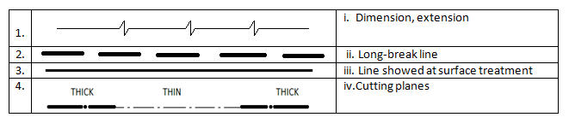
Test III: Short Answer Questions
- What is lettering: __________________________________________________

Test III: Fill in the black
- If a right cone is cut by a plane which is parallel to one slant side of the cone, then the true shape of the curve to be produced is _________.
- A line drawn with a long section, short dash, and another long section is a __________.
- Which type is the line A in the following figure?
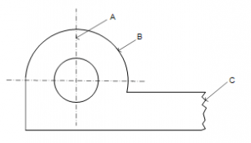
- In the following figure line C is used for irregular boundaries, what is its name?
Note: Satisfactory rating -15 points Unsatisfactory – below 15 points

Operation Sheet -1

- Sketch straight lines
- Tools and equipments
- Mechanical pencils  - Technical pens  - Drawing boards (tables) | - Erasers  - Sharpeners.  - Rulers
- Procedures to sketch straight lines.
- Select and Prepare required instruments
- Sequire drawind paper on drawing table (board)
- Mark the end and start points.
- Make a few trial motions between the marked points to adjust the eye and hand to the contemplated line.
- Sketch a very light line between the points by moving the pencil in two or three sweeps. When sketching the trial line, the eye should be on the point toward which the movement is directed.
- Darken the finished line, keeping the eye on the pencil point on the trial line. The final line, replacing the trial line, should be distinct, black, uniform, and straight.
- Sketch boarder lines
- Tools and equipments
- Mechanical pencils  - Technical pens  - Rulers  - Drawing boards (tables) | - Erasers  - Sharpeners.  - T-squers

- Techniques to sketch boarder lines.
- Select and Prepare required instruments
- Sequire drawind paper on drawing table (board)
- Begin by aligning the edge of the paper with that of the board. Prevent the paper from sleeping by one hand while holding the pencil firmly by the other hand
- Use the idle fingers of the hand holding the pencil as a guide against the edge of the board.
- Then slowly sketch the line pulling the pencil toward you.
- Here you need not to sketch a trial line; instead produce a final bold line at the first stroke.

- Construct 90 degree angle
- Tools and equipments:
- Mechanical pencils  - Technical pens  - Rulers  - Drawing boards (tables)  - T-squers | - Erasers  - Sharpeners.  - Protractors  - Set-squares

- Procedures to draw 9 degree angle.
- Select and Prepare required instruments
- Sequire drawind paper on drawing table (board)
- First draw a line segment EF of line L.
- Release your compasses to an appropriate separation.
- Using E as centre, construct an arc to intersect the line L at M and N.
- Then release your compasses to more than half the distance of MN.
- Using M and N as centres, construct two arcs to intersect above the line L at O.
- Now draw a straight line passing through the point E and O.
- You have finally constructed angle FEO of size 90°.

- Draw 25 mm diameter circle.
- Tools and equipments

- Pencil
- A4 size paper
- Compass
- Scale
- Procedures to draw 25mm diameters circle.
- Select and Prepare required instruments
- Sequire drawind paper on drawing table (board)
- Sketch a center line by drawing a horizontal and a vertical line that intersect at the center of the desired circle. Estimate and mark off the radius distance from the centerpoint on each side of the centerline.
- Sketch one quarter of the circle lightly and then sketch the other quarter of the circle.
- Sketch the other half of the circles in the same manner. Darken the finale circle and change the light horizontal and vertical construction lines intersecting at the center of the circle into centerlines.

- Construct an ellipse
- Tools and equipments
- Scale  - Compass | - pencil  - Set square | - Instrument for measuring angle
- Procedures of ellpse consrtruction.
- Select and Prepare required instruments
- Sequire drawind paper on drawing table (board)
- Draw any vertical line CD as directrix.
- At any point A in it, draw the axis.
- Mark a focus F on the axis such that AF1=50mm.
- Divide AF1 in to 5 equal divisions.
- Mark the vertex V on the third division-point from A.
- Thus eccentricity e= VF1/VA = 2/3.
- A scale may now be constructed on the axis which will directly give the distances in the required ratio.
- At V, draw a perpendicular VE = VF1. Draw a line joining A and E.
- Mark any point 1 on the axis and through it draw a perpendicular to meet AE produced at 1'.
- With centre F and radius equal to 1-1', draw arcs to intersect a perpendicular through 1 at points P1 and P'1.
- Similarly mark points 2, 3 etc. on the axis and obtain points P2 and P'2, P3 and P'3, etc.
- Draw the ellipse through these points, it is a closed curve two foci and two directrices.

- Write freehand the following, using single stroke vertical CAPITAL letters of 5 mm (h) size.

- Tools and equipments

- 2H pencl
- Scale
- HB grade conical end pencil
- A4 paper
- Rulers

- Procedures of freehand the vertical CAPITAL letters using single stroke.
- Select and Prepare required instruments
- Sequire drawind paper on drawing table (board)
- Drawn thin horizontal guide lines first at a distance ' h' apart.
- Drawn horizontal lines of the letters from left to right.
- Drawn vertical, inclined and curved lines from top to bottom.
- Dont erase guidelines after lettering has been completed.

LAP TEST-1 | Performance Test

Name………………………………. ID…………………………….. Date…………………………………….

Time started: ________________________ Time finished: ________________

Instructions: Given necessary templates, tools and materials you are required to perform the following tasks within 4:00 hour. The project is expected from each student to do it.
Task-1: Sketch straight line.
Task-2: Sketch boarder line.
Task-3: Construct 90 degree angle.
Task-4: Draw 25 mm diameters circle.
Task-5: Construct an ellipse.
Task-6: Write freehand the following, using single stroke vertical CAPITAL letters of 5 mm (h) size.

LG -20 | LO #3- Schetch geometry

Instruction sheet
This learning guide is developed to provide you the necessary information regarding the following content coverage and topics:
- Performing bisecting and dividing
- Constructing perpendicular and tangent

This guide will also assist you to attain the learning outcomes stated in the cover page. Specifically, upon completion of this learning guide, you will be able to:
- Perform bisecting and dividing
- Construct perpendicular and tangent

Learning Instructions:
- Read the specific objectives of this Learning Guide.
- Follow the instructions described below.
- Read the information written in the information Sheets
- Accomplish the Self-checks
- Perform Operation Sheets
- Do the “LAP test”

Information Sheet 3 | Bisecting and Dividing

Geometry
A branch of mathematics that deals with the measurement, properties, and relationships of points, lines, angles, surfaces, and solids broadly : the study of properties of given elements that remain invariant under specified transformations.

Geometric forms are forms that can be constructed using geometry, such as squares, rectangles, circles, cones, cubes, and so on. Geometric forms are commonly found in architecture, structural and civil engineering.

Most people consider sketching to be a looser, less refined form of drawing. Sketches are typically created as preliminary drawings in order to prepare for a more finished work of art. Sketches are typically created with quick marks and are usually lacking some of the details that a finished drawing may have.

- Bisecting and Dividing
Bisection is the process of dividing into two equal parts. Thus, to bisect a line is to divide it into two equal parts. While the line which divides another line or angle into two equal parts is called a bisector.
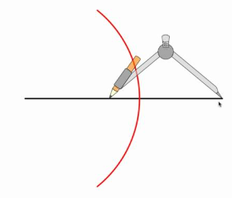 | 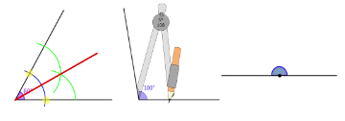
Fig.3.1: Line bisecting | Fig.3.2: Angle bisecting

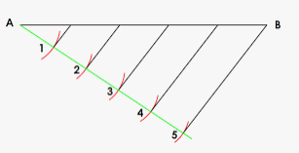 | 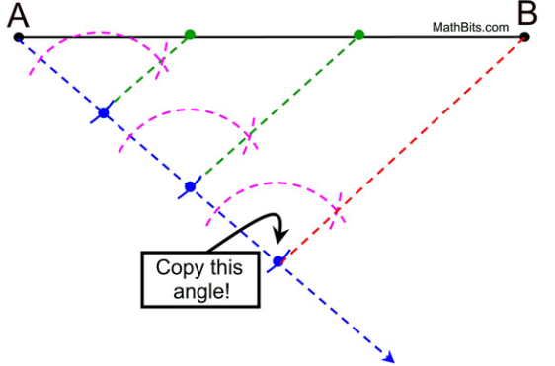
Fig.3.3: Bisecting and dividing a line

- Perpendicular and Tangent
Perpendicular lines are coplanar lines intersecting at 90° angles. A perpendicular shape is a shape that has at least two sides that come together at a 90-degree angle. The box symbol where two lines or sides meet verifies that they are perpendicular. A right triangle has one right angle and two perpendicular lines.

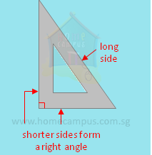 | 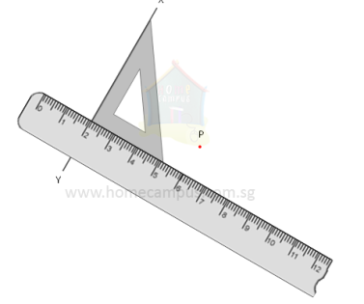 | 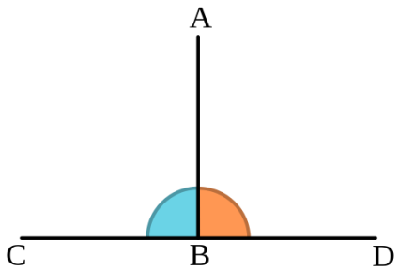
Fig.3.4: Perpendicular lines, angles and objects

A Tangent is a line that touches the edge of a curve or circle at one point, but does not cross it.
In the diagram below, the tangent is the length of the vertical line ED that is tangent from the point of tangency, E, to the point D where the tangent line intersects the ray AD formed by the angle Fig.3.2.2.
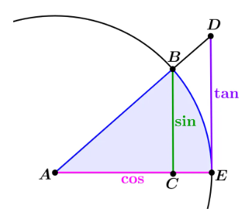
Fig.3.5:Tangent of an angle
Self-Check – 3 | Written test

Name…………………………………………… ID………………………… Date…….

Test I: Multiple choice
Directions: Answer all the questions listed below.
- A tangent to a circle is a line which touches the circle at one and only one point.
A.True B. False
- The line perpendicular to a tangent and is passing through the point of contact is called as _____
- Perpendicular bisecto B. Angle bisector C. Normal D. Tangent
- Which of the following is a conic section?
A. Circle B. Rectangle C. Triangle D. Square
- The angle bisector cuts an angle exactly _____?
A. In thirds B. In half C. In quarters D. At a 60 degree angle E. At a right angle
- Finding the bisector of an angle _____.
- Can only be done with a protractor to measure it exactly
- Requires no measuring at all, just a compass and straightedge
- Requires a specialized laser tool
- Cannot be done
- For a 4 inch line segment divided into 8 equal parts, how long should each part be?
- 1 inch B. 0.5 inches C. 2 inches D. 0.75 inches E. 1.5 inches
Test II: Fill in the blank
- ______ is a shape that has at least two sides that come together at a 90-degree angle.
- ______ is the process of dividing into two equal parts

Note: Satisfactory rating - 5 points Unsatisfactory - below 5 points

You can ask you teacher for the copy of the correct answers.

You can ask you teacher for the copy of the correct answers.

Operation Sheet -2

- Bisect angle ө.

- Tools and equipments
- Pencil  - A4 size paper  - Compass  - Scale  - T-squers | - Mechanical pencils  - Technical pens  - Rulers  - Drawing boards (tables) | - Erasers  - Sharpeners  - Protractors  - Set-squares
- Procedures of bisecting an angle.
- Select and Prepare required instruments
- Sequire drawind paper on drawing table (board)
- Draw a line AB and AC making angle ө.
- With centre A and any convenient radius R draw an arc intersecting the sides at D and E.
- With centre’s D and E and radius larger than half the chord length DE, draw arcs intersecting at F 4.
- Join AF, <BAE=<FAC

- Divide a given straight line into a given number of equal parts say 5.
- Tools and equipments
- Pencil  - A4 size paper  - Compass  - Scale  - T-squers | - Mechanical pencils  - Technical pens  - Rulers  - Drawing boards (tables) | - Erasers  - Sharpeners  - Protractors  - Set-squares

- Procedures of bisecting an angle.
- Select and Prepare required instruments
- Sequire drawind paper on drawing table (board)
- Draw AC at any angle 𝜃 to AB.
- Construct the required number of equal parts of convenient length on AC like 1,2,3.
- Join the last point 5 to B 4.
- Through 4, 3, 2, 1 draw lines parallel to 5B to intersect AB at 4',3',2' and 1'.

LAP TEST-2 | Performance Test

Name………………………………. ID…………………………….. Date…………………………………….

Time started: ________________________ Time finished: ________________

Instructions: Given necessary templates, tools and materials you are required to perform the following tasks within 2 hour. The project is expected from each student to do it.

Task-1 : Bisect angle ө.
Task-2 : Divide a given straight line in to 5 parts.

LG-21 | LO #4 - Multi view and Sectioning

Instruction sheet
This learning guide is developed to provide you the necessary information regarding the following content coverage and topics:
- Viewing orientation
- Sketching auxiliary view
- Multi view drawing
- Sketching full sectioning
- Skeching half sectioning
- Skeching revolved sectioning
This guide will also assist you to attain the learning outcomes stated in the cover page. Specifically, upon completion of this learning guide, you will be able to:
- View orientation
- Sketch auxiliary view
- Draw multi view
- Sketch full section
- Sketch half section
- Sketch revolving section
Learning Instructions:
- Read the specific objectives of this Learning Guide.
- Follow the instructions described below.
- Read the information written in the information Sheets
- Accomplish the Self-checks
- Perform Operation Sheets
- Do the “LAP test”
Information Sheet 4: Multi view and Sectioning

- View orientation
Orientation is the action of orienting someone or something relative to the points of a compass or other specified positions.
Drawing view orientation is usually derived from orientation of the model. If a model is rotated in the assembly or part file, orientation of related drawing views updates to match the model orientation. Tip: To reset orientation of a drawing view, change the view orientation or rotate the view.
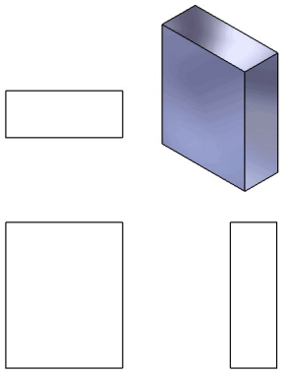 | 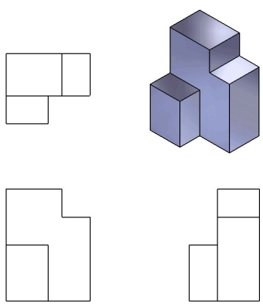
Fig.4.1: Front, Top, and Right views of a box and a shape formed by unioning and subtracting boxes

- Auxiliary view
An auxiliary view is an orthographic view. taken in such a manner that the lines of sight are not parallel to the principal projection planes (frontal, horizontal, or profile). There are an infinite number of possible auxiliary views of any given object.

Additional or auxiliary views are necessary to represent the true size and shape of other plane surfaces. A plane perpendicular to only one of the three principal planes is said to be in an inclined position; a plane not perpendicular to any of the principal planes is said to be in an oblique position.

- Front view auxiliaries
- Top view auxiliaries
- Side view auxiliaries

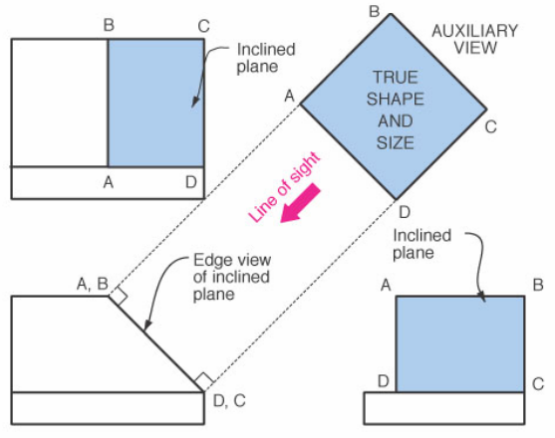 | 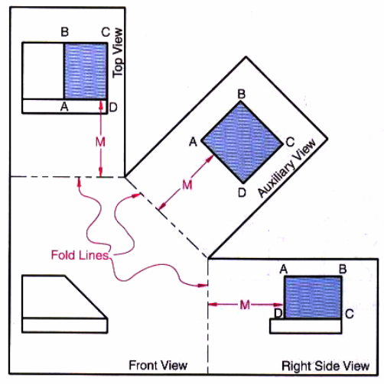
Fig.4.2: Auxilary and inclined views
- Multi view drawing
Multiview drawing is a technique used by drafters and designers to depict a three-dimensional object (an objecthaving height, width and depth) as a group of related two-dimensional (having only width and height, or widthand depth) views. A person trained in interpreting multiview drawings, can visualize an object’s three-dimensional shape by studying the two-dimensional multiview drawings of the object.

For example, Fig. 4.3 provides a three-dimensional (3D) image of a school bus, and while a 3D view of thebus is very helpful in visualizing its overall shape, it doesn’t show the viewer all of the sides of the bus, or the truelength, width, or height of the bus.
A better way to fully describe the bus graphically would be to create a multiview drawing as shown in Fig.4.3. The multiview drawing of the bus is represented by six views, the front, top, sides, back and bottom.These views represent the six “regular” views of the bus.
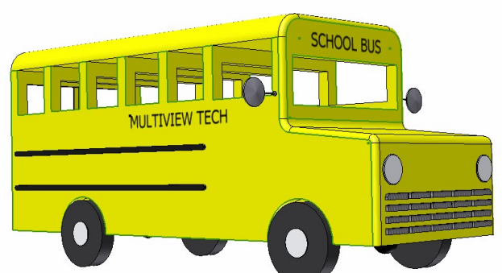
Fig.4.3: Image of a school bus
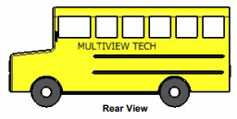 |  | 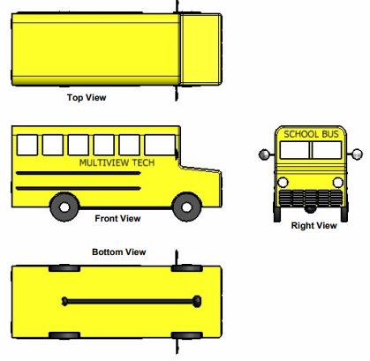
Fig.4.4: The multiviews of the bus depicting the six regular views:- front, top, bottom, right, left and rear
- The Front View
Abbreviated as FV, is that view of utmost importance in representing the object (normally the most complicated of all the views) as seen when the object is placed directly in front of the viewer. This view generally serves to represent the object (e.g. a work piece) in the most common position in which it is used. It is normally the first view to be drawn – other views following thereafter.

- The Rear View
RV (EFGH) is directly opposite the FV at the back of the object.

- The Right Hand Side View
RHSV (BFGC) and the Left Hand Side View – LHSV (AEHD) appear on the right and left sides of the object, respectively.

- The Top and Bottom Views
Are at the top and bottom sides of the FV. As you must have noted, these six views are at right angles to one another.

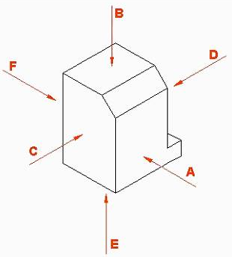 | 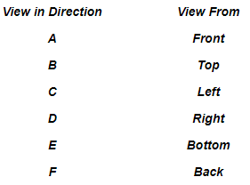
Fig.4.5: The six principal planes of projection
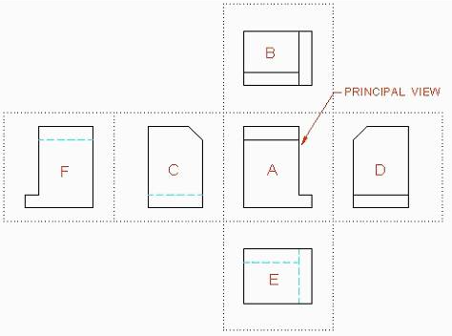
Fig.4.6: All 6 orthographic views positioned correctly on drawing surface

- Sectioning
For complex components with a number of hidden details, external views may not be enough to enable machining of such components. In such cases, sectioning is recommended. Sectioning is achieved by assuming an imaginary cutting/sectioning plane (or several planes) passing through the detail of interest. The “cut section”, as it would appear, is drawn. The position of the cutting plane is indicated by a thin, long chain, line with thick extremities. This chain line is labeled with capital letters with the direction of viewing indicated by arrows. The capital letters are placed behind the arrows in the direction of viewing. The layout of sections and the designation/naming of sectional views is the same as for the corresponding ordinary external views.
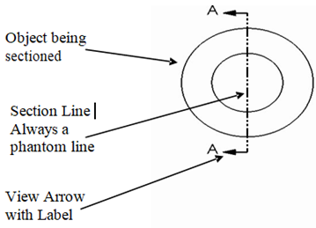 | 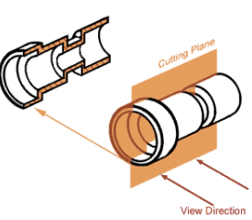
Fig.4.7: Sectional views

- Types of Sections
The following are the most common types of sectional views:
- Full section  - Half section  - Offset section | - Revolved section  - Removed section  - Broken-out section

- Sketching full section
- In a full sectional view, the cutting plane cuts across the entire object.
- Half of the object is removed.
- Interior lines behind cutting plane became visible.
- No hidden lines on the sectional view, if possible.
- Show the cutting plane in the top view or side view; and make a full section in the front view.
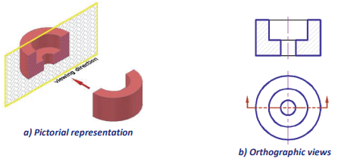
Fig.4.8: Full sectional view
- Sketching half section
- Half section used mainly for symmetric objects.
- In a half sectional view, the cutting plane do not cut across the entire object. It cuts only half way and intersect at the centerline.
- A quarter of the object is removed.
- Hidden lines are omitted.
- Show the cutting plane in the top view or side view; and make a half section in the front view.
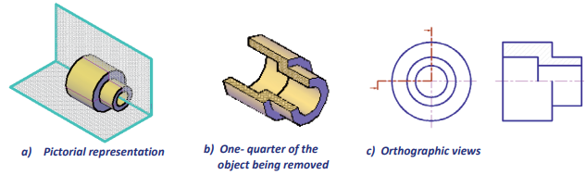
Fig.4.9: Half sectional view

- Revolved section sketch
- A revolved section is created by passing a cutting plane through the cross section of the
- object, then revolving the cross section by 90º.
- Revolved section is used to show the cross-sectional shape of a bar, spoke, or arm in a single view.
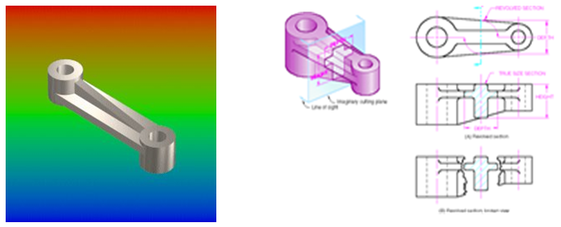
Fig.4.10: Revolved sectional view
Self-Check – 4 | Written test

Name…………………………………………… ID………………………… Date…….

Test I: Multiple choice
Directions: Answer all the questions listed below.
- Oblique sections are useful to show this:
- Foreshortened features B. Oblique lines C. Interior shapes D. Projected features
- Oblique drawings are dimensioned in a similar fashion as these types of drawings:
  - Orthographic B. Isometric C. Angular D. Parallel
- The principle views associated with orthographic projection are ________.
  - Front view B. Right side view C. Top view D. All of the above
- This is formed where three or more surfaces intersect:
  - Oblique B. Line C. Edge D. Vertex
- The ________ is a standard element of a section view in a technical drawing.
- Cutting plane line B. Section lines C. Lines D. All of the above
- In this type of section, one quarter of the object is removed:
- Revolved section B. Removed section C. Quarter section D. Half section
- A ________ section allows the drafter to create a Cutting Plane line which is not in a straight line across the part.
- Offset B. Half C. Whole D. Broken out

Test II: Fill in the blank space
- When only a small section of an interior area needs to be revealed the drafter can use a ________ section.
Test II:Short answer
- Geometric primitives include shapes such as ________.
- ____________________
- ____________________
- ____________________

Note: Satisfactory rating - 10 points Unsatisfactory - below 10 points

You can ask you teacher for the copy of the correct answers.

You can ask you teacher for the copy of the correct answers.

Operation Sheet -3

- Draw the three principal views of the following object.
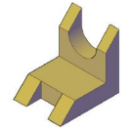
- Materials and tools
- Pencil  - A4 size paper  - Scale  - T-squers | - Mechanical pencils  - Technical pens  - Rulers  - Drawing boards (tables) | - Erasers  - Sharpeners  - Set-squares

- Procedures of drawing the three principal views of the given object.
- Select and Prepare required instruments
- Sequire drawind paper on drawing table (board)
- Choose a front view.
- Decide how many views are needed to completely describe the object.
- Draw the visible features of the front view.
- Draw projectors off of the front view horizontally and vertically in order to create the boundaries for the top and right side views.

- Draw the six principal views of the following object in the first angle projection.
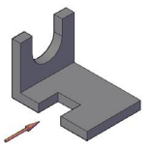
- Materials and tools
- Pencil  - A4 size paper  - Scale  - T-squers | - Mechanical pencils  - Technical pens  - Rulers  - Drawing boards (tables) | - Erasers  - Sharpeners  - Set-squares

- Procedures of drawing the six principal views.
- Select and Prepare required instruments
- Sequire drawind paper on drawing table (board)
- Draw border line and title block.
- Draw diagonal lines from the corners of the net working area.
- Calculate the total horizontal and vertical distance covered by the drawing byconsidering the space between each view.
- Draw line from the center line (intersection point of the diagonal lines) to half of horizontal and vertical distance.
- Draw the area required for each view.
- Draw each view.

LAP TEST-3 | Performance Test

Name………………………………. ID…………………………….. Date…………………………………….

Time started: ________________________ Time finished: ________________

Instructions: Given necessary templates, tools and materials you are required to perform the following tasks within 3 hour. The project is expected from each student to do it.
Task-1: Draw the three principal views of the given object.
Task-1: Draw the six principal views of the given object in the first angle projection.

LG -22 | LO #5 - Axonometric projection

Instruction sheet
This learning guide is developed to provide you the necessary information regarding the following content coverage and topics:
- Sketch isometric projection
- Sketch dimetric projection
- Sketch trimetric projection
This guide will also assist you to attain the learning outcomes stated in the cover page. Specifically, upon completion of this learning guide, you will be able to:
- Isometric projection
- Dimetric projection
- Trimetric projection
Learning Instructions:
- Read the specific objectives of this Learning Guide.
- Follow the instructions described below.
- Read the information written in the information Sheets
- Accomplish the Self-checks
- Perform Operation Sheets
- Do the “LAP test”

Information Sheet 5: Axonometric projection

Introduction
In order to obtain a drawing that pictorially visualizes the object, several forms of one plane conventional or projection picture methods are used. In these methods, the third dimension is taken care of by turning the object so that its 3 dimensions are visible or by using oblique projection. In these types of drawings, only the visible edges are shown. Mechanical or structural details that are not clear in orthographic views can be drawn pictorially or supplemental pictorial views can be provided.
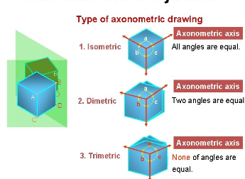
Fig.5.1: Types of axonometric projections (A)

- Axonometric projection
Is a type of orthographic projection used for creating a pictorial drawing of an object, where the object is rotated around one or more of its axes to reveal multiple sides. In geometry, axonometry is a drawing technique that which they show 3D parts in 2D planes.

According to the foreshortening situation of the edges, there are three types of axonometric projection.
- Isometric projection: In a three-axis direction, the amount of the foreshortening is equal.
- Dimetric projection: In this projection, two axes are the body is foreshortened in the same amount and the third axis is foreshortened in different amount.
- Trimetric projection: Foreshortenings in three directions are different.
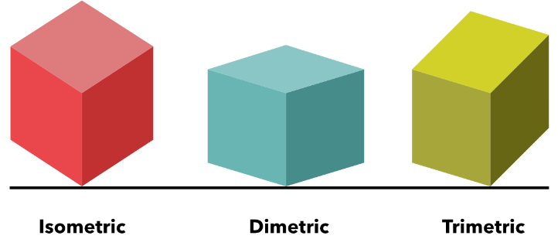
Fig.5.2: Types of axonometric projections (B)

Axonometric projections are more realistic than oblique. Horizontal edges of an object in axonometric projections are parallel to each other and inclined to the plane. There are three types of axonometric projections: isometric, dimetric and trimetric.
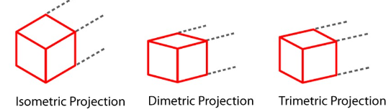
Fig.5.3: Three types of axonometric projections (C)

- Isometric Drawing
The first method of axonometric viewing and drawing is showing the 3D part in an isometric view. In this axonometry method, we place all the primary sides of the objects at equal angles as shown below.
- Dimetric Viewing Technique
The second method of axonometry is, showing all the sides of a 3D object with 2 equal primary sides of the object. We call this method dimetric, which means the positioning of two sides is equal. Take a look at the basic example below.

- Trimetric Viewing
The third method of axonometric drawing is showing all the primary sides of the 3D part equally. To understand it check the basic example below.

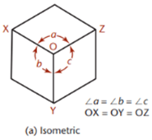 | 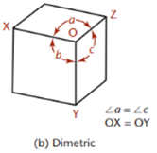 | 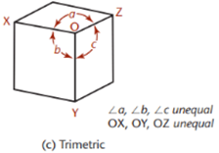
Fig.5.4: Three types of axonometric projection’s angle representation

Self-Check – 5 | Written test

Name…………………………………………… ID………………………… Date…….

Directions: Answer all the questions listed below.
Test I: Multiple choice
- A method for visually representing three-dimensional objects in two dimensions in technical and engineering drawings.
A. Orthographic B. Isometric C. Oblique D. Perspective
- A common method of representing three-dimensional objects, usually by three two-dimensional drawings in each of which the object is viewed along parallel lines that are perpendicular to the plane of the drawing.
A. Orthographic B. Isometric C. Oblique D. Multiview
- A projective drawing of which the frontal lines are given in true proportions and relations and all others at suitable angles other than 90 degrees without regard to the rules of linear perspective.
A. Isometric B. Orthographic C. Oblique D. Auxiliary
- This type of axonometric drawing has equal foreshortening along two axis directions and a different amount on the third axis:
- Dimetric B. Multiview C. Isometric D. Trimetric
- In this type of projection, each of the axes has different ratios of foreshortening:
- Isometric B. Dimetric C. Trimetric D. Parallel

Test II: Fill in the blank
- In this ________ method, we place all the primary sides of the objects at equal angles.
- Although six different sides can be drawn, usually three views of a drawing give enough information to make a three-dimensional object. These views are known as ________, _________ and _________.

Note: Satisfactory rating - 7 points Unsatisfactory - below 7 points

You can ask you teacher for the copy of the correct answers.

You can ask you teacher for the copy of the correct answers.

Operation Sheet -4

- Draw the isometric view of a circle with a 60mm diameter on all three principle Planes Using Coordinate net.

- Materials and Tools
- Pencil  - A4 size paper  - Compass  - Scale  - T-squers | - Mechanical pencils  - Technical pens  - Rulers  - Drawing boards (tables) | - Erasers  - Sharpeners  - Protractors  - Set-squares

- Procedures of isometric draw of circle.
- Select and Prepare required instruments
- Sequire drawind paper on drawing table (board)
- Draw a circle with 60mm Diameter and enclose it in a square abcd.
- Mark midpoints of the sides 1, 2, 3 and 4, where the square touches the circle tangentially
- Draw the Diagonals of the square which cut in the circle at points 5, 6, 7 and 8.
- Draw a Rhombus ABCD to represent Isometric view of a square abcd.
- Mark points 1, 2, 3 and 4 on it as the midpoint of the sides.
- Mark points 5, 6, 7 and 8 on it, such that they are at a distance equal to Ax from the side of the square .join points to obtain isometric view as shown in figures(b)(c)(d).

- Draw the front view, side view and top view of the military tent given.
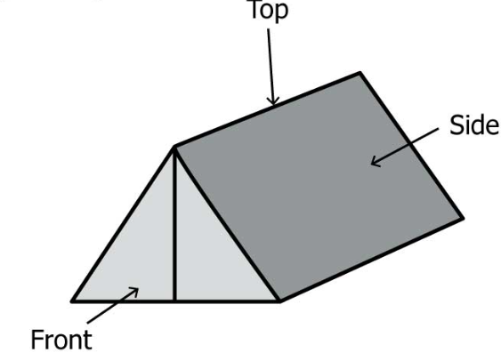

- Materials and Tools
- Pencil  - A4 size paper  - Scale  - T-squers | - Mechanical pencils  - Technical pens  - Rulers  - Drawing boards (tables) | - Erasers  - Sharpeners  - Set-squares
- Procedures of drawing an isometric axonometric projection of given object
- Select and Prepare required instruments
- Sequire drawind paper on drawing table (board) then,
- First observe the given figure in the of fron direction.
- Second observe the given figure in the of side direction.
- Third observe the given figure in the of top direction.
- Finally skech observe vewieus

LAP TEST-4 | Performance Test

Name………………………………. ID…………………………….. Date…………………………………….

Time started: ________________________ Time finished: ________________

Instructions: Given necessary templates, tools and materials you are required to perform the following tasks within 3 hour. The project is expected from each student to do it.

Task-1: Draw the isometric view of a circle.
Task-1: Draw an isometric axonometric projection of military tent.

Reference Materials
Engineering Drawing. Second Edition. K. Venkata Reddy. Prof. & HOD of Mechanical Engineering Dept. C.R. Engineering College.
DRAWING. Student Textbook First edition, 2003(E.C.). Developed Second edition,2007 (E.C.)
STIRLING, N. (1989): An Introduction to Technical Drawing – Metric Edition Delmar Publishers. Albany, New York.

Web addresses
https://classbasic.com/drawing-instruments-and-their-uses/ (access date 28/08/2022 G.C)
http://www.mva-org.jp/Proceedings/CommemorativeDVD/1992/papers/1992393.pdf (access date 28/08/2022 G.C)
https://civiljungle.com/drawings-instruments/ (access date 29/08/2022 G.C)
https://mechanicalenotes.com/engineering-drawing-instruments/ (access date 29/08/2022 G.C)
http://www.historyofpencils.com/drawing-tools/ (access date 29/08/2022 G.C)
https://toolsindrafting.weebly.com/drawing-tools.html (access date 28/08/2022 G.C)
https://civiljungle.com/drawings-instruments/ (access date 28/08/2022 G.C)
https://toolsindrafting.weebly.com/drawing-tools.html(access date 28/08/2022 G.C)
https://www.sanfoundry.com/1000-engineering-drawing-questions-answers/#projection-points(access date 29/08/2022 G.C)
https://ecolebooks.com/v2/2nd-term-ss1-technical-drawing-scheme-of-work-and-note/(access date 29/08/2022 G.C)

AKNOWLEDGEMENT
Ministry of Labor and Skills and wish to extend thanks and appreciation to the many representatives of TVET instructors who donated their time and expertise to the development of this Teaching, Training and Learning Materials (TTLM).

The experts who developed the learning guide
No | Name | Qualification | Organization/ College | Mobile number | E-mail
1 | Daniel Derese | Bsc. Agricultural Engineering | W/sodo VET | 0912-79-28-85 | danielderesse7@gmail.com
2 | Serawit Gensa | Msc. Water Resource Engineering | W/Sodo VET | 0916740916 | serawitgen@gmail.com
3 | Edao Hassen | Msc.Irrigation Engineering | Alage AVET | 0911098097 | hassedao@gmail.com
4 | Mekete Agizew | Msc. Water Resource Engineering | Amhara. Kombolcha ATVET | 0925221192 | gen.mam09@gmail.com
5 | Wondu Alemayehu | Msc.Irrigation Engineering | Oromia Kombolcha ATVET | 0910-28-99-61 | woldualem@gmail.com
6 | Ademe Ayalew | Msc.Irrigation Engineering | Agarfa AVET | 0912720547 | Ademe2004@gmail.com
7 | Said Mohammed | Msc.Irrigation & drainage Engineering | Alage ATVET | 09-17-18-01-81 | Siyamsdmhmmd@gmail.com/
8 | Molalign Asfaw | Bsc.Water Resource &Irrigation Engineering | Alage ATVET | 0921431096 | Mollalign410ass@gmail.com
9 | Yonas Hailu | Bsc.Water Resource &Irrigation Engineering | Agarfa AVET | 0934715578 | yonashailuw@gmail.com
10 | Lemessa Mulata | Msc.Irrigation Engineering | Agarfa AVET | 0913266845 | Lamimulle2022@gmail.com
11 | Misganew Yimer | Bsc. Soil and Water Engineering | Woreta ATVET |  | Misge1976@gmail.com
12 | Teshome Getachew | Msc.Irrigation& drainage Engineering | Alage ATVET | 0925-50-13-99 | teshomegetachew131@yahoo.com

