IRRIGATION AND DRAINAGE

Level-I

Based on March 2022, Version 3 Occupational standard




Module Title: - Basic Properties of Soil
LG Code: AGR IRD1M07LO (1-2) LG (23-24)
TTLM Code: AGR IRD1TTLM 0822v1

August, 2022
Addis Ababa, Ethiopia
Table of Contents

Introduction to the Module 1
LO #1-Collect soil samples for testing 2
Instruction sheet 2
Information Sheet 1 4
Self-check 1 15
Operation Sheet -1 16
LAP TEST-1 17
LO #2- Perform basic soil tests 18
Instruction sheet 18
Information Sheet 2 19
Self-Check – 2 26
Operation Sheet -2 27
LAP TEST-2 29
Reference Materials 30

Introduction to the Module
Agricultural viability depends upon a healthy soil. A healthy soil is obtained through knowledge of the soil and the application of appropriate management practices. Poor management practices can lead to soil degradation, which can reduce productivity. Soil is not a renewable resource
Soil is essentially made up of four main fractions, but the fractions vary greatly in arrangement and form, hence soils can be physically and chemically quite different. Understanding why soil can be so varied, and how different soils require different management is important for an effective farming enterprise.
The first step in soil analysis is soil sample collection. It’s important to realize that only a tiny portion of a field is actually analyzed in the laboratory. Thus, collecting a representative soil sample is critical for accurate results

The vertical section of the soil showing the various layers from the surface to the unaffected parent material is known as a soil profile. The various layers are known as horizons. A soil profile contains three main horizons. They are named as horizon A, horizon B and horizon C.
There are three characteristics of soil that are important for plant growth and productivity: physical, biological, and chemical. A change in one characteristic is likely to affect another.
This module covers the processes of determining the basic properties of soil. It requires collect soil samples and perform basic soil test. It includes collect soil sample for test and perform basic soil test principles for determine basic properties of soil.

LG #23 | LO #1-Collect soil samples for testing

Instruction sheet
This learning guide is developed to provide you the necessary information regarding the following content coverage and topics:
  - Introduction to the module
  - Purpose of soil sample
  - Tools and materials preparation
  - Identifying area for soil sample collection
  - Locating soil sample using site plan
  - Personal protective equipment
  - Soil sample techniques
  - Labelling and recording soil sample

This guide will also assist you to attain the learning outcomes stated in the cover page. Specifically, upon completion of this learning guide, you will be able to:
- Define soil sample
- prepare tools and materials for soil samples
- Identify area for soil sample collection
- Locate soil sample using site plan
- Select personal protective equipment
- Perform soil sample techniques
- Label and record soil samples

Learning Instructions:
- Read the specific objectives of this Learning Guide.
- Follow the instructions described below.
- Read the information written in the information Sheets
- Accomplish the Self-checks
- Perform Operation Sheets
- Do the “LAP test”

Information Sheet 1
Introduction
Soil: is a mixture of organic matter, minerals, gases, liquids, and organisms that together support life. Earth's body of soil is the pedosphere, which has four important functions. It is a medium for plant growth; it is a means of water storage, supply and purification; it is a modifier of Earth's atmosphere; it is a habitat for organisms; all of which, in turn, modify the soil.

Soil testing is an essential component of soil resource management. Each sample collected must be a true representative of the area being sampled. Utility of the results obtained from the laboratory analysis depends on the sampling precision. Hence, collection of large number of samples is advisable so that sample of desired size can be obtained by sub-sampling.
1.1 Purpose of soil sampling
- To measures the nutrients that are left in your field following harvest.
- Tells you which nutrients are lacking or are in excess
- To determine the most favorable fertilizer plan to increase or maintain yields for the following year
- To know soil textural and structure
- To recommend type of irrigation based on soil type
- To know whether soils are well- drained or poorly drained

1.2 Tools and materials preparation
Tools and Materials required for soil sampling collection

- Spades
- Augers
- Core sampler
- Recording materials
- Field test kits
- Interpreting charts
- Sampling bags
- Plastic tray or bucket and permanent marking pen
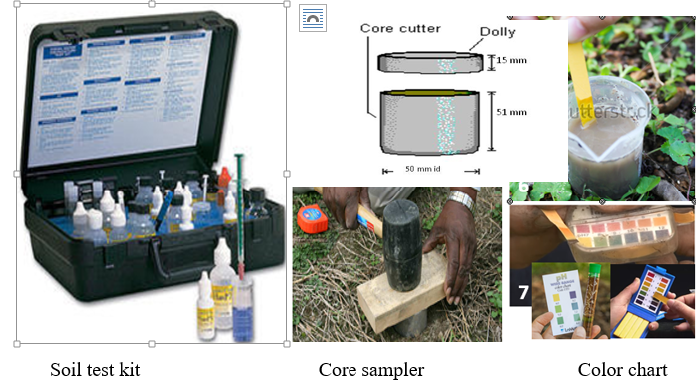
Fig.1.1: Soil sampling tools
1.3 Identifying area for soil sample collection
- Areas within the same field can have different slope, color, texture, drainage, and cropping practice. Sample these areas separately, as well as areas that are managed differently.
- If there is an abnormal area which may have poor crop growth, take separate soil samples.
- Name and record these special samples and areas on a sample bag.
- Don’t sample field entrances, edges, depressions, and hill tops near water ways, old burn sites, and areas where animals congregate
- Remove all non-soil particles from the sample, such as grass, thatch, leaves, and rocks.
Remember -A soil test is only as good as the sample it was taken from. Taking a poor-quality sample is a waste of your time and money.
To get the most from your soil test, make sure the sample,
- Accurately represents the field
- Is handled and packaged properly
- Has enough information on the field submission forms to Laboratory
A good sample
- Taken at the same time of the year
- Taken from the right depth
- Mixed with clean, plastic pail, not metal
- Properly labeled
- Submitted to laboratory

1.4 Locating soil sample using site plan
Using a trowel, shovel, or auger, and a clean pail, obtain thin slices or borings of soil from at least 13 places in a given area. Follow the diagram below to properly locate the samples. For contour strips, take 6 samples 20 feet in from the edge of the entire strip and 6 samples from the opposite side of the strip. Sample to plow depth in cultivated land or to a depth of 6 inches. Sample to a depth of 3 or 4 inches in permanent pastures. If the field varies in soil type, previous fertilizer or lime application, or cropping history, sample each area separately.
Methods of sampling
The two most commonly used soil sampling methods are grid sampling and zig zag sampling. Each method requires different sampling techniques and influences how the results are used and how nutrients are applied.

- Zig zag
Zig-zag sampling pattern for whole field sampling. Subsamples are collected by traveling in a zig-zag pattern collecting subsamples at each locations indicated by black dots. Background lines represent the various soil types in the field. Ideally, zig- zag sampling samples each soil type equally.

- Grid methods
Two main types of grid sampling
- Grid-cell soil sampling randomly collects either one or multiple subsamples throughout the cell for a composite sample
- Grid-point soil sampling collects one or multiple subsamples around a geo referenced point within a grid or at a grid intersection.
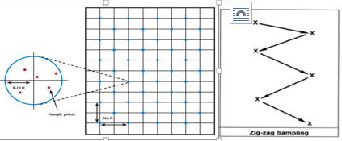
Fing1.2: Sampling Methods
- Stratified systematic sampling
To avoid sampling bias caused by patterns in the field due to tillage, crop residue, fertilizer application, and other patterns associated with crop production, a staggered pattern can be used. It helps avoid the pattern bias, yet provides an organized sampling scheme to represent the entire field. This pattern can be set up by counting rows, using a measuring wheel or using a global positioning satellite (GPS) navigation system.

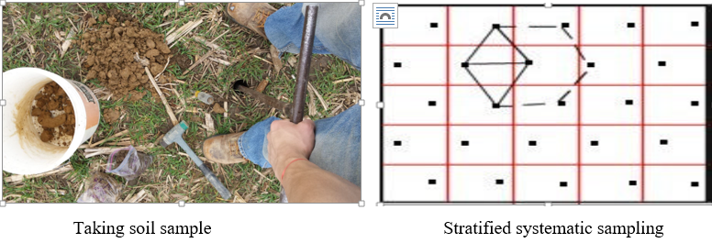
Fig.1.3: Soil sample and system of sampling

1.5 Identifying OHS hazards

OHS hazards may be associated with performing a soil sampling like
- Disturbance or interruption of services
- Solar radiation
- Dust, noise, soil- and water-borne micro-organisms
- Chemicals and hazardous substances
- Sharp hand tools and equipment
- Manual handling, moving machinery and machinery parts
- Falling objects, and uneven surfaces.

How to prevent workplace hazards
The best way to protect yourself and your employees from workplace hazards is to identify and manage them and take reasonable steps to prevent their potential to harm.
In order to control workplace hazards and eliminate or reduce the risk, you should take the following steps:
- identify the hazard by carrying out a workplace risk assessment;
- determine how employees might be at risk;
- evaluate the risks;
- Record and review hazards at least annually, or earlier if something changes.

1.6 Personal protective equipment
Personal protective equipment, or PPE, protects workers from serious workplace injuries or illnesses resulting from physical, electrical, mechanical, chemical, or other workplace hazards.
PPE includes

- Hat/hard hat
- Boots
- Overalls
- Gloves
- Goggles
- Protective eyewear
- Hearing protection
- Respirator or face mask
- Sun protection

Table 1.1 Some Personal Protective Equipment
Name of Personal protective equipment and functions | Picture
Foot protection:- Potential hazards which may lead to foot and leg injuries include falling or rolling objects, crushing or penetrating materials, hot, corrosive or poisonous substances, electrical hazards, static electricity, or slippery surfaces. | 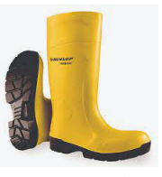  Boot
Safety Helmet: Used to protect the head from injury |   Head protection
Eye protection:-Used to protect the eye from injury | 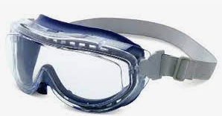  Goggles
Hand protection:-Used to protect the hand from injury |   Gloves
Body protection: Hazards that affect the entire body can include temperature extremes, chemical exposure, radioactive materials, arc flash, infectious materials, sparks or flames, falls and sharp objects. |   Body protection
Respiratory protection  Wearing respirators to protect themselves against the inhalation of harmful air contaminants in the work place. | 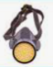  Respiratory protection
Hearing protection:- Exposure to high noise levels can have detrimental physical and mental health effects. | 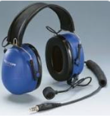  Hearing protection

1.7 Taking Soil Samples from the designated area
A soil sample is the representative of the whole lot from which it is taken. It completely represents all the characteristics of the lot from which it is recovered. Following are some of the types of samples which are generally retrieved in geotechnical engineering:
Soil Sampling should reflect tillage, past fertilizer/soil amendment placement, cropping patterns (and corresponding irrigation requirements), soil type (including drainage and slope characteristics) and perhaps old field boundaries (such as old feedlots, windrows, altered stream beds, etc.).
The most commonly used method for soil sampling would be based on soil types. Fields are split into sampling areas that contain similar soils. Hillsides are kept separate from bottoms since the soil types will vary. Once the sampling area is determined, a sufficient number of cores should be taken to acquire a representative sample.
This is generally 10 to 20 cores. The depth of sample for surface soils would be 0 to 6 inches or as deep as the primary tillage. Deeper samples to 24 or 36 inches can be taken for residual nitrate-nitrogen.
Samples
- Disturbed soil samples (DS):
- Undisturbed soil samples (UDS
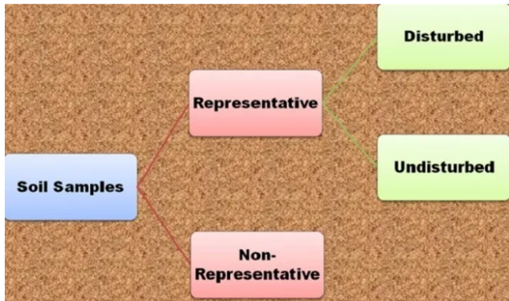
Fig. 1.3: Types of sample
Disturbed soil samples
Disturbed soil samples are those in which the in-situ soil structure and moisture content are lost, but the soil particles are intact.
- They are representative
- They can be used for grain size analysis, liquid and plastic limit, specific gravity, compaction tests, moisture content, organic content determination and soil classification test performed in the lab
- Examples of such sample are those obtained through cuttings while auguring, grab, split spoon (SPT), etc.
Undisturbed soil samples
Undisturbed soil samples are those in which the in-situ soil structure and moisture content are preserved.
- They are representative and also intact
- These are used for consolidation, permeability or shear strengths test (Engineering properties)
- More complex jobs or where clay exists
- In sand is very difficult to obtain undisturbed sample
- Obtained by using Shelby tube (thin wall), piston sampler, surface (box), vacuum, freezing.

1.8 Proper soil sampling techniques
Proper soil sampling technique for soil sample collection and sub mission (Results are only as good as the soil sample submitted.
These includes
- Collecting- collecting disturbed or undisturbed sample soils.
- Packing- Pack the sample inside the bag to send for laboratory.
- Labelling- Label the sample box or bag with your name, sample identification, and address.
- Preparing- Prepare on site or of site soil samples for analysis
Depth of sampling
The depth of penetration by plant roots is the guiding principle in deciding the depth of sampling. Therefore, the following factors may be kept in mind:
- For cereals, vegetables and other seasonal crops the samples should be drawn from 0-15cm i.e., plough layer or furrow slice.
- For deep rooted crops or longer duration crops like sugar cane or under dry farming conditions, samples should be collected from different depths depending on the requirements of individual situations.
- For plantation crops or fruit trees, composite sample from 0-30, 30-60, and 60-90cm depths should be made from 4-5 pits dug in about 0.5 ha field.
- For alkalinity, acidity and salinity testing the sample may be drawn up to 15 cm depth from surface.
- In case the composite samples are drawn from profile depths exceeding 15 cm as for certain flowering plants like roses, the actual depth of sampling should be indicated.

1.9 Labelling and recording soil sample
Labelling of samples
Label the samples properly for identification. A label of thick paper with identification mark and other details should be put inside the sample bag, and another one carrying same details tied/pasted outside the bag. In case the soil sample is wet, the label should be written with lead pencil or a permanent ink marker, before air drying the sample label should include the producer's name, field ID, sample ID, and depth of sample.
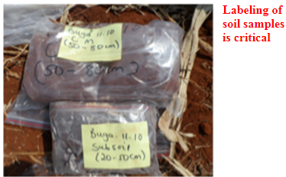
Fig.1.4: label soil sample

Recording samples
When taking soil samples it is important to keep clear records of what you do for a number of reasons:
You may be carrying out tests on a number of different soil samples in an area.
You may be carrying out some tests in the field while further tests will require special equipment and need to be carried out off-site under laboratory conditions.
Soil samples may be stored over long periods as part of a monitoring program for your land.
In each of these cases there may be more than one person handling the soil samples. To avoid confusion it is important to make sure that the correct information is attached to each sample. It is also a good idea to standardize your recording technique so that it is easier to compare results from different samples.

Self-check 1 | Written test

Name…………………………………………… ID………………………… Date…….
Directions: Answer all the questions listed below.
Test I: Choose the best answer (5% point)
1. Material used to protect our body from injury
A. Glove B. over cot C. Boot D. All
2. One of the following is true about collecting soil sample
A. To know types of soil B. To identify nutrient of the soil C. for fertilizer application D. All E. All except C
3. Which one of the following is/are true?
A. Take sample from representative area B. Labeling sample is not necessary
C. A fertile bed to grow crops D. All E. A and C
4. Is not function of a soil?
A. Storage of water B. Habitat for organisms C. Media for plan grew D. All
5. Which one is true
A. sample soil to recommended depth B. Follow OHS at work site C. Auger used to take sample D. All

Note: Satisfactory rating - 5 points Unsatisfactory - below 5

Operation Sheet -1

- Procedures for collecting and labeling soil sample

- Tools and equipment

- Auger
- Knife
- Core sampler
- Bag container
- Permanent marker
- Note book
- Pencil

- Procedures for collecting soil samples
- Divide the field into different homogenous units based on the visual observation and farmer’s experience.
- Remove the surface litter at the sampling spot.
- Drive the auger to a plough depth of 15 cm and draw the soil sample.
- Collect at least 10 to 15 samples from each sampling unit and place in a bucket or tray.
- If auger is not available, make a ‘V’ shaped cut to a depth of 15 cm in the sampling spot using spade.
- Remove thick slices of soil from top to bottom of exposed face of the ‘V’ shaped cut and place in a clean container.
1inch / 2.5 cm 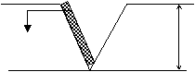 6 inches (15 cm)
- Mix the samples thoroughly and remove foreign materials like roots, stones, pebbles and gravels.
- Reduce the bulk to about half to one kilogram by quartering or compartmentalization.
- Quartering is done by dividing the thoroughly mixed sample into four equal parts. The two opposite quarters are discarded and the remaining two quarters are remixed and the process repeated until the desired sample size is obtained.
- Compartmentalization is done by uniformly spreading the soil over a clean hard surface and dividing into smaller compartments by drawing lines along and across the length and breadth. From each compartment a pinch of soil is collected. This process is repeated till the desired quantity of sample is obtained.
- Collect the sample in a clean cloth or polythene bag.
- Label the bag with information like name of the farmer, location of the farm, survey number, previous crop grown, present crop, crop to be grown in the next season, date of collection, name of the sampler etc.

LAP TEST-1 | Performance Test

Name………………………………. ID…………………………….. Date…………………………………….

Time started: ________________________ Time finished: ________________

Instructions: Given necessary templates, tools and materials (Use mentioned under operation sheet 1) you are required to perform the following tasks within 1 hour. The task is expected from each student to do it.
Task -1 Perform soil sample collection procedure and labeling

LG #24 | LO #2- Perform basic soil tests

Instruction sheet
This learning guide is developed to provide you the necessary information regarding the following content coverage and topics:
  - Soil profile
  - Soil profile determination
  - Physical properties of soil
  - Chemical properties of soil
  - Recording and reporting
This guide will also assist you to attain the learning outcomes stated in the cover page. Specifically, upon completion of this learning guide, you will be able to:
  - Define soil profile
  - Determine soil profile
  - Test physical properties of soil
  - Test chemical properties of soil
  - Record and report the result
Learning Instructions:
- Read the specific objectives of this Learning Guide.
- Follow the instructions described below.
- Read the information written in the information Sheets
- Accomplish the Self-checks
- Perform Operation Sheets
- Do the “LAP test”

Information Sheet 2

2.1 Soil profile
The soil profile is defined as a vertical section of the soil that is exposed by a soil pit. A soil pit is a hole that is dug from the surface of the soil to the underline.
The soil profile is one of the most important concepts in soil science. It is a key to understanding the processes that have taken in soil development
And is the means of determining the types of soil that occur and is the basis for their classification.
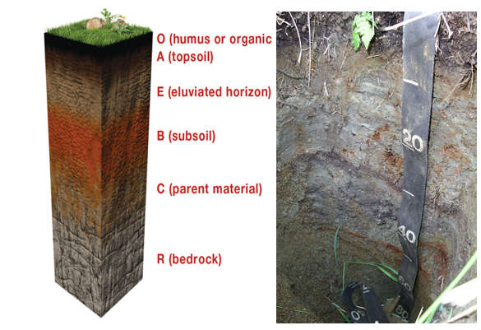
Fig.2.1 Soil profile

2.2 Soil profile determination
The soil forming factors, think about how they might influence a parent material differently in different locations or situations.
An easy way to remember the five soil forming factors is to remember the word ClORPT,
Where:
- Cl - stands for climate,
- O - for organisms,
- R - for relief (another way of saying topography),
- P - for parent material, and T for time.

Time is the last soil forming factor. Soils take a very long time to develop; new soils do not have distinguishing profiles or horizons. But given enough time and the other four soil-forming factors, soils develop interesting and storytelling horizons.

The Horizons
Now that we know the different factors that drive soil development, we can move on to the features the development creates, giving each soil its unique profile. Again, most developed soils have horizons that can tell us about the type of environment in which the soil was produced. The most commonly referred-to horizons are easy to remember: they are the O, A, E, B, and C horizons.
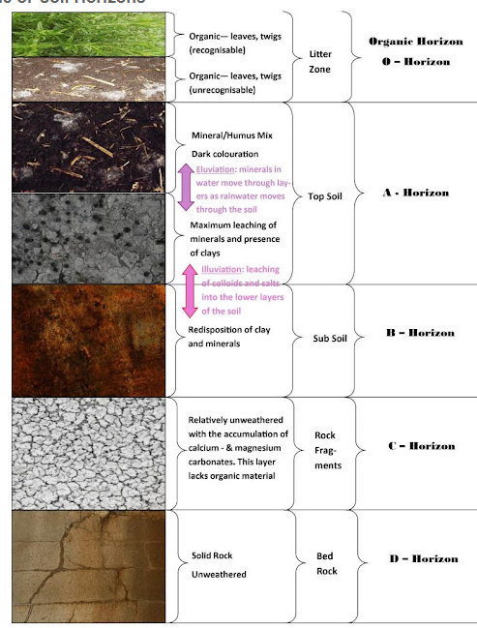
Fig 2.2 soil horizon

The O horizon, when it is present, is the uppermost horizon. The O stands for 'organ.' You can think of dead plants and animal parts falling on the surface of the soil. Sometimes it's very recognizable and sometimes, the organic material is decomposed enough that it just looks like muck.
The A horizon is usually the first mineral horizon. Often referred to as the topsoil, the A horizon is rich in organic matter, which gives it its characteristic brown color. In fact, many soils don't have a true A horizon because there isn't enough organic matter to make the surface horizon brown enough.

2.3 Physical properties of soil
Soil Texture:
The texture of soil is based on the size distribution of the constituent particles. In simple terms, the relative percentage of clay, sand, and silt in a soil mass determines its texture. Furthermore, the soil texture determines the water retention capacity of a soil sample. Sand particles have the largest diameter, whereas clay particles have the smallest diameter among the three soil constituent particles. The American Association of State Highway Officials (AASHO) and the USDA divide soil texture into twelve classes. Depending upon the percentage of sand, silt and clay in soil, it is defined as coarse, fine, or medium aggregate soil.
The name of the compartment in which the two lines intersect is the class name of the soil in question. For examples soil containing 15% clay, 20% silt and 65% sand is sandy loam and a soil containing equal amounts of sand, silt and clay is clay loam.

The percentages of sand, silt and clay in a soil could be determined in a soil laboratory by two standard methods –
- Hydrometer method and
- pipette method

Both methods depend on the fact that at any given depth in a settling suspension the concentration of the particles varies with time, as the coarser fractions settle at a faster rate than the finer.
In the field, soil texture could be estimated by the following methods
- Feel method.
- Ball and ribbon method
- Ball throwing method

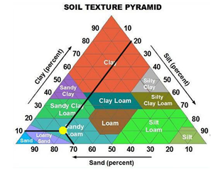
Fig 2.3 Soil textural triangle

- Soil Structure:
Soil structure refers to the arrangement of sand, silt, and clay particles within a soil mass. Air and water movement through a soil mass directly depends upon the structure of soil mass. Symmetry leads to stability, so if a soil mass has symmetrical or good structure, water and air movement through it will be smooth. However, if the structure is asymmetrical, water and air movement will not be smooth and the soil will be unstable. By knowing soil structure, the moisture content of the soil mass can be worked on, which is equally important for engineering and agricultural works.
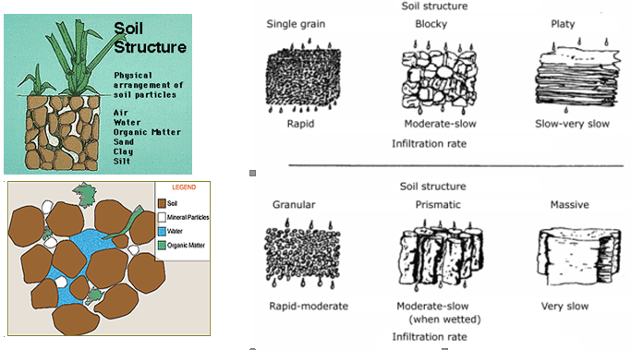
Fig. 2.4 Soil structure

- Color of Soil:
Generally speaking, soils are classified as dark and light colored soils. By looking at the color of a soil mass, a rough idea of the moisture content of the soil, drainage properties, and degree of oxidation can be obtained. A dark color reflects poor drainage, high organic content, and low annual temperatures. On the other hand, light colored soils have better drainage, high annual temperatures, and highly leached conditions. However, these are rough estimates that only help engineers and agriculturists to adopt suitable measures to study soil properties in detail.

- Porosity of Soil:
Porosity of a soil mass means the pore space or void space in a soil mass. It affects the strength of a soil mass and it depends upon other physical properties of the soil like texture, structure, and presence of organic matter in soil.

- Determination of Soil Bulk Density
To convert soil water content determined on weight basis to volume basis the bulk density of the soil layer is needed. The bulk volume includes the actual volume occupied by the soil solids and pore volume. Bulk density will vary not only with the actual density of the solids but, also more importantly with the packing of the soil particles. In general, the bulk density of fine textured mineral soils may range from about 1.0 to 1.3 g /cc and that of sandy soils from 1.4 to 1.7 g cm⁻³
Core sampler technique: Bulk density is generally obtained by removing a block of soil from the field under natural conditions. This can be done by using any method that forces a straight-sided container of known volume into the soil without altering the area to be sampled. The container is then dug out, excess soil is trimmed away, dried and weighed and BD. calculated. This involves inserting a core of known dimensions into the soil and extracting a sample of known volume.

Bulk density of soil is the dry mass, per unit volume of a given soil in its natural undisturbed condition and is given by:

$$BD=\frac{Weight of oven dry soil}{ Volume of wet soil}$$
Volume of core sampler = π r² h
Where M_{s.} = Mass of dry soil solid (g). r=radius of core sampler
h=height of core sampler V_{s.} =Volume of wet soil (cm³)

Thus, the volume of water is an indication of the total porosity of the soil (i.e., the volume of pores). You can also calculate the percent of the core taken up by pores in the soil from the ratio of bulk density to particle density (PD). Soil particles have a more or less fixed density of 2.65 g/ cm³.
Soil porosity can be calculated as follows:
$$\%soil porosity=\left(1-\left(\frac{BD}{PD}\right)\right)*100\%$$

2.4 Chemical properties of soil
- Soil Chemical Properties
Soil testing is the best way to identify the chemical properties of soils. The tests may include Soil pH, Cation Exchange Capacity (CEC), Organic Carbon, Phosphorus Sorption Capacity, Sodality, Salinity, and Nutrient level.

- Cation Exchange Capacity, CEC
CEC is a measure of the soil’s ability to retain or hold positively charged ions (cations). The effective CEC is determined by calculating the sum of the five most abundant cations – calcium, magnesium, potassium, sodium and aluminum. Sands have low CECs, silts have moderate CECs, while various clay minerals have a wide range of CECs from moderate to high.

- PH
The most significant property of soil is its pH level, its effects on all other parameters of soil.
Therefore, pH is considered while analyzing any kind of soil. If the pH is less than 6 then it is
said to be an acidic soil, the pH range from 6-8.5 it’s a normal soil and greater than 8.5 then it
is said to be alkaline soil.

Self-Check – 2 | Written test

Name…………………………………………… ID………………………… Date…….
Directions: Answer all the questions listed below.
Test I: Short Answer Questions
1. Climate affect how soil is form.
A. True B. False
2. The movement of air and water in the soil depends on
A. types of soil particles B. structure of the soil C. Porosity D. All E. None
3. One of the following is physical property of the soil
A. Structure B. Texture C. porosity D. All
4. Is chemical property of the soil
A. PH B.CEC D. Salinity D. All
5. Texture is analyzed by
A. Feel method B. Laboratory C.A and B D. All

Operation Sheet -2

- Techniques of Determining bulk density and porosity
- Tools and equipment
- Auger
- Core sampler
- Knife
- Hammer

Procedure to calculate bulk density and porosity
- Assemble the core sampler with the core placed inside after a thorough cleaning.
- Remove vegetation and loose soil and smoothen the soil surface for surface soil samples. For samples from lower depths, excavate the soil to the appropriate depth. (Layer wise bulk density samples are best taken when the soil profile pit studies are being carried out).
- Insert the core sampler into the soil with the hammer.
- Carefully take out the core sampler and dismantle the assembly and trim out excess soil from the two ends of the core with a spatula.
- Transfer the core into a container or remove the soil from the core into the labeled sample bag for transporting to the laboratory.
- Dry the soil samples in a hot air oven at 105-110ºC till constant mass is attained. The dried soil samples are weighed and their masses are recorded on the observation sheet.
- Calculate the volume of the core by measuring its diameter and length using calipers. The bulk density is then calculated by the formula given above. viii. In case of swell-shrink soils, taking the fresh mass (core + moist soil) of the core is essential as bulk density values change with change in soil water content.
- Use the attached data collection sheet to record the mass of each empty core (a), the mass of each core with the moist soil (b), and the mass of each core with its dry soil (c).
- Calculate the BD and soil moisture content of the soil.
- Then calculate porosity

2.2. Techniques of Determining soil profile
A. Tools and Equipment’s
- Meter tap
- Spade
- Hand hoe
- Notebook
- Peg
B. Procedures to determine soil profile
- Wear appropriate PPE
- Select the area
- Dig a hole of 2m x2m and the depth to 2.5m
- Observe soil layers very carefully (opposite to the direction of the sun or exposed side to the sun to avoid shad problem)
- Make mark to separate the soil layers and designate as O,A,B,C /1,2,3,
- Write the result that you obtained from this activity and submit to your instructor

LAP TEST-2 | Performance Test

Name………………………………. ID…………………………….. Date…………………………………….

Time started: ________________________ Time finished: ________________

Instructions: Given necessary templates, tools and materials (use mentioned under operation sheet 2) you are required to perform the following tasks within 2 hour. The task is expected from each student to do it.

Task-1: Calculate bulk density and porosity
Task-2: Determine soil profile

Reference Materials

Mansell soil color charts (Mansell soil color charts, 1973).
Dhyansingh, B.S Dived, Manual on soil, plant and water analysis
FAO, 1998. Irrigation and drainage engineering.
Rogers, D.H. and M. Alam. 2007. What is ET? An evapotranspiration primer. Kansas State University Research and Extension. Irrigation Management Series, MF-2389 rev. 4 pp.
Rogers, D.H., P.L. Barnes, J. Aguliar, I. Kisekka, and F. Lamm. 2014. Agricultural Crop Water
Use. Kansas State University Research and Extension. Irrigation Management Series, L934

Web addresses
https://www.gardeningknowhow.com/garden-how-to/soil-fertilizers/testing-soil.htm
https://us.search.yahoo.com/yhs/search?hspart=elm&hsimp
https://www.ksre.k-state.edu/irrigate/reports/L904.pdf accessed date 25/08/2022.
https://smallgrains.wsu.edu/soil-structure-critical-for-soil-stability-and-crop-production/ accessed date 26/08/2022.
https://smallgrains.wsu.edu/soil-structure-critical-for-soil-stability-and-crop-production/
https://theconstructor.org/geotechnical/soil-structures-types/21354/#google_vignette accessed date 26/08/2022.
https://www.epa.nsw.gov.au/about-us/publications-and-reports/state-of-theenvironment/state-of-the-environment-2015/10-soil-condition accessed date 26/08/2022
https://sanangelo.tamu.edu/extension/agronomy/agronomy-publications/how-to-estimate-soil-moisture-by-feel/ accessed date08/29/2022
https://extension.umd.edu/resource/soil-testing-and-soil-testing-labs accessed date 30/8/2022

AKNOWLEDGEMENT

Ministry of Labor and Skills wish to extend thanks and appreciation to the many representatives of TVET instructors and respective industry experts who donated their time and expertise to the development of this Teaching, Training and Learning Materials (TTLM).

The experts who developed the learning guide
No | Name | Qualification | Organization/College | Mobile number | E-mail
1 | Serawit Gensa | Msc. Water Resource Engineering | W/Sodo AVET | 0916740916 | serawitgen@gmail.com
2 | Edao Hassen | Msc.Irrigation Engineering | Alage AVET | 0911098097 | hassedao@gmail.com
3 | Mekete Agizew | Msc. Water Resource Engineering | Amh/Kombolcha ATVET | 0925221192 | gen.mam09@gmail.com
4 | Wondu Alemayehu | Msc.Irrigation Engineering | Or/Kombolcha ATVET | 0910-28-99-61 | woldualem@gmail.com
5 | Ademe Ayalew | Msc.Irrigation Engineering | Agrafa AVET | 0912720547 | Ademe2004@gmail.com
6 | Said Mohammed | Msc.Irrigation& drainage Engineering | Alage ATVET | 09-17-18-01-81 | Siyamsdmhmmd@gmail.com/
7 | Molalign Asfaw | Bsc.Water Resource &Irrigation Engineering | Alage ATVET | 0921431096 | Mollalign410ass@gmail.com
8 | Yonas Hailu | Bsc.Water Resource &Irrigation Engineering | Agrafa AVET | 0934715578 | yonashailuw@gmail.com
9 | Lemessa Mulata | Msc.Irrigation Engineering | Agrafa AVET | 0913266845 | Lamimulle2022@gmail.com
10 | Misganew Yimer | Bsc. Soil and Water Engineering | Woreta ATVET |  | Misge1976@gmail.com
11 | Daniel Derese | Bsc. Soil and Water Engineering | W/sodo AVET | 0912-79-28-85 | danielderesse7@gmail.com
12 | Teshome Getachew | Msc.Irrigation & drainage Engineering | Alage ATVET | 0925-50-13-99 | teshomegetachew131@yahoo.com

