IRRIGATION AND DRAINAGE
LEVEL-I

Based on March 2022, Version 3 Occupational standard

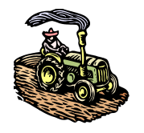

Module Title: - Observing and Reporting on Weather
LG Code: AGR IRD1 M08 LO (1-3) LG (25-27)
TTLM Code: AGR IRD1 M08 0822 v1

August, 2022
Addis Ababa, Ethiopia

Table of Contents

Introduction to the Module 3
LO # 1- Collecting Weather and Climate Data 4
Instruction sheet 1 4
Infarction sheet 1 5
Self-check 1 22
Operation sheet 1 24
LAP TEST-1 26
LO # 2- preventative Action 27
Instruction sheet 2 27
Information Sheet 2 28
Self-check 2 37
Operation sheet 2 38
LAP TEST 2 39
LO # 3- Monitor Weather and Climate 40
Instruction sheet 3 40
Information Sheet 3 41
Self-check 3 46
Operation Sheet 3 47
LAP TEST 3 48

Introduction to the Module
This module specifies the outcomes required to observe and report on weather and climate conditions for an agricultural, horticultural or land management enterprise. It also requires the application of skills and knowledge to recognize adverse weather and climate conditions and to monitor record and report on weather and climate information.

Weather and climate affects our lives. Basic example of how weather dictates
the type of clothing we wear, while climate inﬂuences what type of clothing we
buy. Climate determines when is the right time to plant certain crops as well
as what type of crops can be planted. Weather determines if these same
crops will grow to maturity. Although weather and climate affect our lives in
many ways, perhaps their most immediate effect is on our comfort. In order to
survive the cold of winter and heat of summer, we build homes, heat them, air
condition them, insulate them—only to ﬁnd that when we leave our shelter, we
are at the mercy of the weather elements.
Even when we are dressed for the weather properly, wind, humidity, and
precipitation can change our perception of how cold or warm it feels. On a
cold, windy day the effects of wind chill tell us that it feels much colder than it
really is, and, if not properly dressed, we run the risk of frostbite or even
hypothermia (the rapid, progressive mental and physical collapse that
accompanies the lowering of human body temperature).
On a hot, humid day we normally feel uncomfortably warm and blame it on the
humidity. If we become too warm, our bodies overheat and heat exhaustion or
heat stroke may result.
Weather and climate affects our lives. Basic example of how weather dictates
the type of clothing we wear, while climate inﬂuences what type of clothing we
buy. Climate determines when is the right time to plant certain crops as well
as what type of crops can be planted. Weather determines if these same
crops will grow to maturity. Although weather and climate affect our lives in
many ways, perhaps their most immediate effect is on our comfort. In order to
survive the cold of winter and heat of summer, we build homes, heat them, air
condition them, insulate them—only to ﬁnd that when we leave our shelter, we
are at the mercy of the weather elements.
Even when we are dressed for the weather properly, wind, humidity, and
precipitation can change our perception of how cold or warm it feels. On a
cold, windy day the effects of wind chill tell us that it feels much colder than it
really is, and, if not properly dressed, we run the risk of frostbite or even
hypothermia (the rapid, progressive mental and physical collapse that
accompanies the lowering of human body temperature).
On a hot, humid day we normally feel uncomfortably warm and blame it on the
humidity. If we become too warm, our bodies overheat and heat exhaustion or
heat stroke may result.
LG #25 | LO #1-Collecting Weather and Climate Data

Instruction sheet 1
This learning guide is developed to provide you the necessary information regarding the following content coverage and topics:
  - Gathering weather condition
  - Familiarizing change of weather and climate situation
  - Determining Impact of climate change
  - Reporting impact of climate change
This guide will also assist you to attain the learning outcomes stated in the cover page. Specifically, upon completion of this learning guide, you will be able to:
- Gather weather condition
- Familiarize change weather and climate situation
- Determine Impact of climate change
- Report impact of climate change
Learning Instructions:
- Read the specific objectives of this Learning Guide.
- Follow the instructions described below.
- Read the information written in the information Sheets
- Accomplish the Self-checks
- Perform Operation Sheets
- Do the “LAP test”

Information sheet 1

  - Gathering Weather Condition
Weather and climate affects our lives. Basic example of how weather dictates the type of clothing we wear, while climate inﬂuences what type of clothing we buy. Climate determines when is the right time to plant certain crops as well as what type of crops can be planted. Weather determines if these same crops will grow to maturity. Although weather and climate affect our lives in many ways, perhaps their most immediate effect is on our comfort. In order to survive the cold of winter and heat of summer, we build homes, heat them, air condition them, insulate them—only to ﬁnd that when we leave our shelter, we are at the mercy of the weather elements. Even when we are dressed for the weather properly, wind, humidity, and precipitation can change our perception of how cold or warm it feels. On a cold, windy day the effects of wind chill tell us that it feels much colder than it really is, and, if not properly dressed, we run the risk of frostbite or even hypothermia (the rapid, progressive mental and physical collapse that accompanies the lowering of human body temperature). On a hot, humid day we normally feel uncomfortably warm and blame it on the humidity. If we become too warm, our bodies overheat and heat exhaustion or heat stroke may result.
First, it’s really important to understand the difference between weather and climate. Climate is what you expect, but weather is what you actually get on a day to day basis. Weather and climate are part of a continuum.
Weather is a result of atmospheric conditions at a certain place and time. Weather is always changing with time. It is the condition of Earth’s Atmosphere at the particular space and time.
Climate is the result of average atmospheric conditions in a certain region over a long period of time. For example, if we say it is hot or raining on a particular day, we are talking about the weather; but if we say a particular place always has hot summers or rainy winters, we are talking about its climate.
The World Meteorological Organization designates particular weather stations for collecting data on a range of weather variables for determining the “climate normal” or the 30-year average of weather variables in a particular location. Projecting what could happen over 30-year time periods is, in some ways, less challenging that forecasting what will happen tomorrow or next week. Weather, then, is the day to day variability in climate that we experience.
Climatology is the science of climate, study of the climatic elements and the factors that affect it.
Meteorology is the study of atmospheric phenomena.
The atmosphere is the layer of gases that surrounds the Earth and makes life possible on the planet. It extends for thousands of kilometers. Its composition is mainly nitrogen and oxygen, but also argon, carbon dioxide and other gases (hydrogen, ozone, methane and water-vapor).
The atmosphere is divided into layers. These layers include the troposphere, stratosphere, mesosphere, thermosphere and exosphere. The temperature, thickness and composition of each layer are different.
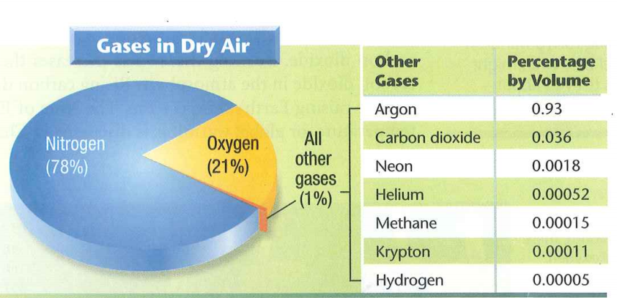
Fig. 1.1: compositions of Atmosphere
Meteorological stations are facilities with instrumentation and equipment intended to punctually measure and record different meteorological variables, such as air temperature, atmospheric pressure, rainfall, relative humidity and wind direction, among others, for different usages, including weather forecasting and climate study.

- Importance of measuring or gathering atmospheric/ weather elements
- To understand climate, climate variability and climatic changes at the local national and regional
levels
- To better understand how climate [change] impacts our societies
- To better plan adaptation measures to combat the real and or potential impacts of climate change
Eight primary weather/ atmospheric elements drive all weather condition are:

1. Temperature
2. Air (Atmospheric) Pressure
3. Wind (Speed & Direction)
4. Humidity
5. Precipitation
6. Visibility
7. Clouds (Type & Cover)
8. Sunshine Duration

1. Temperature
- Temperature is a measurement of the amount of kinetic energy present in the air, which manifests itself physically through the experience of heat or cold.
- The scales typically used to measure temperature, is Celsius, Fahrenheit, and Kelvin.
- The instrument used to measure temperature is called a thermometer.
T°C = TK – 273.15
Tºc= 5/9(ºF-32)
T°F = 9/5 T°C + 32
2) Air Pressure
- Air Pressure is the result of the pressure created by the weight of the air in the Earth's atmosphere.
- It is also called a barometric pressure, named after the instrument used to measure air pressure.
- Although it may not be visible, air has weight since it is not empty. It is filled with small particles of nitrogen, oxygen, argon, carbon dioxide and a few other gases.
- The weight of the particles in the air creates pressure due to the gravitational force of the Earth.
- Since more air is present above the air close to the ground, air pressure is the highest on the planet's surface and decreases as altitude increase.
- The barometer is the instrument used to measure air pressure.

3) Wind (Speed & Direction)
- Wind is the large-scale movement of air from an area of high to an area of low pressure in the atmosphere.
- The speed and strength of wind are determined by the distance between the low-pressure and high-pressure areas, as well as the difference in air pressure.
- The anemometer is the instrument used to measure wind speed. Consisting of 3-4 half-cups on arms rotating around a central axis, you can typically find it on top of a weather station or at an elevated position.
- A wind vane (or weather vane) is the instrument used to measure wind direction. It is a flat-shaped object that spins freely on an axis. Very often in the shape of an arrow or cockerel, you can also find it on top of a weather station or highly elevated objects.
4) Humidity
- Humidity is the amount of water vapor that is present in the atmosphere at any specific time. Water vapor is water in a state of gas (after the liquid has evaporated).
- Although humidity and its effects can usually be felt, it is normally invisible to the naked eye.
- Humidity can be challenging to understand and interpret correctly. Then you also have to be able to make a clear distinction between absolute and relative humidity.
- The hygrometer is the instrument used to measure Humidity. You also find more than one type of this device, like the psychomotor and the resistance hygrometer.
5) Precipitation
- Precipitation is water in all its different states, which formed after condensation turned water vapor into its solid form, which falls to the ground after it becomes too heavy to stay suspended in the air. Precipitation can take the form of rain, snow, hail, or graupel.
- Precipitation is primarily the result of evaporation and condensation.
- A rain gauge is the instrument used to measure rainfall.
6) Visibility
- Visibility is the measurement of the degree through which an object can be observed horizontal over a certain distance.
- This measurement is crucial when conditions like mist, haze, fog, and freezing drizzle are present, which can severely impede visibility.
- The importance to be able to measure this element is often underestimated. It is especially applicable in areas where visibility plays a crucial role, like airports and harbors where it can literally be a matter of life or death.
- Visibility sensors like "forward scatter sensor" are the instruments used to measure visibility.
- In the past, using your own vision (eyes) to measure the degree to which you can observe an object, was the standard.
7) Clouds (Type & Cover)
Clouds are water droplets or water in different states (like ice and snow crystals), which formed after water vapor reached condensation level and could no longer remain in gaseous form.
- Clouds are one of the quickest ways to determine current and future weather conditions. Studying them in more detail with scientific equipment is very valuable to make very accurate assessments of present and feature atmospheric conditions.
- The advanced instruments meteorologists use to study clouds in detail are weather satellites and radars.
- Satellite and radar images are able to accurately measure cloud density in (oktas), the amount of moisture, the temperature, and movement of the clouds.
8) Sunshine Duration
- Sunshine duration is the length of time the Earth's surface is directly exposed to solar radiation in hours per day.
- Sunshine recorders, more specifically Campbell–Stokes recorders, are the instruments used to record sunshine duration. Campbell–Stokes recorders basically consist of a spherical lens that focuses sunlight on a specific type of tape to make its measurement.

  - Methods of gathering weather information (data)
Meteorological stations are spread along a particular area in order to set up a network; they are placed in strategic locations for the sake of data collection according to the ultimate objective for which the network is specifically designed.
- Surface observation
The types of surface network includes manmade observations and automatic observations recorded by sensors on the ground. The surface network has about one or two land station every hundred kilometers, but almost none over the oceans.
- Manned weather station: visual and instrumental observations;

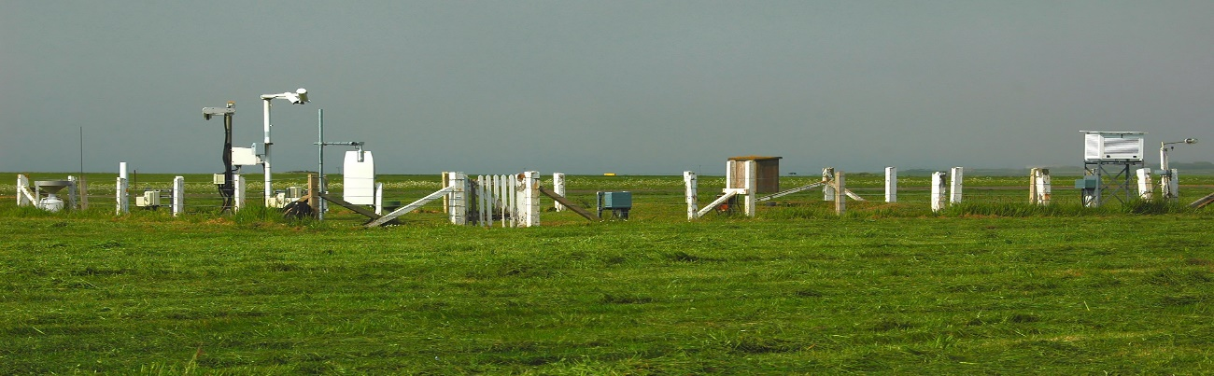
Fig.1.2: Surface meteorological Station

- Based on overfed element and instrument availability, meteorological stations can be categorized as follow
- Synoptic- contains all instrument and observe all weather elements
- Frist class – contains somewhat less instrument than synoptic station
- Third class-contains, thermometer and rain gauge to observe temperature and precipitation
- Froth class _ contain only rain gauge and observe precipitation

- Automatic weather station (AWS): exclusively instrumental observations
An automatic weather station (AWS) is defined as a meteorological station at which observations are made and transmitted automatically.
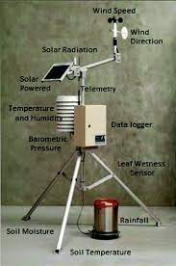
Fig.1.3: Automatic weather stations
- Advantages AWS
Automatic weather stations are used for increasing the number and reliability of surface observations. They do this by:
- Increasing the density of an existing network by providing data from sites which are difficult to access and are inhospitable;
- Supplying, for manned stations, data outside the normal working hours;
- Increasing the reliability of the measurements by using sophisticated technology and modern, digital measurement techniques;
- Ensuring homogeneity of network by standardizing the measuring techniques;
- Satisfying new observational needs and requirements;
- Reducing human errors;
- Lowering operational costs by reducing the number of observers;
- Measuring and reporting with high frequency or continuously.
- Disadvantages AWS
- Some elements are difficult to automate (e.g. cloud cover)
- AWS requires a large capital investment.
- AWS are less flexible than human observers
Weather stations report a set of meteorological information every hour in order to monitor the weather more closely and to adjust or produce small‐scale forecasts.
Synoptic observations are made at the surface four times a day at 0000, 0600, 1200, and 1800 UTC (Universal Time Coordinated) at all stations in the world. The routine surface observations include: pressure, temperature, dew‐point temperature, cloudiness types and heights) wind speed and direction, current weather, pressure tendency, and amount of precipitation since the last report.
These observations are transmitted every six hours in a stand code that includes the station identifier and the observed weather.
- Upper air observation
- Radiosonde
The upper air observations of the troposphere and lower stratosphere are generally observed by radiosondes. Theyare made principally with radiosondes, which are probes carried aloft by large hydrogen or helium balloons. As the radiosonde is carried aloft, Sensors measure profiles of pressure, temperature, and relative humidity.
The information is sent back to a fixed receiver and the disposable probe falls back to earth
Whenthe balloon explodes. By tracking the position of the radiosonde in flight, information on mwind speed and direction aloft is also obtained.
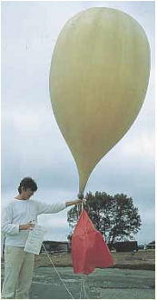

Fig. 1.4: Balloon with radiosonde

The radiosonde flight can last in excess of two hours, and during this time the radiosonde can ascend to over 35 km and drift more than 200 km from the release point. When the balloon has expanded beyond its elastic limit and bursts (about 6 m in diameter), a small parachute slows the descent of the radiosonde, minimizing the danger to lives and property.
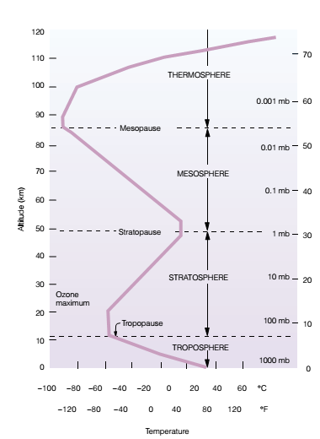
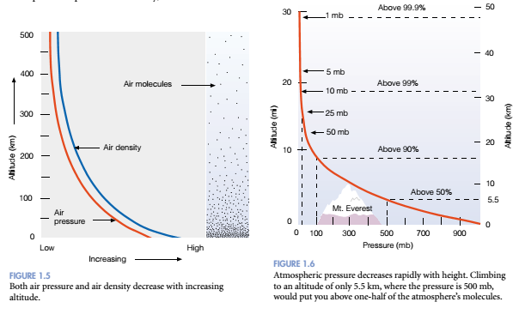
Fig.1.5A: Atmospheric temperature profile Fig.1.5B Pressure profile

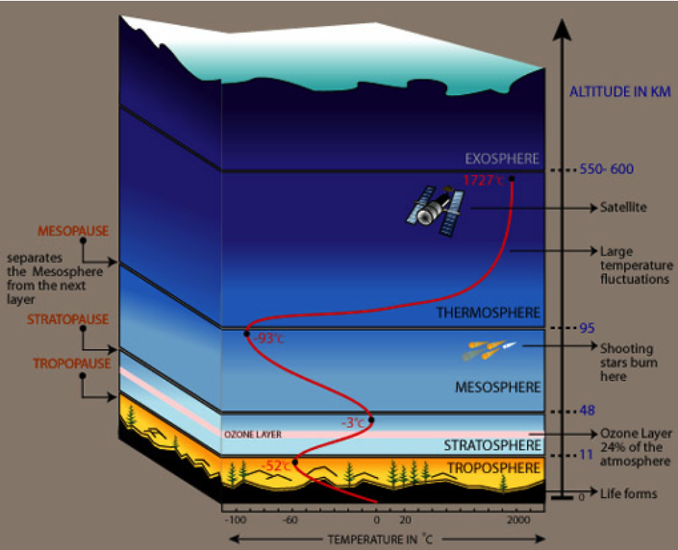
Fig.1.6 Atmospheric layers
This decrease in air temperature with increasing lapse rate in this region of the lower atmosphere in average is about 6.5 degrees celsius (°C) for every 1000 meters (m) or about 3.6 degrees Fahrenheit (°F) for every 1000 ft rise in elevation.
- Radars
Remote sensing can use either active or passive sensors. Active sensor systems emit some form of radiation, which is scattered by various targets; the sensors detect the backscatter. Passive sensors measure radiation being emitted (or modified) by the environment.
The most common surface based active remote sensing technique is weather radar. A short pulse of high power microwave energy is focused by an antenna system into an arrow beam. This beam is scattered back by the target precipitation, with the backscattered radiation received, generally by the same antenna system. The location of the precipitation can be determined from the azimuth and elevation of the antenna and the time between transmitting and receiving the reflected energy. The power of the received radiation depends on the nature of the precipitation, and the signal can be processed to estimate its intensity.
Its primary purpose is the early detection of developing precipitation, thunderstorms and high impact weather. The radar has a range of 250 km around the site. Weather radar systems generally use a parabolicantenna much like a searchlight revealing objects caught in its beam. From the transmitter, a narrow beamsweeps the sky as the antenna slowly rotates while pointing at different elevation angles above the horizon. When the energy emitted by the radar antenna strikes particles of precipitation, such as drops of water, snowflakes, ice pellets or hail, it is reflected (echoe) with intensity proportional to the number and size of the particles.

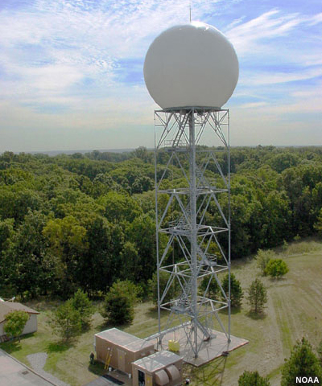
Fig.1.7: weather radar

- Satellites
Satellites are used to collect information about the surface of the earth and the earth’s atmosphereThe data is then processed into a variety of image products. Weather satellites circle the earth in one of two orbit patterns:
- Geostationary satellites: which orbit high above the earth’s equator (35,786 km) at the same rotation speed as the earth itself, hence remaining constantly over the same location;
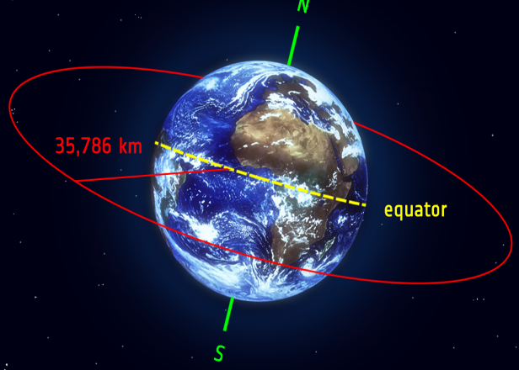

Fig.1.7: Geostationary satellites
- Polar orbiting satellites:
The orbit about 879 km above the earth’s surface, passing over the PolarRegions each time they circle the earth while passing over midlatitude locations twice per day. The meteorological sensor found on satellites can detect a variety of things, including the location and movement of clouds and cloud systems; snow and ice cover; particles from fires, pollution, and sand and
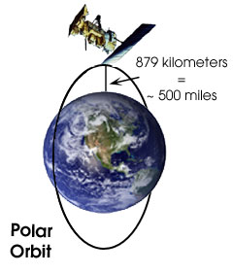

Fig.1. 8: Polar orbiting satellites

dust storms; ocean currents; and many other types of environmental information. However for the purpose of weather forecasting, two types of imaging sensors are used: infrared (IR) and visible

(VIS).
  - Familiarizing change weather and climate situation
One of the main causes of climate change are changes in Earth’s atmosphere due to
changes in the amounts of greenhouse gases, aerosols, and cloudiness. The anthropogenic
increase in greenhouse gas emissions, not natural variability, is responsible for most of the
warming in recent decades [6]. Since the start of the industrial era (ca. 1750), the overall effect
of human activities on climate has been one of warming. The major greenhouse gases, for
example, carbon dioxide (CO
2
), methane (CH
4
), nitrous oxide (N
2
O), and the halocarbons,
are the result of human activities, and they accumulate in the atmosphere, and the concentra-
tion increases with time, as shown in Fig. 11.2 [7]. The major causes of the increase in CO
2
are
the increased use of fossil fuel use in transportation, building heating and cooling, and the
manufacture of cement and other goods. Human activities, such as agriculture, natural gas
distribution, and landﬁlls, result in increases in CH
4
, whereas the use of fertilizer and the
burning of fossil fuels leads to increases in N
2
O. The increasing use of the principal
halocarbons (chloroﬂuorocarbons) as refrigeration agents and in other industrial processes
has been found to cause stratospheric ozone depletion.
One of the main causes of climate change are changes in Earth’s atmosphere due to
changes in the amounts of greenhouse gases, aerosols, and cloudiness. The anthropogenic
increase in greenhouse gas emissions, not natural variability, is responsible for most of the
warming in recent decades [6]. Since the start of the industrial era (ca. 1750), the overall effect
of human activities on climate has been one of warming. The major greenhouse gases, for
example, carbon dioxide (CO
2
), methane (CH
4
), nitrous oxide (N
2
O), and the halocarbons,
are the result of human activities, and they accumulate in the atmosphere, and the concentra-
tion increases with time, as shown in Fig. 11.2 [7]. The major causes of the increase in CO
2
are
the increased use of fossil fuel use in transportation, building heating and cooling, and the
manufacture of cement and other goods. Human activities, such as agriculture, natural gas
distribution, and landﬁlls, result in increases in CH
4
, whereas the use of fertilizer and the
burning of fossil fuels leads to increases in N
2
O. The increasing use of the principal
halocarbons (chloroﬂuorocarbons) as refrigeration agents and in other industrial processes
has been found to cause stratospheric ozone depletion.
One of the main causes of climate change are changes in Earth’s atmosphere due to
changes in the amounts of greenhouse gases, aerosols, and cloudiness. The anthropogenic
increase in greenhouse gas emissions, not natural variability, is responsible for most of the
warming in recent decades [6]. Since the start of the industrial era (ca. 1750), the overall effect
of human activities on climate has been one of warming. The major greenhouse gases, for
example, carbon dioxide (CO
2
), methane (CH
4
), nitrous oxide (N
2
O), and the halocarbons,
are the result of human activities, and they accumulate in the atmosphere, and the concentra-
tion increases with time, as shown in Fig. 11.2 [7]. The major causes of the increase in CO
2
are
the increased use of fossil fuel use in transportation, building heating and cooling, and the
manufacture of cement and other goods. Human activities, such as agriculture, natural gas
distribution, and landﬁlls, result in increases in CH
4
, whereas the use of fertilizer and the
burning of fossil fuels leads to increases in N
2
O. The increasing use of the principal
halocarbons (chloroﬂuorocarbons) as refrigeration agents and in other industrial processes
has been found to cause stratospheric ozone depletion.
One of the main causes of climate change are changes in Earth’s atmosphere due to
changes in the amounts of greenhouse gases, aerosols, and cloudiness. The anthropogenic
increase in greenhouse gas emissions, not natural variability, is responsible for most of the
warming in recent decades [6]. Since the start of the industrial era (ca. 1750), the overall effect
of human activities on climate has been one of warming. The major greenhouse gases, for
example, carbon dioxide (CO
2
), methane (CH
4
), nitrous oxide (N
2
O), and the halocarbons,
are the result of human activities, and they accumulate in the atmosphere, and the concentra-
tion increases with time, as shown in Fig. 11.2 [7]. The major causes of the increase in CO
2
are
the increased use of fossil fuel use in transportation, building heating and cooling, and the
manufacture of cement and other goods. Human activities, such as agriculture, natural gas
distribution, and landﬁlls, result in increases in CH
4
, whereas the use of fertilizer and the
burning of fossil fuels leads to increases in N
2
O. The increasing use of the principal
halocarbons (chloroﬂuorocarbons) as refrigeration agents and in other industrial processes
has been found to cause stratospheric ozone depletion.
One of the main causes of climate change are changes in Earth’s atmosphere due to
changes in the amounts of greenhouse gases, aerosols, and cloudiness. The anthropogenic
increase in greenhouse gas emissions, not natural variability, is responsible for most of the
warming in recent decades [6]. Since the start of the industrial era (ca. 1750), the overall effect
of human activities on climate has been one of warming. The major greenhouse gases, for
example, carbon dioxide (CO
2
), methane (CH
4
), nitrous oxide (N
2
O), and the halocarbons,
are the result of human activities, and they accumulate in the atmosphere, and the concentra-
tion increases with time, as shown in Fig. 11.2 [7]. The major causes of the increase in CO
2
are
the increased use of fossil fuel use in transportation, building heating and cooling, and the
manufacture of cement and other goods. Human activities, such as agriculture, natural gas
distribution, and landﬁlls, result in increases in CH
4
, whereas the use of fertilizer and the
burning of fossil fuels leads to increases in N
2
O. The increasing use of the principal
halocarbons (chloroﬂuorocarbons) as refrigeration agents and in other industrial processes
has been found to cause stratospheric ozone depletion.
One of the main causes of climate change are changes in Earth’s atmosphere due to
changes in the amounts of greenhouse gases, aerosols, and cloudiness. The anthropogenic
increase in greenhouse gas emissions, not natural variability, is responsible for most of the
warming in recent decades [6]. Since the start of the industrial era (ca. 1750), the overall effect
of human activities on climate has been one of warming. The major greenhouse gases, for
example, carbon dioxide (CO
2
), methane (CH
4
), nitrous oxide (N
2
O), and the halocarbons,
are the result of human activities, and they accumulate in the atmosphere, and the concentra-
tion increases with time, as shown in Fig. 11.2 [7]. The major causes of the increase in CO
2
are
the increased use of fossil fuel use in transportation, building heating and cooling, and the
manufacture of cement and other goods. Human activities, such as agriculture, natural gas
distribution, and landﬁlls, result in increases in CH
4
, whereas the use of fertilizer and the
burning of fossil fuels leads to increases in N
2
O. The increasing use of the principal
halocarbons (chloroﬂuorocarbons) as refrigeration agents and in other industrial processes
has been found to cause stratospheric ozone depletion.
EVIDENCE OF CLIMATE CHANGE
The following section discusses the changing patterns of temperature and precipitation
during the twentieth century as evidence of climate change.
Weather and climate affects our lives. Basic example of how weather dictates
the type of clothing we wear, while climate inﬂuences what type of clothing we
buy. Climate determines when is the right time to plant certain crops as well
as what type of crops can be planted. Weather determines if these same
crops will grow to maturity. Although weather and climate affect our lives in
many ways, perhaps their most immediate effect is on our comfort. In order to
survive the cold of winter and heat of summer, we build homes, heat them, air
condition them, insulate them—only to ﬁnd that when we leave our shelter, we
are at the mercy of the weather elements.
Even when we are dressed for the weather properly, wind, humidity, and
precipitation can change our perception of how cold or warm it feels. On a
cold, windy day the effects of wind chill tell us that it feels much colder than it
really is, and, if not properly dressed, we run the risk of frostbite or even
hypothermia (the rapid, progressive mental and physical collapse that
accompanies the lowering of human body temperature).
On a hot, humid day we normally feel uncomfortably warm and blame it on the
humidity. If we become too warm, our bodies overheat and heat exhaustion or
heat stroke may result.
Understanding the risk profile provides critical information for the other multi-hazard early warning system elements, namely:
- Risk knowledge: Monitoring and forecasting data and information provide the basis for quantifying hazards and exposure to risk.
- Warning dissemination and communication: Warnings are the trigger for communication mechanisms and initiate the processes for decision-making and enacting emergency plans.
- Preparedness and response capabilities: Risk-informed warnings provide the necessary information for people to protect themselves and their property and start emergency response processes.
Weather and climate affects our lives. Basic example of how weather dictates the type of clothing we wear, while climate inﬂuences what type of clothing we buy. Climate determines when is the right time to plant certain crops as well as what type of crops can be planted. Weather determines if these same crops will grow to maturity.
Although weather and climate affect our lives in many ways, perhaps their most immediate effect is on our comfort. In order to survive the cold of winter and heat of summer, we build homes, heat them, air condition them, insulate them—only to ﬁnd that when we leave our shelter, we are at the mercy of the weather elements. Even when we are dressed for the weather properly, wind, humidity, and precipitation can change our perception of how cold or warm it feels. On a cold, windy day the effects of wind chill tell us that it feels much colder than it really is, and, if not properly dressed, we run the risk of frostbite or even hypothermia (the rapid, progressive mental and physical collapse that accompanies the lowering of human body temperature). On a hot, humid day we normally feel uncomfortably warm and blame it on the humidity. If we become too warm, our bodies overheat and heat exhaustion or heat stroke may result.
There are two classes of climate change namely natural causes and man-made causes. Natural causes include variations in solar radiation, volcanic activity and so on. They Further, asserts that man-made weather change is of major concern because it appears to be leading to a progressive and accelerating warming of the planet, as a result of the release of greenhouse gases (GHG), primarily carbon-based emissions.
Floods cause signiﬁcant damage to the economies of affected areas, and this is considered
to be one of the commonly occurring natural hazards around many parts of the world due to
the impact of climate change [50]. The causes of ﬂooding are many and include heavy rainfall,
torrential rain, and snowmelt; their spatial locations since 1985 are shown in Fig. 11.7. Severe
ﬂoods from high rainfall (of long or short duration) have occurred in almost all humid regions
of the world, as well as some semiarid zones. Tropical storms (known as hurricanes, cyclones,
- Floods
Floods cause signiﬁcant damage to the economies of affected areas, and this is considered to be one of the commonly occurring natural hazards around many parts of the world due to the impact of climate change. The causes of ﬂooding are many and include heavy rainfall, torrential rain, and snowmelt. Severe ﬂoods from high rainfall (of long or short duration) have occurred in almost all humid regions of the world, as well as some semiarid zones. Tropical storms (known as hurricanes, cyclones.
- Drought
Of twentieth century natural hazards, droughts have had the greatest detrimental impact and large-scale intensive droughts have been observed on all continents in recent decades affecting large areas.
- Water Quality
Warmer temperatures can affect water quality in several ways, including decreased dissolved oxygen levels, increased contaminant load to water bodies, reduced stream and river ﬂows, increased algal blooms, and an increased likelihood of saltwater intrusion near coastal regions. Acid rain is one of the primary reasons for degrading water quality, and the principal cause of this is sulfuric and nitrogen compounds from human actions, and variations in stream ﬂow characteristics will alter the transport of chemical loads in rivers. Due to low ﬂows in rivers, the dilution process between water and waste will be affected, which can increase the mineralization of organic nitrogen in soil.
- Groundwater
Global warming will likely affect groundwater resources by altering precipitation and
temperature patterns, which will likely be further aggravated by overexploitation. Based on
NASA’s Gravity Recovery and Climate Experiment (GRACE) twin satellites [103], the
groundwater in the states of Rajasthan, Punjab, and Haryana in India is declining at a rate
of 33 cm/year. Similar studies in the United States showed that groundwater in the San
Joaquin Valley in California has been dropping by 60–150 cm over the last 5 years
[104]. Groundwater recharge is affected by land-use and land-cover change, urbanization,
loss in forest cover, changes in cropping patterns and rotation, and changes in soil properties
occurring over a long period of time that may affect inﬁltration capacity
Global warming will likely affect groundwater resources by altering precipitation and temperature patterns, which will likely be further aggravated by over exploitation. Groundwater recharge is affected by land-use and land-cover change, urbanization, loss in forest cover, changes in cropping patterns and rotation, and changes in soil properties occurring over a long period of time that may affect inﬁltration capacity.
- Agricultural
The vulnerability of agricultural sectors to climate change is mainly due to changes in precipitation and temperature, and, consequently, the likely impacts on the agricultural sector have prompted concern over the magnitude of future global food production.. Many countries are agriculture dependent; therefore, climate change could create a linkage between the agricultural sector and poverty and is likely to affect many developing countries. For example, in Africa, it is estimated that nearly 80 % of the population is dependent on the agricultural sector for employment, and this sector contributes on average nearly 34 % to the gross domestic product (GDP) per country. Vulnerability of the agricultural sector depends on local biological conditions, moisture content, cropping patterns, extent of knowledge, and awareness of expected changes in the climate, and the increased uncertainty of climate effects represents an additional problem that farmers must address.
The vulnerability of agricultural sectors to climate change is mainly due to
changes in precipitation and temperature, and, consequently, the likely impacts on the
agricultural sector have prompted concern over the magnitude of future global food produc-
tion [123]. Many countries are agriculture dependent; therefore, climate change could create a
linkage between the agricultural sector and poverty and is likely to affect many developing
countries. For example, in Africa, it is estimated that nearly 60–70 % of the population is
dependent on the agricultural sector for employment, and this sector contributes on average
nearly 34 % to the gross domestic product (GDP) per country, whereas in the case of the West
African Sahel alone, more than 80 % of the population is involved in agriculture and stock
farming in rural areas [124]. Findings of several investigations highlight that the degree of
vulnerability of the agricultural sector depends on local biological conditions, moisture
content, cropping patterns, extent of knowledge, and awareness of expected changes in the
climate, and the increased uncertainty of climate effects represents an additional problem that
farmers must address.
Human-induced climate change has the potential to substantially alter agricultural systems
[125–127]. Climate change will affect agricultural productivity characterized mainly by ﬁve
factors, including changes in precipitation, temperature, carbon dioxide (CO
2
) fertilization,
climate variability, and surface water runoff [128]. However, precipitation and temperature
will have direct effects as these combinations are useful for determining the availability of
freshwater and the level of soil moisture, which are critical inputs for crop growth. Also,
higher precipitation leads to a reduction in yield variability [129], and higher precipitation
will reduce the yield gap between rainfed and irrigated agriculture, but it may also have
      - Ecosystems
Physical processes and biological systems on many scales have been altered due to global climate change caused by the sudden increase in the energy balance of the planet, which affects ecosystems that support human society. This may cause sudden, irreversible effects that fundamentally change the function and structure of the ecosystem, with potentially huge impacts on human society. The global ecosystem is sensitive to many components, including large variability and extremes of CO2 and climate throughout geological history. Anthropogenic changes, such as land use, nitrogen deposition, pollution, and invasive species, natural disturbance regimes (e.g., wildﬁre); and subtle changes in management practices within a given land-use type, e.g., intensiﬁcation of agricultural practices. Land-use changes, habitat loss, and fragmentation have long been recognized as important causes of ecosystem change, particularly changes in biodiversity. A regime shift occurs in ecosystems, such that even small changes in physical conditions can provoke a regime shift that may not be easily or symmetrically reversed, and most initial ecosystem responses appear to dampen change. Although ecosystems are likely to respond to increasing external forcing in a nonlinear manner.

  - Anticipate Impact of climate change
Weather forecasts and warnings are the most important services provided by the meteorological profession. Forecasts are used by government and industry to protect life and property and to improve the efficiency of operations, and by individuals to plan a wide range of daily activities.
Loss and damage addressed may include:
- Economic loss
- Property loss and damage
- Loss of life
Prospective climate information includes predictions and projections of future climate and weather conditions and trends. Forecasts and predictions are all statements about the expected or possible weather or climate conditions in the future. For each of these statements there is an associated.
Timescale: The length of period for which the forecast applies. For example, if the forecast is for June30–August1, 2022, the timescale is three months.
Forecasts and predictions are specific statements about the expected conditions either for the immediate future, or for lead times of up to about one year. A weather forecast provides information for a specific weather system or condition at a specific place and time. In contrast, a climate forecast indicates only the general weather conditions over the target period. For example, a seasonal rainfall forecast (sometimes called an outlook) typically describes the total rainfall over the next three or four months, but does not indicate when the rain might fall within that season. 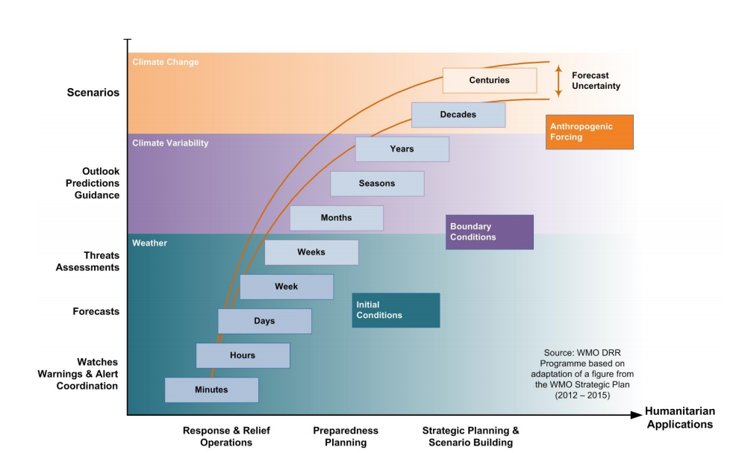
Fig.2.1:Weather forcasting wwith time scale
Forecasts are used as the basis for issuing alerts for immediate or imminent weather conditions, information that can be of great value in humanitarian contexts. The specifications for issuing formal alerts for hazardous climate conditions are still being formulated by the World Meteorological Organization (WMO), although many countries and regions have developed their own formal drought alert systems.
There has been an increase in temperature as observed in the past century, and climate
change models also predict increasing temperatures. Warmer temperatures can affect water
quality in several ways, including decreased dissolved oxygen levels, increased contaminant
load to water bodies, reduced stream and river ﬂows, increased algal blooms, and an
increased likelihood of saltwater intrusion near coastal regions. Acid rain is one of the
primary reasons for degrading water quality, and the principal cause of this is sulfuric and
nitrogen compounds from human actions, and variations in streamﬂow characteristics will
alter the transport of chemical loads in rivers. Due to low ﬂows in rivers, the dilution process
between water and waste will be affected, which can increase the mineralization of organic
nitrogen in soil
  - Reporting impact of climate change
- Weather and climate have become so much a part of our lives that the ﬁrst
- Thing many of us do in the morning is to listen to the local weather forecast.
- For this reason, many radio and television newscasts have their own “weather
- person” to present weather information and give daily forecasts. To make
- weather presentation as up-to-the-minute as possible such as computerized
- weather forecasts, time-lapse satellite pictures, and color Doppler radar
- Displays are used to predict more accurate weather forecast.
Reporting and Documenting climate and its impact. The type, intensity, and character of climate impact in any form must be reported in the body of the weather report whenever it is observed to occur at the station. Weather observed at a distance from the station must be reported in the remarks section. The reporting of Weather observed at a distance is not required, but may be done. To report and document Weather, the observer must determine:

- Time of beginning,
- ending, and
- changes in intensity
- Type
- Character
- and intensity

Weather and climate have become so much a part of our lives that the ﬁrst thing many of us do in the morning is to listen to the local weather forecast. For this reason, many radio and television newscasts have their own “weather person” to present weather information and give daily forecasts. To make weather presentation as up-to-the-minute as possible such as computerized weather forecasts, time-lapse satellite pictures, and color Doppler radar displays are used to predict more accurate weather forecast.
The changes in precipitation and temperature can directly influence crop production. Moreover, they might alter the distribution of agro-ecological zones. Precipitation patterns determine the availability of freshwater and the level of soil moisture, which are critical inputs for crop growth. Moderate precipitation may reduce the yield gap between rain-fed and irrigated agriculture by reducing crop yield variability. However, heavy precipitation is very likely to result in soil erosion and difficulty to cultivate land due to water logging of soils. Taken as a whole, heavy precipitation will adversely affect crop production.
Temperature and soil moisture determine the length of growing period and the crop`s development and water requirements. Higher temperature will shorten the freeze periods, promoting cultivation in marginal croplands. However, in arid and semi-arid areas higher temperature will shorten the crop cycle and reduce crop yield. In addition, the ecological changes brought on by warming such as the pattern of pests and diseases will depress agricultural production. Globally, temperature increases of up to 2⁰C may have positive impacts on pasture and livestock productivity in humid temperate regions. However, it will reduce livestock production in arid and semi-arid regions.
Crop production will be depressed by increased climate variability and increased intensity and frequency of extreme weather events such as drought and floods. Its negative impact is much higher in areas where rain-fed agriculture dominates. For instance, frequent droughts not only reduce water supplies but also increase the amount of water needed for evapotranspiration by plant. These events will also increase diseases and mortality of livestock which results in production losses.

Self-check 1 | Written test

Name…………………………………………… ID………………………… Date…….
Directions: Answer all the questions listed below.
Test I: Choose the best answer (5point)
- The importance of measuring atmospheric elements are?

- To understand climate
- To better understand climate change impact
- To better plan adaptation measures
- All

- Which one of the following is the lowest layer of the atmosphere?

- Stratosphere
- Troposphere
- Mesosphere
- Thermosphere

- The instrument used to measure air temperature is ---.

  - Barometer
  - Thermometer
  - Rain gauge
  - Anemometer

- The most dominant gas in the atmosphere is?

A. Argon
B. Nitrogen
C. Oxygen
D. Carbon dioxide
- Which one of the following is not the weather induced hazards?

A. Outbreak of disease and pest
B. Volcanic eruption
C. Flooding
D. Drought

- Short answer (10 point)

- List at least three equipment used for upper air observations.

- Mention the two gases used to filling the balloon.

- The maximum air temperature recorded at Agarfa College on August 2, 2022 was 22ºc, then how much in ºF?

Operation sheet 1

1. 1. Procedure of observing rainfall
Students can use tap water to practice reading the measurement of the rain gauge in the classroom. They will be taking measurements to the nearest 1/4" (5mm). If there is a safe spot outside, the students can leave the gauge outside and take a reading after each rainfall, remembering to empty the jar after each reading. If the gauge can't be left outside, the students should place it outside on each rainy day.
- Tools and equipment
- Clear measuring cylinder
- Cylinder shaped clear jar
- Rubber band
- Funnel
- Transparent tape
B. Procedure
- Remove the jar's label.
- Attach the ruler to the outside of the jar with the rubber band; make sure that the Bottom edge of the ruler is even with the bottom of the jar. Or secure the ruler inside the jar so it is standing vertically with the end at the base of the jar/bottle. Tape the ruler in place so the numbers can be read from the outside of the jar/bottle.
- Place the funnel in the top of the jar. The top end of the funnel should cover the entire mouth of the jar.
- If you would like, you can practice filling the jar with water and measuring the total amount.
- Read the ruler to determine how much rain was collected.
- Record the amount in mm
- Empty the jar after each use.

1.2. Techniques of observing temperature
Temperature is measured with a thermometer. As the air gets hotter, the level of the liquid rises and, as the air gets cooler, the level falls.
- Tools and equipment
- Dry bulb thermometer
- Note book
- Pen/pencil
B. Procedure of how to record air temperature
        - giving each group a thermometer
        - handle the thermometer carefully
        - Let each student practice reading the air temperature.
        - Students should look straight at the thermometer at eye level.
        - Read the mercury (colored object) in the thermometer in ºC/ ºF
        - Record the value of reading.

LAP TEST-1 | Performance Test

Name………………………………. ID…………………………….. Date…………………………………….

Time started: ________________________ Time finished: ________________

Instructions: Given necessary templates, tools and materials you are required to perform the following tasks within 1.5 hour. The project is expected from each student to do it.

Task -1. Perform observation of rainfall
Task -2. Observe and record the air temperature

LG #26 | LO # 2- preventative Action

Instruction sheet 2
This learning guide is developed to provide you the necessary information regarding the following content coverage and topics:
  - Disseminating of information
  - Communicating information
  - Determining preventative action.
  - Implementing action to minimize loss and damage
  - Adjusting effect of weather condition on irrigation

This guide will also assist you to attain the learning outcomes stated in the cover page. Specifically, upon completion of this learning guide, you will be able to:
  - Dissemination of information
  - Communicate information
  - Determine preventative action.
  - Implement action to minimize loss and damage
  - Adjust effect of weather condition on irrigation

Learning Instructions:
- Read the specific objectives of this Learning Guide.
- Follow the instructions described below.
- Read the information written in the information Sheets
- Accomplish the Self-checks
- Perform Operation Sheets
- Do the “LAP test”

Information Sheet 2
  - Dissemination of information
Once generated, climate information should be publicly disseminated to ensure that it is integrated into responses for affected populations and sectors (including health, transport, agriculture, industry and etc.). The knock-on effects of strong climate data and analysis capabilities will include improved management of water resources and disaster risks. In order to predict the weather at any time by empirical or numerical methods, the meteorologist needs to know the state of the weather at the present time. Information is needed to represent the state of theatmosphere in a way that is understandable. This information is gathered through the observation of certain meteorological parameters.
According to the WMO, “The primary objective of a warning system is to empower individuals and communities to respond timely and appropriately to the hazards in order to reduce the risk of death, injury, property loss and damage. Warnings need to get the message across and stimulate those at risk to take action.”
In order to do this, one needs to collect and analyze data, package and distribute early warnings, build appropriate processes and response matrixes to allow fast delivery, and share relevant information with stakeholders and actors to ensure people know what to do when bad weather hits.
Data dissemination: ICT tools can also be used to disseminate weather information directly to users in a cost effective way that can be customized by geography, language and specific needs of the users. With weather information particularly, the granularity of the information and the timing is very important; this is a key strength of ICT over the traditional dissemination strategies. For example, farmers prefer to receive daily forecasts of weather information early in the morning by TV, Radio, Telephone, Fax, Newspapers, word of mouth, etc so that they can plan accordingly. No other traditional channel can be as precise as an automated weather feed sent out via SMS or voice message to the farmer at a specific time and for his particular geographic area down to village level.
  - Historical information: Data on past conditions and trends can be used for mapping hazards, assessing trends, identifying relationships with historical impacts (such as disease outbreaks and food insecurity), and providing a reference against which to compare current and anticipated conditions. Historical data can also be used for identifying the seasonality of climate, which can, for example, be important information for understanding the monthly distribution shifts of disease-carrying vectors, or identifying likely cropping cycles.
  - Current information: Data on current and recent conditions can be useful for indicating whether potentially impactful weather and climate events, such as severe storms, have recently occurred, or are under way, such as droughts.
  - Prospective information: Forecasts, projections, and scenarios are useful for anticipating climate hazards, for planning humanitarian operations, and for longer-term recovery and development planning. Inevitably, the proper use of such information is fraught with difficulties in fragile states, because of disruptions to the network of observations and operational climate services, as well as the lack of human resources in these contexts to generate and understand such information. But even in fragile states, climate information can be of value if its limitations are known and made explicit and climate-sensitive decisions are addressed appropriately.
  - Communicate information
The communications system is responsible for transmitting data logged in the station to the Control Center. SICE integrates any kind of communication solutions which allows to provide a great number of ideas and solutions appropriate to the project and client needs. The communication solutions go through, for instance, satellite, GSM/GPRS mobile networks, analogue and digital radio, meteorological satellites, carrier wave communications and others. Highly qualified on all the necessary IT tools to manage the network system in a strong, reliable, efficient and comfortable way, offering high quality real-time information.
The provision of climate information and predictions improves economic and social decision making and supports sustainable development. These are achieved through the Climate Information and Prediction Services. Disaster risk reduction could be more efficiently achieved by deploying resources to strengthen early warning systems. Human diseases injury suffering and death, caused by adverse climate effects, can be reduced when climate alerts reach the community in a timely and easy-to-understand manner.
Weather- and climate-related hazards are responsible for losses of lives and capital, damages to infrastructures, and effects on ecosystems. Disposing of well-validated weather and climate risk estimates for the present and future would enable more informed decision making and is therefore societally important. Climate risk assessment—both for the present and future—increasingly uses numerical models and relies on quantitative data. However, suitable data products, for example, to drive impact models, typically cover only recent decades and other methods (combinations of climate model simulations with semi empirical or purely stochastic models, or expert judgment) are therefore often used.
There is a long tradition in analyzing information on historical extreme events for present day risk assessment, for instance, in the areas of ﬂood risk or coastal protection, and their relation to culture is reﬂected. However, analyzing historical weather events for climate risk assessment was up to now largely separate from the numerical tools used in climate risk assessment as the historical data not directly fed into quantitative methods and impact model chains.
Agriculture is highly sensitive to even minor climate variations, and have an impact on agricultural output even for a single growing season, so ongoing climate change can affect long-term agricultural productivity and food security. Climate change impacts on crops affect human health, largely through potential for mal nutrition and as a result, few studies have estimated millions of peoples are at risk of hunger.
In general, some of the climate change impact information include the following points
- Climate vulnerability
- Drought
- Hunger
- Vector borne disease
- Heat-related mortality
- Flooding
- Water-borne disease
- Water scarcity
- Sea level rise
- Human migration
  - Determine preventative action
In terms of managing these impacts, there are two main policy responses to managing the risks of climate change: adaptation and mitigation.
Mitigation actions reduce greenhouse gas emissions or enhance the sinks (e.g. sources that
take up carbon dioxide, such as soil and rocks).
Adaptation is a term used in the climate change community to describe the process of adjustment of human and natural systems to actual or expected climate change. This is similar to the idea of prevention in public health.
- Preventing health risks
- Reduce exposures:
- Legislative policies
- Alterations in built environment
- Alterations in natural environment
• Prevent onset of adverse outcomes:
- Early warning systems
- Surveillance & monitoring
- Vector control programmes
- Public education & outreach
• Response / treatment:
- Medical training & awareness
- Emergency response
  - Implement preventive actions to minimize loss and damage
Agriculture is highly sensitive to even minor climate variations, and have an impact on agricultural output even for a single growing season, so ongoing climate change can affect long-term agricultural productivity and food security. Climate change impacts on crops affect human health, largely through potential for mal nutrition and as a result, millions of peoples are at risk of hunger.
- Agro meteorology is very important in the following ways:
- Helps in planning cropping patterns/systems.
- Selecting of sowing dates for optimum crop yield.
- To go for cost effective ploughing, harrowing, weeding etc.
- Reducing losses of applied chemicals and fertilizers. Avoid fertilizer and chemical sprays when rain is forecast
- Judicious/sensible irrigation to crops.
- Efficient harvesting of all crops.
- Reducing or eliminating outbreak of pests and diseases.
- Efficient management of soils, which are formed out of weather action.
- Managing weather abnormalities like cyclones, heavy rainfall, floods, drought etc.
- This can be achieved by weather forecasting.
- Mitigation measures such as shelterbelts against cold and heat waves, effective environmental protection. etc.
- Avoiding or minimizing losses due to forest fires.
Adaptation measures in the agricultural sector aim at securing food production and reducing poverty. It is imperative for decision-makers, including farmers, herders, and business owners and others, to receive climate information in a timely and easy-to-understand manner.
WMO aims to enhance food security through the application of agro-meteorological products to improve land use, crop selection, locust control and management practices. Enhanced assessment of water availability and quality is essential for sustainable development, as is international cooperation, especially, within river basins shared among countries.
Adaptation is efficient if cost of making efforts is less than the resulting benefits. Joint adaptations will be beneficiary only if it is through governmental actions, In addition, political forces are likely encouraged if governments are engaged in inefficient adaptation behavior, and thus, it is not at all clear whether efficient levels of joint adaptation will be undertaken.
The practices, mentioned here are cultural practices; which do not need high capital and most of the options can be easily applicable by individual or group of farmers who are vulnerable to climate change.
Irrigation requirements are determined by climate and by crop and soil characteristics. Differences in crop evapotranspiration (ET) rates are caused by differences in canopy resistance and percent of green ground cover. Since evaporative demands are controlled by climatic parameters, changes in the climatic regime would affect both the hydrology and the irrigation requirements of an area.
In regions under water stress, irrigation is the most relevant factor for allowing stable and high crop production. In these areas, irrigated agriculture is the biggest user of water requiring almost 70% of total water use. Climate variables such as temperature and precipitation play an essential role in the evapotranspiration and water requirement of crops and therefore affect irrigation.

Table.2.1 adaptation strategy of climate impact
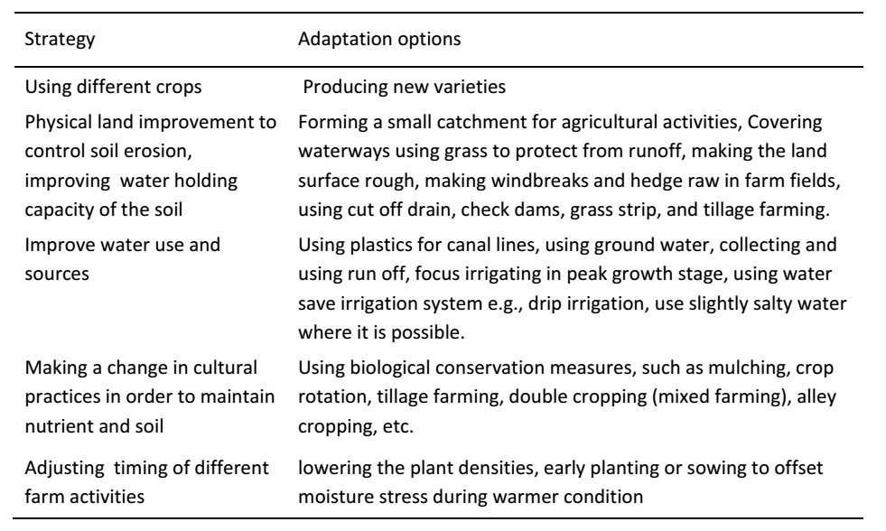

  - Adjusting Effect of weather condition on irrigation
Climate change will affect agricultural productivity characterized mainly by ﬁve factors, including changes in precipitation, temperature, carbon dioxide (CO2) fertilization, climate variability, and surface water runoff. However, precipitation and temperature will have direct effects as these combinations are useful for determining the availability of freshwater and the level of soil moisture, which are critical inputs for crop growth. Also, higher precipitation leads to a reduction in yield variability, and higher precipitation will reduce the yield gap between rainfed and irrigated agriculture, but it may also have a negative impact if extreme precipitation causes ﬂooding. The combination of temperature and soil moisture determines the length of the growing season and controls crop development and water requirements; however, in arid and semiarid areas, higher temperature will shorten the crop cycle and reduce crop yields.

- Adaptation Strategies

- Schedule irrigation based on soil water data.
Information on selecting and using soil water sensors to measure soil water status and its practical applications for irrigation scheduling method in various soil textures.
- Conserve water by decreasing evapotranspiration during vegetative growth stages.
- Approximately 30% of crop water use is due to evaporation, and evaporative losses are highest early in the growing season prior to canopy closure.
- Reducing evaporation via no or reduced tillage,
- Narrower row spacing, etc.
- It can lead to more water being available for transpiration, which is the driving force for yield production.
- Residue cover/cover crops can increase infiltration of precipitation and irrigation.
- In addition to infiltration, improving soil structure can lead to higher amounts of precipitation being stored in the profile.
- This increased storage would be available for crop production, potentially helping meet crop water demands in excess of irrigation capacity during droughts.
- In addition, increasing infiltration and water-holding capacity can allow for increased irrigation application amounts, as water is less likely to runoff.
- This decrease in the number of applications is beneficial to reduce canopy evaporation and get more of the applied water into the soil.
In general, weather and climate is a resource and considered as basic input or resources in agricultural planning, every plant process related with growth development and yield of a crop is affected by weather.
Similarly every farm operation such as ploughing harrowing, land preparation, weeding, irrigation, manuring, spraying, dusting, harvesting, threshing, storage and transport of farm produce are affected by weather. The scope of Agricultural management in terms of climate impact can be illustrated through the following few applications.

    - Characterization of agricultural climate:
For determining crop growing season, solar radiation, air temperature, precipitation, wind, humidity etc. are important climatic factors on which the growth, development and yield of a crop depends Agro-meteorology considers and assess the suitability of these parameters in a given region for maximum crop production and economic benefits.
    - Crop planning for stability in production:
To reduce risk of crop failure on climatic part, so as to get stabilized yields even under weather adversity, suitable crops/cropping patterns/contingent cropping planning can be selected by considering water requirements of crop, effective, rainfall and available soil moisture.
- Crop management:
Management of crop involves various farm operations such as, sowing fertilizer application. Plat protection, irrigation scheduling, harvesting etc. can be carried out on the basis of specially tailored weather support. For this the use of operational forecasts, available from agro met advisories, is made e.g. 1) Weeding harrowing, mulching etc are undertaken during dry spells forecasted.
2) Fertilizer application is advisable when rainfall is not heavy wind speed is<30 km/hr and soil moisture is between 30 to 80%
3) Spraying/dusting is undertaken when there is no rainfall, soil moisture is 90% and wind speed is<25km/hr.
- Crop Monitoring:
To check crop health and growth performance of a crop, suitable meteorological tools such as crop growth models. Water balance technique or remote sensing etc. Can be used.
- Crop modeling and yield –climate relationship:
Suitable crop models, devised for the purpose can provide information or predict the results about the growth and yield when the current and past weather data is used.
- Research in crop –climate relationship:
Agro-meteorology can help to understand crop-climate relationship so as to resolve complexities of plant process in relation to its micro climate.
- Climate extremities:
Climatic extremities such a frost floods, droughts, hail storms, high winds can be forecasted and crop can be protected.

- Climate as a tool to diagnose soil moisture stress:
Soil moisture can be exactly determined from climatic water balance method, which is used to diagnose the soil moisture stress, drought and necessary protective measures such as irrigation, mulching application of a nititranspirant, defoliation, thinning etc. can be undertaken.
- Livestock production is a part of agriculture.
The set of favorable and unfavorable weather conditions for growth, development and production of livestock is studied in Agricultural Meteorology. Thus to optimize milk production poultry production, the climatic normal are worked out and on the suitable breeds can be evolved or otherwise can provide the congenial conditions for the existing breeds.
- Soil formation:
Soil formation process depend on climatic factors like temperature, precipitation, humidity, wind etc, thus climate is a major factor in soil formation and development.

Self-check 2 | Written test

Name…………………………………………… ID………………………… Date…….
Directions: Answer all the questions listed below

Test I: Choose the best answer (5 point)
    - Which one off the following is the means to reduce evapotranspiration

      - Improve soil water holding capacity
      - Improve water use and souse
      - Adjusting time of activity
      - All

    - Climate change Factors affecting agricultural productivity may including.

  - changes in precipitation
  - climate variability
  - Surface water runoff
  - All

        - Air
        - Air pressure
    - The primary objective of disseminating climate information (warning system) is to

  - Empowering communities to respond the hazards
  - To reduce the risk of death
  - To reduce property loss and damage
  - All
  - None

- One of the following sector is not affected by weather condition and climate change.

A. Transport B. Agriculture C. Health D. none

Test II: Short Answer Questions (5 points)

- List at least three equipment used for upper air observations.

- Mention at least five layers of the atmosphere.

- explain preventive actions to minimize loss and damage due to weather

Operation sheet 2

2.1. Techniques of protecting weather impact on your health
- Be interest to get daily weather information
- Seek to prefer & Select the means/source of information available
- Follow the National or regional daily weather forecast
- Based on the forecast decide what you have to wear in outdoor
- If weather is hot close light wearing
- If weather is cold use thick jacket

LAP TEST 2

Name………………………………. ID…………………………….. Date…………………………………….

Time started: ________________________ Time finished: ________________

Instructions: Given necessary templates, tools and materials you are required to perform the following tasks within 1 day. The project is expected from each student to do fundamentals that are various.

Task 1. Execute the protection system of weather impact on your health.

LG #27 | LO # 3- Monitor Weather and Climate

Instruction sheet 3
This learning guide is developed to provide you the necessary information regarding the following content coverage and topics:
- Accessing regular updates
- Reviewing irrigation practice on weather condition
- Documenting and recording relevant information
This guide will also assist you to attain the learning outcomes stated in the cover page. Specifically, upon completion of this learning guide, you will be able to:
- Access regular updates
- Review irrigation practice on weather condition
- Document and recording relevant information
Learning Instructions:
- Read the specific objectives of this Learning Guide.
- Follow the instructions described below.
- Read the information written in the information Sheets
- Accomplish the Self-checks
- Perform Operation Sheets
- Do the “LAP test”

Information Sheet 3

  - Access regular updates
Continuous monitoring of hazard parameters and their precursors (when available for a particular hazard) is essential to generate accurate warnings in a timely fashion that allow sufficient time for the affected community or communities to enact their disaster management plans appropriate for that hazard. The systems used for detection and monitoring, which could be automated, should allow for strict quality control of the data under international standards when these are available. Warning services should have a multi-hazard perspective (e.g. heavy rainfall may not only trigger flooding but also landslides, the warning for which may come from a separate authority) and be coordinated whenever possible to gain the benefit of shared institutional, procedural and communication networks and capacities. Data, forecasts and warnings should be archived in a standardized way to support post-event analysis and improvements of the system over time.
- Monitoring network established that monitors hazards that impact the country
- Measurement parameters and specifications documented for each relevant hazard
- Technical equipment, suited to local conditions and circumstances, in place and personnel trained in its use and maintenance
- Monitoring data received, processed and available in an interoperable format in real time or near real time
- Monitoring data and metadata routinely curated with quality controls, archived and accessible for verification, research purposes and other applications
- Monitoring hardware and software maintenance conducted routinely and costs and resources considered from the beginning to ensure optimal operation of the system over time
- The system is able to combine and benefit from new and older technology allowing for exchange of data among countries with different technical capabilities
- Data analysis and processing, modelling, prediction and warning products generated based on accepted scientific and technical methodologies and disseminated within international standards and protocols
- New data analysis and processing, modelling, prediction and warning products can be integrated easily in the system as science and technology evolve
- Warning centers are operational at all times (24 hours/day, seven days/week) and staffed by trained personnel following appropriate national and international standards
- Warning messages are clear, consistent and include risk and impact information and are designed with consideration for linking threat levels to emergency preparedness and response actions
- Software and data analysis for the received data updated periodically and to high security standards
- The state of the monitoring and data analysis systems continuously monitored for any data gaps, connection issues or processing issues
- Warnings generated and disseminated in an efficient and timely manner for each type of hazard
- Warning system(s) subjected to regular system-wide tests and exercises
- Process established to verify that warnings have reached the principal stakeholders and people at risk
- Mechanisms in place to inform people when the threat and its impacts have ended
- Operational processes, including data quality and warning performance, are routinely monitored and evaluated
- Fail-safe systems in place, such as power backup, equipment redundancy and on-call personnel systems
- Strategies developed to build credibility and trust in warnings (e.g. understanding difference between forecasts and warnings)
- False alarms minimized and improvements communicated to maintain trust in the warning system
- Warning and forecast archival processes and systems in place
  - Reviewing irrigation practice on weather condition
Climate variability is something all farmers need to react to in most years. One of the main weather extremes that impacts irrigation management is extended periods of dry conditions, commonly referred to as drought. Drought can increase daily crop water use due to lower relative humidity and is often accompanied by higher temperatures. When managing under these extreme conditions, irrigators need to understand daily and seasonal crop water use patterns, as well as adopt practices and technology that result in more bushels of grain per inch of water applied.
- Conserve water by decreasing evapotranspiration during vegetative growth stages.
Approximately 30% of crop water use is due to evaporation, and evaporative losses are highest early in the growing season prior to canopy closure. Reducing evaporation via no or reduced tillage, narrower row spacing, etc. can lead to more water being available for transpiration, which is the driving force for yield production. Furthermore, research has shown that both corn and soybeans can be stressed during vegetative growth stages without significantly affecting yield. This may leave more water available for grain fill.
- Residue cover/cover crops can increase infiltration of precipitation and irrigation.
In addition to infiltration, improving soil structure can lead to higher amounts of precipitation being stored in the profile. This increased storage would be available for crop production, potentially helping meet crop water demands in excess of irrigation capacity during droughts. In addition, increasing infiltration and water-holding capacity can allow for increased irrigation application amounts, as water is less likely to runoff. This decrease in the number of applications is beneficial to reduce canopy evaporation and get more of the applied water into the soil.
  - Documenting and recording weather data
Once the raw data for the desired variables has been gathered, compiled and processed, an appropriate Supervisory Control and Data Acquisition must be provided. The System Operations and Control Center is a central space where all these data collecting, saving, displaying, and processing takes place. Data is turned into useful information that allows competent technicians to make an assessment of the current state of the system and thus leads to improved decision-making, encompassing forecasting, communication, reporting, alarm and emergency management.
Standard record formats have been adopted for climatologically data which are archived at minutely, fifteen minute, hourly, daily or monthly intervals. Each record consists of station identification, date and element number followed by the data repeated for each time interval.

- List of meteorological Instruments
- Thermometer –
- Maximum
- minimum
- dry bulb
- wet bulb
- Soil thermometer:
        - 5cm depth
        - 10cm
        - c-20cm
        - 50cm
        - 100cm/1m
- Raingauge :
        - Self-recorder
        - Ordinary
- Barometer
- Sunshine duration recorder
- Solar intensity measurement/ hygrometer
- Wind vane/
- Anemometer
- Thermo hygrograph
- Pitch
- Stevenson screen (big)
- Self-recorder soil thermometer
- Evaporation pan
For a week, record the weather forecast including each day temperature in your area through media or news. Record and compare the temperature and weather forecast to the actual weather each day and answer the following questions below.

Table 3.1 format of weekly weather forecast and verification
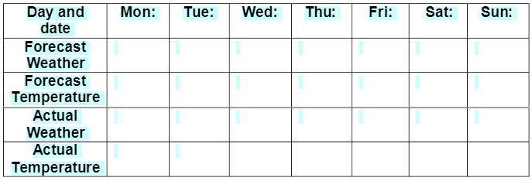

Self-check 3 | Written test

Name…………………………………………… ID………………………… Date…….
Directions: Answer all the questions listed below.

Test I: Choose the best answer (5 point)
  - Which one of the following main weather extremes that impacts irrigation
        - Drought
        - Sunlight
        - Sunlight
        - Air

  - Temperature and soil moisture determine one of the following.

A. length of growing period
B. The crop`s development and yield
C. Crop water requirements
D. All

  - Which one of the following is the upper air observation method?

Test II: Short Answer Questions (5 points)
  - List type of thermometer

  - Explain meteorological instruments

  - Mention preventive actions to minimize loss and damage due to weather

Operation Sheet 3

3.1. Techniques of observing your environment to determine the local weather condition without instrument.
Materials
- Pen
- Paper
- Notebook
Observe:
- Temperature (hot or cold?)
- Sunshine (sunny or cloddy)
- Cloud (fully covered or partial)
- Horizontal visibility (hazy, mist etc obscure or clearly visible)
- Wind (high windy or calm)

LAP TEST 3 | Perform recording weekly weather data/information

Name………………………………. ID…………………………….. Date…………………………………….

Time started: ________________________ Time finished: ________________

Instructions: Given necessary templates, tools and materials you are required to perform the following tasks within 1 hour. The project is expected from each student to do fundamentals that are various.
  - Materials
Pen
Note book
  - Perform recording weekly weather data/information
Temperature – minimum to maximum in degrees Fahrenheit;
- Humidity – minimum to maximum percentage of humidity;
- Sky cover – minimum to maximum percentage of sky cover;
- Chance of precipitation – minimum to maximum percentage chance of precipitation;
- Wind speed – minimum to maximum wind speed in miles per hour;
- Wind direction – direction of the prevailing wind.

Reference Materials
Gedney N, Cox PM, Betts RA, Boucher O, Huntingford C, Stott PA (2006) Detection of a direct carbon dioxide effect in continental river runoff records. Nature 439(7078):835–838
Genta JL, Perez-Iribarren G, Mechoso CR (1998) A recent increasing trend in the streamﬂow of rivers in southeastern South America. J Clim 11:2858–2862
IPCC (2018), “Annex 1: Glossary”, in Global Warming of 1.5°C, Masson-Delmotte, V. et al. (eds.), Intergovernmental Panel on Climate Change, Geneva.
IPCC (2021), Climate Change 2021: The Physical Science Basis. Contribution of Working Group I to the Sixth Assessment Report of the Intergovernmental Panel on Climate Change, Masson-Delmotte, V. et al. (eds.), Cambridge University Press, Cambridge, United Kingdom, and New York, in press.
IPCC .2014, Climate Change 2014: Impacts,Adaptation, and Vulnerability. Part A: Global and Sectoral Aspects. Contribution of Working Group II to the Fifth Assessment Report of the Intergovernmental Panel on Climate Change, University of Cambridge, Cambridge, United Kingdom, and New York.
Karl TR, Knight RW (1998) Secular trends of precipitation amount, frequency, and intensity in the USA. Bull Am Meteorol Soc 79:231–241
Karl TR, Knight RW (1998) Secular trends of precipitation amount, frequency, and intensity inthe USA. Bull Am Meteorol Soc 79:231–24134.
Katz RW (1999) Extreme value theory for precipitation: sensitivity analysis for climate change. Adv Water Resour 23:133–139
Katz RW (1999) Extreme value theory for precipitation: sensitivity analysis for climate change.Adv Water Resour 23:133–13932. Trenberth KE, Shea DJ (2005) Relationships between precipitation and surface temperature.Geophys Res Lett 32, L14703. doi:10.1029/2005GL02276033.
Lins HF, Michaels PJ (1994) Increasing U.S. streamﬂow linked to greenhouse forcing. Eos Trans Am Geophys Union 75:281, 284–285
Lins HF, Slack JR (1999) Streamﬂow trends in the United States. Geophys Res Lett 26:227–230. doi:10.1029/1998GL900291
McCabe GJ, Wolock DM (2002) A step increase in streamﬂow in the conterminous United States. Geophys Res Lett 29:2185–2188. doi:10.1029/2002GL015999
Milly PCD, Dunne KA, Vecchia AV (2005) Global pattern of trends in streamﬂow and water availability in a changing climate. Nature 438:347–350
Mote PW (2003) Trends in snow water equivalent in the Paciﬁc Northwest and their climatic causes. Geophys Res Lett 30:1601. doi:10.1029/2003GL017258
Regonda SK, Rajagopalan B, Clark M, Pitlick J (2005) Seasonal cycle shifts in hydroclimatology over the western United States. J Clim 18:372–384
Rudnick, D., S. Irmak, C. Ray, J. Schneekloth, M. Schipanski, I. Kisekka, A. Schlegel, J.Aguilar, D. Rogers, D. Mitchell, C. West, T. Marek, Q. Xue, W. Xu, D. Porter. 2017. Deficit Irrigation Management of Corn In The High Plains – A Review. Central Plains Irrigation Conference.
Semenov VA, Bengtsson L (2002) Secular trends in daily precipitation characteristics: green- house gas simulation with a coupled AOGCM. Clim Dyn 19:123–140
Semenov VA, Bengtsson L (2002) Secular trends in daily precipitation characteristics: green-house gas simulation with a coupled AOGCM. Clim Dyn 19:123–140
Stewart IT, Cayan DR, Dettinger MD (2005) Changes towards earlier streamﬂow timing across western North America. J Clim 18:1136–115
Strzepek K, McCluskey A (2007) The impacts of climate change on regional water resources and agriculture in Africa policy research working paper 4290. World Bank, Washington, DC
Trenberth KE, Shea DJ (2005) Relationships between precipitation and surface temperature. Geophys Res Lett 32, L14703. doi:10.1029/2005GL022760

AKNOWLEDGEMENT

Ministry of Labor and Skills and Ministry of Agriculture wish to extend thanks and appreciation to the many representatives of ATVET instructors and respective industry experts who donated their time and expertise to the development of this Teaching, Training and Learning Materials (TTLM).

The experts who developed the learning guide
No | Name | Qualification | Organization/ College | Mobile number | E-mail
1 | Serawit Gensa | Msc. Water Resource Engineering | W/Sodo AVET | 0916740916 | serawitgen@gmail.com
2 | Edao Hassen | Msc.Irrigation Engineering | Alage AVET | 0911098097 | hassedao@gmail.com
3 | Mekete Agizew | Msc. Water Resource Engineering | Amhara. Kombolcha ATVET | 0925221192 | gen.mam09@gmail.com
4 | Wondu Alemayehu | Msc.Irrigation Engineering | Oromia Kombolcha ATVET | 0910-28-99-61 | woldualem@gmail.com
5 | Ademe Ayalew | Msc.Irrigation Engineering | Agrafa AVET | 0912720547 | Ademe2004@gmail.com
6 | Said Mohammed | Msc.Irrigation& drainage Engineering | Alage ATVET | 09-17-18-01-81 | Siyamsdmhmmd@gmail.com/
7 | Molalign Asfaw | Bsc.Water Resource &Irrigation Engineering | Alage ATVET | 0921431096 | Mollalign410ass@gmail.com
8 | Yonas Hailu | Bsc.Water Resource &Irrigation Engineering | Agrafa AVET | 0934715578 | yonashailuw@gmail.com
9 | Lemessa Mulata | Msc. Irrigation Engineering | Agrafa AVET | 0913266845 | Lamimulle2022@gmail.com
10 | Misganew Yimer | Bsc. Soil and Water Engineering | Woreta ATVET |  | Misge1976@gmail.com
11 | Daniel Derese | Bsc. Soil and Water Engineering | W/sodo AVET | 0912-79-28-85 | danielderesse7@gmail.com
12 | Teshome Getachew | Msc.Irrigation & drainage Engineering | Alage ATVET | 0925-50-13-99 | teshomegetachew131@yahoo.com

