
Irrigation and Drainage
Level-I

Based on March 2022, Version 3 Occupational standard




Module Title: - Basic Soil Water Plant Relationships
LG Code: AGR IRD1 M09 LO (1-3) LG (28-30)
TTLM Code: AGR IRD1 TTLM 0822v1

August 2022
Addis Ababa, Ethiopia

Table of Contents

Table of Contents II
Introduction to the Module 1
LO #1- Physical property of soil 2
Instruction sheet 2
Information Sheet 1 3
Self-check 1 12
Operation Sheet -1 13
LAP TEST-1 16
LO #2- Soil- plant relationship 17
Instruction sheet 17
Information Sheet 2 18
Self-Check – 2 22
LO #3- Soil -Water relationship 23
Instruction sheet 23
Information Sheet 3 24
Self-Check – 3 32
Operation Sheet -3 33
LAP TEST-3 35
Reference Materials 36

Introduction to the Module
Water is introduced to the soil by an irrigation system, by a regulated water table, or by precipitation. It is stored in the soil matrix and then extracted by plant roots to meet the plant evapotranspirational (ET) needs. This module on soil plant-water relationships treats the physical properties of soils and plants that affect the movement, retention, and use of water and that must be considered in designing and operating systems for conservation irrigation. In planning and designing an irrigation system, the technician is concerned primarily with the water-holding capacity of a soil, particularly in the root zone of the plant; with the water-intake rate of the soil; with the root system of the crop to be grown; and with the amount of water that the crop uses. In addition, a working knowledge of all soil-plant water relationships is necessary in order to plan and manage efficiently the irrigation for particular crops grown on particular soils and in order to adjust the design to various conditions.
Soils function as a storehouse for plant nutrients, as habitat for soil organisms and plant roots, and as a reservoir for water to meet the evapotranspirational demands of plant communities. The amount of water that a soil can hold for plant use is determined by its physical and chemical properties. This amount determines the length of time that a plant can be sustained adequately between irrigations or rainfall events. This amount also determines the frequency of irrigation, the amount to be applied, and the capacity of the irrigation system needed for continuous optimum crop growth
Mineral soils are porous mixtures of inorganic particles, decaying organic matter, air, and water. They also contain a variety of living organisms. Physical and chemical weathering, with the translocation and the accumulation of various substances, give rise to a horizontal layering of the soil mass that is frequently visible in trenches and road cuts. Collectively, these horizons or layers are called the soil profile. The characteristics of the layers of the profile affect root growth and the retention and transmission of water in the soil. Two important physical properties of soils are texture and structure. Soil texture refers to the relative proportion of variously sized groups of mineral particles in a specific soil or horizon. Soil structure refers to the manner in which soil particles are arranged in groups or aggregates. Together, soil texture and soil structure help to determine the supply of water and air in a soil. The inherent characteristics of a soil may be adversely affected by soil compaction. Compaction can extensively modify soil aeration, water retention, transmission properties, root penetration, temperature relations, and the nutritional properties of a soil system.
LG #28 | LO #1- Physical property of soil

Instruction sheet
This learning guide is developed to provide you the necessary information regarding the following content coverage and topics:
- Soil types
- Soil characteristics
This guide will also assist you to attain the learning outcomes stated in the cover page. Specifically, upon completion of this learning guide, you will be able to:
- Identify tools and equipment used
- Identify Soil types
- Identify soil characteristics
Learning Instructions:
- Read the specific objectives of this Learning Guide.
- Follow the instructions described below.
- Read the information written in the information Sheets
- Accomplish the Self-checks
- Perform Operation Sheets
- Do the “LAP test”

Information Sheet 1

  - Soil types
A .Definition of soil
Natural body that occurs on the land surface that is characterized by one or more of the following:
  - Consists of distinct horizons or layers.
  - The ability to support rooted plants in a natural environment.
  - Upper limit is air or shallow water.
  - Lower limit is bedrock or limit of biological activity.
  - It is generally classified based on a typical 2m deep soil profile characteristics.

B. Soils are a three-phase system
A soil matrix consists of solid, liquid and gaseous phases (Fig 1). The solid phase is the soil matrix comprising mineral, organic matter and various chemical compounds. The liquid phase contains all the dissolved substances. Liquid phase also referred by the soil moisture or soil water or soil solution. The gaseous portion of the soil consists of soil air and it occupies those spaces between the soils particles which are not filled with water.
In a completely dry soil, all of the pore spaces (i.e., space between soil particles) are filled with air, and in a completely wet soil all of the pores are filled with water. However, in most of the field situations the pore spaces are filled with both air and water. Finally, soil water and air vary in composition, both in time and space.
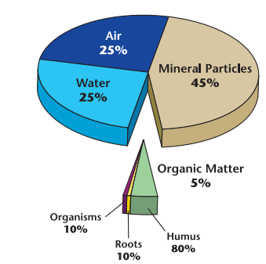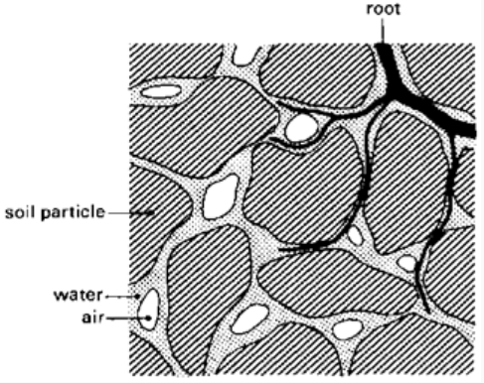
Figure1.1 Volume composition & sectional view of soil.

C. Soil types
Clay is also a fine-textured soil that usually forms very hard or extremely hard blocks or prisms. It is hard when dry, very sticky, and very plastic when moist; it ribbons very well and forms a very good fingerprint. Some clays are very firm or extremely firm when moist. Clay exhibits both cohesion (it sticks to itself) and adhesion (it sticks to other things).

Loam is a soil having a relatively even mixture of different grades of sand, silt, and clay. It is mellow with a somewhat gritty feel, yet fairly smooth and slightly sticky and slightly plastic. Dry aggregates are slightly hard or hard to break. When moist it will form a cast that can be handled without breaking. It stains fingers. When placed in water it turns the water cloudy.

Silt is a rare textural class that is not easy to find in nature. Silt feels quite floury and soft when dry. When moist it is greasy feeling and is neither sticky nor plastic.

Sand is loose and single grained. The individual grains can readily be seen and felt. Squeezed in the hand when dry, it will fall apart when the pressure is released. Squeezed when moist, it will form a cast (a mass that holds together), but will crumble when touched.

D. Tools and equipment
  - Hand or mechanical augers
  - Core sampler
  - Shovel
  - Oven
  - Sieves
  - Sensitive balance
  - Water bottle
  - Soil textural classification triangle
  - Plastic tray or bucket
  - Sampling bags

  - . Soil characteristics
- Soil Composition.
A unit of soil is a combination of solid material, composed of mineral and organic matter, and open space, called pores. By volume, most soils are roughly 50 % solids and 50 % pore space. The mineral matter makes up about 45 to 47 % of the total soil volume. This mineral matter consists of small particles of either sand, silt, or clay. Organic matter is made up of decaying plant and animal substances and is distributed in and among the mineral particles. Organic matter can account for up to about 5 % of the overall soil makeup by volume. The pores, spaces that occur between the mineral particles, are important because they store air and water in the soil. Figure 2 shows the approximate relationship between the substances in the soil composition, with the pore space shown split between air and water. The amount of water and air present in the pore spaces varies over time in an inverse relationship. This means that for more water to be contained in the soil there has to be less air.
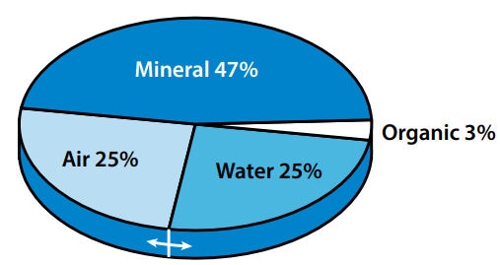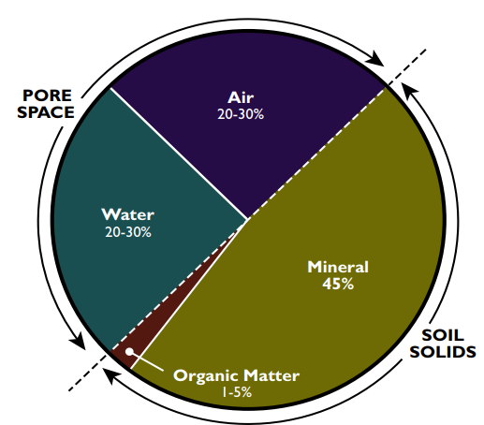

Figure 1.2 Typical soil composition by volume.

II. Soil Texture.
Texture is the relative proportions of sand, silt and clay in the soil. Generally, only particles smaller than 2 mm in size are categorized as soil particles.
The mineral particles in the soil are divided into the following size classes:
Coarse fragments larger than 2 mm (gravel, cobbles, stones)
Sand 0.05 to 2 mm
Silt 0.002 to 0.05 mm
Clay smaller than 0.002 mm

Soil texture is determined by the mass ratios or the percent by weight, of the three soil fractions. The soil textural triangle, Figure 3, shows the different textural classes and the percentage by weight of each soil fraction. For example, a soil containing 30 % sand, 30 % clay, and 40 % silt by weight is classified as a clay loam.

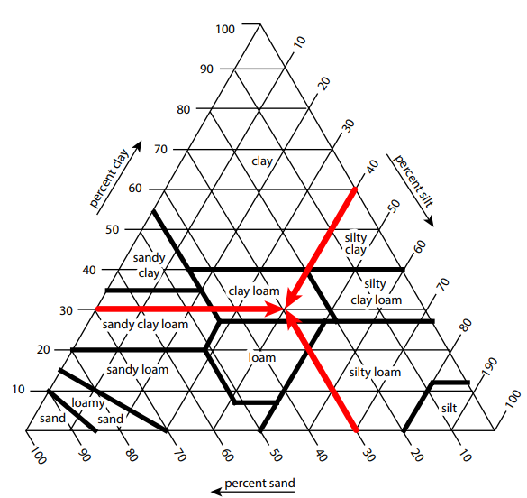
Figure 1. 3 A soil textural classification triangle, showing a clay loam soil composed of 30 % sand, 30 % clay, and 40 % silt.

- Soil Structure.
Soil structure is the shape and arrangement of soil particles into aggregates. Soil structure is an important characteristic used to classify soils and heavily influences agricultural productivity and other uses, such as load-bearing capacity for structures.

Soil structures are characterized into:
- Grade describes how strongly the aggregates hold together
- Type refers to shape and arrangement of aggregates
- Class refers to the size of the aggregates

- Grade. The terms used to describe grades are structureless (single grain or massive), weak, moderate and strong.
Structureless soils can be either single-grained (individual unattached particles, such as a sand dune) or massive (individual particles adhered together without regular cleavage, such as claypans or hardpans.) Soil structure is unstable and can change with weather conditions, biological activity, and soil management practices.
- Type: There are six types of structure, each with its own distinctive shape and arrangement.
- Granular - approximately spherical with no accommodation of faces to surrounding peds/ aggregates.
- Platy _with vertical dimension smaller with regard to horizontal dimensions; faces accommodate with those of adjacent peds/ aggregates.
- Prismatic - without rounded caps, vertical faces well defined and with angular vertices, vertical length relatively long with respect to horizontal dimensions; faces accommodate with those of adjacent peds/ aggregates.
- Columnar - with rounded caps, otherwise similar to the prismatic.
- Angular blocky - block like with all three dimensions of the same order of magnitudes, faces flattened, most vertices sharply angular; faces accommodate with those of adjacent peds/ aggregates.
- Sub angular blocky - similar to angular blocky but both rounded and flattened faces occur with many rounded vertices.
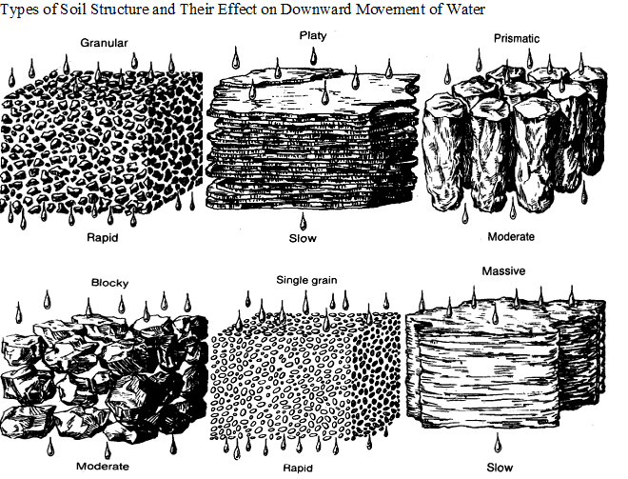
Figure 1.4 Some examples of soil structures

Aggregated soil types are generally the most desirable for plant growth.
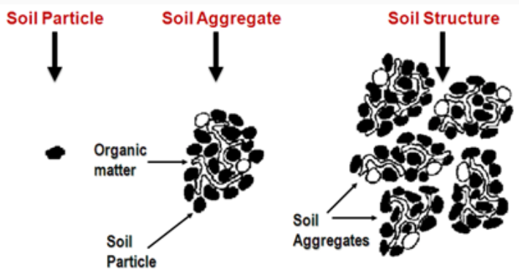
Figure 1.5 Soil structure

IV. Soil Bulk Density:
Soil bulk density expresses the ratio of the mass weight of dry soil to its total volume. The total volume includes both the solids and the pore spaces. Soil bulk density is important because it is an indicator of the soil’s porosity.

V. Porosity:
Porosity of a soil is defined as the volume of pores in a soil. A compacted soil has low porosity and thus a greater bulk density. A loose soil has a greater porosity and a lower bulk density.
Soil texture and structure inﬂuence porosity by determining the size, number and interconnection of pores. Coarse- textured soils have many large (macro) pores because of the loose arrangement of larger particles with one another. Fine-textured soils are more tightly arranged and have more small (micro) pores (Figure 6). Macropores in ﬁne-textured soils exist between aggregates. Because ﬁne-textured soils have both macro- and micropores, they generally have a greater total porosity, or sum of all pores, than coarse-textured soils.
Unlike texture, porosity and structure are not constant and can be altered by management, water and chemical processes.
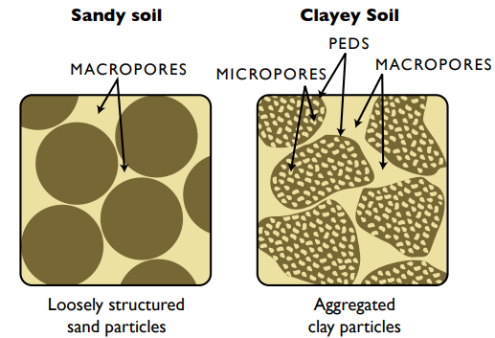
Figure 1.6. Generalized porosity in sandy and clayey soils.

VI. Organic matter
Organic matter consists of dead plants, animal, microbes and fungi or their parts, as well as animal and microbial waste products in various stages of decomposition. Eventually, all of these break down into humus, which is relatively stable in the soil.
a) Forms of organic matter
b) Importance of organic matter: Although organic matter makes up a minor part of the soil, it has a very strong impact on a number of factors
- Structure
Organic matter acts like glue that helps hold soil aggregates together. These will hold even upon wetting.
- Available Water Capacity (AWC)
Organic matter helps bind water to the soil, keeping it from being lost through percolation and making it available to plants for uptake. This is especially important in sandy soils.
- Cation Exchange Capacity (CEC)
Like clay particles, organic matter particles have a negative charge and thus attract, hold, and release cations necessary for plant growth and reproduction
- Binding plant toxins

VII. Color Soil
Color varies with parent material, how long the soil has been forming, and the environment itself
a) Describing soil color Soil color is described using Munsell Color Notation (show Munsell Soil Color Book). The notation breaks soil color into hue (the particular color), value (how light or dark the color is), and chroma (how washed out or intense it is).
b) Meaning of soil color
- Drainage and wetness (also called “redoximorphic features”) (show samples) Greenish, bluish, and gray colors in the soil indicate wetness.
- Organic matter Dark colors in the soil usually indicate organic matter. However, they may also indicate wetness (remember, wetter soils can accumulate more organic matter).

VIII. Soil depth
Soil depth determines how far the roots can grow and how much water the soil can hold. Depth is measured to the shallowest root-limiting layer.
a) Factors that can limit soil depth:
- Bedrock
- Hardpans
- Water tables

IX. Soil temperature
Soil temperature is important to growers, especially for spring planting. Many seeds need a certain minimum temperature for germination.
a) Factors influencing soil temperature
- Local climate: Soil temperature is highly correlated to air temperature
- Slope steepness and aspect:
- Topography:
- Cover:
- Soil color
- Horticultural practices:
b) Soil temperature influences on soil properties
- Biological activity:
- Organic matter accumulation:
- Weathering of parent materials:
- Nutrient availability:
X. Drainage
Soil drainage is a way of expressing the frequency and duration of periods in which the soil is saturated (has free water or water in excess of field capacity). Excess free water in the root zone can kill plants or keep them from becoming established.
a) Drainage classes:
b) Factors that affect drainage
- Soil texture (coarser soils tend to drain more rapidly)
- Soil depth (shallow soils tend to drain more rapidly)
- Precipitation (areas with greater rainfall may drain more slowly)
- Topography (soils on level ground may drain more slowly

XI. Permeability and infiltration
a) Rate at which water moves through the soil
Permeability is the rate at which water moves down through the soil. It is usually measured in inches per hour. Infiltration is the rate at which water enters the soil. It is similar to permeability, except that it also takes into account surface conditions such as soil crusting. Permeability and infiltration affect the rate at which you can safely apply water to the field.
b) Measurement Permeability is normally measured in inches per hour or mm/hour
c) Properties influencing permeability and infiltration
- Texture
- Structure
- Dryness
- Slope

XII. Water holding capacity
The maximum amount of water that the soil can hold that is available for plant growth. It is the difference between the amount of water in the soil at field capacity and the amount of water in the soil at wilting point. It is also referred to as Available Water Capacity (AWC) and as Plant Available Water (PAW).

Self-check 1 | Written test

Name…………………………………………… ID………………………… Date…….
Directions: Answer all the questions listed below.

Test I: Choose the best answer (4 point)
1. Of the soil separates listed below, which has the smallest particle size?
a. Sand b. Silt c. Clay
2. Which one of the following is not considered one of the major constituents of soil?
a. Chemical b. Mineral c. Organic matter
3. A soil that has a balanced amount of sand, silt and clay has which one of the following for a texture?
a. Platy b. Loam c. Silt d. Granular
4. Of the following, which is the best to add to a clay soil to help offset the negative effects of the clay?
a. Sand b. Silt c. Organic matter d. Sodium salts
5. Which of the following influence the available water-holding capacity of the soil?
a. Texture b. Structure c. Organic matter d. Salts e. a, b and c f. a, c, and d

Test II: Short Answer Questions
- What soil structure is most desirable for gardening?
- Use a soil textural class triangle to determine the soil texture for the following combinations of sand, silt and clay
a) 25% sand, 30% silt, 45% clay
b) 40% sand, 30% silt, 30% clay
c) 60% sand, 10% silt, 30% clay
- What is soil structure?
- Write common types of soil structure

Operation Sheet -1

- Techniques/Procedures/Methods of Soil Composition Ribbon Test
- Tools and equipments
- Auger
- Water bottle
- Shovel
- Note book & marker

- Procedures/Steps/Techniques
- Take a small handful of soil and dampen it enough so that it sticks together but is not oozy. It should have a similar consistency to plasticize or putty.
- Roll it around in your hands and work your way through the following flowchart to identify the soil type:
Flow chart for determining textural class.
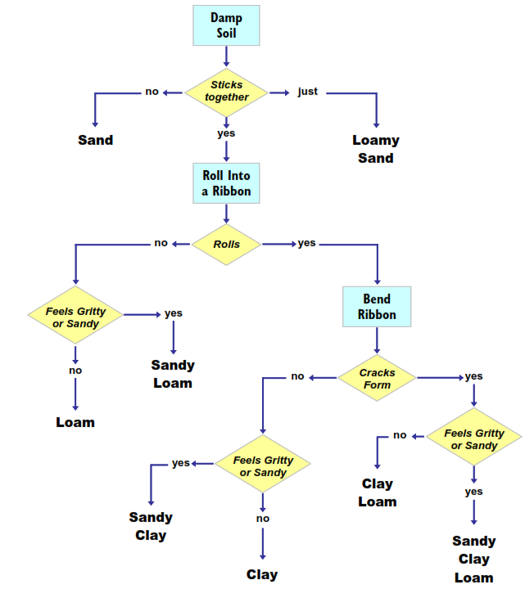
.
- .Techniques/Procedures/Methods of Soil color determination
- Tools and equipments
- Soil color charts (e.g., Munsell Color, 2000)
- Water bottle
- Water
- Procedure (Munsell Color, 2000)
- Take a lump of soil from the layer/horizon to be described and break it to expose a fresh face.
- If soil is dry, moisten (without glistening) the face by adding water drop by drop.
- Stand with the sun over your shoulder, allowing the sunlight to shine on the color chart and soil sample.
- Estimate Munsell notation by holding soil sample behind apertures separating the closest matching color chips. Determine color for both dry and moist samples.
- Use enclosed masks to determine color matches.
- Record Munsell notation as Hue Value/Chroma or symbolically H V/C (e.g., 10YR 5/8).
- Report Munsell notation as Hue Value/Chroma for soil along with moisture state (dry, moist).
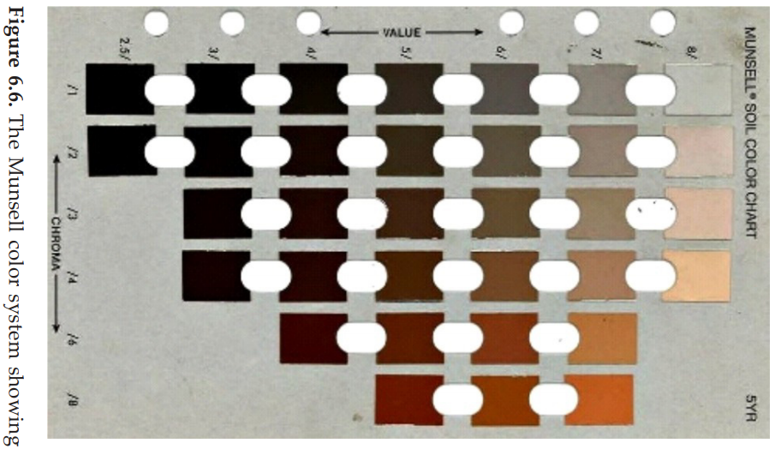
LAP TEST-1 | Performance Test

Name………………………………. ID…………………………….. Date…………………………………….

Time started: ________________________ Time finished: ________________

Instructions: Given necessary templates, tools and materials you are required to perform the following tasks within 1 hour. The project is expected from each student to do it.

Task1: Testing what type of soil you are working with involves moistening the soil and rolling it into a ball to check the predominating soil.
Task 2: Identify soil physical properties

LG #29 | LO #2- Soil- plant relationship

Instruction sheet
This learning guide is developed to provide you the necessary information regarding the following content coverage and topics:
- Soil conditions
- Soil characteristics affect plant growth and development
- Effect of soil structure on plant

This guide will also assist you to attain the learning outcomes stated in the cover page. Specifically, upon completion of this learning guide, you will be able to:
- Identify soil conditions
- Identify soil characteristics affect plant growth and development
- Determine effect of soil structure on plant

Learning Instructions:
- Read the specific objectives of this Learning Guide.
- Follow the instructions described below.
- Read the information written in the information Sheets
- Accomplish the Self-checks
- Perform Operation Sheets
- Do the “LAP test”

Information Sheet 2

- Soil conditions
I. Soil aggregate stability
The structure of soil can be a highly dynamic property, governed by a range of soil properties and external stresses. Freshly tilled seedbeds, for instance, can change over time as the tilth coalesces due to raindrop impact, fluctuations in soil water content and compaction from machinery.

In a given soil, the quantity, quality and distribution of carbon are the major variables controlling stability in addition to the amount of clay minerals and their mineralogy. With the massive losses in carbon experienced in many managed soils, particularly those under arable production, declines in soil stability are posing a major threat to the environment and crop productivity

Good soil management strives to maintain or increase the range of water contents available for tillage. The major variables influencing the size of the range of water contents are organic matter and pore structure. Both of these properties can be degraded through intensive soil cultivation that enhances carbon mineralization, disrupts aggregates and decreases their stability and mechanically deforms the soil through wheel damage or the action of an implement

II. Availability of nutrients and water
The supply of water and nutrients to support plant growth critically depends on uptake from the soil across root membranes, so any factor that impedes plant root growth will impact water and nutrient uptake and apparent soil fertility. The rate of supply of nutrients to any root depends on the rates of mass flow and diffusion, but of critical overall importance for water and nutrient uptake is the distribution of roots within the soil, i.e. the total surface area over which uptake can occur. Root growth shows responses and interactions with a range of chemical, physical and biological factors in the soil. In turn, many of these interact and plants are often able to compensate, so that restricted root growth in one part of the soil may be compensated for by increased growth in other regions that are less constrained. The ability of the plant root to find space in which to extend through the soil is often an important factor limiting plant growth. The preparation of seedbeds with a good structure (‘tilth’) and consequent network of pores, holding the right balance of air and water appropriate to the seed to be sown.

III. Soil PH
The degree of soil acidity or alkalinity, expressed as soil pH, is a master variable that affects a wide range of soil properties. Soil pH greatly influences the availability for plant roots to take up nutrients and toxins. Soil pH also affects soil microbial activity and influences what plant
species can grow at a particular site. Soil pH affects the mobility of many pollutants in soil by
influencing the rate of biochemical breakdown, solubility, and adsorption to colloids. Acids can
build-up to such high concentrations in soils, typically associated with mine tailings, that the acid itself is considered a pollutant. Soil pH also influences soil structure by dispersing or
stabilizing clays. At low pH fungi dominate, fungi cause soils to form large soil aggregates. At
high pH clays are dispersed and the soil has little or no structure. Remember that structure in
part controls the movement of air and water into and through the soil profile.

IV. Organic matter
Soil physical properties are determined to a very great extent by soil texture but it has been well known for centuries that they are strongly modified by organic matter. For example, OM increases water holding capacity, facilitates the formation of stable aggregate, increases formation of stable pore spaces that improve aeration and make root penetration easier.

It is the presence of organic matter that makes the difference between a collection of mineral particles and a functioning soil with a recognizable physical structure that provides a suitable medium for plant growth. Soils often contain only a small quantity of organic matter (typically a few per cent by mass in agricultural soils), yet this has a major influence on soil properties. For example, organic matter is a key factor determining the interactions between mineral particles and thus the formation of aggregates of varying size and stability and the distribution of spaces (pores) between the solid particles that may be filled with either air or water. This physical structure, relying in large part on the quantity and type of organic matter, determines whether or not a soil retains water, whether it becomes flooded or is well drained, whether it becomes easily compacted or retains a structure conducive to root growth.
Organic matter also provides substrate for soil organisms and, often, anchorage points for bacteria or fungi. Interactions between organic matter, organisms and mineral particles form the basis for nutrient transformations on which all plant growth depends. Organic matter is a reservoir of many plant nutrients (such as N, P and S) and also provides a substantial part of the soil’s cation exchange capacity (CEC), which is important for the retention of many nutrients.

- Soil characteristics affect plant growth and development
The performance of plants is affected considerably by the soil physical environment. High-quality soil is characterized by a porous structure that drains well but stores water to support plants, breaks up easily and allows roots to elongate so that they can capture nutrients and water. If soil is damaged through compaction or drains poorly, the yield of crops can decrease.

Soil structure is the physical framework in which all soil processes occur. The arrangement of solids, gases, liquids, voids, organic matter and organisms defines soil structure. It thus has a large influence on the capacity of plant roots to grow through soil, extract water and nutrients, exchange gases and interact with other plants, herbivores and pathogens.

Bulk density of soil is influenced by soil texture, structure, organic matter content and land management practices. Increase in organic matter content decreases the bulk density of soil. The bulk density is usually higher with the depth of the soil.

Therefore, lower value of bulk density of soil is good for optimum growth of plants because at this point of soil conditions, soils are believed to be provided with proper aeration and drainage resulting in optimum root and microbial proliferation in soils which help to greater absorption of water and nutrients by plants.

- Effect of soil structure on plant
Soil structure is the important physical properties that can greatly affect a variety of soil physical processes viz. porosity, density, aeration, water holding capacity, infiltration, permeability, movement of water, thermal conductivity etc.
Different soil management practices like, tillage, crop cultivation, application of fertilizers and manures, amendments (lime/gypsum), application of irrigation water have the ability to moderate soil structure which in turn affects root growth, uptake of nutrients and water, plant growth and yield by influencing other soil properties.
Soil structure is not a plant growth factor, in-spite of that, all plant growth factors are affected by soil structure. Soil structure has a pronounced effect on soil erosion. Usually, if the soil aggregation is more than the erodibility will be less. Soil structure also affects the supply of water to plants particularly in soils having spheroidal type of crumb sub-type structure which is especially porous consisting of micro pores paces.
Soil structure influences the availability of plant nutrients by moderating redox potential which is related to soil aeration, supply of water, organic matter content and microbial activity.
But in case of platy type of poorly aggregated structure, the germination of seeds, root penetration and growth, proliferation of micro-organisms, aeration, movement of water etc. are very poor and limited and hence affect the plant growth and crop production.
Therefore, for the optimum growth of plants, the most desirable soil structure is spheroidal type compared to other types. Soil structure has both direct and indirect effects on plant growth.
In case of its direct effects, seedling emergence on crusted soils, restriction of root development particularly of hard surface soils, inhibition of root penetration on compacted soils etc. are found. In addition to the direct effects of soil structure on expansion of plant parts, various indirect effects may be of significance.
Because of roots commonly occurs between structural units and not within them, the size of the structural units may affect the rate of delivery of nutrients and water from interior parts to the roots at the surfaces. Air-water relationships are sensitive to the size and continuity of pores. Structural modifications most easily effected in soils result in changes in volume percentage of large or non-capillary pores.

Self-Check – 2 | Written test

Name…………………………………………… ID………………………… Date…….

Directions: Answer all the questions listed below.

Test I: Multiple choice
1. Soil structure affect a variety of soil physical processes
a) porosity b) water holding capacity c) infiltration d) thermal conductivity e) all
2. Soil pH also affects:
a) availability of nutrients and toxins taken up by plant root b) soil microbial activity c)
3. Bulk density of soil is influenced by soil texture, structure, organic matter content and land management practices.
a) True b) False
4. Organic matter plays an important role as it:
a) increase water holding capacity b) facilitates the formation of stable aggregate c) increases formation of stable pore spaces d) a, b and c
5. The performance of plants is affected considerably by the soil physical environment
a) True b) False

Note: Satisfactory rating - 5 points Unsatisfactory - below 5 points

You can ask you teacher for the copy of the correct answers.

You can ask you teacher for the copy of the correct answers.

LG #3 | LO #3- Soil -Water relationship

Instruction sheet
This learning guide is developed to provide you the necessary information regarding the following content coverage and topics:
- Soil Water Contents
- Soil Water Tension
- Water quality
- Plant water use
This guide will also assist you to attain the learning outcomes stated in the cover page. Specifically, upon completion of this learning guide, you will be able to:
- Measure soil water content
- Measure soil water tension
- Estimate plant water use
- Test soil water quality
Learning Instructions:
- Read the specific objectives of this Learning Guide.
- Follow the instructions described below.
- Read the information written in the information Sheets
- Accomplish the Self-checks
- Perform Operation Sheets
- Do the “LAP test”

Information Sheet 3

- Soil water contents
Soil and Water Interactions
Soil acts like a reservoir that holds water and nutrients plants need to grow. Some soils are large reservoirs with more holding capacity that release water and nutrients easily to plants, while other soils have limited reservoirs and releasing capacity.

A soil system consists of a framework of solid material enclosing a complex system of pores and channels, which provide space within the soil for air and water. This can be best explained by taking the soil systems as a simple reservoir, which contains solids (soil particles), liquid (water), and gas (air).

Soil moisture refers to the relative water content in the soil. It can be expressed in the form of:
- Dry -weight basis
- Volumetric basis
- Depth basis

3.1.1. Measurement of soil water/moisture
The most commonly used methods for determination of soil moisture status are:
- Gravimetric method (soil sampling or oven dry method)
In this method, known volume of soil samples are taken from the field, weighed, and then dried in an oven for 24hours at an average temperature of 105 ⁰c.
After dried, the samples will be taken out from the oven and weighed again. The difference in weight before and after drying is the amount of moisture present in the soil. i.e.
M= M_{wet} – M_{dry} x 100
M_{dry}
Gravimetric method is an accurate method but time consuming. Moreover, the method is not practical for farm use, as the oven cannot ordinarily be owned by farmers. But it is a standard against which other methods of moisture determination are compared.

b) Touch & feel Method
This is a rough but quick method and needs no equipment. It may be used as a check on more sophisticated methods.

c) Tensiometers
It is an instrument consists of a porous cup filled with water and connected by a continuous water column to a vacuum-measuring device, either a gage or manometer. The cup is placed in the soil at the desired depth, and measurements are read above ground on the vacuum indicator.
This instrument only measures soil moisture tension. And, therefore, a moisture characteristic curve for each soil is needed to convert moisture tension measurements into available moisture percentages.

3.1.2. Soil water classification
The purpose of irrigation is to keep a soil water condition in the root zone that doesn't greatly restrict plant growth or we may say, to maintain a water condition that is 'comfortable' for the plants. The water comfort of plants doesn't depend as much on the quantity of water present in the soil but it does on the water potential. That is, how easily the soil water is absorbed by root of plants or it refers how the water is held by soil particles. Accordingly, the moisture in the soil can be classified into three classes. These are gravitational (free) water, Capillary water and hygroscopic water

(a) Gravitational (free) water
It is the water in the large pores that moves downward freely under the influence of gravity and is hence called gravitational or free water. It drains out from the soil rapidly. Therefore, it is not normally included in the amount available to plants. The upper limit or maximum level of gravitational water is when the soil is saturated.

(b) Capillary water
When the supply of water to the soil is cutoff, the large pores are emptied and filled with air; water in the small pores moves because of capillary forces and is called capillary water. It is the amount of water retained by the soil after gravitational water has drained out. Capillary water is the major source of water available for the plant and moves in the direction of greatest tension or low potential.

(c) Hygroscopic water
Hygroscopic water: the water that an oven dry sample of soil absorbs when exposed to moist air is termed as hygroscopic water. It is held as a very thin film over the surface of the soil particles and is under tremendous negative (gauge) pressure. This water is not available to plants.

3.1.3. Soil water constants
For a particular soil, certain soil water proportions are defined which dictate whether the water is available or not for plant growth. These are called the soil water constants, which are described below.
I. Saturation capacity:
It is the total water content of the soil when all the pores of the soil are filled with water. It is also termed as the maximum water holding capacity of the soil. At saturation capacity, the soil moisture tension is almost equal to zero.
II. Field capacity (FC)
This is the water retained by an initially saturated soil against the force of gravity. Hence, as the gravitational water gets drained off from the soil, it is said to reach the field capacity. At field capacity, the macro-pores of the soil are drained off, but water is retained in the micropores. Though the soil moisture tension at field capacity varies from soil to soil, it is normally between 1/10 (for clayey soils) to 1/3 (for sandy soils) atmospheres.
III. Permanent wilting point (PWP)
Plant roots are able to extract water from a soil matrix, which is saturated up to field capacity. However, as the water extraction proceeds, the moisture content diminishes and the negative (gauge) pressure increases. At one point, the plant cannot extract any further water and thus wilts.

Soil that has been oven dried is used as a reference point for determining soil water content.
When the soil is oven dried, all soil water has been removed from the soil. The amount of water at any soil-water content varies by soil type. Specific water-holding capacities can be obtained from various sources. Figure 3.1 illustrates typical amounts of water held at the defined soil water content for sand, loam, and silty clay loam soils. The reasons for the differences between soil types is explained in the next sections.
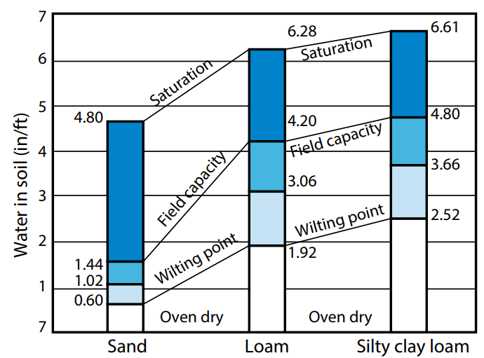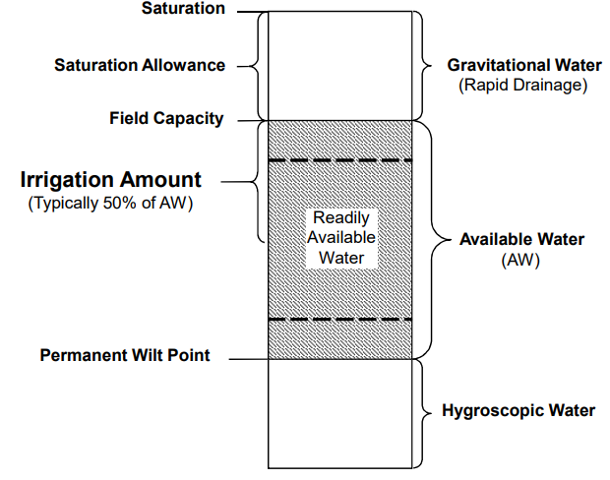
Figure 3.1. Typical soil water content within three soil textures.

How Soil Holds Water.
Soil holds water in two ways: (1) as a thin film on individual soil particles and (2) as water stored in the pores of the soil. Water stored as a thin film on individual soil particles is held in place by adsorption forces.
Adsorption involves complex chemical and physical reactions but in simple terms, a thin film of water adheres to the outside layers of soil particle molecules. Water stored in the pores of the soil is stored by capillary forces.
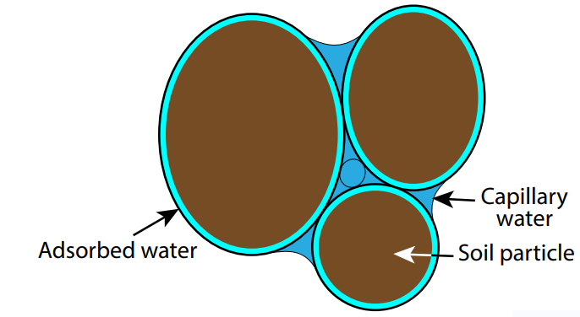
Figure 3.2 How soil holds water

- Soil Water Tension
The ease by which water can be extracted from the soil depends on the soil water tension, also known as the soil water potential. These are equivalent values, except for the sign (negative vs. positive), which might be thought of as either a push or a pull on the water.
Water being held in pores by the capillary storage is held in the soil at a certain tension. The same is true for water held with the adsorption phenomenon. As the soil dries, these tensions become larger. It is easier for a plant to extract water being held at lower tensions.

A soil water retention or soil water characteristic curve illustrates the tension relationship (Figure 3.3). These curves are slightly different for different types of soils due to different soil textures and structures.
Water between the field capacity and the wilting point is water available to the plant. Best plant growth and yield for most field crops occur when the soil water content remains in the upper half of the plant available soil water range, which is sometimes referred to as readily available soil water.
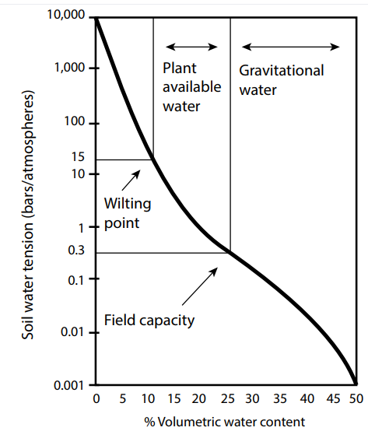
Figure 3.3. The relationship between soil water content and soil water tension for a loam soil type.

Soil water potential is a measure of the energy status of the soil water. Water flows from a greater potential area to an area of less potential. The units of measurement are normally either bars or atmospheres. What can be confusing is that soil water potentials are negative pressures that are also expressed as tension or suction. In this case, water flows from greater (less negative) potential to a lesser (more negative) potential. Plants develop the tension, or potential, to move water from the soil into the roots and distribute the water through the plant by adjusting the water potential, or tension, within their plant cells. Water potential is made up of several components, but one of particular importance is the osmotic or solute potential. Solute potential is due to the presence of dissolved solutes, such as sugars and amino acids, in the plant cell.
For water to move from soil, into roots, into stems, into leaves, and finally into air, the water potential must always be decreasing. This is illustrated in Figure 3.4, moving from the greater water potential soil (less negative) to the lower water potential air (more negative). The water potential in air is always low as compared to plants, so water movement is toward the air through the plants. However, plants are limited in the amount of adjustment they can make.
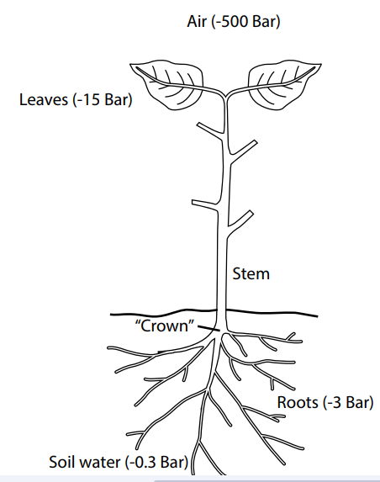
Figure 3.4. Illustration of decreasing water potential to move water from the soil to the atmosphere through a plant.

- Water quality
Another factor on the amount of soil water available to the plant is the soil and water quality. For good plant growth, a soil must have adequate room for water and air movement, and for root growth. A soil’s structure can be altered by certain soil management practices. For example, excessive tillage can break apart aggregated soil and excessive traffic can cause compaction. Both of these practices reduce the amount of pore space in the soil, reducing the availability of water and air, and reducing the room for root development.

The quality of the water is also important to plant development. Irrigation water with a high content of soluble salt is not as available to the plant, so greater soil water content must be maintained in order to have water available to the plant. Increasing salt content of the water reduces the potential to move water from the soil into the roots. Some additional water would also be needed to leach the salt below the crop root zone to prevent salt build up in the soil. Poor quality water can affect soil structure.

- Plant water use
- Use of Water by Plants
A plant’s root system must provide a negative tension (pressure) to extract water from the ground. This tension must be equivalent to the tension that holds the water in the soil. For example, if the water in the soil is at 0.3 bars (around field capacity), the plant must provide at least 0.3 bars of negative tension to pull the water from the ground.
At the wilting point, the maximum negative tension that a plant can provide is balanced by the soil water tension. At this point, the plant can no longer extract water from the soil and will be under severe stress to the point of death. There are several factors that determine when and where a plant uses water, and how much water a plant will use. These factors include daily plant water need as influenced by climatic conditions and stage of growth, plant root depth, and soil and water quality.

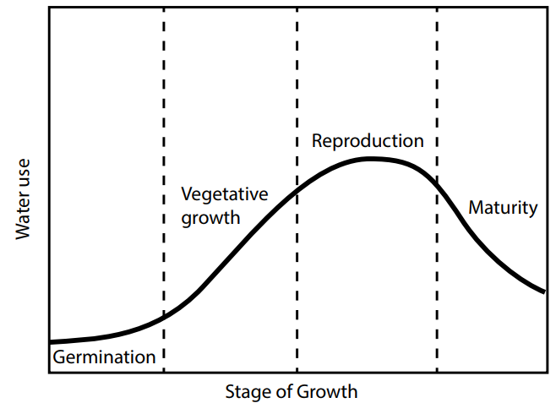
Figure 3.5. Typical plant water-use curve by stage of growth

- Plant Water Need.
A plant has different water needs at different stages of growth. While a plant is young, it requires less water than when it is in the reproductive stage. As a plant approaches maturity, its water needs drops. Curves have been developed that show the daily water needs for most types of crops.

- Plant Root Depth.
A plant’s root depth determines the depth to which soil water can be extracted. A young plant with only shallow roots will not have access to soil water deeper than its rooting depth. Plants typically extract about 40 percent of their water needs from the top quarter of their root zone, then 30 percent from the next quarter, 20 percent from the third quarter, and taking only 10 percent from the deepest quarter, as illustrated in Figure 3.6. Therefore, plants will extract about 70 percent of their water from the top half of their total root penetration. Table 2 shows the depth of root penetration and 70 percent water extraction for several common field crops.

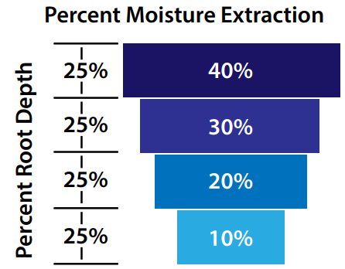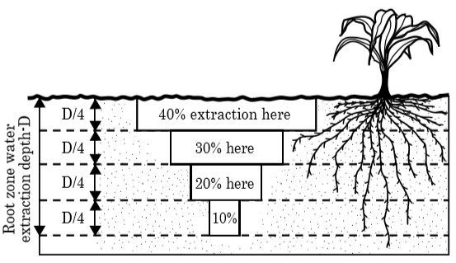
Figure 3.6. Generalized crop water extraction by depth of root zone for a non-layered and unrestricted soil profile.

Deeper portions of the root zone can supply a higher percentage of the crop’s water needs if the upper portion is largely depleted. However, reliance on use of deeper water reduces optimum plant growth. For irrigation scheduling purposes, the total potential plant root zone is not used. Instead, a managed root zone depth of no more than 4 feet is recommended. Applying water to deeper depths subjects the irrigation to higher potential for deep percolation losses. The managed root depth may be much less than 4 feet if soils have restrictive layers that prevent root penetration.

Table 3.1. Depth of root penetration and 70% of their water extraction for several common field crops.

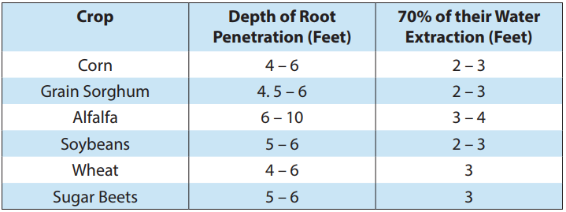

Self-Check – 3 | Written test

Name…………………………………………… ID………………Date…….

Directions: Answer all the questions listed below.

Test I: Multiple choice
1. The water that can be utilized by the crop from the soil is called:
a) field capacity water b) capillary water c) hygroscopic water
2. Permanent wilting moisture content for a plant represents the:
a) Hygroscopic water b) capillary water c) field capacity water
3. The most commonly used methods for determination of soil moisture status are:
a) gravimetric method b) touch and feel c) tensiometer d) none
4. Water between the field capacity and the wilting point is:
a) total available water b) readily available water c) capillary water
5. The ease by which water can be extracted from the soil depends on the soil water tension.
a) False b) True

Note: Satisfactory rating - 5 points Unsatisfactory - below 5 points

You can ask you teacher for the copy of the correct answers.

You can ask you teacher for the copy of the correct answers.

Operation Sheet -3

- Techniques/Procedures/Methods of soil moisture measurement
- Tools and equipment
- Core sampler
- Plastic hammer
- Sensitive Balance
- Spade
- Pickaxe
- Caliper
- Oven dry
- Note book
- wooden block etc.

- Procedures/Steps/Techniques of Gravimetric method
- Select and decide the sampling location
- Carefully clear all residue from sampling area
- Take a soil sample in which the moisture content to be determined is taken from the field using the core sample form.
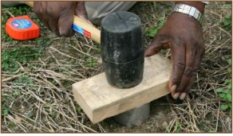
Figure 3.7 Drive ring depth.
- A soil samples should be taken from the soil profile up to a depth of 0-30 cm, 30-60 & 60-90 cm from different spot to ensure representativeness.
- Remove ring by cutting around the outside edge with a knife and using the small folding trowel underneath of it and carefully lift the ring out preventing loss of soil by holding trowel under it.
- Remove excess soil from the bottom of cylinder with serrated sharp knife as shown in Figure
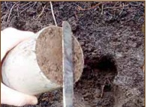
Figure 3.8 Remove excess soil from bottom of ring
- Weight the sample container along with the soil sample before drying and record the weight.
- Place the sample in an oven dry for 24 hours at 105 º C.
- Weigh the dry weight of the soil sample with container.
- Calculate moisture content from the dry and wet weights of the soil as:
$$=\frac{weight of water evaporate}{dry weight sample}*100$$

$$=\frac{(W1-W3)-(W2-W3)}{W2-W3)}*100$$
$$=\frac{(W1-W2)}{ (W2-W3)}*100$$
Where: W1- Fresh weight of soil sample with container (gm);
W2- Oven dry weight of soil sample with Container (gm);
W3- Empty weight of the container (gm)

LAP TEST-3 | Performance Test

Name………………………………. ID…………………………….. Date…………………………………….

Time started: ________________________ Time finished: ________________

Instructions: Given necessary templates, tools and materials you are required to perform the following tasks within 1 hour. The project is expected from each student to do it.

Instructions:-
You are requested to perform the following activities:-
Task 1: Prepare tools, Materials and equipment for measuring soil moisture content and bulk density
Task 2: Take soil sample from field.
Task 3: Determine soil moisture content
Task-4 Determine bulk density

Reference Materials

Books:
Rogers, D.H. and M. Alam. 2007. What is ET? An evapotranspiration primer. Kansas State University Research and Extension. Irrigation Management Series, MF-2389 rev. 4 pp.
Rogers, D.H., P.L. Barnes, J. Aguliar, I. Kisekka, and F. Lamm. 2014. Agricultural Crop Water
Use. Kansas State University Research and Extension. Irrigation Management Series, L934

Web addresses
https://www.ksre.k-state.edu/irrigate/reports/L904.pdf accessed date 25/08/2022.
https://www.soilmanagementindia.com/soil-condition/soil-and-plant-growth/2905 accessed date 26/08/2022.
https://www.soilmanagementindia.com/plant-nutrients/environmental-factors-thatinfluence-plant-growth/2584 accessed date 26/08/2022.
https://smallgrains.wsu.edu/soil-structure-critical-for-soil-stability-and-crop-production/ accessed date 26/08/2022.
https://smallgrains.wsu.edu/soil-structure-critical-for-soil-stability-and-crop-production/
https://theconstructor.org/geotechnical/soil-structures-types/21354/#google_vignette accessed date 26/08/2022.
https://www.epa.nsw.gov.au/about-us/publications-and-reports/state-of-theenvironment/state-of-the-environment-2015/10-soil-condition accessed date 26/08/2022
https://sanangelo.tamu.edu/extension/agronomy/agronomy-publications/how-to-estimate-soil-moisture-by-feel/ accessed date08/29/2022
https://extension.umd.edu/resource/soil-testing-and-soil-testing-labs accessed date 30/8/2022

AKNOWLEDGEMENT

Ministry of Labor and Skills and Ministry of Health wish to extend thanks and appreciation to the many representatives of TVET instructors and respective industry experts who donated their time and expertise to the development of this Teaching, Training and Learning Materials (TTLM).

The experts who developed the learning guide
No | Name | Qualification | Organization/College | Mobile number | E-mail
1 | Serawit Gensa | Msc. Water Resource Engineering | W/Sodo AVET | 0916740916 | serawitgen@gmail.com
2 | Edao Hassen | Msc.Irrigation Engineering | Alage AVET | 0911098097 | hassedao@gmail.com
3 | Mekete Agizew | Msc. Water Resource Engineering | Amh/Kombolcha ATVET | 0925221192 | gen.mam09@gmail.com
4 | Wondu Alemayehu | Msc.Irrigation Engineering | Or/Kombolcha ATVET | 0910-28-99-61 | woldualem@gmail.com
5 | Ademe Ayalew | Msc.Irrigation Engineering | Agrafa AVET | 0912720547 | Ademe2004@gmail.com
6 | Said Mohammed | Msc.Irrigation& drainage Engineering | Alage ATVET | 09-17-18-01-81 | Siyamsdmhmmd@gmail.com/
7 | Molalign Asfaw | Bsc.Water Resource &Irrigation Engineering | Alage ATVET | 0921431096 | Mollalign410ass@gmail.com
8 | Yonas Hailu | Bsc.Water Resource &Irrigation Engineering | Agrafa AVET | 0934715578 | yonashailuw@gmail.com
9 | Lemessa Mulata | Msc.Irrigation Engineering | Agrafa AVET | 0913266845 | Lamimulle2022@gmail.com
10 | Misganew Yimer | Bsc. Soil and Water Engineering | Woreta ATVET |  | Misge1976@gmail.com
11 | Daniel Derese | Bsc. Soil and Water Engineering | W/sodo AVET | 0912-79-28-85 | danielderesse7@gmail.com
12 | Teshome Getachew | Msc.Irrigation & drainage Engineering | Alage ATVET | 0925-50-13-99 | teshomegetachew131@yahoo.com

