Irrigation and Drainage
Level-I
Based on March 2022, Version 3 Occupational standard

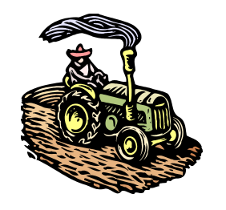

Module Title: IRRIGATION AND DRAINAGE WORKS
LG Code: AGR IRD1 M11 LO (1-4) LG (34-37)
TTLM Code: AGR IRD1 TTLM 0822v1

August, 2022
Addis Ababa, Ethiopia

Table of Contents

Introduction to Module 1
LO#1-Materials, Tools and equipment 2
Instruction sheet 2
Information Sheet 3
Self-check 1 12
Operation Sheet -1 13
LAP TEST-1 14
LO#2. Irrigation and drainage work 15
Instruction sheet 15
Information Sheet-2 16
Self-Check – 2 22
Operation sheet-2 24
LAP TEST-3 25
LO#3.Handle materials and equipment’s 27
Instruction sheet 27
Information Sheet 3 28
Self-Check – 3 31
Operation Sheet -3 33
LAP TEST-3 34
LO#4.Completion of irrigation and drainage works 35
Instruction sheet 35
Information Sheet 36
Self-Check –4 45
Operation Sheet -4 48
LAP TEST 4 49
Reference Materials 50

Introduction to Module
This module covers the knowledge, skills and attitude required to prepare materials, tools and equipment, undertake basic irrigation and drainage work.
Irrigation is defined as the science of artificially providing water to the land in accordance with the "crop requirement" throughout the "crop period" for the complete nourishment of the plant.
Nutrients may also be provided to the crops through irrigation. The various sources of water for irrigation are wells, ponds, lakes, canals, tube-wells and even dams. Irrigation offers moisture required for growth and development, germination and other related functions to crop. The frequency, rate, amount and time of irrigation are different for different crops and also vary according to the types of soil and seasons. For example, summer crops require a higher amount of water as compared to winter crops. Irrigation can be classified in to two based on application of water to the crop:-
- Surface Irrigation:- is the application of water to the fields at ground level so that Either the entire field is flooded or the water is directed into furrows or borders. Surface irrigation can be furrow, border, basin, flooding, etc.
- Sub-surface Irrigation:- is type of irrigation system which uses a network of polyethylene pipes located just under the ground's surface to apply water in the root zone of plants with minimizing runoff.
A drainage system is removal of excess water from the irrigated land to increase agricultural production. When all the pores are filled with water, the soil is said to be saturated and no more water can be absorbed; when rain or irrigation continues, pools may form on the soil surface. This excess water may be e.g. waste water from irrigation or surface runoff from rainfall. It may also include leakage or seepage water from the distribution system. Excess surface water is removed through shallow open drains. Excess groundwater is removed through deep open drains or underground pipes.

LG#33 | LO#1-Materials, Tools and equipment

Instruction sheet
This learning guide is developed to provide you the necessary information regarding the following content coverage and topics:
- Introduction to the module
- Identification of materials, tools and equipment
- Conduct checks on all materials, tools and equipment.
- Loading and unloading materials
- Personal Protective Equipment (PPE)
- Gender sensitive irrigation and drainage work
- Identification and report of OHS hazards

This guide will also assist you to attain the learning outcomes stated in the cover page. Specifically, upon completion of this learning guide, you will be able to:
Identification of materials, tools and equipment
- Conduct checks on all materials, tools and equipment.
- Loading and unloading materials
- Personal Protective Equipment (PPE)
- Gender sensitive irrigation and drainage work
- Identification and report of OHS hazards

Learning Instructions:
- Read the specific objectives of this Learning Guide.
- Follow the instructions described below.
- Read the information written in the information Sheets
- Accomplish the Self-checks
- Perform Operation Sheets
- Do the “LAP test”

Information Sheet

1.1 Identification of materials, tools and equipment
An irrigation tool is any type of tool or device that is used to design, maintain, and/or repair irrigation systems. Irrigation tools are typically sold under several main categories, including drip and underground irrigation tools, sprinklers, hoses, and irrigation timers.
Irrigation equipment can be divided into pipes, pipe connector fittings, flow control devices, filters, fertigation equipment, water emitters, automation equipment, operation equipment, water-lifting devices. Materials, Tools, and equipment used for irrigation and drainage can be digging tools, wrenches and cutting materials which can range from the basic tools such as shovel, hacksaw, wire cutter, wrenches, and knives to more specialized tools, such as sensors for soil moisture, irrigation scheduling tools, and trencher machines to facilitate irrigation activity in agricultural land.
Table 1.1: Tools, materials and equipment s
Name of tools and equipment with its function | Picture
Pick axe: - a tool for breaking hard surfaces, with a long wooden handle and a curved metal bar with a sharp point. | 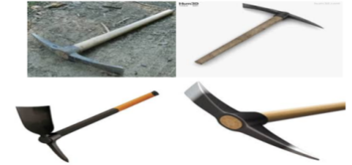  Fig 1.1 Different types of Pick axe
Shovels: -  - Used for moving earth, sieving soil, soil mixing, etc.  - Shovels are used for digging and lifting loose soil or other substances.  - A shovel is a tool for digging, lifting, and moving bulk materials, such as soil, coal, gravel, snow, sand, or ore  Spades - Useful for cutting and digging heavy soil, digging straight-sided, flat-bottomed trenches, or removing a layer of soil. | 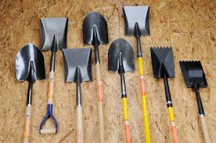  Fig 1.2 Different types of Shovels
Pegs are used to make fast a rope or string on, to stop a hole, or to mark some point. |  | 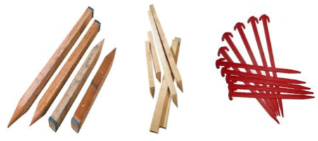  Figure 1.3 Different kinds of pegs  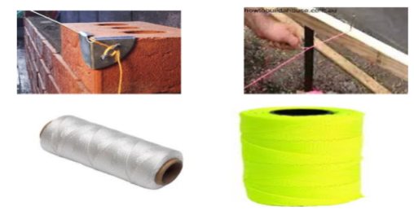  Fig 1.4 String lines
Spirit Levels  A spirit level, bubble level or simply a level is an instrument designed to indicate whether a surface is horizontal (level) or vertical (plumb).  Different types of spirit levels may be used by carpenters, stonemasons, bricklayers, other building trades workers, surveyors, millwrights and other metalworkers |  | 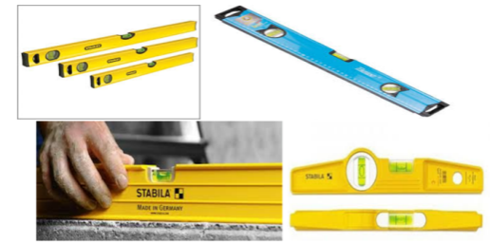  Fig 1.5 Different types and size of sprit levels
Hammers are used nails or hooks into walls or wood (small hammers). Rubber hammers are used to level tiles. It used for driving and pulling out nails |  | 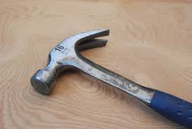  Fig 1.6 Hammers
Hacksaws: - used to cut pipes, woods and metal sheet. |  |   Fig 1.7 hacksaw
Tap meter: used two measure distance between two points (eg.distance between point A and point B). |  | 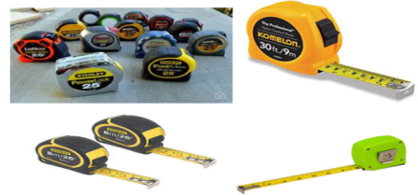  Fig 1.8 Different types tape measures
Wheelbarrow; for transporting all kinds of materials concrete, stone, sand, soil and other, etc |  | 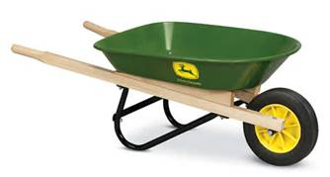  Fig 1.9 Wheelbarrows
Leveling equipment: used for theprocess of modifying the surface relief by grading and smoothing. |  | 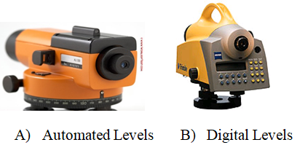  Fig 1.10 Types Leveling equipments
Level Rods (Staff): The rod is then observed with the level and read by the instrument person on the target rod. |  | 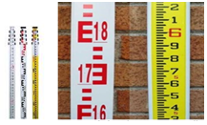  Fig 1.11 Survey Leveling Rod

1.2. Conducting checks on all materials, tools and equipment.
It is essential to check materials, tools and equipment for damage or malfunction and shall report damage or malfunction to the authorized representative in writing. If failed to maintain the broken or malfunctioning of material, tools and equipment within few days of the breakage or malfunction, there will be a loss due to damages resulting from the broken system component.
It is necessary to check materials, tools and equipment. In addition, maintenance of the system has to be carried out regularly
- Note: Reporting any insufficient or non-functional or faulty items to your supervisors before carrying out work.

It is important check materials and tools for defects and damage before receiving them so that you can ask for replacements for those that you found defective.
- Check if the materials and tools are complete in terms of quantity and specification (number of pieces, length, width, etc.)
- Check the physical condition of tools, (check tools against the specification, quantity, and quality,) see to it that parts are complete, cutting edges or tooth free from damages,
- Check the accessories of each material and tool. See to it that nothing is missing.
- If any of the materials or tools is found missing or defective, report it immediately to your supervisor.
- Get a replacement for the materials and tools found defective. Store the received materials and tools in a safe area or store room nearest your workplace. Generally Carrying out checks on tools, equipment and materials of irrigation and drainage system is important to identify malfunctioning or damage and maintenance requirement. It is essential to check irrigation system, tools and equipment’s for damage or malfunction and shall report damage or malfunction to the authorized representative.
1.3. Loading and unloading materials
- Manual handling techniques for loading and unloading materials
The techniques used when loading and unloading materials should demonstrate correct manual handling and minimize damage to the load and the vehicle while transporting irrigation equipment’s.
The most common techniques of loading and unloading materials use the following guidelines:
- Read manual handling precautions
- Select and checks personal protective equipment
- Develop an operations plan that describes procedures for loading and/or unloading.
- Conduct loading and unloading in dry weather if possible.
- Cover designated loading/unloading areas to reduce exposure of materials to sunlight, rain and so on
- Place all materials and equipment in covered areas such as building overhangs at loading docks if feasible.
- Pave loading areas with asphalt instead of concrete.

- Basic safety rules for procedures
The following rules apply for loading and unloading hazardous materials:
- Load packages with orientation marks (up arrows) so that the marks remain pointed up.
- Do not allow any smoking or any source of ignition on or near the working area.
Note: Avoid lifting from the floor whenever possible. If you must lift from the floor, do not bend at the waist.

1.4. Personal Protective Equipment (PPE)
Personal protective equipment’s (PPE): are devices worn, put on, tied on, or inserted in such as hearing protectors inserted in the ears of workers for protection against industrial hazard health hazards and accidents.
Personal protective equipment’s are used:
- As supplementary means of protection, and
- As direct means of protection.
Table 1.2: PPE
Name of Personal protective equipment | Picture
Foot protection:- Potential hazards which may lead to foot and leg injuries include falling or rolling objects, crushing or penetrating materials, hot, corrosive or poisonous substances, electrical hazards, static electricity, or slippery surfaces. |   Fig 1.12: foot protection
Safety Helmet: Used to protect the head from injury |   Figure 1.13:helmet
Eye protection:-Used to protect the eye from injury | 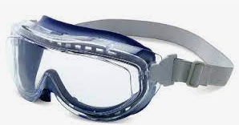  Fig 1.14: eye protection
Hand protection:-Used to protect the hand from injury |   Fig 1.15: hand protection
Body protection: Hazards that affect the entire body can include temperature extremes, chemical exposure, radioactive materials, arc flash, infectious materials, sparks or flames, falls and sharp objects. |   Fig 1.16: body protection
Respiratory protection  Wearing respirators to protect themselves against the inhalation of harmful air contaminants in the work place. | 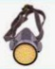  Fig 1.17:respiratory protection
Hearing protection:- Exposure to high noise levels can have detrimental physical and mental health effects. |   Fig 1.18:hearing protection

1.5. Gender sensitive irrigation and drainage work
Women play a central part in the provision, management and safeguarding of irrigation water application and drainage system ‘This pivotal role of women as providers and users of water and guardians of the living environment has seldom been reflected in institutional arrangements for the development and management of water resources. Acceptance and implementation of this principle requires positive policies to address women-specific needs and to equip and empower women to participate at all levels in water resources programmes, including decision-making and implementation.
A. Reasons for Limitation of women's involvement in irrigation and drainage sector
- Gender division of lab our work
- Lesser access to economic opportunities than men
- Less Participation in irrigation management training
- Under-representation in agricultural market.
- Low access to information and knowledge .
- Poor collaboration opportunities.
- Restricted mobility due to social, economic and cultural norms.
- Limited involvement in the decision making or irrigation and drainage planning.
- Deemed lesser productive
- Higher lab our burden than men
- Mostly employed in part-time, seasonal and/or low-paying jobs
Gender-specific responsibilities, ownership and rights are different; however, policies mostly do not consider this Patriarchal structures assumes men as the natural choice for the leader.
1.6. Identification and report of OHS hazards
- Hazard identification
Hazard identification is a process used to identify all possible situations where people may be exposed to injury, illness or disease, the type of injury or illness that may result from these and the way in which work is organized and managed. It is the first part of a risk management strategy described in Occupational Health & Safety Management System (OHSMS).
Workplace Health and Safety Regulations require employers to ensure that appropriate measures are undertaken to identify all hazards and to manage risk in the workplace.
- Hazard: a situation at the workplace capable of causing harm (i.e. capable of causing personal injury, occupationally related disease or death). It may include to:
- Solar radiation, dust,
- Noise,
- air- and soil-borne micro-organisms,
- Chemicals and hazardous substances,
- Sharp hand tools and equipment
- Holes and slippery and uneven surfaces.
- Risk: the chance of a hazard actually causing injury or disease. It is measured in terms of consequences and likelihood.
- Risk Management: - the overall process of risk identification, risk analysis, control of risks and risk evaluation.
- Risk Control: that part of risk management which involves the implementation of policies, standards, procedures and physical changes to eliminate or minimize adverse risks.
- Reporting Hazards and Accidents
It is required that all injuries, incidents and hazards are properly reported, investigated and recorded in accordance with the procedures detailed below.
- An accident is commonly used to describe an incident which has resulted in an injury.
- An incident is any unplanned event resulting in or having the potential for injury, ill health, damage or loss.
A hazard is a source or a situation with the potential for harm in terms of human injury or ill health.
- Injury Reporting
In the event of an injury the person involved should;
- seek first aid or medical attention as required;
- inform their supervisor as soon as possible;
- complete the Confidential Incident / Injury Report Form
- Assist their supervisor in the investigation and reporting on the incident or accident.
The Supervisor of the person(s) involved in the incident is required to;
- Ensure that any injured person is promptly attended to;
- Conduct an initial investigation into the cause of the incident;
- Complete the Confidential Incident / Injury Report Form and ensure that it reaches the Safety and Health; and
- Notify and liaise with the local Safety & Health Representative and line management in relation to the incident.
- Ensure that all serious injuries are reported to the Safety and Health immediately after hours of assistance.
On identifying a hazard, staff must act as quickly as possible to eliminate it. This may mean a simple alteration, substitution or removal of the hazard or even talking to the people involved to enlighten them of their hazardous practices.

Self-check 1 | Written test

Name…………………………………………… ID………………………… Date…….
Directions: Answer all the questions listed below.
Test I: Choose the best answer (2 points each)
- Hazard Identification process involves
- Risk control B. Risk management C. identifying injuries D. all E. all
- What are the causes for limitation of women’s involvement in irrigation and drainage work activity.
- Gender division of lab our work.
- Lesser access to economic opportunities than men.
- Less Participation in irrigation management training.
- High representation in agricultural market.
- .ALL except D
3. Which one of the following is not included in tools ,materials and equipment of irrigation and drainage work.
A. Tape meter B. pipe C. Microscope D.fittings E. All except ‘C’
4. Which one of the following is not used as cutting tool for irrigation and drainage work?
A. Pipe wrench. B. Bolo C. PVC pipe cutter D. Hacksaw.
5. Which one of the following is used as digging tool in irrigation and drainage work?
A. Crow bar B. Pick Mattock C. Spade D. all E. all
Test II: Short Answer Questions (5 points each)
- Write some of the tools and equipment’s used in irrigation work?
- List irrigation PPEs?
- Discuss the techniques used to load and unload irrigation equipment?
- Write few OHS hazards?
- What is the role of gender consideration in irrigation and drainage work?

Operation Sheet -1

- Identify irrigation tools, materials and components.
- Tools and Equipment’s

- Note book/paper
- Pen
- Marker

- Procedures
- Wear personal protective equipment
- List out all required tools, equipment and materials required on paper.
- Check the materials availability in storage
- Collect the materials from storage

1.2. Techniques for loading and unloading materials and equipment.
- Tools and equipment
- Use Leveling equipment( as sample)
- PPE
Procedures
- Wear appropriate personal protective equipment.
- Clean working environments and material
- Make sure if all materials and equipment and are available/present in the display room.
- Prepare and arrange the materials required for such techniques
- Properly handle and move the material to the vehicle as shown below

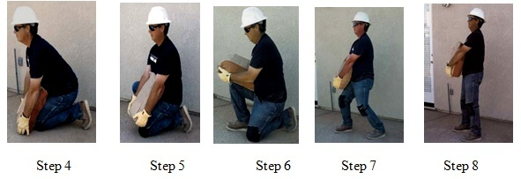
Figure 1.19 Techniques for Loading and unloading.

Note: Avoid lifting from the floor whenever possible. If you must lift from the floor, do not bend at the waist.

LAP TEST-1 | Performance Test

Name………………………………. ID…………………………….. Date…………………………………….

Time started: ________________________ Time finished: ________________

Instructions: Given necessary templates, tools and materials you are required to perform the following tasks within 1 hour. The project is expected from each student to do it.

Task-1.1: list out materials, equipment and tools.
Task-1.2: Perform Loading and unloading.

LG#34 | LO#2. Irrigation and drainage work

Instruction sheet
This learning guide is developed to provide you the necessary information regarding the following content coverage and topics:
- Standard operating procedures
- Environmentally friendly irrigation and drainage work.
- Interactions with other staff in professional manner.
- Observing guideline and procedures.

This learning guide will also assist you to attain the learning outcomes stated in the cover page. Specifically, upon completion of this learning guide, you will be able to:
- Apply Standard operating procedures
- Consider environmentally friendly irrigation and drainage work.
- Interact with other staff in professional manner.
- Observe guideline and procedures.

Learning Instructions:
- Read the specific objectives of this Learning Guide.
- Follow the instructions described below.
- Read the information written in the information Sheets
- Accomplish the Self-checks
- Perform Operation Sheets
- Do the “LAP test”

Information Sheet-2

2.1. Standard operating procedures
Standard operating procedures are procedures needed to start up and distribute proper amount of water to irrigation field and to operate drainage system properly.
Five Fundamental Steps to Creating Powerful Standard Operating Procedures(SOP)
- Develop a list of processes that you believe need SOP creation.
- Plan the process for developing and managing SOPs.
- Collect information for the content of your SOP.
- Write and review your SOp.
- Maintaining your SOP over time.
- Develop a list of processes that you believe need SOP creation
The best way to complete this task is to have discussion in irrigation teams in order to create a list of potential SOP. Then, organize time for your team to meet to review the lists of activity keeping in mind that not all processes need to be formalized only those which require for standardization. As you write SOPs, you’ll find you may be able to combine some processes while others may need to be split up into different SOPs. The main function of this list is to give you a necessary starting point.
- Plan the process for developing and managing SOP
Determine the format for your Standard Operating Procedures. Once you have your list ready, you need to begin to plan your process for creating your SOPS; this is your first procedure to create. First, you’ll have to determine the format of the SOPs. The format is how you’re going to describe your process. Will you do step by step narrative or will you use diagrams? Or will you use a combination of both? Once the format is defined, you can begin to create your SOP Template. It can be beneficial in some cases to research SOP formats online, identifying an SOP example to work from and that works for your organization.
- Collect information for the content of your SOP
Identify the subject matter experts you’ll need to get information from. One of the most common and effective ways to collect this information is scheduling interviews with the subject matter experts (SMEs). However, be sure to check before you begin the interviews with your SMEs to see if they already have documentation on a process.
Check for documentation that may already be available. Often a well-organized department will have some documented processes. If you can take this information and put it into your SOP template before the meeting it provides an added bonus to the exercise and can speed up information gathering. Begin interviewing your SMEs. With your SOP template in place, and any information already available in check you’re ready to begin the interviews. Interviewing subject matter experts (SME) who perform the process being documented is the best way to understand the process. Asking managers to describe a process that they don’t often perform could lead to misinformation or missing information. It’s important to understand that the people who actually do the work, know the process the best.
- Write, and review your SOP
Begin writing draft of the SOP. Once you’ve completed the steps in the SOP creation process and have developed your SOP Template you’re ready to actually write the SOP, adding all of the information into the template during and after the process. By doing this you’ll quickly see gaps in the information and can follow up with the SME as soon as possible.
- Maintaining your SOP over time
Now that you’ve written your SOP, it’s now time to set up some rules to periodically review the SOP for relevancy and accuracy as your business grows. The best way to ensure that this process is standardized and is completed properly is to document it.

2.2. Environmentally friendly irrigation and drainage work.

Irrigation and drainage works are supplementary to each other in irrigated agricultural environment. However, the sustainability of irrigated agriculture is being questioned, both economically and environmentally. Irrigation systems deal with redirecting water from rivers, lakes, and underground sources, and they have a direct impact on the surrounding environment such as increased groundwater level in irrigated areas, decreased water flow downstream of sourced rivers and streams, and increased evaporation in irrigated areas.
- Problems that can occur in irrigation work area
- Water logging:- is problem that occurs when the water table rises and the soil in the root zone of the plants gets saturated and the air circulation is stopped. Water logging generally occurs because of intensive irrigation and inadequate drainage of the irrigated land and affects the productivity and the fertility of the land and causes a reduction in the crop yield.
- Salinization: is accumulation of soluble salts at the soil surface, or at some point below the soil surface, to levels that have negative effects on plant growth and on soils
- Causes of Problems in irrigation work environment:-
A. Over-Irrigation: is intensive application of irrigation water depth beyond irrigation interval on agricultural land, which can create excess amount of water ponging. The excess water applied to the land percolates deep into the ground and joins the water table. As the ground water storage is augmented, the water table rises. As soon as the water table comes close to the land surface, water logging occurs.
B. Inadequate surface drainage: Water logging usually occurs when there is inadequate surface drainage of the irrigated land. Heavy precipitation along with inadequate surface drainage causes flooding of the land. The prolonged flooding (or inundation) results in heavy percolation of water into the ground, which causes a rise of the water table and hence water logging.

- Measures for prevention of problems occurred in irrigation and drainage work
The main cause of water logging in an area is the introduction of canal irrigation in the area. It is; therefore, better to plan an irrigation scheme in such a way that the land is prevented from getting waterlogged. The following measures are usually adopted for prevention of water logging and salinization or relieving the area,
- Limiting the intensity of irrigation: In regions where there is a possibility of water logging, the annual intensity of irrigation should be kept low, not more than 40 to 60%.
- Providing a drainage system: Water logging can be prevented by providing a properly designed drainage system.
- Lining the canal section: When the canal section is made fairly watertight by providing lining, the seepage loss is reduced to quite a good extent.
- By lowering the FSL of the canal: Loss may be due to percolation or absorption but when FSL is lowered the loss is reduced to sufficient extent. The canal should be designed such that its FSL is as low as possible, consistent with the requirements of flow irrigation for the commanded area.

- Drainage of Irrigated lands
Drainage is the removal of excess water and dissolved salts from the surface and subsurface of the land in order to enhance crop growth. Land drainage plays an important role in maintaining and improving crop yields. It prevents a decrease in the productivity of arable land due to rising water tables and the accumulation of salts in the root zone. The accumulation of soluble salts at the soil surface, or at some point below the soil surface, to levels that have negative effects on plant growth and/or on soils. Large portion of the land that is currently not being cultivated has problems of water logging/ponging and salinity. Drainage is the only way to reclaim such land Surface:
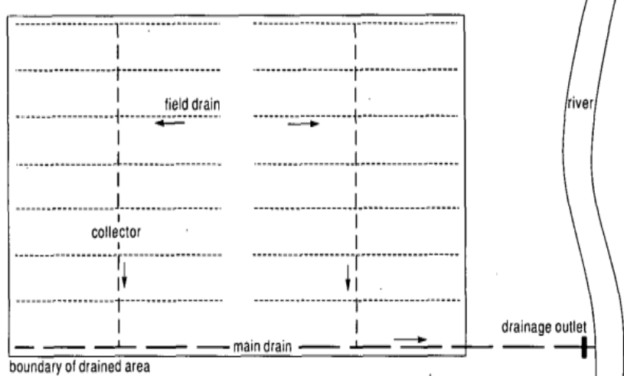
Figure 2.1: Layout of drainage on agricultural feild.
Irrigation projects and irrigated agriculture practices can impact the environment in a variety of ways. For this review it is possible to distinguish the following sources of environmental impact:
a) Construction of irrigation projects,
b) Water supply and operation of irrigation projects, and
c) Irrigated agriculture management practices.
- Positive impacts of irrigation
From a positive perspective on environment, irrigation would have importance and also increase the opportunities for environmental enhancement. Such as
- Reduce the erosion risk within given place
- Have significance to poverty alleviation,
- Ensures food security, and
- improving the quality of life for rural populations
- To maintain landscapes with providing water needed water during a drought.
- Negative impacts of irrigation
From a negative perspective, irrigation increases the risk of contamination of ground and surface waters and could adversely impact upon landscape values. Negative impacts such as;-
- The overflowing irrigated water gives insects a place to make their habitat which is harmful to surroundings giving rise to various diseases.
- Irrigation causes increases in water evaporation, impacting surface air temperature and pressure as well as atmospheric moisture conditions.
- alteration of the natural conditions of the landscape

2.3. Interactions with other staff in professional manner.

We can all agree that social interaction is critical in today’s work environment, but what does that mean? According to VerchelleDehn, CSI Manager for Ivan Gandrud Chevrolet in Green Bay, WI, “We fundamentally believe that our social interaction want three things in any of the departments; tell them the truth, do what you say you are going to do and keep them informed.” The term “social interaction” may have several definitions. Let’s define it as communication between one of agricultural group members and with others. We still need to improve at the basics; smile, make eye contact, slow down, be sincere, focus on your customer, tell the truth now, make promises and keep them, ask good questions then shut up and listen. Do not take these for granted. We all tend to get wrapped up in our busy days and we slip a little further away from what we know is right without intention. Watch your people execute these fundamentals daily.
“Ask the people what they want and give it to them” has long been our premise for doing work activity and needs. This includes how they wish to interact with us on a personal level, how often, in how much detail and method.
Positive interactions with irrigation water users can help create an atmosphere which is calming and safe, especially it encourage treating each other with kindness and respect.
An environment where agricultural staff relationships are positive, where staffs are able to express their emotions appropriately and where staffs feel satisfaction within their job helps create an ideal environment. High quality interactions lead to meaningful experiences on both sides.
2.4. Observing guideline and procedures.
The essential concepts and principles in irrigation and drainage work sector include:
- Participatory approach
Adoption of low key and open-ended approach i.e. the developed project where
Possible should allow for an expansion phase at minimal cost. The development of an Irrigation scheme should adopt the learning process approach, as in most cases Irrigation means the introduction of a new technology. A phased development approach- meaning that the initial scheme development should be modest in size. This will allow all actors/players to assess how the development fits into the normal activities of the beneficiaries.
- Stakeholder coordination
The success of irrigation work depends on the effective and efficient coordination of the efforts of all stakeholders operating at different levels. The lead agency being the Ministry responsible for Irrigation, which formulates policies, provides sector regulation, Coordination and guidance, and monitoring and evaluation. The Ministry also oversees State agencies and other entities on irrigation development and management. Stakeholders;-
- Private Sector actors.
- Farmers and Farmer Organizations.
- Financial Institutions.
- Marketing Organizations.
- Input suppliers.
- Non-Governmental Organizations.
- Private sector participation
Private sector participation is important in irrigation and drainage works with contributing the following functions;-
- Provision of technical and financial services
- Investment in irrigation infrastructure
- Provide market information
- Train farmer organizations in marketing
- Provision of irrigation support services
- Concerning gender, youth, vulnerable and marginalized groups.
Gender concerns are important for the sustainability of the irrigation work. The issues to be addressed should include Profile of the group in order to determine the gender composition (males and females) and also the dominant gender grouping for effective planning of irrigation works. Attempts should be made to include the disadvantaged and active groups in the decision-making process especially women and youth. Irrigation technologies - Those adopted should be gender friendly and in addition to addressing needs of the physically challenged persons.
Women and youth play a dominant role in agricultural production.
- Environmental management
The main focus for these concerns in irrigation and drainage schemes are; health, natural resources and social economic factors. In this assessment, issues relevant to irrigation work development are as follows:
- The occurrence of water borne diseases
- Pollution caused by waste disposal and farm inputs.
- Noise and Dust
- Workman Safety
- Flooding and drainage hazards

Self-Check – 2 | Written test

Name…………………………………………… ID………………………… Date…….

Directions: Answer all the questions listed below.
Test I: Multiple choice (2 points each)
- Private sector participation is important in irrigation and drainage works with contribution of …………………….
A. Provision of technical and financial services
B. Investment in irrigation infrastructure.
C. Provision of irrigation support services
D. Provision of irrigation support services
E. All
2. What is the main concern in environmental management of irrigation and drainage?
A. The occurrence of water borne diseases
B. Pollution caused by waste disposal and farm inputs.
C. Noise and Dust
D. Marketing organization
E. All except ‘D’.
3. Which one of the following is negative impact of irrigation work?
A. alteration of the natural conditions of the landscape
B. Increased agricultural production
C. Reduce erosion risk.
D. All
4. The success of irrigation work depends on
A. Consideration of gender, youth, vulnerable and marginalized groups.
B. Private sector participation
C. Stakeholder coordination
D. Non-Governmental Organizations.
E. All
5. Which one of the following is sources of environmental impact.
A. Work man Safety
B. Construction of irrigation projects,
C. Water supply and operation of irrigation projects
D. Irrigated agriculture management practices.
E. All except ‘A’
Test I: Short Answer Questions (2 ponits each)
- Identify negative and positive impacts of irrigation works.
- What is the importance of social interaction in irrigation and drainage work?
- Write essential principles in irrigation and drainage works?
- What are standard operating procedures?
- Who are stake holders in irrigation and drainage work?

Note: Satisfactory rating - 10 points Unsatisfactory - below 10 points

You can ask you teacher for the copy of the correct answers.

You can ask you teacher for the copy of the correct answers.

Operation sheet-2

2.1. Maintenance of surface drains
A. Tools and equipment’s: Use tools, equipments, and materials of irrigation and drainage work
B. Procedure
1. Wear PPE.
2. Prepare materials and tools.
3. Remove Weeds and grasses manually.
4. Remove silt & mud.
5. Provide stability for the side slopes of the drain ditch with shaping.
6. Plant trees on banks of drain.

LAP TEST-3 | Performance Test

Name………………………………. ID…………………………….. Date…………………………………….

Time started: ________________________ Time finished: ________________

Instructions: Given necessary templates, tools and materials you are required to perform the following tasks within 2 hour. The project is expected from each student to do it.

Task-1. Perform Maintenance of surface drains

LG#35 | LO#3.Handle materials and equipment’s

Instruction sheet
This learning guide is developed to provide you the necessary information regarding the following content coverage and topics:
- Safe work practices
- Instructions and organization guidelines
- Clean and safe work site
This guide will also assist you to attain the learning outcomes stated in the cover page. Specifically, upon completion of this learning guide, you will be able to:
- Apply Safe work practices
- Follow Instructions and organization guidelines
- Create Clean and safe work site
Learning Instructions:
- Read the specific objectives of this Learning Guide.
- Follow the instructions described below.
- Read the information written in the information Sheets
- Accomplish the Self-checks
- Perform Operation Sheets
- Do the “LAP test”

Information Sheet 3

3.1. Safe work practices.
Irrigation systems are important to farmers to enhance agricultural production, However they carry many risks that farmers should be aware of and know how to manage.
Removing disposal of Unwanted waste materials left during pre-season maintenance and post season maintenance should placed in a safe disposal area for safe environmental condition of the irrigation and drainage working area
- Some of safety precautions around field irrigation systems can keep you safe on the job:
- Keep the systems traveling path free of objects and people at all times.
- Never climb on the machine; use proper ladders for access.
- Always shut off and lock the master electrical control switch before servicing the machine.
- Avoid moving irrigation equipment on windy days when pipes could be blown into nearby power lines.
- Keep pipes horizontal to the ground rather than vertical to minimize the risk of an irrigation pipe comes in contact with a power line, never try to remove it yourself. Stay away from it and call your local electric utility for help in contact with power lines.
- Store unused irrigation pipes far away from power lines or electrical equipment.
3.2. Instructions and organization guidelines.
To be safe in irrigation and drainage work, read the operator’s manual and receive training for each irrigation system and specific equipment components that you use and maintain. Follow all of the manufacturer’s suggestions for inspection, maintenance, and repair schedules and procedures.
Some general safety guidelines include the following:-
- Reading and understand the danger, warning, and caution signs on all equipment parts.
- Wearing personal protective equipment (PPE) such as sturdy boots, coveralls, gloves, and a hard hat.
- Use hearing and eye protection if needed and properly inspect and maintain the irrigation systems.
- Make sure to report and repair malfunctioning systems.
Look for the following conditions to ensure safe work environment in irrigation and drainage work:
- Low tire pressure and damage.
- Signs of sprinkler blockage or breakage.
- Problems with end gun flows that maintain appropriate water pressure in the system.
- Problems with debris in systems. If necessary, flush the system to remove debris.
- Deficient levels of lubrication.
- Water or fluid leaks.
- Barriers in the field that could halt or hinder system movement.
3.3. Clean and safe work site
To ensure safety during operation, maintenance, inspection and testing of irrigation systems, employees must be aware of the potential hazards they might be exposed to and understand safe work practices necessary around the systems. Even if the equipment and installation is correct and the system has been well maintained, people still need to use safe work practices to avoid the normal hazards associated with operation of the equipment.

Clearing work site usually begins with grubbing, stripping, and Removal of debris in the areas upon which a irrigation structure will be built. These activities are designed to remove materials having undesirable engineering qualities, that could interfere with irrigation work operations and/or provide un safe work environment. Clearing Waste materials involves removal of Plant debris, and broken components, mulches, plastic, metal, and paper-based materials. These may be recycled, re-used, returned to the manufacturer, or disposed of according to organization work procedures in irrigation and drainage work environment.

The inspector must know the specified limits of the work, see that they are marked on the ground, and assure the work is conducted within these limits as to not damage adjacent property. The inspector must also verify surveys are made prior to clearing when necessary for computing payment quantities. The inspector may be required to verify that machinery does not operate within the drip line of specific trees and that the drip line of those trees are marked or fenced to protect the area within the drip line.
- The inspector’s responsibilities related to clearing
- The limits for clearing should be clearly demarkated
- Surveys should be completed prior to clearing ,when necessary for computing quantities all materials are removed and disposed of as specified
- The clearing operation does not damage nearby property
- Burning of waste materials should be performed according to local ordinances and job specifications
- General safety training for type of irrigation system involves the following consideration:-
- Understanding Equipment and Installation Requirements (What systems look like).
- Identifying Common Hazards.
- Understanding Safe and Unsafe Work Practices.
- Manufacturers should have to design equipment to safety standards.
- Owners, Irrigators and Service people must maintain equipment correctly.
Visually inspect for any signs of loose or missing bolts or visual indications that an irrigation machine is close to a structural collapse before moving the machine or climbing onto the machine.

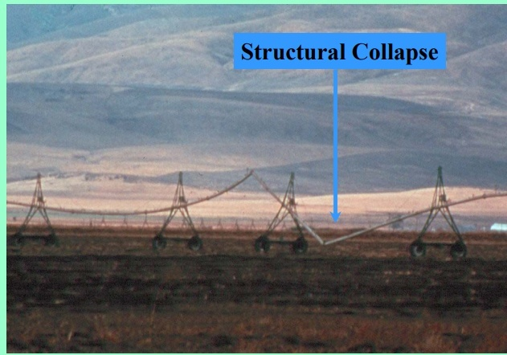
Figure 3.1: unsafe work environment.
Hold people accountable and makes sure everyone does their part. Establish an active workplace safety and health safety committee. Make daily safety inspections part of some employees' jobs. Keep employees informed about safety inspections, injury and illness statistics, and other safety-related issues.

Self-Check – 3 | Written test

Name…………………………………………… ID………………………… Date…….

Directions: Answer all the questions listed below.
Test I: Multiple choice (2 points each)
- Which one of the following can show unsafe work environment?
- Structural collapse B. injuries C. climbing to the machine D. all E. none
- Why Clean and safe work site?
- To control potential hazards
- To implement safe maintenance
- To facilitate human hazard
- To ensure safe operation system
- All except ‘C’
Test II: Short Answer Questions (2points each)
1. What are safe work practices in irrigation and drainage work?
2. State safety guide lines?
3. How do you ensure safe work environment?
4. What are safety precautions in irrigation field?
5. What is the significance of maintaining safe work environment?

Note: Satisfactory rating - 10 points Unsatisfactory - below 10 points

You can ask you teacher for the copy of the correct answers.

You can ask you teacher for the copy of the correct answers.

Operation Sheet -3

3.1. Handle materials and equipment for irrigation work
- Tools and equipment’s: Use tools ,equipments, and materials of irrigation and drainage
- Procedure
- Wear appropriate PPE
- Prepare tools and equipment’s
- Observe and list materials and equipment.
- Maintain the correct posture, avoid bending over and keep lifts close to the body.
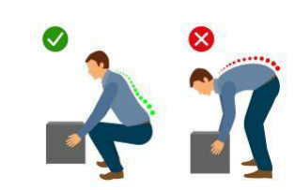
Figure 3.1 Safety of material handling.

- Handle materials with appropriate manner.
- Store the tool, materials and equipment’s in appropriate place.

LAP TEST-3 | Performance Test

Name………………………………. ID…………………………….. Date…………………………………….

Time started: ________________________ Time finished: ________________

Instructions: Given necessary templates, tools and materials you are required to perform the following tasks within 2 hour. The project is expected from each student to do it.

Task-1. Perform handling of materials and equipments.

LG#36 | LO#4.Completion of irrigation and drainage works

Instruction sheet
This learning guide is developed to provide you the necessary information regarding the following content coverage and topics:
- Cleaning up tools and equipment
- Maintaining, storing of tools and equipment
- Repairing and maintaining of irrigation components
- Applying Safe environmental practices.
- Reporting work outcomes
This guide will also assist you to attain the learning outcomes stated in the cover page. Specifically, upon completion of this learning guide, you will be able to:
- Clean up tools and equipment
- Maintenance, storage of tools and equipment
- Repair and maintenance of irrigation components
- Safe environmental practices.
- Report work outcomes

Learning Instructions:
- Read the specific objectives of this Learning Guide.
- Follow the instructions described below.
- Read the information written in the information Sheets
- Accomplish the Self-checks
- Perform Operation Sheets
- Do the “LAP test”

Information Sheet

4.1. Clean up tools and equipment.
The equipment’s used in irrigation work require cleaning, maintaining and storing properly after use. Cleaning is one of the most essential elements in maintaining a safe tool and equipment. Some of the equipment’s commonly used for cleaning purpose are listed below.
- air freshener dispenser,
- sealer applicators, rubbish bins, waste bins, large industrial bins, tidy bins,
- brooms, handles, buckets, mop buckets, window cleaning buckets, brushes, Bannister, flue, bottle brush, brickies brushes, dairy scrub, deck scrub, grout brush, kitchen brush, lint roller, nail brush, shoe brush, spirit brush, scrubbing brush,
- wire brush, toilet brush, toilet set, dust pans, duster, lamb’s wool duster, feather duster, mops, mop heads, carpet bonnets, nippers,
- rubbish picking up tools, wall washers, wall washing, warning sign, safety signs,
- wet floor sign, tool holders,
Irrigation work sites are expected to be clean, tidy, comfortable and good to create conducive environment for work.
Cleaning is the most essential elements in maintaining a healthy and safe work environment. Not only does a clean workplace reflect the professionalism of a business or facility and help motivate employees, it also promotes a healthy workforce as a clean environment prevents accidents and the spread of germs.
Many office managers strive to maintain a clear work site policy, few succeed. However, each employee Like Health & Safety, maintaining a clean work environment is the responsibility of everyone. However, there is only so much cleaning the team can do during each shift and in such cost conscious times it makes sense for employees to adopt some simple good housekeeping practices and allow the cleaning team to concentrate on hygiene and deep cleaning tasks.
Preventing mess as well as clearing up as you go along helps create a healthy workplace and provides the professional cleaning teams with a good platform to make effective use of their time on-site, allowing them to concentrate on hygiene, germ containment, recycling and deep cleaning. Working together we can all contribute to creating a safe and healthy workplace and a professional looking facility for employees, visitors and customers?
- Clean environment.
1) The job site shall be kept in a neat, clean, and orderly condition at all times during the installation process.
2) All scrap and excess materials are to be regularly removed from the site and not buried in trenches.
3) Trenching, laying pipe and backfilling shall be continuous so that the amount of open trench at the end of each work day is minimized. Any open trench or other excavations shall be barricaded and marked with high visibility flagging tape.

4.2. Maintenance, storage of tools and equipment
The equipment’s used in irrigation work require cleaning, maintaining and storing properly after use. Cleaning is one of the most essential elements in maintaining a safe tool and equipment. Some of the equipment’s commonly used for cleaning purpose are listed below.
  - air freshener dispenser,
  - sealer applicators, rubbish bins, waste bins, large industrial bins, tidy bins,
  - brooms, handles, buckets, mop buckets, window cleaning buckets, brushes, Bannister, flue, bottle brush, brickies brushes, dairy scrub, deck scrub, grout brush, kitchen brush, lint roller, nail brush, shoe brush, spirit brush, scrubbing brush,
  - wire brush, toilet brush, toilet set, dust pans, duster, lamb’s wool duster, feather duster, mops, mop heads, carpet bonnets, nippers.
  - rubbish picking up tools, wall washers, wall washing, warning sign, safety signs.
  - wet floor sign, tool holders.
The maintenance activities of open irrigation canals includes at least the following operations:
  - light deforestation on irrigation
  - weed control in the canal section
  - seeding grass in the canal section
  - maintenance of flow gauges and other measuring devices
  - removal of silt
  - Maintenance of pumping stations

4.2.1 Flushing and cleaning irrigation equipment
Before operation of drip irrigation system, Filters should be cleaned every couple of months, depending on the amount of debris in the water. During the growing season, periodically check and clean (or replace)emitters. Flush the system thoroughly after any main line break to avoid emitter clogging. Flushing your system is the best way to clear out build-up debris and ensure an even water application. To flush a reasonable supply of water must be available if Line flushing is needed when the following conditions occur:-
- Particulate matter not removed by filters accumulated in irrigation pipes and laterals .
- Chemical precipitation may occur inside pipe lines after irrigation system shuts down
- Suspended materials will be carried with the irrigation water, but as the water velocity decreases near the end of lines, particles will settle
- Flushing procedures for drip irrigation distribution system may includes
- Close the valve on the water lines behind a system and disconnect the water lines from the system.
- Open control valves.
- Run water through the valve and dispose of water.
- Close control valves.
- Reconnect the water line to system inlet.
- Open the valve.
4.3. Repair and maintenance of irrigation components
- How to maintain a drip irrigation system?
After installation of drip irrigation system, Filters should be cleaned every couple of months, depending on the amount of debris in the water. During the growing season, periodically check and clean (or replace)emitters. Flush the system thoroughly after any main line break to avoid emitter clogging. Flushing your system is the best way to clear out build-up debris and ensure an even water application. You can flush your irrigation lines using nitric acid, phosphoric acid, or sulphuric acid for about an hour. Afterward, flush the lines with water to ensure that the acids are no longer in the system.
Flushing the lines can help clear out the buildup of unwanted material in them like bacteria and residual calcium salts. Use an acid to flush your lines out at the end of the growing season. Nitric, phosphoric, and sulphuric acids work especially well for this, as do most other solutions with a pH of about 4.5.
Broken pipes from freeze damage and electrical equipment failure are results of poor winter preparation of irrigation equipment. Spending time now on your irrigation equipment can help avoid irrigation start up repairs and delays next spring.
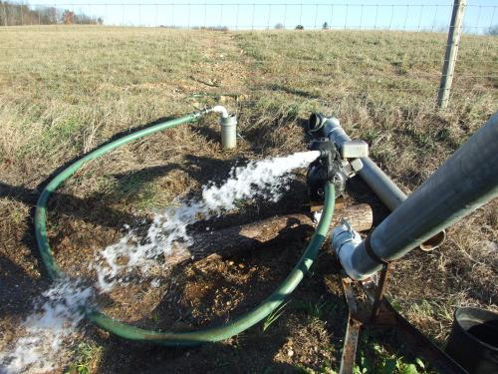
Figure 4.1 Broken pipe from freeze damage.
Often next year’s irrigation startup problems are winter damage that can be prevented. Time spent now on how to manage will prevent damage and lead to a better start on next year’s irrigation season. Inspection of the system now allows you to make improvements and repairs in the less costly off season and get irrigation problems out of the way for spring planting season when everyone is busy. Steel pipes up in the air may freeze solid days before we think of freezing weather on the ground.
- Mechanisms of damage control in irrigation component.
Some of methods to control irrigation component damage are listed below.
- Park pivots in a safe location
When choosing a location to park the system for the winter, consider the three most common potential sources of winter damage: Wire theft is less likely in a visible but inaccessible area of the field; Wind damage is less likely if pivot points into or away from the wind direction rather than perpendicular to wind direction; and squirrels and other rodent damage to span wire is rare when pivots are a few hundred feet from the tree line.
- Get rid of the bush and branches near equipment
Squirrel and chipmunk damage to span-wire and gasket can be minimize by removing limbs near equipment parked for the winter preventing animals jumping between trees and the structure. Trimming trees and removing brush near control panels and disconnect boxes reduces the chance of rodent damage. Removing woodchucks from the vicinity of pivot and pumping plant pads or electrical box can also help prevent damage.
- Drain pivots and solid set systems
Most of the currently designed pivots have automatic frost drains that drain the main overhead pipe. Solid set systems may have automatic drains but you should always inspect that water has been eliminated from the pump to the furthest ends of the system. Plugged automatic frost drains can lead to major repairs if not caught in a fall inspection. Rock traps need to be cleaned and drained, some designs may accumulate water condensing in the pipe over the winter leading to freeze cracks in rock traps that are emptied and put back in place. To avoid this issue many producers install a piece of hardware cloth held in place by the lock ring to allow condensate to leave the system. Pivot supply lines, end gun supply and hydro control hoses are often installed to allow drainage but the hose may sag and trap water which can lead to damage. Remember to cap all large openings into the system to prevent bird nesting.
- Drain travelers and big guns
Travelers and stationary big guns often have portions of their system that hold water. Drain and roll-up hoses, unhook and drain ends couplers and drain water drive piston and motors/impeller drive systems that may be damaged by freezing.
- Drain Trickle and drip lines and tape
Trickle and drip lines and tape are designed to be self-draining but manifolds and supply systems need attention to make sure no water pockets remain to freeze. Winter rodent damage can turn usable drip tape and trickle line into junk rapidly. Lines that are to be moved for next year are best stored in the barn(farm building). Lines over wintering in the field stand less rodent damage if not covered by plastic, plant material or mulch.
- Pump down or drain underground pipe lines
Most underground pipe lines are buried deep enough to prevent freeze damage but they often require pumping or draining enough water from them to empty the upper portion of Z-pipe risers and pump manifolds. This is typically done by purging the system with air or modifying a fertilizer transfer pump to pump system at its lowest outlet or inlet points. Remember to cap all pipe inlets and outlets to prevent animals from entering.
- Drain the pumping plant
Drain pumps and manifolds to the lowest point they can hold water. Replace brass drain plugs if damaged. Good designed pumping installations will be easy to drain without striping drain plug threads or the need for air purging. Inspect gauges, supply and control wires for needed repairs. Service the engine with attention to engine oil, bearing and seal lubrication. Check the cooling system for adequate anti-freeze level and concentration. Drain the fuel tank to reduce water accumulation in fuel tank and potential theft.
- Inspect and lock down electrical power supplies
Inspect each electrical box in the system from power supply to the last pivot or disconnect on system line for damage and holes that may be accessible for rodents. Sealing small holes helps keep rodent damage to a minimum. Both snakes and mice have even been known to crawl into electrical boxes and control panels through small hole or underground conduit with unprotected ends resulting in electrical fire and damage. Locking down electrical power supplies helps prevent vandals from turning wells and pivots on midwinter and minimizes potential electrical system damage. Now is an excellent time to inspect grounding, system test resistance and make repairs.
- Methods of maintaining irrigation components.
With respect to planning of maintenance there are basically there are three options:
- Identify the components to be maintained.
- Determine the activities that are needed for maintenance.
- An effective monitoring system is installed to identify when and how the actual situation deviates too much from the desired one, and on the basis of that the required maintenance is determined and executed.
- On the basis of experiments or knowledge on the system a fixed plan of regular routine maintenance is developed and implemented, including fixed frequencies (periods), techniques.
A kind of mixture of fixed maintenance plan and schedule, effective monitoring, the latter enabling more flexibility and prioritizing as per availability of funds.

4.4 .Safe environmental practices
Irrigation systems move and deliver water that is vital for the survival of agricultural crops. Moving equipment, electricity, water pressure, pumping systems, and field conditions related to irrigation and agriculture require workers to follow safety protocols. Follow proper lockout/tag out practices to control unsafe startup or power to the irrigation equipment each time you perform maintenance or repair. Remember that equipment can be controlled locally, remotely, or on timers. Never assume that equipment that is turned off will stay off. Pay attention to potential hazards when applying lockout /tag out. Some of activities to ensure safety;-
- Fix the main machine control to the off position.
- Control mechanical hazards such as center drives, overhead hazards, tires, rotation, and engines.
- Control power to the motor, tower boxes, and wiring.
- Control water systems to the sprinklers, end guns, pumps, and pipeline.
Use caution around overhead power lines when installing, maintaining, and using irrigation systems. Accidental contact of water spray, the piping, or the power units with electrical lines can cause severe electric shock injuries and death. Things to consider are:
- Make sure all equipment is properly wired and grounded.
- Know where power lines are located and their heights.
- Know the heights of the towers and the heights and lengths of the piping system.
- Maintain proper clearances from power lines at all times.
- When clearing pipes, keep them horizontal, don’t lift them vertical where they could meet with power lines.
Note that extreme weather can move your equipment and power lines, so always survey the work area after a storm.
4.5. Report work outcomes
Work outcome reports must be submitted to the supervisor after completion of irrigation work.
- The reports shall include;
- Specification of the quantity and each of the principal work accomplished
- The results of the environmental monitoring program,
- A summary of disposal unit survey and maintenance activities,
- A summary, by waste class, of activities and quantities of waste disposed of,
- Any instances in which observed site characteristics were significantly different from those described in the application; and
- Any other information the Commission may require.

If you are the person asked with doing a site visit as well as coming up with the report, then follow that there are things that you will have to do to acquire what the report needs. With that in mind, here are the steps that will help you create a proper site visit report: https://www.youtube.com/watch?v=hJuLo-A9-wg video of report format.
Step 1: Start With the General Information
The first thing that you will need to do is to come up with an introduction. Start by pointing
Out the location of the site that you visited, followed by the date on which you visited it.
Also, provide information on the person you contacted that permitted the visit. If extensive
Travel was needed, then provide a brief explanation in regards to how you made it to the site.
Step 2: Define the Site and Its Purpose
Next is for you to describe the type of site that you visited. Was it a factory, construction
Site, business, or school? You will want to include details such as the size of the site, its
Layout, and the different materials and equipment that were being used. State the number of
People working on the site and its owner.
Step 3: Explain the Sequence of Events
This is where you will be talking about everything that you have noticed during your visit.
Start at the very beginning of your visit. Who were the people you met?
What it is that you did?
Describe the events of the day going on until you left the site. Include details such as
What you managed to see, the events that took place, demonstrations conducted, etc.
Step 4: Summarize the Site Operations
This is the summary report of all the processes and procedures of the site that you visited.
Provide detailed information such as the special techniques that were used or the site’s
Entire manufacturing process. You can get more information by looking into the site’s many
Different departments; doing this also helps you understand the corporate structure.
Step 5: Identify the Site’s Strengths and Weaknesses
It is here where you will need to do something similar to a SWOT analysis as you’ll want to take note of which processes, policies, and practices work well at the site. If there are any flaws or glaring weaknesses, then you will need to point them out in your report. When doing this, make sure to be as specific as possible.
Step 6: Make Your Conclusion and Provide Suggestions
Once you are done with the entire report, the last thing that you will need to do is to provide your feedback and your suggestions; only give the latter if you are required to do so. Make Psure that you come up with a logical conclusion based on all of the information you’ve Gathered from the visit.
- If you are asked to write a reflection of your visit, try to:
- Make links between theory and practice, i.e. what you’ve been doing in your subject,
- What you’ve read, any previous professional experience you have in the field and the
practices you observed at the site.
- Demonstrate in your reflection that you understood the most important features of the
site. Evaluate and discuss the relative strengths and weaknesses of the processes and Procedures you observed (e.g. technology, efficiency).

Self-Check –4 | Written test

Name…………………………………………… ID………………………… Date…….

Directions: Answer all the questions listed below.
Test I: Short Answer Questions (2 points each)
- Identify cleaning materials.
- Write activities to ensure safety in irrigation environment.
- How do you control damage of irrigation components?
- What is the importance of maintaining irrigation component?
- What are components of work outcome report?
Test II: Multiple choices
- Maintenance of irrigation component can include one of the following.
- Repair B. Replace C.Monitoring D. all E.none.
- Causes for damage of irrigation component can be
- Poor storing trend of materials, equipments and tools.
- Lack of proper inspection
- Improper cleaning of materials, equipments, and tools.
- Improper allocation of resources.
- Reporting irrigation outcomes consists of one of the following.
- Result of environmental monitoring program
- Specification
- Maintenance activity
- Quantity of disposal.
- All
- Which one of the following have significance in maintenance activity.
- Knowledge B. Planning C. Skill D. monitoring E. all
- Irrigation and drainage problems can occur with…………….
- Improper material storage
B. Un drained pipe lines
C. Skill and planning
D. Lack of inspection on nearby electricity
E. All are answers except ‘C’.
Note: Satisfactory rating - 10 points Unsatisfactory - below 10points

You can ask you teacher for the copy of the correct answers.

You can ask you teacher for the copy of the correct answers.

Operation Sheet -4

4.1. Clean, maintain and store tools and equipment’s
A. Tools and equipment’s: spade, rake, hoe, shovel, mater tape, string, wheelbarrow and PPE
B. Procedure
- Wear appropriate PPE.
- Inspect tools and equipment’s.
- Separate damaged tools and equipment’s.
- Repair damaged tools and equipment’s correctly.
- Clean tools and equipment’s properly.
- Store tools and equipment’s properly in the appropriate place.
4.2. Apply Flushing for drip irrigation system maintenance.
A. Materials, Tools and equipments
- Control valves
- Pipe
- water

- Procedures
1. Close the valve on the water lines behind a system and disconnect the water lines from the system.
2. Open control valves.
3. Run water through the valve and dispose of water.
4. Close control valves.
5. Reconnect the water line to system inlet.
6. Open the valve.

LAP TEST 4 | Performance Test

Name………………………………. ID…………………………….. Date…………………………………….

Time started: ________________________ Time finished: ________________

Instructions: Given necessary templates, tools and materials you are required to perform the following tasks within 2hour. The project is expected from each student to do it.

Task-1 perform cleaning, maintaining and storing of materials.
Task-2 perform flushing of drip irrigation.

Reference Materials
Books:
Chow V.T., (E.d) hand book of Applied Hydrology, McGraw-Hill, New York,NY, 1964
D. Lenka, 3rd revised edition, 2005. Irrigation and drainage
Guidelines for Environmental Assessment of Water Management. Published on February, 2005
Santosh Kumar garg, Irrigation engineering and hydraulic Structures, Naraina, Delhi, 2005
S.K Garg, 19th revised edition, 2005. Irrigation engineering and hydraulic structures
Vander leeden.F, water Resources of the world, water information center, port Washington, N.Y, USA, 1975.
Web addresses:
https://www.waternsw.com.au › accessed date August,26,2022
https://www.fao.org , CHAPTER 6 - DRAINAGE - Fao.org accessed date August,26,2022
https://sonomamg.ucanr.edu › Drip Irrigation › Accessed date August27,2022
https://safeelectricity.org › irrigation-equipment-safety accessed date August28,2022
https://davesgarden.com › guides › articles › cleaning accssed date August29,2022
https://blog.montrium.com › experts › 5-fundamental-step. Accessed date August, 30,2022
https://www.fao.org › .accessed date August 30, 2022

AKNOWLEDGEMENT
Ministry of Labor and Skills wish to extend thanks and appreciation to the many representatives of TVET instructors and respective industry experts who donated their time and expertise to the development of this Teaching, Training and Learning Materials (TTLM).

The experts who developed the learning guide
No | Name | Qualification | Organization/ College | Mobile number | E-mail
1 | Serawit Gensa | Msc. Water Resource Engineering | W/Sodo AVET | 0916740916 | serawitgen@gmail.com
2 | Edao Hassen | Msc.Irrigation Engineering | Alage AVET | 0911098097 | hassedao@gmail.com
3 | Mekete Agizew | Msc. Water Resource Engineering | Amhara. Kombolcha ATVET | 0925221192 | gen.mam09@gmail.com
4 | Wondu Alemayehu | Msc.Irrigation Engineering | Oromia Kombolcha ATVET | 0910-28-99-61 | woldualem@gmail.com
5 | Ademe Ayalew | Msc.Irrigation Engineering | Agrafa AVET | 0912720547 | Ademe2004@gmail.com
6 | Said Mohammed | Msc.Irrigation& drainage Engineering | Alage ATVET | 09-17-18-01-81 | Siyamsdmhmmd@gmail.com/
7 | Molalign Asfaw | Bsc.Water Resource &Irrigation Engineering | Alage ATVET | 0921431096 | Mollalign410ass@gmail.com
8 | Yonas Hailu | Bsc.Water Resource &Irrigation Engineering | Agrafa AVET | 0934715578 | yonashailuw@gmail.com
9 | Lemessa Mulata | Msc.Irrigation Engineering | Agrafa AVET | 0913266845 | Lamimulle2022@gmail.com
10 | Misganew Yimer | Bsc. Soil and Water Engineering | Woreta ATVET |  | Misge1976@gmail.com
11 | Daniel Derese | Bsc. Soil and Water Engineering | W/sodo AVET | 0912-79-28-85 | danielderesse7@gmail.com
12 | Teshome Getachew | Msc.Irrigation & drainage Engineering | Alage ATVET | 0925-50-13-99 | teshomegetachew131@yahoo.com

