IRRIGATION AND DRAINAGE
Level – II

Based on March 2022, Version-3 Occupational standard

Module Title: - Basic Estimation of Crop water Requirement
LG Code: AGR IRD2 M02 LO (1-2) LG (3-4)
TTLM Code: AGR IRD2 TTLM 0822v1

August, 2021
Addis Ababa, Ethiopia

Table of Contents
Table of Contents I
Introduction to the Module 1
LO #1- Collect & organize all Required Data 2
Instruction sheet 2
Information Sheet 1 3
Self-check 1 21
Operation Sheet -1 23
LAP TEST-1 26
Performance Test 26
LO #2-Compute crop water requirement 27
Instruction sheet 27
Information Sheet 2 28
Self-Check – 2 41
Operation Sheet -2 43
LAP TEST-2 46
Reference Materials 47

Introduction to the Module
This module covers the knowledge, skills and attitude required to collect & organize all required data and compilation of data and compute crop water requirement. This module has two learning guides which has collecting and compiling the data which are required to calculate the crop water requirement for selected crop types. The second learning guide contains the basic estimation of crop water requirement by using pan evaporation meter and Balney-criddle methods among the different methods.

To calculate the CWR the required data collection methods will be discussed on the first learning guide which contains the factors affecting crop water requirement such as soil, crop, climatic factors and agronomic management. The second learning guide discussed about the crop selection according to agronomic and economic benefit. It also gives information about selection criteria for methods of crop water requirement estimations and how to calculate the reference and actual evapotranspiration of the given field by using selected estimation method. In both learning guide there are theoretical and practical session and LAP tests are included.

LG #3 | LO #1- Collect & organize all Required Data

Instruction sheet
This learning guide is developed to provide you the necessary information regarding the following content coverage and topics:
  - Understanding of Crop water requirement
  - Identifying factors influencing Crop water requirement (CWR)
  - Crop characteristics
  - Collecting and organizing climatic data
  - Collecting and organizing Soil data.
  - Using and maintaining tools, Materials and Equipment
This guide will also assist you to attain the learning outcomes stated in the cover page. Specifically, upon completion of this learning guide, you will be able to:
  - Identify factors influencing Crop water requirement (CWR)
  - Identify Crop characteristics, crop coefficient, growth stage, period and root depth at different growth stages.
  - Collect and organize climatic data and crop types
  - Collect and organize Soil data.
  - Use and maintenance of tools, Materials, and Equipment
Learning Instructions:
- Read the specific objectives of this Learning Guide.
- Follow the instructions described below.
- Read the information written in the information Sheets
- Accomplish the Self-checks
- Perform Operation Sheets
- Do the “LAP test”

Information Sheet 1

1.1 Understanding of Crop water requirements
Crop water requirements are defined as the depth of water needed to meet the water loss through evapotranspiration (ETcrop) of a disease-free crop, growing in large fields under no restricting soil conditions including soil water and fertility, and achieving full production potential under the given climatic conditions.
Crop water requirement or potential evapotranspiration is the amount of water required to compensate for the evapotranspiration loss from the cropped field. The values for crop evapotranspiration and crop water requirement are identical, and is expressed in terms of mm/day, mm/season
- Crop water requirement refers to the amount of water that needs to be supplied, while
- Evapotranspiration refers to the amount of water that is lost through evapotranspiration.

Evapotranspiration (ET)
The combination of two separate processes whereby water is lost on the one hand from the soil surface by evaporation and on the other hand from the crop by transpiration is referred to as evapotranspiration (ET).
- Evaporation
Evaporation is the process whereby liquid water is converted to water vapour (vaporization) and removed from the evaporating surface (vapour removal). Water evaporates from a variety of surfaces, such as lakes, rivers, pavements, soils and wet vegetation.
- Transpiration
Transpiration consists of the vaporization of liquid water contained in plant tissues and the vapour removal to the atmosphere. Crops predominately lose their water through stomata. These are small openings on the plant leaf through which gases and water vapour pass.
Evaporation and transpiration occur simultaneously and there is no easy way of distinguishing between the two processes. Apart from the water availability in the topsoil, the evaporation from a cropped soil is mainly determined by the fraction of the solar radiation reaching the soil surface. This fraction decreases over the growing period as the crop develops and the crop canopy shades more and more of the ground area. When the crop is small, water is predominately lost by soil evaporation, but once the crop is well developed and completely covers the soil, transpiration becomes the main process.The evapotranspiration rate is normally expressed in millimetres (mm) per unit time. The rate expresses the amount of water lost from a cropped surface in units of water depth.

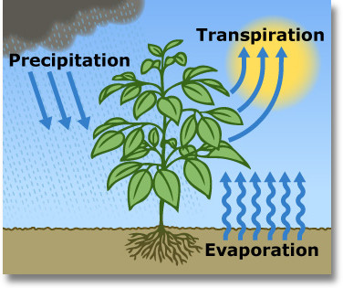Fig.1.1: Evaporation and Transpiration losses | 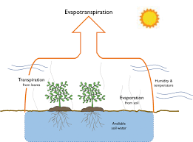  Fig.1.2: Evapotranspiration

1.2 Factors influencing Crop water requirement

1.2.1 Climatic factors
The principal climatic parameters affecting crop water requirements are radiation, air temperature, humidity and wind speed. The major climatic factors (see fig.1.3) which influence the crop water requirements are includes: Temperature, Sunshine hours, Relative humidity, Wind speed and Rainfall.

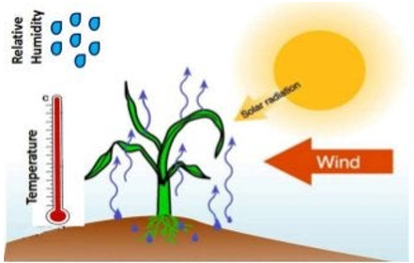
Fig.1.3: Major climatic factors influencing crop water requirements

A certain crop grown in a sunny and hot climate needs more water per day than the same crop grown in a cloudy and cooler climate. However, apart from sunshine and temperature, other climatic factors that influence the crop water requirement. These factors are humidity and wind speed. When it is dry, the crop water needs are higher than when it is humid.

- The highest crop water requirements are found in areas that are hot, dry, windy, and sunny. The lowest values are found when it is cool, humid, and cloudy with little or no wind.
- In windy climates, the crops will use more water than in cool climates.
- Crops grown in different climatic zones will have different water needs. Similar varieties grown in a cool climate will need less water per day than the same variety grown in a hotter climate.
Table 1.1: Effect of major climatic factors on Crop water requirement
Climatic factor | Crop water need
Climatic factor | High | Low
Temperature | Hot | Cool
Humidity | Low (dry) | High (humid)
Wind speed | Windy | Little wind
Sunshine | Sunny (no clouds) | Cloudy (no sun)

1.2.2 Crop factors
The crop type, variety and development stage should be considered when assessing the evapotranspiration from crops grown in large, well-managed fields. Differences in resistance to transpiration, crop height, crop roughness, reflection, ground cover and crop rooting characteristics result in different ET levels in different types of crops under identical environmental conditions. The crop factors should be considered when assessing the evapotranspiration from crops grown in fields.
- Crop variety
- Growth stages
- Plant population
- Growing season
Differences in resistance to transpiration, crop height, ground cover and crop rooting characteristics result in different ET levels in different types of crops under identical environmental conditions.
The influence of the crop type on the crop water need have two ways.
- The crop type has an influence on the daily water needs of a fully grown crop; i.e. the peak daily water needs: a fully developed maize crop will need more water per day than a fully developed crop of onions.
- The crop type has an influence on the duration of the total growing season of the crop.

1.2.3 Soil factors
The influence of the soil characteristics that affects crop water requirement includes
- Soil types and its texture
- Soil structure
- Soil depth
- Topography
- Soil chemical composition

1.2.4 Agronomic Management and environmental conditions
Agronomic management and environmental condition which affects crop water requirement are includes:
- Irrigation methods used
- Frequency of irrigation and its efficiency
- Tillage and other cultural operation like weeding, mulching
Irrigation water application, Cultural practice of field (mulching, tillage, windbreak, anti-transpirant and etc). Factors such as soil salinity, poor land fertility, and limited application of fertilizers, the presence of hard or impenetrable soil horizons, the absence of control of diseases and pests and poor soil management may limit the crop development and reduce the evapotranspiration. Other factors to be considered when assessing ET are ground cover, plant density and the soil water content. The effect of soil water content on ET is conditioned primarily by the magnitude of the water deficit and the type of soil. Too much water will result in waterlogging which might damage the root and limit root water uptake by inhibiting respiration.
Cultivation practices and the type of irrigation method can alter the microclimate, affect the crop characteristics or affect the wetting of the soil and crop surface.
- A windbreak reduces wind velocities and decreases the ET rate of the field directly beyond the barrier. The effect can be significant especially in windy, warm and dry conditions although evapotranspiration from the trees themselves may offset any reduction in the field.
- Water application methods: Soil evaporation can be reduced by different water application methods like using a well-designed drip or trickle irrigation system. The drippers apply water directly to the soil near trees, thereby leaving the major part of the soil surface dry, and limiting the evaporation losses.
- The use of mulches, when the crop is small, it is another way of substantially reducing soil evaporation.
- Anti-transpirants, such as stomata-closing, film-forming or reflecting material, reduce the water losses from the crop and hence the transpiration rate.
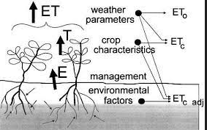
Fig 1.4: Major factors influencing crop water requirements

1.3 Crop characteristics
Crop characteristics which define potential yields include physiological and phenological traits. The physical environment and management can influence these characteristics. However, the response of the crop and thus its potential yield under optimum conditions is genetically determined. Crop characteristics vary even between varieties.

1.3.1 Growth stage and crop coefficient
As the crop develops crops change over the growing periods as the ground cover, crop height and the leaf area change. There are four growth stages are recognized for the selection of crop coefficient.

Generally, lengths for the four distinct growth stages and the total growing period for various types of climates and locations. Crop growing season is mostly divided in to four stages
- Initial stage
- Crop development stage
- Mid-season stage
- Late season stage
        - Initial stage: this is the period from sowing or transplanting until the crop covers about groundcover < 10% soil surface. The Kc during this initial stage (Kc ini) is large when the soil is wet from irrigation and rainfall and is low when the soil surface is dry.
        - Crop development stage: This is the stage from the end of the initial stage to attainment of effective full groundcover (groundcover 70-80%). As the crop develops and shades more and more of the ground, soil evaporation becomes more restricted and transpiration becomes the dominant process. During the crop development stage, the Kc value corresponds to amounts of ground cover and plant development and thus varies. If the soil is dry, Kc dev = 0.5 corresponds to about 20-40% groundcover. A Kc dev = 0.7 often corresponds to about 40-60% groundcover.

        - Mid-season stage: The stage from attainment of effective full groundcover to the start of maturity, as indicated for example by discolouring of leaves (as in beans) or falling of leaves (as in cotton). The mid-season stage is the longest stage for perennial crops and for many annual crops, but it may be relatively short for vegetables that are harvested fresh for their green vegetation. At this stage, Kc reaches its maximum value. The value of Kc mid is relatively constant for most growing and cultural conditions.

        - Late season stage: this period starts at the end of the mid-season stage and lasts until the last day of the harvest; it includes ripening. The late season stage runs from the start of maturity to harvest or full senescence. The calculation of Kc and ETo is presumed to end when the crop is harvested, dries out naturally, reaches full senescence, or experiences leaf drop.

Table 1.2: Determination four growth stages and duration of days for selected crops

Crop types | Growth stages (days)
Crop types | Initial | Crop dev. | Mid-season | Late season
Tomatoes (140 days from transplant) | 15 | 40 | 60 | 25
Potatoes (130 days) | 30 | 35 | 40 | 25
Lentils (160 days) | 25 | 30 | 65 | 40
Maize (100 days) | 20 | 30 | 40 | 10
Cotton (190 days) | 3050 | 60 | 50
(Source, FAO.1992)

- Crop coefficient and its curves

Crop coefficient is a property of plants used in predicting evapo-transpiration (ET). The most basic crop coefficient, K_{c}, is simply the ratio of ET observed for the crop studied over that observed for the well calibrated reference crop under the same conditions.
The crop coefficient, Kc, is basically the ratio of the crop ETc to the reference ETo, and it represents an integration of the effects of four primary characteristics that distinguish the crop from reference grass.

The Kc begins to increase from the initial Kc value, Kc ini, at the beginning of rapid plant development and reaches a maximum value, Kc mid, at the time of maximum or near maximum plant development. During the late season period, as leaves begin to age and senesce due to natural or cultural practices, the Kc begins to decrease until it reaches a lower value at the end of the growing period equal to Kc end.

- Factors determining the crop coefficient:
The crop coefficient, Kc, is basically the ratio of the crop ETc to the reference ETo, and it represents an integration of the effects of four primary characteristics that distinguish the crop from reference grass. These characteristics are: Kc value depends on different factors includes:
- Time of planting or sowing,
- Crop growth stages or development
- Climatic conditions.
Crop coefficient (Kc) and the type of crop
Fully developed crop, with its large leaf area will be able to transpire, and thus use, more water than the reference evapotranspiration crop: Kc, crop may have higher than 1.

Different crops will have different Kc coefficients. The changing characteristics of the crop over the growing season also affect the Kc coefficient. Evaporation is an integrated part of crop evapotranspiration, conditions affecting soil evaporation will also have an effect on Kc. Due to differences in evapotranspiration during the various growth stages, the Kc for a given crop will vary over the growing period.
Kc and the growth stage of the crop: A certain crop will use more water once it is fully developed, compared to a crop which has just recently been planted.
The climate influences the duration of the total growing period and the various growth stages. In a cool climate a certain crop will grow slower than in a warm climate. It also varies with the climatic conditions and crop height. For many agricultural crops as compared to the grass reference, the ratio of ETc to ETo (i.e., Kc) for many crops increases as wind speed increases and as relative humidity decreases. More arid climates and conditions of greater wind speed will have higher values for Kc. More humid climates and conditions of lower wind speed will have lower values for Kc.
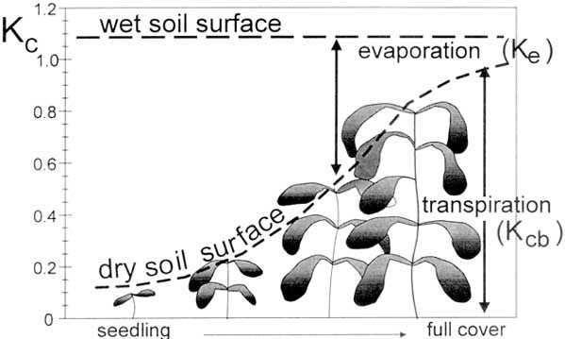

Fig 1.5: Changes in crop coefficient over the length of the growing season

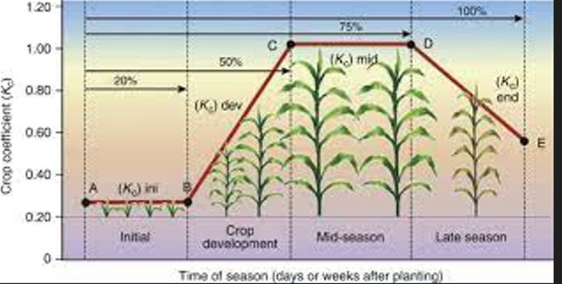

Fig 1.6: Generalized crop coefficient curve for the crop coefficient

Table 1.3: Values of the crop factors (Kc) for various crop sand growth stages

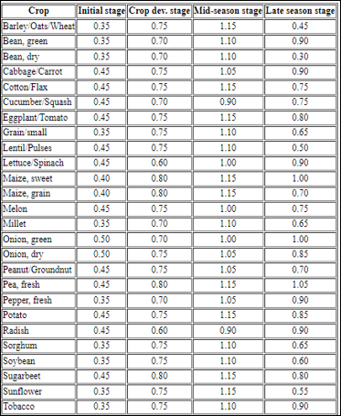
(Source, FAO.1992)

1.3.2 Crop Root depth
The effective root zone depth is the depth of soil used by the main body of the plant roots to obtain most of the stored moisture and plant food under proper irrigation. Root zone depth will vary according to the effective soil depth, fertility management, and the rooting characteristics of the plant. Each plant has its own root development characteristics, which vary only slightly under adequate soil moisture conditions in a given soil profile.

The root depth of a crop also influences the maximum amount of water which can be stored in the root zone. If the root system of a crop is shallow, little water can be stored in the root zone and frequent - but small - irrigation applications are needed. With deep rooting crops more water can be taken up and more water can be applied, less frequently. Young plants have shallow roots compared to fully grown plants. Thus, just after planting or sowing, the crop needs smaller and more frequent water applications than when it is fully developed.
Water uptake by a specific crop is closely related to its root distribution in the soil. About 70 % of a plant's roots are found in the upper half of the crop's maximum rooting depth. Deeper roots can extract moisture to keep the plant alive, but they do not extract sufficient water to maintain optimum growth.
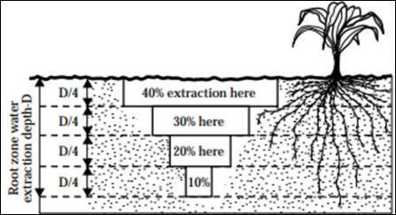
Fig 1.7: Typical water extraction pattern in crop root depth

Table 1.4: Rooting depth of fully grown crops and MAD
Crop | Rz (cm) | MAD (fraction)
Banana | 50 – 90 | 0.35
Beans | 50 – 70 | 0.45
Cabbage | 40 – 50 | 0.45
Carrots | 50 – 100 | 0.35
Lettuce | 30 – 50 | 0.3
Maize | 100 – 170 | 0.60
Onion | 30 – 50 | 0.25
Peppers | 50 – 100 | 0.25
Potatoes | 40 – 60 | 0.25
|Sugarcane | 120 – 200 | 0.65
Tomatoes | 70 – 150 | 0.40
Wheat | 100 – 150 | 0.55

1.4 Collecting and organizing climatic data and crop types

1.4.1 Collecting and organizing Climate Data
A climatic data element is a measured parameter which helps to specify the climate of a specific location or region, such as precipitation, temperature, wind speed and humidity used to calculate crop water requirement. Data of climate such as sunshine hour, wind speed, humidity are collected from meteorological agency or from relevant institute and organized for calculating evapotranspiration from meteorological data require various climatological and physical parameters.
- The meteorological data consist of:
        - Air temperature: daily or monthly average daily maximum (Tmax) and average daily minimum temperature (Tmin). Thermometers measure temperature.
        - Relative humidity: daily or monthly average daily actual vapour pressure. Relative humidity is measured using hygrometers.
        - Wind speed: day or monthly average of daily wind speed data measured at 2 m height. , wind vanes measure wind direction, anemometers measure wind speed.
        - Radiation: day or monthly average of daily net radiation computed from the mean day or monthly measured shortwave radiation or from actual duration of daily sunshine hours.
        - Rainfall: day or monthly average of daily precipitation data measured. Instrument used to measure rainfall is called rain gauge.

- Organizing data: is the process organizing raw data by categorizing and classifying data to make it more usable. Collected data from stations require a careful analysis of their validity before their use. It requires the correction of data observed and completion of partial or missing weather data or assessing the integrity of weather data for computing ETo according to selected crop water requirement methods. The methods that we use to organize data include classification, tabulation, graphical presentation and diagrammatic presentation.

1.4.2 Collecting and organizing Crop types
Crop type’s data such as Crop and crop variety, crop coefficient (Kc), maximum rooting depth, length of growing season and crop yield obtained from reports and research publications and other relevant organization and from respective stakeholders. Crop types are assessed the crop grown in rainfall as well as under irrigation in specific location. Crop data collection may assessed through field observations, interviews with extension agents and farmers and additional information from other agencies.

- Essential data needed to be collected for a given crop types should include:
- Crop and crop variety.
- Total length of growth period (The first and last date of harvesting)
- Date required before transplanting
- Crop yield
- Crop sensitive to moisture stress at critical growth stags and root depth
- Crop coefficient and Crop water requirement
- Irrigation frequency of the crop or irrigation application depths
- First and last planting date
- Classification crop types
- Annual Crops: They are crops which grow and mature within one year e.g. melon, maize, rice, wheat, groundnut, cowpea, cotton etc.
- Biennial Crops: They are crops which grow and mature within two years e.g. cassava, pepper, ginger etc.
- Perennial Crops: They are those crops that grow and mature in more than two years

1.5 Collecting and Organizing Soil data.
Soil is a medium comprised of soil particles, organic matter, water, air and living organisms, all of which are important to the overall health of the soil and the plants that grow in it. The three primary soil particles are sand, silt, and clay. The relative percentages of these components present make up the soil’s texture. Texture is important to overall soil and plant health as it relates to soil porosity, which refers to the pore spaces where air and water reside.
- The soil data is collected on several levels: point data, map unit data, spatial data, and interpretative data.
- Point data describe a pedon profile, is site specific, and should represent what is typical about a particular soil.
- Map unit data is the information that describes the soil forming factors and includes, where different soil types are found on the landscape, the soils range in characteristics such as color and texture, and how they relate to each other, and topography, climate, vegetation, and geology.
- The spatial data consists of soil delineations and special features located on georeferenced orthoquadrangle base maps.
- Soil Data types : the soil data types should include;
    - Soil texture and soil types
    - Soil moisture content,
    - Bulk density,
    - Field capacity and permanent wilting point of the soil.
    - Infiltration rate
    - Soil salinity
    - Soil water holding capacity
During data collection data include, field notes, soil profile and landscape descriptions, laboratory data, photographs, descriptions of soil map units and map unit components, and the basic soil map. Soil data either from soil sampling or secondary data from published soil surveys can be found at some libraries and Online GIS data of the Gridded Soil Survey Geographic Database.

- Soil physical properties influencing irrigation: Soil provides the room for water to be used by plants through the roots present in the same medium. Water as such need also as carrier of large amount of nutrients. It required in a large measure for the successful growth of crop.

- Soil texture: it may be defined as the relative proportion of various soil separates in a soil material. It indicates fineness or coarseness of the soil. The texture of soil is more or less constant and does not change with tillage or other practices. Soil texture influence infiltration, permeability, water holding capacity, cohesion, plasticity and soil structure.

The soil type influences the maximum amount of water which can be stored in the soil per meter depth of the soil.
- Sand can store only a little water or, in other words, sand has low available water content.
- On sandy soils it will thus be necessary to irrigate frequently with a small amount of water.
- Clay has high available water content. Thus on clayey soils, larger amounts can be given, less frequently.

1.6 Using and maintaining tools, Materials and Equipment
Tools and equipment may include Auger, core sampler, Computer and software, spatula, oven, pressure apparatus, sensitive balance, sieve, soil grinder, hydro meter, shaker and measuring cylinder, thermometer, stop watch, and flasks are used properly to collect and collate data to estimate crop water requirement plant.

You should have to know these tools and equipment by their name and should identify those tools and equipment physically.
- Shovels and spade are tools used to take an individual sample from the top surface of soil. To make a composite sample shovel and spade should be avoided because to make a composite/average mixture equal volume of different soil samples should be used for mix up, then to get this equal volume of soil an auger is best used as it can take similar volume of soil sample from same depth.
- A clean bucket is used to mix the samples to make it composite
- Paper bag is used to hold each sample separately and take to laboratory
- Mortar and pistil or soil grinder is used to break the soil clods in to pieces, to suit the soil for the different tests.
- Sieves are used to separate the desired size of soil particles according to the test for example to test soil texture a sieve with 2mm diameter is needed, and different diameter sieves for nutrient tests.
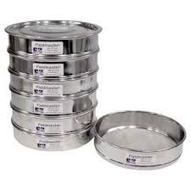
Fig: 1.8 sieve at different diameter
- Ruler, pencil and note pad is use to label the soil sample after preparation and documentations.
- Hydrometer:- to measure soil texture
- Measuring cylinder:- to measure water during determination of soil pH, soil particle density, nutrient analysis, etc.
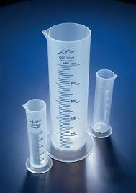
Fig 1.9: Measuring cylinder
- Oven dry: for determination of soil moisture contents, particle density, bulk density, etc.
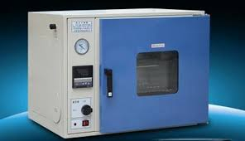
Fig 1.10: soil oven dryer
- Auger is used to drill the soil and can be used for sampling various soil types.to take soil samples.
- A core sampler is a cylindrical section of (usually) a naturally-occurring substance. Most core samples are obtained by drilling with special drills and to take undisturbed soil sample.
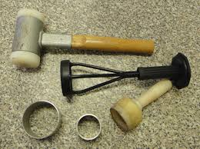
Fig 1.11: Core sampler and accessories
- Computer software is a computer program for the calculation of crop water requirements and irrigation requirements based on soil, climate and crop data.
- Pre-operational checkup and maintenance of tools and equipment
Check all the tools and equipment before use, are all functional and sufficient in number? Are all clean of any soil contaminants? During sampling any contaminant soil remaining on the sampling tools can affect the test of the new sample. If any faulty tool and equipment is found, maintain it
- Shovel and spade : - stiffen the handle and the head together and clean from soil
- Auger :- put together tightly the head and the handle and clean from soil remains
- Prepare the appropriate number and desired size of the paper bag
- Prepare the appropriate sieve size in diameter
- Clean and sterilize mortar and pestle
- Calibrate hydrometer, spectrometer, etc. before uses.
If there is any material totally none functional and cannot be maintained purchase it before starting the job.
- Maintenance
Routine maintenance of weather station equipment is recommended. The nature of the maintenance will be somewhat dependent on the operating environment and conditions. Insects, dust, debris, snow, large animals, rodents, and other factors can differ dramatically from site to site. The following are suggestions that users might consider as part of their maintenance and inspection.

To keep the standard conditions, try to make the pan clean, painted and levelled. Maintain the recommended level above ground. Check the status of attached measuring tape (visibility, deterioration) and replace if required. And Remove also any surrounding shades to avoid interference.
- Selection of suitable safety and PPE

PPE required to perform a soil survey and testing may include: - hat, boots, overalls, gloves, goggles, respirator or face mask, face guard, hearing protection, sunscreen lotion and hard hat.

Self-check 1 | Written test
Name…………………………………………… ID………………………… Date…….
Directions: Answer all the questions listed below.
Test I: Choose the best answer (5 point)
- Which one of the following is NOT a factor affecting crop water requirement?
- Climate C. soil type
- Crop type D. None
- Which one of the following is Not the major climatic factor that influence the crop water requirements
- Temperature
- Relative humidity
- Wind speed
- None
- Which one is factors which Kc value depends on:
- Time of planting or sowing,
- Crop growth stages or development
- Climatic conditions.
- All
- Which one following is the amount of water required to compensate for the evapotranspiration loss from the cropped field.
          - Crop water requirement
          - Irrigation water need
          - Water loss
          - None
- Which of the following is important data when collecting Crop character
          - Crop and crop variety
          - Crop coefficient (Kc),
          - Maximum rooting depth
          - Length of growing season and crop yield
          - All
Test II: Matching (5 points)
Match column A with column B. Select the letter of the correct answer from column B and place your answer on the space provided in column A.
Column “A” | Column “B”
- _____ is consists of the vaporization of liquid water contained in plant tissues and removes to the atmosphere.  - _______ is the process whereby liquid water is converted to water vapour (vaporization) and removed from the evaporating surface  - _____is used to measure soil texture.  - _____ is the total amount of water losses due to combined effect of evaporation and transpiration.  - _______ is the process organizing raw data by categorizing and classifying data to make it more usable. | - Hydrometer:  - Evaporation  - Organizing data  - Transpiration  - Crop water requirement  - Evapotranspiration

Note: Satisfactory rating - 5 points Unsatisfactory - below 5 points

You can ask you teacher for the copy of the correct answers.

You can ask you teacher for the copy of the correct answers.

Operation Sheet -1

  - Method of collection and organizing climatic data
  - Tools and Equipment
- Paper, Note book or format
- Pencil,
- pen,
  - Procedures:
- Go to nearby meteorological station as instruction of instructor
- Check the available data present in the station
- Collect the following climate date from the nearby meteorological station. Daily or monthly rainfall, maximum and minimum temperatures, relative humidity, wind speed, sunshine hours, and rainfall.
- Check completeness of the data and adjust missing climatic data as directive of your instructors and organizing the data in tabular form to use.
- Calculate monthly averages of climatic data
- Set up your data as format given below table.
Monthly averages data (mm/monthly) = $\frac{sum data in each days}{30 days}$
Station Name: - -------
Element: ……………..
Table 1: Monthly _________ data
Year | Jan | Feb | Mar | Apr | May | Jun | Jul | Aug | Sep | Oct | Nov | Dec | Total (mm) | Monthly Ave. (mm)

1.2. Techniques of identifying soil types by Feel methods
- Tools and Equipment’s
- Water
- Shovel, spade, spatula
- Bucket
- Paper sack (soil bag)
- Permanent marker, Watch or stop, Sieve,
- Ruler, pencil and note pad for labeling each container and recording information
- Procedures
Step 1: Wear appropriate PPE
Step 2: Take soil sample from intended field
Step 3: Wet and knead soil
- Add 25 g of soil to the palm and distilled water
- Add water a little time.
- Use spatula to help mix soil.
- Knead soil to break down all aggregates
- Knead soil until feels like , if it moist putty
Step 4: Can the soil form a ball
- If able to form ball, then other soil texture.
- If not able to form ball, the soil will be sand.
Step 5: Does the soil ribbon?
- Place ball between thumb and forefinger
- Squeeze upward to form ribbon
- Allow ribbon to break under its own weight
If able to form ribbon, then other soil texture.
If not able to form ribbon, loamy sandy
Step 6: how long is the soil ribbon?
- Types of loam ≤2.5cm ribbon
- Types clay loam 2.5 – 5cm ribbon
- Type’s clay ≥ 5cm ribbon.
Step 7: is the soil gritty or smooth?
- Place some soil in palm
- Rub with forefinger and add excessive wet.
- Then is it gritty or smooth?
Types of loam ≤ 2.5cm ribbon
- If feel very gritty, then sandy loam, or
- If feels very smooth, then it is silt loam and
- If it is neither gritty nor smooth, then it is loam
Types sandy clay loam 2.5 – 5cm ribbon
- If feels very gritty, then sandy clay loam, or
- If feels very smooth, then it is silt clay loam and
- If it is neither gritty nor smooth, then it is clay loam
Type’s clay ≥ 5cm ribbon.
- If feels very gritty, then sandy clay.
- if feels very smooth, then it is silt clay and
- If it is neither gritty nor smooth, then it is clay.

Fig: 1: Steps for feel methods

LAP TEST-1 | Performance Test

Name………………………………. ID………… Date………………….

Time started: ________________________ Time finished: ________________

Instructions: Given necessary templates, tools and materials you are required to perform the following tasks within 4 hour. The task is expected from each student to do it.

Task-1.1: Collect and organize climatic data
Task-1.2: Determine soil types by feeling method

LG #4 | LO #2-Compute crop water requirement

Instruction sheet
This learning guide is developed to provide you the necessary information regarding the following content coverage and topics:
  - Crop selection
  - Selecting methods crop water requirement estimation
  - Estimating Crop Water Requirement

This guide will also assist you to attain the learning outcomes stated in the cover page. Specifically, upon completion of this learning guide, you will be able to:
  - Select crop economically and agro-ecologically beneficial
  - Select method for estimating crop water requirement.
  - Estimate Crop Water Requirement

Learning Instructions:
- Read the specific objectives of this Learning Guide.
- Follow the instructions described below.
- Read the information written in the information Sheets
- Accomplish the Self-checks
- Perform Operation Sheets
- Do the “LAP test”

Information Sheet 2

Crop selection
Crop selection is the act of choosing which crops to grow. Crop selection methods refers to a method of selecting crop(s) over a specific season depending upon various environmental as well as economic factors for the maximum benefit. These factors are precipitation levels, average temperature, soil types, market prices and demand etc. By selecting the right crop for given conditions, one can optimize the requirement of irrigation water and added fertilizer and increase yields. Farmer can select the best suitable crop from the list for his/her field.

In addition to the purpose of farming the major factors to be considered in crop selection include the following:
    - Prevailing farm conditions
    - Crop or varietal adaptability
    - Marketability and profitability
    - Resistance to pest and diseases
    - Available technology
    - Farming system
In irrigated agriculture crops must be selected based on their main economical and agro-ecological benefits.
- Economic benefit:- the economic importance of is depend on;
- Producing higher productivity on irrigated land:
- Market value of the crop
- Agronomic effects (soil fertility improvement, suitability to inter cropping e.t.c)
- Agro-ecological benefits: - Some crops are an effective tool to reduce soil erosion and increase nutrient recycling on farmlands, thereby also decreasing the soil and nutrient loads entering waterways. Cover crops can have numerous other benefits including;
    - Improvement of soil quality
    - Pest management and Fertility management
    - Water availability
    - Landscape diversification, and Wildlife habitat.
- Factors influencing when crop selection
Factors influencing decision of the selection crops and cropping system; climatic factors, soil conditions, water availability, cropping system options, past and present experiences of farmers/farming practice.
- Climatic factors - Is the crop/cropping system suitable for local weather parameters such as temperature, rainfall, sun shine hours, relative humidity, wind velocity, wind direction, seasons and agro-ecological situations?
- Soil conditions - Is the crop/cropping system suitable for local soil type, pH and soil fertility?
- Water availability
- Do you have adequate water source like a tanks, wells, dams, etc.?
- Do you receive adequate rainfall?
- Is the distribution of rainfall suitable to grow identified crops?
- Is the water quality suitable?
- Cropping system options
- Do you have the opportunity to go for inter-cropping, mixed cropping, relay cropping, crop rotation, etc.?
- Do you have the knowledge on cropping systems management?
- Past and present experiences of farmers
- What were your previous experiences with regard to the crop/cropping systems that you are planning to choose?
- What is the opinion of your friends, relatives and neighbors on proposed crop/cropping systems?
- Expected profit and risk
- How much profit are you expecting from the proposed crop/cropping system?
- Whether this profit is better than the existing crop/cropping system?
- What are the risks you are anticipating in the proposed crop/cropping system?
- Economic conditions of farmers including land holding
- Are the proposed crop/cropping systems suitable for your size of land holding?
- Are your financial resources adequate to manage the proposed crop/cropping system?
- Labour availability and mechanization potential
- Can you manage the proposed crop/cropping system through your family labour?
- If not, do you have adequate labours to manage the same?
- Is machinery available? Affordable? Cost effective?
- Is family/hired labour equipped to handle the machinery?
- Technology availability and suitability
- Is the proposed crop/cropping system suitable?
- Do you have technologies for the proposed crop/cropping system?
- Do you have extension access to get the technologies?
- Are technologies economically feasible and technically viable?
- Market demand and availability of market infrastructure
- Are the crops proposed in market demand?
- Do you have market infrastructure to sell your produce?
- Do you get real time market information on proposed crops?
- Policies and irrigation schemes
- Do Government policies favour your crops?
- Is there any existing scheme which incentivizes your crop?
- Are you eligible to avail those benefits?
- Post-harvest credit and extension influence
- Do you get adequate agricultural inputs such as seeds, fertilizers, pesticides, and implements in time?
- Do you have access to institutional credit and extension
- Do you have your own storage facility?

Selecting methods of crop water requirement estimation
Method for estimating crop water requirement is selected based on data preference. Selection of the proper method of computing crop water requirement or reference crop evapotranspiration depends on:
- Type, accuracy, and duration of available climatic data.
- Natural pattern of evapotranspiration during the year.
- Intended use of the evapotranspiration estimations.

Type, accuracy, and duration of available climatic data
- The type, quality, and length of record of climatic data affect the selection of an ETo method.
- The length of time that various types of data are available may dictate the type of method to use in estimating ETo.

Wind speed, relative humidity, and solar radiation data are less available and are more difficult to measure, causing these data to be less reliable. Thus, some locations may require use of the temperature based ETo method while at other locations, other methods would be more appropriate. The usable methods can be identified once data quality has been determined.
- Natural pattern of crop water use
- The natural pattern of crop water use can affect the selection of an ETo method.
- Crop evapotranspiration varies from day to day because of fluctuating climatic conditions and plant growth.
The combined processes of less natural variation in average evapotranspiration for long periods and the error compensation within a period for ETo predictions cause the magnitude of potential errors in ETo estimates to decrease with the length of the computation period. Thus, less precise ETo methods may provide adequate accuracy for long-term estimates.

- Penman-Monteith method is more reliable for any length period than methods that use less climatic data. The method works well for daily calculations and for estimating monthly or seasonal water needs. If adequate data are available or can be estimated, the Penman-Monteith equation should be considered. If high-value, shallow-rooted crops are grown on coarse textured soils, daily ETo estimates may be necessary for accurate scheduling. In such cases the Penman-Monteith method would be best suited.

- The radiation method and the temperature (FAO Blaney-Criddle) method is less precise than the Penman-Monteith method. These methods are acceptable for predicting the average daily water use for a period of days. However, they can produce significant errors for an individual day.
- The evaporation pan method is less reliable for short-term estimates than other ETo methods and is recommended for periods of 10 days or longer. Evaporation pans can be accurate if well maintained and properly located. If the pan has a history of proper use, 10-day periods can be used. Poorly maintained pans and inappropriate siting can lead to severely biased data. If little previous history is available for a pan, caution should be exercised even for computing ETo for longer periods.

Estimating Crop water requirement
Basic crop water requirements can be calculated by means of the two methods described in this content which is relatively simple. The basic formula for the calculation reads as follows:
ETcrop = kc x ETo
Where: ETcrop =the water requirement mm/day, mm/month or mm/season.
- kc = crop factor
- ETo = reference crop evapotranspiration in mm/day, mm/month or mm/season.

Determining Crop Evapotranspiration (ETo)
- Reference Evapotranspiration: the evapotranspiration rate from a reference surface, not short of water, it is denoted as ET_{o}. The reference surface is a hypothetical grass reference crop with specific characteristics.
The only factors affecting ET_{o} are climatic parameters. ET_{o} is a climatic parameter and can be computed from weather data. ET_{o} expresses the evaporating power of the atmosphere at a specific location and time of the year and does not consider the crop characteristics and soil factors.
- Actual evapotranspiration (ET_{c}), under standard conditions, it is denoted as ET_{c} and is the evapotranspiration from disease-free, well-fertilized crops grown in large fields under optimum soil-water conditions and achieving full production under a given climatic conditions.
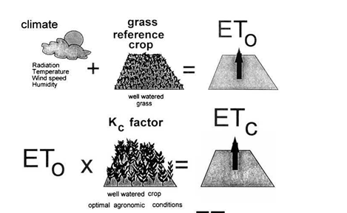
Fig 2.1: Actual crop evapotranspiration (ET_{c} )

- ETo measurement:
Evapotranspiration is not easy to measure. Specific devices and accurate measurements of various physical parameters or the soil water balance in lysimeters are required to determine evapotranspiration. Although the methods are inappropriate for routine measurements, they remain important for the evaluation of ET estimates obtained by more indirect methods.

- Direct Measurement of ET include:

  - Lysimeter experiment
  - Field experimental plots
  - Soil moisture studies
  - Water balance method

- Climatic Approaches to estimate evapotranspiration
Some empirical equations are derived on the basis relationship between measured ET and climatic factors. The following methods are the combination of some empirical, and theoretical approaches.
- FAO Balnney-criddle method
- FAO radiation method
- Hargreaves method
- FAO Penman-monteith method
- FAO Class A pan Evaporation method
- Thornthwaite Method

- Pan Evaporation Method
Pan evaporation provide a measurement of the integrated effect of radiation, wind, temperature and humidity on the evaporation from specific open water surface. It is the simplest, reasonably accurate and most commonly used is pan evaporation method.

The commonly used standard pan is the US class a pan. It has standard size of 120cm diameter and 25cm depth and made of galvanized iron. For measuring evaporation, the pan should be properly sat on wooden open frame with its bottom 15cm above the ground level.
The pan evaporation is related to the reference evapotranspiration by an empirically derived pan coefficient:
ET_{o} = K_{p} * E_{pan}
Where ET_{o} : reference evapotranspiration (mm/day)
K_{p}: pan coefficient,
E_{pan} : pan evaporation [mm/day].
Pan coefficient (K_{p}) ;In selecting the appropriate pan coefficient, not only the pan type, but also the ground cover in the station, its surroundings as well as the general wind and humidity conditions, should be checked.

Measurement and recording
The depletion level of the water in the evaporation pan due to evaporation is measured by using ruler or measuring tape attached on the inside wall of the pan. Always fill up water after each measurement to the water surface at zero measurement level from top to create the same conditions for each measurement. In case of rain time, lower the level to avoid spillage and take the difference between previous level and new level and deduct the rainfall depth by taking record taken by rain gauge at the same date and time. Take daily records, and todays level minus yesterday level gives today evaporation in depth. If water is filled back and zero measurements level is considered, it is possible to take daily measurements as it is without deducting, being initial is zero. Use the format provided below for daily recording.

The same to manual rain gauge, evaporation measurement requires daily follow-up and recording of data. To do so, format is provided to takedown the records at least once daily.
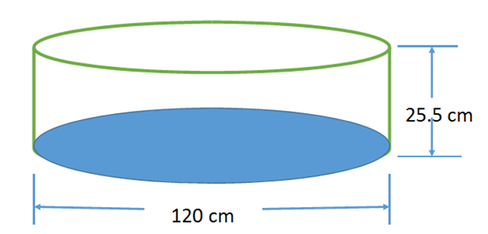
Fig 2.2: Class A US pan Evaporation meter.
The pan coefficient, K pan, depends on:
  - The type of pan used
  - The pan environment: if the pan is placed in a fallow or cropped area
  - The climate: the humidity and wind speed

The K pan is high if: |  | The K pan is low if:
 | The pan is placed in a fallow area |  | The pan is placed in a cropped area
 | The humidity is high (i.e. humid) |  | The humidity is low (i.e. dry)
 | The wind speed is low |  | The wind speed is high
Example. 2.1: Type of pan: Class A evaporation pan and evaporation measurement was recorded at 24 hour as indicated (see Fig. 2.3 and 2.3b), use K pan = 0.75, then calculate ETo?
Water depth in pan on day 1 = 150 mm
Water depth in pan on day 2 = 144 mm (after 24 hours; )
Rainfall (during 24 hours) = 0 mm
Formula: ETo = K pan × E pan E pan = 150 - 144 = 6 mm/day
ETo = 0.75 × 6 = 4.5 mm/day
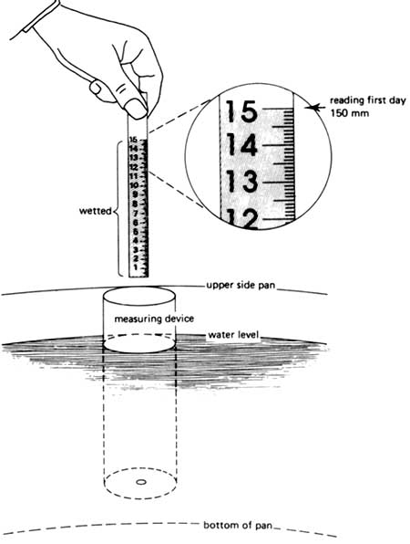  Fig. 2.3 Measuring the water depth on day 1 | 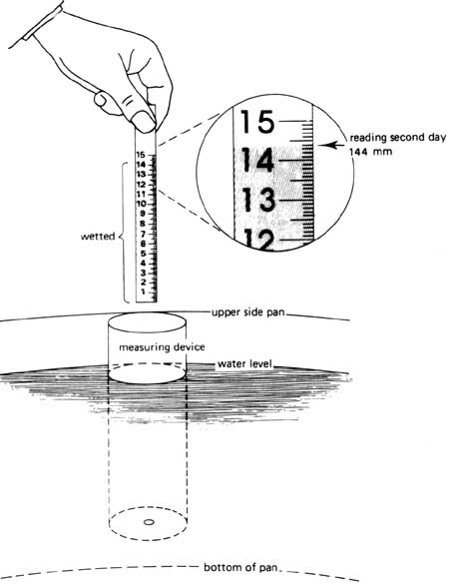  Fig. 2.4 Measuring the water depth on day 2 (after 24 hours)
Example. 2.2: Using similar Class A evaporation pan
- Water depth in pan on day 1 = 411 mm
- Water depth in pan on day 2 = 409 mm (after 24 hours)
- Rainfall (during 24 hours) = 7 mm and K pan = 0.75

Formula: ETo = K pan × E pan E pan = 411 - 409 + 7 = 9 mm/day
ETo = 0.75 × 9 = 1.5 mm/day

- Blaney-Criddle Method
If no measured data on pan evaporation are available locally, a theoretical method to calculate the reference crop evapotranspiration ETo has to be used. It is simple, using measured data on temperature only.
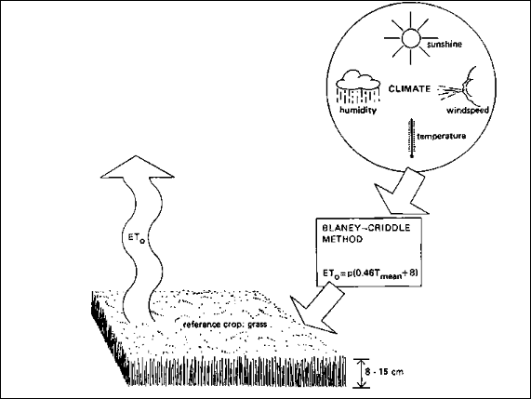
Fig.2.5: The Blaney-Criddle method

- The Blaney-Criddle formula: ETo = p (0.46 T mean +8)
- ETo = Reference crop evapotranspiration (mm/day) as an average for a period of 1 month
- Tmean = mean daily temperature (°C)
- p = mean daily percentage of annual daytime hours
To determine the mean daily percentage of annual daytime hours (P) there is a special table which is presented below. To use Table 2.1 we must have some information about latitude of the area (the number of degrees north or south of the equator)

Table 2.1. Mean daily percentage of annual daytime hours for different latitude
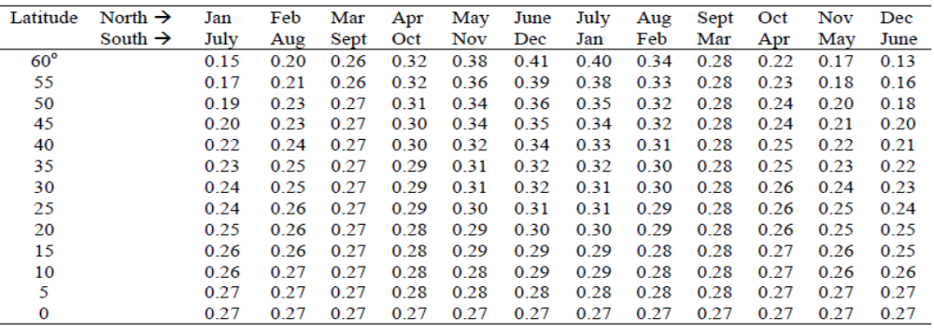

Example 2.3: Calculate ETO, using the formula: ETo = p (0.46 T mean + 8), when p = 0.29 and T mean = 21.5°C the ETo is calculated as follows:
ETo = 0.29 *(0.46 × 21.5 + 8) = 0.29 *(9.89 + 8)
= 0.29 × 17.89 = 5.2 mm/day

Computing crop water requirement (ET_{C})
In order to get actual evapotranspiration, first it is important to determine the reference evapotranspiration (ETo).
ETc = ET_{o} * K_{c}
Where, ETc: crop water requirement or crop evapotranspiration (mm/day)
ETo: reference evapotranspiration (mm/day)
Kc: crop factor (crop coefficient)

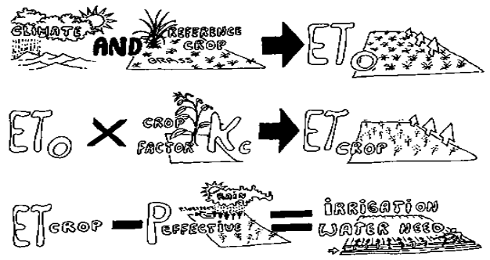
Fig 2.6: determination of the reference crop evapotranspiration (ETo), the crop water need (ET crop) and the irrigation water need.
Learning outcomes of the chapter
Upon the completion of this chapter, training participants will be able to:
- Clearly understand the different irrigation methods, i.e. surface irrigation (furrow, border and basin), drip irrigation and sprinkler irrigation
- Identify the factors that determine choice of irrigation methods;
- Choose appropriate irrigation methods for different irrigated crops;

Materialsrequired: PPT slides, Flip chart papers, note books and pens,
Methodology: the training methodology will be:
- lectures on concepts, principles, practices and approaches of method of irrigation,
- Demonstration of the theoretical concepts using facts and figures and exercises and discussion and field observation
- Given the opportunity to apply the knowledge and skill they acquired from their work experience through assignments, group works and presentation
Facilitator will ask participants to divide the whole session into equal number of participant to make a group;
Each group will be asked to discuss on theadvantages and disadvantages of using different irrigation methods;
After the discussion each group will come up with its group work report and present for the whole group.
Q1. In your area, which irrigation method is used by most farmers? Why?
Q2. Identify the practical problems in the use of the different irrigation methods andsuggest possible solutions

Crop water requirement is the amount of water required to compensate the evapotranspiration loss from the cropped field is defined as crop water requirement. While, irrigation water requirement basically represents the difference between the crop water requirement and effective precipitation. The irrigation water requirement also includes additional water for leaching of salts and to compensate for non-uniformity of water application

Irrigation requirement of Crops
The irrigation water requirement of crops is defined as the part of water requirement of crops that should be fulfilled by irrigation. In other words, it is the water requirement of crops excluding effective rain fall, carry over soil moisture and ground water contributions.
- If irrigation is the sole source of water supply for the plant, then the irrigation requirement will be at least equal to the crop water requirement, and is generally greater to allow for inefficiencies in the irrigation system.
- If the crop receives some of its water from other sources (rainfall, water stored in the soil, underground seepage, etc.), then the irrigation requirement can be considerably less than the crop water requirement.

- Effective Rainfall (Peff); can be defined as the rainfall that is stored in the root zone and can be utilized by crops. All the rainfall that falls is not useful or effective. As the total amount of rainfall varies, so does the amount of useful or effective rainfall. There are different methods for calculating the effective rainfall from entered monthly total rainfall data. But, in this section we can use dependable rain methods;
- Effective Rainfall = 0.6 * Total Rainfall - 10 ... (Total Rainfall < 70 mm)
- Effective Rainfall = 0.8 * Total Rainfall - 24 ... (Total Rainfall > 70 mm)

Irrigation water requirements are formulated mathematically as:
$$IWR(mm)=k_{c}*ETo-P_{eff}$$

Where; IWR: irrigation water requirement (mm/day)
- Kc is the crop coefficient
- ETo = reference crop Evapotranspiration (mm/day).
- Pe; effective rainfall:
Example 2.4; Calculate crop water requirement of which have crop types with Kc_{ave} = 0.65 and ET_{o} =7mm/day.
Solution, ETc =Kc * ETo =0.65* 7 = 4.55 mm/day
Example 2.5; Calculate irrigation water requirement of which have crop types with Kc_{ave} = 0.65 and ET_{o} =7mm/day and have effective precipitation of 2.2 mm in that day.
Solution, ETc =Kc * ETo =0.65* 7 = 4.55 mm/day
$$IWR\left(mm\right)=4.55-2.2=2.35mm/day$$
Example 2.6; Assume that ETo values calculated by using Cropwat software see table 2.2 below: Estimated crop water requirement and irrigation requirement per day.
Table 2.2: Estimated crop water requirement per day
Days | Kc | ET₀  mm/day | ETcrop  Kc.*ETo mm/day | Peff  mm/day | Irrigation water need  mm/day
1 | 0.30 | 4.00 | 1.20 | 0 | 1.20
2 | 0.30 | 4.20 | 1.26 | 0 | 1.26
3 | 0.30 | 3.90 | 1.17 | 0.6 | 0.67

Self-Check – 2 | Written test
Name…………………………………………… ID………………………… Date…….
Directions: Answer all the questions listed below.
Test I: Choose the best answer (5 point)
- Which one is factors considered when selecting method for estimating crop water requirement?
      - Type, accuracy, and duration of available climatic data
      - Intended use of the evapotranspiration estimations.
      - Natural pattern of evapotranspiration during the year.
      - All
- Measured pan evaporation data from the field was 8.5 mm/day and determine the reference evapotranspiration. The pan coefficient was 0.85
- 7.22 mm/day B. 0.722 mm/day C. 8 mm/day D. All
- Determine the net irrigation depth based on the following given data
- Kc= 0.7 , ETo=3.89mm/day and Effective rainfall =0.75mm/day
          - 1.973 mm/day B. 2.723 mm/day C. 3.72 mm/day D. All
- Which one of the following is Not the major factors to be considered in crop selection include the following:
- Soil condition, Crop or varietal adaptability
- Resistance to pest and diseases
- Marketability and profitability
- Available water and technology
- climatic factors
- None
- Which one is factors which Kc value depends on:
- Time of planting or sowing,
- Crop growth stages or development
- Climatic conditions.
- All

Test II: Matching (5 points)
Match column A with column B. Select the letter of the correct answer from column B and place your answer on the space provided in column A.
Column “A” | Column “B”
- ______ is the evapotranspiration rate from a reference surface, not short of water  - ______ is the only factors affecting ET_{o}.  - ______is the climatic approaches to estimate evapotranspiration.  - ________ is the direct measurement of ET.  - _______ can be defined as the rainfall that is stored in the root zone and can be utilized by crops. | - Hydrometer:  - Lysimeter experiment  - Effective Rainfall  - climatic parameters  - Balnney criddle  - Crop water requirement  - Reference Evapotranspiration

Note: Satisfactory rating - 5 points Unsatisfactory - below 5 points

You can ask you teacher for the copy of the correct answers.

You can ask you teacher for the copy of the correct answers.

Operation Sheet -2

- Techniques of Estimating Evapotranspiration(ETo) using Evaporation Pan
  - Tools and Equipment
- Class A pan
- Water
- Ruler
- Note book
- Pencil/pen
- Graduated cylinder or Bucket
  - Procedures:
- Wear appropriate PPE
- Install Pan at levelled in the field
- Measure the surface area of the pan.
- Fill the pan with known quantity of water until 5cm below the top of pan (see fig 1). and Take water out of the pan when the water depth rises too much(see fig;2)
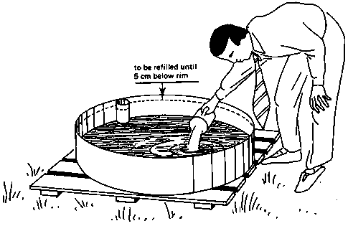
Fig. 1: Add water when the water depth in the pan
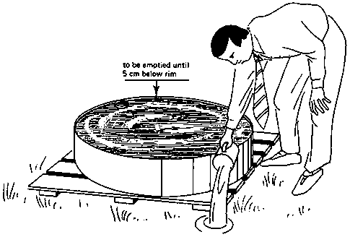
Fig.2: Take water out of the pan when the water depth rises too much
- Measure the depth of water in the pan by using ruler or measuring tape attached on the inside wall of the pan.
- Start recording time taken and allow the water to evaporate for period of time (usually 24 hours), Take measurement at each morning at 1 o'clock (local time).
- Measure the water depth before and after the water is added. If the water level rises too much (due to rain) water is taken out of the pan.
- And If the water depth in the pan drops too much (due to lack of rain), water is added. Then take the recorded rainfall depth by using rain gauge at the same date and time.
- Calculate the amount of evaporation per day (Epan) using formula below.
- Calculate ETo by using formula below.
Formula: ETo = K pan × E pan
ETo: reference crop evapotranspiration
Table 1; Data sheet for Determination ETo by Pan Evaporation Method
Days | Water depth  (mm)  Day 1 | Water depth after 24hr (mm) | Rainfall (mm) | Epan  (mm) | Kpan  = 0.7 | ETo  mm/day  Epan*Kpan
1
2
3
4
5
6
7
8
9

  - Epan = (Water depth day 1- water depth day2)
  - If there is rainfall, then Epan = (Water depth day 1- water depth day2) +Rainfall
  - ETo= Kpan *Epan = ------- mm/day

  - Techniques of Estimating crop water requirement (ETc)
              - Tools and Equipment
    - Note book
    - Pencil/pen
    - Calculator
    - Computer
          - Procedures:
- Select the type of irrigated crops to be grown;
- Choice the planting date and harvesting date
- selected K_{c} coefficients for each growth stages for climatic conditions during the stage;
- Determine reference crop evapotranspiration: ETo, daily value ETo for a given area
- Calculate ETc from; ETc = Kc x ETo

Table 2; Data sheet for Determination ETc: Pan Evaporation Method
Days | Rainfall (mm) | ETo, mm/day  Epan*Kpan | Peff  (mm) | Kc  use take (0.95) | ETc, mm/day  ETo*Kc | Irrigation need,  (mm/day )  ETc-Peff
1
2
3
4
5
6
7
8

LAP TEST-2 | Performance Test

Name……………………………….ID…………. Date……………………

Time started: ________________________ Time finished: ________________

Instructions: Given necessary templates, tools and materials you are required to perform the following tasks within 2 days interval. The project is expected from each student to do it.
Task-2.1: Estimate Evapotranspiration (ET_{O}) using Evaporation Pan.
Task-2.2: Estimate crop water requirement (ETc) using the result of task-1 and crop coefficient Kc=0.95 for a given crop type.

Reference Materials

FAO.1992. CropWat: A Computer Program for Irrigation Planning and Management: Irrigation and Drainage Paper. No. 46. FAO, Rome.
Mausbach, and Maurice J., 1998. Assessment and Future Direction for a National Soil Survey Program, Papers for the annual conference of the Soil and Water Conservation Society.
TTLM. 2018. Assist Estimation of Crop Water Requirements for small scale irrigation development level-II, version 1st , Adama, Ethiopia.
Web addresses
https://www.fao.org/3/s2022e/s2022e07.htm(access date 27/8/2022)
https://www.fao.org/3/x0490e/x0490e04.htm(access date 27/8/2022)
https://hgic.clemson.edu/factsheet/soil-texture-analysis-the-jar-test/(access date 27/8/2022)
https://www.youtube.com/watch?v=GWZwbVJCNec (access date 30/8/2022)

AKNOWLEDGEMENT

Ministry of Labor and Skills wish to extend thanks and appreciation to the many representatives of ATVET College instructors and respective industry experts who donated their time and expertise to the development of this Teaching, Training and Learning Materials (TTLM).

The experts who developed the learning guide
No | Name | Qualification | Organization/College | Mobile number | E-mail
1 | Serawit Gensa | Msc. Water Resource Engineering | W/Sodo AVET | 0916740916 | serawitgen@gmail.com
2 | Edao Hassen | Msc.Irrigation Engineering | Alage AVET | 0911098097 | hassedao@gmail.com
3 | Mekete Agizew | Msc. Water Resource Engineering | Amh/Kombolcha ATVET | 0925221192 | gen.mam09@gmail.com
4 | Wondu Alemayehu | Msc.Irrigation Engineering | Or/Kombolcha ATVET | 0910-28-99-61 | woldualem@gmail.com
5 | Ademe Ayalew | Msc.Irrigation Engineering | Agrafa AVET | 0912720547 | Ademe2004@gmail.com
6 | Said Mohammed | Msc.Irrigation& drainage Engineering | Alage ATVET | 09-17-18-01-81 | Siyamsdmhmmd@gmail.com/
7 | Molalign Asfaw | Bsc.Water Resource &Irrigation Engineering | Alage ATVET | 0921431096 | Mollalign410ass@gmail.com
8 | Yonas Hailu | Bsc.Water Resource &Irrigation Engineering | Agrafa AVET | 0934715578 | yonashailuw@gmail.com
9 | Lemessa Mulata | Msc.Irrigation Engineering | Agrafa AVET | 0913266845 | Lamimulle2022@gmail.com
10 | Misganew Yimer | Bsc. Soil and Water Engineering | Woreta ATVET |  | Misge1976@gmail.com
11 | Daniel Derese | Bsc. Soil and Water Engineering | W/sodo AVET | 0912-79-28-85 | danielderesse7@gmail.com
12 | Teshome Getachew | Msc.Irrigation & drainage Engineering | Alage ATVET | 0925-50-13-99 | teshomegetachew131@yahoo.com

