Irrigation and Drainage Works
Level II
Based on March, 2022, Version- 3 Occupational standard

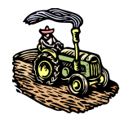

Figure 1

Module Title: - Micro Irrigation System
LG Code: AGR IRD2 M03 LO (1-4) LG (5-8)
TTLM Code: AGR IRD2 TTLM 0822v1

August, 2022
Addis Ababa, Ethiopia

Table of Contents
Table of Contents 1
Introduction to the Module 1
LO #1- Preparation of Materials and tools for installation 2
Instruction sheet 2
Information Sheet 1 3
Self-check 1 20
Operation Sheet -1 21
LAP TEST-1 22
LO 2 #- Set out and site Preparation 23
Instruction sheet 23
Information Sheet 2 24
Self-check 2 31
Operation Sheet – 2 32
LAP TEST-1 33
LO #3 - Micro irrigation System installation 34
Instruction sheet 34
Information Sheet 3 35
Self-check 3 48
Operation Sheet -3 49
LAP TEST-1 51
LO #4- Completing micro irrigation installation 52
Instruction sheet 52
Information Sheet -4 53
Self-check- 4 60
Operation Sheet - 4 61
LAP TEST-2 62

Introduction to the Module
Module Description: This module covers the knowledge, skills and attitude required to prepare
tools and materials, setting out, installing components and complete layout and installation work of micro irrigation systems.

LG #5 | LO #1- Preparation of Materials and tools for installation

Instruction sheet
This learning guide is developed to provide you the necessary information regarding the following content coverage and topics:
- Selecting materials, tools and accessories
- Identifying Surveying and leveling equipment
- Checking parts and accessories
This guide will also assist you to attain the learning outcomes stated in the cover page. Specifically, upon completion of this learning guide, you will be able to:
- Select tools and materials for installation
- Identify Surveying and leveling equipment
- Check parts accessories
Learning Instructions:
- Read the specific objectives of this Learning Guide.
- Follow the instructions described below.
- Read the information written in the information Sheets
- Accomplish the Self-checks
- Perform Operation Sheets
- Do the “LAP test”

Information Sheet 1

  - Selecting Materials, tools, Equipments and accessories
Micro-irrigation: refers to low-pressure irrigation systems that spray, mist, sprinkle or drip. The water discharge patterns differ because emission devices are designed for specific applications due to agronomic or horticultural requirements. Micro-irrigation components include pipes, tubes, water emitting devices, flow control equipment, installation tools, fittings and accessories. Before installing micro irrigation system, it is important to select the appropriate materials, tools and equipments.
The appropriate Materials, tools, equipments and accessories for micro -irrigation systems are listed below.
- Hand tools
- Spade
A spade is a tool designed primarily for the purpose of digging or removing earth. With a metal tip, a spade can both break and move the earth in most situations, increasing efficiency. Small spade for clay soil; the other one for sandy soil and loamy soil
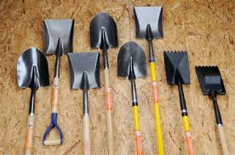
Fig,1.1: Spade
- shovel
A shovel is a tool for digging, lifting, and moving bulk materials, such as soil, coal, gravel, snow, sand, or ore.
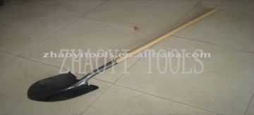
Fig. 1.2: Shovels
- Rake
A rake is a tool used to gather or loosen material or to grade or level a surface.
There are two major kinds of rakes: an attachment for a tractor and a hand tool.
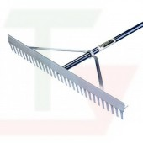
Fig. 1.3: Rake
- Pick axe
Pick axe: - a tool for breaking hard surfaces, with a long wooden handle and a curved metal bar with a sharp point.
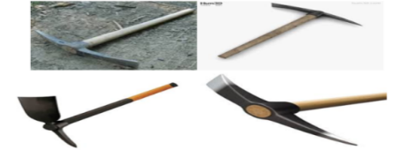
Fig 1.4: Different types of Pick axe
- Wheel barrow
Wheel barrow for transporting all kinds of materials in the nursery: potting soil, seedling ready for delivery…etc.
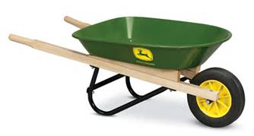
Fig 1.5: Wheelbarrows
- Roller
The roller is an agricultural tool used for flattening land or breaking up large clumps of soil. Typically, rollers are pulled by tractors or, prior to mechanization, a team of animals such as horses or oxen.
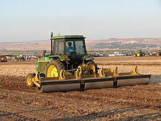
Fig. 1.6: Roller
- Hoses
A hose is a flexible hollow tube designed to carry fluids from one location to another. Hoses are also sometimes called pipes (the word pipe usually refers to a rigid tube, whereas a hose is usually a flexible one), or more generally tubing. The shape of a hose is usually cylindrical (having a circular cross section).
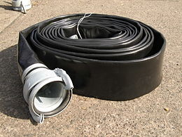
Fig. 1.7: Hoses
- Pipe
Pipe hollow cylinder of metal, wood, or other material, used for the conveyance ofwater
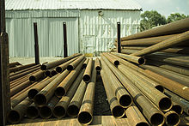
Fig. 1.8: Pipe
- Fitting
A fitting is used in pipe systems to connect the straight pipe or tubing sections, adapt to different sizes or shapes and for other purposes, such as regulating fluid flow.
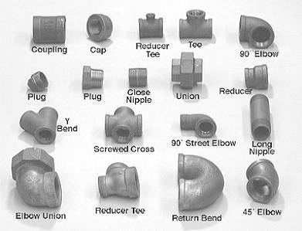
Figure 1.9: Fittings
- pumps and pump fittings
There are many types of water pumps being used for irrigation. Each pump type has different characteristics and capabilities. A pumping unit or “pump” has a “prime mover” or engine that uses energy to drive the pump mechanism that lifts or moves water from the source. The most common energy sources are:
- Manual (human) power,
- Diesel, petrol or electricity.
- Solar and wind-powered pumps
Solar and wind-powered pumps do not usually provide enough power to pump the volume of water required for irrigation. They are more appropriate for pumping water for domestic supply or for livestock.
The most common pumps for small-scale irrigation are:
- manual pumps, and
- centrifugal (radial flow) pumps
Axial flow (propeller) pumps and mixed flow pumps are also used on irrigation systems but are usually to be found where large volumes of water are being lifted for use on surface irrigation schemes. Axial flow pumps may be expensive because of the high cost of materials, particularly the drive shaft and bearings to support the propeller.
- Manual pumps
There are several different designs and manufacturers of manual pumps used for irrigation. They vary in their performance and suitability for use in the field. For example, some pumps are heavier than others, which is an important factor if the farmer needs to carry the pump regularly between house and field. The effort required to operate the pump also varies between different models and designs.

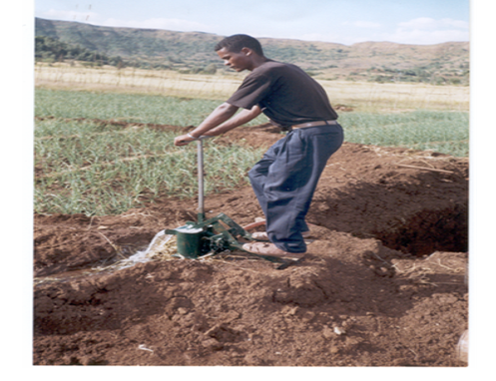
Fig.2.10: Typical treadle irrigation pump
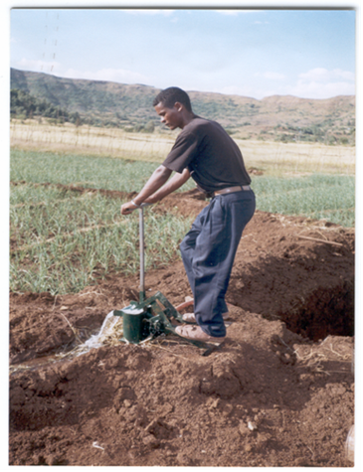
Manual pumps cost much less than electric, petrol- or diesel-powered pumps, but the quantity of water (discharge) they produce is many times lower. For a farmer wanting to irrigate only a small area – less than 0.2 ha / day – from a shallow water source (less than 4 m below the surface) a manual pump can be a good choice because of its low purchase and operating costs.
The treadle pump is a simple, low-cost pump that is now available in many areas. Much of the repair and maintenance can be done by the farmers themselves or by a village pump contractor using locally available materials. The treadle pump can be used to lift water from shallow wells or any water body where the water surface is less than 4 m below the ground-surface. The average discharge from a treadle irrigation pump can vary between 0.4 to 1,2 l/s depending on the person operating it and the depth from which they are pumping water.
- Centrifugal (radial flow) pump
The centrifugal pump is the most commonly used type of motorized pump for small-scale irrigation. They are relatively cheap and are available as small, low-power units that can be used by an individual or small group of farmers.

Table 1.1: Approximate relationship between pump size and discharge
Power kW (hp) | Pump size (mm) | Discharge (l/s)
1.5 (2) | 25 | 0–5
3.7 (5) | 50 | 5–15
5.2 (7) | 75 | 15–25
6.7 (9) | 100 | 25–35
> 6.7 (>9) | 125 | 35–50
Source: FAO. 1992. Irrigation water management training Manual. Small-scale pumped irrigation: energy and cost. Rome
The centrifugal pump has an impeller with blades or vanes, which spin at high speed inside the pump casing, Water is drawn into the pump from the source through a short inlet pipe called the suction pipe. As the impeller spins, water is thrown outwards and is collected by the pump casing and guided towards the outlet / delivery pipe.
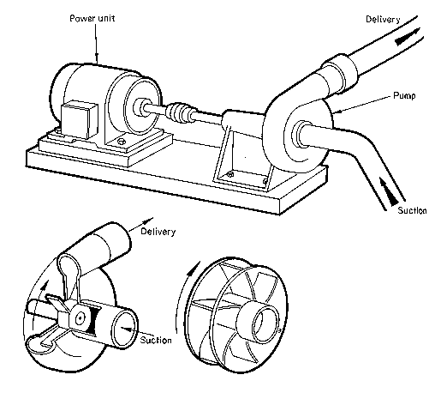

Fig. 1.11: Typical centrifugal pump

A centrifugal pump can be used where pressure is required, for example with sprinklers, or drip. Most manufacturers produce a range of different impeller designs for any size of pump and depending on the impeller design the output pressure and discharge of the pump will vary. The operator should ensure that the pressure and discharge of the pump are matched to the requirements of a pressurized irrigation system to avoid wasteful use of fuel. A person who understands pump characteristics should select the pump.
- Pump selecting
A pump operates most satisfactorily under a head and at a speed for which it is designed. The operating conditions should therefore be determined as accurately as possible to select pumps well adapted to the particular conditions of operation.
Factors to be considered while selecting a pump:
- Purpose to which the pump is going to be used.
- Capacity of pump required.
- Depth of water source (suction head)
- Friction head
- Discharge head
- Pressure head
- Break horsepower
- Pump efficiency
- Pump speed

1.2 Identifying Surveying and leveling equipment
Surveying is the science or art of making the measurement necessary to deter mine or establish the relative position of points.
Leveling is a type of surveying which is carried out for measuring the elevation difference b/n points and to establish the elevation or heights of points
The different types of Surveying and leveling equipments are listed below

- automatic level,
- laser level,
- dumpy level,
- Cowley level,
- staff,
- boning rods,
- pegs,
- notebook,
- pencil and
- calculator;

Types of level
- Automatic Level
Auto levels are electronic surveying instruments that contain optical compensators. This self-leveling feature enables it to maintain a level line of sight even though the instrument is slightly tilted. After the bubble was manually centered, the automatic compensator takes over and levels the line of sight.
An automatic level is a special leveling instrument used in surveying which contains an optical compensator which maintains line of sight or line of collimation even though instrument is slightly tilted.
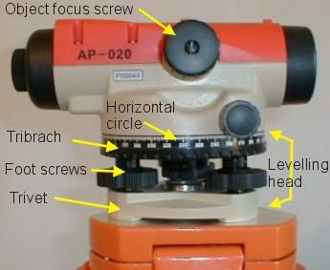
Fig.1.12: auto level
- laser level
The laser level is a control tool consisting of a laser beam projector that can be affixed to a tripod. The tool is leveled according to the accuracy of the device and projects a fixed red or green beam about the horizontal and/or vertical axis.^{[1]}
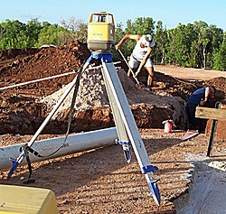
Fig.1.13: Laser level
- Cowley level
'In appearance this level does not look like an ordinary level but resembles a small amateur's cine camera. It is particularly suitable in building and engineering work for setting our foundations, gradients, etc., and, although it can be used for running short lines of levels from point to point, it is not so suitable as an ordinary level for carrying forward long lines of levels. It has the advantage of being very simple and quick to use and it is very cheap considering the degree of accuracy obtainable with it. It has also the advantage of not requiring a skilled surveyor to manipulate it (D. Clark, J., 1963).

Figer1.14: Cowley level
- Dumpy level
Dumpy level is commonly used leveling instrument to locate the points in same horizontal plane. It is also called as automatic level or builder’s level. Elevations of different points and distance between the points of same elevation can be determined by dumpy level.

Fig.1.15: dumpy level

Accessories of level equipment
- Reading /leveling staff
Leveling staff is a graduated rod of rectangular section. It is usually made of thick wood. It may be made of fiberglass or metal.
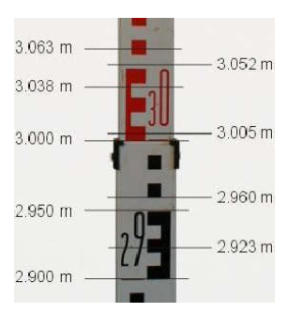
Fig.1.16: Reading staff
- Tripod

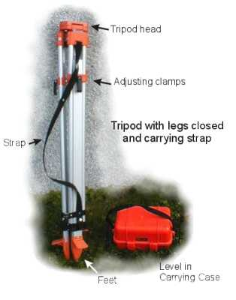
Fig.1.17: Tripod
Basic components of level
- Telescope
Telescope is an optical instrument used for magnifying and viewing the image of distant objects. It is used to provide line of sight. It consists of two lenses. The lens fitted near the eye is called the eyepiece and the other fitted at the end near to the object is called the objective lens. The objective provides a real inverted image in front of the eyepiece at a distant lesser than its focal distance. Two essential conditions are involved:
- The real image of the object must be formed
- The plane of the image must coincide with that of crosshairs.
- Level tube
It is also known as bubble tube consists of a glass tube placed in a brass tube which sealed with plaster of Paris. Parts of level tube space is filled with alcohol; the remaining space is occupied by an air bubble. The Centre of air bubble always rest at the highest point of the tube. Outer surface of the bubble tube is graduated in both the directions from the Centre. The line tangential to the circular is at its highest point i.e. the middle at the tube is called the axis of bubble tube. When the bubble is central the axis of bubble becomes horizontal. The level tube is attached on the top of telescope by means of capstan headed nuts.
- Levelling head
It generally consists of two parallel plates with three-foot screws. Upper plate is known as tribrach and the lower plate is trivet which ca n be screwed on to the tripod. Levelling head has to perform three functions:
- to support the telescope
- To attach the level to the tripod
- To provide means for level (foot screws)
Other accessories used in surveying and leveling
- Pegs
Pegs are used when certain points on the field require more permanent marking. Pegs are generally made of wood; sometimes pieces of tree-branches, properly sharpened, are good enough. The size of the pegs (40 to 60 cm) depends on the type of survey work they are used for and the type of soil they have to be driven in. The pegs should be driven vertically into the soil and the top should be clearly visible.
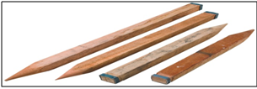
Fig. 1.18: pegs
- Notebook
A notebook (notepad, writing pad, drawing pad, legal pad) is a book or binder of paper pages, often ruled, used for purposes such as recording notes or memoranda, writing, drawing or scrapbooking.

Fig.1.19: Note book
- Scientific calculator
Scientific calculator is a type of electronic calculator, usually but not always handheld, designed to calculate problems in science, engineering, and mathematics. They have almost completely replaced slide rules in traditional applications, and are widely used in both education and professional settings.

Fig.1.20: scientific calculator
- Pencil
Pencil is an implement for writing or drawing constructed of a narrow, solid pigment core inside a protective casing which prevents the core from being broken and/or from leavingmarks on the user’s hand during use.
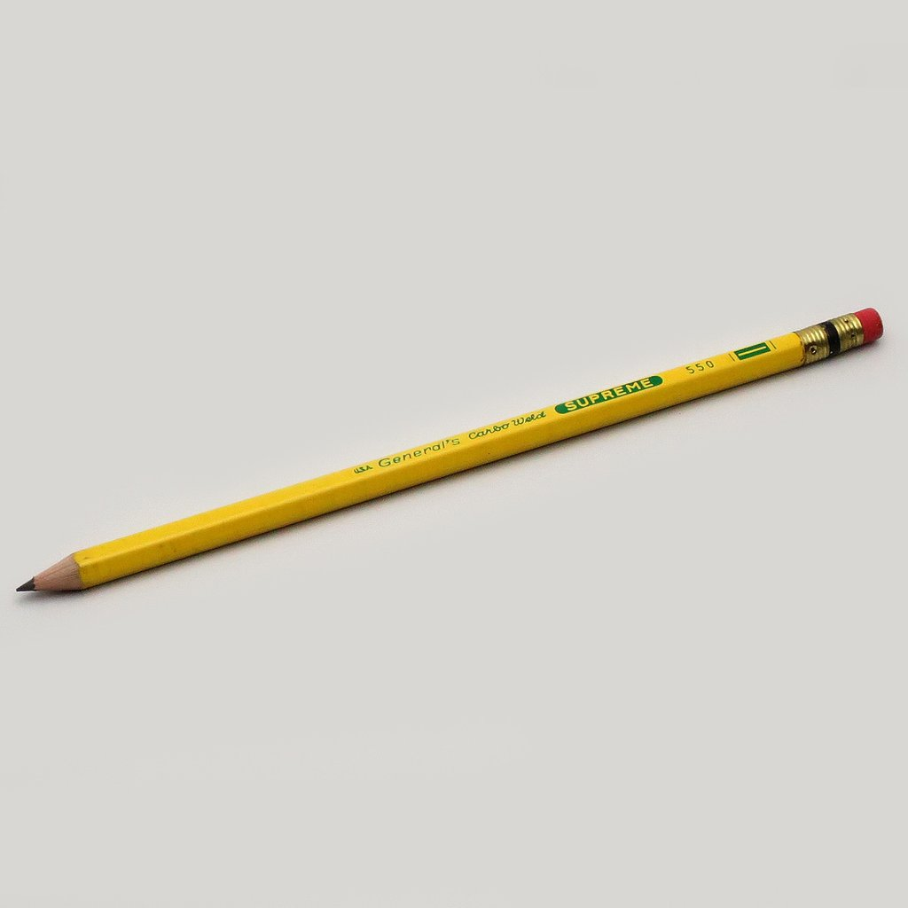
Fig.1.21: Pencil
1.3 Identifying site for installation of micro-irrigation system
In order to identify the suitable site for installation of micro- irrigation, the following points should be taken in to consideration
- Conduct Survey
The following survey inputs are required to select site for installation of the micro-irrigation system
- Size of the area
The area should have sufficient size for the intended activities and should have extra area for future expantgion.
- Topography of the area /Elevation:
Slope of the ground surface may be judged with the naked eye for small plots wherever possible and taken into consideration. If the ground surface is too undulating and the slope is difficult to judge, levels should be taken with a leveling instrument and contours drawn on the map to make a proper design of the drip system.
- Water Source:
Check the Position and the presence of sufficient water source (tank, well, reservoir, pond, river, stream, existing pump, pipeline, etc.). Size, volume, and flow rate, water source also, should be checked
- Quality of water,
Check and ensure that the water is free from salt and other impurities.
- Agro-climatic details
Ensure that the ago- climatic is suitable for intended growing crops. Crops should be noted including specific areas, crop spacing (plant to plant distance x row to row distance), number of plants and number of rows, crop duration, expected canopy, rainfall, evapotranspiration, etc.
- Soil details:
The details of soil quality visible to the naked eye should be noted including heavy soil or light soil depending on soil texture (proportion of clay, silt & sand.)

1.4 Checking parts and accessories
In micro irrigation systems checking both the parts and accessories that delivered to the site helps:
- To identify damages during transportation
- To ensure that parts and accessories are delivered based on design and specification.
- To ensure the size and quality of parts and accessories
Here is a checklist for parts and accessories of micro irrigation systems
- Inspect all components of your watering system, from the backflow preventer to the valves, for standing water, soggy ground, or eroded soil. If you have a controller, check that the programs are correct.
- Sprinklers parts and accessories should be checked frequently since they are above ground and can easily get damaged or misdirected. Check the irrigation line from the valve to the spray heads for leaks. Replace spray heads if necessary, and be sure to replace with the proper spray head. Check that sprinkler heads are flush with the soil surface and straight, not tilted. Clear grass, plants and other obstructions that block sprinkler spray. Finally, adjust sprinkler heads so they don’t spray walls, driveways, or sidewalks.
- For drip irrigation, turn on the system 20-30 minutes before the inspection to allow enough time for emitter wetting patterns to show. Check from the valve to the end of the irrigation line for leaks or clogged emitters. Check for proper emitter placement on plants as they grow. You may need to move emitters out to the drip line of the plant each season.

Self-check 1 | Written test

Name…………………………………………… ID………………………… Date…….
Directions: Answer all the questions listed below.
Test I: Choose the best answer (4pts)
      - Which one of the following is belongs to Surveying and leveling equipment
    - Rake
    - Pump
    - Automatic level
    - Roller

- Which one is commonly used leveling instrument to locate the points in same horizontal plane? (2pts)

- Laser level
- Auto level
- Cowley level
- Dumpy level

Test II: Mach the following questions from `B ` to `A` (4pts)
‘A’ | ‘B’
---------- 1 Spade | - a graduated rod of rectangular section
-----------2. Roller | - a tool designed primarily for the purpose of digging or removing earth
-----------3. Leveling  staff/rod | - The most commonly used type of motorized pump for small-scale irrigation.
-----------4. Centrifugal  Pump | - used for flattening land or breaking up large clumps of soil.
 | - a tool for breaking hard surfaces

Test III: Short Answer Questions
- Mention and discuss the type of level (4pts)
- List the types of hand tools used to lay micro irrigation (3pts)
- Mention the types of surveying and leveling equipment used to lay micro irrigation (3pts)

Operation Sheet -1

1.1 Identify tools and equipments used in micro irrigation system
A. Tools and equipments
- PPE
- Note book
- Pen
B. Procedure
- Wear personal protective equipment
- Go to work shop where tools and equipments are found
- List out and naming tools and equipments used in micro irrigation systems.
- Identify and naming tools and equipments used in micro irrigation systems

LAP TEST-1 | Performance Test

Name………………………………. ID……………………………. Date…………………………………….

Time started: ________________________ Time finished: ________________

Instructions: Given necessary templates, tools and materials you are required to perform the following tasks within 1 hour. The project is expected from each student to do it.

Task-1 Identify and naming tools and equipments used in micro irrigation systems

LG #6 | LO 2 #- Setting out and site Preparation

Instruction sheet
This learning guide is developed to provide you the necessary information regarding the following content coverage and topics:
- Cleaning site
- Setting out installation work
- Personal protective equipment
- Identifying OHS hazards
This guide will also assist you to attain the learning outcomes stated in the cover page. Specifically, upon completion of this learning guide, you will be able to:
- Clean up the site
- Set out installation work
- Select personal protective equipment (PPE)
- Identify OHS hazards
Learning Instructions:
- Read the specific objectives of this Learning Guide.
- Follow the instructions described below.
- Read the information written in the information Sheets
- Accomplish the Self-checks
- Perform Operation Sheets
- Do the “LAP test”

Information Sheet 2

2.1. Cleaning site
Cleaning /clearing is the process of removing trees, stumps, brush, stones and other obstacles from an area as required to increase the size of an existing farm or to provide land for a new farm operation. The newly cleared land must be ready for cultivation, including liming and leveling to meet acceptable installation and operation goals.
- How Site cleaning/ Clearing Prepares a Construction/ installation Site
We remove all rocks, roots, and trees before we begin to level out the ground. Before creating a brand-new parking lot or road, we first have to clear the site. Site clearing is the process of clearing away the vegetation and surface soil of the construction site. There are several steps involved in a successful site clearing. Here is what we do when site clearing to ensure that we get a project set up for success.
- Clearing vegetation
After designating the area to be cleared, the first step is to remove vegetation. This begins with undergrowth. After the undergrowth is cleared away, only large vegetation, such as trees and shrubs, is left to be cleared. Clearing the undergrowth first creates a safer, easier space to do the labor or tree removal. then focus on removing the roots, stumps and roots. We also remove large stones and dig out animal burrows and fill them with clay. Vegetation within a surrounding designated workspace area should be cleared.
- Cleaning equipment
Proper and well-maintained industrial cleaning equipment and skilled operators shall be used for land clearing. The primary land clearing equipment shall be one of the following: Crawler tractors with piling blades, cutting blades or earth blades. Cutting blades shall be used only for cutting and piling method. Earth blades shall only be used for walking-down standing timber. Excavator with piling rake. Generally, auxiliary land clearing equipment shall be breaking discs and breaking plows pulled by crawler tractors. Generally, land clearing equipment used for debris cleanup operations shall be wheel rakes, power drum brakes, specialized reel head rock pickers and debris pickers powered by farm tractors. Brush cutters (rotary brush mowers) powered by farm tractors, may be used for clearing light growth and ground brush, if normal cultivation can proceed after brush cutting.
Making the site good
Irrigation work sites are expected to be clean, tidy, comfortable and good to create conducive environment for work. Cleanliness is the most essential elements in maintaining a healthy and safe work environment. Not only does a clean workplace reflect the professionalism of a business or facility and help motivate employees, it also promotes a healthy workforce as a clean environment prevents accidents and the spread of germs.
Working together we can all contribute to creating a safe and healthy workplace and a professional looking facility for employees, visitors and customers.
Basic land clearing/cleaning operations include the following operations:
- removal of trees and bushes, wood, stones, etc. from earth surface;
- elimination of tussocks and moss;
- removal of stones;
- leveling and primary treatment of soils;
- deep tillage of soil, including leveling of earth hills and banks, filling up of pits and ditches.

2.2. Setting out installation work
- Undertaking measurement and marking out of irrigation lines
Irrigation lines are measured and marked using appropriate tools and materials based on the design of the systems
Steps of undertaking irrigation site measurements
          - Interpreting an Irrigation Design Plan
The foundation of a reliable irrigation system is based on adequate data on the crop, soil and root system being incorporated in a good irrigation design plan. The irrigation system is usually designed by a qualified irrigation consultant.

    - Laying Out the Irrigation System
Now that we have developed an understanding of the irrigation design plan, the blocks can be pegged out in the field. The assumption is made that the land has been cleared and soil preparation has been done, and that other infrastructure items, such as roads and waterways, has already been demarcated. Care must be taken when laying out the irrigation blocks that it is done correctly and precisely. It may take a day or two longer to get it right, but remember that the result will be visible for the lifespan of the orchard.
    - Marking the Corners of the Blocks
The corners of the blocks are first pegged out roughly to see the relation of the blocks to one another. The lengths of the sides of the blocks are now measured on the irrigation design plan, and the scale of the plan is used to calculate the actual length. The scale is a ratio that shows the relation between the measurement on the plan and the actual distance on the ground
    - Marking the Rows
Start by measuring the rows on the side of the block with the mother line, using a measuring tape. Remember that poor-quality measuring tapes can stretch and expand. Use a good quality measuring tape made of fiber.
    - Marking the Plant Positions
Set up the dumpy at the end of a row and look at the other end. Use the tape measure to measure the inter-plant spaces. If the plant spacing is 6x2m, this would be 2m. Plant pegs at every spot where a tree must be planted. Check the pegs visually to see that they are in line. Check them also at an angle, meaning from one corner to the corner diagonally opposite, to see if they are aligned.
    - Marking Conveyance System Trenches
Conveyance system trenches are the trenches into which the pipelines are buried. Before the trenches are dug, they must first be pegged out. The Centre of the trench can be pegged with pegs about 50m to 100m apart. Tie a wire or a rope to the pegs to mark out line between them, and use ordinary lime to mark out the line of the trench. When the trenches are dug, the chalk line must be in the center of the trench. Trenches are dug depending on the size of the pipe. Trenches for pipes that go through lands and roads, such as mainlines and sub-mainlines, should be 1,000mm deep. Trenches for mother lines can be a bit shallower, at about 400mm. Trenches must be free of protruding rocks on the bed since these rocks can break the pipes. Trenches can be dug by either using manual labor or a back-end loader, also called an excavator. Manual labor may be cheaper, but will take longer, while using a back-end loader will be faster but more expensive. Keep in mind that back-end loaders are also more suited for rocky terrain. The choice will depend on the budget.
2.3. Personal protective equipment selection
Personal protective equipment (PPE) is used to protect an individual from hazards associated with their work tasks or environment. Personal protective equipment should be selected based on work requirement. Specific types of personal protective equipment include protective clothing, eyewear, ear muff, mouth clamp, gloves, hard hat and safety shoe. Some of the commonly used PPE are listed in the table below.
Table 2.1 Personal protective equipment
Body protection (PPE) | Purpose
respiratory protection | It is used to protect dusts and chemicals from entering to the mouth
Gloves | It is used to protect severe cuts,  abrasions, punctures, temperature, and chemical hazards.
Hard hat | It is required to protect the head from sun, accident and dust.
Safety shoe/Boot | It is required to protect the foot from different hazards.
Goggles | It is required to protect eye from dusts, chemicals, etc by all workers engaged in hazardous activities.
Ear muff | It is required to protect the ear from dangerous sound and dust.
Mouth clamp / Mouth guard | It is required to protect the mouth from the entering of dust and different chemicals.
Overalls | It retains heat radiated from the body and keeps the wearer warm in the cold weather

- Selecting personal protective equipment
Suitable personal protective equipments should be selected, used, maintained and stored in accordance with Occupational Health and Safety requirements.
During selection of personal protective equipment Consider the following points:
- Type of hazardous materials, processes, and equipment involved
- Routes of potential exposure (ingestion, inhalation, injection, or dermal contact)
- Correct size for maximum protection
- Minimal interference with movement
2.4. Identifying OHS hazard
Occupational health and safety are one of the most important aspects of human concern. It aims an adaptation of working environment to workers for the promotion and maintenance of the highest degree of physical, mental and social wellbeing of workers in all occupations.
Workplace injury is a major cause of concern for all involved in occupational health and safety. An “occupational hazard” is any workplace condition that causes a risk to employee health. The factors which cause workplace accidents and occupational illnesses are called hazards. The need for systematic management of OHS hazards and their attendant risks applies to all organizations and all activities and functions within an organization.
- Identifying hazards in the workplace
The Occupational Safety and Health Administration (OSHA), the government organization in charge of keeping workers safe, has defined six main categories of occupational hazards:
          - Safety
This category includes any condition, substance, or object that can injure a worker, like working from heights, spills on floors, machinery with moving parts, confined spaces, steep stairs, or exposed electrical wiring.
          - Chemical

There are many kinds of hazardous chemicals and toxins in different workplaces, including environmental smoke, cleaning products, acids, pesticides, carbon monoxide, and flammable liquids.

          - Biological
In some settings, such as farms, zoos, hospitals or medical offices, or veterinary clinics, workers can be exposed to biological health hazards like blood, fungi, mold, viruses, animal droppings, and insect bites.
          - Physical
These are hazards in the environment that can harm your body without you actually touching it, like radiation, prolonged exposure to sunlight, extreme high or low temperatures, and loud noise.
          - Ergonomic
These hazards put strain on your body over a period of time. You may just feel sore or cramped in the short term, but repeatedly sitting or standing in awkward positions or completing the same movements over and over, across a long period of time, can lead to long-term injury and illness.
          - Work organization hazards.
Workplace violence, discrimination, lack of respect, sexual harassment, and other conditions are hazardous to mental, emotional, and physical health.
Risk management is a four-step process:
            - Identify the hazard
            - Assess the risk associated with the hazard
            - Control the risk
            - Review the process.
The first and most important step in reducing the likelihood of an accident is hazard identification. This means identifying all workplace situations or events that could cause injury or illness.
The second step is an assessment of the level of risk of the hazards you have identified. This step involves collecting information and making decisions. It is important you consider the extent of the harm or consequence from a hazard and the likelihood of harm occurring. If your assessment is that an unacceptable risk to health and safety exists, you must introduce controls to reduce the risk to an acceptable level.
There are three categories of control measures you might take. You can
  - eliminate the hazard
  - minimize the risk
  - introduce ‘back-up’ controls
The third step in effective risk management is to establish and maintain systems which give opportunity for regular evaluation and review procedures (i.e. PPE)
Implement additional risk controls
Having identified the hazards in your workplace, assessed their risks and reviewed the existing controls, all hazards must be managed before:
- people are hurt,
- People become ill or
- damage to plant, property or the environment.
The management of risks in the workplace requires eliminating risks so far as reasonably practicable in the first instance. Where elimination is not possible, then risks should be minimized, so far as reasonably practicable.
All hazards that have been assessed should be dealt with in order of priority. The most effective control option/s should be selected to eliminate or minimize risks. The Hierarchy of Controls ranks control options from highest level of protection and reliability to lowest. This should be used to determine the most effective control/s.

Self-check 2 | Written test

Name…………………………………………… ID………………………… Date…….
Directions: Answer all the questions listed below.
Test I: Mach the following questions from `B ` to `A` (8pts)
‘A’ | ‘B’
---------- 1 Hard hat | - It is required to protect the ear from dangerous sound and dust
-----------2. Hazards | - Protect eye from hazard
-----------3. Control the  risk | - protect the head from sun, accident and dust.
-----------4. Ear muff | - Risk management process
 | - factors which cause workplace accidents and occupational illnesses

Test II: Short Answer Questions
      - Mention steps of undertaking irrigation site measurements(3pts)
      - List personal protective equipment used in micro irrigation system (2pts)
      - Define hazard (2pts)
      - list and discuss Risk management process steps (3)
      - Mention the techniques used to load and unload irrigation structure equipment (3pts)

Operation Sheet – 2

2.1 Setting out installation work
A. Tools and Tools
- PPE
- Rake
- Spade /Shovel
- Pick axe
- Wheel barrow
- Meter
- Note book
- Pen
B. Procedure
      - Wear PPE
      - Select Suitable
      - Clear / prepare site
- Remove trees and bushes, wood, stones, etc. from earth surface;
- eliminate tussocks and moss;
- remove stone
      - Conduct layout
      - Determine area
- Apply 3,4,5 method
      - plough the selected area
      - Level the selected area

LAP TEST-1 | Performance Test

Name………………………………. ID……………………………. Date…………………………………….

Time started: ________________________ Time finished: ________________
Instructions: Given necessary templates, tools and materials, you are required to he following tasks within 2 hours. The project is expected from each student to do it.
Task1: Set out installation work
Task 2: perform site cleaning

LG #7 | LO #3 - Micro irrigation System installation

Instruction sheet
This learning guide is developed to provide you the necessary information regarding the following content coverage and topics:
- Identifying Components and techniques of micro irrigation
- Assembling and connecting components
- Irrigation components installation
- Maintaining a clean and safe working area
This guide will also assist you to attain the learning outcomes stated in the cover page. Specifically, upon completion of this learning guide, you will be able to:
- Identify components and techniques of micro irrigation
- Assemble and connecting components
- Install irrigation components
- Maintain a Clean and Safe working area
Learning Instructions:
- Read the specific objectives of this Learning Guide.
- Follow the instructions described below.
- Read the information written in the information Sheets
- Accomplish the Self-checks
- Perform Operation Sheets
- Do the “LAP test”

Information Sheet 3

3.1. Identifying Components and techniques of micro irrigation
Micro-irrigation systems are typically designed to make the best use of the amount of water available. The type and size of pump selected will depend on the amount of water required, the desired pressure and the location of the pump relative to the distribution network.
Basic components of micro irrigation system
      - Control head
The heads control unit of micro-irrigation system includes the following components.
          - Pump/Overhead tank:
It is required to provide sufficient pressure in the system. Centrifugal pumps are generally used for low pressure trickle systems.
    - Fertilizer applicator
Application of fertilizer into pressurized irrigation system is done by either a by-pass pressure tank, or by venturi injector or direct injection system
    - Filters
The hazard of blocking or clogging necessitates the use of filters for efficient and trouble free operation of the micro-irrigation system. The different types of filters used in micro-irrigation system are described below.
- Gravel or Media filter
- Screen filters
- Centrifugal filters
- Disk filters
- Pressure relief valves, regulators or bye pass arrangement

These valves may be installed at any point where possibility exists for excessively high pressures, either static or surge pressures to occur.
- Check valves or non-return valves
These valves are used to prevent unwanted flow reversal. They are used to prevent damaging back flow from the system to avoid return flow of chemicals and fertilizers from the system into the water source itself to avoid contamination of water source.
  - Water Distribution Network/system
The water distribution network constitutes main line, submains line and laterals with drippers and other accessories
  - Mainline
The mainline transports water within the field and distribute to submains. Mainline is made of rigid PVC or High-Density Polyethylene (HDPE). Pipelines of 65 mm diameter and above with a pressure rating 4 to 6 kg/cm² are used for main line pipes.
  - Submains
Submains distribute water evenly to a number of lateral lines. For sub main pipes, rigid PVC, HDPE or LDPE (Low Density Polyethylene) of diameter ranging from 32 mm to 75 mm having pressure rating of 2.5 kg/cm² are used.
  - Laterals
Laterals distribute the water uniformly along their length by means of drippers or emitters. These are normally manufactured from LDPE and LLDPE (Fig.5.8). Generally, pipes having 10-, 12- and 16-mm internal diameter with wall thickness varying from 1 to 3 mm are used as laterals.

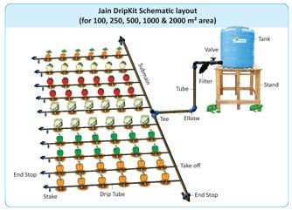
Fig Typical water distribution line of micro irrigation system

  - Emission Devices
The actual application of water in a micro- irrigation system is through an emitter. The emitter is a metering device made from plastic that delivers a small but precise discharge. Some emitters are pressure compensating meaning they discharge water at a constant rate over a range of pressures.
Emission devices deliver water in three different modes:
- drip,
- bubbler and
- micro-sprinkler.
In drip mode:
- water is applied as droplets or trickles.
In bubbler mode:
- water `bubbles out' from the emitters.
In the micro-sprinkler mode
- Water is sprinkled, sprayed, or misted.
Emitters for each of these modes are available in several discharge increments. Some emitters are adapted to apply water to closely spaced crops planted in rows. Other emitters are used to irrigate several plants at once. There are emitters that apply water to a single plant.
They function as energy dissipaters, reducing the inlet pressure head (0.5 to 1.5 atmospheres) to zero atmospheres at the outlet. The commonly used drippers are online pressure compensating or online non-pressure compensating, in-line dripper, adjustable discharge type drippers, vortex type drippers and micro tubing of 1 to 4 mm diameter. These are manufactured from Poly- propylene or LLDPE.

Types of Emitters / Drippers
    - Online pressure compensating drippers
A pressure compensating type dripper supplies water uniformly on long rows and on uneven slopes. These are manufactured with high quality flexible rubber diaphragm or disc inside the emitter that it changes shape according to operating pressure and delivers uniform discharge. These are most suitable on slopes and difficult topographic terrains.
    - Online non-pressure compensating drippers
Such type of drippers discharge tends to vary with operating pressure. They have simple thread type, labyrinth type, zigzag path, vortex type flow path or have float type arrangement to dissipate energy. However, they are cheap and available in affordable price. Different types on line non-pressure compensating types of drippers are shown through.
    - Point source emitters
Point source emitters are typically installed on the outside of the distribution line. Point source emitters dissipate water pressure through a long narrow path and a vortex chamber or a small orifice before discharging into the air. The emitters can take a predetermined water pressure at its inlet and reduce it to almost zero as the water exits. Some can be taken apart and manually cleaned. The typical flow rates range from 2 to 8 Lh⁻¹.
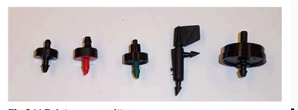
Fig. 3.1 Point source emitters
    - Line source emitter
Line source emitters are suitable for closely spaced row crops in fields and gardens. Line source emitters are available in two variations:
- Thin wall drip line
- Thick wall drip hose.
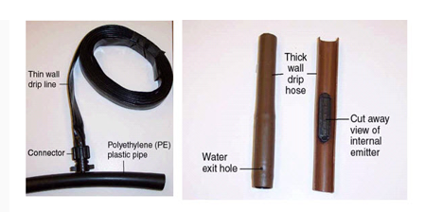
Fig.3.2: Thin wall drip line & thick wall drip line
    - Bubblers
Bubblers typically apply water on a "per plant" basis. Bubblers are very similar to the point source external emitters in shape but differ in performance. Water from the bubbler head either runs down from the emission device or spreads a few inches in an umbrella pattern. The typical flow rate from bubbler emitters varies between 8 and 75 Lh⁻¹.
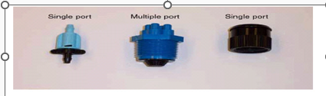
Fig.3.3: Bubbles
    - Micro sprinklers
Micro-sprinklers are emitters commonly known as sprinkler or spray heads. These are of several types. The emitters operate by throwing water through in air, usually in predetermined patterns. Depending on the water throw patterns, the micro-sprinklers are referred to as mini-sprays, micro-sprays, jets, or spinners. The sprinkler heads are external emitters individually connected to the lateral pipe typically using "spaghetti tubing," which is very small (1/8 inch to 1/4 inch) diameter tubing. The sprinkler heads can be mounted on a support stake or connected to the supply pipe. Micro-sprinklers are desirable because fewer sprinkler heads are necessary to cover larger areas. The flow rates of micro-sprinkler emitters vary from 16 lph to 180 lph depending on the orifice size and line pressure
Emission devices selection
The selection of emission devices involves:
- choosing the type of device to be used and then
- determining the capacity of the device.
The selection of type of emission device depends on:
- the crop to be irrigated, filtration requirements,
- the need for a cover crop and/or frost protection,
- cost and grower preference.

Line-source emitters are especially well suited for row crops, although closely spaced point-source emitters, bubblers and micro sprinklers can also be used. In situations where filtration requirements are high, bubblers and micro sprinklers may be the most viable alternatives.
Micro irrigation system includes:
  - low pressure micro-sprays
Micro-sprinkler/spray irrigation is a low pressure, low to medium volume irrigation system suitable for high value crops such as tree fruits. If managed properly, micro irrigation can increase yields and decrease water use and fertilizer and labor requirements when compared to gated pipe/furrow irrigation systems. Micro-sprinkler irrigation saves water because of the high application efficiency and high-water distribution uniformity with little if any waste if managed properly.
Micro sprinklers operate at low pressure and are designed for areas where drip irrigation is not practical, for keeping plant foliage constantly moist or when overhead watering is required. Micro-Spray Irrigation provides many of the same benefits as drip irrigation with a few exceptions.
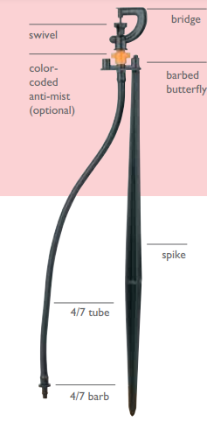

  - Micro-drippers.

In drip irrigation (micro irrigation), water is run through pipes (with holes in them) either buried or lying slightly above the ground next to the crops. Water slowly drips onto the crop roots and stems.
Drip irrigation is a very efficient way to irrigation crops and has the advantage of lower evaporation than other irrigation methods; it is the most common type of "micro irrigation." Drip irrigation is one of the more advanced techniques being used today because, for certain crops, it is much more efficient than traditional spray irrigation, where a larger portion of the water is lost to evaporation.
Essential components of a typical drip irrigation system?

- Water source (Well with motor or water tank)
- By pass valve
- Non-return valve
- Filtration system
- Fertigation device (venturi or fertilizer tank or fertigation pump)
- Pressure regulators
- Pressure gauges
- Water meters or hydrometers
- Back wash valve
- Air valve
- Main pipe (75, 63 mm PVC pipe)
- Sub main pipe (50, 40 mm PVC pipe)
- Laterals (12 or 16 mm LLDPE)
- Emitters (drippers, micro tubes)/emitting tubes in case of drip line /inline
- drippers
- Flush valves at Sub main and laterals
- End cap

Undertaking installation work
The purpose of professionally installed irrigation system is to provide supplemental water when rainfall is not sufficient to maintain the turf and landscape for its intended purpose. A quality irrigation system and its proper management are required to distribute supplemental water in a way that adequately maintain plant health while conserving and protecting water resources and the environment.

In the pre-construction period, the work of an irrigation installer is primarily in planning. Most irrigation installations start with an irrigation design. This includes a plan of:
- the layout,
- all the components and
- where they are to be placed in relation to each other.
The irrigation installer must interpret the design to establish the scope of work. It will define the size of the task and its complexity. Installation of Ideal Micro Irrigation Systems is a very simple process. It can be divided in to three stages:
- Installing water source (bucket, barrel, tank, pump, etc.).
- Laying of pipes and emitters / micro-tubes / setting up sprinklers.
- Commissioning
For drip irrigation it has to be installed above ground level on a stable support platform at the required height to achieve minimum pressure requirements for the system (minimum 1 meter). The system then can be connected to the water source. Micro-sprinkler and overhead sprinkler kits can be directly connected with the equivalent discharge outlet of a pump or water supply system. Make sure that the control valve and filter are connected to the system through the main line.
For drip systems, lateral pipes are laid on the ground in a straight line or along the plant rows. Emitters / micro tubes are pre-fixed on the lateral. They are placed at equal spacing so that plants receive a uniform amount of water. For sprinklers, stakes are used to place them properly. Care should be taken so that dirt, sand etc. does not enter into the pipes while making connections.
Before operating the system, end caps at the end of the laterals and sub-main are flushed so that if there is dirt in the pipes it is washed away and air is also driven out. Open the control valve and let the water flow freely through the pipes for some time (flush the system). Then close the end caps and ensure that water is coming out from each emitter.

3.2 Assembling and connecting components
The installation of your irrigation system begins at the control valve assembly. It consists of the control valve, the filter and the pressure regulator respectively.

- Assembling and connecting Pipes
Before installing pipes all the necessary materials, tools and equipments;
- Identified
- Assembled
- Delivered to the selected site and
- Connected each other
During assembling and connecting pipes, it is good practice to flush the pipes as the work continues. First flush the mainline before the valves are fitted. Then flush the mother lines before the laterals are fitted. Next, the laterals can be flushed before emitters are fitted.
Considerations during assembling and connecting of pipes
- Sun burnt pipe and fittings should not be used.
- Pipe should not be dropped.
- Pipe cuts should be straight.
- Pipe and fittings should be clean before gluing.
- Pipe and fittings should be primed PVC primer before gluing.
- Glue type should match the manufacturer’s recommendations for pipe size.
- A light, even coat of glue should be applied to both the pipe and fitting.
- Fittings should be held in place until the glue forms an adequate bond.
- Any excess glue on the connection should be wiped off immediately.
- Assembling and connecting Filters and Valve Clusters
Pump and filter bank installation is a specialized job that should be carried out by a competent contractor.
Inline filters can however be installed very easily. The filter is attached to risers so that it is above ground. At the bottom end of the risers are riser outlet bends, which are spigot to slide over the pipe. At the back of each riser leg, a Y-standard is hammered in and tied down to the riser to keep the leg from popping out. The valve clusters are installed in the same way.
- Assembling and connecting Emitter and Tubing
  - Emitters and tubing should be installed in a way that reduces damage due to vandalism, insects, animals, and landscape maintenance
  - With emitters installed at the end of the line, tubing is under pressure and may flow out large quantities of water if damaged.
  - Emitter tubing length should not exceed 10 feet from the point of emission.
  - Long tubing lengths are difficult to service.
  - Emitters or connector barbs should be installed into the polyethylene tube with holes made by hollow point punches of the correct size.
  - Nails, ice pick, and other pointed devices are not properly sized or designed to ensure a proper fit.
  - Emitter tubing outlets should be exposed between 1" and 3" above the ground surface

3.3 Irrigation components installation
Micro-irrigation refers to low-pressure irrigation systems that spray, mist, sprinkle or drip. The water discharge patterns differ because emission devices are designed for specific applications due to agronomic or horticultural requirements. Micro-irrigation components include pipes, tubes, water emitting devices, flow control equipment, installation tools, fittings and accessories.

Drip and Sprinkler irrigation systems installation guide/Techniques
- Marking pipe lines and intersections
- Main lines ditches excavation
- Assembling irrigation control and distribution heads.
- Main lines piping placement and union.
- Connections between main lines with control and distribution heads.
- Main lines ends and intersections and anchoring.
- Covering main lines ditches
- Manifold lines, ditches excavation
- Manifold lines, pipes placement, union and lateral outlets preparation.
- Drip irrigation (mini sprinklers) laterals distribution.
- Covering manifold lines ditches
- Main lines flushing and testing.
- Manifold lines flushing and testing.
- Emitters/sprinkler head insertion and placement.
- Laterals flushing and testing, emitters inspection.
- Irrigation shifts flow rates measurement inspection.

3.4 Maintaining a clean and safe work area
Cleaning is one of the most essential elements in maintaining a healthy, safe work environment. Not only does a clean workplace reflect the professionalism of a company and help motivate employees, it also promotes healthy workers as a clean environment prevents accidents and the spread of illnesses. Although we are talking simple matters of common sense here, it might be worthwhile pointing out some of the salient reasons why cleanliness is a major factor when it comes to providing a safe work area. A place for everything and everything in its place, or so the saying goes. One of the first principles of a tidy workplace is to make sure that tools are kept in their place at all times. This alleviates the problem of losing bits and pieces and cluttering up walkways. Work practices which were developed in factories over many decades concluded that it was not only safer to keep everything in its place were not being used, but it also contributed to high rates of efficiency.

As dirt, dust and grime accumulate bacteria start to breed and this can be catastrophic in any enclosed working space such as an office. Bacterial infections can lead to illness, a major contributor to staff absentee rates so; once again, a clean environment contributes to greater workplace safety.
Hazardous materials are commonly used in some workplaces. The very nature of these products means that they are dangerous to human health and pose a risk unless properly handled. By keeping it in special containers/safe place, and out of the workspace when not being used, risk is minimized and a clean environment is maintained.
Site maintenance
- The job site shall be kept in a neat, clean, and orderly condition at all times during the installation process.
- All scrap and excess materials are to be regularly removed from the site and not buried in trenches.
- Trenching, laying pipe and backfilling shall be continuous so that the amount of open trench at the end of each work day is minimized. Any open trench or other excavations shall be barricaded and marked with high visibility flagging tape.
- Disabling unused tools, equipment and machinery and storing neatly out of the way of installation activities;
- safely storing materials on site;
- Using signage and safety barriers during and removing after construction activities are completed; and swiftly and efficiently removing and processing debris and waste from the work area.
During the site maintenance activity, we are expected to remove/dispose Waste material may include
- Unused construction and excavated materials,
- plant debris,
- Litter and broken components.
Waste may be removed to designated areas for
- Recycling,
- Reuse, and
- Return to the manufacturer or disposal.
Plant-based material may be mulched or composted, plastic, metal, paper-based materials may be recycled, re-used, returned to the manufacturer, or disposed of according to enterprise work procedures

Safe working practices must be employed
During installation work safe lifting and material handling means keeping your back aligned and balanced when lifting. With a little practice, precautionary methods outlined below can become good daily habits that could help prevent back injuries both on and off the job. Before, excavating, lifting and installing take a moment to think about what you're about to do.
OHS requirements include identifying hazards; assessing risks and implementing controls; cleaning, maintaining and storing tools, equipment and machinery.

Self-check 3 | Written test

Name…………………………………………… ID………………………… Date…….
Directions: Answer all the questions listed below.
      - Which of the following is included in to ideal micro irrigation systems installation stage? (4pts)
- Installing water source (bucket, barrel, tank, pump, etc.).
- Laying of pipes and emitters / micro-tubes / setting up sprinklers.
  - Commissioning
  - All
      - Which one of the following distribute the water uniformly along their length by means of drippers or emitters? (2pts)
- Main pipe
- Laterals
- Riser
- Sub main
Test I: Mach the following questions from `B ` to `A` (4pts)
‘A’ | ‘B’
---------- 1. Check valve | - transports water within the field and distribute to submains
-----------2. Bubble mode emission device | - suitable for closely spaced row crops in fields and gardens
-----------3. Line source emitters | - used to prevent unwanted flow reversal
-----------4. Main line | - water `bubbles out' from the emitters
 | - water is applied as droplets or trickles

Test II: Short Answer Questions
      - Mention basic components of micro irrigation system
      - List and discuss types of emitters

Operation Sheet -3

3.1 Installing and testing drip/ micro irrigation system
- Materials, Tools and equipments

  - Pick axe
  - Spade
  - Rake
  - Wheelbarrow
  - Matchet
  - Meter
  - String
  - Pigs
  - Water tanker
  - Nipples or male and female adaptors
  - Ball valve
  - Filters
  - Elbow
  - Riser
  - Tee joint
  - Main pipe, Sub mail pipe, Laterals
  - End plug, End cup or line end
  - Inserter, Puncher, Cutter and Teflon

- Procedure
            - select site
            - Identify tools and material
            - Conduct lay out
- Lay main line along the contour
- Lay submain line along the slope
- Lay Laterals line along the slope
            - Install drip irrigation system components

- Put water tank on stand if not already installed
- Insert and install nipples or male and female adaptors in to water drain out let of tanker
- Connect ball/gate valve to nipples or male and female adaptors
- Connect filter to ball/gate valve
- Connect elbow to filter
- Connect riser /main line to elbow
- Connect main line and sub main using Tee
- Install water meter tat the beginning of sub main
- Make hole on sub main using puncher
- Insert grommet in to the hole
- Insert start connector/off take in to grommet using inserter
- Connect lateral to start connecter
- Flush the system to remove dirty materials
- Close sub main by end plug and laterals by end cup/line end
            - Check / test the functionality of the installed system
            - Clean, maintain, transport and store safely tools and materials

LAP TEST-1 | Performance Test

Name………………………………. ID…………………………….. Date…………………………………….

Time started: ________________________ Time finished: ________________

Instructions: Given necessary templates, tools and materials you are required to perform the following tasks within 4 hours. The project is expected from each student to do it.
Task 1- Install drip/ micro irrigation system.

LG #8 | LO #4- Completing micro irrigation installation

Instruction sheet
This learning guide is developed to provide you the necessary information regarding the following content coverage and topics:
- Site restoration and removing waste material
- Finishing earth work
- Flushing and commissioning the system
- Cleaning, maintaining and storing tools
- Reporting operation fault
This guide will also assist you to attain the learning outcomes stated in the cover page. Specifically, upon completion of this learning guide, you will be able to:
- Restore site and remove waste material
- Finish earth work
- Flush out and commission the system
- Clean, maintain and store tools
- Report operational fault
Learning Instructions:
- Read the specific objectives of this Learning Guide.
- Follow the instructions described below.
- Read the information written in the information Sheets
- Accomplish the Self-checks
- Perform Operation Sheets
- Do the “LAP test”

Information Sheet -4

4.1. Site restoration and removing waste materials
Irrigation structure work sites are expected to be clean, tidy, comfortable and good to create conducive environment for work. Cleanliness is the most essential elements in maintaining a healthy and safe work environment. Not only does a clean workplace reflect the professionalism of a business or facility and help motivate employees. Whether you are installing irrigation systems or other construction, site restoration is an important piece of the job
Like Health & Safety, maintaining a clean work environment is the responsibility of everyone. Working together we can all contribute to creating a safe and healthy workplace and a professional looking facility for employees, visitors and customers.
In micro irrigation installation or other construction, the goal of site restoration is:
- to restore the worksite to its pre-construction condition.
To do this, it’s a good idea to create a site restoration plan. This site restoration checklist can help you better prepare for your next construction project and the site restoration.
Site Restoration Checklist
- Runoff Reduction
- Water Quality Protection
- Site Topography
- Water Table

          - Runoff Reduction
It is important to reduce runoff as much as possible. Runoff is created when rain falls and if the ground is not restored and runoff reduced after a construction project, it can lead to issues with erosion and habitat loss.
    - Water Quality Protection

One of the most important parts of the restoration process is being in compliance with water quality and protection. It is imperative that chemicals and other hazardous materials are not dumped on land or in water and that they are properly disposed of to prevent harm to the water in the area.

    - Site Topography
Restoring the site topography is another top concern when it comes to site restoration. It is important to document the existing topography so it can properly be replaced after the construction process. Restoring the site topography after construction is important. Be sure to document topographic variation prior to project work, including shape, slope, elevation, aspect and contour.
    - Water Table
When you pull water out of a site for construction purposes, the water table risks contamination, which can seep into the groundwater. It is important to return the water table back to its original depth.
Irrigation structure and site maintenance
- The job site shall be kept in a neat, clean, and orderly condition at all times during the installation process.
- All scrap and excess materials are to be regularly removed from the site and not buried in trenches.
- Trenching, laying pipe and backfilling shall be continuous so that the amount of open trench at the end of each work day is minimized. Any open trench or other excavations shall be barricaded and marked with high visibility flagging tape.
After finishing the work:
- All debris and rubbish removed and properly disposed off.
- All cut and fill slopes and any other areas that were disturbed left reasonably smooth and uniform
- Any loose and overhanging rock removed
- Weeds, brush, and stumps cut close to the ground and properly disposed of as directed

4.2. Finishing earthwork
Earthworks are engineering works created through the processing of parts of the earth's surface involving quantities of soil or unformed rock. Excavation may be classified by type of material
Classification of excavation based on type of excavated materials
- Topsoil excavation
- Earth excavation
- Rock excavation
- Muck excavation – this usually contains excess water and unsuitable soil
- Unclassified excavation – this is any combination of material types
- Backfill
Backfill is used to fill trenches for pipe structures, culverts, utility cuts and other work extending under pavement locations, to fill cavities beneath slope walls and other locations which are excavated during micro irrigation work.

Unbalanced backfill is not allowed until the concrete required to resist the backfill is at least 10 days old or a flexural strength of 440 lb/in2 for third point loading has been attained. The unbalanced height may not exceed 10 ft until the concrete is at least 15 days old or a flexural strength of 480 lb/in2 for third point loading has been attained.

Protect earthworks and in particular road formations from the effects of erosion and deposition. Grade earth works and particularly sub grades to drain at all stages without ponding. Where run-off must cross the formation, ensure that the stream is a broad sheet flow which crosses roughly at right angles to the alignment and minimizes the likelihood of sub grade softening. When rain is likely or when work is not proposed to continue in a working area on the following day, precautions shall be taken to minimize ingress of any excess water into earthworks material. Ripped material remaining in cuttings and material placed on embankments shall be sealed off by adequate compaction to provide a smooth tight surface. Should insitu or stockpiled material become over wet as a result of the Contractor not providing adequate protection of earthworks, the Contractor shall be responsible for replacing and/or drying out the material and for any consequent delays to the operations.

Final trimming and cleaning consist of trimming and cleaning the otherwise completed micro irrigation for the entire contract specification. At the time of acceptance of the contract, the following conditions are required for the entire length and right-of-way width of the contract.
4.3. Flushing and commissioning the system
The goal of flushing is to discharge water at sufficient velocity so that any particulate matter will be suspended and removed from the system with the flush water. Pipelines must be equipped with valves or other means of allowing the pipeline to be opened quickly. Either manual or automatic valves can be used, or flexible polyethylene (PE) tube can simply be folded over and clamped or tied. Manual valves are often used if infrequent flushing is adequate, while automatic valves are preferred when frequent flushing is needed.
Flushing Procedure
- Open the end cup or end plug
- Open the gate /ball valve
- Allow water to freely discharge through pipes until dirty materials removed
- Finally close the gate /ball valve and then the end plug and end cap
When flushing pipelines, it is important to observe what type and how much debris is being discharged.
Before installing the system, the following materials and valve s should be Flushed.
- Flush backflow preventer before installing valves.
- Flush valves before installing laterals.
- Debris needs to be flushed out of the lines so the equipment does not clog.
- Flush laterals before installing drip emitters.
- Tubing outlets should be placed above ground so that their discharge can be observed.
- Outlets placed above ground reduce the potential of dirt being drawn back into the tubing.

4.4. Cleaning, maintaining and storing tools
In workplaces, there are different types of equipment, tools and materials that we use to carry out everyday tasks. Equipments, tools and materials may have the potential to cause problems in the workplace, so you need to check and ensure that it remains safe to use and that you’re not

putting employees at risk. In work place also equipment, tools and materials are inspected to check presence of damage and to ensure they need maintenance or not. The equipments, tools and materials used in micro irrigation system require checking, cleaning, maintaining and storing properly after use.
- Cleaning equipment, tool and materials
Cleaning is one of the most essential elements in maintaining a safe tool and equipment. Some of the materials, tools and equipments commonly used for cleaning purpose are listed below.
- Air freshener dispenser
- Sealer applicators, rubbish bins, waste bins, large industrial bins, tidy bins,
- Brooms and wire brush
- Rubbish picking up tools, wall washers, warning sign, safety signs
- Detergents and oils
- Grease and other lubricants
stages of cleaning are:
      - pre-Clean
The first stage of cleaning is to remove loose debris and substances from the contaminated surface you’re cleaning. You can do this by wiping with a disposable towel, sweeping, or rinsing. The aim is to remove as much loose debris as possible to prepare the area for the next stage of cleaning.
      - Main Clean
The second stage of cleaning is to loosen any substances, dirt, grease, and debris that you were unable to remove during the pre-clean stage. This involves using hot water and a detergent. You may be able to wipe away the loosened substances right away with something suitable, such as a cloth or mop, or you may have to allow the disinfectant to do its work for a certain amount of contact time before doing so.
      - Rinse
The third stage of cleaning is to remove all the loosened substances, dirt, and debris as well as the detergent, that was present in the second stage. You can do so using clean, hot water with a cloth, mop, squeegee, etc.

      - Disinfection
The fourth stage of cleaning is to disinfect the surface, which will destroy bacteria and other microorganisms. For example, by using heat or a chemical disinfectant for an adequate contact time. Follow the instructions for any products or equipment you use.
      - Final Rinse
The fifth stage of cleaning is to remove any disinfectants from the previous stage using clean, hot water. This step may not always be carried out however, depending on the disinfectant and surface you’re cleaning.
      - Drying
The sixth and final stage of cleaning is to dry the surface, and it’s recommended that you air dry where possible. You can use drying cloths if needed
- Maintaining equipment, tool and materials
Tools and equipment require proper care and maintenance, not only for longevity but also to remain useful and safe for the task at hand. Here are some care and maintenance Practices for tools and equipment.
Maintaining equipments, tools and materials after the use for work and finally must be store in the stock pile.
- The Importance of Proper Tool and equipment Maintenance
- Ensures a Longer Life
- Results in Cleaner Projects
- Keeps Users Safe
Types of maintenance
- Routine or normal maintenance
- Special maintenance
- Deferred maintenance
- Storing equipment, tool and materials
Proper storage entails shielding tools from harsh weather conditions, damage and theft. It is particularly crucial for metallic tools to be kept away from moisture to avoid rusting. Having a cabinet where these tools and equipment are stored will be vital to ensuring a secure storage area. Also, greasing, lubricating or oiling metallic tools and equipment is essential to prevent rust from forming while keeping the tools in the best condition for future tasks.
4.5. Reporting operation fault
Checking and reporting of faulty and insufficient materials of all type is the first step. In operation of micro irrigation system all components are check for proper functionality. During operation of the systems faults may be created due to:
- Un proper installation
- Lack of experience
- Lack of skill
- Poor quality of materials, tools and equipment
The techniques to report operational faults are:
- Identify the operational faults
- Analyze the causes of faults
- Organize the analyzed data manually or electronically
- Report to the concerned body b

Self-check- 4 | Written test

Name…………………………………………… ID………………………… Date…….
Directions: Answer all the questions listed below.
Test I: Choose the best answer (2point)
      - Which one of the following is one of the most essential elements in maintaining a safe tool and equipment?
  - Cleaning
  - Reporting
  - Storing
  - All
Test I: Mach the following questions from `B ` to `A`
‘A’ | ‘B’
---------- 1 Ensures a Longer Life | - Stages of cleaning
-----------2. Disinfection | - Type of excavation based on type of excavated materials
-----------3. Top soil excavation | - Materials used for cleaning purpose
-----------4. Grease and other lubricants | - Importance of Proper Tool and equipment Maintenance
 | - techniques to report operational faults

Test II: Short Answer Questions
- Mention the types of maintenance
- List and discus stages of cleaning

Operation Sheet - 4

  - Flushing micro irrigation system
- Materials and tools
- PPE
- Water
B. Flushing Procedure
- Wear PPE
- Open the end cup or end plug
- Open the gate /ball valve
- Allow water to freely discharge through pipes until dirty materials removed
- Close the gate /ball valve
- Finally close the end plug and end cap

LAP TEST-2 | Performance Test

Name………………………………. ID……………………………. Date…………………………………….

Time started: ________________________ Time finished: ________________

Instructions: Given necessary templates, tools and materials, you are required to perform the following tasks within 2 hours. The project is expected from each student to do it.
Task:1. Flush micro irrigation system

Reference

Adhikari, Deepak. 2000 Simplified and Low-Cost Drip Irrigation Manual, International Development Enterprises, Kathmandu, Nepal.
Anonymous (2004). Report of the Task Force on Micro-irrigation, Ministry of Agriculture, Dept. of Agriculture & cooperation, Govt. of India, New Delhi, Jan, 2004)
Clark, J. Clendening, Plane and Geodetic Surveying for Engineers, Vol. 1, Plane Surveying, (London, 1963), p.607.
Frederick S. Merritt, M. Kent Loftin, Jonathan T. Ricketts, Standard Handbook for Civil Engineers, Fourth Edition, McGraw-Hill Book Company, 1995.
Keller, Jack and Ron B. (2000). Sprinkler and Trickle Irrigation. ISBN: 1-930665-19-9. Blackburn Press, Caldwell, New Jersey.
Proceedings of Drip and Sprinkler Workshop 1994, Jalgaon (M.S.), India. Proceedings of Micro Irrigation Congress 1995, Orlando, FL, USA.
Suryawanshi. S. (2000). Affordable Micro Irrigation Technology, International Development Enterprises, Delhi, India.

http://fvtchort.wikispaces.com/Soils+Group+1(access date August 2022)
Source: www.ag.ndsu.edu/pubs/ageng/irrigate/ae1243w.htm 16th Aug, 2012.
Image source: http://fvtchort.wikispaces.com/Soils+Group+1(access date August 2022)
Image source: http://fvtchort.wikispaces.com/Soils+Group+1 (access date August 2022)
Image source: http://fvtchort.wikispaces.com/Soils+Group+1(access date August 2022)
www.ag.ndsu.edu/pubs/ageng/irrigate/ae1243w.htm 16th Aug, 2012.

AKNOWLEDGEMENT

Ministry of Labor and Skills to extend thanks and appreciation to the many representatives of ATVET instructors and respective industry experts who donated their time and expertise to the development of this Teaching, Training and Learning Materials (TTLM).

The experts who developed the learning guide
No | Name | Qualification | Organization/ College | Mobile number | E-mail
1 | Serawit Gensa | Msc. Water Resource Engineering | W/Sodo AVET | 0916740916 | serawitgen@gmail.com
2 | Edao Hassen | Msc.Irrigation Engineering | Alage AVET | 0911098097 | hassedao@gmail.com
3 | Mekete Agizew | Msc. Water Resource Engineering | Amhara. Kombolcha ATVET | 0925221192 | gen.mam09@gmail.com
4 | Wondu Alemayehu | Msc.Irrigation Engineering | Oromia Kombolcha ATVET | 0910-28-99-61 | woldualem@gmail.com
5 | Ademe Ayalew | Msc.Irrigation Engineering | Agrafa AVET | 0912720547 | Ademe2004@gmail.com
6 | Said Mohammed | Msc.Irrigation& drainage Engineering | Alage ATVET | 09-17-18-01-81 | Siyamsdmhmmd@gmail.com/
7 | Molalign Asfaw | Bsc.Water Resource &Irrigation Engineering | Alage ATVET | 0921431096 | Mollalign410ass@gmail.com
8 | Yonas Hailu | Bsc.Water Resource &Irrigation Engineering | Agrafa AVET | 0934715578 | yonashailuw@gmail.com
9 | Lemessa Mulata | Msc.Irrigation Engineering | Agrafa AVET | 0913266845 | Lamimulle2022@gmail.com
10 | Misganew Yimer | Bsc. Soil and Water Engineering | Woreta ATVET |  | Misge1976@gmail.com
11 | Daniel Derese | Bsc. Soil and Water Engineering | W/sodo AVET | 0912-79-28-85 | danielderesse7@gmail.com
12 | Teshome Getachew | Msc.Irrigation & drainage Engineering | Alage ATVET | 0925-50-13-99 | teshomegetachew131@yahoo.com

