IRRIGATION AND DRAINAGE
Level II

Based on March 2022, Version 3 Occupational standard

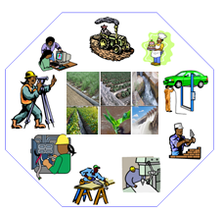

Module Title: - Surface Irrigation System
LG Code: AGR IRD1 M04 LO (1-4) LG (9-12)
TTLM Code: AGR IRD1 M04 0522 V1

August, 2022
Addis Ababa, Ethiopia

Table of Contents

Introduction to the Module 1
LO #1 Operation of surface Irrigation system 2
Instruction sheet 1 2
Information Sheet 1: 3
Self-Check #1 16
Operation sheet-1 17
LAP Test-1 18
LO #2-- Maintenance of surface irrigation 19
Instruction sheet -2 19
Information Sheet 2: 20
Self-check -2 27
Operation Sheet -2 28
LAP test-2 31
LO #3- Clean and store irrigation equipment 32
Instruction sheet -3 32
Information Sheet -3 33
Self-check-3 36
Operation Sheet –3 37
LAP test-3 38
LO #4 Record and report maintenance activities 39
Instruction sheet -4 39
Information Sheet -4 40
Self-check -4 41
Operation Sheet-4 42
LAP test-4 43
Reference Materials 44

Introduction to the Module
This module covers the knowledge, skill and attitude required to prepare and set up field for surface irrigation operation, carry out irrigation operations and maintenance, and clean and store surface irrigation equipment.

LG #9 | LO #1 Operation of surface Irrigation system

Instruction sheet 1
This learning guide is developed to provide you the necessary information regarding the following content coverage and topics:
  - Surface irrigation system
  - Handling and positioning irrigation equipment
  - Water delivery mechanisms
  - Water control devices
This guide will also assist you to attain the learning outcomes stated in the cover page. Specifically, upon completion of this learning guide, you will be able to:
- Select surface irrigation system
- Handle and position irrigation equipment
- Identify water delivery mechanisms
- Select water control devices.
Learning Instructions:
- Read the specific objectives of this Learning Guide.
- Follow the instructions described below.
- Read the information written in the information Sheets
- Accomplish the Self-checks
- Perform Operation Sheets
- Do the “LAP test”

Information Sheet 1:
Introduction
Irrigation is defined as the science of artificially providing water to the land in accordance with the "crop requirement" throughout the "crop period" for the complete nourishment of the plant.
Water application methods are grouped as:

- Flooding
- applying it beneath the soil
- Spraying it under pressure surface
- Applying in drops

Irrigation methods
- Surface
- Sub-surface
- Pressurized irrigation
1.1 Surface irrigation system
Surface irrigation refers to water application through gravity flow to the cultivated land. Water is applied either the entire field (uncontrolled flooding) or part of the field (furrows, basins, border strips). For efficient application of water it is important to select the method of irrigation which best suits the crop and soil characteristics of the field. In doing so it may be essential to use more than one method of irrigation in an area or a given farm.
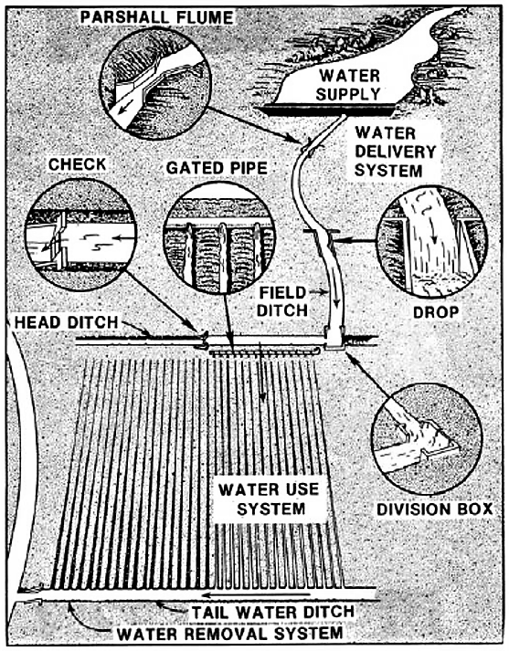

Fig. 1.1: irrigation schemes
1.2 Types of Surface irrigation systems
Border irrigation
The land is divided into number of long parallel strips called borders. These borders are separated by low ridges. The border strip has a uniform gentle slope in the direction of irrigation. Each strip is irrigated independently by turning the water in the upper end. The water spreads and flows down the strip in a sheet confined by the border ridges.
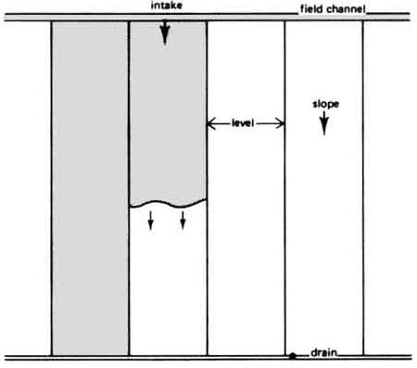
Fig. 1.2: Border irrigation systems
Suitability: To soils having moderately low to moderately high infiltration rates. It is
not used in coarse sandy soils that have very high infiltration rates and also in heavy soils having very low infiltration rate. Suitable to irrigate all close growing crops like wheat, barley, fodder crops and legumes and not suitable for rice.
Advantages
  - Border ridges can be constructed with simple farm implements like bullock drawn “A” frame ridger or bund former.
  - Labor requirement in irrigation is reduced as compared to conventional check basin
method.
  - Uniform distribution of water and high water application efficiencies are possible.
  - Large irrigation streams can be efficiently used.
  - Adequate surface drainage is provided if outlets are available
  - Width of border strip: It varies from 3-15 m
Table 1.1: Border length classification based on soil type
Slope | Soil | Length
0.25 - 0.60% | Sandy and sandy loam | 60-120 m
0.20 - 0.40% | Medium loam soil | 100-180 m
0.05 – 0.20% | Clay loam and clay soil | 150-300 m
Basin Irrigation: are flat areas of land surrounded by low bunds. The bunds prevent the water from flowing to the adjacent fields. The basins are filled to desired depth and the water is retained until it infiltrates into the soil. Water may be maintained for considerable periods of time.
Basin method may be divided into two types:
- Check basin irrigation
It is the most common method. Here the field is divided into smaller unit areas so that each has a nearly level surface. Bunds or ridges are constructed around the area forming basins within which the irrigation water can be controlled. The water applied to a desired depth can be retained until it infiltrates into the soil. The size of the basin varies from 10m2 to 25 m2 depending upon soil type, topography, stream size and crop.
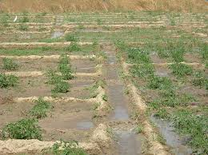
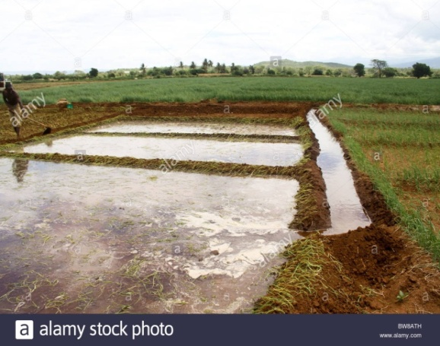
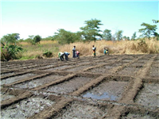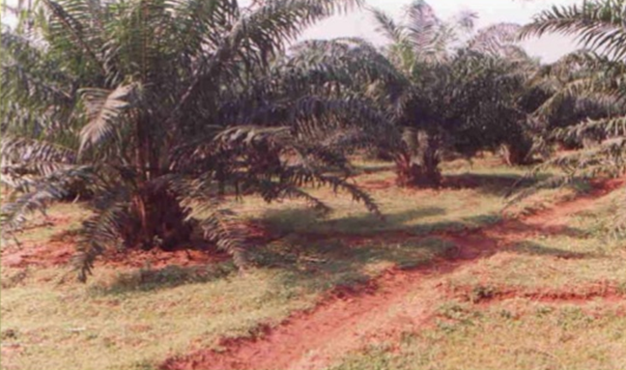
Ring basin irrigation for tree
Rectangular basin for rice production
Basin for rice production water application
Rectangular basin crop production
Fig. 1.3 Basin irrigation methods

Check Basin irrigation is suitable.
- Paddy rice grows best when its roots are submerged in water
- Closely spaced crops like maize, pearl millet, groundnut etc.
- Not suitable for crops which are sensitive to wet soil conditions around the stem.

- Ring Basin Irrigation
It used for growing trees in orchards. In this method, generally for each tree, a separate basin is made which is usually circular in shape. Sometimes, basin sizes are made larger to include two more trees in one basin. Water to the basins is supplied from a supply channel through small field channels.
Adaptability of basin
- Small gentle and uniform land slopes
- Soils having moderate to slow infiltration rates.
- Adapted to grain and fodder crops in heavy soils.
- Suitable to permeable soils.
Advantages
- Check basins are useful when leaching is required to remove salts from the soil profile.
- Rainfall can be conserved and soil erosion is reduced by retaining large part of rain
- High water application and distribution efficiency.
Limitations
- The ridges interfere with the movement of implements.
- More area occupied by ridges and field channels.
- The method impedes surface drainage
- Precise land grading and shaping are required
- Labor requirement is higher.
- Not suitable for crops which are sensitive to wet soil conditions around the stem.
Furrow irrigation
Used in the irrigation of row crops. The furrows are formed between crop rows. The dimension of furrows depend on the crop grown, equipment used and soil type. Water is applied by small running streams in furrows between the crop rows. Water infiltrates into soil and spreads laterally to wet the area between the furrows. In heavy soils furrows can be used to dispose the excess water.
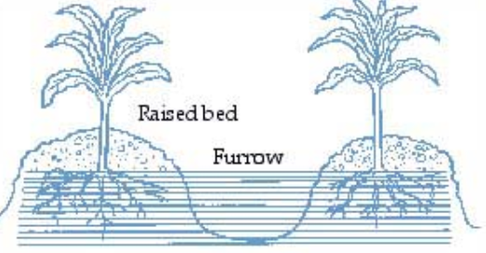

Adaptability
- Wide spaced row crops including vegetables.
- Suitable for maize, sorghum, sugarcane, cotton, tobacco, groundnut, potatoes
- Suitable to most soils except sand.
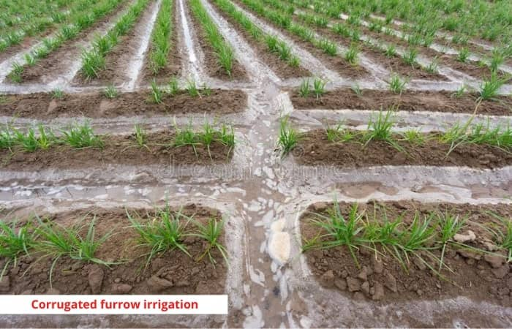  Fig. 1.4: furrow irrigation methods | 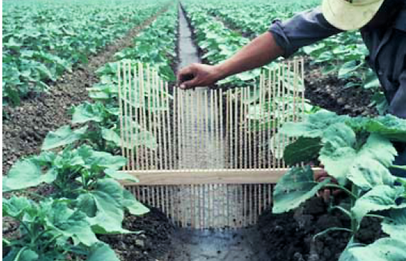
Advantages
- Water in furrows contacts only one half to one fifth of the land surface.
- Labor requirement for land preparation and irrigation is reduced.
- Compared to check basins there is less wastage of land in field ditches.
Types of furrow irrigation

Based on alignment of furrows
1. Straight furrows
2. Contour furrows

Based on size and spacing:
1. Deep furrows
2. Corrugations
Based on irrigation:
All furrow irrigation: Water is applied evenly in all the furrows and are called furrow system or uniform furrow system.
Alternate furrow irrigation: It is not an irrigation layout but a technique for water saving. Water is applied in alternate furrows for e.g. during first irrigation if the even numbers of furrows are irrigated, during next irrigation, the odd number of furrows will be irrigated.
Skip furrow irrigation: They are normally adopted during the period of water scarcity and to accommodate intercrops. In the skip furrow irrigation, a set of furrows are completely skipped out from irrigation permanently. The skipped furrow will be utilized for raising intercrop. The system ensures water saving of 30-35 percent. By this method, the available water is economically used without much field reduction.
Contour-furrow irrigation, water is carried across a sloping field rather than down the slope. The furrows have just enough grade to carry the irrigation streams. Head ditches or pipelines are run downhill, or slightly across the slope, to feed the individual furrows.
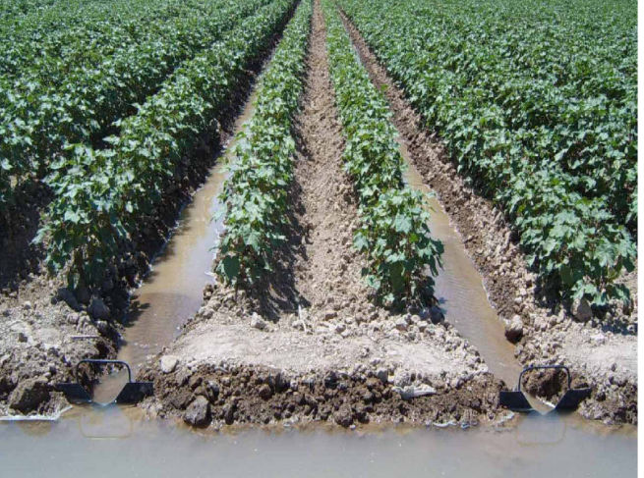
Fig. 1.5: Skip furrow irrigation
Surge irrigation: Surge irrigation is the application of water in to the furrows intermittently in a series of relatively short ON and OFF times of irrigation cycle. It has been found that intermittent application of water reduces the infiltration tare over surges there by the water front advances quickly. It results reduce net irrigation water requirement. This also results in more uniform soil moisture distribution and storage in the crop root zone compared to continuous flow. The irrigation efficiency is in between 85 and 90%.
II. Sub-surface irrigation
In these methods, water is applied beneath the ground by creating and maintaining an artificial water table at some depth, usually 30-75 cm below the ground surface. Moisture moves upwards towards the land surface through capillary action Water is applied through underground field trenches laid 15-30 m apart.
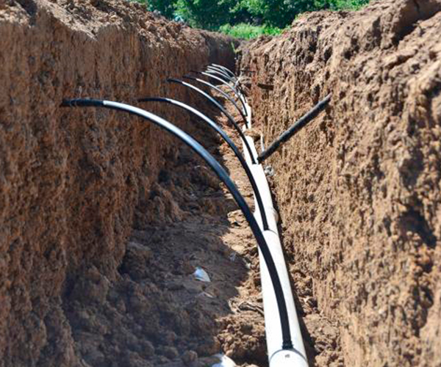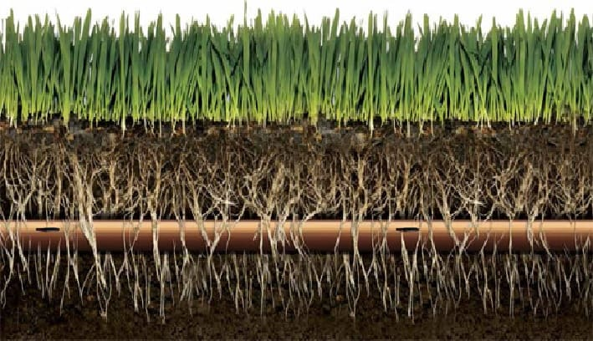
Advantages
- Minimum water requirement for raising crops
- Minimum evaporation and deep percolation losses
- No wastage of land
- No interference to movement of farm machinery
- Cultivation operations can be carried out without concern for the irrigation period.
Disadvantages
- Requires a special combination of natural conditions.
- There is danger of water logging
- Possibility of choking of the pipes lay underground.
- High cost
1.3 Water delivery mechanisms
canal: is an artificial channel, generally trapezoidal in section, constructed to carry water to fields from source (River/Reservoir).
Classification of canals based on
- Discharge capacity
- Based on canal surface
Hence the canal system comprises of based on discharge are:

- Main Canal
- Branch Canal
- Distributaries or major distributaries
- Minors or minor distributaries
- Water course
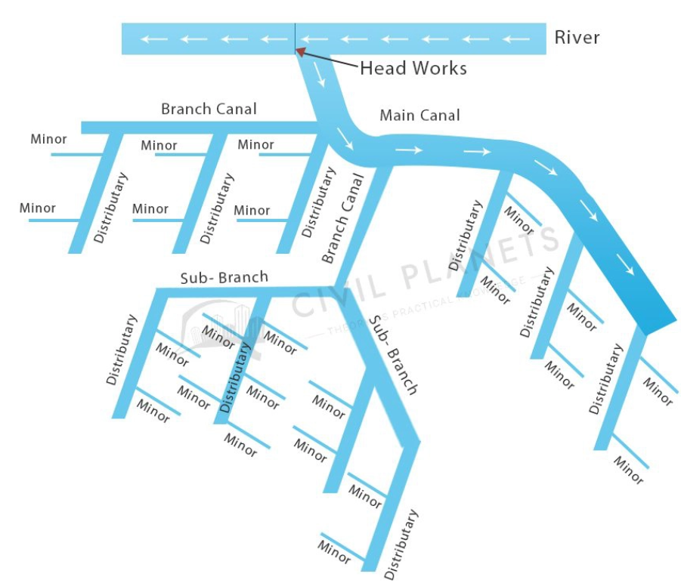
Fig. 1.6: Layout of the Canal System
Classification canals based on discharge capacity and relative importance of canal
Main canal: carry water from rivers (dams) and feed to branch canals, distributaries. They do not supply water directly to fields. Q will be in range of 30-150 comics
Branch canal: branch out at regular intervals from main canal on either side. They are feeder canals & supply water to major and minor distributaries. Not for direct irrigation. The discharge, Q ranges from 10-30 comics.
Major Distributaries: take off from branch canal and/or main canal & distribute water to field. The discharge, Q ranges from 1-40 comics.
Minor distributaries: similar to major distributaries but have Q in range of 0.3-1 comics
Field channel: small channels carry water from outlets to fields. Owned and constructed by farmers.
Classification based on canal surface
- Lined canal: A lined canal is the one which has its surface lined with an impervious material on its bed and sides to prevent seepage of water. Also, in lined canals, high velocity can be permitted and hence the cross-sectional area is less.
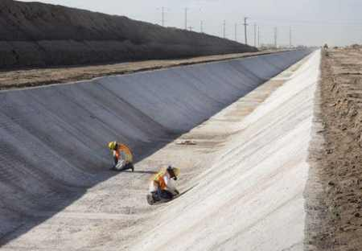 | 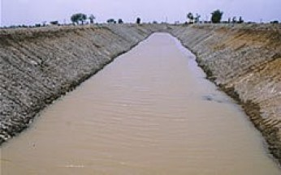 | 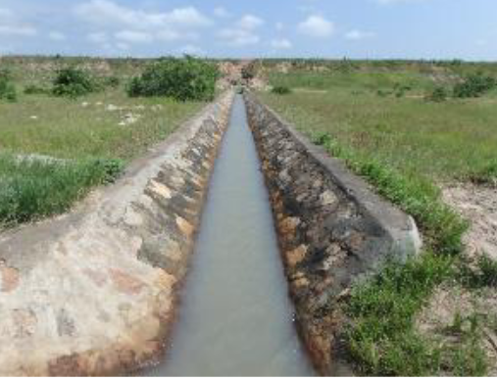 | 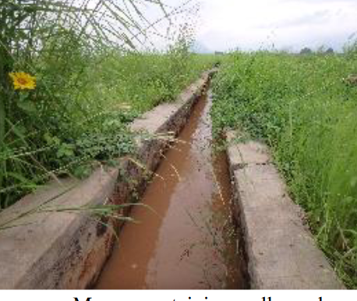
Fig. 1.7: Trapezoidal, rectangular stone paved lined canal for irrigation work
- Unlined canal: An unlined canal is the one which has the surface of the natural material through which it is constructed and it is not provided with a lining on its surface. These are further of two types:
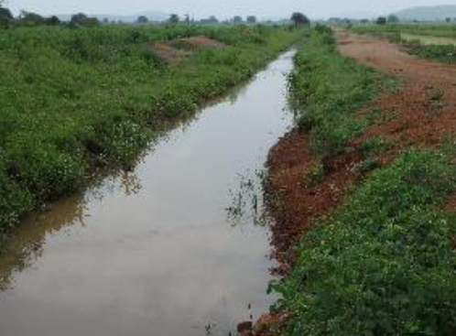
Fig. 1.8: Unlined canals for irrigation
Canal Alignment
The canal alignment is selected based on the following considerations:
- Canal alignment must be chosen such that the maximum area is served with the least length. It also must minimize the use of cross-drainage works.
- If the length of the canal is short, there is less evaporation loss, seepage loss, and head loss. This also brings additional areas for irrigation.
- Following a straight alignment helps to reduce the loss.
- Always a canal alignment with less cross-drainage work must be chosen.
- The canal must not pass through forest, town, village or costly areas reducing the chance of giving heavy compensation.
- Among different canals, ridge canals help to irrigate either side of the canal.
- It must help reduce heavy cutting and filling i.e. costly embankment construction must be avoided.
- It is recommended to attain a balance in depth of cutting and depth of filling.
- The selection of alignment over brackish, rocky or cracked strata must be avoided.
Outlets: Outlets are used to transfer water from the supply channel to a field or bay. There are three main types employed in surface irrigation.
Gates or doors: Gates or doors are mostly used in border check systems where large flows are needed. A slide gate or door usually comes in a pre-fabricated structure that is installed into the channel bank or head ditch. The gate or door is adjusted vertically to control water flow onto a bay. For efficient operation the difference in water level between the field and the channel should not be greater than 350 mm, since this leads to erosive velocities, and probably not less than 150 mm, since this limits how quickly water can get onto the field.
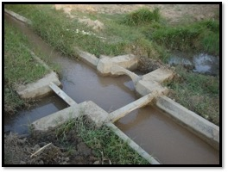
Figure 1.9: Water distribution system in Surface Irrigation
Through-the-bank pipes: through-the-bank pipes, commonly high-density polyethylene, are installed through or below the channel bank. The flow rate is affected by the head difference between the supply channel and the field or bay. The pipes should be installed with the top on the field or bay side level with the ground. Through-the-bank pipes are easily operated from the channel bank. The control valve can be positioned on the inlet or outlet end.
Siphons: Siphons are pipes of various compositions, lengths and sizes that convey water over the channel bank by using the head difference to cause flow. The channel end must be fully submerged and, for maximum flow, the field or bay end should be too.
1.4 Water control devices
What does water irrigation control system mean?
A Water control system is a device used to operate Irrigation watering systems.
Check Gates: The check gate is a structure used to maintain or increase water level in an open channel.
A check structure consists of canvas, metal or masonry walls built across the channel and provided with a suitable gate or outlet device. The masonry wall is built in place while the check gate is usually precast and fixed to the wall. The crest of the check gate is at the same level as the bottom of the upstream channel.
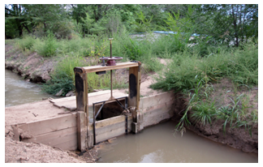
Fig. 1.10: Canal check gates
Portable checks can be removed when irrigation is complete and reset at another location along the canal or open channel to irrigate another area.
Turnouts: Turnouts are constructed in the bank of a canal to divert part of the water from the canal and ditches to basins, borders, and distribution laterals. Turnouts can be concrete structures or pipe structures.
Siphon Tubes: Siphon tubes are curved plastic, rubber or aluminum pipes that are laid over the bank of delivery channels to deliver water to borders and furrows.
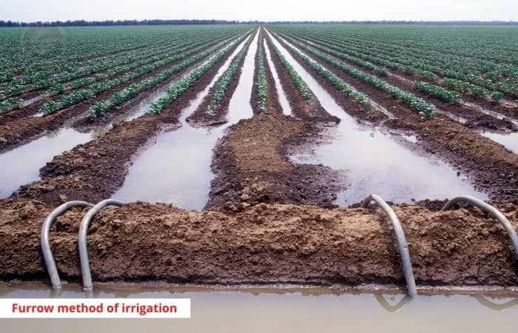
Fig. 1.11: Siphon tubes
Flumes: flumes are constructed to carry irrigation water across streams, canals, gullies, ravines or other natural depressions. They may be open channels or pipes which are often supported by pillars or may be fixed to bridges.
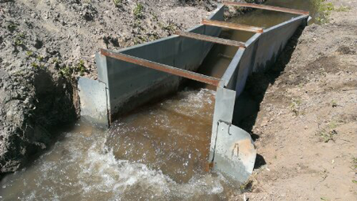  Fig. 1.12: Flume structure | 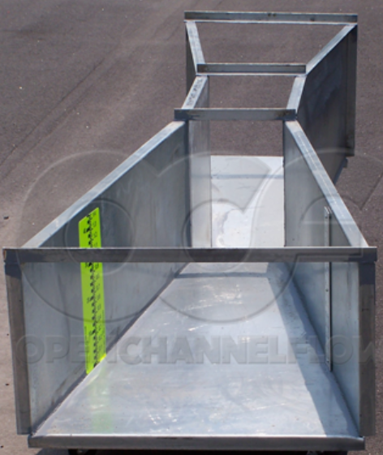
Culverts: culvert is a drain or pipe that allows water to flow under a road.
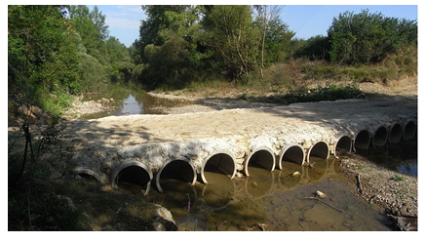
Fig. 1.13: Culverts
Inverted Siphons: is constructed when a channel has to cross a wide depression or where the road surface lies close to the field surface. It has an inlet and an outlet tank connected together at their bottom by a pipe.
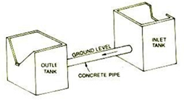 | 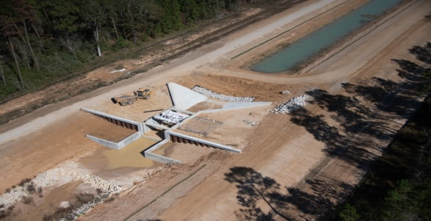

Fig. 1.14: Inverted siphons

Self-Check -1
Name: _________________________ Date: ____________ Date: ____________
Time started: _______________ Time finished: __________________________
Directions: Answer all the questions listed below.
Test I: Multiple choice (2 pts. each)
1. A type of irrigation which application of water by gravity flow to the surface of the field
A) Surface irrigation B) sprinkler C) sub-surface D) wild
3. From the following which one is not component of surface irrigation?
A) Water supply (channel, ditch, river, dam) C) Water conveyance or delivery
B) Pipe network D) Drainage
4. Which one is incorrect about irrigation methods?
A) Furrow irrigation used for row crops C) furrow irrigation used for closely grow crops
B) Basin irrigation preferable for clay soil D) basin irrigation used for perennial crop
5. Which one is false about furrow irrigation?
- Furrows can be longer when land slope is steeper,
- But maximum recommended slope is = 0.5% (non-erosive)
- length should be short Sandy soil
- use stream sizes smaller than 3.0 l/s but justify

Operation sheet-1

Name: _________________________ Date: ____________ Date: ____________
Time started: _______________ Time finished: __________________________
Practical: observing leak in unlined canal
Materials tools and equipment needed

- Meter
- Spade
- Shovel
- Sickle
- Note book
- PPE

Procedure
- Conduct reconecence survey around irrigation canals you wants to observe.
- Observe swampy, water logged and moist areas around the canal.
- Empty the canal and indicate the location of leakage with pegs. They are placed at its entrance in the canal bed and at its exit in the outer bank
- Remove the vegetation and keep it apart. Excavate the canal bank which leaks is excavated in steps, with the smallest step well below the leak
- Rebuild the canal bank with moist soil and compact each layer well.

LAP Test-1
Name: _________________________ Date: ____________ Date: ____________

Time started: _______________ Time finished: __________________________

Task 1: Observe canal seepage.

LG #10 | LO -2 Maintenance of surface irrigation

Instruction sheet -2
This learning guide is developed to provide you the necessary information regarding the following content coverage and topics:
- Opening and shutting down gate valves
- Maintenance activities
- Maintenance of irrigation components
- Desilting activities
- Siphons installation
- Monitoring water flow
- Irrigation shift
This guide will also assist you to attain the learning outcomes stated in the cover page. Specifically, upon completion of this learning guide, you will be able to:
- Open and shut down gate valves
- Apply basic maintain activities
- Maintenance of irrigation components
- Conduct desilt activities
- Install Siphons
- Monitor water flow
- Select irrigation shift
Learning Instructions:
- Read the specific objectives of this Learning Guide.
- Follow the instructions described below.
- Read the information written in the information Sheets
- Accomplish the Self-checks
- Perform Operation Sheets
- Do the “LAP test”

Information Sheet 2:
2.1 Open and shut down gate valves
Gate valves are used to shut off the flow of water by inserting a rectangular gate or wedge into the path of a flowing fluid. Gate valves consist of three major components: body, bonnet, and trim.
2.2 Maintenance activities
Maintenance is a repair to an existing structure to keep it in its existing state or proper condition or to prevent it from failure or decline.
Maintenance activities includes
Inspection, upkeep, testing, fault detection, measurement, replacement of parts, adjustment servicing lubrication, cleaning etc.
Planning Maintenance Activities
A maintenance activity requires data for good planning
The following steps must be taken at scheduled time (good planning)
- Make an inventory of all the works that require maintenance
- Determine the volume of maintenance activities to be undertaken
- Establish the optimum cycle of maintenance for each type of work
- Determine the machinery and manpower requirements to undertake the maintenance
- Budgeting and establishing the maintenance priorities
Characteristics of poor planning
- Insufficient funds made available to the management.
- Lack of interest by the farmers in participating or collaborating in the maintenance work.
- Poor organization of the work.
- May also result from inadequate planning of such work, or it may be that the available resources have not been used to the best advantage.
- Use low cost technologies for scheme construction because of limited funds, then maintenance requirements is greater (selecting earthen canal than concrete lining)

To maintain satisfactory operation of your channels :
- Prevent weeds growing in a channel because they reduce capacity.
- Drain channels when not in use, and de-silt them regularly to maintain capacity.
- Check pipes regularly for fractures or damage.
2.3 Types of maintenance
Preseason maintenance
Pre-season maintenance is maintenance activity done before starting operation of irrigation system for new season. Before placing the system into service each season, it is necessary to check
  - Visual inspection of system components: is used to know whether the system is in proper way or not
  - Flushing/draining the system: is used to remove unwanted particles from inside of the system through applying water in the system

- Lubrication
- Switches
- Filters
- Generators etc.
.Post season maintenance: is the maintenance activity done after the completion of irrigation works or after completion of irrigation operation season.
Activities undertaken during post-season maintenance may includes

- Flushing/Draining the System
- Cleaning Water Lines
- Closing down
- Storing equipment’s

Routine maintenance: Includes all work necessary to keep the irrigation or drainage system functioning satisfactorily and is normally done annually.
Routine activities include:
- Replacement of joints
- replacement of damaged concrete slabs
- weed control in joints and on the surface of concrete slabs
- control and treatment of filters
- Control and removal of silt.
In the case of concrete flumes, chemical sterilization is also needed around the supporting structures.
- Periodic maintenance: It is repairs of damages caused by major disasters, such as floods, earthquakes and typhoons.
- Deferred maintenance: Includes any work necessary to regain the lost flow capacity in canals, reservoirs and structures when compared to the original design. It often includes large modifications to the canal system and structures arising from important changes (cropping patterns, drainage problems, etc.)
2.4 Maintenance of irrigation components
The maintenance activities have been grouped according to the major elements of an irrigation system; they are:
Dam and reservoir
Maintenance activities in a reservoir itself comprises
  - Controlling aquatic weeds (water hyacinth (Eichhornia crassipes) is most common water weed in reservoirs in semi-tropical area).
  - Removing large debris floating in the water that may damage hydraulic works
  - Monitoring the water quality not only from the salt content point of view, but also from a biological stand point in order to detect possible sources of pollution
  - Surveying the solid deposition in the bottom of a reservoir
Diversion weir

- Over topping (high flood)
- D/S degradation
- Miss-use of Intake / sluice gate
- Its accessories

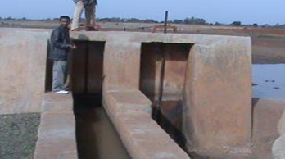 | 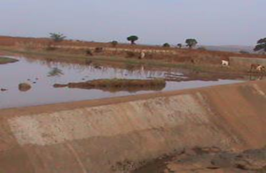 | 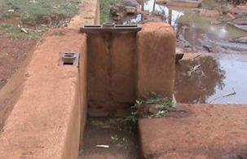
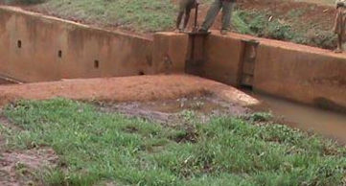 | 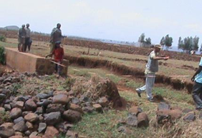 | 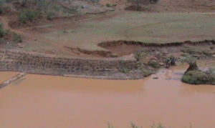
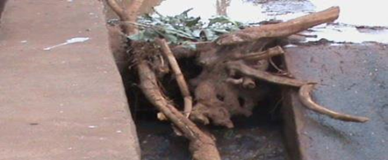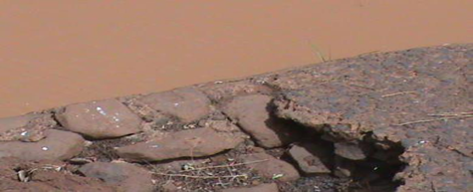

Fig. 2.1: Different problems on diversion weir structures
8/22/2013
2.5 Desilting activities
Silt removal is necessary when the breakdown of dead plant leaves and other organic material along with run off from surrounding fields causes a buildup on the bed of a lake, pond or river. This can have serious consequences on the future of that water and the life there is within it. Buildup of silt will lead to a reduction in water depth of the watercourse, increased risk of flooding, and the release of nasty smelling odors from the process of biological decomposition and potentially the loss of the watercourse.
2.6 Siphons installation
The discharge from a siphon tubes depend on the diameters of the tube and the difference in elevation between the water surface at the upstream and downstream ends of the tube. It may be estimated by the following formula:
$$Q=0.65 x {10}^{-3} a\sqrt{2gH}$$
Which,
Q = discharge from siphon tube (L s⁻¹)
a = internal area of cross-section of tube (cm²)
g = acceleration due to gravity (cm/sec²)
H = effective head causing flow (cm)
If the outlet is not submerged, the effective head is the vertical distance from the water level over the inlet end to the center of the discharge end.
2.7 Monitoring water flow
Water flow measurements in canals are
Float Method: It is inexpensive and simple. This method measures surface velocity. Mean velocity is obtained using a correction factor. The basic idea is to measure the time that it takes for the object to float a specified distance downstream.
V_{surface}= travel distance/ travel time = L/t
Because surface velocities are typically higher than mean or average velocity
V _{mean} = k .V_{surface}

Where,
K is a coefficient that generally ranges from 0.8 for rough beds to 0.9 for smooth beds (0.85 is a commonly used value).
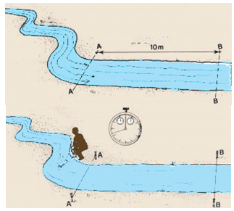
Fig.2.2. Float Method
Area-velocity Method: The rate of flow of water passing a point in open channel is determined by multiplying the cross sectional area of the flow section at right angles to the direction of flow by the average velocity of water. The cross sectional area is determined by measuring the depths at various locations. The depth can be measured by different methods like sounding rods or sounding weights or echo-depth sounder for accurate measurement.
Tracer Method: In the tracer-dilution methods, a tracer solution is injected into the stream at one point and the tracer is measured at a point downstream to the first point. Knowing the rate and concentration of tracer in the injected solution and the concentration in the downstream section, the stream discharge can be computed. Either constant rate injection method or sudden injection method may be used for determining the discharge of a stream by tracer dilution.
Current meters: In the area velocity method current meters are generally used to measure the velocity of flow at the different sections. The current meter consists of a small revolving wheel or vane that is turned by the movement of water.
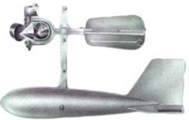
Fig. 2.3: Current meter
2.7 Irrigation shift
Irrigation scheduling determining irrigation time it is an important activity that should be carried out for success of any irrigation project.
Based on the following environmental conditions and stage of crop growth, crop water requirements will be changed

      - Increase in sun shine intensity
      - Increase in day time duration
      - Fall in temperature
      - Increase in humidity Rise in temperature
      - Increase in wind speed
      - Unusual rain fall etc.

We have to recommend irrigation shifts according to
  - Environmental conditions and
  - Crop water requirements

Self-check -2
Name: _________________________ Date: ____________ Date: ____________
Time started: _______________ Time finished: __________________________
Directions: Answer all the questions listed below.
Test I: Choose the best answer (4 point)
- A type of maintenance activity which involves or describes a repair for the damage part that is caused by major disasters is called (3pts)
A) Routine B) normal C) special D) deferred
- In servicing mechanical equipment for maintenances activities, which activity comes first? (3pts)
A) Planning B) implementing C) monitoring
- __________ is the pipes usually made of rubber or plastic or aluminum that measurer and divert water from canal without cut the ridge.
A. v-notch B. Siphon C. checks D. Off take pipe
- ________ is the device which lifts water from deep elevated water level to the upper land surface or to irrigation field.
A. culvert B. gates C. pump D. canal
5. A type of maintenance activity which involves or describes a repair for the damage part that is caused by major disasters is called (3pts)
A) Routine B) normal C) special D) deferred
Part II Match the best alternatives from column “B” to column “A” (2 pts. each)
A |  | B
____1 | . access roads are required to cross the channel | A | Gates
____2 | to bring water to a channel lower in height | B. | Weirs
____3 | stop water flow | C. | Checks
____4 | increase the height of the water level in the channel | D. | Drop structures
____5 | to control the direction of flow of water | E | Culverts
___6. | Flume | F. | cross structure
 |  | G. | Air valve
 |  | H | Flow back control valve
 |  | I | Open Chute
Note: Satisfactory rating 15 and above points Unsatisfactory below 15 points
You can ask your teacher for the copy of the correct answer

Operation Sheet -2
Name: _________________________ Date: ____________ Date: ____________
Time started: _______________ Time finished: __________________________
  - Conduct maintenance activities
Materials and equipment

- PPE
- Cutter
- Sickle
- Note book
- String
- Shovel
- Rack
- etc.

Objective: to identify equipment needed for pre- season maintenances
Procedure:
1. Identify maintenances requiring areas
2. Securing maintenance requiring areas
3. Shutting down system for maintaining
4. Select the required equipment for maintaining
5. Maintaining the area either by replacing or providing support for the equipment determined
2.2 Flow measurement by floating methods
Materials and tools required

- Stop watch
- Note book
- Peg
- hammer
- PPE
- Tape mater

Procedure:
1. Choose a suitable straight reach with minimum turbulence (ideally at least 3 channel widths long).
2. Mark the start and end point of your reach.
3. If possible, travel time should exceed 20 seconds.
4. Drop your object into the stream upstream of your upstream marker.
5. Start the watch when the object crosses the upstream marker and stop the watch when it crosses the downstream marker.
6. You should repeat the measurement at least 3 times and use the average velocity in further calculations.
2.3 Siphoning
Materials and equipment

- Siphon tube
- Note book
- PPE

Here’s how to try your hand at setting a siphon tube:
- Use the hose to fill the concrete ditch section with water.
- Pick up a siphon tube. Notice how one end (“end A”) has an extra curve upwards compared to the other end? That extra curve helps to direct the flow of water out of the tube so it doesn’t wash away the soil in the crop rows. So, “end B” is the “entrance” for the water and “end “A” is the “exit.”
- Put “end B” of the siphon tube into the water. Angle it to get as much of the tube into the water as you can.
- Place your hand at the other end of the siphon tube so you can close off the end with the palm of your hand.
- The tricky part: “pump” the tube back and forth, pressing your palm tightly against the tube opening as you pull back, and releasing the tube as you push forward.
- When water starts to spray from the tube, quickly lay it down where you want the water to go so the “exit” end is lower than the “entrance” end – this is what sets up the gravity flow. (Please: direct the water into the empty side of the concrete ditch, not into the dirt, so mud is minimized. thanks!)
- If you don’t get it on the first try, keep trying! There’s a knack to getting the timing right to make siphon tubes flow – it comes with practice.
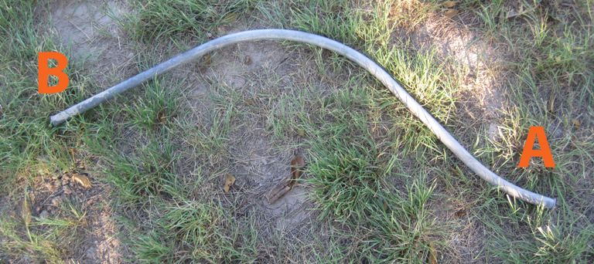

LAP test-2
Name: _________________________ Date: ____________ Date: ____________
Time started: _______________ Time finished: __________________________

Task 2.1: Conduct maintenance activities
Task 2.2: Measure water flow by floating method
Task 2.3: Apply siphoning

LG #11 | LO #3- Clean and store irrigation equipment

Instruction sheet -3
This learning guide is developed to provide you the necessary information regarding the following content coverage and topics:
- Cleaning equipment
- Loading and storing equipment
This guide will also assist you to attain the learning outcomes stated in the cover page. Specifically, upon completion of this learning guide, you will be able to:
- Clean equipment
- Load and store equipment
Learning Instructions:
- Read the specific objectives of this Learning Guide.
- Follow the instructions described below.
- Read the information written in the information Sheets
- Accomplish the Self-checks
- Perform Operation Sheets
- Do the “LAP test”

Information Sheet -3
Some of tools and Equipment used to carry out irrigation works may include:
Name of tools and equipment with its function
Pick axe: - a tool for breaking hard surfaces, with a long wooden handle and a curved metal bar with a sharp point.
Shovels: - Used for moving earth, sieving soil, soil mixing, etc.
Spades-for cutting and digging heavy soil, digging straight-sided, flat-bottomed trenches, or removing a layer of soil.
Pegs are used to make fast a rope or string on, to stop a hole, or to mark some point.
Spirit Levels- an instrument designed to indicate whether a surface is horizontal (level) or vertical (plumb).
Hammers are used nails or hooks into walls or wood (small hammers). Rubber hammers are used to level tiles. It used for driving and pulling out nails
Hacksaws: - used to cut pipes, woods and metal sheet.
Tap meter: used two measure distance between two points (eg. distance between point A and point
Wheelbarrow; for transporting all kinds of materials concrete, stone, sand, soil and other, etc
Leveling equipment: used for the process of modifying the surface relief by grading and smoothing.
Level Rods (Staff): The rod is then observed with the level and read by the instrument person on the target rod.
3.1 Cleaning the site and equipment
Flushing irrigation equipment
To flush and clean a system, a reasonable supply of water must be available
Line flushing is needed when
  - Particulate matter not removed by filters accumulated in irrigation pipes and laterals
  - Chemical precipitation may occur inside pipe lines after irrigation system shuts down
  - Suspended materials will be carried with the irrigation water, but as the water velocity decreases near the end of lines, particles will settle

Flushing procedures may includes
    - Close the valve on the water lines behind a system and disconnect the water lines from the system
    - Open the valve, run water through the valve and dispose of water
    - Close the valve
    - Reconnect the water line to system inlet
    - Open the valve
Weed control: Removing and controlling weeds is crucial aspect around irrigation and drainage system areas for efficient operation of the system.
  - Weed growth may be controlled by maintaining higher velocities in canals.
  - Moreover, many times, the weed growths will have to be physically removed from the canals in order to improve their efficiencies.
Weed management decisions vary due to:

    - Plant life cycles
    - infestation size
    - environmental parameters and
    - management objectives

The choice depends primarily on
    - availability of labor,
    - predominant environmental and
    - Economic conditions.
Successful weed management requires;
    - proper plant identification
    - selection of effective management methods and
    - Monitoring the effects over time.
Methods of weed control in irrigation
a) Preventive Control
- Prevention is the most essential aspect of weed management.
- Awareness of weed seed sources and plant identification is a must.
- Weed seed can be spread from neighboring properties.
b) Cultural Control
C) Chemical: Chemicals have been developed which can control weeds effectively and safely e.g. herbicides
d) Biological
• Introduction of an animal,
• Fish or insect which feeds especially on the problem plant.
e) Mechanical
Specially designed machines available for specific weed control purposes.
3.2 Loading and storing equipment
Dismantling equipment’s by encouraging males and females: is way of taking apart equipment’s in separate pieces according to their type
Loading Equipment by Encouraging females and Males: is way of carrying equipment to transporter machine either by labor force or by loading machine.
Transporting by encouraging females and males: Is a way of taking equipment’s from working place to storage area.
Storing Equipment’s by Encouraging Females and males: Is the process of keeping equipment’s in a particular safe place until it is needed?

Self-check-3
Name: _________________________ Date: ____________ Date: ____________
Time started: _______________ Time finished: __________________________
Directions: Answer all the questions listed below.
Test I: Choose the best answer (4 point)
Direction 1: Choose and write the correct answer for the following Questions
1. one of the following is not a factor for weed management decisions to be varies? (4pts)
A) Plant life cycles B) infestation size
C) Management objectives D) none
2. One of the following is a weed controlling type which uses a competitive and desired vegetation to prevent weeds? (4pts)
A) Preventive B) biological
C) Chemical D) cultural
Note: Satisfactory rating - 4 and above points Unsatisfactory - below 4 points

Directions 2: Answer all the questions listed below.
1. What is weed? (3pts)--------------------------------------------------------------------------------------------------------------------------------------------------------------------------------------------------
2. Why maintaining of weeds are needed? (5pts)-------------------------------------------------------------------------------------------------------------------------------------------------------------------
3. What are the different methods of weed control? (5pts.)-------------------------------------------------------------------------------------------------------------------------------------------------------
4. What are the factors in which weed management decisions vary? (4pts)-------------------------------------------------------------------------------------------------------------------------------------
5. Why we protect crops and plants from damage? (5pts)--------------------------------------------------------------------------------------------------------------------------------------------------------

Note: Satisfactory rating – 30 and above points Unsatisfactory - below 30 points
You can ask your teacher for the copy of the correct answer

Operation Sheet –3
Name: _________________________ Date: ____________ Date: ____________
Time started: _______________ Time finished: __________________________
Objectives: To identify the suitable weed management method for the given area
3 weed controlling
Materials and equipment

- PPE
- Sickle
- Herbicide
- mower

Procedure:
1 .Identify plants life cycle found around your visit area
2. Identify infestation size of crop area
3. Identify environmental parameters
4. Select the suitable controlling method
5. Apply the selected controlling method

LAP test-3
Name: _________________________ Date: ____________ Date: ____________
Time started: _______________ Time finished: __________________________

Task 3 Control weed

LG #12 | LO #4 Record and report maintenance activities

Instruction sheet -4
This learning guide is developed to provide you the necessary information regarding the following content coverage and topics:
- Recording damage and blockage of the system
- Recording routine maintenance activities
This guide will also assist you to attain the learning outcomes stated in the cover page. Specifically, upon completion of this learning guide, you will be able to:
- Record damage and blockage of the system
- Record routine maintenance activities
Learning Instructions:
- Read the specific objectives of this Learning Guide.
- Follow the instructions described below.
- Read the information written in the information Sheets
- Accomplish the Self-checks
- Perform Operation Sheets
- Do the “LAP test”

Information Sheet -4
4.1 Record damage and blockage of the system
The reports on damaged or faulty pumps, valves, electrical components shall include:
- specification of the quantity of each of the principal damage and blockage
- specification of the quantity of each of the principal location and the section of the system affected
- a summary of maintenance activities,
- a summary, by waste class, of activities and quantities disposed of,
- any instances in which observed site characteristics were significantly different from those described in the application for a license; and
- any other information the Commission may require
4.2 Recording routine maintenance activities
The record on routine maintenance activities of open irrigation canals includes at least the following operations:
- light deforestation on irrigation
- weed control in the canal section
- seeding grass in the canal section
- maintenance of flow gauges and other measuring devices
- removal of silt
- Maintenance of pumping stations where water cannot be evacuated by gravity etc.
Note: After completing the records, a report has to be submitted to authorized personnel for corrective measures
4.3 Removing disposal for safe Environment
Unwanted waste materials left during pre-season maintenance and post season maintenance should place in a safe disposal area for safe environmental condition of the working area.

Self-check -4
Name: _________________________ Date: ____________ Date: ____________
Time started: _______________ Time finished: __________________________
Directions: Answer all the questions listed below.
Directions: Answer all the questions listed below. Illustrations may be necessary to aid
some explanations/answers.
1. What to be recorded and reported? (5pts)--------------------------------------------------------------------------------------------------------------------------------------------------------------------------
2. Why record and report of any damage or faulty part of irrigation system is needed? (10pts)--------------------------------------------------------------------------------------------------------------------------------------------------------------------------------------------------------------------
3. Let say you are an irrigation technician for one irrigation site area. If you encounter Maintenance requiring area, to whom do you report for maintenance activities to be undertaken? (5pts)------------------------------------------------------------------------------------------------------------------------------------------------------------------------------------------------------

Note: Satisfactory rating - 10 above Unsatisfactory - below 10 points
You can ask your teacher for the copy of the correct answers

Operation Sheet-4
Name: _________________________ Date: ____________ Date: ____________
Time started: _______________ Time finished: __________________________
4.1 hazard identifications
Objectives: To record and then to report any maintenance activities which you may see around irrigation site areas of your college or else where
Tools and equipment requirement
- Note book
- PPPE
Procedure:
1. Observe your irrigation site
2. Identify areas which needs routine or normal maintenance on gravity fed irrigation system
3. Record what you see on your site which needs maintenance
4. Finally, report what you record to the concerned body

LAP test-4
Name: _________________________ Date: ____________ Date: ____________
Time started: _______________ Time finished: __________________________
Task 4.1 Identify hazard

Reference Materials
Books

Ackers, P. W. (1978.). Weirs and Flumes for Flow Measurement. . Chichester, West Sussex, UK.: John Wiley & Sons Ltd. .
Barrett, P. a. ( 1999). ramework for Water Use Efficiency. Australia .
Booher., F. L. (1974.). Surface irrigation. Rome. 160p.
FAO. (1974). Agricultural Development Paper No. 95. . Rome.
Humphery s,A.S.J. (1999). Irrigation System Performance Testing south east natural resource conservation. Australia.
Humpherys, A.S. J. . (1969). Mechanical structures for farm irrigation, Irrig. and Drainage 95(IR4) DivASCE:.

Web addresses
Source: http://www.weatherstation.co.in/full-images/730336.jpg: (accessed on August 28, 2022)
Source:ftp://ftp.fao.org/fi/CDrom/FAO_Training/FAO Training/General/x6705e/x6705e0.htm (accessed on August 29, 2022)
Source http://cwi.csufresno.edu/wateright/880105.asp- (accessed on 08/22)
Source http://www.cigr.org/documents/CIGRHandbookVol1.pdf (08/22)
Source http://www.fao.org/docrep/V8350E/V8350E00.htm (accessed on August 30, 2022)
Source http://www.irrigationtoolbox.com/NEH/Part623_Irrigation/H210-623-04-DRAFT.pdf (accessed on August 29, 2022)
Source http://www.vlirrigation.org/cms/fileadmin/content/ejlw/2007/ejlw 2007-01-01 clemmens simple approach to surface irrigation design-theory.pdf (accessed on 08/22)

AKNOWLEDGEMENT
Ministry of Labor and Skills and Ministry of labor and skill wish to extend thanks and appreciation to the many representatives of TVET instructors and respective industry experts who donated their time and expertise to the development of this Teaching, Training and Learning Materials (TTLM).

The experts who developed the learning guide
No | Name | Qualification | Educational background | Region | Phone number | E-mail
1 | Serawit Gensa | M.sc. | Water Resource Engineering | W/Sodo AVET | 0916740916 | serawitgen@gmail.com
2 | Edao Hassen | M.sc. | Irrigation Engineering | Alage AVET | 0911098097 | hassedao@gmail.com
3 | Mekete Agizew | M.sc. | Water Resource Engineering | Amhara. Kombolcha ATVET | 0925221192 | gen.mam09@gmail.com
4 | Wondu Alemayehu | M.sc. | Irrigation Engineering | Oromia Kombolcha ATVET | 0910-28-99-61 | woldualem@gmail.com
5 | Ademe Ayalew | M.sc. | Irrigation Engineering | Agrafa AVET | 0912720547 | Ademe2004@gmail.com
6 | Seid Mohammed | M.sc. | Irrigation& drainage Engineering | Alage ATVET | 09-17-18-01-81 | Siyamsdmhmmd@gmail.com
7 | Molalign Asfaw | B.sc. | Water Resource &Irrigation Engineering | Alage ATVET | 0921431096 | Mollalign410ass@gmail. com
8 | Yonas Hailu | B.sc. | Water Resource &Irrigation Engineering | Agrafa AVET | 0934715578 | yonashailuw@gmail.com
9 | Lemessa Mulata | M.sc. | Irrigation Engineering | Agrafa AVET | 0913266845 | Lamimulle2022@gmail.com
10 | Misganew Yimer | B.sc. | Soil and Water Engineering | Woreta ATVET |  | Misge1976@gmail.com
11 | Daniel Derese | Bs. c. | Soil and Water Engineering | W/sodo AVET | 0912-79-28-85 | danielderesse7@gmail.com
12 | Teshome Getachew | M.sc. | Irrigation & drainage Engineering | Alage ATVET | 0925-50-13-99 | teshomegetachew131@yahoo.com

