IRRIGATION AND DRAINAGE
LEVEL-II

Based on March, 2022, Version 3 Occupational standard

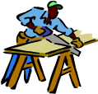


Module Title: - Technical drawings and specifications
LG Code: AGR IRD2 M05 LO (1-3) LG (13-17)
TTLM Code: AGR IRD2 TTLM 0822v1

August, 2022
Addis Ababa, Ethiopia

Table of Contents

Introduction to the Module 1
LO #1- Tools and equipment’s for Drawing 2
Instruction sheet 2
Information Sheet 1 4
Self-check 1 29
LO #2- Map reading 30
Instruction sheet 30
Information Sheet 2 31
Self-Check – 2 49
Operation Sheet -2 51
LAP TEST-2 54
LO #3- Check specification document 55
Instruction sheet 55
Information Sheet 3 56
Self-Check – 3 65
LO #4- Implementation of map 67
Instruction sheet 67
Information Sheet 4 68
Self-Check – 4 79
Operation Sheet -4 80
LAP TEST-4 84
LO #5: Cleaning work site and equipment 85
Instruction sheet 85
Information Sheet 5 86
Self-check 5 88
Reference Materials 89

Introduction to the Module
Technical drawing is concerned mainly with using lines, circles, arcs etc., to illustrate general configuration of an object. It is a language of communication between architects and Engineers, usually to convey information about the object. However, it is very important that the drawing produced to be accurate and clear.

The ability to read and understand drawings is a skill that is very crucial for technical education students; this text aims at helping students to gain this skill in a simple and realistic way, and gradually progress through drawing and interpreting different level of maps, plan drawings and specifications.

LG #13 | LO #1- Tools and equipment’s for Drawing

Instruction sheet
This learning guide is developed to provide you the necessary information regarding the following content coverage and topics:
  - Introduction to the module
  - Drawing tools and equipment / Requirements and purpose of drawing
  - Drawing instruments / Drawing tools and equipment
  - Basic data to produce drawing
  - Confirmation of drawing requirements
  - Drawing object identification
  - Drawing scale and legend
  - Measurement of features on map and ground.
  - Map preparation
  - Drawing symbols and abbreviations
This guide will also assist you to attain the learning outcomes stated in the cover page. Specifically, upon completion of this learning guide, you will be able to:
  - Identify purpose of drawing tools and equipment
  - Use drawing instruments
  - Identify basic data’s to produce drawing
  - Draw relevant personnel and timeframes
  - Identify drawing object
  - Use drawing scale and key
  - Read map legend
  - Measure features on map and ground.
  - Prepare local area map
  - Draw symbols and abbreviation

Learning Instructions:
- Read the specific objectives of this Learning Guide.
- Follow the instructions described below.
- Read the information written in the information Sheets
- Accomplish the Self-checks
- Perform Operation Sheets
- Do the “LAP test”

Information Sheet 1

  - Drawing tools and equipment.
1.1.1. Introduction
To record information on paper instruments and equipments are needed. Engineering drawing is entirely a graphic language hence instruments are essentially needed. Drawing must be clear, neat and legible in order to serve its purpose. Hence, it is extremely important for engineers to have good speed, accuracy, legibility and neatness in the drawing work.

1.1.2. Important Drawing Equipment
All drawings are made by means of various instruments. The quality of drawing depends to a large extent on the quality, adjustment and care of the instruments.
Some basic equipment is necessary in order to learn drawing effectively, here are the main ones.
- T-square:
A T-square is a technical drawing instrument primarily used for drawing horizontal lines on a drafting table; it is also used to guide the triangle that is used to draw vertical lines. The name “T square” comes from the general shape of the instrument where the horizontal member of the T (blade) slides on the side of the drafting table.)

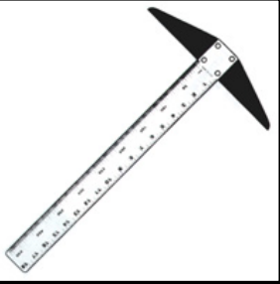
Figure 1.1. Tee Square
- Set- square
A set square or triangle is a tool used to draw straight vertical lines at a particular planar angle to a baseline. The most common form of Set Square is a triangular piece of transparent plastic with the centre removed. The outer edges are typically bevelled. These set squares come in two forms, both right triangles: one with 90-45-45 degree angles, and the other with 90-60-30 degree angles.
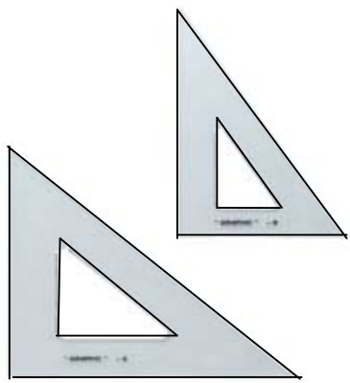
Figure. 1.2. Set square
- Compass
Compasses are usually made of metal, and consist of two parts connected by a hinge which can be adjusted. Typically one part has a spike at its end, and the other part a pencil. Circles can be made by pressing one leg of the compasses into the paper with the spike, putting the pencil on the paper, and moving the pencil around while keeping the hinge on the same angle. The radius of the circle can be adjusted by changing the angle of the hinge.
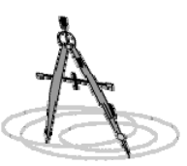
Figure. 1. 3. Compass

- Drawing table
It is a multi-angle desk which can be used in different angle according to the user requisite. The size suites most paper sizes, and are used for making and modifying drawings on paper with ink or pencil. Different drawing instruments such as set of squares, protractor, etc. are used on it to draw parallel, perpendicular or oblique lines.
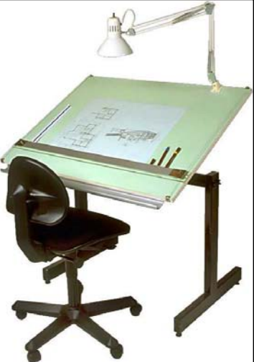
Figure. 1.4. Drawing table

- Irregular Curves (French curves):
French curves are used to draw oblique curves other than circles or circular arc, they are irregular set of templates. Many different forms and sizes of curve are available.
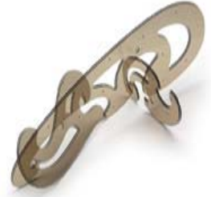
Figure. 1. 5. French curve
- Protractor:
The Protractor is a circular or semi-circular tool for measuring angles. The units of measurement used are degrees. Some protractors are simple half-discs.
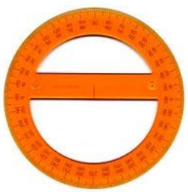
Figure. 1. 6. Protractor
- Drawing Pencil:
This is a hand-held instrument containing an interior strip of solid material that produces marks used to write and draw, usually on paper. The marking material is most commonly graphite, typically contained inside a wooden sheath. Mechanical pencils are nowadays more commonly used, especially 0.5mm thick.
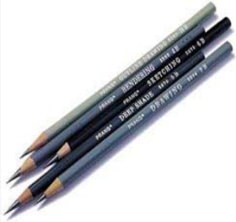
Figure. 1. 7. Drawing pencils
- Eraser:
Erasers are article of stationery that are used for removing pencil writings. Erasers have made of rubbery material, and they are often white. Typical erasers are made of rubber, but more expensive or specialized erasers can also contain vinyl, plastic, or gum-like materials.
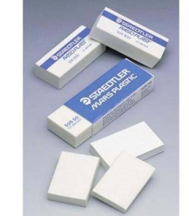
Figure. 1. 8. Erasers
- Drawing paper
- Drawing paper sizes
The dimensions of the sheet are 841 mm x 1189 mm. For smaller sheets the longest side is progressively halved and the designations and dimensions are given in Table 1.1 and Figure. 1.9. Since the A0 size has the area of 1 m², paper weights are conveniently expressed in the unit ‘grams per square metre’.
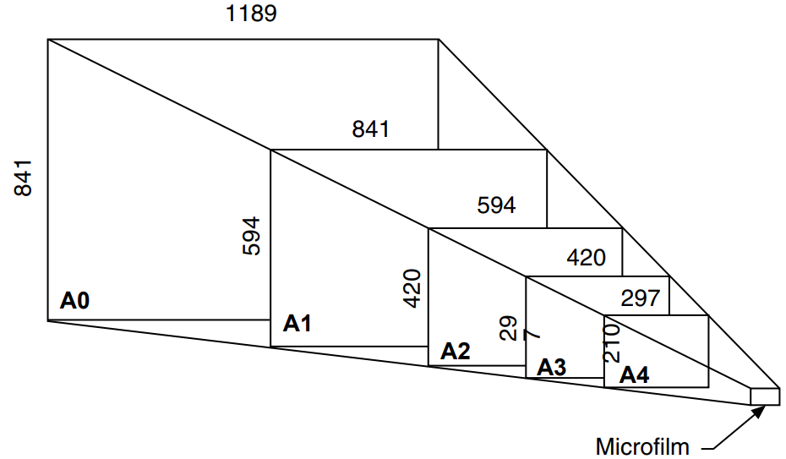
Figure. 1.9: Standard size reductions from A0 to 35 mm microfilm.

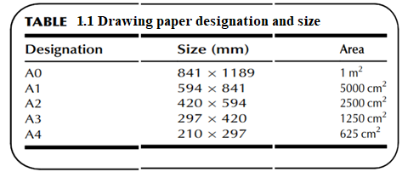

Drawing sheets may be obtained from a standard roll of paper or already cut to size. Cut sheets sometimes have a border of at least 15 mm width to provide a frame and this frame may be printed with microfilm registration marks, which are triangular in shape and positioned on the border at the vertical and horizontal centre lines of the sheet.

Title blocks are also generally printed in the bottom right- hand corner of cut sheets and contain items of basic information required by the drawing office or user of the drawing.
Typical references are as follows:
- Name of firm,
- Drawing number,
- Component name,
- Drawing scale and units of measurement,
- Projection used (first or third angle) and or symbol,
- Draughtsman’s name and checker’s signature,
- Date of drawing and subsequent modifications,
- Cross references with associated drawings or assemblies.
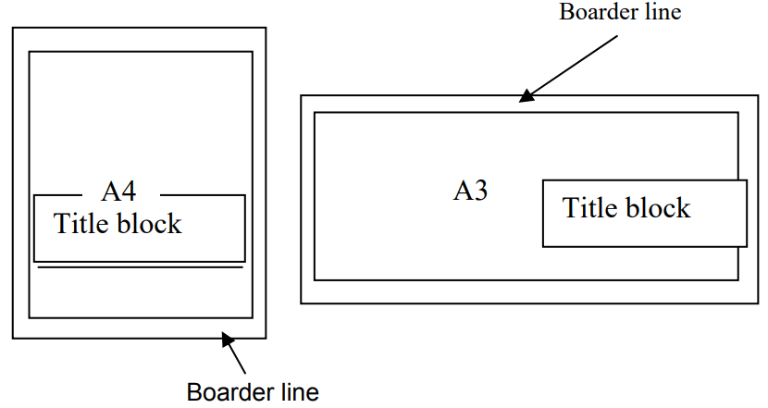
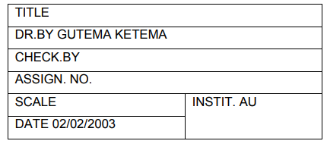
Figure. 1.10 Sample title block
- Presentation
Drawing sheets and other documents should be presented in one of the following formats:
(a) Landscape—presented to be viewed with the longest side of the sheet horizontal.
(b) Portrait—presented to be viewed with the longest side of the sheet vertical.
- Divider
Used chiefly for transferring distances and occasionally for dividing spaces into equal parts. i.e. for dividing curved and straight lines into any number of equal parts, and for transferring measurements.
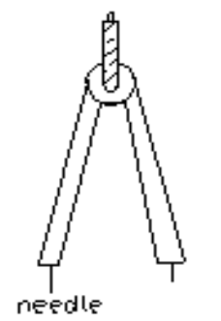
Figure. 1.11 Divider
- Template
A template is a thin, flat piece of plastic containing various cutout shapes. It is designed to speed the work of the drafter and to make the finished drawing more accurate. Templates are available for drawing circles, ellipses, plumbing’s, fixtures etc. Templates come in many sizes to fit the scale being used on the drawing. And it should be used wherever possible to increase accuracy and speed.

  - . Drawing instruments
The drawing instrument /equipment mentioned above needs to be prepared to carry the intended drawing works.

1.3. Basic data to produce drawing
The following are some of the design processes
- For most designers the first step in any design project is to clearly define the need that the design will fill and what parameters the design must meet in order to be considered a success. Many designers refer to this step in the design process as problem identification.
- For example, before designing a house, an architectural designer needs to know what style of home the client wants, how many bedrooms and baths, and an idea of the budget for the project. The designer also needs to know some things about the site where the house will be built. Is the site hilly or flat? Are there trees on the site, and if so, where are they located? What is the site’s orientation relative to the rising and setting of the sun? These concerns represent just a few of the dozens of other design parameters that the designer needs to define before beginning the design process.
- Once the design problem is clearly defined, the designer begins preparing preliminary designs that can meet the needs and parameters defined by the problem identification step. The preparation of the potential designs is often referred to by designers as the ideation, or brainstorming, step of the process. During this step, multiple solutions to the design problem may be generated in the form of free-hand sketches, formal CAD drawings.
- The preliminary designs are shown to the client to see if the design is in-line with the client’s expectations. Meeting with the client allows the designer to further define the client’s needs and expectations. These meetings are also an opportunity for a designer to educate the client about other, possibly better, solutions to the design problem.
- After the client decides on a design that meets the parameters set out in the first step, the designer begins preparing design inputs that clearly define the details of the design project. Design inputs may include free-hand sketches with dimensional information, detailed
notes, or even CAD models. Figure 1.12 shows an example of an architectural designer’s sketch of a foundation detail for a house.
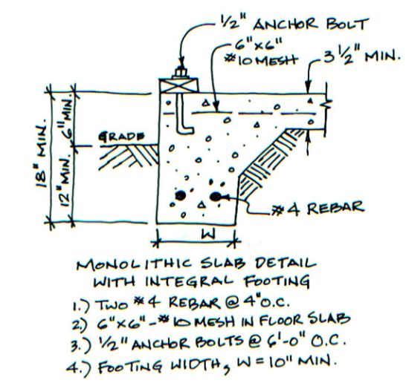
Figure 1.12 Architectural Designer’s Sketch.
- When the design inputs are finished, they are given to the drafter(s) responsible for preparing the technical drawings for the project. To accomplish this task, drafters usually work closely with other members of the design team which may include designers, checkers, engineers, architects, and other drafters.

- CAD (computer aided drawing) allows drafters to create drawings more quickly than traditional drafting techniques. Figurer 1.13 shows an AutoCAD® drawing prepared from the designer’s sketch shown in Figurer 1.12.
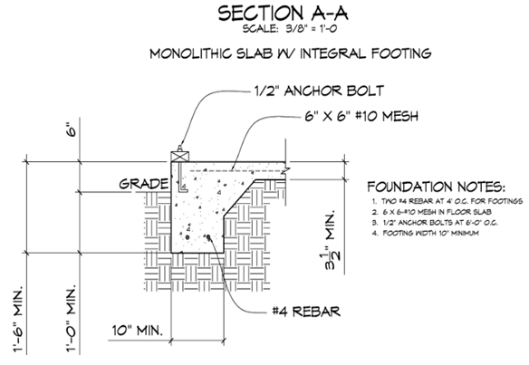
Figure 1.13 An AutoCAD® drawing of Figure 1.12.
- When the drafter is finished preparing the technical drawings, the designer, or in some cases a “checker”, reviews the drawings carefully for mistakes. If mistakes are found, or if the design has been revised, the drafter will make the necessary corrections or revisions to the drawings. This process is repeated until the construction drawings are considered to be complete. When the entire of construction drawings is finalized, the drafter and designer(s) will put their initials in an area of the drawing called the title block.
- The completed construction drawings represent the master plan for the project. Everything required to complete the project, from applying for a building permit to securing financing for the project, revolves around the construction drawings. Building contractors use the construction documents to prepare bids for the project and the winning bidders will use them to build the house.

Engineering designers follow a similar process when designing products. Most engineering projects begin by clearly identifying the design problem and progress through the steps of preliminary design, design refinement, preparation of technical drawings, manufacturing, and inspection.

Catching problems and mistakes during the design and drafting stages of the project can result in huge savings versus correcting mistakes on the job site, or after the project has been manufactured. A good example would be to compare the enormous cost incurred by an automobile manufacturer who has to issue a recall of thousands of cars to correct a design problem versus the cost of catching the problem on the technical drawing before the cars are manufacture.
Steps to planning drawing

1.4. Confirmation of drawing requirements

To appreciate the need for technical drawings, one must understand the design process. The design process is an orderly, systematic procedure used in accomplishing a needed design.
Any product that is to be manufactured, fabricated, assembled, constructed, built, or subjected to any other types of conversion process must first be designed. For example, a house must be designed before it can be built.

With the completion of preliminary design work an agreed design concept will be established, but it is necessary to obtain customer approval before work continues. If our product is to be used in conjunction with others in a large assembly, then, for example, expected overall dimensions and operational parameters need to be conﬁrmed with the client before money is spent on further development.

The plan will go through many stages before final approval is granted for the building to be erected. This approval starts with the client or owner approving the design and cost of the building and then there are the many divisions within the local authority approving the construction methods.

1.5 Drawing object identification
1.5.1 The different types of drawings and their applications
It would not be possible to give a builder a written description how to construct a building. The construction of any building would require a complete set of drawings that would show all the aspects and outlay of a proposed building. These drawings are commonly referred to as the construction drawings, building plan or plan.
Buildings are designed by professional architects who employ the services of draughts-persons to draw the working drawings for a project. The draughts- person must ensure that he conveys the architects design correctly and accurately to the builder and in doing so he must ensure that he includes all the necessary information on the plan for the successful completion of the building.
A construction drawing for a single-storey house would consist of the following drawings:
- A site plan
- A plan view of the floor layout
- Sectional views
- Elevations
- Schematic layout of the sewage plan
- Details
Each of these drawings would be accompanied with all dimensions, notes and labels. The builder must be provided with all the required information to construct the house. Supposing the house has an additional floor above, that is, a double_storey house, then there will have to plans for the reinforced concrete floor and staircase. These are plans that are prepared by a professional civil engineer and would include:
- A steel reinforcement layout plan for the floor and staircase
- A schedule that would show the sizes and shapes of the reinforcing steel.

1.5.2 The key functions of the drawing in terms of the finished product
The key function of the drawings is that it must be clear, easy to read. The drawings must consist of sufficient plan lay-outs, sections and elevations, together with details for special parts of the construction. The drawings must be neatly drawn; with all dimensions, notes and specifications clearly stated. It must have a clear indication what the finished building will look like. The construction team must be able to understand the purpose of the building. There must be no uncertainty which will confuse the builders. Buildings are designed as fit for purpose for its intended use. The building must be erected to the correct specifications as designed by the architect. Changes to the original design can only be affected by the owner via the architect. The owner or the builder is not allowed to make any changes without consulting the architect.

1.5.3 The key users of the drawings
Before and during the construction the plans will be used by various people who are either directly or indirectly involved with the construction of the building.

It might be worth mentioning at this stage that many months would pass between the drawing of the plans and the building being constructed. The reason for this is that the plan will go through many stages before final approval is granted for the building to be erected. This approval starts with the client or owner approving the design and cost of the building and then there are the many divisions within the local authority approving the construction methods.

Once the drawings are approved and a building contractor is appointed, the contractor will then use the drawings to calculate and order the required building materials. Copies of the drawings are also sent to companies who specialize in certain parts of the construction, these companies are called sub-contractors. Examples of sub-contracting companies are plumbing, electrical and painting companies.

1.5.4 The purpose of each view in terms of the result of the end product
Designers must supply the builders with all the information required to successfully erect and complete a building. This is done by presenting a proposed building in the form of a graphical layout which will consist of various types of drawings. The layout drawings are also commonly referred to as the construction drawings or building plan. A builder uses the layout drawings to interpret the designer’s idea into reality.
All drawings must be fully dimensioned and labelled with all notes and specifications.
The title panel: Each drawing must consist of a title panel. This panel is situated at the bottom right-hand corner of the drawing page and contains a summary of the information of the drawings on the page.
A typical title panel for a normal house will read as follows and assuming it’s a new house:

New house for Mr and Mrs __________
Zone, District.
Signed: ………………………

This signifies to the builder where (location) the house is to be erected. The address will also be shown on the site plan. The information of the draughts-person must also be included in the title panel.
Drawn by:
Name ___________
Signed……………………
Other information would include:
- The north point
- The date the drawing was completed.
- The applicable notes relating to the drawing.

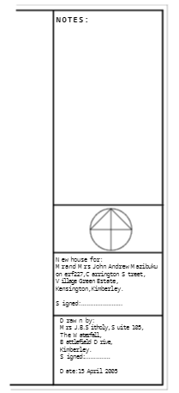
Figure 1.14 Atypical title panel

A typical set of layout drawings will consist of:
I. Locality drawings: Identifies and locates the site from a town plan.
II. Site plan: The site plan is normally situated on the bottom right-hand corner of the drawing page, next to the title block. Figurer 1.15 below shows an example of a site plan.
This is the first drawing which the builder inspects and extracts the following information from the site plan:
- The position of the boundary pegs;
- The dimensions of the site;
- The location of the proposed building;
- The dimensioned position of the building line;
- The position of true north;
- The registered number of the site;
- Excess to the site;
- The positions of the any drains, storm water channels and sewer lines;

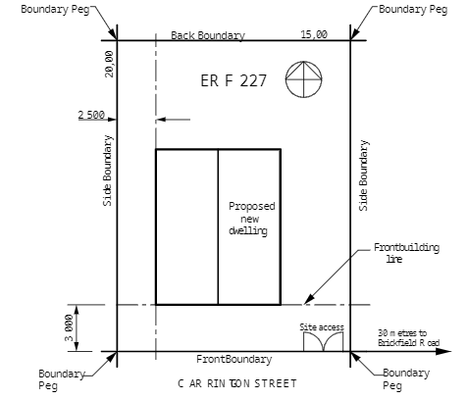
Figure 1.15 An example of a site plan.

III. The plan layout of the building: This is the horizontal or top view of the building which also shows the shape of the building. A double storey building will have two plan layouts. Figurer 1.16 below shows a typical plan layout for a single house. The following information will be provided:
- The dimension of the building which will include the overall size of the building, the thickness of the walls, the sizes of rooms;
- The designations of the rooms, example, bedroom, bathroom, kitchen;
- The positions of the doors, windows and openings;
- The plumbing layout of the bathroom and kitchen;
- The floor levels;
- The floor finishes, example, tiles, carpet, timber;
- The positions of any fixed furniture, example, bedroom and kitchen cupboards.

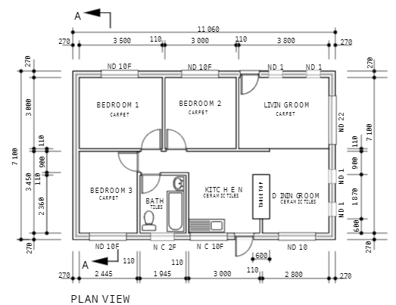
Figure 1.16 A typical plan layout for a single house

IV. Sectional views: This is a vertical section which shows a “cut-through” view which would indicate the following:
- The dimensions and position of the concrete foundations;
- The height of the foundation wall, not less than 4 brick courses below ground level;
- The position of the natural ground level (NGL);
- The position of the damp proof course (DPC), minimum 150 mm above the natural ground level;
- The thickness of the concrete floor;
- The height of the external walls from the finish floor level to the underside of the wall plate;
- The finishes to applied to the walls;
- The heights of the door and window frames;
- The pattern and pitch of the roof truss;
- The overhang of the roof truss;
- The fascia board and gutter;
- The description of the roof covering;
The description of the ceiling;
All the notes and specifications pertaining to the sectional view; Figurer 1.17 shows a typical sectional view through one of the eaves.
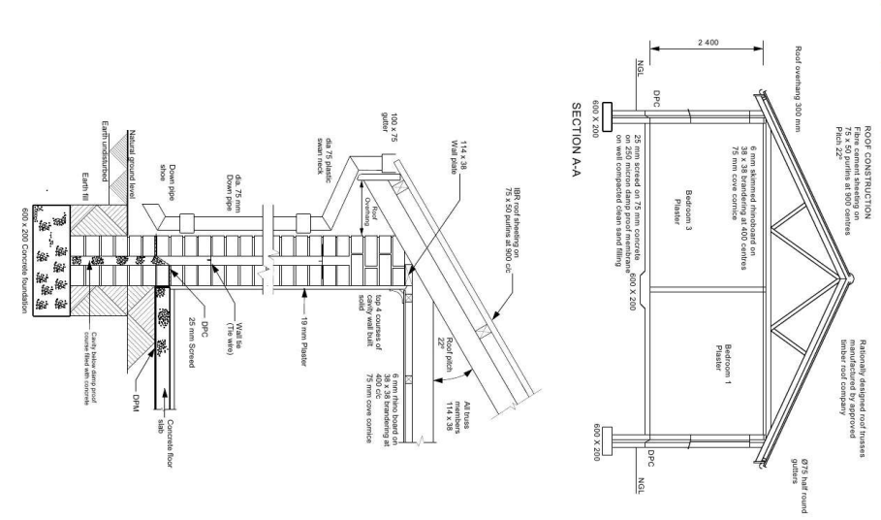
Figure 1.17. A typical sectional view through one of the eaves.

V. Elevations: Elevation drawings would normally consist of four drawings which would show the outside views of the house. Each view being orientated towards the four points of a compass, as shown in Figurer 2.5 below, that is, north, south, east and west. The purpose of the elevations are as follows:
- The outside height of the building to show the floor level in relation to the ground level;
- The height and shape of the roof;
- The fascia board, gutters and down-pipe;
- The position and heights of all the doors, windows, steps and sills;
- Applied finishes to the walls
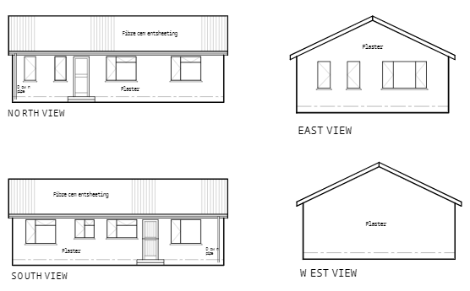
Figure 1.18 Elevation views oriented in four directions

1.5.5. Dimensions are interpreted from the drawings in terms of site requirements
A completed construction drawing for a building plan must consist of all notes and dimensions before it is issued to the building contractor. The plan will also state that all dimensions and levels be checked and veriﬁed before any building work commences. This would imply that the builder is required to check the levels and dimensions on site before the building is set out. It would be wise of a site foreman to spend time with the plans and write down all important dimensions, this would help him when he gets to the building site by which time he would have a complete mental picture of the building.
Checking the construction drawings would also eliminate any discrepancies which could be cleared with the architect. Some of the important notes would include:
The physical address of the site. This should be given at the bottom right-hand corner of the drawing sheet, see Figurer 1.14 above, or at one of the corners of the site plan which would indicate the measurement to the nearest cross-road. The importance of this is that many buildings have been built on the wrong site.
- The size and shape of the plot as stated on the site plan. The size of the site boundaries are normally written at the corners of the site plan.
- The dimensions of the building lines in relation to the site boundaries. There should be at least two dimensions showing the distance of the building line from the front boundary and the distance from a side boundary.
- The internal dimensions must be equal to the overall external dimensions of the building. Should there be an error then the overall dimensions will take preference over the sum of the internal dimensions. Any major differences must be cleared with the architect before the commencement of any work.

1.6 Drawing scale and legend
Dimensions of large objects must be reduced to accommodate on standard size drawing sheet. This reduction creates a scale of that reduction ratio, which is generally a fraction and such a scale is called Reducing Scale and the ratio is called Representative Factor.
Representative Fraction:
The ratio of the dimension of the object shown on the drawing to its actual size is called the
Representative Fraction (RF).
For computing R.F, the numerator and denominator should be in same units

Scale
Drawings shall be made to full scale unless the parts (or assembly) are too large to permit it or so small and complex that drawing to an enlarged scale is essential for clarity. When the main views of large parts are drawn to a reduced scale, the detail views “taken” to clarify detail should be made to full scale whenever possible. When the part has been drawn to an enlarged scale for clarity, it is not necessary to make an actual-size view.
a. The scales preferred for engineering drawings are:
- Full size 1:1,
- Reduced 1:2, 1:4, 1:10, 1:20, and
- Enlarged 2:1, 4:1, 10:1, 20:1.
The computer database for the format size shall be 1/1 at all times.
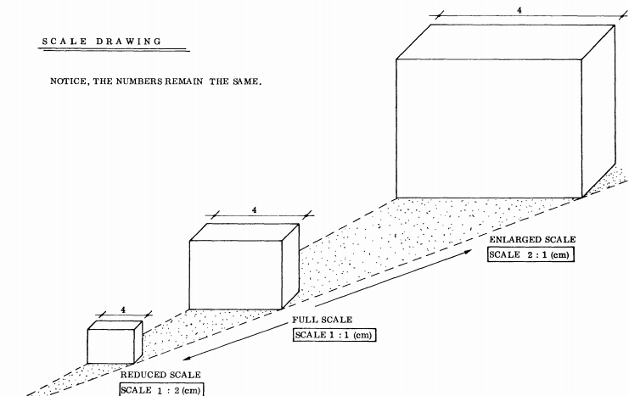
Figure 1.19. Drawing scale

EXCEPTION:
Certain drawings or Figurers, by their very nature, cannot be drawn to a specific scale (for example, wiring and schematic diagram drawings.) The scale designation for these cases is “NONE.”
- The scale, as noted above, or the word “NONE” must be entered in the Title block. Do not use the word “SIZE” following the ratio. The notations “1/4 & NOTED” or “1/2 & NOTED,” etc., apply to those drawings on which the main views are to a reduced scale and auxiliary views are to some other scale.
- To maintain consistency with title block callout for scale, detail views shall be noted thus:
DETAIL – A
SCALE 1:1
Note: The scale of the view shall be stated only when it differs from that noted in the Title block, which represents the majority of views and sections.
- Original pencil drawings should be to scale within 0.03 inch. When changes to an existing drawing take place, it is required to indicate that a particular feature is not to scale by underlining the dimensions with a straight line.
- The geometry of CAD-produced drawings shall be entered into the electronic database at one-to-one (full) scale.

1.7. Measurement of features on map and ground
Maps are useful for more than just directions. They can also help you determine the distance between two (or more) places. The scales on a map can be of different types, ranging from words and ratios to pictorial scales. Decoding the scale is the key to determining your distance.

Here is a quick guide on how to measure distances on a map. All you'll need is a ruler, some scratch paper, and a pencil.
- Use a ruler to measure the distance between the two places. If the line that you are trying to measure is quite curved, use a string to determine the distance, and then measure the string.
- Find the scale for the map you are going to use. They are typically located in one of the corners of the map. It might be pictorial a ruler bar scale, or a written scale in words or numbers.
- If the scale is a verbal statement (i.e. "1 inch equals 1 mile"), determine the distance by simply measuring it with a ruler. For example, if the scale says 1 inch = 1 mile, then for every inch between the two points on the map, the real distance on the ground is that number in miles. If your measurement on the map is 3 5/8 inches, that would be 3.63 miles on the ground.
- If the scale is a representative fraction (and looks like 1/100,000), multiply the distance of the ruler by the denominator (100,000 in this case), which denotes distance in the ruler units. The units will be listed on the map, such as 1 inch or 1 centimeter. For example, if the map fraction is 1/100,000, the scale says inches, and your points are 6 inches apart, in real life they will be 6x100,000 so 600,000 centimeters or 6 kilometers apart.
- If the scale is a ratio (and looks like 1:100,000), you'll multiply the map units by the number following the colon. For example, if you see 1:63,360, that means 1 inch on the map represents 63,360 inches on the ground, which is 1 mile.
- With a graphic scale, you'll need to measure the graphic, for example, white and black bars, to determine how much ruler distance equates to distance in reality. You can either take your ruler measurement of the distance between your two points and place that on the scale to determine real distance, or you can use scratch paper and go from the scale to the map. To use paper, you'll place the edge of the sheet next to the scale and make marks where it shows distances, thus transferring the scale to the paper. Then label the marks as to what they mean, in real distance. Finally, you'll lay the paper on the map between your two points to determine the real-life distance between them.
- After you've found out your measurement and compared it with the scale, convert your units of measurement into the most convenient units for you (i.e., convert 63,360 inches to 1 mile or 600,000 cm to 6 km, and so on).

Watch out for maps that have been reproduced and have had their scale changed. A graphic scale will change with the reduction or enlargement, but other scales become wrong. For example, if a map was shrunk down to 75 percent on a copier to make a handout and the scale says that 1 inch on the map is 1 mile, it is no longer true; only the original map printed at 100 percent is accurate for that scale.

1.8. Map preparation
When you plan a topographical study, the most important rule to remember is that you must work from the whole to the part, keeping in mind all of the work you will need to do as you begin the first steps. Different types of survey require different levels of accuracy, but you should lay down the first points of each survey as accurately as possible. You will adjust all the work you do later to agree with these first points.
For example, you need to plan survey a demonstration farm/ site to prepare its map.
- First, you must make a perimeter survey ABCDEA. Besides these summits and boundaries, add several major points and lines, such as AJ and EO. They run across the interior to create right angles, which will help you in your calculations. This survey gives the primary survey points, which you should determine and plot very accurately.
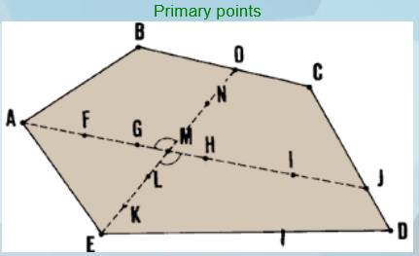
Figure 1.20

- Then, lay out minor lines such as FP and TN. They go between the major lines to divide the area into blocks. This gives you the secondary survey points, which you may determine less accurately.
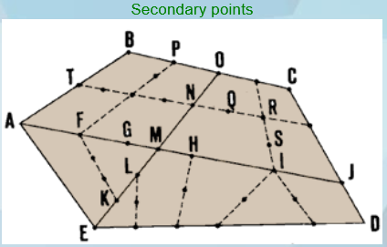
Figure 1.21 dividing the site in to different geometrical shape
- Finally, survey details in each block using tertiary points, for which less accuracy is also acceptable.
- Put a mark to indicate the existing features (manmade or natural) in and around the site.

1.9. Drawing symbols and abbreviation
Some drawings need to convey a lot of information. To avoid confusion and to save space, abbreviations and symbols are used. These are standardised and you will find that you soon become used to interpreting what they mean.

- Abbreviations
Abbreviations can be created in different ways. In some cases the word is shortened. Examples include ‘ENS’ for ensuite and ‘CPBD’ for cupboard.
In other cases initials are used. Examples include ‘WIR’ for walk-in robe and ‘WC’ for water closet (toilet).
There might be several recognised abbreviations for the same thing. For example, you may see ‘brickwork’ shortened to BRK, BWK or just BK.
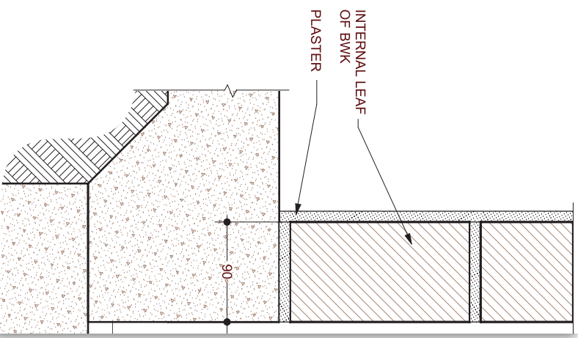
Figure 1.22. Symbol and Abbreviations

If you come across a new abbreviation in a drawing and you are not sure what it means, have a look at where it is in the drawing, as that will often give you a clue.

- Symbols
Like abbreviations, symbols are used instead of words on drawings to save space. There are a lot of them, but they’re standardised (drawn the same way) to avoid confusion, so don’t worry. Some of them look a lot like what they represent. For example, the symbol:

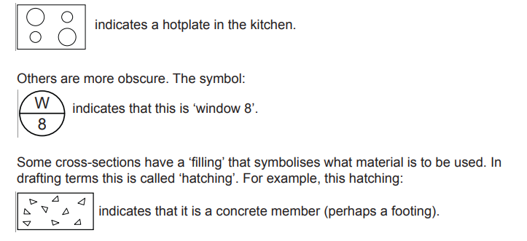

Some drawings have a legend to indicate what the symbols used on the drawing mean.
The legend shown in Figure 1.24 is from a site plan. Without this legend, the symbols on
the drawing could be misinterpreted.

Electrical, hydraulic and engineering drawings commonly have legends on them.
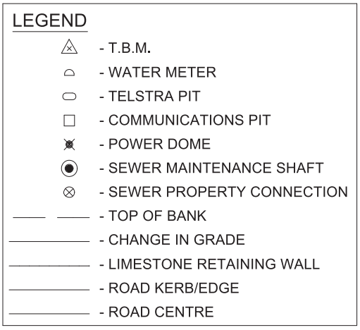
Figure 1.23. A legend from a site plan showing several symbols and their meanings.

Plan symbols
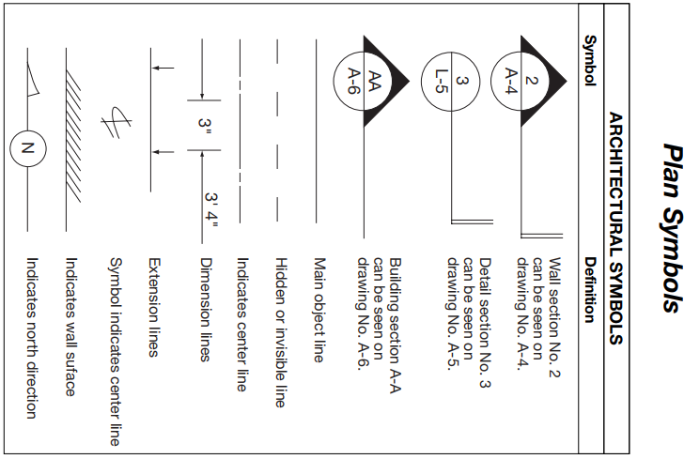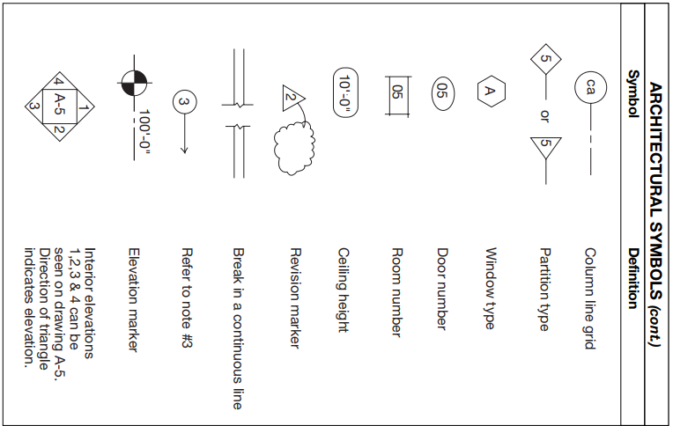
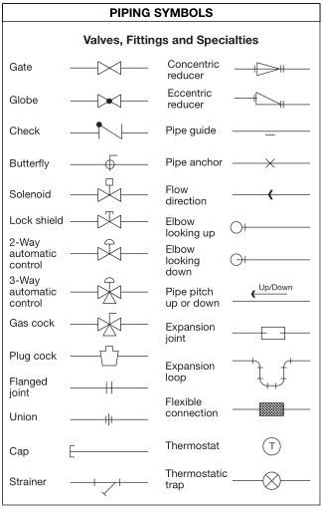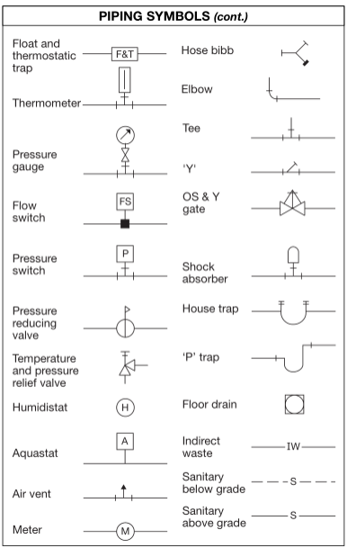
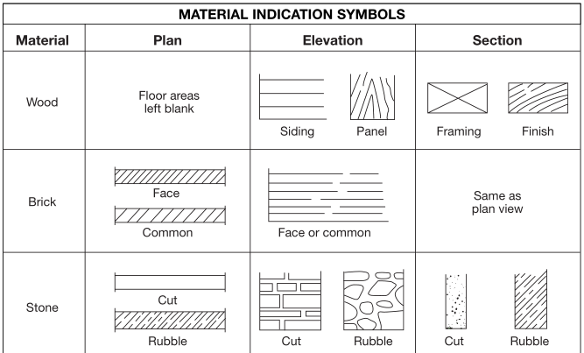

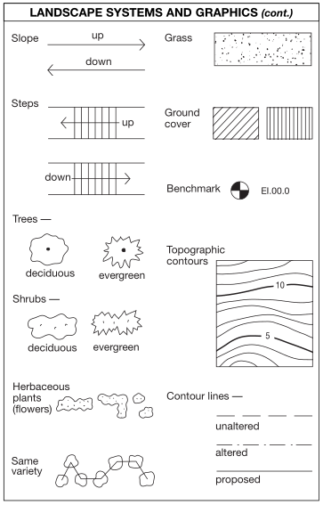
Fig. 1.24: Symbol

Self-check 1 | Written test

Name…………………………………………… ID………………………… Date…….
Directions: Answer all the questions listed below.

Test I: Short Answer Questions
1. The lines shown below are drawn to various scales. The scale of each line is shown to its left.
Use your scale rule to measure each line and write its scale length in the box to the right of it.
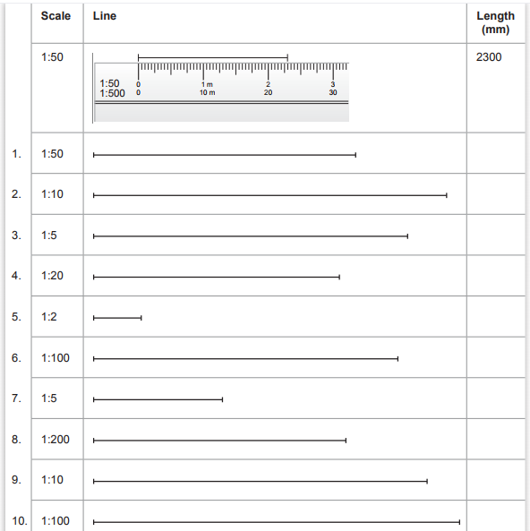
2. Below are some symbols that are commonly used on construction drawings. Write what you think the symbol represents.
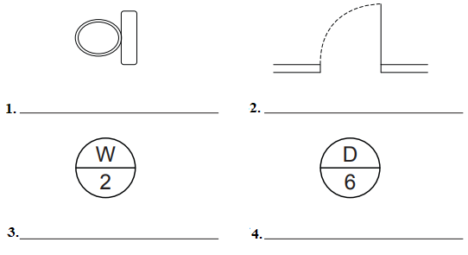
Note: Satisfactory rating - 5 points Unsatisfactory - below 5 points
You can ask you teacher for the copy of the correct answers.

LG #13 | LO #2- Map reading

Instruction sheet
This learning guide is developed to provide you the necessary information regarding the following content coverage and topics:
  - Types of maps, plans, drawings and specifications
  - Map and site plan
  - Symbols and abbreviation interpretations
  - Features on maps, plan and drawings
  - Environmental effect of the project
This guide will also assist you to attain the learning outcomes stated in the cover page. Specifically, upon completion of this learning guide, you will be able to:
  - Identify types of maps, plans, drawings and specifications
  - Identify key features of maps and site plans
  - Interpret symbols and abbreviation
  - Identify natural and man-made features on maps, plans and drawings
  - Assess environmental effect of the project

Learning Instructions:
- Read the specific objectives of this Learning Guide.
- Follow the instructions described below.
- Read the information written in the information Sheets
- Accomplish the Self-checks
- Perform Operation Sheets
- Do the “LAP test”

Information Sheet 2

2.1 Types of maps, plans, drawings and specifications
A map is a visual drawing of a whole region or some of a locality that’s often shown on a flat surface. A map’s purpose is to illustrate precise and elaborated aspects of a particular location, most ordinarily want to show geography. There are many types of maps, together with static, two-dimensional, three-dimensional, dynamic, and interactive maps.
Maps show physical features of the natural or built environment at established scale and orientation.
Key Map Elements
- Title
- North Arrow
- Scale
- Legend
What is the purpose of this Map?
- Town Planning
- Regulatory
- Wetland Impacts (IWW)
- Subdivision (Planning)
- Site Plan (Zoning)
Types of Maps
There are seven different types maps
- Political Maps
- Physical Maps
- Thematic Maps
- Topographic Maps
- Climate Maps
- Economic / Resource Maps
- Road Map

- Political Maps
Political map mainly focuses on national and state boundaries. counting on the quality of the maps, these maps additionally give the locations of major and small cities. Topographic elements such as mountains aren’t enclosed on a political map.
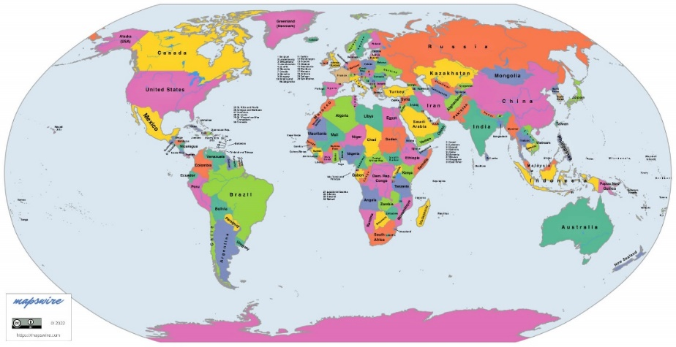
Figure 2.1: Political map
- Physical Maps
It describes a location geographical element. Mountains, rivers, and lakes are commonly pictured on these maps. Blue is wide used to show bodies of water. Mountains and height variations are sometimes shown in a variety of colours and shades to demonstrate elevation. Greens on physical maps usually represent lower altitudes, whereas browns typically show higher elevations.
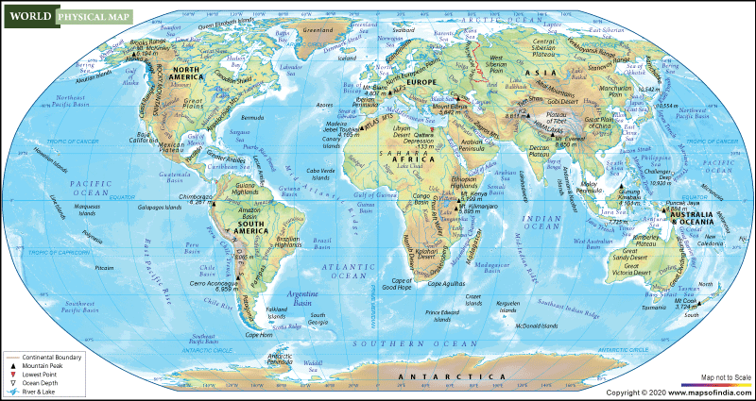
Figure 2.2: Physical map of world
- Thematic Maps
A thematic map is a map that focuses on a particular theme or special topic. It concentrates on a specific theme or issue. These maps differ from the previous six general reference maps because they do not just show features like cities, rivers, political subdivisions, highways, and elevation. If these items appear on a thematic map, they are background information and are used as reference points to enhance the map's theme.

Figure 2.3: A thematic map
- Topographic Maps
A topographic map, like a physical map, depicts several physical terrain aspects. However, not like physical maps, this way of mapping employs contour lines instead of colors to depict changes within the landscape. Topographic maps usually have contour lines spread at regular intervals to depict elevation variations (e.g. every line represents a 100-foot elevation change). Approximate lines indicate that the ground is steep.

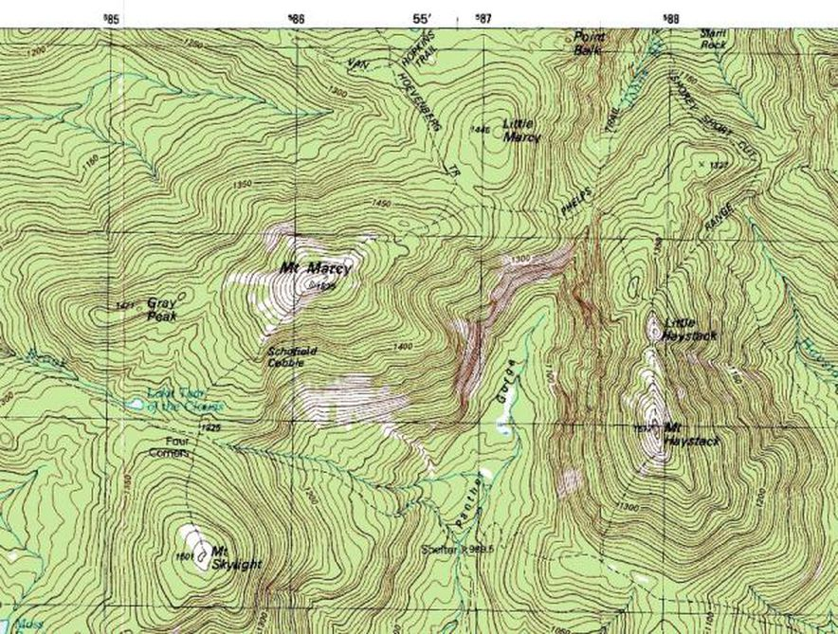
Figure 2.4: Topographic Maps
- Climate Maps
A climate map shows information about the climate of an area. These maps can show things like the specific climatic zones of an area based on the temperature, the amount of snow an area receives, or the average number of cloudy days. Color is usually used to show distinct climate zones on these maps.
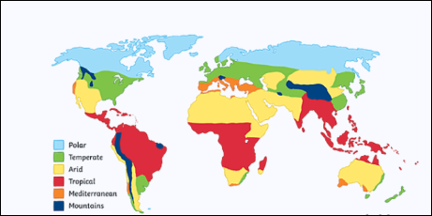
Figure 2.5: climatic maps
- Economic / Resource Maps
An economic or resource map shows the several forms of economic activity or natural resources found in a given region using numerous symbols or colors according to what’s being shown.
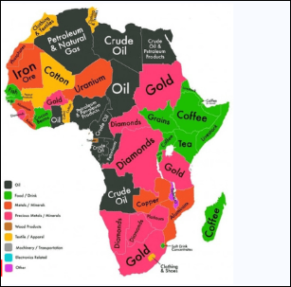
Figure 2.6: Economic / Resource Maps
- Road Maps
A road map is one of the most widely used map types. These maps show main and smaller highways and roads, cities, and areas of interest like campgrounds, parks, and monuments (depending on the extent of detail). Major highways are often pictured on a map with red lines, broad, while lesser roads are demonstrated with softer colors and narrower lines.
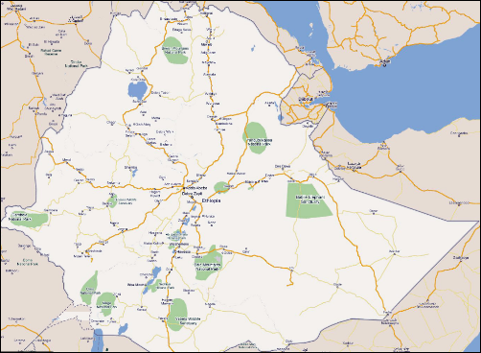
Figure 2.7: Road map
What is plan?
The plan is a two-dimensional drawing of a location, area, structure, or building that includes numerous specific information. It also incorporates illustrations and data. It provides extensive information in the symbolic form regarding small regions. Plans are engineered drawings made to scale showing existing physical features of a site and proposed changes to accommodate development.
- Seven different types of Plans
- Site Plan
- Floor Plan
- Structural Plan
- Terrace Plan
- Cross-section.
- Elevation
- Landscape plan
- Site Plan
The site plan is the 1st design created for any project and shows the layout of the development site. Site plans offer data on property borders, site access, and existing structures on or close to the construction site, like roads and buildings.

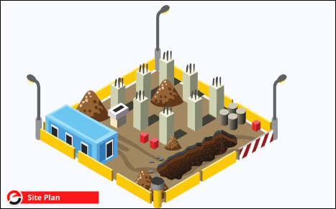
Figure.2.8: Site Plan
- Floor Plan
One of the most important types of building plans is the floor plan. It’s a top-down perspective of a floor plan. Floor plans are a sort of vertical orthographic projection that’s depicted by a plan cut at the window sill level on its floor.
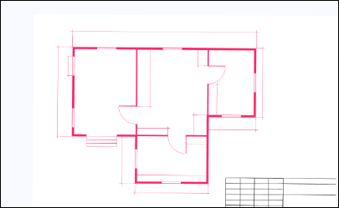
Figure 2.9: Floor map
- Cross-section Plan
A section plan is a vertical cut section of a building that shows the scale and thickness of any component. merely put, it depicts a sliced image of a building. Section plan consists of
- Beams
- Columns
- Height of the floor,
- Beam height
- Height of the sill, etc

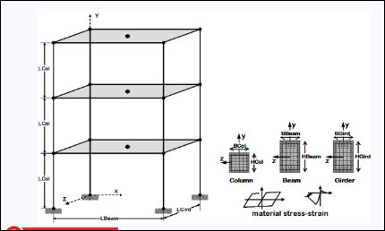
Figure 2.10: Beam cross section

- Structural Plan
This sort of plan offers a comprehensive perspective of the building’s structural aspects. The structural design gives details of the size, nomenclature, location, and placement of reinforcement of structural elements and load-carrying elements of the structure. The structural plan is important since it focuses on the structure’s strength.
- Terrace Plan
It is the building plan at the roof level. It depicts the stair cabin, lifts cabin (if any), above water tanks, and roof drainage layout. The parapet walls also are enclosed on the terrace layout.
- Elevation Plan
An elevation plan sketch is an orthographic projection of one of the building’s side faces. It is a two-dimensional illustration of the building’s facade. The main aim of an elevation sketch is to portray the complete appearance of a certain side of a structure. There are two kinds of elevation plans: External Elevation & Internal Elevation.
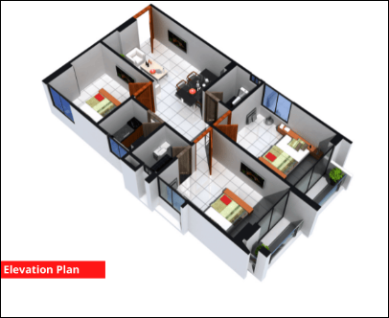
Figure. 2.11: Elevation plan
- Landscape Plan
The landscape plan includes all of the specifics about the flowers, plants, pathways, lawn decorations, fountains, swimming pools (if any), and so on. Well-designed landscaping may improve your living space while also increasing the value of your home. As a result, landscape designs have become one of the most popular forms of construction plans in today’s world.

2.2 Map and site plan
A map is a visual drawing of a whole region or some of a locality that’s often shown on a flat surface.
Purposes/Types of Maps
  - Physical map – shows land and water features shaped by nature
  - Pictorial map – uses drawings to indicate features on the map, such as buildings, forests, and landmarks.
  - Political map – shows countries, states, capitals, etc.
  - Relief map – shows three-dimensional aspects of the planet
  - Satellite map – map of earth taken from space
  - Thematic map – map that tells about a special topic such as rainfall, population density, etc.
  - Topographical map – shows the elevations, related to a relief map
Table 2.1: Difference between map and plan
Map | Plan
- A map is a visual drawing of a whole region or some of a locality that’s often shown on a flat surface.  - On some map, (topographic specifically) Vertical direction is also shown along with the horizontal and directions.  - Normal scale used in the map is 1cm = 100m or more than 100m.  - A map is generally drawn for a large area. | - The plan is a two-dimensional drawing of a location, area, structure, or building that includes numerous specific information.  - It also incorporates illustrations and data.  - It provides extensive information in the symbolic form regarding tiny regions.  - Plan generally only shows horizontal and direction on it.  - Plan are generally drawn for a small area.

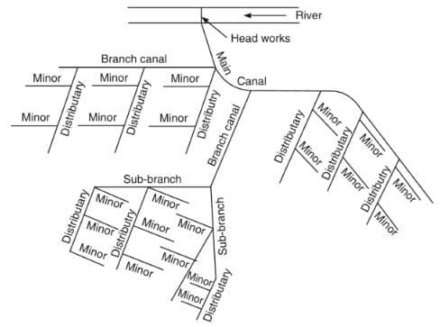
Figure 2.12: Site plan of irrigation canal network.

2.3 Symbols and abbreviation interpretations
Standard map symbols indicate three main features on maps. These features include areas, lines and points. These symbols or images are listed and explained in a key on the map. Symbols are used to keep the map tidy and easy to read, too many words would make the map difficult to read. It is impossible to label every single feature in words on a map, therefore we use map symbols. Every map is accompanied by a legend or key. The Key is essential since it contains what each symbol on the map stands for. Such symbols may be drawings, letters, lines, shortened words or coloured areas. Most map symbols are conventional signs as they are understood by everyone around the world; for example a lighthouse and church.
Purpose of map symbols
A map is a reduced representation of three-dimensional space. Since a map is a limited representation, it's impossible to accurately convey all proportions and features of the depicted area. To overcome these limitations, maps have a system of symbols to explain objects, features, distances and characteristics. Map symbols make it possible for people to understand the map and use the information to meet their needs.

Map symbols consist of lines, letters and graphics. The symbols can be anything from a dot to a more complex illustration. Map features and symbols vary somewhat based on the type of map. Every map has a legend that provides a key for the symbols. A map without symbols is a useless tool. Symbols provide important information on distances, geography and locations. Maps are extremely limited in what they can represent. Symbols are necessary to convey the information maps provide.

Map Symbols Use of Color Blue – used for all water features.
- Red – major roads & highways.
- Green – identifies vegetation such as forest cover, orchards, etc.
- Brown – used to depict contour lines as well as some landform features.
- Black – man-made features & all labeling & lettering.
- Purple – revisions & new map data
Topographic Symbols ;symbols on a map that represent natural and man-made features found on the earth’s surface.

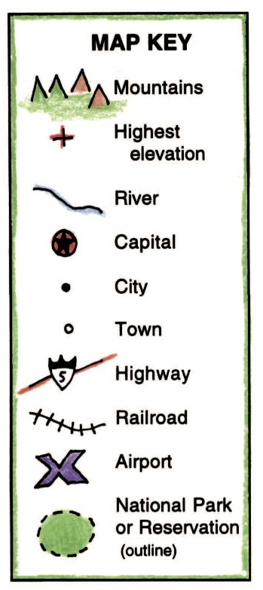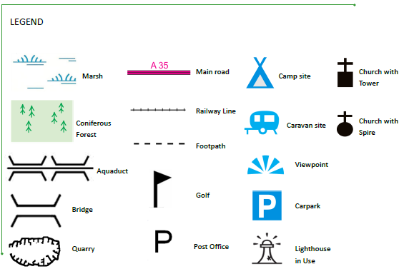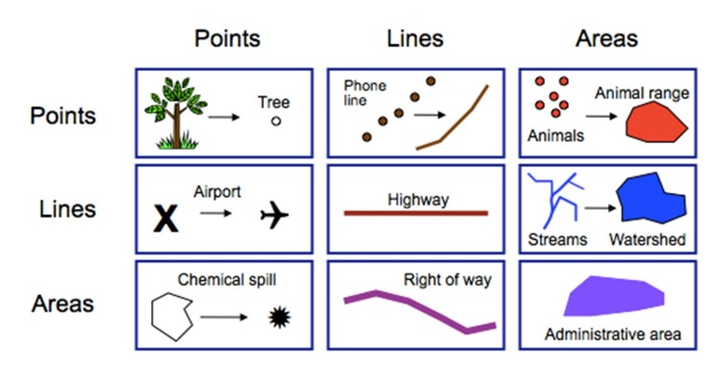
Figure. 2.13: Symbol in the Map

2.4 Features on maps, plan and drawings
Along with scale, symbols, and grids, other features appear regularly on maps. A good way to remember these features: date, orientation, grid, scale, title, author, index, legend, and sources. They are- title, direction, legend(symbols), north areas, distance(scale), labels, grids and index, citation – which make it easier for people like us to understand the basic components of maps.
Map Elements
- Main map body. Exactly what it sounds like, this is the map itself.
- Legend. Also known as a key, the legend explains any symbols used on the map.
- Title. The map title reflects the subject of the map.
- Inset map.
- Scale indicator.
- Orientation indicator.
- Source note.
- Creator graphic
Man-made features on a map
Manmade features on a map include physical infrastructure (buildings, roads, fences, tracks) through to human-perceived boundaries (e.g. private properties vs. national parks). Different shapes are used to mark physical features on a map such as roads, pathways, railways lines. Topography is the study of the forms and features of land surfaces. The topography of an area could refer to the surface forms and features themselves, or a description (especially their depiction in maps).
What color are man-made features on topographic map?
- Brown is used to indicate contour lines,
- Green is used to show vegetation,
- Blue is used to indicate water features such as lakes or rivers and
- Black and Red are used for man-made features such as roads or administrative boundaries.

Terrain Features
As you look at the land around you, you will notice different terrain features: the hills, valleys, and other features on the ground. Maps represent these features in specific ways. The Army divides terrain features into three groups: major, minor, and supplementary terrain features. Major terrain features include hills, saddles, valleys, ridges, and depressions.
- A hill is an area of high ground. If you stand on a hilltop, the ground slopes away from you in all directions. A map represents a hill with contour lines forming concentric circles. The inside of the smallest circle is the hilltop (Figurer 2.14).
- A saddle is a dip or a low point between two areas of higher ground. If you stand in a saddle, you have high ground in two opposite directions and lower ground in the other two directions. The contour lines on a map representing a saddle are shaped like an hourglass (Figurer 2.15).
- A valley is a groove in the land, usually formed by a stream or a river. A valley usually begins with high ground on three sides and has a course of running water through it. If you stand in a valley, you will have higher ground in three directions and lower ground in one direction. Depending on the size of the valley and where you are standing, you may not see the higher ground in the third direction, but the stream or the river will flow from higher to lower ground (Figurer 2.16).
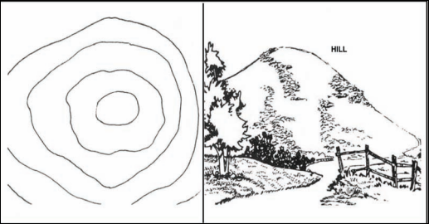
Figure. 2.14: Hill
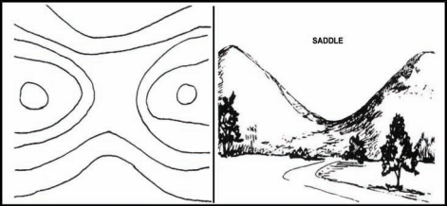
Figure 2.15: Saddle
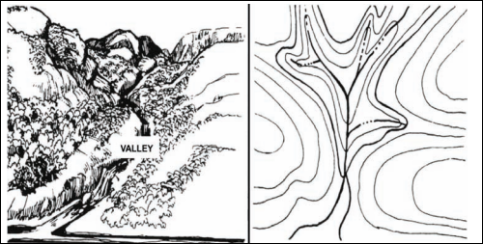
Figure.2.16: Valley
Features on site plan
Site plans should include the following: the size and position of the existing building (and any extensions proposed) in relation to the property boundary. The position and use of any other buildings within the property boundary. The position and width of any adjacent streets.

A site plan is a graphic representation of all existing and proposed improvements to a site. Sometimes referred the site plan functions as a map for a development project, incorporating all aspects of landscaping, construction, paving, utilities, and terrain features in a single depiction.

A site plan will provide all the information you need on how the project will be oriented on the property. A builder or contractor will draw a diagram that depicts the plot of land, property lines, landscape features, structural elements, setbacks, roadways, utility poles and power lines, fencing, and on-site constructions. A site design may even include landscape aspects that don’t quite fit on your property.

Most site plans are 2D (two dimensional) aerial maps that give you a clear overview of your property’s features. A 3D (three dimensional) rendering is a three-dimensional, full-color plan that’s particularly useful for understanding the landscape, including plantings, the building’s parking, and outdoor structures. The site plan is usually found on the title page of your property’s collection of documents (also known as blue prints) and serves as a summary of the land. All of the different prints’ sheet indexes are included.
- Key features of maps and site plans
In the maps and site plan the following key features will be incorporated:
- Shape and orientation of site.
- Road.
- Existing buildings and structures.
- Services, including:
- Drainage
- Water supply
- Dimensions
- Grades of pipelines and channels
- Geographical features
- Types of structures, including:
- Buildings
- Bridges
- Fences
- Pipelines
- Regulators
- Poles
- Environmental barriers
- Environmental features, including:
- Fauna and flora habitats
- Cultural and Heritage features
- Water catchments
- Shape of structure and building
- Vertical and horizontal measurements
- Geological features
- Service layouts
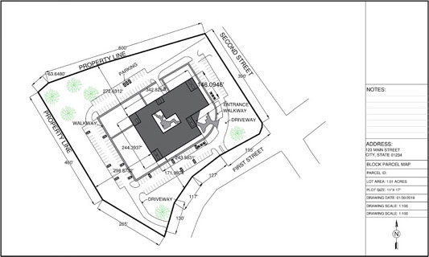
Figure.2.17: Site plan
The information shown on a site plan will vary depending on the size and nature of the project, however, certain information is likely to appear on most site plans:
- Title block, giving the project name, drawing type, author, revision number, status, the scale used, and so on.
- Notes highlighting changes from previous revisions.
- Directional orientation. This could be a compass or a north-pointing arrow.
- Key dimensions.
- Key materials.
- Site boundaries and delineation of adjacent properties, including where necessary, adjoining or adjacent structures, and surrounding streets.
- The location of the building or buildings in relation to their surroundings.
- Trees, tree protection orders, and the main elements of the landscape.
- Parking areas with dimensions or capacities, traffic flows, and signage.
- Roads, footpaths, ramps, paved areas, and so on.
- Easements such as right-of-ways, right of support, and so on.

2.5 Environmental Effect of the project
An environmental management plan may be required for a project, depending on the type of project and where it is located. Environmental management includes the following controls: OHS and environmental regulations/requirements, equipment, material and personal safety requirements
- Land disturbance – for example management of storm water, dust control and erosion.
- Noise and vibration – for example working only during prescribed site operating hours and monitoring noise and vibration levels of vehicles and equipment.
- Waste management – for example minimizing waste, sorting waste into the appropriate bins and leaving the site clean and tidy at the end of each day.
- Hazardous goods – for example ensuring material safety data sheets (MSDS) are available and ensuring correct storage procedures are followed.
An environmental management plan can be either a separate written document, included in the specifications, or depicted as a plan similar to the project site plan. Everyone involved in a project needs to follow the environmental management plan.

Self-Check – 2 | Written test
Name…………………………………………… ID………………………… Date…….
Directions: Answer all the questions listed below.
Test I: Choose the best answer (5 point)
- Which one of the following is a visual drawing of a whole region or some of a locality that’s often shown on a flat surface
- A map
- Drawing
- Plan
- All
- Which one of the following describes a location geographical element
- Physical Maps
- Political Map
- Economic map
- All
- Which one of the following is a two-dimensional drawing of a location, area, structure, or building that includes numerous specific information.
- Drawing
- A map
- Plan
- All
- Which one is incorrect about the plan
- It also incorporates illustrations and data.
- It provides extensive information in the symbolic form regarding tiny regions.
- Plan generally only shows horizontal direction on it.
- None
- Which one of the following explains any symbols used on the map
- subject
- Symbol
- legend
- scale
Test II: Matching (5 points)
Match column A with column B. Select the letter of the correct answer from column B and place your answer on the space provided in column A.
Column “A” | Column “B”
- ___is giving the project name, drawing type, author, revision number, status, and the scale used.  - ___ is a graphic representation of all existing and proposed improvements to a site.  - ___is used to indicate contour lines in topographic map.  - ___ is used to show vegetation in topographic map.  - ___It describes a location geographical element. Mountains, rivers, and lakes are commonly pictured on these maps. | - Green  - Physical Maps  - Title block  - Brown  - A site plan  - Political map

Note: Satisfactory rating - 5 points Unsatisfactory - below 5 points

You can ask you teacher for the copy of the correct answers.

You can ask you teacher for the copy of the correct answers.

Operation Sheet -2

2.2 Reading and interpreting map(Topo maps)
- Tools and equipment
- Topo map
- Pencil
- Ruler
- Note book

- Procedures/Steps/Techniques
- Choose the correct type of Map (Topographic Map)
- Point your map north direction
- Identify key features and list them
- Tell what your map information about the title, legend, title, scale,stream line and terrain
- Identify the landscape, the contour line closer the contour lines are together( the steeper the gradient), and flatten gentler slopes(see Figure.1 below).
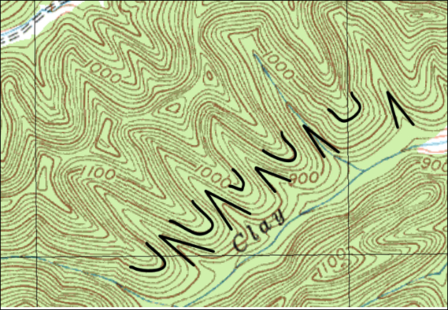
Figure. 1: Valley and cliff point on the map

- Identify the side of mountain on a map as contour lines pointing against the natural slope of a mountain.
- Identify the saddle points on the maps (feature that slopes down on two sides, and slopes up on two sides(see Figure.2 below)
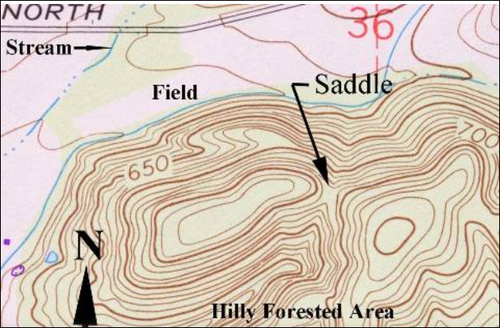
Figure. 2: contour line and mountains
2.2 Measuring accurate dimension on the drawing
  - Tools and equipment
- Drawing paper with sketch
- Pencil
- Ruler
- Note book
  - Procedures
    - Identify the sketches on drawing
    - Understand some details form the drawing or scale and convert the scale in to the ground distance
    - Using rule measure the missing dimension indicated by the arrows on the drawing(see Figure.1).
    - Write the dimension distance on the ground

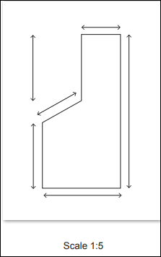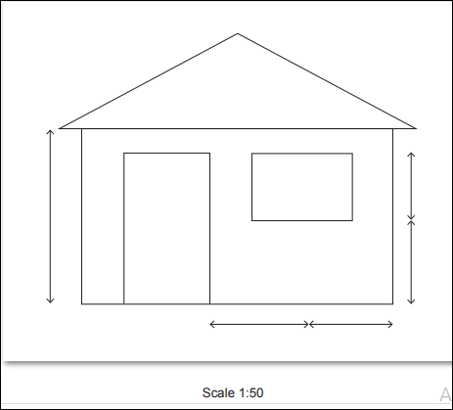
Figure.1: missing dimension on Drawing

LAP TEST-2 | Performance Test

Name…………………… ID…………… Date…………….

Time started: ________________________ Time finished: ________________

Instructions: Given necessary templates, tools and materials you are required to perform the following tasks within 50 minute. The project is expected from each student to do it.

Task-1: Read and interpret key features on topographic map

LG #17 | LO #3- Check specification document

Instruction sheet
This learning guide is developed to provide you the necessary information regarding the following content coverage and topics:
  - Working instructions
  - Reading and interpreting specification document
  - Validation of map, plan and drawing
  - Amendments for project documentation
This guide will also assist you to attain the learning outcomes stated in the cover page. Specifically, upon completion of this learning guide, you will be able to:
  - Follow and used working instructions
  - Read and interpret specification document
  - Check and validate map, plan or drawing
  - Check and amend project documentation
Learning Instructions:
- Read the specific objectives of this Learning Guide.
- Follow the instructions described below.
- Read the information written in the information Sheets
- Accomplish the Self-checks
- Perform Operation Sheets
- Do the “LAP test”

Information Sheet 3

3.1 Work Instruction
A Work instruction is a document that provides specific instructions to carry out an activity. A Work instruction is a step by step guide to perform a single instruction. It contains more detail than a procedure and is only created if detailed step-by-step instructions are needed. It is document that clearly and precisely describe the correct way to perform certain tasks that may cause inconvenience or damage if not done in the established manner.
- Specifications
A detailed description of the dimensions, construction, workmanship, materials etc., of work done or to be done, prepared by an architect, engineer etc. A specification is the document that describes in words what cannot be visualized or explained on a drawing or model. It is a method of commercial construction project delivery where design drawings (or plans) are created along with written specifications to further describe the equipment and parts shown in the drawings.

A specification is often a type of technical standard. There are different types of technical or engineering specifications, and the term is used differently in different technical contexts. They often refer to particular documents, and/or particular information within them.
- A requirement specification is a documented requirement, or set of documented requirements, to be satisfied by a given material, design, product, service, etc. It is a common early part of engineering design and product development processes in many fields.
- A functional specification is a kind of requirement specification, and may show functional block diagrams.
- A design or product specification describes the features of the solutions for the requirement Specification, referring to either a designed solution or final produced solution.
Any technical specification may include to;
- Design information
- Customer requirements
- Sketches and preliminary layouts

Design information
These types of documents define how a specific document should be written, which may include, the systems of a document naming, version, layout, referencing, structuring, appearance, language, copyright, hierarchy or format, etc….Very often, this kind of specifications is complemented by a designated template.
Drawings and Specifications means the final working drawings for the work, issued by Engineer and describing the size, character, design, construction, materials, finishes, and structural, mechanical, electrical and other systems of the Project.
Design information have the basic idea behind a site plan is to show:
- The shape of the site
- The size of the site - shown using a scale
- The orientation (i.e. which way is north)
- The geographical location of the site
- The precise positions of things like trees or rocks
- Any variations in height (shown as contour lines)
- Any easements, rights of carriage, driveways, existing storm water drainage etc.
- The exact location and footprint of any existing structures
- Any relevant features of the area surrounding your building site - particularly things which might affect access to the site or construction

Sketches and Preliminary drawings:
Preliminary sketches and drawings include concept drawings, floor plans and design ideas. These drawings can range from quick freehand sketches to measured perspective drawings. Any designers will often provide a concept drawing.

Drawings and Specifications means the final working drawings and specifications for the Work, issued by Engineer and describing the size, character, design, construction, materials, finishes, and structural, mechanical, electrical and other systems of the Project.

In work instruction the following points are essential in the instruction document:
- Write a Clear and Easy-to-Understand Title.
- Write a Descriptive Introduction.
- Describe the purpose of the task.
- Describe how to do the task.
- Format for easy reading.
- Validate the Information.
- Rewrite and Simplify.

3.2 Read and interpret specification document
Technical drawing is essential for communicating ideas in industry and engineering. To make the drawings easier to understand, people use familiar symbols, perspectives, units of measurement, notation systems, visual styles, and page layout.
It is important that the purpose for which technical drawings are being prepared and the people that will use them are carefully considered to ensure they are properly structured and adopt an appropriate presentational techniques. It is also important to have an understanding of how to read them.
Some of the components common to many types of technical drawing are set out below.
- Border: This helps ensure that the full drawing is included in reproductions. The border sometimes includes letters and numbers to delineate zones, in the same way as a map, to help locate and pinpoint certain areas. These letters are in alphabetical order from the bottom up on the vertical axis. The numbers are in numerical order from right to left on the horizontal access. The zones are to be read from right to left.
- Title : A title block will typically appear in the bottom-right corner of a drawing and contains information related to the drawing, including:
- Name: The company or agency that prepared the drawing.
- Address: Location of the company or agency.
- Names and dates: Individuals who drew, checked and approved the drawing, and the date they did so.
- Description: What the drawing is of.
- Status: What the drawing is for (e.g. for construction / for information).
- Drawing number: The assigned number to identify the drawing.
- Revision: Identifies the correct version of the drawing, as it may have been revised several times.
- Scale: Ratio of actual size compared to the size on the drawing / or 'do not scale' if dimensions are not to be relied upon.
- Size: The original drawing sheet size (important for determining the scale for reproductions..
- Scale: It is essential to understand the size scale that the drawing has been produced to. Actual size is 1:1. Where the scale is 100:1, it means that the actual size is 100 times that shown on the drawing; the first number represents the size of the physical element, and the second number represents the drawing. It is usual that the scale will be provided in the title block.
- Symbol: used to identify common features such as topography, roads, pipeline, canal ,drainage, brickwork, doors, windows, fixtures and other elements. Understanding these, or having access to a key which notates them, will be useful in terms of interpreting the drawing.
- Units: The same notation conventions should be followed by all so that there is clear communication between different people and mistakes are avoided.

3.3 Validation of Map, plan and Drawing
Validation is the documented process of demonstrating that a system or process meets a defined set of requirements. When you develop a mapping, you must configure it can read and process the entire mapping. The Designer marks a mapping invalid when it detects errors that will prevent the Integration Service from running sessions associated with the mapping.
The validation plan is a document that clearly states the entire plan (in great detail) for the validation whereas the validation report is the document that maps the correctness and deviations of the test from what is described in the plan through performed experiments and obtained results and provides information.
There are a common set of validation documents used to provide this evidence. A validation project usually follows this process:
- Validation Planning – The decision is made to validate the system. A project lead is identified, and validation resources are gathered.
- Requirement Gathering – Requirements are documented in the appropriate specifications. Specification documents are reviewed and approved.
- System Testing – Testing Protocols are written, reviewed, and approved. The rules is executed to document that the system meets all requirements.
- System Release – The Summary Report is written and system is released to the end-users for use.
- Change Control – If changes need to be made after validation is complete, Change Control ensures that the system changes does not affect the system in unexpected ways.
Drawing Sheet Standards
The drawing sheet should have the following standard:
- Plans must include a north arrow; all plans, including key plans, shall be oriented to match.
- All spaces on plans must be clearly identified and labeled.
- All drawings must clearly distinguish between new (proposed) and existing construction.
- All notes, lettering, and dimensions shall be a minimum of 1/8” tall if handwritten or a minimum of 3/32” tall if computer generated.

Post Approval Amendments (PAAs):
All changes made to previously approved drawings shall be graphically outlined per professional practice standards and marked with the PAA’s corresponding revision number or decimal. Prior to filing any Post Approval Amendment, all graphic outlines were used to identify changes made in previous PAA applications shall be removed.
- Work shown not in the application’s scope:
Any work shown on a drawing sheet that is not included in the plan/work application’s scope of work shall be indicated by notes and graphic representation in such a way that it is clear that the work is not part of the application for approval/acceptance.
- All drawing sheets must include a title block.
Guidelines for Preparation of Plans and Specifications documents
The plan and specification documents have the following contents
- Purpose
- Definitions
- Background
- Plans
- Specifications
- Estimates
- Required Contract Provisions
- PS&E Assemblies
  - Purpose. To set forward guidelines for the preparation of plans, specifications, and estimates (including standard plans, and specifications) for physical construction projects.
  - Definitions
    - Developmental Specifications - a specification developed around a new process, procedure, or material with the prior knowledge that subsequent adjustments might be necessary prior to adoption for standard usage.
    - Estimate - the predicted project cost at the time of receipt of bids developed from a knowledge of the costs for materials, labor, and equipment required to perform the necessary items of work.
    - Plans - the contract drawings which show the locations, character, and dimension of the prescribed work, including layouts, profiles, cross sections, and other details.
    - Required Contract Provisions - those provisions required by law or regulation of the various jurisdictions involved in funding projects and administering contracts for construction projects.
    - Special Provisions - additions and revisions to the standard and supplemental specifications applicable to an individual project.
    - Specifications - the compilation of provisions and requirements for the performance of prescribed work.
    - Standard Plans (Standard Detail Drawings) -drawings approved for repetitive use showing details to be used where appropriate.
    - Standard Specifications - a book of specifications approved for general application and repetitive use.
    - Supplemental Specifications - approved additions and revisions to the standard specifications.
  - Background. The preparation of plans, specifications, and estimates (PS&E) for projects is essential in order to facilitate construction, provide contract control, estimate construction costs, and provide a uniform basis for bidding purposes.
  - Plans: A typical set of abbreviated plans consists of only that information necessary to describe the type of work and its limits such as:
    - General plan, sketch, or line drawing,
    - Cross section, if appropriate,
    - Estimate of quantities,
    - Tabulation of items, providing station, offset, and evaluation,
    - General notes, and/or
    - Special details.
  - Specifications. Specifications contains the written instructions for constructing projects, outlining in detail a description of the work, materials, construction methods, method of measurement, basis of payment, and the pay item for each item of work involved in the contract.
  - Estimates: The Engineer's Estimate should be prepared and reviewed carefully to reflect as realistically and accurately as possible the expected costs of the work at the time of receipt of bids. The unit prices used for estimates, and corresponding actual unit bid prices when available, for the preceding 12 months should be reviewed to determine if changes in estimated unit prices are needed to reflect any trends that have occurred. The estimate should reflect prices that are realistic for the areas, times, and characteristics of the work to be done (regional adjustment and seasonal adjustment are especially important).

  - Required Contract Provisions
Required contract provisions covering employment, records of materials and supplies, subletting or assigning the contract, safety, false statements, termination, non-segregated facilities, and environmental requirements among others that are to be included in contracts for construction projects. Because requirements may change on short notice, required contract provisions should not be included in bound books of general specifications.
- PS&E Assemblies. should include: complete sets of plans (Applicable plans previously approved as standards should be incorporated by reference and need not be included as part of each PS&E assembly.), proposal assembly including bidding documents, special provisions and required contract provisions (Previously approved standard and supplemental specifications should be incorporated by reference and need not be included as part of each PS&E assembly.),
3.4 Amendments for project documentation
After marking of check documents, said check documents (complete with checking officer’s initials and date in the amendment block) shall be returned to the drafting project leader responsible for the project so that necessary amendments can be completed. The drafting project leader shall be responsible for the amendment of the drawing using available drafting resources.

Upon completion of required amendments, the check print being used as the basis for the amendments shall be marked as superseded(with the date being shown) and a new check print shall be issued with the required details being shown in the upper right hand corner of the sheet.

The following criteria should be used as a basis for checking and amendment of the document by the responsible:
- Clarity of document:
- Have the sketches been followed and is the resultant drawing clear in its intent? Has sufficient information been shown?
- Accuracy:
- Is the document to scale?
- Are dimensions, levels at correct?
- If any document is used, is it the latest information available from the latest catalogue?
- Consistency: is the document consistent with other document in the same set?
- Drafting: have the requirements of the with other document manual been met?
Colour code | Description
GREEN | Details checked as being correct
RED | Details checked as being incorrect and some amendments and/or deletions required
YELLOW | Amendments to details marked in red and/or any additional requirements shall be marked with graphite pencil on yellow background.

A complete set of the document final shall be provided to the manager, drawing, plan and specification for review prior to being provided to the relevant personal for review.

Self-Check – 3 | Written test
Name…………………………………………… ID………………………… Date…….
Directions: Answer all the questions listed below.
Test I: Choice the best answer
- Which one is the documented process of demonstrating that a system or process meets a defined set of requirements
- Validation
- Specification
- Document
- All
- Which one of the following is quick freehand sketches that any designer will often provide concept drawing
- Drawing
- Preliminary sketches
- Specification
- All
- Which one of the following is criteria should be used as a basis for checking and amendment of the document by the responsible:
              - Clarity document
              - Accuracy
              - Consistency
              - Drafting
- Any technical specification may include
- Design information
- Customer requirements
- Sketches and preliminary layouts
- All
- Drawing Sheet Standards should have contains
- North arrow
- Title block
- Scale
- Legend
- All
Test II: Matching (5 points)
Match column A with column B. Select the letter of the correct answer from column B and place your answer on the space provided in column A.
Column “A” | Column “B”
- ____ is typically appears in the bottom-right of corner of a drawing and contains information related to the drawing  - _____is a documented requirement, or set of documented requirements, to be satisfied by a given material, design, product and service.  - _____ is often a type of technical standard  - _____is a document that provides specific instructions to carry out an activity  - ___ is ratio of actual size compared to the size on the drawing | - Specification  - A requirement specification  - Scale:  - A title block  - Work instruction  - Political map

Note: Satisfactory rating - 5 points Unsatisfactory - below 5 points

You can ask you teacher for the copy of the correct answers.

You can ask you teacher for the copy of the correct answers.

LG #17 | LO #4- Implementation of map

Instruction sheet
This learning guide is developed to provide you the necessary information regarding the following content coverage and topics:
- Map, plan, drawing and specification
- Translation of technical data.
- Map scale.
- Features orientation and boundaries
- Error identification
This guide will also assist you to attain the learning outcomes stated in the cover page. Specifically, upon completion of this learning guide, you will be able to:
  - Perform maps, plans, drawings and specifications.
  - Translate technical data into work site environment.
  - Read map scale.
  - Observe feature orientation and boundaries
  - Identify error
Learning Instructions:
- Read the specific objectives of this Learning Guide.
- Follow the instructions described below.
- Read the information written in the information Sheets
- Accomplish the Self-checks
- Perform Operation Sheets
- Do the “LAP test”

Information Sheet 4

  - Map, plan, drawing and specification
- Specifications
A specification is a written description of the building to be constructed. It supplements the information on the drawings and, like the drawings, it is a legal part of the contract between the client and the builder.
A specification might only be a few pages long for a small project such as an addition to a house, or it might be a multi-volume set of bound books for a big project such as a shopping mall or high-rise building.
For a large commercial or industrial project there may be a specification for the architectural features, and additional specifications for the plumbing, electrical and mechanical requirements of the job. For house construction, one specification booklet is usually sufficient.
- The purpose of a specification
Drawings are the best way to convey most of the information required for a building project, but a specification is needed to explain anything that cannot be included clearly in the drawings. Specifications are commonly used to communicate the following.
- Fixture and fittings to be used, where things like dimensions, colour or model number are important.
- To provide instructions to the builder or tradespeople for how something is to be done. For example, drawings might show that internal walls are to have a plaster finish, but it is the specification that tells the plasterer how – ‘bring walls to a reasonable flat surface by the application of a cement render float coat while the plaster is setting’. Instructions can also relate to regulations.
- To provide instructions to the builder about things that may not be part of the finished building but that nevertheless need to happen during the project – for example, safety barriers, disposal of rubbish or protection or adjoining properties.
Specifications usually include a clause about making good any damage to footpaths, fences and any other amenities in the vicinity of the project.
There will also be a clause that deals with the general quality of the materials and workmanship to be used. This usually reads something like:
All materials are to be new and of best quality and all work is to be carried out to best practice and to the relevant Ethiopian Standard® where one applies.

4.2. Translation of technical data
- Prepare drawing board and instruments for simple drawings
To carryout drawing activities drafters and designers should prepare tools like technical pens, pencils, triangles, scales, protractors, T-square, drawing table, templates and straight-edges to draw on sheets drawing paper.

Steps in Constructing a Simple Drawing
- Clean all the instruments before use
- Attach the drawing paper on the drawing table with scotch tape
- Drawing a Light Construction Line
- Marking the Desired Length with Light Tick Marks
- Darkening the Line Between the Tick Marks
- The Finished Line
- Drawing a Horizontal Construction Line
- Using a Scale to Make a Measurement on the Horizontal Line
- Darkening the Horizontal Line
- Floating the Triangle to Connect the Endpoints of the Lines
- The Finished Drawing
- Interpret map and Set specifications
Specification The specifications form part of the building contract and therefore cover the full criteria governing the design and safety of the works, this along with the owner’s requirements for submission of detailed specifications.

Construction specifications fall into d/t categories:
- Materials- These refer to the specific type and quality level of each material required in the project together with its treatment and testing by the supplier.
- Workmanship- These refers to how the materials are to be used throughout the project, their fabrication into the structure, the method of installation, the quality level of labour to be employed, the standard of workmanship required, and the tolerances permitted.

4.3. Map scale
Just about every drawing used in the construction industry is drawn to scale. A small but important detail may be drawn full size – that is, at a scale of 1:1 – but this is quite rare.
A standard range of scales is used, ranging from 1:2 (the drawing is half of the real-life size) down to 1:500 (the drawing is one-five-hundredth of the real-life size). The scale the draftsperson will use will depend on what needs to be shown in the drawing and the size of the sheet of paper used.
In this section, we look at which scales are commonly used and how to use a scale rule.
- Paper sizes
It is obviously not practical to draw a building at full size, so a suitable scale and paper size must be chosen. We use the metric system of paper sizes. It is a logical system (except that the bigger the number, the smaller the paper!).
Most drawings in the residential sector of the industry are on A3 or A2 size paper. There are also A1 and A0 sizes (A0 paper is quite large – 841 mm × 1189 mm). These are sometimes used on projects where the whole floor plan of a large building needs to be shown on a single sheet.
- Scale
Scale is depicted as a ratio. An example is 1:10, which is spoken as ‘one to 10’ or ‘one in 10’. This means that at that scale, each millimeter on the drawing represents the 10 millimeters on the building.
The scale of a drawing is chosen so that it can show the builder sufficient detail for the building to be constructed the way the architect or designer wants.

- Interpreting scaled drawings
You should always use the written dimensions when getting sizes from drawings, unless there is a very good reason not to.
On a well-drawn set of drawings, all the sizes the builder needs will be written somewhere on the drawings. Occasionally, however, if a required dimension is not written, the tradesperson will need to ‘scale’ from the drawing. This means that a scale rule is used to measure directly from the drawings.
- Using a scale rule
Scale rules are usually white and made of plastic. They have a different scale printed along each edge. Some have a single scale per edge, and others have two scales combined on one edge. Different brands may vary in the way the scales are grouped. A scale rule can be
- triangular shaped or
- flat, like a standard ruler.
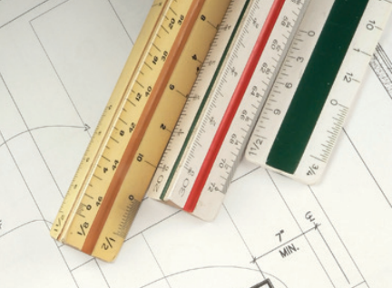
On the top edge of the rule below, the scales are 1:1 and 1:100, so the dimensions they show differ by a factor of 100.
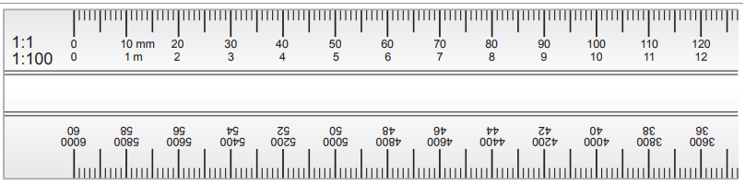
Another scale rule edge is shown below. In this case, the dimensions differ by a factor of 10 (1:50 is 10 times larger than 1:500).
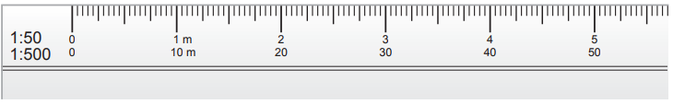
To measure something to scale, put the zero mark on the left-hand edge of what you are measuring, and read the length at the right-hand edge, as shown below.
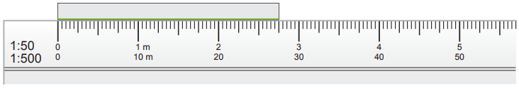
Occasionally you may need to draw something yourself in order to explain part of the construction to an employee or subcontractor. Knowing how to use a scale rule will enable you to do it accurately.

4.4. Features orientation and boundaries of site
Site plans
A site plan shows the entire block of land, or at least the part of the block where the building will be. Site plans are drawn at a small scale so that they can show the entire block of land (or at least the part of the block where the building will be). Most importantly, they show where the building is to be located on the block.

Site plans also typically show things like driveways, fences, clothes lines, paths and retaining walls. These things are called ‘ancillary’ works (that is, additional to the main building works and usually of a relatively minor nature). In some cases, the ancillary works are not included in the building contract; the owner organizes them later.

Figure 4.4 is a site plan for a residential project. You will see that lots of parts of it are numbered. A description of these numbered features is provided after the plan. Find each numbered feature on the site plan, and then read the information about it.

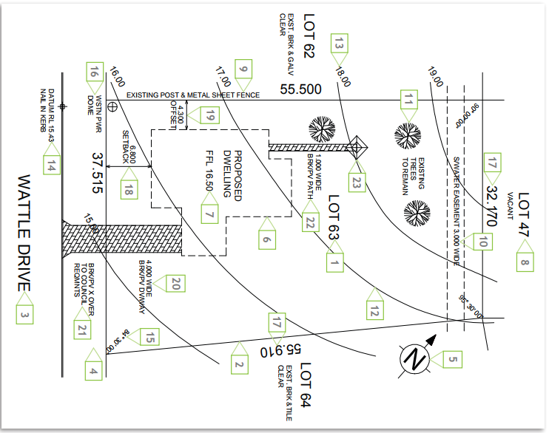
Figure 4.4 Site plan

- Block identification. When land is subdivided, each block is given a lot number. The street number is allocated later.
- Boundary. The boundary is the imaginary line that defines the block of land. At each corner is a small wooden peg with the numbers of the adjacent lots stamped onto a metal plate. If a boundary changes direction, a peg is located at that point too.
- Road identification. The name of the road shows where the front of the block is.
- Verge. The verge is the area of land between the block and the road. It is not part of the block and must not be built on (apart from a crossover) or damaged in any way. It usually has services running beneath it (water, telephone, etc.).
- North point. The direction of north is shown to assist in orientating the drawing with the block when on-site.
- Proposed building. The location of the proposed house is shown, usually just as an outline.
- Finished floor level. The level of the finished floor of the house is given
- Adjacent properties. The adjacent lot numbers are shown, and sometimes indications of existing structures are given.
- Existing fences. Any existing boundary fences should be shown.
- Easement. An easement is a part of the land over which another party has some sort of legal right. In this case, a strip near the rear of the block is an easement for a council storm water line to be laid. It still belongs to the landowner but the council has the right to lay and maintain a storm water pipe there, so no structure is allowed to be built over this area
- Existing trees. If there are any features on the block that are to be left undisturbed they are clearly indicated.
- Contour lines. These are imaginary level lines that indicate the shape of the land (you might have seen these on maps.) In this site plan, they indicate that the land slopes down from the north corner to the south corner
- Contour level. This indicates the ‘reduced level’ of the contour. In this case, they are shown at one-meter intervals, but this varies depending on the steepness of the land.
- Datum. This is a point on or near the block that all heights for the project are measured from Angle of boundary intersection. This indicates at what angle the boundaries meet. It is not always shown, especially if the block has square corners.
- Location of power connection. This indicates to the electrician where the electrical connection will be made. In this case, the block has underground power, but if overhead lines pass the block, the nearest power pole may be shown
- Boundary length. This indicates the length of each boundary.
- Setback. This is the distance from the front boundary to the nearest part of the building. A minimum distance for this is set by the local authority (council) and varies depending on the zoning of the land.
- Offset. Similar to the setback, the offset indicates how far from the side boundary the building is to be. There are by-laws regulating the minimum distance for this, mainly to minimize the spread of fire.
- Driveway. This indicates where and how wide the driveway should be
- Crossover. This is the continuation of the driveway across the verge
- Path. Any paving included in the contract is shown.
- Clothes hoist. The position of the clothes hoist is indicated.

4.5. Error identification
Drawings are vital to any project, as they are what contractors have to work off throughout the entire job, from planning and ordering required materials to carrying out the work. It is therefore extremely important for designers to take as much care as possible to avoid mistakes/errors on building drawings, as they can often lead to additional expense and delays for a project.

List of the most common mistakes to be aware of when it comes to building drawings.
- Incomplete drawings
It seems like a basic error, but drawings being incomplete is unfortunately a common mistake that causes issues during construction projects. This can arise if the designer is overworked and does not have significant time to create your drawings, is ill equipped or is relatively inexperienced.
To avoid the possibility of this occurring (and the requests for information and change orders this mistake would bring), it is extremely important to check the brief you gave the designer against the completed drawing, as you may be able to spot any missing elements and let the designer know ahead of the work commencing.
- Inconsistent documentation
When working on a project, the drawings are often not the only documents you must refer to, as there could also be written documentation (such as specifications) that you must adhere to as well. This could present an issue if the drawing designer is unaware of such documentation and the drawings end up with different information to that on the written documents.
To avoid this issue, it’s best to ensure that the designer has seen any other documentation, especially if the written documentation includes any additional information that could have an impact on the design.

- Designers amending drawings during construction
It is not uncommon for designers to leave some details out of the initial drawing with the intent to return to the drawing and add in these details at a later stage. In such scenarios, designers may leave in some brief notes in the meantime, however, if the detailed information isn’t added into the drawing before work commences this can present further issues. The designer amending the drawing once construction has began could cause problems as by the time the designer comes to amend the drawing, any existing work that has been completed on site may conflict with the details outlined in the amended drawing.

- Drawings that do not match up
Another key mistake that can occur on occasion is having drawings that do not match up. Unfortunately, this can be quite common, especially when drawings are produced with input from different teams working within different trades. An example of this would be if the ductwork drawings and electrical drawings conflict with each other – this could result in some electrical wires running through a ventilation duct if the work were to go ahead based on the drawings.
To minimize this risk, it’s important to arrange for all drawing designers to frequently have access to all of the drawings throughout the design process, plus they need an appropriate working knowledge of the logistics when it comes to installing multiple services in one location. This will enable them to identify any such issues and ensure they are corrected in time.

Drawing mistakes are part of the learning process. A number of CAD programs are now pushing for 3D model-based design drawings and installations, which will eliminate paper drawings and help reduce errors. However, the transition is slow and many legacy programs still require 2D drawing updates. Here are some common pitfalls to avoid in the 2D and 3D CAD world.

- Basic dimensions are useful when you are controlling the geometric tolerance of a part. Basic dimensions should always be to three decimal places and be boxed. Basic dimensions are used in conjunction with a geometric tolerance block.
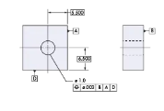
- Extension lines of dimensions should not touch the model sides. They should fall just short of the feature being dimensioned. Extension lines should also never be shortened.
- A dimension line will not be used a dimension feature nor coincide with another dimension line.
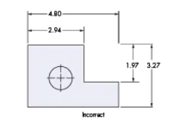
- Short dimensions should be placed close to the model and long dimensions should be farthest away. One should always avoid crossing dimension when possible.
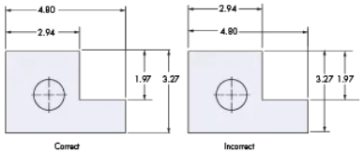
- Dimensions should line up in chain fashion. Do not create double dimensions unless you plan to make them reference dimensions.
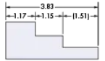
- Do not dimension to hidden lines as they cannot be inspected.
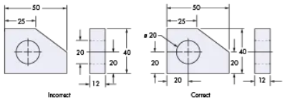
- Always identify electrical ports and their clocking angles. This will help with installation.
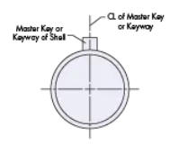
- Dimensions should not be placed in the area of the model, but always outside of the model.
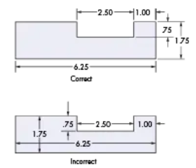

Self-Check – 4 | Written test

Name…………………………………………… ID………………………… Date…….

Directions: Answer all the questions listed below.

Test I: Short Answer Questions
1. Check what______________________________ to use for a particular drawing.
2. Scaling should only be done when you’re certain that a written dimension is______________.

Test I: Multiple choice
1. The purpose of a specification is to describe in words information that is difficult to show on drawings.
a) False b) True
2. What is the most commonly used scale for a site plan?
a) 1:10 b)1:20 c) 1:100 d)1:200
3. Which of the following drawing types contains information about boundary dimensions?
a) A site plan b) An elevation c) A floor plan d) A cross-sectional plan
4. What is the meaning of the term scale?
a) The ratio of a pictorial drawing
b) The ratio used when calculating the volume of concrete
c) The ratio of length on a drawing to the corresponding real length
d) The ratio to determine the volume of chemicals used to prevent hazards
Note: Satisfactory rating - 5 points Unsatisfactory - below 5 points
You can ask you teacher for the copy of the correct answers.

Operation Sheet -4

- Techniques/Procedures/Methods of drawing an object

A .Tools and equipment

- T-square
- Steel rule
- Triangles (right angle and isosceles)
- Eraser shield
- Drafting brush
- Masking tape (drafting dots)
- Drafting board
- Lettering guide
- French curve/spline
- Circle template
- Compass
- 2H mechanical pencil

- Procedures/Steps/Techniques of drawing simple object
- Draw a 30 degree construction line.
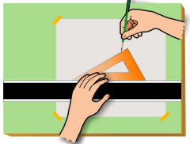
Figure 1 Drawing a Light Construction Line
- Align the scale along the construction line and place light “tick marks” to denote the desired measurement as shown in Figure 2
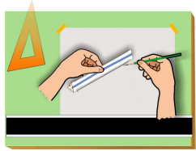
Figure 2.Marking the Desired Length with Light Tick Marks
- Align the edge of the 30-60 triangle with the construction line and draw a dark visible line along the top edge of the triangle between the tick marks. See Figure 3.
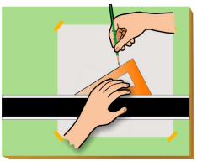
Figure 3 Darkening the Line between the Tick Mark
- The darkened visible line is drawn the desired distance as shown in Figure 4.
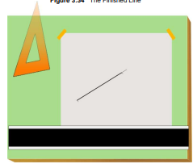
Figure 4 The Finished Line
- Slide the straight-edge until it is aligned with the lower end of the darkened line and lightly draw a horizontal construction line. See Figure 5.

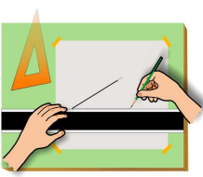
Figure 5 Drawing a Horizontal Construction Line
- Measure the along the horizontal construction line with the scale and mark off the desired distance with a small tick mark. See Figure 6.
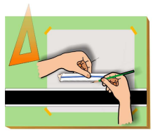
Figure 6 Using a Scale to Make a Measurement on the Horizontal Line
- Draw a dark visible line between the tick marks. See Figure 7.
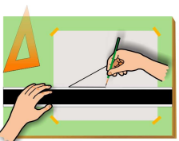
Figure 7 Darkening the Horizontal Line
- Because the angle between the ends of the lines does not match an angle on either triangle, float the triangle until it is aligned with the ends of each line and draw a dark visible line connecting them. See Figure 8.
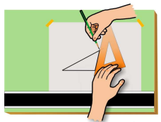
Figure 8 Floating the Triangle to Connect the Endpoints of the Lines
- The completed drawing is shown in Figure 9.
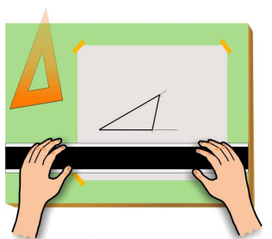
Figure 9 The Finished Drawing

- Fill in the title block at the bottom of the page with the information below. Remind students that drafting convention requires that all lettering be done in CAPITALS.
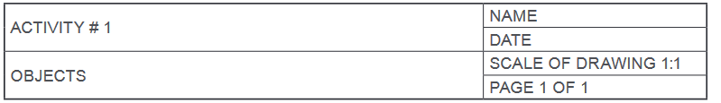

LAP TEST-4 | Performance Test

Name………………………………. ID…………………………….. Date…………………………………….

Time started: ________________________ Time finished: ________________

Instructions: Given necessary templates, tools and materials you are required to perform the following tasks within 1 hour. The project is expected from each student to do it.

Task-1 Draw site plan for demonstration plot

LG #17 | LO #5: Cleaning work site and equipment

Instruction sheet
This learning guide is developed to provide you the necessary information regarding the following content coverage and topics:
- Cleaning and inspection
- Tagging faulty unserviceable equipment
This guide will also assist you to attain the learning outcomes stated in the cover page. Specifically, upon completion of this learning guide, you will be able to:
- Clean and inspection of equipment and work area
- Identify and tag faulty unserviceable equipment.
Learning Instructions:
- Read the specific objectives of this Learning Guide.
- Follow the instructions described below.
- Read the information written in the information Sheets
- Accomplish the Self-checks
- Perform Operation Sheets
- Do the “LAP test”

Information Sheet 5

5.1 Cleaning and Inspection
After completion of drawing, plan or map, all tools and equipment’s must be cleaned and site area maintained as necessarily. Tools and equipment require proper care and maintenance, not only for longevity but also to remain useful and safe for the task at hand. Here are some care and maintenance practices for tools and equipment
Using a tool for the task it is intended helps to keep it in its best shape. This reduces unnecessary damage and protects the user. It is also important to check whether the tools are in the right condition before using them.
Cleaning is the process of removing unwanted substances, such as dirt, and other impurities, from an object or environment.
Purpose of cleaning the Tools and equipment
- Make material easy to use
- Protect material from dust, rust or rot
- Clean for future use
- Clean for long life use and etc.....

Storing dirty tools without cleaning them can cause them to deteriorate. Routine cleaning reduces the chances of rust and can reduce the rate of wear and tear
Regular inspection of tools is beneficial since it provides an opportunity to see if tools may need repair or replacing. Inspections can help to prevent a situation where a last minute trip to the store to new tool or equipment.
Inspection and checklist

The inspection of the tools and equipment should include at least the following:
- Right tool being used for the job
- Tool in good condition
- Tools stored correctly, not left lying around
Inspection items must be marked “OK” if in good condition, “X” if damaged, or “N/A” if not applicable.

Table 5.1: Items marked “X” may not be used and must be removed from site.
DESCRIPTION OF EQUIPMENT  (Technical pens • Square sets • Drafting machine • Compasses • T-square etc...) | DATE OF INSPECTION
TOOL INSPECTOR’S SIGNATURE:

5.2 Tagging faulty unserviceable equipment
Use Equipment Tags to record maintenance or inspections keeping your equipment and tool running without issues and ensuring operations run smoothly in your tools and equipments.
- Identify the asset type and category.
- Assign a Unique ID Number.
- Choose The Appropriate Tag Type.
- Enter basic information about the asset.
- Apply asset tags.
- Implement quality and verification processes.
Tags: can be attached onto any tools, equipment by anyone who considers the tools or equipment to be unsafe or unserviceable
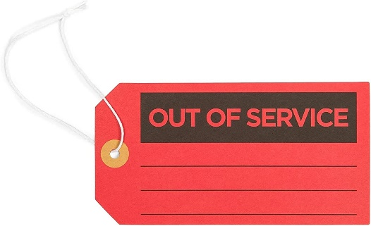
Figure.5.1: Notice Tag

Self-check 5 | Written test

Name………………………………………… ID………………………… Date…….
Directions: Answer all the questions listed below.
Test I: Choose the best answer (5point)
- Which one of the following is the process of removing unwanted substances, such as dirt, infectious agents, and other impurities, from an object or environment
  - Cleaning
  - Tagging
  - Storing
  - All
- Which one is incorrect about the purpose of cleaning the tools and equipment
- Make material easy to use
- Protect material from dust or rust
- Clean for future use
- Clean for long life use
- None
- Which one is used to attach onto any tools, equipment by anyone who considers the tools or equipment to be unsafe or unserviceable
  - Storing
  - Cleaning
  - Tagging
  - None
- The inspection of the tools and equipment should include at least:
- Right tool being used for the job
- Tool in good condition
- Tools stored correctly, not left lying around
- All

Reference Materials

Map Reading and Land Navigation. 18 January 2005.
Field Manual 21-31, Topographic Symbols. Change 1. December 1968

Web addresses
https://www.acpsd.net/cms/lib/SC02209457/Centricity/Domain/7231/Chapter%201%20Technical%20Drawing.pdf accessed date 1/9/2022.
http://flooringtech.com.au/unit15_work_documents/docs/work_documents_fl_learner_guide.pdf 2/9/2022.
https://ensignonline.co.uk/4-common-building-drawing-errors/ accessed date 2/9/2022.
https://www.fao.org/fishery/docs/CDrom/FAO_Training/FAO_Training/General/x6707e/x6707e03.htm#25 3/9/2022.
https://vdocument.in/read-and-interpret-construction-drawings-specifications.html?page=38 accessed date 4/9/2022.
https://www.machinedesign.com/3d-printing-cad/article/21831848/8-common-drawing-mistakes-to-avoid.acessed date2/9/2022
https://www.joshuanava.biz/engineering/requirements-of-engineering-drawings.html(28/8/2022)
https://beach.k-state.edu/participate/curricula/pictorial-maps/purposes-types.html(access date 28/8/2022)
https://roads-waterways.transport.nsw.gov.au/business-industry/partners-suppliers/documents/guides-manuals/sdadmsect14.pdf(access date 28/8/2022)
https://policies.anu.edu.au/cs/groups/confidential/@hrd/documents/edrms/dxbf/mdaw/~edisp/anup_000571.pdf(access date 2/9/2022)

AKNOWLEDGEMENT

Ministry of Labor and Skills wish to extend thanks and appreciation to the many representatives of TVET instructors and respective industry experts who donated their time and expertise to the development of this Teaching, Training and Learning Materials (TTLM).

The experts who developed the learning guide
No | Name | Qualification | Organization/ College | Mobile number | E-mail
1 | Serawit Gensa | Msc. Water Resource Engineering | W/Sodo AVET | 0916740916 | serawitgen@gmail.com
2 | Edao Hassen | Msc.Irrigation Engineering | Alage AVET | 0911098097 | hassedao@gmail.com
3 | Mekete Agizew | Msc. Water Resource Engineering | Amhara. Kombolcha ATVET | 0925221192 | gen.mam09@gmail.com
4 | Wondu Alemayehu | Msc.Irrigation Engineering | Oromia Kombolcha ATVET | 0910-28-99-61 | woldualem@gmail.com
5 | Ademe Ayalew | Msc.Irrigation Engineering | Agrafa AVET | 0912720547 | Ademe2004@gmail.com
6 | Said Mohammed | Msc.Irrigation& drainage Engineering | Alage ATVET | 09-17-18-01-81 | Siyamsdmhmmd@gmail.com/
7 | Molalign Asfaw | Bsc.Water Resource &Irrigation Engineering | Alage ATVET | 0921431096 | Mollalign410ass@gmail.com
8 | Yonas Hailu | Bsc.Water Resource &Irrigation Engineering | Agrafa AVET | 0934715578 | yonashailuw@gmail.com
9 | Lemessa Mulata | Msc.Irrigation Engineering | Agrafa AVET | 0913266845 | Lamimulle2022@gmail.com
10 | Misganew Yimer | Bsc. Soil and Water Engineering | Woreta ATVET |  | Misge1976@gmail.com
11 | Daniel Derese | Bsc. Soil and Water Engineering | W/sodo AVET | 0912-79-28-85 | danielderesse7@gmail.com
12 | Teshome Getachew | Msc.Irrigation & drainage Engineering | Alage ATVET | 0925-50-13-99 | teshomegetachew131@yahoo.com

