Irrigation and Drainage
Level- II

Based on March, 2022, Version 3 Occupational standard

Module Title: - AGR IRD2 M06 0822 -Crop and pasture establishment
LG Code: AGR IRD2 M05 LO (1-4) LG (18-21)
TTLM Code: AGR IRD2 TTLM 0822v1

August, 2022
Addis Ababa, Ethiopia

Table of Contents

Introduction to the Module 1
LO #1- Pasture Establishment 2
Instruction sheet-1 2
Information Sheet 1 3
Self-check 1 13
LO#2:-Site for pasture production 14
Instruction sheet-2 14
Information Sheet 2 15
Self-Check – 2 25
Operation Sheet -3 26
LAP TEST-2 27
LO#3- Planting Operations 28
Instruction shee-3 28
Information Sheet-3 29
Self-check 3 36
Operation Sheet -3 37
LAP TEST-3 38
LO#4- Handle pasture and crop 39
Instruction shee-4 39
Information Sheet 4 40
Self-check 4 46
Reference Materials 47

Introduction to the Module
This module covers the knowledge, skill and attitude required to Perform crop and pastures establishment operations, prepare the site for planting and Care for young plants

LG #18 | LO #1- Pasture Establishment

Instruction sheet-1
This learning guide is developed to provide you the necessary information regarding the following content coverage and topics:
- Interpretation of instructions
- Selection of machinery, equipment and tools
- OHS hazards
- Personal protective equipment
This guide will also assist you to attain the learning outcomes stated in the cover page. Specifically, upon completion of this learning guide, you will be able to:
- Interpret instructions about establishing the crop and pasture
- Select machinery, equipment and tools
- Identify OHS hazards, risks assessed and reported to the supervisor
- Personal protective equipment (PPE)
Learning Instructions:
- Read the specific objectives of this Learning Guide.
- Follow the instructions described below.
- Read the information written in the information Sheets
- Accomplish the Self-checks
- Perform Operation Sheets
- Do the “LAP test”

Information Sheet 1

INTRODUCTION
Irrigated crops are also called “Agronomic crops”. They are mostly annual herbaceous plants that are grown under extensive or large-scale culture. By tradition, cereals, seed legumes, oil crops, root and tuber crops, sugar crops, latex and rubber crops, pasture and forage crops, and fiber crops are classified under field or irrigated crops
Pasture: is a land which is enclosed and separated from surrounding areas by fence or other barriers and devoted to the production of forage for harvest primarily by grazing
Forage: herbaceous plants or plant parts consumed by animals
Forage crop: plants grown primarily for livestock feeding and either used for grazing or harvested for green chop feeding, silage or hay
Browse: leaf and twing growth of shrubs, woody vines trees cacti and other non-herbaceous vegetation available for animal consumption

  - Interpreting of instructions
Careful planning for establishment of irrigated crops is an essential part of good production of irrigated crops. During establishment of irrigated crop one of the earliest decisions that must be taken is where to locate the farm (correctly selection of the site).
  - Selecting of machinery, equipment and tools
Before starting to establishment of field or irrigated crops, all necessary tools and equipment should be gathered.

- Tractors and associated land preparation,
- Seeding equipment,
- Cultivators and Fertilizer spreaders,
- Seeding or planting machinery bagged or bulk seed,

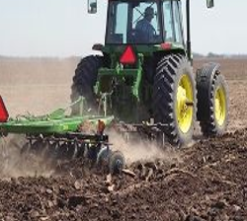
Tractor: farm vehicle ( a motor vehicle )used for pulling heavy loads, especially on farms, where its large rear wheels enable it to move in fields

Fig.1.1. Tractor
Tractor 3 Point Single Row Cultivators
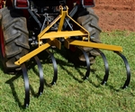There are many different sizes and configurations of field cultivators and single row cultivators. Some of these factors include the size of area you plan on cultivating, the tractor you are going to use for cultivating, and the type of ground you will be cultivating or breaking.

Fig 1.2. Single row cultivars

Planter
Planter functional requirements for crop establishment .To successfully establish crops over the range of conditions likely to exist at planting; a planter should be able to:

- open a furrow;
- meter the seed;
- deliver the seed to, and place the seed appropriately in, the furrow;
- cover the seed in the furrow;
- firm the seedbed; and
- Perform other functions as required, e.g. weed control, apply crop chemicals, et
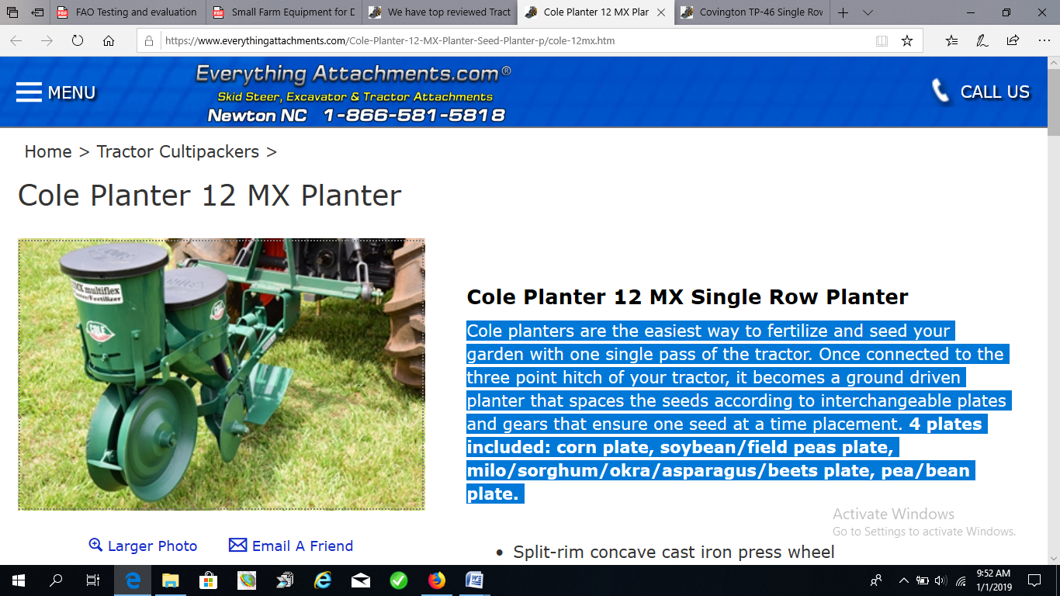
.

Fig 1.3. Planter
Fertilizer spreaders
The smallest are handheld with a hopper of several liters and which operate via hand cranking. A bit larger are push units with the spinning disk powered by gearing to the wheels. The next size up is designed to be towed behind a garden tractor. Very similar in size to the tow behind units are broadcast seeders that mount to the three-point hitch of a compact utility tractor, these are ideal for landscape and small property maintenance. Still larger are commercial broadcast seeders/spreaders designed and sized appropriately for agricultural tractors and mount to the tractor's three point hitch. The broadcast seeders that are mounted to a three-point hitch are powered by a power take-off (P.T.O.) shaft from the tractor. At the largest size are pull behind or chassis mounted units for agricultural use that can spread widths of up to 90 feet.
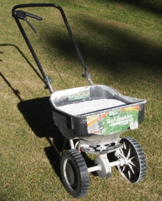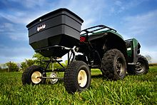
Fig 1. 4 Hand-pushed broadcast spreader Tractor mounted spreaders
Plough : a heavy farming tool with a sharp blade or series of blades for breaking up soil and making furrows, usually pulled by a tractor or draft animal
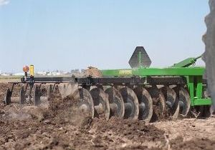

Fig.1.5. Plough
Mulcher: is a specialized rotary cutter used to cut grass, mulches and spreads it evenly over the cutting width, encouraging quick re-growth
.
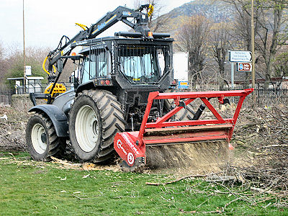
Fig 1.6. Mulcher
Mower: a machine, often power-operated, that cuts grass with rotating blades
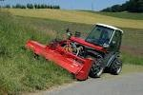

Fig 1.7. Mower
Sacks: a large bag, especially one that is made from coarse cloth or thick heavy-duty paper used to hold grain and other similar products
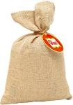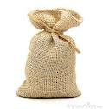
Fig 1.8. Sack

  - OHS hazards
During establishment of irrigated crops, some activities can be potentially toxic or hazardous to human beings and pollutant environmental conditions. Occupational and environmental hazards may be occurred through:-

- Use of machinery
- Moving machinery and machinery parts from one place to another
- Plant debris
- Chemicals and hazardous substance
- Manual handling
- Solar radiation
- Dust, and noise
- The contamination of off-site ground water
- Land disturbance
- Spread of noxious weeds and water run-off.
Purpose of occupational health
- For keeping the highest degree of physical, mental and social wellbeing of workers in all occupation
- The protection of workers from risks causing factor
- To summarize the adaptation of worker to man and of each man to his job.
Hazard: a situation at the workplace capable of causing harm (i.e. capable of causing personal injury, occupationally related disease or death).
Risk: the chance of a hazard actually causing injury or disease. It is measured in terms of consequences and likelihood.
Risk Management: - the overall process of risk identification, risk analysis, control of risks and risk evaluation.
Risk Control: that part of risk management which involves the implementation of policies, standards, procedures and physical changes to eliminate or minimize adverse risks.
Reporting hazards and Accidents
Employees are required to report any situation or occurrence in the workplace that may present a risk or have the potential to affect the health and safety of employees or others in the workplace.
It is required that all injuries, incidents and hazards are properly reported, investigated and recorded in accordance with the procedures detailed below.
An accident is commonly used to describe an incident which has resulted in an injury
In the event of an injury the person involved should;
- seek first aid or medical attention as required
- inform their supervisor as soon as possible
Assist their supervisor in the investigation and reporting on the incident or accident.
The Supervisor of the person(s) involved in the incident is required to;
- ensure that any injured person is promptly attended to;
- conduct an initial investigation into the cause of the incident;
- complete the and ensure that it reaches the Safety and Health; and
- Notify and liaise with the local Safety & Health Representative and line management in relation to the incident.
- Ensure that all serious injuries are reported to the Safety and Health immediately after hours of assistance.
- This may mean a simple alteration, substitution or removal of the hazard or even talking to the people involved to enlighten them of their hazardous practices
Environmental implication of the crop establishment program
Crop production is one of the oldest and most widespread forms of land use and supports a uniquely adapted and diverse fauna and flora. Such environmental impacts include:
- Damage to, and removal of soil, thereby threatening agricultural sustainability and
- The pollution of water sources which provide drinking water for a growing human population.
- Modern arable systems also impact upon biodiversity within the system itself, and in associated non-cropped habitats such as grassland, field boundaries and watercourses.
- The deterioration in arable ecosystems is also reflected in the aesthetic quality of the arable landscape.
- Tillage affects the soil and the surrounding environment
Besides erosion, cultivation can have other impacts including
- Salinization
- Acidification
- Loss of organic matter
Besides soil, plant’s needs.

- Soil and water
- Biodiversity and RF, temperature, light,
- Climate and air.
- Humidity and solar radiation,
- wind and atmospheric gases
- Temperature:
- Water supply/irrigation availability
Altitude/Elevation:-The choice of a crop to be cultivated in a given locality is determined by its altitude. Based on altitude or elevation field crops are classified in to different group
- Wurch: - greater than 3500m a.s.l.
- High land (Dega):- 2500-3500m a.s.l.
- Medium land (Woynadega):- 1500-2500m a.s.l.
- Low land (kola):- 500-1500m a.s.l.
- Desert (harrur):- less than 500ma.s.l.

Pests: - the presence or absence of particular diseases or pests that attack the proposed crops should be checked. Availability of inputs and other materials, tools and equipment:-Different nputs like land, planting materials, labor, etc. and other materials like tools and equipment should be available.
Accessibility: - The site should be accessible to all times and preferably be near the road, markets, processing facilities and ease for supervision.
  - Personal Protective Equipment (PPE)
During establishment of irrigated crops you should have to follow safety required to avoid hazards. Skin contact with crop residues which may be toxicants during clearing, working with sharp machinery and use of other chemical substances must be avoided. Wearing of persons engages like: -hat, boots, overalls, gloves, goggles, respirator or face mask, hearing protection, and sunscreen lotion is a must.
Selection of PPE
- Type of hazardous materials, processes, and equipment involved
- Routes of potential exposure (ingestion, inhalation, injection, or dermal contact)
- Correct size for maximum protection
- Minimal interference with movement

Personal protective clothing and equipment may include:

- Boots
- Hat/hard hat
- Overalls
- Gloves
- Protective eyewear
- Hearing protection]
- Respirator or face mask
- Sun protection, e.g., sun hat, sunscreen

Selecting Suitable personal protective equipment (PPE)
Personal protective equipment’s (PPE): are devices worn, put on, tied on, or inserted in such as hearing protectors inserted in the ears of workers for protection against industrial hazard health hazards and accidents.
Foot protection: Workers must wear closed-toe shoes at all times to protect feet from chemical spills and sharp objects. Steel-toed footwear and puncture-resistant soles. Slip-resistant shoes for anyone who works in wet environments
Eye protection: Use safety glasses for minor splash hazards, goggles for moderate hazards, and goggles combined with a face shield for severe hazards.
Hand protection: Hand protection is indicated for the possibility of severe cuts, lacerations, or abrasions, punctures, temperature extremes, and chemical hazards. (Nit rile loves are usually a good choice for general use.) Use heavy-duty gloves for non-incidental contact and gross contamination.
Body protection: Protective clothing includes lab coats, smocks, scrub suits, gowns, rubber or coated aprons, coveralls, uniforms, and pierce-resistant jackets and vests.
Head protection: Hard hats must be worn by electricians, construction workers, and any other workers when there is a danger of objects falling from above

Self-check 1 | Written test

Name…………………………………………… ID………………………… Date…….
Directions: Answer all the questions listed below.
Test I: Matching part
A | B
---- 1. Hazard | A. Implementation policy of risk management
-----2. Risk | B. Overall process of risk identification
-----3. Risk management | C. The chance of hazard actuality
-----4. Risk control | D. Situation of causing arm

Test II: Short Answer Questions
- What is machinery?
- What is equipment?
- What are the most common types of machinery
- What are the purposes or uses of machineries and equipment’

. LG #19 | LO#2:-Site for pasture production

Instruction sheet-2
This learning guide is developed to provide you the necessary information regarding the following content coverage and topics:
  - Removal and disposal of waste materials
  - Soil sample testing
  - Soil treatment and amendments
  - Preparation of growing media
  - Crop protection implementation
  - Planting pattern marking
  - Operation of materials & tools
This guide will also assist you to attain the learning outcomes stated in the cover page. Specifically, upon completion of this learning guide, you will be able to:
  - Remove and dispose of old crop and other waste materials
  - Test soil sample
  - Apply soil treatment and amendments
  - Prepare growing media based
  - Implement crop protection
  - Mark planting pattern
  - Operated materials & tools
Learning Instructions:
- Read the specific objectives of this Learning Guide.
- Follow the instructions described below.
- Read the information written in the information Sheets
- Accomplish the Self-checks
- Perform Operation Sheets
- Do the “LAP test”

Information Sheet 2

Introduction
Site selection for pasture production
When assessing a locations potential for pasture production, it is important to consider the following site characteristics
- Annual precipitation
Available soil moisture is the limiting factor for plant growth and establishment .sites with less precipitation have limited productivity and may not provide the site should adequate economic return. Therefore the site with adequate annual precipitation should be selected. Most dry land forage species require at least 12 inches of annual precipitation for adequate growth and long term survival.
- Soil depth
To provide sufficient water holding capacity for productive plant growth, the soil depth must be at least 18 inches.
- Soil texture
Soil texture and depth determine a soil’s water holding capacity and therefore strongly influence a site’s potential for forage production. Soil texture ranging from a sandy loam to silt or clay loam is most suitable for plant growth.
- Drainage
Most forage species thrive in well-drained soils that have no shallow sub surface restrictive layers. The common types of restrictive layer are clay lenses and volcanic ash layers.
- Salt accumulation
Salt –affected soils present several problems for pasture establishment. The accumulation of salt in soils has negative influences on several soil properties, including soil structure, water infiltration and nutrient availability.
- Freedom from rocks
The presence of large rocks in the soil rules out most cultivation and planting options and significantly reduces the potential for success in establishing pasture.
- Slope
Slopes should be less than 15% in order to accommodate planting and soil preparation equipment and minimize the potential for erosion.
- Freedom from over story vegetation
Dense over story vegetation should be removed or thinned both to decrease competition for moisture and light and to reduce the potential for soil erosion.
The particular preparation techniques to be used

  - Herbicides
  - Site clearing and cultivation
  - Burning
  - Ripping
  - Post-raking.

Scheduling resource requirements: for the supply of materials, tools and equipment we can consider:-
- People
- Budget
- Plant
- Identify the material required
- Get the basic data for an area

- Layout/designing of the project
- Supply the basic map to implement the work
- Put forward the minimum requirement of investment
- Meet the reserved bed of managing planting
- Block and compartment division
- Physical condition.

  - Removal and disposal of waste materials
After selection of a good site, proper site preparation is one of the most important factors in the ultimate success or failure of a vineyard. This is the time when changes can be made to the site to improve soil conditions, water handling, and the overall efficiency of managing the vineyard. Many experienced grape growers will say that investing the time and money in good site preparation will save both in the long run.
The first step in preparing a virgin land for establishment of irrigated crops is clearing the land to remove existing vegetation, crop residue either completely or partially. The amount of vegetation removed during land clearing is depends on:-
- The production region:- grass land, shrubs or forest land
- Production system:- mechanized or non-mechanized
- Crops to be grown: - cereals or legumes or forage crops or fiber crops, etc.
Once the site for the farm has been selected and acquired, the farmer proceeds with clearing. It involves
- Cutting down the vegetation
- Removal of dead plant materials(collecting and burning)
- Stumping: - removal of stumps is used to facilitate cultivation of the land and to control infestation of diseases and insect pests.
  - Testing Soil sample
A soil test is a test which is used to gather information about the composition of the soil in a particular area. In a classic soil test, multiple samples are taken from the region of interest and tested before being averaged, ensuring that a random area of contaminated soil does not skew the sample. A Soil Test is a process by which nutrients are chemically removed from the soil and measured for their plant available content within the sample. The quantity of available nutrients in the sample determines the amount of fertilizers needed for a particular crop. A soil sample test also measures pH, salinity, water repellence, slaking, proportion of organic matter and the amount of acidity within the soil to determine if lime is needed and how much should be applied.
  - Applying soil treatments and amendments
Lack/shortage of rainfall in dry regions results in an accumulation of salts (cations like Ca ^{++,} Mg⁺⁺, Na⁺, etc.). When such accumulation exists the production of crops may be uncertain, or even impossible, over relatively large areas. At times the excessive may be leached out by irrigation or corrected by the addition of gypsum, organic matter or sulfur and use proper drainage system. It often may happen in some area that soil acidity is so great lime must be applied before satisfactory crop production is achieved. Low soil fertility may reduce the productivity of soil. Therefore, application of organic fertilizer and artificial fertilizers like compost, inorganic fertilizer and planting of a temporary or permanent cover crop is a good way.
Soil amendment or soil conditioner is a material added to soil to improve plant growth and health. A conditioner or a combination of conditioners corrects the soil's deficiencies in structure and-or nutrients.
The type of conditioner added depends on:-
- The current soil composition
- Climate and
- The type of plant.
Some soils lack nutrients necessary for proper plant growth. Some hold too much or too little water, with water conservation aided in the latter. They can be incorporated into the soil or applied to the surface.
Types of soil problem
Broadly there are two sets of soils as:
Physical nature:-Highly eroded soils, ravines, soils on sloping land, Soil physical constraints
Chemical nature:-saline soil, alkali soil, saline alkali soil, acidic soil.
Physical nature of soil problem
Highly eroded soils, ravines, & soils on sloping land:-The erosion is mainly caused by wind, water, & land slide
- Soil physical constraints
Highly permeable coarse textured soil:-improved by soil compaction &clay mixing
Slowly permeable soil:-reclaimed by growing crops on raised beds, deep tillage through M.B plough &chiseling to break the hard pan in sub soil
Crusting soils: - reclaimed by application of FYM or green manuring
Red soil: - incorporation of slow decomposing crop residue & other inorganic materials
Chemical nature of soil problem
Salt affected soil:-Basic soils have a high saturation of base cations (K⁺, Ca²⁺, Mg²⁺ and Na+). This is due to an accumulation of soluble salts are classified as either:-

- Saline soil
- Sodic soil
- Saline-sodic soil
- Alkaline soil.

All saline and sodic soils have high salt concentrations, with saline soils being dominated by Ca and Mg salts and sodic soils being dominated by Na. Alkaline soils are characterized by the presence of carbonates.
A. Saline soils:-these soil is characterized by EC more than4.0ds/m, ph less than 8.5, exchangeable sodium percentage (ESP) less than15.
Reclamation of saline soil:-
Physical approaches:-By leaching with good quality water
Biological approaches:-Mulching helps to reduce soil salinity which reduce the upward movement of salt due to decline in evaporation loss. Addition of organic matter, grow tolerant crops.

Table 2.1. Relative tolerance of crops to salts
Tolerant | Medium tolerance | sensitive
Barley, cotton, sugar beet | Wheat, rice, oats, maize, sorghum, potato | Legumes, beans, ground nut

Alkali soil: - these soils is characterized by EC less than 4.0 ds/m, ph more than 8.5, ESP more than 15.
Reclamation of alkali soils:-
Physical approaches:-deep ploughing is necessary to bring the soil in good physical condition& to make the soil pervious. Heavy irrigation is applied after the addition of gypsum to facilitate the leaching of soluble salts of Na. There should be sufficient provision for drainage.
Chemical approaches:-in order to replace the excessive amount of Na, application of Ca is essential. Several amendments such as Gypsum, S, H2SO4, CaCl₂, FeSO₄, Iron pyrite, Al₂ (SO₄)₃, etc.
Biological approaches:-the addition of organic matter is always good in improving soil physical condition, grow tolerant crops.

Saline alkali soils:-these soil are characterized by EC more than 4.0 ds/m, PH more than 8.5, ESP more than15. Soil showing high salinity & ESP should be reclaimed for both but first for salinity & later for excessive exchangeable sodium.

Acid soil:-these soils are high in exchangeable Al⁺³ and H⁺ with a ph value less than 5.5& respond to lime application. Reclamation of acid soil:-first of all work out the lime requirement of the acid soil in the laboratory. The liming material commonly uses along with their neutralizing value are given below.

  - Preparation of growing media
Growing media are materials that plants grow in. Growing media is specifically designed to support plant growth and can either be a solid or a liquid. Different components are blended to create homemade and commercial growing media. Different types of growing media are used to cultivate various plants. Growing media have three major functions:
- Physically support plant growth
- Allow for maximum root growth
- Supply roots with necessities such as water, air, and nutrients
Plants need a growing medium to provide them with:
- Air for root respiration;
- sufficient water;
- Sufficient nutrients.
Soil is the most common growing medium for plants. Soil is a mixture of solid particles (mineral and organic material), water and air.
- Minerals are inorganic. Mineral particles in soil are formed by the break-up of much larger rocks by physical, chemical and biological weathering.
- Organic material is made when dead organisms such as plants and animals decompose and decay.
- The space between solid particles is filled with water which had a number of solutes dissolved in it. There are also pockets of air trapped in the water.
- Compost is a growing medium used in greenhouses for:
- Germinating seeds;
- Growing plants.
It is also used for indoor (household) plants. There are many different types of compost. Each is made by mixing different components according to a known formulation. Sometimes the term ‘compost’ is used to describe the product of organic waste when it rots and decays. This usually happens in a compost heap. Some growers say it may be better to call composts that plants are grown in ‘growing media’ and use the term compost to mean only the product of organic waste decay.
  - Crop protection implementation
After the land has been cleared various tillage operations should be carried out. Tillage includes all operations and practices used for the purpose of modifying the physical characteristics of the soil. These are:-
a) Plowing/Digging: plowing is initially done to open the compact or hard soil. During this operation the soil is inverted, weed uprooted and stubbles incorporated into the soil. The depth of digging varies from 10 to 45cm. It has different purposes like:

- Cutting and turning the soil
- Loosening the soil and good root penetration
- Aerating the soil and making it permeable
- Reducing weeds and insect infestation
- Incorporating organic matter and soil amendments to improve the structure of the soil
- Shaping soil: - tillage is done to create raised beds for planting or to create furrows for irrigation.
- Erosion control:- like in conservation tillage

b) Harrowing/pulverizing: if the lumps (clods) of soil left after digging are too large, they must be broken up before planting/sowing if broadcasting and before furrow preparation if row methods of sowing.
Purpose of harrowing are:-
    - Cutting the clods and sods to a considerable depth
    - Producing fine seedbed and leveled soil
    - Obtaining weed free soil
c) Leveling: - is done to improve surface drainage, for installation of irrigation equipment, or to facilitate the use of farm machineries and equipment
  - Crop protection implementation
Crop protection include wind protection such as artificial structures, permanent shelter belts or temporary plantings of cereals, stakes; and mulch, including straw, plastic, cover crop or any vegetative material. To protect soil erosion which may be occur through winds and water (rain drops) implementing crop protection techniques like wind protection such as permanent shelter belts or temporary plantings of plants and mulching the soil by straw materials, cover crop or any vegetative material is necessary.
  - Planting pattern marking
Based on types of crops, sowing/planting methods/pattern can be divided in to three.
- Broadcasting,
- Drilling and
- Dibbling
.
Mostly land preparation activities influenced by this factors. Therefore, based on types of crops to be sown/planted selecting of planting pattern is very important.
What planting pattern to use and how many seedlings to plant?
The most commonly used planting patterns are square spacing or triangular spacing where the distance between the rows are the same as along the rows. If strip clearing or weeding is used, a rectangular pattern, where trees are closer in the rows, than between the rows might reduce labor input. For very harsh climates and on poor soils, it might be appropriate to plant in clusters.
  - Operation of materials & tools
For establishment of irrigated crop selecting and preparing materials, tools and equipment is the first steps. Next to this checking serviceability of materials, tools and equipment is one the important ways. After serviceability of material, tools and equipment has been checked operating (making ready) machinery, tools and equipment are the necessary steps which make land preparation activities more easy and suitable.

Self-Check – 2 | Written test

Name…………………………………………… ID………………………… Date…….

Directions: Answer all the questions listed below.

Test I: Short Answer Questions
- What is pasture?
- What do you understand by growing media?
- What’s are the methods to reclaim alkaline soils?.
- What is the purpose of operating equipment and tools during land preparation for establishment of irrigated crops?
- List some types of tools and equipment which are used for land preparation during establishment of irrigated crops
- Describe steps of land preparation.
- What is the difference between ploughing and harrowing?

Test I: Multiple choice
      - Which one is categorized under physical nature of soil problem?
- Highly eroded soil. B. Ravines C. soil on sloping land D. all
      - Crusting soils are reclaimed by application of_____?
A. Green manuring B. FYM C. A and B D. None
3. The salty problems soils are reclaimed by ______?
A. leaching B. Mulching C. Over irrigation D. all
4. Which one is categorized under planting methods?
A. Broad casting B. Drilling C. Dribbling D. All

Operation Sheet -2

3.1. Procedures to land preparation for pasture establishment.
    - Tools and equipment

- Machete
- Sickle
- Shovel/spade
- Plough
- Tractor
- Seeders

- Select site
- Prepare and make ready (operate) your materials, tools and equipment
- Clear and dispose waste materials like weed, stone, insects, etc from selected areas
- Plough/dig the land by tractor or by other ploughing system
- Harrow/pulverize the ploughed land to break clods and make fine soil
- Level the land to improve surface drainage, for installation of irrigation equipment (canal), or to facilitate the use of farm machineries and equipment.
- Prepare row or hole based on selected planting pattern and calculate number of seedling per ha.

LAP TEST-2 | Performance Test

Name………………………………. ID…………………………….. Date…………………………………….

Time started: ________________________ Time finished: ________________

Instructions: Given necessary templates, tools and materials you are required to perform the following tasks within 6 hour. The project is expected from each student to do it.

Task 1. Prepare land pasture establishment

LG #20 | LO#3- Planting Operations

Instruction shee-3
This learning guide is developed to provide you the necessary information regarding the
following content coverage and topics:
  - Selection of planting material
  - Planting material treatment
  - watering plant
  - Handle and transportation
  - Plantation
This guide will also assist you to attain the learning outcomes stated in the cover page. Specifically, upon completion of this learning guide, you will be able to:
  - Select planting material
  - Treat planting material
  - Apply water to planting material
  - Planting material is handled and transported to the site
  - Carryout planting
Learning Instructions:
      - Read the specific objectives of this Learning Guide.
- Follow the instructions described below.
- Read the information written in the information Sheets
- Accomplish the Self-checks
- Perform Operation Sheets
- Do the “LAP test”

Information Sheet-3

  - Selection of Planting material
Seeds are the pre-operational unit of flowering species and the economic part of grain crops, consists miniature plant called embryo. To produce high quality and quantity of irrigated crops selection of good seeds are very important.

Good seeds have the following characteristics: -

- Pure( true to type)
- Viability/good germination capacity
- Matured, well developed, uniform size, shape, color , texture etc
- Health, clean, and free from inert matter
- Free from other crop seeds
- Free from any pest and seeds borne diseases
- Should be whole, not broken, crushed, shriveled, rotten etc
- Should contain the required amount of moisture
- Fitting within the usual period of the raining season
- High and stable yield
- Resistance to insect pests and diseases
- Uniform heading and fruiting

Seed purity test (Physical purity test): -Seed purity is the percentage of pure seed (only the seed of the desired kind without contaminants) in the sample tested.
Seed viability test: - Seed viability is the capacity of seeds to germinate. A viable seed is one capable of germinating to produce a health, normal seedlings. The seeds are placed in proper conditions of moisture, temperature and oxygen, the growth of embryo or germination commence.
Germination (%) = Numbers of germinated seeds x 100%
Numbers of planted seeds

  - Planting material treatment
Seed treatment is the process of applying physical, chemical or biological treatment to the seed to keep it viable and health.
- Physical seed treatment
It includes subjecting seeds to solar exposure, immersion in conditioned water etc. To induce higher germination, the seeds may be soaked in water before sowing or may be exposed to warm temperature. Early rooting may be induced by treating seeds with IBA or GA solutions. To induce or facilitates sowing and better germination in cotton seed treated with sulphuric acid (H₂SO₄).
- Biological Seed Treatment
It includes the treatment of seeds with microbial cultivars such as that of Rhizobium to inoculate the seeds with microbial cultivars, to fix atmospheric nitrogen and release to the soil.
- Chemical seed treatment
It includes treating seeds with fungicides, insecticides, nematodes etc.
  - Watering plant
After selecting the appropriate cultivars and preparing the land, there are four major procedure/decisions to make towards the establishment of irrigated crops.
Depth of seed placement (sowing depth)
If seeds are sown at different depth, germination will be uneven, resulting an uneven crop stand, which will, in turn affect later crop production activities such as harvesting( crop mature unevenly). Shallow or deep sowing result in lesser population, as all seeds will not germinate together. The crop shows uneven spread of plant with large number of gaps, and serious weed problem. It is therefore, essential to sow the crop at optimum depth for obtaining good crop stand.
Factors that influence the sowing depth

- Seed size
- Types of seedling emergence: -
- Soil type:
- Depth of soil moisture
- Economic factor:- cost of seeds
- Quality of seed bed

Determining optimum sowing time
Field seeding should be done at the appropriate time. Field cropping is a seasonal operation. Weather conditions are not conducted for cropping all year round. Many crop production regions have a large major cropping season, and a shorter minor cropping season. Time of seeding is especially critical if production is to be rained. The optimal time of seeding is chosen for several reasons.
Factors that affect time of sowing

- Optimal soil condition for germination:-at certain times in the growing season.
- Occurrence of disease and insect pest: - is diseases and pest that destroy seeds and seedlings are more prevented at certain times in the growing season.
- Rain fall has a dominant influence in crop production: - the effect of moisture on crop grown can be attributed to at least two of its aspects.
- Distribution of rainfall: during germination and emergence of seedling, the amount of moisture needed is much less but sensitive
- Temperature: - temperature is also an important factor in limiting the growing of certain crops. Each plant has its own temperature range i.e. minimum, optimum, and maximum for growth
- Day length:-long day plant need relatively long flowering time, but they increase their vegetative growth at short day. Short day plants need short interval of light for flowering
- Market
- Cropping system
- Availability of labor
- Time taken to maturity

Deciding Recommended Seedling Rate
Factors that influence plant population (seed rate)

- Size of the cultivar
- Amount of moisture available
- Soil fertility
- Number of crop grown together
- Planting methods
- Germination capacity of the seeds

Selecting proper sowing/planting methods
Based on types of crops sowing/planting methods can be divided in three. These are broadcasting, drilling and dibbling.
Broadcasting: - the seeds are spread uniformly over well prepared land by plowing or planking. It may be done by hand or seed driller. When the number of plant per unit area is more important than definite spacing from plant to plant, this is usual method of sowing.
Drilling: - is the practice of dropping the seeds in the rows or lines. Furrows at specified distance, covered with soil and are compacted.
Dibbling or planting: - It consists of putting or placing individual seed or seed materials in a hole or pit, made at pre-determined spacing and depth by manual or with the use of mechanical dibbler or planter.
  - Handling, transportation
Seed handling is the procedure of drying, cleaning, grading, treating and storing seeds. Care to be taken during drying sowing seeds are: -
- Temperature is controlled under 40⁰c
- Do not dry seeds too fast
- Don’t make seeds over dry
- Avoid seed mechanical damage
For storage of sowing seeds the following condition should be fulfilled:
- Low seed moisture content (wheat and barley (13%), maize (14%), oil crops (10 %) etc.
- Maintain low temperature by installing ventilators
- Effective pest control
- Low relative humidity
During transporting sowing seeds from storage area to the site appropriate care should be undertaken to avoid damage of seeds
  - Plantation
After the pasture selection, of course, it's time for the real work, planting the pasture.
First thing to do is to remove any unwanted vegetation, then, we follow the processes below:
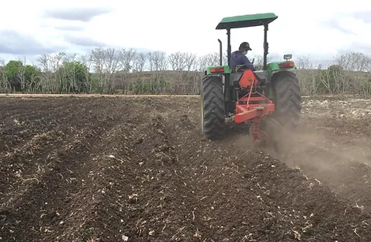
      - Level the soil to protect it from erosion.

Fig.3.1. leveling the soil.
- Plant and cover the seeds. With the planting area prepared, the seeds should be inserted between 3 to 5 cm deep in furrows.

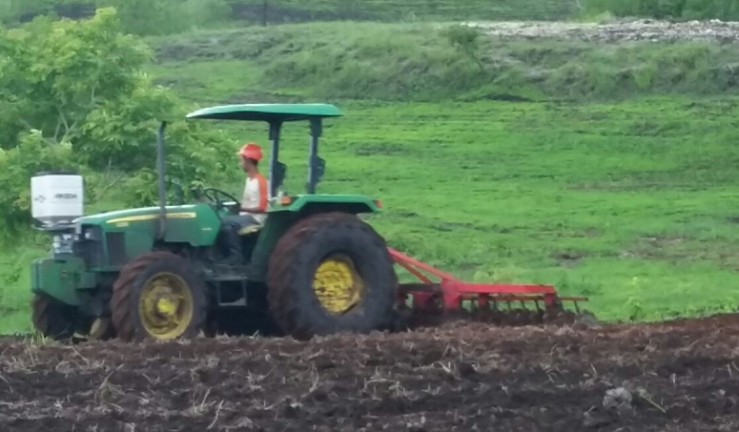

Fig.3.2. ploughing
- Correct the soil and add fertilizers, if necessary.
- Watch for insects and pests.
- Take care of the soil moisture
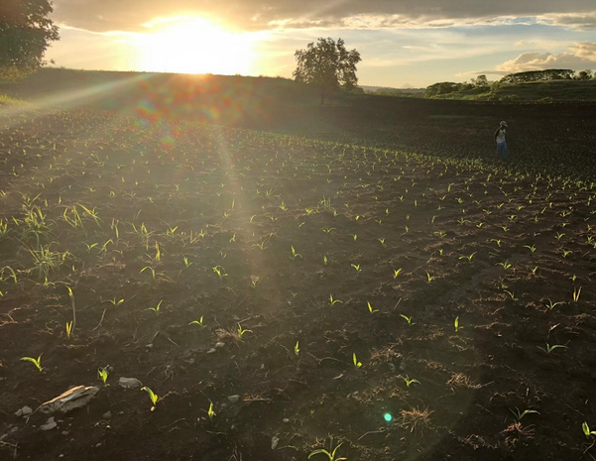

Fig 3.3. New grass growing
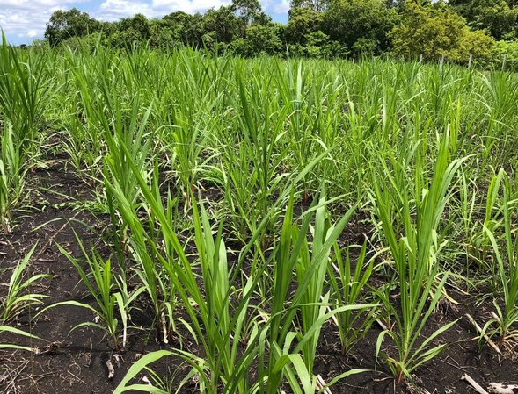

Fig.3.4. Growing plant

Self-check 3 | Written test

Name…………………………………………… ID………………………… Date…….
Directions: Answer all the questions listed below.
- What is planting materials?
- List some characteristics of good seeds?
- Mention some techniques which are used to determine seed quality?
- Write factors that can be considered during sowing or panting, planting materials?
- What is the importance of determining time of sowing, depth of sowing, rate of sowing and methods of sowing during establishment of field crops?

Test I: Matching column ‘A’ with column ‘B’
“A” “B”
----1. Broad casting A. dropping the seed in the row
----2. Drilling B. seed spread uniformly
----3. Planting C. placing individual seeds
----4. Soil factors D. Treating seed with fungicides
----5. Chemical treatment E. Factor that influence sowing depth
----6. Biological treatment F. Treating seed by microbial cultivers

Operation Sheet -3

  - Procedures of pasture establishment planting activities.

Material

- Shovel
- Auger
- Kit
- Hammer
- Seed
- Cow dung/fertilizer
- Rope
- Hay stock
- baller

Procedures
- wear personal protective equipment
      - Test soil by laboratory
      - Clean land site
      - Land preparation through plough
      - Select irrigation method through flood/sprinkler
      - Select seed type
      - Select seeding techniques
      - Apply fertilizer
      - Apply water (flood/sprinkler)
      - Remove weed
      - Harvesting
      - Store for hay making for feeding.

LAP TEST-3 | Performance Test

Name………………………………. ID…………………………….. Date…………………………………….

Time started: ________________________ Time finished: ________________

Instructions: Given necessary templates, tools and materials you are required to perform the following tasks within 8 hour.

Task 1. Establish pasture planting activities.

LG #21 | LO#4- Handle pasture and crop

Instruction shee-4
This learning guide is developed to provide you the necessary information regarding the
following content coverage and topics:
- Application of treatments
- Water application to plant
This guide will also assist you to attain the learning outcomes stated in the cover page. Specifically, upon completion of this learning guide, you will be able to:
- Apply Treatments to plantings
- Apply water to plantings based on schedule
- Train plants
Learning Instructions:
      - Read the specific objectives of this Learning Guide.
      - Follow the instructions described below.
      - Read the information written in the information Sheets
      - Accomplish the Self-checks
      - Perform Operation Sheets
      - Do the “LAP test”

Information Sheet 4

  - Application of treatments
Application of treatments are applied to assist plant growth as directed by the supervisor. Generally, application of treatment for irrigated plants includes Pesticides, fungicides, Fertilizer, mulching, removing, weeds, removing dead, material, tip, pruning, formative pruning, aeration, staking, tying, spacing and thinning
    - Pesticides
Pesticides are chemicals used to kill insects. Usually the larval stage of an insect life cycle is harmful. At this stage, most feeding on leaves, shoots, roots and boring in stem takes place. An exception is the weevil group in which adults mostly cause the damage.
The final choice of insecticides depends on:-
- Local availability,
- Use of pest detection survey,
- Cultural practice
- Sources of advice and on site expertise
    - Fungicides
Fungicides are chemicals used to kill fungi. Damping-off is a disease of young seedlings caused by a number of soil born fungi (such as fusarium, pythium, Rhizoctoniaetc) altogether there are about 30 species of fungi.
    - Cultural practices (Aeration)
The most effective preventive measures are avoiding of excessive watering and maintain of good aeration in seedbeds. Correct density of sowing is important as aeration in dense patches of seedlings is much reduced. Too heavy shading must be avoided. During long periods of cloudy weather, it is advisable to remove the shades entirely.

    - Soil sterilization
- Soil sterilization helps in controlling pre-emergence damping-off. However, it is much less effective in controlling post-emergence damping-off.
- Cooking the soil with some water for some minutes can treat small quantities of seedbed soil. Bigger amount of soil can be treated with formaldehydes (formal). Commercial (40%) formaldehyde is applied to the bed at the rate of 80 cc per 5-liter of water per one square meter. Formaldehyde should be applied 7 to 10 days before sowing to avoid soil damage to seed.
- Methyl bromide is widely used for soil sterilization in Zambia and other countries. Standard dosage is 50 to 100 grams per square meter applied as vapor under an absolutely air tight polythene cover several days before sowing. For the time being, no methyl bromide treatments have been applied in Ethiopian nurseries irrigated crop and other planting crops.
    - Removing weeds
The chemicals used to kill weeds are referred to as Herbicides.
Weeds can be eliminated by:
- Manually by hand
- mechanically
- Chemically
    - Fertilizer
Fertilization of irrigated filed soils is necessary to replace the lost nutrients. Conifer seedlings removed completely with root system and often soil contains substantial quantities of mineral nutrients when they leave the nursery (for bare root seedlings). Developing and maintaining high levels of fertility in nurseries of irrigated crops are essential for producing good quality of irrigated crop stocks. However, soil fertility is only one of a number of factors influencing stock quality. Fertile irrigated soil does not compensate for poor practice.
    - Mulching
Mulching is any artificial modification of the soil surface. In irrigated crop operations, mulching means covering the bed surface with a 0.5 - 0.2 cm layer of organic materials Germinating seeds need warmth, moisture, light is not necessary in most cases. To be effective a, layer of mulching should be 1-2cm thick.
    - Removing dead material and diseased plants
Plant stock material from other nurseries or irrigated areas (seed, cuttings, scion wood and rootstock) can harbor irrigated crop pests. Wherever possible, accept propagation material from nurseries or irrigated areas only if it has a plant inspection certificate. If in doubt, surface sterilization should be carried out on all new and unknown material.
Pruning
Root pruning is a standard in most Ethiopian nurseries or irrigated areas. Root pruning involves cutting of the taproot, in some cases also of lateral roots, to encourage the development of fibrous root system. This kind of root system gives the seedlings the best possible start in plantation. Root pruning also controls depth of root penetration and makes lifting of seedlings easier and less harmful. If root pruning is not done, tap-rooted species in pots send their roots down deep into the soil. This may result vigorous growth compared with root-pruned neighbors.
  - Applying Water
Water may be applied using irrigation systems, which may include drips; overheads, central pivot, micro irrigation, under tree, and flood. Water is applied in required quantity and in an appropriate method specified by enterprise work procedures.

    - Frequency of watering
There is no fixed rule about the intervals between watering and quantity of water required, because this varies with species, soil conditions, age of plants, weather condition, etc. Watering should be done frequently, at least twice a day in small quantities.
    - Time of watering
The watering should do early the morning, before 10.00 a.m. & in the afternoon after 4:00 p.m. This will enable the seedlings to utilize efficiently with the water sprayed on to them without being lost.
Methods used to apply water
Methods used to apply water may be applied manually or by operating the irrigation system too heavy watering should be avoided, as this causes pudding of soil and poor aeration, which creates favorable condition to damping off-fungi.
  - Training plant
Training may involve thinning, trimming, staking and trellising. Thinning is a term of agriculture to mean the removal of some plants or plant parts to make room for the growth of others.
Thinning required: Where the number of seedlings that has emerged is greater than the desired final density extra seedlings should be removed from the field this operation is known as thinning.
The purpose and methods of thinning
- To obtain the current plant population density per unit area/hectare
- Usually, in raw planted crops sowing is done by hand or using planters 2 – 3 seeds per hole
To avoid competition among plants
- Thinning is much like weeding it reduces crop competition between plants.
- If plant population density is higher the recommended rate competition is occurred.
- Thinning also improves air circulation around seedlings.
- Thinning is conducted by hand at early stage of the plant
Cares which should be taken prior to thinning
- Thinning should not be taken too early or too late because
- In the first case / too early thinning/ final population density may become very low if disease or pest attack happens after thinning,
- In the second case /too late thinning during uprooting neighboring plants or retain plants may be damaged, causes high root disturbance.
Water plants thoroughly before thinning plants
It will soften the soil and making the task of removing plants along with roots easier.
Identify the proper spacing for the plants
    - Apply enterprise guide line or
    - Apply research recommendation
Identifying seedlings to be thinned

    - Plants that should be thinned
    - Weak seedlings, Diseased /infected/ seedlings ,Infested seedlings
    - Damaged seedlings
    - Seedlings that emerged last
    - Plants that should remain
    - Strong, healthy
    - Seedlings that emerged first

The early emergences seedlings are usually develop into strong and healthy plants, whereas the late emergences are normally weak and non-fruit bearing
Carry out thinning

- Grasp /catch the seedlings to be removed on close to the ground as possible slowly and gently pullout of the soil.
- Add more soil if roots are exposed during uprooting.
- After thinning apply water for the remaining plants
- This will help to redistribute soil around the plants
- You need to work carefully with minimal disturbance to those plants that will remain
- During thinning you may observe pests and diseases on the crop this should be reported to the concerned person or body immediately,

Self-check 4 | Written test

Name…………………………………………… ID………………………… Date…….
Directions: Answer all the questions listed below.
      - What are the applications of treatment for irrigated plants?
      - What are fungicides?
      - Explain briefly thinning, trimming, staking and trellising
      - Mention some techniques which are used to determine seed quality?
      - Write factors that can be considered during sowing or panting, planting materials?
Test I: Choose the best answer
- Among the following which one is used as to kill insects?
- pesticides B. Fungicides C. Cultural practices D. all
- Which one is used as preventive measures to avoid excessive watering and maintain good aeration?
- Cultural practices B. Soil sterilization C. methyl bromide D. all
- Weeds can be eliminated through ______?
- Manual method B. Mechanical method C. Chemical method D. all
- Which one is used as an artificial modification of the soil surface?
- Terracing B. Mulching C. Pruning D. all
- Among the following which one is categorized under the purpose and methods of thinning?
- To obtain current plant population
- To avoid competition among plants
- To improve air circulation around seedlings
- all

Reference Materials
Books:
Daniel Kiftassa, 1988. Role of crop residues as livestock feeds in Ethiopian Highlands. pp. 430-439. In: B.H. Dzzowela (eds.). Proceedings of a Workshop on African Forage Plant Genetic Resources, Evaluation of Forage Germplasm and Extensive Livestock Production Systems. Arusha, Tanzania, 27-30 April 1987.
C.D.and J.H. Fike. 2005. Virgini’s Horse Pastures: Forage Establishment. Virginia Coop. Ext. Serv. Pub. 418-103. Meyer, D.W. 1999. Forage Establishment. North Dakota State Univ. Coop. Ext. Serv. Pub. R-563.C-127.
Sellers, B., J. Ferrell, J. Vendramini, and Y. Newman. 2007. Weed Management During Pasture Establishment. Univ. of Florida Coop. Ext. Serv. Pub. SS AGR 287. Teutsch,
Majewski, C. 2004. Establishi Forage Seedings. Univ. of New Hampshire Coop. Ext. Serv. Newhall, R.L. 2005. Pasture Establishment and/or Renovation.
Henning, J.C. and H.N. Wheaton. 1996. Establishing Forages. Univ. of Missouri Coop.
Ext. Serv. Pub. G4650.
Henning, J.C., G.D. Lacefield, R.J. Coleman, L.M. Lawrence. 2000. Establishing and Managing Horse Pastures. Univ. of Kentucky Coop. Ext. Serv. Pub. ID147.
Muhammad, R. 2016. Elephant grass as forage for ruminant animals. Department of Forage Crops and Grassland Management, Faculty of Animal Science, Hasanuddin University, Indonesia.

AKNOWLEDGEMENT
Ministry of Labor and Skills wish to extend thanks and appreciation to the many representatives of TVET instructors and respective industry experts who donated their time and expertise to the development of this Teaching, Training and Learning Materials (TTLM).

The experts who developed the learning guide
No | Name | Qualification | Organization/ College | Mobile number | E-mail
1 | Serawit Gensa | Msc. Water Resource Engineering | W/Sodo AVET | 0916740916 | serawitgen@gmail.com
2 | Edao Hassen | Msc.Irrigation Engineering | Alage AVET | 0911098097 | hassedao@gmail.com
3 | Mekete Agizew | Msc. Water Resource Engineering | Amhara. Kombolcha ATVET | 0925221192 | gen.mam09@gmail.com
4 | Wondu Alemayehu | Msc.Irrigation Engineering | Oromia Kombolcha ATVET | 0910-28-99-61 | woldualem@gmail.com
5 | Ademe Ayalew | Msc.Irrigation Engineering | Agrafa AVET | 0912720547 | Ademe2004@gmail.com
6 | Said Mohammed | Msc.Irrigation& drainage Engineering | Alage ATVET | 09-17-18-01-81 | Siyamsdmhmmd@gmail.com/
7 | Molalign Asfaw | Bsc.Water Resource &Irrigation Engineering | Alage ATVET | 0921431096 | Mollalign410ass@gmail.com
8 | Yonas Hailu | Bsc.Water Resource &Irrigation Engineering | Agrafa AVET | 0934715578 | yonashailuw@gmail.com
9 | Lemessa Mulata | Msc.Irrigation Engineering | Agrafa AVET | 0913266845 | Lamimulle2022@gmail.com
10 | Misganew Yimer | Bsc. Soil and Water Engineering | Woreta ATVET |  | Misge1976@gmail.com
11 | Daniel Derese | Bsc. Soil and Water Engineering | W/sodo AVET | 0912-79-28-85 | danielderesse7@gmail.com
12 | Teshome Getachew | Msc.Irrigation & drainage Engineering | Alage ATVET | 0925-50-13-99 | teshomegetachew131@yahoo.com /

