Irrigation and Drainage
Level-II

Based on March 2022, Version Occupational standard

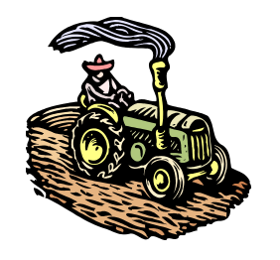

Module Title: Construct Irrigation and Drainage Structures
LG Code: AGR IRD1 M08 LO (1-6) LG (22-27)
TTLM Code: AGR IRD1 TTLM 0822v3

August, 2021
Addis Ababa, Ethiopia
Table of Contents

INTRODUCTION TO MODULE 1
LO #1- MATERIALS AND TOOLS FOR IRRIGATION AND DRAINAGE 2
Instruction sheet- 1 2
Information Sheet- 1 4
Self-check 1 23
Operation Sheet -1 24
LAP TEST-1 25
LO #2- MASONRY AND CONCRETE WORK 26
Instruction sheet - 2 26
Information Sheet - 2 27
Self-check 2 30
Operation Sheet -2 31
LAP TEST-2 33
LO #3- CONSTRUCTION MATERIAL 34
Instruction sheet - 3 34
Information Sheet - 3 35
Self-check 3 47
LO # 4- INSTALL DRAINAGE CHANNELS AND PIPE 48
Instruction sheet - 4 48
Information sheet - 4 49
Self-check 4 59
Operation Sheet -4 60
LAP TEST-4 62
LO #5 - FORMWORK AND CLEANUP 63
Instruction sheet- 5 63
Information sheet - 5 64
Self-check -5 69
Operation Sheet -5 70
LAP TEST-5 71
LO #6 - RESTORE WORK SITE AND EQUIPMENT 72
Instruction Sheet- 6 72
Information Sheet - 6 73
Self-check 6 77
REFERENCE MATERIALS 78
AKNOWLEDGEMENT 79

INTRODUCTION TO MODULE

This unit covers knowledge, skills and attitude required to plan and prepare for work, set out for masonry and concrete work, construct and install drains, channels, pipes and associated fittings, Inspect construction material for masonry and concrete works, carry out masonry and concrete works, carry out Strip formwork and cleanup for concrete works, and Restore work site and equipment.

Irrigation is the artificial application of water to the soil through various systems of tubes, pumps, and sprays. Irrigation is usually used in areas where rainfall is irregular or dry times or drought is expected. There are many types of irrigation systems, in which water is supplied to the entire field uniformly. The most common sources of water for irrigation include rivers, reservoirs and lakes, and groundwater. Likewise, irrigation has immediate effects on the provision of moisture to the atmosphere, inducing atmospheric instabilities and increasing downwind rainfall, or in other cases modifies the atmospheric circulation, delivering rain to different downwind areas.
What is drainage and types of drainage?

Drainage is the process of disposal of excess water from the surface and subsurface soil, the drainage can be divided into two types, namely (1) surface drainage and (2) subsurface drainage. Excess water may be caused by rainfall or by using too much irrigation water, but may also have other origins such as canal seepage or floods. In very dry areas there is often accumulation of salts in the soil. A drainage system provides the benefits of drainage that keep water from flowing back into your house and base, keeping any dirt and debris out of your base. It is also crucial to have a water drain in place if you live in an area where heavy rainfall can be expected throughout the year. There are different types of drainage systems. Such as:
- Surface Drainage System, Surface drainage systems remove excess water from the land's surface through channels or ditches. ...
- Subsurface Drainage System. Subsurface drainage systems are implemented beneath the top layer of soil.
- Slope Drainage System.
- Downspouts and Gutter Systems.

LG #22 | LO #1- Materials and tools for irrigation and drainage

Instruction sheet- 1
This learning guide is developed to provide you the necessary information regarding the following content coverage and topics:
  - Introduction to the module
  - Determination of work requirement
  - Site identification
  - Constructing Drainage and diversion structures
  - Identifying Equipment and excavation methods
  - Interpreting Signage requirements
  - Selection of plant, tools and equipment
  - understanding Environmental protection requirements
This guide will also assist you to attain the learning outcomes stated in the cover page. Specifically, upon completion of this learning guide, you will be able to:
  - Determine work requirement
  - Site identification
  - Construct drainage and diversion structures
  - Identify excavation equipment and excavation methods
  - Analyze Signage requirements
  - Select plant, tools and equipment
  - Understand Environmental protection requirements
Learning Instructions:
- Read the specific objectives of this Learning Guide.
- Follow the instructions described below.
- Read the information written in the information Sheets
- Accomplish the Self-checks
- Perform Operation Sheets
- Do the “LAP test”

Information Sheet- 1

  - Determination of work requirement
Need of irrigation
- Irrigation: is the artificial application of water to the soil through various systems of tubes, pumps, and sprays. Irrigation is usually used in areas where rainfall is irregular or dry times or drought is expected. It helps to grow agricultural crops, maintain landscapes, and revegetate disturbed soils in dry areas and during periods of less than average rainfall. Irrigation also has other uses in crop production, including frost protection, suppressing weed growth in grain fields and preventing soil consolidation.

Types of irrigation: There are several methods of irrigation. They vary in how the water is supplied to the plants. The goal is to apply the water to the plants as uniformly as possible, so that each plant has the amount of water it needs, neither too much nor too little. Irrigation can also be understood whether it is supplementary to rainfall as happens in many parts of the world, or whether it is 'full irrigation' whereby crops rarely depend on any contribution from rainfall.

Types of irrigation methods include:
- Surface irrigation: is where water is applied and distributed over the soil surface by gravity
- Drip (or micro) irrigation: also known as trickle irrigation, functions as its name suggests. In this system, water is delivered at or near the root zone of plants, one drop at a time.
- Sprinkler or overhead irrigation: water is piped to one or more central locations within the field and distributed by overhead high-pressure sprinklers or guns.

The irrigation system consists of:
- (Main) intake structure or (main) pumping station: directs water from the source of supply, such as a reservoir or a river, into the irrigation system.
- Conveyance system: assures the transport of water from the main intake structure or main pumping station up to the field ditches.
- Distribution system: assures the transport of water through field ditches to the irrigated fields.
- Field application system: assures the transport of water within the fields.
- Drainage system: removes the excess water (caused by rainfall and/or irrigation) from the fields.

Need of drainage
- Drainage: means the removal of surface water or groundwater from land by drains, grading or other means and includes control of runoff during and after construction or development to minimize erosion and sedimentation,to assure the adequacy of existing and proposed culverts and bridges,to water recharge into the ground where practical, tolessen nonpoint pollution, to maintain the integrity of stream channels for their biological functions as well as for drainage, and the means necessary for water supply preservation or prevention or alleviation of flooding.
- Excess surface water is removed through shallow open
- Excess groundwater is removed through deep open drains or underground.
- Protective equipment: including personal protective equipment for eyes, face, head, and extremities, protective clothing, respiratory devices, and protective shields and barriers, shall be provided, used, and maintained in irrigation and drainage work. Wherever it is necessary by reason of hazards of processes or environment, chemical hazards, radiological hazards, or mechanical irritants encountered in a manner capable of causing injury or impairment in the function of any part of the body through absorption, inhalation or physical contact.

Guidelines to select PPE for work
This guide is designed to help departments, organizations, and units, and supervisors in the steps to assess their workplace, select the right equipment, train employees and document this work.
- Assessment: Select the job, process or procedure you are going to assess. Survey the worksite and identify the hazards the worker will be exposed to while doing the work.
- PPE Selection: If PPE must be used, list the PPE that will be used for each hazard identified on your form and must sign and date the form.
- Training: After the assessment and selection, employees required to use PPE must be trained before they are required to use the PPE. Retraining must be done if PPE requirements change and as needed. All of the following must be covered:
- What PPE to use and when to use it
- Limitations of the PPE
- How to put it on, take it off and adjust it
- Inspection and maintenance
- any manufacturer instructions and warnings
- Make sure the PPE fits well
- How to obtain PPE
- How to dispose of PPE
- Documentation: The following information must be retained to document the PPE hazard assessment, PPE selection and training.
- Job, process, or activity being assessed
- Hazards identified
- Selection of PPE used for each hazard identified. PPE type.
- Person(s) or job title identified to use PPE
- Name and title of person completing the hazard assessment
- Date hazard assessment was completed
- Name, title, training date for all employees required to wear PPE.

1.2. Site identification
When planning a drainage system construction, it should consider factors such as; -
- The types and functions of the construction systems,
- Methods to construct the drainage structures
- Design options, and the environmental effects of drainage installation.
- OHS hazards and prevention mechanisms
Before implementing the drainage structure construction the following important conditions must be determined; -
- The desired depth to which the water table should be lowered
- The amount of rainfall received and the amount of irrigation to be applied
- The proper depth and spacing of the relief and collector lines
- The maximum length of laterals, collectors and outlets
- The material and diameter of the pipe
- The slope grade at which the lines should be installed
Installation and construction of drainage structure can utilize manual system to sophisticated equipments and machinery. Construction method of drainage system is decided based on the following conditions:
- Availability of tools, equipments and machinery
- Type of material to be installed
- Suitability and accessibility of the land (accessibility, soil wetness during installation, trench backfilling and
- The general quality of the work.
Factors to Consider in selecting irrigation construction site
- Compatibility with other farm operations
- Economic feasibility
- Availability of construction material and labor in the construction site
- Topographical characteristics
- Soil properties
- Water supply
- Crop characteristics
- Social influences
- External influences

1.3 Drainage and diversion structure
Diversion structures: are used to separate all or part of the flow in a stream to a location where it will be used or stored. Diversion structures may be either temporary or permanent. If high flows make a permanent structure very expensive, then temporary structures that can be easily and economically reconstructed might be installed. The diversion may be constructed across only a part of the stream's bed.
Advantages:
- Reduces the volume of flow across disturbed areas, thereby reducing the potential for erosion.
- Breaks up concentration of water on long slopes.
- Maintaining a separation between clean water and sediment-laden water allows sediment basins and traps to function more efficiently.
Disadvantages:
- High flow velocities can cause erosion in the diversion structure.
- Diversion structures must be stabilized immediately after installation.
- Easily constructed with equipment found on most construction sites and thus often improperly designed
General Characteristics Diversion Structures
- All diversions should be designed by a Licensed Professional Engineer
- Areas above a diversion should be stabilized to prevent excessive sediment from accumulating in the diversion channel
- Channel dimensions should be adapted for the equipment that will be used to maintain the diversion.
- The length of the diversion is often fixed by the availability of stabilized outlets.
- To prevent scour or excessive seepage a stabilized outlet should be constructed
Types of construction materials for diversion structure
Depending on the availability and cost of materials, and the size and purpose of the structure, the following materials are commonly used:

- soil,
- boulders and rocks,
- logs,
- sand bags,
- gabions,
- masonry, and
- Concrete.

Construction and maintenance factors
- Many diversions are only temporary structures, so they should be built with the understanding that they will be destroyed by flood water during hard rainfall.
- Diversions can be constructed so that part of the structure is permanent and the other part temporary. In areas where there is a large variation in stream flow during a relatively short period of time, this system of diversion reduces the amount of labor required to reconstruct the structure after each rainfall.
- Design of any permanent structure should take into consideration the amount of sediment that will settle upstream and reduce water storage volume.
- If the diversion structure will be used as a check dam to allow for water storage, the site of the diversion should have a natural basin upstream to maximize water storage volume and decrease the necessary height of the diversion or dam.
- Gabions are baskets made of heavy duty galvanized wire mesh that are filled with rocks and wired shut. The gabion provides an easily constructed unit that is large enough and heavy enough to remain stable in moving water.
- Diversions constructed of materials that allow excess amounts of seepage may require some type of impervious core or barrier to reduce losses.
- Diversion structures require upstream and downstream side slopes to assure their stability.
- A spillway, overflow structure, or other bypass structure is necessary to allow water from the stream to pass over the diversion structure and flow back into the natural watercourse without washing out or damaging the structure.
- If the diversion provides water to a pipeline, a trash removal system may be required to prevent blockage of the pipe.

Drainage structure: means a device composed of a virtually non-erodible material such as concrete, steel, plastic or other such material that conveys water from one place to another by intercepting the flow and carrying it to a release point for storm-water management, drainage control, or flood control purposes.

Types of drainage structure: there are two types of drainage structures. Such as:
- Surface drainage structure: is used for the removal of excess water from the surface of the land. Thus structure includes shallow ditches, also called open drains. The shallow ditches discharge into larger and deeper collector drains. In order to facilitate the flow of excess water toward the drains, the field is given an artificial slope by means of land grading
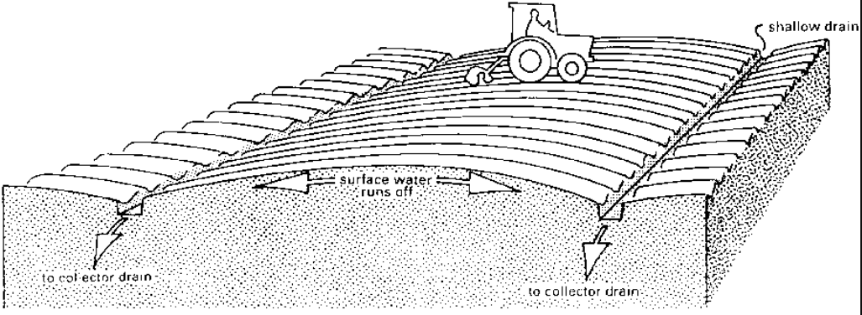
Fig 1.1: the field is given artificial slope to facilitate surface drainage

- Subsurface drainage structure: is the structure used to removal of water from the root zone and lower ground water table. It is accomplished by deep open drains or buried pipe drains.
- Deep open drains: The excess water from the root zone flows into the open drains. The disadvantage of this type of subsurface drainage is that it makes the use of machinery difficult.
- Pipe drains: Pipe drains are buried pipes with openings through which the soil water can enter. The pipes convey the water to a collector drain

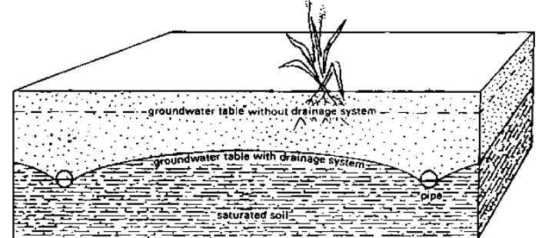
Fig 1.1: Control of the groundwater table by means of buried pipes

- Drainage structures: includes manholes, catch basins, leaching basins, inlets and drop inlets. Drain pipes are made of clay, concrete or plastic. They are usually placed in trenches by machines. In clay and concrete pipes (usually 30 cm long and 5 - 10 cm in diameter) drainage water enters the pipes through the joints (see Fig 1.1 below). Flexible plastic drains are much longer (up to 200 m) and the water enters through perforations distributed over the entire length of the pipe

Which material is used for drainage pipe?
- PVC: This plastic has become the number one choice for wastewater drainage pipes, thanks to its lightweight durability and its resistance to rust and chemicals. PVC is also an affordable choice that can be fitted together and installed easily, and be linked up to existing metal pipes, too.

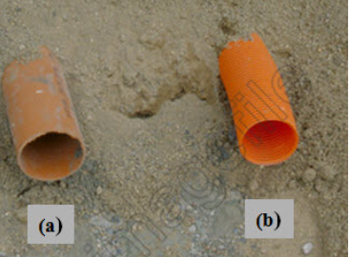
Fig 1.3: Plastic drain pipes: (a) Smooth pipe; (b) Corrugated pipe.

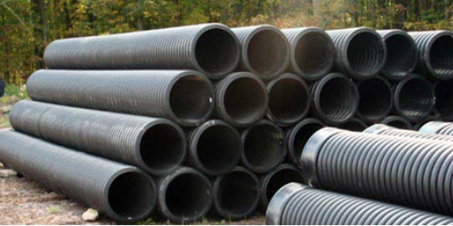
Fig 1.4: High-density polyethylene (HDPE) drain pipes.

- Concrete Pipes: Concrete pipes were used as field drains like clay tiles in various countries, until they virtually became obsolete with the introduction of plastic pipes. In larger diameters, concrete pipes are still commonly used as collectors. Concrete pipes can be manufactured in comparatively simple (mobile) production units that can easily be erected in the project area. Water entry is almost exclusively through the joints between pipe sections. For larger diameters, openings at the joints may become rather large; this is the reason that some manufacturers supply rubber sealing rings.
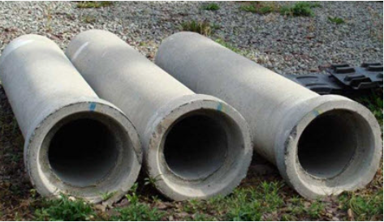
Fig 1.5: Reinforced concrete drain pipes.

- Drainage structure sheets show:
- The drainage structures,
- their location
- cross section
- flow line elevations of all weirs or slots
- Top of grates
- culverts
- Top of manhole elevations, and similar data.
- The vertical relationships of the entire drainage system.
- Solutions to resolve drainage structure conflicts with existing or proposed utilities as early in the design process as possible.

- Drainpipes and Their Accessories: - PVC and PE are generally used as pipe materials for corrugated plastic lateral drains. Concrete pipes are used for larger collector drains. Specifications and standards for clay, concrete and corrugated plastic pipes are required. Pipe accessories, such as end caps, couplers, pipe fittings and reducers, and rigid pipes for drain bridges and lateral outlets are also mandatory.
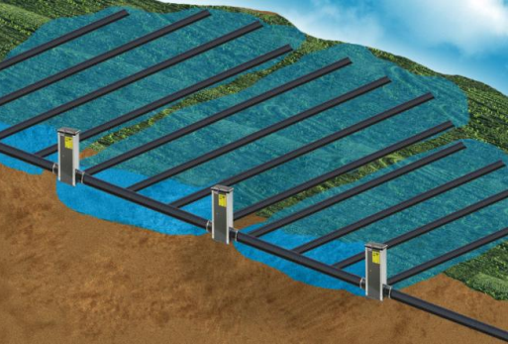
Fig 1.2: drain pipes and their accessories

- Envelopes: - Drain envelopes restrict the entrance of soil particle into the drain, improve the hydraulic conductivity at the soil-drain interface and provide structural stability around the drain.

Fig 1.4: Drain-envelope materials: (a) Coconut fiber; (b) Polypropylene

- Auxiliary Drain Structures: - Connection structures, inlets and outlets of water and special structures, such as cleaning facilities and structures for controlled drainage and sub-irrigation, are common auxiliary structures of drainage systems. In this order the following issues can be covered:
- Quality control and maintenance of outlet structures: - In composite drainage systems, junction boxes and manholes are sometimes hardly used or not used at all and may be unnecessary with GPS.
- Availability: - Designs for special structures for controlled drainage in the lateral and collector outlets must be available, but examples of construction and operation of such structures are not frequent.
- Equipment: - Drainage equipments include land survey equipments and accessories involve in locating and measuring both man-made and natural features in the field. Some of these accessories and equipments are;
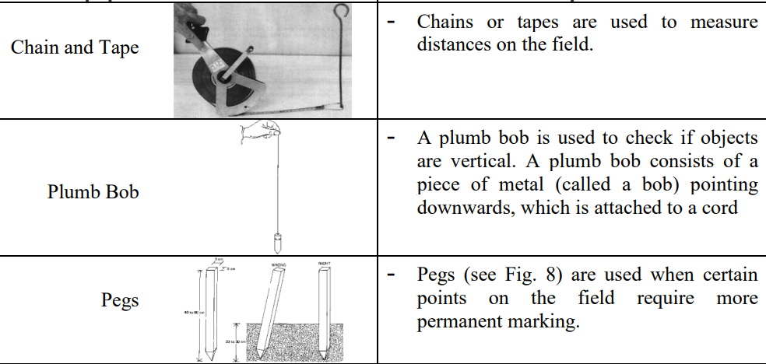
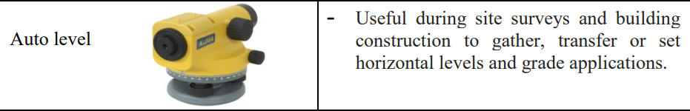

Drainage Machinery some special machines are used for construction, installation and maintenance of subsurface drains. I
- Installation Machinery: - Trenchers of various types have been used in the past and still are used with success to install subsurface drains, especially for clay and concrete pipes and for granular mineral envelopes.
- Maintenance Equipment: - Drainage systems adequately installed with appropriate drainage materials should have low maintenance requirements. Dry rodding is sufficient to remove slight clogging, fresh ochre and roots proliferating inside the drainpipe, especially near the lateral outlet. To remove sediments and serious ochre deposits and to clean clogged perforations jet flushing is necessary. Medium pressure equipment is also most recommended and flushing should be used only in case of dissatisfaction with or deterioration of drainage system performance.
1.4. Equipment and excavation methods
- Trenchers: are heavy machines designed for earthmoving. No matter what specific type of trencher you’re using, they all have the same basic components.
Trenchers have a metal chain with teeth made of high-strength steel. This allows the machine to tear into the ground, lifting and moving massive amounts of earth. Because of the sheer size and strength of the machine, trenchers are capable of tearing through heavy tree root systems and densely packed earth.

- Digging trenches: is the first step of laying drainage pipe. Depending on the size of the project and area, hand tools may suffice. But you will likely need some high power equipment to make the work easier and reduce manual effort. We’ve put together a list of both powered and hand tools, to cover all possibilities:
- Trencher machine - for big trenches
- Turf cutter - powered machinery which will neatly cut through grass layers to reveal the ground underneath
- Excavator - powered machinery for moving large amounts of dirt
- Backhoe - powered machinery similar to an excactor but for moving smaller amounts of dirt
- Shovel - for scooping
- Spade - for digging

The following procedures should be taken into account to Installation of subsurface drainage system:
- Mark out the location of all the lines with either lime or spray paint
- Check for any service lines that may intercept your drainage line. Establish levels
- Excavation of trench
- Install components
- Backfill the trench with the topsoil originally removed and consolidate
- Finish off according to the plans and specification

There are three methods of mechanical installation:
- Excavator: All steps in the implementation process are separate steps, implemented one after the other. The trench is dug by the excavator to about 5 cm above the required drain depth and up to the last few centimeters, when the leveling and placing the drain pipes is done by manual labor;
- Trencher: Digging the trench, placing the drain pipes and (if applicable) the envelope, is done in a one-time operation. The pit from where the laying of the pipe will start is either dug by the trencher itself or an excavator;
- Trenchless: Just like the trencher method, it is a one-time operation, but instead of digging a trench the pipe is directly ploughed into the soil.

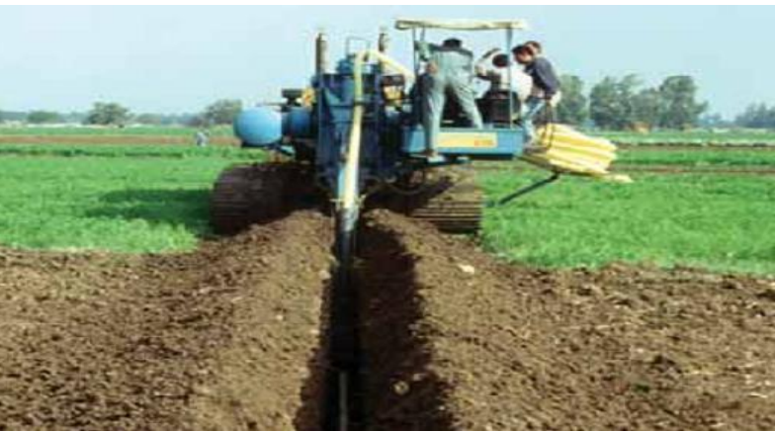
Fig 1.5: Excavating the trench

1.5. Signage requirements
Construction signage can be used to convey information in and around buildings by means of text or symbols. Construction site safety signs are displayed to deliver a clear health and safety message. Failing to understand the meaning of a health and safety sign on site might mean you lose your life - or your job.
There are 5 health and safety signs, and they all mean different things.
- Prohibition Signs
- Mandatory Signs
- Warning Signs
- Safe Condition Signs
- Fire Equipment Signs
Every type of health and safety looks different. Through shape and colour combinations, they can send their message through just a picture or icon. Once you know what you are looking for, you can quickly understand the exact meaning of the sign (even without reading the words).

Here are the 5 health and safety signs and their meanings.
- Prohibition Signs: Prohibitions signs are there to tell you not to do something. They are a danger sign, telling you that it is not safe to proceed. And what colour makes you think of danger? Red of course! These signs have a red circle with a red diagonal line through it. The pictogram is black on a white background.
An easy way to remember the shape of prohibition signs is that is a circle, like a full stop. And the sign literally means, stop
Example: no smoking, no entry, don’t touch etc.


- Mandatory Signs: are there to tell you to do something. Consider these the opposite of prohibition signs. These signs are round in shape. The pictogram is white on a blue background. The circle usually has a white border.
Instead of being round for full stop (like prohibition signs), you can remember that mandatory signs are round for 'Obey'. Because that is what you must do, obey them.

Examples:
- Wear a face mask
- Ear protection must be worn
- Keep fire door closed
- Keep clear
- Pedestrians only
- Warning Signs: are there to warn you of dangers. Unlike the two previous signs, they don't tell you not to do something, or to do something. They simply aim to make you aware of a danger, so you can protect yourself. These signs are triangular in shape. The pictogram is black on a yellow background, the triangle has a black border.


Examples:
- Caution hot water
- Danger 440 volts
- Mind the step
- Fragile roof
- Caution slippery floor
- Safe Condition Signs: usually be followed to safety. And what colour better represents safety than green? That's right, they are green!
These signs are rectangular or square in share. The pictogram is white on a green background, and will often have a white border


Examples:
- Fire exit
- Push bar to open
- Assembly point
- First aid box
- Emergency stop
- Fire Equipment Signs: Fire equipment/fighting signs show you where fire equipment is. What colour do we think of for fire? Red. But we already used red, with the prohibition sign. Well, fire equipment signs are also red, but a different shape. These signs are square or rectangular in shape. The pictogram is white on a red background, and will often have a white border.

Examples:
- Fire extinguisher
- Fire alarm call point
- Fire alarm control panel
- Gas shut off valve
- For fire use only

1.6 Selection of plant, tools and equipment
- The term ‘plant’: refers to machinery, equipment and apparatus used for an industrial activity. Typically, in construction. ‘Plant’ refers to heavy machinery and equipment used during construction works. At the smaller scale, there may be some overlap between what is considered plant, small plant, tools, small tools or equipment. Very broadly, ‘tools’ might be considered to be instruments that are used by hand, whereas ‘equipment’ might refer to a set of tools used for a single purpose.
- Complex plant may have additional service requirements, some of which might be provided by the plant supplier:

- Design.
- Site accommodation.
- Operation.
- Communication links.
- Transportation.
- Fabrication and installation.
- Temporary services.

- A multitude of varying factors exist for every project and owner, including but not limited to:
- First cost:
- Suitability:
- Constructability due to schedule, lead time, start-up/commission-ability:
- Ease and cost of operations and maintenance:
- Total cost of ownership:
- Experience and reputation of the equipment manufacturer:
- Impact on other building design elements (size, location, interference): reroute or core a hole in the floor because elevator hydraulic lines are already in the proposed path for the chilled-water supply and return.
- Noise criteria (NC):
- Lifespan
- Energy benefits (code requirements, energy efficiency, or value of the property):
- Scalability, staging, and modularity of equipment:
- Redundancy and failure-node risk:
- Environmental health attributes
- Safety:

Selection Criteria for Earthwork Equipment:
- Quantities of material to be moved
- The available time to complete the work the job conditions
- The prevailing soil types, the swell and compaction factors, etc.
- The job conditions include factors such as availability of loading and dumping area, accessibility of site, traffic flows and whether conditions at site
1.7 Environmental protection requirements
- Environmental protection: shall be based on the principles of public participation in and transparency of the decision making process regarding environmental protection, public awareness regarding the state of the environment and access to justice in environmental matters.
The main requirement of environmental protection during irrigation and drainage structure work includes:
- To develop the knowledge, techniques, systems, and models to design and operate sustainable agricultural irrigation and drainage systems in humid areas, with minimal environmental impacts and efficient use of water resources, including waste water.
- To develop drainage practices that enable crops to use shallow groundwater efficiently, while reducing the use of agricultural chemicals.
- To develop ecologically sound water, pest, and nutrient management practices and technologies for rotational cropping systems that maximize the economic benefits of irrigated agriculture.
- To develop precision irrigation systems and technologies for site-specific management of high-value crops.
- To develop improved practices and systems that mitigate the adverse effects of irrigation on water quality and the environment.
- To use controlled drainage systems in semiarid and arid areas that reduce the environmental effects of salts and trace elements carried in drainage discharge.
- To use controlled drainage or water-table management systems in humid areas that reduce flood flows and the environmental effects of nutrients carried in drainage discharge
- To develop methods for managing salts and trace elements in irrigation and drainage waters that would eliminate their harmful effects on soils, groundwater, and crop productivity.
- To dispose of the concentrated salts and toxic elements in waste products and reduce the associated hazards.
- To develop instruments that measure salinity and models that predict the effects of salinity on crops, soils, watersheds, and aquifers.
The major causes of environmental issues are:

- Pollution
- Solid Waste
- Deforestation
- Global Warming
- Depletion of Natural Resource

- What are the practical measures taken to reduce environmental issues? As we all know, the primary cause of environmental issues is human activity. Therefore, the following are the specific measures taken to reduce the environmental issues:
- Plant more trees
- Reduce the use of automobiles
- Use renewable sources of energy
- Reuse and recycle waste products
- Disposal of solid and harmful waste properly
- Why should the environment be so important to all of us? Here I would like to introduce you to my personal reasons and motives to stand up for the protection of our planet through my daily actions.

- Save lives
- Create jobs
- Conserve resources
- Protect animals
- Improve coexistence
- Solve environmental problems
- Prevent natural disasters
- Be smart
- Have fun
- Be a role model

- The expansion and intensification of agriculture made possible by irrigation has the potential for causing:
- increased erosion;
- pollution of surface water and groundwater from agricultural biocides;
- deterioration of water quality;
- increased nutrient levels in the irrigation and
- drainage water resulting in algal blooms,

Self-check 1 | Written test

Name: __________________________________________ ID: ______________Date: _________
Directions: Answer all the questions listed below.
Test I: Choose the best answer (2point each)
  - Which of the following structure is used to deliver water to the irrigation field?
    - Reservoir B. canal C. field ditch D. field drain
  - One of the following is NOT the importance of environmental protection?
    - Save life C. deterioration of water quality
    - B. Conserve resources D. Create jobs
  - Identify the specific measures taken to reduce the environmental issues?
    - Plant more trees C. Disposal of solid and harmful waste properly
    - Reuse and recycle waste products D. All
Test II: Short Answer Questions
- How to identify construction site for irrigation and drainage system? (3pts)
- What are the advantages and disadvantage of irrigation and drainage structure construction?(5pts)
- List and explain the materials used for drainage pipes?(3pts)
- List and explain the different types of safety signage with their picture.(5pts)
- What is the impact of irrigation on environmental protection?(4pts)
- What are the main requirement of environmental protection during irrigation and drainage structure work?(5pts)

Note: Satisfactory rating – 25 points above Unsatisfactory - below 25 points
You can ask your teacher for the copy of the correct answers

Operation Sheet -1

  - Techniques/Procedures/Methods for excavating trenches
- Tools and equipments
- Hand and power tools
- Trenching machine
- PVC or polyethylene
- PPE
- Tap
- Surveying equipment
- Procedures to excavate trenches
- Select the type of drainage work
- Pick Your Trencher: select proper machines for the selected work
- Prepare Your Job Site for trench excavation
- Obtain the proper permits.
- Contact relevant utility entities before trenching to ensure you don’t cut through any cables, pipes, or protected tree roots.
- Clearly marking where trenching will occur and clear any major obstructions.
- Make sure you and your team fully read the operating instructions and safety precautions before getting started.
- Operate Your Trencher: You’ll find the following on most trenchers:-
- Steering mechanism.
- Depth control.
- Chain or wheel control.
- Speed control.
- Gear shift.
- Safety.

LAP TEST-1 |  | Performance Test

Name: _________________________________________________ ID: ________________ Date: _____________________________

Time started: ________________________ Time finished: ________________

Instructions: Given necessary templates, tools and materials you are required to perform the following tasks within 1 hour. The project is expected from each student to do it.

Task – 1: operate trench excavation

LG #23 | LO #2- Masonry and concrete work

Instruction sheet - 2

This learning guide is developed to provide you the necessary information regarding the following content coverage and topics:
- Setting straight lines
- Checking grades
- Servicing identification
This guide will also assist you to attain the learning outcomes stated in the cover page. Specifically, upon completion of this learning guide, you will be able to:
- Sett straight lines
- Check grades
- Apply Service identification
Learning Instructions:
- Read the specific objectives of this Learning Guide.
- Follow the instructions described below.
- Read the information written in the information Sheets
- Accomplish the Self-checks
- Perform Operation Sheets
- Do the “LAP test”

Information Sheet - 2

- Concrete is a construction material consisting of conglomerate gravel, pebbles, broken stone or slag in a mortar or cement matrix.
- Masonry: is building and fabricating in stone, clay, brick, or concrete block. Masonry also refers to the building units (stone, brick, etc.) themselves.
- The constituent masonry materials: concrete block, mortar, grout, and steel, each contribute to the performance of a masonry structure. Concrete masonry units provide:
- Strength,
- durability,
- fire resistance,
- energy efficiency, and
- Sound attenuation to a structure.
In addition, concrete masonry units are manufactured in a wide variety of sizes, shapes, colors, and architectural finishes achieve any number of appearances and functions.

2.1 Setting straight lines
The location and alignment of the drain lines must be set out before the actual digging can begin, (Figure 2.1):
Setting out the alignment of drain line
- The downstream location of the drain is marked off by placing a row of pegs along the collector drain at the design drain spacing.
- The center line of each drain is set out by placing another row of pegs at the upstream end. Stakes are placed in the soil at both ends of the drain line with the top of the stakes at a fixed height above the future trench bed using a leveling instrument. This very clearly indicates the drain line.
- The direction of the field drains is assessed standing at the starting point at the collector line, there after marking off the location of the field drains with pegs
- Setting out the drainage system (with pegs in the field indicating where the drainage system will come, where the manholes are to come etc.);
- Giving reference levels for the installation of the drainage system (for adjustment of the laser);
- Managing the laser: transporting, charging and setting up the emitter and adjusting the slope;
- Giving levels for installation of manholes and checking the levels during installation.
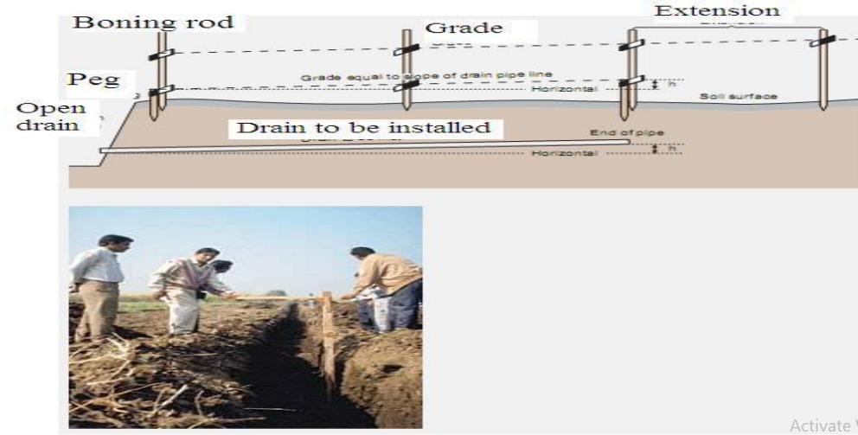
Fig 2.1: Setting out alignments and levels

2.2. Check grades
- Slope or grade: refers to the change in the elevation of land over a distance. In other words, it is the measurement of how much higher an incline, or how much lower a decline, is at a specific points compared to where you are currently standing. People use slope or grade measurements from everything to building construction. Steps to check grades:
- Find the distance between your starting and ending elevation. In other words, mark your beginning and end point of the slope (or grade) you're looking to find. This is called your run.
- Find your starting and ending elevation. You can use either an accurate elevation measuring device if you're working on a large construction, or a ruler if you're simply in your backyard working on a small piece of land.
- Subtract your ending elevation from your starting elevation. This will be your rise. If your ending elevation is higher than your starting elevation, then the number should be positive. If your ending elevation is lower, then the number should be negative.
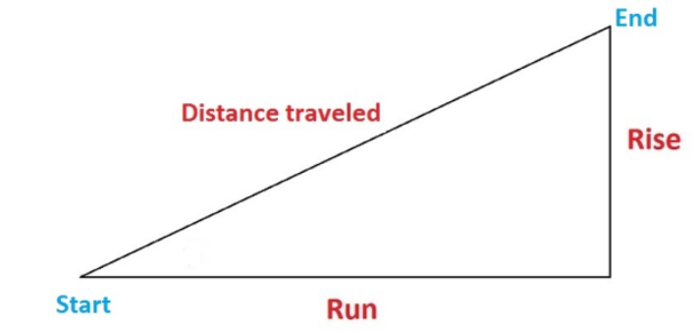
Fig 2.1: measurement of grade as decimal or percentage

- Divide your rise (Step 3) by your run (Step 1) in order to find the slope. For instance, if you are measuring a distance of 12 inches and the elevation difference is 4 inches, then your slope is 6 divided by 12, which equals 0.5.
- Once again, if you are going uphill, your slope will be positive. But if you are going downhill, your slope will be negative.
- Multiply your slope by 100 to find your grade. Grade is the same as slope but uses a percentage to indicate the measurement. In our example, a 0.5 slope means that it has a grade of 50 percent
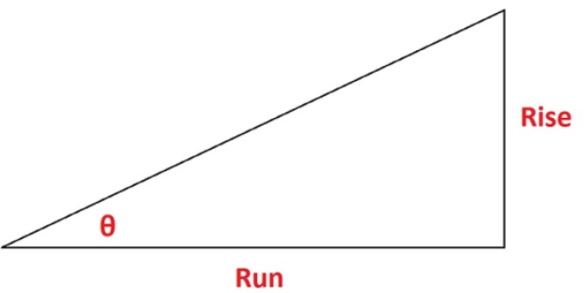
Fig 2.2: measurement of grade as degree

2.3 Services are identified and protected to prevent damage
Ways to Maintain a Healthy Drainage System
- Drain Guard. Use a drain guard on all your plug holes to reduce the amount of waste that gets washed down your sink.
- Drain Cleaner.
- Use Boiling Water Regularly
- Garbage Disposal.
- Washing Pets.
- Look for Signs of Trouble.
- Let the Professional Do the Hard Work.

Self-check 2 | Written test

Name: __________________________________________ ID: ______________Date: _________
Directions: Answer all the questions listed below.
Test I: Choose the best answer (2point each)
    - A construction material consists of gravels, sand, cement and water is called________.
    - Concrete B. mortar C. formwork D. masonry
  - One of the following is NOT the requirement of concreter work?
    - Strength B. durability C. fire resistance D. temporary
  - One of the following tool or equipment is NOT required for setting out the alignment of drain line.
    - Laser B. pegs C. shovel D. hammer
Test II: Short Answer Questions
- Write the procedures to setting out the alignment of drain line?(4pts)
- What is grade or slope?(2pts)
- List and explain services that prevent damage of drainage structure.(4pts)
- List the tools or equipments required for measuring grade/slope.(5pts)

Note: Satisfactory rating – 16 points above Unsatisfactory - below 16 points
You can ask your teacher for the copy of the correct answers

Operation Sheet -2

  - Techniques for Setting out the alignment of drain line
    - Tools and equipments
- pegs
- drain pipe
- PPE
- Tap
- Surveying equipment
- Marking tool
- Notebook
- calculator
  - Procedures to Setting out the alignment of drain line
- The downstream location of the drain is marked off by placing a row of pegs along the collector drain at the design drain spacing.
- The center line of each drain is set out by placing another row of pegs at the upstream end. Stakes are placed in the soil at both ends of the drain line with the top of the stakes at a fixed height above the future trench bed using a leveling instrument.
- The direction of the field drains is assessed standing at the starting point at the collector line, there after marking off the location of the field drains with pegs
- Setting out the drainage system (with pegs in the field indicating where the drainage system will come, where the manholes are to come etc.
- Giving reference levels for the installation of the drainage system (for adjustment of the laser);
- Managing the laser: transporting, charging and setting up the emitter and adjusting the slope;
- Giving levels for installation of manholes and checking the levels during installation.

  - Techniques to check grades
    - Tools and equipments
- Tap
- Rope or tread
- Staffs/pegs
- PPE
- Water level/laser
- Notebook
- calculator
    - Procedures to check grades
- Find the distance between your starting and ending elevation. In other words, mark your beginning and end point of the slope (or grade) you're looking to find. This is called your run.
- Find your starting and ending elevation. You can use either an accurate elevation measuring device if you're working on a large construction, or a ruler if you're simply in your backyard working on a small piece of land.
- Subtract your ending elevation from your starting elevation. This will be your rise. If your ending elevation is higher than your starting elevation, then the number should be positive. If your ending elevation is lower, then the number should be negative.
- Divide your rise (Step 3) by your run (Step 1) in order to find the slope. For instance, if you are measuring a distance of 12 inches and the elevation difference is 4 inches, then your slope is 6 divided by 12, which equals 0.5.
- Once again, if you are going uphill, your slope will be positive. But if you are going downhill, your slope will be negative.
- Multiply your slope by 100 to find your grade. Grade is the same as slope but uses a percentage to indicate the measurement. In our example, a 0.5 slope means that it has a grade of 50 percent

LAP TEST-2 |  | Performance Test

Name: _________________________________________________ ID: ________________ Date: _____________________________

Time started: ________________________ Time finished: ________________

Instructions: Given necessary templates, tools and materials you are required to perform the following tasks within 1 hour. The project is expected from each student to do it.

Task 2.1: Set out the alignment of drain line
Task 2.2: check grades or slopes

LG #24 | LO #3- Construction material

Instruction sheet - 3
This learning guide is developed to provide you the necessary information regarding the following content coverage and topics:
- Provision of foundations
- Construction of earthen channels, batters and cast
- Concrete and mortar construction ratio
- Pointing and plastering masonry works
- Damage and blockage recording
- .Construction and installation
- Selection and installation of pipe systems
This guide will also assist you to attain the learning outcomes stated in the cover page. Specifically, upon completion of this learning guide, you will be able to:
- Identify the Provision of foundations
- Construct earthen channels, batters and cast
- Apply Concrete and mortar construction ratio
- Point and plaster masonry works
- Can recording Damage and blockage
- Perform Construction and installation of pipes
Learning Instructions:
- Read the specific objectives of this Learning Guide.
- Follow the instructions described below.
- Read the information written in the information Sheets
- Accomplish the Self-checks
- Perform Operation Sheets
- Do the “LAP test”

Information Sheet - 3

3.1 Provision of foundations
Foundation: is the lowest part of the building or the civil structure that is in direct contact with the soil which transfers loads from the structure to the soil safely. The foundation must be rigid and strong enough to distribute the incoming load to the ground without being seriously compromised. The primary objective of the foundation includes even transfer of the incoming load to the ground so as to impart overall stability to the structure i.e. stronger the foundation, more is the stability of the structure.

Generally, the foundation can be classified into two, namely shallow foundation and deep foundation.
- A shallow foundation transfers the load to a stratum present in a shallow depth.
- The deep foundation transfers the load to a deeper depth below the ground surface.
Foundations are provided for all load carrying structure for following purposes:
- Even Distribution of Load: is subjected to both the dead loads and the live loads coming from the superstructure built on top of it.
- The dead load: refers to the constant weight of the superstructure itself that does not change
- The live load: refers to the changing weights coming from the superstructure.
  - Reduction of Load Intensity: When the area increases the pressure decreases. Similarly, the foundation serves the purpose of transferring the loads coming from the superstructure to a larger area below such that the intensity of the incoming load is greatly minimized at its base.
  - Protection against Varied Natural Force: The foundation acts as an anchor against the different types of natural forces that may be exerted on the structure as a whole.
  - Protection against Ingress of Moisture: Foundation is the component of the structure that acts as a barrier to the ingress of moisture in the structure by checking the entry of the moisture into the structure.
  - Provision of Level Surface: The foundation ensures that a hard levelled surface is provided over which the superstructure can be built easily and evenly.
  - Lateral Stability: Another important purpose of the foundation is to provide lateral stability to the structure. The foundation anchors the superstructure above it to the ground underneath there by delivering lateral stability to the structure as a whole.
  - Protection against Undermining: Undermining of the structure basically refers to the deterioration or weakening of the structure due to flood water, burrowing animals, etc.
  - Protection against Soil Movements: One of the important purposes of the building foundation is to prevent or resist the movement of soil.
  - Passive Thermal Control: Foundations also serve as a means of passive thermal climate control for the structures.

3.2 Construction of earthen channels, batters and caste are two types of canals
- Unlined channels: Most of our main irrigation canals are unlined/earthen canals which cause seepage and result in losses and raising in the water table of the adjoining area.
- Lined channels: lined with RC, PCC, Bricks, and Stones etc., to minimize the seepage losses and increase the efficiency of the system. Recently irrigation canals are built with lining.
Earthen Canal Design Criteria
- Design cross sections are usually trapezoidal
- Field measurements of many older canals will also show that this is the range of averaged side slopes, even though they don’t appear to be trapezoidal in shape
- When canals are built on hillsides, a berm on the uphill side should be constructed to help prevent sloughing and landslides.

3.3 Concrete and mortar construction ratio
- The standard ratio for average mortar mix is 3:1 or 4:1 for bricklaying. If you are using a pointing mix, then you should have a ratio of 1:4 or 1:5 mortar to sand. As for concrete, it depends on the strength you need it to be at. Usually, it is good practice to mix concrete at 1:2 mix to materials.
- A cement mortar: is prepared by mixing of cement, sand and water in required proportion to achieve the targeted compressive strength of masonry work like brick wall, plastering and bricklaying.
There are various cement to sand ratios for each element of the building construction. It is generally as follows:-
- For masonry construction block/ brick work, ratio of cement to sand is = 1:3, 1:4, 1:5 and 1:6.
- For reinforced concrete, ratio of cement to sand (fine aggregate) is = 1:2, 1:1.5, and 1:1. The coarse aggregate of 20 mm graded down to 10 mm will be two times the respective fine aggregate.
- For plastering, ratio of cement to sand is = 1:2, 1:3, 1:4, and 1:5.
- For plain cement concrete, ratio of cement to sand is = 1:3, 1:4, 1:5, and 1:6.

- Cement to sand ratio for brickwork: - as per general guidelines, for block/ brick work or masonry construction or mortar mix, typically, ratio of cement to sand is 1:3, 1: 1:5 and 1:6 are used.
- Cement to sand ratio for plastering: - as per general guidelines, for plastering or rendering of external or internal wall typically, ratio of cement to sand is 1:4, 1:5 and 1:6 are used.
- Cement to sand ratio for RCC: - as per general guidelines, for reinforced concrete or rcc, typically, ratio of cement to sand is 1:2, 1:1.5 and 1:1 are used.
- Cement to sand ratio for PCC: - as per general guidelines, for plain cement concrete or pcc, typically, ratio of cement to sand is 1:3, 1:4, 1:5 and 1:6 are used.
- Cement to sand ratio for mortar mix: - as per general guidelines, for mortar mix used for block/ brick work or masonry construction or plastering, typically, ratio of cement to sand is 1:3, 1:4, 1:5 and 1:6 are used.

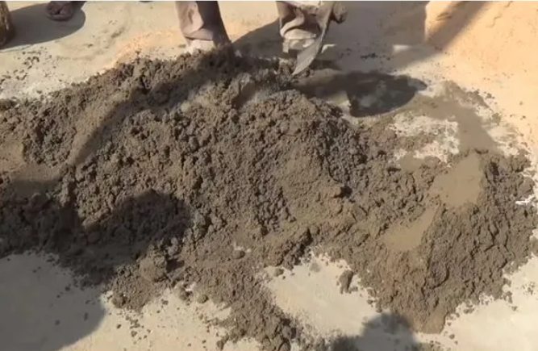
Fig 3.1: cement sand ratio for mortar

Estimation of Water, Cement & Sand quantity for Cement Mortar
Let us assume a standard quantity of 1m³ Cement mortar and a mix proportion of CM 1:6 (1 part Cement & 6 parts Sand). The quantity can calculated in two ways, one is by weight and the other by volume.

Example: Dry quantity of mortar is equivalent to 1.2 to 1.3 times the quantity of wet mortar. This is due to the fact that voids are present in aggregates and cement. Actual value depend on the void ratio of the ingredients which are being used.
Hence, let us assume the quantity of dry cement mortar mix as 1×1.3 = 1.3m³.
Volume of dry ingredient = Volume of dry mortar x (Parts by volume of ingredient / Total parts of ingredient).
= 1.3 x (Parts by volume of ingredient / Total parts of ingredient)
- Quantity of cement in Cement Mortar: Here, for 1:6 mix, total number of ingredients in the mortar is 6+1 = 7. Hence, volume of cement in mortar = Volume of dry mortar x (Parts of cement / Total parts of ingredient)
= (1.3×1)/7 = 0.185m³
since the cement is available in bags, volume of 1 cement bag (50kg) is 0.0347 m³.
0.185 m³ = (1.3×1)/ (7×0.0347) = 5.35 bags
- Quantity of sand: Volume of sand is = Volume of dry mortar x (Parts of sand / Total parts of ingredient) = (1.3×6)/7=1.14 m3 of sand or fine aggregate
- Quantity of Water: For wet mortar recommended water-cement ratio varies from 0.4 to 0.6. Further, water requirement depends on any admixture added to mortar to improve its workability. Admixtures must be added as per supplier’s specifications. Hence, water required
= 5.35 bags x 0.0347 = 0.11 m³ water
= 0.11 x 1000 l = 111 liters of water
Apart from this, labor is also required for the purpose of batching and mixing of the cement mortar.

Mortar Material Cost Estimate:
- Volume of wet mortar = 1m³
- Volume of dry mortar = 1.3m³
- Mix Ratio = 1:6
- Quantity of cement = 5.35 bags
- Quantity of sand = 1.14 m³
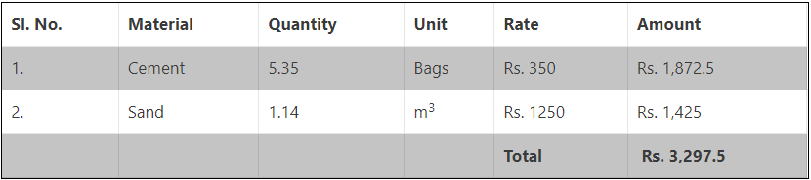
- Estimation of labor cost for Cement Mortar
1 Mazdoor = 0.27 days
1 Bhishti = 0.07 days
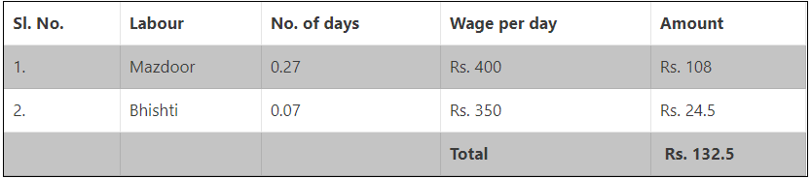

- Total Estimation of Cement Mortar
Sum of material and labour cost = 3,297.5 + 132.5 = 3430/-
Assume 1.5% for water charges = (1.5/100) x 3430 = 51.45/-
Assume 10% for contractor’s profit = (10/100) x 3430 = 343/-
Total Cost = 3430 + 51.45 + 343 = 3,824.45/-

3.4. Pointing and plastering masonry works
- Plastering: is a method of coating the internal and external surfaces of walls and ceilings with cement mortar to achieve the required finish and aesthetic view to the bare R.C.C. and masonry surfaces. It protects the R.C.C. and masonry work from atmospheric effects and increases the durability
Different types of plaster finishes with different appearances are available as follows.

- Smooth cast finish.
- Rough cast finish.
- Sand faced finish.
- Pebble dash finish.
- Scrapped finish.
- Depeter finish.
- Textured finish.

The purpose of plastering is provided below:
- To hide faulty workmanship.
- To offer a smooth surface to prevent dust.
- To give a good glance.
- To cover the wall from rainwater as well as other environmental entities.
- To shield the surfaces from the permit.
- Pointing: is a method of removing old defective mortar from the joint by hand or power tool and refilled with fresh mortar. The pointing work not only protects the mortar joints from the adverse effect of the atmosphere but also improves the appearance of the wall by proving the pattern of the joint, their thickness, colors, and texture prominently.

Following are the usual types of pointing in construction,
- Flush Pointing: the mortar filled and pressed into a mortar joint. After that, it is finished off flush with the edges of the bricks or stones, to give a smooth appearance. Flush pointing is also done by wiping over the finished pointing with the trowel or piece of rough cloth.
- Weathered Pointing: the mortar pressed into a joint, and while the mortar is still fresh the top of the horizontal joints is neatly pressed back by 3-6 mm with the pointing tool. They look like sloping from the top of the joint to the bottom of the joint.
- Keyed Pointing: the mortar is pressed into joints by trowel and well finished off with the face of the masonry surface. After that, the joint is presses back by small-diameter steel lengthwise (6 mm dia). It will form a curved arc groove into a mortar joint. The vertical joint also finishes similar manner.
- V-Grooved Pointing: are similar to keyed pointing work. The mortar filled and pressed into a joint. After that, the V-shaped groove is formed in the joint by use of V shape tool.
- Beaded Pointing: the mortar pressed into a masonry joint and concave grooves are formed into a joint by using a steel tool having a concave shape.
- Struck Pointing: the mortar is first filled and pressed to match the face of brick masonry work, and then the top edge of the joint is pressed inside around 10 mm compared to the bottom corner.
- Recessed Pointing: These types of pointing generally not suitable for buildings in exposed situations because they do not readily shed water.
- Tuck Pointing: the mortar joint is filled and pressed to the level surface of masonry. While the mortar is still fresh, grooves are cut in the mortar joint. The slot size of 5mm width and 3mm depth. Ti is then filled with white cement putty, kept projecting beyond the face of the joint by 3 mm. in case if these projections are done in a mortar then it is called bastard pointing or half tuck pointing.

The following are the advantages of pointing work,
- Improve structure integrity of the building structure.
- Provide weatherproof external walls.
- Restore overall building appearance.
- Maintain or significantly increase the overall value of your home or property
- Reduce any ongoing maintenance on your brickwork

3.5 Damage and blockage recording
- Clogged drains and blocked pipes: may start as minor issues but can quickly escalate into major problems. A clogged drain can cause slow water drainage, corrosion, flooding, and, in extreme cases, sewage backup and costly repairs.
- A drain inspection: is a systematic process of evaluating drainage systems to ensure smooth wastewater transitions from pipeline to sewage systems. Performing a drain inspection aims to prevent drainage problems such as pipe cracks, corrosions, frost, and major clogs including tree roots, toilet paper buildup, and food waste.
- A drainage inspection checklist: is a tool used by trained engineers to evaluate drain problems and document the nature of the incident. The checklist contains the following:
- Supply the general information including pipe length, size, and ownership;
- Identify the nature of the incident and consequence of the problem;
- Capture and annotate photo evidence and attach detailed notes;
- Document the action and outcome of work;
- Assign corrective actions for immediate rectification;
- Provide overall recommendations; and
- Major cause of drainage blockage: Maintaining your drainage systems can save your project from severe damages caused by sullage, unfiltered chemicals, drain line leaks, and odor-inducing problems. major causes of drainage blockage that you can attend to mitigate the risks:
- Sanitary wastes
- Industrial wastes that mix with the drain pipe
- Liquid impurity wastes
- Plant matter
- Effective Tips to Prevent Drainage Blockage: Drainage system maintenance is necessary to prevent blocked or damaged channels causing overbank flooding, unexpected erosion, and sedimentation. Poor drainage maintenance may result in a negative impact on your project which can cost you expensive repair on damages, environmental penalties, or worse property loss. You can avoid these hassles by performing regular drain survey and implement the following.

Preventive tips to eliminate drain blockages:
- Drain Guard. Use a drain guard on all your plug holes
- Drain Cleaner.
- Use Boiling Water Regularly.
- Garbage Disposal.
- Washing Pets.
- Look for Signs of Trouble.
- Let the Professional Do the Hard Work.

3.6 Construction and installation
- Alignment and Grade: Experience is desirable in the proper location of pipe drains, but there are a few general rules:
- place the outlet at the best possible location;
- provide as few outlets as possible;
- layout the system with short mains and long laterals
- use the available slope to best advantage, especially on flat land
- follow the general direction of natural water ways, particularly with mains and submains on land with considerable slope
- avoid routes that result in excessive cuts
- avoid crossing waterways except at an angle of 45º or greater; and
- Avoid soil conditions that increase installation and maintenance costs.
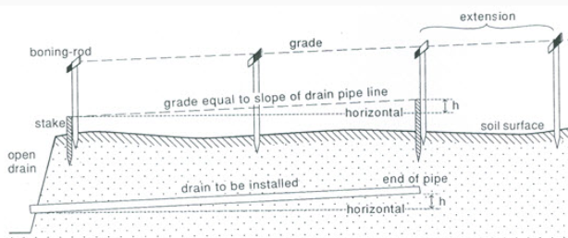
Fig 3.1: Staking out for grade control of drain pipeline.

- Drainage Machinery: Some special machines are used for construction, installation and maintenance of subsurface drains.
- Installation Machinery: - Trenchers of various types have been used in the past and still are used with success to install subsurface drains, especially for clay and concrete pipes and for granular mineral envelopes. The most common types of machines for installing field drains can be classified into two major types :
- Trenchers: Trench-excavating drainage machines vary from attachments to a wheel tractor, suitable for installation depths of up to 1 m, to heavy-duty machines, suitable for installing large-diameter collector pipes to a depth of about 3.5 m. Most machines move on tracks, but especially the lighter ones may have rubber tyres. The digging implement is commonly a continuous chain with knives.
- The excavation depth and trench width of a machine can be varied through interchanging digging attachments.
- The maximum depth of a trencher is somewhere between 1 and 3.5 m.
- The trench width varies roughly between 0.12 and 0.65 m
- a standard width for field drains being 0.20 to 0.25 m.
- The engine power ranges from 75 to 300 kW (100 to 400 hp), and
- One machine weighs between 10 and 50 tons.
- The grade-control system is optional for most machines: either by the driver or by laser.
- Trenchless Drainage Machines: Trenchless drainage machines have been used after flexible corrugated plastic pipe appeared on the market. Two main types of trenchless devices are:
- A vertical plough: acts as a subsoiler: the soil is lifted and large fissures and cracks are formed. If these extend down to the drain depth, the increased permeability leads to a low entrance resistance and an enhanced inflow of water into the pipe. The critical depth depends mainly on the soil texture and on the water content during pipe installation.
- V-plough: which lifts a triangular ‘beam’ of soil while the drain pipe is being installed, has a hazard of deforming the corrugated pipe under the weight of the soil beam. The problem was found to occur in heavy alluvial clay soil in The Netherlands, but it can be solved by simple adjustments to the plough.

3.7. Selection and installation of pipe systems
What is Drainage Pipe?
A drainage pipe: is any pipe used to facilitate the transfer of water from one place to another. The main purpose is to dispose of wastewater from homes, office buildings, or industrial areas. Disposing water properly and efficiently can prevent water build-up, leading to flooding, structural damage, soil erosion, and other issues. For this reason, drainage pipes can even be used for the work at the job site as well as the final project.

These drainage pipes vary in both material and use. Some drainage pipes are used to remove water from specific areas such as roofs, while others are exclusively used to move water underground because of their material and composition. The type of drainage pipe a contractor chooses will often be based on the project’s drainage situation. Choosing based on price alone is usually insufficient due to the severity of the ramifications of failure. The three qualities contractors will utilize to determine the type of drainage pipe used are strength, size, and installation ease. Typically, almost all new drainage pipes are plastic so as to be resilient to all weather and ground conditions.

Types of Drainage Pipes
- PVC: Polyvinyl Chloride pipes are the most commonly used pipes for any drainage project. Due to the material’s malleable properties, PVC pipes can come in almost any size. These types of pipes are great for drainage situations where the water and environment exert a great deal of pressure and weight. PVC’s strength, durability, and resistance to both water and some chemicals make it one of the more inflexible pipe types, especially amongst plastics.
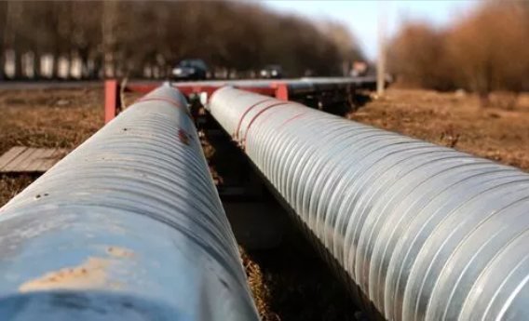
Fig: PVC drainage pipe

- Concrete: While plastics are the drainage industry’s status quo, concrete can be a frequently inexpensive choice for drainage systems that utilize heavy-duty or industrial piping. Concrete, while completely inflexible, is used in projects and situations that demand zero leaks. Concrete piping can also be used as a complimentary exterior shell for drainage pipes of another material. In this case, the concrete would protect a weaker or more vulnerable pipe by acting as its outer shell.
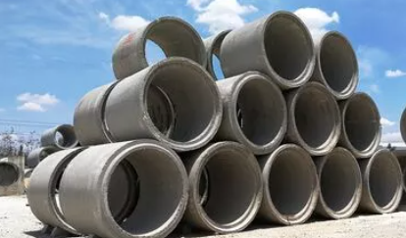
Fig: concrete drainage pipe

- Polyethylene: This is the most flexible of the plastic pipe types. Polyethylene’s easy manipulability makes installing these types of pipes incredibly simple. If the project requires piping and water to be transferred in small spaces with many turns, polyethylene pipes are likely the optimal choice.
- Single Wall Corrugated: These corrugated pipes are typically low-cost, flexible, and super easy to install. The largest drawback is that the pipes’ corrugated texture can make them vulnerable to clogging, and they often require steeper angles for drainage than regular pipes.
- Dual Wall Corrugated: This is the compromise between the smooth wall and the single wall corrugated pipes. It is not as easy to install or as flexible as the single wall corrugated pipes, but it does have a smooth interior wall. This type of fusion cost requires money, as these pipes are usually more expensive.

What are the various factor to be consider while selecting a pipe material?
- Carrying capacity of the pipe.
- Durability, strength, and life of the sewer pipe.
- Imperviousness and weight.
- Resistance to corrosion and abrasion

There are numerous factors that need to be considered when selecting a pipe system, such as:
- Type of fluid.
- Fluid pressure.
- Fluid temperature.
- Fluid flow rate.
- Code and authority having jurisdiction requirements.
- Service life.
- Project cost.
- Project schedule

Self-check 3 | Written test

Name: __________________________________________ ID: ______________Date: _________
Directions: Answer all the questions listed below.
Test I: Choose the best answer (2point each)
    - A method of coating internal and external surface of wall and ceiling with mortar is called ___
    - Curing B. plastering C. pointing D. flushing
    - One of the following is NOT a material for drainage pipe?
  - Concrete B. PVC C. timber D. polyethylene
Test II: Short Answer Questions
- List and explain the purpose of foundation (4pts).
- List and explain types of pointing in construction of structures (5pts).
- What is the difference between trencher and trenchless machine? (4pts).
- What are the factors to be considered when selecting a pipe system?(3pts)
- Explain:
    - Pointing (2pts).
    - Plastering (2pts).
    - Drainage pipe (2pts).
    - PVC (1pt).
- For the construction of a circular concrete drainage pipe of length 5meter and diameter 4cm, the 1:2:4 ration is recommended. For this ratio, calculate the amount of cement, sand and concrete with necessary steps (6pts).

Note: Satisfactory rating – 25 points above Unsatisfactory - below 25 points
You can ask your teacher for the copy of the correct answers

LG #25 | LO # 4- Install drainage channels and pipe

Instruction sheet - 4
This learning guide is developed to provide you the necessary information regarding the following content coverage and topics:
- Inspection of stone and sand
- Performing cement ratio
- Curing
- Reinforcement and formwork
- Drawings and specifications
- Reinforcement materials
- Fixing and fasteners selection
- Cut, bent and tied reinforcement
- Location of cast-ins
This guide will also assist you to attain the learning outcomes stated in the cover page. Specifically, upon completion of this learning guide, you will be able to:
- Inspect stone and sand
- Perform cement ratio
- Apply Curing
- Perform Reinforcement and formwork
- Prepare drawings and specifications
- Select reinforcement materials
- Apply fixing and fasteners selection
- Workout Cut, bent and tied reinforcement
- Indicate Location of cast-ins

Learning Instructions:
- Read the specific objectives of this Learning Guide.
- Follow the instructions described below.
- Read the information written in the information Sheets
- Accomplish the Self-checks
- Perform Operation Sheets
- Do the “LAP test”

Information sheet - 4

Introduction: Installing channel drain in on field is especially useful if you have a sloped drive which leads onto a main road. This slope will naturally direct the excess rainwater into the channel drain before hitting the road. This is the preferred method so that any run off from your property goes into the channel drain system rather than flooding the road.

4.1. Inspection of stone and sand
- tests for sand at construction site:
- Organic impurities test – this test is conducted at the field, for every 20 cum or part thereof.
- Silt content test – this is also a field test and to be conducted for every 20 cum.
- Particle size distribution - this test can be conducted at site or in laboratory for every 40 cum of sand.
- Bulking of sand – this test is conducted at site for every 20 cum of sand. Based on bulking of sand, suitable water cement ratio is calculated for concrete at site.
Methods of Sand testing

- Moisture Content Test.
- Clay Content Test.
- Grain Fitness Test.
- Air Permeability Test.
- Strength Test.
- Refractoriness Test.
- Mould hardness Test (Brinell Hardness, Rockwell)

Based on the grain size of the particle, sand is classified as:
- Fine Sand(0.075 to 0.425mm)
- Medium Sand(0.425 to 2mm)
- Coarse Sand(2.0 mm to 4.75mm)
Based on origin, sand is classified as:
- Pit sand,
- River sand,
- Sea sand, and
- Manufactured sand.
- Qualities of Good Stone
The following are the prime requirements of good quality stones.
- The heavy stones have less porosity and high compactness. Thus the specific gravity of stones should be high.
- Uniform and appealing colour stones are employed for decorative works.
- Should possess a homogeneous composition and should have less water absorption.
- It should have the ability to receive good polish.
- Moreover, it should be free from iron oxides and calcium carbonate to resist fire.
- The dense compaction of rocks can withstand the consequences of external agencies.
- A good stone must be free from quarry sap.
To conclude the strength, durability and other engineering properties of the stone, the following tests are performed:

- Acid test.
- Attrition test.
- Crushing test.
- Crystalline test.
- Freezing and thawing test.
- Hardness Test.
- Impact test.
- Water absorption test.

The following are the engineering and physical properties of the stones that should be looked into before selecting them for engineering works:

- Structure.
- Texture.
- Density.
- Appearance.
- Strength.
- Hardness.
- Percentage Wear.
- Porosity and Absorption

  - Performing cement ratio
There are only four fundamental ingredients in concrete. Thus are cement, aggregate, sand, and water, but each serves a particular purpose. Understanding the purpose of each ingredient is key to determining what concrete mix proportions are best in a given situation.
- Cement: An adhesive, the principal ingredient in cement is calcium oxide. Calcium oxide is a product of superheated limestone. Cement also has silicon, aluminum, iron, and a variety of other secondary ingredients. Cement is the bonding agent that holds the aggregate and sand of concrete together once it cures.
- Aggregate: Washed, crushed rock — often mistakenly called gravel — aggregate is the component that gives concrete its compressive structural integrity. Concrete has tremendous compressive strength. The rocks and sand support the concrete when it is being compressed.
- Sand: Not only the filling agent that eliminates air pockets and spaces between the individual crushed rocks, sand also has a very high compressive strength.
- Water: Water creates the chemical change in the quicklime of cement that makes it adhere to rock and sand, water also makes concrete workable. Without water, mixing, forming, and finishing concrete is not possible.

Concrete Mix Proportions
- Four-two-one and the Seven Part Mix Ratio: In this ratio four parts crushed rock; two parts sand; and one part cement. The four-two-one mix, obviously, has seven parts. Conveniently, when mixing concrete, the ratio can be mixed on any range of scales. That can mean four shovel full of rock with two of sand and one of cement; four 5-gallon buckets full of rock, two of sand and one of cement; or four front-end loader buckets full of rock, two sand and one cement. But, the four-two-one mixture is not ideal for every situation.
- Water Proportions: The biggest x-factor in concrete, water is an unpredictable variable. The amount of water required depends on the air temperature outside, the humidity, the amount of direct sunlight, and the concrete mix ratio. The most important thing to remember about water is that the more there is in concrete mix proportions, the weaker the cement’s cured tensile strength, adhesive strength. Ideally, the least amount of water possible is the best if strong adhesion is a high priority. But, again, sometimes there are situations where workability is a higher priority than structural integrity and water is the secret to workability.

Concrete Mix Proportions Notes to Remember
- The more rock, the greater the compressive strength of concrete. The more sand, the greater the workability.
- Adhesion (cement) and compressive strength (rock) are two different factors in the quality of concrete. More cement does not mean more compressive strength; it means more tensile strength.
- The less water, the stronger the adhesion of cement, but the more difficult it is to work with the concrete.
- In making concrete strong, these ingredients should usually be mixed in a ratio of 1:2:3:0.5 to achieve maximum strength. That is 1 part cement, 2 parts sand, 3 parts gravel, and 0.5 part water.
- For concrete of 1:2:4 mix proportion, first two boxes of sand and one bag of cement should be dry-mixed thoroughly. Then, a dry mix of cement and sand is placed over a stack of 4 boxes of stone aggregates and the whole mixture is dry-mixed, turning at least three times to have a uniform mix
- 1: 2: 3. The point of a ratio is to compare things using equal parts. This ratio of 1:2:3 tells me that for every 1 part of cement, I have 2 parts of sand and 3 parts of gravel. All of these parts are equal, and make up the concrete. 1 + 2 + 3 = 6.

4.3. Curing
- Curing of concrete: is defined as providing adequate moisture, temperature, and time to allow the concrete to achieve the desired properties for its intended use. Curing plays an important role on Strength development and durability of concrete.
- Curing takes place immediately after concrete placing and finishing, and involves maintenance of desired moisture and temperature conditions, both at depth and near the surface, for extended periods of time.
- Properly cured concrete has an adequate amount of moisture for continued hydration and development of strength, volume stability, resistance to freezing and thawing, and abrasion and scaling resistance.

The length of adequate curing time is dependent on the following factors:
- Mixture proportions
- Specified strength
- Size and shape of concrete member
- Ambient weather conditions
- Future exposure conditions
There are three main functions of curing:
- Maintaining mixing water in concrete during the early hardening process
- Ponding and immersion
- Spraying and fogging
- Saturated wet coverings
- Left in Place Forms
- Reducing the loss of mixing water from the surface of the concrete
- Covering concrete with impervious paper or plastic sheets
- Applying membrane-forming curing compounds
- Accelerating strength gain using heat and additional moisture

4.4. Reinforcement and formwork
- Reinforcement in Concrete: bars, wires, strands, fibers, or other slender elements that are embedded in a matrix such that they act together to resist forces. Most concrete used for construction is a combination of concrete and reinforcement that is called reinforced concrete. Reinforcement for concrete is provided by embedding deformed steel bars or welded wire fabric within freshly made concrete at the time of casting.

The purpose of reinforcement is to provide additional strength for concrete where it is needed. The steel provides all the tensile strength where concrete is in tension, as in beams and slabs; it supplements the compressive strength of concrete in columns and walls; and it provides extra shear strength over and above that of concrete in beams.

- Formwork: Mold used to form concrete into structural shapes (beams, columns, slabs, shells) for building. Formwork can be of timber, steel, plastic, or fiberglass. The inside surface is coated with a bond breaker (plastic or oil) to keep the concrete from sticking to the mold.
Types of formworks:
- Traditional timber formwork.
- Engineered Formwork System. ...
- Re-usable plastic formwork. ...
- Permanent Insulated Formwork. ...
- Stay-In-Place structural formwork systems. ...
- Flexible formwork.

4.4.1 Drawings and specifications
Working drawings and specifications are the primary working documents used by a contractor to bid and execute a project. Specifications are the written documents that go with the construction documents and describe the materials as well as the installation methods.
Both Working drawings and specifications consist of precisely written documentation that describes a project to be constructed, supplementing drawings and forming part of the contract and describing qualities of materials, their methods of manufacture and installation into the project, workmanship and mode of construction.

Specifications should complement the drawings, not overlap or duplicate information in the drawings, and normally prescribe the quality standards of construction expected on the project. Specifications indicate the procedure by means of which it may be determined whether the requirements given are satisfied. Because specifications are an integral part of the contract documents, they are considered to be legal documents, and should therefore be comprehensive, accurate, and clear.

Specification writing has two principal objectives:
- defining the scope of work and
- Acting as a set of instructions.
What is the difference between drawing and specification?
- Specifications are drawing notes that specify materials, equipment, systems, standards, or workmanship, and they are defined as such by the International Standards Organization
- Construction drawing: is a general phrase that refers to drawings that are utilized as part of the production information that is put into tender papers, and subsequently into the contract documents for the construction work that is being performed. Constructing construction drawings is primarily intended to provide a pictorial depiction of what is to be constructed.

4.4.2 Reinforcement materials
Reinforcement materials: usually add rigidity and greatly impede crack propagation. In particular, they enforce the mechanical properties of the matrix and, in most cases, are harder, stronger, and stiffer than the matrix. The reinforcement can be divided into four basic categories:
- Flakes: are in flat platelet form and have a primarily two-dimensional geometry with strength and stiffness in two directions. They can form an effective composite material when suspended in a glass or plastic. Ordinarily, flakes are packed parallel to one another with a resulting higher density than fiber-packing concepts. Typical flake materials are mica, aluminum, and silver.
- Fillers: are particles or powders added to material to change and improve the physical and mechanical properties of composites. They are also used to lower the consumption of a more expensive binder material. In particular, fillers are used to modify or enhance properties such as thermal conductivity, electrical resistivity, friction, wear resistance, and flame resistance. Typical fillers are calcium carbonate, aluminum oxide, lime (also known as calcium oxide), fumed silica, treated clays, and hollow glass beads.
- Particulates: used in composites can be small particles (< 0.25 μm), hollow spheres, cubes, platelets, or carbon nanotubes. In each case, the particulates provide desirable material properties, and the matrix acts as a binding medium necessary for structural applications. Typical particle materials are lead, copper, tungsten, molybdenum, and chromium.
- Fiber: is a rope or string used as a component of composite materials whose aspect ratio (length/diameter) is usually very large (> 100). The cross-section can be circular, square, or hexagonal.

Steel is the most common material used as reinforcement, but other materials used in the composite include the following

- glass fiber,
- aramid fiber
- carbon fiber,
- boron fiber
- silicon carbide fiber

There are mainly 4 types of steel reinforcement used in concrete structures:
- Hot Rolled Deformed Bars:
- Mild Steel Plain bars:
- Cold Worked Steel Reinforcement:
- Restressing Steel:

4.4.3 Fixing and fasteners selection
- Fixing: is the act of holding and securing an object in place (sometimes called the fixing method).
- Fastener: is the holding down and securing connectors used for fixing (sometimes called the fixing device). Another name of fasteners are Latch, screw, bolt, buckle, button, catch and clasp
- Fixings (or fasteners): are used to hold things together or to attach them to the surfaces such as walls, floors or roof. They are a form of connector and play an indispensable role in construction. Choosing the right fixing for the particular job is important.

Different Types of Fasteners includes Mechanical fasteners come in many forms, including

- Screws
- Nails
- Nuts
- Bolts
- Washers
- Anchors and rivets.

Permanent Fastener Examples:

- Clutch Head Security Screws.
- Sentinel Security Screws.
- Kinmar Permanent Security Fasteners.
- Security Wave Nuts.
- Shear Snap-off Fasteners.
- No-Go Security Enclosures.

4.4.4 Cut, bent and tied reinforcement
- Steel Reinforcement Bar, Cut and Bent or Rebar: is a ribbed steel bar of high tensile steel designed for use as a tension device in reinforced concrete structures to strengthen and bond with the concrete
- BENT: A self-supporting reinforced concrete frame with one or more columns, usually at right angles to the length of the structure it supports. Example: The columns and cap supporting the spans of a bridge is called a bent.

Manually bending rebar or bending it by hand is the most basic method of bending rebar. It is also the safest and easiest method. The first step is to encase the steel bar inside two pieces of metal piping. Next, thread the steel bar through both pipe pieces and let them intersect at the point where you want to bend. Some steel grades can be bent fairly easily. And, some steel grades in some conditions should never be bent. Before attempting to bend steel you must fully understand its limitations.

- TIE: is used to define the transverse reinforcement provided in column where the primary mode of load transfer is compression. Here the requirement of transverse reinforcement is primarily to prevent the premature buckling of individual bar and to confine the concrete in core.

Tying keeps the rebar cool, so you don't have structural issues down the road. It allows flexibility for the slab and the rebar to move independently to a certain extent without causing stress fractures in your finished project.

Types of Rebar Ties
- The Snap Tie. The snap tie is the most common type of rebar “knot.” It can be done manually or with a rebar tying tool kit. ...
- The Saddle Tie. The saddle tie, often called a “U” tie, is a bit more complicated than the snap tie.
- The Wrap and Snap Tie.
- The Figure Eight Tie.
- BN Products Rebar Cutting Tool Kits.

Rebars are made of carbon steel. So, for the best results, use a circular saw blade suitable for cutting metal. This means you either need an abrasive disc or a metal cutting blade. As with angle grinders, circular saws with abrasive discs will create sparks when cutting rebar, which is a safety hazard

4.4.5 Location of cast-ins
- Cast-in-place concrete: also known as “site-cast” or “poured-in-place” concrete, is poured and cured onsite in the concrete’s finished position.it locates at the construction site. For specific applications, this type of casting can be ideal. For example, some foundations and other very large concrete components would be difficult to transport between a concrete plant and job site, making cast-in-place concrete more feasible.

Cast-in-place concrete is also commonly used for small projects. Precast concrete pricing scales with projects, so smaller projects can actually cost more. In these cases, cast-in-place concrete may be preferred. But overall, precast concrete is the best choice for building foundations with structural integrity and dimensions built to your precise specifications.

What is precast concrete?
Precast concrete, sometimes called “prefabricated” or “pre made” concrete, is a concrete product that is created offsite, then delivered to its project destination for final use.
Advantages of precast concrete
- Simplified material inputs and cost
- Less time needed to install
- Cost-effective for large projects
- Stronger than cast-in-place concrete
- Higher-quality control

Self-check 4 | Written test

Name: __________________________________________ ID: ______________Date: _________
Directions: Answer all the questions listed below.
Test I: Choose the best answer (2point each)
  - The act of holding an object on a place is called____________
    - Fastener B. fixing C. Curing D. Pointing
  - ___________ is a flat platelet and have primary two dimensional geometry with strength and stiffness in two dimension.
    - Flake B. fiber C. filter D. particulate
Test II: Short Answer Questions
- What are the factors affecting the strength of adequate curing time?
- Write the difference between reinforcement and formwork in concrete work.
- How to check the quality of sand and stone for concrete and masonry work?
- Write the classification of sand based on:
  - Grain size of the particle
  - Origin of sand
- Write the ingredients for the following construction materials:
  - Concrete
  - Mortar
  - Masonry
- In the 4:2:1 concrete proportion identify the quantity of the ingredients?
- What is the difference between drawing and specification
- Explain:
  - Cast-In Place Concrete
  - Precast concrete
  - Bent
  - Tie
Note: Satisfactory rating – 16 points above Unsatisfactory - below 16 points
You can ask your teacher for the copy of the correct answer.

Operation Sheet -4

  - Techniques/Procedures/Methods for installing drain line.
  - Tools and equipments
- pegs
- channel drain
- PPE
- Tap
- Trenching Tools/Equipment
- Drain accessories
- Concrete
- Marking tool
- Backfilling tools
- hammer
  - Procedures to installing drain line.
- Dig the trench: Dig a trench which is large enough in height to accommodate a 50mm compacted sand base at the bottom, and is wide enough so that 100mm of concrete side fill on each side can surround the channel. As you dig the trench you need to allow for a fall of around 5mm per every 1m length of channel drain.
- Lay the drain: Start installing the channel at the lowest point to ensure that if you need to cut any lengths, they’re at the furthest point form the outlet. Connect the lengths as you go along, they will slot into the next one at the end. When you get to the end, the last length can be cut to fit the space needed.
- Once finished, install an end cap at the highest point and seal the joints with a silicone sealant to ensure the system has longevity and connect the lowest point of the drain to an underground drainage pipe.
- Place the grate: Place the grating onto the channel making sure it is securely attached and cover the grating with tape or something similar. Pour concrete into the trench, finishing 2mm above the surface of the grate.
- Connecting channel drain to a main drain: Each length of channel drain has integral bottom outlets. If the drainage pipe that you need to connect to is lower than the actual channel drain, these outlets should be used.

  - Techniques/Procedures/Methods Cutting and bending reinforcement bars
  - Tools and equipments require:
- Reinforcement bar
- Bending table
- Bending tool
- Tap or ruler
- Angle measuring tool
- Bar cleaning liquid.eg. oil
- PPE
  - Procedures to Cutting and bending reinforcement bars
  - Prepare and clear a level area with adequate space for cutting and bending the required reinforcement bars and stack them neatly.
  - Have the reinforcement bar bending schedule ready and make sure that you are fully conversant with all the bending requirements for your work.
  - Prepare all the necessary tools and bending table required to cut and bend the reinforcement bars.
  - Start with the first bar listed in the bending schedule, measure the correct total length, cut and bend according to the schedule. This first bar is your pilot piece.
  - Before continuing with the remaining bars, check again that the pilot bar conforms exactly to the required shape and size. If it does, continue preparing the remaining bars of this particular shape. After completing one type of bar, stack them neatly and lifted off the ground so as to be easily recognized and kept clean. Keep the reinforcement bars free from mud, oil or any other dirt.
  - Proceed with the same method for each type of bar listed in the bar bending schedule and stack them separately as described above.

LAP TEST-4 |  | Performance Test

Name: _________________________________________________ ID: ________________ Date: _____________________________

Time started: ________________________ Time finished: ________________

Instructions: Given necessary templates, tools and materials you are required to perform the following tasks within 1 hour. The project is expected from each student to do it.

Task 4.1: Install drain line.
Task 4.2: Cut and bend reinforcement bars

LG #26 | LO #5 - Formwork and cleanup

Instruction sheet- 5
This learning guide is developed to provide you the necessary information regarding the following content coverage and topics:
- Edge boxes and braces
- Cleaning timber and steel components.
- Discard damage formwork components
- Cleaning screen and work areas
- Cleaning tools and equipment
This guide will also assist you to attain the learning outcomes stated in the cover page. Specifically, upon completion of this learning guide, you will be able to:
- Identify Edge boxes and braces
- Clean timber and steel components.
- Discard damage formwork components
- Clean screen and work areas
- Clean tools and equipment
Learning Instructions:
- Read the specific objectives of this Learning Guide.
- Follow the instructions described below.
- Read the information written in the information Sheets
- Accomplish the Self-checks
- Perform Operation Sheets
- Do the “LAP test”

Information sheet - 5

5.1 Edge boxes and braces
Introduction:
High-pressure cleaners, such as the DYNAJET 350me with up to 350 bar working pressure, can quickly and efficiently remove dirt and residues from formwork, producing visibly appealing concrete. The adjustable rotating nozzles directed at the required area and adjustable water pressure give impressive results every time.

All rubbish, particularly, chippings, shavings and sawdust shall be removed from the interior of the forms before the concrete is placed. The face of formwork in contact with the concrete shall be cleaned and treated with form release agent.

5.1 Edge boxes and braces
The edge is defined as the outside edge of an area, the sharp end of something or to a point right before something happens. An example of edge is the perimeter of the yard right before where you put your fence. The joining line between two vertices of structures in construction. An example of edge is the area right before a cliff begins. An example of edge is the sharp side of a knife. It is used to give something a border or to slowly move in a specific direction.

Edge boxes are commonly used in open areas that are away from utilities, roadways, and foundations. Edge boxes can be used to protect workers in cases of cave-ins, but not to shore up or support trench walls. They can support trench walls if the space between the box and the trench wall is backfilled with soil and compacted properly. Otherwise, a cave-in or collapse may cause the trench box to tilt or turn over. Workers should not be present in the box when it has to be moved.

Braces: Another fundamental concept in engineering, bracing involves added additional elements to a frame in order to increase its ability to withstand lateral loads . There are two main varieties of braced frames. Thus are concentric and eccentric.
- Concentric bracing: Concentric bracing consists of diagonal braces located in the plane of the frame. Both ends of the brace join at the end points of other framing members to form a truss, creating a stiff frame.

Concentric bracing may be arranged in several different configurations. Such as X, K or one-directional diagonal bracing and the bracing members may be designed to act in tension or compression or both. Balanced diagonal bracing is the most common for medium-rise structures because it provides the same strength in both directions. Efficient energy dissipation is difficult to achieve in concentrically braced frames.
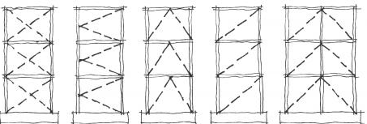
Fig 5.1: Common types of concentric bracing.
- Eccentric bracing: Eccentric bracing consists of diagonal braces located in the plane of the frame where one or both ends of the brace do not join at the end points of other framing members. The system essentially combines the features of a moment frame and a concentrically braced frame, while minimizing the disadvantages of each system.

The eccentric connection to the frame means an eccentric brace transfers lateral forces via shear either to another brace or to a vertical column. When properly proportioned, eccentric braced frames may exhibit a more ductile characteristic and greater energy dissipation capabilities than a concentric braced frame in the same material.
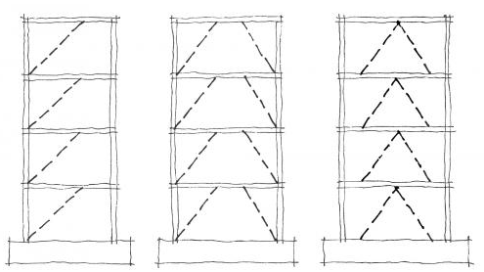
Fig 5.2: Common types of eccentric braced framing.

5.2 Cleaning timber and steel components.
The steel forms are more resistant, durable and last longer when compared to wooden formworks; plus, their reuse is more frequent. Steel formworks can be installed and removed easily and quickly. Using steel formworks ensures a better quality of the concrete surface and do not require further treatment.

Here is what makes a formwork perfect:
- Resistance against the pressure of fresh concrete, the speed of it welling up while being poured and it’s vibro-tamping.
- High quality and smooth finishing of concrete surfaces.
- Sturdy formation supported and efficiently reinforced both horizontally and vertically, in order to maintain shape and stability.
- Formwork materials must be economical, procurable and facilitate reutilization
- The formwork follows a precise positioning line, along with a smooth, flat surface.
- The material cannot get misshapen when exposed to weathering.

Why we select Steel formwork rather than wood formwork:
- The steel forms are more resistant, durable and last longer when compared to wooden formworks; plus, their reuse is more frequent.
- Steel formworks can be installed and removed easily and quickly.
- Using steel formworks ensures a better quality of the concrete surface and do not require further treatment.
- Steel formworks do not absorb moisture from concrete
- Steel formworks do not shrink nor deform.

5.3 Discard damage formwork components
The time from which the concrete is placed in formwork till the time the formwork is removed is called as supporting period. This time period will vary, based on different factors like:
- Type and grade of concrete
- Admixtures used in concrete mix
- The formwork designs
- Temperature
- The type of structural element (Columns/beams/slabs)
- Material quality
- Curing conditions

The following are the formwork safety checklist requirements:
- The formwork is designed for the structural element under consideration. The working drawing of the same have to be available at the site.
- The strength of the elements that is used as formwork must be sufficient to support the structural load as well as the load that is imposed.
- While designing the formwork, all the loads have to be considered including the loads coming during the process of casting.
- The rate of pour, the height of concrete pour, the sequence, the temperatures and the schedule of concrete pouring must be considered during formwork design.
- The formwork designing must take into consideration the safe bearing capacity of soil.
- The working drawing at site must include the detailed dimension of the compacting opening, the cleanouts.
- All props must be checked. They must lie over bearing plates.
- Defective props have to be removed

The major causes of formwork failure are:
- improper stripping and shore removal pattern by workers,
- inadequate bracing works
- vibration due to machines
- uneven level of soil under mudsills
- improper placing of shoring,
- unable to control on concrete placement during filling and
- lack of awareness to deep formwork

5.4. Cleaning screen and work areas
Benefits of Regular Drain Cleaning
- Improves the lifespan of your drain: Regular cleaning can actually increase the lifespan of your drains by minimizing the damage that can accumulate over time.
- Gets rid of bad odors: Drain cleaning removes food particles and debris that are trapped in drains. When you have your drains professionally cleaned, this can remove foul odors as well.
- Faster drainage and reduce clogs: Drains can be prone to obstructions over time, which can lead to serious clogs. Cleaning your drains can clear clogs and you’ll even notice faster draining as a result!
- Keeps expensive repairs at bay: When you schedule regular drain maintenance, you can often catch small issues before they turn into big problems. Whether you have aging pipes, overflowing pipes, or pipe-damaging clogs, your plumber will be able to spot these early on.

How To Prevent Drain Clogs:
- Be careful what you put down the sink, toilet, and shower drain
- Invest in a drain grate or screen
- Look at the drain stoppers in your sink every few weeks for any hair, soap buildup or other particles that have started to accumulate
- Avoid putting any over-the-counter chemical cleaners down the drain as they can cause issues with your pipes
- Run hot water down your bathroom drains every week to clear any buildup
- Have cold water running when your garbage disposal is on

5.5. Cleaning tools and equipment
Keeping track of your construction equipment and keeping it up to standard, although can seem daunting and time-consuming, is essential to reaching its full lifetime potential, as well as saving you time and money and helping keep machine operators safe.
It’s easy to just let your equipment look after itself and, once it’s worn out or broken, discard and replace it. However, regular maintenance and spending time on equipment will benefit you in many ways, and operators don’t like using a tired piece of equipment that no one can be bothered to maintain.

The following points indicate how to improve lifespan of equipments:
    - Read the User Guide
    - Use the Correct Equipment for the Job:
    - Know Your Machinery:
    - Inspect Regularly:
    - Carry out Regular Maintenance, Using a Schedule:
    - Replace Parts When Needed:
    - Clean After Use:
    - Repair and Refurbish, Rather Than Replace
    - Store Correctly
    - Use Quality Equipment
Self-check -5 | Written test

Name: __________________________________________ ID: ______________Date: _________

Directions: Answer all the questions listed below.
Test I: Short Answer Questions
    - Compare and contrast the difference between steel formwork and timber form work.(4pts)
    - How to remove damage formwork components(3pts)
    - How to prevent drain clogged?(5pts)
    - Write the factors affecting supporting period of the formwork.(5pts)
    - List the cause of formwork failure.(4pts)

Note: Satisfactory rating – 15 points above Unsatisfactory - below 15 points
You can ask your teacher for the copy of the correct answers

Operation Sheet -5

  - Techniques for safe removing of formwork
  - Tools and equipments
- Detaching /dismantling Tools
- Steel formwork fixed for concrete work
- PPE
- Cleaning liquid
- Support
- Transporting tools for storing
- Safe storage area
  - Procedures for safe removing of formwork
- Wait for the time required before dismantling.
- Unhook and take the loose elements off the formwork ( tie rods and connecting elements)
- Detach the form from the concrete surface with proper tools.
- Attach the unit to the crane and lift it up
- Unhook the stabilization struts if any
- Lift and move the unit up to the next site or temporary warehouse.
- Clean the panel as instructed
- You can now proceed with mantling the system.

LAP TEST-5 |  | Performance Test

Name: _________________________________________________ ID: ________________ Date: _____________________________

Time started: ________________________ Time finished: ________________

Instructions: Given necessary templates, tools and materials you are required to perform the following tasks within 1 hour. The project is expected from each student to do it.

Task 5.1: safely remove formwork.

LG #27 | LO #6 - Restore work site and equipment

Instruction Sheet- 6
This learning guide is developed to provide you the necessary information regarding the following content coverage and topics:
- Storing equipment, tools and materials
- Restore environmental improvements controls
- Maintaining workplace area.
This guide will also assist you to attain the learning outcomes stated in the cover page. Specifically, upon completion of this learning guide, you will be able to:
- Store equipment, tools and materials
- Restore environmental improvements and controls
- Perform Maintenance of workplace area.
Learning Instructions:
- Read the specific objectives of this Learning Guide.
- Follow the instructions described below.
- Read the information written in the information Sheets
- Accomplish the Self-checks
- Perform Operation Sheets
- Do the “LAP test”

Information Sheet - 6

6.1. Storing equipment, tools and materials

Material handling: is the process of moving, protecting, storing, and controlling materials throughout the construction process. It includes the steps taken when dealing with construction materials from when they're delivered to the construction site until when they're disposed of. On the other hand, material storage is a sub-section of the handling process. It involves holding construction materials in a safe place until these are required during the construction process.

Moreover, different materials need to be kept in special conditions to maintain their quality. In short, you should handle and store materials in a coordinated and organized process, so everyone knows their duties, safety protocols, and methods they need to employ:
- Train Your Workers
- Store Similar Materials Together
- Dispose Of Waste Construction Materials Appropriately
- Choose Storage Space
- know Each Storage Weight Limits
An efficient system of storekeeping has the following objectives:
- To prevent over-stocking and under-stocking of materials.
- To check all materials in terms of quality and quantity.
- To minimize storage costs.
- To ensure effective and continuous control over materials.
- To ensure optimal utilization of available storage space and workers.
- To protect materials from loss and wastage due to defective storage.
- To protect and safeguard material items from pilferage, theft, fire, and others.

The main factors that determine the location of stores in a manufacturing operation are outlined as follows:

    - Minimization of Material Handling Efforts
    - Nature of the Materials
    - Quantity, Weight, etc., of Materials
    - Flow of Materials:
    - Free from Risk of Loss:
    - Flexibility:

Factors to Consider to Decide Stores Layout
- Similarity: Items of a similar nature should be stored in one place for the sake of convenience and easy identification.
- Popularity: The turnover of each item should be considered to enable fast-moving items to be stored near the point of issue/usage.
- Size of Item: Items that are large or bulky in nature should be stored near the point of use.
- Nature of Materials: The nature of the materials to be stored is important in determining the layout of stores. Hazardous, sensitive, and perishable goods should be stored separately in safe places.
- Physical Movement of Materials: Strictly adhere to the principle of ‘first in, first out’ in the matter of physical movement of materials.
- Physical Facilities: To create an efficient layout, it is important to consider physical facilities such as lighting arrangements, ventilation, wall paint, availability of cranes, and other handling equipment.

  - Restore environmental improvements controls
Ecological restoration aims to recreate, initiate, or accelerate the recovery of an ecosystem that has been disturbed. Disturbances are environmental changes that alter ecosystem structure and function
There are Ten Simple Things You Can Do to help environmental improvements:
- Reduce, reuse, and recycle. Cut down on what you throw away. Follow the three "R's" to conserve natural resources and landfill space.
- Volunteer. Volunteer for cleanups in your community. You can get involved in protecting your watershed, too.
- Educate. When you further your own education, you can help others understand the importance and value of our natural resources.
- Conserve water. The less water you use, the less runoff and wastewater that eventually end up in the ocean.
- Choose sustainable. Learn how to make smart seafood choices.
- Plant a tree. Trees provide food and oxygen. They help save energy, clean the air, and help combat climate change.
- Don't send chemicals into our waterways. Choose non-toxic chemicals in the home and office.
Ecosystem Restoration types comprise:
- Erosion control.
- Reforestation.
- Removal of non-native species and weeds.
- Re-vegetation of disturbed areas.
- Daylighting streams.
- Reintroduction of native species, and habitat.
- Range improvement for targeted species.

Construction contributes to environmental damage both on a global scale, as well as locally. It is important to learn what impact construction causes in order to scale back damage.
Here are five ways to help limit environmental impact during your construction project.
- Limit Fuel Usage: Construction firm’s biggest negative impact on the environment is caused by the burning of fossil fuels, like gas and diesel
- Reduce Noise: Construction noise is a major source of noise pollution. Most of this noise is produced by machinery in site preparation, demolition, and landscaping.
- Properly Dispose of Waste: By salvaging, reusing and recycling existing materials, you can cut down on materials harming our precious earth.
- Utilize Reusable Technology: There are a lot of green building options that help you decrease a negative environmental impact. For example, inflatable water dams help combat erosion, water runoff, and prevents sedimentation.
- Expedite Your Project: By accelerating your construction project, you reduce traffic disturbances and also reduce associated emissions and fuel costs.

6.3. Maintaining workplace area.
When working in construction or similar occupations, it's important to keep the job site clean, well-maintained and free of hazards. A clean job site offers safety to those working there, which can help maintain productivity. A clean job site is one free of clutter and other debris. It follows a set list of organizational guidelines to help promote safety, productivity and other benefits for the employees, their leaders and the clients who contracted the work.
Construction work is one of the most dangerous professions, and work on the job site is where most accidents occur. Employers do need to mitigate safety hazards to construction workers, but workers need to keep in mind a lot of precautions themselves when working in such hazardous conditions.
Follow the following simple construction site safety rules to keep yourself, and others, safe.
- Wear your PPE at all times
- Do not start work without an induction
- Keep a tidy site
- Do not put yourself or others at risk
- Follow safety signs and procedures
- Never work in unsafe areas
- Report defects and near misses
- Never tamper with equipment
- Use the right equipment
- If in doubt, ask

Maintaining a clean job site offers many benefits that can help keep your employees safe and productive. Some of the most important reasons to keep your job site clean include the following:
- It's free of slip and trip hazards
- It makes work tools easier to find
- It sets a positive tone
- It encourages personal responsibility
- It helps leaders assess the work
- Tips for maintaining a clean job site

There are many ways to help maintain your job site. When keeping your workspace clean for yourself and employees, consider the following tips:
- Determine which areas need the most attention
- Create a checklist
- Establish accountability
- Designate areas for scraps and waste
- Use materials efficiently
- Use a dust collection system
- Perform a final clean

Self-check 6 | Written test

Name: __________________________________________ ID: ______________Date: _________
Directions: Answer all the questions listed below.
Test I: Short Answer Questions
    - List the main factors that determine the location of stores in a manufacturing operation (5pts).
    - What is material handling mean?(2pts)
    - How to maintaining workplace area (4pts)
    - What are the factors that limit environmental impact during construction project(5pts)
    - How to conserve construction environments? (4pts)

Note: Satisfactory rating – 15 points above Unsatisfactory - below 15 points
You can ask your teacher for the copy of the correct answers

REFERENCE MATERIALS

Books:
- Irrigation Engineering and Hydraulic Structures
- Irrigation Engineering and Hydraulic Structures by Santosh Kumar Garg
- Irrigation Engineering Books
- “Agricultural Drainage Engineering” by H V Parmar
- Humpherys, A.S. 1969. Mechanical structures for farm irrigation. J. Irrig. and Drainage Div., ASCE, 95(IR4):463-479. Humpherys, A.S. 1971

Web addresses:
- https://www.youtube.com/watch?v=aWG8tPHV5y0 (access date: 08, 2022)
- https://www.youtube.com/watch?v=I9_Nz9TeCo8 (access date: 08, 2022)
- https://www.youtube.com/watch?v=0hg04CmggTM (access date: 08, 2022)

AKNOWLEDGEMENT

Ministry of Labor and Skills and Ministry of ATVET wish to extend thanks and appreciation to the many representatives of ATVET instructors and respective industry experts who donated their time and expertise to the development of this Teaching, Training and Learning Materials (TTLM).

The experts who developed the learning guide
No | Name | Qualification | Educational background | Region | Phone number | E-mail
1 | Serawit Gensa | M.sc. | Water Resource Engineering | W/Sodo AVET | 0916740916 | serawitgen@gmail.com
2 | Edao Hassen | M.sc. | Irrigation Engineering | Alage AVET | 0911098097 | hassedao@gmail.com
3 | Mekete Agizew | M.sc. | Water Resource Engineering | Amhara. Kombolcha ATVET | 0925221192 | gen.mam09@gmail.com
4 | Wondu Alemayehu | M.sc. | Irrigation Engineering | Oromia Kombolcha ATVET | 0910-28-99-61 | woldualem@gmail.com
5 | Ademe Ayalew | M.sc. | Irrigation Engineering | Agrafa AVET | 0912720547 | Ademe2004@gmail.com
6 | Seid Mohammed | M.sc. | Irrigation& drainage Engineering | Alage ATVET | 09-17-18-01-81 | Siyamsdmhmmd@gmail.com
7 | Molalign Asfaw | B.sc. | Water Resource &Irrigation Engineering | Alage ATVET | 0921431096 | Mollalign410ass@gmail. com
8 | Yonas Hailu | B.sc. | Water Resource &Irrigation Engineering | Agrafa AVET | 0934715578 | yonashailuw@gmail.com
9 | Lemessa Mulata | M.sc. | Irrigation Engineering | Agrafa AVET | 0913266845 | Lamimulle2022@gmail.com
10 | Misganew Yimer | B.sc. | Soil and Water Engineering | Woreta ATVET |  | Misge1976@gmail.com
11 | Daniel Derese | Bs. c. | Soil and Water Engineering | W/sodo AVET | 0912-79-28-85 | danielderesse7@gmail.com
12 | Teshome Getachew | M.sc. | Irrigation & drainage Engineering | Alage ATVET | 0925-50-13-99 | teshomegetachew131@yahoo.com

