IRRIGATION AND DRAINAGE
Level-II

Based on March 2022, Version-3 Occupational standard



Module Title: - Irrigation Pumps
LG Code: AGR IRD2 M08LO (1-5) LG (28-27)
TTLM Code: AGR IRD2 TTLM 0822v1

August, 2022
Addis Ababa, Ethiopia

Table of Contents
Table of Contents I
Introduction to the Module 1
LO #1- Select site for irrigation pumps 2
Instruction sheet 2
Information Sheet 1 3
Self-check 1 7
LAP TEST-1 9
LO #2- : Pump installation and Operation 10
Instruction sheet 10
Information Sheet 2 11
Self-Check – 2 29
Operation Sheet -2 30
LAP TEST-2 31
LO #3- Pump Inspection 32
Instruction sheet 32
Information Sheet #3 33
Self-check - 3 35
Operation Sheet #3 36
LAP TEST- #3 37
LO #4- Pump Maintenance 38
Instruction sheet 38
Information Sheet #4 39
Self-check #4 53
Operation Sheet #4 54
LAP TEST #4 55
LO #5- Report maintenance activities 56
Instruction sheet 56
Information Sheet #5 57
Self-Check #5 60
Operation Sheet #5 61
LAP TEST #5 62
Reference Materials 63

Introduction to the Module
Introduction: Pumps are used to lift and move water from a source to the field. Many different pump types and energy sources exist. The pump selected should be the most appropriate for the physical and economic conditions. A pump makes the collection and application of water easier and within the control of farmers themselves. However, there are costs for using any pump the purchase cost, maintenance and repair costs and energy or fuel costs. You need to be aware of the various pumps that are available on the market, and understand something of their different characteristics uses and costs. Irrigation pumps are many and varied. Pumps used for irrigation can cover a range of applications including:

This unit covers the knowledge, skill and attitude of site selection for irrigation pumps. It requires the ability to select, install, operate, and carry out pre- and post-seasonal inspection, out routine maintenance activities on irrigation pump and store irrigation pumps.

Most irrigation pumps fall within the category of pumps that use kinetic principles that is centrifugal force or momentum in transferring energy. This category includes pumps such as centrifugal pumps, vertical turbine pumps, submersible pumps and jet pumps. Most of these pumps operate within a range of discharge and head where the discharge will vary as the head fluctuates

LG #28 | LO #1- Select site for irrigation pumps

Instruction sheet
This learning guide is developed to provide you the necessary information regarding the following content coverage and topics:
- Pump site selection
- Optimizing power suction & delivery head.
This guide will also assist you to attain the learning outcomes stated in the cover page. Specifically, upon completion of this learning guide, you will be able to:
- Select pumping site
- Optimize power suction & delivery head.
Learning Instructions:
- Read the specific objectives of this Learning Guide.
- Follow the instructions described below.
- Read the information written in the information Sheets
- Accomplish the Self-checks
- Perform Operation Sheets
- Do the “LAP test”

Information Sheet 1

1.1Pump site selection
Pump should be set on a firm, adequate foundation and securely fastened so that it will withstand the pump vibrations a well as the dead load of the pump and structure. The entire weight of the complete pump unit is supported by the base or floor plates.
- Required quantity of water should be available as the site.
- The pumping station should be at higher level above all the sources of contamination.
- The location site should be such that future growth and expansion may be possible.
- The source of water should be permanent.
In case site selection is not done properly, there will be scarcity of water causing permanent trouble.

1.2 Checking proximity of site
Many small irrigation schemes are located close to natural river channels and lakes and obtain water by pumping from these sources. They provide a supply which can be seen by the farmer and be judged whether sufficient or not for the seasonal needs of the farm. Usually, the pumping pressures, and hence energy requirements, needed to use such sources are small because the difference in elevation between the source water level and the level of the field are usually not large.
The Location of a Pumping Station
When the site for a pumping station is being selected, the following factors should be kept in mind:
- Drainage pumping stations almost always have to be located at the lowest point in the area. Soil conditions at such a site are usually poor. A foundation resting on different levels is not recommended because the bearing capacities of the soil may differ from one level to another;
- Groundwater levels will change after the canals and the pumping station become operational. It may be necessary to take measures to prevent excessive groundwater flow under the station;
- Pumping stations must be easily accessible. It must be possible to transport fuel by road or water, or to provide an easy link-up with the electric network;
- Pumping station should never be placed on or close to dikes that contains layers of high permeability(e.g. sand); nor should they be built on old dikes;
- New dikes and newly drained land are subject to varying degrees of subsidence, which are difficult to predict with accuracy. pipe line and concrete structures on or through new dikes should therefore be flexible;
- Trash and debris must be easily removed from the screens; a site must be available to deposit trash awaiting disposal.

1.3 Optimizing power suction & delivery head
Pump Head
The pump head or discharge head of a water pump is a measure of the power of a pump. The greater the pump head, the greater the pressure that the pump can generate. This statistic is measured in meters (or feet) and is calculated by placing a tube on a pump’s discharge and measuring the maximum height to which it can pump water.

A much more useful measure of the head is the difference between the liquid level in the suction tank and the head in the vertical discharge pipe. This number is known as the “total head” that the pump can produce.
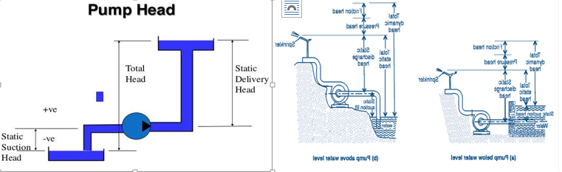
Fig.1.1: Head of pump
Pump suction
An aspect of using centrifugal and mixed flow pumps which is not always fully understood, and which can seriously impair efficiency, is the suction side of the pump.
In cases of shallow groundwater or surface water pumping, the pump is located above the water surface and water has to be sucked up a short length of pipe into the pump. The difference in height between the water surface and the pump is called the Suction lift.For operating convenience, pumps are usually located above the water source and a short length of pipe is used to draw water into the pump. This is the suction pipe and the difference in height between the water surface and the pump is the suction lift.

Total Dynamic Head: the total dynamic head of a pump is the sum of the total static head, the pressure head, the friction head, and the velocity head. The total static head is the total vertical distance the pump must lift the water. When pumping from a well, it would be the distance from the pumping water level in the well to the ground surface plus the vertical distance the water is lifted from the ground surface to the discharge point. When pumping from an open water surface it would be the total vertical distance from the water surface to the discharge point.
- Power sources for Water Pumping (pump)

- Solar
- Electricity
- Wind
- Water
- Engine
- Hand Pumps(human)

The pump may be driven by a power unit such as a diesel or petrol engine, or an electric motor. In some special cases solar or wind power, or even hand or animal power, may be used to provide the power source for the pump, but they are not so common and are generally limited to very small irrigated plots.
The distribution system conveys water from the pump to the fields and may consist of pipes or open channels. Some systems are a combination of both. The choice of distribution system has a significant effect on the energy demand.
The method of irrigation may be surface, sprinkler or trickle irrigation. This may also affect the choice of distribution system and is also significant in determining the energy demand. Surface irrigation may be supplied by either pipe or open channel systems. Sprinkler and trickle irrigation systems would normally use piped distribution systems.

Small-scale pumped irrigation systems are made up of the following components
- Water source
- pump and power unit
- Distribution system; and
- Method of irrigation
The water source, the distribution system and the method of irrigation determine the energy demand. The pump and power unit provide the energy supply. The amount of water abstracted and the height through which it must be lifted from the river or borehole add to the energy demand. The pump may be driven by a power unit such as a diesel or petrol engine, or an electric motor. In some special cases solar or wind power, or even hand or animal power, may be used to provide the power source for the pump, but they are not so common and are generally limited to very small irrigated plots.

The distribution system conveys water from the pump to the fields and may consist of pipes or open channels. Some systems are a combination of both. The choice of distribution system has a significant effect on the energy demand. The method of irrigation may be surface, sprinkler or trickle irrigation. This may also affect the choice of distribution system and is also significant in determining the energy demand. Surface irrigation may be supplied by either pipe or open channel systems. Sprinkler and trickle irrigation systems would normally use piped distribution systems.

Self-check 1 | Written test

Name…………………………………………… ID………………………… Date…….
Directions: Answer all the questions listed below.
Test I: Short Answer Questions (25%)
- List power sources for irrigation pump (5%)
- Write pump site selection methods (5%)
- How irrigation methods affect pump selection (5%)
- What are the components of small-scale pumped irrigation (treadle pump) (5%)
5. Explain what pump and proximity mean. (5%)

Operation Sheet -1
Procedures on site selection of irrigation pump
- Tools and equipment

- Note books
- Meter
- Pegs
- Pins

- Procedures
- Wear appropriate PPE
- Select suitable level ground
- Clean site free from unwanted substance
- Select adequate foundation
- Site withstand vibration of the pumps
- Site supply enough water
- Check Suction head
- Check delivery head
- Sources of water should be permanent as much as possible

LAP TEST-1 | Performance Test

Name………………………………. ID…………………………….. Date…………………………………….

Time started: ________________________ Time finished: ________________

Instructions: Given necessary templates, tools and materials (mentioned above) you are required to perform the following tasks within 1 hour. The task is expected from each student to do it.

Task-1:Perform the site selection for irrigation pump

LG #27 | LO #2- : Pump installation and Operation

Instruction sheet
This learning guide is developed to provide you the necessary information regarding the following content coverage and topics:
- Pump selection criteria
- Types of irrigation pump
- Components of pump
- Pump installation
- Pump operation
- Determining pump capacity (horse power)
This guide will also assist you to attain the learning outcomes stated in the cover page. Specifically, upon completion of this learning guide, you will be able to:
- Identify type of irrigation pump
- Identify components of pump
- Install and operate pump
- Maintain of irrigation pump
- Determine pump capacity (horse power)

Learning Instructions:
- Read the specific objectives of this Learning Guide.
- Follow the instructions described below.
- Read the information written in the information Sheets
- Accomplish the Self-checks
- Perform Operation Sheets
- Do the “LAP test”

Information Sheet 2

2.1 Pump selection criteria
Pump selection is the process of choosing the most suitable pump for a particular irrigation system. The performance requirements of the water system must be specified and the pump type must be selected. Alternate pumps that meet the requirements of the system also should be specified. Normally, the most suitable pump is chosen from these pumps considering economic factors.
The selection of pumps requires the use of manufacturers' pump curves. As a first step, by looking at the various pump curves we can identify a pump that can provide the discharge and head required at the highest possible efficiency. Following the identification of the pump, the NPHSR-Q curve is checked and evaluations are made to ensure that its NHPSA is higher than the NPHSR.
Most manufacturers provide four different characteristic curves for every pump: the Total Dynamic Head versus Discharge or TDH-Q curve, the Efficiency versus Discharge or EFF-Q curve, the Brake Power versus Discharge or BPQ curve and Net Positive Suction Head Required versus Discharge or NPSHR-Q curve. All four curves are discharge related.
Figure below presents the four typical characteristic curves for a pump, with one stage or impeller.
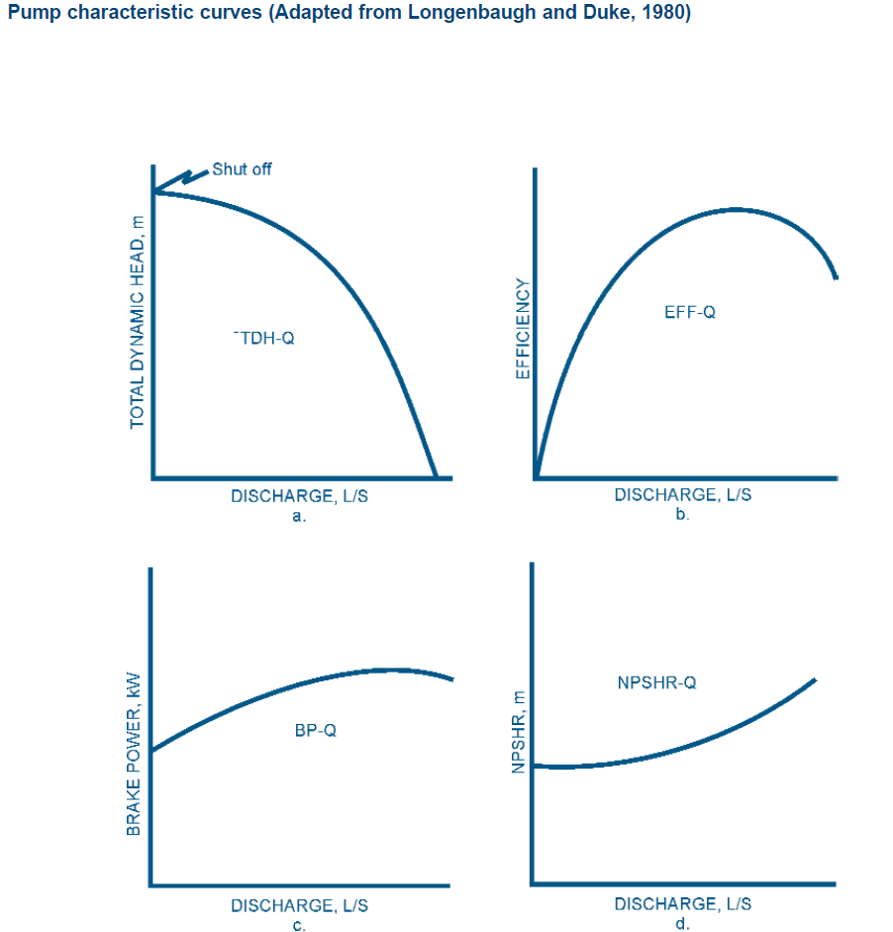
Fig.2.1: Pump characteristic curves

Classification of pump
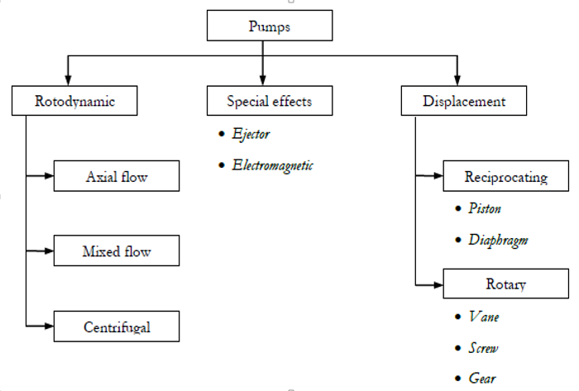
Fig 2.2. classification of pump
Measuring Pump Capacity
The capacity of a pump has two components, the pump discharge rate and the discharge pressure. The discharge rate is normally measured in gallons per minute (gpm) in English units or liters per second (lps) in metric units. Pressure is normally measured in pounds per square inch (psi) in English units or kilo Pascals (kPa) in metric units. It is necessary to measure both discharge rate and pressure. Under normal operating conditions in order to determine how the pumping system will operate as a part of an irrigation system. The cost of flow rate meters varies widely.
Brake horsepower (BHP) is the measure of an engine’s horsepower before the loss in power caused by the pump. This gives the operator an idea of what size pump or the amount of horsepower is needed to move the required amount of water with the best efficiency.
Calculating Horsepower
Horsepower is a measurement of the amount of energy necessary to do work. In determining the horsepower used to pump water, we must know the:
- Pumping rate in gallons per minute (gpm), and
- Total dynamic head (TDH) in feet.
The theoretical power needed for pumping water is called water horsepower(whp) and is calculated by:
$$WH=\frac{Q*TDH}{3960}$$
Where; WHP: water horsepower
Q:Flow rate in gallons
TDH:Total dynamic head(feet)

1.2Basic Pump Operating Characteristics
Suction Head: A pump operating above a water surface is working with a suction head. The suction head includes not only the vertical suction lift, but also the friction losses through the pipe, elbows, foot valves and other fittings on the suction side of the pump. There is an allowable limit to the suction head on a pump and the net positive suction head (NPSH) of a pump sets that limit. The total lifting head of the pump can be

$$TDH=HS+Hd+hf$$
Where:
Hs: Suction head
Hd: Delivery head
Hf: Head loss
The head loss by friction (hf) can be calculated using Equation 6 (Michael, 1978)
$$hf=\frac{flQ^{2}Q}{3d^{5}}$$

Where:
F: coefficient of friction
L: total length of pipe (suction plus delivery), m
D: diameter of pipe, m
Q: m3/s
Pump Power Requirements: The pump power requirement of a pump is determined by the work done by the pump in raising a particular quantity of water to some height. Work is defined as force time’s distance and Power is defined as work per unit of time or the rate of doing work. Work is required to lift water out of a well and the amount of water delivered in a unit of time can be related to power and is referred to units of horsepower.
The power added to water as it moves through a pump is:-

$$WHp=\frac{Q*TDH}{273}$$
Where:
WHp: Water Horse Power
Q: Flow rate in m cubic per hour (m3/hr)
TDH: Total dynamic head
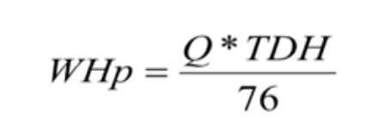
Where:-
Hp: horsepower
WHp: Water Horse Power
Q: Flow rate in l/s
TDH: Total dynamic head However, the actual power required to run a pump will be higher than this because pumps and drives are not 100 percent efficient. The horsepower required at the pump shaft to pump a specified flow rate against a specified TDH is the Brake Horsepower (BHP) which is calculated as :

$$BHP=\frac{WHP}{pump Eff}$$

Where:
BHP: Brake Horsepower (continuous horsepower rating of the pump unit)
Pump Eff Efficiency of the pump usually read from a pump curve and having a value between 0 and 1

Motor (drive) horsepower
The motor (drive) horsepower (MHP) can be calculated :

$$MHP=\frac{BHP}{Motor\left(drive\right)Eff}$$

Motor (drive) Eff Efficiency of the drive unit between the power source and the pump. For direct connection this value is 1, for right angle drives the value is 0.95 and for belt drives it can vary from 0.7 to 0.85.

A centrifugal pump is required to lift water at a rate of 150 l/s. Calculate the BHP of the engine from the following data:
- Suction head = 6 m
- Coefficient of friction = 0.01
- Efficiency of pump = 75%
Water is supplied to the field channel
Diameter of pipe 15 cm
Solution
Calculate for h;
TDH = hs+hd+h = 6m +0+hf, hd= 0 since water is supplied to the irrigation field directly, while hf to be calculated

$$hf=\frac{flQ^{2}Q}{3d^{5}}$$

Hence, TDH will be:
TDH = hs+hd+hf= 6+0+5.92 = 11.92 m
Then, BHP will be:

$$BHP=\frac{Q*TDH}{pump Eff x76}$$

BHP = 150 x11.92 = 1788/.57 = 31hp
.75x76

Note, when buying a pump, the following points shall be checked:
- Discharge
- BHP
- Head (total head)
- Efficiency of pump

2.1 Types of irrigation pump
Centrifugal pump
Centrifugal pumps are dynamic pumps. A centrifugal pump raises the pressure of the liquid by giving it a high kinetic energy and then converts it into pressure energy before the fluid exits the pump. It normally consists of an impeller (a wheel with blades), and some form of housing with a central inlet and a peripheral outlet. The impeller is mounted on a rotating shaft and enclosed in a stationary casing. Casings are generally of two types: volute and circular. The impeller design and the shape of the casing determine how liquid is accelerated though the pump.

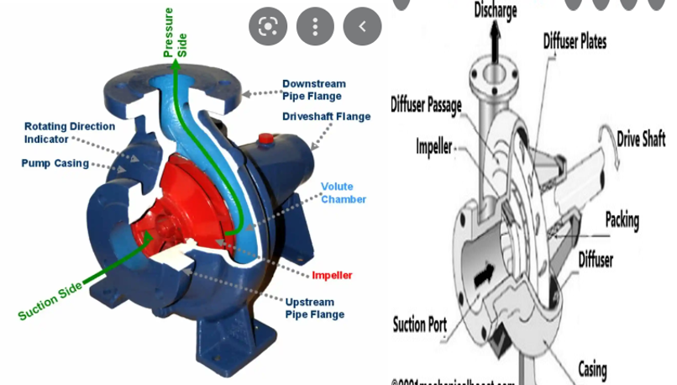
Fig.2.3: Centrifugal pump and parts
Submerged pump
A submersible pump is a centrifugal pump which is attached to an electric motor and operates while submerged in water. The sealed electric motor spins a series of impellers. Each impeller in the series forces water through a diffuser into the eye of the one above it. Submersible pumps are designed to prevent pump cavitation. The driver components inside are completely surrounded by the pumped fluid.
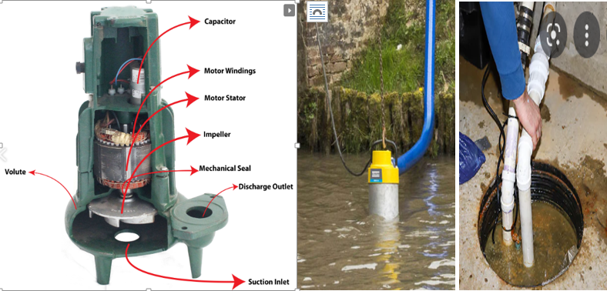
Fig.2.4: Submersible pump and parts

Treadle pump
Low cost water lifting technologies are important tools for resource poor farmers. They are mostly applicable in a condition where the lift requirement is less than 7 meters above the water surface.
The treadle pump is operated by moving two pedals while standing on the pump and can be operated for several hours as opposed to the more arduous process of hand pumping and hand watering. From low cost human powered pumps treadle pump is the most appropriate for extracting water from surface ponds and shallow wells as well.

The main difference is the positioning of the valves. A suction pump can merely raise water from a source, which then spills over for gravity irrigation. The pump therefore has to be at the highest level. The pumps can pump up to about 12 meters head, depending on the distance from the water source.
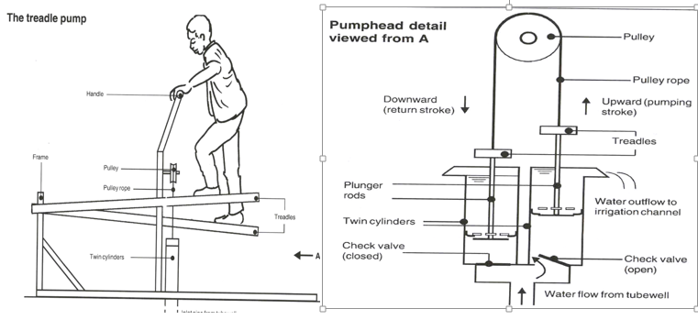
Fig.2.5: Treadle Pump
Rope and washer pump
The rope pump is being promoted for its low cost, ease of maintenance, availability of spare parts, good yield, and suitability for families/small groups. It does not have expensive pump rods, piston seals which need frequent replacement, or heavy and costly pump head works. The principles of its operation are described in Figure below. With no foot valve the riser pipe must always be filled by water lifted from well storage before discharge starts.
This is not a problem for shallow water tables but can be an effort at depths over 20m, where the weight of water can make the handle difficult to turn. To counteract this, the riser pipe on deeper wells is of smaller diameter as are the washers, and a second handle may be added.
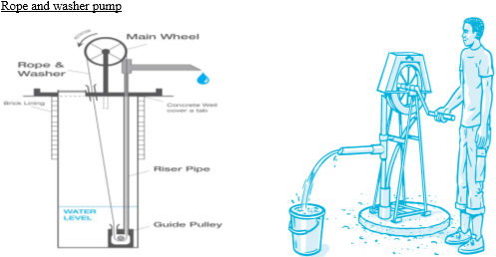
Fig.2.6 Rope and washer pump
Electrical driven pump
Electric motors are very efficient in energy use (75 - 85%) and can be used to drive all sizes and types of pumps. The main drawback is the reliance on a power supply which is beyond the control of the farmer, and which in many places is unreliable. Inevitably electrical power supplies usually fail when they are most needed. Heavy demands occur when crops need most water and so a power failure over several days can have disastrous consequences for a crop. When using trickle irrigation on light sandy soils, serious crop losses may well occur after only a few days without power.
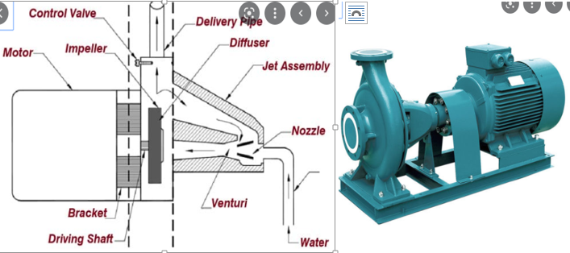
Fig.2.7: Electrical driven pump and parts
Engine driven pumps
An engine driven pump runs off gasoline or diesel and helps operators safely transfer fluids and chemicals in corrosive environments. Common uses include industrial, agricultural, manufacturing, flood recovery, and chemical operations.
The only difference between the two is how the explosions occur. Gasoline engines use a perfect mix of fuel and air that are compressed by the pistons and ignited from the sparks created by spark plugs. Conversely, in diesel engines the air is compressed before the fuel is directly injected into the combustion chamber.

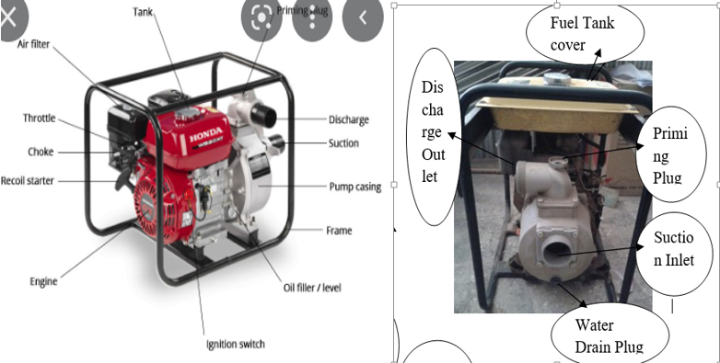
Fig.2.8: Engine driven pump and parts
Solar pump
Solar Water Pumping System can help offset the cost of traditional irrigation fuels. The more often a pump is run, the greater the opportunity for savings from solar. Solar pumps are reliant exclusively on the sun to provide power and therefore operate only during daylight hours unless coupled with a battery/storage system. Solar pumps may be a good option for lower water volume and daytime irrigation systems. As yet, affordable solar technology is unable to supply sufficient power to pump enough water for large-scale flood irrigation.
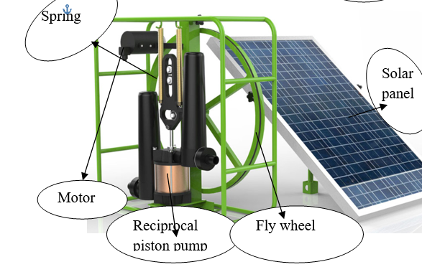
Fig.2.9: Solar pump and parts
2.2 Components of pump
The main components of irrigation pumps are:
- Suction hose: - It is connected to the suction side of the pump. It is two types.
The hard suction hose, and the flexible suction hose.
- Delivery hose:- It is connected to the delivery side of the pump.

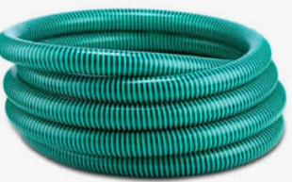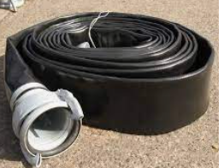

Fig 2.10: Section and delivery hose

- Foot valve: A foot valve is found at the end of a pipe line in a suction lift application. They function as a check valve, but they also have a strainer affixed to their open end. The check valve is spring assisted. When the pump turns on, the pressure inside the pump column changes and the valve responds by opening. Foot valves are beneficial because they prevent damage to water pumps that can occur due to dry runs, as well as stopping wastage of energy. These valves are a necessary part of all water pumping systems.

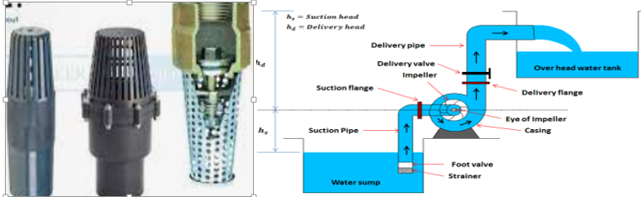
Fig.2.11: Foot valve and application

Impeller: - Impellers is a rotating disc, having bore in the middle which has to couple with motor shaft. The source of driving force transfers through shaft and connection at the bore of impeller at the center.

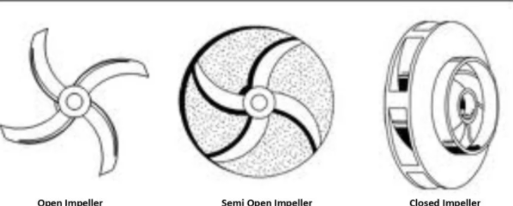

Fig: 2.12: Impeller types
Shaft:- The purpose of the shaft is to convert energy from the motor into the end use application.

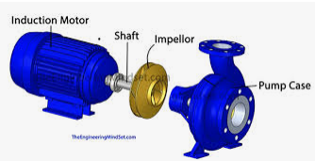
Fig: 2.13: Shaft:

Bearing:The pump bearings support the hydraulic loads imposed on the impeller, the mass of impeller and shaft, and the loads due to the shaft coupling or belt drive. Pump bearings keep the shaft axial end movement and lateral deflection within acceptable limits for the impeller and shaft seal.

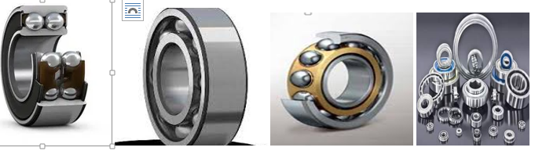
Fig.2.14: Types of bearing
Stuffing box;- also called a stuffing gland, packing gland or packing box—forms a seal between the prop shaft and the hole in the hull through which the shaft passes while allowing the shaft to turn freely.
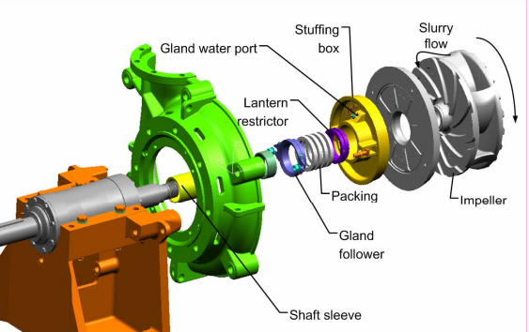
Fig.2.15: Stuffing box

Flanges and coupling:-Flange coupling comprises two cast iron flanges fitted at the end of each shaft. These flanges are bolted together with bolts to complete the drive. Bringing two tubes together in a sealed manner can represent these types of flange coupling Flanges are fitted or provided at the end of shafts. The flanges are tightened together by means of a number of nuts and bolts. One of these flanges or chutes is fixed at the end of each shaft

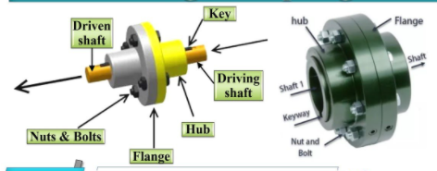
Fig.2.16: Flange coupling

Seal: - The mechanical seal acts as a check valve and a slider bearing. The obvious function is that of a check valve to prevent liquid under pressure from leaking out of the pump, or from drawing air into the pump when under vacuum conditions.
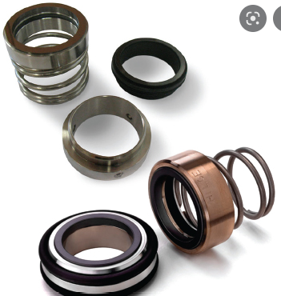
Fig.2.17: Seal
2.3 Pump installation
When the correct type of pump has been selected it must be installed properly to give satisfactory service and be reasonably trouble-free. Pumps are usually installed with the shaft horizontal, occasionally with the shaft vertical (as in wells).
- Coupling
Pumps are usually shipped already mounted, and it is usually unnecessary to remove either the pump or the driving unit from the base plate. The unit should be placed above the foundation and supported by short strips of steel plate and wedges. A spirit level should be used to ensure a perfect levelling. Levelling is a prerequisite for accurate alignment.

To check the alignment of the pump and drive shafts, place a straightedge across the top and side of the coupling, checking the faces of the coupling halves for parallelism.
The clearance between the faces of the couplings should be such that they cannot touch, rub or exert a force on either the pump or the driver
- Grouting
The grouting process involves pouring a mixture of cement, sand and water into the voids of stone, brick, or concrete work, either to provide a solid bearing or to fasten anchor bolts. A wooden form is built around the outside of the bedplate to contain the grout and provide sufficient head for ensuring flow of mixture beneath the only bedplate. The grout should be allowed to set for 48 hours; then the hold-down bolts should be tightened and the coupling halves rechecked.
- Suction pipe
The suction pipe should be flushed out with clear water before connection, to ensure that it is free of materials that might later clog the pump. The diameter of the suction pipe should not be smaller than the inlet opening of the pump and it should be as short and direct as possible. If a long suction pipe cannot be avoided, then the diameter should be increased. Air pockets and high spots in a suction pipe cause trouble. After installation is completed, the suction pipe should be blanked off and tested hydrostatically for air leaks before the pump is operated.
A strainer should be placed at the end of the inlet pipe to prevent clogging. Ideally the strainer should be at least four times as wide as the suction pipe. A foot valve may be installed for convenience in priming. The size of the foot valve should be such that frictional loses are very minimal
- Discharge pipe
Like the suction pipe, the discharge pipe should be as short and free of elbows as possible, in order to reduce friction. A gate valve followed by a check valve should be placed at the pump outlet. The non-return valve prevents backflow from damaging the pump when the pumping action is stopped. The gate valve is used to gradually open the water supply from the pump after starting and to avoid overloading the motor. The same valve is also used to shut off the water supply before switching off the motor.

2.4 Pump operation
There are several types of pumps available on the market. All pump manufacturers provide users' operation and maintenance manuals specific to their pumps. These have to be closely adhered to in order to ensure the most efficient operation of the pump and avoid unnecessary pump breakdowns.In view of the wide variety of operational instructions, which can be expected for different pumps, only general guidelines can be provided here

Manual pumps are operated by people or animals, whereas motorized pumps are operated by prime movers, engines and electric motors. In general, the principles of operation of pumps are the same. The discharge and pumping head relationship of all pumps is dependent on the type of pump and the amount of energy that the manual operator or prime mover can transfer to the pump, among other factors. Since the principles of pump operation are the same, this section will deal with the general aspects of pump operation, but with specific reference to motorized pumps.
- Pump start-up and shut-down
There are certain procedures that are recommended by pump manufactures before any pump start-up. Some of the pre-start-up inspections recommended immediately after pump installation are checking for correct pump-motor wiring connections, valve connections, shaft and gland clearance. It has to be remembered that starting a pump dry will cause seizing or destructive wear between the pump components. Therefore, pumps that are not self-priming or those with a positive suction lift should be primed before they are started. Different manufacturers also have specific instructions for pump shut down after operation. These have to be adhered to strictly.
- Priming
While deep well pumps, such as submersible pumps, are submerged into the water and have no need for priming, the well-known horizontal centrifugal pump usually needs priming. Priming is the process of removing sufficient air from the pump and the suction pipe so that theatmospheric pressure can cause the flow of water inside the pump.
The pump must not be run unless it is completely filled with liquid, otherwise there is danger of damaging some of the pump components. Wearing rings, bushings, seals or packing and internal sleeve bearings all need liquid for lubrication and may seize if the pump is run dry.
- Starting the pump
The pump is started with the gate valve closed. This is because the pump operates at only 30-50% of full load when the discharge gate valve is closed. In cases where the pump is below the water source, the pump can be started with an open gate valve. To avoid water hammer, the gate valve has to be opened gradually until it is fully open
- Stopping the pump
The first step is to close the gate valve. This eliminates surges that may occur in case of an abrupt closure. When this has been done, the prime mover is then closed or shut down. If the pump remains idle for a long time after it is stopped, it gradually loses its priming. Thus the operator should re-prime the pump every time before start-up.

Self-Check – 2 | Written test

Name…………………………………………… ID………………………… Date…….

Directions: Answer all the questions listed below.

Test I: Short Answer Questions
1.Explain how treadle pump is working (5%)
2. Write procedure must be followed to start engine pump. (5%)
3.List and explain components of pump (5%)
4. What is the difference between delivery and suction hose (5%)
5.What are the pump selection critera?(5%)

Note: Satisfactory rating - 25 points Unsatisfactory - below 20 points

You can ask you teacher for the copy of the correct answers.

You can ask you teacher for the copy of the correct answers.

Operation Sheet -2

- Techniques of installing pump
- Tools and equipments

- Pump (Treadle pump)
- PPE
- Suction hose
- Foot valve and screen filter
- Delivery hose
- Connectors

- Procedures/Steps/Techniques
- Use users' installation manual
- Select site
- Connect screen filter and foot valve together
- Connect screen filter and foot valve together with suction hose
- Connect treadle pump with suction hose
- Connect delivery hose to treadle pump

2.2 Techniques of pump operation
- Tools and equipment’s

- Pump ( small engine pump)
- PPE
- Fuel and oil
- Screw and wrench
- Connectors

- Procedures
- Use users' operation manual
- Ready necessary materials to the site
- Check Oil and fuel level
- Check fuel line whether chock open or close
- Prime the pump
- Adjust speed level to the minimum
- Stand firmly 45 degree and pull starting handle until feel resistance
- Push the decompression level down and release (diesel engine) if gasoline on ignition line
- Pull the rope fast and release if pump not start try again step 3-10
LAP TEST-2 | Performance Test

Name………………………………. ID…………………………….. Date…………………………………….

Time started: ________________________ Time finished: ________________

Instructions: Given necessary templates, tools and materials (mentioned above) you are required to perform the following tasks within 1 hour. The project is expected from each student to do it.

Task-1:Perform installing and operation of treadle pump
Task-2:Perform operating of small engine pump

LG #30 | LO #3- Pump Inspection

Instruction sheet
This learning guide is developed to provide you the necessary information regarding the following content coverage and topics:
- Performing pre-season and day to day inspection
- Performing annual or post seasonal inspection

This guide will also assist you to attain the learning outcomes stated in the cover page. Specifically, upon completion of this learning guide, you will be able to:
- Pre-season and day to day inspection
- Annual or post seasonal inspection

Learning Instructions:
- Read the specific objectives of this Learning Guide.
- Follow the instructions described below.
- Read the information written in the information Sheets
- Accomplish the Self-checks
- Perform Operation Sheets
- Do the “LAP test”

Information Sheet #3

- Pre-season and day to day inspections
Running through a checklist of inspections and repairs for each irrigation system greatly improves the chance of being able to start irrigating the day the crop needs it.
A visual inspection test is performed on the pump to determine the conditions of the pump and all it's components. Pumps are inspected to ensure that the product contains no small air leaks, oil leaks, or grease leaks.
There are certain procedures that are recommended by pump manufactures before any pump start-up. Some of the pre-start-up inspections recommended immediately after pump installation are checking for correct pump-motor wiring connections, valve connections, shaft and gland clearance. It has to be remembered that starting a pump dry will cause seizing or destructive wear between the pump components. Therefore, pumps that are not self-priming or those with a positive suction lift should be primed before they are started. Different manufacturers also have specific instructions for pump shut down after operation. These have to be adhered to strictly.
- Day to Day Inspections
- Inspect bearings and oil rings through filling ports
- Wipe bearing covers clean
- Check oil leaks at the gaskets
- Self-flush pumps - Hand check the flush line temperature to determine flow through the line

- Routine inspections
Weekly to monthly should examine oil level and condition, noise and vibration, bearing temperatures, leaks from the pump housing, leaks from pipe connections, cracks in pipes or hoses, discharge pressure, intake pressure, seal integrity, and operating temperature.
- Pree-season Inspections(checks)
- Clean and inspect foot valve (if applicable)
- Inspect suction and discharge piping for corrosion and leaks
- Fully close and open all valves to ensure they are still functioning
- Ensure air valve on discharge is functioning and sealing
- On systems drawing from a water source below the pump, ensure the suction assembly rises to th pump flange i.e. ensure there is no high point above the pump flange this includes the fitting bolted to the pump flange
- Ensure system is primed / priming pump or system working if applicable
- Spin the pump by hand if possible to ensure it is free
- Run the pump
- Check pressure gauges are working, replace as necessary
- If they do get frost damage, consider fitting a drain so you can vent the gauge and only pressurise it when required
- Check it runs up to pressure – note pressure
- Check pump rotation direction – Phase switching can occur with works outside the property
- Check for leaks around pump station and from the pump mechanical seal or gland packing
- Test and control systems
- Check water meter is functioning and check flow rate
- Annual or post seasonal inspection
- Check stuffing box, glands, lantern ring, mechanical seal and rectify if necessary
- Check condition of gaskets; replace if needed to prevent water leaks
- Assess vibration level with instruments if available; otherwise rely on manual observation and assessment
- Seasonal inspection for motor pump
- Clean the bearing housing and examine it for signs of wear, grooving etc.
- Clean and flush the bearings with kerosene and check them for signs of corrosion, wear and scratches. Immediately after cleaning, the bearings should be coated with oil or grease to prevent accumulation of dirt or moisture
- Check and correct the alignment of the pump and the motor drive. The pump and motor should be decoupled while correcting the alignment
- Examine shaft sleeves for wear or scour and necessary rectification. (If shaft sleeves are not used, the shaft at gland packing’s should be examined for wear)
- Grease all moving parts of motor to control corrosion
- Clean calamine in exhaust pipe
Self-check - 3 | Written test

Name…………………………………………… ID………………………… Date…….
Directions: Answer all the questions listed below.
Test I: Choose the best answer (1 point)
- Pree-season inspection (check):
- Fully close and open all valves to ensure they are still functioning
- Wipe bearing covers clean
- Check oil leaks at the gaskets
- Self-flush pumps
- Not annual or post seasonal inspection:
- Check stuffing box D. Check glands
- Check lantern ring E. Check mechanical seal
- None
- Routine inspections should examine:
- Oil level and condition D. Noise and vibration,
- Bearing temperatures E. Leaks from the pump housing
- All
Test II: Fill in the blanck
- Running through a ____________ and ________ for each irrigation system greatly improves the chance of being able to start irrigating the day the crop needs it.
- A _________________ is performed on the pump to determine the conditions of the pump and all it's components.

Note: Satisfactory rating - 5 points Unsatisfactory - below 5 points

Operation Sheet #3

- Perform seasonal inspection of pump
- Tools and equipments
- Measuring Tape  - Dial Calipers.  - Custom Measurement Gauges.  - Air Gauge. | - Check Lists.  - Check Sheets
- Procedures to perform seasonal pump inspection
- Check free movement of the gland of the stuffing box; check gland packing and replace if necessary
- Clean and apply oil to the gland bolts
- Inspect the mechanical seal for wear and replace if necessary
- Check condition of bearing oil and top up if necessary
- Seasonal inspection for pump
- Check impeller for pitting or any other signs of wear.
- Check impeller clearance.
- Check interior of pump (volute, casing and diffuser) for pitting, erosion and rough surface
- Check and change oil in seal and motor housing

LAP TEST- #3 | Performance Test

Name………………………………. ID…………………………….. Date…………………………………….
Time started: ________________________ Time finished: ________________

Instructions: Given necessary templates, tools and materials you are required to perform the following tasks within 4 hour. The project is expected from each student to do it.

Task-1: Perform seasonal inspection of pump.

LG #31 | LO #4- Pump Maintenance

Instruction sheet
This learning guide is developed to provide you the necessary information regarding the following content coverage and topics:
- Perform maintenance activities
- Maintain small motor and manual irrigation pump
- Flushing and cleaning pump components

This guide will also assist you to attain the learning outcomes stated in the cover page. Specifically, upon completion of this learning guide, you will be able to:
- Maintenance activities
- Small motor and manual irrigation pump maintenance
- Flushing and cleaning

Learning Instructions:
- Read the specific objectives of this Learning Guide.
- Follow the instructions described below.
- Read the information written in the information Sheets
- Accomplish the Self-checks
- Perform Operation Sheets
- Do the “LAP test”

Information Sheet #4

Maintenance: is the act of keeping something in good condition by checking or repairing it regularly. To keep in an existing state (as of repair, efficiency, or validity) : preserve from failure or decline maintain machinery.
Pumps are often designed to operate at a single point known as the Best Efficiency Point (BEP). As components begin to wear, a pumps performance begins to decline, with operation away from this point leading to issues such as accelerated bearing or seal wear, vibration, excess temperature rise or cavitation. Quite often declining performance can start gradually, before quickly accelerating until failure if performance issues are not addressed in a timely fashion.
- Maintenance is required to:
- Keep the pump system in top operation condition at all times.
- To obtain the longest life and greatest use of the system is facilitates by providing adequate maintenance and replacements.
- To achieve the above two objectives at the lower possible cost.
- Inspection during Maintenance:
- Pump Impeller.  - Mechanical Seal | - Gland Packing.  - Shaft Sleeve | - Relieve Valve.  - Pump Element (PD).

- Maintenance Activities
Pump maintenance is needed to restore performance, reliability and ensure process performance is restored to original design criteria.There are 3 types depending onreactive and proactive:
- Corrective (Reactive)  - Preventative (Semi Proactive | - Monitoring (Proactive & Predictive)
- Corrective Maintenance is undertaken when failure has occurred. The unit may be leaking, efficiency reduced, pump stopped or motor tripped, leading to loss of production resulting in an urgent situation where parts must be sourced and fitted quicky.
At times specialist labour may be required but also specialist lifting equipment. The average cost of downtime is £12K per incident, takes on average 8 hours to resolve and occurs 4 times a year. This is without considering customer dissatisfaction, and product wastage, so ideally this situation is one to be avoided.
- Preventative Maintenance is inspection and repair scheduled at specific intervals (daily, weekly, monthly, yearly) or based on the number of hours run. Visual inspections are made externally and internally by dismantling the unit, replacing seals such as gaskets and mechanical seals, with pump parts checked for wear.

A Typical Preventative Maintenance Checklist Consists of:
Differential Pressure: Check the operating pressure by calculating the difference between the inlet and outlet pressure of the pump ensuring it is operating on curve.
. 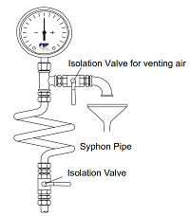
Fig.4.1: Pressure gauge assembly
Vibration – Ensure vibration is minimal, and within designed limits.
Noise – Check for high pitched squealing, grinding, or the sound of gravel within the pump (cavitation). Check noise limits are within design limits.

Excess Temperature – Check motor, bearing and casing temperature. Thermal imaging cameras can detect excess temperature quickly, without stoppage, dismantling or contact with the unit.
Corrosion – Check for corrosion on parts such as main body, flanges, impeller & casing plug.
Gaskets – Monitor swelling, Wear or leaks from the casing.
Wearing Part Tolerance – Check parts are within design tolerance through use of a vernier. Measure Shaft OD and condition, Impeller Diameter, bearing tautness around the shaft and casing thickness.
Motor Measure current draw, continuity of windings and condition, whether bearings should be renewed, grease & oil levels.
Mechanical Seal (barrier fluid) – Check for contamination such as changes in general colour or appearance, PH, presence of particles, viscosity, or if fluid is at excess temperature during operation.
Clogging - The presence of solids can result in the clogging of impellers or valves if the pump is not capable of handling the size of the solids that have attempted to pass through. You will usually notice clogging quite quickly as the pump will not be delivery the same quantities of fuid.
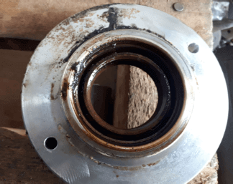
Fig.4.2: Seal leak causing bearing contamination and subsequent failure
Maintenance Types based on Irrigation Seasons
- Pre-season maintenance is maintenance activity done before starting operation of pump system for new season. It can allow the grower to realize the full benefits of irrigation system. Before you begin operating the pump system each year, you should prepare your pump system for the new season.
Before placing the system into service each season, it is necessary to check components of the pump system. Pre-season maintenance may include Checking, inspecting and servicing pumps operation.
- Post-season maintenance is the maintenance activity done after the completion of irrigation works or after completion of irrigation operation season.
Activities undertaken during post-season maintenance may includes Draining and flushing diesel tanks of diesel sediments, treating and flushing the system, capping open pipes on fixed systems, and covering fixed systems to protect from environmental degradation.
Maintain pumps and all system components in virtually new condition to avoid efficiency loss. Wear is a significant cause of decreased pump efficiency. Bearings must be properly lubricated and replaced before they fail. Shaft seals also require consistent maintenance to avoid premature mechanical failures. Most important is the renewal of internal wearing ring clearance and the smoothness of impeller and casing waterways.
Equipment Cleaning - It is important to clean all equipment during and especially at the end of each work day. Thorough flushing of pumps, tanks, and hoses with clean water is a necessary standard procedure for both health and safety of personnel as well as equipment care and longevity.
- Routine maintenance are maintenance activities such as regular inspections or machine servicing. Routine maintenance is done on a regular basis, whether that be daily, weekly, monthly, or yearly. Routine maintenance is an important part of keeping systems up to date and functional.

Typical examples of routine maintenance include:
- Lubricating, cleaning, or adjusting machinery
- Inspecting equipment to ensure proper operation and safety
- Replacing parts that show deterioration
- Checking, testing, and maintaining safety equipment, such as safety barriers, fire extinguishers, or alarm systems
- Checking for and replacing damaged signage or utilities, like light bulbs
- General workplace maintenance, such as cleaning floors, replacing HVAC filters, and washing windows, trash removal, and landscaping
- Periodic maintenance refers to activities performed on equipment based on a set time interval. The purpose of periodic maintenance, or time based maintenance, is to maintain smooth operation of a machine or other asset.
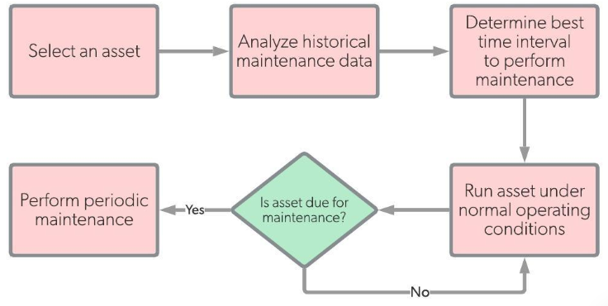
Fig. 4.3: sequance of periodic maintanance

- Small Motor and Manual Irrigation Pump
- Motor Pump Maintenances
In real applications, breakdown of pumps is a common event. The typical failure causes are:
- Mechanical seal failure
- Excessive vibrations
- Pump rubbing or seizure
- Inadequate performance (flow rate, head developed, power consumption)
- Leaking casing.
Before a pump is removed for a repair or an overhaul, it is essential to know the failure type before its dismantling in the workshop. Thus prior to the removal of the pump the following exercise must be conducted:
- Check with the operating cause on the perceived cause of failure
- If it is safe to operate the pump, rerun it to diagnose failure by
- Sight, smell, noise, and touch
- Perform a vibration analysis
- Measure bearing temperatures
- Carry out a performance check.
The above steps will positively indicate the probable cause of failure and ascertain that it is specific to the pump and not to the process or pumping system, which includes the suction and discharge system associated with the pump. If the above analysis indicates the problem is due to the pump, the following sequence of field checks are recommended:
- Check flush lines and quench lines for leak, corrosion, or plugging
- Check the balance line if included in the pump design
- Check the suction strainer for blockage and insure all valves are open
- Visually check the oil condition and the oil level
- Check coupling for wear or lack of grease
- Check the condition of the gages
- Observe the condition of the base plate and pump supports
- Isolate and danger tag the pump valves and motor (pad lock motor switch)
- While dismantling notice the pipe strain on the pump
- Once the pump is decoupled, measure the radial and end clearance of both the pump and the motor
- Maintenance plan
- After start-up the pump will need to be checked at least at the following intervals to make sure it is pumping properly and not making strange noises: 10 min. / 1 hour / 10 hours / 1 day / 1 week / 1 month. Inspection may take place thereafter at monthly intervals provided the conditions of use do not change.
- Every month, if present, check and adjust the packing seal.
- Every month check the ball bearing (Pos. 38) with regard to wear or noise. If necessary replace it to avoid the explosion hazard due to high temperature.
- Every 3 months, if present, lubricate the ball bearings. See.
- Every 3 months, if present, change the quench liquid in the quench reservoir.
- Every 6 months clean the pump and the motor. If necessary, check more frequently.
- Every 5-10 years make a general pump recondition.

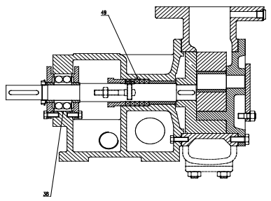
Fig.4.4: Balls in pump bearing
- Quench reservoir +O2
- The purpose of the reservoir is to keep a quench liquid inside the mechanical seal, preventing any contact between pumped liquid and air.
- The most suggested quench liquids are viscous, thermo stable oils, compatible with the pumped liquid (e.g. Vaseline, glycerine, glycol, Balistol).
- Install the quench reservoir after the ¼” curve, near the seal.
- Unscrew the cap of the quench reservoir and fill half of the glass with the quench liquid.
- The level of the quench liquid can increase or decrease according to the temperature and the tightness of the seal. Should the liquid overflow, drain the quench liquid up to half of the reservoir and each day during one week check if the mechanical seal is tight. If not, replace the mechanical seal.
- Every 3-4 months drain the liquid through the ¼” taps near the mechanical seal and re-fill the reservoir with non-used quench liquid.
- Shaft seal
- The pump is equipped with one shaft seal of the following types:
- Packing seal: If the leakage along the packing is excessive, tighten the nuts of the eye bolts gradually.

- Mechanical seal:
- Single: maintenance free.
- Double, tandem: with reservoir
- Double, back to back: according to API Plan 53 (min. 1 bar over the pump pressure).
- Magnetic coupling: Is maintenance free.
- Replacement of packing rings

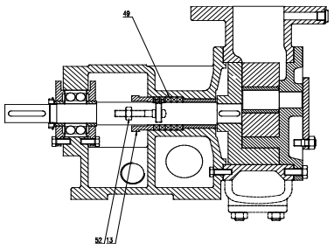
Fig.4.5:Packing rings
- Loosen the screws (Pos. 52) and push the packing gland (Pos. 13) to the rear.
- Remove the old packing rings (Pos. 49) and clean the packing space.
- Check the surface of the shaft with regard to wear and, if necessary, replace the shaft.
- Insert new packing rings one by one, and pre-seal them with the cut ends offset by 180°.
- Slide in the packing gland (Pos. 13) and screw in the screws (Pos. 52) by hand.
- Start-up the pump like a first time.
- Bearing
- The pump is equipped with bushings which are maintenance free as either lubricated by the liquid being pumped or self-lubricated.
- The ball bearing on the pedestal is generally maintenance free. Some have grease nipples and have to be lubricated every 500 operating hours or every 3 months with just one hub of grease.

- Rotor axial adjusting
- If pressure and/or capacity of the pump is no more sufficient, the axial clearance of the gears can be set-up by adjusting the rotors. This is not possible for magnetic coupling pumps that can only be adjusted with thicker cover gaskets (1-3 gaskets).
- A high axial clearance is better against wear and high viscosity, but worse for the pumping pressure and self-priming with low viscosity products.
- Adjusting:
(a) Loosen the inner bearing cover.
(b) Tighten the outer bearing cover.
(c) Loosen the outer bearing cover screws.
(d) Re-tighten the inner bearing cover.

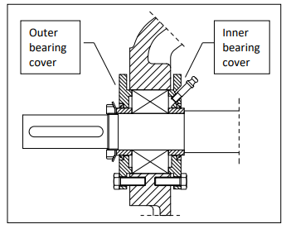
Fig.4.6: Bearing cover
- Manual Irrigation Pump Maintenance
Manual pumps are operated by people or animals, whereas motorized pumps are operated by prime movers, engines and electric motors. In general, the principles of operation of pumps are the same.
The discharge and pumping head relationship of all pumps is dependent on the type of pump and the amount of energy that the manual operator or prime mover can transfer to the pump, among other factors.

- Treadle Maintenance
If a treadle breaks than all you have to do is disconnect it from the pivot points, the wood blocks on the rod at the back of the pump, and from the pistons and simply reconnect a new board.
- Seal maintenance:
- Lubricate the piston seals with vegetable shortening (such as Crisco) or vegetable oil.
- After using the pump, removing the pistons from the cylinders will help the cylinders dry and prevent rot. However, doing this may allow the lower seal to flare out and make it difficult to put the pistons back in the cylinder. One solution would be to remove the piston almost completely from the cylinder, leaving the very bottom of the bottom seal in the top of the cylinder. This will allow the seals to dry but make sure the bottom seal holds its shape.
- The seals may eventually begin to rot. When the seal rots, it will need to be replaced. Customers should be able to manufacture replacements by attaching a wet leather disc to the piston (in the position of the top seal), and forcing it into the cylinder as though the pump is about to be used.
- Cylinder Maintenance:
The one way valve flaps may eventually become worn or break. A new flap could easily be cut from an old inner tube or other scrap of thin rubber. The plug of the water chamber can be unscrewed for easy access. Broken Elbows can be repaired with PVC primer and cement.

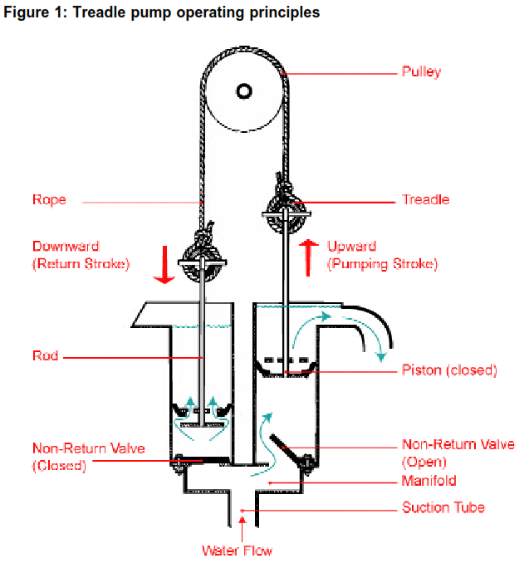
Fig.4.7 : Treddle pump
- Rope Pump Maintenance
- Replacement of pistons
- The pistons should be changed, when the user has noted a reduction output.
- Before changing the pistons, check the clearance in a piece of riser main to check whether a reduced output is due to worn-out pistons.
- Painting
To avoid corrosion, it is essential to paint parts again that start corroding.
- Clean the parts with a steel brush and roughen it with sand paper.
- Then apply anticorrosive primer paint, and when it’s completely dry, finish it with paint. Allow the paint to dry in the shade, NOT in the sun.
- The bushings
If bushings are worn out, dismantle and replace them. (If properly oiled, bushes last for 10 years or more!)

- PVC tubing
- If a pump is placed in direct sunlight, the ultra-violet rays will affect the PVC parts, causing cracks. (To prolong life of PVC, paint it!)
- If the well contains fine sand, the sand will wear out PVC parts as well. In case wear is excessive, replace tubing.
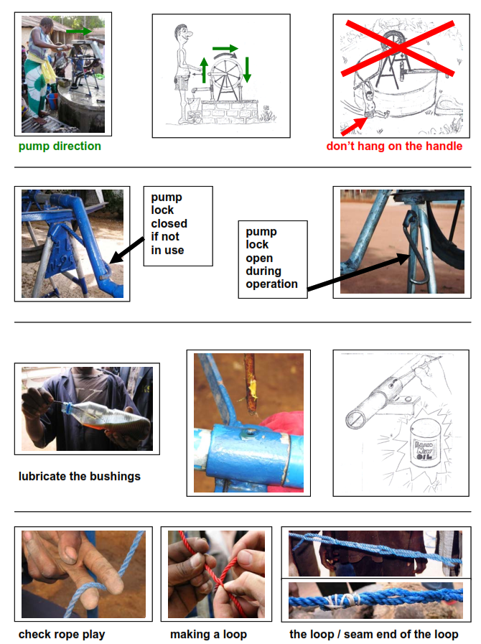
Fig.4.8 :Schematic diagram of rope pump maintenace
- Flushing and cleaning pump components
If the engine has been running, allow it to cool for at least half an hour before cleaning. Clean all exterior surfaces, touch up any damaged paint, and coat other areas that may rust with a light film of oil.
NOTICE
- Using a garden hose or pressure washing equipment can force water into the air cleaner or muffler opening. Water in the air cleaner will soak the air filter, and water that passes through the air filter or muffler can enter the cylinder, causing damage.
- Water contacting a hot engine can cause damage. If the engine has been running, allow it to cool for at least half an hour before washing.
- If the engine coolant is water, drain and refill the cooling system with water, a rust inhibitor, and antifreeze.
- Drain all fuel from the tank and lines and shut off the fuel valve.

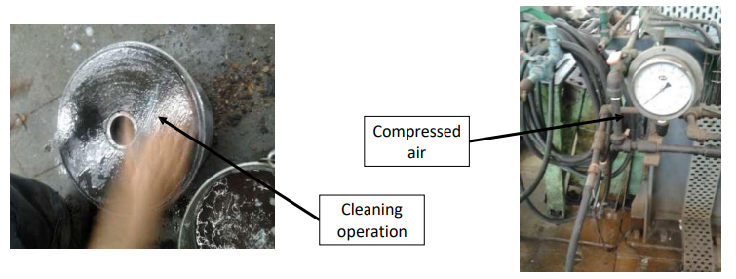
Fig.4.9: Cleaning operation
Generally following sequence during cleaning is maintained:

Typical Maintenance Hazards
There are hazards during any maintenance activity. Always ensure the correct PPE is worn before attempting repair, that sufficient expertise is on hand and chemical data sheets of any fluid being pumped are checked prior to undertaking work. A full risk assessment should be completed in advance.
Table 4.1: Typical hazards
HAZARD | POSSIBLE DANGER | POSSIBLE REMEDY
Pump Pressurised | Steam Escape with contaminants  Jets of Hot Liquid | Ensure pump has cooled sufficiently and pipework drained before attempting  disconnection  Check external casing temperatures  Open bolts slowly
Hazardous Fluids | Irritation, Chemical burns, ignition | Ensure when pump is opened the unit is cool, not pressurized, ignition sources are not present, and any fluids spilt are contained.
Cartridge Seal Removal | Sparks, Heat generation or damage | Use Centering clips and ensure set screws are loosened
Manual Handling | Injury | Check weight of pump, ensure use of lifting apparatus, and that pump is not lifted by motor alone
Electricity Supply | Electrocution or unintended startup | Ensure electricity supply is shut off and pump driver locked out
Static Discharge | Spark | Flush with conductive fluid / ensure unit is grounded

Self-check #4 | Written test

Name…………………………………………… ID………………………… Date…….
Directions: Answer all the questions listed below.
Test I: Choose the best answer (1 point)
- Maintenance is required to:
- Keep the pump system in top operation condition at all times
- To obtain the longest life and greatest use of the system
- To achieve the above two objectives at the lower possible cost
- All
- _________ is not type maintenance depending on reactive and proactive
- Corrective (Reactive)  - Preventative (Semi Proactive | - Monitoring (Proactive & Predictive)  - None
- Operated by people or animals:
- Centrifugal pump B. Tredle pump C. Money maker pump D. B and C
- Not type of shaft seal:
- Packing seal: B. Magnetic coupling C. Mechanical seal D. None
- The following is not a classification of maintenance:
- Corrective maintenance C. Timely maintenance
- Schedule maintenance D. Preventive maintenance
Test II: Fill in the blanck
- _____________ Maintenance is undertaken when failure has occurred
- Lubrication oil type of the piston seals : (such as _______ ) or vegetable oil.

Note: Satisfactory rating - 6 points Unsatisfactory - below - 6 points

Operation Sheet #4

- Clean your pump componets
- Tools and equipments
- Tool set
- Standard Tools
- Wrenches
- screwdrivers and other basic resources are the easiest to use when gaining access to the actual clog.
- Snake- Wrenches, screwdrivers, and other basic resources are the easiest to use when gaining access to the actual clog.
- Plunger - used to suction and release backup in order to get drainage working again.
- Wire Brushes
- Drain Cleaning Chemicals
- Procedures (steps) to clean pump components
To clean your water pump without causing more problems along the way, make sure to follow these steps carefully:
- Prepare the work area: Cleaning a water pump is a pretty quick and easy process.
- Remove the pump cover.
- Loosen the impeller cap.
- Start washing.
- Use a wash basin- Place pump parts in a clean wash basin used only for washing infant feeding equipment.
- Add soap and water-Fill wash basin with hot water and add soap.
- Scrub- Scrub items according to pump kit manufacturer's guidance.
- Rinse.

- Dry.
- Return the impeller.
- Put the cover back.
- Test your water pump.
LAP TEST #4 | Performance Test

Name………………………………. ID…………………………….. Date…………………………………….
Time started: ________________________ Time finished: ________________
Instructions: Given necessary templates, tools and materials you are required to perform the following tasks within 4 hour. The project is expected from each student to do it.

Task-1: Perform clreang of pump components

LG #32 | LO #5- Report maintenance activities

Instruction sheet
This learning guide is developed to provide you the necessary information regarding the following content coverage and topics:
- Recording and reporting faulty pump components
This guide will also assist you to attain the learning outcomes stated in the cover page. Specifically, upon completion of this learning guide, you will be able to:
- Recor and report faulty pump component
Learning Instructions:
- Read the specific objectives of this Learning Guide.
- Follow the instructions described below.
- Read the information written in the information Sheets
- Accomplish the Self-checks
- Perform Operation Sheets
- Do the “LAP test”

Information Sheet #5

- Recording and reporting faulty pump components

- What is the main reason that broken equipment or leaks should be reported?
- The reasons you consider the product to be defective. details of any injuries or harm resulting from the defect. a description of the defect with, where relevant, measurements (such as gaps in safeguards and the distance through such gaps to parts giving rise to danger).
- Helps prevent reoccurrences. Even the “minor” incidents and hazards count. Reporting these incidents and hazards increases the likelihood that repeating failures will be noticed and corrected before they develop into more serious ones.
For major faults, complete an Equipment Fault Report. Submit the Equipment Fault Report to the Administration Officer who will notify the relevant equipment supplier. The Administration Officer will place an 'Out of Order' sign on the equipment item, showing when the fault will be rectified.
- A pump operator should report defects (faults) immediately:
- If a defect is considered to be a hazard to safety, pumping operations should be stopped until the defect is repaired.
- The details of reported defects and subsequent action taken should be entered into a log book.
- Log books and inspection record sheets
- Instruction, maintenance and repair manuals should be kept in a safe place at the registered premises, and should include a parts catalogue.
- The operator should be familiar with the contents of the instruction manual which should be available at the site of operation.
- All log books and inspection record sheets must show complete details of all inspections, tests, repairs, replacements and modifications carried out on equipment and be available for inspection by the principal contractor or person in control of the workplace.
- Evidence that the pump and other equipment has been inspected and certified to be 'suitable for continued service' (i.e. in a safe working condition), should be made available to the principal contractor or person in control of the workplace for inspection (on request), before the unit is allowed to operate on site.
What does a maintenance log include?
An equipment maintenance log is a document that records activities that have been performed on an asset. It takes at least a handful of key equipment to keep a plant operational. It is unimaginable how much time and effort goes into maintenance activities for each asset annually.
- How to Create Pump Maintenance Log
- Name of the asset.
- Serial number.
- Equipment manufacturer and its contact details.
- Date of purchase.
- Date of first use.
- Operator responsible for the asset.
- Location of facility.
- Date of maintenance.

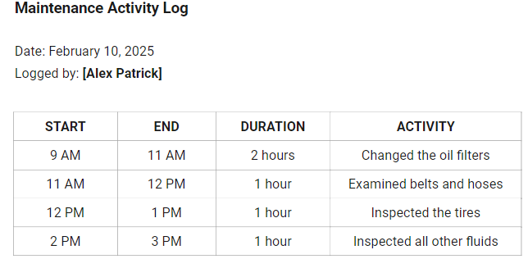
Warning and safety signs
Ensure that all warning and safety signs/stickers are in good condition, legible and positioned on all equipment (after being inspected and found to be serviceable).
The maintenance recordkeeping system must be kept current so that a complete maintenance history of each piece of equipment is available at all times. This is important for planning and conducting an ongoing maintenance program. Regular maintenance and emergency maintenance must be well documented, as should special work done during overhauls and replacement.

Table 5.1 : Sample record sheet
No. | Components | Damage & blockage type | Degree of damage & blockage | Cause | Location | Section of the system affected | Date of detection | Action taken | Effect of maintenance action | Cost | Remark
1
2

Prepared by: Name__________________________ Signature: _____________ Date:
Self-Check #5 | Written test

Name…………………………………………… ID………………………… Date…….
Directions: Answer all the questions listed below.
Test II: Multiple choice (1 point)
- __________ is a document that records activities that have been performed on an asset.
- An equipment maintenance log
- Name of the asset.
- Serial number
- All
- The details of reported defects and subsequent action taken should be entered into a log book
- True B. False
Test I: Short Answer Questions
- What is the main reason that broken equipment or leaks should be reported?
________________________________________
________________________________________
________________________________________
- __________ maintenance and ___________ maintenance must be well documented, as should special work done during overhauls and replacement.
- Ensure that all _________ and ________ signs/stickers are in good condition, legible and positioned on all equipment.

Note: Satisfactory rating - 7 points Unsatisfactory - below 7 points

You can ask you teacher for the copy of the correct answers.

You can ask you teacher for the copy of the correct answers.

Operation Sheet #5

- Record and report maintenance activities
- Tools and materials
- Paper
- Pen
- Pencil
- Clipboard
- Methods of record and report component maintenance activities
- Use the following table as a sample format:
No. | Components | Damage & blockage type | Degree of damage & blockage | Cause | Location | Section of the system affected | Date of detection | Action taken | Effect of maintenance action | Cost | Remark
1
2

LAP TEST #5 | Performance Test

Name………………………………. ID…………………………….. Date…………………………………….
Time started: ________________________ Time finished: ________________
Instructions: Given necessary templates, tools and materials you are required to perform the following tasks within 2 hour. The project is expected from each student to do it.
Task-1: Record and report maintenance activities.

Reference Materials

A.M Michael. Irrigation principle and practice 2nd edition
FAO by W.R. Walker. Irrigation and drainage management. 2nd edition
FAO C. Brouwer. Irrigation water management. 2nd editions
Karassik, I.J., J.P. Messina, P.C. Charles and C. Heald (2001). Pump Handbook. McGraw-Hill Compay, NY, USA.
Garg k.2005, Irrigation engineering and hydraulic structure, 19th edition India
Garg k. 2005. revised edition. Drainage engineering, India
George’s. Technical irrigation information 2nd editions

Web addresses
https://www.linquip.com/blog/what-is-head-of-a-pump/acessed date august 31,2022
https://www.engineeringenotes.com/water-engineering-2/pumping-stations/pumping-stations-location selection and sizing pumping stations water engineering/16184 accessed date September 1,2022

AKNOWLEDGEMENT
Ministry of Labor and Skills wish to extend thanks and appreciation to the many representatives of TVET instructors and respective industry experts who donated their time and expertise to the development of this Teaching, Training and Learning Materials (TTLM).

The experts who developed the learning guide
No | Name | Qualification | Organization/ College | Mobile number | E-mail
1 | Daniel Deresse | BSc. Agricultural Engineering | W/sodo AVET | 0912-79-28-85 | danielderesse7@gmail.com
2 | Edao Hassen | Msc.Irrigation Engineering | Alage AVET | 0911098097 | hassedao@gmail.com
3 | Serawit Gensa | Msc. Water Resource Engineering | W/Sodo AVET | 0916740916 | serawitgen@gmail.com
4 | Mekete Agizew | Msc. Water Resource Engineering | Amhara. Kombolcha ATVET | 0925221192 | gen.mam09@gmail.com
5 | Wondu Alemayehu | Msc.Irrigation Engineering | Oromia Kombolcha ATVET | 0910-28-99-61 | woldualem@gmail.com
6 | Ademe Ayalew | Msc.Irrigation Engineering | Agrafa AVET | 0912720547 | Ademe2004@gmail.com
7 | Said Mohammed | Msc.Irrigation& drainage Engineering | Alage ATVET | 09-17-18-01-81 | Siyamsdmhmmd@gmail.com/
8 | Molalign Asfaw | Bsc.Water Resource &Irrigation Engineering | Alage ATVET | 0921431096 | Mollalign410ass@gmail.com
9 | Yonas Hailu | Bsc.Water Resource &Irrigation Engineering | Agrafa AVET | 0934715578 | yonashailuw@gmail.com
10 | Lemessa Mulata | Msc.Irrigation Engineering | Agrafa AVET | 0913266845 | Lamimulle2022@gmail.com
11 | Misganew Yimer | Bsc. Soil and Water Engineering | Woreta ATVET |  | Misge1976@gmail.com
12 | Teshome Getachew | Msc.Irrigation& drainage Engineering | Alage ATVET | 0925-50-13-99 | teshomegetachew131@yahoo.com

