Irrigation and Drainage
Level II

Based on March 2022, Version 3 Occupational standard


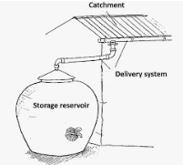

Module Title: - Water Harvesting Structures
LG Code: AGR IRD2 M09 (1-7) LG (33-39)
TTLM Code: AGR IRD2 TTLM 0822v1

August, 2022
Addis Ababa, Ethiopia

Table of Contents

Introduction to the Module 1
LO #1- Data collection 2
Instruction sheet 2
Information Sheet 1 3
Self-check 1 12
Operation Sheet -1 14
LAP TEST-1 15
LO #2- Design storage capacity 16
Instruction sheet 16
Information Sheet 2 17
Self-check 2 5
LO #3- Construction materials 6
Instruction sheet 6
Information Sheet - 3 7
Self-check 3 11
Operation Sheet -3 12
LAP TEST-3 13
LO #4- Water harvesting techniques 14
Instruction sheet 14
Information Sheet - 4 15
Self-check 4 28
Operation Sheet -4 30
LAP TEST-4 31
LO #5 Roof top Water harvesting structure 32
Instruction sheet 32
Information Sheet – 5 33
Self-check 5 40
Operation Sheet -5 41
LAP TEST-5 42
LO #6- Ground surface and water storage structure 43
Instruction sheet 43
Information Sheet - 6 44
Self-Check – 6 53
LO #7- Construct ground Surface catchments, diversion canals & sediment ponds 55
Instruction sheet 55
Information Sheet - 7 56
Self-Check – 7 60
Operation Sheet -7 62
LAP TEST-7 63
Reference Materials 64

Introduction to the Module

This module covers the knowledge, skill and attitude required collect, organized and identify all required data, design water storage capacities, identify construction material, design and construct flood water harvesting, micro catchments techniques, construct roof top water harvesting structures, ground and surface water storage structure, ground Surface catchments, diversion canals & sediment ponds.
LG #33 | LO #1- Data collection

Instruction sheet
This learning guide is developed to provide you the necessary information regarding the following content coverage and topics:
  - Introduction to the module
  - Metrological data collection
  - Runoff estimation
  - Soil sampling and sampling techniques
  - Soil sample analysis
  - Catchments and cultivation area selection
  - Crops selection criteria
This guide will also assist you to attain the learning outcomes stated in the cover page. Specifically, upon completion of this learning guide, you will be able to:
  - Collect Metrological data
  - Estimate Runoff
  - Soil sampling and sampling techniques
  - analysis soil sample
  - Select Catchments and cultivation area
  - Identify Crops selection criteria
Learning Instructions:
- Read the specific objectives of this Learning Guide.
- Follow the instructions described below.
- Read the information written in the information Sheets
- Accomplish the Self-checks
- Perform Operation Sheets
- Do the “LAP test”

Information Sheet 1

Introduction
Meteorological Data consisting of physical parameters that are measured directly by instrumentation, and include temperature, dew point, wind direction, wind speed, cloud cover, cloud layer(s), ceiling height, visibility, current weather, and precipitation amount.
Topographic map” name refers to information (contour lines) about terrain/elevation topography “topographic maps” generally contain much more than just elevation info Topographic base map info increasingly digital many developed countries are well into the conversion process.
Water harvesting can be define as is capturing potentially damaging rainfall runoff and translate this into plant growth or water supply.
Crop water requirement or potential evapotranspiration is the amount of water required to compensate the evapotranspiration loss from the cropped field is defined as crop water requirement.

1.1. Metrological data collection
The weather variables for driving the hydrological balance are precipitation, air temperature, solar radiation, wind speed and relative humidity. Required daily data are precipitation, max and min air temperature, solar radiation, wind speed and humidity. These metrological data were collected from local meteorological station.

- Rainfall data analysis

Rainfall in dry areas is characterized by short duration, high intensity and poor distribution. The low duration high intensity combination is conducive to high runoff production. The great rainfall variation with time presents the biggest challenge to dry land agriculture. Cropping seasons are usually longer than the rainfall seasons, and drought within the growing season is a common feature of most growing seasons. In water harvesting design, the aim is to use a rainfall figure that will meet the water requirement and produce a crop with a level of certainty.

Although the average rainfall value can be used, it is not a good figure since most of the rainfall consists of a few very wet seasons and many drier ones. Therefore there would be many seasons with actual rainfall figures below the average, and designs based on averages are bound to fail. A more appropriate figure is the median. This is the middle value of any set of seasonal rainfall data arranged from the biggest to the smallest. The best design value is the probability rainfall because it is related to the frequency of occurrence of such rainfall. It helps the planner to get a reasonable catchment size to supplement rainfall, rather than one which is inadequate or too large and uneconomical.

1.2. Runoff estimation.
- Types of Runoff
- Surface runoff: runoff as sheet or rill flow at the surface before it reaches a stream.
- Over land flow: is that part of precipitation that flows in undefined channel.
- Sub surface runoff: is the part of infiltrated water which flow laterally through the unsaturated zone of soil mass and joins streams.
- Stream flow (base flow): runoff in seasonal streams or rivers. In other words the water that percolates to the ground water table, and later after long periods, joins the rivers, streams. Most or the water harvesting methods are related to the harvest of surface runoff.
- Factors Affecting Runoff
Climatic or characteristics of precipitation- plays an important role in determining the amount of consequent runoff. It includes:
- Type of precipitation
- Intensity of precipitation
- Duration of precipitation
- Distribution of precipitation
- Frequency of precipitation
- Direction of prevailing wind
- Direction of prevailing storm
- Watershed characteristics (physiographic factors): on which water (rain) falls also plays a significant part in determining the quantity of runoff. It includes:
- Character of catchment surface (its geological formation)
- Soil moisture
- Topography
- Land use
- Shape and size of the catchment
- Vegetable cover

- Determination of Runoff
Various methods used for computing runoff:
- Computing runoff by using runoff coefficient (K): the volume of runoff Q, (m³) can be directly computed approximately, by using an equation of the form
$Q=K*P*A$
Where p= mean annual precipitation (m) & A=area of catchment (m²)
K=runoff coefficient
This method of computing runoff should be avoided for rural areas and for analysis of major storms.

- The Curve Number Method
For drainage basins where no runoff has been measured, the Curve Number Method can be used to estimate the depth of direct runoff from the rainfall depth, given an index describing runoff response characteristics. The Curve Number Method was originally developed by the Soil Conservation Service (Soil Conservation Service 1964; 1972) for conditions prevailing in the United States. Since then, it has been adapted to conditions in other parts of the world.
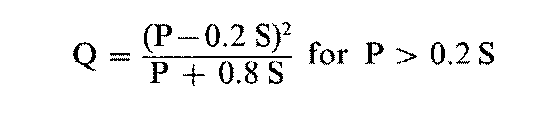

Where: S = potential maximum retention (mm)
Q = accumulated runoff depth (mm)
P = accumulated rainfall depth (mm) = initial abstraction (mm)
The potential maximum retention S has been converted to the Curve Number (CN) in order to make the operations of interpolating, averaging, and weighting more nearly linear. This relationship is:


- Rational method:
The following rational formula is used to estimation of run-off from surface catchments.

$$Q=\frac{CIA}{360}$$
Where Q= run off discharge rate (m3/s)
C = run-off coefficient
I= rain fall intensity (mm/hr)
A= catchment area (ha)

Table 1.1: Runoff coefficient of land use land cover
 |  | Loam | Clay and silt loam | Tight clay
Wood land | Flat(<5%slop) | 0.10 | 0.30 | 0.40
Wood land | Rolling(5-10) | 0.25 | 0.35 | 0.50
Wood land | Hilly (10-30) | 0.30 | 0.50 | 0.60
Pasture | Flat(<5%slop) | 0.10 | 0.30 | 0.40
Pasture | Rolling(5-10) | 0.16 | 0.36 | 0.55
Pasture | Hilly (10-30) | 0.22 | 0.42 | 0.60
Cultivated | Flat(<5%slop) | 0.30 | 0.50 | 0.60
Cultivated | Rolling(5-10) | 0.4 | 0.60 | 0.70
Cultivated | Hilly (10-30) | 0.52 | 0.72 | 0.82
Urban area |  | 30% of area impervious | 50% of area impervious | 70% of area impervious
Urban area | Flat(<5%slop) | 0.40 | 0.55 | 0.65
Urban area | Rolling(5-10) | 0.50 | 0.65 | 0.80

Runoff is also estimated from from roof catchments by the following formula.
$Q=A*(C*P)$ Where
A = roof area required (m2)
Q = Run –off amounts that is harvested (m3 or liter)
C = run-off coefficient
p = annual precipitation (mm)

Table 1.2 Runoff coefficient
Roof catchment | Runoff coefficient
Sheet metal | 0.9
Cement tile | 0.7
Clay tile | 0.4

1.3. Soil sampling and sampling techniques
Soil sampling should reflect tillage, cropping patterns (and corresponding irrigation requirements), soil type (including drainage and slope characteristics).
The most commonly used method for soil sampling would be based on soil types. Fields are split into sampling areas that contain similar soils.

Generally soil sampling in the case of water harvesting is useful to know:
- The physical characteristics of soil which helps to choose soil for cropping or catchment area
- The chemical & biological characteristics of soil
- The constructional aspects of soil
- The bearing capacity of soil – to construct different water harvesting storage structures

1.4. Soil sample analysis
Soil sample taken from the field organized based on the location, depth and date of sampling etc. Following the standard procedures we can determine the physical and chemical characteristics of the soil with respect to water harvesting.

1.5. Selection of Catchment and cultivation area
Soils of different characteristics are required to the catchment as well as cropping areas in a water harvesting scheme.
- For Macro-catchment system
- The Catchment area requires
- Clayey/loamy soils with some clay and silt.
- Sodic soils and rock surfaces
- compact structure
- Shallow soils (< lm)
- The Cropping area requires
- Medium texture/infiltration
- Good structure with organic matter
- 1 -2.5m deep
- nutrient -rich, low salinity

1.6. Crops selection criteria
Water harvesting helps crops by providing extra moisture at different stages of growth although timing cannot be controlled. Periods when the extra moisture can make a significant difference are:
- Around sowing time when germination and establishment can be improved;
- During a mid-season dry spell when a crop can be supported until the next rains;
- While the crop is at the vital stages of flowering and grain fill.
The most common cereal crops grown under water harvesting are:
- Sorghum (Sorghum bicolor) is the most common grain crop under water harvesting systems. It is a crop of the dry areas, and in addition to its drought adaptation, it also tolerates temporary water logging - which is a common occurrence in some water harvesting systems.
- Pearl Millet (Pennisetum typhoides) is grown in the drier areas of West Africa and India, and apart from being drought tolerant, it matures rapidly.
- Maize (Zea mays) is occasionally grown under water harvesting but is neither drought adapted nor water logging tolerant - but in parts of East and Southern Africa it is the preferred food grain, and farmers are often reluctant to plant millet or sorghum instead.
- Legumes are less frequently grown under water harvesting but should be encouraged because of their ability to fix nitrogen and improve the performance of other crops. Suitable legumes are cowpeas (Vigna unguiculata), green grams (Vigna radiana), lablab (Lablab purpureus), and groundnut (Arachis hypogea). All are relatively tolerant of drought and are fast maturing.
- Perennial trees must with stand long periods of drought such as carob.

Table 1.3 suitability of crop for water harvesting
Crop group | Examples | Well suited water harvesting techniques
Trees | Pistachio, Almond, Fruit trees,  Fodder trees, Citrus trees,  Eucalyptus | Micro catchments (bunds, terraces, semi-circular bunds).
Cereals | Sorghum, Millet, Wheat | Macro-catchments  Flood water diversion
Horticultural Crops | Pulses ,(Water) melons | Micro catchment(semi- circular bund)
Range land grasses | Local grasses | Macro catchment (trapezoidal bunds) Flood water diversion

- General sensitivity to drought
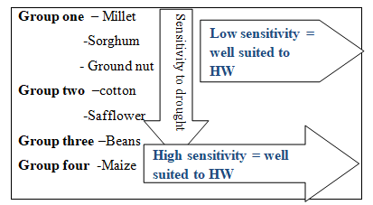
Figure 1.1 sensitivity of crop for water harvesting

Table1.4. Tolerance of crop
Crop | Ideal water requirement per season (mm) | Drought  tolerance | Tolerance to water logging
Sorghum | High(450-600) | Yes | Yes
Pearl millet | < Sorghum | Very good | No
Maize | High (450-600) | Yes | No
Grain legumes | As sorghum | Most | No
Fodder &grasses | Low to high | Yes | ?
Trees | Variable | variable | Some

Self-check 1 | Written test

Name: ----------------------------------------------------- Date: ------------------------
Directions: Answer all the questions listed below.
Test I: Choose the best answer from the given alternatives 10 points
- Which one of the following is true about plays an important role in determining the amount of consequent runoff?
A. Climatic or characteristics of precipitation B. Watershed characteristics
C. Over land flow D. Stream flow
- Which one of the following is true water (rain) falls also plays a significant part in determining the quantity of runoff? (5pts)
A. Climatic or characteristics of precipitation B. Watershed characteristics
C. River size D. Runoff coefficient
- Which one of the following is true volume of runoff Q, (m³) can be directly computed approximately, by using an equation of the form?
A. Computing runoff by using runoff coefficient B. Curve Number Method
C. ground collapse D. Rational method
- Which one of the following is true used to estimate the depth of direct runoff from the rainfall depth, given an index describing runoff response characteristics?
A. Curve Number Method B. Rational method
C. Runoff coefficient D. A and B
- Which one of the following is true a part of infiltrated water which flow laterally through the unsaturated zone of soil mass and joins streams?
A. Sub surface runoff B. Stream flow
C. Over land flow D. All

Test II: Mache column A to B (2 pts each)
 | A | B
 | --------Watershed | A. physiographic factors
 | ------- Stream flow | B. Topography
 | -------- Intensity of precipitation | C. common outlet
 | -------- Watershed characteristics | D. Climatic or characteristics of precipitation
 | -------- Watershed characteristics | E. base flow

Note: Satisfactory rating - 15 points and above Unsatisfactory - below 15 points
You can ask your teacher for the copy of the correct answer

Operation Sheet -1

  - Identify water harvesting site

- Tools and equipment
- Tools used for identify water harvesting site: - Note book, pen, measuring tape, line level, and clinometer, Gps, Auger, double ring infiltrometer, stopwatch, watering can, Altimeter, Graduated staff.
- Personal protective equipment: Safety shoes, Sun hat, Gloves, Overall.
- Procedures identifying water harvesting site
      - Transact walk
      - Measuring the slope of the area
      - Determine soil type of the area
      - Identify land use land cover of the area
      - Determine rainfall of the area
      - Measure the catchment size
      - Observing the available material for construction
      - Measure the distance of agricultural area
  - Delineate catchment area
- Steps Delineate catchment area

      - Read a top-sheet and makes the location of water body
      - Mark the contour line
      - Trace the waterway from it’s the catchment source to its outlet tributaries
      - Represent narrow contour lines by ridge
      - Identify and mark the divide points
      - Connect the divide points
      - Delineate the catchment

LAP TEST-1 | Performance Test

Name………………………………. ID…………………………….. Date…………………………………….

Time started: ________________________ Time finished: ________________

Instructions: Given necessary templates, tools and materials you are required to perform the following tasks within 9 hour. The project is expected from each student to do it.
Task-1.1. conduct water harvesting site identification
Task-1.2 perform delineation of catchment area

LG #34 | LO #2- Design storage capacity

Instruction sheet
This learning guide is developed to provide you the necessary information regarding the following content coverage and topics:
- Identifying water demand and supply
- Design capacity
This guide will also assist you to attain the learning outcomes stated in the cover page. Specifically, upon completion of this learning guide, you will be able to:
- Identify water demand and supply
- Design capacity

Learning Instructions:
- Read the specific objectives of this Learning Guide.
- Follow the instructions described below.
- Read the information written in the information Sheets
- Accomplish the Self-checks

Information Sheet 2

2.1. Identification of water demand and supply
Water demand is the volume of water requested by users to satisfy their needs. A simplistic interpretation considers that water demand equals water consumption. The amount of water to be harvested and stored is based on the demand, type and nature of storage structures.
- Water demand may be for:
- Domestic water supply
- Livestock water supply
- Irrigation purposes
- The amount of water of stored is based on:
- Number and age of beneficiaries (domestic and livestock)
- Living standard
- Length of dry seasons
- Area to be irrigated
- Losses (due to seepage, evaporation and poor water management)

Water storage is divided in to two: Short-term storage and Long -term storage. Based on the relative position of the storage structure with respect to normal ground surface storages can be divided into above or below ground. There are different shapes of storage structures

- Cylindrical
- Spherical
- Hemispherical
- Rectangular
- Bottle shape
- Circular frustum with concrete dome cup
- Circular frustum with brick cup

2.2. Design capacity

- In order to decide the storage tank capacity required for household or small groups. The following step has to be followed.
- Obtain average monthly rainfall over an area for a minimum of 8-10 years
- Rank rainfall data in terms of months with highest rainfall.
- Select the type and also determine size of the catchment that will be available for use
- Calculate the amount of runoff (inflow) from the catchment per day if daily data is available or per month.
- Calculate the demand of water (out flow) for one day or for a month and for each of users.
- Calculate the amount of inflow (supply) and out flow demand for each month.
- Calculate the cumulative inflow and out flow.
- Compute the difference between total water available (inflows) in each month and demand out flow in the same month.
- Subtract the smallest negative differences from the largest positive differences
- The maximum differences between the largest value and the subsequent lowest value of the cumulated difference will be the required storage tank.

- Required catchment size (area)
In order to decide the size of the catchment area the following factors must be considered.
- Run off coefficient
- Rainfall of the area
- Construction cost
- Storage capacity

- Required storage capacity (V_{t})
In order to design the capacity of the storage the following factors must be considered and quantified.
- Number, age and type of beneficiaries
- Length of dry season
- Loss due to seepage and evaporation
- Cost of construction
- Living standard

Storage capacity (V_{t}):
$Vt=WD + 20\% WD = 1.2WD$Where WD is water demand & 20% is loss
Runoff from catchment area (Q):
$Q=AxPxK$ Where P is mean annual rainfall & K is runoff coefficient
Q= V_{t} =APK =1.2 WD
The required catchment area (A) can be calculated as follows
$A=\frac{1.2WD}{KP}$
Estimation of Evaporation and seepage losses
Evaporation loss: can be calculated or measured using class A pan evaporimeter. Seepage losses: difficult to assess as it depends on permeability of the prevailing soil. The seepage losses can be assumed equal to ETO losses as a rule of thumb.

- Method of estimation of storage capacity

Estimation of volumes of different shapes of containers
- Cylindrical
V = Base area x height
V = Πr²h
- Spherical
4
V = Πr³
3

- Hemispherical
2
V = Πr³
3

- Rectangular

V = L x W x D

Example 1.

A farmer has a house covered with corrugated iron sheet roof (C.I.S) required to fulfill water requirements of his family members consisting of six persons each require 20lit/day, length of dry season 180 days and losses 20% of the water demand. Use the mean annual rainfall. = 600mm and runoff coefficient of C.I.S = 0.8.
Calculate: a). domestic water demand
b). storage capacity
c). the required size of the catchment
Solution:
P_{O} × D_{C} × T
1000
a). Water demand for domestic uses (WD): WD =
= (6 x20 x 180) /1000 =21.6m³

b). Storage capacity: Vt = WD + 20% WD = 1.2WD = 1.2 x 21.6 m³ = 25.92 m³
1.2WD
KP
c). The required size of the catchment: A =
= (25.92m³)/ (0.8 x 0.6) =54m²

Self-check 2 | Written test

Name: ----------------------------------------------------- Date: ------------------------
Directions: Answer all the questions listed below.
Test I: Mache column A to B (2 Pts each)
 | A | B
 | ------- Water demand | A. V = L x W x D
 | ------- Evaporation loss | B. ETO losses as a rule of thumb
 | -------- Seepage losses | C. V = Πr²h
 | -------- volume cylinder | D. A pan evaporimeter
 | -------- volume Rectangle | E. Domestic water demand

Test II: workout (9 Pts)
A farmer has a house covered with corrugated iron sheet roof (C.I.S) required to fulfill water requirements of his family members consisting of six persons each require 20lit/day, length of dry season 180 days and losses 20% of the water demand. Use the mean annual rainfall. = 600mm and runoff coefficient of C.I.S = 0.8.
Calculate:-
- domestic water demand
- storage capacity
- the required size of the catchment
Note: Satisfactory rating - 15 points and above Unsatisfactory - below 15 points
You can ask your teacher for the copy of the correct answer

LG #35 | LO #3- Construction materials

Instruction sheet
This learning guide is developed to provide you the necessary information regarding the following content coverage and topics:
- Selecting construction material
- Selecting tools and equipment
This guide will also assist you to attain the learning outcomes stated in the cover page. Specifically, upon completion of this learning guide, you will be able to:
- Select construction material
- Select tools and equipment
Learning Instructions:
- Read the specific objectives of this Learning Guide.
- Follow the instructions described below.
- Read the information written in the information Sheets
- Accomplish the Self-checks
- Perform Operation Sheets
- Do the “LAP test”

Information Sheet – 3

3.1. Selecting construction material
Different construction materials are selected based on:
- The type of water harvesting structures i.e. above or below ground surface water harvesting structures.
- Availability
- Skill of workmanship
- Basic categories of construction materials
A building or Water Harvesting schemes may have two basic parts
- The super-structure- is above ground level, which serves the intended use. For example wall, column, roof, ceiling etc.
- Sub-structure /foundation - is part of a structure which has a direct contact with the ground to which the loads are distributed.
- Foundation & wall construction materials
Soils for foundations should have firmness and less porous nature and required soils are like clay soil, reed ash etc.

Foundation also requires stone, gravel and so on.
- Stones are one of the most prevalent building materials from the olden days due to its availability in abundance from the natural rocks. These stones possess strength and durability and are therefore used in the construction of structures like dams, retaining walls and roads, etc. Stones are load bearing materials that add to the look in addition to providing strength to the construction aspect
- Sand- dirty sand must be washed & should be clean. If the sand is too wet, it is needed to dry the sand.
- Water- dirty water contains impurities & may not be appropriate. Water fit for dirking is usually fit for making cement -mortar
- Cement- should be stored in dry place
- Open storage requires plastic sheet cover
- The plat form at the bottom must be raised
- Reinforcement – These includes steel bars, mesh wire and some of other materials required at construction are bricks, block nails, paints, gypsum, wood, soil, grass, straw etc.
- Reinforcing materials- barbed wires withstand the tensile stresses.
- Mesh wire helps to hold the plaster together
- The joints require extra enforcement as well as extra plastering to avoid cracks.

Roofing materials- these includes Thatch-grass straw, Al sheet, Brick Tiles, cement concrete Tiles etc.
Lining Materials – are essential to control loss due to seepage (binding materials).These includes materials for finishing purpose. E g. Cement, lime, gypsum, fine sand, paints.
Pipes & fittings – these includes washout pipe, outlet pipes, down pipes, vent pipes, vents and overflow pipes etc.
Form working materials: - materials required for formwork are hard board; ply wood, timber, steel, etc.

- Concrete & Mortar
All water tanks require the use of cement including tanks made up of metal, plastic or fibre grass, because they need concrete foundations.
- Concrete - is mixture of cement, coarse sand, crushed stones (aggregates) & water. Commonly tank floors or waterproof slab should be with a mix ratio of 1:2:3 (cement, sand, Gravel)
- Mortar -is a mixture of cement, sand & water without crushed stone.

Table 3.1 Ratio of cement to sand
Type of mortar | cement: sand
Ordinary masonry | 1:4
Reinforced brick slabs | 1:3
1st coat plaster | 1:4
Rough plaster (2nd coat) | 1:3
Final plaster (3rd coat) | 1:2

- Block work
- Brick masonry -is the term used for mortar to build with burnt brick
- Rubble stone Masonry -is the term used mortar with uncut, undressed rubble stone
- Stone masonry- Is the term used for mortar with regular dressed stones & brick.
- Ferro- cement -mortar reinforced with welded mesh, chicken mesh, and barbed wire.
- Pointing -is the processes of finishing joints in brick or masonry work with mortar
- Curing - is the process of assisting the hardening of mortar by keeping it moist.

Table 3.2. Standard dimension for wooden box (Batching box)
Length | 50cm
Width | 40cm
Depth | 20cm
i.e. volume(v) = 0.5m x 0.4m x 0.2m =0.04 m³

3.2. Tools and equipment selection
Based on the constructed water harvesting storage different types of tools and equipment s are selected. This includes:

- Line level/A-frame,
- String,
- Graduated staff,
- Clinometers,
- Altimeter,
- Measuring tape,
- Digging
- instruments,
- watering can,
- Double-ring infiltrometer,
- Soil sampler(Auger),
- Stop-watch,
- Ranging pole,
- Strings,
- Pegs,
- Water tank /pump,
- Hooker,
- Soil texture chart,
- Compass,
- GPS,
- Aerial photographs,
- Top maps,
- Automatic level and
- Gabion Wire box

Self-check 3 | Written test
Name: ----------------------------------------------------- Date: ------------------------
Directions: Answer all the questions listed below.
Test I: Choose the best answer
- Which one of the following is true about processes of finishing joints in brick or masonry work with mortar? (5 pts)
A. curing B. pointing
C. stone masonry D. brick masonry
- Which one of the following is true process of assisting the hardening of mortar by keeping it moist? (5pts)
A. curing B. pointing
C. stone masonry D. brick masonry
- Which one of the following is true used for mortar to build with burnt brick? (5pts)
A. curing B. pointing
C. stone masonry D. brick masonry
- Which one of the following is true is mixture of cement, coarse sand, crushed stones (aggregates) & water? (5pts)
A. mortar B. masonry C. cement D. brick masonry
- Which one of the following is true a mixture of cement, sand & water without crushed stone? (5pts)
A. mortar B. masonry C. cement D. brick masonry

Test II: Mache column A to B (2 pts each)

 | A | B
 | ------- super-structure | - washout pipe
 | ------- Pip and fitting | - lining material
 | -------- Sub-structure | - above ground level
 | -------- control loss due to seepage | - Hardening of mortar by keeping it moist.
 | -------- Curing | - Direct contact with the ground to which the loads are distributed.
Note: Satisfactory rating - 25 points and above Unsatisfactory - below 25 points
You can ask your teacher for the copy of the correct answer

Operation Sheet -3

3.1. Identify construction material
- Tools and equipment
- Tools used for identify construction material water harvesting: - Note book, pen, measuring tape, rope, and leveling, concrete mixer, wheelbarrow, ladder, spade, trowel, pickaxe, hammer, shovel, crowbar.
- Personal protective equipment: Safety shoes, Sun hat, Gloves, Overall.
- Steps of identifying construction material
- cost construction material
- durability of material
- availability of material
- sustainability of material
- maintenance of construction
- aesthetic Appeal of construction
- construction material
- Stone, sand, water, cement, mesh wire, hard board, timber, steel, soil if necessary gypsum

LAP TEST-3 | Performance Test

Name………………………………. ID…………………………….. Date…………………………………….

Time started: ________________________ Time finished: ________________

Instructions: Given necessary templates, tools and materials you are required to perform the following tasks within 2 hour. The project is expected from each student to do it.
Task-1 list out construction material and ways of selecting construction material for water
Harvesting

LG #36 | LO #4- Water harvesting techniques

Instruction sheet
This learning guide is developed to provide you the necessary information regarding the following content coverage and topics:
- Flood water harvesting
- Designing procedures for water harvesting structures
- Constructing water harvesting structures
This guide will also assist you to attain the learning outcomes stated in the cover page. Specifically, upon completion of this learning guide, you will be able to:
- Flood water harvesting
- Designing procedures for water harvesting structures
- Constructing water harvesting structures

Learning Instructions:
- Read the specific objectives of this Learning Guide.
- Follow the instructions described below.
- Read the information written in the information Sheets
- Accomplish the Self-checks
- Perform Operation Sheets
- Do the “LAP test”

Information Sheet - 4

4.1. Flood water harvesting
4.1.1. Types of water harvesting
- Rainwater Harvesting: Rainwater harvesting is defined as the method for inducing, collecting, storing and conserving local surface runoff for agriculture in arid and semi-arid regions. Three types of water harvesting are covered by rainwater harvesting.
- Water collected from roof tops, courtyards and similar compacted or treated surfaces is used for domestic purpose or garden crops.
- Micro-catchment water harvesting is a method of collecting surface runoff from a small catchment area and storing it in the root zone of an adjacent infiltration basin. The basin is planted with a tree, a bush or with annual crops.
- Macro-catchment water harvesting, also called harvesting from external catchments is the case where runoff from hill-slope catchments is conveyed to the cropping area located at foothill on flat terrain.
- Flood Water Harvesting: Flood water harvesting can be defined as the collection and storage of creek flow for irrigation use. Flood water harvesting, also known as ‘large catchment water harvesting’ or ‘Spate Irrigation’, may be classified into following two forms:
- In case of ‘flood water harvesting within stream bed’, the water flow is dammed and as a result, inundates the valley bottom of the flood plain. The water is forced to infiltrate and the wetted area can be used for agriculture or pasture improvement.
- In case of ‘flood water diversion’, the wadi water is forced to leave its natural course and conveyed to nearby cropping fields.
- Groundwater Harvesting: Groundwater harvesting is a rather new term and employed to cover traditional as well as unconventional ways of ground water extraction. Qanat systems, underground dams and special types of wells are a few examples of the groundwater harvesting techniques. Groundwater dams like ‘Subsurface Dams’ and ‘Sand Storage Dams’ are other fine examples of groundwater harvesting. They obstruct the flow of ephemeral streams in a river bed; the water is stored in the sediment below ground surface and can be used for aquifer recharge.
4.1.2. Flood Water Harvesting
To harvest flood water, wide valleys are reshaped and formed into a series of broad level terraces and the flood water is allowed to enter into them. The flood water is spread on these terraces where some amount of it is absorbed by the soil which is used later on by the crops grown in the area. Therefore, it is often referred to as "Water Spreading" and sometimes "Spate Irrigation". The main characteristics of water spreading are:
- Turbulent channel flow is harvested either (a) by diversion or (b) by spreading within the channel bed/valley floor.
- Runoff is stored in soil profile.
- It has usually a long catchment (may be several km)
- The ratio between catchment to cultivated area lies above 10:1.
- It has provision for overflow of excess water.
- The typical examples of flood water harvesting through water spreading are given below.
- Permeable Rock Dams (for Crops)
These are long low rock dams across valleys slowing and spreading floodwater as well as healing gullies (Fig. 4.1). These are suitable for a situation where gently sloping valleys are likely to transform into gullies and better water spreading is required.

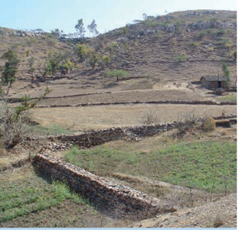
Fig. 4.1. Permeable Rock Dams.
Water Spreading Bunds (for Crops and Rangeland): In this method, runoff water is diverted to the area covered by graded bund by constructing diversion structures such as diversion drains. They lead to the basin through channels, where crops are irrigated by flooding. Earthen bunds are set at a gradient, with a "dogleg" shape and helps in spreading diverted floodwater (Fig. 4.2). These are constructed in arid areas where water is diverted from watercourse onto crop or fodder block.
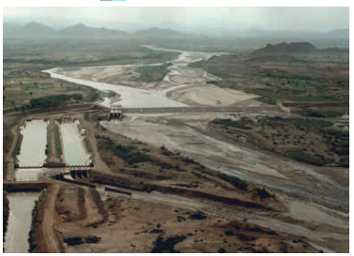
Fig. 4.2. Flood water farming systems:

4.2. Design procedures for water harvesting structures
- Procedure designing water harvesting structure is as follows:-
- Begin with long and thoughtful observation. Use all of your senses to see where the water flows and how. What is working, what is not? Build on what works
- Start at the top or highpoint of your watershed and work your way down. Water travels downhill. Start at the top where there is less volume and velocity so it is easier to follow the next principle.
- Start small and simple. Work at the human scale so you can build and repair everything. One thousand small are far more effective than one big one when you are trying to infiltrate water into the soil.
- Spread and infiltrate the flow of water. Rather than having water run erosively off the land’s surface, encourage it to stick around, walk around, and infiltrate into the soil.
- Always plan for an overflow route, and manage that overflow water as a resource. Always have an overflow for the water in times of extra-heavy rains, and use that overflow as a resource.
- Maximize living, organic groundcover. Create a living sponge so the harvested water is used to create more resources, while the soil’s ability to infiltrate and hold water steadily improves.
- Maximize beneficial relationships and efficiency by “stacking functions.” Get your water-harvesting strategies to do more than hold water. Berms or swales can double as high and dry raised paths. Plantings can be placed to cool buildings. Trees can be selected to provide food.
- Continually reassess your system: the “feedback loop.” Learn from your work. We begin again with the first principle.

4.3. Construct water harvesting structures
- In most cases the water harvesting techniques fall under four basic categories.
- Rooftop and Courtyard WH
- Micro catchments rainwater harvesting
- Macro-catchment rainwater harvesting
- Floodwater farming

4.2.1. Construct Micro catchment rainwater harvesting structures
Main characteristics of micro-catchment:-
- Overland flow harvested from short catchment length
- Catchment length usually between 1 and 30 meters
- Runoff stored in soil profile
- Normally no provision for overflow
- Plant growth is even
Types of micro catchment
- Negarim Micro catchment
Negarim micro catchments are diamond shaped basin surrounded by small earth bunds with an infiltration pit in the lowest corner of each. Runoff is collected from within the basin and stored in the infiltration pit. Micro catchment is mainly used for growing trees or bushes. This technique is appropriate for small scale tree planting in any area, which has a moisture deficit. Besides harvesting water for the trees, it simultaneously conserves soil.
- Technical details
- Suitability: Negarim micro catchment’s is mainly used for tree growing in arid and semi-arid areas.
- Rain fall: -ranges from 150mm-700mm per annum.
- Soil: -should be at list 1m-2m deep in order to ensure adequate root development and storage of the water harvested.
- Slope: -from flat to 8%
- Topography: -need not to be even, if uneven a block of micro catchment should be sub divided.
- Layout and construction of Negarim

The first step to construct Negarim is to find a contour line using a line level or other equipment’s. The first line at the top of the block is marked, if the topography is very uneven, separate small block of micro catchment should be considered. By means of tape measure the tips of the bund are now marked along the straight contour. The first line should be open ended. The distance between a-b depends on the selected catchment size, the formula to find the distance a-b is, ab2=ac2+bc2 for 25 meter selected catchment, length of the catchment will be 5mx5m micro catchment, is held at one tip(a) and the second string of the same length at other tip(b) they will exactly meet at apex (c). The apex is now marked with a peg and the catchment sides (a-c) and (b-c) marked on the ground alongside the string with a hoe. This procedure will be repeated until bund alignment in the first row has been determined. The next row of micro catchments is staked out. The apex of the bunds of the upper row will be the tip for for the second row and the corresponding apex will be found according the first step. Repeat the procedure for the third row.

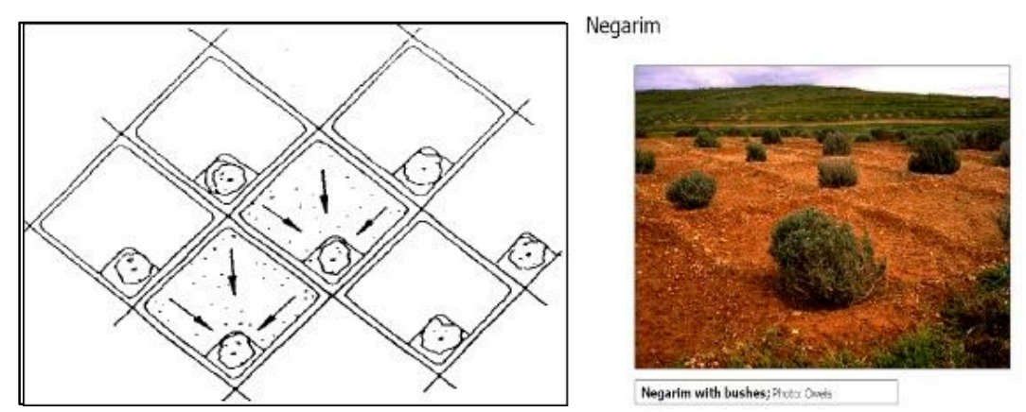

Figure 4.3 Negarim

- Construction of Contour bund for trees
The contour bunds for trees are very similar to the contour ridges for crops system. The difference is that the system for trees, the harvested water is collected in an infiltration pit instead of in a furrow. As with the contour ridges for crop the efficiency of contour bund for tree is high due to the comparatively short slope length of the catchment area.
- Technical Details
- Suitability Contour bund for tree planting can be used under the following conditions:
- Rain fall:- 200mm-750mm;for semi-arid to arid areas
- Soil: must be 1m-2m deep to insure adequate root development and water storage
- Slope:- 5%-20%
- Layout and construction
- Step one: - Contours are surveyed by a simple surveying instrument such as a water tube level or line level. The real contour should be smoothened to obtain a better alignment for agricultural operations.
- Step two: - Contour key lines should be staked out every 10 or 15 meters. The alignment for ridge is then marked in between the key lines according to selected spacing.
- Step three: - The furrows are excavated usually by means of a hoe or are ploughed parallel to the marked alignments for the ridges. The excavated soil is placed down slope next to the furrow and the ridge is formed.
- Step four: - Small cross ties are built at intervals of about 5 meters dividing each furrow in to a number of segments. The ties are 15-20 cm high and 50-70 cm long.
- Step five: - A diversion ditch should be provided above the block of contour ridges if there a risk.
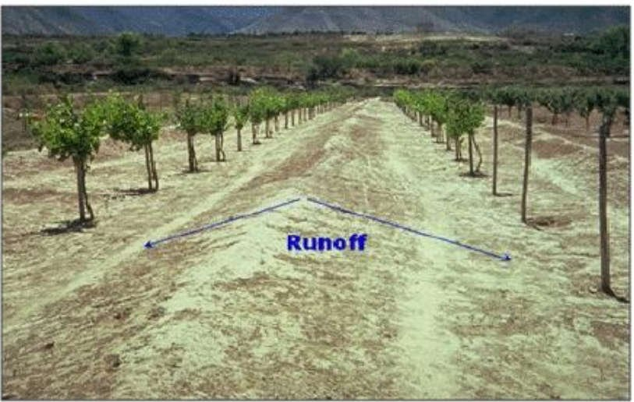

Figure 4.4. Direction of runoff to the contour bund

- Semicircular bunds
Semi-circular bunds are usually made of earth or stone and have commonly a diameter of 2-8 m (up to 12 m). The bund tips are set on the contour line, facing upslope. Bunds are 30-50 cm high. They are built in a staggered sequence over a plot; that is the second line catches runoff that flows between the structures in the line above; and so on. They are applied on slopes up to 15%, however earthen bunds are rarely used on slopes steeper than 5%, receiving more than 300 mm/y of rainfall.
- Layout and construction
The layout for both designs is similar, only diminution differs.
- Step one: -The first contour, at the top of the scheme, is staked out using a simple surveying instrument like line leveling.
- Step two: -A tape measure is now used to mark the tip of the semicircular bund on the contour. For design semicircular bund for tree planting having a radius of 3m, the tips of one structure are 6meters apart ( 2times the radius) and the distance to the next unit is 1.5m, which is half of the radius of the semi-circle.
- Step three: -The center point between the tips of each semicircular unit is marked. A piece of string as long as the selected radius is now fixed at the center point by a means of pegs. Holding the string tight at the other end, the alignment of the semi-circle is defined by swinging the end of the string from one end to the other. The alignment can be marked by pegs or scratching the earth with the peg.
- Step four: - It is important that the structures in each row are staggered in relation to structure in the row above. It must be ensured that the space between bund from one row to another is according to the chosen distance that is half of the radius of the bund, which is 1.5m.
- Step five: -After setting out, bund construction is started with excavation of small trench inside the bund. Further excavation should always be from inside the bund as evenly as possible. This will increase the storage capacity of the semicircular bund, the bund height must be greater than 40cm when the slope exceed 20%. The bund bottom width is 75cm with the side slope 1:1. It is advisable to provide one or more diversion ditches within the block as a safety factor.
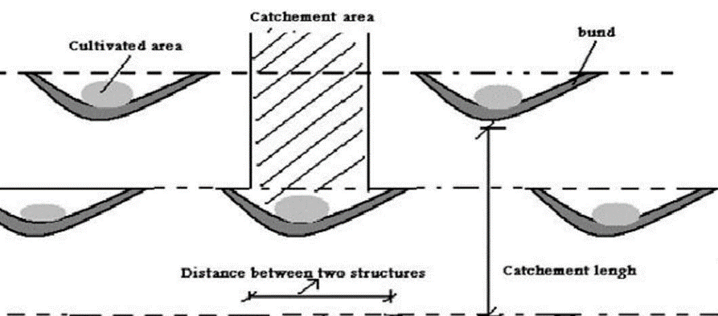
Figure 4.5. Semicircular bunds
- Construction of Zai, planting pit

- Layout and construction

ZAI are series of pits dug following the contours, the diameter of the pit can be between 40- 50cm at the depth of 15-20cm, and the spacing between two Zai can be range 60-80cm. The second line of pit must be arranged in a staggered configuration against the first line of pits. The spacing between two lines of pits is 60-75cm. the excavated soil could be piled down ward of each pit. After construction apply organic matter like compost, crop residues or dung at each pit.
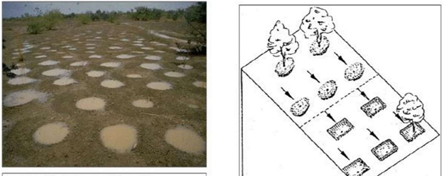Figure 4.6. Zai, planting pit
4.2.2. Constructions of Macro catchment rainwater harvesting structures
Macro-catchment WH is a method of harvesting runoff water from a natural catchment such as the slope of a mountain or hill. Sometimes known as external catchment systems, handle large runoff flows diverted from some source such as a road, home compound, pasture or hillside. The harvested water is mainly used for crop and livestock production but also for domestic use, depending on the quantity and quality. It may be:
- runoff collection from shallow soils or sealed and compacted surfaces;
- direct diversion and spreading of overland surface water
- Flow onto application area at the foot of hills or flat terrain (mainly cultivated areas) or impeding and collecting runoff through barriers and storage facilities.
- Main Characteristics:
- overland flow or rill flow harvested
- runoff stored in soil profile
- catchment usually 30 - 200 meters in length
- ratio catchment: cultivated area usually 2:1 to 10:1
- provision for overflow of excess water
- uneven plant growth unless land leveled
- typical example Trapezoidal Bunds (for crops) , Contour Stone Bunds (for crops
- Contour stone bunds
Contour stone bunds are used to slow down and filter runoff thereby increasing \infiltration and capturing sediments. The water and sediment harvested lead directly to improve crops performance.
- Technical Details
- Suitability Stone bunds for crop production can be used under the following conditions:
- Rain fall:- 200-750mm from arid to semi-arid areas
- Soils:- agricultural soils
- Slopes:- preferably below 2%
- Topography:- need not be completely even
- Stone availability:- must be good local supply of stone
- Construction of Contour stone bunds
Step one: -Determined the average slope of the field by a simple surveying instrument to decide on the spacing of the bunds. A horizontal distance of 20 meter is recommended for slopes of up to 1%, and 15 meters apart for 1-2% slopes.
Step two: -After the exact contour is laid out, the line should be smoothed by moving individual pegs up to down slope. as a guideline, for ground slopes up to 1% pegs can be moved 2 meters up slope or down slope to create a smoother curve.
Step three: -A shallow trench is now formed along the smoothed contour. The trench is formed by hand tools or ploughed by oxen and then excavated by hand. The trench need only be 5-10 cm deep and equal to the base width of the bund (35-40 cm). The excavated soil is placed up slope.
Step four:- Construction begins with large stones laid down at the base and the down slope side of the trench, and then smaller stones laid in front and on top of this ”anchor” line. Small stones should be used to plug gaps between the larger ones. Where possible, a line of small or gravelly stones should run along up slope face of the bund to create a fine filter.
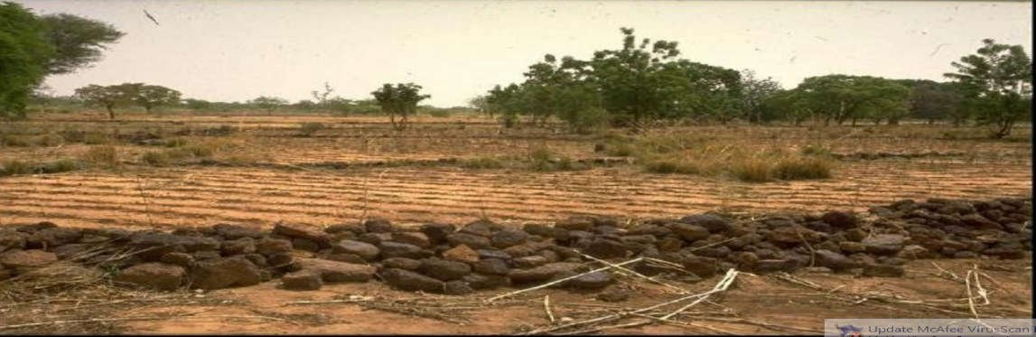

Figure 4.7. Stone bund
- Trapezoidal bunds
Trapezoidal bunds are used to enclose larger areas (up to 1ha) and to impound larger quantities of runoff which is harvested from an external or “long slope” catchment. The name is derived from the layout of the structure which has the form of a trapezoid a base bund connected to two side bunds or wing walls which extend up slope at an angle of usually 135 degree. Crops are plants within the enclosed area of over flow discharges around the tips of the wing wall. The concept is similar to semi-circular bunds; in this case, three sides of a plot are enclosed by bunds while the fourth (up slope) side is left open to allow runoff to enter the field The simplicity of design and construction and the minimum maintenance required are the main advantages of this technique.
- Technical details
- Suitability Trapezoidal bunds can be used for growing crops, trees and grasses. Their most common application is for crop production under the following site conditions.
- Rain fall: -250-500mm arid to semi-arid areas
- Soils: agricultural soils with good constructional properties
- Slopes: - from 0.25%-1.5%, but most suitable below 0.5%.
- Topography: -area within bunds should be even
- Limitation: - this technique is limited to low ground slopes. Construction of trapezoidal bunds on slopes steeper than 1.5% is technically feasible, but involves prohibitively large quantities of earth work.

- Layout and construction
Step one: - When the site for the bund has been decided, the first thing to do is to establish the land slope using an abney level or line level. The dimensions of bund vary with the slope of the area. Starting at the top of the field a peg is placed which will be the tip of one of the wing walls. The second wing wall tip is at the same ground level at the distance obtained from table above.
Step two: -Stake out the four dimensions of the bund and measure the right angle using a wooden right angle triangular template
Step three: - The accuracy of the setting can be checked by measuring the distances between points 4ocm.
Step four: -Having the main points of the bund it is necessary to set out pegs or stones to mark the earth work limits.
Step five: -Construction of a set of trapezoidal bunds must start with the row furthest up-slope. The bund is constructed in two layers each having a maximum thickness of 0.3m, the thickness of the first layer will gradually taper off to zero as filling proceeds up slope along the wing bunds.
- Step six: -The tips of the bunds are only 20 cm high and exceed runoff drains around them. To prevent erosion of the tips they should be shaped with a small extension or “lip” to lead water away.
- Step seven: -Where the catchment is large in relation to the bunded area it is advisable to construct a diversion ditch to prevent excess water or inflow to the bunds. This ditch usually 50cm deep and of 1-1.5 meters width, and is usually graded at 0.25%.
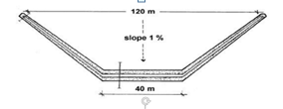
Figures 4.8. Trapezoidal bund

Self-check 4 | Written test

Name: ----------------------------------------------------- Date: ------------------------
Directions: Answer all the questions listed below.
Test I: Choose the best answer
- Which one of the following is true about water harvesting techniques? (5 pts)
A. roof top water harvesting B. micro- water harvesting
C. sea D. macro water harvesting techniques
- Which one of the following is true micro catchments are diamond shaped basin surrounded by small earth bunds with an infiltration pit in the lowest corner of each? (5pts)
A. Negarim B. Counter bund
C. trapezoidal bund D. semi-circular bund
- Which one of the following is true used to enclose larger areas (up to 1ha) and to impound larger quantities of runoff which is harvested from an external or “long slope” catchment? (5pts)
A. Negarim B. Counter bund
C. trapezoidal bund D. semi-circular bund
- Which one of the following is true usually made of earth or stone and have commonly a diameter of 2-8 m (up to 12 m)? (5pts)
A. Negarim B. Counter bund
C. trapezoidal bund D. semi-circular bund
- Which one of the following is true about the characteristics of contour stone bund? (5pts)
A. 500-2750mm from arid to semi-arid areas
B. 200-750mm from arid to semi-arid areas
C. 2000-3000mm from arid to semi-arid areas
D. 250-1050mm from arid to semi-arid areas

Test II: Mache column A to B (2 pts each)

 | A | B
 | ------- Zia | - Begin with long and thoughtful observation
 | ------- Negarim | - Peoples priority
 | -------- water harvesting technique | - Floodwater farming
 | -------- Social and cultural habit | - Rain fall ranges 150mm-700mm per annum.
 | -------- design procedure of water harvesting techniques | - Series of pits dug following the contours.

Note: Satisfactory rating - 25 points and above Unsatisfactory - below 25 points
You can ask your teacher for the copy of the correct answer

Operation Sheet -4

4.1. Identifying different water harvesting techniques

- Tools and equipment
- materials used for identify water harvesting techniques: - Note book, pen
- Personal protective equipment: Safety shoes, Sun hat, Gloves, Overall.
- Techniques water harvesting
To identify water harvesting techniques use the following parameters
- consider social and cultural aspect of peoples
- catchment length
- Runoff coefficient
- slope of the area
- list out different water harvesting techniques
- Roof top water harvesting techniques
- Micro catchment water harvesting techniques
- Macro catchment water harvesting techniques
- Flood water harvesting techniques
  - Layout of ground rain water harvesting
- Steps Layout of ground rain water harvesting system
1. Establish the land slop using line level
2. Stake out the four dimension of structure
3. Check the accuracy by using measuring tape
4. Set out pegs
5. On the layout start excavation

LAP TEST-4 | Performance Test

Name………………………………. ID…………………………….. Date…………………………………….

Time started: ________________________ Time finished: ________________

Instructions: Given necessary templates, tools and materials you are required to perform the following tasks₁, within 2 hour and task₂ within 3 hours. The project is expected from each student to do it.
Task-4.1. perform different water harvesting techniques and method of identifying water harvesting
Techniques
Task- 4.2- conduct layout of ground rain water harvesting

LG #37 | LO #5 Roof top Water harvesting structure

Instruction sheet
This learning guide is developed to provide you the necessary information regarding the following content coverage and topics:
- Selecting Site
- Preparing construction materials
- Harvesting and supplying water based on demand
- Construction of Ferro-cement storage structure
This guide will also assist you to attain the learning outcomes stated in the cover page. Specifically, upon completion of this learning guide, you will be able to:
- Select Site
- Prepare construction materials
- Harvest and supply water based on demand
- Construct Ferro-cement storage structure
Learning Instructions:
- Read the specific objectives of this Learning Guide.
- Follow the instructions described below.
- Read the information written in the information Sheets
- Accomplish the Self-checks
- Perform Operation Sheets
- Do the “LAP test”

Information Sheet – 5

Introduction
A rainwater harvesting system comprises components of various stages - transporting rainwater through pipes or drains, filtration, and storage in tanks for reuse or recharge. The common components of a rainwater harvesting system involved in these stages are illustrated here.
- Catchments: The catchment of a water harvesting system is the surface which directly receives the rainfall and provides water to the system.
- Coarse mesh at the roof to prevent the passage of debris
- Gutters: used to collect water

- Conduits are pipelines or drains that carry rainwater from the catchment or rooftop area to the harvesting system.
- A first flush device is a valve that ensures that runoff from the first spell of rain is flushed out and does not enter the system.
- The filter is used to remove suspended pollutants from rainwater collected over roof.

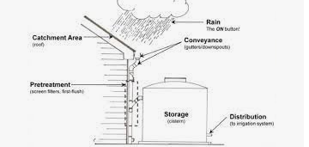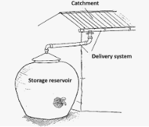

Figure 5.1. Roof top water harvesting

5.1. Site selection
Selection of site for roof top water harvesting is related to both the catchment and storage tank. For the construction of water harvesting tank availability of suitable roofs is crucial. The site should not be exposed to land erosion, near gullies or not on tops of swampy ground. Storage tank must be set on good foundation or soil for the constructions of foundation firm soil need less depth and sandy or loose soil requires deep foundation. As our catchment area is roof of houses & available rainfall of the areas are very much important
5.2. Preparing required materials
The quantity of each and every construction materials can be obtained from the bill of quantities estimated from the design plan. During construction, the material required for super structure and substructure /foundation/ of water harvesting schemes should have to be identified and make use of necessary material for desired objective. Some of the required materials for constricting roof top water harvesting are:-

- Reinforcement bar of different diameters
- Barbed wire /(wire mesh)
- Corrugated iron sheet (CIS)/Aluminium sheet
- Sand
- Water
- Cement
- Lime
- Bricks
- Capped nail
- Washout pipe
- Paints
- Outlet pipe
- Soil
- Down pipe
- Grass straws
- Vent pipe
- Overflow pipe etc.
- Gravel

5.3. Construction of Ferro-cement storage structure
Lay out and construction of roof top water harvesting storage structures (Ferro-cement tank). Roof top water harvesting is the collection and concentration of water from impervious surface (roof covering) for human or agricultural uses for growing of crops.

- Construction Procedures:
The steps followed during construction of Ferro-cement tank (capacity 5m3) of cylindrical shape.
- Calculate the radius of the tank. The height (h) need to be not more than 1.5meter, otherwise it will more reinforcement.
$$V= Пr2h where, h =1.5m then, r = 1.1meter$$
- Select the construction site which is 3meter away from the wall of the building (home)
- Clear soft top soil off the site so that the tank is constructed on firm ground.
- At the center of the cleared site, hammer one wooden peg, tie a rope to the center peg equal to
- Meter long (1.1 m radius + 10cm foundation footing + 10cm thickness).
- Draw a circle using the tied rope (1.3 meters long).
- Remove the soil inside the marked circle to a depth of 50 cm (if the soil is stable, otherwise the depth can be more)
- Fill stone foundation to the depth of 38cm.
- On the top of the stone foundation, put one ring made from steel diameter of 10/12mm at the radius of 1.15 meter (1.10m + 0.05m).
- Calculate the circumference of the circle (r =1.15m) and then install 1.62 meter long steel bar of diameter 10 or 12mm at 40cm interval.
- On the top of stone foundation fill 10 cm thick concrete with the ratio of 1:3:4.
- Be sure the steel poles are vertical. To be more precise prepare one additional ring similar to the foundation and put at the top of the poles. Tie firmly with soft wire to the poles.
- On the top of the concrete floor, lay steel bars diameter 8/10/12 mm at 40 cm interval across the circumference, and tie them with the vertical firm poles.
- On the top of stretched steel bars, fill 10cm thick concrete having a ratio of (1: 2: 3).
- On the next day, make the concrete floor damp and spread 25mm of cement mortar (1:3) across the floor of the tank. Make the surface of the mortar flat, but scratch it to make little bit rough.
- Install a galvanized pipe 3/4'' for drainage with elbow joints.
- Before the cement hardened, place one or two layer of wire mesh ( chicken mesh wire across the floor of the tank. bend it up ward at least 300cm behind the steel poles so it can be cart in the wall formed outside the poles. tie the chicken mesh wire to the poles.
- Stand or kneel on planks of wood to spread your weight and not to damage the first layer of mortar. Sprinkle water on the first mortar surface. If it has begun to dry out, then quickly add another 25mm later of mortar.
- Install a galvanized pipe for delivery of water. The pipe should be equipped with elbow, nipple and gate valve.
- Put bamboo or any sheet metal (for form work) at the inside of the tank & tie firmly to the poles.
- Strengthen the outside wall by winding 6 mm diameter steel and the distance between each winding should be 20cm apart.
- Prepare the wall reinforcement by winding chicken mesh wire on the top of the steel rings. You can use one or two layers of chicken mesh wire. The chicken mesh wire should be stretched very well in order to have uniform plastering.
- Begin plastering the tank wall from the outside with cement- sand ratio of 1: 3 mortars to a thickness of 20 mm. scratch the surface to make it rough, and then apply the second layer of 20 mm thick mortar to the dampened area of the outside surface of the tank in order to give a smooth finish.
- Three days later, carefully remove the bamboo and plaster the inside part of the tank with cement- sand mortar to a thickness of 20 mm. After a day, add a second layer of 20 mm thick mortar to dampen inside surface of the wall, giving it a smooth finish.
- Apply the final coat for the walls (inside and outside surface) and the floor in order to make the surface water proofing. To do this coat cement and water (nil) will mix and apply on the same day. Again keep the surface damp all the time. Make the wall and floor thicker, where the pipes go through it.
- Cover the tank with Ferro-cement the same thing as prepared for floor foundation, but the spacing for steel bars should be 20 cm apart. The steel bar should be strengthen with chicken mesh wire reinforce.
- Put the prepared roofing material at the top of the tank, tie firmly with the poles.
- Prepare different lengths of wooden poles and by standing at the center of the tank (inside part) push it with one king post until completely stretched them with other wooden poles. Push the roofing at all direction until it becomes dome shape.
- Then, apply cement-sand mortar plastering from the outside as it was used for inside wall plastering. The thickness is similar with inside wall plastering. Leave the support poles for a minimum of 7 days, remove the poles and apply plastering from the inside. The total thickness should not be more than 10cm.
- The roofing should have a man-hole 60 cm*60 cm and an inlet 20 cm*20 cm.
- Fill the tank very slowly with water. Leave some water in the tank to prevent from drying. The tank should be watered three times a day for about 21 days.
- If you find any cracks you can repair them when the tank is empty by chipping away the mortar from the mesh and then filling the hole with fresh mortar. Keep the repair damp for at least two weeks.
- Make a small pit under the tap, so that a bucket can fit beneath it.
- Cover the tank with Ferro-cement the same thing as prepared for floor foundation, but the spacing for steel bars should be 20 cm apart. The steel bar should be strengthen with chicken mesh wire reinforce.
- Put the prepared roofing material at the top of the tank, tie firmly with the poles.
- Prepare different lengths of wooden poles and by standing at the center of the tank (inside part) push it with one king post until completely stretched them with other wooden poles. Push the roofing at all direction until it becomes dome shape.
- Then, apply cement-sand mortar plastering from the outside as it was used for inside wall plastering. The thickness is similar with inside wall plastering. Leave the support poles for a minimum of 7 days, remove the poles and apply plastering from the inside. The total thickness should not be more than 10cm.
- The roofing should have a man-hole 60 cm*60 cm and an inlet 20 cm*20 cm.
- Fill the tank very slowly with water. Leave some water in the tank to prevent from drying. The tank should be watered three times a day for about 21 days.
- If you find any cracks you can repair them when the tank is empty by chipping away the mortar from the mesh and then filling the hole with fresh mortar. Keep the repair damp for at least two weeks.
5.4. Harvesting and supplying water based on demand
The distribution of harvested rainwater consists of two basic processes: providing sufficient pressure to move water out of the tank and providing a means to deliver water to its intended use.

Harvested rainwater can be moved out of the tank using gravity flow or using more complex electric or solar powered systems. Piping, hoses, and in many cases irrigation technology are used to deliver water to its intended use. Note that hose threads and pipe threads are not the same size although there are parts that allow connections between hose and pipe threads. Different types of pipes have different inside diameters, just as different brands of drip lines have different diameters.

It is important to note that distribution systems can be responsible for more water waste than tank collection, conveyance, and storage systems combined. If you forget to turn off a hose that taps a tank, tank water can quickly drain away. When a pressurized pipe leaks 24 inches below ground, it will often go unnoticed until a large volume of water has been wasted. When a pump or irrigation system gets stuck in the “ON” position, it does not take long for a tank to drain. Paying close attention to good design, maintenance, and operation of the distribution system is key to efficient tank water use.

Control over the quantity of water abstracted from the tank is important to optimize water use. Water use should be managed so that the supply is sufficient to last through the dry season.

Failure to do so will mean exhausting all the stored water. In effect it will mean going back to where the user began, i.e. trekking long distances for poor quality water. On the other hand, underutilization of the water source due to severe rationing may leave the user dissatisfied with the level of the service provided.

The storage tanks designed for domestic use or watering animals should be constructed at nearby to the village so that travelling to the tank should not be difficult.
- The storage tank must be set
- The site should be selected such that the expected seepage and evaporation losses are kept as minimum as possible.
- The catchment area size should be sufficient enough (not too big or too small) to produce sufficient amount of run-off to the tank.
- Storage tank should be located where construction materials are easily available in the near vicinity
- Near the catchment area (the root and the house or around 3m away)
- With good foundation (firm soil condition)
- With necessary parts or components
- It should be away from latrine, drainage etc.
- Large trees near the structure and over hanging braches near the rooftop should be avoided, thus roots can penetrate the tank wall and cause seepage
- The site should be free from ant- hills (‘kuyissa’), old latrine and waste pits
- The foundation should be stable (i.e. in situ test like: - strength compressibility or settlement and other engineering properties of the foundation should be identified.
- Estimation of household water demand
$$D or Vd=t * n * q$$
Where: V_{d} = household demand
t = number of days without rain in the longest dry Period of the year (days)
n = number of people in the house hold
q = consumption per day (liters)
- Estimation of water demand for a given community (village, town) or communal water demand

In order to estimate the total water demand of a given community or villagers, first the population must be forecasted for the given design period. Thus, the total water demand of the community (village) can be calculated as:
$$D =PN* Q * T$$
Where: D = the design period total water demand of the community
P_{N} = Total no of community at the end of N year
Q = average daily per capita water demand at the end of N years.
T = the length of dry & period (days)

- Estimation of amounts of runoff
- Calculating the area of catchments (roof top area) (A)
$Area =Length*Width$
- Calculating the amount of (runoff) that can be harvested Q (m³)
$Area Q=P*A* RC$Where: P = Mean annual rainfall (m)
A = Area of catchment. (m²)
R_{C} = Runoff coefficient
Table 5.1. Runoff coefficient (R_{C}) for various catchments
Surface type | Rainfall region (mm)
 | 250 -500 | 500 -1000 | 1000 -1500
Corrugated iron sheet | 0.8 - 0.9 | 0.8- 0.9 | 0.8 - 0.9
Organic thatch | 0.2 | 0.2 | 0.2
Concrete | 0.75 | 0.75 | 0.75

- Estimating the required capacity of a tank
- First, estimate the demand of water (Vd) for the dry season by: -
- Determining the number of persons in the house hold (n)
- Determining the number of liters of water consumed per person per day (q)
- Determining the number of days with no rain in the longest dry period of the year (t)
- Determining the loss due to seepage and evaporation, usually 20%of the estimated house hold water demand, then
$$Vt =t*n*q +Vd*20\% t * n * q= Vd + Vd* 0.2=Vd (1+0.2) =1.2Vd$$

Self-check 5 | Written test

Name: ----------------------------------------------------- Date: ------------------------
Directions: Answer all the questions listed below.
Test I: Mache column A to B (2 pts each)

 | A | B
 | ------- amount of (runoff) that can be harvested | - $Area =Length*Width$
 | ------- volume of cylinder | - Filtering of water
 | -------- area of rectangle | - 0.8-09
 | -------- screening runoff coefficient | - $V= Пr2h$
 | --------- Concrete runoff coefficient | - 0.75
 | ---------Organic thatch | - 0.2
 | -------- Corrugated iron sheet runoff coefficient | - $Q=P*A* RC$

Note: Satisfactory rating - 10 points and above Unsatisfactory - below 10 points
You can ask your teacher for the copy of the correct answer

Operation Sheet -5

5.1. Identify roof top and ground surface water harvesting storage structure
- Tools and equipment
- Tools and materials used for identify roof top and ground surface water harvesting storage structure: - Note book, pen, pip, gutter, meter, ladder, mesh wire, cement, sand, stone, trowel, mixer, and wheelbarrow.
- Personal protective equipment: Safety shoes, Sun hat, Gloves, Overall.
Objective: The main objective of identifying roof top and ground surface water harvesting storage structure is to harvest water for irrigation.
- Techniques of roof top and ground surface water harvesting
- Assess availability of roof catchment
- Calculate the area of roof top
- Read the precipitation of the area from metrological station
- Estimate runoff to be captured per unite area of the roof
- Assess availability and location of construction material
- Estimate capacity of storage structure

LAP TEST-5 | Performance Test

Name………………………………. ID…………………………….. Date…………………………………….

Time started: ________________________ Time finished: ________________

Instructions: Given necessary templates, tools and materials you are required to perform the following tasks within 2.30 hour. The project is expected from each student to do it.

Task-1 conduct roof top and ground surface water harvesting storage

LG #38 | LO #6- Ground surface and water storage structure

Instruction sheet
This learning guide is developed to provide you the necessary information regarding the following content coverage and topics:
- Collecting Construction materials
- Designing Structures based on catchment area.
- Constructing Surface storage structure
This guide will also assist you to attain the learning outcomes stated in the cover page. Specifically, upon completion of this learning guide, you will be able to:
- Collect Construction materials
- Design Structures based on catchment area.
- Construct Surface storage structure

Learning Instructions:
- Read the specific objectives of this Learning Guide.
- Follow the instructions described below.
- Read the information written in the information Sheets
- Accomplish the Self-checks

Information Sheet - 6

6.1. Collect Construction materials
The following materials are collected to construct ground surface and water storage structures.

- Cement
- Stone
- Gravel
- Mesh wire
- C.I.S
- Caped nail
- Wooden purlins & rafter
- PVC/concrete pipe

6.2. Design Structures based on catchment area
Below/underground storage structures can be constructed to store rain water runoff from rooftops and/or ground surfaces. Below ground storage tanks are cheaper than the above ground storage structures because the soil profile provides structural support (i.e. reinforcement requirement is less).
- Typical examples of ground surface water storage structure are :
- Hemispherical,
- Dome cap,
- Farm pond & small dam.
- Hemispherical storage structure
In order to decide the size of the catchment area the following factors must be considered.
- Run off coefficient
- Rainfall of the area
- Construction cost
- Storage capacity

- Required storage capacity (V_{t})
- Storage capacity (V_{t}):
$Vt =wd+30\%wd=1.3wd$Where wd is water demand & 30% is loss
- Runoff from catchment area (Q):
$Q=A*P*K$Where P is mean annual rainfall & K is runoff coefficient
$Q=Vt=APK=1.3wd$
- The required catchment area (A) can be calculated as follows
$$A=1.\frac{3wd}{kp}$$
- Estimation of Evaporation and seepage losses
- Evaporation and. Seepage losses are controlled by applying roofing and lining material respectively. A 30% loss accounts for siltation and management.
- Design specification and standard size of hemispherical tank
- Wall- lining materials cement-sand mortar (1:3) or soil cement mortar (1:6) chicken mesh wire if the soil is unstable.
- Masonry ring- 60 cm high and 30 cm wide, cement-sand mortar (1:3) for binding and plastering.
- Roof cover - corrugated iron sheet /poly ethane sheet/ canvas and nailed on wooden beam of 10 cm diameter and rafter 4-6 cm diameter.
- Silt trap -stone /brick masonry with cement –sand mortar (1:3) for binding and plastering.
- Standard size of hemispherical storage:
- Capacity (m³):- 89, 82, 75, 68, 62, 56, 51, 45, 41, 36, 32, 28, 25, 22, 19, 16, 14 and 10.
- Suitability
- Deep or shallow soils (not less than 3 m)
- Soils which are not too sandy or clayey .If the soil is too sandy or clayey use stone, brick or steel (mesh wire).
- Suitable for horizontal pumps like rower pump or treadle pump, not suitable for rope and washer pump.

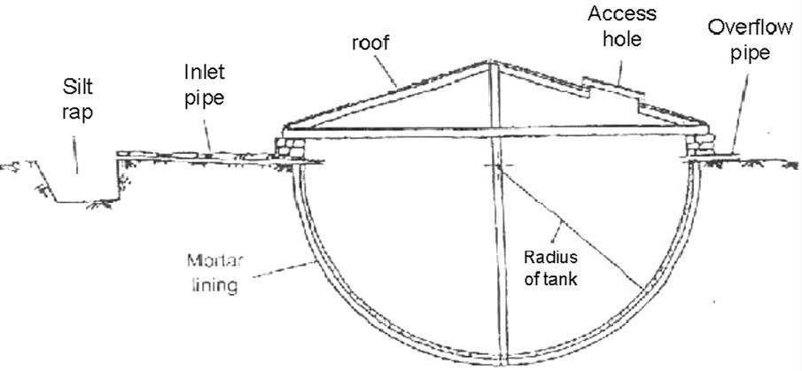

Figure 6.1. Components of hemispherical storage tank

- Design and construction of Farm ponds

Farm ponds are small tank or reservoir like constructions, are constructed for the purpose of storing the surface run off, generated from the catchment area. The farm ponds are water harvesting structure; solve several purposes of farm needs such as supply of the water for irrigation, domestic, fish production etc.
- Types of Farm Pond
In broad sense, the farm ponds are divided in to two general categories;
- Embankment type- farm ponds are generally construction across the stream or water course such ponds consist of earthen dam, which dimensions are evaluated on the basis of volume of water to be stored etc.
- Excavated type/dugout type- farm ponds are constructed by excavating the soil from the ground relatively in level areas. The depth of pond is decided on the basis of its desired capacity which is obtained almost by excavation .The use of this type of pond is suitable, particularly where a small supply of water is required.
- The design of excavated or dugout pond include the determination of specifications for the following:
- Pond capacity,
- Shape of pond,
- Dimensions (depth, top & bottom widths and side slopes),
- Inlet channels and
- Emergency spillway or Outlet.
- Pond Capacity
The capacity of the dugout pond depends on purpose for which water is needed and by the amount of inflow that can be expected in a given period. The capacity of the pond depends upon the catchment size and factors affecting its water yield.
- Shape of Pond
- square,
- rectangular,
- Inverted cone. They are trapezoidal in shape)
- Dimensions of farm pond
The selection of dimensions for excavated pond depends on the required capacity, soil type, purpose and type of machine available for pond construction. The size of a pond should be relative to the size of the catchment area contributing surface runoff to the site.
- Depth and side slope of farm ponds
The side slope of the pond is decided based on their angle of repose of the material being excavated and this angle of repose varies with type of soil. For the most cases, the side slopes of 1: 1 to 1.5:1 are recommended for practical purpose.
- Volume of pond – The following formula can be used for determining the volume of excavation required, (prismoidal formula). Once the volume, depth and side slope are known, the dimensions of different shape of farm ponds can be calculated using the prismoidal formula as given below as per the definition sketch (Figure 6.2:2).

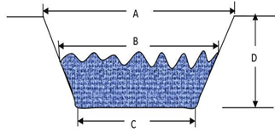

Figure 6.2:2. Sketch of farm pond

$V=\frac{A+4B+C}{6} *D$ Where,

V = volume of excavation (m³)
A = area of excavation at the ground surface (m²)
B= area of excavation at the mid- depth point (D/2) (m²)
C = area of the excavation at the bottom of pond (m²); and
D = average depth of the pond (m).

Example
Calculate the volume of excavation required to construct a dugout farm pond if average depth of pond is 4.5m, Bottom width is 12m, Bottom length is 25m and Side slope to be used as 2:1.
Solution
Using the following formula$V=\frac{A+4B+C}{6} *D$
X= 2D = 9m
At mid depth
D= 9/2
= D = 4.5m
Computation of A = Top length x Top width
= ( 25+2(9) x 12+2(9))
= 43x30 =1290
Computation of 4B
Mid length =25+2(4.5) = 34m
Mid width = 12+2(4.5) = 21
4B= 4*(34x21) =2856m²
Computation of C
C= 12x25= 300m²
Volume = (1290 +2856+300) X 4.5 = 3334.5m³

- Dome cap water tank
It is a type of underground water storage structure which is mostly excavated and constructed to a shape of dome at the upper part & circular frustum at the lower part. Excavation of dome cap water tank carried out below ground with top dome built first. And can be used to store runoff water collected from ground surface or rooftops.

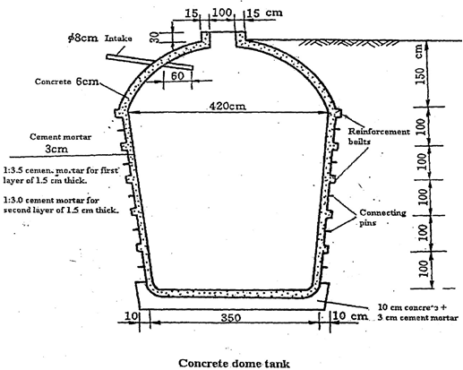
Figure 6.2 Dome cap water tank

  - Constructing Surface storage structure
- Construction Procedures of hemispherical storage structures
- Determine the total volume of water to be stored
- Calculate the capacity of the storage by adding 20% of the demand
- Determine the lining material to be used
- Find the size of hemisphere using V= 2/3πR3
- Level the area and clear the site to a depth of 20 cm to remove the top soil
- Locate the position of silt trap and level it with respect to the storage
- At the center of the selected site hammer one wooden peg
- Add the thickness of the selected lining material to the radius of the hemisphere to get the external radius Ro.
- Tie a rope to a center peg and make a loop at Ro meter put a nail through the loop and draw a circle
- Put a wooden pole of length 2Ro +2 meter across the center peg: put a nail at the center of a wooden pole at (2Ro+2)/2 position .The nail should be at position of the center peg.
- Remove the center peg and tie the plastic (nylon) string of Ro to the nail on the wooden pole.
- Using the rope Ro (i.e. length of rope=Ro) at all times, the soil inside the marked circle should be excavated to the shape of a hemisphere.
- To prevent the wall from collapsing construct two layers of masonry ring .The first ring 30 cm high and 30 cm thick built below ground surface and the second layer 30 cm X 30cm on the upper profile of the hemisphere.
- Watering the wall of excavated hemispherical tank, and then apply one layer (first) of cement sand mortar (1:3) to a thickness of 1.5 cm including the first layer of masonry ring. The work should be completed within one day.
- The next day, put the chicken mesh wire across the surface area of the tank. To fix the mesh wire use capped nail at 15 to 20 cm spacing.
- Construct the second layer of masonry ring and black wire embedded in the masonry wall to enable tie roofing materials (i.e. wooden pole/beam and truss).
- Then apply the second coat with cement –sand mortar (1:3) of 1.5 cm thick over the mesh wire including the second masonry ring.
- At the third day, apply 2 cm thick cement –sand mortar coat. For water proofing a coat of cement slurry (nil) on the same day as the final coat of plaster.
- The roof is constructed from two wooden poles each 10 cm diameter and a length o 2Ro plus half the thickness of the masonry ring. They are placed at a right angle across the center of the tank and tied down with black wire embedded in the masonry wall. At the center, where they cross, a wooden post of 10 cm diameter and 60 cm long is erected, and then the truss and rafter will be installed.
- Cover the roof with corrugated iron sheet. Opening 60 cm x 60 cm and 20 cm x 20cm should be provided for man hole and inlet respectively.
- Damp the structure for about 21 days.

- Construction of dugout Farm ponds
These ponds are constructed on the principle to expose a minimum water surface area in proportion to their volume. This feature of dugout pond proves beneficial particularly where evaporation losses are high and water is very scares. After the site selection and pond dimensions decided, the pond site should be cleared of all stones and woody vegetation. Before construction of farm pond, proper layout should be made for proper construction. The design drawings for farm pond with silt trap, inlet and outlet construction are Figure 6.2:4. Stakes are used to mark the limits of the excavation and spoil placement areas and the depth of cut from the ground surface to the pond bottom should be indicated on the stakes. Excavation and placement of the dugout material are the principal items of work required in the construction of pond.

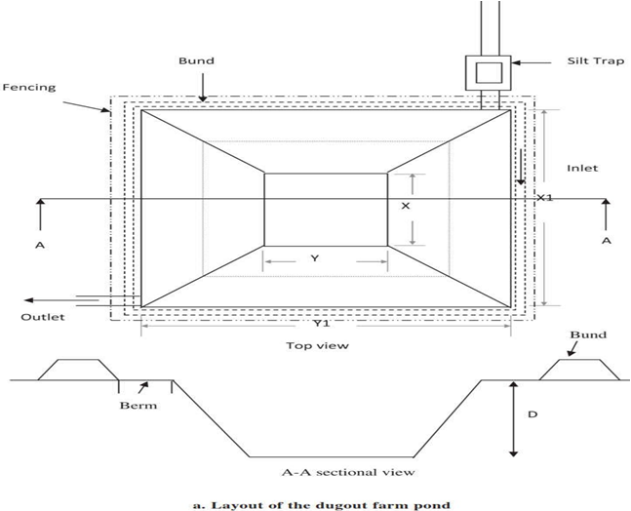

Figure 6.3. Layout of dug out farm pond.

Self-Check – 6 | Written test

Name…………………………………………… ID………………………… Date…….

Directions: Answer all the questions listed below.

Part I: Choose the best answer from the given alternatives. (10 points).
- Which one of the following material is not used to construct ground surface and water storage structures?
  - Cement c. Stone
  - GPS d. Gravel
- One of the following is not factors consider to decide the size of the catchment area for water harvesting.
  - Run off coefficient c. Rainfall of the area
  - Construction cost d. Availability of labor
- One of the following is types of farm pond that constructs by crossing streams or water course.
  - Excavated type c. dugout type
  - embankment type d. inverted cone
- All of the following is not include in the construction procedures of hemispherical storage structures.
  - Determine the total volume of water to be stored
  - Calculate the capacity of the storage by adding 50% of the demand
  - Determine the lining material to be used
  - Find the size of hemisphere using V= 2/3πR3

Part II: match column “A” to “B”(2 pt each)

 | A | B
 | ------ Cement | - corrugated iron sheet
 | ------- Excavated type | - dugout type
 | -------- ground surface water storage | - Construction material
 | -------- Roof cover | - rectangular shape
 | --------- Shape of Pond | - Dome cap

Note: Satisfactory rating – 17.5 points Unsatisfactory - below 17.5 points

You can ask you teacher for the copy of the correct answers.

You can ask you teacher for the copy of the correct answers.

LG #39 | LO #7- Construct ground Surface catchments, diversion canals & sediment ponds

Instruction sheet
This learning guide is developed to provide you the necessary information regarding the following content coverage and topics:
- Identifying Surface catchments, diversion canals and sediment ponds
- Arranging materials
- Constructing Surface catchments, diversion canals and sediment ponds
This guide will also assist you to attain the learning outcomes stated in the cover page. Specifically, upon completion of this learning guide, you will be able to:
- Identify surface catchments, diversion canals and sediment ponds
- Arrange materials
- Construct surface catchments, diversion canals and sediment ponds
Learning Instructions:
    - Read the specific objectives of this Learning Guide.
    - Follow the instructions described below.
    - Read the information written in the information Sheets
    - Accomplish the Self-checks
    - Perform Operation Sheets
    - Do the “LAP test”

Information Sheet - 7

7.1. Identifying Surface catchments, diversion canals and sediment ponds
Catchment area: - It is a natural or manmade unit draining runoff water to a common point. Water can be made available by damming a natural rainwater catchment area, such as a valley, and storing the water in the reservoir formed by the dam, or diverting it to another reservoir.
- Classification of catchment area:-
- Natural catchment
- Borrowed catchment
- Constructed catchment
- Basic components of ground surface water harvesting:
- Catchment area
- Diversion channel
- Sediment pond
- Storage
Diversion Canals:-The purpose of a diversion canal is to lower a watercourse's downstream water level. Such a canal is most often water supplied by a spillway on levees located along a main watercourse. Generally, these canals must make up for a watercourse's insufficient local conveyance, and join together further downstream.

Sediment pond: - a small, temporary ponding basin formed by an embankment or excavation to capture sediment. Purpose To detain sediment-laden runoff and trap the sediment to protect receiving streams, lakes, drainage systems, and protect adjacent property. Conditions where practice applies specific criteria for installation of a temporary sediment trap are as follows:
- At the outlets of diversions, channels, slope drains, or other runoff conveyances that discharge sediment-laden water.
- Below areas that are draining 5 acres or less.
- Where access can be maintained for sediment removal and proper disposal.
- In the approach to a storm water inlet located below a disturbed area as part of an inlet protection system.
- Structure life limited to 2 years.

7.2. Arranging materials
Construction of diversion channel and sediment pond can be constructed from locally available materials such as soil, stone, cement, sand etc. Catchment can be constructed if the existing catchment is not sufficient or suitable to generate the required amount of runoff for example if the roof is organic thatch it can be covered with plastic sheets or corrugated iron sheet (CIS).

7.3. Constructing surface catchments, diversion canals and sediment ponds
- Construct catchment area
It is an area specifically designed and constructed for runoff water collection. Can be constructed necessarily in areas where the existing catchment is not sufficient and suitable for harvesting requirements, such as concrete, plastic tiles(floors),compacted clay soil, stone- paved floors etc.
- Important points to be considered for catchment area selection to construct
- Sufficient runoff should be collected to meet the designed storage capacity.
- The runoff water collected from the catchment area should be easily diverted to the storage facility.
- The catchment area selected should not affect other production activities.
- The catchment area selected should be located sufficiently away from sources of pollution, and it should be protected against pollution.

- Runoff collected from certain catchment area.
Runoff yield varies with the size and texture of the catchment area. In principle, 1mm of rainfall on an impervious catchment area, can generate 1 liter of runoff water per square meter. However, due to several factors the rainfall on a particular catchment must not be totally resulted as runoff. The expected runoff is therefore, the expected design rainfall multiplied by the runoff coefficient and the area of the catchment.

$R=K*P*A$
Where R= annual runoff (m³)
K= runoff coefficient =R/P
P= annual rainfall (design R.F) m
A = area of catchment (m²)
Runoff coefficient denotes the percent of rain water which flows down the land slope as surface runoff.
- Factors influencing runoff coefficient
- Rainfall characteristics (amount, intensity, duration)
- Infiltration rate of the soil
- Slope gradient of the catchment
- Soil moisture content
- Vegetative cover
- Soil type
- Geology
- Size of the catchment
- Construct Diversion channels
Diversion channels flow ways of runoff water collected from the catchment area to silt trap. If the catchment area is rooftop the diversion channel could be gutter attached to the roof edges. Diversion channels should have a certain gradient, for lined channel the gradient should not be greater than 0.33% (1/300) and not greater than 0.2% (1/500) for earth compacted channel.
- The capacity of diversion channel can be calculated using the following equation.
$Q=V*A$
Where Q = runoff discharge (m³/sec)
V= velocity of flow (m/sec)
A= cross sectional area of the diversion channel (m²)

The velocity of flow is given Manning’s equation:
${(R}^{2/3}*S^{\frac{1}{2}})/n =V$
Where n= Manning’s roughness coefficient
R= hydraulic radius = A/P
S = longitudinal slope of the channel (%)
- Sediment pond
Sediment pond is used to settle sediment or silt carried in the runoff. It should be located 3m away from the storage facility. The size of sediment pond should be determined accurately, to the silt characteristics, flow discharges and size of the catchment. Most widely used silt trap is rectangular in shape. For simple storage up to 60m³ capacity the following dimensions are used.
- Max depth 100 cm , Max length 250 cm, Max width 100 cm
- The channel from catchment should be connected to the inlet of the sediment pond at a depth of 20 cm and width 40cm.
- The partition at 150 cm should have a trapezoidal or rectangular spillway at 30 cm depth and 50 cm length.
- The outlet to the storage need to be made with 10 to 20 cm diameter pipe (concrete or pvc) at depth of 50 cm.
- To reduce the sediment/silt load as much as possible excavate a primary silt trap along the flow way before the sediment pond.
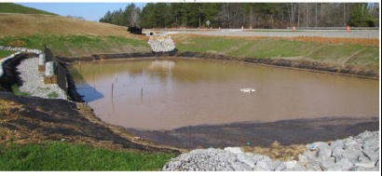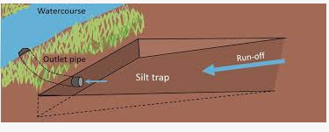
Fig. 7.1. Silt trap
Self-Check – 7 | Written test

Name…………………………………………… ID………………………… Date…….

Directions: Answer all the questions listed below.
Part I. Choose the best answer from the given alternatives. (10 points).
  - One of the following is a natural or manmade unit draining runoff water to a common point.
- Storage C. Catchment area
- Storage capacity D. Diversion cannel
  - One of the following structures is formed by an embankment or excavation to capture sediment.
- Diversion cannel C. Sediment pond
- Catchment area D. Hemispherical pond
  - One of the following is not true about catchment area construction.
- It is an area specifically constructed for runoff water collection
- Can be constructed necessarily in areas where the existing catchment is not sufficient and suitable for harvesting requirements
- Can be constructed necessarily in areas where the existing catchment is not sufficient and suitable for harvesting requirements
- It is an area specifically designed for runoff water collection.
  - All of the following are factors influenced runoff coefficient except:
  - Infiltration rate of the soil C. Vegetative cover
  - Soil moisture content D. Wind speed
  - One of the following is a flow ways of runoff water collected from the catchment area to silt trap.
  - Storage C. Catchment area
  - Storage capacity D. Diversion cannel

Part II: match column “A” to “B”(2 pt each)

 | A. | B.
1. | ------- Types of catchment | - slope
2. | ---------types of materials used in Constructing ground Surface catchments, diversion canals & sediment ponds | - Constructed catchment
3. | -------Equations used to calculate the capacity of diversion channel. | - Corrugated iron sheet (CIS).
4. | ------ Basic components of ground surface water harvesting | - ${(R}^{2/3}*S^{\frac{1}{2}})/n$
5. | ---- Manning’ equation to calculate velocity of runoff. | - Storage
 |  | - $V*A$
 |  | - Vegetation cover.

.Note: Satisfactory rating - 8 points and above Unsatisfactory - below 8 points
You can ask your teacher for the copy of the correct answer

Operation Sheet -7

  - Identify catchment area
  - Tools and equipment
- Tools and materials used for identify catchment area: - Note book, pen, pencil, Gps, top map.
- Personal protective equipment: Safety shoes, Sun hat, Gloves, Overall.
Objective: The main objective of identifying catchment area is to locate the area of water
Harvesting area
  - Steps to identify catchment area
- Identify the boundaries of your catchment and make a working (base) map
- Gather the entire watershed component on the catchment
- Conducts a field assessment of your catchment
- Find the outlet point of your catchment. It will be the lowest elevation in your catchment
- Trace the stream from its outlet

LAP TEST-7 | Performance Test

Name………………………………. ID…………………………….. Date…………………………………….

Time started: ________________________ Time finished: ________________

Instructions: Given necessary templates, tools and materials you are required to perform the following tasks within 3.0 hour. The project is expected from each student to do it.
Task-1. Identify catchment area

Reference Materials

Books:

African Development Bank. 2009. Rainwater Harvesting Handbook: Assessment of Best Practises and Experience in Water Harvesting. African Development Bank.
Alvord ED. ;( 1978); Development of native agriculture and land tenure in southern Rhodesia, Unpublished mos. Harare: Rhodes House, University of Zimbabwe..
Barrow C (2013); Design and construction of water harvesting schemes for plant production;Lowa State University, USA.
Bruins P.N (1986); Evaluation of the benefits Bratton M. (1987); Drought, food and the social organization of small farmers in Zimbabwe.
Chow V.T., 1964, (E.d) hand book of Applied Hydrology, MCGraw-Hill, New York,NY.
Cambridge of infiltration pits on soil moisture in semi-arid area; Michigan University.

Web addresses

https://www.canr.msu.edu/uploads/235/67987/presentations/Water_Sources_for_Irrigation.pdf (accessed date, 28/08/2022).
https://en.wikipedia.org/wiki/Irrigation (accessed date, 27/08/2022).
https://www.fao.org/3/U5835E/u5835e03.htm (accessed date, 27/08/2022).
http://www.waterandnature.org/sites/default/files/national_irrigation_act2013.pdf (accessed date, 26/08/2022).
https://www.lawinsider.com/clause/suitability (accessed date, 25/08/2022).
http://eagri.org/eagri50/AGRO103/lec04.pdf (accessed date, 25/08/2022).

AKNOWLEDGEMENT

Ministry of Labor and Skills and Ministry of Health wish to extend thanks and appreciation to the many representatives of TVET instructors and respective industry experts who donated their time and expertise to the development of this Teaching, Training and Learning Materials (TTLM).

The experts who developed the learning guide
No | Name | Qualification | Organization/ College | Mobile number | E-mail
1 | Serawit Gensa | Msc. Water Resource Engineering | W/Sodo AVET | 0916740916 | serawitgen@gmail.com
2 | Edao Hassen | Msc.Irrigation Engineering | Alage AVET | 0911098097 | hassedao@gmail.com
3 | Mekete Agizew | Msc. Water Resource Engineering | Amhara. Kombolcha ATVET | 0925221192 | gen.mam09@gmail.com
4 | Wondu Alemayehu | Msc.Irrigation Engineering | Oromia Kombolcha ATVET | 0910-28-99-61 | woldualem@gmail.com
5 | Ademe Ayalew | Msc.Irrigation Engineering | Agrafa AVET | 0912720547 | Ademe2004@gmail.com
6 | Said Mohammed | Msc.Irrigation& drainage Engineering | Alage ATVET | 0917180181 | Siyamsdmhmmd@gmail.com/
7 | Molalign Asfaw | Bsc.Water Resource &Irrigation Engineering | Alage ATVET | 0921431096 | Mollalign410ass@gmail.com
8 | Yonas Hailu | Bsc.Water Resource &Irrigation Engineering | Agrafa AVET | 0934715578 | yonashailuw@gmail.com
9 | Lemessa Mulata | Msc.Irrigation Engineering | Agrafa AVET | 0913266845 | Lamimulle2022@gmail.com
10 | Misganew Yimer | Bsc. Soil and Water Engineering | Woreta ATVET |  | Misge1976@gmail.com
11 | Daniel Derese | Bsc. Soil and Water Engineering | W/sodo AVET | 0912-79-28-85 | danielderesse7@gmail.com
12 | Teshome Getachew | Msc.Irrigation & drainage Engineering | Alage ATVET | 0925-50-13-99 | teshomegetachew131@yahoo.com

