IRRIGATION AND DRAINAGE

LEVEL-II

Based On March 2022, Version 3 Occupational Standard



Module Title: - Erosion and Sediment Control
LG Code: IRD IRD2 M10 LO (1-2) LG (40-41)
TTLM Code: IRD IRD2 TTLM 0822v1

August, 20222
Addis Ababa, Ethiopia

Table of Contents

Introduction to the Module 1
LO #1-Erosion and sedimentation control 2
Instruction sheet 1 2
Information Sheet 1 3
Self-cheek 1 21
Operation Sheet -1 22
LAP TEST-1 23
LO #2-Erosion and sediment control measures 24
Instruction sheet 2 24
Information Sheet 2 25
Self-check 2 50
Operation Sheet -2 51
LAP TEST-2 53

Introduction to the Module
This module specifies the outcomes required to observe and report on weather and climate conditions for an agricultural, horticultural or land management enterprise. It also requires the application of skills and knowledge to recognize adverse weather and climate conditions and to monitor record and report on weather and climate information.

LG #40 | LO #1-Erosion and sedimentation control

Instruction sheet 1
This learning guide is developed to provide you the necessary information regarding the following content coverage and topics:
  - Introduction to the module
  - Erosion and sedimentation control legislations
  - Erosion and sedimentation control principles
  - Erosion and sedimentation control methods
  - Erosion and sedimentation control structures
  - Catchment characteristics
This guide will also assist you to attain the learning outcomes stated in the cover page. Specifically, upon completion of this learning guide, you will be able to:
  - Select erosion and sedimentation control methods
  - Construct erosion and sedimentation control structures
  - Adhere erosion and sedimentation legislation
  - Identify catchment characteristics of erosion and sedimentation

Learning Instructions:
- Read the specific objectives of this Learning Guide.
- Follow the instructions described below.
- Read the information written in the information Sheets
- Accomplish the Self-checks
- Perform Operation Sheets
- Do the “LAP test”

Information Sheet 1

1.1 Erosion and sedimentation legislations
- Regulatory Requirements
The Clean Water Act established a set of requirements called the National Pollutant Discharge Elimination System (NPDES). The NPDES regulates storm water discharges associated with industrial activities, municipal storm sewer systems, and construction sites. The purpose of these regulations is to reduce pollution of the nation’s waterways. At the present time there are no specific loss monitoring requirements. Uses of Best Management Practices (BMP) identified in an approved Stormwater Pollution Prevention Plan (SWPPP) have been identified as the means and methods to meet the NPDES requirements. On-going discussions indicate that in the future where NPDES authorities determine that construction discharges have the reasonable potential to cause or contribute to a water quality standard excursion, numeric effluent limitations may be imposed. In the future, specific emphasis will be placed on containing soil erosion and minimizing soil compaction.
Federal Construction and Development Effluent Guidelines for all sites and activities required to be authorized under NPDES permits shall comply with the following federal effluent guidelines as applicable to each site and activity.
- Erosion and Sediment Controls: Design, install, and maintain effective erosion controls and sediment controls to minimize the discharge of pollutants. At a minimum such controls must be designed, installed, and maintained to:
- Control stormwater volume and velocity to minimize soil erosion in order to minimize pollutant discharges.
- Control stormwater discharges including both peak flow rates and total stormwater volume, to minimize channel and streambank erosion and scour in the immediate vicinity of discharge points.
- Minimize the amount of soil exposed during construction activity.
- Minimize the disturbance of steep slopes.
- Minimize sediment discharges from the site. The design, installation, and maintenance of erosion and sediment controls must address factors such as the amount, frequency, intensity, and duration of precipitation, the nature of the resulting stormwater runoff and soil characteristics including the range of soil particle sizes expected to be present on the site
- Provide and maintain natural buffers around waters of the United States, direct stormwater to vegetated areas, and maximize stormwater infiltration to reduce pollutant discharges, unless infeasible.
- Soil Compaction and Topsoil Preservation: Implement practices to minimize soil compaction and preserve topsoil.
- Soil Stabilization: Stabilization of disturbed areas must, at a minimum, be initiated immediately whenever any clearing, grading, excavating, or other earth disturbing activities have permanently ceased on any portion of the site or temporarily ceased on any portion of the site and will not resume for 14 calendar days. In drought stricken areas and areas that have recently received such high amounts of rain that seeding with field equipment is impossible and initiating vegetative stabilization is infeasible, alternative stabilization measures must be employed as specified by the regulatory agency. In limited circumstances, stabilization may not be required if the intended function of a specific area of the site necessitates that it remain disturbed.
- Dewatering: Discharges from dewatering activities, including discharges from dewatering trenches and excavations, are prohibited unless managed by appropriate controls.
- Pollution Prevention Measures: Design, install, and maintain effective pollution prevention measures to minimize discharge of pollutants. At a minimum such measures must be designed, installed, and maintained to:
- Minimize the discharge of pollutants from equipment and vehicle washing, wheel wash water, and other wash water. Wash waters must be treated in a sediment basin or alternative control that provides equivalent or better treatment prior to discharge.
- Minimize the exposure of building materials, building products, construction wastes, trash, landscape materials, fertilizers, pesticides, herbicides, detergents, sanitary waste, and other materials present on the site to precipitation and stormwater. Minimization of exposure is not required in cases where the exposure to precipitation and to stormwater will not result in a discharge of pollutants, or where exposure of a particular material or product poses little risk of stormwater contamination, such as final products and materials intended for outside use.
- Minimize the discharge of pollutants from spills and leaks and implement chemical spill and leak prevention and response procedures.
- Prohibited Discharges: The following discharges are prohibited:
- Wastewater from wash out and cleanout of stucco, paint, form release oil, curing compounds, and other construction materials.
- Fuels, oils, and other pollutants used in vehicle and equipment operation and maintenance.
- Soaps or solvents used in vehicle and equipment washing.
- Surface Outlets: When discharging from basins and impoundments, utilize outlet structures that withdraw water from the surface, unless infeasible.

- REGULATORY LIST
The following federal, provincial and municipal acts, regulations, bylaws, codes of practice, standards, and guidelines may be applicable to urban development activities that result or could result in erosion, sedimentation and adverse effects on the environment.
Note: The list below identifies the primary regulatory requirements that may apply to activities and projects that result in erosion and sedimentation. It is not exhaustive, and specific legal advice should be sought to ensure that all relevant legislation has been identified when a specific regulatory issue arises. This information is not offered, nor intended to be offered, as any form of legal advice.
- Provincial
- Environmental Protection and Enhancement Act, R.S.A. 2000, c. E-12
- Release Reporting Regulation, A.R. 117/93
- Release Reporting Guideline (June 2001)
- Wastewater and Storm Drainage Regulation, A.R. 119/1993
- Code of Practice for Wastewater Systems Using a Wastewater Lagoon
- Code of Practice for Wastewater Systems Consisting Solely of a Wastewater Collection System
- Standards and Guidelines for Municipal Waterworks, Wastewater and Storm Drainage Systems
- Water Act, R.S.A. 2000, c. W-3
- Soil Conservation Act, R.S.A. 2000, c. S-15
- Public Lands Act, R.S.A. 2000, c. P-40

- Municipal
- Municipal Government Act, R.S.A. 2000, c. M-26
- Sewers Use Bylaw No. 9675
- Sewers Bylaw No. 9425
- Surface Drainage Bylaw No. 11501
1.2 Erosion and sedimentation control methods
Erosion control methods fall basically into one of two broad categories. These are designated as vegetative and structural measures. In actual field practice a combination of methods, suitable to the particular site, are employed. Chemical mulches may be placed in a class by themselves. However, because they are usually applied to support and insure emergence of vegetation seeds, they are included in this report under vegetative measures.
- Vegetative measures include: perennial grasses and legumes; annual cover; trees, shrubs, and vines; and mulches (organic and inorganic) to support vegetation and protect soil. The recent development of hydromulching has gained a degree of success in applying grass seed mixed with wood fiber and water under pressure. Well - anchored vegetative mulch has proven to be an effective and least costly of all mulching materials in controlling erosion from denuded areas. Commercial materials available for controlling erosion used in conjunction with or without vegetative treatment are many and varied. Chemical mulching products, which are designed to prevent erosion during rainstorms until vegetation takes hold, include: polyvinyl alcohol, a resin product, an elastromeric polymer emulsion and curasol.
- Structural measures include: small flood control dams, dikes and levees; stream channel improvements and bank stabilization works; sediment basins and outfall structures; terraces, diversion structures and channels; grassed waterways and outlets; grade stabilizing structures such as chutes, check dams and drop spillways. A recent development in highway cut sections is the serrated side slope.
The purpose of the erosion and Sediment Control Law is to provide for the protection of the land, and water resources of the state with minimum adverse effect upon economic activity. The rapid shift in land use from agricultural to nonagricultural has accelerated the processes of soil erosion and sedimentation with the' result that ‘waters are being polluted and spoiled to scuttle degree that fish, aquatic life, and recreation and other uses of lands and waters are being adversely affected.
Natural resources become increasingly more important. Their preservation, is easier and less expensive to accomplish than their restoration--a restoration that may never be physically possible or economically feasible. Soil erosion is the disintegration or wearing away of the land surface by running water, wind, and other geological agents. Sediment is the end product of erosion. Sedimentation involves four fundamental processes: weathering, erosion, transportation, and deposition. Sediment consists primarily of clay, silt, sand, gravel, rock fragments, and mineral particles.
Sediment has a two-fold effect on the environment':
- It depletes the land resource from which it is derived, and
- It impairs the quality of the water resource in which it.is entrained and deposited and may impair the quality-of the land on which it is deposited:

- Some of non-structural and structural to control erosion and sediment control methods
- Managerial

  - Critical Area Stabilization
  - Dune/Sand Stabilization
  - Dust Control
  - Equipment/Maintenance Storage Areas
  - Fertilizer Management
  - Lawn Maintenance
  - Organic Debris Disposal
  - Pesticide Management
  - Pond Construction & Management
  - Pond Sealing & Lining
  - Slope/Shoreline Stabilization
  - Stream bank Stabilization
  - Winter Road Management

- Construction Site Preparation

- Access Road
- Construction Barriers
- Grading Practices
- Land Clearing
- Spoil Piles
- Staging & Scheduling
- Tree Protection

- Runoff Conveyance & Outlets

- Check Dams
- Diversions
- Grade Stabilization Structures
- Grassed Waterways
- Riprap
- Stabilized Outlets
- Storm Water Conveyance Channels
- Subsurface Drain

- Sedimentation Control Structures

- Buffer/Filter Strips
- Dewatering
- Filters / Filter Fencing
- Sediment Basins
- Watercourse Crossing

- Runoff Storage

- Catch Basins
- Extended Detention Basin
- Infiltration Basin
- Infiltration Trench
- Modular Pavement
- Oil/Grit Separators
- Parking Lot Storage
- Porous Asphalt Pavement
- Roof Top Storage
- Wet Detention Basin

- Vegetative Establishment

- Mulching
- Seeding
- Sodding
- Soil Management
- Trees, Shrubs and Ground Cover

- Wetland
- Constructed Wetland Use in Storm Water Control
- Wetland Crossings

1.3 The Erosion and Sedimentation Process
Erosion and sedimentation are naturally occurring processes. However, human activities have accelerated these processes well beyond the rate desired by nature. The removal of large volumes of soil from the land, and their deposition in waterways, has destroyed ecosystems and degraded the environment.
In order to minimize and control erosion and sedimentation, it is important to understand the process and cause of each.
A. The Erosion Process
- Water: Erosion from water typically occurs in the following ways:
- Raindrop Splash and Sheet Erosion:
The first step in the erosion process begins as raindrops impact the soil surface. Raindrops typically fall with a velocity of 20 to 30 feet per second. The energy of these impacts is sufficient to displace soil particles as high as two feet vertically. In addition, the impact of rainfall on bare soil can compact the upper layer of soil, creating a hard crust that inhibits plant establishment and infiltration.
Sheet erosion occurs as runoff travels over the ground, picking up and transporting the particles dislodged by raindrop impacts. The process of sheet erosion is uniform, gradual, and difficult to detect until it develops into rill erosion. If runoff is maintained as sheet flow, the velocity remains low and there is little potential that the flow will remove particles that have not been dislodged by other means (i.e. raindrop splash).
The method used to prevent erosion from raindrop splash and sheet erosion is stabilization. Stabilizing techniques such as temporary and permanent vegetation, sodding, mulching, compost blankets, and rolled erosion control products absorb the impact of raindrops and protect the ground surface. By protecting the surface, soil particles are not dislodged and transported by sheet flow. Typically, sheet flow does not have sufficient volume or velocity to dislodge soil particles from a bare surface by itself. It is dependent on raindrop impacts to disturb the surface. Therefore, stabilizing a surface protects the ground from both raindrop and sheet erosion.
- Rill Erosion:
Rill erosion occurs as runoff begins to form small concentrated channels. As rill erosion begins, erosion rates increase dramatically due to the resulting higher velocity concentrated flows. Construction sites that show signs of rill erosion need to be re-evaluated and additional erosion control techniques employed. Rilling can be repaired by tilling or disking (filling in the rills and discouraging concentrated flows) and should be repaired as soon as possible in order to prevent gullies from forming.
- Gully Erosion:
Gully erosion results from water moving in rills, which concentrates to form larger channels. When rill erosion can no longer be repaired by merely tilling or disking, it is defined as gully erosion. Gullies must typically be repaired with earthmoving equipment. Gully erosion can be prevented by quickly repairing rill erosion and addressing the cause of the rill erosion.
- Stream Channel Erosion:
Stream channel erosion consists of both streambed and streambank erosion. Streambed erosion occurs as flows cut into the bottom of the channel, making it deeper. This erosion process will continue until the channel reaches a stable slope. The resulting slope is dependent on the channel materials and flow properties.
As the streambed erodes and the channel deepens, the sides of the channel become unstable and slough off, resulting in streambank erosion. Streambank erosion can also occur as soft materials are eroded from the streambank or at bends in the channel. This type of streambank erosion results in meandering waterways. One significant cause of both streambed and streambank erosion is the increased frequency, volume, and duration of runoff events that are a result of urban development.
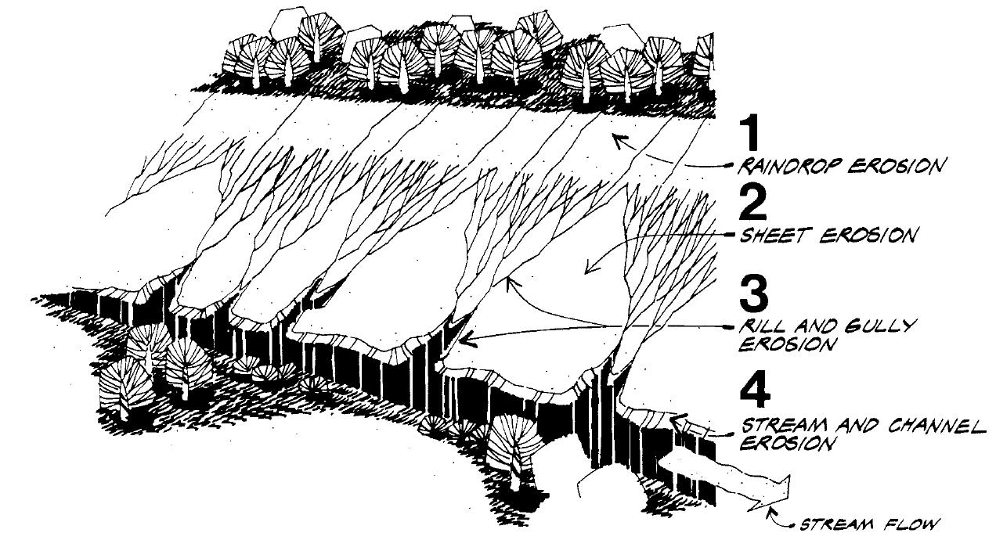
Fig.1.1: Types of Soil Erosion by Water

2. Wind: Wind can also detach soil particles. Detached soil is moved by wind in one of three ways:
  - Suspension
Very fine silt and clay particles (smaller than 0.002 inches in diameter) may be picked up by the wind and carried in suspension. Suspended dust may be moved great distances, but does not drop out of the air unless rain washes it out or the velocity of the wind is dramatically reduced.
  - Saltation
Fine silts up to medium sand particles (0.002 to 0.02 inches in diameter) move in the wind in a series of steps, rising into the air and falling after a short flight. This movement is called saltation. A vast majority of wind erosion is a result of the saltation process.
  - Creep
Soil particles larger than medium sands (greater than 0.02 inches) cannot be lifted into the wind, but particles up to 0.04 inches (coarse sand) may be pushed along the soil surface by saltating grains or direct wind action. This action is called creep.
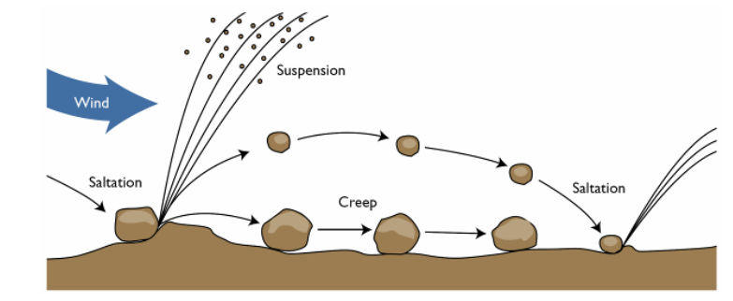
Fig.1.2: Movement of soil particles by wind erosion

B. Factors Affecting Erosion
The extent of erosion that occurs is dependent on a number of factors including soil erodibility, climate, vegetative cover, topography, and season.
    - Soil Erodibility:
The erodibility of a soil depends on its texture and physical properties. The characteristics that influence the potential for erosion are those related to the infiltration capacity of the soil and its ability to resist detachment. Soil properties that affect erodibility include texture, organic matter content, soil structure, and permeability.
In general, soils with a high percentage of fine sand and silt are the most erodible. These particles are easily detached and carried away by rainfall and runoff. As the clay and organic content of a soil increases, the erodibility of the soil tends to decrease. Clay particles have the ability to bind together, reducing the potential for detachment by raindrop splash. However, they are also more impermeable, resulting in increased runoff. The increase in runoff increases the erosion potential (especially rill and gully), offsetting some of the benefit that the binding effect has against resisting erosion. The problem with clay particles is that once they have eroded, they are easily transported by water and are very difficult to remove.
Soils that are high in organic matter content have a more stable texture and increased permeability. This allows the soil to resist detachment and infiltrate more precipitation.
Well-draining sands and gravels are the least erodible soils. Soils with high infiltration rates such as these significantly reduce the amount of runoff, thereby reducing the potential for erosion.
The USDA county soil surveys provide an indication of soil erodibility. This value (K) ranges from 0 to approximately 0.7. Higher values indicate a greater potential for erosion.

    - Precipitation:
The rate of erosion is directly related to the amount and type of precipitation that occurs. High intensity storms increase particle detachment. In addition, frequent or lengthy storms can saturate the soil, reducing infiltration and increasing runoff. Increased detachment and runoff both contribute to erosion. Erosion risks are high where precipitation is frequent, intense, or lengthy.
- Ground Cover:
Ground cover can significantly reduce erosion potential. Vegetative residue, mulch, and compost, as well as the leaves and branches of vegetation, intercept precipitation and shield the ground from raindrop impacts. The roots of vegetation help hold soil particles together and prevent them from becoming detached. Ground cover slows runoff velocity, increases infiltration, and can even filter sediment out of runoff.
- Topography:
Areas with long and/or steep slopes increase the potential for erosion. Long slopes increase the potential for runoff to accumulate and develop into erosive concentrated flow near the bottom of the slope. On steep slopes, high-velocity flows can develop quickly and cause significant erosion.
- Season:
The potential for erosion varies throughout the year. In winter months when the ground surface is frozen, there is little chance of water erosion. As spring approaches, the surface soils begin to thaw, but the ground below remains frozen. This creates a high potential for erosion. An early spring rain at this time cannot infiltrate into the frozen subsoils. However, the newly thawed surface can be easily washed away, even by a light rain. Erosion potential is also high in the summer months, due to the high-intensity thunderstorms that occur during this period.
C. Sediment Transportation
Once soil particles are detached from the surface and suspended in runoff waters, they will remain there until the velocity of the water is reduced. Flowing waters create turbulence that constantly churns and mixes the flow, holding the particle in suspension. In order for the particles to be removed, the velocity of the flow must be reduced sufficiently to allow the particle to settle out by gravity.
Once sediment reaches a natural waterway or stream, it is nearly impossible to remove. As discussed above, the flowing nature of the stream holds the particles in suspension until the flow velocity is reduced. For natural waterways, this reduction in flow velocity does not normally occur until the waterway empties into a water body. At this point, the sediment settles out and is deposited on the bottom of the pond or lake. Over time, this sediment accumulates, forming large deposits and can eventually fill in a water body completely. Sediment is the largest pollutant (by volume) in storm water runoff. The resulting deposits can destroy ecosystems and are difficult and expensive to remove.
Estimation of potential soil loss under a specified set of circumstances and over a particular period of time requires the use of some reasonable approach. For the purposes of this the universal soil loss equation is the most appropriate to use. The universal soil loss equation developed by the Agricultural Research Service is a semi empirical predictive relationship between the mass of soil - loss per unit area and all major factors known to influence rain fall erosion. It has the form:
A = RKLSCP
Where:
A: = the computed soil loss in tons (dry -weight) per acre from a given storm period;
R = the rainfall erosion index for the given storm period in units of ft -ton in: per acre –hr
(Described further below);
K = the soil erod ibility value, defined as the erosion rate in tons per acre per unit of R for a
specific soil in continuous fallow condition on a 9 percent slope having a length of 72.6 ft ;
L = the slope length factor, defined as the ratio of soil loss from a specific field to that from a
unit field having the same soil type and slope but with a length of 72.6 ft ;
S = the slope factor defined as the ratio of soil loss from a specific field to that from a similar
field but having a 9 percent gradient;
C = the cropping management factor defined as the ratio of soil loss from a field with specified
cropping and management to that from the same field but under fallow condition, and;
P = the erosion control practice factor defined as the ratio of soil loss with a given practice
Contouring, strip - cropping, or terracing) to that with straight - row, up - and -down slope
farming.
1.3 Erosion and sedimentation control structures procedures
- Stabilized Construction Entrance

- Definition- A stabilized construction entrance (SCE) is a temporary pad of aggregate with a geotextile under liner located where vehicles enter or leave a construction site.
- Purpose
Stabilized construction entrances reduce the amount of sediment transported onto streets or public rights-of-way by vehicles exiting the construction site.
- Conditions Where Practice Applies
Locate stabilized construction entrance at point where construction vehicles enter & exit the site.
- Design Criteria
- Length
A minimum of 50 feet (30 feet for a single-family residence lot).
- Width
A minimum of 10 feet and flared at the existing road to provide a turning radius.
- Geotextile
Place nonwoven Geotextile Class SE over the existing ground prior to placing stone.
- Stone
Place crushed aggregate 2 inches to 3 inches in size), or recycled concrete equivalent (without rebar) at least 6 inches deep over the length and width of the entrance.
- Surface Water
Pipe all surface water flowing to or diverted toward construction entrances under the entrance to maintain positive drainage. Protect pipe installed under the SCE with a mountable berm. Size the pipe with a minimum diameter of 6 inches to convey the 2-year, 24-hour storm. A pipe is not necessary when the SCE is located at a high spot and conveys no drainage.
- Location
Locate a stabilized construction entrance at every point where construction traffic enters or leaves a construction site. Vehicles leaving the site must travel over the entire length of the stabilized construction entrance. Where possible, locate construction entrances at the high side of the project area. Where the stabilized construction entrance creates an opening in perimeter silt fence, securely tie the silt fence into the mountable berm at its centerline to provide a continuous
barrier.

- Construction Specifications
  - Place the stabilized construction entrance in accordance with the approved plan. Vehicles must travel over the entire length of the SCE. Use a minimum length of 50 feet (30 feet for single-family residence lot) and a minimum width of 10 feet. Flare the SCE at the existing road to provide a turning radius.
  - Pipe all surface water flowing to or diverted toward the SCE under the entrance maintaining positive drainage. Provide pipe as specified on approved plan. Protect pipe installed through the SCE with a mountable berm with 5:1 slopes and a minimum of 12 inches of stone over the pipe. When the SCE is located at a high spot and has no drainage to convey, a pipe is not necessary. A mountable berm is required when the SCE is not located at a high spot.
  - Prepare subgrade and place nonwoven geotextile.
- Place crushed aggregate (2 inches to 3 inches in size) or equivalent recycled concrete (without rebar) at least 6 inches deep over the length and width of the SCE.

- Maintenance
Maintain the SCE in a condition that will minimize tracking of sediment onto public rights of way. This may require adding stone or other repairs as conditions demand. All sediment spilled, dropped, or tracked onto public rights-of-way must be removed immediately by vacuuming, sweeping, or scraping. Washing the roadway to remove mud tracked onto pavement is not acceptable unless wash water is directed to an approved sediment control practice. Daily inspection and maintenance is required.
Remove sediment from vehicle wheels before driving onto public rights-of-way. When washing is required, it must be done on an area stabilized with stone that drains into an approved sediment-trapping device. After construction is complete and the site is stabilized, remove the SCE and stabilize the subsequent area, unless it will be used as an underlayment for a driveway.

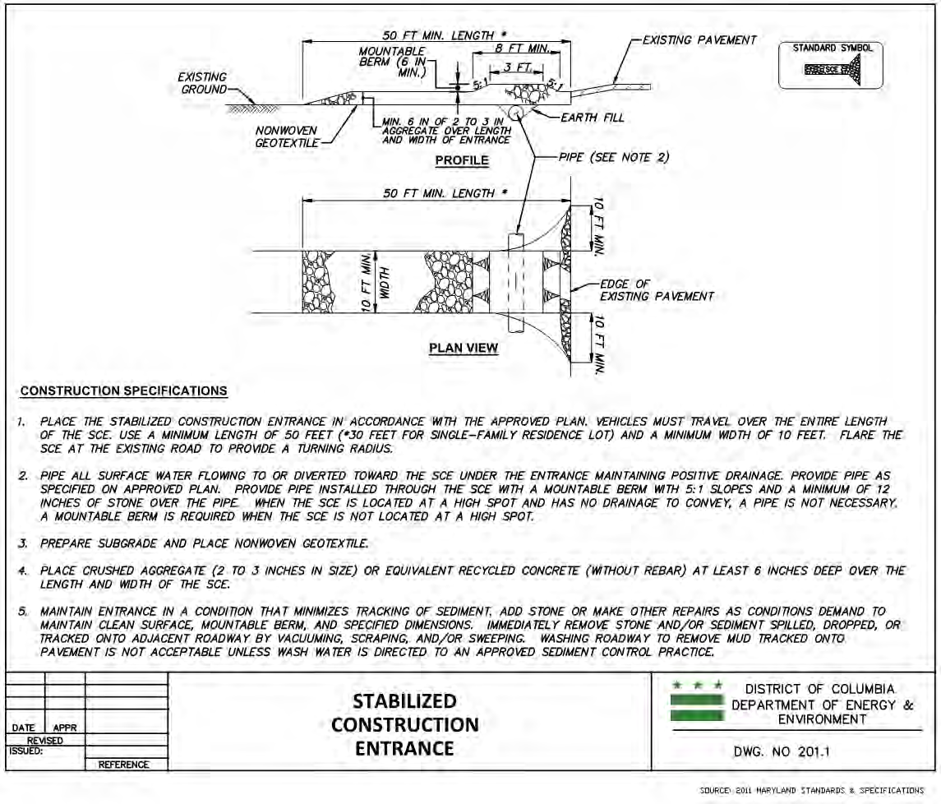
Fig. 1.3 Stabilized Construction Entrance

1.4 Erosion and sedimentation control principles
The following principles are the basis for creating an effective erosion and sediment (ESB) Plan.
  - Minimize clearing and grading
Limiting the amount of clearing and grading reduces the area of bare soil that is exposed.
Where site conditions allow, this is the most cost-effective method for reducing soil erosion.
It is critical to clearly identify the limits of disturbance on the ESC Plan and to ensure that
clearing limits are adhered to in the field.
  - Protect waterways and stabilize drainage ways
Construction and the resulting sedimentation can severely impact natural waterways, which
need to be protected by a buffer and sufficient sediment controls. Engineered drainageways,
such as swales, have the potential to transport sediment if they are not properly designed. Use
conveyance practices to divert clean water around disturbed areas and convey runoff with minimal erosion.
  - Phase construction to limit soil exposure
Site construction is often a long process. Plan construction activities in a sequence of phases
that minimize the soil area exposed at one time and reduce the length of time between initial
exposure and final grading.
  - Immediately stabilize exposed soils
Temporary erosion control measures, such as mulches and temporary grasses, can
significantly reduce erosion at a site. Figure 1.1 shows that the erosion potential from bare
ground is over 15 times greater than from ground with a heavy mulch cover (2 tons per acre)
and 100 times greater than from established sod. Therefore, the construction sequencing plan
needs to ensure soil is stabilized as soon as possible.
  - Protect steep slopes and cuts
Topography influences the amount of erosion, particularly for very steep slopes greater than
15%. Minimize the creation and disturbance of steep slopes where possible, or safely convey
flows through or around them. According to the District’s code (21 DCMR § 543.11), when
land development occurs on steep slopes, the ESC Plan “shall be designed, signed, and
sealed by a professional engineer, licensed in the District of Columbia, and the applicant shall incorporate additional protection strategies which the Department of Energy and Environment (DOEE) may require in order to prevent erosion or transportation of sediments
from the site.” The US Environmental Protection Agency’s (EPA’s) National Pollutant
Discharge Elimination System (NPDES) General Permit for Construction Activities also
requires minimizing disturbance of steep slopes.
  - Install perimeter controls
Prevent flow from leaving the site by installing silt fences or other barriers/filters at the site boundaries and other exit points, such as storm drains.

  - Employ advanced settling controls
When sediment traps and basins are used to control sediment, design features such as improved outlet devices or settling agents can greatly enhance effectiveness.

1.5 Catchment characteristics
- Factors that influence erosion
The Universal Soil Loss Equation (USLE) has been used to estimate soil erosion. The underlying factors that impact the amount of erosions are: rainfall (or climate), soil, topography,
and soil cover.
- Rainfall
Rainfall intensity influences the rate of soil erosion and varies significantly depending on the season. In addition, summer storms are typically much more intense, creating greater erosion potential. Regardless of the season, a single intense storm event can create a tremendous amount of erosion. A good ESC Plan will call for stabilizing the site as quickly as possible and ensuring that any cleared land drains to a sediment-capture practice.
- Soil
Soil types differ in their erodibility, or potential to erode, and an Erodibility Index has been determined for most mapped soil types. Since many District areas are mapped as Urban Soils, which have highly variable soil characteristics, those soils need to be assessed on site in more detail. In general, sites with higher clay or organic content are less erodible. When an initial site investigation identifies highly erodible soils, the ESC Plan may call for enhanced erosion control measures.
- Topography
The topography of the site (as measured by a “length-slope” factor) also influences the amount of erosion. In general, longer and steeper slopes result in greater erosion potential, particularly for gully or rill erosion. The area’s regulations and this TTLM advise minimizing erosion from steep slopes by avoiding clearing or creating these slopes where possible and by utilizing specialized erosion and sediment controls where steep sites are disturbed.
- Cover and Management Factor
The cover and management factor reflects the potential for erosion based on the type of vegetation or other material placed over soil. Bare ground has far greater erosion potential than soil covered by mulch or grass at various densities. As a result, construction sites have tremendous potential to generate erosion, which must be limited using temporary or permanent stabilization with grasses or mulch.

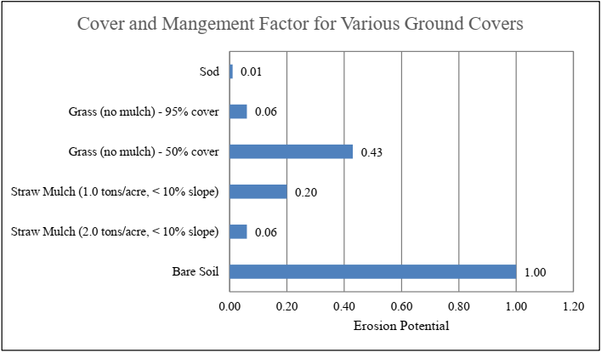
Fig. 1.4: Cover and management factors

Self-cheek 1

Name…………………………………………… ID………………………… Date…….
Directions: Answer all the questions listed below.
Test 1: Choose the best answer (5 point)
1. An erosion control measure consisting of rip-rap placed at the end of outlet is _____.

- Outlet protection structure
- Dust control
- Stabilizing channel
- Sediment fencing

2. The uniform removal of thin layer soil from land surface is

- Rill erosion
- Sheet erosion
- Gully erosion
- Splash erosion

3. Which one is the most destructive type of soil erosion?

A. Gully erosion
B. Rill erosion
C. Raindrop erosion
D. Stream bank erosion

4. How ground cover or grasses can control soil erosion?

A. By catching sediments
B. By reducing velocity of runoff
C. By minimize disturbance
D. All

5. All are the factor that affect soil erosion EXCEPT

- Dust control
- Slope
- Soil structure
- Organic material

Test 2. Short answer (5 point)

- What are the purpose of erosion and sediment control?

- Explant types water erosion

- Mention types wind erosion

Operation Sheet -1

- Steps of Minimum Requirements for Planning erosion and sediment control work
NB: The plan will consist of a scaled map of small scale
Materials
- Map
- Pen pencil
- Notebook
- Ruler
- Drawing paper
- Site location sketch.
- Proximity of any proposed earth change to village/town.
- Predominant land features including lakes, streams and wetlands.
- Contour intervals or slope information.
- A soils survey or a written description of the soil types of the exposed land area contemplated for the earth change.
- Description and location of physical limits of each proposed earth change.
- Description and location of existing and proposed on-site drainage and dewatering facilities.
- Timing and sequence of each proposed earth change.
- Description and location of all temporary erosion and sedimentation control measures, including timing on installation and removal of temporary measures.
- Location and description for installing permanent erosion and sedimentation control measures.
- Program and schedule for maintaining all control measures.

LAP TEST-1 | Performance Test

Name………………………………. ID…………………………….. Date…………………………………….

Time started: ________________________ Time finished: ________________

Instructions: Given necessary templates, tools and materials you are required to perform the following tasks within 1 hour. The project is expected from each student to do it.

Task 1: Performance planning for erosion and sediment control work

LG #41 | LO #2-Erosion and sediment control measures

Instruction sheet 2
This learning guide is developed to provide you the necessary information regarding the following content coverage and topics:
  - Applying erosion and sediment control
  - Estimating the Cost of erosion and sedimentation structure
This guide will also assist you to attain the learning outcomes stated in the cover page. Specifically, upon completion of this learning guide, you will be able to:
  - Apply erosion and sediment control
  - estimat cost of erosion and sedimentation control structure
Learning Instructions:
- Read the specific objectives of this Learning Guide.
- Follow the instructions described below.
- Read the information written in the information Sheets
- Accomplish the Self-checks
- Perform Operation Sheets
- Do the “LAP test”

Information Sheet 2
2.1. Applying erosion and sediment control
- Design information for erosion and sediment Control measures
A. General
The following sections provide design information for a variety of erosion and sediment control
measures. Each section describes the measure, how to properly design and implement it, and the
benefits that it provides. Each measure’s benefits are shown on the first page and a rating (high, medium, or low) is given for each; a summary of the individual measures and their benefits is shown in. The benefits have been divided into five categories that directly affect erosion or sediment transportation. The following are descriptions of each of the benefits.
B. Flow Control
Flow control refers to the ability of a practice to reduce flow velocity (either sheet or concentrated flow). Reducing flow velocity helps reduce erosion and transportation of sediment. Controlling velocity is important on long or steep slopes. High-velocity flows can quickly cause severe erosion.
C. Erosion Control
Erosion control is the measure’s ability to stabilize the surface and prevent soil particles from
becoming displaced. Erosion control should be utilized on all disturbed surfaces. Preventing erosion from taking place is the simplest and most cost-effective method of keeping sediment from leaving a site.
D. Sediment Control
Sediment control is the ability of a practice to remove suspended soil particles from runoff after
erosion has taken place. Sediment control measures are the last line of protection against releasing sediment laden runoff into water bodies or waterways.
E. Runoff Reduction
Runoff reduction is the ability to reduce the volume of runoff from a site. Reducing the volume from an area also reduces the potential for both erosion and sediment transportation. These methods utilize absorption or increase the potential for infiltration of stormwater into the soil.

F. Flow Diversion
Flow diversion consists of routing upland runoff around disturbed areas. By reducing the amount of runoff over a disturbed area, the potential for erosion and sediment transportation are also reduced.
G. Selecting Control Measures
The following can be used to select a system of both erosion control and sediment control
measures. No single measure should be relied upon as the sole method of erosion control and
sediment control.

    - Filter Berms
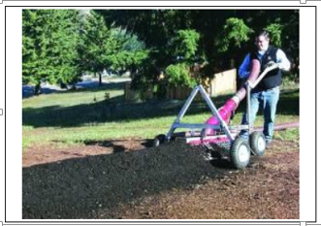
Fig. 2.1: filter berm

- Description/Uses
A filter berm typically consists of a three-dimensional matrix of biologically active stable composted organic material with various sized particles formed in a continuous windrow fashion (triangular) that slows and filters water to capture sediment and degrade pollutants. Its natural permeability allows water to seep through it while capturing sediment in its pore space and behind its mass, slowing water velocity and absorbing water pollutants, such as hydrocarbons, nutrients, and bacteria.

B. Design Considerations
- Materials: The key to achieving the proper balance between sediment removal and flow-through rate is using a filter material with the proper particle size. Filter material with a high percentage of fine particles will clog and create a barrier to flow. This will cause water to pond and the pressure may cause the installation to fail. Alternatively, filter material with particles that are too large will allow runoff to pass through the barrier with little or no resistance, eliminating the velocity reduction and sediment trapping benefits of the barrier.
C. Application
As mentioned previously, the material properties of the filter material are a significant factor in the performance of the berm. The wood chip product typically used as a filter material may not be readily available in all areas. This may limit the utilization of filter berms as an economical sediment control option in some areas.
Table 2.1: Maximum Filter Berm Spacing
Slope | Maximum Spacing  (feet) | Compost Berm Size  Height x Width (feet)
0% to 2% | 125 | 1 x 2
2% to 5% | 75 | 1 x 2
5% to 10% | 50 | 1 x 2
D. Maintenance
Accumulated sediment should be removed, or a new berm installed, when it reaches approximately one-half of the berm height. If concentrated flows are bypassing or breaching the berm, it must be expanded, enlarged, or augmented with additional erosion and sediment control practices. Additional filter material should be added as required to maintain the dimensions of the berm. Any damage should be repaired immediately.

- Check Dam
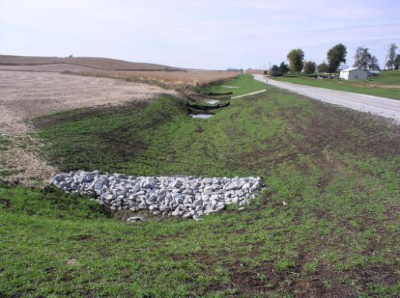
Fig.2.2: Check Dams
- Description/Uses
A check dam is a small, temporary obstruction in a ditch or waterway used to prevent erosion by reducing the velocity of flow. A dam placed in the ditch or channel interrupts the flow of water, thereby reducing the velocity. Although some sedimentation may result behind the dam, check dams do not function as sediment trapping devices and should not be designed as such. Check dams are most commonly constructed of loosely placed erosion stone or rip rap, or from stone filled gabions.
- Maintenance
Check dams should be inspected for damage every seven days and after any 1/2 inch or greater rainfall until final stabilization is achieved. Sediment should be removed when it reaches one-half of the original dam height. Upon final stabilization of the site, the check dams should be removed, including any stone that has been washed downstream, and any bare spots stabilized.

- Temporary Earth Diversion Structures

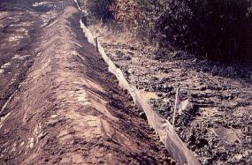
Fig 2. 3: Temporary earth diversion structures
- Description/Uses
Diversion structures consist of swales or berms that are used to temporarily divert water around an area that is under construction or is being stabilized. Specific applications include perimeter control, diversion away from disturbed slopes, and diversion of sediment-laden water to treatment facilities. As a perimeter control, temporary swales and/or berms may be constructed above a large disturbed area to divert upstream run-on around the site. This serves several purposes. First, the amount of runoff flowing over the disturbed area is reduced, thereby reducing the erosion potential. Secondly, clean water can be separated from the sediment-laden water and can be passed through or around the site. Sediment-laden water can be directed to a sediment trap or basin for treatment. Separating the upstream runoff from the sediment-laden water allows the designer to reduce the required size of the sediment removal structure, and allows the structure to work more efficiently.
- Design Considerations
Diversion structures should be designed to carry peak flows from the 2 year, 24 hour storm. The maximum drainage area conveyed through a diversion structure should be 5 acres. The depth of the diversion should be based upon the design capacity, plus an additional 4 inches of freeboard. The minimum depth provided should be 18 inches. This may be provided solely by a berm or swale or may be developed with a combination of berm and swale. The shape of the diversion may be parabolic, trapezoidal, or V-shaped, with side slopes of 2:1 or flatter. The minimum slope of the diversion structure should be sufficient to carry the design flow. The maximum slope of the diversion is limited by the permissible velocities of flows within the structure, as shown in the following table. Since any existing vegetation will likely be destroyed upon construction of the diversion structure, the bare surface situation should be considered for most applications. construction of the diversion structure, it is important to stabilize the surface immediately with seed and mulch, sod, or other means.

Table 2.2: Diversion Structure Slopes by Soil Type
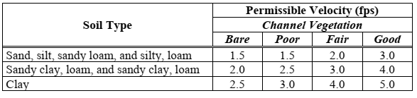
- Application
Diversion structures should be used around the perimeter of sites to prevent run-on of off-site flows over disturbed ground.
- Maintenance
The channel should be inspected every seven days and after any 1/2 inch or greater rainfall. Any
damage to the vegetated lining should be repaired. All debris should be removed and properly
disposed of to provide adequate flow conveyance.
- Rip Rap
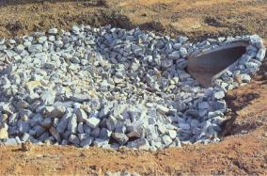
Fig.2.4: Rip Rap
- Description/Uses
The most common method of protecting a channel at an outlet is to place a layer of crushed stone along the bottom and sides of the channel. The purpose of the stone is to protect the channel until the outlet flow loses sufficient velocity and energy, so that erosion will not occur in the downstream channel. Rip rap is provided by constructing a blanket of crushed stone, to a specified depth at the outlet. The layer of the stone is constructed so that the top is flush with the invert elevation of the outlet pipe. The stone should be placed on a layer of engineering fabric to protect the underlying soil from the erosive action of the churning water.
- Design Considerations
The following design information only applies to the design of rock protection at outlets. It does not apply to rock lining of channels or streams. In addition, the design of rock plunge pools or stilling basins, and other types of energy dissipaters is not covered in this section. Refer to the, “Hydraulic Design of Energy Dissipators for Culverts and Channels” for information on designing these structures.
- Application
Outlet protection should be considered at all pipe and culvert outlets. Rip rap is an easily constructed method of protection and is sufficient for many situations.
- Maintenance
After installation, rock aprons should be inspected regularly. Special attention should be paid to the end of the apron, as it transitions to a natural channel. If scour or erosion is occurring at this junction, the apron should be extended, and additional stabilization methods may be required.
- Temporary Pipe Slope Drains
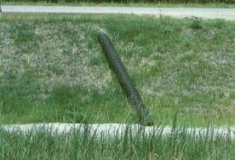
Fig.2.5: Temporary Pipe Slope Drains

- Description/Uses
Temporary slope drains are constructed of flexible pipe or tubing, running from the top to the bottom of a disturbed slope. Slope drains provide a means of transporting collected runoff from the top of the slope to the bottom of the slope and prevent the erosive potential created by concentrated runoff flowing over the face of a disturbed slope. Slope drains are commonly used in conjunction with diversion structures. A diversion structure at the top of the slope collects upland runoff and transports it to the desired outlet point. The slope drain provides an outlet for the diversion structure, safely carrying the collected runoff down the slope.
- Design Considerations
Temporary slope drains should be sized to carry a two-year storm event. Summary of recommended pipe diameters based upon the contributing drainage area. Slope Drain Diameters by Drainage Area
Table.2.3: Slope Drain Diameters by Drainage Area
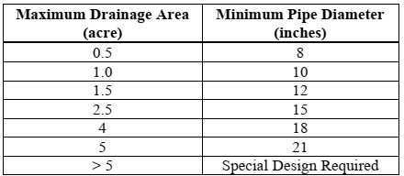

Note: Values assumed a 2 year storm, 15 minute Tc, and a runoff coefficient of 0.5
- Maintenance
The slope drain should be inspected for signs of leaking joints, pipe movement, erosion at the inlet and outlet, and seepage through the berm at the inlet.
- Design Example
Assume the runoff from 7.5 acres of bare ground is intercepted by a diversion structure and carried to the location of a proposed slope drain. Determine the required diameter of the slope drain. Time of Concentration, Tc = 15 minutes Rainfall Intensity, I = 3.48 (Region 7) Runoff Coefficient for bare ground, C = 0.5. Using this information, the peak runoff is found to be 13.1 cfs by the Rational Method.
The minimum pipe diameter is found with the orifice equation (assume head to top of pipe).
Q = (0.6) (A) 2gh
Where:
Q | = | Runoff volume, cfs
A | = | Area of pipe opening
g | = | Acceleration of gravity, 32.2 ft/s2
h | = | Head pressure (h=D/2 for head to top of pipe)
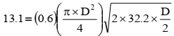
, Solving for D yields a diameter of 1.9’ or 23 inches
- Sediment Basin
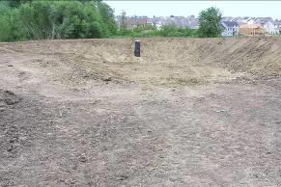
Fig.2.6: Sediment Basin
  - Description/Uses
Sediment basins, like sediment traps, are temporary structures used to detain runoff so sediment will settle before it is released. Sediment basins are much larger than sediment traps, serving drainage areas up to 100 acres. If properly planned and designed, sediment basins can be converted to permanent storm water management facilities upon completion of construction.
  - Design Considerations
Adequate storage volume is critical to the performance of the basin. Sediment basins that are undersized will perform at much lower removal efficiency rates. Sediment basin volumes and dimensions should be sized according to the criteria in. A sediment basin consists of several omponents for releasing flows: a principal spillway, adewatering device, and an emergency spillway. The principal spillway is a structure which passes a given design storm. It also contains a de-watering device that slowly releases the water contained in the temporary dry storage. An emergency spillway may also be provided to safely pass storms larger than the design storm.
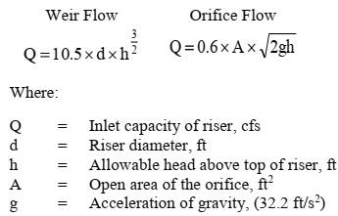

  - Application
Sediment basin volumes and dimensions should be sized according to the criteria.
Sediment basins are normally required for disturbed drainage areas of 10 acres or greater.
  - Maintenance
Maintenance and cleanout frequencies for sediment basins depend greatly on the amount of precipitation and sediment load arriving at the basin. During inspections, the embankment should be reviewed for signs of seepage, settlement, or slumping. These problems should be repaired immediately. Sediment should be removed from the basin when it accumulates to one-half of the wet storage volume. During sediment cleanout, trash should be removed from the basin, and the dewatering device and riser pipe should be checked and cleared of any accumulated debris.
- Design Example Assume a construction site has 12 acres of disturbed ground which drains to a common location. In addition, 8 acres of off-site area drains through the construction site. Due to site restrictions, the 8 acres of off-site drainage cannot be routed around the site. Design a temporary sediment basin, with and emergency spillway, to handle and treat the runoff from the 20 acre site.
Solution:
- Basin Volume: requires a minimum storage volume of 3,600 cubic feet of storage per acre drained. Therefore: 20 acres x 3,600 cf = 72,000 cf. this volume should be split equally between wet and dry storage (36,000 cf each). For the remaining calculations, assume that a basin has been sized and laid out to provide the following elevations:
Elevation A (Bottom of Basin) = 100
Elevation B (Wet Storage) = 103.0
Elevation C (Dry Storage) 105.0
Elevation D (Invert of emergency spillway) = 106.5
Elevation E (Top of embankment) = 108.5
- Sediment Traps
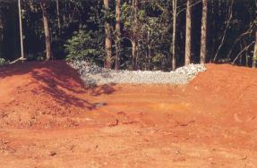
Fig.2.7: Sediment Traps
  - Description/Uses
Sediment traps are temporary sediment control structures or ponds, having a simple outlet structure stabilized with engineering fabric and rip rap. They are typically installed in a drainage way or other point of discharge downstream from a disturbed area. Sediment traps are one of the most reliable measures for treating sediment-laden runoff from small construction sites and may be considered the primary method of sediment removal for many sites. Sediment traps are highly effective at treating runoff from disturbed sites up to 5 acres. For larger sites, multiple traps are recommended. For disturbed areas greater than 10 acres, a sediment basin may be required.
  - Design Considerations
Sediment trap volumes and dimensions should be sized according to the criteria. A storage volume of 3,600 cf should be provided for every acre of disturbed ground. This storage volume should be divided equally between wet storage and dry storage. Sediment traps should be constructed at a low point, or at the point where concentrated flows leave the site. The location should be reviewed to ensure that the trap can be easily accessed for cleanout and maintenance, and that a failure of the sediment trap will not cause a loss of life or property. Sediment traps are often constructed in ditches or swales by excavating a small area to create a depression.

Table 2.4: Embankment Widths for Sediment Traps
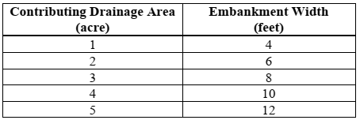
  - Application
Sediment traps, in conjunction with other erosion control features, should be considered whenever more than 2 acres are disturbed. If more than 5 acres are disturbed, a sediment basin should be considered. If less than 2 acres are disturbed, sediment laden runoff may be controlled by other means such as silt fence or filtering products. Sediment trap volumes and dimensions should be sized according to the criteria in 3,600 cf of storage should be provided for every acre of disturbed ground. This storage volume should be divided equally between wet storage and dry storage.
  - Maintenance
Sediment traps must be cleaned out as sediment accumulates within the trap. It is recommended to clean out the trap when it has lost one-half of the wet storage volume. Upon completion of the
project, the trap area should be backfilled and stabilized. Alternatively, the trap may be converted to a permanent sediment basin or detention basin.
- Silt Fences
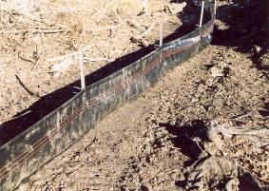
Fig.2.8: Silt fences

  - Description/Uses
Silt fence is a temporary barrier used to remove sediment from runoff. The fence works by intercepting sheet flow from slopes, causing the runoff to pond behind the fence, thereby promoting deposition of sediment on the uphill side of the fence. Silt fence consists of a geotextile fabric that is trenched or sliced into the ground. The bottom of the fence is anchored into the ground by compacting the disturbed soil along both sides of the trench or slice. The top of the fence is attached to steel posts for support, creating a barrier to the flow of contaminated stormwater runoff. Silt fence is one of the most commonly used sediment control practices. As such, it is often used improperly, or installed incorrectly. It should be placed at regular intervals on slopes to impound water. Silt fence can also be used in ditches and swales to create a small sediment containment system or ditch check. However, use as a ditch check should be limited to minor ditches and swales due to the potential for blow-out or undermining of the silt fence by high flows. A common misconception among many designers is that the silt fence actually “filters” suspended particles from runoff. The effectiveness of silt fence is primarily derived from its ability to pond water behind the fence. This ponding action allows suspended particles to settle out on the uphill side of the fence. Particles are not removed by filtering the runoff through the fabric.
- Design Considerations
- Overland Flow:
- General Guidelines: Silt fence for sediment and slope control should be installed along the contour of the slope (i.e. the entire length should be at the same elevation). At each end of the silt fence a 20 foot segment should be turned uphill (“J”-hook) to prevent ponded water from flowing around the ends of the silt fence. Individual sections of silt fence should be limited to 200 foot lengths. This limits the impact if a failure occurs, and prevents large volumes of water from accumulating and flowing to one end of the installation, which may cause damage to the fence.
- Sediment Control: When used for sediment control, silt fence should be located to maximize the storage volume created behind the fence. Larger storage volumes increase the sediment removal efficiency of the silt fence, and decrease the required replacement/cleanout intervals. A common location to place silt fence for sediment control is at the toe of a slope. When used for this application, the silt fence should be located as far away from the toe of the slope as practical to ensure that a large storage volume is available for runoff and sediment.
- Slope Control: Silt fence can be installed on a slope to reduce the effective slope length and limit the velocity of runoff flowing down the slope. Silt fence also helps prevent concentrated flows from developing, which can cause rill and gully erosion. As a secondary benefit, silt fence installed on slopes can remove suspended sediment from runoff that results from any erosion that has occurred. For slopes that receive runoff from above, a silt fence should be placed at the top of the slope to control the velocity of the flow running onto the slope, and to spread the runoff out into sheet flow.
- Perimeter Control: Silt fence is commonly used as a perimeter control along streets or adjacent to water bodies to prevent polluted water from leaving the site. When a diversion or perimeter control silt fence is installed in the direction of a slope, a 20 foot length of fence should be turned in, across the slope, at regular intervals (100 feet) to create a “J”-hook. These “J”-hooks act as check dams, controlling the velocity of the diverted runoff as it travels along the fence.
- Concentrated Flow: For concentrated flows in swales or ditches, the silt fence is installed at right angles to the flow of water with the end posts turned uphill to prevent water from flowing around the edges. The 2 year discharge in the ditch should be checked to ensure that it does not exceed 1 cfs. For ditch or swale applications greater than 1 cfs, alternative methods of sediment removal and velocity control within the ditch, such as rock or manufactured ditch checks and sediment traps, are required.
- Diversion: Silt fence can also be utilized as a synthetic diversion structure to redirect clean water around a site and intercept sediment-laden runoff and transport it to a sediment removal practice.
- Application
For sediment control applications, the maximum contributing area should not exceed 1/4 acre per 100 feet of fence. If the contributing area exceeds this value, additional silt fence should be installed to break up the runoff into multiple storage areas. When used as a velocity control measure for sheet flow on long slopes of disturbed ground, silt fence should be placed at the spacing interval stated in the table below:

Table 2.5: Silt Fence Spacing on Slopes
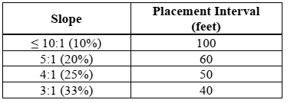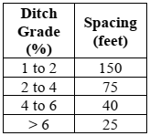
When silt fence is used under concentrated flow, as a ditch check to intercept soil and debris from
water flowing through ditches or swales, the following spacing guidelines should be used:
- Maintenance
When accumulated sediment reaches approximately one-half of the fence height, new silt fence
should be installed, leaving the existing fence in place, and locating the new silt fence a sufficient
distance away from it to provide area for sediment accumulation. When site conditions require that
the silt fence be cleaned out, rather than replaced, extreme care must be taken to ensure that the silt
fence is not damaged. Removed sediment should be spread out and stabilized. Any areas of damaged
silt fence should be replaced immediately.
- Temporary Erosion Control Seeding

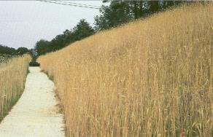
Fig.2.9: Temporary Erosion Control Seeding

A. Description/Uses
Temporary seeding for construction site erosion control consists of planting appropriate rapidly growing vegetation on disturbed/denuded soil areas to reduce soil loss (erosion and sedimentation), decrease stormwater runoff volume, and lessen problems associated with mud and dust production from bare, unprotected soil surfaces. Through seeding, a fibrous root system is established. This holds the soil in place and provides a canopy over the soil, protecting it from raindrop impact. Typical applications for temporary seeding include stabilizing the denuded surface of excavations, slopes, diversions, dams, sediment basins, road embankments, and stockpiles.
B. Design Considerations
The following should be considered for all sites that are to be stabilized with either temporary or
permanent seeding.
1. Site Stabilization: Minimize steep slopes, which increase the erosion hazard, and make seedbed
preparation difficult. Concentrated flows should be diverted away from the seeding area.
2. Sediment and Water Control Devices: Prior to seeding, necessary control practices such as dikes, swales/waterways, or sediment basins or diversions should be installed.
3. Seeding Methods:
C. Application
In order to achieve the appropriate vegetation density, temporary seed mixtures and fertilizer should be applied at the rates specified in the SUDAS Specifications.
D. Maintenance
Once the area is seeded, it should not be disturbed and should be protected from traffic. Newly
seeded areas should be inspected weekly as part of the overall erosion control inspection, to ensure that grass is growing satisfactorily. Areas that have bare spots or where erosion has occurred, should be re-seeded. Temporary seeding should be maintained until the area is again disturbed by construction, or permanent stabilization is achieved.

- Grass Channel

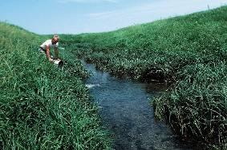
Fig.2.10: Grass Channel
A. Description/Uses
Grass channels consist of swales, ditches, and waterways that are lined with permanent vegetation. The purpose of the vegetation is to stabilize the surface of the channel and prevent erosion from concentrated stormwater flow. Because these structures are lined with vegetation, they cannot be used for channels which have constant flow, or which will be submerged for extended periods of time. Grass channels are the least costly and most aesthetically pleasing option for lining channels.
B. Design Considerations
As water flows through any conduit or channel, the surface of the conduit or channel imparts drag on the flowing water. The amount of drag a particular surface will create is related to the commonly known Manning’s “n” coefficient. This drag force not only slows the flow of the water, but also imparts a corresponding force onto the lining of the channel. This force is known as shear stress.

C. Application
Grassed channels are an excellent low-cost stabilizing method for swales and ditches that carry intermittent low to moderate concentrated flows.
D. Maintenance
Proper maintenance of the channel is critical. For designs where vegetation is assumed to be unmowed or at a minimum height, it is important to ensure that the vegetation in the channel is maintained in the manner intended. Mowing a channel, which was not designed to be kept at a short height, could result in failure of the grass channel. If there is a possibility that the channel could be mowed, it should be designed as such.
- Permanent Seeding
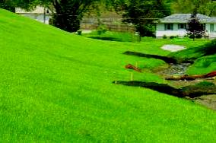
Fig.2.11: Permanent Seeding
A. Description/Uses
Permanent seeding consists of planting perennial vegetation on disturbed/denuded soil areas.
Through seeding, a fibrous root system is established. This holds the soil in place and provides a
canopy over the soil, protecting it from raindrop impact. The vegetation slows the velocity of the
runoff, protecting the surface from sheet and rill erosion, while allowing suspended sediment to be removed. Vegetation also absorbs water from the soil, reducing the total volume of runoff.
B. Design Considerations
Permanent seeding is the most commonly used method of providing permanent surface stabilization.
It is an economical, long-term method of providing highly effective stabilization, and is aesthetically pleasing. However, in order to be effective, the designer must select the proper vegetation and recognize the practical limits of vegetation.
C. Application
In order to achieve a dense, healthy stand of vegetation that will provide long-term surface
stabilization, seed mixtures and fertilizer should be applied at the rates specified.
D. Maintenance
Once the area is seeded, it should not be disturbed and should be protected from traffic. Newly
seeded areas should be inspected weekly as part of the overall erosion control inspection, to ensure that grass is growing satisfactorily. Areas that have bare spots, or where erosion has occurred should be re-seeded.
- Sodding

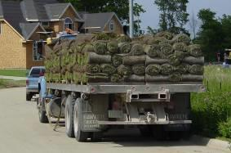
Fig.2.12: Sodding
A. Description/Uses
Sodding consists of transplanting turf-type vegetation to promptly stabilize areas that are subject to
erosion. Sod may be field sod or commercial sod, a cultured product utilizing specific grass species.
A sodded area provides one of the best methods for preventing soil particles from leaving the site,
providing immediate protection against soil erosion from water and wind.
- Rock Chutes and Flumes

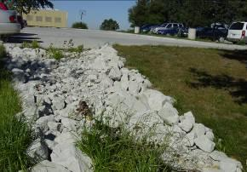
Fig.2.13: Rock chutes and flumes
A. Description/Uses
Rock chutes are devices used to stabilize the inlet slopes to sediment traps, sediment basins, rivers, ponds, lakes, and other drainage structures. The chutes consist of a rock-lined channel constructed on a steep slope. Proper construction of the rock chute is imperative to its performance. The chute must be carefully notched into the ground to the thickness of the rock, to ensure positive drainage into the chute from the edges. If drainage into the chute from the edges is not provided, runoff will flow along the top of the chute, creating the potential for scouring under the chute. After constructing the chute to the appropriate cross-section, a layer of engineering fabric is usually placed to protect the underlying soils. Crushed stone of the size or weight specified is then placed over the fabric, creating a stable surface to transport large flows down steep grades.
B. Design Considerations
The design of a rock chute is dependent on several factors including: the steepness of the slope; the shape of the channel; the volume and velocity of the water; the size of the rip rap material; and the downstream tail water.

C. Application
Rock chutes should be considered at all locations where an elevation drop may create flow velocities that exceed the ability of the existing ground surface (bare or vegetated) to prevent erosion.
D. Maintenance
If designed and installed properly, maintenance of rock chutes is normally minimal. If the chute is left over a winter, it should be inspected in the spring to ensure that it is level. Any movement caused by freeze-thaw should be corrected.

  - Cost estimation of erosion and sedimentation structure
- Basic elements of construction costs
For maximum usefulness the cost of any specific structure or measure should be defined in terms of:
(1) Makeup of Cost figure
(a) Equipment Costs (depreciation, interest, taxes, insurance, fuel, maintenance, and repairs)
(b) Labor (operators, others)
(c) Materials
(d) Supervision
(e) Design (if required)
(2) The procedure, measure, operations, or practice, to which it applies
(3) The time period for performing the work
(4) The physical and climatic conditions under which the work is performed
- Assumptions and conditions governing cost estimates
Wherever possible, uniform application procedures were used for the several elements of the cost estimates. Unless an exception is noted thereto in the detailed estimate, the following conditions apply to all estimates.
(1) Climatic conditions are considered to be average.
(2) Access conditions are considered to be average.
(3) Materials, Labor and Equipment Costs are as of the end of the calendar year
(4) Labor and equipment charges during " move- in and move - out " are included for most non-structural practices. For structural measures it has been assumed that the erosion control work is part of an on-going construction project, and that men and equipment may be delivered from other parts of the work.
(5) Non - emergency conditions are assumed. Hence labor at overtime rates is minimal, being applicable only in a few instances.
(6) No contingency allowances are provided.
(7) Maintenance costs are not included.

- Cost estimates for a number of different types of erosion control measures
        - Gravel and earth check dam:
Check dams are small structures constructed in gullies or other small watercourses. Made of concrete, masonry, rock, rock and earth, metal, wood, or other erosion-resistant materials, check dams reduce or prevent erosion by reducing velocities, promoting deposition of sediment, and stabilizing channel grades.
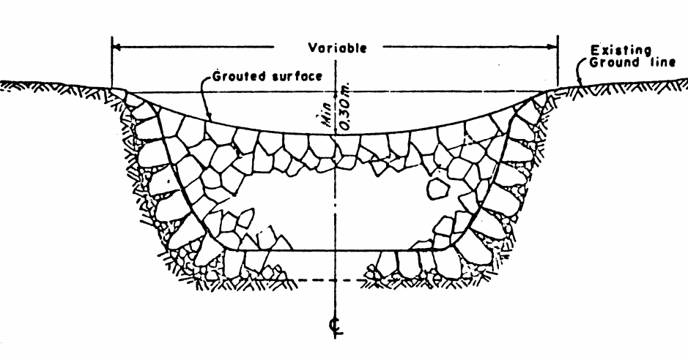
Fig.2.1: Gravel and earth check dam
Given Very small, low dams, with 1 ft crest width, 2: 1 downstream slope, and 4: 1 upstream slope, Hand labor. Unit costs given in $ per cubic foot (cf) of total (gravel and earth) fill.
- Size
1 ft high, 5 ft avg width, total volume = 19cf
Total cost $ 35
Unit cost / cf 1.84
1.5ft high, 10 ft avg width, total volume = 85cf
Total cost $ 146
Unit cost/ cf 1.72
2 ft high, 15 ft avg. width, total volume = 225cf
Total cost 187
Unit cost /cf 0.83
- Concrete check dam
Small structure constructed of reinforced concrete. Unit costs are per cubic yard (cy) of reinforced concrete on drawings.

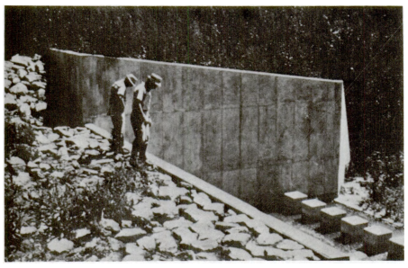
Fig.2.2: Concrete check dam

- Size
2 ft 4 in. high x 5 ft wide x 4 ft long Volume reinforced concrete = 1.9cy
Total cost $ 1,136
Unit cost / cy 598
5 ft 6 in . high x 9 ft 8 in . wide x 8 ft long Volume reinforced concrete = 10.8cy
Total cost 3,108
Unit cost / cy 288
5 ft high x 17 ft 6 in . wide x 14 ft long Volume reinforced concrete = 17.8cy
Total cost 4,647
Unit cost / cy 261
7 ft high x 20 ft wide x 20 ft long Volume reinforced concrete = 33.0cy
Total cost 7,154
Unit cost /cy 217

- Gabions
Gabions are large, multi- celled, rectangular wire mesh boxes, filled with rock. Individual gabions serve as building blocks which when properly wired together, form monolithic, yet flexible, structures and mats. They are used in channels, revetments, abutments, check dams, retaining walls, levee facings, and other erosion control structures.
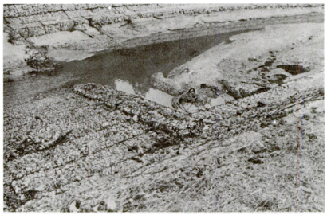
Fig. 2.3: Gabions

Cost Estimates - Gabions Estimates were made for 3 sizes of small jobs, using gabions 1 ft deep, as follows:
Unit costs are per sq . yd of surface area
10 sq . yd $ 30.10
100 sq . yd 15.49
1000 sq . yd 12.67

Self-check 2

Name…………………………………………… ID………………………… Date…….
Directions: Answer all the questions listed below.

- Which statement is NOT true about wind erosion?
A. Caused when soil surface is smooth and bare
B. Wind velocity reduced by vegetative measures
C. Very fine soil particles can cause suspension erosion
D. Wind erosion is more predominant in high rainfall area
2. Cost estimation includes one of the following

- Labor
- Materials
- Design
- all

Test I: Choose the best answer (5 point)

- What are the requirement principles of erosion and sedimentation control?

- . List the three control structure of soil erosion.

- Describe the points to be considered for designing filter fence.

Operation Sheet -2
- These procedures used for routine operations; to minimize sediment transport to nearby waterways, or to remove sediment if a waterway.
Materials
PPE
Overall
Spade
Shovel
Hoe….
- Locate the site nearest to storm water drainage system.
- Prepare the plan to excavated or disturbed during the maintenance activity.
- Contact Facilities Management, in advance, and provide the expected date of completion, so they can prepare to grade and re-vegetate the work area immediately after project completion.
- Install SESC measures/BMPs around the perimeter of the site and on adjacent roadways. Use silt fencing to control incidental release of sediment to the storm water system during the maintenance activity.
- Install temporary inlet filters at all adjacent and down-gradient storm water inlets, catch basins and manholes that may be impacted.
- Place stockpiles and other spoil piles away from the drainage system to minimize sediment transport. If the stockpile and/or spoil pile must remain on-site overnight, or if the weather conditions indicate the chance for precipitation,
- Cover the pile with water repellent material to prevent erosion and/or
- Install silt fencing around the base of the pile to prevent transport of sediment to the storm water system, or apply other control methods appropriate to the site.
- Control measures to guard against wind erosion must also be employed, such as wetting or covering the stockpiles.
- Keep as few stockpiles as possible during the course of the project.
- Remove any unused soil from the site as soon as the maintenance activity is completed.
- Remove all temporary erosion and sediment control devices from the site once work is completed and vegetation has been established.

- Procedure of ditch maintenances.
Materials

PPE
Overall
Spade
Shovel
Wheelbarrow
Hoe….

- Ditching activities within 500 feet of a waterway require a fully developed,
- Install SESC measures/BMPs around the perimeter of the site and on adjacent roadways.
- Use silt fencing to control incidental release of sediment to the storm water system during the maintenance activity.
- Install temporary inlet filters at all adjacent and down-gradient storm water inlets, catch basins and manholes that may be impacted.
- Install temporary or permanent check dams or sediment traps if existing vegetation is inadequate, to prevent discharge of sediment.
- Complete ditching and stabilize other parts of the ditch before removing the 500 feet of vegetation nearest the surface water.
- Replace topsoil and mulch and stabilize all exposed earth with protective landscaping such as hydroseed, sod, mulch, or other erosion resistant materials to prevent runoff.
- Procedure of excavating erosion control and embankment
- Excavation erosion controls:
- Install sediment basins or other structures below excavation areas. Submit calculations for sediment basin design.
- Do temporary and permanent seeding methods and frequency
- Install contour ditches as appropriate
- Embankment erosion controls:
- Maintain temporary berms and temporary slope drains as embankment is constructed
- Install sediment traps at inlets and/or outlets of temporary slopendrains and at the outer outlets of the temporary berms such as gutters
- Install sediment basins where appropriate below embankment areas if not already constructed during clearing and/or excavation operations. Submit calculations for sediment basin design.
- Indicate location of access routes for maintenance of sediment control structures on the plans.
- Construct concurrent with the embankment gutter and channel linings to be construction.
- Install hay or straw diversions or silt fence at toe of fills.
LAP TEST-2 | Performance Test

Name………………………………. ID…………………………….. Date…………………………………….

Time started: ________________________ Time finished: ________________

Instructions: Given necessary templates, tools and materials you are required to perform the following tasks within 1 hour. The project is expected from each student to do it.

Task2. 1. Performance removal of sediment in the waterway
Task2. 2. Performance ditch maintenances
Task 2.3. Execute excavation erosion control and embankment

Reference
East Bay Municipal Utility District, the Land Use Master Plan of East Bay Municipal Utility District, 25 pp (February 23, 1971)
Engineering - Science , Inc. Relationship of Treatment Methods to Suspended Matter in Water , for Division of Water Supply and Pollution , U.S. Public Health Service (Contract No. PH 86-64-69)
Georgia Soil and Water Conservation Commission (GSWCC). 2000. Guidelines for Stream bank Restoration. Revised March. 59 pp.
Security Pacific National Bank, Research Department, Monthly Report of Building Permit Activity in the Cities and Counties of California (May 1972).
Soil Conservation Service, Engineering Field Manual, September 1969.
Soil Conservation Service, Georgia, Manual of Standards and Specifications for Control of Soil Erosion and Sediment in Areas Undergoing Urban Development, July 1972.
Soil Conservation Service, Guide to Sedimentation Investigation, Technical Guide No. 12, September, 1975.
Soil Conservation Service, Guidelines for the Control of Erosion and Sediment in Urban Areas of the Northeast, August, 1970.
Soil Conservation Service, National Engineering Handbook, Section 3, Sedimentation, Section 4, Hydrology.
Soil Conservation Service, North Carolina, Guide for Sediment Control on Construction Sites in North Carolina, March, 1973.
Soil Conservation Service, Ohio, Water Management and Sediment Control for Urbanizing Areas, April, 1972.
Soil Conservation Service, Planning and Design of Open Channels, Technical Release No. 25, December, 1964.
Soil Conservation Service, Procedure for Computing Sheet and Rill Erosion on Project Areas, Technical Release No. 51, Geology, January 1975.
Soil Conservation Service, Standards and Specification for Soil Erosion and Sediment Control in Urbanizing Areas, November, 1968.
U.S. Department of Agriculture , Soil Conservation Service , Grasses and Legumes for Soil Conservation in the Pacific Northwest and Great Basin States , Agriculture Handbook # 339 by Hafenrichter , A.L. , et al . , 69 pP (April 1968)
U.S. Rating Department Forest Service of Agriculture Manual,Title Forest 2400 Service - Timber , Erosion Management Hazard , Region 5 , Supplement # 15 (July 1968)
Wischmeier , ' W.H. and Smith , D.D. , Predicting Rainfall –Erosion Losses from Cropland East of the Rocky Mountains, Guide for Selection of Practices for Soil and Water Conservation , U.S. Department of Agriculture , Agricultural Research Service in Cooperation with Purdue Agricultural Experiment Station , Agriculture Handbook No. 282 , 47 pp ( May 1965 )

AKNOWLEDGEMENT

Ministry of Labor and Skills wish to extend thanks and appreciation to the many representatives of ATVET instructors and respective industry experts who donated their time and expertise to the development of this Teaching, Training and Learning Materials (TTLM).

The experts who developed the learning guide
No | Name | Qualification | Organization/ College | Mobile number | E-mail
1 | Serawit Gensa | Msc. Water Resource Engineering | W/Sodo AVET | 0916740916 | serawitgen@gmail.com
2 | Edao Hassen | Msc.Irrigation Engineering | Alage AVET | 0911098097 | hassedao@gmail.com
3 | Mekete Agizew | Msc. Water Resource Engineering | Amhara. Kombolcha ATVET | 0925221192 | gen.mam09@gmail.com
4 | Wondu Alemayehu | Msc.Irrigation Engineering | Oromia Kombolcha ATVET | 0910-28-99-61 | woldualem@gmail.com
5 | Ademe Ayalew | Msc.Irrigation Engineering | Agrafa AVET | 0912720547 | Ademe2004@gmail.com
6 | Said Mohammed | Msc.Irrigation& drainage Engineering | Alage ATVET | 09-17-18-01-81 | Siyamsdmhmmd@gmail.com/
7 | Molalign Asfaw | Bsc.Water Resource &Irrigation Engineering | Alage ATVET | 0921431096 | Mollalign410ass@gmail.com
8 | Yonas Hailu | Bsc.Water Resource &Irrigation Engineering | Agrafa AVET | 0934715578 | yonashailuw@gmail.com
9 | Lemessa Mulata | Msc. Irrigation Engineering | Agrafa AVET | 0913266845 | Lamimulle2022@gmail.com
10 | Misganew Yimer | Bsc. Soil and Water Engineering | Woreta ATVET |  | Misge1976@gmail.com
11 | Daniel Derese | Bsc. Soil and Water Engineering | W/sodo AVET | 0912-79-28-85 | danielderesse7@gmail.com
12 | Teshome Getachew | Msc.Irrigation & drainage Engineering | Alage ATVET | 0925-50-13-99 | teshomegetachew131@yahoo.com

