Automotive Electrical & Electronics Level – I
Based on March, 2022 Version -1
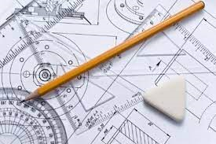

Module Title: - Reading and Interpreting Electrical Drawings
Module code: EIS AEE 1 M06 0322
Nominal duration: 40 Hours
Prepared by: Ministry of Labor and Skill
September, 2022
Addis Ababa, Ethiopia
Table of Content
Acknoledgment
Introduction to the Module 5
1. Identify electrical drawings 6
1.2. Tool and equipment of drawing 6
1.3. Electrical Drawing 12
1.4. Free hand sketch 20
1.5. Units of measurement 22
Self check -1 22
Operation Sheet-1 23
Operation Sheet-2 24
LAP TEST 25
2. Identify views, standard symbols and lines 26
2.1. Orthographic and isometric drawing 26
2.3. Orthographic and isometric views 31
2.4. Alphabet or types of lines 34
2.5. Drawing Technique 34
2.6. Dimensioning Techniques 35
2.7. Projections 36
Self check-2 40
Self check-3 40
LAP test 41
3. Interpret electrical Drawing and symbols 43
3.1. Recognizing component, assembly or object 43
3.2. Interpreting dimensional tolerances and notation 45
Self check-3 52
Written test 52
Operation Sheet 3 52
To perform dimensional Views 52
LAP Test 53
Practical Demonstration 53
Reference 55

Acknowledgment
Ministry of Labor and Skills wish to extend thanks and appreciation to the many representatives of TVET instructors and respective industry experts who donated their time and expertise to the development of this Teaching, Training and Learning Materials (TTLM).

Acronym
HB---------------------------------------------------------------------hard black
H-----------------------------------------------------------------------harder
2B----------------------------------------------------------------------no. is indicate degree of hardness
B---------------------------------------------------------------------- Black
V -----------------------------------------------------------------------Voltmeter
A -----------------------------------------------------------------------Ammeter
LED--------------------------------------------------------------------Light Emitting Diode
N/O----------------------------------------------------------------------Contactor
HP-----------------------------------------------------------------------Horizontal Plane
VP-----------------------------------------------------------------------Vertical Plane
PP------------------------------------------------------------------------Side or Profile Plane
FV-----------------------------------------------------------------------Front View
VP------------------------------------------------------------------ ----Projected on
TV-----------------------------------------------------------------------Top View
HP-----------------------------------------------------------------------Projected on
SV ----------------------------------------------------------------------Side View
PP------------------------------------------------------------------------Projected on

Introduction to the Module

This module covers the knowledge, skill and attitude required to read and interpret electrical drawings, electric symbols and sketches. It requires interpretations of standard drawings by using symbols, dimensional tolerances and notations
This module covers the units:
- Identify electrical drawings
- Identify views, standard symbols and lines
- Interpret electrical Drawing and symbols
Learning Objective of the Module
- Identify electrical drawings
- Identify views, standard symbols and lines
- Interpret electrical Drawing and symbols
Module Instruction
For effective use this modules trainees are expected to follow the following module instruction:
- Read the information written in each unit
- Accomplish the Self-checks at the end of each unit
- Perform Operation Sheets which were provided at the end of units
- Do the “LAP test” giver at the end of each unit and
- Read the identified reference book for Examples and exercise

Unit one: Identify electrical drawings
This unit is developed to provide you the necessary information regarding the following content coverage and topics:
- Introduction to technical drawing
- Tool and equipment of drawing
- Electrical Drawing
- Free hand sketch
- Units of measurement
This unit will also assist you to attain the learning outcomes stated in the cover page. Specifically, upon completion of this learning guide, you will be able to:
- Electrical drawing is checked and validated against job requirements
- Identify electric symbols and sketches
- Instructions are confirmed and followed as required

1. Identify electrical drawings

1.1. Introduction to technical drawing
Definitions of drawing
Different literatures define drawing in different terms while basically their core message remains the same.
For instance, look the following definitions given for drawing on different literatures;
Drawing:-IS a graphic representation of a real thing, an idea, or a proposed design for later manufacture or construction.
A graphic: - that represents an idea, a concept, or an entity which actually or potentially exists in life.
A way of communicating all necessary information about an abstraction such as an idea or a concept.

1.2. Tool and equipment of drawing

1.2.1. Introduction to drawing tools and equipment
The preparation of technical drawing is possible only through knowledge and skill in the use of a variety instruments. With the aid of knowledge and skill practice will bring perfection. The following listed drawing instruments are the basic ones:
1.2.2 Types of drawing tools and equipment
Drafting equipment like T-square, drawing board or binder, ruler, set squares, compasses, protractors, French curves, templates, eraser, dividers, … etc
A.T-square
T-square is provides a parallel straight edge for the beginning drawing drafter.
It is composed of two parts:
- The head and
- The blade.
The two parts are fastened together at an exact right angle. The blade must be straight and free of any necks and imperfections. Used to draw horizontal lines on the drawing sheet Used to draw vertical lines and slanted lines with the help of additional equipment basically 45⁰and 60⁰ set- squares. Draw lines only against the upper edge of the blade. Make sure the head is held against the left edge of the drawing board to guarantee parallel lines.
The uses of T-square are to align the drawing paper to the drawing board, and to draw parallel horizontal lines on the paper.
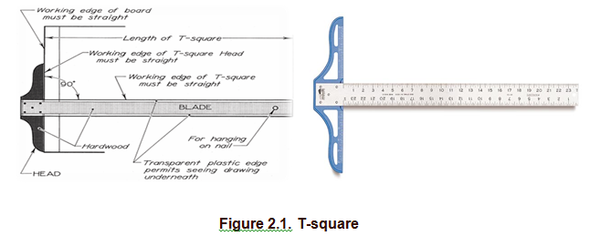
B.Drawing Board
Drawing Board; is Available in a variety of styles and sizes. Most are adjustable up and down, and can tilt to almost any angle from vertical 90º to horizontal. The drawing surface must be clean, flat, smooth, and large enough to accommodate the drawing and some drafting equipment. If a T-square is to be used, at least one edge on the board must be absolutely true. Most quality boards have a metal edge to ensure against warping and to hold the T-square securely.

Figure 1.2. Drawing Board

C. Compass
Drawing Compass History and Types of Compasses
A technical drawing tool named drawing compass is used to draw circles or arcs.
This tool is also known as a pair of compasses, or simply as a compass. It can also be used for measuring distances or more precisely distances on the maps. Apart from that, drawing compasses are used in navigation, mathematic, drafting and any many other disciplines. Materials of which compasses are made are usually plastic or metal. Drawing compass has two parts connected by a hinge so the radius of the circle that is drawn can be adjusted and changed. Usually at the end of one part is a needle and at the end of another is a pencil. First drawing compasses were found in the archeological digging of ancient Rome. Every drawing compass before the eighteenth century didn't have a pen but a needle instead so it scratches the surface. By the twentieth century, drawing compasses were spread widely throughout the world.
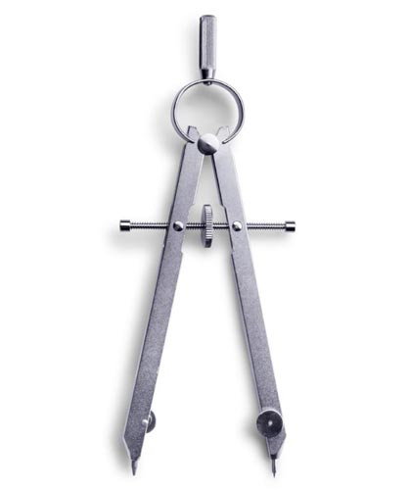
Figure1.3 Compass

D.Divider
Dividers are similar to compasses, except that both legs are provided with needle points. As with compasses, dividers are available in large and small sizes, Dividers are used to transfer measurements. To step off a series of equal distances, and to divide lines into a number of equal parts A divider is similar to a compass, except that it has a metal point on each leg.It is used to lay off distances and to transfer measurements
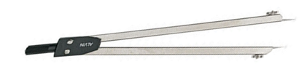
Figure1. 4 Divider
E.Triangles 2.5 (Set- square)
Triangles (setsquares):- They are used to construct the most common angles (i.e. 30⁰, 45⁰, and 60⁰) in technical drawings. The 45⁰ x 45⁰ and 30⁰ x 60⁰ triangles are the most commonly used for ordinary work.
Triangles are used in combination with the T square or straightedge to draw vertical and inclined lines. They are usually made of transparent plastic, which allows you to see your work underneath the triangles
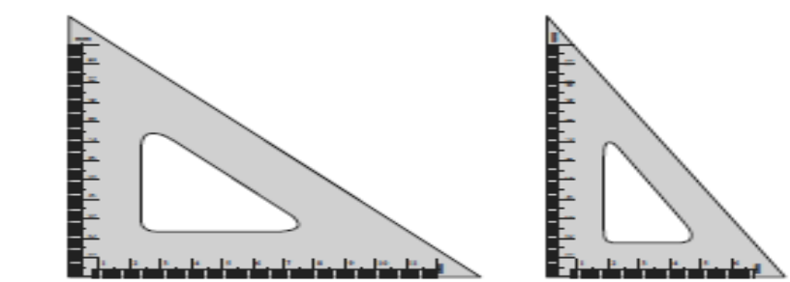

Fig.1.6 (a): 45 Set Square Fig. 1.6 (b): 30|60 Set Square
F.Drawing Templates
A template is a thin, flat piece of plastic containing various cutout shapes. It is designed to increase the speed and accuracy of the Drafter.
Templates are available for drawing is see as following circles, ellipses
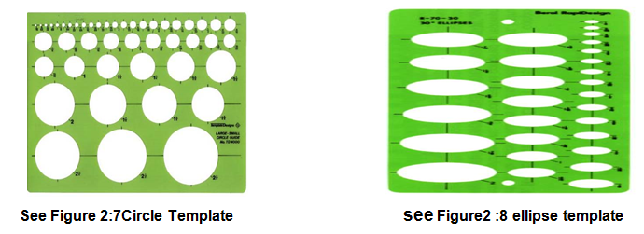
G.French curves and flexes curves
French curves are thin plastic tools that come in assortment of curved surfaces. They are used to produce curved lines that cannot be made by a compass. Most common French curves are actually segments of ellipses, parabolas and hyperbolas.
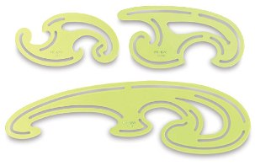
Figure 1.9 French curves and flex curves
H.Protractor
Protractors used to mark or measure angles between 0 and 180°. They are semicircular in shape (of diameter 100mm) and are made of Plastic or celluloid which has more life. Protractors with circular shape capable of marking and measuring 0 to 360° are also available in the market.
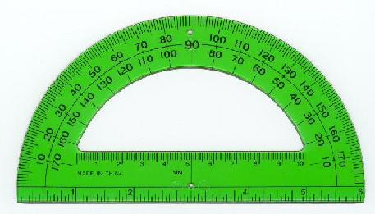
Figure.1.10 Protractor
Drawing Materials
Drawing Paper
Designation | Designation mm  Trimmed Size
A0 | 1189 × 841
A1 | 841 × 594
A2 | 594 × 420
A3 | 420 × 297
A4 | 297 × 210
A5 | 210 × 148
They are available in many varieties and good quality paper with smooth surface should be selected for Drawings which are to be preserved for longer time. Recommended Standard size of drawing sheet Designation Size (mm) is.

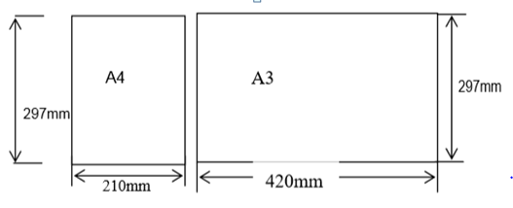

Fig. 1.11.Paper illustration

Drawing Pencils:
The accuracy and appearance of a Drawing depends on the quality of Pencil used to make Drawing.The grade of a Pencil lead is marked on the Pencil. HB denotes medium grade. Increase in hardness is shown by value put in front of H such as 2H, 3H etc., Softer pencils are marked as 2B, 3B, and 4B etc. A Pencil marked 3B is softer than 2B and Pencil marked 4B is softer than 3B and so on. Beginning of a Drawing may be made with H or 2H. For lettering and dimensioning, H and HB Pencils are used.
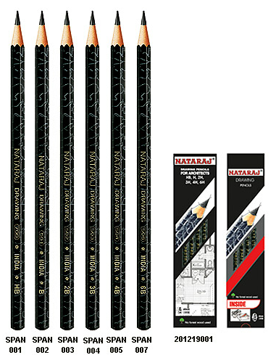
Figure 1.12. Drawing Pencils

1.3. Electrical Drawing

1.3.1.Electric symbol/ signs/ code/ circuit

Common Schematic Drawing Symbols
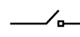
Switch

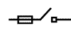
Switch- fuse

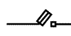
Fuse-switch

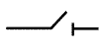
Isolator (Disconnector) general symbol

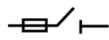
Disconnector - fuse (fuse combination unit)

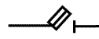
Fuse - disconnector

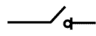
Switch - disconnector

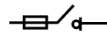
Switch - disconnector - fuse (fuse
combination unit)

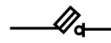
Fuse - switch - disconnector

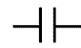
Capacitor, general symbol

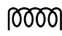
Inductor, coil, winding or choke

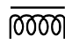
Inductor, coil, winding or choke with
magnetic core

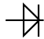
Semi Conductor Diode - general symbol

Common Schematic Drawing Symbols

Microphone

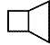
Loudspeaker

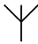
Antenna, general symbol

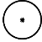
Machine, general symbol
* Function M=Motor G=Generator


Generator, general symbol


Indicating instrument, general symbol
* function V = Voltmeter A = Ammeter etc.

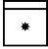
Integrating instrument or Energy meter
* function Wh = Watt-hour
VArh = Volt ampere reactive hour
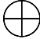
Lamp, or signal lamp, general symbol
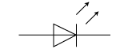

Light Emitting Diode (LED)

Common Schematic Drawing Symbols


Plug Male
Socket (plug female)

Slow Operating Relay -
Delay On

Wire Connections
(crossed)

Terminal Connector

Earth Connection

Protective Earth

Equipotentiality

Voltmeter

Selector Switch
(N/O) Normally Open
(N/C) Normally Closed

Contactor
(N/O)
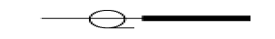
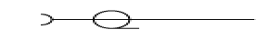
Coax Plug
Male

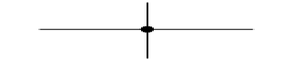
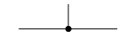
Wire
Connections
(Two Wires)
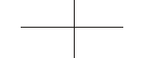

Wires
Crossing (Not
Connected)



Terminal
Block




Noiseless
Earth

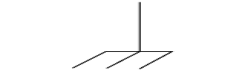


Chassis Earth

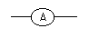
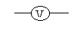
Ammeter
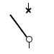
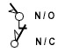
Circuit
Breaker

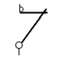
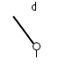

Contactor
(N/C)

Common Schematic Drawing Symbols
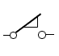
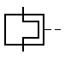

Limit Switch
Thermal Overcurrent

Voltage Transformer

Solenoid Valve

Normally Closed
Contact
(N/C)
Fused Switch Open
Contact
(N/O)
Limit Switch
(N/C)

Flow Switch
(N/C)

Time Delay
(N/O)
Delay on re-opening

Thermal Switch -
Overload
(N/C)

Temperature Switch
(N/C)

Pressure Switch
(N/C)

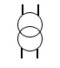
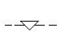
Mechanical
Interlock

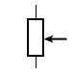
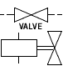

Potentiometer

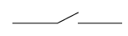
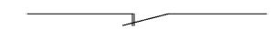
Normally open
Contact
(N/O)
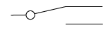
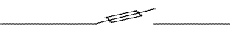
Change Over or
2 way Contact
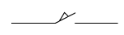
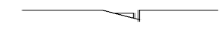
Made position
Limit Switch
(N/O)

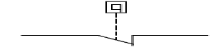
Flow Switch
(N/O)

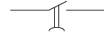
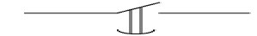
Time Delay
(N/O)
Delay on
Closing

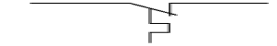
Thermal Switch -
Overload
(N/O)

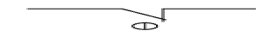
Temperature
Switch
(N/O)

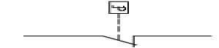
Pressure Switch
(N/O)


Common Schematic Drawing Symbols
Normally Open PB
(N/O)
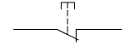
Normally Closed PB
(N/C)

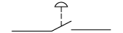
Emergency Stop PB
(N/O)
Indication Contact

Emergency Stop PB
(N/C)
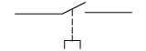
Pull Switch
(N/O)
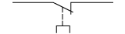
Pull Switch
(N/C)

Turn/Rotary Switch
(N/O)
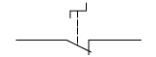
Turn/Rotary Switch
(N/C)
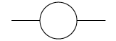

Contractor Coil

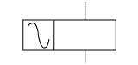

Relay with AC Supply

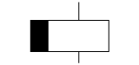

Slow Release Relay
Delay Off


General Relay
(DC Supply)

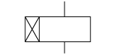
Common Schematic Drawing Symbols

Slow Operating Relay
Delay On

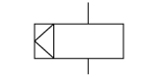

Mechanically Latched Relay

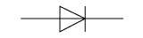
Diode

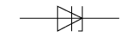
Diode Reverse Conducting

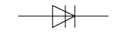
Diode Reverse Blocking

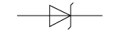
Zener Diode

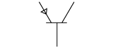
Transistor
(PNP)

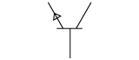

Transistor (NPN)

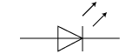

Light Emitting Diode (LED)
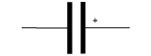

Capacitor

    - Exploded View
A.Exploded drawing is a diagram, picture, schematic or technical drawing of an object, that shows the relationship or order of assembly of various parts.
It shows the components of an object slightly separated by distance, or suspended in surrounding space in the case of a three-dimensional exploded diagram. An object is represented as if there had been a small controlled explosion emanating from the middle of the object, causing the object's parts to be separated an equal distance away from their original locations.
The exploded view drawing is used in parts catalogs, assembly and maintenance manuals and other instructional material.
The projection of an exploded view is usually shown from above and slightly in diagonal from the left or right side of the drawing. (See exploded view drawing of a gear pump to the right: it is slightly from above and shown from the left side of the drawing in diagonal.).
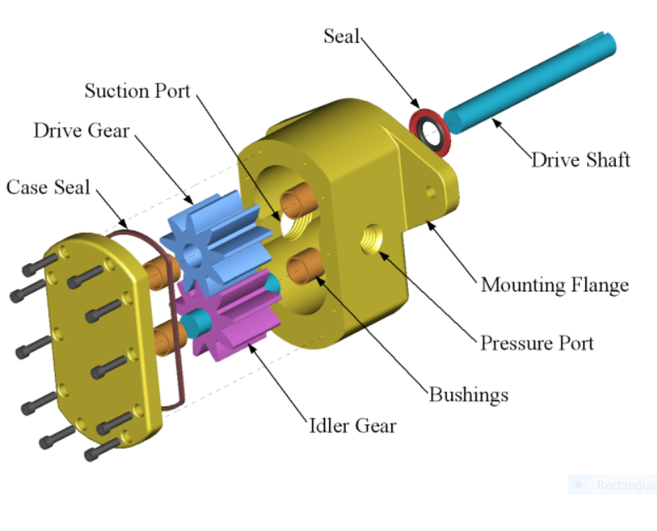Figure: 1.13 exploded drawing
1.3.2. Block diagram
A block diagram is used primarily to present a general description of a system and its functions. This type of diagram is generally used in conjunction with text material. A block diagram shows the major components of a system and the interconnections of these components. All components are shown in block form, and each block is labeledforidentificationpurposes. 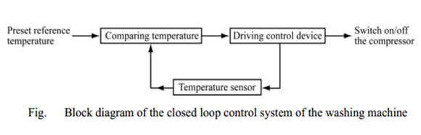

1.4. Free hand sketch

Definition: Free hand sketch the first step of drawing which is not required tools and equipments rather than pen or pencil and paper.
Sketch, is locating and marking out of lines, and points. Also layout is sketching of a drawing using drawing instrument without pencil.
The significance of the sketch is: -
For marking
Locating the area
Lining
Circling
Making arcs etc
Interpreting details:- means transferring the information that stated or design on the blue print to the object which makes easy the production process and minimize different wastages.
Methods for proportioning a sketch
- Approximation by eye method
  - Object is studied for its various shapes.
  - Size of each shape is compared to each other.
  - Size of shape is compared with overall width, height, and depth of object. (NOTE: Use part of the object as reference point to compare against.)
30°
30°
BASE
Guidelines for sketching an isometric
1. Lay out the isometric axes.

1. Sketch an isometric box so the height, width, and depth of the box, are the same as the object (cube).
DEPTH

HEIGHT

WIDTH

3. Darken all final lines.
4. Erase construction lines.

Guidelines for sketching an oblique
1. Sketch the front view of the object. The height and width are the same as the object.
HEIGHT
WIDTH

VERTICAL

HORIZONTAL
2. Sketch receding axis lines.
(NOTE: 45◦ angle is a common angle to use.)
3. Estimate the depth. Then draw the back edges.
45°

4. Sketch all details and darken final lines

1.5. Units of measurement

On technical drawing we need to show lengths and angles. The most convenient unit for length is millimeter. In civil engineering and architectural drawing, inch or foot is often used as a unit of length. Angles are shown in degrees.
- Symbols : Symbols are incorporated to indicate specific geometry whenever necessary.
- Notes : Notes are provided to give specification of a particular feature or to give specific information necessary during the manufacturing of the object
Self check -1 | Written test
Directions: Answer all the questions listed below. Use the Answer sheet provided in the next page:
Choose the correct answer from the following Questions
1. _________is a kind of technical drawing instruments used to prepare drawings
A. set squares B. French curve
C. T-square D. all
2. Which one is used to mark or measure angles between 0 and 180
A. Protractor B. Divide
C. ellipse template D. Circle Template
3. ________is a thin, flat piece of plastic containing various cutout shapes
A. Template B. French curve set squares
C. T-square D. curve set squares
4. Which one of the following is the largest size of drawing sheets
Name ____________________________ date__________________
Answer Sheet
1.
2.
3.
4._____________ score: -------------------rating ---------------------
Operation Sheet-1 | Methods of Using Drawing instruments
The steps of fastening Paper to Drafting Board are as follows:
1. Place the paper close to the table‟s left edge.
2. Move the paper until its lower edge place about the top edge of T-square.
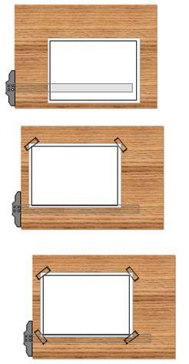
3. Align the top edge of the paper with T-square blade.
4. Attach the paper’s corners with tape
5. Move T-square down to smooth the paper
6. Attach the remaining paper‟s corners with tape

Operation Sheet-2 | Methods of Using Drawing instruments: T-Square, Set-square, Compass.
Procedures to Draw a Horizontal, parallel, perpendicular Lines are:

1. Press the T-square head against the left edge of the table.
2. Smooth the blade to the right.

3. Lean the pencil at an angle about 60º with the paper in the direction of the line and slightly “toed in”.

4. Draw the line from left to right while rotating the pencil slowly
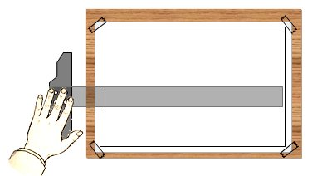
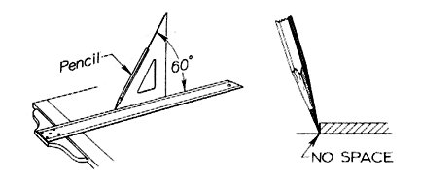

Procedures to Draw a Vertical, parallel, perpendicular Line are:
1. Set T-square as before Place any triangle on T-square edge.
2. Slide your left hand to hold both T-square and triangle in position.

3. Lean the pencil to the triangle.

4. Draw the line upward while rotating the pencil slowly..

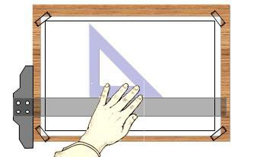
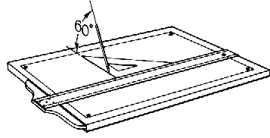

LAP TEST | Practical demonstration

Name: _____________________________ Date: ________________
Time started: ________________________ Time finished:
Instructions: Using the drawing instrument, you are required to do the following exercises:
Task1: Create the drawing template (Title Block), shown with the following dimensions
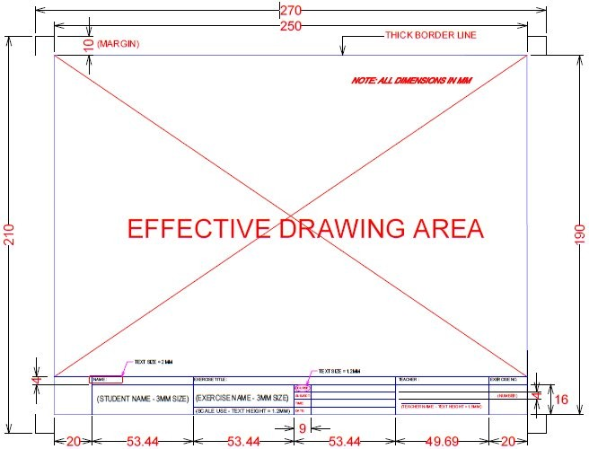

• Section Lines = 0.5 mm HB
• Visible Lines = 0.7 mm HB
• Hidden Lines = 0.5 mm HB
• Centerlines = 0.5 mm HB
• Construction Lines = 0.5 mm 2H
Request from your teacher the following materials.
HB drawing pencil lead
•
•
•
•
•
•
•

•
•

Page 26 of 85
4H drawing pencil lead
45º x 90º triangle
30º x 60º triangle
Eraser
T-square
Drafting pens
Drawing table
Drawing papers
Unit two: Identify views, standard symbols and lines
This unit is developed to provide you the necessary information regarding the following content coverage and topics:
- Orthographic and isometric drawing
- Orthographic and isometric views
- Alphabet or types of lines
- Drawing Technique
- Dimensioning Techniques
- Projections
This unit will also assist you to attain the learning outcomes stated in the cover page. Specifically, upon completion of this learning guide, you will be able to:
- Orthographic and isometric drawing are identified
- Orthographic and isometric views are explained
- Alphabet of lines are identified
- Uses of the alphabet of lines are explained
- Projections codes and symbols are correctly identified and explained according to drawing standards

2. Identify views, standard symbols and lines

2.1. Orthographic and isometric drawing

A. PROJECTION
A projection is a drawing or representation of an entity on an imaginary plane or planes. It consist four components: The actual object that the drawing or projection represents the eye of the viewer looking at the object The imaginary projection plane (Viewers drawing paper Imaginary lines of sight called projectors

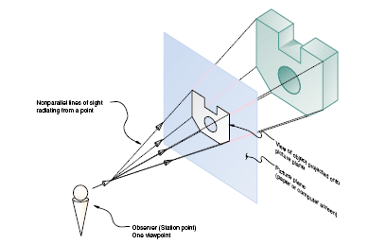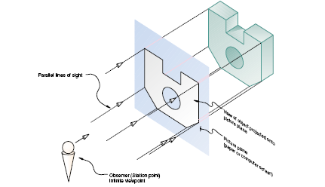
Fig: 2.1. Classification of projections (perspective and Parallel projection)
Two broad projection types are viable with different further classifications. These are:
- Parallel projection
- Perspective projection
- Parallel projection:
It is a projection where imaginary projection lines will not converge as a point on the viewer’s eye. This implies that, all projection lines are either parallel or perpendicular to each other. There are three main types of parallel projection system illustrated below:
- Orthographic projection
- Axonometric projection.
- Oblique projections
2.2. Orthographic projection
Orthographic is a system of views of an object formed by projectors from the object perpendicular to the desired planes of projection.
Orthographic Projections are a technical drawing in which different views of an object are projected on different reference planes observing perpendicular to respective reference plane.
Different Reference planes are;
- Horizontal Plane (HP)
- Vertical Plane (VP)
- Side or Profile Plane (PP)
Different views are;
- Front View (FV) –Projected on VP
- Top View (TV) –Projected on HP
- Side View (SV) –Projected on PP
There are three principal projection planes. That is to say:
- Horizontal projection plane (H.P)
- Frontal projection plane (F.P)
- Profile projection plane (P.P)
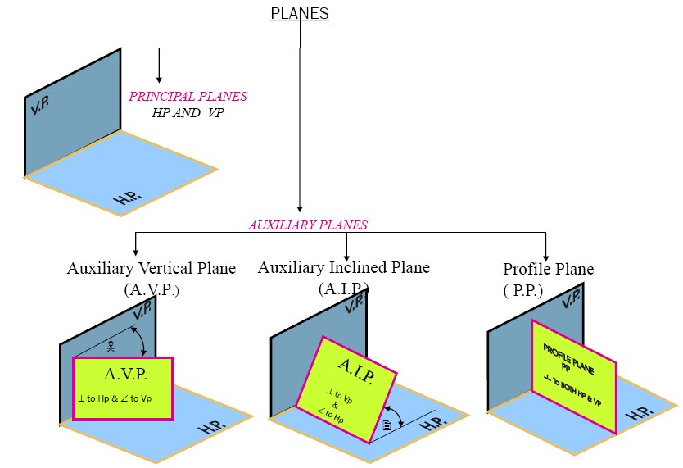

The Six Principal Views
Let us surround the object entirely by asset of six planes, each at fight angles to each other. On these planes, views of the object can be obtained as is seen from the top, front, and right side, left side, bottom and rear. Think now of the six sides, or the plane of the paper. The front is already in the plane of the paper, and the other sides are, as it were, hinged and rotated in position as shown..
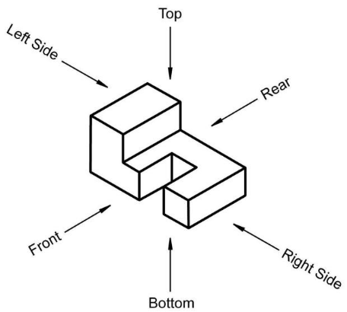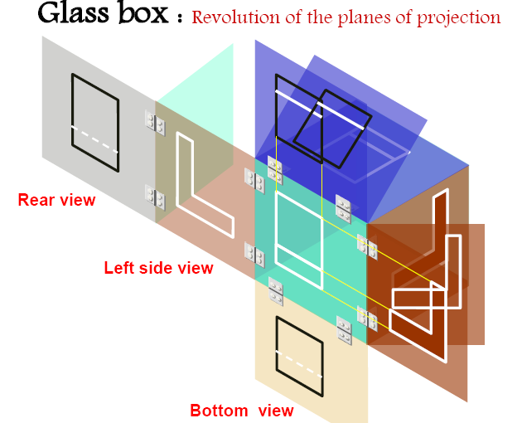
The projection on the frontal plane is the front view vertical projection, or front elevation, that on the horizontal plane, the top view, horizontal projection, or plan, that on the side, profile view, side view, profile projection, or side elevation. By reversing the direction of sight, a bottom view is obtained instead of a top view, or a rear view instead of a front view.
The 6 principal views are created by looking at the object, straight on, in the directions indicated
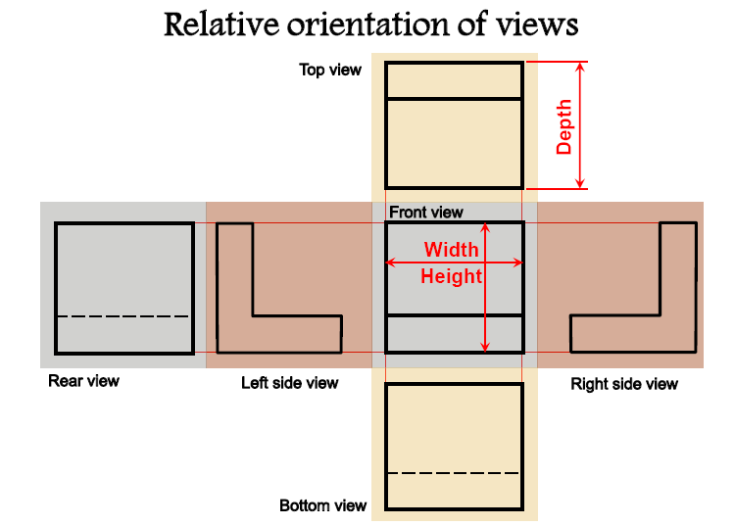
Fig. 2.5. Six Principal Views
Orthographic projection = 2-D representation of a 3-D object.
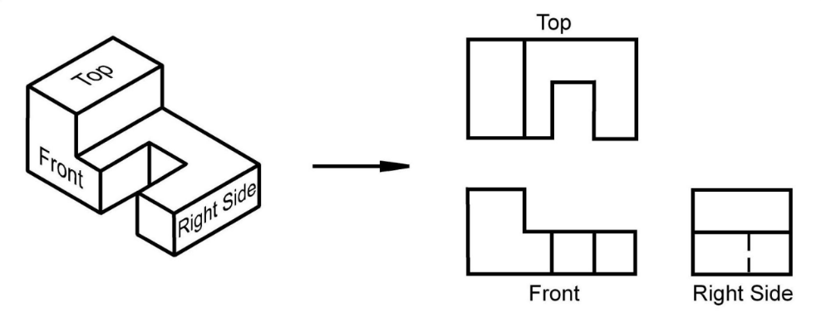

2.3. Orthographic and isometric views

They are two common standards use in orthographic projection of drawings;
The First Angle Projection (European projection) and
The Third Angle Projection (American projection).
It should be noted that corresponding views are identical in both methods of projection except for their relative positions on the drawing paper.
The following principles of orthographic views are considered in making the drawings:
- In first angle projection; the Front view on the above and the Top view at the bottom are always in line vertically.
- The front view and the side view are always in line horizontally.
- Each view gives two dimensions; usually the front view gives length and height, top view gives length and width and side view gives height and width.
- When the surface is parallel to a plane its projection on that plane will show its true shape and sizes. When the surface is inclined its projection will be for shortened

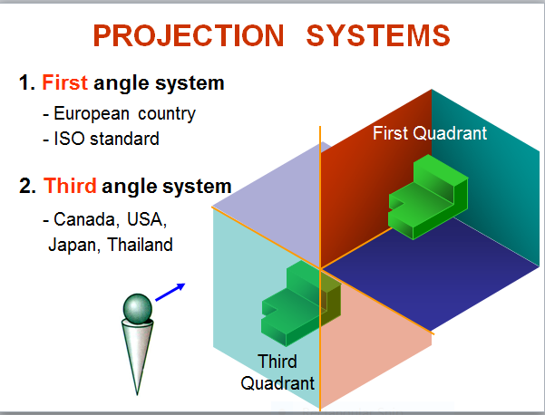
Figure: 2.5.First Quadrant

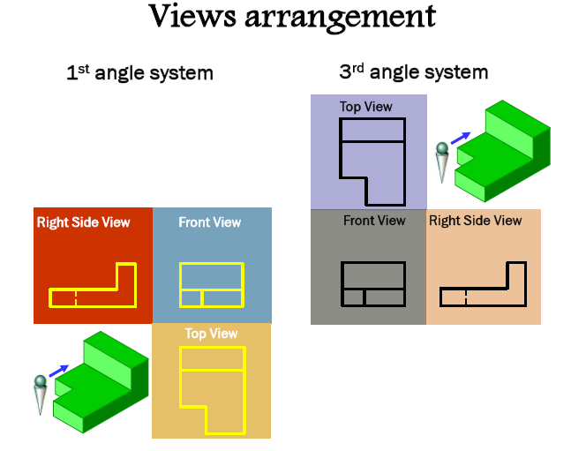
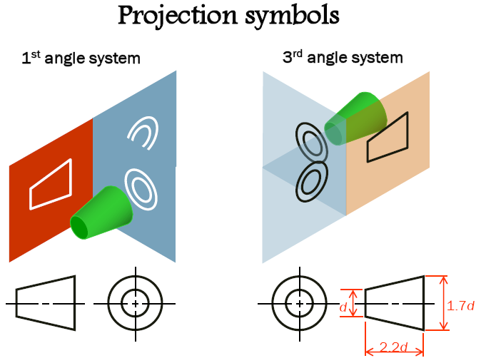
Selection of views
- The number of orthographic views required for clear description of the object is taken as the criteria to select the views. As far as possible least number of views is drawn.
- While selecting the views; the object is placed in such a way the numbers of hidden lines are kept to minimum.
- Front view is drawn seeing the object in a direction is which its length is seen. It is also chosen such that the shape of the object is revealed. The direction of the view is indicated by arrows.

2.4. Alphabet or types of lines

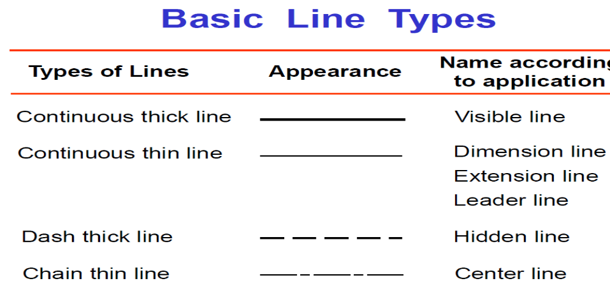

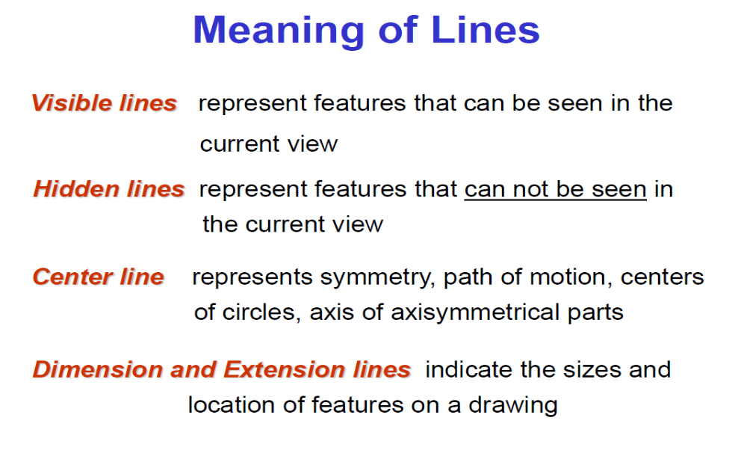

2.5. Drawing Technique

There are standard drawing techniques that you need to be familiar with as you put pencil to paper. Some are so basic that you’ve probably used them before without even realizing it.
Back and forth: When we say basic, what we’re talking about. This approach challenges you to move your drawing utensil back and forth across the paper in an even, level motion. Depending on how much pressure you apply, the darker your drawing will appear.
Hatching: Hatching involves making tiny ticks on your page. Make sure that each mark is parallel to the other. Lines that are close together will look darker, while lines further apart will indicate highlights.
Hatching Cross Hatching: This technique is the logical extension to hatching. But instead of creating a series of parallel lines, have your marks intersect one another in a cross-like formation.
Scribble: Scribbling allows your hand the opportunity to fly across the page. Move your pencil in a random formation—no precise marks necessary. The more you scrawl all over an area, the darker it will look.
Stippling: For those who love meticulous processes, this one’s for you.
Stippling involves making a countless amount of tiny dots on your paper. Like all other approaches, the closer the dots, the darker the drawing.
Blending: If you’re using charcoal or pencil, try blending them. To do so, begin with the back-and-forth technique to cover your paper, and then rub the medium into it. You can use your finger, a blending stick (aka tortillon), or chamois cloth. Another option for blending is to experiment with powdered graphite and use a paintbrush to gradually blend and build tone onto

2.6. Dimensioning Techniques

Dimensions
A drawing without dimensions is meaningless. Dimensions are necessary to show the exact size of an object. Dimensioning refers to the act of giving dimensions, i.e., length, width, height, diameter, etc., of the object. This information is provided by giving numeric values to various features of the object on the drawing. A feature is an individual characteristic such as a flat or cylindrical surface, a slot or a groove, a taper, a shoulder, a screw thread, etc.
Dimensioning is often done by a set of elements, which includes extension lines, dimension lines, leader lines, arrowheads and dimensions.
- Extension line – is a short line drawn perpendicular to an object line. These line start immediately or a few millimeters from the ends of object lines and extend a few millimeters beyond a dimension line. Extension lines may be used to show an angle due to space constraint. In such case, extension lines are drawn parallel to and at the ends of object lines.
- Dimension line – is drawn between two extension lines parallel to the object line. As a rule, there must be one and only one dimension line between any two extension lines. One dimension line represents one dimension. While dimensioning an angle, a curved dimension line is drawn by drawing a suitable are having its center at the vertex of the angle.
- Leader line – is a line which connects a note or a dimension with the feature to which it applies. Leaders are drawn at suitable angles, preferably 30º, 45º or 60º, and are never drawn horizontal or vertical. One end of the leader carries an arrowhead which connects it to the outline of the object. A dot is used instead of an arrowhead, if the leader ends inside the object, figure (b). The other end of the leader is made horizontal. A note or dimension is placed above the horizontal portion of the leader. Leaders are frequently used to indicate the diameter or radius of a circular feature.
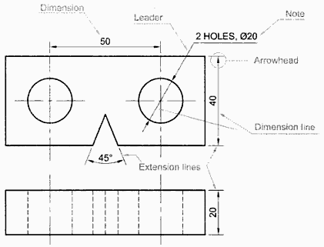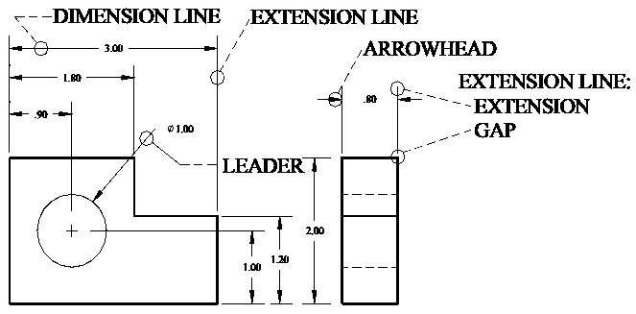
Figure A Figure B
Elements of dimensioning

2.7. Projections

2.7.1. First angle projections
First angle projections
Multi view projection is a method by which the exact shape of an object can be represented by two or more separate views produced on projection planes that are at right angles to each other.
The system of constructing multi view drawing is orthographic projection. Orthographic views are two dimensional views of three dimensional objects.
There are two types of projection systems in use today. These are:
- First-angle projection is used mainly in
- Europe.
- Third-angle projection is used in the United States, Canada, and in many other countries.
Basically their difference relays on the position of projection plane or imaginary projection plane or viewer’s drawing paper.
First angle projection system: Observer <============> object <==============> Projection Plane
Here imagine that, the viewer is at left of the front view and looks at the object.
Note:
- Always top view will be placed below front view
- Always left side will be drawn on the right side of front view
- Always we place the right side to the left of the front view
- Bottom view will be shown above the front view

Symbolic representation of first angle orthographic projection is:
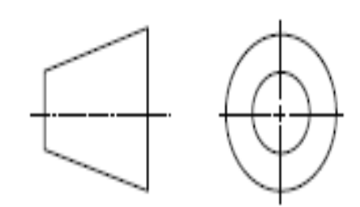
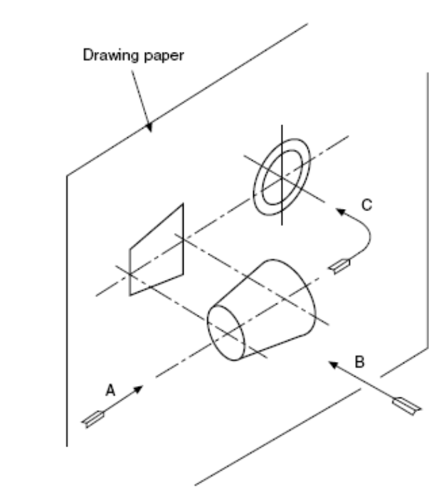

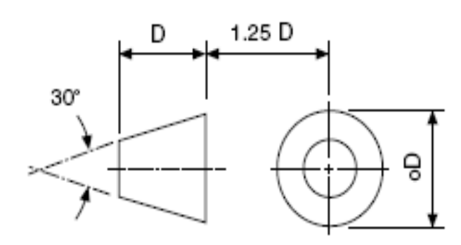

Figure 2.8 First angle projections
Example
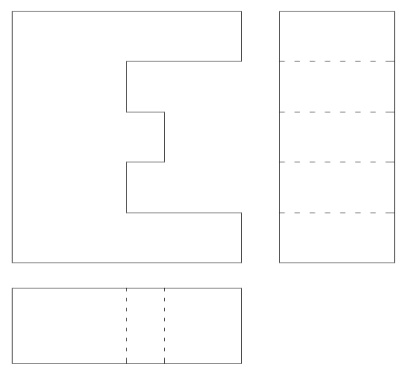
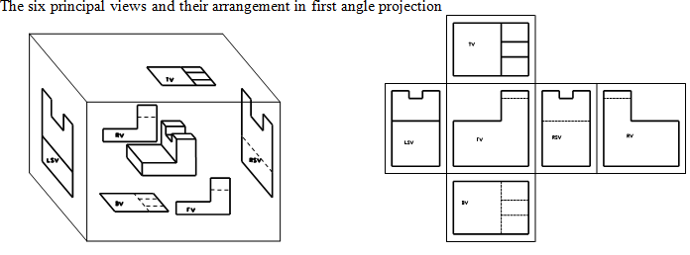
Figure 2.9 the six principle views and their arrangement in first angle projection
2.7.2. Third angle projections
Third angle projections
- Third angle projection system: Observer <============> Projection Plane <==============> object
Note:
- Top view is always projected above the front view
- The right hand side view is shown on the right hand side of the front view
- The left hand side view is shown on the left hand side of the front view
The standard symbolic representation for the third angle projection is:
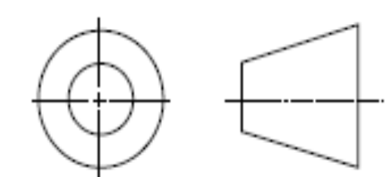
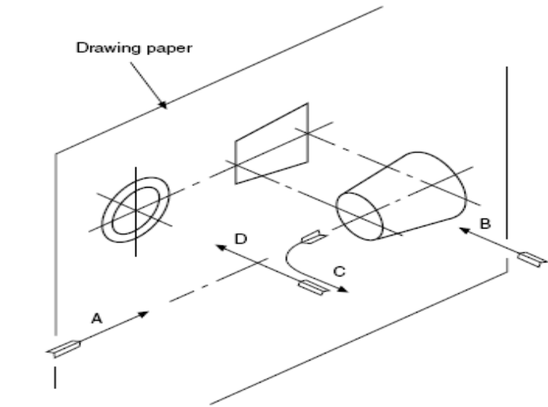
Figure 2.9 third angle projections

Examples:
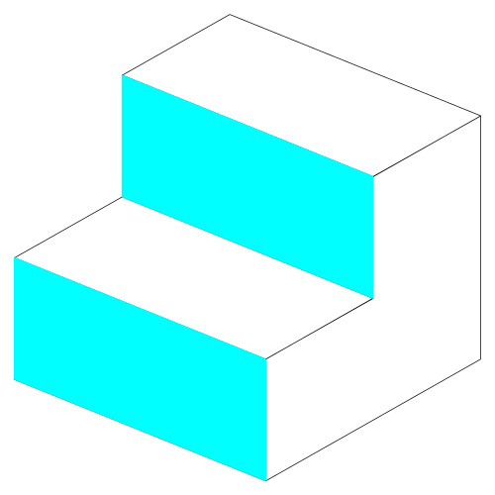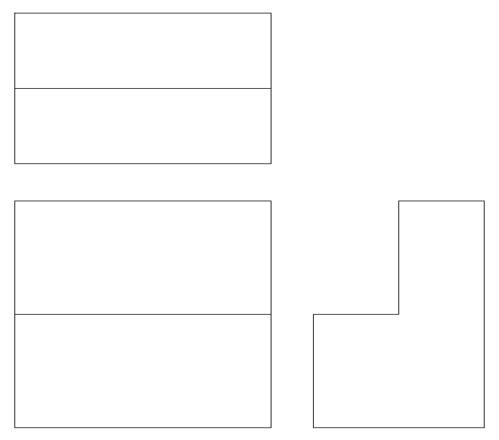
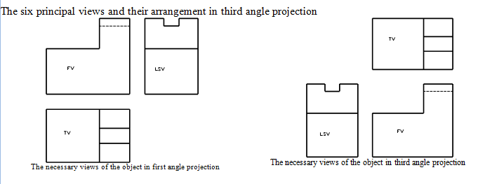

Figure 2.10 first and third angle projections

Self check-2 | Written test
Directions: Answer all the questions listed below. Use the Answer sheet provided in the next page:
Write the true if the statement is correct if not write False

1. Hidden lines are only shown in isometric sketches unless.

2. Exploded drawing is a diagram, picture, schematic or technical drawing of an object

3. Perspective projections are drawings which attempt to replicate what the human eye actually sees when it views an object.
Name ____________________ date ________________

Answer sheet score-------------------------
1. -------------
2. -------------- rating---------------------
3. --------------------
Self check-3 | Written test
Directions: Answer all the questions listed below. Use the Answer sheet provided in the next page:
Choose the correct answer from the following Questions
1 .One of the following views gives length and width of dimensions
A. side view C. Front view

B. top view D. none
2. Which one of common standards used in orthographic projection of drawings
A. First Angle Projection B. European projection
C. Third Angle Projection D. all are answer
3. Which Orthographic views principles are correct in making drawing In first angle projection
B. Front view on the above and the Top view at the bottom
C. front view and the side view are always in line horizontally
D. Front view is drawn seeing the object in a direction is which its length is seen.
E. All above answer are correct
LAP test | practical Demonstrate

Name: _____________________________ Date: ________________
Time started: ________________________ Time finished:
Instructions: Given necessary templates, tools and materials you are required to perform the following tasks within 8 hours.
3. You are required to do the following activities as required in the problem.
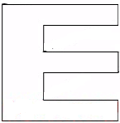
Task 1: Draw the one point perspective view of letter “ E “ below.

Task 2: Draw the one point perspective view of the isometric figure below. (One to one scale)
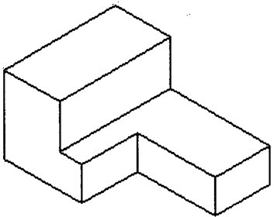

Task 3: - Draw the isometric view of the object whose orthographic projections are given in fig. All dimensions are in mm.
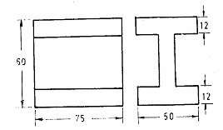

Task 4:- Draw front view, top view and side view of the model shown below by first and
third angle projection respectively.

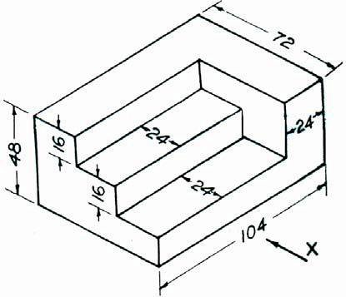

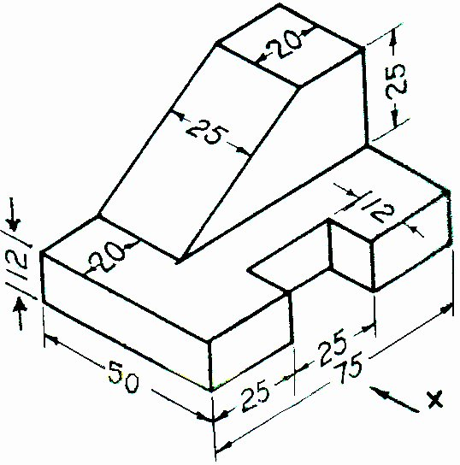
Task 4:- Draw the Orthographic views of the Isometric view shown in the following figure:

Unit three: Interpret electrical Drawing and symbols
This unit is developed to provide you the necessary information regarding the following content coverage and topics:
- Recognizing component, assembly or object
- Interpreting dimensional tolerances
This unit will also assist you to attain the learning outcomes stated in the cover page. Specifically, upon completion of this learning guide, you will be able to:
- Component, assembly or object is recognized as required
- Interpret electrical Drawing, symbols and codes are interpreted appropriately
- Dimensions and material requirements are identified, understood and followed as required
Dimensional tolerances, notations are interpreted according to specifications

3. Interpret electrical Drawing and symbols

3.1. Recognizing component, assembly or object

Assembly Drawing
Anassemblyworking-drawingindicateshowtheindividualpartsofamachineor mechanism is assembled to make a complete unit.
An assembly drawing serves the following purposes:
•Describes the shape of the assembled unit.
•Indicateshowthepartsoftheassembledunitarepositionedinrelationtoeach other.
•Identifies each component that forms sprat of the assembled unit.
•Providesapartslistthatdescribesandlistsessentialdataconcerningeachpartof the assembled Unit.
•Provides, when necessary, reference information concerning the physical or functional Characteristics of the assembled unit. Assembly drawings may show one, two or three views to describe the assembled components; they must contain apartslist(mayalsobecalledmaterialorcuttinglistdependingontheengineeringdiscipline),crossreferencing(inballoonsorcircles),andgeneralnotespertainingtotheassembly
The drawings normally show the over dimensions and center-to-center distances for specific assemblies.

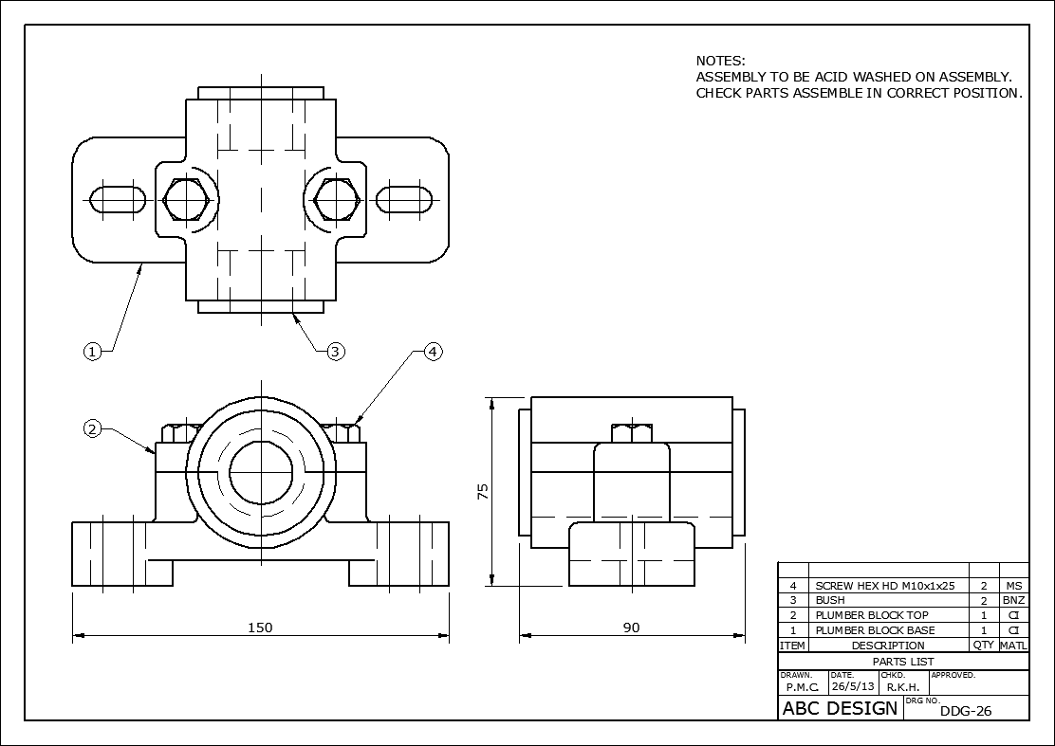

Figure 3.1

Figure3.1 shows a completed assembly drawing with the Plumber Block Base, Plumber BlockTopandBushesdrawninplaceandsecuredwiththeHexagonalHeadScrews.Mostdesignsarecommencedwithanassemblydrawingandwhentheconceptofthe design is finalized ,the separate components can be broken out and detailed accordingly.

Intersections
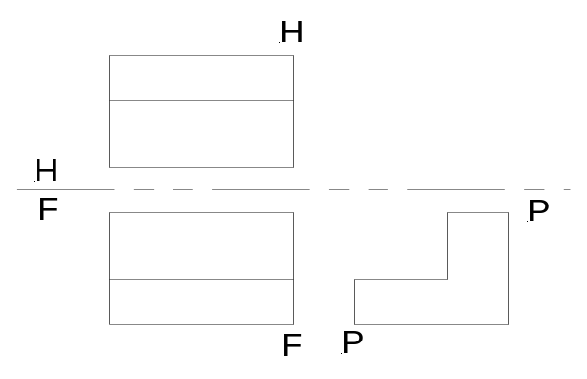

For the above object we can have orthographic projection as follow:
Figure 3.2 orthographic projection
Here we have three principal projection planes. That is to say:
  - Horizontal projection plane (H)
  - Frontal projection plane (F)
  - Profile projection plane (P)

In orthographic projection, an intersection between planes results in a line. The standard types of intersections between cylinders are shown below
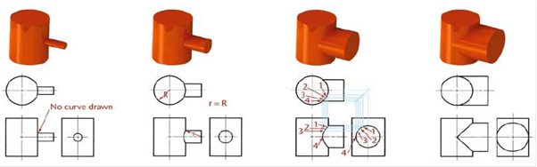

  - 1.Interpreting dimensional tolerance

3.2. Interpreting dimensional tolerances and notation

The purpose of dimensioning is to provide a clear and complete description of an object.
A Complete set of dimensions will permit only one interpretation needed to construct the part.
Dimensioning should follow these guidelines.
- Accuracy: correct values must be given.
- Clearness: dimensions must be placed in appropriate positions.
- Completeness: nothing must be left out, and nothing duplicated.
- Readability: the appropriate line quality must be used or legibility
Type of tolerances.
1. General tolerance
If no tolerances are specified at the dimension level, then general tolerances may be applied by deliberately controlling the number of values past the decimal point on each dimension.

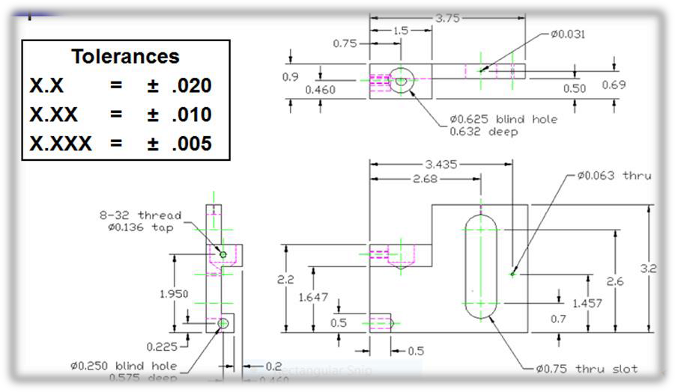

Fig 3.3. General tolerance

No two manufactured objects are identical in every way. Some degree of variation will exist. Engineers apply tolerances to part dimensions to reduce the amount of variation that occurs. The tolerance may be applied directly to the dimension or indicated by a general note located in the title block of the drawing
A tolerance is an acceptable amount of dimensional variation that will still allow an object to function correctly
1. Angular tolerance
In a mechanical drawing of a part, angularity tolerance allows the designer to specify the degree to which the orientation of an angled part feature may vary.
The angularity symbol is often used to insure that the part can properly mate with another.
In GD&T, the degree of permissible variation is not specified as a tolerance on the angle.
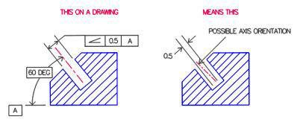
Rather an indirect method is used where one specifies a tolerance zone at a specified angle from adatum, within which a part feature, axis, or center plane must
Figures: 3.4. Angular tolerances
In the left figure above, the boxed angularity symbol, tolerance and datum are used to control the center axis of an angled hole.
The boxed symbols can be read “This axis must lie within two planes 0.5 apart , the planes inclined 60° to surface A”.
In the right figure above, the tolerance zone created is indicated by the parallel lines.
This form of angularity tolerance applies only in the drawing view in which the tolerance is specified, and requires the permissible variation to be defined for other views. However, if a diameter symbol were placed in front of the boxed 0.5, this would create a cylindrical tolerance zone which would then apply to all drawing views.
Angularity is used in a tolerance stack when applied to a surface or line element.
Angularity refines the orientation of the surface or line element, acting like a flatness control for the purposes of performing a tolerance stack
2. Geometric tolerance
In a typical engineering design and production environment, the designer of a part rarely follows the design to the shop floor, and consequently the only means of communication of the design intent are the design drawings.
Problems of validation and interpretation of design arise when the drawings do not clearly reflect what the designer intended, when they do not communicate to manufacturing how the design should be implemented and When the drawings are subjected to a number of different interpretations.
The use of linear tolerances when dimensioning the part can control the size of a product.
It is however possible for limits of size to be maintained while the shape of a part or
feature deviates significantly from the intended form.
To control this deviation, a method of specifying the acceptable tolerance of form is required and this is done using geometric dimensioning and tolerance symbols.
These enable the designer to specify on the drawing, the geometry or shape of a component and they provide a precise definition of what constitutes a functionally good part.
Features of a component
Geo- metrical tolerances may be applied to these features. For example, an axis may
have straightness or a positional tolerance, a face may have a flatness tolerance and a
cylindrical surface may have a circularity tolerance. It may be combined to form other
features such as slots, grooves and tongues. Thus, a tongue consists of a pair of parallel
plane surfaces with another plane surface at right angles to them, and a median plane.
Slots, grooves and tongues may need tolerances of position or symmetry.
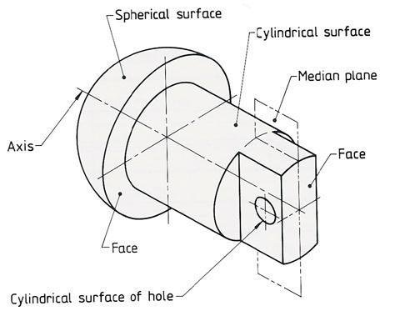

Figure: 3.4 Feature of a Component

Tolerance Frame:
Geometrical tolerances are placed in rectangular frames that are divided into Compartments as shown in bellow. In the first compartment from the left the symbol for the characteristic being tolerance is given. The next compartment contains the tolerance value in the units used for linear dimensions.
If the tolerance zone is circular or cylindrical the symbol Ø appears before the tolerance value. The third and succeeding compartments contain the. Letters which identify the datum feature or features, where appropriate
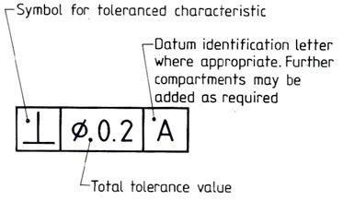

Figure 3.5. Tolerance Frame
The capitol letter “M”, “P” or “E” may appear in the tolerance frame as appropriate, to
indicate
• Maximum Material Condition qualification
•
Projected Tolerance Zone
Envelope Requirement
•
Tolerance Characteristic Symbol:
The straightness of an axis, the flatness of a face, etc, are characteristics of features
and these are indicated on drawings using the symbols shown in bellows
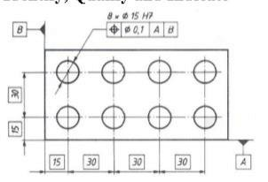

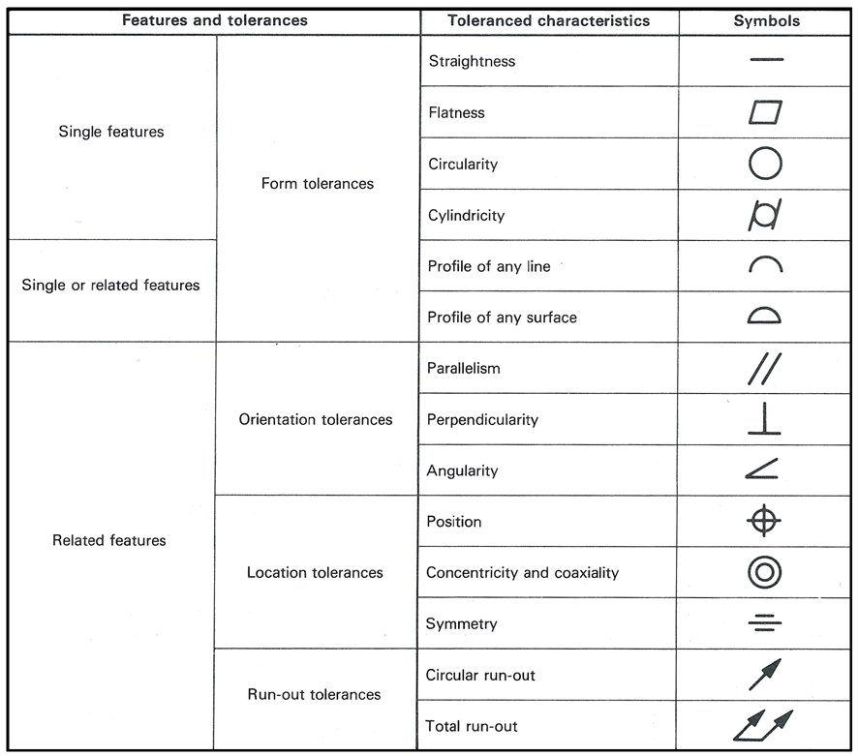

Figure: 3.6.Tolerance Characteristic Symbols

Theoretically Exact Dimensions
When tolerances of position, profile or angularity are specified for a feature, the ideal position or angle is defined by theoretically exact dimension. These dimensions are enclosed in a rectangular frame, called a box as shown using the example opposite
Projected Tolerance Zone:
When indicating the positional tolerance zone for the axis of a hole, the perpendicularity
deviations of the axis may be specified also. If the hole is to be used to secure a
cylindrical part such as a press-fit pin, the maximum permitted perpendicularity deviation
of the hole axis could cause the pin to interfere with the clearance hole in the mating part.
This may be avoided by specifying a projected tolerance zone for the axis of the securing
hole, as shown opposite.
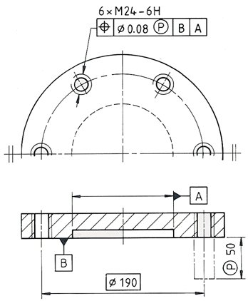

Self check-3 | Written test

Directions: Answer all the questions listed below. Use the Answer sheet provided in the next page
Write true if the statement is correct write False if not correct
1. The purpose of dimensioning is to provide a clear and complete description of an object.
2. Complete set of dimensions will permit only different interpretation needed to construct the part.
3. Geometrical tolerances should be specify for all requirements critical to functioning and Inter changeability
4. Suitable locations on the part, called datum targets
Name: ________________________ Date: _______________
Answer Sheet
1.
2.
3. Score = ___________
Rating: ____________

Operation Sheet 3 | To perform dimensional Views

To perform dimensional Views
Procedure:
Step1 Set up your drawing paper on top of the drawing board.
Step2 Use the drawing template format given to you by your teacher.
Step3 Be sure to check the sharpness of your pencil lead.
Use standard sharpening for good aesthetic result of your work.
Step4 Using the basic drawing instruments and materials, perform the drawing task in the given following problems 1 to ___ below.
Step5 Use appropriate pencil lead in your drafting works.
Step6 There are two part of problem exercises, Part A – complete the st
Step7 orthographic views by finding the missing line/s given the orthographic views and isometric view;
Step8 Part B – provide the 3 basic orthographic views (top, front and side/end views) given the isometric view.
Step9 You may submit your finish work once you are true but should be within the time specified for submission.
LAP Test | Practical Demonstration

Name: _____________________________ Date: ________________
Time started: ________________________ Time finished:
Instructions: Given necessary templates, tools and materials you are required to perform the following tasks within 4 hours.
Perform the following tasks
Task-1 Draw the orthographic projections needed to fully describe the part.
Choose the best view for the front view.
Use a scale of 1:1 with 50 mm spacing between the views.
Apply all dimensioning style. Note: All Dimensions in mm.
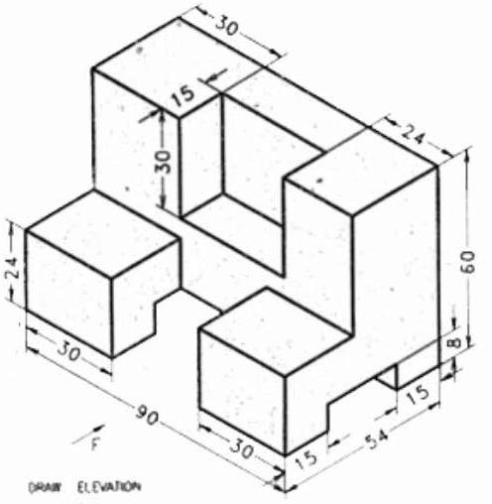

Task: 2 draw the orthographic projections needed to fully describe the part. Choose the best view for the front view. Use a scale of 1:1 with 50 mm spacing between the views.
Apply all dimensioning style. Note: All Dimensions in mm.
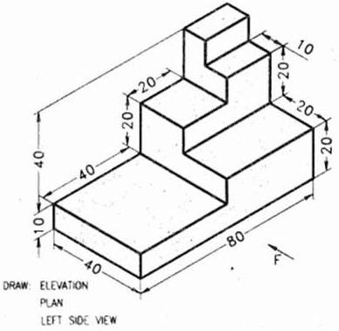

Reference

    - Jenson,CecilHoward,Engineeringdrawinganddesign,1925,4thed.,Macmillan/McGram-Hill

2. . Louis Gary Lamit, Descriptive Geometry,1981,1st ed.,Prentice-Hall

3. Frederick E.,Technical Drawing,1958,4thed.,The Macmillan Company

4. David L Goetsch et al, Technical drawing,1994,3rd ed., Delmar Publishers Inc.

5. A text book of engineering drawing, B.Gupta. Nasaka Pashakar publisher

6. V.B. Sikka ,A course in civil engineering drawing ,1998,4th ed.

7. T. Jeyapoovan, Engineering Drawing with autocad 2000, Vikas publishing

Participants of this Module (training material) preparation
No | Name | Qualification (Level) | Field of Study | Organization/ Institution | Mobile number | E-mail
1 | Tesfaye Bedada | A(MSC) | Automotive technology | Hawassa P.T. C | 0927831195 | Tesfayebedada51@gmail.com
2 | Biratu Desalegn | A(MSC) | Automotive | Ambo PTC | 0913033783 | Biratudesalegn01@Gmail.com
3 | Mathewos Markos | A(MSC) | AutomotiveTechnology/ TVET Leadership and management | Durame P.T.C | 0911062645 | Birukmark2009@gmail.com
4 | SenaitWagshumAsmare | A(MSC) | Automotive technology | w/ro shieen poly technical collage | 0913282217 | Senaitwagshum2@gmail
5 | Zinabu solomon | B(Bsc) | Motor vehicle engineering | MGMBPTC | 0960964523 | zinabusolomon565@gmail.com

