Automotive Electrical & Electronics Level – II
Based on March, 2022 curriculum (V-1)

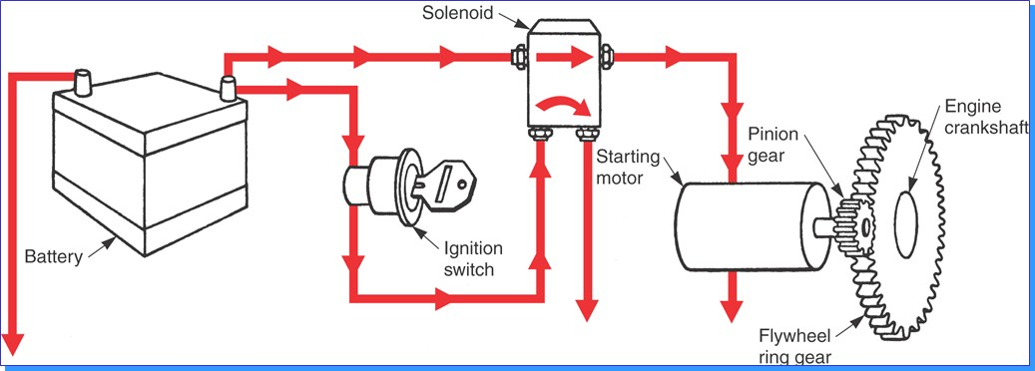

Module Title: - Inspecting and Repairing Starting System

Module code: - EIS AEE2 M03 0322

Nominal duration: - 40 Hours

Prepared by: Ministry of Labor and Skill
September, 2022
Addis Ababa, Ethiopia

Table of Content
Contents
Acknowledgment 4
Acronym 5
Introduction to the Module 6
Module Instruction: 7
Unit one: Overview of starting system 8
1.1 Safety on starting system 9
1.2 Purpose of starting system 10
1.3. Component of starting system and its function 11
1.4. Working principle of starter motor and system 17
1.5. Tools and Equipment 25
Self-Check 1 27
Unit Two: Overhauling and dismantle starting system 28
2.1 Overhaul Starter motor and system component 28
2.2. Disassembling Starter motor and Components 29
2.3. Cleaning starter motor and System components 32
Self-Check 2 33
Operation Sheet 34
Lap Test-2 34
Unit Three: Inspecting, Testing, Repairing and Replacing starting systems 35
3.1. Inspecting Starting system circuit 36
3.2. Testing starter motor and associated component 36
3.3. Starter motor repair procedure 42
3.4. Repair and Replace starting systems and associated components 42
3.5. Reassemble starter motor 44
3.6. Starting System Trouble shooting 44
Self-Check 3 46
Operation Sheet 47
Lap Test-3 52
Unit Four: Cleanup work area and maintain equipment 53
4.1. Removing methods of waste and scrap 53
4.2. Cleaning and inspecting equipment and work area 54
Self-Check -4 56
Referance 57

Acknowledgment

Ministry of Labor and Skills and Ministry of Health wish to extend thanks and appreciation to the many representatives of TVET instructors and respective industry experts who donated their time and expertise to the development of this Teaching, Training and Learning Materials (TTLM).

Acronym

DC - Direct current
AC - Alternative current
EMF – Electro motive force
DMM - Digital multimeter

Introduction to the Module

Engine start is the initial phase, and a very crucial phase in the operation of automotive engines. “starting system” is the heart of the electrical system in your car, begins with the Battery. The key is inserted into the Ignition Switch and then turned to the start position. A small amount of current then passes through the Neutral Safety Switch to a Starter Relay or Starter Solenoid which allows high current to flow through the Battery Cables to the Starter Motor. The starter motor then cranks the engine so that the piston, moving downward, can create a suction that will draw a Fuel/Air mixture into the cylinder, where a spark created by the Ignition System will ignite this mixture. If the Compression in the engine is high enough and all this happens at the right Time, the engine will start. The starter motor plays a vital role in this short transient period. The main function of the starter system is to supply cranking torque to the crankshaft of the I.C. engine until a sustainable RPM is achieved due to consecutive robust engine combustion events.
This module covers the units: -

Overview of starting system

Overhaul and dismantle starting system

Inspect, Test, Repair and Replace starting systems

Clean up work area and maintain equipment

Learning Objective of the Module

Understand Overview of starting system

Perform Overhaul and dismantle starting system

Apply Inspect, Test, Repair and Replace starting systems

perform Cleanup work area and equipment

Module Instruction:

For effective use this modules trainee are expected to follow the following module instruction:
- Read the information written in each unit
- Accomplish the Self-checks at the end of each unit
- Perform Operation Sheets which were provided at the end of units
- Do the “LAP test” giver at the end of each unit and
- Read the identified reference book for Examples and exercise

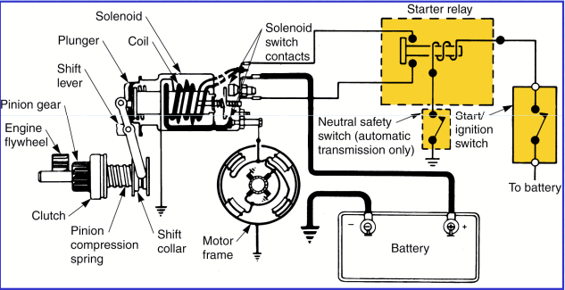
Over view of starter motor circuit

Unit one: Overview of starting system
This unit is developed to provide you the necessary information regarding the following content coverage and topics:
- Safety On starting system
- Purpose of starting system
- Component of starting system and its function
- Working principle of starting system
- Tools and Equipment
This unit will also assist you to attain the learning outcomes stated in the cover page. Specifically, upon completion of this learning guide, you will be able to:
- Apply Safety for starting system
- Understand Purpose of starting system
- Identify Component of starting system and its function
- Understand Working principle of starting system
- Use Tools and Equipment

Figure 1.1 over view of starting system.

1.1 Safety on starting system
Safety:- means protecting yourself and others from possible danger and injuring in the shop, you are ' Safe' when you protect your eyes, your fingers, your hands all of yourself from danger as well as others.Much of your work on an automobile will be around or with the vehicle’s electrical system. To prevent personal injury or damage to the vehicle, you should always take the necessary precautions before working. When possible, you should disconnect the vehicle’s battery before disconnecting any electrical wire or component. This prevents the possibility of a fire or electrical shock. It also eliminates the possibility of an accidental short, which can ruin the car’s electrical system. Disconnect the negative or ground cable first, then disconnect the positive cable. Because electrical circuits require a ground to be complete, by removing the ground cable you eliminate the possibility of a circuit accidentally becoming completed. When reconnecting the battery, connect the positive cable first, then the negative.
Also, remove wristwatches and rings before servicing any part of the electrical system. This helps prevent the possibility of electrical arcing and burns. When disconnecting electrical connector do not pull on the wires. When reconnecting the connectors, make sure they are securely connected.
- Always make sure that you wear the appropriate personal protection equipment before starting the job. It is very easy to hurt yourself even when the most exhaustive protection measures are taken.
- Always ensure that your work area/environment is as safe as you can make it. Do not use damaged, broken or worn out workshop equipment.
- Always follow any manufacturer's personal safety instructions to prevent damage to the vehicle you are servicing.
Make sure that you understand and observe all legislative and personal safety procedures when carrying out the following tasks. If you are unsure of what these are, ask your supervisor.
- A spark created above a battery can cause an explosion. So always follow these precautions:
  - Keep your face and body as far back as you can while connecting jumper leads.
  - Connect the leads in the correct order -- positive on discharged battery; then positive on charged battery; then negative on charged battery; then negative to a good ground on the vehicle with the discharged battery -- away from the battery itself.
  - Do not connect the negative cable to the discharge battery because this may cause a spark.
  - Only use specially designed heavy-duty jumper cables to start a vehicle with a dead battery. Do not try to connect the batteries with any other type of cable.

1.2 Purpose of starting system
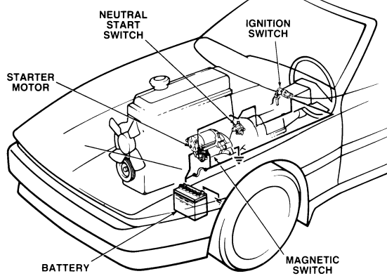
The IC engines are not capable of starting by it but they require external power to crank it and help it to start. The engine must be rotated before it will start and run under its own power. The starting system is a combination of mechanical and electrical components that work together to start the engine. The starting system is designed to change electrical energy that is being stored in the battery into mechanical energy.
The purpose of the starting system is to convert chemical energy stored in the battery into electrical energy, then into mechanical energy in the starter motor. This mechanical energy is then transferred through gears and drives from the starter motor to the engine flywheel. After the transfer and conversion of all this energy the engine flywheel begins to rotate. The rotation must be of sufficient speed to allow the engine to form the combustible air-fuel mixture required for starting.

1.2.1. Types of starting system

  - Electrical starting system
  - Mechanical starting system
  - Air cranking system
  - Hydraulic cranking system
- Electrical Starting System: - use chemical energy stored in batteries. The batteries are automatically recharged by an engine-driven alternator. Applied for Battery powered electric motors provide fast, convenient, push-button starting with lightweight, compact, engine-mounted components.
Types of electrical starter motor
- Pre-engaged starter motor
- Reduction type starter motor
- Bendix drive type starter motor (Bajaj)
- Permanent magnet starter motor
- Mechanical/Non motor Starting System: - a spring starter uses potential energy stored in a spring wound up with a crank to start an engine without a battery or alternator. Turning the crank moves the pinion into mesh with the engine’s ring gear, then winds up the spring. Pulling the release lever then applies the spring tension to the pinion, turning the ring gear to start the engine and automatically disengages after operation. Applied for Motorcycle, Tricycle, and small size generator.
- Hydraulic Starting System: - use hydraulic oil stored in steel pressure vessels under high pressure. The vessels are automatically recharged by a small engine driven hydraulic pump with an integral pressure relief valve. Applied for Agricultural Water Pumps, Underground Locomotives, and Lifeboats …etc.
- Air/Pneumatic Starting System: - use compressed air in pressure tanks. The tanks are automatically recharged by an electric motor or engine-driven air compressor. Applied to large engines in work-boats, on land where facilities have existing plant air, or where a combustible gas may be present in the atmosphere.

1.3. Component of starting system and its function
The starting system consists of the following components: Battery, Ignition Switch, Starter Relay, Starter Motor Assembly, EWS (if equipped), Starter Safety Switch, Cables and Wiring Harness.
- Battery is the primary EMF source in the automobile, an Electro-Chemical device that provides the potential difference (voltage). State-of-charge and capacity of the battery are important factors in the ability of the engine to start, especially in cold and harsh conditions.
- Ignition Switch it is a mechanical device used to connect or disconnect the current flow in all circuits of the vehicle. provides a request to the starting system to engage the starter motor. This request is handled differently depending on the year of the vehicle and particular systems the vehicle is fitted with. In non EWS systems the ignition switch provided power directly to the starter solenoid or a starter relay.
- Starter Relay: - Opens or closes one circuit by responding to an electrical signal from another circuit. Uses a small current from the ignition switch to control a larger current through the starter solenoid Reduces the load on the ignition switch.
- Starter Motor: - it is an electrical device, which converts electrical energy to mechanical energy in order to spin the engine crankshaft at the minimum speed that is required to induce initial combustion to produce engine power.
- Starter Safety Switch is part of the transmission range switch on automatic transmission vehicles and a clutch switch on manual transmission vehicles (beginning MY 1997). The purpose of the switch is to prevent engine start-up with the vehicle in gear or the clutch not depressed. On vehicles with EWS, this signal is sent directly to the EWS module for processing.
- Cable and Wiring Harness Cables to the starter from the battery must carry large amounts of current. The wiring harness from the ignition switch and/or EWS carry little current as they are control signals to a relay or starter solenoid. Minimum voltage drop in starter cables is necessary to ensure sufficient starter speed and torque. Direct Drive Starter Components.

1.3.1 Classification of starter motor
Starter Motor vehicles are fitted with one of two types of starter motors:
- Conventional Drive (Direct Drive): - in starter the pinion gear is located directly on the armature shaft. The pinion and overrunning clutch form the driver assembly. The driver assembly rides on a helical spline on the armature shaft so that when the driver is thrust by the solenoid, a combined axial and rotary motion occurs which greatly facilitates the meshing of the pinion.
Older models vehicle use conventional type starters. This type of starter drives the pinion gear directly. The pinion gear turns at the same speed as the motor shaft. These starters are heavier and draw more current than gear reduction and PS (Planetary Reduction Segment) type starters. It is currently used on some Vehicle.
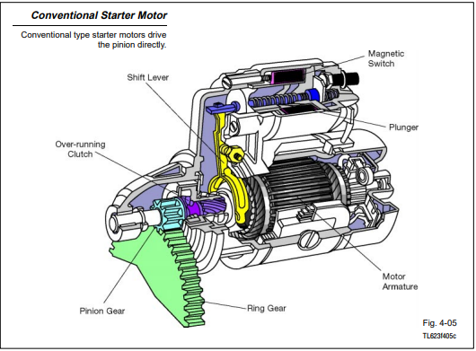
Figure 1.2. Conventional starter motor
- Gear reduction Drive: - this Starter Motor type of starter has a compact, high−speed motor and a set of reduction gears. While the motor is smaller and weighs less than conventional starting motors, it operates at higher speed. The reduction gears transfer this torque to the pinion gear at 1/4 to 1/3 the motor speed. The pinion gear still rotates faster than the gear on a conventional starter and with much greater torque (cranking power).
The reduction gear is mounted on the same shaft as the pinion gear. Unlike the conventional starter, the magnetic switch plunger acts directly on the pinion gear (not through a drive lever) to push the gear into mesh with the ring gear. this type of starter was first used on the 1973 Corona MKII with the 4M, six-cylinder engine. In their design and function, Gear Reduction Drives are much the same as conventional drive starters. The main difference in the gear reduction drive starter is a planetary gear set added between the field frame and the drive end shield. This design allows for the use of smaller and lighter starters.
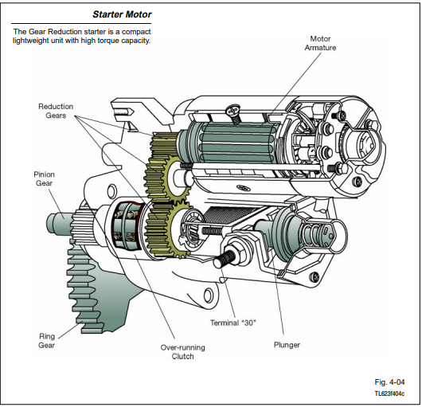
Figure 1.3 gear reductionstarter motor

1.3.2. Starter motor construction
An engine starting system must be able to crank the engine at sufficient speed for fuel combustion to begin normal firing of the cylinders and keep the engine running. Start ability of an engine is affected by factors such as ambient temperature, engine jacket water temperature, and lubricating oil viscosity. In addition, parasitic loads, usually associated with the driven equipment, can greatly influence the start ability. So that starter motor designing and construction consider the above factors and other relevance parameters.
- Electric Starter Motor: - provides the mechanical energy to rotate the engine through a direct or a gear reduction drive. The major components of the starter motor are: Armature Shaft, Armature Winding, Armature Stack, Commutator, Poles Shoes, Field Coil, Carbon Brushes, Brush Holder
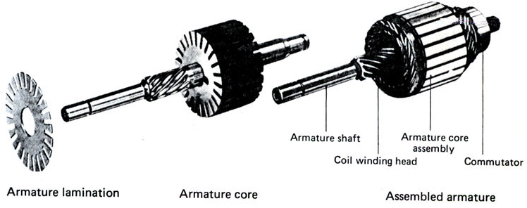
- Armature the Armature assembly is comprised of the armature shaft, armature winding, armature stack and commutator. Thin iron stampings are laminated together to form the stack or core. The slots on the outside of the laminations hold the armature windings. The windings loop around the core and are connected to the commutator. Each commutator segment is insulated from the adjacent segments. The commutator may have up to 30

Figure 1.4 Armature component
- segments. A steel shaft is inserting in the center hole of the laminations with the commutator insulated from the shaft.
- Field Coils (Magnet): Heavy copper windings that create a strong magnetic field when field when current flows through them.
- Pole shoes: Iron cores for the field coils that help to increase magnetism.
- Brushes: - are electrically conductive sliding contacts, usually made of copper and carbon. The brushes make contact with the commutator and as the starter begins to rotate the brushes reverse the flow of current to the armature. Starter brushes carry the full flow of current through the motor.
- Brush holders: Spring loaded to keep the brushes in contact with the armature.
- Brush End cap: Opposite end of the starter from the nose piece. Supports brush holder assembly and the other armature shaft bushing.
- Starter housing (Motor frame): Centre section that holds the pole shoes and field coils in place.
- Nose piece (Drive end housing): the drive end of the starter where the pinion gear is located. Holds the shift lever in place and supports the armature shaft with a bushing.
- Solenoid: - has two windings (Pull-In and Hold-In) that get energized by the starter control circuit and magnetically move a plunger. The plunger is connected to a heavy

contact disc that is a switch. The switch will send current from the battery terminal to the field coils. The plunger could also be connected to a shift lever that will move the pinion.
The solenoid has two functions
- Pushing the pinion forward so that it engages in the ring gear of the engine.
- Closing the moving contact, providing the main current path for the starter.
- Pinion Engaging Drive: - the starter’s end shield assembly contains the Pinion Engaging Drive with pinion, overrunning clutch, engagement lever and spring. The drive mechanism is responsible for coordinating the thrust motion of the solenoid switch and the rotary motion of the electric starter motor and transferring them to the pinion. The starter engages the ring gear on the flywheel by means of the pinion. A high conversion ratio of pinion teeth to flywheel teeth (between 10:1 and 15:1) make it possible to overcome the high cranking resistance of the engine using a relatively small but high-speed starter motor.
- Overrunning Clutch In all starter designs the rotary motion is transmitted via an Overrunning Clutch. The overrunning clutch allows the pinion to be driven by the armature shaft (or planetary gear set), however it breaks the connection between the pinion and the armature shaft as soon as the accelerating engine spins the pinion faster than the starter. The overrunning clutch is located between the starter motor and the pinion and prevents the starter motor armature from being accelerated to an excessive speed when the engine starts.
- Shift lever: Used to push the pinion out to engage with the ring gear.
Gear Reduction Starter Construction
In their design and function, Gear Reduction Drives are much the same as conventional drive starters. The main difference in the gear reduction drive starter is a planetary gear set added between the field frame and the drive end shield. This design allows for the use of smaller and lighter starters. Starter motor components (armature, brushes, brush holder, field coils, and pole shoes) are the same as a direct drive starter.
- Gear reduction: the armature shaft will have a gear output that will drive an intermediate gear that drives the pinion gear shaft.
- Solenoid: the solenoid performs the same electrical functions as the direct drive starter but may directly push the pinion gear out.
- Overrunning clutch: Same as direct drive.

1.4. Working principle of starter motor and system
The starting system is designed to turn or crank the engine until it can operate under its own power. To do this, the starter motor is engaged to the engine’s flywheel. As it spins, it turns the engine’s crankshaft. The sole purpose of the starting system is to crank the engine fast enough to run. The engine’s ignition and fuel system provide the spark and fuel for engine operation, but they are not considered part of the starting system. They do affect how well an engine starts.
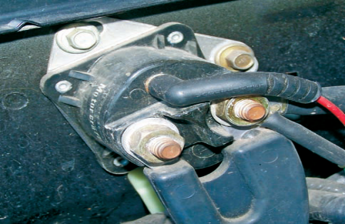
Starter relay: - two positive cables are needed. One runs from the positive battery terminal to the relay and the second from the relay to the starter motor terminal. In any case, these cables carry the required heavy current from the battery to the starter and from the starter back to the battery. Starter relays are similar to starter solenoids. However, they are not used to move the drive pinion into mesh. Figure1.5 Starter relay mounted on a vehicle.
They are used as an electrical relay or switch. When current from the ignition switch arrives at the relay, a strong magnetic field is generated in the relay’s coil. This magnetic force pulls the plunger contact disc up against the battery terminal and the starter terminal of the relay, allowing full current flow to the starter motor.
Electric Starter Motor The starter motor converts current into torque through the interaction of magnetic fields. The magnetic field developed at the field windings and the armature has opposite polarities. When the armature windings are placed inside the field windings, part of the armature coil is pushed in one direction as the field opposes the field in the windings. This causes the armature to begin to rotate. As the armature moves, the contact between a brush and commutator segment is broken and the brush contacts a new segment. This causes a reverse in the polarity of the magnetic field around the armature. The new opposition of magnetic fields causes the armature to rotate more. This process continues and the armature continues to rotate until current stops flowing to the armature. Many armature segments are used. This provides for a uniform turning motion because as one segment rotates past a brush, another immediately takes its place. This also provides for constant torque.
This constant reversal of current flow in the armature provides continual rotation. Direction of rotation is determined using Flemings Left Hand Rule.
Loop Is Being Force Out Of Magnetic Field
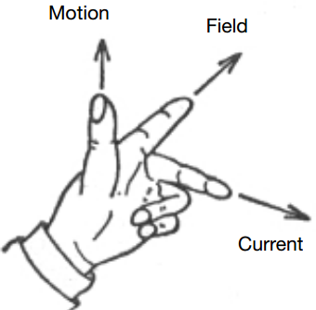
- Point your First finger in the direction of the magnetic Field (from N to S).
- Rotate your hand about that finger until your second finger points in the direction of the Current (conventional current, from + to -).
- Then your thumb points in the direction of the Movement of the wire.
To increase torque and speed in the starter motor, more windings in the armature are added, and the field has more pairs of magnets.
The basic law of motors, the direction of force
on a wire that is carrying current when it is in a magnetic field.
Field Coils (Magnet): Heavy copper windings that create a strong magnetic field when current flows through them. There are two types of Magnet:
- Electromagnetic
- Permanent magnet
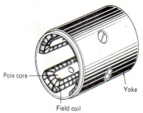
- Electromagnetic
Wire ribbons or coils wrapped around a pole shoe, attached to the inside of the starter housing. The iron pole shoes and the iron starter housing work together to increase and concentrate the strength of the field coils, when current flows thought the field coils strong electromagnetic fields with North and South poles are created.
Torque and speed of the starter motor is dependent on the wiring of the field coils.
Figure 1.6 Feld coil holder

DC electric motors have three common types of internal connections field coil
Series Wound motors
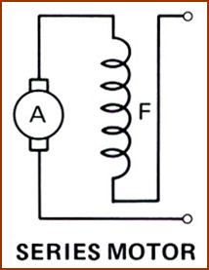
In series would motors the excitation and armature windings are connected in serried. The excitation current is not tapped Off, rather the armature current also passes through the excitation winding. The armature current in this type of motor generates a strong magnetic field because it is usually high when the motor starts under load. The motors therefore develop high initial torque, which develops sharply as motor speed increases these characteristics make the motor a particular good starter motor. When used in small starters, the motor is switched on as the starter engages the engine so that it’s full torque in immediately available.
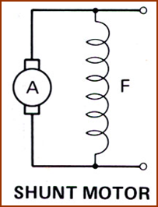
Shunt wound motors
In shunt wound motors the excitation winding is connected in parallel with the armature. When energized with constant voltage, excitation and speed are therefore practically of torque this would not be desirable for starter operation. However, the drop in battery voltage caused by the starter current yield a beneficially characteristics similar to that of series-wound motors.
Compound wound motors
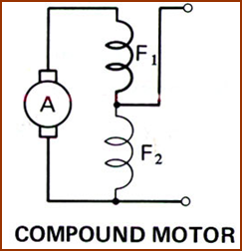
Large starters used compound wound motors which have a shunt winding and a series winding which act in to two stages. In the first stage, the armature current is limited because the shunt winding connected in series with the armature and acts as a dropping resistance. This keeps the meshing torque of the armature low. In the second stage the full current is applied to the starter motor which then develops its full torque. The shunt winding is now connected in parallel with the armature and the series winding is connected is additionally connected is series with the armature when the pinion returns to its initial position the shunt windings stops the armature quickly.
Motor Characteristics
The characteristics of a motor are those which show the relation between torque and armature current (T/Ia) this is also known as electrical characteristics, speed and armature current (N/Ia) speed and torque (N/T) characteristics, this is also known as mechanical characteristics.

While discussing motor characteristics, the following relations should be kept in mind
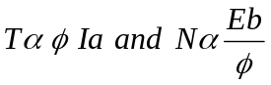
Where T = Torque φ
φ = Flux density (magnetic)
Ia = Armature current
N = Speed
Eb = Back e.m.f
Compound
In these types of motors, series excitation helps shunt excitation. The mechanical characteristics of such motors lie between those of shunt and series motors.
Comparison of shunt and series motors
- Series motors
- have a relatively huge starting torque
- Have low speed at high loads and dangerously speed at low loads
- Shunt motors
- The speed of shunt motors is sufficiently constant
- For the same current input its starting torque is not as high as that of series motors
3, Permanent Magnet
Multiple permanent magnets manufactured from an alloy of boron, neodymium and iron are positioned in the starter housing. Use of permanent magnets allow for the elimination of the field circuit and windings and realize a 50% weight savings.

Conventional Starter Motor
IGNITION SWITCH IN "ST"
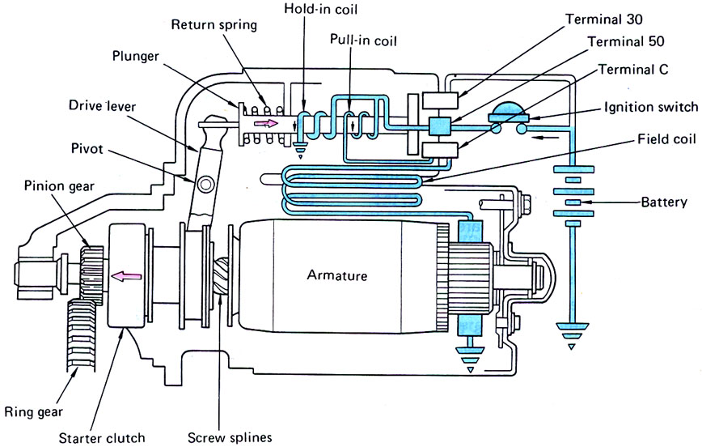
- Current flows from the battery through terminal"50" to the hold-in and pull-in coils. Then, from the pull-in coil, current flows through terminal "C" to the field coils and armature coils.
- Voltage drop across the pull-in coil limits the current to the motor, keeping its speed low.
- The solenoid plunger pulls the drive lever to mesh the pinion gear with the ring gear.
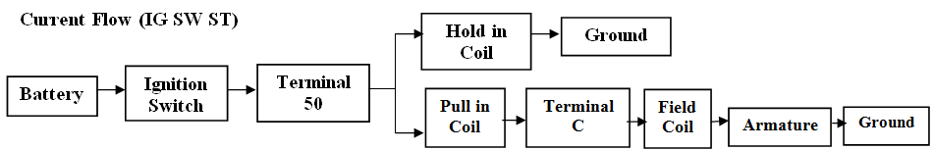
- The screw spline and low motor speed help the gears mesh smoothly.

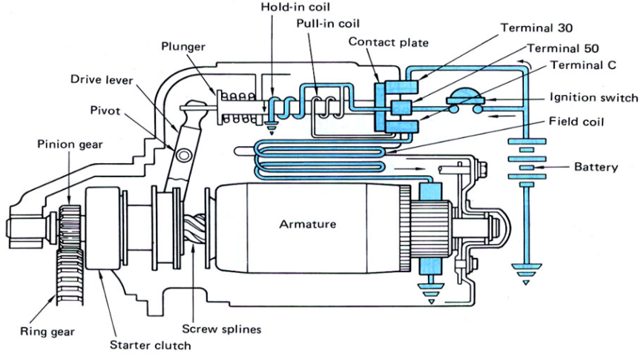
PINION AND RING GEARS ENGAGED
- When the gears are meshed, the contact plate on the plunger turns on the main switch by closing the connection between terminals "30" and "C."
- More current goes to the motor and it rotates with greater torque (cranking power).
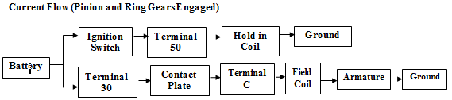
- Current no longer flows in the pull-in coil. The plunger is held in position by the hold-in coil's magnetic force.

IGNITION SWITCH IN "ON"
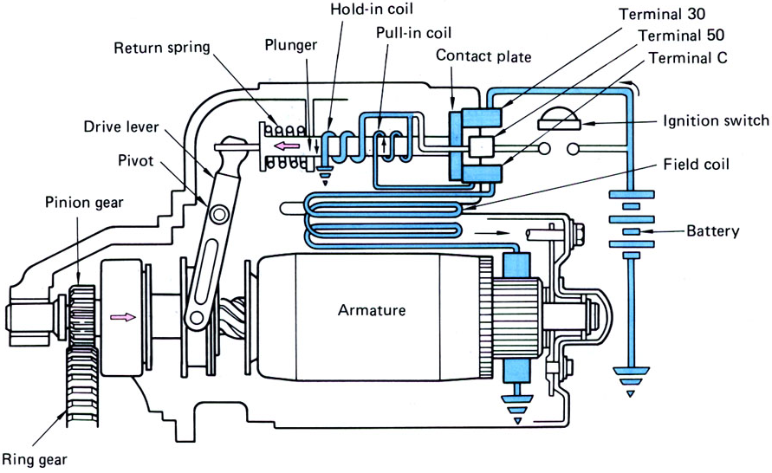
- Current no longer flows to terminal "50," but the main switch remains closed to allow current flow from terminal "C" through the pull-in coil to the hold-in coil.
- The magnetic fields in the two coils cancel each other, and the plunger is pulled back by the return spring.
- The high current to the motor is cut off and the pinion gear disengages from the ring gear.
- A spring-loaded brake stops the armature.
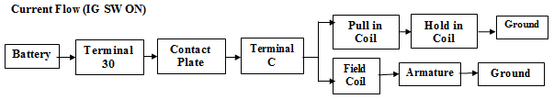

REDUCTION TYPE
- The extra gears reduce the motor speed by the factor of one to three or four and transmit it to the pinion gear.
- The plunger of the magnetic switch directly pushes the pinion gear, which is located on the same axis, causing it to mesh with the ring gear.
- This type of starter motor generates much greater torque, in proportion to size and weight, than the conventional type.
OVER-RUNNING CLUTCH
Both conventional and gear reduction starter motors are fitted with a one−way or over−running clutch. The clutch prevents damage to the starter when the engine starts. Clutch Operation:
- During engine start, the starter pinion gear drives the engine’s flywheel ring gear.
- Once the engine fires, the ring gear almost instantly begins to turn faster than the starter pinion gear. Over−speeding would damage the starter motor if it were not immediately disengaged from the pinion gear.
- The clutch uses its wedged rollers and springs to disengage the pinion shaft from the clutch housing (which turns with the motor armature). This happens any time the pinion shaft tries to turn faster than the clutch housing race which is combined with the pinion gear. Spring loaded wedged rollers are used.
- Without an over-running clutch, the starter motor would be quickly destroyed if engine torque was transferred through the pinion gear to the armature.
Table 1.1 over running clutch principle
Engine Starting The clutch housing, armature, and pinion gear turn together. | Engine Started The clutch housing and the armature turn together. The ring gear drives the pinion gear. The pinion shaft is disengaged from the clutch housing.
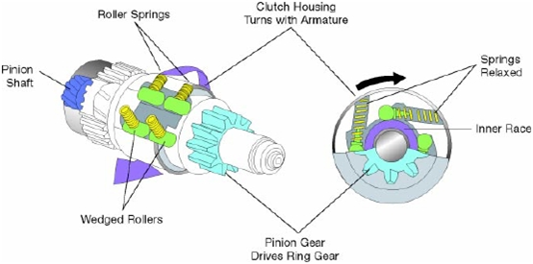 | 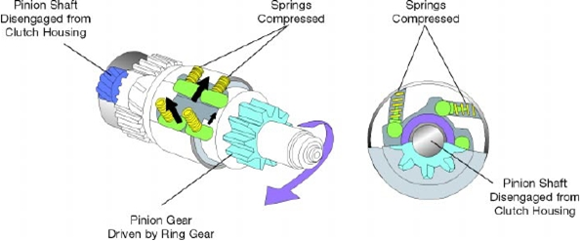

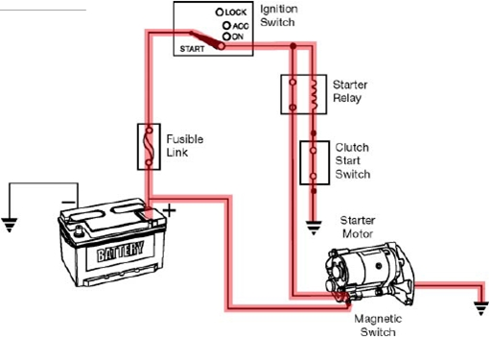
Clutch Start Switch (Manual Transmission):- for manual transmissions the clutch start switch performs the same function as the park/neutral position switch. The clutch start switch opens the starter control circuit unless the clutch is engaged.
Clutch Start Switch: - the switch closes when the clutch pedal is depressed

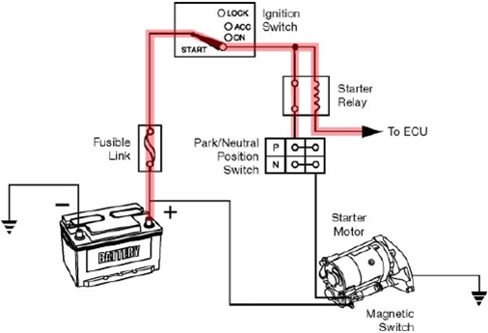
Park/Neutral Position Switch (Automatic Transmission)
The park/neutral position switch prevents operation of the starter motor unless the shift lever is in Park or Neutral. The switch contacts are in series with the starter control circuit. The switch closes with the shift lever in Park or Neutral.
Ignition Switch The ignition switch incorporates contacts to provide B+ to the starter. The relay energizes the starter magnetic switch when the driver turns the ignition key to the START position.
Figure 1.7 clutch switch circuit

1.5. Tools and Equipment
HAND TOOLS: The word wrench means twist. A wrench is a tool for twisting and/or holding bolt heads or nuts.
- Open-End Wrench: The jaws of the open-end wrench allow the wrench to slide around two sides of a bolt or nut head where there might be insufficient clearance above or on one side of the nut to accept a box wrench.

- Box-End Wrench: The end of the box-end wrench is boxed or closed rather than open. The jaws of the wrench fit completely around a bolt or nut, gripping each point on the fastener. The box-end wrench is not likely to slip off a nut or bolt. It is safer than an open-end wrench.
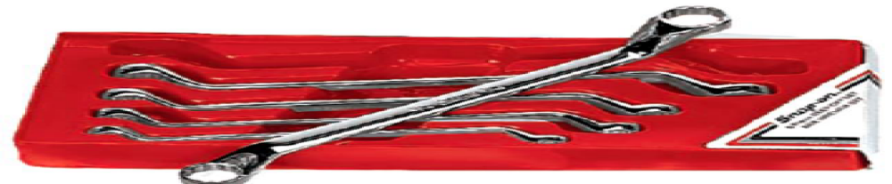

- Combination Wrench: The combination wrench has an open-end jaw on one end and a box-end on the other. Both ends are the same size. The combination wrench is probably the best choice for the second set. It can be used with either open-end or box-end wrench sets and can be used as an open-end or box-end wrench.
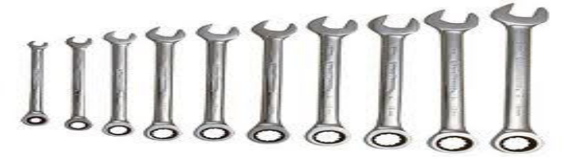

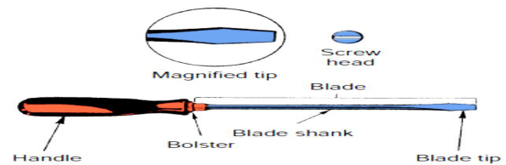
- Screwdrivers: A screwdriver drives a variety of threaded fasteners used in the automotive industry. Each fastener requires a specific kind of screwdriver. Screwdrivers are defined by their sizes, their tips, and the types of fasteners they should be used with. Special screwdrivers.

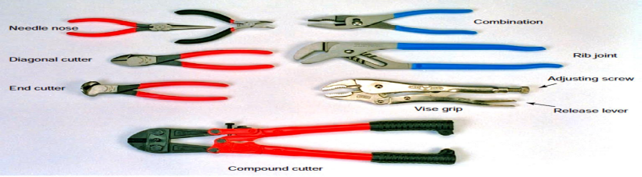
- Pliers: are gripping tools used for working with wires, clips, and pins. At a minimum, an auto technician should own several types: standard pliers for common parts and wires, needle nose for small parts, and large, adjustable pliers for large items and heavy-duty work.

- Circuit Tester :- Circuit testers are used to check for voltage in an electrical circuit. A circuit tester commonly called a test-light.
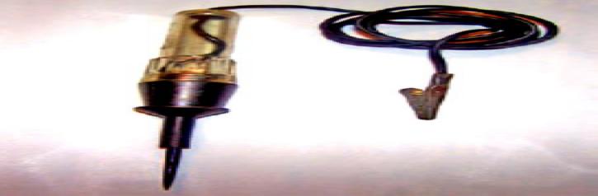

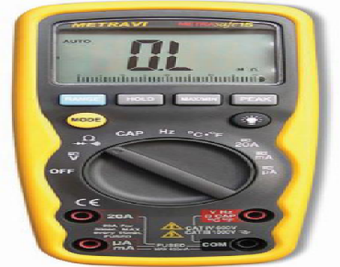
- Multi-meters A multi-meter is a must for diagnosing the individual components of an electrical system. A digital multi-meter (DMM) can measure volts, ohms, and low current such as direct current (dc) and alternating current (ac) amperes, diode continuity. DMMs provide great accuracy by measuring volts, ohms, or amperes in tenths, hundredths, or thousandths of a unit.

Self-Check 1
Instruction: Answer all the questions listed below, if you have some clarifications- feel free to ask your teacher.
1. Types of electrical starter motor
A. Pre-engaged starter motor B. Bendix drive type starter motor (Bajaj)
C. Reduction type starter motor D. Permanent magnet starter motor E. all
2. a spring starter uses potential energy
A. Electrical Starting System B. Bendix drive type starter motor
C. Mechanical/Non motor Starting System D. regulator
3. When an engine starts, the pinion gear is disconnected from the starter by the:
A. magnetic switch B. plunger C. over-running clutch D. switch return spring
4. If the engine cranks too slow to start, the problem may be caused by:
A. engine problems B. a faulty neutral start switch
C. an open relay in the control circuit D. a damaged pinion gear
5. it is a mechanical device used to connect or disconnect the current flow in all circuits of the vehicle
A. Battery B. Starter Motor C. Ignition Switch D. Starter Safety Switch
Test II: short Answer
Instruction: write short answer for the given question. You are provided 2 minutes for each question and each point has 5Points.
- What is the purpose of starting system?
- Write down types of electrical starter motor
- Write down the classification of starter motor
Part III: Short answer writing
Direction: Give short answer to the following questions. Time allotted for each item is 2mniut and each question carry 4 point.
- Battery 2. Ignition switch 3. Starter relay
- Starter motor 5. Starter safety switch
Note: Satisfactory rating – above 60% Unsatisfactory - below 60%
You can ask you teacher for the copy of the correct answers

Unit Two: Overhauling and dismantle starting system
This unit to provide you the necessary information regarding the following content coverage and topics:
  - Overhaul Starter motor and system component
  - Disassembling Starter motor and components
  - Cleaning Starter motor and components
This guide will also assist you to attain the learning outcomes stated in the cover page. Specifically, upon completion of this learning guide, you will be able to:
- Apply Overhaul Starter motor and system component
- Perform Disassembling Starter motor and components
- Make Cleaning Starter motor and components

Overhaul Starter motor and system component
- Disconnect the battery negative terminal.
- Remove the intake manifold. (Refer to Engine Mechanical System - "Intake Manifold"
- Disconnect the starter cable (B) from the B terminal on the solenoid, then disconnect the connector (A) from the S termina

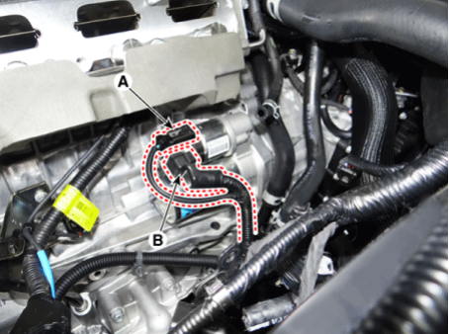
- Remove the starter mounting bolts (A)
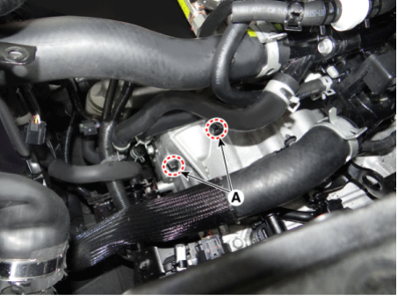
- Remove the starter (A).
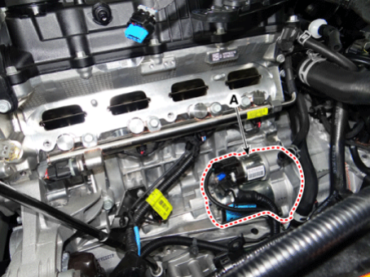
Figure 2.1 starter motor overhaul procedure

Disassembling Starter motor and Components
- Before being to disassemble the starter motor first roughly pinpointing the source of the problem by the performance test is recommended since it helps speed up the overhaul.
- Also perform this test after assembly is completed to make sure that the starter motor is operating correctly.
- Complete each test as quickly as possible (within approximately 3-5 seconds). Otherwise, the coil in the starter motor may burn out.

Typical Procedure for Disassembling a Starter motor

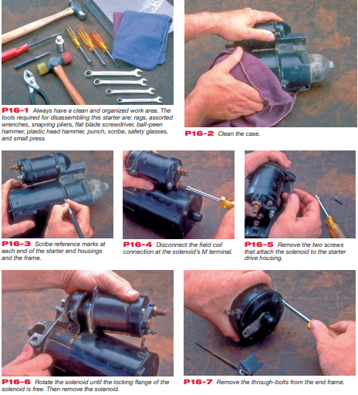

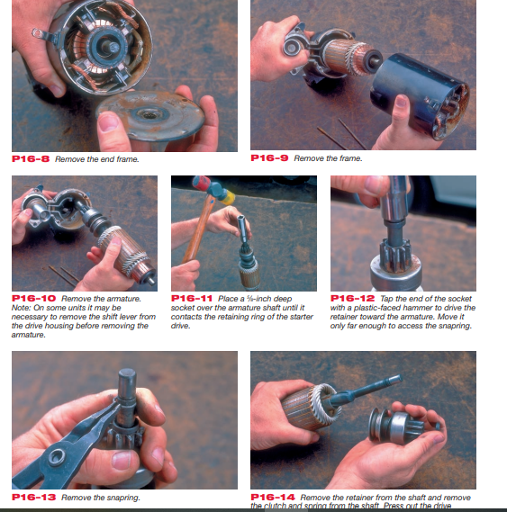

Figure 2.2 starter motor disassembling procedure

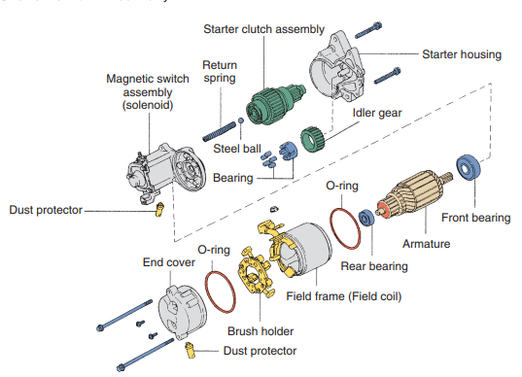
Figure 2.3 After Disassembling starter component view

Cleaning starter motor and System components
- Clean the outside of the starter, I just wiped it over with a petrol-soaked rag.
- Clean the battery terminals and posts by battery brushes.
- Battery corrosion applying a mixture of baking soda and water, do not immerse parts in cleaning solvent.
- Do not immerse the drive unit in cleaning solvent.
- The drive unit may be cleaned with a brush, moistened with cleaning solvent and wiped dry with cloth.

Self-Check 2
Instruction: Answer all the questions listed below, if you have some clarifications- feel free to ask your teacher.
1. If the starter spins but does not crank the engine, the likely cause would be:
A. a bad overrunning clutch B. a bad solenoid
C. high resistance in the motor feed circuit. D. high resistance in the motor control circuit
2. If the engine cranks too slow to start, the problem may be caused by:
A. engine problems B. neutral start switch
C. an open relay in the control circuit D. a damaged pinion gear
3. A solenoid uses two coils. Their windings are called:
A. push-in and pull-out B. pull-in and push-out.
C. push-in and hold-out. D. pull-in and hold-in
Test II: short Answer
Instruction: write short answer for the given question. You are provided 5 minutes for each question and each point has 5Points.
4, Write the disassembling procedure of starting system?
5, Write is the cleaning material of battery terminal?

Note: Satisfactory rating – above 60% Unsatisfactory - below 60%
You can ask you teacher for the copy of the correct answers.

Operation Sheet 2.1: Disassembling the starter motor
- Operation Title: Disassembling the starter motor
- Purpose: Diagnosis the problem of the starter motor.
- Instruction: Follow the procedure correctly.
- Tools and requirement: socket set, plier, screw driver, hammer
- Steps in doing the task:
  - Disconnect the M-terminal on the magnet switch assembly.
  - After loosening the screws detach the magnet switch assembly.
  - Loosen the through bolts.
  - Remove the brush holder assembly, yoke and armature.
  - Remove the lever plate and lever packing.
  - Remove the packing and shield.
  - Disconnect the planet gear.
  - Disconnect the planet shaft assembly (or reducer assembly) and lever.
  - Press the stopper using a socket.
  - After removing the stop ring using stop ring pliers.
  - Disconnect the stopper, overrunning clutch, internal gear, planet shaft and/or gasket sheet.
- Quality Criteria: Use the right tools at the right time.
- Precautions Prepare the table before disassembling the starter

Lap Test-2

- Task-2 Disassembling the starter motor using procedure

Unit Three: Inspecting, Testing, Repairing and Replacing starting systems
This unit to provide you the necessary information regarding the following content coverage and topics:
  - Inspecting Starting system circuit
  - Testing starter motor and associated component
  - Starter motor repair procedure
  - Repair and Replace starting systems and associated components
  - Reassemble starter motor
  - Starting System Trouble shooting
This guide will also assist you to attain the learning outcomes stated in the cover page. Specifically, upon completion of this learning guide, you will be able to:
- Inspect Starting system circuit
- Test starter motor and associated component
- Understand Starter motor repair procedure
- Repair and Replace starting systems and associated components
- Perform Reassemble starter motor
- Identify Starting System Trouble shooting

Inspecting Starting system circuit
A visual inspection of the starting system can save you time and effort by uncovering obvious or simple and easy−to−fix problems
Include these components in your inspection
Include these components in your inspection:  BATTERY  - Inspect the battery for external damage to the case or the cables, corroded terminals, and loose connections.  - Check the battery’s state of charge (with a battery analyser). Charge if needed.  - Check the electrolyte level and top up with distilled water if needed.  STARTER  - Inspect the starter motor for external damage to the case or wiring (including the magnetic switch circuit), corroded terminals, and loose connections.  - Check for loose mounting hardware. Tighten as needed. | IGNITION SWITCH  - Inspect the ignition switch for loose connections and damaged wiring.  - Confirm that the battery voltage is available at the magnetic switch with the ignition switch set to ON and the clutch switch or neutral start switch closed.  - If you suspect the ignition switch is faulty, use a remote starter switch and jumper wire to confirm starter operation.  PARK/NEUTRAL/CLUTCH START SWITCHES  - Conduct a voltage drop test to verify proper operation (max. 0.1 V drop).

Testing starter motor and associated component
As mentioned earlier, the starter motor is a special type of electrical motor designed for intermittent use only. During testing, it should never be operated for more than 15 seconds without resting for 2 minutes in between operation cycles to allow it to cool. Diagnosis of starting system problems is usually straightforward. Problems may be electrical or mechanical.
Starting System Quick Testing
Procedure:
- Check the cables for loose or defective connections
- Turn on the head lights
- With the headlight on operate the starter motor.
No crank with no headlights:
- Dead Battery (corroded terminals) or an open in electrical circuit.
- Burned fuse.
- Starter motor may be shorted.
Head lights stay bright but, no crank:
  - High resistance or an open in starting circuit.
  - Possibly Ignition switch
  - Wiring, solenoid, cable connections, relay, fuse.

The Starting System Troubleshooting chart lists the most common starting system problems, the possible causes, and recommended actions to resolve the problem.
Begin with a thorough visual inspection. If this fails to turn up the possible cause, several tests are available to help you find the problem:
- Starter motor current draw test
- Voltage drop tests
- Operational and continuity tests
- Starter motor bench tests
Starter motor current draw test
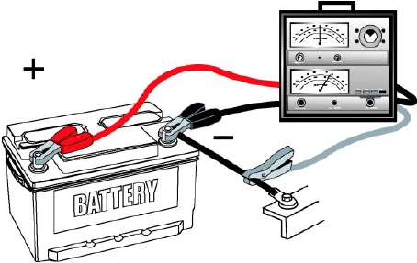
Measures the amount of current the starter circuit draws to crank the engine. Nearly all starter current testers use an inductive pickup to measure the current draw
- Measures the current used by the starting system
- Connect a voltmeter and ammeter
- Disable the engine
- disconnect the coil primary supply
- ground the coil wire
- disable the electric fuel pump
- Crank the engine for 15 seconds while
noting voltage and current readings
- Compare the readings to specifications

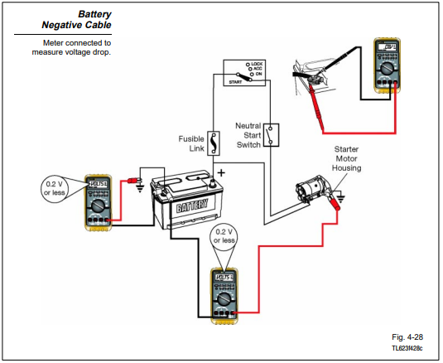
Starter Motor Voltage Drop Test
Measures the available voltage to the starter during cranking. To perform the test, disable the ignition or use a remote starter switch to bypass the ignition switch. Normally, the remote starter switch leads are connected to the positive terminal of the battery and the starter terminal of the solenoid or relay.
Locates higher-than-normal resistance. Whenever current flows through a circuit, electrical resistance causes a voltage drop
- Disable the fuel or ignition system so engine will not start while cranking.
- Set the DMM, select a low voltage scale
- Connect the DMM leads to measure voltage drop for the following:
Battery Negative Cable: Meter connected to measure voltage drop
- Battery + post to + cable
- Battery + cable to starter
- Terminal C to terminal 30 (gear reduction type)
- Battery to terminal 50 (gear reduction type)
Normal voltage drops in the starting system are in the range of 0.2 volts to 0.5 volts.
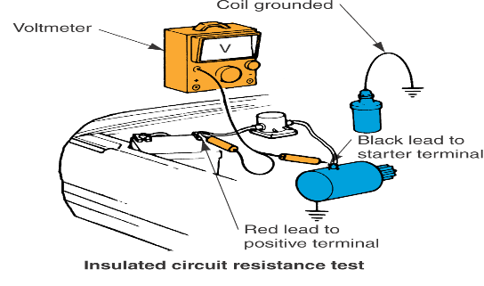
Insulated Circuit Resistance Test
- Connect the voltmeter between the battery positive and the starting motor terminal
- Crank the engine, noting voltage
- Maximum should be 0.5 volts
- Excessive voltage indicates dirty or loose connections, or burned or pitted solenoid contacts

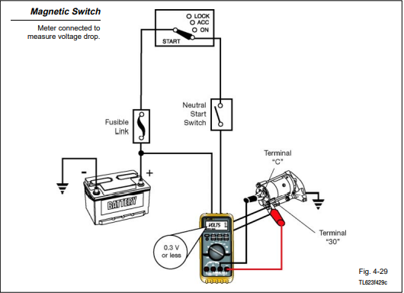
Magnetic Switch (Solenoid) Tests
1. Connect the tester or meter leads:
2. Crank the engine and note the voltage reading:
- 0.3 volts or less is acceptable resistance
- More than 0.3 volts is excessive resistance
If you find excessive resistance, perform these steps:
- Isolate the cause
- Repair the fault
- Re−test the voltage drops
A faulty magnetic switch could cause excessive resistance

Starter Motor Bench Testing
If the on-vehicle checks have indicated that the starter motor is faulty. It should be removed for bench testing and replacement

Always disconnect the battery ground ( - ) cable before removing the starter motor.
- Complete each bench test within 3 – 5 seconds to avoid burning out the coil.
- Refer to the appropriate repair manual for test specification.

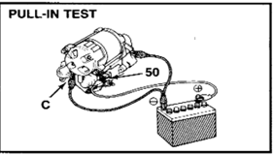
Solenoid Switch Test
Pull-in Pulling Test
Impress 8volts between the magnetic switch (50) terminal and lower side main terminals. If the plunger is pulled is strongly, the pull-in coil is satisfactory.

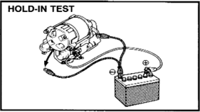
Hold-in Coil Holding Test
Have the plunger pulled in by impressing 8 volts between the (50) terminal and lower main terminal, and also with the magnetic switch body.
- If at this time, the main terminal is disconnected and the 8volts impressed only on the hold-in coil, the plunger should still be pulled-in.
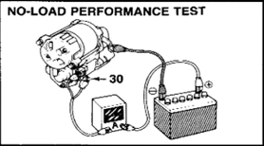
Return Test
- Impress 12volts between the lower main
terminal and magnetic switch body.
- Push in the plunger and then release it. The plunger should return quickly to its original position.

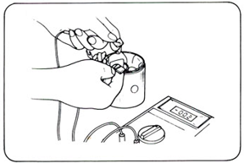
Field Coil Test

Ground Test
- Check for continuity between field coil end and yoke. If there is continuity, locate the grounded parts by removing the pole cores one by one and make necessary repair.
- Open Circuit Test
- Check for continuity between the lead wire and field coil brush soldered part.
If there is no continuity, there is an open circuit in the field coil.

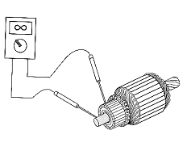Armature Test
- Ground Test
- Using an armature/continuity tester, check for continuity between the commutator and armature shaft. If there is continuity, the armature is grounded and must be repaired or replaced.

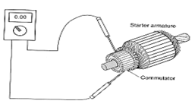
Open Circuit Test
- Using armature/continuity tester, check for short circuit between the segments.
If the pilot lamp fails to light or if the tester needle fails to move at any test point, there is an open circuit
necessitating repair or replacement of the armature.

No Load Performance Test
- 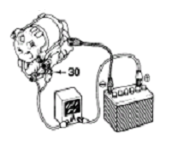Connect the battery negative ( - ) lead to the switch housing, the positive ( + ) lead to the ammeter.
- Connect the ammeter negative ( - ) leads to terminal “30” and to terminal “50”.
- The starter should rotate smoothly with the pinion gear moving out. The ammeter should read specified current.

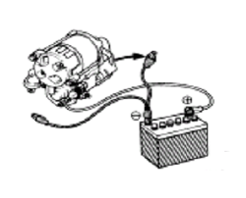Clutch Pinion Return Test

Dis-connect the negative (-) lead from the switch body.
- The clutch pinion gear should return inward. If it doesn’t, replace the magnetic switch.

Starter motor repair procedure
Step 1. Stuff you will need
Step 2. Diagnosis
Step 3. Remove starter
Step 4. Stripping the starter
Step 5. Assess the damage part
Step 6. Repairing the armature and field winding
Step 7. Purchase the parts
Step 8. Lubricating the new bushes
Step 9. Fitting the new bushes
Step 10. Check the bushes and pinion
Step 11, Fitting the brushes
Step 12. Assembling the starter
Step 13. Testing

Repair and Replace starting systems and associated components
The starting system requires little maintenance. The battery should be fully charged and connection kept clean and tight.
Starting system problems is usually straightforward. Problems may be electrical or mechanical
Starter Repair
- Many shops replace starter drives and solenoids if damaged. Because the cost is to high to try to repair or rebuild the starter.
- Most repairs are cleaning the terminals, replacing the solenoid, replacing the drive gear, and cleaning corrosion off the armature the gear and armature repairs require breaking the starter down probably won’t do this anymore.
- Adjusting a grinding or noisy started will involve trying different shims between the starter and engine. (1% of starters need this fix).
- Brushes may wear thin and have to be replaced whenever a starter motor is disassembled.
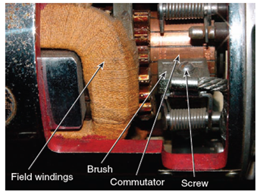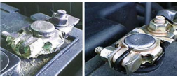
Corroded battery terminal
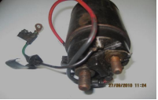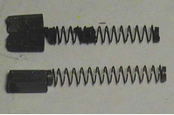
Damaged Solenoid terminal damaged brush
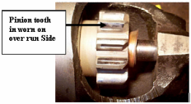
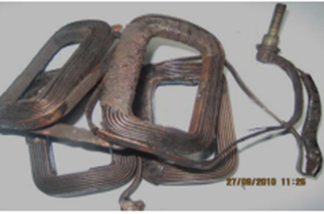

Damaged field winding

- For inspection and testing the component/parts was damaged or not good condition repair and replace carefully.

Reassemble starter motor
- Reassembly is the reverse of disassembly
- Pay attention to the following point
    - Ensure the shift lever is positioned in the correct direction.
    - Apply grease to each sliding surface.

Starting System Trouble shooting
Common Starter Motor Faults
• Clicks only: Poor wiring connections, Defective solenoid, Defective ignition switch, Defective Starter Motor, Poor earth connection.
Turns slowly: Poor battery condition, Poor wiring connections, Corroded battery cables, generally worn Starter Motor. Running in mesh: Defective ignition switch, sticking solenoid, ticking pinion.
Noisy in operation: Loose mountings, locating dowel (if applicable) not fitted, or fitted askew, Ring gear damage (although this is extremely rare the ring gear is made of hardened steel and the drive pinion is made of mild steel, Defective pinion.

Table 3.1 starting system troubleshooting chart
STARTING SYSTEM TROUBLESHOOTING CHART
Symptoms | Possible Cause | Action Needed
Engine will not crank | - Dead battery  - Melted fusible link  - Loose connections  - Faulty ignition switch  - Faulty magnetic switch, relay, neutral start switches or clutch switch  - Mechanical problem in engine  - Problem in theft deterrent system | - Check battery state-of-charge  - Replace fusible link  - Clean and tighten connections  - Check switch operation; replace as needed  - Check and replace as needed  - Check engine  - Check repair manual for system tests
Engine cranks too  slowly to start | - Weak battery  - Loose or corroded connections  - Faulty starter motor  - Mechanical problems with engine or starter | - Check battery and charge as needed  - Clean and tighten connections  - Test starter  - Check engine and starter; replace worn out parts
Starter keeps running | - Damaged pinion or ring gear  - Faulty plunger in magnetic switch  - Faulty ignition switch or  control circuit  - Binding ignition key | - Check gears for wear or damage  - Test starter pull-in and hold-in coils  - Check switch and circuit components  - Check key for damage
Starter spins, but  engine will not crank | - Faulty over-running clutch  - Damaged or worn pinion gear  or ring gear | - Check over-running clutch for proper operation  - Check gears for damage and wear; replace as needed
Starter does not  engage/disengage  properly | - Faulty magnetic switch  - Damaged or worn pinion gear or ring gear | - Check and replace as needed  - Check gears for damage and wear; replace as needed

Self-Check 3
Instruction: Answer all the questions listed below, if you have some clarifications- feel free to ask your teacher.
1, Which of the following is not part of the starter circuit?
A. battery. B. starting safety switch C. starter motor D. relay solenoid
2. When the starter spins but does not engage the flywheel, which of the following may be true?
A. defective starter drive B. excessive resistance in the control circuit
C. a faulty starter relay D. all of the above
3. If a ground circuit test reveals a voltage drop of more than 0.2 volt, the problem may be.
A. a loose starter motor mounting bolt B. a poor battery ground terminal post connector
C. a damaged battery ground cable D. all of the above
- The normal minimal cranking voltage specification is approximately.
A. 9.6 volts B 11.0 volts C. 10.5 volts D. 12.65 volts
- If the solenoid clicks while trying to crank the engine with the starter, which of the following is not a probable cause?
A. a faulty neutral safety switch B. low battery voltage C. low voltage available to the solenoid D. an open in the hold-in winding
Test II: short Answer
Instruction: write short answer for the given question. You are provided 3 minutes for each question and each point has 5Points

1, Write the procedure of Starting System Quick Testing
2, ------------------- Measures the available voltage to the starter during cranking

Operation Sheet 3.1: Starter motor performance test
- Operation Title: Check Starter motor performance test
- Purpose: Also perform this test after assembly is completed to make sure that the starter motor is operating correctly.
- Instruction: Follow the procedure
- Tools and equipment: Battery, jumper cable, DMM
- Steps in doing the task:
A, PULL-IN TEST
      - Disconnect the field coil lead from Terminal C
      - Connect the battery to the magnetic switch as shown. Check that the pinion moves outward.
OBSERVATION___________________________________________
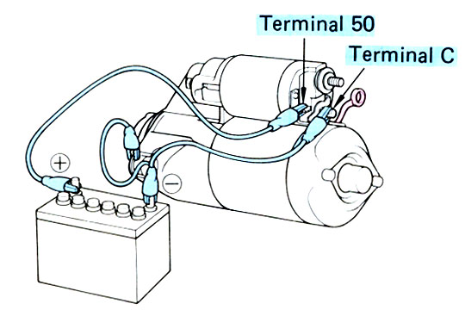

B. HOLD-IN TEST

    - With the battery connected as above and with the pinion out, disconnect the negative lead from.
Check that the pinion remains out. OBSERVATION___________________________________________
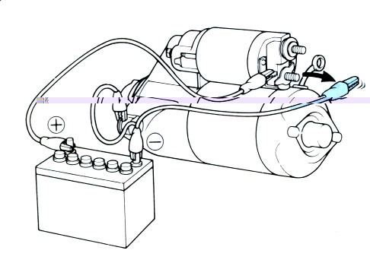

C. PINION RETURN TEST

    - Disconnect the negative lead from.
    - Check that the pinion reacts. OBSERVATION______________________________

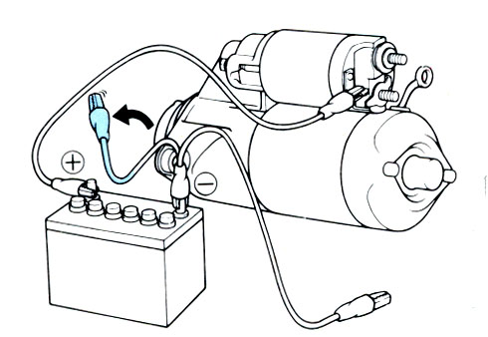

D. NO-LOAD TEST
        - Securely fix the starter motor with a vice
        - Connect the field coil lead to Terminal C. Make sure the lead is not grounded
        - Connect the battery and ammeter to the starter as shown.
        - Check, that the starter rotates smoothly and steadily, and that the pinion moves out.
        - Check that the ammeter reads the specified current.
Specified Current. Less than 50 A at 11V.
OBSERVATION______________________________
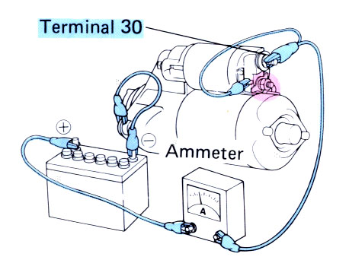

- Quality Criteria: The battery voltage is 9.6 and above.
- Precautions: Complete each test as quickly as possible (within approximately 3-5 seconds). Otherwise, the coil in the starter motor may burn out.

Operation Sheet 3.2: Starter Motor Current Draw Test
- Operation Title: Starter Motor Current Draw Test
- Purpose: Cconnects to the battery to measure starting current and cranking voltage.
- Instruction: Read all instruction before starting
- Tools and equipment: Multimeter, safety glasses
- Steps in doing the task:
    - Make a visual inspection of the battery, electrolyte, and battery cables.
    - Insure the battery is serviceable (at least 50% charged)
    - Turn off all electrical accessories and lights in the vehicle; set ignition switch to OFF.
    - Prepare VTA-40 tester according to manufacturer specification
    - Disable the fuel or ignition system so the engine will not start while cranking.
    - Connect the test leads to battery terminal in this sequence:
- Red lead to positive battery terminal
- Black lead to negative battery terminal
- Current probe on negative battery cable
    - Set test selector switch to “Starting position”
    - Crank engine and note voltmeter and ammeter readings record readings
    - Disconnect VTA-40 and connect ignition plug.
- Quality Criteria: Complete this job within 15 minutes
- Precautions: Wear safety glasses while doing this job.

Operation Sheet 3.3: Starter Motor Voltage Drop Tests
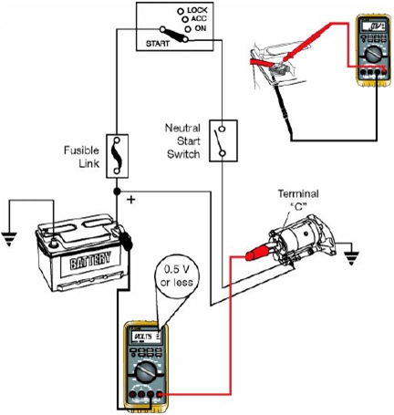
- Operation Title: Starter Motor Voltage Drop Tests
- Purpose: find excessive resistance in the starting system.
- Instruction: Read all instruction before starting
- Tools and equipment: Voltmeter
- Steps in doing the task:
1.Disable the fuel or ignition system so engine will not start
while cranking.
2. Set the DMM, select a low voltage scale.
3. Connect the DMM leads to measure voltage drop for the following:
Battery Negative Cable: Meter connected to measure voltage drop
- Battery + post to + cable
- Battery + cable to starter
- Terminal C to terminal 30 (gear reduction type)
- Battery to terminal 50 (gear reduction type)
- Write voltage reading on meter face in diagram.
Normal voltage drops in the starting system are in the range of 0.2 volts to 0.5 volts.

This test measures the voltage drop across the positive battery cable.
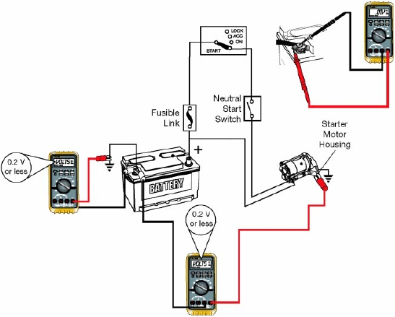
1,Connect the tester or meter leads:
- Red lead to the starter motor housing
- Black lead to negative terminal of the battery
2. Crank the engine and note the voltage reading:
- 0.2 volts or less is acceptable resistance
- More than 0.2 volts is excessive resistance
3, Crank the engine and note the voltage reading:
- 0.5 volts or less is acceptable resistance
- More than 0.5 volts is excessive resistance
If you find excessive resistance, perform these steps:
- Isolate the cause
- Repair the fault
- Re−test the voltage drop
Excessive resistance could be caused by any of these:
- Damaged battery cable
- Poor connection at battery or starter terminal
- Defective magnetic switch
- Quality Criteria: Normal voltage drops in the starting system are in the range of 0.2 volts to 0.5 volts.
- Precautions You can pull the Electronic Fuel Injection (EFI) fuse
or relay to prevent engine start.

Operation Sheet 3.4: Magnetic Switch (Solenoid) Tests
- Operation Title: Magnetic Switch (Solenoid) Tests
- Purpose: Measures the voltage drop across the magnetic switch.
- Instruction: This test measures the voltage drop across the positive battery cable.
- Tools and equipment: Multimeter
- Steps in doing the task:
1. Connect the tester or meter leads:
- Red lead to starter terminal C
- Black lead to starter terminal 30
2. Crank the engine and note the voltage reading:
- 0.3 volts or less is acceptable resistance
- More than 0.3 volts is excessive resistance
If you find excessive resistance, perform these steps:
- Isolate the cause
- Repair the fault
- Re−test the voltage drops
A faulty magnetic switch could cause excessive resistance.
- Quality Criteria: Follow the test procedure
- Precautions Do not crank the engine longer than 10 seconds at a time. Starters with planetary gear reduction do not have a magnetic switch.

Lap Test-3

- Task-1 Perform Starter motor bench test
- Pull-in test
- Hold- in test
- Pinion return test
- No-load test
- Task-2 Inspect starter motor current draw test
- Task-3 Test Starter Motor Voltage Drop Tests
- Task-4 Perform Magnetic Switch (Solenoid) Tests.

Unit Four: Cleanup work area and maintain equipment
This unit to provide you the necessary information regarding the following content coverage and topics:
  - Removing methods of waste and scrap
  - Cleaning and inspecting equipment and work area
This guide will also assist you to attain the learning outcomes stated in the cover page. Specifically, upon completion of this learning guide, you will be able to:
- Identify Removing methods of waste and scrap
- Apply Clean and inspect equipment and work area

4.1. Removing methods of waste and scrap
Collect and store reused material
Automotive recycling industry is continuously implementing creative ways to reuse components, reduce waste and increase recycling rates from the process of manufacturing Separating wastes allows for easier recycling and may reduce disposal costs.
- Keep hazardous wastes separate, do not mix used oil solvents, and keep chlorinated solvents (like, tricolor ethane) separate from non-chlorinated solvents (like kerosene and mineral spirits)
- Promptly transfer used fluids to the proper waste or recycling drums. Don’t leave full drip pans or other open containers lying around.
- Provide cover and secondary containment until these materials can be removed from the site.
- Oil filters can be recycled. Ask your oil supplier or recycler about recycling oil filters.
- Do not dispose of extra paints and coatings by dumping liquid onto the ground or throwing it into dumpsters.
Allow coatings to dry or harden before disposal into covered dumpsters. Store cracked batteries in a non-leaking secondary container. Do this with all cracked batteries, even if you think all the acid has drained out. If you drop a battery, treat it as if it is cracked. Put it into the containment area until you are sure it is not leaking. Vehicles are through their end-of-life recycling
Recycling
Recycling, recovery and reprocessing of waste materials for use in new products.
Auto recyclers remove parts such as engines, transmissions, doors and bumpers for reuse in other vehicles. Other parts that can also be remanufactured include starters, alternators and water pumps.
Batteries, catalytic converters, tires and some plastics are removed and their materials are recycled into new products.
Fluids such as engine oil, coolant, and gasoline are carefully managed to prevent releases by storing them in double-walled tanks and/or secondary containment prior to being reused or recycled. The automotive recycling industry also saves energy, conserves natural resources, reduces air and water pollution and greenhouse gas (GHG) emissions, and recycles environmentally sensitive substances including lead, mercury, oil and unspent fuel. Using recycled scrap iron and steel reduces the use of virgin iron ore, among other environmental benefits. Every ton of new steel made from scrap steel conserves

Cleaning and inspecting equipment and work area
What is cleaning

Cleaning is the removal of all visible soil in an approved way with the use of mechanical and chemical action or both, so that all areas are cleaned and sanitized to a high standard. Cleaning is an investment in the assets of a building Maintenance is the upkeep of all body, seat interior and dashboard fittings and equipment to an exacting standard within the property so that all areas look consistently new and pristine
Whydoweclean?
There are many reasons why we clean but the most important ones are Health Regulations If your local government authority has health regulations regarding cleaning and sanitizing, then you must know these and follow their recommendations at all times. It is important when you are cleaning that you clean to a high standard that has been set for you by your supervisor or manager.
Use dry clean, soft and stain free cloth for cleaning. If necessary, moisten the cloth with pure alcohol. Use no other liquids. Figure 4.1 work area cleaning

Kinds of Cleaning Solvents
Solutions are homogeneous mixture of two or more components. They can be gaseous, liquid or solid. Solvent is a component of a solution that dissolves solute and is usually present in large proportion or amount. Solvents usually used for cleaning in automotive shops are: water, gasoline, kerosene, thinner and detergent soap.
Safe work procedures
Safe work procedures are a means of briefly documenting the risks associated with a work task and incorporating appropriate controls into a sequence of steps for doing the task safely.
Maintain tools and equipment’s
- Inspect vehicles and equipment daily at startup for leaks, and repair immediately
- Keep vehicles and equipment clean; do not allow excessive build-up of oil and grease.
- Segregate and recycle wastes, such as greases, used oil or oil filters, antifreeze, cleaning solutions, automotive batteries, hydraulic and transmission fluids. Provide secondary containment and covers for these materials if stored onsite.
- Consider use of new, alternative greases and lubricants, such as adhesive greases, for chassis lubrication and fifth-wheel lubrication.
- Properly dispose of used oils, fluids, lubricants, and spill cleanup materials.
- Do not place used oil in a dumpster or pour into a storm drain or watercourse.
- Properly dispose of or recycle used batteries.

Self-Check -4
Directions: Answer all the questions listed below. Use the Answer sheet provided in the next page
  - Describe briefly how to collect and store material that can be reused in automotive industry?
  - Write the wastes and scrapes recycled in automotive industry?
  - What is cleaning and maintenance?
  - Write the Solvents for cleaning in automotive shops
  - Why do we clean the work area?
  - What is machinery tag out program?
  - What does it mean when we say maintain tools and equipment’s?

Referance
- An overview of automobile starting system faults and diagnosis method.
- http://www .autoshop101
- http://www.autobahncollision.com/repair-process/final-inspection-and-vehicle-delivery.htm
- https://www.vehicleservicepros.com/in-the-bay/tools-equipment/article/10717421/shop-floor-maintenance-101-clean-as-you-go
- Automotive mechanics 9th edition

Participants of this Module (training material) preparation
No | Name | Qualification (Level) | Field of Study | Organization/ Institution | Mobile number | E-mail
1 | Fadli Aman | BSc. B-Level | Automotive Technology | General Wingate PTC | 0927283100 | Fadli.ziyad@gmail.com
2 | Gashaw Zawudie | MSc. A-Level | Automotive Technology | AKPTC | 0910730747 | Gashawgashaw69@gmail.com
3 | Muna Gabreil | MSc. A-Level | Automotive Technology
4 | Sisay Dawit | MSc. A-Level | Automotive Technology | Harar PTC | 0910672115 | Sisaydawit058@gmail.com
5 | Yohannes Negatie | MSc. A-Level | Automotive Technology | W/ro Siheen PTC | 0922094453 | Yohannes2013n@ gmail.com

