Automotive Electrical & Electronics Level – II

Based on March, 2022 curriculum (V-1)

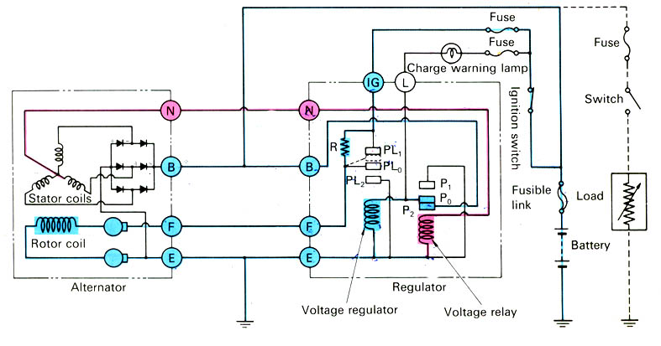

Module Title: - Inspecting and Repairing Charging System

Module code: - EIS AEE2 M04 0322

Nominal duration: - 45 Hours

Prepared by: Ministry of Labor and Skill
September, 2022
Addis Ababa, Ethiopia

Table of Content
Contents
Acknowledgment 4
Acronym 5
Introduction to the Module 6
Module Instruction: 7
Unit one: Overview of Charging system 8
1.1 Safety on charging system 9
1.2 Purpose of charging system 11
1.3. Component of charging system and its function 15
1.4. Working principle of Alternator and system 21
1.4.1. DC Generator 24
1.4.2 AC Generator 26
1.5. Tools and Equipment 38
Self-Check 1 41
Unit Two: Overhauling and dismantle Charging system 42
2.1 Overhaul Alternator and system component 43
2.2. Disassembling Alternator and Components 43
2.3. Cleaning Alternator and System components 45
Self-Check 2 46
Operation Sheet 48
Lap Test-2 48
Unit Three: Inspecting, Testing, Repairing and Replacing Charging systems 49
3.1. Inspecting Charging system circuit 50
3.2. Testing Alternator and associated component 53
3.3. Alternator repair procedure 59
3.4. Repair and Replace Charging systems and associated components 59
3.5. Reassemble Alternator and associated components 61
3.6. Charging System Trouble shooting 62
Self-Check 3 63
Operation Sheet 64
Lap Test-3 68
Unit Four: Cleanup work area and maintain equipment 69
4.1. Removing methods of waste and scrap 69
4.1. Cleaning and inspecting equipment and work area 70
Self-Check -4 72
Referance 73
Participants of this Module (training material) preparation 74

Acknowledgment

Ministry of Labor and Skills and Ministry of Health wish to extend thanks and appreciation to the many representatives of TVET instructors and respective industry experts who donated their time and expertise to the development of this Teaching, Training and Learning Materials (TTLM).

Acronym

DC - Direct current
AC - Alternative current
EMF – Electro motive force
DMM - Digital multimeter

Introduction to the Module

A motor vehicle uses a lot of electrical energy whilst in operation. Systems like the starter motor, lights, radio, electronic control units, engine ignition systems, etc. require sufficient electrical energy at all times to operate reliably. The charging system in the motor vehicle ensures that the electrical consumers are supplied with the current they require to operate at all times. When the charging system's output is greater than that needed by the vehicle, it sends current into the battery to maintain the battery's state of charge.
The charging system has two essential functions:
a) It recharges the battery
b) It supplies electrical current to meet the operating needs of Vehicle electrical system.
With the engine switched OFF, the battery supplies all the electrical energy required by any electrical consumers switched ON, in the vehicle. If electrical loads are switched ON for extended periods, the battery can be discharged. The battery also supplies electrical energy to the consumers when the alternator stops charging with the engine running.
When the engine is running, the alternator supplies the electrical loads with electrical energy and also charges the battery. At idle speed, a three-phase alternator already delivers at least a third of its rated output. This charging current is increased when the electrical loads increase.

This module covers the units: -

Overview of charging system

Overhaul and dismantle charging system

Inspect, Test, Repair and Replace charging systems

Clean up work area and maintain equipment

Learning Objective of the Module

Understand Overview of charging system

Perform Overhaul and dismantle charging system

Apply Inspect, Test, Repair and Replace charging systems

perform Cleanup work area and equipment

Module Instruction:

For effective use this modules trainee are expected to follow the following module instruction:
- Read the information written in each unit
- Accomplish the Self-checks at the end of each unit
- Perform Operation Sheets which were provided at the end of units
- Do the “LAP test” giver at the end of each unit and
- Read the identified reference book for Examples and exercise

Unit one: Overview of Charging system
This unit is developed to provide you the necessary information regarding the following content coverage and topics:
- Safety on charging system
- Purpose of charging system
- Component of charging system and its function
- Working principle of charging system
- Tools and Equipment
This unit will also assist you to attain the learning outcomes stated in the cover page. Specifically, upon completion of this learning guide, you will be able to:
- Apply Safety for charging system
- Understand Purpose of charging system
- Identify Component of charging system and its function
- Understand Working principle of charging system
- Use Tools and Equipment
The Charging System
- The charging system has three major components. The Battery, Alternator, and the Regulator.
- This alternator works together with the battery to supply power when the vehicle is running.
- The output of an alternator is direct current, however AC voltage is actually created and then converted to DC as voltage leaves the alternator on its way to the battery and the electrical loads.

.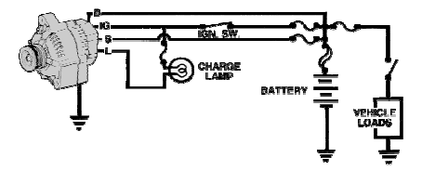
Figure 1.1 Charging system circuit.

1.1 Safety on charging system
Safety:- means protecting yourself and others from possible danger and injuring in the shop, you are ' Safe' when you protect your eyes, your fingers, your hands all of yourself from danger as well as others.Much of your work on an automobile will be around or with the vehicle’s electrical system. To prevent personal injury or damage to the vehicle, you should always take the necessary precautions before working. When possible, you should disconnect the vehicle’s battery before disconnecting any electrical wire or component. This prevents the possibility of a fire or electrical shock. It also eliminates the possibility of an accidental short, which can ruin the car’s electrical system. Disconnect the negative or ground cable first, then disconnect the positive cable. Because electrical circuits require a ground to be complete, by removing the ground cable you eliminate the possibility of a circuit accidentally becoming completed. When reconnecting the battery, connect the positive cable first, then the negative.
Also, remove wristwatches and rings before servicing any part of the electrical system. This helps prevent the possibility of electrical arcing and burns. When disconnecting electrical connector do not pull on the wires. When reconnecting the connectors, make sure they are securely connected.
- Always make sure that you wear the appropriate personal protection equipment before starting the job. It is very easy to hurt yourself even when the most exhaustive protection measures are taken.
- Always ensure that your work area/environment is as safe as you can make it. Do not use damaged, broken or worn out workshop equipment.
- Always follow any manufacturer's personal safety instructions to prevent damage to the vehicle electrical system you are servicing.
Make sure that you understand and observe all legislative and personal safety procedures when carrying out the following tasks. If you are unsure of what these are, ask your supervisor.
- A spark created above a battery can cause an explosion. So always follow these precautions:
  - Keep your face and body as far back as you can while connecting jumper leads.
  - Connect the leads in the correct order -- positive on discharged battery; then positive on charged battery; then negative on charged battery; then negative to a good ground on the vehicle with the discharged battery -- away from the battery itself.
  - Do not connect the negative cable to the discharge battery because this may cause a spark.
  - Only use specially designed heavy-duty jumper cables to start a vehicle with a dead battery. Do not try to connect the batteries with any other type of cable.
- Do not attempt to operate the alternators set with a known unsafe condition.
- Read and understand all safety precautions and warnings before operating charging system components.

1.2 Purpose of charging system

The charging system has two jobs. These are

a). To put back in to the battery the current used to start the engine

b). To handle the load of the lights, ignition, radio and other electrical and electronic equipment's while the engine is running

When the engine is stopped the battery is the source of energy. When the engine is running the alternator or the Dynamo is the electricity generating device supplying power to all electrical loads

The charging system includes the alternator, regulator and battery with connecting wires. The charging system keeps a charge in your battery and provides electrical energy for the radio, lights and other features while the car is running. The modern charging system consists of the alternator, battery, wiring and Electronic Control Unit (ECU). Older cars may have a regulator, but in newer cars, that is now part of the car's computer.

The computer (or in older cars, the regulator) acts as a "traffic cop" to control the alternator's output. It senses when the battery needs charging or when the demand for electricity changes. The battery is a reservoir of electrical power. Its biggest job is to crank the engine to start the car. The battery also supplies power to the accessories when the engine isn't running.

If something is not right with the charging system, you'll see a warning light. The warning light may be labeled "Gen", "Bat" or "Alt". If this warning lamp lights up while the engine is running, it means that there is a problem in the charging system, usually that the battery has gone bad or the alternator has stopped working.

1.2.1. Types of voltage Regulator
There are two types of regulators according to purpose
- Conventional type: - the point type/ conventional uses two coils to adjust the alternator output voltage.
- IC (Integrated Circuit):- uses an IC circuit to regulate the output voltage and now a day ECM controlled charging system. This type of charging system, the IC regulator is connected to the engine control module via two terminals. (FR and C terminals).
It limits the DC output voltage according to external load and state of charge of the battery. If the output is not controlled the battery will be overcharged and the electrical equipment will be

damaged.
Controlling the electrical flow through the field coil in the rotor does control. according to design two types:
A. One-point type regulator
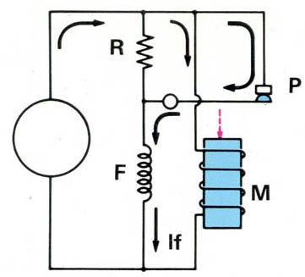
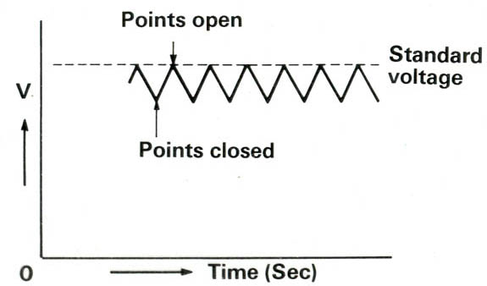In this regulator a resistor (R) is connected in series with the field coil (F) of the rotor. This resistance is by passed by the points while the engine is running at low speed. Since the magnetic field in the coil is weak, the points remain closed. When the voltage of the alternator is increased the magnetic field will be strong and the points open. So, current passes through the resistor and the field coil. This decreases the magnetic
Figure1.2 one- type of regulator

field strength and the voltage of the alternator reduces and the points close again. In this manner the voltage is stabilised by this type of regulator.
However, one-point type regulator is not used very often in present day automobiles because of the following disadvantage.
- There is great fluctuation of voltage at low speed when the points are opened and closed
- A large resistance will cause more sparking when the points are open, resulting in shorter life of the points.

B. Two-point type regulator
The characteristic of the two-point type regulator is that it has both low speed and high-speed operating ranges.
At low speed, the moving point opens and closes the low speed point (P1) in the same manner as one-point type regulator makes and break the contact. At high speed the moving point contacts P2 and field current ceases to flow. The voltage output of the alternator decreases. This decreases the field strength of the regulator and the moving point closes again with P1 and the cycle is repeated.
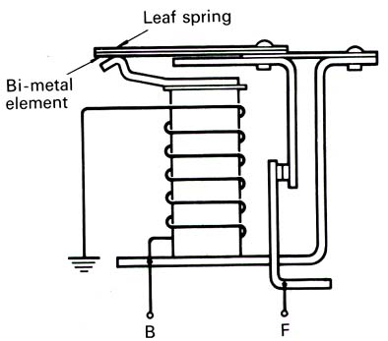
But the disadvantage of this type of regulator is the voltage drop due to the hysteresis’s effect when changing from the high-speed side to low speed side. Nevertheless, compared to the one-point type, the resistance can be made smaller so there is less sparking so there is a longer life of the points.
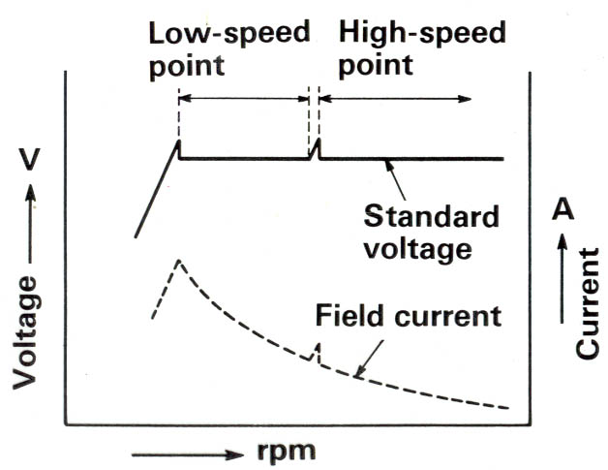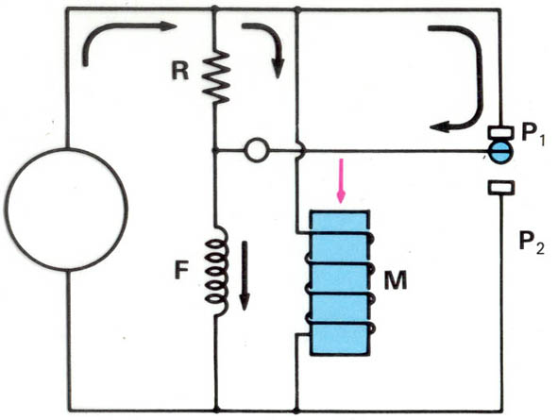

Figure 1.3 Two- type of regulator.
- Characteristics of the Regulators
For the point type regulators, there are various reasons why voltage fluctuates. But the primary causes are due to its hysteresis and temperature characteristics.
  - The hysteresis characteristics
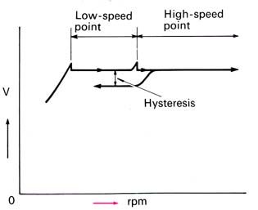
The lowering of voltage when the moving point change from high speed side to the low speed point called hysteresis effect and causes to remain a residual magnetism from the high-speed operation in the coil core and continue to pull the moving point for a short time. This phenomena cause to the alternator output to decline. Therefore, no attempt should be made to adjust the regulator when the voltage is dropping due to this effect. A 12-volt system will drop from 0.5 to 1 volt.
Figure 1.4 hysteresis circuit
  - The temperature characteristics
The magnetic coil of the voltage regulator employs copper wiring. If the temperature of this wire rises, the resistance is increased and there will be a reduction of force (electromagnetic force) of the magnetic coil. This results a higher alternator output voltage. To prevent such, arise in voltage, the regulator utilizes either a resistor or bimetal element for temperature compensation, but some use both. The resistor reduces the overall resistance in accordance with the temperature fluctuation as a result strong electromagnetic force is developed and the contact point will be pulled sufficiently.
The bimetal element is used together with a spring which supports the moving point. The bimetal element reduces the spring tension as the temperature rises. Therefore, the contact point will be easily opened to prevent the rise of alternator output voltage.
- Voltage Relay (Charge lamp relay)
A Charging system employs a two-element combination accurate voltage regulation. This is because, the voltage regulator operates in accordance with the voltage generated by the alternator. If there were no voltage relay, there would occur a drop in voltage in the magnetic coil because the voltage is applied to a long circuit via the ignition switch. A reduction of voltage would cause a proportionate decrease in magnetic force of magnetic coil so the moving points would not pull sufficiently. As a result, alternator voltage would rise to high.

1.3. Component of charging system and its function

In general, the components of the charging system are composed of alternators and regulators. However, the charging system needs to add some additional components so that the electricity generated can be supplied to the battery and to all electrical loads safely and precisely. The component, consisting of:

1. Battery

The battery supplies current to energize the alternator field coil. The battery also acts as a voltage stabilizer. The battery must always remain attached to the electrical system while the engine is running.

2. Fuse and Fusible links

Fuse and fusible links have different functions even though have the same shape. Fusible link can be called as main fuse which is placed near the battery positive terminal. The function of this fuse is to protect the entire electrical system of the car from excessive currents. Generally, the fusible link has a capacity of up to more than 60 Ampere.

While the function of the fuse is as a safety of a series of specific electrical wiring, in conventional charging system there are two fuses with same capacity (it’s about 10-15 Ampere). A fuse is used as a voltage regulator fuse and another fuse is used to secure the CHG and Voltage relay.

3. CHG Lights

CHG lamp or commonly also called “Charging Warning Light” is an indicator light. The charging indicator is usually an ON/OFF warning lamp. When the system is running, the light should be OFF. The lamp lights when the charging system is not providing sufficient charge.

4. Ignition key

The ignition key works as a switch. The charging system will be activated automatically when the engine is running, but to generate a magnetic field on the rotor coil must be done by a switch.

Ignition switch is used as a switch to connect and disconnect power (positive battery currents) from battery to rotor coil. When the ignition key is ON, then the electricity from the battery to the coil rotor will be connected. However, when the ignition key is turned OFF then the power supply will be cut off. So, it is not possible the alternator generates electricity when the ignition key is OFF even the engine crankshaft is rotate.
5. Voltage Regulator
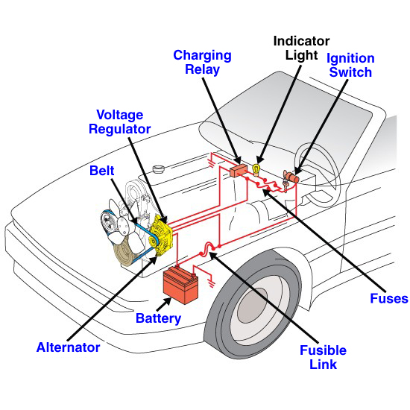
The function of the regulator is to regulate the voltage generated by the alternator. Why should it be there? Because the voltage generated by the alternator depends the engine's RPM. This means that if the engine RPM is low, the alternator voltage is also low, but if the engine RPM is high then the alternator voltage is also high.
The regulator will be used to keep the voltage generated by the alternator not exceeding 14 volts even if the engine runs in high RPM. This voltage setting aims to protect the electrical components of the vehicle to prevent over- voltage. Figure 1.5 charging system on vehicle
6. Alternator
The function of the alternator is to convert a partial engine's rotating energy into electricity when the engine is running. The alternator input comes from the engine pulley connected through a V belt; the rotation of the rotor will cause the intersection of the magnetic force line with the stator coil so that the electrons flow on the stator coil. The electricity in the stator coil is not directly connected to the battery, but it must pass through the diode bridge to rectify the current. This is done because the current in the stator coil is AC (Alternate Current).
Four wires connect the alternator to the rest of the charging system.
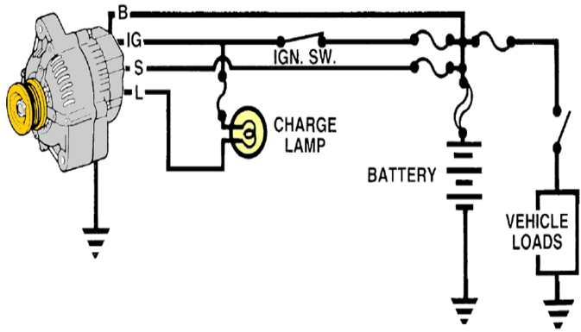
- B is the alternator output wire that supplies current to the battery.
- IG is the ignition input that turns on the alternator/regulator assembly.
- S is used by the regulator to monitor charging voltage at the battery.
- L is the wire the regulator uses to ground the charge warning lamp.
Figure 1.6 Charging system wire connection

7. Charging Wires
The function of charging wires are to connect every component of the charging system, there are at least two types of wires: standard wire and B + wire. The standard wire has a small diameter like the car's electrical wiring in general, the function of this wire is connecting each terminal on the entire charging system. While the B + wire has a larger diameter than the standard wire and almost matches the stator wire. The function of this wire is to connect the terminal B alternator with Battery.

1.3. 1. The main components of the alternator and their functions
- Fans: pull air through the slip ring end frame and cool the rectifier and regulator for inbuilt type alternators. The vent holes in both end frames allow the fan to pull ventilating air to the alternator.
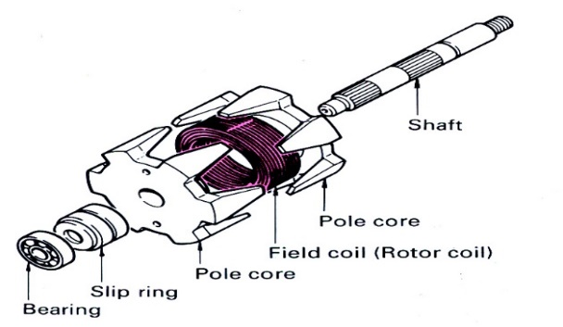
- Rotor: is composed of two cores, a field coil, slip rings and rotor shaft. The field coil is wound in the same direction as rotation and each end of the coil is connected to a slip ring. The two cores are installed at each end of the coil so as to enclose the field coil. Magnetic flux is produced as current flows through the coil and one pole becomes the North Pole and the other the South Pole. The slip rings are made of metal with a highly brush contacting surface and they are insulated from the rotor shaft. Figure 1.7 Rotor
- Brushes: they ride on each slip ring and conduct battery current to the rotor winding to create magnetic field. One is insulated from the frame but the other is grounded.
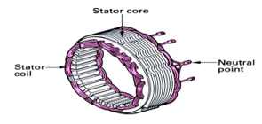
- Stator: the stator assembly is composed of laminated iron frame and three sets of windings, wound into slots in the frame. The windings make a three-phase unit due to the manner of their connection. The type of connection is Star and Delta connections.

Figure 1.8 Stator.

Star (Y) connection
The first three ends of the windings are connected together to form a common point. The other three ends are connected to the output lines. A fourth cable, called the neutral line, is often brought out from the common point. The availability of the neutral line makes it possible to use all three
phase voltages as well as all three-line voltages.
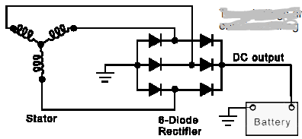
Figure 1.9 star (Y) connection
- The voltage between any line and the common is called the phase voltage. The voltage between any two lines is called the Line- to -Line voltage or simply Line voltage.
Delta_ connection
If the three phase windings are connected in series to form a loop, we would have a Delta connection. There is no common connection for the three phases. Hence, the Delta cannot have a neutral line. The three lines are taken from the ends of the windings; therefore, the line voltages are also the winding or phase voltages. The current in each line is drawn from the two windings join to feed a single line. single line.
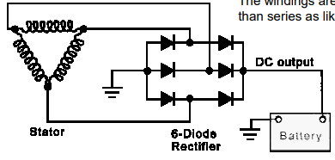
Figure 1.10 Delta- connection

Diodes
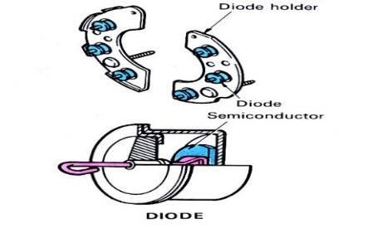
Three positive diodes and three negative diodes are usually mounted in a metal bracket called a heat sink. The heat sink takes heat from the diodes, which gets hot in operation, and transfers the heat into the air. It has large surfaces. The current generated by the alternator is supplied from the positive side diode holder so it is insulated from the end frames. Figure 1.11 Diode component
Table 1.1 Comparison of Delta &star connection
The difference between the Star and Delta Connection are given below in the tabulated form
Star(Y) Connection | Delta (Δ) Connection
In STAR connection, the starting or finishing ends (Similar ends) of three coils are connected together to form the neutral point. A common wire is taken out from the neutral point which is called Neutral. | In DELTA connection, the opposite ends of three coils are connected together. In other words, the end of each coil is connected with the start of another coil, and three wires are taken out from the coil joints
There is a Neutral or Star Point | No Neutral Point in Delta Connection
Three phase four wire system is derived from Star Connections (3-Phase, 4 Wires System) We may Also derive 3 Phase 3 Wire System from Star Connection | Three phase three wire system is derived from Delta Connections (3-Phase, 3 Wires System)
Line Current is Equal to Phase Current. i.e.  I_{L} = I_{PH} | Line Voltage is Equal to Phase Voltage. i.e.  V_{L} = V_{PH}
Line Voltage is √3 times of Phase Voltage. i.e. V_{L} = √3 V_{PH} | Line Current is √3 times of Phase Current. i.e I_{L} = √3 I_{PH}
The Total Power of three phases could be found by  P = √3 x VL x IL x CosФ …. Or  P = 3 x VPH x IPH x CosФ | The Total Power of three phases could be found by  P = √3 x VL x IL x CosФ … or  P = 3 x VPH x IPH x CosФ
The speeds of Star connected motors are slow as they receive 1/√3 voltage. | The speeds of Delta connected motors are high because each phase gets the total of line voltage
In Star Connection, the phase voltage is low as 1/√3 of the line voltage, so, it needs a low number of turns, hence, saving in copper. | In Delta connection, the phase voltage is equal to the line voltage; hence, it needs a greater number of turns.
Low insulation required as phase voltage is low | Heavy insulation required as Phase voltage = Line Voltage.
In Power Transmission, Star Connection system is general and typical to be used. | In Power Distribution and industries, Delta Connection is general and typical to be used.

Function of Voltage Regulator
It limits the DC output voltage according to external load and state of charge of the battery. If the output is not controlled the battery will be overcharged and the electrical equipment will be damaged. Controlling the electrical flow through the field coil in the rotor does the control.

1.3.2. Alternator construction
Generally, two different types of alternator are used on vehicles.
A conventional alternator and Separate voltage regulator were used on all vehicles. A new compact, high-speed alternator with a built in IC regulator is now used on most models. Both type of alternators is rated according to current output. typical rating ranges from 40 amps to 80 amps.
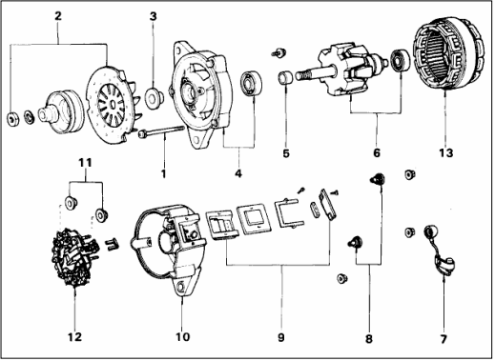

Figure 1.12 Alternator construction.

1. Through Bolt 2. Space Collar, Pulley & Fan 3. Space Collar 4. Drive End Frame & Front Bearing 5. Space Collar 6. Rotor & Rear Bearing 7. Noise Suppression Condenser 8. Insulator 9. IC Regulator 10. Rear End Frame 11. Insulator 12. Brush Holder & Rectifier Holder 13. Stator Coil

1.4. Working principle of Alternator and system

Electromagnetism and Electric Generating Principle
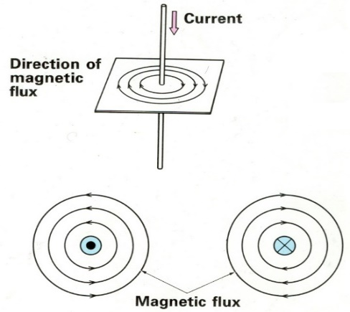
It is magnetism produced by electric current. It has the same characteristics with horseshoe magnet, or earth’s magnetic field. Magnetism develops in the centre of the conductor and expands outward into space around the conductor. The lines of force appear in the form of circles around and distributed uniformly along its entire length and at right angles to the conductor. They do not remain stationary but travel in a circle around the conductor. The strength of the magnetism is in direct proportion to the amount of current flowing. If for instance, the amount of current is doubled, the resultant magnetism will be doubled.
- Electromagnetic Induction
Induced e.m.f. can be generated in two ways:
- By relative movement (the generator effect)
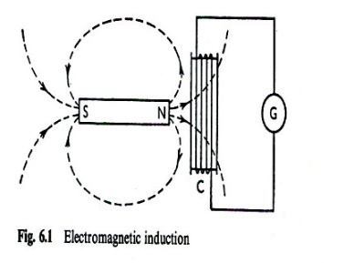
- By changing a magnetic field ( the transformer effect )
The Generator Effect
M
Let us take a coil C wound with a large number of turns, and connects it to a galvanometer G. (it is a very sensitive moving coil ammeter). If a permanent magnet M is moved up to and along the axis of C, as shown in the figure bellow, the moving coil of G is deflected, thereby indicating that there must be an electromotive force induced or generated in coil C. Immediately as the movement of M ceases, the moving coil of G returns to its original position.
This effect proves that e.m.f is induced only while M is moving relative to C. Let us now move M away from C. The galvanometer deflection is found to be in the reverse direction, showing that the direction of the induced e.m.f depends upon the direction in which M is moved relative to coil C.
If next, we hold the magnet stationary but move the coil towards the magnet and then away from it, the deflection of the galvanometer is found to follow exactly the same sequence as it did when the magnet was moved and the coil held stationary. This result shows that the generation of e.m.f in C depends only upon the relative movement of the magnet and the coil.

If the permanent magnet is turned through 180⁰ so that its south pole is pointing towards the coil it is found that a repetition of the movements described above is accompanied by galvanometer deflections similar to those previously obtained, except that their directions are reversed. Thus, the direction of the e.m.f induced by bringing the South Pole up to the coil is the same as that previously obtained when the North Pole was moved away from the coil. Let us next bring the magnet up to the coil at different speeds. It is found that the greater the speed, the greater is the deflection of the galvanometer and, therefore, the greater must be the e.m.f induced in the coil.
Direction of the Induced E.M.F
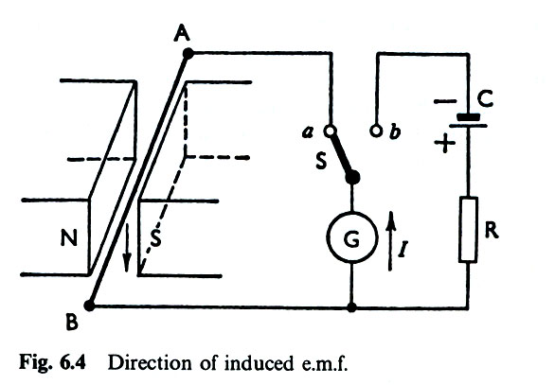
The simplest method of determining the direction of the e.m.f. induced or generated in a conductor is to find the direction of the current due to that e.m.f Thus in fig on left side; AB represents a metal rod with its ends connected through a changeover switch to a moving coil galvanometer G. With Son side a, let as move AB downwards between the poles NS of an electromagnetic and not the direction of G, S deflection Let us then moves S over to be so as to connect G in series with a high resistance R across a cell C. G may again be deflect in the same direction. The polarity of C must be that shown in fig that is the current through the galvanometer must be in the direction by the arrow alongside G. Hence, the e.m.f. generated in AB must be acting from A towards B when the rod is moved down wards through the magnetic poles NS.

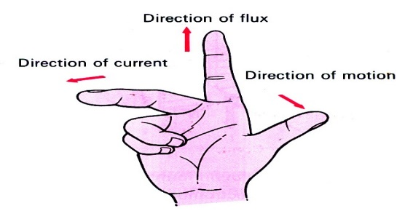
Fleming's Right-Hand Rule
If the first (fourth) finger of the right hand be pointed in the direction of the magnetic flux, and if the thumb be pointed in the direction of the motion of the conductor relative to the magnetic field, then the second fingers (third middle) held at right angles to both the thumb and the first finger, represents the direction of the e.m.f..
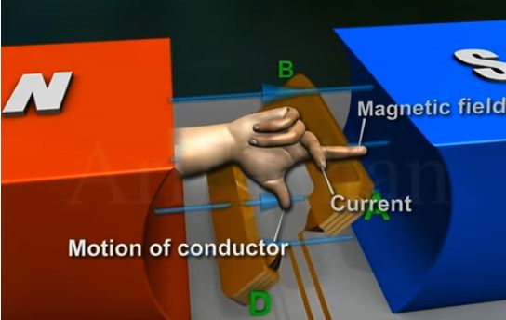
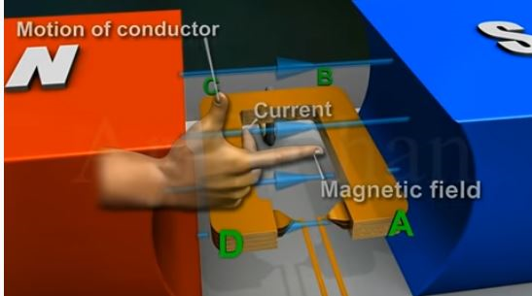

Lenz's Law
The direction of an induced e.m.f is always such that it tends to set up a current opposing the motion or the change of flux responsible for inducing that e.m.f. Example When a N-pole is being pushed towards a coil, the current flows in the direction to produce a N-pole at the near end, and repel the approach of the magnet. When a north pole is withdrawn, a south pole is induced at the near end to attract it.
- Magnitude of the Induced E.M.F
Factors that determine the magnitude of the induced voltage;
- The strength of the magnetic field
- The speed at which lines of force are cutting across the conductor
- The number of conductors that are cutting across the lines of force
Calculate force on a current in a magnetic field
Force of Conductor
F = B I L [Newtons] | F = Force on current in magnetic field Newtons (N)  B = Density of the magnetic flux in Teslas(T)  I = Induced current in Amps(A)  L = Length of conductor in field in metres(m)
Torque produced
T = 2 n F r [Newton meter] | T = Torque (Nm)  n = number of coil turns  F = force on single conductor(N)  r = radius of coil(m)
Example 1
A 100 turn coil has a radius of 0.1m and a length of 0.15m. It is placed at right angles in a magnetic field of flux density 0.08T and carries 12A, calculate the force on each conductor and the total torque produced by the coil.

Solution
F = B I L = 0.08 x 12 x 0.15 = 0.144 N
T = 2 n F r = 2 x 100 x 0.144 x 0.1 = 2.88 Nm
EMF induced in the coil of wire
Є = B L v [Volts] | Є = The induced emf (V)  B = Density of the magnetic flux in Teslas (V)  L = Length of conductor in field in metres (m)  v = velocity in metres per second(m/s)
Example 2
Calculate the EMF induced across the ends of a wire of length 0.3m when it is moved through a magnetic field of flux density 0.015T at a speed of 50m/s.
Solution
Є = 0.015 x 0.3 x 50 = 0.225 Volts

1.4.1. DC Generator
Generator Principle
An electrical generator is a machine which converts mechanical energy (or power) into electrical energy (or power). Induced e.m.f is produced in it according to Faraday's law of electromagnetic induction. This e.m.f causes a current to flow if the conductor circuit is loosed. Hence, two basic essential parts of an electrical generator are:
  - Magnetic field.
  - Conductor or conductors which can move as to cut the flux.
Generators are driven by a source of mechanical power, which is usually called the prime mover of the generator (steam turbine, diesel engine, or even an electric motor).
- The direct current (dc) machine can be used as a motor or as a generator.
- DC Machine is most often used for a motor.
- The major advantages of DC machines are the easy speed and torque regulation.
DC Machine Construction
- The stator of the dc motor has poles, which are excited by dc current to produce magnetic fields.
- In the neutral zone, in the middle between the poles, commutating poles are placed to reduce sparking of the commutator. The commutating poles are supplied by dc current.
- The poles are mounted on an iron core that provides a closed magnetic circuit.
- The motor housing supports the iron core, the brushes and the bearings.
- The rotor has a ring-shaped laminated iron core with slots.
- Coils with several turns are placed in the slots. The distance between the two legs of the coil is about 180 electric degrees
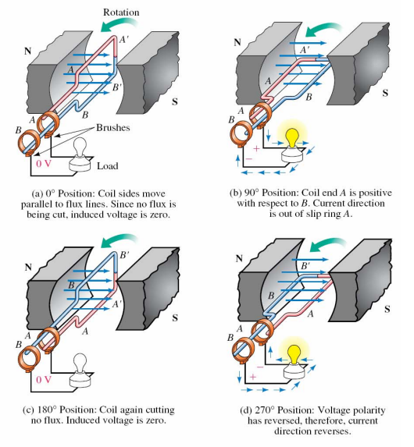
The parts of a simple DC generator are shown in fig below. The principle of operation of a DC generator is similar to that of the AC generator. A rotating armature coil passes through a magnetic field that develops between the north and south polarities of permanent magnets or electromagnets. As the coil rotates, electromagnetic induction causes current to be induced into the coil. The current produced is an alternating current. However, it is possible to convert the alternating current that is induced into the armature into a form of direct current. This conversion of AC into DC is accomplished through the use of a commutator. The conductors of the armature of a DC generator are connected to commutator segments. The commutator shown below in has two segments, which are insulated from one another and from the shaft of the machine on which it rotates. An end of each armature conductor is connected to each commutator segment. The purpose of the commutator is to reverse the armature coil connection to the external load circuit at the same time.
Figure 1.13 Simple drawing of the basic generator parts of DC.

1.4.2 AC Generator
Components AC Generator System: Battery, Alternator, Voltage regulator, and Charge indicator (Ammeter) with connecting wires and ground.
Alternator: it converts mechanical energy into electrical energy. The engine crankshaft pulley drives the alternator through a belt a two to three times crankshaft speed.
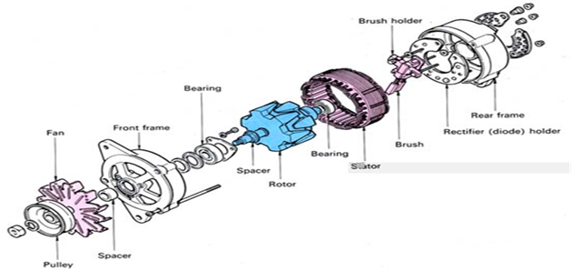
Figure 1.14 Alternator component

- Operation of Alternator
Alternators produce electricity by means of the induction principles. Hence, the essential parts of the alternator are:
a) A magnetic field, and
b) Conductors which can move so as to cut the flux
In the alternator the magnet (rotor) revolves but the conductors (stator) remain stationary. It produces alternating current in the stator. Let’s take a single loop.

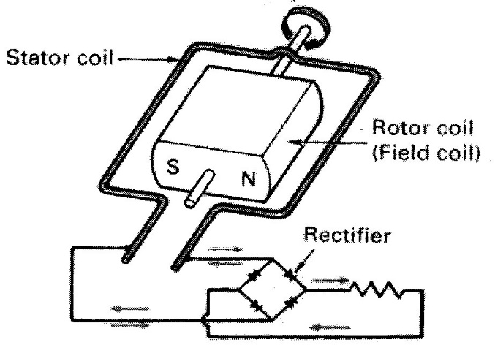
The rotating bar magnet supplies the moving field. As the loop rotates magnetic lines of force are being cut by the two legs in the opposite direction so, current is induced in the loop. Therefore, as the magnet spins and the two poles alternatively pass the two legs of the loop, current in the loop flows first in one direction and then in the other and alternating current flows.
Figure 1.15 Operation of alternator
The single loop in the above discussion results in a pulsating current when it is rectified. To provide a smooth flow of current three phases is built which give overlapping pulses of alternating current. When these pulses are rectified a comparatively smooth flow of direct current is obtained.
But in the actual alternator, the number of loops is increased as well as the magnetic field strength. That is to say the electromagnet is made up of many turns of a wire. When current flows in the electromagnetic winding, a strong magnetic field is created. The winding is connected to the battery through a pair of insulated rings that rotate with the shaft. A pair of stationary brushes rides on the rings which make continuous sliding contact with the slip rings.
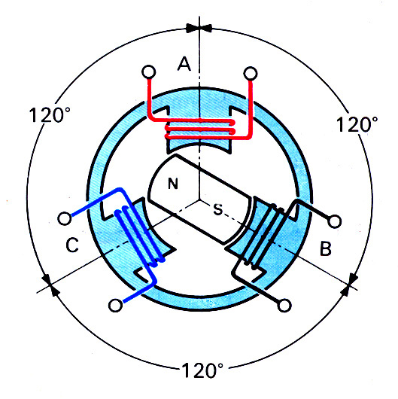
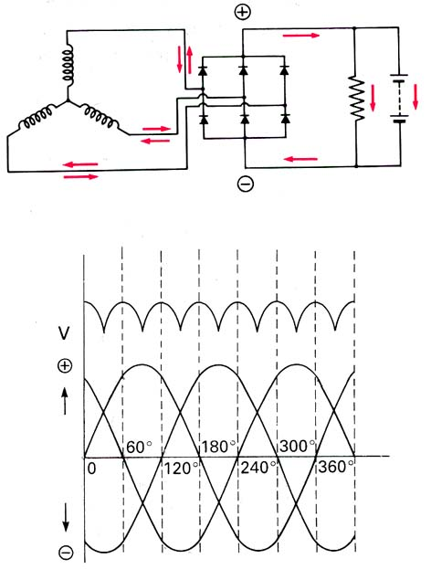
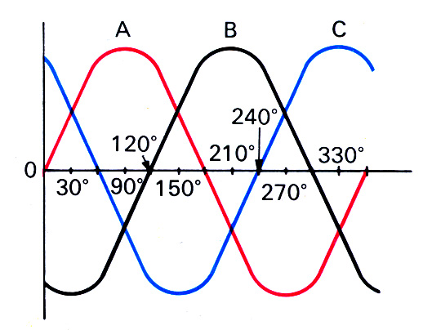
The alternating current generated in the three legs of the stator circuit passes through the six diodes and is converted it to direct current.
Figure 1.16 Phase winding

- Rectification
The electrical components of an automobile require direct current for operation and battery needs direct current for charging. The alternator produces three phases alternating current but the charging system of the automobile cannot use this electricity unless it is converted to direct current. Therefore, the alternating current is rectified into direct current by diodes which are built in the alternator circuit. Thus, we can see current from each coil to the diodes is constantly changing direction in the three leads so the direction of current from the diodes does not change but forms a circuit with varying polarity.
Rectification Operation
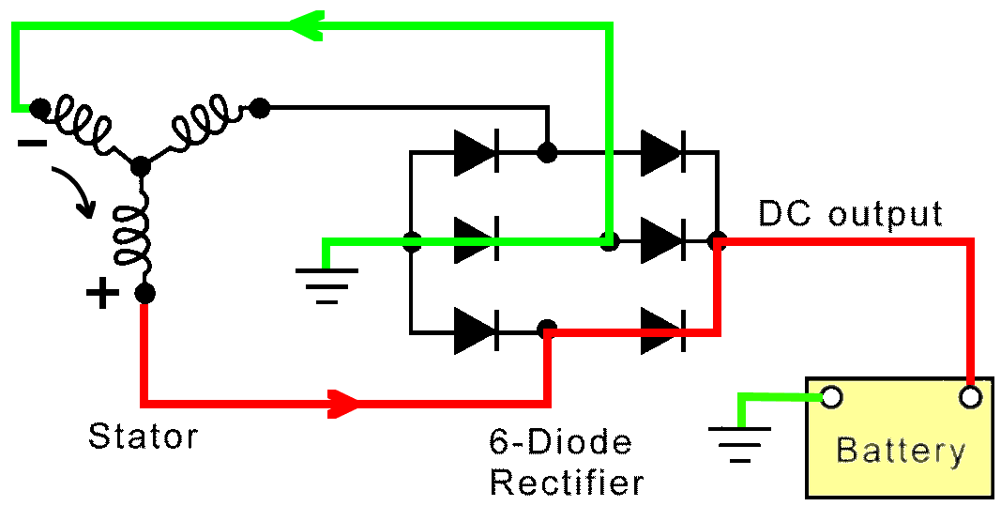  Red  Green | - In red you can see B+ current pass through to the rectifier as it goes to the battery. In green you can see the return path.  - Now, in red B+ current passes through to the rectifier however, this time current has the opposite polarity. In green you can see the new return path.  - Even though it enters the rectifier at a different location, current goes to the battery in the same direction.
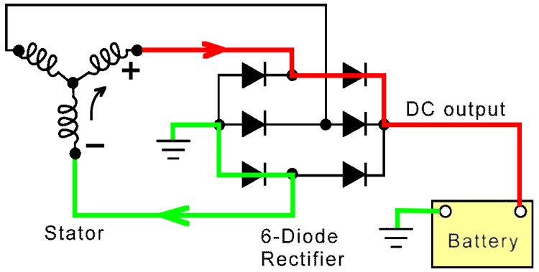
Red
Green
Figure 1.17 Rectification operation
Factors that are affecting the alternator output are:
- The speed of the rotor,
- Strength of the magnetic field, i.e., number of turns of wire in the rotor winding, amount of electricity applied to the rotor coil, the air gap between the rotor poles and the stator
- The number of turns of wire in the stator coils, and
- Inductive reactance
Circuits of the Alternator
There are three standard circuits for the alternator:
- Pre- excitation circuit
- Excitation circuit (self- excitation)
- Generator or main circuit
1, Pre-excitation circuit
The battery current first flows through the charge indicator lamp and to the excitation winding in the rotor. This is necessary because the resonance in the excitation winding of the iron core is very weak at the instant of starting and at low speeds, and does not suffice to provide the self-excitation needed for building up the magnetic field.
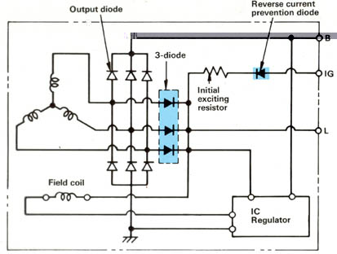
2, Excitation Circuit
The excitation current generates the magnetic field during the operation of the alternator so that the required alternator voltage can be induced in the stator windings. The excitation current comes from the current flowing in the three-phase windings. It comes from the alternator through the regulator IG and F terminals or flows through the three exciter diodes if present. Hence, no external power source is required for self-excitation.
Diode-trio (Exciter Diodes)
These are three field diodes in order to excite the field coil. When the ignition switch is ON, field current is supplied through the reverse current prevention diode and initial exciting resistor, from IG terminal. The field current is as small as 0.5A when the alternator stops with the ignition switch ON. Therefore, the discharge from the battery is small.
When the alternator starts to generate, a portion of the generated current is supplied directly from the three field diodes during power generation. The reduction in the field current becomes less due to the resistance of external wiring and the like. Therefore, it is possible to improve the output.

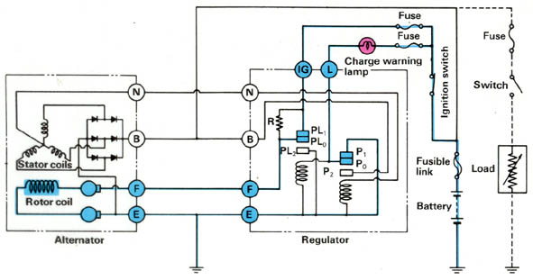
3, Generator circuit
The induced voltage in the stator windings is first rectified by the power diodes. Then, the current flows to the battery and the loads in the vehicle electrical system. The stator winding voltages are a function of the angle of rotation of the rotor.
Figure 1.17 Generator circuit
1. Let’s take 30⁰
Current from A and C winding ends takes the same path to winding end B. In this case there is voltage present across all the phases.
2. Taking 120⁰
Voltage at the star point of A is positive. But for winding C it is negative, and for winding B it is zero. So current flows from the end of the winding A and through the positive diodes to alternator terminal B⁺ from where it flows through the battery, or the load, to ground and via negative diodes to winding C
Whereas the DC supplied for battery charging and for the loads always maintains the same direction. This is due to the fact that irrespective of the rotor’s position, all the diodes always involved in the rectification process.
1.4.3. Operation of a Regulator with Voltage Relay
- When the ignition switch is on engine stepped.
When the ignition switch is turned on field current from the battery flows to the rotor and excites the rotor coil. At the same time, battery current also flows to the charge warning lamp and the lamp comes on.
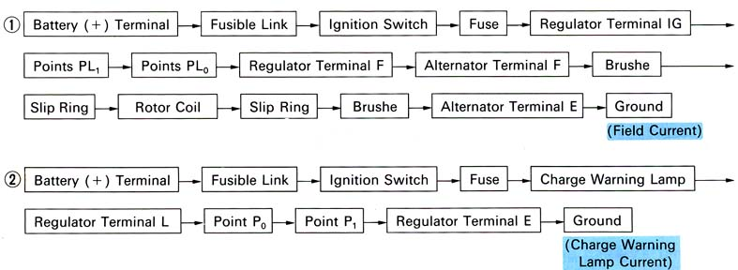
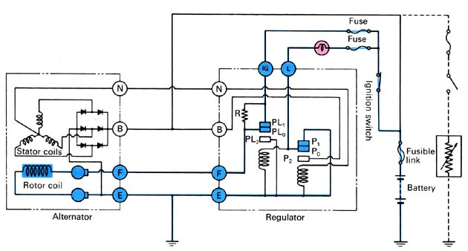 Figure 1.18 Operation of regulator
- Engine operation- (low speed to middle)
After the engine is started and the rotor is turning Voltage is generated in the stator coil, and neutral voltage is applied to the voltage relay so the charge warning lamp goes out. At the same time; output voltage is acting on the voltage regulator. Field current to the rotor is controlled in accordance with the output voltage acting on the voltage regulator. Thus, depending on the condition of point PL₀, the field current either passes through or does not pass through the resistor.

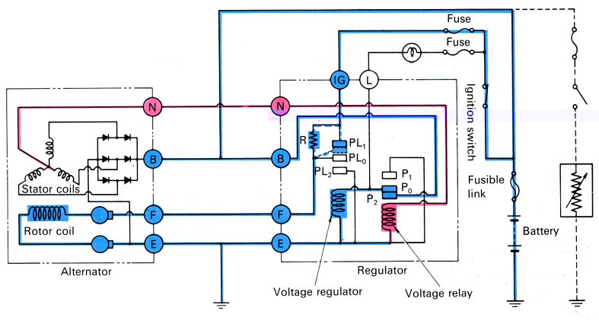
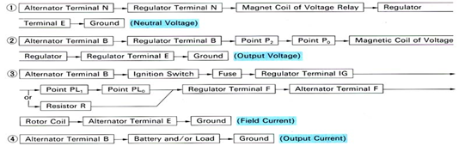
Figure 1.19 Operation of regulator
C. Engine operating (Middle speed to high speed)
As engine RPM increases, the voltage generated by the stator coil rises and the pulling force of the magnetic coil becomes stronger with a stronger pulling force, field current to the rotor will flow intermittently. In other words, moving point PL₀ of the voltage regulator intermittently makes contact with point PL_{2.}

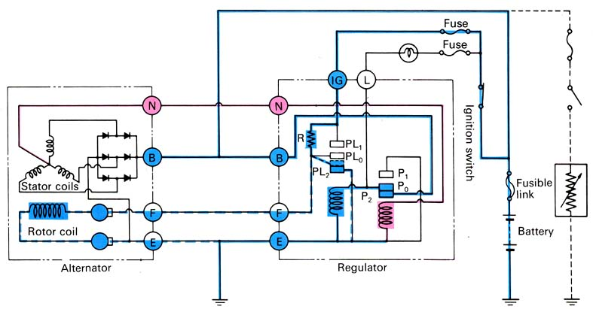
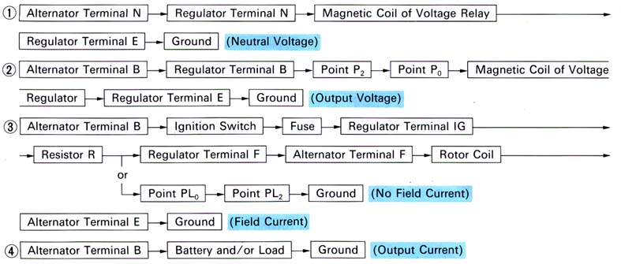

Figure 1.20 Operation of regulator
IC-Regulator
The solid state regulator allows battery current to excite alternator field coils, and also controls charging voltage at safe values. It may be separately mounted or inbuilt type.
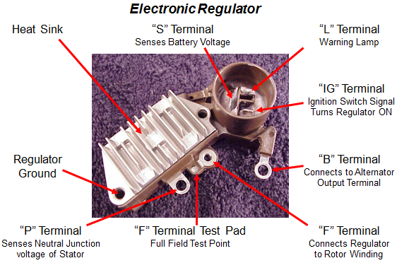
Figure 1.21 Construction of IC regulator

- It is almost fool proof i.e., incapable of error or failure
- It is smaller in size i.e., compact and light
- It can control higher field current with improved durability and reliability (this is due to lack of mechanical points).
- A narrower output voltage range and little or no variation with alternator speed and input voltage i.e., no hysteresis characteristics.
- Voltage variation at the rated load, or at maximum output current of the alternator is between 0.5-1v
- Good resistance to vibration, climatic effects and high durability due to lack of moving parts
- Voltage output becomes lower as its temperature rises; hence proper charging of the battery can be performed. This is because the Zener diode become more conductive as temperature rises
- Spark free switching prevents radio interference
Disadvantage
- Susceptible to unusually high voltage and temperatures

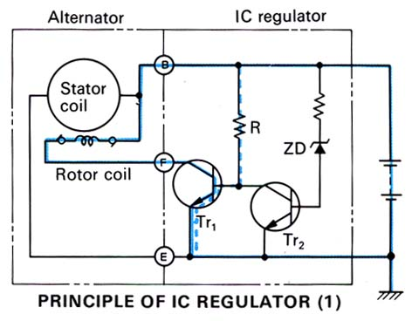
1.4.4. Operating principles of IC Regulator
The solid-state regulator controls the field current using transistors, diodes, and resisters. As in the illustration shown below, when the output voltage at terminal B is low, the battery voltage is applied to the base of Tr₁ through resistor R and Tr₁ turns on. At the same time, field current flows from B to rotor coil.
When the output voltage at terminal B is high a higher voltage is applied to the zener diode (ZD) and when this voltage reaches the zener voltages, the zener diode becomes conductive. Accordingly, as Tr₂ turns on Tr₁ turns off. This interrupts the field current. Regulating the output voltage
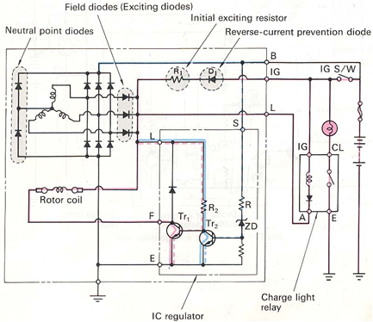
A-Type IC regulator
Principle of operation
When T1 turns on and the ground circuit is closed, exciting current flows through the rotor coil.
If the output voltage is higher than a predetermined voltage, the Z-diode allows a signal to pass to Tr2. This signal interrupts the rotor coil ground circuit via Tr2 and Tr1.
Figure 1.22 A type regulator
B-Type IC Regulator
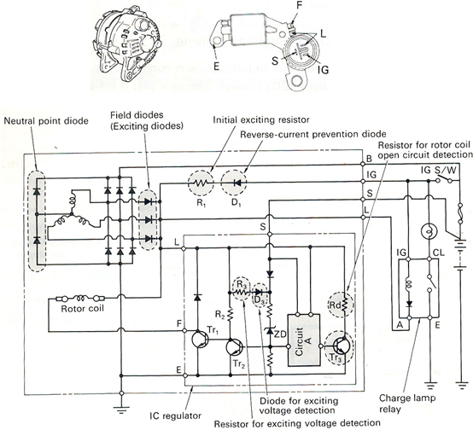
Figure 1.23 B-type regulator

M-TYPE IC REGULATOR Figure 1.24 M-type regulator

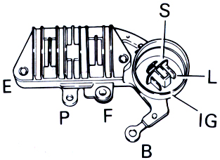
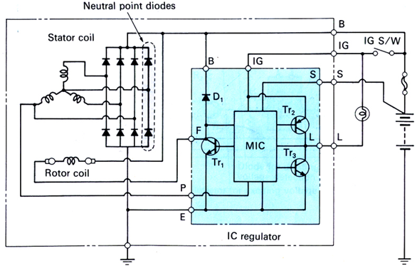
Figure 1.24 M-type regulator
Ignition Switch On, Engine Stopped | Generation Of Current By Alternator (Less Than Standard Voltage)
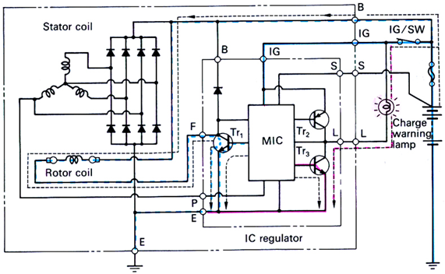 | 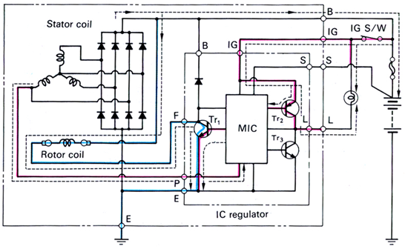

GENERATION OF CURRENT BY ALTERNATOR (Standard voltage reached) | OPEN IN REGULATOR SENSOR (Terminal S) CIRCUITRY
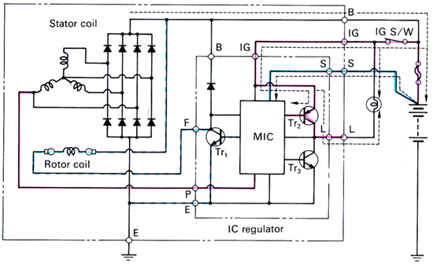 | 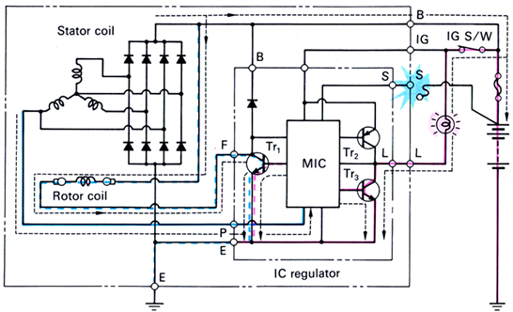

- ECM controlled charging system

In this type of charging system, the IC regulator is also connected to the engine control module via two terminals. (FR and C terminals). Figure 22 shows an example of how these components are connected in type of charging system

Operation

Engine control module (13) controls the output voltage of the alternator using the “C” terminal based on the following information:

Engine condition (ECT, vehicle speed, engine speed, TP, etc. (14))

Battery voltage (ECM backup power voltage (15))

Electric load condition (blower motor, rear defogger, A/C, headlights, etc. (16))

“FR” terminal output (field coil control duty) which indicates the electricity generation rate of the alternator.

Then the IC regulator uses the “C” terminal duty cycle from the ECM to adjust the current to the slip rings thus the output voltage (B+ terminal voltage). The generated current is also sent to the ECM via the FR terminal in duty cycle forms.

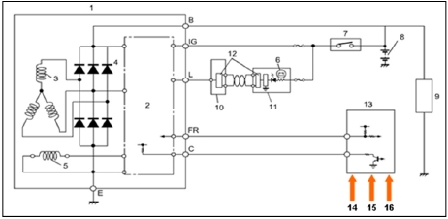
This method of alternator control results in more accurately controlled charge rate, allowing for smaller and lighter batteries to be used. The module can also monitor system operation to simplify diagnosis and repair by producing DTC’s.

ECM controlled charging circuit diagram (Suzuki Alto AMF310)
[1] Alternator [2] IC regulator [3] Stator coil [4] Diode
[5] Rotor [6] Charge warning light [7] Ignition switch [8]
[8] Battery [9] Electric load [10] BCM [11] IC [12] CAN driver
[13] Engine control module

Figure 1.25 ECM controlled charging circuit.

1.5. Tools and Equipment
HAND TOOLS: The word wrench means twist. A wrench is a tool for twisting and/or holding bolt heads or nuts.

- Open-End Wrench: The jaws of the open-end wrench allow the wrench to slide around two sides of a bolt or nut head where there might be insufficient clearance above or on one side of the nut to accept a box wrench.

- Box-End Wrench: The end of the box-end wrench is boxed or closed rather than open. The jaws of the wrench fit completely around a bolt or nut, gripping each point on the fastener. The box-end wrench is not likely to slip off a nut or bolt. It is safer than an open-end wrench. Box-end wrenches are available as 6 point and 12 point. The 6-point box end grips the screw more securely than a 12-point box-end wrench can and avoids damage to the bolt head.


- Combination Wrench: The combination wrench has an open-end jaw on one end and a box-end on the other. Both ends are the same size. The combination wrench is probably the best choice for the second set. It can be used with either open-end or box-end wrench sets and can be used as an open-end or box-end wrench
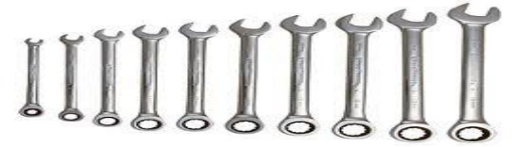

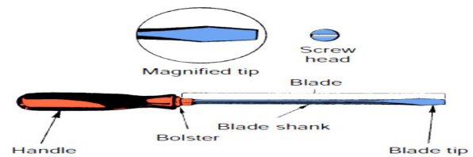
- Screwdrivers: A screwdriver drives a variety of threaded fasteners used in the automotive industry. Each fastener requires a specific kind of screwdriver. Screwdrivers are defined by their sizes, their tips, and the types of fasteners they should be used with. Special screwdrivers.

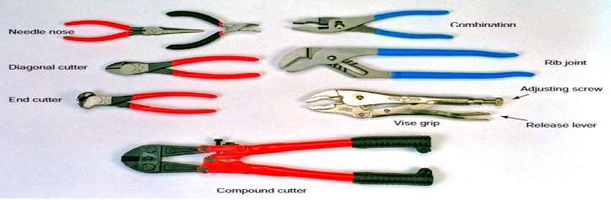
- Pliers: are gripping tools used for working with wires, clips, and pins. At a minimum, an auto technician should own several types: standard pliers for common parts and wires, needle nose for small parts, and large, adjustable pliers for large items and heavy-duty work.

- Circuit Tester :- Circuit testers are used to check for voltage in an electrical circuit. A circuit tester commonly called a test-light.

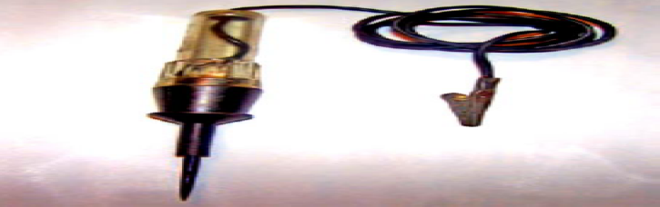

- Multi-meters A multi-meter is a must for diagnosing the individual components of an electrical system. A digital multi-meter (DMM) can measure volts, ohms, and low current such as direct current (dc) and alternating current (ac) amperes, diode continuity. DMMs provide great accuracy by measuring volts, ohms, or amperes in tenths, hundredths, or thousandths of a unit.

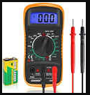

- A special battery thermometer for measuring temperature of electrolyte.



- Hydrometer is an instrument used to measure the specific gravity of electrolyte for drawing off electrolyte and for adding water.



Self-Check 1
Instruction: Answer all the questions listed below, if you have some clarifications- feel free to ask your teacher.
1. In the vehicle charging system the voltage regulator directly controls:
A. Stator circuit B. Output current
C. Field current D. ALL
2. When the input voltage to a voltage regulator coil decreases, the alternator output voltage should normally: A. Increase B. Decrease
C. remain the same D. Turn ON the charging lamp indicator.
3. Two technicians are arguing about electromagnetic induction and Induced e.m.f. Technician A says
Induced e.m.f. can be generated by relative movement. Technician B says Induced e.m.f. can be generated by changing a magnetic field. Who is correct?
A. Technician A. B. Technician B.
C. Both technicians A and B. D. neither technicians A or B
Test II: short Answer
Instruction: Write short answer. Your hand writing should be clear and correct spelling.
- What is the purpose of charging system?
- Write the charging system two jobs
- Write the two types of charging circuits
- Write the operational principle of generator
- Write the types of voltage regulator according to purpose.
Part III: Fill in the blank
Direction: Fill in the blank to the following questions. Time allotted for each item is 2mniut and each question carry 5 point.
- A faulty drive belt--------------------------- can cause low charging system output.
- Before removing either the starter or generator, first --------------------- the battery --------------------- cable.
Note: Satisfactory rating – above 60% Unsatisfactory - below 60%
You can ask you teacher for the copy of the correct answers.

Unit Two: Overhauling and dismantle Charging system
This unit to provide you the necessary information regarding the following content coverage and topics:
  - Overhaul Alternator and system component
  - Disassembling Alternator and components
  - Cleaning Alternator and components
This guide will also assist you to attain the learning outcomes stated in the cover page. Specifically, upon completion of this learning guide, you will be able to:
- Apply Overhaul Alternator and system component
- Perform Disassembling Alternator and components
- Make Cleaning Alternator and components

Overhaul Alternator and system component

Removal Information

CAUTION: Personal injury or damage to the vehicle or its components may occur if this step is not performed.

Disconnect the negative battery cable from the vehicle.

Identify each wire connection and note the location of each on the alternator.

Disconnect the wires from the alternator.

Loosen the alternator pivot bolt. Do not remove the bolt at this time.

Loosen the tension assembly’s lock nut or bolt and turn the adjustment bolt so that drive belt tension is reduced far enough to allow belt removal. Some vehicles may be equipped with an automatic, spring-loaded tensioner. Rotate the spring-loaded tensioner using the appropriate tool far enough to allow drive belt removal.

Remove the drive belt(s) from the alternator.

Support the alternator and remove the bolts holding the alternator in place. Set the bolts and alternator aside. Be sure to note bracket orientation and fastener length and location before removing the alternator.

Inspect the condition of the wiring and connectors. Inspect for frayed wire ends, continuity, lose or broken connectors, corrosion and pliability. Repair or replace as necessary.

Disassembling Alternator and Components
- Before being to disassemble the Alternator, a simple bearing test should be performed regardless of reason for alternator removal from the engine. the purpose of the test is to determine whether either of the bearings are a potential noise or failure complaint.
- To perform a test for faulty bearings, hold the alternator in one hand snap- spin the pulley with the other. A defective bearing will be heard or felt.in noisy locations, press the alternator adjusting ear to your ear lobe and snap-spin the pulley a few times.

Typical Procedure for Disassembling AC Generator (alternator)

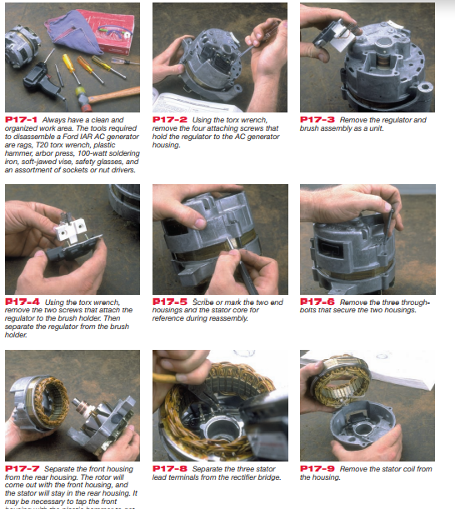

Figure 2.1 Alternator disassembling procedure

Cleaning Alternator and System components
- Clean the outside of the alternator by rag.
- Clean the battery terminals and posts by battery brushes.
- Battery corrosion applying a mixture of baking soda and water, do not immerse parts in cleaning solvent.
- Do not immerse the drive unit in cleaning solvent.
- The drive unit may be cleaned with a brush, moistened with cleaning with rag.
- Using a cloth and brush, clean the slip ring and rotor. If the level of the dirtiness and burn is remarkable, replace the rotor assembly.

Self-Check 2

Instruction: Answer all the questions listed below, if you have some clarifications- feel free to ask your teacher.
1. Slip rings and brushes ----------------------------
a. mount on the rotor shaft
b. conduct current to the rotor field coils
c. are insulated from each other and the rotor shaft
d. all of the above
2. Which type of stator winding produces higher AC generator output at low speeds?
a. wye b. delta
c. trio d. series
3. Select the words that correspond to "a" in the following illustration of the alternator
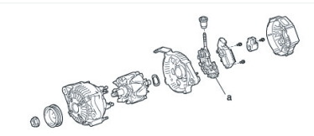
from the word group below

a. Rotor b. Rear end frame
c. Rectifier holder d. Drive end frame
Test II: short Answer
Instruction: write the answer clearly and orderly for the given question. You are provided 10 minutes for each question and each point has 30 Points.
3, Write the corresponding parts of the alternator without looking at previous pages.

1.----------------------------------------- 7. --------------------------------------
2.----------------------------------------- 8. ---------------------------------------
3.------------------------------------------ 9. .---------------------------------------
4.---------------------------------------- 10. .--------------------------------------
5. --------------------------------------- 11. .--------------------------------------
6. --------------------------------------- 12. --------------------------------------
13.-----------------------------------------

Note: Satisfactory rating – above 60% Unsatisfactory - below 60%
You can ask you teacher for the copy of the correct answers

Operation Sheet 2.1: Disassembling the Alternator
- Operation Title: Disassembling the Alternator
- Purpose: Diagnosis the problem of the alternator
- Instruction: Follow the procedure correctly.
- Tools and requirement: Open and box wrench, socket set, plier, screw driver, hammer
- Steps in doing the task:
  - Clean and organized work area and prepare tools.
  - Remove the four-attachment screw
  - Remove the regulator and brush assembly as a unit.
  - Remove the two screws that attach the regulator to the brush holder.
  - Scribe or mark the two-end housing and the stator core for reference during reassembly.
  - Remove the three through bolts that secure the two housing.
  - Separate the front housing from the rear housing. The rotor will come out with the front housing and the stator will stay in the rear housing.
  - Separate the three stator lead terminals from the rectifier bridge.
- Quality Criteria: Use the right tools at the right time.
- Precautions Prepare the table before disassembling the alternator.

Lap Test-2
- Task-1 Disassembling the Alternator using procedure

Unit Three: Inspecting, Testing, Repairing and Replacing Charging systems
This unit to provide you the necessary information regarding the following content coverage and topics:
  - Inspecting Charging system circuit
  - Testing Alternator and associated component
  - Alternator repair procedure
  - Repair and Replace Charging system and associated components
  - Reassemble Alternator
  - Charging System Trouble shooting
This guide will also assist you to attain the learning outcomes stated in the cover page. Specifically, upon completion of this learning guide, you will be able to:
- Inspect Charging system circuit
- Test Alternator and associated component
- Understand Alternator repair procedure
- Repair and Replace Charging systems and associated components
- Perform Reassemble Alternator
- Identify Charging System Trouble shooting

Inspecting Charging system circuit
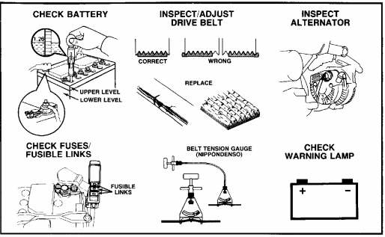

As with all types of service, a thorough visual inspection is important. The visual inspection can reveal many minor problems before they turn into larger problems and can provide a good overall indication of the general state of the vehicle.
A visual inspection of the charging system can save you time and effort by uncovering obvious or simple and easy−to−fix problems.
Alternator performance test Perform the following tests: -
- visual inspection (on vehicle)
- battery check
- fuses and fusible link check
- drive belt inspection
- alternator inspection
- warning lamp circuit check
- charging without load
- charging with load
- alternator output test
- voltage-drop test
- charging circuit relay test and
- ignition main relay check
Include these components in your inspection
- BATTERY
- Inspect the battery for external damage to the case or the cables, corroded terminals and loos connection.
- Check the specific gravity of each cells
- Check the amount of the electrolyte in each cell. If necessary, refill with distilled water
- System cables & wires
- Make sure all connections are clean and tight
- Check wires for fraying, insulation damage, and other physical damage
- Alternator drive belt
- Belt condition
- Alignment
- Check the drive belt tension.
- Visually check alternator wiring and listen for abnormal noises
- Check that the wiring is in good condition.
- Check that there are no abnormal noises from the alternator while the engine is running
- Inspect charge warning lamp circuit
- Warm up the engine and then turn it off
- Turn off all accessories
- Turn the ignition switch to the ON. Check that the charge warning lamp is on
- Start the engine. Check that the light goes out.
- If the light does not operate as specified, troubleshoot the charge warning lamp circuit.
- Check charging circuit without load
- Connect a voltmeter and ammeter to the charging circuit as follows
- Disconnect the wire from terminal B of the alternator and connect it to the negative probe of the ammeter.
- Connect the test probe from the positive terminal of the ammeter to terminal B of the alternator.
- Connect the negative probe of the voltmeter to ground and positive to the B terminal of the alternator.
- If the voltage reading is not within standard, adjust regulator or replace it.
- Check the charging circuit with load
- With engine running at 2000rpm, turn on the high-beam head lights and place the heater fan control switch to Hi.
- Check the reading on the ammeter. Standard amperage = more than 30A, If the ammeter reading is less than 30A repair the alternator.
Inspect Alternator Holder with Rectifier
- Inspect diode in rectifier
1. Using the diode test mode in the electrical tester.
2. Measure between the terminal B of the rectifier and terminals P1 to P4, when reversing
the polarity of the tester lead, and check that only one way has continuity.
3. Change the connection of terminal B to terminal E. The procedure is the same as the above.
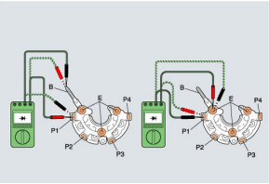
Figure 3.1 Alternator Holder with Rectifier
Inspect Alternator Brush Holder
- Inspect alternator brush holder
1, Using Vernier calipers, measure the length of the brush.
- Measure the (brush) length at the middle of the brush, because that part is worn most.
- The slip ring contacts the brush and turns on an electric current while turning itself. For this reason, as the length of the brush becomes shorter than the specified value, the connection gets worse, interfering with the flow of electric current. As a result, the alternator's electric generating capacity lowers.
- If the measurement value is below the standard, replace the brush with brush holder.
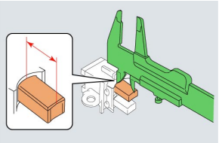

Figure 3.2 Alternator Brush test

Testing Alternator and associated component
The Charging System require little maintenance. The battery should be fully charged and connections kept clean and tight.
Begin with a thorough visual inspection. If this fails to turn up the possible cause, several tests are available to help you find the problem:
- Alternator output test (no load)
- Alternator output test (with load)
- Voltage drop tests
- Charging current relay test
- Diode tests.
- Alternator and Regulator tests
NB: - It is advisable always to follow the testing procedure recommended by the manufacturer.
Procedure: -
1. Check the alternator drive belt and adjust as required.
2. Remove lead from alternator output (Bat) terminal and connect ammeter negative lead to disconnected alternator lead and ammeter positive lead to alternator output (Bat) terminal.
3. Connect voltmeter positive lead to alternator output (Bat) terminal and voltmeter negative to ground.
4. Connect tachometer between distributor primary terminal and ground.
5. Run the engine at 1500rpm and observe meters. Voltmeter should read between 13.5 volts and 15 volts. Ammeter should read approximately 10 amperes. (No-load Performance Test)
7. Run the engine at 1500rpm, turn on the head lights and all accessories. Voltmeter should read between 13.5 volts and 15 volts. Ammeter should read approximately 20 amperes. (Load Performance Test)

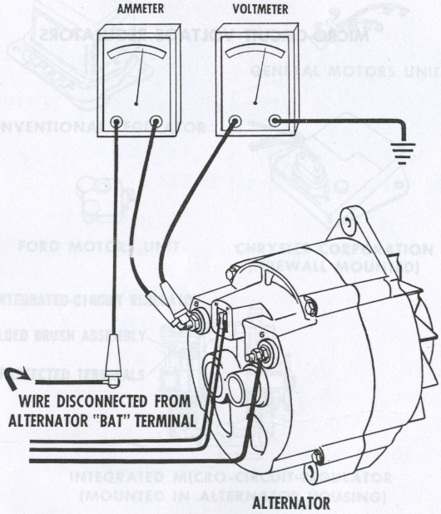

Figure 3.3. Alternator and Regulator tests

If the voltmeter reading is less than 13 volts, disconnect the field lead from the alternator being careful not to touch it to ground. Connect a jumper from the alternator field terminal to the alternator output (Bat) terminal. If a higher voltage and amperage is obtained, a defective regulator is indicated. If the voltage remains low, the alternator is defective.
If voltmeter reading is more than 15 volts, disconnect the field lead from the alternator being careful
not to touch it to ground. If voltmeter reads 12 volt (battery voltage) and the ammeter reads zero amperes, the regulator is defective.
- Charging Without Load
1, Prepare the tester:
- Rotate the Load Increase control to OFF.
- Check each meter's mechanical zero. Adjust, if necessary.
- Connect the tester Load Leads to the battery terminals; RED to positive, BLACK to negative.
- Set Volt Selector to INT 18V.
- Set Test Selector to #2 CHARGING.
- Adjust ammeter to read ZERO using the electrical Zero Adjust control.
- Connect the clamp-on Amps Pickup around the battery ground (-) cables.
2, Turn the ignition switch to "ON" (engine not running) and read the amount of discharge on the ammeter. This is a base reading for current the alternator must supply for ignition and accessories before it can provide current to charge the battery.
NOTE: The reading should be about six amps
3, Start the engine and adjust the speed to about 2000 rpm. Some models may require a
different speed setting. 4.
4, After about 3-4 minutes, read the ammeter and voltmeter. Add this ammeter reading and
the reading found in step 2 (engine not running).
NOTE: The total current should be less than 10 amps. If it is more, the alternator may still
be charging the battery. Once the battery is fully charged, you should get specified results.
The voltage should be within the specs for the alternator. This is usually between 13 and 15 volts. Refer to the appropriate repair manual. If the voltage is more than specified, replace the regulator. If the voltage is less than specified, ground the alternator field terminal "F" and check the
voltmeter reading. This bypasses the regulator, so do not exceed the specified test speed. If the reading is still less than specified, check the alternator.
5. Remove ground from terminal "F."
- Charging with Load
6. With the engine running at specified speed, adjust the Load Increase control to obtain the highest ammeter reading possible without causing the voltage to drop lower than 12 volts.
7. Read the ammeter.
NOTE: The reading should be within 10% of the alternator's rated output. If it is less, the alternator requires further testing or replacement.

- Charging circuit Relay tests
1, Check relay continuity.
- Connect the ohmmeter positive (+) lead to terminal "4," the negative (-) lead to terminal "3." Continuity (no resistance) should be indicated.
- Reverse the polarity of the ohmmeter leads. No continuity (infinite resistance) should be indicated.
- Connect the ohmmeter leads between terminals 1 and "2." No continuity (infinite resistance) should be indicated. If the relay continuity is not as specified, replace the relay.
2. Check relay operation.
- Apply battery voltage across terminals "3" and NOTE: Make sure polarity is as shown.
- Connect the ohmmeter leads between terminals "1" and "2." Continuity (no resistance) should be indicated.
If relay operation is not as specified, replace the relay.
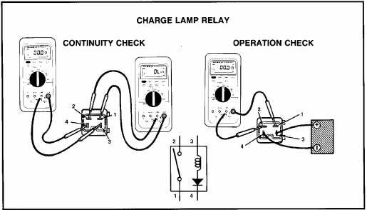

Figure 3.4 Charging relay circuit test
- Voltage drop test
Check the resistance of the charging circuit by measuring the voltage drop from the positive side of the battery to the output terminal of the generator. Remember, the system must be working and current flowing to measure voltage drop.
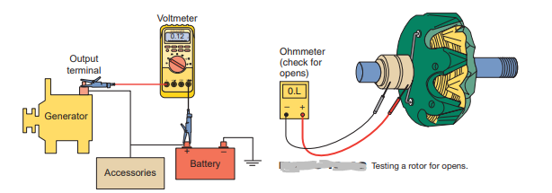
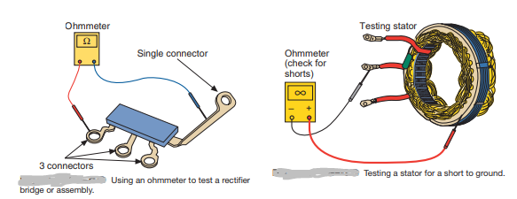

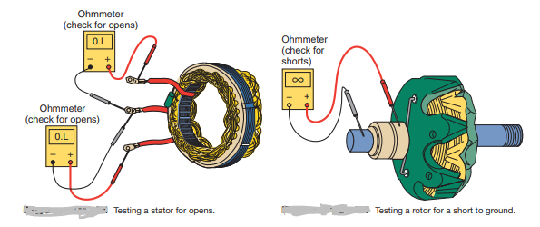
Figure 3.5. Voltage drop test

Alternator Bench Testing
If the on-vehicle checks have indicated that the alternator is defective, it should be removed for bench testing and replacement.
Specific procedures for removal, disassembly, inspection, and assembly are noted in the appropriate repair manuals. Only the electrical bench tests are covered here.

Always disconnect the battery ground (-) cable before removing the Alternator.
Refer to the appropriate repair manual for test specification. An ohmmeter is used for electrical bench tests on the rotor, stator, and diode rectifier. The following steps are typical:
- Check the rotor for an open circuit by measuring for resistance between the slip rings. Some resistance (less than 5 ohms) indicates continuity. If there is no continuity (infinite resistance), replace the rotor.
- Check the rotor for grounded circuits by measuring for resistance between the rotor and slip ring. Any amount of resistance indicates a ground (continuity). The resistance should be infinite (0 ohms). If not, replace the rotor.
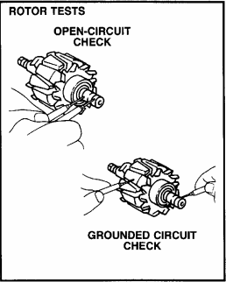
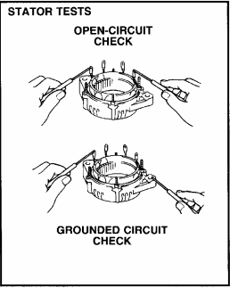

Figure 3.6. Alternator bench test.

Alternator repair procedure
During driving a vehicle alternator can damage the alternator shaft bearings and possibly the brushes and electronics inside the unit as well. Water can also cause corrosion that over time will damage the wiring and bearings inside the alternator.
Step 1: Before You Start, Purchase the Right Kit for Your Alternator. ...
Step 2: Safety First, Disconnect the Car Battery. ...
Step 3: Remove the Alternator. ...
Step 4: Remove the Rear Cover on the Alternator. ...
Step 5: Remove Old Regulator and Brushes, bearing Fit New Kit. ...
Step 6: Refit Rear Plastic Cover. ...
Step 7: Refit the Alternator.

Repair and Replace Charging systems and associated components
Begin the charging system tests with a visual inspection of the charge indicator or warning light on the instrument panel.
The charge warning light should illuminate during the key-on bulb check and engine start and then go out. If the light remains on, a problem in the charging system is indicated.
Perform a visual inspection of the belt, generator, and wiring. Inspect the battery and battery connections. Look for any aftermarket wiring and accessories, especially stereo systems. Improperly installed accessories can affect many aspects of the vehicle’s operation, including the charging system.
Repairing /replacing component
Alternator bearing, plate washer, brush, brush wire,
rectifier holder, regulator, diode… drive belt, battery ..
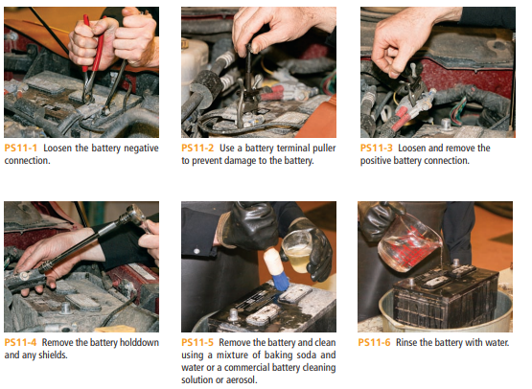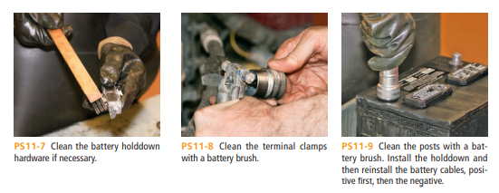
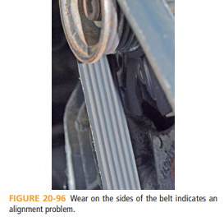

Figure 3.7 Repair and replace component.
- For inspection and testing the component/parts was damaged or not good condition repair or Replace carefully.

Reassemble Alternator and associated components
Physically compare the replacement alternator to the original. Compare the case and pulley offsets, pulley size and type, pivot and adjustment hole locations and wire connector locations or rear housing clocking with the original alternator.
- Install the mounting bracket (s). Do not completely tighten the bolts at this time.
- Support the alternator and fasten it into position. Do not completely tighten the bolts at this time.
- Install the drive belt(s). If the drive belt(s) was found to be worn, stretched, cracked, oily or glazed during the charging system inspection, replace the belt(s).
- Set the belt tension while tightening the mounting and adjusting bolts. Be sure to set the belt tension and torque the mounting bolts to the vehicle manufacturer’s recommended specifications.
CAUTION: DO NOT pry or hit the alternator housing to adjust belt tension.
- Check the drive belt alignment between the alternator pulley and drive pulley(s). Be sure
there is no interference between the drive belt(s) and other components.
- Re-connect the wire connector(s) to their proper location on the alternator. Be sure there is no interference between the wire harness and other components.
- Re-inspect that all components are correctly installed, all threaded fasteners properly torqued and there is no interference between components.
- Re-connect the battery negative cable.
- Start the engine and be sure there is no interference between components. Let the engine idle for 5 minutes to break-in the drive belt(s). Readjust the drive belt(s) using the “used” tension specification.
- Shut the engine off and re-inspect that all components are correctly installed, all fasteners properly torqued and there is no interference between components.
Re-test the charging system to verify it is performing to the vehicle manufacturer’s specifications.

Charging System Trouble shooting
- Charging system Faults, Symptom, Probable cause and Corrective action
For the faults listed below state a possible symptom, probable cause and a corrective action.
Table 3.1 charging system troubleshooting.
System Fault | Symptom | Probable cause | Corrective action
No low or high output | Battery cranks engine slowly. | Rectifier or regulator faulty.  Dirty connection. | Check alternator output and connections – replace regulator.
Overheating | Alternator is making unusual noise and is too hot to touch. | Output diodes short circuiting to earth. | Replace rectifier pack.
Abnormal noise | A squealing noise. | Drive belt slack or bearing dry. | Tighten or replace belt, lubricate or replace bearing.
Incorrect warning lamp operation | Light remains on or is intermittent.  Light not operating before starting. | Faulty diodes in rectifier pack. Bulb fault or . Brushes worn. Regulator faulty. | Check output and replace faulty component.

Self-Check 3

Instruction: Answer all the questions listed below, if you have some clarifications- feel free to ask your teacher.
1, In an alternator, alternating current is converted to direct current by the:
A. stator B. brushes
C. rectifier D. regulator
2. With the engine not running and the ignition ON, the charge lamp should light. If it
doesn't, this may indicate a:
A. burned out bulb B. grounded bulb
C. loose drive belt D. overcharged battery
3. To check for excessive voltage drop on the insulated side of the alternator's output circuit, you would connect a voltmeter between the:
A. battery terminal and ignition switch B. battery terminal and ground
C. battery terminal and alternator "S" terminal D. battery terminal and alternator "B" terminal 4. High resistance in an alternator output circuit is often caused by:
A. a discharged battery B. a shorted diode
C. loose or corroded connections D. a bad regulator
5. The amount of current the alternator must supply or ignition and accessories is
about: A. four amps B. six amps
C. eight amps D. ten amps
Test II: short Answer
Instruction: write short answer for the given question. You are provided 3 minutes for each question and each point has 5Points
1, what is the probable cause alternator is making unusual noise and is too hot to touch.
2, Light not operating before starting. Write the probable cause

Operation Sheet 3.1: Check Brush Measurement
- Operation Title: Check Brush Measurement
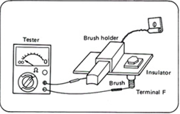
- Purpose: Diagnoses the brush length
- Instruction: Include these components in your inspection
- Tools and requirement: Vernier caliper, Multimeter
- Steps in doing the task: Check the components orderly.
1, measure the length of the brush projecting from the brush
Holder Using Vernier calipers.
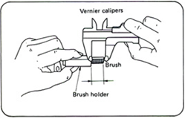
- Replace if the length is less than the limit.
- Check the continuity between the brush and terminal F.
- If the tester shows no continuity the brush holder is normal.
If continuity is indicated replace.

- Quality Criteria: The battery should be fully charged and connections kept clean and tight.
- Precautions: prepare precise measurement.
Operation Sheet 3.2. Alternator Output Test (No Load)
- Operation Title: Alternator Output Test (No Load)
- Purpose: Also perform this test completed to make sure that the alternator is operating correctly.
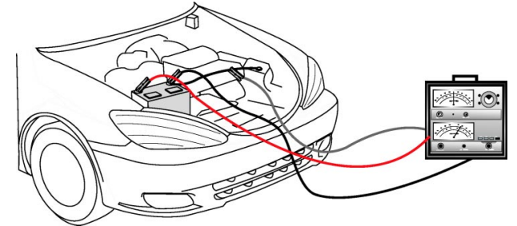
- Instruction: Use the following steps to perform the test with a Sun VAT-40 or VAT-60tester:
- Tools and equipment: Battery, ammeter,
- Steps in doing the task:
1, Set the tester’s Load control to OFF.
2, Connect the tester leads
- Red lead to positive terminal.
- Black lead to negative terminal.
- Clamp the ammeter clamp-on probe onto the battery’s ground cable.
3, Set the tester’s voltage range to the appropriate setting.
- Zero both meters on the tester, if needed.
- Turn the ignition switch to ON (do not start the engine).
- Record the ammeter reading.
- This is the discharge current (typically about 6 amps).
- Alternator must supply this amount of current before it can provide charging current to the battery.
- Start the engine and adjust engine speed to about 2,000 RPM.
- Allow engine to warm up for 3 to 4 minutes.
- Record the ammeter reading.
- Add the discharge current (from Step 4) to the reading now on the ammeter. The total should be less than 10 amps.
- The battery may not have been fully charged if the total current is more than 10 amps. Monitor the ammeter; the reading should decrease as the battery charges.
- Record the voltmeter reading.
- The voltmeter reading should be within specification for the alternator during the entire test. This value is typically between 13 and 15 volts refer to the appropriate service manual for the correct specification.
- If the voltmeter reading is higher than specified, the voltage regulator is probably defective. Replace the regulator if possible or replace the alternator.
- If the voltmeter reading is lower than specified, the cause could be a bad regulator or a fault in the alternator windings. Replace alternator if it has an internal voltage regulator.
- For alternators with externally mounted regulators, confirm the cause by grounding Terminal F on the alternator. This bypasses the regulator. If voltage increases, the voltage regulator is probably defective. If the voltage remains low, replace the alternator; there is a problem with the windings.
- Remove ground from alternator Terminal F.
- Quality Criteria: The battery should be fully charged and connections kept clean
and tight.
- Precautions: Check overall battery condition.

Operation Sheet 3.3. Alternator Output Test (with Load)
- Operation Title: Alternator Output Test (with Load)
- Purpose: Also perform this test completed to make sure that the alternator is operating correctly.
- Instruction: Use the following steps to perform the test with a Sun VAT-40 or VAT-60tester:
- Tools and equipment: Battery, ammeter, service manual.
- Steps in doing the task:
1, Keep the tester connections as for the alternator output test with no load.
2, Adjust engine speed to specified RPM (refer to the appropriate
service manual).
3, Adjust the tester’s load control to obtain the highest ammeter reading
possible while keeping the voltage reading at or above 12 volts.
- Record the highest ammeter reading.
- The reading should be within 10% of the alternator’s rated output.
- Replace the alternator if the reading is more than 10% below the value specified.
- Quality Criteria: The battery should be fully charged and connections kept clean
and tight.
- Precautions: Check overall battery condition.

Operation Sheet 3.4: Voltage Drop Test
- Operation Title: Voltage Drop Test.
- Purpose: Voltage drop tests can isolate unwanted high resistance in the charging
system.
- Instruction: Use a DMM to perform a voltage drop test on the positive side and ground side of the battery as follows.
- Tools and equipment: Battery, DMM, service manual.
- Steps in doing the task:
1. Connect the red meter lead to Terminal B on the alternator.
2. Connect the black meter lead to the positive battery terminal.
3. Start the engine; adjust engine speed to 2,000 RPM.
4. Note the voltage reading.
- The voltage drop should be less than 0.2 volts.
- If the reading is higher, look for poor connections at the alternator and at the battery. Also, look for damaged wires or corroded wires.
Test for voltage drop on the ground side of the battery as follows:
5. Keep the engine running at 2.000 RPM.
6. Connect the red meter lead to the negative (ground) battery
terminal.
7. Connect the black meter lead to the alternator frame.
Note the voltage reading.
- The voltage drop should be less than 0.2 volts.
- If the reading is higher, look for poor connections between the battery and ground and from the alternator frame to ground. Also, look for a damaged or corroded battery ground cable.
- Quality Criteria: The battery should be fully charged and connections kept clean
and tight.
- Precautions: Check overall battery condition.

Lap Test-1

- Task-1 Measure the brush
- Task-2 Perform Alternator Output Test (No Load).
- Task-3 Perform Alternator Output Test (with Load).
- Task-4 Perform Voltage Drop Test.

Unit Four: Cleanup work area and maintain equipment
This unit to provide you the necessary information regarding the following content coverage and topics:
  - Removing methods of waste and scrap
  - Cleaning and inspecting equipment and work area
This guide will also assist you to attain the learning outcomes stated in the cover page. Specifically, upon completion of this learning guide, you will be able to:
- Identify Removing methods of waste and scrap
- Apply Clean and Inspect equipment and work area

4.1. Removing methods of waste and scrap
Collect and store reused material
Automotive recycling industry is continuously implementing creative ways to reuse components, reduce waste and increase recycling rates from the process of manufacturing Separating wastes allows for easier recycling and may reduce disposal costs.
- Keep hazardous wastes separate, do not mix used oil solvents, and keep chlorinated solvents (like, tricolor ethane) separate from non-chlorinated solvents (like kerosene and mineral spirits)
- Promptly transfer used fluids to the proper waste or recycling drums. Don’t leave full drip pans or other open containers lying around.
- Provide cover and secondary containment until these materials can be removed from the site.
- Oil filters can be recycled. Ask your oil supplier or recycler about recycling oil filters.
- Do not dispose of extra paints and coatings by dumping liquid onto the ground or throwing it into dumpsters.
Allow coatings to dry or harden before disposal into covered dumpsters. Store cracked batteries in a non-leaking secondary container. Do this with all cracked batteries, even if you think all the acid.

has drained out. If you drop a battery, treat it as if it is cracked. Put it into the containment area until you are sure it is not leaking. Vehicles are through their end-of-life recycling
Recycling
Recycling, recovery and reprocessing of waste materials for use in new products.
Auto recyclers remove parts such as engines, transmissions, doors and bumpers for reuse in other vehicles. Other parts that can also be remanufactured include starters, alternators and water pumps.
Batteries, catalytic converters, tires and some plastics are removed and their materials are recycled into new products.
Fluids such as engine oil, coolant, and gasoline are carefully managed to prevent releases by storing them in double-walled tanks and/or secondary containment prior to being reused or recycled. The automotive recycling industry also saves energy, conserves natural resources, reduces air and water pollution and greenhouse gas (GHG) emissions, and recycles environmentally sensitive substances including lead, mercury, oil and unspent fuel. Using recycled scrap iron and steel reduces the use of virgin iron ore, among other environmental benefits. Every ton of new steel made from scrap steel conserves

Cleaning and inspecting equipment and work area
What is cleaning

Cleaning is the removal of all visible soil in an approved way with the use of mechanical and chemical action or both, so that all areas are cleaned and sanitized to a high standard. Cleaning is an investment in the assets of a building Maintenance is the upkeep of all body, seat interior and dashboard fittings and equipment to an exacting standard within the property so that all areas look consistently new and pristine
Whydoweclean?
There are many reasons why we clean but the most important ones are Health Regulations If your local government authority has health regulations regarding cleaning and sanitizing, then you must know these and follow their recommendations at all times. It is important when you are cleaning that you clean to a high standard that has been set for you by your supervisor or manager. Figure 4.1 cleaning of work area

Use dry clean, soft and stain free cloth for cleaning. If necessary, moisten the cloth with pure alcohol. Use no other liquids.
Kinds of Cleaning Solvents
Solutions are homogeneous mixture of two or more components. They can be gaseous, liquid or solid. Solvent is a component of a solution that dissolves solute and is usually present in large proportion or amount. Solvents usually used for cleaning in automotive shops are: water, gasoline, kerosene, thinner and detergent soap.
Safe work procedures
Safe work procedures are a means of briefly documenting the risks associated with a work task and incorporating appropriate controls into a sequence of steps for doing the task safely.
Maintain tools and equipment’s
- Inspect vehicles and equipment daily at startup for leaks, and repair immediately
- Keep vehicles and equipment clean; do not allow excessive build-up of oil and grease.
- Segregate and recycle wastes, such as greases, used oil or oil filters, antifreeze, cleaning solutions, automotive batteries, hydraulic and transmission fluids. Provide secondary containment and covers for these materials if stored onsite.
- Consider use of new, alternative greases and lubricants, such as adhesive greases, for chassis lubrication and fifth-wheel lubrication.
- Properly dispose of used oils, fluids, lubricants, and spill cleanup materials.
- Do not place used oil in a dumpster or pour into a storm drain or watercourse.
- Properly dispose of or recycle used batteries.

Self-Check -4

Directions: Answer all the questions listed below. Use the Answer sheet provided in the next page
  - Describe briefly how to collect and store material that can be reused in automotive industry?
  - Write the wastes and scrapes recycled in automotive industry?
  - What is cleaning and maintenance?
  - Write the Solvents for cleaning in automotive shops
  - Why do we clean the work area?
  - What is machinery tag out program?
  - What does it mean when we say maintain tools and equipment’s?

Referance

- An overview of automobile starting system faults and diagnosis method.
- Automotive mechanics 9th edition William H. cruse
- Automotive maintenance & light repair (2019) Rob Thompson
- http://www .auto shop 101
- http://www.autobahncollision.com/repair-process/final-inspection-and-vehicle-delivery.htm
- https://www.vehicleservicepros.com/in-the-bay/tools-equipment/article/10717421/shop-floor-maintenance-101-clean-as-you-go

Participants of this Module (training material) preparation

No | Name | Qualification (Level) | Field of Study | Organization/ Institution | Mobile number | E-mail
1 | Fadli Aman | BSc. B-Level | Automotive Technology | General Wingate PTC | 0927283100 | Fadli.ziyad@gmail.com
2 | Gashaw Zawudie | MSc. A-Level | Automotive Technology | AKPTC | 0910730747 | Gashawgashaw69@gmail.com
3 | Muna Gabreil | MSc. A-Level | Automotive Technology
4 | Sisay Dawit | MSc. A-Level | Automotive Technology | Harar PTC | 0910672115 | Sisaydawit058@gmail.com
5 | Yohannes Negatie | MSc. A-Level | Automotive Technology | W/ro Siheen PTC | 0922094453 | Yohannes2013n@ gmail.com

