Automotive Electrical and Electronic Level -II
Based on March 2022, Curriculum Version -1
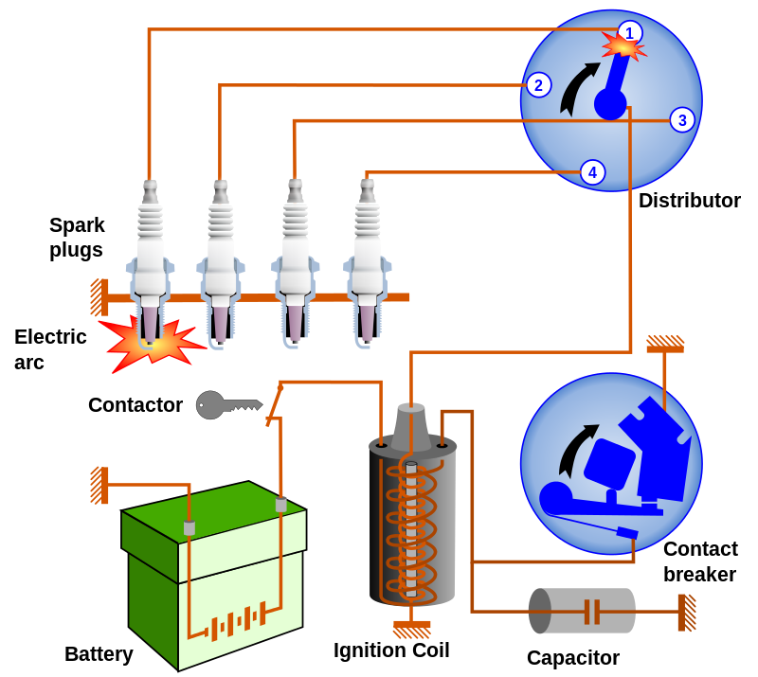

MODULE TITLE : Inspecting and Repairing Ignition System
MODULE CODE : EIS AEE2 M05 0322
NOMINAL DURATION : 35 Hours

Prepared by: Ministry of Labor and Skill

September, 2022
Addis Ababa, Ethiopia

ACKNOWLEDGEMENT
Ministry of Labor and Skills wish to extend thanks and appreciation to the many representatives of TVET instructors and respective industry experts who donated their time and expertise to the development of this Teaching, Training and Learning Materials (TTLM).

TABLE OF CONTENT
Contents
ACKNOWLEDGEMENT 2
TABLE OF CONTENT 3
Introduction to the module 4
Unit one: Overview of ignition system 5
1.1. Safety on ignition system 5
1.2. Purpose of ignition system 6
1.3. Components of conventional & magneto ignition system & its function 9
1.4. Working principle of ignition system 25
1.5. Tools & equipment’s 27
Self-check-1 28
Unit Two: Inspect & Test ignition system on vehicle 30
2.1. Testing & determine fault 30
2.2. Testing ignition system components 31
Operation Sheet-2-1 38
Operation sheet-2-2 39
LAP Test -2 40
Unit Three: Repairing ignition system /components 41
3.1. Perform replacement and adjustment of ignition systems/component 41
3.2. Retesting ignition system 46
Operation sheet-3-1 47
LAP Test -3-1 48
Unit Four: Adjusting ignition timing and dwell angle 49
4.1. Adjust Dwell angle and Contact point 49
4.2.Adjust ignition timing 52
Operation sheet-4-1 53
Operation sheet-4-2 54
LAP Test -4 55
Unit Five: Clean-up work area and maintain equipment 56
5.1. Collecting and storing Material 56
5.2. Removing waste and scrap 57
5.3. Make Cleaning and inspecting equipment and work area. 57
Self-Check - 5 58
Operation sheet-5 59
LAP Test -5 60
Reference 61

Introduction to the module
The ignition system supplies high - voltage sparks to the spark - plug in the engine cylinders. These high voltage sparks must be supplied at the exact instant they are needed. That is a spark must come along just as the piston nears TDC on the compression stroke. The spark then ignites the compressed air - fuel mixture.
This module identifies overview of ignition system trouble and perform testing. You will be performing activities to develop your skill in inspecting/testing ignition system on vehicle, inspecting/testing and replacing spark plugs, inspecting/replacing contact point condenser; testing/adjusting dwell angle and ignition setting, adjusting engine idle speed and mixture, checking advance mechanism and adjusting ignition timing.
This module covers the units:
- Overview of ignition system
- Inspecting & testing ignition system on vehicle
- Repairing ignition system /component
- Adjusting ignition timing & dwell angle
- Clean up work area & Equipment
Learning Objective of the Module
- Understand Overview of ignition system
- Perform Inspect & test ignition system on vehicle
- Carry out Repair on ignition system /component
- Perform Adjustment on ignition timing & dwell angle
- Make Clean-up work area & Equipment
Module Instruction
For effectively use this modules trainee are expected to follow the following module instruction:
- Read the information written in each unit
- Accomplish the Self-checks at the end of each unit
- Perform Operation Sheets which were provided at the end of units
- Do the “LAP test” giver at the end of each unit and
- Read the identified reference book for Examples and exercise

Unit one: Overview of ignition system
This unit is developed to provide you the necessary information regarding the following content coverage and topics:
  - Safety on ignition system
  - Purpose of ignition system
  - Components of conventional & magneto ignition system & its function
  - Working principle of ignition system
  - Tools & equipment’s
This unit will also assist you to attain the learning outcomes stated in the cover page. Specifically, upon completion of this learning guide, you will be able to:
  - Apply safety on ignition system
  - Explain & discuss the purpose of ignition system
  - Explain & identify the components of conventional & magneto ignition system & its function
  - Understand working principle of ignition system
  - Select & use tools & equipment’s

1.1. Safety on ignition system
- Always wear OSHA-approved safety glasses when working on any ignition system.
- When working on any ignition system when the engine is running, always keep your hands away from the spark plug wires. In addition, be careful not to drop any tools into the fan or pulleys on the front of the engine.
- Never use your hands to pull high-tension wires off the spark plugs when the engine is running. Use the correct spark plug wire pliers to remove a spark plug wire.
- When replacing parts or doing other work on the ignition system, always make sure the ignition system is off. If it is left on, a spark may be produced, causing gasoline fumes to ignite.
- Always use the correct tools when working on electronic and computerized ignition systems.
- When removing spark plug wires from any ignition system, be careful of the hot exhaust manifolds or the headers. Make sure the engine has cooled down before removing wires and spark plugs.
- If you are using a volt/ohmmeter to check resistances on an ignition system, make sure the circuit has been disconnected and the ignition system is off.
- When testing any ignition system, always follow the manufacturer’s suggested diagnosis and service procedure.
Much of your work on an automobile will be around or with the vehicle’s electrical system. To prevent personal injury or damage to the vehicle, you should always take the necessary precautions before working. When possible, you should disconnect the vehicle’s battery before disconnecting any electrical wire or component. This prevents the possibility of a fire or electrical shock. It also eliminates the possibility of an accidental short, which can ruin the car’s electrical system. Disconnect the negative or ground cable first, then disconnect the positive cable. Because electrical circuits require a ground to be complete, by removing the ground cable you eliminate the possibility of a circuit accidentally becoming completed. When reconnecting the battery, connect the positive cable first, then the negative.
Also, remove wristwatches and rings before servicing any part of the electrical system. This helps prevent the possibility of electrical arcing and burns.
When disconnecting electrical connector do not pull on the wires. When reconnecting the connectors, make sure they are securely connected.

1.2. Purpose of ignition system
- Produces the high voltage surges (up to 50,000 volt) spark across spark plug to ignite the compressed air fuel mixture in the engine combustion chamber
- Distributes high voltage to each spark plug in correct sequence
- Times the spark so it occurs as piston is nearing top dead center
- Varies spark timing with load, speed, and other conditions.
The ignition system is supplied a 12 volt or less battery voltage or charging system voltage and increases to 10,000 to 30,000 volts required to create a spark across the spark plug electrodes in the combustion chamber.
Requirements of the ignition system
a). A strong spark
The voltage that is supplied to the plugs must be high enough to ensure the generation of the powerful spark across the spark plug gaps. This is because the compressed air fuel mixture has electrical resistance.
b). Proper ignition timing
To obtain optimal combustion of the air fuel mixture, there must be means of varying ignition timing in accordance with the engine RPM and load.
c). Sufficient durability
The ignition must have sufficient reliability to endure the vibration and heat of combustion and high voltage of the ignition system itself

    - Types of ignition system
Currently, we recognize four types of ignition systems used in most cars and trucks: conventional breaker-point ignitions, high energy (electronic) ignitions,
distributor-less (waste spark) ignition and coil-on-plug ignitions.
1.Conventional Breaker-Point Ignition System
This is the oldest types of igntion system & has been used since the early days of the automobile ,especailly through the 1970s.The mechanical nature of these igntion system ,as well as the length of time these systems have been used ,they are relatively easy to diagnosis & repair.However ,they do incoroprate a large number of moving parts increasing potential for breaking.
Basically Convectional Ignition systems are of 2 types :
(a) Battery or Coil Ignition System, and
(b) Magneto Ignition System.
(a) Battery or Coil Ignition System

Figure 1.1a Battery or Coil Ignition System

(b) Magneto Ignition System.
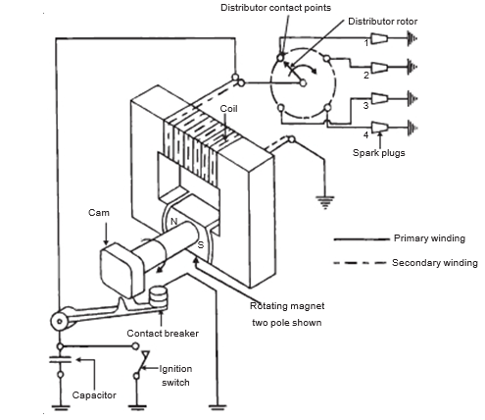
Figure 1.1b Magneto Ignition System.
2. High Energy (Electronic) Ignition System
This system replaces the breaker points & condensor with a transistorized switch within an ignition module that also handles the task of triggering the igntion coil to generate high-voltage current.This can prove advantages ,as the use of this electronic switch means there are fewer moving parts than in a breaker -point ignition system while still being relatively easy to diagnosis & repair,this can also provide a consistent ,high voltage spark through out the life of engine meaning fewer misfires.
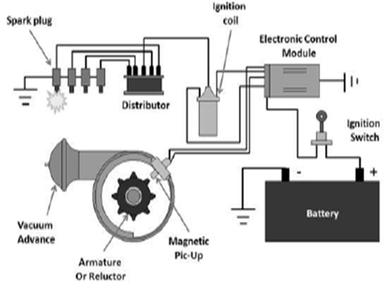
Figure 1.2 High Energy (Electronic) Ignition System
3. Distributor-less (Waste Spark) Ignition System
Multiple ignition coil are used for each pair of cylinders.Using engine sensors to determine crankshaft position & camshaft position.an electronic control unit triggers the appropriate igntion coil & directs the distributor of electrical current to the spark plugs.
This system also uses a “waste spark” for one of the pair cylinders,pairing two pistons that will beat the top dead center at the same time one at the end of its compression stroke & the other at end of exhaust stroke.
Each of the spark plugs in these cylinders wii fire at the same time using the high voltage from one coil.
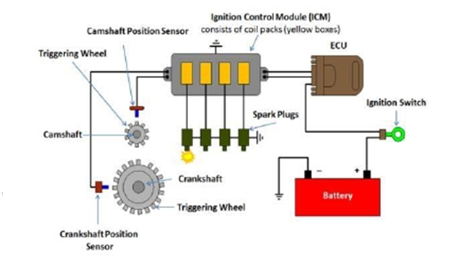
Figure 1.3 Distributor-less (Waste Spark) Ignition System
4. Coil-On-Plug (Direct) Ignition System
The most sophisticated of all ignition systems, these systems an ignition coil directly on the top of each spark plug & is ideal for modern engines. All of the ignition timing is handled by the engine control unit, based on input from various sensors

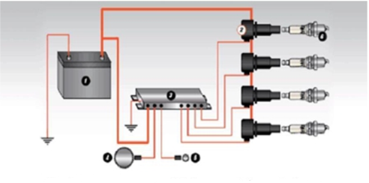
Figure 1.4 Coil-On-Plug (Direct) Ignition System

1.3. Components of conventional & magneto ignition system & its function
A. Depending on the exact type of ignition system, the main parts of magneto ignitions system include the following:
- Transformer core
- Ignition switch
- Capacitor
- Contact breaker
- Cam
- Spark plugs
- Distributor rotor
- Distributor contact point
Basic operation/function of components in magnetos ignitions systems
Transformer core-The main part of the Magneto ignition system is the Transformer Core which consists of two types of windings. One is the Primary winding and the other is the Secondary winding. The primary winding is also called the low-tension winding and the Secondary winding is called the high-tension winding.
There are two types of winding we can see in Magneto Ignition System, those are:
Primary Winding: The main function of this winding is to draw the power from the source.
One end of the primary winding is grounded and the other end is connected with the link, contact breaker and the capacitor.
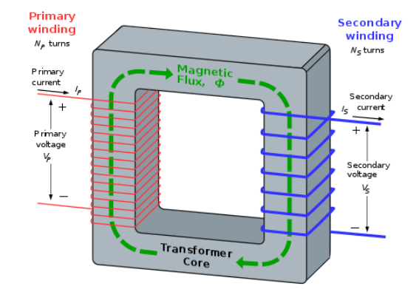
Figure 1. 5 Transformer core
Secondary Winding: This winding has more turns of wire (the number is 1000 of turns of wire) as compared to the primary winding. This is connected to the Distributor (Which is having a rotor).
Ignition switch- It is placed parallel to the capacitor to avoid excessive power passing through it. [If you have seen, the ignition switch is in series in battery ignition system whereas here, it is in parallel]. Works for off and on the vehicles and this is set to the parallel of the capacitor because it helps to avoid the damage of excessive air. One end of the ignition switch is in contact with the capacitor and the other end is grounded which is generally used to ON/OFF the engine by means of a key.
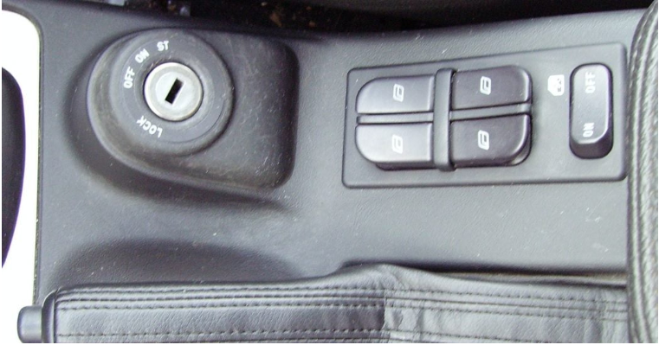
Figure 1 .6 Ignition switch
Capacitor- The main work of the capacitor is to Store the charger. The capacitor is used here is a simple electric capacitor. One end is connected with the primary winding and the other end is grounded and it is generally used to store the charge coming from the primary winding.
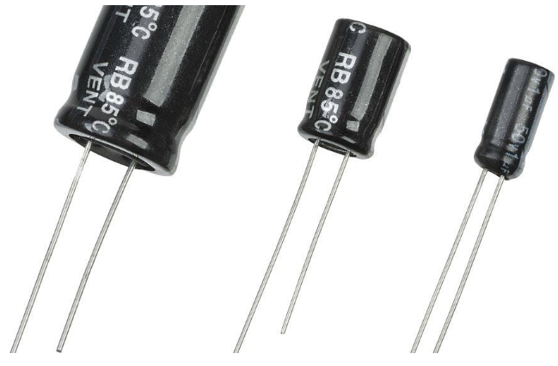
Figure 1. 7 Capacitor
Contact breaker- The contact breaker is regulated by the cam and when the breaker is open, current flows through the capacitor and charges it. The upper contact is grounded and the lower contact point is connected with the link. It is generally used for making and breaking of Primary circuit. The pivoted arm(link) has a heel attached in the middle which breaks the contact point due to the action of a cam (which is driven by the engine)
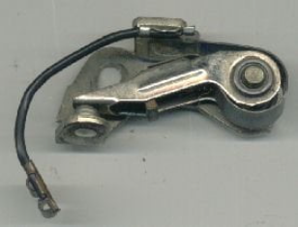
Figure 1.8 Contact breaker
Cam- One end of the shaft is connected with the cam and the other end is connected with the magnet which has two poles, North and South.
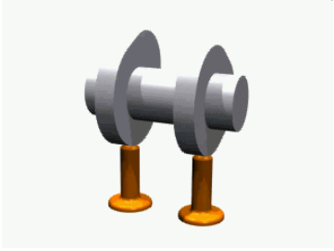

Figure 1. 9 Cam
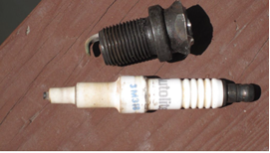
Spark plugs- The main work of the spark plug is firing the explosive mixture in the IC engine. It is the last component of the Magneto Ignition System. It consists of 2 electrodes, one attached to the high-tension current-carrying wires and the other is grounded. which ignites the combustible mixture.

Figure 1.3 – 10 Spark plug

Distributor rotor- A distributor is provided for distributing the ignition surges to individual spark plugs in the correct sequence with respect to the firing order. It consists of the rotor in the middle and the metallic electrode on the periphery. These metallic electrodes are directly connected to the spark plugs and are also known as Ignition harness.
As the rotor rotates, it passes the high-tension current to the ignition harness which then carried these high-tension currents to the spark plugs.
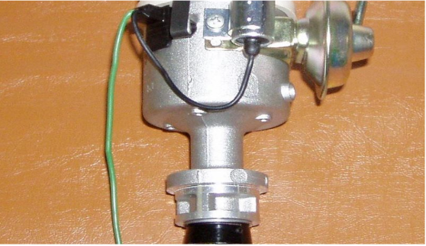
Figure 1.11 Distributor rotor
B. Depending on the exact type of ignition system, components in conventional breaker-point ignitions include the following:
- Battery
- Ignition switch
- Ballast resistor or resistance wire (some systems)
- Ignition coil primary winding
- Ignition coil secondary winding
- Distributor cap and rotor (some systems)
- High-voltage cables (some systems)
- Spark plug
Basic operation/function of components in conventional breaker-point ignitions system
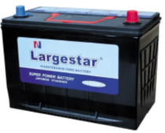
BATTERY-supplies current to starter in order to crank the engine for operation. It also supplies the required electric current to the ignition system.

Figure 1.12 Battery
IGNITION SWITCH- The ignition switch connects the ignition coil to the battery when the ignition key is ON. When the key is turned to START, the starting motor cranks the engine for starting or Your ignition switch does at least three things:
- It turns on the car's electrical system so that all accessories can be operated.
- It turns on the entire primary ignition system.
- It energizes the starter.
Most automotive ignition switches incorporate four positions, which are as follows:
OFF- The OFF position shuts off the electrical system. Systems, such as the headlights, are usually not wired through the ignition switch and will continue to operate.
ACCESSORY-The ACCESSORY position turns on power to the entire vehicle electrical system with the exception of the ignition circuit.
IGNITION ON- The IGNITION-ON position turns on the entire electrical system including the ignition circuit.
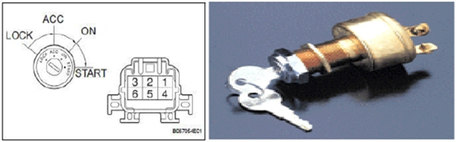
START- The START position will energize the starter solenoid circuit to-crank the engine. The START position is spring-loaded to return to the IGNITION-ON position when the key is released automatically.
Figure 1. 13 Ignition swich
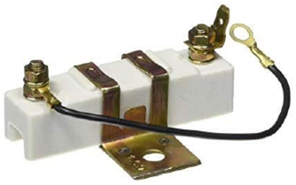
Ignition Resistor - a resistor connected into the ignition primary circuit to reduce battery voltage to the coil during engine operation. But in Electronic ignition systems where breaker points were not utilized, ballast resistor therefore is not actually needed.

Figure 1.14 Ignition Resistor
Ignition Coil - the ignition system component that set as a transformer to step up(increase) the battery voltage into many thousands of volts. An ignition coil consists of a laminated iron core surrounded by two coils of copper wire. The primary winding has relatively few turns of heavy wire. The secondary winding consists of thousands of turns of smaller wire, insulated from the high voltage by enamel on the wires and layers of oiled paper insulation.
Has essential components
- Primary winding
- Secondary winding
- Laminated iron core
- Electrical connection
The two main sections of an ignition system coil are:
Primary winding operation
When the ignition switch is on, current from the battery flows through the ignition switch and primary circuit resistor to the primary winding of the ignition coil. From there it passes through some type of switching device and back to ground. The current flow through the ignition coil’s primary winding creates a magnetic field. As the current continues to flow, the magnetic field gets stronger. When the triggering device signals to the switching unit that the piston is approaching TDC on the compression stroke, current flow is stopped. This causes the magnetic field around the primary winding to collapse across the secondary winding. The movement of the magnetic field across the winding induces a high voltage in the secondary winding.
The action of the secondary circuit begins at this point. Some older ignition systems had a ballast resistor or resistance wire connected between the ignition switch and the positive terminal of the coil. This resistor limited the voltage and current to the coil. Today, ignition systems do not use a resistor, and voltage to the coil is controlled by the PCM.
Secondary winding Operation
The secondary circuit carries high voltage to the spark plugs. The exact manner in which the secondary circuit delivers these high-voltage surges depends on the system. Until 1984 all ignition systems used some type of distributor to accomplish this job. However, in an effort to reduce emissions, improve fuel economy, and boost component reliability, most auto manufacturers are now using distributor-less or electronic ignition (EI) system
To generate a spark to begin combustion, the ignition system must deliver high voltage to the spark plugs. Because the amount of voltage required to bridge the gap of the spark plug varies with the operating conditions, most late-model vehicles can easily supply30,000 to 60,000 volts to force a spark across the air gap. Since the battery delivers 12 volts, a method of stepping up the voltage must be used. Multiplying battery voltage is the job of a coil.
The ignition coil is a pulse transformer that transforms battery voltage into short bursts of high voltage. As explained previously, when a magnetic field moves across a wire, voltage is induced in the wire.
If a wire is bent into loops forming a coil and a magnetic field is passed through the coil, an equal amount of voltage is generated in each loop of wire. The more loops of wire in the coil, the greater the total voltage induced. If the speed of the magnetic field is doubled, the voltage output doubles.
An ignition coil uses these principles and has two coils of wire wrapped around an iron core. An iron or steel core is used because it has low inductive reluctance. In other words, iron freely expands or strengthens the magnetic field around the windings. The first, or primary, coil is normally composed of 100 to 200 turns of 20-gauge wire. This coil of wire conducts battery current. When a current is passing through the primary coil, it magnetizes the iron core. The strength of the magnet depends directly on the number of wire loops and the amount of current flowing through those loops. The secondary coil of wires may consist of 15,000 to 25,000, or more, turns of very fine copper wire.
Because of the effects of counter EMF on the current flowing through the primary winding, it takes some time for the coil to become fully magnetized or saturated. Therefore, current flows in the primary winding for some time between firings of the spark plugs. The period of time during which there is primary current flow is often called dwell. The length of the dwell period is important.
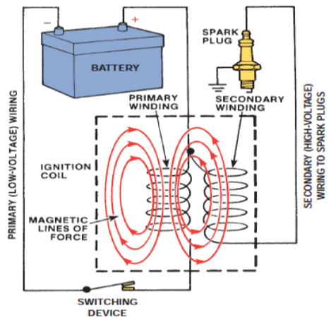
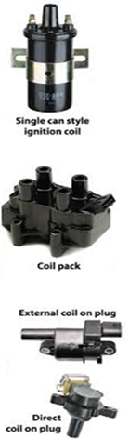
When current flows through a conductor, it will immediately reach its maximum value as allowed by the resistance in the circuit. If a conductor is wound into a coil, maximum current will not be immediately achieved. As the magnetic field begins to form as the current begins to flow, the magnetic lines of force of one part of the winding pass over another part of the winding. This tends to cause an opposition to current flow. This occurrence is called reactance. Reactance causes a temporary resistance to current flow and delays the flow of current from reaching its maximum value. When maximum current flow is present in a winding, the winding is said to be saturated and the strength of its magnetic field will also be at a maximum.

Figure 1.15 Ignition Coil
Current passing through the coil’s primary winding creates magnetic lines of force that cut across and induce voltage in the secondary windings. Saturation can only occur if the dwell period is long enough to allow for maximum current flow through the primary windings. A less-than-saturated coil will not be able to produce the voltage it was designed to produce.
If the energy from the coil is too low, the spark plugs may not fire long enough or may not fire at all. If the current is applied longer than needed to fully saturate the winding, the coil will overheat.
A typical coil requires 2 to 6 milliseconds to become saturated. The actual required time depends on the resistance of the coil’s primary winding and the voltage applied to it. Some early systems electronically limit the primary current flow at low speeds to prevent the coil from overheating. When the engine reaches higher speeds, the current limitation feature is disabled. When the primary coil circuit is suddenly opened, the magnetic field instantly collapses. The sudden collapsing of the magnetic field produces a very high voltage in the secondary windings. This high voltage is used to push current across the gap of the spark plug.
Distributor Assembly- The ignition distributor does two jobs. First, it has a set of contact points or breaker points that work as a fast-acting switch. When the points close, current flows through the coil. When the points open, current flow stops and the coil produce a high-voltage surge.
A condenser connects across the points. It aids in the collapse of the magnetic field and helps reduce arcing that bums away the points.
Second, the distributor distributes the high-voltage surges to the spark plugs in the correct firing order. A coil wire delivers the high voltage from the coil to the center terminal of the distributor cap. Inside the cap, a rotor is on top of the distributor shaft. In most contact-point distributors, the distributor shaft is driven from the engine camshaft by a pair of spiral gears. The rotor has a metal blade. One end of the blade contacts the center terminal of the distributor cap.
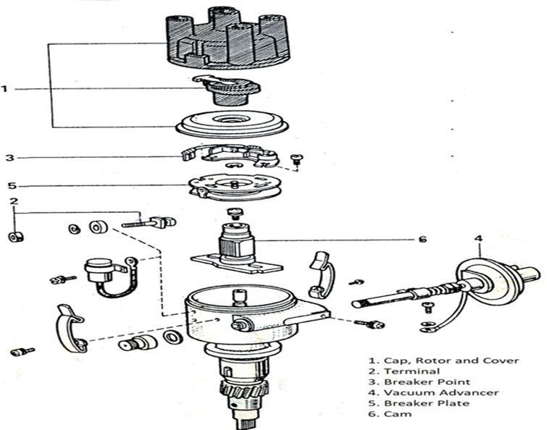
Figure 1.16 Distributor Assembly
BASIC PARTS OF A DISTRIBUTOR
a. Distributor Cap
It is a cover which protects the internal parts of the distributor. It has one post for each cylinder and in contact points types ignition system it also has one central post which is connected to the ignition coil to receive the current from it.
b. Rotor
The rotor is present at the top of the distributor shaft. It is driven by the camshaft of engine and hence synchronized to it. The rotating parts of the distributor assembly that distributes high voltage from coil center cable to different spark plug.

C. Contact Breaker/ Contact Point
It is mechanically designed breaker point. It’s one end is fixed and another end is movable. It is attached to the breaker assembly. Its main function is to makes and breaks the primary circuit current. The contact-point set mounts on a breaker plate in the distributor. The points are operated by a breaker cam on top of the distributor shaft.
The cam has the same number of lobes as there are cylinders in the engine. As the cam revolves, the points close and open, they act as a mechanical switch to make and break the primary circuit.
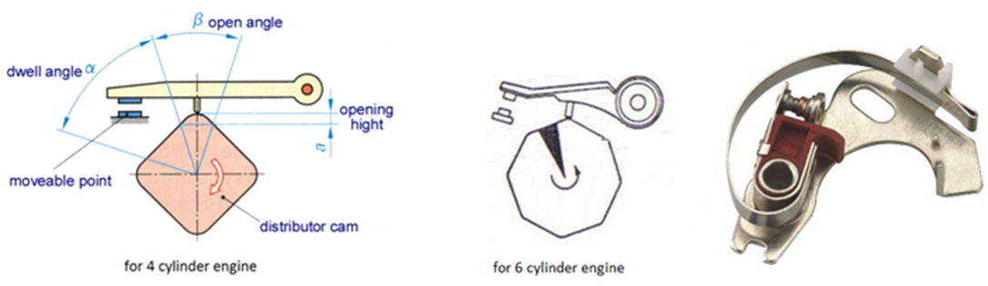
One contact point mounts on the grounded breaker plate and is stationary. The other point mounts on the end of an insulated movable arm. The arm swings back and forth on a pivot as the cam lobes push on the rubbing block to open the points. A spring attached to the movable point arm closes the points.

Figure 1.17 Contact Breaker/ Contact Point
When the points close, this connects the coil primary winding to the battery. A magnetic field builds up in the coil. As the breaker cam rotates, the next lobe pushes the movable arm away from the stationary contact point. This opens the points and stops the current flow. The magnetic field collapses and a high-voltage surge result. The length of time in degrees of distributor-shaft rotation that the contact points remained closed is the dwell. The distance that separates the points when they are fully open is the gap. Points are normally adjusted by dwell or gap measurements.
The distributor shaft and cam are driven by the engine camshaft which turns at one-half crankshaft speed. It takes two complete revolutions of the crankshaft to rotate the distributor shaft one complete revolution. The relationship between piston position and spark-plug firing is ignition timing.
Dwell - is the length of time the points are closed and current flows through the primary winding of the coil. The points open and the cycle begin again at as the spark occurs at the spark plug. The whole procedure repeats continuously as long as the engine runs.
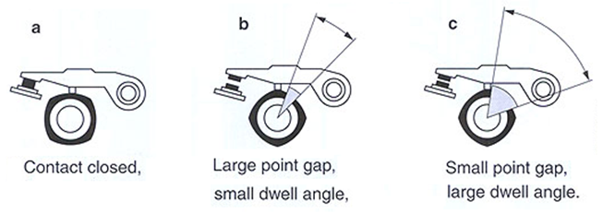
Figure 1.18 Dwell
d. Distributor Shaft
It is a shaft which lies in the middle of the ignition distributor. It is connected directly to the camshaft of the engine through a gear drive. It consists of a cam which is used to break the point of the contact breaker.
e. Cam
It is attached to the distributor shaft and rotates with it. It has lobes which are used to open the contact breaker point. The number of lobes is equal to the number of engine cylinder. As the cam rotates, it pushes the cam follower and the breaker points moves apart leads to breaking of current.
f. Capacitor/Condenser
It is used to prevent the overheating of the contact point of the contact breaker. It helps in production of high voltage current by reverse the current flow through the primary coil. Condenser connected across the contact point to prevent arcing and burning. It also provides the storage of electricity when breaker point is open.
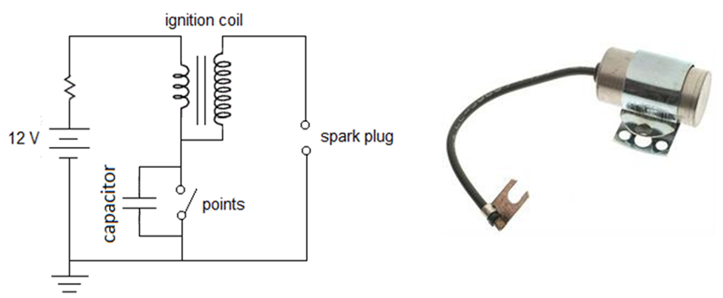
Figure 1.19 Capacitor/Condense
g. Spark Advance Mechanism
It is a mechanism which is used to advance the spark in the spark ignition engine. We have generally two types spark advance mechanism and i.e., centrifugal advance spark and vacuum spark advance mechanism.
When the engine is idling, the spark is timed to reach the spark plug just before the piston reaches TDC on the compression stroke. At higher speeds, the spark must occur earlier. If it does not, the piston will be past TDC and moving down on the power stroke before combustion pressure reaches its maximum. The piston is ahead of the pressure rise which results in a weak power stroke. This wastes much of the energy in the fuel.
To better use the energy in the fuel, the spark takes place earlier as engine speed increases. This spark advance causes the mixture to bum producing maximum pressure just as the piston moves through TDC. Most contact-point distributors have two mechanisms to control spark advance. A centrifugal-advance mechanism adjusts the spark based on the engine speed. A vacuum advance mechanism adjusts the spark based on engine load. On the engine, both works together to provide the proper spark advance for the engine operating conditions.
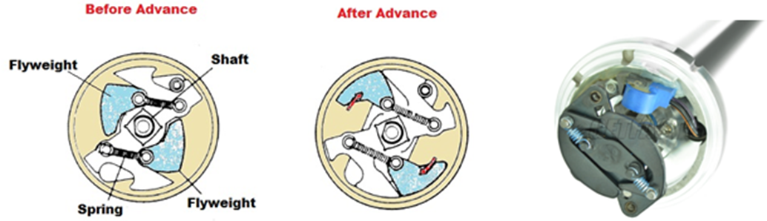
1.CENTRIFUGAL ADVANCE - The centrifugal-advance mechanism advances the spark by pushing the breaker cam ahead as engine speed increases. Two advance weights, two weight springs, and a cam assembly provide this action. The cam assembly includes the breaker cam and an oval-shaped advance cam. At low speed, the springs hold the weights in. As engine speed increases, centrifugal force causes the weights to overcome the spring force and pivot outward. This pushes the cam assembly ahead. The contact points open and close earlier and advancing the spark.

Figure 1.20 centrifugal advance
2.VACUUM ADVANCE
When the throttle valve is only partly open, a partial vacuum develops in the intake manifold. Less air-fuel mixture gets into the engine cylinders. Then the fuel bums slower after it is ignited. The spark must be advanced at part throttle to give the mixture more time to burn. The vacuum-advance mechanism advances spark timing by shifting the position of the breaker plate. The vacuum-advance unit has a diaphragm linked to the breaker plate. A vacuum passage connects the diaphragm to a port just above the closed throttle valve. When the throttle valve moves past the vacuum port, the intake-manifold vacuum pulls on the diaphragm. This rotates the breaker plate so the contact points open and close earlier. Any vacuum port above the throttle valve provides ported vacuum.
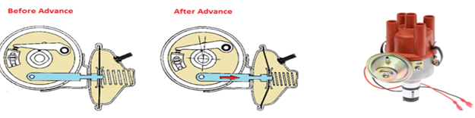
Figure 1. 21 Vacuum advance
COMBINED CENTRIFUGAL AND VACUUM ADVANCE
At any speed above idle, there is some centrifugal advance. Depending on intake-manifold vacuum, there may also be some vacuum advance. For example; at 40 miles per hour (64 km/h), there are 15 degrees of centrifugal advance and the vacuum advance can produce up to 15 degrees of additional advance at part throttle. The advances combine to produce a maximum advance of 30 (15 + 15) degrees. When the engine runs at wide-open throttle, intake manifold vacuum drops to zero. There is no vacuum advance.
Secondary ignition cable/High tension cable - The secondary cables or wiring include the coil wire and the spark-plug wires. These cables connect between the center of the ignition coil and the distributor cap, and between the distributor cap and the spark plugs. Secondary cables for contact-point ignition systems have a 7 mm (0.276 inch) diameter. Many electronic ignition systems require 8 mm (0.315 inch) cables. The use of a silicone insulating jacket makes these cables larger
Coil Cable- a cable that connects the ignition coil secondary or high output terminal and the distributor cap center post/terminal.
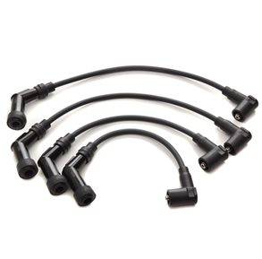
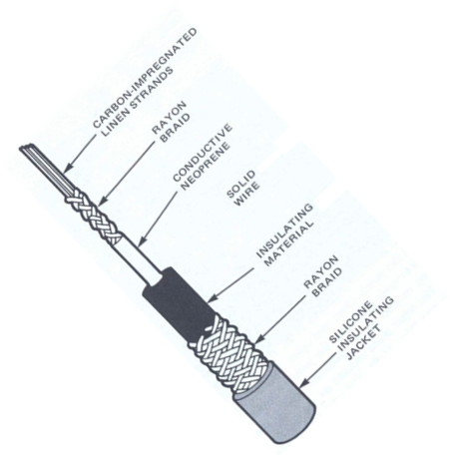
Sparkplug cables- passage of high voltage from the distributor cap to the sparkplugs.
Figure 1.22 Secondary ignition cable/High tension cable
Spark Plug - The spark plug has a metal outer shell enclosing a ceramic insulator. Centered in the insulator is the center electrode which carries the high-voltage current from the ignition coil. A ground electrode attaches to the metal shell and is bent inward to produce the proper spark gap. The gap varies from 0.035 inch [0.9 mm] for contact point ignition systems to 0.080 inch (2.03 mm) for some electronic ignition systems. The spark jumps from the center electrode to the ground electrode. The wider the gap, the higher the voltage required to jump it.
Spark plugs may have a suppressor or resistance (normally about 5 K ohms) built into the center
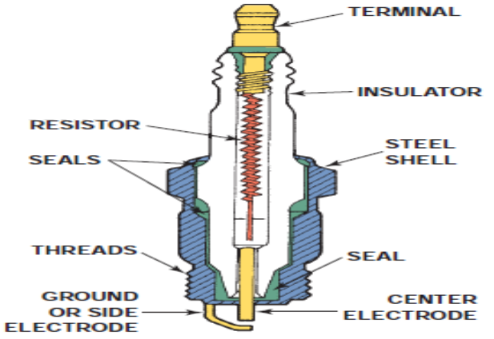
electrode. It reduces television and radio interference (static) caused by the ignition system. Spark plugs may require gaskets when installed to assure a leak-proof seal. Many engines use spark plugs with tapered seats which seal without a gasket.

Figure 1.23 Spark Plug
Some engines have two spark plugs in each combustion chamber. Both plugs may fire together or one slightly ahead of the other. The additional plugs help reduce exhaust emissions and increase engine power.
SPARK·PLUG HEAT RANGE AND REACH
One important design characteristic of sparkplugs is the reach . This refers to the length of the shell from the contact surface at the seat to the bottom of the shell, including both threaded and non-threaded sections. Reach is crucial because the plug’s air gap must be properly placed in the combustion chamber to produce the correct amount of heat.
Spark plug reach: long versus short and heat range: hot versus cold.
When a plug’s reach is too short, its electrodes are in apocket and the arc is not able to adequately ignite the mixture. If the reach is too long, the exposed plug threads can get so hot they will ignite the air-fuel mixture at the wrong time and cause pre-ignition. Pre-ignitionis a term used to describe abnormal combustion, which is caused by something other than the heat of the spark.
Automotive spark plugs are available with a threaddiameter of 12 mm, 14 mm, and 18 mm. The 18-mm spark plugs are mostly found on older engines and have a tapered seat that seals, when tightened properly, into a tapered seat in the cylinder head. The 12-mm and 14-mm plugs can have a tapered seat or a flat seat that relies on a thin steel gasket to seal in its bore in the cylinder head. All spark plugs have a hex-shaped outer shell that accommodates a socket wrench for installation and removal.
Electrode Designs - Spark plugs are available with manydifferent shapes and numbers of electrodes. When trying to ascertain the advantages of each design, remember the spark is caused by electrons moving across an air gap. The electrons will always jump in the direction of the least electrical resistance.
Therefore, if there arefour ground electrodes to choose from, the electronswill jump to the closest. Also, keep in mind that the quality and pressure of the air in the air gap influences the resistance of the air gap. Again, the electrons will jump across the path of least resistance. Therefore, spark plugs with four ground electrodes do not typically supply a spark to all four electrodes .
The shape of the ground electrode may also be altered. A flat, conventional electrode tends to crush the spark, and the overall volume of the flame front is smaller. A tapered ground electrode increases flame front expansion and reduces the heat lost to the electrode.
One brand of spark plug has a V-shaped ground electrode. This style of electrode does not block the flame front and allows it to travel upward through the V notch into the combustion chamber. These spark plugs may be equipped with three separate points of platinum, one ateach end of the V and the other at the center electrode.
a) spark plug with four ground electrodes, b)spark plug has a small diameter Iridium center electrode and a grooved ground electrode.
There are also different center electrode designs. These variations are based on the diameter and shape of the electrode. A small diameter center electrode requires less firing voltage and tends to have a longer service life. Some center electrodes are tapered.
Spark Plug Gaps
The correct spark plug air gap isessential for achieving optimum engine performance and long plug life. A gap that is too wide requires higher voltage to jump the gap. If the required voltage is greater than what is available, the result is misfiring. Misfiring results from the inability of the ignition to jump the gap or maintain the spark. A gap that is too narrow requires lower voltages and can lead to rough idle and prematurely burned electrodes, due to higher current flow.

Table 1.1Igntion system trouble shouting chart
SYMPTOM-Engine cranks normally but will not start and run
Possible Cause  Open or grounded primary circuit  Coil shorted or grounded  Points burned or not opening  Wrong basic ignition timing  Fouled spark plugs  Secondary voltage leak | Correction  Check all primary wiring and connections. Inspect and test the coil, condenser, breaker points, and ignition switch,  Test and replace the coil  Adjust or replace the points. Check voltage and current.  Adjust the timing  Replace the spark plugs  Inspect the coil, distributor cap and rotor, and spark plug cables, replace as necessary
SYMPTOM-Engine runs, but one-cylinder misfires
Possible Cause  Bad spark plug  Bad distributor cap terminal  Loose or bad spark plug cable | Correction  Locate and replace the bad plug  Replace the distributor cap  Tighten or replace the cable
SYMPTOM-Engine runs, but various cylinders misfire
Possible Cause  Breaker points are dirty, worn, or out of adjustment  Bad condenser  Intermittent open or short circuit in ignition coil  Spark advance mechanisms not working properly  Leaking secondary wiring or distributor cap  Intermittent open circuit or high resistance in primary wiring or connections  Fouled spark plugs | Correction  Clean and adjust or replace the points  Test and replace the condenser.  Test and replace the coil if necessary.  Test and repair the spark advance devices.  Inspect, test, and replace spark plug cables and cap as necessary  Inspect, test, and repair primary wiring and connections  Replace spark plugs and correct the fouling problem

SYMPTOM-Engine backfires
Possible Cause  Incorrect timing or spark advance  Wrong spark plugs heat range  Ignition crossfire |  | Correction  Test and adjust timing and advance as necessary  Install correct plugs.  Check the routing of spark plug cables Inspect the cables for leakage
SYMPTOM-Engine knocks or pings
Possible Cause  Incorrect timing or spark advance  Wrong spark plugs heat range  Breaker points out of adjustment  Low-octane gasoline | Correction  Test and adjust timing advance as necessary  Install correct plugs.  Adjust or replace the points  Use higher-octane gasoline.
SYMPTOM-Engine has low power and poor performance
Possible Cause  Incorrect timing or spark advance  Breaker points out of adjustment |  |  | Correction  Test and adjust timing and advance as necessary  Adjust or replace the points
SYMPTOM-Breaker points burn or oxidize
Possible Cause  High charging system voltage  Long dwell angle  High resistance in the condenser  Weak point spring tension  Oil vapor collecting on the points due to over lubricated distributor or high crankcase pressure |  |  | Correction  Test and repair the charging system  Adjust the dwell  Test and replace the condenser  Replace points and check spring tension.  Clean the distributor and service the PCV system.

1.4. Working principle of ignition system
A. Magneto Ignition System:
When the engine starts, the cam rotates which also rotates the magnet connected on the other end of the shaft. When the magnet rotates from North to South, the magnetic flux is generated which can travel in the direction from north to south and because of this flux, the current will be produced in the primary winding.
In the Magneto Ignition System, magneto is used. When the engine of the system starts, it helps the magneto to rotate and thus it’s producing the energy in the form of high voltage then, one end of the magneto is grounded through a contact breaker, and the ignition capacitor is connected to its parallel. The contact breaker is regulated by the cam and when the breaker is open, current flows through the capacitor and charges it. Now the capacitor is acting as a charger now, the primary current flow is reduced, thus reducing the overall magnetic field, generated in the system.
This increases the voltage in the capacitor. This increased high voltage in the capacitor will act as an EMF thus producing the spark, at the right spark plug through the distributor. And at the starting stage, the speed of the engine is low and hence the voltage generated by the magneto is low. But as the rotating speed of the engine increases, it also increases the voltage generated by the magneto thus the flow of the current is also increased.
B. Conventional ignition System:
When the ignition switch is closed and engine in cranked, as soon as the contact breaker closes, a low voltage current will flow through the primary winding. It is also to be noted that the contact beaker cam opens and closes the circuit 4-times (for 4 cylinders) in one revolution. When the contact breaker opens the contact, the magnetic field begins to collapse. Because of this collapsing magnetic field, current will be induced in the secondary winding. And because of more turns (@ 21000 turns) of secondary, voltage goes unto 28000-30000 volts.
This high voltage current is brought to centre of the distributor rotor. Distributor rotor rotates and supplies this high voltage current to proper stark plug depending upon the engine firing order. When the high voltage current jumps the spark plug gap, it produces the spark and the charge is ignited-combustion starts-products of combustion expand and produce power.
Note:
- The Function of the capacitor is to reduce arcing at the contact breaker (CB) points. Also, when the CB opens the magnetic field in the primary winding begins to collapse. When the magnetic field is collapsing capacitor gets fully charged and then it starts discharging and helps in building up of voltage in secondary winding
- Contact breaker cam and distributor rotor are mounted on the same shaft.
In 2-stroke cycle engines these are motored at the same engine speed. And in 4- stroke cycle engines they are motored at half the engine speed.
Note:
Both these conventional, ignition systems work on mutual electromagnetic induction principle. Battery ignition system was generally used in 4-wheelers, but now-a-days it is more commonly used in 2-wheelers also (i.e., Button start, 2-wheelers like Pulsar, Kinetic Honda; Honda-Activa, Scooty, Fiero, etc.). In this case 6 V or 12 V batteries will supply necessary current in the primary winding. Magneto ignition system is mainly used in 2-wheelers, kick start engines. (Example, Bajaj Scooters, Boxer, Victor, Splendor, Passion, etc.).
In this case magneto will produce and supply current to the primary winding. So, in magneto ignition system magneto replaces the battery.

1.5. Tools & equipment’s
An automotive technician must adhere to the following shop safety guidelines when using all tools and equipment.
Hand Tool Safety
Careless use of simple hand tools such as wrenches, screwdrivers, and hammers cause many shop accidents that could be prevented. Keep in mind the following tips when using hand tools:
- Keep all hand tools grease-free. Oily tools can slip out of your hand, causing broken fingers or at least cut or skinned knuckles.
- Inspect your tools for cracks, broken parts, or other dangerous conditions before you use them.
- Hand tools should only be used for the purpose they were designed for. Use the right tool for the job.
- Make sure the tool is of professional quality.
- Never use broken or damaged tools.
- When using a wrench, always pull it, not push it, toward you.
- Always use the correct size of wrench.
- Use a box-end or socket wrench whenever possible.
- Do not use deep-well sockets when a regular size socket will work. The longer socket develops more twist torque and tends to slip off the fastener.
- Use an adjustable wrench only when it is absolutely necessary; pull the wrench so that the force of the pull is on the nonadjustable jaw.
Always hand a pointed or sharp tool to someone else with the handle toward the person to whom you are handing the tool
Tooling and equipment may include hand tooling, multimeter, vehicle lifting devices, power tooling, specialist tooling for removal/replacement, test light, ignition timing light, dwell angle tester, spark plug tester, electronic testing equipment, oscilloscope and scan tooling
Power Tool Safety
Power tools are operated by an outside power source, such as electricity, compressed air, or hydraulic pressure. Always respect the tool and its power source. Carelessness can result in serious injury. Also, always wear safety glasses when using power tools. Never try to use a tool beyond its stated capacity.

Self-check-1
Test-I. Choice
Instruction: Select the correct answer for the give choice. You have given 1 Minute for each question.
1. Which of the following is a function of all ignition systems?

a) To generate sufficient voltage to force a spark across the spark plug gap

b) To time the arrival of the spark to coincide with the movement of the engine’s pistons

c) To vary the spark arrival time based on varying operating conditions

d) All of the above

2. Reach, heat range, and air gap are all characteristics that affect the performance of which ignition system component?

a) Ignition coils

b) Ignition cables

c) Spark plugs

d) Breaker points

3. The voltage required to ignite the air-fuel mixture ranges from:

a) 5 to 25 volts

b) 50 to 250 volts

c) 500 to 2,500 volts

d) 5,000 to 40,000 volts

4. The two circuits of the ignition system are:

a) The “Start” and “Run” circuits

b) The point circuit and the coil circuit

c) The primary circuit and the secondary circuit

d) The insulated circuit and the ground circuit

5. Which of the following components is part of both the primary and the secondary circuits?

a) Ignition switch

b) Distributor rotor

c) Switching device

d) Coil

6. The contact-point distributor has two major jobs;

a) To advance and retard the spark

b) To distribute the high-voltage surges and switch the current to the coil on and off

c) To distribute the battery voltage and switch the current to the spark plugs on and off

d) To provide centrifugal advance and vacuum advance

7. Technician A says the spark occurs when the contact points open. Technician B says the spark occurs when the coil magnetic field collapses. Who is right?

a) A only

b) B only

c) Both A and B

d) Neither A nor B

8. The device that provides spark advance by pushing the breaker cam ahead as engine speed increases is the;

a) Vacuum-advance mechanism

b) Throttle body

c) Primary resistance

d) Centrifugal-advance mechanism

9. In the electronic ignition system, the primary circuit is opened and closed by;

a) A solenoid

b) Contact points

c) A mechanical switch

d) An electronic switch

10. Technician A says a Hall-effect switch uses the presence or absence of a magnetic field to switch a supplied voltage on and off. Technician B says the Hall voltage switches on when a steel blade enters the air gap of a Hall-effect switch. Who is right?

a) A only

b) B only

c) Both A and B

d) Neither A nor B

Unit Two: Inspect & Test ignition system on vehicle
This unit to provide you the necessary information regarding the following content coverage and topics:
- Testing & determine faulty
- Testing Ignition system components
This guide will also assist you to attain the learning outcomes stated in the cover page. Specifically, upon completion of this learning guide, you will be able to:
- Carry out Test & determine faulty
- Test Ignition system components

2.1. Testing & determine fault

Fault
A fault is an abnormal condition in a system or component. Something has gone wrong which we need to identify and repair. It is the root cause of a symptom/problem.
Symptom:
A symptom might indicate a fault in a customer’s vehicle, and a faulty (worn, broken) component might be found, but what produced that fault? Something must have caused that change. Finding the cause of the faults will allow the technician to choose the right repair to correct the fault, and prevent any re-work under warranty (‘come backs’).
The following is a brief description how to locate faults in the ignition system.
1. Check the ignition system if there is any moisture or water on the components of the system.
2. If you find that there is some moisture or water present, remove all the high-tension wires from the spark plugs and distributor cap. Then dry all the parts with a clean cloth.
3. When necessary, mark the high-tension cable to ensure that you do not reconnect it in the wrong place.
4. When you have dried the high-tension cable, rotor cap and plug terminals, re-fit them. Watch that you fit the high-tension cables back in their correct firing order and start the engine.

2.2. Testing ignition system components
The ignition system should be tested whenever you know or suspect there is no spark, not enough spark, or when the spark is not being delivered at the correct time to the cylinders.
No ignition system is maintenance free. All have parts that deteriorate, wear, and sometimes fail. Various inspections, tests, and services are performed on the ignition system to help prolong normal engine operation. Many of these procedures are the same for both contact-point and electronic ignition systems.

When performing ignition-system service, look for the vehicle emission control information (VECI) label in the engine compartment. The VECI label has specifications and tune-up instructions for the engine in the vehicle. The information includes firing order, how to set ignition timing, recommended spark plug, and spark-plug gap
- Hard starting -The engine requires an excessive amount of time to start.
- Rough idle -The engine idles poorly and may stall.
- Engine stalling -The engine quits unexpectedly. It may occur right after engine startup, while idling, or during deceleration.
- Hesitation - The engine does not immediately respond to opening of the throttle.
- Stumble - The engine temporarily loses power during acceleration.
- Poor acceleration - The vehicle accelerates slower than expected.
- Surge - The engine’s speed fluctuates with a constant throttle during idle, steady cruise, acceleration, or deceleration.
- Bucking - The vehicle jerks shortly after acceleration or deceleration.
- Knocking (pinging) - The engine makes a sharp metallic noise during acceleration.
Backfire and after-fire - Backfire is a loud pop coming from the intake system, usually during rapid throttle opening. After-fire is a popping that occurs in the exhaust system, usually during quick deceleration.

2.2.1. Ignition switch
Check the ignition switch for loose mounting, damaged wiring, sticking contacts, and loose connections. Additional check the continuity of the terminals on the ignition key.

2.2.2. Ballast resistor
Check the ballast resistor for loose mounting, damaged wiring, sticking contacts, and loose connections. Additional check the resistance of the ballast resistor.

2.2.3. Ignition coil
Testing ignition coil
Inspect the coil and coil cable.
- Wipe away any dirt from the coil tower using a clean cloth and soap and water.
- Look for cracks, carbon tracking, and arcing and burning of the tower. Replace a coil that has any of these conditions.
- Check for damage to the boot on the coil end of the secondary cable. Replace the cable if the boot is damaged. Arcing at the tower damages the boot. Placing a damaged boot on a new coil will cause coil failure. Replace the coil cable if it is damaged or shows carbon tracking.
- Continued use will also cause a new coil to fail. Coil operation can be checked on the engine by making a spark test.
- Disconnect the coil wire from the distributor. Insert a metal extender into the terminal. Using insulated pliers, hold the extender about 3/8 inch [10 mm] from a good ground. Or attach a spark tester to the coil high-voltage terminal and a jumper wire from the spark tester to ground.
- Crank the engine and watch for sparking across the gap. If blue sparks jump the gap when the engine cranks, the coil is probably good.
Ignition coil resistance test
A. Primary winding resistance
1. Disconnect the coil from the circuit.
2. Connect ohmmeter across the primary terminals.
3. Connect ohmmeter on the lowest scale.
4. Compare the reading to manufacturer’s specification; replace the coil if it is out of specification.
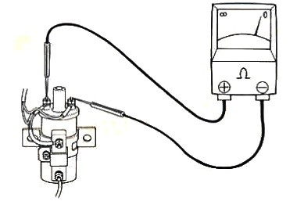
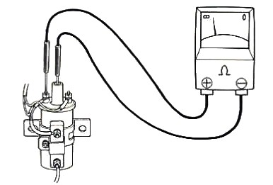
Figure 2. 24 a primary winding Figure 2.24b secondary winding
B. Secondary winding resistance
1. Disconnect the coil from the circuit.
2. Set the ohmmeter on the highest scale.
3. Connect one-meter lead to the center terminal and touch the other lead alternately to both primary terminals.
4. Take the lower reading and compare the reading with the specification.
5. If the reading is above or below the specifications, replace the coil.
C. Checking coil for shorted windings
1. Disconnect the coil from the circuit
2. Set the meter on the lowest scale
3. Touch one lead to the coil case and the other to either primary terminal.
4. The meter should indicate infinite.
5. A reading, lower than infinity means that the windings are shorted to the coil case and the coil must be replaced.
D. Coil current draw test
- Connect an ammeter − lead to the coil BAT, or +, terminal.
- Connect the ammeter + lead to the + primary cable, disconnected from the coil + terminal.
- Start or crank the engine, or turn the ignition ON and close the contact points.
- Read the ammeter.
- Current draw lower than specification can be caused by: -
- A discharged battery
- High resistance in the coil primary winding
- Loose or corroded primary connections or high resistance elsewhere in the primary circuit.
- No current reading means the primary circuit is open.
- Current draw higher than specification can be caused.
- A short circuit in the coil or ballast resistor.
  - An incorrect coil or ballast resistor installed on the car
E. Coil polarity test
- Remove one of the sparks plug lead.
- Keep it away somewhat 20mm from a ground.
- Place a lead pencil between the spark plug lead and the ground.
- Crank the engine and observe the flare.
- If the flare is between the spark plug lead and the lead pencil then the polarity is incorrect.
- If the flare is between the ground and the lead pencil, then the polarity is correct.

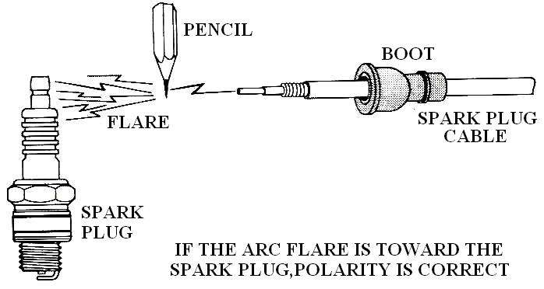

Figure 2.25 Coil polarity test

2.2.4. Distributor assembly
Inspecting/checking distributor Units
If you find any of the defects listed under it, replace the inspected part.
1. Check the distributor cap for cracks, carbon tracks, and burnt or corroded terminals and check the center contact for wear.
2. Check rotor for cracks, carbon tracks, and burnt or corroded terminals.
3. Check breaker plate for smooth rotation.
4. Rotate the governor weight to check for binding. Check the governor weights and bearings for wear or damage.
5. Apply vacuum to the vacuum advance diaphragm chamber. The diaphragm should move.
6. Check the breaker cam for wear or damage. Check the fit between the cam and shaft.
7. Check the drive gear for wear or damage.
8. Check the governor shaft for wear or damage.
9. Check the housing bushing for wear, deformation or damage

2.2.5. High tension cable
Inspect ignition high-tension cables as follows:
- Remove the cap from the distributor with the cables attached.
- Disconnect one cable from its spark plug
- Connect the ohmmeter lead to the plug terminal of the cable and the other lead to the corresponding terminal inside the distributor cap.
- Read the ohmmeter. If the resistance is within specification, the cable and its connection to the cap terminal are good.
- If the resistance is out of limit, disconnect the cable from the cap and read the resistance of just the cable. If the resistance is still out of limits, replace the cable. If cable resistance is okay, clean or tighten the connection to the cap or replace the cap.
- Repeat steps 2 through 5 for each plug cable and for the coil cable.

2.2.6. Spark plug
SPARK TEST
When an engine cranks normally but does not start, make a spark test. This quick check of the ignition system determines if high-voltage surges from the coil secondary winding reach the spark plugs.
- Disconnect the spark-plug cable from a spark plug.
- Insert a metal extender into the terminal at the end of the cable.
- Using insulated pliers, hold the extender about3/8 inch [10 mm] from the cylinder head or block. Or attach the cable terminal to a spark tester.
- Then fasten the tester to a good ground on the engine. Be sure the battery is charged. Crank the engine and watch for sparking across the gap.
- If blue sparks jump the gap when the engine cranks

Making a spark test (A) using insulated pliers and (B) using a spark tester
CAUTION~
Hold secondary cables with insulated pliers made of nonconductive material. Do not use metal pliers with insulated handles. The spark in a high-energy ignition system can jump an inch [25.4 mm] or more. It could jump around or through the insulation and give you a dangerous shock. Be sure there is no fuel or fuel vapor near where the spark will occur.
The spark could ignite the fuel causing a fire or explosion.

probably in the fuel system. No sparking indicates trouble in the ignition system. Make a triggering test of the primary circuit. This will show if the primary circuit is opening and closing.
2.2.7. Magneto ignition
The ignition troubleshooting procedure that follows can be used for any small one- or two-cylinder gasoline engine that employs a breaker point magneto ignition. With reference to the ignition system, here is a list of the critical components listed in the order of their likelihood of failing: Spark Plug, Breaker Points, Coil, HV Wire, Condenser.
Spark plug check
Remove the cowling (if necessary) to gain access to the spark plugs. For a twin cylinder engine, label the spark plug wires so that they can be replaced in the correct order. Pop the wires off and unscrew the spark plug(s). Keep track of which plug came out of each cylinder. Now, examine each plug care-fully. This is like palm reading; the condition of the plug tip can tell a story about
what is going on in each cylinder. If the plugs are wet with gasoline, fuel is undoubtedly reaching the cylinders. Now, touch one probe tip to the engine block and the other to the metal connector inside the plug wire cap. The meter should read the resistance of the coil and HV wire in series. Good readings will range from 3 kΩ to 15 kΩ.
Higher readings mean a poor connection, which typically occurs either where the HV wire connects to the coil or at the other end where the HV wire connects to the spark plug clip inside the cap. A reading of OL means an open circuit or break in the electrical path. If a bad reading is indicated, double check to make sure you are making a good connection with both test leads.
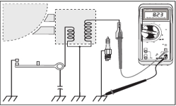
Figure 2.26 Spark plug check/test
Coil and HV wire resistance/continuity test
If you are testing a 2-Cylinder, 2-Cycle engine (mixed fuel) then perform the test as above for each cylinder individually. Look for a correlation between a bad reading (OL) and a fouled spark plug on the same cylinder. If the engine is a 4-Cycle model (unmixed fuel) such as a Honda or
Onan, the test is performed slightly differently as shown in Figure 2. Here we will be looking for continuity from one spark plug clip to the other since there is only one secondary coil which is not connected to the engine block. An open spark path will kill the spark to both cylinders.
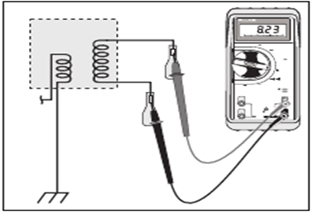
Figure 2.27 Coil and HV wire resistance/continuity test
Breaker point test
The breaker points on a magneto ignition are often located under the
flywheel. Remove any parts that might interfere with the flywheel removal. Hold the flywheel in a stationary position with a strap wrench and remove the large nut that holds the flywheel to the
crankshaft. Measure the contact resistance as follows: place the multimeter in the Ω function and hold the probe tips tightly together to obtain a reference reading with the tips shorted. The reading should show between 0.0 and 0.3 ohms, note the value. This is the reference reading.

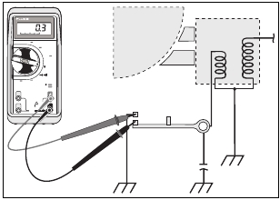

Figure 2.28Breaker point test
Condenser test
Next check the condenser as follows: Disconnect the condenser lead, then place the multimeter in the capacitance function and hold one test lead to the capacitor case and the other to the terminal. Check for leaking condensers with the Ohms function. As the condenser charges up, the resistance should increase
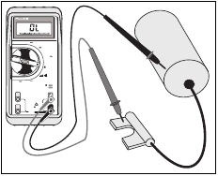
to infinity. Any other reading indicates that you should replace the condenser.
Figure 2.29 Condenser test
Reassembly and final check Once you’ve checked out and repaired the ignition system, reas-
semble the engine and repeat the spark plug test. If the spark looks good, install the plug(s) and try again to start the engine. If troubles persist, look to the fuel system. Carburetor cleaning may be required. Remember that most engine manufacturers recommend the addition of fuel stabilizer for long periods of storage.

Operation Sheet-2.1
Operation title: Ignition coil resistance test (Primary winding)
Purpose: To identify the problems/fault on ignition coil
Instruction: Perform the test by applying the steps which is listed below
Tools and requirement: Live engine(gasoline), Multimeter & Engine service manuals.

Precaution: If you are using a volt/ohmmeter to check resistances on an ignition system, make sure the circuit has been disconnected and the ignition system is off. When testing any ignition system, always follow the manufacturer’s suggested diagnosis and service procedure.
Procedures in doing the task:
Step-1: Disconnect the coil from the circuit.
Step-2: Connect ohmmeter across the primary terminals.
Step-3: Connect ohmmeter on the lowest scale.
Step-4: Compare the reading to manufacturer’s specification; replace the coil if it is out of specification.
Quality Criteria: Use the specified tools & use service manual

Figure 2.2- 30 a primary winding

Operation sheet-2.2
Operation title: Ignition coil resistance test (Secondary winding)
Purpose: To identify the problems/fault on ignition coil
Instruction: Perform the test by applying the steps which is listed below
Tools and requirement: Live engine(gasoline), Multimeter& Engine service manuals.

Precaution: If you are using a volt/ohmmeter to check resistances on an ignition system, make sure the circuit has been disconnected and the ignition system is off. When testing any ignition system, always follow the manufacturer’s suggested diagnosis and service procedure.
Procedures in doing the task:
Step-1: Disconnect the coil from the circuit.
Step-2: Set the ohmmeter on the highest scale.
Step-3: Connect one-meter lead to the center terminal and touch the other lead alternately to both primary terminals.
Step-4: If the reading is above or below the specifications, replace the coil.

Figure 2.31 Ignition coil resistance test (Secondary winding)

LAP Test -2 | Practical Demonstration

Task-1: Measure ignition coil secondary winding resistance by applying correct technical steps
Task-2: Always use ammeter
Task-3: Test coil current draw by applying correct technical steps
Task-4: Measure ignition coil primary winding resistance by applying correct technical steps
Task-5: Compare the result with the specification

Unit Three: Repairing ignition system /components
This learning guide is developed to provide you the necessary information regarding the following content coverage and topics:
- Replacement and adjustment of Ignition systems/component
- Retesting Ignition system
This guide will also assist you to attain the learning outcomes stated in the cover page. Specifically, upon completion of this learning guide, you will be able to:
- Perform replacement and adjustment of ignition systems/component
- Demonstrate how to retests ignition system

3.1. Perform replacement and adjustment of ignition systems/component
Many parts in the ignition system should be inspected or replaced at the time or mileage given in the vehicle maintenance schedule. These include the spark plugs, spark-plug cables, and distributor cap and rotor (if used).
VISUAL INSPECTION
Make a visual inspection if parts fail or other problems occur in the ignition system. This will locate and identify many troubles and potential troubles.
Checking secondary wiring
Secondary cables should be:
- Clean and attached tightly to the distributor cap or coils and the spark plugs.
- Terminals should be fully seated. Loose connections corrode and increase in resistance.
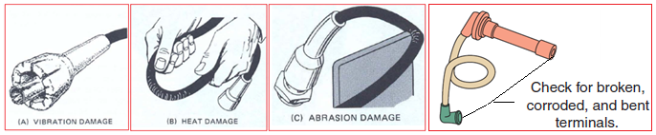
- Boots should be in good condition and fit tightly on the cap or coils and spark plugs. Loose or punctured boots allow water to enter the towers. Erosion, arc-over, and other ignition problems may result.
Figure 3.32 Checking secondary wiring
- Bend each cable or wrap it around your finger. Cracks will open and be easily seen.
Any of these conditions allows high-voltage leakage and causes engine miss. Some manufacturers recommend coating the inside of each boot with silicone grease before installation.
- To install new secondary cables or a new cap, replace one cable at a time.
- Grasp the boot and push the terminal and boot into the proper tower until the terminal seats.
- Then position each cable correctly in the cable brackets and looms. This helps prevent cable damage and cross-firing.
- Be sure each cable is in its specified position.
Checking Spark Plug
Spark plug replacement is part of the preventive maintenance program for all vehicles. The recommended replacement interval depends on a number of factors but ranges from 20,000 to 100,000 miles (32,000 to 160,000 km).
Removal of an engine’s spark plugs is pretty straightforward. Remove the cables from each plug, being careful not to pull on the cables. Instead, grasp the boot and gently twist it off. (To save time and avoid confusion later, use masking tape to mark each of the cables with the number of the plug it attaches to.
Removing spark plugs from vehicle
1. Disconnect the cables from the plugs by grasping the boots and twisting gently while pulling. Do not jerk on the cables, or you will damage them. Use insulated spark plug cable pliers.
2. Loosen each plug one or two turns and then blow dirt away from the plugs with compressed air.
3. Remove the spark plugs and place them in a tray or holder in cylinder number sequence.
- If the plugs have gaskets, be sure that the old gaskets come out with the plugs.
Spark Plug Cleaning
1. Wipe dirt, oil, and grease from the plugs with a clean cloth. Blow loose deposits away with compressed air.
2. Place the plug in a spark plug blaster and rotate the plug while applying short bursts of abrasive material.
3. After blasting, use compressed air to remove all traces of abrasive from the plug.
4. Clean the threads and gasket or seat area with a soft-bristled cable brush.
5. Carefully file the center electrode to get a flat, shiny surface.
Adjusting spark plug gap/ Re-gapping Spark Plugs
Both new and used spark plugs should have their air gaps set to manufacturer’s specifications.
- Always use round wire gauges when checking and setting the gap.
- After the gap has been adjusted, make sure that the ground electrode is as horizontal as it can be.
- Always check the air gap of a new spark plug before installing it. Never assume the gap is correct just because the plug is new.
- Do not try to reduce a plug’s air gap by tapping the side electrode on a bench. Use a spark plug gapping tool to bend the ground electrode to its correct height. When doing this, be careful not to contact or put pressure on the center electrode.
- Some engines are equipped with spark plugs that have more than one ground electrode. The gap between the center electrode and each ground electrode should be checked. If the gap between the center electrode and one of the ground electrodes is less than that of the others, spark will occur only at the smallest gap.
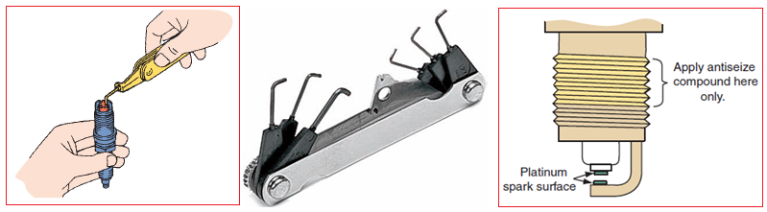
Figure 3.32 Check & adjusting spark plug gap
Installing Spark plug on vehicle
1. Remove dirt and grease from the engine plug seats with a clean cloth. Do not let dirt fall into the combustion chambers.
2. If the engine requires spark plugs with gaskets, be sure the gaskets are in good condition and correctly installed on the plugs. Be sure there is only one gasket on each plug.
3. If the engine requires gasket – type plugs in metal cylinders, remove the gaskets before installing the plugs.
4. Be sure that tapered seats of cylinder heads and plugs are clean and free from nicks.
5. Install the plugs into the engine by hand. Use nylon or rubber tubing on the plug terminals or insulators to turn hand-to-reach plugs. Be sure the plugs turn freely in their holes and are not cross threaded. If the plugs do not turn easily, you may have to clean the cylinder head threads with a thread chaser.
6. If possible, use a torque wrench to tighten the plugs to the values listed below

Table 3.2 Spark plug torque wrench specification
Plug type | Cast Iron Head (Nm) | Aluminum Head (Nm)
14mm gasketed | 34-40 | 20-30
14mm tapered seat | 9-20 | 9-20
18mm tapered seat | 20-27 | 20-27
7. If you can’t use a torque wrench, install the plugs finger tight. Then tighten 14mm gasketed plugs an additional ¼ turn, 14mm and 18mm tapered – seat plugs – 1/16 turn.
Checking distributor assembly
Removing distributor assembly from vehicle
- Remove the accessories which create obstacle to reach to the distributor.
- Disconnect the vacuum hose or hoses from the distributor.
- Disconnect the primary wiring running from the ignition coil to the distributor.
- Remove the distributor cap, and push the cap and cable assembly aside.
- Scratch a mark on a distributor housing.
- Scratch another mark, which lines up with the first, on the engine block.
- Scratch a mark on the distributor housing which is in line with the direction of the
rotor tip.
- Remove the distributor hold – down bolt and clamp.
- Lift the distributor out of the block.
Disassembling the Distributor Units
Disassembling distributor is different for different makes and models of vehicles. We can’t give you here a general procedure to disassemble all types of distributors. In most service manuals of vehicles, you can find the procedure to disassemble the distributor. Follow it carefully. The following figure shows the procedure of disassembling distributor in numerical order of one model, figure 7.17. Study it carefully so that you can be easily familiarized with other models.
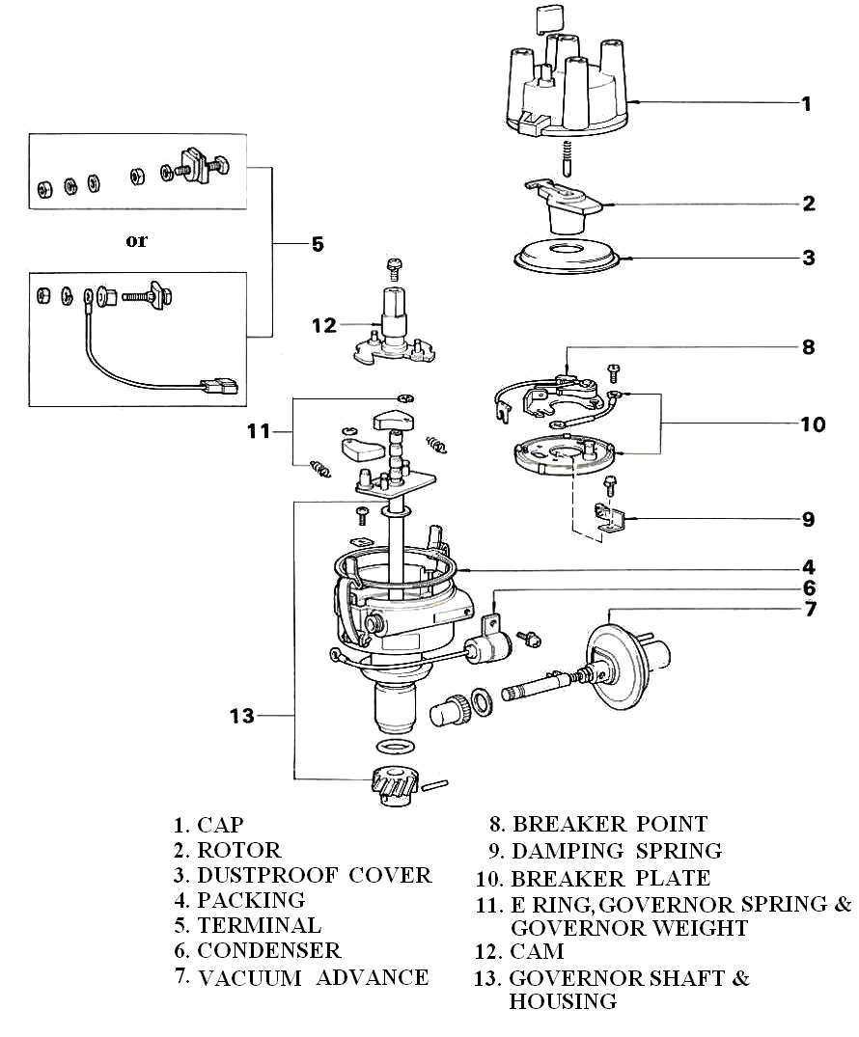
Figure 3.34Disassembling order of Distributor
Inspecting Distributor Units
If you find any of the defects listed under it, replace the inspected part.
1. Check the distributor cap for cracks, carbon tracks, and burnt or corroded terminals and check the center contact for wear.
2. Check rotor for cracks, carbon tracks, and burnt or corroded terminals.
3. Check breaker plate for smooth rotation.
4. Rotate the governor weight to check for binding. Check the governor weights and bearings for wear or damage.
5.Apply vacuum to the vacuum advance diaphragm chamber. The diaphragm should move.
6.Check the breaker cam for wear or damage. Check the fit between the cam and shaft.
7.Check the drive gear for wear or damage.
8.Check the governor shaft for wear or damage.
9.Check the housing bushing for wear, deformation or damage

Reassembling Distributor Units.
Distributor reassembling is usually the reverse of disassembling. Follow the service manual of the vehicle carefully. The following diagram shows the reassembling procedure of one vehicle in numerical order.
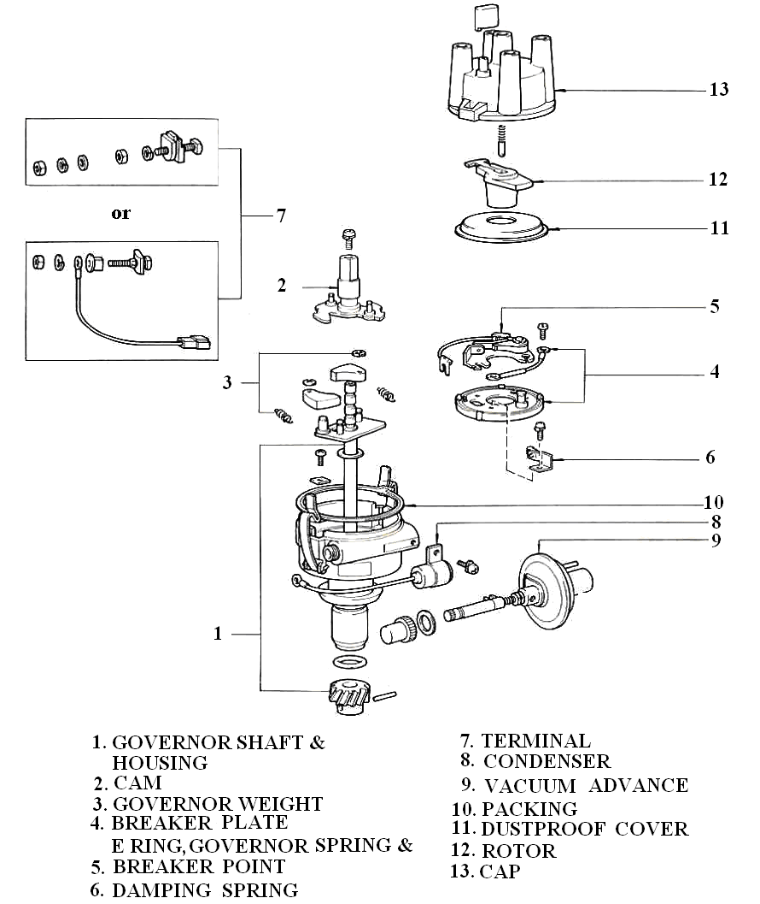

Figure 3. 35Reassembling order of Distributor

3.2. Retesting ignition system
Reassembly and final check Once you’ve checked out and repaired the ignition system, reas-
semble the ignition system components on an engine and repeat the spark plug test. If the spark looks good, install the plug(s) and try again to start the engine. If troubles persist, look to the fuel system. Carburetor cleaning may be required. Remember that most engine manufacturers recommend the addition of fuel stabilizer for long periods of storage.

Operation sheet-3.1
Operation title: Ignition System Trouble Shooting “Secondary”
Purpose: To locate/detect the fault/problems on the system
Instruction: Perform the trouble shouting by applying the steps which is listed below
Tools and requirement: Live vehicle & Multimeter
Precaution: When testing any ignition system, always follow the manufacturer’s suggested diagnosis and service procedure
Procedures in doing the task
Step-1: Disconnect H.T. cable from terminal 4 of the distributor cap and hold it near to terminal 31. Crank the engine.
Step-2: If there is a spark, reconnect the H.T. cable to the distributor cap. Disconnect H.T. cable from spark plug of cylinder No. 1 and ground it. Crank the engine.
Step-3: If there is a spark, repeat step 2 with all other remaining cylinders
Step-4: If there is spark at all 4 H.T. cables, remove spark plugs and check them.
Step-5: If there is no spark, check rotor, distributor cap and the four H.T. cables to the spark plugs
Step-6: If there is no spark at terminal 4 (see step 1 above), check the terminal 4 H.T. cable for
Step-7: If the terminal 4 H.T.-cable is without fault, check the primary circuit
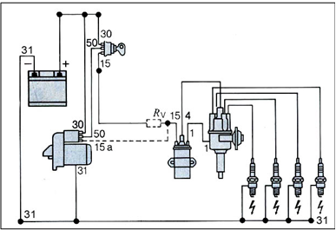
Quality Criteria: Use the specified tools & use service manual

Figure 3.36 Ignition System Trouble Shooting “Secondary”

LAP Test -3.1 | Practical Demonstration

- Task-1: Measure the resistance of high-tension cable
- Task-2: Measure the resistance of rotor
- Task-3: Measure the resistance at distributor cap

Unit Four: Adjusting ignition timing and dwell angle
This learning guide is developed to provide you the necessary information regarding the following content coverage and topics:
- Adjusting Dwell angle and Contact point
- Adjusting Ignition timing
This guide will also assist you to attain the learning outcomes stated in the cover page. Specifically, upon completion of this learning guide, you will be able to:
- Adjust Dwell angle and Contact point
- Adjust ignition timing

4.1. Adjust Dwell angle and Contact point
The dwell angle is the number of degrees of rotation of the cam/distributor during which the points are closed during each rotation of the cam/distributor, the point must open & close one for each cylinder. The point must stay closed long enough to allow primary current to reach an acceptable value, then open long enough to discharge & produce a spark.
Functionality
With primary circuit being switched on & off repeatedly each coil has to be designed for particular application so that it operates efficiently. For a four stroke 4-cylinder engine running at 2000Rpm/4ooo sparks must be supplied every minute. The time available to make & break the primary circuit each time is very short. AS engine speed rises the time available is even short. It is very important then to ensure that the length of time current flows through the primary winding is sufficient to creat the necessary magnetic field. In contact breaker systems this briefly period of time is the period during which the contacts are closed, this referred to the “dwell angle). It is usually specified in degrees of distributor rotation. This closed period is influenced by the setting the contact breaker gap. Once this has been set the angle remain fixed regardless of engine speed.
A large gap gives a small dwell angle
A small gap gives a large dwell angle
The manufacturers recommended gap provides the specified dwell angle for each application & those recommendation should be followed.

If the dwell angle is not within specification, proceed as follows:
A. Procedure for adjusting dwell angle
1. Remove the coil high tension lead from the distributor& ground it.
2. Remove the distributor cap & place it out of the way. Remove the rotor.
3. Connect an auxiliary starter switch in the circuit.
5. Loosen the breaker point assembly retaining screw near the breaker point contacts.
6. With the ignition on, crank the engine with an auxiliary starter switch & adjust the gap to specifications.
7. Release the auxiliary starter switch & tighten the breaker point attaching screw.
8. Since the adjustment may have changed when the attaching screw was tightened, crank the engine again with the auxiliary starter switch & check the dwell. When the dwell is properly adjusted, remove the jumper wire, auxiliary starter switch & tester leads & install the rotor, distributor cap, coil high tension lead & starter relay wires, connect the distributor vacuum line.
B. Procedure for adjusting contact point
Adjusting contact point gap
1. Remove the distributor cap and rotor.
2. Rotate the engine with the starter or by turning the belt until the points are fully open.
3. Measure the gap with feeler gauge
4. Loosen the point hold – down screw and move the points if adjustment is necessary.
5. Tighten the screw and check the gap
Apply cam grease on the distributor cam
4.2. Adjusting ignition timing
In any sort of timing advance system, there must be a starting point. This is called the Basic Timing Setting. It is the position of the distributor plate and cam at idle speed when none of the advance systems are in operation. In older engines the basic timing is usually 5 to 10 degrees before TDC. Newer, pollution - control engines, often operate at 0⁰ TDC or as much 4⁰ after TDC.
Timing advance is usually fixed, unless the mechanism breaks. However, basic timing is adjustable according to manufacturer's specifications. Basic timing is usually adjusted by loosening the distributor lock - down bolts and moving the distributor housing clockwise or counter clockwise. The correctness of the adjustment can be determined by shining a timing light marking inscribed on one of the crankshaft pulleys or on a plate alongside the pulley.
Correct ignition timing is essential for optimum engine performanceand fuel efficiency.

4.2.1. Static timing
Procedures for adjusting Static ignition timing
During installation, the distributor must be timed to the engine if the crankshaft has turned while the distributor was out. Locate the firing order and cylinder numbering illustration for the engine. This is in the vehicle service manual and auto repair manuals. Note the position of the cap latches or screws.
- Install the distributor in the engine in the same position. Also note the location of the number one terminal on the distributor cap. When the number one piston is at TDC ending the compression stroke, the rotor tip should point to the number one terminal in the cap.
To time the distributor to the engine,
- Remove the number one spark plug. Locate the timing marks. Most engines have a rotating mark that aligns with a specified stationary mark when ignition timing is correct. The timing marks are usually on the crankshaft vibration damper and the engine front cover. Some are on the flywheel and the housing.
- Place a shop towel over your finger and cover the sparkplug hole. Do not allow your finger to enter the spark-plug hole! Crank the engine with the starting motor until you feel compression pressure push against your finger.
- Continue bumping the engine with the starting motor until the timing marks align. This shows that the number one piston is in firing position.
- Install the distributor, making sure the rotor tip aligns with the cap terminal for the number one spark plug.
- Install but do not tighten the distributor clamp and bolt.
- Rotate the distributor until the primary trigger opens the primary circuit. This occurs when:
- The contact points start to open.
- The reflector tip passes alignment with the pole piece.
- The shutter leaves the air-gap in the Hall-effect switch.
- The rotating disk interrupts the light beam striking the photodiode.
- Hold the cap in its mounting position above the distributor.
- Check that the rotor tip aligns with the number one terminal on the cap. Install the cap.
- Connect the primary lead.
- Start the engine and check that the oil light in the instrument panel goes out.
- If not, stop the engine and check for proper seating of the distributor.

4.2.2. Dynamic timing

Procedures for adjusting Dynamic ignition timing
- Check distributor breaker point dwell and if necessary, adjust to manufacturer's specification. Replace breaker points if needed.
- Disconnect vacuum hose from distributor vacuum advance unit and plug hose to insure proper operation of the carburetor.
- Connect timing light battery leads to a 12 Volt vehicle battery; red to positive (+) and black to negative.
- Connect timing light inductive pickup or clip lead to No. one spark plug cable as follows: Place the inductive Pickup around the appropriate spark plug wire.
- For best results the pickup should be hooked up with its label side facing toward the spark plug end of the wire, but placed near the distributor and away from the spark plug. This provides a"cleaner" electrical signal and keeps away from the hot manifold.
Initial Dynamic ignition Timing check
1. Start engine and adjust speed to that specified for ignition timing.
2. With timing light aimed at timing pointer, press trigger and observe position of timing mark when light flashes. Refer to manufacturer's specifications for correct setting.
NOTE: For the Timing-Advance Tester, be sure that the control knob is fully counterclockwise in the timing position.
Be sure to view the timing mark from a position that allows your eyes to be squarely in line with the timing mark and measurement scale. An error in timing could result if the mark is viewed from another angle.
3. To adjust, loosen distributor-locking screw and turn distributor until specified timing mark is lined up with pointer.
4. Tighten the distributor locking screw, and recheck timing.

Operation sheet-4.1
Operation title: Dwell Angle (point gap) Adjustment
Purpose: To allow primary current to reach an acceptable value, then open long enough to discharge & produce a spark
Instruction: Perform the adjustment by following the proper procedure, using relevant tools & measuring equipment as specified by the manufacturer.
Tools and requirement: Dwell angle tester, Manual of dwell angle meter, screwdrivers & Engine service manual
Precaution: When testing any ignition system, always follow the manufacturer’s suggested diagnosis and service procedure or (Make sure that you use the proper tool in the proper manner! Do not spoil the screws!)
Procedures in doing the task
Step-1: Adjust the point gap to 0.3 mm.
Step-2: Connect the dwell meter to the engine.
Step-3: Crank the engine and measure the dwell angle at cranking speed
Step-4: Now determine (check) the static ignition timing
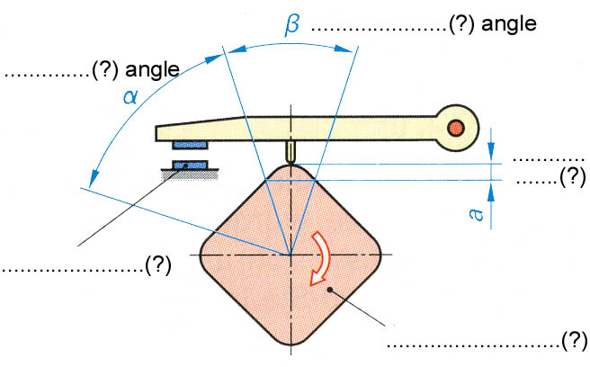
Quality Criteria: Dwell angle is adjusted / set in accordance with the manual of specifications and instruction.

Figure 4.37 Dwell Angle (point gap) Adjustment

Operation sheet-4.2
Operation title: Ignition Timing Adjustment "static”
Purpose: To prepare cylinder number for a power
Instruction: Perform the adjustment by following the proper procedure, using relevant tools & measuring equipment as specified by the manufacturer.
Tools and requirement: Live engine(gasoline), Gasoline fuel, wrenches, Engine service manual, Multi meter, Test Light12v, Extension Lamp,12v70AH car battery, Feeler gauge, cleaning rug & other tools as specified by the manufacturer
Precaution: When testing any ignition system, always follow the manufacturer’s suggested diagnosis and service procedure or (Make sure that you use the proper tool in the proper manner! Do not spoil the screws!
Procedures in doing the task:
Step-1: Identify advance & TDC mar
Step-2: Identify direction of distributer shaft rotation
Step-3: Know engine firing order
Step-4: Mount distributor shaft while cylinder number one is at the end of compression stroke & advance mark aligned with timing mark.
Step-5: Crank the engine to start it
Quality Criteria: Use specified tools & service manual
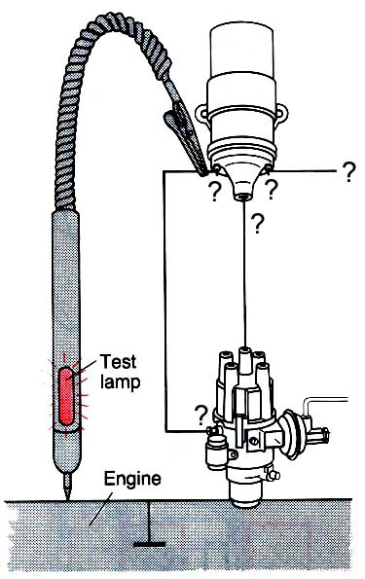

Figure 4.38Ignition Timing Adjustment "static”

LAP Test -4 | Practical Demonstration

Task-1: Measure ignition coil secondary winding resistance by applying correct technical steps
Task-2: Always use ammeter
Task-3: Test coil current draw by applying correct technical steps
Task-4: Adjust ignition timing statically
Task-5: Measure voltage drop test by using a multimeter
Task-6: Check power supply for the circuit

Unit Five: Clean-up work area and maintain equipment
This learning guide is developed to provide you the necessary information regarding the following content coverage and topics:
- Collecting and storing Material
- Removing waste and scrap
- Cleaning and inspecting equipment and work area.
This guide will also assist you to attain the learning outcomes stated in the cover page. Specifically, upon completion of this learning guide, you will be able to:
- Collect and storing Material
- waste and scrap
- Clean and inspect equipment and work area.

Collecting and storing Material
Follow these three general principles to develop records and documents:
- Keep it short and simple. Use bullet points and flow diagrams instead of long sentences and lengthy paragraphs.
- Clarity is important. Step-by-step instructions are easily understood.
- Use a standardized, consistent format. Although different programs may need different documents and records, using a similar approach will help staff learn quickly.
Completing and delivering report to appropriate person
Delivery is the process of transporting something/ like reports/ from a source location to a predefined destination after the work is done. The technician should be preparing a report and deliver to appropriate person. The reporting procedures are as follows
- Record the work to be done
- Inspect/test the repaired engine accordance with manufacturer procedure
- Record/ capture the problem with the necessary information
- Order the recorded problems /work done in accordance with their damaging area
- Preparing reports have no error/discrepancy
- Deliver reports to appropriate person.

5.2. Removing waste and scrap
There are some tasks that a technician will not carry out frequently. It would be unrealistic for a technician to have a detailed knowledge of seldom-performed procedures. In these circumstances, job cards or checklists are very useful as they give a step-by-step guide to follow whenever the rarely-used procedure needs to be performed. The required knowledge is often kept in manuals which may not be easily accessible. However, going through a large manual, possibly in front of a customer, does nothing for time effectiveness or professional image.
A job card is also used as the basis of a recording process for the organization. In addition to refreshing the process for the technician it will be a list of the workplace expectations as well. It is suggested that the final task on a job card will be to ensure that the equipment is cleaned for use or storage.

5.3. Make Cleaning and inspecting equipment and work area.
Material that can be reused is collected and stored based on storage procedures.
Waste and scrap are removed according to workplace and OHS procedures.
Equipment and work area are cleaned and inspected for serviceable conditions in accordance with workplace procedures.
Unserviceable equipment is tagged and faults identified in accordance with workplace procedures.
Operator maintenance is completed in accordance with manufacturer specifications and site procedures.
Tools are maintained in accordance with workplace procedures.
Cleaning procedures
- Clean up every time whenever you leave an area, including sweeping the floor.
- Clean and return all tools to where you got them.
- Use compressed air sparingly; never aim it at another person or use it to clean hair
- Shut off and unplug machines when cleaning, repairing, or oiling.
- Never use a rag near moving machinery.
- Use a brush, hook, or a special tool to remove chips, shavings, etc. From the work area. Never use the hands.
- Keep fingers clear of the point of operation of machines by using special tools or devices, such as, push sticks, hooks, pliers, etc.
- Keep the floor around machines clean, dry, and free from trip hazards. Do not allow chips to accumulate.
- Mop up spills immediately and put a chair or cone over them if they are wet enough to cause someone to slip.

Self-Check - 5
Directions: Answer all the questions listed below
- What are the three general principles to develop records and documents
A. --------------------------------
B. -------------------------------
C. --------------------------------
2. List out the cleaning procedure
A. ---------------------------------
B. --------------------------------
C. --------------------------------
D. --------------------------------
E. -------------------------------

Operation sheet-5
Operation title: - cleaning work area and equipment’s
Purpose: - prevents hazard and injuries
Instruction: -
- Bright/good visibility work area
- Cleaned and properly organized shop
- Good ventilation working area
- Occupied work shop by proper tools and equipment’s
- Hazard free work shop
Tools and requirement: -
Consumable materials rugs, brooms, cleaning solvent and any cleaning materials.
Procedures in doing the task:
- Clean up every time whenever you leave an area, including sweeping the floor.
- Clean and return all tools to where you got them.
- Use compressed air sparingly; never aim it at another person or use it to clean hair or clothes.
- Shut off and unplug machines when cleaning, repairing, or oiling.
- Never use a rag near moving machinery.
- Use a brush, hook, or a special tool to remove chips, shavings, etc. From the work area. Never use the hands.
- Keep fingers clear of the point of operation of machines by using special tools or devices, such as, push sticks, hooks, pliers, etc.
- Keep the floor around machines clean, dry, and free from trip hazards. Do not allow chips to accumulate.
- Mop up spills immediately and put a chair or cone over them if they are wet enough to cause someone to slip.
Precaution: -
- Wear appropriate clothes, shoe ...
- prepare tools, equipment’s and materials used for cleaning purpose
- read and interpret manuals which guide you how to clean work area, tools and equipment’s
Quality Criteria: All work area, tools and equipment’s should be cleaned in a correct procedure. Check and inspect work area, tools and equipment’s for cleanness, attractiveness, and conformability for the next work activities.

LAP Test -5 | Practical Demonstration

Instructions: Given necessary templates/guides, workshop, tools and materials you are required to perform the following:
- Using the given template, note and document observations during the service
- Using the given template, complete workshop practice scheduled documentation
- Using the given template, complete and delivering report to appropriate person
- Using the given template, clean and make ready workplace for next work

Reference
1.Automotive Mechanics 10th Edition by Cruise and Anglin (Textbook)
2.Auto service & repair, Stochel,1969
3.Motor repair manual
4.Igntion & cranking system, Delco Remy
5.Auto mechanic, Glenn
6.Vehicle service manual

Participants of this Module (training material) preparation

No | Name | Qualification (Level) | Field of Study | Organization/ Institution | Mobile number | E-mail
1 | Fadli Aman | BSc. B-Level | Automotive Technology | General Wingate PTC | 0927283100 | Fadli.ziyad@gmail.com
2 | Gashaw Zawudie | MSc. A-Level | Automotive Technology | AKPTC | 0910730747 | Gashawgashaw69@gmail .com
3 | Muna Gabrie | BSc. B-Level | Automotive Technology | Dire PTC | 0910511196 | Munamulunhe@gmail.com
4 | Sisay Dawit | MSc. A-Level | Automotive Technology | Harar PTC | 0910672115 | Sisaydawit058@gmail.com
5 | Yohannes Negatie | MSc. A-Level | Automotive Technology | W/ro Siheen PTC | 0922094453 | Yohannes2013n@ gmail.com

