

Automotive Electrical & Electronics
Level-II
Based on March 2022, Curriculum Version 1
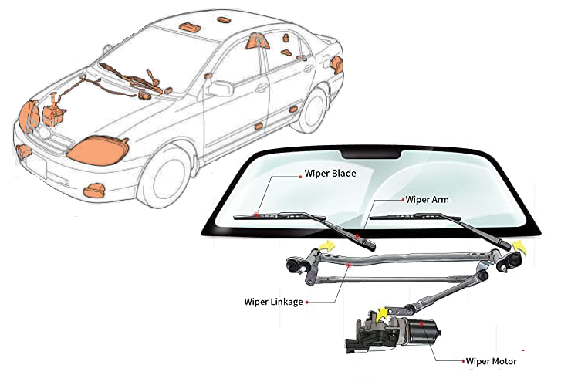
Module Title: - Repair and Install lighting and windshield wiper system
Module code: EIS AEE2 M07 0322

Nominal duration: 60Hours

Prepared by: Ministry of Labor and Skill
September, 2022
Addis Ababa, Ethiopia
Table of Contents
Acknowledgment 4
Acronym 5
Unit one: Overview of lighting system and windshield wiper and washer system 7
1.1 Purpose of lighting and windshield wiper system 8
1.2 Lamps (or) Light Bulbs 8
1.2.1 Types of lamps 8
1.3 Installation and testing procedures 12
1.3.1 Electrical Installation, Test/Commissioning and Maintenance 12
1.4 Identifying materials, tools and equipment 13
1.5 Safety precautions associated with lighting and windshield wiper system 18
Self-check-1 20
Operation sheet 1: Greeting with DMM 21
Lap test 1 22
Unit two: lighting wiring system 23
2.1 Component of lighting system with their function 24
2.1.1 Exterior Lights 24
2.1.2 Interior Light Assemblies 38
2.1. 3 Horn 40
2.2 Interpreting wiring diagram of lighting systems 41
2.3 Inspect and service interior and exterior lighting components. 46
2.4 Head Light Aiming 50
2.5 Post-Repair Testing 52
2.6 Troubleshooting electrical wiring system 52
Self-check 2 54
Operation sheet 2.1: Identify headlight switch terminals 56
Operation sheet 2.2: Identify light control switch terminals 57
Operation sheet 2.3: Identify turn signal and hazard switch terminals 58
Operation sheet 2.4: draw and interpret lighting system circuit 59
Operation sheet 2.5: Install lighting system 60
Lap test: 2 62

Unit three: Windshield wiper and washer system 63
3.1 identify component of windshield wiper and washer system 63
3.1.1 Windshield wiper system 64
3.1.2 washer system 67
3.2 interpret windshield wiper and washer system 68
3.3 Testing and Repairing 69
3.3.1 Testing wiper motor 69
3.3.2 Testing Washer motor 71
Self-check-3 73
Operation sheet 3.1: Identify windshield wiper system switch terminal 74
Operation sheet 3.2: Identify windshield wiper Motor terminals 75
Lap test: 3 76
Unit four: Install lighting and windshield wiper wiring systems 77
4.1 Removing and Installing procedure of lamp 77
4.2 Installing lighting system components 78
4.3 Installing wind shield wiper system components 80
Self-check-4 82
Lap test: 4 83
Reference 84

Acknowledgment

Ministry of Labor and Skills wish to extend thanks and appreciation to the many representatives of TVET instructors and respective industry experts who donated their time and expertise to the development of this Teaching, Training and Learning Materials (TTLM).

Acronyms
LAP Test | Learning Activity Performance Test
TTLM | Teaching, Training and Learning Materials
B | Battery
E | Earth (ground)
HL | Head low
HU | Head high
ED | Earth dimmer
TB | Turn battery
TL | Turn left
TR | Turn right
T | Tail
H  LED  HID  DMM  HV | Head  Light emitting Diode  High intensity discharge  Digital Multi meter  High voltage

Introduction to module
In Automotive Electrical & Electronics field study Repair and Install lighting and windshield wiper system covers Information and practices in testing repairing and installing lighting and windshield wiper system. Includes definite instruction on how to install lighting and windshield wiper system components perform testing of possible defects and carry out repairs clear instructions and technique required on how to install wiring connection of lighting and windshield wiper system is also embedded.
You need to complete this module by learning the theories and principles required closely coupled with practical activities to master the skills required in this module desirable values and altitude must also be taken into consideration.
This module is designed to meet the industry requirement under the Automotive Electrical & Electronics occupational standard, particularly for the unit of competency: Repair and Install lighting and windshield wiper system
This module covers the units:
- Overview of lighting system and windshield wiper and washer system
- Lighting wiring systems
- Windshield wiper and washer system
- Install lighting and windshield wiper wiring systems
Learning Objective of the Module
- Understand lighting system and windshield wiper and washer system
- Explain Lighting wiring systems
- Explain Windshield wiper and washer system
- Install lighting and windshield wiper wiring systems
Module Instruction
For effective use this modules trainees are expected to follow the following module instruction:
- Read the information written in each unit
- Accomplish the Self-checks at the end of each unit
- Perform Operation Sheets which were provided at the end of units
- Do the “LAP test” giver at the end of each unit and
- Read the identified reference book for Examples and exercise

Unit one: Overview of lighting system and windshield wiper and washer system
This unit is developed to provide you the necessary information regarding the following content coverage and topics:
- Introduction to lighting and windshield wiper system
- Lamps
- Installation and testing procedures
- Identifying materials, tools and equipment
- Safety requirements
This unit will also assist you to attain the learning outcomes stated on the cover page. Specifically, upon completion of this learning guide, you will be able to:
- Understand the lighting and windshield wiper systems.
- Comprehend Lamps
- Identify the procedures for testing and installing
- Determine the materials, tools and equipment
- Apply Safety requirements

1.1 Purpose of lighting and windshield wiper system
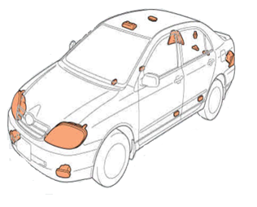
The lighting and wiper systems are responsible for maintaining optimal visibility both in and out of the vehicle. well-designed vehicle lighting systems enhance vehicle safety. The lighting system provides nighttime visibility, signals and alerts other drivers of your intentions, and supplies light for viewing instruments and the vehicle’s interior. The wiper system keeps excessive dirt, water, or snow from building up on the windshield. It removes these things and other debris from the windshield to increase visibility. The chances for accidents increase if you cannot see or be seen, so your vehicle’s lighting and wipers play an important role in safe driving.
Figure 1-1 automobile lighting system
Figure 1 1 automobile lighting system

1.2 Lamps (or) Light Bulbs
A lamp generates light as current flows through the filament. This causes it to get very hot. The changing of electrical energy to heat energy in the resistive wire filament is so intense that the filament starts to glow and emits light.
The glass enveloped that encloses the filament is evacuated so that the filament “burns” in a vacuum. If air enters the envelope, the oxygen would cause the filament to oxidize and burn up.

1.2.1 Types of lamps
Modern vehicles use many different kinds and sizes of lamps. These are known in some places as lightbulbs or light globes. There are several lamp types available.
These include:
- standard incandescent lamps,
- halogen lamps,
- vacuum tube fluorescent (VTF) lighting,
- HID xenon gas systems,
- LEDs, and more.
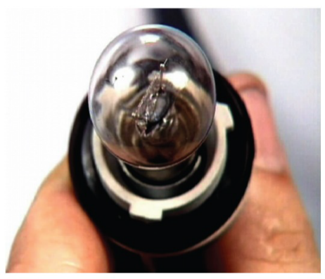
Incandescent lamp: consist of one or more tungsten filaments. The filaments heat up to approximately 5000°F (2760°C) and glow white-hot The fi lament material does not burn because there is no oxygen in the bulb. Most of the oxygen has been replaced by inert gases that stop combustion from occurring. The power in watts consumed is often marked on the lamp. Wattage (work performed) is found by multiplying the voltage used by the lamp by the current flowing through it. The higher the wattage, the more light that can be created when compared with a similar type of bulb. Incandescent bulbs are inefficient, converting only about 10% of the electricity to visible light
Figure 1-2 Incandescent lamp
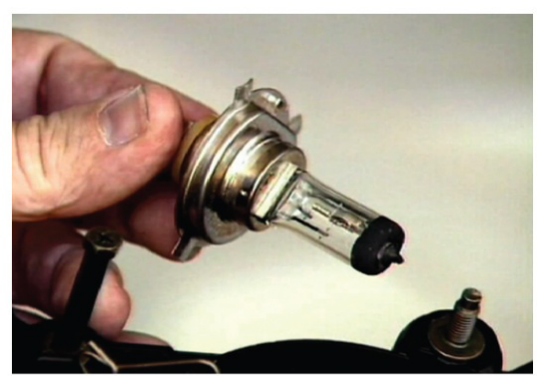
Halogen lamps: are another type of incandescent lamp. They are filled with a halogen gas such as bromine or iodine These lamps have a much longer life and are generally brighter than standard incandescent bulbs. They also produce more light per unit of power consumed. However, they become very hot in use. They are manufactured from highly heat-resistant materials. The bulbs must be handled carefully because they can be damaged even by fingerprint residue.
Figure 1-3 Halogen lamp
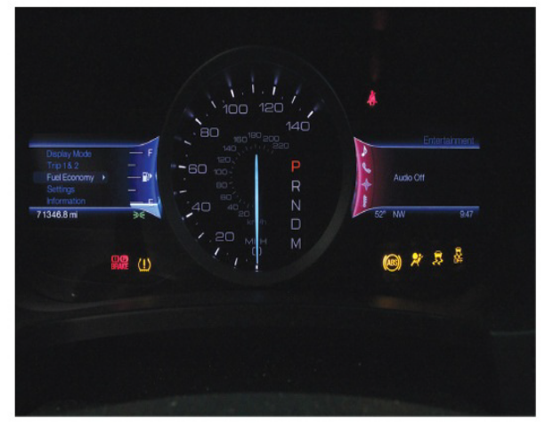
Vacuum tube fluorescent (VTF) lighting is also called a vacuum fluorescent display(VFD). They are used for instrumentation displays on instrument panel clusters. This type of lighting emits a very bright light with high contrast.
They can display various colors VTFs usually
- display bar graphs,
- seven-segment numerals,
- multi-segment alphanumeric characters,
- or a dot-matrix pattern
Figure 1-4 Typical vacuum fluorescent display.
VTF displays include different kinds of alphanumeric characters and symbols to alert drivers of various conditions.
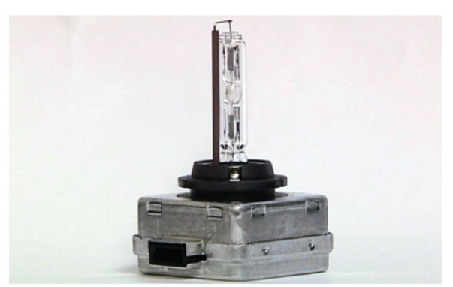
High-Intensity Discharge
High-intensity discharge (HID) headlamps produce light with an electric arc. This is instead of a glowing filament. The high intensity of the arc comes from metallic salts that are vaporized within an arc chamber. HIDs produce more light fora given level of power consumption than ordinary tungsten or halogen bulbs.
Figure 1-5 HID lamp
Automotive HID lamps are commonly called xenon headlamps. However, they are actually metal halide lamps that contain xenon gas. The light from HID headlamps exhibits a distinct bluish tint. This is compared with the yellow-white color of tungsten-filament head lamps.
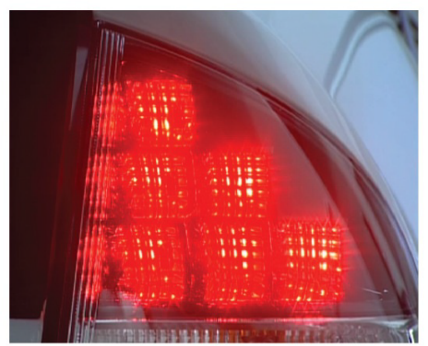
Light-emitting diodes (LEDs): LEDS are not new in automotive applications. Examples include warning indicators and alphanumeric displays. More recent developments have seen the production of a wider range of LED colors. They are also becoming much brighter than previous types. It is now possible to get LEDs that emit bright red, green, blue, yellow, and clear or white light. This has made it possible to use LEDs for many new applications, such as more general lighting applications.
Figure 1-6 LED lights.
For example, LEDs are now often used for stop lights, turn signals, and interior lighting.
light bulb configurations.
All lamps or lightbulbs have letters and numbers on them They typically indicate the part number, operating voltage, and power consumed. For instance, in a bulb marked 12V/21W, the filament will consume 21 watts of power when 12 volts is applied across the filament. The wattage is not necessarily an indication of light output. But it can generally be assumed that the higher the wattage, the greater the light output. This is at least true when comparing the same types of lights with each other.
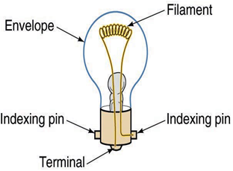
- Design of lamps bulbs
Lamps and lightbulbs come in a variety of configurations to fit the various applications within a vehicle. One designation is how many filaments the bulb has.
- Single-filament bulbs are common for use as courtesy lights, dash lights, and warning lights, stop light, and the turn signal.
Figure 1-7 single -filament bulb.
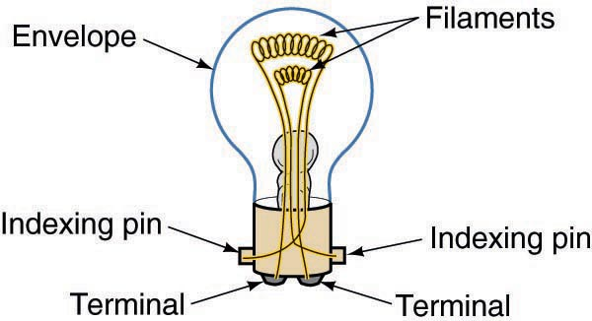
- Dual-filament bulbs have two filaments of different wattage One filament emits a small amount of light. The second filament emits more light. these bulbs work well as a combination taillight and brake light. The taillight emits less light and the brake light emits more light. Dual-filament bulb. Headlights can also be dual-filament bulbs. In some cases, the low-beam filament is lower wattage than the high-beam filament,

Figure 1-8 Dual-filament bulb.

Another feature that differs among lights is the type of base on the lamp There are several types of light bulbs used in today’s vehicles. Each design has a unique purpose and a unique way it fits into its socket.
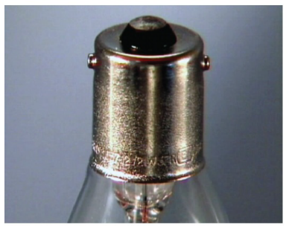
Bayonet-style bulbs have been around for a long time. They get their name from the two retaining pins on the side of the base (The pins follow slots in the side and bottom of the socket. At the bottom, the slots turn sideways into a small pocket. The pins are retained in the pocket by the spring-loaded base in the bottom of the socket. This pushes the bulb up ward and locks it in place. This design resists vibration very well.
Figure1- 9 Bayonet-style bulbs.

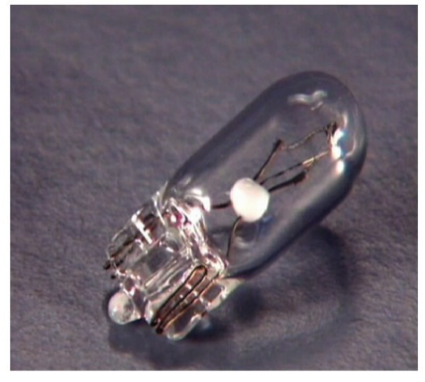
A wedge base: use either made from the glass bulb itself or with a built-in plastic base The bulbs are pushed straight into the socket, and tension from the socket retains the bulb. The electrical contact on the glass based bulbs is made by wires extending from the base of the bulb and bent over opposite sides of the wedge. Many newer bulbs a wedge type

Figure 1-10 Wedge-style bulbs.
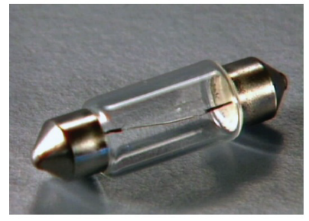
festoon lights, which have a base on each end of a cylindrical lightbulb Each end of the filament is connected to one of the bases. Generally, the bases fit in spring steel contacts, which hold the light bulb securely in place. Use on Some dome lights.
Figure 1-11 Festoon-style bulbs.
However, within a particular design, there may be different bulbs, each with its own power rating. Whenever replacing a bulb, make sure it is the exact replacement. Most bulbs fit into sockets and are held in place by spring tension or mechanical force.

1.3 Installation and testing procedures
- Products should only be fitted by competent persons.
- Read the product fitting instructions carefully and check all components are included in the fitting kit before commencing installation.
- Clean off all road dirt, under seal and sound deadening mastic where parts are to fit to ensure correct seating of all components.

1.3.1 Electrical Installation, Test/Commissioning and Maintenance
Failure to comply with the following instructions may cause damage to the towing vehicle’s wiring loom and/or drawing electrics installation. Where displacement tap connectors e.g. Scotch, are the preferred method of connection, always use the correct color coded tap connector for the size of cable to which it is to be connected. Automotive manufactured relays with integral cables should be connected using red tap

Electrical maintenance jobs requirements
- Clean and tighten battery cables and connections.
- Jump-start the car if your battery is low.
- Check all lights and replace bulbs.
- Remove and replace turn-signal flasher.
- Replace blown fuses.

Identifying materials, tools and equipment
- Multi-meters
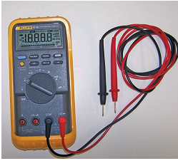
A multi meter is a must for diagnosing the individual components of an electrical system. Multi meters have different names, depending on what they measure and how they function. A digital multi meter (DMM) can measure many more things than volts, ohms, and low current. Most multi meters (measure direct current (dc) and alternating current (ac) amperes, volts, and ohms. More advanced multi meters may also measure diode continuity, frequency, temperature, engine speed, and dwell, and/or duty cycle.
Figure 1-12 Typical multifunctional, low-impedance multi meter
Multimeters are available with either digital or analog displays. DMMs provide great accuracy by measuring volts, ohms, or amperes in tenths, hundredths, or thousandths of a unit. Several test ranges are usually provided for each of these functions. Some meters have multiple test ranges that must be manually selected; others are auto ranging.
A digital meter is a necessary tool for any electrical diagnosis and troubleshooting. A digital multimeter, abbreviated DMM, is usually capable of measuring the following units of electricity.
- DC volts
- AC volts
- Ohms
- DC Amperes
- AC Amperes
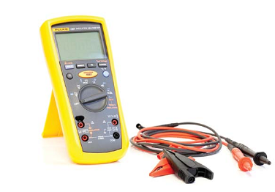
- Insulation testers
An insulation tester can be a stand-alone meter or an additional function of a DMM It is used to measure the insulation resistance on the powered down HV system when servicing a HEV. Isolation tests are only performed on systems that have the power removed.
To test for insulation leakage of the high-voltage
Figure 1-13 insulation meter
system, begin by inserting the insulation test probe into the + terminal and the ground lead into the – terminal. Do not connect the leads to the volt-ohm terminals. Turn the knob to the “INSULATION” position. In this position, a battery level check is performed. Conﬁrm that the battery level test has passed. Press the “RANGE” button to select the desired voltage range. If performing an isolation test on an HEV, this should be set to 500 volts. Next, connect the leads to the circuit you are testing. The meter will automatically detect if the circuit is powered. The meter display should indicate a series of dashed lines. If the meter displays >30 V, then there is voltage greater than 30 volts in the circuit and the test meter will not perform the insulation test. Push and hold the “TEST” button on the red insulation test lead. While the test is in progress, the applied voltage will be displayed in the lower right corner on the screen and the resistance in M ohms or G ohms will be displayed in the centre of the screen. Leave the test leads attached to the circuit and release the “TEST” button. The meter will continue to display the resistance reading while the circuit is discharged through the meter.
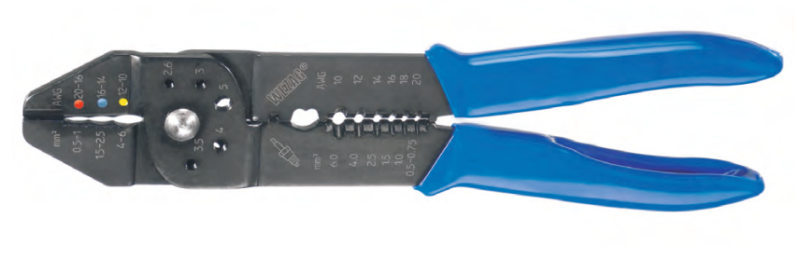
- Crimping tools
Crimpers are tools used to make cold weld joints between two wires or a wire and a connector, such as lugs. Ideally, the electrical and mechanical properties of the weld joint are as strong as the parent materials. Crimping tools are sized according to the wire gauges (using AWG - American Wire Gauge) they can accept. Some come with interchangeable die heads that allow for a wider range of wire sizes and connectors.
Figure 1-14 crimper

How to Use a Crimping Tool?
First you will need to strip the length of wire that you want to crimp. Then, attach the connector. For crimping tools with interchangeable dies, you will need to select the right die head for the connector by matching wire gauge ratings. For die less crimpers, you will need to match to the proper groove. Finally, apply pressure, take out the newly crimped connector, and give a few tugs to make sure you have a solid and secure connection.
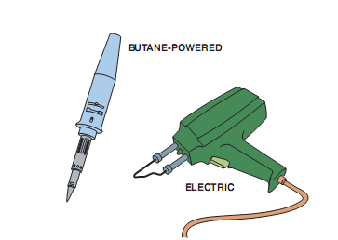
- Soldering equipment (soldering guns)
Electric soldering gun: - This type of soldering gun is usually powered by 110-volt AC and often has two power settings expressed in watts. A typical electric soldering gun will produce from 85 to 300 watts of heat at the tip, which is more than adequate for soldering.
An electric soldering gun used to make electrical repairs.
Figure 1-15 soldering gun

In addition to a soldering iron, most service technicians who do electrical-related work
should have the following:
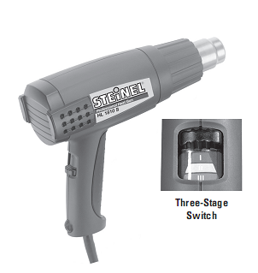
- Wire cutters
- Wire strippers
- Wire crimpers
- Heat gun
- Heat-gun or blower: Heat Guns (blower) are powerful heat blowers with lightweight ergonomic design, a soft grip handle and quiet operation for convenient long-term use. Interchangeable temperature keys lock in specific output ranges.
Figure 1-16 Heat-gun

- Wires and cable
A wire in a wiring harness is made up of a conductor and an insulator. The metal core of the wire, typically made of copper, is the conductor. The outer jacket (made of plastic or other material) coating the core is the insulator. Under normal circumstances, electrons move a few inches per second. Yet when an electrical potential is applied to one end of a wire, the effect is felt almost immediately at the other end of that wire. This is so because the electrons in the conductor affect one another, much like billiard balls in a line.
Wire Types
Automotive wiring or circuit conductors are used in one of three forms, as follows:
- Solid wires (single-strand)
- Stranded wires (multi strand)
- Printed circuitry
- Solid or single-strand wire is used where current is low and flexibility is not required. In automotive electrical systems, it is used inside components such as alternators, motors, relays, and other devices with only a thin coat of enamel or shellac for insulation.
- Stranded or multi strand wire is made by braiding or twisting a number of solid wires together into a single conductor insulated with a covering of coloured plastic, as shown in Most automotive electrical system wiring uses stranded wire, either as single conductors or grouped together in harnesses or looms.

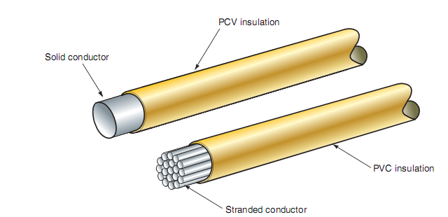
Figure 1-17 Comparison between solid and stranded primary wire
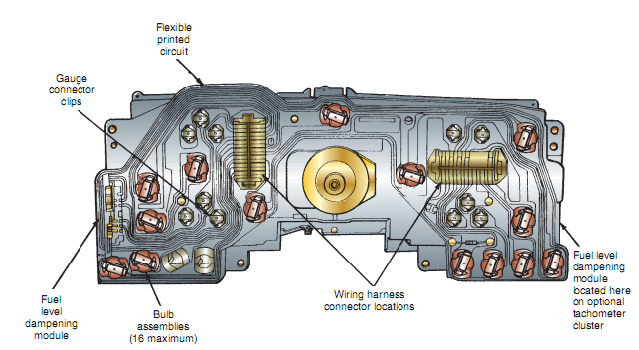
- Printed circuitry is a thin film of copper or other conductor that has been etched or embedded on a flat insulating plate. A complete printed circuit consists of conductors, insulating material, and connectors for lamps and other components, and is called a printed circuit (PC) board. It is used in places where space for individual wires or harnesses is limited, such as behind instrument panels.
Figure 1-18 Printed circuits eliminate bulky wires behind the instrument panel
- Heat shrink sleeve and flexible conduit
Heat-shrink tubing (or, commonly, heat shrink or heat shrink) is a shrinkable plastic tube used to insulate wires, providing abrasion resistance and environmental protection for stranded and solid wire conductors, connections, joints and terminals in electrical work. It can also be used to repair the insulation on wires or to bundle them together, to protect wires or small parts from minor abrasion, and to create cable entry seals, offering environmental sealing protection. Heat-shrink tubing is ordinarily made of polyolefin, which shrinks radially (but not longitudinally) when heated, to between one-half and one-sixth of its diameter.
- Terminals and connectors
To perform the function of connecting the wires from the voltage source to the load component reliably, terminal connections are used. Today’s vehicles can have as many as 500 separate circuit connections. The terminals used to make these connections must be able to perform with very low voltage drop. Terminals are constructed of either brass or steel. Steel terminals usually have a tin or lead coating. A loose or corroded connection can cause an unwanted voltage drop those results in poor operation of the load component. For example, a connector used in a light circuit that has as little as 10% voltage drop (1.2 V) may result in a 30% loss of lighting eﬃciency.
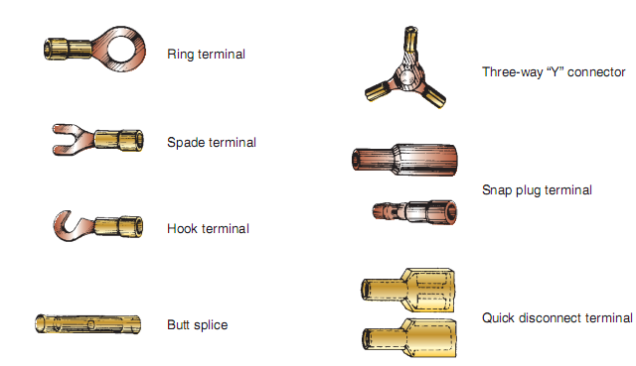
Terminals can be either crimped or soldered to the conductor. the terminal makes the electrical connection, and it must be capable of withstanding the stress of normal vibration.
- Electrical tape
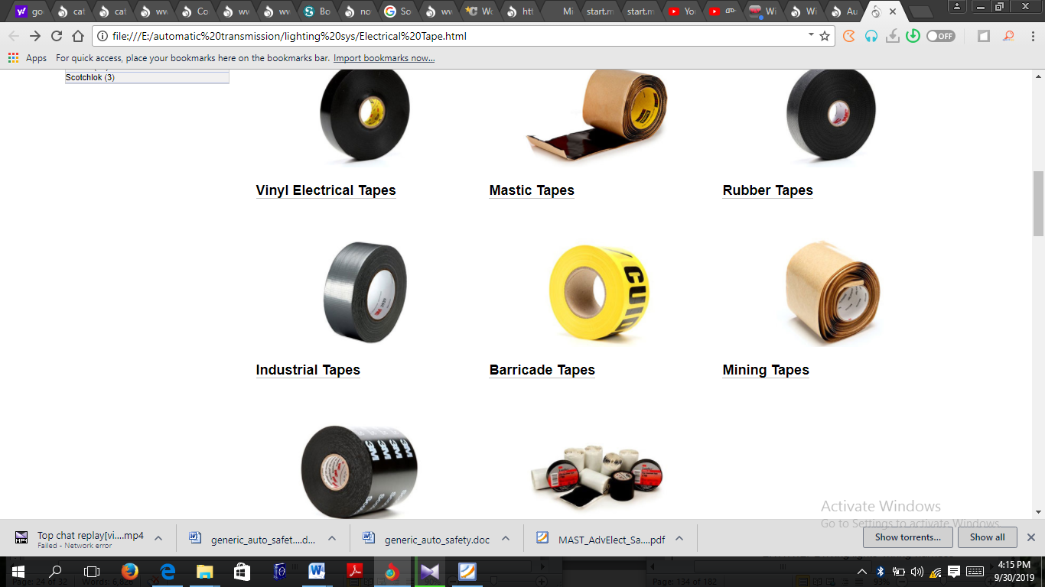
Electrical tape (or insulating tape) is a type of pressure-sensitive tape used to insulate electrical wires and other materials that conduct electricity.
Figure 1-19 Examples of primary wire terminals and connectors used in automotive applications

It can be made of many plastics, but vinyl is most popular, as it stretches well and gives an effective and long lasting insulation. Electrical tape for class H insulation is made of fiberglass cloth.

Figure 1-20 Electrical Tape

Safety precautions associated with lighting and windshield wiper system
- draw attention to specific safety concerns and how to avoid injury in the shop.
- Instructors know that reinforcement is key for many of these very important, but less exciting, practices.
- Safety Tips alert students to potential hazards and remind instructors to address the dangers in class ahead of exposure in the shop.
Before perform any electrical tasks on the vehicle, follow safety rules in order to prevent personal and material damage and injuries.
- wear proper personal safety clothes
- always put a vehicle in park, turn ignition switch off if it is not necessary.
- Never touch cut or open any electric conductor
- Do not put any tools on the top of battery and electrical surfaces
- Use right tools for right property
Safe of material handling
Material handling is the movement, protection, storage and control of materials and products throughout manufacturing, warehousing, distribution, consumption and disposal Their application helps with Forecasting, Resource allocation, Production planning, Flow and process management, Customer delivery
What Are the Principles of Material Handling?
When designing a material handling system, it is important to refer to best practices to ensure that all the equipment and processes—including manual, semi-automated and automated—in a facility work together as a unified, system. By analyzing the goals of the material handling process and aligning them to guidelines, such as the 10 Principles of Material Handling, a properly designed system will improve customer service, reduce inventory, shorten delivery time, and lower overall handling costs in manufacturing, distribution and transportation. These principles include:
- Planning: Define the needs, strategic performance objectives and functional specification of the proposed system and supporting technologies at the outset of the design.
- Standardization: All material handling methods, equipment, controls and software should be standardized and able to perform a range of tasks in a variety of operating conditions.
- Work: Material handling processes should be simplified by reducing, combining, shortening or eliminating unnecessary movement that will impede productivity. Examples include using gravity to assist in material movement, and employing straight-line movement as much as possible.
- Ergonomics: Work and working conditions should be adapted to support the abilities of a worker, reduce repetitive and strenuous manual labor, and emphasize safety.
- Unit load: Because less effort and work is required to move several individual items together as a single load (as opposed to moving many items one at a time), unit loads—such as pallets, containers or totes of items—should be used.
- Space utilization: To maximize efficient use of space within a facility, it is important to keep work areas organized and free of clutter, to maximize density in storage areas (without compromising accessibility and flexibility), and to utilize overhead space.
- System: Material movement and storage should be coordinated throughout all processes, from receiving, inspection, storage, production, assembly, packaging, unitizing and order selection, to shipping, transportation and the handling of returns.
- Environment: Energy use and potential environmental impact should be considered when designing the system, with reusability and recycling processes implemented when possible, as well as safe practices established for handling hazardous materials.
- Automation: To improve operational efficiency, responsiveness, consistency and predictability, automated material handling technologies should be deployed when possible and where they make sense to do so.
- Life cycle cost: For all equipment specified for the system, an analysis of life cycle costs should be conducted. Areas of consideration should include capital investment, installation, setup, programming, training, system testing, operation, maintenance and repair, reuse value and ultimate disposal.

Self-check-1
Part: I Multiple Choice
1. Many vehicles use halogen light bulbs. What must you avoid when handling? halogen bulbs?
a. Touching the glass.
b. Touching the metal.
c. Touching the halogen gas.
d. Touching the terminal.
2. Which of the following lamps produce more lumens with a bluish tinge for the
given wattage when compared with all other lamps?
a. Incandescent lamps
b. Halogen lamps
c. High-intensity discharge lamps
d. VTF lamps
3. Which type of light bulb have a base on each end of a cylindrical bulb?
a. Bayonets style
b. Festoon style
c. Wedge style
d. Dual-filament style
Part: II short answer
      - What is the purpose of lighting and wind shield wipers?
      - Describe the types, operation, and construction of the various automotive lamps.
      - identify tools and equipment needed for service lighting systems.
      - Enumerate safety practices associated with lighting and wind shield wipers?

Note: Satisfactory rating – above 60% Unsatisfactory - below 60%
You can ask you teacher for the copy of the correct answers

Operation sheet 1: Greeting with DMM

Operation title: measure three electrical terms
Purpose: To know how to measure the three electrical terms:
- Instruction: Accomplish the activity by select the appropriate tools following You have been given 20 minutes
- Tools and requirement: Battery, wire, multi meter
- Steps in doing the task
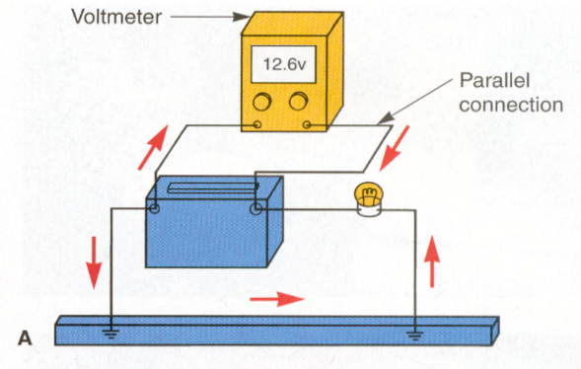
1. Used to measure the amount of voltage in a circuit
2. Connected in parallel with the circuit

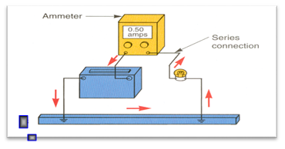
3.Measures the amount of current in a circuit
4. Connected in series with the circuit
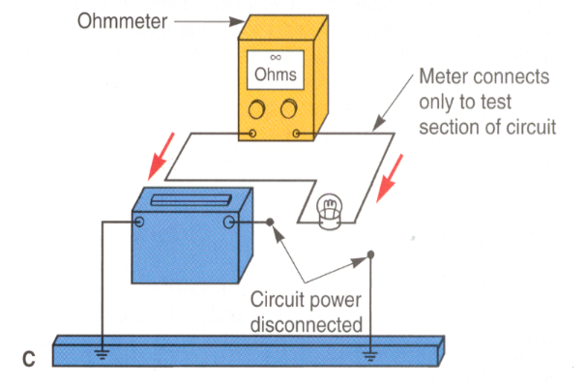
5. All the current in the circuit must pass through a conventional ammeter
6.Measures the amount of resistance in ohms in a circuit or component
7.Connected in parallel with the wire or component being tested
8.Wire or component being tested must be disconnected from power
9. Ohmmeter reading can be compared to specifications to determine if a part is defective.
- Quality Criteria: Using an electrical meter safely and efficiently is perhaps the most valuable skill an electronics technician can have.
- Precautions: It is always best to proceed cautiously when using meters. Carelessness, more than any other factor, is the reason that leads technicians to electrical accidents

Lap test 1
- Continuity testing
- Measure the resistance
- Measure battery and circuit voltage
- Measure circuit amperage

Unit two: lighting wiring system
This unit to provide you the necessary information regarding the following content coverage and topics:
- Component of lighting system with their function
- Interpreting wiring diagram of low voltage lighting and wiring systems
- Repairing and install electrical wiring
- Troubleshooting electrical wiring system
- Post-repair testing
This guide will also assist you to attain the learning outcomes stated in the cover page. Specifically, upon completion of this learning guide, you will be able to:
- Understand lighting system and component with their function
- Interpret wiring diagram of low voltage lighting and wiring systems
- Repair and install electrical wiring
- Troubleshoot electrical wiring system
- Perform Post-repair testing

2.1 component of lighting system with their function
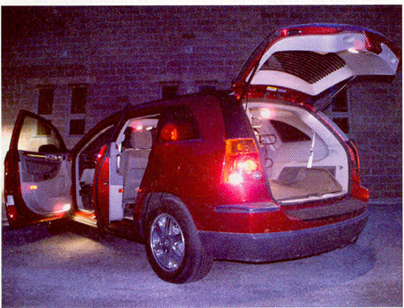
Modern automotive lighting is used for both functional and decorative purposes. Exterior lights are required to meet governmental regulations for color and in brightness. Interior lighting is used to illuminate driver controls and to provide style and decoration inside the vehicle. The lighting system provides power to both exterior and interior lights.
Automobiles exterior lights consist such as head lights, turn signals, parking lights, side marker light, back up lights, tail lights, number plate lights
Figure 2-1 automobile interior and exterior light

Interior lights such as instrumental-panel lights, coach lights (if so equipped), headlight switch, and various other control switches. map lights, various warning & indicator lights and. courtesy lights, dome/map lights, Other lights, such as vanity mirror lights, the under hood light, are used on some vehicles and are also part of the lighting system.

2.1.1 Exterior Lights
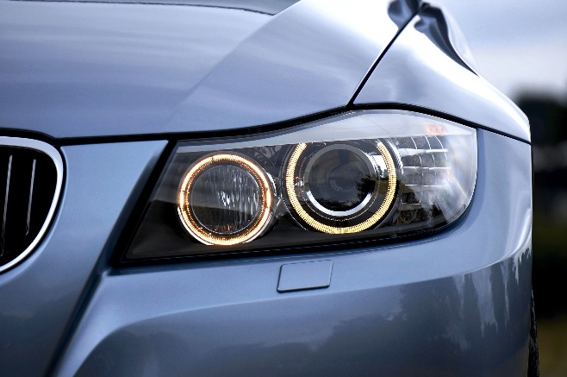
HEADLIGHTS
Headlights are mounted on the front of a vehicle to light the road ahead during darkness or other times when normal visibility is poor.
Headlight designs and construction have been influenced by the changes in technology. In the past, all cars had two or four round headlights. Now headlights are an integral part of vehicle’s overall design. There are two types of headlights. These are the sealed beam head light and the semi-sealed beam head lights. The headlights of today’s vehicles are based on sealed-beam, composite, or high intensity discharge lamps.
Figure 2 -2 head light
A. Sealed beam headlight
Until recently, all vehicles had sealed-beam headlights. A sealed-beam headlamp is an air-tight assembly with a filament, reflector, and lens.

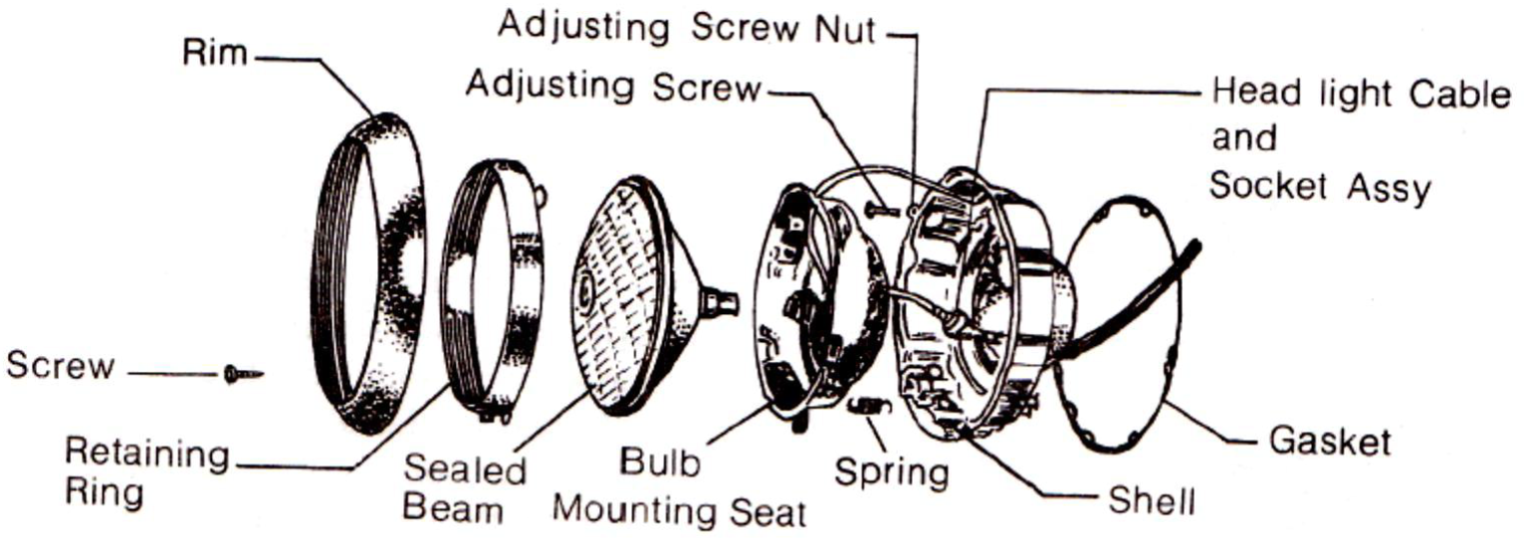
Figure 2 -3 various component of sealed beam head light
The curved reflector is sprayed with vaporized aluminum and the inside of the lamp is normally filled with argon gas.
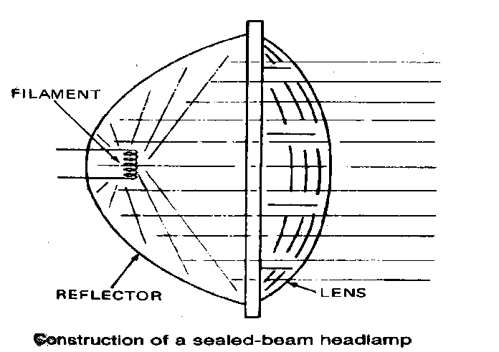
The reflector intensifies the light produced by the filament, and the lens directs the light to form a broad flat beam. To direct the light, the surface of the glass lens has concave prisms.
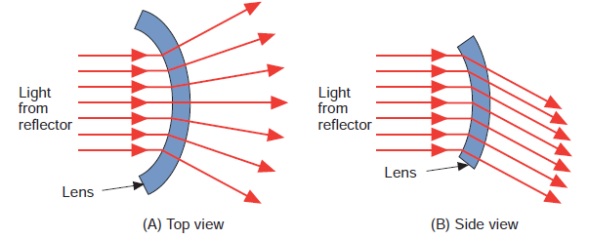
In a sealed beam headlight, no separate light bulb is used. Instead, the whole assembly itself is a light bulb. The filament is placed in front of a reflector, to which a glass lens is welded. The reflector directs the lights from the filament through the lens. The lens focuses the light from the reflector into the desired pattern.
Figure 2 -4 construction of sealed beam head light

` Figure 2 -5 The reflector intensifies the light produced by the filament, and the
lens directs the light to form a broad flat beam
Low- and high-beam filaments are placed at slightly different locations within a sealed-beam bulb. The filaments’ location determines how light passes through the bulb’s lens. This, in turn, determines the direction of the light beam.
In a dual-filament lamp, the lower filament is used for the high beam and the upper filament is used for the low beam.
There are various ways to identify sealed-beam headlights, such as #1, #2, and the “halogen” or “H” marking molded on the front of the headlight lens.
A type #1 is high beam only and has two electrical terminals. The type #2 has both low beam and high beam and three terminals. When a type #2 is switched to low beam, only one of its filaments is lit. When the high beam is selected, the second filament lights in addition to the low beam When there are four headlights (two on each side), the single filament of the #1 lamp lights when the high beam is selected, along with both filaments of the #2 bulb. H1 and H2 quartz halogen bulbs are the most commonly used sealed-beam headlights
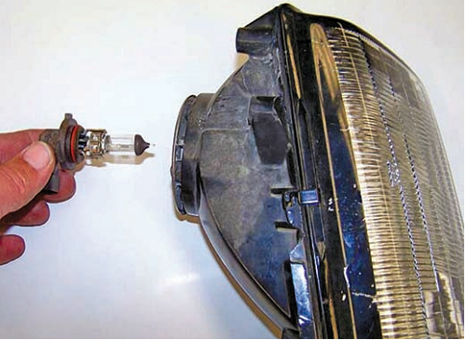
B. Semi sealed beam headlight
The difference between the sealed beam and semi-sealed beam headlight is its design, which allows bulb replacement. In this type of head light, if the bulb is blown, the bulb can be replaced without replacing the whole assembly. Furthermore, when a bulb is replaced, the orientation (direction and angle) is not likely to change.
Figure 2 -6 construction of semi sealed beam head light
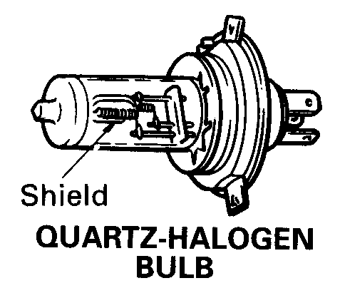
In the semi-sealed beam head light, bulbs are available in the following types. These are: -
- Ordinary bulb
- Quartz halogen bulb

Cylindrical Housings
- To provide more precise light beam patterns, many m manufacturers are using headlamp assemblies that have cylindrical bulb housings
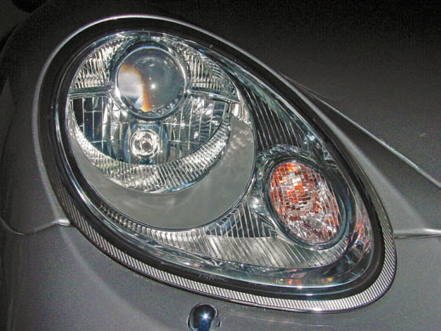
- The light beam is shot out of the cylinder. The aim of the cylinder projects the beam without much scattering

Figure 2 -7 Cylindrical Housings

TYPES OF BEAM
- Low beam Operation
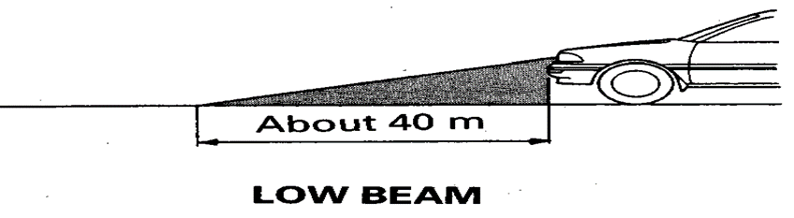
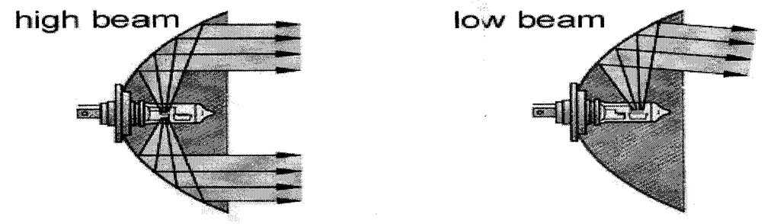
The dipped or low beam produces a light pattern that illuminates the road a certain distance (about 40m) from the vehicle. The low beam is low enough to prevent glare to oncoming vehicles. The low beam filament is located in front of the focal point of the parabolic reflector, so that all the light rays it emits are inclined to the mirror axis. A screen plate or cap or shield is located under the dipped beam filament. It prevents light rays from reaching the lower half of the reflector and being deflected upwards through the glass. It is the screen or cap, which provides the sharp boundary between the light and dark area visible.
Figure 2-8 low beam

- High beam operation
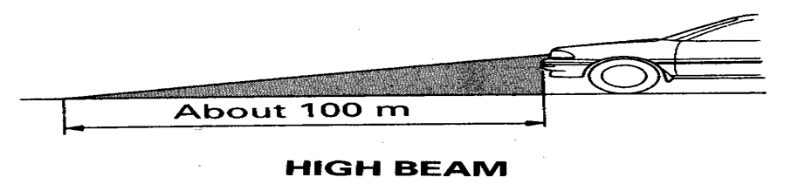
The upper or far or high beam filament is focused to produce a high intensity light pattern to illuminate the road a greater distance (about 100m) from the vehicle for night driving. The high beam filament is precisely located at the focal point of the parabolic reflector. The light rays are reflected and rays grouped so that they emerge parallel to the axis of headlight. This makes the light intensity within the beam about thousands times higher than if the bulbs had no reflector. Cylindrical or prismatic areas formed in the headlight glass ensures that part of the light is deflected sideways and down wards so that the road surfaces directly ahead of the vehicle and the edge of the road are adequately illuminated.
Figure 2- 9 High beam
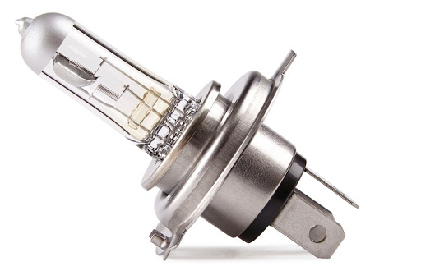
Halogen head lamps
Halogen headlights are used on some vehicles. Halogen is the name given to a certain group of chemically related non-metallic elements, which include chlorine, fluorine and iodine. Iodine is the halogen most commonly used in automotive headlights.
A halogen headlamp consists of a small bulb filled with iodine vapor located inside the light housing.
Figure 2-9 halogen bulb
The filament of the bulb is made of tungsten and is designed to operate at a higher temperature than the filaments of conventional headlights.
- Most often a halogen headlamp is filled with iodine vapor.
- This headlamp is actually a bulb made of high-temperature resistant glass surrounding a tungsten filament.
- The tungsten filament is capable of withstanding higher temperatures than that of standard sealed-beam lamps because of the presence of the halogen.
- It can burn brighter.
- They emit much whiter and brighter light than other sealed beam head lights. This improves visibility on high beam by 25%.
- Halogen head lamps require about 40% less power on low beam. This allows the car to have a smaller and lighter weight alternator
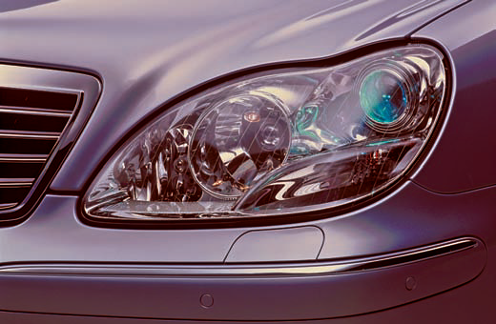
HID Headlamps
High-intensity discharge (HID) or xenon headlamps use gas-discharge lamps and are electronically controlled. These lights are recognizable by the blue-white color of their light. They have this color because the light spectrum is much closer to daylight than that of the halogen bulb.
Figure 2 -10 HID Headlamps

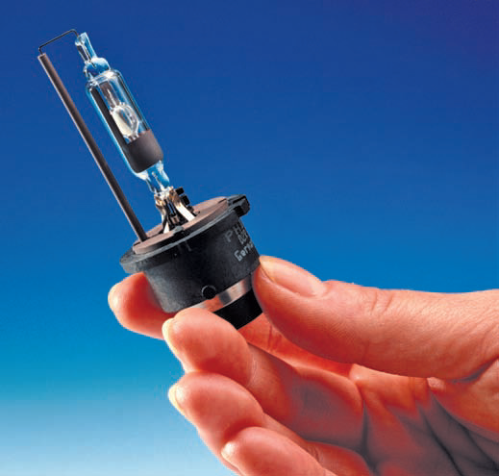

Instead of using a filament, an electrical arc is created between two electrodes that excite a gas (usually xenon) inside the headlamp, which in turn vaporizes metallic salts that sustain the arc and emit light. The presence of an inert gas amplifies the light given off by this arcing.
Figure 2-11 HID headlight bulb
More than 15,000 volts are used to jump the gap between the electrodes. To provide this voltage, a voltage booster and controller is required. Once the high voltage bridges the gap, only about 80 volts are needed to keep current flowing across the gap. When the headlights are switched on, it takes approximately 15 seconds for the lamp to reach maximum intensity. However, even during ignition these lamps provide more than adequate light for sale driving.
Xeon headlights illuminate the area to the front and side of the vehicle with a beam that is both brighter and much more consistent than that the light generated by the headlamps. The great light output of these lamps allows the headlamp assembly to be smaller and lighter. Xenon lights also produce significantly less heat.
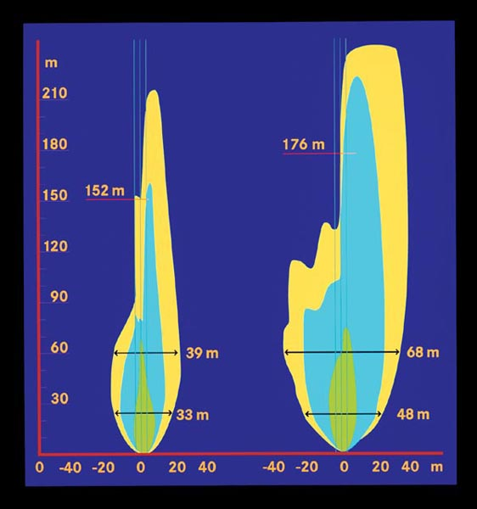
Xenon headlights produce about twice as much light as comparable halogen headlights and make night driving safer and less tiring for the driver’s eyes. Xenon headlamps also use about two-thirds less power to operate and will last two or three times as long.
Bi-Xenon Lights some vehicles have bi-xenon headlamps that provide xenon light for how low and high beams. These may also be fitted with halogen lights that are used for the flash-too-pass feature. Bi-Xenon lights rely on a mechanical shield plate, or shutter, that physically obstructs a portion of the overall light beam emitted by the arc. When the driver selects the high beams, the shutter reacts and allows the headlights to project the complete, unobstructed light beam.
Figure 2- 12 a comparison of the light pattern and intensity between the halogen (left) and a xenon (right) headlamp
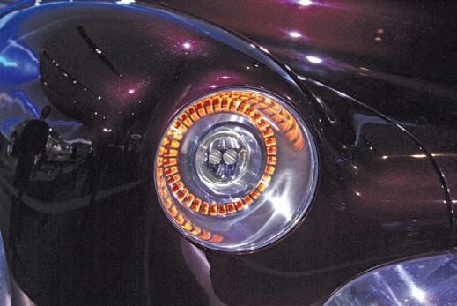
LED Headlights Currently under development and perhaps available on some vehicles at this time are LED headlamps.
Light-emitting diodes (LEDs) are semiconductors that change electrical energy into light. An individual LED does not produce enough light to serve as a head lamp. Ten to twenty LEDs are needed for ample forward lighting
Figure 2-13 LED head light

There are many reasons for using LEDs in headlights:
- LEDs do not require a vacuum bulb or high voltage to work.
- LED-based lighting sources require up to 40% less power than traditional lighting sources, this improves a vehicle’s fuel economy.
- LEDs provide a whiter light than xenon.
- Prototype LED headlights have achieved a 1,000- lumen output in the low-beam mode; this is the same as a xenon headlamp.
- LEDs are mercury-free, making them environmentally friendly unlike some HID/xenon systems.
- The average operating life of an LED is twice that of the vehicle itself. This means the headlamp may never need to be replaced.
- LEDs are resistant to shock and vibration.
- LED headlamps reduce oncoming driver perception of glare.
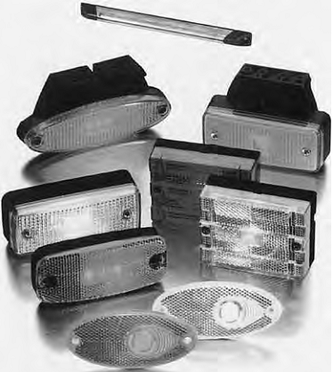
- LED-based headlamps are up to 55% thinner than other designs, which gives designers more flexibility and freedom.
Figure 2- 14 light units with LEDs
Disadvantages of LED:
- LEDs are more expensive.
- The heat from the engine compartment and the lamp can cause failure. Therefore, LEDs need temperature controls and must be mounted to heat retarding materials.
- LEDs also require precise current control, which requires complicated electronic circuitry.
- The current trend is to use LEDs rather than standard bulbs in many different lighting systems.
- Taillights, turn signals, hazard lights, side lights, parking lights, and fog lamps may use an LED or a cluster of LEDs.
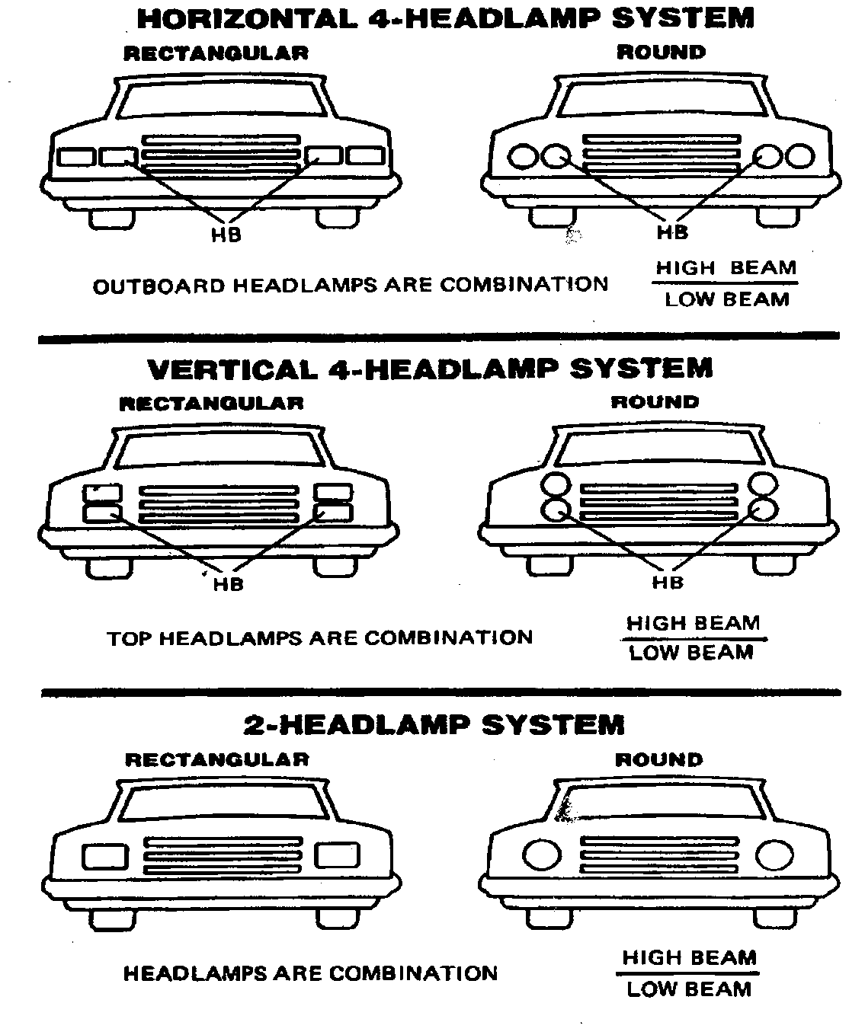
Headlamp Arrangement
The shape of the headlights may be round or rectangular. The headlights are arranged in three different ways.

Figure 2 15 Head light arrangement
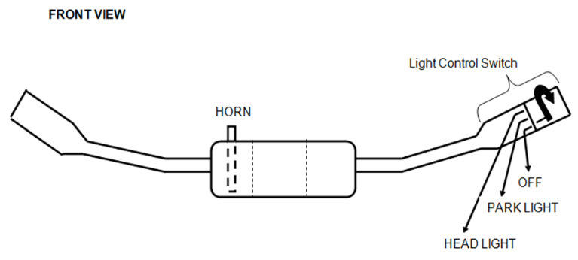
Headlight Switches
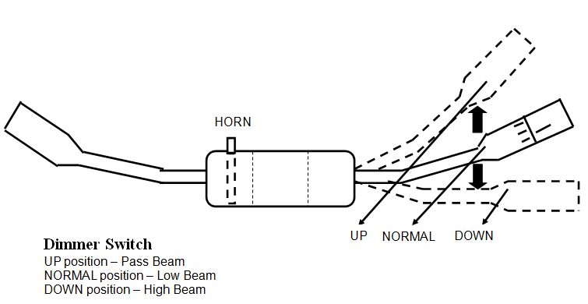
- Headlight switches are either mounted to the instrument panel or are part of the multifunction switch on the steering column. The head light switch controls most of the exterior lighting for the vehicle.
- Most switches have three positions: off, park, and head light. When the headlight switch is in the OFF position, the open contacts prevent battery voltage from continuing on to the lamps.
- When the switch is in the PARK position, battery voltage is applied to the parking lights, side markers, taillights, license plate lights, and instrument panel lamps.
Figure 2-16 head light switch
- This circuit is usually protected by a 15- or 20-amp fuse that is separate from the headlight circuit.
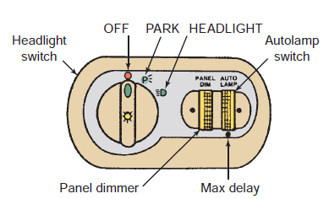
- When the switch is in the HEADLIGHT position, battery voltage is applied to the headlights. The lamps lit by the PARK position remain on.
- Some vehicles have a separate fuse for the headlight on each side of the vehicle. This allows one headlight to operate if there is a problem in the circuit for one side of the vehicle.
- The instrument panel lights come on whenever the headlight switch is in the PARK or HEADLIGHT position. Headlight switch, instrument panel light control, and the auto lamp control
Figure 2-17 Headlight switch, instrument panel light control, and the auto lamp control

Dimmer Switches
- The dimmer switch provides a way for the driver to switch between high and low beams.
- A dimmer switch is connected in series with the headlight circuit and controls the current path to the headlights. The low beam headlights are wired separately from the high beam lamps.
- Often there is a relay for each set of beams. Newer vehicles have the dimmer switch on the steering column
- When the headlight switch is in the HEADLIGHT position, current flows to the dimmer switch.
- If the dimmer switch is in the LOW position, current flows through the low-beam circuit. When the dimmer switch is in the HIGH position, current flows to the high-beam circuit
Flash to Pass
Most steering column-mounted dimmer switches have an additional feature called flash to pass. This circuit illuminates the high-beam headlights even with the headlight switch in the OFF or PARK position.
When the driver activates the flash to pass feature, the contacts of the dimmer switch complete the circuit to the high-beam filaments
Adaptive Headlights
Adaptive headlight systems are electronically controlled through inputs from the steering system and vehicle speed. They aim the lights in the direction the vehicle is turning
Currently there are two basic system designs for adaptive lighting. Both are controlled by the vehicle’s body control module (BCM). The systems respond in real time by responding to the vehicle’s current steering angle, yaw rate, and road speed.
One design swivels the entire headlamp assembly. Bidirectional electric motors attached at the base of the assembly can move the left headlamp up to 15 degrees to the left and 5 degrees to the right, and the right headlamp up to 5 degrees to the left and 15 degrees to the right.
Another design uses extra lamps that turn on according to steering angles.
These cornering lights may be housed in the headlamp or fog light assembly, or they can be a separate unit. These lamps normally only turn on during low-speed turning.
Adaptive headlights can also be controlled by GPS navigation and digital road maps. With information about the road ahead, the system can anticipate curves in the road and move the headlamps to illuminate curves before the driver starts to turn the steering wheel
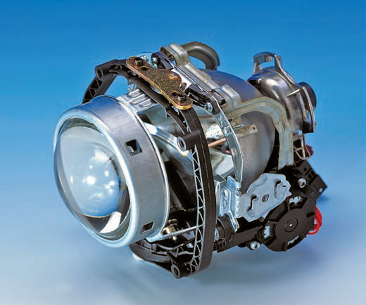
Smart headlights: Smart headlights dim when passing cars to prevent dazzling other drivers.
Headlight illuminates the road without blinding other drivers.
It uses a camera and a beam splitter to track other vehicles, and then dims the rays of light that would reach the oncoming drivers' eyes
Lights improve driver visibility during poor weather such as snowstorms.
Figure 2 -18 smart head lights
- They also increase contrast of lanes, markings, and sidewalks. Programmable headlights have been in development since 2012.
- The idea behind the programmable headlight is to integrate a camera, processor, and spatial light modulator with a light source.
- The camera captures images that are illuminated by the light source, and the processor detects which objects in these images will impact the driver.
- It then controls the spatial light modulator to change the direction of the light rays.
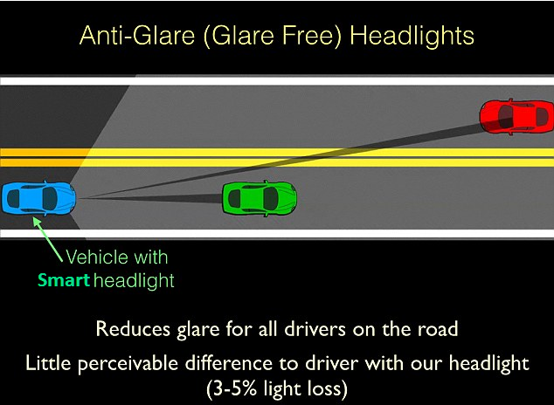

Figure 2-19 Anti-glare headlight
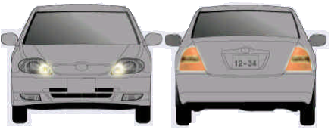
Clearance lights and Tail Lights
These are low-intensity lights to indicate the presence and width of a vehicle at night or in tunnel to other vehicles in the front or behind. Those in the front are called clearance-lights and those in the back are called taillights. The power rating of these lights is 5 watts.
Figure 2-20 clearance and tail lights

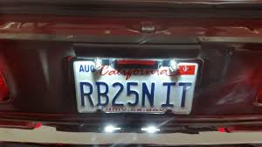
License plate lights
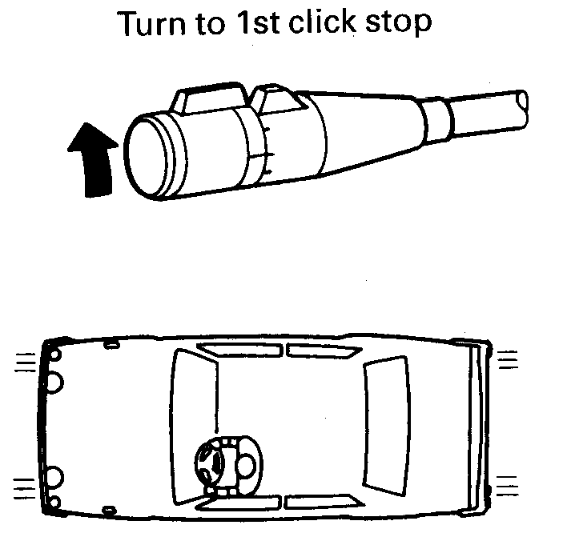
These lights illuminate the rear license plate. The license plate lights go on when the taillights go on.
Figure 2-21 Tail light

Figure 2 -22 Tail light and clearance lights switch

Signal Light Systems/ Cornering Lights

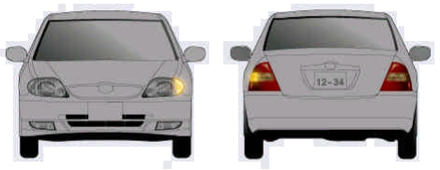
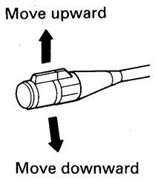
Cornering lights are lamps that illuminate when the turn signals are activated. They burn steady when the turn signal switch is in a turn position to provide additional illumination of the road in the direction of the turn.
Figure 2-23 Turn signal switch
Figure 2-24 Turn signal

Vehicles equipped with cornering lights have an additional set of contacts in the turn signal switch. These contacts operate the cornering light circuit only.
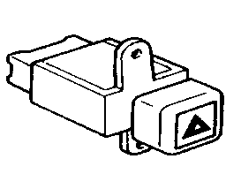
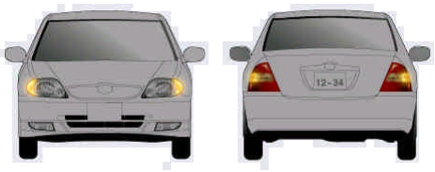
Hazard Warning Lights in the event of an emergency, such as a roadside breakdown, all the lamps should be capable of working simultaneously, when they are called "hazard warning lights". The hazard warning lights indicate the existence of the vehicle to the front, rear and both sides during emergency stopping or parking.
Figure 2-25 Hazard light

The emergency warning lights are turned on with a separate switch that causes all four turn signals to flash at once. The power rating of turn signal lights is 21 watts.
Figure 2 -26 Hazard switch
Flasher relays/units - used for operating indicators and hazard warning lights and employ electronics to control the timing of the contact opening and closing rather than a traditional bi-metallic strip.
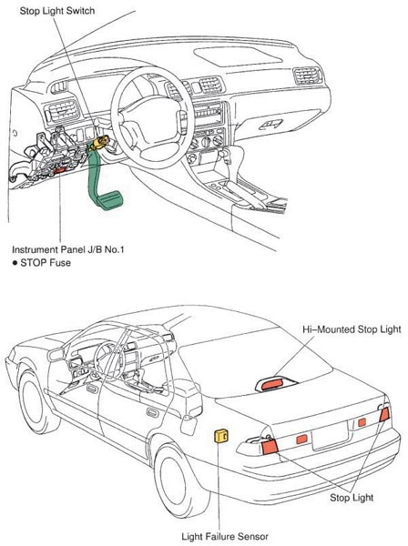
Brake Lights
The brake (stop) lights are usually controlled by a stop light switch that is normally mounted on the brake pedal arm. Some cars are equipped with a brake or stop switch mounted on the master cylinder, which closes when hydraulic pressure increases as the brake pedal is depressed.
In either case, voltage is present at the stop light switch at all times. Depressing the brake pedal causes the stop light switch to close. Current can run then floe to the stop light filament of the rear light assembly. These stay illuminated until the brake pedal is released.
Figure 2-27 Brake switch and brake light
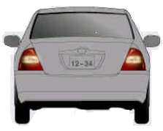
Backup Lights
When the transmission is placed in reverse gear, backup lights are turned on to illuminate the area behind the vehicle and to let drivers know that the vehicle is in reverse. The major components in the system are the backup light switch and the lights. Power for the backup light system is provided by the fuse panel.
Figure 2 -28 Back up light

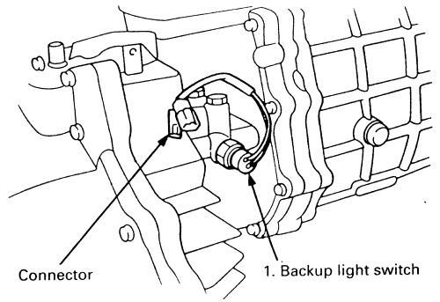
When the transmission is shifted to reverse, the backup lights s witch closes and power flows to the backup lights. That is, anytime the transmission is in reverse, current flows from the fuse panel through the backup light switch to the backup lights. On many vehicles, the fuse that protects the backup light system also protects the turn signal system.
Figure 2-29 Back up light switch
Fog light
Fog lights are designed to be used when visibility is severely restricted, chiefly by fog, but also in other poor visibility conditions such as snow or heavy rain.
They are designed to make you more visible, rather than helping to light your way so they are not needed in good visibility conditions at night -that’s what your headlights are for. They should only be used when your car's main lights won't be enough to make you visible to other road users.

Turn the headlight switch on to the low-beam position. Press the fog light switch (pilot indicator is on).
If the fog lights don’t come on, check the fuse and all the connectors, including the ground cable and the fusible link. The fog light lenses can cloud when the outside temperature is cold; this is normal and should go away in warm weather.
Figure 2- 30 Front fog light

2.1.2 Interior Light Assemblies
Modern automotive lighting is used for both functional and decorative purposes. Interior lighting is used to illuminate driver controls and to provide style and decoration inside the vehicle. The interior light illuminates the interior of the passenger compartment, but is designed so as not to dazzle the driver at night. A car’s interior can have up to 20 lamps. The bulbs that light when a door is opened are called courtesy lights. Instrument panel lights are used to illuminate the meters on the instrument panel at night, to enable the driver to read the meters and gauges quickly and easily while driving. The instrument panel lights go on when the taillights go on.
The Instrumental panel warning lights on the dashboard are used to warn the driver of a car with problem. These indicates unclosed door, low engine oil pressure, an under charging alternator, high coolant temperature, problems in the brake system and other potentially harmful situations.
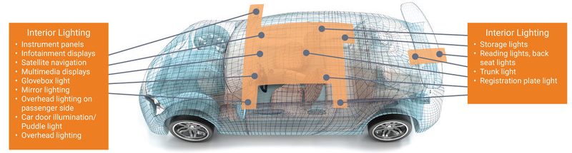
Figure 2-31 Interior lights
The types and numbers of interior light assemblies used vary significantly from one vehicle to another. Following are the more common.
Engine Compartment Light
Operating the hood causes the engine compartment light mercury switch to close and light the under hood area.
Glove Box Light
Opening the glove box door closes the glove box light switch contacts and the light comes on.
Luggage Compartment Light
The light is mounted in the underside of the trunk deck lid in the luggage compartment.
Trunk Lid Light
Lifting the trunk lid causes the light mercury switch to close and the light to come on.

Vanity Light
Pivoting the sun visor downward and opening the vanity mirror cover causes the vanity light switch contacts to close and the light to come on.
Courtesy Lights
Vehicles may have courtesy lights in the door trim panels, under each side of the instrument panel, above the foot wells, or in the center of the headlining.
Their sole purpose is to allow light inside the vehicle. They are illuminated when one of the doors is opened, by rotating the headlight switch to the full counterclockwise position, or by depressing the designated switch.
Dome/Map Light
Map lights are typically located on each side of the dome/map light housing. They are operated independently of the dome light by switches located at each map light. The dome light is actuated by a switch or along with the courtesy lights when the door is opened.
Illuminated Entry System
This system assists vehicle entry during the hours of darkness by illuminating the door lock cylinder so it may be easily located for key insertion.
The vehicle interior is also illuminated by the courtesy lights. Most of these systems have an electronic actuator module, an illuminated door lock cylinder, a door latch switch, and wiring harness.
The system is activated by raising the outside door handle, by depressing a key on the key fob, or by entering a code on the keyless entry system.

2.1. 3 Horn
- The horn is an electromagnetic vibrating device, which is operated by the driver to produce an audible warning signal.
- It provides a warning sound to other road users. Automotive horns are usually wired directly to battery voltage from the fuse panel.
- The majority of automobiles, except most fords, utilize a horn relay. With a relay, the horn button on the steering wheel or column completes a circuit to ground which closes a relay, and the heavy current flow required by the horn then travels from the relay to the horns.
- Horns are manufactured in several different tones or frequencies ranging between 1800 and 3550 Hz.
- Car manufacturers can select various horn tones for a particular car sound.
- When two horns are used, each has a different tone when operated separately, yet the sound combines when both are used.
When the horn button is depressed, current starts flowing through the field coil produces a magnetic field that pulls the armature with the diaphragm and opens the contact points due to which circuit is broken. So that current cannot flow. The magnetic field in the coil collapses and the diaphragm is released. The contact points are closed then. The cycle again starts which is repeated again and again resulting in continuous vibration of the diaphragm which produces sound.
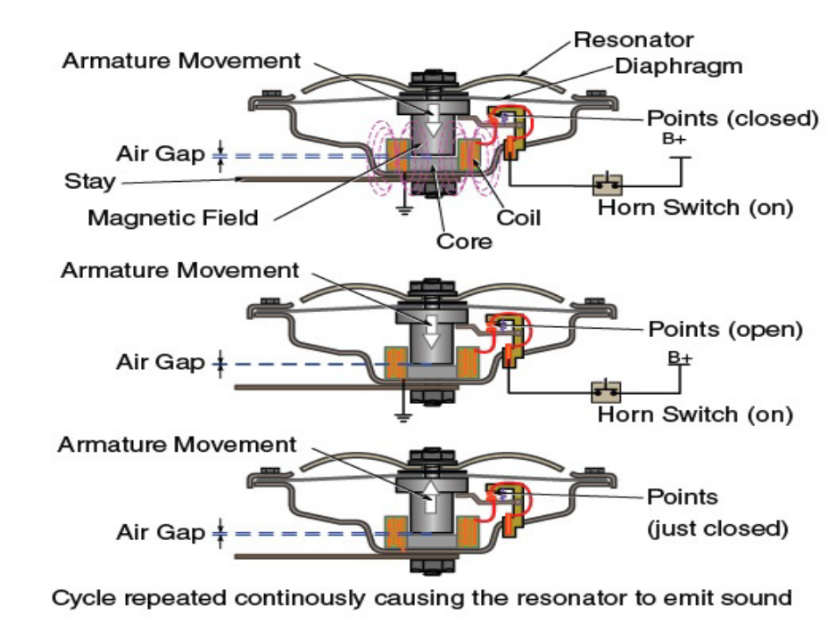
The design and shape of the horn determine the frequency and tone of the sound.
Figure 2-32 horn working principle
Horn consists:
  - body,
  - field winding,
  - diaphragm,
  - armature and
  - contact breaker.

Interpreting wiring diagram of lighting systems
Learning how to read wiring diagrams takes time and practice. Understanding wiring diagram information can then be used to diagnose circuit faults. The layouts of electrical circuits and their components are shown as diagrams.
The diagrams are made up of symbols and connecting lines. Being able to read a wiring diagram is probably the most important skill when diagnosing an electrical fault

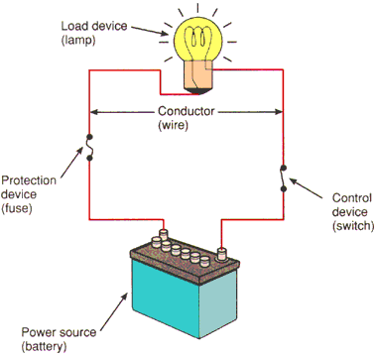
All circuits require the same basic components:
- Power source
- Protection device
- Conductors
- Load
- Control device

Figure 2-33 simple circuit
      - Power Sources – Battery Everything electrical in a vehicle is supplied current from the battery. The battery is one of the most important parts of a vehicle because it is the heart or foundation of the electrical system. The primary purpose of an automotive battery is to provide a source of electrical power for starting and for electrical demands that exceed alternator output.
      - protection devices: Each electrical circuit contains one or more circuit protection devices to prevent damage to electrical wiring and electronic component e.g. fuse, fuse blink and circuit breaker
      - Control device: the simplest control device is switch a switch opens or closes the path for current. close the switch and current is present to operate the load open the switch and current stops load no longer operates there are other types of control device relays transistor, ECUs
      - Load: the load can be any component that uses electricity to do work like, light, coil, motor
      - Conductor: material that allows electricity to flow through it.

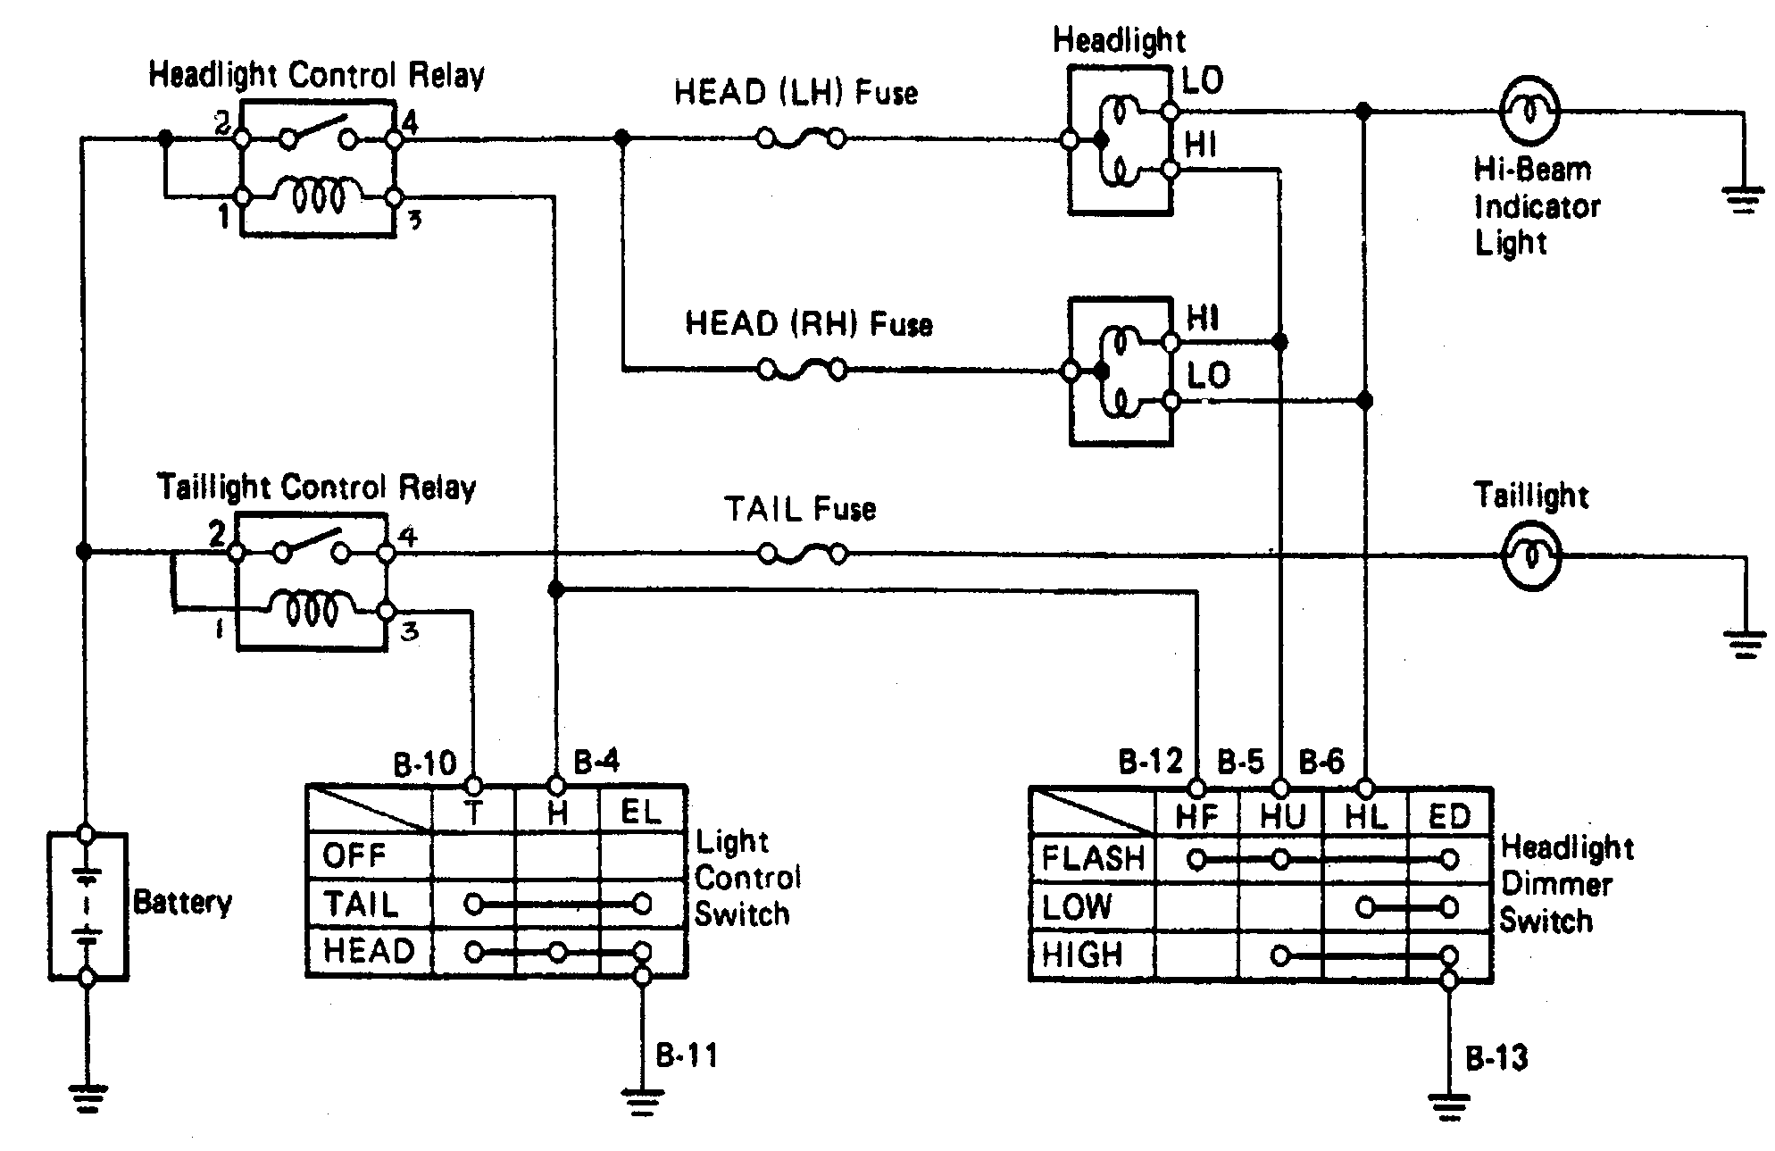
Head and tail light circuit
Figure 2-34 head light and tail light circuit

Turn and hazard light circuit
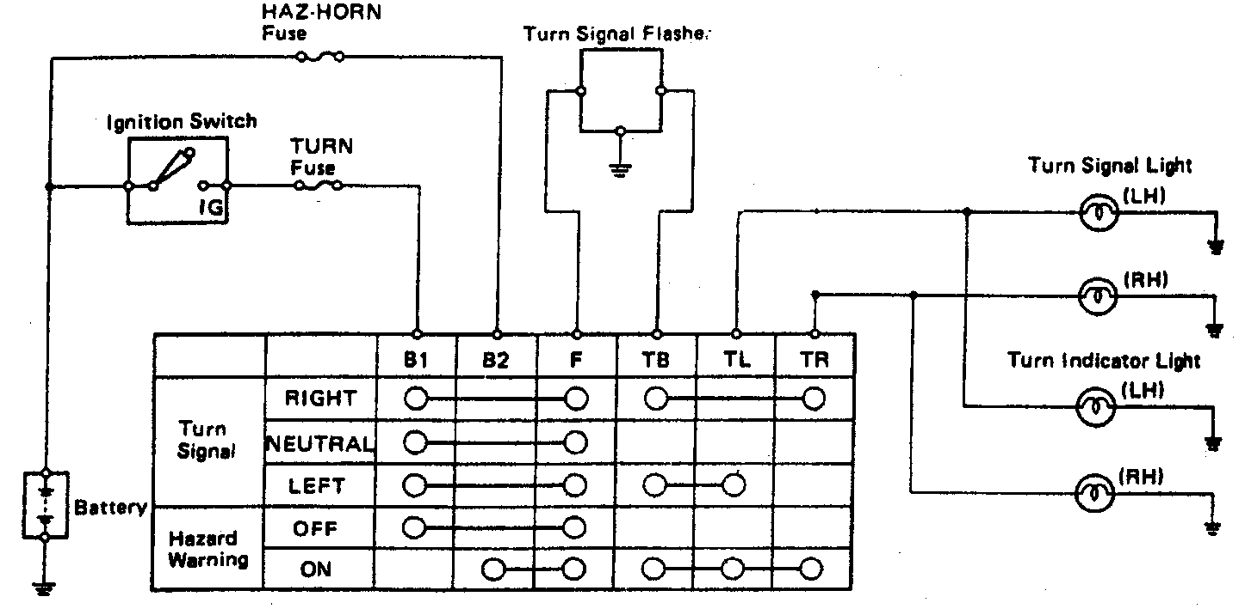
Figure 2-35 Turn and hazard circuit

Stop and back up light circuit

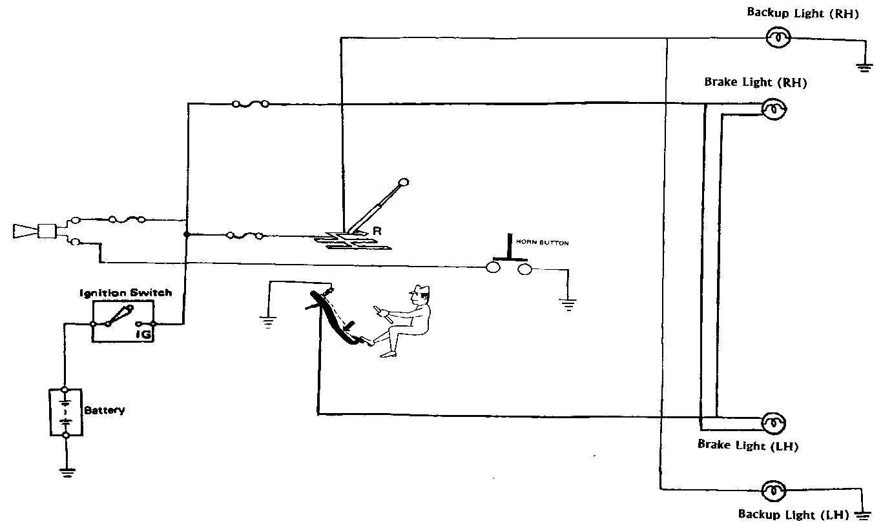
Figure 2-36 back up and stop light circuit

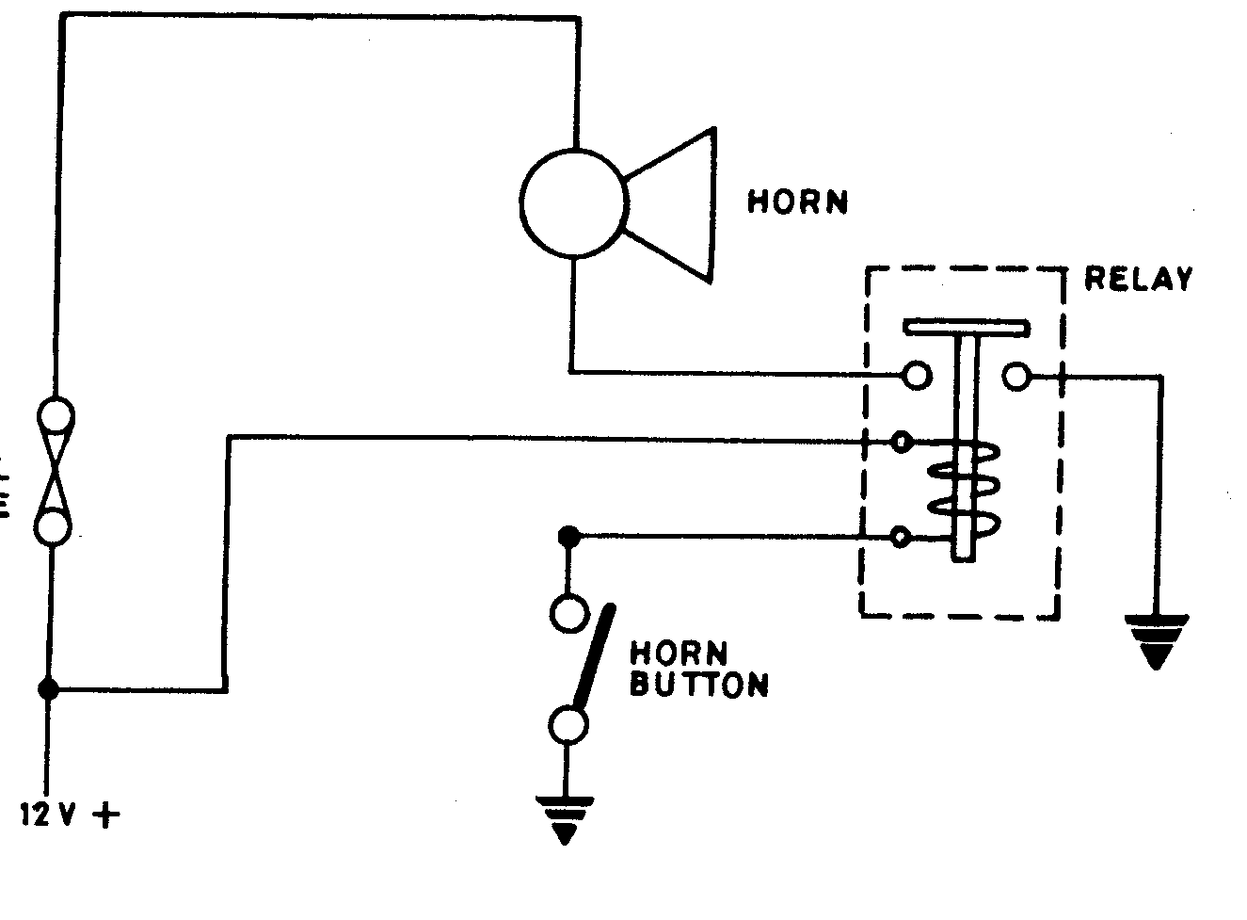
Horn circuit
Figure 2-37 Horn circuit

Dome light circuit

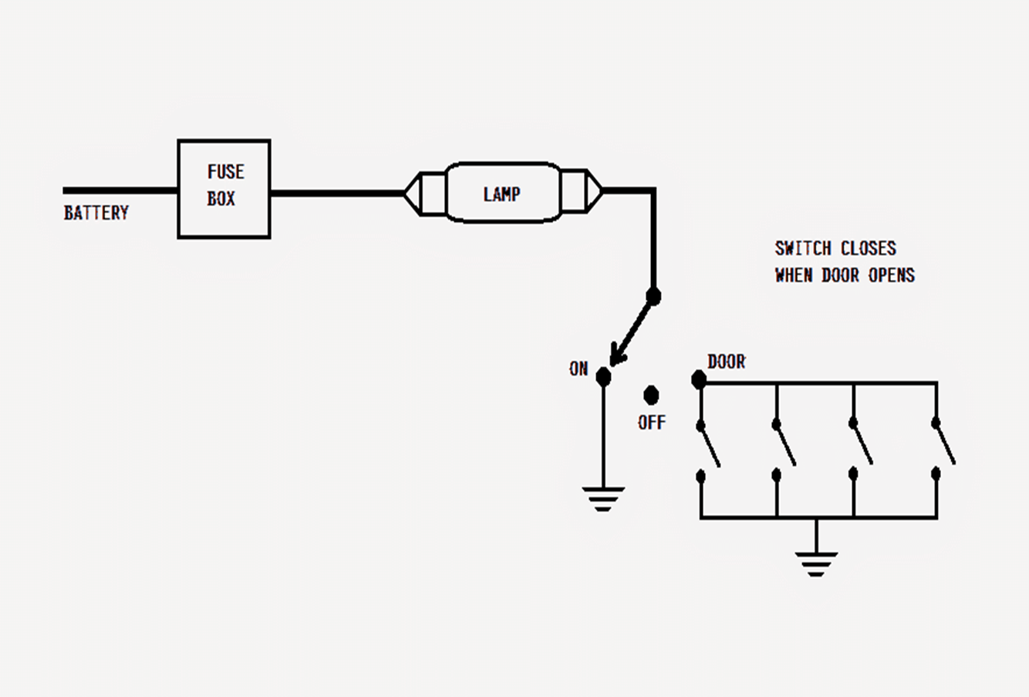
Figure 2-38 Dome light circuit

Inspect and service interior and exterior lighting components.
Each lighting circuit has particular operating characteristics. They are based on its purpose and the system design. Knowing how a circuit is designed to operate and how it interacts with other related circuits is critical. It will help you to better know how to go about diagnosing the system.
Check all vehicle lights for correct operation
Procedure
Note that if the left or right turn signals, or the hazards work, the unit is probably functioning correctly.
- Remember that a flasher unit is designed to flash at a different rate when a bulb is blown.
- Turn signal flasher units are usually located either as part of the fuse box or on the steering column.
- Remove covers or shrouds as necessary.
- Most types of flasher unit simply pull out of the socket.
- Replace by pushing the new unit into the holder.
- Make sure the new unit is the correct one for the vehicle. Note that more powerful units may be required if a towing socket is fitted.
- After renewal, make sure indicators and hazard lights operate.
Checking operation of the main instruments and warning lights
Procedure
Note: this is a generic test routine; refer to manufacturer’s procedures and circuits for specific details.
- Switch the ignition on but do not start the engine.
- Check that the rev-counter and speedometer both read zero (or less).
- Check that the oil pressure warning light (WL) and charge WL are on.
- Check that the fuel gauge reads appropriate to fuel in the tank.
- Check that the temperature gauge reads appropriate to the engine temperature (best to start from cold if possible).
- Check for neutral or park, and start the engine.
- Oil light and charge light should go out as engine revs – and stay out at idle speed.
- Check rev-counter reads correctly by comparing with a test meter reading.
- Check fuel gauge reading remains constant and that temperature gauge rises to ‘normal’ level.
- Road test to check speedometer operation

Checking Lighting and Peripheral Systems
When checking lighting and peripheral systems, be sure to work in a systematic manner to avoid missing a faulty bulb or other component. A vehicle may have warning lights that activate only if that circuit is in use. You may need to turn that circuit on to see the warning lights. If you are unsure of where these are, ask your supervisor.
            - a darkened area, turn on or activate the ignition. The dash warning lights should be displayed. Start the engine. If any warning light stays on after the engine is started, it could indicate a problem in one of the vehicle’s safety or mechanical systems. If you are unsure about what any of the warning lights mean, consult the owner’s manual.
            - Have someone stand behind the vehicle to report any problems. Turn the ignition to run. Switch on the park lights, taillights, marker lights, and license plate lights. Do the same for left and right turn indicator lights. Depress the brake pedal to make sure the brake lights work and have the proper intensity. Also, place the transmission in reverse and check the backup lights
            - With someone in front of the vehicle, make sure the high and low head light beams, park lights, turn signals, driving lights, fog lights, and cornering lights are all working properly.
            - With the interior light switch in the correct position, open the driver’s side door to make sure the interior lights work. If any of these lights do not operate, you may need to replace a bulb or diagnose the fault.
Inspecting and Changing an Exterior Lightbulb
- Lightbulbs have a limited life span and burn out occasionally.
- Inspecting the lighting system’s operation periodically will help identify any lightbulb issues. It is good practice to do this during oil changes.
- If none of the bulbs in a particular circuit are working, there may be a bigger electrical problem to resolve.

Perform headlight service.
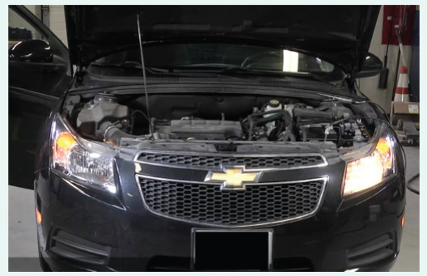
Checking and Changing a Headlight Bulb
- Switch the headlights on at low beam, then to high beam. Check that the high-beam indicator is operating. If one of the lights does not operate or is dim, that headlight will have to be diagnosed and potentially replaced.
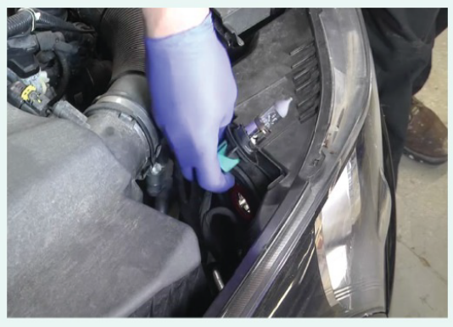
2.Test the vehicle headlights. Obtain the replacement lamp for the vehicle.
Unplug the electrical connector at the back of the lamp unit.
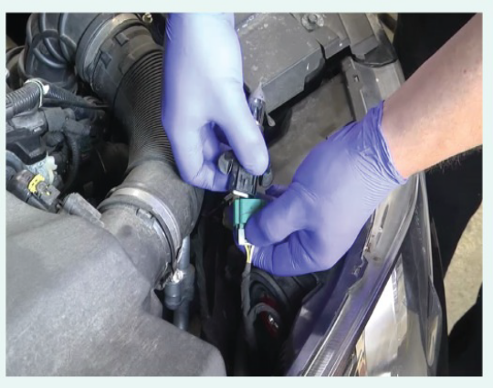
3. Remove the old bulb, and replace it with the new one. Handle the new bulb only by its base or, if supplied, by the card cover
4. Replace the unit and the retaining ring or bulb assembly, and then plug in the connector. Switch on the lights again to confirm that they are both operating
correctly.

Replacing a blown bulb is often a simple and easy repair for technicians and the vehicle owner.
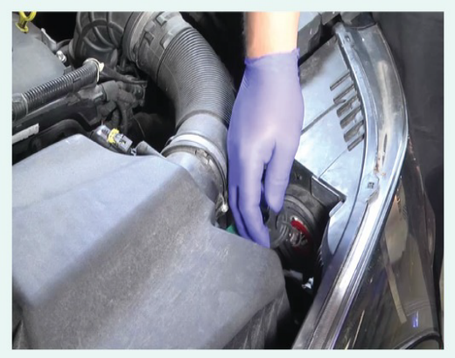
However, because of the introduction of HID lamps and the adoption of onboard computers as part of lighting circuits, closer attention must be paid when you are diagnosing and servicing lighting systems.
Headlamp Diagnosis. Headlamp circuits on non-computerized systems are generally simple, consisting of the fuses, headlamp switch, dimmer switch, relay(s), bulbs, and wiring.
Figure 2-39 Checking and Changing a Headlight bulb

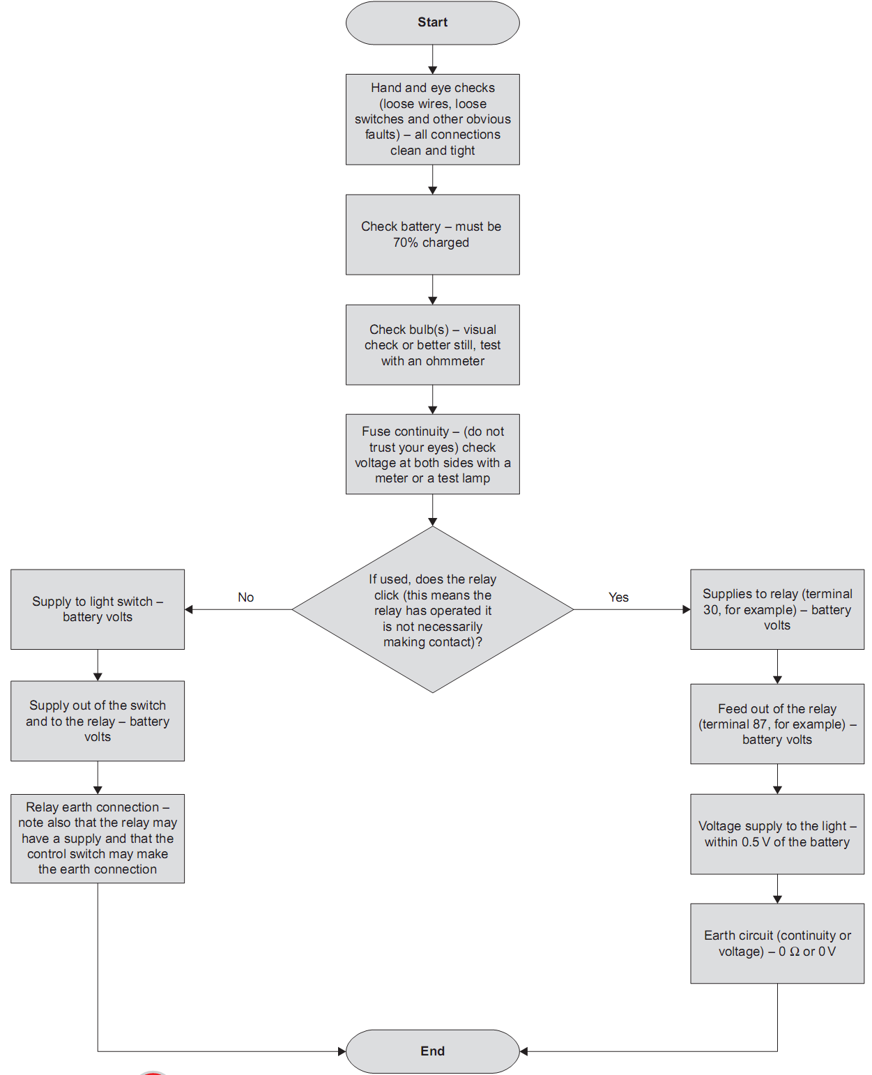
The process of checking a lighting system circuit is broadly presented in Figure.

Lighting system diagnostics chart

2.4 Head Light Aiming
Headlight aiming is a critical service item on cars, the headlights must be aimed correctly, aim of headlights that are properly adjusted cover the correct range and afford the driver the proper night time view
If they are aimed too high or to the left, they might blind an oncoming driver and cause a serious accident. Incorrect aiming can also reduce the driver’s ability to see the road properly. Headlights that are out of adjustment can cause other drivers discomfort and sometimes create hazardous conditions.
This could also lead to an accident. Headlight aim should be checked and adjusted:
- every 12 months,
- when a headlamp bulb is replaced,
- when there are special situations of vehicle rear loading, or
- when front end sheet metal is repaired or adjusted.
Headlamp aiming methods are:
  - Visual aiming
  - Mechanical aiming
  - Optical aiming
  - Photoelectric aiming
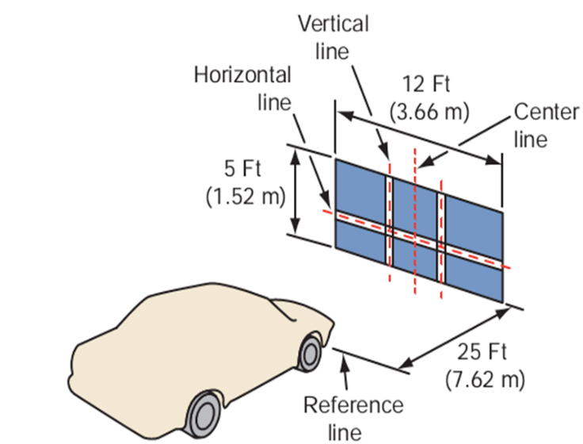
Visual aiming method requires a darkened area and utilizes an aiming screen, usually a wall, with vertical centring and horizontal height lines placed 25 ft (7.6m) in front of the vehicle.
The head light pattern is then projected on the screen.
It fails to produce accuracy because even skilled test drivers are unable to centre the vehicle exactly to the screen, and this is essential to obtain precision with this method.
Finally, the beam projection patterns on the screen are open to subjective judgment by even the most skilled technician.

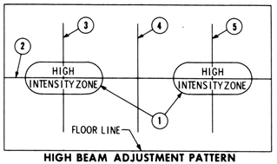
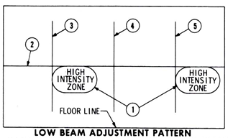

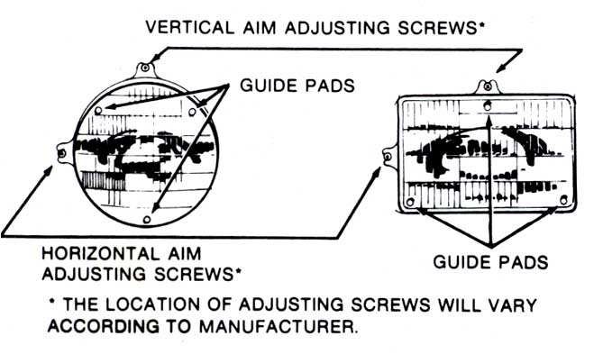
Line 1: Intensity Zone
Line 2: Horizontal center of head lamps
Line 3 & 5: Vertical center at of head lamps
Line 4: vertical at center of car
Some vehicle preparation tips for head light aiming:
- Position the vehicle on a reasonably flat surface.
- The tire pressure should be equalised to the specifications recommended by the manufacturer.
- The vehicle should be loaded with an average weight. This includes (a) the driver, (b) fuel tank half-full, and (c) normal load carried in the trunk.
- Rock the vehicle sideways to equalise the springs.
Head light dazzling and preventive methods
At night drivers need to be able to see traffic control devices, lane lines, vehicles, pedestrians, animals, and other potential hazards.
Artificial lighting can illuminate the roadway, but too much light or improper lighting may result in glare (dazzle), which causes visual discomfort and a diminished ability to see the environment.
Changes in headlamp designs that affect light intensity, beam pattern, and aiming have significantly improved night vision.
Glare or dazzle occurs when visual field brightness is greater than the luminance to which the eyes are adapted. Dazzling causes discomfort, fatigue and pain. Headlight dazzling is prevented in four methods by:
  - Reducing the intensity of the glare source;
  - Reducing the illumination reaching the driver’s eyes;
  - Increasing the glare angle; and
  - Indirectly minimizing the effects of glare.

When oncoming vehicles shine light directly into your eyes, look down and to the right.
- Countermeasures that can only be initiated by a highway agency include the following:
  - Wide medians and independent alignment
  - Glare screens
  - Fixed roadway lighting
- Countermeasures that are primarily the responsibility of car manufacturer are:
  - Headlamp height
  - Color-corrected headlamps
  - Headlamp area
  - Adaptive headlamps
- Countermeasures that are under the control of driver/motorists are:
  - Reduced night driving
  - Using night-driving glasses
  - Install anti-glare mirrors

Post-Repair Testing
Post-repair testing may include: validating the effectiveness of the repair action; confirming that the reported fault has been rectified and confirming that no other faults are present as a result of the repair action.

Troubleshooting electrical wiring system
Electrical Trouble- Shooting Guide
When troubleshooting any electrical component, remember the following hints to find the problem faster and more easily.
- For a device to work, it must have two things: power and ground.
- If there is no power to a device, an open power side (blown fuse, etc.) is indicated.
- If there is power on both sides of a device, an open ground is indicated.
- If a fuse blows immediately, a grounded power-side wire is indicated.
- Most electrical faults result from heat or movement.
- Most non-computer-controlled devices operate by opening and closing the power side of the circuit (power-side switch).
- Most computer-controlled devices operate by opening and closing the ground side of the circuit (ground-side switch).
When a burnt-out bulb is not the problem, corroded or loose wiring is the next most common problem. All wiring connections should be clean and tight; light assemblies need to be securely mounted to provide a good ground.
No_ | Concern | Most Probable Cause
 | One light does not work | - Bad bulb  - Open in that circuit
 | One light is dim | - High resistance in the power  - or ground circuit
 | All lights in a circuit  do not work | - Open in the power or ground circuit  - Blown fuse  - Bad (control) switch
 | All lights in a circuit are  dim | - High resistance in the power  - or ground circuit
 | One low-beam  headlamp does not work | - Bad bulb  - High resistance in the power  - or ground circuit
 | Flickering lights | - Loose electrical connection  - A circuit breaker that is kicking out because of a short
 | One low-beam  headlamp does not work | - Bad bulb  - High resistance in the power  - or ground circuit
 | Both low beams do not  work | - Open in the power or ground circuit  - Bad (control) switch  - Blown fuse  - Bad bulbs due to overcharging
 | One high-beam  headlamp does not work | - Bad bulb  - High resistance in the power  - or ground circuit
 | Both high beams do not  work | - Open in the power or ground circuit  - Bad (control) switch  - Blown fuse  - Bad bulbs due to overcharging
 | Slow turn signal  operation | - Bad flasher unit  - High resistance in the power  - or ground circuit  - Incorrect bulb
 | Turn signal on one side  does not work | - Bad bulb  - High resistance in the power  - or ground circuit
E 20–1 GENERAL LIGHTING

Self-check 2
Instruction: Circle the letter of the best and most probable answer to each question. You have given 1 Minute for each question. Each question carries 0.5 Point.
1. Which component of the vehicle is controlled by the headlamps switch?
a. courtesy lights b. head lights c. break light
2. If the turn signal works properly in one direction but not in the other. Which of this is
the most probable cause?
a. defective flasher b. blown fuse c. blown bulb or poor ground on the problem side
4. How is the vehicle lighting system usually connected?
a. series circuit b. parallel circuit c. combination of both series and parallel
5. What part of turn signal circuit provides pulsating voltage?
a. hazard switch b. flasher c. voltage regulator
6. Which vehicle light is intended for emergency purposes?
a. signal light b. hazard light c. break light
7. What part of the lighting system protects the bulb from a fluctuating voltage?
a. fuse b. voltage regulator c. relay
8. Which part of the lighting system is considered as the weakest thermo link in a circuit?
a. bulb b. relay c. fuse
9. Which light illuminates every time the transmission is shifted to reverse?
a. back-up light b. reverse gear c. reverse horn
10. Which device controls the flow of electric current in every circuit?
a. current regulator b. switch c. battery
11_______ headlamps produce light with an electric arc rather than a glowing filament.
a. Vacuum tube fluorescent b. High-intensity discharge
c. Incandescent and halogen d. Light-emitting diode
12. Two technicians are discussing brake light bulbs. Technician A says that a two filament bulb uses the second filament as a back-up if the first filament burns out. Technician B says that two-filament bulbs have different wattage filaments. Who is correct?
a. Technician A b. Technician B
c. Both Technicians A and B d. Neither Technician A nor B

13. Auto lighting circuits that are used when turning on a curve while driving
a. brake system b. back-up light c. signal light
14. Both head lamps are dim in the high beam and normal in the low beam, which is
the probable cause?
a. shorted head lamp b. loose head lamp ground c. all of the above
15. The weakest point of the circuit
a. bulb b. fuse c. terminal block
16. Lights at the rear indicates that brakes are applied
a. signal b. tail lamp c. brake light
17. An electrical device that opens or close a circuit in response to a voltage signal
a. fuse b. relay c. timer
18. Light that automatically on when the car door is opened
a. passenger light b. dashboard light c. courtesy light
19. A part connecting the battery and the horns by pressing the switch leading to the
ground
a. head light relay b. horn relay c. push button switch

Part -II short answer
- Describing Component parts of the lighting system
- Explain Functions of every lighting system parts
- Draw and interpret Lighting system circuit

Operation sheet 2.1: Identify headlight switch terminals
- Operation title: Identification headlight dimmer switch terminals
- Purpose: To know headlight (dimmer) switch terminals
- Instruction: Accomplish the activity by select the appropriate tools following You have been given 10 minutes
- Tools and requirement: Multi-meter, Headlight switch (combination switch), circuit diagram, vehicle or lighting board
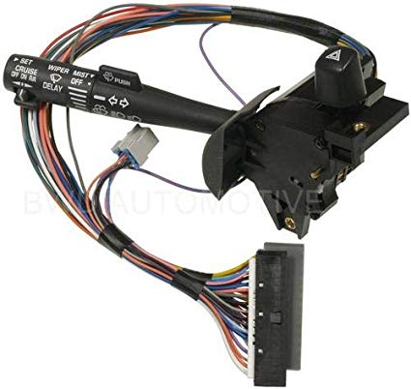
- Steps in doing the task

      - Turn on the multi meter
      - Make it on continuity position
      - Using the table as reference
      - By changing the position dimmer switch identify terminals
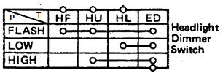
      - Label the wire that you have identified.

- Quality Criteria: Now test the different functions your combination switch has to verify the repair is complete.
- Precautions: Plug the two probes into the multi meter and set the dial to 'continuity.

Operation sheet 2.2: Identify light control switch terminals
- Operation title: Identification of light control switch terminals
- Purpose: To know the light control switch terminals
- Instruction: Accomplish the activity by select the appropriate tools following You have been given 5 minutes
- Tools and requirement: Multi-meter, Headlight switch (combination switch), circuit diagram, vehicle or lighting board
- Steps in doing the task
      - Turn on the multi meter
      - Make it on continuity position
      - Using the table as reference
      - By changing the position of light control identify terminals.
      - Label the wire that you have identified
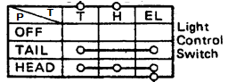

- Quality Criteria: Now test the different functions your combination switch has to verify the repair is complete.
- Precautions: Plug the two probes into the multi meter and set the dial to 'continuity.

Operation sheet 2.3: Identify turn signal and hazard switch terminals
- Operation title: Identification of turn signal and hazard switch
- Purpose: To know the turn signal and hazard switch terminals
- Instruction: Accomplish the activity by select the appropriate tools following You have been given 10 minutes
- Tools and requirement: Multi-meter, Headlight switch (combination switch), circuit diagram, vehicle or lighting board with all full parts (lamp, lamp holder, switches, fuses, etc.)
- Steps in doing the task
- Turn on the multi meter.
- Make it a continuity position.
- Using the table as a reference
- By changing the position of the turn signal switch, identify the terminals.
- Label the wire that you have identified.
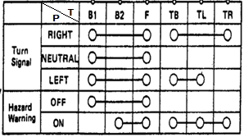

- Quality Criteria: Now test the different functions your combination switch has to verify the repair is complete.
- Precautions: Plug the two probes into the multi meter and set the dial to 'continuity.

Operation sheet 2.4: draw and interpret lighting system circuit
- Operation title: draw and interpret lighting system circuit
- Purpose: draw and interpret lighting system circuit
- Instruction: Accomplish the activity by select the appropriate tools following You have been given 15 minutes
- Tools and requirement: Multi-meter, combination switch, circuit diagram, vehicle or lighting board with all full parts (lamp, lamp holder, switches, fuses, etc.)
- Steps in doing the task
      - Frist understand properly lighting system wiring diagram one by one
      - Draw lighting system circuit
      - Identify combination switch terminals properly
      - Install all lighting system circuit one by one
- Quality Criteria: Electrical symbols are used when drawing circuit diagrams to represent the basic components that make up the circuit
- Precautions: sketch need to conform to standards symbols

Operation sheet 2.5: Install lighting system
- Operation title: install all lighting system
- Purpose: install all lighting system
- Instruction: Accomplish the activity by select the appropriate tools following You have been given 20 minutes
- Tools and requirement: Multi-meter, combination switch, circuit diagram, vehicle or lighting board with all full parts (lamp, lamp holder, switches, fuses, etc.)
- Steps in doing the task
- Frist understand properly lighting system wiring diagram one by one
- Read and Interpret lighting system wiring diagram
- Use as reference wiring diagram from next page
- Identify combination switch terminals properly
- Install all lighting system circuit
- Quality Criteria:
- Precautions: Due to safety concerns involved, only trainees who have their trainer's direct permission should perform this task.

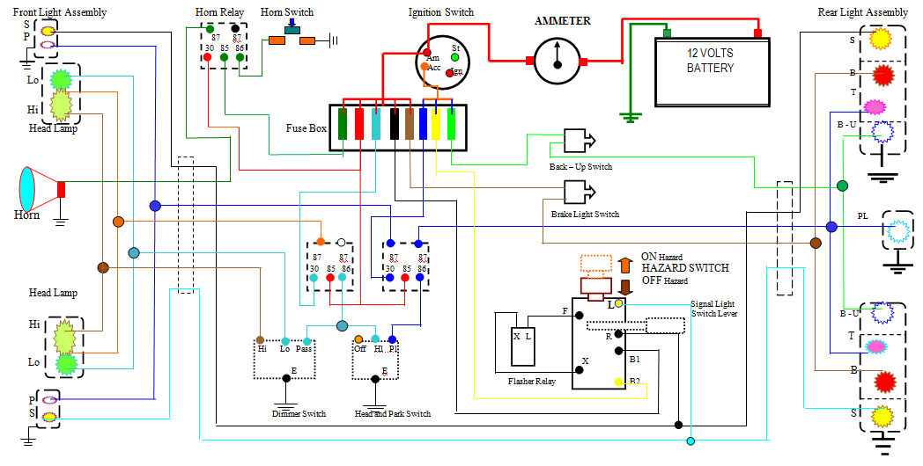

Lap test: 2

- Identify Combination switch Terminals
- Install All lighting system

Unit three: Windshield wiper and washer system
This unit to provide you the necessary information regarding the following content coverage and topics:
- Determining Windshield wiper and wiring system
- Testing and Repairing of Windshield wiper
- Wiper motor
- washer motor
This guide will also assist you to attain the learning outcomes stated in the cover page. Specifically, upon completion of this learning guide, you will be able to:
- Determine Windshield wiper and wiring system
- Test and Repair of Windshield wiper

3.1 identify component of windshield wiper and washer system
The wipers are important safety-related features installed to ensure that the driver's view remains unobstructed by wiping off rainwater, snow, bugs, mud, oil, grease from the windshield.
It is frequently used in combination with the washer for cleaning off dirt from the windshield glass.
Functional requirements
The requirements of the wiper system are simple. The windscreen must be clean enough to provide suitable visibility at all times. To do this, the wiper system must meet the following requirements.
- Efficient removal of water and snow.
- Efficient removal of dirt.
- Operate at temperatures from _30 to 80 ° C.
- Pass the stall and snow load test.
- Service life in the region of 1500 000 wipe cycles.
- Resistant to corrosion from acid, alkali and ozone

Windshield wiper system
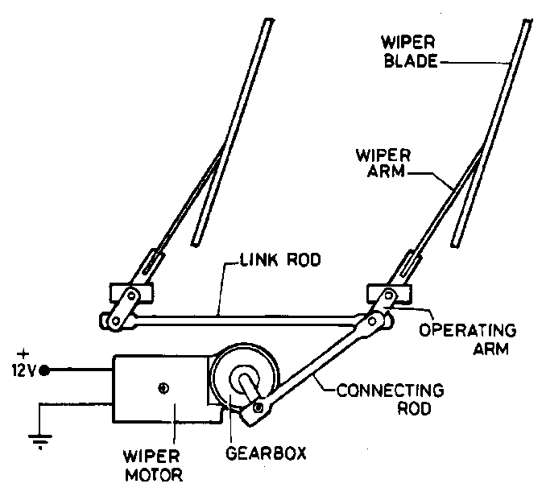
Wipers ensure the visibility of the driver by wiping the rain or dirt from the front or rear windshield. Recently, a wiper is often installed also on the rear window to improve rear visibility. The wipers usually have a number of speeds and intermittent operation for varying rainfall conditions. Most vehicles have two wiper arms for the windshield. Windshield wipers are operated by a wiper switch (controlled by the driver), a wiper motor and a mechanism which links the motor to the wiper arms. Wiper switches can be mounted on the dash board or on the steering column. The wiper mechanism includes a gear reduction unit at the motor. A crank and linkage connect to the wiper arms and convert the rotary motion of the motor into back and forth movement of the wiper arms.
Figure 3-1 wiper system component
The wiper system consists of a wiper switch, wiper motor, wiper linkage, wiper arm, and wiper blade.
- Wiper Switch: Turns the wipers ON/OFF and changes their speeds.
Wiper switch functions
- Speed function: Switches the wiper speed between HI and LO.
- Intermittent function Operates the wipers intermittently at the LO speed. There is also a type in which the intervals can be adjusted in several steps.
- Mist function: Operates the wipers once when the switch is operated.
- Auto park function: Regardless of the position of the wipers during operation, turning the switch to OFF returns the wipers to their park position.
The park switch is built inside the motor and gearbox housing. It switches the power feed to the low-speed brush when the wiper switch is in the Off position and the wiper blades move toward the park position Once in the park position, the park switch opens the circuit to the motor the wiper switch, an intermittent timer and/or body computer
- Washer-linked function: Automatically operates the wipers when the washer switch is turned ON for a few seconds.

- Wiper Motor This motor produces the power to operate the wipers.
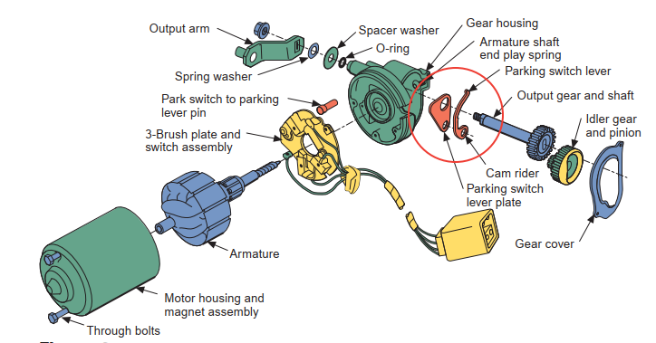
Most windshield wiper motors are two-speed electric motors with permanent field magnets. Three brushes contact the commentator: a high-speed brush, a low-speed brush and a common brush. The speed of the motor is controlled by the number of armature windings that are connected in the circuit.
Figure 3 2 An exploded view of a wiper motor with a park mode.
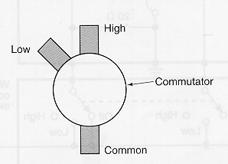
Fewer armature windings are connected between the high-speed brush and the common brush. Because the cemf opposes battery voltage, a lower cemf in the armature means there will be greater armature current. Greater armature current means a higher armature speed
More armature windings are connected between the low-speed brush and the common brush.
Figure 3-3 One style of brush arrangement has the
high-speed brush opposite the common brush.
A higher cemf means there will be less armature current. This results in a lower armature speed.
Three-Speed Motors: The control switch for a three speed motor determines what resistors, if any, will
be connected to the circuit of one of the fields When the switch is in the low-speed position, both field coils have the same amount of current flow. Therefore, the total magnetic field is weak and the motor runs slowly.
When the switch is in the medium-speed position, current flows through a resistor before going to the shunt field. This connection weakens the shunt coil and the motor’s speed increases.
With the switch in the high-speed position, a resistor of greater value is connected to the shunt field.
This connection weakens the magnetic strength of the coil and the motor runs faster.
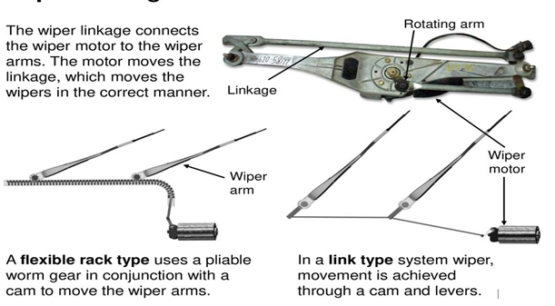
- Wiper Linkage: Changes the rotational movement of the wiper motor into a reciprocal movement and operates both right and left wipers in unison.
- Wiper Arm: Applies a constant pressure to the wiper blade against the windshield surface, in addition to transmitting the movement to the wiper blade.
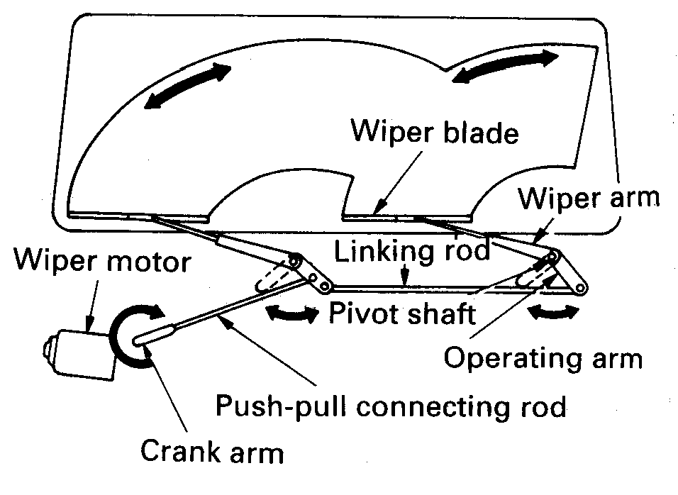
Wiper arms are mechanical arms, which sweep back and forth across the windshield to remove water, snow, or dirt.
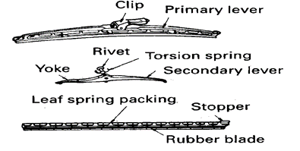
The wiper arms have rubber blades, which contact the windshield. The wiper arm consists of a head for mounting it onto the wiper shaft, a spring to provide the necessary blade holding force, an arm piece for blade installation, and a retainer for retaining all of these.
Wiper Blade: is the portion that wipes the windshield glass. The rubber insert of the wiper blade must be replaced periodically

3.1.2 washer system
The washer system provides a cleaning spray. When used in conjunction with the wipers, it helps to clean road grime from the windshield A windshield washer sprays washer fluid to remove dirt or oil that cannot be removed by the wipers alone.
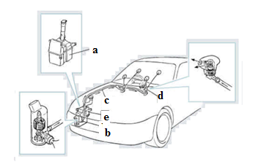
The windshield washer system consists of a washer fluid reservoir, washer motor, hose, washer nozzle, and washer fluid.

Figure 3-4windsheild washer system component
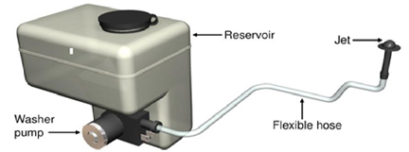
- Washer Fluid Reservoir: Stores washer fluid. Water (plus screen wash) is pumped from a reservoir onto the wind screen through flexible hoses and small jets the jets can be adjusted to vary the spray angle
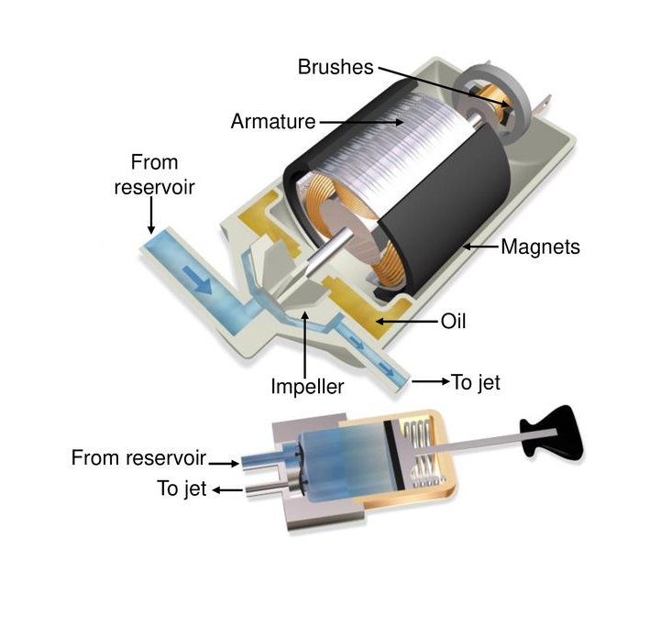
- Washer Motor: The washer pump motor may be it contains an impeller that produces a centrifugal force which pressurized the system water is forced from reservoir to the windscreen. compact motor that pumps washer fluid and sprays it through the washer nozzles. The DC motor on the pump is a permanent magnet motor.
It has power supplied to one brush and ground supplied by the other brush.
The switch for the washer is usually located on the same switch assembly as the wipers. Operating the washer switch usually also activates the wipers for at least one cycle.
Figure 3-5washer motor

However, some systems allow for multiple wipe cycles before parking the wiper blades Generally, it is mounted below the washer fluid reservoir internally or externally
- Hose Transports washer fluid from the reservoir to the nozzles.
- Washer Nozzle spout that sprays washer fluid.
It contains check valves that prevent the fluid from flowing back into the reservoir.
The spraying angle of the nozzle can be changed.
- Washer Fluid A type of fluid that removes dirt from the windshield glass. When the glass surface is dry, this fluid helps to protect the rubber blade of the wiper and the glass surface from damage. In winter, use the fluid with a low solidifying point to prevent its freezing.

interpret windshield wiper and washer system
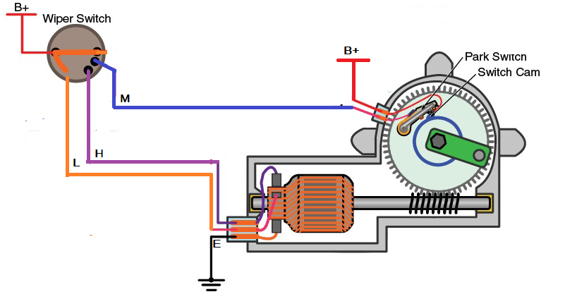
    - windshield wiper circuit
Figure 3-6 windshield wiper circuit
    - windshield washer circuit
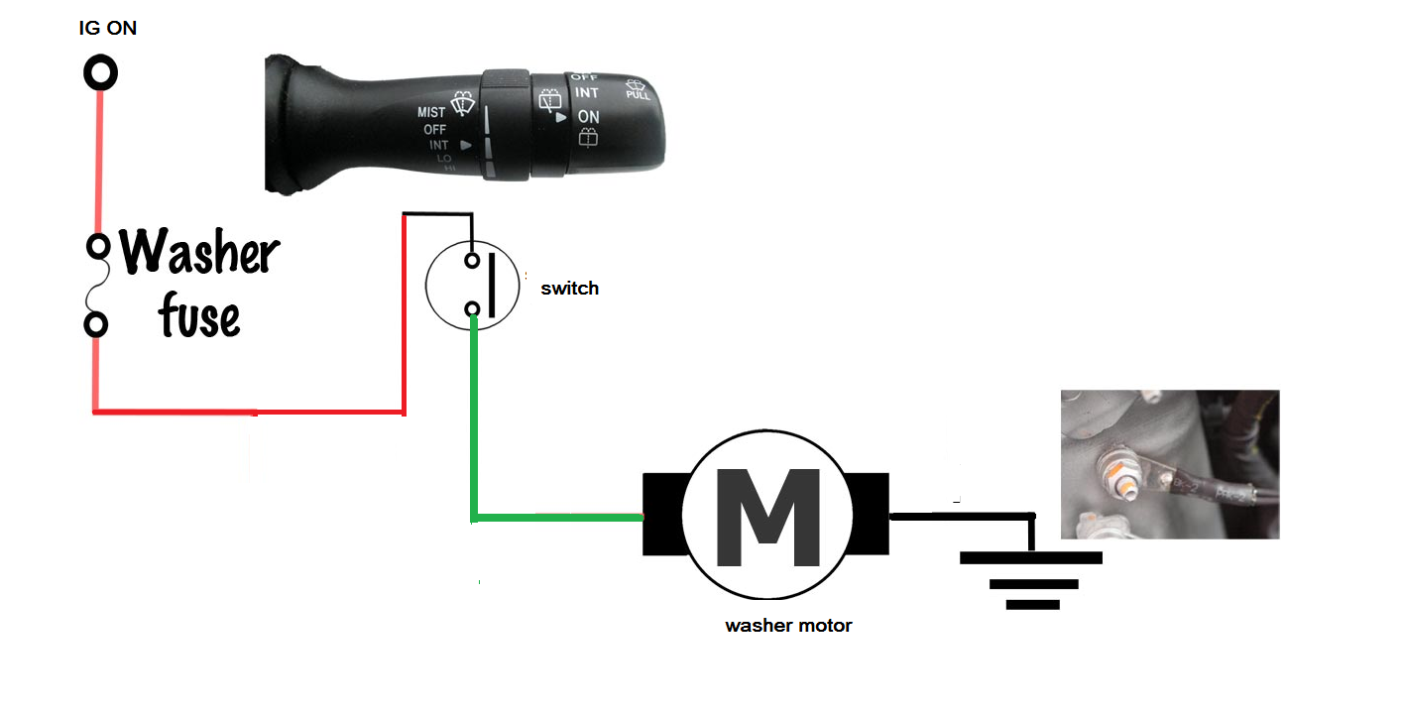
Figure 3-7 windshield washer circuit

Testing and Repairing

3.3.1 Testing wiper motor
The windshield wipers can fail in a number of ways.
- First, they may not work at all, such as when a fuse or motor is bad.
- Second, they may work on only some speeds, such as when the switch or one of the brushes in the motor is faulty.
- Third, they may not work on the intermittent speed, such as when the delay module is faulty. Fourth, they may not park, as when the park contacts in the motor are faulty or the wiper switch is bad.
- Each of these faults can be diagnosed by using a DMM and referring to the wiring diagram to locate the fault. Another fault with wiper systems is that the linkage wears out, which can prevent one or both of the wiper arms from operating, or operating properly.
- To diagnose this, you have to inspect the linkage for worn or disconnected joints.
- Customer complaints about windshield wiper operation can include poor wiping, no operation intermittent operation, continuous operation, and wipers that do not park.
- Other complaints will be related to wiper arm adjustments, such as slapping the molding or one blade parks lower than the other.
When the wipers move as they should but do not wipe the glass surface the way they should or make noise while moving across the glass, the blades and/ or arms should be replaced.
If the wipers work slower than expected, disconnect the wiper linkage at the motor Turn on the wiper system. If the motor runs properly, the problem is the linkage and is not electrical. If the motor runs slower than normal, check for resistance in the circuit. If the motor does not run at a particular speed or at all, the problem is electrical.
Carefully inspect the motor, wires, connectors, and switch. Your diagnosis should continue according to the guidelines given in the service manual. Pay attention to the circuits that could cause the problem, not the entire wiper circuit.
Test for voltage at the motor in the various switch positions. Also check the ground circuit. If the motor is receiving the right amount of voltage at the various switch positions and the ground circuits are good, the problem must be the motor. Wiper motors are replaced, not repaired or rebuilt.
Disconnect the battery’s negative cable before removing or installing wiper linkages.

As with all systems the six stages of fault-finding should be followed.
- Verify the fault.
- Collect further information.
- Evaluate the evidence.
- Carry out further tests in a logical sequence.
- Rectify the problem.
- Check all systems.
INSPECTION
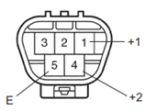
1. INSPECT WINDSHIELD WIPER MOTOR ASSEMBLY
(a) LO Operation Check
(1) Connect the positive battery (+) lead to terminal
1 (+1) of the connector, and the negative
battery (-) lead to terminal 5 (E), and check that the windshield wiper motor operates at low speed (LO).
OK: The motor operates at low speed (LO).
b) HI Operation Check
(1) Connect the positive battery (+) lead to terminal
4 (+2) of the connector, and the negative
battery (-) lead to terminal 5 (E), and check that the windshield wiper motor operates at high speed (HI).
(c) Automatic Stop Position Inspection
(1) Operate the windshield wiper motor, and then stop the operation.
(2) Check the automatic stop position when stopping the windshield wiper motor operation.

3.3.2 Testing Washer motor
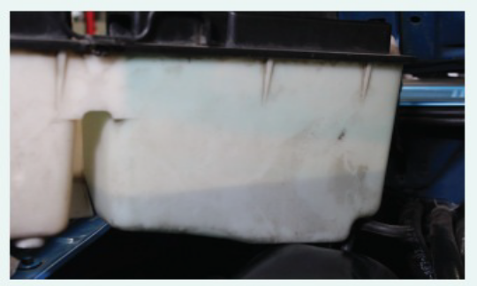
Testing the Washer System
1. Check for the correct solution level in tanks, and listen for washer pump operation.
2. If an electrical fault is indicated by lack of a washer motor sound, check for battery voltage and ground at the pump when it is activated.
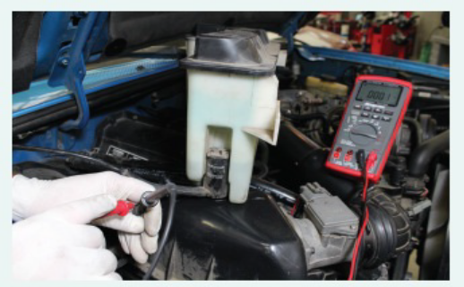
3. If the power or ground circuit is faulty, perform voltage drop tests on the faulty side until the fault is located.
4. If the power and ground circuits are good, measure the resistance of the pump motor, and compare with specifications.
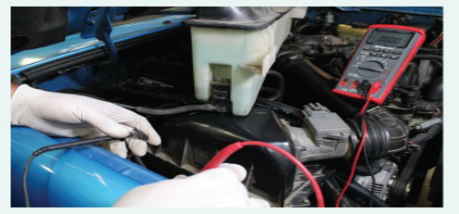
5.If the pump spins when activated but does not pump washer fluid, check the hoses and nozzles for obstructions. Blow out with compressed air if necessary.

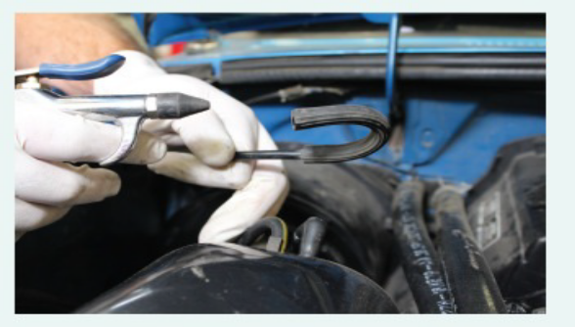
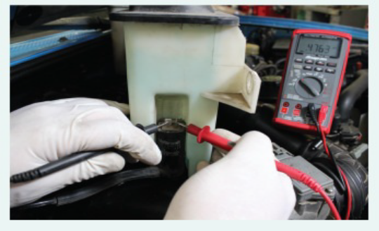

Figure 3-8 Washer System Testing procedure

Washer motor service
- Many washer problems are caused by restrictions in the fluid lines or nozzles.
- To check for restrictions, remove the hose from the pump and operate the system.
- If the pump ejects a stream of fluid, then the fault is in the delivery system. The exact location of the restriction can be found by reconnecting the fluid line to the pump and disconnecting the line at another location. If the fluid still streams out, the problem is after that new disconnect.
- If the fluid does not flow out, the problem is before where the hose was disconnected.
- Repeat this process until the problem is found. If the pump does not spray out a steady stream of fluid, the problem is in the pump circuit.
- It should be tested in the same way as any other electrical circuit.
- Make sure it gets power from the switch when it should, then check the ground.
- If the power to the pump is good and there is a good ground, the problem is the pump.
Symptom | Possible fault
Wipers not working or poor operation | - Loose or broken wiring/connections/fuse.  - Corrosion in wiper connections.  - Switch not making contact.  - High resistance contact on switch or wiring.  - Relay/timer not working.  - Motor brushes or slip ring connections worn.  - Limit switch contacts open circuit or high resistance.  - Blades and/or arm springs in poor condition
Washers not working or poor operation | - Loose or broken wiring/connections/fuse.  - Corrosion in washer motor connections.  - Switch not making contact.  - Pump motor poor or not working.  - Blocked pipes or jets.  - Incorrect fluid additive used.
- These are not rebuilt or repaired; they must be replaced.
Common symptoms and possible faults of windshield wipers and Washers system malfunction

Self-check-3

Directions: Answer all the questions listed below. Use the Answer sheet provided in the next page:
1. Wiper and washer systems are being discussed. Technician A states that before testing a washer system, be sure there is adequate liquid in the washer tank. Technician B states that some vehicles use a rain sensor to indicate water on the windshield to the body computer. Who is correct?
a. Technician A only b. Technician B only
b. Both Technicians A and B d. Neither Technician A nor B
2. A malfunctioning windshield wiper system is being discussed. The wipers do not move. Technician A states that if the motor can be heard running, the problem is likely mechanical rather than electrical. Technician B states that if the motor cannot be heard, the problem could be the motor, or a problem in the electrical circuit or control device. Who is correct?
a. Technician A only b. Technician B only
c. Both Technicians A and B d. Neither Technician A nor B
3.After the wipers are turned off, the ______ switch provides power to the wiper motor until the wiper’s blades reach the bottom of the windshield.
A. Interval B. Rest C. Overrun D. Park
Part I: Short answer
- Bravely explain the basic procedure of windshield wiper motor repairing
- List out six stages of fault-finding
- Enumerate Procedure in repairing electrical system

Note: Satisfactory rating – above 100% Unsatisfactory - below 60%
You can ask you teacher for the copy of the correct answers

Operation sheet 3.1: Identify windshield wiper system switch terminal

- Operation title: identification of windshield wiper system switch terminals
- Purpose: To identify the windshield wiper system switch terminals
- Instruction: Accomplish the activity by supplying the appropriate symbol for each of the following You have been given 5 minutes for the task, and you are expected to draw the symbol on the table in the given space.
- Tools and requirement:
- Windshield wiper switch
- Multi meter
- Steps in doing the task
- Put the multi meter on.
- Put on a position of continuity.
- By changing the position of the wiper switch,
- Identify the terminals one by one.
- Quality Criteria: The given wiper motor is a two-speed motor
- Precautions: Use the appropriate tools and equipment for the job.

Operation sheet 3.2: Identify windshield wiper Motor terminals

- Operation title: identification of windshield wiper motor terminals
- Purpose: To identify the windshield motor terminals
- Instruction: Accomplish the activity by supplying the appropriate symbol for each of the following You have been given 5 minutes for the task, and you are expected to draw the symbol on the table in the given space.
- Tools and requirement:
- Windshield wiper motor
- Multi meter
- Steps in doing the task
- Turn on the multi meter
- Put on continuity position
- Check terminal E with ground for continuity
- Change multi meter to ohm position
- Check resistance value
- Identify terminals
- Quality Criteria: The given wiper motor is a two-speed motor
- Precautions: Use the appropriate tools and equipment for the job.

Lap test: 3
- Identify wiper and washer switch Terminals
- Draw windshield wiper and washer system circuit diagram
- Install windshield wiper and washer system circuit

Unit four: Install lighting and windshield wiper wiring systems
This unit to provide you the necessary information regarding the following content coverage and topics:
- Removing and Installing procedure of lamp
- Installing lighting system components
- Installing wind shield wiper system components
This guide will also assist you to attain the learning outcomes stated in the cover page. Specifically, upon completion of this learning guide, you will be able to:
  - Perform remove and Installing Lamp
  - Install lighting system components
  - Install wind shield wiper system components

Removing and Installing procedure of lamp
- It is important that any burned-out lamp be replaced with the correct lamp. You can determine what lamp’s standard trade number, usually present on the lamp’s housing.
- When replacing a bulb, make sure it is the correct replacement bulb. Using the wrong bulb can cause problems, such as an incorrect blink rate. Inspect the bulb socket. Often moisture gets into a bulb socket and causes corrosion at the electrical contacts in the socket. At times, the corrosion can be removed with sandpaper. Other times, the socket or light assembly should be replaced.
- Light bulbs are contained in an assembly and access to the bulb is gained by reaching around the rear of the assembly and removing the socket. Other assemblies require the removal of the light’s outside lens. With the lens removed, the bulb is removed from the front. While doing this, inspect the lens and gasket for damage and replace any damaged parts.
- If the lens is not sealed, dirt and moisture can enter the assembly and cause problems in the future. On some light fixtures, the light assembly must be removed and the bulb and socket are removed from the rear of the assembly.
- Do not remove the lens from the assembly. It is a sealed unit and dust and other contaminants can cause serious damage to the reflector. Also, never attempt to clean the reflector. Wiping its surface can seriously reduce the light’s brightness.
- Bulbs are held in their sockets in a number of ways.
- Some bulbs are simply pushed into and pulled out of their and some are screwed in and out.
- Some bulbs must be depressed and turned counterclockwise to remove them.

Installing lighting system components
Remove and replace headlight unit
Procedure
- Fit memory keeper and disconnect the battery earth/ground lead.
- Remove covers as required and disconnect wires to lights.
- Remove grill and/or trim as necessary for access to light unit fixings.
- Undo bolts and/or clips and remove light unit from the car.
- Refitting is a reverse of the removal process.
- Note that some manufacturers require special contact grease to be applied to the terminals. This makes for a good electrical contact and keeps water out.
- Check and adjust alignment.
- Check all other lights.
Installation Procedure A typical head light
1. Install headlight assembly
(a) connect each connector.
(b) install the headlight assembly with the bolt and 3 screws.
2. Install front bumper assembly
3. Connect cable to negative battery terminal
Notice: when disconnecting the cable, some systems need to be initialized after the cable is reconnected
4. Adjust headlight aiming

How to Install LED Lights in Your Vehicle's Interior
  - Gathering Parts and Planning
- Figure out how many lights you want. Depending on the size of your vehicle,
- Purchase the light kit. Installation kits are fairly inexpensive and include most of the parts needed to install the lights.
- Determine where you want to put your lights. Options include under the dash, under the seats, or both.

- Determine the most efficient way for you to power the lights. The recommended way is to use the fuse box, which is normally under the driver side foot well. There are other methods as well for powering the lights, such as using a cigarette lighter.
Method 1: Using the Fuse Box
- Look for the fuse box diagram in your vehicle’s owner’s manual.
- Remove the existing accessory fuse from the fuse panel. Place the fuse in a fuse adaptor, and insert the fuse adaptor back into the original fuse spot.
- Connect the other end of the fuse adaptor to the light’s power box. Connect the lights to the power box.
- Connect the black wire to a grounding point inside the vehicle. To do this, loosen up a bolt, put the wire under it, and tighten it back up. A grounding point is a metal part under the dash, such as the firewall. Without a proper grounding point, your lights will not turn on.
Method 2: Using the Cigarette Lighter
- Locate a 12-volt power outlet inside your vehicle. They are also known as a cigarette lighter, or car charger.
Use a wire cutter to strip the red and black power wires. The wire should be exposed.
- Connect the exposed wires to butt connectors. Crimp the connectors so they are secured.
- Connect the butt connectors to the cigarette charger adapter. Plug the cigarette charger adapter into the 12-volt outlet.
  - Connecting and Organizing
- Connect your light’s power box to the desired power source
- Place a piece of Velcro under on each light.
- Secure each light. Ensure all wires are hidden. If they are not secure, the lights can easily fall out when a car hits a bump, so this is a crucial step.
  - Testing
- Test the lights to see if they work, using the included remote.
- Set your desired light color and pattern

Installing wind shield wiper system components
Remove and refit windscreen wiper motor
Procedure
Note: this is a generic procedure for a motor that can be accessed from the
- engine compartment; refer to the specific manufacturer’s instructions. Switch
off the ignition. Mark the position of the wiper blades with masking tape, and
remove the wiper arms.
- Raise the bonnet and remove rubber strip and/or covers from the
- heating/ventilation system area.
- Remove wiper motor cover panels.
- Remove retaining screws as appropriate and remove the wiring harness plug from the motor.
- Unscrew the large nut on the wiper spindles.
- Slacken and remove the motor mounting bracket screws.
- Man oeuvre the motor and drive linkage out from its fittings, and remove from the vehicle.
- Undo the nut on the wiper spindle after marking the position of the crank arm. Unscrew the motor fixing bolts and remove the motor.
- Refitting is a reversal of the removal process. However, note the following points.
- Connect the motor to the harness and run it (without the linkage) until it stops in the ‘park’ position as normal. Disconnect from the wiring.
- Refit the crank and linkage exactly as it was removed.
- After refitting the motor and linkage, run the motor and make sure the movement is correct before refitting the arms and blades.
- Finally, fit the arms and blades, wet the screen and check for correct operation at all speeds and settings. Check that the blades park correctly.

How to Install Wiper Blades
1. Replacement Preparation
- Decide which part of the wiper you need to replace
- proper blades for your car model at an automotive-supply store.
- Pull the entire wiper assembly arm away from the windshield and into a standing position.
2. Wiper Blade Replacement
- Release the wiper
- Take out the new wiper. If the left and right wipers are different sizes, be sure to match the new wiper to the correct side.
- Line the new blade up with the metal arm so that the metal hook will go through the hole in the blade.
- Pull up on the blade until you hear as well as feel it click it into place
- Check the wiper arm angle.
- Turn on the ignition and wet the windshield with wiper fluid to test the new wipers for proper installation
3.Rubber Insert Replacement
- Begin by locating the pads at end of the blade; the pads should have small tabs sticking out.
- Slide the rubber insert off of the wiper arm.
- Take out the new rubber insert.
- Gently push the blade back down to a resting position against the windshield and then repeat with the other rubber insert.
This is a simple service operation but it is important that the tasks are carried out correctly.
- Check washer and wiper operation. Top up the washer fluid as required.
- Inspect the wiper blades and recommend renewal as appropriate.
- Adjust and clean washer jets as required. A pin is often useful for this.

Self-check-4

Part –I Directions: Answer all the questions listed below. Use the provided space
Instruction: write short answer to the given question. each question carries 1Point.
            - Write Removing and Installing procedure of lamp
            - How to Install LED Lights in Your Vehicle's Interior
            - Describe remove and replace headlight unit
            - Discuss how to Install wind shield wiper system components

Lap test: 4
- Remove and install lamp
- Install lighting system component
- Install windshield wiper and washer system component

Reference

        - AUTOMOTIVE TECHNOLOGY A SYSTEMS APPROACH 5th Edition Jack Erjavec, © 2010 Delmar, Cengage Learning (website at www.cengage.com.)
        - Classroom Manual for Automotive Electricity and Electronics Fifth Edition Barry Hollem beak © 2011 Delmar, Cengage Learning
        - AUTOMOTIVE TECHNOLOGY Principles, Diagnosis, and Service FOURTH EDITION by James D. Haldeman, publishing as Pearson Education, in 2012
        - Automobile Mechanical and Electrical Systems First published 2011, Copyright © 2011 Tom Denton. Published by Elsevier Ltd. All rights reserved
        - Automobile Mechanical& Electrical system Thom Denton (2011)
        - Automotive Mechanics 10th ed. By Anglin,
        - Automotive Lighting System (CD)
        - Automotive maintenance &Light Repair, (second edition) (Rob Thompsom,2014

Participants of this Module (training material) preparation
No | Name | Qualification (Level) | Field of Study | Organization/ Institution | Mobile number | E-mail
1 | Fadli Aman | BSc. B-Level | Automotive Technology | General Wingate PTC | 0927283100 | Fadli.ziyad@gmail.com
2 | Gashaw Zawudie | MSc. A-Level | Automotive Technology | AKPTC | 0910730747 | Gashawgashaw69@gmail.com
3 | Muna Gabrie | BSc. B-Level | Automotive Technology | Dire PTC | 0910511196 | Munamulunhe@gmail.com
4 | Sisay Dawit | MSc. A-Level | Automotive Technology | Harar PTC | 0910672115 | Sisaydawit058@gmail.com
5 | Yohannes Negatie | MSc. A-Level | Automotive Technology | W/ro Siheen PTC | 0922094453 | Yohannes2013n@ gmail.com

