Automotive Electrical & Electronics
Level-II
Based on March 2022, Curriculum Version I
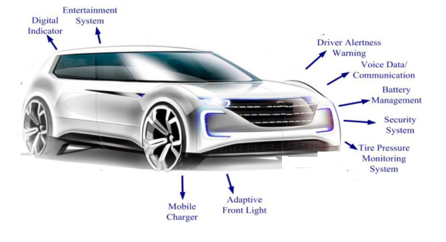
Module Title: - Repair and Install Ancillary Electrical Components
Module code: EIS AEE2 07 1221
Nominal duration: 35 Hours

Prepared by: Ministry of Labor and Skill
September, 2022
Addis Ababa, Ethiopia

Table of Contents

Acronyms 4
Introduction to the Module 5
Unit one: Overview ancillary electrical components 6
1.1 Safety for Ancillary Electrical Components 7
1.2 Overview ancillary electrical components 10
1.3 Tools and Equipment’s 26
Self-check-1 27
Unit Two: Test and Repair ancillary electrical components 28
2.1 Location of ancillary electrical components 28
2.2 Techniques and procedure of testing and repairing 31
Self-check-2 33
Operation sheet 2.1: Test car audio 34
Operation sheet 2.2: Techniques and procedure of testing 36
Lap Test: 2 39
Unit three: Check functionality of installed ancillary electrical components 40
3.1 Carrying out installations 40
3.2 Carrying out checks 46
Operation sheet 3 Installing car Audio 50
Lap test 3 52
Reference 53

Acknowledgment
Ministry of Labor and Skills wish to extend thanks and appreciation to the many representatives of TVET instructors and respective industry experts who donated their time and expertise to the development of this Teaching, Training and Learning Materials (TTLM).

Acronyms

DVDs/CDs Digital Versatile Disc/compact disc
USB Universal serial Bus
GPS Global Position System
EQ Stereo's Equalizer
Hz Hertz
MEM Memory
HID High-Intensity Discharge
LED Light Emitted Diode
RE Renewable Energy
AM Amplitude Modulation
OEM Original Equipment Manufacturer
RPM Revolutions per Minute
HU Head Unit

Introduction to the Module
In Automotive Electrical & Electronics field Repairing and Installing Ancillary Electrical Components covers several different methods of automobile ancillary power exist.
the ultimate source of power for most of them is the automobiles main power source-normally an internal combustion engine of some kind but some way of transferring power to vehicles ancillary system is required.
The trend in modern vehicles is towards making all ancillaries run on electrical power, simplifying the vehicles system and making them easier to control automatically.

This module is designed to meet the industry requirement under the Automotive Electrical & Electronics occupational standard, particularly for the unit of competency Repairing and Installing Ancillary Electrical Components
This module covers the units:
- Overview ancillary electrical components
- Test and Repair ancillary electrical components
- Check functionality of installed ancillary electrical components
Learning Objective of the Module
- Standard and Principle of electric ancillary component
- Test and Repair ancillary electrical components for vehicles and
- installing and test functionality
Module Instruction
For effective use this modules trainees are expected to follow the following module instruction:
- Read the information written in each unit
- Accomplish the Self-checks at the end of each unit
- Perform Operation Sheets which were provided at the end of units
- Do the “LAP test” giver at the end of each unit and
- Read the identified reference book for Examples and exercise

Unit one: Overview ancillary electrical components

This unit is developed to provide you the necessary information regarding the following content coverage and topics:
- OHS requirements
- Overview ancillary electrical components
- Tool and equipment
This unit will also assist you to attain the learning outcomes stated in the cover page. Specifically, upon completion of this learning guide, you will be able to:
- Apply OHS requirements
- Understand ancillary electrical components
- Select Tool and equipment

1.1 Safety for Ancillary Electrical Components
Knowledge during the work
1. Always work safely to prevent injuries.
2. Take care to prevent accidents to yourself. If you become injured on the job, this will not only affect you, but it will also have an effect on your family, coworkers, and company as well.
Factors of the accidents
A, Accidents due to human factors
Accidents caused by the improper use of a machine or tool, by wearing inappropriate clothes, or by the carelessness of the technician
B, Accidents due to physical factors
Accidents caused by the malfunctioning of a machine or tool, the lack of integrity of a safety device, or a poor working environment.
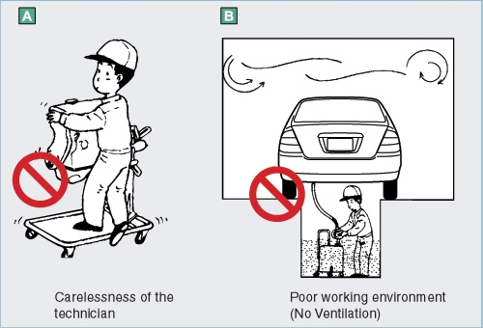
Figure 1.1 factor of accidents
Work wear
To prevent accidents, select work wear that is strong and fits well to facilitate work. Avoid work wear with exposed belts, buckles, and buttons, which can cause damage to vehicles while working. As a safety measure against injury or burns, avoid exposing the bare skin.

A Work shoes
Make sure to wear safety shoes while working. Because it is dangerous to wear sandals or sneakers that slip easily or reduce work efficiency. They also make the wearer vulnerable to injury due to accidentally dropped objects.
B Work gloves
When lifting heavy items or removing hot exhaust pipes or similar objects, it is advisable to wear gloves. However, it is not necessary to make a rule of wearing them for ordinary maintenance work. Whether you should wear gloves must be determined according to the type of work you will be performing.

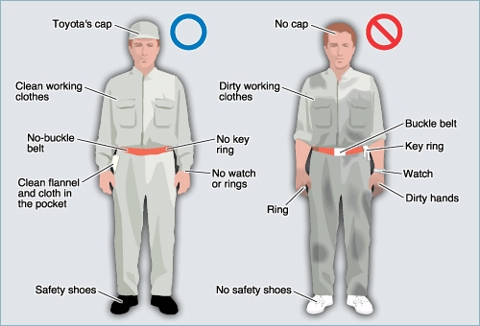

Figure 1.2 work shop wearing
In the Workshop
Always keep your workplace clean to protect yourself and others from injury.
• Do not leave tools or parts on the floor where you or somebody else may trip over them. Make a habit of putting them on a workbench or work stand.
• Immediately clean up any spilled fuel, oil, or grease to prevent yourself or others from slipping on the floor.
• Do not assume an uncomfortable posture while working. It will not only affect your work efficiency, but it could cause you to fall and injure yourself.
• Be extremely careful when handling heavy objects because you could be injured if they are dropped on your feet. Also, remember that you could hurt your back if you try to lift an object that is too heavy for you.
• To move from one area of the workplace to another, make sure to walk on a designated walkway.
• Do not use combustibles' near switches, switchboards or electric motors etc. as they could easily spark creating a fire.
When working with tools, observe the following precautions to prevent injury:
1. Electrical, hydraulic, and pneumatic equipment can cause serious injury if incorrectly used.
2. Wear protective goggles before using tools that scatter chips
Remove dust and chips from tools such as grinders and drills after use.
3. Do not wear gloves when operating a tool that rotates or when working in an area that has a rotational movement. Gloves can get caught in the rotating object and injure your hands.
4. To raise a vehicle on a lift, initially raise it until the tires are slightly off the ground. Then, make sure that the vehicle is securely supported on the lift before raising it entirely. Never attempt to shake the vehicle once it is raised, as this could cause the vehicle to fall and cause serious injury.
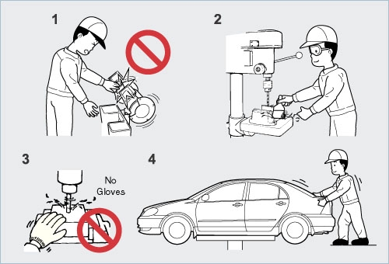
Figure 1.3 work shop work tools

1.2 Overview ancillary electrical components
Ancillary means providing necessary support to the primary activities or operation of the main system.
This topic contains several ancillary components, each of which has a specific purpose.
1.2.1 Car audio system
Car audio is used to provide in-car entertainment and information for the vehicle occupants.
Components and terms
Head unit: includes the screen and buttons. It is the centerpiece of the car's sound and information system. Typically located in the center of the dashboard, modern head units are densely integrated electronic packages housed in detachable face plates. As high-end head units are common targets for theft, many head units are typically integrated into the vehicle's alarm system.
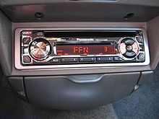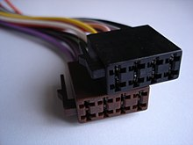
Figure 1.4 Car audio system and harness adapter
Head units give the user control over the vehicle's information and entertainment media: AM/FM radio, satellite radio, DVDs/CDs, cassette tapes, USB MP3, Dashcams, GPS navi, Bluetooth, WiFi etc. Many audio-only head units afford the user precise control over detailed audio functions such as volume, band, frequency, speaker balance, speaker fade, bass, treble, EQ and so on. Connectors for car audio, Harness Adapter are used.
Amplifiers
Amplifiers increase the power level of audio signals. Some head units have built-in stereo amplifiers. Other car audio systems use a separate stand-alone amplifier. Every amplifier has a rated power level sometimes noted on the head unit with the built in amplifier, or on the label of a stand-alone unit.

Speakers
Speakers take an amplified electrical signal and convert it into mechanical energy that moves the speaker cone back and forth to create sound. Sound is essentially vibrations in the air that we hear, and a speaker cone creates these vibrations. The human ear hears these vibrations in a frequency range from about 20 hertz (very low bass) to 20,000 Hz.

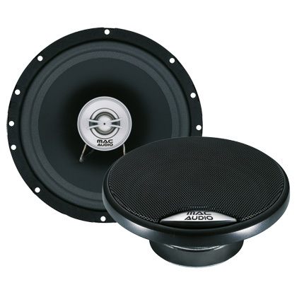
Figure 1.5 Speakers
Damping: sound deadening material is often used in the door cavities and boot/trunk area to damp excess vibration of the panels in the car in response to loud subwoofer bass tones, especially the boot/trunk
1.2.2 Fog and special lamps
Regular headlights can reflect off the fog, snow, or dust particles in the air, causing glare and confusing the eyes of drivers so that they cannot see the road adequately. Fog lights, as their name suggests, were developed for use in dangerously thick fog. They can also be used for other conditions in which visibility is severely limited. Fog lights are completely separate units from standard headlights
Driving in fog: when to use fog lights
Fog lights need to be used at the right times to combat reduced visibility, otherwise you could be a danger to yourself and other drivers.
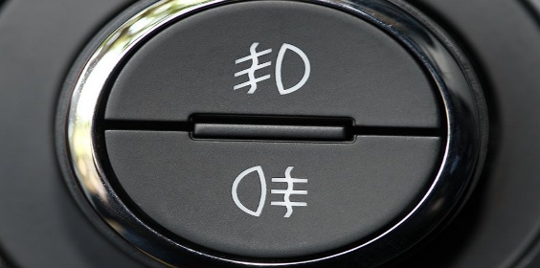
Fog light symbol
These are the fog light symbols you're looking for if you want to switch them on. They can usually be found on a button on the dashboard, on a steering wheel stalk, or next to the dial you use to control your regular lights.
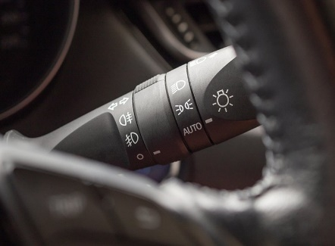
Here's what your fog light switch might look like on a steering wheel:


Front fog light: the one showing a lamp pointing to the left and with lines pointing diagonally down through the vertical wavy line is for your front fog lights.
The one pointing in the opposite direction, with lines pointing horizontally straight through the wavy line is for your rear fog lights.
Rear fog light
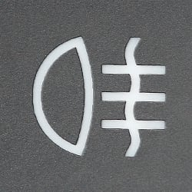
Take a look in your vehicle's logbook if you can't track them down or work out how to switch them on.

Fog Light Beams
Fog lights have a unique beam shape. Their beams are flat and wide, and they are positioned low on the car, usually near the front bumper. The shape of the fog light beams usually resembles a narrow bar. They are meant to cut through the fog and light up the surface of the road so that drivers can see well enough to stay on the road and within their lane. In addition to fog and mist, fog lights are also useful where there are significant amounts of dust and snow on the road, either drifting in through the air or being churned up from the surface of the road. Without fog lights, drivers might not see obstacles such as tree branches, wild animals, or debris in time to avoid them.
Front and Rear Fog Lights Vehicles are typically equipped with both front and rear fog lights. Those in the front extend the driver’s visibility range as far as possible directly ahead of the car. However, even if the driver can see the road ahead, other drivers may not be able to distinguish objects clearly through the fog, mist, smoke, or other hazardous conditions. The fog lights installed at the back of the car serve to warn other drivers of the car’s presence. Usually, the rear fog lights are wired on a separate circuit, apart from the rest of the car’s lighting.
Front fog lights are use in extremely poor visibility. Proper front fog lights are mounted low down on the bodywork, and are angled down at a steeper angle than normal headlights. The beam pattern is wide and flat, with a distinct cutoff at the top-this reduces the amount of light reflecting off the fog. By switching the low-beam lights off, the driver can use the fog lights to illuminate the road directly in front of them, so they can proceed at low speed.

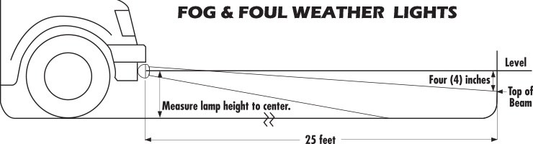
Figure 1.6 fog and foul weather light
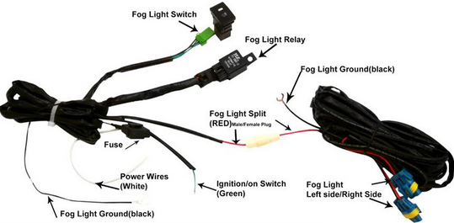

Figure 1.6 fog and foul weather light parts
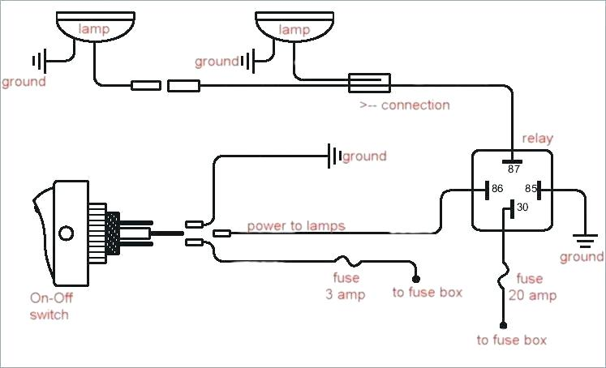
Figure 1.6 circuir of fog and foul weather light
1.2.3 Gauges and Indicators
A dashboard is a control panel located under the windshield of an automobile. It contains gauges and instrumentation which is displays various conditions of car and engine conditions.
The instrument and gauge cluster contains gauges such as a speedometer, tachometer, odometer, fuel gauge, and indicators such as a gear shift position, seat belt warning light, and engine malfunction light. Also heating and ventilation controls and vents, lighting controls, and audio equipment. In more modern cars, automotive navigation systems are mounted in the dashboard.
Dashboard is called instrument panel.
Instrument panels
The two basic types of instrument panel displays are:
  - Analog and
  - Digital
Analog display:
- An indicator moves in front of a fixed scale to indicate a condition.
- The indicator is often a needle but it can also be a liquid crystal or graphic display.
- Show relative change better than digital displays.
- Are useful when the driver must see something quickly and the exact reading is not important.
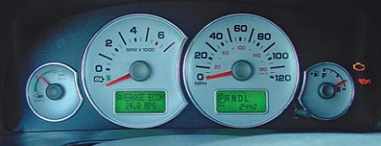
Figure : An analog instrument panel
Digital display:
- Uses numbers instead of a needle or graphic symbol.
- Is better for showing exact data such as miles travelled.
Three types of digital electronic displays are used today.
    - Light-Emitting Diode (LED):
    - Liquid Crystal Diode (LCD):
    - Vacuum Fluorescent
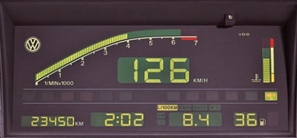
Figure: a digital instrument panel

- Light-Emitting Diode (LED): These displays are either used as single indicator lights or they can be grouped to show a set of letters or numbers. LED displays are commonly red, yellow, or green and can be hard to see in bright light.
- Liquid Crystal Diode (LCD): These displays are made of sandwiches of special glass and liquid. A separate light source is required to make the display work. When there is no voltage, light cannot pass through the fluid. When voltage is applied, the light passes that point of the display. The action of LCDs slows down in cold weather. These displays are also very delicate and must be handled with care.
- Vacuum Fluorescent: These displays use glass tubes filled with argon or neon gas. The segments of the display are little fluorescent lights. When current is passed through the tubes, they glow very brightly. These displays are both durable and bright.
Instrument gauges
- Gauge provide the driver with a scaled indication of the condition of a system.
- Two components are needed for the operation of an electrical gauge, these are:
    - Instrument voltage regulators and
    - Sending units (Sensor).
- Instrument voltage regulators (IVRs):
  - Are used to stabilize and limit voltage for accurate instrument operation.
  - Vehicles equipped with an IVR also have a radio choke.
  - A radio choke is a small coil of wire installed in the power lead to the IVR.
  - The choke prevents radio interference caused by the pulsations of the IVR.
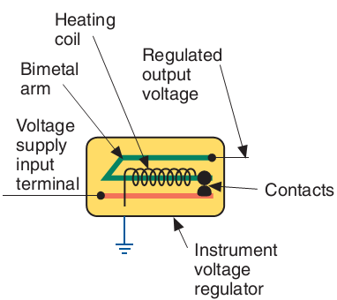
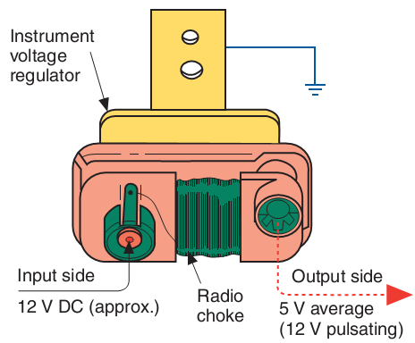
Fig: Instrument voltage regulator

Sending units (Sensor):
    - All gauges require an input from either a sending unit or a sensor.
    - With sending or sensor units, a change or movement made by an external component causes a change in electrical resistance.
    - Movement may be caused by pressure, heat or motion.
1. Magnetic Gauges
A. Ammeter type Gauge
- It is the simplest form of magnetic gauge, in which a permanent magnet attracts a pointer connected to a pivot and holds it on the gauge.
- An armature, or coil of wire, is wrapped around the base of the pointer.
- When current flows through the armature, a magnetic field is formed. This magnetic field opposes that of the permanent magnet.
- Attractive or repulsive magnetic forces cause the needle to swing left or right.
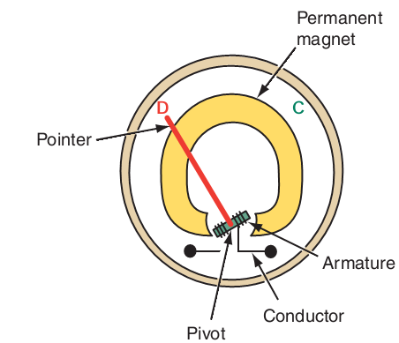
- The needle of the gauge (pointer) pivots on the armature, often called a bobbin.
- When sending unit resistance changes, current flow through the coil changes, causing the strength of the magnetic field created around the bobbin to change.
- As the resistance in the sending unit increases, the circuit’s current decreases and a lower indicator position on the gauge results.
B. Balancing coil type gauge
- A balancing coil gauge also operates on principles of magnetic attraction and repulsion. However, a permanent magnet is not used.
- The base of the indicating arm is pivoted and includes an armature.
- Two coils are used to create magnetic fields.
- The two coils are connected so that electricity can flow through either one.
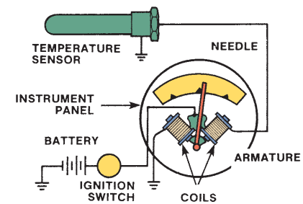
- When the resistance of the sending unit is low, the right-hand coil receives more current than the left-hand coil, attracting the armature. Thus, the gauge needle moves to the right.
- When the resistance of the sending unit is high, the left-hand coil receives more current. More magnetic force is created in the left-hand coil and the needle swings to the left.
2. Thermal or Bimetallic Gauge
A bimetallic or thermal gauge operates through heat created by current flow.
A variable resistance sending unit causes different amounts of current to flow through a heating coil within a gauge.
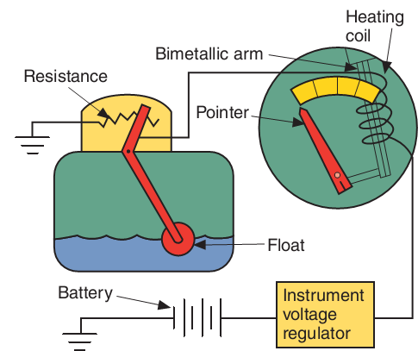
The heat acts on a bimetallic spring attached to a gauge needle.
- When more heat is created, the needle swings farther up the scale.
- When less heat is created, the needle moves down the scale.

Figure: Typical bimetallic fuel gauge circuit

Basic information gauges
1. Speedometer
Speedometers are used to indicate vehicle speed in mph or kph.
Speedometers may be driven either by:
    - mechanically,
    - electrically, or
    - Electronically.
- The mechanical speedometer consist of a permanent magnet that is rotated by a speedometer cable.
- Surrounding the rotating magnet there is a metal cup that is attached to the indicating needle. The revolving magnetic field exerts a pull on the cup that forces it to rotate. The rotation of the cup is countered by a calibrated hairspring.
- The influence of the hairspring and the rotating magnetic field on the cup produces accurate readings by the attached needle.
- Speedometer cable is driven by gears on the transmission output shaft.
- The electric speedometer use a mechanically driven permanent magnet generator to supply power to a small electric motor. The electric motor then is used to rotate the input shaft of the speedometer.
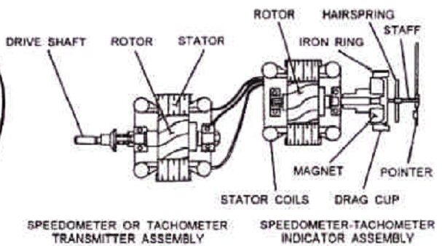
The voltage from the generator will increase proportionally with speed, and speed will likewise increase proportionally with voltage enabling the gauges to indicate speed.
The signal generator for the speedometer is usually driven by the transmission output shaft through gears.

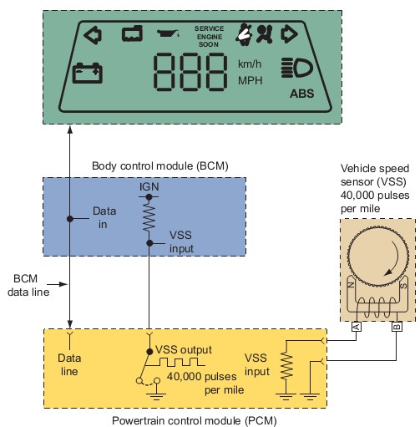
Electronic speedometers receives speed information from the transmission mounted vehicle speed sensor (VSS). This speed signal is used by speed control module, ride control module, the engine control module, and others

2. Odometer
- It records the number of miles or kilometers a vehicle has traveled.
- A mechanical odometer is driven by a spiral gear cut on the speedometer’s magnetic shaft. The odometer’s numbered drums are geared so that when any one drum finishes a complete revolution, the drum to the left is turned one tenth of a revolution.
- An electronic odometer, uses a stepper motor to drive the odometer. The motor receives signals from the PCM and causes the odometer to move in steps. An electronic odometer receives information from the VSS.
- The accumulated mileage value of the digital display odometer is stored in a nonvolatile ROM.
- Trip Odometer: it is a part of the normal odometer. It records the distance traveled in intervals. The driver activates this gauge and it can be reset to zero whenever the driver desires.

3. Oil Pressure Gauge
The oil pressure gauge indicates engine oil pressure.
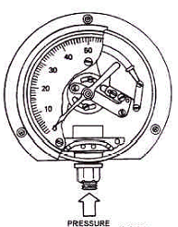
The oil pressure typically should be between 45 and 70 psi when the engine is running at a specified engine speed.
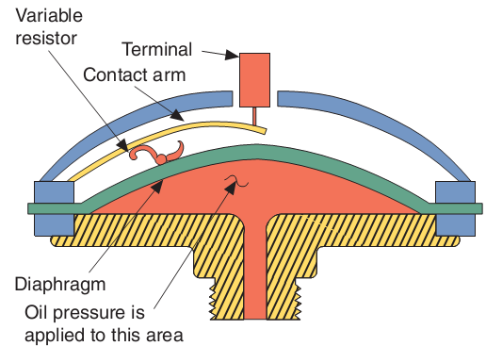
- The mechanical gauge uses a thin tube to carry an actual pressure sample directly to the gauge. The gauge basically consists of a hollow, flexible C-shaped tube, called a bourbon tube. As air or fluid pressure is applied to the bourbon tube, it will tend to straighten out. As it straightens, the attached pointer will move, giving a reading.
- A piezoresistive sensor is threaded into the oil delivery passage of the engine. The pressure of the oil causes a flexible diaphragm to move. This movement is transferred to a contact arm that slides down the resistor. The position of the sliding contact arm determines the resistance value and the amount of current flow through the gauge.
  - Fuel Level Gauge
- The fuel level gauge indicates the fuel level in the fuel tank.
- It is a magnetic indicating system that can be found on either an analog (meter) or digital (bars) instrument panel.
- The fuel sending unit consists of a variable resistor controlled by the level of an attached float in the fuel tank.

Figure: Thermostatic fuel gauge
  - Temperature gauge
- The most common uses of temperature gauges are to indicate engine coolant, transmission, differential oil, and hydraulic system temperature.
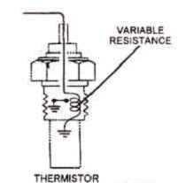
- Depending on the type of equipment, the gauge may be mechanical, electric, or a warning light.
- The electric gauge may be the thermostatic or magnetic type.
- The magnetic gauge contains a bourbon tube and operates by the same principles as the mechanical pressure gauge.
- Charging Gauges
- These allow the driver to monitor the charging system.
- Whereas a few older cars use an ammeter, most charging systems use a voltmeter or an indicator light.
- The indicator lamp will light when the voltage from the charging system is less than voltage at the battery.
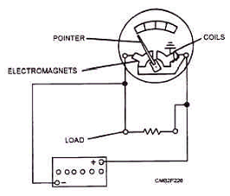
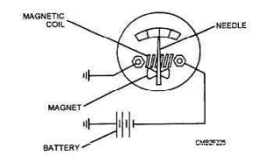

Ammeter schematic Voltmeter schematic

INDICATOR AND WARNING DEVICES
- Vehicles are equipped with several warning devices to alert the driver to problems. Most of these are safety or emissions related.
- Some of the more common indicator and warning lights are:
Brake Warning Light

This reminds you to release the parking brake before moving the vehicle. If the light comes on while you are pressing the foot brake or while you are driving, part or all of the braking system is not working properly.

Safety Belt Light
This light reminds to fasten safety belt before moving vehicle. In some vehicles, the light stays on for a few seconds after the engine is started and there may also be a beeping sound.
Antilock Braking System Light
This light tells if the antilock braking system (ABS) is functioning properly. If the ABS light comes on while driving, it indicates a problem with the system.


Air Bag Warning Light
When the air bag light comes on and then goes off, this tells you that the air bags are in proper working condition. If the air bags are not in proper operating condition, the warning light will stay on.
Turn-Signal Indicators
These indicators tell you the direction you have signaled to turn.

High-Beam Indicator
This indicator usually appears as a small blue light in some area of the instrument panel when the high-beams are on.
Check Engine Light
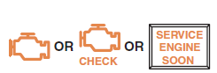
The check engine light can either blink or remain constant, depending on the problem. A blinking light indicates a problem that needs immediate attention. However, whenever the check engine light comes on, you should have the vehicle checked by a service
technician.


Door opens warning light.
If a door is open, a warning light is used to notify the driver. Check and close all doors and tailgates before driving.


Windshield washer fluid low
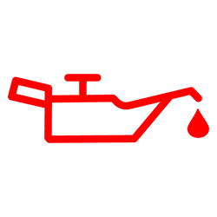
A sensor in the windshield washer fluid reservoir is used to turn on the low washer fluid warning lamp.
Oil Pressure Light
When the oil warning light comes on, it is a sign that the engine oil pressure has dropped to a low level,
Maintenance Reminder: it turns on to alert the driver that maintenance needs to be performed on the vehicle.
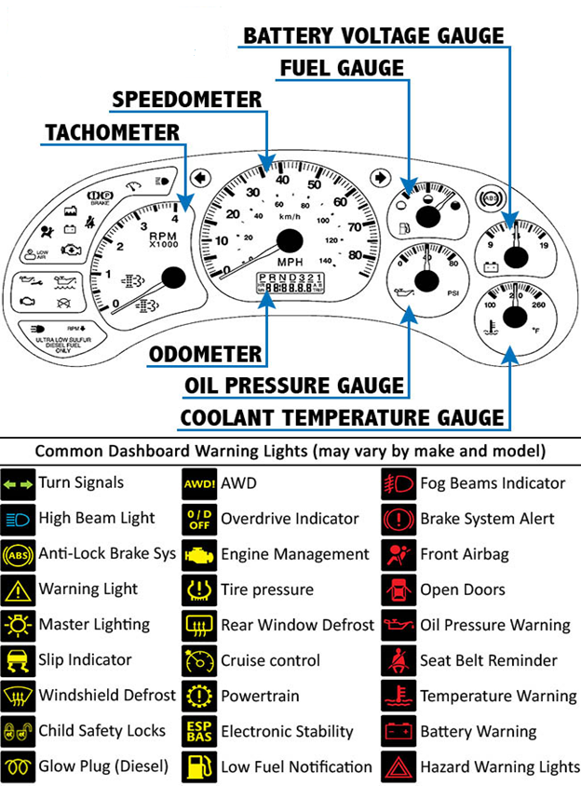
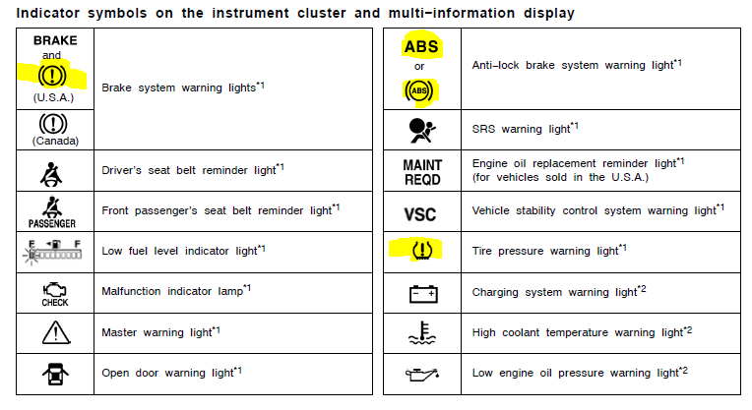

1.3 Tools and Equipment’s
May include:
- hand tools
- testing equipment, including multi meters and ohmmeters
- insulation testers
- crimping tools
- soldering iron
- heat-gun or blower
- wire and cabling of various colours and sizes
- heat shrink sleeving and flexible conduit
- terminals and connectors
- electrical tape.

Self-check-1
Test I: Fill the black space
Instruction: Fill the black space with the correct answers. You have given 1 Minute for each question. Each question carries 2 Point.
1 used to provide in-car entertainment and information for the vehicle occupants. (car audio )
2, increase the power level of audio signals.( Amplifiers)
3, take an amplified electrical signal and convert it into mechanical energy that moves the speaker cone back and forth to create sound.
4, is located at the back of the driving wheel.( Speedometer)
5, is an instrument that measures the rotation speed of a shaft or wheel in a vehicle.( Tachometer)
6, is a device used for indicating distance traveled by a vehicle.( An odometer)
7, is used to indicate the level of fuel contained in a tank.( A fuel gauge)
8, is a control panel located under the windshield of an automobile.( A dashboard)
9, are completely separate units from standard headlights.( Fog lights)
10, The gauge consists of two parts in any car: the and .( the sender unit and the indicator)
Test II: short Answer writing
Instruction: write short answer for the given question. You are provided 3 minute for each question and each point has 5Points
1, what is the advantage of safety around working areas?
2, what is the difference between amplifiers and speakers?
3, How Fog light is different from the head light?

Unit Two: Test and Repair ancillary electrical components
This unit to provide you the necessary information regarding the following content coverage and topics:
- Location of ancillary electrical components
- Techniques and procedure of testing and repairing
This guide will also assist you to attain the learning outcomes stated in the cover page. Specifically, upon completion of this learning guide, you will be able to:
- Identify Location of ancillary electrical components
- Apply Techniques and procedure of testing and repairing

2.1 Location of ancillary electrical components
2.1.1 Audio Systems
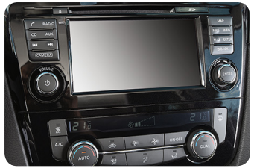
Any Car Audio, Any Measurement Sound Check offers simple, fast and accurate testing of vehicle audio quality, from individual speaker components to complete in-vehicle infotainment and telematics systems. With interfaces to connect via Bluetooth, Lightning, USB and with individual MEMs devices, as well as analog connections, Sound Check can handle the complexity and demands of testing in today’s vehicles

Figure 2.1 Audio system

Measurements include:
• Speaker/system response
• Speaker/panel buzz, squeak and rattle
• Bluetooth audio performance
• Head unit and amplifier response & THD+N
• Microphone/microphone array response
• Active noise cancellation effectiveness
• Spatial reproduction accuracy

There are many possible in-vehicle test configurations. These are just a few options for testing
Automotive audio.
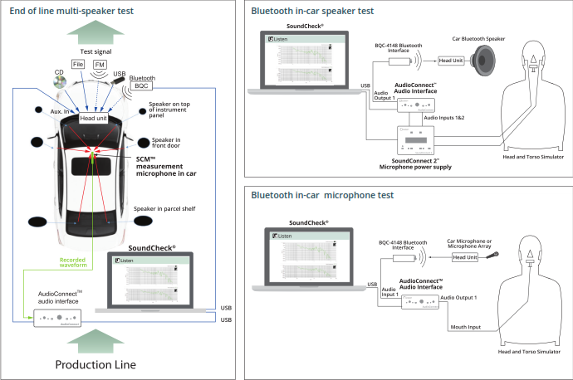
Figure 2.2 Test configuration
2.1.2 Fog and Special Lamps
Fog lights are separate to your headlights, in most occasions they can be found below the main headlights and there will be a separate switch on your dash or instrument panel to turn them on and off. You can find your fog light and switch locations in your vehicle owner’s manual. If your car has factory fitted fog lights, they will be located at the front and rear of your vehicle.
The front will emit a white or yellow light and the rear will be red. The rear fog lights are designed to be more visible in hazardous conditions. The front fog lights have a specific beam designed to stay low and wide and light up the road under the fog. Once weather conditions have improved, be sure to turn your fog lights off as they can blind other road users once the fog has dispersed.

A fog light is a very bright light on the front or back of a car to help the driver to see or be seen in fog.
Fog lights are intended to be used in conjunction with standard headlamp low beams. Driving lights are mounted to provide illumination forward of the vehicle and intended to supplement the high beam of a standard headlamp system. It is not intended for use alone or with the low beam of a standard headlamp system.
Rear fog lights are a legal requirement on all cars. Front fog lights are only fitted to certain models, usually as an aesthetic add-on for higher spec cars. All new cars have DRL, daytime running lights that are also intended to do help the car be seen on the road.
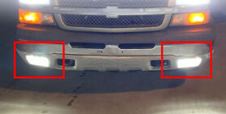
Figure 2.3 Fog light indicator
Gauges are used to measure different types of objects having various sizes, shapes, and thicknesses, the gap in space, diameter of materials, or pressure of the flow. Specific types of gauges are used to measure each parameter. Gauges are classified into eight types, they are: Plug gauge. A gauge, in science and engineering, is a device used to make measurements or in order to display certain dimensional information. A wide variety of tools exist which serve such functions, ranging from simple pieces of material against which sizes can be measured to complex pieces of machinery.

2.2 Techniques and procedure of testing and repairing
Procedure:
- Prepare the tools and materials
- Ensure safety in your working area
- Gather information from the driver or the service history of the vehicle
- Identify the test locations by which most trouble or failure may appear
- Carry out visual inspection for loose connection, blown and disconnected parts
- Test the individual system and its components by using appropriate test instrument as specified on owner’s manual
- Record the information and data collected and prepare the failed system or component for repair
Testing and Repairing
- Diagnose the cause of brighter than normal, intermittent, dim, continuous or no operation of exterior lighting; determine needed repairs.
- Inspect, test, repair and/or replace switches, relays, bulbs, LEDs, sockets, connectors, terminals, wires, and control modules of exterior lighting.
- Diagnose the cause of turn signal and/or hazard light system malfunctions; determine needed repairs.
- Inspect, test, repair and/or replace switches, flasher units, bulbs, sockets, connectors, terminals, wires, and control modules of turn signal and hazard light circuits.
- Diagnose the cause of intermittent, dim, continuous or no operation of interior lighting circuits (such as: courtesy, dome, map, vanity, glove box, cargo, trunk, hood, instrument, and accent lighting); determine needed repairs.
- Inspect, test, repair and/or replace switches, relays, bulbs, sockets, connectors, terminals, wires, and control modules of interior lighting circuits (such as: courtesy, dome, map, vanity, glove box, cargo, trunk, hood, instrument, and accent lighting).
- Diagnose the cause of intermittent, dim, no lights, continuous operation, or no brightness control of instrument lighting circuits; determine needed repairs.
- Diagnose the cause of constant, intermittent, or no operation of warning lights, indicator lights, audible warning devices, and other driver information systems; determine needed repairs.
- Inspect, test, repair and/or replace bulbs, sockets, connectors, terminals, switches, relays, sensors, timers, wires, gauges, sending units, electronic components, and control modules of electronic instrument clusters and driver information system circuits.
- Diagnose operation of comfort and convenience accessories and related circuits (such as: power windows, power seats, adjustable pedal height, power locks, trunk locks, remote start, moon roof, sunroof, sun shade, keyless entry, voice activation, phone pairing technology, wireless connectivity, steering wheel controls, camera systems, park assist, cruise control, and automated exterior lighting); determine needed repairs.
- Inspect, test, repair and/or replace components, connectors, terminals, and wiring of comfort and convenience accessories.
- Diagnose operation of heated and cooled accessories and related circuits (such as: heated/cooled seats, heated steering wheel, heated mirror, heated glass, and heated/ cooled cup holders); determine needed repairs.
- Inspect, test, repair and/or replace components, connectors, terminals, and wiring of heated and cooled accessories.
- Diagnose operation of security/anti-theft systems and related circuits (such as: theft deterrent, door locks, keyless entry, remote start, and starter/fuel disable); determine needed repairs.
- Inspect, test, repair and/or replace components, connectors, terminals, and wiring of security/anti-theft systems.
- Diagnose operation of entertainment/infotainment and related circuits (such as: radio, DVD, navigation, amplifiers, speakers, antennas, and voice-activated accessories); determine needed repairs.
- Inspect, test, repair and/or replace components, connectors, terminals, and wiring of entertainment/infotainment systems.
- Diagnose operation of safety systems and related circuits (such as: supplemental restraint systems, wipers, washers, horn, speed control, collision avoidance, telematics, heads-up display, park assist, and camera systems); determine needed repairs.
- Inspect, test, repair and/or replace components, connectors, terminals, and wiring of safety systems.

Self-check-2
Test-I True or False
Instruction: select the correct answer for the give questions say true if the statements are true or false if the statements are false. You have given 1 Minute for each question.
Each question carries 1 Point.
1, The System Sound Check’s modular combination of hardware and software is cost-effective, flexible and expandable.
2, Virtual instruments offer the functionality of stand-alone hardware on your laptop.
3, If your car has factory fitted fog lights, they will be located at the front and rear of your vehicle.
4, A fog light is a very bright light on the front or back of a car to help the driver to see or be seen in fog.
5, Fog lights are intended to be used in conjunction with standard headlamp high beams.
6, Rear fog lights are a legal requirement on all cars.
7, All new cars have DRL, daytime running lights that are also intended to do help the car be seen on the road.
8, Specific types of gauges are used to measure each parameter.
9, Rear fog lights are only fitted to certain models, usually as an aesthetic add-on for higher spec cars.
10, Driving lights are mounted to provide illumination forward of the vehicle and intended to supplement the high beam of a standard headlamp system.
Test II: short Answer writing
Instruction: write short answer for the given question. You are provided 3 minute for each question and each point has 5Points.
1,What are the eight types of gauges?
2,What is the difference between scientific gauges and engineering gauges?
3,What is system sound?

Operation sheet 2.1: Test car audio
- Operation title: Procedures of car audio , amplifier ,sound and speakers
- Purpose: To practice and demonstrate the knowledge and skill required in test the functionality of car audio and its components
- Instruction: Use the given figure below (Figure given below), the tools and equipment given from the procedure given below check the completed your work. For this operation you have given 3Hour.
Procedure
1. Take out the old stereo. Unlink the negative cable from the battery.
2, Take off the front paneling of the dashboard.
3, Place the connector in your wiring harness.
4, Attach every wire if you are not using a harness
5, Link the positive wire to the connector located on the stereo.
6, Take the black wire and link it to the stereo. You can use a screw that is close to the radio inside the dashboard. The wiring should be wrapped around metal.
7, Link the red ignition and 12 constant wiring to the stereo. Use the stereo manual to make sure you are putting these in the correct location.
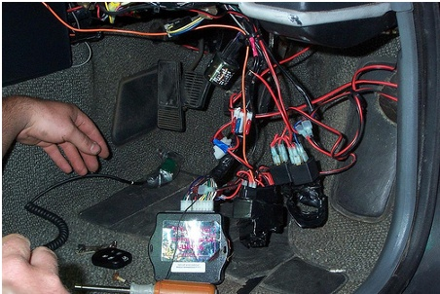
8, your connector should be housing all the wiring you need through a harness. You could purchase it separately or use the one that comes with the stereo.

9, Put the stereo into the mounting bracket. If it didn’t come with one, use the one from the other stereo system.
10, Link the harness connector up to the stereo in the back. You will only have one single wire to attach from the previous system at this point. This wire is your antenna wire. Attach it to the stereo. If there is a power antenna wire link it as well.
11, Place the stereo into the hole inside the dashboard. Do not secure it in yet. Test it before you add any screws to it.
12, Reattach the negative cable back to the car battery.
13, Place the key in the ignition and crank your vehicles. Turn on the radio and listen to the quality of sound. You need to verify that all the speakers are working and the radio is functioning properly.
14, Secure the new stereo. Use the screws and a screwdriver to put the face onto the radio and replace the dashboard cover.
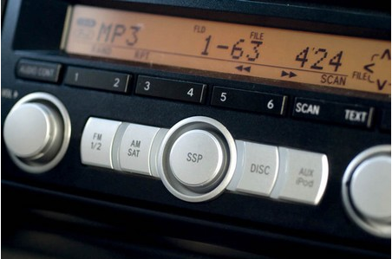

Operation sheet 2.2: Techniques and procedure of testing and repairing the Audio systems
Procedure:
1, Prepare the tools and materials
2, Ensure safety in your working area
3, Gather information from the driver or the service history of the vehicle
4, Identify the test locations by which most trouble or failure may appear
5, Carry out visual inspection for loose connection, blown and disconnected parts
6, Test the individual system and its components by using appropriate test instrument as specified on owner’s manual
7, Record the information and data collected and prepare the failed system or component for repair

Measurements include:
• Speaker/system response
• Speaker/panel buzz, squeak and rattle
• Bluetooth audio performance
• Head unit and amplifier response & THD+N
• Microphone/microphone array response
• Active noise cancellation effectiveness
• Spatial reproduction accuracy

Operation Sheet: 2.3 Fog light and fog light bulb replacement
Procedures:
- Insert a medium-long screwdriver into the upper hole next to the fog light. Push the screwdriver in to release the fog light mounting latch.
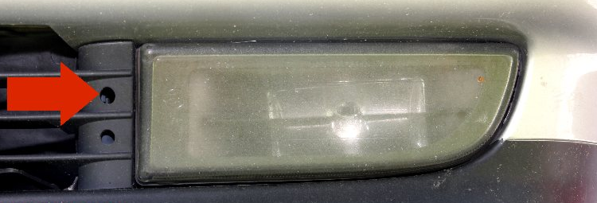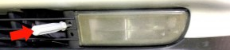
- Pull the inboard end of the light assembly out of the bumper and remove the assembly.
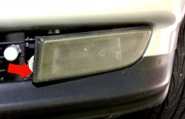
- Remove the harness plug from the light assembly
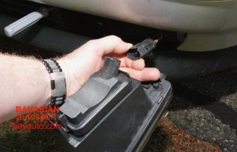
- Depress the retaining clip and remove the bulb access cover from the light assembly.
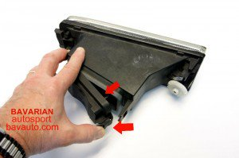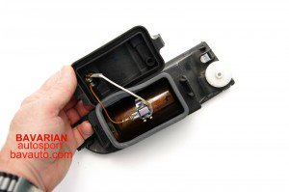
- Press the bulb retainer clip down and to the side to release the clip.
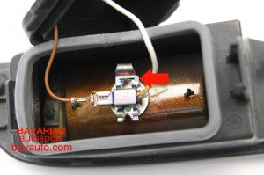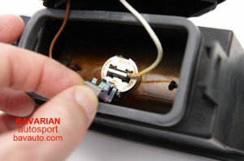

- Remove the bulb and disconnect the female spade on the end of the bulb’s connection wire from the male spade on the access cover.
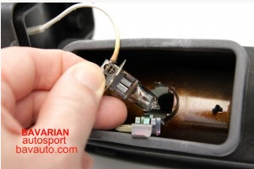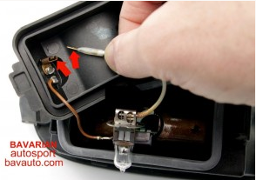

Lap Test: 2
Task 1 perform the techniques and procedures of testing and repairing the audio systems.
Task 2 replace the fog light

Unit three: Check functionality of installed ancillary electrical components
This unit to provide you the necessary information regarding the following content coverage and topics:
- Carrying out installations
- Carrying out checks

This guide will also assist you to attain the learning outcomes stated in the cover page. Specifically, upon completion of this learning guide, you will be able to:
- Apply Carry out installations
- Understand Carry out checks

Ancillary services refers to functions that help grid operators maintain a reliable electrical system.
Ancillary services maintain in the proper flow and direction of electricity, address imbalance between supply and demand, and help the system recovery system events. In systems with significant variable renewable energy (RE) penetration, additional ancillary service may be required to manage increased variability and uncertainty.
The ancillary components in an ultrasonic transducer comprise the casing, the cabling and any electronic circuitry, including electrical impedance matching.

3.1 Carrying out installations
How to Install a Car Stereo
Installing a new car stereo can often be simple enough to do yourself, and this article will provide you with a general guide on how to do it. Keep in mind that some cars and systems are more complicated than others and that every car and stereo system will be different, so some specifics may vary. Be sure to read any instructions that come with the new car stereo before attempting to install it.

How to Take Out the Old Stereo
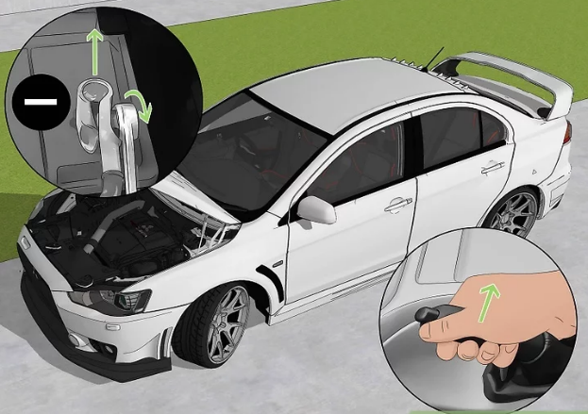
    - Set the parking brake and disconnect the negative cable from your car battery.
Be sure to do this to avoid short-circuiting the electrical system during the installation, which could lead to fire or physical harm for you. For instructions on disconnecting the battery, see How to Disconnect a Car Battery.
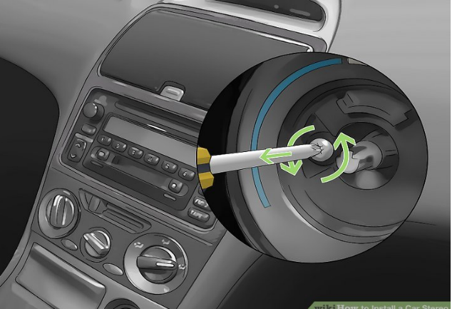
    - Unscrew any screws that are securing the trim in place.
Be careful to remove all screws before trying to pry off the trim or you may break it.
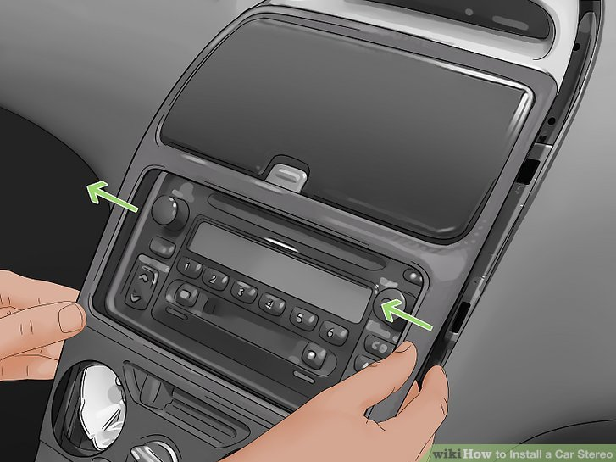
    - Remove the trim.

For some cars, you may need to remove several pieces of plastic trim, usually working from the bottom up. If you need to remove trim that includes any knobs or drawers, remove them before trying to pry off the trim. Use your hands or a pry tool to pry off each piece of trim. Pry tools are specifically for this purpose and will not damage the trim pieces.
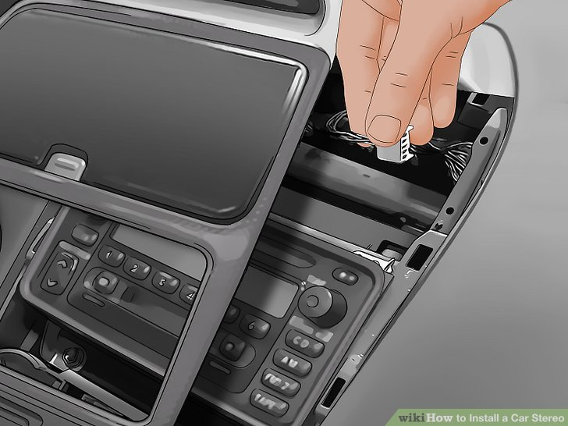
    - Pull out any necessary components.
If you need to remove any components before being able to access the stereo, do so. Disconnect components that are wired to the car. Take a picture of how each is wired for later reference.

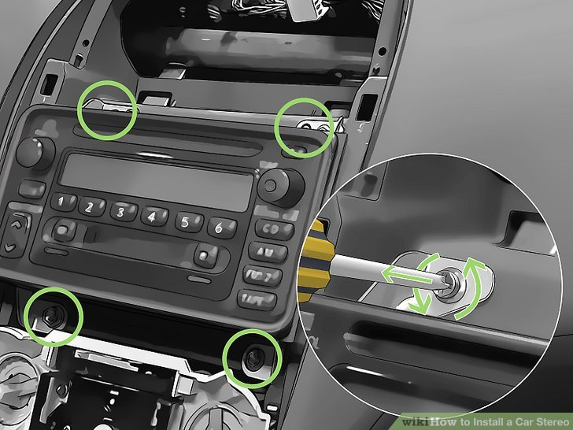
    - Loosen the stereo. Different cars may have varying elements securing the stereo in place.
- If the stereo is held in place by screws or nuts, loosen them with the appropriate tool (screwdriver or nut driver, respectively).
- If the stereo isn't held in place by screws or nuts, you'll need to use a radio-removal key.
This tool is commonly necessary in Ford vehicles.
Radio-removal keys (sometimes also referred to as radio-removal tools) will typically either be in an elongated horseshoe shape or will have a circular shape at one end and a notched shaft at the other. They’re available at most auto-parts stores.
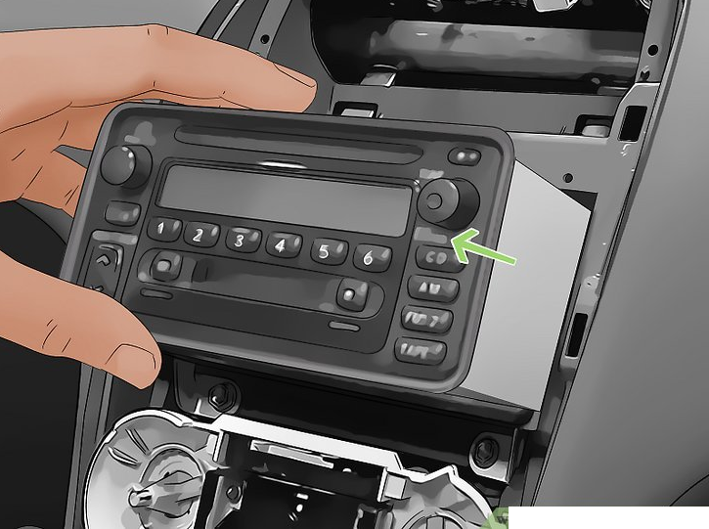
- Insert the keys into the two small slots in the face of the stereo. You will release a mechanism holding the stereo in place. Slide the radio-removal keys into each slot again until you feel the stereo loosen from in its housing. You should then be able to pull out the stereo relatively easily
    - Pull the stereo out of the panel.
You may want to use needle-nose pliers to grip the edge of the stereo and help you pull it out. Pull it gently, and if the stereo doesn't come out easily, double check that you haven't missed any components that may be holding it in place.

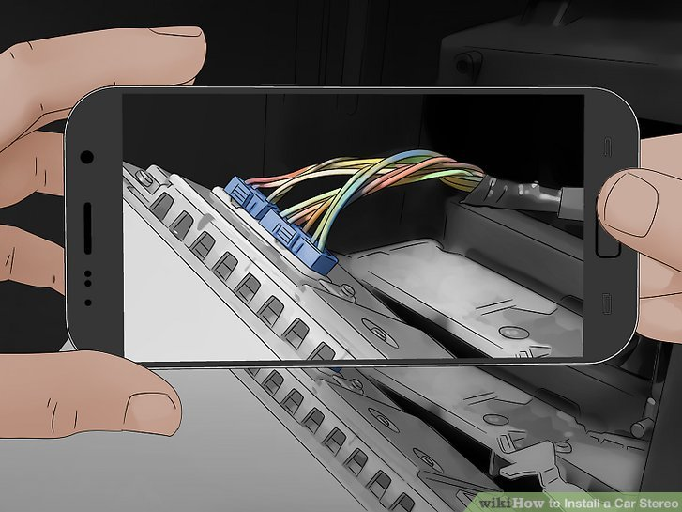
    - Take a picture of how the stereo is wired. This is an important step because the photo will serve as a reference later when you’re wiring in the new stereo

    - Unplug the stereo connections.
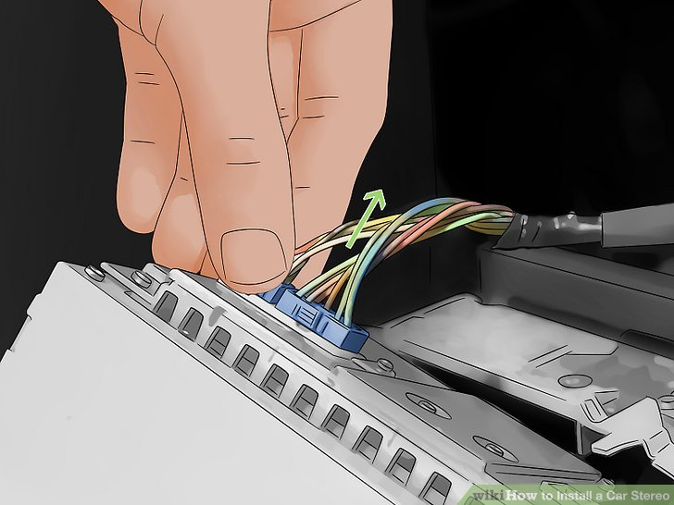
You’ll see a series of wires connected to the back of the stereo, and you’ll need to disconnect each of them.
- First unplug the antenna wire, which will typically be a thicker wire plugged in separately from the rest. Once it’s unplugged, you should be able to move the stereo around more freely.
- Next unplug the each of the wire harness connectors. There will typically be several of these and you can recognize them because a series of wires will feed into each one. The plastic piece into which the wires are fed should have either a tab or a button you can push, which will release the harness.
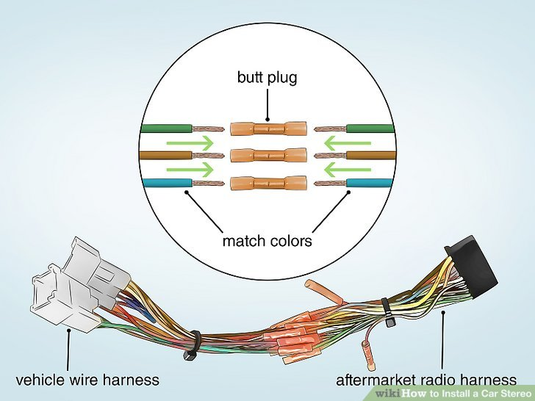
How to Install the New Stereo
- Match up the wires. Match the wires of the car’s harnesses to the new stereo’s harnesses
Each harness connector is unique, so it should be easy to figure out which ones fit together.
- To be safe, check the wiring diagrams for both your car and the new stereo to verify you’ve connected them correctly.
- If your car's stereo doesn’t use wire harnesses, you’ll need to match up each wire manually. The wires are color-coded; however, the wires on an after-market stereo may not match with the color-coded wires in your vehicle. It's best to study and follow the wiring diagram that came with the stereo.
- Connect the matched wires. There are two options for connecting the wires, crimping or soldering. Crimping is faster and easier, but soldering will provide a more stable and secure connection. Be sure to use the proper size crimper and don’t try to bundle the wires with tape — it will eventually dry out and fall off. Bundle wires using zip ties instead.
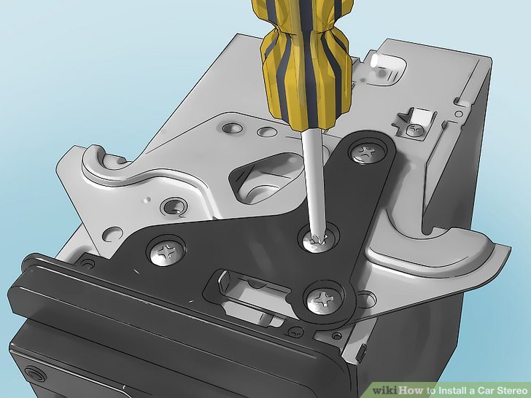
- Assemble the mounting kit. If your new stereo came with a separate mounting kit, assemble it according to the stereo's instructions (it will often mean fitting a metal housing sleeve into the mounting frame).
- Push down on the tabs located around the metal sleeve with a screwdriver to secure the metal sleeve in place.

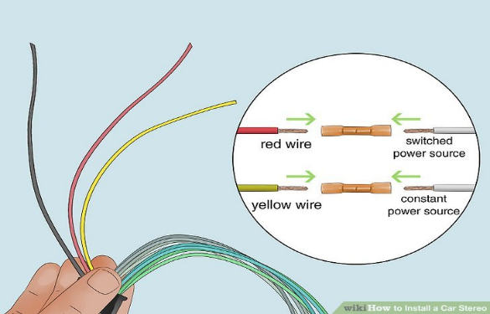
- Connect the power source. Typically, if you have a wiring harness, this connection will be made when you connect the new stereo harnesses to the harnesses in the car.If you aren't using a wiring harnesses, you’ll need to manually connect the power. Determine whether your car has a switched power source (typically a red wire) or a constant power source (typically a yellow wire). Some vehicles even have both types of power sources. For more information on switched versus constant power, go here.
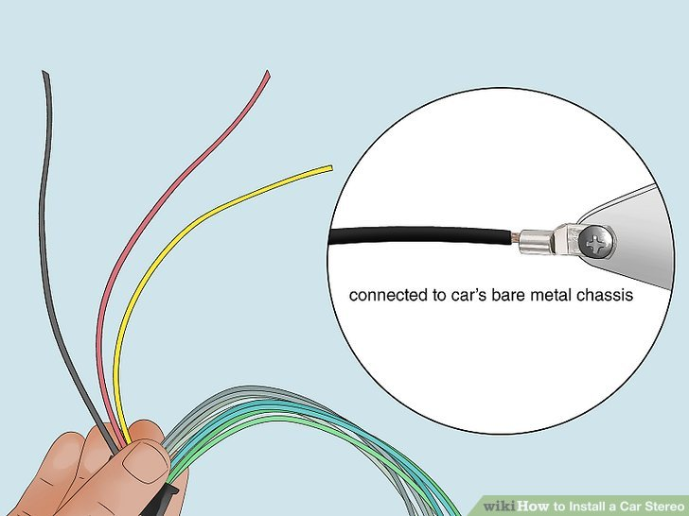
- Ground the stereo. If you're using wiring harnesses, this connection will be made when you connect the harness pieces.
- If you aren't using a wiring harness, you'll need to locate the bolt, wire, or screw that connects with the car's bare metal chassis. Loosen the bolt, wire, or screw and slip the stereo's ground wire (usually black) underneath, then tighten.
- Note that the ground connection is important to the optimal performance of the stereo. If the ground wire doesn't connect to the bare metal, it won't work. And if the ground wire connection is loose, it could result in poor audio output. Sand down the area with sand paper to ensure a good connection.

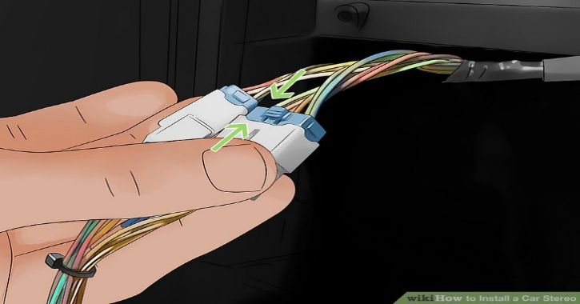
- Connect the remaining wires.
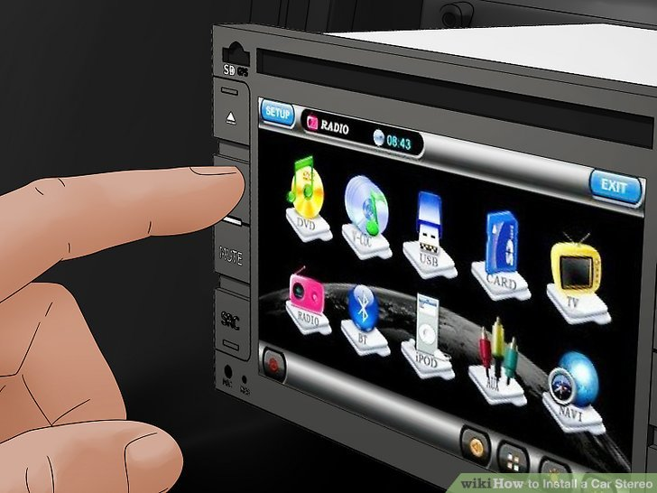
Plug in the antenna cable and connect the stereo's wiring adapter to the the car's wire harness. Connect the output converter if one is needed to make the new stereo compatible with the car's audio system. Have in mind that all wires should be connected in the end and there should no single one hanging unattended.
- Test the stereo.
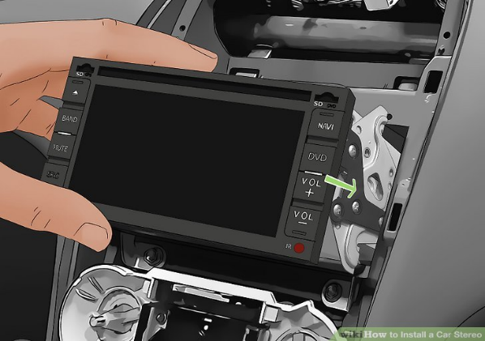
Turn the power on and test the AM, FM, and CD components. Test the fade and balance settings to be sure the speakers are working properly. Turn the power back off.

How to Finish the Installation
- Push the stereo into place.
When the stereo is fully in, you should hear it click into place.
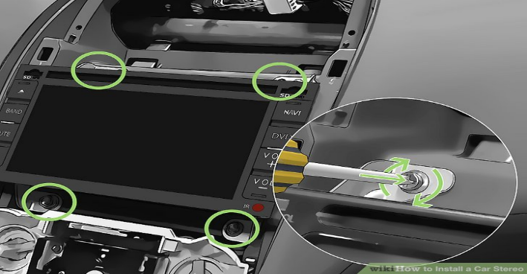
- Reconnect the components. Fasten in any screws that are needed to hold the stereo in place, reconnect any wired components, and replace any knobs or drawers that were removed.

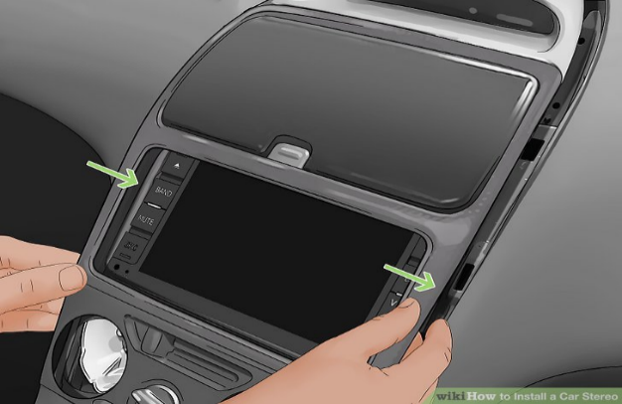
- Snap all the pieces of trim back into place over the stereo. Double check that all screws and trim pieces are securely in place.

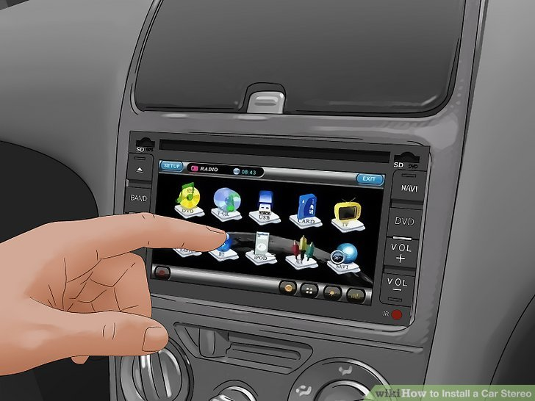

4. Try out the new stereo. Turn the car power on again and play around with the stereo and its settings to be sure everything is in working order.

3.2 Carrying out checks
3.2.1 Carrying out checks audio system
Audio Systems: These first few diagrams will allow you to get a good clear look at all of the connections on the devices which will come later on this page. These components will be much smaller in the later diagrams. This is the head unit and all of its connections
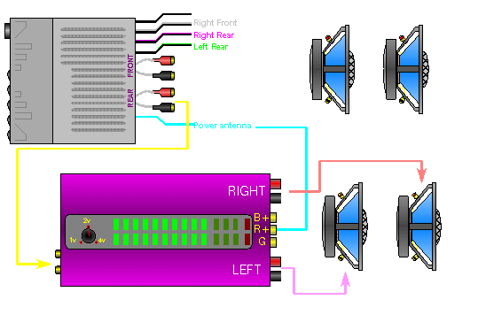
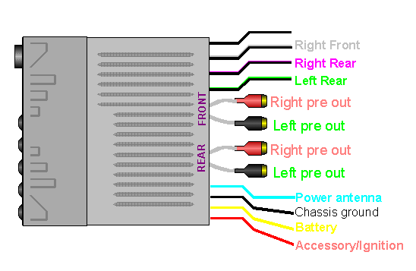

Car radio is not working Inspection Service
The main point of a car is to get you from point A to point B, but most of us are a lot more comfortable with some entertainment along the way. Car radios have become standard equipment. In fact, they’ve become quite advanced, even on entry-level models. Today’s systems include everything from CD players to satellite radio, built-in subwoofers and a great deal more.
How this system works:
Like other automotive electrical systems, your car’s radio is actually very complex. It pulls power from the alternator while the engine is running, or from the battery if the radio is on but the engine isn’t running. Wiring connects the radio to the battery and alternator, as well as to each of the speakers located throughout the cabin.
All car radios require at least one fuse in order to operate, but depending on the make and model in question (as well as the trim package for the vehicle), your radio may have multiple fuses. Fuses work to protect electrical components from power spikes, and will “blow” if too much current floods the system.
Of course, the radio must also work in tandem with other audio components. For instance, higher-end car audio systems often include an onboard amplifier. If the amp isn’t getting electricity, the system as a whole will not work (but the radio will usually turn on). Troubleshooting car radio problems can be frustrating simply due to the number of potential problems.
Common reasons for this to happen:
Blown Fuse: One of the most common reasons for a car radio to stop working is a blown fuse. If the radio itself will not turn on, chances are good that there’s one or more blown fuses causing the problem. This should be verified by testing the radio for power and ground with a voltmeter, as well as an inspection for blown fuses.
Wiring Short: If one of the wires (or more than one) has shorted out in the audio system, you may see either erratic operation, or no operation at all. This can also cause fuses to blow in rapid succession (you replace a fuse and it blows again shortly after).
Damaged Antenna or Tuner: If the car’s CD player still works, but the radio itself doesn’t, then the problem most likely lies with either the antenna or the tuner. A damaged antenna means that your radio isn’t able to receive signal from stations. A damaged tuner means that you’ll most likely need to replace the head unit itself.
Damaged Speaker Wires - If your car radio will turn on, but you’re not getting sound (or are getting sound from just one or two speakers), the culprit is most likely a speaker wire that’s been damaged. These run through the cabin, connecting each speaker to the head unit (or the amplifier).
What to expect:
A top-rated mobile mechanic will come to your home or office to inspect the entire audio system and determine the cause of the problem. Depending on the exact symptoms you’re experiencing, the mechanic may have to conduct voltage testing, inspect for blown fuses, and trace wiring and more. The mechanic will then provide a detailed inspection report that includes the scope and cost of the necessary repairs.
How it's done:
The mechanic will need to inspect the vehicle, including the radio, fuses, wiring harness and possibly more depending on the exact symptoms you’re experiencing. The complexity of the modern automotive audio system means that there could be any number of problems present. Depending on the situation, the mechanic will test for voltage into the radio, to the amplifier, to each of the speakers and more. Once the problem has been located, the mechanic will recommend the next step in the process.
How important is this service?
While a nonfunctional car radio won’t prevent you from driving, it can be a serious inconvenience. It limits your entertainment options, but it can actually be a safety issue. Many drivers rely on their radio to help them stay alert and awake while driving.
Car radio problems are most common with aftermarket equipment installed, but even OEM equipment can experience problems ranging from shorts to blown fuses to corrosion. If your car radio isn’t working, or the system isn’t working properly, one of our mechanics can inspect and diagnose the problem, and then repair the system for you.

Self-check-3
Test I: Fill the black space
Instruction: Fill the black space with the correct answers. You have given 1 Minute for each question. Each question carries 2 Point.
1, the process that keeps you from making costly mistakes and ending up with equipment you don't want or can't use.
2, the term for your in-dash radio source unit, whether it be CD, cassette or whatever.
3, tuner means that you’ll most likely need to replace the head unit itself.
4, One of the most common reasons for a car radio to stop working is a................................
5, create sound through vibration
6, antenna means that your radio isn’t able to receive signal from stations.
7, tuner means that you’ll most likely need to replace the head unit itself.
8, The most basic automotive speakers are designed to be "full range" to cover the entire......................................
9, can also be used to control media players like the iPod or navigate the content of a USB flash drive that's connected to the stereo system.
10, is a two-stage process handled by a preamp and a power amplifier.

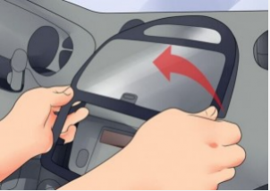
Operation sheet 3 Installing car Audio
Procedures:
1, Remove the original panel with a plastic knife, pry gently along the gap and pick up the panel, then remove it and then set it aside.
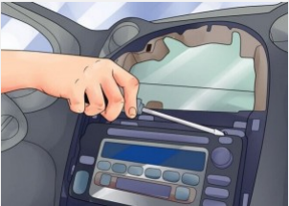

2, Remove screws that fixed the radio on the dashboard.
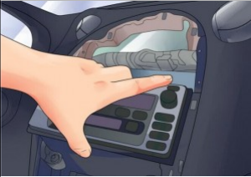

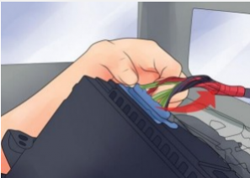
3, Pull the factory radio out of the dash. Pull it with medium force, as the wires are connected to the radio.

4, Unplug the connectors at the back of the factory radio.

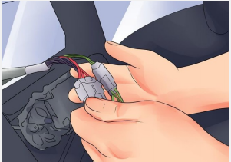
5, Make antennas and cables connected step by step, and you should be very careful when you are doing this for it will affect whole procedure.

6, Put the new radio into your car, you should check whether your connections are correct, and you’d better have a tidy for the cables.
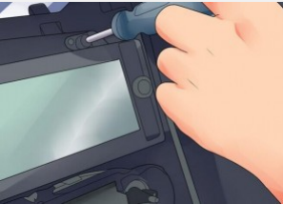
- If everything is OK, firm screws into their original place.

8. Firm the panel on the new radio. Finally the new radio is installed and a comprehensive test should be conducted on the new radio.
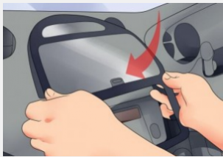

Lap test 3
Task 1 Install car audio

Reference

        - AUTOMOTIVE TECHNOLOGY A SYSTEMS APPROACH 5th Edition Jack Erjavec, © 2010 Delmar, Cengage Learning (website at www.cengage.com.)
        - Classroom Manual for Automotive Electricity and Electronics Fifth Edition Barry Hollem beak © 2011 Delmar, Cengage Learning
        - AUTOMOTIVE TECHNOLOGY Principles, Diagnosis, and Service FOURTH EDITION by James D. Haldeman, publishing as Pearson Education, in 2012
        - Automobile Mechanical and Electrical Systems First published 2011, Copyright © 2011 Tom Denton. Published by Elsevier Ltd. All rights reserved

Participants of this Module (training material) preparation
No | Name | Qualification (Level) | Field of Study | Organization/ Institution | Mobile number | E-mail
1 | Fadli Aman | BSc. B-Level | Automotive Technology | General Wingate PTC | 0927283100 | Fadli.ziyad@gmail.com
2 | Gashaw Zewde | MSc. A-Level | Automotive Technology | AKPTC | 0910730747 | Gashawgashaw69@gmail .com
3 | Muna Gabrie | MSc. A-Level | Automotive Technology | Dire PTC | 0910511196 | Munamulunhe@gmail.com
4 | Sisay Dawit | MSc. A-Level | Automotive Technology | Harar PTC | 0910672115 | Sisaydawit058@gmail.com
5 | Yohannes Negatie | MSc. A-Level | Automotive Technology | W/ro Siheen PTC | 0922094453 | Yohannes2013n@ gmail.com

